Contribution Accounts Delegated to the
Assistant Secretary for Intergovernmental and Interagency Affairs

Executive Summary 1

Audit Results 2

GAO Standard - #1 Control Environment 3

GAO Standard - #2 Risk Assessment 4

GAO Standard - #3 Control Activities 5

GAO Standard - #4 Information and Communication 11

GAO Standard - #5 Monitoring 13

Other Matters 14

Department Comments 15

Background 16

Objective, Scope, and Methodology 17

Appendix A – Department’s Comments 19

Executive Summary

The Department of Education Organization Act authorizes the Secretary of Education “to accept, hold, administer, and utilize gifts, bequests and devises of property, … for the purpose of aiding or facilitating the work of the Department.” In August 1994, the Assistant Secretary for the Office of Intergovernmental and Interagency Affairs (OIIA) received delegated authority from the Secretary of the U.S. Department of Education (Department) “to solicit, accept, hold, administer, and utilize … gifts that are earmarked for a specific event, such as a conference, meeting, or ceremony.” These gifts (donations) are accounted for in one of 20 accounts (also referred to as projects or limitations) within the Department’s Contribution Fund. For the delegated accounts, in fiscal years (FY) 2000 and 2001, the Department recorded the receipt of 54 donations totaling $1,046,800. On September 30, 2001, the unobligated balance in the accounts delegated to OIIA was $100,046.

Our objectives were to determine if (1) controls over the receipt and disbursement processes for the contribution accounts delegated to the Assistant Secretary for OIIA were adequate, and (2) controls over the accounting for the activity in those contribution accounts were adequate.

Based on our audit, we have determined that controls over (1) the receipt and disbursement processes and (2) the accounting for the activity in the contribution accounts delegated to the Assistant Secretary for OIIA are not adequate. The control system does not meet General Accounting Office’s (GAO) Standards for Internal Control in the Federal Government. As a result, the following occurred:

- A donation was not cleared by the Office of the General Counsel (OGC).
- Some expenses were unrelated to the purposes of the donations.
- Documentation was insufficient to determine specifically for what purpose two donations were spent.
- The unobligated balance for one account was understated by $4,011, or four times the recorded balance.

We recommend that the Assistant Secretary for OIIA provide written delegations of authority to staff, conduct a risk assessment, strengthen control activities, prepare financial reports, and develop a monitoring strategy. We also recommend that the Chief Financial Officer designate fund balance at Treasury at the account level in the proprietary accounts and reconcile the proprietary accounts and the budgetary accounts.

During our audit, we discussed the issues above and other control weaknesses we identified with OIIA. OIIA has initiated steps to address some of the control weaknesses.

During our audit, we noted another matter that warrants consideration by the Assistant Secretary for OIIA. The statute authorizing the Department to accept gifts does not specifically state that the Department has the authority to solicit. We recommend that the Assistant Secretary for OIIA request OGC to reexamine this issue in light of recent laws that specifically provide Federal Agencies with the authority to solicit.

OIIA generally concurred with our findings and recommendations. The full text of the OIIA’s response is included as Appendix A.

Audit Results

Based on our audit, we have determined that controls over the receipt and disbursement processes and the accounting for the activity in the contribution accounts delegated to the Assistant Secretary for OIIA are not adequate. We evaluated OIIA’s control system over the contribution accounts delegated to the Assistant Secretary for OIIA in effect during FYs 2000 and 2001. For the purpose of this report, we assessed and classified the management control structure for the receipts, disbursement, and accounting processes under the five standards from the GAO’s Standards for Internal Control in the Federal Government:

- Control environment – “Management and employees should establish and maintain an environment throughout the organization that sets a positive and supportive attitude toward internal control and conscientious management.”

- Risk assessment– “Internal Control should provide for an assessment of the risks the agency (OIIA) faces from both external and internal sources.”

- Control activities– “Internal control activities help ensure that management’s directives are carried out. The control activities should be effective and efficient in accomplishing the agency’s control objectives.”

- Information and communication– “Information should be recorded and communicated to management and others within the entity who need it and in a form and within a time frame that enables them to carry out their internal control and other responsibilities.”

- Monitoring– “Internal control monitoring should assess the quality of performance over time and ensure that the findings of audits and other reviews are promptly resolved.”

The Assistant Secretary for OIIA and the management of OIIA are responsible for establishing and maintaining a management control structure. In fulfilling this responsibility, estimates and judgments by management are required to assess the expected benefits and related costs of control procedures. The objectives of a control system are to provide management with reasonable, but not absolute, assurance that assets are safeguarded against loss from unauthorized use or disposition, and that the transactions are executed in accordance with management’s authorization and recorded properly, so as to permit effective and efficient operations.

Because of inherent limitations in any management control structure, errors or irregularities may occur and not be detected. Also, projection of any evaluation of the system to future periods is subject to the risk that procedures may become inadequate because of changes in conditions, or that the degree of compliance with the procedures may deteriorate.

Based on our assessment, we determined that the control system does not meet GAO’s Standards for Internal Control in the Federal Government. As a result, the following occurred:

- A donation was not cleared by the Office of the General Counsel (OGC).
- Some expenses were unrelated to the purposes of the donations.
- Documentation was insufficient to determine specifically for what purpose two donations were spent.
- The unobligated balance for one account was understated by $4,011, or four times the recorded balance.

Below we have grouped the conditions we found under the five internal control standards from GAO’s Standards for Internal Control in the Federal Government. During our audit, we discussed the conditions listed below with OIIA. OIIA has begun corrective actions to address some of the control weaknesses.

GAO Standard - #1 Control Environment

Delegations of authority did not comply with Department policy.

The Secretary’s delegation of authority permits the Assistant Secretary for OIIA to redelegate. Staff in OIIA informed us that the current and previous Assistant Secretaries for OIIA have verbally authorized managers and staff in OIIA to solicit and accept gifts.

The Departmental Directive on “Delegations of Authority” states:

The transfer of authority must be stated in writing and signed by the official authorized to delegate the authority.

The control environment over contribution accounts delegated to the Assistant Secretary for OIIA can be strengthened if authority and responsibility are clearly assigned and communicated.
GAO’s Standards for Internal Control in the Federal Government states:

Authorizations should be clearly communicated to managers and employees.

Written delegations would help ensure that authority and responsibility are clearly communicated.

Recommendation to Strengthen Control Environment

We recommend that the Assistant Secretary for OIIA:

1.1 Provide written delegations of authority to staff involved with the contribution accounts. Those delegations should indicate the scope of authority being delegated.

GAO Standard - #2 Risk Assessment

A risk assessment of the contribution accounts delegated to OIIA had not been done.

Prior to this audit, a risk assessment of the contribution accounts delegated to OIIA had not been done. As part of this audit, we discussed with staff from OIIA, OGC, Office of the Chief Financial Officer (OCFO), and Budget Service the objectives of the accounts, the risks inherent in the process, and the consequences and likelihood of those risks occurring. We also discussed what control activities had been established to provide reasonable assurance that objectives are met.

GAO’s Standards for Internal Control in the Federal Government states:

Management needs to comprehensively identify risks and should consider all significant interactions between the entity and other parties as well as internal factors at both the entity-wide and activity level.

A risk assessment can provide the basis to determine the nature and type of control activities needed. The lack of a risk assessment coupled with weak monitoring, discussed later in this report, contributed to other control weaknesses not addressed by not identifying risk and weaknesses in control activities.

Recommendations on Conducting a Risk Assessment

We recommend that the Assistant Secretary for OIIA:

2.1 Meet periodically with staff in the other offices involved with the contribution accounts to discuss the objectives, risks, and controls in the processes. Based on these discussions, update the risk assessment for the contribution accounts. As appropriate, modify existing controls or institute new controls to address risks identified.

  - Include a requirement for a periodic risk assessment as a part of the Assistant Secretary’s delegation of authority to OIIA staff involved with the contribution accounts.

GAO Standard - #3 Control Activities

For the contribution accounts, the Department and OIIA have established control activities over the receipt, disbursement, and accounting processes. In this section, we discuss control activities for each process separately.

Control Activities in the Receipt Process

The Department established a clearance process for the acceptance of donations to prevent conflict of interest. For donations to the contribution accounts delegated to the Assistant Secretary for OIIA, OGC reviews a list of potential sponsors prior to the sponsors being contacted to support a particular activity. The donations from the sponsors on that list are cleared by OGC only for that particular activity. Additional donations from those sponsors require a new clearance. The clearance process is documented in e-mail messages.

During our review, we identified a donation that was not cleared by OGC. We also found that the responsibility for receiving checks was not separate from the responsibility for soliciting donations and that documentation in OIIA’s central files was incomplete.

A donation was not cleared by OGC.

One of the 18 donations we selected to review was not cleared by OGC. Specifically, the Department received a donation in March 2001 from the Daimler Chrysler Corporation Fund for $25,000 for the School Recognition or Blue Ribbon project. Attached to that donation was an OGC clearance dated April 5, 2000, for Daimler Chrysler Corporation. This April 5, 2000, clearance was also attached to a $6,000 donation from Daimler Chrysler Corporation Fund in May 2000 for the “Building Partnerships for the New Century” event.

We contacted OGC to determine if there was another clearance for one of these two donations. OGC’s records confirmed the one clearance on April 5, 2000. OGC also indicated that the April 2000 clearance might not apply to a March 2001 donation because situations may change over time, making a previously acceptable donation unacceptable at a later date. Therefore, the clearance on April 5, 2000, appears to have been intended for the May 2000 donation and the March 2001 donation was not cleared.

The Secretary’s Delegation of Authority states:

The authority under this delegation to accept gifts, bequests, and devises of property, both real and personal, or unconditional gifts of services, may not be exercised without advance written concurrence by the Office of General Counsel.

Accepting donations without written concurrence by OGC could result in a conflict of interest.

The responsibility for receiving checks from sponsors was not separate from the responsibility for soliciting donations.

Staff in OIIA told us that sponsors were instructed to mail checks to the staff member who solicited the sponsor for the donation. When the check arrives, the staff member who solicited the donation prepared a memorandum to transmit the check to OCFO and gave the memorandum and the check to another staff member in OIIA. That person then took the check to OCFO.

GAO’s Standards for Internal Control in the Federal Government states:

Key duties and responsibilities need to be divided or segregated among different people to reduce the risk of error or fraud. This should include separating the responsibilities for authorizing transactions, processing and recording them, reviewing the transactions, and handling any related assets.

Soliciting donations and receiving the checks from the donors are key duties that should be divided among different people. To ensure that checks are received from the sponsor, the person receiving the checks would need to be diligent in monitoring the checks being received. In many cases, the timeframe between the identification of a need for funds and the need for the funds is short. Having a second person monitor for the receipt of the check and deposit that check with OCFO would strengthen overall control.

The documentation in OIIA’s central files on receipts was incomplete.

We also found that the documentation in OIIA’s central files on receipts was insufficient to demonstrate compliance with the Department’s policies on clearance, timely deposit with OCFO, and recording in the accounting records. Specifically,

- The documentation in the central file for two of the 18 receipts we selected to review did not include an OGC clearance. Ultimately, the clearances for these two donations were provided.
- The central file did not include documentation of the date the check was transferred to OCFO. Such documentation provides evidence that checks are deposited with OCFO in a timely manner.
- The central file did not include documentation on the purpose of the donation, such as a letter to or from the sponsor. Such a letter provides evidence that the donation was assigned to the correct project in the accounting records.

In addition, we noticed that the e-mail messages that document the OGC clearances were not always precise about what the clearance was for. For example, the April 5, 2000, clearance for Daimler Chrysler Corporation was for “Blue Ribbon and other stuff.” Since clearances are for each activity, the activity should be specifically stated in the e-mail messages.

GAO’s Standards for Internal Control in the Federal Government states:

Internal control and all transactions and other significant events need to be clearly documented, and the documentation should be readily available for examination.

The documentation in OIIA’s central files should be readily available to demonstrate compliance with Department policies and procedures. To address these issues, OIIA has already begun to include the letter to the sponsor in the central files for the receipts. The letter provides documentation of the donation’s purpose. The transmittal letter to OCFO now includes a list of the attachments: OGC’s clearance and the correspondence to or from the donor. Preparing such a list should promote better documentation.

Recommendations to Strengthen Control Activities over the Receipt Process:

We recommend that the Assistant Secretary for OIIA:

3.1 Instruct staff to clearly identify the activity to receive the donation when requesting clearances from OGC.
3.2 Separate the responsibilities for the solicitation of funds from the receipt of checks. The person responsible for receiving the checks would also be responsible for ensuring that all the checks are received.

We recommend the General Counsel:

3.3 Instruct staff to clearly identify the activity to receive the donation when responding to requests for clearances and be more specific on what entities are being cleared.

Control Activities in the Disbursement Process

OIIA developed Request Forms for purchase orders, third party drafts, and purchase cards to document approvals and the purposes for the expense. These forms provide for the approval of expenses by the team leader, executive officer, and chief of staff. During our review, we identified some expenses that were unrelated to the purposes of the donations. We also found that for some expenses supporting documents were incomplete and evidence of approval was missing.

Some expenses were unrelated to the purposes of the donation.

Expenses should be assigned to accounts based on the purpose of the donation. We identified expenses that were unrelated to the account to which the expense was charged. For example, the following expenses paid from the Higher Education Meetings Account lacked supporting documentation linking the expense to that account:

- Luncheon at the National Press Club for 15 guests - $476
- Performance at the U.S. Brazil Conference - $500
- Luncheon for the Hero's award program - $2,000
- A working dinner related to the Memorandum of Understanding (MOU) with Northern Ireland - $388

The total expenses in this account were $32,179. The remaining expenses in this account were spent for a Summit on Teacher Quality.

In another example, in December 1999, the Department paid $21,570 for 55,000 bags to be handed out during “America Goes Back to School” events. Part of the cost, $5,306, was charged to the Education Technology Conference project because there were not sufficient funds in the America Goes Back to School project. As of September 30, 2001, the $5,306 had not been returned to the Education Technology Conference project nor was there sufficient balance in the America Goes Back to School project to return the funds.

In most cases, a donor specifies the use for a donation, sometimes broadly and sometimes narrowly. As with all funding, donated funds provided to the Department for a particular purpose should be used for that purpose. When donated funds are used for other purposes not specifically authorized by the donor, the Department’s integrity may be negatively affected.

Supporting documentation for some expenses was incomplete.

The documentation in the central files on some expenses was insufficient to demonstrate readily the appropriateness of the expense. Documentation should provide information on what the expense was for, how much the expense was, and how the expense relates to the account it is charged against.

We found that some payments from contribution accounts were for charges on a credit card used for office travel. The supporting documents for these payments in the central files were the first pages of the credit card statements. There was no explanation of the charges paid by the contribution accounts.
We also found that the supporting documents for an expense of $150 included only the request forms. There was no invoice attached. In another example, the request form indicated an expense of $500 while the actual expense was $600. There was no indication that the additional $100 expended was authorized. The explanation on the request form for another expense of $140 was “food for special lunch.” There was no documentation on how this lunch related to the project that paid for it.

GAO’s Standards for Internal Control in the Federal Government states:

Internal control and all transactions and other significant events need to be clearly documented, and the documentation should be readily available for examination.

Evidence of approval of some expenses was missing.

We reviewed the Request Forms and other supporting documents to determine that the executive officer and at least one other person, for example, a team leader, approved each expense. We randomly selected 30 expenses for each of FY 2000 and 2001 for review.

- For FY 2000, eight expenses in the sample of 30 (or 26 percent) did not have all the signatures for approval.
- For FY 2001, seven expenses in the sample of 30 (or 23 percent) did not have all the signatures for approval.

In some cases, the Request Form, which contains a space for approvals, was not included in the supporting documents. In other cases, the spaces for approval on the Request Form were blank. The executive officer indicated that his review was to determine availability of funds and allowability in accordance with government regulations. His review did not include determining if the expense related to the purpose of the donation. By reviewing the expenses, management helps ensure that the expense is appropriate.

Recommendations to Strengthen Control Activities over the Disbursement Process:

We recommend that the Assistant Secretary for OIIA:

3.4 Define responsibilities in the approval process to ensure that someone is specifically charged with determining that the expense relates to the purpose of the donation.
3.5 Require that OIIA’s Request Forms be filled out completely.

Control Activities in the Accounting Process

The Department established accounts or projects within the Contribution Fund to provide accounting and funds control over the donations. Accounting control is provided by the donation and the expenses paid with that donation being recorded in the same account. During our review, we found that the unobligated balance for one account was understated by $4,011, and that donations assigned to the Receptions Account were not subject to specific, individual, donation-by-donation accounting or fund control, although the account itself was subject to the same accounting or fund control as every other account.

The unobligated balance for one account was understated by $4,011, or four times the recorded balance.

Our review showed that the unobligated balance for one account was understated. Specifically, at September 30, 2001, the unobligated or available balance for the Hispanic American Initiative was $651. This balance did not include a refund of $3,015 that was received in August 2000. OIIA had the refund deposited in a timely manner, but it did not deobligate the funds from the purchase order in a timely manner. In addition, OIIA should have deobligated $996 when the final bill was paid in April 2000 for less than the amount obligated.

Donations assigned to the Receptions Account were not subject to specific, individual, donation-by-donation accounting or fund control.

OIIA used 20 separate accounts to record the receipts and expenses. Nineteen of the 20 accounts were for specific activities and contain only a few donations. For donations recorded in these 19 accounts, OIIA could determine what expenses were paid with the donations.

The remaining account, the Receptions Account, was used for several activities. In FYs 2000 and 2001, 24 different donations were recorded in the Receptions Account. According to staff in Budget Service, the Receptions Account was established because setting up a project in the accounting system for every donation would place a heavy burden on the system. We determined that the information in the accounting system was not sufficient to determine what expenses were paid for each specific donation because all the donations are commingled. However, we were able to identify expenses for the Receptions Account as a whole.

We selected two donations recorded in the Receptions Account and requested OIIA to identify the expenses paid for by each donation. We found that:

- For a July 2001 donation of $40,000 to support the Principal Leadership Summit, OIIA identified expenses of $32,432 or 80 percent of the donation.
- For a June 2000 donation of $50,000 to support the Early Childhood Summit, OIIA identified expenses of $29,242 or 60 percent of the donation.

Since the September30, 2001, unobligated balance, in the Receptions Account was $1,028, the remainder of both donations has been spent. However, because so many donations were recorded in the Receptions Account, the specific expenses that were paid for with the remainder of these two donations cannot be identified.

GAO’s Internal Control Management and Evaluation Tool states:

Transactions and events are appropriately classified and promptly recorded so that they maintain their relevance, value, and usefulness to management in controlling operations and making decisions.

Not tracking donations in the Receptions Account limits OIIA’s ability to account for the use of funds back to the donor. Since the number of accounts OIIA can use to track donations is limited by practicality, the accounts need to be set up efficiently. Five of the 20 accounts had a zero balance as of September 30, 1999, and received no donations in FY 2000 or 2001.

Recommendations to Strengthen Control Activities over Accounting:

We recommend that the Assistant Secretary for OIIA:

3.6 Reassess the separate accounts currently being used to identify those accounts that can be closed.
3.7 Track funds in the Receptions Account to ensure that they are spent for the purpose intended.
3.8 Develop and implement a mechanism for communicating to donors how unspent funds will be handled.

GAO Standard - #4 Information and Communication

Our review found that there were no management reports on receipts and expenses or written policies and procedures for the contribution accounts delegated to the Assistant Secretary for OIIA.

There were no management reports on the receipts and expenses of the contribution accounts delegated to the Assistant Secretary for OIIA.

Our review disclosed no management reports have been generated on receipts and expenses of the contribution accounts delegated to the Assistant Secretary for OIIA. OIIA staff provided to OIIA management a report on unobligated balances. The report listed the 20 accounts and the unobligated balance for each from the accounting system.

In addition, no year-end management reports on receipts and expenses were prepared. Not having these reports made it difficult for the Department to respond efficiently to requests for information by external parties. For example, to respond to a GAO request on donations received, the Department relied upon a worksheet maintained by the Budget Analyst instead of the official accounting records.

GAO’s Standards for Internal Control in the Federal Government states:

Financial information is needed for both external and internal uses. It is required to develop financial statements for periodic external reporting, and on a day-to-day basis, to make operating decisions, monitor performance, and allocate resources.

OIIA management should have periodic reports on the donations received and how those donations were spent. The Secretary should also receive periodic reports on the contribution accounts. During our audit, OIIA staff began preparing a management report on the contribution accounts.

There were no complete, current, written policies and procedures for the contribution accounts.

Our review found that while there were some written policies and procedures for some activities related to the contribution accounts, there were no written policies and procedures for other activities. OCFO had written policies for the deposit of funds and for the reconciliation of the proprietary accounts to Treasury. OGC provided guidance on ethics issues related to the accounts. The Secretary’s delegation includes the requirement for clearance by OGC. The policy of clearance for each activity was not in writing. There were no other written policies and procedures for the process. For example, there were no written policies on what documents should be maintained in OIIA’s central files.

GAO’s Standards for Internal Control in the Federal Government states:

Internal control and all transactions and other significant events need to be clearly documented, and the documentation should be readily available for examination. The documentation should appear in management directives, administrative policies, or operating manuals and may be in paper or electronic form.

The lack of written policies and procedures hindered efficient control and management. During our review, we noted weaknesses that may have been prevented had applicable policies and procedures been communicated. Written policies and procedures also make it easier for someone else to fill in when the assigned person is absent. At the request of the Secretary of the Department, OGC is preparing written policies and procedures for all the Department’s contribution accounts.

Recommendations to Strengthen Information and Communication

We recommend that the Assistant Secretary for OIIA:

4.1 Prepare a year-end report on the accounts delegated to the Assistant Secretary for OIIA, obtain concurrence from OCFO and Budget Service, and submit the report to the Secretary of the Department.
4.2 Prepare and review periodic financial reports on donations received and expenses paid.
  - Once completed, review the Department’s policies and procedures with OIIA staff involved with the process to ensure that everyone understands their role and responsibilities in the process.

GAO Standard - #5 Monitoring

Our review found that the Proprietary Accounts were not reconciled to the Budget Accounts and that deposits of checks may not have been made timely with OCFO.

Proprietary Accounts were not reconciled to the Budgetary Accounts.

Even though the Contribution Fund does not include appropriated funds, the budget process of allotments and setting up obligations is still followed. The total of the available balance (money received but not obligated) plus the obligated balance (obligated but not paid) should reconcile to the fund balance at Treasury.

The Proprietary Accounts were not reconciled to the Budgetary Accounts. At September 30, 2001, the available balance on the Year End Closing Statement for the entire contribution fund was $115,581 and the obligated/unexpended balance was $41,024. Fund balance at Treasury was $265,418. We were unable to reconcile the difference between available balance plus obligated balance and the fund balance at Treasury of $108,813. We identified part of the difference as a $3,015 refund that was included in fund balance at Treasury but not in the budgetary accounts.

GAO’s Standards for Internal Control in the Federal Government states:

It [monitoring] includes regular management and supervisory activities, comparisons, reconcilations, and other actions people take in performing their duties.

Reconciling the proprietary accounts to the budgetary accounts at the account level would provide some assurance that transactions are properly recorded. The first step in reconciling would be assigning the balance from 1996 and some accounting adjustments to specific projects. Receipt and disbursements have been designated at the account level in the proprietary accounts but the balance from 1996 and adjustments have not been designated at the account level.

Deposits do not appear to have been made timely.

We reviewed the timeliness of deposits. The number of days between the date on OIIA memorandums indicating receipt of the check from a sponsor and the date on the deposit ticket (Standard Form 215) indicating when OCFO deposited the check exceeded two days for seven of eighteen donations we reviewed. The number of days for deposit ranged from three to twenty-two days. We selected the 18 donations at random from the 54 receipts recorded in FYs 2000 and 2001. We used the deposit tickets to determine the date OCFO took custody of the check because OIIA did not have documentation on when the checks were delivered to OCFO.

Recommendations to Strengthen Monitoring:

We recommend that the Assistant Secretary for OIIA:

  - Develop a monitoring strategy to ensure that policies and procedures, including timely deposit with OCFO, are being followed.

We recommend the Chief Financial Officer:

5.2 Designate fund balance at the account level in the proprietary accounts.
5.3 Reconcile the proprietary accounts and the budgetary accounts.

Other Matters

The Department’s Gift Authority

The Department's gift authority was established by section 421 of the Department of Education Organization Act that created the Department. This statute does not specifically state that the Department has the authority to solicit for gifts. OGC provided us with a 1991 memorandum addressing the gift acceptance authority of the Institute of Museum Services. In that memorandum, OGC concluded that the Department’s gift authority included solicitation, as there has been no general prohibition against the solicitation of donations, when the agency has authority to accept donations.

That memorandum relied on a 1977 memorandum opinion from the Office of Legal Counsel of the Department of Justice (Justice), which noted that only one federal statute dealt with the solicitation of gifts by federal employees. The OGC memorandum concluded that the Institute of Museum Services could, as part of its gift acceptance authority, solicit gifts as long as, among other things, it was not part of a formal, broad scale program and staff avoided excessive involvement in solicitation. Since Justice’s 1977 opinion, Congress has specifically included authority to “seek”, “encourage” or “solicit” gifts in various gift acceptance statutes. In one instance, Congress amended a gift acceptance statute to specifically include solicitation authority.

We recommend that the Assistant Secretary for OIIA request OGC to reexamine whether the Department’s gift acceptance statute is sufficient to authorize the solicitation of gifts on the scale conducted by OIIA and seek additional legislative authority if necessary.

Reimbursement Unrelated to the Contribution Accounts

During our review of expenditures, we identified a $42.90 reimbursement to an OIIA employee in February 2001 that was unrelated to the contribution accounts.

We recommend that the Assistant Secretary for OIIA request repayment of this reimbursement from the employee.

Department Comments

In general, OIIA concurred with the findings and recommendations in the report and has begun corrective action. The full text of OIIA’s response is included as Appendix A.

OIG had recommended that the requirement for periodic risk assessment be included in the delegation of authority for OIIA staff involved with the contribution accounts (Recommendation 2.2). Instead, OIIA proposed to include a procedure for a periodic risk assessment in the new policies and procedures manual. In our opinion, including a procedure for periodic risk assessment in the policies and procedure manual is a reasonable alternative to the recommendation.

OIIA notes that while developing the new Delegation of Authority, OGC reviewed the issue of solicitation and has determined that the Department’s gift acceptance statute is sufficient. We were referred to a Justice directive that authorized solicitation under Justice's gift acceptance statute, which like the Department's did not include "solicit" in the statutory language. Solicitation, however, is severely restricted under the Justice directive; every proposed solicitation must be personally approved in advance by the Attorney General or the Deputy Attorney General. Since OIIA's delegation from the Secretary does not have similar controls we continue to believe that OIIA would benefit from additional review of this issue to ensure that the Department's solicitation program is fully authorized by the Department's gift acceptance statute.

Background

The Department's gift authority was established by section 421 of the Department of Education Organization Act that created the Department. This statute states:

The Secretary is authorized to accept, hold, administer, and utilize gifts, bequests, and devises of property, both real and personal, and to accept donations of services, for the purpose of aiding and facilitating the work of the Department. Gifts, bequests, and devises of money and proceeds from sales of other property received as gifts, bequests, or devises shall be deposited in the Treasury and shall be available for disbursement upon the order of the Secretary.

The Department has interpreted this statute to include the authority to solicit funds. In August 1994, the Assistant Secretary for OIIA was delegated by the Secretary of the Department of Education “to solicit, accept, hold, administer, and utilize … gifts that are earmarked for a specific event, such as a conference, meeting, or ceremony.” On September 5, 2002, the Secretary signed a delegation of authority for the Assistant Secretary for OIIA.

The gifts are accounted for in the “Contribution, Department of Education – 91X8258” fund. Within this fund, the Department establishes projects or limitations to account for the various gifts. In this report, these projects or limitations are referred to as “accounts.” The 20 accounts listed below have been delegated to the Assistant Secretary for OIIA:

Nine accounts received donations in FYs 2000 or 2001:
- Receptions
- Presidential Scholars Program
- Hispanic American Initiative
- Satellite Town Meetings
- Professional Development Awards
- School Recognition or Blue Ribbon
- Family Involvement
- Education Technology Conference
- Historically Black Colleges and Universities

Five accounts did not received donations in FYs 2000 or 2001 but had expenses:
- U.S. Mexico Conference
- Higher Education Meetings
- School Design Conference
- Regional Conference
- America Goes Back to School

One account, OSERS/OECD Conference, had a balance of $132 as of September 30, 2001, but no recorded activity during FYs 2000 or 2001.

Five accounts had no balance as of September 30, 1999, and no recorded activity during FYs 2000 and 2001:
- Presidential Education Awards
- High School Reform
- National Education Goals
- Professional Development
- Cooperative Publishing

Except for the Receptions Account, the other 19 accounts were set up for specific activities. In FY 2000 and 2001 for the accounts delegated to OIIA, the Department recorded 54 donations, totaling $1,046,800. On September 30, 2001, the available balance in the accounts delegated to OIIA was $100,046.

Objective, Scope, and Methodology

Our objectives were to determine if (1) controls over the receipt and disbursement processes for the contribution accounts delegated to the Assistant Secretary for OIIA were adequate, and (2) controls over the accounting for the activity in the contribution accounts were adequate.

To accomplish our audit objective, we reviewed applicable federal laws and regulations, Department policy guidance, and program information available in reports and on the Internet. We interviewed staff in OIIA, OCFO, OGC, and Budget Service. During those interviews, we discussed the processes for receipts and disbursements, and the accounting for the contribution accounts. We tested controls over receipts and disbursements from FYs 2000 and 2001.

To test controls over receipts, for FYs 2000 and 2001, we selected 18 donations at random from the 54 donations recorded in FYs 2000 and 2001. To assure that we had a complete list of receipts, we reconciled the receipts listed in a worksheet maintained in Budget Service with the deposit account of fund balance at Treasury. We obtained the electronic file of the deposit account of fund balance at Treasury from OCFO. Our sample has a plus or minus 19 percent accuracy with 95 percent confidence.

To test controls over expenses, we selected 30 expenses at random from each fiscal year. We selected our sample from the items recorded by fiscal year in the payment account of fund balance at Treasury. For FY 2000, 227 items were recorded. For FY 2001, 156 items were recorded. Our sample was biased towards expenses in excess of $10,000 that were paid for with Third Party Drafts. Third Party Drafts were limited to $10,000. Expenses in excess of $10,000 paid with the drafts appear as more than one item in the payment account. An expense paid for this way has a greater likelihood of being included in the sample. This bias does not affect our objective of determining if controls were being followed.

To test the accounting control, we reviewed all the transactions in three projects: Historically Black Colleges and Universities, Higher Education Meetings, and School Design Conference. We selected these projects because the budgetary and proprietary data were reconciled providing some assurance that all transactions related to these projects were identified. We also reviewed all the expenses OIIA identified as related to the two donations accounted for in the Receptions Account. We judgmentally selected these two donations to review.

We performed on-site fieldwork at the offices of the OIIA, OCFO, and Budget Service located in Washington, DC, during the time period October 2001 and March 2002. We held an exit conference on April 24, 2002, with the Assistant Secretary for OIIA and staff from OIIA, OGC, and OCFO. We conducted the audit in accordance with government auditing standards appropriate to the scope of review described above.

Appendix A – Department’s Comments

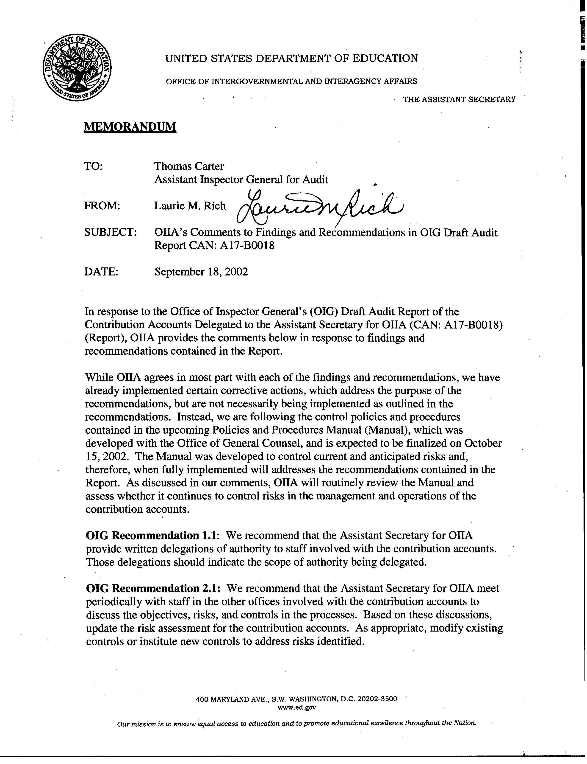

Appendix A – Department’s Comments (Continued)

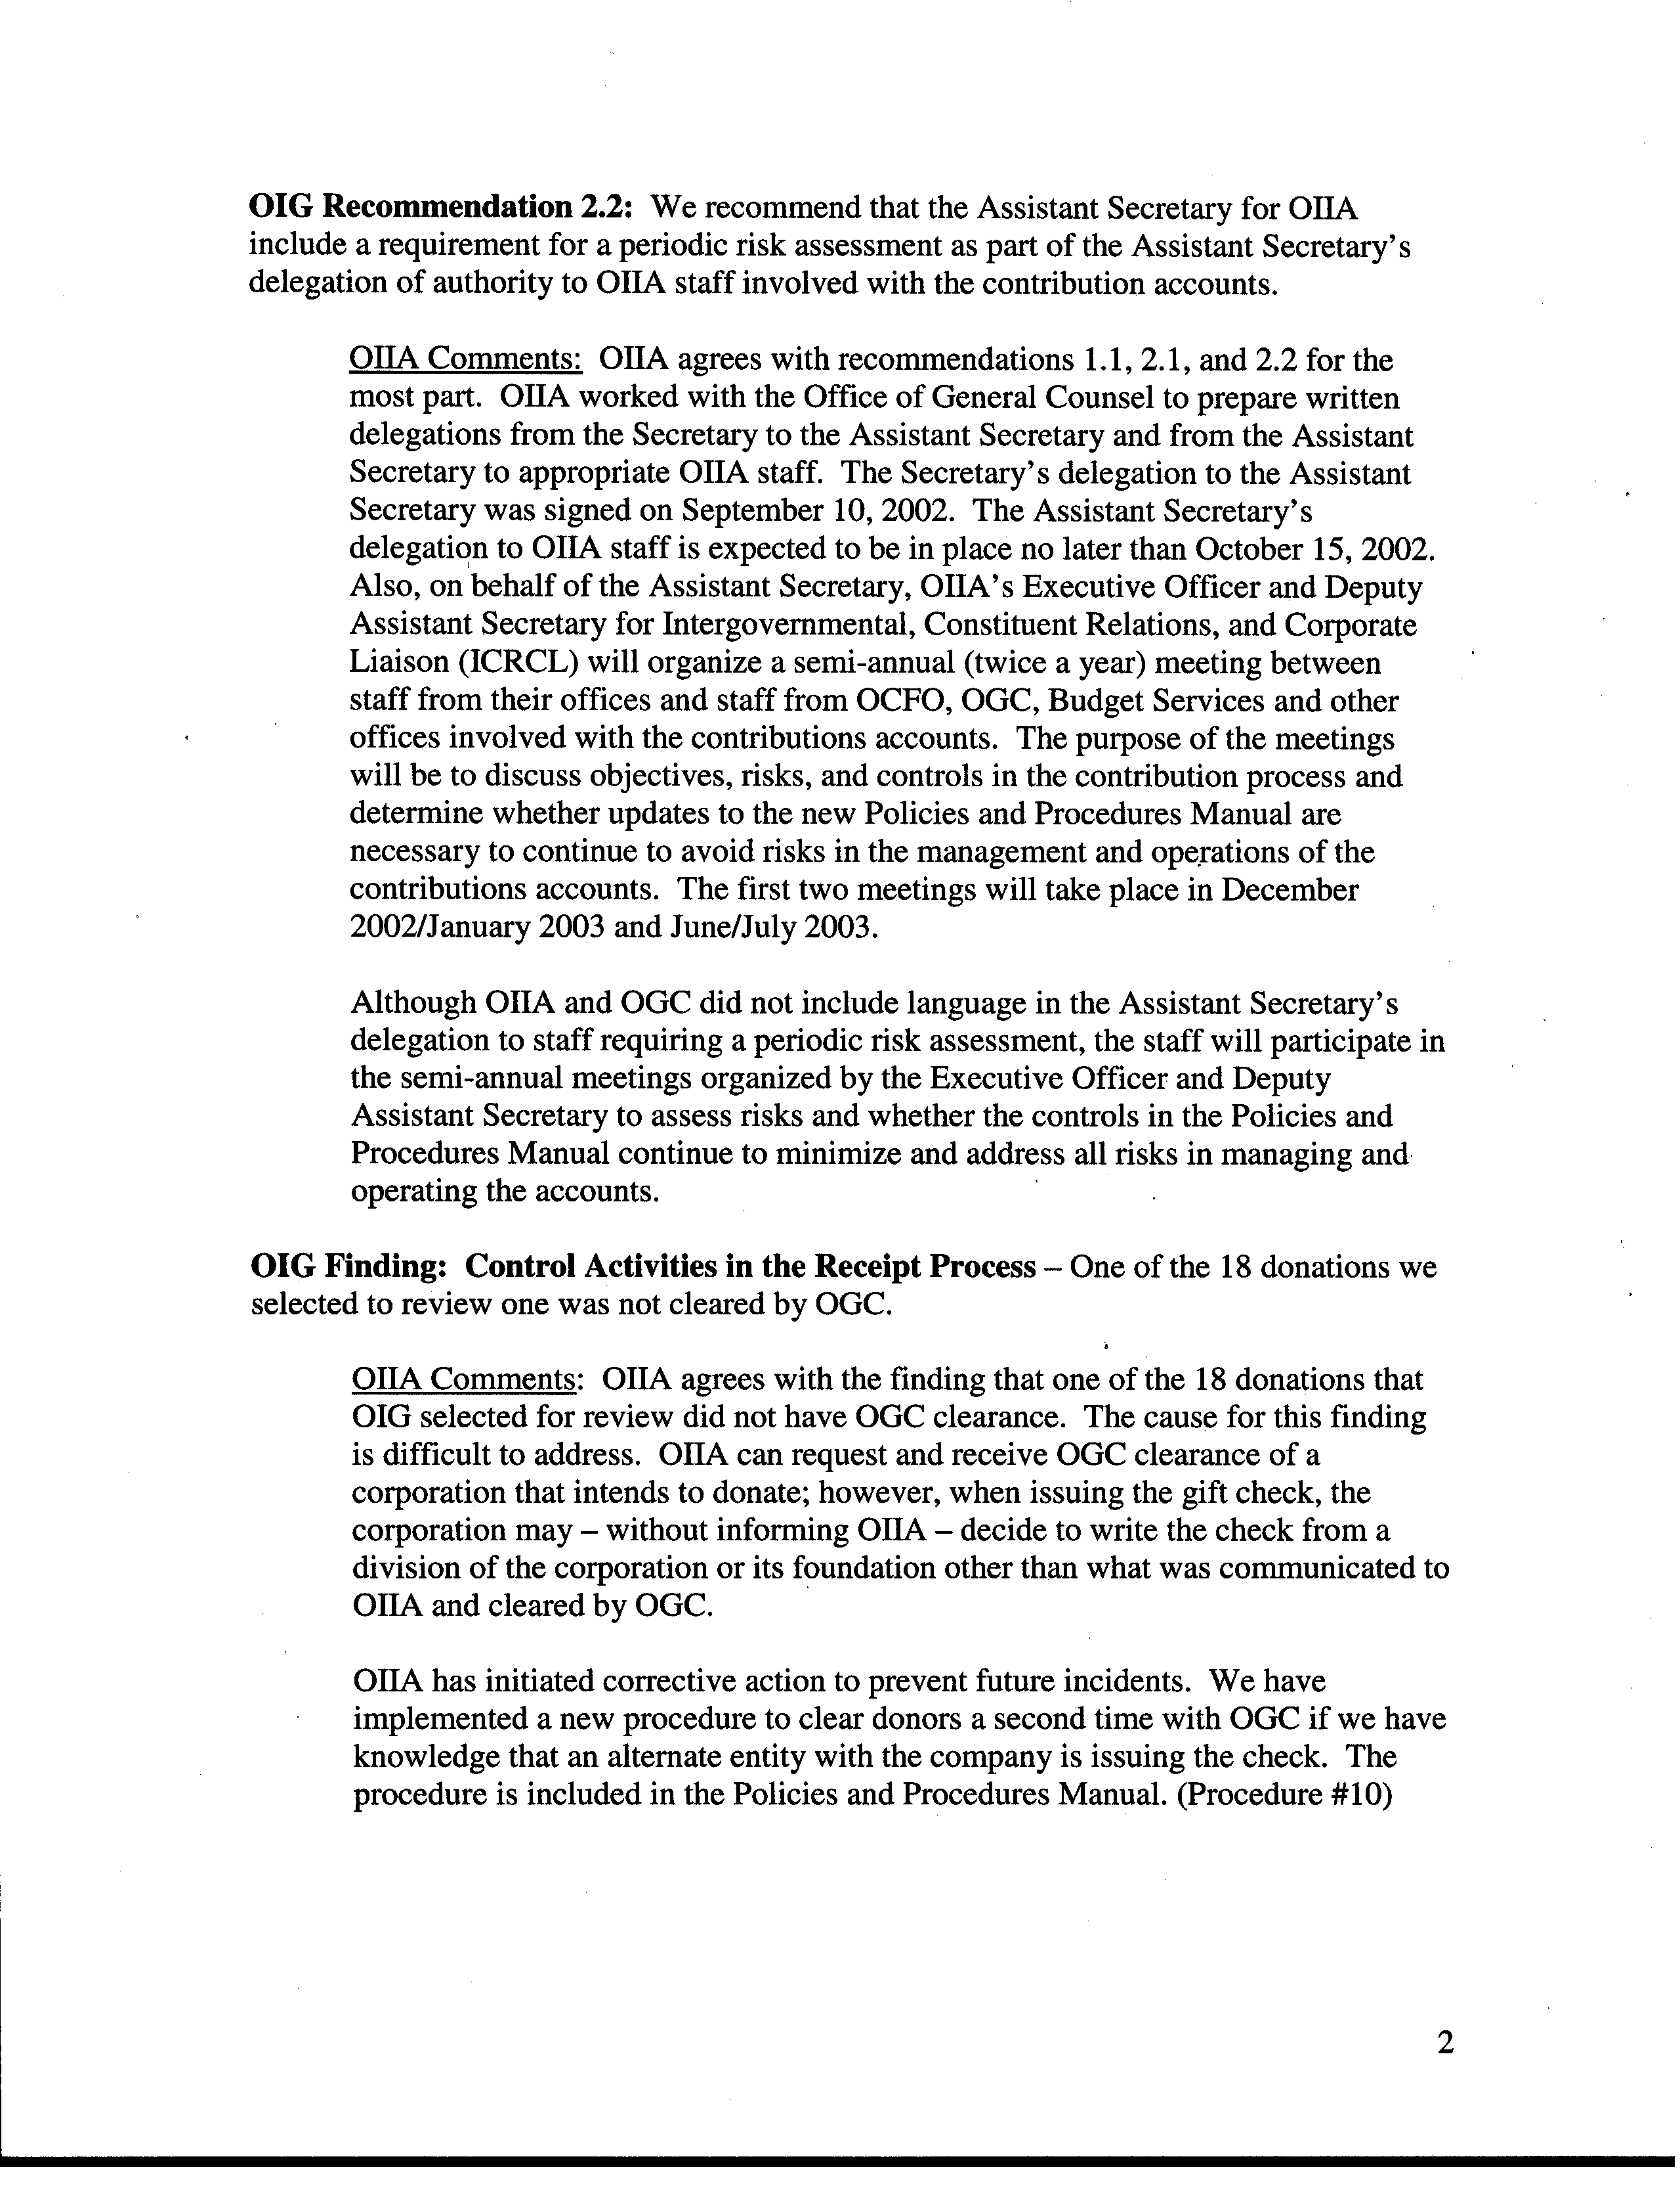

Appendix A – Department’s Comments (Continued)

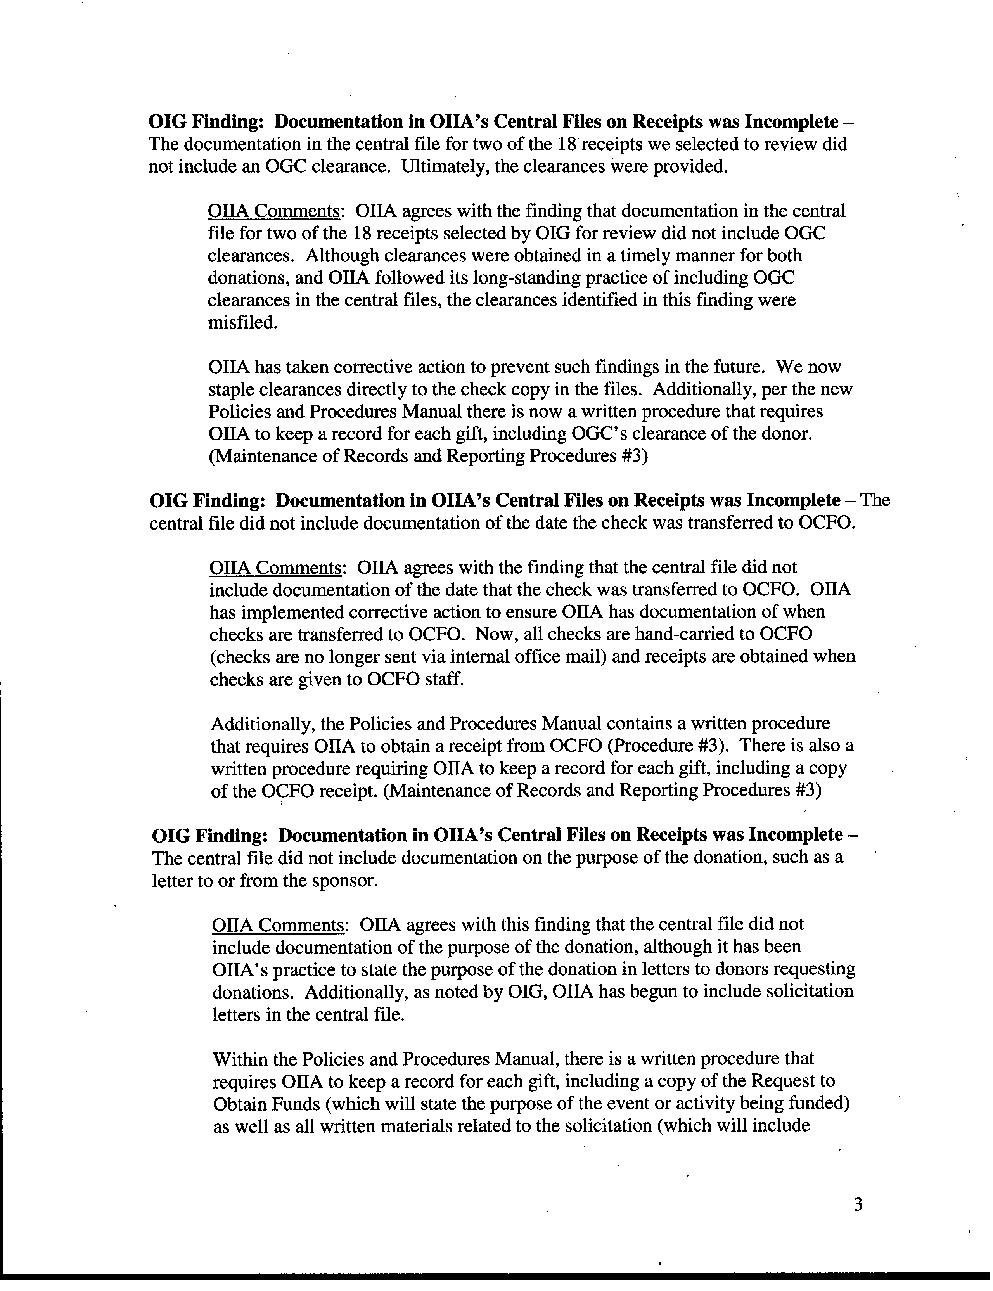

Appendix A – Department’s Comments (Continued)

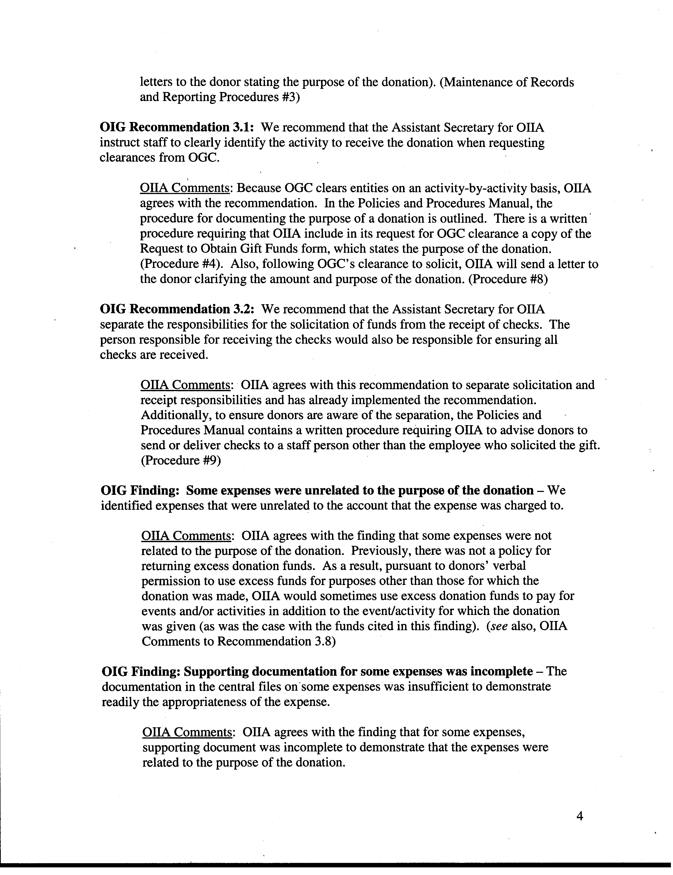

Appendix A – Department’s Comments (Continued)

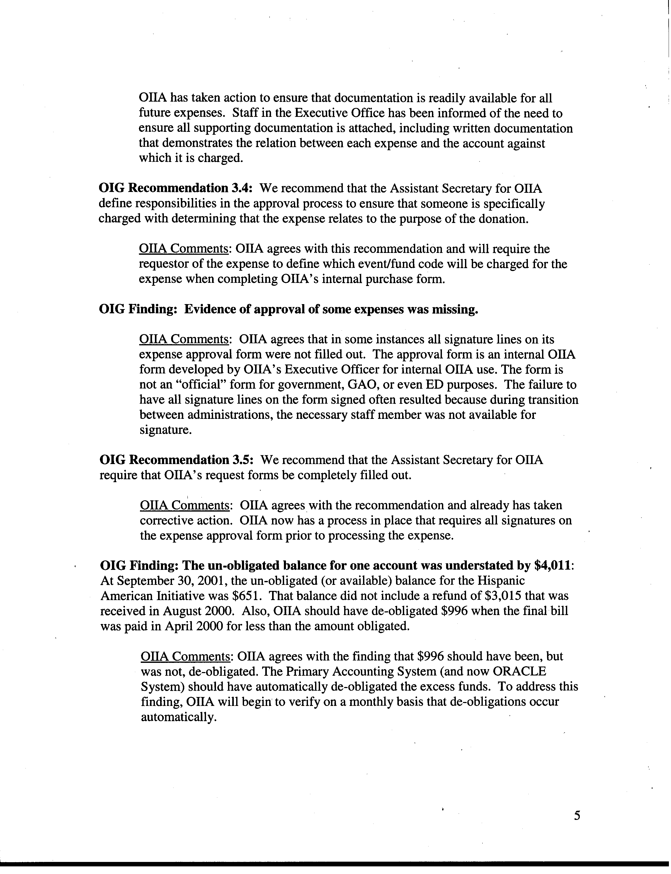

Appendix A – Department’s Comments (Continued)

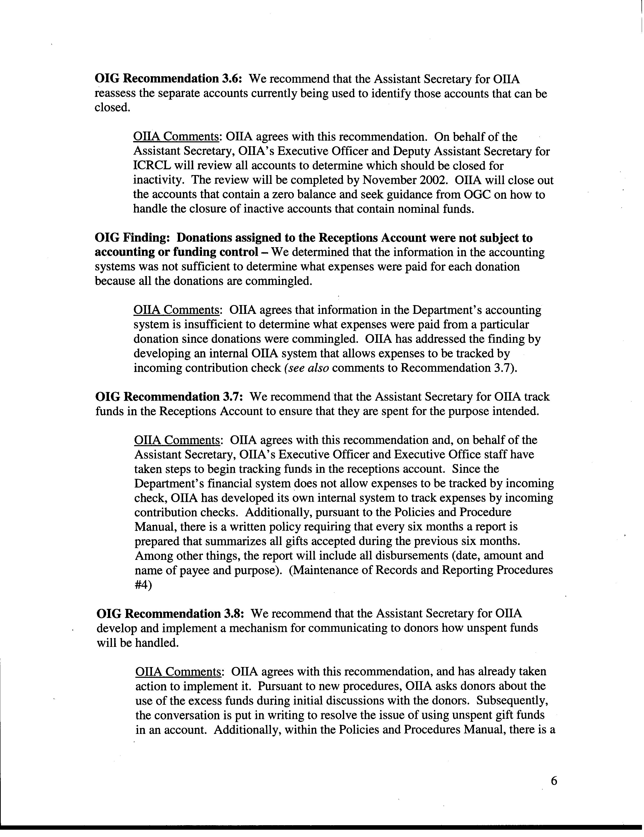

Appendix A – Department’s Comments (Continued)
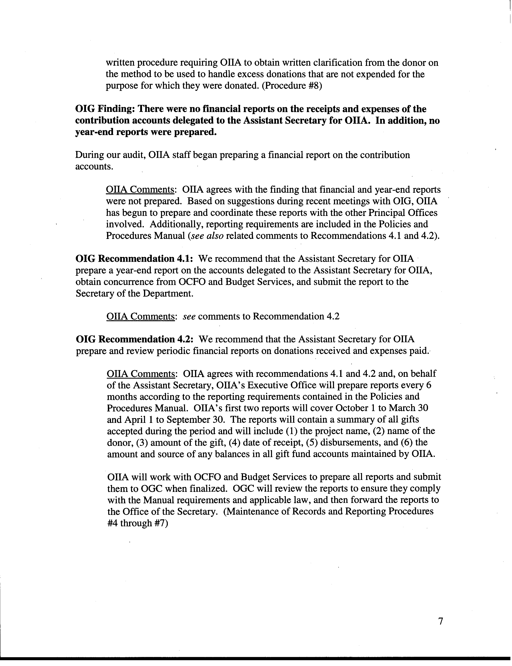

Appendix A – Department’s Comments (Continued)
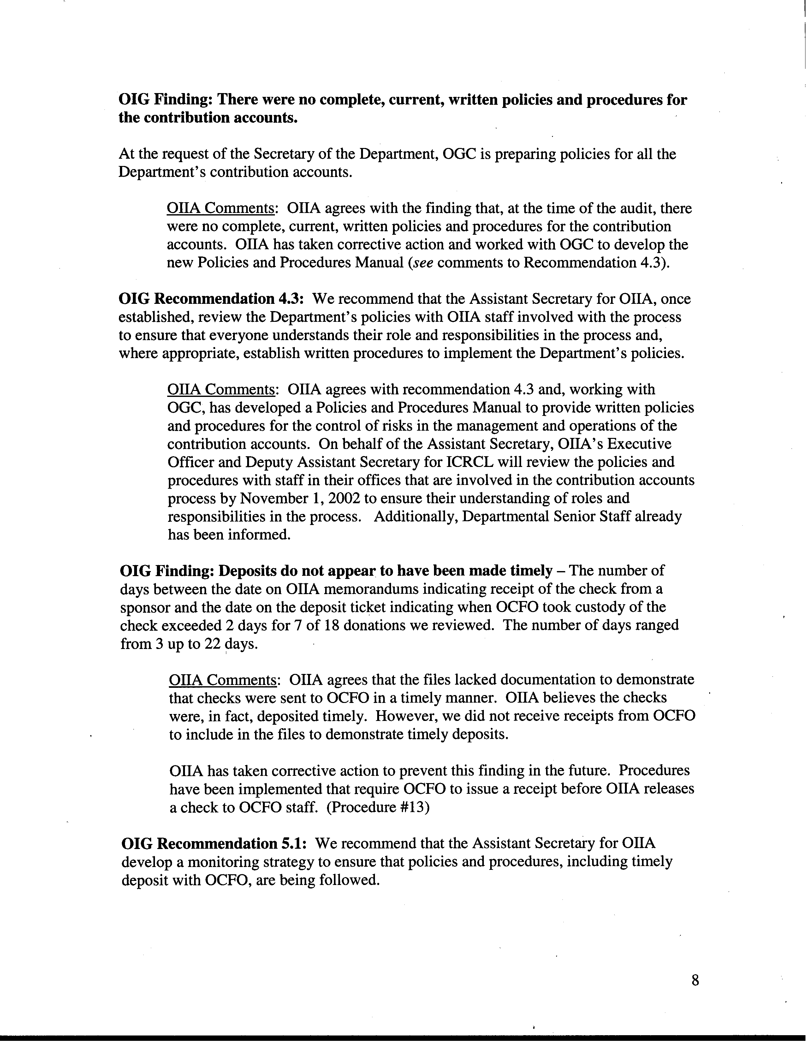

Appendix A – Department’s Comments (Continued)
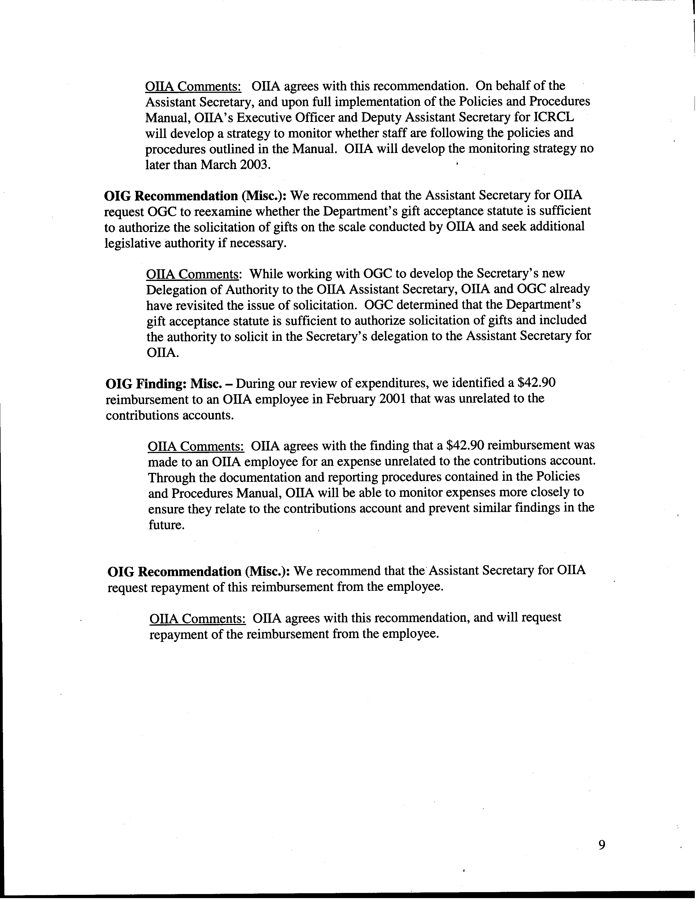

(GAO/AIMD-00-21.3.1, November 1999)
(GAO-01-1008G, August 2001)
Federal accounting involves proprietary and budgetary accounting. Proprietary accounting accounts for assets, liabilities, and capital. Budgetary accounting tracks the status of budget authorities.
(Pub. L. 96-88; 93 Stat. 687; 20 U.S.C. 3481)

