United States Department of Agriculture


Indiana - March 2007 (ver. 1.0)

CRP Mid-Contract

Management:

Prescribed Burning
Conservation Program Job Sheet

Conservation Reserve Program (CRP) policy requires newly enrolled participants, starting with Signup 26, to do some type of “disturbance” to certain CRP practices during the life of the contract to benefit wildlife. This job sheet describes that guidance in more detail.
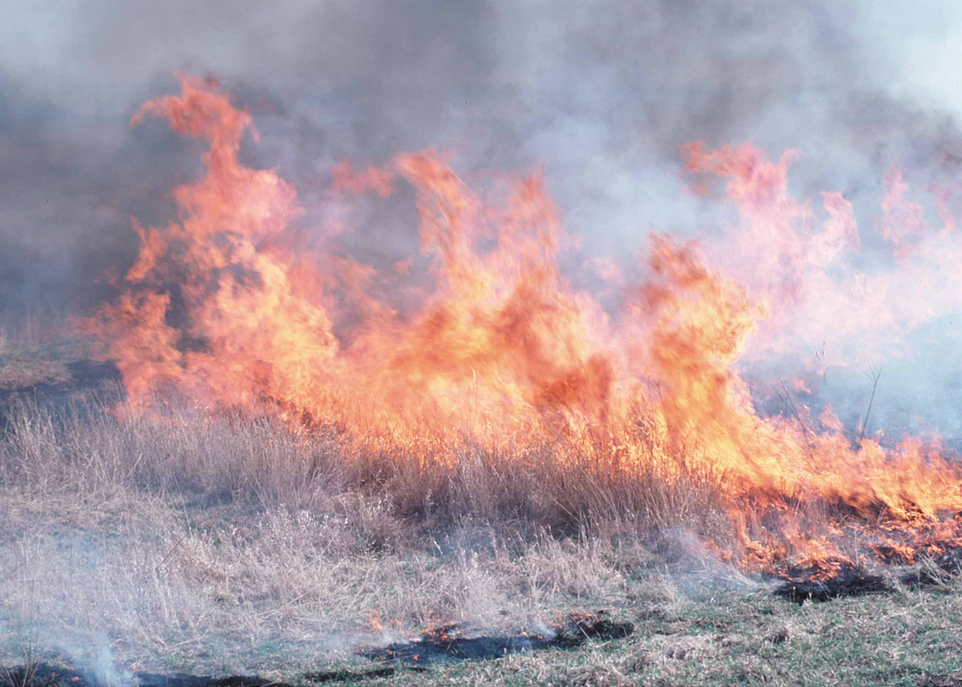
Bob Dayton, USDA-NRCS
Normally, mid-contract management activities are conducted between the 4th and 7th year of the contract. However, on land with existing cover, disturbance activities can begin as soon as technically feasible.
PRESCRIBED BURNING
Once established, grassland fields need to be managed so that the grasses do not crowd out the forbs and/or legumes over time. In the absence of disturbance, the composition of grassland communities will change over several years through normal plant succession. The vegetative structure changes as annual forbs and legumes are replaced by perennial forbs, grasses, and eventually, woody plants. Changes also occur structurally, as bare ground declines, litter accumulates, and vegetation density increases. These changes lead to a decline in wildlife benefits.
The purpose of mid-contract management activities is to enhance the wildlife habitat value of the enrolled acres by increasing the amount of bare soil and by encouraging a diverse forb/legume community. Forbs (any broadleaf plant) and legumes in grasslands are beneficial to birds, insects such as butterflies, along with other wildlife. Prescribed Burning is an effective management tool that can be utilized where the grassland community has become too thick to benefit the target species.
Fire, if properly applied, can improve grassland habitats by:
- Creating open ground for wildlife movement by reducing excess plant litter,
- Allowing sunlight to reach the soil surface, encouraging the germination and growth of forbs and legumes,
- Suppressing woody plants, and
- Retarding the growth of nonnative plants.
In addition, Prescribed Burning removes naturally occurring wildfire hazards, enhances the aesthetic appearance of natural landscapes, and keeps maintenance costs low.
The structural diversity that results from this type of management is especially helpful for maintaining brood-rearing habitat for bobwhite quail, wild turkey, ring-necked pheasant and other early successional grassland wildlife species. Prescribed Burning also improves habitat for a variety of grassland songbirds, including dickcissels, bobolinks and savannah sparrows. Many of these grassland songbird species have experienced population declines over the last several decades. The habitat quality is enhanced because fire inhibits woody growth, promotes favored seed producing plants, reduces plant residue, increases bare ground, and increases insect abundance. The insects associated with annual weed communities provide critical nutrients, including protein, and essential amino acids for growing nestlings and chicks.

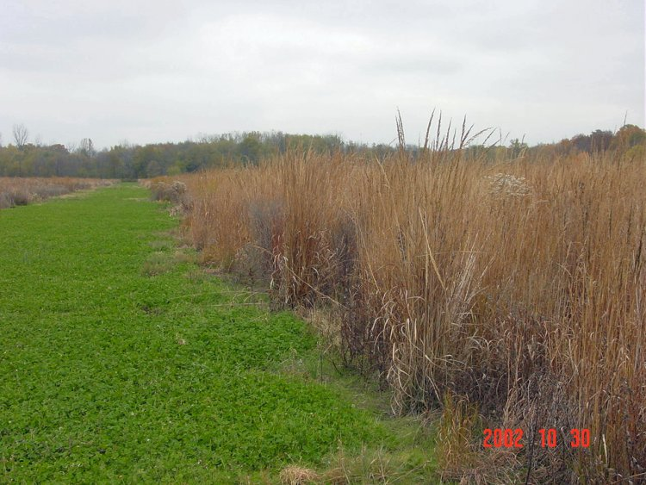
SPECIFICATIONS
The following are specifications for Prescribed Burning on CRP acreage. Note that this practice can be used in conjunction with the mid-contract management technique Inter-seeding.
- The landowner is responsible for securing a written burn plan developed by a qualified individual.
- A written prescribed burn plan must be completed before any fires are started. The burn plan will identify suitable weather conditions, needed personnel and equipment, adjacent and in-field hazards, and the safest firing method, in addition to the time of year to conduct the burn for the best management results.
- The landowner is responsible for adhering to the burn plan, as well as all applicable local, state and federal laws. Landowners are responsible for confining prescribed burns to their lands and are liable for damages and costs to others should the fire escape from the designated area.
- Only NRCS employees with appropriate training may discuss prescribed fire, or write a conservation plan containing prescribed fire as a management alternative. NRCS employees are not authorized to write burn plans or to assist with igniting or spreading of fire for private landowners.
- The following chart shows the maximum area that can be disturbed during any year (unless a waiver is received from the Farm Services Agency):
 | CP33 | All other CP practices
Greater than 1.5 acres | 1/3 of the area | 1/3 of the area
1.5 acres or less | ½ of the area | ½ of the area or  the total area
- Environmentally Sensitive Areas will be marked on the plan map to ensure Mid Contract Management activities are avoided on these areas.
- Prescribed burning will be avoided on environmentally sensitive areas including:
- Concentrated flow areas
- Critical areas
- Within the first 20 feet of a practice that borders a water resource to avoid water quality resource concerns
- Other areas where gully erosion is likely
- Rotate fields through a 3-year burning cycle.
- NRCS eFOTG Standard Early Successional Habitat Development/Management (647) will be utilized for this practice.
- Prescribed Burning will not be performed from April 1 through August 1, the primary nesting period for grassland bird species. It is highly recommended, but is not required, that Prescribed Burning be delayed until after August 15, reducing the chance of harming fledgling birds and other young wildlife.
- Grassland fields must be established for a minimum of three years before initiating burning, and strips will not be burned more than once in a two-year period.
- When Prescribed Burning will be used as site preparation for inter-seeding forbs, the burn will result in a seedbed that consists of 40-70% bare soil.
- Erosion will not exceed tolerable limits.
- Firebreaks will be constructed according to the specifications stated in the burn plan. See NRCS FOTG Standard 394 Firebreak for additional guidance.
SPECIFICATIONS (continued)
- Designated filter strips will be left adjacent to all water bodies to maintain water quality. See NRCS Field Office Technical Guide (FOTG) Standard 393 - Filter Strip for additional guidance.
- All guidance provided in NRCS FOTG Standard 338 - Prescribed Burning will be followed.
- Areas planted to trees will not be burned.
- Areas planted to shrubs should normally not be burned. However, under some circumstances, shrubs can be stunted by fire to produce a beneficial low-growing structure. Consult your IDNR District Biologist for guidance.
- The presence of annual weeds (such as foxtail, common ragweed, and perennial forbs) is not a concern since these plants are important sources of food for wildlife, especially bobwhite quail. The purpose of seedbed preparation is to control the density of these annual weeds during the establishment year, not to eliminate this group of plants.
CONSIDERATIONS
- Consider the following primary components when planning for a prescribed burn:
- Evaluate the proposed site to determine what the intended objective of the burn is, and what conditions are needed to meet the intended objective.
See Table 1.
- Prepare a comprehensive burn plan describing all the necessary elements to have a safe and effective burn. Consult your local IDNR District Biologist for further guidance.
- Select trained and qualified persons to write the burn plan and conduct the prescribed burn.
- Fall and late winter burns decrease Big Bluestem, Indiangrass, and Switchgrass but favor forbs and legumes.
- Use discretion if soil conditions are dry or drought conditions are predicted as burning under these conditions may damage or destroy prairie plant crowns and plants.
- Prescribed Burning should be planned for the least erosive parts of fields and not in places where gully formation is a problem.
CAUTION: If soil erosion is a concern, landowners should rule out a fall or early spring burn since the burn will remove plant vegetation and make the site more susceptible to erosion from rainfall. Consider drilling ½ bushel of winter wheat per acre, between September 15 and October 30, to reduce erosion potential.
- Whenever practical, warm season grass fields should be divided into 3-5 sections, or units, so that each unit can be managed individually. Under these conditions, it would be ideal to burn 33% to 20% of your total grasslands in any given year. By having your warm season grass fields in various stages of development, you will increase plant diversity, which is beneficial to many wildlife species.
- Consider spot spraying or mowing areas where noxious weeds, such as Johnsongrass, Canada Thistle, or other warm season invasive species exist. This will reduce the potential for unintentional establishment of these species.
- After completion of the prescribed burning, consider planting wheat at a rate of one (1) bushel per acre. In addition to adding food and habitat structure, wheat may suppress grass growth and increase forbs resulting in longer-term wildlife benefits.

REFERENCES
Indiana Department of Natural Resources, Division of Fish & Wildlife, Habitat Management Fact Sheet: Legume Food Plots
Indiana Department of Natural Resources, Division of Fish & Wildlife, Habitat Management Fact Sheet: Prescribed Burning (draft)
Indiana Department of Natural Resources, Division of Fish & Wildlife, Warm Season Grass Management (draft)
Natural Resources Conservations Service, Illinois Biology Technical Note No. 21, Establishment and Management of Forbs in Grass Plantings

Natural Resources Conservation Service, Watershed Science Institute, Light Disking to Enhance Wildlife Habitat in Grasslands and Oldfields

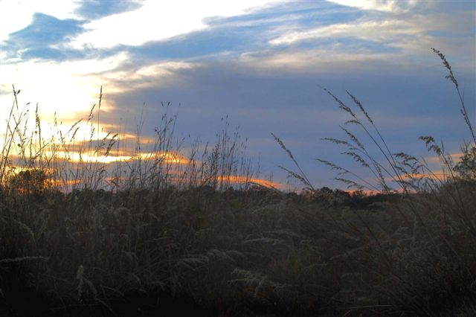
Julie Smith, USDA-NRCS

Table 1. Burn Objective and Relationship to Burning Time Frame
Burn Objective | Time of Burn | Comments
Prepare tall fescue or other cool season grasses for fall herbicide application | September/October | Time burn to allow fescue to re-grow 6 inches prior to herbicide application
Prepare tall fescue or other cool season grasses for spring tillage. | September/October  February/March | Time burn to reduce the amount of residual re-growth prior to tillage
Increase forb component in established native grasses. | August through October | Burn prior to green-up
Revitalize a wildflower planting. | August through October | Burn prior to green-up

The United States Department of Agriculture (USDA) prohibits discrimination in all its programs and activities on the basis of race, color, national origin, sex, religion, age, disability, political beliefs, sexual orientation, and marital or family status. (Not all prohibited bases apply to all programs.) Persons with disabilities who require alternative means for communication of program information (Braille, large print, audiotape, etc.) should contact USDA’s TARGET Center at (202) 720-2600 (voice and TDD).

To file a complaint of discrimination, write USDA, Director, Office of Civil Rights, Room 326W Whitten Building, 1400 Independence Avenue, SW, Washington, DC 20250-9410 or call (202) 720-5964 (voice and TDD). USDA is an equal opportunity provider and employer.

