Areas Evaluated:
Orientation/Signage
Exhibit 1 - First Families
Exhibit 2 - Symbol and Image
Exhibit 3 - White House Architecture
Exhibit 4 - White House Interiors
Exhibit 5 - Working White House
Exhibit 6 - Ceremonies and Celebrities

Overall Exhibit Facility

1. Does access to the exhibit meet the HFC and ABAAS guidelines for circulation space throughout the exhibit area? (36"-wide clear width for passageways, requirements for turning spaces, etc. p. 24- p.26) | The exhibits meet the minimum wheelchair access standards, but there are pinch points in areas between the building columns and where the exhibits jut outward which are awkward for visitors in wheelchairs. There are some other places that are awkward to navigate, between the freestanding vertical exhibit units and the exhibits along the wall. An example of one of the pinch points behind a column is shown in Photo No. 1. The clearance here is 41 inches.
2. Are the floors stable, level, firm, and slip-resistant, and are all changes in level in accordance with the HFC and ABAAS guidelines? Do any ramps have less than a 1" rise per 12" run? (p.23) | Yes, the exhibit room is all on one level, and carpeted with a low-nap carpet. It has a ramp at the entrance which complies with the guidelines.
3. Does the information desk have a section made to accommodate both a visitor in a wheelchair and an employee in a wheelchair, in accordance with the HFC and ABAAS standards? (p.30-p.31) | Yes, the information desk complies with a lift-up top surface area which the staff uses to go into and out of the kiosk and is totally open underneath. It is about 34" above the floor.
4. Does any fixed seating area in the exhibit area, lobby or theater area of the facility comply with the ABAAS requirement for wheelchair spaces under Table 221.2.1.1, and dimensions under ABAAS 801 and 802? | All the seating is either lightweight folding chairs which visitors can move, or benches which can be rearranged by park staff.
5. Has a lighting system been chosen to light the exhibit text for good readability, reduce glare, and allow for flexibility and adjustability? Has the designer chosen finishes and surfaces for graphics and other exhibit elements which reduce glare, harsh shadows or reflections? | Lighting is a problem in the overall exhibit space. Some of the exhibit graphics have their own internal lighting; they are backlit graphic panels. The artifact cases have light chambers. Some of the graphic panels have their own light fixtures, although these are aging and become a maintenance problem. Some of the backlit fixtures are in need of replacement as well. The exhibit room is an extremely large space in an old building, with large chandeliers hanging from the very high ceiling to provide ambient light. Several exhibit panels are without their own dedicated, functioning, light source and are too dimly lit by the ambient light to be fully accessible. The visitors eyes are drawn to the brightly lit exhibits, and they tend to miss the dimly lit panels, which may have interpretive or orientation information which could be useful to them in their visit.  Adding additional lighting to the existing exhibits is hampered by the lack of electrical outlets.
6. Is there adequate illumination on the floor circulation routes? Is glare from windows treated with film, etc.? Are transitions between walls and floors clearly visible? | There is glare from the outside light and lack of adequate artificial light inside. The ramp and stairs at the entrance are lit and circulation routes are OK, however.
7. Have emergency exhibit signs and fire alarm strobe lights been repositioned to allow for line-of-sight blocking by new exhibit structures? | Fire alarm strobes and emergency lighting is clearly visible above the exhibits and other structures.
8. Is audio description provided for the exhibits? What kind of system is being provided, and how many playback units are available to visitors at any given time? | No audio description is provided.
9. Do the type layout typicals in the design meet the HFC guidelines as specified on p. 34 and p. 35 for fonts, sizes, spacing and line lengths? | Many of the smallest type labels - the captions for images and the artifact labels - use too small a type size. They are smaller than 24 point. In addition, when type is placed in a location that it out of a comfortable viewing range, such a high on a panel or on the back wall of an exhibit case, the type size was not increased as it should have been to enhance readability.
10. Do the design layout typicals meet the HFC guidelines for type and background colors and contrast? | The exhibit text was designed with a limited palette of white text on a black background, black text on a light gray background, or white text on a wood grain background, except for a few exceptions in artifact cases and on illustrations. For the most part, the degree of contrast is adequate; lighting conditions, type placement, and type sizes create the readability problems with text.
11. Does the exhibit present the main interpretive themes on a variety of levels of complexity so they can be understood by people with varying abilities? Is the content arranged in a hierarchy of information, from the most important concepts to the most detailed? Can people of various learning levels, ages, and language skills walk away with an understanding of the basic message the exhibit is meant to convey? | The freestanding exhibit units which introduce each exhibit interpretive theme are poorly lit, and the eye is first drawn, instead, to the backlit exhibit panels behind them which contain the detailed content of graphic images and captions. The result is that the visitor would tend to walk into the exhibit missing the title and therefore what the particular exhibit area is all about.  Overall, there is lack of hierarchy in the exhibit content, with heads, subheads, main themes, more detailed information, body copy, and captions. This would have allowed the visitor to get the main interpretive message right away, or to delve into to the subject in more detail, according to their ability or inclination.
12. If there are mini-theaters, do they meet the HFC and ABAAS guidelines for a wheelchair space (p. 32 of the HFC guidelines)? | The White House Visitor Center contains mini-theater areas within it: the Welcome to the White House videos on the east end of the exhibit hall, and the centrally-located curtained-off area that the park has created for special programs. These areas use movable folding chairs and some benches which are not fixed in place. There are no barriers to accommodating wheelchairs in these areas.
13. If there are mini-theaters, do the programs meet the HFC and Section 508 guidelines for captioning, assistive listening and audio description? | Audiovisual accessibility such as captioning and assistive listening of the visitor center's current video programs is being addressed under a separate evaluation report.  The visitor center does not have audio description of the exhibits available to the visitors who are blind. Since there also are no tactile exhibits, it is vitally important to remedy the circumstance of these exhibits being only visual in nature.
Detailed Exhibit Evaluation
1. Does the exhibit meet the minimum ABAAS guidelines for physical access to the exhibit and the ABAAS guidelines for reach ranges, barriers, and objects protruding from walls? | See comments under No. 1 above for Overall Exhibit Facility.
2. Does the exhibit present the main interpretive themes on a variety of levels of complexity so they can be understood by people with varying abilities? Is the content arranged in a hierarchy of information, from the most important concepts to the most detailed? The important concepts are explained in large, easy-to-understand headers and sub-headers and the more detailed information is in the body copy in smaller text sizes. | Orientation/Signage: There is no panel, paper handout, or audio program to direct visitor flow through the space. There are structures for the NPS information desk and the Park Police which look alike, and the overall space is confusing from the additional setup of folding tables, chairs, and mini-theater areas. The restroom sign in the back of the room is poorly lit and hard to see. There is an orientation panel, but it needs to be relocated beyond the entrance/security screening area. The original orientation map is a layout of the visitor center room which became out-of-date with operational alterations to the space which have happened since the exhibits were installed in the 90's.  Exhibit 1: As described above, the main title is overlooked; the eye is drawn to the back-lit exhibits behind them, which then lack a strong, visual interpretive title, subtitle and easy-to-understand text. The plaque printed on wood is poorly lit and lost next to the back-lit panels. If the text on the wooden panels is the main theme, it needs to be larger type size, a more basic idea, and at a lower reading level. See Photo No. 3 taken with flash to make it visible.  Exhibit 2: Same comment as for Exhibit 1. In addition, the text is mainly captions and some quotations. There are few interpretive paragraphs.  Exhibit 3: Same comment as for Exhibit 1. In addition, the exhibit is detailed and technical in content to a greater extent than any of the other exhibits.  Exhibit 4: This exhibit meets this criterion better than any of the others. It has a greater range of detail in the interpretation, and the simpler information is in the lower level backlit panels which are the easiest to access panels for children to read, which is good.  Exhibit 5: This exhibit has some variation in its levels of interpretation but could use some improvement (see general comments).  Exhibit 6: Same as general comments as for Exhibit 1, except at least here there are some general themes, "Formal Occasions", "State Dinners", etc.
3. Does the exhibit meet the HFC guidelines for height of artifact cases and placement of artifact labels? | Exhibit 1: In the Inaugural Medals Case, some labels are so low people have to squat or bend very low to read them. Also, the text is too small. The layout of the medals should be re-done to make room for the next one, anyway since the original layout did not allow for the 21st Century (It has an area for "1800's", "1900's" and it has run out of room.)  Exhibit 2: Placement of labels is acceptable, but type size of labels still needs to be increased for good readability.  Exhibit 3: Labels in case with column fragment reproduction are acceptable. However, the case with the marble mantel fragment has labels on the case floor which are too low, too small, poorly lit, and hard to read.  Exhibit 4: Location of labels in Blue Room Case is acceptable, but the label sizes need to be larger. The label on the floor of the Lincoln Cabinet Room Case is too small, too low, in shadow, and hard to read. The label on the back wall of the case is too small for that distance.  Exhibit 5: The label for the typewriter is too hard to see. It should be larger, brought forward and angled. All labels in this case appear to have text a little too small.(Contrast not a problem; just size. See Photo 5)  Exhibit 6: In the Presidential China Case, the label type size is too small, especially for the glassware, which is not well lit in the back. In the Presidential Seal Case the white labels on the blue pedestals are too small. The light level in the case seems very low, and it needs to be evaluated if the particular artifacts in this case require this low of a light level.
4. Does the exhibit contain tactile models or other touchable exhibits, as described in the HFC guidelines? | All exhibits in general: There are no tactile or touchable exhibit elements. There are cut-out graphics that people can reach, and they do touch, but these elements are not really meant to be touched and become damaged and broken off by the visitor handling.
5. If there are tactile models or touchable objects, are they placed at heights where people in wheelchairs can reach the entire surface, in accordance with the HFC and ABAAS guidelines? | N/A
6. Is there a minimum of 70% contrast between type and background? Is the background solid, instead of a graphic image? Are type and background colors chosen for good contrast and which do not use a red/green combination which a person with red/green color blindness would not be able to read? | Exhibit 1: The panels with the white text on the wood grain backgrounds are hard to read, since they are poorly lit and adjacent to exhibits that are brightly back-lit. They are also mounted at the upper limit of the allowable eye level for body copy text.  Exhibit 2: Same comment as for Exhibit 1.  Exhibit 3: The exhibits are front-lit panels with good contrast of text and background; either white on black or black on light gray.  Exhibit 4: Contrast and readability is O.K. overall. Backlit panels are especially readable, as largest type sizes are used here. The illustration "Cross Section of the White House from the South" on the freestanding unit has readability problems. The graphic itself is a low-contrast artwork, originally intended for a publication, and loses too much resolution at this large size.  Exhibit 5: The only contrast problem is the wood text plaque.  Exhibit 6: The only contrast problem is the wood text plaque.
7. Is all exhibit text located at heights, positions and angles where people in wheelchairs, as well as standing visitors, can read it comfortably? | All exhibits in general: There are many image captions located above the recommend viewing height for body copy and captions of 60" from the floor. They were also under the minimum point size of 24 point. If captions or labels need to be placed higher than 60", the point size should be increased considerably to make up for the greater distance from the viewer, in addition to meeting the minimum size standard.  Exhibit 1: The photo captions are too small, below 24 point in size. Many of them are above the maximum eye level range allowed in the guidelines, making them even harder to read. This is true of both back-lit photo captions and front-lit exhibits, and some artifact case labels are too low.  Exhibit 2: Positions of most labels OK, except for some captions in the freestanding exhibit unit, which are too high, and the type too small. See Photo No. 2, captions under cutouts of Jefferson and Adams.  Exhibit 3: Some captions are located too high, and the type size is too small for all the captions.  Exhibit 4: The illustration "Cross Section of the White House from the South" on the freestanding unit has readability problems. It is poorly lit and also receives glare from the curved mounting and ambient light. The graphic key text is too small.  Exhibit 5: Some image captions are too high and the type size is too small. Some stand-off panels are blocking views of captions.  Exhibit 6: See general comments.

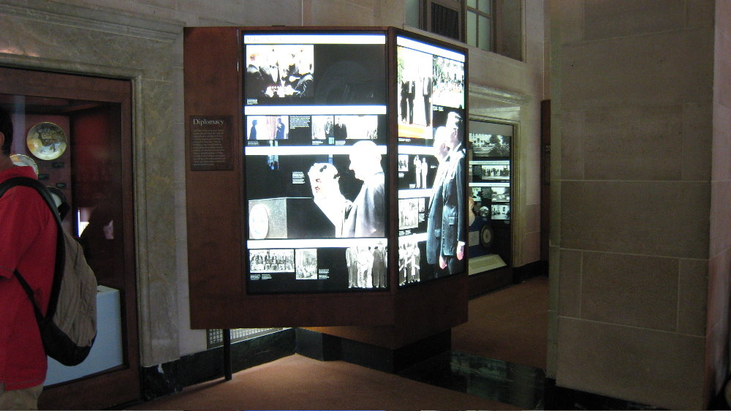

Photo 1

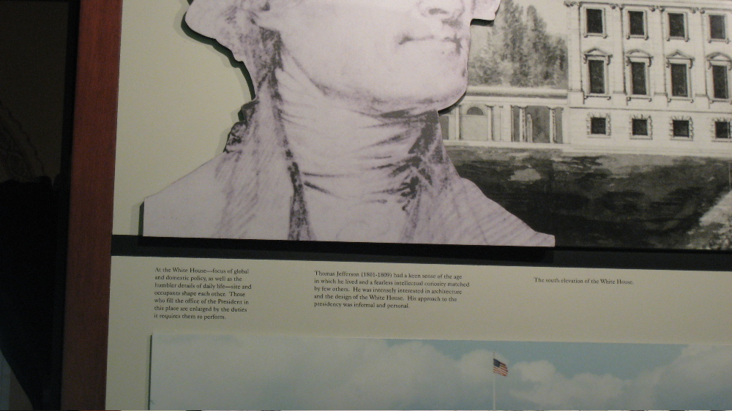

Photo 2
These are typical caption labels in the exhibits, and like these, many are located above eye level and below 24 point in size.

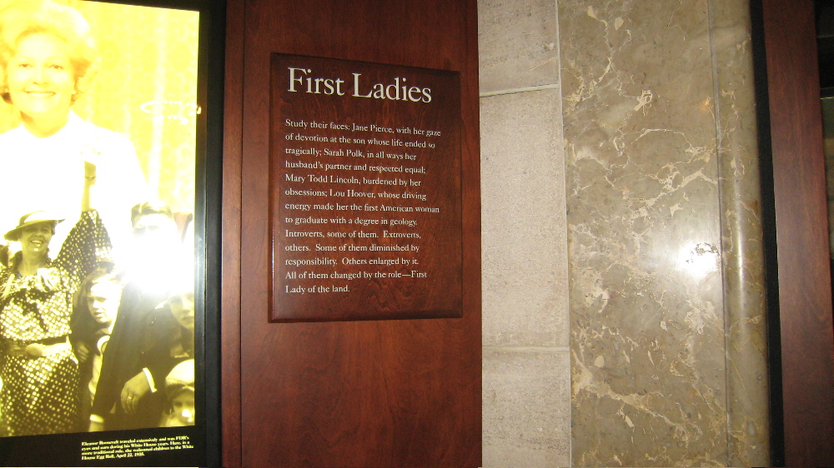

Photo 3
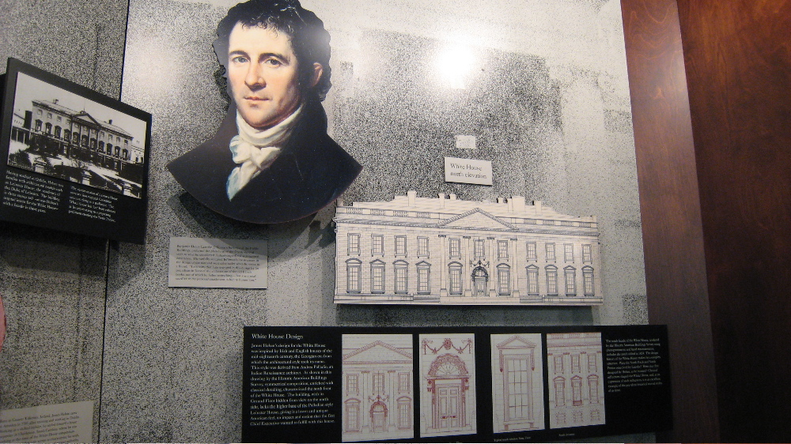

Photo 4
This is cut-out of the White House is example of a feature which visitors might want to touch but are not meant to. The graphics on this panel would lend themselves to being made into tactile bas-relief exhibits that are meant to be touched.

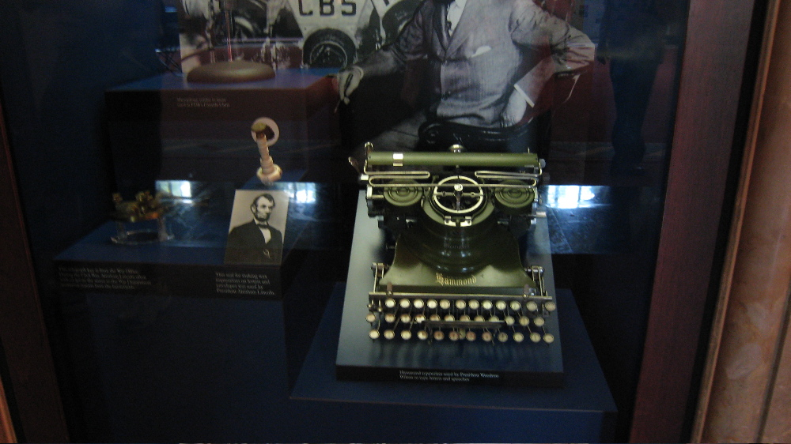

Photo 5
Can you read these labels?
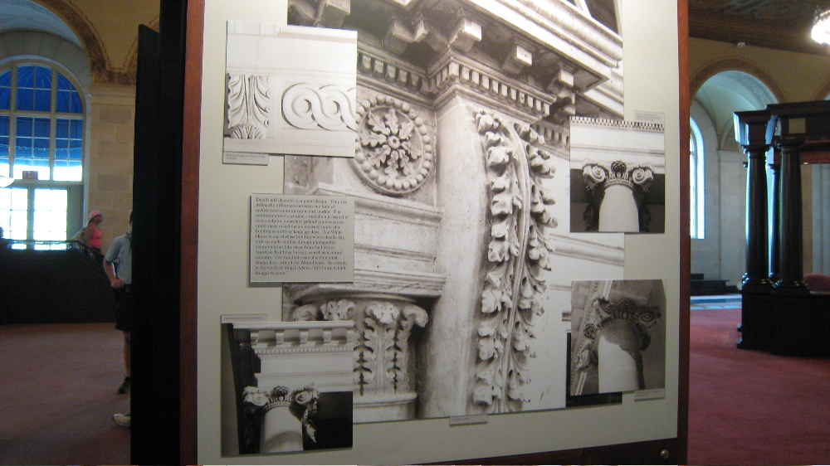

Photo 6
These are 2D images, but 3D casts of the same thing would make the exhibits much more accessible and interesting.

