The CardioSEAL Septal Occlusion System
Instructions For Use - VSD
Table of Contents

1. PRODUCT DESCRIPTION 1
2. INDICATION FOR USE 1
3. CONTRAINDICATIONS 1
4. WARNINGS 1
5. PRECAUTIONS 2
5.1 CardioSEAL – Handling Precautions 2
5.2 CardioSEAL – Sizing Precautions 2
5.3 CardioSEAL – Procedural Precautions 2
5.4 CardioSEAL – Post Implant Precautions 3
6. ADVERSE EVENTS Error! Bookmark not defined.
6.1 Observed Adverse Events Error! Bookmark not defined.
Device Related Error! Bookmark not defined.
Upper respiratory tract infection Error! Bookmark not defined.
Urinary retention Error! Bookmark not defined.
Venous thrombosis, suspected Error! Bookmark not defined.
Ventricular tachycardia Error! Bookmark not defined.
Wheezing Error! Bookmark not defined.
Number of Events Error! Bookmark not defined.
Total Error! Bookmark not defined.
TOTAL Error! Bookmark not defined.
6.2 Potential Adverse Events 4
6.3 Observed Device Malfunctions 4
7. CLINICAL STUDIES 4
7.1 Study Design/Objective 4
7.2 Patient Entry 5
7.3 Methods 5
7.4 Primary Endpoints 5
7.5 Results 6
8. HOW SUPPLIED 8
9. DIRECTIONS FOR USE 8
9.1 Detailed Product Description 8
9.2 CardioSEAL Size Selection and Inspection 8
9.3 Preparation for Delivery 9
9.4 General Description of the CardioSEAL Occluder and Front Loading Delivery System with Qwik load adaptation 9
9.5 Attachment and Loading of the Occluder to the FL Delivery System 11
9.6 Insertion 15
10. PATIENT INFORMATION 19

CardioSEAL® Septal Occlusion System with QwikLoad™
Instructions for Use
Caution : Federal law (USA) restricts this device to sale by or on the order of a physician.

PRODUCT DESCRIPTION
The CardioSEAL Septal Occlusion System consists of two primary components:
- The CardioSEAL (Occluder), a permanent implant, which is constructed of a metal (MP35N) framework to which polyester fabric is attached, and
- The Delivery Catheter, a coaxial polyurethane catheter designed specifically to facilitate attachment, loading, delivery and deployment of the CardioSEAL to the defect.
The occluder is available in sizes 17mm, 23mm, 28mm and 33mm.

INDICATION FOR USE
The CardioSEAL Septal Occlusion System is for use in patients with a complex ventricular septal defect (VSD) of a significant size to warrant closure, but that based on location, cannot be closed with standard transatrial or transarterial approaches.

CONTRAINDICATIONS
Presence of thrombus at the intended site of implant, or documented evidence of venous thrombus in the vessels through which access to the defect is gained.
Active endocarditis, or other infections producing a bacteremia.
Patients whose vasculature, through which access to the defect is gained, is inadequate to accommodate the appropriate size sheath.
Patients whose defect is too small to allow the 10 F sheath to cross the defect.
Anatomy in which the CardioSEAL size required would interfere with other intracardiac or intravascular structures, such as valves or pulmonary veins.
Patients with coagulation disorders who are unable to take Aspirin, Heparin, Coumadin, or other anticoagulants.

WARNINGS
This device should only be used by those physicians trained in transcatheter defect closure techniques.
Physicians attempting to recover an embolized device should be limited to those that have completed appropriate device retrieval technique training.
Embolized CardioSEAL devices should be removed. Dislodged CardioSEALs have embolized to the pulmonary and systemic vasculature.
Embolized CardioSEALs may disrupt critical cardiac functions. Physicians must be prepared to deal with urgent requirements to extract or move embolized CardioSEALs that result in critical hemodynamic compromise.
Embolized CardioSEALs should not be withdrawn through intracardiac structures unless they have been adequately collapsed within a sheath. Devices that are not adequately collapsed within a sheath may entangle valvular or other cardiac structures.
Do not attempt to repair or reuse damaged product. Do not reuse or resterilize product. Return to manufacturer.
Surgical support should be readily available if needed.
Transient hemodynamic compromise may be encountered during device placement, which may require fluid replacement or other medications as determined by the physician.

PRECAUTIONS

CardioSEAL – Handling Precautions
Do not use the system if, during loading of the CardioSEAL, difficulty is encountered in transferring the CardioSEAL into the loader or from the loader.
Do not modify the delivery catheter or CardioSEAL. Modification may result in damage that can result in complications such as embolism, framework fracture, failure to release, and improper seating at the target defect.

CardioSEAL – Sizing Precautions
The use of a compliant balloon catheter to determine defect localization is recommended.
Accurate defect sizing is critical to CardioSEAL size selection. Defect sizing methods, such as contrast angiography, echocardiography and / or balloon sizing should be considered as procedural alternatives. The defect and surrounding structures should be fully examined in multiple planes to assure proper sizing of the CardioSEAL.
The anatomic area surrounding the target defect should have sufficient contiguous structure to support the CardioSEAL.

CardioSEAL – Procedural Precautions
The ability of the patient to remain still during implantation must be weighed against the need for “conscious” sedation versus general anesthesia. The decision to use general anesthesia in any individual patient is subject to physician judgment.
Patients should be fully heparinized throughout the procedure using adequate dosing so as to keep the ACT greater than 200 msec.
Antibiotic therapy periprocedurally is recommended to reduce the risk of perioperative infection.
The use of Transesophageal Echocardiography (TEE) should be considered as a potential aid in placing the CardioSEAL.
Placement of the CardioSEAL requires the use of fluoroscopic X-ray guidance. The risk of increased x-ray exposure for patients who are pregnant must be weighed against the potential benefits of the technique.
Malpositioned CardioSEALs may interfere with cardiac, vascular or valvular structures. Physicians should consider removing malpositioned CardioSEALs in these patients.

CardioSEAL – Post Implant Precautions
The time course of endothelialization of the device is unknown. Patients should receive appropriate endocarditis prophylaxis for the six months following implantation. The decision to continue prophylactic treatment after six months is subject to physician judgment.
Patients should be treated with antiplatelet/anticoagulation therapy, such as Aspirin (see Section 8 Clinical Studies for the dosage used in the High-Risk Study) for six-months following implant. The decision to continue medical treatment beyond six months is subject to physician judgment.
All CardioSEALs are non-ferromagnetic. Independent studies of the CardioSEAL in a 1.5 Tesla magnetic field demonstrated no movement of the CardioSEAL. However, MRI image quality may be compromised in the area of the implant.
6.0 Adverse Events
  - Observed Adverse Events
Observed adverse events are summarized in Table 1.

Table 1 - Observed Adverse Events
 | Percent  [95% Confidence Interval] | Number
Device-Related  Major Adverse Events  48-hours  30-days  6-month  Most recent follow-up | 13.8% (6.1, 25.4)  17.2% (8.6, 29.4)  17.2% (8.6, 29.4)  17.2% (8.6, 29.4) | 8  10  10  10
Procedure-Related  Major Adverse Events  48-hours  30-days  6-month  Most recent follow-up | 55.2% (41.5, 68.3)  56.9% (43.2, 69.8)  58.6% (44.9, 71.4)  58.6% (44.9, 71.4) | 32  33  34  34
Minor Adverse Events  48-hours  30-days  6-month  Most recent follow-up | 27.6% (16.7, 40.9)  37.9% (25.5, 51.6)  41.4% (28.6, 55.1)  60.3% (46.6, 73.0) | 16  22  24  35
Device-embolization  Percutaneous retrieval  Surgical retrieval | 1.7% (0.0, 9.2)  0.0% (0.0, 6.2) | 1  0
Device Malposition  No intervention  Intervention required | 8.6% (2.9, 19.0)  0.0% (0.0, 6.2) | 5  0
Device Fracture  48-hours  30-days  6-month  Most Recent follow-up | 1.7% (0.0, 9.2)  3.4% (0.4, 11.9)  5.2% (1.1, 14.4)  20.7% (11.2, 33.4) | 1  2  3  12
Device Fracture  Associated with adverse event  No adverse events | 20.7% (11.2, 33.4)  0.0% (0.0, 6.2) | 12  0
Cardiac Perforation | 1.7% (0.0, 9.2) | 1
Blood Loss Requiring Transfusion | 62.1% (48.4, 74.5) | 36

Potential Adverse Events
Placement of the CardioSEAL involves using standard interventional cardiac catheterization techniques. Complications commonly associated with these procedures include, but are not limited to:
- Air Embolus
- Allergic dye reaction
- Anesthesia reactions
- Apnea
- Arrhythmia
- Death
- Fever
- Headache / Migraines
- Hematoma and/or Pseudoaneurysm including blood loss requiring transfusion
- Hypertension; Hypotension
- Infection including Endocarditis
- Perforation of Vessel or Myocardium
- Stroke / Transient Ischemic Attack
- Thromboembolic events
- Valvular regurgitation.

Observed Device Malfunctions
There were four reports of a kink in the delivery system, identified during the device placement, and one report of a kink in the delivery system during loading of the device. There were no clinical sequelae associated with any of these device malfunctions.

CLINICAL STUDIES

Study Design/Objective
The multi-center clinical trial conducted by Children’s Hospital, Boston, Massachusetts, is a prospective, non-randomized trial studying the use of the CardioSEAL® Septal Occlusion system to close a variety of hemodynamically significant defects. The risks of surgical closure for the patients enrolled in this trial were considered sufficient to justify the known and potentially unknown risks of transcatheter closure with the CardioSEAL device. The study (referred to as the High-risk study) is ongoing and is summarized below. Data from patients undergoing VSD closure were extracted from this study.

Patient Entry
Patients were eligible for enrollment in the High Risk Study if they had a defect(s) of sufficient size to require closure, but were considered to be at high risk for surgical closure, due to either complex medical or cardiac disease. An independent peer review group determined whether a patient should be enrolled into the trial based on the following criteria:
- the patient had a type of defect that was technically difficult or impossible to close surgically, such that the surgical risks were sufficient to justify the known and potential unknown risks of the device, or
- the patient’s overall medical condition was such that the surgical risks were sufficient to justify the known and potential unknown risks of the device.

Methods
After enrollment, patients underwent cardiac catheterization. Position and size of the defect were confirmed by angiography. A hemodynamic assessment was performed pre-implant, and after test occlusion of the defect with a balloon. When these data suggested that the defect contributed to unfavorable hemodynamics and was feasible for transcatheter closure, device placement proceeded. Patients received aspirin, 1mg/kg/day, rounded to the nearest half tablet of 80 mg size, for at least six months following the procedure. Patients were seen for follow up assessments at 1, 6, 12 and 24 months.

Primary Endpoints
A 6-category ordinal scale (clinical status scale) was used to measure clinical status. The Clinical Status Scale grouped patients into eight different categories (right to left shunt, left to right shunt, anatomic, systemic embolic, hemodynamic compromise not due to shunt, arrhythmia, elevated PVR, and medical illness). The left to right shunt category was the category most closely related to the patient’s indication for device closure of the VSD. This scale is shown in Table 2 below. The scale took values from 0 to 5, and was constructed so that an improvement by one category (e.g., from category 1 to category 2, or from 2 to 3, etc.) would be considered clinically meaningful. Deceased patients and those who have had their device explanted receive a value of –1). Data used in the construction of the scale were measured objectively by diagnostic laboratory tests, documented clinical status, or echocardiography. The data were collected prospectively before device implantation, at discharge from the hospital, and at each follow-up visit, so that patient classification at each time point could be implemented using a computer algorithm.
Clinical Status Scale¹ – Table 2
Category | 0 | 1 | 2 | 3 | 4 | 5
L to R shunt | Ventilator dependent and/or intractable CHF | Heart failure, symptomatic | Left ventricular volume overload, significant/ large shunt | moderate shunt | small shunt | trivial or no shunt
1. Deceased patients and those who have had their device explanted are rated as –1 on the Clinical Status Scale.
Patients with prior placement of a pulmonary artery band to limit the degree of left to right shunting are categorized, where possible, according to the estimated anatomic size of the defect.
Additionally an assessment of the echocardiographic closure status was made at each time point both at the evaluating facility, and by an unaffiliated core laboratory. Residual flow was assessed using Doppler color flow mapping, and graded using the following guidelines:
- "Trivial" to "Absent": barely detectable or no detectable residual color flow through the defect. If flow is present, it is a single color flow jet, well-circumscribed, with a proximal jet width measuring less than 1 mm in diameter in all views.
- "Small": single color flow jet, well-circumscribed, and measuring 1-2mm (maximal proximal width) in all views in infants and children weighing less than 20 kg, or between 1 and 3 mm in diameter in larger children and adults.
- "More than small": single color flow jet, well-circumscribed, measuring greater than 2 mm in diameter in all views in infants and children weighing less than 20 kg, or greater than 3 mm in diameter in all views in larger children and adults.

Results
At the time the VSD data was analyzed, 74 patients with no additional anatomic lesions were enrolled in the study for closure of a VSD. Enrollment occurred at two investigational sites. Thirteen of these patients did not have a device implant attempted, in most cases because the defect was smaller than anticipated.
Device placement was successful in 57 of 58 patients (98%) in whom an implant was attempted. Multiple procedures were performed in 6 patients, and multiple devices were implanted in 26 patients for a total of 107 implanted devices. There were 4 device embolizations which all occurred in the same patient while attempting to close a large post operative residual defect. All 4 were retrieved at catheterization. No other embolizations occurred.
The types of VSD defects closed with a CardioSEAL device were: congenital muscular (26); and post-operative (31). Seventeen patients (23%) had previously undergone placement of a pulmonary artery band.
Among the 57 patients implanted with a CardioSEAL device, there were 24 (42%) males and 33 (58%) females. The age of the patients ranged from 0.3 years to 70.1 years, with a median age of 3.7 years.
Four patients had devices that were explanted, 2 at the time of a heart transplant, 1 at a Fontan surgery performed after a failed septation, and 1 at a catheterization during which an unsuccessful attempt was made to close a large residual defect.
Among the 57 implanted patients, 44 (77%) could be assessed according to the Clinical Status Scale by Lesion at both pre-implantation and at the 6-month follow-up time point. In this group, the median change in scale value was an increase of 2 categories (p<0.0001 compared to no improvement); 84.1% of the procedures were successful at 6 months (95%CI [69.9, 93.4]). Six patients were in a lower clinical status category than prior to implantation; this includes 3 patients who died and 2 who had their devices explanted. Success rates at 6 months did not differ for patients with congenital defects (85.7%, [63.7, 97.0]) and those with postoperative defects (82.6% [61.2, 95.0]). Patients under 10 years of age had a higher rate of success than those between 10 and 30 (p=0.008).
Fifty-three of the 57 implanted patients (93%) could be evaluated according to the Clinical Status Scale by Patient at both pre-implantation and at the 6 month follow-up visit. The median change in scale value was an increase of 2 categories (p <0.0001); 71.7% [57.7, 83.2] of the procedures were successful at 6 months.
Echocardiographic closure status changed from a median of 3 (more than small residual flow) prior to implantation to a median of 2 (small residual flow) at the 6-month time point (p<0.0001).

Table 3 - Baseline Demographics, Principal Effectiveness Measures, & Principal Safety Measures
Patient Enrollment (number of patients)
Enrolled |  |  | 74
Occluder Implant not Attempted¹ |  |  | 13
Occluder Implant Attempted² |  |  | 61
Occluder(s) Implanted |  |  | 57
Single Procedure |  |  | 52
Multiple Procedures³ |  |  | 6
More than One Occluder Placed⁴ |  |  | 25
Principal Effectiveness Measures
(n=57, patients with CardioSEAL Device)
 |  | Percent  [95% C.I.] |  | Median Scale Value |  | p-value | Number of Patients
Technical Success⁵ |  | 71.7% [57.7, 83.2] |  |  |  |  | 53
Pre-implant Clinical Status Score |  |  |  | 1 |  | - | 56
Post-implant clinical Status Score⁶  6-month  Most recent follow-up |  |  |  | 3.5  4 |  | <.0001  <.0001 | 54  56
Pre-implant Echo Closure Score^{7,8} |  |  |  | 3 |  | - | 34
Post-implant Echo Closure Score  6-month  Most recent follow-up |  |  |  | 2  2 |  | <.0001  <.0001 | 22  28
Principal Safety Measures
(n=58, patients with implant attempted)
 | Percent  [95% C.I.] |  |  |  | Number of Patients
Major Adverse Events⁹  48-hours  30-days  6-month | 63.8% (50.1, 76.0)  70.7% (57.3, 81.9)  74.1% (61.0, 84.7) |  |  |  | 37  41  43
Minor Adverse Events  48-hours  30-days  6-month | 27.6% (16.7, 40.9)  37.9% (25.5, 51.6)  41.4% (28.6, 55.1) |  |  |  | 16  22  24
Device-related Adverse Events  Embolization  Delivery System  Fractures | 1.7% (0.0, 9.2)  8.6% (2.9, 19.0)  20.7% (11.2, 33.4) |  |  |  | 1  5  12
Procedure-related Adverse Events ¹⁰ | 84.5% (72.6, 92.7) |  |  |  | 49
Blood loss requiring transfusion | 62.1% (48.4, 74.5) |  |  |  | 36
Vascular | 15.5% (7.3, 27.4) |  |  |  | 9
ANY Adverse Event | 98.3% (90.8, 100.0) |  |  |  | 57
- Occluder implant not attempted: defect smaller than anticipated (12), unfavorable anatomy (1).
- 3 patients received a StarFLEX device (which is not the subject of this PMA); 1 attempted but not placed.
- Multiple procedures: 2 procedures (4), 3 procedures (2).
- More than one occluder placed: 2 occluders (11), 3 occluders (8), 4 occluders (3), 5 occluders (2), 7 occluders (1).
- Technical success: a one category improvement from pre-implantation score at 6 month follow-up.
- Clinical Status Score: A 6-category ordinal scale used to measure clinical status was developed for the High-Risk Study. The scale takes values from 0 to 5, & was constructed so that an improvement by 1 category (e.g., 1 to 2, etc.) is considered clinically meaningful. All data used in the construction of the scale are measured objectively by diagnostic lab tests, documented clinical status, and/or echocardiography. Data are collected pre-implant, at discharge and at each follow-up visit.
- Echo Closure Score: A 3-category ordinal scale used to measure residual flow, categorized as (1) trivial to absent, (2) small, (3) more than small.
- Only patients with echocardiographic images adequate to assess flow are included.
- Major Adverse Events: equals serious and moderately serious adverse events. Minor adverse events are all those not considered serious or moderately serious.
- Includes all implantation and catheterization procedure related events.

HOW SUPPLIED
The occluder and delivery system are packaged separately and are supplied sterile. Product is sterilized with ethylene oxide.

DIRECTIONS FOR USE

Detailed Product Description
The CardioSEAL Septal Occlusion System consists of two primary components. The CardioSEAL (Occluder) is comprised of a metal alloy (MP35N) framework to which polyester fabric material has been attached.
From the center of the CardioSEAL, a small wire with a pin at its end extrudes out at approximately 90 degrees to the plane of the CardioSEAL. The CardioSEAL is attached to sutures through a loading funnel. The loader should always be connected via sutures to the side of the CardioSEAL opposite the side from which the pin wire extrudes.
The delivery catheter is comprised of a coaxial catheter shaft through which a spring guide travels, connected to a solid control rod. At the proximal end of the control rod, a control handle is connected to an inner control wire, which courses through the spring guide to the distal end of the catheter shaft, where it terminates within a small tubular sleeve. The control wire terminates at the distal end in a pin, for attachment to its mate on the CardioSEAL. When retracted, the pin slides inside the sleeve. The distal end of the catheter terminates in a pod. Retraction on the control rod moves the sleeve into the pod. Refer to figure 1 for an illustration of the delivery system and CardioSEAL.

CardioSEAL Size Selection and Inspection
Selection of an appropriately sized CardioSEAL should be based upon measuring the defect diameter through the use of a sizing balloon (stretched defect diameter – SDD), procedural angiography and/or Transesophageal echocardiography, unless the size of the defect is known from the medical record. It is recommended that the CardioSEAL to Stretched Defect Diameter ratio (O:SDD) be 1.7-2.0:1, and that the area containing the target defect be large enough to allow the CardioSEAL to fully deploy. The defect and surrounding structures should be fully examined in multiple planes to assure proper sizing of the CardioSEAL.
The Right Femoral Vein or Right Internal Jugular vein is recommended for vascular access although physicians should consider the VSD location and the route of introducer sheath travel relative to the potential for access in selecting the venous access site.
An 11F, 75cm long, hemostasis control introducer sheath with NIH type curve is recommended for CardioSEAL delivery. Sheath curve shape may need modification based on individual patient conditions and defect location. As the use of long sheaths represents a potential risk of air embolus, care should be taken to insure adequate irrigation and ‘backfilling’ of the sheath with saline during removal of the dilator in order to avoid air entry.
A 14F or 16F short introducer sheath may be placed coaxially over the long introducer sheath prior to long sheath insertion if the physician believes the circumstances of the case raise the potential for device retrieval after attempted placement.
Prior to use, inspect the delivery system and CardioSEAL for signs of damage, such as kinks or bends in delivery wire or framework of the CardioSEAL. Check for secure attachment of the fabric to the framework.
Manipulate the delivery system and actuate the control handle to ensure that the attach release pin exits and retracts into the sleeve, and that the spring guide wire exits and retracts into the pod.

Preparation for Delivery
NOTE: Attachment and loading of the CardioSEAL into the delivery catheter should not occur until
a. the defect has been determined to be of appropriate size and position to accommodate the CardioSEAL, and
b. access to the defect with an appropriate French size and length introducer sheath has been obtained.

NOTE: NMT Medical recommends that the CardioSEAL family of Septal Occluders be delivered to the target defect via a Cook 10F (minimum) style transseptal length introducer sheath with radiopaque marker band.

General Description of the CardioSEAL Occluder and Front Loading Delivery System with Qwik load adaptation
The CardioSEAL® Occluder incorporates a loading system, called Qwik Load™ that serves to transfer the loaded Occluder into the delivery sheath. The Qwik Load Assembly is comprised of a Funnel Pod that directs the Occluder into a tubular section called the Funnel Pod Tube. The Funnel Pod Tube is protected by a clear Outer Jacket that acts as a stop to prevent the occluder from being pulled out the end. The Funnel Pod has luer threads on the outer rim for connection to the Irrigation Toughy on the delivery catheter to facilitate irrigation of the Occluder prior to insertion in the sheath. See Figure 1 for a diagram of the Occluder and associated nomenclature.

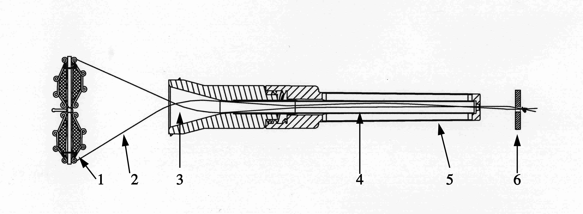
Figure 1

1. | Occluder | 4. | Funnel Pod Tube
2. | Suture | 5. | Outer Jacket
3. | Funnel Pod | 6. | Suture button

The Delivery System with Qwik Load (Figure 2) is a coaxial catheter that facilitates attachment of the Occluder and transfer of the Occluder from the Funnel Pod to a previously placed and irrigated 10F (minimum) sheath.

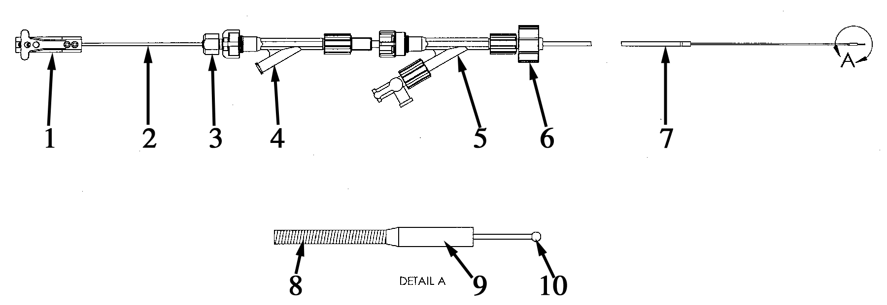
Figure 2
1. | Pin Wire Control Handle | 6. | Irrigation Toughy Cap
2. | Control Rod | 7. | Blue Catheter Shaft
3. | Locking Collar | 8. | Spring Guide
4. | Control Toughy | 9. | Sleeve
5. | Irrigation Toughy | 10. | Pin Wire

Attachment and Loading of the Occluder to the FL Delivery System
Open and remove components from the Occluder and Delivery System packages and inspect for obvious signs of damage from shipment. If damage is suspected, do not use. Place the Occluder with Qwik Load Assembly into sterile saline for irrigation.

Figure 3: Recheck Irrigation Toughy on the blue delivery catheter shaft and, if loose, gently tighten to prevent it from slipping off the catheter and to keep it out of the way until required for irrigation later in the loading process.

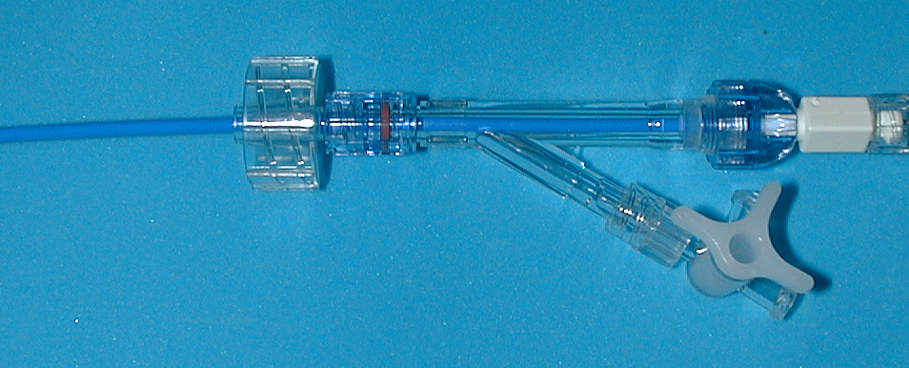
Figure 3
Loosen the locking collar on the delivery system and fully extend the spring guide from the tip of the blue catheter shaft. This will facilitate irrigation of the delivery system and allow for easier attachment of the Occluder.
Irrigate the delivery system via the side port on the control toughy. Remember to tighten the locking collar around the control rod to facilitate downstream irrigation of the catheter shaft portion. Leave locking collar in the tightened position to fix relationship of blue catheter to spring guide.
Using the Pin Wire Control Handle, extrude the Pin Wire about 2-3 mm out from the sleeve.

Figure 4: Holding the Occluder, insert the Occluder pin into the sleeve of the delivery system, and then retract delivery system pin wire back into the sleeve using the Pin Wire Control Handle.

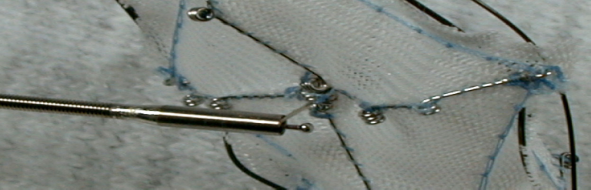
Figure 4
Lightly pivot the occluder to assure that pivoting mechanism is operating. The Occluder is now securely attached to the delivery system and ready for collapsing into the Qwik Load assembly.

Loading of the Occluder
Irrigate the Funnel Pod loader with the Irrigation Toughy with normal saline. DO NOT REMOVE LOADER JACKET.
Figure 5: While holding the blue catheter shaft steady, pull the suture button to draw the distal arms of the Occluder into a fully collapsed position.

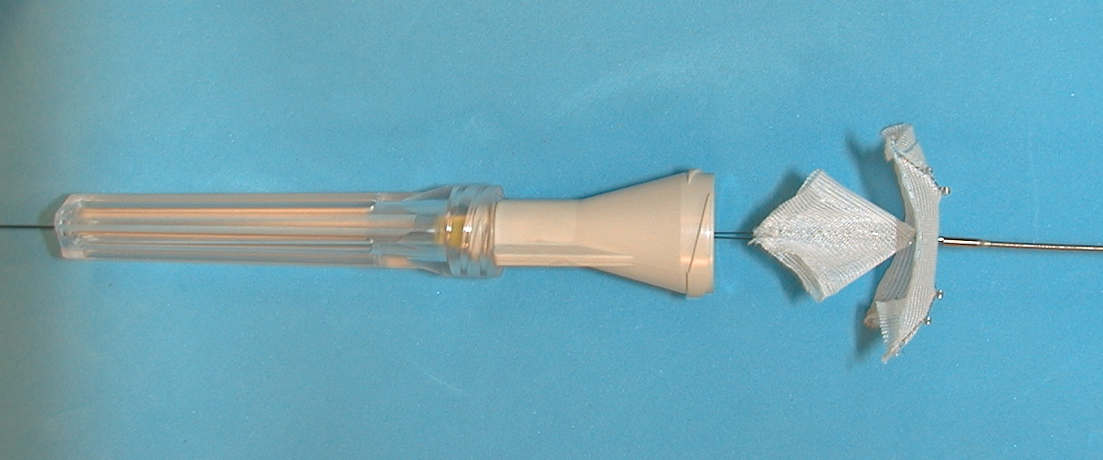
Figure 5

Figure 6: While holding light tension on both the suture button and the blue catheter, gently advance the Funnel Pod over the collapsed Occluder arms and then over the proximal arms.

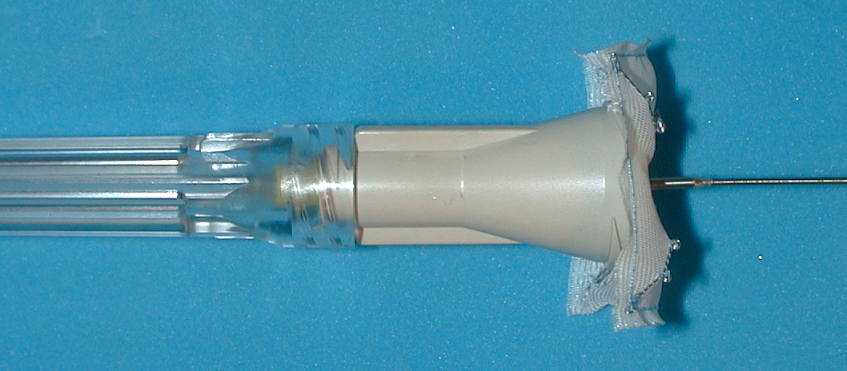
Figure 6

Figure 7: Pull gently until resistance is felt when the collapsed Occluder reaches the end of the Funnel Pod Tube (visible through Outer Jacket).

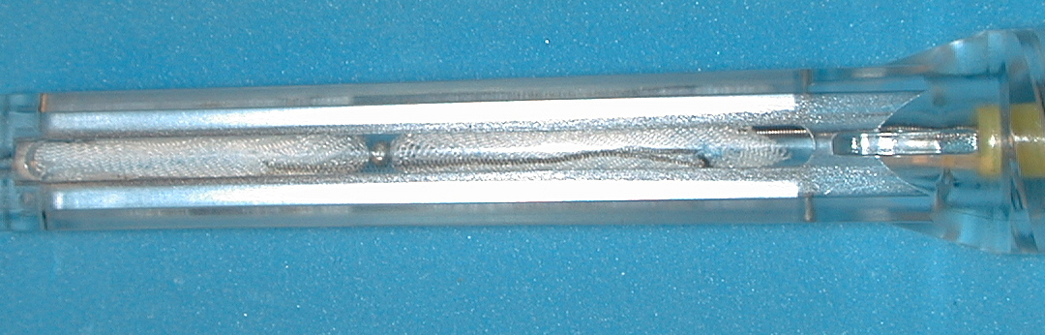
Figure 7

Figure 8: Loosen the locking collar on the delivery system and advance the blue catheter into the Funnel Pod Tube until the tip of the blue catheter is adjacent to the collapsed (or within 1mm) Occluder. Then, retighten locking collar.

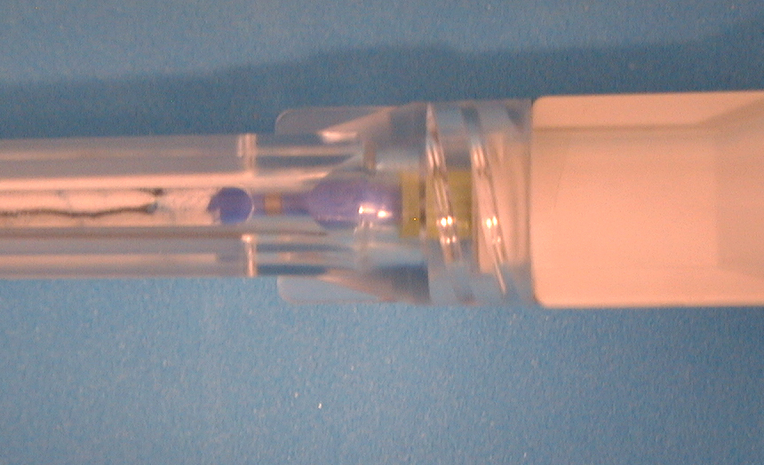
Figure 8

Figure 9: Cut the Suture and remove and discard Suture and Suture Button.

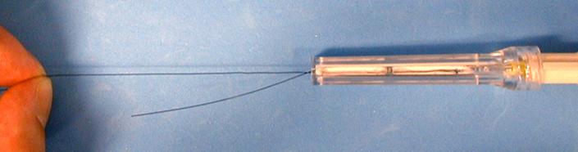
Figure 9

Figure 10: Remove and discard Outer Jacket (attached by luer connection).

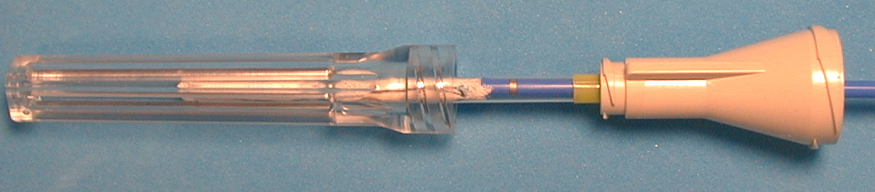
Figure 10

Figure 11: The Occluder should now be fully collapsed inside the Funnel Pod. Note how the blue catheter is adjacent to the Occluder.

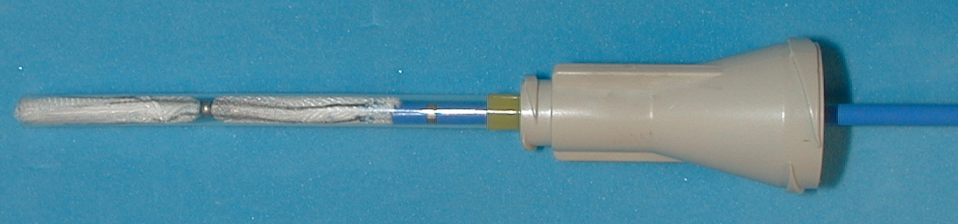
Figure 11

Figure 12: Loosen the Irrigation Toughy and advance it over the blue catheter, connecting it securely to the Funnel Pod.

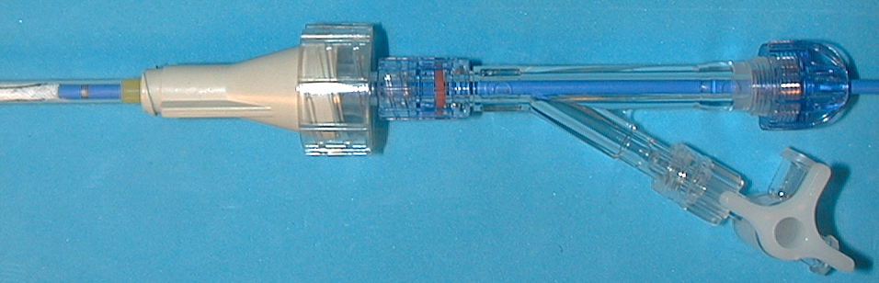
Figure 12

Irrigate the Funnel Pod thoroughly by attaching a syringe to the 3-way stopcock. First, loosen the toughy portion of the Irrigation Toughy and irrigate proximally toward the catheter hub. Tighten the toughy portion of Irrigation Toughy and irrigate distally through the Funnel Pod, which contains the collapsed Occluder. The Occluder is now ready to be transferred into the previously placed delivery sheath. Re-irrigation of the delivery sheath prior to Occluder insertion is recommended; especially if the sheath has been inserted for some time prior to implant transfer.

Figure 13: Insert the Funnel Pod Tube into the hub of the previously placed long sheath. Advance it (the Funnel Pod Tube) through the sheath hub and into the sheath, until resistance is met. The Occluder is now ready to be transferred into the sheath, which is in place through the defect.

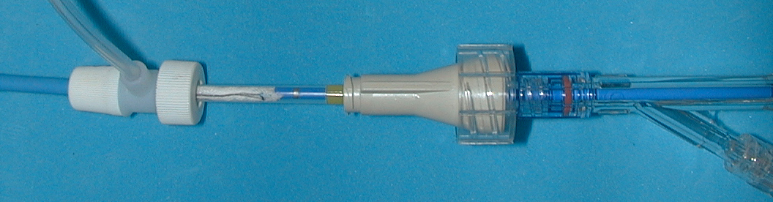
Figure 13

Insertion
NOTE: As previously discussed in Section C, Preparation, Note B, an introducer sheath of sufficient French size for the CardioSEAL and of adequate length to reach the target defect should have been placed via the venous system across the defect.

Reposition sheath across the VSD so that the distal tip of the sheath is approximately 1cm into the distal side of the VSD (Figure 14). Thoroughly irrigate the previously placed introducer sheath to minimize risk of air entry and air embolus.
Figure 14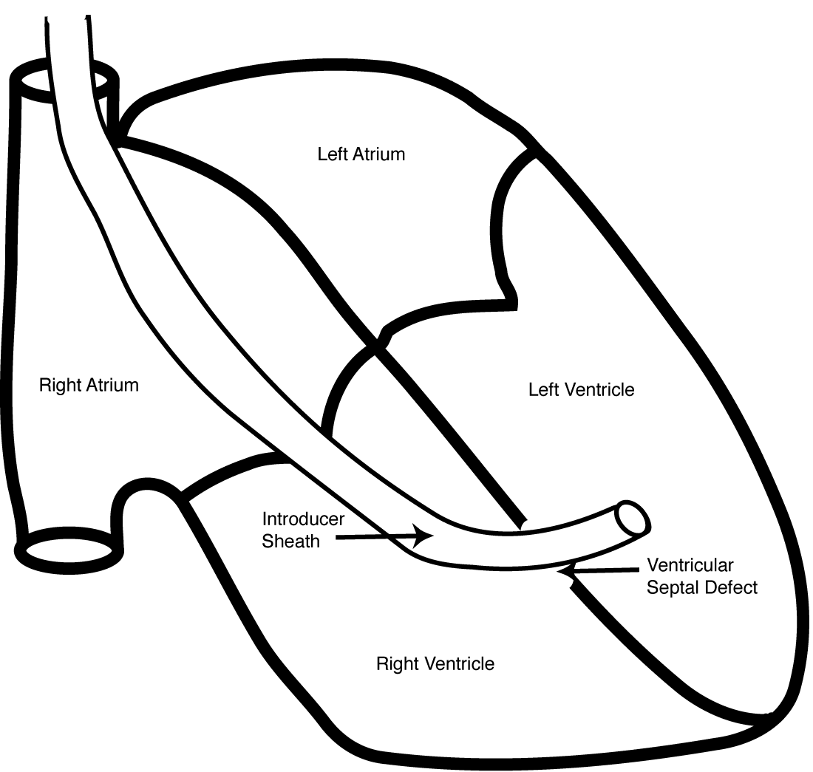

Transfer Occluder into the sheath using the delivery catheter to advance it out of the loader, and advance until the Occluder is at the tip of the sheath (Figure 15)
Figure 15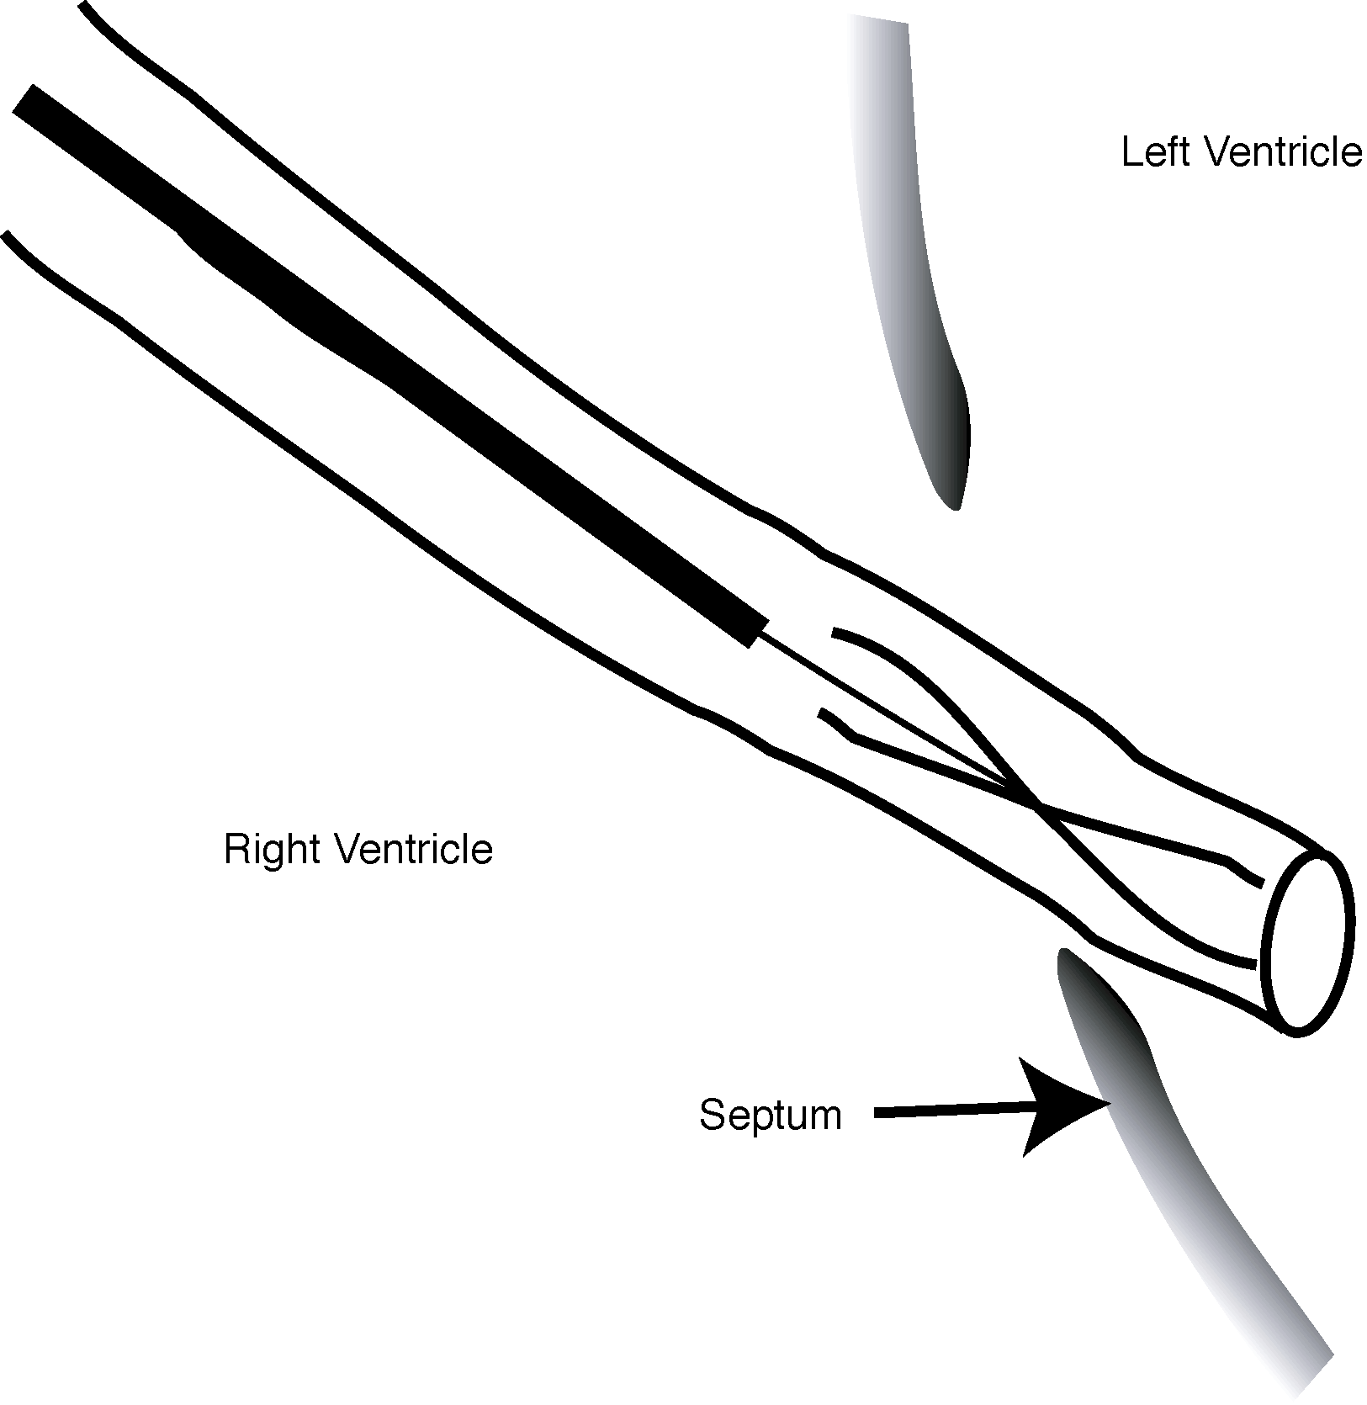

Recheck sheath tip position to verify location on distal side of VSD. Holding the sheath and Occluder steady, loosen the locking collar and retract the delivery catheter approximately 10 cm away from the implant (Figure 16).
Figure 16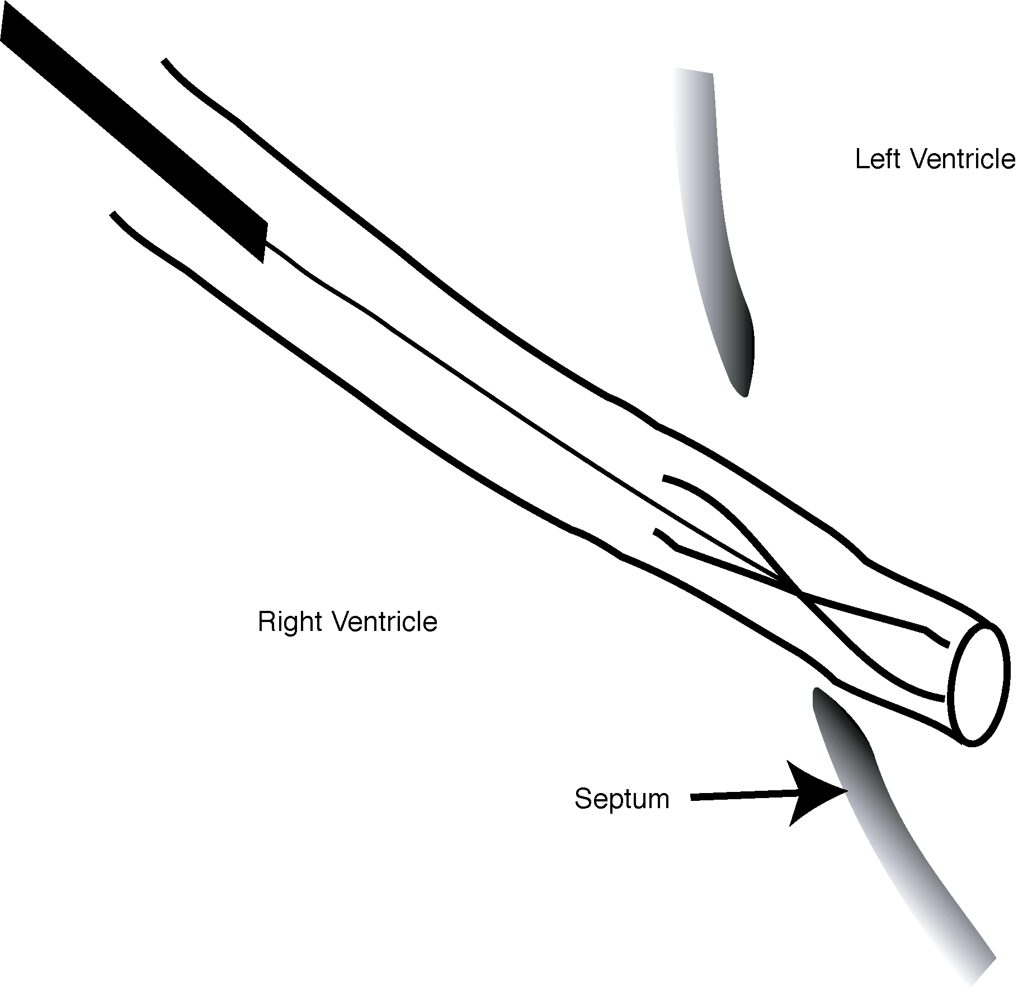

Holding the sheath steady, advance the distal set of CardioSEAL arms out of the sheath by advancing the blue catheter forward. Alternatively, open distal set of CardioSEAL arms by retracting sheath off of the distal arms. Under fluoroscopy and transesophageal echo, ascertain that all four distal CardioSEAL arms have fully deployed and are intact (Figure 17).
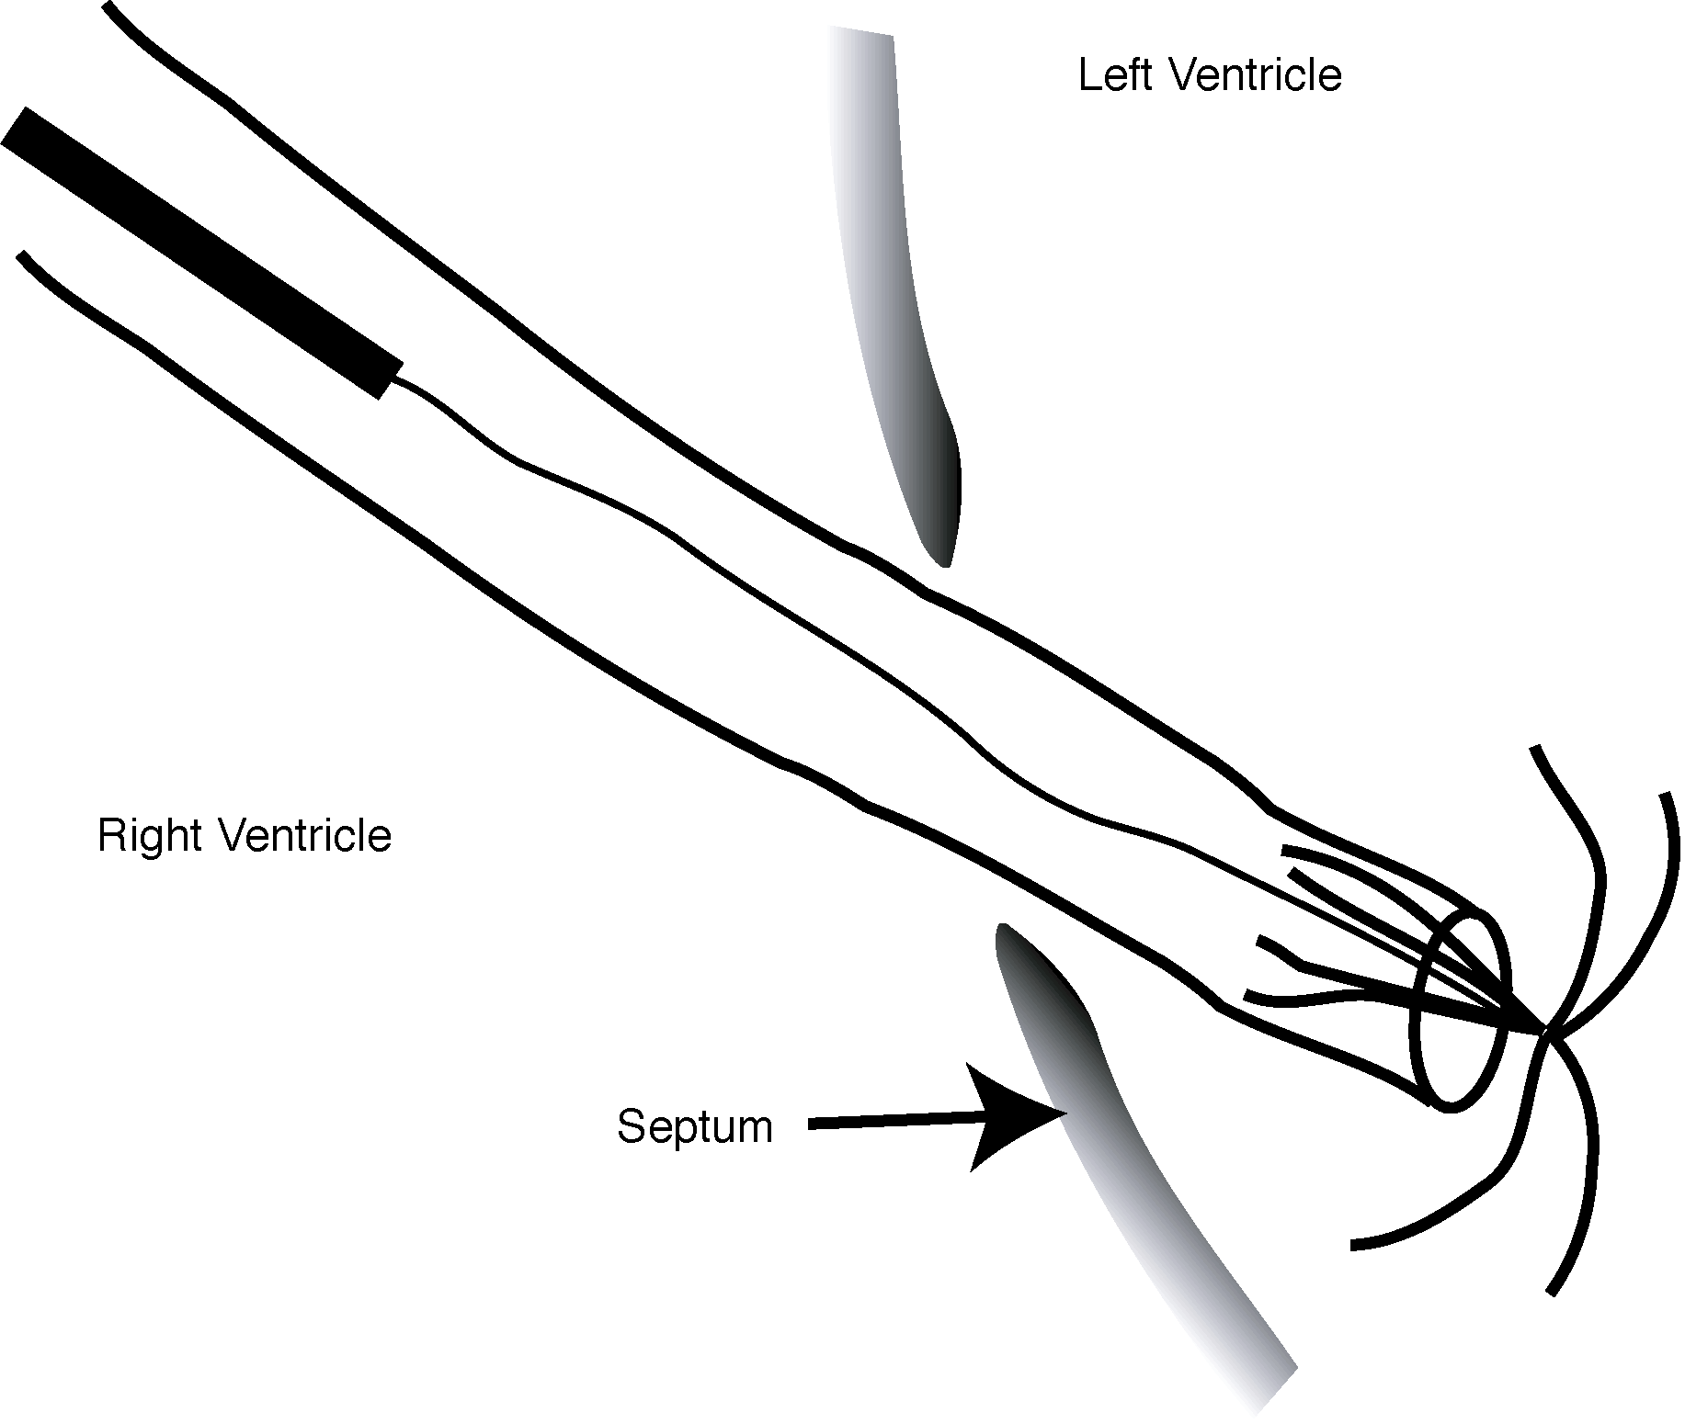
Figure 17

Holding the sheath and catheter steady, retract entire sheath – catheter - CardioSEAL until the distal CardioSEAL arms approximate or engage the distal wall of the VSD (Figure 18).
Figure 18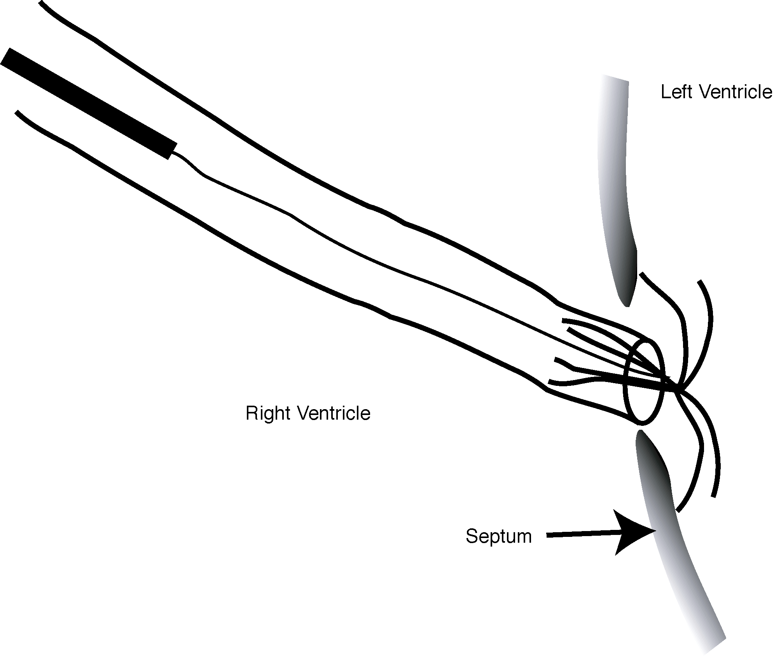

Once approximated or engaged, retract CardioSEAL further to slightly flex the CardioSEAL arms. Retract sheath off of proximal CardioSEAL arms while maintaining position in the VSD. This will release the proximal arms of the CardioSEAL to engage the proximal VSD wall (Figure 19).
Figure 19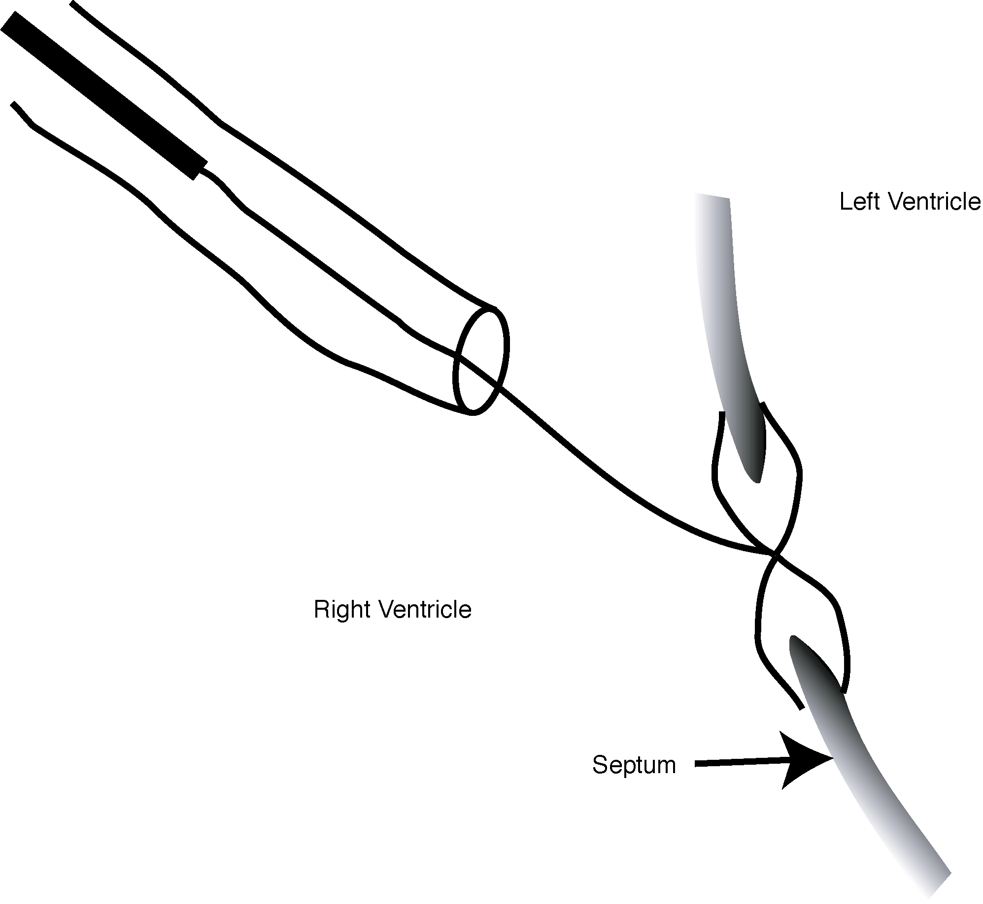

Allow delivery catheter and sheath to assume a neutral (i.e. no retraction) position and confirm correct placement of all arms on appropriate sides of the VSD.

Once proper positioning is confirmed, advance the pin from the sleeve using the control handle at the proximal end of the delivery system. This will release the CardioSEAL from the delivery system (Figure 20).
Figure 20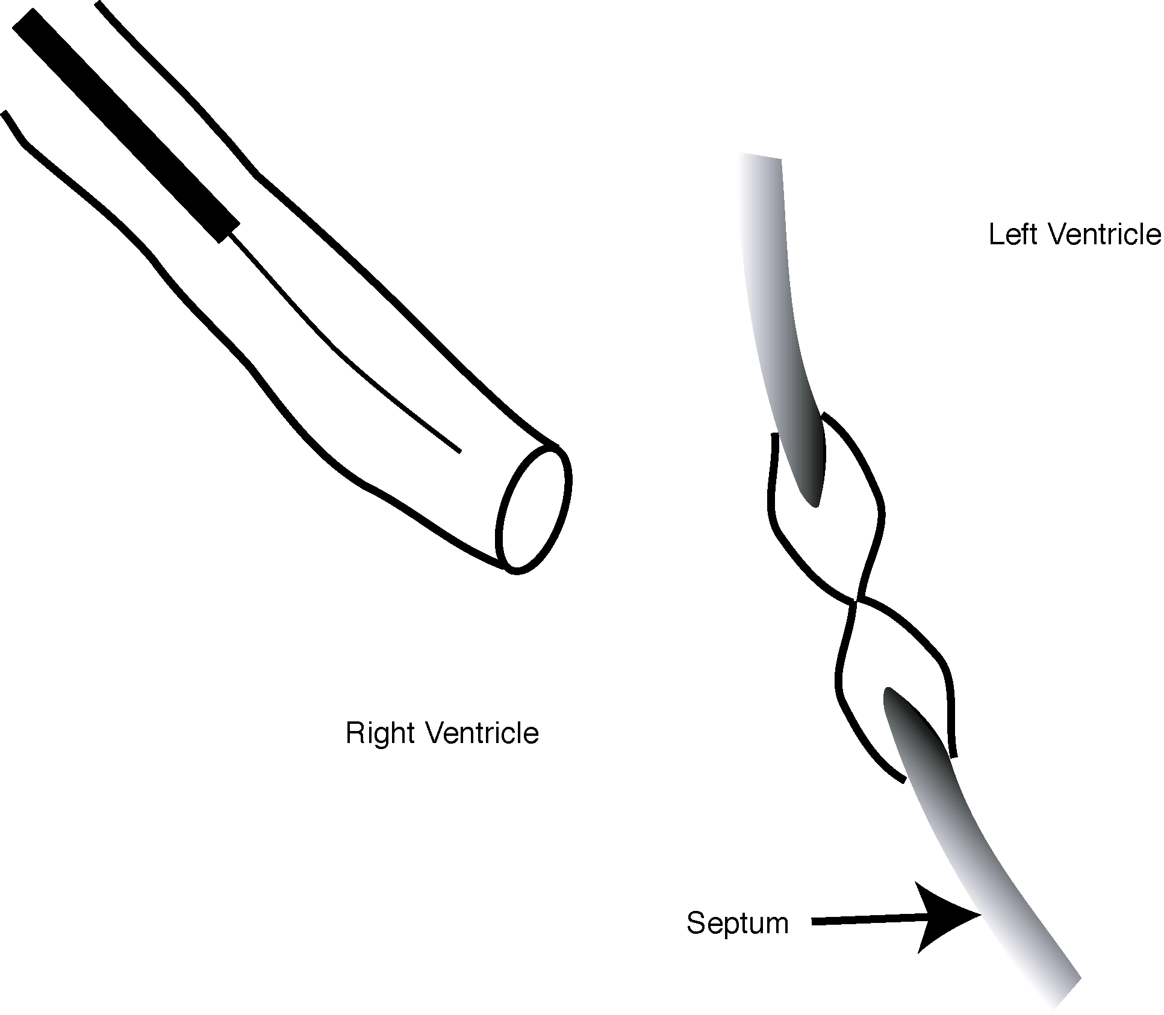

Remove delivery system from sheath.

PATIENT INFORMATION
The following counseling information should be provided to the patient:
- Patients should be reminded of the importance of adhering to their aspirin and endocarditis prophylaxis regimens.
- If an MRI is required, the patient should inform MRI staff of the presence of the CardioSEAL.
- Patients should be encouraged to contact their physician if they have any questions or concerns
- A patient brochure is available and is entitled: “A Patient’s Guide to Transcatheter Hole Closure of a Ventricular Septal Hole using The CardioSEAL® Septal Occlusion System.”

