A Technical Evaluation of Smoke Dispersion from the Hogback and Shortoff Prescribed Fires and Possible Impacts on Air Quality in Bryson City, NC

Prepared by Air Specialists, Cindy Huber and Bill Jackson
Finalized August 8, 2007
Revised August 29, 2007

On March 22, 2007 the fine particulate monitor in Bryson City, NC registered concentrations above normal from about 1700 until 0900 the following day, March 23, 2007. The concentrations were high enough to cause the 24-hour average for March 22, 2007 to exceed the new 24-hour fine particulate National Ambient Air Quality threshold of 35 micrograms per cubic meter.

Satellite imagery (Figure 1) reveals two fires burning on March 22, one in southwestern NC and another in southeastern Tennessee. These are prescribed fires that were being conducted by the US Forest Service (Figure 2). The focus of this evaluation is to determine the likelihood that smoke from one or both of these prescribed fires affected the air quality in Bryson City and contributed to higher than normal nighttime fine particulate measurements.

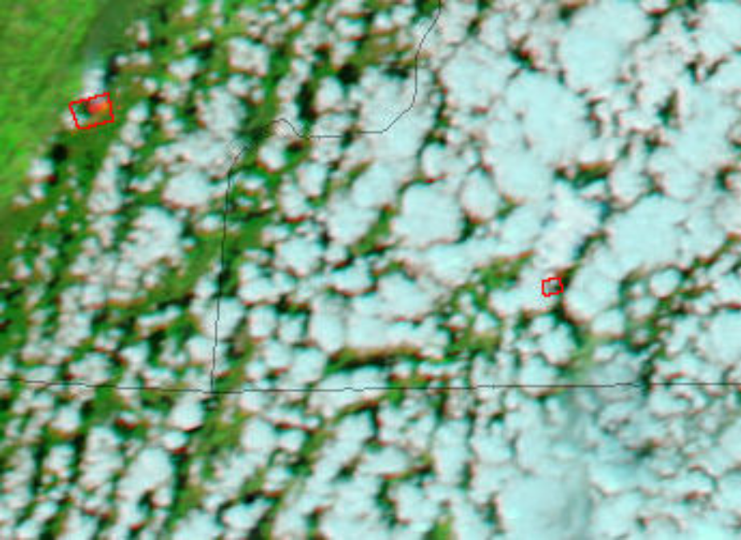
Figure 1. MODIS image from March 22, 2007 showing fires (red outline) in southwestern NC and southeastern TN.

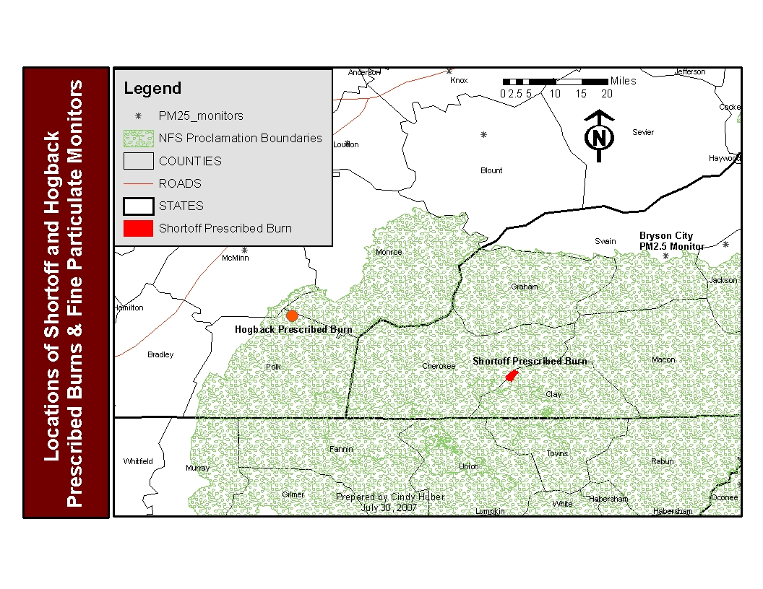
Figure 2. Locations of prescribed burns and fine particulate monitors used for this evaluation.

Air Quality at Bryson City, NC

Smoke from wildland fire contains particulate matter, primarily fine particulate less than 2.5 microns in diameter (PM_{2.5}). High concentrations of PM_{2.5} can have a negative impact on people's health and reduce visibility along roadways and scenic views. To help people understand the relationship between pollutant concentration and human health, the Environmental Protection Agency has developed a system that color codes air quality data based on human health effects (Appendix A) and it is called the Air Quality Index (AQI). The index is color-coded from green (no effect) to maroon (hazardous for all people). When the AQI value for any pollutant is color-code green or yellow it carries no cautionary health statement. But at the next level, AQI equals orange, people who are sensitive to air pollutants or have other health problems, may experience health effects. This means they are likely to be affected at lower levels than the general public. Sensitive groups of people include the elderly, children, and people with either lung disease or heart disease. The general public is not likely to be adversely affected when the AQI equals orange. Everyone may begin to experience health effects when AQI equals red, and those sensitive to air pollutants may experience more serious health effects. Purple and maroon, the next two levels in the AQI, represent increasingly hazardous conditions for human health.

Elevated fine particulate concentrations were measured at the continuous PM_{2.5} monitor (AIRS Site ID: 371730002) in Bryson City on March 22-23, 2007. The continuous monitoring conducted by North Carolina Division of Air Quality meets Federal Reference methods criteria established by the Environmental Protection Agency. The highest hourly average concentrations were measured between 1700 March 22 and 0900 March 23, and reached a maximum of 170 micrograms per cubic meter at 1700 March 22 (Figure 3). This value is equivalent to a 1-hour AQI value of code red which has an associated “unhealthy” level of health concern. The average PM_{2.5} concentrations returned to normal levels for the monitoring site at about 1000, March 23.

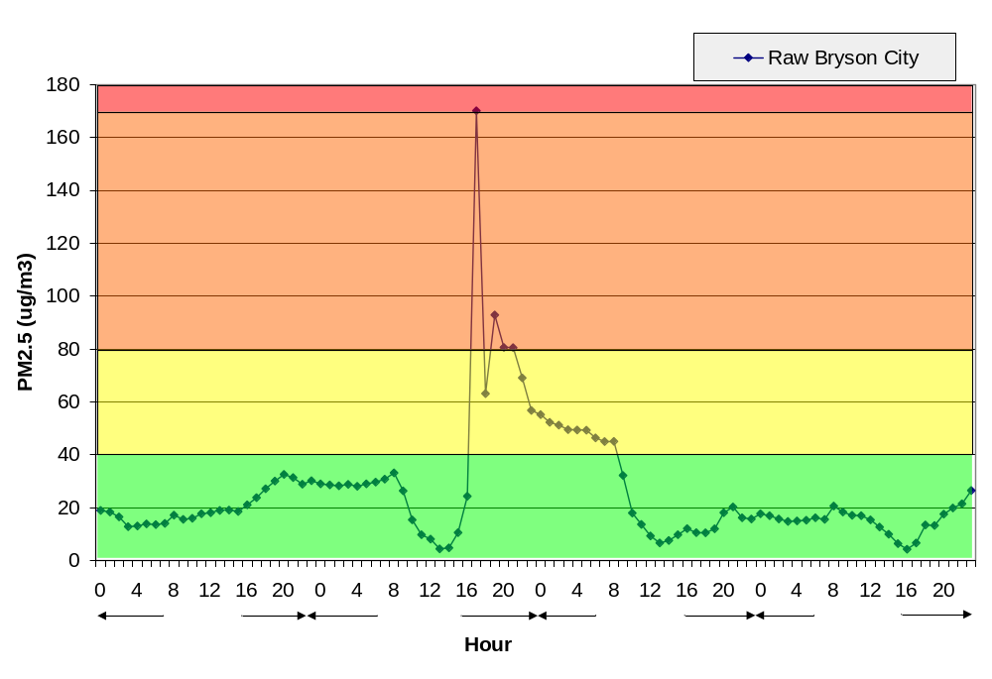
Figure 3. Fine particulate measurements from the Bryson City, NC Federal Reference Monitor for March 21-24, 2007.

Figure 4 shows how the inclusion of higher hourly concentrations on March 22 contributed to increases in the daily average PM_{2.5} concentrations. Daily averages are important because there is a National Ambient Air Quality Standard (NAAQS) for PM_{2.5} which states must attain. The red line in Figure 3 shows the new 24-hour standard for PM_{2.5}, which is 35 micrograms per cubic meter. (The standard was lowered from 65 to 35 micrograms per cubic meter in September 2006, based on current health effects research.)

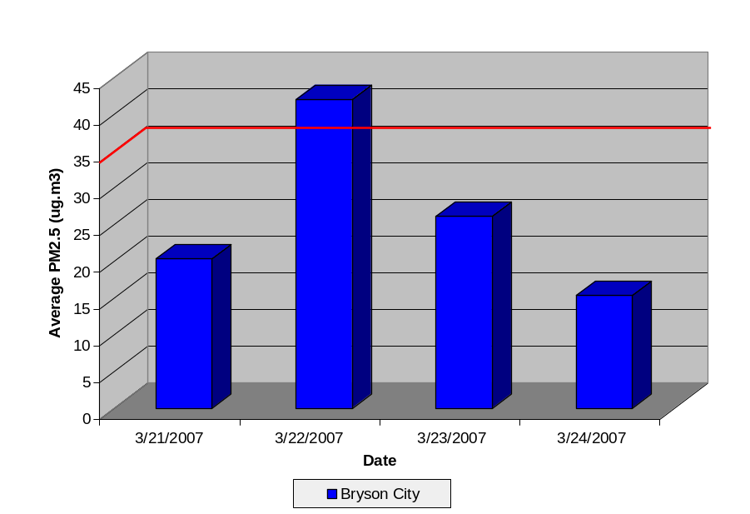
Figure 4. Comparison of daily average concentrations to the 24-hour National Ambient Air Quality Standard for fine particulate (PM_{2.5}).

What happened to the smoke dispersed from the Hogback and Shortoff prescribed fires on March 22, 2007?

Fire Activity: On March 22, 2007 prescribed burning was taking place at two sites, the Hogback prescribed fire on the Ocoee District of the Cherokee National Forest in TN and the Shortoff prescribed fire on the Tusquitee District of the Nanatahala National Forest in NC. The areas are approximately 35 miles apart (Figure 2).

Hogback Prescribed Fire: The Cherokee National Forest (TN) implemented the Hogback prescribed fire using a combination of hand ignition and aerial ignition from a helicopter. The burn unit covers 1875 acres and elevation varies from 1000-2100 feet. Ignition began around noon on March 22 and was completed by 1700 the same day. It is estimated that fuels were consumed on about 1700 acres of the burn unit. The active fire phase continued into the night until about midnight. The Fire Emissions Production Simulator (FEPS) was used to estimate hourly fine particulate emissions (Figure 5) and heat release rate from the burn unit. Maximum emissions from the prescribed fire probably occurred between 1400 and 1700 the afternoon of March 22.

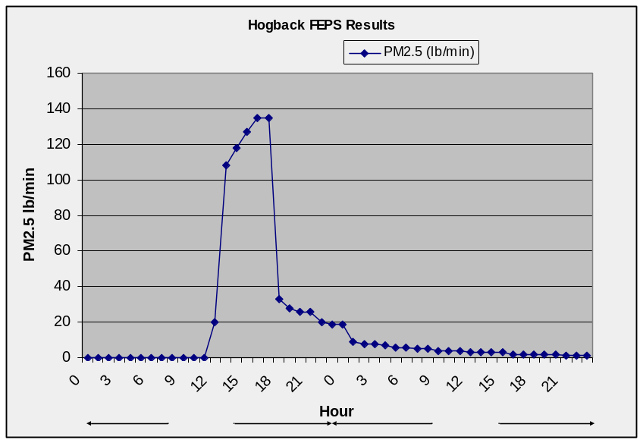
Figure 5. Hourly fine particulate emissions estimates from the Hogback prescribed fire using FEPS.

The Morristown, TN National Weather Service (NWS) office provides daily fire weather forecasts for both areas (east Tennessee and southwestern NC) where prescribed burning was planned. The NWS also provides spot weather forecasts for specific burn units at the request of the Forest. The following chart summarizes the weather parameters reported in both the fire weather and spot weather forecasts for the Hogback prescribed fire.

March 22, 2007 | Fire Weather Forecast (0515) | Spot Weather Forecast (0721)
Mixing Height (above mean sea level) | 6100 | 5500
Transport Winds (miles per hour) | From SW at 17 mph | from SW at 20 mph
Dispersion | 93 | 97
Sky/Weather | Partly Cloudy* | Partly Cloudy*
Surface Temperature (ºF) | 72-77 | Max 76
Relative Humidity (%) | 35-40 | Min 38
Windspeed at 20 ft above ground (miles per hour) | From SW at 7 mph | From SW at 7-12 mph, with occasional higher winds
*According to the Georgia Forestry Commission website a Partly Cloudy day is interpreted to have 30% to 50% cloud cover (http://weather.gfc.state.ga.us/Info/WXexp.aspx).

The NWS forecasts predicted transport winds from the SW at speeds of 17-20 mph on March 22, which would have moved smoke from the Hogback prescribed fire toward Knoxville, TN which is located NE of the burn unit.

Weather observations and measurements are taken on-site the day of the burn, for all prescribed fires conducted by the US Forest Service. Observed surface winds were of variable low speeds and from the SW throughout the day. Weather measurements are also taken automatically at remote stations located across the National Forest System.
This network of weather stations is called RAWS (Remote Automated Weather Stations) and the closest site to the burn unit is Coker Creek (CCKT1, elevation 1700 feet). Data from this site shows that surface winds on March 22 were from the S and SW. Surface wind speeds were 6-7 mph during the afternoon hours. Winds became more variable on March 23 shifting from S to SSW throughout the day. Based on the combination of predicted and observed weather information, it is unlikely that smoke from the Hogback prescribed fire would have affected the Bryson City monitor.

Shortoff prescribed fire: The Shortoff prescribed fire was accomplished using a combination of hand ignition and aerial ignition from a helicopter. The burn unit covers 1644 acres and elevation varies from 2000-3900 feet. The burn actually began on March 21, 2007 when the Forest used hand ignition of fuels on the perimeter of the burn to prepare control lines used to contain the fire. This began at approximately 1200 hours and continued until about 1800. The fire was allowed to burn (in what is called a “backing” fire) through the night and into the next day. Hand ignition resumed on March 22 at 1000 to complete preparation of the control lines. It is estimated that 300 acres had burned before aerial ignition began.

Aerial ignition was used on March 22 to treat the interior of the burn unit, and began at approximately 1345-1400. All ignitions were completed by 1600 and the active/flaming fire phase ceased in the burn unit about 1700. It is estimated that fuels were consumed on 95 percent of the area, or 1561 acres. FEPS was used to estimate hourly fine particulate emissions (Figure 6) and heat release rate from the burn unit. Maximum emissions from the prescribed fire probably occurred between 1500 and 1700 the afternoon of March 22.

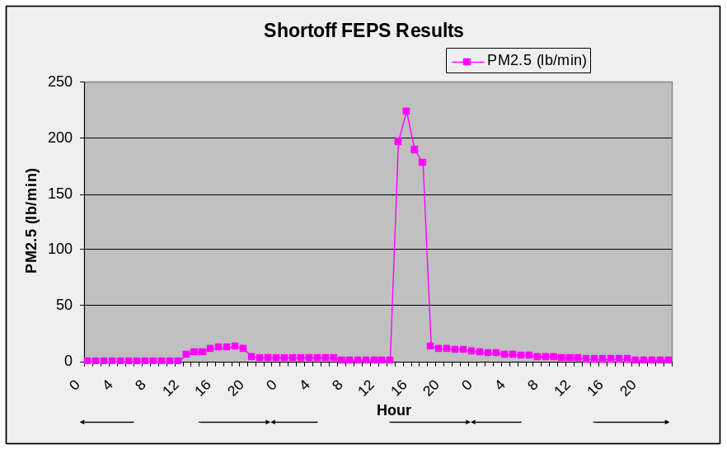
Figure 6. Hourly fine particulate emissions estimates from the Shortoff prescribed fire using the Fire Emissions Production Simulator.

National Weather Service forecasts were obtained for the Shortoff project and the following chart summarizes the parameters from both the fire weather and spot weather forecasts for the Shortoff prescribed fire on March 21 and 22.

March 21, 2007 | Fire Weather Forecast (0515) | Spot Weather Forecast (1456 on March 20, 2007)
Mixing Height (above mean sea level) | 6600 | 6400
Transport Winds (miles per hour) | From S at 17 mph | from S at 18 mph
Dispersion | 98 | 102
Sky/Weather | Partly Cloudy* | Partly Cloudy*
Surface Temperature (ºF) | 64-69 | Max 68
Relative Humidity (%) | 43-48 | Min 50
Windspeed at 20 ft above ground (miles per hour) | From S at 7 mph | From S at 6-9 mph
Nightime dispersion conditions |  | Decreasing to near zero (reflects light transport winds and mixing height decreasing near surface)
*According to the Georgia Forestry Commission website a Partly Cloudy day is interpreted to have 30% to 50% cloud cover (http://weather.gfc.state.ga.us/Info/WXexp.aspx).

March 22, 2007 | Fire Weather Forecast (0515) | Spot Weather Forecast (0641)
Mixing Height (above mean sea level) | 6000 | 5500
Transport Winds (miles per hour) | From SW at 16 mph | from SW at 20 mph
Dispersion | 81 | 84
Sky/Weather | Partly Cloudy* | Partly Cloudy*
Surface Temperature (ºF) | 71-75 | Max 75
Relative Humidity (%) | 33-38 | Min 37
Windspeed at 20 ft above ground (miles per hour) | From SW at 6 mph | From SW at 7-12 mph
*According to the Georgia Forestry Commission website a Partly Cloudy day is interpreted to have 30% to 50% cloud cover (http://weather.gfc.state.ga.us/Info/WXexp.aspx).

Weather forecasts for March 22 predicted transport winds from the SW at speeds of 16-20 mph, which would have moved smoke from the Shortoff prescribed fire unit toward Bryson City. Considering that the Shortoff prescribed fire unit is only 33 miles from Bryson City, smoke could have traveled to Bryson City in about 2 hours.

Field measurements taken near the burn at Barlow High Top (elevation 2280 feet) on March 22 showed ground level wind speeds of 3-5 mph in the morning increasing to 8 by afternoon. Surface winds were from the SE when burning began on March 22, and became variable form SSE, S or SSW during the afternoon, and shifted to the S by the evening. Perhaps most important for smoke dispersion is the observation that cloud-cover increased from about 30% in the morning to 80% at 1600; affecting stability of the atmosphere. This will be important in the smoke dispersion modeling discussion that follows.

The nearest representative RAWS station for the Shortoff prescribed fire unit would be Wayah, (TOPN7, elevation 2160 feet) but data is not available for March 21 and 22. The next closest station is Tusquitee (TSQN7, elevation 1000 feet), which is considerably lower than the burn unit. However, for the record, data from the Tusquitee site is comparable to the field observations taken at Barlow High Top. Another nearby site in Jackson County (315902) located at 2800 feet elevation also matched the field observations at Barlow High Top (Appendix B).

Smoke Dispersion Modeling: Atmospheric dispersion models have many uses. Two that are of particular interest to fire managers are predictive modeling of smoke dispersion to help inform the decision for the burn, and retrospective modeling to help understand where and how smoke actually dispersed. Provided with information about the Hogback and Shortoff prescribed fires and the weather, it is possible to conduct dispersion modeling to estimate the direction and ground-level particulate concentrations within the smoke plumes on March 22, and in doing so consider the likelihood that smoke from these fires affected Bryson City air quality monitor.

The VSMOKE-GIS model was run using as much measured or observed meteorological data as possible, to get post-burn estimates of smoke dispersion. VSMOKE allows modeling of only one burn at a time, and assumes that smoke is dispersed to the mixing height, but not above it. More advanced models will be needed to assess the possibility that: 1) smoke moved through the mixing height and was dispersed by different wind conditions, and/or 2) the plumes merged and affected Bryson City and other downwind communities.

VSMOKE predictions of daytime smoke dispersion from the Hogback and Shortoff prescribed fires are shown in Figure 7. The colors in the “plumes” represent different fine particulate concentrations (Appendix A, EPA Air Quality Index) at ground level for the hour with highest estimated emissions. For Hogback this occurred at 1600, for Shortoff at 1500. VSMOKE results are most reliable at distances less than 30 miles downwind; and therefore the plume plots are truncated at 30 miles. Details of the modeling can be found in the VSMOKE reports for each burn located in Appendix C.

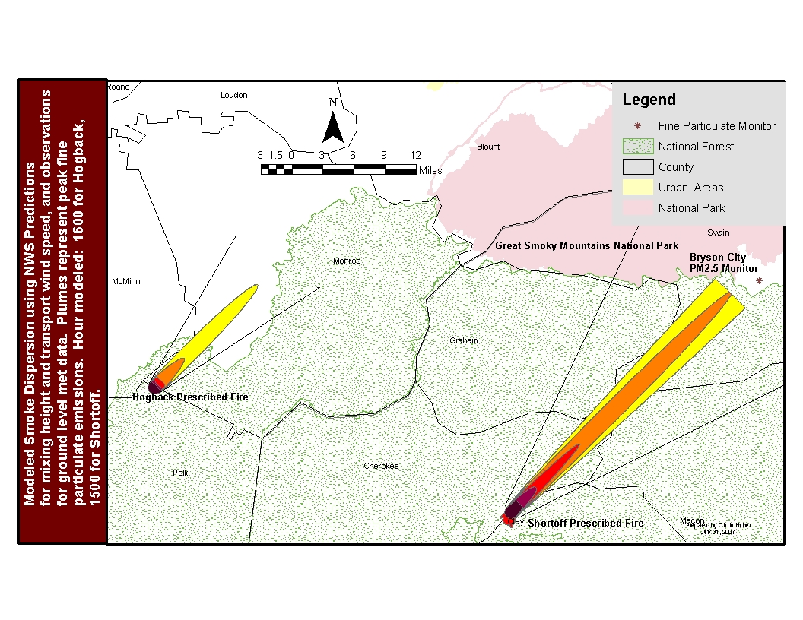
Figure 7. VSMOKE-GIS results showing ground-level fine particulate concentrations for time of peak emissions from the Shortoff and Hogback prescribed fires.

The plume plots show that smoke from the Hogback prescribed fire was not traveling toward Bryson City; the NWS forecast predicted transport winds from the SW; and observations taken on-site also showed surface winds from the SW. All indications are that the smoke from the Hogback prescribed fire probably did not affect Bryson City (located to the east of the Hogback fire) and no additional analysis is warranted.

On the other hand, the plume plots show that smoke from the Shortoff prescribed fire was traveling toward Bryson City. VSMOKE shows that ground level concentrations were elevated for a considerable distance downwind. The presence of ground-level smoke downwind from the burn was confirmed by Forest personnel observations (at about 1700) of noticeable smoke near Topton, NC which is located at the head of the Nantahala River gorge. Aerial observations of smoke dispersion also indicate that smoke was moving toward Bryson City from the Shortoff prescribed fire. During the peak active burning period from about 1430 to 1600, the NC Division of Forestry spotter plane reported that the smoke was rising to about 10,000 feet and the plume was going toward Sylva, NC (Jackson County). However, it should be kept in mind that this is a view of the plume from above and that a portion of the smoke remains below the mixing height (research has demonstrated that about 25 percent of the smoke is dispersed at ground level). At 1630 the helicopter pilot who was conducting the aerial ignition reported that the smoke column was rising and dispersing well to the northeast (consistent with predicted transport winds from the southwest). At 1700 the helicopter pilot reported that smoke seemed to be dropping down in the Nantahala River Gorge areas of Cherokee, Macon and Swain Counties (directly in the modeled plume path shown in Figure 7).

It seems likely that some emissions from the Shortoff prescribed fire could have been transported to Bryson City. Maximum emissions occurred at 1500, and predicted transport winds would have moved the plume toward Bryson City at 16-20 miles per hour. This would put whatever smoke remained in the “plume” over Bryson City at 1700, the same time that the air quality monitors registered an increase in fine particulate. Aerial observers could see a visible plume during the afternoon and early evening and reported that it was moving in the direction of Bryson City. They also reported the plume “dropping down” at 1700. About an hour before sunset (approximately 1700 in March) it is typical for a surface-based inversion to begin. This inversion tends to trap smoke closer to the ground and results in the plume appearing to drop or be pushed toward the earth. Furthermore, emissions/smoke that were below 6000 feet elevation when they reached the Great Smoky Mountains (a Federally mandated Class 1 area) would have become trapped on the east side of the mountains and dispersed down slope during the night, which would include Bryson City.

VSMOKE predicted the maximum ground-level fine particulate concentrations of 92 micrograms per cubic meter, 25 miles from the Shortoff prescribed fire (see Appendix C, Shortoff VSMOKE report). This pattern of dispersion is probably due to the relatively low mixing height of 1800 feet above ground level (even though this is above US Forest Service, Region 8 minimum standards) and near neutral stability at the time when maximum emissions were released. (Weather observations taken on-site at Barlow High Top showed that cloud cover increased about 10 % each hour from 0900 (30%) to 1600 (80%), changing conditions from moderately unstable to near neutral between early morning and early afternoon.) It appears that the mixing height was not adequate to overcome the near neutral stability conditions and the large amount of smoke entering the atmosphere over a relatively short period of time.
The HYSPLIT (http://www.arl.noaa.gov/ready/hysplit4.html) model was the second tool used to examine what direction smoke released from the Shortoff Mountain would travel. HYSPLIT is a complete system for computing simple air parcel trajectories to complex dispersion and deposition simulations. The model forecast was operated in the forecast mode with the smoke released from the burn site at 1500. The HYSPLIT results predict the smoke released from the burn unit at 1500 would have reached Bryson City between 1700 and 1800 on March 22, 2007 (Figure 8).

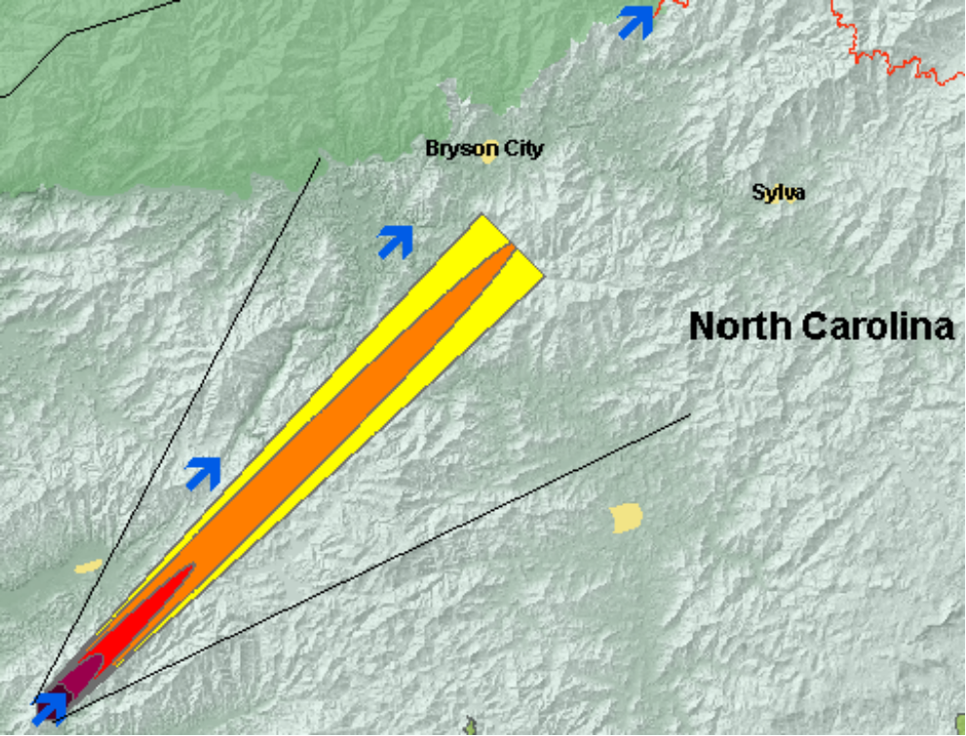
Figure 8. Predicted trajectory of the smoke released at 1500 (blue arrow on lower left) from the Shortoff Mountain prescribed fire. Each arrow shows the approximate location of the smoke dispersion for each hour to 1800 (upper right blue arrow).

What can we learn from this evaluation?

Good smoke dispersion requires a balance between adequate atmospheric conditions and the amount of fuel consumed (and emissions released) over each hour. If large amounts of fuel are consumed over a short period of time, the ventilation index must be high (high mixing height and transport wind speed) and stability class unstable (fewer clouds and moderate surface winds) in order to achieve maximum dilution and dispersion.

To demonstrate the effects of mixing height and atmospheric stability on smoke dispersion we used VSMOKE and the Shortoff prescribed fire inputs for all parameters; changing only mixing height and/or stability class. VSMOKE modeling results in the table below show that a change in either mixing height or stability class results in similar substantial reductions of particulate matter downwind. Of course the greatest reductions occur when mixing height increases considerably and the atmosphere is more unstable. Had the stability class of the atmosphere been more unstable and mixing height greater on the day of the Shortoff prescribed fire, then ground level concentrations would have been lower and the potential impacts to Bryson City decreased or eliminated.

 |  | Downwind Fine Particulate Concentrations in micrograms per cubic meter
Mixing Height in feet | Stability Class | At 10 miles | At 30 miles | At 50 miles
1800 | Near Neutral | 170 | 80 | 60
5000 | Near Neutral | 105 | 45 | 35
1800 | Mod Unstable | 95 | 50 | 40
5000 | Mod Unstable | 47 | 30 | 27

One additional analysis was conducted for this evaluation. The NC Division of Forestry currently posts Voluntary Smoke Management Guidelines for prescribed burning on their website (http://www.dfr.state.nc.us/fire_control/fire_menu.htm). We used these guidelines and found that for the fuel loading (and estimated consumption) on the Shortoff prescribed fire unit and the weather conditions on March 22, a mixing height of 5600 feet above ground level was needed. VSMOKE was run again for the Shortoff prescribed fire unit, changing only the mixing height from 1800 to 5600 feet above ground level. Figure 9 shows that higher fine particulate concentrations would not have extended as far downwind, if the mixing height had been higher on the day of the burn.

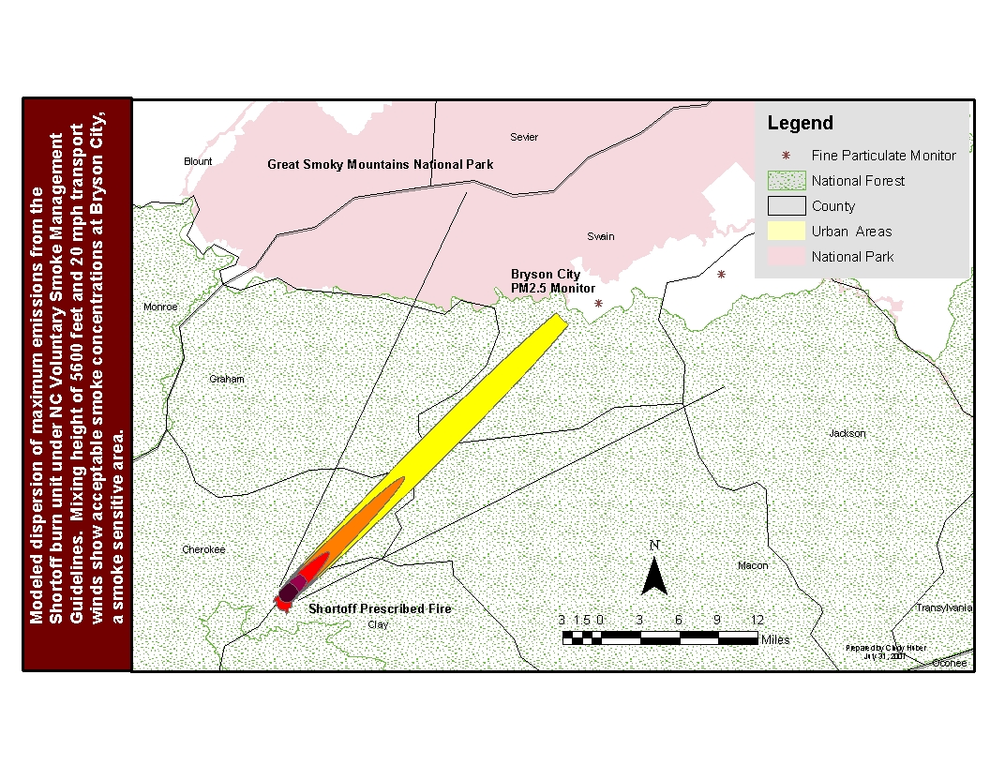
Figure 9. VSMOKE-GIS modeling results for the Shortoff prescribed fire with mixing height increased to 5600 feet above ground level.

APPENDIX A

EPA’s Air Quality Index (AQI) for Particulate Matter _{2.5} (PM_{2.5}) including the breakpoints of PM _{2.5} concentrations for the Air Quality Index rankings

PM_{2.5} 24-hr Avg. Concentration (ug/m³) | PM_{2.5} 1-hr Avg. Concentration (ug/m³) | Index Values | Visibility (Miles) | Level of Health Concern | Cautionary Statements
0.0 – 15.4 | 0.0 – 40.0 | 0-50 | > 10 | Good | None
15.5 – 40.4 | 40.1 – 80.0 | 51 – 100** | 5.1 – 10.0 | Moderate | None
40.5 – 65.4 | 80.1 – 175.0 | 101 - 150 | 3.1 – 5.0 | Unhealthy for Sensitive Groups | People with respiratory or heart disease, the elderly, and children should limit prolonged exertion.
65.5 – 150.4 | 175.1 – 300.0 | 151 – 200 | 1.6 – 3.0 | Unhealthy | People with respiratory or heart disease, the elderly and children should avoid prolonged exertion, everyone else should limit prolonged exertion.
150.5 – 250.4 | 300.1 – 500 | 201 – 300 | 1.0 – 1.5 | Very Unhealthy | People with respiratory or heart disease, the elderly and children should avoid any outdoor activity, everyone else should avoid prolonged exertion.
250.5 + | 500.0 + | 301 - 500 | < 1.0 | Hazardous | Everyone should avoid any outdoor exertion; people with respiratory or heart disease, the elderly and children should remain indoors.

Health index rankings are based on 1-hour and 24-hour concentration averages. EPA developed the health indices based on 24-hour averages. Idaho State’s Department of Environmental Quality developed health indices based on 1-hour averages.
** An AQI of 100 for PM_{2.5} corresponds to a PM_{2.5} level of 40 micrograms per cubic meter (24-hr avg.).
APPENDIX B

Jackson County Weather Station (315902) Elevation: 2800 feet
Obs | Ob | Dry |  | Wind |  | Temp |  | RH% |  | Precip | Precip
Date | Tm | Tmp | RH | Dir | SP | Max | Min | Max | Min | Dur | Amt
22-Mar-07 | 0 | 54 | 79 | 112 | 4 | 66 | 49 | 100 | 52 | 0 | 0
22-Mar-07 | 1 | 54 | 78 | 90 | 5 | 66 | 49 | 100 | 52 | 0 | 0
22-Mar-07 | 2 | 53 | 79 | 107 | 4 | 66 | 49 | 100 | 52 | 0 | 0
22-Mar-07 | 3 | 54 | 82 | 83 | 4 | 66 | 49 | 100 | 52 | 0 | 0
22-Mar-07 | 4 | 51 | 86 | 40 | 2 | 66 | 49 | 100 | 52 | 0 | 0
22-Mar-07 | 5 | 53 | 77 | 224 | 3 | 66 | 49 | 99 | 52 | 0 | 0
22-Mar-07 | 6 | 53 | 82 | 76 | 1 | 66 | 50 | 99 | 52 | 0 | 0
22-Mar-07 | 7 | 52 | 85 | 220 | 1 | 66 | 51 | 97 | 52 | 0 | 0
22-Mar-07 | 8 | 54 | 80 | 322 | 1 | 66 | 51 | 88 | 52 | 0 | 0
22-Mar-07 | 9 | 57 | 75 | 15 | 3 | 66 | 51 | 86 | 52 | 0 | 0
22-Mar-07 | 10 | 61 | 62 | 8 | 3 | 66 | 51 | 86 | 52 | 0 | 0
22-Mar-07 | 11 | 64 | 58 | 12 | 3 | 66 | 51 | 86 | 52 | 0 | 0
22-Mar-07 | 12 | 69 | 45 | 242 | 5 | 69 | 51 | 86 | 45 | 0 | 0
22-Mar-07 | 13 | 66 | 46 | 198 | 10 | 69 | 51 | 86 | 45 | 0 | 0
22-Mar-07 | 14 | 69 | 42 | 233 | 7 | 69 | 51 | 86 | 42 | 0 | 0
22-Mar-07 | 15 | 68 | 41 | 217 | 7 | 69 | 51 | 86 | 41 | 0 | 0
22-Mar-07 | 16 | 70 | 41 | 222 | 8 | 70 | 51 | 86 | 41 | 0 | 0
22-Mar-07 | 17 | 66 | 44 | 199 | 8 | 70 | 51 | 86 | 41 | 0 | 0
22-Mar-07 | 18 | 63 | 49 | 218 | 7 | 70 | 51 | 86 | 41 | 0 | 0
22-Mar-07 | 19 | 61 | 52 | 216 | 9 | 70 | 51 | 86 | 41 | 0 | 0
22-Mar-07 | 20 | 59 | 56 | 202 | 4 | 70 | 51 | 86 | 41 | 0 | 0
22-Mar-07 | 21 | 59 | 59 | 33 | 2 | 70 | 51 | 86 | 41 | 0 | 0
22-Mar-07 | 22 | 57 | 64 | 165 | 3 | 70 | 51 | 86 | 41 | 0 | 0
22-Mar-07 | 23 | 52 | 72 | 101 | 3 | 70 | 51 | 86 | 41 | 0 | 0

APPENDIX C

Hogback Prescribed Fire (Polk/Monroe County, TN) on the Ocoee District of the Cherokee National Forest (Assumes 1700 acres of 1875 were blackened)
VSMOKE-GIS results appear in Figure 7 of the main paper.
Prepared by: Cindy Huber
Date: 8/8/2007

The smoke dispersion modeling analysis (using VSmoke and/or VSmoke-GIS) for this project was performed for 1130.0 acres to be burned on 03/22/2007 at the time period of 1600 hours. This time period has daytime dispersion characteristics to disperse the pollutants from the fire. The location of the fire is at approximately 35.285 degrees latitude and -84.473 degrees longitude (356653.011 meters east and 1250873.42 meters north using US Albers projection). The emission rate of PM2.5 (fine particles) this hour was 1022.0 grams/second, and carbon monoxide was 12605.3 grams/second. The heat release rate was 388911.4 megawatts. Both emission rates and the heat release rates were calculated using the Fire Emission Production Simulator (FEPS) model. The estimated background concentration of fine particles and carbon monoxide of the air carried with the winds into the fire are 20 micrograms/cubic meter and 5 parts per million, respectively. The proportion of the smoke subject to plume rise was -0.75 percent, which means 75 percent of the smoke is being dispersed gradually as it rises to the mixing height, and 25 percent is dispersed at ground level.

The meteorological conditions used in this model run were:

1.) Mixing height was 4000 feet above ground level (AGL).
2.) Transport wind speed, and surface wind speed were 20 and 7 miles per hour, respectively.
3.) The sky had 30 percent cloud cover, and the clouds were located 5000 feet above the ground.
4.) Surface temperature was 78 degrees Fahrenheit, and the relative humidity was 38 percent.
5.) The calculated stability class from VSmoke was slightly unstable.

The VSmoke model produces three types of outputs that estimate: a.) The ability of the atmosphere to disperse smoke and the likelihood the smoke will contribute to fog formation, b.) Downwind concentrations of particulate matter and carbon monoxide, and c.) Visibility conditions downwind of the fire.

The Dispersion Index (DI) is an estimate of the ability of the atmosphere to disperse smoke to acceptably low average concentrations downwind of one or more fires. This value could represent an area of approximately 1000 square miles under uniform weather conditions. Typically, the Dispersion Index value should be greater than 30 when igniting a large number of acres within an area. The calculated Dispersion Index value was 75, which predicts the atmosphere has a good capacity to disperse smoke.

Combining the Dispersion Index and relative humidity values provide an estimate (like is used in insurance actuary tables) of the likelihood of the smoke contributing to fog formation. The Low Visibility Occurrence Risk Index (LVORI) ranges from 1 (lowest risk) to 10 (greatest risk) and usually you want the value to be less than 4. The base line risk of having low visibility as a result of smoke contributing to fog formation is about 1 in 1000 accidents. The Low Visibility Occurrence Risk Index value for this VSmoke analysis was 1 and this is equal to the base line.

High concentrations of particulate matter, especially fine particles (PM2.5), and carbon monoxide can have a negative impact on people's health. The Environmental Protection Agency has developed a color coding system called the Air Quality Index (AQI) to help people understand what concentrations of air pollution may impact their health. When the AQI value is color code orange then people who are sensitive to air pollutants, or have other health problems, may experience health effects. This means they are likely to be affected at lower levels than the general public. Sensitive groups of people include the elderly, children, and people with either lung disease or heart disease. The general public is not likely to be affected when the AQI is code orange. Everyone may begin to experience health effects when AQI values are color coded as red. People who are sensitive to air pollutants may experience more serious health effects when concentrations reach code red levels.

This analysis shows the air quality at downwind distances less than 0.98 miles from the edge of the fire may have a 1-hour particulate matter concentrations predicted to be code red or worse, while distances less than 4.94 miles are predicted to be code orange or worse. At distances less than 656 feet from the edge of the fire the one-hour carbon monoxide concentrations are predicted to be code red or worse, and distances less than 0.25 miles from the fire are predicted to be code orange or worse.

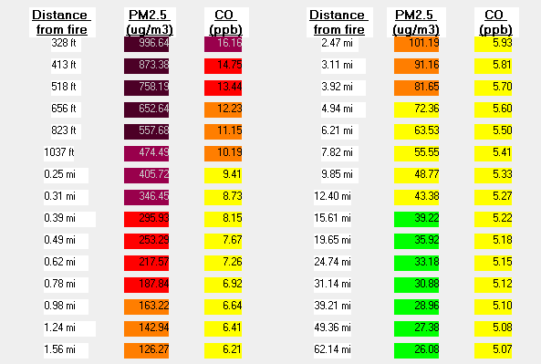

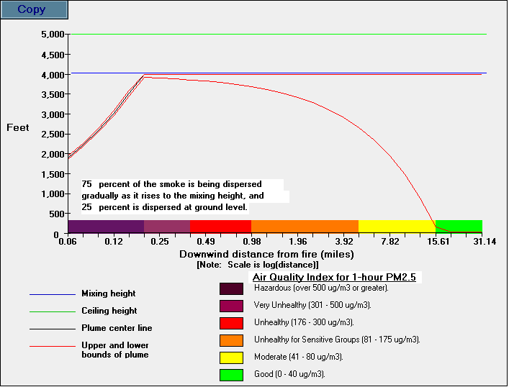

Smoke can also have an impact on how far and how clearly we can see on a highway or in viewing scenery. The fine particles in the smoke are known to be able to scatter and absorb light, which can reduce visibility conditions. The visibility estimates from VSmoke are valid only when the relative humidity is less than 70 percent. Also, the visibility estimates assume the smoke is passing in front of a person who is looking through the plume of smoke. The visibility thresholds used for this modeling analysis were to maintain a contrast ratio of greater than 0.05 and a visibility distance of 0.25 miles. Visibility conditions may exceed the threshold less than 328 feet from the edge of the fire.

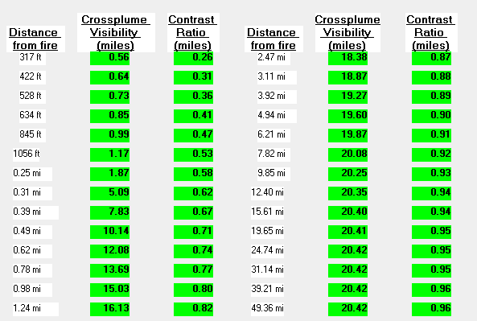

The VSMOKE-GIS model estimates the distance downwind of the fire that pre-selected fine particulate matter concentrations (41, 81, 176, 301, and 501 micrograms per cubic meter) are predicted to occur. The map of results can be viewed in Figure 7 of the main report. The VSmoke-GIS analysis had daytime dispersion characteristics to disperse the pollutants from the fire and this is the same as the VSmoke analysis. The downwind spacing interval was set at 0.025 kilometers, and the model ceased making downwind estimates at 30 miles from the edge of the fire. The stability class used for the VSmoke-GIS analysis was slightly unstable and this is the same as the calculated stability from VSmoke.

Shortoff Prescribed Fire (Clay County, NC) on the Tusquitee District of the Nantahala National Forest (Assumes 95% of the acres in the burn unit were blackened; 1561 acres)
VSMOKE-GIS results appear in Figure 7 of the main paper.
Prepared by: Cindy Huber
Date: 8/6/2007

The smoke dispersion modeling analysis (using VSMOKE and/or VSMOKE-GIS) for this project was performed for 931 acres to be burned on 3/22/2007 at the time period of 1500 hours. This time period has daytime dispersion characteristics to disperse the pollutants from the fire. The location of the fire is at approximately 35.109 degrees latitude and -83.868 degrees longitude (412096.048 meters east and 1231394.321 meters north using US Albers projection). The emission rate of PM2.5 (fine particles) this hour was 1695.1 grams/second, and carbon monoxide was 20788.5 grams/second. The heat release rate was 708123.5 megawatts. Both emission rates and the heat release rates were calculated using the Fire Emission Production Simulator (FEPS) model. The estimated background concentration of fine particles and carbon monoxide of the air carried with the winds into the fire are 20 micrograms/cubic meter and 5 parts per million, respectively. The proportion of the smoke subject to plume rise was -0.75 percent, which means 75 percent of the smoke is being dispersed gradually as it rises to the mixing height, and 25 percent is dispersed at ground level.

The meteorological conditions used in this model run were:

1.) Mixing height was 1800 feet above ground level (AGL), for the upper elevations of the burn unit (from the spot weather forecast).
2.) Transport wind speed (from the spot weather forecast) and surface wind speed (from field observations) were 20 and 8 miles per hour, respectively.
3.) The sky had 70 percent cloud cover (based on field observations and the satellite image in Figure 1 of the main report), and the clouds were located 5000 feet above the ground.
4.) Surface temperature was 74 degrees Fahrenheit, and the relative humidity was 45 percent (both from on-site measurements).
5.) The calculated stability class from VSMOKE was near neutral.

The VSMOKE model produces three types of outputs that estimate: a.) The ability of the atmosphere to disperse smoke and the likelihood the smoke will contribute to fog formation, b.) Downwind concentrations of particulate matter and carbon monoxide, and c.) Visibility conditions downwind of the fire.

The Dispersion Index (DI) is an estimate of the ability of the atmosphere to disperse smoke to acceptably low average concentrations downwind of one or more fires. This value could represent an area of approximately 1000 square miles under uniform weather conditions. Typically, the Dispersion Index value should be greater than 30 when igniting a large number of acres within an area. The calculated Dispersion Index value was 38, which predicts the atmosphere has a fair to good capacity to disperse smoke.
Combining the Dispersion Index and relative humidity values provide an estimate (like is used in insurance actuary tables) of the likelihood of the smoke contributing to fog formation. The Low Visibility Occurrence Risk Index (LVORI) ranges from 1 (lowest risk) to 10 (greatest risk) and usually you want the value to be less than 4. The base line risk of having low visibility as a result of smoke contributing to fog formation is about 1 in 1000 accidents. The Low Visibility Occurrence Risk Index value for this VSMOKE analysis was 1 and this is equal to the base line.

High concentrations of particulate matter, especially fine particles (PM2.5), and carbon monoxide can have a negative impact on people's health. The Environmental Protection Agency has developed a color coding system called the Air Quality Index (AQI) to help people understand what concentrations of air pollution may impact their health. When the AQI value is color code orange then people who are sensitive to air pollutants, or have other health problems, may experience health effects. This means they are likely to be affected at lower levels than the general public. Sensitive groups of people include the elderly, children, and people with either lung disease or heart disease. The general public is not likely to be affected when the AQI is code orange. Everyone may begin to experience health effects when AQI values are color coded as red. People who are sensitive to air pollutants may experience more serious health effects when concentrations reach code red levels.

This analysis shows the air quality at downwind distances less than 9.85 miles from the edge of the fire may have a 1-hour particulate matter concentrations predicted to be code red or worse, while distances less than 31.14 miles are predicted to be code orange or worse. At distances less than 0.78 miles from the edge of the fire the one-hour carbon monoxide concentrations are predicted to be code red or worse, and distances less than 1.96 miles from the fire are predicted to be code orange or worse.

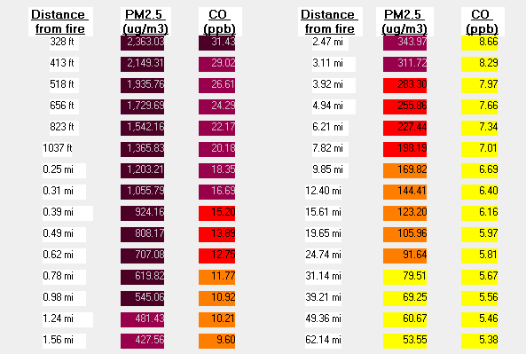

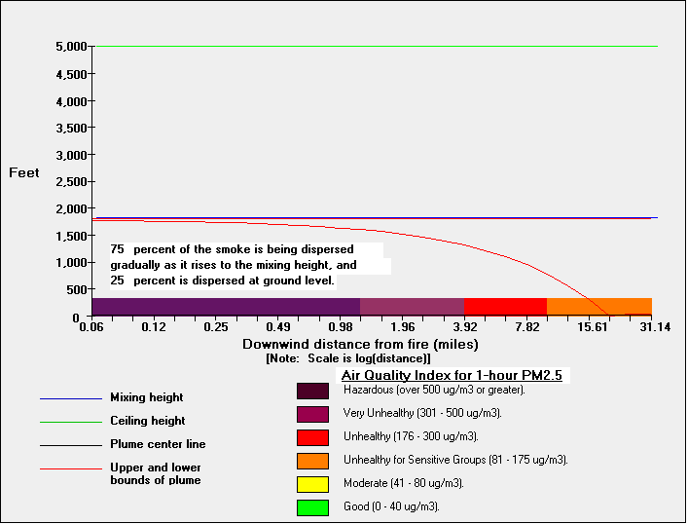

Smoke can also have an impact on how far and how clearly we can see on a highway or in viewing scenery. The fine particles in the smoke are known to be able to scatter and absorb light, which can reduce visibility conditions. The visibility estimates from VSMOKE are valid only when the relative humidity is less than 70 percent. Also, the visibility estimates assume the smoke is passing in front of a person who is looking
through the plume of smoke. The visibility thresholds used for this modeling analysis were to maintain a contrast ratio of greater than 0.05 and a visibility distance of 0.25 miles. Visibility conditions may exceed the threshold less than 413 feet from the edge of the fire.

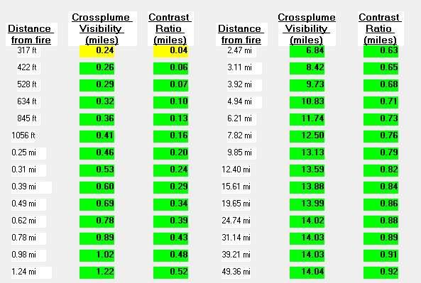

The VSMOKE-GIS model estimates the distance downwind of the fire that pre-selected fine particulate matter concentrations (41, 81, 176, 301, and 501 micrograms per cubic meter) are predicted to occur. The map of results can be viewed in Figure 7 of the main report. The VSMOKE-GIS analysis used daytime dispersion characteristics to disperse the pollutants from the fire and this is the same as the VSMOKE analysis. The downwind spacing interval was set at 0.025 kilometers, and the model ceased making downwind estimates at 30 miles from the edge of the fire. The stability class used for the VSMOKE-GIS analysis was near neutral and this is the same as the calculated stability from VSMOKE.

Shortoff Prescribed Fire (Clay County, NC) on the Tusquitee District of the Nantahala National Forest (Assumes 95% of the acres in the burn unit were blackened; 1561 acres)
Modeled to show dispersion under the NC Voluntary Smoke Management Guidelines, VSMOKE-GIS results appear in Figure 8 of the main paper.
Prepared by: Cindy Huber
Date: 8/8/2007

The smoke dispersion modeling analysis (using VSmoke and/or VSmoke-GIS) for this project was performed for 931 acres to be burned on 3/22/2007 at the time period of 1500 hours. This time period has daytime dispersion characteristics to disperse the pollutants from the fire. The location of the fire is at approximately 35.109 degrees latitude and -83.868 degrees longitude (412096.048 meters east and 1231394.321 meters north using US Albers projection). The emission rate of PM2.5 (fine particles) this hour was 1695.1 grams/second, and carbon monoxide was 20788.5 grams/second. The heat release rate was 708123.5 megawatts. Both emission rates and the heat release rates were calculated using the Fire Emission Production Simulator (FEPS) model. The estimated background concentration of fine particles and carbon monoxide of the air carried with the winds into the fire are 20 micrograms/cubic meter and 5 parts per million, respectively. The proportion of the smoke subject to plume rise was -0.75 percent, which means 75 percent of the smoke is being dispersed gradually as it rises to the mixing height, and 25 percent is dispersed at ground level.

The meteorological conditions used in this model run were:

1.) Mixing height was 5600 feet above ground level (AGL). This is the mixing height that would be required under the current Voluntary Smoke Guidelines in North Carolina (This assumes consumption of 9000 tons of fuel on a day with fair to good smoke dispersion or a Burn Category 5 day. Burn Category 5 requires a ventilation rate of 112,000 or higher, and carries a warning of Burn with Caution, Good Smoke Dispersion, and Potential Severe Fire Behavior. Given the transport wind speed of 20 mph, a mixing height of 5600 would be needed to get a ventilation rate of 112,000.)
2.) Transport wind speed, and surface wind speed were 20 and 8 miles per hour, respectively.
3.) The sky had 70 percent cloud cover, and the clouds were located 5000 feet above the ground.
4.) Surface temperature was 74 degrees Fahrenheit, and the relative humidity was 45 percent.
5.) The calculated stability class from VSmoke was near neutral.

The VSmoke model produces three types of outputs that estimate: a.) The ability of the atmosphere to disperse smoke and the likelihood the smoke will contribute to fog formation, b.) Downwind concentrations of particulate matter and carbon monoxide, and c.) Visibility conditions downwind of the fire.

The Dispersion Index (DI) is an estimate of the ability of the atmosphere to disperse smoke to acceptably low average concentrations downwind of one or more fires. This value could represent an area of approximately 1000 square miles under uniform weather
conditions. Typically, the Dispersion Index value should be greater than 30 when igniting a large number of acres within an area. The calculated Dispersion Index value was 58, which predicts the atmosphere has a good capacity to disperse smoke.

Combining the Dispersion Index and relative humidity values provide an estimate (like is used in insurance actuary tables) of the likelihood of the smoke contributing to fog formation. The Low Visibility Occurrence Risk Index (LVORI) ranges from 1 (lowest risk) to 10 (greatest risk) and usually you want the value to be less than 4. The base line risk of having low visibility as a result of smoke contributing to fog formation is about 1 in 1000 accidents. The Low Visibility Occurrence Risk Index value for this VSmoke analysis was 1 and this is equal to the base line.

High concentrations of particulate matter, especially fine particles (PM2.5), and carbon monoxide can have a negative impact on people's health. The Environmental Protection Agency has developed a color coding system called the Air Quality Index (AQI) to help people understand what concentrations of air pollution may impact their health. When the AQI value is color code orange then people who are sensitive to air pollutants, or have other health problems, may experience health effects. This means they are likely to be affected at lower levels than the general public. Sensitive groups of people include the elderly, children, and people with either lung disease or heart disease. The general public is not likely to be affected when the AQI is code orange. Everyone may begin to experience health effects when AQI values are color coded as red. People who are sensitive to air pollutants may experience more serious health effects when concentrations reach code red levels.

This analysis shows the air quality at downwind distances less than 4.94 miles from the edge of the fire may have a 1-hour particulate matter concentrations predicted to be code red or worse, while distances less than 15.61 miles are predicted to be code orange or worse. At distances less than 0.62 miles from the edge of the fire the one-hour carbon monoxide concentrations are predicted to be code red or worse, and distances less than 1.24 miles from the fire are predicted to be code orange or worse.

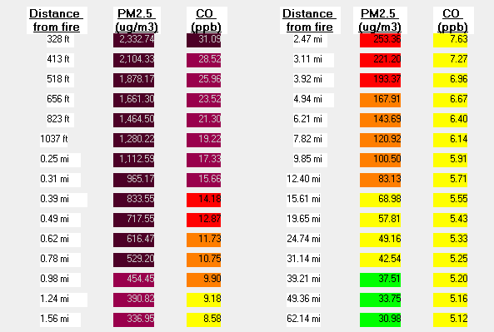

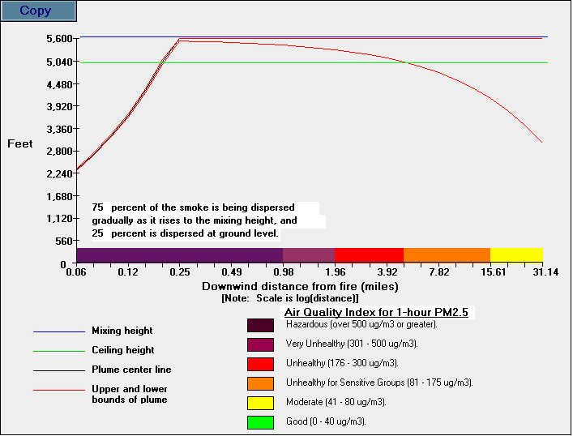

Smoke can also have an impact on how far and how clearly we can see on a highway or in viewing scenery. The fine particles in the smoke are known to be able to scatter and absorb light, which can reduce visibility conditions. The visibility estimates from VSmoke are valid only when the relative humidity is less than 70 percent. Also, the visibility estimates assume the smoke is passing in front of a person who is looking through the plume of smoke. The visibility thresholds used for this modeling analysis were to maintain a contrast ratio of greater than 0.05 and a visibility distance of 0.25 miles. Visibility conditions may exceed the threshold less than 413 feet from the edge of the fire.

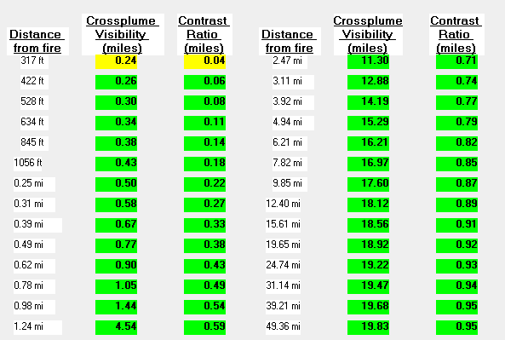

The VSMOKE-GIS model estimates the distance downwind of the fire that pre-selected fine particulate matter concentrations (41, 81, 176, 301, and 501 micrograms per cubic meter) are predicted to occur. The map of results can be viewed in Figure 8 of the main report. The VSmoke-GIS analysis had daytime dispersion characteristics to disperse the pollutants from the fire and this is the same as the VSmoke analysis. The downwind spacing interval was set at 0.025 kilometers, and the model ceased making downwind estimates at 30 miles from the edge of the fire. The stability class used for the VSmoke-GIS analysis was near neutral and this is the same as the calculated stability from VSmoke.

