A COMPUTER PROGRAM FOR CHOOSING WELDING PARAMETERS
IN SPIRALLY WELDED PIPE PRODUCTION

Kahraman ŞİRİN, Mannesmann Pipe Company
Şule Y. ŞİRİN, University of Kocaeli
Erdinç KALUÇ, University of Kocaeli

Abstract: The main problem faced in the manufacturing of the pipe by SAW is the choosing of the process variables. Therefore, identification the effect of the process parameters and finding their limits are essential in order to get the required bead size and quality. Regarding with the pipe production, a computer program in Excel is developed to choose the welding parameters. This program is mainly based on the relation between welding parameters and weld bead size and quality.

Introduction: The principle of the spiral pipe production is simply the bending of the steel strip into cylindrical shape and ultimately welding edges together in two steps as inside and outside weld. The submerged arc welding (SAW) process is widely used for spirally welded pipe production. In this process, welding parameters namely welding current, arc voltage, weld speed, diameter of the wire, number of the electrodes, melt-off rates, edge joint design including bevel angle and root face, wire configuration and etc. are very effective on welding quality. All those parameters should be optimized to get satisfactorily weld quality. This computer program is developed to optimize welding parameters. The working steps of the program are given below in detail.

The working steps of the program:

After entering the diameter and wall thickness of the pipe to the program, it will be seen automatically permissible number of the electrodes, which can be used for inside weld. In spirally welded pipe production, there is only a very limited area to positioning the inner welding heads, when the diameter of the pipe is getting smaller. Therefore, the number of electrodes for inside weld should be limited in accordance with the diameter of the pipe.

Secondly, the program asks the required pipe production to define the main geometrical dimension of the weld. Penetration, width of the bead and height of the reinforcement are taken into consideration as main characteristics of weld by the program. Penetration, for both inside and outside weld, should be at least 60 per cent of wall thickness to provide good joint. Width of the bead should be as wide as to give enough surface area to the gases to leave easily to the weld pool.

As a third step of the program, the grade of the material is asked to give the lower and upper limits of the heat input. An increase in heat input could result in a wide heat affected zone (HAZ) with low impact strength. In spirally welded pipe production, high rates of welding speeds can be achieved by using multiple electrodes. In two-pass SAW process, each pass (inside and outside weld) can be considered as one puddle even using multiple electrodes. Heat input for each pass could be calculated equation given below;

_{n}
H_{n} = (f Σ I .E) / v
¹

where, H_{n} is net heat input, I is welding current, E is arc voltage, v is welding speed, f is heat transfer efficiency and n is number of electrodes. Also, two-pass multi-electrode SAW process could be characterized by cooling time, which is around 50 seconds. Cooling time, between 800 to 500 ºC, can be calculated by using Rosenthal’s equations given below.

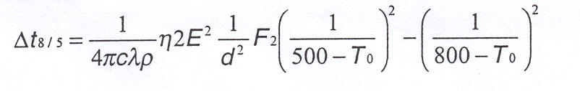

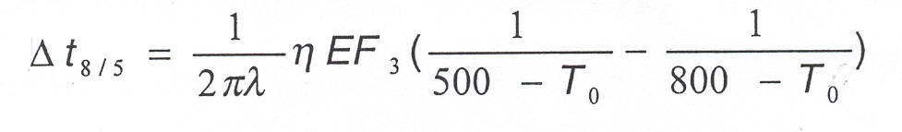

On the next step, user should define the joint preparation in conjunction with the wall thickness. Generally, Y or X type of joints could be used for thickness from 8 mm (see figure 1). The main purpose of joint preparation is to ensure required penetration. Here the main criteria are the angle of the bevel and the height of the root face. The bead width and depth ratio (W/D) should be between 1 and 4 to prevent hot cracking. Therefore, bevel angle should be bigger than 60º. This will also help not to having flux inclusions in the weld. The root face could be 60 per cent of wall thickness.

I type Y type X type

Figure 1. Type of joints

After definition of joint type, automatically the cross-sectional area of reinforcement and bevel are calculated in accordance with weld geometry design and type of joint. By this way, the cross-sectional area of the added filler metal in mm² is cleared. This is done for both inside and outside weld separately. After that, the program easily computes possible highest weld speed. As a last step of in this stage, the weld speed is chosen by the user according to permissible limits given by the computer.

Finally, the user should choose welding currents starting from the first head of the inside weld then second and third ones if necessary. Multiple arc welding usually consist of a DC(+) welding head on the lead arc followed by AC welding heads on trailing arcs. To define the current levels it is necessary to know the relation between current and wire melt-off rate. The below equations developed by Chandel and Baya could be used for predicting of the deposition rate of submerged arc welding process; where MR is melting rate in kg/h, I is welding current, L is the electrode extension and d is diameter of the wire.

MR _{DC(+)} = 0.010371.I + (2,2426x10⁻⁶ .I².L)/d² – 0,462
MR _{DC(-)} = 0.016178 .I + (2,087x10⁻⁶.I².L)/d² – 0,643

Measured wire feeding values, under various conditions, are plotted in Figure 2. It can be seen that actual values are closed to the theoretical values, originated from Chandel’s equation (Table 1). There is around 5,5 % difference which is acceptable to make prediction about deposition rate.

Table 1. Comparison between actual and theoretical values about deposition rate.
# | Type of current | Current (A) | Wire diameter (mm) | Wire extension (mm) | Average feeding speed (m/min) | Calculated deposition rate (kg/hour) | Deposition rate acc. to Chandel (kg/hour) | (%)
1 | AC | 675 | 3,2 | 26 | 2,77 | 10,30 | 10,91 | 5,6
2 | DC(+) | 600 | 3,2 | 26 | 2,02 | 7,51 | 7,81 | 3,8
3 | AC | 460 | 3,2 | 28 | 1,87 | 6,94 | 6,81 | 1,9
4 | DC(+) | 750 | 4,0 | 26 | 1,59 | 9,26 | 9,37 | 1,2
5 | DC(+) | 550 | 4,0 | 26 | 1,05 | 6,09 | 6,34 | 3,9

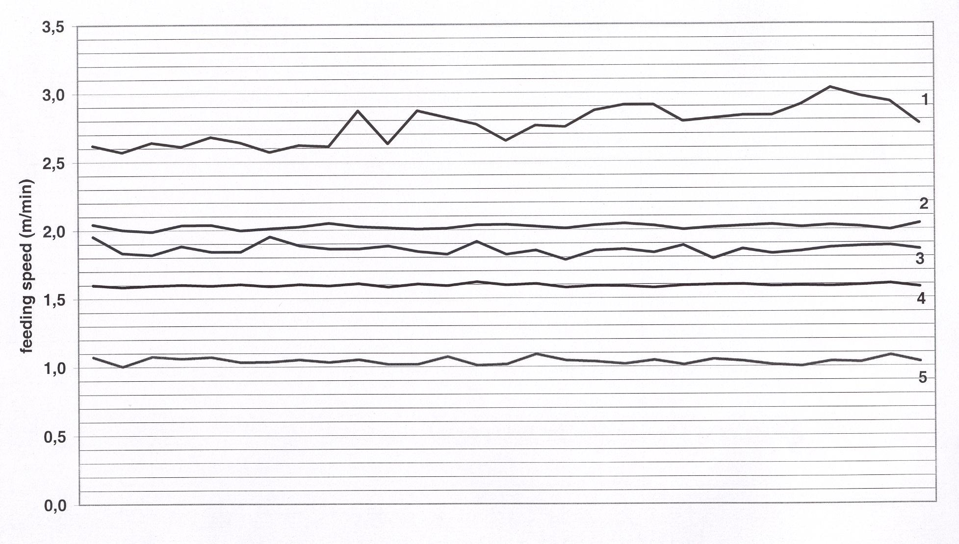
Figure 2. Wire feeding speed diagrams.
On the real work condition, another experiment is done to check the deposition rate. 1016 x 17,7 mm dimension pipe is produced under various conditions. The weld speed is changed while all the other electrical parameters, given in Table 2, kept constant. Geometrical dimensions are measured by taking samples from each step of the weld process. Then the real deposition rate is calculated (Table 3). Maximum 5,4 % difference is found in compare with the formula basis calculation. The sequence of the weld seam is given in Figure 3.

Table 2. Electrical parameters of 1016x17,7 mm dimension pipe.

 | Inside weld |  |  | Outside weld
 | Current (A) | Voltage (V) | Wire diameter (mm) | Current (A) | Voltage (V) | Wire diameter (mm)
DC (+) | 1100 | 30 | 4,0 | 1100 | 30 | 4,0
1. AC | 850 | 30 | 3,2 | 750 | 30 | 3,2
2. AC | 550 | 30 | 3,2

Table 3. Electrical parameters of 17,7 mm wall thickness pipe

Weld speed (m/min) | Weld position | Cross sectional area of the added filler metal (mm²) | Cross sectional  area of the reinforcement (mm²) | Cross sectional area of the weld bead (mm²) | Deposition rate (kg/hour) | Theoretical deposition rate for 26 mm wire extension (kg/hour) | %
1,80 | Inside | 48,22 | 23,51 | 145,52 | 40,10 | 28,47 | 4,2
1,80 | Outside | 31,85 | 21,37 | 120,81 | 26,49 | 27,90 | 5,0
1,50 | Inside | 58,53 | 33,82 | 169,76 | 40,56 | 38,47 | 5,4
1,50 | Outside | 39,89 | 29,41 | 153,11 | 27,64 | 27,90 | 1,0
1,20 | Inside | 72,46 | 47,75 | 195,63 | 40,17 | 38,47 | 4,4
1,20 | Outside | 48,19 | 37,71 | 187,24 | 26,72 | 27,90 | 4,2

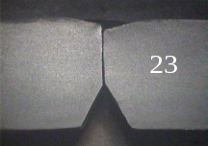
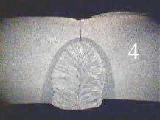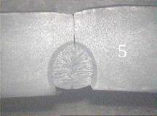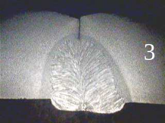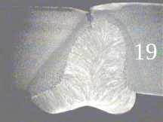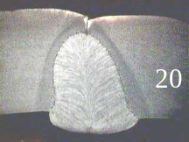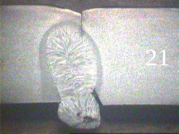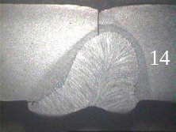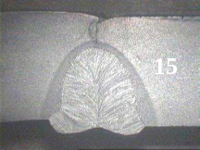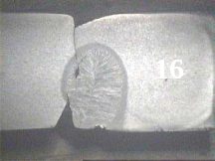
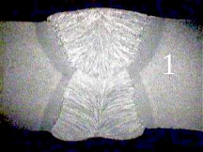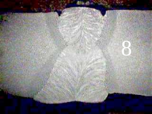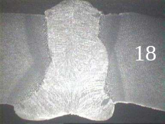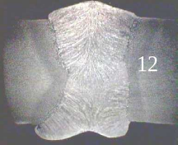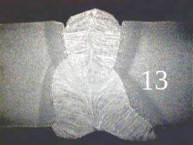
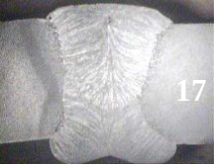 1,80 m/min 1,50 m/min 1,20 m/min

Figure 3. The sequence of the weld seam with the different weld speeds.
(Pipe dimension : 1016x17,7 mm Grade of the material : St 52)

After the choosing the welding current, the program automatically gives the diameter of the wire, arc voltage, deposition rate, heat input applied to the material and cooling rate. Also computer always checks the results and compare to the permissible values. If the results are beyond the limits, immediately warning are sent o the user and also blocked to the next stages of the program. A view of the program is given in Figure 4.

Figure 4. A view of the computer program.

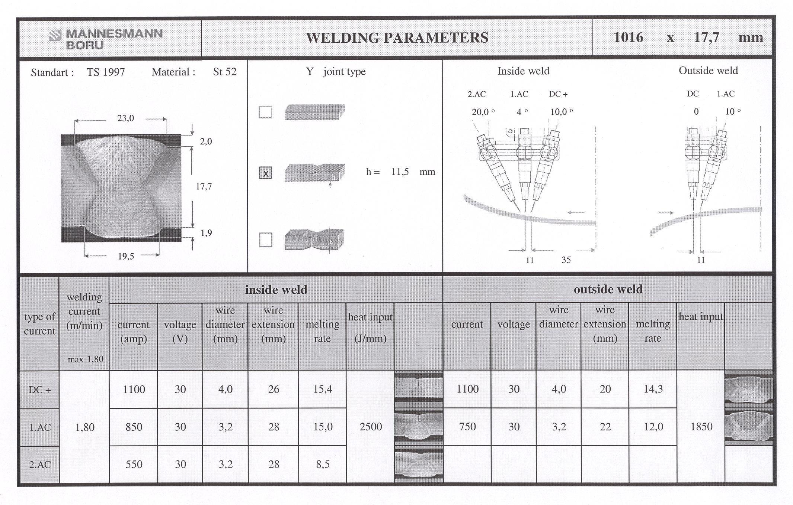

References

- ASM Handbook, “Welding, Brazing and Soldering”, Metals Handbook, vol.6, page 115-152, 1983

- Lincoln Electric Company, “The Procedure Handbook of Arc Welding”, 13th Edition, Sec. 6, 1994.

- G.E.Linnert, “Welding Metallurgy” Fourth edition, vol.1, chapter 7, 1994.

- J.Tusek, “Mathematical Modeling of Melting Rate in Twin-Wire Welding”, Journal of Materials Processing Technology 100, page: 250-256, 1999.

- R.S.Chandel, H.P.Seow, F.L.Cheong, “Effect of Increasing Deposition Rate on the Bead Geometry of Submerged Arc Welding”, Journal of Materials Processing Technology 72, page: 124-128, 1996.

- M.Graf, K.Niederhoff, “Toughness Behavior of the Heat-Affected Zone (HAZ) ın Double Submerged-Arc Welded Large-Diameter Pipe”, Mannesmann Röhrenwerke.

- P.A.Peters, H.G.Frackmann, “The Manufacture of Spiral Welded Pipe with Integrating Quality Assurance” Mannesmann Röhrenwerke

