Docket Management Facility
U.S. Department of Transportation
400 7th Street, SW
Nassif Building, PL-401
Washington, D.C. 20590-0001

RE: Dept. of Transportation
Docket No. OST-2007-26829
RIN 2105-AB87
Comments regarding NPRM (72 F.R. 2833) as to proposed DOT regulations (49 CFR Part 39)
Transportation for individuals with Disabilities: Passenger Vessels

Dear Sir or Madam,
Grays Harbor Historical Seaport Authority is a non-profit organization based in Grays Harbor, Washington, sixty miles north of the Columbia River on the Washington coast. We own and operate four Subchapter ‘T’ “passenger vessels”.
Lady Washington is a 67-foot full scale reproduction of the original Lady Washington, which departed Boston in 1787 to become the first American vessel to visit the west coast of North America. Hawaiian Chieftain is a 65 foot steel hulled representation of an early 19th-century merchant trading ship.
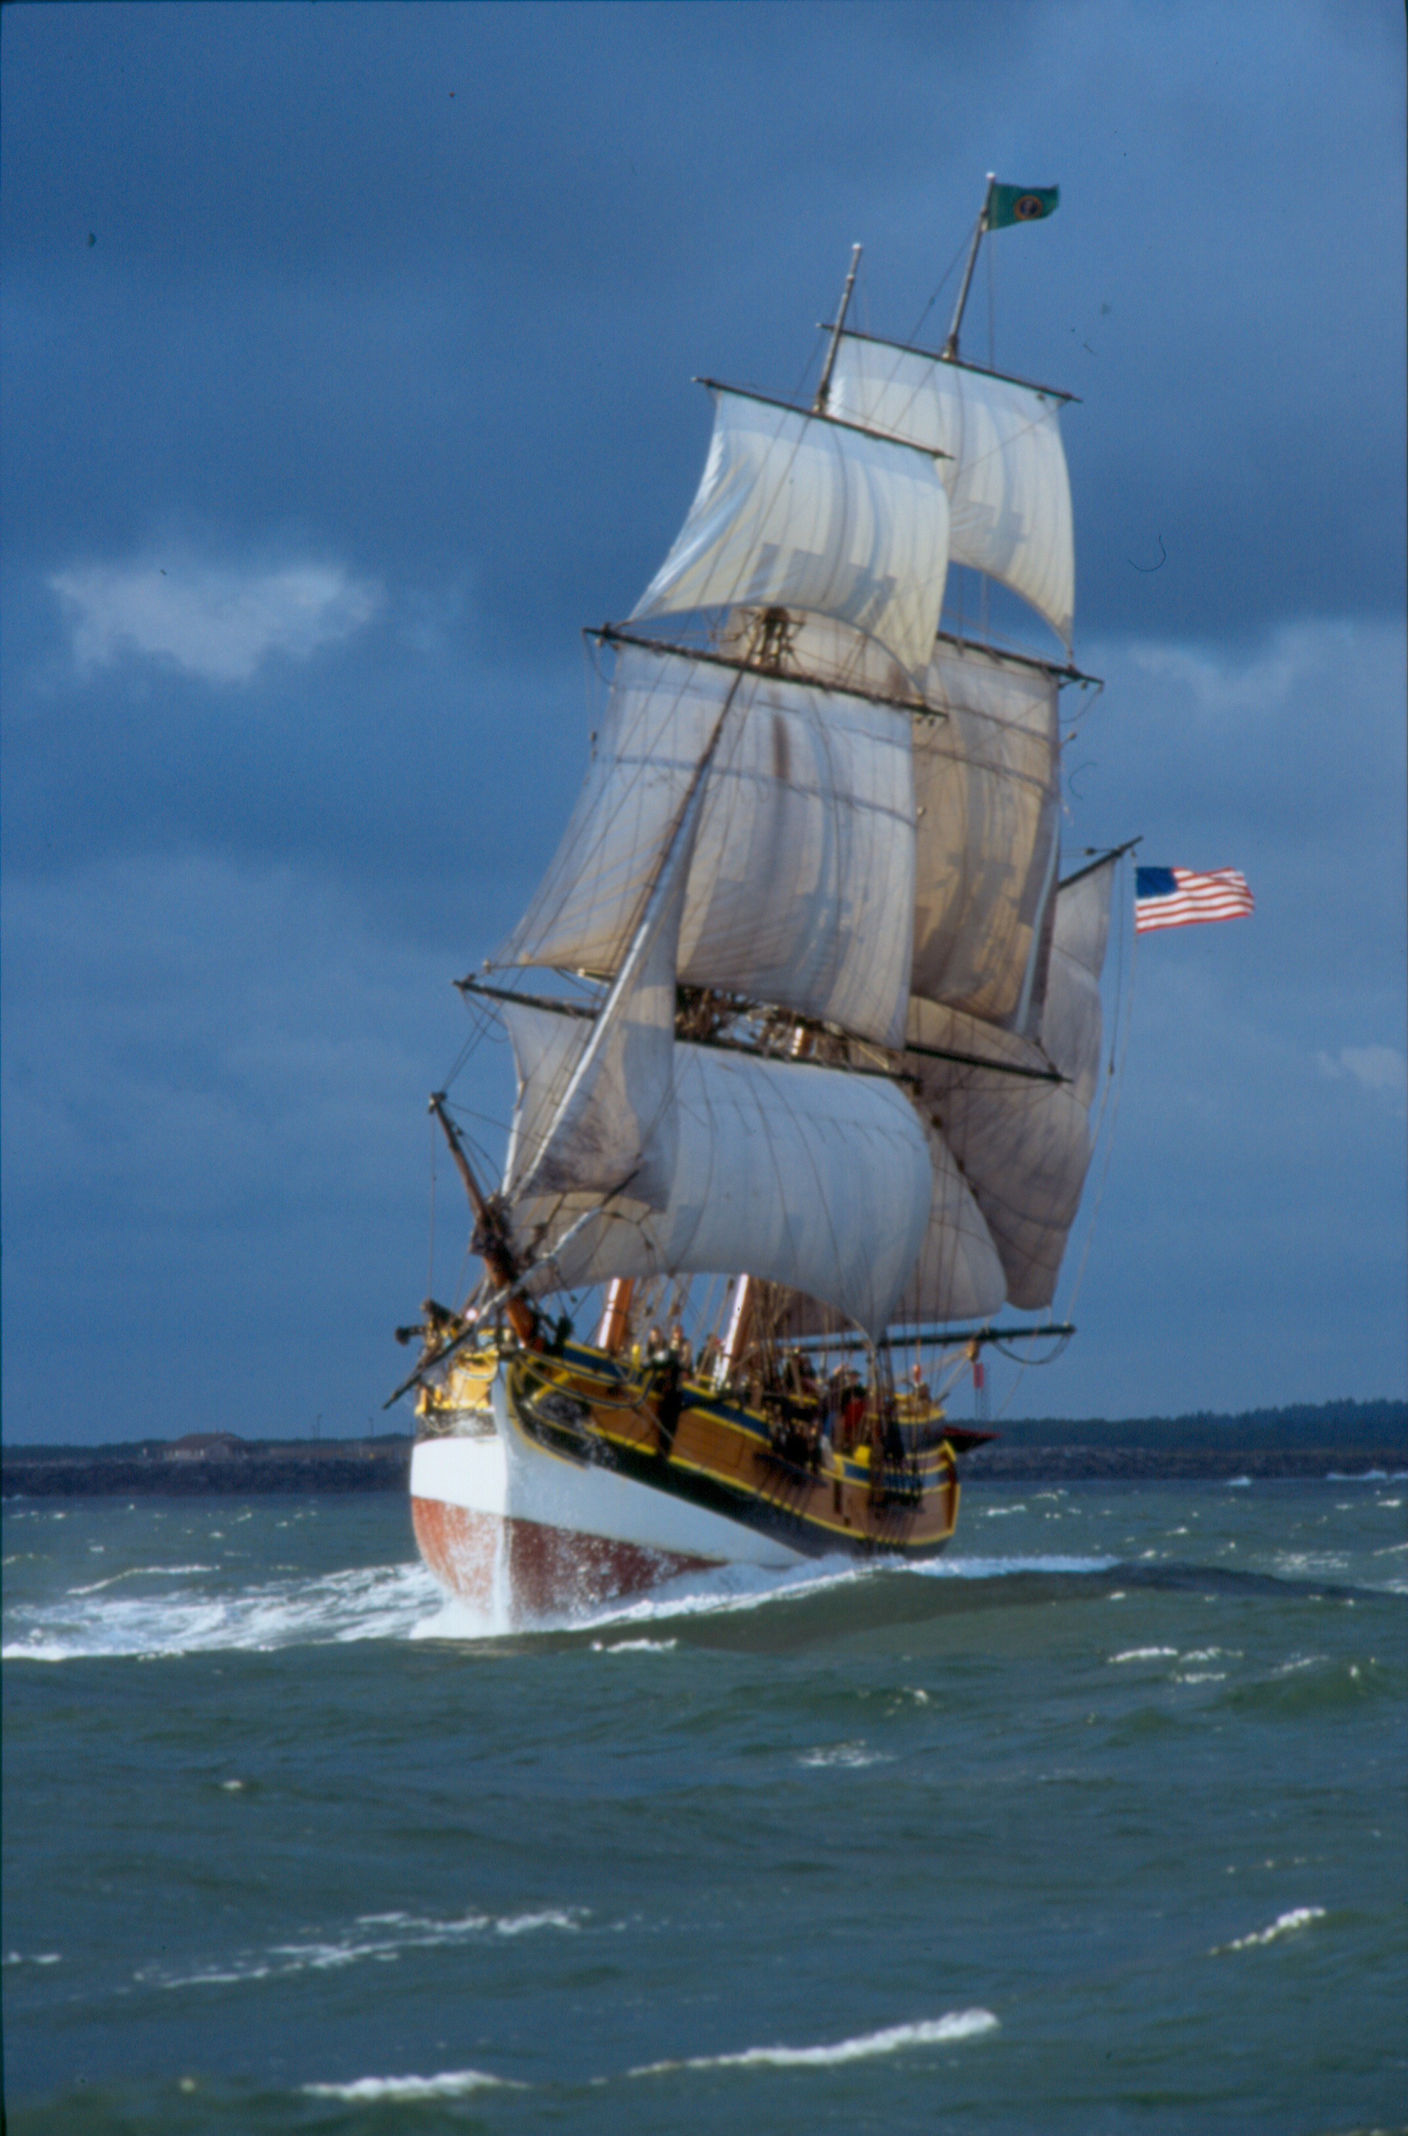
These two tall ships sail the west coast from the Canadian border to San Diego on a year round basis providing shipboard education programs to schools and the general public in forty to fifty port communities each year. Between 10,000 and 12,000 school children participate in our programs each year. More than 50,000 people cross our decks in a year. Additionally we have approximately 200 “crew trainees” (passengers by USCG definition) that participate in our Two weeks before the Mast crew training program each year. These trainee “passengers” sign up for an intensive training program that requires the ability to work on deck and to work aloft in all types of weather. These experiences can be powerful life changing experiences, or they can be life threatening.
Many of our transit passages include high winds, steep seas, and potentially dangerous bar crossings. These particular passages are not suitable for all persons. All of our crew, and trainee “passengers” are pre-screened (criminal background checks and medical screening) prior to signing aboard. This pre-screening is essential to reduce the risk to our ships, our passengers, our crews, and to the rescue personnel responding to an emergency.
Our organization, like most sail training organizations, makes every effort to provide access to all people. We have had 78 year old “trainees” up working in the rigging. We have had a school for the blind sail the ship and beat to weather, we have had many sails with the “Footloose Sailors”, a club of wheelchair bound paraplegics, but we carefully select the dates, the times, and the operating parameters to ensure a safe and positive experience for these participants.
Our other two Subchapter ‘T’ vessels are Hewitt R. Jackson and Capt. Matt Peasley. These are 18th-century ship’s longboat reproductions. They are powered by ten, fourteen-foot oars, or by a three masted sailing rig where sails are controlled by holding on to the sheet line, and movable human ballast is critical for safe operation.
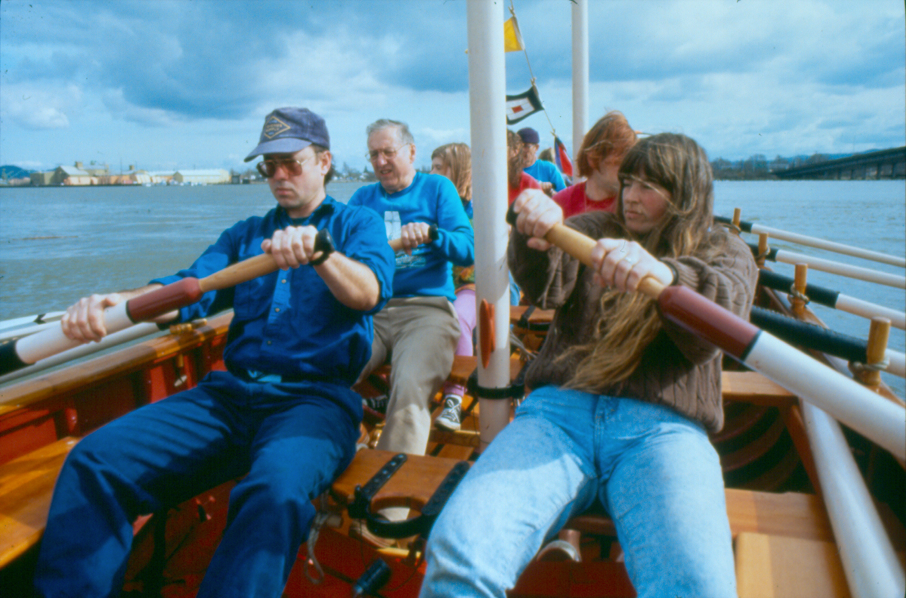
Our longboats are basically large rowboats. Participants must be able to climb into the longboat, or be lifted in (which we have done). Getting underway requires full body function. Feet must be firmly planted on the foot stretchers, bodies ready to lay back, arms and hands ready to control blade angle, and ears able to hear the coxswain’s commands. These are 10-manpower vessels. While it may be possible and at times appropriate to have a person, or group of persons onboard with a disability, manpower is the primary means of propulsion. Able bodies are required for these vessels to move, restricting the number of disabled “passengers” may be absolutely necessary in order for the vessel to depart the dock. It is impossible to modify these museum quality reproduction vessels to provide an equal experience to a large proportion of disabled persons who can not fully contribute to the propulsion of the vessel.
It must be left up to the vessel operator whether a person or group of persons with disabilities is an appropriate match for a specific vessel and specific conditions.
I am very concerned that mandatory ADA compliance requirements for small vessels engaged in sail training will result in tremendous costs, increased risk, an overall reduction in safety, and quite probably a reduction in opportunities for the disabled as small owner operators are forced out of business.
In closing, for small sailing vessels carrying “passenger” trainees we would ask DOT to:
Allow operators to restrict the number of disabled persons on a particular voyage based on vessel capabilities and expected sea conditions.
Continue retention of the “fundamentally alter/undue burden” clause in proposed Section 39.21(b).
Allow “main office” staff to address ADA complaints as it does any other customer complaint. Due to crew turnover, maintaining consistency would be difficult, and documentation is more easily lost or damaged onboard the vessels
Assure that crew assistance is specifically allowed, as deemed appropriate by the vessel Master. This is an important safety issue.
Thank you for your consideration of our concerns.
Sincerely,

Capt. Les Bolton,
Executive Director
Grays Harbor Historical Seaport Authority
S/V Lady Washington
S/V Hawaiian Chieftain
S/V Hewitt R. Jackson
S/V Capt. Matt Peasley

