Hydrology

P.D. Thorne, D.G. Horton, and G.V. Last

Characterization of hydrology at the Hanford Site includes surface water, the vadose zone, and groundwater. The vadose zone is the unsaturated or partially saturated region between the ground surface and the saturated zone. Water in the vadose zone is called soil moisture. Groundwater refers to water within the saturated zone. Permeable saturated units in the subsurface are called aquifers.

Surface Water

Surface water at Hanford includes the Columbia River, springs, and ponds. Intermittent surface streams, such as Cold Creek, may also contain water after large precipitation or snowmelt events. In addition, the Yakima River flows along a short section of the southern boundary of the Hanford Site (Figure 4.4-1), and there is surface water associated with irrigation east and north of the Site.

Columbia River

The Columbia River is the second largest river in the contiguous United States in terms of total flow and is the dominant surface-water body on the Hanford Site. The original selection of the Hanford Site for plutonium production and processing was based, in part, on the abundant water provided by the Columbia River. The existence of the Hanford Site has precluded development of this section of the river for hydroelectric production and barge transportation.

Originating in the Canadian Rockies of southeastern British Columbia, Canada, the Columbia River drains a total area of approximately 680,000 km² (262,480 mi²) en route to the Pacific Ocean. Most of the Columbia River is impounded by 11 dams within the United States: 7 upstream and 4 downstream of the Hanford Site. Priest Rapids is the nearest upstream dam, and McNary is the nearest downstream dam. Lake Wallula, the impoundment created by McNary Dam, extends upstream past Richland, Washington, to the southern part of the Hanford Site. Except for the Columbia River estuary, the only unimpounded stretch of the river in the United States is the Hanford Reach, which extends from Priest Rapids Dam downstream approximately 82 km (51 mi) to Lake Wallula, north of Richland. The Hanford Reach of the Columbia River was recently incorporated into the land area established as the Hanford Reach National Monument.

Flows through the Hanford Reach fluctuate significantly and are controlled primarily by releases from three upstream storage dams: Grand Coulee in the United States, and Mica and Keenleyside in Canada. Flows in the Hanford Reach are directly affected by releases from Priest Rapids Dam; however, Priest Rapids operates as a run-of-the-river dam rather than a storage dam. Flows are controlled for purposes of power generation and to promote salmon egg and embryo survival. ⁽⁾ Columbia River flow rates near Priest Rapids during the 83-year period from 1917 to 2000 averaged nearly 3360 m³/s (120,000 ft³/s). Daily average flows during this period ranged from 570 to 19,500 m³/s (20,000 to 690,000 ft³/s). The lowest and highest flows occurred before the construction of upstream dams. During the 10-year period from 1991 through 2000, the average flow rate was also about 3360 m³/s (120,000 ft³/s). Daily average flows through the Hanford Reach for 1994 through April 2005 are plotted in Figure 4.4-2. Storage dams on tributaries of the Columbia River also affect flows.

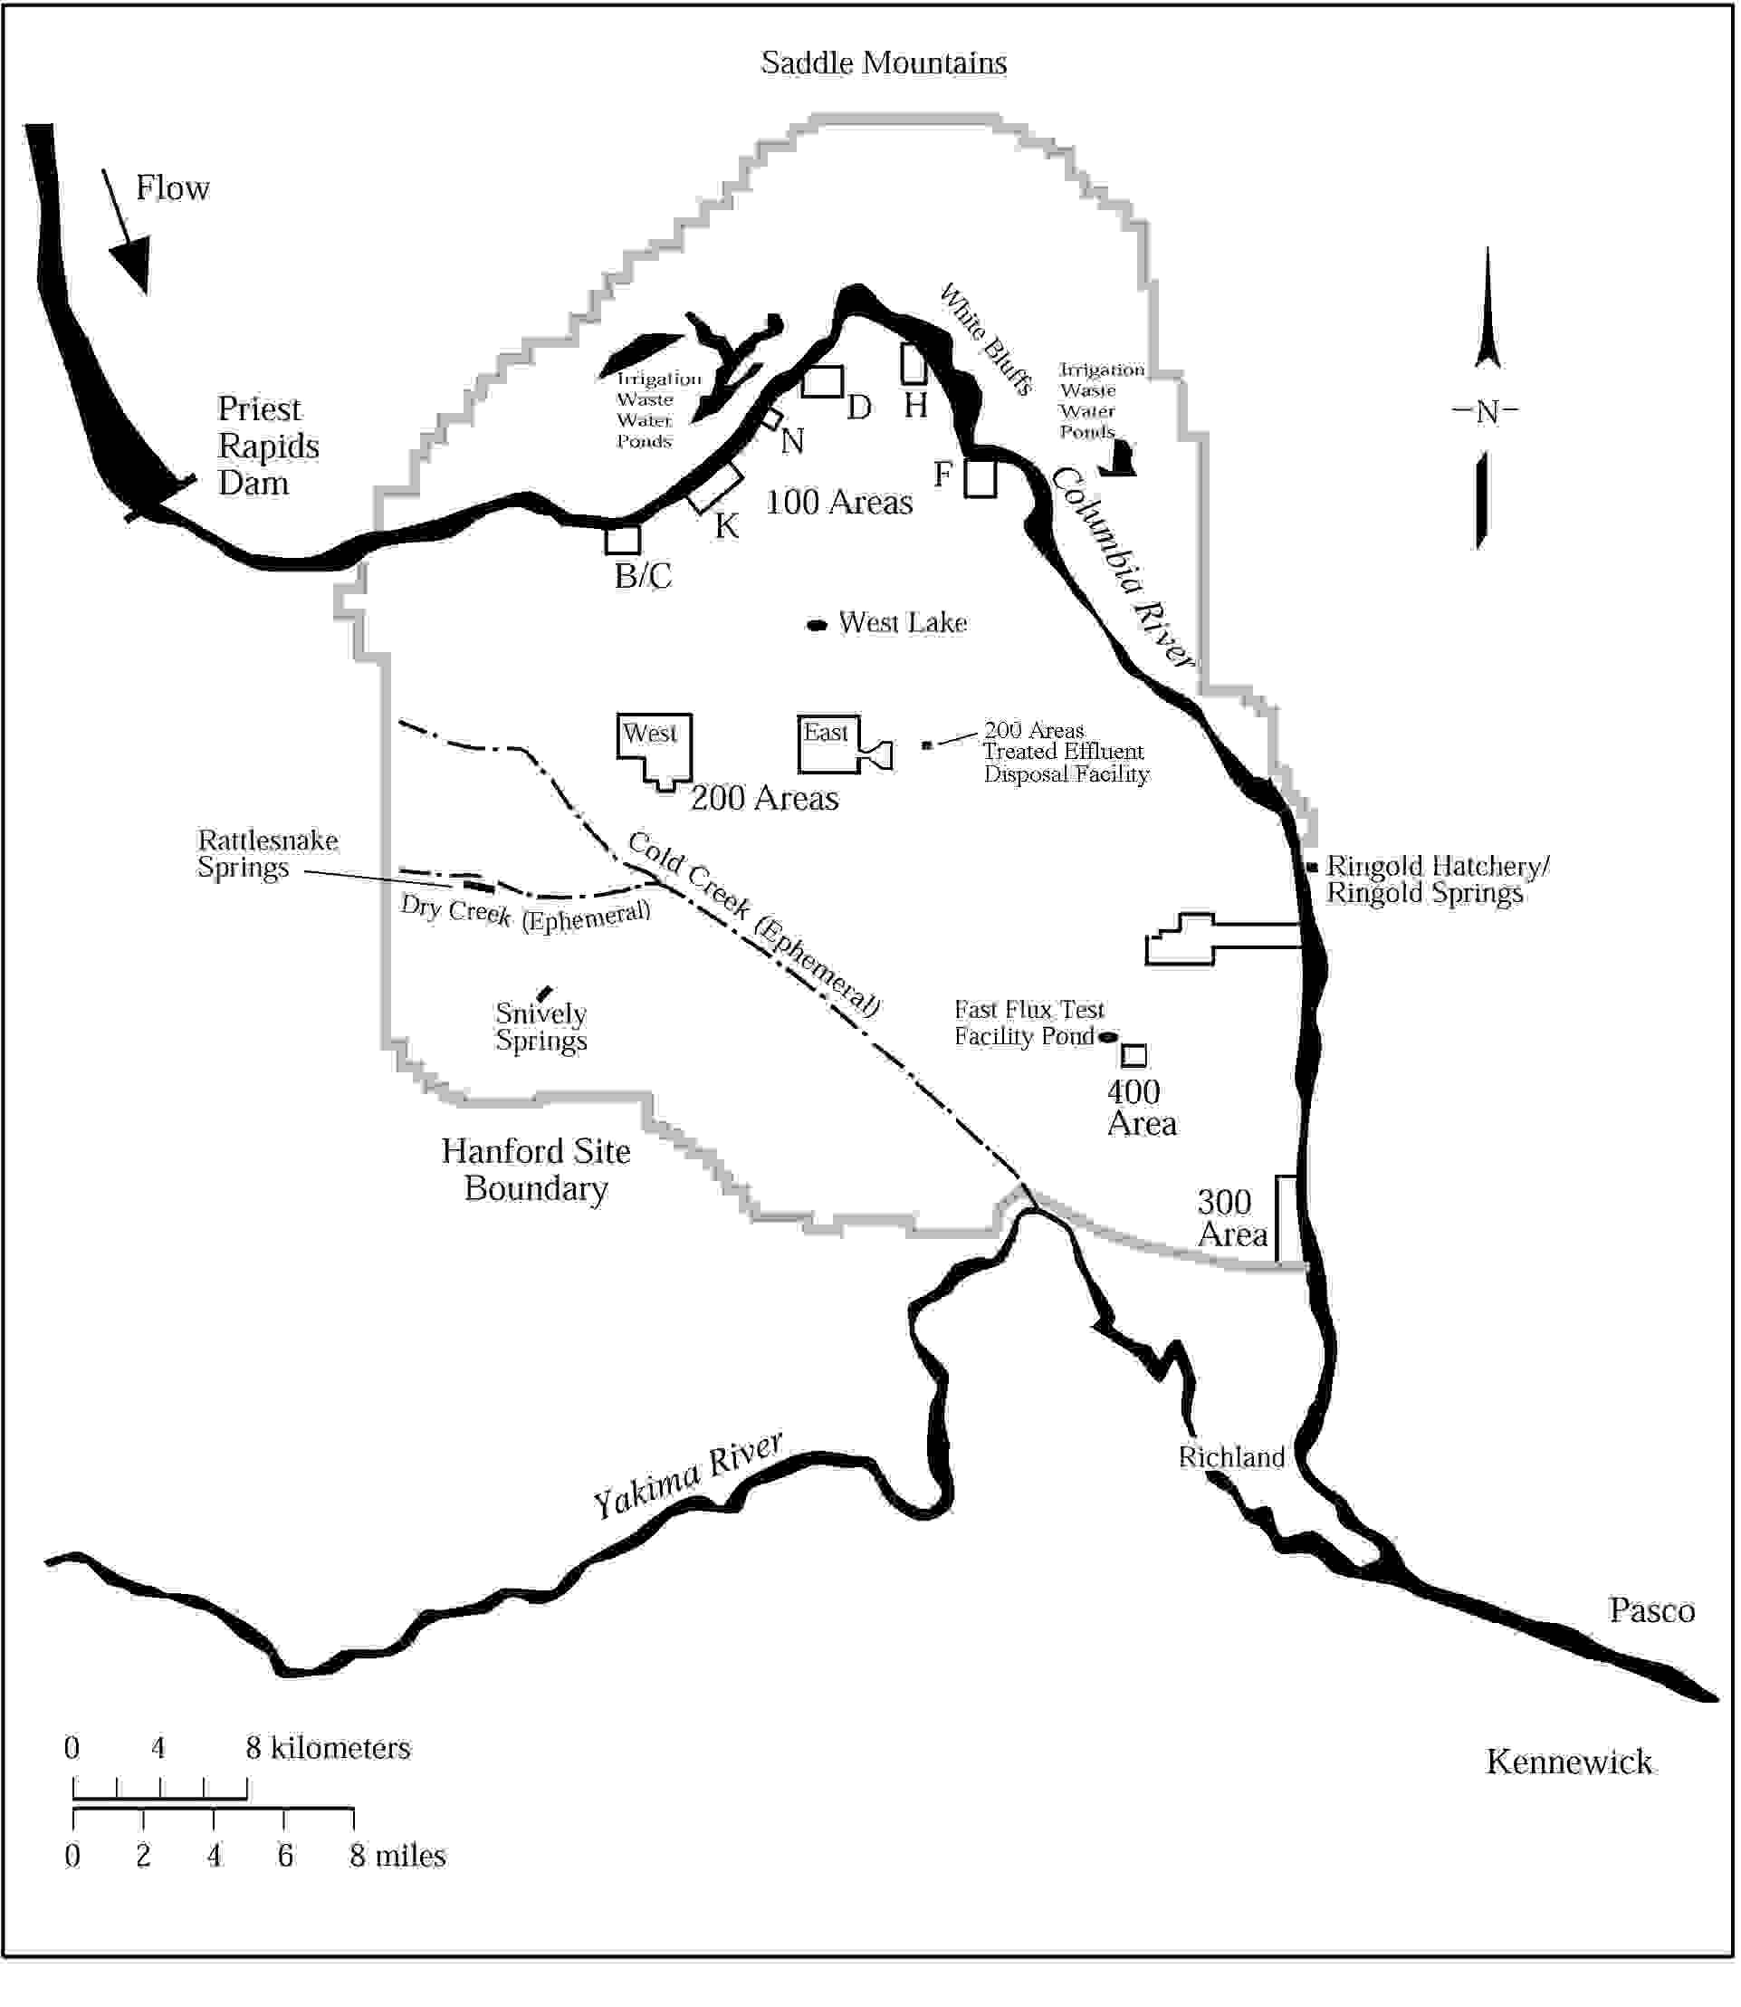

Figure 4.4-1. Surface Water Features on the Hanford Site, Washington, including Rivers, Ponds, Major Springs, and Ephemeral Streams

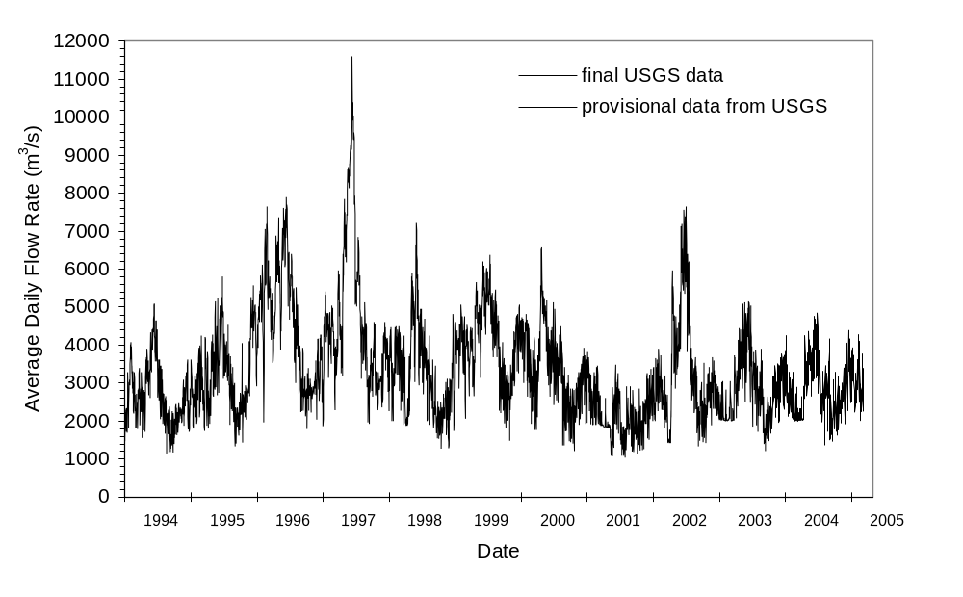

Figure 4.4-2. Average Daily Flow for the Hanford Reach, Columbia River, Washington, from January 1994 through April 2005 (data from USGS 2005, provisional data not yet reviewed and subject to change) (1 m³/s = 35.3 ft³/s)

During 1996 and 1997, exceptionally high spring runoff resulted from larger than normal snowpacks. The highest daily average flow rate during 1997 was nearly 11,750 m³/s (415,000 ft³/s) (USGS 2005). Peak daily average flow during 2004 was 4842 m³/s (171,000 ft³/s) (Figure 4.4-3). Columbia River flows typically peak from April through June during spring runoff from snowmelt and are lowest from September through October. As a result of daily discharge fluctuations from upstream dams, the depth of the river varies over a short time period. River stage changes of up to 3 m (10 ft) during a 24-hr period may occur along the Hanford Reach (Poston et al. 2003). The width of the river varies from approximately 300 m (1000 ft) to 1000 m (3300 ft) within the Hanford Reach. The width also varies with the flow rate, which causes repeated wetting and drying of an area along the shoreline.

The primary uses of the Columbia River include the production of hydroelectric power, irrigation of cropland in the Columbia Basin, and transportation of materials by barge. The Hanford Reach is the upstream limit of barge traffic on the mainstem Columbia River. Barges are used to transport reactor vessels from decommissioned nuclear submarines to Hanford for disposal. Several communities along the Columbia River rely on the river as their source of drinking water. The Columbia River is also used as a source of both drinking water and industrial water for several Hanford Site facilities (Poston et al. 2003). In addition, the Columbia River is used extensively for recreation, including fishing, hunting, boating, sailing, water-skiing, diving, and swimming.

Water Quality of the Columbia River

The water quality of the Columbia River from Grand Coulee Dam to the Washington-Oregon border, which includes the Hanford Reach, has been designated as Class A, Excellent (WAC 173-201A) by Washington State (Poston et al. 2003). Class A waters are suitable for essentially all uses, including raw
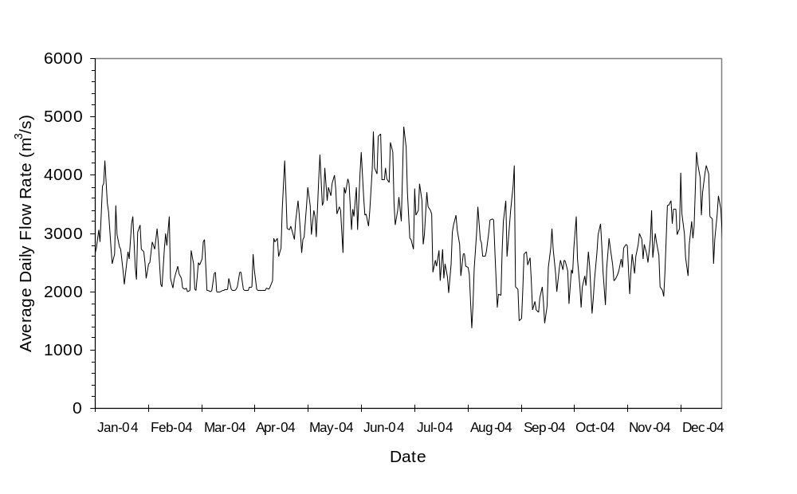

Figure 4.4-3. Average Daily Flow for the Columbia River During Calendar Year 2004 (data from USGS 2005, provisional data not yet reviewed and subject to change) (1 m³/s = 35.3 ft³/s)

drinking water, recreation, and wildlife habitat. State and federal drinking water standards apply to the Columbia River (Section 6.2.2).

During 2002, the USGS measured several water quality parameters at Vernita Bridge, upstream of Hanford Site operations areas, and at the Richland pumphouse, which is downstream of the Hanford Site (Figure 4.4-4). Total dissolved solids measured near the Hanford Site during 2002 ranged from 71 to 99 mg/L, and total dissolved nitrogen ranged from 0.16 to 0.37 mg/L. Dissolved oxygen ranged from 10 to 14 mg/L and pH was 7.7 to 8.2. There were no statistically significant differences between upstream and downstream samples for these parameters (Poston et al. 2003).

PNNL measured both radiological and nonradiological constituents in Columbia River water during 2002 as part of a continuing environmental monitoring program (Poston et al. 2003). Cumulative water samples are collected at Priest Rapids Dam and at the Richland pumphouse (Figure 4.4-4). Additional samples were taken at transects of the river and at near-shore locations at the Vernita Bridge, 100-F Area, 100-N Area, the Hanford Townsite, and the 300 Area. These water samples were collected at frequencies varying from quarterly to annually. Results are presented in Bisping (2003) and summarized in Poston et al. (2003). These data show a statistical increase in tritium, nitrate, uranium, and iodine-129 along the Hanford Reach. All these constituents are known to be entering the river from contaminated groundwater beneath the Hanford Site (Section 4.4.3). Measurements of strontium-90 at the Richland pumphouse were not statistically higher than those at the Vernita Bridge even though strontium-90 is known to enter the river through groundwater inflow at 100-N Area. Measurements of tritium along transects showed higher concentrations near the shoreline relative to mid-river for samples from the 100-N Area, the Hanford Townsite, the 300 Area, and the Richland pumphouse.

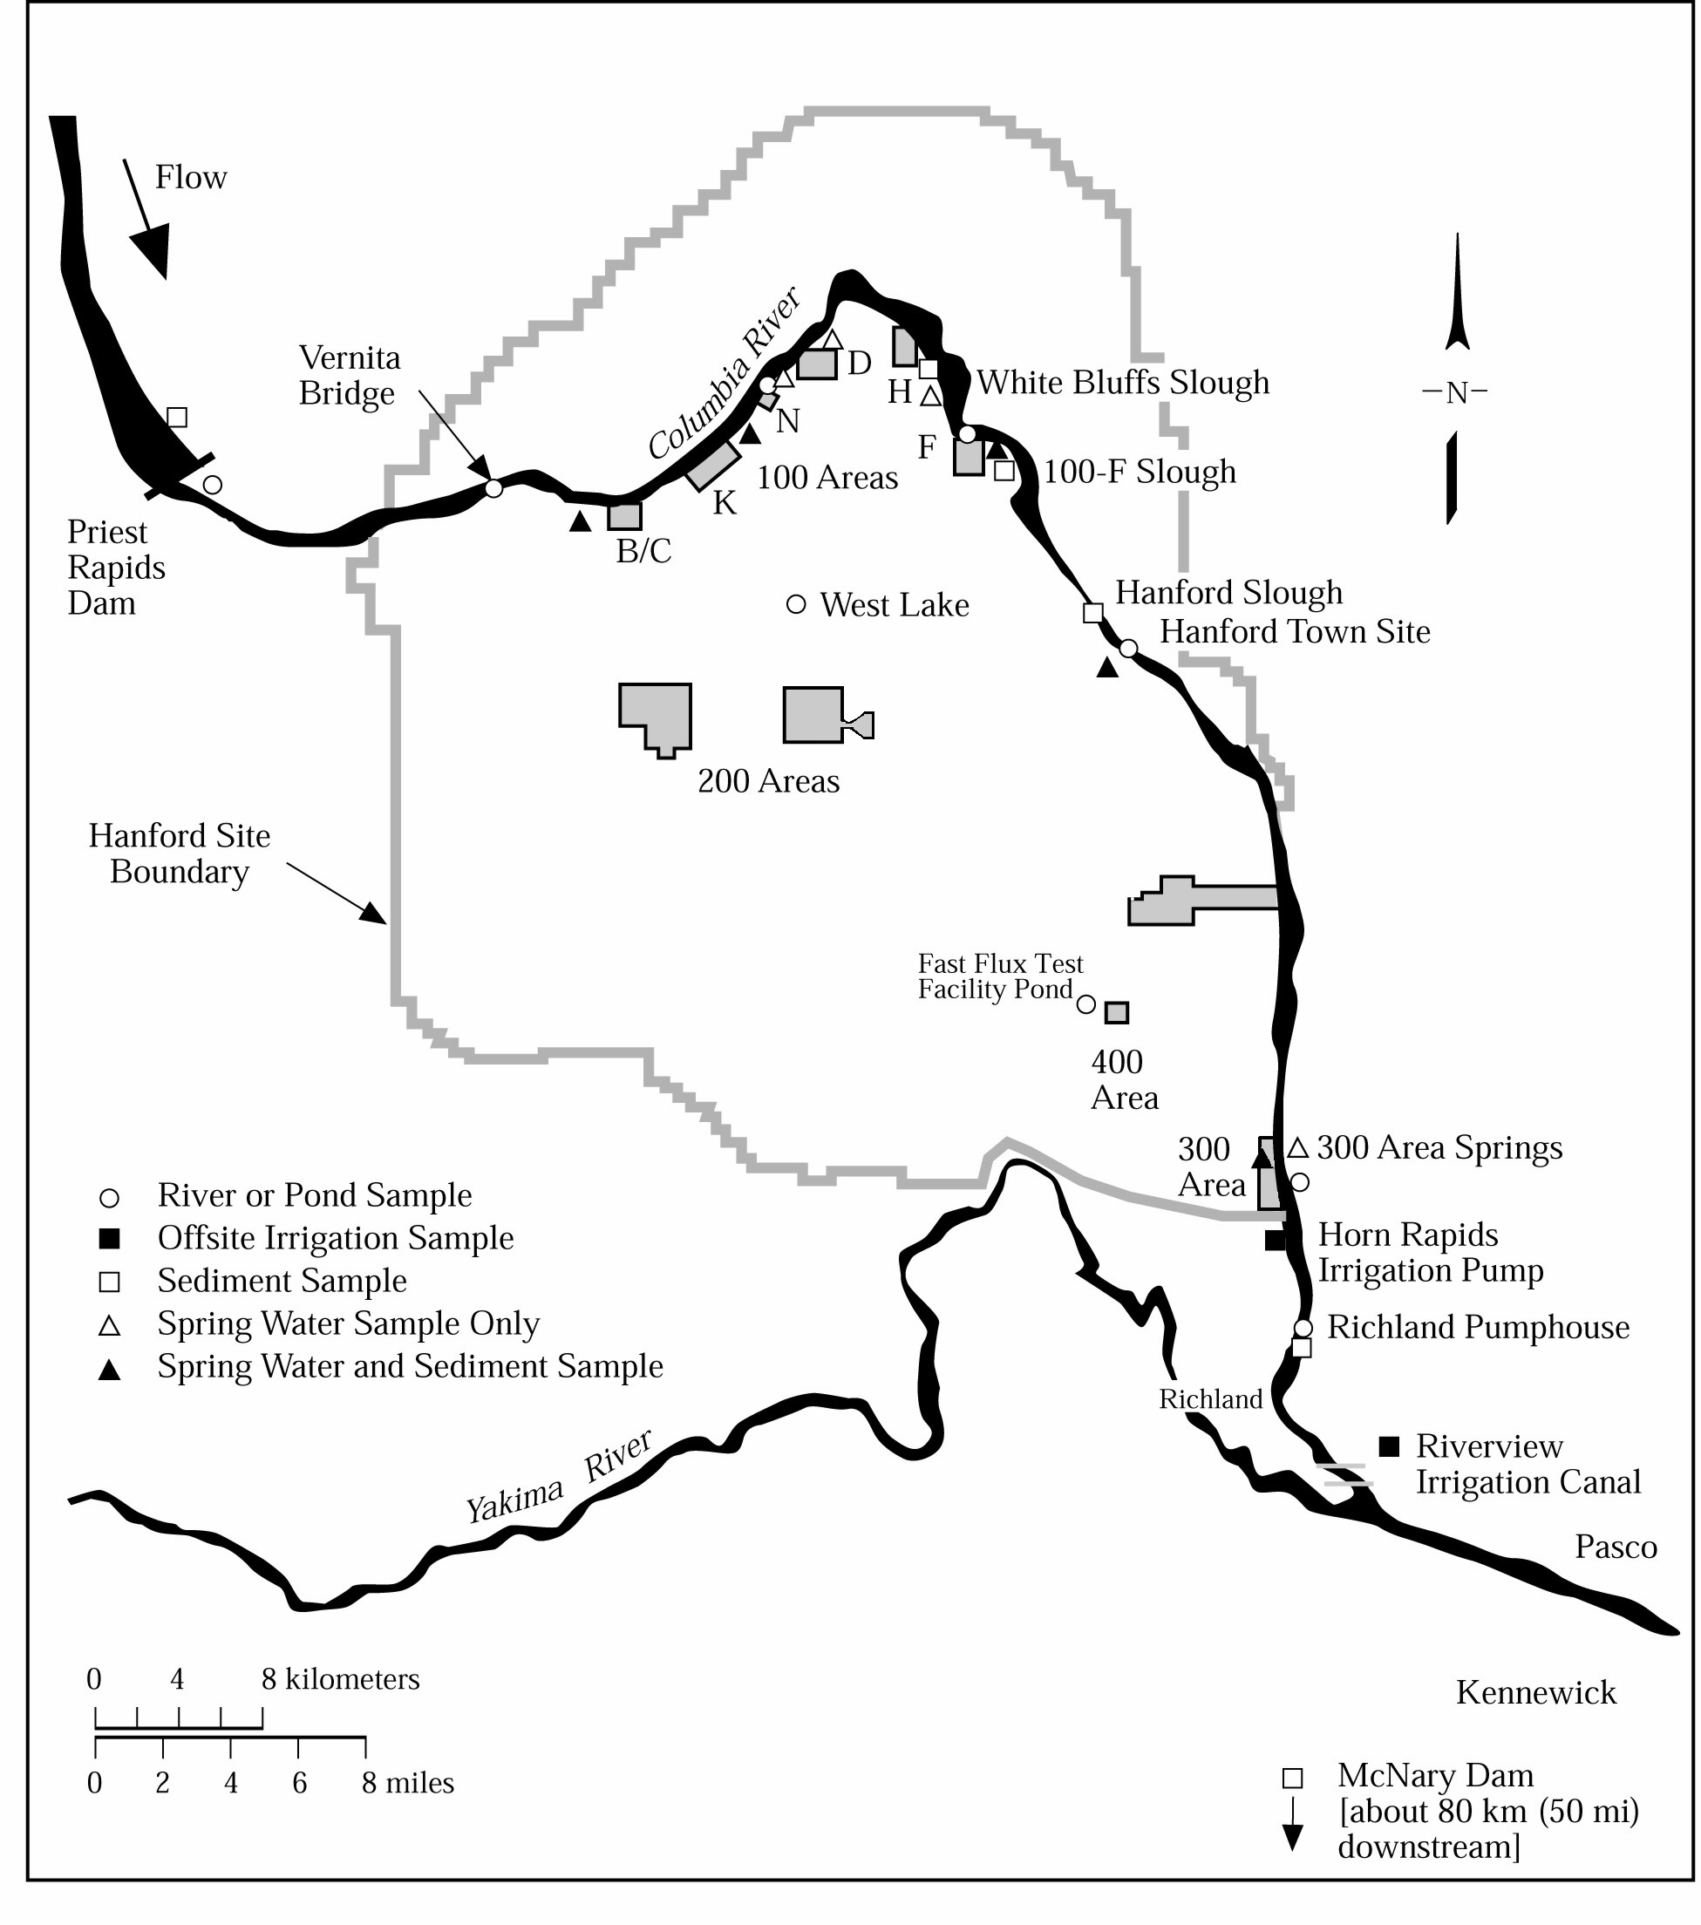

Figure 4.4-4. Surface Water and Sediment Monitoring Locations, Hanford Site, Washington (Poston et al. 2003)

Other sources of pollutants entering the river are irrigation return flows and groundwater seepage associated with irrigated agriculture. The USGS (1995) documented nitrate groundwater contamination in Franklin County, which also seeps into the river along the Hanford Reach. However, in spite of pollutants introduced from both the Hanford Site and other sources, dilution in the river results in contaminant concentrations that are below drinking water standards (Poston et al. 2003).

Yakima River

The Yakima River follows a portion of the southwestern boundary of the Hanford Site and has much lower flows than the Columbia River. The average flow, based on 70 years of daily flow records (USGS 2005), is about 100 m³/s (3530 ft³/s), with an average monthly maximum of 497 m³/s (17,550 ft³/s) and minimum of 4.6 m³/s (165 ft³/s). Exceptionally high flows were observed during 1996 and 1997 (Figure 4.4-5). The highest average daily flow rate during 1996 was nearly 1300 m³/s (45,900 ft³/s). Average daily flow during 2000 was 89.9 m³/s (3176 ft³/s). Average daily flow during 2004 was 73 m³/s (2580 ft³/s) (USGS 2005). The Yakima River System drains surface runoff from approximately one-third of the Hanford Site. Groundwater is expected to flow from the Yakima River into the aquifer underlying the Site rather than from the aquifer into the river because, based on well water-level measurements, the elevation of the river surface is higher than the adjacent water table (Thorne et al. 1994). Therefore, groundwater contaminants from the Hanford Site do not reach the Yakima River.

Springs and Streams

Springs are found on the slopes of the Rattlesnake Hills along the western edge of the Hanford Site (DOE 1988). There is also an alkaline spring at the east end of Umtanum Ridge (Hall 1998). Rattlesnake and Snively springs form small surface streams. Water discharged from Rattlesnake Springs flows in Dry Creek for about 3 km (1.6 mi) before disappearing into the ground (Figure 4.4-1). Cold Creek and its tributary, Dry Creek, are ephemeral streams within the Yakima River drainage system in the southwestern portion of the Hanford Site. These streams drain areas to the west of the Hanford Site and cross the southwestern part of the Site toward the Yakima River. When surface flow occurs, it infiltrates rapidly and disappears into the surface sediments in the western part of the Site. The quality of water in these springs and streams varies depending on the source. However, they are upgradient of Hanford waste sites and groundwater contamination plumes.

Columbia Riverbank Springs

Riverbank springs were documented along the Hanford Reach long before Hanford operations began (Jenkins 1922). During the early 1980s, researchers identified 115 springs along the Benton County shoreline of the Hanford Reach (McCormack and Carlile 1984). Seepage occurs both below the river surface and on the exposed riverbank, particularly at low-river stage. Riverbank springs flow intermittently, apparently influenced primarily by changes in river level. In many areas, water flows from the river into the aquifer at high river stage and then returns to the river at low river stage. This “bank-storage” phenomenon has been modeled numerically for the 100-H Area (Peterson and Connelly 2001).

In areas of contaminated groundwater, riverbank springs are also generally contaminated. However, the concentrations in seeping water along the riverbank may be lower than groundwater because of the bank-storage phenomenon. Contaminants have been detected in near shore samples downstream from riverbank springs (Poston et al. 2003). Riverbank springs are monitored for radionuclides at the 100-N Area, the Hanford Townsite, and the 300 Area (Figure 4.4-4). Hanford-origin contaminants occur in some of these springs (Peterson and Johnson 1992, Poston et al. 2003). Detected radionuclides include strontium-90, technetium-99, iodine-129, uranium-234, -235, and -238, and tritium. Other detected
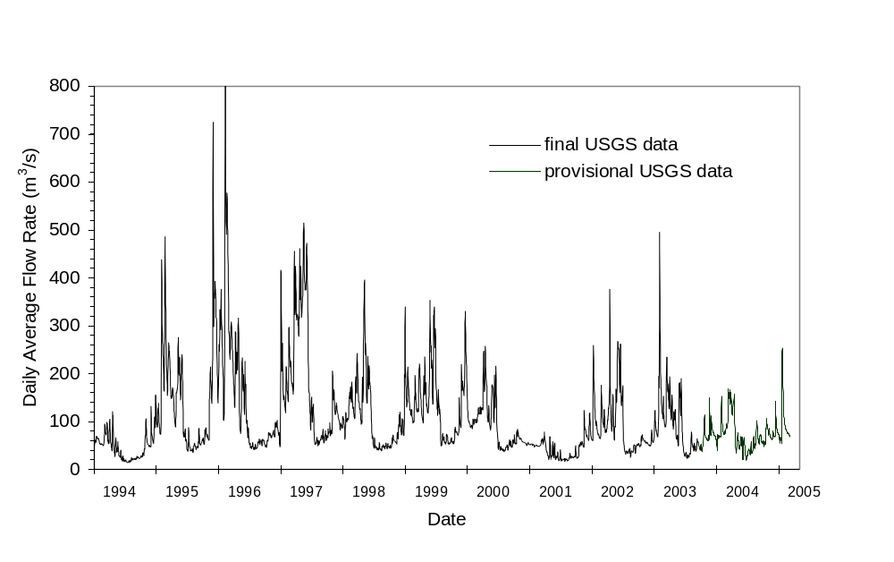

Figure 4.4-5. Average Daily Flow for the Yakima River, Washington, from 1994 through April 2005 (data from USGS 2005, provisional data not yet reviewed and subject to change) (1 m³/s = 35.3 ft³/s)

contaminants include arsenic, chromium, chloride, fluoride, nitrate, and sulfate. Volatile organic compounds were below detection limits. Results for riverbank spring samples analyses are listed in Bisping (2003) and summarized in Poston et al. (2003). For a listing of the regulatory standards for groundwater, refer to Table 4.4-1.

The highest strontium-90 concentration detected in riverbank springs during 2002 was 3.3 pCi/L (0.12 Bq/L) at the 100-N Area. A spring in this area previously had a reported strontium-90 concentration higher than 1000 pCi/L (37.34 Bq/L). However, because of decreased groundwater elevations, no flow has been observed at this spring during the past six years (Poston et al. 2003). Tritium concentrations in riverbank springs varied widely with location. The highest tritium concentration detected in riverbank springs during 2002 was 58,000 pCi/L (2,100 Bq/L) at the Hanford Townsite. The highest iodine-129 concentration of 0.19 pCi/L (0.007 Bq/L) was also found in a Hanford Townsite spring. Concentrations of radionuclides including tritium, technetium-99, and iodine-129 in riverbank springs near the Hanford Townsite have generally been increasing since 1994. This is an area where a major groundwater plume from the 200 East Area intercepts the river. However, tritium concentration has declined since 1997. This decline may be due to the effects of radioactive decay and/or less wastewater disposal, which would cause the groundwater tritium plume to move at a slower velocity.

Table 4.4-1. Regulatory Drinking Water Standards for Groundwater
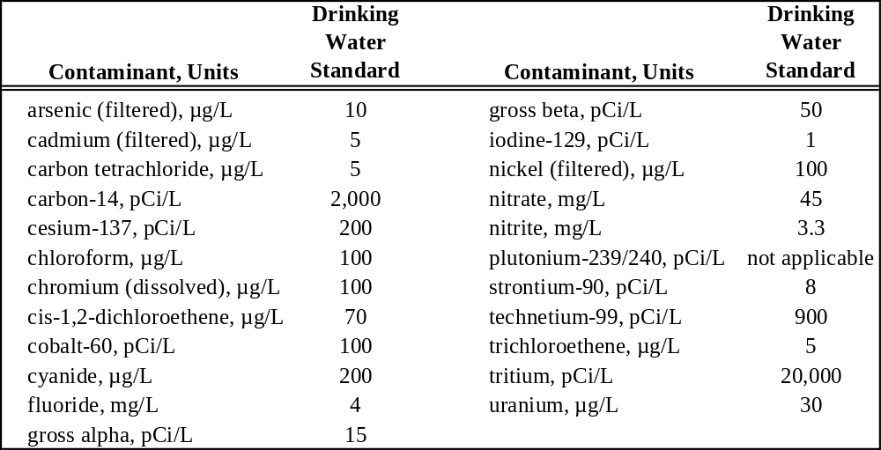

Runoff and Net Infiltration

Total estimated precipitation over the Pasco Basin is about 9 x10⁸ m³ (3.2 x 10¹⁰ ft³) annually (DOE 1988). This was calculated by multiplying the average annual precipitation averaged over the Pasco Basin by the 4900 km² (1900 mi²) basin area. Precipitation varies both spatially and temporally with higher amounts generally falling at higher elevations. Annual precipitation measured at the HMS has varied from 7.6 cm (3 in.) to 31.3 cm (12.3 in.) since 1945. Most precipitation occurs during the late autumn and winter, with more than half of the annual amount occurring from November through February. Mean annual runoff from the Pasco Basin is estimated at 3.1 x 10⁷ m³/yr (1.1 x 10⁹ ft³/yr), or approximately 3 percent of the total precipitation (DOE 1988). Most of the remaining precipitation is lost through evapotranspiration; however, a portion of the precipitation that infiltrates the soil is not lost to evaporation or transpiration and eventually recharges the groundwater flow system. The amount of recharge varies spatially based primarily on soil texture and vegetation (Gee et al. 1992, Fayer and Walters 1995). Recharge also varies temporally with the majority occurring in the winter and spring. There is some evidence that the most significant recharge events are associated with rapid melting of relatively large snowpacks, which may only occur a few times in a decade (Fayer and Szecsody 2004).

Flooding

Large Columbia River floods have occurred in the past (DOE 1987), but the likelihood of recurrence of large-scale flooding has been reduced by the construction of several flood control/water-storage dams upstream of the Hanford Site (Figure 4.4-6). Major floods on the Columbia River are typically the result of rapid melting of the winter snowpack over a wide area augmented by above-normal precipitation. The maximum historical flood on record occurred June 7, 1894, with a peak discharge at the Hanford Site of 21,000 m³/s (742,000 ft³/s). The floodplain associated with the 1894 flood was modeled based on topographic crosssections of the river channel (ERDA 1976) (Figure 4.4-7). The largest recent flood

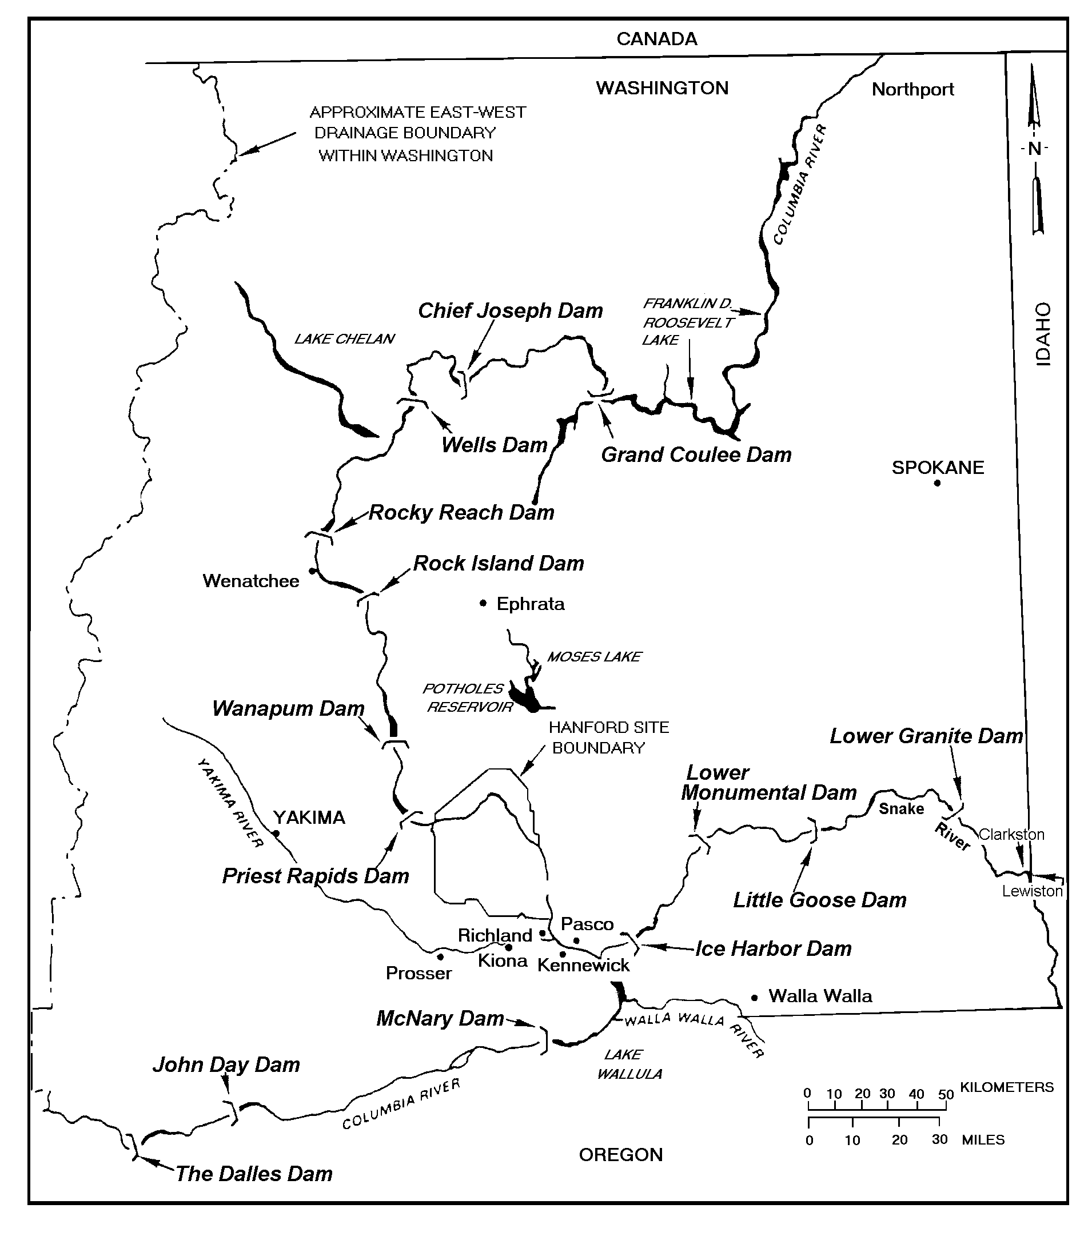

Figure 4.4-6. Locations of Principal Dams within the Columbia Plateau, Washington and Oregon (DOE 1988)

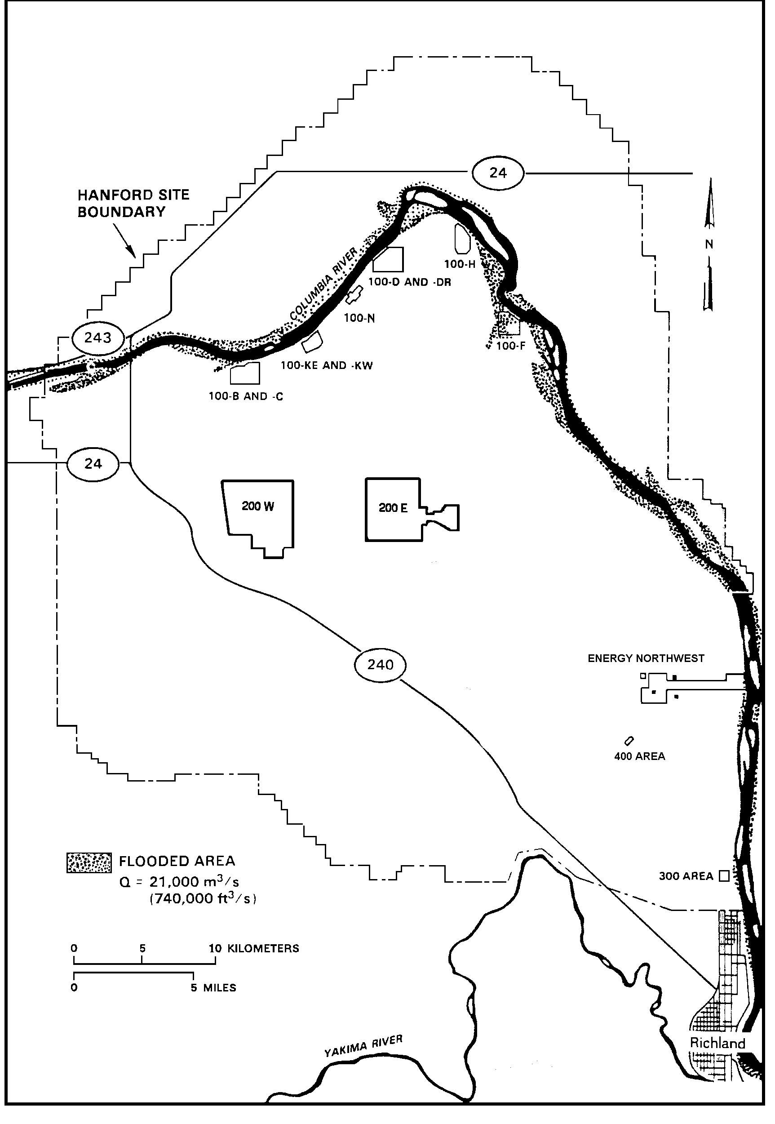

Figure 4.4-7. Flood Area on the Hanford Site, Washington, during the 1894 Flood Based on Modeled Topographic Cross Sections (DOE 1986)

took place during 1948 with an observed peak discharge of 20,000 m³/s (700,000 ft³/s) at the Hanford Site. The exceptionally high runoff during the spring of 1996 resulted in a maximum discharge of nearly 11,750 m³/s (415,000 ft³/s) (USGS 2002b). There are no Federal Emergency Management Agency (FEMA) floodplain maps for the Hanford Reach of the Columbia River. FEMA only maps developing areas, and the Hanford Reach has been specifically excluded because the adjacent land is primarily under federal control.

Evaluation of flood potential is conducted in part through the concept of the probable maximum flood, which is determined from the upper limit of precipitation falling on a drainage area and other hydrologic factors such as antecedent moisture conditions, snowmelt, and tributary conditions that could result in maximum runoff. The probable maximum flood for the Columbia River downstream of Priest Rapids Dam has been calculated to be 40,000 m³/s (1.4 million ft³/s) and is greater than the 500-year flood (Figure 4.4-8). This flood would inundate parts of the 100 Area adjacent to the Columbia River, but the central portion of the Hanford Site would remain unaffected (DOE 1986).

The U.S. Army Corps of Engineers (Corps) (1989) has derived the Standard Project Flood with both regulated and unregulated peak discharges given for the Columbia River downstream of Priest Rapids Dam. Frequency curves for both unregulated and regulated peak discharges are also given for the same portion of the Columbia River. The regulated Standard Project Flood for this part of the river is given as 15,200 m³/s (54,000 ft³/s) and the 100-year regulated flood as 12,400 m³/s (440,000 ft³/s) (DOE 1998c). Impacts to the Hanford Site are negligible and would be less than the probable maximum flood (Figure 4.4-8).

Potential dam failures on the Columbia River have been evaluated. Upstream failures could arise from a number of causes, with the magnitude of the resulting flood depending on the degree of breaching at the dam. The Corps evaluated a number of scenarios on the effects of failures of Grand Coulee Dam, assuming flow conditions of 11,000 m³/s (400,000 ft³/s). For emergency planning, they hypothesized that 25 and 50 percent breaches, the “instantaneous” disappearance of 25 or 50 percent of the center section of the dam, could result from the detonation of explosives. The discharge or floodwave resulting from such an instantaneous 50 percent breach at the outfall of the Grand Coulee Dam was determined to be 600,000 m³/s (21 million ft³/s). In addition to the areas inundated by the probable maximum flood (Figure 4.4-8), the remainder of the 100 Area, the 300 Area, and nearly all of Richland would be flooded (DOE 1986, ERDA 1976). No determinations were made for failures of dams upstream, for associated failures downstream of Grand Coulee or for breaches greater than 50 percent of Grand Coulee Dam. The 50 percent scenario was believed to represent the largest realistically conceivable flow resulting from either a natural or human-induced breach (DOE 1986). It was also assumed that a scenario such as the 50 percent breach would occur only as the result of direct explosive detonation, and not because of a natural event such as an earthquake, and that even a 50 percent breach under these conditions would indicate an emergency situation in which there might be other overriding major concerns.

The possibility of a landslide resulting in river blockage and flooding along the Columbia River has been examined for an area bordering the east side of the river upstream of the city of Richland. The possible landslide area considered was the 75-m- (250-ft-) high bluff generally known as White Bluffs. Calculations were made for an 8 x 10⁵ m³ (1 x 10⁶ yd³) landslide volume with a concurrent flood flow of 17,000 m³/s (600,000 ft³/s) (a 200-year flood), resulting in a floodwave crest elevation of 122 m (400 ft) above mean sea level. Areas inundated upstream of such a landslide event would be similar to those occurring during the probable maximum flood (DOE 1986).

Figure 4.4-8. Flood Area for the Probable Maximum Flood on the Hanford Site, Washington, as Determined by the Upper Limit of Precipitation and Maximum Runoff (DOE 1986)
There have been fewer than 20 major floods on the Yakima River since 1862 (DOE 1986). The most severe occurred during November 1906, December 1933, May 1948, and February 1996; discharge magnitudes at Kiona, Washington, were 1870 m³/s (66,000 ft³/s), 1900 m³/s (67,000 ft³/s), 1050 m³/s (37,000 ft³/s), and 1300 m³/s (45,900 ft³/s), respectively. The average flow of the Yakima River is 104 m³/s (165 ft³/s), and the average monthly maximum is 490 m³/s (17,500 ft³/s). The recurrence intervals for the 1933 and 1948 floods are estimated at 170 and 33 years, respectively. The development of irrigation reservoirs within the Yakima River Basin has considerably reduced the flood potential of the river. The southern border of the Hanford Site could be susceptible to a 100-year flood on the Yakima River (Figure 4.4-9).

During 1980, a flood risk analysis of Cold Creek was conducted as part of the characterization of a basaltic geologic repository for high-level radioactive waste. Such design work is usually done according to the criteria of Standard Project Flood or probable maximum flood, rather than the worst-case or 100-year flood scenario. Therefore, in lieu of 100- and 500-year floodplain studies, a probable maximum flood evaluation was performed based on a large rainfall or combined rainfall/snowmelt event in the Cold Creek and Dry Creek watershed (Skaggs and Walters 1981). The probable maximum flood discharge rate for the lower Cold Creek Valley was 2265 m³/s (80,000 ft³/s) compared to 564 m³/s (19,900 ft³/s) for the 100-year flood. Modeling indicated that State Route (SR) 240 along the Site’s southwestern and western areas would not be usable (Figure 4.4-10).

Non-Riverine Surface Water

Active ponds on the Hanford Site include West Lake and the 200 Area Treated Effluent Disposal Facility (TEDF) disposal ponds (Figure 4.4-1). West Lake is north of the 200 East Area and is a natural feature recharged from groundwater (Gephart et al. 1976, Poston et al. 1991). West Lake has not received direct effluent discharges from Site facilities; rather, its existence is caused by the intersection of the elevated water table with the land surface in the topographically low area. Water levels of West Lake fluctuate with water table elevation, which is influenced by wastewater discharge in the 200 Areas. The water level and size of the lake has been decreasing over the past several years because of reduced wastewater discharge (Section 4.4.3.2). There is unsubstantiated information that sewage sludge may have been dumped in the vicinity of West Lake during the 1940s, and this has been cited as the reason for elevated dissolved solids and nitrate in the lake water (Emery and McShane 1978, Meinhardt and Frostenson 1979). However, it is possible that the concentration of salts resulted from evaporation of groundwater at the lake, which has no outlet. Total dissolved solids are approximately 15,000 mg/L and pH is greater than 9. Nitrate and ammonia concentrations of about 1.8 and 2.6 mg/L, respectively, have been reported, which are greater than freshwater lakes, but lower than other alkaline lakes in Washington such as Soap Lake and Lake Lenore. West Lake contains relatively high levels of uranium that are thought to be from natural sources concentrated by evaporation in the lake (Poston et al. 1991, 2003).

TEDF is east of the 200 East Area and consists of two disposal ponds. These ponds are each 0.02 km² (0.008 mi²) in size and receive industrial wastewater permitted in accordance with Ecology’s State Waste Discharge Permit Program (WAC 173-216). The wastewater evaporates into the air or percolates into the ground from the disposal ponds.

There are several naturally occurring vernal ponds near Gable Mountain and Gable Butte (Hall 1998). These ponds appear to occur where a depression is present in a relatively shallow buried basalt surface. Water collects within the depression over the winter resulting in a shallow pond that dries during the summer months. The formation of these ponds in any particular year depends on the amount and temporal distribution of precipitation and snowmelt events. The vernal ponds range in size from about 20 ft x 20 ft to 150 ft x 100 ft (6.1 m x 6.1 m to 45.73 m x 30.5 m), and were found in three clusters.
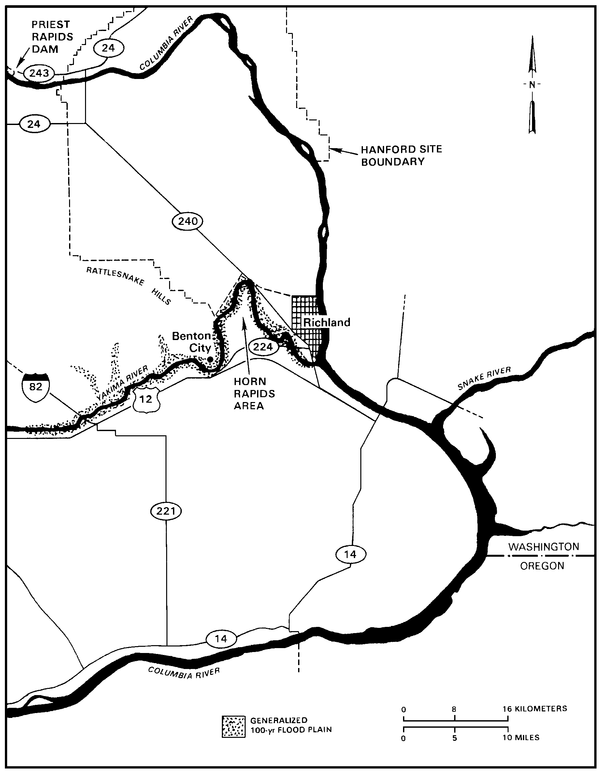

Figure 4.4-9. Flood Area from a 100-Year Flood of the Yakima River near the Hanford Site, Washington (DOE 1986)
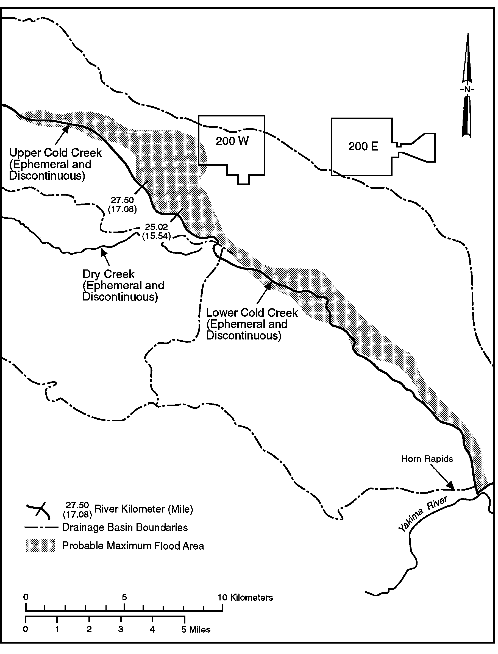

Figure 4.4-10. Extent of Probable Maximum Flood in Cold Creek Area, Hanford Site, Washington, delineated using the U.S. Army Corps of Engineers’ HEC-2 Water Surface Profiles model (Skaggs and Walters 1981)

Approximately 10 were documented at the eastern end of Umtanum Ridge, 7 were observed in the central part of Gable Butte, and 3 were found at the eastern end of Gable Mountain (Figure 4.0-1).

Other than rivers and springs, there are no naturally occurring bodies of surface water adjacent to the Hanford Site. There are wetlands caused by irrigation, on the east and west sides of the Wahluke Slope, which lies north of the Columbia River and on the White Bluffs east of the Columbia River. Hatcheries and irrigation canals constitute the only other surface water in the Hanford Site vicinity. The Ringold Hatchery is located just south of the Hanford Site boundary on the east side of the Columbia River (Figure 4.4-1).

Hanford Site Vadose Zone

The vadose zone is that part of the geologic media which extends from the earth’s surface to the water table. At the Hanford Site, the thickness of the vadose zone ranges from 0 m (0 ft) near the Columbia River to greater than 100 m (328 ft) beneath parts of the central plateau (Hartman 2000). Unconsolidated glacio-fluvial sands and gravels of the Hanford formation make up most of the vadose zone. In some areas, such as most of the 200 West Area and in some of the 100 Areas, the fluvial-lacustrine sediments of the Ringold Formation make up the lower part of the vadose zone. The Cold Creek unit also makes up part of the vadose zone. The integrated knowledge obtained from previous and on-going studies provides a good conceptual understanding of the geologic, hydraulic, and geochemical environment and its controls on the distribution and movement of contaminants within the vadose zone (DOE 1999b; Last et al. 2004).

Moisture movement through the vadose zone is important because it is the driving force for migration of most contaminants to the groundwater. Radioactive and hazardous wastes in the soil column from liquid-waste disposals, unplanned leaks, solid waste burial, and underground tank storage are potential sources of continuing and future vadose zone and groundwater contamination. Contaminants may continue to move downward for long periods (tens to hundreds of years depending on recharge rates and the distribution coefficient of the contaminant) after termination of liquid waste disposal.

Except for the State Approved Land Disposal Site (SALDS), the 200 Area TEDF ponds (Figure 4.4-1), and septic drain fields, liquid discharges to the vadose zone ended during the mid-1990s. Currently, the major source of moisture to the vadose zone is precipitation. Infiltration and deep drainage of meteoric water in the vadose zone causes older preexisting water to be displaced downward by newly infiltrated water. The amount of deep drainage (below the root zone) at any particular site is dependent on the total amount of water available at the time of the event, soil type, and the presence of vegetation. Usually, vegetation reduces the amount of deep drainage through the biological process of transpiration.

The vadose-zone stratigraphy influences the movement of liquid through the soil column. Where conditions are favorable, lateral spreading of liquid effluent and/or local perched water zones may develop. Lateral spreading can occur along any strata with contrasting conductivity. Perched water zones form where downward moving moisture accumulates on top of less-permeable soil lenses or highly cemented horizons. Even in relatively uniform sediments the influence of grain orientation is important and can give rise to anisotropic hydraulic properties, causing significant lateral movement of contaminant plumes (Ward et al. 2002a, b; Zhang et al. 2003). Lateral spreading can delay the arrival of contaminants at the water table but may cause mixing of the subsurface plume at one site with that of an adjacent site. Spreading may also require increasing the area of surface barriers to cover wider plumes.

Preferential flow may also occur along discontinuities, such as clastic dikes and fractures. Clastic dikes are a common geologic feature in the suprabasalt sediments at the Hanford Site. Their most important feature is their potential to either enhance or inhibit vertical and lateral movement of contaminants in the subsurface, depending on textural relationships (Fecht et al. 1999).

Vadose Zone Contamination

The Hanford Site has more than 800 past-practice liquid-disposal facilities. Radioactive liquid waste was discharged to the vadose zone through reverse (injection) wells, French drains, cribs, ponds, trenches, and ditches. From 1944 through the late 1980s, 1.5 to 1.7 billion m³ (396 to 449 billion gal) of effluent were disposed to the soils (Gephart 1999). Most effluent was released in the 200 Areas. The major groundwater contaminant plumes emanating from the 200 Areas are those of tritium and nitrate. The major source for both was discharges from chemical processing of irradiated nuclear fuel rods.

Also present are technetium-99 and iodine-129 which, like tritium and nitrate, are mobile in both the vadose zone and groundwater. The major sources of technetium-99 and iodine-129 were discharges to liquid disposal facilities. Vadose zone sources for these contaminants remain beneath many past-practice disposal facilities. However, other than physical sampling and laboratory analysis, there are few direct ways to monitor tritium, nitrate, technetium-99, and iodine-129 in the vadose zone.

Liquid wastes generated during plutonium recovery processes at Z Plant in the 200 West Area contained carbon tetrachloride. These wastes were discharged to nearby subsurface liquid waste disposal facilities from 1955 to 1973 (Rohay et al. 1994, Swanson et al. 1999). Soil vapor extraction is being used to remove carbon tetrachloride from the vadose zone in the 200 West Area (Hartman et al. 2004).

Approximately 280 unplanned releases in the 200 Areas also contributed contaminants to the vadose zone (DOE 1997b). Many of these were from underground tanks and have contributed significant contamination to the vadose zone. In addition, approximately 50 active and inactive septic tanks and drain fields and numerous radioactive and non-radioactive landfills and dumps have impacted the vadose zone (DOE 1997b). The landfills are and were used to dispose of solid wastes, which, in most instances, are easier to locate, retrieve, and remediate than are liquid wastes.

One hundred and forty-nine single-shell tanks and 28 double-shell tanks have been used to store high-level radioactive and mixed wastes in the 200 Areas. The wastes resulted from uranium and plutonium recovery processes and, to a lesser extent, from strontium and cesium recovery processes. Sixty-seven of the single-shell tanks are assumed to have leaked an estimated total of 2839 to 3975 m³ (750,000 to 1,050,000 gal) of contaminated liquid to the vadose zone (Hanlon 2001). The three largest tank leaks were 435,320 L (115,000 gal), 37,850 to 1,048,560 L (10,000 to 277,000 gal), and 265,980 L (70,365 gal). The average tank leak was between 41,640 and 60,565 L (11,000 and 16,000 gal) (Hanlon 2001).

In addition to removing pumpable liquids from the single-shell tanks, interim measures have been taken to reduce the movement of tank farm contaminants in the vadose zone. Infiltration of water has been identified as the primary means by which contaminants are displaced beneath the farms. Surface water controls have been constructed to reduce surface water run-on from major meteorological events and from breaks in waterlines. Also, waterlines that were determined unnecessary have been isolated, cut, and capped. Waterlines that were found to be necessary for continued operations are being leak tested and any lines found to be leaking will be replaced.

Cooling water from the single-pass reactors along the Columbia River was routinely routed to retention basins in the 100 Areas prior to return to the river. Thermal shock from the hot cooling water cracked the basins so that much of the cooling water leaked into the vadose zone. In addition, trenches were used for disposal of cooling water from 100-KE, 100-KW, and 100-N Reactors. The disposed cooling waters contained fission and neutron activation products and some chemicals and actinides. Tritium, strontium-90, nitrate, and chromium migrate through the vadose zone to groundwater, and ultimately, to the Columbia River in the 100 Areas. Chromium is actively being remediated at the 100-K and 100-H Areas by pump-and-treat methods and in the 100-D/DR Area by pump-and-treat and in situ redox methods (Hartman et al. 2004).

Contaminated cooling water that had contacted broken fuel rods was routed to trenches rather than being directly returned to the river. These fluids contained large quantities of fission and neutron activation products. In addition, leakage from fuel-storage basins in the 100-K Area also contributed quantities of fission products, transuranics, and carbon-14 to the soil column (Johnson et al. 1995). Thus, both past-practice sites and fuel-storage basin leakage are potential vadose zone sources of contaminants in the 100 Areas. Groundwater monitoring data from wells near the 100-KE and 100-KW basins do not show any indication of current leakage from either basin.

The amount of contamination remaining in the vadose zone is uncertain. Several compilations of vadose zone contamination have been formulated through the past years. DOE (1997b), Kincaid et al. (1998, 2001), and Simpson et al. (2001) contain the most recent inventories of contaminants disposed to past-practice liquid disposal facilities in the 200 Areas. Dorian and Richards (1978) list contaminant inventories disposed to most 100 Area past-practice facilities. Agnew (1997) and Anderson (1990) list inventories of effluents sent to single-shell tanks and Simpson et al. (2001) list the compositions of fluids leaked from single-shell tanks. Most recently, the Hanford Tank Farm Vadose Zone Project has issued a series of reports that estimate the curies of gamma-emitting radionuclides and the volumes of contaminated soil associated with each single-shell tank farm (http://www.gjo.doe.gov/programs/hanf/ ).

Further information on vadose zone characterization and monitoring activities on the Hanford Site is available online at http://vadose.pnl.gov and http://www.hanford.gov/cp/gpp/ as well as in the annually updated Hanford Site groundwater monitoring report (i.e., Hartman et al. 2004).

Hanford Site Groundwater

Groundwater at the Hanford Site originated as either recharge from rain and snowmelt, or from excess irrigation, canal seepage, and wastewater disposal. Most of this groundwater will eventually discharge to the Columbia River. Some will be brought to the surface through wells, or excavations, or through evaporation or transpiration in shallow water table areas.

Groundwater beneath the Hanford Site is found in both an upper unconfined aquifer system and deeper basalt-confined aquifers. The unconfined aquifer system is also referred to as the suprabasalt aquifer system because it is within the sediments that overlie the basalt bedrock. Portions of the suprabasalt aquifer system are locally confined. However, because the entire suprabasalt aquifer system is interconnected on a site-wide scale, it is referred to in this report as the Hanford unconfined aquifer system.

Basalt-Confined Aquifer System

Relatively permeable sedimentary interbeds and the more porous tops and bottoms of basalt flows provide the confined aquifers within the Columbia River Basalts. The horizontal hydraulic conductivities of most of these aquifers fall in the range of 10⁻¹⁰ to 10⁻⁴ m/s (3 x 10⁻¹⁰ to 3 x 10⁻⁴ ft/s). Saturated but relatively impermeable dense interior sections of the basalt flows have horizontal hydraulic conductivities ranging from 10⁻¹⁵ to 10⁻⁹ m/s (3 x 10⁻¹⁵ to 3 x 10⁻⁹ ft/s), about five orders of magnitude lower than some of the confined aquifers that lie between these basalt flows (DOE 1988). Hydraulic-head information indicates that groundwater in the basalt-confined aquifers generally flows toward the Columbia River and, in some places, toward areas of enhanced vertical interaquifer flow with the unconfined aquifer system (Hartman et al. 2004, DOE 1988, Spane 1987). The basalt-confined aquifer system is important because there is a potential for significant groundwater movement between the two systems. Head relationships presented in previous reports (DOE 1988) demonstrate the potential for such interaquifer flow. In addition, limited water chemistry data indicate that interaquifer flow has occurred in an area near the Gable Mountain anticlinal structure, north of the 200 East Area (Graham et al. 1984, Jensen 1987).

Unconfined Aquifer System

The unconfined aquifer system is composed primarily of the Ringold Formation and overlying Hanford formation (Section 4.3). In some areas, the coarse-grained multilithic facies of the Cold Creek unit (pre-Missoula gravels) lie between these formations and below the water table. The other subunits of the Cold Creek unit are generally above the water table.

Water table elevations (Figure 4.4-11) show that groundwater in the unconfined aquifer at Hanford generally flows from recharge areas in the elevated region near the western boundary of the Hanford Site toward the Columbia River on the eastern and northern boundaries. The Columbia River is the primary discharge area for the unconfined aquifer. The Yakima River borders the Hanford Site on the southwest and is generally regarded as a source of recharge. Along the Columbia River shoreline, daily river level fluctuations may result in water table elevation changes of up to 3 m (10 ft). During the high river stage periods of 1996 and 1997, some wells near the Columbia River showed water level changes of more than 3 m (10 ft). As the river stage rises, a pressure wave is transmitted inland through the groundwater. The longer the duration of the higher river stage, the farther inland the effect is propagated. The pressure wave is observed farther inland than the water actually moves. For the river water to flow inland, the river level must be higher than the groundwater surface and must remain high long enough for the water to flow through the sediments. Typically, this inland flow of river water is restricted to within several hundred feet of the shoreline (McMahon and Peterson 1992).

Gee et al. (1992) and Fayer et al. (1996) estimate that recharge rates from precipitation across the Hanford Site range from near zero to over 100 mm/year (3.94 in./yr). Recharge is variable both spatially and temporally. It is greatest for coarse-textured soils bare of deep-rooted vegetation and in years with rapid snowmelt events and precipitation during cool months. The magnitude of recharge at a particular location is influenced by five main factors: climate, soils, vegetation, topography, and springs and streams. Events such as the fire that burned vegetation from a large portion of the Hanford Site during the summer of 2000 also affect recharge rates. Fayer et al. (1996) used several types of field data and computer modeling to estimate the areal distribution of mean recharge rates for the soil and vegetation conditions at the Hanford Site, including any disturbance by Hanford operations.

Between 1944 and the mid-1990s, the volume of artificial recharge from Hanford wastewater disposal was significantly greater than recharge from precipitation. An estimated 1.68 x 10¹² L (4.44 x 10¹¹ gal) of liquid was discharged to disposal ponds, trenches, and cribs during this period. Wastewater discharge has decreased since 1984 and currently contributes a volume of recharge in the same range as the estimated natural recharge from precipitation. Because of the reduction in discharges, groundwater levels are falling, particularly around the operational areas (Hartman et al. 2004).

After the beginning of Hanford operations during 1943, the water table rose about 27 m (89 ft) under the U Pond disposal area in the 200 West Area and about 9.1 m (30 ft) under disposal ponds near the 200 East Area (Figure 4.4-11). The volume of water that was discharged to the ground at the 200 West Area was actually less than that discharged at the 200 East Area. However, the lower hydraulic conductivity of the aquifer near the 200 West Area inhibited groundwater movement in this area resulting in a higher groundwater mound. The presence of the groundwater mounds locally affected the direction
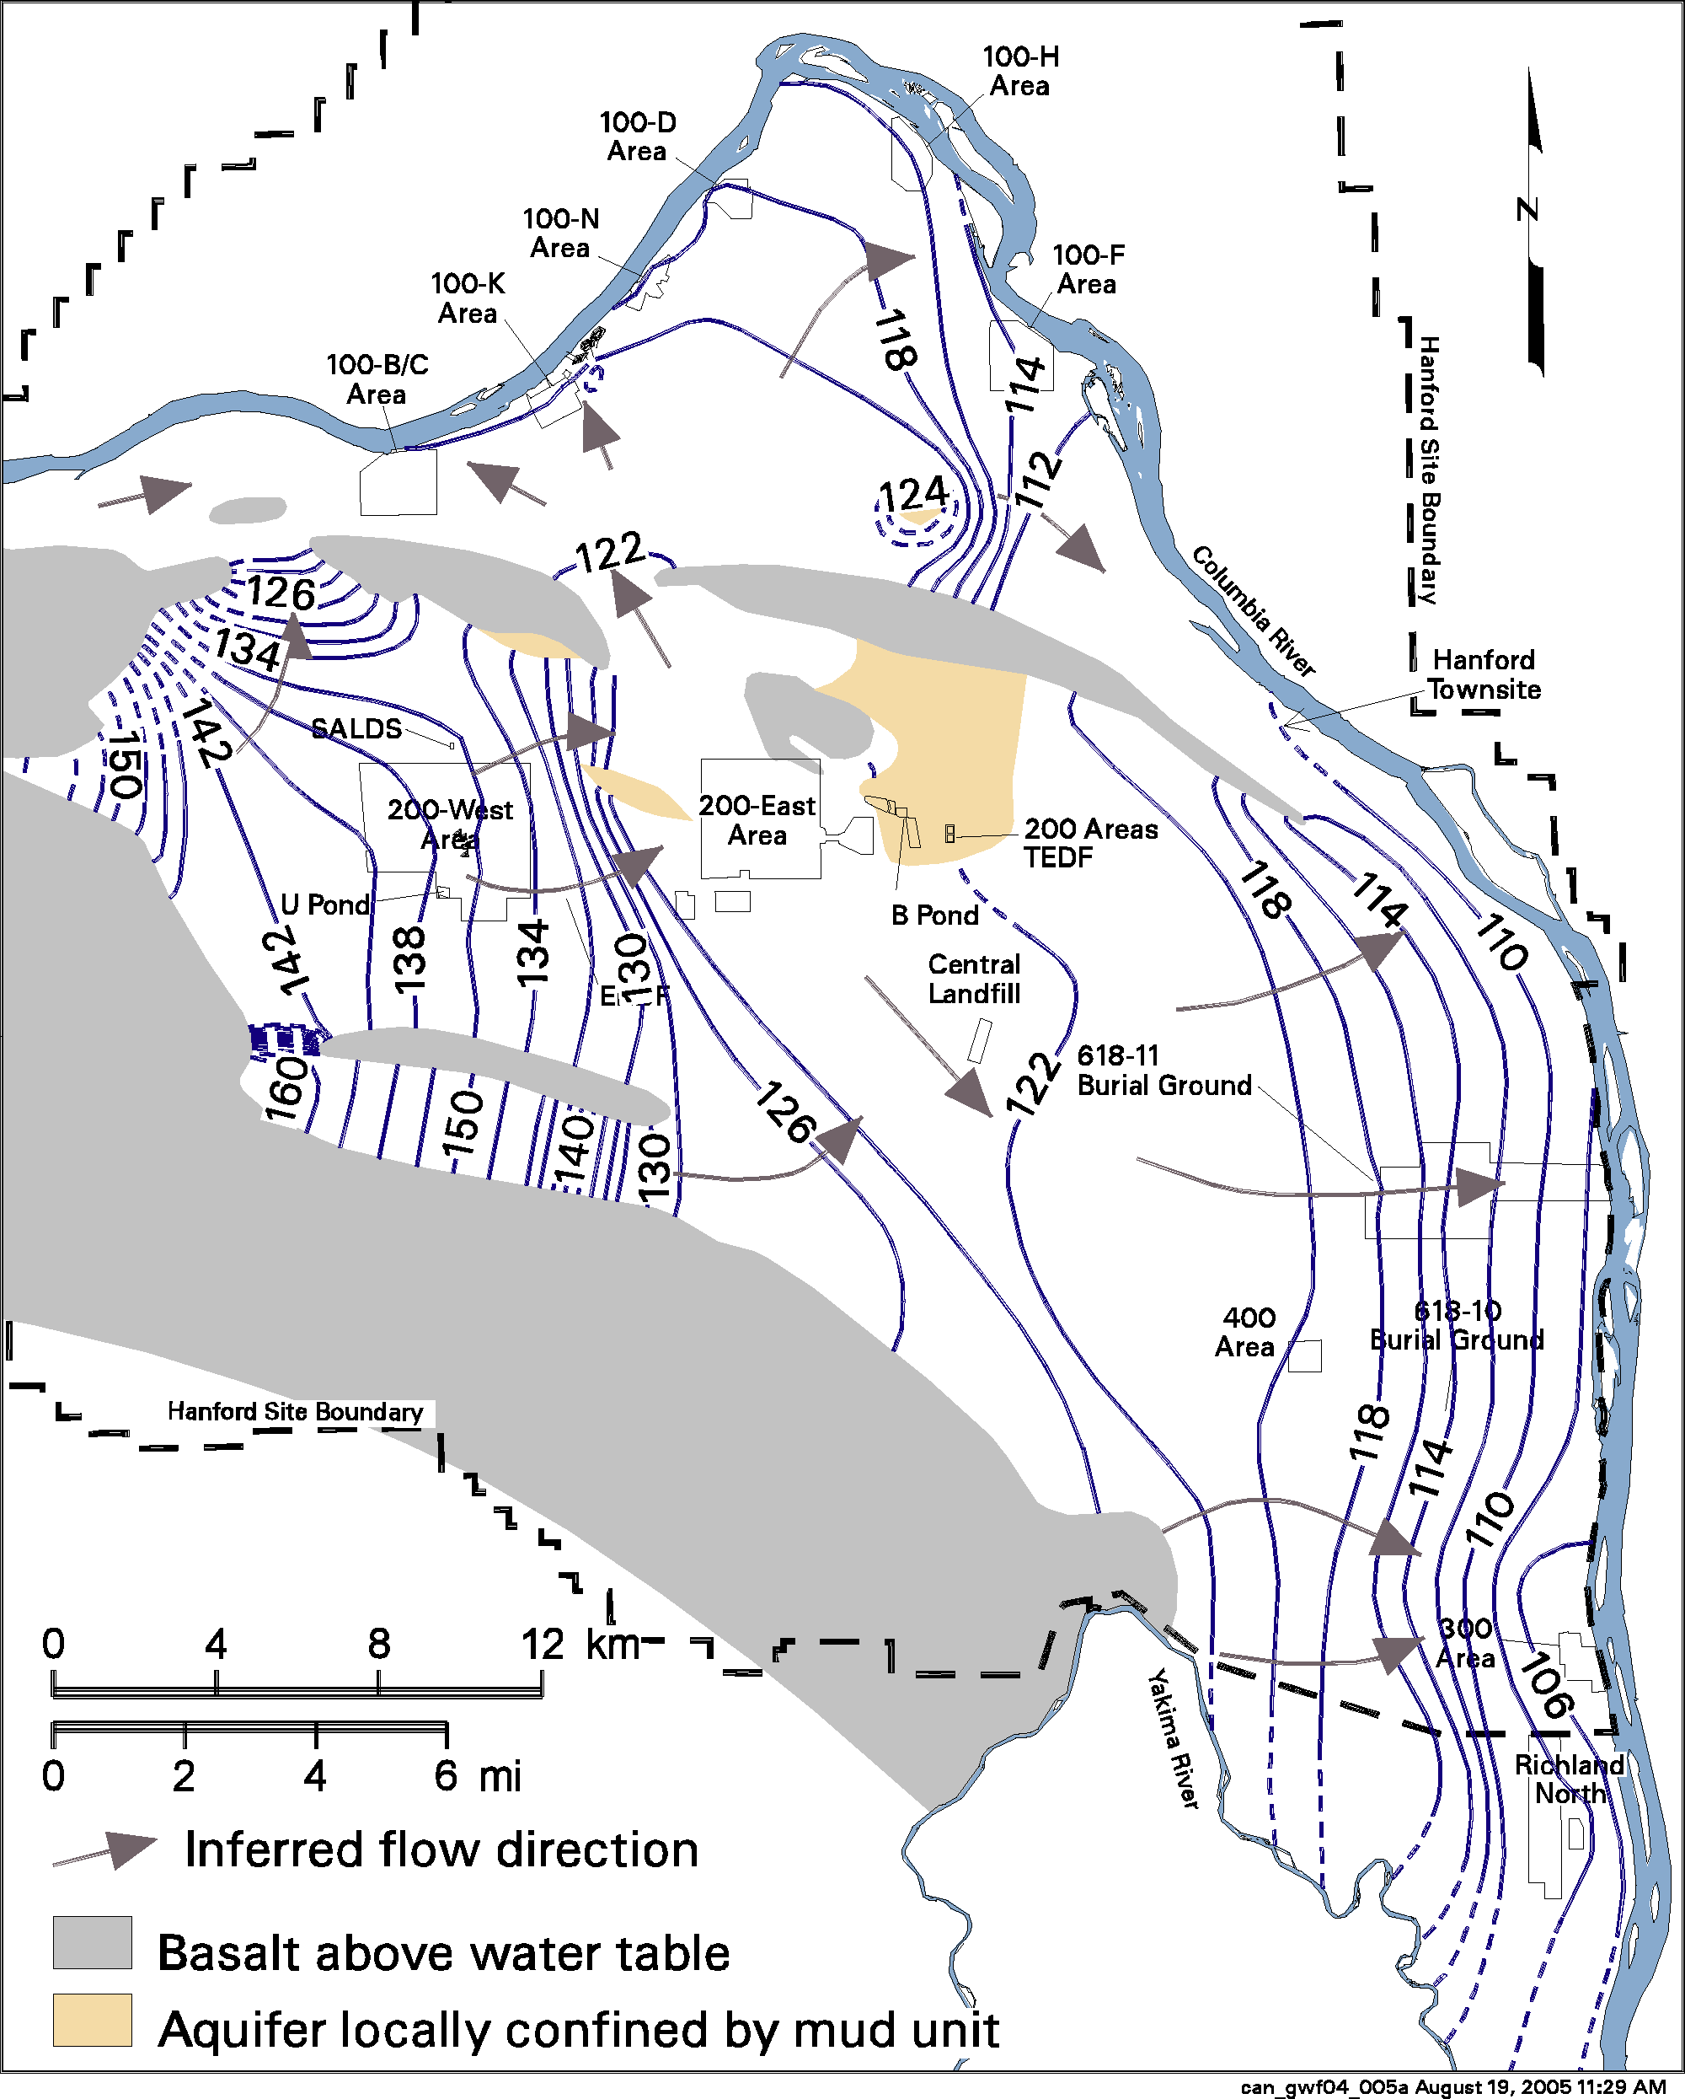

Figure 4.4-11. Water Table Elevations in Meters (1 m = 3.28 ft) and Inferred Groundwater Flow Directions for the Unconfined Aquifer at Hanford, Washington, March 2004 (Hartman et al. 2005)

of groundwater movement, causing radial flow from the discharge areas. Zimmerman et al. (1986) documented changes in water table elevations between 1950 and 1980. Until about 1980, the edge of the mounds migrated outward from the sources over time. Groundwater levels have declined over most of the Hanford Site since 1984 because of decreased wastewater discharges (Hartman et al. 2004). Although the reduction of wastewater discharges has caused water levels to drop significantly, a residual groundwater mound beneath the 200 West Area is still shown by the curved water table contours near this area and small groundwater mounds exist near the 200 Area Treated Effluent Disposal Facility (TEDF) and SALDS wastewater disposal sites (Figure 4.4-11).

Horizontal hydraulic conductivities of sand and gravel facies within the Ringold Formation generally range from about 1 to 100 m/d (3 to 330 ft/d), compared to 10 to 3000 m/d (33 to 10,000 ft/d) for the Hanford formation and the coarse-grained multilithic facies of the Cold Creek unit (pre-Missoula gravels) (DOE 1988, Cole et al. 2001, Thorne and Newcomer 2002). Because the Ringold Formation sediments are more consolidated and partially cemented, they are about 10 to 100 times less permeable than the sediments of the overlying Hanford formation. Before wastewater disposal operations at the Hanford Site, the uppermost aquifer was mainly within the Ringold Formation, and the water table extended into the Hanford formation at only a few locations (Newcomb et al. 1972). However, wastewater discharges raised the water table elevation across the Site. The general increase in groundwater elevation caused the unconfined aquifer to extend upward into the Hanford formation over a larger area, particularly near the 200 East Area. This resulted in an increase in groundwater velocity because of both the greater volume of groundwater and the higher permeability of the newly saturated Hanford formation sediments.

Limitations of Hydrogeologic Information

The sedimentary architecture of the unconfined aquifer is very complex because of repeated deposition and erosion. Although hundreds of wells have been drilled on the Hanford Site, many penetrate only a small percentage of the total unconfined aquifer thickness, and there are a limited number of wells that can be used for defining the deeper sediment facies. A number of relatively deep wells were drilled in the early 1980s as part of a study for a proposed nuclear power plant (PSPL 1982), and these data are helpful in defining facies architecture. For most of the thinner and less extensive sedimentary units, correlation between wells is either not possible or uncertain. Major sand and gravel units of the Ringold Formation (e.g., Units A, B, C, D, and E) are separated by mud-dominated units (Figure 4.3-5). In some places the mud units act as aquitards that locally confine groundwater in deeper permeable sediments.

A limited amount of hydraulic property data is available from testing of wells. Hydraulic test results from wells on the Hanford Site have been compiled for the Hanford Groundwater Monitoring Project and for environmental restoration efforts (Kipp and Mudd 1973; Connelly et al. 1992 (a, b); Thorne and Newcomer 1992, 2002; Spane and Thorne 1995, 2000; Spane et al. 2001(a, b); Spane et al. 2002). Most hydraulic tests were conducted within the upper 15 m (49 ft) of the aquifer, and many were open to more than one geologic unit. In some cases, changes in water table elevation may have significantly changed the unconfined aquifer transmissivity at a well since the time of the hydraulic test. Few hydraulic tests within the Hanford Site unconfined aquifer system have yielded accurate estimates of aquifer-specific yield.

Groundwater Travel Times

Tritium and carbon-14 measurements indicate that groundwater residence time (time that ground water has been in the subsurface) is up to thousands of years for the unconfined aquifer and more than 10,000 years for groundwater in the shallow confined aquifer (Johnson et al. 1992). Chlorine-36 and noble gas isotope data suggest groundwater ages of greater than 100,000 years in the deeper confined systems (Johnson et al. 1992). These relatively long residence times are consistent with semiarid-site recharge conditions. However, groundwater travel time from the 200 East Area to the Columbia River has been shown to be much faster, in the range of 10 to 30 years (USGS 1987, Freshley and Graham 1988). This is because of large volumes of recharge from wastewater that was disposed in the 200 Areas between 1944 and the mid-1990s and the relatively high permeability of Hanford formation sediments, which are below the water table between the 200 East Area and the Columbia River. Travel time from the 200 West Area is greater because of the lower permeability of Ringold Formation sediments. Plume monitoring indicates that groundwater from the 200 West Area has moved about 6 km (3.7 mi) during the past 50 years. Groundwater travel times from the 200 Areas to the Columbia River are expected to decrease because of diminishing wastewater recharge in the 200 Areas and the resulting reduction of the hydraulic gradient.

Groundwater East and North of the Columbia River

The Hanford Site boundary extends east and north of the Columbia River. Hanford Site activities in these areas have not impacted the groundwater. However, the groundwater in this area is impacted by high recharge from irrigation and canal leakage. The South Columbia Basin Irrigation District manages surface water used to irrigate land east and north of the Columbia River. Recharge from irrigation water has increased water table elevations in large areas of the Pasco Basin by as much as 92 m (300 ft) (Drost et al. 1989).

There are two general hydrologic areas that impinge upon the Hanford Site boundaries to the east and north of the river. The eastern area extends from north to south between the lower slope of Saddle Mountain and the Esquatzel Diversion canal and includes the Ringold Coulee, White Bluffs area, and Esquatzel Coulee. The water table occurs in the Pasco gravels of the Hanford formation in both Ringold and Esquatzel Coulees. Brown (1979) reported that runoff from spring discharge at the mouth of Ringold Coulee is greater than 0.631 m³/s (22.3 ft³/s). Elsewhere in this area, the unconfined aquifer is in the less-transmissive Ringold Formation. Irrigation has also created perched aquifers and resulted in a series of springs issuing from perched water along the White Bluffs. The increased hydraulic pressure in these sediments has caused subsequent slumping and landslides (Brown 1979, Newcomer et al. 1991).

The other principal irrigated area is the northern part of the Pasco Basin on the Wahluke Slope, which lies between the Columbia River and the Saddle Mountain anticline. Irrigation return waste-water paths off of the Wahluke Slope have created ponds and springs in the Saddle Mountain Wildlife Refuge. The direction of unconfined groundwater flow is southward from the basalt ridges toward the Columbia River. Bauer et al. (1985) reported that lateral water table gradients are essentially equal to or slightly less than the structural gradients on the flanks of the anticlinal fold mountains where the basalt dips steeply.

Groundwater Quality

The quality of groundwater at the Hanford Site, uncontaminated by Hanford activities, varies depending on the aquifer system and depth, which generally is related to residence time in the aquifer (DOE 1992a, 1997c; Hartman et al. 2004). DOE has conducted a study examining historical data and new data from wells in areas not affected by Hanford Site contaminants (DOE 1997c).

Groundwater chemistry in the basalt-confined aquifers displays a range depending on depth and residence time (DOE 1988). The chemical type varies from calcium- and magnesium-carbonate water to sodium- and chloride-carbonate water. Some of the shallower basalt-confined aquifers in the region (e.g., the Wanapum basalt aquifer) have exceptionally good water quality characteristics: less than 300 mg/L dissolved solids; less than 0.1 mg/L iron and magnesium; less than 20 mg/L sodium, sulfate, and chloride; and less than 10 ppb heavy metals (Johnson et al. 1992). However, deeper basalt-confined aquifers typically have high dissolved solids content and some have fluoride concentrations greater than the drinking water standard of 5 mg/L (DOE 1988).

Groundwater beneath large areas of the Hanford Site has been contaminated by radiological and chemical constituents resulting from past Hanford Site operations. These contaminants were primarily introduced through wastewater discharged to cribs, ditches, injection wells, trenches, and ponds (Kincaid et al. 1998). Additional contaminants from spills, leaking waste tanks, and burial grounds (landfills) have also entered groundwater in some areas. Contaminant concentrations in the existing groundwater plumes are expected to decline through radioactive decay, mineral adsorption, chemical degradation, and dispersion. However, contaminants also exist within the vadose zone beneath waste sites (Section 4.4.2) as well as in waste storage and disposal facilities. These contaminants have a potential to continue to move downward into the aquifer.

Some contaminants, including tritium and chloride, move at the same velocity as groundwater. The movement of other contaminants is slower because they react with or are sorbed on the surface of minerals within the aquifer or the vadose zone. The factor by which the velocity of a constituent is reduced compared to average groundwater flow velocity is called the “retardation factor.” Therefore, tritium in groundwater will move ten times faster than a contaminant with a retardation factor of ten. For Hanford sediments, it has been estimated that technetium and chromium have small retardation factors and move at nearly the same velocity as groundwater (Thorne 2004). Iodine, nitrate, uranium, and carbon tetrachloride were estimated to have median retardation factors between 3 and 12. Strontium, cesium, and plutonium were estimated to have median retardation factors between 290 and 27,000. Cantrell et al. (2002) and Serne and Kaplan (2000) offer additional information on retardation of chemicals transported in groundwater.

Groundwater contamination is being actively remediated through pump-and-treat operations at the 200-West Area, 100-F Area, and 100-K Area. These operations are summarized in Hartman et al. (2004). At the 100-N Area, pump-and-treat remediation has been terminated and a passive treatment barrier is being used to reduce contaminant migration.

Monitoring of radiological and chemical constituents in groundwater at the Hanford Site is performed to characterize physical and chemical trends in the flow system, establish groundwater quality baselines, assess groundwater remediation, and identify new or existing groundwater problems. Groundwater monitoring is also performed to verify compliance with applicable environmental laws and regulations. Samples were collected from 710 wells and 79 shoreline aquifer sampling tubes during FY 2003 to determine the distributions of radiological and chemical constituents in Hanford Site groundwater (Hartman et al. 2004).

To assess the quality of groundwater, concentrations measured in samples were compared with maximum contaminant levels (MCL) or interim Drinking Water Standards (DWS) and DOE’s Derived Concentration Guides (DCG). The MCL or DWS standards are legal limits for contaminant concentrations in public drinking water supplies enforceable by the Washington State Department of Health or EPA. Although these standards are only applicable at the point of consumption of the water, they provide a useful indicator of negative impacts to the groundwater resource. The DCG applies only to radionuclides and is based on the concentration that would result in a dose exposure of 1 mSv/year (100-mrem/year) effective dose equivalent, a calculation of dose that assumes ingestion under specified intake scenarios.

Radiological constituents including carbon-14, iodine-129, strontium-90, technetium-99, gross alpha, gross beta, tritium, and uranium were detected at levels greater than the DWS in one or more onsite wells. Concentrations of strontium-90, tritium, and uranium were detected at levels greater than DOE’s DCG. Certain nonradioactive chemicals regulated by EPA and the State of Washington (nitrate, fluoride, chromium, cyanide, carbon tetrachloride, chloroform, trichloroethylene, and tetrachloroethylene) were also present in Hanford Site groundwater during fiscal year 2003 (Table 4.4-2). The extent of radiological and non-radiological contamination in Hanford Site groundwater above the applicable DWS is determined annually (Figures 4.4-12 and 4.4-13). The area of contaminant plumes on the Hanford Site with concentrations exceeding drinking water standards was estimated to be 190 km² (89.2 mi²) during fiscal year 2004.

100 Area Hydrology

The hydrology of the 100 Area is affected by its location adjacent to the Columbia River. The water table ranges in depth from near 0 m (0 ft) at the river edge to 30 m (107 ft). The groundwater flow direction is generally toward the river. However, during high river stage, the flow direction may reverse immediately adjacent to the river. The unconfined aquifer in the 100 Area is composed of either the Ringold Unit E gravels or a combination of the Unit E gravels and the Hanford formation (Figure 4.3-5). There are two large areas where the water table is within the Ringold Formation (Lindsey 1992), and the Hanford formation is unsaturated (Figure 4.4-14). In the 100-H and 100-F Areas, the Ringold Unit E gravels are missing and the Hanford formation lies directly over the fine-grained Ringold lower-mud unit. In most of the 100 Area, the lower Ringold mud forms an aquitard, and the Ringold gravels below the mud are locally confined. Additional information on the hydrology of the 100 Area is available in Hartman and Peterson (1992) and Peterson et al. (1996). A number of studies of various sites in the 100 Area present specific hydrologic information. These include: 100-B/C Area - Lindberg (1993a); 100-D Area - Lindsey and Jaeger (1993); 100-F Area - Lindsey (1992), Peterson (1992); 100-H Area - Liikala et al. (1988), Lindsey and Jaeger (1993); 100-K Area - Lindberg (1993b); and 100-N Area - Gilmore et al. (1992), Hartman and Lindsey (1993).

200 Areas Hydrology

In the 200 West Area, the water table occurs almost entirely in the Ringold Unit E gravels, while in the 200 East Area, it occurs primarily in the Hanford formation and in the Ringold Unit A gravels (Figure 4.3-5). Along the southern edge of the 200 East Area, the water table is in the Ringold Unit E gravels. The upper Ringold facies were eroded in most of the 200 East Area by the ancestral Columbia River and, in some places, by the Missoula floods that subsequently deposited Hanford gravels and sands on what was left of the Ringold Formation (DOE 2002b). Because the Hanford formation and possibly the Cold Creek unit sand and gravel deposits are much more permeable than the Ringold gravels, the water table is relatively flat in the 200 East Area, but groundwater flow velocities are higher. On the north side of the 200 East Area, there is evidence of erosional channels that may allow interaquifer flow between the unconfined and uppermost basalt-confined aquifer (Graham et al. 1984, Jensen 1987).

The hydrology of the 200 Areas has been strongly influenced by the discharge of large quantities of wastewater to the ground during a 50-year period. The discharges caused elevated groundwater levels across much of the Hanford Site resulting in a large groundwater mound beneath the former U Pond (Figure 4.4-11) in the 200 West Area and a smaller mound beneath the former B Pond, east of the 200 East Area. Water table changes beneath the 200 West Area have been greatest because of the lower transmissivity of the aquifer in this area (Cole et al. 2001). Discharges of water to the ground have been greatly reduced, and corresponding decreases in the elevation of the water table have been observed.
Table 4.4-2. Maximum Concentrations of Selected Groundwater Contaminants during Fiscal Year 2003 (modified from Hartman et al. 2004)
100-BC-5 100-KR-4 100-NR-2 100-HR-3-D 100-HR-3-H 100-FR-3
----------------------- ----------------------- ------------- -------------------- ------------------- ---------------------
Contaminant, units DWS(a) Aquifer Aquifer Aquifer Aquifer Aquifer
(alphabetical order) Wells Tubes Wells Tubes Wells Wells Tubes Wells Tubes Wells Tubes

arsenic (filtered), µg/L 10
cadmium (filtered), µg/L 5 3.3 3.1 3.4 3.9
carbon tetrachloride, µg/L 5
carbon-14, pCi/L 2,000 20,900 67.2 15.4
cesium-137, pCi/L 200 ND
chloroform, µg/L 100 1 7.2 1.1
chromium (dissolved), µg/L 100 46 38 542 52 168 5,440 295 154 43 90
cis-1,2-dichloroethene, µg/L 70
cobalt-60, pCi/L 100 ND
cyanide, µg/L 200
fluoride, mg/L 4 0.51 0.49 1 0.45 0.45 0.72
gross alpha, pCi/L 15 2.99 7.14 3.07 3.94 72.4 10.1
gross beta, pCi/L 50 221 3,590 16,000 466 183 51.1
iodine-129, pCi/L 1
nickel (filtered), µg/L 100 28.8 17 416 21.6
nitrate, mg/L 45 27.9 195 3.6 228 107 474 177
nitrite, mg/L 3.3 0.135 0.299 7.55
plutonium-239/240, pCi/L NA(b)
strontium-90, pCi/L 8 98.9 15 2,440 ND 8,000 7.06 23.2 27.8
technetium-99, pCi/L 900 46.7 85.4 986 ND
trichloroethene, µg/L 5 11 9.8
tritium, pCi/L 20,000 21,900 32,200 1,270,000 ND 31,400 23,700 29,700 6,210 11,500
uranium, µg/L 30 3.58 119
Note: Location description refers to Operable Unit groundwater interest area designation.
Table lists highest measured concentration for fiscal year 2003 in each groundwater interest area. Concentrations in bold exceed drinking water standards. Blank space indicates the constituent not of concern in the given area.
(a) DWS = Drinking water standard or U.S. Environmental Protection Agency maximum contaminant level (MCL) if there is no DWS
(b) There is no drinking water standard for plutonium-239/240. The Department of Energy Derived Concentration Guide is 30 pCi/L (1.1 Bq/L)
Conversion: 27 pCi/L = 1 Bq/L
NA = Not applicable ND = Not detected.

Table 4.4-2. (cont’d)

200-ZP-1 200-UP-1 200-BP-5 200-PO-1 300-FF-5 1100-EM-1
Contaminant, units DWS(a) ----------------- ---------------- ------------- ------------- ------------ --------------
(alphabetical order) Wells Wells Wells Wells Wells Wells

arsenic (filtered), µg/L 10 4.1 8.7 7.6 9.2
cadmium (filtered), µg/L 5 3.2 3.1 4.6 3.3
carbon tetrachloride, µg/L 5 6,200 690 0.29 0.35
carbon-14, pCi/L 2,000
cesium-137, pCi/L 200 1,170
chloroform, µg/L 100 31 20 0.46 3 4.4
chromium (dissolved), µg/L 100 592 209 54.9 6,250 7.3
cis-1,2-dichloroethene, µg/L 70 0.09 160 48
cobalt-60, pCi/L 100 48.4
cyanide, µg/L 200 6.4 275
fluoride, mg/L 4 4.3 0.7 0.98 1.3 0.52 4.3
gross alpha, pCi/L 15 6.73 13.9 324 10.7 43.9 77
gross beta, pCi/L 50 4,390 71,200 12,100 79.7 97.5 34.7
iodine-129, pCi/L 1 36.7 35.3 3.65 11.9
nickel (filtered), µg/L 100 328 120 133 864 41.6
nitrate, mg/L 45 2,160 1,930 735 170 134 261
nitrite, mg/L 3.3 0.361 0.46 1.12 0.233 0.069 0.043
plutonium-239/240, pCi/L NA(b) 74.8
strontium-90, pCi/L 8 1.29 53.6 5,680 21.4 4.03
technetium-99, pCi/L 900 11,117 188,000 10,600 287 319 27
trichloroethene, µg/L 5 18 11 0.88 7.2 27
tritium, pCi/L 20,000 2,170,000 634,000 27,600 5,570,000 3,670,000 251
uranium, µg/L 30 367 1,190 554 7.19 235 18
Note: Location description refers to Operable Unit groundwater interest area designation.
Table lists highest measured concentration for fiscal year 2003 in each groundwater interest area. Concentrations in bold exceed drinking water standards. Blank space indicates the constituent was not of concern in the given area..
(a) DWS = Drinking water standard or U.S. Environmental Protection Agency maximum contaminant level (MCL) if there is no DWS
(b) There is no drinking water standard for plutonium-239/240. The Department of Energy Derived Concentration Guide is 30 pCi/L (1.1 Bq/L)
Conversion: 27 pCi/L = 1 Bq/L
NA = Not applicable ND = Not detected.
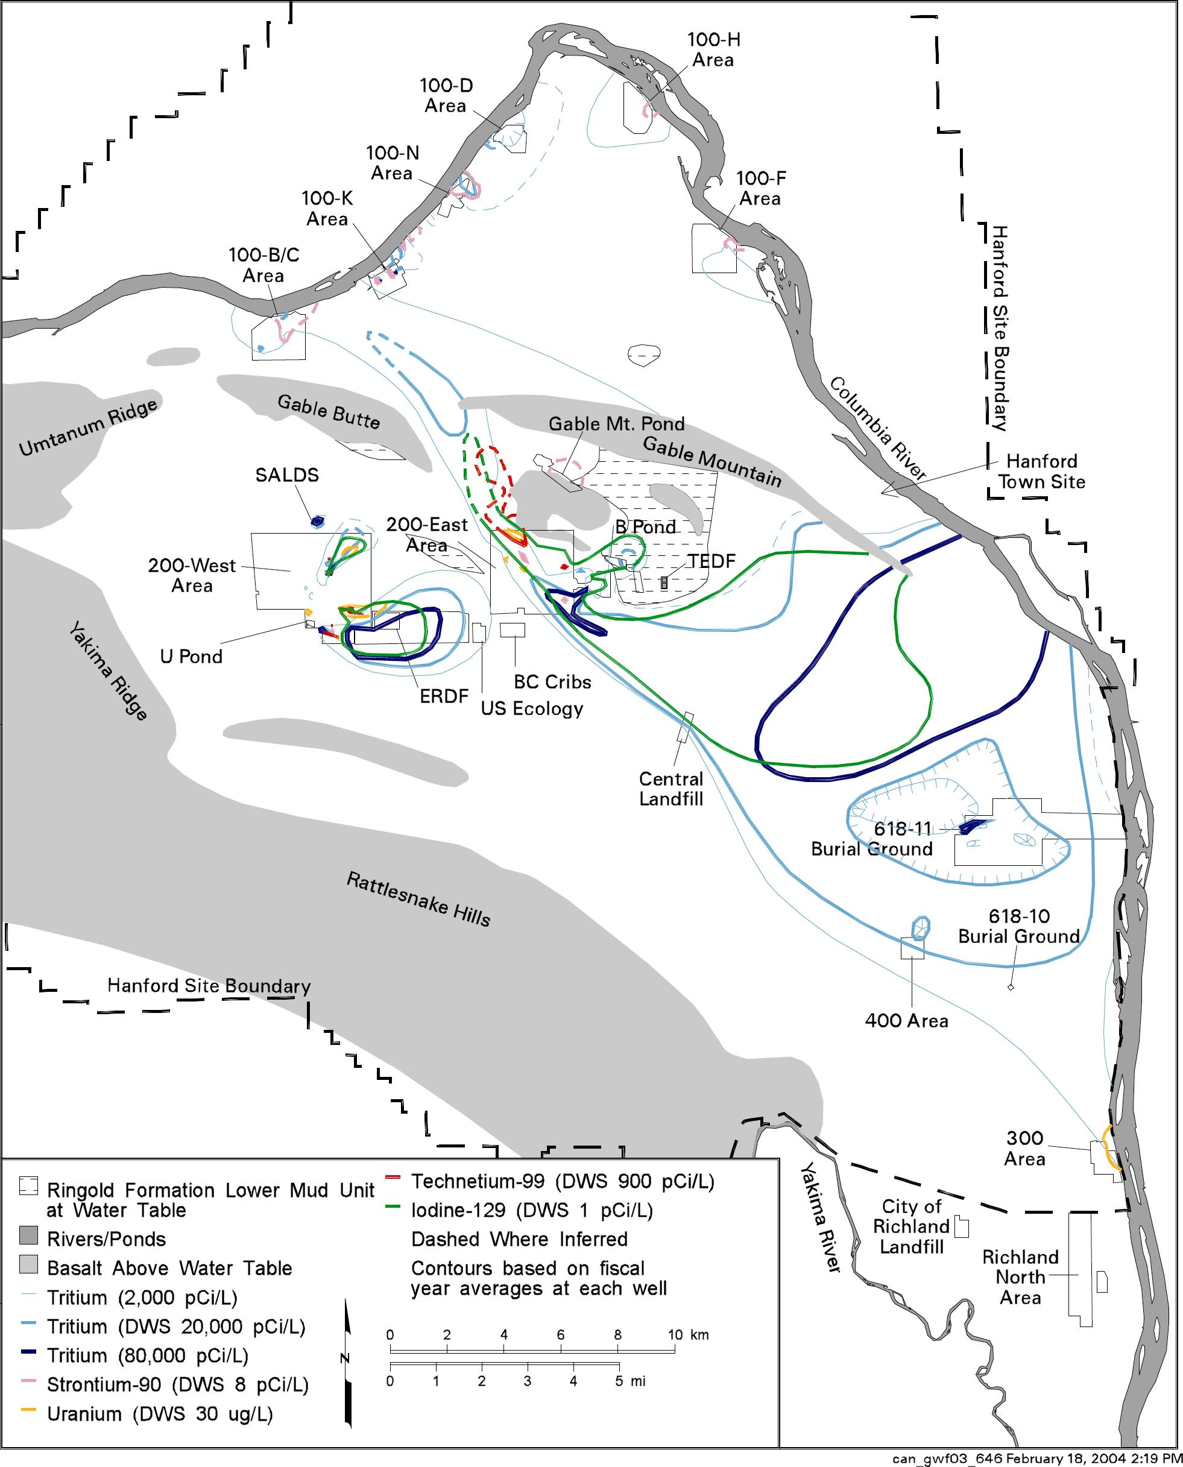

Figure 4.4-12. Distribution of Radionuclides in Groundwater on the Hanford Site, Washington, at Concentrations above the Maximum Contaminant Level or Interim Drinking Water Standard during Fiscal Year 2003 (Hartman et al. 2004) (27 pCi/L = 1 Bq/L)
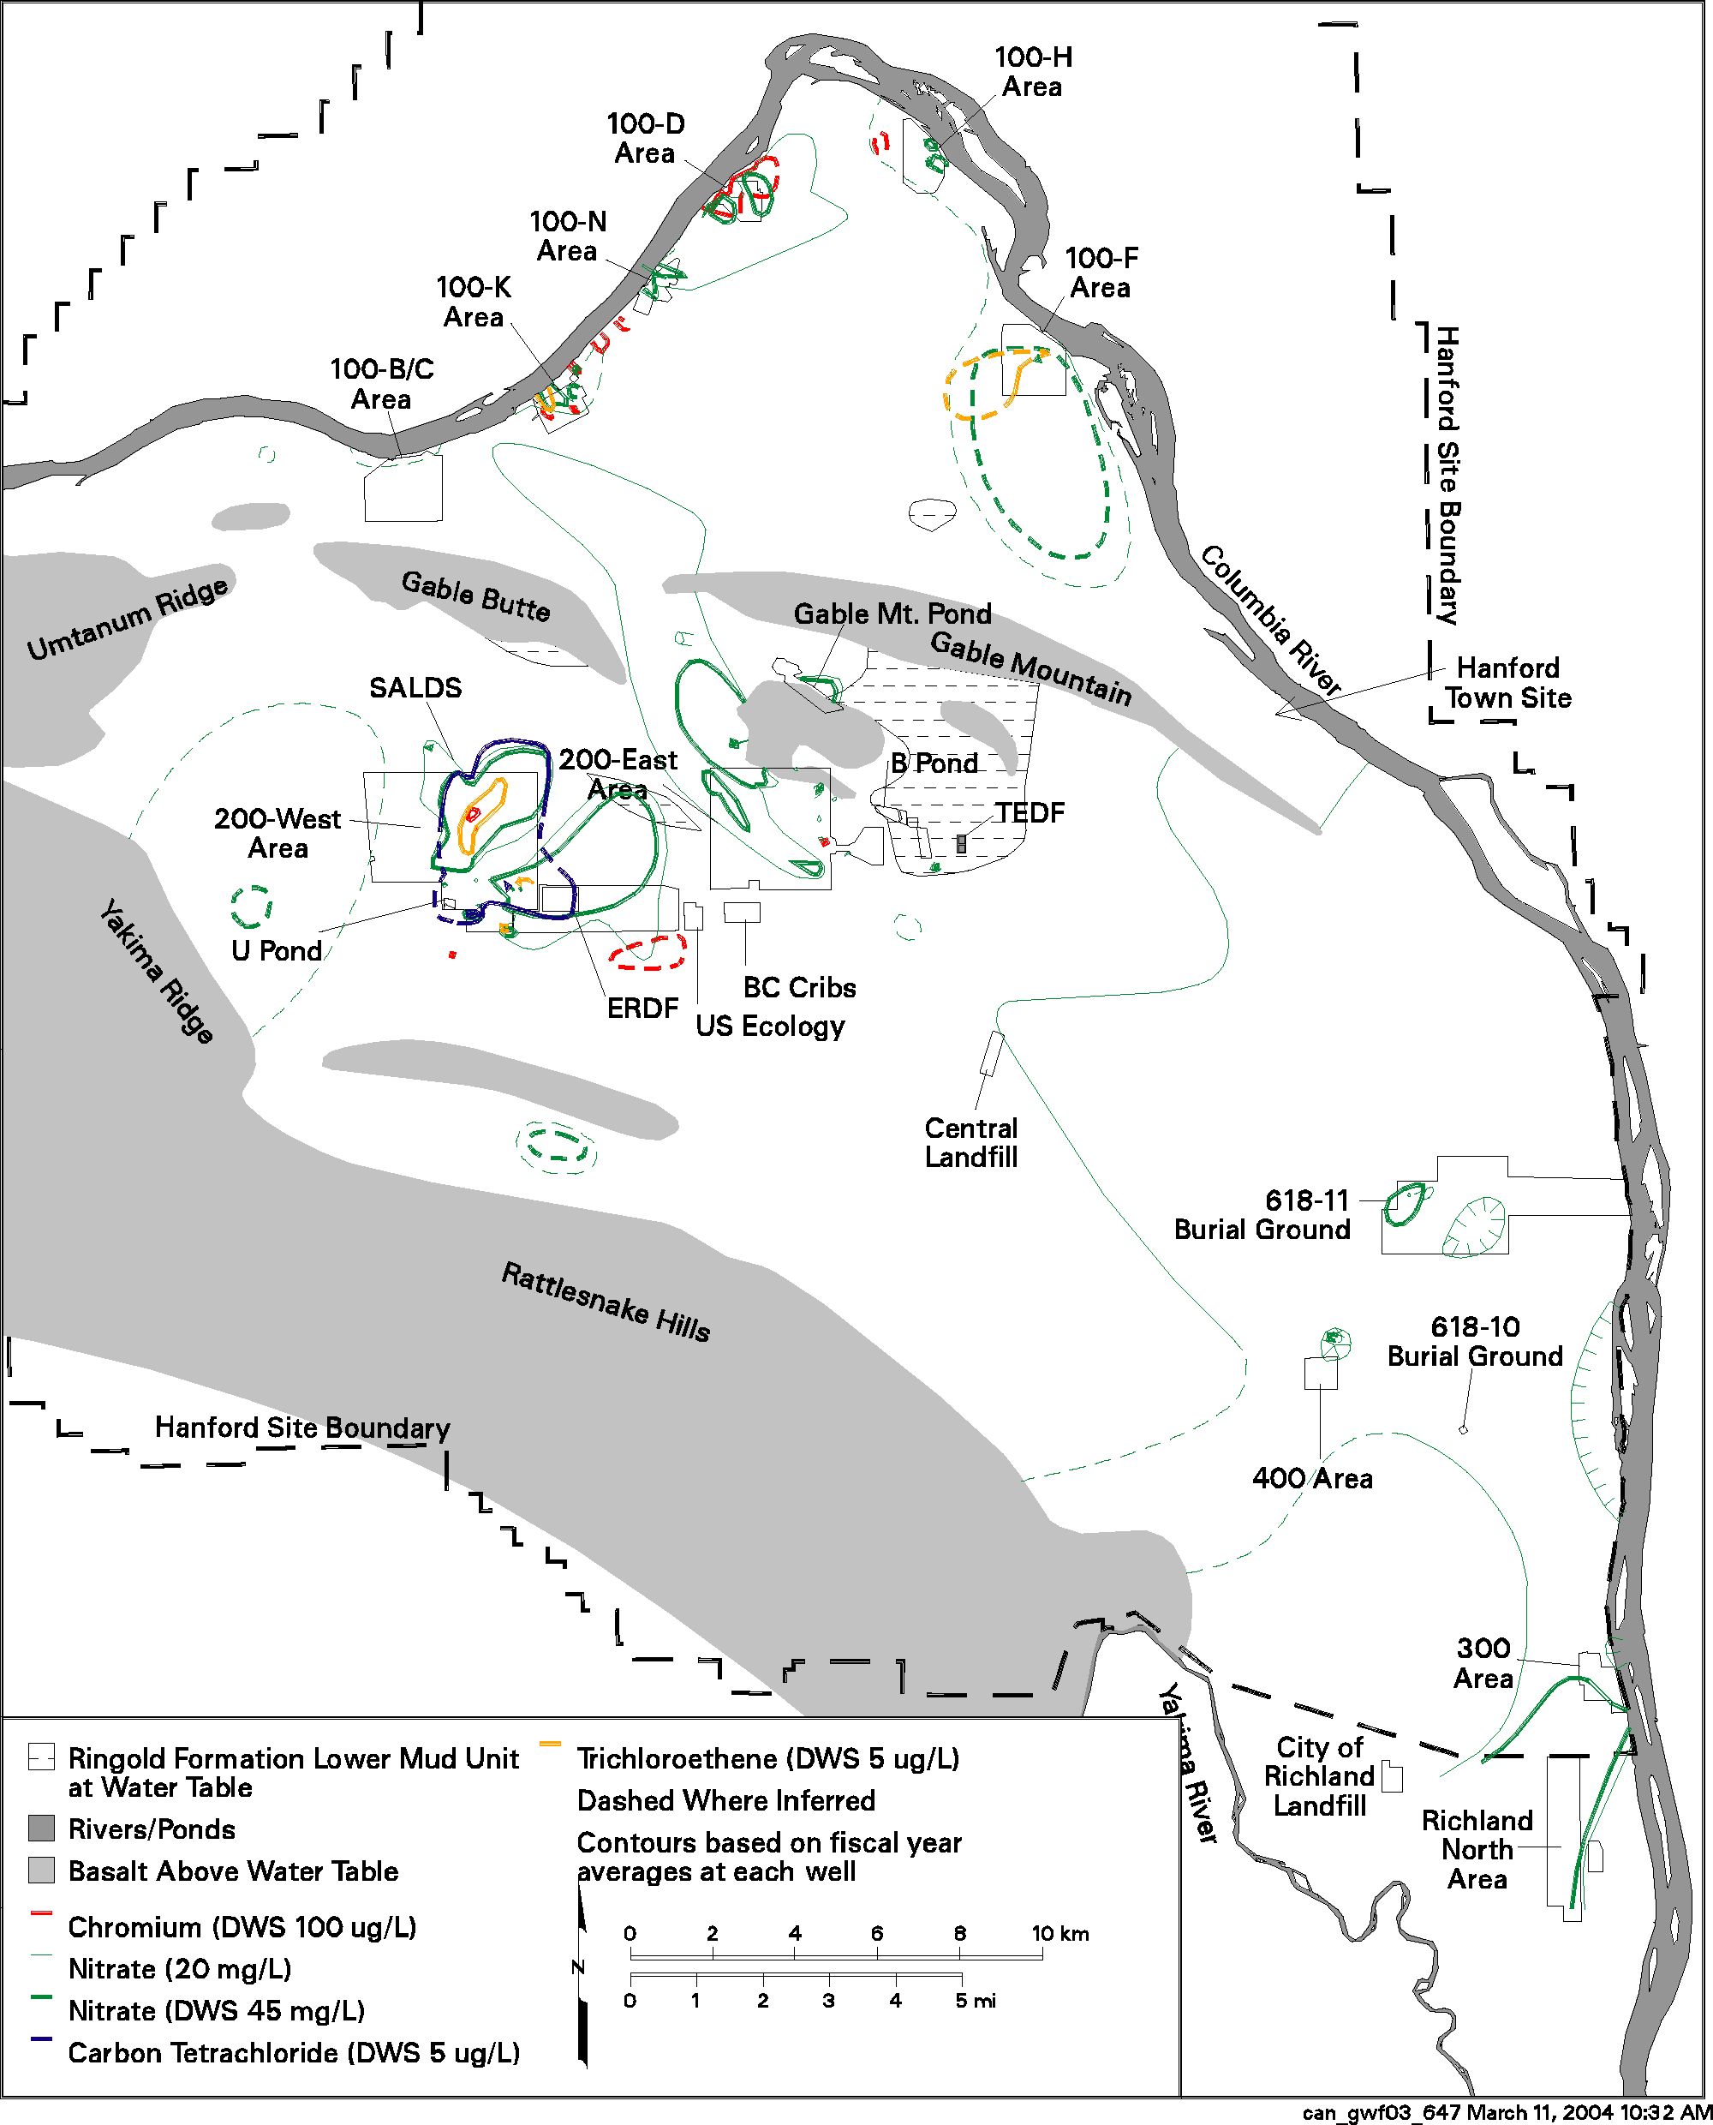

Figure 4.4-13. Distribution of Hazardous Chemicals in Groundwater on the Hanford Site, Washington, at Concentrations above the Maximum Contaminant Level or Interim Drinking Water Standard during Fiscal Year 2003 (Hartman et al. 2004)

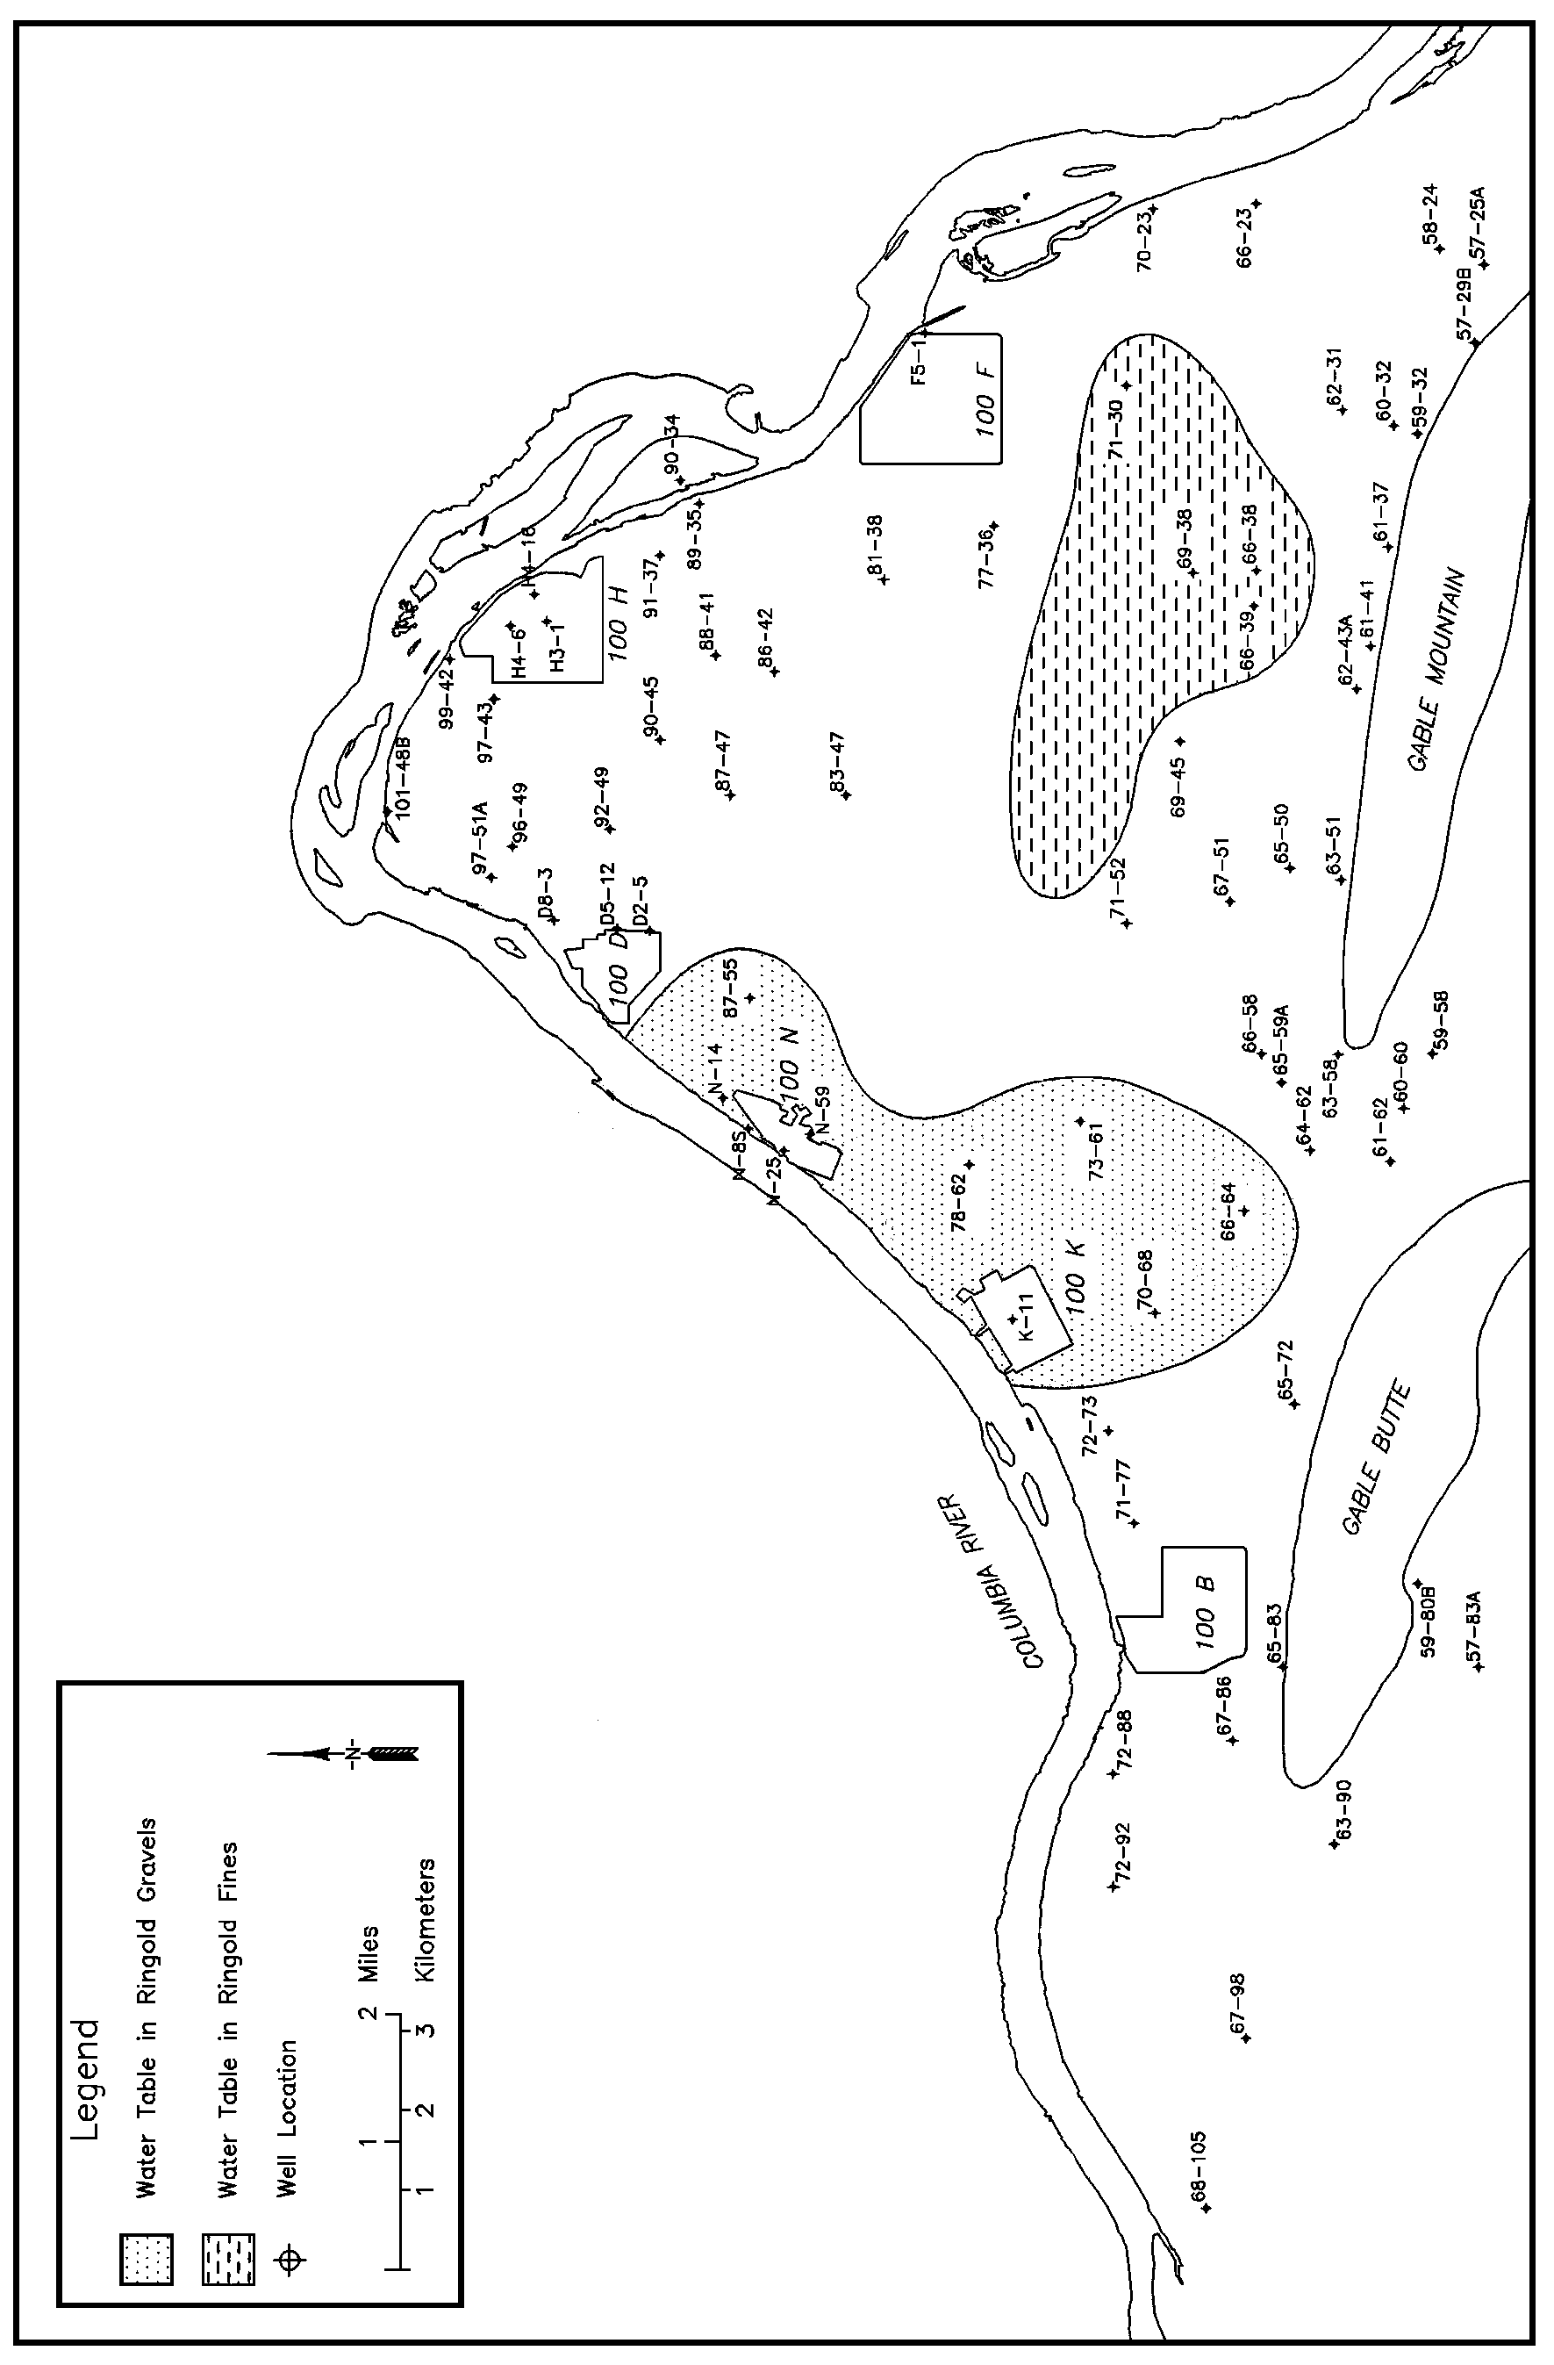
Figure 4.4-14. Geologic Units Intersected by the Water Table in the 100 Areas, Hanford Site, Washington (modified from Lindsey 1992.
The decline in part of the 200 West Area groundwater mound has been more than 8 m (26 ft) (Hartman et al. 2004). Water levels are expected to continue to decrease as the unconfined groundwater system reaches equilibrium with the new level of artificial recharge (Wurstner and Freshley 1994).

A number of reports dealing with the hydrogeology of the 200 Areas are available including Williams et al. (2000, 2002), Graham et al. (1981), Last et al. (1989), and Connelly et al. (1992a, b).

300 Area Hydrology

The unconfined aquifer water table in the 300 Area (Figure 4.4-11) is found in both the Hanford formation and the Ringold Formation. It is 0 to 19 m (0 to 62 ft) below ground surface depending on location. Elevation of the Columbia River stage strongly affects the groundwater levels and flow near the river in the 300 Area. Water table contours in the vicinity of the 300 Area are somewhat concentric, showing that there is a groundwater discharge area for the unconfined aquifer system in the area of convergence. Groundwater flows from the northwest, west, and even the southwest to discharge into the Columbia River near the 300 Area. Schalla et al. (1988), Swanson (1992), and Hartman et al. (2004) have provided more detailed information on the hydrogeology of the 300 Area.

Richland North Area Hydrology

The Richland North Area (Figure 4.4-13) is located in the southern part of the Hanford Site and includes the former 1100 Area,⁽⁾ which was transferred from the DOE to the Port of Benton on October 1, 1998. The groundwater in this area is influenced by artificial recharge associated with the North Richland recharge basins and nearby irrigated farming (Liikala 1994). Water is pumped from the Columbia River to the recharge basins and subsequently pumped from nearby wells. This system is used by the city of Richland as a backup filtration system for city water. Because an excess of water is pumped into the recharge basins, a mound has been created in the water table, which helps to reduce the potential for groundwater flow from the Hanford Site into this area (Hartman et al. 2004). The river stage elevation of the Yakima River, which flows just west of the area, is high enough such that the river also acts as a recharge source for the groundwater system. However, a study of water levels in wells adjacent to the river showed that flow between the Yakima River and aquifer may be inhibited in some areas by mud deposited along the riverbed (Thorne et al. 1993).

The southern portion of the tritium plume from the 200 East Area extends to the 300 Area. However, tritium concentrations decrease from greater than 10,000 pCi/L (373.4 Bq/L) to less than 100 pCi/L (3.734 Bq/L) across the 300 Area and the distribution across this area has changed little since fiscal year 1999 (Hartman et al. 2004). A few wells south of the 300 Area, in the vicinity of Richland’s recharge ponds, have shown slightly elevated tritium levels compared to expected background levels for the groundwater. However, the observed tritium levels are consistent with tritium concentrations in the Columbia River water that is pumped into the ponds (Hartman et al. 2004). Nitrate contamination is also found in the Richland North Area. This is the result of industrial and agricultural sources off the Hanford Site. The nitrate plume is migrating eastward and entering the Columbia River. Concentrations above the 45-mg/L maximum contaminant level are found over most of the Richland North Area (Hartman et al. 2004).

(?) The Vernita Bar Agreement (signed June 16, 1988 by the U.S. Department of Energy, federal and state agencies, Tribal governments, and public utility districts in Grant, Chelan, and Douglas counties) was created to prevent redds (salmon nests) from being left high and dry when river flows fluctuate to meet peak power demands.
(?) The 1100 Area was the location of general stores and transportation maintenance facilities at the Hanford Site. The 1100 Area was declared clean by the regulatory agencies during September 1996.

