Report to Congress on Incentives in Federal Transit Formula Grant Programs

Report of the Secretary of Transportation to the United States Congress Pursuant to 49 U.S.C. 5336(c)

August 2008

Prepared by:
Federal Transit Administration

Available from:
Federal Transit Administration
Office of Budget and Policy
1200 New Jersey Avenue, SE Room E52-314
Washington, DC 20590

TABLE OF CONTENTS

Alphabetical List of Acronyms ii
Executive Summary 2
1. The Availability of Appropriate Measures to be Used as a Basis for the Distribution of Incentive Payments. 2
2. The Optimal Number and Size of Any Incentive Programs 2
3. What Types of Systems Should Compete for Various Incentives 2
4. How Incentives Should be Distributed 2
5. The Likely Effects of the Incentive Funding System 2
Department of Transportation’s Recommendation 2
1.0 Objectives of the Incentive Study 2
2.0 Review of Performance Incentives in Other State and Federal Programs 2
2.1 Examples of Incentive Use in Capital Programming Outside the U.S. Transit Industry to Foster Maintenance and/or Asset Preservation 2
2.2 Examples of State and MPO Funder’s Use of Incentives 2
2.3 Lessons Learned in Using Incentives to Allocate Transit Funding 2
2.4 Summary of Findings from Literature Review 2
3.0 Incentive Systems for the Urbanized Areas (Section 5307) Program 2
3.1 Alternative Incentive Systems Considered for Large Urbanized Areas (Section 5307) Program 2
3.2 Synthesis from Expert Panel Meeting 2
3.3 Candidate Incentive Systems for Further Evaluation 2
3.4 Previous Industry Experience with Asset Management 2
3.5 Analysis of a Process-Based Incentive System 2
3.6 Requirements of the CAMP 2
3.7 CAMP Qualification Thresholds 2
3.8 Data Sources and Issues 2
3.9 Certification Process 2
3.10 Consistency with the Regional Planning Process 2
3.11 Incentive Program Funding Requirements 2
3.12 Funding Distribution 2
3.13 Analysis of the Hybrid Incentive System 2
4.0 Incentive Systems for Non-Urbanized Area Recipients 2
4.1 Section 5311 Goals and Potential Incentives 2
4.2 Federal Incentives for System Performance or Incentives to Encourage States to Adopt Incentive Systems for 5311-Funded Programs? 2
4.3 Evaluation of Incentives for the 5311 Program 2
4.4 Optimal Mix of Incentives for the 5311 Program 2
4.5 Structuring FTA Incentives 2
4.6 Structuring State Incentives 2
5.0 Procurement Incentive Systems for Section 5307 and 5311 Formula Grants 2
5.1 Background of Standard Specifications and Joint Procurements 2
5.2. Incentive Systems 2
5.3. Appendix: APTA Standards (finished or in development) 2
6.0 Study Findings 2
6.1 Findings From Section 5307 Incentive Systems 2
6.2 Findings From Section 5311 Incentive Systems 2
6.3 Findings from Standardized and Joint Vehicle Procurement Incentive Systems 2
6.4 Conclusion 2

Alphabetical List of Acronyms
Acronym | Name
AASHTO | American Association of State Highway and Transportation Officials
ACM | Asset Condition Module
ADB | Advanced Design Bus
AM | Asset Management
AMP | Asset Management Plan
API | Asset Priority Index
APTA | American Public Transportation Association
BIA | Bureau of Indian Affairs
CAAM | Capital Assistance and Asset Maintenance (Pennsylvania)
CAMP | Capital Asset Management Plan
CPPP | Cooperative Procurement Pilot Program
CTA | Chicago Transit Authority
DART | Dallas Area Rapid Transit
DOT | Department of Transportation (e.g., U.S., State, or Local)
EDTAP | Elderly and Disabled Transportation Assistance Program (North Carolina)
FCI | Facility Condition Index
FTA | Federal Transit Administration
GASB | Governmental Accounting Standards Board
GSA | U.S. General Services Administration
GSFIC | Georgia State Finance and Investment Commission
HARTline | Hillsborough Area (FL) Regional Transit Authority
IEEE | Institute of Electrical and Electronics Engineers
ISTEA | Intermodal Surface Transportation Efficiency Act
LOS | Level of Service (e.g., highway traffic volume)
MARTA | Metropolitan Atlanta Rapid Transit Authority
MBTA | Massachusetts Bay Transportation Authority (Boston, MA)
MDBF | Mean Distance Between Failure
MPO | Metropolitan Planning Organizations
MRR | Major Repairs and Rehabilitation
MTA | Maryland Transit Administration
MTC | San Francisco Metropolitan Transportation Commission
NPS | National Park Service
NTD | National Transit Database
O&M | Operations and Maintenance
PAAC | Port Authority of Allegheny County (Pittsburgh, PA)
PCC | Presidents’ Conference Committee Car
PHA | Public Housing Authority
PM | Preventive Maintenance
PONTIS | Bridge Management System licensed by AASHTO
PRESS | Passenger Rail Equipment Safety Standards
PTMS | Public Transportation Management System
RGP | Rural General Public Program (North Carolina)
SANDAG | San Diego Association of Governments (regional planning body)
SBPG | Standard Bus Procurement Guidelines (APTA "White Book")
SEPTA | Southeastern Pennsylvania Transportation Authority (Philadelphia, PA)
SGR | State of Good Repair
SMAP | State Maintenance Assistance Program (North Carolina)
TCRP | Transit Cooperative Research Program
TDP | Transit Development Plan
TEAM | Transportation Electronic Award and Management (FTA’s grants management system)
TERM | Transit Economic Requirement Model
TIP | Transportation Improvement Plan
USG | University System of Georgia
UZA | Urbanized Area
VDOT | Virginia Department of Transportation
WMATA | Washington Metropolitan Area Transit Authority
YOE | Year of Expenditure

Executive Summary
A study on the feasibility of an incentive funding system for transit formula programs was mandated by the Congress in Title 49 Section 5336(c), United States Code. The legislation directed the Secretary of Transportation to assess the feasibility and appropriateness of developing and implementing an incentive funding system (under sections 5307 and 5311) for operators of public transportation, and submit the resulting study to Congress. Specifically, the Congress required the study to address the following components:
- An analysis of the availability of appropriate measures to be used as a basis for the distribution of incentive payments.
- The optimal number and size of any incentive programs.
- What types of systems should compete for various incentives.
- How incentives should be distributed.
- The likely effects of the incentive funding system.
Incentive systems under two Federal Transit Administration (FTA) programs—the Urbanized Areas (Section 5307) and Rural and Small Urban Areas (Section 5311) formula grant programs—may take the form of two separate incentive systems, with one for large urbanized areas and a second for small and non-urbanized areas. To be effective, the incentive funding should be separate from and in addition to other funds allocated to the grantees (“new funds”). For the urbanized areas, where Federal interest in capital assets is most pronounced, an increase in formula funding would be based on the recipients developing and maintaining their own Capital Asset Management Plans (CAMPs). A joint procurement incentive system for rolling stock procurements, to foster the economies of standardized transit equipment, is presented as an option as well. For non-urbanized programs administered by the States, this report discusses incentives to States to implement their own performance programs for subrecipients and potential direct Federal performance incentives.

1. The Availability of Appropriate Measures to be Used as a Basis for the Distribution of Incentive Payments.
The legislation for this study contained no findings concerning the condition of transit capital assets. However, recurring Departmental reports on transit performance, conditions, and needs have recorded backlogs in deferred capital investment. For the purpose of this study, therefore, the Department focused on improving the transit industry’s “state of good repair,” particularly assets procured and constructed with Federal transit assistance. The Department observes that the condition of transit assets, like many other forms of public infrastructure, tends to suffer from “deferral” in perennially tight local budget processes. As it assists in the purchase of transit assets, and as a transit partner for current and future capital investments, it is only prudent for the Federal government to consider measures, perhaps an incentive program, to support program recipients in influencing local budgets on behalf of transit infrastructure.
This study examined measures to encourage the preservation and timely replacement of transit assets in urbanized areas. The results show that the specific data needed to develop quantitative incentive systems is not readily available. However, existing data sources do offer a number of measures that could be refined and standardized to form the basis of an asset management incentive system. These sources include the National Transit Database (NTD)—a database that FTA uses to collect transit statistics reported annually by grantees; the Transit Economic Requirement Model (TERM), a tool used by FTA to evaluate the nation’s capital investment needs for transit; and the existing asset management systems of transit operating agencies. The following issues are addressed:
- Refine the reporting of asset replacement expenditures under the NTD system
- Standardize reporting the replacement value of transit assets
- Standardize reporting deferred investment in those assets
The TERM model currently reports the latter two measures for a national sample, but no such report is available for individual transit agencies.
In developing the idea of a process incentive for CAMPs, three principles are observed in this report: First, the generation of uniform asset management data for the allocation of incentive funds may not be feasible or credible. Secondly, to influence local budgets, any capital investment program must have the transparent participation, authorship, and endorsement of local professionals and decision-makers. Third, FTA program oversight achieves the most effective compliance when it takes the form of technical assistance, coaching, and peer advice rather than Federal directives. For these reasons, a process requirement is the most appropriate incentive.
This report examines the feasibility of a Federal requirement to develop and maintain independent Capital Asset Management Plans. Much as FTA’s standardized reporting of accounts and performance, i.e., the National Transit Database (NTD), helps to foster professionalism in the management of transit operations, CAMPs could foster higher standards of asset management. FTA would establish minimum requirements for the level of detail and completeness of local CAMPs. FTA would also set up a CAMP review and certification process, possibly within the framework of existing FTA planning requirements. From local CAMPS, FTA could possibly develop indicators of CAMP performance. The withholding of Section 5307 CAMP incentive tier funds from large urbanized areas would occur under two conditions: (1) failure to create and maintain a qualifying CAMP or (2) “egregious” neglect of capital infrastructure reported in the CAMP performance indicators.
Small urbanized, small urban, and rural transit systems receive significant amounts of Federal operating assistance. For this reason, a broader range of measures was considered for the small urbanized and non-urbanized area systems. These measures range from ridership and service coverage to local funding efforts. Also, because States administer the rural and small urban program (Section 5311), the report focuses on process incentives to promote State performance management of the State sub-grantees. An incentive for such processes has a particular advantage: such a system is not heavily reliant on quantitative measures. Although even fewer data are available for agencies in non-urbanized areas than for those in urbanized areas, limited data availability is not necessarily an impediment to a process-based incentive system.
Procurements of standardized vehicles could reduce unit costs up to 20 percent. Although the Department has sought equipment standardization for many years, it has been an elusive goal. Nor has the most recent pilot program proved successful. Formula program incentives for standardized vehicles might remove the current disincentives.

2. The Optimal Number and Size of Any Incentive Programs
For the Large Urban Cities program (Section 5307), Congress might create an incentive tier that would correspond in scale, initially, with the costs to recipients of developing their CAMPs. Since few CAMPs exist, it is difficult to estimate its costs across diverse transit systems. To suggest the order of magnitude of costs, however, we extrapolated from one CAMP (Atlanta, Georgia) based the ratio of CAMP to the magnitude of capital assets. On this basis, the costs are estimated to be on the order of $250 million beginning in 2010, and $45 million per year to maintain the plans (beginning in 2011). Together with escalation of the maintenance incentive, the combined program is estimated to be on the order of $475 million for the 6 years from 2010 through 2015.
The size of the incentive system for the Rural and Small Urban Areas program (Section 5311) is estimated by multiplying the ratio of 5307 maintenance funding to the total Large Urban Cities (Section 5307) apportionment, and applying that ratio to the total Rural and Small Urban Areas (Section 5311) apportionment. The resulting estimate is $4.6 million in 2010, and (with escalation) results in $29.5 million for the years 2010 through 2015.

3. What Types of Systems Should Compete for Various Incentives
For the purpose of this research, it is assumed that asset management is important to all operating agencies in the Large Urbanized Areas (Section 5307) formula program. The incentive systems would encourage the participation of all eligible transit systems. Within this group of systems, the key distinction to be drawn would be between those systems with significant rail infrastructure (track, structures, power supply, communication, and train control systems), and those systems that are primarily motor bus or demand-responsive systems.
The State performance incentive system for Rural and Small Urban Areas (Section 5311) program would benefit transit service in all States. Each State would decide whether the system benefits should apply to all sub-recipients.
The joint procurement incentive system for urbanized areas would apply to bus and rail car procurements. After submission of competitive grant applications, discretionary awards would be made to selected lead agencies for the major respective modes and vehicle configurations. The terms of the award would require standardization of the vehicle specifications. The incentive system would provide for reimbursement of 50 percent of each lead agency’s procurement administration costs. The incentive to participating agencies would be in the form of cost savings resulting from the lower vehicle prices achieved under joint procurement.

4. How Incentives Should be Distributed
For the purposes of this report, it is assumed that the asset management incentive for Large Urban Cities (Section 5307) would be distributed as an increase in the Section 5307 formula funding allocated to the qualifying grantees. Significant administrative issues would arise in allocating asset management incentive funds for the development and implementation of CAMPs. The incentive should be for specific operating agencies, even though the Large Urban Cities (Section 5307) formula funding is normally granted to designated recipients for each urbanized area (UZA). To be effective, the incentive should be received only if the operating agency develops and maintains a CAMP. However, many urbanized areas are served by multiple operating agencies, so determining compliance for an entire area would be problematic. If the asset management system is implemented, perhaps the Secretary of Transportation could be authorized to sub-allocate the incentive funds to the respective operating agencies. This allocation could be based on the Secretary’s determination of the appropriate shares of urbanized area funds.
Distribution of the Rural and Small Urban Areas (Section 5311) incentive funds would be calculated as a proportionate increase in the Section 5311 formula funding for the qualifying States.
The joint procurement incentive funds would be distributed directly to lead procuring agencies. The grant would reimburse 50 percent of the administrative costs of the procurement incurred by the lead agency in the joint procurement.

5. The Likely Effects of the Incentive Funding System
The CAMP incentive system could reasonably be expected to result in the certification of asset management programs in the great majority of urbanized area transit systems within six years after its implementation. Those programs are also likely to be maintained so that participating transit systems can continue to qualify for the CAMP maintenance incentive allocations. Although the cost-benefit ratio of asset management systems is unknown and unexplored in this report, experience with systematic asset management suggests that the transit industry could thereby achieve meaningful savings, reducing the combined costs of maintaining and replacing transit assets. Much depends, however, on how effectively CAMPs increase the priority of transit capital assets in perennial local budgets. It is unrealistic to expect CAMPs to completely overcome natural obstacles to optimal capital budgeting in State and local governments. Moreover, this report did not explore means other than Federal formula incentives to encourage effective transit CAMPs. The rarity of systematic transit CAMPs might suggest the need for powerful Federal intervention to overcome barriers, but incentives in the Formula program is just one approach and possibly not the most effective. In fact, Federal incentives for CAMPs in other Federal programs, including the protection of our Military’s capital assets, are every bit as rare as transit CAMPs.
The Rural and Small Urban Areas (Section 5311) incentive system would probably have widespread effects, but they would be more difficult to measure. Some increases in coverage would result from the coverage component of the incentive system, and certainly some market research and resulting service improvement programs could be attributed to the program. Equally important, this system would engage the non-urbanized systems and the State agencies more intensely in managing the quality and extent of the services offered. An important caveat, however, stems from recent report that State agencies that administrator transit programs tend to be overburdened. Further, owing to severe financial and other constraints, some State agencies are unable to take on more transit administrative burdens.
The joint procurement incentive system would demonstrate the advantages of joint procurement, and it is likely to result in some ongoing portion of the transit industry’s bus replacements being procured in this manner. However, earlier steps to promote standardization have shown that many agencies, including some of the larger agencies, will probably continue to procure buses independently (the incentive program notwithstanding).

Department of Transportation’s Recommendation
The Department of Transportation recommends that federal capital funds distributed by formula to large urban areas under the Section 5307 Program would be more effectively invested if transit agencies formally managed their capital assets. Accordingly, the Department recommends the following actions:
- Capital Asset Management Plan
    - Congress enacts incentives for capital asset management. In the initial years of such a program, formula incentive grants should be awarded to program recipients for the development of their own capital asset management plans. The incentive grants would be matched by other Federal or local funds available to program recipients. The capital asset management incentives program described in this report is consistent with the Department’s recommendation. Pending Congressional action on this idea, the Department will continue its study of this option, including the calculation of potential benefits, costs to implement, transit agency experiences, and feasibility.
- Standardized Vehicle Procurement
    - To foster standardized vehicle procurements, the Department proposes formula incentives to overcome barriers to pooled procurements that have surfaced in the current pilot program. Specifically, we propose to offer incentives that will ensure that all partners in pooled procurements are protected from the risks that plague the process; and,
- Process Incentive for Rural and Small Urban Areas
    - Finally, to foster the most cost effective use of Federal resources in the rural and small urban formula program, the Department proposes a “process incentive” that would encourage States to develop and maintain their own performance monitoring programs. This is the most prudent means to enlist States and their program constituents to formalize their records and practices. The result over time would be increasing professionalism among rural and small urban providers that receive Section 5311 assistance. This will also improve their ability to partner with other agencies that provide transportation in rural and small urban areas.

1.0 Objectives of the Incentive Study
In an effort to protect and advance the Federal interest in transit capital assets, FTA commissioned this study to assess the feasibility of implementing an incentive funding system in the existing urbanized area formula funding program. The legislation for this study contained no findings concerning the condition of transit assets. However, recurring Departmental reports on transit performance, conditions, and needs have recorded backlogs in deferred capital investment. For the purpose of this study, therefore, the Department focused on a concern for improving the transit industry’s “state of good repair,” particularly assets procured and constructed with Federal transit assistance. The Department observes that the condition of transit assets, like many other forms of public infrastructure, tend to suffer from “deferral” in perennially tight local budget processes. As part owner of transit assets, and as a transit partner, the Federal government may consider measures, perhaps through an incentive program, to influence local budgets on behalf of transit infrastructure.
This report documents the project team’s efforts in reviewing and evaluating alternative incentive systems that promote transit infrastructure preservation philosophy and practices as they pertain to Section 5307 incentive systems. Specifically, the report describes the background that lent impetus to the study and its objectives; summarizes the literature reviewed; and presents examples of performance incentive systems that are tied to the allocation of capital funding. The report also discusses the list of candidate incentive systems identified by the project team, and presents analyses of a process-based certified asset management plan (CAMP) system and a hybrid system (which includes a formula-based incentive). The report also discusses a vehicle procurement incentive system. A summary of findings and recommendations appears at the end of the report.
The purpose of this report is also to evaluate a select list of incentive programs that could be incorporated into the 5311 Program. This work assessed the goals of the 5311 Program and created a broad list of potential incentives that might be incorporated in 5311 funding. Based on further research and discussions with FTA staff, a subset of the incentives has been identified for further analysis. Such an analysis would need to assess data availability, program feasibility, the administrative burden, and the likelihood that the incentives would have a meaningful impact on achieving goals.

2.0 Review of Performance Incentives in Other State and Federal Programs
This section reviews examples of the use of performance incentives in the allocation of capital funding. In particular, examples of incentives tied to asset condition, maintenance, or monitoring are emphasized. A summary of non-asset-related incentive metrics used by States and metropolitan planning organizations (MPOs) is also included for the purposes of assessing the 5311 incentive system.
The review identified a growing literature on the use of performance measures, and many of these measures included asset condition and maintenance activity. However, examples in which incentives were developed to connect funding allocations to the quality of stewardship practices—particularly as measured by performance indicators—were sparse. As a consequence, this review broadened its scope to include programs with closely related practices, or with important elements that would support the development of asset performance incentives, notwithstanding whether the program was currently in use, or even whether the program was formally a performance incentive. This approach was adopted on the assumption that the ultimate use for the review is to uncover ideas on how to approach the development of a capital funding incentive.
The balance of this section is divided into four subsections (A through D). The first provides examples of incentives that are used for capital programming and asset condition tracking, but outside of the U.S. transit industry. The next section describes the use of performance measures among non-Federal transit grant providers. This is followed by a discussion of the literature that evaluates the use of incentives in the provision of transit funding, and approaches to integrating incentives into the transit funding allocation. The last section highlights some findings drawn from among common themes found in the program examples.

2.1 Examples of Incentive Use in Capital Programming Outside the U.S. Transit Industry to Foster Maintenance and/or Asset Preservation
This section presents information on nine programs that have either already implemented a performance incentive tied to asset condition into their funding allocations, or that have developed one or more of the underlying components. The Virginia Department of Transportation (VDOT) and State Transit (Sydney Australia) are not grant-making organizations, but they are tying their asset management system to their own budget decisions. The Department of Housing and Urban Development does make grants for capital improvements and does use an incentive system. However, the basis for the performance incentive is not clearly articulated in the legislation (except to indicate that “high performers” receive the bonus payment). Washington State took a different approach; rather than provide incentives for past performance, the Washington DOT requires an asset management plan to be filed as a condition of receiving funds. The Department of Interior and the Saint Lawrence Seaway Development Corporation are developing condition indexes as a more robust measure of asset condition that moves beyond “age of asset.” The Department of Interior’s National Park Service has had success in reducing its maintenance backlog, and continues to develop and adapt the program. The University of Georgia moved to incorporate age adjusted for rehabilitation as a means to focus allocations away from square footage and more toward maintaining existing stock. The PONTIS and State of Good Repair (SGR) databases are useful tools that could be utilized in the implementation of an asset-focused performance incentive fund allocation process. A brief description of each program is provided below, followed by a short summary of how the program relates to FTA’s interest in providing performance incentives to grant recipients that are good stewards of their capital assets.

Virginia Department of Transportation Highway Maintenance
Virginia’s transportation system is the third largest to be managed by a department of transportation (DOT). The system is diverse, comprising 123,960 lane miles, over 12,000 bridges, four underwater crossings, two mountain tunnels, four ferries, and a portfolio of parking lots and rest areas. Responding to increasing pressures to understand the condition, remaining useful life, funding needed for replacement/repair, and performance targets for their assets, the department developed an asset management system. The system models 80–90 percent of the department’s $1.1 billion budget, addressing bridge maintenance, pavement management, and random condition assessment (RCA) (which includes drainage, signage, pavement markings, and unpaved shoulders).

The system tracks and measures maintenance performance. Budgets are tied to performance targets established for the asset. The department uses the system to set performance targets, monitor performance, and enhance the safety and life expectancy of the assets it manages.

Comment: Although the VDOT is not primarily making grants, it is using the system to allocate its own funds to projects. The detailed asset information is directly linked to the budget process. Maintenance performance is tracked directly, and outcomes are monitored.

Washington State Department of Transportation
The Washington State legislature wanted to ensure that public transit infrastructure is kept in good repair. Rather than develop a funding incentive system whereby some recipients receive more funding than others based on a performance metric, the legislature instead simply made the development of an asset management plan a condition of receipt of funds. The inventory details the condition of each asset (on a 0–100 point scale), its age, its remaining useful life, and the replacement cost for all transportation assets.

Comment: The Washington State approach reduces the funding agency’s initial monitoring costs; recipients have either filed an acceptable asset management plan or they have not. There is, however, little ongoing monitoring of whether the plan is followed. The law simply states that each recipient must file a follow-up letter every two years, certifying that it still meets the requirement. Translating this approach to FTA’s initiative would require establishing an ongoing verification process to demonstrate that fund recipients not only created appropriate plans, but followed them.

State Transit, Sydney, Australia
State Transit is a large urban system serving the Sydney urban area; the system’s buses and ferries carry an estimated 600,000 passengers daily. Founded in 1997, State Transit has used performance indicators since its inception. Performance measures are developed for each system objective in order to monitor progress and identify problem areas. For example, State Transit has an objective of providing reliable service. There are four performance measures related to this objective: (1) on-time performance in normal traffic conditions; (2) no early departures; (3) no mechanical failures that are preventable through regular maintenance; and (4) specified number of road calls per 100,000 kilometers.

Proposals related to capital expenditure are evaluated using one or more objectives. For example, the bus maintenance performance target is to have no preventable mechanical failures. The system monitors the number of buses affected by each type of problem.

Comment: Although State Transit is not making incentive grants to outside agencies, it is evaluating its own internal funding decisions, including those on maintenance, based on an asset condition database that is regularly updated. Of additional interest are the performance metrics used to monitor asset maintenance (mechanical failures preventable through regular maintenance, and road calls made per 100,000 kilometers).

Department of Housing and Urban Development
The Capital Fund uses a distribution formula to fund capital and management activities, including development, financing, and modernization of public housing projects. The formula is based on objective, measurable data concerning the Public Housing Authority (PHA) the communities served, and development characteristics related to the age, number of units, average number of bedrooms, cost index for rehabilitation, and geographic location. The Capital Fund formula also has a performance reward factor for PHAs that are designated as “high performers” within the Public Housing Assessment System. The performance awards add about 3 percent to the recipients’ base formula amount in the first five years the awards are given, and 5 percent above their base formula in subsequent years. The performance awards are distributed on the condition that no PHA would lose more than 5 percent of its base formula amount as a result of redistribution of funding from non–high performers to high performers.

Comment: Although this program is outside the transportation community, it is an example of an explicit performance incentive providing support for maintenance activities. Incidentally, the basis on which a PHA is designated a “high performer” is not defined in the authorizing legislation, but is outlined in HUD regulations.

U.S. Department of the Interior
The U.S. Department of the Interior—steward of the nation’s natural assets—had discretionary budget authority of $10.6 billion in 2006; its major programs include the Bureau of Indian Affairs, the Bureau of Land Management, the Bureau of Reclamation, the Fish and Wildlife Service, the National Park Service, and the U.S. Geological Survey. The department is developing performance-based asset management programs for several of its major functions. Though not yet tied to incentives, the asset management approach is in development and is beginning to be tied to budget considerations. Both the Bureau of Indian Affairs (BIA) and the National Park Service (NPS) use a facility condition index (FCI) as a tool for assessing the condition of a building and prioritizing spending accordingly. The BIA uses the index to prioritize investment in school facilities. In this application, there is no incentive; the index is a quantitative measure of need.

The National Park Service’s Capital Assets and Service Acquisition Program is more ambitious in its application of the FCI. The NPS has completed initial asset condition reviews of 99 percent of its assets. NPS can now use an FCI to measure its performance in maintaining regular assets. It can also measure an asset’s importance to the park mission by using an asset priority index (API). By combining these two measures, NPS staff can target funding to improve the condition of high-priority assets.

Work to date has focused on documenting conditions. Since this work is well under way, NPS has begun to shift its focus to using the data to allocate resources and adjust program priorities. This is an emerging initiative. NPS leadership has allocated certain maintenance funds to parks on the basis of their progress toward completion of condition assessments. Park superintendents’ performance evaluations are based on program performance, though not specific FCI targets. In the 2003 fall assessment of this program, it was reported that NPS has gone from a laggard to a leader in facility management, just since the mid 1990s. The backlog of deferred maintenance at national parks has been reduced.

Comment: In the NPS case, incentives were offered to encourage collection of the data needed to implement an asset-based performance incentive approach. It is also one of the few examples identified in which the size of the maintenance backlog (and how it changed over time) is explicitly monitored.

Saint Lawrence Seaway Development Corporation—Operations and Maintenance

The Department of Transportation’s Saint Lawrence Seaway Development Corporation (in tandem with its Canadian counterpart) is responsible for operating and maintaining the series of locks and the waterway connecting the Great Lakes with the Atlantic Ocean. The agency uses performance measures extensively to monitor its program. Key metrics include the number of transits, and system availability. The Seaway’s annual system availability goal is 99 percent. The Seaway is developing a performance rating system/index related to the U.S. Seaway infrastructure to assist in determining structural conditions. The Seaway has been in operation roughly 50 years. As a consequence, lock repairs and replacement expenses are a rising share of the budget. The infrastructure index is a critical tool in managing resources going forward.

All staff are held accountable for meeting the agency’s performance measures. The annual bonus pool for wage-grade employees is directly contingent on the results of key agency-wide performance metrics.

Comment: The Seaway example establishes precedent for the use of performance incentives that are related to system availability, and represents an additional example of an organization that is moving beyond “age of asset” to a more robust measure of asset condition. The link between performance and compensation, however, does not transfer to the grant-making context.

University System of Georgia
University System of Georgia (USG) institutions receive funding annually from the Georgia State Finance and Investment Commission (GSFIC) for capital facility repair and rehabilitation. The major repairs and rehabilitation (MRR) formula is the method used to allocate the system's overall MRR allocation to individual campuses. This formula underwent two revisions in the 1990s. Originally, allocations were made on the basis of square footage. This was a proxy for need, but was perceived to provide a perverse incentive to expand, but not maintain. The first revision kept the square footage factor, but added in age (adjusted for renovations) and replacement cost. This formula was revised once again in 2000. The revised allocation formula maintained the same factors for a base amount of funds (approximately $50 million). However, new funds (approximately $1.6 million) would be distributed based on age. This methodology would provide an increase in MRR funds to all campuses, and would give a slightly higher increase to those campuses with older buildings. The age factor would provide for a 25 percent increase when a building reaches 25 years of age, an additional 15 percent when the building reaches its 50th birthday, and a final additional 10 percent when a building is 100 or more years old. MRR funds are used only to maintain or enhance existing facilities; property acquisitions and new construction projects are not eligible uses of MRR funds.

Comment: Although asset age was added as a funding consideration to partially reduce the incentive to expand square footage, the criterion is still essentially an indicator of “need” and not a performance incentive. The example is included here because (1) the “age adjusted for renovations” indicates that there is a well developed asset tracking database in place, and (2) funds are restricted to maintenance or enhancement, and cannot be used for expansion.

Data Management Requirements for an Asset-Based Incentive System: PONTIS Bridge Engineering and Management Software and the Massachusetts Bay Transportation Authority (MBTA) State of Good Repair Database
Two final examples are provided at the end of this section, although neither is technically an “incentive” program. Rather, each describes in detail the type of information needed to implement an asset-based incentive system that relies on a comprehensive assessment of asset condition. The first step in the Forest Service, Washington State, and Saint Lawrence Seaway examples above was a detailed database of performance metrics. Both PONTIS and the MBTA represent such data systems.

PONTIS stores bridge inventory and inspection data; formulates network-wide preservation and improvement policies for use in evaluating the needs of each bridge in a network; and makes recommendations for what projects to include in an agency’s capital plan in order to derive the maximum benefit from limited funds. PONTIS integrates the objectives of public safety and risk reduction, user convenience, and preservation of investment to produce budgetary, maintenance, and program policies. Although not an incentive program, PONTIS permits a structured comparison of needs in order to prioritize maintenance investments. It contains both the requisite inventory and condition data, and permits an evaluation of a candidate project’s impact on program goals such as safety, risk reduction, and preservation—information needed to implement an asset-based incentive bridge maintenance program.

The State of Good Repair (SGR) Database is a tool used by the Massachusetts Bay Transportation Authority (MBTA) to identify and prioritize the renewal and replacement actions that are needed to bring capital assets to a State of good repair and keep them there. In the SGR analysis process, a need is generated when an individual asset is at or beyond its useful life. The program uses a prioritization process to generate necessary actions (either maintenance/overhaul activities or replacement of an individual asset). These actions are identified and prioritized by the SGR algorithm, using different analysis scenarios.

Comment: This review found no examples of PONTIS being used to allocate funding to grant recipients, but such an application can be easily imagined. MBTA developed the SGR Database to prioritize maintenance and track its own progress in maintaining assets; this tool could readily be applied to grant management.

2.2 Examples of State and MPO Funder’s Use of Incentives
The Transit Cooperative Research Program (TCRP), which is funded by FTA, has sponsored two national studies of the States’ use of performance measures for allocating funding. The first study was conducted in 1994. It was updated in 2004. One of the main findings of the update was that even though performance measures are used throughout the transit industry, they are less frequently applied in funding decisions. Moreover, the 2004 TCRP update suggests that interest in using them in this manner has diminished in the intervening years.

There is likely to be a resurgence of interest in coming years, however, as more providers compete for limited Federal support and as States and local governments take on a larger funding role. In responding to a national survey, six State DOTs (Iowa, Maryland, Michigan, Ohio, Oklahoma, and Virginia) and three MPOs (Metropolitan Council, Minneapolis/St. Paul, Minnesota; Metropolitan Transportation Commission, San Francisco Bay Area, California; and San Diego Metropolitan Transit Development Board, San Diego, California) reported having investigated the use of performance measures in the past five years.
Exhibit 1 (p. 18) illustrates how factors describing needs and incentives are used in the funding process. Key findings include:
- Incentives are used for both capital and operating support.
- Incentives are generally combined with some measure of need (such as share of the population that is elderly or a measure of the overall population size).
- Measures of cost efficiency (such as cost per passenger, or farebox recovery) and measures of effectiveness (such as passengers per mile or hour) are most often used.
- Some States have incorporated less traditional measures in an effort to foster a broader set of transit goals.
Interest in incentives is likely to continue because DOTs and MPOs now have some experience in incentive use, and non-Federal partners are playing a larger role in the funding process.

In the Exhibit 1, Michigan, Ohio, Virginia, and the San Francisco Metropolitan Transportation Commission (MTC) use a measure of capital assets to allocate capital funding. We looked more closely into these agencies to see how capital factors were used in funding decisions.

Michigan. Michigan’s Bureau of Public Transportation provides grants for bus acquisition as part of its intercity bus program. The program funds replacement buses first; if grant funds remain after all eligible bus replacement applications are approved, expansion buses are funded. Applicants must show that the buses that they want to replace have met or exceeded their useful life in years or service miles. The application and discussion of evaluation criteria are silent on whether/how to adjust the measurement of useful life for overhauls and periodic maintenance, although the grant application does require a copy of the vehicle maintenance plan and an inventory of vehicles.

Ohio. Ohio’s Discretionary Capital Program (now discontinued) required applicants to provide information on the age and mileage of vehicles to be replaced, as well as the average age of the fleet. These were two of several factors considered in the grant review process. Since the program has been discontinued, information is less readily available on how these factors were utilized in the scoring process.

Virginia. Virginia’s Department of Rail and Public Transportation uses the age and condition of assets when making capital grant decisions. Additional information on how these measures are used could not be verified directly with the department in the time available for this study. However, the Transit Cooperative Research Digest reports that transit capital assistance is allocated based on grant applications where “each project is funded at the same percentage of State participation, which may change each year.” An equal percentage cancels the opportunity for an incentive use—age and condition are most likely indicators of need, but not performance indicators.

Metropolitan Transportation Commission (MTC). Located in the San Francisco Bay Area, the Metropolitan Transportation Commission (MTC) allocates Urbanized Area 5307 and 5309 fixed guideway funds via its transit capital priorities process and criteria. Prior to scoring, all submitted projects are screened for conformity with regional planning, financial, project-specific, ADA, and air quality requirements. Asset replacement or rehabilitation projects must demonstrate that the asset meets a certain age requirement set for each class of assets. For example, steel hull ferries must be at least 30 years old to qualify; trolleys must be 18 years old to qualify. Once projects pass this screening process, they are scored. Scores are applied by project category. The scoring favors replacement; the lowest scores are assigned to expansion projects. For example, revenue vehicle and fixed guideway replacement/rehabilitation earn a project score of 16. Expansion projects earn a score of 8, the lowest point on the scale.

The MTC would give an equivalent score to all operators submitting qualified vehicle replacement projects, regardless of their performance in maintaining their fleets. The scoring system, however, does provide a strong incentive for grant applicants to submit replacement or maintenance-type projects rather than expansion projects. This supports the objective of encouraging maintenance, but it is a weaker incentive than an approach that explicitly tracks and rewards or penalizes maintenance performance over time (such as the program at the Saint Lawrence Seaway Development Corporation, or the internal controls used at VDOT and State Transit).

Exhibit 1: Examples of Factors Used in Funding Decisions in States and MPOs

State/MPO |  | Measures or Factors Used |  | Program Where Applied/ Other Comments
California (capital and operating support) |  | Capital allocations uses:  - 20% farebox recovery in urban areas of more than 500,000  - 10% farebox recovery in nonurban areas of less than 500,000  - Service performance data  Operating support uses:  - Farebox recovery ratio as above |  | State Transportation Assistance Program (operating)
Florida (capital and operating support) |  | - One-way passenger trips  - Vehicle revenue miles  - Population |  | Public Transit Block Grant Program
Illinois (operating support) |  | - Farebox recovery (Chicago area)  - Operating budget balance
Indiana (operating support) |  | - Service area population  - Passenger trips  - Operating expense  - Vehicle miles  - Locally derived income |  | Public Mass Transit Fund
Iowa (operating support) |  | State Transit Assistance uses:  - Trips per operating expense  - Revenue miles per operating expense  - Locally determined income  Section 5311 and 5310 (Formula grants to States for the special needs of elderly individuals and individuals with disabilities) uses:  - Trips  - Revenue miles  - Net public deficit |  | State Transit Assistance: Section 5311 and 5310 –partial
Maryland (capital support) |  | - Ridership  - Service levels  - Emission reduction |  | MDOT provides capital and operating grants to 22 locally operated transit systems (LOTS) throughout the State. Initiatives are under way to establish standards for LOTS service efficiency and cost effectiveness. The Montgomery and Prince George’s County transit systems provide annual performance reports to the State legislature.
Michigan (capital support) |  | - Vehicle age
Missouri (operating and capital support) |  | Capital funding uses:  - Replacement needs  - Services provided  - Vehicle mileage  - Hours of service  - Trips weighted by trip purpose  Operating funding uses:  - One-way passenger trips  - Types of trips |  | Elderly and Handicapped Transportation Assistance Program—operating support
New Hampshire (operating support) |  | - Vehicle miles  - Passenger trips
New York (operating support) |  | - One-way passenger trips  - Revenue per vehicle mile |  | State Transit Operating Assistance--partial
North Carolina (operating support) |  | SMAP (State Maintenance Assistance Program) funding utilizes  - Passengers per vehicle hour  - Net cost per passenger  - System’s share of total local revenues  - 10% allocated in equal shares  RGP funding utilizes  - 50% population  - 50% equity  EDTAP funding utilizes  - 50% equity by county  - 22.5% elderly population  - 22.5% disabled population  - 5% population density  Work First funding utilizes  - 45% population  - 45% number of Work First case loads  - 10% equity |  | SMAP provides assistance to regional urban and small urban areas for fixed-route and dial-a-ride service costs not covered by Federal funding.  RGP is the Rural General Public Program.  EDTAP is the Elderly and Disabled Transportation Assistance Program. This formula is set out in State legislation and was not set out by NCDOT.  Work First is North Carolina’s Employment Transportation Assistance Program.
Ohio (capital and operating support) |  | Discretionary Capital  - Amount of local support secured  - Economic distress of area directly impacted  - Auto ownership rate of area directly affected  - Private sector participation?  - Intermodal benefits?  - Spare ratio  - Age/mileage of vehicles to be replaced  - Average age of fleet  - Ridership growth  - Development supports system expansion?  Formula Funds for Operating, Planning, or Capital  - System measures account for half the score: Ridership, revenue miles, farebox revenue.  - Performance measures account for the other half of the score: Cost/hour, passengers/mile, and farebox recovery. |  | Ohio Public Transportation Grant Program; discretionary grant program assigns points for each factor. (Ohio has discontinued its discretionary capital grant program—it is included here to illustrate the program’s approach.)
Pennsylvania (capital and operating assistance) |  | Urban PTAF Fund (capital assistance and asset maintenance) Class 3 funds are allocated using a weighted combination of  - Total vehicle miles  - Total vehicle hours  - Total passengers  - Share based on 1990/91 funds received as a “hold harmless” provision to provide funding stability  Flex funds  - Division of funds between Class 3 and Class 4 systems varies over time, according to need. Funds allocated according to vehicle miles.  State operating assistance  - Each Class 3 system receives 100% of its FY1990–91 adjusted base operating assistance grant.  - Excess is allocated based on the agency’s percentage of total Class 3 adjusted base grant, vehicle miles, and operating revenue. |  | There is only one Class 1 system (SEPTA) and only one Class 2 system (PAAC) in the State, so allocation among systems in the class is effectively not an issue.
South Dakota (capital and operating support) |  | Capital funding uses:  - Degree of coordination  Operating funding uses:  - Vehicle miles  - Passenger trips  - Locally derived income
Virginia (capital support) |  | - Non-Federal share of cost  - Age and condition of asset
Wyoming (capital support) |  | - Percentage of elderly in community population  - Unique features, such as whether it is a resort community
Factors Used by MPOs in Their Capital Fund Allocations through the TIF Process
MTC (California) | - Age of asset  - Critical to system?  - Safety an issue?
SANDAG (California) | - Safety  - Replacement value  - Operating cost-benefit  - Travel time savings  - Customer benefit
Metropolitan Orlando | - Basic service  - Service development  - Capital—bus replacement  - Customer amenities  - Non-basic service  - Systems development
Metropolitan Council (MN) | - Net operating cost per passenger  - Ridership  - Trips/platform hour
Sources: Institute for Transportation Research and Education, North Carolina State University, 2004; TCRP, 2004; selected individual State reports.

2.3 Lessons Learned in Using Incentives to Allocate Transit Funding
Two recent publications provide a comprehensive overview of the advantages and drawbacks to using performance measures in transit fund allocation. The following discussion summarizes the key points in these publications relating to how the incentive system could be structured, possible conflicts with equity goals, and considerations for the implementation and ultimate effectiveness of incentives.
Structure. Transit funding incentives can be structured in three alternative ways. There are strengths and weaknesses to each.
- Applying Uniform Standards: A system must meet or exceed a minimum threshold in order to be eligible to receive funding. This approach is easy to apply and treats all applicants equally. However, it provides no incentive to ever exceed the minimum threshold. FTA could use this approach to encourage the collection of asset condition data or to encourage the application of asset management systems. This approach could also serve to phase-in industry practices that would later support a more aggressive approach.
- Making Individual Comparisons: A system’s current performance is compared to its own past performance or relative to a predetermined goal. This approach rewards relative improvement, but does not permit comparisons to other systems. An agency that was improving at a much slower pace than other similar systems would still be rewarded. This approach is difficult to use in fully allocating a congressionally determined appropriation because the scores of the urbanized areas would not be known in advance. One approach would be to use the improvement in a competition (e.g., rank the reduction in capital renewal backlog at all agencies). The incentive budget would be allocated among the 10 urbanized areas with the largest percentage reduction in backlog.
- Making Group Comparisons: A system is compared to peers selected from within the State or nationwide. This permits comparisons between systems and relative to a peer average, but such an approach can mask important differences in local goals or operating conditions. Sorting out whether a score reflects performance or strategic peer selection can be daunting.

Rewarding Performance versus Achieving Equity
Performance-based funding allocations have the potential to conflict with perceived equity. This point is made throughout the transportation literature on performance-based transit funding allocations. When funds are distributed equally across agencies, each agency receives the same amount of funding even if it does a poor job. Distributions of transit funding can be based on the following factors:
  - Recipient size-based distributions allocate funds across jurisdictions based on population or square miles or some other aspect of the jurisdiction correlated to need. Population/population density is a sophisticated application of this approach.
  - Operation-based funds are distributed according to the amount of service provided. Allocation based on revenue vehicle miles is an example of this approach.
  - Passenger-based funds are distributed according to the amount of service consumed, and are considered the closest of the three to a performance orientation.
  - Asset-renewal backlog-based distributions would reward recipients according to the amount of maintenance backlog eliminated. In the examples provided above, the National Park Service and Public Housing examples may come closest to the performance incentive that FTA is considering. Using the “high performer” label of the public housing example, a high performer could be an operator that reduces backlog by at least some threshold percentage.

Though not a basis for allocation, but rather a check on the result, funding allocations should be socially equitable in that the benefits should not be enjoyed disproportionately by, or adverse impacts imposed on, a particular social or economic stratum. If equity is the policymaker’s primary consideration, performance-based funding allocations may not be an appropriate policy tool. One way to mitigate this conflict is to apportion part of the available funding according to one of the equitable distributions described above in order to ensure a minimum amount (or baseline) of funding support, and to allocate the balance of the funding pool through an incentive-based allocation formula.

Exhibit 2: Lessons Learned in Incentive Use
Incentive System Objective | Incentive System Pitfall | Mitigating Factors
Ensures that public resources are applied in the most productive way. Ensures best return on investment. | Factors outside the agency’s control can lead to a deterioration in performance. For example, a fleet defect could rapidly accelerate the rehabilitation required. | Funding applications can permit applicants to identify special circumstances.
Encourages agencies to improve performance and accomplish goals. | Success requires accurate and high-quality data that is collected and reported on a consistent basis, and that is verifiable. Anything less can lead to poor resource allocations. | Performance measures are widely used in the transit industry for other functions.
Documents accomplishment and performance, supporting communication between the agency, the board, and the public. | Relative to the status quo, there would be winners and losers. If resources are shifted to the better performers, some systems would lose, leading to political pressure on behalf of the poor performers to change the system. | Drastic disparities could be avoided by only allocating new money with the new system, or by incorporating various types of “hold harmless” formulas.
Potential to improve management and decision making. | Reducing the funds allocated to already poor performers may simply lead to a further deterioration. | Agencies can be given a probationary period prior to any funding reduction for poor performance.
Objective basis for funding—reduces potential political impact. | Federal goals may differ from community goals. For example, the community may have the goal to expand the hours of operation into the weekend. This has the potential to reduce the useful life of the fleet since annual utilization would increase.
Improves accountability and builds credibility among the public, leading to greater support for transit. | The magnitude of the actual incentive effect is unclear because funding tied to incentives may be only a small part of the overall funds received by the agency. Funding decisions may use data that is a year or more old—diluting the link between performance and consequence. | Explanation of the importance of asset management, targeted to the public and policymakers, could facilitate acceptance of an asset preservation incentive system. Year-to-year changes could be small, but sustained rewards/penalties would build over time. Improves the timeliness of data reporting.

Implementation and Effectiveness Concerns
In addition to the advantages and drawbacks outlined above, grant recipient respondents to the national studies noted above raise important points about how the incentives are implemented and about their true efficacy in motivating a change in behavior or outcome. These concerns reflect the complexity of designing a meaningful and targeted incentive structure that achieves particular efficiency or effectiveness outcomes without reducing transit’s contribution to the social safety net. This in turn suggests the following:
- Transit systems should be rewarded for good performance but not penalized for poor performance; rather, they should be helped. Otherwise it is the transit-dependent public that would ultimately be penalized.
- The allocation method should be flexible in order to not stifle creativity. Transit providers would otherwise not be willing to take risks that might diminish their performance and reduce their funding.
- Incentives should be used in conjunction with a minimum amount of baseline funding. The baseline amount would be allocated according to some measure of need. The incentive would reward performance.
- The introduction of performance-based funding allocations should be phased in over several years in order to make sure the data collection methods and application of the measures are accurate and well understood by all parties.

Integrating Incentives into Transit Funding Allocation
Section 2.0 of this report has outlined some of advantages and drawbacks to using incentives in the funding process. It has also provided some examples of how they are used in current practice. The following discussion outlines some of the key considerations that grant providers would need to address if they wanted to build a new incentive component into an existing transit funding process.
- Identification of Goals and Objectives: The desired change in asset maintenance should be clearly defined.
- Realistic Targets: The amount of improvement sought through implementation of the incentive must be realistically attainable through changes within the agency’s control. For example, any transit agency should be able to create and maintain a credible capital asset inventory and rating system. Most transit agencies only influence the governmental budgets that provide the funds needed to keep transit assets in good repair.
- Link Measure to Goal: The metric used to assess performance or improvement along some criterion must be clearly connected to the goal. The State Transit approach, for example, links road calls and incidence of preventable mechanical failures to the broader goal of reliable service.
- Transparency (Clarity): Policymakers, transit providers, and the public must be able to understand the metric used to measure performance and to award the incentive (or assess the penalty).
- Political Acceptability: The allocation must be politically acceptable and perceived as fair.
- Reporting Burden: The measure on which the incentive is awarded (or penalty assessed) should be based on readily available information, or information that could be readily attained without imposing a large ongoing burden on resources. This may be the largest impediment to designing a performance incentive approach to asset management.
- Timeliness of Data: The data used to award the incentive must be sufficiently timely so that receipt of the reward/penalty is tied to the agency’s current behavior or performance. The effectiveness of the incentive is diluted if there is a significant time lag between a change in an agency’s provision of service and the receipt of funding.

2.4 Summary of Findings from Literature Review
There are a few general findings that emerge from reviewing the available literature on programs that use performance incentives to allocate capital funding, or that have items of interest for the design of an incentive system to foster maintenance or asset preservation.
- There is not a large body of literature on the use of performance incentives to allocate capital funding. Sources that use capital condition or maintenance activity as an evaluation criterion are scarce, even when the search extends well beyond transit industry literature.
- There is, however, precedent for the use of performance incentives that reward good stewardship of assets.
- Most performance incentives used to allocate capital grants relied on operating characteristics.
- Those organizations that did include a capital condition metric as an element in the allocation formula were most likely to use “age of asset.” Though unstated, this is likely due to the ready availability of such data.
- Taken together, the absence of a large body of literature on capital incentives targeting asset preservation (despite a large literature on the use of performance measures in transit), a reliance on operating characteristics to allocate capital funding, and the use of “asset age” all suggest one thing: the data system needed to allocate funding on the basis of asset condition measurements is undeveloped.
- The lack of data required to implement an asset-based performance incentive is not a permanent obstacle, however. The development of asset management systems and related tools such as PONTIS and the State of Good Repair Database are closing the data gap. Independent efforts such as those at the National Park Service and at the Saint Lawrence Seaway Development Corporation are also having success.
- With the exception of the National Park Service, the Virginia DOT, and the State of Good Repair Database examples, a measurement of maintenance backlog was not explicitly developed.

3.0 Incentive Systems for the Urbanized Areas (Section 5307) Program

3.1 Alternative Incentive Systems Considered for large URBANized areas (SECTION 5307) PROGRAM

The incentive systems considered by the study team can broadly be classified into the following three categories.
- Formula-based incentive system – Incentive funds distributed based on one performance measure
- Process-based incentive system – Incentive funds distributed contingent on a certified asset management plan and qualification thresholds to monitor egregious behavior
- Hybrid incentive system – Incentive funds distributed based on a process-based system, eventually transitioning to a formula-based system

A. Formula-based incentive system
In this system, the incentive funds would be distributed to the grant recipients proportionate to any one of the following measures:
- Expenditures on Asset Renewal/Preservation: This incentive system compares a recipient’s total spending on asset preservation over a time period, and distributes grant funding proportionately. The time period and threshold over which this measure is used are determined based on a policy decision that incorporates industry best practices.

Pros | Cons
Motivates Desired Behavior: This incentive system seeks to increase the spending on repair, maintenance, and rehabilitation of current assets. Gradual and sustained investments would eventually lead to improvement in the condition of the assets.  Data Availability: The amount spent on asset preservation is a measure that can easily be tracked by the transit agencies from their capital budget, and is generally addressed in the NTD. With minimal technical assistance, transit agencies could improve their reporting standards in conjunction with FTA strengthening its validation mechanisms. | Unintended Consequence: This might give transit agencies an incentive to spend more on their current assets. For example, systems might replace assets in working condition before the end of their useful life because there is a financial incentive to spend more on asset preservation. This would apply particularly where State matching programs resulted in an agency paying a small share of the investment.  Scalability: The size of the recipient is not accounted for in this incentive system, which might require additional scaling mechanisms to apply as threshold. Since the spending reflects the recipient’s size, it would not have to be scaled to apportion the grant funding.  Other: There can be disagreement on the definition of the horizon period over which the average infrastructure preservation spending should be calculated.
- Expenditures on Existing Assets in Relation to Total Expenditures: Grant funding under this incentive system is distributed proportional to the percentage ratio of total expenditures on existing assets (includes operating, maintenance, and renewal expenditures) over total capital and operating expenditures of these assets.

Pros | Cons
Motivates Desired Behavior: This incentive system is attractive because it captures the effect of capital spending on operations. O&M expenses are directly correlated with capital spending on existing assets. For example, an increase in spending on routine maintenance and replacement results in decreased spending on O&M expenses, and vice versa.  Data Availability: Capital expenses on asset preservation, O&M expenses, and total capital and O&M expenses are financial indicators that many transit agencies are use to tracking in their budgets, and reporting to FTA. With minimal effort, the reporting standards could be improved to obtain more credible data.  Easy to Understand and Implement: It is easy to understand an incentive system, which is based on indicators that are reported and tracked regularly by the transit agencies. It is also easy to implement an incentive system that is easily understood.  Scalability: This measure is indexed to reflect recipient size, and can therefore be used in the CAMP system as a threshold. To use this to apportion funds, it would have to be scaled to the size of the recipient. | Unintended Consequence: This incentive system penalizes transit agencies that expand their service. Since any expansion results in an increase in expenses, this incentive system rewards systems with zero or slight expansion, even when replacement spending is also lagging. Therefore, the balance between funding apportionment for system preservation and for expansion must be carefully evaluated.  Unfavorable Reception: The decision to forego system expansion in favor of asset preservation would be a highly contentious policy decision that would embroil the transit industry, FTA, and other Federal agencies in an extended debate. When arrayed against other major FTA policy goals, this incentive system would not get a favorable reception from the major stakeholders.
- Backlog in Relation to Total Asset Replacement Value: This incentive system measures deferred investment for asset preservation against the total replacement value of assets. Distribution of funding under this incentive is done proportionately to the ratio of backlog to total asset replacement value.

Pros | Cons
Motivates Desired Behavior: Minimizing deferred investments in infrastructure preservation or backlog is one of the objectives of the proposed incentive system. This incentive system employs that measure directly in the allocation mechanism.  Scalability: The total asset replacement value is a proxy measure for the size of the recipient, and this ratio is suitable as a threshold. The presence of that measure in the denominator scales the ratio to account for small and large recipients, and would have to be rescaled to apportion incentive funding reflecting recipient size. | Data Availability: Lack of reliable data for measuring backlog and for estimating what a transit system needs to bring assets to a state of good repair is an problem in the transit industry, according to the expert panel meeting. Using backlog as one of the measures to apportion grant funds would require transit agencies to increase their data collection efforts. Replacement value is not a new concept to many agencies, but it is not currently reported; definitions and reporting processes would need to be developed.  Other: This measure alone cannot be a determinant factor for apportioning grant funds. Taken in conjunction with other measures, it would constitute a suitable incentive system.
- Annual Percentage Reduction in Infrastructure Preservation Backlog: Funding under this incentive system is distributed proportional to the percentage change in deferred investments for asset preservation, rewarding those agencies that achieve a higher reduction percentage.
Pros | Cons
Motivates Desired Behavior: An incentive based on change in backlog (since the previous year) is also an effective measure to use, because it directly relates to some of the objectives that this study intends to address.  Scalability: The size of the recipient is already accounted for in this incentive system. | Data Availability: According to the expert panel meeting, a transit industry problem is the lack of reliable data for measuring backlog and for estimating what is needed to bring transit system assets to a state of good repair. Using backlog as one of the measures to apportion grant funds would require transit agencies to increase their data collection efforts.
- Asset Failure Rate: Funding under this incentive system is distributed proportional to the average intervals between asset failures, where examples of failure are as follows:
- Mean Distance Between Failure (MDBF) for Rolling Stock – Tracks effective asset preservation measures in terms of increase in mean distance between failures.
- Reduction in Speed due to Track Conditions – Monitors effectiveness of track preservation in terms of miles of track slow orders or travel time.
In both cases, only failures based on asset management would be included; unrelated causes (such as other projects that interrupt operations, or independent outside actions or omissions) would be explicitly excluded. This distinction has already been developed in the NTD definition of rolling stock failures.
Pros | Cons
Motivates Desired Behavior: These asset performance-based measures are truer metrics of asset value and performance than the preceding measures, and would more accurately reward management choices that result in cost-effective service.  Scalability: The size of the recipient is already accounted for in these measures. | Definition Consistency: The definition of failure varies from one agency to another. Unless a consistent definition of failure, or a common denominator, is applied industry-wide, this measure would not be effective.  Data Availability: Although the industry has developed measures for revenue vehicle failure rates, there is nearly no such data for infrastructure. Further, among asset management systems, the only system identified that had successfully used asset performance for funding decisions was in the U.S. military, where mission readiness was measured in this manner.

B. Process-based incentive system – Certified Asset Management Plan (CAMP) with Qualification Thresholds
This incentive system is a structured qualitative process that qualifies the recipients of incentive funds on the basis of successfully developing a baseline asset management plan. As part of their CAMP, recipients would be required to demonstrate an accurate inventory of all transportation system assets and their current conditions, and provide a preservation program that is based on lifecycle cost methods. Recipient CAMPs would be periodically certified by State departments of transportation (DOTs) or metropolitan planning organizations (MPOs), and self-certified by the transit agencies every year, with comparisons made against established thresholds to help identify egregious choices or noncompliance. The study team considered five quantitative thresholds:
        - Backlog as a percentage of asset replacement value: Compares amount of deferred investment in existing assets to the total replacement valuation of the recipient’s assets.
        - Renewal as a percentage of backlog: Compares expenditures on asset renewal (preservation) to total deferred investments, and establishes a percentage threshold.
        - Renewal as percentage of asset replacement value: Compares expenditures on asset renewal (preservation) to the total asset replacement value, and establishes a percentage threshold.
        - Reduction in failures (Mean Distance Between Failures, MDBF) for rolling stock: Tracks effective asset preservation measures in terms of increase in mean distance between failures.
        - Reduction in speed due to track conditions: Monitors effectiveness of track preservation in terms of miles of track slow orders or travel time.

Pros | Cons
Motivates Desired Behavior: This incentive system requires the recipients to have a certified plan to qualify for incentive funds. This plan would provide information to accurately measure the size of the backlog and prioritize transit agency needs. Upon qualification, transit agencies are further motivated to sustain sufficient levels of investment on existing assets and maintain the backlog below or above the established thresholds to receive incentive funds. These thresholds should be ascertained after careful deliberation and sufficient analysis.  Unintended Consequences: This incentive system eliminates the perverse behavior of overspending to earn funds proportional to spending amounts. Instead, incentive funds are received upon attaining the established thresholds. In effect, there is no incentive to be an “over-achiever.” This incentive system eliminates the need for a contentious debate on prioritizing between system expansion and asset preservation, which is a problem in the other incentive systems considered.  Scalability: By design, this incentive system eliminates the need for any scaling mechanism to be applied either as thresholds or to apportion grants.  Data Availability: Reliable estimates of capital spending on asset preservation can be collected from the transit agencies with a significant incremental effort in their reporting process and FTA’s validation process. Backlog and replacement value can be estimated more accurately from the condition assessment plan required as part of the CAMP.  Easy to Understand and Implement: This incentive system could be designed to be straightforward administratively, and easily understood by both FTA and the grantee.  Favorable Reception: This plan could get a favorable reception from FTA if it addresses the needs estimates that FTA prepares biennially for Congress. | Reporting Burden: The reporting requirements for CAMP could add a significant burden to the transit agencies, at least initially. This is especially a concern for large transit systems operating multiple modes, and small transit agencies that do not possess the technical expertise required to develop such a plan. However, this impediment may be overcome if FTA is willing to provide the necessary technical and financial assistance.  Unfavorable Reception: Transit agencies may react negatively to the underlying reporting burden associated with developing a CAMP, which is discussed as a disadvantage above.

C. Hybrid incentive system
The hybrid method employs a qualitative certified asset management plan (CAMP) component and a quantitative incentive formula component in the allocation process. This system would incorporate the CAMP for initial compliance, with up to 100 percent of new funding apportionment based on current 5307 formula grants during the first year of the mandate. After the first year, the amount to be distributed using the current Section 5307 formula would be gradually reduced, and the amount to be distributed using the incentive formula would be increased in phases over a six-year period. Thereafter, 100 percent of the apportionment would be distributed by the formula. The incentive formula would be a weighted combination of the three incentive factors, namely backlog as a percentage asset replacement value; renewal as a percentage of asset replacement value; and renewal as a percentage of backlog. Exhibit 3 provides an illustration of this incentive system.
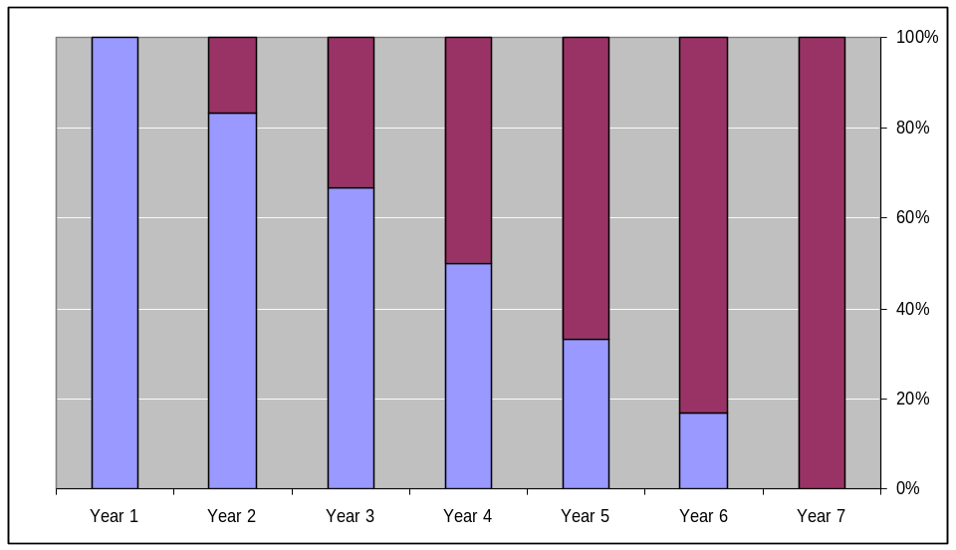
Exhibit 3: Illustration of Phase-in Mechanism
Distributed Using Section 5307 Formula
Distributed Using Incentive Formula
Incentive Funds (%)

Pros | Cons
Motivates Desired Behavior: A hybrid incentive system combines the advantages of a formula system and a process-based system. This incentive system establishes a level playing field for all recipients, and further motivates them to improve the performance.  Unintended Consequences: Placing emphasis on performance might motivate transit agencies to compete against each other. This could promote improved performance across many agencies.  Data Availability: Reliable estimates of capital spending on asset preservation can be collected from the transit agencies with minimal incremental effort required in the transit agencies’ reporting process and FTA’s validation process. Backlog and replacement value can be estimated more accurately from the condition assessment plan required as part of the CAMP.  Scalability: The size of the agency is accounted for in the three qualification thresholds. | Easy to Understand and Implement: This incentive system would be a new process, and hence might be difficult to administer.  Unintended Consequences: To the contrary, this could result in more pressure from elected officials and board members of the agencies classified as “low performers,” resulting in perverse incentives.  Reporting Burden: The reporting requirements for CAMP would impose a significant burden on the transit agencies. This is especially a concern for large transit systems operating multiple modes, and for small transit agencies that do not possess the technical expertise required to develop such a plan. However, this impediment may be overcome by an FTA commitment to provide any technical and financial assistance required.  Favorable Reception: This plan may not be received well within FTA and the transit industry.

3.2 Synthesis from Expert Panel Meeting
The study team convened a team of expert panelists, including FTA staff, to obtain their feedback on the incentive systems in general, and on the list of incentive systems identified above in particular. Apart from the study team, the expert panel consisted of the following members from FTA, as well as private consultants possessing vast experience in the transit industry
- Participants from FTA
  - Katherine Mattice, Office of Budget and Policy, FTA
  - Fred Williams, Office of the Administrator, FTA
  - Nancy Ody, Office of Policy Development, FTA
  - Scott Faulk, Office of Program Management, FTA
- Participants from the consultant team:
  - Jerry Premo, DMJM Harris
  - Ray Ellis, AECOM Enterprises
  - Nancy Butler, DMJM Harris
  - Richard White, DMJM Harris
  - William Woodford, AECOM Consult
  - Randall Crane, UCLA
The following key themes emerged from the panel meeting:
- There is a lack of credible and reliable data on backlog and capital spending on asset preservation, renewal, and rehabilitation available from the three major national data sources, namely, the National Transit Database (NTD), the Transit Economic Requirement Model (TERM), and FTA’s grant management system (Transportation Electronic Award and Management, or TEAM).
- The limited data collected for monitoring transit system performance is oriented toward capital assets.
- There is a need for a data-intensive analytical approach and prioritization process to make sound decisions on resource allocation.
- There is a need to develop an incentive system based on data that is easily measurable and auditable.
The NTD has assembled capital expenditures by asset class on existing assets only since 2004. Even with the limited historical data, there is evidence of inaccurate reporting of investment in existing assets versus expenditures on new capacity. In addition, NTD data becomes usable only after a one- or two-year lag after the agency fiscal year end. The effectiveness of any incentive system would be diluted if there is a significant lag between the provision of service and receipt of funding. TERM results may be relied upon for aggregate national estimates, but they exhibit significant variations between model results and agency-specific needs. Finally, TEAM does not collect data on capital expenses using non-Federal funds; hence it fails to provide a comprehensive picture of an agency’s capital budget.
Within the transit industry, processes are employed with varying levels of sophistication for tracking the condition of capital assets, estimating the backlog, and reducing the backlog. The wide spectrum includes processes that have sound asset management principles and others that have a simple fleet management plan. Transit agencies that adopt good asset management systems are being good stewards of their assets. Examples where such processes are in place include the transit agencies in Atlanta, New York, and Boston. Such processes have enabled these transit agencies to maintain their assets in a state of good repair and reduce backlog (with varying levels of success). However, the majority of the industry is still making decisions based on relatively limited information. A consensus from the panel meeting was the need for an analysis-based approach to establish the baseline condition of these assets, compute the needs, and optimally allocate scare resources. Parallel to such an effort would be the development of performance measures that monitor the progress made by transit agencies on these activities.
Based on this feedback from the expert panel meeting, the study team decided to further evaluate the process-based incentive system and the hybrid incentive system, both of which require the development of a certified asset management plan.

3.3 Candidate Incentive Systems for Further Evaluation
This section documents the analyses conducted on incentive systems for the formula funding program, and demonstrates how such systems might be applied if adopted by FTA. We present an analysis of two incentive systems:
- A certified asset management plan (CAMP) system
- A hybrid system that includes a formula-based incentive
The principal analysis is of a process-based incentive system that rewards development and maintenance of a certified asset management plan (CAMP). An outline of an illustrative plan is presented, together with the inventory, condition assessment, and life-cycle cost plan that constitute the minimum requirements. The requirements for implementation and maintenance of the plan include consistency of the transportation improvement program with the CAMP, and the implementation of asset management actions called for in the CAMP. Quantitative indicators of asset management would be used to track the performance of the recipients and to identify egregious neglect or gross violations of the plan. These indicators, and illustrative thresholds that would trigger review, are analyzed as well. A discussion is also provided on the reliability of current data, and certain additional reporting requirements. Two options for periodic certification of the asset management plan have been identified. Finally, the analysis estimates the incentive levels required to achieve widespread development of CAMPs, and the separate ongoing incentive required to maintain the CAMPs. The funding section of the analysis illustrates the administration of the incentive funding. The analysis of the CAMP incentive system is followed by the analysis of the formula-based hybrid system.

3.4 Previous Industry Experience with Asset Management
The transportation industry’s experience with asset management principles has been limited in the United States when compared to other countries (particularly New Zealand, Australia, England, and Canada). This experience is particularly thin within the transit industry (when compared to the highway industry). Emphasis on asset management started over a decade ago with the passage of the Intermodal Surface Transportation Efficiency Act (ISTEA) of 1991. ISTEA mandated the development of six management systems for use by the State DOTs to ensure effective management and efficient operation and maintenance of transportation infrastructure. These systems were as follows:
- Pavement management system
- Bridge management system
- Public transit facilities management system
- Intermodal management system
- Congestion management system
- Safety management system
The first three management systems focused primarily on the application of asset management principles to these particular infrastructure assets. They were intended to track asset conditions concerning the operational, maintenance, safety, repair, and replacement needs of these facilities, and provide input to the transportation planning and program development processes to ensure their continued viability. The other three systems were oriented toward ensuring efficient performance of the transportation network and making management systems development and integration an important part of the overall transportation planning process.
However, only the first two mandated systems (pavement management and bridge management) were close to being fully developed, with the remaining systems lacking clear definition. This deficiency, coupled with industry resistance, led Congress to repeal the mandates for these systems and instead just encourage their development and use. However, the pavement management and bridge management systems did begin to enjoy greater acceptance as the highway system began to show the results of years of use and the deleterious effects of deferred maintenance.
As this history demonstrates, care must be taken in developing any asset management incentive system. In particular, the objectives and the minimum requirements must be clearly defined, in terms that will result in effective asset management. Further, attention should also be given to the certification and review processes.

3.5 Analysis of a Process-Based Incentive System
In the pages that follow, a process-based incentive system is discussed in detail. In developing the CAMP idea, three principles are observed: First, the generation of uniform asset management data for the allocation of incentive funds may not be feasible or credible. Secondly, to influence local budgets, any capital investment program must have the transparent participation, authorship, and endorsement of local professionals and decision-makers. Third, FTA program oversight achieves the most effective compliance when it takes the form of technical assistance, coaching, and peer advice rather than Federal directives.
Therefore, this report examines the feasibility of a Federal requirement to develop and maintain independent Capital Asset Management Plans. Much as FTA’s standardized reporting of accounts and performance, i.e., the National Transit Database (NTD), helps to foster professionalism in the management of transit operations, CAMPs could foster higher standards of asset management. FTA would establish minimum requirements for the level of detail and completeness of local CAMPs. FTA would also set up a CAMP review and certification process, possibly within the framework of existing FTA planning requirements. From local CAMPS, FTA could possibly develop indicators of CAMP performance.
The purpose of the discussion is to give voice to the most practical potential incentive systems that might serve the purposes of the Section 5307 formula program. This detailed discussion is intended to respond fully to Congress’s mandate for this study. It is not intended to imply the Department’s endorsement for such a program. Rather—as the reader will see in our discussion—the complexity and cost of implementation may weigh against adoption of such a program. In addition, Federal formula incentives have policy and Federal budgetary implications that are far better addressed in detailed re-authorization discussions (in Congress and the Executive Branch) than in a technical report such as this. Nor should the Department’s reservations on this question, in this report or otherwise, be interpreted as principled opposition to the pursuit by other means of aggressive capital asset management programs for transit.
The CAMP approach is process-focused rather than results focused. The most effective asset management programs are produced by the controlling organization’s intimate understanding of customer requirements, the existing and projected network, and ongoing asset conditions and performance. The concept behind proposing the CAMP system was to help transit agencies optimize performance and utilization of their assets by building, preserving, replacing, and operating these assets more cost-effectively. This approach was in turn expected to deliver best value for the public tax dollar spent, enhancing the agencies’ credibility and accountability with the public and key decision-makers. Credibility itself is an important “capital” asset. We need only consult periodic referenda on capital bond issues to see the penalties public authorities pay when, through perceived mismanagement of capital assets, they lose the confidence of the electorate. Various candidate systems were evaluated and analyzed from this perspective. To the study team, the CAMP system is likely to be the most feasible system to employ if FTA were to adopt any incentive system.
The CAMP process-based system encourages sound planning that extends from the strategic level (using a long-term horizon of 10–25 years) to the tactical level. This methodology translates the practices developed at the strategic level into procedures to develop sub-plans for allocating resources (e.g., human, physical, financial) to achieve those strategic goals. The operational planning level then translates the tactical plans into implementation plans (with a short-term focus of 1–3 years).

3.6 Requirements of the CAMP
The capital asset management plan must inventory all transportation system assets and provide a preservation and replacement schedule based on lifecycle cost methodologies. Specifically, the CAMP should define the level of service required of the assets, even if these are existing levels of service. It should also define the time frame (life cycle) for which the asset must deliver the required service. The plan should describe the system assets (physical and financial) and include financial information (at least 10 years’ worth) that translates the physical aspects of planned maintenance, renewal, and new work into financial terms. This data should be projected for at least the next 10 years, and in a manner that is transparent and in accordance with good accounting principles (e.g., GASB 34). It is also important that the CAMP recognize decline-in-service potential, to show how decline in value would be measured.
The CAMP should be prepared by qualified persons, such as specialized engineers. They should clearly state the assumptions they used, and the confidence level assigned to the reliability of the underlying data (e.g., condition, performance, remaining useful life, forecasted maintenance, and renewal expenditure) that supports the plan. In addition, the CAMP should outline improvement programs that address known weak areas, specify the time frame over which improvements would take place, and identify the resources (human and financial) needed. Finally, the CAMP should be reviewed and updated on a regular basis.
Key benefits of the CAMP incentive system include the following:
- An inducement explicitly to link the service level expectations with the assets needed to sustain that service;
- Clear quantitative statements of the present and future demands on the assets;
- An inducement to maintain a current estimate of the long-term financial commitments necessary to maintain both the assets and the services they provide;
- An incentive to maintain current an evaluation of the business risks associated with the failure of the transit assets;
- An incentive to develop a set of strategies to address both the shorter-term operations and maintenance, and the longer-term strategic planning of the assets;
- An instrument to model future costs and asset performance;
- A recurring process for introducing discipline and logical processes into all of the asset management planning activities;
- A tool to assist the transit agency’s ability to meet goals and objectives in a way that best serves customers; and
- A document that is clear and direct so that it enhances full public debate over the transit agency’s budget priorities and needs.

A. Structure and elements of the CAMP Incentive System
There is no single right way to structure asset management plans, since these structures would vary depending on individual agency needs and preferences. However, irrespective of the plan structure, it is necessary to ensure that the plan is fully integrated into the agency’s business planning framework and that the outputs cover all elements of the asset management (AM) planning process. More important, to facilitate industry-wide acceptance, the CAMP must capture these key principles while being simple enough to implement.
To that end, capital management experts have identified principles for infrastructure preservation. They have developed guidance for asset management plans that incorporate asset management best practices. Two key resources, relied upon in defining the CAMP system, are the International Infrastructure Management Manual (2006 Edition) and the Guide to Preparing Your Transit Asset Management Plan (developed by Washington State DOT – 2005). A recommended structure for the CAMP is outlined below; it is based on asset management best practices and the industry resources cited above. It should be noted that there is no “ideal” framework for the CAMP. Transit agencies have complete flexibility to tailor their CAMP to reflect local conditions, as long as the key principles outlined below are covered in a logical order.
SECTION 1: EXECUTIVE SUMMARY – Emphasizes the key issues contained in the body of the asset management (AM) plan, and provides a succinct overview of the entire AM plan.
  - The Purpose of the Plan
- To demonstrate responsible management
- To communicate and justify funding requirements
- To comply with regulatory requirements
  - Asset Description
- Summary of assets covered by the plan
  - Levels of Service
- Summary of levels of service
- Summary of performance measures
- Methodology for developing levels of service and performance measures
  - Future Demand
- Factors influencing future demand
- Impact of changing demand on assets
  - Lifecycle Management Plan
- Summary of lifecycle management strategies (operations, maintenance, disposal, etc.)
  - Financial Summary
- Long-term income and expenditure (cash flow) projections for each significant asset group (e.g., bus, light rail transit, heavy rail transit, wayside systems and facilities)
- Sources of funding
  - Asset Management Practices
- Summary of AM data
- Summary of information systems currently in place or to be acquired
- Summary of decision-making processes
- Description of implementation tactics
  - Monitoring and Improvement Programs
- Summary of how performance of the AM plan would be monitored
- Summary of actions required to improve accuracy and confidence in the AM plan
- Timetable for review of the AM plan
SECTION 2: INTRODUCTION – Provides an overview of all the network assets within the AM plan. It provides a sound justification for owning and operating the assets covered and the reasons for preparing the AM plan.
  - Background
- Purpose of the plan
- Relationship with other planning documents (e.g., Transportation Improvement Plans (TIPs), Transit Development Plan (TDPs))
- Transportation system assets included in the plan
- Key stakeholders in the plan (e.g., DOT, MPO)
- Organizational structure
  - Goals and Objectives of Asset Ownership
- Reasons and justification for asset ownership
- Links to agency’s vision, mission, goals, and objectives
  - Plan Framework
- Key elements of the plan
SECTION 3: LEVEL OF SERVICE – Clearly defines the levels of service that are proposed, and confirms the basis of the levels of service that are currently provided.
  - Customer Research and Expectations
- Background and customer research undertaken
- Details of how research translates into levels of service (e.g., bus/rail service plans)
  - Strategic Goals
- Agency’s strategic goals and impacts on AM plan
  - Legislative and Regulatory Requirements
- Legislative and regulatory requirements that affect transit operation or require certain levels of service
  - Current Level of Service
- Define current levels of service being provided by the transit assets
- Identify related performance measures (e.g., MDBF; percent availability of escalators, elevators, traction power)
  - Desired Level of Service
- Provide details on the level of service desired (if different from what is being provided)
- Provide details of differences between current and desired levels of service and how these gaps would be progressively closed
SECTION 4: FUTURE DEMAND – Provides details of growth forecasts that affect the management and utilization of the transit assets. Transit improvement and expansion programs outlined in section 5 would be prepared based on information outlined in this section.
  - Demand Forecast
- Factors influencing demand
- Details of projected growth or decline of demands on services
- Anticipated changes in customer expectations
- Impact of changes in demand on transportation system asset utilization
  - Changes in Technology
- Use of new technology and effects on provision of future services
- Obsolescence
  - Demand Management Plan
- Describe non-asset solutions available as alternatives to asset-based solutions (e.g., demand management, insurance, managed failures)
- Summaries of improvement and expansion programs, and costs
SECTION 5: LIFECYCLE MANAGEMENT PLAN – This section outlines exactly what is planned in order to manage and operate the assets at the agreed levels of service (as defined in the plan) while optimizing lifecycle costs. Consideration should be given to dividing the transit network into separate geographical service areas (e.g., orange line, bus route). A one-page summary of each subsection in section 5 should be considered, for added clarity.
  - Background Data
- Physical Parameters
- An inventory of the transit agency’s assets, describing asset mix, size, location, and current issues
- Summary of total asset parameters in table or graph formats (e.g., age distribution, size); inventory can be prepared using the same form required for the transit system’s TDP
- An overall plan of the asset system or network
- Information on how to obtain part-by-part asset information (e.g., a public transportation management system, or PTMS)
- Asset Capacity/Performance
- Design capacity, actual measured capacity, and current utilization of assets; include a summary of details and statistics (e.g., percentage and distribution of assets operating under capacity, if known) related to level of service
- Refer to location of detailed information (e.g., computer models, calculations and analyses)
- Asset capacity decay curves and failure modes
- Asset Condition
- Summary of current asset condition based on best information currently available
- Brief details on how condition is monitored
- Age and condition decay curves
- Asset Valuations
- Define replacement schedule and maximum useful life for asset types based on local conditions (FTA established a minimum for vehicles)
- Depreciated asset replacement valuation summary
- Description of valuation method
- Basis for determining useful lives used for valuation (agency-defined based on local conditions)
- Key assumptions made in preparing valuation
- Details of historical valuations
- Historical Data
- Summary of type of historical data available and location
- Relevant financial information (historical expenditure)
  - Routine Maintenance Program – Routine maintenance is the regular ongoing day-to-day work that is necessary to keep transit assets operating, including instances where portions of the asset fail and need immediate repair to make the asset operational again.
- Graduated Maintenance Program
- A graduated preventative maintenance (PM) program that is detailed, step-by-step (A-B-C or 1-2-3), based on manufacturer’s recommendations, and adapted to local conditions
- A description of the transit agency’s practices and policies that form the basis of their graduated PM program
- General description of local conditions that affect PM service intervals of the transit agency (e.g., travel speed, ridership, topography, weather, local policies)
- Preventative maintenance schedules (can be modified over time as experience and technology warrant, or as changes occur)
- Sample inspection sheet for each level of the PM intervals, keyed to the asset type that is representative of the transit agency’s asset base
- Maintenance Reporting System Standards and Specifications
- Asset-specific form of recordkeeping to identify, track, and report maintenance, repair, and preservation activities and costs
- Defined methods and service standards to meet required levels of service
- Risks associated with alternative standards
- Maintenance Management Protocol
- Description of the process to authorize, direct, and control maintenance work activities and costs
- Description of the method used to ensure that maintenance activities contracted to others (i.e., not performed directly by the transit agency’s employees) are performed and completed in accordance with agency standards; may require reviewing the documentation of work performed by subcontractors, periodic physical inspections, etc.
- Description of the system used for warranty recovery
- Summary of Future Costs
- Forecast of planned and unplanned maintenance work and costs
- Identification of any maintenance deferred and associated risk
- Outline of how maintenance would be funded
  - Renewal/Replacement Plan – Renewal plan expenditures represent major work that does not increase the asset’s design capacity, but that does restore, rehabilitate, replace, or renew an existing asset to its original capacity.
- Renewal Plan
- Show how replacements/renewals are identified and to what standards they are replaced (e.g., modes of failure, options for treatment, risk)
- End-of-life projections
- Renewal decision-making process
- Renewal Standards
- Define methods and service standards to meet required levels of service
- Identify risks associated with alternative standards
- Summary of Future Costs
- Forecast program of replacement and costs
- Prepare cash flow forecast of costs
- Note any renewals that are deferred
- Prepare risk analysis (i.e., risks and long-term effects of deferral)
- Identify how replacement would be funded
SECTION 6: FINANCIAL SUMMARY – This section identifies the financial requirements generated by all the material presented in previous sections. This section also includes a cost model that reflects the agency’s policies and standards, resulting in the lowest maintenance costs over the life of the asset.
  - Financial Statements and Projections
  - Cash flow forecasts by year (at least 10 years)
  - Breakdown of expenditure by service groups (10 years)
  - Breakdown of expenditure into routine maintenance, renewal, and expansion
  - Trends from the previous 2–3 years
  - Funding Strategy
  - Provide details of how expenditure would be funded
  - Determine whether any planning is needed to smooth out variations in cash flow
  - Valuation Forecasts
  - Forecast of future value of transit asset and valuation methodology
  - Forecasts of decline in value
  - Key Assumptions Made in Financial Forecasts
  - Clearly state assumptions used to develop the information presented
  - Describe how the accuracy and reliability of future financial forecasts would be improved
  - Include a sensitivity analysis, qualifying variations in the forecasts resulting from possible scenarios relating to key assumptions
SECTION 7: ASSET MANAGEMENT PRACTICES – Provides an outline of the information available on the agency’s transit assets, the information systems used (e.g., software, files) and the process used to make decisions on how transit assets will be managed. This section also demonstrates a logical, thorough, and convincing decision-making process that ensures a sound basis is used for the management strategy and financial estimates.
  - Accounting/Financial Systems
  - Identify accounting system details, and any changes required as a consequence of the CAMP
  - Define differences between maintenance, renewal, and expansion expenditures
  - Provide details of accounting standards/guidelines that must be complied with (e.g., GASB 34)
  - Asset Management Systems
  - What types of data are available on the transit assets to help agency AM decision making?
  - What is the qualifying/reliability/adequacy of data?
  - Is any software used to store and analyze asset data?
  - Where is the information stored?
  - How often is the information collected/updated?
  - Information Flow Requirements and Processes
  - What are the key information flows to and from the CAMP?
  - What processes are used to make decisions on AM, replacement/renewal, and expansion?
  - Is there a formal project ranking/prioritizing system?
  - How is the best decision made?
  - Does it take into account risk cost, lifecycle costs, performance prediction, and optimized decision making?
  - Standards and Guidelines
  - What are the key standards and guidelines that influence AM activities?
SECTION 8: PLAN IMPROVEMENT AND MONITORING – This section describes the plan for monitoring the performance of the CAMP, and identifying any improvements to the AM systems that would improve the level of confidence in the CAMP. One possible consideration is to include a three-year program (aligned with FTA’s triennial reviews) for implementing the improvements identified in this section.
  - Performance Measures
  - Outline performance measures for the CAMP system
  - Describe how effectiveness of the CAMP would be measured
  - Improvement Program
  - Details of actions proposed and timetables for improving accuracy and confidence in the CAMP, indicating responsibility for each action
  - Details of resources required to implement the improvement program
  - Monitoring and Review Procedures
  - Procedures and timetable for performance reporting (3-year review of the CAMP)
  - Timetable for external audit and review (of process, data integrity, level of service)

B. Definition of Lifecycle Cost Methodology
Lifecycle cost methodologies in the CAMP need to focus on management options and strategies that take into consideration all economic and physical consequences, from initial planning through complete asset replacement (disposal). Application of asset management principles would ensure reliable delivery of services and reduce long-term costs of ownership, thus reducing service costs. Exhibit 5 illustrates the lifecycle processes within the context of asset management.
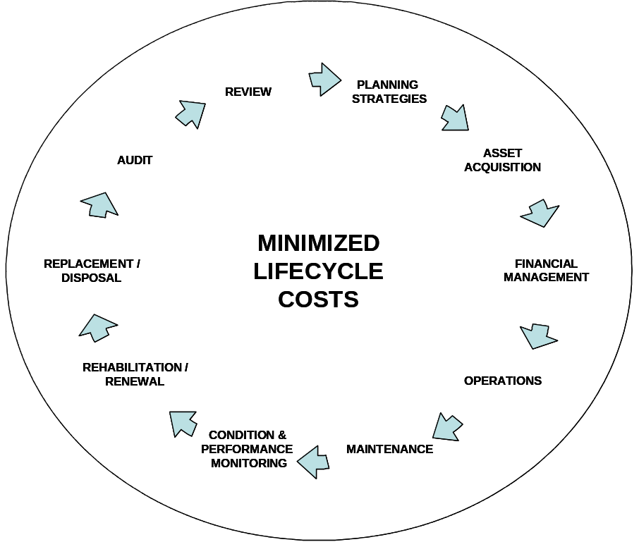
Exhibit 5: The Process of Lifecycle Asset Management
More specifically, the lifecycle processes to be considered by transit agencies as they undertake asset management are as follows:
- Asset planning – Involves confirming the service that is required from the customer and ensuring that the proposed asset is the most effective solution to meet customer’s need.
- Asset acquisition – Involves providing (or improving) an asset where the value can reasonably be expected to provide benefits beyond the year that cost is incurred. A value management approach may be adopted to optimize this decision.
- Financial management – Requires the recognition of all costs associated with ownership of the asset, including acquisition, O&M, rehabilitation, renewals, and replacement (disposal), within a cost-effective decision-making context.
- Asset operations and maintenance – Involves functions that relate to the day-to-day running of the assets, along with the associated costs.
- Asset condition and performance monitoring – Involves monitoring assets whose condition and performance directly affect the level of service provided, throughout their lifecycle, in order to identify under-performers and predict failure.
- Asset Rehabilitation/Renewal –Involves significant upgrading or restoration of an asset, or an asset component, to its required functional condition and performance. Key to this process is identification of the optimum long-term solution in a methodical and formal decision-making process.
- Asset Replacement/Disposal – Involves reviewing the configurations, type, and location of assets, as well as service delivery processes for assets that are deemed no longer required, or uneconomical to maintain or rehabilitate.
- Asset Management Audit and Review – Involves carrying out regular internal and external audits to ensure a continuous asset management improvement cycle, and to achieve/maintain appropriate industry practice.

C. Inventory and Condition Assessment Level of Detail
One of the key elements of the CAMP is a complete inventory of all transit assets and an accurate condition assessment of each asset. This is the most labor- and cost-intensive step that drives the transit system’s asset management effort. The point was made earlier that while there is no prescribed structure or format to be followed, the information contained in the inventory needs to address asset descriptive parameters (e.g., vehicle year/make/model, facility name), current asset condition rating, asset remaining useful life, and replacement cost. If the CAMP incentive system is implemented, the implementation process should weigh the range of conditions to which the system would apply, and further specify the minimum level of detail required in the inventory and the minimum requirements for condition assessment.

3.7 CAMP Qualification Thresholds
Aside from civil rights and accessibility protections, and procedural measures to foster regional coordination among decision-makers to protect the financial integrity of FTA’s grant agreements, FTA is very reluctant to substitute its transit service goals for the goals of local governments. As suggested earlier, however, the Department interprets Congress’s intent to consider an incentive program to foster sound capital asset management. The Federal government is a partner in the acquisition in these assets and a transit ally in local budgets. Also, local governments have been known to approach the Federal government for financial relief from the ravages of prolonged local neglect of transportation infrastructure.
Finally, a larger question looms for every Congress that re-authorizes Federal programs like transit assistance. Congress is likely to be more generous to programs for which they can hold recipients accountable. Accountability thus can be a powerful influence for incremental program funding. But, as emphasized throughout this report, incentives and accountability must earn their pay. The Department is extremely reluctant to impose unenforceable or unproductive requirements whose burdens outweigh their benefits to the taxpayer.
The qualification thresholds discussed below may well be interpreted as performance measures. That is only natural. Let us be clear, however. The performance measures would apply to an incremental “tier” of Federal formula funding to which every urbanized area is entitled (or not) to subscribe. The cost of subscription is to (1) to develop a CAMP, (2) to maintain the CAMP, and (3) to avoid extreme failure in living up to the CAMP. Agencies elected to forego this “incentive tier” are free to do so, just as current recipients are free to not update or report certain data FTA uses to allocate existing “incentive” tiers based, for instance, on fixed guideway route miles.
The purpose of the CAMP incentive system, once in place, would be defeated if grant recipients did not live up to their CAMPs. Accordingly, it is necessary to establish a threshold that would qualify a recipient to receive its CAMP incentive funding. The thresholds should be general enough, and sensible enough, to win the assent both of transit professionals and the local decision-makers who control any transit agency’s annual capital budget. Also, in view of long enduring capital investment backlogs in the most aged transit systems, the qualification thresholds must be lenient. Their purpose is not to penalize agencies, or to withhold Federal support from the agencies most in need.
In what follows, it is understood that any system that elects not to develop a CAMP, is ineligible for formula grants to develop and maintain the CAMP and also ineligible for formula grants for complying therewith. For reasons discussed elsewhere, in a few urbanized areas where FTA formula grants are fungible among more than one transit operating agency, this condition is a problem.
One purpose of a CAMP is to unveil to local decision-makers—and the public—the most egregious neglect of valuable transit assets. The most egregious neglect is the most avoidable, almost by definition. In cases where capital neglect is extreme, such neglect implies waste of the Federal funding. In the face of such waste, withholding a portion of Federal funding would have no affect on the capital assets per se, only the people wasting the resource. The threat of withholding Federal funds in such circumstance, however, stands a chance of spurring corrective action.
Qualification of CAMPs also must follow a sensible cycle. Management actions on transit’s major capital assets tend to be uneven from year to year. Delivery of replacement vehicles for even a small portion of a transit bus or rail car fleet occurs over months and years, for example. Repair of a rail system’s signaling or electronic controls, involving major subsystems, can take years to complete. Thus, yearly comparisons can be misleading. To “smooth out” year-to-year fluctuation in the management of FTA capital grants, FTA conducts oversight of its grant recipients in three-year cycles. A similar cycle, and using the existing Triennial Review process, makes sense for findings of qualification for CAMP incentive grants.
Once again, FTA’s intent is to encourage and assist transit systems in adopting asset management tenets. FTA would like to promote a rational asset management approach without creating additional burdens on those transit systems. In keeping with that intent, care was taken in defining the qualification thresholds against which transit systems would be assessed. These thresholds were defined to reflect the goals and objectives of the proposed CAMP incentive system. Specifically, the main criteria for defining suitable thresholds were simplicity and, to the extent possible, the utility of existing sources of data (so as to achieve the most effective results from the industry). Furthermore, the thresholds had to be lenient enough to allow participation of most transit systems, and structured to identify only the most extreme cases of non-compliance or neglect.
Based on deliberations with FTA and industry experts, the following three ratios were identified as the potential qualification thresholds:
- Renewal Expense to Deferred Investment Cost – This threshold measures how well the transit system is reducing its backlog of under-performing assets.
- Renewal Expense to Replacement Cost – This threshold captures the transit system’s propensity to honor asset management principles; it measures what percentage of the total value of system assets is allocated to the preservation of those assets.
- Replacement Cost to Deferred Investment Cost – This measure provides a snapshot of the overall condition of a transit system’s assets. This threshold may also provide insight into the organizational philosophies, recurring budgetary challenges, and operating policies in place.
To use these values in reviewing CAMP compliance and implementation, it is critical to recognize that the data must be available according to some standard definitions. FTA must either require submission of such data in, say, triennial CAMP documents (and train agencies in how to meet those reporting requirements), or FTA must add these data elements to a required reporting system such as the National Transit Database (although NTD data is reported annually, certain data may naturally recur over more than one year, e.g., delivery dates on long lived capital assets)

A. Threshold Variables Defined
- Renewal Expense is the cost incurred by a transit system for undertaking capital repairs or improvements to bring an under-performing asset back to its original condition and performance capacity.
- Deferred Investment Cost (also referred to as investment backlog) is the total unspent cost associated with repairs that are deemed necessary to bring under-performing assets into a state of good repair.
- Replacement Cost is the total cost of completely replacing its assets if they failed (i.e., the asset value)

B. Description of Data Used in Analysis
The following discussion used the data reported to the National Transit Database (NTD) and estimates from the Transit Economic Requirements Model (TERM) to show the current trends in CAMP variables and descriptive statistics for the proposed threshold ratios computed using the CAMP variables.
In 2004, transit systems started reporting the rehabilitation, replacement, reconstruction, and improvement expenses on existing service to the NTD. These actual values reported to NTD were used to measure the renewal expenditure for all transit systems. The estimates of replacement cost and deferred investment cost or backlog for each agency were based on projections obtained from the TERM model for 2004. A discussion of the methodology adopted by TERM to estimate replacement cost and deferred investment cost is beyond the scope of this report; the reader is advised to refer to the TERM guide.
In order to perform a meaningful analysis, the data was stratified into seven discrete categories. This stratification was based on the total number of transit vehicles operated by the agency in directly operated service (combining all modes together). The source for the data was the 2004 NTD.
Extreme caution must be used in interpreting this quantitative analysis because the TERM data was not intended to accurately reflect individual transit system experience, and because these data collection systems (NTD renewal expense and TERM) are of limited maturity. (For further detail, refer to Section 3.8 – Data Sources and Issues). However, these analyses convincingly illustrate the potential for measuring individual system performance. Substantial work and investment would be required to achieve the reliability prerequisite to such measurements.

C. Summary of Threshold Variables
Exhibit 6 provides a summary of renewal expense, replacement cost, and backlog for 2004 for the seven vehicle size categories.
Exhibit 6: Summary of CAMP Variables by Fleet Size
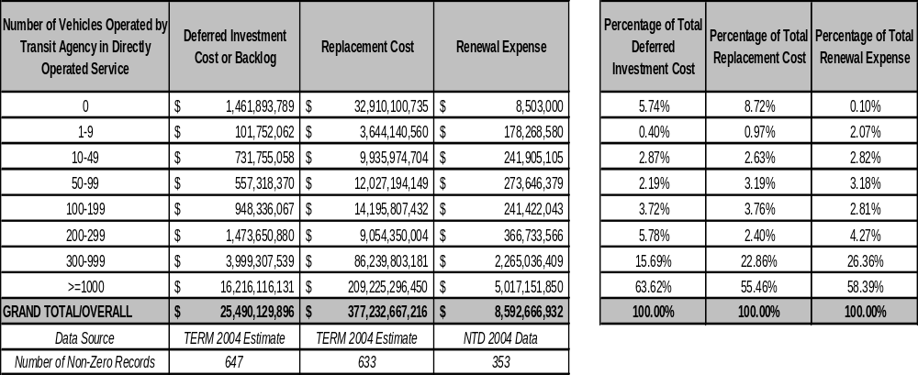
It can be observed from exhibit 6 that some transit agencies reported operating zero vehicles in 2004. This is only possible if a transit agency did not provide any service during that year, or failed to report this data, or reported data under the “purchased transportation” category in NTD. TERM estimates a backlog of around 6 percent and replacement cost of 9 percent for these agencies.
Even though the majority of the transit systems are smaller agencies operating fewer than 100 vehicles, the combined backlog for that group is only around 5.5 percent of the total backlog. The replacement cost is around 7 percent of the total replacement cost, accounting for around 8 percent of total renewal expenses in 2004. Even though there are only about 42 transit agencies operating between 300 and 1,000 vehicles, these agencies account for 16 percent of total backlog, 23 percent of total replacement cost, and 26 percent of total renewal expenditures. The larger systems that operate more than 1,000 vehicles are more complicated due to the multimodal nature of their operations, and hence account for the majority of backlog, total replacement cost, and total renewal expenditures.

D. Descriptive Statistics on Qualification Thresholds
As indicated earlier, the three threshold variables (renewal expenses, deferred investment cost, and replacement cost) were used to estimate qualification threshold ratios. In this section, for each ratio, descriptive statistics such as weighted mean, minimum, maximum, average, median, and standard deviation are provided.

Renewal Expense to Deferred Investment Cost (or Backlog)
A total of 348 transit agencies had renewal expense and deferred investment cost greater than zero. The corresponding qualification threshold ratio is summarized by vehicle size category in exhibit 7. The transit agencies with fewer than 10 vehicles had the highest weighted mean, maximum value, and standard deviation. It was observed that, in this category, there was one agency that reported a high renewal expense in 2004. This could be due to a reporting error (for example, a capital expansion expense being coded as renewal expense). The standard deviation seems to be lower for large transit agencies, and it increases as the agency size decreases. This suggests that there is more dispersion from the mean, especially for agencies operating 50–299 vehicles.

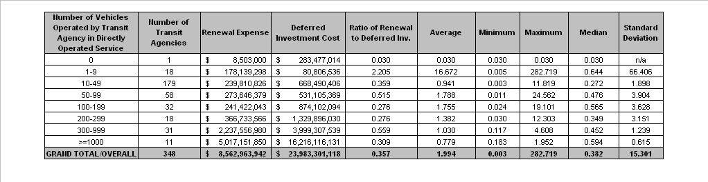
Exhibit 7: Descriptive Statistics for Renewal Expense to Deferred Investment Cost Ratio
In keeping with the leniency criteria for qualifying transit systems under this threshold, the lower bound renewal expense to deferred investment cost ratio was established at 0.02, below which transit agencies would be disqualified. Exhibit 8 presents the cumulative distribution curve, highlighting the lower bound “cutoff” point.

Exhibit 8: Cumulative Distribution Curve for Renewal Expense to Deferred Investment Cost Ratio
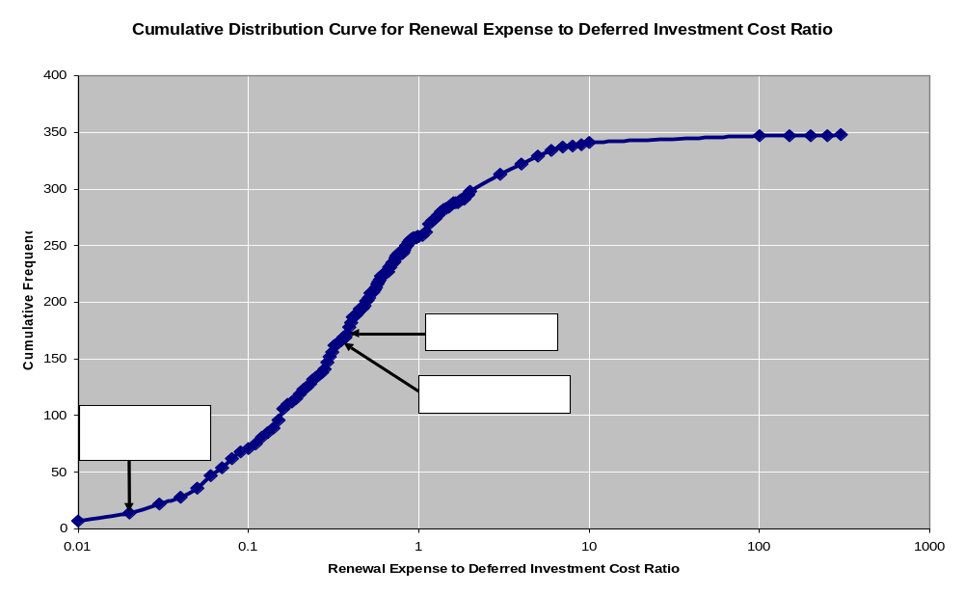

Renewal Expense to Replacement Cost
The ratio of renewal expense to replacement cost was based on data from 353 transit agencies. Exhibit 9 summarizes the descriptive statistics by vehicle size category. The smallest transit systems have the highest weighted mean, maximum value, and standard deviation. This could be due to data reporting errors (arising due to inaccurate classification of capital expense as renewal expenditure). Similar to the previous ratio, the standard deviation increases as the agency size decreases (except for the agencies operating 10–49 vehicles).

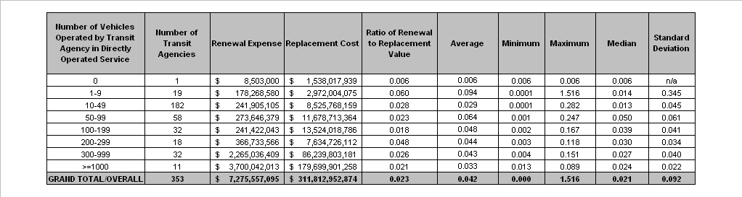
Exhibit 9: Descriptive Statistics for Renewal Expense to Replacement Cost Ratio
The lower bound “cutoff” point for this qualification threshold was determined to be 0.001, as shown in exhibit 10.

Exhibit 10: Cumulative Distribution Curve for Renewal Expense to Replacement Cost Ratio
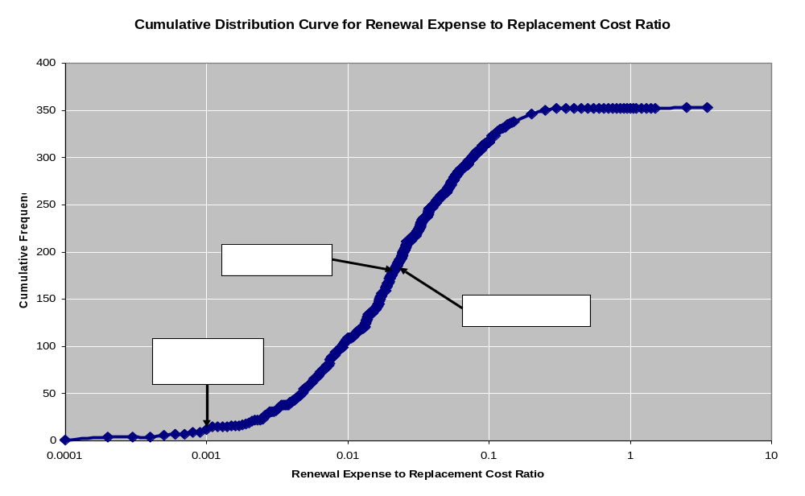

Replacement Cost to Deferred Investment Cost
The replacement cost and deferred investment cost are based on TERM estimates; hence data is available for a wider range of 614 transit agencies. The descriptive statistics are shown in exhibit 11. According to TERM, about 150 transit agencies did not report operating any vehicles in the 2004 National Transit Database (NTD). TERM estimates the replacement costs and deferred investment costs for these agencies, and the weighted mean for this category, to be the second highest. This category also has the highest standard deviation and maximum. The one agency that had the highest maximum value of 1085.778 had a high replacement cost and relatively small deferred investment cost. It was found that this is a commuter rail agency that reported its 18 vehicles operated under the “purchased transportation” category. Similar to the previous two ratios, the standard deviation is low for large systems, and increases with decreasing transit agency size.

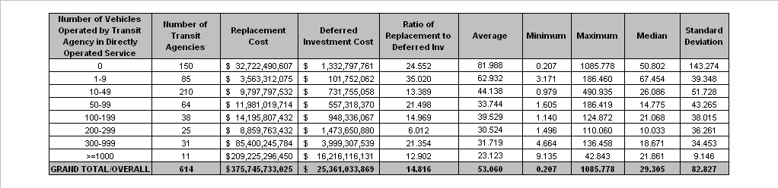
Exhibit 11: Descriptive Statistics for Replacement Cost to Deferred Investment Cost Ratio
The following are some key observations from these descriptive statistics:

- In most cases, the standard deviation within the respective vehicle size category is high. Therefore, a standardized rule (like defining “egregious behavior” as one standard deviation away from the mean) cannot be meaningfully applied.

- The ratio of renewal expenses to replacement cost is the most reliable measure available that is based on the existing data sources. Renewal expenses are actual values reported by transit agencies, and replacement costs are estimated based on inventory data compiled in TERM. Also, replacement cost for a transit agency has less year-to-year volatility than backlog and renewal expense.
- Since renewal expenses are constrained by availability of funds within the transit agency, there can be big fluctuations in year-to-year renewal spending. Hence a rolling average of renewal expenses, for example over a six-year period, should be developed and applied in the qualification thresholds.
Exhibit 12 shows the cumulative distribution curve for this qualification threshold. The lower bound “cutoff” point, below which transit agencies are disqualified, was identified at 2.0.
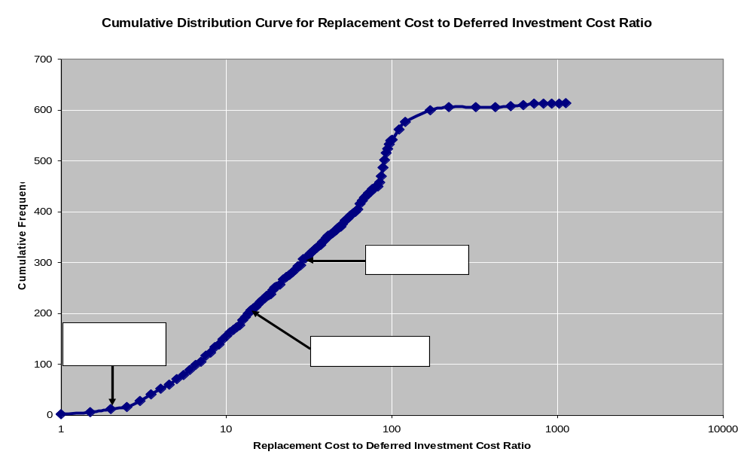
Exhibit 12: Cumulative Distribution Curve for Renewal Expense to Replacement Cost Ratio
Exhibit 13 shows the weighted mean by vehicle size category for each of the three qualification thresholds.
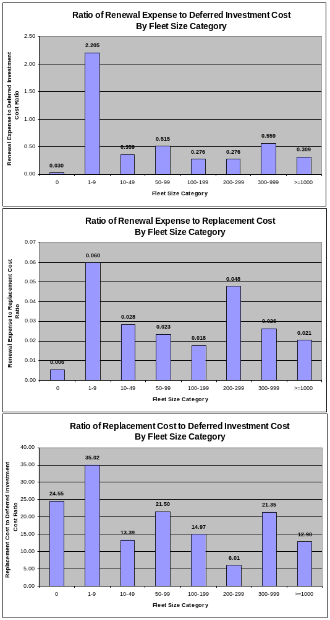
Exhibit 13: Weighted Mean by Fleet Size Category for Each Qualification Threshold

3.8 Data Sources and Issues
In the pages that follow, data inconsistencies among transit agencies are discussed at length. To funding agencies like FTA that might “benefit” from standardized transit capital data, the lack of uniform data may seem to be a deficiency. This interpretation would be a mistake. Data inconsistencies are common across businesses, even businesses competing in the same markets. As often as not, inconsistent data arise from the diverse business models, technologies, production techniques, and management practices characteristic of efficient economies.
A second issue considered here is the absence of a Federal reporting requirement for local agency transit asset holdings. Without this requirement, FTA does not currently possess a single data source that provides both current and comprehensive information on the quantities, types, ages, and condition of the nation’s transit asset holdings. Rather, FTA is forced to rely on data collated from a variety of incomplete sources when estimating either the replacement value or investment backlog of individual transit operators, regions, or the nation as a whole. The availability of high-quality data on local transit asset holdings would greatly improve the quality of such estimates, and would also support other FTA analyses and objectives (e.g., long-term capital needs estimation, natural disaster damage assessments, safety and security evaluations).
As before, a number of daunting data questions discussed in this section add to the department’s reservations about a CAMP incentive except as a process requirement.

A. Current data reliability and Availability
External monitoring of the effectiveness of programs using the CAMP qualification measures identified above—either by FTA or entities designated to certify agency asset management programs—would require reliable reporting or estimation of the variables underlying each measure. Specifically, FTA would require reliable measures for each of the following variables:
- Current renewal expenditures
- Deferred investment costs (backlog)
- Asset replacement cost
The currently available measures for each of these variables suffer from one or more data reliability issues. These issues must be addressed before these measures could be used in the evaluation of agency asset management program effectiveness. Each of these variables is considered in turn.
Of the three variables, operators receiving 5307 funds are currently only required to report current capital renewal expenditures. Specifically, these amounts are reported annually at the asset category level through NTD (categories here include expenditures on guideway, stations, administrative facilities, maintenance facilities, rolling stock, revenue and non-revenue vehicles, and systems). Current renewal expenditures for projects receiving Federal funding assistance are also recorded in FTA’s TEAM database (projects with no Federal funding are not reported there).
Data from both of these sources are unreliable. Specifically, the reporting of current renewal expenditures to NTD is a new requirement (beginning with the 2002 NTD reporting year). Data inconsistencies have arisen as agencies have adapted to the new requirement. At the same time, the reporting rules provide flexibility in whether projects are reported as either renewal investments or expansion investments. This contributes to variability in the amount reported as “capital renewal.” Finally, the initial three years of reporting have revealed broad variations in the level of expenditures reported from one year to the next—even within individual agencies. It has yet to be determined whether these variations represent true fluctuations in agency capital expenditures, or just reporting inconsistencies. As a result, we cannot vouch for the validity and reliability of these data.
Similarly, comparisons of the capital renewal expenditures reported in TEAM and those reported to NTD reveal discrepancies. While it might be expected, a priori, that the TEAM expenditures are consistently less than those reported to NTD (i.e., as the former only includes Federally funded projects), the expenditures reported in TEAM were found to be both higher and lower than those reported to NTD (depending on the agency or type of expenditure). TEAM data also suffer from the same issue of flexibility as to whether some projects (e.g., replacement of an existing facility with a larger, expanded facility) are categorized as renewal or expansion.
In contrast to the NTD and TEAM data on capital renewal, agencies receiving Section 5307 funds are not required to report either their current deferred investment needs or their asset replacement costs. FTA’s only current means of estimating these values is to use analytic results produced by TERM. While TERM applies a consistent methodology to the estimation of deferred needs and asset replacement costs, these estimates ultimately rely on asset inventory information submitted to FTA through a combination of formal data requests (individually to each of the larger transit agencies) and generated estimates of asset holdings (for all other agencies and non-responsive large agencies). Information obtained from these sources, which are not standardized across agencies, must then be modified on an agency-by-agency basis for use within TERM. Given the inconsistencies in the asset inventory data provided for use in TERM (or the current need to estimate transit asset holdings for medium and small agencies), the quality of TERM’s needs estimates are not fully consistent across operators. Stated differently, while TERM’s estimates have proven valuable at the national level, the absence of a consistent and comprehensive asset inventory reporting requirement prevents accurate estimation of individual agency needs.
Because the concept of replacement value has been more widely used (e.g., for capital planning and grant applications), and the accounting as well as asset management professions have developed replacement valuation methods, it can be anticipated that a standardized national definition of asset replacement value can be implemented over a period of three to six years. However, the estimation, aggregation, and management of backlog estimates may require more research, development, training, and standardization time. If incentive funding is to depend in some part on each transit system’s replacement value and backlog statistics, the plan for developing and using these statistics should be carefully laid out.

B. Proposed reporting requirements
The absence of an asset inventory reporting requirement (e.g., through NTD) has been a topic of discussion for many years. Without such a reporting requirement, neither FTA nor its designated certification agencies would be able to derive consistent estimates of either deferred capital needs or asset replacement value at the individual agency or agency-mode level. Development of such a reporting requirement could be useful for monitoring of agency asset management plan execution and effectiveness. (Insofar as CAMP compliance, as discussed above, is based on internal inventories, a national reporting system may not be necessary. A summary of CAMP inventories, depending upon the rate of compliance, could be tantamount to a national inventory.)
In 2002 NTD staff conducted a test of an “asset condition module” (ACM) whereby a sample of 5307 operators provided relatively comprehensive reporting of their asset holdings. This format provided effective guidance and a reasonable level of detail for local agencies to report their asset holdings to FTA. The level of reporting detail specified in the ACM study is significantly less than what the agencies should maintain themselves for their own asset management purposes. Yet it is sufficiently detailed to allow FTA to conduct useful analysis of individual operator needs and current capital condition.

c. Local Agency Capital Asset Data
Local operator reporting of capital asset data would necessarily rely on the internal systems and processes operators currently use to maintain such information. However, few U.S. transit operators at present maintain comprehensive electronic capital asset inventories designed to support the specific needs of asset management processes. Rather, most operators generally maintain capital asset–related data in one or more unrelated databases. Examples include:
- Fixed asset ledgers (accounting system)
- Grants management systems
- Maintenance management systems
- Department/division level documentation
- Vehicle rosters/NTD vehicle records
In general these sources are either incomplete (i.e., do not cover all asset holdings) and/or are designed for purposes other than asset management (e.g., fixed asset ledgers support financial accounting reporting) that are ill-suited for asset management purposes. The fact that many local transit operators, including some large rail operators, do not maintain good quality asset inventory data raises questions about:
- Transit operators’ ability to report reliable asset inventory holding data to FTA;
- Transit operators’ ability to complete their own, internal analyses of investment needs; and
- Local agencies’ ability to effectively maintain assets purchased using Federal funds
More broadly speaking, the concern here is not just that many agencies may not be able to provide quality data on their asset holdings, but whether these agencies have data of sufficient quality and comprehensiveness to support their own internal asset management programs. Development of such quality asset inventory databases is a key prerequisite to the development and implementation of asset management processes at the local level, and there may be a role here for FTA to provide guidance and technical assistance to support this development.

3.9 Certification Process
Certification is critical to any full-blown CAMP incentive program. For the incentive system to improve the condition of the national transit fleet and infrastructure, the agencies must achieve a minimum level of quality in their asset management plans, and must follow through with implementation. Agencies may be tempted to reduce the CAMP effort toward preexisting asset management data, even if it is only a financial inventory of assets, list of vehicles, and maintenance record. Indeed, such shortcuts might appeal to advocates of an incentive program, to reduce the burden on program recipients. Such an approach, however, would undermine an incentive program.
Accordingly, a CAMP requirement can ensure and sustain results only through a certification process. Implementation would be ensured through the consistency of the planning process (discussed below), and the application of thresholds to find instances of neglect or failure to implement. We think a three-tiered approach to certification would be necessary.

A. Self-Certification versus independent certification
The first and most basic level of certification for the ongoing administration of the incentive system would be the self-certification of the transit agency. Based on the agency’s certifications, submitted with its formula grant application, FTA would routinely include the incentive amounts in the formula grant. This would apply to both the initial development of the CAMP and its ongoing maintenance.
The agency would lose its privilege to self-certify if deceit or gross error were shown in a self-certification. After loss of the self-certification privilege, for the period determined by FTA on a case-by-case basis, an independent, FTA-sponsored certification of compliance with the CAMP criteria would be required before the incentive amount would be included in a formula grant. This could require a grant amendment if the independent certification was delayed.

B. Annual Independent Certification
There could also be an annual independent certification of CAMP compliance. This independent certification would have substantial value because it could bring an independent judgment to the more subjective assessments and decisions involved in maintaining the CAMP. If asset condition is routinely overstated or if requirements to bring assets into a state of good repair are underestimated, the independent review would be necessary to detect these failings. There are two possibilities for the independent certification:
- A State agency (potentially the same agency that is responsible for state rail safety oversight in States with rail systems, or for the small urbanized area programs in States without rail systems) would be required to independently certify that each operating agency’s CAMP complied with the Federal criteria before incentive funds would be granted; many States have the necessary expertise, and a vested interest in transit fleet and infrastructure condition and management, and would be well suited to this role. However, the State is not as routinely involved in the 5307 grant administration process for large urbanized areas, and requiring State certification prior to entering into the formula grant may be disruptive. Also, a recent study of State transit programs found most of them understaffed and unable to increase their staffs.
- The metropolitan planning organization (MPO) is more routinely involved in the formula grant process as part of the current planning process requirements for formula funding, but has not traditionally played as large a role as the State in many urbanized areas in protecting fleet and transit infrastructure condition.
To receive its allocation of formula funding, each transit agency should assume the responsibility for obtaining the independent certification of CAMP compliance.

C. Triennial Review
The final level of routine review would be FTA’s triennial reviews. In addition to a basic checklist of CAMP requirements that may be included at the discretion of FTA in some triennial reviews, every triennial review should include a verification of the effective date of the current CAMP, if any; the self-certification completion; and the independent certification completion. If the triennial review raises questions, FTA regional office and headquarters asset management specialists would cooperate in investigating and recommending a resolution. This may result in the reversal of a CAMP incentive allocation (presumably to be deducted from the current or future formula grants), loss of the privilege of self-certification, or required improvements in the CAMP (such as accelerated asset investment).

3.10 Consistency with the Regional Planning Process
The development of a transportation improvement program (TIP), as required by FTA, presents an opportunity for internal coordination between the various transit agency subdivisions in order to incorporate asset management into the agency’s overall transportation improvement program. Regional coordination is also fostered with agencies at the regional level like State DOTs, local MPOs, and other transit agencies. Thus, the development of a CAMP system as discussed here could be incorporated as a line item project in the TIP project priority list. A clear budget for the CAMP system would need to be presented in accordance with the requirements of the TIP. Specifically, the cost associated with the assets that are identified for renewal in CAMP would need to be included in the annual elements and future years of the TIP.

3.11 Incentive Program Funding Requirements

A. Initial Development
It is anticipated that new funding would be appropriated for instituting the proposed CAMP incentive system. Careful consideration needs to be given to determining the size of the appropriation so that it is just the right amount to achieve the objective of this incentive system. A small appropriation would not go very far in encouraging transit agencies to undertake the level of effort needed to develop the CAMP. Rather, it would likely be viewed as another unnecessary and burdensome procedure. The incentive funding would need to be large enough to induce and encourage the recipients to embrace asset management principles and incorporate a lifecycle philosophy into the overall operation. This amount might be substantially less than the full cost of implementation. Alternatively, initial funding might be calculated to induce a subset of agencies to pioneer a first generation of CAMPs.
The initial CAMP development would require a higher incentive than would the maintenance of the CAMP once it has been developed. However, some incentive would also be required to maintain the CAMP; otherwise, agencies would be forced to choose between CAMP maintenance and service or fare control. A one-time incentive for CAMP development would be advisable, together with an ongoing allocation for maintenance of the CAMP.
To quantify the adequate level of funding for fully developing and maintaining the CAMP, the study team relied on industry experience and on information obtained from transit agencies that have gone through the process of developing an AM plan. In particular, the study team interviewed expert members from the following six agencies:
- Washington State Department of Transportation
- Metropolitan Atlanta Rapid Transit Authority (MARTA)
- Maryland Transit Administration (MTA)
- Washington Metropolitan Area Transportation Administration (WMATA)
- Chicago Transit Authority (CTA)
- Dallas Area Rapid Transit (DART)
While these agencies represented a good mix, only MARTA provided documented information based on their asset management program currently under development. Washington State DOT provided a conceptual estimate of level of effort and cost it would require for developing a CAMP. Using MARTA’s CAMP estimate and total replacement cost for MARTA, the study team calculated a ratio of the MARTA-estimated CAMP cost to MARTA total asset replacement cost. This ratio was applied to the replacement cost estimates from TERM to derive a CAMP development cost estimate for each transit agency. The total cost of developing the CAMP for all the transit agencies was then derived by adding up the individual agency’s CAMP cost. Based on these calculations, the order-of-magnitude estimate for the funding level required for CAMP development by all agencies is $251 million (in 2010 dollars).
This estimate may be biased by its heavy reliance on the single example of MARTA. A more accurate estimate of the incentive (CAMP) funding can be arrived at using the average cost incurred by a representative number of agencies (rail and non-rail). On the other hand, MARTA has one of the more complete and advanced asset management plans (when compared to its transit industry peers). Moreover, the reliability of the data provided by MARTA was found to be substantially superior to that obtained from other sources.
Exhibit 14 shows the estimated total cost of CAMP development, based on applying the MARTA cost per replacement-value-dollar to the replacement values of the assets of all U.S. transit systems.
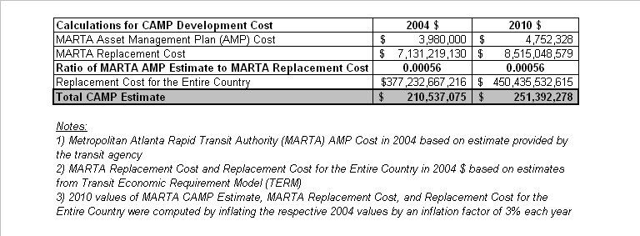
Exhibit 14: Cost Estimate for CAMP Development

B. Ongoing Maintenance and Certification
The initial development of the CAMP by agencies would require a significant level of effort, particularly for those medium-large agencies that have no prior experience in developing an AM program. In general, the development of the CAMP would take 1–3 years, depending on the size and level of experience. Once transit agencies have gone through the initial development of their CAMP, the learning curve would typically smooth out, and with it the level of effort required would decrease. Thus, the study team estimates that this level of effort would be around one-sixth of the CAMP development fund annually.

3.12 Funding Distribution
The incentive program would be allocated to the transit industry based on the 5307 Program formulas (rail and bus, but excluding the existing incentive tier). This would incorporate the equity principles in the current 5307 Program into the incentive program. The recipient of incentive funds can either be the recipient as defined by the Section 5307 Program, or the transit agencies, if they are not otherwise direct recipients of Section 5307 funds. The following is a brief discussion of each approach and its relative merits and demerits.

A. Designated Recipient Based on Current Section 5307 Program
Based on the current Section 5307 Program, the designated recipient of the incentive funds would be the urbanized area designated recipient for areas with populations above 200,000, and the State governors for urbanized areas with UZA populations between 50,000 and 200,000.
In such a case, a UZA would qualify to receive incentive funds if, at a minimum, operating entities accounting for 75 percent of the total asset base within that UZA have Capital Asset Management Plans and are in compliance with the plan requirements. The asset base is defined as either the sum total of replacement values, or number of revenue vehicle miles operated within the UZA. For example, if a UZA has more than one transit system operating within its jurisdiction, then at least 75 percent of the UZA’s asset base should be certified. If an operating entity provides service in more than one UZA, revenue vehicle miles by mode could be used to allocate its asset base by mode between the UZAs to determine whether the 75 percent threshold is met. There are pros and cons associated with this approach.
The incentive funds would be distributed to the designated recipients for large urban areas with a UZA population over 200,000, or State governors for the small urban areas with UZA population under 200,000 (based on a proportion of Section 5307 funds received by the UZA). In the case of the small urban area UZAs, the State’s allocation of 5307 funds to UZAs would be used in allocating the incentive funds to the State for compliant UZAs.

Pros
From the administrator’s point of view, the grant administration process is very simple and follows the established sub-State allocation procedures based on the Section 5307 Program.
New legislation would match the allocation process to the existing 5307 Program.

Cons
FTA is seeking to alter the behavior of transit agencies; but by providing incentive funds to the urbanized area’s designated recipient or the State governor, the administrator is not motivating the transit agencies directly.
For UZAs with more than one transit agency, the sub-allocation of 5307 funds among the transit agencies is at the discretion of the urbanized area’s designated recipient, or the State governor. So even though a transit agency demonstrates the desired behavior, it may not be compensated because the incentive funds may be diverted to agencies with dire needs. In many instances, the process used to sub-allocate 5307 funds among transit agencies is not transparent.
By making all transit agencies within a qualifying UZA eligible for incentive funds, FTA might be diverting incentive funds to agencies that do not have an asset management plan. For smaller operating entities in UZAs where one operator held 75 percent of the asset base, there would be no material incentive to develop and maintain CAMPs. Similarly, there would be no incentive if a larger operator held more than 25 percent of the asset base and had not reached certification (i.e., the 75 percent threshold could not be met).

B. Distribution of Incentive Funds Directly to Transit Agencies
In this approach, the transit agencies would be the direct recipients of the incentive funds upon having a certified asset management plan (see self and independent certification options on Pages 62 - 63). This approach is highly desirable because the transit systems are directly rewarded for being good stewards of transit capital assets. The agencies are further motivated to comply with the plan and maintain or improve their performance so that they continue to receive incentive funds in the future. However, this method would require a newly legislated process to enable FTA to administer funds directly to qualifying agencies. The allocation process would require that each operating agency’s share of a UZA incentive allocation be computed based on the agency’s share of the revenue vehicle miles for the respective bus and rail 5307 tiers.

Illustration of Incentive Fund Distribution over Two Authorization Cycles
According to the CAMP plan, transit agencies would be required to have a CAMP within six years of the program start date. The period associated with these six years is henceforth referred to as the CAMP development phase. It is assumed that the incentive program would be effective from the first year of the next authorization cycle beginning in Federal fiscal year 2010. It is assumed that transit agencies would start receiving the incentive funds during the same year that the plan was certified. For demonstration purposes, during the first six-year authorization cycle, it was assumed that a certain percentage of transit agencies would get certified each year during the CAMP development phase. Exhibit 15 shows the percentage and cumulative percentage of certified transit agencies every year. It was also assumed that some agencies may not ever certify their plans. Hence, at the end of the development phase, the percentage of transit agencies getting certified is capped at 95 percent to account for noncompliant transit agencies.
Exhibit 15: Assumptions Regarding Distribution of CAMP
Development and Maintenance Funds
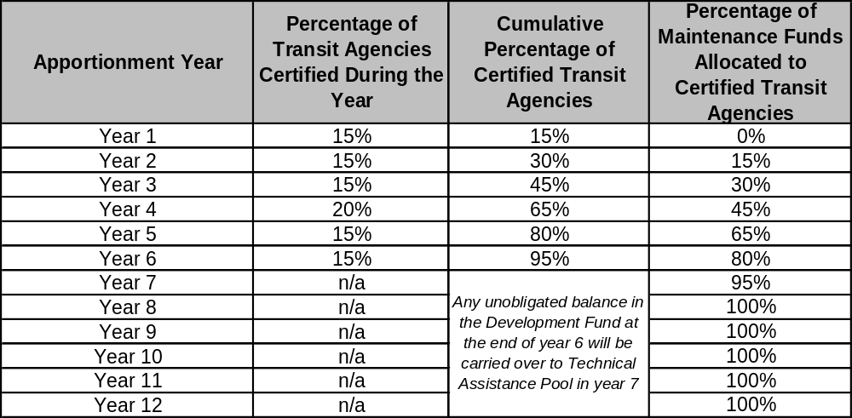

Distribution of CAMP Development Fund
Each year during the CAMP development phase, the CAMP development funds would be distributed to all transit agencies currently receiving 5307 assistance based on the first year’s proportion of 5307 funds. The unobligated development funds would be carried over to the next year, until the seventh year. During the seventh year, when the CAMP development phase is complete, these funds would be carried over to a technical assistance pool establish to provide technical assistance for transit agencies that do not comply with the plan requirements. This technical assistance pool would be distributed on a discretionary basis by FTA.

Distribution of CAMP Maintenance (Ongoing Certification) Fund to Transit Agencies
The incentive for ongoing certification, henceforth referred to as the CAMP maintenance fund, is assumed to be approximately one-sixth of the total development fund each year, inflating at a 3 percent annual rate, and the agencies would start receiving it one year after their asset management plan was certified. The maintenance funds would be distributed to the transit agencies based on the proportion of the compliant transit agencies’ Section 5307 funds for that Federal fiscal year. Because adherence to the plan is both critical and difficult to achieve, maintenance of the CAMP would be essential to the effectiveness of the incentive system. The history of transit asset management is characterized more by poor implementation and lack of budget discipline than by lack of plans and good intentions.
The total maintenance fund distributed each year is based on the scheme shown in exhibit 15. For example, in the above exhibit, 15 percent of the transit agencies had a certified plan in Year 1, and hence 15 percent of the maintenance funds were distributed to these agencies in Year 2. Similarly, 30 percent of transit agencies had a certified plan in Year 2, and hence 30 percent of the maintenance funds were distributed in Year 3. Any year-to-year unobligated maintenance funds would be carried over to a technical assistance pool. This technical assistance program would decline in size as the proportion of the industry in compliance with the requirements increases. It is assumed that from Year 8, the maintenance funds would be completely distributed (no carryover) to the certified transit agencies.
Exhibit 16 shows the cost of the incentive program broken out by CAMP development cost and CAMP maintenance cost for two authorization cycles beginning in 2010. During the first authorization cycle, the total cost of the incentive program, which includes development and maintenance, would be around $481 million in year of expenditure (YOE) currency. In the second authorization cycle, the total cost of the incentive program, which includes maintenance funds only, would be around $324 million.

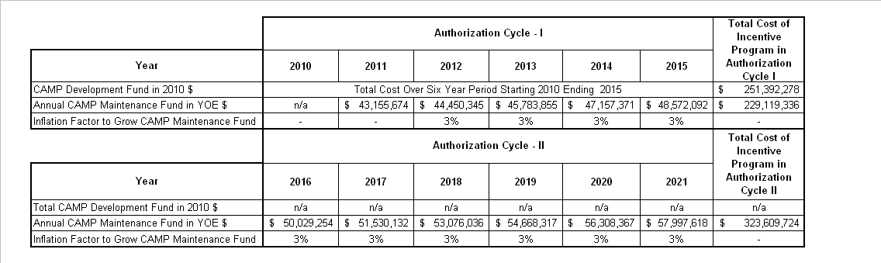
Exhibit 16: Cost of Incentive Program for Two Authorization Cycles
in a Process-Based System
Exhibit 17 illustrates the distribution of the development and maintenance fund over two six-year authorization cycles. In the exhibit, columns 5 and 10 represent the actual development and maintenance funds distributed to transit agencies each year. Column 12 represents the unobligated technical assistance pool before any spending. Column 13 represents the total expenses to FTA after distributing development and maintenance funds, but before any technical assistance spending.

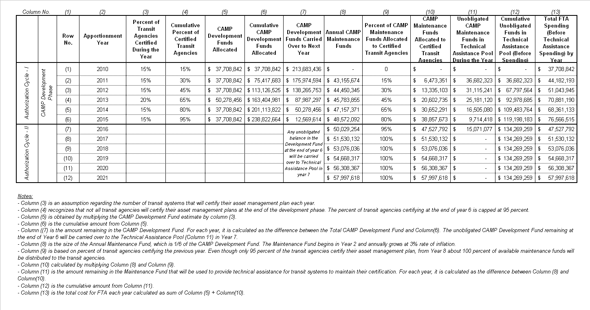
Exhibit 17: Illustrative Drawdown of CAMP Development and Maintenance Funds in a
Process-Based System

3.13 Analysis of the Hybrid INCENTIVE SYSTEM
The hybrid incentive system is a combination of the process-based system (discussed above) and a formula-based system. The formula, in this case, is based on a mathematical weighting of the three qualification thresholds, namely, the ratio of renewal expense to deferred investment cost (or backlog ratio); the ratio of renewal expense to replacement cost; and the ratio of replacement cost to deferred investment cost.
The main intention of a hybrid incentive system is to combine the advantages of the process-based system and the quantitative formula system. Hence the hybrid incentive system has two components:
- Process-based tier: During the first authorization cycle (CAMP development phase), transit agencies would receive funding under the process-based system. However, the amount of funds distributed each year under this tier is gradually reduced at a rate of one-sixth each year. At the end of the sixth year, no more funds would be available under this tier.
- Formula tier: The formula tier would be created primarily to distribute CAMP maintenance funds. From the second year, the maintenance funds would be distributed to the recipients that have a CAMP, and the amount distributed under this tier gradually increases at the rate of one-sixth each year. After the sixth year, 100 percent of the incentive funds under this program are distributed based on the formula.
Exhibit 18 illustrates this concept.
Exhibit 18: Hybrid Incentive System Concept
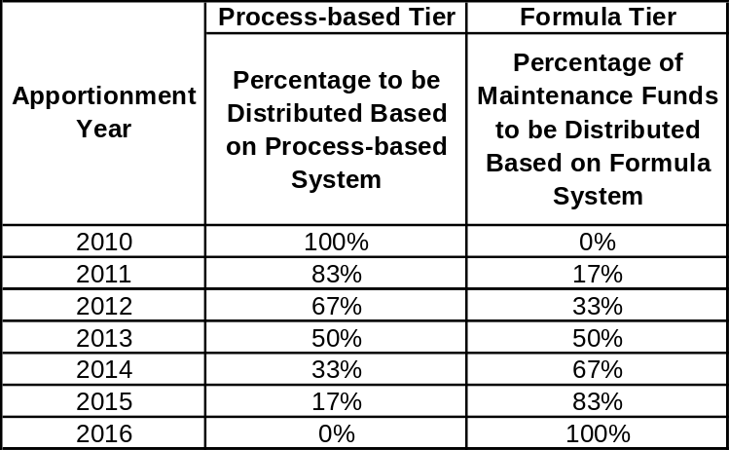
The size of the process-based tier each year is obtained by multiplying the corresponding percentage from the above table with the spending levels computed for the process-based system (refer to column 13 in exhibit 17). The size of the formula tier each year is obtained by multiplying the corresponding percentage from the above table with the cost of maintenance funds.
Exhibit 19 shows the distribution of funds for two authorization cycles, beginning from Federal fiscal year 2010. Columns 3 and 4 show the transition from the process-based system to the formula-based system, with more emphasis on the formula-based system during the later years of the authorization cycle. Columns 7 and 8 show the funds allocated based on each tier, and column 10 shows the total FTA spending each year.

Exhibit 19: Illustrative Drawdown of Funds in Hybrid Incentive System
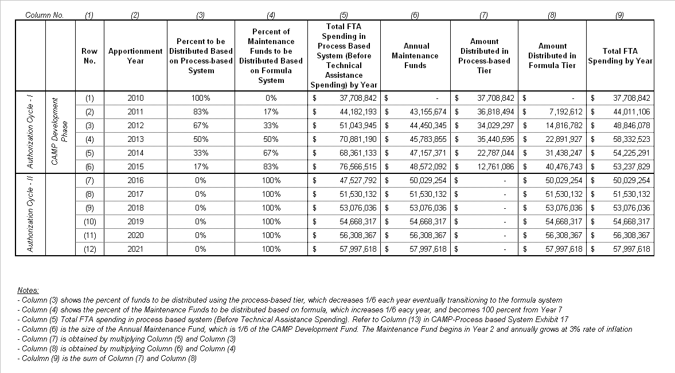

In the hybrid incentive system, the overall cost of the incentive program for an authorization cycle is computed by summing the total FTA spending during that period. As shown in exhibit 20, the total cost of the incentive program for the first authorization cycle would be $296,361,668. In comparing this amount with the cost of the process-based system for the same period, it is observed that the hybrid incentive system costs less than the process-based system. In the hybrid system, the recipients have an added incentive to certify the plan sooner rather than later to recover the actual cost of CAMP development. Since the formula-based system is strongly tied to performance and the allocation is less weighted toward the formula during the initial years, recipients certifying their plan sooner have a better chance of recovering the actual cost of development than do the ones that certify later.
The cost of maintaining the plan during the second authorization cycle is estimated at $323,609,724. That is the same as the cost estimated for the process-based system.

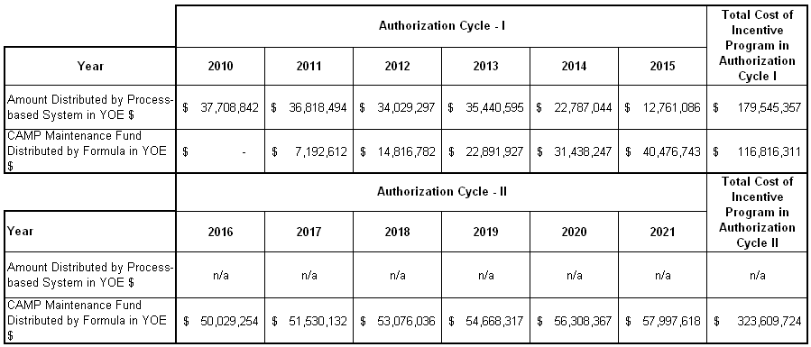
Exhibit 20: Cost of Incentive Program for Two Authorization Cycles
in the Hybrid Incentive System

A. Establishing Weights to Qualification Thresholds in the Formula
The weights assigned to each qualification threshold should be designed in a way that motivates the transit agencies to invest more in repair, rehabilitation, reconstruction, and improvement of their existing assets. This in turn has the positive effect of reducing their backlog.
In practice, some transit systems would be close to “attaining” an optimal state of good repair, while others would be “improving” toward attaining the optimal state of good repair. A formula system with more emphasis on the ratio of renewal to asset replacement costs would reward transit systems that are “improving” to attain the optimal state of good repair. In contrast, a formula system that places more emphasis on the ratio of asset replacement costs to backlog would reward transit systems that are close to “attaining” an optimal state of good repair. A formula system that places more emphasis on renewal-to-backlog ratio would reward both behaviors discussed here.
Prior to actual implementation, the combination of weights in the incentive formula should be carefully studied, and funds allocated to recipients using alternative formulae thoroughly analyzed.

B. Distribution of Incentive Funds
In the hybrid formula system, the transit agencies would be assumed to be the direct recipients of the incentive funds. The distribution would be based on the following:
- Process-based tier: Applicable only for the first six years, this amount would be distributed based on the proportion of Section 5307 funds.
- Formula tier: The incentive formula would be used to derive a weighted incentive fund index based on the values of qualification thresholds for each agency. The incentive funds would then be calculated based on a proportion of the weighted incentive fund index, multiplied by Section 5307 funds received by the transit agency.

4.0 Incentive Systems for Non-Urbanized Area Recipients

4.1 Section 5311 Goals and Potential Incentives
Federal assistance for rural and small urban transit services (Section 5311) is used primarily to fund transit operations per se. Consequently, oversight of this program includes an interest in use of program funds in transit operations as well as capital acquisition and maintenance. An incentive program to support the Federal goals for this program is a prudent policy option worth exploring.
A number of explicit and implicit goals of the Section 5311 Program are listed in exhibit 21. Progress toward a number of these goals may be enhanced by the use of well-designed funding incentive programs. However, transit services and benefits are not homogeneous; disparate transit goals undermine one another. The pursuit of the lowest cost per passenger mile, for instance, is compromised by the equally important goal of reasonable coverage of service areas with widely different population density and factors that drive transit demand. This particular trade-off is especially acute in small urban and rural programs funded under Section 5311. Thus, State experiences with funding incentives for performance have always entailed compromises and trade-offs among State and local transit goals.
The research team systematically identified transit’s numerous goals. The complete set is shown in Exhibit 21. The goals displayed in bold have been selected as candidates for promotion through funding incentives and are evaluated in this report.

Exhibit 21: SECTION 5311 Goals

GOAL | DESCRIPTION
Efficiency | Providing quality service at the lowest cost
Ridership Growth | Increasing the number of passengers over time
Coordination | Minimizing duplicative services
Coverage | Increasing the geographic area in which service is provided
Local Commitment | Increase in State and local contribution to services
Utilization | High rate of use of capital assets
Asset Maintenance | Ensuring that capital assets provide service through their design life
Accessibility | Provide services to people with disabilities
Private Provider Participation | Encourage private delivery of services
Timely Reporting of Requirements | Ensure compliance with all regulations
Affordability | Keep price of services low for customers
Intercity Bus Services | Ensure mobility throughout the State
Equity | Ensure equitable distribution of funds within States
Service Quality | Ensure acceptable reliability, schedule, and waiting times
In addition to cataloging Section 5311 Program goals, the research team has assembled process and performance incentives for both capital (asset preservation and utilization) and operations. Exhibit 22 shows the set of incentives, listed by purpose (capital or operation) and type (process or performance). Exhibit 22 also shows, in bold, the incentives that are evaluated in this report. These are appropriate to promote one or more of the chosen goals, which are listed along with the incentive.

EXHIBIT 22: Goals and Potential Incentives

GOal | Incentive funds linked to: | Type
Efficiency | Periodic route analysis | Operating/process
Efficiency | Reducing Federal subsidy per trip | Operating/performance
Efficiency | Lowering the cost per vehicle hour | Operating/performance
Efficiency | Lowering cost per mile | Operating/performance
Efficiency/Ridership | Retain operating surplus for future expanded service | Operating/process
Efficiency/Ridership | Retain capital surplus for future capital improvement | Capital/process
Ridership Growth | Annual ridership surveys | Operating/process
Ridership Growth | Increase in number of passengers | Operating/Performance
Ridership Growth | Vehicle miles of service | Operating/Performance
Ridership Growth | Vehicle hours of service | Operating/Performance
Service Quality | High ratings based on customer surveys | Operating/process
Service Quality | Short scheduling and waiting times | Operating/performance
Service Quality | Develop service standards | Operating/process
Coordination | Annual coordination plan | Operating/process
Coverage | Develop and adhere to specific growth plan | Operational/process
Coverage | Increase in the number of counties served | Operation/performance
Coverage | Share of counties served | Operation/performance
Local Commitment/Local Share Of Costs | State or local share of operating costs | Operation/process
Asset Maintenance | Life cycle asset maintenance plan | Capital/process
Asset Maintenance | Vehicle availability | Capital/performance
Asset Maintenance | Mean distance between failure | Capital/performance
Asset Utilization | Annual vehicle hours of operation | Capital/performance
Asset Utilization | Number of vehicles per passenger mile | Capital/performance
Intercity Bus | Public/private review process for subsidy | Operating/process
Equity | Equitable distribution report | Operating/process

4.2 Federal Incentives for System Performance or Incentives to Encourage States to Adopt Incentive Systems for 5311-Funded Programs?
When considering incentive programs to promote Section 5311 goals, there is the question of the most advantageous role that FTA can play in creating incentives, such as the policy and management choices by small urban and rural transit operators. Satisfaction of prescribed processes or achievement of specified performance criteria could yield additional funding for the successful system. These programs would directly link local system actions with FTA goals.
However, FTA does not administer the Section 5311 Program. The States do. Introducing specific Federal incentives that reward individual systems would impose an additional layer of direction for local operating authorities. Moreover, some FTA goals, such as increasing geographic coverage, require authority beyond the geographic scope of individual transit systems. Exhibit 22, therefore, also includes alternative approaches to following two objectives:
- An inducement for the States to pursue State or sub-State region-wide goals and
- An inducement for the States to maintain, consistent with FTA goals, incentive funding systems for operators.
Incentives for States to develop their own incentive programs would have at least five advantages:
- States already have monitoring responsibility for local systems.
- Most State goals and FTA goals coincide.
- Some States already have begun to put incentive systems in place.
- FTA would not have to bear a significant increase in monitoring costs, as it would only have to monitor the 50 State programs and not individual systems. However, increasing the management burden for many State transit offices would be difficult or prohibitive, even if additional funding were made available. (cf. National Cooperative Highway Research Program, “State DOT Staff Resources for Administering Federal Public Transportation Programs,” Research Results Digest 314 (April, 2007).
- FTA would not be imposing a new regulatory burden on local operators.
Although FTA would not have the burden of monitoring local systems, FTA may define standards for State incentive systems so that funding incentives directed to the States are well defined and oriented toward achieving FTA goals. In the discussion of specific incentives that follows, we examine both FTA incentives for local systems and incentives for States to develop incentive programs, which may, in fact, be similar to the direct Federal incentives.

4.3 Evaluation of Incentives for the 5311 Program
Regardless of whether incentives are directed to rural transit systems or States administering the Section 5311 Program, funding incentives must be clearly defined, focused on specific goals, measurable, based on available data, and of sufficient magnitude to affect the choices of States and rural transit providers.
Thus, we evaluate each potential incentive on the following six criteria:
- Transparency how unambiguously an incentive indicates what you need to know
- Measurability: how simple it is to detect compliance with an incentive
- Data Availability: the difficulty of generating data required for the incentive
- Burden on State and Local Systems: increased administrative work, because of the incentive, required on the part of the State (which would administer the program) and the locality (which would implement the program)
- Link to Goals: how the incentive advances a specific FTA goal, and any conflicts among goals it would generate.
- Potential Effectiveness: the likelihood the incentive actually motivates decisions, and whether achieving the incentive leads to desired results
Each goal is ranked excellent, good, fair, or poor against each of the above criteria.
In addition to assessing individual incentives against the above criteria, there are common concerns across all incentives, particularly potential conflicts and interactions with other goals.
Properly designed State incentive programs can lead to changes in the choices transit providers make. For example, one State introduced four criteria that would trigger performance bonuses: increase operating revenue per vehicle hour; increase in ridership per vehicle hour; increase ratio of operating revenue to operating expenses; and increase in operating expenses per vehicle hour below the rate of inflation. Two of the four bonuses encouraged fare increases at the rate of inflation, but two others encouraged holding operating expenses below the inflation rate. The average transit system earned two of the four bonuses, which increased the State share by an average of 4 percent. The result was that providers made changes in response to the incentives.

A. Efficiency Incentives for the Section 5311 Program
Exhibit 22 identifies one process-based incentive and two performance-based incentives. Efficiency-based incentives are intended to reward operators that (1) deliver services for which there is demand, and (2) deliver a given service at a lower cost. As mentioned earlier, basic efficiency incentives in small urban and rural services often conflict with coverage and service quality goals.

Periodic Route Analysis
Providing new funding for the successful completion of periodic route analyses is a process-based incentive that encourages operators formally to calculate the relative cost and use of fixed routes, and therefore enable operators to evaluate tradeoffs across goals in resource allocation. This simple process-based incentive is attractive based on a number of criteria, but probably limited in effectiveness.
Transparency
Excellent: Requiring a periodic route analysis is straightforward and clear in its application.
Measurability
Good: While it is easy to measure whether a transit agency has complied with conducting a route analysis, ensuring its quality requires greater monitoring.
Data Availability
Excellent: One of the reasons for adopting an incentive to perform periodic route analyses is to motivate operators to collect the rudimentary data for good operational and investment decisions. In addition, recent FTA guidance for Section 5311 requires collection of the basic data for route analysis.
Burden on Systems
Good: Performing route analyses clearly puts additional burdens on local systems; however, the presumption is that the FTA incentive for performing the route analysis would be greater than its cost. Moreover, the benefits of the route analysis for potential efficiency gains would offset the modest effort.
Link to Goals
Good: Route analyses would allow the rank ordering of inefficient routes to support fine tuning at the margin as opportunities and needs change. Since this is simply a process incentive system, managers can still obtain the incentive funding—even if they do not act on the implications of the route analysis.
Potential
Fair: Because operators are not compelled to take action based on the findings, the potential to have a significant impact is limited.

Funding Based on Lowering Federal Subsidy per Trip
This incentive would reward systems that manage to lower the Federal subsidy per trip. This results in a greater number of people served for any given amount of Federal subsidy. Operators could reduce their Federal subsidy through a variety of operational changes. First, they could become more efficient with respect to the delivery of any given service. Second, they could shift resources to areas that carry more people per vehicle mile, or carry people shorter distances. Third, local governments could increase their contribution, which would reduce the Federal component on a per trip basis. Each of these policy changes might conflict with other goals, particularly in service quality.
The cost of providing a given trip may be lowered by reducing the service quality in the form of longer waits, increased scheduling requirements, or more Spartan vehicles. This obviously conflicts with service quality goals.
To the extent that operators lower Federal subsidy per trip by reducing long-distance trips in favor of shorter ones, this objective is likely to conflict with coverage goals. This incentive may also shift resources among service types, for example fixed-route versus on-demand. Thus, it may be desirable to specify the incentive with respect to type of trip or transportation goal.
Transparency
Excellent: The incentive program only requires tracking the number of passengers and Federal dollars.
Measurability
Good: While it is easy to measure the average subsidy per trip, if the incentive is specified by trip type, the allocation of overhead costs to alternative services may be controversial.
Data Availability
Good: Again, if the incentive is on the average trip, the data is clearly available. However, if the incentive is based on subsidy by trip type, then additional data is required to allocate overhead costs.
Burden on Systems
Good: Systems may incur small additional burdens to allocate costs across trip types.
Link to Goals
Excellent: The incentive is directly linked to the goal, and is only available if there is progress toward the goal. However, moving toward the goal may be in conflict with other goals.
Potential
Good: Operators that innovate can increase their funding and expand their services. On the other hand, the incentive may make it more difficult to achieve other goals.

Funding Based on Lowering Costs per Vehicle Revenue Hour
This incentive would reward systems that manage to lower the hourly costs of revenue vehicle operation. This incentive could positively affect efficiency by lowering labor costs, minimizing non-revenue hours, and increasing maintenance efficiency. Depending on how the incentive is specified, this incentive could result in shifts in vehicle and trip type. For example, if the incentive were specified without reference to vehicle type, it could result in shifts away from operations of larger, more expensive vehicles that can carry more people to smaller vehicles and on-demand services. This incentive does not provide an incentive to orient service to areas of highest demand.
Transparency
Excellent: The incentive program requires only tracking the number of operating vehicle revenue hours and total operating costs.
Measurability
Good: While it is easy to measure the revenue hours of service, if the incentive is specified by vehicle or service type, the allocation of overhead costs to alternative services may be controversial.
Data Availability
Good: Again, if the incentive is on the average trip, the data is clearly available. However, if the incentive is based on revenue hours by vehicle or service type, additional data is required to allocate overhead costs.
Burden on Systems
Good: Systems may incur small additional burdens to allocated costs across trip and vehicle types.
Link to Goals
Good: The incentive is directly linked to lowering unit costs. It does not, however, provide incentives to best match service to demand.
Potential
Good: Operators that control costs would have the opportunity to grow with increased funding.

B. Ridership Incentives for the Section 5311 Program
Among urban transit systems, incentives to increase ridership seem to be obvious choices. Success in this dimension would mean that Federal capital would be serving more travel, and the negative externalities of urban congestion may be reduced. For rural systems, the picture is not as clear. In many circumstances, the mobility provided by rural transit services is mobility of last resort. It is a lifeline for people without cars, the elderly, or people who otherwise don’t have access to a car. Unlike urban transit service, rural transit is not intended to reduce congestion or provide general mobility. The number of people that choose to use rural transit may reflect many factors that are not related to the transit service, and may also significantly change for reasons unrelated to transit service. Still, incentives designed to induce more people to use transit are worthy of consideration. Moreover, FTA has a goal of increasing ridership by 3 percent annually on systems receiving Section 5311 funding.

Funding Contingent on the Completion of Annual Ridership Surveys
Annual ridership surveys enable transit operators to assess how customers value the services. Surveys that included people choosing not to ride would also provide information from people who find the services unhelpful. Funding based on the successful completion of marketing surveys would help transit operators make their services more responsive to customers.
Transparency
Excellent: A requirement for an annual marketing survey is straightforward and clear in its application.
Measurability
Good: It is easy to measure whether a transit agency has complied with conducting a marketing survey. But, unless the survey is standardized, quality control requires significant monitoring.
Data Availability
Excellent: Marketing surveys can be self-sufficient. Also, several States have subscribed to expanded samples for their own use from the National Household Travel Survey (NHTS) sponsored by U.S. DOT.
Burden on Systems
Good: Performing a marketing survey clearly puts additional burdens on local systems; however, the presumption is that the FTA incentive for performing the survey analysis would be greater than its cost. Moreover, the benefits of the survey in terms of potential ridership gains may offset the modest effort.
Link to Goals
Fair: Marketing surveys allow the identification of pluses and minuses in services. Since this is simply a process incentive, system managers can still obtain the incentive funding even if they do not act on the implications of the surveys.
Potential
Fair: Because operators are not compelled to take action based on the findings, the potential to have a significant impact is limited. On the other hand, existence of market data in the pubic domain can increase wider participation in policy issues like coverage and funding levels.

Funding Based on Percent Increase in Ridership
Funding based on ridership growth could ensure that rural transit agencies are focusing on meeting customer needs and delivering efficient services. Providers that deliver increasing value to riders would see ridership growth, and those that focus on lowering costs would have the ability to provide more services for any given level of subsidy (and therefore realize greater ridership as well). Thus, incentives for increases in ridership are a natural opportunity. In the rural context, however, the focus on ridership raises concerns as well. In particular, that goal may conflict with the goal of increasing the extent of coverage, and might result in the concentration of resources in a few areas. Also, rural transit agencies may be affected by community factors that both reduce ridership and increase costs. For example, a rural county that has an aging, diminishing population may require fewer trips, but those trips may also be more expensive to serve. Incentives based solely on ridership would hurt these communities.
Transparency
Excellent: The incentive program requires only tracking the number of passengers and Federal dollars.
Measurability
Excellent: It is easy to measure the number of trips, even by trip type.
Data Availability
Excellent: Providers are currently required to collect and report ridership data.
Burden on Systems
Excellent: Very little burden placed on operators.
Link to Goals
Excellent: The incentive is directly linked to the goal, and is only available if there is progress toward the goal. However, moving toward the goal may be in conflict with other goals.
Potential
Good: Rewarding ridership growth is likely to cause operators to reallocate their resources to better meet the needs of a larger number of passengers. This incentive, however, may be more difficult to achieve than other goals, such as geographic coverage and equity.

C. Service Quality Incentives for the 5311 Program
Incentives to improve service quality are intended to provide greater satisfaction to customers. In so doing, they are similar to ridership incentives. However, service quality incentives are not market driven, and can be spurred simply through incentives or imposed through regulation. Service quality incentives may be at odds with other incentives, such as those intended to increase efficiency or to increase service coverage.

Funding Contingent on the Creation of Service Standards
Transit operators frequently develop standards for their operations. Examples include minimum frequency and hours of service. One approach to improving service quality is to reward transit operators that institute service standards.
Transparency
Excellent: Requiring development of a system of service standards and annual monitoring process of those standards is straightforward and clear in its application.
Measurability
Good: Not all service standards are equal. Monitoring the quality of service standards would require FTA to set a standard and to enforce it.
Data Availability
Excellent: Service standards can be self-sufficient.
Burden on Systems
Good: Developing service standards requires limited effort on the part of operators, and should be more than offset by the funding incentive.
Link to Goals
Fair: There is no guarantee that standards developed by the operator would cause any change in operations.
Potential
Fair: Because operators are not compelled to adopt stringent standards, the potential of this incentive is limited. Over time the State or FTA could raise the standard and tighten compliance.

D. Coordination Incentives for the Section 5311 Program
SAFETEA-LU requires many recipients of Federal transportation funds to coordinate across agencies and across social service programs. These requirements are especially important for FTA programs administered by the States. Such coordination could reap significant economies and improved mobility for passengers. Coordination is recommended, but not required for the Section 5311 Program as well.

Funding Contingent on Creation of a Coordination Plan by Agencies Receiving Section 5311 Funds
Similar to most of the other process-oriented incentives, eligibility for incentive funds could be made dependent on developing a plan for cross-agency coordination. Like other process incentives, this is easy to implement but has only limited potential. The incentive is easy to implement in the sense that FTA can easily observe whether a coordination plan has been developed, and States or agencies can develop plans. It is of limited potential, however, for two reasons. First, other transportation programs have already mandated coordination plans, so there may be little gained by providing incentives for another plan. Second, while coordination plans can be developed, agreement on significant coordination may be very difficult.
Transparency
Excellent: Requiring a coordination plan is straightforward and clear in its application.
Measurability
Good: While it is easy to measure whether a transit agency has completed a coordination plan, the plan’s quality is more complex.
Data Availability
Fair: Assembling cross-agency service data is difficult, but could improve over time. However, at its inception, an incentives program for coordination might require five items: (1) an “order of magnitude” estimate of need, (2) an inventory (or cross-tabulation) of which agency plans to address which need (perhaps with agency level cost estimates), (3) a summary of needs to be met in this way, (4) the roll up of estimated costs, and (5) the balance of unmet needs. Initial allowance for rough estimates could begin the process with the expectation (and incentives) for improved data in future years.
Burden on Systems
Good: A coordination plan could be a time-consuming burden for local systems. The potential for endless disagreement, stonewalling, and even litigation, among providers, service recipients, and funding agencies is daunting. However, the presumption is that the incentive for performing the survey analysis is greater than its cost.
Link to Goals
Fair: An agreed upon coordination plan does not ensure actual coordination across agencies. However, a coordination plan can fuel the transparency needed to generate inter-agency pressures for compliance with the plan.
Potential
Fair: Because operators are not compelled to take action based on the coordination plan, the potential to have a significant impact is uncertain, especially in the short run.

E. Coverage Incentives for the Section 5311 Program
Increasing the geographic coverage of rural transit is a key goal of FTA, and of many States. FTA has an explicit goal of increasing the percentage of counties served by Section 5311 funds from 63 percent to 75 percent. States have similar goals. For example, in Pennsylvania the Transportation Funding and Reform Commission has suggested increasing the number of counties with rural transit services from 43 to 65—all rural counties in Pennsylvania. Increasing geographic coverage may be at odds with other goals, including efficiency goals and service quality goals, as resources are spread increasingly thin. Still, increasing geographic coverage appears to be a straightforward goal to encourage both process and performance incentives.

Funding Contingent on Completion and Adherence to an Expansion Plan
States could be required to detail plans for increasing geographic coverage in order to receive Section 5311 funds.
Transparency
Excellent: Requiring an expansion plan is straightforward and clear in its application.
Measurability
Excellent: It is easy to measure whether a transit agency has increased coverage based on the expansion plan.
Data Availability
Excellent: Coverage plans do not require detailed data.
Burden on Systems
Good: Expansion would be a State responsibility, raising once again the problem of overburdened transit staffs in many State DOT’s.
Link to Goals
Fair: Funding would be tied to the existence of a plan and adherence to the plan, but there is no guarantee of an aggressive plan for expansion.
Potential
Fair: States are not compelled to expand rapidly, and therefore the incentive is likely to have limited impact.

Funding Tied to Increases in the Fraction of Rural Counties Served
Incentive funds flowing to States could be made proportional to the share of all counties receiving funds. This has the attractive feature of giving more funds to States that expand coverage, while States with high levels of coverage receive high levels of incentive funds.
Transparency
Excellent: The incentive program requires only tracking the number of counties served.
Measurability
Good: While a county may be served, there is no assurance that it is well served. Thus, States may expand by providing skeletal service simply to receive incentive funds.
Data Availability
Excellent: Data on counties served is readily available.
Burden on Systems
Excellent: The burden is exclusively on the State.
Link to Goals
Good: The incentive is directly linked to serving larger geographic areas. It does not, however, ensure adequate service in the broader area.
Potential
Good: This is one incentive that would unambiguously encourage the geographic expansion of the program. It may do so at the expense of other goals.

F. Local Commitment Incentives for the Section 5311 Program
One way to increase the impact of Federal transit funds is to reward local contribution. If Federal dollars are matched by State or local dollars, they have a larger impact on the level of transit services. At one level this is very attractive because it expands the ability of FTA to pursue its goals. From an equity point of view, this approach may be problematic; very low-income communities that may require the most rural transit services may have reduced access to Federal funds.

Funds Based on Local Contribution
Requiring local contributions has become the rule in competitive programs like the New Starts program. An incentive program that rewards local contributions, but does so taking into account county income levels, could be an efficient, equitable way to leverage 5311 funds.
Transparency
Good: Local contribution is a straightforward requirement. This becomes less transparent in that the required local contribution is a function of ability-to-pay factors as well.
Measurability
Good: Local contribution is straightforward to observe (unless “in kind” contributions are allowed).
Data Availability
Fair: Virtually no data is required unless the required contribution is a function of ability-to-pay factors. In this case the data requirement could be significant, and beyond that typically available to local operators.
Burden on Systems
Fair: Significant financial burden on local systems to come up with matching funds. Additionally, there are burdens to prove “need” if the requirement depends on ability to pay.
Link to Goals
Good: The incentive is directly linked to increasing the local contribution.
Potential
Good: The net result is likely to be an increase in local contributions.

G. Asset Maintenance Incentives for the Section 5311 Program
In addition to operating funds, Section 5311 provides significant funds for capital assets in the form of vehicles and facilities. Ensuring that these assets are properly maintained is a key goal of FTA. Process-based and performance-based incentives could spur proper maintenance of assets. However, measuring asset condition and performance are demanding issues; for this goal we only consider a single process-based incentive.

Funding Contingent on Development and Conformance with a Lifecycle Asset Maintenance Plan
By making funding contingent on a lifecycle asset maintenance plan and conformance with that plan, FTA could ensure that operators consider the proper time horizon for their decision making. In particular, local operators would have to consider the future implication of their current operating and maintenance choices.
Transparency
Excellent: Requiring a lifecycle asset maintenance plan and adherence to that plan is straightforward and clear in its application.
Measurability
Fair While it is easy to measure whether a transit agency has completed an asset maintenance plan, ensuring compliance is problematic. In particular, measuring an asset’s current condition is difficult.
Data Availability
Fair: There is little reliable data available on asset performance or conditions.
Burden on Systems
Good: The costs borne by the system would be more than offset by the incentive.
Link to Goals
Fair Funding would be tied to the existence of a plan, but it is very difficult to monitor compliance with any planned expansion.
Potential
Fair Simply developing a plan is useful; however, the issues that arise in ensuring compliance limit its potential effectiveness.

H. Asset Utilization Incentives for the 5311 Program
In addition to having an interest in preserving capital assets, FTA also has an interest in the efficient use of those assets. There are straightforward measures of the use of capital assets, and thus it should be possible to create incentives for their efficient use.

Funding Dependent on Annual Hours of Revenue Service per Vehicle
“Annual hours of revenue service per vehicle” is a natural indicator of the intensity of use, and also of the availability of the asset (hence an indicator of the quality of maintenance, but not from a lifecycle perspective.) High annual usage is an indication that FTA capital expenditures are delivering service to transit patrons.
Transparency
Excellent: The incentive program requires only tracking the number of operating vehicle revenue hours and number of vehicles.
Measurability
Excellent: It is easy to measure the revenue hours of service, even if disaggregated by vehicle type.
Data Availability
Fair: Local transit providers are not currently required to collect revenue hours of service.
Burden on Systems
Good: Systems may incur small additional burdens to measure revenue vehicle hours of service.
Link to Goals
Excellent: The incentive is directly linked to more efficient use of capital assets.
Potential
Excellent: Operators that efficiently use and maintain capital would be rewarded with additional funds and the opportunity to grow.

4.4 Optimal Mix of Incentives for the 5311 Program
As is evident from the discussion in section 4.3 (Evaluation of Incentives), the number of incentives that can be used effectively is limited. Moreover, the interaction of incentives may be as important as the incentives themselves. Any design of an effective incentive program for Section 5311 funds must focus on a limited number of specific goals and take into account the interactions among incentives.
Based on our understanding of FTA and State goals and our assessment of individual incentives, we discuss two alternative approaches to funding incentives for the 5311 Program, one based on process-based incentives and another, more aggressive approach, focused on performance-based incentives. Of course, a combination of process-based and performance-based incentives could be pursued as well.

A. Process-Based Alternative
Virtually all of the process-based incentives discussed in section 4.3 (Evaluation of Incentives) are easy to implement because FTA can observe whether the processes have been implemented, and States and providers can straightforwardly fulfill the requirements for the incentives. Moreover, these incentives generally do not pose conflicts with one another, in part because they do not require specific actions beyond analysis and planning. For this same reason, the linkage of the process incentives to their goal, and potential for progress to the goal, is limited. Still, providing incentive funding to undertake process changes may be an easy-to-implement, non-controversial approach to incentive funding.
Given the stated goals of increased ridership, increased geographic coverage, and improved efficiency and maintenance of capital assets, FTA could adopt a program that made funding contingent on the following four conditions:
- Operators performing annual route assessments
- Operators performing annual marketing surveys
- Operators creating and adhering to an asset maintenance plan
- States developing a service area expansion plan
These actions would help ensure that operators have a sufficient knowledge base to properly manage their systems. There are four drawbacks of this approach:
- No action to improve performance is required to realize the incentive funds.
- Federal funds are diverted from the actual operation of transit services.
- The incentive program may simply be perceived as a new Federal mandate.
- Many State transit programs are understaffed, and those States are unable to increase their staffs—even in the event of increased Federal financial support.

B. Performance-Based Alternative
Performance-based incentive programs are significantly more likely to result in changes in operations and investment decisions because funding is tightly linked to actual outcomes. Such incentives are, however, more difficult to implement, and may induce actions that are not consistent with other goals. For example, if an incentive based on reducing the subsidy per trip is used to increase efficiency, it might result in operators limiting the areas served, which conflicts with another key goal. Another example is the use of an incentive that provides additional funds for increases in ridership. While this incentive is tied directly to its goal, it also may induce operators to cut back on long-term maintenance to provide more service in order to gain additional ridership and funds.
The fact that performance incentives are likely to change operator choices in a number of ways means that incentives have to be balanced, so that the potential negative impacts of an individual incentive are counterbalanced by another incentive. Consistent with a workable balance among incentives, the overall incentive program must remain simple, measurable, and easily understood.
Based on FTA goals and our assessment of performance-based incentives, we will discuss a set of four incentives that, taken together, would encourage improved performance without having negative side effects on important FTA goals. These incentives address basic efficiency, market needs, asset preservation and utilization, and program expansion. They provide funds for the following:
- Lowering the cost per vehicle revenue hour of operation
- Increasing the number of passengers per year
- Increasing the average revenue miles per vehicle
- Greater share of counties served
All four performance incentives are conceptually simple, measurable, and readily supported by available data. They impose modest burdens on operators and States, and they are tightly linked with goals. When taken together, these incentives provide a balanced approach that tends to offset potential undesirable outcomes of any individual incentive. It is important to note, however, that the first three incentive programs would require greater specificity to ensure that undesirable shifts across vehicle and trip type do not occur. In particular, lowering the cost of vehicle revenue hours of operation should be specified by vehicle class; passengers should be specified by type (fixed route or on-demand); and revenue miles per vehicle should be specified by vehicle type as well.

4.5 Structuring FTA Incentives
Structuring incentives for process incentives is straightforward. The applicant either qualifies or does not qualify for the incentive payment.
The considerations are different in the case of quantitative performance-based incentives. The magnitude of the incentives becomes of crucial importance. Incentives that are too small would result in little change. Incentives that are too large would disproportionately reduce the authorized incentive funding pool and provide the recipient with a windfall
In addition to the importance of the overall share of incentive-based funding, the relative magnitudes of incentives are of crucial importance as well. Unbalanced incentive magnitudes would result in undesirable shifts in operational choices to exploit the largest incentives. Prior to the implementation of any performance-based incentive system, it is necessary to have credible estimates of the marginal impacts of alternative subsidies on operator choices. For example, if there is a very large incentive for ridership growth, to what degree are operators likely to avoid spending on “lifeline” services and focus services on areas where they have the greatest market opportunities? And how comfortable is FTA with that shift?

4.6 Structuring State Incentives
An alternative approach to FTA developing incentives and monitoring performance of individual systems is to encourage States to develop and monitor incentive programs that are consistent with FTA goals. States already administer the Section 5311 Program for local operators and some States have their own incentive programs.
The simplest approach for FTA to take with respect to State incentives would be to decide the pool of funds that are subject to incentives and distribute these funds based on (1) the development and implementation of an incentive plan, and (2) the aggregate performance along the dimensions of the program. The set of performance-based incentives listed in an earlier section would be an appropriate set of incentives upon which to reward aggregate performance. FTA might wish to add an equity-based criterion for funding to ensure that States equitably allocate incentive funds.

5.0 Procurement Incentive Systems for Section 5307 and 5311 Formula Grants
A Federal incentive program to encourage the standardization of transit vehicle specifications offers compelling promise. History has shown that vehicle standardization improves vehicle quality, reduces unit prices and life-cycle costs, reduces maintenance costs and spare parts, and increases safe vehicle operations. If such a program could be designed, it would generate clear benefits for the Federal taxpayer, for transit agencies and for transit customers. Such a program might even increase the competitiveness of transit vehicle parts manufacturers and vehicle assembly companies. Vehicle standardization has many pluses. That’s why it has succeeded in the past. It has also faltered. It might be time to try again, especially in the face of increased demand for transit services.
This section evaluates shared procurement incentives and vehicle standardization benefits. The vehicle standardization incentive system is intended to (a) encourage larger, interagency procurement sizes in Federally funded transit vehicle acquisitions, and (b) promote the use of standard vehicle specifications. The principal benefits are expected to be lower costs of manufacturing (including lower manufacturer costs for testing and contracting); more effective fully developed designs; and less ambiguity from minor changes in vehicle specifications from grantee to grantee. This should benefit both FTA and FTA grantees by engendering lower purchase prices, lower procurement management costs to secure the needed vehicles, and over a long period, reduced diversity of vehicle models and spares. Since this discussion concerns vehicle procurements, it may be implemented equally across FTA’s formula grant programs. In principle, a Section 5311 rural bus operator might conceivably enter a joint procurement with a Section 5307 urban bus agency.

5.1 Background of Standard Specifications and Joint Procurements
U.S. urban transit buses and rail cars are manufactured and acquired almost exclusively through the issuance of a technical specification that is promulgated by a grantee or operating agency. After any modifications of the specification are made to conform with he accepted proposal (with agency consent, and through a process governed by the agency), the agency selects a bid or proposal for award. A 2004 study by the American Public Transportation Association (APTA) found several barriers to the industry’s implementation of standards, including this key obstacle:
Transit Culture – Agencies Believe They Are Unique . . . The agencies are justifiably proud of their corporate cultures and heritage, and their pride may have many positive effects. However, if the industry is to realize the full benefits of standards, the systems must weigh their traditions against the benefits of standards and make the collective effort that is necessary to settle on safety standards and adhere to economical design standards.
The historical precedent for transit industry vehicle standards and their benefit is offered convincingly by the Presidents’ Conference Committee (PCC) Car. The PCC standard for light rail vehicles was adopted by a consensus of the committee, which consisted of industry representatives.
The relatively high price ($556,119 in 2004 dollars) was justified by a 30 percent increase in speed; a smooth and rapid vehicle start due to the use of a newly designed, multi-notch propulsion mechanism; and a reduction in noise due to the extensive use of rubber throughout the car. The high degree of standardization of both the PCC car body and electrical and mechanical components permitted the use of assembly-line techniques. The first of two manufacturers, Pullman-Standard, delivered the first two PCC cars to Chicago in June of 1934.
The average price for the original PCC cars was higher than that of the streetcars it replaced, but it was worth the price. Passenger revenue increases ranged from 11.5 percent to 24 percent, and transit labor cost reductions ranged from 10.8 percent to 33 percent. In almost every case, the new PCC cars increased ridership, spawned operating economies, and increased revenues.

A. Original White Book
In the 1970’s FTA developed The Baseline Advanced Design Transit Coach Specification, or “White Book.” Published in April 1977, the White Book was intended for use by FTA grantees to facilitate normal transit bus purchases and to establish production of advanced design buses (ADBs) through the use of a standard, complete bus procurement package. The White Book was periodically updated by addendum for several years after original publication. In the late 1970s, FTA made the White Book a requirement for all Federally supported advanced-design transit bus procurements. The requirement was lifted in the 1980s, leaving only certain safety specifications in place as FTA requirements.

B. APTA White book
In 1997, APTA issued the Standard Bus Procurement Guidelines (SBPG, sometimes called the “APTA White Book”), and has subsequently issued technical specifications to revise or supplement the SBPG. The current set of guidelines can be viewed or downloaded at the following Web page:
http://www.apta.com/research/info/online/
Commercial Terms and Conditions (October 10, 1997)
High-floor Diesel Buses – Introduction (March 25, 1999)
High-floor Diesel Buses – Text (March 25, 1999)
Low-floor Compressed Natural Gas Buses – Introduction (May 8, 2000)
Low-floor Compressed Natural Gas Buses – Text (May 8, 2000)
30-foot Low-floor Diesel Buses – Introduction (June 28, 2002)
30-foot Low-floor Diesel Buses – Text (June 28, 2002)
40-foot Low-floor Diesel Buses – Introduction (July 3, 2001)
40-foot Low-floor Diesel Buses – Text (July 3, 2001)
Use of some portion of these guidelines is widespread throughout the industry, and small agencies in particular have taken advantage of this document. However, manufacturers are particularly disappointed that few agencies have in fact used the SBPG. Rather, agencies have used those portions that they found to be to their advantage, and have used their own specifications, terms, or conditions when they preferred their own.

C. APTA and Institute of Electrical and Electronics Engineers Vehicle Standards
APTA has more recently undertaken the development of additional operational, safety, and equipment standards, building upon standards they developed in cooperation with the Institute of Electrical and Electronics Engineers (IEEE). These include the following:
- IEEE rail standards
- Commuter rail
- Rail transit
- Bus
A more detailed listing of these standards appears in the appended table.

D. Background of Joint Procurements
A related aspect of transit vehicle design, production, and acquisition is the joint procurement of vehicles by more than one agency. This can occur in several forms:

- A simple joint or consortium procurement, where one agency takes the contracting lead in procuring a specific number of vehicles for themselves and several agencies within a consortium
- Piggybacking, wherein an agency acquires options for additional identical vehicles that may be assigned to other agencies
- A procurement pool in which an entity takes the lead and acquires the right to order buses with operating agencies subsequently placing orders within the terms of the pool
- Procurement schedules, wherein an entity, such as a State department of transportation or the U.S. General Services Administration (GSA), obtains binding price offers from one or more suppliers for a limited number of bus configurations, which operating agencies may then exercise through independent contracts
To contrast joint procurement with specification standards, a joint procurement could be carried by (for example) three agencies. In theory, the joint procurement could incorporate three complete technical specifications, identical to the three specifications that the agencies used in their most recent stand-alone procurements. No design standardization would have been accomplished through the joint procurement, but the agencies would achieve the competitive and pricing advantage of the buying power of the aggregate purchase size. However, it is also likely that the agencies would compromise to some degree on common specifications, and some degree of design standardization would be realized.
Joint procurements involve significant administrative efforts because the agencies must reconcile their requirements and practices to each other’s. Conflict-of-law issues, differing operating requirements, and differing professional opinions must be resolved.

E. Demonstration Project
FTA has implemented the Cooperative Procurement Pilot Program (CPPP) to demonstrate joint procurement of buses. Five awards have been made to pilot projects. Under the CPPP, participating agencies may use Section 5307, 5309 or 5311 funds at a 90 percent Federal share. However, no additional funds or new funds are provided to transit agencies under the program. Three of the awards did not result in successful joint procurement of rolling stock, demonstrating some of the difficulties of joint procurement in the industry. The demonstration indicated that the incentive must be significant and that (1) more advantageous matching ratios on preexisting formula funds are not adequate, and (2) continuous production of vehicles without significant configuration changes is important to achieving the potential savings.

5.2. Incentive Systems
The following paragraphs suggest an incentive system for the joint procurement lead agency; this system reflects the lessons learned from the cooperative procurement demonstration. Two alternatives to the leader system are suggested: one providing new money for both lead and participating agencies and one offering a matching ratio for greater efforts at standardization.

A. Joint Procurement Leader Incentive
In this incentive system, FTA would award incentive grants to applicants who would lead joint procurements for significant segments of the transit vehicle purchase requirements for the next few years. The incentive award segments would be determined based on the grant applications and FTA’s review. Each award would encompass a single vehicle type (e.g., less than 30-foot-long urban transit bus, a 60 foot articulated urban transit bus, a single articulated Light Rail Vehicle (LRV), a passenger rail car or a locomotive for passenger operations).

The concept consists of six elements:
- FTA would develop a competitive award process to support the project management costs of a vehicle procurement managed by a grantee that has allowed additional grantee options to be included in the Request for Proposal.
- The FTA would competitively select vehicle procurement proposals that would qualify for the incentive payment based on the judged quality of the proposal and its contribution to FTA grantee procurement efforts.
- The funding would be new grant funds over and above any formula or earmark. The full project management cost of small procurements or a portion of the project management would be reimbursed on large procurements. The incentive accrues to the lead grantee, as a reimbursement of the qualifying procurement-related costs.
- The competitive submittal to FTA would include an evaluation of potential demand for a vehicle procurement of FTA-funded rolling stock, including buses and rail vehicles. The competitive submittal evaluation would consider the committed purchases of the lead grantee and take into account the proposed options other grantees have asked to have included in the procurement documents.
- The lead grantee would have control of the vehicle specification and the lead grantee’s delivery schedule. The specification of the options must be for the same vehicle specification with changes to the fabrics, colors paint and decals available to each of the rolling stock option procurements.
  - Deletion of a bolt-on item is permitted as specified in the RFP option.
  - Changes due to state law must be specified in the RFP option description.
- To provide for the variety of rail and bus vehicle types, the vehicle procurement management grants would be awarded over a period of years. The award of a procurement incentive grant would remove that vehicle type from incentive award consideration for a period of years to allow other vehicle types to be considered.
The lead grantee is provided a grant for a portion of their program management cost and the option holding grantees should benefit from a lower purchase price and little or no program management cost.
The manufacturing and delivery of all of the vehicles must allow continuous production by the manufacture within each delivery period, usually one each year. All of the participating grantees must be willing to work around the delivery schedule of the lead grantee to allow continuous production. As with current contracts, the contract term may be up to five years and may include a delivery period and quantity in each of those years. The terms of the award would prohibit changes by participating agencies in the vehicle specifications beyond a limited range (such as system livery, deletions, and State law) that were specified in the RFP and procurement contract.
This incentive payment would be based on reimbursement of up to 50 percent of the lead agency’s procurement administration expense, including any contract administration and inspection expenditures by the lead agency. The awards would range from less than $1 million for smaller market segments to $3 million to reimburse a portion of the cost for a major rail car joint procurement contract. The total annual program funding level and the proposed reimbursement of the top rated proposals would determine the number of awards and proportion of the total transit vehicle market that could be accommodated in joint procurements in each year.

B. Two Alternatives to the Procurement Leader Incentive System
There is some experience (e.g., the HARTline joint procurement for Florida systems, or the Texas CPPP effort) to suggest that multiple-agency participation is as difficult to achieve as is leadership in the joint procurements. The participating agencies must reconcile their requirements and procedures with the lead agency’s, and must often compromise their specification preferences.
An incentive could be provided to agencies that participate in compliant joint procurements. The compliant procurement would involve a definition of “joint procurement” based on selecting a single offer from a supplier that was accepted for vehicle delivery to, and operation by, more than one agency.
To provide an adequate incentive for joint procurements based on the CPPP experience, new funding should be provided to participants in compliant joint procurements. New funding as a percentage of the vehicle contract cost (effectively increasing the matching ratio with new money) would be provided. To reflect the economies of scale in large procurements, a sliding scale would be used based on the total vehicles purchased by each respective agency under the joint procurement:
- 0–10 vehicles: New Federal funding for the procurement in the amount of 15 percent of the vehicle costs
- 10–25 vehicles: 10 percent
- 25–50 vehicles: 7 percent
- 50–100 vehicles: 5 percent
- 100–200 vehicles: 3 percent
- 200–400 vehicles: 2 percent
- 400–800 vehicles: 1.3 percent
- More than 800 vehicles: 1 percent
This funding would be drawn down with the vehicle purchase funds from a new authorization of funding.
A second alternative incentive system is similar but compliant procurements would be those that adhered to Federally-designated standard terms and specifications. FTA would define the degree of adherence required (e.g., permitting deviations in some cases, with the deviation explained in the procurement documents). In this case, an adequate incentive would be an increase in the Federal matching ratio to 90 percent, without any new funding provided. This is the least radical of the three vehicle procurement incentive systems discussed, and would accomplish an incremental advance in standardized vehicle procurements. Joint procurements would be encouraged only to the extent that joint procurement would reduce the cost of establishing compliant procurement processes.

5.3. Appendix: APTA Standards (finished or in development)

Passenger Rail Equipment Safety Standards (PRESS)

Construction and Structural

- APTA RP-C&S-001-98 – Recommended Practice for Passenger Equipment Roof Emergency Access
- APTA RP-C&S-003-98 – Recommended Practice for Developing a Clearance Diagram for Passenger Equipment
- APTA SS C&S-004-98 – Standard for Austenitic Stainless Steel for Railroad Passenger Equipment
- APTA SS-C&S-006-98 – Standard for Attachment Strength of Interior Fittings for Passenger Railroad Equipment
- APTA SS-C&S-007-98 Rev 1 – Standard for Fuel Tank Integrity for Non-Passenger-Carrying Passenger Locomotives
- APTA SS-C&S-011-98 – Standard for Cab Crew Seating Design and Performance
- APTA SS-C&S-012-02 – Standard for Door Systems for New and Rebuilt Passenger Cars
- APTA SS C&S-015-99 – Standard for Aluminum and Aluminum Alloys for Passenger Equipment Car Body Construction
- APTA SS-C&S-016-99 Rev 1 – Standard for Row-to-Row Seating in Commuter Rail Cars
- APTA SS-C&S-020-03 – Standard for Passenger Rail Vehicle Structural Repair
- APTA SS-C&S-034-99 Rev 1 – Standard for the Design and Construction of Passenger Railroad Rolling Stock
Electrical

- APTA SS-E-001-98 – Standard for Insulation Integrity
- APTA RP-E-002-98 – Recommended Practice for Wiring of Passenger Equipment
- APTA RP-E-003-98 – Recommended Practice for Load Testing of Diesel Engines
- APTA RP-E-004-98 – Recommended Practice for Gap and Creepage Distance
- APTA SS-E-005-98 – Standard for Grounding and Bonding
- APTA RP-E-006-99 – Recommended Practice for Diesel Electric Passenger Locomotive Dynamic Brake Control
- APTA RP-E-007-98 Rev 1 – Recommended Practice for Storage Batteries and Battery Compartments
- APTA RP-E-009-98 – Recommended Practice for Wire Used on Passenger Equipment
- APTA SS-E-010-98 – Standard for the Development of an Electromagnetic Compatibility Plan
- APTA RP-E-011-98 – Recommended Practice for Head End Power Load Testing
- APTA RP-E-012-99 – Recommended Practice for Normal Lighting System Design for Passenger Cars
- APTA SS-E-013-99 – Standard for Emergency Lighting System Design for Passenger Cars
- APTA RP-E-014-99 – Recommended Practice for Diesel Electric Passenger Locomotive Blended Brake Control
- APTA RP-E-015-99 – Recommended Practice for Head End Power Source Characteristics
- APTA RP-E-016-99 – Recommended Practice for 480 VAC Head End Power System
- APTA RP-E-017-99 – Recommended Practice for 27-Point Control and Communication Trainlines for Locomotives and Locomotive Hauled Equipment
- APTA RP-E-018-99 – Recommended Practice for 480 VAC Head End Power Jumper and Receptacle Hardware
- APTA RP-E-019-99 – Recommended Practice for 27-Point Jumper and Receptacle Hardware for Locomotives and Locomotive Hauled Equipment. IEEE Rail Transit Vehicle Interface Standards Committee Standards

Inspection and Maintenance

- APTA RP-I&M-001-98 Rev 1 – Recommended Practice for Battery System Periodic Inspection and Maintenance
- APTA RP-I&M-002-98 – Recommended Practice for Rail Car Technical Documentation
- APTA RP-I&M-003-98 Rev 1 – Recommended Practice for Door System Periodic Inspection and Maintenance
- APTA SS-I&M-004-98 – Standard for Handbrake Periodic Inspection and Maintenance
- APTA SS-I&M-005-98 Rev 2 – Standard for Passenger Compartment Periodic Inspection and Maintenance
- APTA SS-I&M-006-98 – Standard for Draft Gear Periodic Inspection and Maintenance
- APTA SS-I&M-007-98 Rev 2 – Standard for Car Body Exterior Periodic Inspection and Maintenance
- APTA SS-I&M-008-98 Rev 1 – Standard for Electrical Periodic Inspection and Maintenance
- APTA SS-I&M-009-98 – Standard for Tread Brake Shoes and Disc Brake Pad Periodic Inspection and Maintenance
- APTA SS-I&M-010-98 – Standard for Disc Brake Periodic Inspection and Maintenance
- APTA SS-I&M-011-98 – Standard for Tread Brake Unit and Brake Cylinder Periodic Inspection and Maintenance
- APTA SS-I&M-012-98 – Standard for Truck and Suspension Periodic Inspection and Maintenance of Passenger Coaches
- APTA SS-I&M-013-99 Rev 1 – Standard for Passenger Car Periodic Inspection and Maintenance
- APTA SS-I&M-014-99 – Standard for Modification Methodology for the Periodic Inspection and Maintenance of Passenger Coaches
- APTA SS-I&M-015-00 – Standard for Inspection and Testing of Roller Bearings on Passenger Equipment After a Derailment
- APTA SS-I&M-016-020 – Standard for Pantograph Current Collection Equipment Periodic Inspection and Maintenance
- APTA SS-I&M-017-02 – Standard for Third Rail Current Collection Equipment Periodic Inspection and Maintenance

Mechanical

- APTA RP-M-001-97 – Recommended Practice for Air Connections, Location and Configuration of, for Passenger Cars Equipped with AAR Long Shank Tight Lock or Similar Long Shank Type Couplers
- APTA RP-M-001-98 – Recommended Practice for Passenger Car Axle Design
- APTA RP-M-002-98 – Recommended Practice for the Inspection and Maintenance of Type H-Tightlock Couplers
- APTA RP-M-003-98 – Recommended Practice for the Purchase and Acceptance of Type H-Tightlock Couplers
- APTA RP-M-004-98 – Recommended Practice for Secondhand and Reconditioned Type H-Tightlock Couplers
- APTA SS-M-005-98 Rev 1 – Standard for Code of Tests for Passenger Car Equipment Using Single Car Testing Device
- APTA SS-M-006-98 Rev 1 – Standard for Parking Brakes on New Passenger Cars and Locomotives
- APTA SS-M-007-98 – Standard for Conductor’s Valve—New Passenger Car/MU Locomotives
- APTA RP-M-009-98 – Recommended Practice for New Truck Design
- APTA RP-M-010-98 – Recommended Practice for Derailment Investigation Reports
- APTA SS-M-011-99 – Standard for Compressed Air Quality for Passenger Locomotive and Car Equipment
- APTA SS-M-012-99 Rev 1 – Standard for the Manufacture of Wrought Steel Wheels for Passenger Cars and Locomotives

Passenger System

- APTA SS-PS-001-98 – Standard for Passenger Railroad Emergency Communications
- APTA SS-PS-002-98 Rev 2 – Standard for Emergency Signage for Egress/Access of Passenger Railroad Equipment
- APTA SS-PS-003-98 – Standard for Emergency Evacuation Units for Rail Passenger Cars
- APTA SS-PS-004-99 Rev 1 – Standard for Low-Location Exit Path Marking

- APTA RP-PS-005-00 – Recommended Practice for Fire Safety Analysis of Existing Passenger Rail Equipment

Bus Transit Standards

- APTA-BTS-RP-003-03 – Transit Bus HVAC System Instrumentation and Performance Testing
- APTA-BT-RP-004-03 – Transit Bus Cooling System Performance Capability Testing

6.0 Study Findings

6.1 Findings From Section 5307 Incentive Systems
This study examined a range of measures that might be used to encourage the preservation of transit assets and to extend the useful lives of transit assets in urbanized areas. The word “encourage” is used advisedly. It recognizes decisive pressures on governmental budget processes that, perennially, lead to the neglect of capital infrastructure. A ribbon cutting for a preserved asset, whatever its value, is rare. A Federal transit incentive program for infrastructure preservation, to be effective, must exert counter-pressures against neglect. Since the financial stakes are so large in some transit systems, a modest expectation at the margin may be enough to justify a Federal incentive program. It is modest, but realistic, to expect Federal incentives to disclose consequences that would in turn rally support for marginal gains for transit infrastructure in the local budget process.
The results reported here show that the specific data needed to develop quantitative incentive systems is not readily available, at least not currently. However the National Transit Database (NTD), the Transit Economic Requirement Model (TERM), and the existing asset management systems of transit operating agencies offer a number of measures that could be further refined and standardized to form the basis of an asset management incentive system. Among the most important data are the following:
- Further refinement of the reporting of asset replacement expenditures under the National Transit Database system (NTD)
- The creation of standard reporting systems for the replacement value of transit assets
- The creation of standard reporting systems for the backlog of deferred investment in those assets
The latter two measures are estimated on a national basis in TERM, but are not generally available for the respective operating agencies.
Based in part on the difficulty of obtaining uniform asset management data for allocation of incentive funds, FTA investigated the feasibility of a requirement to develop Capital Asset Management Plans (CAMPs). Objective minimum requirements for the level of detail and completeness of the planning methods would be established and implemented through a certification and review process. Asset management measurement data systems would be developed and used primarily as indicators of general levels of performance.
The Section 5307 (urbanized area) asset management incentive system may take the form of an incentive to develop CAMPs, estimated to cost on the order of $250 million beginning in 2010 and on the order of $45 million per year as an incentive to maintain the plans (beginning in 2011). Together with escalation of the maintenance incentive, the combined program is estimated on the order of $480 million for the six years from 2010 through 2015.
Any asset management incentive for urbanized areas could be distributed as an increase in the Section 5307 formula funding allocated to the qualifying grantees. Significant administrative issues would arise in allocating asset management incentive funds for the development and implementation of CAMPs. The incentive should be for specific operating agencies, although the Section 5307 formula funding is granted to designated recipients for each urbanized area (UZA). To be effective, the incentive should be received if and only if the operating agency develops and maintains a CAMP. Many urbanized areas are served by multiple operating agencies, and determinations of compliance for the entire area would be problematic. If the asset management system is implemented, consideration could be given as well to implementing a specific provision that authorizes the Secretary of Transportation to sub-allocate the incentive funds (based on the Secretary’s determination of the appropriate share of urbanized area funds for the respective operating agencies).
The CAMP incentive system could result in the certification of asset management programs in the great majority of urbanized area transit systems within six years after its implementation, and the general maintenance of those programs to continue qualifying for the CAMP maintenance incentive allocations. Experience with systematic asset management suggests that the transit industry would achieve savings in the combined cost of maintaining and replacing transit assets. This research did not estimate, however, whether these savings would exceed the costs of the national CAMP incentive program described here. An important consideration in these potential savings, even with a CAMP in hand, is the historical tendency of governmental budget processes to neglect capital infrastructure.

6.2 Findings From Section 5311 Incentive Systems
Process-based incentive plans are easy to implement and relatively non-controversial. However, these incentive plans are less likely to promote significant improvement. Performance-based incentives that impose relatively small burdens on States and operators are feasible. However, these incentive programs must be more carefully structured because they almost certainly affect operator choices.
The issues of incentive magnitudes are particularly important in the context of performance incentives. The incentive pool must be large enough to affect behavior, but must also not threaten the viability of operators when there are changes that are outside of operator control. In addition, the implementation of incentives needs to be phased so that operators can adjust to the new funding approach.
One of the most important questions for 5311 incentive funding is whether it should be oriented directly at operating systems, or oriented toward the States. There are very strong reasons to consider implementation through State incentives, because States administer and monitor the program. In addition, it would require a significant effort on the part of FTA to monitor the incentive program directly.
An even broader range of measures was considered for the non-urbanized area systems. This consideration was not limited to asset management incentive systems, but included measures ranging from ridership and service coverage to local funding efforts. Because this funding program is administered primarily at the State level, the primary incentive system emerging from these considerations is an incentive system to promote State performance management of the State sub-grantees. Performance in service coverage and rider market research is included in the measures reviewed. An advantage of an incentive for the creation and implementation of such processes is that the system is not heavily reliant on quantitative measures. Although even fewer data are available for agencies in non-urbanized areas than for those in urbanized areas, availability of data is not necessarily an impediment to a process-based incentive system.
Incentive systems—particularly simple, market-oriented, performance-based programs that focus on a limited number of goals—have the potential to improve the performance of operators receiving 5311 funds. These systems are likely to be most feasible if implemented through the States. However, it is crucial to recognize that many States are short on staff to administer FTA’s existing State-administered programs. In many of these cases, moreover, more Federal funding would not relieve their staff shortages.

6.3 Findings from Standardized and Joint Vehicle Procurement Incentive Systems
Specification standardization and joint vehicle procurements have been promoted by FTA, but with limited success. Barriers and difficulties that contributed to the limited implementation of these procurement systems included the following:
- Transit Culture: “Agencies Believe They Are Unique . . . The agencies are justifiably proud of their corporate cultures and heritage, and their pride may have many positive effects. However, if the industry is to realize the full benefits of standards, the systems must weigh their traditions against the benefits of standards and make the collective effort that is necessary to settle on safety standards and adhere to economical design standards.”
- Joint procurements involve significant administrative efforts because the agencies must reconcile their requirements and practices to each other’s.
- Conflicting legal issues, differing operating requirements, and differing professional opinions must be resolved.
Alternative approaches were considered that included an incentive for joint procurement of vehicles to encourage standardization and efficiency in procurement. The joint procurement incentive funds would be distributed directly to lead procuring agencies. The grant would reimburse 50 percent of the administrative costs of the procurement incurred by the lead agency in the joint procurement. Competitive grants would be awarded to provide a lead agency for each major vehicle mode and configuration.

6.4 Conclusion
The Department conducted this study to explore incentives by which Federal transit formula grants could improve the performance of transit agencies. We determined that the fundamental Federal interest lies in the most productive use of Federal grant dollars. The benefits of Federal grants to society and the economy are shaped by the transit agencies that deploy transit services. Ultimately, however, local governments decide where, when, and how frequently to deploy transit services. They also decide who pays the operating costs of these services, costs that far outweigh their capital costs. In consequence of these powerful local forces in the shape of transit services, Federal incentives would have limited competence and potential in service outcomes like patronage and operating efficiency per se.
The study findings and our recommendations, therefore, are tailored to the points of greatest Federal “leverage” through FTA’s formula programs. Most Federal grant dollars in the Section 5307 urban program are used for transit capital purposes. For this program, therefore, the study focuses on two areas of longstanding concern to the industry and to the Federal government: (1) capital asset management and (2) standardized vehicle procurements. As discussed more fully below, we recommend that Congress enact incentives to encourage formal capital asset management programs and standardized vehicle procurements. These two areas offer promise to advance the Federal interest in the most economical use of Federal capital grants in the Section 5307 Program. These recommendations also are consistent with the Department’s perennial concern with the industry’s state of good repair.
In the Section 5311 small urban and rural program, Federal dollars are used for transit capital assets, operations and program administration. State agencies administer this Federal program and are responsible for its results. States use a significant portion of Section 5311 Program funds to administer the program on behalf of the Federal government. Logically, and in deference to State authority, we recommend therefore a “process incentive” in Section 5311 to encourage States to adopt, implement, and maintain their own performance management programs. Many already have such programs
Thus, we urge Congress to authorize formula incentives that would reward the initiative of transit agencies and the States to adopt sound capital asset management, standardization of vehicle fleets, and performance management systems.

A. Section 5307: Two Formula Incentive Programs
Capital Asset Management Plans. This study is not the final word on the pros and cons of formula incentives for transit capital asset management. This is a very large and complicated topic. Our review of the literature and practice suggest, moreover, a remarkable lack of experience with formal asset management incentives in transit agencies or in any government programs. However, for its shortcomings, our study identified key issues that Congress should consider in devising such a program. As we recommend the Congress examine these key issues, we are commissioning research to further that examination.
We are convinced that any “new” Federal funds set aside (as the initial incentive, as described in these pages) to create capital asset management plans must be matched from other resources at the recipient’s disposal, including other Federal grant funds. This is necessary to promote the recipient’s “ownership” of the capital asset management plan they devise, to accelerate this program, and to stretch the limited incentive dollars to more recipients.
It was beyond the scope of this report to calculate quantitatively the benefits of a capital asset management program. The Department is currently designing studies to arrive at such a calculation. Please remember that the creation of an industry-wide inventory and condition model, such as the Transit Economic Requirements Model (TERM), is an entirely different challenge than asset management plans for individual transit agencies.
The “ballpark” cost estimate for creating capital asset management plans in every U.S. transit agency is an extrapolation from a single noteworthy example and is therefore highly uncertain.
Throughout the discussion of capital asset management in this report, we have drawn attention to persistent data problems within and across transit agencies, and from one class of capital assets to another. Depending on how an incentives system is devised, these data problems can be expensive to overcome. On the other hand, data “consistency” problems could be somewhat reduced or obviated by an incentives program that focused on processes rather than content—as would occur with locally designed and locally certified asset management plans.
Individual Federal transit grants turn on formal local planning activities, coordination, and planning decisions. As discussed in this report, capital asset management plans would become an integral part of those planning processes, e.g., resolving trade-offs between recapitalization of existing capacity and capacity expansion. This integration may require amendments to the Federal transit planning requirements.
The Department is anxious to work with Congress to address these issues, but wholeheartedly views the Federal government as an indispensable champion of the transit infrastructure’s state of good repair. Aggressive Federal incentives for capital asset management are a key to this Federal role.
Standardized Vehicle Procurements. Transit agencies, and the Federal government, stand to gain considerable purchasing power by standardizing transit rolling stock. This is not a new concept. Congress, the Department, and the transit industry have pursued standardization for many years. With some success, we have tried organizing large “bus buys,” bus procurement consortia, and pooled procurement pilot programs. With this report we propose a standard vehicle incentive program that would remove difficulties we have encountered in the current pilot program. We urge Congress to adopt this approach to enable transit agencies to increase their buying power without losing control of their procurement processes or violating sound procurement principles. The key to successful pooled purchases is an ironclad guarantee that the lead agency in pooled procurements will not incur losses from these procurements.

B. Section 5311: A Process Incentive for the Rural and Small Urban Program
Congress appropriately designates the States to administer the Rural and Small Urban transit assistance program under Section 5311. A portion of these resources is set aside to pay the States’ expenses in doing so. Some States have already established performance monitoring systems for recipients of Section 5311 funds. Moreover, State goals are consistent with Federal goals for this program. States are asking program recipients to report on costs, efficiency, ridership, and cost effectiveness. Above all, however, States are looking for simple accountability. In this endeavor, the States encounter the same issues that FTA has encountered over the years in implementing the National Transit Database. Many otherwise capable transit professionals are unfamiliar with quantitative performance measurement and formal record keeping. Performance reporting systems predictably improve the “professionalism” of any transit operation, however small or short on resources. Moreover, in this case, standardized reporting systems imposed by State authority become an important management and budgetary tool of program recipients. It helps them hold their employees accountable and it helps them in their local budget battles.
Performance management will not be accomplished overnight. States with performance reporting already in place have found that it can take years and considerable technical assistance to bring their program recipients into compliance. In addition, as mentioned in this report, many State transit programs suffer from staff shortages that increased Federal funding cannot solve. Also, speaking for program recipients, some States resist the idea of a standard national reporting system for their recipients. Finally, the States argue, convincingly, that urban and small urban transit providers are too diverse in their capabilities and institutional characteristics to yield to a uniform National data standard. We agree with them that State efforts in this realm are far more practical and palatable.
In light of this experience with Section 5311 grants, the most prudent approach to achieve improved performance and accountability among recipients of the Section 5311 Program is a formula incentive program that encourages States to adopt and maintain their own performance reporting. We recommend legislation that would give States the authority and resources they need to develop their own systems.

This program (49 U.S.C. 5307) makes Federal resources available to urbanized areas and to governors for transit capital and operating assistance in urbanized areas, and for transportation-related planning. The U.S. Department of Commerce, Bureau of the Census designates “urbanized areas.” They are defined as ”one or more places ('central place') and the adjacent densely settled surrounding territory ('urban fringe') that together have a minimum of 50,000 persons.”
This program (49 U.S.C. 5311) provides formula funding to States for the purpose of supporting public transportation in areas of less than 50,000 population. It is apportioned in proportion to each State’s non-urbanized population. Funding may be used for capital, operating, State administration, and project administration expenses.
The formula program addressed is the program under Title 49 of the United States Code, Section 5307 (for urbanized areas), hereinafter “the 5307 Program.”
The second formula program addressed is the program under Title 49 of the United States Code, Section 5311 (for non-urbanized areas), hereinafter “the 5311 Program.”
The Department of Defense maintains a large portfolio of physical assets; keeping these in a State of good repair is essential to mission success. AECOM Consult has searched several publicly available sources, but was unable to document the department’s approaches to asset management or determine whether performance incentives are used in the process.
“The Budget that Virginia Built: How Virginia Transformed Budgeting for Highway Maintenance,” Virginia Department of Transportation Asset Management Division, presentation by Phebe Greenwood. Virginia’s asset management efforts are also described in “Data Integration: The Virginia Experience,” FHWA Transportation Asset Management Case Studies.
As described in TCRP Report 88: A Guidebook for Developing a Transit Performance Measurement System, November 2002. Sydney Case Study, pp. 40–41, 84.
“Allocation of Funds under the Capital Fund; Capital Fund Formula; Final Rule,” Part V, Department of Housing and Urban Development, Federal Register Volume 65 Number 52: March 16, 2000, pp. 14421–14429, codified at 24 C.F.R. Part 905.
42 U.S.C. 1437g; see also, 24 C.F.R. Ch. IX, Section 905.10
OMB, ExpectMore.gov, Accessed March 10, 2007, Detailed Information On The National Park Service Facility Maintenance Assessment.
OMB, ExpectMore.gov, Accessed March 10, 2007, Detailed Information On the Saint Lawrence Seaway Development Corporation—Operations and Maintenance.
Georgia Board of Regents, Policy Direction for Capital Priorities and Master Plans, May 1995, and Office of the Chancellor, Directives, 2005.
PONTIS is proprietary software licensed by the American Association of State Highway and Transportation Officials (AASHTO).
July 2003, Number 60, p. 2–88.
MTC Resolution No. 3580, July 23, 2003, San Francisco Bay Area Transit Capital Priorities Process and Criteria.
Cook, Thomas J. and Judwon Lawrie. 2004. “Use of Performance Standards and Measures for Public Transportation Systems,” Final Report FHWA/NC/2004-10. The second publication is Transit Cooperative Research Program (TCRP), Synthesis 56: Performance-Based Measures in Transit Fund Allocation, Transportation Research Board, Washington, D.C. 2004.
Taylor, Brian. 1994. “Linking Operating Subsidies to Transit Performance: A Report to the North Carolina Department of Transportation,” Department of City and Regional Planning, University of North Carolina at Chapel Hill. This is the earliest known citation to make this point.
The total renewal expense and deferred investment cost reported in exhibit 7 were computed for agencies with non-zero values. These totals are not nationwide estimates. Refer to exhibit 6 for nationwide values of renewal expense and deferred investment cost.
The total renewal expense and replacement cost in exhibit 9 were computed for transit agencies with non-zero values. These totals are not nationwide estimates. Refer to exhibit 6 for nationwide values of renewal expense and replacement cost.
The total replacement cost and deferred investment cost in exhibit 11 were computed for transit agencies with non-zero values. These totals are not nationwide estimates. Refer to exhibit 6 for nationwide values of replacement cost and deferred investment cost.
The Transit Economic Requirements Model (TERM) is designed to estimate annual capital investment needs for transit at the national level for the next 20-year period. This includes investment in rehab and replacement of existing assets, investment in expansion assets to serve ridership growth, and investments designed to address deficiencies in the overall performance of the nation’s transportation system. TERM output supports production of DOT’s biennial conditions and performance report to Congress, as well as the analytical needs of the National Surface Transportation Policy and Revenue Study Commission.
Note: Section 5307 agencies do currently provide comprehensive reporting of their revenue vehicle holdings through NTD, as well as limited information on their non-vehicle holdings (e.g., number of facilities and stations, number of track miles). However, this information lacks detail on asset replacement cost or age (excluding vehicles), and hence does not provide sufficient detail on asset holdings to support TERM’s capital needs and replacement cost analyses.
As already noted, TERM must rely on special data requests to individual operators to obtain the asset inventory data required to operate the model. Similarly, in late 2005, shortly after the passage of hurricanes Katrina and Rita, DOT asked FTA to prepare an estimate of the value of the transit assets exposed to these two storms. But given the absence of an asset-reporting requirement, FTA could not easily respond to this request.
The distribution of the funds is thus provided for on a basis different from the original estimation of the amount of funding for the program. Economies of scale in the CAMP development process, the bus and rail tiers in the existing 5307 Program, and the history of evolution of the 5307 Program render this an appropriate distribution of funding.
Alternatively, the funds can be allocated based on each agency’s compliance and each agency’s proportion of the UZA’s revenue vehicle miles, but included in the formula grant to the designated recipient. While the region would still have discretion, it is anticipated that the agency would claim its allocated share of incentive funds or something of equivalent value in the regional suballocation process.
We have not included local participation in this list of goals for two reasons. First, it is important to keep the incentive system as simple as possible, and second, we were concerned that areas with the greatest need for rural transit may also be the least able to pay. We also excluded service quality and coordination from the goals because operators that maximize ridership and utilization will likely choose the most appropriate service quality and engage in coordination.
“The Business Case for Transit Standards,” Scott Baker and Vi Truong, AECOM Consult, Inc., and Thomas Peacock, the American Public Transportation Association; TCRP Project J-6/Task 57, Transit Cooperative Research Program, Transportation Research Board, October, 2004.
The national consumer price index from the U.S. Department of Labor, Bureau of Labor Statistics, was used to convert the price into 2004 dollars.
FTA’s Office of Procurement Policy has responded to some joint procurement practices that were determined to be anti-competitive or otherwise objectionable with the following footnotes to Circular 4220.1E: “[9] - FTA has introduced a limited definition of ‘piggybacking’ and, to differentiate vastly different practices, has separated this practice of assigning contractual rights among grantees from joint procurements or other intergovernmental agreements. Paragraph 7.e. further explains these different practices. Our intent was to eliminate some of the confusion that has grown around this term. [10] - We have similarly attempted to limit the definition of ‘tag-on’ and align it with the concept of a ‘cardinal change’ or ‘out-of-scope change.’ FTA believes that earlier attempts to categorize virtually any change in quantity, for example, as a forbidden ‘tag-on’ failed to account for the realities of the marketplace and unnecessarily limited grantees from exercising reasonable freedom to make those minor adjustments “fairly and reasonably within the contemplation of the parties when the contract was entered into.” Freund v. United States, 260 U.S. 60 (1922). In applying the concept of ‘cardinal change’ to third party contracts, FTA recognizes that this is a difficult concept, not easily reduced to a percentage, dollar value, number of changes, or other objective measure that would apply to all cases. We also recognize that the various Boards of Contract Appeals, Federal courts, and Comptroller General have wrestled with these issues over many years and built an extensive array of case law differentiating in-scope from out-of-scope or cardinal changes. We do not imply that the Boards of Contract Appeals cases are controlling, only that we will look to their collective wisdom in judging where changes in grantee contracts fall along the broad spectrum between clearly in-scope and clearly out-of-scope changes. It is our intent to monitor our grantees and oversight contractors to ensure this concept is well understood and uniformly applied, and to issue additional guidance as necessary to assist our grantees in exercising this authority. Before attempting any change in quantity of major items (e.g., buses, rail cars), grantees should review their contract clauses to ensure they allow for such changes. For instance, in Federal practice, the ‘changes’ clause from the Federal Acquisition Regulation has been interpreted not to allow changes in quantity of major items. Federal contracting officers use additional clauses specific to this desired flexibility when they anticipate that there may be a need to add quantities of these major items.”

