Summary of Water Processing Trade Studies and Analysis of
JSC Integrated Water Recovery System (IWRS)

Abstract

Many different technologies have been proposed as solutions to “close the loop” and provide nearly total water recovery for long-duration space craft missions. In this trade study, the technologies used on the International Space Station (ISS) are compared to the Integrated Water Recovery System (IWRS) evaluated in tests at the Johnson Space Center (JSC) in 2000 and 2001 and to the Vapor Phase Catalytic Ammonia Removal (VPCAR) system. The systems were scaled to estimate the mass, power, and volume of each system for a number of different mission scenarios. Based on the assumptions made in this analysis, and the equivalent system mass (ESM) technique for system comparisons, the IWRS system outperformed the ISS technologies for very long duration missions, but the VPCAR system outperformed both systems for all cases.

Using the ESM analysis performed to do the trade study, the system drivers that most affect the mass, volume, and power consumption costs in the IWRS system can be identified. Directing future research to these critical areas can help the IWRS and similar systems be more competitive in the future.
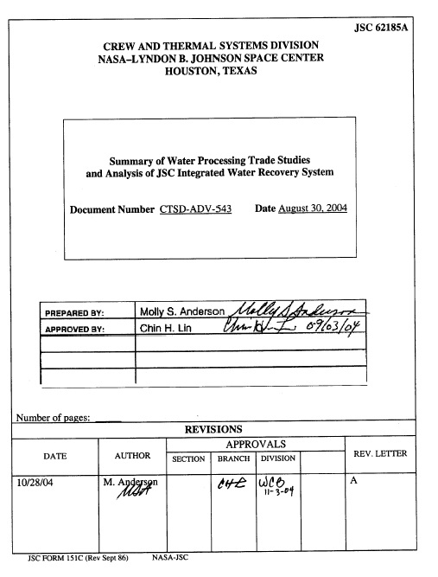

JSC 62185A
CREW AND THERMAL SYSTEMS DIVISION
NASA–LYNDON B. JOHNSON SPACE CENTER
HOUSTON, TEXAS

Summary of Water Processing Trade Studies
and Analysis of JSC Integrated Water Recovery System

Document Number CTSD-ADV-543 Date August 30, 2004
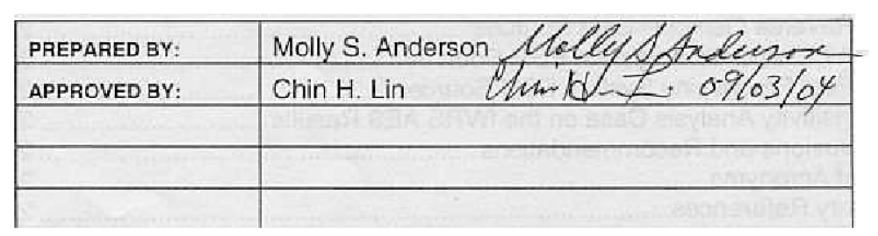
 | PREPARED BY: |  |  | Molly S. Anderson
 | APPROVED BY: |  |  | Chin H. Lin
Number of pages: _____
REVISIONS
 |  |  |  |  | APPROVALS
DATE |  |  | AUTHOR |  | SECTION | BRANCH | DIVISION |  | REV. LETTER
10/28/04 |  |  | M. Anderson |  |  |  |  |  | A
JSC FORM 151C (Rev Sept 86) NASA-JSC
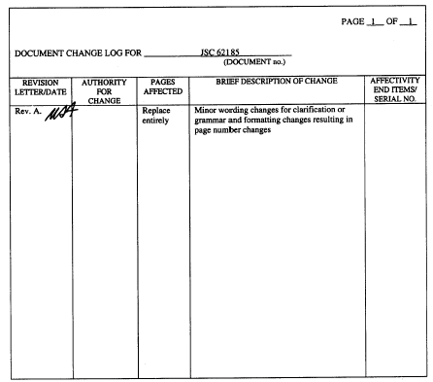
PAGE _1__ OF __1_

DOCUMENT CHANGE LOG FOR _____________JSC 62185____________
(DOCUMENT no.)

REVISION  LETTER/DATE | AUTHORITY  FOR  CHANGE | PAGES  AFFECTED | BRIEF DESCRIPTION OF CHANGE | AFFECTIVITY  END ITEMS/  SERIAL NO.
Rev. A. |  | Replace entirely | Minor wording changes for clarification or grammar and formatting changes resulting in page number changes

Table of Contents
List of Figures ii
List of Tables iv
Introduction 1
1 System Descriptions 1
1.1 International Space Station Water Recovery System 1
1.2 Integrated Water Recovery System 3
1.3 Vapor Phase Catalytic Ammonia Removal System 3
2 System Scaling and Assumptions 4
2.1 Making More Equal Comparisons 4
2.1.1 Infrastructure Factors 5
2.1.2 Adding or Removing Components 6
2.2 System Scaling Methods 6
3 Mission Assumptions 7
3.1 Mission Summaries 7
3.2 Wastewater Flowrates 7
3.3 Equivalent System Mass (ESM) Equivalency Factors 8
3.4 Makeup Water Mass 9
4 Trade Study Results 9
5 ESM Drivers for the IWRS 10
5.1 Biological Water Processor ESM Sources 12
5.2 Reverse Osmosis ESM Sources 14
5.3 Air Evaporation System ESM Sources 15
5.4 Post Processing System ESM Sources 16
6 A Sensitivity Analysis Case on the IWRS AES Results 18
7 Conclusions and Recommendations 20
8 List of Acronyms 21
9 Primary References 22
Papers and Reports: 22
Data References: 22

List of Figures
Figure 1: Simplified schematic of the ISS Urine Processor Assembly, which is a primarily distillation based system. 2
Figure 2: Simplified schematic of the ISS Water Processor Assembly. The primary processing technologies in the ISS WPA are multifiltration, oxidation, and ion exchange. 2
Figure 3: The Integrated Water Recovery System included the Biological Water Processor subsystem that performed oxidation of organic contaminants and nitrification of ammonia. Reverse osmosis and Air Evaporation system provided most of the inorganic contaminant removal, and a post-processing system provided polishing. 3
Figure 4: The VPCAR system uses distillation as a primary processing step, followed by oxidation and reduction reaction. The system is highly thermally integrated. 4
Figure 5: The summary ESM results for the three technologies (and one variation) evaluated show that the VPCAR consistently outperforms the ISS and IWRS systems. The IWRS system less suited for short duration missions than the ISS system, but better suited for long duration missions due to its greater water recovery rate and reduced use of consumables. 9
Figure 6: For the shorter surface missions considered in this trade study, the AES system provides more than 50% of the ESM of the IWRS system. 11
Figure 7: The lower cost of cooling helps reduce the ESM of the AES to less than 50% of the total for the 360-day transit mission, but the AES still provides a significant fraction of the ESM in the longer duration cases. 12
Figure 8: ESM sources for the Biological Water Processor design based on modifications of the original IWRS test bioreactors are shown for a 500-day Mars surface mission. 13
Figure 9: The sources of system mass for the BWP system show that pumps are a significant source of mass in the system. The values shown are for the 500-day Mars surface case. 13
Figure 10: The ESM of the RO system is primarily due to the mass of components, followed by power consumption. The values shown are for a 500-day Mars surface case. 14
Figure 11: Pumps provide the largest source of mass for the RO system in the 500-day Mars surface case shown here. 15
Figure 12: The AES is a large consumer of power, and consequently of cooling, both of which contribute to the ESM of the subsystem. The AES ESM also includes a large mount of consumable mass due to the short wick lifetime, especially for the 500-day Mars surface mission considered here. 15
Figure 13: For a Mars surface mission and assumptions based on IWRS test performance, most of the power consumption in the AES is due to heater power. Only approximately 10% of this heater power is needed to provide the heat of vaporization energy to the brine water. 16
Figure 14: The ESM of the PPS system on the 500-day Mars surface mission is primarily due to consumable mass. 17
Figure 15: The resupply mass of the PPS is primarily due to the consumable IX resin. 17
Figure 16: Reducing the power and cooling required by the AES by 75% does improve the results for the IWRS. More improvement would still be needed from this iteration to be competitive with the VPCAR technology, but the IWRS still consumes more resources than the ISS WRS on the shorter 30 and 90 day surface missions. 18
Figure 17: An alternate AES case was considered due to uncertainty in the AES source data and the significance of the AES values to the IWRS results. The AES still is the largest contributor of ESM to the IWRS, even when the power and cooling are reduced by 75%. 19
Figure 18: Reducing the assumed power consumption and cooling of the AES makes the consumable mass of the system, totally attributed to the replacement of the wicks, more important. Power is still significant, and power and cooling together (as they are linked) still have greater impact than the mass of the wicks. 20

List of Tables
Table 1: A sample of the analysis used to derive the installation infrastructure penalty factor for the Fluids Control and Pump Assembly (FCPA) ORU in the ISS UPA. 5
Table 2: Values for wastewater production rates from the ALS BVAD were used to determine the total amount of wastewater processed daily in each mission scenario. 8
Table 3: Volume, Power, and Cooling equivalency factors used for the ESM analysis of water processing technologies in this trade study. 8

Introduction
Many different technologies have been proposed as solutions to “close the loop” and provide nearly total water recovery for long duration space craft missions. In this trade study, the technologies used on the International Space Station (ISS) are compared to the Integrated Water Recovery System (IWRS) evaluated in tests at the Johnson Space Center (JSC) in 2000 and 2001 and to the Vapor Phase Catalytic Ammonia Removal (VPCAR) system. The systems were scaled to estimate the mass, power, and volume of each system for a number of different mission scenarios. Based on the assumptions made in this analysis, and the equivalent system mass (ESM) technique for system comparisons, the IWRS system outperformed the ISS technologies for very long duration missions, but the VPCAR system outperformed both systems for all cases.

Using the ESM analysis performed to do the trade study, the system drivers that most affect the mass, volume, and power consumption costs in the IWRS system can be identified. Directing future research to these critical areas can help the IWRS and similar systems be more competitive in the future.

System Descriptions
Three systems were compared in this trade study. The first system considered was the ISS Urine Processor Assembly (UPA) and Water Processor Assembly (WPA). ISS technologies are frequently used as a baseline for comparison when evaluating Advanced Life Support (ALS) technologies. The second system evaluated was the IWRS evaluated at JSC to produce potable water using a biological water processor (BWP) as the primary organic removal step. The VPCAR system, evaluated as a third option, is a highly integrated physical-chemical water processing system.

International Space Station Water Recovery System
The ISS Water Recovery System (WRS) processes urine and other wastewaters separately. The UPA, shown in Figure 1, purifies pretreated urine and flushwater with a vapor compression distillation (VCD) process and filtration. The WPA, shown in Figure 2, processes the UPA distillate and other wastewaters including condensate and hygiene waters with multifiltration, partial oxidation, and ion exchange. The system achieves approximately 95% total recovery, with most losses occurring in the UPA.

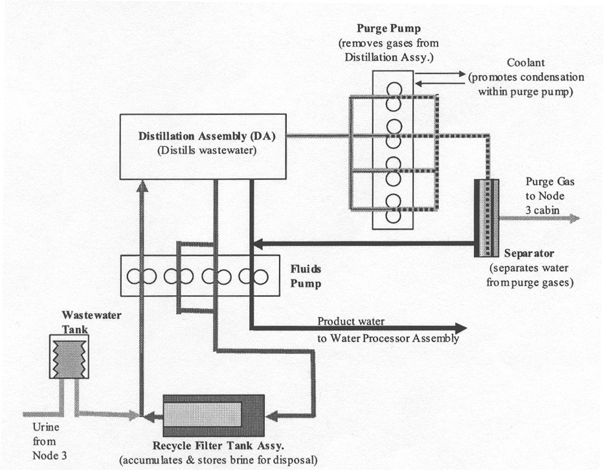
Figure 1: Simplified schematic of the ISS Urine Processor Assembly, which is a primarily distillation based system.

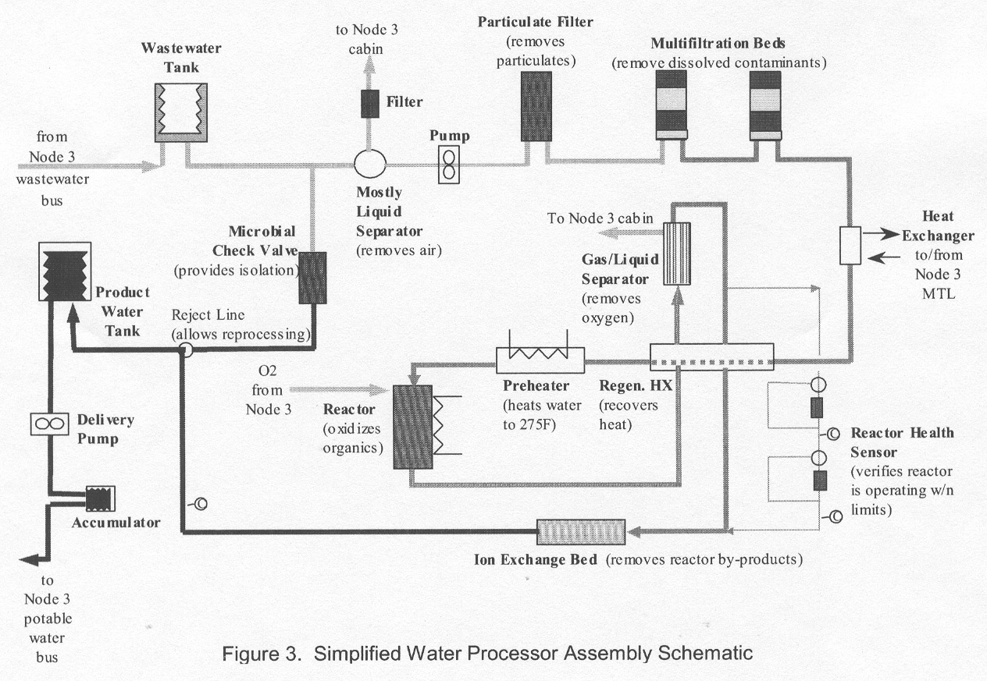
Figure 2: Simplified schematic of the ISS Water Processor Assembly. The primary processing technologies in the ISS WPA are multifiltration, oxidation, and ion exchange.

Integrated Water Recovery System
The IWRS system, shown in Figure 3, processes a combined wastewater stream. It uses biological reactors to oxidize organic compounds and convert ammonia to nitrogen. A reverse osmosis (RO) system treats the BWP effluent and is the primary inorganic removal system. The RO system produces concentrated brine that is processed by the Air Evaporation System (AES). In the AES, a wick absorbs the brine and a hot air stream evaporates the water out while the contaminants accumulate in the wick. That water is condensed from the air stream and combined with the RO permeate to be polished by the Post-Processing System (PPS). The PPS uses ion exchange beds to remove any remaining inorganic contaminants and photo-oxidation to destroy any remaining organic contaminants. The components are all separately designed and have not been optimized for an ISS rack packaging. The IWRS system achieved 98% water recovery.
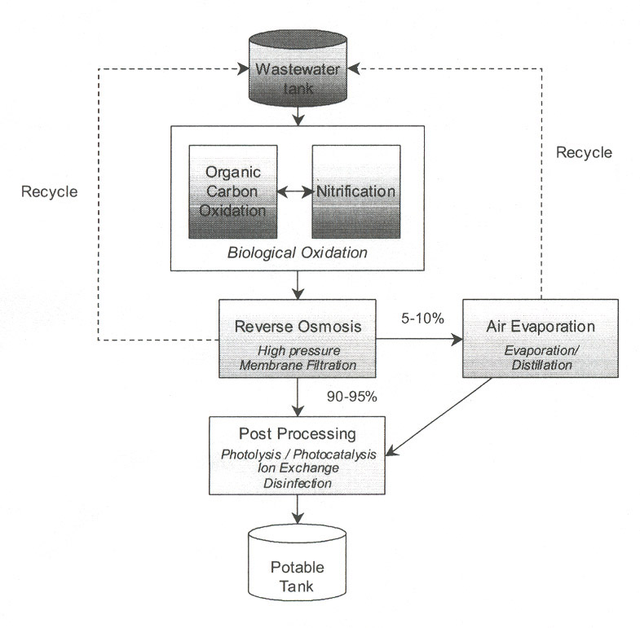

Figure 3: The Integrated Water Recovery System included the Biological Water Processor subsystem that performed oxidation of organic contaminants and nitrification of ammonia. Reverse osmosis and Air Evaporation system provided most of the inorganic contaminant removal, and a post-processing system provided polishing.

Vapor Phase Catalytic Ammonia Removal System
The VPCAR system, shown in Figure 4, is a highly integrated unit that processes a combined wastewater stream to produce potable water. Distillation of the wastewater occurs in the Wiped Film Rotating Disks (WFRD) to remove many inorganic contaminants. The distillate is treated in oxidation and reduction reactors to oxidize lightweight organic components and ammonia and reduce any oxidized nitrogen compounds such as N₂O to nitrogen gas. The design is highly thermally integrated and all components designed to be packaged in an ISS-like rack configuration. The VPCAR system is assumed to achieve 98% water recovery.

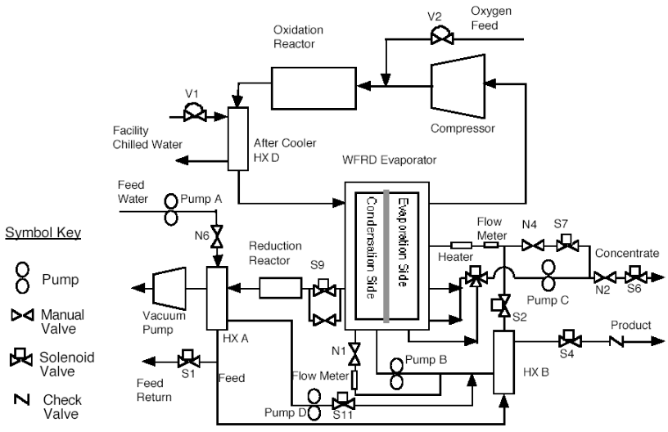
Figure 4: The VPCAR system uses distillation as a primary processing step, followed by oxidation and reduction reaction. The system is highly thermally integrated.

System Scaling and Assumptions
Because the water recovery systems evaluated may have been developed for significantly different wastewater loads, each system must be scaled to the appropriate size for the mission cases considered in this trade study. Scaling relationships used in this study vary from the very simple to the very complex. In addition to scaling the size of the components in each system, it is important to make sure that each system provides all of the same functions and attempt to equally account for the mass of the infrastructure required to install and operate the system.

Making More Equal Comparisons
Whenever systems being developed in the ALS program are compared to systems already optimized, packaged, and designed for spaceflight, issues arise as to the fairness of the comparisons. It can be argued that ALS systems are not optimized to the degree that systems at a higher technology readiness level (TRL) are, and that their mass would be reduced as they mature. It can also be argued that ALS systems do not account for the additional mass due to additional safety requirements, installation requirements, and reliability issues that flight systems include.

To address the optimization issue in the IWRS, flight components from other systems were substituted for commercial components in many cases. Commercial components, such as pumps, were assumed to be used at their maximum recommended flowrates to achieve a minimum reasonable mass for each unit, unless directed otherwise by the system designer for performance reasons, as in the case of membrane contactors that appear to be overdesigned according to manufacturer recommendations.

The VPCAR system claims to be designed as a somewhat flight-like unit. No modifications or adjustments were made to the current values to account for optimization.

Oxygen consumption is not included in this trade study comparison, but could impact the size of the ECLSS Architecture, as oxygen demands for one system may be significantly larger than others. Systems that perform total oxidation through chemical or biological means will impact consumable and oxygen production systems more than those that remove and dispose of many organic contaminants before oxidizing the remaining components.

Infrastructure Factors
A detailed study of the ISS UPA and WPA was conducted to assess what portion of the mass of each Orbital Replacement Unit (ORU) consisted of components that performed water processing functions, and what portion of the mass was due to components such as lines, packaging or acoustic enclosures, brackets, bolts, and other miscellaneous hardware. After this assessment, it was determined that on average, a factor of 1.6 would have to be assessed to the water processing components to include the additional mass needed to install the units as ORUs in an ISS rack. Table 1 shows an analysis of the Fluids Control and Pump Assembly (FCPA) ORU as an example. This factor of 1.6 was applied to the mass of each component in the IWRS system. A study of the VPCAR system, with slightly less detail available, determined a factor of 1.4 would be derived from comparing the mass of the water processing components to the mass of the installed system, not including the rack and outside frame. Further study may be helpful for determining how to assess penalties for installation infrastructure to be applied to ALS systems in development.

Fluids Control and Pump Assembly ORU  Subcomponents | Direct Water Processing Function? | Component Mass (kg) | Water Processing Mass (kg) | Other Function Mass (kg)
Motor Support | NO | 0.027215 |  | 0.027215
Fluid Pump Control Assy | YES | 31.9282 | 31.9282
Flex Line Assy | NO | 3.188738 |  | 3.188738
Wire Harness Assy | NO | 2.313309 |  | 2.313309
Seat Track Channel | NO | 0.240403 |  | 0.240403
Coolant Loop Motor | NO | 0.072574 |  | 0.072574
Bracket, Clamp | NO | 0.009072 |  | 0.009072
FCPA Enclosure Base | NO | 4.499613 |  | 4.499613
FCPA Enclosure Top | NO | 2.140945 |  | 2.140945
Front Enclosure Assy | NO | 1.514991 |  | 1.514991
Rear Enclosure Assy | NO | 2.236199 |  | 2.236199
Misc Hardware | NO | 0.557916 |  | 0.557916
FCPA Water | NO | 2.385883 |  | 2.385883
Totals |  | 51.11506 | 31.9282 | 19.18686
Factor = Total/Water Processing | 1.600938
Table 1: A sample of the analysis used to derive the installation infrastructure penalty factor for the Fluids Control and Pump Assembly (FCPA) ORU in the ISS UPA.

Adding or Removing Components
Components were added to the current IWRS and VPCAR system to ensure that the masses compared accounted for performing the same function. A controller unit was added to the IWRS based on the ISS WPA controller. The VPCAR system includes a controller already. A feed tank, microbial check valve (MCV), potable water storage tank, and potable water delivery system were added to both the IWRS and the VPCAR system.

System Scaling Methods
The scaling methods used to size the ISS UPA and WPA, the IWRS, and the VPCAR system were all slightly different.

For the ISS systems, commercial components of the same type were used to determine how the size of these units varied with flowrate. It is important to recognize that the flight unit sizes were used as the basis for scaling, and only the rate of change was based on commercial units. The ISS system was designed to be adaptable for varying loads of wastewater. Increasing the daily processing time provides much of this adaptability. For components such as pumps and heaters, which are scaled based on flowrate, not daily load, both the maximum and minimum load cases result in the same flowrate. For tanks, which depend on daily load for sizing and are not replaced, the maximum case was used. For consumables, such as multifiltration and ion exchange beds, it is assumed that the stated design lifetimes are for the nominal case.

The JSC IWRS is built primarily of commercial components. The primary goal of the IWRS test was to demonstrate that using a system with a bioreactor as a primary processor to recover potable water from wastewater was possible. The system was not optimized for mass or power consumption. Some components were selected based on availability rather than their ideal size, and some components were deliberately oversized to provide plenty of margin. In this trade study, an attempt was made to use more appropriately sized components where possible. This includes selecting commercial pumps based on use at their maximum flowrate. Some units, such as the membrane contactors used in the post-processing system, were significantly oversized according to manufacturer recommendations, but were used in the trade study as they were used in the test according to direction from the system designer.

Significant adjustments were made to the designs of the bioreactors themselves to provide more optimized designs than were used in the test. The anoxic oxidation reactor used in the IWRS test used ceramic saddles as packing. In this analysis, a bio-bale like material is used while scaling to maintain the same surface area for microbial growth. The nitrifying reactor used in the test was a tubular reactor that had significant maintenance issues in the test. A new design for a nitrification reactor using a bio-bale packed bed and external membrane oxygenation was substituted for the tubular design. There is still a large amount of uncertainty in determining what the correct sizing methods for bioreactors should be, but as the mass of the bioreactors does not appear to be one of the largest drivers of the IWRS mass, these uncertainties can be accepted. New research beginning at JSC should help address these bioreactor sizing questions for future trade studies.

The VPCAR system was not originally in the primary focus of this trade study, but because updated information was made available, it was included for comparison. The VPCAR processing components were scaled based on a 40/60 assumption. Essentially, 40% of the mass of the system is kept constant, while 60% of the mass scales linearly with flow. Power was scaled linearly, based on the assumption that pumps and heaters would maintain the same efficiency and specific energy to process the wastewater. The controller was kept constant in all cases, as in the ISS and IWRS cases.

Mission Assumptions
Four separate mission scenarios were considered in this analysis. These missions had crews of four or six, included surface and transit scenarios, and had significant variations in the sources and amounts of wastewater to be processed.

Mission Summaries
The first category of missions considered is short-term surface stays. These missions included a 30-day and 90-day scenario with four crewmembers. For the 30-day scenario, the wastewater sources were assumed to be crew urine, flushwater, oral hygiene, handwash and facewash water, and condensate water for a load of 35 kg/day. For the 90-day surface mission, wastewater from a shower system is added for a load of 49 kg/day. These missions are variations on the lunar outpost scenario developed by the JSC water team, or possibly short-term Mars surface stays.

The next mission scenario is a 360-day transit mission, used to estimate the trip to and from Mars using current propulsion technologies. In this transit mission, a crew of six is expected to produce wastewater from urine, flushwater, condensate, and water recovered from CO₂ reduction in a Sabatier reaction. Only 29 kg/day of wastewater is produced.

The final mission scenario is a 500-day surface stay. This case is similar to the Mars habitat or Early Planetary Base (EPB) scenario developed by the JSC ALS water team with some modifications. The crew of six produces wastewaters from urine, flushwater, oral hygiene, handwash and facewash, shower, as well as condensate water and water recovered from a Sabatier reaction. The total wastewater load in this case was 77 kg/day.

Wastewater Flowrates
Wastewater flowrates from each source were taken from the ALS Baseline Values and Assumptions (BVAD) document. For the 30-day and 90-day surface cases values from the Early Planetary Base categories were used. For the 360-day transit mission, values from the Transit Mission category were used, including a reduction in the amount of flushwater. For the 500-day surface stay, the Mature Planetary Base (MPB) case was used, including an increase in the amount of condensate recovered. Table 2 shows these values as reported in the ALS BVAD.

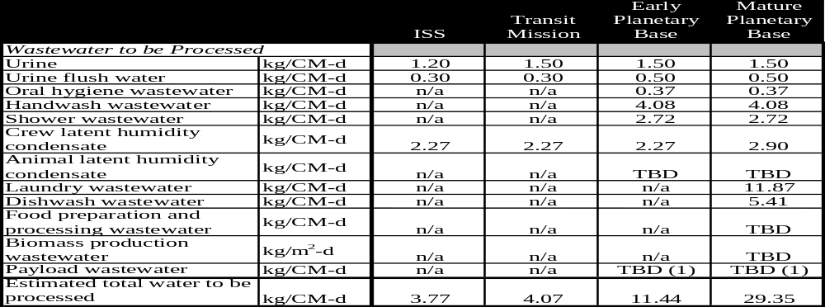
Table 2: Values for wastewater production rates from the ALS BVAD were used to determine the total amount of wastewater processed daily in each mission scenario.

Equivalent System Mass (ESM) Equivalency Factors
The Systems Integration, Modeling, and Analysis (SIMA) element of ALS frequently uses ESM as a technique for determining the least resource intensive technology while trading the cost of mass, volume, power, and cooling. Equivalency factors allocate the cost of structure, power generation, and thermal control systems to the technologies based on the use of these infrastructures. The equivalency factors for each system depend on the mission and the technology selected, and are shown in Table 3.

 | Equivalency | Units | Assumed System
Mars Surface
Volume | 9.16 | kg/m³ | Unshielded inflatable volume
Power | 228 | kg/kW | 20% efficient photovoltaic system  with regenerative fuel cells
Cooling | 146 | kg/kW | Flow through radiators on Mars
Mars Transit
Volume | 9.16 | kg/m³ | Unshielded inflatable volume
Power | 237 | kg/kW | Hybrid solar array
Cooling | 60 | kg/kW | Internal coolant loop and advanced lightweight radiators
Table 3: Volume, Power, and Cooling equivalency factors used for the ESM analysis of water processing technologies in this trade study.

For all of the surface cases, infrastructure factors based on a Mars surface case were selected. The 30-day and 90-day surface cases could also be representative of a lunar surface case. However, until a reference mission for a lunar case is better established, it will be difficult to determine the correct factors for that case. Also, it is possible that these lunar cases will be simulations of Mars missions, in which case it makes sense to select technologies most appropriate for the Mars missions, and gain experience with them on the lunar surface. For the transit case, the Mars transit factors are assumed. Table 3 documents the equivalency factors used in this trade study and the assumed infrastructure technology that factor is derived from. These values are used for calculating the ALS Metric annually and are listed in the ALS BVAD.

Makeup Water Mass
While all of the systems considered have nearly total recovery of wastewater, over long durations small differences in the fraction of water recovered can have a significant impact on the system mass as replacement for lost water has to be provided. After the systems have been sized to process the wastewater for each case, and the volume, power, and cooling have been converted to equivalent masses, the final addition of mass before comparison is from makeup water used to replace water lost during processing. For the ISS systems, that is 5% of the daily wastewater load multiplied over the mission duration. For the IWRS and VPCAR systems, only 2% of the feed wastewater is lost.

Trade Study Results
In an ESM based trade study, the system with the lowest ESM should be selected. The three systems discussed above were compared, with the addition of a fourth option. As later sections will show, the AES contributes a large portion of the ESM of the IWRS system, but only processes 10% of the wastewater. The fourth option simply subtracts the ESM of the AES from the IWRS values and assumes that 10% of the daily wastewater load must be replaced instead of 2%. Based on the results shown in Figure 5, the VPCAR system is clearly the best performing system in all cases. For short duration missions (30-90 days), the JSC IWRS without the AES or the ISS UPA and WPA are the next best candidates. The full JSC IWRS system had the highest ESM for short duration missions. For long duration missions (360-500 days), the full JSC IWRS system has a lower ESM than the IWRS system without an AES or the ISS UPA and WPA.

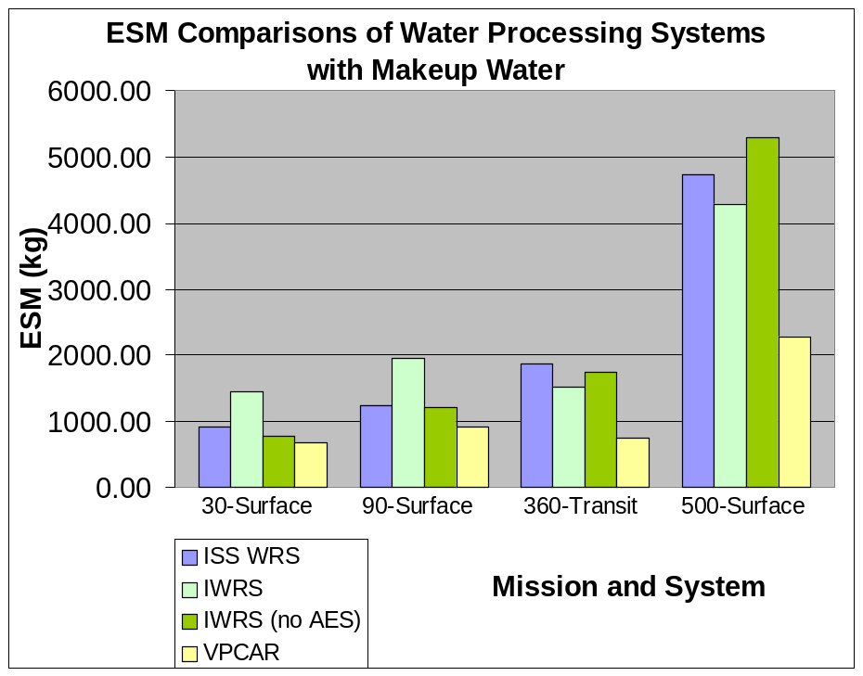
Figure 5: The summary ESM results for the three technologies (and one variation) evaluated show that the VPCAR consistently outperforms the ISS and IWRS systems. The IWRS system less suited for short duration missions than the ISS system, but better suited for long duration missions due to its greater water recovery rate and reduced use of consumables.
These results show the benefit of systems with no or reduced consumables over long duration missions. The performance of the VPCAR system demonstrates the power of a highly integrated system in achieving efficiencies over the less integrated ISS UPA and WPA or the IWRS units.

ESM Drivers for the IWRS
ESM analysis can be used as a powerful not just for comparing systems, but for determining what are the most costly portions of the system for an efficient use of time and effort to reduce the mass, volume, or power consumption for the most benefit. The sections below compare the ESM due to the system mass and stored consumable parts mass, the system volume and consumable parts volume, and system power for the BWP, RO, AES, and PPS subsystems of the IWRS. The most costly portion of each subsystem is then analyzed in greater detail to determine which components would provide the most payoff if efforts to reduce their size or power consumption were made.

The relative contributions of each of the subsystems to ESM are revealing as they show how the drivers for each mission shift or stay the same depending on whether the mission is short or long. Figure 6 shows the ESM sources for the short duration missions, and Figure 7 shows the ESM contributions of the IWRS subsystems for the longer duration missions. The AES contributes a large fraction of the system ESM regardless of the mission. The significant power consumption of the AES is expensive in every case. The relative contribution of the BWP system decreases over time, as its resupply cost is smaller than the initial investment in the system mass. The system described as “Potable” in Figure 6 and Figure 7 is the mass of the MCV, potable water storage, and potable water delivery system. These systems were not originally included in the IWRS, but are required for a fair trade study between the IWRS and the ISS systems. They do not change much over time. The RO ESM increases for the very long 500-day Mars surface mission, but still provides a relatively small fraction of the system ESM. The relative contribution of the PPS increases over longer durations. The PPS resupply cost increases beyond the initial investment in system mass over long missions due the consumables designed into the system. The amount of makeup water increases over long durations as well. This makeup water increase has a significant impact on the total ESM values displayed in Figure 5.

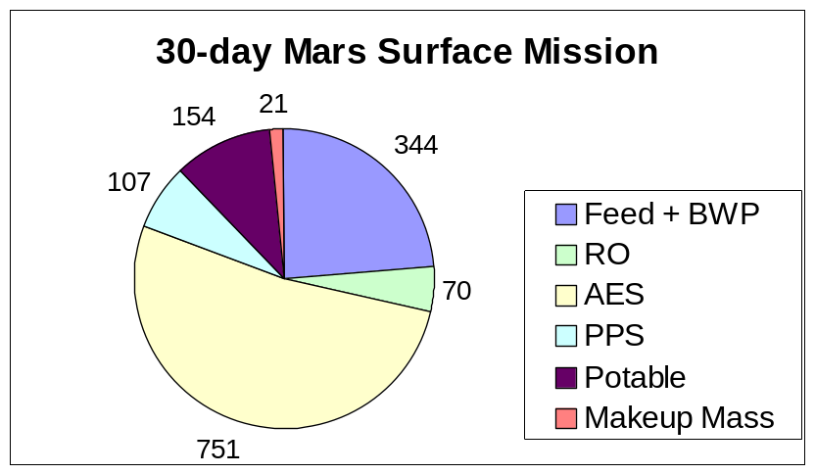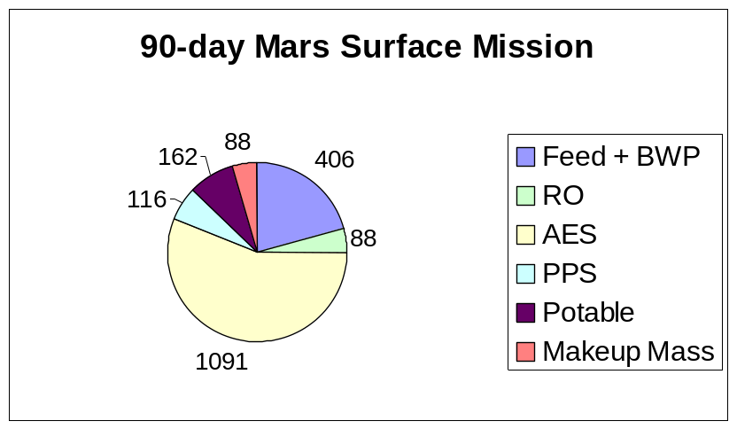
Figure 6: For the shorter surface missions considered in this trade study, the AES system provides more than 50% of the ESM of the IWRS system.

Overall, it can be seen from Figure 6 and Figure 7 that decreasing the AES ESM will have results for all missions. Decreasing the BWP system mass would be helpful as well. Decreasing the resupply mass of the PPS could have a significant impact, but primarily for long duration missions. While increasing system water recovery would reduce the resupply water, it is possible that 100% water recovery is not necessary in all life support architectures. Increasing the water recovery is most likely a more difficult process than decreasing the mass of the other systems, considering the current TRL of the IWRS, and is not recommended as the primary improvement in the system.

The IWRS seems most promising for the 500-day surface mission with a long duration and large water load. In sections 5.1 through 5.4 the sources of ESM for each subsystem will be analyzed to find promising routes for reducing the ESM of the entire system.

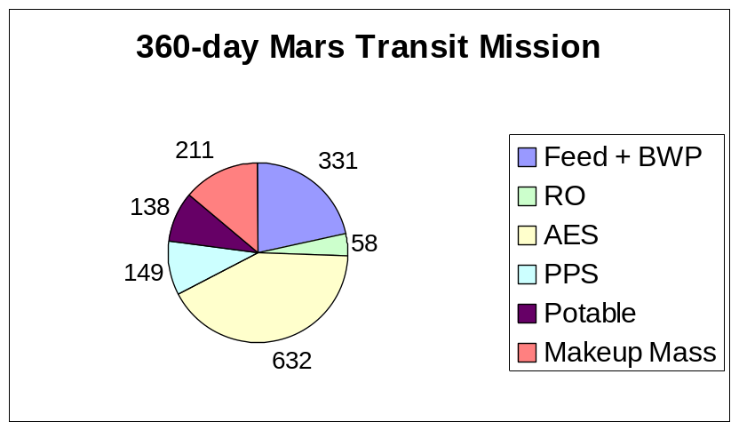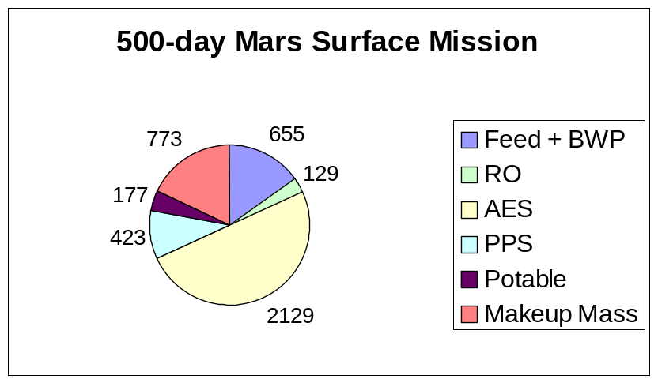
Figure 7: The lower cost of cooling helps reduce the ESM of the AES to less than 50% of the total for the 360-day transit mission, but the AES still provides a significant fraction of the ESM in the longer duration cases.

Biological Water Processor ESM Sources
The benefits of biological systems are advertised as low power consumption because the system operates at ambient temperatures and relatively low pressures, and low consumable usage rates. The bioreactors used in this trade study were modified from the actual designs used in the IWRS test, assuming packed beds for both the anoxic oxidation denitrification reactor and the nitrifying reactor. The beds are packed with Bio-bale material, and an external membrane oxygenation unit is used. There is significant uncertainty in the sizing relationships for the reactors due to these modifications, and uncertainty in the correct basis for sizing the reactors. The resulting numbers for these units have been verified by system developers as at least reasonable values for reactor sizes, but improvements in future trade studies will provide good information. Based on these assumptions, it can be seen in Figure 8 that the original mass of the BWP system is the largest source of ESM in the system, which shows that the advertised benefits of the BWP system are valid.

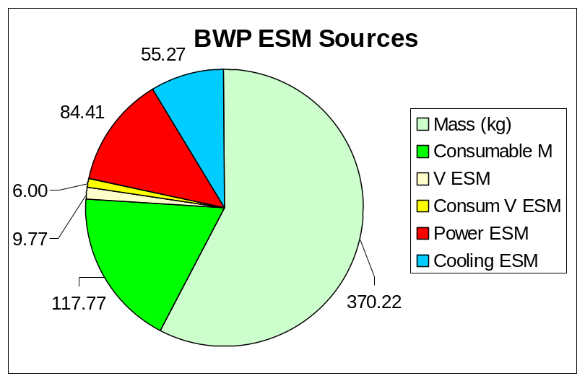
Figure 8: ESM sources for the Biological Water Processor design based on modifications of the original IWRS test bioreactors are shown for a 500-day Mars surface mission.

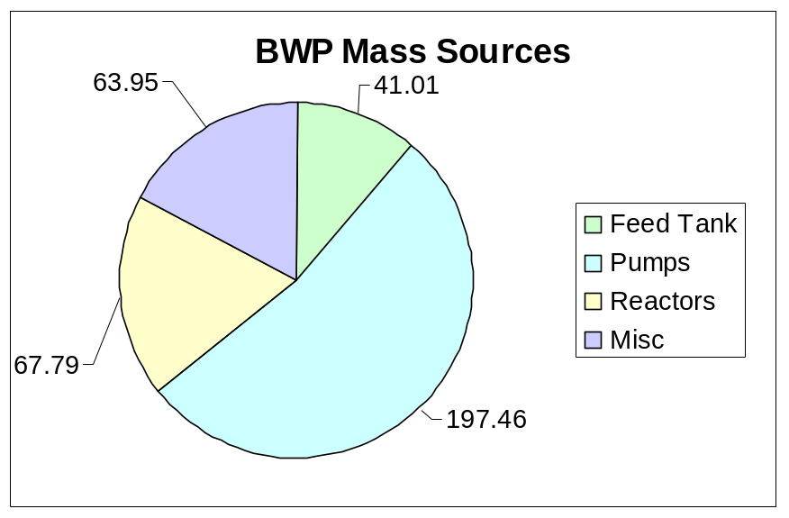
Figure 9: The sources of system mass for the BWP system show that pumps are a significant source of mass in the system. The values shown are for the 500-day Mars surface case.
Based on the results in Figure 8, an analysis of the source of the BWP mass can be used to determine the components that will be the most advantageous to reduce in mass. In Figure 9, the masses of the components of the BWP are grouped by type. One of the largest sources of mass is due to the pumps in the system. The BWP operated with a 20:1 recycle ratio in the IWRS test. Current research uses smaller recycle ratios, on the order of 10:1. This change will reduce the size of the pumps and should reduce the mass of the BWP system. This change could also improve the size of the oxygenator units and gas-liquid separator listed under “Misc” in Figure 9. Optimizing the pumps required for this system may be an important engineering task as the IWRS matures.

Reverse Osmosis ESM Sources
The RO system is the primary inorganic removal step in the IWRS system. The contaminants are concentrated in a brine stream that is sent to the AES. The RO system provides a relatively small amount of the mass of the IWRS system. The mass of the system is the largest fraction of the RO ESM, followed by power consumption, as shown in Figure 10. Based on these results, and the assumptions in the study, such as using spiral wound membranes with a one-year life, the RO system has relatively small resupply requirements. The RO process requires high pressure provided by pumps, so some significant power consumption is inevitable. Selecting pumps with high efficiencies could be very beneficial for this system. But any changes to the RO will likely have a relatively small impact on the IWRS system mass because the RO is already small compared to the other IWRS subsystems.

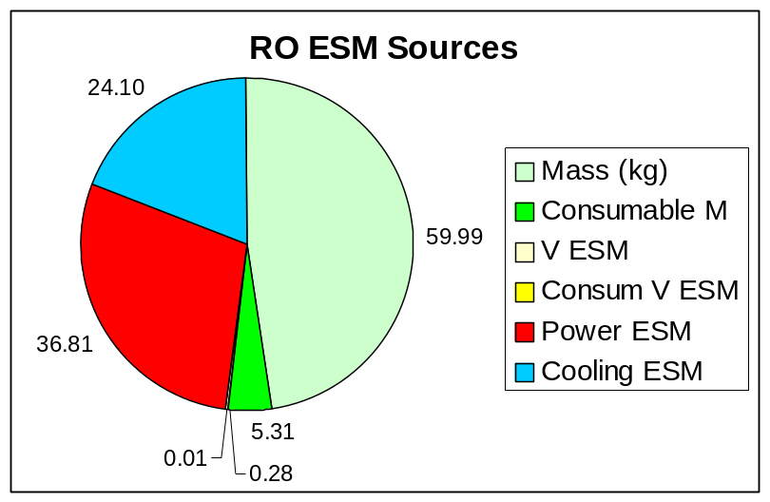
Figure 10: The ESM of the RO system is primarily due to the mass of components, followed by power consumption. The values shown are for a 500-day Mars surface case.

Like the BWP, the largest source of mass in the RO system is due to the pumps. The RO system requires a low flowrate high-pressure pump, and a high-speed low-pressure drop pump to handle the recycling of fluids in the system. Finding membranes that operate at lower pressure, or minimizing the flowrate in the recycle loop without fouling the membrane may be beneficial routes of investigation for the RO system.

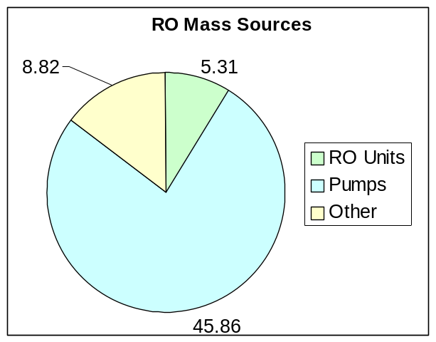
Figure 11: Pumps provide the largest source of mass for the RO system in the 500-day Mars surface case shown here.

Air Evaporation System ESM Sources
Examining and improving the AES may be one of the most efficient ways of improving the IWRS system. The AES regularly provided on the order of 50% of the ESM of the IWRS system. Figure 12 shows that the majority of the ESM for the AES system on the 500-day Mars surface is due to power. Over this long duration, the resupply mass due to replacing wicks is also significant. In this study, it is assumed that only the wick mass is replaced, and not the container. If this is not feasible, the resupply mass and the AES ESM would increase further.

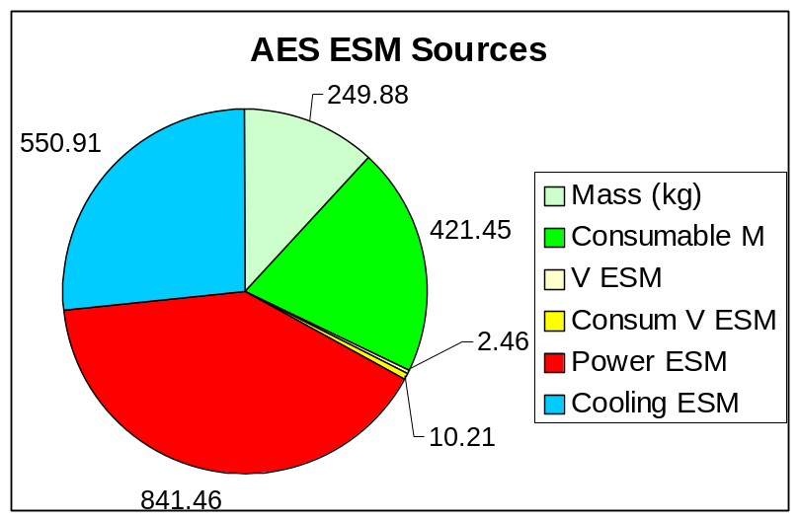
Figure 12: The AES is a large consumer of power, and consequently of cooling, both of which contribute to the ESM of the subsystem. The AES ESM also includes a large mount of consumable mass due to the short wick lifetime, especially for the 500-day Mars surface mission considered here.

Previous studies of the AES assumed much less power would be needed to recover water from the RO brine. In the IWRS test, approximately 1550 W was needed to process 2.29 kg of brine each day. An earlier trade study (Yeh 1999) assumed that 577 W would be used to recover 5.08 kg/day of brine. An earlier analysis by Dr. Kevin Lange estimated that 490 W could be used to recover 11.08 kg/day of water from the brine. Clearly, the performance in test is significantly different from early estimates. If there were reasons that the power consumption had to be increased in test to make the system function successfully, those need to be documented as lessons learned. Future efforts with the AES should focus on reducing the power consumption of the AES. Most of this power consumption is due to the heaters, as is shown in Figure 13. Based on the ratio of airflow to water recovered, and the change in air temperature from 7C to 58C used in the IWRS test, only approximately 10% of the heater energy is actually used to vaporize water from the brine.

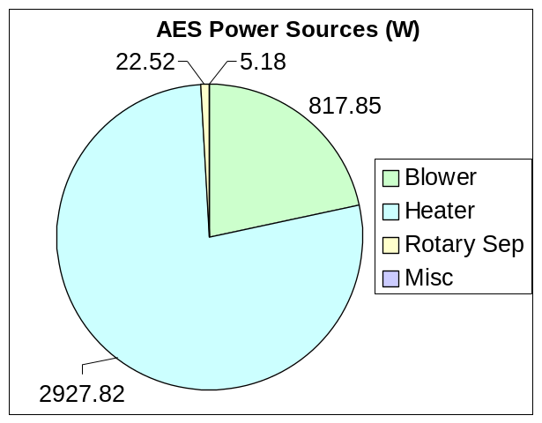
Figure 13: For a Mars surface mission and assumptions based on IWRS test performance, most of the power consumption in the AES is due to heater power. Only approximately 10% of this heater power is needed to provide the heat of vaporization energy to the brine water.

Post Processing System ESM Sources
The PPS provides final polishing of the RO permeate and the AES condensate water. The system is designed to use ion exchange (IX) resin, a consumable, to remove remaining inorganic components. The remaining organic components are oxidized with ultraviolet light lamps.

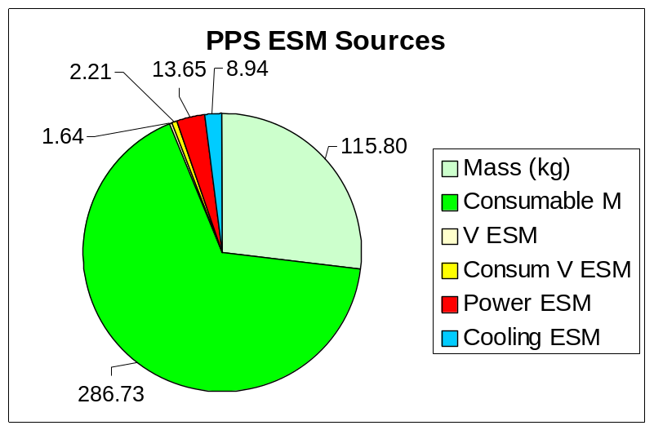
Figure 14: The ESM of the PPS system on the 500-day Mars surface mission is primarily due to consumable mass.
As a consequence of using the consumable IX resin, resupply mass is a significant portion of the PPS ESM for a long duration mission, as shown in Figure 14. Current PPS optimization efforts are focused on extending the life of the PPS IX resin by removing CO₂ that can fill the bed as carbonate ions. The removal of CO2 is accomplished by adding additional membrane contactors. The current contactors used to supply oxygen to the UV units provide the second largest portion of the PPS system mass, and are significantly oversized. The membrane contactors in the study are based on the ISS membrane based Gas-Liquid Separator (GLS) ORU, not the small plastic commercial units used in the test. The size and lifetime of the membrane contactors added to the system should be considered to ensure that they do not add as much mass as they save in IX resin mass. Finding more support for using lightweight commercial membrane contactors, or estimating the mass added to give them needed structural strength, could improve the mass estimates for the PPS as well.

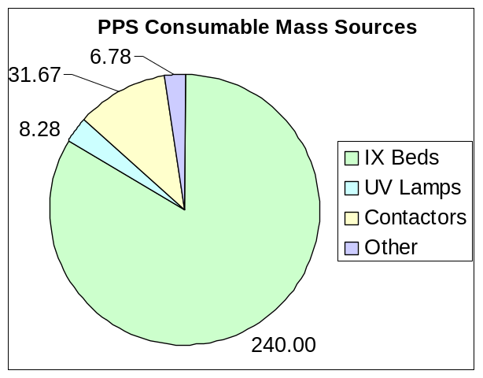
Figure 15: The resupply mass of the PPS is primarily due to the consumable IX resin.

A Sensitivity Analysis Case on the IWRS AES Results
The AES system clearly has significant impact on the ESM of the IWRS design for water processing. A review of these results uncovered the possibility that the system power consumption should be calculated as significantly less than the values presented. The original goal for AES performance in the IWRS test was to continuously process brine using a coolant loop at a 18C-32C temperature. The coolant temperature was changed to 7C, and the duty cycle of the unit may was reduced from continuous operation to something less, though the cycle likely varied with experimentation.

The previous results would be valid if the maximum power consumption is the power scaling parameter of interest. This is especially true because the maximum power is sustained for long periods of time, and does not simply spike like actuating valves or other instantaneous power users. However, the time averaged power value would be much lower. This sensitivity analysis considers the results if the time averaged power were used.

To look for impacts of this change, a second analysis of the IWRS was done assuming that the power and cooling of the system is one quarter of what was calculated in the results in previous sections. A comparison of the modified IWRS values to the ISS and VPCAR systems is shown in Figure 16. The reduction does improve the ESM results for the IWRS, but not change the qualitative results. The IWRS still consumes more resources than the ISS WRS for the 30 and 90-day surface missions. The IWRS is more economical on long duration missions, but still is not better than the VPCAR system based on the current assumptions.
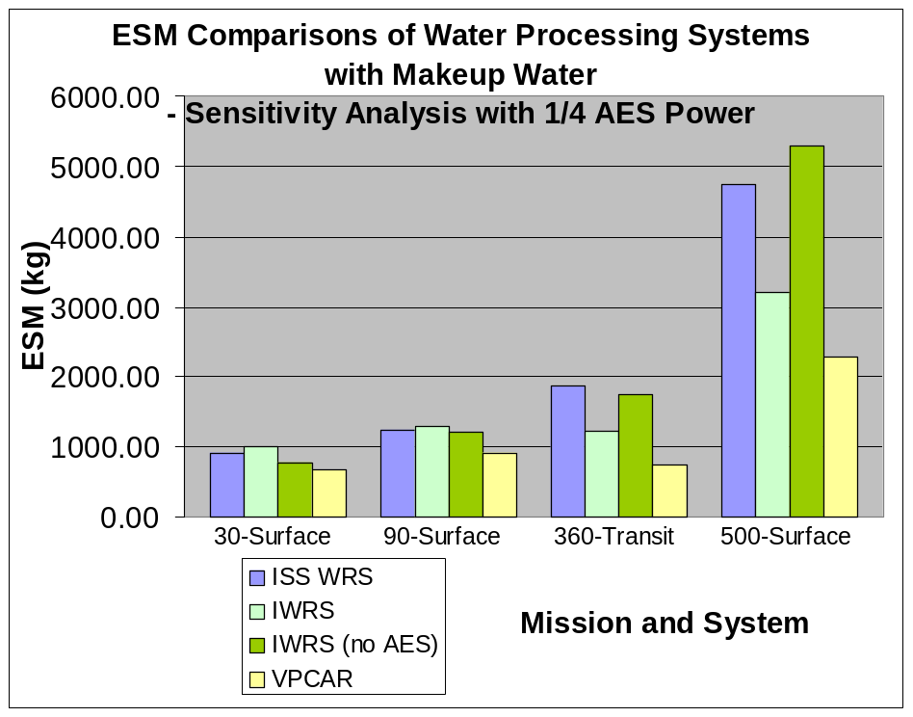
Figure 16: Reducing the power and cooling required by the AES by 75% does improve the results for the IWRS. More improvement would still be needed from this iteration to be competitive with the VPCAR technology, but the IWRS still consumes more resources than the ISS WRS on the shorter 30 and 90 day surface missions.

The AES is still the largest source of ESM in the IWRS when the power calculations are reduced. For the 30 and 90-day surface missions, the AES contributes 40% and 42% of the total ESM. For the longer cases, shown in Figure 17 below, the AES contributes 34% of the IWRS ESM for the 360-day transit case, and 39% of the IWRS ESM for the 500-day surface case.
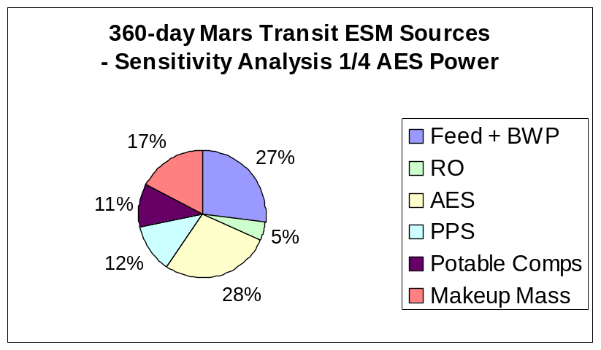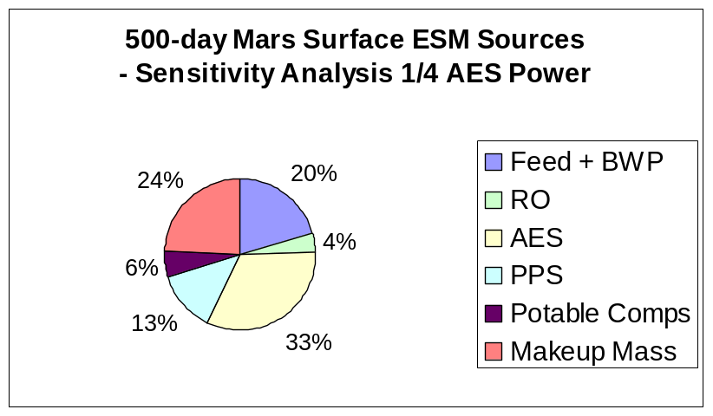
Figure 17: An alternate AES case was considered due to uncertainty in the AES source data and the significance of the AES values to the IWRS results. The AES still is the largest contributor of ESM to the IWRS, even when the power and cooling are reduced by 75%.

With this change in the assumed power consumption, the replacement wick mass becomes the most important ESM driver for the three shorter duration missions. The power is still significant, especially if power and cooling are considered together (as they are directly related). This suggests that significant reductions in ESM for a long mission could also be accomplished by extending wick life in the AES.

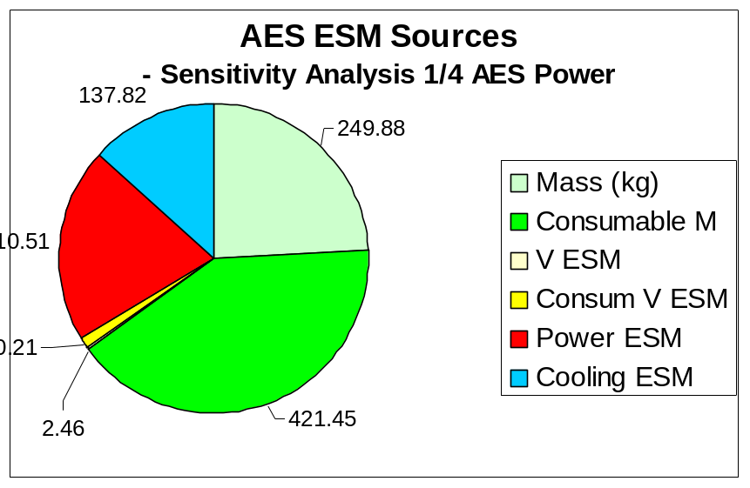
Figure 18: Reducing the assumed power consumption and cooling of the AES makes the consumable mass of the system, totally attributed to the replacement of the wicks, more important. Power is still significant, and power and cooling together (as they are linked) still have greater impact than the mass of the wicks.

Conclusions and Recommendations
The performance of the JSC IWRS and the VPCAR system show that increased water recovery and reduced use of consumables can provide significant mass savings over long duration missions. Based on the values currently available, the VPCAR system performs very well. This system has a lot of potential and should be followed closely in development to ensure that the assumptions made here are valid. The JSC IWRS system showed that the biological technologies that perform a large portion of the water processing are relatively low cost due to their low power consumption and low resupply rate. There are opportunities to reduce the costs of the BWP systems. However, systems downstream of the BWP, especially the AES, contribute significantly to the total water recovery system design. Reducing the ESM of the systems downstream of the BWP, especially the AES, is imperative to make the system competitive with other ALS water recovery technologies in development.

List of Acronyms

Acronym Definition

AES Air Evaporation System
ALS Advanced Life Support
BVAD Baseline Values and Assumptions Document
BWP Biological Water Processor
EPB Early Planetary Base
ESM Equivalent System Mass
FCPA Fluids Control and Pump Assembly
ISS International Space Station
IX Ion Exchange
IWRS Integrated Water Recovery System
JSC Johnson Space Center
MCV Microbial Check Valve
MPB Mature Planetary Base
ORU Orbital Replacement Unit
PPS Post-Processing System
RO Reverse Osmosis
SIMA Systems Integration Modeling and Analysis
TRL Technology Readiness Level
UPA Urine Processor Assembly
VCD Vapor Compression Distillation
VPCAR Vapor Phase Catalytic Ammonia Removal
WFRD Wiped Film Rotating Disk
WPA Water Processor Assembly

Primary References

Papers and Reports:
Carter, Layne. “Waste Water Characterization for the ISS Water Processor.” SAE No. 981616. 28th International Conference on Environmental Systems. Danvers, MA. 13-16 July 1998.

Campbell, Melissa, Barry W. Finger, Charles E. Verostko, Kristina R. Wines, Gina M. Pariani, Karen D. Pickering. “Integrated Water Recovery System Test.” SAE No. 2003-01-2577. 33rd International Conference on Environmental Systems. Vancouver, BC, Canada. 7-10 July 2003.

Flynn, Michael, John Fisher, Mark Kliss, Badawi Tleimat, Maher Tleimat, Gregory Quinn, James Fort, Tim Nalette, Gale Baker, Joseph Genovese. “The Development of the Vapor Phase Catalytic Ammonia Removal (VPCAR) Engineer Development Unit.” SAE No. 2004-01-2495. 34th International Conference on Environmental Systems. Colorado Springs, CO. 19-22 July 2004.

Hanford, Anthony. “Advanced Life Support Baselines Values and Assumptions Document, Revision A.” NASA CTSD-ADV-484A. NASA Johnson Space Center. February 2004.

“Integrated Water Recovery System Final Report.” (Draft) NASA Johnson Space Center Crew and Thermal Systems Division.

Norman, Ed. “Environmental Control and Life Support System Water Recovery System Electrical Power and Energy Management Report (EPEMR).” SLS-WRS-007. National Aeronautics and Space Administration, George C. Marshall Space Flight Center, Huntsville, Alabama. 9 June 2003.

Parker, David S., Edward W. O’Connor, and Robert Bagdigian. “ISS Water Reclamation System Design.” SAE No. 1999-01-1950. 29th International Conference on Environmental Systems. Denver, CO. 10-13 July 1999.

Pisharody, Suresh, K. Wignarajah, and John Fisher. “Oxygen Penalty for Waste Oxidation in an Advanced Life Support System – A Systems Approach.” SAE No. 2002-01-2396. 32nd International Conference on Environmental Systems. San Antonio, TX. 15-18 July 2002.

Volk, Tyler, and John D. Rummel. “Mass Balances for a Biological Life Support System Simulation Model.” Advances in Space Research. Vol. 7 No. 4 (1987): 141-148.

Walton, Timothy. “ECLSS Project Mass Properties Report.” SLS-JA21-012 Rev A. National Aeronautics and Space Administration, George C. Marshall Space Flight Center, Huntsville, Alabama. 31 October 2004.

Wydeven, Theodore, and Morton A. Golub. “Generation Rates and Chemical Compositions of Waste Streams in a Typical Crewed Space Habitat.” NASA TM 102799. Ames Research Center. August 1990.

Yeh, H. Y. “VPCAR and BWRS Trade Study.” Lockheed Martin Nos. LMSEAT 33212 and HDID-2G42-1164. September 17, 1999.

Data References:
ECLSS ORU List (Excel spreadsheet)
Provided by Dave Williams, ISS ECLS System Manager, NASA JSC-EC
Source for ORU level mass, dimensions, and volume information

Molly Anderson PL (Excel spreadsheet)
Provided by Donna Grossman, Lead Designer for WPA, Hamilton Sundstrand
Source for detailed WPA component mass information, including actual masses

