USDA Foreign Agricultural Service
GAIN Report

Template Version 2.09

Global Agriculture Information Network

Required Report - public distribution
Date: 3/10/2005
GAIN Report Number: AR5008
AR5008
Argentina
Grain and Feed
Annual
2005

Approved by:
Bob Hoff
U.S. Embassy
Prepared by:
Kari Rojas

Report Highlights:
Wheat production for Marketing Year (MY) 2005/06 (December - November) is forecast at 15.5 million metric tons (MMT) on 6.25 million hectares (has.), down 3 percent from the previous year. Corn production in MY2005/06 is forecast down slightly at 17.5 MMT on 2.65 million has.. The wheat harvest for MY2004/05 ended in late January with 16 MMT collected. The MY2004/05 corn harvest is expected to reach a record level, and is forecast at 19.5 MMT, with excellent quality.

Includes PSD Changes: Yes
Includes Trade Matrix: No
Annual Report
Buenos Aires [AR1]
[AR]
Table of Contents
Executive Summary 3
Production 3
Wheat 3
Corn 4
Barley 4
Rice 5
Sorghum 5
Transportation 5
Storage Infrastructure 6
Consumption 6
Wheat 6
Corn 7
Barley 7
Rice 7
Sorghum 7
Trade 8
Wheat 8
Corn 8
Barley 9
Rice 9
Sorghum 9
Stocks 10
Storage 10
Fixed Storage 12
Prices 12
Policy 12
Export Taxes 13

Executive Summary

Although commodity prices fell over the past year, the Argentine agricultural sector continues strong. Faced with several limitations, such as an inadequate transportation system, an inefficient wheat grading system, and agricultural export taxes, production, exports, and domestic consumption continue to increase.

While production for the 2005/06 marketing year (MY) is not expected to reach this year’s near-record levels, corn and wheat area and production are forecast up slightly from two years ago at 17.5 and 15.5 million metric tons (MMT), respectively.

The preliminary estimates for MY2004/05 show wheat and corn production this year are up 22 and 30 percent, respectively, from the previous year, due to excellent weather throughout the growing season. Wheat production for MY2004/05 is estimated at 16 MMT. Corn production in MY2004/05 is estimated at 19.5 MMT. Additionally, wheat area in the central Argentine production area increased slightly due to an increase in wheat/soybean double cropping. This area is expected to increase slightly again next year, as producers look for ways to generate more income on the same amount of land.

Barley harvested area is forecast stable at 275,000 has., but yields are expected to return to normal, resulting in a slight reduction in production to 850,000 MT. The malting industry is expected to absorb much of the overproduction of the past few years, due to increasing demand for malt beverages.

Argentina will continue to be a key player in international grains markets due to its large exportable supply and relatively low price. Post forecasts that wheat exports will finish this year up about 25 percent over last year, at 12 MMT. Corn exports are forecast up as well, 28 percent from last year, at 14 MMT.

The Argentine producer is resilient and innovative. While some producers are divided along political lines, most strive for the knowledge and technical assistance found in non-political organizations such as AAPRESID (Argentine No-Till Organization) and AACREA (Argentine Association of Regional Consortiums of Agricultural Experimentation). These groups rely on the experience of others to teach new conservation and agricultural practices and techniques. Producers try innovative ways to increase their income on the same amount of land such as, corn/soybean double cropping, and corn double cropping. This drive to succeed has helped producers through the past year of falling prices and increased costs and empowered them with the confidence to persevere.

Production

Wheat

Post forecasts wheat production for next marketing year (MY) at 15.5 MMT on 6.25 million has.. This forecast is based on higher than normal yields (2.48 MT/ha) and increased area due to very good wheat/ second soybean results in the central Argentine production area.

Post has not changed its MY 2004/05 production estimate of 16 MMT on 6.1 million has. in line with official Argentine statistics from the Secretariat of Agriculture (SAGPyA). Yields were higher than the 5-year average throughout the country, averaging 2.6 MT/ha.

Wheat yields throughout the agriculture areas vary greatly, ranging from 1.5 MT/has., in marginal areas (Northern Santa Fe, Northern Cordoba, La Pampa), to over 4.0 MT/has. in the wheat belt (Southern Buenos Aires). Over half of total wheat production is found in the southern Buenos Aires province.

Surprisingly, during MY2004/05, wheat producers in Northern Buenos Aires, Southern Santa Fe, and Southern Cordoba (Venado Tuerto, Marcos Juarez, Junin, Pergamino, Bragado, Casilda, Cañada de Gomez) had yields of approximately 3.3 MT/has., well above national five and ten-year averages. In this area, in the face of falling soybean prices, producers can spread out their risk by planting wheat followed by second crop soy, rather than concentrating on only first crop soybeans. This trend is likely to continue next year, contributing to the increased wheat area and production.

Corn

Post forecasts MY 2005/06 corn production at 17.5 MMT on 2.65 million harvested has.. Harvested area remains unchanged from the previous year, but production is forecast to decrease as yields return to normal. Planted acreage may increase, although, corn area harvested for grain will most likely remain unchanged due to low grain prices and higher milk and beef prices (see Consumption section).

Post increased MY2004/05 corn production and area estimates to 19.5 MMT and 2.65 million has., respectively. USDA field travel during February confirmed reports that the corn crop this year is excellent and historical yields in many areas are expected. While some small areas experienced drought followed by heavy rains and flash drying, corn in the main producing areas look excellent.

Harvest for grain began in the northern areas of the country at the end of February. As of February 26, 2005, less than 5 percent of total corn area was harvested, compared to around 9 percent harvested at the same date last year.

Barley

Post forecasts barley production for MY2005/06 to fall slightly from the higher levels seen in the past two years. Assuming normal yields of 2.4 MT/ha, production is forecast at 850,000 MT on 275,000 has..

Post estimates MY2004/05 production at 890,000 MT on 272,000 has., based on preliminary harvest statistics from January 2005. Although harvested area and production fell 20 percent from record production of MY2003/04, yields throughout the producing areas were excellent, averaging 3.3 MT/ha.

The sharply increased production in MY2003/04 occurred as a result of a shortfall in production in 2001 and 2002. While barley is normally produced under contract, producers without contracts can sell their production to the malting industry, usually at excellent prices, when there is an undersupply of production. In MY2002/03, barley production reached only 543,420 MT, causing a decrease in stocks to cover demand. In MY2003/04, producers, reacting to the underproduction of the previous year, planted without contracts with the hope that they would be able to sell their production at harvest, due to high demand by the malting industry. However, the increase in area (some contracted, others not), combined with higher than average yields led to a sharply increased production in MY2003/04 of 1 MMT. Producers without contracts had no choice but to sell their production at lower than desirable prices.

Due to increased production over the past two years, malters are expected to manage their contracts more closely, and control the distribution of seeds and other inputs to rein in future production.

While production has recovered from levels in 2001 and 2002, it has been at the expense of quality. In MY2003/04, protein levels averaged 9.2 percent. This year (MY2004/05) protein levels are near 9 percent. Protein levels lower than 9 percent are a concern to malters, who demand protein levels between 10 – 11 percent with some tolerance up to 12 percent. With lower than average protein levels, malters are forced to be more particular when accepting grains to assure they have adequate supplies to mix grains to reach an average protein level of 10 – 11 percent.

In order for the grain to be accepted by the malters, it must meet the very demanding industry standards, which are fixed in the contracts. The contract also establishes planted area, purchase price, delivery conditions, transportation expenses, and marketing expenses. If contract conditions are not met, the purchaser will not accept the grain. One condition that will lower the quality of the grain significantly is the sprouting ability of the grain. During maturation, premature sprouting will occur under certain temperature and humidity conditions, causing the barley to lose its industrial qualities and forcing it to be used as forage at a lower price.

Rice

Post forecasts MY2005/06 milled rice production stable at 645,000 MT on 170,000 has.. Due to increased pressure from the expansion of area planted to soybean, area planted to rice has tended to move further out of the Entre Rios area into Corrientes and Missiones.

Post estimates MY2004/05 production at 637,000 MT on 160,000 has.. Harvest began in the northern delegation of Parana, Entre Rios the week of March 3, 2005. Total planted area in Parana is 39,800 has. and average yields are reported to be 6.6 MT/ha.

Post estimates final MY2003/04 milled rice production at 742,000 MT on 174,000 has.. Yields were above normal throughout much of the rice producing area which lead to a 39-percent increase in production from MY 2002/03. Estimates for rough rice production from SAGPyA and private analysts range from 1 – 1.1 MMT.

Over the past several years, the Argentine rice sector has experienced a consolidation of productive area and an increase in large producers (over 500 has.), with access to irrigation either rainfall or well. This consolidation led to increased efficiency, lower costs (by decreasing labor costs), and ultimately higher yields overall.

Sorghum

Post forecasts sorghum production for MY2005/06 at 2.7 MMT on 500,000 has.. Sorghum area harvested for grain will vary according to the relative price between sorghum and corn. The two grains are interchangeable in terms of grain, as well as forage for dairy cattle.

Post estimates sorghum production for MY2004/05 at 2.8 MMT on 550,000 has.. Area is up this year due to an increase in sorghum plantings in marginal areas. Yields in the principle production areas of Cordoba, Santa Fe, and Entre Rios are expected to be higher than the national average.

Transportation

Transportation of grains is a major limiting factor to production. Many production decisions are based on the location of producers and elevators from ports and the availability of alternate types of transportation. Historically, only 15 percent of production is transported by train, and the remaining production relies on truck transport. In very few instances, transport is on waterways.

The following is a breakdown of transportation costs:

Mode | Cost (US$) per MT/KM
Truck | .05-.06
Train | .02 -.025
Water | .008 - .009

Analyses show that, in terms of corn production, it is more profitable for producers located more than 300 – 400 kilometers from port to convert their corn production into meat or milk, by feeding directly to cattle, instead of exporting.

Additionally, up-river ports around the Rosario area in Santa Fe province are unable to fully load large sea vessels due to inadequate dredging. Currently, the main channel of the Rio de la Plata is dredged to 32 feet. Vessels must be partially loaded in the Rosario ports and then topped off either in Bahia Blanca, Argentina, or Paranagua, Brazil. This additional stop dramatically increases transportation costs from Argentina. Some analysts calculate that every hour a vessel must wait to finish loading at other ports can cost upwards of US$1,800.

The cost for dredging the main channel to an optimal 42 feet is great. Calculations show that to reach a less optimal 36-foot dredge, over 40 million cubic meters of earth must be moved. The cost of moving 1 cubic meter of earth is approximately US$2.50. Although it is a major limitation to the comptetiveness of Argentine agriculture, it is unlikely this project will be undertaken in the near future due to the cost.

Storage Infrastructure

As soybean production began to take off, most elevators and silo plants began to think exclusively in the soybean trade and built large silos and warehouses capable of handling large volumes, an infrastructure that makes it difficult to separate and classify grains. Producers are very interested in capturing any added value that they can and have begun to incorporate more on farm storage in the form of silo bags to segregate their production in order to receive bonuses for higher protein level, etc. Many producers will sample their field a week or so before harvest in order to classify and segregate wheat at the time of harvest according to protein level and variety.

Consumption

Wheat

Post forecasts that MY2005/06 domestic wheat consumption will be flat at 4.5 MMT. An increase in domestic consumption is not probable as demand for wheat products (bread, cookies, pastas) is relatively inelastic. As income changes, the Argentine consumer does not change his overall consumption of wheat products, although the composition of consumption may change; i.e. he may substitute pasta for bread or vice versa.

Post estimates that MY2004/05 domestic wheat consumption will remain at the level of MY2003/04 - 4.5 MMT.

According to SAGPyA statistics, 5.148 million tons of wheat was milled for flour and feed in MY 2003/04. Durum wheat accounted for close to three percent of total wheat milled. Wheat milled for feed (durum and common) in MY 2003/04 totaled approximately 3,253 MT, down slightly from 4,300 MT in MY 2002/03.

Of the total wheat milled in MY2003/04, 672,000 MT of flour, pasta, and pre-mix (wheat equivalent) was exported. Total domestic consumption for MY 2003/2004 is estimated at 4.5 million MT.

Corn

Feed corn grown in Argentina is destined to mostly milk and poultry production. Poultry production is concentrated in the province of Entre Rios. This area accounts for 10 percent of total corn production, or 1.5 MMT. This production, however, only satisfies 50 percent of local feed demand. An additional 1.5 MMT of grain must be imported from other areas of the country to satisfy the demand. Overall, the poultry and egg industries demand large amounts of corn; the feed rations for these industries are normally 60 – 70 percent corn. Poultry production in 2005 is forecast to increase 10 percent.

At current prices it is excellent business to convert cheap corn into high-priced milk. Total milk production is slated to increase approximately 6 percent in 2005.

Approximately 25 percent of the Argentine cattle herd is finished on feedlots with balanced feed rations, usually containing 50 percent corn. It is common practice that a large part of the remaining 75 percent of the cattle herd will receive some form of balanced rations in the field. The Argentine beef herd is expected to increase in 2005 to 49.2 million head (See Attache Livestock Report AR5005), which means an increase in feed consumption by not only large producers, but smaller ranchers, as well, especially in the finishing of the last 80 – 100 kilograms.

Additionally, as stated above, the farther corn production is from major ports, the more likely it is that producers will feed the grain to their livestock. Therefore, producers in the provinces of Salta, Chaco, Corrientes, Tucuman, San Luis, and parts of Cordoba, will opt to consume corn on the farm instead of paying high transportation costs.

Barley

Post forecasts MY2005/06 barley domestic consumption at 700,000 MT due to increased demand in the malting industry.

Domestic consumption of barley is exclusively for the beer industry. There are three major malters in Argentina: Quilmes, Pampa, and Cargill. Cargill produces mainly for the export market, while the other two produce malt for the local beer industry and export.

As per capita beer consumption increases, domestic consumption of barley will increase as well. Currently per capita beer consumption is 36 liter/year.

Rice

Post forecasts domestic rice consumption for MY2005/06 up slightly from previous year at 285,000 MT due to slight population increases. Rice is not a staple product for the Argentine consumer and is not well incorporated into the Argentine diet. Per capita rice consumption in Argentina is very stable at approximately 7 -8 kilos (rough basis).

Sorghum

Post forecasts MY2005/06 sorghum domestic consumption at 2.5 MMT, up slightly from the previous year. Similar to corn consumption, most sorghum feed is destined to the dairy industry. At current prices, it is good business for producers to convert cheap feed grains to more expensive beef and dairy. This can be done by either feeding livestock balanced rations made mainly from corn, which will be substituted by sorghum if the prices are right, or by chopping sorghum for silage (see Storage section below). Argentine dairy production is expected increase 6 percent in the coming year.

Post estimates MY2004/05 sorghum domestic consumption at 2.4 MMT.

Trade

Wheat

Post forecasts MY2005/06 wheat and wheat product exports at 11 MMT due to the price competitiveness of Argentine wheat. Argentina will continue to be an international player in the wheat trade due to the low prices, but not necessarily due to the quality of its wheat. While the quality of Argentine wheat in general is good, the lack of a well-developed classification system has led producers to concentrate on quantity instead of quality.

Post estimates MY2004/05 exports up from the previous year to 12 MMT. According to customs data collected by private sources, from December 1, 2004 through March 6, 2005, Argentine wheat and wheat product exports totaled approximately 6.2 MMT, compared to 2.6 MMT for the same period last year. See the year-to-date comparison below.
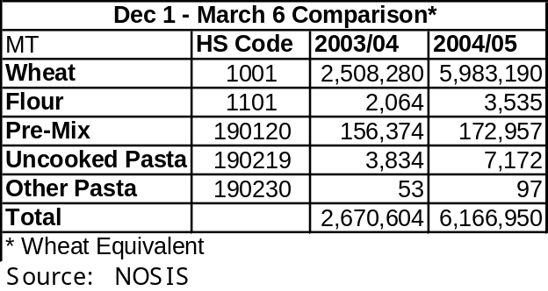

MY2003/04 wheat and wheat product exports are estimated at 9.56 MMT, as shown in the table below.

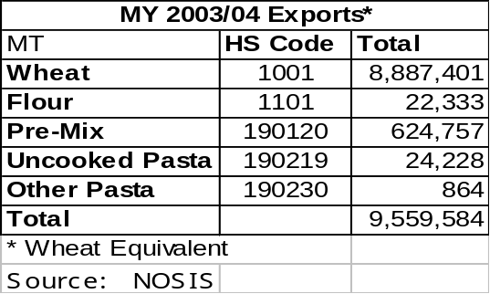

Corn

Post forecasts MY2006/07 corn exports at 12 MMT, down slightly from the previous year due to a forecast decrease in production, and an increase in demand for feed due to an expansion of livestock, dairy, and poultry production.

Post estimates MY2005/06 exports at 14 MMT. At the end of February, port reports show that over the following three weeks, 550,000 MT of corn would be loaded in the up-river ports. Total forecast loading during this period, in all ports in the country, is 600,000 MT. Export pace is forecast to continue as domestic demand for export quality grain decreases.

Export commitments for the new crop have also picked up speed over the past few weeks due to the large exportable supply forecast for the new crop and the availability of cheap corn. It may be difficult, however, for Argentine corn to continue to win favor in the international markets due to the global oversupply of corn. At the end of February 2005 there was still over 9 MMT left to sell, compared to the same time last year when all but 5.84 MMT was already sold.

Post estimates MY2003/04 corn exports at 10.9 MMT. Preliminary end of year data show corn exports between March 2004 and February 2005 were 10.9 MMT. Additionally, popcorn exports were 124,000 MT, which is not included in Post’s corn export estimate.

Corn for export depends heavily on the location of producers and elevators to ports, as transportation costs are high. Normally, production for export is centered 300-400 kilometers from ports; farther distances are not as profitable.

Barley

Post forecasts MY2005/06 barley exports steady at 200,000 MT. Barley exports are normally calculated as a residual, or in other words, barley not consumed by the local malting industry will be exported.

In MY 2003/04, barley exports were 201,356 MT. Over 70 percent of the exports went to Brazil. Other destinations included United States, Uruguay, and Chile. Malt exports during the same period totaled 247,130 MT. Over 85 percent of the exports went to Brazil. Other destinations included Bolivia, Uruguay, Paraguay, Chile, and Venezuela.

Rice

Post forecasts MY2005/06 total rice exports up from previous year to 350,000 MT due to stable demand, a slight increase in production, and increased stocks.

Post estimates MY2004/05 milled rice exports at 300,000 MT. Preliminary data from private sources show MY exports through March 6, 2005 total 275,051 MT.

Official trade statistics for MY2003/04 show rice exports (milled rice equivalents) totaling 192,010 MT. Other private sources, however, calculate exports between 200,000 and 295,000 MT. The discrepancy in data between the different sources may be explained by trade that is not captured in official channels due to the proximity of the exporters to international borders (Brazil, Paraguay, Uruguay). Due to relatively low, and stable, domestic consumption and the tendency for low stocks, the likelihood of higher than reported exports is probable.

Sorghum

Post forecasts MY2005/06 sorghum exports at 400,000 MT, up slightly from previous year. As with corn exports, sorghum exports will depend heavily on transportation costs and distance from port (see Transportation section).

Post estimates MY2004/05 exports at 300,000 MT. This crop’s export sales pace is slow, compared to MY2003/04. As of March 9, 2005, reported sales were only 47,500 MT, compared to prior years accumulated sales of 130,200 MT for the same date.

Stocks

The increase in on-farm storage, mainly in silo bags, complicates calculations of grain stocks. Prior to this increase, stock calculations were made based on official surveys of storage facilities. While these official data are still available, they do not provide a realistic calculation of stocks due to the unknown factor of on-farm storage, which is not included in the survey. What is certain about on-farm storage is that there has been an increase in silo bag sales of 25 – 30 percent over the past year. Last year approximately 80,000 bags were sold. This year sales of 100,000 bags are expected. Additionally, sales of 5-6,000 sillage bags are expected. With capacity of between 150-200 MT/each, there may be an additional 15-20 MMT of storage in the countryside (see Storage section, below).

Storage

Storage capacity is not a limiting factor in Argentina due to the increased use of silo bags for on farm storage. The tendency of producers to use on-farm storage of this type increased rapidly over the past few years after the peso devaluation and the accompanying financial crisis.

Prior to the financial crisis of 2001/02, the agricultural sector was heavily indebted and many producers were forced to turn over their production to elevators and exporters immediately after harvest in order to cancel debts incurred during the growing season (seeds, fertilizers, etc). After the devaluation, producers found themselves in a good financial position due to a reduction in debt (loans were reduced by two-thirds, due to the ‘depegging’ of the 1 Argentine Peso to the 1 U.S. Dollar) and an increase in commodity prices. Many producers paid off their loans and found that their operations were more liquid than before the devaluation, which allowed them to invest in on farm storage (silo bags, or in some cases, fixed storage). Producers now have the luxury of holding on to their production after harvest, and selling when prices reach attractive levels. Additionally, many producers experience the added security of being able to physically see and touch their production on their own farms.

The advantages of using silo bags are numerous. First, producers can store grains on the farm at a very low cost. Additionally, because a producer does not have to coordinate with local transportation to carry his harvest to off-farm storage, he can begin to harvest whenever he wants, according to the stage of development of the crop. Producers also have the ability to separate grains according to qualities and to cash in on bonuses for higher proteins, etc. Finally, producers can store grains in a more humid environment than found in conventional silos, without using insecticides.

The basic principle of silo bags is to keep dry grains in a controlled atmosphere. By maintaining low oxygen (O2) and a high concentration of carbon dioxide (CO2), funguses and insects are controlled, and grain temperatures are stabilized. Grain-filled silo bags can last up to two seasons in high temperature regions and up to three years in lower temperature areas.

Silo bags come in a variety of sizes and widths as shown in the chart below. The thickness of the bags used for grains range between 180 microns (in the case of 5 foot diameter) and 250 microns (in the case of 9 foot diameters). There are three layers that make up the bags; the two inside layers are black, the outside, and thickest, layer is white.

In addition to the purchase of the silo bags, producers must also pay for the filling of the bags, which is done with special machines, called ‘embutidores’ (directly translated as ‘stuffers’). Additionally, special extractors must be used to remove the grain from the bags at the time of sale.

It is not common for producers to own their own equipment for filling silo bags. Therefore, most rely on contractors to complete the harvest, as well as filing the silo bags. This phenomenon is very different than in other parts of the world. Contract harvesters, normally, begin in the north of the country and work their way south as the harvest progresses. These specialized workers are usually contracted by word of mouth from two months, and sometimes up to one year, before the harvest begins. They are normally paid by hectare harvested, although some may be paid by quantity of grain harvested.

Grain Storage

Diameter  (Feet) |  | Length | Capacity  (metric tons)
5 |  | 200 ft | 55 / 60
6 |  | 200 ft | 90 / 100
9 |  | 200 ft | 200 / 210
9 |  | 250 ft | 250 / 260
Silage Storage

Diameter  (Feet) | Length | Capacity  (metric tons)
7 | 200 ft | 130 / 140
8 | 200 ft | 160 / 170
9 | 200 ft | 200 / 210
9 | 250 ft | 240 / 250
10 | 200 ft | 240 / 250
In addition to silo bags for grains, they are also used for storing silage. These bags range from 7 to 10 feet in diameter and 216 – 228 microns thick. The capacity of these bags ranges from 130 – 250 MT. This process is an economic and efficient method to preserve forage and pasture based on an anaerobic fermentation process that maintains quality for long periods of time. Optimal silage conditions are obtained when moisture is between 58 – 68 percent and plants are chopped to 8-12 mm.

Most producers will harvest corn for silage between the milk and dough stages of development. Larger producers will plan ahead of time for their silage needs according to the number of head of cattle they need to feed, or according to size of their dairy production. If they meet their silage needs before completing all of the area they planned for, they will most probably leave the remaining corn in the field and harvest for grain at a later date. Thus forecasting in any given year the amount of corn planted for grain and for silage becomes a quite difficult exercise.
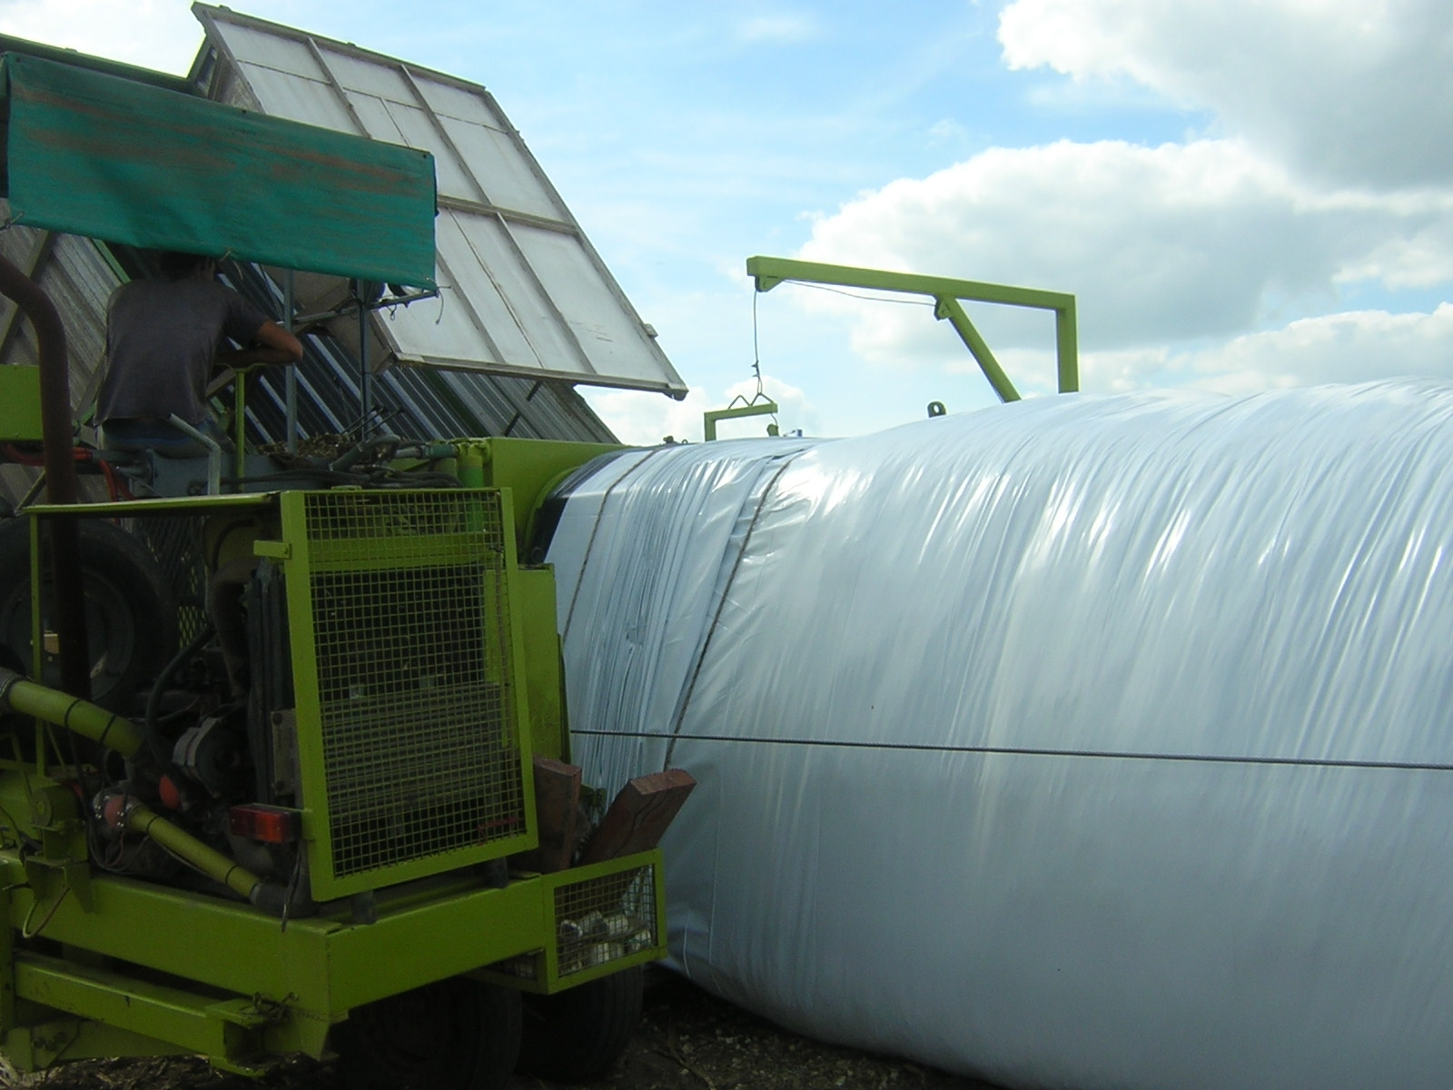
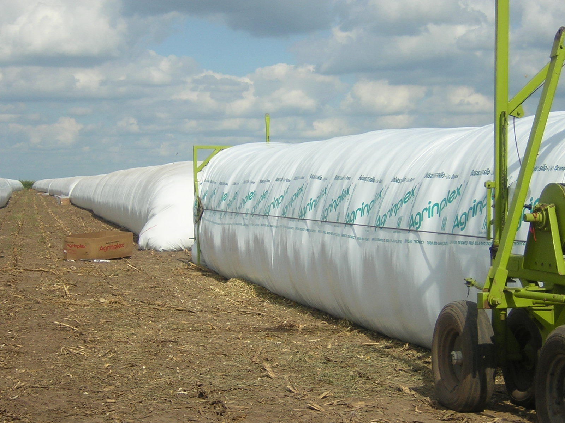

Filling of a silo bag.

Fixed Storage

As of January 31, 2005, total installed fixed capacity for all grains was just over 44 MMT (calculated on wheat basis of 80 falling weight). Total used capacity was only 29 percent, or 12.8 MMT.

The following chart details the amount and location of the various storage facilities throughout the country, as of January 31, 2005.

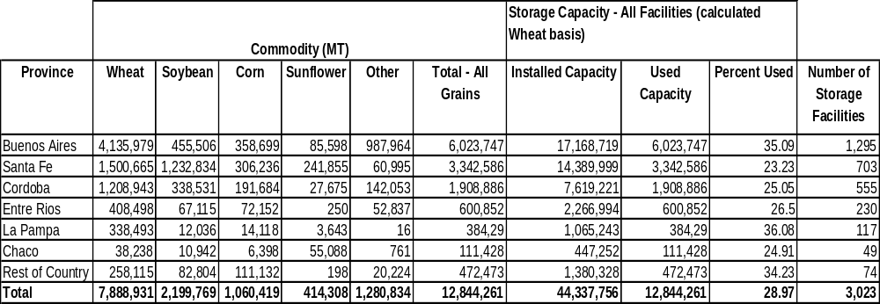
Source: ONCAA/SAGPyA/Ministry of Economy, Argentina

Prices

Commodity prices in Argentina are set at the different Grains Exchanges throughout the country. There are three principal exchanges that set prices: Buenos Aires, Rosario, and Bahia Blanca. The spot prices set by these markets are usually a reflection of CBOT prices, less a percentage, relatively close to the export tax for the product. Curiously, producers are paid this spot price for their production (less transportation), regardless of the final destination of their product (local or export market).

Policy

Export Taxes
The GOA collects export taxes on grains and their sub-products depending on their level of processing. Normal rates range from 5 – 20 percent. 

