EO-1 Technology Demonstration of Silicon Carbide Polishing

September 2001
Contract #1205103

SSG Precision Optronics
65 Jonspin Road
Wilmington, MA 01810

- INTRODCTION

The material properties of Silicon Carbide (SiC) are extremely well suited for space-based, high precision, visible optical instrumentation. The combination of high specific stiffness and high thermal stability enable highly lightweighted mirrors that can withstand the extreme thermal environments encountered in space.

SSG, in cooperation with MIT/LL, has designed, fabricated and deliver the flight telescope subsystem for the Advanced Land Imager (ALI). This system demonstrates the viability of SiC technology for the EO-1 and future space-based missions. The SiC optical telescope design incorporates a wide field-of-view (15 degrees in the cross-track direction) and a flat image plane with low distortion and excellent image quality. The optics consisted of hot-pressed SiC; polished SiC for flat and spherical surfaces and Silicon coated SiC for the aspheric surfaces.

The system performance of the SiC ALI telescope met the specifications for component level surface figure, reflectivity, field of view, angular resolution, point spread function, system throughput, image quality over FOV, distortion map over FOV, focal length, aperture uniformity, mechanical stability, thermal stability, size and weight

. However, the specification for stray light was not achieved.

SSG has worked with NASA to develop a technology program to optimize the process for generating low scatter SiC optics and demonstrate the process on SiC optics both flat and aspheric which satisfy the ALI flight optics requirements.

Summary of results:
  - BRDF measurements made before and after Denton FSS-99 silver coating demonstrate that there is no significant degradation in stray light performance for either bare RB SiC or Si clad RB SiC optics from the Denton coating.
  - Bare RB SiC flats polished using the optimized polishing process resulted in a 10x (@ 10 degrees) improvement over the ALI F1 optics and fully satisfied the derived component level BRDF requirements.
  - Si-Clad RB SiC aspheric sample (concave ellipsoid) showed a 10x improvement at 10 degrees over ALI M2 asphere and have met the ALI specification.
  - A spare hot-pressed Si-clad EO-1 M1 processed with the optimized procedure resulted in a 12x improvement over flight EO-1 M1 and demonstrates meeting stray light specification for ALI flight hardware.

Stray light analysis of the ALI telescope design conducted by two outside contractors (Lambda Research, Littleton, MA and Computational Physics Applications, Inc.) has identified the scatter from the M1 as the major contributor to the system stray light.

The BRDF improvements can be attributed to two critical changes to the optical fabrication process (1) Use of Si-cladding which is highly ductile leading to excellent diamond turnability and ease of figuring and polishing and (2) the addition of a superfinishing step after the previously utilized polishing process.

2. Program Objectives

The primary objective of this technology program is to demonstrate polishing processes for low-scatter SiC optics. The program has demonstrated that SiC mirrors both flat and aspheric, can be produced, in a repeatable and reliable fashion, which meet the requirements of the ALI flight optics. The overall objective was divided into three technical objectives:

- Demonstrate bare SiC (flat) and silicon coated (aspheric) optics with finish and figure in line with ALI specifications.
- Quantify the effects of Denton FSS-99 silver coating on SiC optics scatter performance.
- Incorporate current state-of-the-technology SiC materials into the technology program (replacement of hot-pressed substrates with reaction bonded substrates).

The program objectives were pursued in two technical tasks: (1) Sample Development Demonstration and (2) EO-1 M1 Demonstration Mirror Fabrication and Testing.

The objective of the sample development task is to generate a set of optimized process flows for the critical process steps in the fabrication of SiC optics. These steps are:

- Silicon cladding for aspheric optics
- Polishing of bare SiC which is consistent with flats and spherical optics
- Polishing of silicon clad aspheric optics.

The optimized flow is then applied to a spare EO-1 M1 mirror.

The technical discussion will detail the background and results for this program. An overview of the ALI telescope will present the overall design and performance of the flight hardware. Particular attention will be given to the stray light requirements and the derivation of a component level BRDF from system level specifications. The experimentation and results will be detailed for the bare RB SiC flats, Si-clad SiC aspheres and the spare EO-1 M1.

  - Technical Discussion

  - ALI Telescope Subsystem Overview

The ALI telescope subsystem specifications are presented in Table 3-1. The optical design is a four mirror, all reflective, unobscured system with an Invar 36 metering structure. The focal surface is flat. All optics are hot-pressed SiC. Figure 3-1 shows the complete as delivered instrument.

TABLE 3-1.

ALI Telescope Specifications
Aperture | 12.5 cm
Focal Length | 94 cm
Field-of-View | 1.0 x 15 degrees
Wavelength | 0.4 – 2.5 microns
MTF @ 0.6 microns (37.5 lp/mm) | >0.5
Distortion | < 275 microns, < 250 microns

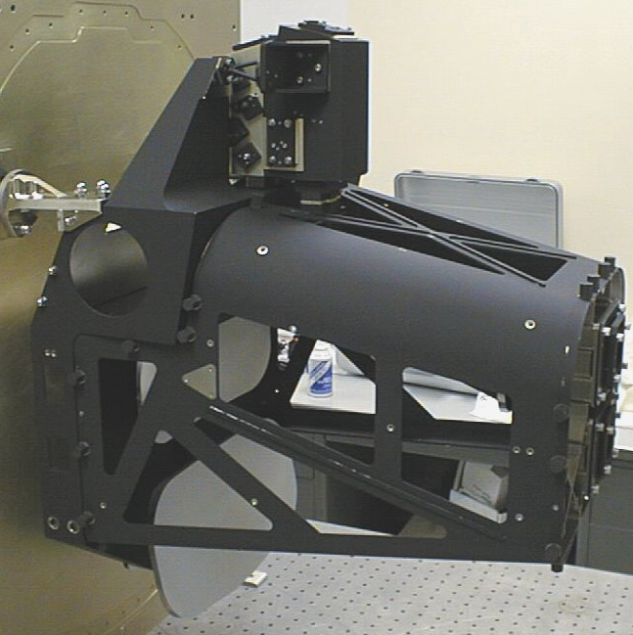
Invar Base
Grating Imaging Spectrometer (supercede by Hyperion)
Invar
SiC Tertiary
SiC Primary
Invar top plate
(secondary – fold flat locations)
Figure3-1. SiC ALI Telescope Subsystem.

3.3.1 ALI Optical Design

The optical design form is a reflective version of a Cooke Triplet. The off-axis design provides for the 15 degree wide FOV. The aperture stop is located on the secondary mirror. Image plan is flat. The ray trace is shown figure 3-2. Table 3-2 provides the mirror parameters.

IMAGE
F1
M3
SPHEROID
M2
ELLIPSOID
(STOP)
M1
ASPHERE
Figure 3-2. ALI Telescope Raytrace.

TABLE 3-2

ALI Telescope Mirror Parameters
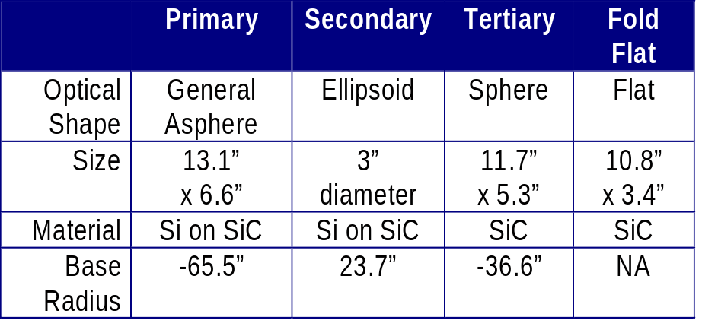

The primary and the secondary mirrors are aspheric. (See figure 3-3 for photographs of these optics). The hot-pressed substrates are machined to the base radius, coated with a layer of amorphous Si, then diamond turned to the desired asphere. Final figure and finish were achieved by hand polishing. The tertiary and fold flat were finished and figured in the bare hot-pressed SiC. All optics were coated with Denton FSS-99. Moderate lightweighting was used for the primary mirror.

Invar 36 was chosen as the metering structure and optical bench. Invar was selected to avoid brittle damage risks associated with conventional ceramic SiC. The CTE match between Invar 36 and SiC minimizes bi-material effects, improving the optical performance under varying thermal loads. SiC composites are available, but were not sufficiently mature at the time and therefore not considered. MIT/LL machine shop was responsible for optical bench fabrication.

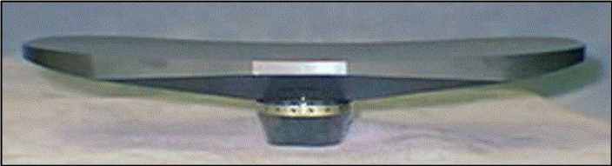
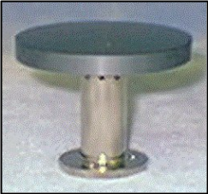

Figure 3-3. ALI Primary and Secondary Mirrors

3.1.2 ALI Optical Performance

The optical performance of the ALI telescope were characterized by image quality, distortion and stray light analysis. System level wavefront error (WFE) and modulation transfer function (MTF) were used to quantify the image quality.

3.1.2.1 Image Quality

The WFE was derived from the MTF specifications using Code V. The system level requirement at temperature is less than 0.15 λ RMS at 0.63 microns. The measured WFE is shown in figure 3-4. 12 field points were tested with the WFE at temperature ranging from 0.089 to 0.148 λ RMS.

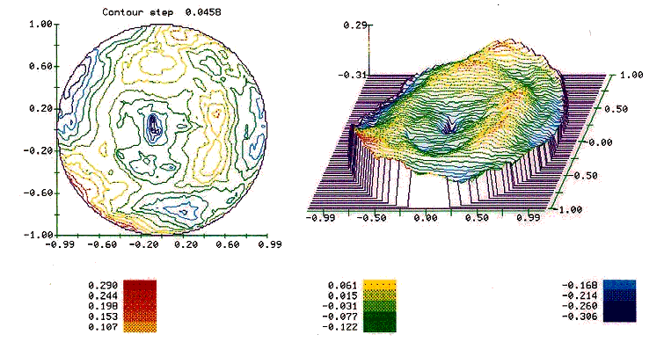

Figure 3-4. On-Axis, System Level WFE ( 0.596λ Pk-Valley, 0.089λ RMS)

System level MTF performance was projected from wavefront maps using Code V. Figure 3-5 shows the specification and measured MTF. The performance meets or exceeds the specificatio at 18.75 lp/mm the 37.5 lp/mm.

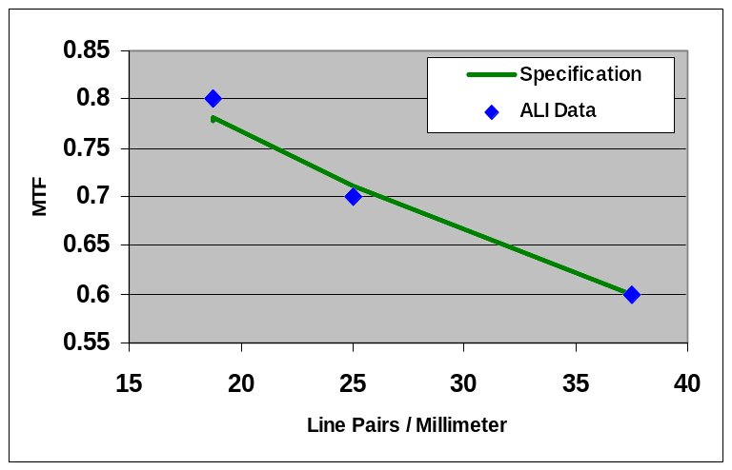
Figure 3-5. MTF Specification and Performance.

      - Distortion

Optical performance was also assessed by measuring the system level distortion. A target with 40 scribed points was used to map the distortion of the optical system. The uncorrected data (figure 3-6) shows a maximum distortion vector length of 928 microns. Using a cubic polynominal (Dr. David Hearn, MIT/LL) the corrected residual distortion is below 9 microns. This corrected value is much below the system specification of 250 microns

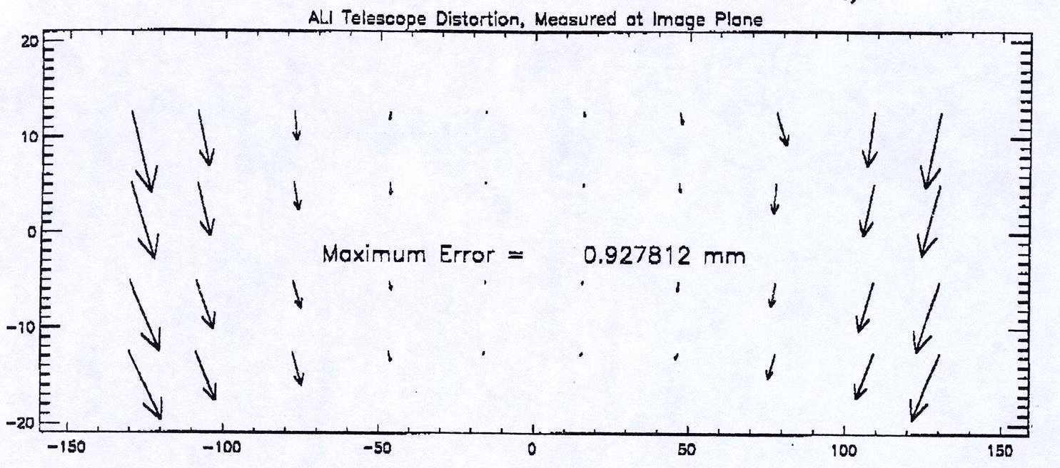

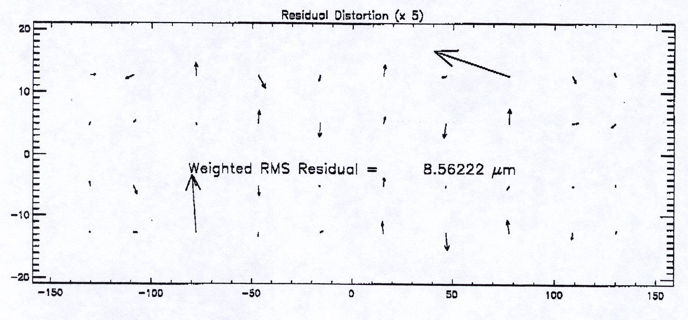

Figure 3-6. Distortion map prior to and after correction.

      - Stray Light

The stray light requirement for the ALI flight optics was specified at the system level. The stray light contribution in any of the bands was to be less than 2% of the nominal full-scale signal level in the panchromatic and spectral bands 1-5 and 7. This specification was met in four of the eight spectral bands, but was out of spec by 2x to 10x in the other five bands.

Analysis of the stray light performance for the flight optics and the stray light requirements [1,2] has indicated that if the component level BRDF were at the level of the ALI M2, the system level stray light requirements would be satisfied. In addition, the analysis indicated that M1 was the primary contributor to the system stray light, greater than 70% depending on the spectral band. The M3 was also a significant factor accounted for up to 27% of the stray light. Similar analysis conducted at SSG derived a component level BRDF goal, which is shown in figure 3-7 along with the measured component level BRDF data and the ABg curve fit to the data. Therefore, the goal of this program is to define a polishing process, which demonstrates BRDF levels in in-line with these derived component level specifications. Of primary importance is the demonstration of the process using a spare EO-1 M1.

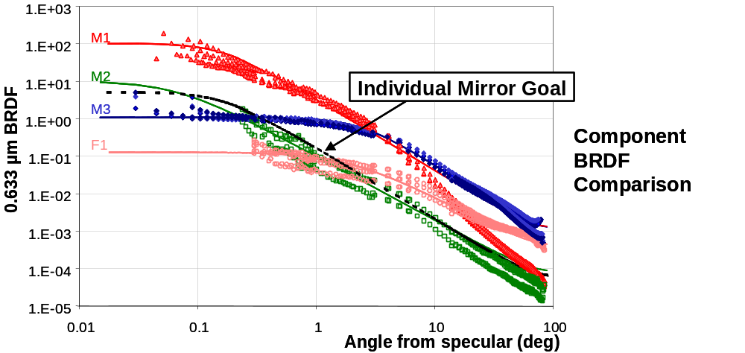
Figure 3-7. BRDF Measurements of ALI Telescope optics after coating with Denton FSS-99.

3.1.3 ALI Performance Summary

The ALI SiC optical system met or exceeded the majority of the telescope requirements including the component level surface figure, system transmission, field-of-view, angular resolution, point spread function, system throughput and image quality over the FOV. The one exception where the system performance did not meet the requirement was the stray light performance. A stray light analysis of the ALI telescope indicated that the primary contributors to the high BRDF levels were M1 and M3, with greater than 70% resulting from M1 and up to 27% from M3.

The effort in the present EO-1 Technology program is to demonstrate that the BRDF issues encountered in the ALI flight optics are a limitation associated with the specific ALI flight optics, not a fundamental limitation of SiC optics.

3.2 Program Overview

In the first task a series of sample pieces were used to optimize the process flow for producing low-scatter optics. Included in this set of samples were bare, flat RB SiC and silicon clad aspheric optics (see figure 3-8). RB SiC was chosen rather than hot-pressed SiC (used in the ALI flight optics) because it represents the state-of-the technology in lightweight SiC optics. BDRF and surface roughness measurements were made before and after coating with Denton FSS-99 silver. This allowed any effects on scatter due to the Denton coating to be isolated. Surface figure measurements were also made. Table 3-3 summaries the witness sample set.

Table 3-3. Summary of Witness Samples
4-2” diameter RB SiC Flats
2.5” diameter RB SiC/Si coated Convex Hyperboloid
4” diameter RBSiC/Si coated Concave Ellipsoid (rib supported)

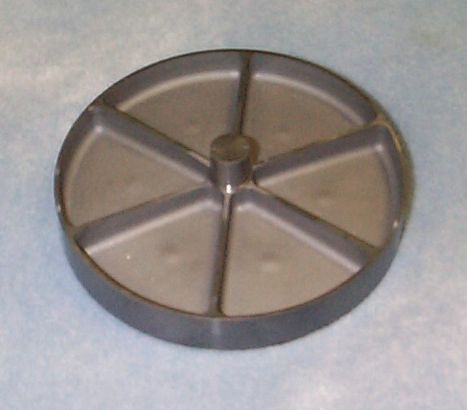
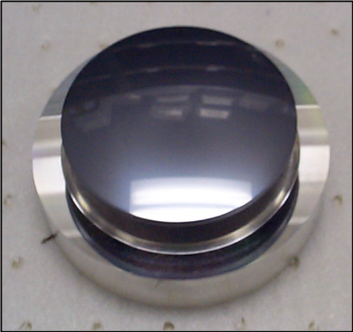
Figure 3-8. (a) Back rib structure of RB SiC Concave Ellipsoid and (b) Si-clad Convex Hyperboloid optic used in EO-1 Technology Program.

3.2.1 Reaction Bonded SiC Flat Sample Results

The results for the RB SiC flats are presented in figures 3-9 to 3-14 and table 3-4. Interferograms were taken before the Denton FSS-99 coating. As the surface roughness and BRDF data indicate there is no significant degradation from the Denton FSS-99 silver coating evident. Samples #1 and #2 were polished by an outside vendor using a planetary lapping and polishing technique. Samples #3 and #4 were worked at SSGoptics division using a planetary lapping machine and spindle polishing. All BRDF measurements were made at Schmitt Measurement Systems (Portland, OR). Three BRDF measurements were made on each sample for both the before and after Denton coating. The angle of incidence was 5 degrees from normal to mirror.

Measurements were made from 0.01 degrees to 90 degrees in both the forward and back scatter directions. Figure 3-10 shows the signature scan and the average BRDF for three spots on sample #1. For small angles (< 0.2 degrees) is evident that the background light level, given by the signature scan, do not allow sufficient signal to noise to provide valid BRDF data. Typically a SNR of 10 is desired for valid data. Therefore, only the data for angles greater than 0.2 degrees will be presented.

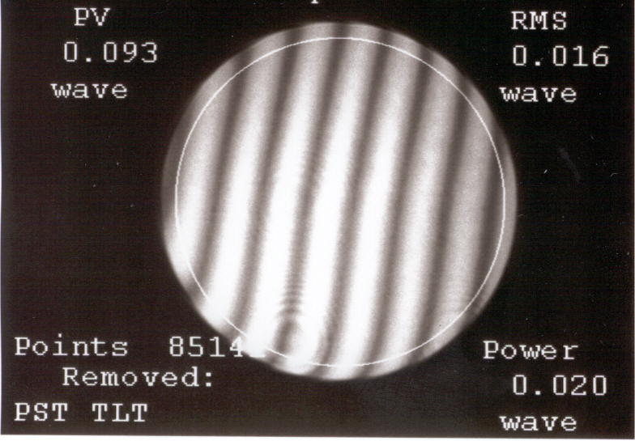
Figure 3-9. Typical surface figure of RB SiC flats. (0.016λ RMS 0.093λ Pk-valley).

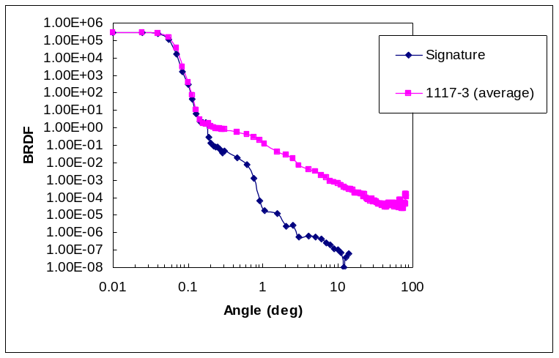
Figure 3-10. Curve showing low signal to noise ratio (<1) for BRDF measurements less than 0.2 degrees. Data below this angle are assumed not valid.

Table 3-4 presents surface roughness results for before and after Denton FSS 99 silver coating along with surface figure. Surface roughness measurements were made at GSFC using a WYKO TOPO-3D at 10x. Between 4 and 6 measurements were made on each sample. The presented results are the average of these measurements.

In all cases the BRDF measurements made after the Denton coating were lower than those made before the coating. This result is counter intuitive, but similar results have been seen on other bare RB SiC sample sets and may be attributed to the two-phase nature of RB SiC. As light impinges on the uncoated RB SiC two materials contribute to the scattering of light. In addition, the interface between the individual phases will contribute to scatter. When the Denton coating is applied to the bare RB SiC these contributions are eliminated and the BRDF level decreases. The surface roughness data indicate no significant degradation due to the Denton coating.

Table 3-4. Surface roughness and figure for RB SiC flats.
 | Sample #1 | Sample #2 | Sample #3 | Sample #4
Part # | 10350001117-3 | 10350001117-5 | 112106 | 112104
Surface Figure | 0.016λ RMS @0.6 μm | 0.016λ RMS @0.6 μm | <λ/4 RMS@ 0.6 μm | <λ/4 RMS@ 0.6 μm
Surface Roughness (prior to Denton coating) | 7.18 Angstroms RMS | 8.14 Angstroms RMS | 13.5 Angstroms RMS | 12.3 Angstroms RMS
Surface Roughness (after Denton coating) | 7.30 Angstroms RMS | 7.58 Angstroms RMS | 15.2 Angstroms RMS | 12.6 Angstroms RMS

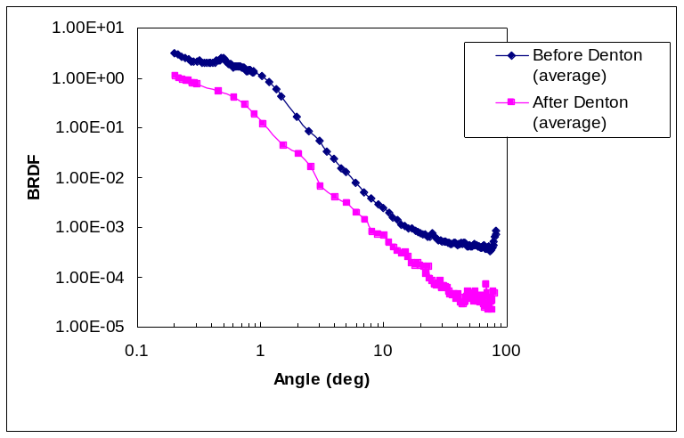
Figure 3-11. BRDF data for sample #1. Data is the average of 3 points on the mirror.

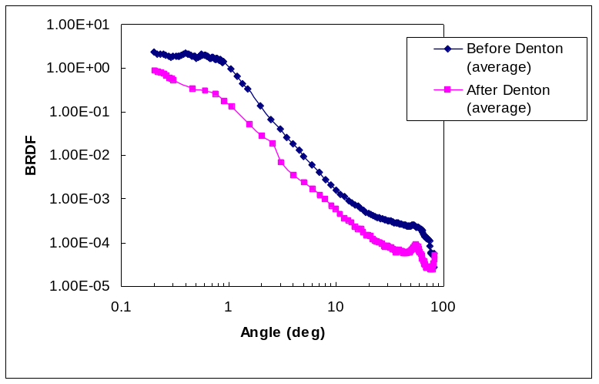
Figure 3-12. BRDF data for sample #2. Data is the average of 3 points on the mirror.

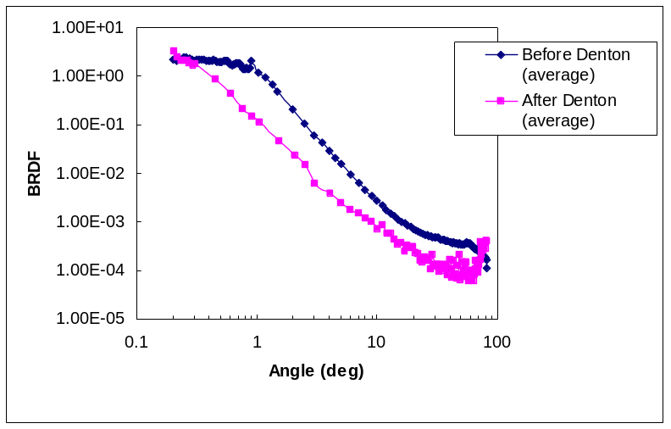
Figure 3-13. BRDF data for sample #3. Data is the average of 3 points on the mirror.

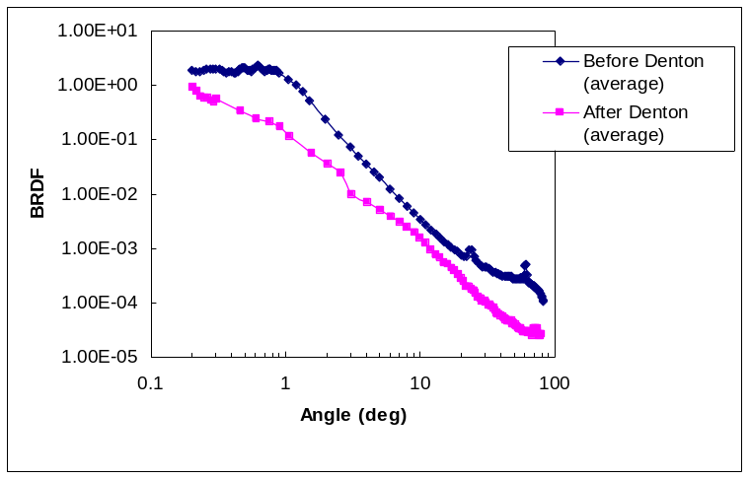
Figure 3-14. BRDF data for sample #3. Data is the average of 3 points on the mirror.

Figure 3-15 presents a comparison between the derived ALI BRDF component specification and the bare RB SiC flats. These results are an significant improvement from the performance of the ALI flight optics and meet or beat the BRDF requirements. They also indicate that RB SiC can out perform hot-pressed SiC for flats and spheres.

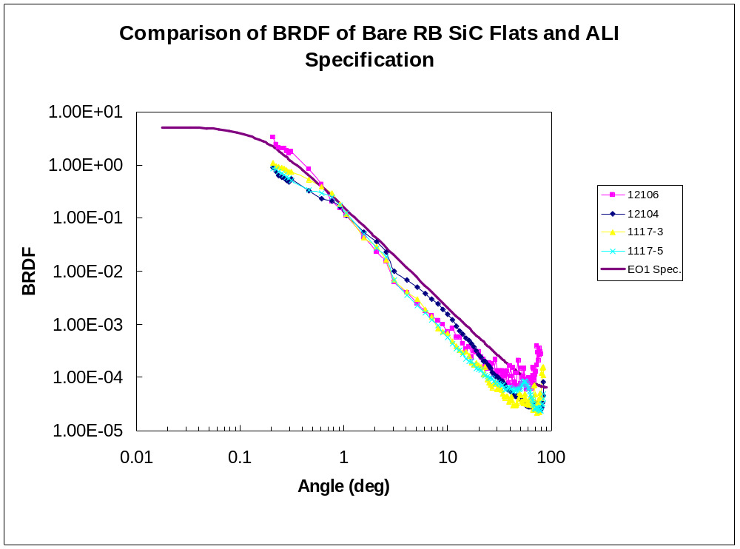
Figure 3-15. BRDF results from Bare RB SiC flats compared with ALI component level specification.

3.2.2 Silicon-coated SiC Asphere Sample Results

The two asphere witness samples represent optics similar to the ALI telescope M2. Both of these samples have RB SiC substrates with a sputtered amorphous Si cladding approximately 0.006” thick. The Si-clad substrate is then diamond turned and finished by hand. These samples, as with the RB SiC flats, had surface roughness (2 –3 locations on each mirror) and BRDF measurements (three locations on each mirror) made before and after a Denton FSS99 silver coating. The surface roughness and BRDF measurements were made at GSFC and Schmitt, respectively. As was the case with the RB SiC flats, the BRDF signature scan indicated that small angle data was not valid due to unacceptable SNR. In the case of the aspheres only data at angles larger than 0.5 degrees will be reported.

Table 3-5 presents the surface figure and surface roughness results. A slight increase in surface roughness was observed for both samples (6% for the convex hyperboloid and 13% for the concave ellipsoid). A small increase is also seen in the BRDF measurements after the Denton coating (see figures SD and DF). The BRDF data presented in figures 3-16 and 3-17 are the average of the all multple locations on the mirror. One set of data was dropped from the concave ellipsoid because of the scatter in the data and a significant difference from the other data taken on the sample.

Table 3-5. Surface figure and roughness of SiC apsheres
 | Convex Hyperboloid | Concave Ellipsoid
Surface Figure | 0.0349 λ RMS @ 0.633 μm | --
Surface Roughness  (prior to Denton coating) | 27.0 Angstroms RMS | 13.4 Angstroms RMS
Surface Roughness  (after Denton coating) | 28.6 Angstroms RMS | 15.4 Angstroms RMS

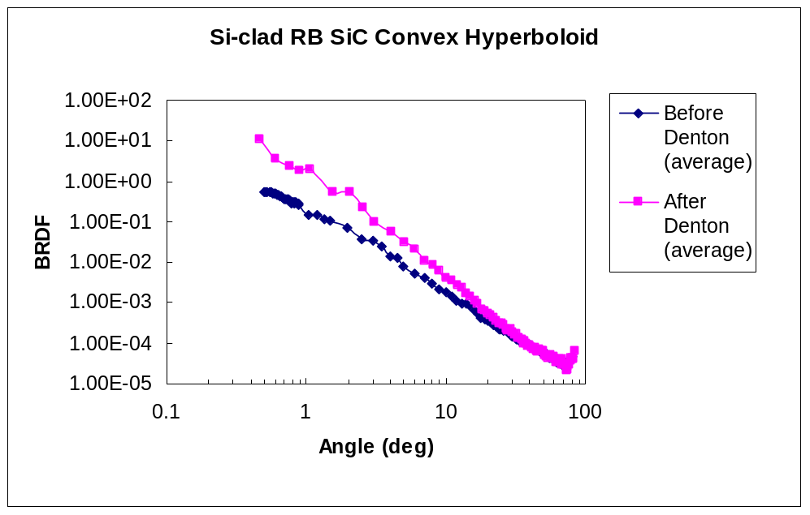
Figure 3-16. BRDF results for Si-clad RB SiC convex hyperboloid before and after Denton FSS99 sliver coating.

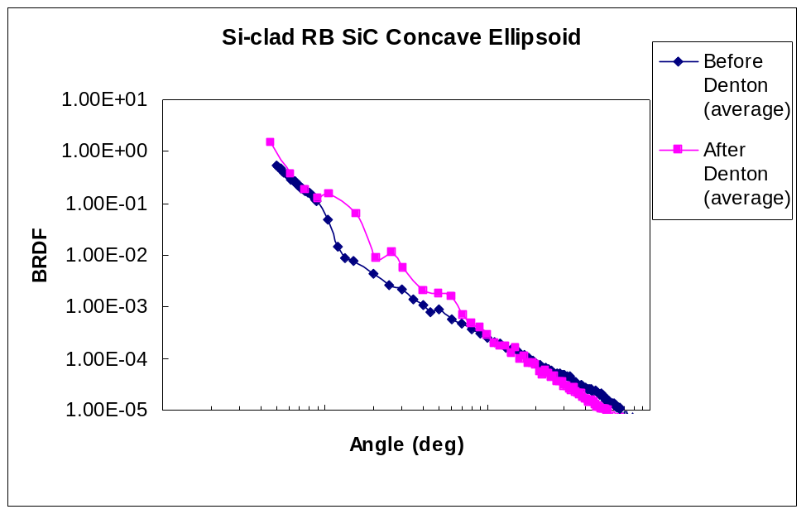
Figure 3-17. BRDF measurements of Si-clad RB SiC concave ellipsoid. Values are the average of three points on the mirror.

Figure 3-18 shows a comparison of the results from this program and the ALI component specification and the results from the flight ALI M2. The results indicate that the Si-clad RB SiC concave ellipsoid meets the ALI specification and the flight M2.

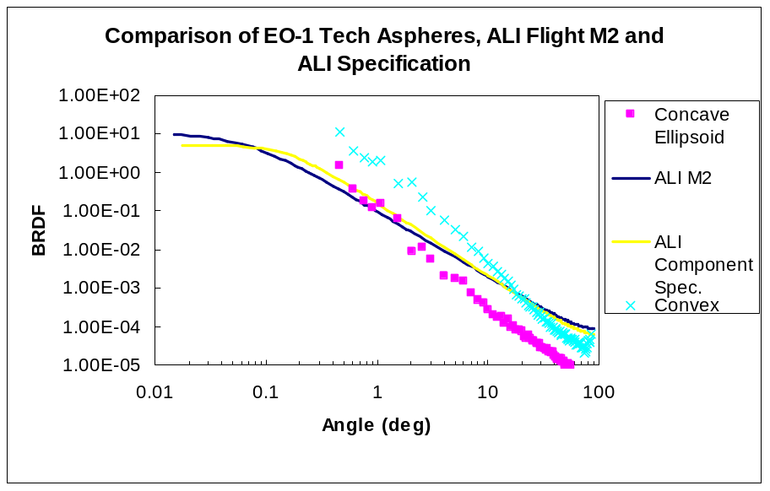
Figure 3-18. BRDF results for aspheres compared with ALI M2 and component level specification.

3.2.3 EO-1 M1 Demonstration

The optimized process demonstrated on the SiC witness samples was applied to a spare EO-1 M1 substrate (see figure 3-19 for photo of finished M1). Two critical improvements have been made in the optical fabrication process in comparison to the flight ALI M1. First, modifications were made to the Si sputter coating process to produce a more ductile Si layer. Improvements in the ductility of the Si-cladding allowed better diamond turning results and eased the effort in obtaining final figure and finish (the material was easier to work and took less time to obtain the requirements). The second critical process improvement was the addition of a superfinishing step to the polishing schedule. Scatterometer measurements made prior to the superfinishing step were 30 – 40 angstroms, After the superfinishing step the values were between 5 and 10 angstroms. These process changes produced an M1 with a 12x improvement in comparison to the flight ALI M1 and produced BRDF results in-line with the derived component level specification.

Figure 3-20 shows the interferogram of the spare M1. The pk-valley is 0.294λ and RMS is 0.035λ.

BRDF measurements were made in SSGs stray light lab. It was anticipated that Schmitt would do these measurements, but a facility shutdown prohibited us from following this path. Measurements where made at three locations on the spare EO-1 M1 at 632.8 nm. The spot size on the mirror was 0.25” in diameter. Figure 3-21 shows the results along with the ALI M1 flight optics and the component BRDF specification. The spare EO-1 M1 did not have the Denton FSS99 applied. Therefore, the results presented in the figure have been scaled to account for the increase in BRDF from coating being applied. The scaling factor was derived from the aspheric samples from Task 1 in which before and after Denton coating BRDF measurements were taken.

Comparison with the ALI flight M1 shows a 12x improvement and demonstrates BRDF levels, which meet the ALI specification. In addition, by obtaining a figure within our original goal of λ/2 to λ/5, it has been demonstrated that both figure and finish to visible quality can be obtained in SiC optics.

Figure 3-19. Photograph of Spare EO-1 M1.

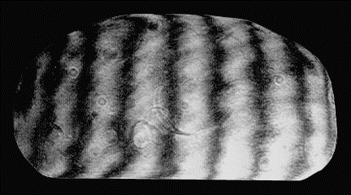
Figure 3-20. Interferogram of EO-1 Technology M1. Final figure 0.294λ pk-valley, 0.035 λ RMS.

Figure 3-21. BRDF results for EO-1 M1, ABg model of ALI flight M1and the derived ALI component level specificaton.

4.0 Summary

ALI SiC flight instrument demonstrates excellent image quality, MTF, and distortion performance over a wide field of view. SSG’s continuing SiC materials development allows new SiC materials to be applied to similar missions with significant cost savings, weight reduction and improved material properties.

The 12x improvement in BRDF achieved on the spare EO-1 M1 is the result of two process changes, the use of a ductile Si-cladding and the addition of a superfinishing step in the polishing process.

EO-1 Technology Program has demonstrated RB SiC flats and silicon clad RB SiC aspheres that meet or exceed BRDF-stray light requirements specified in EO-1 ALI. Spare ALI primary mirror was processed and demonstrated excellent optical figure and BRDF needed to meet all ALI requirements.

REFERENCES

- Wang, Xindong, Godden, Gerald and Qiu, Shi-Yue, “The EO-1 Advanced Land Imager (ALI) Scattered Light Study Report.” Oct. 12, 1998.
- MIT Lincoln Laboratory and Lambda Reseach Corp., “EO-1 Stray Light Analysis Report No. 3.” May 4, 1998.

