2008 Census Dress Rehearsal  Local Update of Census Addresses (LUCA) Program  User Guide | June 2006
Option 2 – Title 13 Local Address List Submission
Computer-Readable Format


101



Table of Contents
Chapter 1 Introduction to the 2008 Census Dress Rehearsal Local Update of Census Addresses (LUCA) Program 1
The 2008 Census Dress Rehearsal Local Update of Census Addresses (LUCA) Program 1
Background 1
The Census Address List Improvement Act 1
The Census Bureau’s Master Address File (MAF) 2
The Topologically Integrated Geographic Encoding and Referencing (TIGER®) Database 2
Census Bureau LUCA Responsibilities 2
LUCA Participant Responsibilities 3
Training and Technical Support 3
Schedule 3
The 2008 Census Dress Rehearsal LUCA User Guide Overview 4
Chapter 2 Before You Begin Your Review 6
What is a Housing Unit? 6
What are Group Quarters? 6
Unacceptable Types of Housing Units and Group Quarters 7
Census Bureau Addresses 7
Residential and Nonresidential Addresses 7
Address Formats 7
City-style Address Format 7
Noncity-Style Address Format 8
Strategies for Reviewing the Census Bureau’s Address List 8
Local Address Sources 8
Chapter 3 The LUCA Program’s Computer-Readable Address List and Address Count List 10
Introduction 10
Protecting Census Bureau Address Information 10
The File Names 12
The File Format 13
Example – Computer-Readable Address List File Record Layout 14
Example – Address Count List File Record Layout 15
Software Requirements 15
Opening the Files 16
Example – Pipe-delimited Address List File – City-style Address 17
Example – Pipe-delimited Address List File – Noncity-style Address 18
Example – Pipe-delimited Address Count List File 19
Chapter 4 The Census Bureau Maps 20
Introduction 20
Reading a Census Bureau Paper Map 20
Examples 22
Map Example 1: Adding a New Street and Associated Address Ranges 22
Map Example 2: Correcting a Street Name 23
Map Example 3: Moving a Street 23
Map Example 4: Deleting a Street 24
The MAF/TIGER Accuracy Improvement Project: Digital Update of the TIGER® Database 24
Shapefiles 24
Submitting Shapefile Feature Information 25
The Census Bureau’s Shapefile Coordinate System and Projection Information 25
General File Setup Guidelines 25
Changing Our Coordinate System to Match Yours 26
Feature Information 26
Updating the Feature Shapefile 27
Displaying Features Based on CFCC1 27
Address Information 29
Data Dictionary and Metadata 29
Data Dictionary 29
Metadata Requirements 31
Digital File Submission 32
Compressing the File 32
Boundary and Annexation Survey (BAS) 33
Chapter 5 The LUCA Program’s Predefined Local Address List File Format 34
The LUCA Program’s Predefined Local Address List File Format 34
The Address List Template Record Layout File 34
Chapter 6 Sumitting Your Local Address List File and Map Updates 37
Submitting LUCA Materials 37
Your Local Address File 37
Census Bureau Paper Maps 37
Shapefile 37
Shipping Census Bureau Title 13 Materials 38
Chapter 7 Returning Or Destroying Census Bureau Title 13 Materials 39
Returning Census Bureau Title 13 Materials 39
Methods for Destroying Census Bureau Title 13 Materials 40
APPENDIXES
Appendix A Confidentiality and Security Guidelines 42
Appendix B Confidentiality Agreement Form 48
Appendix C Boundary and Annexation Survey (BAS) Paper Map 49
Appendix D Boundary and Annexation Survey (BAS) Digital File Submission 52
Appendix E Annexations and Detachments Form 83
Appendix F Contact Update Information Form 84
Appendix G Inventory Form 85
Appendix H Special Disclosure Notice 86
Appendix I Return/Destruction of Title 13, U.S.C. Materials Form 87
Appendix J The Map Legend 88
Appendix K Physical Location Description and Street Type Abbreviations Examples 93
Appendix L Unit Designation Abbreviations Examples 94
Glossary 95
Index 99
Table of Figures
Figure 3.1: Entity Identification Codes 12
Figure 3.2: Computer-Readable Address List File Record Layout 14
Figure 3.3: Address Count List File Record Layout 15
Figure 3.3.1: Address Count List File “Total Row” Layout 15
Figure 3.4: Pipe-delimited LUCA Program Address List File – City-style Address 17
Figure 3.5: Pipe-delimited LUCA Program Address List File – Noncity-style Address 18
Figure 3.6: Pipe-delimited Address Count List File 19
Figure 4.1: Sample of a Census Bureau Paper Map 21
Figure 4.2: Adding a New Street and Associated Address Ranges 22
Figure 4.3: Correcting a Street Name 23
Figure 4.4: Moving a Street 23
Figure 4.5: Deleting a Street 24
Figure 4.6: Change Type Codes for Feature Corrections 27
Figure 4.7: Digital Road Correction Example 28
Figure 4.8: Table Extract for Figure 4.7 29
Figure 4.9: Data Dictionary for all Line Shapefiles 30
Figure 4.10: Data Dictionary for Census Tracts 30
Figure 4.11: Data Dictionary for Census Blocks 31
Figure 5.1: LUCA Program’s Predefined Format for Local Address List Submission 34
Figure C.1: Boundary Changes 50
Figure C.2: Signature Box 50
Figure C.3: Example of a Completed Annexations and Detachments Form 51

Quick Reference

How to:

Protect the Census Bureau’s Address List 10
Open files 16
Save files 37
Read a Census Bureau Map 20
Add a street 22
Add address ranges on a new street 22
Correct a street name 23
Move a street 23
Delete a street 24
Update the feature shapefile 27
Submit shapefile feature information 32
Correct boundaries 49, 52
Use the template address record layout file 34
Submit my address list and updated map 37
Return Census Bureau Title 13 materials 39
Destroy Census Bureau Title 13 materials 40

Chapter 1 Introduction to the 2008 Census Dress Rehearsal Local Update of Census Addresses (LUCA) Program
The 2008 Census Dress Rehearsal Local Update of Census Addresses (LUCA) Program
Background
The Census Address List Improvement Act
The Census Bureau’s Master Address File (MAF)
The Topologically Integrated Geographic Encoding and Referencing (TIGER®)
Database
Census Bureau Responsibilities
Participant Responsibilities
Training and Technical Support
Schedule
The 2008 Census Dress Rehearsal LUCA User Guide Overview

The 2008 Census Dress Rehearsal Local Update of Census Addresses (LUCA) Program

In preparation for the 2010 Census, the U.S. Census Bureau is conducting the 2008 Census Dress Rehearsal for selected jurisdictions. The Local Update of Census Addresses (LUCA) Program is an integral part of the census dress rehearsal activities and utilizes the expertise of tribal, state, and local governments to improve the accuracy and completeness of the address list used to take the census.

The Census Bureau invited the highest elected official of your jurisdiction to participate in this program. Your jurisdiction selected Option 2, Title 13 Local Address List Submission in computer-readable format. This option allows you to:

- Review the Census Bureau’s address list (Address List) and Address Count List for your jurisdiction (for reference purposes only).

- Submit your local address list file (city-style addresses only) in a predefined Census Bureau computer-readable format. The Census Bureau will only accept local address files in the predefined format as explained in Chapter 5.

- Identify any additions, deletions, or corrections to boundaries, roads, or other physical features on the Census Bureau paper maps or submit an updated version of the digital map file (shapefile) provided by the Census Bureau.

Background

The Census Address List Improvement Act

The Census Address List Improvement Act of 1994 (Public Law 103-430) strengthened the Census Bureau’s partnership capabilities with tribal, state, and local governments by expanding the methods the Census Bureau could use to exchange address information. Designed to improve the accuracy of the Census Bureau’s address list, the Act authorized the Census Bureau to provide individual addresses to officials of tribal, state, and local governments who agreed to conditions of confidentiality. Census 2000 marked the first decennial census for which the Census Bureau could provide its address list for review to governments that signed the required confidentiality agreement.

The Census Bureau’s Master Address File (MAF)

In preparation for Census 2000, the Census Bureau created the Master Address File (MAF) by merging the 1990 Address Control File with the latest version of the U.S. Postal Service’s (USPS) Delivery Sequence File (DSF). The MAF is a nationwide list of all address records used to support many of the Census Bureau’s operations. Besides containing mailing addresses and ZIP Codes, a MAF record also contains geographic information about the location of addresses. In areas where there are no noncity-style (e.g., rural route or post office box number) addresses, the MAF record may contain additional information such as a location description (See Appendix K).

The Topologically Integrated Geographic Encoding and Referencing (TIGER®) Database

The MAF address records are linked to feature segments in the Topologically Integrated Geographic Encoding and Referencing (TIGER®) database. The TIGER® database includes the geographic coordinates and names of all streets, water features, and other linear features, and boundaries for all jurisdictions and statistical areas (census tracts, census blocks, etc.) used to tabulate decennial census data. The TIGER® database also includes address ranges along streets that have city-style addresses and the hierarchy of census geographic area codes from the state level down to individual census blocks (http://www.census.gov/geo/www/geodiagram.html). By linking the MAF address records to the TIGER® database, the Census Bureau is able to identify street segments along which an individual address exists and determine the geographic code that applies to that address.

The Census Bureau’s Geography Division regularly updates the MAF and TIGER® from various sources. In addition to the USPS DSF, other sources of updates include Census 2000 field operations, updates from current household surveys, special censuses, and local sources.

Census Bureau LUCA Responsibilities

The Census Bureau’s LUCA responsibilities include:

- Providing training to LUCA Program participants.
- Providing the necessary materials to participants.
    - Providing technical support.
    - Processing the updates submitted by LUCA participants.
    - Conducting a 100% address canvassing (field check) operation to validate the content of the Address List.
    - Providing feedback materials to participants.

LUCA Participant Responsibilities

Your responsibilities include:

  - Selecting staff to perform the LUCA Program review.
  - Ensuring that everyone accessing the Address List signed the Confidentiality Agreement and returned it to the Census Bureau. (See Appendix A for the terms of the LUCA Program Confidentiality Agreement and the Security Guidelines.)
  - Ensuring the receipt of all required materials for the LUCA Program review.
  - Ensuring that everyone working on the LUCA Program understands the procedures for participating in the program and Census Bureau terminology.
  - Keeping Census Bureau addresses and maps showing housing unit and group quarters location (structure points) confidential and ensuring their use only for census purposes.
  - Preparing a strategy to conduct the review of LUCA materials.
  - Conducting the review of LUCA materials.
  - Returning the updated maps and submitting your local address list file to your Census Bureau Regional Office.
  - Reviewing the Census Bureau’s detailed feedback report.
  - Relaying to the Census Bureau any questions regarding the feedback report.
  - Returning or destroying all Census Bureau Title 13 materials after the program is completed.

Training and Technical Support

Training workshops conducted by Census Bureau staff will provide you with “hands-on” experience in using the 2008 Census Dress Rehearsal LUCA Program materials. Should you need additional information, please contact your Census Bureau Regional Office listed on the back cover.

Schedule

January 2006 LUCA advance notification letters and materials mailed to highest elected officials

March – May 2006 Census Bureau invited local governments to participate in the LUCA Program

May 2006 Census Bureau conducted training workshops for participants

June 2006 Census Bureau mailed LUCA materials to participants
June – October 2006 Participants conduct LUCA review

October 2006 Participants return updated maps and their local address list to the Census Bureau’s regional offices

November – December 2006 Census Bureau processes submissions and updates

April – May 2007 Census Bureau conducts address canvassing (field check) operation

December 2007 – January 2008 Participants review feedback materials

The 2008 Census Dress Rehearsal LUCA User Guide Overview

The 2008 Census Dress Rehearsal LUCA User Guide provides instructions and examples for your review of the LUCA Program materials.

Before you begin your review, read Chapter 2. This chapter discusses:

  - The Census Bureau’s definitions of housing units and group quarters.
  - An explanation of the acceptable types of housing units and group quarters to include in your local address list
  - An explanation of the types of addresses classified by the Census Bureau.
  - Strategies for updating your address list.
  - Sources for local address information.

Chapter 3 explains how to protect computer-readable Census Bureau Title 13 address information and describes the computer-readable Address List and Address Count List, software requirements, and how to open the files.

Chapter 4 describes the information contained on a Census Bureau paper map. Census Bureau paper maps or a digital file (shapefile) are available to all LUCA participants to use as a reference with the Address List and Address Count List and to make any necessary updates or corrections to features and boundaries. This chapter includes:

  - How to read a Census Bureau paper map.
  - An example of a portion of a Census Bureau paper map.
  - Examples of the most common paper map updates.
  - A brief outline of the MAF/TIGER Accuracy Improvement Project (MTAIP).
  - How to submit shapefile feature information.
  - An overview of the Boundary and Annexation Survey (BAS) Program.

Appendix J provides detailed information about the map legend. If you need to make updates or corrections to your jurisdiction boundaries, the Census Bureau’s BAS program is explained in Appendix C. Appendix D contains the Digital BAS Guidelines Supplement, Boundary and Annexation Survey (BAS) User’s Guide for submitting shapefiles. A blank Annexations and Detachments Form is included for documentation in Appendix E.

Chapter 5 describes the LUCA Program’s predefined local address file format, which you must use to submit your address file. This chapter also includes a description of the template address record layout that you may use to import your local address list for submission.

Chapter 6 explains how to submit your local address file and updated maps to the Census Bureau.

Chapter 7 provides instructions for returning or destroying all Title 13, U.S.C. address lists (both computer-readable and any paper copies) and maps (including copies) containing structure points after you have reviewed your feedback materials.

After you have reviewed your feedback materials, you must return or destroy all Title 13, U.S.C. materials. A Return/Destruction of Title 13, U.S.C. Materials form is included in Appendix I. Your primary LUCA liaison must sign and return this form to the Census Bureau after destroying your Title 13 materials or include the form with your returned Title 13 materials. All LUCA Program reviewers are required to sign and date this form at the completion of the LUCA Program. Should any liaison or reviewer leave before the completion of the LUCA Program, they are required to “sign-out” of the program by signing and dating this form. If any liaison or reviewer fails to sign and date this form, the current liaison can “sign-out” on their behalf.

If you need to add additional LUCA reviewers, Appendix B provides a blank Confidentiality Agreement Form. Be sure additional reviewers have read and understand the Confidentiality and Security Guidelines included in Appendix A before signing the Confidentiality Agreement Form and returning it to the Census Bureau.

Should you need to update your Census Bureau contact person(s), Appendix F provides a Contact Update Information Form.

Appendix G provides an inventory form to enclose with your returned materials. In addition, Appendix H provides a special disclosure statement notice that must be included with the return of the Census Bureau’s Title 13 information.

Appendix K contains examples of the most common abbreviations for physical location descriptions (BRICK HSE w/ATTACHED GARAGE) and street types (ST, TWP RTE, etc.) used on the Address List. In addition, Appendix L contains examples of unit designation identifiers (APT, BSMT, etc) used by the Census Bureau.

A glossary of Census Bureau terms related to the LUCA Program is included. For additional Census Bureau terms and information, please visit the Census Bureau Web site at http://www.census.gov/.

The Census Bureau’s regional office addresses, telephone numbers, and E-mail addresses are listed on the back cover.
Chapter 2 Before You Begin Your Review

What is a Housing Unit?
What are Group Quarters?
Unacceptable Types of Housing Units and Group Quarters
Census Bureau Addresses
Strategies for Reviewing the Census Bureau’s Address List
Local Address Sources

Chapter 2 provides some terms and concepts used by the Census Bureau and strategies for your LUCA review. Refer to the Glossary or visit the Census Bureau’s Web site at http://www.census.gov for additional terms and definitions.

What is a Housing Unit?

A single-family house, townhouse, mobile home, trailer, vacant trailer park pad, apartment, group of rooms, or a single room occupied as a separate living quarters or, if vacant, intended for occupancy as a separate living quarters. A separate living quarters is one in which one or more occupants (or intended occupants, if vacant) live separate from any other individual(s) in the building and have direct access to the living quarters without going through another living quarters, such as from outside the building or through a common hall.

The following types of housing units are acceptable and should be included on your address list:

  - Houses, including townhouses and condominiums.
  - Apartments.
  - Living quarters within an otherwise nonresidential structure. For example, an apartment within a church, school, or business.
  - Mobile homes or trailers occupied as separate living quarters, or if vacant, intended for occupancy as separate living quarters.
  - Any units under construction that will be habitable (closed to the elements with final roof, windows, and doors) on Census Day, April 1, 2008.

What are Group Quarters?

A place where people live or stay that is normally owned or managed by an entity or organization providing housing and/or services for the residents. These services may include custodial or medical care, as well as other types of assistance, and residency is commonly restricted to those receiving those services. People living in group quarters are usually not related to each other.

The following types of group quarters are acceptable and should be included on your address list:

- Correctional facilities.
- Juvenile facilities.
- Nursing homes.
- Hospitals with long-term care facilities.
- College or university dormitories, fraternities, sororities.
- Dormitories for workers.
- Religious group quarters.
- Shelters.
- Group homes.
- Any group quarters under construction that will be habitable (closed to the elements with final roof, windows, and doors) on Census Day, April 1, 2008.

Note: Housing units and group quarters can exist within the same structure.

Unacceptable Types of Housing Units and Group Quarters

Exclude the following unacceptable types of housing units and group quarters addresses from your address list:

- Used as nonresidential storage facilities or as offices or businesses in which no one is living.
- Condemned of scheduled for demolition.
- Being converted or remodeled for nonresidential purposes.
- Used solely for nonresidential storage.
- Used solely as offices or businesses in which no one is living.
- Used solely for ceremonial purposes.
- Under construction and will not be habitable (closed to the elements with final roof, windows, and doors) on Census Day, April 1, 2008.

Census Bureau Addresses

Residential and Nonresidential Addresses

The Census Bureau divides all addresses into two use types, residential and nonresidential. Residential addresses are addresses of housing units and group quarters. Nonresidential addresses are addresses of a structure or unit within a structure that do not serve as a residence, such as commercial establishments, schools, government offices, and churches.

Some structures can contain both residential and nonresidential units, even though they have a single address.

Address Formats

City-style Address Format

The majority of housing units and group quarters in the United States have a house number and street name address; for example, 212 Elm Street or 137 Clark Ct., Apt. 316. The Census Bureau refers to these as city-style addresses. Addresses for housing units in multi-unit structures, such as apartment buildings, should contain a unit designator, for example, Apt 101 or Ste D (See Appendix L, Unit Designation Abbreviations). The Census Bureau and the U.S. Postal Service treat these designators as part of the housing unit address, and they are included in each affected census address record. Some city-style addresses, referred to as E-911 addresses, are used only to provide location for emergency services, such as police, fire, and rescue.
Noncity-Style Address Format

The Census Bureau classifies addresses that do not include a house number and street name as noncity-style addresses. The majority of noncity-style addresses are located in the more sparsely settled areas of the United States; however, they may exist in small or medium sized towns as well. Frequently used noncity-style mailing addresses include:

- General delivery.
- Rural route and box number.
- Highway contract route and box number.
- Post Office box only delivery.

Noncity-style addresses often do not follow any numeric sequence, and may not be associated with the name of the street or highway on which they are located. For this reason, the Census Bureau uses different methods to compile the list of addresses for inclusion into the Address List, such as location descriptions (BRICK HSE w/ATTACHED GARAGE), structure points (geographic coordinates), and geographic codes. Census Bureau maps may show structure points in selected areas, generally those with sparse settlement.

Strategies for Reviewing the Census Bureau’s Address List

You must decide for yourself how to conduct the LUCA Program review. Consider your available time, the information you have readily available, and the staff and computer resources you have. If resources are limited, the Census Bureau recommends focusing on areas where addresses are more likely to be missed or incorrect. For example:

- Areas of new construction.
- E-911 address conversion areas.
- Areas that have changed from single-family homes to multi-family homes and vice versa.
- Warehouses converted to residential lofts.
- New mobile home parks or new scattered mobile homes.
- Apartment buildings with irregular or missing numbering schemes for the individual units.
- Recently added territory.
- Addresses near governmental boundaries.

Local Address Sources

There are many possible sources of local address information. Some of these sources may not match the Census Bureau’s address list exactly, but they may be good indicators of where change is taking place. The following list provides suggestions for local address source materials:

- New housing construction or building permits (include units that are under construction only if final roof, doors, and windows will be in place on Census Day, April 1, 2008).
- E-911 address files.
- Housing occupancy permits.
- Planning or zoning records.
- Local utility records.
- Drivers’ license files.
- Annexation records.
- Assessment or taxation files.
- Voter registration files.

Chapter 3 The LUCA Program’s Computer-Readable Address List and Address Count List
Introduction
Protecting Electronic Census Bureau Address Information
The File Names
The File Format
Software Requirements
Opening the Files

Introduction

The Address List and Address Count List files for your jurisdiction are included on your CD-ROM. This chapter discusses how you must protect the Census Bureau’s computer-readable address information and explains the:

  - File names and formats.
  - Software requirements.
  - How to open the files.

Protecting Census Bureau Address Information

The most efficient method to review and match your local address list to the Address List is to copy the address file onto a computer hard drive or a network server in a useable format. You must first ensure the protection of the Census Bureau’s Title 13 address information including your Census Bureau computer-readable address file, all address list paper copies, and maps (including copies) containing structure points. For detailed information see Appendix A, Confidentiality and Security Guidelines.

The Census Bureau addresses must be accessible only to the LUCA Program liaison and reviewers who signed the Confidentiality Agreement. The automated data processing (ADP) system should restrict the read, write, delete, and execute functions applicable to the Census Bureau’s addresses.

The ADP system must use log-on routines that require a user-ID and password that conform to the following guidelines:

- Assign a unique user-ID and password for each LUCA Program liaison and reviewer.

- Passwords must consist of at least eight (8) characters:

- Use at least one (1) alphabet character.
- Use either one number or one special character ($,*, &).
- No more than six (6) identical, consecutive characters (AAAAAA) may appear in the password, and then only once.

- Reject passwords that are the same as the user-ID or used within the last 6 months.

- Encrypt passwords.
- Disable passwords after three bad attempts.

- Do not display passwords on terminals or printers.

- Change passwords every 90 days (more frequent change is optional) or immediately, if compromised.

- On new accounts, change the assigned password to a unique password the first time users log on.

The ADP system must display a warning log-on feature. Computer screens must display a warning that states:

**WARNING*WARNING*WARNING**
YOU HAVE ACCESSED A COMPUTER SYSTEM CONTAINING UNITED STATES GOVERNMENT INFORMATION. USE OF THIS COMPUTER WITHOUT AUTHORIZATION OR FOR PURPOSES FOR WHICH AUTHORIZATION HAS NOT BEEN EXTENDED IS A VIOLATION OF FEDERAL LAW AND CAN BE PUNISHED BY FINE OR IMPRISONMENT (Public Law 99-474). ALL USE MAY BE INTERCEPTED, MONITORED, RECORDED, COPIED, AUDITED, INSPECTED AND DISCLOSED TO AUTHORIZED LAW ENFORCEMENT OFFICIALS. REPORT SUSPECTED VIOLATIONS TO YOUR AGENCY SECURITY OFFICER. USE OF THIS SYSTEM INDICATES YOU CONSENT TO THIS WARNING. LOG OFF IMMEDIATELY IF YOU DO NOT AGREE TO THE CONDITIONS OF THIS WARNING.
**WARNING*WARNING*WARNING**

- If you place Census Bureau address information on a shared computer system, construct electronic security profiles to allow only the LUCA liaison and reviewers access to the Census Bureau’s address information. Test your security to ensure that only the LUCA liaison and reviewers are permitted access to the Census Bureau’s address information.

- Encrypt all Title 13 Census address information transmitted via FTP to the Census Bureau’s data site with an appropriate product.

- Lock all rooms containing computers and all associated media during non-work hours.

- Do not leave computers with Census Bureau address information unattended during work hours. Log-off the computer or lock the room whenever you leave.

- Label any computer diskettes, CD-ROMs, DVDs, tapes, cartridges or other computer storage media containing Census Bureau address information with the following:

“This document contains information the release of which is prohibited by Title 13 U.S.C. and is for Bureau of the Census official use only.”

  - If backup is necessary, do not send the tapes, cartridges, or disks off-site. Store them in a secured area. Do not mix, store, or back-up LUCA data with other data.

- Clear magnetic media (tapes, disks, hard drives) containing Census Bureau address information before reuse. To clear magnetic media, overwrite all Title 13 data three times at a minimum using a commercial disk utility program or degauss using a commercial degausser.

- Program any software you develop for displaying the Census Bureau addresses to label each affected page of a printout containing Census Bureau address information with the following:

“This document contains information, the release of which is prohibited by Title 13 U.S.C. and is for Bureau of the Census official use only.”

The File Names

The Address List (AL) file contains all of the addresses currently recorded by the Census Bureau for your jurisdiction. The Address Count List (ACL) file contains the address counts for each census block within your jurisdiction. The name of each of the files is:

1. Address List – XXyyyyyyyy.8AL
2. Address Count List – XXyyyyyyyy_08.ACL

Where:

XX = 2 character, alpha entity type (ST for State, CO for county, PL for place, and MC for minor civil division, and
yyyyyyyy = variable length, numeric entity ID code.

The numeric portion of the entity identification code is of variable length, depending on the type of entity:

- State: 2 digits
- County: 3 digits
- Census Minor civil division (MCD): 3 digits
- Census Place: 4 digits

Figure 3.1: Entity Identification Codes

Entity | Entity Identification Code | Total Characters
State | ST (2 alpha) + (2 numeric) | 4
County | CO (2 alpha) + State (2 numeric) + County (3 numeric) | 7
Minor civil division (MCD) | MC(2 alpha) + State (2 numeric) + County (3 numeric) + MCD (3 numeric) | 10
Census Place | PL (2 alpha) + State (2 numeric) + Place (4) | 8

An example of an Address List 4-character state file name is ST36.8AL where “ST” is state and “36” is the state code for New York. An example of a 7-character county file name for Erie County, New York is CO36029.8AL, where “ST” is state, “36” is the state code for New York, and “029” is the county code for Erie County.

The file name for a minor civil division is 10-characters while the file name for a Census place is 8-characters. For example, the Address List file name for My Township, Indiana County, Pennsylvania is MC42063985.8AL where:

- “MC” is minor civil division.
- “42” is the state code for Pennsylvania.
- “063” is the county code for Indiana County.
- “985”, the Census minor civil division code for My Township.

An example of the file name for the place Lake Zurich, Illinois, is PL173115.8AL, where “PL” is place, “17”, the state code for Illinois, and “3115” is the Census place code for Lake Zurich.

One example of an Address Count List 8-character file name for the place Mitchell, Wyoming, is PL564578_08.ACL, where “PL” is place, “56” is the state code for Wyoming, and “4578” is the Census place code for Mitchell.

The File Format

All of the files are formatted as pipe-delimited ASCII text files.

  - Each address record has a maximum length of 314 characters and contains 24 fields of information. The length for each record may vary. See Figure 3.2 for the Address List file record layout.

  - Each block record is at least 56 characters in length and contains nine (9) fields of information. The character length of each record may vary. See Figure 3.3 for the Address Count List file record layout.

Example – Computer-Readable Address List File Record Layout

Maximum  Character  Length | Field Name | Description/Notes
11 | Entity ID Code | Unique number assigned by the Census Bureau to each entity
7 | Line Number | Unique number for each address record in the file
13 | MAFID | Unique number assigned to each MAF address
2 | Action Code | Valid codes: A, C, D, J, N, entered by participant
2 | State Code | 2-digit Current State Code
3 | County Code | 3-digit Current County Code
7 | Census Tract Number | 4-digit Census Tract Number, plus 2-digit number suffix, if applicable, includes a period for suffixed tracts
5 | Census Block Number | 4-digit Current Census Block Number, plus 1-digit alpha character suffix if applicable
1 | Group Quarters Flag | Display a ‘Y’ if the unit is a group quarters
23 | House Number | Housing unit’s or group quarter’s assigned house number
2 | Street Name Prefix Direction | e.g., N, W, SE
4 | Street Name Prefix Type | e.g., HWY, RT, US
40 | Street Name | Full street or road name
4 | Street Name Suffix Type | e.g., ST, CT, AVE, DR
2 | Street Name Suffix Direction | e.g., N,W, SE
3 | Street Name Street Extension | e.g. EXT, ALT, BUS
100 | Location Description or GQ Name | Description of living quarter (Red Rancher w/White Shutters) or name of group quarter (Dobbs Hall-University of Dobbs)
27 | Apartment/Unit Number | Within structure descriptor or identifier, such as APT 5 or 1st FL FRNT
5 | City-Style Mailing ZIP Code | 5-digit ZIP Code for city-style mailing addresses
24 | Noncity-Style Mail Delivery Address (RR#, HCR#, or PO BOX#) | Rural Route and Box Number, Post Office Box Number, etc.
5 | Noncity-Style Mailing ZIP Code | 5-digit ZIP Code for the noncity-style mailing address
5 | Structure Point | 4-digit number plus 1-digit alpha assigned by the Census Bureau to structures in areas that contain predominately noncity-style addresses (RR, PO Box #, General Delivery, etc.)
9 | Structure Latitude | The latitude coordinate in degrees, with 6 implied decimals
10 | Structure Longitude | The longitude coordinate in degrees, with 6 implied decimals
Figure 3.2: Computer-Readable Address List File Record Layout

Example – Address Count List File Record Layout

Figure 3.3: Address Count List File Record Layout

Maximum  Character Length | Field Name | Description/Notes
11 | Entity ID Code | Unique number assigned by the Census Bureau to each entity
2 | State Code | 2-digit Current State Code
3 | County Code | 3-digit Current County Code
7 | Census Tract and Suffix | 4-digit Census Tract Number, plus 2-digit number suffix, if applicable, includes a period for suffixed tracts.
5 | Census Block and Suffix | 4-digit Current Census Block Number, plus 1-digit alpha character suffix if applicable
7 | Census Count of Housing Unit Addresses | Census Bureau’s most recent count of housing unit addresses
7 | Local Count of Housing Unit Addresses | Most recent count of housing unit addresses entered by participant
7 | Census Count of Group Quarters Addresses | Census Bureau’s most recent count of group quarters addresses
7 | Local Count of Group Quarters Addresses | Most recent count of group quarters addresses entered by participant

Figure 3.3.1: Address Count List File “Total Row” Layout

Maximum  Character Length | Field Name | Description/Notes
7 | Census Tract and Suffix | The word “Total” appears in this column
5 | Census Block and Suffix | Total number of Census Blocks on the Address Count List
7 | Census Count of Housing Unit Addresses | Total number of Census Bureau Housing Unit Addresses on the Address Count List
7 | Local Count of Housing Unit Addresses | Total number of Housing Unit Address challenges recorded by participant
7 | Census Count of Group Quarters Addresses | Total number of Census Bureau Group Quarters Addresses on the Address Count List
7 | Local Count of Group Quarters Addresses | Total number of Group Quarters Address challenges recorded by participant

Software Requirements

Many commercial spreadsheet and database programs can open the LUCA files. Use spreadsheet programs such as Microsoft Excel or Lotus 123 to open, view, and edit small files. For larger files, use a database program such as Corel Paradox, QuattroPro, Microsoft Access, or dBase.

Note: Some computer programs that can open and view pipe-delimited text files
CANNOT save an edited file in the correct format. Make sure your program
has the ability to save or export a file with pipe-delimited fields.

Opening the Files

Refer to the Readme file (Readme1st.txt) for instructions on opening the encrypted Address List.

- The Census Bureau recommends that you make a copy of each of the files and place them on the hard drive of a computer that is password protected. This will preserve the original files should you need to look at an original record or require another original copy of the file.

Note: The files you receive are pipe-delimited ASCII text files, meaning they can be viewed and read as letters and numbers with a text editor. All spreadsheet and database programs can read and understand these text files.

- Some spreadsheet and database software packages will not recognize text files unless the file name includes the .TXT file name extension. If necessary, change the file name extension to .TXT. For instance, the Address List file name for Lake Zurich, Illinois, PL173115.8AL, must be changed to PL173115.txt and the Address List Count file, PL173115_08ACL, must be changed to PL173115_08.txt.

- To help keep your work organized, create a new directory or new folder on your hard drive. Copy the files from the CD-ROM into that directory or folder.

- When you open the text files with your application, some spreadsheets and databases will prompt you to supply some information about the file. Be prepared to tell the application program the following:

- Fields are delimited.
- Delimiter is pipe.
- Text qualifier is none.
- All field types are text.

- Define all field types as “text” including numeric fields such as census tract number, census block number, ZIP Code, and so forth.

- Follow the record layout to name and define the sizes of your fields.

Example – Pipe-delimited Address List File – City-style Address

The following is an example of how the information may appear in the Address List file before importing the file using your software program. The example is a city-style address, 10 Main Street, Mytown, PA 15888.

PL429059|107|1234567898765| |42|134|7654.01|2345| |10| | |Main|St| | | | |15888| | | |4063010|
7922646
Figure 3.4 displays the data in the appropriate fields.

Figure 3.4: Pipe-delimited LUCA Program Address List File – City-style Address
Field Number | Field Name | Example
1 | Entity ID Code | PL429059
2 | Line Number | 107
3 | MAFID | 1234567898765
4 | Action Code | Blank
5 | State Code | 42
6 | County Code | 134
7 | Census Tract Number | 7654.01
8 | Census Block Number | 2345
9 | Group Quarters Flag | Blank
10 | House Number | 10
11 | Street Name Prefix Direction | Blank
12 | Street Name Prefix Type | Blank
13 | Street Name | Main
14 | Street Name Suffix Type | St
15 | Street Name Suffix Direction | Blank
16 | Street Name Street Extension | Blank
17 | Location Description or GQ Name | Blank
18 | Apartment/Unit Number | Blank
19 | City-Style Mailing ZIP Code | 15888
20 | Noncity-Style Mail Delivery Address (RR#, HCR#, or PO BOX#) | Blank
21 | Noncity-Style Mailing ZIP Code | Blank
22 | Structure Point | Blank
23 | Structure Latitude | 4063010
24 | Structure Longitude | 7922646

Example – Pipe-delimited Address List File – Noncity-style Address

The following is an example of how the information may appear in the Address List file for a noncity-style address: Box 223, Scott Level Road, Myhome, Ohio 45555. Note that the information includes a description in the location description field –
2-STORY BRICK W/ATTAXHED GARAGE ON LEFT.

PL394868|678|2345678912345| |39|074|2345|5432| | | | |Scott Level|Road| | |2-story brick w/ATTACHED GARAGE ON LEFT| | |Box 223|45555|9|4005716|8461787

Figure 3.5: Pipe-delimited LUCA Program Address List File – Noncity-style Address

Field Number | Field Name | Example
1 | Entity ID Code | PL394868
2 | Line Number | 678
3 | MAFID | 2345678912345
4 | Action Code | Blank
5 | State Code | 39
6 | County Code | 074
7 | Census Tract Number | 2345
8 | Census Block Number | 5432
9 | Group Quarters Flag | Blank
10 | House Number | Blank
11 | Street Name Prefix Direction | Blank
12 | Street Name Prefix Type | Blank
13 | Street Name | Scott Level
14 | Street Name Suffix Type | Road
15 | Street Name Suffix Direction | Blank
16 | Street Name Street Extension | Blank
17 | Location Description or GQ Name | 2-story brick w/ATTACHED GARAGE ON LEFT
18 | Apartment/Unit Number | Blank
19 | City-Style Mailing ZIP Code | Blank
20 | Noncity-Style Mail Delivery Address (RR#, HCR#, or PO BOX#) | Box 223
21 | Noncity-Style Mailing ZIP Code | 45555
22 | Structure Point | 9
23 | Structure Latitude | 4005716
24 | Structure Longitude | 8461787

Example – Pipe-delimited Address Count List File

The following is an example of how the information may appear in the Address Count List file before importing the file using your software program. This example is for a place, entity ID code PL162233, in the state of Idaho, state code 16, place code 2233. There are 765 housing unit addresses and three (3) group quarters addresses in Census Tract 6789.01, Census Block 5432.

PL162233|16|089|6789.01|5432|765| |3|

Figure 3.6: Pipe-delimited Address Count List File

Field Number | Field Name | Example
1 | Entity ID Code | PL162233
2 | State Code | 16
3 | County Code | 089
4 | Census Tract and Suffix | 6789.01
5 | Census Block and Suffix | 5432
6 | Census Count of Housing Unit Addresses | 765
7 | Local Count of Housing Unit Addresses | Blank
8 | Census Count of Group Quarters Addresses | 3
9 | Local Count of Group Quarters Addresses | Blank

Chapter 4 The Census Bureau Maps
Introduction
Reading a Census Bureau Paper Map
Examples
Map Example 1: Adding a New Street and Associated Address Ranges
Map Example 2: Correcting a Street Name
Map Example 3: Moving a Street
Map Example 4: Deleting a Street
The MAF/TIGER Accuracy Improvement Project: Digital Update of the TIGER® Database
Shapefiles
Submitting Shapefile Feature Information
Data Dictionary and Metadata
Digital File Submission
Boundary and Annexation Survey (BAS)

Introduction

The Census Bureau provides you with one set of paper maps or a digital file (shapefile) to use in conjunction with the Address List and Address Count List. If you requested paper maps, you receive a Map Sheet to Block Number Relationship List that identifies the map sheet(s) on which each census block is located. You may use the paper maps or shapefile to submit any needed updates and/or corrections to your jurisdiction’s features and boundaries. The Boundary and Annexation Survey (BAS) section of this chapter provides an overview of the BAS program. If you need to make changes or corrections to your jurisdiction’s boundaries, refer to Appendixes C and D for instructions.

This chapter also provides an overview of the Census Bureau’s MAF/TIGER Accuracy Improvement Project (MTAIP) undertaken by the Census Bureau to update and improve the accuracy of the TIGER® database.

The map updates you provide will allow the Census Bureau to update the TIGER® database so that all subsequent map and address list products reflect these changes.

Note: Census Bureau maps that show structure points in selected areas (generally those with sparse settlement) are Title 13, U.S.C. confidential material.

Reading a Census Bureau Paper Map

The Census Bureau paper map shows some of the same information found on a typical road map, such as streets and roads, water features, and legal boundaries. However, the Census Bureau map displays this information using symbols unique to the Census Bureau. See Appendix J for a detailed explanation of the map legend. Figure 4.1 provides a sample of a Census Bureau map. The maps display the following information:

- The area inside your jurisdiction is colored white.
- The area outside of your jurisdiction is shaded.
- Boundaries.
- Streets/roads and their names.
- Water features and their names, if any.
- Other features, including their name, if applicable.
- Jurisdiction codes and names for your jurisdiction and the adjacent area.
- Census blocks.
- Census tracts.
- Fishhooks.
- Structure points and structure point numbers.
- All map sheets contain a legend that display the symbols used on the maps (See Appendix J)

Figure 4.1: Sample of a Census Bureau Paper Map

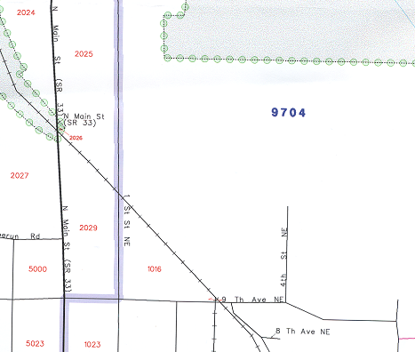

Census block number

Railroad

Structure points and structure point numbers

Street name

Alternate street name

Census tract boundary
Fishhook Unnamed Road
StreetIncorporated place boundary
Water feature

Census tract number

Incorporated place name and FIPS Entity Code

1
2

The following examples display the most common updates you can make to the Census Bureau maps.

Examples

Map Example 1: Adding a New Street and Associated Address Ranges

During your review, you may find addresses missing from the Address List that are on streets that are partially or entirely missing from the maps.

For example, Spring Street is a new street with newly constructed housing units in census tract 9704 and census block 1017. The addresses are missing from the Address List and the street is missing from the map.

Figure 4.2: Adding a New Street and Associated Address Ranges
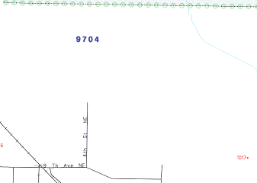
Spring Street
101-199

100-198
221

222

Using a red pencil, draw the location of Spring Street on the map and label it Spring St.

- Print the address range for each side of Spring St.

- Print the address breaks where the new street intersects 4th Street NE.

- Be sure that the missing addresses are on your address list to ensure that your address list matches the map.

Map Example 2: Correcting a Street Name

The Address List and map show MILTON HOSE DR instead of the correct name, MILTON HOUSE DR.
Figure 4.3: Correcting a Street Name
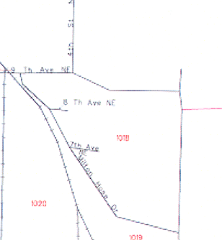
- Using a red pencil, cross out HOSE and print HOUSE above it.
(Co Rd 9)
House

- Use double hatch marks to show the extent of the name change on the maps, if applicable.

- Provide, if applicable, any alternate names that may exist for a street (such as Co Rd 9) by printing this name in parentheses on the map.

- Make any corrections to your address list, as needed, so that the maps match your list.

Map Example 3: Moving a Street

Figure 4.4: Moving a Street
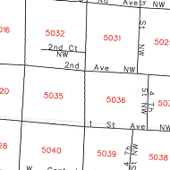
The Census Bureau map shows 2nd Ct NW located in census block 5032. Actually, 2nd Ct NW is located in census block 5035.
200
2nd Ct NW
213 201
111113
110 112

- Using a red pencil, circle the feature in its current location

- Redraw the feature and print the feature name in the correct census block

- Draw an arrow to the correct location of the moved street

- Print any necessary address ranges and address breaks along the streets as shown in Figure 4.4.

- Make corrections to your address list, as needed, so that your list matches the map.

Map Example 4: Deleting a Street
Figure 4.5: Deleting a Street
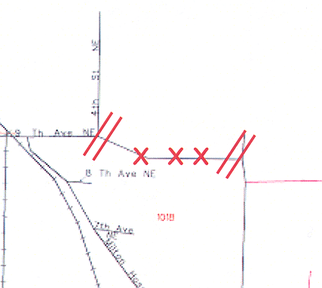
All of the housing units along a portion of 9th Avenue NE in census block 1018 have been demolished and this section of the street no longer exists.

- Using a red pencil, “X” out the section of 9th Avenue NE that no longer exists. Use double hatch marks to define the extent of the deleted segment when deleting only part of the street. When deleting an entire street, “X” out the street and put a red line through its name.

- Correct all affected addresses on your address list, as needed so that the maps match your list.

The MAF/TIGER Accuracy Improvement Project: Digital Update of the TIGER® Database

In 2002, the Census Bureau initiated the MAF/TIGER Accuracy Improvement Project (MTAIP) as part of the MAF/TIGER Enhancements Program (MTEP). This project acquired geographic information system (GIS) files, aerial photography, and GPS data from various sources nationwide to update the TIGER® database. One of the primary goals of the project was to develop a highly accurate geographic database of the United States. The Census Bureau focused on improving the accuracy of street feature coordinates to provide base information suitable for use with GPS-equipped hand-held devices that would facilitate the gathering of accurate location and census information for all living quarters and workplaces.

If your jurisdiction has been updated through the MTAIP process, carefully review the features and boundaries and make corrections where necessary. Pay special attention to the shape of the overall boundary because boundary segments may have been realigned based on changes to underlying roads or water features. Boundary segments that do not follow physical features (i.e., boundary lines through space) were adjusted relative to the surrounding physical features. Some water and road features shown as a single line may now be shown as two lines representing shorelines where you will need to determine the correct alignment of the boundary.

Shapefiles

The shapefiles, created from the Census Bureau’s Topographically Integrated Geographic Encoding and Referencing System (TIGER®), allows participants to submit feature updates electronically. Shapefiles require the use GIS software. All shapefiles provided by the Census Bureau are in Environmental Systems Research Institute (ESRI) shapefile format. Participants that submit shapefiles with map feature updates must follow Census Bureau requirements.

In order to maintain topology, the Census Bureau has provided an “all lines” shapefile layer. In addition to the all lines layer, the Census Bureau has provided shapefile layers for legal and statistical boundaries that may be edited by the user. For more details on the contents of the shapefiles, view the readme.txt file that is included in the CD containing the shapefiles.

Submitting Shapefile Feature Information

In order to submit digital feature information, you must have a GIS capable of importing ESRI shapefiles, editing the features, and exporting layers back into ESRI shapefile format.

The Census Bureau’s Shapefile Coordinate System and Projection Information

All shapefiles provided by the Census Bureau are in the following unprojected
geographic based coordinate system:

- GCS_NAD83
- Angular Unit: Degree (0.017453292519943299)
- Prime Meridian: Greenwich (0.000000000000000000)
- Datum: D_North_American_1983
- Spheroid: GRS_1980
- Semi-major Axis: 6378137.000000000000000000
- Semi-minor Axis: 6356752.314140356100000000
- Inverse Flattening: 298.257222101000020000

Please feel free to project these files into your local coordinate system/projection.

General File Setup Guidelines

Upon receipt of your shapefile, please follow the setup guidelines listed below before beginning actual updates:

- Open the CD and enclosed zip file to ensure it contains the shapefiles for your entity.
- Copy and decompress shapefiles to a directory on your server or hard drive.
- Open the shapefiles in a GIS.

Note: The use of brand names does not represent an endorsement of a company or its products by the U.S. government. Due to the wide use of ESRI products by our partners in the GIS community, and the ubiquitous use of the shapefile format as a medium for GIS data exchange, the Census Bureau is providing this data in shapefile format. You should not encounter any problems when importing these shapefiles into your local GIS software. If you are using GIS software that does not contain a shapefile translator, please contact the Census Bureau for further instructions at
301-763-1099.

Changing Our Coordinate System to Match Yours

Our files are in GCS NAD83 format. The spatial referencing information is also stored in each shapefile's *.PRJ file. Most GIS software packages contain projection wizards, or something similar, allowing the user to transform file coordinate systems and projections. For example, if your office uses ArcView to update files, please activate and utilize ArcView’s “Projection Utility Wizard” extension. If using ArcGIS, please use its “Projection Utilities” in ArcToolbox. TIGER® extract shapefiles contain defined projection information in the *.PRJ file. Both ArcView and ArcGIS access the *.PRJ file for projection information; therefore, there is no need for you to define these parameters before changing a file’s coordinate system.

In addition, if your files are in a datum other than NAD83, you must geographically transform our files to match your datum. Most GIS software has tools for performing geographic transformations on files. However, if you encounter problems transforming our files, please contact the Census Bureau at
301-763-1099 for assistance.

Feature Information

The Census Bureau will collect feature changes designated by the participant. Please note that all feature-related update processing occurs at a different location and time within the Census Bureau.

If you have reviewed your features using our line feature network and have determined that the Census Bureau needs to add, remove, or rename features in a given area, you may submit your modifications in a separate layer. To move or correct a feature, first delete the feature then add the correction.

Note: In the future, large numbers of feature changes will be made through a program called the Automated Feature and Attribute Update System (AFAUS). AFAUS will have the ability to add new road features, names, and address ranges to the MAF/TIGER database directly from local GIS files (we cannot process scanned maps or cadastral boundary files). The files must represent road centerlines (and eventually other feature types). The update process will be able to match local features to the MAF/TIGER database and update it with new and revised information. The Census Bureau will evaluate local files provided. The AFAUS is scheduled to begin production in 2007.

Please use the appropriate update code located in the coding scheme to identify the type of feature modification you submit.

If any issues arise with the feature layer that you submitted, a member of the RO team will attempt to contact you to clarify the issue. If clarification is not made prior to our project deadline, the updates may not be incorporated into TIGER®. Your updates are considered provisional until their existence is confirmed during our field check.

Updating the Feature Shapefile

Create a new line layer in the shapefile provided by the Census Bureau that includes the following feature updates:

- Each change must contain a separate line record for each update made to the file.

- Each update related line must contain one of the codes listed in the coding scheme and that code must be recorded in the attribute field for the line.

See Figure 4.7 for an example.

Figure 4.6: Change Type Codes for Feature Corrections

Change Type Codes for Feature Corrections

Code | Translation | Additional Requirements (if applicable
NF | New Feature | If adding a new feature (Road, Railroad, Hydrography, etc.), code all new feature segments with a ‘NF’ value in CHNG_TYPE field.
CN | Change Name | If changing the name of a feature, code the line segment(s) with a ‘CN’ in the CHNG_TYPE field, and provide the feature’s new name in the ‘FENAME’ field.
CF | Change Feature Class | If changing the feature class code for a feature, code the CHNG_TYPE field with a ‘CF’ (i.e., a local road was mistakenly coded as a highway).
DF | Delete Feature | If deleting a feature, provide all deleted feature segments in a change line layer, and code all deleted segments with a ‘DF’ value in the CHNG_TYPE field.

Displaying Features Based on CFCC1

Within the *.shp file you may want to display different feature types based on the Census Feature Class Code (CFCC1). For example, you may want to display all roads in black, hydro features in blue, etc. Some of the CFCC1 values listed below may not appear in the shapefiles you have, but for your reference:

- ‘A’ → Roads
- ‘B’ → Railroad
- ‘C’ → Miscellaneous Ground Transportation
- ‘D’ → Landmark
- ‘E’ → Physical Features
- ‘F’ → Nonvisible Features (such as boundaries for
incorporated places, counties, school districts, etc.)
- ‘G’ → US Census Bureau Usage (for internal
programs)
- ‘H’ → Hydrography
- ‘P’ → Provisional Features
- ‘X’ → Not Yet Classified

For more detailed information on CFCC’s, you can refer to pp. 3-28 to 3-45 of the most recent TIGER/Line® documentation at http://www.census.gov/geo/www/tiger/index.html.

Figure 4.7: Digital Road Correction Example
Road Name Change: Include all affected road segments, write new road name in the “FENAME” filed for those road segments, and populate the “CHNG_TYPE” field with “CN”.

New Road Feature: Include all new road segments,
Write new road name in the “FENAME” field for all
new segments, and populate the “CHNG_TYPE”
field with “NF”.

Delete Feature: Include all road segments that you want to delete, and populate the “CHNG_TYPE” field with “DF”.

Road Segments

Figure 4.7 consists of road corrections that you may wish to submit. Create a separate layer containing just those road segments that you would like the Census Bureau to add, remove, or rename.
Figure 4.8: Table Extract for Figure 4.7

TLID | CFCC | CFCC1 | FIDELITY | FENAME | CHNG_TYPE
 | A41 | A | 0 | Oak Street | NF
 | A41 | A | 0 | Oak Street | NF
 | A41 | A | 0 | Oak Street | NF
9999999998 | A41 | A | 0 | Cherry Street | CN
9999999998 | A41 | A | 0 | Cherry Street | CN
9999999998 | A41 | A | 0 | Cherry Street | CN
9999999998 | A41 | A | 0 | Cherry Street | CN
9999999998 | A41 | A | 0 | Cherry Street | CN
9999999998 | A41 | A | 0 | Cherry Street | CN
9999999998 | A41 | A | 0 | Elm Street | DF
9999999998 | A41 | A | 0 | Elm Street | DF
9999999998 | A41 | A | 0 | Elm Street | DF
9999999998 | A41 | A | 0 | Elm Street | DF

Figure 4.8 is an example of a table extract from Figure 4.7. Provide the CFCC, CFCC1, Fidelity, FENAME, and CHNG_TYPE when adding new road features. The participant is required to provide CFCC, FENAME, and CHNG_TYPE information only for each road name change. The “TLID,” “CFCC,” “CFCC1,” and “Fidelity” fields are informational fields that do not require filling by the participant for existing road features. When deleting roads/features, provide the CHNG_TYPE.

Address Information

The Census Bureau will not collect address break information through digital feature submission. A process is being designed to capture this information digitally in future programs. If you have an accurate address source that you would like to share with the Census Bureau at this time, please contact your Census Bureau Regional Office.

Data Dictionary and Metadata

Data Dictionary

Submit a data dictionary, either as part of the metadata or as a separate file. The table in Figure 4.9 provides a data dictionary for all line shapefiles, while Figure 4.10 provides a data dictionary for census tracts and Figure 4.11 provides a data dictionary for census blocks.

Figure 4.9: Data Dictionary for all Line Shapefiles

Data Dictionary for all Line Shapefiles

Field | Length | Type | Description
TLID | 10 | Integer | TIGER/Line® ID
CFCC | 3 | String | Feature CFCC
CFCC1 | 1 | String | First Character of feature CFCC
Fidelity | 1 | Integer | Shape Fidelity Flag
FENAME | 90 | String | Feature Name
CHNG_TYPE | 2 | String | Type of digital linear update

Figure 4.10: Data Dictionary for Census Tracts

Data Dictionary for Census Tracts

Field | Length | Type | Description
STATE | 2 | String | Current state Federal Information Processing Standard (FIPS) code
COUNTY | 3 | String | Current county FIPS code
TRACT | 6 | String | Current census tract code
GEOID | 11 | String | Current state and county FIPS codes, and current census tract code
Figure 4.11: Data Dictionary for Census Blocks

Data Dictionary for Census Blocks

Field | Length | Type | Description
STATE | 2 | String | Current state Federal Information Processing Standard (FIPS) code
COUNTY | 3 | String | Current county FIPS code
TRACT | 6 | String | Current census tract code
BLOCKCU | 4 | String | Current census block (base) code
BLOCKCU_SUF | 1 | String | Current census block (suffix) code
GEOID | 16 | String | Current state and county FIPS codes, current census tract code, current census block (base) code, and current census block (suffix) code

Metadata Requirements

Submit appropriate metadata with your file.

Metadata that describe the data content, coordinate system/projection, author, source, and other characteristics of GIS files are critical for Census Bureau staff to efficiently and accurately process files. The Census Bureau requires that a metadata text file accompany every GIS file and layer submitted.

The Federal Geographic Data Committee’s (FGDC) Content Standard for Digital Spatial Metadata provides a national standard that enables the data-sharing public to easily locate critical information about a file and ensure that no critical information is omitted inadvertently when creating metadata. For this reason, the Census Bureau requests that metadata be submitted using this standard. For information about the FGDC and its geospatial metadata standards, please visit http://www.fgdc.gov/metadata/metadata.html

The Census Bureau requires that the following sections of the FGDC metadata form be completed:

- Citation (information about the originator, publication date, title edition, and other publications or information).
- Description (section that contains an abstract describing your data set).
- Time period of content (section that describes the vintage of the data).
- Spatial domain (information about bounding coordinates).
- Point of contact (general contact information).
- Data quality information (information about attribute accuracy).
- Spatial reference information (section on coordinate system / projection of the data set).
- Entity and attribute information (section that describes the contents of your table).

To help you fulfill the requirement of filling out and submitting metadata, the Census Bureau suggests visiting the USGS web site. This site contains useful information about FGDC compliant metadata, from which one can read about metadata frequently asked questions, view FGDC metadata examples, and connect to other FGDC related Web pages. The USGS's metadata URL is http://geology.usgs.gov/tools/metadata/.

Moreover, if you are using Arc/Info, the following link points to a useful Arc Macro Language (AML) tool that, when executed, completes most of the required sections of the metadata form automatically http://marinemetadata.org/tools/refs/FGDCMeta. (This AML is a product of the Illinois State Geological Survey.)

Note: ESRI’s ArcCatalog also has an embedded program that uses the FGDC standard in its creation of geospatial metadata.

If you have questions regarding the data dictionary or metadata requirements, please contact the Census Bureau at 301-763-1099.

Digital File Submission

Use the following as a guide to ensure that you have included all the required layers.

- Name the feature update layer as the following (this file is only required if making updates to your road features) and export the layer to a shapefile:

LUCA08_<ST><COU>_FEAUpdates.shp

The feature update layer must include:

  - A value in its “CHNG_TYPE” field that indicates the type of change.
  - Only feature updates (do not include unmodified features).

Compressing the File

Compress all updated materials, Shapefile, Data Dictionary, and Metadata, into one ZIP formatted file called:

LUCA08_<ST><COU>_Return.ZIP.

Note: Please use PkZip or GZip software, if possible.

Burn the file to a CD-ROM and submit according to the directions provided in Chapter 6.

Boundary and Annexation Survey (BAS)

The Census Bureau conducts the Boundary and Annexation Survey (BAS) each year to determine the inventory of correct names, legal descriptions, and legal boundaries of counties and equivalent entities, minor civil divisions, incorporated places, American Indian reservations, and American Indian off-reservation trust lands. The Census Bureau enters all boundary and area information obtained through the BAS into the TIGER® database so that all subsequent map and address list products reflect these changes.

During your review, you may find that the boundary for your jurisdiction, as shown on the Census Bureau map, does not depict the correct current location. You may submit boundary corrections on the paper Census Bureau map as explained in Appendix C or using a digital file as described in the Appendix D, Digital BAS Guidelines Supplement Boundary and Annexation Survey (BAS) User’s Guide. This user’s guide is included for your reference as a supplement to the LUCA Program.

For more information on submitting digital boundary files and the BAS program, please, visit the BAS Web site at http://www.census.gov/geo/www.bas/bashome.html.

Chapter 5 The LUCA Program’s Predefined Local Address List File Format

The LUCA Program’s Predefined Local Address File Format
The Address List Template Record Layout File

The LUCA Program’s Predefined Local Address List File Format

You must submit your local address file (city-style addresses only) in the predefined format as shown in Figure 5.1. The Census Bureau will only accept and process address files submitted in the LUCA Program’s predefined format. We will not accept/process noncity-style addresses.

Figure 5.1: LUCA Program’s Predefined File Format for Local Address List Submission
 | Maximum  Character  Length | Field Name | Description/Notes
1 | 11 | Entity ID Code | Unique number assigned by the Census Bureau to each entity
2 | 2 | State Code | 2-digit Current State Code
3 | 3 | County Code | 3-digit Current County Code
4 | 7 | Census Tract Number | 4-digit Census Tract Number, plus 2-digit number suffix, if applicable, includes a period for suffixed tracts
5 | 5 | Census Block Number | 4-digit Current Census Block Number, plus 1-digit alpha character suffix if applicable
6 | 1 | Group Quarters Flag | Display a ‘Y’ if the unit is a group quarters, if applicable
7 | 23 | House Number | Housing unit’s or group quarter’s assigned house number
8 | 2 | Street Name Prefix Direction | e.g., N, W, SE
9 | 4 | Street Name Prefix Type | e.g., HWY, RT, US
10 | 40 | Street Name | Full street or road name
11 | 4 | Street Name Suffix Type | e.g., ST, CT, AVE, DR
12 | 2 | Street Name Suffix Direction | e.g., N,W, SE
13 | 3 | Street Name Street Extension | e.g. EXT, ALT, BUS
14 | 100 | GQ Name | Name of group quarter (Dobbs Hall-University of Dobbs)
15 | 27 | Apartment/Unit Number | Within structure descriptor or identifier, such as APT 5 or 1st FL FRNT
16 | 5 | Mailing ZIP Code | 5-digit ZIP Code for mailing addresses

The Address List Template Record Layout File

An address list template record layout is included on your CD-ROM. If you choose, you may use this template to import your local address file for submission. The name of this file is:

AddressListTemplate.txt

- Create a new directory or new folder on your hard drive. Copy the file from the CD-ROM into that directory or folder.

- When you open the text file with your application, tell the application program the following:

  - Fields are delimited.
  - Delimiter is pipe.
  - Text qualifier is none.
  - All field types are text.

Define all field types as “text.”

Be sure that the required address information is in the appropriate field for each address. Your Entity ID, state, and county codes can be found on the address list materials and/or on the maps.

- Entity ID Code

- State code

- County code

- Census tract number

- Census block number

- Group quarters flag, if applicable:

- Enter a “Y” in the “Group Quarters Flag” field (Field 6) for a group quarters address.

- Add the name of the group quarters in the “GQ Name” field (Field 14).

- House number

- Street Name Prefix Direction

- Street Name Prefix Type

- Street or road name

- Street Name Suffix Type

- Street name Suffix Direction

- Street Name Street Extension

- Group Quarters name, if applicable (Be sure that the “Group Quarters Flag” in Field 6, displays a ‘Y’).

- Apartment/unit number, if applicable:

If you have multi-unit structures (apartments, condominiums, etc.) listed in your address file or need to add these addresses, use the following guidelines for identifying individual units.

- Enter the unit designation (e.g., APT 5, UNIT 103) in the “Apartment/Unit Number” field, if known.

- If the apartment/unit numbers are unknown, but you know the number of units at the multi-unit structure, enter “*#” in the “Apartment/Unit Number” field for each unit added. For example, the new multi unit structure located at the basic street address 505 Wells Blvd, contains twenty units.

        - Create twenty records with the correct census geography (i.e., state code, county code, census tract number, census block number) and the basic street address, 505 Wells Blvd.

        - For each unit added at 505 Wells Blvd enter in order, the appropriate “*#” in the “Apartment/Unit Number” field. For example, for the first unit added at 505 Wells Blvd, enter “*1” in the “Apartment/Unit Number” field; for the second unit record added, enter “*2” in the “Apartment/Unit Number” field, and so on, until you get to the twentieth unit record, where you enter “*20” in the “Apartment/Unit Number” field.

The “*” character will alert the Census Bureau that the actual unit identifiers are unknown and that we need to obtain further information during our field check of the addresses.

Note: You may use the procedure described above to add addresses for
mobile home or trailer lots, whether occupied or vacant.

- ZIP Code

Chapter 6 Sumitting Your Local Address List File and Map Updates

Submitting LUCA Materials
Your Local Address File
Census Bureau Paper Maps
Shapefiles
Shipping Census Bureau Title 13 Materials

Submitting LUCA Materials

After completing your review and update of the LUCA materials, submit your local address list and map updates to the Census Bureau Regional Office responsible for your jurisdiction (See the back cover for a list of Regional Offices). Please include the inventory form, Appendix G, with your materials. All maps containing structure points must be submitted according to the instructions in the section, Shipping Census Bureau Title 13 Materials, below. For all submissions, use shipping contractors that provide tracing services, such as U.S. Postal Service (USPS) certified or registered mail, Fed Ex, United Parcel Service (UPS), or similar service.

Your Local Address File

- Save your address list file under a new name (so that you have a backup copy).

- Save the file in a pipe-delimited ASCII format and burn it to a CD-ROM.

- Keep the backup copy of your file until the regional office staff informs you that they have received and successfully processed your files.

Census Bureau Paper Maps

- Separate the Census map sheets with annotations from those without annotations.

- Make a copy of all map sheets containing annotations to keep for your records and to use during the feedback process, if necessary.

- Organize the map sheets by map sheet number.

- Fold the maps if there are five or fewer map sheets.

- If there are more than five map sheets, roll the maps and mail them in a mailing tube or box.

Note: Maps containing structure points must be submitted according to the instructions in the section, Shipping Census Bureau Title 13 materials, below.

Shapefile

- Burn the shapefile to a CD-ROM.

- Keep a backup copy of your updated digital file for your records.

Shipping Census Bureau Title 13 Materials

If five or fewer maps containing structure points are returned:

  - Ship them in two opaque sealed envelopes that are durable enough to prevent someone from viewing or tampering with the enclosed materials.

- Label both sides of the inner envelope or wrapping with “DISCLOSURE PROHIBITED BY Title 13 U.S.C.” as shown in Appendix H.

- DO NOT label the outer addressed envelope with the “DISCLOSURE PROHIBITED BY Title 13 U.S.C.” notice.

- Address the outer envelope to the Director, Census Bureau Regional Office for your jurisdiction as provided on the back cover to the attention of the LUCA Staff.

If more than five maps containing structure points are returned:

  - Wrap them in opaque paper before placing them in a mailing tube or box to prevent someone from viewing or tampering with the enclosed materials.

  - Include the “DISCLOSURE PROHIBITED BY Title 13 U.S.C.” special notice as shown in Appendix H.

  - Address the mailing tube or box to the Director, Census Bureau Regional Office for your jurisdiction as provided on the back cover to the attention of the LUCA Staff.

Chapter 7 Returning Or Destroying Census Bureau Title 13 Materials

Returning Census Bureau Title 13 Materials
Methods for Destroying Census Bureau Title 13 Materials

Once you have reviewed your LUCA Program feedback materials, you must return or destroy all Title 13, U.S.C. address lists and maps containing structure points according to the Census Bureau’s specific guidelines for returning or destroying Title 13 materials.

The primary liaison is required to verify the return or destruction of any remaining Title 13 materials, both paper and computer-readable (i.e., paper copies, backup files, etc.). The primary liaison must sign and return to the Census Bureau the Return/Destruction of Title 13, U.S.C. Materials form found in Appendix I. (This form must be included with your returned Title 13 materials.) All LUCA Program reviewers are required to sign and date this form at the completion of the LUCA Program. Should any liaison or reviewer leave before the completion of the LUCA Program, they are required to “sign-out” of the program by signing and dating this form. If any liaison or reviewer leaves and fails to sign and date this form, the current liaison can “sign-out” on their behalf.

Returning Census Bureau Title 13 Materials

- Use shipping contractors that provide tracing services, such as U.S. Postal Service (USPS) certified or registered mail, Fed Ex, United Parcel Service (UPS), or similar service.

- Ship all Census Bureau Title 13 materials in two opaque sealed envelopes that are durable enough to prevent someone from viewing or tampering with the enclosed materials.

- Label both sides of the inner envelope or wrapping with “DISCLOSURE PROHIBITED BY Title 13 U.S.C.” as shown in Appendix H.

- DO NOT label the outer addressed envelope with the “DISCLOSURE PROHIBITED BY Title 13 U.S.C.” notice.

- Include the signed and dated Return/Destruction of Title 13, U.S.C. Materials form.

- Address the outer envelope to the Director, Census Bureau Regional Office for your jurisdiction as provided on the back cover to the attention of the LUCA Staff.
Methods for Destroying Census Bureau Title 13 Materials

Only those individuals who signed the Confidentiality Agreement Form are permitted to destroy the materials.

- Never deposit Census Bureau confidential materials in a trash or recycle container.

- Store the materials in a secure area in a container labeled “document destruction container” until they are destroyed.

- The destruction process must prevent recognition or reconstruction of the paper or computer-readable information. Use one of the following methods to destroy census confidential materials:

- Never deposit Census Bureau confidential materials in a trash or recycle container.

- Store the materials in a secure area in a container labeled “document destruction container” until they are destroyed.

- The destruction process must prevent recognition or reconstruction of the paper or computer-readable information. Use one of the following methods to destroy census confidential materials:

- Shredding.

- Chemical decomposition.

- Pulverizing (such as, hammer mills, choppers, etc.).

- Burning (only in a facility approved by the Environmental Protection Agency).

- Clear magnetic media (tapes, disks, hard drives) containing Census Bureau address information before reuse. To clear, overwrite all Title 13 data a minimum of three times using a commercial disk utility program or degauss using a commercial degausser.

- Clear diskettes by running a magnetic strip, of sufficient length to reach all areas of the disk over and under each surface a minimum of three times. If the information cannot be destroyed as suggested, damage the disk in an obvious manner to prevent use in any disk drive unit and discard.

Note: Hand tearing or burying information in a landfill are unacceptable methods of disposal.

- Destroy CD-ROMs and DVDs using a commercial grade shredder, suitable for rendering them un-useable; or cut them up with scissors in an obvious manner to prevent use in a drive unit.

Once you have destroyed all Title 13 materials, you must return the signed and dated Return/Destruction of Title 13, U.S.C. Materials Form to the Census Bureau.

If you have any questions regarding the return or destruction of Title 13 materials, please call your Census Bureau Regional Office.

Appendixes

Appendix A Confidentiality and Security Guidelines

Confidentiality and Security Guidelines

The law requires the U.S. Census Bureau to maintain the confidentiality for all of the information that it collects. The Census Bureau takes its responsibility to protect the confidentiality of the information it collects very seriously. Respondents place their trust in the Census Bureau each time they complete a survey or an interview. This trust in confidentiality is critical to the success of the Census Bureau’s mission to collect and report the most accurate data possible. To uphold the law, the Census Bureau requires that all individuals who work with the Census Bureau’s confidential materials read, understand, and agree to abide by the confidentiality and security guidelines outlined below.

Why Address Information Is Protected

Title 13, United States Code (U.S.C.), provides for the confidential treatment of census-related information. Chapter 1, Section 9 of the code states:

“Neither the Secretary, nor any other officer or employee of the Department of Commerce or bureau or agency thereof, or local government census liaison, may, except as provided in section 8 or 16 or chapter 10 of this title…

- use the information furnished under the provisions of this title for any purpose other than the statistical purposes for which it is supplied; or

- make any publication whereby the data furnished by any particular establishment or individual under this title can be identified; or

- permit anyone other than the sworn officers and employees of the Department or bureau or agency thereof to examine the individual reports.”

Section 214 of the Code and the Uniform Sentencing Act of 1984 set the penalty for the wrongful disclosure or release of information protected by Title 13 at a fine of not more than $250,000 or imprisonment for not more than 5 years, or both.

To implement this law, all Census Bureau employees (both temporary and permanent) take an oath to maintain the confidentiality of the census information they encounter in their work. Census information includes:

- Everything on a completed or partially completed questionnaire or obtained in a personal or telephone interview.

- Individual addresses maintained by the Census Bureau that Local Update of Census Addresses (LUCA) Program liaisons review.

- Maps that identify the location of individual housing units and/or group quarters (“structure points”).

Title 13 of the U.S.C. does not protect generalized address information, such as the address range data available in the Census Bureau’s TIGER/Line products.

In 1994, the U.S. Congress amended Chapter 1 of Title 13 to allow local government designated census liaisons to review the Census Bureau’s address list for their area. This amendment recognizes the important role that local knowledge and participation can play in building and updating an accurate, comprehensive census address list. In amending this chapter, the Congress reaffirmed the confidential nature of address information.

The Confidentiality Agreement

Each participating government must designate a primary liaison. The primary liaison and all reviewers must understand and sign the Confidentiality Agreement. The Census Bureau considers all individuals who have access to the Census Bureau’s address information and maps showing the location of housing units and group quarters, liaisons. Therefore, all Option 1 and
Option 2 LUCA Program reviewers must sign the Confidentiality Agreement and Self-Assessment Forms.

Signatures on this form constitute an agreement by each individual to abide by the security guidelines outlined below. While access to Title 13 protected information is temporary, the commitment to keep the information confidential is permanent.

- The Census Bureau will not deliver the address list materials to participants choosing Option 1 and Option 2 until we have received a completed and signed Confidentiality Agreement and Self-Assessment Form.

- Although you may have prior confidentiality agreements on file at the Census Bureau, these will not fulfill the requirements of the LUCA Program.

Security Guidelines

The Census Bureau recognizes the fact that the implementation of these guidelines may vary slightly from one participant to another. Regardless, the result must be the same for each participant – nondisclosure of information protected by Title 13, U.S.C.

The primary liaison accepts the responsibility for protecting and safeguarding the LUCA Program materials covered by Title 13, U.S.C. This includes any list that shows individual Census Bureau addresses and any Census Bureau map or digital file that shows individual housing units and/or group quarters location (“structure points”). The primary liaison must restrict access to the Census Bureau’s address information to those individuals who have signed the Confidentiality Agreement. Only those individuals directly involved in the review should sign the Confidentiality Agreement.

As you read the Census Bureau’s security requirements, keep in mind the important role security plays in the overall responsibilities of each LUCA Program liaison and reviewer. The Census Bureau must have your full cooperation and commitment to following these guidelines. Together, we will maintain the confidential information entrusted to the Census Bureau by the Congress and the American public.

Protecting Census Bureau Address Information

The Census Bureau will conduct workshops covering all aspects of the LUCA Program. In addition, the workshops will provide the participating governments with an opportunity to review the security guidelines and safeguards to protect against illegal use of Census Bureau address information. Census Bureau staff conducting the workshops will help you decide who in your organization needs to have access to the Address List and will review the civil and criminal penalties for improper or illegal use of the data.

Onsite Visits

To ensure that participating entities or organizations are maintaining adequate security safeguards, the Census Bureau may make on-site visits to review your entity or organization’s security procedures. The Census Bureau will strive not to disrupt your office’s operations. A typical visit would include a review of:

- Storage and handling of Census Bureau address information.

- Employee access to Census Bureau address information.

- The physical safeguard of the computers, rooms, and buildings where the Census Bureau address information is stored.

- Instructions to employees about security.

- Data processing operations (including use of passwords).

- Employee awareness of their responsibilities to protect the confidentiality of Census Bureau addresses.

Protecting Paper Copies of Census Bureau Address Information and Maps

- Keep all Census Bureau address information in a locked room during non-work hours. If possible, store the Census address materials and maps showing structure points in locked desks or cabinets.

- During work hours, do not leave a room unattended where Census Bureau address information is stored. Lock the room whenever you leave.

- Do not leave Census Bureau address information unattended at your desk. Return any Title 13 data to secure storage when you are not using it.

- Only make copies of the information necessary to complete your task. Do not leave the copying machine unattended while making copies. All copied material containing Title 13 information must bear the statement:

“This document contains information, the release of which is prohibited by Title 13, U.S.C., and is for U.S. Census Bureau official use only.”

- To FAX a document containing Census Bureau address information to a Census Bureau location, make sure the document is properly labeled, verify the FAX number before sending, and arrange for a Census Bureau employee to be at the FAX machine to receive it and acknowledge receipt.

- Do not disclose precise or even anecdotal information about Census Bureau addresses or locations to anyone who is not a liaison, reviewer, or a Census Bureau employee.

Protecting Electronic Census Bureau Address Information and Maps

Operating systems, programs, applications, and data related to the review of Census Bureau addresses must be accessible only to LUCA Program liaisons and reviewers. The automated data processing (ADP) system should restrict the read, write, delete, and execute functions applicable to the Census Bureau’s addresses.

The ADP system must use log-on routines that require a user-ID and password that conform to the following guidelines:

- Assign a unique user-ID and password for liaisons and reviewers.

- Passwords must consist of at least 8, nonblank characters consisting of at least one alphabet letter and either one number or one special character ($,*, &). No more than six consecutive characters (AAAAAA) may appear in the password, and then only once.

- Reject passwords that are the same as the user-ID or that have been used within the last 6 months.

- Encrypt passwords.

- Disable passwords after three bad attempts.

- Do not display passwords on terminals or printers.

- Change passwords every 90 days (more frequent change is optional) or immediately, if compromised.

- On new accounts, the user must change the assigned password to a unique password the first time they log on.

The ADP system must display a warning log-on feature. Computer screens must display a warning that states:

**WARNING*WARNING*WARNING**
YOU HAVE ACCESSED A COMPUTER SYSTEM CONTAINING UNITED STATES GOVERNMENT INFORMATION. USE OF THIS COMPUTER WITHOUT AUTHORIZATION OR FOR PURPOSES FOR WHICH AUTHORIZATION HAS NOT BEEN EXTENDED IS A VIOLATION OF FEDERAL LAW AND CAN BE PUNISHED BY FINE OR IMPRISONMENT (Public Law 99-474). ALL USE MAY BE INTERCEPTED, MONITORED, RECORDED, COPIED, AUDITED, INSPECTED, AND DISCLOSED TO AUTHORIZED LAW ENFORCEMENT OFFICIALS. REPORT SUSPECTED VIOLATIONS TO YOUR AGENCY SECURITY OFFICER. USE OF THIS SYSTEM INDICATES YOU CONSENT TO THIS WARNING. LOG OFF IMMEDIATELY IF YOU DO NOT AGREE TO THE CONDITIONS OF THIS WARNING.
**WARNING*WARNING*WARNING**

If Census Bureau address information is placed on a shared computer system, construct electronic security profiles to allow only LUCA Program liaisons and reviewers access to the Census Bureau’s address information. Test your security to ensure that only LUCA liaisons and reviewers are permitted access to the Census Bureau’s address information.

Encrypt all Title 13 Census Bureau address information transmitted via FTP to the Census Bureau’s data site with an appropriate product.

Lock all rooms containing computers and all associated media during nonwork hours.

Do not leave computers with Census Bureau address information unattended during work hours. Log-off the computer or lock the room whenever you leave.

Label any computer diskettes, CD-ROMs, DVDs, tapes, cartridges or other computer storage media containing Census Bureau address information with the following:

“This document contains information, the release of which is prohibited by Title 13, U.S.C., and is for U.S. Census Bureau official use only.”

If backup is necessary, do not send the tapes, cartridges, or disks off-site. Store them in a secured area. Do not mix, store, or back-up LUCA data with other data.

Clear magnetic media (tapes, disks, hard drives) containing Census Bureau address information before reuse. To clear magnetic media, overwrite all Title 13 data three times at a minimum using a commercial disk utility program or degauss using a commercial degausser.

Program any software you develop for displaying the Census Bureau addresses to label each affected page of a printout containing Census Bureau address information with the following:

“This document contains information, the release of which is prohibited by
Title 13, U.S.C., and is for U.S. Census Bureau official use only.”

Returning Census Bureau Title 13 Materials

Once you have completed your initial review and update of the LUCA materials, return only those materials with updates to the Census Bureau’s Regional Office responsible for your jurisdiction. Retain all nonannotated Title 13 materials until you receive your feedback materials. Use the following guidelines to ship the updated materials:

- Enclose a letter to the Census Bureau’s Regional Office notifying them of the shipment and listing its contents.

- Ship all Census Bureau confidential material in two opaque sealed envelopes that are durable enough to prevent someone from viewing or tampering with the enclosed materials.

- Seal and reinforce all packages.

- Label both sides of the inner envelope or wrapping with “DISCLOSURE PROHIBITED BY Title 13, U.S.C.”

- DO NOT label the outer addressed envelope with the “DISCLOSURE PROHIBITED BY Title 13, U.S.C.” notice.

- Address the outer envelope to the Director, Census Bureau Regional Office for your jurisdiction, to the attention of the LUCA Staff.

- Use shipping contractors that provide tracing services, such as U.S. Postal Service certified or registered mail, FedEx, United Parcel Service, or similar service.

Methods for Destroying Census Bureau Confidential Materials

After receiving and reviewing your feedback materials, all Title 13, U.S.C., Census Bureau address lists and maps containing structure points must be destroyed and/or returned according to the Census Bureau’s specific guidelines for destroying or returning confidential material.

The primary liaison is required to verify the destruction of any remaining Title 13 materials, both paper and computer-readable (i.e., paper copies, backup files, etc.). The primary liaison must sign and return to the Census Bureau the Destruction of Title 13, U.S.C., Materials form. In addition, all LUCA Program reviewers are required to sign this form at the completion of the LUCA Program. Should any liaison or reviewer leave before the completion of the LUCA Program, they are required to “sign-out” of the program by signing and dating this form.

Only those individuals who signed the Confidentiality Agreement are permitted to destroy the materials.

- Never deposit Census Bureau confidential materials in a trash or recycle container.

- Store the materials in a secure area in a container labeled “document destruction container” until they are destroyed.

- The destruction process must prevent recognition or reconstruction of the paper or computer-readable information. Use one of the following methods to destroy census confidential materials:

- Shredding.
- Chemical decomposition.
- Pulverizing (such as, hammer mills, choppers, etc.).
- Burning (only in a facility approved by the Environmental Protection Agency).
- Clear magnetic media (tapes, disks, hard drives) containing Census Bureau address information before reuse. To clear, overwrite all
Title 13 data a minimum of three times using a commercial disk utility program or degauss using a commercial degausser.
- Clear diskettes by running a magnetic strip of sufficient length to reach all areas of the disk over and under each surface a minimum of three times. If the information cannot be destroyed as suggested, damage the disk in an obvious manner to prevent use in any disk drive unit and discard.
Note: Hand tearing or burying information in a landfill are unacceptable methods of disposal.
- Destroy CD-ROMs and DVDs using a commercial grade shredder, suitable for rendering them un-usable, or cut them up with scissors in an obvious manner to prevent use in a drive unit.

Once you have selected a method of destruction, contact the Census Bureau’s Regional Office staff who will provide you with the precise specifications for the destruction method you have selected.

Appendix B Confidentiality Agreement Form
Confidentiality Agreement
2008 Census Dress Rehearsal Local Update of Census Addresses (LUCA) Program

1. Name of the Participating Governmental Unit

2. Name of LUCA Liaison’s Office or Department (Assessor’s Office, Planning Department, etc.)

3. Address (House Number and Street Name, RR, HC, or PO Box Number)

4. City, State, ZIP Code

5. Responsibilities of Liaisons and Reviewers Participating in the 2008 Census Dress Rehearsal LUCA Program
All 2008 Census Dress Rehearsal LUCA Program liaisons and reviewers must agree to keep confidential the U.S. Census Bureau address information (including structure points) they review or to which they have access. They may use this information solely for suggesting improvements to the Census Bureau’s address list and maps. All individuals from your organization who will be reviewing Census Bureau addresses must sign below to indicate they have read and understand the Census Bureau’s rules regarding restrictions related to confidential information. Upon signing this agreement, your governmental unit agrees to destroy and/or return all Title 13, Census Bureau confidential materials to the Census Bureau after reviewing your LUCA Program feedback materials. In addition, those who sign the agreement indicate they that understand the penalty for disclosing information about addresses or individuals obtained by the Census Bureau, including maps that contain structure points showing the location of housing units or group quarters, is a fine of not more than $250,000, or imprisonment for not more than 5 years, or both. Although access to the data is temporary, this commitment is permanent.
Date | Liaison’s Printed Name and Signature | Telephone Number | Your address, if different from above
 | Printed Name
 | Signature |  | City State ZIP Code
Date | Reviewers’ Printed Name(s) and Signature(s) | Telephone Number | Your address, if different from above
 | Printed Name
 | Signature |  | City State ZIP Code
 | Printed Name
 | Signature |  | City State ZIP Code
 | Printed Name
 | Signature |  | City State ZIP Code
 | Printed Name
 | Signature |  | City State ZIP Code

Appendix C Boundary and Annexation Survey (BAS) Paper Map

The Census Bureau conducts the Boundary and Annexation Survey (BAS) each year to determine the inventory of correct names, legal descriptions, and legal boundaries of counties and equivalent entities, minor civil divisions, incorporated places, American Indian reservations, and American Indian off-reservation trust lands. Title 13, U.S.C. authorizes this voluntary survey. Specifically, the Census Bureau requests up-to-date boundary information for local governments and information on the legal actions associated with the changed boundaries. The Census Bureau enters all boundary and area information obtained through the BAS into the TIGER® database so that all subsequent map and address list products reflect these changes.

Boundary Changes

During your review of addresses and/or the Address Count List, you may find that the boundary for your jurisdiction, as shown on the Census Bureau map, does not depict the correct current location. If there is a discrepancy, you can correct the Census Bureau map to reflect the current boundary for your jurisdiction and complete the signature box located in the lower right corner on the map. For the Census Bureau to process this correction you must complete the 2008 Census Dress Rehearsal LUCA Annexations and Detachments form found in Appendix E. Photocopy this form if you need additional pages. It is not necessary to correct the Address List. Addresses are geocoded to the correct jurisdiction when the Census Bureau digitizes the maps.

Using a red pencil, update the Census Bureau map as shown in Figure C.1.

- Draw the new boundary in its correct location and cross out the portion of the old boundary using a string of red “X’s”.

- Add the ordinance number or other legal identifier of the action authorizing the change, along with the effective date of each annexation or detachment that you draw on the map.

- Complete the red signature box found in the lower right corner of the Census Bureau map as shown in Figure C.2.

Note: If the boundary change represents a correction to the Census Bureau map where the boundary was previously reported correctly, but not digitized accurately, correct the location of the boundary using a red pencil, and annotate with the letters “BC” for boundary correction next to the corrected line as shown in Figure C.2.

- If a boundary is shown as coincident with a feature, but the feature location is not shown correctly, use a purple pencil to cross out the incorrect feature location and redraw the feature in purple pencil in the correct location. There is no need to make any annotation to the boundary.

- Complete the 2008 Census Dress Rehearsal LUCA Annexation and Detachment form found in Appendix E. Figure C.3 provides an example of a completed form.

Note: Use the 5-digit FIPS code in the subject matter area of your map. (Minor civil division FIPS codes are in red, while incorporated place codes are in green.)

Figure C.1: Boundary Changes

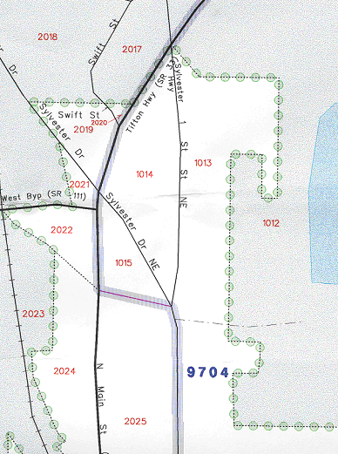
“X” out boundary

New boundary

Ordinance number and effective date

Boundary correction “BC”
X X
X X

X
X
X
BC
ORD 01-3
3/12/05
X
X
X

“X” out coincidental feature

Redraw feature in correct location

Figure C.2: Signature Box
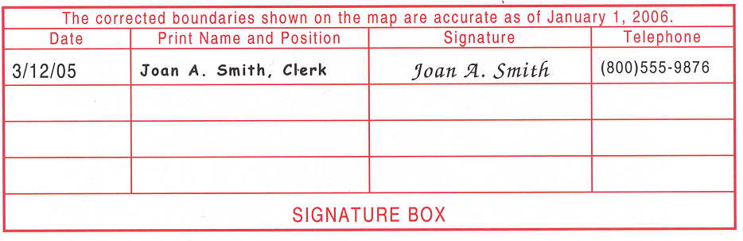
Figure C.3: Example of a Completed Annexations and Detachments Form

2008 Census Dress Rehearsal
Local Update of Census Addresses (LUCA) Program
Annexations and Detachments Form

Please print or type the information about your government in the boxes below.

Government Name Mitchell, Wyoming

Entity Code* 56789

PERSON COMPLETING THIS FORM

Signature Joan A. Smith

Your Name (Printed) Joan A. Smith

Title City Clerk

Telephone (800) 555-9876

FAX (800) 555-9876 E-Mail Address smithj@mitchell.com

Record below the information requested for all annexations (A) or detachments (D) that you have added to the 2008 Dress Rehearsal LUCA program map(s). Be sure that you put the authorization number and effective date in or near the area on the map. The Census Bureau will supply this information to the state certifying agency for your state; please ensure that you properly file all legal changes with your state government in accordance with your state’s laws.

Type of  Change  A or D  (1) | Authorization  Enter in column 2 -  O – Ordinance  R – Resolution  L – Local Law  S – State-level action  X – Other type  Type Number  (2) (3) | Effective date  Month/day/year  (4) | County or parish  in which  A (annexation)  D (detachment)  or  O (other) occurred  (5) | Minor Civil Division (if any) in which  A (annexation)  D (detachment)  or  O (other) occurred  (6) | Estimated Area  Square miles o r Acres (in hundredths) (in tenths)  (7) (8)
A | O 01-3 | 3/13/2005 | Cameron |  | 8 sq miles

* Use the 5-digit FIPS code in the subject matter area of your map. (Minor civil division FIPS codes are in red, while
incorporated place codes are in green.)
D-1642

Appendix D Boundary and Annexation Survey (BAS) Digital File Submission

This user guide is included for your reference as a supplement to the LUCA Program
Digital BAS Guidelines Supplement Boundary and Annexation Survey (BAS) User’s Guide

1. Introduction 53
2. Digital BAS Submission Requirements 53
3. Topologically Integrated Geographic Encoding and Referencing System (TIGER) and Master Address File (MAF) 54
4. MAF/TIGER Accuracy Improvement Project (MTAIP) 55
5. Census Provided Shapefiles 55
6. Updating the Provided Shapefile 56
6.1 General File Setup Guidelines 56
6.2 Changing Our Coordinate System to Match Yours 57
6.3 Annexations, Deannexations and Boundary Corrections 57
Example 1: Shapefile Example of County Update for Two Entities 59
Example 2: New Place Annexation 60
Example 3: Annexation with Geographic Offset 61
Example 4: Union 62
Example 5: MCD Annexation 63
Example 6: Changes in One Layer 64
Example 7: Example 6 Extract 64
Example 8: Current Entity Boundaries for Updated Entities 65
6.4 Feature Information (Optional) 66
Example 9: Road Correction Examples 68
Example 10: Example 9 Extract 69
6.5 Address Information 69
6.6 Metadata and Data Dictionary 69
6.7 File Submission 69

7. Submitting BAS Form via Electronic BAS 20
Appendix D-1 – Coding Scheme 73
Appendix D-2 – Data Dictionary 75
Appendix D-3 – Metadata Requirements 78
Appendix D-4 – Flowchart 80
Appendix D-5 – Flowchart Boundary Update Example 82
1. Introduction

The U.S. Census Bureau conducts an annual survey called the Boundary and Annexation Survey (BAS) to collect information about selected legally defined geographic areas, such as counties, cities, and towns. The BAS also provides an opportunity for participants to review the names and geographic relationships for these areas. The BAS information is used to provide an appropriate record for reporting the results of the decennial and economic censuses, and to support the population estimates program and the American Community Survey. In compliance with the Office of Management and Budget Circular A-16, the BAS supports the spatial data steward responsibilities of the Geospatial One-Stop by updating the inventory of, and boundaries, for governmental units. In addition, the BAS is the source of up-to-date information on boundaries, codes, and names for the U. S. Geological Survey’s (USGS) National Map, the Federal Information Processing Standards (FIPS) program and the Geographic Names Information System. The BAS is also the source for changes in the boundaries of incorporated places, minor civil divisions (MCDs), counties, and federally recognized American Indian Areas, which include reservations and off-reservation trust lands.

2. Digital BAS Submission Requirements

The Digital BAS program is an added option to report changes for the BAS. In order to facilitate the accurate transfer of boundary data from our Digital BAS partners and to aide in their ability to analyze and understand the differences between the Topologically Integrated Geographic Encoding and Referencing System (TIGER®) and local files, the Census Bureau has created new guidelines and procedures for the submission of digital files for BAS. This process will allow participants to submit changes via updating shapefiles created from a version of the Census Bureau’s TIGER®. The new process allows the Census Bureau to process boundary changes, corrections, and differences between files. To participate in the Digital BAS program, you must meet the following requirements:

- Your county must have completed the realignment process for the MAF/TIGER Accuracy Improvement Project (MTAIP). The current list of counties that have completed the realignment process is posted on our Web site at http://www.census.gov/geo/www/bas/bashome.html.

- You must provide information for the BAS point of contact, the person updating the shapefiles, and the highest elected official for your entity (See form at end of document for required data.).

- You must have the ability to edit a Census Bureau shapefile extract of your entity.

If you have questions or concerns about the participation requirements, please contact a member of the BAS team at 301-763-1099 or e-mail
geo.bas@census.gov with your contact information and someone will respond.

3. Topologically Integrated Geographic Encoding and Referencing System
(TIGER) and Master Address File (MAF)

The Geography Division of the Census Bureau is responsible for developing geographic applications and executing the geographic and cartographic activities needed to support the Census Bureau in collecting and disseminating census data. For the last 20 years, the Census Bureau’s Topologically Integrated Geographic Encoding and Referencing System (TIGER®) and Master Address File (MAF) have become the two most critical geographic resources for supporting the Census Bureau in its collection and dissemination of data.

The Census Bureau’s TIGER® system automates the mapping and related geographic activities required to support the decennial census and sample survey programs of the Census Bureau starting with the 1990 decennial census. The TIGER® database includes geographic features such as roads, railroads, water, boundaries, and other geographic information needed to support the programs of the Census Bureau. In addition, the TIGER® database is repository of street address ranges, ZIP codes, and feature names. However, note that TIGER® does not contain specific addresses. TIGER® is a topologically integrated geographic database, in which the topological structures of TIGER® define the location and relationship of streets, rivers, railroads, and other features to each other and to the numerous geographic entities for which the Census Bureau tabulates data for its censuses and sample surveys. Because TIGER® is an integrated database where all boundaries and features reside within one layer, we must adhere to strict topology rules and be cognizant of feature/boundary relationships when making modifications to entities in TIGER®. If you are interested in acquiring more information about the Census Bureau’s TIGER® database and products, please visit the following Web site http://www.census.gov/geo/www/tiger/index.html.

To assemble accurate address data that could be maintained and updated, the Census Bureau developed the MAF in the 1990s. The MAF includes addresses that allow census forms to be mailed and, in some cases, provide descriptions of living quarters enabling census enumerators to deliver forms. In addition, the MAF has a geocoding linkage to the postal information in TIGER®. Although TIGER® is part of the public domain, the MAF is restricted from public use by Title 13 of the U.S. Code.

4. MAF/TIGER Accuracy Improvement Project (MTAIP)

The Census Bureau has embarked on an initiative to enhance and streamline the
MAF/TIGER system. This effort is referred to as MTAIP. The Census Bureau’s goal for MTAIP is to spatially improve features and boundaries in the TIGER® database. The Census Bureau is currently in the process of updating TIGER® based on digital files submitted by state, local, and tribal governments. This is because many state, local, and tribal governments have geographic information systems (GIS) that maintain a significantly greater positional accuracy than that in the TIGER® database and meet our minimum accuracy requirements. Once acquired, the Census Bureau evaluates the various layers associated with the file(s) submitted and determines whether the file(s) can be used for the MTAIP process. Because we are improving feature and boundary coordinates based on state, local, and tribal MTAIP submissions there is a greater likelihood that Digital BAS submissions from the aforementioned governments will closely align with modified TIGER® making both boundary corrections and changes easier to identify. This will also create a solid common geographic foundation for future boundary exchanges for governments that have participated in the MTAIP process. If you have additional questions about the MTAIP process, please contact a geographer at your Census Bureau Regional Office listed on the back cover.

5. Census Provided Shapefiles

The Census Bureau is providing all Digital BAS participants with entity layers in
Environmental Systems Research Institute (ESRI) shapefile format. The number of polygon-based shapefiles that the Census Bureau sends to each Digital BAS participant depends on the type of entities contained within each county. However, each participant, regardless of the number of geographic entities, receives only one shapefile for the linear feature network for the county.

All shapefiles, provided by the Census Bureau, are in the following unprojected
geographic based coordinate system:

GCS_NAD83,
Angular Unit: Degree (0.017453292519943299),
Prime Meridian: Greenwich (0.000000000000000000),
Datum: D_North_American_1983,
Spheroid: GRS_1980,
Semi-major Axis: 6378137.000000000000000000,
Semi-minor Axis: 6356752.314140356100000000, and
Inverse Flattening: 298.257222101000020000.

Please feel free to project these files into your local coordinate system/projection. After completing your updates, you may submit the boundary shapefile using your local coordinate system/projection provided that the shapefile's coordinate system contains a defined projection file (e.g., *.PRJ file) and spatial reference materials (e.g., metadata).

6. Updating the Provided Shapefile

The following will describe how to update the Census provided shapefiles to reflect corrections to your boundary or changes that may have occurred since the last BAS survey. You may also use the following procedures to submit information documenting the creation of new incorporations and dissolutions of incorporated places, MCDs, counties, and county equivalent areas. Please use the feature layers provided to create edits, which maintain accurate boundary to feature relationships. This is important since TIGER® is a topologically integrated system.

In order to update our digital file, overlay our digital boundary file with your entity’s individual boundary shapefile. Code each boundary update with the appropriate boundary coding scheme found in Appendix D 1. The data dictionary in Appendix D 2 will provide you with field definitions and naming conventions used for updating the attribute table with the appropriate boundary codes. The following subsections will provide detailed explanations and examples of the boundary update process. As a supplement, flowcharts can be located in Appendixes D 4 and D 5 to aide in the boundary update and submission processes.

If we have any problems processing the boundary file which you submitted, a member of the Census Bureau’s BAS team will get in touch with the point of contact to clarify the issue. If we cannot clarify the problem prior to our project deadline, the updates will not be incorporated into TIGER®. We will continue to try to resolve these issues before the next BAS cycle.

6.1 General File Setup Guidelines

Upon receipt of your shapefile, please follow the setup guidelines listed below before beginning actual updates:
- open the CD and enclosed zip file to ensure it contains the shapefiles for your entity,
- copy and decompress shapefiles to a directory on your server or hard drive, and
- open the shapefiles in a GIS.
6.2 Changing Our Coordinate System to Match Yours

Our files are in GCS NAD83 format. The spatial referencing information is also stored in each shapefile's *.PRJ file. Most GIS software packages contain projection wizards, or something similar, that allows the user to transform file coordinate systems and projections. For example, if your office uses ArcView to update files, please activate and utilize ArcView’s ‘Projection Utility Wizard’ extension. If using ArcGIS, please use its ‘Projection Utilities’ in ArcToolbox. TIGER® extract shapefiles contain defined projection information in the *.PRJ file. Both ArcView and ArcGIS access the *.PRJ file for projection information; therefore, there is no need for you to define these parameters before changing the file coordinate systems.

6.3 Annexations, Deannexations, and Boundary Corrections: (Areas added, deleted,
or corrected for your entity)

The Census Bureau has provided shapefiles for all entities that are eligible for update as part of the BAS. Select the shapefile that contains the entity requiring updates, and make all revisions to that shapefile. Once all updates are completed, create a new polygon layer that contains only the new updates that you would like the Census Bureau to make for your entity(s). If a boundary update crosses into a new county and additional shapefiles are needed, please contact a BAS team member at 301-763-1099, or send e-mail to geo.bas@census.gov.
Geographic corridors and offsets can be submitted through the Digital BAS process. Please refer to the 2006 BAS User’s Guide for definitions of Geographic Corridors (formerly Corporate Corridors) and Geographic Offsets (formerly Corporate Offsets). http://www.census.gov/geo/www/bas/bashome.html

For your reference, we are providing detailed examples of how you can update the
Shapefiles. For example, a county planner wishes to make two annexations for a place within their county. Although there are many ways to use GIS to accomplish these updates, we are providing one suggested method:
- Make a copy of the Census Bureau place shapefile.
- Make all updates to the newly created layer using GIS editing techniques (as a reminder, please use the Census Bureau provided linear features layer as a referencing guide when making boundary placement decisions) (See Examples 2-3).
- Union the modified place layer with the original Census Bureau place shapefile to identify the changes which you made (See Example 4).
- Create a new polygon layer by selecting the change polygons from the newly created unionized layer. Be sure to only select the change polygons before exporting to a new file (See Examples 5-6)
- Populate the various BAS-related fields in the polygon’s attribute table with annexation information and other census related codes (use the coding scheme in Appendix D 1 for information on how to fill-in the CHNG_TYPE field because every change polygon requires a code - See Example 7).

If more than one level of geography requires updating (e.g., MCDs and places), continue making updates to each layer using methods similar to those mentioned above. Merge all the change polygons for the modified boundary layers into one change polygon layer.

The attribute table should contain all BAS-related fields (e.g., annexation date, ordinance number, etc.), and the various levels of geography being updated. The spatial examples illustrate how to make updates to our spatial layers for two entities, at different geographic levels.

Note: If you are utilizing ArcGIS 9.x software you may simplify the process by using the ‘Symmetrical Difference’ and ‘Multipart to Singlepart’ tools in ArcToolbox. Instead of creating a union between the modified layer and the Census Bureau layer you may use the ‘Symmetrical Difference’ tool. Input the modified feature layer into the ‘Input Features’ box and the Census Bureau layer into the ‘Union Features’ box. This will provide you with a change polygon layer. In order to separate the grouped change polygons into single change polygons, utilize the ‘Multipart to Singlepart’ tool. This will free you from having to select change polygons from the union layer and then use XTOOLS or REGIONPOLY to separate your change polygons. The remainder of the process will stay the same.

Example 1
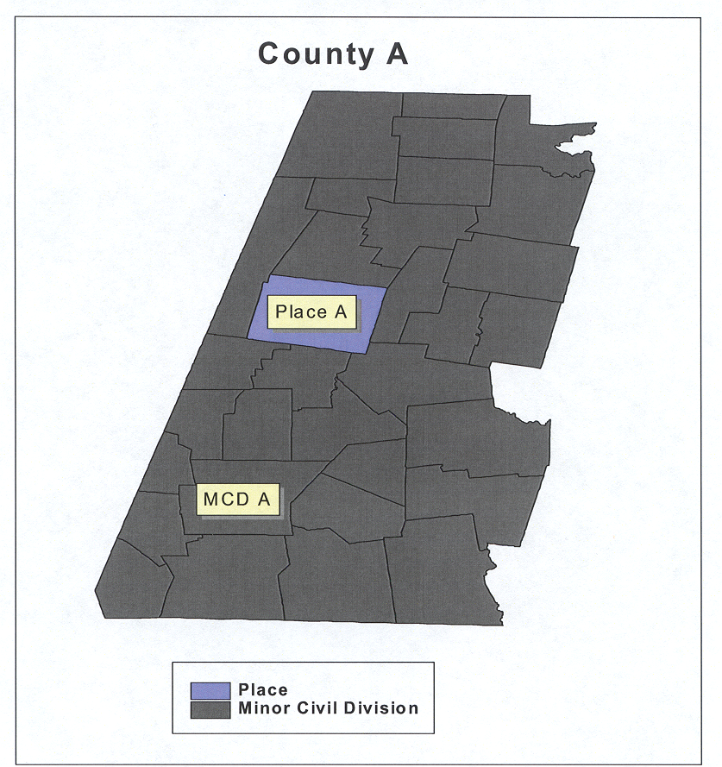

This example depicts two entities (e.g., MCD and place) from the Census Bureau provided shapefiles that County A wishes to update. Note, make copies of all Census Bureau shapefiles that you wish to update and make changes only to those copied versions.

Example 2
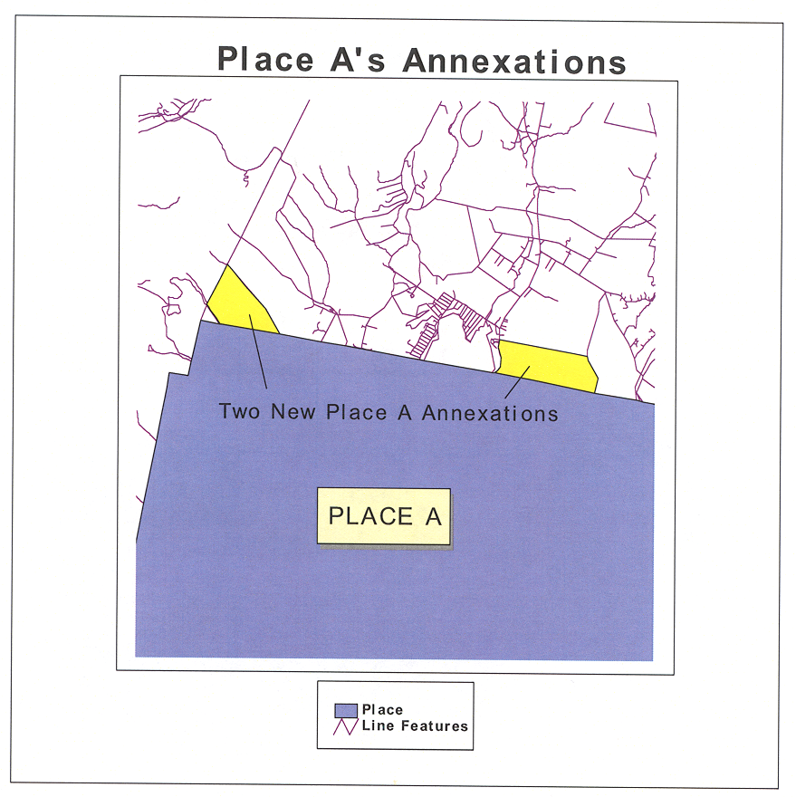

The participant made two updates to the copied version of Place A’s Census Bureau provided place boundary, using the linear feature network provided by the Census Bureau (e.g., DB06<ST><COU>AllLines.shp) as a guide for boundary placement. These updates were made using various GIS editing methods (e.g., vertex edit in ArcView).

Example 3
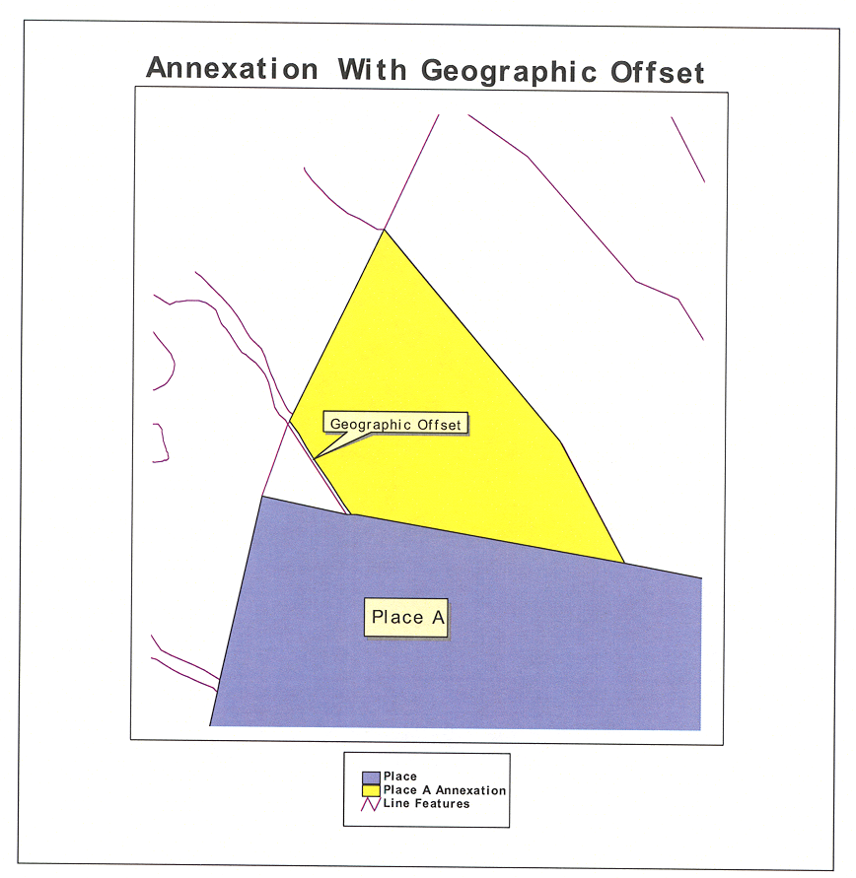

In the above example, one of Place A’s two annexations involves a geographic offset 35 feet from a road feature. In the change polygon attribute table, the participant must populate the CHNG_TYPE field with a ‘AO’ code. This code alerts the Census Bureau that an annexation is offset from a feature. In addition, the participant will also populate the OFFSET field in the polygon’s attribute table with the distance value that the boundary is offset from the road (See Example 7 below).

Example 4

Place A Union
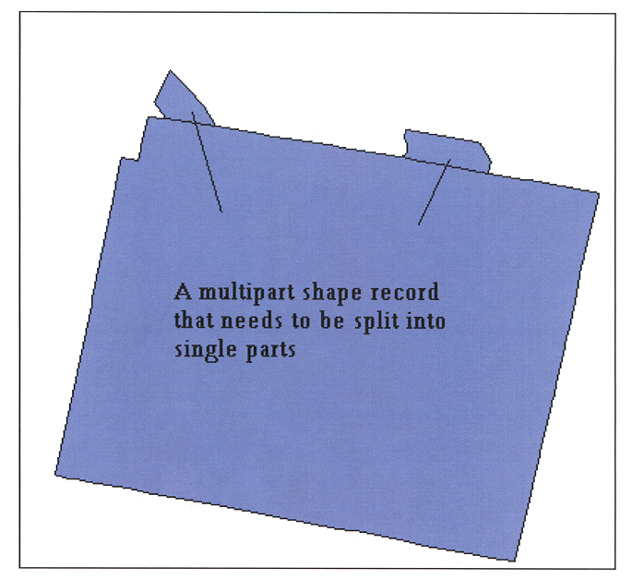

Upon completion of your boundary updates for a particular entity, union the modified copy and the original to create a layer that contains only separate change polygons. However, if multiple changes occurred to one entity (see above), the result of the union is a multipart shape record. In order for the participant to input all the necessary annexation related information into the attribute table, each polygon must be a separate record. There are several methods for creating single parts from multipart shapes (e.g., XTOOL extension for ArcView or ArcGIS, REGIONPOLY in ArcInfo, etc), so please ensure that each polygon has its own record in the attribute table. If each polygon does not have its own record, the Census Bureau may be unable to process your changes.

Example 5
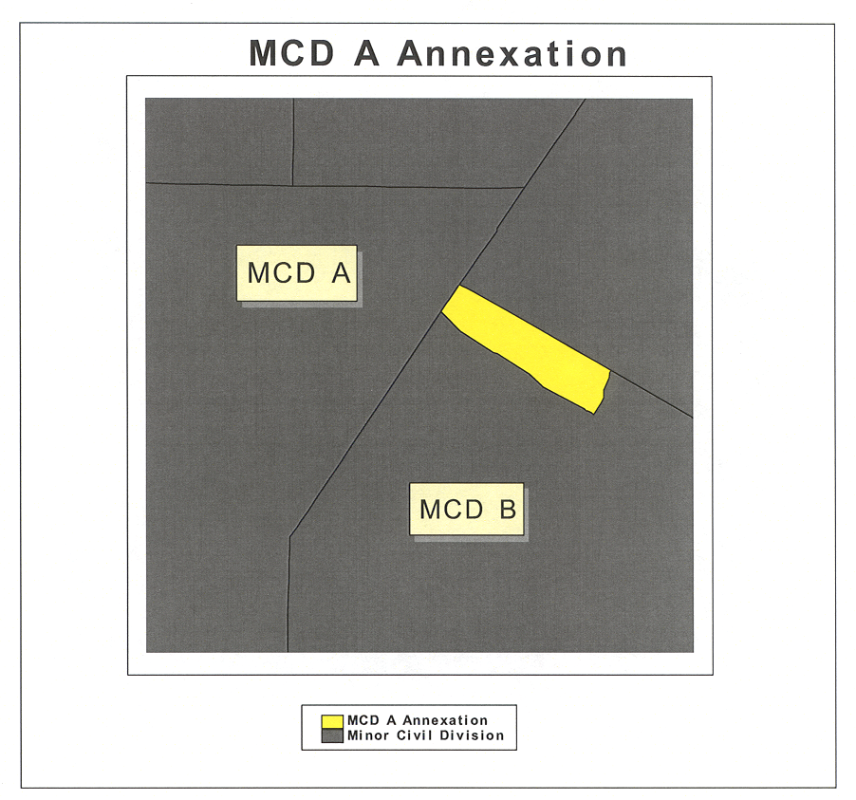

In the above example, MCD A is annexing a piece of MCD B. Therefore, MCD B is losing territory to MCD A. Using similar editing techniques used in Example 4 for places, you should have one polygon record for each update. Create a change polygon layer for the MCD boundary change.

Example 6
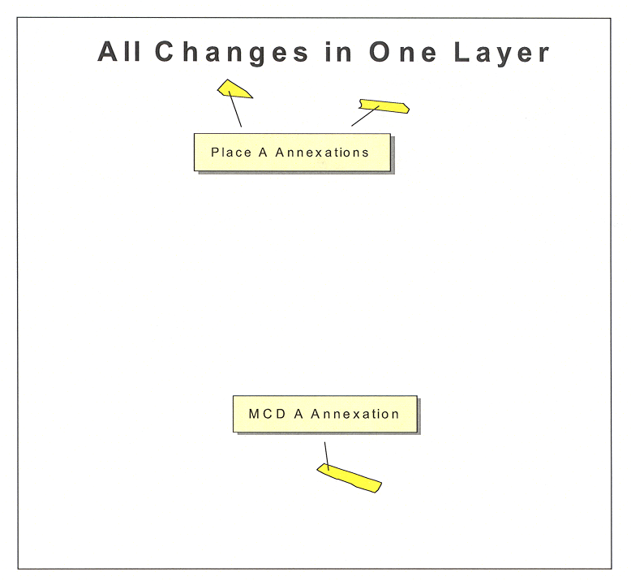

At this point you will have two change polygon layers (place and MCD). Please merge those two layers into one polygon layer. This can be done by using the “merge” GIS geoprocessing tool. Example 6 depicts the change layer the Census Bureau requires for Digital BAS submissions.

Example 7
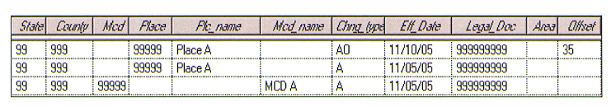

This table extract is from Example 6. Note: the first record in the table is the geographic offset depicted in Example 3. Remember to use actual state/county/entity FIPS codes for the state, county, MCD, and place fields above. Also remember to use actual local codes in the LEGAL_DOC field.

Example 8
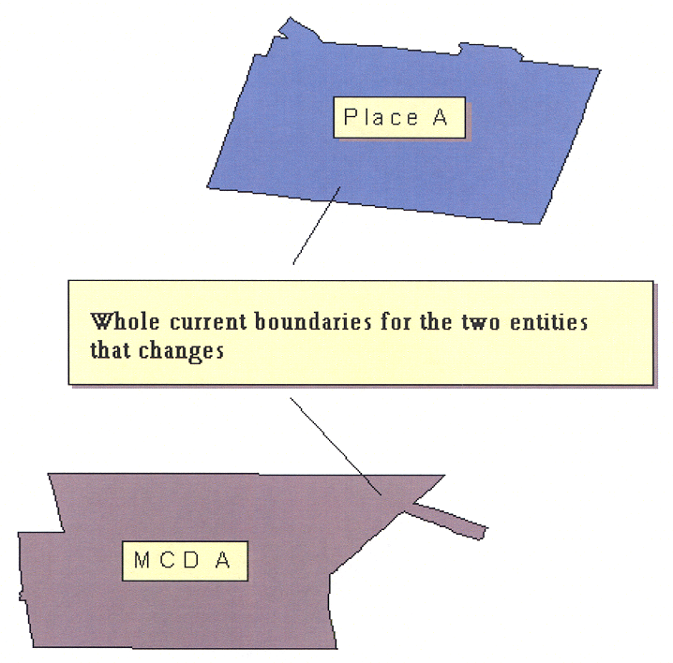

In the example above, the participant will submit two more layers (current place and MCD boundaries) in addition to the layer containing the change polygons. Therefore, the participant for this county will submit a total of three layers to the Census Bureau unless feature updates are being included along with boundary submissions. If feature updates accompany the boundary layers, then the total number will be four (See Example 9).

6.4 Feature Information (Optional)

The Census Bureau will collect feature changes designated by the participant. Please note that all feature-related update processing occurs at a different location and time within the Census Bureau. This may delay the inclusion of your feature updates on next year’s BAS maps. If you have reviewed your features using our line feature network and have determined that the Census Bureau needs to add, remove, or rename features in a given area, you may submit your modifications in a separate layer. If your entity requires a large number of feature changes (>50), please contact the Census Bureau Regional Office for your area to discuss sending them your updates. To locate the Regional Office for your area, please click the link below:

http://www.census.gov/field/www/

Note: In the future, large numbers of feature changes will be made through a program called the Automated Feature and Attribute Update System (AFAUS). AFAUS will have the ability to add new road features, names, and address ranges to the MAF/TIGER database directly from local GIS files (we cannot process scanned maps or cadastral boundary files). The files must represent road centerlines (and eventually other feature types). The update process will be able to match local features to the MAF/TIGER database and update it with new and revised information. The Census Bureau will evaluate local files provided. The AFAUS is scheduled to begin production in 2007.
There is no guarantee that street and name updates from local files will appear in the next BAS update cycle products at this time.

Please use the appropriate update code located in the coding scheme (Appendix D 1) to identify the type of feature modification being submitted. If any issues arise with the feature layer, which you submitted, a member of the BAS team will attempt to contact the respondent to clarify the issue. If clarification is not made prior to our project deadline, the updates may not be incorporated into TIGER®. These updates will then be held in suspense until clarification has been made.

6.4.1 Updating the Feature Shapefile (See Examples 9 and 10)

Create a new line layer which includes the following feature updates:
- Each change must contain a separate line record for each update made to the file, and
- Each update related line must contain one of the codes listed in the coding scheme (Appendix D 1) and that code must be recorded in the attribute field for the line.

6.4.2 Displaying Features Based on CFCC1

Within the *.shp file you may want to display different feature types based on the Census Feature Class Code (CFCC1). For example, you may want to display all roads in black, hydro features in blue, etc. Some of the CFCC1 values listed below may not appear in the shapefiles you have, but for your reference:

- ‘A’  Roads
- ‘B’  Railroad
- ‘C’  Miscellaneous Ground Transportation
- ‘D’  Landmark
- ‘E’  Physical Feature
- ‘F’  Nonvisible Features (such as boundaries for incorporated
- places, counties, school districts, etc.)
- ‘G’  US Census Bureau Usage (for internal programs)
- ‘H’  Hydrography
- ‘P’  Provisional Features
- ‘X’  Not Yet Classified

For more detailed information on CFCC’s, you can refer to pp. 3-28 to 3-45 of the most recent TIGER/Line® documentation at:

http://www.census.gov/geo/www/tiger/index.html

Example 9

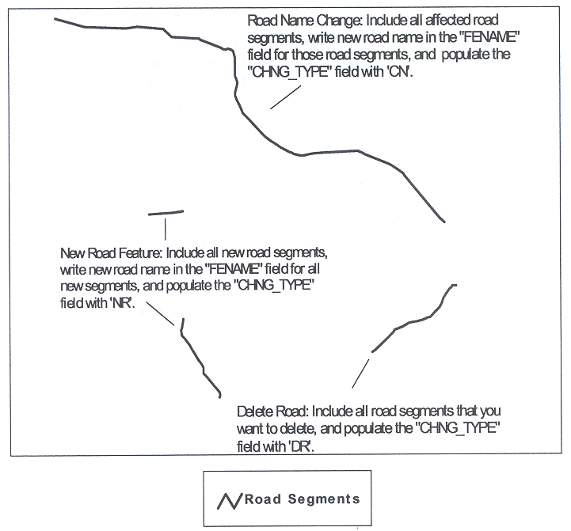

This example consists of road corrections that you may wish to submit in addition to your boundary update layers. Please create a separate layer containing just those road segments that you would the like the Census Bureau to add, remove, or rename. Include this layer along with all the other required boundary layers in your return submission to the Census Bureau.

Example 10
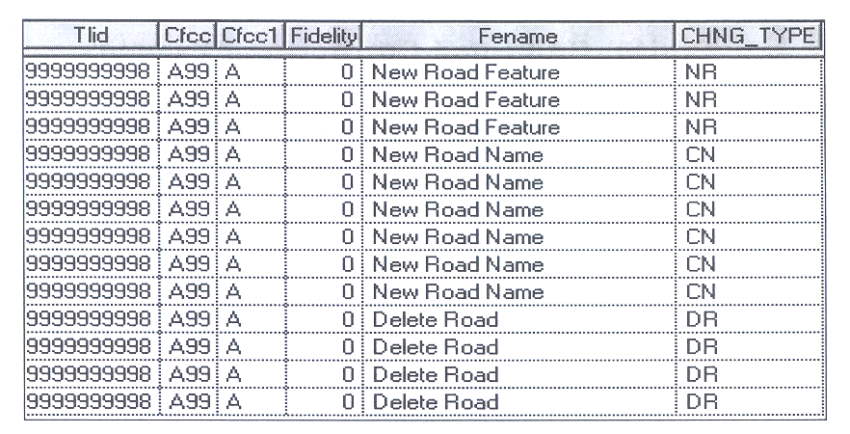

This is a table extract from Example 9. The participant is only required to provide
CHNG_TYPE and FENAME information for each road change. The “TLID,” “CFCC,” “CFCC1,” and “Fidelity” fields are informational fields that do not require filling by the participant.

6.5 Address Information

The Census Bureau will not collect address break information through Digital BAS in 2006. A process is being designed to capture this information digitally in future surveys. If you have an accurate address source that you would like to share with the Census Bureau at this time, please contact your Census Bureau Regional Office listed on the back cover.

6.6 Metadata and Data Dictionary

- Submit a data dictionary, either as part of the metadata or as a separate file. (See Appendix D 2)
- A data dictionary describes the fields included in any data tables associated with your submission. A data dictionary should list all the fields, describe the data in each field, and provide the legal values and their definitions for each field.
- Submit appropriate metadata with your file (See Appendix D 3).

6.7 File Submission

The Census Bureau requires the participant to submit at least two spatial layers with the potential of more (e.g., a layer containing road updates). These layers are described below:

- Change Polygon Layer (required)
- This layer consists of all the changes that you would like the Census Bureau to make to your entity.

- Whole Modified Entity Layer (required)
- This layer should only contain the complete and current boundary for the entity being updated.

- Feature Update Layer (required only if there are road additions, deletions, or name changes)
- If you have road updates that you would like the Census Bureau to make, include this layer with just the road segments that you would like us to adjust.

Use the following as a guide to be sure you have included all the required layers.

6.7.1 Change Polygon Layer

Name the return change polygon layer as the following where <ST><COU> refers to the state/county FIPS code for your area:

DB06_<ST><COU>_Changes.*

- The change polygon layer must include:
- a separate record for each polygon in the layer,
- a code from the coding scheme (Appendix D 1), in the “CHNG_TYPE” field for
- each record. No exceptions,
- closed polygons,
- legal document or ordinance numbers (except Georgia). This information goes in the “LEGAL_DOC” field,
- effective dates,
- acreage of each change polygon (for the State of Georgia only) in the “AREA” field, and
- distance (in feet) in the “OFFSET” field if identified as on offset in the “CHNG_TYPE” field.

6.7.2 The Whole Modified Entity Layer

Name the whole modified entity layer as the following:

DB06_<ST><COU>_WholeEntity_<{PLC, MCD or COU}>.*

- The whole modified entity layer includes:
- the whole entity as it currently exists after updating (this is essentially an “outline” of your updated entity), and
- the entity name and code (e.g., five-digit FIPS from the “PLACE” field and Name from the “PLC_NAME” field for places).
- Please submit each level of geography in a separate whole entity layer and name as follows:
  - Place  PLC
  - Minor Civil Division  MCD
  - County  COU

6.7.3 The Feature Update Layer (Optional)

Name the feature update layer as the following (this file is only required if making updates to your road features):

DB06_<ST><COU>_RDUpdates.shp

- The feature update layer must include:
- a value in its “CHNG_TYPE” field that indicates the type of change, and
- only feature updates (please do not include unmodified features).

6.7.4 Compressing the File

Compress all updated materials, Shapefile, Data Dictionary, and Metadata, into one ZIP formatted file called: DB06_<ST><COU>_Return.ZIP. (Please use PkZip or GZip software if possible).

6.7.5 Submit File via File Transfer Protocol (FTP)

Please FTP all files to the following address:

ftp://ftp2.census.gov/pub/incoming/geo/Digital_BAS/

To submit your file you must obtain a user name and password. Contact a member of the BAS team at 301-763-1099, or geo.bas@census.gov to obtain your user name and password. If you contact the BAS team via e-mail include a phone number where we can reach you. This is necessary because we will not provide your FTP password in e-mail.

6.7.6 Additional Information

The Census Bureau recommends using FIPS codes to identify entities such as counties, county subdivisions, and places. Using a standard code scheme facilitates the digital exchange of data. The USGS maintains FIPS codes for incorporated places and MCDs. The codes can be obtained at:

http://geonames.usgs.gov/fips55.html

If you have any questions or problems, please contact us by e-mail at
geo.bas@census.gov or telephone at 301-763-1099.

- Submitting BAS form via Electronic BAS

Please complete and submit your BAS form through Electronic BAS using the
instructions provided below.

- Using Internet Explorer navigate to the BAS web site
- www.census.gov/geo/www/bas/bashome.html

  - Select the appropriate BAS survey
    - BAS 1: Incorporated Place Survey
    - BAS 2: County or Statistically Equivalent Entity Survey
    - BAS 3: Minor Civil Division (MCD) Survey

      - Enter your ‘User Name’ and Password located under Special Instructions (pp. 2 for Places and MCDs and pp. 5 for Counties) on your paper BAS form.
(Note: The User Name and Password are not the same as those obtained for the FTP process.)

- Enter the required information into Electronic BA
Appendix D 1 - Coding Scheme
(CHNG_TYPE Field Information for both Change Polygon and Line Layers)

Polygon Codes

Polygon Change Layer:

This participant-provided layer should contain a separate update polygon record for each update made to our files. Each update related polygon must contain one of the following codes.

Code | Translation | Additional Requirements (if applicable)
A | Annexation | All polygons coded with an ‘A’ value require an annexation effective date. Note: Only supply ordinance and/or area values if your state requires such information.
AO | Geographic Offset | Same requirements as ‘A.’ However, supply an offset value (e.g., feet from road feature) if your annexation is offset from a road feature. An offset requires a value in the CHNG_TYPE field if the change polygon contains an ‘AO.’ Note: If a polygon gives the appearance of being offset and does not contain an ‘AO,’ then the change polygon boundary will be snapped to the nearest road centerline. For a definition of geographic offsets and corridors, refer to the BAS User’s Guide.
AC | Geographic Corridor | Same requirements as ‘AO.’ However, provide  change polygon with an ‘AC’ value if annexation  creates a geographic corridor.
B | Boundary Correction | Boundary corrections do not require filling the  annexation, offset, or area fields unless the correction involves offsets or geographic corridors. If a boundary correction creates an offset or a corridor, assign one of the codes documented below.
BO | Boundary Geographic Offset | Same requirements as ‘B’ above, however, provide  an offset distance (e.g., feet from road feature).
BC | Boundary Geographic | Same requirements as ‘B.’ However, provide a  Corridor geographic corridor distance (e.g. feet from road feature).

Line Codes
Road Corrections:

After reviewing road features in our line feature network and you have determined that the Census Bureau needs to add, delete, or rename road features in a given area, you may submit, in a separate layer, your road modifications using one of the following codes to identify the type of road modification needed:

Code | Translation | Additional Requirements (if applicable)
NR | New Road Feature | Within the change line layer, please code all new road segments with a ‘NR’ value in the CHNG_TYPE field.
CN | Change Road Name | If changing the name of a road feature, code  the line segment(s) with a ‘CN’ in the CHNG_TYPE field and provide the road feature’s new name in the “FENAME field.
CF | Change Feature Class | If you are changing the feature class code for a  road, code the CHNG_TYPE field with a ‘CF.’  For instance, a local road was mistakenly coded as a  highway.
DR | Delete Road | If deleting a road from you network, please provide  all deleted road segments in a change line layer and  code all deleted segments with a ‘DR’ value in the  CHNG_TYPE field.

As mentioned in Section 6.4, the Census Bureau will collect any road modification designated by the participant. However, please note that all road-related updates are processed at a different location and time within the Census Bureau which may delay the inclusion of your road updates on next year’s BAS maps.
Appendix D 2 - Data Dictionary

County Boundary Shapefile

Field | Length | Type | Description
STATE | 2 | String | Current State FIPS Code
COUNTY | 3 | String | Current County FIPS Code
COU_NAME | 30 | String | Current County Name
CHNG_TYPE | 2 | String | Type of Digital BAS Area Update
EFF_DATE | 8 | String | Annexation Effective Date
LEGAL_DOC | 20 | String | Annexation Ordinance Number
OFFSET | 10 | String | Geographic Corridor or Offset Dist.
AREA | 10 | Double | Acreage of Annexation

Consolidated City Shapefile

Field | Length | Type | Description
STATE | 2 | String | Current State FIPS Code
COUNTY | 3 | String | Current County FIPS Code
CONCITY | 5 | String | Current Consolidated City FIPS
CC_NAME | 90 | String | Current Consolidated City Name
CHNG_TYPE | 2 | String | Type of Digital BAS Area Update
EFF_DATE | 8 | String | Annexation Effective Date
LEGAL_DOC | 20 | String | Annexation Ordinance Number
OFFSET | 10 | String | Geographic Corridor or Offset Dist.
AREA | 10 | Double | Acreage of Annexation

Area Landmark Shapefile:

Field | Length | Type | Description
LNDK_CFCC | 3 | String | Area Landmark CFCC
LNDK_CFCC1 | 1 | String | First Char. of Area Land. CFCC
LNDK_NAME | 90 | String | Primary Area Landmark Name

Minor Civil Division (MCD) Shapefile

Field | Length | Type | Description
STATE | 2 | String | Current State FIPS Code
COUNTY | 3 | String | Current County FIPS Code
MCD | 5 | String | Current MCD FIPS
MCD_NAME | 90 | String | Current MCD Name
CHNG_TYPE | 2 | String | Type of Digital BAS Area Update
EFF_DATE | 8 | String | Annexation Effective Date
LEGAL_DOC | 20 | String | Annexation Ordinance Number
OFFSET | 10 | String | Geographic Corridor or Offset Dist.
AREA | 10 | Double | Acreage of Annexation

Incorporated Place Shapefile

Field | Length | Type | Description
STATE | 2 | String | Current State FIPS Code
COUNTY | 3 | String | Current County FIPS Code
PLACE | 5 | String | Current Place FIPS
PLC_NAME | 90 | String | Current Place Name
CHNG_TYPE | 2 | String | Type of Digital BAS Area Update
EFF_DATE | 8 | String | Annexation Effective Date
LEGAL_DOC | 20 | String | Annexation Ordinance Number
OFFSET | 10 | String | Geographic Corridor or Offset Dist.
AREA | 10 | Double | Acreage of Annexation

All Line Shapefiles

Field | Length | Type | Description
TLID | 10 | Integer | TIGER/Line ID
CFCC | 3 | String | Feature CFCC
CFCC1 | 1 | String | First Character of feature CFCC
FIDELITY | 1 | Integer | Shape Fidelity Flag
FENAME | 90 | String | Feature Name
CHNG_TYPE | 2 | String | Type of Digital BAS linear update

Note: If the ‘Fidelity’ flag contains a value of ‘1,’ then the Census Bureau was unable to
maintain the boundary’s shape fidelity during the MTAIP process. Please review all line
segments (not just roads) in the Census Bureau’s all-line layer for lines with this flag and make any necessary boundary corrections to the affected entity if the boundary has been coordinately shifted.

Appendix D 3 – Metadata Requirements

Metadata that describes the data content, coordinate system/projection, author, source, and other characteristics of GIS files is critical for Census Bureau staff to efficiently and accurately process files for Digital BAS. The Census Bureau requires that a metadata text file accompany every GIS file and layer submitted.

The Federal Geographic Data Committee’s (FGDC) Content Standard for Digital Spatial Metadata provides a national standard that enables the data-sharing public to easily locate critical information about a file and ensure that no critical information is omitted inadvertently when creating metadata. For this reason, the Census Bureau requests that metadata submitted as part of Digital BAS is submitted using this standard. For information about the FGDC and its geospatial metadata standards, please visit the following site:

http://www.fgdc.gov/metadata/metadata.html

The Census Bureau requires that the following sections of the FGDC metadata form be completed as a minimum for considerations:

- citation (information about the originator, publication date, title edition, and other publications or information),
- description (section that contains an abstract describing your data set),
- time period of content (section that describes the vintage of the data),
- spatial domain (information about bounding coordinates),
- point of contact (general contact information),
- data quality information (information about attribute accuracy),
- spatial reference information (section on coordinate system / projection of the data set), and
- entity and attribute information (section that describes the contents of your table)

To help you fulfill the requirement of filling out and submitting metadata, the Census Bureau suggests visiting the USGS web site. This site contains useful information about FGDC compliant metadata, from which one can read about metadata frequently asked questions, view FGDC metadata examples, and connect to other FGDC related Web pages. The following is the USGS's metadata URL:

http://geology.usgs.gov/tools/metadata/

Moreover, if you are using Arc/Info, the FGDC link relating to metadata creation Tools (http://www.FGDC.gov/metadata/toollist/fgdcmeta.html) contains a useful Arc Macro Language (AML) (e.g., fgdcmeta.aml) that when executed, completes most of the aforementioned required sections of the metadata form automatically. This AML is a product of the Illinois State Geological Survey.

Note: ESRI’s ArcCatalog also has an imbedded program that uses the FGDC standard in its creation of geospatial metadata.
Appendix D 4 – Flowchart
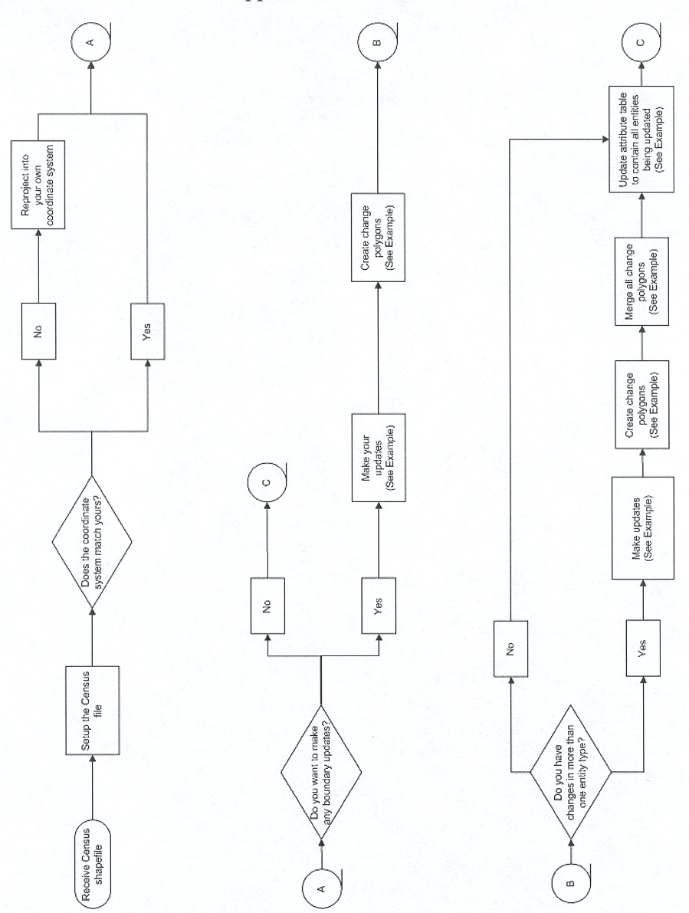
Appendix D 4 – Flowchart Continued
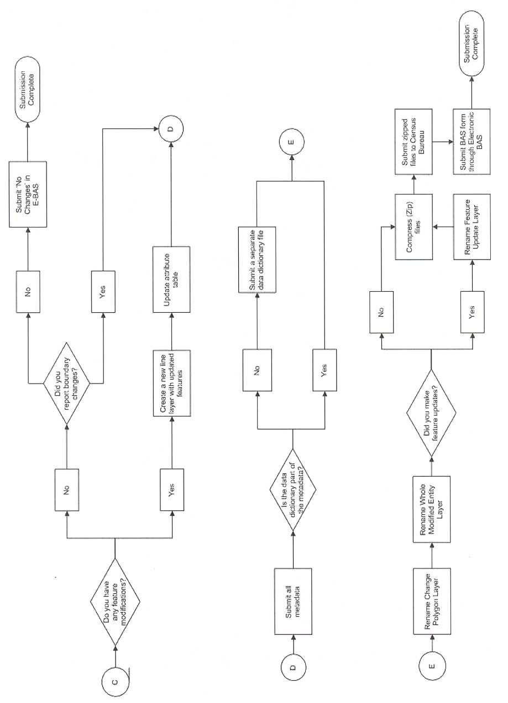
Appendix D 5
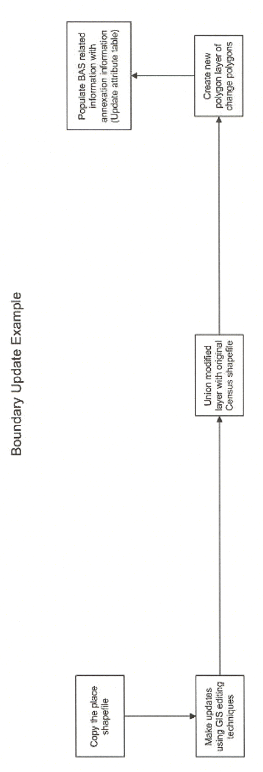

Appendix E Annexations and Detachments Form

2008 Census Dress Rehearsal
Local Update of Census Addresses (LUCA) Program
Annexations and Detachments Form

Please print or type the information about your government in the boxes below.

Government Name _____________________________________________________________________

Entity Code* ___________________________________________________________________________

PERSON COMPLETING THIS FORM

Signature _____________________________________________________________________________

Your Name (Printed) ____________________________________________________________________

Title __________________________________________________________________________________

Telephone ____________________________________________________________________________

FAX ________________________________E-Mail Address ____________________________________

Record below the information requested for all annexations (A) or detachments (D) that you have added to the 2008 Dress Rehearsal LUCA program map(s). Be sure that you put the authorization number and effective date in or near the area on the map. The Census Bureau will supply this information to the state certifying agency for your state; please ensure that you properly file all legal changes with your state government in accordance with your state’s laws.

Type of  Change  A or D  (1) | Authorization  Enter in column 2 -  O – Ordinance  R – Resolution  L – Local Law  S – State-level action  X – Other type  Type Number  (2) (3) | Effective date  Month/day/year  (4) | County or parish  in which  A (annexation)  D (detachment)  or  O (other) occurred  (5) | Minor Civil Division (if any) in which  A (annexation)  D (detachment)  or  O (other) occurred  (6) | Estimated Area  Square miles o r Acres (in hundredths) (in tenths)  (7) (8)

D-1642

* Use the 5-digit FIPS code in the subject matter area of your map. (Minor civil division FIPS codes are in red, while
incorporated place codes are in green.)

Appendix F Contact Update Information Form

Contact Information Update Form

Person completing this form: Name _________________________________________________________________

Address: ______________________________________________________________

Phone: ________________________________________________________________

New or Corrected Chief Executive/Highest Elected Official Information

Title (mark one): □ Ms. □ Miss □ Mrs. □ Mr. □ Dr. □ The Honorable
□ Tribal President □ Tribal Chairperson □ Tribal Chief □ Tribal Governor

Name: __________________________________________________________________________________________ (First Name, MI, Last Name)
Name Suffix (mark if appropriate): □ Jr. □ Sr. □ II □ III □ IV

Position: ________________________________________________________________________________________
(e.g., Commissioner, Mayor, Supervisor, please do not abbreviate)

Department/Office: _______________________________________________________________________________
(e.g., Commissioner’s Office, Mayor’s Office, please do not abbreviate)

Address: ________________________________________________________________________________________

_______________________________________________________________________________________ (City, State, ZIP)

Phone: _________________________ Ext____________________Fax:____________________________________

E-mail: _________________________________________________________________________________________

New or Corrected Contact Information

Title (mark one): □ Ms. □ Miss □ Mrs. □ Mr. □ Dr. □ The Honorable
□ Tribal President □ Tribal Chairperson □ Tribal Chief □ Tribal Governor

Name: __________________________________________________________________________________________ (First Name, MI, Last Name)
Name Suffix (mark if appropriate): □ Jr. □ Sr. □ II □ III □ IV

Position: ________________________________________________________________________________________
(e.g., Planning Director, Planner, Clerk, please do not abbreviate))

Department/Office: ______________________________________________________________________________
(e.g. Planning and Zoning, please do not abbreviate)

Address: _______________________________________________________________________________________

_______________________________________________________________________________________ (City, State, ZIP)

Phone: _________________________ Ext____________________ Fax:__________________________________

E-mail: ________________________________________________________________________________________

Appendix G Inventory Form

Please use this form to identify the LUCA materials that you have updated and are returning to the Census Bureau for the 2008 Census Dress Rehearsal LUCA Program.

Government Name ____________________________________________________________________

Entity ID Code (i.e., CO18057, MC18057020, PL181420) ______________________________________

State ___________________________ County _______________________________________

[ ] Local Address List File File Name ____________________________________

_______ Number of address records

[ ] Census Bureau map sheets

_______ Number of map sheets

[ ] Annexations and Detachments Form

[ ] Shapefile

D-1656

Appendix H Special Disclosure Notice

Special Notice

This Package Contains
U.S. Census Bureau
Address Information

Disclosure Prohibited by
Title 13, U.S.C.

U.S. Department of Commerce
U.S. Census Bureau
3/15/2006

D-1657

Appendix I Return/Destruction of Title 13, U.S.C. Materials Form

2008 Census Dress Rehearsal LUCA Program

Return/Destruction of Title 13, U.S.C. Materials

(fill in the name of your government or organization)

_________________ __________________________________________________________
Date Signature (2008 Census Dress Rehearsal LUCA Program Liaison)

has properly destroyed or returned to the U.S. Census Bureau, the original 2008 Census Dress Rehearsal Local Update of Census Addresses (LUCA) Program materials and any copies using the security requirements provided to us by the U.S. Census Bureau.

2008 Census Dress Rehearsal LUCA Program Reviewers

_________________ __________________________________________________________
Date Signature

_________________ __________________________________________________________
Date Signature

_________________ __________________________________________________________
Date Signature

_________________ __________________________________________________________
Date Signature

_________________ __________________________________________________________
Date Signature

_________________ __________________________________________________________
Date Signature

All LUCA Program reviewers are required to sign and date this form at the completion of the LUCA Program. Should any liaison or reviewer leave before the completion of the LUCA Program, they are required to “sign-out” of the program by signing and dating this form. If any liaison or reviewer fails to sign and date this form, the current liaison can “sign-out” on their behalf.
D-1658

Appendix J The Map Legend
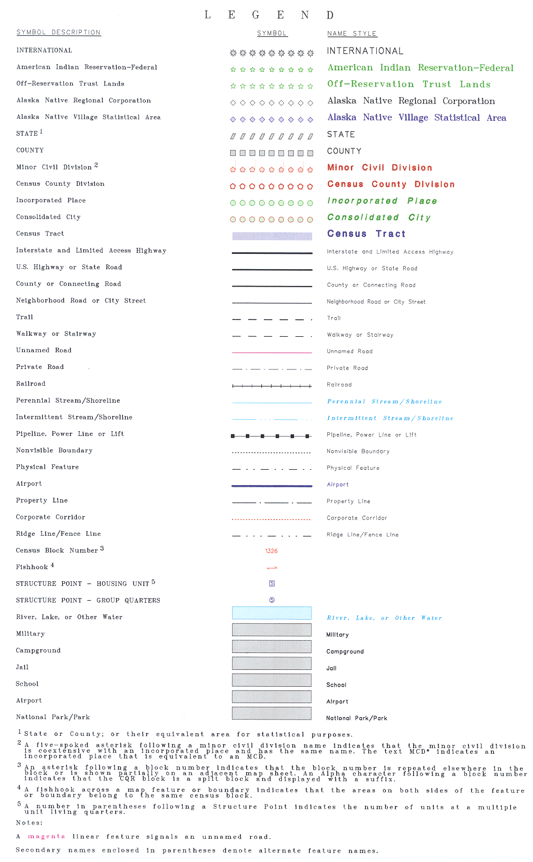
The map legend describes the various symbols and colors used on the maps. The legend is divided into three columns:

- The Symbol Description column includes the type of features, boundaries, and geography shown on the map.
- The Symbol column shows the symbols representing the feature in the symbol description.
- The Name Style column shows an example of the name of a particular feature such as a road, waterway, or geographic area displayed on the map.

Boundaries

The first group of symbols in the legend refers to different boundary types or geographic area shown on the map. Each type of boundary has a distinct color.

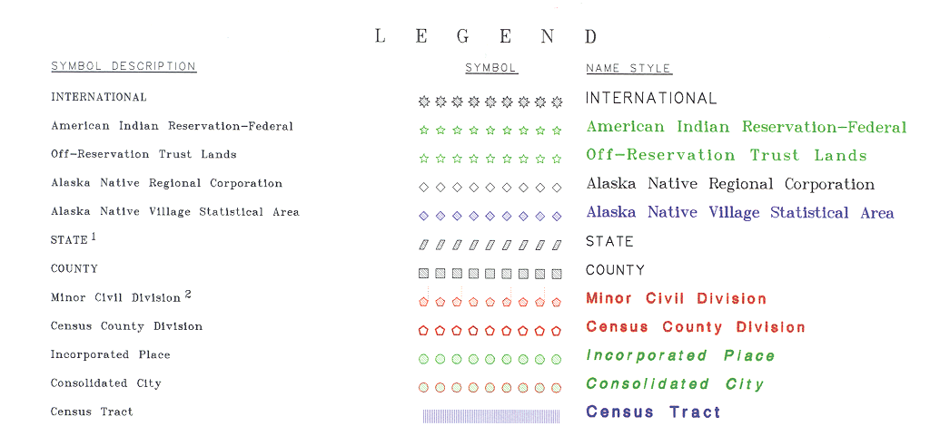

Transportation

The second group of symbols represents various types of transportation features. Thicker lines identify major roadways while thinner lines represent secondary roads and city streets. Private roads, walkways, ferries, and railroads represented by distinctive dashed lines are included in this section.

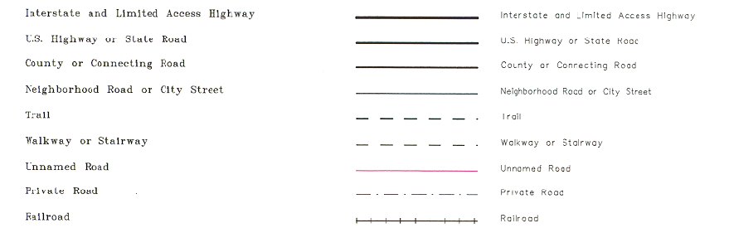

Other Features

The third group of symbols represents other feature types such as pipelines and streams, and non-visible boundaries. Streams and shorelines are blue, airport landing strips are purple, corporate corridors are a dashed red line, and offset corporate boundaries are a solid red line.

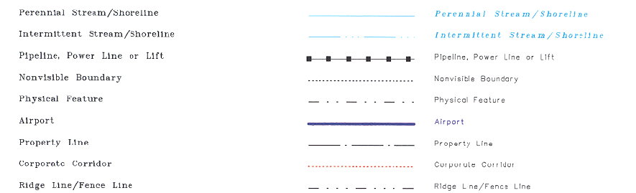
Census Blocks and Symbols

The fourth group of symbols are associated with census blocks. Census blocks are identified numerically and are color-coded. An asterisk next to a census block number indicates that the block number is repeated elsewhere on the map or is partially shown on an adjacent map.

A fishhook symbol across a map feature or boundary area indicates that the area on both sides of the feature or boundary belong to the same census block.

For those participants choosing Option 1, Full Address List Review and Option 2, Title 13 Local Address List Submission, this section also contains structure point symbols, which represent the exact location of residential structures. Structure points for multi-unit structures, such as apartment buildings, are identified by a structure point number, followed by the number of units within the structure in parentheses.

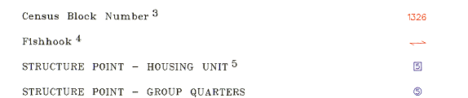

Landmarks

The last group of symbols represents various landmarks on the map such as rivers and lakes, campgrounds, jails, schools, airports, and parks. The Census Bureau maps for the 2008 Census Dress Rehearsal LUCA Program show the rivers and lakes in blue while campgrounds, jails, schools, airport, and parks are gray. The area outside of the subject area is speckled gray.

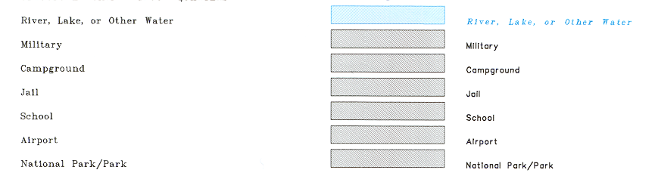

Footnotes and Notes

The footnote and notes section of the legend provide additional information and details on geographic relationships, boundaries, and symbols

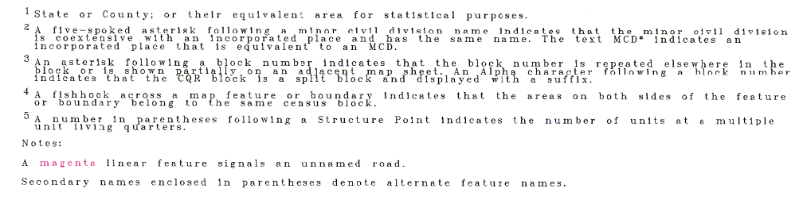
Appendix K Physical Location Description and Street Type Abbreviations Examples
Full Name | Abbreviations
Alternate Route | ALT
Avenue | AVE
Blue | BL
Boulevard | BLVD
Brown | BRN
Boarded Up | BU
Circle | CIR
County Highway | CO Hwy
Count Road | CO Rd
Court | CT
Drive | DR
East | E
Four-Wheel Drive Trail | 4WD
Freeway | FWY
Green | GR
General Delivery | GEN DEL
Hospital | HOSP
Highway Contract Route | HCR
House | HSE
Interstate | I
Intersection | INT
Lane | LN
North | N
Parkway | PKWY
Post Office Box | PO BOX
Railroad | RR
Road | RD
Route | RTE
Rural Route | RR
South | S
Star Route | ST RT
State Highway | ST HWY
State Road | ST RD
State Route | ST RTE
Street | ST
Thoroughfare | THFR
Township Highway | TWP HY
Township Road | TWP RD
West | W
White | WHT
Yellow | YLW
With | W/
Appendix L Unit Designation Abbreviations Examples

Name | Abbreviation
Apartment | APT
Basement | BSMT
Bottom | BOTM
Downstairs | DOWN
Floor | FLR
Front | FRNT
Interior | INTE
Level | LVL
Lower | LOWR
Middle | MIDL
Mobile Home | MH
Number | #
Penthouse | PH
Room | RM
Right | RGHT
Space | SP
Studio | STUD
Suite | STE
Suites | STES
Trailer | TRLR
Upper | UPPR
Upstairs | UPPR

Glossary

Address breaks – The city-style address on each side of a boundary or at an intersection of a street with another feature.

Address Count List – Identifies the number of housing units and group quarters on the Census Bureau’s address list for each census block within a jurisdiction.

Address range – The lowest and highest address numbers used to identify structures along each side of a street segment that has city-style addresses. Usually one side of the street has even address numbers and the other side has odd address numbers.

Annexations and Detachments Form – To be used by the participant to document legal boundary changes for the jurisdiction.

Block – See census block.

Block number – A 4-digit number, plus 1 alpha character block suffix, if applicable, used by the Census Bureau to identify each census block. For this program, census blocks are numbered uniquely within each census tract.

Boundary – A line, either invisible or coincident with a visible feature that identifies the extent of a geographic entity, such as a census tract, city, or county.

Boundary and Annexation Survey – An annual survey of all counties, and selected incorporated places and minor civil divisions conducted by the Census Bureau to determine the correct legal limits and related information as of January 1 of the survey year.

Census Bureau address list – A nationwide list of all housing unit and group quarter addresses known to the Census Bureau. In addition to the mailing address and ZIP Code, the Address List may identify the location of each housing unit and group quarters.

Census block – A geographic area bounded by visible features, such as streets, roads, streams, and railroad tracks, and invisible features, such as the boundaries of governmental units and other legal entities. A census block is the smallest area for which the Census Bureau collects and tabulates statistical information.

Census Bureau – An agency within the U.S. Department of Commerce. The Census Bureau is the country's preeminent statistical collection and dissemination agency. It publishes a wide variety of statistical data about people and the economy of the nation. The Census Bureau conducts approximately 200 annual surveys and conducts the decennial census of the United States population.

Census Bureau map – Any map produced by the Census Bureau. A Census Bureau map displays geographic entities used in a Census Bureau sponsored census or survey for which the Census Bureau tabulates data.

Census tract – A small, relatively permanent statistical division of a county or statistically equivalent entity, delineated for the purpose of presenting Census Bureau statistical data. Census tract boundaries were delineated for Census 2000 in accordance with Census Bureau guidelines that specify the need for visible and stable boundaries. Census tracts never cross the boundary of a county or statistically equivalent entity, but may split other geographic entities; e.g., minor civil divisions and places.

Census tract number – A 4-digit, plus 2-digit suffix, if applicable, used to identify a census tract uniquely within a county or statistically equivalent entity. Leading zeros are not shown on Census Bureau maps

Chief executive/highest elected official – The person most responsible for the governmental activities of a local government. This person receives the LUCA Program invitation letter, and must designate a LUCA liaison, if desired.

City-style address – An address that consists of a house number and street name; for example, 201 Main Street. The address may or may not be used for the delivery of mail and may include apartment numbers/designations or similar identifiers.

Confidentiality – The guarantee made by law (Title 13, United States Code) to individuals who provide information about themselves or their business to the Census Bureau. This item refers to the Census Bureau’s promise of nondisclosure of that information to others.

County – The primary legal division of most states. Most are governmental units with powers defined by state law.

Delivery Sequence File (DSF) – A computerized file containing all delivery point addresses serviced by the U.S. Postal Service (USPS). The USPS updates the DSF continuously as its letter carriers identify addresses for new delivery points or changes in the status of existing addresses.

Feature – Any part of the landscape, whether natural (such as, a stream or ridge) or artificial (such as, a road or power line). In a geographic context, features are any part of the landscape portrayed on a map, including nonvisible boundaries of legal entities, such as, city limits or county lines.

Geocode – A code that identifies a specific geographic entity. For example, geocodes needed to identify a census block for data collection are the state code, the county code, and the block number.

Geographic Information System (GIS) – A computer system for the storage, retrieval, and maintenance of information about the points, lines, and areas that represent the streets and roads, rivers, railroads, geographic entities, and other features on the surface of the Earth-information that previously was available only on paper maps.

Global Positioning System (GPS) – A satellite navigation system that provides coded satellite signals to a GPS receiver to compute location.

Governmental unit – A geographic entity established by legal action for the purpose of implementing specified governmental functions. Most governmental units provide a number of general government services and raise revenues (usually through taxing authority).

Group quarters – The Census Bureau classifies a group quarters as a place where people live or stay that is normally owned or managed by an entity or organization providing housing and/or services for the residents. These services may include custodial or medical care, as well as other types of assistance, and residency is commonly restricted to those receiving those services. People living in group quarters are usually not related to each other.
Group quarters include such places as college residence halls, residential treatment centers, skilled nursing facilities, group homes, military barracks, correctional facilities, workers’ dormitories, and facilities for people experiencing homelessness.

Housing unit (HU) – A single-family house, townhouse, mobile home, trailer, vacant trailer park pad, apartment, group of rooms, or single room occupied as a separate living quarters, or, if vacant, intended for occupancy as a separate living quarters. A separate living quarters is one in which one or more occupants (or, intended occupants, if vacant) live separate from any other individual(s) in the building and have direct access from outside the building or through a common hall.

Incorporated place – A type of governmental unit, incorporated under state law as a city, town, village, or borough, having legally prescribed boundaries, powers, and functions.

Legal boundary – The legally defined boundary of a governmental unit, usually referring to a county, minor civil division, or incorporated place. The legal boundary identifies the area within a local government's jurisdiction, and thus bounds the area of LUCA responsibility.

LUCA liaison – Also known as the program liaison or designated liaison. A person voluntarily appointed by the chief executive/highest elected official of each jurisdiction to review the Census Bureau’s address list and maps against local records to identify differences.

Map Sheet to Block Number Relationship List – A list identifying census block numbers and the Census Bureau map(s) on which each block is located.

Master Address File (MAF) – A nationwide list of all addresses to support many of the Census Bureau’s operations. Besides containing mailing addresses and ZIP Codes, a MAF record also contains geographic information about the location of addresses.

Minor civil division (MCD) – A type of governmental unit that is the primary governmental or administrative subdivision of a county. MCDs are identified by a variety of terms, such as town (in 8 states), township, and/or district, and include both functioning and nonfunctioning governmental entities.

Noncity-style address – An address that does not use a house number and street name. This includes rural route and box number address and highway contract route addresses, etc., which may include a box number, post office boxes and drawers, and general delivery.

Occupied housing unit – A housing unit is classified as occupied if it is the usual place of residence of the individual or group of persons living in it at the time of enumeration or if the occupants are only temporarily absent; for example, away on vacation. Occupied rooms or suites of rooms in hotels, motels, and similar places are classified as housing units only when occupied by permanent residents, that is, individuals for whom the facility is their usual place of residence.

Regional Office – One of 12 permanent Census Bureau offices responsible for the Census Bureau’s office and field operations within its region.

Shapefile – Data set used to represent geographic features such as streets and boundaries. Shapefiles can represent point, line, or area features and require GIS or mapping software.

Street segment – The portion of a street or road between two features that intersect that street or road, such as, other streets or roads, railroad tracks, streams, and governmental unit boundaries. The Census Bureau records the known address ranges for every street segment with city-style addresses.

Structure Point – A dot on a Census Bureau map, used to show the location of one or more living quarters. Unique numbers are assigned within the census block to each structure point, which corresponds to the entry in the address register for a basic street address. Structure points are stored in the TIGER® database.

TIGER/Line® file – The computer-readable extract of the TIGER® database that the Census Bureau makes available to the public. It contains data representing the locations of all roads, railroads, bodies of water, boundaries of legal and statistical entities, and other visible and nonvisible features, along with their attributes (names, address ranges, geographic codes, census feature class codes, and the like).

Topologically Integrated Geographic Encoding and Referencing (TIGER®) – A computer database that contains a digital representation of all map features (streets, roads, rivers, railroads, lakes, and so forth) required to support Census Bureau operations, the related attributes for each, and the geographic identification codes for all entities used by the Census Bureau to tabulate data for the United States, Puerto Rico, and Island Areas.

Tract – See Census tract.

Vacant housing unit – A habitable structure containing living quarters that is not occupied. New housing units not yet occupied are classified as vacant housing units if construction has reached a point where exterior windows and doors are installed and final usable floors and a roof are in place. Vacant units are excluded if open to the elements, or if there is positive evidence, such as a sign on the house, that the housing unit is to be demolished or has been condemned.

1990 Address Control File – The 1990 residential address list used to label questionnaires, control the mail response check-in operation, and determine the nonresponse followup workload.

Index

A
Address control file 1990, 2
defined, 2
Address count list
file name, 12
file record layout, 15
pipe-delimited file, 19
Address list
protecting information, 10
Title 13, 42
Address range, 22
adding a new street, 22
defined, 95
in Census Bureau records, 98
moving a street, 23
Address types, 7
nonresidential, 7
residential, 7
Annexations and detachments
boundary changes, 49
completed form example, 51
defined, 49, 95
form, 83
B
Block. See Census block
Block number
defined, 95
Boundary
corrections, 49
defined, 95
Boundary and annexation survey
defined, 49, 95
paper map, 49
submitting digital files, 52
Boundary changes, 49
annexations and detachments, 49
C
Census address list improvement act of 1994, 1
Census block
defined, 95
Census Bureau
responsibilities, 2
Census Bureau map
information, 20
sample, 21
Census tract. See also census tract number
defined, 96
Census tract number. See also census tract
defined, 96
Chief executive/highest elected official
defined, 96
invitation, 1
City-style address. See house number and street name addresses
address range, 95
defined, 1, 7, 96
street segment, 98
Confidentiality
defined, 96
Correcting street names, 23
D
Deleting streets, 24
Delivery sequence file (DSF), 2
Destroying Title 13 materials, 40
F
Feature
defined, 96
Fishhook
defined, 91
G
Governmental unit
defined, 96
Group quarters
defined, 97
unacceptable types, 7
H
House number and street name addresses. See city-style addresses
Housing unit
defined, 6, 97
unacceptable types, 7
I
Incorporated place
defined, 97
L
Legal boundary
defined, 97
Liaison
chief-executive/highest elected official, 96
defined, 97
Local address sources, 8
LUCA program
2010 census dress rehearsal, 1
explained, 1
schedule, 3
training, 3
LUCA program address list
file format, 13
file name, 12
file record layout, 16
opening the file, 16
pipe-delimited file, 17, 18
software requirements, 15
LUCA program materials
destruction, 40
M
Master address file (MAF)
creation, 2
defined, 97
updates, 2
Minor civil division. See legal boundary
in computer readable files, 12
Mobile home or trailer lots
adding addresses, 36
Moving streets
on maps, 23
N
Noncity-style address
defined, 8, 97
mailing addresses, 8
Non-house number and street name addresses. See noncity-style addresses
Nonresidential addresses, 7
O
Occupied housing unit
defined, 97
P
Participant responsibilities, 3
Pipe-delimited file
address count list, 19
address list, 17, 18
defined, 16
Protecting Title 13 information, 10
R
Residential addresses, 7
Returning Census Bureau title 13 materials, 34, 37
S
Shapefile
Boundary and annexation survey (BAS) digital file submission, 52
defined, 98
submitting feature information, 25
Software requirements, 15
Strategies for review, 8
Street segment
defined, 98
Structure point
confidential, 42
defined, 98
Title 13, 42
T
TIGER®, 24
TIGER/Line file
defined, 98
TIGER/Line® file. See also topologically integrated geographic encoding and referencing
Topologically integrated geographic encoding and referencing. See also TIGER/Line® file
defined, 98
Tract. See census tract
V
Vacant housing unit
defined, 98

Census Bureau Regional Offices
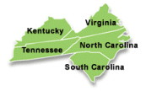 | Charlotte Regional Office  901 Center Park Drive  Ste. 106  Charlotte, NC 28217-2935  (704) 424-6420  Fax: (704) 344-6169  E-mail: charlotte.regional.office@census.gov
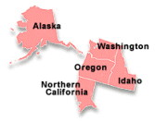 | Seattle Regional Office  601 Union Street, Suite 3800  Seattle, WA 98101-1074  (206) 381-6260  Fax (206) 381-6629  E-mail: seattle.regional.office@census.gov

A city-style address is an address that consists of a house number and street name; for example, 201 Main Street. The address may or may not be used for the delivery of mail and may include apartment numbers/designations or similar identifiers. See Chapter 2.
The 1990 residential address list used to label questionnaires, control the mail response check-in operation, and determine the nonresponse followup workload.
A computerized file containing all delivery point addresses serviced by the U.S. Postal Service (USPS). The USPS updates the DSF continuously as its letter carriers identify addresses for new delivery points or changes in the status of existing addresses.
A census tract is a small, relatively permanent statistical division of a county or statistically equivalent entity, delineated for the purpose of presenting Census Bureau statistical data.
A census block is a geographic area bounded by visible features, such as streets, roads, streams, and railroad tracks, and invisible features, such as the boundaries of governmental units and other legal entities. Census blocks are the smallest area for which the Census Bureau collects and tabulates statistical information.
A structure point is a coordinate location that represents the location of one or more housing units and/or group quarters. Structure points are protected by Title 13. See Appendix A, Confidentiality and Security Guidelines.
The Census Bureau does not endorse or recommend the use of any specific software to view its files. The program names included here are only examples of programs that are able to read computer-readable files.
Address ranges are the first and last house address numbers that could exist along a given section of a street. An address range is usually separated into two component ranges to reflect addresses along the left and right sides of the street. Usually one side of the street has only even address numbers and the other side has only odd address numbers.
Address breaks are the city-style address on each side of a boundary or at an intersection of a street with another feature.
A data dictionary describes the fields included in any data tables associated with your submission. A data dictionary should list all the fields, describe the data in each field, and provide the legal values and their definitions for each field.
A code that identifies a specific geographic entity. For example, geocodes needed to identify a census block for data collection are the state code, the county code, the census track number, and the block number.
The use of brand names does not represent an endorsement of a company or its products by the U.S. government. Due to the wide use of ESRI products by our partners in the GIS community, and the ubiquitous use of the shapefile format as a medium for GIS data exchange, the Census Bureau is providing this data in shapefile format. You should encounter no problems when importing these shapefiles into your local GIS software. However, if you are using GIS software that does not contain a shapefile translator, please contact the Census Bureau for further instructions (301-763-1099 or e-mail geo.bas@census.gov).

