

Utilizing the Space Budget Justification Template Exhibit 54

Exhibit 54 Utilizing the Space Budget Justification Template

Utilizing the Space Budget Justification Template

Objectives

In this chapter, you will learn:

- What is a Space Budget Justification Template
- How to prepare a “Corrections (FY06)” space budget justification worksheet
- How to prepare a “FY 2006” Space Budget Justification worksheet
- How to prepare a “FY 2007” Space Budget Justification worksheet
- How to prepare a “FY 2008” Space Budget Justification worksheet
- How to prepare a “FY 2009” Space Budget Justification worksheet
- How to read and prepare a “SUM” worksheet
- Resources

Exhibit 54 Utilizing the Space Budget Justification Template

What is a Space Budget Justification Template?

The Space Budget Justification Template allows you to prepare by fiscal year all the worksheets and summary report in the Exhibit 54. The template will provide specific information “on how to prepare” the supporting detailed information for the Space budget justification required in section 54.5 of OMB Circular A-11. Please refer to
A-11 for further conceptual guidance. http://www.whitehouse.gov/omb/a11

This template contains a worksheet for each fiscal year including a “Corrections (FY06)” and a summary report. Each fiscal year worksheet is made of several parts which you will enter data if applicable. The three or four parts are as follows. The summary worksheet summarizes the values entered into the previous worksheets.

- Part I Agency Identification
- Part II April 2006 GSA Bill or Part II GSA FY 2007 Rent Estimate or Part II FY 2008 Rent Estimate
- Part III Agency Adjustments to the Bill or Part III Planned Changes In Inventory
- Part IV Requested Program Changes In Inventory

Exhibit 54 Utilizing the Space Budget Justification Template

Steps to prepare the “Corrections (FY06)” worksheet

- Open Excel workbook “Shell_exhibit54_for_FY2008”. This is provided with your agency’s Rent Estimate.

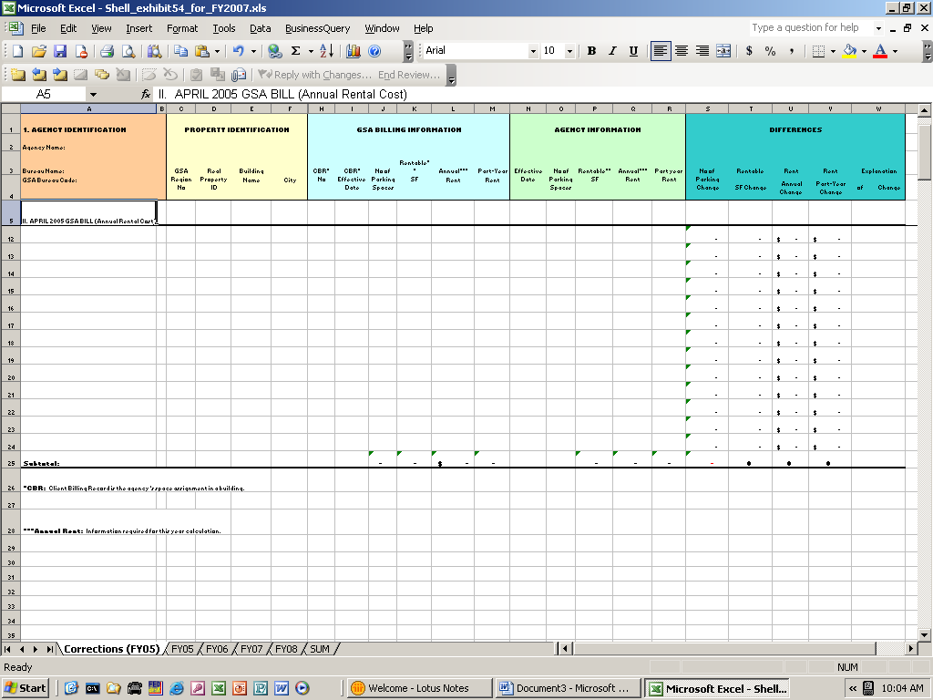
Select Corrections (FY06) worksheet
For changes prior to 4/16/2006

- Select and open Corrections (FY06) worksheet.

- Save the report.

Exhibit 54 Utilizing the Space Budget Justification Template

Part I AGENCY IDENTIFICATION

Enter the Agency’s name in cell B2.

Enter the Agency’s Bureau name in cell B3.

Enter GSA Bureau code for the agency in cell B4.

Exhibit 54 Utilizing the Space Budget Justification Template

Part II APRIL 2006 GSA Bill

Go to Rent on the Web to retrieve bureau’s GSA March and April 2006 bill. http://bis.pbs.gsa.gov/row

Enter square footage (charge basis) from April 2006 rent bill in cell K5.

Calculate bureau’s 2006 annual rent and enter amount in cell L5. Computation of this value is as follows.

Exhibit 54 Utilizing the Space Budget Justification Template

Computation Example:
Rent on the Web (ROW) April
Amount Due Year To
(monthly) Date *

D. Total Monthly Rent (A+B+C) $650,000 $3,700,000
14. Billing Adjustments & Corrections

E. Adjustments Subtotal $0 $500

F. Total Rent Bill $650,000 $3,700,500

Compute:
$650,000 X 6 = $3,900,000
$3,900,000 + $0 = $3,900,000
-----------------------------------------------------------------------------------------------------------------------------
Rent on the Web (ROW) March
Amount Due Year To
(monthly) Date*

D. Total Monthly Rent (A+B+C) $650,000 $3,700,000
14. Billing Adjustments & Corrections

E. Adjustments Subtotal $0 $500

F. Total Rent Bill $650,000 $3,700,500

Compute:
$650,000 X 6 = $3,900,000
$3,900,000 + $0 = $3,900,000
$3,900,000 + $3,700,500 = $7,600,500 ( Total Rent for FY 2006)

Enter amount in cell L5, Annual Rent.
* Note: YTD total for April will be displayed the same as on the March bill due to OA Tool conversion.

Take April bill rent amount on Line D, Total Monthly Rent, and multiple by 6.

Add the amount on Line E, Adjustment Subtotal, to the computed number.

From the March rent bill, add the “Year to Date” amount from Line F, Total Rent Bill, to the computed number.

Enter amount in cell L5.

Exhibit 54 Utilizing the Space Budget Justification Template

PART III AGENCY ADJUSTMENTS TO THE BILL

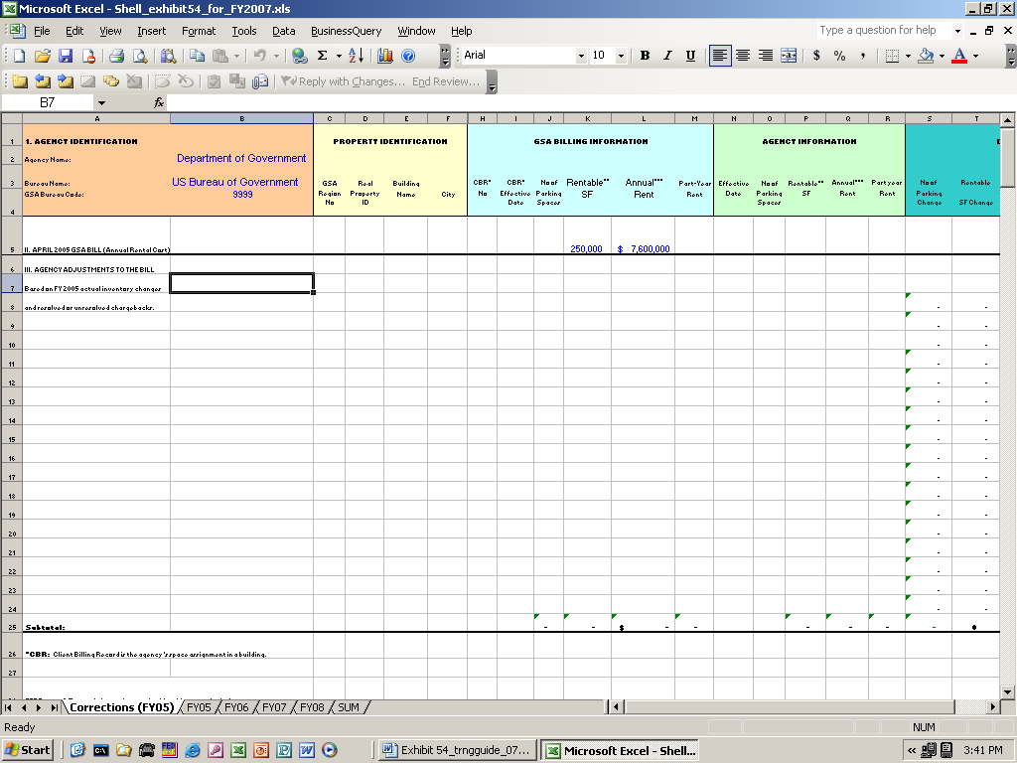

Property Identification
For each correction to the rent bill for FY 2006 on or before the April rent bill that isn’t reflected on the GSA April bill, follow the instructions as follows.

- Enter the GSA regional number where the Space is located in column C, GSA Regional No.
(The regional number can be found on the upper left hand corner of rent bill.)

- Enter the Real Property ID number (same as GSA building number) in column D, Real Property ID.

- Enter the Building name in column E, Building Name.

Exhibit 54 Utilizing the Space Budget Justification Template

- Enter the name of the city where property is located in column F, City.

- Enter the state in column G, State.

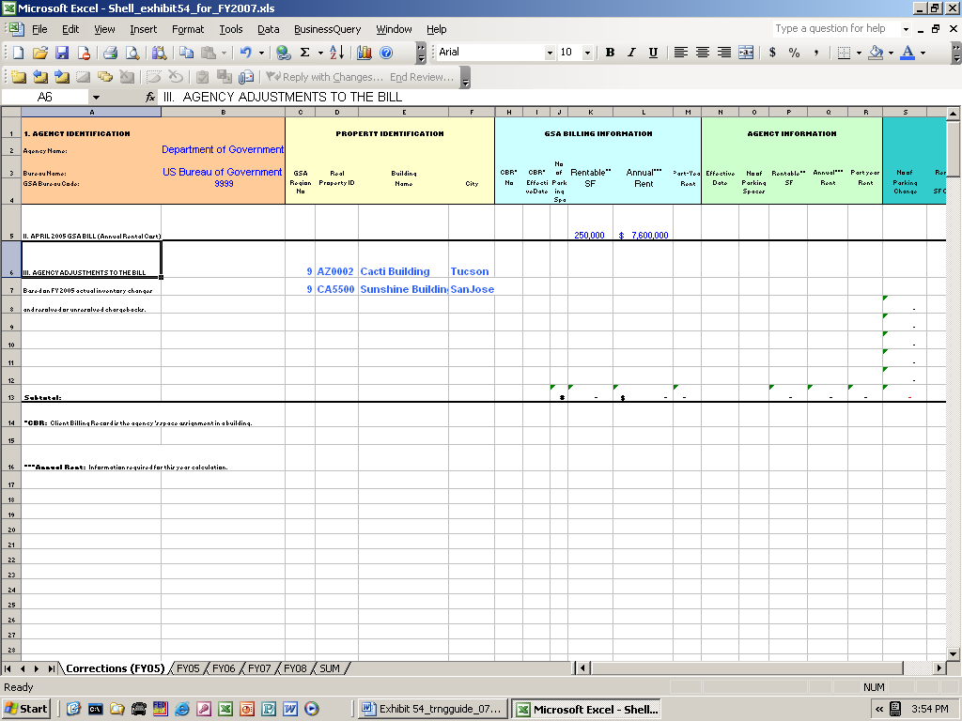

GSA Billing Information

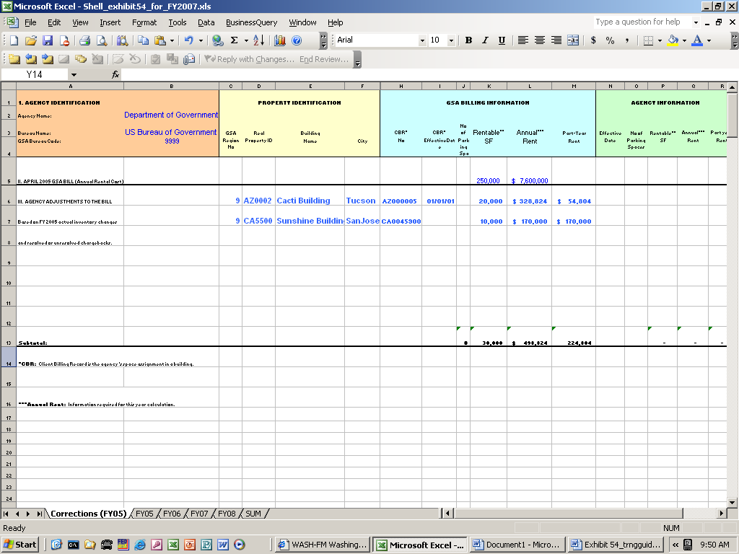

Exhibit 54 Utilizing the Space Budget Justification Template

- Enter Occupancy Agreement (OA) number for the agency adjustment in column H, OA no.

- Enter the effective date of the data discrepancy with the GSA bill in column I, Effective Date. Leave cell blank if there is no date discrepancy.

- Enter the number of parking Spaces indicated on the GSA April bill in column J, No. of Parking Spaces.

- Enter the rentable square feet of Space indicated on the GSA April bill in column K, Rentable SF.

- Compute and enter the annual rent amount in column L, Annual Rent. Use March and April rent bill to calculate annual rent.

- Enter part year rent amount in column M, Part Year Rent. Use GSA March (YTD) and April (current) bills.

Exhibit 54 Utilizing the Space Budget Justification Template

Agency Information

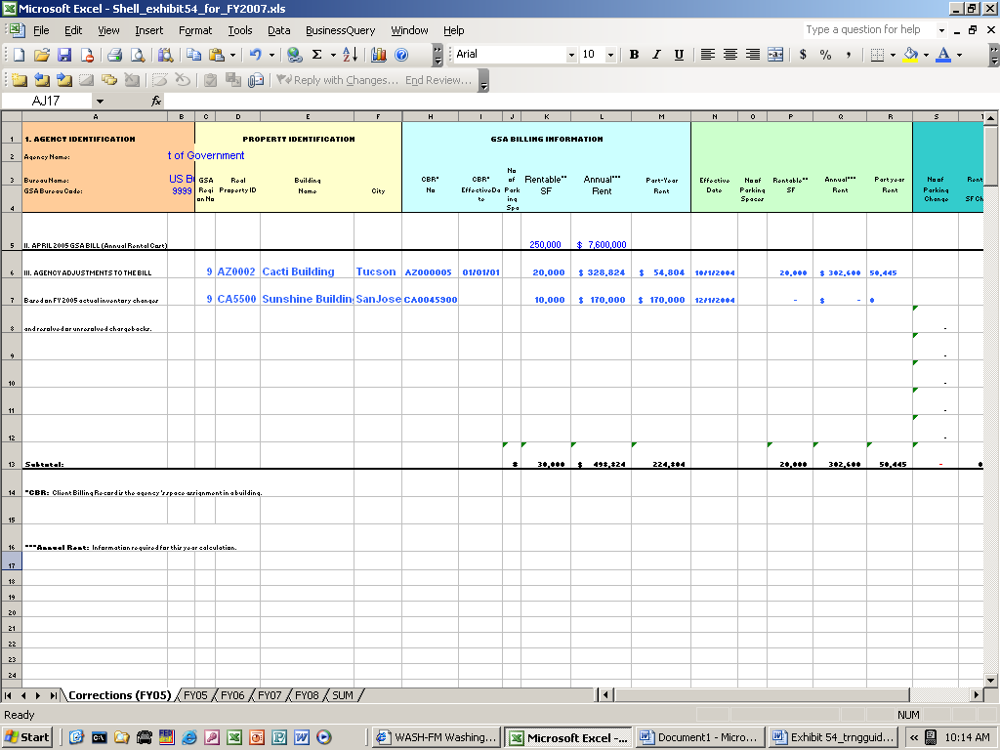

- Enter effective date for agency’s Space occupancy in column N, Effective Date. Use only if there is a discrepancy with the GSA April bill.

- Enter the revised number of parking Spaces in column O, No. of Parking Spaces. Use only if there is a discrepancy with the GSA bill.

- Enter the revised rentable square feet in column P, Rentable SF.

- Compute the annual rent and enter the revised annual rent amount in column Q, Annual Rent.

- Enter the revised part year rent amount based on the agency’s effective date in column R, Part Year Rent.

Exhibit 54 Utilizing the Space Budget Justification Template

Differences

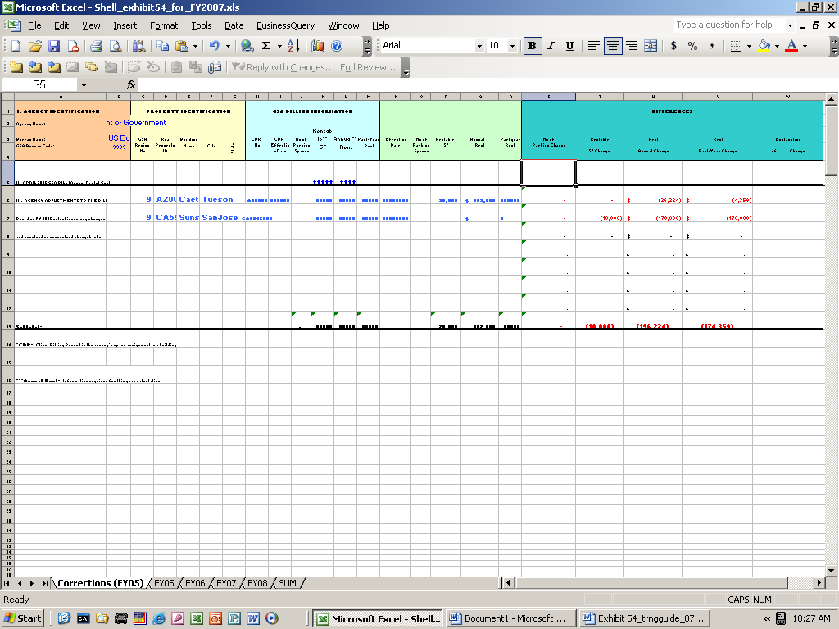
Do not enter values in these columns.

After data is entered for GSA Billing Information and Agency Information, the differences will be calculated automatically in columns S, T, U and V. Do not enter values in these columns.

- Enter reasons for changes such as vacated Space, MOU difference, parking difference, rate difference, etc. in column W, Explanation of Change.

Exhibit 54 Utilizing the Space Budget Justification Template

Steps to prepare the “FY06” worksheet

- Select and open “FY06” worksheet.

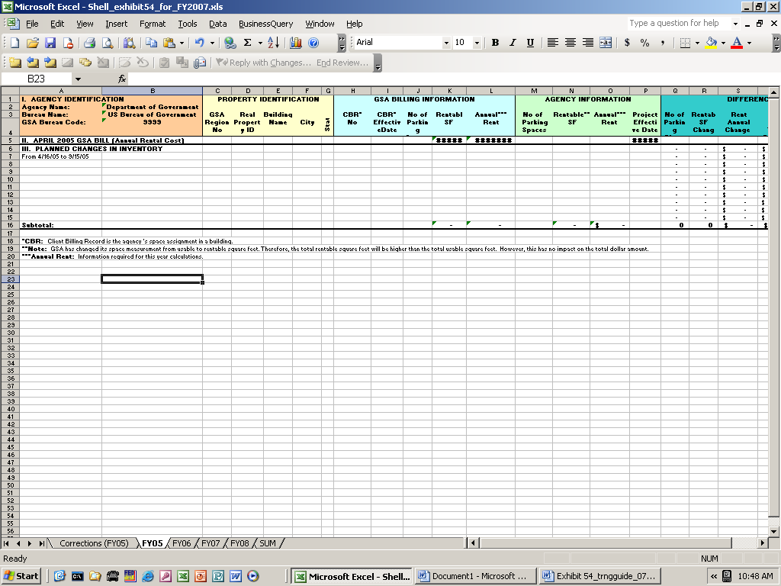
Select FY06 worksheet
For changes from 4/16/2006 to 9/15/2006

The FY06 worksheet is for changes after the April bill through September bill. The Agency Identification and April 2006 GSA Bill fields will be populated automatically from the “Corrections (FY06)” worksheet.

The approved and planned inventory changes from April 16, 2006 to September 15, 2006 will be entered in rows identified as “III. Planned Changes In Inventory.” For inventory changes after September 15, 2006 enter changes on the “FY07” worksheet.
Exhibit 54 Utilizing the Space Budget Justification Template

Part III PLANNED CHANGES IN INVENTORY

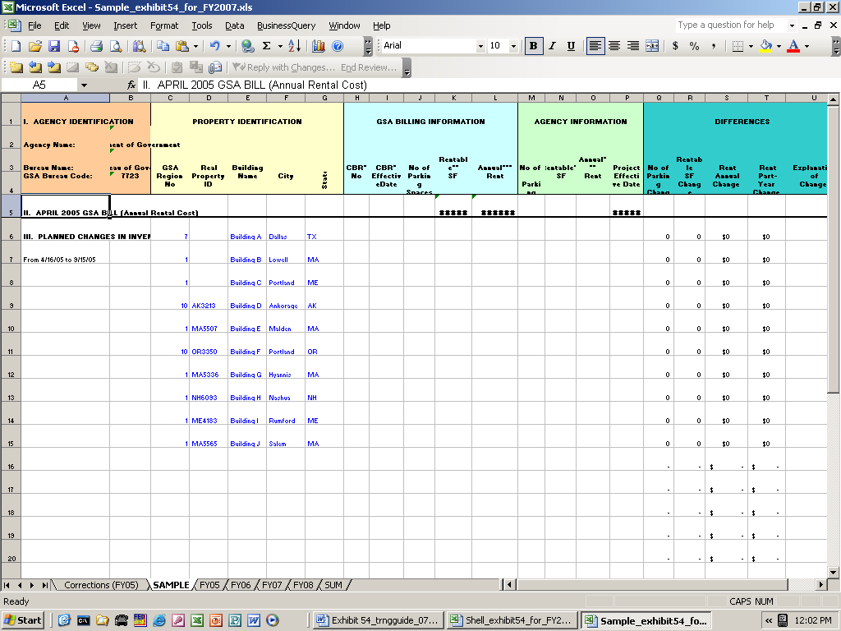

- Enter property identification data in columns C through G, “Property Identification.” Use the same instructions provided on previous pages for “Corrections (FY06)” worksheet.

Exhibit 54 Utilizing the Space Budget Justification Template

GSA Billing Information

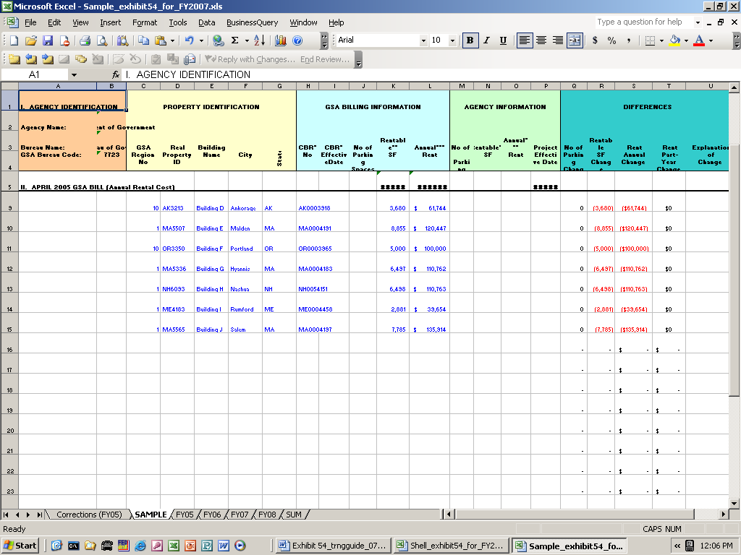

- Enter the Occupancy Agreement (OA) number for the assignment for which change will occur in column H, OA No. Use only if OA number is applicable.

- Enter the effective date for the current assignment as reported on the GSA April bill.

Exhibit 54 Utilizing the Space Budget Justification Template

- Enter the number of parking Spaces reported on GSA April bill in column J, No. of Parking Spaces. Use only if changes are anticipated.
- Enter the current rentable square feet of Space reported on GSA April bill in column K, Rentable SF.
- Enter the current annual rent amount for the Space reported on GSA April bill in column L, Annual Rent.

Agency Information

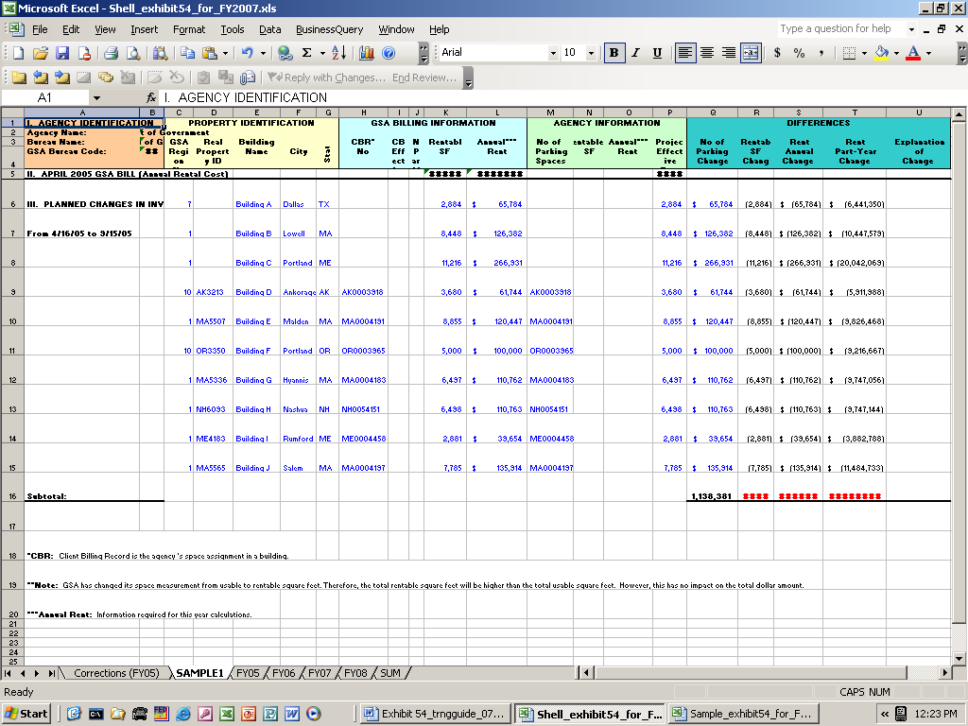

- Enter the number of parking Spaces only if anticipated in column M, No of Parking Spaces.

- Enter the new rentable square feet in column N, Rentable SF.

- Enter the new annual rent amount in column O, Annual Rent.

- Enter the effective date when the change in Space and/or rent will occur in column P, Project Effective Date.
Exhibit 54 Utilizing the Space Budget Justification Template

Differences

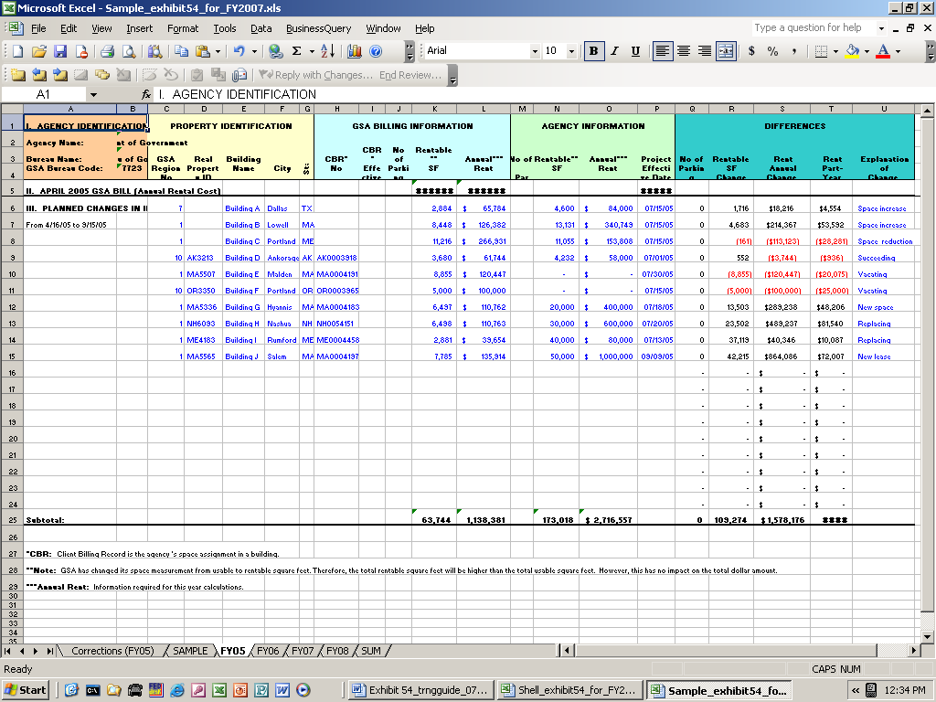
Do not enter values in these columns.

After data is entered for GSA Billing Information and Agency Information, the differences will be calculated automatically in columns Q, R, S, and T. Do not enter values in these columns.

- Enter reason for planned and proposed projects, such as new Space, vacated Space, replacing lease, etc in column U, Explanation of Change.

Exhibit 54 Utilizing the Space Budget Justification Template

Steps to prepare the “FY07” worksheet

- Select and open “FY07” worksheet.

Part I AGENCY INFORMATION

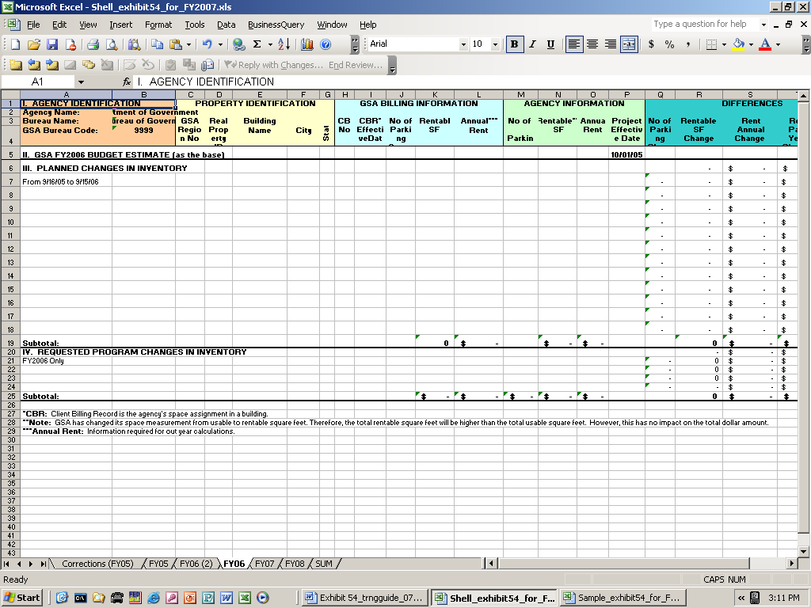
Select FY07 worksheet
For changes from 9/16/2006 to 9/15/2007

The FY07 worksheet is to be used for planned changes in inventory from September 16, 2006 to September 15, 2007. The Agency Identification cells will be populated automatically from the “Corrections (FY06)” worksheet.

The approved and planned inventory changes from April 16, 2006 to September 15, 2007 will be entered in rows identified in Part III Planned Changes In Inventory section. For inventory changes after September 15, 2007 enter changes on the “FY08” worksheet.
Exhibit 54 Utilizing the Space Budget Justification Template

Part II GSA FY2007 BUDGET ESTIMATE

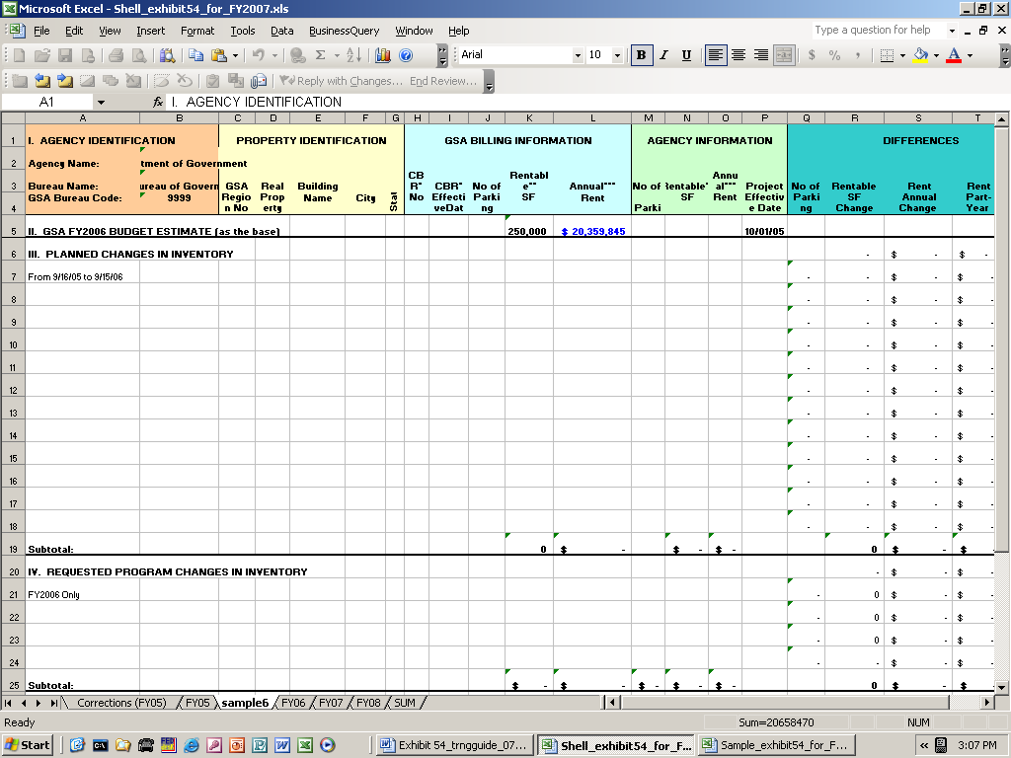

- For Agency Identification the cells will be populated automatically from “Corrections (FY06)” worksheet.

- Enter the FY 2007 square feet in cell K5, Rentable SF. The entry is reported on section II, “GSA FY 2007 Budget Estimate.”

- Enter the FY 2007 annual rent in cell L5, Annual Rent.

Exhibit 54 Utilizing the Space Budget Justification Template

Part III PLANNED CHANGES IN INVENTORY

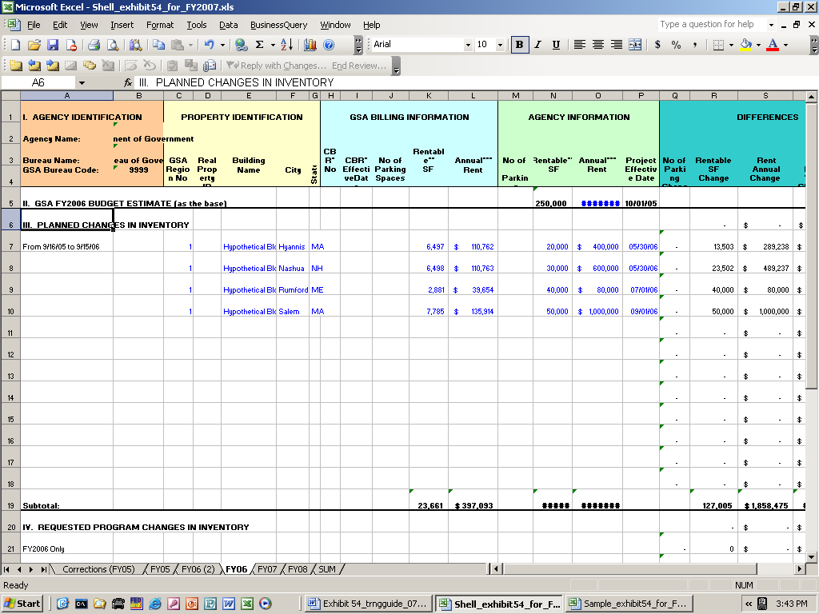

For each approved and planned change including projects in the pipeline from September 16, 2006 to September 15, 2007, follow the previous instructions provided for “FY 05 Worksheet – Planned Changes Inventory.”

Exhibit 54 Utilizing the Space Budget Justification Template

Part IV REQUESTED PROGRAM CHANGES IN INVENTORY

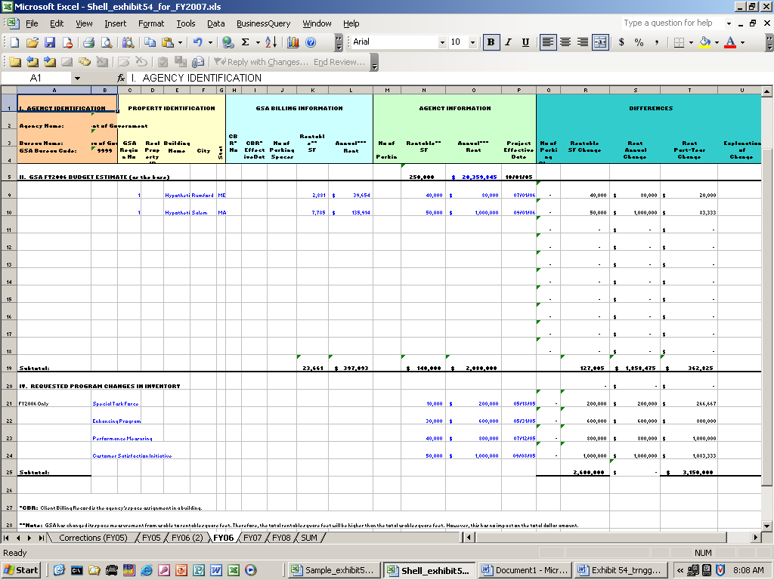
Do not enter any values in columns C through G, Property Identification. Do not enter any values in columns H through L, GSA Billing Information.

For each fiscal year 2007 requested program change, enter data on Part IV Requested Program Changes In Inventory as follows.

- Enter the type of program such as Special Task Force, Customer Satisfaction Initiative, etc in column B.

- Enter the projected number of parking Spaces if applicable in column M, No. of Parking Spaces.

- Enter the projected rentable square feet in column N, Rentable SF.
- Enter the projected FY 2007 annual rent for the required Space in column O, Annual Rent. If possible, make sure the projected rent reflects the market rate escalated to FY 2007.
Exhibit 54 Utilizing the Space Budget Justification Template

Differences

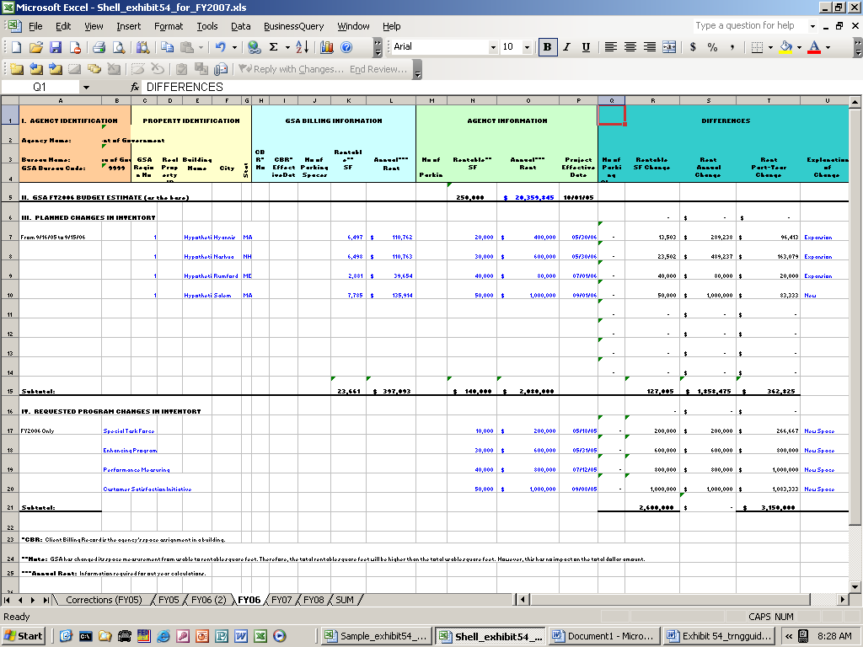

Do not enter any values in columns Q, R, S, and T. The cells will be calculated automatically.

      - Enter the projected effective date for the required Space in column P, Project Effective Date.

      - Enter the type of Space required such as new Space, expansion Space, or Space to be vacated, etc in column U, Explanation of Change.

Exhibit 54 Utilizing the Space Budget Justification Template

Steps to prepare the “FY08” worksheet

- Select and open “FY08” worksheet.

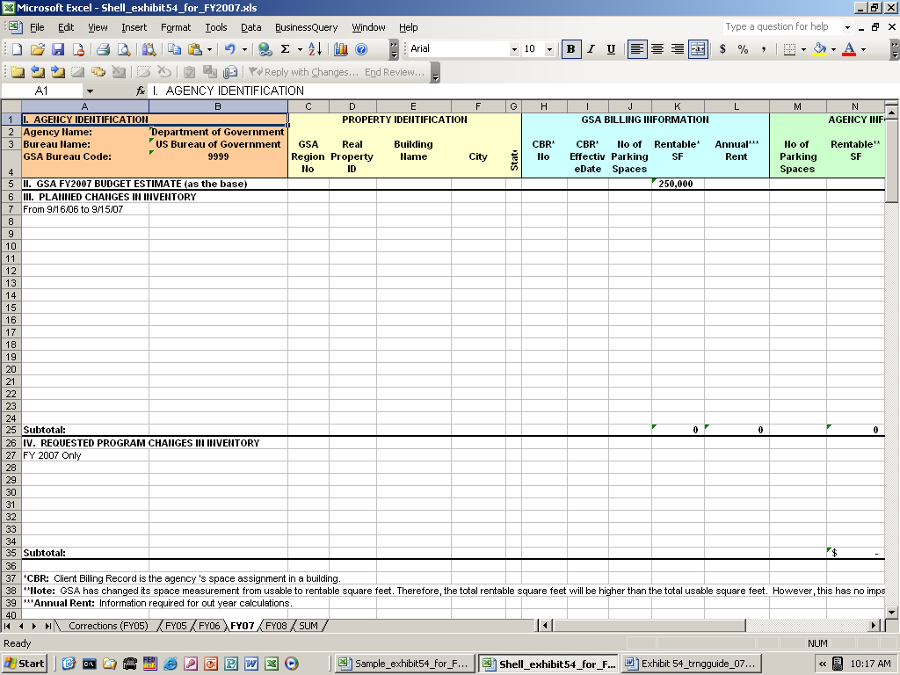
Select FY08 worksheet
For changes from 9/16/2007 to 9/15/2008

No entry is required in Part I, Agency Identification section.

For Part II GSA FY 2008 Rent Estimate section, enter values as follows.

- Enter FY 2008 square feet in cell K5, Rentable SF.

- Enter FY 2008 annual rent in cell L5, Annual Rent.
Exhibit 54 Utilizing the Space Budget Justification Template

Part III PLANNED CHANGES IN INVENTORY

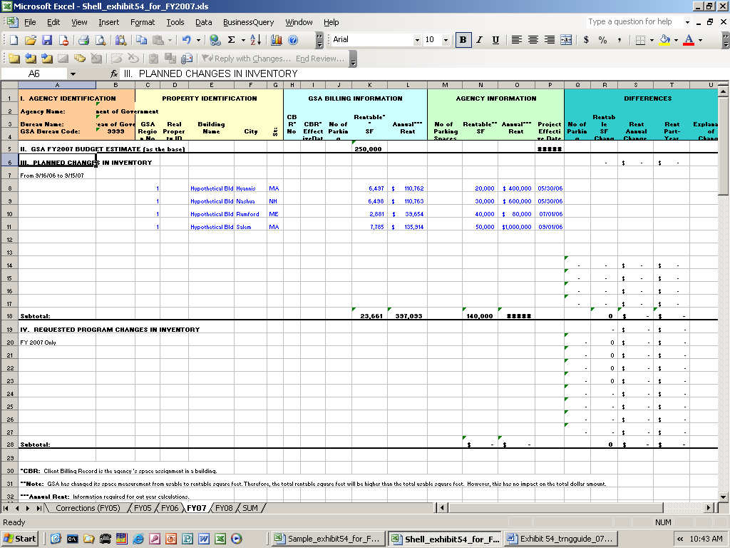

For each approved and planned change including projects in the pipeline from September 16, 2007 to September 15, 2008, follow the previous instructions provided for “FY 05 Worksheet – Planned Changes Inventory.”

Exhibit 54 Utilizing the Space Budget Justification Template

Part IV REQUESTED PROGRAM CHANGES IN INVENTORY

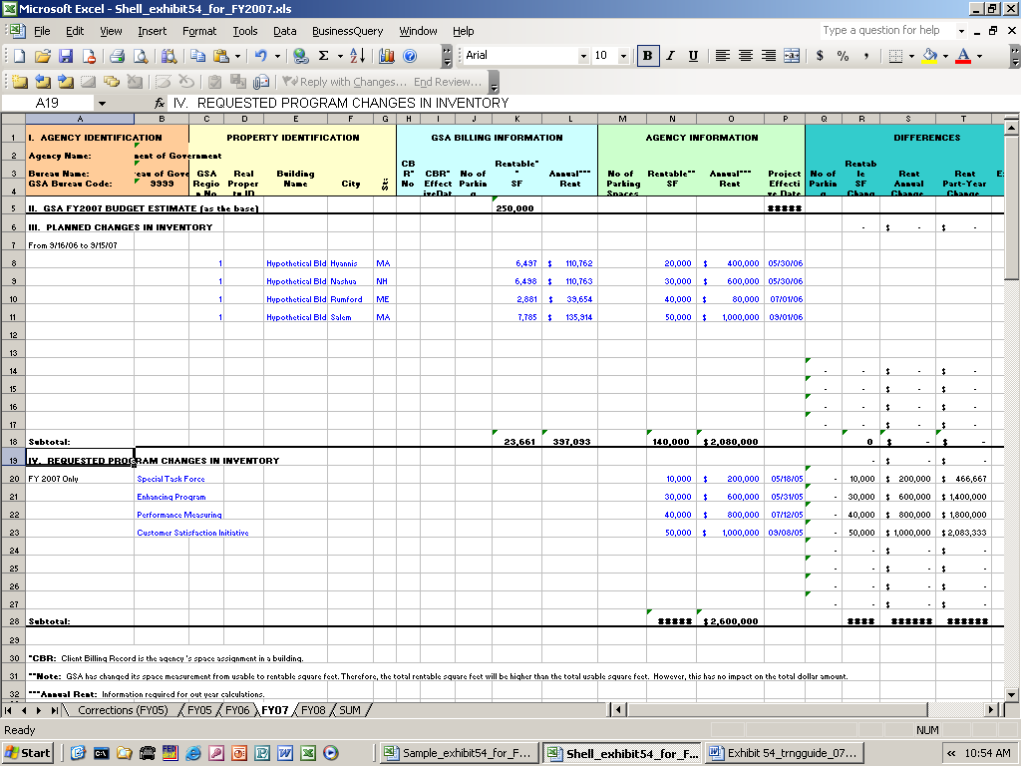

For each of the fiscal year 2008 requested program changes, enter the data as follows.

- Enter the type of program such as Special Taskforce, etc in column B.

- No entry is required for columns C through L.

- Enter the projected number of parking Spaces if applicable in column M, No of Parking Spaces.

- Enter the projected rentable square feet in column N, Rentable SF.

Exhibit 54 Utilizing the Space Budget Justification Template

- Enter the projected FY 2008 annual rent for the required Space in column O, Annual Rent. If possible, make sure the projected rent reflects the market rate escalated to the fiscal year 2008.

Differences

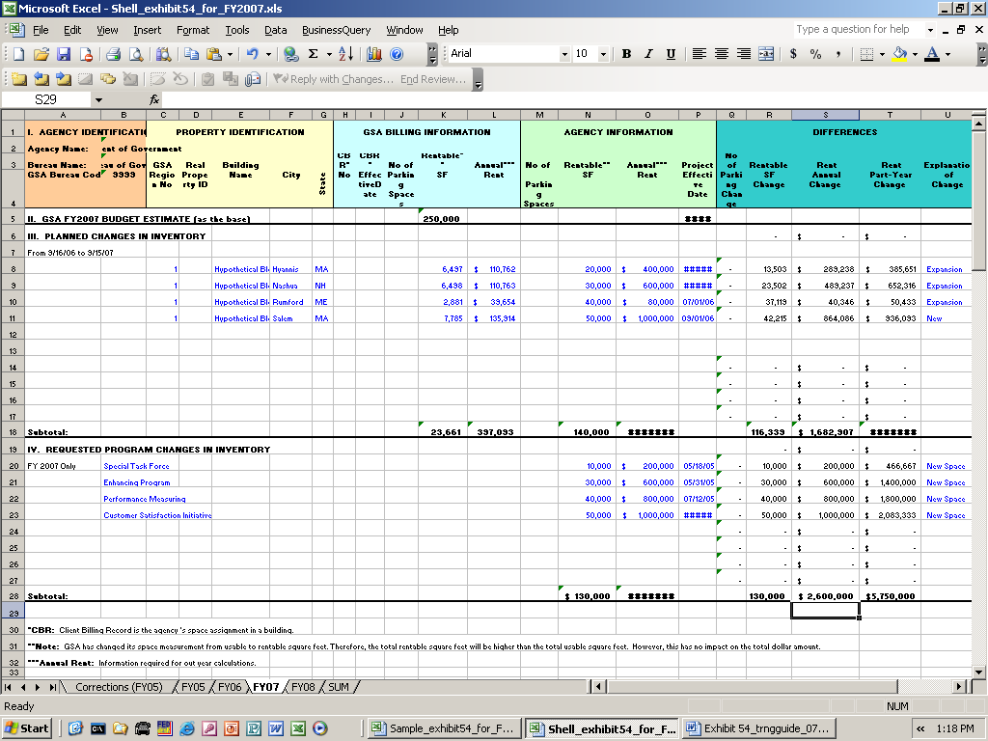

Do not enter any values in columns Q, R, S, and T. These cells will be automatically calculated.

- Enter the projected effective date for the required Space in column O, Project Effective Date.
- Enter type of Space required such as new Space, expansion Space, Space to be vacated, etc in column U, Explanation of Change.

Exhibit 54 Utilizing the Space Budget Justification Template

Steps to prepare the “FY09” worksheet

- Select and open “FY09” worksheet.

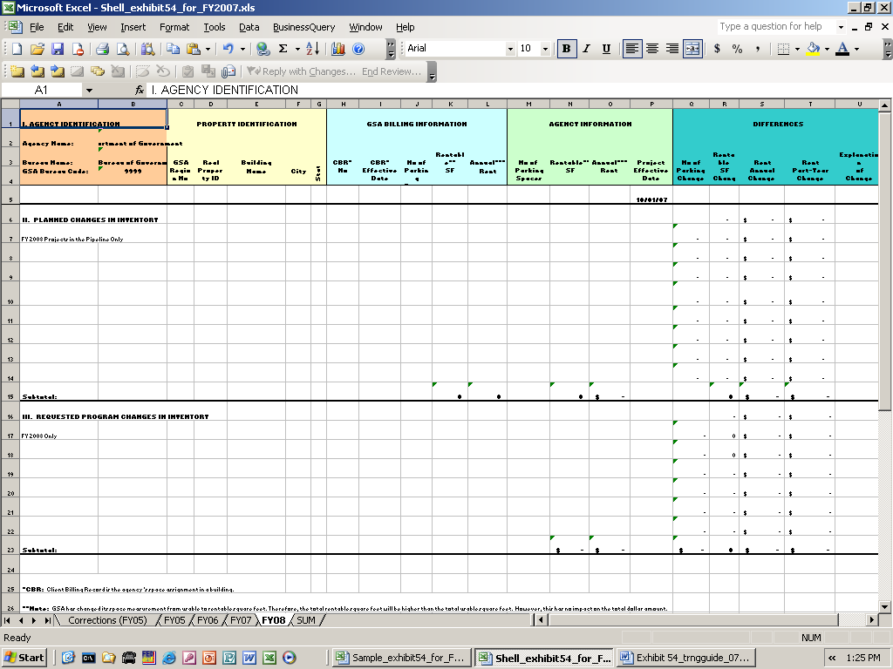
Select FY09 worksheet
For changes after 9/15/08

No entry is required in Agency Identification section.

Part III REQUESTED PLANNED CHANGES IN INVENTORY

For each project in the pipeline with an expected occupancy date after September 15, 2008, follow the previous instructions provided for “FY 05 Worksheet – Planned Changes Inventory.”
Exhibit 54 Utilizing the Space Budget Justification Template

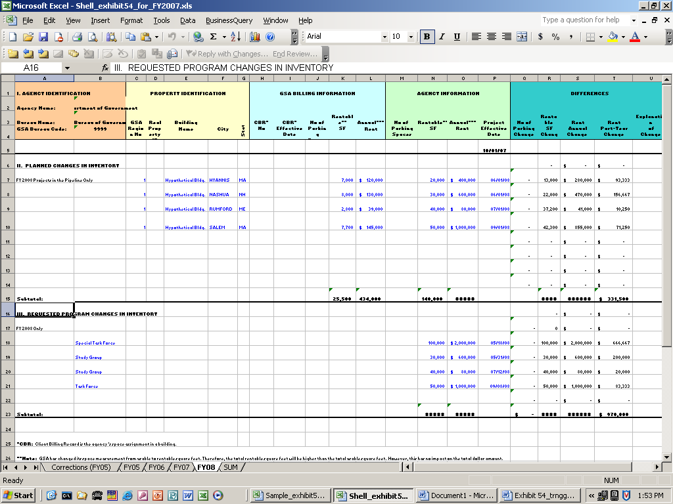

For each of the fiscal year 2009 requested program changes, enter the data as follows.

- Enter the type of program such as Special Taskforce, etc in column B.

- No entry is required for columns C through L.

- Enter the projected number of parking Spaces if applicable in column M, No of Parking Spaces.

- Enter the projected rentable square feet in column N, Rentable SF.

- Enter the projected FY 2009 annual rent for the required Space in column O, Annual Rent. If possible, make sure the projected rent reflects the market rate escalated to the fiscal year 2009.

Exhibit 54 Utilizing the Space Budget Justification Template

Differences

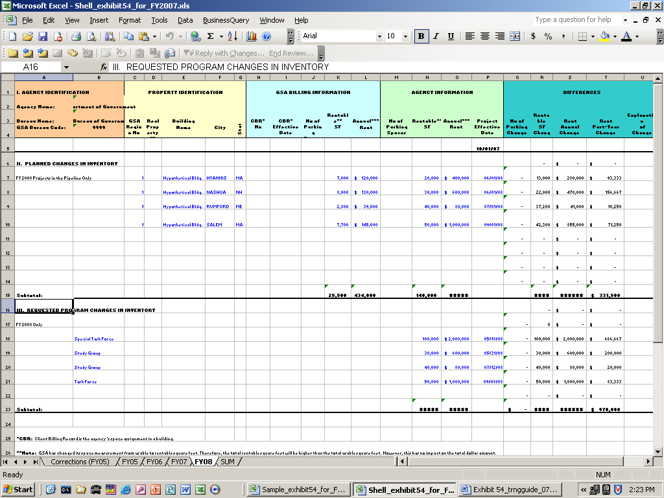

Do not enter any values in columns Q, R, S, and T. The cells will be calculated automatically.

      - Enter the projected effective date for the required Space in column P, Project Effective Date.

      - Enter the type of Space required such as new Space, expansion Space, or Space to be vacated, etc in column U, Explanation of Change.

Exhibit 54 Utilizing the Space Budget Justification Template

Steps to prepare the “SUM” worksheet

- Select and open “SUM” worksheet

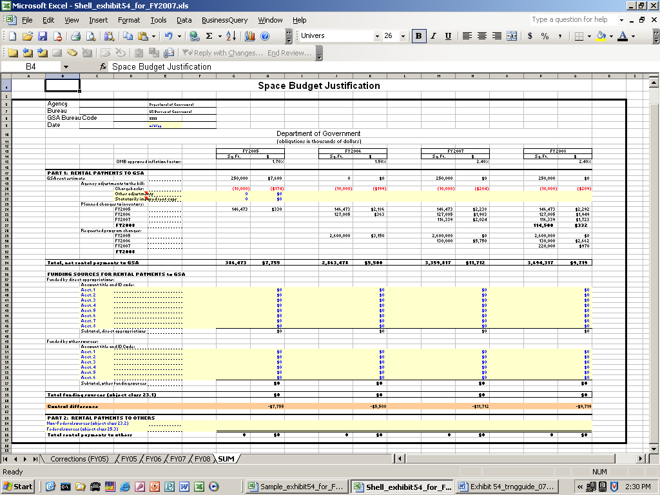

This worksheet summarizes the information entered into the five previous worksheets and provides for entry of additional information regarding sources of funds for rental payments to GSA and rental payments to others.

Only the yellow shaded areas require entries. The remaining cells will be calculated automatically.

- Enter today’s date in cell E9.

Refer to instructions on OMB Circular No. A-11 (2008), for remaining data entry on this worksheet.

Exhibit 54 Utilizing the Space Budget Justification Template

You must submit all worksheets and summary report in the Exhibit 54. This report provides a justification of your agency’s budget request for rent. You must submit a separate report for each bureau or subordinate organization that makes rental payments over $5 million annually. Submit a single agency-wide summary report if these costs are paid centrally from one account.

Exhibit 54 Utilizing the Space Budget Justification Template

RESOURCES

OMB Circular A-11, http://www.whitehouse.gov/omb/a11

