ENVIRONMENTAL ASSESSMENT

Reintroduction of the Puerto Rican Parrot
Río Abajo Commonwealth Forest
Puerto Rico

August 2006

U.S. Fish and Wildlife Service
Río Grande Field Office
P.O. Box 1600
Río Grande, PR 00745
Phone: (787) 887-8769
Fax: (787) 887-7512

TABLE OF CONTENTS

SECTION I - PURPOSE AND NEED FOR PROPOSED ACTION 1
1.1 PURPOSE 1
1.2 NEED 1
1.3 REQUIRED DECISIONS 2
1.4 BACKGROUND 2
SECTION II - ALTERNATIVES 3
2.1 ALTERNATIVES NOT CONSIDERED FOR DETAILED ANALYSIS 3
2.1.1 – Create a second population within the Caribbean National Forest 3
2.2 ALTERNATIVES ANALYZED IN DETAIL 3
2.2.1 Alternative A – No Action 4
2.2.3 Alternative C – Reintroduce Puerto Rican Parrots in the Guajataca Forest 4
2.2.4 Alternative D – Reintroduce Puerto Rican Parrots in the Cambalache Forest 4
SECTION III - AFFECTED ENVIRONMENT 4
3.1 PHYSICAL CHARACTERISTICS 4
3.1.1 Location 4
3.1.2 Geomorphic/Physiographic 5
3.1.3 Soils 5
3.1.4 Climate and Hydrology 5
3.2 BIOLOGICAL ENVIRONMENT 6
3.2.1 Habitat/Vegetation 6
3.2.3 Other Wildlife Species 7
3.3 LAND USE 7
3.4 CULTURAL/PALEONTOLOGICAL RESOURCES 7
3.5 LOCAL SOCIO-ECONOMIC CONDITIONS 8
SECTION IV - IMPACTS ANALYSIS 8
4.1 ALTERNATIVE A – NO ACTION 8
4.1.1 Habitat Impacts 9
4.1.2 Biological Impacts 9
4.1.3 Listed Species and Trust Resources 9
4.1.4 Predator Control Impacts 9
4.1.5 Public Use and Landowner Impacts 9
4.2 ALTERNATIVE B – Reintroduce Puerto Rican Parrots in the Río Abajo Forest (PREFERRED ALTERNATIVE) 9
4.2.1 Habitat Impacts 10
4.2.2 Biological Impacts 10
4.2.3 Listed Species and Trust Resources 10
4.2.4 Predator Control Impact 10
4.2.5 Public Use and Landowner Impacts 11
4.3 ALTERNATIVE C – Release Puerto Rican Parrots in the Guajataca Forest 11
4.3.1 Habitat Impacts 11
4.3.2 Biological Impacts 11
4.3.3 Listed Species and Trust Resources 12
4.2.4 Predator Control Impact 12
4.2.5 Public Use and Landowner Impacts 12
4.4 ALTERNATIVE D – Release Puerto Rican Parrots in the Cambalache Forest 12
4.3.1 Habitat Impacts 13
4.3.2 Biological Impacts 13
4.3.3 Listed Species and Trust Resources 13
4.2.4 Predator Control Impact 13
4.2.5 Public Use and Landowner Impacts 13
SECTION V - LITERATURE CITED 15
SECTION VI - LIST OF PREPARERS 18
SECTION VII - CONSULTATION AND COORDINATION 19
SECTION VIII – LIST OF AGENCIES, INDIVIDUALS AND ORGANIZATIONS CONSULTED: 20
SECTION IX – LIST OF ALL FEDERAL, STATES AND LOCAL LAWS AND PERMITS: 21
APPENDIX I Map of Puerto Rico showing the location of the Río Abajo Forest. 23
APPENDIX II: STANDARD OPERATIONS PROTOCOLS 24
A. BANDING 24
B WILD NEST MONITORING 26
C TRANSFERRING EGG(S) AND/OR CHICK(S) FROM FIELD TO AVIARY OR VICE VERSA 28
D. WILD NEST INSPECTION 30
APPENDIX III: Typical haystack hill formations characteristic of the Puerto Rican northern karst region 33
APPENDIX IV: Federally endangered and threatened species present in the Northern Karst Region of Puerto Rico 34
APPENDIX V: Flow chart listing the various studies and sources of information used to evaluate potential release sites, including the Río Abajo Forest Reserve, and to develop a reintroduction plan to establish the second wild population of Puerto Rican parrots in the island. The Río Abajo Forest (2340 ha), and surrounding forests, ranked 1 among 3 potential release sites (protected areas) in the northwestern karst (limestone) region of Puerto Rico. 35
APPENDIX VI: Predator management protocols used to protect wild Puerto Rican parrots and their nests in the Caribbean National Forest. 36

Reintroduction of the Puerto Rican Parrot
Río Abajo Commonwealth Forest

SECTION I - PURPOSE AND NEED FOR PROPOSED ACTION

1.1 PURPOSE

The US Fish and Wildlife Service and the Puerto Rico Department of Natural and Envrionmental Resources plan to reintroduce the Puerto Rican Parrot (Amazona vittata) at the Río Abajo Forest in the municipality of Utuado, Puerto Rico (Appendix I). The reintroduction is a stated recovery objective of the draft Recovery Plan for the Puerto Rican Parrot. It is aimed at creating a second wild population in the north-central karst region of the island to minimize the species’ risk of extinction and foster its recovery.

The purpose of this Environmental Assessment is to consider a range of reintroduction alternatives that have been proposed, evaluated, and discussed among concerned agencies, and to select a preferred alternative. Alternative B is the preferred alternative, which maximizes its ability to restore and manage the population in a portion of the species’ historic range and manage the habitat selected for reintroduction with minimal ecological disruption. Cost-effective reintroduction of parrots will maximize benefit to wildlife and provide the most opportunities for public in the form of environmental education and awareness.

1.2 NEED

The goal of this action is to help achieve the recovery of the Puerto Rican Parrot. Specifically, the goals are to downlist and then delist the species, and assure its long-term viability in the wild. The Puerto Rican parrot is listed as endangered. This endemic species is the only native parrot in the United States and it is considered one of the ten most endangered birds in the world. Presently, 18-20 individuals survive in the wild and are restricted to the Caribbean National Forest in eastern Puerto Rico. Two captive population facilities hold an additional 159 individuals: the Luquillo Aviary and the José L. Vivaldi Aviary in eastern and west-central Puerto Rico, respectively.

The proposed action is a fundamental element of the Puerto Rican Parrot recovery program (Lacy et al. 1989, Muiznieks 2001, FWS 2005). It minimizes the risks of the species’ extinction because it is less likely that catastrophic events (e.g., hurricanes), and other threats (e.g., predation), will affect equally and simultaneously two spatially segregated populations. The proposed action is expected to foster the recovery of the species because parrots would be released in an environment that should result in more vigorous population growth than what has characterized the extant wild population at the Caribbean National Forest over the past 35 years.

Actions needed include: 1) release of captive-reared parrots in the Río Abajo Forest, 2) protect and manage the reintroduced population; 3) protect and improve parrot habitat in the Río Abajo Forest; and 4) work with private landowners and stakeholders to develop and implement short and long term habitat conservation programs in the lands surrounding the release area as proposed in the Draft Río Abajo Forest Management Plan (2006).

1.3 REQUIRED DECISIONS

The Regional Director will determine whether and how to create the biological and physical conditions necessary to restore the Puerto Rican Parrot to its former range while protecting the ecological integrity of the Río Abajo Forest.

The Service’s decision must incorporate measures to protect related resources if action is taken. In the meantime, any decision the Service reaches will include avoidance and minimization measures for reasonably foreseeable adverse impacts. The Service must coordinate and consult with its partners, in particular, the Puerto Rico Department of Natural and Environmental Resources who have management authority over the Río Abajo Forest.

1.4 BACKGROUND

Once abundant and widespread throughout the Puerto Rican archipelago, the Puerto Rican parrot (Amazona vittata) is presently one of the 10 most endangered birds in the world. Habitat loss together with natural enemies is considered among the major causes for the precipitous decline of the species during the 20th century. Currently, a single wild population of 18-20 individuals survives in the Caribbean National Forest (hereafter Luquillo Mountains.)

Intensive efforts to protect and recover the species started in 1968, a year after the species was designated as endangered by the Secretary of the Interior. In 1973, a captive rearing facility (Luquillo Aviary) was established to prevent the immediate extinction of the species, and later, to rear and foster chicks into wild nests to increase breeding productivity. Given the regularity of hurricane disturbance, a second aviary (José L. Vivaldi Aviary hereafter Vivaldi Aviary) was created in 1993 in the Río Abajo Commonwealth Forest in the limestone lowlands of north-central Puerto Rico to safeguard the population (Lacy et al. 1989). Presently, the two aviaries shelter 220 parrots (including the chicks produced in the 2006 breeding season).

At present, in addition to low numbers and a limited distribution, major threats are nest competition and predation of eggs and chicks by Pearly-eyed thrashers (Margarops fuscatus), predation of fledglings and adults by Red-tailed hawks (Buteo jamaicensis), predation by rats (Rattus rattus and R.. norvegicus), parasitism by warble flies (Philornis pici), and the impact of hurricanes. Other threats include competition for cavities with European and Africanized honeybees (Apis mellifera). Many of the threats have been controlled through management strategies.

The karst region of Puerto Rico, and specifically the Río Abajo Forest, has been identified for the reintroduction of the Puerto Rican Parrot outside the Caribbean National Forest (FWS 2005). Forests in this region receive less precipitation, contain many of the food plant species used by parrots, and harbor a lower density of Red-tailed Hawks (0.0023 ± 0.0005/ha) than the Caribbean National Forest ((0.0156 ± 0.0025/ha; Cardona et al. 1986, Frank Rivera-Milán unpubl. data, Collazo and Groom 2000, Trujillo 2005). While tree nesting opportunities are not readily available, certainly not as in the Caribbean National Forest (Cardona et al. 1984, Thompson 2000, Trujillo 2005), crevices in the limestone-dominated landscape and artificial nest structures offer suitable alternatives (FWS 2005). The Río Abajo Forest offers two additional advantages as a release site. First, it is a protected area under governmental control, which facilitates the implementation of recovery actions. Second, it harbors the José L. Vivaldi Aviary. Captive birds could serve as a “surrogate” wild population providing a focal point where released birds could converge daily while they adjust to wild conditions, hopefully, prior to expanding their home range, or disperse from the release area.

SECTION II - ALTERNATIVES

2.1 ALTERNATIVES NOT CONSIDERED FOR DETAILED ANALYSIS

2.1.1 – Create a second population within the Caribbean National Forest

Under this alternative, the fundamental goal of the action would not be accomplished. Specifically, create a second, spatially segregated population of Puerto Rican Parrots. Although the creation of a second sub-population within the Caribbean National Forest is contemplated in the Recovery Plan of the species, its creation does not offset the benefits accrued by spatial segregation and the environmental characteristics (e.g., dryness) of a lowland forested area such as the Río Abajo Forest. At present, available resources and opportunities at the Caribbean National Forest are aimed at releasing captive-reared birds to bolster the extant population. Actions should not be mutually exclusive, but complementary of each other.

2.2 ALTERNATIVES ANALYZED IN DETAIL

The alternatives under consideration include: (A) no action; (B) reintroduce parrots in the Río Abajo Forest; (C) reintroduce parrots in the Cambalache Forest; and (D) reintroduce parrots in the Guajataca Forest. The alternatives are presented separately to highlight salient strengths in terms of suitability and tradeoffs. Detailed site-specific assessments considered for reintroduction are summarized by Trujillo (2005).

2.2.1 Alternative A – No Action

Under this alternative, there would be no reintroduction of parrots in the Río Abajo Forest. Recovery activities would continue to be restricted to the Caribbean National Forest.

2.2.2 Alternative B – Reintroduce Puerto Rican Parrots in the Río Abajo Forest (Preferred Alternative)

Under this alternative, the Service and the Department of Natural and Environmental Resources would release Puerto Rican Parrots in the Río Abajo Forest starting in the fall of 2006. Population and habitat management would be required to foster establishment and population growth (Appendix II, White et. al., 2005a, White and Vilella, 2004, Snyder et. al. 1987).

2.2.3 Alternative C – Reintroduce Puerto Rican Parrots in the Guajataca Forest

Under this alternative, the Service and the Department of Natural and Environmental Resources would release Puerto Rican Parrots in the Guajataca Forest. Population and habitat management would be required to foster establishment and population growth as in Alternative B. The site lacks the benefit of a parrot aviary within its premises.

2.2.4 Alternative D – Reintroduce Puerto Rican Parrots in the Cambalache Forest

Under this alternative, the Service and the Department of Natural and Environmental Resources would release Puerto Rican Parrots in the Cambalache Forest. Population and habitat management would be required to foster establishment and population growth as in Alternative B. The site lacks the benefit of a parrot aviary within its premises. Site-specific facilities (e.g., recreational) would interfere directly with release facilities and efforts.

SECTION III - AFFECTED ENVIRONMENT

3.1 PHYSICAL CHARACTERISTICS

3.1.1 Location

The Río Abajo Commonwealth Forest (18°20’N, 66°42’W), is approximately 2,340 ha and is located between Dos Bocas Lake and the Tanamá River in the municipalities of Utuado and Arecibo (Appendix I).

3.1.2 Geomorphic/Physiographic

The Río Abajo Forest occurs within the northern karst region (Lugo et al. 2001). The karst region covers more than 27.5 percent of the surface of Puerto Rico. The forest has a very irregular topography, dominated by haystack hills whose elevation can reach 350-400 m (see Appendix III). The forest is also characterized by subterranean drainage, caves, natural depressions or sinkholes, all typical of karst geological developments. Formations in the reserve are dominated by Cibao-Montebellow limestone (Tcm) and Lares (T1) limestone. The former comprises 54% of the reserve (north, north-east, east) whereas the remaining percent (Lares) dominates the southeast, south and western portion of the reserve (RA Forest draft Management Plan 2006).

3.1.3 Soils

There are 19 types of soils reported for the Río Abajo Forest (DNR 2006). The most dominant belongs to the Soller-Rock outcrop complex. It extends over 1900 ha of the reserve. This soil type is considered inadequate for cultivation, but not so for pasture lands or forests.

3.1.4 Climate and Hydrology

The Río Abajo Forest is located in the Río Grande de Arecibo watershed. The forest makes significant contributions (recharging) to the aquifer located in the northern coast of the island, specifically, the lower aquifer. The North Coast Limestone aquifer system in Puerto Rico consists of an upper and lower aquifer separated by a confining unit and extends from the western part of Puerto Rico to east of San Juan (Ground Water Atlas of the United States Alaska, Hawaii, Puerto Rico and the U.S. Virgin Islands HA 730-N).

Based on a NOAA station located in the nearby Arecibo Observatory (18° 21’N; 66° 46’ W), 13.7 mm of precipitation are recorded daily on average in the area encompassing the forest reserve. The driest months of the year are January/February through March/April. Conversely, the highest amount of precipitation is usually recorded in May and September and October.

Water from the forest flows into the Río Grande de Arecibo and Río Tanamá. The Jobos Creek is the only body of surface running water occurring in the forest. Its headwaters are located in the southern portion of the forest, flowing into the Dos Bocas Reservoir to the east-southeast of the reserve. Its drainage (catch) area is about 453 ha, and it runs for about 4.2 km. Other bodies of water exist within the reserve, but they are mostly ephemeral in nature (DNR 2006).

3.2 BIOLOGICAL ENVIRONMENT

3.2.1 Habitat/Vegetation

Forests in the karst region, which includes the Río Abajo Forest, are mostly within the Subtropical Moist Life zone (Ewel and Whitmore 1973). According to Chinea (1980) four vegetation types occur in the karst region. Mesic forest and dry woodland are the two major vegetation formations, occurring at the base of mogotes and slopes or exposed tops. The other two vegetation types are mixed woodland and cliff fringe occurring on several slopes and at the edges of the cliff (see Chinea 1980 for details).

As of 1974, 175 species of trees, contained in 53 families, had been reported for the forest (Little and Wadsworth 1964). Later Acevedo and Axelrod (1999) described 1,036 forms (taxa) of flora. Of these, 878 species were natives (included 88 endemics) and 158 were exotic or naturalized after cultivation. Families with most common species were Euphorbiaceae, Laureaceae, Leguminosae, Myrtaceae y Rubiaceae (Lugo et.al. 2001).

Alvarez et al. (1997) conducted an evaluation and description of the vegetation of Río Abajo. Prestoea montana, the principal food for parrots in the Caribbean National Forest, was uncommon in Río Abajo. Many dominant tree species are potential food resources for the parrots and include Petitia domingensis, Calophyllum calaba, Andira inermis, Guarea guidonia, Sideroxylon foetidissimum. Cardona et al. (1986) studied the phenology of 19 plant species known to be part of the diet of parrots. They concluded that food would not be a limiting factor for parrots in Río Abajo. Cardona et al. (1985) also estimated the natural nest cavity availability in the forest, and concluded that nest cavities were rare as in the Caribbean National Forest. In a more recent vegetation study, Collazo and Groom (2000) concurred with the assertion that the Río Abajo Forest could be a suitable habitat for the reintroduction of parrots.

3.2.2 Threatened, Endangered, and Candidate Species

This region possesses extraordinary ecological diversity, including the habitats of several endangered and threatened species, as well as approximately 23% of Puerto Rico's endemic tree species (Lugo et al. 2001).

Four endangered avian species have been reported in the Río Abajo Forest, namely, the Puerto Rican Sharp-shinned Hawk (Accipiter straitus venator), Broad-winged Hawk (Buteo platypterus brunnescens), Peregrin Falcon (Falco peregrinus), and the Plain Pigeon (Columba inornata wetmorei). The forest also harbors the endangered Puerto Rican Boa (Epicrates inornatus).

Twenty four plant species belonging to 21 families are considered endangered, threatened, or vulnerable by Federal and Commonwealth agencies (Lugo et.al. 2001). Of those, 21 plant species federally listed as threatened or endangered are found in the Río Abajo Commonwealth Forest and surrounding forested areas (Appendix IV).

3.2.3 Other Wildlife Species

Records indicate that 39 species of resident bird species have been reported for the northern karst forest. Records also indicate that there are 9 species of mammals (bats), 7 species of amphibians (mostly Eleutherodactylus tree frogs), and 16 of reptiles (mostly Anolis lizards).

3.3 LAND USE

The karst region represents some of the least disturbed karst habitats remaining in the Caribbean. Economic changes, including the shift to an industrial economy after 1940, resulted in the abandonment of agricultural lands, and concomitantly allowed an increase in the forest cover (Lugo et al., 2001). Although, forest reserves such as Cambalache, Río Abajo, Vega Alta, and Guajataca have been established within this region, protecting more of 4,000 ha, previous studies have emphasized that the karst region is vulnerable to human activities and is suffering radical changes (Lugo et al., 2001).

The PR Planning Zone Board has designated the Río Abajo Forest and surrounding lands as SREP (Suelo Rustico Especialmente Protegido; DNR 2006). Lands under this designation are not foreseen or permitted to be used for urban development due to its location, topography, or aesthetic, archeological, ecological or natural resources value.

The Department of Natural and Environmental Resources currently administers 2,340 ha in the Río Abajo Forest. As of 1983, land use in the forest was distributed as follows: 1335 ha young secondary forest, 692 ha of plantations, 855 ha of dense crown forest (not deforested at least since 1936), and about 12 ha were deforested or were used for agriculture. Other uses of the forest include research and management (e.g., J. L. Vivaldi Aviary) and recreation.

3.4 CULTURAL/PALEONTOLOGICAL RESOURCES

Section 106 of the National Historic Preservation Act of 1966 requires the Service to evaluate the effects of any of its actions on cultural resources (historic, architectural, and archeological) that are listed or eligible for listing in the National Register of Historic Places (NRHP).

The activities associated with the reintroduction project will cause only very minor, localized soil disturbances, and will not require the demolition or alteration of any historic buildings or structures.

3.5 LOCAL SOCIO-ECONOMIC CONDITIONS

The north-central karst region where the Río Abajo Commonwealth Forest is located is one of the least populated areas in Puerto Rico. The economic activity within the area is restricted to very small (mostly less than 20-acre) agricultural settings scattered along the boundaries of the area. The entire north-central karst region plays a critical role in the protection of water and soil resources important for the adjacent communities and the San Juan metropolitan area.

SECTION IV - IMPACTS ANALYSIS

Since 1996, the Puerto Rico Department of Natural and Environmental Resources and the US Fish and Wildlife Service have sponsored research to determine whether the Río Abajo Forest was a suitable habitat for the reintroduce of Puerto Rican Parrots and to develop management strategies to foster a successful reintroduction (Collazo and Groom 2000, Appendix V). Assessments of Río Abajo, Cambalache and Guajataca Forest Reserves included selected habitat features (e.g., availability of food plant species, cavity bearing trees) as well as factors such as abundance of predators (e.g., Pearly-eyed thrasher, Red-tailed hawks; Hengstenberg 2003, Gleffe 2005, Trujillo 2005, Llerandi-Roman 2005). Other studies have been designed to enhance food availability for parrots through regeneration of native species and prescribed plantings (e.g., Sierra Palm, Prestoea Montana, Royal Palm Roystonea borinquena; Inman 2005).

Releases in the karst region, specifically the Río Abajo Forest, are possible because the biological and methodological foundation to support the endeavor exists. Two aviaries currently support over 200 captive birds and are capable of producing birds to support a coordinated release program, both at Caribbean National Forest and Río Abajo. Prospective birds for release are selected on the basis of behavioral traits (e.g., group compatibility) and genetics (White et al. 2005b, Haig et al. 2004). Pre-release protocols and methods to quantify the success of releases (e.g., survival) exist (Collazo et al. 2000, 2003; White et al. 2005b).

The following alternatives are organized around the ability to successfully reintroduce the parrot into the selected forested areas in the karst region.

4.1 ALTERNATIVE A – NO ACTION

Under this alternative, the Service would cease to actively pursue reintroducing the Puerto Rican Parrot in the Río Abajo Forest. This is the only option that does not require human intervention and active management of the system. This alternative is unlikely to achieve the recovery objectives outlined in the Recovery Plan of the species, that is, downlist and delist the species by 2020 (FWS 2005).

4.1.1 Habitat Impacts

If this alternative were selected, there would be no need to manage habitat in the Río Abajo Forest.

4.1.2 Biological Impacts

None. Even if management for parrots were effected (e.g., enhance food resources), other members of the resident avian community would have a minor benefit from such actions (Collazo and Groom 2000, Inman 2005, Trujillo 2005).

4.1.3 Listed Species and Trust Resources

Choosing this alternative would result in a negative impact to the Puerto Rican Parrot because the probability of extinction would not be mitigated by the creation of a second population. This option would not affect any other species.

4.1.4 Predator Control Impacts

There would be no need to implement management activities to control potential parrot predators.

4.1.5 Public Use and Landowner Impacts

If this alternative was chosen, opportunities to diversify public use such as environmental education and interpretation, and wildlife observation and photography would be lost.

4.2 ALTERNATIVE B – Reintroduce Puerto Rican Parrots in the Río Abajo Forest (PREFERRED ALTERNATIVE)

Under this alternative, the Service would minimize risks of the species’ extinction and foster the recovery of the species. The population and habitat would be managed to increase the likelihood of a successful reintroduction.

This alternative would require implementing many of the management activities used in the Caribbean National Forest (Appendix II, Appendix VI, White et. al., 2005a, White and Vilella, 2004, Snyder et. al. 1987). Other activities include implementing forest management practices that will promote greater availability of food resources. This action requires that Service and US Forest Service staff assist the Puerto Rico Department of Natural and Environmental Resources in monitoring and managing the population and habitat throughout the year. This alternative has the greatest likelihood of success because Río Abajo reunite a number of desirable features for reintroduction including year-round food resources, presence of an aviary, and management infrastructure (Trujillo 2005).

4.2.1 Habitat Impacts

Provisioning artificial nest cavities is required to insure a successful reintroduction. This is a management practice commonly used in the Caribbean National Forest. Resident avian species should not be affected by this action. Monitoring population numbers, survival and reproduction will require maintaining (and creating) trails and setting up platforms to facilitate the said activities. Impact of these activities on forest resources is localized, restricted to the immediate area of the action. The Río Abajo Forest Management Plan (DNR 2006) calls for managing sectors of the forest for timber and habitat quality (e.g., food resources). Habitat management (e.g., enhance food resources) would only enhance the value of the forest to avifauna, and should not devalue its flora. The impact of the reintroduction on timber management activities can be minimized by maintaining the greatest distance between timber management areas and the release area (see DNR 2006).

4.2.2 Biological Impacts

This alternative does not represent a threat and should not have a negative impact on avifauna, resident or migratory, or on any other biological resource. The Puerto Rican Parrot is an endemic species and was part of the biological community in the karst region as recent as the 1930s. The threat of disease by the reintroduction is minimized by releasing birds after they have undergone a medical examination.

4.2.3 Listed Species and Trust Resources

Choosing this alternative will restore an endemic species that went locally extinct in the karst region since the 1930s. The habitat management and protection activities related to the restoration of the Puerto Rican parrot population may result in a positive impact to all listed bird species. The parrot is a frugivore, and for some plants, a disperser of seeds. This option would not affect other listed animal or plant species.

4.2.4 Predator Control Impact

To foster a successful reintroduction and reproduction the suite of predator control programs implemented at the Caribbean National Forest needs to be implemented in Río Abajo (see Appendix VI). These include rat poisoning, measures to prevent thrasher predation (e.g., nest boxes), and Red-tailed Hawk removal. To prevent harm to non-target species, the same procedures and safety protocols used in the Caribbean National Forest will be adopted for the Río Abajo Forest. Poison application (for rats) and raptor removal will require staff time for planning and implementation.

4.2.5 Public Use and Landowner Impacts

If this alternative is chosen, recreational activities (e.g., picnic areas, camping) might be restricted or prohibited in areas near parrot activity areas, or nesting areas. Restrictions and no-use zones will be designated and posted for the public. Criteria to impose restrictions have been defined for the Caribbean National Forest, and can be adapted to the Río Abajo Forest. Maintenance activities (e.g., power line corridors) could be affected if close to core parrot activity areas. Such activities could be allowed on a seasonal basis (e.g., non-breeding season). New/additional power line corridors or towers would not be allowed in or in close proximity of core parrot activity areas. Public use opportunities such as environmental education and interpretation, and wildlife observation and photography could be maximized.

4.3 ALTERNATIVE C – Release Puerto Rican Parrots in the Guajataca Forest

Under this alternative, the Service would minimize risks of the species’ extinction and foster the recovery of the species. The population and habitat would be managed to increase the likelihood of a successful reintroduction.

This alternative would require implementing many of the management activities used in the Caribbean National Forest (e.g., predator control). Other activities include implementing forest management practices that will promote greater availability of food resources. This action requires that Service and US Forest Service staff assist the Puerto Rico Department of Natural and Environmental Resources in monitoring and managing the population and habitat throughout the year. Guajataca is second to the Río Abajo Forest in terms of habitat suitability as a reintroduction site. A lower suitability was adjudicated primarily because the Guajataca Forest does not have the presence of an aviary (Trujillo 2005).

4.3.1 Habitat Impacts

Provisioning artificial nest cavities is required to insure a successful reintroduction. This is a management practice commonly used in the Caribbean National Forest. Resident avian species should not be affected by this action. Habitat management (e.g., enhance food resources), if implemented, would only enhance the value of the forest to avifauna, and should not devalue its flora. Monitoring population numbers, survival and reproduction will require maintaining (and creating) trails and setting up platforms to facilitate the said activities. Impact of these activities on forest resources is localized, restricted to the immediate area of the action.

4.3.2 Biological Impacts

This alternative should provide the greatest benefit to wildlife. It does not represent a threat or should not have a negative impact on avifauna, resident or migratory, nor on any other biological resource. The Puerto Rican Parrot is an endemic species and was part of the biological community in the karst region as recent as the 1930s. The threat of disease by the reintroduction is minimized by releasing birds after they have undergone a medical examination.

4.3.3 Listed Species and Trust Resources

Choosing this alternative will restore an endemic species that went locally extinct in the karst region since the 1930s, and should result in a positive impact to all listed bird species. The parrot is a frugivore, and for some plants, a disperser of seeds. This option would not affect other listed animal or plant species.

4.2.4 Predator Control Impact

To foster a successful reintroduction and reproduction the range of predator control programs in use at the Caribbean National Forest needs to be implemented in Guajataca. These include rat poisoning, measures to prevent thrasher predation (e.g., nest boxes), and Red-tailed Hawk removal. To prevent harm to non-target species, the same procedures and safety protocols used in the Caribbean National Forest shall be adopted for the Río Abajo Forest. Poison application (for rats) and raptor removal will require staff time for planning and implementation.

4.2.5 Public Use and Landowner Impacts

If this alternative is chosen, recreational activities (e.g., picnic areas, camping) might be restricted or prohibited in areas near parrot activity areas, or nesting areas. Restrictions and no-use zones will be designated and posted for the public, and should based on the same criteria used in the Caribbean National Forest. Public use opportunities such as environmental education and interpretation, and wildlife observation and photography could be maximized.

4.4 ALTERNATIVE D – Release Puerto Rican Parrots in the Cambalache Forest

Under this alternative, the Service would minimize risks of the species’ extinction and foster the recovery of the species. The population and habitat would be managed to increase the likelihood of a successful reintroduction.

This alternative would require implementing many of the management activities used in the Caribbean National Forest (e.g., predator control). Other activities include implementing forest management practices that will promote greater availability of food resources. This action requires that Service and US Forest Service staff assist the Puerto Rico Department of Natural and Environmental Resources in monitoring and managing the population and habitat throughout the year. Cambalache is the site with the lowest habitat suitability for a reintroduction site. Low suitability was adjudicated because the Guajataca Forest does not have the presence of an aviary, is embedded in a more densely human population area, and is more fragmented (Trujillo 2005).

4.3.1 Habitat Impacts

Provisioning artificial nest cavities is required to insure a successful reintroduction. This is a management practice commonly used in the Caribbean National Forest. Resident avian species should not be affected by this action. Habitat management (e.g., enhance food resources), if implemented, would only enhance the value of the forest to avifauna, and should not devalue its flora. Monitoring population numbers, survival and reproduction will require maintaining (and creating) trails and setting up platforms to facilitate the said activities. Impact of these activities on forest resources is localized, restricted to the immediate area of the action.

4.3.2 Biological Impacts

This alternative should provide the greatest benefit to wildlife. It does not represent a threat or should have a negative impact on avifauna, resident or migratory, nor on any other biological resource. The Puerto Rican Parrot is an endemic species and was part of the biological community in the karst region as recent as the 1930s. The threat of disease by the reintroduction is minimized by releasing birds after they have undergone a medical examination.

4.3.3 Listed Species and Trust Resources

Choosing this alternative will restore an endemic species that went locally extinct in the karst region since the 1930s, and should result in a positive impact to all listed bird species. The parrot is a frugivore, and for some plants, a disperser of seeds. This option would not affect other listed animal or plant species.

4.2.4 Predator Control Impact

To foster a successful reintroduction and reproduction the range of predator control programs in use at the Caribbean National Forest needs to be implemented in Cambalache. These include rat poisoning, measures to prevent thrasher predation (e.g., nest boxes), and Red-tailed Hawk removal. To prevent harm to non-target species, the same procedures and safety protocols used in the Caribbean National Forest shall be adopted in the Río Abajo Forest. Poison application (for rats) and raptor removal will require staff time for planning and implementation.

4.2.5 Public Use and Landowner Impacts

If this alternative is chosen, recreational activities (e.g., picnic areas, bike paths) might be restricted or prohibited in areas near parrot activity areas, or nesting areas. Restrictions and no-use zones will be designated and posted for the public, and should based on the same criteria used in the Caribbean National Forest. Public use opportunities such as environmental education and interpretation, and wildlife observation and photography could be maximized. These need to be conceived and executed without impinging upon the species’ biology and habitat requirements.

SECTION V - LITERATURE CITED

Acevedo-Rodriguez, P. and F. S. Axelrod. 1999. Annotated checklist for the Tracheophytes of Río Abajo Forest Reserve, Puerto Rico. Caribbean J. Sci. 35:265-285.

Alvarez-Ruiz, M., P. Acevedo-Rodriguez, and M. Vazquez. 1997. Quantitative description of the structure and diversity of the vegetation in the limestone forest of Río Abajo, Arecibo-Utuado, Puerto Rico. Acta Cientifica 11:21-66.

Cardona, J. E., M. Rivera, M. Vázquez-Otero, C. R. Laboy. 1986. Availability of food resources for the Puerto Rican parrot and the Puerto Rican plain pigeon in Río Abajo Forest. Puerto Rico Department of Natural Resources, Draft Report Project No. W-10 (ES-1).

Collazo, J. A., & M. J. Groom. 2000. Avian conservation in north-central forested habitats in Puerto Rico. Final report, Puerto Rico Dept. of Natural and Environmental Resources, Federal Aid Project W-20, San Juan, Puerto Rico.

Collazo, J. A., F. J. Vilella, T. H. White, and S. Guerrero. 2000. Survival, use of habitat, and movement of captive-reared Hispaniolan parrots released in historical, occupied habitat: implications for the recovery of the Puerto Rican parrot. Final Report. North Carolina Cooperative Fish and Wildlife Research Unit. Raleigh, NC.

Collazo, J. A., T. H. White, F. J. Vilella, and S. Guerrero. 2003. Survival of captive-reared Hispaniolan Parrots released in Parque Nacional del Este, Dominican Republic. Condor 105: 198-207.

Chinea, J. D. 1980. The forest vegetation of the limestone hills of northern Puerto Rico. M.S. thesis, Cornell University, Ithaca, New York, USA.

Departamento de Recursos Naturales. 2006. Plan de Manejo Forestal y Vida Silvestre del Bosque Estatal de Río Abajo (Borrador). Depto. Recursos Naturales, San Juan, Puerto Rico.

Ewel, J.J. and J.L. Whitmore. 1973. The ecological life zones of Puerto Rico and the US Virgin Islands. Forest Service Research Paper ITF-18. USDA Forest Service, Institute of Tropical Forestry, Río Piedras, PR.

Gleffe, J. D. 2005. Avian conservation in north-central Puerto Rico: assessing the conservation value of shaded coffee plantations and the influence of location and habitat on nest predation rates. M.S. Thesis, North Carolina State University, Raleigh, North Carolina.

Haig, S. M., J. Collazo, H. Draheim, and S. Daniels. 2004. Population structure and pedigree definition in captive and wild Puerto Rican Parrots (Amazona vittata). Conservation Genetics. Report to USFWS-Río Grande Field Office and the PR Department of Natural and Environmental Resources.

Hengstenberg, D. W. 2003. Reproductive biology, abundance, and movement patterns of the Puerto Rican Broad-winged Hawk in a limestone forest of Puerto Rico. M.S. Thesis, Mississippi State University, Mississippi.

Inman, F. 2005. Canopy removal and recruitment of important food plants for the endangered Puerto Rican Parrot. M.S. Thesis, North Carolina State University, Raleigh.

Lacy, R. C., N. R. Flesness, and U. S. Seal. 1989. Puerto Rican Parrot population viability analysis. Captive Breeding Specialist Group, Apple Valley, MN 55124. FWS Cooperative Agreement 14-16-0004-89-927.

Little, E.L., & Wadsworth, F.H. 1964. Common trees of Puerto Rico and the Virgin Islands. Agriculture Handbook No. 249 Department of Agriculture, Washington, D.C.

Lugo, A.E., L.M. Castro, A. Vale, T.D.M. López, E.H. Prieto, A.G. Martinó, A.R.P. Rolón, A.G. Tossas, D.A. McFarlane, T. Miller, A. Rodríguez, J. Lundberg, J. Thomlinson, J. Colón, J.H. Schellekens, O. Ramos, and E. Helmer. 2001. Puerto Rican Karst-A Vital Resource. USDA Forest Service, San Juan, PR.

Llerandi-Roman, I. 2005. Red-tailed Hawk home range, habitat use, and activity patterns in moist limestone forest proposed for the reintroduction of the Puerto Rican Parrot. M.S. Thesis, Mississippi State University, Mississippi.

Muiznieks, B. D. 2003. Population viability analysis of the Puerto Rican Parrot: an evaluation of its current status and prognosis for recovery. M.S. Thesis, North Carolina State University.

Snyder, N. F. R., J. W. Wiley, and C. B. Kepler. 1987. The parrots of Luquillo. West. Found. Vert. Zool., Los Angeles.

Trujillo, A. M. 2005. Assessment of the suitability of the northern karst region of Puerto Rico for the reintroduction of the Puerto Rican Parrot (Amazona vittata). M.S. Thesis, University of Puerto Rico, Mayagüez Campus.

U.S. Fish and Wildlife Service. 2005. Technical/Agency Draft Revised Recovery Plan for the Puerto Rican Parrot (Amazona vittata). Atlanta, Georgia.

White, T.H., Jr., and F. J. Vilella. 2004. Nest Management for the Puerto Rican parrot (Amazona vittata): Gaining the technological edge. Ornitología Neotropical 15:467-476.

White, T.H., Jr., W. Abreu-González, M. Toledo-González, and P. Torres-Báez. 2005a. From the field: Artificial nest cavities for Amazona parrots. Wildlife Society Bulletin 33:756-760.

White, T. H., Jr., J. A. Collazo, and F. J. Vilella. 2005b. Survival of captive-reared Puerto Rican Parrots released in the Caribbean National Forest. Condor 107:426-434.

SECTION VI - LIST OF PREPARERS

The U.S. Fish and Wildlife Service, Río Grande Field Office prepared this Environmental Assessment, with assistance from the Ecological Services Caribbean Field Office, the Southeast Regional Office, and the Puerto Rico Department of Natural and Environmental Resources. The primary author was Fernando Núñez-García (Río Grande Field Office Supervisor).

Fernando Nuñez-García
Río Grande Field Office
Calle García de la Noceda
Rio Grande, Puerto Rico, 00745

P.O. Box 1600
Río Grande, Puerto Rico 00745

Edwin Muñiz
Ecological Services Caribbean Field Office
Carr. 301 Km. 5.1, Corozo Ward
Boquerón, Puerto Rico, 00622

P.O. Box 491
Boquerón, Puerto Rico, 00622

Marisel López Flores
Río Grande Field Office
Calle García de la Noceda
Rio Grande, Puerto Rico, 00745

Richard Warner
Staff Archeologist (Review and coordination)
Southeast Regional Office
1875 Century Blvd.
NE Suite 400
Atlanta, Georgia, 30345

Miguel A. García-Bermúdez
Department of Natural and Environmental Resources
Terrestrial Resources Division
P.O. Box 9066600
Puerta de Tierra Station, Puerto Rico, 00906-6600

SECTION VII - CONSULTATION AND COORDINATION

This Environmental Assessment was prepared in accordance with the National Environmental Policy Act of 1969 (NEPA). It is consistent with the NEPA-compliance procedures contained in the Service’s manual (550 FW 1-3), and employs a systematic, interdisciplinary approach.

An Intra-Service Section 7 consultation was completed in compliance with the Endangered Species Act (ESA). The findings of this consultation were that no endangered bird species would be negatively affected by the proposed action.

Pursuant to Executive Order 12898 (Environmental Justice for Minority Populations), the Service has determined that the Preferred Alternative will not result in disproportionately high and adverse human health or environmental impacts on minority and low-income populations.

Other Federal and state issues reviewed for compliance for the proposed action include, but are not limited to Archeological and Historic Preservation Act of 1974; Executive Order 13186 (Protection of Migratory Birds).

On April 21 2005 an information table was set up at the Arecibo campus at the University of Puerto Rico. Over 76 students and professors were informed of the proposed parrot release at the nearby Rio Abajo Forest. On May 5, 2005 an all-day workshop was held at the Rio Abajo Forest Information Center. In attendance there were multiple community leaders as well as educators and law enforcement agents from the Ponce and Arecibo District Offices of the Puerto Rico Department of Natural and Environmental Resources. Representatives from the following organizations were also present: Ciudadanos Del Karso, Ciudadanos en Defensa Del Ambiente, and Organización Para la Promoción y el Desarrollo Humano Inc.

The Service met also with representatives and members of local communities at the Comunidad de Jobos Community Center, Rio Arriba, Arecibo (November 15, 2005). Forty participants assisted the informal meeting including representatives for the NGOs that attended May 5 workshop and representatives for the following organizations: The Puerto Rico Conservation Trust, Sociedad Ornitológica Puertorriqueña (SOPI), and Aministración para el Adiestramiento de Futuros Empresarios y Trabajadores (AAFET). The proposed action was described and also helped clarify which alternatives were considered, and which alternative would be most beneficial. Transcripts are available in the Rio Grande Field Office and Ecological Service Caribbean Field Office (See list of preparers for addresses).

This environmental assessment will be available at the web page http://www.fws.gov/southeast/prparrot or at the Service Río Grande Field Office, Calle Garcia de la Noceda #38, Río Grande Puerto Rico 00745
SECTION VIII – LIST OF AGENCIES, INDIVIDUALS AND ORGANIZATIONS CONSULTED:

Miguel A. García
Dept. of Natural and Environmental Resources
Terrestrial Resources Division
Road # 8838, Km 6.3, Sector El Cinco
Rio Piedras, PR 00926

Pedro Rios
US Forest Service
Caribbean National Forest
HC-01 Box 13490
Rio Grande, Puerto Rico 00745

Lilibeth Serrano (Scoping)
US Fish and Wildlife Service
Caribbean Field Office
PO Box 491
Boquerón, Puerto Rico, 00622

Astrid Green (Scoping)
Dept. of Natural and Environmental Resources
Road # 8838, Km 6.3, Sector El Cinco
Rio Piedras, PR 00926

Blanca Ruiz (Scoping)
US Forest Service
Caribbean National Forest
HC-01 Box 13490
Rio Grande, Puerto Rico 00745

Dr. Antonio Rivera D.V.M.
1834 Glasbow Avenue
Collage Park
Rio Piedras, Puerto Rico 00921

University of Puerto Rico
P.O. Box 140885
Arecibo Puerto Rico 00614-0885

Ciudadanos en Defensa Del Ambiente:
P.O. Box 140885
Arecibo, Puerto Rico 00614-0885
Ph. (787) 878-5427
Ciudadanos Del Karso
Urb. La Cumbre
497 Ave. E. Pol. PMB 230
San Juan, PR 00926-5636
Ph. (787) 755-0410

Organización Para la Promoción y el Desarrollo Humano Inc.
P. O. Box 353
Ave. Luis Llorens Torres #242
Arecibo, PR 00613
Ph. (787) 817-6951

The Puerto Rico Conservation Trust
PO Box 9023554
San Juan Puerto Rico
00902-3554
Ph: 722-5834

Sociedad Ornitológica Puertorriqueña (SOPI)
PO Box 195166
San Juan, PR
00919-5166

Aministración para el Adiestramiento de Futuros Empresarios y Trabajadores (AAFET)
HCO2 Box 15104
Rio Arriba
Arecibo PR 00612
SECTION IX – LIST OF ALL FEDERAL, STATES AND LOCAL LAWS AND PERMITS:

Endangered Species Act of 1973
Ley de Bosques- Ley Num. 133 del 1 Julio 1975
Ley para la protección patrimonio arqueológico – Ley Num. 112 del 20 Julio 1988
Ley del programa de Patrimonio Natural de Puerto Rico – Ley Num. 150 del 4 Agosto 1990
Ley para fomentar la siembra de árboles cuyas frutas o semillas provean alimento a especies de aves silvestres de Puerto Rico – Ley Num. 97 del 25 Junio 1998
Ley de vida Silvestre del Estado Libre Asociado de Puerto Rico – Ley Num. 241 del 15 Agosto 1999
Ley para la protección y conservación de la fisiografía cársica de Puerto Rico – Ley Num. 292 del 21 Agosto 1999

APPENDIX I Map of Puerto Rico showing the location of the Río Abajo Forest.

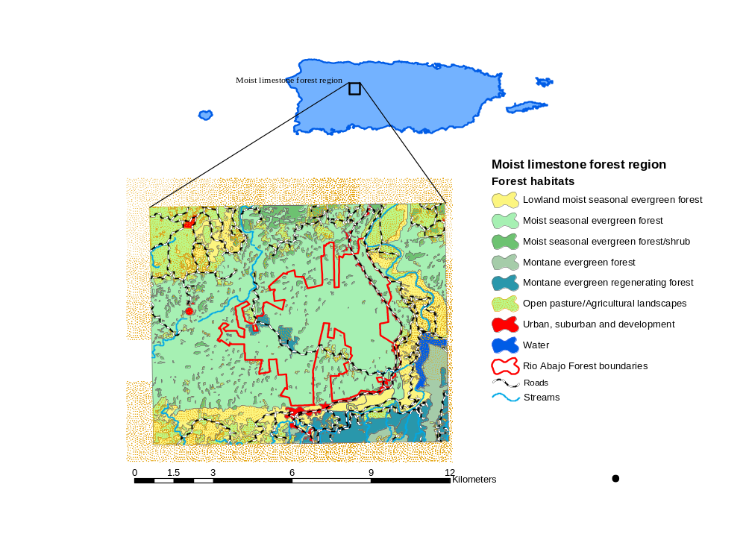
Llerandi-Román, 2005

APPENDIX II: STANDARD OPERATIONS PROTOCOLS

A. BANDING

I. Area of Applicability: Caribbean National Forest (CNF)

II. Background: Banding has been an efficient technique throughout the history of this project. This allows us to identify chicks in the wild after fledglings. Chicks are color banded when they reach a certain weight. The chick left band identifies the nest and the right band the year it was born.

III. Resources Required:
A. Personnel
1. Biological Science Technician,
2 Wildlife Biologists and/or Volunteer (2)

B. Equipment/Materials
1. Hand Sanitizing Solution and/or Latex Glove
2. Round, 8" diameter minimum, container with safety top or Clothes Bags
3. Notebook
4. Color Leg Bands
5. Safety Equipment

IV. Procedure:

- Chicks must be marked when they weigh approximately100 g using a close color band. To perform this procedure at least two people are needed.

- Chicks should be marked when the pair leave the nest, preferable early in the morning (i.e., first or second time after leaving the area).

- Before handling the chicks, hands should be cleaned with sanitizing solution or using latex gloves.

- One person must climb the nest using the safety climbing equipment. The other must stay near the tree making sure that the pair do not arrive or is near the nest.

- Chicks will be marked with one color band in each leg. The left band identifies the nest where chicks were born. All chicks born from the same nest, regarding the year will have the same color band. The right band indicates the year. Every chick in the field, born in the same year, will have the same color band. Consequently, every cohort born in different year will have another color scheme.

- The color scheme for nests in the wild are the following:

Nest | Color scheme
South Fork 2A | Blue
South Fork 2B | Yellow
Libertad | Purple
South Fork 1T | Green
Quebrada Grande | Orange

7. After chicks are banded, one person must stay in the blind to verify that the pair behavior seems normal (e.g., feeding hatchling soon after arriving to the nest).

8. When performing nest inspection, bands should be checked. Improper banding procedure may cause bands to fall or leg problems.

V. Reports: Banding procedure will be reported in the blind observation notebook.

VI. Review Period: Annually

VII. Authors: Wilfredo Abreu, Marisel López-Flores and Pablo Torres-Báez

VIII. Approval: Scientific Advisor Team

B WILD NEST MONITORING

I. Area of Applicability: Caribbean National Forest (CNF)

II. Background: To increase the wild population in the CNF, we need to assure that wild pairs using the nest cavities are successful in the breeding season. A successful nest implies that at least one chick fledge from every active wild nest. This may increase the probabilities of wild pairs re-nesting in the same cavity. To increase the nest success, field personnel need to monitor regularly the nests using observational blinds. Normally, a person is assigned to a blind for half days. However, nests are watched full-time when chicks are about to fledge.

III. Resources Required:
A. Personnel
- Biological Science Technician, Wildlife Biologist or/and volunteers
with training in nest monitoring.

B. Equipment/Materials
- Blind (permanent or temporary)
- Portable Radio
- Data Notebook
4. Listening Device System
5. Monitoring Camera System
- Climbing Equipment
- Eggs or Chicks transference equipment
- First Aid kit
- Binoculars

IV. Procedure:

- Normally the nests are monitories 3 half days for a week. However, if the nest presents problems the period time of monitoring and the numbers of day may change.

- Under normal conditions, the observer should enter the blind before dawn. If observer arrives after sunset, entering the blind should be done slowly and quiet. It is critical that the breeding pair is not in the vine and/or close to the blind..

- While in the blind, sudden movements or noises must be avoided to prevent parrots detecting the presence of the observer.

- As soon as observer arrives to the blind, listening device and camera system must be turn-on. If no noise is listened, check the 9-volt battery and 1.5-volt and replace if necessary for listen device. For the camera system, check the 12-volt battery. If the listening device or the cameras are not working properly, do not leave the blind to check any component (e.g., cables, camera inside the nest).

- Inside the blind, the observer must remain completely alert while observing the nest and its surroundings.

- If any situation or emergency occurs, especially if the observer is along in the blind, a radio called must be performed before and after inspecting the nest to the nearest personnel in the field.

- Before leaving the blind, the observer must fill the data sheet inside the blind. Original copy should remain in the blind and the carbon copy must be taken to the Field Operation Coordinator.

- When departing the blind turn-off the listening device and camera system.

- Do not leave the blind if the pair is at the vine or near the nest and/or blind.

- In any circumstances, unauthorized person should entered the blind unless, previous arrangement have been made with Field Supervisor or Field Operation Coordinator. Is recommended to have no more than two persons in the blind, unless an emergency occurs.

- During the fledging period, observation time will be from dawn to dusk.

V. Reports: Data will be reported in blind observation notebook.

VI. Review Period: Annually

VII. Authors: Wilfredo Abreu, Marisel López-Flores, Pablo Torres-Báez

VIII. Approval: Scientific Advisor Team

C TRANSFERRING EGG(S) AND/OR CHICK(S) FROM FIELD TO AVIARY OR VICE VERSA

I. Area of Applicability: Caribbean National Forest (CNF)

II. Background: For a number of reasons, eggs and/or chicks are transferred among the field and aviary. This protocol assures a safe and rapid transportation of eggs or chicks with minimal mortality.

III. Resources Required
A. Personnel
Field personnel and/or Veterinarian

B. Equipment/Materials
Round, 8" diameter minimum, container with safety top
Avian heat brooder
Small seeds
Paper towels
Disposable hand warmers
Clothes bag

IV. Procedure

- If removal of eggs or chicks is necessary, contacting aviary personnel beforehand is mandatory. This will give the personnel time before delivery to prepare the aviary.

2. Do not feed the chick before removing from nest; excessive movement while transferring, may cause chick to aspirate.

3. Before handling the eggs or chicks, clean your hand with sanitizing solution or use latex glove.

4. Place eggs into a lined container with small seeds and hand warmers. This will prevent movement and possible breakage of the egg. Seeds should cover at least half the egg.

5. Chicks with few or no feathers would need additional heat source, especially if outdoor temperature is less than 80F◦. Use good reasoning regarding additional heat source (e.g., hand warmer) when transferring chicks. One or two hand warmers should be added. Make sure warmers are under and wrapped by small seeds. Direct contact with chicks can cause serious burns. If chick is feathered and temperature outside is warm, heat source may not be necessary.

6. Place container into clothes bag and proceed directly and rapidly to destination.

7. If eggs or chicks are place in a wild nest, the foster parent behavior should be monitored thoroughly. This should be done within the first 24 hours after fostering the egg or chick. Use listening device and/or cameras to monitor.

- If an aviary chick is placed in a wild nest, be sure to prepare food and feed the chick before placing it in the nest. Use discretion because stressed chick may need a few hours to settle down before feeding is attempted.

9. Eggs and/or chicks must be transported only by trained personnel, except in emergency cases.

10. Transfer eggs or chicks from aviary to field early in the morning after sunrise.

V. Reports: Transferring eggs and/or chicks will be reported in the blind observation notebook and aviary logbook.

VI. Review Period: Annually

VII Authors: Wilfredo Abreu, Pablo Torres-Báez, Jafet Vélez

VIII. Approval: Scientific Advisor Team

D. WILD NEST INSPECTION

I. Area of Applicability: Caribbean National Forest (CNF)

II. Background: The goal of the Puerto Rican Parrot Recovery Program is to produce successful nests (i.e., at least one chick fledge) every year. To assure the best conditions for Puerto Rican Parrots in the wild, is critical to have dry, clean, free of parasites and safe (e.g., predators and competitors) nests. This may increase the likelihood of wild pairs re-nesting in the same cavity. The main objective of nest inspections is to increase the probabilities of wild pairs using the improved natural nests or the artificial PVC nest cavities

III. Resources Required:
A. Personnel
1. Biological Science Technician and/or Wildlife Biologist (2)
2. Veterinarian (Blood Drawing)

B. Equipment/Materials
1. Portable Radios (2)
2. Nest Material made from Palo Colorado (Cyrilla racemiflora) and/or Mahogany (Swietenia sp.)
3. Hand Sanitizing Solution and/or Latex Glove
4. Scales
5. Plastic Bags and Clothes Bags
6. Data Notebook
7. Leg Bands
8. Safety Equipment
9. Small Flashlight

IV. Procedure:
Quick inspection = quickly check nest material, eggs(s) and chick(s)
condition.

Full inspection = replace nest material, verify chick(s) health condition (weight and physical exam), blood sampling, and banding if is necessary.

A. Early in the breeding season, before nest becomes active, cavities should be checked to make sure that nest material is dry, also if the vine is properly placed and in good condition. Equipment such as the listening device and camera should be tested.

B. Once the nest is active:

a. Egg incubation stage: Check the egg(s) fertility during the 12-15 days after laid. During this period a weekly inspection will be conducted to check nest material status, unless the nest does not have a video camera system.

b. First 1-4 days after hatching: During this time a quick inspection should be conducted to verify the condition of chicks. If nest material is dirty, humid and contains parasites, it should be change.

c. 5-15 days: Replace nest material and add Sevin dust to the new material. Weigh the chick twice and remove the un-hatched egg(s). During this period, at least two full inspection and all necessary quick inspections should be conducted.

d. 16-30 days: During this period a weekly full inspection should be done. In every inspection new nest material and Sevin dust must be added. A minimum of two full inspection and all necessary quick inspections should be done.

e. 31- 45 days: One full inspection per week. In every inspection nest material should be change with new material without Sevin dust. Chicks will be banded and blood sample must be drawn approximately 45 days after hatched. A minimum of two full inspection and two quick inspections (day after banded and blood samples) should be conducted.

f. 46 - 60 days: One full inspection must be done. Nest material should be changed with new material without Sevin dust. Chicks must be radio-marked approximately 45-50 days after hatched. A quick inspection should be conducted the day after radio-marking the chicks.

C. Inspection time: Nest inspections must be done soon after the female leaves the nest for the first time. Disturbing the female inside the nest should not be done, unless is strictly necessary.

If any situation or emergency occurs, especially if the observer is along in the blind, a radio called must be performed before and after inspecting the nest to the nearest personnel in the field.

Before handling the eggs or chicks, clean hands with sanitizing solution or use latex gloves.

V. Reports: Inspections will be reported in the blind observation notebook.

VI. Review Period: Annually

VII. Authors: Hernán Abreu, Wilfredo Abreu, Pablo Torres, Jafet Vélez, Thomas White, Gilberto Ortiz and Miguel Toledo.

VIII. Approval: Scientific Advisor Team

APPENDIX III: Typical haystack hill formations characteristic of the Puerto Rican northern karst region

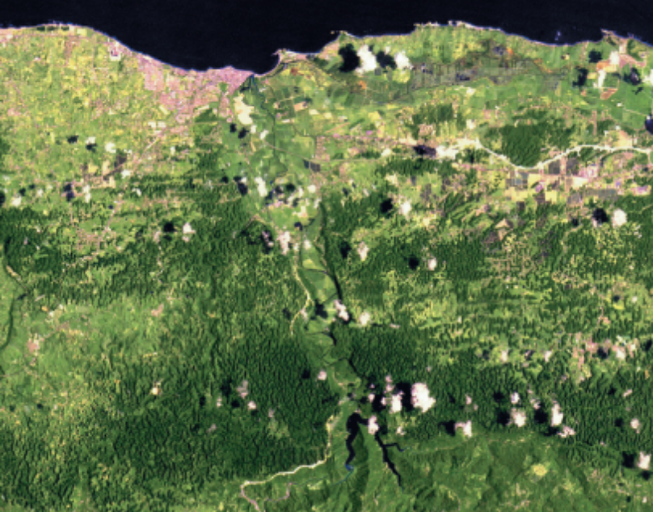

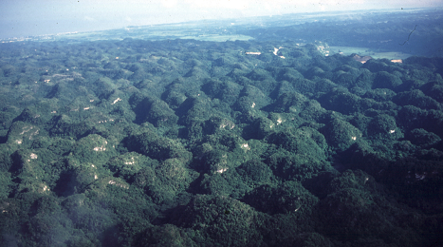

APPENDIX IV: Federally endangered and threatened species present in the Northern Karst Region of Puerto Rico

Birds (6) Common name | Scientific name
Broad-Winged Hawk | Buteo platypterus
Sharp-Shinned Hawk | Accipiter striatus
Yellow-Shouldered Blackbird | Agelaius xanthomus
Plain Pigeon | Columba inornata wetmorei
Reptiles (1)
Puerto Rican Boa | Epicrates inornatus
Plants (21)
Palo de Rosa | Ottoschulzia rhodoxylon
Beautiful Goetzea | Goetzea elegans
Cóbana Negra | Stahlia monosperma
Bariaco | Trichilia triacantha
Vahl’s Boxwood | Buxus vahli
Chupacallos | Pleodendron macranthum
Palo de Ramón | Pleodendron macranthum
Palma de Manaca | Banara vanderbiltii
No common name | Calyptronoma rivalis
No common name | Ottoschulzia rhodoxylon
No common name | Myrcia paganii
No common name | Auerodendron pauciflorum
No common name | Schoepfia arenaria
No common name | Daphnopsis hellerana
Palo de Niqua | Cornutia obovata
No common name | Solanum drymophilum
No common name | Cordia bellonis
No common name | Peperomia wheeleri
No common name | Adiatum vivesii
No common name | Tectaria estremerana
No common name | Thelypteris verecunda
St. Thomas Prickly Ash | Zanthoxylum thomasianum
No common name | Chamaecrista glandulosa var. mirabilis

APPENDIX V: Flow chart listing the various studies and sources of information used to evaluate potential release sites, including the Río Abajo Forest Reserve, and to develop a reintroduction plan to establish the second wild population of Puerto Rican parrots in the island. The Río Abajo Forest (2340 ha), and surrounding forests, ranked 1 among 3 potential release sites (protected areas) in the northwestern karst (limestone) region of Puerto Rico.

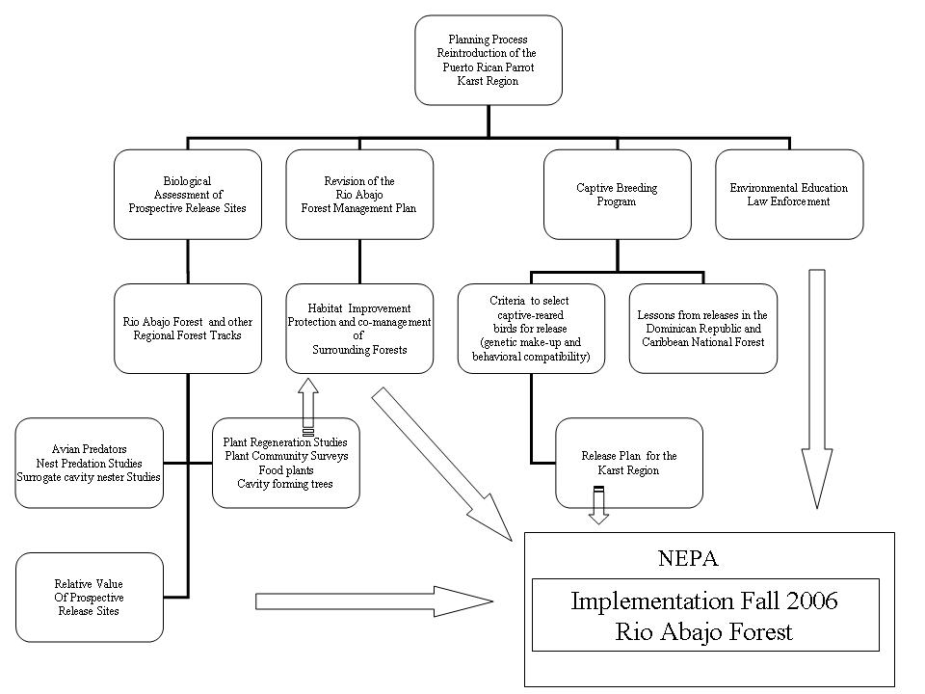

APPENDIX VI: Environmental assessment and biological evaluation of non-native exotic species management to protect wild Puerto Rican parrots and their nests for the Caribbean National Forest prepared by the U.S. Forest Service.



