Final Report for Application of Machine Learning Technology to Martian Geology

Submitted to:

Applied Information Systems Research Program
Office of Space Science
NASA
Washington, DC

Prepared by:

Ruye Wang
Engineering Department
Harvey Mudd College
Claremont, CA 91711

James Dohm

Department of Hydrology and Water Resources

University of Arizona,

Tucson, AZ, 85721

Rebecca Castano
Jet Propulsion Laboratory
Pasadena, CA, 91101

Are the Rock Compositions of the Ancient Mountain Range of Mars,

Thaumasia Highlands, Distinct from Tharsis Lavas?:

Machine Learning Evaluation of TES Data

and Implications on Early Evolution of Mars

Abstract-Prominent characteristics of the Thaumasia highlands mountain range include magnetic signatures, complex tectonic structures, cuestas, hog backs, and valley networks (characteristics similar to the mountain ranges of Earth), revealed through Viking, Mars Odyssey (MO), Mars Express (MEX), and Mars Global Surveyor (MGS) information. We have applied Machine Learning and Geographic Information Systems (GIS) techniques to published geologic and Thermal Emission Spectrometer (TES) hyperspectral image cube information. When compared to the ancient mountain-forming materials, the younger plains-forming materials record a different TES emissivity signature. This finding is consistent with Viking-era, geological mapping-based interpretations that the mountain-forming materials could be comprised of a diversity of rock types, other than lava flow materials. These include ancient highly eroded and geochemically altered crystalline igneous and/or metamorphic rocks that generally underlie sedimentary rock sequences including aeolian, fluvial, alluvial, and colluvial deposits. In contrast, the plains-forming materials are lava flow materials. Here, we describe a useful Machine Learning approach that aids in assessment of the spectral data, the significance of the Thaumasia highlands mountain range to unraveling the early evolutionary phases of Mars, and a rationale for continued investigation of such ancient features including other mountain ranges such as Coprates rise of Mars through MGS, MO, and Mars Reconnaissance Orbiter (MRO).

I. INTRODUCTION

Ancient mountain ranges form the southern and southeastern margins of the Thaumasia plateau in the southeast part of Tharsis. These are known as the Thaumasia highlands and Coprates rise, respectively (Fig. 1 and 2) [1,2]. Information acquired from the Mars Express (MEX) spacecraft highlights the significance of the Thaumasia highlands mountain range as a window into the ancient phase of Mars evolution [3-4]. Stratigraphic and cross-cutting relations, impact crater statistics, an order of magnitude greater density of tectonic structures in the mountains compared to the younger lava plains of the shield complex of Syria Planum, and distinct magnetic signatures indicate that the mountain ranges began to form before the shut down of the magnetosphere, prior to the evolution of Tharsis [5-6]. Determination of the mineralogic composition of these ancient structures has the potential to significantly improve understanding of the early geologic and geochemical evolution of Mars. For example, are the rock compositions of the largest mountain range of Mars, Thaumasia highlands, different from Tharsis lavas? Is there a distinct ancient rock record in the Thaumasia highlands that is not obscured by Tharsis-era geologic activity, activity which dates back to at least the Middle Noachian epoch [1,2,5,6] or more than 3.7Ga to present [7]? More specifically, are there rocks other than volcanic compositions (e.g., basalt/basaltic-andesite) such as basement complex rocks in the ancient mountain range (a suite of mostly crystalline igneous and/or metamorphic rocks that generally underlies the sedimentary rock sequence) that are poking up through an aeolian mantle chiefly composed of basaltic/basaltic-andesite materials? In addition, is such a potential ancient rock record free of thin-skinned secondary weathering products (e.g., see [9,10] for information on MER-based investigations that reveal secondary weathering rinds) or contributing fragmented materials to the development of fan materials on and along the southern flanks of the Thaumasia highlands mountain range [2], all at sufficient areal extent to be detected from orbital platforms ranging from the Thermal Emission Spectrometer (TES) on Mars Global Surveyor (MGS) to the Compact Reconnaissance Imaging Spectrometer for Mars (CRISM) on the Mars Reconnaissance Orbiter (MRO)? Addressing whether the mountain range is comprised of rocks other than volcanic is further prompted by similarities to terrestrial mountain ranges of diverse rock compositions [1,2]. These include magnetic signatures [11-13], complex tectonic
structures, cuestas, and hog backs, and the potential significance to the early evolution of Mars [1,2,5,6].

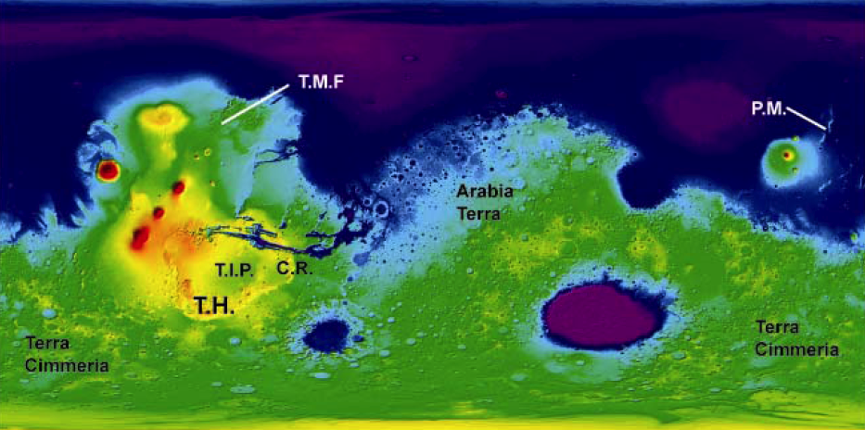

Fig. 1. MOLA-based map showing ancient features such as Thaumasia highlands (T.H.) and Coprates rise (C.R.) mountain ranges, Phlegra Montes, Tempe Mareotis Fossae (T.M.F), and ancient geologic provinces such as Terra Cimmeria and Arabia Terra, all of which are considered as ancient markers of the early evolution of Mars. The “T” denoting Thaumasia highlands is approximately located at the central part of the region under investigation.

Mars is commonly viewed as a one-plate planet based largely on geophysical and geochemical arguments mainly from analysis of SNC meteorites [14-15]. Just as the ancient rock record may be obscured by mantling and secondary weathering processes, the SNC—associated sampling may only reveal a part of the geological and geochemical histories of Mars. Whether the Thaumasia highlands mountain range is other than basalt/basaltic andesite is a significant query to address since the range records an ancient part of Mars’ evolution, which includes hypothesized Earth-like evolutional phases, including plate tectonism, particularly during its embryonic stages of evolution [5,16]. These are invoked to account for many enigmatic features in regard to the geological history of Mars. Included in these features are the ancient mountain ranges, Thaumasia highlands and Coprates rise, extremely large ancient tectonic structures such as Tempe Mareotis Fossae and Phlegra Montes, and ancient geologic provinces such as Terra Cimmeria and Arabia Terra (Fig. 1 and 2) that record pronounced magnetic anomalies [5,13,17].
Below, we discuss the approach that was used to evaluate the TES data, present the results, and discuss why such an investigation may improve our understanding of the early geological evolution of Mars. We also explain why it is necessary for further investigation of ancient features and geologic provinces of Mars through MGS, MO, and MRO.

II. METHODOLOGY

As part of the geological investigation of the ancient Thaumasia highlands mountain range (Fig 1 and 2), the TES data taken by the MGS spacecraft are analyzed by Machine Learning methodologies using both unsupervised (clustering) and supervised (classification) techniques. Canonical spectral endmembers representing atmospheric contributions [20] as well as surface types and pure mineral endmembers from the Arizona State University (ASU) Spectral Library [e.g., 17-22] were used for the clustering investigation, while the published Viking-era geologic information [2] were used to select prime mountain- and plains-forming TES spectral types for the supervised investigation.

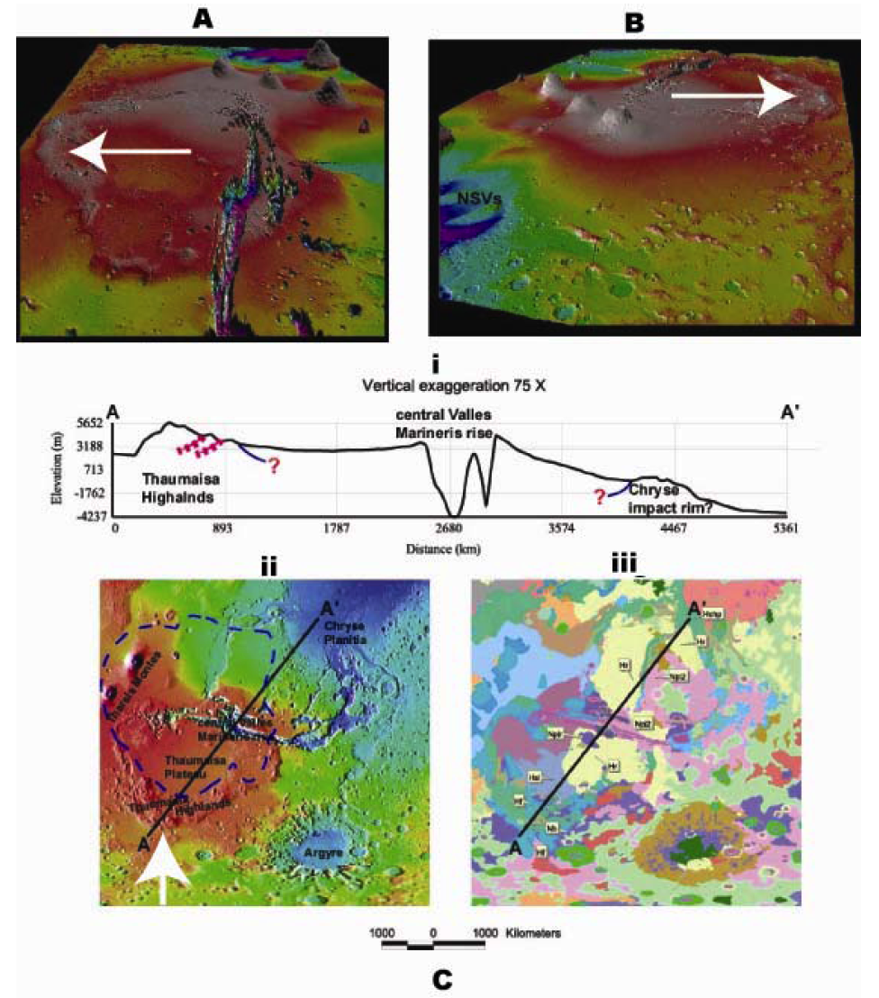

Fig. 2. A. MOLA-based 3D projection looking to the west obliquely across the Thaumasia highlands mountain range (white arrows). B. MOLA-based 3D projection looking to the east obliquely across the Thaumasia highlands mountain range (white arrows). C. Based on [1], (i) present-day MOLA profile (Transect A-A’) across the west-central part of Thaumasia highlands mountain range, central part of a putative Noachian drainage basin (queried blue line represents uncertain basin extent), including west-central Valles Marineris rise (center of tectonic activity, interpreted to be the result of magmatic-driven uplift [1], and Tempe Terra plateau, (ii) MOLA shaded relief map showing features of interest, including the approximated boundary of the Noachian drainage basin (dashed blue line) and the central Valles Marineris rise, and (iii) part of the geologic map of the western equatorial region of Mars (representative map units are shown—[8]).

To determine whether there are distinctions in spectral signatures among the ancient mountain-forming materials of Thaumasia highlands and the younger lava plains of the complex shield volcano, Syria Planum (e.g., Syria, Sinai and Solis Planae; for detailed mountain range and shield complex information, see [1,2,23]), our approach requires the following steps; (1) determine distinguishing TES information using unsupervised and supervised Machine Learning techniques, which included TES-based Surface Type 1 vs. Surface Type 2 spectral information [18] and selected mountain-forming pixels vs. plains-forming pixels, (2) select “quality” tracks of TES data that have the least contributions from clouds, atmospheric and surface dust, or noise for comprehensive analysis, (3) apply unsupervised and supervised techniques to the “quality” tracks of TES data to visualize whether there is a spectral distinction between the ancient mountain-building materials and plains-forming materials, (4) separate out ancient mountain-forming materials from relatively young plains-forming materials based on published geologic information using Geographic Information Systems (GIS) for coupling with the Machine Learning-based results, and (5) quantify the comparison among the Machine Learning-based results and the published geologic information, which includes determining the density of untrained Type 1 and Type 2 pixels and trained mountain-forming and plains-forming pixels (e.g., total amount of pixels of a specific type divided by the total area of either mountain-forming or plains-forming units) (Fig. 3 and 4).

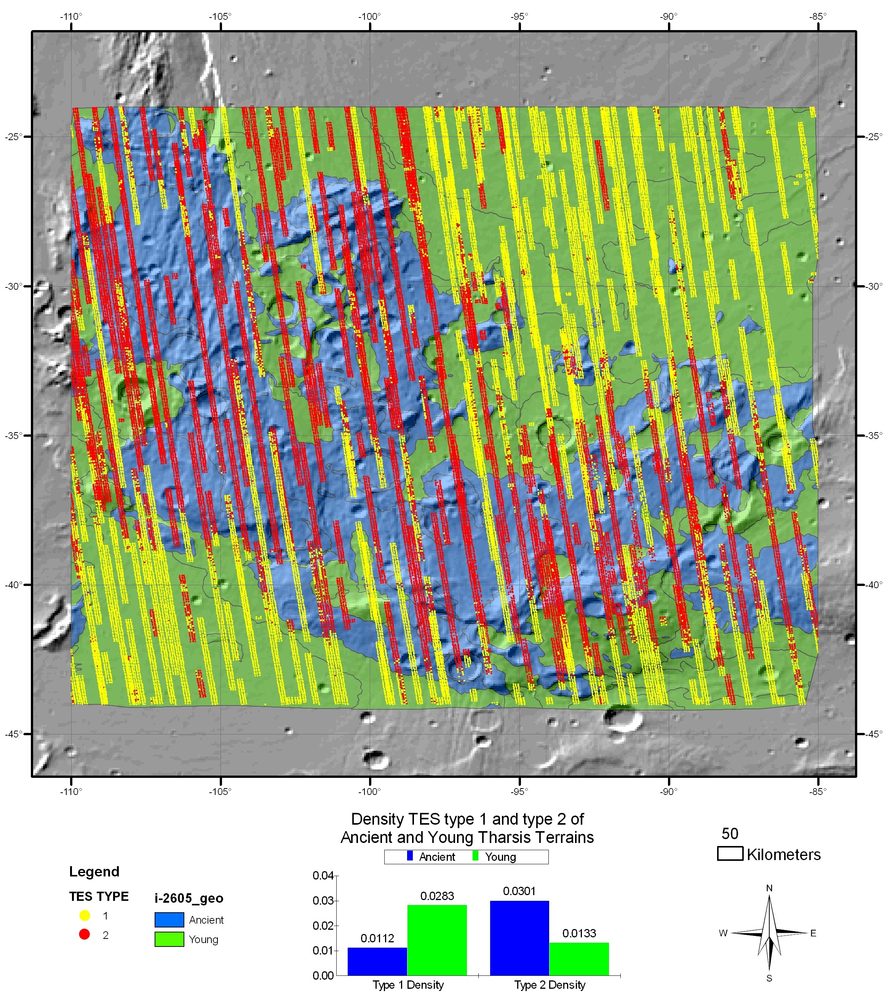

Fig. 3. Map shows TES type 1 and 2 plotted over a MOLA hillshade and a part of the USGS I-2605 map [2] (see corresponding Table 1). The TES data was classified by applying Machine Learning “untrained” techniques to Type 1 and Type 2 information [18,21,22] using quality TES strips that cover part of the ancient Thaumasia highlands mountain range and younger plains-forming materials to the north and south of the mountain range. The Geology has been reclassified into two units: Ancient (mostly Early and Middle Noachian—Stage 1 map units) and Young (Late Noachian and younger—Stages 2-4 map units) based on [2]. The histogram chart shows the density of the type 1 and 2 TES data. This was calculated by dividing the individual TES points by the area of the ancient and young terrains. The density results clearly indicate that the mountain-forming materials are distinct from the plains-forming materials with more dominant Type-2 and Type-1 signatures, respectively. This is consistent with Viking-era geologic investigations [2,8].

To associate both the Machine Learning “untrained” classified TES type 1 and 2 information and “trained” classified mountain- and plains-forming TES spectral information with the Thaumasia ancient mountain terrain and the younger surrounding plains, we co-located all the datasets into a GIS for analysis. The USGS map publication I-2605 [2] was used to select mountain- and plains-forming pixel types at prime locales, as well as to segregate geologic map units into two types for comparative analysis with the Machine Learning-based results: (1) ancient mountain-forming map units (mostly Stage 1, Early to Late Noachian), and (2) younger map units (Stages 2-4: Late Noachian to Early Hesperian). Area calculations for the two types of geologic units were computed using an Equal-area Sinusoidal projection. The TES-based information of Fig. 14 and 15 were then read into our GIS as simple point locations. Because the region for this TES-based investigation was smaller in extent than the extent of the total area of the I-2605 geologic map, the geology was clipped to match the study region (matching the limits of the TES data). Lastly, we intersected the TES points with the two geologic unit types to create the density calculations (Fig. 14 and 15 and corresponding Tables 1 and 2).

Geologic  Type | Total Area  km² | Total TES-  Type1 Pixels | Total TES-  Type 2 Pixels | Density-  TES Type 1 | Density-  TES Type 2
Ancient | 631718.96 | 7095 | 19017 | 0.0112 | 0.0301
Young | 819600.71 | 23165 | 10862 | 0.0283 | 0.0133

Table 1. Corresponding with Fig 3, the TES data was classified by applying Machine Learning to Type-1 and Type-2 end member information of [18,20] by selecting pixels of quality TES strips that occur in the ancient mountain-building materials and younger plains-forming materials. The Geology has been reclassified into two units: Ancient (mostly Early and Middle Noachian—Stage 1 map units) and Young (Late Noachian and younger—Stages 2-4 map units) based on [2]. The density results clearly indicate that the mountain-forming materials are distinct from the plains-forming materials with more dominant Type-2 and Type-1 signatures, respectively. This is consistent with Viking-era geologic investigations [2,8].

III. RESULTS

The density results clearly indicate that the mountain-forming materials are distinct from the plains-forming materials with more dominant Type 2 and mountain-type for the ancient mountain-forming materials of the Thaumasia highlands mountain range and Type 1 and plains-forming type for the plains-forming materials, respectively. This is consistent with Viking-era geologic investigations [2,8], which indicated that the mountains could be comprised of diverse rock materials such as basement complex and the plains-forming materials mostly composed of basaltic lava flows. Those pixels that do not show such a correspondence could be explained by multiple factors. There may be atmospheric obscuration and dust loading in some locations. Alternatively, materials shed from the prominent mountains may create alluvial fan materials comprised of both mountain-forming materials and plains-forming materials, lateral and vertical variations in the mantles may obscure bedrock, and younger volcanoes and lava flows occur in the mountain range [2].

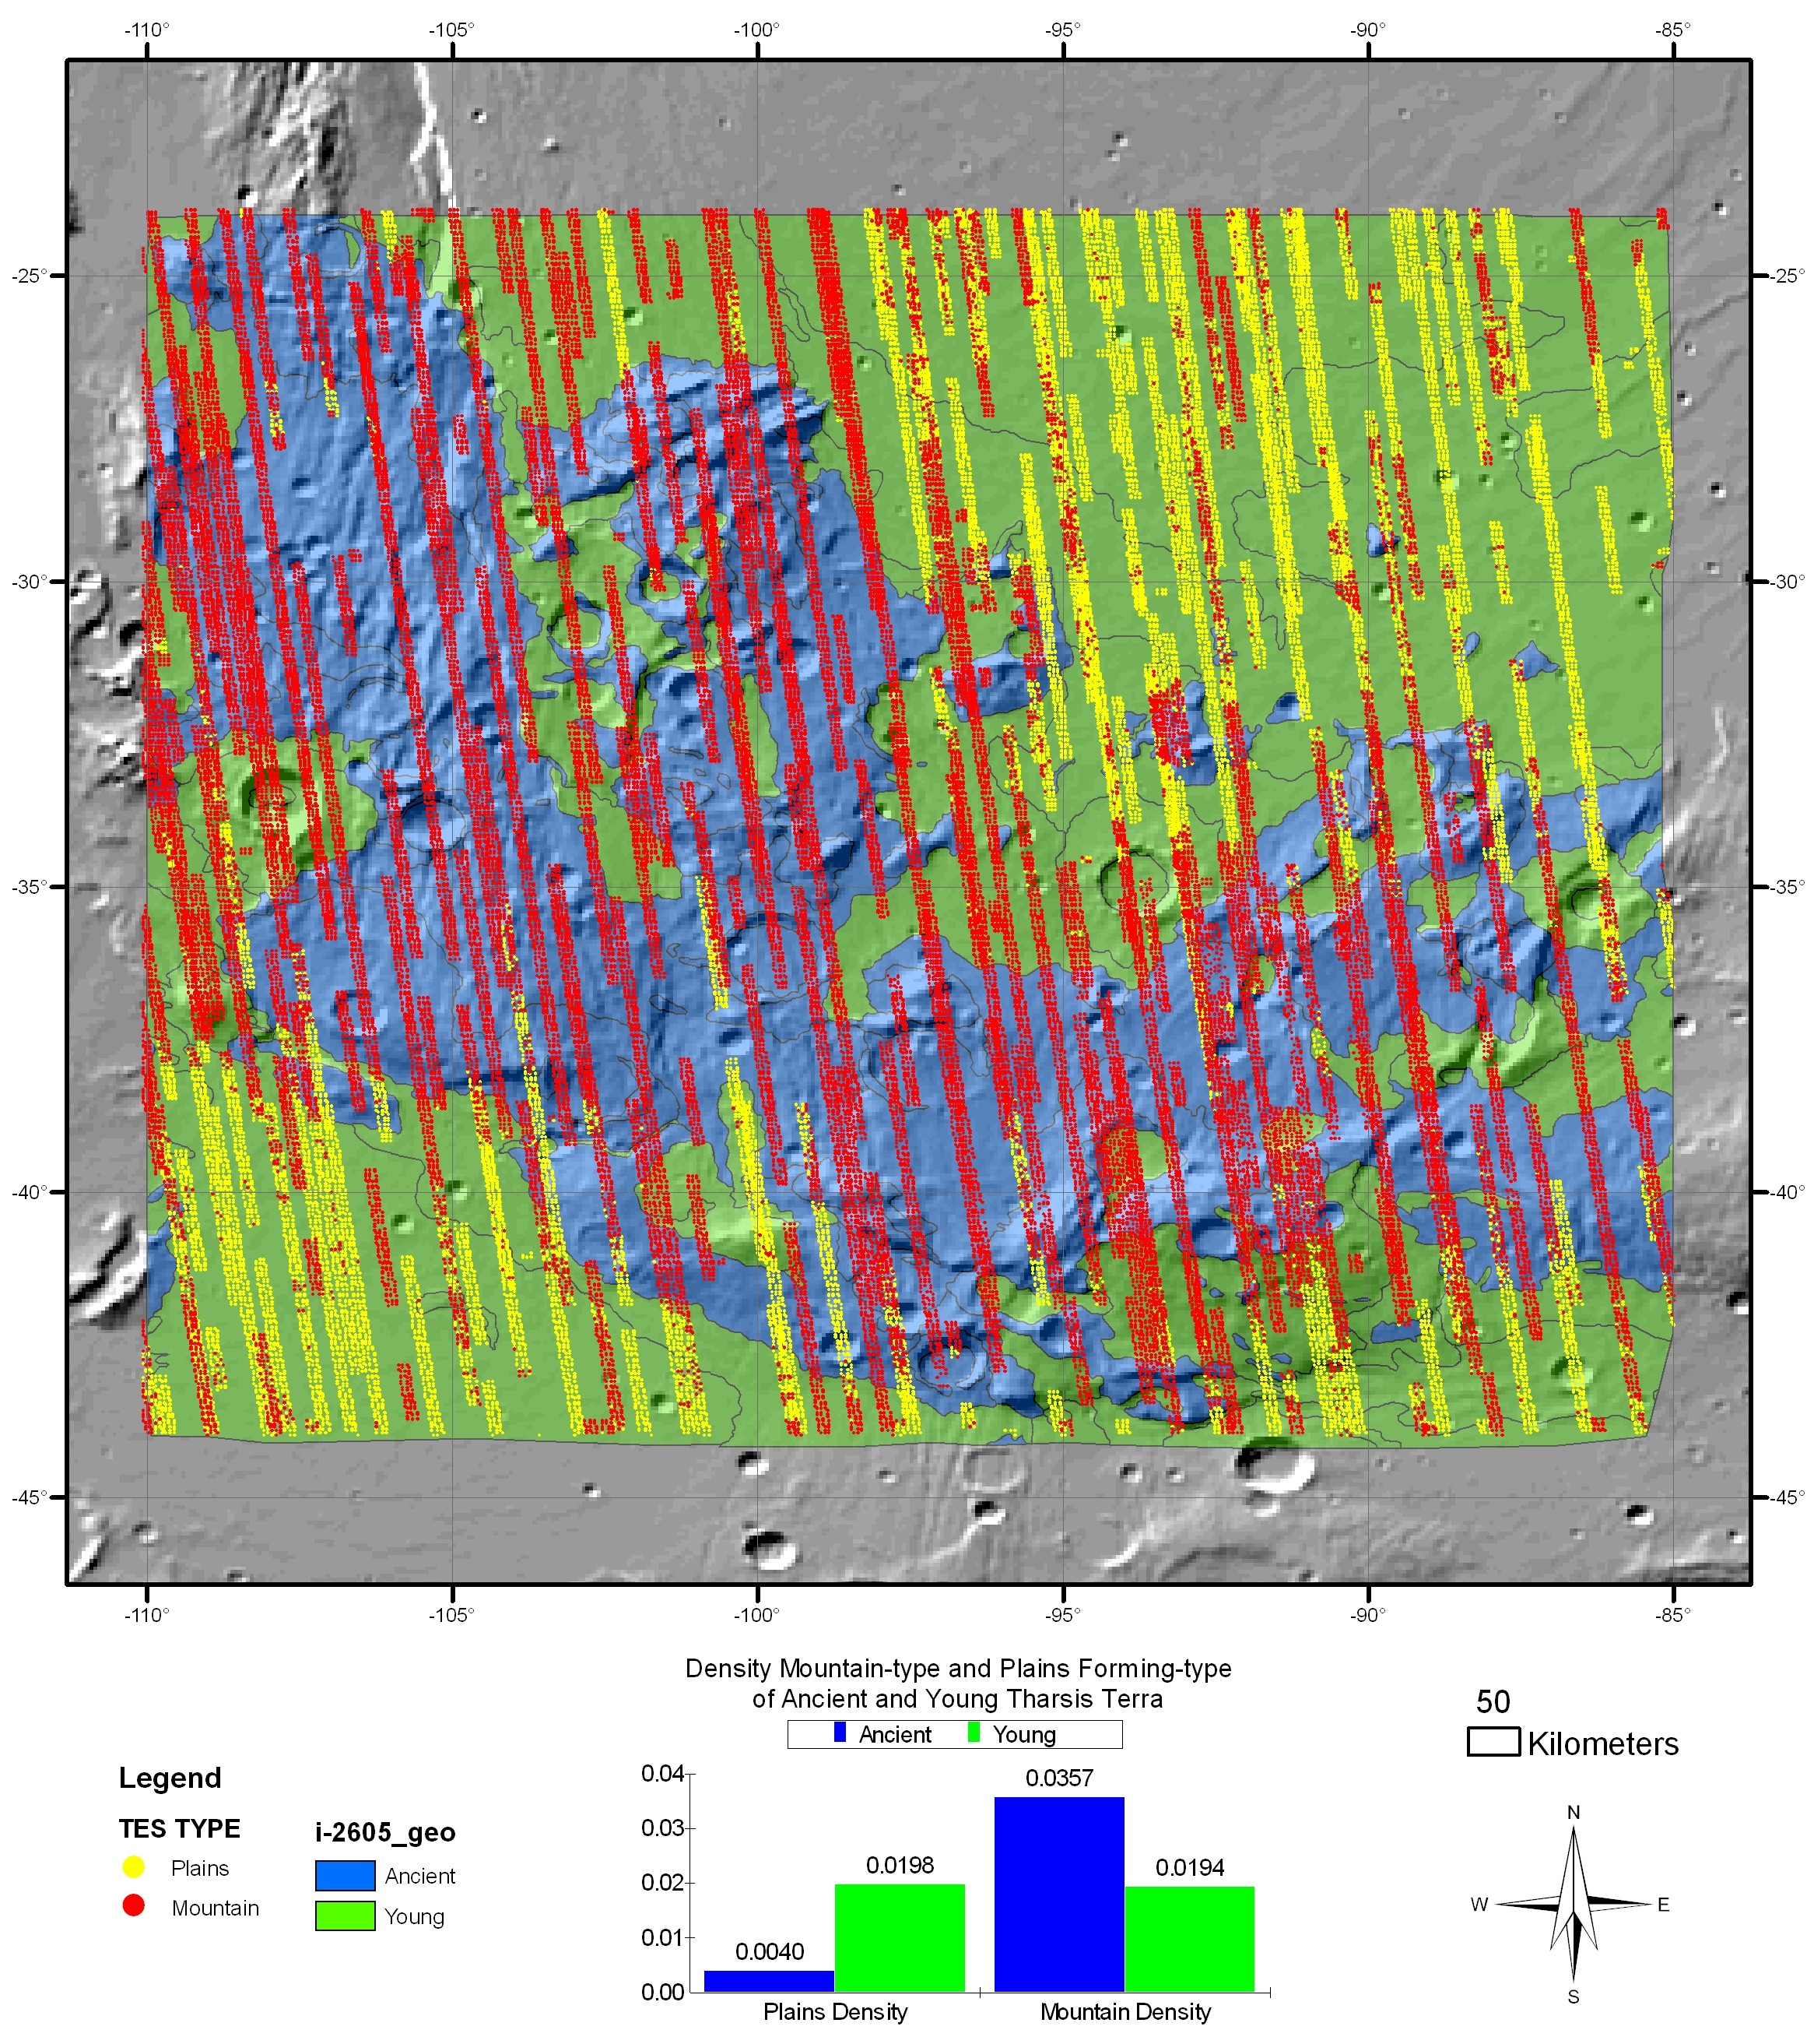

Fig. 4. Map shows mountain- and plains-forming- pixel types plotted over a MOLA hillshade and a part of the USGS I-2605 map [2] (see corresponding Table 1); the pixel location for each type was also based on the USGS I-2605 map). The TES data was classified by applying Machine Learning “trained” techniques to identify mountain-forming pixels from plains-forming pixels using quality TES strips that cover part of the ancient Thaumasia highlands mountain range and younger plains-forming materials to the north and south of the mountain range. The Geology has been reclassified into two units: Ancient (mostly Early and Middle Noachian—Stage 1 map units) and Young (Late Noachian and younger—Stages 2-4 map units) based on [2]. The histogram chart shows the density of the mountain-forming and plains-forming TES-based information. This was calculated by dividing the number of individual TES pixels by the area of the ancient and young terrains. The longitudes are positive East. The density results clearly indicate that the mountain-forming materials are distinct from the plains-forming materials with corresponding mountain-forming and plains-type signatures, respectively. This is consistent with Viking-era geologic investigations [2,8].

We have developed an intelligent software system (referred to here as Machine Learning) for robust analysis of hyper-spectral Thermal Emission Spectrometer (TES) data (e.g., [17-20]) with the impetus to determine whether the rock materials of the ancient Thaumasia highlands comprise rock materials beyond just basalt/basaltic andesite as the published TES maps have portrayed [17,18,20]. Through Machine Learning Systems we can perform expeditious comparative analysis among any type of multispectral image information. Using Geographic Information Systems, we can also readily separate out ancient mountain-forming materials from relatively young plains-forming materials based on published geologic information and couple the geologic information with the Machine Learning-based results to determine the density of pixels of both end member types in both the mountain-forming and plains-forming rock materials.
The results clearly indicate that there is a spectral distinction between the two types of materials. But what does the distinction mean? Clearly from the results at least we can say that the Thaumasia highlands mountain range comprises a greater diversity of rocks than just basalt-basaltic andesite. But can we properly identify the rock types that compose the mountain-forming materials with existing orbital platforms? For example, will CRISM be able to accurately identify ancient rock materials that may be poking up through Tharsis-era mantles?

Geologic  Type | Total Area  km² | Total plains-forming type pixel | Total moutain-forming type pixels | Density- total plains-forming type pixels | Density- total moutain-forming type pixels
Ancient | 631718.96 | 2505 | 22537 | 0.0040 | 0.0357
Young | 819600.71 | 16260 | 15886 | 0.0198 | 0.0194

Table 2. Corresponding with Figure 15, the TES data was classified through Machine Learning by selecting pixels of quality TES strips that occur in the ancient mountain-building materials and younger plains-forming materials. The Geology has been reclassified into two units: Ancient (mostly Early and Middle Noachian—Stage 1 map units) and Young (Late Noachian and younger—Stages 2-4 map units) based on [2]. The density results clearly indicate that the mountain-forming materials are distinct from the plains-forming materials with more dominant mountain-type and plains-forming-type signatures, respectively. This is consistent with Viking-era geologic investigations, interpreted to be largely basement complex and basaltic lava flows, respectively, based on Viking-era geologic investigations [2,8].

Determining the composition of the Thaumasia highlands mountain range is of first order importance since the range records an ancient part of Mars’ evolution, which includes possible Earth-like evolutional phases such as plate tectonism, particularly during its embryonic stages of evolution [5]. In addition to the Thaumasia highlands mountain range, there are other markers of an ancient Mars that are difficult to explain in the absence of plate tectonism [3], including the Coprates rise mountain range [1,2] and other tens to thousands-km-long structures such as Tempe Mareotis Fossae and Phlegra Montes (Fig. 1). Many of the features (a) are interpreted to be the result of compressional deformation such as thrust faulting [2-4], (b) occur among highly degraded promontories (interpreted to be silicate-rich constructs or intrusives [8]), (c) are embayed by relatively younger rock materials [8], and (d) form the margins of elongated basins and “banded” magnetic anomalies [11] (such as those in the Terra Cimmeria and Terra Sirenum regions), similar to what is observed in geologic terrains of Earth that have recorded plate tectonism (e.g., for further details on why the banded anomalies in Arabia Terra and Terra Cimmeria may be explained by plate tectonism, see [13,24], respectively). Other seemingly anomalous observations in regard to the geological evolution of Mars include major variations in crustal thickness, from thin beneath the northern plains (~30 km) to thick (~60 km) beneath the southern highlands and Tharsis [25], and linear crustal magnetization anomalies of remarkable intensity that occur in the southern highlands [11-13].
Though Mars is commonly viewed as a one plate planet based largely on geophysical and geochemical arguments, mainly from analysis of SNC meteorites [14,15], MO, MEX, MRO, and the Mars Exploration Rovers are increasingly showing a greater diversity of rock types for Mars such as hematite, andesite, sulfates, and even quartz-bearing granitoids, etc. [18, 26-30]. For example, detailed chemical compositional studies of volcanic plains and adjacent ancient uplands are available for the Spirit landing site in Gusev Crater. The plains consist of olivine-rich basalts [31]. The adjacent Columbia Hills contain a more ancient suite of complex alkali volcanic rocks [32]. Locally these include rocks highly enriched in volatile elements, and there is evidence of explosive volcanism followed by aeolian reworking of pyroclastic materials [33].
Basement complex may present an alternative to hematite, sulfates, basalt, and basaltic andesite in the ancient rock record. With resolutions as high as 25 centimeters per pixel, CRISM should shed further light on the potential for such an ancient rock record.

IV. Summary

The results of our investigation coupled with recent MGS-, MO-, and Mars Express-based findings, which indicate a greater diversity of rock types through recent data acquisitions, are promising, and designing an effective system to perform expeditious analysis of huge data sets such as TES and THEMIS will ultimately lead to an improved understanding into the geological evolution of Mars. The results presented here indicate that the ancient mountain-forming materials record a distinct thermal infrared emission signature from the plains-forming materials. This is consistent with Viking-era, geological mapping-based interpretations that the mountain-forming materials could be comprised of a diversity of rock types, which includes basement complex, whereas the plains-forming materials are mostly volcanic. Such a potential rock record and possible implications on Mars’ embryonic stages of planetary evolution underscore the necessity for further investigation through MGS, MO, Mars Reconnaissance Orbiter (MRO), and future science-driven reconnaissance missions. Ongoing investigation includes refining the fidelity of the mineral mapping through the addition and deletion of materials from the spectral database. This will produce a suite of minerals most suited to modeling the actual surface materials. Through application of the refined spectral database, we anticipate modest improvements to the preliminary mineral interpretations. A mixing model will also be applied in a couple of different configurations such as in the case of the clustering results from the artificial intelligence algorithm, which will be used to separate contiguous regions of specific spectral types. This information will then be modeled using a linear mixing algorithm to determine if previously separated spectral classes can reveal more detailed mineralogical analyses using TES.
Moreover, in addition to the scientific results obtained as discussed above, this study has also demonstrated clearly that the machine learning methods are effective in unraveling geologic histories of Mars and other planetary bodies, as it allows expeditious comparative analysis of tier-scalable information. In this particular investigation, various algorithms in machina learning (endmember separation, supervised classification, clustering análisis, etc.) appled to the TES data show that there is a clear distinction between the ancient mountain ranges and the much younger lava plains. The same approach could be used for identifying anomalies through robotic reconnaissance (e.g., transient events such as spring-fed activity or volatile release, water-ice vs. rocks, etc.) while in transit (e.g., rovers) using diverse information sets at varying scales.

REFERENCES
[1] J.M. Dohm, J.C. Ferris, V.R. Baker, R.C. Anderson, T.M. Hare, R.G. Strom, N.G. Barlow, K.L. Tanaka, J.E. Klemaszewski, D.H. Scott, “Ancient drainage basin of the Tharsis region, Mars: Potential source for outflow channel systems and putative oceans or paleolakes,” J. Geophys. Res., vol. 106, pp. 32,943-32,958, 2001a.
[2] J.M. Dohm, K.L. Tanaka, T.M. Hare, “Geologic map of the Thaumasia region of Mars,” US Geol. Survey Map I-2650, 2001b.
[3] F. Anguita, C. Fernández, G. Cordero, S. Carrasquilla, J. Anguita, A. Núñez, S. Rodriguez, and J. Garcia, “Evidences for a Noachian-Hesperian orogeny in mars,” Icarus, vol. 185, pp. 331-357, 2006.
[4] M. Grott, E. Hauber, S.C. Werner, P. Krongberg, and G. Nuekum, ”Mechanical modeling of thrust faults in the Thaumasia region, Mars, and implications for the Noachian heat flux,” Icarus, vol. 186, pp. 517-526, 2007.
[5] V.R. Baker, S. Maruyama, J.M. Dohm, “Tharsis superplume and the geological evolution of early Mars, in Superplume: beyond plate tectonics, D.A. Yuen, S. Maruyama, S.-i. Karato, and B.F. Windley, B.F. Eds. Springer, Geophysics and Geodesy.
[6] J.M. Dohm, V.R. Baker, S. Maruyama, R.C. Anderson, “Traits and evolution of the Tharsis superplume, Mars,” in Superplume: beyond plate tectonics, D.A. Yuen, S. Maruyama, S.-i. Karato, and B.F. Windley, B.F. Eds. Springer, Geophysics and Geodesy, in press.
[7] W.K. Hartmann, and G. Neukum, “Cratering chronology and the evolution of Mars,” Spa. Sci. Rev., vol. 96, pp. 165-194, 2001.
[8] D.H. Scott, and K.L. Tanaka, “Geologic map of the western equatorial region of Mars,” USGS Misc. Inv. Ser. Map I-1802-A (1:15,000,000).
[9] Squyres, S. W. et al., “The Spirit Rover's Athena Science Investigation at Gusev Crater, Mars,” Science, vol. 305, pp. 794-799, 2004a.
[10] S.W. Squyres, et al., “In situ evidence for an ancient aqueous environment at Meridiani Planum, Mars,” Science, vol. 306, p. 1709, 2004b.
[11] M.H. Acuña, et al., “Global distribution of crustal magnetization discovered by the Mars Global Surveyor MAG/ER experiment,” Science, vol. 284, pp. 790-793, 1999.
[12] J. Arkani-Hamed, “Thermoremanent magnetization of the martian lithosphere,” J. Geophys. Res., vol. 108, 10.1029/2003JE002049, 2003.
[13] J.E.P. Connerney, et al. (2005), Tectonic implications of Mars crustal magnetism, Science, 102, 14970–14975.
[14] A.N. Halliday, H. Wanke, J-L Birck, R.N. Clayton, “The accretion, composition andearly differentiation of Mars,” Space Sci. Rev., vol. 96, 197–230, 2001.
[15] F. Nimmo, K.L. Tanaka, “Early crustal evolution of Mars,” Ann. Rev. Earth Planet. Sci., vol. 33, pp. 133-161, 2005.
[16] A.G. Fairén, J. Ruiz, F. Anguita, “An origin for the linear magnetic anomalies on Mars through accretion of terranes: implications for dynamo timing,” Icarus 160, pp. 220-223, 2002.
[17] P.R. Christensen, et al., “Identification of a basaltic component on the martian surface from Thermal Emission Spectrometer data,” J. Geophys. Res. 105, pp. 9609-9621, 2000.
[18] J.L. Bandfield, V.E. Hamilton, and P.R. Christensen, “A global view of Martian surface compositions from MGS-TES,” Science, vol. 287, p. 1626, 2000.
[19] M.D. Smith, J.L. Bandfield, and P.R. Christensen, “Separation of atmospheric and surface spectral features in Mars Global Surveyor Thermal Emission Spectrometer (TES) spectra,” J. Geophys. Res., vol. 104 pp. 9589-9608, 2000.
[20] J.L. Bandfield, and M.D. Smith, “Multiple emission angle surface-atmosphere separations of Thermal Emission Spectrometer data,” Icarus vol. 161, 47-65, 2003.
[21] M.B. Wyatt, and H.Y. McSween, “Spectral evidence for weathered basalt as an alternative to andesite in the northern lowlands of Mars,” Nature, vol. 417, pp. 263-266, 2002.
[22] Ruff, S. W., “Basaltic Andesite or Weathered Basalt: A New Assessment,” paper presented at Sixth International Conference on Mars, Lunar and Planetary Institute, Pasadena, California, July 20-25 2003.
[23] R.C. Anderson, J.M. Dohm, A.F.C. Haldemann, T.M. Hare, V.R. Baker, “Tectonic histories between Alba Patera and Syria Planum, Mars, Mars,” Icarus, vol. 171, pp. 31-38, 2004.
[24] A.G. Fairén, J. Ruiz, and F. Anguita, “An origin for the linear magnetic anomalies on Mars through accretion of terranes: implications for dynamo timing,” Icarus, vol. 160, pp. 220-223, 2002.
[25] M.T. Zuber, et al., ”Internal structure and early thermal evolution of Mars from Mars Global Surveyor topography and gravity,” Science, vol. 287, pp. 1788-1793, 2000.
[26] P.R. Christensen, et al., “The Mars Global Surveyor Thermal Emission Spectrometer experiment: Investigation description and surface science results,” J. Geophys. Res., vol. 106, pp. 23,823-23,871, 2001a.
[27] P.R. Christensen, R.V. Morris, M.D. Lane, J.L. Banfield, M.C. Malin, “Global mapping of Martian hematite mineral deposits: Remnants of water-driven processes on early Mars,” J. Geophys. Res., vol. 106, pp. 23,873-23,885, 2001b.
[28] P.R. Christensen, et al., “The Igneous Diversity of Mars: Evidence for Magmatic Evolution Analogous to Earth,” Lunar Planet. Sci. Conf., XXXVI, #1273 (abstract) [CD-ROM], 2005.
[29] A. Gendrin, et al., “Sulfates in martian layered terrains: The OMEGA/Mars Express view,” Science, vol. 307, pp. 1587-1591, 2005.
[30] R. Rieder, et al., “Chemistry of rocks and soils at Meridiani Planum from the Alpha Particle X-ray Spectrometer, Science, vol. 306, pp. 1746-1749, 2004.
[31] H.Y. McSween, et al., “Characterization and petrologic interpretation of olivine-rich basalts at Gusev Crater, Mars,” J. Geophys. Res., vol. 111, E02S10, doi:10.1029/2005JE002477, 2006a.
[32] H.Y. McSween, et al., “Alkaline volcanic rocks from the Columbia Hills, Gusev crater, Mars,” J. Geophys. Res., vol. 111, E09S91, doi:10.1029/2006JE002698, 2006b.
[33] S.W. Squyres, et al., 2007, “Pryroclastic activity at Home Plate in Gusev Crater, Mars,” Science, v. 316, pp. 738-742, 2007.
[34] G.J. Taylor, et al., “Bulk composition and early differentiation of Mars,”J. Geophys. Res., vol. 111, E03S10, doi:10.1029/2005JE002645, 2006.

