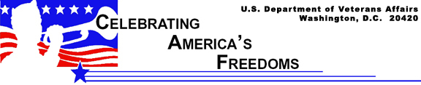

The Origin of the VA Motto
Lincoln’s Second Inaugural Address

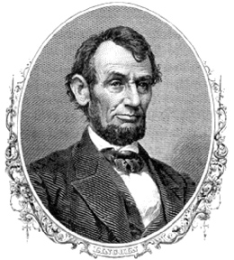

As the nation braced itself for the final throes of the Civil War, thousands of spectators gathered on a muddy Pennsylvania Avenue near the U.S. Capitol to hear President Lincoln’s second inaugural address. It was March 4, 1865, a time of great uneasiness. In just over one month, the war would end and the president would be assassinated.

President Lincoln framed his speech on the moral and religious implications of the war; rhetorically questioning how a just God could unleash such a terrible war upon the nation. “If we shall suppose that American slavery is one of those offenses in the providence of God, ... and that He gives to both North and South this terrible war as the woe due to those by whom the offenses came.”

With its deep philosophical insights, critics have hailed the speech as one of Lincoln’s best.

As the speech progressed, President Lincoln turned from the divisive bitterness at the war’s roots to the unifying task of reconciliation and reconstruction. In the speech’s final paragraph, the president delivered his prescription for the nation’s recovery:

“With malice toward none, with charity for all, with firmness in the right as God gives us to see the right, let us strive on to finish the work we are in, to bind up the nation’s wounds, to care for him who shall have borne the battle and for his widow, and his orphan, to do all which may achieve and cherish a just and lasting peace among ourselves and with all nations.”

With the words, “To care for him who shall have borne the battle and for his widow, and his orphan,” President Lincoln affirmed the government’s obligation to care for those injured during the war and to provide for the families of those who perished on the battlefield.

Today, a pair of metal plaques bearing those words flank the entrance to the Washington, D.C. headquarters of the Department of Veterans Affairs (VA). VA is the federal agency responsible for serving the needs of veterans by providing health care, disability compensation and rehabilitation, education assistance, home loans, burial in a national cemetery, and other benefits and services.

Lincoln’s immortal words became the VA motto in 1959, when the plaques were installed, and can be traced to Sumner G. Whittier, administrator of what was then called the Veterans Administration. A document on VA medical history prepared for the congressional Committee on Veterans’ Affairs and titled, “To care for him who shall have borne the battle,” details how the words became VA’s motto. “He (Whittier) worked no employee longer or harder than himself to make his personal credo the mission of the agency. What was that credo? Simply the words of Abraham Lincoln, to care for him who shall have borne the battle and for his widow, and his orphan. To indicate the mission of his agency’s employees, Mr. Whittier had plaques installed on either side of the main entrance.”

President Lincoln’s words have stood the test of time, and stand today as a solemn reminder of VA’s commitment to care for those injured in our nation’s defense and the families of those killed in its service.

