Status of Neural Network Hardware in High Energy Physics
Bruce Denby
Université de Versailles and
Laboratoire des Instruments et Systèmes, Paris, France
Abstract. This paper examines the current status of hardware implementations of neural networks in high energy physics experiments, as reflected in the applications presented at ACAT 2000, Fermilab, October, 2000.

Introduction
It has now been 8 years since the first simple test of neural network hardware in high energy physics [1]. Today, the technique is well established in running experiments and has been proposed for LHC. Currently, efforts are hampered by a lack of available commercial NN products, obliging physicists to examine other solutions for implementing NN in their experiments. We present here some of the more recent NN applications as well as some possible solutions for future developments.

Use of Nn in the triggers of running experiments
Two currently running experiments, Dirac at CERN and H1 at DESY use NN hardware directly in the trigger.

The Dirac Experiment at CERN
Neural network hardware is used in the first level trigger of the Dirac experiment at the CERN PS [2]. The experimental setup is illustrated in figure 1. The experiment is designed to detect pionium production on a copper target with a 34 GeV proton beam and to measure the lifetime of pionium.
Figure 1. Experimental setup of the Dirac experiment at CERN. A proton beam impinges on a copper target. Two –track event are analyzed in a dipole magnet followed by hodoscopes.
Tracks produced in the collisions are detected in hodoscopes following a dipole magnet. Hodoscope positions are read out as binary words. As shown in figure 2, the hodoscope information passes first into a data formatting and event selection card, which essentially reduces the dimensionality of the hodoscope data and reformats it, and then is passed into 4 neural network cards. All of the electronics was produced at the University of Basel.
Figure 3 shows the architecture of the Basel NN cards. The unique feature of these cards is that the synaptic multiplications and the transfer function evaluations are all subsumed into memory lookups. This enables the neural networks to produce a result in only 60 ns. Full level-1 trigger processing occurs in only 210 ns.
Figure 2. Trigger electronics schematic of the Dirac experiment at CERN showing preprocessing and reformating card and the 4 neural net cards.

Figure 3. Schematic of the basel NN cards. Synaptic multiply and activation function are performed in memories. The MLP structure is 55-2-1.
The Dirac trigger achieves an overall background reduction factor of 2.5 and is 95% efficient for the pionium events under study. The trigger is functioning normally as an integral part of the Dirac experiment.

The H1 Experiment at DESY
The H1 experiment of the HERA accelearator at DESY in Hamburg has adopted a completely neural architecture for its level 2 trigger [3]. An initial 10 MHz data rate off the detectors is reduced to 1 kHz by a hardwired level-1 trigger with a 2.3 microsecond latency. Then the level-2 trigger, which performs its function in under 20 microseconds, takes effect, reducing the background by an additional factor of 20. The background is predominantly from beam-gas events.
The hardware chosen is the CNAPS chip from Cromemco in Germany, which is a 64 processor SIMD architecture. Twelve separate CNAPS cards are used, each one tuned to a particular physics channel. The networks have typically several tens of variables at the input, several tens of hidden units, and a single output unit which simply signals whether the corresponding physics process is believed to be present or not.
It is important to realize that in online NN applications, any preprocessing must also be done online. In the case of H1, this is done in data distribution bus DDB boards constructed at MPI in Munich using FPGA technology. The entire procedure must be completed in 4 microseconds which is a challenging electronics task. The overall system is illustrated in figure 4.
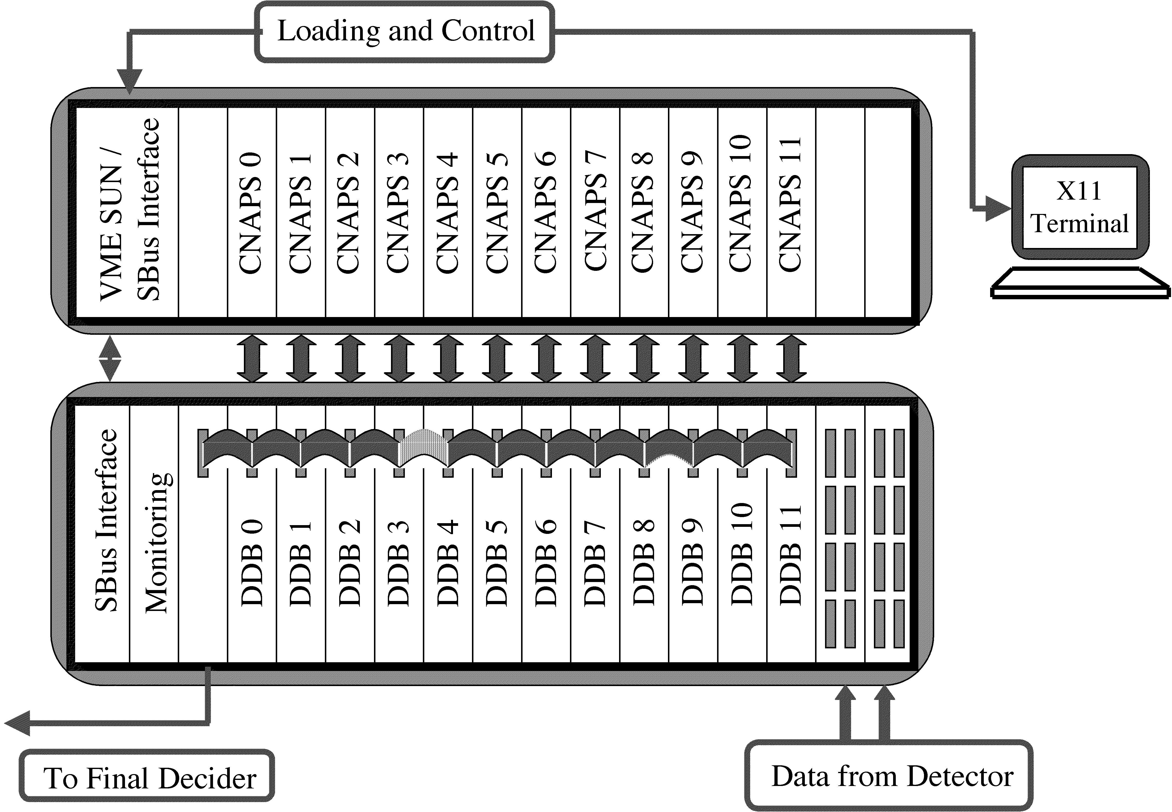
Figure 4. Schematic Diagram of the H1 NN trigger including the DDB preprocessing cards and the 12 corresponding CNAPS NN cards.
The H1 NN trigger has been in operation for 5 years and has enabled the H1 collaboration to produce physics results which would otherwise have been unattainable, particularly in the realm of vector meson photoproduction (phi, psi, etc.). The additional acceptance for these channels is due to the intelligent triggering of the NN hardware.

Future developements foreseen
Apart from the currently running NN trigger applications mentioned above, there are also a certain number of new projects that are being planned using these techniques. We shall speak here about the upgrade to H1 and a possible application to a muon trigger in ATLAS at CERN, and conclude with some new approaches to NN hardware.

The Dirac Experiment at CERN
For its next run, the H1 experiment will be upgrading its NN trigger [3,4]. The number of CNAPS cards will be extended to 16 and a new DDBII preprocessing system will be built. The DDBII is based on intelligent preprocessing achieved in only 4 microseconds, and are implemented in FPGA using the Virtex family of Xylinx chips. The overall plan is to execute the preprocessing in 4 steps: clustering in the individual detectors; matching of corresponding clusters between devices into physics objects; ordering of phyics objects by energy or other criteria; and finally construction of the network in put variables. The procedure is shown schematically in figure 5.
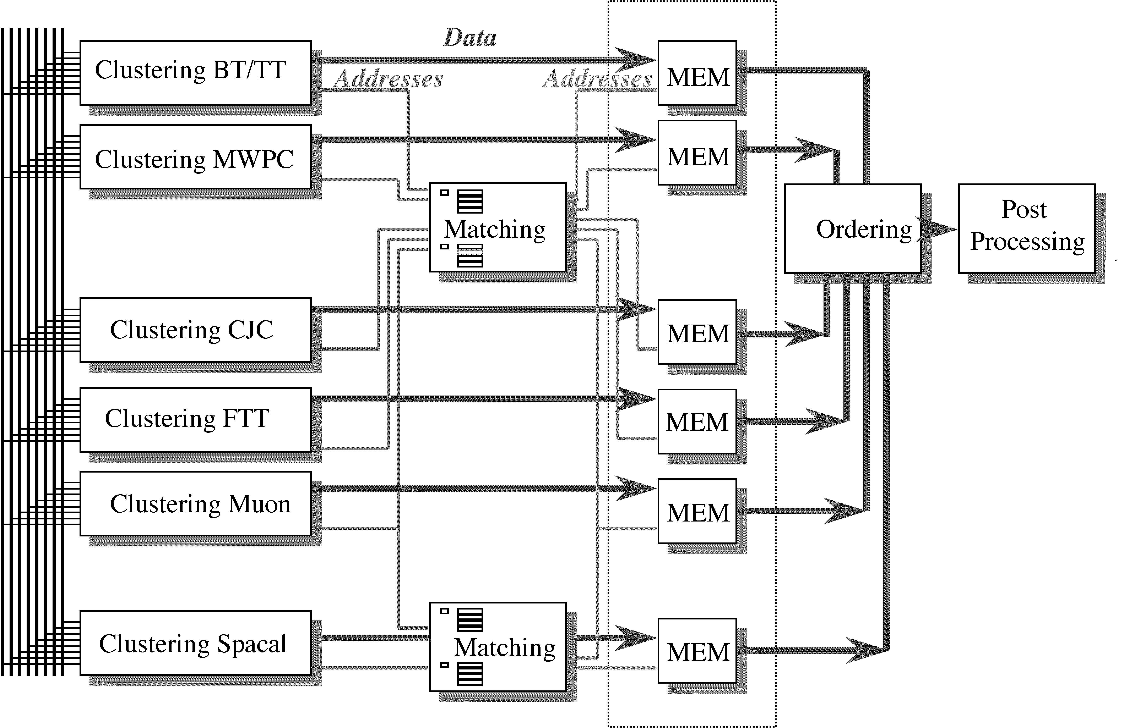
Figure 5. Schematic of the DDBII architecture for the H1 upgrade. The circuit will be implemented with FPGA’s.
The DDBII’s have shown, in simulation, to be able to improve rather dramatically the ability of H1 to study certain processes, in particular photoproduction of phi’s.

A Possible Muon Trigger for ATLAS
As the magnetic field in the ATLAS experiment is rather non-uniform, the mapping between raw track parameters (slopes and intercepts in two planes) and physics quantities such as the 3-vector and charge of a muon is a complicated function which varies with position around the ATLAS detector. In an experimental simulation [5], it was shown that this mapping can be learned by a 4-7-7-4 multilayer perceptron architecture with very good accuracy. Given the parallel nature of neural networks, it is interesting to ask the question as to whether or not this architecture could also be realized at the trigger level to providean ‘intelligent’ muon trigger. This will be addressed in a preliminary way in the next section.

Future Hardware Approaches
It is worth noting that the CNAPS chips is no longer manufactured. Many of the other sorts of NN chips such as the ETANN which used to exist have also over the years been discontinued. One may ask the question today, if one wanted to build an NN trigger, what hardware should be used?
One approach, as already cited [2], is to implement the NN, both synaptic multiply and transfer function using memory lookups. Another method, proposed by a group in Paris [6], is to use some the new of FPGA’s coming out today to build an NN architecture directly. Such a circuit, named MAHARADJAH, is illustrated in figure 6.
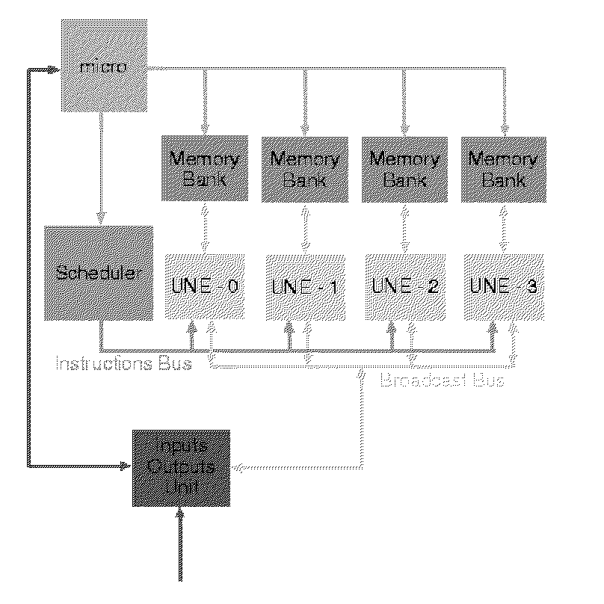
Figure 6. Architecture of the MAHARADJAH system for evaluating NN in realtime. Implementation is in FPGA’s.
The architecture consists of four UNE units containing multiply-accumulators, in communication with memory banks holding synaptic weights and lookup tables of activation function. Control is via a simple microcontroller. Such a circuit can equal the performance of a Pentium III or a Sparc Ultra workstation while running at only 40 MHz. As a test, the architecture was benchmarked against the ATLAS 4-7-7-4 network presented in the previous section. The predicted execution time was of the order of only 2 microseconds, which would be quite acceptable at trigger level and is thus very interesting.

CONCLUSIONS
Neural network triggers have been incorporated into a certain number of running experiments and are being used to produce physics. In the case of H1, the NN trigger has been instrumental in obtaining certain classes of physics. For the future, H1 will be upgraded and along with it the NN trigger, which will include a new, more intelligent preprocessor based on FPGA’s. Additionally, there is a possibility of a neural muon trigger for ATLAS.
In a general sense, neural network hardware is difficult to find; a number of longstanding products are no longer available. In future, it should be possible to turn for example to full-FPGA solutions such as the MAHARADJAH architecture cited above, or other digital approaches such as memory lookups.

Acknowledgments
The author is indebted to the authors of the presentations which served as the basis for this rapporteur’s summary.

References
1. C.S. Lindsey et. al,, Nucl. Instrum. Meth. A317 (1992) 346.
2. Sotirios Vlachos, these proceedings.
3. Christophe Kiesling, these proceedings.
4. Jean-Christophe Prévotet, these proceedings.
- Erez Etzion, these proceedings.
- Bertrand Granado, these proceedings.

