A Low-Redshift Supernova Survey Using the ARC 2.5m Telescope
S. Asztalos¹, B. Bassett^{2,3}, A. Becker⁴, R. Blandford⁵, F. Cattaneo⁶, D. Cinabro⁷, C. Clarkson³, D. DePoy⁸, B. Dilday⁶, M. Doi⁹, J. Frieman⁶, P. Garnavich¹⁰, S. Hawley⁴, C. Hogan⁴, J. Holtzman¹¹, S. Jha^{5,12}, J. Johnson⁸, S. Kahn⁵, R. Kessler⁶, A. Khoklov⁶, D. Lamb⁶, H. Lampeitl¹³, K. Maeda⁹, R. Nichol¹⁴, K. Nomoto⁹, S. Olivier¹, J. Prieto⁸, M. Richmond¹⁵, A. Riess^{12,16}, R. Romani⁵, M. Sako^{5,17}, D. Schneider¹⁸, N. Suntzeff¹⁹, M. Tanaka⁹, N. Tominaga⁹, K. van der Heyden², N. Yasuda⁹, D. York⁶, L. Wang^{1,19}
¹Lawrence Livermore National Laboratory ²South African Astronomical Observatory
³University of Cape Town ⁴University of Washington ⁵Stanford University
⁶University of Chicago ⁷Wayne State University ⁸Ohio State University
⁹University of Tokyo ¹⁰University of Notre Dame ¹¹New Mexico State University
¹²Rutgers University ¹³Space Telescope Science Institute ¹⁴University of Portsmouth
¹⁵Rochester Institute of Technology ¹⁶Johns Hopkins University ¹⁷University of Pennsylvania ¹⁸Pennsylvania State University ¹⁹Texas A&M University

Abstract

We propose to devote the ARC 2.5m telescope and its imager to a new supernova survey during the first ten months of operations after the end of SDSS II (Sept. 2008 through June 2009). In combination with and building upon the success of the SDSS II Supernova Survey, the ARC Supernova Survey (ARCSS) will discover and measure densely sampled, well-calibrated, multi-band optical light curves for ~250 low-redshift type Ia supernovae, quadrupling the SDSS II sample in the range 0.05<z<0.15. This sample will be an order of magnitude larger than currently available low-redshift SN samples of comparable data quality. With less stringent quality cuts, the ARCSS sample will total ~500 light curves. The ARCSS survey efficiency will be well above 90%, resulting in an unbiased sample. The survey will also probe other supernova types, and its large volume will enable study of peculiar and relatively rare supernovae, including peculiar SNe Ia and Ib/c. To achieve such a high SN discovery rate, ARCSS will scan at three times sidereal rate. We will carry out tests to ensure that we can operate in this mode and obtain precision photometry using the associated binned readout; if that proves infeasible, scanning at sidereal rate will produce a sample five times larger than the comparable, current low-redshift sample. Spectroscopic follow-up observations to determine supernova types, obtain precise redshifts, and measure detailed spectroscopic features at several epochs per supernova will be provided by a number of telescopes around the world. The proposed ARCSS sample will result in significantly improved anchoring of the Hubble diagram and understanding of supernova luminosity variations and K-corrections; combining this information with ongoing and future high-redshift surveys will lead to stronger and more robust constraints on the nature of the dark energy.

1. Introduction: Motivation and Survey Overview

The use of supernovae to measure cosmological distances led to the discovery of the accelerating Universe in 1998 (Riess, et al. 1998, Perlmutter, et al. 1999). Since then, the field has expanded rapidly, and the evidence for cosmic acceleration from supernovae, the cosmic microwave background anisotropy, and the large-scale clustering of galaxies has solidified (e.g., Riess, et al. 2004, Tegmark, et al. 2004). Several national reports, including From Quarks to the Cosmos and the Physics of the Universe, have identified the nature of the dark energy as one of the most profound questions about the Universe. While several promising techniques for probing dark energy are being developed, supernovae remain ``at present the most powerful and best proven technique for studying dark energy”, according to the recent Report of the Dark Energy Task Force.

These considerations motivated the SDSS II Supernova program, which comprises three 3-month observing periods in Fall 2005, 2006, and 2007. The SDSS II Supernova Survey is designed to fill in the `redshift desert’ in the SN Ia Hubble diagram at redshifts 0.05 < z < 0.35 with a large, well-calibrated sample of supernova light curves. This sample will be used to probe dark energy and explore systematics of the SN Ia population that impact distance estimates. The first full season of the survey in 2005 proved extremely successful, with discovery and measurement of about 130 spectroscopically confirmed type Ia supernovae with median redshift of 0.2. Spectroscopic confirmation and redshifts were provided by a coordinated follow-up program using a number of telescopes, including the ARC 3.5m, MDM 2.4m, WHT 4.2m, HET 9.2m, Subaru 8.2m, and Keck 10m. Additional optical photometry was supplied by the UH88in, NMSU 1m, MDM 2.4m, ARC 3.5m, and VATT, while optical and near-infrared follow-up was carried out by the Carnegie Supernova Project on a subsample. Photometry and spectroscopy of several of the 2005 objects were also carried out by the CfA group at Mt. Hopkins upon their public release. The Fall 2005 SDSS data are now being analyzed, with first results expected later in 2006. (For further information, see http://sdssdp47.fnal.gov/sdsssn_data/sdsssn.html and Sako, et al. 2004).

The increasing importance of supernovae as `standardizable’ candles for cosmology has motivated a number of other on-going surveys at high redshift, e.g., ESSENCE, SNLS, and several programs using HST, as well as ambitious proposals for future high-redshift supernova surveys from the ground, e.g., PanSTARRS, DES, LSST, and from space, e.g., the Joint Dark Energy Mission (JDEM) supernova proposals SNAP, DESTINY, and JEDI. Since supernovae provide relative distance estimates, these high-redshift surveys must rely on a low-redshift supernova sample to anchor the Hubble diagram. Well-sampled, low-redshift supernova light curves are also needed to train the light-curve fitting algorithms used to infer high-redshift SN distances and to span the range of SN Ia sub-types encountered at high redshift (including variations in SN luminosity, reddening, metallicity, and galaxy host type), so that high-redshift `apples’ (i.e., Ia sub-types) can be directly compared to low-redshift `apples’. Moreover, well-calibrated, multi-epoch, low-redshift supernova spectra are needed to infer the redshift-dependent K-corrections that enter into SN distance estimates.

There has been a growing recognition that the current and currently forecast low-redshift supernova samples are not of the requisite size and data quality to fully support the goals of supernova cosmology: the cosmological power of on-going, high-redshift SN surveys is already limited statistically and systematically by the small size, heterogeneous nature, and often poor light-curve sampling of the available low-redshift SNe. To address these concerns, the Report of the Dark Energy Task Force recently called for ``detailed spectroscopic and photometric observations of about 500 nearby supernovae to study the variety of peak explosion magnitudes and any associated observational signatures of effects of evolution, metallicity, or reddening”. The ARCSS is designed to meet these goals.

A number of low-redshift SN surveys are underway: the Katzman Automatic Imaging Telescope (KAIT) and the Nearby Supernova Factory (SNF) are carrying out searches and follow-up observations, while the Carnegie Supernova Project (CSP) and the CfA Supernova Group (CfA) are carrying out follow-up programs; SkyMapper is a 1.35m telescope under construction at Siding Spring Observatory. A number of features differentiate ARCSS from past and on-going low-z surveys:
- The on-going surveys focus on very low redshifts, z<0.08; recent work (Hui & Greene 2005, Cooray & Caldwell 2006) has shown that this regime is more affected by correlated peculiar velocities than previously recognized (see Sec. 2.1). ARCSS will target a higher but still low-redshift interval, 0.05<z<0.15, that is intrinsically less affected by this source of systematic error in distance estimates.
- With its high cadence and moderate depth, ARCSS will measure well-sampled light curves and in particular have high efficiency for early-time (pre-maximum light) photometry. Early-time photometry increases the utility of the objects as a training sample because the time of maximum is better constrained.
- ARCSS will search with very high efficiency (>90%), even for peculiar and highly extincted type Ia supernovae, and with no explicit bias with respect to host galaxy brightness.
- ARCSS will combine precision photometry with multi-epoch spectroscopy to improve K-corrections; the current set of spectra used for K-corrections is very heterogeneous, and contains only ~200 spectra for all phases of the light curve.

The SDSS II Supernova Survey has demonstrated that the ARC 2.5m is capable of delivering a photometric supernova sample of the requisite size and high data quality in a relatively modest amount of observing time. The ARCSS will build upon the extensive operational experience and data processing expertise that our team has built up during the preparation for, operation of, and analysis of the SDSS II Supernova survey. The dedicated compute cluster we have in place at APO reliably and routinely processes a full night of SDSS imaging through photometric reduction, frame subtraction, and automated target screening in under 24 hours, and we expect that performance to extend to the slightly lower ARCSS pixel-data rate. Essentially the entire team that has been actively involved in SDSS II photometric data processing, candidate target selection, follow-up spectroscopy, and data analysis has expressed interest in collaborating on ARCSS, and we view this collective experience as a tremendous asset to the viability of the project.
Using Monte Carlo simulations, we have considered and compared several survey strategies. We find that increasing the drift scan rate from sidereal to approximately three times sidereal and maintaining the two-day cadence for each sky region is nearly optimal for maximizing the number of well-sampled SN Ia light curves in the redshift regime z<0.15. Fig. 1 shows that we expect to measure approximately 175 high-quality SN Ia light-curves at z<0.15 in this survey mode over a 9-month period, quadrupling the sample that SDSS II will accumulate in this redshift range; for this exercise, the criterion for a `high-quality’ light curve is that it comprise at least 7 well-measured (i.e., with signal to noise above 5) epochs and include epochs both before and after maximum light. This Monte Carlo prediction has been `normalized’ to the Fall 2005 survey results, which yielded 20 such `high-quality’ light curves in this redshift range over the three-month season and 40 spectroscopically confirmed Ia’s in this range overall. As a result, we expect the combined SDSS II+ARCSS sample to comprise about 250 high-quality Ia light-curves at z<0.15 and approximately 500 total confirmed Ia’s in that range (most of the additional 250 with quite useful light curves as well).

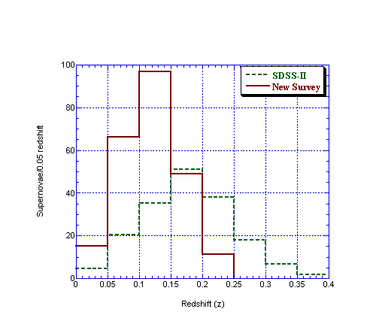
Figure 1. Monte Carlo simulated redshift distribution of SNe Ia for the SDSS II SN Survey (green dashed) and for ARCSS (solid red). In each case, the numbers are for a total of 9 months of observations and have been scaled to agree with the 20 high-quality light curves observed at z<0.15 in the Fall 2005 run. While the total number of supernovae is similar for SDSS II and ARCSS, the number at z<0.15 is ~3 times greater for ARCSS.

Scanning at faster than sidereal rate requires that the ARC 2.5m camera be read out with 2x2 pixel binning. The simulation results in Fig. 1 take into account the increased noise due to both the lower effective exposure time and the larger effective pixel area associated with faster scanning. Fig. 2 shows two supernova light curves from the 2005 SDSS II sample, at the high and low ends of the ARCSS redshift range, with photometric errors artificially scaled up to reflect the faster, binned scans, demonstrating that the increased statistical errors will not compromise the quality of the light curves. The systematic effects of larger pixels on SN photometry will require further study; the results of preliminary studies, which indicate that operating in binned mode should be able to meet the science requirements, are discussed below in Sec. 5.4.

While the 2.5m camera has been used in binned mode (e.g., the 4x4 Apache wheel scans), carrying out a new survey in binned mode will require a well-organized software development and testing effort. We discuss the development and operational issues associated with binned readout in Sec. 5; an end-to-end test run in faster, binned
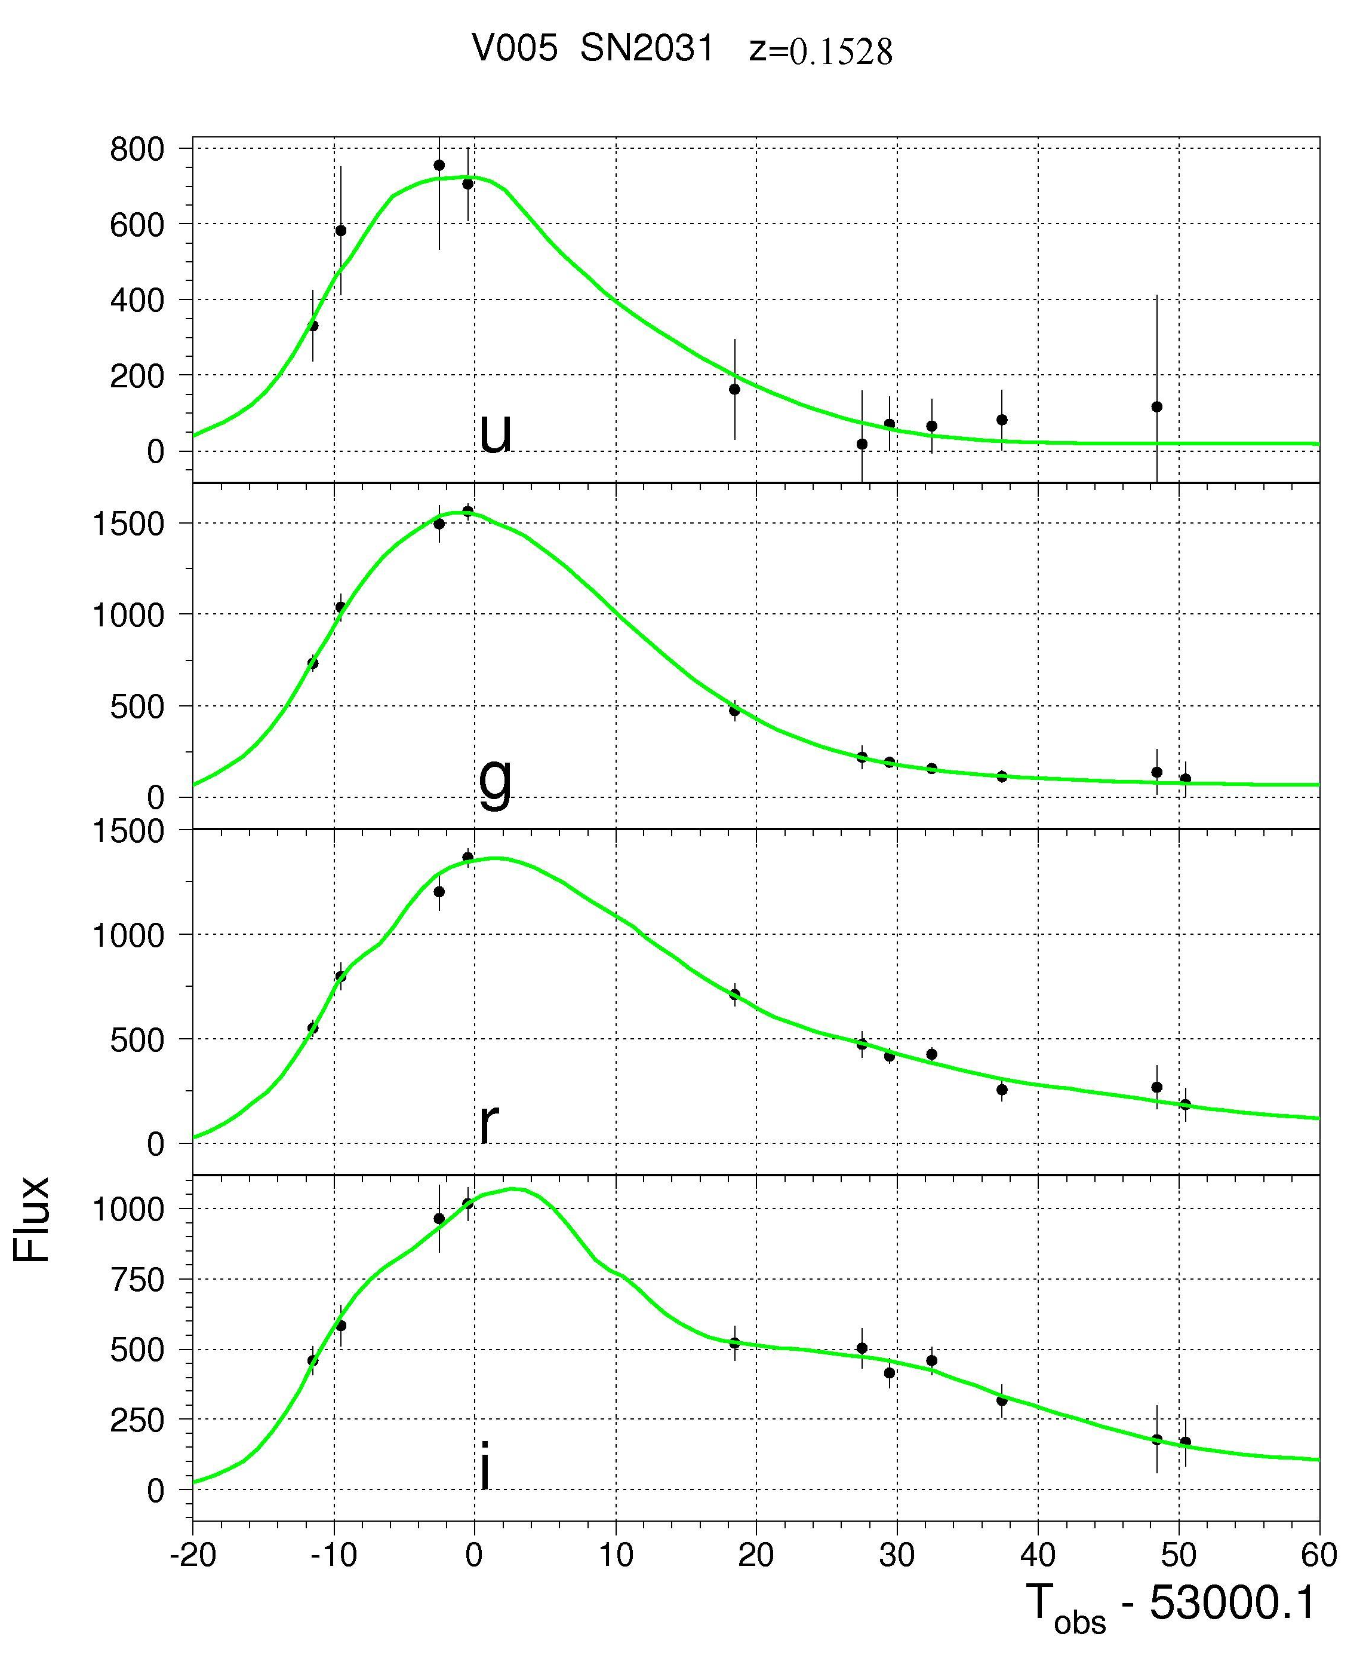
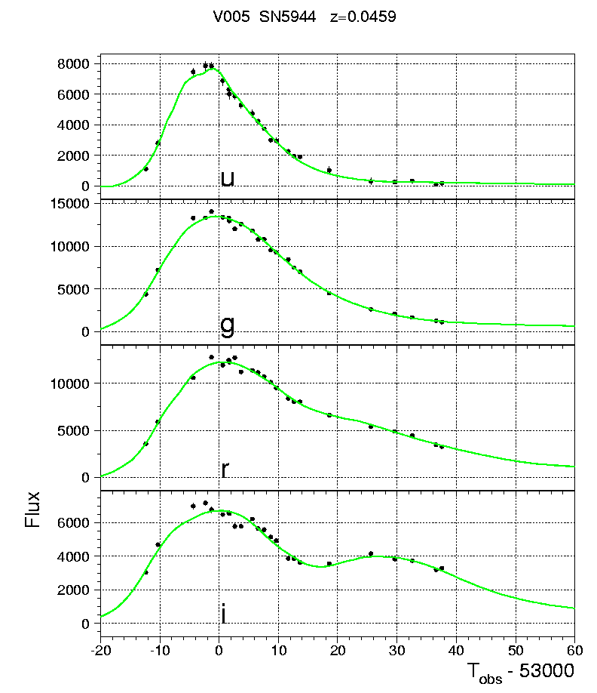

Figure 2: Light-curves and preliminary fits for two SDSS II type Ia supernovae roughly spanning the ARCSS redshift range (z-band not shown): (a) SN2005fm, at redshift z=0.1528 (internal SDSS designation SN2031); (B) SN2005hc, at z=0.0459 (internal SN5944). Errors have been artificially increased to reflect faster, binned scans. (The SN5944 light curve is better sampled due to weather variations, and because it lies in the overlap region between SDSS strips 82N and 82S.)

mode (which we propose to carry out in Fall 2006) will be a crucial feasibility test and is an integral part of the development plan. If this test or others reveal insurmountable barriers to meeting the science goals in binned mode, our alternative strategy would be for ARCSS to scan at sidereal rate and to focus the follow-up resources on the z<0.15 portion of the sample. This would reduce substantially the needed development effort and modestly reduce the cost for the project; over a ten-month survey period, the alternative strategy would more than double the low-redshift sample from SDSS II.

An important ingredient of this proposal is the aim of obtaining multi-epoch spectroscopy, ideally with reasonable spectrophotometric accuracy for the bulk of the `high quality’ sample at z<0.15. Our goal is 10% to 20% accuracy from the spectrographs, refined to a few percent when warped to match the 2.5m photometry. Much (but not all) of this follow-up can be carried out on telescopes with relatively modest apertures (2 to 4 meters). As discussed in Secs. 2.4 and 2.7, this rich spectroscopic sample will enable us to obtain improved K-corrections, to study variations in spectroscopic features and how they correlate (or not) with photometric properties, and it will provide important diagnostics for theoretical models of SN Ia explosions. We discuss the needed and expected spectroscopic resources in Sec. 4. Fig. 3 shows low-redshift, high signal-to-noise SDSS II spectra taken with the WHT 4.2m and the MDM 2.4m telescopes for the two supernovae with light curves shown in Fig. 2.
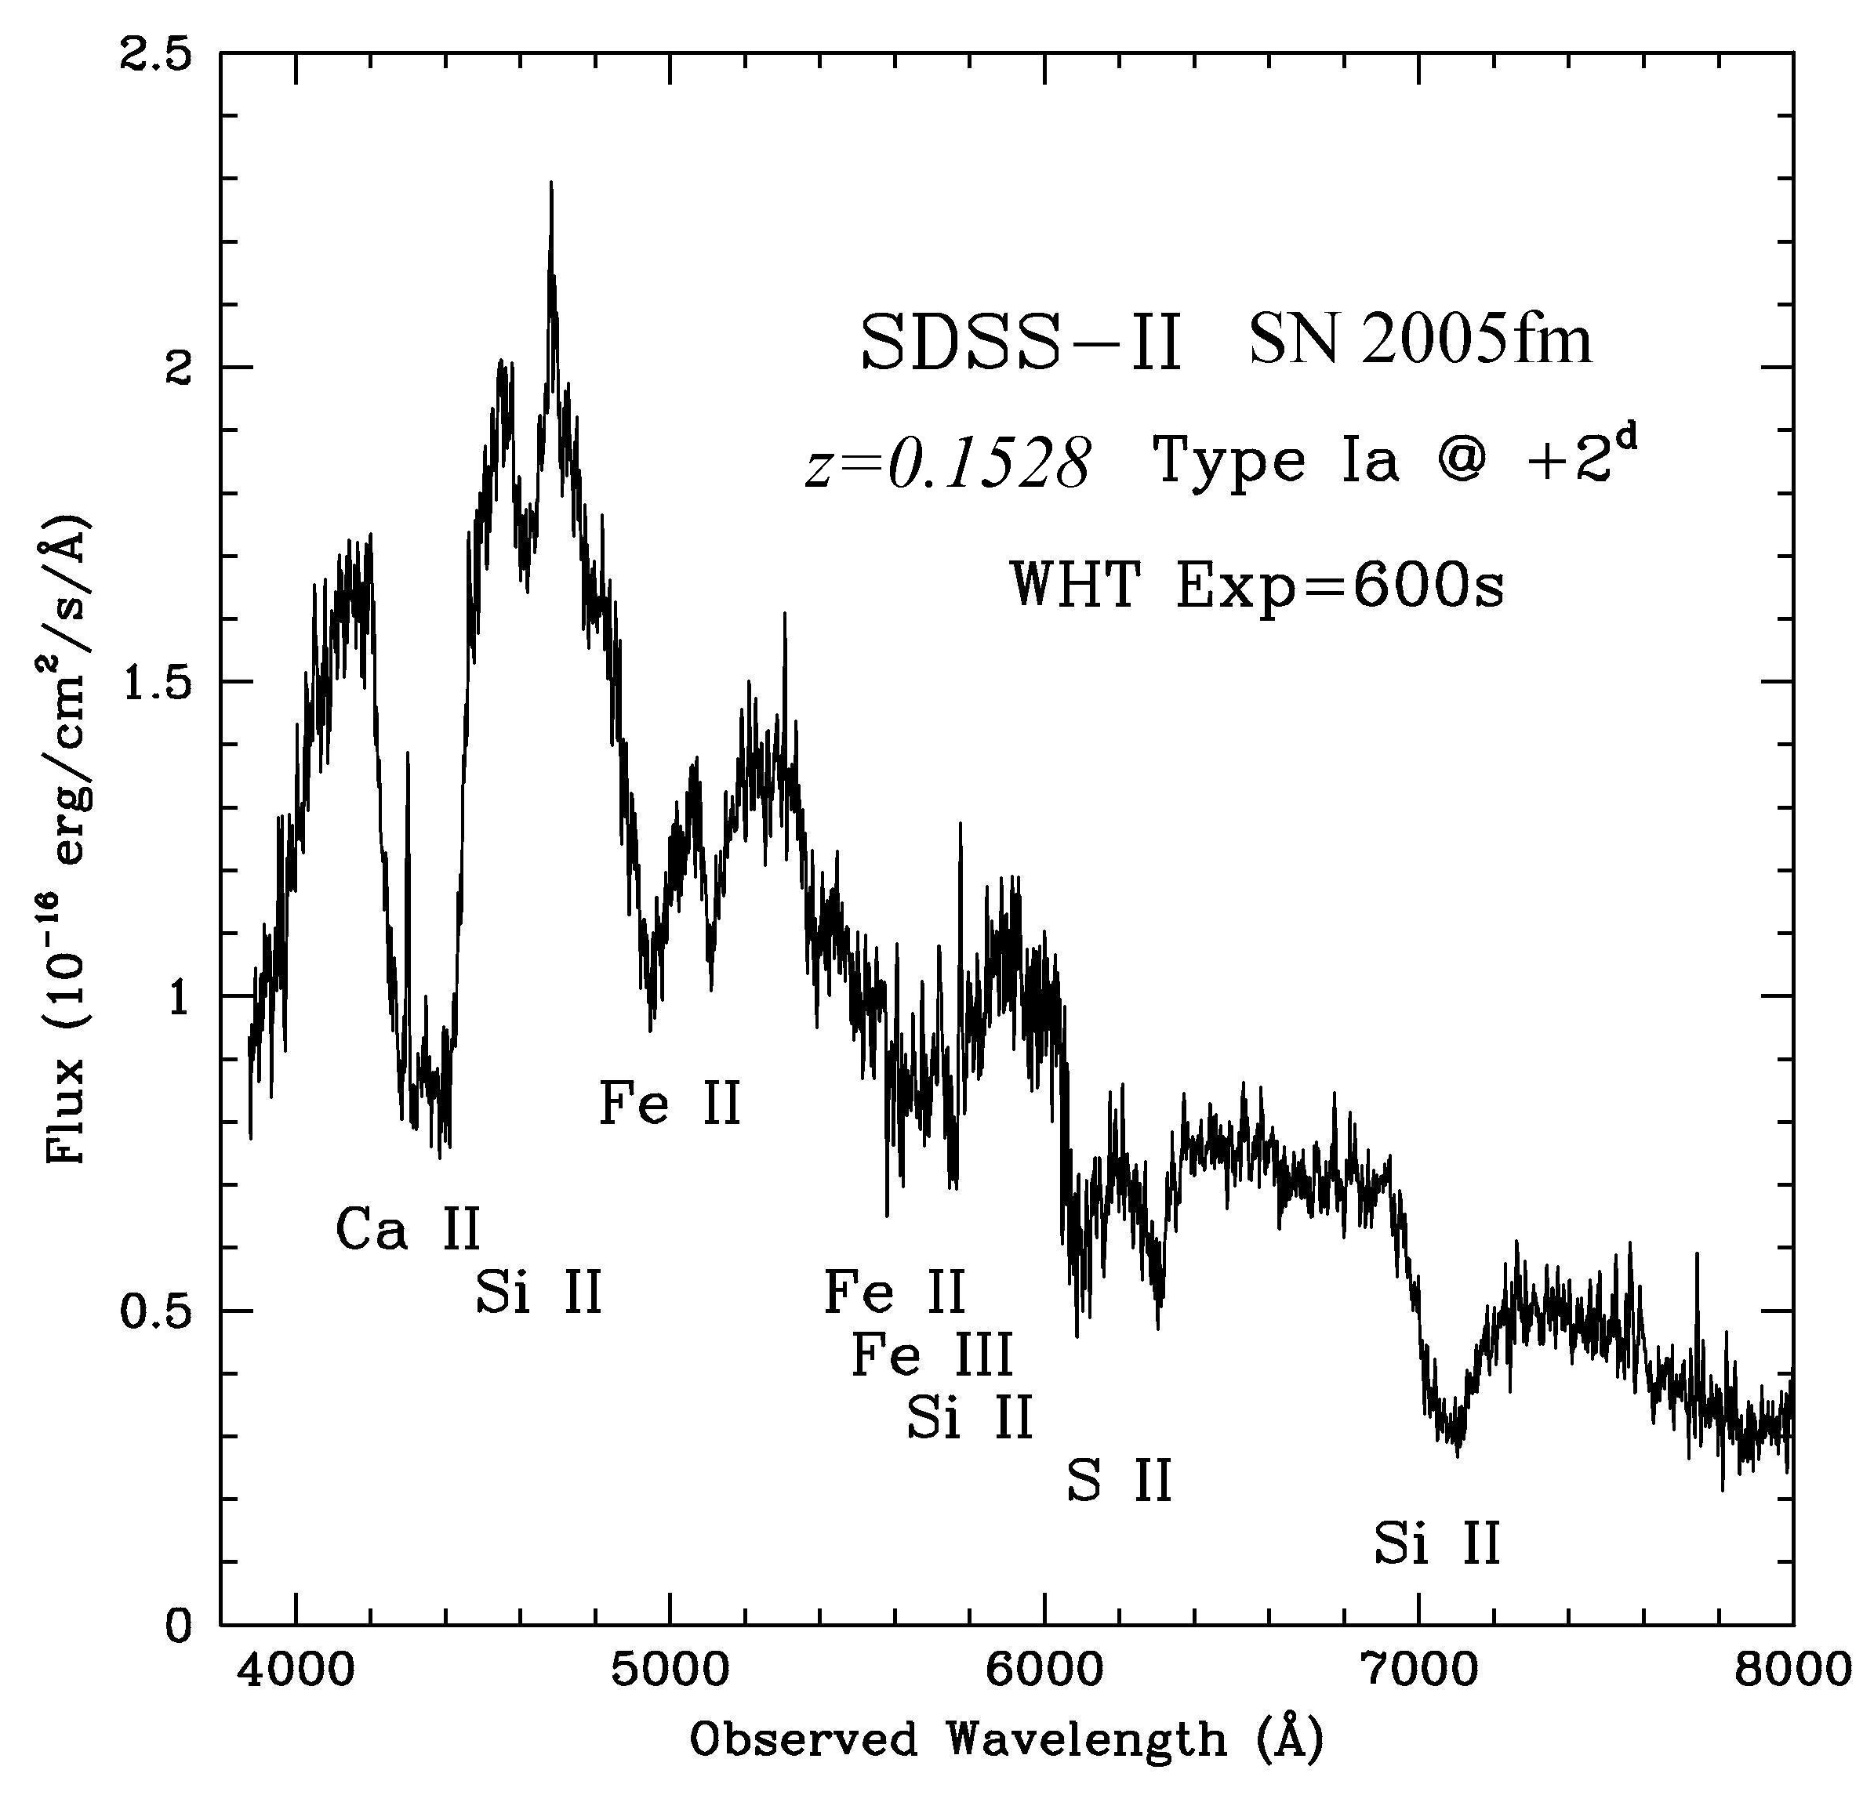
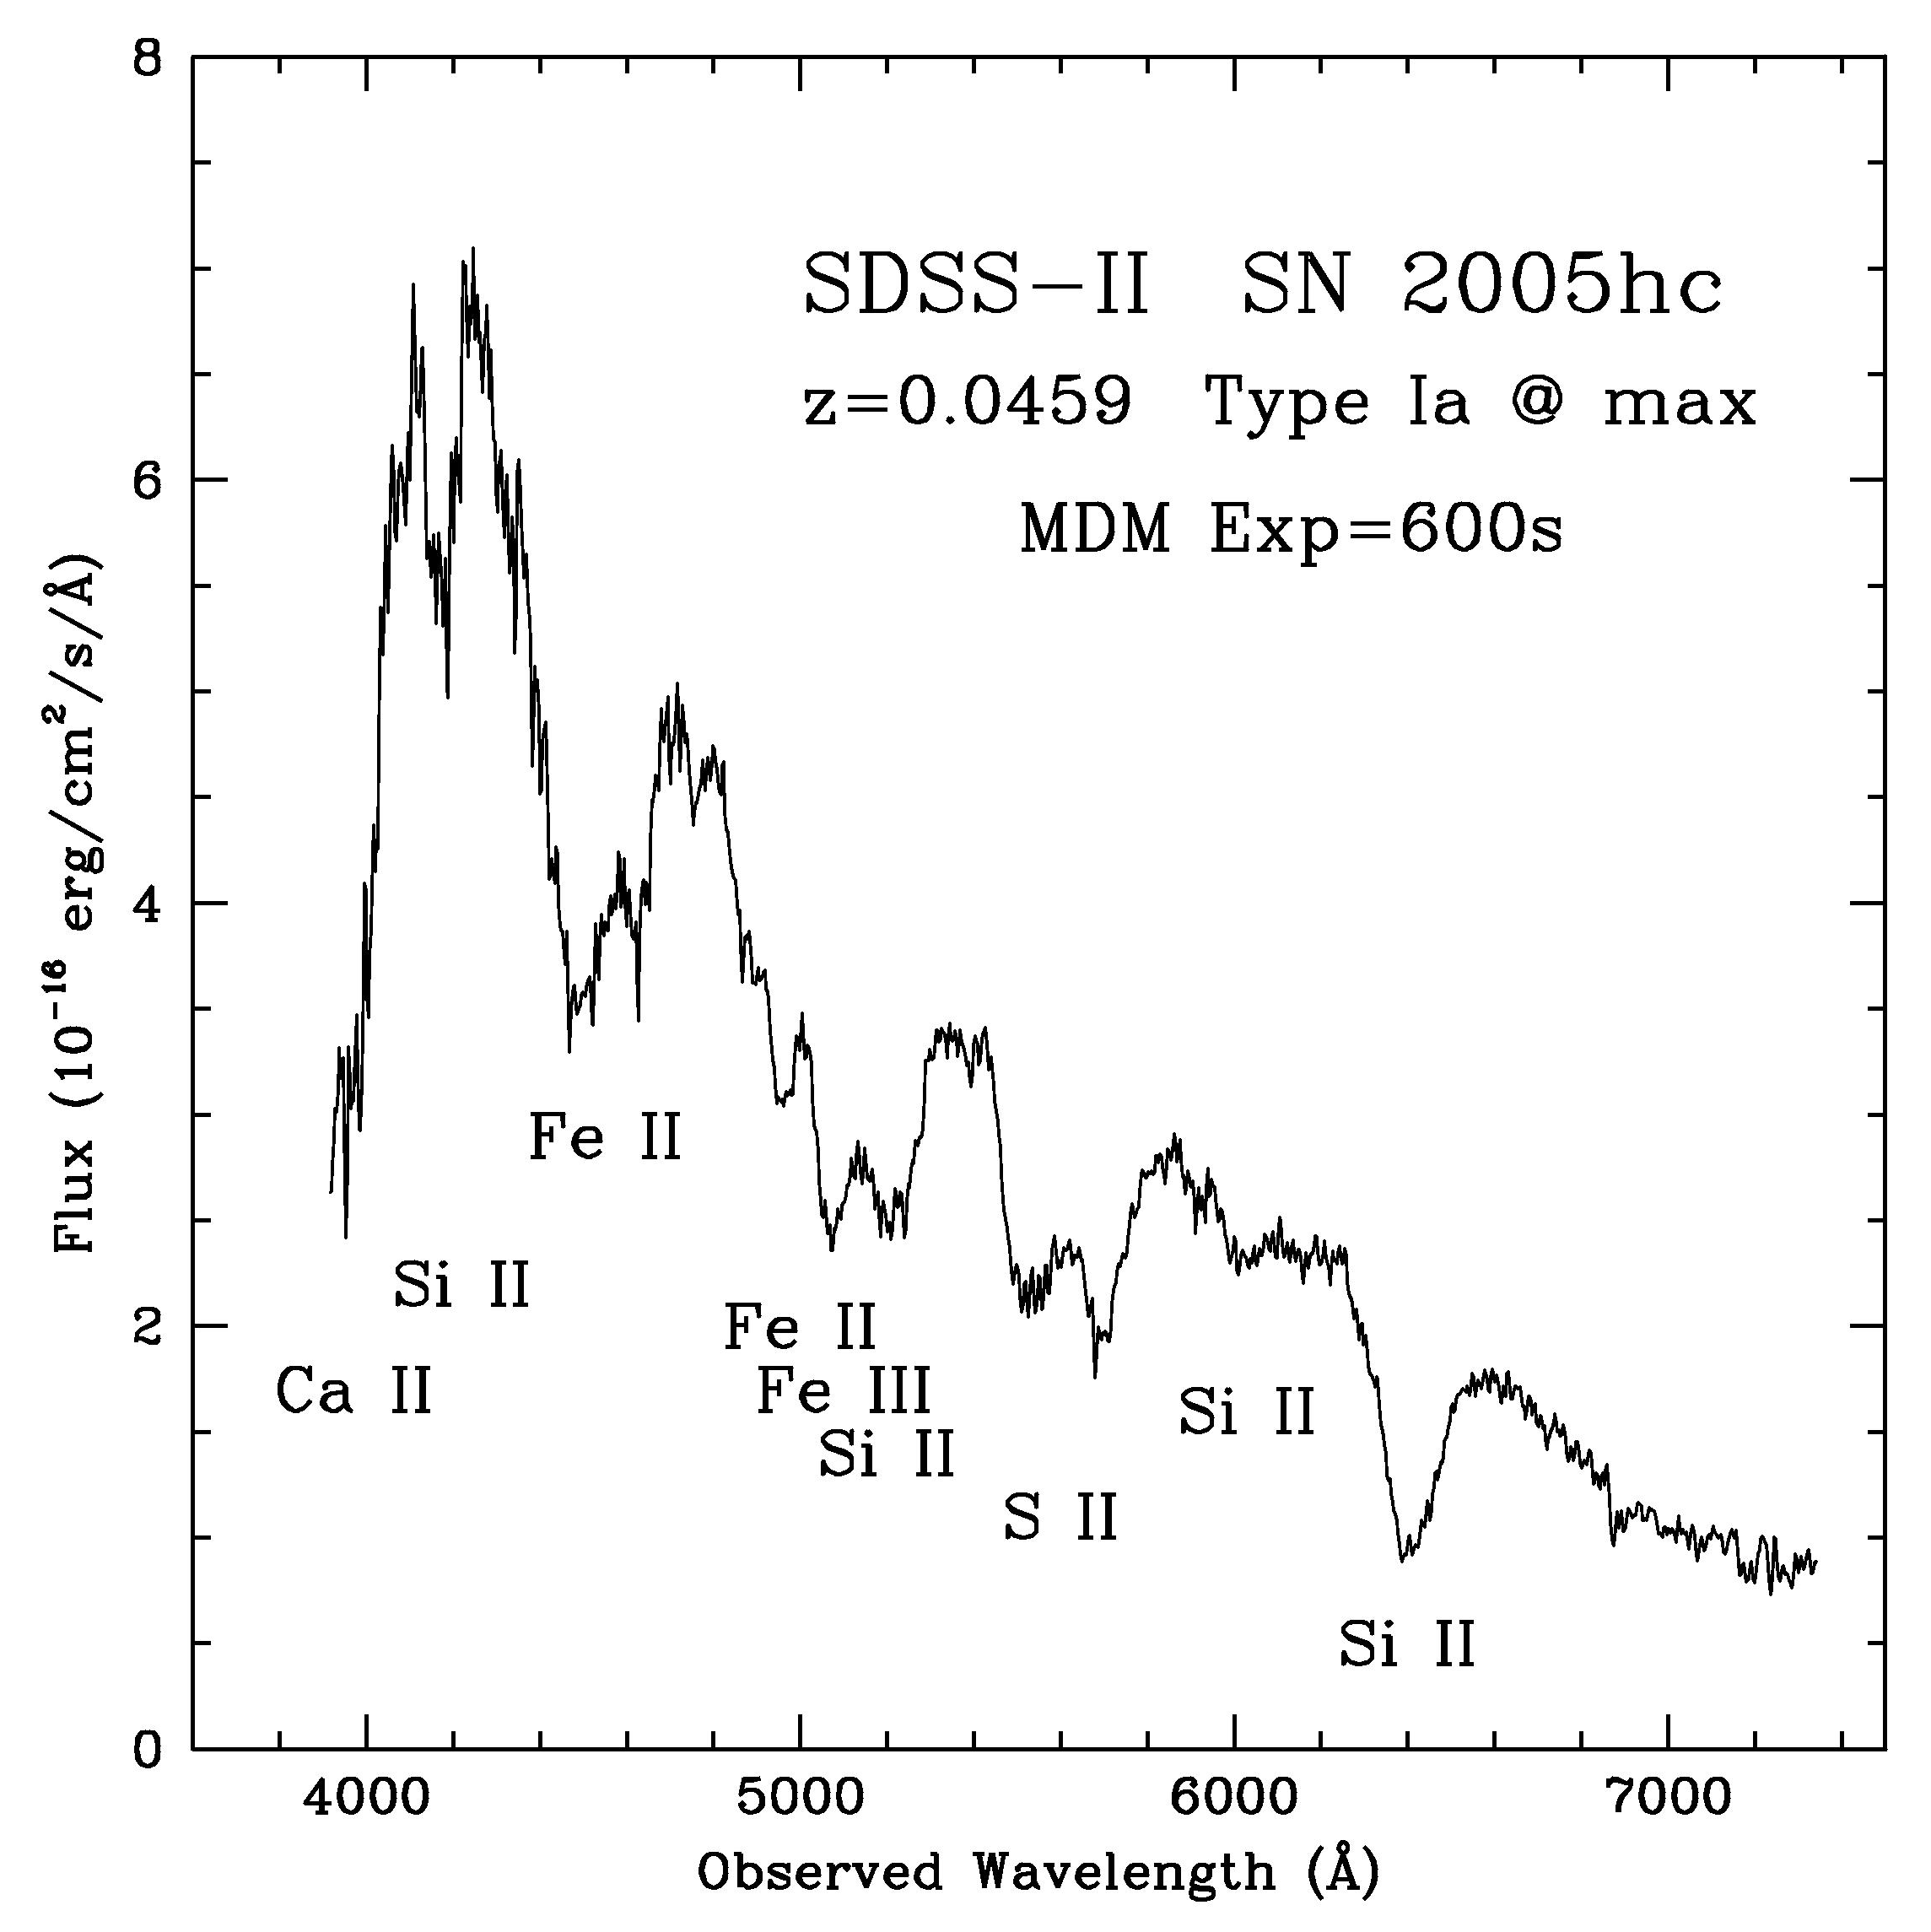
0.133
Exp=2700s
Figure 3: Spectra for same SDSS II supernovae of Fig. 2, showing characteristic type Ia features and roughly spanning the ARCSS redshift range: (a) SN2005fm, taken with the WHT 4.2m telescope ~2 days after peak; (b) SN2005hc, taken at peak with the MDM 2.4m telescope.

2. Science Goals:
2.1 Anchoring the Hubble Diagram
The luminosity distance-redshift relation shows strong dependence on cosmological parameters, such as the amount and equation of state of dark energy, at moderate to high redshifts. Supernovae probe this relation via relative distance estimates, since the peak absolute magnitude of SNe Ia is not precisely determined. Thus, to probe cosmology requires high-redshift SN in the matter-dominated era of the expansion, as well as low-redshift SN in the era where dark energy is dominant.
One of the primary goals of the ARCSS will be to significantly improve the low-redshift "anchor" to the Hubble diagram, which will directly improve the cosmological precision achievable from on-going and future supernova surveys. As one measure of the paucity of the currently available low-redshift samples, the analysis of the first year of data from the Supernova Legacy Survey (SNLS, Astier et al. 2005) was based on 73 SNe at z>0.25 from SNLS but only 44 public, nearby `anchor’ supernovae (z<0.15) that satisfied the rather weak light-curve quality cuts they imposed (which included: z>0.015 to limit peculiar velocity effects [though see below], and the requirement that the first photometric point was no more than 5 days after maximum light). As another measure, the public sample of 89 low-redshift SNe Ia used by Prieto, et al. (2006) to calibrate a new SN Ia distance estimator included only ~25 that were simultaneously observed in more than two passbands, reasonably densely sampled (i.e., more than 2 or 3 epochs of photometry), and with first photometric point no later than maximum light. ARCSS+SDSS II will provide a low-redshift sample an order of magnitude larger (~250) that satisfies even more stringent light-curve quality cuts: 5 passbands, densely sampled (at least 7 photometry epochs above signal-to-noise of 5), uniformly selected, and with first epoch before maximum light.
Fig. 4 shows the importance of having a low-redshift anchor sample of such size: with intermediate-to-high redshift SNe samples (from SNLS and ESSENCE) approaching ~500, a sample of ~250 low-redshift supernovae is needed to exploit their potential to achieve precise constraints on the dark energy equation of state. The same conclusions extend to future SN surveys such as those proposed for JDEM.
The scientific motivation for better anchoring of the Hubble diagram is not driven by theoretical considerations alone: the current low-redshift samples already show evidence for systematic effects that limit precision cosmology from supernovae. Jha, Riess, & Kirshner (2006) have found stronger evidence for a `Hubble Bubble’ at z=0.025, with the Hubble parameter (i.e., the intercept of the low-z SN magnitude/redshift relationship) about 6% higher nearby than beyond that distance. This may be evidence of a large void at that scale, or it may indicate a systematic effect in the nearby SN samples. The resolution of this issue will have a major impact on cosmology: if one exchanges the lower-z sample (z<0.025) for the z>0.025 sample as the anchor, the inferred value of w from the same current high-redshift supernovae (e.g., ESSENCE or SNLS) changes by as much as 0.4, several times larger than the statistical precision shown in Fig. 4. In order to help resolve this puzzle, a new, well-controlled, low-redshift sample at somewhat larger distances, such as ARCSS will provide, will be ideal.

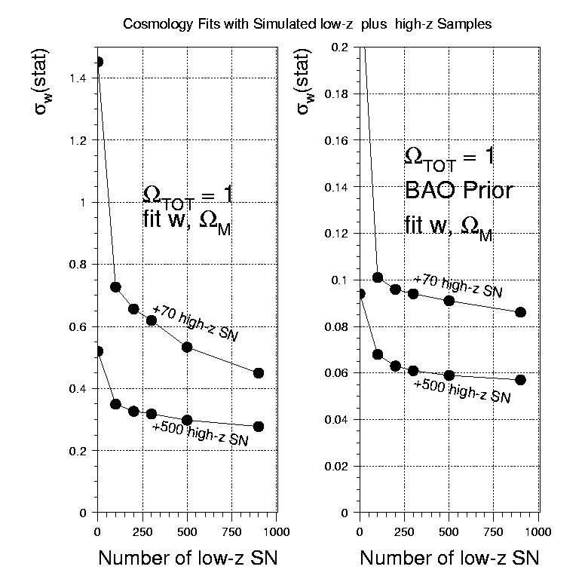
Figure 4: Forecast 68% CL statistical errors on dark energy equation of state parameter w from high-z (0.2<z<0.8) supernova surveys of size 70 (e.g., first-year SNLS) and 500 (expected ESSENCE+SNLS in ~2007-8) vs. number of low-z (z<0.15) anchor SNe: (a) marginalizing over Ω_{m}; (b) same, but with prior from SDSS LRG baryon acoustic oscillations (Eisenstein et al. 2005). In both cases, a flat Universe and constant w are assumed for illustration. Low-z sample assumes pure Hubble distribution; high-z sample assumes the measured SNLS redshift distribution from Astier et al. 2005.

The conventional wisdom on the optimal redshift range for the anchor sample has recently changed. Hui and Greene (2005) and Cooray and Caldwell (2006) showed that correlated large-scale peculiar velocities, neglected in previous studies, lead to larger systematic errors in the low-redshift Hubble diagram than previously realized. When these effects are included, Fig. 5 shows that the optimal redshift range for the anchor sample falls in a broad range starting above z ~ 0.06 and extending beyond z=0.12, depending on the area covered by the survey. As Fig. 1 shows, the redshift distribution for ARCSS is very well matched to this range. By contrast, of the 44 nearby supernovae used in the first-year SNLS analysis, only 10 were at redshift z>0.05; the sample of 89 nearby supernovae used for calibration by Prieto, et al. (2006) included only 12 at z>0.05. The on-going low-redshift supernova searches are primarily targeting very-low redshift, e.g., z<0.04 for KAIT and z<0.08 for the Supernova Factory. The ARCSS will complement both of these lower-z surveys. Fig. 5 shows that a large survey area mitigates the systematic impact of large-scale flows; ARCSS will cover a very large area (~1600 sq. deg.) and will include widely separated areas in the north and south (see Fig. 7).

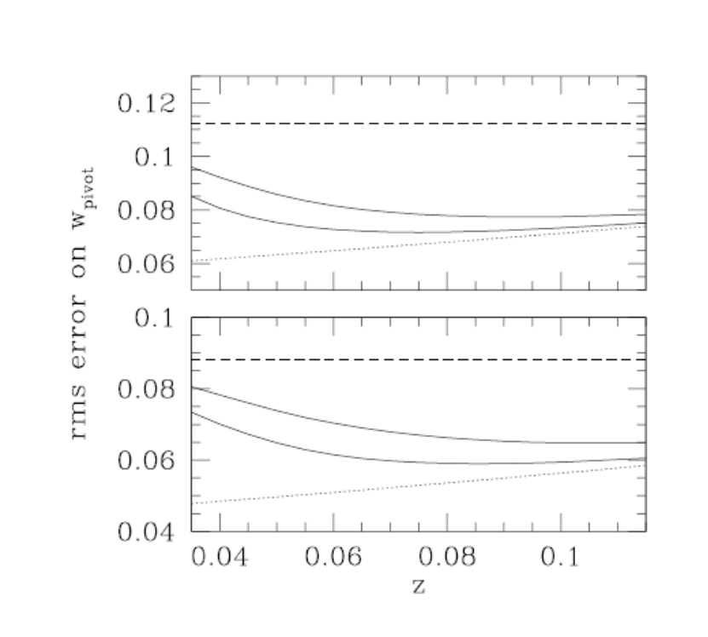
σ=0.1 for
300 SN
SNAP only
1000 sq. deg.
20000 sq. deg
Ignoring effect of peculiar motions
σ=0.15 for
300 SN
Figure 5: Forecast rms error on dark energy equation of state from SNAP vs. redshift of low-z anchor sample of 300 SNe covering 1000 or 20,000 sq. deg. (from Hui & Greene 2006). Top (bottom) plot assumes residual dispersion of relative supernova magnitudes of 15(10)%. w_{pivot} is dark energy equation of state at redshift where it is best determined.

2.2 Systematic Studies for Supernova Cosmology
Future supernova surveys such as those proposed for JDEM aim to achieve exquisite precision in distance estimates, of order 1% distance error in redshift bins of width 0.1 out to redshifts approaching z~2, by measuring thousands of SNe Ia. That level of precision would enable determination of the present dark energy equation of state w at the few percent level and of its time variation at the 20-30% level (in combination with other measurements). To achieve that precision, systematic errors must be controlled to the same level. Examples of systematic errors that could compromise these goals include evolution of the Ia population, variations or evolution of metallicity, and variations or evolution of host galaxy reddening. To quantify such systematic effects, it is necessary to assemble a high-quality, homogeneously selected SN sample of sufficient size to enable breaking into multiple subsamples to study correlation of SN distance estimates with other observables, e.g., host galaxy properties. The ARCSS+SDSS II sample will include ~250 high-quality (~500 total) light-curves at z<0.15, plus another ~150-200 light-curves at z<0.3 from SDSS II, sufficient for division into subsamples for a variety of systematics studies.

2.3 Light Curve Templates
Supernova cosmology rests in part on the empirical correlation between light curve shape and peak luminosity (Phillips 1993); taking into account this correlation through light curve fit techniques, SNe Ia provide relative distance estimates with a dispersion of about 7%. Another motivation for ARCSS is the clear need for a much larger sample of low-redshift light curves with both multi-band observations and photometric coverage well before, near, and after maximum light. Such a sample will enable development and training of improved light curve fit algorithms, e.g., iterations of or developments beyond such methods as Δm₁₅, MLCS, stretch, and CMAGIC (e.g., Phillips 1993, Riess, Press, & Kirshner 1996, Jha 2002, Jha, Riess, & Kirshner 2006, Wang, et al. 2003, Prieto, et al. 2006). As noted above, the currently available low-redshift samples used for training light curve fitters contain very few supernovae with photometry before maximum light; as a result, pre-maximum-light photometry of intermediate to high-redshift supernovae cannot be optimally used in determining SN distances. Since early-epoch photometry helps constrain light curve shape, the distance estimates for current high-redshift supernovae are limited in part by this drawback of the low-z sample. The rolling nature, high cadence, and depth of the ARCSS and SDSS II surveys enable us to obtain well-sampled light curves starting well before maximum light, as Fig. 2 demonstrates.

2.4 Supernova K-corrections and Spectroscopic Correlations
Since light curve fits are based on low-redshift templates, high-redshift light curve data are usually transformed into equivalent rest-frame photometry before fitting. This transformation---the K-correction---in principle requires knowledge of the supernova spectrum at each photometric epoch. In practice, one assumes that the high-z spectrum is similar to a typical or median spectrum for a low-redshift supernova at the same epoch, and the latter are `warped’ by some prescription to yield synthetic colors that agree with the photometry of the high-z supernova. Clearly this prescription does not account for variations in spectral features and their suggested correlations with SN photometric properties (Benetti et al. 2005). One goal of ARCSS will be to assemble a set of high signal-to-noise spectra at several epochs for each supernova with a high-quality light curve, enabling (a) detailed study of such features and correlations and (b) construction of improved K-correction spectral templates.

One issue currently under study is the level of spectrophotometric accuracy needed for constructing better K-correction templates and the optimal strategy for achieving that accuracy. In addition to wavelength-dependent slit losses, which can be limited to some degree by use of wide slits and by observing at the parallactic angle, there will be contamination from host galaxy light which can be subtracted by additional exposures with either the slit displaced away from the supernova or at a later epoch after the supernova has faded. In a preliminary study of the SDSS II spectra taken during 2005, SDSS colors were synthesized for each spectrum and compared with SDSS photometry interpolated to the given spectroscopic epoch. The agreement was at the few % level for objects brighter than r=18 but differed systematically at fainter magnitudes, presumably due to slit losses and host galaxy contamination; an exploratory effort to subtract the latter using Principal Component Analysis is just starting. Fig. 6 shows an example of this comparison for one of the low-redshift SDSS II supernovae with multi-epoch spectroscopy. Since the ARCSS light curves will be densely sampled and in multiple passbands, in principle they can be interpolated to the spectroscopic epochs and used to correct (or warp) the overall shapes of the spectral energy distributions. This is likely to be useful in cases where the host galaxy contribution to the extracted supernova spectrum can be subtracted or is very small, so that warping will correct for differential slit losses.
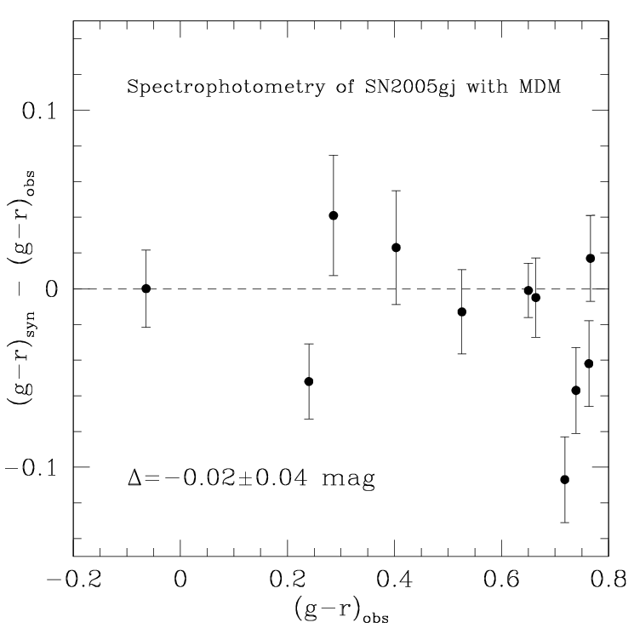

Figure 6. Comparison of interpolated (`observed’) SDSS colors with those synthesized from MDM spectra for the low-redshift (z=0.062) SDSS II supernova 2005gj.

2.5 Peculiar Type Ia Supernovae
Peculiar type Ia supernovae, which comprise perhaps 10% of the Ia population, have different observed luminosities compared to normal type Ia’s and can potentially bias cosmological results if not properly accounted for. If peculiar supernovae affect both low- and high-redshift samples identically, any biases should cancel; in practice, however, the selection of peculiar Ia’s in these samples may differ. A good understanding of the population, variability, and observational signatures of peculiar type Ia’s is likely to be necessary for precision cosmology with supernovae. Since it covers a very large volume, ARCSS will offer an unprecedented opportunity to study peculiar supernovae in a statistically meaningful way.

Peculiar supernovae are often classified as 1991T-like (overluminous) and 1991bg-like (underluminous). While at the extremes of observed peak luminosity for Ia’s, these supernovae do fit the empirical correlation (Phillips 1993) between peak luminosity and light-curve decline rate; they may simply represent extremes of the normal distribution of type Ia supernovae, in which the main features of the light curve and spectra follow from the amount of Ni⁵⁶ produced in the supernova explosion. On the other hand, the advent of larger SN samples is beginning to uncover small numbers of peculiar supernovae, such as 2002cx (Li, et al. 2003, Jha et al. ), that do not fit easily into this picture: this object may be a new twist in the distribution of “normal” supernovae or it may be the manifestation of a new phenomenon. SN2005hk, co-discovered by SDSS II and subjected to intense follow-up observations, is another example of this class (Jha, et al. 2006). SN2005gj (Prieto, et al. 2005, Aldering, et al. 2006) is another example of a peculiar supernova for which SDSS II obtained multiple follow-up spectra; it is a rare instance of a type Ia with Hydrogen Balmer emission lines, similar to SN2002ic (Hamuy, et al. 2003) The broadening of these lines, along with the slow light-curve decline and high luminosity, suggest an interaction with the circumstellar medium.

2.6 Supernova Rate Measurements
Recent measurements of the SN Ia rate at high-redshift (z~0.5) are based on samples of about 100 supernovae (Neil, et al. 2006). Measurements of the Ia rate at low-redshift (z~0.1) are based on very small samples, generally rely on very large and uncertain efficiency corrections, and are statistically discrepant with each other, likely indicating a systematic error in one or more of the measurements. The ARCSS+SDSS II sample, which will be large, homogeneously selected, and have a well-understood and very high detection efficiency (based on insertion of artificial supernovae into the data stream as well as detailed Monte Carlo simulations), will enable a definitive measurement of the SN Ia rate at low redshift. Dilday, et al. (2006) have already made a first start on this, using ~20 SNe Ia at z<0.12, where the efficiency is very high, from the Fall 2005 SDSS II season to estimate the low-z rate; the full ARCSS+SDSS II sample will be much more powerful for this and allow more detailed studies. In combination with rate measurements at higher redshift, it will enable us to test theoretical models for the Ia progenitor population and to probe the evolution of the SN Ia rate with ~10% precision. The sample will also be sufficiently large that it can be used to study supernova rates of different SN types as a function of, e.g., host galaxy properties (e.g., Sullivan, et al. 2006).

2.7 Testing and Improving Models of Type Ia Supernovae
A key feature of this project will be the tight, synergistic connections between SN Ia observers and theorists. Three members of the team (Khoklov, Lamb, and Cattaneo) lead the Flash Center for Predictive Science, a proposed follow-on to the ASCI Flash Center,
and have extensive experience in SN Ia modeling. The Flash Center aims to use SNe Ia as a testbed for developing predictive science methodologies able to handle large, 3-D, multi-scale, multi-physics, integrated, and computationally demanding numerical
simulations. As noted above, using SNe Ia to determine the properties of dark energy will require 1% distance measurements per redshift bin. Most scientists in the field believe that achieving this goal will require accurate simulations of SNe Ia and quantification of the uncertainties in the predictions made by such simulations.
To accomplish these objectives and validate the simulations, a large, unbiased, high-quality data set of SN Ia light curves and spectra, such as ARCSS will provide, will be needed. An extensive set of such SNe Ia is necessary in order to fully sample the range of SN Ia properties -- key to understanding the SN Ia phenomenon, as well as to using SNe Ia to constrain the properties of dark energy. The models will benefit particularly from late-time (> 2 months past maximum light) spectroscopy, which probes supernovae as they enter the nebular phase, providing a direct look into the inner iron-peak region that powers the light curve. The ARCSS is therefore of crucial importance for the success of the proposed Flash Center for Predictive Science; at the same time, the interpretation and validation work carried out by the Flash Center will enhance the importance and value of the data.

2.8 Core-Collapse Supernovae
In addition to SNe Ia, ARCSS+SDSS-II will discover and measure light curves of a large number of nearby core-collapse type II and Ib/c supernovae. These supernovae are important for probing star formation and for understanding the physics associated with the deaths of massive stars, as well as the chemical enrichment of interstellar and intergalactic gas. Their average peak luminosities compared to type Ia's are lower by ~1 to 2 mag (Richardson, et al. 2002), so the survey will be sensitive out to z~0.1 for these types. The local rate of core-collapse supernovae, however, is believed to be higher than that of Ia’s by a factor of ~3 (Dahlen, et al. 2004), so a conservative estimate based on Fig. 1 and on Fall 2005 SDSS II data (which included 17 spectroscopically confirmed, and an additional ~15 good photometric candidate, core-collapse events) is that we expect to collect high-quality light curves for at least ~80 core-collapse SNe in ARCSS+SDSS II.

ARCSS will measure high-quality multiband light curves of nearby type II-P supernovae, enabling us to build a library of II-P templates and improve their utility as cosmic distance indicators (Hamuy and Pinto 2002; Nugent, et al. 2006). Roughly one third of all core-collapse supernovae are expected to be of type II-P, so the survey will double the current world sample of high-quality, low-redshift type II-P light curves; this sample will be invaluable for future cosmological studies.

The unbiased wide-area coverage of ARCSS will also enable discovery and detailed study of rare types of core-collapse events that have been poorly sampled in previous surveys. One example of interesting rare supernovae are the energetic Ib/c hypernovae, only six of which have been studied in detail, and several of which now have firm associations with long-duration gamma-ray bursts (e.g., Galama, et al. 1998; Iwamoto, et al. 1998; Hjorth, et al. 2003; Stanek, et al. 2003). Detailed spectral modeling and multi-epoch spectroscopic observations (including very late spectra) of both normal Ib/c and hypernovae can constrain the nature of the progenitor star and the physics and geometry of the explosion, essential for distinguishing the physical conditions that lead to GRBs (Maeda & Nomoto 2003; Proga, et al. 2003, Fryer & Warren 2004; Scheck, et al. 2006). Our collaboration, with expertise in multi-dimensional radiation transport in SN ejecta, is well equipped to carry out detailed modeling of these observations. Correlative studies with other parts of the electromagnetic spectrum (in particular, radio, X-ray, and gamma-rays) will be especially interesting for these types of events that produce non-thermal emission in the central engine. As an example, the Gamma-ray Large Area Space Telescope (GLAST), scheduled for launch in late 2007, in concert with ARCSS will allow us to survey the transient sky across a wide range of the electromagnetic spectrum and will play an important role in unravelling the GRB-SN connection.

3. Schedule and Operations
The proposed schedule for ARCSS is to operate the 2.5m imager from Sept. 2008 through June 2009 and, as in SDSS II, to use most of the dark/grey time and some of the bright time (excluding about 5 days around full moon) over this period. In principle, the survey could run for a longer period and/or, as in SDSS II, be interspersed with other programs, though a contiguous supernova observing season should last a minimum of three months to avoid a substantial efficiency hit in accumulating well-sampled light curves. We prefer a continuous ten-month observing run over interspersal with other large dark/grey programs, since we will largely rely on the expertise, organization, and infrastructure we have in place for the SDSS II Supernova Survey, and we anticipate that it will be most efficient and practical to keep the team in place for this period.

ARCSS will make use of the current infrastructure for data acquisition and processing that exists at APO: the 2.5m imager, the data acquisition system, and the compute cluster installed for rapid SN data processing in summer 2005. We anticipate that the imager will be operated by one or two trained observers per shift, under both photometric and non-photometric conditions, as for the SDSS II Supernova Survey. Connie Rockosi and Jim Gunn have agreed, in principle, to provide `best effort’ camera maintenance expertise through the ARCSS period, with the understanding that catastrophic failure is not covered. The compute cluster will likely require the current level of on-mountain maintenance it receives from APO staff; it runs the PHOTO pipeline through corrected frames, carries out image frame subtraction in gri, and positionally matches objects across the 3 filters. We expect the on-mountain compute processing time to scale approximately with the number of pixels; since the raw pixel rate will be ¾ that for sidereal scanning, we expect the on-mountain cluster will be able to keep up with processing on a <24 hr timescale, as it has for SDSS II. The outputs will be transferred by internet for further analysis by the collaboration, as they are now (with roughly the same bandwith requirement). The Supernova team will coordinate and carry out follow-up observations, as in SDSS II. Currently, we re-process the data through the photometric pipeline for public distribution at Fermilab.

4. Other Resources Needed
Spectroscopic follow-up of ARCSS events will be needed for supernova typing, redshift determination, and study of time-dependent spectral features. The detailed follow-up strategy will depend, of course, on the available resources and on the science interests of those with primary access to those resources. Here we estimate the needed level of spectroscopic resources for the science program described above and a strawman plan that approximately satisfies it.

For ease of comparison with SDSS II, we artificially break the ARCSS into 3 three-month observing quarters that happen to be contiguous (the 10th month can always be added back in at the end). For each quarter, we wish to obtain an average of 4 epochs of spectroscopy on the ~60 expected low-z Ia’s with high-quality light curves and one epoch on the remaining ~60 we expect to discover (see Sec.1). In the Fall 2005 campaign, about 75% of the unique, targeted SN candidates yielded confirmed supernovae; since we expect at least this rate of success for the lower-redshift ARCSS, we will need to take roughly 260 SN spectroscopic exposures per quarter (this estimate does not include additional time that might be desired for host galaxy spectra after the SN has faded and does not include time for multi-epoch core-collapse follow-up). This is the number of supernova-target spectra taken during the Fall 2005 SDSS II campaign, so the basic ARCSS follow-up program could be carried out if resources comparable to those that were available for Fall 2005 are accessible for the ARCSS survey period.

To estimate the needed resources, we make the crude approximation that the average telescope time per SN target, including overheads and time spent on standard stars, will be one hour, roughly consistent with that in Fall 2005. (Low-redshift supernovae near peak light will require less time than this, those a few weeks past peak may take longer, and detailed exposure times will of course depend on aperture, etc.) Assuming typical 50% weather efficiency, this will require ~520 scheduled hours per quarter on non-queue-scheduled telescopes. (In Fall 2005, the queue-scheduled HET measured ~95 spectra in 90 queue-scheduled hours, while the ARC 3.5m measured ~64 spectra in ~124 hours, both consistent with the efficiency and exposure times above.) This time should be spread among smaller aperture (2 to 3m) telescopes, which can acquire good signal-to-noise spectra near peak light, and those with larger aperture (4m and above), which can more efficiently measure early and late spectra.

This required time appears to be reasonably well matched to the estimated quarterly dark/grey resources we can plausibly expect to have access to (though, in almost all cases, the access is competitive and therefore not guaranteed):

- HET (Stanford, Penn State): (~30 hours queue) =60 hrs (non-queue)
- MDM 2.4m (Ohio State 25% share): ~135 hrs
- ARC 3.5m (UC+UW+NMSU+JHU+Director’s Discretionary=25%):~135 hrs
- Subaru (JPG): ~30 hours (3 nights, based on 2005, 2006 allocations for SDSS II)
- ESO or UK 3-4m (Portsmouth, European collaborators): ~60-200 hours (Fall 2005: 6 nights allocated on WHT 4.2m; Fall 2006: 17 nights allocated on NTT 3.5m plus 3 nights on NOT 2.5m)

While the uncertainty in these available follow-up resources is large, the expectation based on two seasons of scheduled SDSS II follow-up is that they could provide ~420-560 of the required 520 hours of needed follow-up time. In addition, we can expect to have additional collaborative access for follow-up to LBT (through Ohio State), SALT (through collaborators at SAAO, U. Cape Town, Rutgers, and the HET consortium), the CfA 1.5m (Kirshner group), and possibly Keck (through possible collaborators at Berkeley and LBL), as well as applying for public time on the CTIO or KPNO 4-m.

SDSS II has secured time for photometric follow-up on small telescopes (NMSU 1m, UH88in, MDM 2.4m, VATT,…) in order to obtain late-epoch photometry for a subsample of confirmed supernovae; we are likely to continue this program for ARCSS, pending confirmation that the color terms between different versions of the SDSS filters can be pinned down to the level needed for accurate SN photometry (so called S-corrections). We also expect to continue collaborative work with the Carnegie Supernova Project, which is carrying out optical and NIR photometry of selected confirmed SDSS II supernovae, and to broaden our NIR follow-up through, e.g., the Liverpool Telescope. In addition, members of the Supernova Legacy Survey (SNLS) team have expressed interest in possible collaboration, though the scope is yet to be determined.

5. Development Plan
The ARCSS will make use only of existing, tested hardware and, to the extent feasible, existing software and will operate in a mode as similar as possible to SDSS II in order to minimize development time and cost. The main development tasks and those best positioned to carry them out are: (a) devising a survey strategy that makes optimal use of the telescope time (D. McGinnis, J. Marriner, Fermilab), (b) acquiring and processing binned 2.5m test data in Fall 2006 to demonstrate that it can be reliably and routinely acquired and processed (Fermilab and APO staff), (c) acquiring and processing sidereal, photometric (i.e., `survey quality’) scans on stripe 79 in Fall 2006 or 2007, to complete the needed template area (part of SDSS II operations), (d) upgrading the data acquisition system to output GANG files in 2x2 binned mode (K. Biery, Fermilab), (e) upgrading the focus loop to operate with 2x2 binned data (R. Lupton, Princeton), (f) upgrading the Skippy program for telescope tracking with 2x2 binned data (J. Munn, USNO), (g) upgrading and commissioning PHOTO at Fermilab to run with 2x2 binned data (J. Adelman-McCarthy, Fermilab, in consultation with R. Lupton), (h) modifying the on-mountain frame subtraction pipeline to operate with 2x2 binned data at the level of accuracy needed for SN target selection (A. Becker, U. Washington), and (i) modifying the final photometry pipeline so that accurate SN photometry can be extracted from 2x2 binned survey data (J. Holtzman, New Mexico State).

Below, we summarize the preliminary feasibility studies that have been carried out along these lines and what remains to be done. A detailed work breakdown structure and schedule will need to be put in place, along with a review schedule that will allow a timely decision about whether to proceed with binned scans or revert to sidereal scans. We estimate that the total effort needed to complete these development tasks is approximately 3 FTE-years. If a negative decision on binned scans were reached sufficiently early, the development effort could be scaled down accordingly.

5.1 Survey Strategy
With the likely exception of one stripe in the south, the ARCSS will carry out imaging of areas that have previously been scanned during SDSS I and II. These earlier data, taken under photometric conditions in good seeing at sidereal rate, will provide template images that will be subtracted from the shallower ARCSS images to search for supernovae; since they are deeper, better sampled, and taken under good conditions, the templates will make only a small contribution to the noise in the subtracted images. The template images will also provide star catalogs for calibrating the subtracted images. From SDSS II, we already have the machinery in place to turn SDSS images and associated catalogs into the templates needed for frame subtraction.

It is likely that one more template stripe outside the current SDSS footprint (stripe 79) will be needed in the south for the Fall observing season. We will propose that two photometric nights with good seeing be used in Fall 2006 or more likely 2007 to cover this region with a scan at the sidereal rate, to ensure uniform template coverage of the survey area.

To demonstrate feasibility, we have devised but not yet optimized a strawman survey strategy. Scans are carried out over the existing SDSS footprint (with the exception noted above) at three times sidereal rate, with the constraint that the airmass be less than 2.0. These constraints require us to cover typically 4 strips per night in about 2 sections per strip (see Table 1). To achieve the desired cadence, we alternate between the north and south strips of the target stripes from night to night. With this strategy, we must repoint the telescope several times per night; Fig. 7 shows an example scan of one section of a strip.

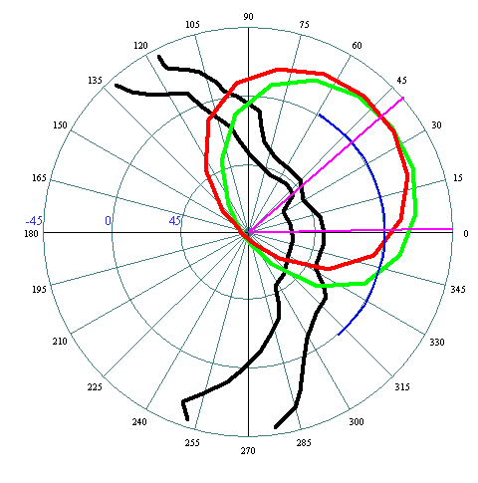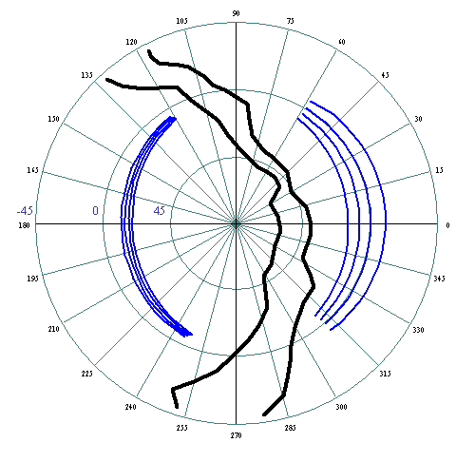

Figure 7. Left: A strip to be scanned is shown (blue) superposed on the region with airmass<2 (green circle at the beginning of the scan, red circle at the end of the scan). Magenta lines delimit the scan section, and the Milky Way is roughly delimited by the black lines. Right: the eight stripes to be surveyed.
As an example, we display the strawman survey plan for selected nights in September, January, and May in Table 1. Note that we assume 15-minute overhead for each telescope repointing and scan ramp-up.

Table 1a. Survey Area for Sept. 14-15 Table 1b. Survey Area for Jan. 14-15

Stripe | Start Time | Stop Time | Scan Deg
82 | 19:34 | 20:34 | 45
86 | 20:49 | 21:49 | 45
79 | 22:04 | 23:04 | 45
76 | 23:19 | 0:19 | 45
82 | 0:34 | 1:34 | 45
86 | 1:49 | 2:49 | 45
79 | 3:04 | 4:04 | 45
Stripe | Start Time | Stop Time | Scan Deg
82 | 18:46 | 19:39 | 40
86 | 19:54 | 20:47 | 40
76 | 21:02 | 22:09 | 50
15 | 22:24 | 23:24 | 45
16 | 23:39 | 0:59 | 60
17 | 1:14 | 2:47 | 70
18 | 3:02 | 4:36 | 70
15 | 4:51 | 5:51 | 45

Table 1c. Survey Area for May 14-15
Stripe | Start Time | Stop Time | Scan Deg
17 | 20:29 | 21:42 | 55
18 | 21:57 | 23:37 | 75
16 | 23:52 | 1:05 | 55
15 | 1:20 | 2:27 | 50

The strawman plan results in a mean scan area per night that is nearly 3 times the SDSS-II SN scan area, as desired, though the nightly scan area varies considerably during the course of the survey (peaking in winter and tailing off toward summer). With this strategy, the telescope is in data-taking mode 83% of the available time between astronomical twilight and sunrise; the remainder of the time is lost to telescope repointing/scan ramp-up and to inefficiency near sunrise when the target area drops toward the horizon, especially in May/June (in Table 3, the last 75 minutes before sunrise are not used). Due to the latter issue, one could consider ramping up another observing program that could use the end of the night starting in late Spring.

One interesting feature of this plan is that the average number of visits (before weather effects) for each region of the survey area is 63, compared to 45 for SDSS II SN. This should modestly improve the efficiency for obtaining well-sampled light curves, because it implies that `edge effects’ due to the finite survey duration will be smaller. Since a given region will be visited over a timescale long compared to that during which a typical SN is bright, it also suggests that some of the ARCSS scans could be used to provide an improved model of the host galaxy light and thereby improve final photometry. We believe the strawman plan can be improved, and this will be one area for development.

5.2 Calibration Strategy
Considerable effort has gone into improving the photometric calibration of SDSS data, both by using multiple photometric runs on stripe 82 (Ivezic, et al. 2006) and by using the Apache Wheel cross-scans to tie the entire survey together (ubercalibration, Padmanabhan 2006). These efforts have demonstrated that we can achieve uniform photometric zeropoints across the sky at the ~1% level. Since ARCSS will overlap with existing survey data and cross-scans, we can take advantage of this excellent photometric calibration. (Depending on the survey strategy adopted, additional cross-scans might be necessary, but this would be a small part of the total survey observations.) A fraction of the ARCSS scans will be photometric and might be used to further refine the calibration.
C. Stubbs has developed a laser photometric calibration system that has been tested on the CTIO 4-m; plans are underway to bring it to the ARC 2.5m in 2007. If successful, this could provide an independent calibration of the SDSS photometric system and would be beneficial in combining SDSS results with other surveys.
5.3 Instrument Operations
An important part of our development plan will be to demonstrate that the telescope, camera, and data acquisition system can operate reliably in 3 times sidereal scanning mode with 2x2 binned readout. A number of faster, 4x4 binned Apache Wheel scans have been taken and successfully reduced as part of the ubercalibration effort. Run 3868, a test run in April 2003 with poor seeing (~2”) and partial moon, was taken at 3 times sidereal with 2x2 binned readout and partially processed through the photometric pipeline (see below).

We propose to allocate a modest amount of time during the Fall 2006 Supernova Survey for a test run in 3xsidereal, 2x2 binned mode to ensure that we understand all the operational issues as well as to perform an end-to-end test of the resulting SN photometry. During October, if the weather is good during the entire night, we can finish scanning stripe 82 before the end of the night; when that happens, on one or two such nights we would repoint the telescope on the same strip and carry out a faster scan of a portion of the area covered earlier that night. The total observing time allocated to this test would be 2 to 3 hours.

While not strictly required, we strongly favor modifying the existing monitoring tools to work with 2x2 binned data. In particular, we would like to make sure that we can produce Gang files for analysis and that Skippy and the Focus Loop can read the files and produce appropriate results.

5.4 Pipeline Operations
In addition to demonstrating that the camera can be operated and data acquired in faster, binned mode, we will also use the test run to ensure that (a) PHOTO and the frame subtraction pipeline deliver preliminary SN photometry with the accuracy needed to identify SN candidates for follow-up and (b) our final photometry pipeline delivers SN photometry with the accuracy needed to meet our science requirements.

The statistical S/N penalty associated with larger pixels, while not desirable, should be tolerable. The effective size of the PSF will increase with 2x2 binning and therefore the measurement of the supernova flux will be contaminated by more sky noise. A rough estimate may be made by adding the rms pixel size (for 2 pixels, it is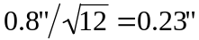) in quadrature with typical good seeing of 0.5” (standard deviation, not FWHM). The result is that the effective sky noise is increased by ~20%.

We have performed some preliminary tests that indicate that the frame subtraction pipeline will yield adequate photometric accuracy to carry out the SN search in binned mode. While the larger binning does not affect the number of photons detected, one might worry that the image undersampling with larger pixels could result in significant photometry errors due to inadequacies in the PSF fitting procedure (especially when the seeing is good). We first tested this with the portion of the frame subtraction pipeline that determines zero-points. This code finds the zero-point and also calculates the rms deviation of the PSF magnitudes of the calibration stars around their catalog values (the latter from a photometric run). We simulated 2x2 binning by rebinning existing stripe 82 SN data and comparing the spread of PSF mags vs. catalog mags with that for unbinned processing of the same run. The results are shown in Table 2. We see that the rms spread in PSF mags does not increase with 2x2 binning, which indicates that the PSF photometry model used by the frame subtraction pipeline is not systematically degraded by the binning.

Table 2. Dispersion of PSF Mags in binned vs. unbinned images
Frame | Filter | Unbinned  (rms in magnitudes) | 2x2 binning  (rms in magnitudes)
529 | g | 0.024 | 0.025
 | r | 0.036 | 0.038
 | i | 0.035 | 0.036
530 | g | 0.036 | 0.036
 | r | 0.028 | 0.027
 | i | 0.031 | 0.031

We performed a similar test using a run with binned data, run 3868. This run had 2x2 binning and a scanning rate of three times sidereal, the proposed mode for ARCSS, but conditions were moony with highly variable seeing. The data were processed through PHOTO at Princeton to produce uncalibrated object catalogs. Matched to objects in the Catalog Archive Surver, this data did show a ~50% increase in scatter in PSF mags for bright objects compared to that for an unbinned, photometric run. While there is lower precision with binned data, the software yields reasonable results, and the resulting scatter (a few %) is small compared with the 15% individual supernova variation.

While the above test concerns point-source photometry for isolated stars in binned scans,
the undersampling of the supernova images will likely be a more important issue in subtracting the galaxy background light. To test this, we have run our standard frame subtraction pipeline on Fall 2005 SDSS II images of a supernova at z~0.1. In Table 3 we compare the unbinned results with those obtained by rebinning the search data in 2x2 format.

Table 3. SN flux measurements in binned vs. unbinned images
Run | Filter | Flux  (Normal bins) | Flux  (2x2 bins) | Difference  (%) | Difference  (std deviations)
5792 | g | 961±33 | 942±33 | −2.0 | −0.58
5792 | r | 2154±43 | 2278±46 | 5.7 | 2.87
5792 | i | 1809±46 | 1847±50 | 2.1 | 0.82
5800 | g | 1008±38 | 1005±39 | −0.3 | −0.08
5800 | r | 2030±48 | 1988±48 | −2.1 | −0.89
5800 | i | 1788±52 | 1726±52 | −3.5 | −1.20
5813 | g | 862±32 | 849±32 | −1.4 | −0.39
5813 | r | 1777±38 | 1871±40 | 5.3 | 2.52
5813 | i | 1548±41 | 1565±25 | 1.1 | 0.41

This test indicates that the frame subtraction photometry with 2x2 bins is typically within a few percent of that for unbinned data, for this object; for rapid selection of supernova candidates for spectroscopic targeting, we have found that systematic SN photometry errors of up to 10% can be tolerated (and were often seen during the 2005 run), indicating that the frame subtraction pipeline will not need modification to carry out the ARCSS search.

Final SN photometry, of course, must be more precise than this. We expect to carry out final ARCSS photometry with a version of the “scene modeling” pipeline written by Jon Holtzman for SDSS II SN analysis, suitably modified for binned scans. A preliminary test, similar to that shown in Table 3, using scene modeling PSF photometry on rebinned vs. unbinned scans of another low-redshift SN Ia from 2005 shows similar scatter at the few % level. Development work will be needed to study the dependence of this scatter on seeing and on relative galaxy surface brightness and to see if it can be reduced to the required ~1% level. If it can, then ARCSS would be carried out in binned mode; if not, we would use sidereal scanning in unbinned mode.

6. Cost Estimate
We have developed an estimate of the person-years of equivalent effort needed for both development and operations, based on consultations with Steve Kent and Bill Boroski. To carry out the development tasks listed at the beginning of Sec. 5, we estimated 3 FTE-years, comparable to but somewhat larger than that needed for SDSS II SN. We have based the operations estimate on current manpower usage at APO and Fermilab, as we do not expect that to change substantially. Operation of the imaging pipeline and associated support at Fermilab uses 2.25 FTE, IOP support is 0.5 FTE, and data distribution is 2 FTE; rapid SN data processing (currently personnel at U. Chicago and U. Washington) uses about 0.8 FTE. Since there will be no spectroscopic operations, telescope engineering could be reduced to 2.75 FTE during this period. We assume project management at the current level of 0.5 FTE would continue to ensure smooth running of the project, and we assume 0.5 FTE for routine camera maintenance beyond that covered by the on-site engineers. Assuming a suite of 6 observers assigned to 2.5m operations, the total development and operations effort required is approximately 16 FTE-years; for the cost estimate, we conservatively assume this will all be supported by the project, although a fraction of the development work (that by senior scientists) will in fact be in-kind. Assuming an average of $130K per FTE-year (including benefits), the total estimated project cost for development and operations would amount to $2.1M. Note that this does not include any subsidization by the project of the additional costs of operating APO (beyond the immediate costs, noted above, of operating the 2.5m). Note that elimination of the development costs for binned scanning would reduce the bottom line by ~$390K, or about 20%.

We have not included the spectroscopic follow-up time that will be contributed by members of the collaboration, since that will not be a cost to the project, but a rough extrapolation from ARC 3.5m operating costs suggests it should be valued at about $1M; indeed, the ARCSS will be leveraging those resources. We have also not included the personnel costs associated with coordinating, taking, and reducing the spectroscopic follow-up data, since we expect that to be effectively in-kind contributions from the team, as in SDSS II.

Since this project will be directly supporting the goals of JDEM and helping fulfill the mandate set out by the Dark Energy Task Force, we would expect to approach the U.S. funding agencies for possible support. We have not explored the possibilities of partial funding from participating institutions in depth, though more than one has expressed willingness/interest in considering it. We would also be open to exploring options for private funding.

7. Public Data Release
The ARCSS data will be released in various levels and stages. First, we plan to make basic information about all SN candidates we identify immediately available via a public alert web page; we also plan to announce candidates through automated e-mails using the nascent VOEvent Net. Since our sample will be relatively bright, we also will likely issue electronic telegrams before (as well as after) they are spectroscopically confirmed. On the timescale of ~a month, we would expect to release corrected image frames and uncalibrated object catalogs in a simple database, as we have done for SDSS II SN. For SDSS II, we are also developing the infrastructure needed to apply calibrations to the non-photometric runs and expect to make calibrated object catalogs for them available soon. We plan to carry that forward to ARCSS, so that calibrated object catalogs can be made available on a timescale of ~months. This will constitute a very substantial, wide-area data set for general astronomical studies of transient and variable phenomena. On a longer timescale, of order a year, we will publish our final SN photometry. There may be interest in producing co-added, 2x2 binned images for the ARCSS area, since the median co-added exposure time will be ~10 times that of SDSS, but we have not included that in the proposed project.

8. Personnel
We expect to operate as a collaborative team in a manner similar to the SDSS II SN project. The proposal team includes most/all of the SDSS II SN science team plus a number of new people at other institutions interested in participating. The people expected to be principally involved in the development work have been identified above in Sec. 5. We expect that 2.5m observing will be carried out by APO staff, following the SDSS model. Telescope and instrument engineering and off-site data processing for the 2.5m are currently carried out by Fermilab staff, paid for by the project. These staffing arrangements need to be resolved in the context of the post-SDSS-II management and funding approach. As in SDSS II, the scientists on the team will be involved in and responsible for day-to-day data 2.5m image processing on the mountain, selection and coordination of spectroscopic targets, proposing for, carrying out, and analyzing spectroscopic follow-up observations, and overall science analysis.

References
Aldering, G. et al., astro-ph/0606499
Astier, P. et al. (SNLS Collaboration) Astron.Astrophys. 447 (2006) 31
Benetti, S. et al. 2005, ApJ, 623, 1011
Cooray, A., & Caldwell, R.R. 2006, astro-ph/0601377
Dahlen, T., et al. 2004, ApJ, 613, 189
Dilday, B., et al. (SDSS collaboration) 2006, AAS Meeting 208, Abstract 72.05
Eisenstein, D., et al. (SDSS collaboration) 2005, ApJ, 633, 560
Fryer, C.L. & Warren, M.S. 2004, ApJ, 601, 391
Galama, T.J., et al. 1998, Nature, 395, 670
Hamuy et al. 2003, Nature, 424, 651
Hamuy, M., & Pinto, P. A. 2002, ApJ, 566, L63
Hjorth, J., et al. 2003, Nature, 423, 847
Hui, L., & Greene, P.B. 2005, astro-ph/0512159
Ivezic, Z., et al. 2006, SDSS Standard Star Catalog for Stripe 82: the Dawn of Industrial 1% Optical Photometry, submitted
Iwamoto, K., et al. 1998, Nature, 395, 672
Jha, S. 2002, PhD thesis
Jha, S. et al., 2006, AJ, 132, 189
Jha, S., Riess, A., & Kirshner, R.P. 2006, ApJ, submitted.
Li, W., et al. 2003, PASP, 115, 453
Maeda, K., & Nomoto, K. 2003, ApJ, 598, 1163
Neil, J. D., et al. (SNLS collaboration), astro-ph/0605148
Nugent, P., et al. 2006, ApJ, 645, 841
Padmanabhan, N., 2006, PhD thesis, Princeton University
Perlmutter, S., et al. 1999, ApJ, 517, 565
Phillips, M. 1993, ApJ, 413, L105
Prieto et al. 2005, IAUC8633
Prieto, J.L., Rest, A., & Suntzeff, N. 2006, astro-ph/0603407, to be published in ApJ
Proga, D., MacFadyen, A. I., Armitage, P. J., & Begelman, M. C. 2003, ApJ, 599, L5
Richardson, D., Branch, D., Casebeer, D., Millard, J., Thomas, R. C., & Baron, E. 2002,
AJ, 123, 745
Riess, A., Press, W.H., & Kirshner, R.P. 1996, ApJ, 473, 88
Riess, A., et al. 1998, AJ, 116, 1009
Sako, M., et al. 2005 (SDSS collaboration), astro-ph/050445, in Proc. of 22nd Texas
Symposium on Relativistic Astrophysics
Scheck, L., Kifonidis, K., Janka, H.-Th., & Muller, E. 2006, A&A, in press
(astro-ph/0601302)
Stanek, K.Z., et al. 2003, ApJ, 591, L17
Sullivan, M., et al. (SNLS collaboration) 2006, Astron. Astrophys. 447, 31
Tegmark, M., et al. 2004, PRD, 69, 103501
Wang, L., et al. 2003, ApJ, 590, 944

