Classic Galvanic Corrosion

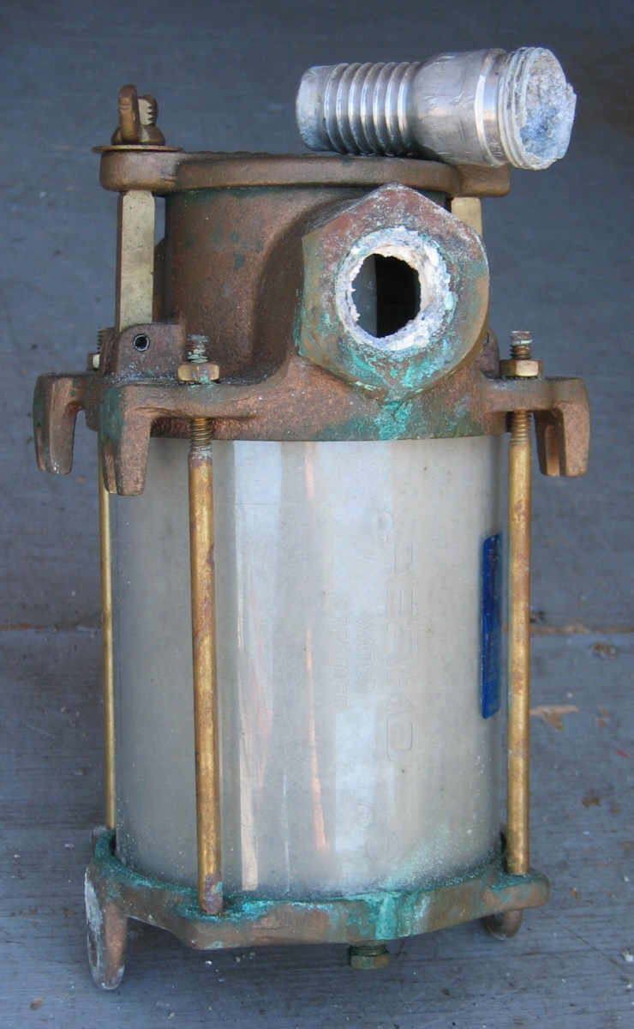

.

What is it? The photo shows the remains of an aluminum hose barb and the bronze sea strainer on which it was installed, in this case in line with the raw water intake hose on NOAA / NRT6s SeaArk Survey Launch S3003, during fabrication.

What's going on? This is what happens when dissimilar metals are placed in contact with each other, in the presence of an electrolyte, in this case sea water. Aluminum is near the bottom of the galvanic (noble) scale (or near the top, depending on which scale you are using) and therefore becomes the anode, while bronze is closer to the top (or bottom) of the galvanic (noble) scale and becomes the cathode. This is essentially like a battery. In simple terms, the less noble aluminum gives up its electrons to the more noble bronze. In the process the aluminum breaks down (corrodes) to aluminum oxide plus free electrons flowing through the electrolyte (sea water) to the bronze. Another good example of this is when we install sacrificial anodes or "zincs" to prevent an aluminum hull (or other metal parts) from corroding. The zincs (less noble) "sacrifice" themselves by giving up their electrons to the aluminum (more noble).
To quote Wikepedia: "Galvanic corrosion is an electrochemical process in which one metal corrodes preferentially when in electrical contact with a different type of metal and both metals are immersed in an electrolyte. Conversely, a galvanic reaction is exploited in primary batteries to generate a voltage. A common example is the carbon-zinc cell where the zinc corrodes preferentially to produce a current. The lemon battery is another simple example of how dissimilar metals react to produce an electric current. When two or more different sorts of metal come into contact in the presence of an electrolyte a galvanic couple is set up as different metals have different electrode potentials. The electrolyte provides a means for ion migration whereby metallic ions can move from the anode to the cathode. This leads to the anodic metal corroding more quickly than it otherwise would; the corrosion of the cathodic metal is retarded even to the point of stopping. The presence of electrolyte and a conducting path between the metals may cause corrosion where otherwise neither metal alone would have corroded."
How come? The aluminum hose barb should never have been installed into the bronze sea strainer. The hose barb should have been made of bronze like the sea strainer or at least stainless steel which is closer to bronze on the galvanic (noble) scale. Because aluminum and stainless steel are quite similar in appearance, most likely this was intended to be a stainless steel barb, but somehow an aluminum barb was installed by an inexperienced or "in a hurry" technician, not realizing the difference. This could easily happen because in building aluminum boats one would usually use aluminum barbs on aluminum fixtures, except in the case where it is used in a dissimilar metal fixture like our bronze sea strainer or stainless steel valve, for instance.

So what? In our case this went unnoticed for about two to three years after taking delivery of the vessel. The first clue was when we spotted a green (bronze oxide) drip in the bottom of the bilge under the sea strainer. (This would have gone undetected, had there been water in the bilge). I remember pointing it out to my co-worker as something to keep notice of, as a possible sign of future trouble. I thought at the time that the fitting was perhaps just leaking slightly and intended to "get back to it later". Wrong! Unfortunately we got busy and forgot about it as we moved on to other things. Just by luck, a few weeks later, we had the boat on the trailer for maintenance on the generator when I accidentally bumped the hose attached to this barb and it literally fell apart. It had completely corroded through due to galvanic corrosion. Had this not happened while on the trailer, it would most likely would have happened while under way.

Typical scenario: You're cruising along in somewhat rough seas. The pounding action of the boat would have caused the hose barb to fall off, causing the generator compartment to flood rapidly. The generator would soon shut down due to over-heating, due to lack of cooling (raw) water. Would the bilge pump be capable of removing the water at the same rate as the inflow? Is your bilge pump working properly?

Of course this could also happen with the vessel tied to the dock. The bilge pump, if working properly, would attempt to pump out the inrush of water until the battery dies, then the boat would sink, at least partially, at the dock. If the bulkhead through-valves are open, the other compartments would also flood and sink the boat, possibly completely.

How to prevent this: With the boat on its trailer or at least with appropriate valves shut off to prevent flooding, inspect any suspect fittings, like the hose barbs that are attached to any bronze or stainless steel fittings, such as sea strainers, valves etc. Look for leaks and/or signs of corrosion between the parts. Grasp the hose attached to the barb and give it a good shake or tap with a hammer or both. If the corrosion is severe the barb might break, like the one in the photo.

If this does not show results, as in a newer vessel, verify the composition (type of metal) of any suspect fittings. If the fitting is bronze it will be a dull golden/brown color. Aluminum is usually duller than stainless steel and has a more "whitish" appearance, while stainless steel has a more silvery color and shine. Aluminum also has less of a "ring" to it when tapped with a metal object such as a wrench, but this may not work if attached to other fixtures. Aluminum is much softer than stainless steel and will scratch much more readily with a knife or other sharp object. Try to find other fittings for comparison. If you're still not sure, have it checked next time the vessel goes into the shop or ask someone with more experience. If you are about to have a vessel inspection done, that might be a good option. Ultimately, the best option is for the vessel operator to know his/her vessel.

Any fittings of dissimilar metals that are attached to each other should be suspect especially in critical applications, as when in contact with seawater. Have these fittings replaced as soon as possible.

Ed Wernicke / NRT6
edmund.wernicke@noaa.gov

For further reference:
http://www.ocean.udel.edu/seagrant/publications/corrosion.html

