Aircraft Laser Infrared Absorption Spectrometer (ALIAS)
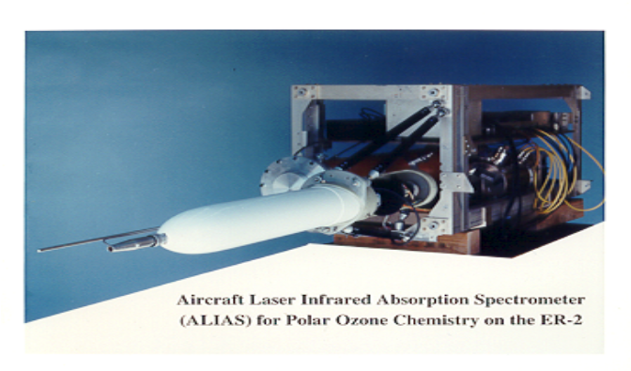Christopher R. Webster (PI), Greg J. Flesch, Katy Modarress,
Jess Landeros, Lance Christensen
The Aircraft Laser Infrared Absorption Spectrometer (ALIAS) instrument is a high resolution four-channel scanning tunable Quantum-Cascade (QC) laser and tunable diode laser (TDL) spectrometer (3.4 to 8 µm) that makes direct, simultaneous measurements of (e.g. HCl, NO₂, CH₄, N₂O, CO, water isotopes) (including vertical profiles of the tracers) in the stratosphere and troposphere at sub-parts-per-billion sensitivities. The instrument weighs 160 lbs.
The measurement technique is based upon using QC lasers operating from 3.4 to 8 µm scanning over absorption lines recorded using second harmonic absorption spectroscopy over an 80-m pathlength in a 1-m multipass optical cell of the Herriott design. ALIAS has flown over 300 times in 7 major NASA missions: AASE-II, SPADE, STRAT, ASHOE/ MAESA, POLARIS, and SOLVE, and CRYSTAL-FACE.
For NASA's July 2002 CRYSTAL-FACE Mission out of Florida, ALIAS was configured with QC and TDL lasers and on the WB-57F made the first in situ measurements of H²₁₆O, HDO, H₂¹⁷O, H₂¹⁸O in and out of clouds, from troposphere to stratosphere.
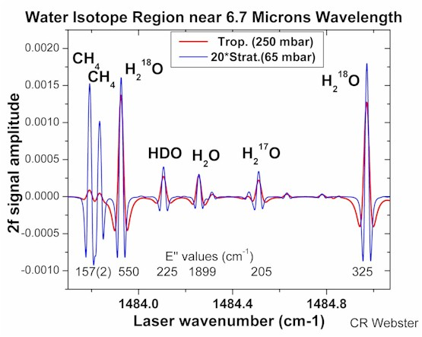
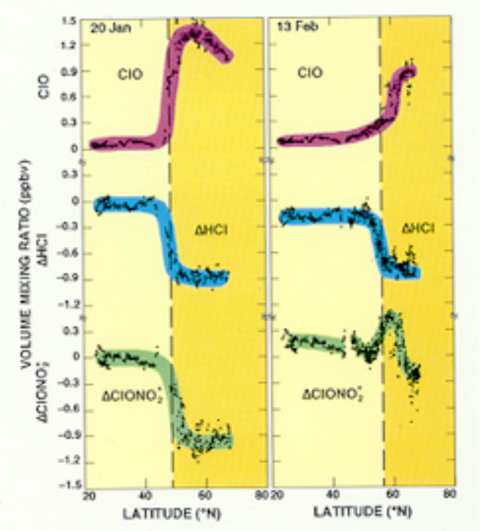
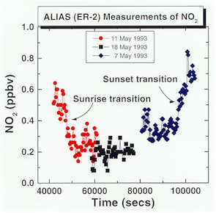
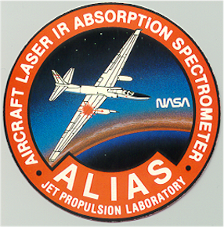
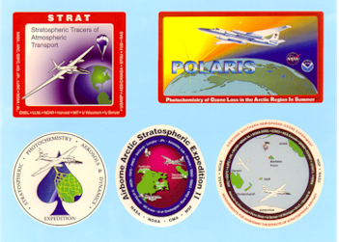

- “Quantum cascade laser measurements of stratospheric methane (CH₄) and nitrous oxide (N₂O)”, C.R. Webster, G.J. Flesch, D.C. Scott, J. Swanson, R.D. May, W.S. Woodward, C. Gmachl, F. Capasso, D.L. Sivco, J.N. Baillargeon, A.L. Hutchinson, A.Y. Cho, Applied Optics, 40, 321-326, 2001.
- "Aircraft (ER-2) Laser IR Absorption Spectrometer (ALIAS) for In-situ Stratospheric Measurements of HCl, N₂O, CH₄, NO₂, and HNO₃", C.R. Webster, R.D. May, C.A. Trimble, R.G. Chave and J. Kendall, Appl. Optics, 33, 454-472, 1994.
Airborne Laser IR Absorption Spectrometer (ALIAS-II)

C.R. Webster (PI), G.J. Flesch, R. Howe, J. Landeros, and L. Christensen
The ALIAS-II instrument is a 2-channel version of the ALIAS-I (ER-2) instrument, with identical electronics, dewar configuration, and instrument- and data processing- software, built under funding from NASA’s UARP and HSRP programs to measure N₂O, CH₄, and H₂O on the UAV Perseus in a nose-to-wing optical path, and reconfigured to fly on a lightweight balloon gondola. ALIAS-II measures N₂O, CH₄, and HCl in a clean, open path defined by a 64-meter (to 128-meter) open cradle optical cell (balloon). The instrument weighs about 65 lbs in its balloon configuration. ALIAS-II has made 9 balloon flights out of Ft.Sumner, NM, Juarzerio del Norte, Brazil, and Kiruna, Sweden, to study the coupling of photochemistry and transport.

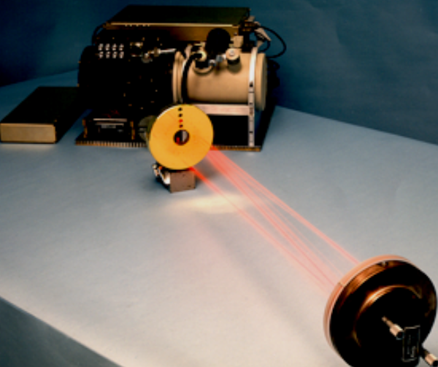
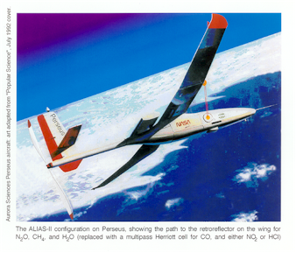
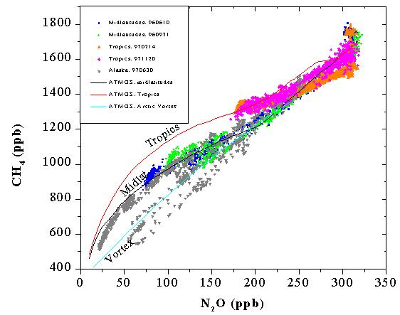
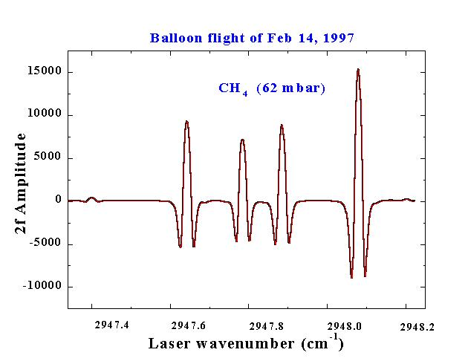
The ALIAS II configuration on Perseus showing the path to the retroreflectors on the wing for N₂O, CH₄, and H₂O (replaced with a multipass Herriot cell for CO, and either NO₂ or HCl)

1. “Airborne Laser Infrared Absorption Spectrometer (ALIAS-II) for in situ stratospheric measurements of N₂O, CH₄, CO, HCl, and NO₂”,
DC Scott, RL Herman, CR Webster, RD May, GJ Flesch, in preparation for Applied Optics, 1998.
2. “Tropical Entrainment Time Scales Inferred from Strat. N₂O and CH₄ observations”, RL Herman, DC Scott, CR Webster, RD May,
EJ Moyer, RJ Salawitch, YL Yung, GC Toon, B Sen, JJ Margitan, KH Rosenlof, HA Michelsen, JW Elkins, Geophys. Res. Letters, 25 , 2781-2784, 1998.

Aircraft Laser Isotope Spectrometer (ALIS) for in situ measurements of ¹³CO₂, OC¹⁸O and ¹²CO₂

C.R. Webster (PI) and L. Christensen

Isotopic CO₂ measurements have also been identified as an important component of NASA’s Earth Science Enterprise’s Carbon Cycle Initiative as part of its program in global climate change. The isotopic composition of atmospheric CO₂, and especially its ¹³CO₂/ ¹²CO₂ ratio, is an established tool for understanding the details of the global carbon cycle, since this ratio can distinguish between oceanic and terrestrial biospheric sinks of CO₂. During flights of the DC-8 for validation of the IIP Laser Absorption Spectrometer (LAS) for global CO₂ (PI Menzies), ALIS will make the first in situ measurements of ¹³CO₂ , OC¹⁸O, and ¹²CO₂ across the tropopause.

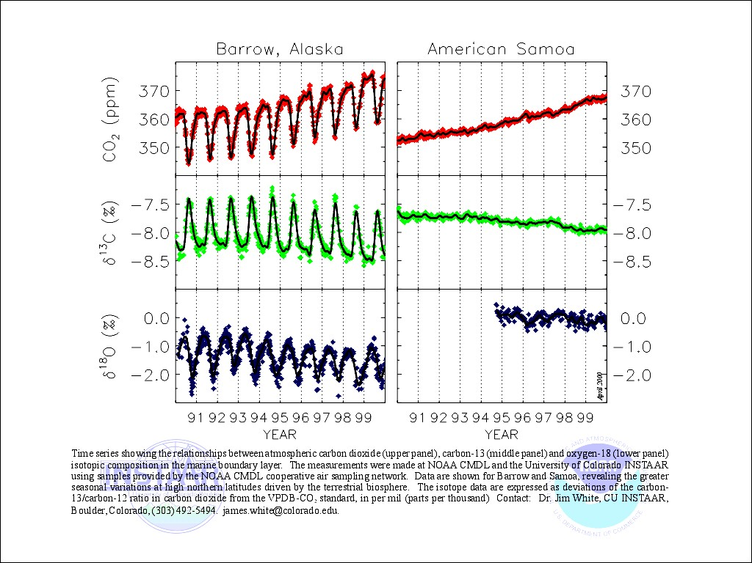
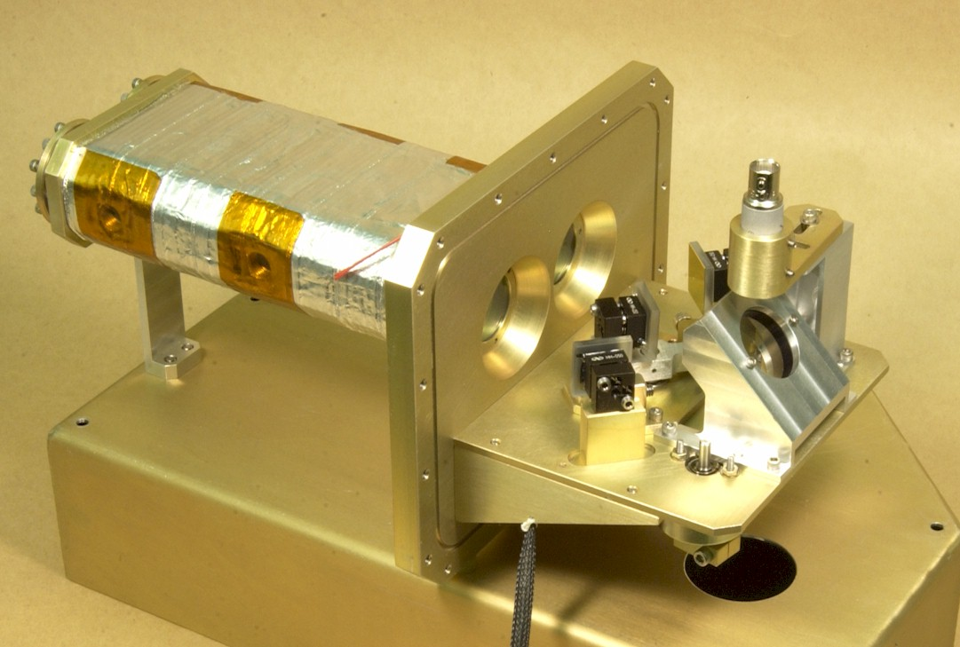
Time series showing the relationship between atmospheric CO₂ and its isotopes in the marine boundary layer, made by NOAA CMDL and UC INSTARR. Greater seasonal variation is seen for the northern high latitudes driven by the terrestrial biosphere.

Measuring ¹³CO₂/CO₂ is not easy, since a precision of better than 1 per mil is required (better than 0.1 per mil desired) to distinguish trends, seasonal, diurnal, and latitudinal variations. This capability has never been demonstrated for in-flight atmospheric measurements, but would have an enormous impact on global carbon science.
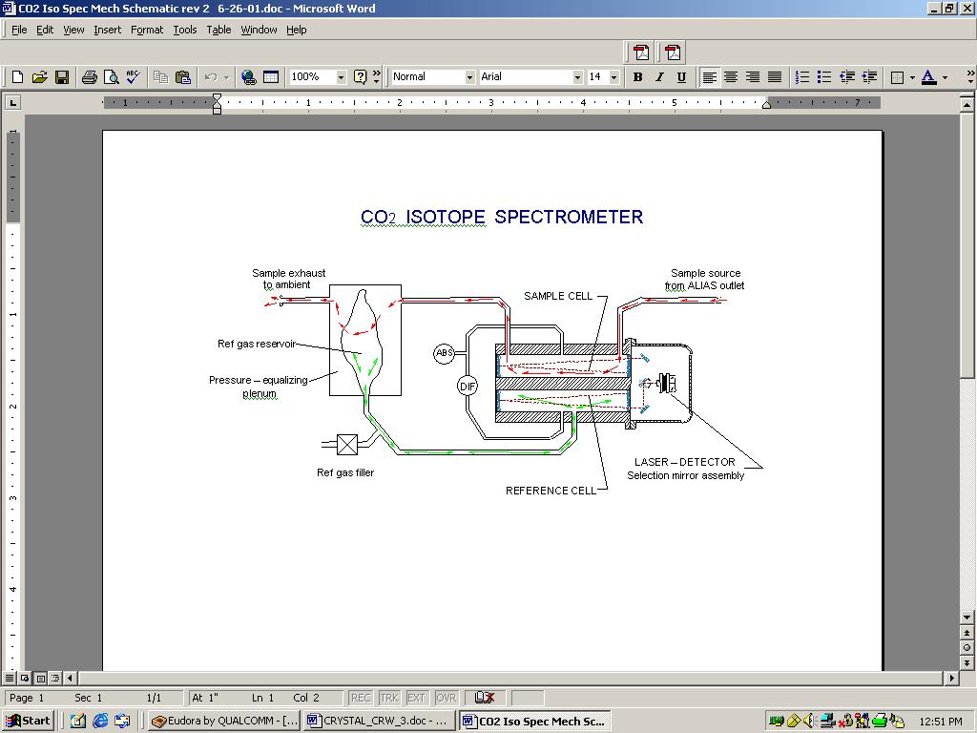
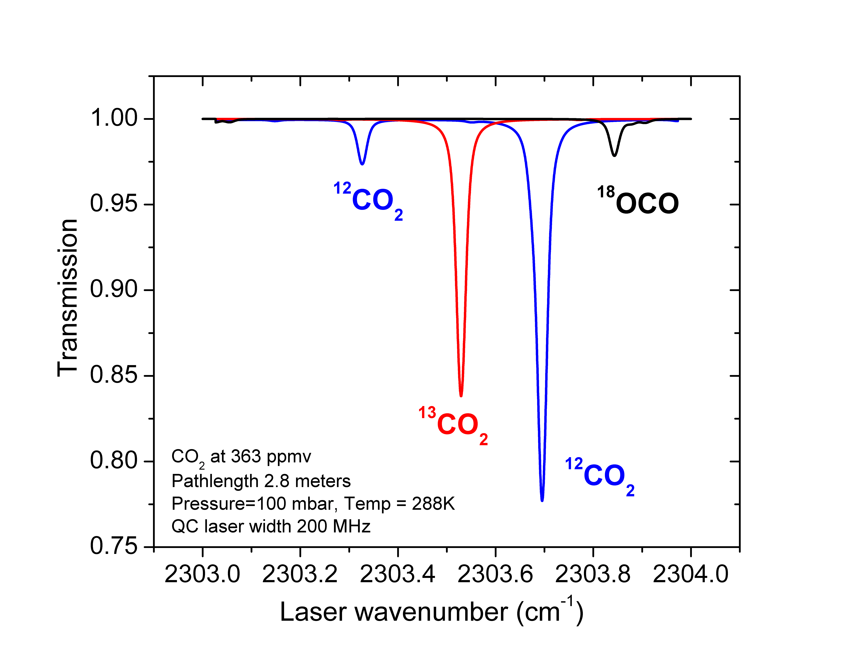

Figure. Synthetic spectral region where ALIS will make ¹³CO₂/¹²CO₂ isotope measurement demonstration, and schematic of laser isotope spectrometer optical head. The calibration standard gas channel “breathes” with the external pressure changes, and both cal gas and measurement channel are isothermal.

JPL Laser Hygrometer for the ER-2 and WB-57F Aircraft

R.L. Herman (PI) and R.D. May (consultant)
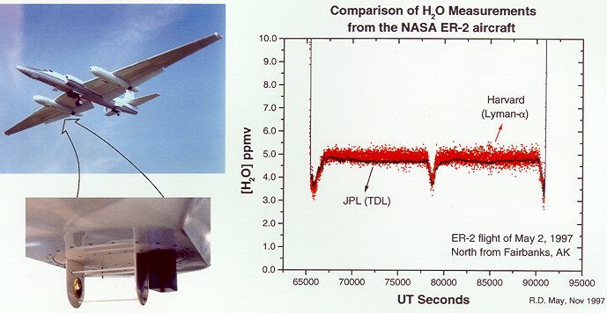
The JPL Near-IR Water Spectrometer is a new instrument for in-situ measurements of atmospheric water vapor from aircraft platforms such as the ER-2, the DC-8, and the WB-57F aircraft. It is based upon near-IR tunable diode laser sources operating near 1.37 μm. The spectrometer features an open-path, multipass (Herriott) cell for true in situ monitoring of H2O concentrations with precision levels exceeding those of Lyman-α and frost-point hygrometers. External sampling outside the aircraft boundary layer minimizes ambiguities. Measurement precision is ±0.05 ppmv in the stratosphere for a 2 s measurement integration period. The flight-ready instrument weight is 18 lbs., and power consumption, exclusive of structural heaters, is 7.5 Watts. The picture below shows the ER-2 instrument as mounted on the right-hand super pod for the POLARIS and SOLVE missions. This same instrument was flown on the NASA WB-57 as part of WAM (WB-57 Aerosol Mission) during April 1998, mounted on an underwing hatch on the right wing of the aircraft.
ER-2 Aircraft
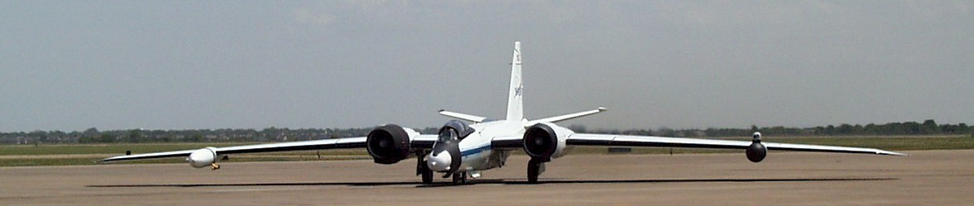
“Open-path, Near-IR Tunable Diode Laser Spectrometer for Atmospheric Measurements of H₂O”, R.D. May, Journal of Geophysical Research, Vol 103, No. D15, pp 19161-19172, August 20,1998.
WB57F Aircraft

JPL Near Infrared Laser Hygrometer for the DC-8 Aircraft
R.L. Herman (PI) and R.D. May (consultant)

The DC-8 version of the laser hygrometer is shown here mounted on a window blank of the DC-8 at fuselage station 490 right. The optical path is 50 cm and is a "there and back" double pass arrangement. The upper blue housing holds the laser and detector, and the lower piece holds a single 0.5" diameter mirror for returning the beam to the detector. Both the laser and detector are mounted on a single Al disk that is stabilized in temperature using a thermoelectric cooler (which actually operates as a heater most of the time during flights).
This instrument has participated in SOLVE and CAMEX-3, and is currently (August 2001) mounted on the DC-8 as part of the Convection and Moisture Experiment (CAMEX-4) where flights are underway in Florida.

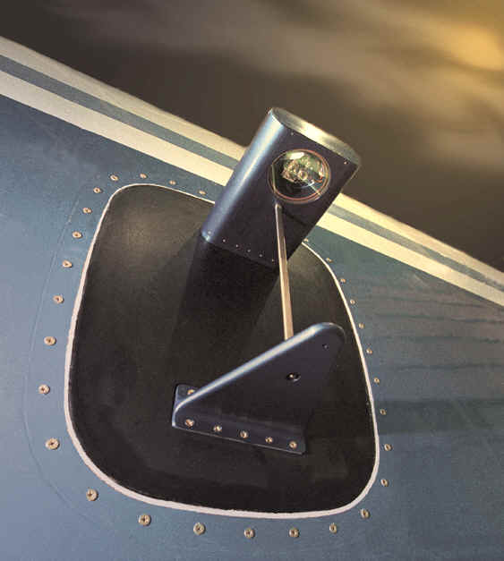
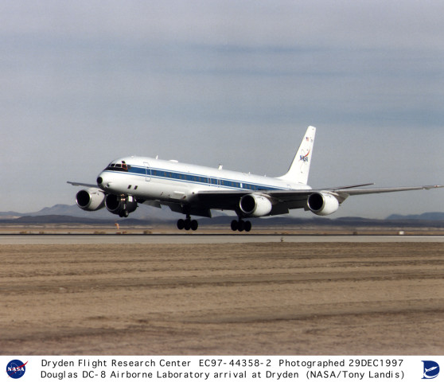
WB57F Aircraft
“Open-path, Near-IR Tunable Diode Laser Spectrometer for Atmospheric Measurements of H₂O”, R.D. May, Journal of Geophysical Research, 103, 19161-19172, 1998.

Atmospheric Water & Climate Change: a proposed UAV Science Demonstration
Christopher R. Webster (PI), Denise E. Hagan, Robert L. Herman, Michael J. Mahoney, Ross J. Salawitch, David C. Scott, and Yuk L. Yung

The tiny amounts of water in the upper troposphere and lower stratosphere have enormous impact on the Earth’s climate, driving both radiative transfer and atmospheric chemistry. We propose to investigate the processes that are responsible for controlling water vapor concentrations in the upper troposphere and lower stratosphere through a series of flight measurements using a suite of already developed and built aircraft instruments. Our UAV science demonstration will produce unique measurements not made by conventional platforms, yet will minimize risk and cost by use of a small suite of existing instruments including a laser hygrometer, a microwave temperature profiler, solar radiometers, and a laser spectrometer specifically developed and built for UAV application. No instrument development is proposed. Our primary measurements will be those of HDO, H₂O, CH₄, N₂O, CO, temperature profiles, and solar flux radiometry. Our chosen UAV platform is AeroVironment’s solar powered aircraft, using flights of Helios (test flights) and Pathfinder Plus that provide cross-tropopause and vertical profiling ability important to our science demonstration. In addition, we also propose to include validation measurements of H₂O and temperature profiles for either or both of the satellite instruments AIRS and SAGE III during measurement coincidences, and thereby further demonstrate the utility of UAVs for satellite validation.
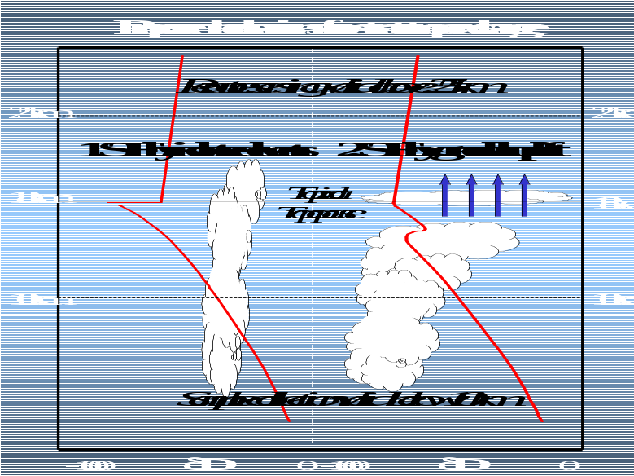
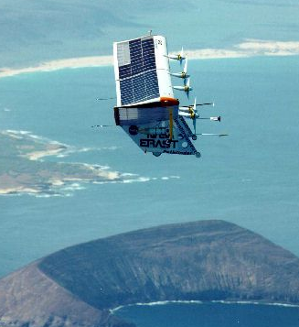

Near-IR Laser Absorption Spectrometer for Global Mapping of CO₂ in the Lower and Middle Troposphere
JPL: Robert T. Menzies (PI), C.R. Webster, David Tratt, Gary Spiers
Colorado State Univ.: Graeme Stevens
Coherent Technologies: Mark Philips
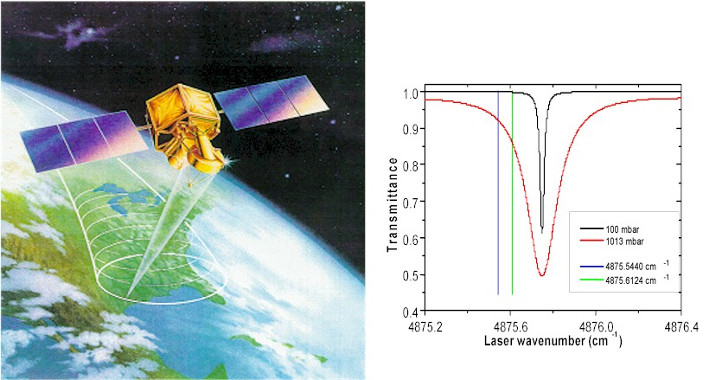

- Near-nadir cw laser (rare-Earth ion doped) illumination of Earth’s surface from orbit.
- Analysis of integrated path differential absorption at selected transmit frequencies within CO₂ absorption region to retrieve tropospheric CO₂ profiles.
- Retrieval of CO₂ profiles in lower and middle troposphere by differential absorption in column above land or ocean backscattering surface.
- Need column to 1-2 ppmv (0.3%) to define spatial gradients.
- Code Y (IIP) has funded DC-8 aircraft demonstration (2003).

Two near-IR regions selected as suitable for satellite measurements of global CO₂ column:
- 1.57 micron band
- 2.05 micron band
- Optimal combination of optical depth, insensitivity to temperature, and few interferences.

H₂¹⁸O Near-IR Tunable Diode Laser Paleothermometer for Determining Climate Change on Earth and Mars

C.R. Webster (PI), G.J. Flesch, M. Hecht and F. Carsey
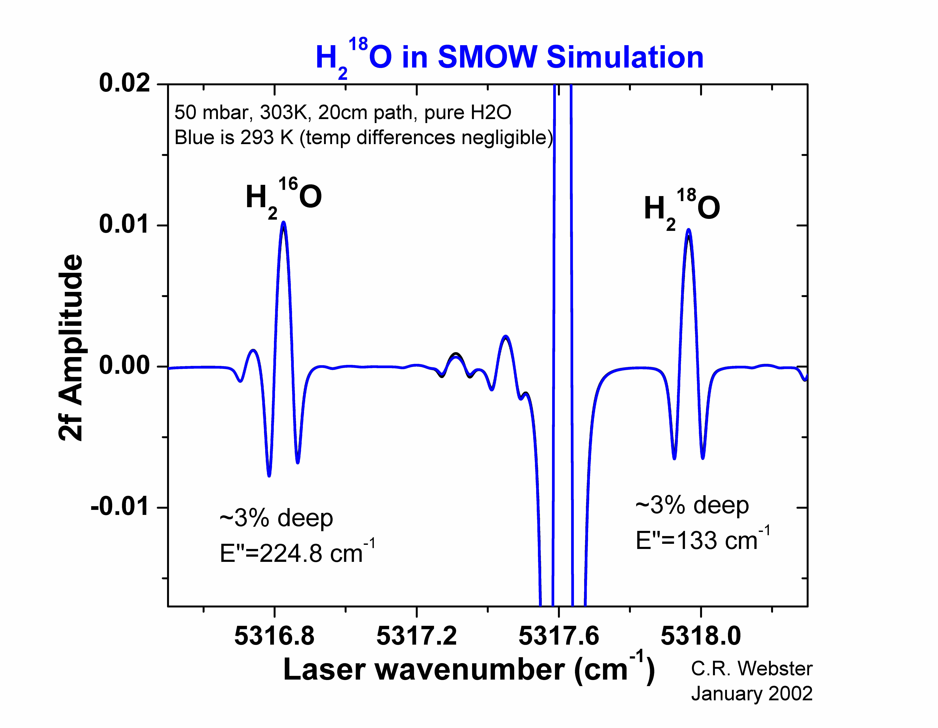
We have designed and built a miniature near-IR tunable diode laser spectrometer for measuring in situ the isotopic fractionation delta-¹⁸O in water samples from ice cores of either Earth or Mars. The H₂¹⁸O/ H₂¹⁶O laser paleothermometer uses a thermoelectrically-cooled single-mode DFB tunable diode laser (TDL) in the near-IR region at 1.88 μm to scan over selected vibration-rotation lines of H₂¹⁸O and H₂¹⁶O. A working prototype weighing only 220 g has been built with electronics based on the Motorolla HC-12 microcontroller, and has been used to generate spectra whose analysis demonstrates sensitivities of delta-¹⁸O of 0.2 per mil precision and 1 per mil absolute accuracy.

Water Isotope Spectrometer (WISP)

for the Pathfinder/Centurion Solar Electric Aircraft

E.J. Moyer, C.R. Webster, D.C. Scott, G.J. Flesch

The WISP instrument inherits much of its design from the ALIAS-II open-path laser spectrometer. Although built for the WB-57F aircraft, and flown without laser sources during a single flight of the ACCENT mission, the WISP Herriott cell has never been tested in the lab or flight.


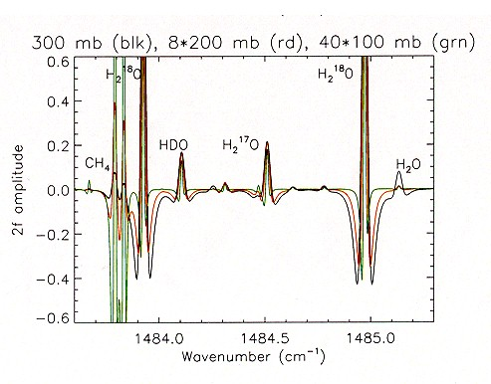
Measurements of the isotopic composition of atmospheric water vapor are a critical tool for diagnosing sources of upper tropospheric humidity and processes of troposphere-stratosphere exchange. WISP (Water Isotope Spectrometer) is a two-channel tunable diode laser spectrometer designed for in-situ measurement of the isotopic composition of water vapor in the upper troposphere and lower stratosphere. Simultaneous, independent measurements of H₂O, HDO, H₂¹⁷O, H₂¹⁸O and CH₄ are made by scanning laser light at 1484 and 7299 cm⁻¹ (6.74 and 1.37 μm) over closely-spaced absorption features of the different gases. Laser light is injected into an open-path multipass Herriott cell for a total pathlength of 100 meters. The instrument is designed for aircraft platforms, and is intended to fly on the remotely-piloted, solar-powered aircraft Centurion, operated by NASA ERAST. Centurion provides long flight durations at upper tropospheric and stratospheric altitudes, while the extreme slowness of the aircraft (airspeeds of ~ 40 mph) allows for long integration times over small spatial regions. The baseline noise on WISP should be approximately one part in 10⁻⁵ absorption, providing an instrument sensitivity for δ¹⁸O (the ratio of H₂¹⁸O to H₂O, relative to a standard, in per mil units) of ~ 35 per mil, limited by systematic errors. Sensitivity for δD is expected to range from ~35 per mil in the troposphere to 80 per mil in the lower stratosphere, limited by loss of signal with altitude.

Balloon-borne Laser In-Situ Spectrometer (BLISS)

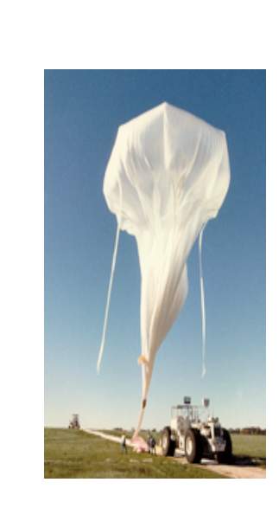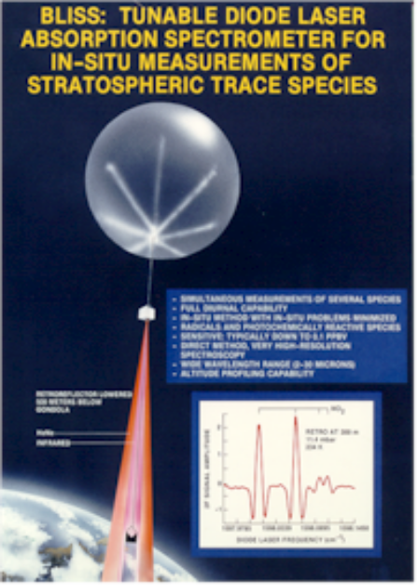C.R. Webster (PI) and R.D. May
The BLISS spectrometer was built at JPL and flown in a series of 12 balloon flights from 1983 through 1992. This instrument uses TDL absorption over a pathlength of up to 1 km defined by a retroreflector lowered below the balloon gondola. BLISS has provided measurements of NO₂, NO, and HNO₃ for studies of the partitioning of active nitrogen in the stratosphere, in addition to producing measurements of other gases such as HCl, CH₄, O₃, N₂O, CO, and CO₂. Its ability to measure photochemically-active species such as NO and NO₂ at any time of day, coupled with the open-path sampling geometry and IR spectroscopic detection through laser absorption, makes it a sensitive, non-invasive means of in situ measurement specifically suited to NO₂. In the lower atmosphere, these in situ measurements were critical to establishing the repartitioning of reactive nitrogen due to heterogeneous processing on background sulfate aerosol.
A significant achievement of the BLISS flight series was the recording of the diurnal variation in NO₂, covering a full cycle through both sunrise and sunset transitions (Webster et al., 1990). With simultaneous measurement of O₃ concentrations, the measured night-time decay in NO₂ abundance was used to model the formation of N₂O₅ during the night through the NO₂+NO₃+M reaction.

Lowered Balloon launch

retroreflector

TDL Spectrum of NO₂ Diurnal Cycle of NO₂ at 30 km 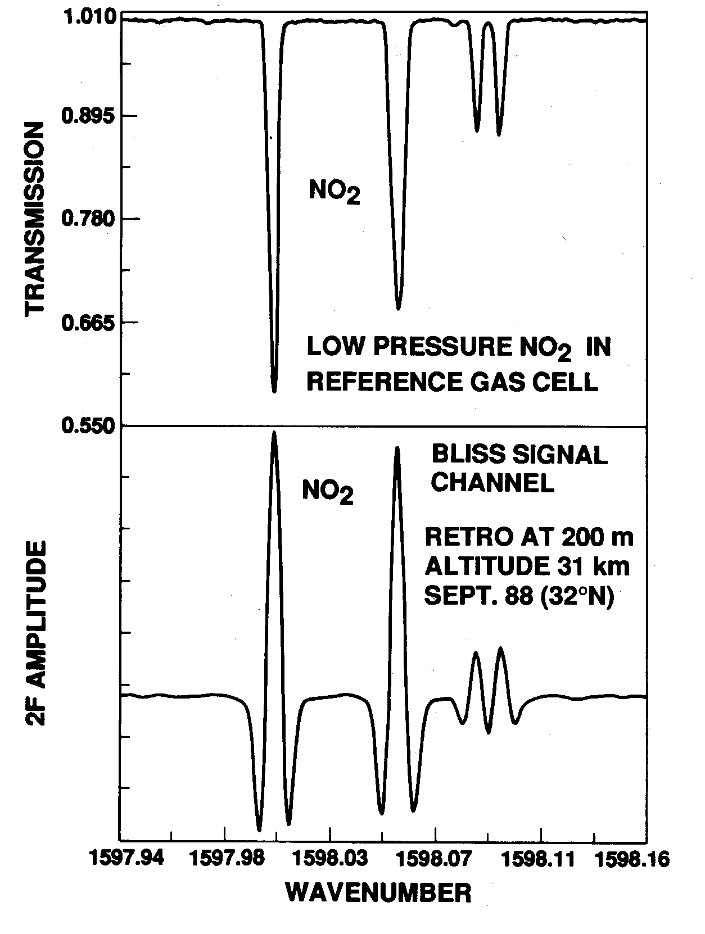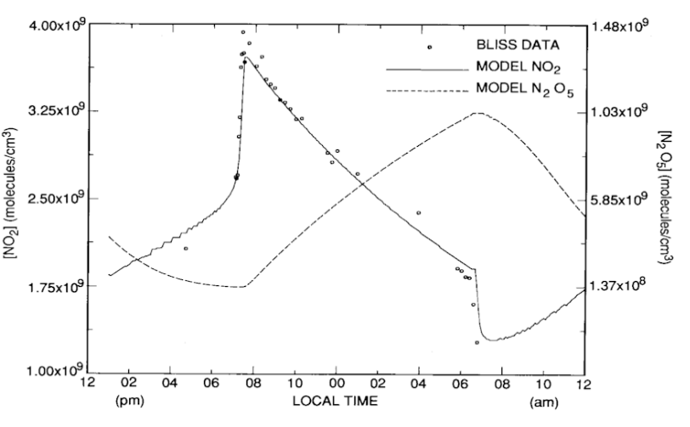

1. "Balloon Profiles of Stratospheric NO₂ and HNO₃ for Testing the Heterogeneous Hydrolysis of N₂O₅ on Sulfate Aerosols", C.R. Webster, R.D. May, M. Allen, L. Jaeglé, Geophys. Res. Letters 21, 53-56, 1994.
2. "Active Nitrogen Partitioning and the Nighttime Formation of N₂O₅ in the Stratosphere: Simultaneous In-situ Measurements of NO, NO₂, HNO₃, O₃, N₂O, and jNO₂ Using the BLISS Diode Laser Spectrometer", C. R. Webster, R. D. May, R. Toumi, and J. Pyle, J. Geophys. Res. 95, 13,851-13,866, (1990)..

