Cruise Report
CLIVAR A16S 2005
R/V Ronald H. Brown, RB0501b
11 January 2005 - 24 February 2005
Punta Arenas, Chile - Fortaleza, Brazil
Co-Chief Scientists:
Dr. Rik Wanninkhof
National Oceanic and Atmospheric Administration
Atlantic Oceanographic and Meteorological Laboratory
Dr. Scott Doney
Woods Hole Oceanographic Institution
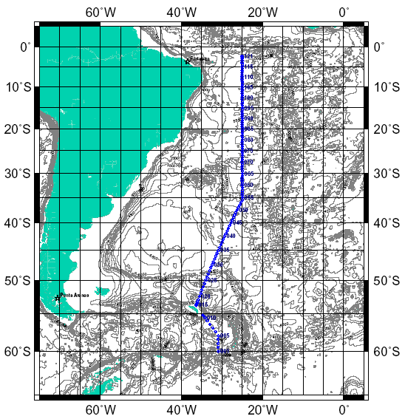

Preliminary Cruise Report
(last modified 2 November 2005)

Table of Contents
Summary 1
Acknowledgments 1
Introduction 2
Description of Measurement Techniques 4
1. CTD/Hydrographic Measurements Program 4
1.1. Water Sampling Package 5
1.2. Underwater Electronics Packages 7
1.3. Navigation and Bathymetry Data Acquisition 7
1.4. Real-Time CTD Data Acquisition System 8
1.5. Shipboard CTD Data Processing 9
1.6. CTD Laboratory Calibration 10
1.7. Shipboard CTD Calibration Procedures 10
1.7.1. CTD Pressure 11
1.7.2. CTD Temperature 11
1.7.3. CTD Conductivity 12
1.7.4. CTD Dissolved Oxygen 14
1.8. Final CTD Data Processing 16
1.9. Final CTD Calibration Procedures 18
1.9.1 CTD Pressure 18
1.9.2 CTD Temperature 18
1.9.3 CTD Conductivity 18
1.9.4 CTD Dissolved Oxygen 19
1.10. Particulate Optical Sensors on CTD Package 22
1.11. Lowered Acoustic-Doppler Current Profiler (LADCP) 24
2. Bottle Sampling 30
2.1. Bottle Sampling Procedures 30
2.2. Bottle Data Processing 30
2.3. Sampling and Analyses of Bottle Data 31
2.4. Tests Performed on Bullister Bottles to Determine Sample Integrity of
CFC, Salts, and O₂ 32
2.5. Discussion of Bottle Sampling for Samples Preserved for Shore-Side Analysis. 38
2.5.1. Helium and Tritium Sampling 38
2.5.2. Particulate Sampling 39
2.5.3. DOC Sampling 40
2.5.4. C-DOM Sampling 40
2.5.5. ¹⁴C Sampling 41
2.5.6. Oxygen, Nitrogen, and Argon (ONAR) Sampling 41
2.6. Parameters Sampled and Analyzed on the Cruise 42
2.6.1. Chlorofluorocarbon (CFC) Measurements 42
2.6.2. Dissolved Oxygen Analyses 46
2.6.3. Discrete Halocarbon/Alkyl Nitrate Analyses 51
2.6.4. Discrete pCO₂ Analyses 55
2.6.5. Total Dissolved Inorganic Carbon (DIC) Analyses 59
2.6.6. Discrete pH Analyses 64
2.6.7. Total Alkalinity Analyses 68
2.6.8. Salinity Analysis 72
2.6.9. Inorganic Nutrients (Phosphate, Nitrate, Nitrite, and Silicate) 74
2.7. Underway Measurements 77
2.7.1 Shipboard Computing System (SCS) 77
2.7.2 Underway pCO₂ (fCO₂) Measurements 78
2.7.3 SAMI Underway pCO₂ Measurement System 83
2.7.4 Underway Spectrophotometric Measurements of pCO₂, TCO₂, and pH 86
2.8. Aerosol Sampling 90
List of Figures
Figure 1.0. Sample distribution, stations 1-34 4
Figure 1.1. Sample distribution, stations 32-62 4
Figure 1.2. Sample distribution, stations 60-92 5
Figure 1.3. Sample distribution, stations 88-121 5
Figure 1.4. T1-T2 by station, p > 500 db 11
Figure 1.5. T1-T2 by pressure, station/casts 5/2-50/1 11
Figure 1.6. Uncorrected C1-C2 by station, p > 500 db 12
Figure 1.7. Uncorrected bottle C-C1 by station, p > 500 db 12
Figure 1.8. Corrected bottle C-C1 by station, all pressures 13
Figure 1.9. Corrected bottle C-C1 by pressure, all pressures 13
Figure 1.10. Corrected bottle C-C1 by station, p > 500 db 13
Figure 1.11. Salinity residual by station, p > 500 db 14
Figure 1.12. O₂ residuals by station, all pressures 14
Figure 1.13. O₂ residuals by pressure, all pressures 15
Figure 1.14. O₂ residuals by station number, p > 500 db 15
Figure 1.15. Calibrated CTD-bottle conductivity differences plotted against station number 19
Figure 1.16. Calibrated CTD-bottle conductivity differences plotted against pressure 19
Figure 1.17. Calibrated CTD-bottle oxygen differences plotted against station number 20
Figure 1.18. Calibrated CTD-bottle oxygen differences plotted against pressure 21
Figure 1.19. Preliminary observations of (a) zonal velocity, (b) meridional
velocity, (c) velocity standard error, and (d) acoustic backscatter 27
Figure 1.20. Preliminary shaded estimates of eddy diffusivity and log-scale
eddy diffusivity uncertainty from cruise-processed LADCP data 29
Figure 2.1. Control plot of the reagent blanks over the cruise 47
Figure 2.2. Control plot of thiosulfate concentration changes over the cruise 48
Figure 2.3. Difference between photometrically and amperometrically determined
oxygen concentration versus photometric oxygen concentration 49
Figure 2.4. Schematic of the automated purge and trap GCMS system 52
Figure 2.5. Comparison of the results from the two SAMIs and the underway
pCO₂ system 84

List of Tables
Table 1.1. Scientific personnel, A16S 2005 2
Table 1.2. Principal programs of A16S 2005 3
Table 1.3. A16S 2005 rosette underwater electronics 8
Table 1.4. A16S 2005 CTD sensor calibration dates 10
Table 1.5. A16S 2005 CTD sensor configurations 10
Table 1.6. Final oxygen calibration coefficients 20
Table 1.7. Initial configuration and instrument and command changes 25
Table 2.1. Water requirements for the different parameters drawn on the
Bullister bottles 31
Table 2.2. Results for station 88 storage tests 33
Table 2.3. Results for station 102 storage tests 34
Table 2.4. Results for station 112 storage tests 34
Table 2.5. Changes in concentrations for station 112 storage test 35
Table 2.6. Summary of CFC changes for the storage tests 35
Table 2.7. Bottle blanks for Bullister bottles 36
Table 2.8. Summary of bottle tests for station 121 37
Table 2.9. Comparison of oxygen concentrations determined by photometric
and amperometric point detection methods at station 106 49
Table 2.10. Calibration standard tanks used for discrete pCO₂ 56
Table 2.11. Duplicate discrete pCO₂ samples 57
Table 2.12. Test results of different sample bottle sizes for DIC 62
Table 2.13. Summary of number of nutrient samples taken and estimated precision 76
Table 2.14. Hourly sampling cycle for the underway pCO₂ system (version 2.5) 79
Table 2.15. Wavelengths used for spectrophotometric determination of inorganic
carbon species 87

Summary
A hydrographic survey consisting of a meridional LADCP/CTD/rosette section in the western South Atlantic was carried out in January-February 2005. The R/V Ronald H. Brown departed Punta Arenas, Chile on 11 January 2005. A total of 121 LADCP/CTD/Rosette stations were occupied, and 12 Argos floats and 11 drifters were deployed from 17 January-21 February. Water samples (up to 36), LADCP, CTD and bio-optical data were collected on each cast to within 20 m of the bottom. Salinity, dissolved oxygen, and nutrient samples were analyzed from every bottle sampled on the rosette. Other parameters from the bottles were sampled at a lower density. The cruise ended in Fortaleza, Brazil on 24 February 2005. This report describes the participants and details of sampling and analytical methodologies of all projects. Further information, pictures, graphics, and data can be found on the A16S 2005 cruise website at http://sts.ucsd.edu/cruise/a16s/hydro/. The data are also posted at http://ushydro.ucsd.edu/
Acknowledgments
The successful completion of the cruise relied on dedicated assistance from many individuals on shore and on the NOAA ship Ronald H. Brown. Funded investigators in the project and members of the Repeat Hydrography Oversight Committee, with Lynne Talley and Richard Feely as co-chairs, were instrumental in planning and executing the cruise. The participants in the cruise showed dedication and camaraderie during their 45 days at sea. Officers and crew of the Ronald H. Brown exhibited a high degree of professionalism and assistance to accomplish the mission and to make us feel at home during the long voyage.
The U.S. CLIVAR/CO₂ Repeat Hydrography Program is jointly sponsored by the National Science Foundation’s Physical and Chemical Oceanography Programs, and NOAA’s Office of Climate Observation, with contributions from the National Aeronautics and Space Administration and the Department of Energy. In particular, we wish to thank program managers Eric Itsweire (NSF/OCE), Don Rice (NSF/OCE), Mike Johnson (NOAA/OCO), and Kathy Tedesco (NOAA/OGP) for their moral and financial support in the effort. Editorial assistance in producing this report by Gail Derr of AOML was greatly appreciated.
Introduction
A sea-going science team from 12 oceanographic institutions in the U.S. participated on the cruise. Several other science programs were supported with no dedicated cruise participant. The science party and their responsibilities are listed in Tables 1.1 and 1.2.
Table 1.1. Scientific personnel, A16S 2005.
Duties | Name | Affiliation*
Co-Chief Scientist | Rik Wanninkhof | AOML
Co-Chief Scientist | Scott Doney | WHOI
Data Manager | Frank Delahoyde | SIO
CTD Processing | Kristy McTaggart | PMEL
Watch Stander | Naomi Levine | MIT/WHOI
Watch Stander | Carlos Fonseca | CIMAS-U. Miami
LADCP/Electronics Technician | Doug Anderson | AOML
LADCP/Electronics Technician | Philip Orton | LDEO
Salinity | David Wisegarver | PMEL
O₂ | Chris Langdon | RSMAS-U. Miami
O₂ | George Berberian | CIMAS-U. Miami
Nutrients | Charlie Fischer | AOML
Nutrients | Calvin Mordy | UW
CFCs | Mark Warner | UW
CFCs | John Bullister | PMEL
CFCs | Eric Wisegarver | PMEL
Helium/Tritium | Andrew Mutter | LDEO
HCFCs | Shari Yvon-Lewis | TAMU
HCFCs | Benjamin Kates | AOML
Alkalinity/pH | William Hiscock | RSMAS-U. Miami
Alkalinity/pH | John Michael Trapp | RSMAS-U. Miami
Alkalinity/pH | Mareva Chanson | RSMAS-U. Miami
Alkalinity/pH | Taylor Graham | RSMAS-U. Miami
DIC | Esa Peltola | AOML
DIC | Robert Castle | AOML
DOM | Wenhao Chen | RSMAS-U. Miami
POC/PIC | Alexandra Thompson | LBNL
CO₂ Development | Zhaohui Aleck Wang | USF
CO₂ Development | Brittany Doupnik | USF
SAMI/pCO₂ | Stacy Smith | U. Montana
Aerosols | Matt Lenington | CWU

*Affiliations:
AOML NOAA-Atlantic Oceanographic and Meteorological Laboratory
CIMAS Cooperative Institute for Marine and Atmospheric Studies
CWU Central Washington University
LBNL Lawrence-Berkeley National Laboratory
LDEO Lamont-Doherty Earth Observatory, Columbia University
MIT Massachusetts Institute of Technology
PMEL NOAA-Pacific Marine Environmental Laboratory
RSMAS Rosenstiel School of Marine and Atmospheric Sciences
SIO Scripps Institution of Oceanography, University California, San Diego
TAMU Texas A&M University
U. Hawaii University of Hawaii
U. Miami University of Miami
U. Montana University of Montana
UCSB University of California at Santa Barbara
USF University of South Florida
UW University of Washington
WHOI Woods Hole Oceanographic Institution
Table 1.2. Principal programs of A16S 2005.
Analysis | Institution | Principal Investigator
CTD | PMEL/AOML | Greg Johnson/Molly Baringer
Salinity | PMEL | Greg Johnson
CFCs | UW/PMEL | Mark Warner/John Bullister
HCFCs | TAMU | Shari Yvon-Lewis
DIC | AOML/PMEL | Rik Wanninkhof/Dick Feely
Discrete pCO₂ | AOML | Rik Wanninkhof
Dissolved O₂ | RSMAS-U. Miami | Chris Langdon
Nutrients | UW/AOML | Calvin Mordy/Jia-Zhong Zhang
Helium/Tritium | LDEO | Peter Schlosser
CO₂-Alkalinity | RSMAS-U. Miami | Frank Millero
CO₂-pH | RSMAS-U. Miami | Frank Millero
PIC/POC | LBNL | Jim Bishop
DOC | RSMAS-U. Miami | Dennis Hansell
CDOM | UCSB | Norm Nelson/Craig Carlson
Underway pCO₂ | AOML | Rik Wanninkhof
¹³C/¹⁴C | WHOI | Ann McNichol
ADCP/LADCP | U. Hawaii/LDEO | Eric Firing/Andreas Thurnherr
Aerosols | CWU | Anne Johansen
SAMI/CO₂ | U. Montana | Mike DeGrandpre
CO₂ System Develop. | USF | Robert Byrne
Description of Measurement Techniques
1. CTD/Hydrographic Measurements Program
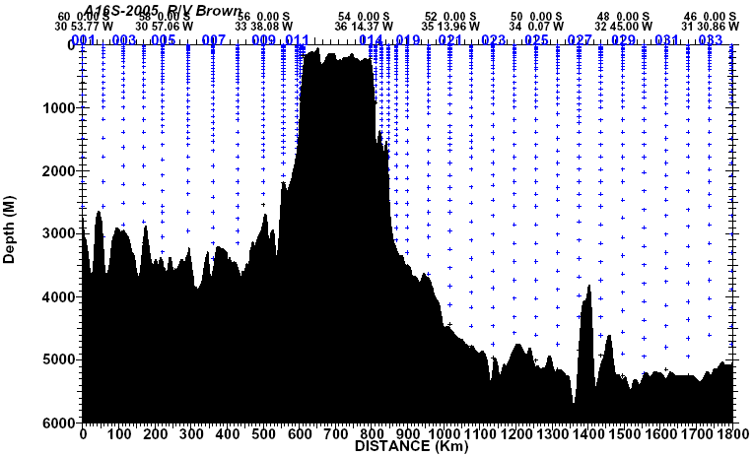
The basic CTD/hydrographic measurements consisted of salinity, dissolved oxygen, and nutrient measurements made from water samples taken on CTD/rosette casts, plus pressure, temperature, salinity, dissolved oxygen, and transmissometer from CTD profiles. A total of 125 CTD/rosette casts were made, usually to within 20 m of the bottom. No major problems were encountered during the operation. The distribution of samples is illustrated in Figures 1.0-1.3.

Figure 1.0. Sample distribution, stations 1-34.

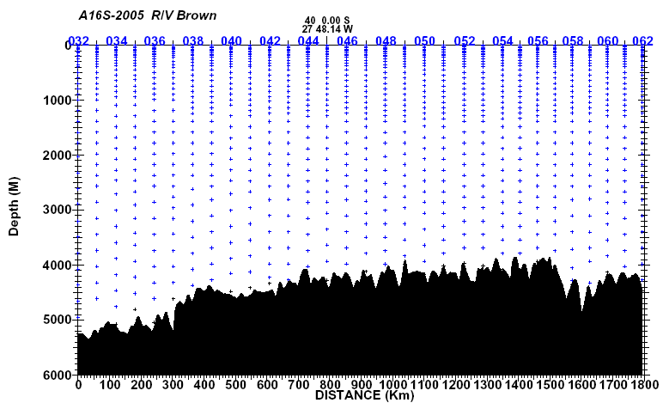

Figure 1.1. Sample distribution, stations 32-62.
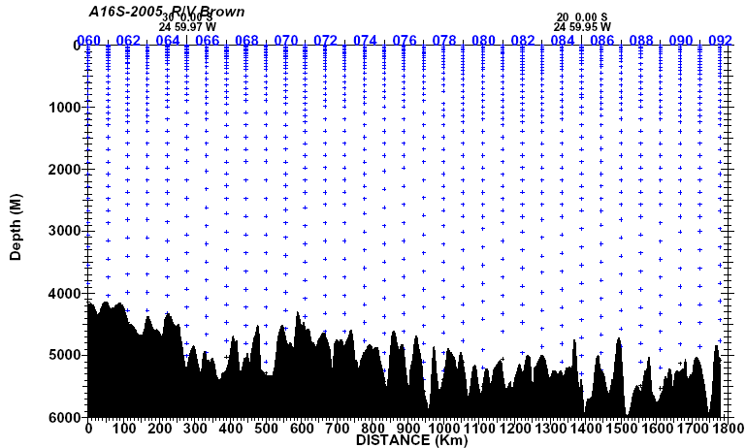

Figure 1.2. Sample distribution, stations 60-92.

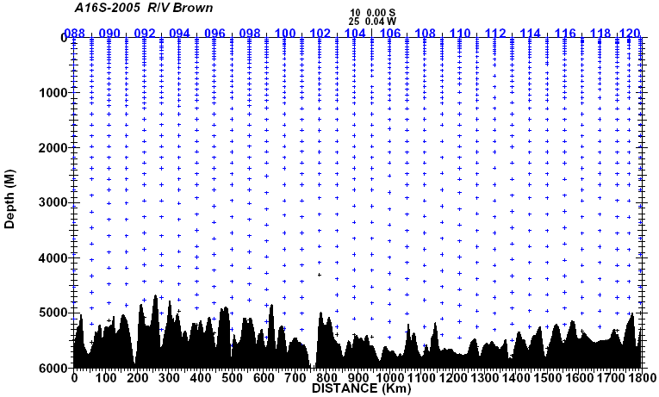

Figure 1.3. Sample distribution, stations 88-121.
1.1. Water Sampling Package
LADCP/CTD/rosette casts were performed with a package consisting of a 36-place, 12-liter rosette frame (PMEL), a 36-place pylon (SBE32) and 36, 12-liter Bullister bottles. This package was deployed on station/casts 5/2-121/1. A smaller 24-place 3-liter foul weather rosette package was deployed on station/casts 1/1-5/1. Underwater electronic components consisted of a Sea-Bird Electronics (SBE) 9 plus CTD with dual pumps and the following sensors: dual temperature (SBE3), dual conductivity (SBE4), dissolved oxygen (SBE43), transmissometer (Wetlabs SeaStar), turbidity (Seapoint Sensors), and PIC (Wetlabs). The other Underwater electronic components consisted of RDI LADCPs, a Simrad or Benthos altimeter, an AM Cells load cell, and a Benthos pinger.
The CTD was mounted vertically in an SBE CTD cage attached to the bottom center of the rosette frame. All SBE4 conductivity and SBE3 temperature sensors and their respective pumps were mounted vertically as recommended by SBE. Pump exhausts were attached to outside corners of the CTD cage and directed downward. The altimeter was mounted on the inside of a support strut adjacent to the bottom frame ring. The transmissometer, turbidity and PIC sensors were mounted horizontally on a fiberglass grid attached off center to the rosette frame adjacent to the CTD. The LADCPs were vertically mounted inside the bottle rings with one set of transducers pointing down, the other up.
The rosette system was suspended from a UNOLS-standard three-conductor 0.322" electro-mechanical sea cable.
The R/V Brown’s forward CTD winch was used with the 24-place 3-liter rosette for station/casts 1/1-5/1. The aft CTD winch was used with the 36-place 12-liter rosette for the remaining station/casts (5/2-121/2).
A single Sea cable termination for each winch served the entire leg. Station/cast 5/1 was aborted due to problems with the forward winch that required lowering the package back to the bottom (~1000 m) after bottles had been tripped. The decision was made to switch to the aft winch, the 36-place12-liter package and CTD #315 for station/cast 5/2. Station/cast 51/1 was aborted when the CTD signal was abruptly lost at 1274 decibars on the down cast. The problem was later traced to the turbidity sensor, which was shorting out the CTD #315 auxiliary power supply. Station/cast 51/2 was made with CTD #209 (installed in the 36-place rosette) which was used for all subsequent casts.
The deck watch prepared the rosette within 40 minutes prior to each cast. All valves, vents, and lanyards were checked for proper orientation. The bottles were cocked and all hardware and connections rechecked. Once stopped on station, the LADCP was turned on and syringes were removed from the CTD sensor intake ports. As directed by the deck watch leader, the CTD was powered-up and the data acquisition system started. Two stabilizing taglines were threaded through rings on the rosette frame. The deck watch leader directed the winch operator to raise the package, the squirt boom and rosette were extended outboard, and the package quickly lowered into the water. The tag lines were removed and the package was lowered to 10 m. The CTD console operator waited for the CTD sensor pumps to turn on, waited an additional 60 seconds for sensors to stabilize, then directed the winch operator to bring the package close to the surface, pause for typically 10 seconds, and begin the descent.
Descent speeds were 30 m/min to 50m, 45 m/min to 200m, and 60 m/min beyond 200m. Each rosette cast was usually lowered to within 20 m of the bottom, using the altimeter and pinger to determine a safe distance.
On the up cast, the winch operator was directed to stop at each bottle trip depth. The CTD console operator waited 30 seconds before tripping a bottle, then an additional 10 seconds after receiving the trip confirmation before directing the winch to proceed to the next bottle stop.
Standard sampling depths were used throughout A16S 2005, depending on the overall water depth. The standard depths were staggered every other pair of stations.
Recovering the package at the end of the deployment was essentially the reverse of launching, with the additional use of poles and snap-hooks to attach tag lines for added safety and stability. The rosette was left on deck for sampling. The bottles and rosette were examined before samples were taken, and anything unusual noted on the sample log.
Each bottle on the rosette had a unique serial number. This bottle identification was maintained independently of the bottle position on the rosette, which was used for sample identification. Nine bottles were replaced on this leg, and parts of others were replaced or repaired.
Routine CTD maintenance included soaking the conductivity and DO sensors in a solution of Triton-X as recommended by Sea-Bird between casts to maintain sensor stability. Rosette maintenance was performed on a regular basis. O-rings were changed as necessary and bottle maintenance was performed each day to insure proper closure and sealing. Valves were inspected for leaks and repaired or replaced as needed.
1.2. Underwater Electronics Packages
CTD data were collected with SBE9plus CTDs (PMEL #315 and #209). These instruments provided pressure, dual temperature (SBE3), dual conductivity (SBE4), dissolved oxygen (SBE43), transmissometer (Wetlabs SeaStar), turbidity (Seapoint Sensors), PIC (Wetlabs), load cell (AM Cells), and altimeter (Benthos/Simrad 807) channels (Table 1.3). The CTDs supplied a standard Sea-Bird format data stream at a data rate of 24 frames/second.
The CTD was outfitted with dual pumps. Primary temperature, conductivity, and dissolved oxygen were plumbed on one pump circuit and secondary temperature and conductivity on the other. The sensors were deployed vertically. The primary temperature and conductivity sensors (T1 #4193, C1 #2882 sation/casts 1/1-5/1, 51/2-120/1; T1 #4341, C1 #2887 station/casts 5/2-51/1; and T1 #4193, C1 #0354 station/casts 121/1) were used for reported CTD temperatures and conductivities on all casts. The secondary temperature and conductivity sensors were used for calibration checks.
The SBE9plus CTD was connected to the SBE32 36-place pylon providing for single-conductor sea cable operation. Power to the SBE9plus CTD (and sensors), SBE32 pylon, auxiliary sensors, and altimeter was provided through the sea cable from the SBE11plus deck unit in the computer lab.
1.3. Navigation and Bathymetry Data Acquisition
Navigation data were acquired by the database workstation at 1-second intervals from the ship’s Trimble PCODE GPS receiver beginning January 11. Although the ship had a Seabeam multibeam system functioning during the cruise and displaying center beam depth, the data were not available to other computers on the ship. The A16S bathymetry data were synthesized from ETOPO₂ data along the cruise track and used for preliminary vertical sections, maps and estimated bottom depths.

Table 1.3. A16S 2005 rosette underwater electronics.
Item | Serial Number (station/cast used)
Sea-Bird SBE32 36-place Carousel Water Sampler
Sea-Bird SBE9plus CTD | PMEL #315
Sea-Bird SBE9plus CTD | PMEL #209
Paroscientific Digiquartz Pressure Sensor | S/N 53960 (5/2-51/1)
Paroscientific Digiquartz Pressure Sensor | S/N 53586 (1/1-5/1, 51/2-121/1)
Sea-Bird SBE3plus Temperature Sensor | S/N 03P-4193 (Primary 1/1-5/1, 51/2-121/1)
Sea-Bird SBE3plus Temperature Sensor | S/N 03P-4335 (Secondary 1/1-5/1,51/2-121/1)
Sea-Bird SBE3plus Temperature Sensor | S/N 03P-4341 (Primary 5/2-51/1)
Sea-Bird SBE3plus Temperature Sensor | S/N 03P-1370 (Secondary 5/2-51/1)
Sea-Bird SBE4C Conductivity Sensor | S/N 04-2882 (Primary 1/1-5/1, 51/2-120/1)
Sea-Bird SBE4C Conductivity Sensor | S/N 04-2882 (Secondary 121/1)
Sea-Bird SBE4C Conductivity Sensor | S/N 04-1434 (Secondary 1/1-5/1, 51/2-58/1)
Sea-Bird SBE4C Conductivity Sensor | S/N 04-2887 (Primary 5/2-51/1)
Sea-Bird SBE4C Conductivity Sensor | S/N 04-0354 (Secondary 5/2-51/1, 59/1-120/1)
Sea-Bird SBE4C Conductivity Sensor | S/N 04-0354 (Primary 121/1)
Sea-Bird SBE43 DO Sensor | S/N 43-0312 (1/1-5/1, 51/2-121/1)
Sea-Bird SBE43 DO Sensor | S/N 43-0664 (5/2-51/1)
Wetlabs SeaStar Transmissometer | S/N CST-391DR
Seapoint Sensors OBS Turbidity Sensor | S/N 10366
Wetlabs PIC Sensor | S/N PIC001
Benthos Altimeter | S/N 1035
Simrad 807 Altimeter | S/N 92010101 (AOML)
AM Cell (Load Cell) | S/N 1109
RDI LADCP | S/N 299 (5/1-10/1, 36/1-63/1, 82/1)
RDI LADCP | S/N 149 (10/1-35/1, 64/1-81/1, 83/1-121/1)
LADCP Battery Pack
1.4. Real-Time CTD Data Acquisition System
The CTD data acquisition system consisted of an SBE-11plus (V1) deck unit and a networked generic PC workstation running Windows 2000. SBE Seasave software was used for data acquisition and to close bottles on the rosette.
CTD deployments were initiated by the console watch after the ship stopped on station. The watch maintained a console operations log containing a description of each deployment, a record of every attempt to close a bottle and any pertinent comments.
Once the deck watch had deployed the rosette, the winch operator would lower it to 10 m. The CTD sensor pumps were configured with a 60 second startup delay. The console operator checked the CTD data for proper sensor operation, waited an additional 60 seconds for sensors to stabilize, then instructed the winch operator to bring the package to the surface, pause for 10 seconds, and descend to a target depth. The profiling rate was no more than 30 m/min to 50 m, no more than 45 m/min to 200 m, and no more than 60 m/min deeper than 200 m depending on sea cable tension and the sea state.
The console watch monitored the progress of the deployment and quality of the CTD data through interactive graphics and operational displays. Additionally, the watch created a sample log for the deployment which would be later used to record the correspondence between rosette bottles and analytical samples taken. The altimeter channel, CTD pressure, wire-out and bathymetric depth were all monitored to determine the distance of the package from the bottom, usually allowing a safe approach to within 20 m.
Bottles were closed on the up cast by operating a “point and click” graphical trip button. The data acquisition system responded with trip confirmation messages and the corresponding CTD data in a rosette bottle trip window on the display. All tripping attempts were noted on the console log. The console watch then directed the winch operator to raise the package up to the next bottle trip location.
After the last bottle was tripped, the console watch directed the deck watch to bring the rosette on deck. Once on deck, the console watch terminated the data acquisition, turned off the deck unit, and assisted with rosette sampling.
1.5. Shipboard CTD Data Processing
Shipboard CTD data processing was performed automatically at the end of each deployment using SIO/ODF CTD processing software. The raw CTD data and bottle trips acquired by SBE Seasave on the Windows 2000 workstation were copied onto the Linux database and webserver workstation, then processed to a 0.5 second time series. Bottle trip values were extracted and a 2-decibar (dbar) down cast pressure series created. This pressure series was used by the web service for interactive plots, sections, and CTD data distribution (the 0.5 second time series was also available for distribution). During and after the deployment the data were redundantly backed up to another Linux workstation and a Windows workstation.
CTD data were examined at the completion of each deployment for clean corrected sensor response and any calibration shifts. As bottle salinity and oxygen results became available, they were used to refine shipboard conductivity and oxygen sensor calibrations.
A total of 125 casts were made (including 1 test cast and 2 aborted casts). The 24-place 3-liter rosette and CTD #209 was used on station/casts 1/1-5/1, the 36-place 12-liter rosette and CTD #315 was used on station/casts 5/2-51/1, and the 36-place 12-liter rosette and CTD #209 was used on station/casts 51/2-121/1.

1.6. CTD Laboratory Calibration
Laboratory calibrations of the CTD pressure, temperature, and conductivity sensors were all performed at SBE. The calibration dates are listed in Table 1.4.
Table 1.4. A16S 2005 CTD sensor calibration dates.
Sensor | Serial Number | Pre-Cruise  Calibration Date | Post-Cruise  Calibration Date
Paroscientific Digiquartz Pressure | 53960 | 23-Sep-03 | 25-May-05
Paroscientific Digiquartz Pressure | 53586 | 17-Aug-00 | Not calibrated
Sea-Bird SBE3plus Temperature | 03P-4193 | 30-Nov-04 | 13-Apr-05
Sea-Bird SBE3plus Temperature | 03P-4335 | 30-Nov-04 | 13-Apr-05
Sea-Bird SBE3plus Temperature | 03P-4341 | 30-Nov-04 | 13-Apr-05
Sea-Bird SBE3 Temperature | 03-1370 | 23-Jul-04 | 13-Apr-05
Sea-Bird SBE4C Conductivity | 04-2882 | 15-Dec-04 | 12-Apr-05
Sea-Bird SBE4C Conductivity | 04-1434 | 30-Nov-04 | Not calibrated
Sea-Bird SBE4C Conductivity | 04-2887 | 30-Nov-04 | 12-Apr-05
Sea-Bird SBE4C Conductivity | 04-0354 | 30-Nov-04 | 12-Apr-05
1.7. Shipboard CTD Calibration Procedures
Two CTDs (PMEL #315 and #209) were used on this leg, for a total of four distinct pressure, temperature and conductivity sensor configurations (Table 1.5).
Table 1.5. A16S 2005 sensor configurations.
Configuration | CTD | T1 | C1 | T2 | C2 | Station/Cast
1 | 0209 | 4193 | 2882 | 4335 | 1434 | 1/1-5/1, 51/2-58/1
2 | 0315 | 4341 | 2887 | 1370 | 0354 | 5/2-51/1
3 | 0209 | 4193 | 2882 | 4335 | 0354 | 59/1-120/1
4 | 0209 | 4193 | 0354 | 4335 | 2882 | 121/1
Each CTD was deployed with all sensors and pumps aligned vertically, as recommended by SBE. CTD #209 was initially configured in the small 24-place 3-liter rosette and was used for the first five stations because of sea conditions. CTD #315 was configured in the 36-place 12-liter rosette and was used on station/casts 5/2-51/1. CTD #209 was installed in the 36-place rosette prior to 51/2 and was used for all subsequent station/casts (51/2-121/1). Secondary temperature and conductivity (T2 and C2) sensors served as calibration checks for the reported primary temperature and conductivity (T1 and C1) on all casts. In-situ salinity and dissolved O₂ check samples collected during each cast were used to calibrate the conductivity and dissolved O₂ sensors.

1.7.1. CTD Pressure
Pressure sensor calibration coefficients derived from the pre-cruise calibrations were applied to raw pressure data during each cast. Residual pressure offsets (the difference between the first and last submerged pressures) were examined to check for calibration shifts. All were <0.5 db, and both sensors exhibited <0.5 db offset shift over their periods of use. No additional adjustments were made to the calculated pressures.

1.7.2. CTD Temperature
Temperature sensor calibration coefficients derived from the pre-cruise calibrations were applied to raw primary and secondary temperature data during each cast.
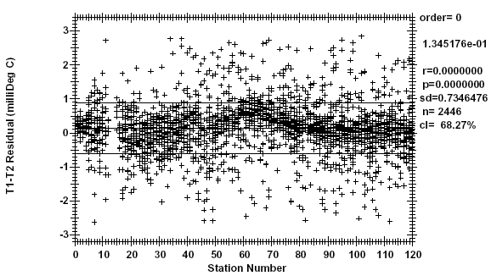
Calibration accuracy was examined by tabulating T1-T2 over a range of pressures (bottle trip locations) for each cast. These comparisons are summarized in Figure 1.4.
Figure 1.4. T1-T2 by station, p > 500 db.
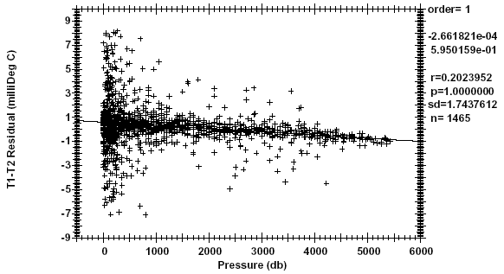
CTD configurations 1, 3, and 4 (CTD #209, station/casts 1/1-5/1,51/2-121/1) exhibit a deep relative calibration error of 0.0008°C at station/cast 59/1, drifting to 0.0002°C by station/cast 85/1 and stabilizing. CTD configuration #2 (CTD #315, station/casts 5/2-50/1) exhibits a relative error of -0.0008°C at station/cast 20/1 and drifts to +0.0004°C by station/cast 50/1. Configuration #2 also shows a T1-T2 pressure response of -2.7e-7°C/db as shown in Figure 1.5.
Figure 1.5. T1-T2 by pressure, station/casts 5/2-50/1.
It is likely that all three temperature sensors used on A16S 2005 exhibited some calibration drift. Although the mean deep T1-T2 for the leg is close to 0, it should not be interpreted as a reliable metric of temperature calibration accuracy.

1.7.3. CTD Conductivity
Conductivity sensor calibration coefficients derived from the pre-cruise calibrations were applied to raw primary and secondary conductivities.
Comparisons between the primary and secondary sensors and between each of the sensors to check sample conductivities (conductivity calculated from bottle salinities) were used to derive conductivity corrections. These corrections were determined for three distinct groupings of station/casts, corresponding to the T1/C1 sensor pair used. Although 1/1-5/1 used the same T1/C1 as 51/2-120/1, it was treated as a separate grouping because of the amount of time between 5/1 and 51/2. 121/1 was a 1-cast grouping in which C1 and C2 were swapped (T1C2, T2C1) in an attempt to resolve the source of a .0007 salinity offset in T1/C1 observed between the down and up casts.
Uncorrected C1-C2 and bottle C-C1 were first examined to identify sensor drift (Figures 1.6 and 1.7).
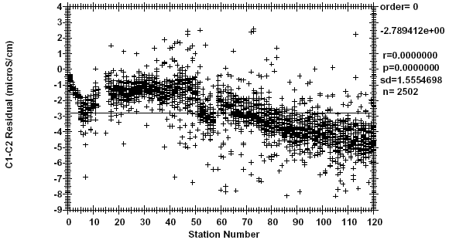
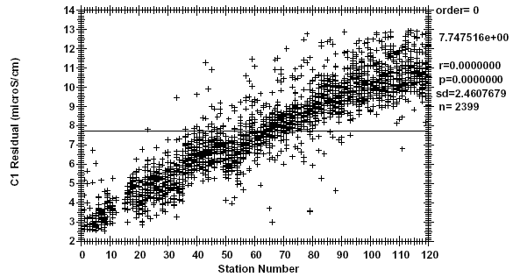
Figure 1.6. Uncorrected C1-C2 by station, p > 500db.

Figure 1.7. Uncorrected bottle C-C1 by station, p > 500db.

C1 offset corrections were determined to account for drift over time. After applying the drift corrections, the residuals were examined to determine conductivity slope and pressure response corrections. Figures 1.8-1.11 show the residuals after applying all corrections.

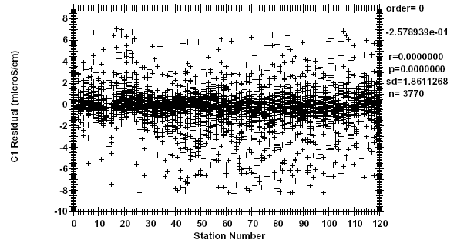
Figure 1.8. Corrected bottle C-C1 by station, all pressures.
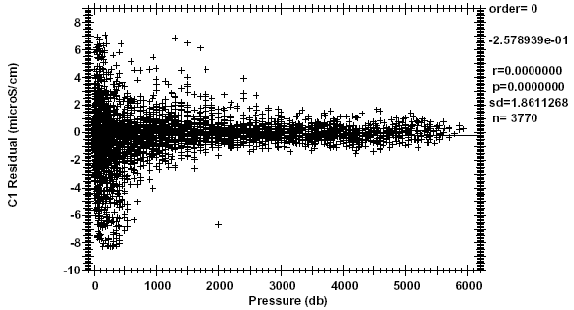
Figure 1.9. Corrected bottle C-C1 by pressure, all pressures.
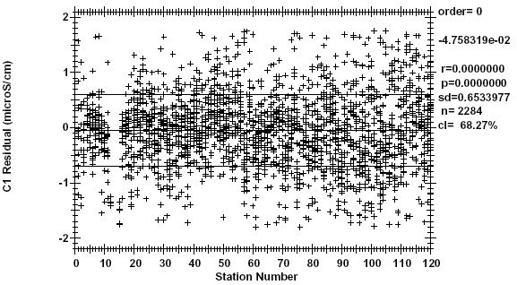
Figure 1.10. Corrected bottle C-C1 by station, p > 500 db.
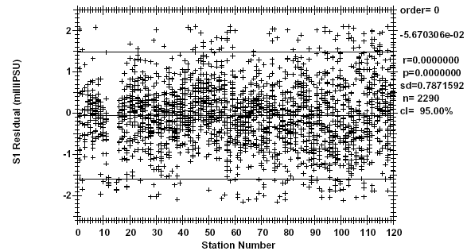
Figure 1.11. Salinity residual by station, p > 500 db.
Figure 1.11 represents an estimate of the salinity accuracy on A16S 2005. The 95% confidence limit is ±0.0015.

1.7.4. CTD Dissolved Oxygen
Two SBE43 dissolved O₂ (DO) sensors were used on this leg; S/N 43-0312 on station/casts 1/1-5/1, 51/2-121/1 and S/N 43-0664 on 5/2-50/1. Both sensors behaved well, the only problems occurring on station/casts 105/1-107/1 when some particulate material clogged the primary pump circuit relief valve. This problem affected the top 50 db of the down casts.
The DO sensors were calibrated to dissolved O₂ check samples by matching the up cast bottle trips to down cast CTD data along isopycnal surfaces, calculating CTD dissolved O₂, and then minimizing the residuals using a non-linear least-squares fitting procedure. The fitting determined calibration coefficients for the sensor model conversion equation and proceeded in a series of steps. Each sensor was fit in a separate sequence. The first step was to determine the time constants for the exponential terms in the model. These time constants are sensor-specific but applicable to an entire cruise. Once the time constants had been determined, casts were fit individually to O₂ check sample data. The resulting calibration coefficients were then smoothed and held constant during a refit to determine sensor slope and offset. The residuals are shown in Figures 1.12-1.14.
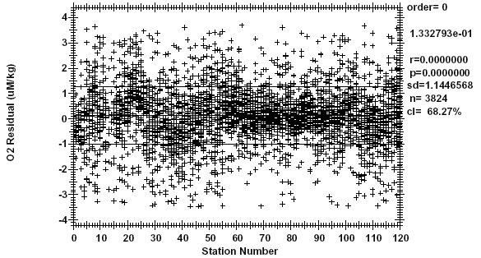
Figure 1.12. O₂ residuals by station, all pressures.
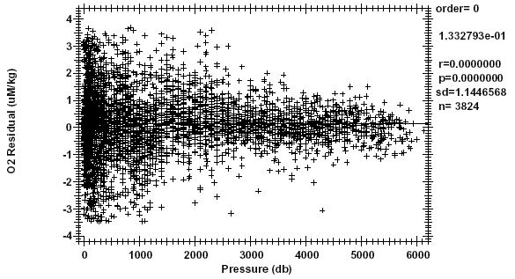
Figure 1.13. O₂ residuals by pressure, all pressures.

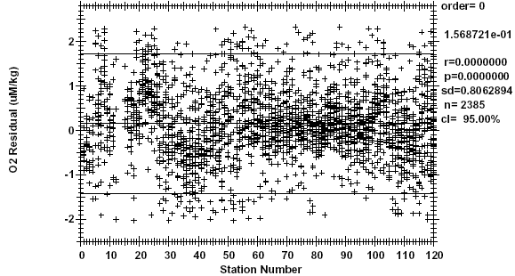
Figure 1.14. O₂ residuals by station number, p > 500 db.
The standard deviations of 1.14 µM/kg for all oxygens and 0.81 µM/kg for deep oxygens are presented as metrics of variability between up cast and down cast dissolved O₂. We make no claims regarding the precision or accuracy of CTD dissolved O₂ data.
The general form of the SIO/ODF O₂ conversion equation for Clark cells follows Brown and Morrison (1978) Millard (1982), and Owens and Millard (1985). ODF models membrane and sensor temperatures with lagged CTD temperatures and a lagged thermal gradient. In-situ pressure and temperature are filtered to match the sensor response. Time-constants for the pressure response, Taup, two temperature responses, TauTs and TauTf, and thermal gradient response, TaudT, are fitting parameters. The thermal gradient term is derived by low-pass filtering the difference between the fast response (Tf) and slow response (Ts) temperatures. This term is SBE43-specific and corrects a non- linearity introduced by analog thermal compensation in the sensor. The Oc gradient, dOc/dt, is approximated by low-pass filtering first-order Oc differences. This gradient term attempts to correct for reduction of species other than O₂ at the sensor cathode. The time-constant for this filter, Tauog, is a fitting parameter. The dissolved O₂ concentration is then calculated:

O₂ ml/l = [c1*Oc+c2.]*fsat(S,T,P)*e**(c3*Pl+c4*Tf+c5*Ts+c6*dOc/dt(1.7.4.0)
where:

O₂ ml/l = Dissolved O₂ concentration in ml/l;
Oc = Sensor current (uamps);
fsat (S,T,P) = O₂ saturation concentration at S,T,P (ml/l);
S = Salinity at O₂ response-time (PSUs);
T = Temperature at O₂ response-time (°C);
P = Pressure at O₂ response-time (decibars);
Pl = Low-pass filtered pressure (decibars);
Tf = Fast low-pass filtered temperature (°C);
Ts = Slow low-pass filtered temperature (°C);
dOc/dt = Sensor current gradient (uamps/secs);
dT = low-pass filtered thermal gradient (Tf - Ts).
1.8. Final CTD Data Processing
The reduction of profile data began with a standard suite of processing modules using Sea-Bird Data Processing Win32 version 5.32 software in the following order:
DATCNV converts raw data into engineering units and creates a .ROS bottle file. Both down and up casts were processed for scan, elapsed time(s), pressure, t0, t1, c0, c1, and oxygen voltage. Optical sensor data were not carried through the processing stream. MARKSCAN was used to determine the number of scans acquired on deck and while priming the system to exclude these scans from processing.
ALIGNCTD aligns temperature, conductivity, and oxygen measurements in time relative to pressure to ensure that derived parameters are made using measurements from the same parcel of water. Primary conductivity is automatically advanced in the deck unit by 0.073 seconds. No additional alignment was necessary for either of the primary conductivity sensors. As for the secondary conductivity sensors used during this cruise, s/n 354 associated with CTD 315 was advanced 0.068 seconds in ALIGNCTD, and s/n 1434 associated with CTD 209 was advanced 0.056 seconds. It was not necessary to align temperature or oxygen.
ROSSUM averages bottle data over an 8-second interval and derives salinity, theta, sigma-theta, and oxygen (µmol/kg). Averaging began at the bottle confirm bit for casts 0011-0251, and from 4 seconds before the confirm bit to 4 seconds after the confirm bit for casts 0261-1211.
WILDEDIT computes the standard deviation of 100 point bins, and then makes two passes through the data. The first pass flags points that differ from the mean by more than 2 standard deviations. A new standard deviation is computed excluding the flagged points and the second pass marks bad values greater than 20 standard deviations from the mean. For this data set, data were kept within a distance of 100 of the mean (i.e., all data).

FILTER applies a low pass filter to pressure with a time constant of 0.15 seconds. In order to produce zero phase (no time shift), the filter is first run forward through the file and then run backwards through the file.
CELLTM uses a recursive filter to remove conductivity cell thermal mass effects from measured conductivity. In areas with steep temperature gradients the thermal mass correction is on the order of 0.005 PSS-78. In other areas the correction is negligible. The value used for the thermal anomaly amplitude (alpha) was 0.03°C. The value used for the thermal anomaly time constant (1/beta) was 7.0°C.
LOOPEDIT removes scans associated with pressure slowdowns and reversals. If the CTD velocity is less than 0.25 m/s or the pressure is not greater than the previous maximum scan, the scan is omitted.
BINAVG averages the data into 1 dbar bins. Each bin is centered on an integer pressure value, e.g., the 1 dbar bin averages scans where pressure is between 0.5 dbar and 1.5 dbar. There is no surface bin. The number of points averaged in each bin is included in the data file.
DERIVE uses 1 dbar averaged pressure, temperature, and conductivity to compute primary and secondary salinities.
TRANS converts the binary data file into ASCII format.
Package slowdowns and reversals owing to ship roll can move mixed water in tow to in front of the CTD sensors and create artificial density inversions and other artifacts. In addition to Seasoft module LOOPEDIT, a PMEL program computes values of density locally referenced between every 1 dbar of pressure to compute N² and linearly interpolates temperature, conductivity, and oxygen voltage over those records where N² is less than or equal to -1 10⁻⁵ per s². During this cruise it was noted that 19 profiles failed the criteria in the top 10 meters. These data were retained but flagged as questionable in the final WOCE formatted files.
Final calibrations are applied to delooped data files. ITS-90 temperature, salinity, and oxygen are computed, and WOCE quality flags are created. ASCII files are converted WOCE format for submission to the CLIVAR and Carbon Hydrographic Data Office (CCHDO).
During casts 105/1-107/1, the air-bleed hole in the plumbing of the primary sensors was blocked, resulting in low surface salinities and oxygen spikes as deep as 53 dbar. Low salinities were flagged as bad and slightly low salinities were flagged as questionable.
1.9. Final CTD Calibration Procedures
1.9.1. CTD Pressure
Pressure calibrations for both CTD instruments used during this cruise are pre-cruise. On deck pressure readings prior to each cast were examined and remained within 1 dbar of calibration. Differences between first and last submerged pressures for each cast were also examined and the residuals for both sensors shifted <0.5 dbar over their periods of use. So no additional adjustments were applied.
1.9.2. CTD Temperature
Using pre- and post-cruise laboratory calibrations, a linearly interpolated drift correction at the midpoint of the cruise was applied to each sensor. For temperature sensor s/n 4193 used for station/casts 1/1-5/1 and 51/2-120/1, this correction is 0.00024°C. For temperature sensor s/n 4341 used for station/casts 5/2-51/1, this correction is 0.00038°C. And for temperature sensor s/n 4335 used for cast 121/1, this correction is 0.00032°C. Also, a uniform correction was applied to all sensors for heating of the thermistor owing to viscous effects. Thermistors are biased high by this effect and were adjusted down by 0.0006°C. This adjustment results in errors of no more than ±0.00015°C from this effect for the full range of oceanographic temperature and salinity.
1.9.3. CTD Conductivity
CTD conductivity are calibrated against bottle salinity data assuming a constant additive correction (bias), a station-dependent multiplicative correction (slope), and where needed, a linear pressure-dependent term. PMEL FORTRAN programs combine individual ROSSUM bottle files into one listing for each conductivity sensor. Sample salinities flagged as “good” are matched to CTD salinities by station/sample number. MATLAB functions CALCOSn are used to determine the best fit of CTD and bottle data, where n is the order of the station-dependent linear or polynomial fit. CALCOSn recursively throws out data greater than 2.8 standard deviations. CALCOSn returns a single conductivity bias and a conductivity slope for each station. A station-dependent slope coefficient best models the gradual shift in the conductivity sensor with time. CALCOPn additionally returns a linear pressure term (modified beta) that is multiplied by CTD pressure and added to conductivity.
For conductivity sensor s/n 2882 used for station/casts 1/1-5/1 and 51/2-121/1, the best results are an overall, second-order, station-dependent fit with a linear pressure correction. About 82% of the 2509 points (2052 points) used in the fit produced a standard deviation of 0.0010 PSS-78. The bias is 0.0018644 mS/cm, the pressure correction is -3.4731617 10⁻⁸ mS/cm/dbar, and the slope coefficients range from 1.0000184-1.0002895. For conductivity sensor s/n 2887 used for station/cast 5/2-051/1, the best results are an overall, linear, station-dependent fit with a linear pressure correction. About 85% of the 1525 points (1302 points) used in the fit produce a standard deviation of 0.0008 PSS-78. The bias is 0.0071032 mS/cm, the pressure correction is -3.3595083 10⁻⁷ mS/cm/dbar, and the slope coefficients range from 0.9998770-1.0000159.
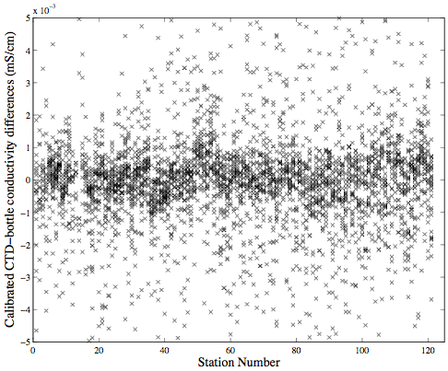
CTD-bottle conductivity differences plotted against station number and pressure (Figures 1.15-1.16) are used to verify the success of the fit parameters. Matlab routines apply post-cruise calibrations to temperature and conductivity, and compute final salinity values.
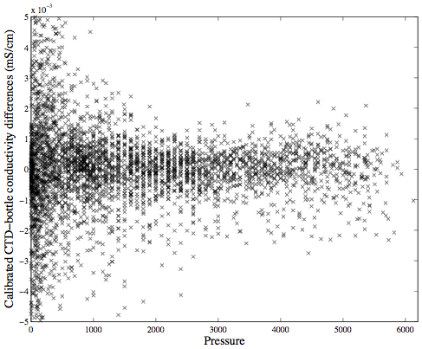
Figure 1.15. Calibrated CTD-bottle conductivity differences plotted against station number.
Figure 1.16. Calibrated CTD-bottle conductivity differences plotted against pressure.
1.9.4. CTD Dissolved Oxygen
CTD oxygen sensors are modeled following the essential form of Owens and Millard (1985). Here, the equation
O₂ = (slope*Oc+bias+lag*dOc/dt)*O_{2sat}(S,T)*exp(Tcor*T+Pcor*P)
is used where O₂ is the calibrated CTD oxygen value, Oc is the reported oxygen current, dOc/dt is its time derivative (smoothed with a 15-dbar hanning filter), and O_{2sat} is the oxygen saturation (Benson and Krause, 1984). CTD temperature, pressure, and salinity are used for T, P, and S. The parameters of slope, bias, lag, Tcor, and Pcor are solved by nonlinear least squares regression of matched bottle oxygen and CTD downcast data, recursively discarding 2.8 standard deviation outliers.
Significant hysteresis between the down and up oxygen profiles at deep stations warrant using the downcast oxygen data for calibration. PMEL FORTRAN programs combine individual ROSSUM bottle files into one listing for each oxygen sensor. Sample oxygen flagged as good (2 or 6) are matched to CTD oxygen by station/sample number. Upcast bottle data are matched to downcast profile data by locally referenced potential densities using MATLAB routine MATCH_SG_N_nnn, where nnn is the oxygen sensor serial number. If interpolated bottle pressures were more than 50 dbar from matched downcast pressures, then matching was redone using pressure instead of density in MATCH_SG_N_nnn. Calibration coefficients are determined using function RUN_OXYGEN_CAL_1. The best results are from a least-squares fit with a linear station-dependent slope (Table 1.6).
Table 1.6. Final oxygen calibration coefficients.
Station | Slope Range | Bias | Lag | Tcor | Pcor | Points Used | Std Dev
1-4 | 0.3477-0.3481 | -0.5814 | 8.2167 | -0.0001 | 0.0001 | 85 88.2% | 0.7401
5-20 | 0.4350-0.4375 | -0.5047 | 4.3258 | 0.0015 | 0.0001 | 464 80.17% | 0.8677
21-34 | 0.4373-0.4426 | -0.5016 | 3.8727 | 0.0008 | 0.0001 | 489 85.5% | 1.1244
35-50 | 0.4423-0.4434 | -0.5036 | 4.3414 | 0.0007 | 0.0001 | 566 86.4% | 0.6828
51-65 | 0.3423-0.3440 | -0.5718 | 7.2016 | 0.0015 | 0.0001 | 535 92.0% | 0.6009
66-89 | 0.3467-0.3499 | -0.5787 | 7.5763 | 0.0013 | 0.0001 | 843 97.0% | 0.7276
90-99 | 0.3517-0.3521 | -0.5841 | 7.1488 | 0.0011 | 0.0001 | 359 93.6% | 0.5822
100-121 | 0.3518-0.3521 | -0.5777 | 5.5720 | 0.0010 | 0.0001 | 774 88.4% | 0.6449
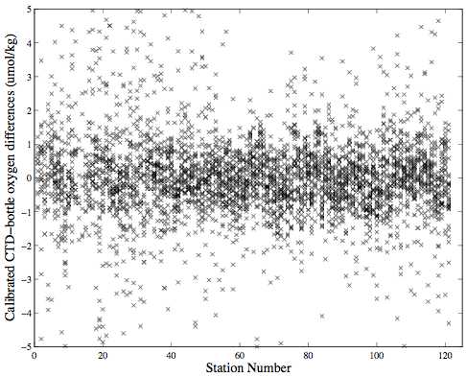
CTD-bottle oxygen differences plotted against station number and pressure show the stability of the calibrated CTD oxygens relative to the bottle oxygens (Figures 1.17-1.18). Matlab routines apply oxygen calibration coefficients to profile and bottle data and compute final oxygen values in µmol/kg.
Figure 1.17. Calibrated CTD-bottle oxygen differences plotted against station number.
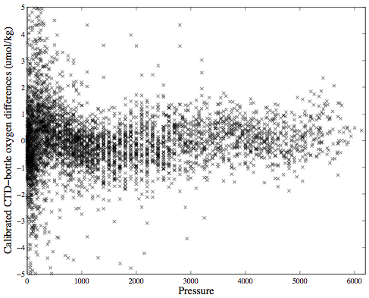
Figure 1.18. Calibrated CTD-bottle oxygen differences plotted against pressure.
References
Benson, B.B., and D. Krause, 1984: The concentration and isotopic fractionation of oxygen dissolved in freshwater and seawater in equilibrium with the atmosphere. Limnol. Oceanogr., v. 29, pp. 620-632.
Brown, N.L., and G.K. Morrison, 1978: WHOI/Brown conductivity, temperature, and depth microprofiler. Woods Hole Oceanographic Institution, Technical Report No. 78-23.
Joyce, T., and C. Corry (eds.), 1994: Requirements for WOCE Hydrographic Programme data reporting. WOCE Hydrographic Programme Office, Woods Hole, MA, USA (May 1994, Rev. 2), Report WHPO 90-1, WOCE Report No. 67/91, pp. 52-55.
Millard, R.C., Jr., 1982: CTD calibration and data processing techniques at WHOI using the practical salinity scale. Proceedings, International STD Conference and Workshop, Marine Technical Society, La Jolla, CA, p. 19.
Owens, W.B., and R.C. Millard, 1985: A new algorithm for CTD oxygen calibration. J. Phys. Oceanogr., v. 15, no. 5, pp. 621-631.

1.10. Particulate Optical Sensors on CTD Package
Principal Investigator: Jim Bishop, LBNL, JKBishop@lbl.gov
On board personnel: Alexandra Thompson, LBNL, alex@nature.berkeley.edu
Equipment:
- Seastar transmissometer (Wetlabs SN: CST-391DR): Detects mainly particulate organic carbon
- PIC equipped with open flow cell (Wetlabs SN: PIC-001): Detects particulate inorganic carbon
- Seapoint (Seapoint): Measures turbidity
Data Collection:
1. The Seastar collected data every cast apart from:
- Stations 1-5/1: due to deployment of small CTD
- Stations 52-57: due to CTD failure and until problem identified
- Total casts: 112 (including test cast)
- Seawater data not available for station 101 when deployed with beam blocked for calibration.
2. The PIC collected data every cast apart from:
- Stations 1-5/1: due to deployment of small CTD
- Stations 52-57: due to CTD failure and until problem identified
- Stations 84-104: due to inconsistent calibration caused by faulty filter holder and then because cabling issues delayed its redeployment.
- Total casts: 91 (including test cast)
- Seawater data not available for station 111 when deployed with beam blocked, and stations 117 and 121 when deployed with filtered beam (4.3 OD) for calibration.
3. The Seapoint collected data on the following casts:
- Stations: Test, 4 (up only), 6 - 20, 21 (up only), 22 - 24, 25 (down only).
- Total casts: 18 (up and down), 3 (up or down)
Calibration:
The Seastar and PIC sensors were calibrated 20 times over the course of the cruise, and the Seapoint 7 times. Calibrations were carried out in air while mounted on the CTD and in the lab using an alternate power supply. The Seastar and Seapoint sensors were calibrated using end points: the signal in air and with a blocked beam. The PIC sensor is calibrated by determining the signal when the beam is subjected to a series of optical density (OD) filters (4.3 OD, 4.6 OD, 4.9 OD, and 5.2 OD, flow cell removed) and when it is completely blocked. The signal through the flow cell in air was also recorded. These calibrations were carried out from 0°C to 25°C.
In order to probe in-situ temperature dependence and response times during casts, the Seastar and PIC were deployed on casts with the beam blocked and, in the case of the PIC, with a 4.3 OD filter in the beam.
Problems:
- The Seapoint began to show an erratic behavior on the downcast of station 21 at >3600 db. The signal returned to normal until the upcast of station 25 when again the sensor produced unreasonable signals and continued to do so until failing completely at station 27. The failure coincides with the first deployments to pressures above ~5000 db. The Seapoint was not removed from the CTD package until the CTD failed at station 52.
- The flow cell of the PIC at cold temperatures can be subject to torque. Torturing results in increased signals, and due to warming delays, at times significant hysteresis between up and down cast data. This problem was solved by increasing the amount of allowable movement of the flow cell. To determine optimal “give,” movement of the cell was probed over the duration of the cruise: i.e., allowing varying amounts of movement in each of three dimensions at the laser or detector end of the cell. Eventually this thermal hysteresis was removed by filing away the inside of both cell mounts and loosening holding screws/adding others to allow ~2 mm up/down and in/out movement at the detector end, less at the laser end, and no movement back and forth between the laser and detector windows.
- In order to determine the in-situ temperature dependence of the PIC sensor, a special apparatus was built on the ship to hold three optical density filters in place perpendicular to the beam over the detector window during a cast while the instrument was on the CTD. However, the middle (and unseen) filter was not positioned correctly or robustly, giving inconsistent calibrations and increasingly erratic signals. This resulted in the PIC sensor being removed from the CTD for 21 stations (stations 84-104). A second filter holder was made and deployed successfully in stations 117 and 121.
- In order to redeploy the PIC sensor on the CTD package at station 105, cabling modifications needed to be made because a spare port was not available following the replacement of the altimeter on the CTD package. To have both the PIC sensor and the Seastar on the CTD package simultaneously, a Y-cable was spliced so that both sensor ends were four point (as opposed to one 4 and one 6 point). During the casts at station 105 and 106, the PIC signal dropped out for short periods and recovered. Before station 107, the cable ends were swapped between the PIC sensor and the Seastar. There were no more dropouts of PIC data. The Seastar had data dropouts on stations 115 and 119-121, indicating that this problem may have been in the Y-cable.
1.11. Lowered Acoustic-Doppler Current Profiler (LADCP)
Principal Investigator: Andreas Thurnherr
Lamont-Doherty Earth Observatory of Columbia
University (LDEO), ant@ldeo.columbia.edu
Onboard Personnel: (primary) Philip Orton, LDEO, orton@ldeo.columbia.edu
Douglas Anderson, NOAA-AOML
Additional Personnel: Bruce Huber, LDEO
Summary:
Paired upward and downward LADCPs on the CTD rosette frame collected data at every station where the primary CTD rosette frame was used (stations 5-121); no LADCP data was collected stations 1-4, where the smaller 24-bottle weather rosette was used due to high wind/sea-state conditions. Preliminary processing was completed during the cruise, using LDEO-LADCP software. A noteworthy highlight is that strong velocities associated with the Antarctic Circumpolar Current were captured very well by the LADCP system. Velocity uncertainties were low relative to resolved velocities in the southern 40% of the section but increased rapidly afterward due to low backscatter levels; the acoustic measurements of velocity rely on the presence of particles in the water column. Uncertainty levels decreased somewhat over the final ten stations, as we approached the equator. Final processing will likely lead to a slight improvement in the data quality, due primarily to the incorporation of shipboard ADCP data that helps constrain the best-fit velocity profile solution. Additional useful data from the LADCP system includes acoustic backscatter and estimates of eddy diffusivity.
Equipment:
One Workhorse Monitor broadband 300 kHz RDI Acoustic Doppler Current Profiler (ADCP) was directed upward and one directed downward on the rosette frame. Both instruments were equipped with RDI’s LADCP firmware upgrade that expands the list of available user commands. The instruments shared one battery pack, which held a stack of 36 alkaline D-cells, and batteries were changed every 5-10 stations. On-deck communication with the ADCPs was facilitated through RS-232 communications with a laptop, via a long cable leading into the main lab. Both instruments were hooked up to a 4-port RS-232 to USB converter, feeding into a Dell laptop running Linux. Communication software written by Andreas Thurnherr (utilizing bbabble and expect scripts) allowed data to be downloaded from both instruments simultaneously at full nominal speed (115 kbps).
Instruments swapouts and command-file changes are summarized in Table 1.7. The first instrument change (station 10) was motivated by perceived failure of a quality control test – the attempted matching of the down-looking instrument only solution with the up-looking instrument only solution. Later, it was discovered that the test was being executed incorrectly, and the instrument was giving comparable data to the 150 kHz shipboard ADCP (SADCP). The next instrument change (station 36) was made due to a “broken beam” warning in the LADCP software (described below), which indicates that power on the beam is low. The beam was still collecting data, and the profile appears to have been of reasonably good quality, however. The station 62 and 64 instrument changes occurred when we tested a high-power LADCP for two stations. The instrument performed poorly on the first cast, and on the second cast reported a broken beam. In this case, the beam collected almost no data, severely reducing the quality of station 63 velocity estimates. The final instrument changes occurred at stations 82-83. There, the up looking and down looking ADCPs were switched to test whether the data quality improved. The result was an apparent decrease in performance – a “bad beam” warning on ADCP S/N 299, which is less severe than a broken beam warning. The ADCPs were switched back again for the next station and no further bad beam warnings were received the rest of the cruise.
Table 1.7. Initial configuration (started at station 5) and instrument and command changes.
Station | Master | Slave | Nbins | Transformation to Earth Coordinates | 3-Beam Solutions
Initial | 299 | 754 | 25 | ADCP | ADP
10 | 149
34 |  | 150
36 | 299
49 |  |  | 20 | Laptop | None*
62 | 5089
64 | 149
82 | 299 | 149
83 | 149
101 |  |  |  | ADCP | ADCP
*No 3-beam solutions are currently computed by the software. By including 3-beam solutions, one could increase the number of samples per depth interval and possibly the data quality.
Calibration drift is not a serious problem with ADCPs, and the instruments are generally only serviced (calibrated and tank-tested) when wear and tear causes equipment malfunctions. Three of the five ADCPs utilized were serviced in recent months and the other two were likely serviced about two years ago.
Sampling:
Stations have the same numbering system as with the CTD data collection, and progress from 5 (58ºS latitude) through 121 (2º20´S). Command files were uploaded to the instruments at each station, ~10 minutes prior to rosette deployment. Sampling parameters included: bin size of 10 m, ambiguity velocity of 250 cm s⁻¹, 0 m blanking distance (but discarding the first bin of data), 1.5 seconds per 1-ping ensemble, and synchronization of the down-looking (master) and up-looking (slave) units. As shown in Table 1.6, the initial configuration called for the transformation from beam coordinates to earth coordinates within the ADCP, with 3-beam solutions enabled. This was changed at station 49, because we were examining the impact of 3-beam solutions on the frequency of warnings of velocities over 3 m s⁻¹. We found that the warnings persisted. At this point, the number of bins was also reduced from 25 to 20 because the range was never over 20 bins. The coordinate transformation and 3-beam solutions was re-enabled at station 101, because there were few scatterers in the water column and it was felt that 3-beam solutions might improve the data.
Preliminary Processing:
Data were processed using the LDEO LADCP Software, Version 8b, written in Matlab by Martin Visbeck and modified by Andreas Thurnherr. This software implements an inversion for the best possible velocity profiles estimates (Visbeck, 2002), and enables the user to incorporate two ADCPs, bottom track estimates from water pings, CTD/GPS data, SADCP data, and a frame/cable drag model, if so desired. LADCP profiles for stations 5-45 were processed with 10 m bins, while those thereafter were processed with 20 m bins in an attempt to combat poor data quality resulting from low backscatter levels (data was collected using 10 m bins, however). Although it is possible with the LDEO software, we did not utilize the “small shear” (i.e., low-mode solution) constraint or the drag model.
In the final post-cruise processing, two steps remain that could improve the data quality. First, the ship based ADCP data will be incorporated into the inversion. Second, 3-beam solutions are not possible with the software, so were not incorporated for the casts that did not have internal ADCP coordinate transformations (49-100). Code may be written that computes these velocity estimates.
Data Quality, Uncertainty and Preliminary Results:
Velocity
Preliminary velocity data are presented in Figures 1.19a-b, with uncertainty estimates in Figure 1.19c. Between 50 and 45ºS latitude, we appear to have observed the well-documented Antarctic Circumpolar Current flow along the Sub-Antarctic and Polar Fronts (Rintoul et al., 2001). Maximum currents in both fronts were 50 cm s⁻¹ at 300-350 m depth and were at least 15 cm s⁻¹ through most of the water column.
Velocity uncertainty was low in the southern 40% of the section, but increased rapidly afterwards due to low backscatter levels (Figure 1.19d); the acoustic measurements of velocity rely on particles in the water column. Uncertainty decreased somewhat as we approached the equator. The estimated standard error was generally below 5 cm s⁻¹ between 57º30´ and 35ºS, then 10-30+ cm s⁻¹ between 35 and 7ºS, and finally back to 5-15 cm s⁻¹ from 7º to 2º20´S. These confidence intervals are conservative; they not only incorporate observed single-ping noise but are also automatically increased when solution consistency checks are not passed. These checks include comparisons of downcast-only versus upcast-only solutions, and shear method versus the inversion solutions. If any of these solutions disagree substantially, the error is amplified.
Figure 1.19. Preliminary observations of (a) zonal velocity, (b) meridional velocity, (c) velocity standard error, and (d) acoustic backscatter. All panels include logarithmically-spaced contours of density anomaly σ₄ (kg m⁻³) to identify density structure and black bathymetry shading interpolated along the ship-track from a satellite-derived global dataset. Velocity data have been omitted (white) where acoustic backscatter was low, generally indicating low data quality. For brief discussions of these preliminary data, their quality, and uncertainty, see the section titled Data Quality, Uncertainty, and Preliminary Results.
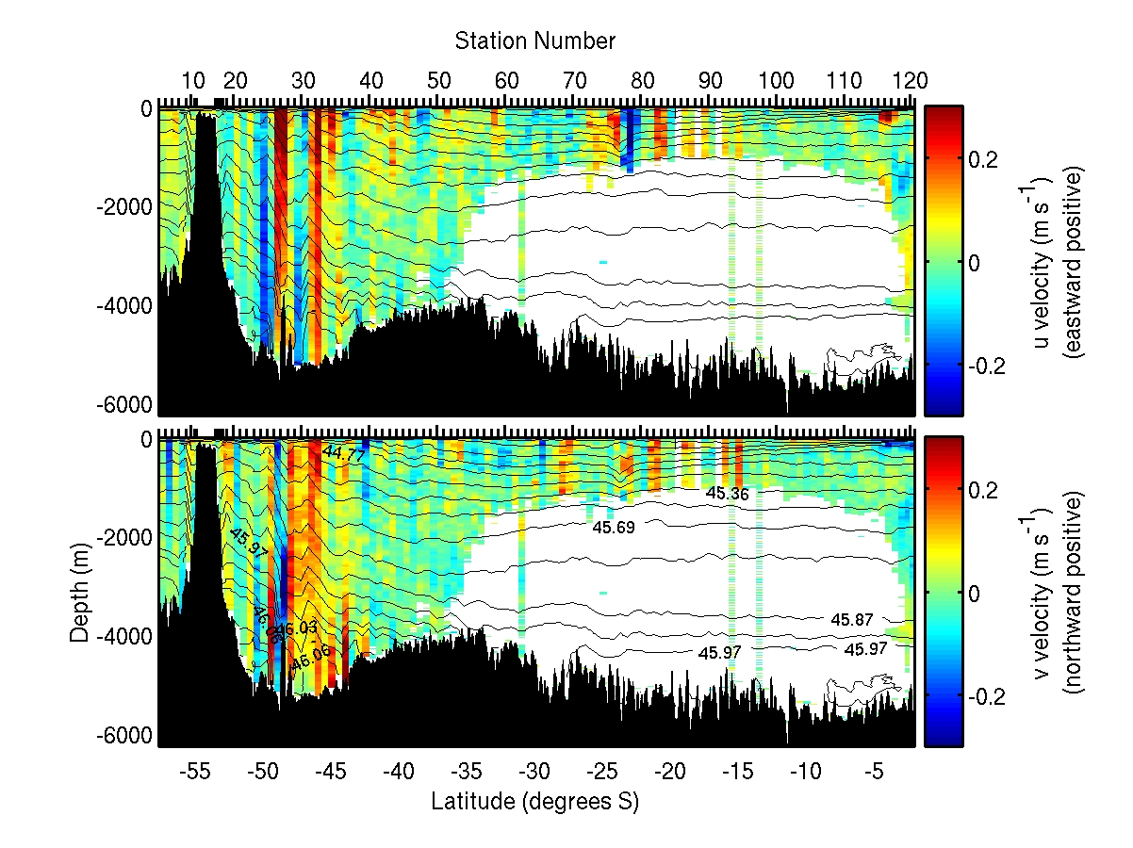
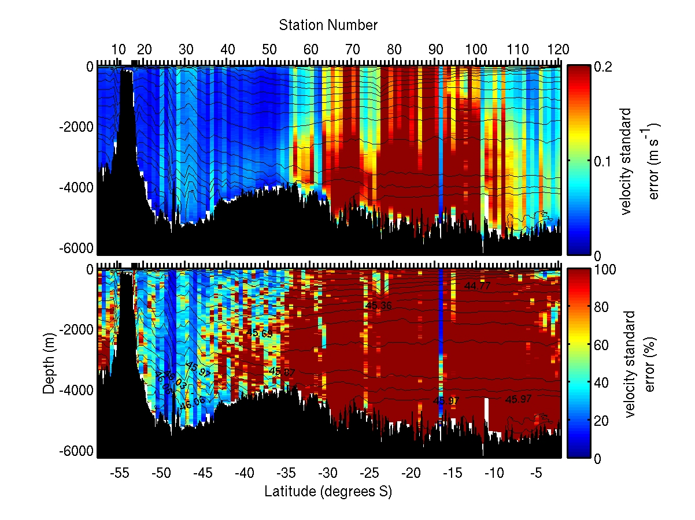
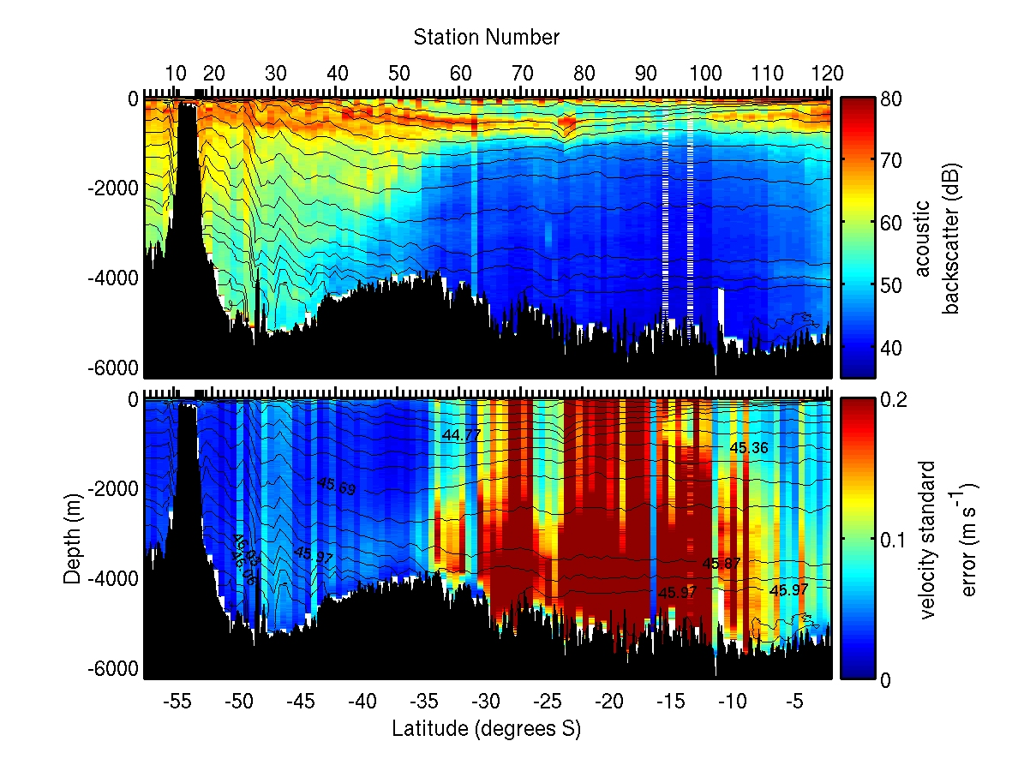
A preliminary test of data quality was possible using the SADCP data. The range of the SADCP was from 0-450 m in the first 40% of the cruise, due to good backscatter levels, and about 0-230 m for the remainder of the cruise. Frequent approximate comparisons between the LADCP and SADCP during the cruise generally showed good agreement. The incorporation of SADCP data, as well as 3-beam solutions for stations 49-100, will likely improve the data quality somewhat. Apart from a few regions with anomalously high backscatter and strong currents (e.g., bottom boundary layers), it is unlikely that uncertainty levels from stations 63-110 below roughly 1000 m can be reduced to be below velocity estimates.
Acoustic Backscatter
Acoustic backscatter (ABS) data (Figure 1.19d) has not been range-normalized, but it would not be difficult to make this alteration if there is interest in more quantitative analyses. Fortunately, the data collection procedure approximately normalizes ABS, because the LADCPs measure backscatter at a given depth from many distances. Depths a few tens of meters above or below rosette stops are likely to have a bias toward high backscatter (the top few hundred meters and the bottom 50 m), but this bias should be constant from station-to-station throughout the cruise. Acoustic pings at 300 kHz dominantly scatter off particles of sizes above roughly 1 mm, and high backscatter is likely due to zooplankton, marine snow, or higher-density falling detritus. There is a clear diurnal periodic signal in the surface 100 m between stations 44 and 80, with high near-surface backscatter at night likely resulting from vertical zooplankton migrations. Also note the elevated backscatter levels at roughly 500 m between stations 50 and 80, particularly in the core of the station 77 eddy.
Eddy Diffusivity
Philip Orton developed a separate Matlab toolbox during the cruise, for LADCP/CTD ocean mixing research. Of four published methods the toolbox uses for determining eddy diffusivity, the most promising utilizes vertical strain (nonlinearity in dρ/dz) and velocity shear, following methods of Polzin et al. (2002) as modified by Naveira Garabato et al. (2004). Preliminary results (Figure 1.20) indicate that typical diffusivities were roughly 10⁻⁴ m² s⁻¹ in the ACC, often higher in the bottom 1000 m, and 10⁻⁴ to 10⁻⁶ m² s⁻¹ in other regions. Note that uncertainties for this method, when applied to individual profiles, are estimated to be close to plus or minus one order of magnitude (±10x). This could be reduced with spatial averaging, as was done in Naveira-Garabato et al. (2004), but this would require major modifications to the toolbox (e.g., to work with the velocity data from the entire transect instead of profile-by-profile).
Files and Directories:
The LADCP datasets should contain the following directories, which contain everything that is needed in order to re-process the LADCP data:
- Raw data, instrument-setup command files, communication logfiles
- CTD time series and profiles used for LADCP processing
- Shipboard ADCP data used for LADCP processing
- Processed data files and processing figures

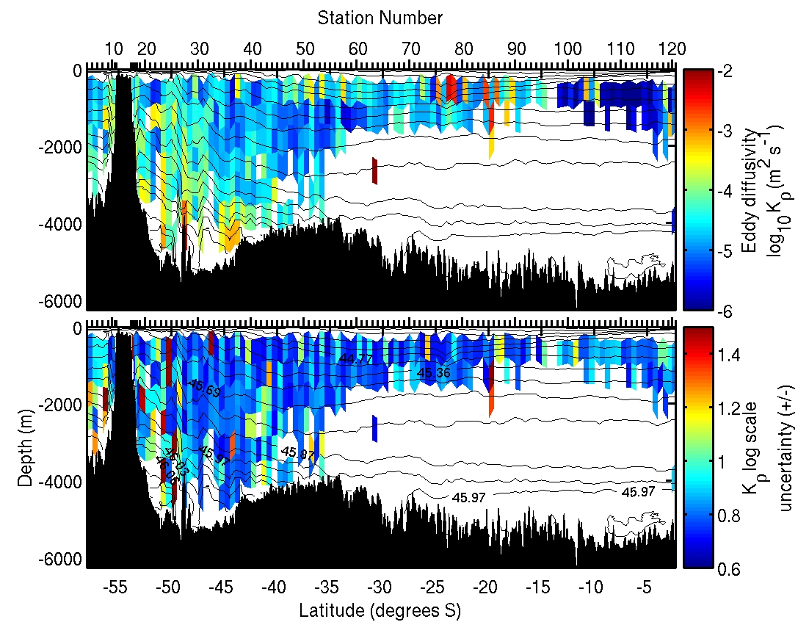

Figure 1.20. Preliminary shaded estimates of (top) eddy diffusivity and (bottom) log-scale eddy diffusivity uncertainty (± log₁₀ std. err.) from cruise-processed LADCP data. As with Figure 1, each panel includes logarithmically-spaced contours of density anomaly σ₄ (kg m⁻³) to identify density structure, and black bathymetry shading interpolated along the ship-track from a satellite-derived global dataset. Data have been omitted (white) where the lower error bar on the estimate was zero.
References
Naveira Garabato, A.C., K.L. Polzin, B.A. King, K.J. Heywood, and M. Visbeck, 2004: Widespread intense turbulent mixing in the Southern Ocean. Science, v. 303, pp. 210-213.
Polzin, K., E. Kunze, J. Hummon, and E. Firing, 2002: The fine-scale response of lowered ADCP velocity profiles. J. Atmos. Oceanic Tech., v. 19, pp. 205-224.
Rintoul, S.R., C.W. Hughes, and D. Olbers, 2001: The Antarctic Circumpolar Current system. In Ocean Circulation and Climate: Observing and Modeling the Global Ocean, G. Siedler, J. Church, and J. Gould (eds.). Academic Press, pp. 271-302.
Visbeck, M., 2002: Deep velocity profiling using lowered acoustic Doppler current profilers: Bottom track and inverse solutions. J. Atmos. Oceanic Tech., v. 19, pp. 795-807.
2. Bottle Sampling
2.1. Bottle Sampling Procedures
At the end of each rosette deployment, water samples were drawn from the bottles in the following order listed below. The correspondence between individual sample containers and the rosette bottle from which the sample was drawn was recorded on the sample log for the cast. This log also included any comments or anomalous conditions noted about the rosette and bottles. One member of the sampling team was designated the “sample cop,” whose responsibility was to maintain this log and insure that sampling progressed in the proper drawing order.
Normal sampling practice included opening the drain valve and then the air vent on the bottle, indicating an air leak if water escaped. This observation, together with other diagnostic comments (e.g., “lanyard caught in lid,” “valve left open”) that might later prove useful in determining sample integrity, were routinely noted on the sample log. Drawing oxygen samples also involved taking the sample draw temperature from the bottle. The temperature was noted on the sample log and was sometimes useful in determining leaking or mis-tripped bottles.
Once individual samples had been drawn and properly prepared, they were distributed for analysis. Oxygen, nutrient, and salinity analyses were performed on computer-assisted (PC) analytical equipment networked to the data processing computer for centralized data management.
2.2. Bottle Data Processing
Water samples collected and properties analyzed shipboard were managed centrally in a relational database (PostgreSQL-7.4.6) run on a Linux workstation. A web service (OpenAcs-5.1.3 and AOL Server-4.0.9) front-end provided ship-wide access to CTD and water sample data through web pages. Web-based facilities included on-demand arbitrary property-property plots and vertical sections, as well as data uploads and downloads.
The sample log (and any diagnostic comments) was entered into the database once sampling was completed. WOCE/CLIVAR quality flags associated with sampled properties were set to indicate that the property had been sampled, and sample container identifications were noted where appropriate (e.g., oxygen flask number).
The results of individual shipboard analyses were then uploaded through the website as results became available. These results included a quality code associated with each measured value and followed the coding scheme developed for the World Ocean Circulation Experiment (WOCE) Hydrographic Programme (WHP) (Joyce, 1994).
Various consistency checks and detailed examination of the data continued throughout the cruise.
2.3. Sampling and Analyses of Bottle Data
Samples for chlorofluorocarbons (CFCs), helium isotopes (³He), oxygen (O₂), hydrochlorofluorocarbon (HCFCs), partial pressure of CO₂ (pCO₂), dissolved inorganic carbon (DIC), hydrogen ion activities (pH), total alkalinity (TAlk), radiocarbon (DI¹⁴C), tritium, dissolved organic carbon (DOC), chromophoric dissolved organic matter (CDOM), particulate inorganic/organic carbon (PIC/POC), salinity, and nutrients were drawn in this sequence from a CTD sampling package containing 36, 12-l Bullister bottles. Sampling of the 36 bottles on the package took about 1.5 hours. The samples analyzed for gases were sampled first and usually drawn within an hour. The deepest bottle was sampled first and bottles were sampled sequentially to the surface bottle. Care was taken to coordinate the sampling to minimize the time between the initial opening of each bottle and the completion of sample drawing. In most cases, CFCs, ³He, dissolved oxygen, and HCFC samples were collected within several minutes of the initial opening of each bottle.
Oxygen, nutrient, and salinity samples were taken from all bottles. Oxygen draw temperature readings were commenced after station 25. For the other parameters, not all stations or all bottles were sampled. The stations at full degrees of latitude (odd numbered stations) were generally completely sampled for CFCs, DIC, pH, and TAlk, with partial sampling for DOC and CDOM. The half-degree stations were partially sampled for HCFC, PIC/POC, CFCs, DIC, pH, and TAlk. Discrete pCO₂ profiles were obtained at every two degrees. ³He, DI¹⁴C, and tritium were sampled at different intervals (primarily at full-latitude stations) as noted below. For casts where many parameters were sampled, water levels in the Bullister bottles were very low when the salinity and nutrients were drawn. This was particularly true for the bottom two bottles and top two bottles that were often used for duplicate sampling for parameters with large water requirements such as DIC and TAlk. Estimated water requirements for the samples are listed in the Table 2.1.
Table 2.1. Water requirements (including bottle rinses and sample) for the different parameters drawn on the Bullister bottles.
Parameter | Volume (l)
Chlorofluorocarbons (CFCs) | 0.5
Helium isotopes (³He) | 0.5
Oxygen (O₂) | 0.5
Hydrochlorofluorocarbons (HCFCs) | 0.5
Partial pressure of CO₂ (pCO₂) | 1.2
Dissolved inorganic carbon (DIC) | 1.5
Hydrogen ion activities (pH) | 0.3
Total alkalinity (TAlk) | 1.5
Radiocarbon (DI¹⁴C) | 0.8
Tritium | 1.2
Dissolved organic carbon (DOC) | 0.2
Chromophoric dissolved organic matter (CDOM) | 0.2
Particulate inorganic/organic carbon (PIC/POC) | 1.5
Salinity | 0.3
Nutrients | 0.3
Most samples were analyzed on board with the exception of ³He, DI¹⁴C, tritium, DOC, CDOM, and PIC/POC that were sampled and preserved for shore-based analysis. Below are the descriptions of sampling and analysis procedures for each parameter, as well as the relevant statistics on data quantity and quality.
2.4. Tests Performed on Bullister Bottles to Determine Sample Integrity of CFCs, Salts, and O₂
Two types of tests were performed on the 12-liter Bullister bottles (“12-B Bottles”) used on A16S cruise:
1. Test Type 1 was designed to estimate the rate of change of dissolved CFCs (CFC-11, CFC-12, CFC-113 and carbon tetrachloride (CCl₄)) concentrations in seawater held inside closed bottles.
2. Test Type 2 was designed to determine the rate of change of dissolved CFCs, CCl₄, oxygen, and salinity in seawater remaining inside a bottle after the bottle had been opened and other seawater samples withdrawn.
Background:
Once a bottle is closed in the water column during a hydrocast, the concentrations of dissolved CFCs in the water inside may increase slowly due to release of trace amounts of CFCs present in the bottle walls, O-rings, and other materials. The release of these contaminants contributes to the non-zero CFC concentrations (“bottle blank”) typically observed even in regions of the deep ocean thought to be essentially CFC-free.
The extent of this contamination is thought to be a function of:
- the materials used in constructing the bottles
- the exposure of these materials to CFCs in the atmosphere prior to the cast
- the length of time the water remains in the bottle before transfer
- the temperature
Once a bottle is opened on deck and water withdrawn for sampling, gas exchange between the air in the headspace and water in the bottle begins and can alter the dissolved gas concentrations and salinity in the remaining water. The unbuffered gases, e.g., He, CFCs, HCFCs and O_{2,} are believed to be most susceptible to these changes. These changes can be especially significant when large gradients in partial pressures are present between the gases in the water and in the headspace, for example, when a deep sample containing near-zero concentrations of dissolved CFC is exposed to a headspace of marine air.
Bottle Tests:
Test Type 1: Changes in CFC Concentration in Closed 12-B Bottles
The following tests were performed to estimate the rates at which dissolved CFCs increase in water stored in closed 12-B Bottles. In each test, replicate sets of bottles were closed at a depth with low CFC concentrations to allow small changes to be more easily detected. Some replicate deep bottles were allowed to warm on deck before sampling, while others were kept cold in a walk-in refrigerator before sampling.
Bottle temperatures (“O₂ Draw Temp”) were recorded as each oxygen sample was drawn using a thermistor inserted into the oxygen flask, following the same procedure used for standard oxygen draw temperatures. These tests were performed at stations 88, 102, and 112.
Station 88: five 12-liter bottles (9-13) were closed at ~3100 m depth (Table 2.2):
- Bottle 9 was sampled normally in sequence (about 32 minutes after arrival on deck);
- Bottles 10 and 12 were left closed on the rosette frame and sampled before the next cast;
- Bottles 11 and 13 were removed from the rosette and placed on a spare frame in the shade on deck to allow for longer storage times.
Table 2.2. Results for station 88 storage tests.
Bot. | CFC  Syringe | HCFC  Flask | Oxygen  Flask | O₂  Draw  Temp¹  (°C) | Salt  Bottle | Sample  Time²  (Z) | CFC-12  (pmol kg⁻¹) | CFC-11  (pmol kg⁻¹) | CFC-13  (pmol  kg⁻¹) | CC1₄  (pmol  kg⁻¹) | Salinity
9 | 5573 | 4 | 161 | 7.3 | 209 | 00:30 | 0.011 | 0.021 | 0 | 0.082 | 34.9137
9 | 7692 |  |  |  |  | 00:31 | 0.013 | 0.024 | 0 | 0.089
10 | 5564 | 4 | 40 | 13.2 | 210 | 01:40 | 0.012 | 0.027 | 0 | 0.084 | 34.9153
12 | 7674 | 4 |  | 17.9 | 212 | 03:05 | 0.014 | 0.022 | 0 | 0.088 | 34.9151
11 | 7735 | 5 |  | 23.4 | 211 | 07:45 | 0.017 | 0.027 | 0 | 0.090 | 34.9148
13 | 9888 | 4 | 40 | 26.5 | 213 | 15:05 | 0.024 | 0.050 | 0 | 0.089 | 34.9155
Cast on deck 11 Feb 2005 at ~23:58Z.
¹Initial (potential) temperature for seawater samples was ~2.430°C.
²Date: 12 Feb 2005; all times are UTC.
Station 102: five bottles (6-10) closed at ~2950 m (Table 2.3):
- Bottle 6 was sampled normally (about 32 minutes after arrival on deck);
- Bottles 6 and 10 were left closed on frame and sampled before the next cast;
- Bottles 7 and 9 were removed from the rosette frame after about 1 hour on deck and placed in walk in cooler at ~4°C Substantial warming occurred during the period on deck, and subsequent cooling may have caused air to be drawn into the bottles. Sounds were detected when bottle 9 was inverted, indicating the presence of an air pocket in this bottle. Consequently, samples from bottle 9 were not drawn, and the data from bottle 7 are considered suspect.

Table 2.3. Results for station 102 storage tests.
Bot. | CFC  Syringe | HCFC  Flask | Oxygen  Flask | O₂  Draw  Temp¹  (°C) | Salt  Bottle | Sample  Time²  (Z) | CFC-12  (pmol kg⁻¹) | CFC-11  (pmol kg⁻¹) | CFC-13  (pmol  kg⁻¹) | CC1₄  (pmol  kg⁻¹) | Salinity
6 | 629 | 3 | 6 | 6.4 | 606 | 05:00 | 0.016 | 0.030 | 0 | 0.100 | 34.9173
6 | 7695A |  |  |  |  | 05:01 | 0.020 | 0.031 | 0 | 0.102
8 | 7638 | 16 |  | 14.7 | 608 | 06:10 | 0.018 | 0.043 | 0 | 0.104 | 34.9175
10 | 367 | 17 |  | 16.9 | 610 | 07:10 | 0.022 | 0.048 | 0.005 | 0.102 | 34.9189
7³ | 7701 | 18 |  | 5.5 | 607 | 19:10 | 0.035 | 0.061 | 0 | 0.110 | 34.9189
Cast on deck 16 Feb 2005 at ~04:18Z.
¹Potential temperature for seawater samples was ~2.507°C.
²Date: 16 Feb 2005; all times are UTC.
³Bottle 7 likely contaminated with air.
Station 112: five bottles (10-14) closed at ~3000 m (Table 2.4):
- Bottle 10 was sampled normally (about 11 minutes after arrival on deck);
- Bottles 12 and 14 were left closed on frame and sampled before the next cast;
- Bottles 11 and 13 were removed immediately after arrival on deck and placed in walk in cooler at ~4°C;
- No oxygen samples were drawn on bottles 11-14.
Table 2.4. Results for station 112 storage tests.
Bot. | CFC  Syringe | HCFC  Flask | Oxygen  Flask | O₂  Draw  Temp¹  (°C) | Salt  Bottle | Sample  Time²  (Z) | CFC-12  (pmol kg⁻¹) | CFC-11  (pmol kg⁻¹) | CFC-13  (pmol  kg⁻¹) | CC1₄  (pmol  kg⁻¹) | Salinity
10 | 7628 | 4 | 10 | 6.7 | 110 | 03:45 | 0.011 | 0.022 | 0.003 | 0.084 | 34.9173
12 | 5567A | 1 |  | 13.0 | 112 | 05:10 | 0.018 | 0.023 | 0 | 0.087 | 34.9179
14 | 674 | 17 |  | 18.2 | 114 | 06:35 | 0.017 | 0.024 | 0 | 0.087 | 34.9170
11 | 7674  7692A | 17, 18 |  | 5.1 | 111 | 19:20 | 0.019 | 0.029 | 0 | 0.086 | 34.9181
13 | 9833 | 1, 2 |  | 4.4 | 113 | 20:40³ | 0.015 | 0.031 | 0 | 0.086 | 34.9159
Cast on deck 19 Feb 2005 at ~03:36Z.
¹Potential temperature for seawater samples was ~2.439°C.
²Date: 19 Feb 2005; all times are UTC.
³Date: 20 Feb 2005.
Discussion of Results from Test Type 1:
During hydrocasts on the A16S cruise, the deep bottles were closed earlier than shallower bottles; however, the deep bottles were sampled first on deck. Hence, for deep hydrocasts on A16S, the mean time that seawater typically remained inside bottles before opening was roughly the same (about 2 hours) for both deep and shallow bottles.
At high latitudes during the A16S cruise, there was typically little warming of the water on deck before sampling. In mid and low latitudes, mid-depth and deep water samples underwent warming (as determined by the difference between the potential temperature and oxygen draw temperature) during their transit through the thermocline, mixed layer, and while on deck before sampling. The amount of warming was determined by temperature measurements made during the oxygen sampling process, and was typically several degrees.
The station 112 experiment examined the CFC changes in bottles where seawater was stored inside at cold temperatures (~5ºC) for an extended period of time. The changes in the cold bottles (relative to the initially sampled bottle) are denoted in Table 2.5.
Table 2.5. Changes in concentrations for station 112 storage test.
Sta. | Bot. | Time  (Hours) | O₂  Draw  Temp  (°C) | CFC-12  (pmol  kg⁻¹) | dCFC-12/dt  (pmol kg⁻¹ hr⁻¹) | CFC-11  (pmol  kg⁻¹) | dCFC-11/dt  (pmol kg⁻¹ hr⁻¹) | CC1₄  (pmol  kg⁻¹) | dCCl₄/dt  (pmol kg⁻¹ hr⁻¹)
112 | 11 | 15.58 | 5.1 | 0.008 | 0.00051 | 0.007 | 0.00045 | 0.002 | 0.00013
112 | 13 | 40.91 | 4.4 | 0.004 | 0.00010 | 0.009 | 0.00022 | 0.002 | 0.00005
 |  |  |  | mean = 0.00031  sd = ±0.00029 |  | mean = 0.00033  sd = ±0.00016 |  | mean = 0.00009  sd = ±0.00006
The scatter in the derived rates in Table 2.5 is likely due to the fact that the observed concentration changes in Table 2.5 are close to detection limits for these compounds (roughly ~0.002-0.004 pmol kg⁻¹). These results do indicate that in regions where there is little warming before sampling (e.g., high latitudes) the rate of increase of CFCs in the 12-B bottles during the 2 hours between closing and sampling is small. CFC-113 showed no consistent pattern of increase (see Table 2.4). CFC-11, CFC-12 and CCl₄ showed very small increases (Table 2.5) of <0.001 pmol kg⁻¹ hr⁻¹.
The station 88, 102, and 112 experiments examined the CFC changes in bottles where seawater inside was allowed to warm on deck for various periods of time. The changes in the bottles (relative to the initially sampled bottle) are listed in Table 2.6.
Table 2.6. Summary of CFC changes for the storage tests.
Sta. | Bot. | Time  (Hours) | O₂  Draw  Temp  (°C) | CFC-12  (pmol  kg⁻¹) | dCFC-12/dt  (pmol kg⁻¹ hr⁻¹) | CFC-11  (pmol  kg⁻¹) | dCFC-11/dt  (pmol kg⁻¹ hr⁻¹) | CC1₄  (pmol  kg⁻¹) | dCCl₄/dt  (pmol kg⁻¹ hr⁻¹)
88 | 10 | 1.17 | 13.2 | 0.000 | 0 | 0.004 | 0.00384 | -0.0014 | -0.00120
88 | 12 | 2.58 | 17.9 | 0.002 | 0.00078 | -0.001 | -0.00039 | 0.0026 | 0.00101
88 | 11 | 7.25 | 23.4 | 0.005 | 0.00069 | 0.004 | 0.00062 | 0.0046 | 0.00063
88 | 13 | 14.58 | 26.5 | 0.012 | 0.00082 | 0.027 | 0.00189 | 0.0036 | 0.00025
102 | 8 | 1.17 | 14.7 | 0.000 | 0 | 0.013 | 0.01068 | 0.003 | 0.00256
102 | 10 | 2.17 | 16.9 | 0.004 | 0.00184 | 0.018 | 0.00806 | 0.001 | 0.00046
112 | 12 | 1.41 | 13.0 | 0.007 | 0.00496 | 0.001 | 0.00071 | 0.003 | 0.00213
112 | 14 | 2.83 | 18.2 | 0.006 | 0.00212 | 0.002 | 0.00071 | 0.003 | 0.00106
 |  |  |  | mean = 0.00140  sd = ±0.00163 |  | mean = 0.00327  sd = ±0.00403 |  | mean = 0.00086  sd = ±0.00116
As in the cold experiment in Table 2.5, since the observed concentration changes were often near the minimum detection limits for the compounds, there is considerable scatter in the rates of CFC increase derived in Table 2.6.
As in the cold tests, CFC-113 showed no consistent pattern of increase (see Tables 2.2 and 2.3) in the warming bottles. CFC-12 and CCl₄ showed small mean increases (Table 2.6) of ~0.0014 and ~0.0011 pmol kg⁻¹ hr⁻¹, respectively. The mean rate of increase in CFC-11 (~0.0033 pmol kg⁻¹ hr⁻¹) was somewhat larger.
The results from Table 2.5 indicate that in cold regions, blanks for seawater stored for 2 hours in the 12-B bottles are <0.001 pmol kg⁻¹ for all four compounds.
An estimate of the deep bottle blanks in warm regions can be made from Table 2.6, assuming that for the typical 2 hours that water is held inside the bottles, significant warming occurs only during the last hour as the bottle passed though the thermocline and were stored on deck.
From Tables 2.5 and 2.6, rough estimates of the bottle blanks are denoted in Table 2.7.
Table 2.7. Bottle blanks for Bullister bottles.
 | Cold Regions  (pmol kg⁻¹) | Warm Regions  (pmol kg⁻¹)
CFC-12 | 0 | 0.002
CFC-11 | 0 | 0.004
CFC-113 | 0 | 0
CC1₄ | 0 | 0.001
Test Type 2: A16S Bottle Time Series
At station 121, three 12-B bottles (19, 20, 21) were closed at the same depth (1000 m) near the oxygen minimum zone and in a region of low CFCs. This depth was chosen to maximize the gradient in partial pressures of these gases between the water and air present in the bottle headspace once the bottles were opened. The goal of this test was to determine possible changes in dissolved CFCs, oxygen, and salinity as a function of time and of the volume of water drained from a 12-B bottle after the bottle was initially opened. Table 2.8 depicts a summary of the bottle tests for station 121.
Procedure:
- Bottle 20 was sampled normally, approximately 20 minutes after the cast was on deck.
- Bottle 19 was sampled for salinity, CFCs, and oxygen ~5 minutes after the cast was on deck and then resampled for these parameters as rapidly as possible four additional times. The total sampling time for the five sets of samples from bottle 19 was ~17 minutes.
- Bottle 21 was sampled for salinity, CFCs, and oxygen ~6 minutes after the cast came on deck, and then resampled for these parameters four more times at ~30 minute intervals over a period of 2.5 hrs.
Samples in bottles 19 and 21 were drawn in the order: salinity, salinity, CFC, oxygen. For bottles 19 and 21, a total of about 2 l of water was used to draw each set of samples, so at the completion of the fifth set, about 2 l of water remained in the bottles.
Bottle temperatures (“O₂ Draw Temp”) were recorded as each oxygen sample was drawn using a thermistor inserted into the oxygen flask, following the same procedure used for standard oxygen draw temperatures.
Table 2.8. Summary of bottle tests for station 121.
Bot | Sample  Time¹ | Salt  Bottle | CFC  syringe | Oxygen  Flask | O₂  Draw  Temp²  (ºC) | CFC-12  (pmol kg⁻¹) | CFC-11  (pmol kg⁻¹) | CFC-113  (pmol kg⁻¹) | CCl₄  (pmol kg⁻¹) | Oxygen³  (umol l⁻¹) |  | Salinity
20 | 17:55 | 820 | 984 | 168 | 9.0 | 0.030 | 0.077 | 0 | 0.155 |  |  | 34.5782
19 | 17:40 | 1001  1002 | 7692A | 41 | 6.7 | 0.036 | 0.077 | 0 | 0.156 | 165.2 |  | 34.5795  34.5781
 | 17:43 | 1003  1004 | 9837 | 42 | 7.7 | 0.034 | 0.077 | 0 | 0.147 | 165. |  | 34.5778  34.5775
 | 17:48 | 1005  1006 | 7701 | 43 | 8.4 | 0.038 | 0.077 | 0 | 0.154 | 165.4 |  | 34.5775  34.5778
 | 17:52 | 1007  1008 | lost | 44 | 9.5 | --- | --- | --- | --- | 166.4 |  | 34.5779  34.5779
 | 17:57 | 1009  1010 | 9825 | 45 | 11.4 | 0.056 | 0.118 | 0 | 0.183 | 167.0 |  | 34.5777  34.5770
 |  |  |  |  |  |  |  |  | mean salinity =  sd = |  |  | 34.5787  0.0006
21 | 17:40 | 1011  1012 | 18⁴ | 46 | 7.0 | 0.052 | 0.076 | 0 | 0.151 |  | 165.3 | 34.5771  34.5762
 | 18:10 | 1013  1014 | 7674 | 47 | 10.2 | 0.047 | 0.103 | 0 | 0.177 |  | 165.9 | 34.5763  34.5766
 | 18:40 | 1015  1016 | 17⁴ | 48 | 13.3 | 0.074 | 0.095 | 0 | 0.169 |  | 166.0 | 34.5762  34.5756
 | 19:10 | 1017  1018 | 9833 | 49 | 16.2 | 0.054 | 0.106 | 0.005 | 0.178 |  | 167.3 | 34.5769  34.5769
 | 19:40 | 1019  1020 | 7638 | 167 | 18.7 | 0.078 | 0.148 | 0.008 | 0.221 |  | 169.9 | 34.5756  34.5759
 |  |  |  |  |  |  |  |  | mean salinity =  sd = |  |  | 34.5763  0.0005
Cast on deck 21 Feb 2005 ~17:29; all times are UTC.
¹21 Feb 2005.
²Potential temperature for seawater samples was ~4.274°C.
³Oxygen values are preliminary and in umol l⁻¹.
⁴Indicates syringe borrowed from HCFC group, CFC values may be suspect.

Notes on Test 2: Ship was underway during this period--little ship roll. Bottles were in shade, relative wind ~10 knots; relative humidity, 84%; air temp, 27.6°C. After sampling, approximately 2 liters remained of original 12 liters--each sampling cycle is estimated to have used ~2 liters of water.

Discussion of Test Type 2:
From the very small data set in this test, changes in dissolved CFC concentrations appear to be functions of the time after the bottle is opened and of the volume of water removed prior to drawing the samples. For bottle 19, the changes in measured CFCs and dissolved oxygen within the first 8 minutes of sampling (and after two sets of samples have been removed previously) were very small and are within the analytical precision of the analyses. These results indicate that under some conditions a short delay in sampling for CFC and oxygen after a bottle is opened (and after a few liters of water are withdrawn) may not cause measurable changes in the resulting CFC and oxygen concentration measurements. It is important to note that these tests were performed using 12-liter bottles on a large, stable research vessel under calm conditions. The rate of change of dissolved CFC and oxygen inside opened bottles may be significantly greater under other conditions.
Significant increases in CFC and oxygen concentrations did occur within 17 minutes in bottle 19, after four sets of samples (~8 liters of water) had been withdrawn. The rate on change of CFCs and oxygen in bottle 21 during the first hour is slower than the rate in bottle 19 during the first 18 minutes, perhaps because of less water draw down (~4 liters vs. ~8 liters) up to that point. Changes in Bottle 21 are large at the end of the 2-hour period, where 8 liters of water had been drawn previously.
There was no significant change in salinity during the drawdown tests, although there was substantial warming of the bottles during the sampling period (see Table 2.8). Changes in salinity observed in some heavily sampled bottles during the A16S cruise may be due water vapor exchange between the water inside the bottle and the air introduced into the headspace. Since the vapor pressure of water is strongly dependent on temperature, this effect may be increased when the bottle undergoes warming on deck, and may also depend on the temperature and humidity of air entering the headspace. These effects may become more pronounced as the volume of water remaining in the bottle decreases during sampling.
2.5. Discussion of Bottle Sampling for Samples Preserved for Shore-Side Analysis

2.5.1. Helium and Tritium Sampling
Principal Investigator: Peter Schlosser, Lamont-Doherty Earth Observatory
Palisades NY 10964
schlosser@ldeo.columbia.edu
Sampler: Andrew Mutter, LDEO, amutter@ldeo.columbia.edu
Sampling of helium isotope (³He) and tritium samples for Peter Schlosser of LDEO was carried out by Andrew Mutter (amutter@ldeo.columbia.edu). A total of 26 stations were sampled with an average of 20 samples taken per cast, for both ³He and tritium. The total number of samples obtained is 508 ³He samples and 570 tritium samples. No duplicates were taken.

Sampling involved separate containers for ³He and tritium. Seawater for ³He analysis was sampled into re-useable stainless steel tubes of 90-ml in volume. Tritium was sampled into 1 liter brown glass bottles. The ³He samples were taken first and care was made to rid the vessel of air bubbles by hitting them with a stick and opening and closing the two valves at each end of the tube. Tritium was sampled by rinsing the bottles twice and filling with water up to the curve at the top of the bottle to allow room to allow for thermal expansion.
The He extraction was done on ship. Eight filled tubes were pumped down on a vacuum extraction system supplied by WHOI (W. Jenkins and D. Lott). The tube was pumped down in two-step processes. First, by a mechanical pump the pressure was taken down to below 10⁻³ torr (approximately 10 min). Second, the pressure was pumped to mid 10⁻⁶ to high 10⁻⁷ torr pressure by a diffusion pump (approximately 1 hr). The water was then allowed out of the container and into a lower metal container where it was heated to 90-100°C. The gas was collected in a glass bulb cooled in ice water. After 10 minutes, the bulbs were flame sealed and stored for on-shore analyses.
One tritium sample was lost (dropped on deck). Two to three ³He samples were lost due to bad seals and one to operator error of the extraction vacuum system, which called for dismantling and cleaning of equipment.

2.5.2. Particulate Sampling
Principal Investigator: Jim Bishop, LBNL, JKBishop@lbl.gov
Onboard Personnel: Alexandra Thompson, LBNL, alex@nature.berkeley.edu
Particulate matter sampling was performed in support of the optics program on the CTD. ICP-MS phosphorus gives us a cross-check on estimating POC, and ICP-MS calcium gives us a calibration/verification of the PIC sensor.
Sampling:
Seawater samples were collected from casts from every even numbered station, excluding stations 60 and 102. From each sampled cast, 7-18 samples were collected from the rosette, chosen with a focus on the first 200 m and either the top 2000 m or bottom 3000 m. The 1-liter samples were collected in plastic bottles and, in most cases, filtering began within 30 minutes. The seawater was filtered under vacuum (0.25-0.5 atm) through polycarbonate 0.4 Micron 47mm filters (Osmonics Cat #K04CP04700) in filter holders equipped with PreSep mesh spacers (Osmonics Cat #C32WP04200). Filtration was carried out in a flow bench (Airclean 600 PCR Workstation) and took between 10 minutes to 5 hours for each sample. After exposure, each filter was rinsed with 0.5 ml MQ water and the filter transferred to 100 ml Nalgene bottles, capped, and stored at room temperature for transport to LBNL. After use all bottles, caps, and filter holders were rinsed in MQ water.

Total number of samples: 921
Number of blanks: 39
Number of repeats: 41
Number of casts sampled: 59
Problems:
The only problems encountered were minor and included leaky bottles and occasional air bubbles causing the filtration to stall.

Shore-Side Analysis:
At LBNL, the filters will be analyzed using ICP-MS for 20 elements, including P, C, Ca, Fe, Ba, and Sr.

2.5.3. DOC Sampling
Principal Investigator: Dennis Hansell, U. Miami, RSMAS, 4600 Rickenbacker
Causeway, Miami, FL 33149, dhansell@rsmas.miami.edu
Sampler: Wenhao Chen, U. Miami, RSMAS
wenchen@rsmas.miami.edu
Seawater samples were taken directly from the Niskin Bottles into the 60 ml precleaned bottles for deeper than 200 m. Samples from the up 200 m were collected by in-line filtration through a GF/F filter. All samples were kept in frozen before analysis.
Total number of samples: 1630
Total number of duplicates: 12
Total number of stations: 60

2.5.4. C-DOM Sampling
Principal Investigator: Norm Nelson, UCSB
Sampler: Wenhao Chen, U. Miami, RSMAS
wenchen@rsmas.miami.edu
Seawater was taken directly from the Niskin bottles into a 120-ml dark glass bottle and then filtered through a 0.2 um Nucleopore filter by vacuum filtration within 2 hours. Filtrates were collected in 40 ml dark glass vials and kept refrigerated before analysis.
Total number of samples: 540
Total number of duplicates: 4
Total number of stations: 36

2.5.5. ¹⁴C Sampling
Principal Investigator: Ann McNichol, WHOI
Samplers: Wenhao Chen, U. Miami, RSMAS
wenchen@rsmas.miami.edu
Matt Lenington, CWU, leningtm@cwu.edu
Seawater was drawn directly from the Niskin bottles into 500-ml glass bottles after about 250 ml overflow of the water. Samples were then poisoned with 100 µl saturated HgCl₂ solution and sealed by greased stoppers. Bottles with samples are kept in cases for shipping back to WHOI.
Reference: Measuring ¹⁴C in Seawater TCO₂ by Accelerator Mass Spectrometry, WHOI in WHP Operation and Methods-July, 2003.
Total number of samples: 496
Total number of duplicates: 16
Total number of stations: 29

2.5.6. Oxygen, Nitrogen, and Argon (ONAR) Sampling
Principal Investigator: Steven Emerson, University of Washington
emerson@u.washington.edu
Samplers: Mark Warner, University of Washington
warner@u.washington.edu
Samples were collected for analyses of dissolved oxygen, nitrogen, and argon (ONAR) at three stations during the A16S repeat hydrography section. At each station, duplicate samples (~100 ml) from six different depths were collected into evacuated glass flasks for analyses in the laboratory of Dr. Steven Emerson at the University of Washington. The samples were collected from the 12-l bottle immediately after the dissolved oxygen sample was drawn. In the shipboard laboratory, the headspace in the neck of the flask was flushed with CO₂ gas and capped for transport back to the laboratory.
The goal of this ancillary project is to determine the saturations of these gases in water masses formed in the northern (NADW) and southern (AABW, AAIW) high latitudes. The differences in saturation values should provide useful information on the relative importance of bubbles in mediating the gas exchange, thus setting the surface ocean boundary conditions, in the formation regions of these water masses.
Total number of samples: 36
Total number of duplicates: 18
Total number of stations: 3
2.6. Parameters Sampled and Analyzed on the Cruise

2.6.1. Chlorofluorocarbon (CFC) Measurements
Principal Investigators: Mark J. Warner, University of Washington
warner@u.washington.edu
John L. Bullister, NOAA-PMEL
John.L.Bullister@noaa.gov
Samplers and Analysts: Mark J. Warner, University of Washington
John L. Bullister, NOAA-PMEL
Eric Wisegarver, University of Washington
esw@u.washington.edu
Samples for the analysis of dissolved CFC-11, CFC-12, CFC-113, and carbon tetrachloride (CCl₄) were drawn from 2378 of the 4192 water samples collected during the expedition. Specially-designed 12-liter Bullister sample bottles were used on the cruise to reduce CFC contamination. These bottles have the same outer diameter as standard 10 liter Niskin bottles, but use a modified end-cap design to minimize the contact of the water sample with the end-cap O-rings after closing. The O-rings used in these water sample bottles were vacuum-baked prior to the first station. Stainless steel springs covered with a nylon powder coat were substituted for the internal elastic tubing provided with standard Niskin bottles. When taken, water samples for CFC and carbon tetrachloride analysis were the first samples drawn from the 12-liter bottles. Care was taken to coordinate the sampling of CFCs with other samples to minimize the time between the initial opening of each bottle and the completion of sample drawing. In most cases, dissolved oxygen, ³He, and HCFC samples were collected within several minutes of the initial opening of each bottle. To minimize contact with air, the CFC samples were drawn directly through the stopcocks of the 12-liter bottles into 100 ml precision glass syringes equipped with two-way metal stopcocks. The syringes were immersed in a holding tank of clean surface seawater until analyzed.
For air sampling, a ~100 m length of 3/8" OD Dekaron tubing was run from the main laboratory to the bow of the ship. A flow of air was drawn through this line into the main laboratory using a KNF Neuburger pump. The air was compressed in the pump, with the downstream pressure held at ~1.5 atm. using a backpressure regulator. A tee allowed a flow (100 ml min⁻¹) of the compressed air to be directed to the gas sample valves of the CFC and HCFC analytical systems, while the bulk flow of the air (>7 l min⁻¹) was vented through the backpressure regulator. Air samples were only analyzed when the relative wind direction was within 60 degrees of the bow of the ship to reduce the possibility of shipboard contamination. The pump was run continuously to insure that the air inlet lines and pump were thoroughly flushed. Analysis of bow air was performed at 26 locations along the cruise track. At each location, five measurements were made to increase the precision.
Concentrations of CFC-11 and CFC-12, CFC-113, and carbon tetrachloride in air samples, seawater, and gas standards were measured by shipboard electron capture gas chromatography (EC-GC) using techniques modified from those described by Bullister and Weiss (1988). For seawater analyses, water was transferred from a glass syringe to a fixed volume chamber (~30 ml). The contents of the chamber were then injected into a glass-sparging chamber. The dissolved gases in the seawater sample were extracted by passing a supply of CFC-free purge gas through the sparging chamber for a period of 4 minutes at 70 ml min⁻¹. Water vapor was removed from the purge gas during passage through an 18 cm long, 3/8” diameter glass tube packed with the desiccant magnesium perchlorate. The sample gases were concentrated on a cold-trap consisting of a 1/8” OD stainless steel tube with a ~10 cm section packed tightly with Porapak N (60-80 mesh). A vortex cooler, using compressed air at 100 psi, was used to cool the trap, to approximately -20°C. After 4 minutes of purging, the trap was isolated, and the trap was heated electrically to ~100ºC. The sample gases held in the trap were then injected onto a precolumn (~25 cm of 1/8” O.D. stainless steel tubing packed with 80-100 mesh Porasil C, held at 70°C) for the initial separation of CFC-12, CFC-11, and CFC-113 from carbon tetrachloride. After the CFCs had passed from the pre-column into the main analytical column (~183 cm of 1/8” OD stainless steel tubing packed with Carbograph 1AC, 80-100 mesh, held at 70°C) of GC1 (a HP 5890 Series II gas chromatograph with ECD), a valve was used to direct the precolumn flow (and more slowly eluting carbon tetrachloride peak) to a second gas chromatograph (Shimadzu Mini II GC with ECD). For the first 52 stations, the chromatographic column in the Shimadzu GC was 1 m of 1/8” OD stainless steel tubing packed with 80/100 mesh Porasil C.
The apparent supersaturation of dissolved CCl₄ observed in the near surface waters of these stations was attributed to an unidentified compound present in near surface waters that co-eluted with CCl₄. The Porasil C column was replaced with a Carbograph 1AC 80-100 mesh column (183 cm of 1/8’ OD SS tubing), resulting in the separation of the CCl₄ peak from this interfering peak. In both cases the column was maintained at 90°C.
Both of the analytical systems were calibrated frequently, with frequency listed below, using a standard gas of known CFC composition. Gas sample loops of known volume were thoroughly flushed with standard gas and injected into the system. The temperature and pressure was recorded so that the amount of gas injected could be calculated. The procedures used to transfer the standard gas to the trap, precolumn, main chromatographic column, and EC detector were similar to those used for analyzing water samples. Two sizes of gas sample loops were used. Multiple injections of these loop volumes could be made to allow the system to be calibrated over a relatively wide range of concentrations. Air samples and system blanks (injections of loops of CFC-free gas) were injected and analyzed in a similar manner. The typical analysis time for seawater, air, standard or blank samples was ~11 minutes.
Concentrations of the CFCs and CCl₄ in air, seawater samples, and gas standards are reported relative to the SIO98 calibration scale (Cunnold et. al., 2000). Concentrations in air and standard gas are reported in units of mole fraction CFC in dry gas, and are typically in the parts per trillion (ppt) range. Dissolved CFC and CCl₄ concentrations are given in units of picomoles per kilogram seawater (pmol kg⁻¹). CFC and CCl₄ concentrations in air and seawater samples were determined by fitting their chromatographic peak areas to multi-point calibration curves, generated by injecting multiple sample loops of gas from a working standard (PMEL cylinder 45191 for CFC-11, CFC-12, CFC-113, and CCl₄) into the analytical instrument. The response of the detector to the range of moles of CFC passing through the detector remained relatively constant during the cruise. Full-range calibration curves were run at intervals of 14 days during the cruise. These were supplemented with occasional injections of multiple aliquots of the standard gas at more frequent time intervals. Single injections of a fixed volume of standard gas at one atmosphere were run much more frequently (at intervals of ~90 minutes) to monitor short-term changes in detector sensitivity. The CFC-113 peak was often on a small bump on the baseline, resulting in a large dependence of the peak area on the choice of endpoints for integration. The height of the peak was instead used to provide better precision. The precisions of measurements of the standard gas in the fixed volume (n = 690) were ± 0.67% for CFC-12, 0.59% for CFC-11, 2.6% for CFC-113, and 1.8% for CCl₄.
Although the CCl₄ calibration and precision are of high quality over most of the cruise, there appears to be a problem with the preliminary calibration of the working standard. The calculated atmospheric concentrations, relative to this standard, are approximately 70 part per trillion (ppt). The values reported by the AGAGE network are approximately 20 ppt higher. This would also explain the undersaturations in the surface waters calculated using the AGAGE concentrations. The working standard will be recalibrated at PMEL when returned at the end of the expedition.
The efficiency of the purging process was evaluated periodically by re-stripping high concentration surface water samples and comparing the residual concentrations to initial values. These re-strip values ranged from approximately 1% for CFC-11 and CFC-12, 3% for CFC-113, and 4% for CCl₄ in cold waters to values of <1% for all four compounds in warm waters. A fit of the re-strip efficiency as a function of temperature will be applied to the final data set. The cold-water values have been applied to all values in the preliminary data set.
There were very few measurements of CFC-11 and CFC-12 concentrations less than 0.005 pmol kg⁻¹ along this section. CFC-113, on the other hand, was extremely low throughout the section. There were also no measurements of CCl₄-free waters. Several tests of the 12-l sampling bottles were performed to estimate the possible desorption of CFCs and CCl₄ from the walls into the seawater sample and the changes in CFCs, CCl₄, dissolved oxygen, and salinity in bottles as a function of time after opening. The results are discussed above under the subsection “Bullister Bottle Tests.”
On this expedition, based on the analysis of 100 duplicate samples, we estimate precisions (1 standard deviation) of 0.45% or 0.003 pmol kg⁻¹ (whichever is greater) for dissolved CFC-11, 0.78% or 0.004 pmol kg⁻¹ for CFC-12 measurements, 2.6% or 0.004 pmol kg⁻¹ for CFC-113, and 1.1% or 0.005 pmol kg⁻¹ for CCl₄ measurements.
A very small number of water samples had anomalously high CFC or CCl₄ concentrations relative to adjacent samples. These samples occurred sporadically during the cruise and were not clearly associated with other features in the water column (e.g., anomalous dissolved oxygen, salinity, or temperature features). This suggests that these samples were probably contaminated with CFCs or CCl₄ during the sampling or analysis processes. Measured concentrations for these anomalous samples are included in the preliminary data, but are given a quality flag value of either 3 (questionable measurement) or 4 (bad measurement). A quality flag of 5 was assigned to samples which were drawn from the rosette but never analyzed due to a variety of reasons (e.g., leaking stopcock, plunger jammed in syringe barrel). A total of 13 analyses of CFC-11, 16 analyses of CFC-12, 10 analyses of CFC-113, and 145 analyses of CCl₄ were assigned a quality flag of 3. A total of 4 analyses of CFC-11, 6 analyses of CFC-12, 7 analyses of CFC-113, and 6 of CCl₄ were assigned a quality flag of 4. A total of 13 samples were given a flag of 5 (sampled but not analyzed).
References
Bullister, J.L., and R.F. Weiss, 1988: Determination of CC1₃F and CC1₂F₂ seawater and air. Deep-Sea Res., v. 25, pp. 839-853.
Prinn, R.G., R.F. Weiss, P.J. Fraser, P.G. Simmonds, D.M. Cunnold, F.N. Alyea, S. O'Doherty, P. Salameh, B.R. Miller, J. Huang, R.H.J. Wang, D.E. Hartley, C. Harth, L.P. Steele, G. Sturrock, P.M. Midgley, and A. McCulloch, 2000: A history of chemically and radiatively important gases in air deduced from ALE/GAGE/ AGAGE. J. Geophys. Res., v. 105, pp. 17,751-17,792.
2.6.2. Dissolved Oxygen Analyses
Principal Investigator: Chris Langdon, U. Miami, RSMAS, 4600 Rickenbacker
Causeway, Miami FL 33149
clangdon@rsmas.miami.edu
Samplers: Chris Langdon (12 midnight-12 noon)
George Berberian, NOAA-AOML (12 noon-12 midnight)
George.Berberian@noaa.gov
Analysts: Chris Langdon (12 midnight-12 noon)
George Berberian (12 noon-12 midnight)
Data Reduction: Chris Langdon
Frank Delahoyde, SIO
Sampling:
Samples were drawn from 12-l Bullister bottles into calibrated 140 ml iodine titration flasks using Tygon tubing with a Silicone adapters that fit over the petcock to avoid contamination of DOC samples. Bottles were rinsed twice and filled from the bottom, overflowing three volumes while taking care not to entrain any bubbles. One-ml of MnCl₂ and one-ml of NaOH/NaI were added, the flask stoppered, and shaken. DIW was added to the neck of each flask to create a water seal. The flasks were stored in the lab in plastic totes at room temperature for 1-2 hours before analysis.
Thirty-six samples were drawn from most stations (exceptions for shallow stations where fewer bottles tripped or for bottles with visible problems during sampling, e.g., leaking, open vent cap, etc.) for a total of 121 stations. Two to three duplicates were drawn at each station. In addition, samples were drawn in duplicate from the underway seawater line at 6-hour intervals between Punta Arenas and the start of the line at 60°S, 31°W which are not included in the tally below.

Total number of samples: 4659
Total number of samples flagged after initial shipboard reduction of quality control:
Questionable (QC=3): 37
Bad (QC=4): 4
Not reported (QC=5): 3
Sampling for dissolved oxygen began within minutes of the rosette being brought on deck. Using a Tygon and silicone drawing tube, nominal 125 ml volume-calibrated iodine flasks were rinsed 3 times, then filled and allowed to overflow for at least 3 flask volumes. From station 33 onward (46.6 ˚S, 31.8 ˚W, 1/25/05) sample draw temperature was measured with a platinum resistance thermometer placed in the flask while the flask was overflowing. These temperatures were used to calculate μmol kg⁻¹ concentrations and a diagnostic check of bottle integrity. For station 1-32 the CTD temperature at trip depth was used. Reagents were added to fix the oxygen before stoppering. The flasks were shaken until thoroughly mixed, once immediately after drawing, and then again after about 20 minutes. Samples were analyzed within 1-4 hours of collection, and uploaded into the cruise database.
Analyzer Description:
Dissolved oxygen analyses were performed with a MBARI-designed automated oxygen titrator using photometric end-point detection based on the absorption of 365 nm wavelength ultra-violet light. The titration of the samples and the data logging were controlled by a 386 PC running the Oxygen program written by Gernot Friedrich (Friederich, 1984). Thiosulfate was dispensed by a Dosimat 665 fitted with a 5.0 ml burette. The whole-bottle titration technique of Carpenter (1965) with modifications by Culberson et al. (1991), but with a more dilute solution of thiosulfate (10 g l⁻¹). The autotitrator and Dosimat generally performed well.
Standardization:
Standard curves were run at the beginning and end of each 1-l batch of thiosulfate, typically 2-3 days. The reagent blank was taken to be the intercept of the standard curve. The titrant for the photometric titrator was standardized via the standard curve method where standards are prepared by dispensing 2, 4, 6, 8, and 10 ml of the 0.0100 N KIO₃ standard solutions. Thiosulfate molarities were calculated from each standard curve and corrected to 20ºC. The 20ºC molarities were plotted versus time and were reviewed for possible problems. Blank volumes and thiosulfate molarities were smoothed (linear fits) at the end of the cruise and the oxygen values recalculated (see Figures 2.1 and 2.2).
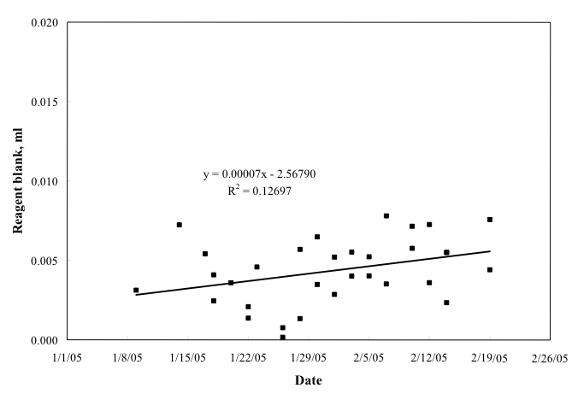
Two to three sets of duplicates were drawn at each station for a total of 265 duplicates. The average standard deviation was 0.25 μmol kg⁻¹.
Figure 2.1. Control plot of the reagent blanks over the cruise.
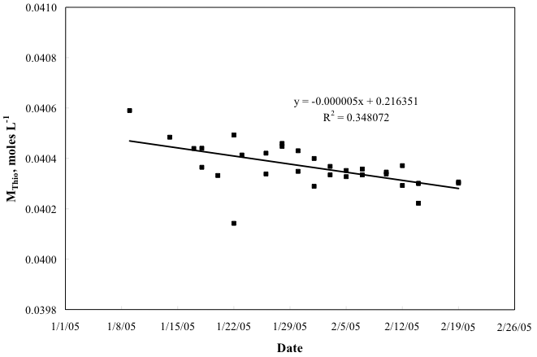
Figure 2.2. Control plot of thiosulfate concentration changes over the cruise.
Comparison of Photometric and Amperometric End Point Titrators:
A comparison was conducted between the photometric end point titrator and a titrator that detected the end point amperometrically. Standardization of the thiosulfate titrant and determination of the reagent blank for the amperometric titrator were done as described in Culberson et al. (1991). The oxygen concentration in the seawater sample was calculated as described by Culberson et al. (1991). Sets of duplicate or quadruplicate flasks were drawn from the same rosette bottle and then analyzed by the two systems. The systems used different burettes (photometric 5 ml and amperometric 2 ml) and different molarity thiosulfate solutions (photometric 0.040 M and amperometric 0.14 M). Blanks and standards for both systems were prepared using the same standard solution and the same dispenser. The reagent blank was assumed to be equal to the intercept of the plot of thiosulfate titer versus ml of standard solution. Standardization of the thiosulfate titrant and determination of the reagent blank for the amperometric titrator were done as described in Culberson et al. (1991). The oxygen concentration in the seawater sample was calculated as described by Culberson et al. (1991). Data are summarized in Table 2.9. Each method was found to have a similar precision, i.e., 0.11 and 0.14 μmol l⁻¹. There was a small but significant bias for the amperometric result to be smaller than the photometric result by 0.47 μmol l⁻¹. This was investigated further by comparing sets of duplicates from station 106 (9º30’S, 25ºW) where the oxygen concentration spanned a very wide range (Table 2.9). It was found that the difference between the two methods was not randomly distributed with respect to oxygen concentration (Figure 2.3). The cause for the systematic bias requires further investigation back at the shore-based laboratory.

Table 2.9: Comparison of oxygen concentrations determined by photometric and amperometric point detection methods at station 106.
 |  | Photometric |  |  | Amperometric
 |  | (µmoles l⁻¹) |  |  | (µmoles l⁻¹)
CTD | Niskin | [O₂] | Mean | SD | [O₂] | Mean | SD | Photo-Ampero
106 | 8 | 259.50 | 259.45 | 0.05 | 259.70 | 259.65 | 0.05 | -0.2
106 | 8 | 259.40 |  |  | 259.60
106 | 20 | 175.20 | 175.20 | 0.00 | 175.80 | 175.80 | 0.00 | -0.6
106 | 20 | 175.20 |  |  | 175.80
106 | 27 | 98.30 | 98.15 | 0.15 | 98.90 | 98.80 | 0.10 | -0.7
106 | 27 | 98.00 |  |  | 98.70
106 | 27 |  |  |  | 98.80
106 | 33 | 218.30 | 218.45 | 0.15 | 218.70 | 218.75 | 0.05 | -0.3
106 | 33 | 218.60 |  |  | 218.80

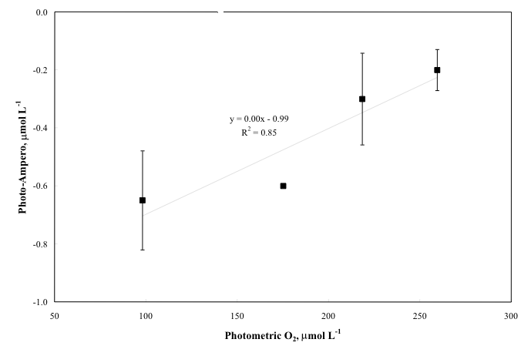
Figure 2.3. Difference between photometrically and amperometrically determined oxygen concentration versus photometric oxygen concentration.
Volumetric Calibration:
Oxygen flask volumes were determined gravimetrically with degassed deionized water to determine flask volumes at AOML. The Dosimat and Wheaton positive displacement dispenser used for dispensing the KIO₃ were calibrated in the same way.

Standards:
Liquid potassium iodate standard solution with a normality of 0.0100 was prepared and bottled at AOML prior to the cruise. A single batch was used during the cruise.
References
Carpenter, J.H., 1965: The Chesapeake Bay Institute technique for the Winkler dissolved oxygen method. Limnol. Oceanogr., v. 10, pp. 141-143.
Culberson, C.H., and S. Huang, 1987: Automated amperometric oxygen titration. Deep-Sea Res., v. 34, pp. 875-880.
Culberson, C.H., G. Knapp, M. Stalcup, R.T. Williams, and F. Zemlyak, 1991: A comparison of methods for the determination of dissolved oxygen in seawater.
Friederich, G.E., P. Sherman, and L.A. Codispoti, 1984: A high precision automated Winkler titration system based on a HP-85 computer: A simple colorimeter and an inexpensive electromechanical buret. Bigelow Lab., Technical Report 42, 24 pp.
2.6.3. Discrete Halocarbon/Alkyl Nitrate Analyses
Principal Investigators: Shari Yvon-Lewis, Dept. of Oceanography, Texas A&M
University, 3146 TAMU, College Station, TX 77845
syvon-lewis@ocean.tamu.edu
Eric Saltzman, Earth System Science, 3325 Croul Hall
University of California-Irvine, Irvine, CA 92697
esaltzma@uci.edu
Samplers: Ben Kates (12 midnight-12 noon), Ben.Kates@noaa.gov
Shari Yvon-Lewis (12 noon-2 midnight)
Analysts: Ben Kates (12 midnight-12 noon)
Shari Yvon-Lewis (12 noon-12 midnight)
Data Reduction: Shari Yvon-Lewis
Sampling:
Samples were drawn from 12-l Bullister bottles into 100 ml ground glass syringes. The syringes have nickel-plated Luer tipped stopcocks. The Luer tips are inserted directly into the petcocks. The syringes are rinsed twice with full 100 ml volumes of water. Bubbles are carefully flushed out, and the third fill is the final sample. The syringes are wrapped with a stiff rubber band to maintain pressure on the plunger and sample reducing the potential for outgassing in the syringes. Storage of the samples is kept to a minimum (<3 hours). They are stored vertically in buckets in the climate controlled cold-room (~4ºC). The cold temperature is used to minimize the chemical degradation of some of the species being measured. Fifteen to 17 samples were drawn from the even numbered stations. This represents 1º latitude spacing on the half degree for a total of 60 stations.
Total number of samples: 893
Each sample was analyzed for 21 chemical species (HCFC-22, CFC-12, HCFC-142b, Halon-1211, CFC-11, HCFC-141b, CFC-113, CH₃CCl₃, CCl₄, C₂Cl₄ (PCE), CH₃Cl, CH₃Br, CH₃I, CH₂Cl₂, CH₂Br₂, CHCl₃, CHBr₃, CH₂ONO₂, C₂H₄ONO₂, i-C₃H₆ONO₂, n-C₃H₆ONO₂). The total number of samples flagged after preliminary shipboard data reduction and quality control, varied by compound:
Questionable (QC=3): ~3
Bad (QC=4): ~21
Not Reported (QC=5): ~22
Analyzer Description:
The halocarbon measurement system was described in Yvon-Lewis et al. (2004). There have been a couple of modifications since to facilitate analysis of alkyl nitrates and to improve performance. The measurements were made with a laboratory-built, automated purge and trap system coupled to a gas chromatograph (GC, HP5890 series II) with mass spectrometer (MS, HP5973) (Figure 2.4). The autosampler allows us to load all of the depth profile samples directly into gas tight glass bulbs (each with a measured volume including tubing of ~70 ml) kept in a temperature-controlled cooler at approximately 5ºC. The entire 100+ ml of seawater in the syringe is flushed through the bulb and tubing.
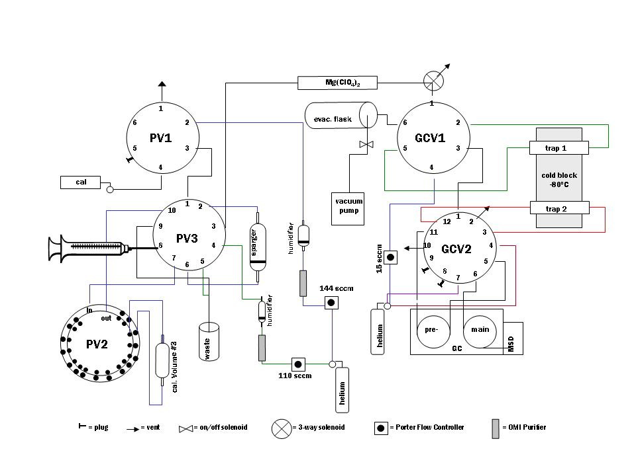
Figure 2.4. Schematic of the automated purge and trap GCMS system. There are 16 calibrated sample bulbs attached to PV2; however, to reduce clutter in the diagram, only calibrated sample bulb #3 is shown.
The computer switches purge valve #2 (PV2), a Valco loop selection valve (VICI Metronics, TX) with 34 ports and 16 positions, from bulb to bulb allowing the humidified helium purge gas stream to push each sample from the bulb into the temperature-controlled (50ºC) sparger. The purge gas passes through the bulb on its way to the sparger and will pick up any trace amounts of the gases left in water along the walls and any of the trace gases that may have undergone some degassing while sitting in the bulb prior to sampling. In this way, we maximize sample recovery and preconcentration on the first cryotrap. The dried (Nafion PD-100T-24SS, PermaPure Inc.) sparger effluent passes over a Unibeads 1S packed trap (3.175 mm OD, 1.6 mm ID) at -80ºC and into a calibrated, evacuated stainless steel flask. The change in flask pressure and the flask temperature are recorded electronically. For a calibration run, the pressure in the flask is used to determine the exact volume of the whole air standard that passed over the cryotrap. GC valve #1 (GCV1) is switched from load to transfer, and the primary trap is then flash heated (200ºC, 3 min.). The sample is focused on a second Unibeads 1S packed trap (1.59 mm OD, 0.5 mm ID) at -80ºC. GC valve #2 (GCV2) is switched from backflush to inject, the focusing trap is flash heated (200ºC, 3 min.) and the sample is injected onto the analytical column (0.25 mm ID  5m pre- and 55m main, DB-VRX; J&W). The pre-column is backflushed at 10 min. after injection to prevent accumulation of the heavier compounds on the column between runs. The GC is temperature programmed to start at 30ºC and end at 210ºC.
Parameters Sampled on the Cruise:
Each sample, blank, and standard is analyzed simultaneously for all of the compounds, HCFC-22, CFC-12, HCFC-142b, CFC-11, HCFC-141b, CFC-113, CH₃CCl₃, CCl₄, PCE, CH₃Cl, CH₃Br, CH₃I, CH₂Cl₂, CH₂Br₂, CHCl₃, CHBr₃, methyl nitrate, ethyl nitrate, isopropyl nitrate, and n-propyl nitrate. The mass spectrometer is programmed to record signals from specific sets of masses over predetermined intervals (i.e., single ion monitoring, SIM). In this way, the mass spectrometer is extremely selective and can detect only the compound of interest at any given time, reducing the potential for co-elution contamination of the signal.
Calibration:
Purge valve #1 (PV1) is used to switch between the humidified purge helium and the calibration gas streams before they enter the rest of the purge system. The calibration gases are from secondary standard cylinders filled with coastal Miami air. These whole air standards (two dry acculife treated cylinders and one wet electropolished 6-l flask) have been calibrated using NOAA/CMDL halocarbon standards and alkyl nitrate standards from the lab of Dr. Eric Saltzman (University of California, Irvine). During a calibration run, the calibration gas follows the same path as the humidified purge helium does during a normal sample run; however, PV2 is kept in the position of the last sample, which has already been analyzed so the sample bulb is empty. The number of moles of gas that pass over the trap is calculated from the known volume of the flask and the recorded temperature and pressure of the flask. The dry mole fractions of the halocarbons and alkyl nitrates in the calibration gas are used to determine the number of moles of each compound in each calibration run, sample, and blank. After a calibration run and before the next sample run, the entire flow path is flushed with the humidified helium. Blanks are run in the same way as calibration runs except that PV1 is in position to allow the humidified helium to flow through the system not the calibration gas. Every seventh injection is a standard. This allows for tracking drift in the detector’s response for each compound.
Data Processing:
As mentioned above, every seventh injection is a calibration gas standard. The three standards were swapped periodically during the cruise. The standard or reference gases are used to determine the response factors (response per mole of analyte) for the mass spectrometer for each compound. Any drift or degradation in signal over time is corrected by interpolating the response factors between reference runs. The interpolated response factor is then used with the observed sample response (blank corrected) to determine the moles of analyte present in that sample. Blanks are run every seventh injection just prior to the reference run. The blank response for a specific compound in any given sample is determined by interpolating between blanks. The three reference gas tanks will be recalibrated after the cruise to determine if there was any drift in their concentrations over time.
Ancillary Measurements:
Approximately once per day, for a total of 40 samples, a calibration run was substituted with an air sample. A 3/8” O.D. Decabon line was run from the aft section of the main lab to the jackstaff on the bow of the ship. A pump (KNF Neuburger with a Viton diaphragm) with a back pressure regulator maintained a 6 l min⁻¹ flow through the Decabon with a back pressure of ~6 psi in sampling line that could be attached to the purge and trap instrument. When an air sample was collected, the calibration gas line was swapped with the sample line from the air pump, and the air sample was collected and analyzed instead of a calibration gas sample. The air data will be reported in the final report after post-cruise calibrations are done.
Problems:
The HCFC-22 concentrations measured in the water samples were excessively high at the beginning of the cruise. There were leaks in the ship refrigerator compressor, and apparently not too long before this cruise a large amount of HCFC-22 was lost in a leak in the engine room and permeated the entire ship. Later in the cruise, the HCFC-22 background appeared to decrease. Some of the HCFC-22 data may be recoverable after some post-cruise analysis. However, at the time of this preliminary data report, all of the HCFC-22 data has been flagged as bad (QC=4).
During the last week of the cruise a possible problem with calibrated volume #1 was observed. Steps were taken to avoid a loss of data after the possible problem was identified. There was not enough time left in the cruise to attempt to fix the problem. Post-cruise analysis will determine the full extent of the data that may have been compromised.
References
Yvon-Lewis, S.A., D.B. King, R. Tokarczyk, K.D. Goodwin, E.S. Saltzman, and J.H. Butler, 2004: Methyl bromide and methyl chloride in the Southern Ocean. J. Geophys Res., v. 109, C02008, doi:10.1029/2003JC001809.
2.6.4. Discrete pCO₂ Analyses
Principal Investigator: Rik Wanninkhof, NOAA/AOML, 4301 Rickenbacker
Causeway Miami Fl 33149
Rik.Wanninkhof@noaa.gov
Samplers: Naomi Levine (12 midnight-12 noon), nlevine@whoi.edu
Rik Wanninkhof (12 noon-12 midnight)
Analysts: Robert Castle (12 midnight-12 noon)
Robert.Castle@noaa.gov
Rik Wanninkhof (12 noon-12 midnight)
Stacey Smith (day time through station 43)
Stacy.Smith@mso.umt.edu
Data Reduction: Robert Castle, Robert.Castle@noaa.gov
Sampling:
Samples were drawn from 12-l Bullister bottles into 500 ml Pyrex™ volumetric flasks using Tygon™ tubing with a Silicone adapter that fit over the petcock to avoid contamination of DOM samples. Bottles were rinsed twice and filled from the bottom, overflowing half a volume while taking care not to entrain any bubbles. About 5 ml of water was withdrawn by removing the pinched off sampling tube from the neck of the flask to create a small expansion volume. 0.2 ml of saturated mercuric chloride (HgCl2 ) solution was added as a preservative. The sample bottles were sealed with a screw cap containing a polyethylene liner. The samples were stored upside down in coolers at room temperature for a maximum of 10 hours.
Thirty samples were drawn every fourth station (@ 2 degree intervals) for a total of 29 stations. In addition, samples were drawn in duplicate from the underway seawater line at 6-hour intervals between Punta Arenas and the start of the line at 60°S, 31°W. These samples are not included in the tally below.
Total number of samples: 847
Total number of samples flagged after initial shipboard data reduction of quality control:
Questionable (QC=3): 9
Bad (QC=4): 1
Not reported (QC=5) (tests): 5
Duplicates (QC=6): 9

Analyzer Description:
The discrete pCO₂ system is patterned after the setup described in Chipman et al. (1993) and is discussed in detail in Wanninkhof and Thoning (1993) and Chen et al. (1995). The major difference between the system of Chipman and ours is that our setup uses a LI-COR™ (model 6262) non-dispersive infrared analyzer, while the system of Chipman et al. (1993) utilizes a gas chromatograph with a flame ionization detector and a methanizer that quantitatively converts CO₂ into CH₄ for analysis.
Samples collected in the 500-ml volumetric flasks are brought to a temperature of 20.00 ± 0.02°C by first inserting the flasks upside down in a pre-bath at ≈21°C and subsequently in a Neslab™ (model RT-220) controlled temperature bath for equilibration and analysis. A 60-ml headspace is created in the sample flask by displacing the water using a compressed standard gas with a CO₂ mixing ratio close to the anticipated pCO₂ of the water. The headspace is circulated in a closed loop through the infrared analyzer that measures CO₂ and water vapor levels in the sample cell. The headspaces of two flasks are equilibrated simultaneously in two channels. While headspace from the flask in the first channel goes through the IR analyzer, the headspace of the flask in second channel is recirculated in a closed loop. After the first sample is analyzed, a valve is switched to put the second channel in line with the analyzer. The samples are equilibrated until the running mean of 20 consecutive 1-second readings from the analyzer differ by less than 0.1 ppm (parts per million by volume), which on average takes about 10 minutes. An expandable volume in the circulation loop near the flasks consisting of a small deflated balloon keeps the content of flasks at room pressure.
Standardization:
In order to account for instrument drift and to maintain measurement precision, a set of six gas standards is run through the system before and after every eight seawater samples. The standards were obtained from Scott-Marin and referenced against primary standards purchased from C.D. Keeling in 1991. The primary standards are on the WMO-78 scale (Table 2.10).
Table 2.10. Calibration standard tanks used for discrete pCO₂.
Standard sequence | Tank number | CO₂ concentration (ppm)
1 | CA05989 | 378.71
2 | CA05980 | 792.51
3 | CA05984 | 1036.92
4 | CA05940 | 1533.7
5 | CA05988 | 593.64
6 | CA05998 | 205.07
These concentrations bracket the pCO₂ at 20°C (pCO₂(20)) values observed during the South Atlantic A16S 2005 cruise.
Data Processing:
The determination of pCO₂(20) in water from the headspace measurement involves several steps. The IR detector response for the standards is normalized for temperature. The IR analyzer raw output of derived dry mole fraction of CO₂ (XCO₂) for samples are normalized to 1 atm pressure. The sample values are converted to the true mixing ratio based on a second-order polynomial fit between the instrument XCO₂ readout and the values of the three nearest concentrations compressed gas standards. The mixing ratio in the headspace is converted to a partial pressure assuming 100% humidity and corrected to partial pressure of CO₂ in the water sample prior to equilibration by accounting for change in total CO₂ in water during the equilibration process (for details see Wanninkhof and Thoning, 1993). The change in pCO₂(20) caused by the change in DIC is calculated using the constraint that TAlk remains constant during exchange of CO₂ gas between the headspace and the water. The calculation is outlined in the appendix of Peng et al. (1987).
Uncertainty based on duplicate sampling of the same Bullister bottle for pCO2 analysis was determined on select stations of the cruise. The comparisons are presented In Table 2.11.
Table 2.11. Duplicate discrete pCO₂ samples.
Station | Sample No. | pCO_{2av} | ∆pCO₂ | % difference
5 | 203 | 1093.8 | 3. | 0.3
5 | 209 | 1089 | 2.3 | 0.2
9 | 103 | 1087.3 | 1.5 | 0.1
9 | 105 | 1088.8 | 2.4 | 0.2
9 | 109 | 1081.6 | 2.7 | 0.2
21 | 135 | 572.7 | 0.4 | 0.07
49 | 121 | 838. | 0.4 | 0.05
65 | 121 | 756.1 | 5.6 | 0.7
93 | 124 | 1040.3 | 2.3 | 0.2
pCO_{2av} = average of the duplicate samples.
∆pCO₂ = absolute difference between the duplicates
% difference = ∆pCO₂/pCO_{2av} * 100
Problems:
The instrument performed very well during the cruise despite its age and outdated DOS GW Basic instrument control software. At the start of the cruise it was noticed that the standard values drifted during the 30-second read sequence. It was determined that diffusion out of the line leading from the IR cell to the internal barometer was the cause. The internal barometer was placed in this unit in the spring of 2003. This problem was remedied by placing a capillary tube in the 1/4” OD tube to decrease its internal volume and decrease exchange. In addition, the read sequence was shortened to 10 readings from the original 30 readings for standards and samples.
One solenoid failed and was replaced without discernable downtime. Three sampling bottles were broken; two because of thermal expansion of the water without adequate headspace and one was dropped on deck during sampling.

References
Chen, H., R. Wanninkhof, R.A. Feely, and D. Greeley, 1995: Measurement of fugacity of carbon dioxide in sub-surface water: An evaluation of a method based on infrared analysis. NOAA Technical Memorandum, ERL AOML-85, 54 pp.
Chipman, D.W., J. Marra, and T. Takahashi, 1993: Primary production at 47°N and 20°W in the North Atlantic Ocean: A comparison between the 14C incubation method and mixed layer carbon budget observations. Deep-Sea Res., II, v. 40, pp. 151-169.
Peng, T.-H., T. Takahashi, W.S. Broecker, and J. Olafsson, 1987: Seasonal variability of carbon dioxide, nutrients, and oxygen in the northern North Atlantic surface water: Observations and a model. Tellus, v. 39B, pp. 439-458.
Wanninkhof, R., and K. Thoning, 1993: Measurement of fugacity of CO₂ in surface water using continuous and discrete sampling methods. Mar. Chem., v. 44, no. 2-4, pp. 189-205.
2.6.5. Total Dissolved Inorganic Carbon (DIC) Analyses (updated 7/27/05)
Principal Investigator: Rik Wanninkhof, NOAA/AOML, 4301 Rickenbacker
Causeway, Miami, FL 33149
Rik.Wanninkhof@noaa.gov
Samplers: Robert Castle (12 midnight-12 noon)
Robert.Castle@noaa.gov
Esa Peltola (12 noon-12 midnight), Esa.Peltola@noaa.gov
Analysts: Robert Castle (12 midnight-12 noon)
Robert.Castle@noaa.gov
Esa Peltola (12 noon-12 midnight), Esa.Peltola@noaa.gov
Data Reduction: Robert Castle, Robert.Castle@noaa.gov
Esa Peltola, Esa.Peltola@noaa.gov
Sampling:
Samples were drawn according to procedures outlined in the Handbook of Methods for CO₂ Analysis (DOE, 1994) from 12-l Bullister bottles into cleaned 540-ml Pyrex bottles using Tygon tubing with a silicone adapter on the petcock to avoid contamination of DOC samples. Bottles were rinsed and filled from the bottom, leaving 5 ml of headspace. Care was taken not to entrain any bubbles. 0.2 ml of saturated HgCl₂ solution was added as a preservative. The sample bottles were sealed with glass stoppers lightly covered with Apiezon-L grease and were stored at room temperature for a maximum of 12 hours prior to analysis.
DIC samples were collected at every degree from 36 depths with three replicate samples. Some samples were also collected at every half-degree. The replicate seawater samples were taken from the surface, 1000 m, and bottom Bullister bottles and run at different times during the cell. The first replicate of the bottom water was used at the start of the cell with fresh coulometer solution, the first one of the 1000 m replicates was run in the middle of the cell after about 12 mg of C were titrated. The second one of the bottom replicates was run at the end of the cell after about 25 mg of C were titrated. A new coulometer cell was started with the second one of the 1000 m replicate and the first one of the surface replicate samples. In the middle of this cell the second one of the surface replicates was run and the first one of the surface duplicates of a partial station. The second one of the duplicates of the partial station was run at the end of this cell. No systematic difference between the replicates was observed. There was no systematic dependency of results with an amount of carbon titrated for a particular cell.
Total number of samples analyzed: 2482
Total number of samples flagged after initial shipboard data reduction of quality control:
Good (QC=2): 2245
Duplicates (QC=6): 180
Questionable (QC=3): 31
Bad (QC=4): 20
Not Reported (QC=5): 6
Analyzer Description:
The DIC analytical equipment was set up in a seagoing laboratory van. The analysis was done by coulometry with two analytical systems (AOML-1 and AOML-2) used simultaneously on the cruise. Each system consisted of a coulometer (UIC, Inc.) coupled with a SOMMA (Single Operator Multi-parameter Metabolic Analyzer) inlet system developed by Kenneth Johnson (Johnson et al., 1985, 1987, 1993; Johnson, 1992) formerly of Brookhaven National Laboratory (BNL). In the coulometric analysis of DIC, all carbonate species are converted to CO₂ (gas) by addition of excess hydrogen ion (acid) to the seawater sample, and the evolved CO₂ gas is swept into the titration cell of the coulometer with pure air or compressed nitrogen, where it reacts quantitatively in with a proprietary reagent based on ethanolamine to generate hydrogen ions. In this process the color changes from blue to colorless, which triggers a current through the cell and causes coulometrical generation of OH– ions at the anode. The OH– ions react with the H⁺, and the color of the solution turn back to blue. A lightbeam shines through the solution and a photometric detector at the opposite side of the cell senses the change in transmission. Once the percent transmission reaches its original value, the coulometric titration is stopped and the amount of CO₂ that enters the cell is determined by integrating the total charge during the titration.
Standardization:
The coulometers were calibrated by injecting aliquots of pure CO₂ (99.995%) by means of an 8-port valve outfitted with two sample loops with known gas volumes (AOML-1: 1.9951 ml @ 25.05°C and 0.9807 ml @ 25.10°C; AOML-2: 2.0018 ml @ 25.09°C and 0.9949 ml @ 25.06°C) bracketing the amount of CO₂ extracted from the water samples for the two AOML systems.
The stability of each coulometer cell solution was confirmed three different ways: the Certified Reference Material (CRM, Batch 66, supplied by Dr. A. Dickson of Scripps Institution of Oceanography, SIO) was measured at the beginning and the middle, gas loops in the beginning and at the end, and the duplicate samples in the beginning, middle and at the end of each cell solution. The coulometer cell solution was replaced after 25 mg of carbon was titrated, typically after 9-12 hours of continuous use.
The pipette volume was determined by taking aliquots at known temperature of distilled water from the volumes. The weights with the appropriate densities were used to determine the volume of the pipettes (AOML1: 28.716 ml @ 20.00°C, AOML2: 22.547 ml @ 20.00°C).
Data Processing:
Calculation of the amount of CO₂ injected was according to the Department of Energy (DOE) CO₂ handbook (DOE, 1994). The concentration of CO₂ ([CO₂]) in the samples was determined according to:
where "Cal. Factor" is the calibration factor, “Counts” is the instrument reading at the end of the analysis, “Blank” is the counts/minute determined from blank runs performed at least once for each cell solution, “Run Time” is the length of coulometric titration (in minutes), and K is the conversion factor from counts to µmol.
The instrument has a salinity sensor, but all DIC values were recalculated to a molar weight (µmol kg⁻¹) using density obtained from the CTD’s salinity sensor. The DIC values were corrected for dilution by 0.2 ml of HgCl₂ used for sample preservation. The total water volume of the sample bottles was 540 ml. The correction factor used for dilution was 1.00037. A correction was also applied for the offset from the CRM. This correction was applied for each cell using the CRM value obtained in the beginning of the cell. The results underwent initial quality control on the ship using property plots: DIC-Depth, DIC-Potential Temperature, DIC-AOU, DIC-NO₃; DIC-SiO₃, DIC-PO₄, DIC-TAlk, and DIC-pH. Also DIC-LAT-Depth contour plots were used to analyze the quality of the data.
Problems:
The overall performance of the instruments was good during the cruise. The air purifier supplying carrier and pneumatic gas malfunctioned during station 24. Compressed tanks of ultra-high purity nitrogen gas were used thereon. At the same time, soda lime traps used to scrub any CO₂ from the carrier gas were removed from the air/N₂ line, since they developed cracks over time and also they appeared to release CO₂ in pulses into the carrier. A coulometer was replaced during the test cast runs. It did not find an endpoint and did not stop counting. A number of pinch valves failed and they were replaced. Also some cell caps started leaking and leads of electrodes broke. The Orbo tubes (filled with silica gel to absorb possible acid vapors) tended to break and leak and they were not used after station 109 on either system.
Tests of Different Size Sampling Bottles:
Because of concerns about the large amount of water used for a DIC sample and use of grease on the stoppers that could contaminate samples for DOM, comparison tests were performed with samples drawn in 250 ml borosilicate bottles with ground glass stoppers stored under cold water with the regular sampling procedures outlined above. The results are shown in Table 2.12.

Table 2.12. Test results of different sample bottle sizes for DIC.
Type | Bottle | RT | DIC | Bullister  Bottle | Volume  (ml) | Average
CRM | 213 | 14 | 1971.11
bottle | A9 | 13 | 2122.29 | 9 | 500
bottle | C9 | 13 | 2121.10 | 9 | 500 | 2121.69
bottle | S76 | 10 | 2119.95 | 9 | 250
bottle | S77 | 12 | 2120.01 | 9 | 250 | 2119.98
bottle | S78 | 12 | 2120.28 | 10 | 250
bottle | S79 | 11 | 2120.89 | 10 | 250 | 2120.58
bottle | A10 | 13 | 2121.04 | 10 | 500
bottle | C10 | 12 | 2122.5 | 10 | 500 | 2121.77
bottle | A11 | 12 | 2121.37 | 11 | 500
bottle | C11 | 14 | 2123.05 | 11 | 500 | 2122.21
CRM | 213 | 15 | 1972.10
bottle | S80 | 13 | 2120.74 | 11 | 250
bottle | S81 | 19 | 2121.09 | 11 | 250 | 2120.915
bottle | S82 | 11 | 2120.51 | 12 | 250
bottle | S83 | 17 | 2121.03 | 12 | 250 | 2120.77
bottle | A12 | 20 | 2126.01 | 12 | 500
bottle | C12 | 20 | 2125.5 | 12 | 500
bottle | A13 | 20 | 2128.34 | 13 | 500
bottle | C13 | 17 | 2122.12 | 13 | 500 | 2122.12
bottle | S84 | 11 | 2120.61 | 13 | 250
bottle | S85 | 11 | 2119.34 | 13 | 250 | 2119.97
bottle | S86 | 9 | 2119.26 | 14 | 250
bottle | S87 | 9 | 2119.41 | 14 | 250 | 2119.33
bottle | A14 | 9 | 2120.74 | 14 | 500
bottle | C14 | 9 | 2121.61 | 14 | 500 | 2121.17
CRM Certified Value 1969.57.
Legend:
Type: CRM = certified reference material; bottle = sample bottle.
Bottle: bottles with prefix “S” are the 250 ml bottle, the others are the 540 ml bottles used during the cruise.
RT: run time of the sample on the coulometer in minutes.
DIC: results of the analyses in µmol kg⁻¹
Bullister Bottle: Bullister bottle number.
Volume: nominal sample bottle volume.
Average: Average of duplicate large or duplicate small bottles taken from a particular Bullister bottle.
Statistics:
Large Small
Average: 2121.79 2120.26
St. Dev.: 0.37 0.55
These test and more ad-hoc tests at the beginning of the cruise showed a small but systematic difference between the small and large sample bottles. The cause of the artifact is not clear, but the tests led to our decision to use the 500-ml greased stopper bottles for the entire cruise.
References
DOE, 1994: Handbook of methods for the analysis of the various parameters of the carbon dioxide system in sea water. Version 2, A.G. Dickson and C. Goyet (eds.), ORNL/CDIAC-74.
Johnson, K.M., K.D. Wills, D.B. Butler, W.K. Johnson, and C.S. Wong, 1993: Coulometric total carbon dioxide analysis for marine studies: Maximizing the performance of an automated continuous gas extraction system and coulometric detector. Mar. Chem., v. 44, pp. 167-189.
Johnson, K.M., 1992: Operator’s manual: Single operator multiparameter metabolic analyzer (SOMMA) for total carbon dioxide (CT) with coulometric detection. Brookhaven National Laboratory, Brookhaven, NY, 70 pp.
Johnson, K.M., P.J. Williams, L. Brandstrom, and J. McN. Sieburth, 1987: Coulometric total carbon analysis for marine studies: Automation and calibration. Mar. Chem., v. 21, pp. 117-133.
Johnson, K.M., A.E. King, and J. McN. Sieburth, 1985. Coulometric DIC analyses for marine studies: An introduction. Mar. Chem., v. 16, pp. 61-82.
2.6.6. Discrete pH Analyses
Principal Investigators: Frank J. Millero, U. Miami, RSMAS
4600 Rickenbacker Causeway, Miami, FL 33149
fmillero@rsmas.miami.edu
Samplers: William T. Hiscock (12 noon-12 midnight)
whiscock@rsmas.miami.edu
John M. Trapp (12 midnight-12 noon)
jtrapp@rsmas.miami.edu
Analysts: William T. Hiscock (12 noon-12 midnight)
whiscock@rsmas.miami.edu
John M. Trapp (12 midnight-12 noon)
jtrapp@rsmas.miami.edu
Data Reduction: William T. Hiscock, whiscock@rsmas.miami.edu
Sampling:
Samples were drawn from 12-l Bullister bottles into 50 ml glass syringes using polycarbonate Luer-lock valves that fit in the petcock. Syringes were rinsed a minimum of three times and filled while taking care not to entrain any bubbles. A rubber band ensured positive pressure on the barrel of the syringe. The samples were stored at room temperature for a maximum of 7 hours. Thirty-six samples and three duplicates were drawn on odd numbered stations (at 1 degree intervals) for a total of 60 full stations. At even number stations, surface water and a duplicate were always taken; in addition, five to 20 other depths were also sampled, for a total of 59 half stations. Typically, nine depths were sampled with a duplicate at the surface for the half-stations. Underway samples were drawn in duplicate from the underway seawater line at 6-hour intervals between Punta Arenas, Chile and the start of the line at 60°S, 31°W which are not included in the tally below.
Total number of samples: 2811
Questionable (QC=3): 44
Bad (QC=4): 64
Not Reported (QC=5): 51
Analyzer Description:
Measurements of the pH of seawater on the total hydrogen ion concentration pH scale (pH_{t}) were made using the multi-wavelength spectrophotometric techniques of Clayton and Byrne (1993). Determination of the absorbance at several wavelengths eliminates the need to know the concentrations of indicator in the sample. Sulphonphthalein indicators such as m-cresol purple (mCP), thymol blue, and cresol red are suitable for the determination of pH. The system is patterned after the standard operating procedure developed by the U.S. Department of Energy (DOE) (1994) and utilizes mCP. This fully automated system performs discrete analysis of pH samples approximately every 12 minutes on a sample volume of 25 ml. A microprocessor controlled syringe and sampling valve aspirates and injects the seawater sample into the 10 cm optical cell at a precisely controlled rate. The syringe rinses and primes the optical cell with 20 ml of sample and the software permits five minutes for temperature stabilization. A refrigerated circulating temperature bath (Neslab, model RTE-17) regulates the temperature of the sample at 25 ± 0.01ºC. An Agilent 8453 UV/VIS spectrophotometer measures background absorbance of the sample. The automated syringe and sampling valves aspirates 4.90 ml seawater and 0.008 ml of indicator and injects the mixture into the cell. After the software permits five minutes for temperature stabilization, a Guildline 9540 digital platinum resistance thermometer measures the temperature and the spectrophotometer acquires the absorbance at 434, 578 and 730 nm.
Reagents:
A concentrated solution, 2.0 mM, of mCP (C21H18O3S) dye solution of known pH_{t} = 7.91 and R = 1.625 at 25ºC.
Standardization:
A precision of better than 0.001 pH units is possible with care, specifically with regard to temperature equilibration and sample handling. Measurements made on duplicate samples, TRIS buffers and Certified Reference Material, Batch 59 (Dr. Andrew Dickson, Marine Physical Laboratory, La Jolla, California) provide validation of the precision and accuracy. Duplicate analyses provide additional quality assurance and were taken from same Bullister bottle. The pH_{sws} for the Certified Reference Material was determined by spectrophotometric methods independently in the laboratory at RMSAS, University of Miami:
Batch #59: pH_{sws} @ 25°C 7.9048 ± 0.0007 (n = 19)
Salinity 33.316
Data Processing:
The pH_{t} of the sample is perturbed by the addition of the indicator. The magnitude of this perturbation is a function of the difference between the seawater and indicator acidity. A correction factor applied for each batch of dye adjusts for this perturbation. For a 4.90 ml sample of seawater, 0.008 ml of mCP is added and the absorbance ratio measured. From a second addition of mCP and a second absorbance ratio measurement, a change in the absorbance ratio per ml of added indicator (DR) is calculated. The value of the absorbance ratio (R_{m}) measured subsequent to the initial addition of the indicator was used to calculate R from:
R = R_{m} + (0.00095 - 0.00133 R_{m}) V_{ind} (1)
where V_{ind} is the volume of mCP used. Clayton and Byrne (1993) calibrated the mCP indicator using TRIS buffers (Ramette et al., 1977) and the equations of Dickson (1993). These equations are used to calculate pH_{t}, the total scale in units of moles per kilogram of solution. The conversion of the pH_{t} (mol/kg_{H2O}) to the seawater scale (mol/kg_{sol}) can be made using equations of Dickson and Millero (1987), Dickson and Riley (1979), and Dickson (1990).
CRM
Total number of Sets: 136
Number of Sets Used: 124
CRM Batch #59: 7.9050 ± 0.0024 (pH_{sws} @ 25°C)
TRIS Buffer
Total number of Sets: 296
Number of Sets Used: 264
TRIS Buffer (0.04 m): 8.0935 ± 0.0019 (pH_{t} @ 25°C)
Duplicates
Total number of Sets: 291
Number of Sets Used: 214
Standard Deviation: ± 0.0019 (pHsws @ 25°C)
Note: The instrumental software automatically runs a duplicate analysis when the baseline absorbance at 730 nm is beyond a set threshold, thus a large number of omitted duplicate results. Duplicate samples whose difference was three times larger than the standard deviation were omitted from the analyses. The number omitted is the difference between the total number of sets and the sets used.
Problems:
At the start of the cruise, the outflow from the optical cell leaked into the thermostated water jacket; this was repaired by replacing the tubing. Sporadically, samples drawn from the syringe entrained an air bubble because the valve was improperly opened, tubing was pinched, or the syringe plunger was dry and became stuck in the barrel. Some syringes suffered from fatigue at the metal Luer-lock and resulted in the sample being lost or a failed analysis. Occasionally the software would lose communication with the microprocessor-controlled syringe pumps and pause analysis; the problem was resolved by following the steps outlined in the software to reestablish communication.
References
Clayton, T.D., and R.H. Byrne, 1993: Spectrophotometric seawater pH measurements: Total hydrogen ion concentration scale calibration of m-cresol purple and at-sea results. Deep-Sea Res., v. 40, pp. 2315-2329.
Dickson, A.G., 1990: Thermodynamics of the dissociation of boric acid in synthetic seawater from 273.15 to 318.15 K. Deep-Sea Res., Part A, v. 37, no. 5, pp. 755-766.
Dickson, A.G., 1993: The measurement of seawater. Mar. Chem., v. 44, no. 2-4, pp. 131-142.
Dickson, A.G., and F.J. Millero, 1987: A comparison of the equilibrium constants for the dissociation of carbonic acid in seawater media. Deep-Sea Res., Part A, v. 34, no. 10, pp. 1733-1743.
Dickson, A.G., and J.P. Riley, 1979: The estimation of acid dissociation constants in seawater media from potentiometric titration with strong base, 1: The ionic product of water-KSUS-w. Mar. Chem., v. 7, no. 2, pp. 89-99.
DOE, 1994: Handbook of methods for the analysis of the various parameters of the carbon dioxide system in sea water. Version 2, A.G. Dickson and C. Goyet (eds.), ORNL/CDIAC-74.
Ramette, R.W., C.H. Culberson, and R.G. Bates, 1977: Acid-base properties of Tris(hydroxymethyl)aminomethane (Tris) buffers in seawater from 5 to 40°C. Anal. Chem., v. 49, pp.867-870.

2.6.7. Total Alkalinity Analyses
Principal Investigator: Frank J. Millero, U. Miami, RSMAS
4600 Rickenbacker Causeway, Miami, FL 33149
fmillero@rsmas.miami.edu
Samplers: Taylor B. Graham (12 noon-12 midnight)
tgraham@rsmas.miami.edu
Mareva Chanson (12 midnight-12 noon)
mchanson@rsmas.miami.edu
Analysts: Taylor B. Graham (12 noon-12 midnight)
tgraham@rsmas.miami.edu
Mareva Chanson (12 midnight-12 noon)
mchanson@rsmas.miami.edu
Data Reduction: William T. Hiscock, whiscock@rsmas.miami.edu
Sampling:
Samples were drawn from 12-l Bullister bottles into 500 ml borosilicate flasks using Silicone tubing that fit over the petcock to avoid contamination of DOC samples. Bottles were rinsed a minimum of two times and filled from the bottom, overflowing a quarter of a volume while taking care not to entrain any bubbles. Approximately 15 ml of water was withdrawn from the flask by arresting the sample flow and removing the sampling tube, thus creating a small expansion volume and a reproducible headspace. The sample bottles were sealed at a ground glass joint with a glass stopper. The samples were stored at room temperature for a maximum of 7 hours. Thirty-six samples and three duplicates were drawn on odd number stations (at 1 degree intervals) for a total of 61 full stations. Typically, nine depths were sampled with a duplicate at the surface at the 60 “half stations.” Periodically, multiple duplicate samples were drawn with a specific focus on photic zone and region of high dissolved organic carbon (DOC). The purpose was to determine the difference in Total Alkalinity after filtration with a 0.45 µm nylon membrane filter. Additional underway samples were drawn in duplicate from the underway seawater line at 6-hour intervals between Punta Arenas, Chile and the start of the line at 60°S, 31°W, which are not included in the tally below.
Total number of samples: 2784
Questionable (QC=3): 64
Bad (QC=4): 42
Not Reported (QC=5): 51

Analyzer Description:
The total alkalinity of seawater (TAlk) was evaluated from the proton balance at the alkalinity equivalence point, pH_{equiv} = 4.5 at 25ºC and zero ionic strength in one kilogram of sample. The method utilizes a multi-point hydrochloric acid titration of seawater according to the definition of total alkalinity (Dickson, 1981).
The titration system used consists of a Metrohm 665 Dosimat titrator, an Orion 720A pH meter and a custom designed plastic water-jacketed titration cell (Millero et al., 1993b). Both the seawater sample and acid titrant are temperature equilibrated to a constant temperature of 25 ± 0.1ºC with a water bath (Neslab, model RTE-17). The plastic water-jacketed cell is similar to the cells used by Bradshaw and Brewer (1988) except a larger volume (~200 ml) is employed to increase the precision. Each cell has a fill and drain valve which increases the reproducibility of the volume of sample contained in the cell. The titration acidified seawater past the carbonic acid endpoint by adding HCl stepwise through an injection tip into the cell. A typical titration recorded the EMF after the readings became stable (deviation less than 0.09 mV) and then enough acid was added to change the voltage a pre-assigned increment (13 mV). A full titration (~25 points) takes about 20 minutes. The electrodes used to measure the EMF of the sample during a titration consisted of a ROSS glass pH electrode (Orion, model 810100) and a double junction Ag, AgCl reference electrode (Orion, model 900200).
Reagents:
A single 50-l batch of ~0.25 m HCl acid was prepared in 0.45 m NaCl by dilution of concentrated HCl, AR Select‚ Mallinckrodt, to yield a total ionic strength similar to seawater of salinity 35.0 (I ≈ 0.7 M). The acid was standardized by a coulometric technique (Marinenko and Taylor, 1968; Taylor and Smith, 1959) and verified with alkalinity titrations on seawater of known alkalinity. Furthermore, Andrew Dickson’s laboratory performed an independent determination of the acid molality on sub-samples. The calibrated molality of the acid used was 0.2434 ± 0.0001 m HCl. The acid was stored in 500-ml glass bottles sealed with Apiezon® L grease for use in the field.
Standardization:
The volumes of the cells used were determined to ± 0.03 ml in the laboratory by multiple titrations using seawater of known total alkalinity and CRM. Calibrations of the burette of the Dosimat with water at 25ºC indicate that the systems deliver 3.000 ml (the approximate value for a titration of seawater) to a precision of ± 0.0004 ml, resulting in an error of ± 0.3 µmol·kg⁻¹ in TAlk and DIC. The reproducibility and precision of measurements are checked using low nutrient surface seawater and Certified Reference Material (Dr. Andrew Dickson, Marine Physical Laboratory, La Jolla, California), Batch 59 and 66. CRM were utilized in order to account for instrument drift and to maintain measurement precision. Duplicate analyses provide additional quality assurance and were taken from same Bullister bottle.
The assigned values of the Certified Reference Material provided by A. Dickson of SIO are:
Batch #59: Total Alkalinity: 2220.98 ± 0.58 µmol·kg⁻¹ Salinity: 33.316
Batch #66: Total Alkalinity: 2193.27 ± 0.60 µmol·kg⁻¹ Salinity: 32.962
Data Processing:
An integrated program controls the titration, data collection, and the calculation of the carbonate parameters (TAlk, pH, and DIC ) (Millero et al., 1993a). The program is patterned after those developed by Dickson (1981), Johansson and Wedborg (1982), and U.S. Department of Energy (DOE) (1994). The program uses a Levenberg-Marquardt nonlinear least-squares algorithm to calculate the TAlk, DIC, and from the potentiometric titration data.
CRM Instrument 1 Instrument 2
Total number of sets: 56 52
Number of sets used: 48 46
Standard deviation: ±3.5 µmol·kg⁻¹ ±2.7 µmol·kg⁻¹

Duplicates Between Systems Instrument 1 Instrument 2
Total number of sets: 143 31 42
Number of sets used: 130 25 35
Standard deviation: ±2.9 µmol·kg⁻¹ ±1.6 µmol·kg⁻¹ ±1.3 µmol.kg⁻¹
Note: Duplicate samples whose difference was three times larger than standard deviation were omitted from the analyses. The number omitted is the difference between the total number of set and the sets used.
Problems:
At the start of the cruise a titration cell was swapped out for a spare cell because of a combination of instability in the electrodes and an air bubble consistently being trapped. One valve and a proximity switch were replaced without discernible downtime. Sporadically, a solenoid valve at the bottom of the titration cell would fail to engage or disengage, resulting in the loss of the sample or a failed titration due to a poor rinse or an air bubble. The titration cell on system one showed some drift in CRM values on February 4, 2005; the titration cells recalibration values were used to correct this. Communication problems between the software and the components of the TAlk system were remedied with replacement of cables and/or components. A Metrohm 665 Dosimat titrator and Orion 720A pH meter were replaced. Computer instability resulted in the loss of one sample.
References
Bradshaw, A.L., and P.G. Brewer, 1988: High precision measurements of alkalinity and total carbon dioxide in seawater by potentiometric titration, 1: Presence of unknown protolyte(s)? Mar. Chem., v. 23, pp. 69-86.
Dickson, A.G., 1981: An exact definition of total alkalinity and a procedure for the estimation of alkalinity and total CO₂ from titration data. Deep-Sea Res., Part A, v. 28, pp. 609-623.
DOE, 1994: Handbook of methods for the analysis of the various parameters of the carbon dioxide system in sea water. Version 2, A.G. Dickson and C. Goyet (eds.), ORNL/CDIAC-74.
Johansson, O., and M. Wedborg, 1982: On the evaluation of potentiometric titrations of seawater with hydrochloric acid. Oceanologica Acta, v. 5, pp. 209-218.
Marinenko, G., and J.K. Taylor, 1968: Electrochemical equivalents of benzoic and oxalic acid. Anal. Chem., v. 40, pp. 1645-1651.
Millero, F.J., R.H. Byrne, R. Wanninkhof, R. Feely, T. Clayton, P. Murphy, and M.F. Lamb, 1993a: The internal consistency of CO₂ measurements in the equatorial Pacific. Mar. Chem., v. 44, pp. 269-280.
Millero, F.J., J.-Z. Zhang, K, Lee, and D.M. Campbell, 1993b: Titration alkalinity of seawater. Mar. Chem., v. 44, pp. 153-165.
Taylor, J.K., and S.W. Smith, 1959: Precise coulometric titration of acids and bases. J. Res. Natl. Bur. Stds., v. 63, pp. 153-159.

2.6.8. Salinity Analysis
Principal Investigators: Gregory C. Johnson, NOAA/PMEL
Analyst: Dave Wisegarver, NOAA/PMEL
Samplers: Dave Wisegarver (primary from 4 a.m.-4 p.m.)
Scott Doney, Rik Wanninkhof, Bill Hiscock, Wenhau Chen
Samples were run on a Guildline 8400B Laboratory Salinometer, serial number 60843. The salinometer had been last calibrated at Guildline in January of 2004. IAPSO Standard Seawater was used to standardize the instrument. The standard water was from batch:
P143, 26-Feb-2003, K15 = 0.99989, Salinity 34.996.
The instrument was located in a small temperature controlled room, off the hydro lab. A recording temperature sensor was placed near the salinometer to monitor the temperature during analyses. For the most part, the temperature logged by this sensor was 22-24°C; however, there were several deviations, one as high as 25.3°C and one as low as 21.7°C. On one occasion, analysis was halted for about half an hour, while the room cooled.
Samples were drawn from the Bullister bottles into 250-ml Kimax borosilicate bottles. The bottles were rinsed at least three times before filling to approximately 220 ml. A plastic insert and Nalgene cap were used to seal the sample in the bottle. At the conclusion of sampling, the time was noted and samples were placed into the salinometer lab so they could equilibrate to the room temperature. Samples were analyzed after a period of at least 10 hours and typically not more than 24 hours from the time of sampling. With the exception of a few shallow casts, an IAPSO standard seawater bottle was analyzed before and after each station.
The software used (ASALW) was developed at Scripps Institution of Oceanography. As per the instructions provided in the software, the cell was rinsed at least two times with sample at a relatively fast flow rate; the flow was adjusted to a slower rate for the final fill, and a reading was taken. The cell was drained and slowly filled for a second reading. If the two readings agreed within 0.00005, the values were accepted; otherwise, an additional reading was required. PSS-78 salinity (UNESCO, 1981) was calculated. Corrections were applied to the data for differences between beginning and ending standards.
A total of 4174 salinity samples were taken, of which 127 were flagged as questionable, 3 as bad, and 2 were lost during analysis. A number of samples could not be drawn during heavily sampled casts, due to a lack of water. This occurred most frequently when using the small 3-liter bottles in the first few stations.
References
UNESCO, 1981: Background papers and supporting data on the practical salinity scale., 1978. UNESCO Technical Papers in Marine Science, No. 37, p. 144.
2.6.9. Inorganic Nutrients (Phosphate, Nitrate, Nitrite, and Silicate)
Principal Investigators: Dr. Calvin Mordy, NOAA/PMEL
Dr. Jia-Zhong Zhang, NOAA/AOML
Samplers and Analysts: Charlie Fischer, NOAA/AOML (12 noon-12 midnight)
Calvin Mordy, UW (12 midnight-12 noon)
Data Reduction: Calvin Mordy
Equipment and Techniques:
Dissolved nutrients (phosphate, silicic acid, nitrate and nitrite) were measured using automated continuous flow analysis with a segmented flow and colorimetric detection. The four-channel autoanalyzer was customized using components from various systems. The major components were an Alpkem 301 sampler, two 24 channel Ismatek peristaltic pumps, four ThermoSeparation monochrometers, and custom software for digitally logging and processing the chromatographs. Glass coils and tubing from the Technicon Autoanalyzer II were used for analysis of phosphate, and micro-coils from Alpkem were used for the other three analyses.
The detailed methods were described by Gordon et al. (1992). Because pump tubing destined for the cruise was lost in transit, some of the pump tube sizes suggested in the manual had to be modified. Pump tubes were changed four times during the expedition.
Silicic acid was analyzed using a modification of Armstrong et al. (1967). An acidic solution of ammonium molybdate was added to a seawater sample to produce silicomolybic acid. Oxalic acid was added to inhibit a secondary reaction with phosphate. Finally, the reduction with ascorbic acid formed the blue compound silicomolybdous acid. The color formation was detected using a 6 mm flowcell at 660 nm. The use of oxalic acid and ascorbic acid (instead of tartaric acid and stannous chloride as suggested by Gordon et al.) was to reduce the toxicity of our waste stream.
Nitrate and nitrite analyses were also modified from Armstrong et al. (1967). Nitrate was reduced to nitrite in a cadmium column, formed into a red azo dye by complexing nitrite with sulfanilamide and N-1-naphthylethylenediamine, and the color formation was detected using a 6 mm flowcell at 540 nm. The same technique was used to measure nitrite (excluding the reduction step), but the color formation was detected using a 10 mm flowcell at 540 nm.
Phosphate analysis was based on the technique of Bernhardt and Wilhelms (1967). An acidic solution of ammonium molybdate was added to the sample to produce phosphomolybdic acid, and this was reduced to the blue compound phosphomolybdous acid following the addition of hydrazine sulfate. The reaction was heated to 55°C to bring the reaction to completion, and color formation was detected using a 10 mm flowcell at 815 nm.

Sampling and Standards:
Nutrient samples were drawn in 40 ml HDPE Boston Round sample bottles that had been stored in 10% HCl and rinsed four to five times with sample before filling. A replicate was always drawn from the deep bottle for analysis on the subsequent station. All samples were brought to room temperature prior to analysis. A separate analytical run was conducted at each station (except for the most shallow stations). An analytical run consisted of blanks and working standards, old working standard, deep water from the previous station, samples analyzed from deep to surface, replicate analysis of the four deep samples and any problem samples, and finally the working standards and blanks. The blanks were deionized water, and the standards were simply a “zero” standard in Low Nutrient Seawater (LNSW), and a high standard. Linearity of the autoanalyzer was checked every ten days, and corrections for non-linearity will be applied during final data reduction.
The high standard was made from the addition of 1 ml of primary nitrite standard and 20 ml of a secondary mixed standard (containing silicic acid, nitrate, and phosphate) in 500 ml of LNSW. A new high standard was prepared for each analytical run. Calibrated Eppendorf pipettes normally used for dispensing the primary and secondary standards were not delivered to the ship, so a calibrated Rainin electronic digital pipette was used.
Dry standards were pre-weighed at PMEL and dissolved to prepare primary standards at sea. Silicic acid (Na₂SiF₆, >98%) and nitrate (KNO₃, 99.99%) were from Aldrich, phosphate (KH₂PO₄, 99.99%), and nitrite (NaNO₂, 98.2%) were from Baker. The mixed standard was prepared by additions of the nitrate and phosphate primary standards during preparation of the silicic acid primary standard.
After each run, the electronic chromatograph was scrutinized to ensure proper selection of individual peak heights. The peak information was inserted into Microsoft Excel and the concentrations were calculated after factoring the baseline drift, carryover corrections, refractive index, and standard drift. Quality control plots were maintained of the baseline, matrix, carryover, standard factor, old standard, and station-to-station variability of the deep water replicate.
Nutrient concentrations were reported to the shipboard data manager in micromole per liter. The laboratory temperature during analysis was also reported to facilitate unit conversion to a micromole per kg basis. The nutrient concentration as shown in µmol kg-¹ units presented in the bottle data files.
Problems:
During the cruise, several detectors and a sampler had to be replaced, but no data were compromised due to these equipment failures. During the first two stations, the phosphate heater was not functioning, and these data were considered suspect.
Number of Samples, Replicates, and Precision:
A replicate sample was almost always drawn from the deepest bottle, and replicate analyses were almost always conducted on the four deepest bottles. A few replicate analyses were conducted for samples in the upper water, and the precision of nitrate was determined from those samples with concentrations >0.05 μM. The precision of phosphate, silicic acid and nitrate was within 2% of full scale (Table 2.13).
Table 2.13. Summary of number of nutrient samples taken and estimated precision.
 | Phosphate | Silicic Acid | Nitrate | Nitrite
Number of samples | 4286 | 4286 | 4243 | 4286
Number of replicates | 755 | 759 | 680 | 19*
Average standard deviation (µM) | 0.01 | 0.4 | 0.08 | 0.005
Percent deviation | 0.8% | 1.7% | 1.4% | 2%
*Samples with nitrate concentrations higher that 0.05 μM.
References
Armstrong, F.A.J., C.R. Stearns, and J.D.H. Strickland, 1967: The measurement of upwelling and subsequent biological processes by means of the Technicon AutoAnalyzer and associated equipment. Deep-Sea Res., v. 14, pp. 381-389.
Bernhardt, H., and A. Whihelms, 1967: The continuous determination of low level iron, soluble phosphate, and total phosphate with the AutoAnalyzer. Technicon Symposia, I., pp. 385-389.
Gordon, L.I., J.C. Jennings Jr., A.A. Ross, and J.M. Krest, 1993: A suggested protocol for continuous automated analysis of seawater nutrients (phosphate, nitrate, nitrite, and silicic acid) in the WOCE Hydrographic program and the Joint Global Ocean Fluxes Study, WOCE Operations Manual, Vol. 3: The Observational Programme, Section 3.2: WOCE Hydrographic Programme, Part 3.1.3: WHP Operations and Methods. WHP Office Report WHPO 91-1; WOCE Report No. 68/91. November, 1994, Revision 1, Woods Hole, Mass., USA, 52 pp.
2.7. Underway Measurements
Several groups measured carbon system parameters from the uncontaminated seawater line. All systems but one were located in the hydrolab where the seawater stream was diverted to the different instruments. A total of about 25 l/min of water was used, while an additional 10-15 l/min was discharged overboard aft of the hydrolab. This decreased the transit time from the intake at 5-m depth at the bow through the 100-m 2" Teflon lined stainless steel tube. Transit time from the bow to the hydrolab was about 2.5 minutes. An EnviroTech nutrient monitor (NAS-2E) was set up at an outlet in the main lab but did not function properly throughout the cruise.
Underway systems that were used on the cruise included an underway pCO₂ system that is installed on a permanent basis from AOML, two SAMI pCO₂ systems from the University of Montana, and a multi-inorganic carbon species analyzer from the University of South Florida. A Seabird thermosalinograph (SBE-45) was situated in the sink of the hydrolab and logged in the datastream from the underway pCO₂ system. In addition, there was an uncalibrated fluorometer in the hydrolab and a thermosalinograph at the bow of the ship approximately 5 m from the intake. The fluorometer and thermosalinograph data are logged on the shipboard computing system (SCS).
The underway data was not submitted to the data manager while at sea as further quality control of the full data set is to be performed on shore. The data will be submitted to the data manager, Frank Delahoyd at SIO, and placed on the A16S website. The data will include the appropriate time and location stamps such that the datasets can be compared with each other and surface bottle data from the CTD casts. The bottle data taken from the underway sample line for a surface survey between Punta Arenas and the start of the CTD section at 60ºS, 32˚W is provided as a separate file.
2.7.1. Shipboard Computing System (SCS)
The shipboard computing system logs all data routinely acquired by the permanent shipboard sensors including TSG, rain, meteorological parameters, and speed and course. The data are logged at 30-second intervals and are available from the chief scientist (RW).
2.7.2. Underway pCO₂ (fCO₂) Measurements
Principal Investigator: Rik Wanninkhof, NOAA/AOML
4301 Rickenbacker Causeway, Miami FL 33149
Rik.Wanninkhof@noaa.gov
Shipboard Analyst: Jonathan Shannahoff, Chief Survey Technician
R/V Ronald H. Brown
Jonathan.Shannahoff@noaa.gov
Data Reduction: Robert Castle, NOAA/AOML
4301 Rickenbacker Causeway, Miami FL 33149
Robert.Castle@noaa.gov
Equipment and Analytical Techniques: Underway pCO₂ System (Version 2.5) AOML:
The shipboard automated underway pCO2 system is situated in the hydrolab. It runs on an hourly cycle during which three gas standards, eight headspace samples from the equilibrator, and three ambient air samples are analyzed. The system consists of an equilibrator where surface seawater from the bow intake is equilibrated with headspace, a valve box that contains the infrared analyzer, and an electronics box with a computer and interface boards that control valves and log sensors.
The equilibrator, designed by R. Weiss of SIO, is made from a 58 cm H X 23 cm ID cylindrical Plexiglas™ chamber. Surface seawater flows through a showerhead in the top at a rate of 10-13 l/min. The water spray through the 16-l headspace and the turbulence of the water streams impinging on the surface of 8 l of water cause the gases in water and headspace to equilibrate. Excess water flows through an outlet 20 cm from the bottom of the equilibrator into an over-the-side drain. Two vents in the top of the equilibrator insure that the headspace remains at the measured laboratory pressure. Headspace gas circulates in a closed loop driven by a KNF pump at 200 ml/min. From the equilibrator the gas passes through a condensor, a column of magnesium perchlorate, a mass flow meter (MFM), the 12 ml sample cell of a Licor™ Model 6251 non-dispersive infrared analyzer (IR), and back into the equilibrator headspace.
A second KNF pump draws marine air from an intake on the bow mast through 100 m of 0.95 cm (= 3/8") OD Dekoron™ tubing at a rate of 6-8 l/min. A filter of glass wool at the intake prevents particles from entering the gas stream. At designated times, the program diverts 250 ml/min of air from this line into the Licor sample cell for analysis. Excess marine air and the two vent lines from the equilibrator empty through an endcap into an open ended PVC tube. This means that any air drawn into the equilibrator is marine air rather than lab air with elevated and variable CO₂ concentration.
Both sample streams (equilibrator headspace and marine air) are analyzed bone dry. They pass first through a cold trap (condensor) at 5ºC and then through a column of magnesium perchlorate. Standard gases also run through the magnesium perchlorate.
A custom developed program run under LabView™ controls the system and graphically displays air and water XCO₂ readings. The program logs the voltage and temperature of the infrared analyzer, water flow, gas flows, equilibrator temperature, and barometric pressure. It also logs temperature and salinity from a Seabird MicroTSG™ unit connected to the seawater line near the equilibrator. An RS-422 feed from the shipboard computing system (SCS) provides additional data including time, latitude, longitude, temperature and salinity in the sea chest near the seawater intake, relative and absolute wind speed and direction, and fluorometer readings. The program writes all of this data to disk at the end of each measurement phase.
The details of instrumental design can be found in Wanninkhof and Thoning (1993), Ho et al. (1995), and Feely et al. (1998).
Sampling Cycle:
The system runs on an hourly cycle during which three standard gases, three marine air samples, and eight surface water samples (from the equilibrator headspace) are analyzed on the schedule listed below (Table 2.14). A Valco multi-port valve selects the gas to be analyzed. Each measurement phase starts by flowing either standard (@~50ml/min), equilibrator headspace (@~200ml/min), or marine air (@~250ml/min) through the Licor. Fifteen seconds before the end of each phase, a solenoid valve stops the gas flow. Ten seconds later, the program logs all sensors and writes the data to disk.
Table 2.14. Hourly sampling cycle for the underway pCO₂ system
(version 2.5).
Minutes after the Hour | Sample
4 | Low standard
8 | Mid standard
12 | High standard
16.5 | Water (= headspace of equilibrator)
21 | Water
25.5 | Water
30 | Water
34 | Air (marine air from the bow line)
38 | Air
42 | Air
46.5 | Water
51 | Water
55.5 | Water
60 | Water

The headspace equilibration time, as determined by return to equilibrium after perturbation by adding nitrogen to the headspace, is approximately 2.5 minutes. The transit time of water from the bow to the equilibrator was determined in 1998 by injecting a slug of dye into the intake and measuring the response on a fluorometer that is located in the hydrolab, close to the equilibrator. The response time, defined as the time elapsed between peak concentration and the half peak level, t_{1/2}, is 1.45 minutes. This short time suggests little dispersion of the water during transit through the tubing.
Standards:
The unit is standardized every hour with three compressed air standards containing known amounts of CO₂ gas in (natural) air. The standard gases are purchased from NOAA/CMDL in Boulder and are directly traceable to the WMO scale.
The standards used on the cruise are:
Mole Fraction
Tank # CO₂ (ppm) (= XCO₂)
CC 71588 531.98
CA05344 411.42
CA05395 315.25
Units:
All XCO₂ values are reported in parts per million (ppm), and fCO₂ values are reported in micro atmospheres (µatm).
Data Processing:
The mixing ratios of ambient air and equilibrated headspace air are calculated by fitting a second-order polynomial through the hourly-averaged response of the detector versus mixing ratios of the standards preceding and following the air and water samples. Mixing ratios of dried equilibrated headspace and air are converted to fugacity of CO₂ in surface seawater (fCO₂) and water saturated air. For ambient air (a) and equilibrator headspace (eq), the fCO_{2a}, or fCO_{2eq}, are calculated assuming 100% water vapor content:
fCO_{2a/eq} = xCO_{2a/eq}(P-pH₂O) exp((B₁₁+2d₁₂)P/RT)
where fCO_{2a/eq} is the fugacity in ambient air or equilibrator, pH₂O is the water vapor pressure at the sea surface temperature, P is the atmospheric pressure (in atm), T is the SST or equilibrator temperature (in K), and R is the ideal gas constant (82.057 ml atm deg⁻¹ mol⁻¹). The exponential term is the fugacity correction where B₁₁ is the second virial coefficient of pure CO₂:
B₁₁ = -1636.75 + 12.0408 T - 0.032795T² + 3.16528E-5 T³
and

d₁₂ = 57.7 - 0.118 T
where d₁₂ is the correction for an air-CO₂ mixture in units of ml mol⁻¹ (Weiss, 1974).
The calculation for the fugacity at SST as measured by the thermosalinograph involves a temperature correction term for the increase of fCO₂ due to heating of the water from passing through the pump and through 5 cm ID Teflon sleeved stainless steel tubing within the ship. The water in the equilibrator is typically 0.2 to 0.3°C warmer than sea surface temperature. At the Southern end of the transect when SST ≈ 2-5 ˚C the difference was as much as 1 ˚C. The empirical temperature correction from equilibrator temperature to SST is outlined in Weiss et al. (1982).
dln(fCO₂)=(t_{eq}-SST)(0.03107-2.7851 10⁻⁴ t_{eq} - 1.839 10⁻³ ln(fCO_{2eq}))
where dln(fCO₂) is the difference between the natural logarithm of the fugacity at t_{eq} and SST, and t_{eq} is the equilibrator temperature in ˚C.
The precision of the measurements is estimated at 0.2 ppm based on repetitive measurements of marine air. The accuracy of the air values is believed to be better than 0.5 ppm based on comparisons with flask samples on tests performed in 1995. Equilibrator headspace values are believed to be accurate to within 2 µatm. The greater uncertainty is attributed to the equilibration efficiency. Outside the calibration range of the standards, an accuracy of 5 ppm (µatm) is assigned based on laboratory tests where the calibrated IR output is compared with standards of known concentration outside the calibration range.
Problems:
At the start of the cruise, from 1/14/05 17:04 (UTC) until 1/16/05 15:50 (UTC), Problems with the electrical power caused the program to run out of sync and the equilibrator thermistor to give bad readings. Connecting the instrument to an uninterruptible power supply (UPS) eliminated the problem. A similar problem surfaced in the spring of 2004 at the end of a cruise when the USF group removed their equipment. We suspect that some electrical interference is caused by the USF instrumentation, although our system was on the ship’s UPS and their water bath was on a different (“dirty power”) outlet.
References
DOE, 1994: Handbook of methods for the analysis of the various parameters of the carbon dioxide system in sea water. Version 2, A.G. Dickson and C. Goyet (eds.), ORNL/CDIAC-74.
Feely, R.A., R. Wanninkhof, H.B. Milburn, C.E. Cosca, M. Stapp, and P.P. Murphy, 1998: A new automated underway system for making high precision pCO₂ measurements onboard research ships. Analytica Chim. Acta, v. 377, pp. 185-191.
Ho, D.T., R. Wanninkhof, J. Masters, R.A. Feely, and C.E. Cosca, 1997: Measurement of underway fCO₂ in the eastern equatorial Pacific on NOAA ships Baldrige and Discoverer. NOAA Data Report, ERL AOML-30, 52 pp.
Masters, J., R. Wanninkhof, D. Ho, M. Steckley, R. Feely, and C. Cosca, 1997: Continuous air and surface seawater measurements of fCO₂ on board the NOAA ship Malcolm Baldrige around the world cruise in 1995. NOAA Data Report, ERL AOML-31, 80 pp.
Wanninkhof, R., and K. Thoning, 1993: Measurement of fugacity of CO₂ in surface water using continuous and discrete sampling methods. Mar. Chem., v. 44, no. 2-4, pp. 189-205.
Weiss, R.F., 1970: The solubility of nitrogen, oxygen, and argon in water and seawater. Deep-Sea Res., v. 17, pp. 721-735.
Weiss, R.F., 1974: Carbon dioxide in water and seawater: The solubility of a non-ideal gas. Mar. Chem., v. 2, pp. 203-215.
Weiss, R.F., R.A. Jahnke, and C.D. Keeling, 1982: Seasonal effects of temperature and salinity on the partial pressure of CO₂ in seawater. Nature, v. 300, pp. 511-513.

2.7.3. SAMI Underway pCO₂ Measurement System
Principal Investigator: Michael DeGrandpre, Chemistry Department
University of Montana, Missoula, MT 59812
Michael.DeGrandpre@umontana.edu
(NOAA grant NA04OAR4310092)
Shipboard analyst: Stacy Smith, Chemistry Department
University of Montana, Missoula, MT 59812
Stacy.Smith@mso.umt.edu
Equipment: SAMI-CO₂ System (Submersible Autonomous Moored Instrument for CO₂):
The SAMI is a chemical sensor designed to measure pCO₂; the technology is based upon CO₂ equilibration with a pH sensitive indicator (DeGrandpre et al., 1999, 2000). The instrument is commercially available from Sunburst Sensors (Missoula, MT). SAMI’s components include the indicator, pump, valve, membrane equilibrator, optical cell and detector.
Briefly, 50 µl of the indicator bromothymol blue (BTB) is pumped through a coiled CO₂-permeable silicone rubber membrane into a custom-made optical cell. A tungsten filament lamp and fiber optic cable direct light into the optical cell, which has a 5 µl volume and path length of 0.75 cm. Another fiber optic cable guides light out of the cell to a 1X3 fiber optic splitter. The splitter ends are each connected to a port in a photodiode detector. Each port is covered with interference filters, one at each of the following wavelengths, 434 nm (acid), 620 nm (base) and 740 nm (reference). The blank solution is deionized water. Data is acquired using the TFX-11 data logger (Onset Computers).
Rationale for Shipboard Analysis:
The SAMI is usually deployed on ocean moorings at varying depths for time periods of up to one year. Since its inception in the commercial realm, few intensive intercomparisons have been made with the conventionally-used equilibrator-infrared method. The goal of underway testing is to provide extensive equilibrator-IR data to evaluate the SAMI-CO₂’s precision, accuracy, time response and temperature coefficient. Shipboard testing is also being used to evaluate different SAMI designs and to determine the potential for using SAMIs as a shipboard underway system on research vessels and volunteer observing ships.
For the A16 cruise in 2005, the SAMI-CO₂s (2) were fitted with flow-through chambers and connected to the same seawater line as the equilibrator-IR. The equilibrator-IR was operated by Rik Wanninkhof’s group from NOAA AOML. Two SAMIs were used for this study, an older model SAMI 16 and the newly built SAMI 48. The SAMIs took measurements every 15 minutes. Water blank measurements were taken every three days.
Results:
Data collected from the two SAMIs and equilibrator-IR are shown in Figure 2.5. One can see from these results that SAMI 48 had ~10 μatm offset until the end of the cruise when the offset approached 20 μatm. SAMI 16 matched more closely with the equilibrator-IR except during some periods when the pump failed (after Year Day ~12, data not shown) and or did not pump efficiently (Year Day 25-30). One weakness in the SAMI technology is the Lee solenoid pump. Factors leading to pump failures are backpressure and general wear on pumps. As stated above, the SAMI periodically records the transmittance through a blank solution. If the pump does not flush the indicator from the optical cell, poor blank readings are obtained which subsequently affect all pCO₂ measurements after the blank. Although we are still evaluating the results, poor flushing of the blank appears to be the source of the large offset between YD 25 and 30 (SAMI 16).
Two other factors may have contributed to the observed pCO₂ offsets between the SAMIs and the equilibrator-IR. First, during the south to north cruise transect the temperature increased from ~1 to 27ºC. This large change leads to a large temperature correction from the calibration temperature (18ºC). Small errors in the temperature coefficient could lead to ~5-10 μatm errors in the calculated pCO₂, based on our recent calculations. We are completing a thorough re-evaluation of the SAMI temperature response based on these results. Secondly, we have found a variable offset in our calibration based on intercomparisons with NOAA CMDL standards that we purchased after completion of the A16 cruise. We are now requantifying the offset to determine the most accurate correction to the A16 data.
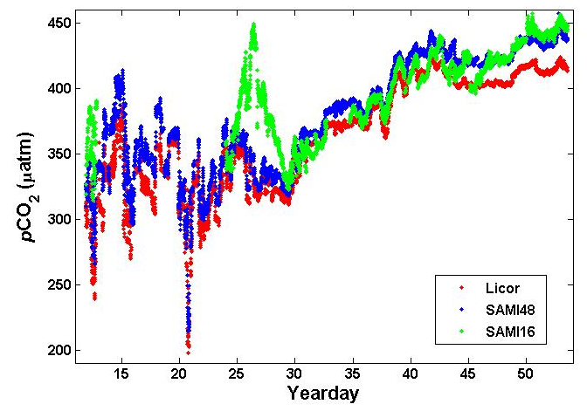
Figure 2.5. Comparison of the results from the two SAMIs and the underway pCO₂ system (Licor). See text for discussion.
References
DeGrandpre, M.D., M.M. Baehr, and T.R. Hammar, 1999: Calibration-free optical chemical sensors. Anal.Chem., v. 71, pp. 1152-1159.
DeGrandpre, M.D., M.M. Baehr, and T.R. Hammar, 2000: Development of an optical chemical sensor for oceanographic applications: The Submersible Autonomous Moored Instrument for Seawater CO₂. In Chemical Sensor in Oceanography, M. Varney (ed.). Gordon and Breach Publ., Amsterdam, pp. 123-141.
2.7.4. Underway Spectrophotometric Measurements of pCO₂, TCO₂, and pH
Principal Investigator: Robert H. Byrne, College of Marine Science
University of South Florida, 140 7th Avenue South
St. Petersburg, FL 33701
byrne@marine.usf.edu
Shipboard Analysts: Zhaohui Aleck Wang, Research Associate
College of Marine Science, University of South Florida
140 7th Avenue South, St. Petersburg, FL 33701
awang@seas.marine.usf.edu
Brittany Doupnik, Graduate Student
College of Marine Science, University of South Florida
140 7th Avenue South, St. Petersburg, FL 33701
bdoupnik@marine.usf.edu
Data Reduction: Zhaohui Aleck Wang
Equipment and Analytical Techniques: Underway CO₂ System, USF:
As part of the USF instrumental development effort, the USF automated underway CO₂ system was tested to simultaneously measure surface sea water pCO₂, TCO₂, pH, and air XCO₂. The resulting data can then be compared to measurements either from the AOML underway LiCOR pCO₂ system (surface sea water pCO₂ and air XCO₂) or discrete surface sampling (surface sea water pH and TCO₂) to evaluate performance.
The system consists of three sea water channels (surface sea water pCO₂, TCO₂, and pH) and an air channel (atmospheric XCO₂). All measurements (four channels) are based on the same spectrophotometric principles. The system can operate continuously with a sample period of around 9 minutes.
Spectrophotometric pH measurements are based on the method described in Clayton and Byrne (1993), but use thymol blue as the pH indicator (Yao and Byrne, 2001). Sea water samples are directly injected with thymol blue (1 mM) and changes of absorbances are monitored by a spectrophotometer.
The method for sea water TCO₂ measurements is based on Byrne et al. (2002), while sea water pCO₂ and air XCO₂ measurements are similar to those described in Wang et al. (2003) (significant differences will be reported elsewhere). In these measurements, Teflon AF 2400 (DuPont) is used as both a CO₂ permeable membrane and a long liquid-core waveguide (LCW). For the pCO₂ and XCO₂ measurements, phenol red (2 µM) is used as the indicator, while Bromcresol purple (2 µM) is used as the indicator in TCO₂ measurements after sea water samples are acidified. During each measurement, the indicator solution in each of three channels is motionless inside the LCW. The sea water or air samples are directed to flow outside the LCW. After CO₂ molecules equilibrate through LCW, the internal indicator solution changes its equilibrium pH. At equilibrium, absorbances are recorded by spectrophotometers.
In each of four channels, three wavelengths are chosen for measurement of absorbances. Two wavelengths assess the absorbance peaks of acid and base forms of the indicator, while a third wavelength serves as a reference wavelength. Absorbances vary at the acid and base wavelengths in response to pH changes, but not at the reference wavelength. Absorbance ratios between acid and base wavelengths are calculated, and used to evaluate CO₂ system parameters. The wavelengths chosen for the four channels are listed in Table 2.15.
Table 2.15. Wavelengths used for spectrophotometric determination of inorganic carbon species.
Channel | Indicator | Acid Wavelength | Base Wavelength | Reference Wavelength
Sea water pCO₂ | Phenol red | 434 nm | 558 nm | 700 nm
Air XCO₂ | Phenol red | 434 nm | 558 nm | 700 nm
TCO₂ | Bromcresol purple | 432 nm | 589 nm | 700 nm
pH | Thymol blue | 435 nm | 596 nm | 730 nm
Four Ocean Optic 2000 spectrophotometers are used to detect the light signals of the four channels. Lamps, spectrophotometers, and detecting channels are connected through optic fibers. The light source of each channel is custom-made with blue and IR glass filters in order to balance the signals at the acid and base wavelengths.
Indicator and reference solutions for all measurements are stored in aluminum bags and pumped through separate lines into their respective channels by digital peristaltic pumps. Surface sea water is pumped on board by a shipboard pumping system. It first flows through a Sea Bird CTD that records salinity and temperature. Sea water samples are then pumped through three sea water channels (pCO₂, TCO₂, and pH). Before entering the TCO₂ channel, sea water samples are acidified with ~3 M HCl using another peristaltic pump. The mixing ratio is approximately ~1000 (sea water to HCl). An in-line mixing coil is used to facilitate mixing. Thymol blue is mixed with sea water samples for pH measurement with a mixing ratio of ~800 (sea water to thymol blue). An in-line mixing coil is also used in this case. Air samples are drawn from a shipboard air sample line set up for the LiCOR IR underway pCO₂ measurement. The air flow rate is controlled at 20 ~ 30 ml/min using a gas flow controller. Atmospheric pressure is recorded by a barometer.
All channels are thermostated in a Lauda E100 water bath that is set to 25 ± 0.1°C. All samples, reference and indicator solutions are also temperature pre-equilibrated in the water bath to 25°C through glass or copper coils. All measurements, as well as calibrations, are taken at this temperature.
All units of the system are connected to a custom-made electronic motherboard and controlled by a laptop computer. The program run cycles to operate the CO₂ system continuously. The time required for each measurement cycle varies depending on the equilibration time (5 to 7 minutes) and flushing time for the indicator/reference solution and samples (2 to 3 minutes). The following sequence is taken during a measurement cycle:
- Flush pH reference (sea water samples without indicator solution).
- Flush reference for pCO₂, XCO₂, and TCO₂.
- Read and store reference readings.
- Flush indicator solutions for pCO₂, XCO₂, and TCO₂, mix thymol blue with sea water samples (pH), and acidify TCO₂ samples.
- pCO₂, XCO₂, TCO₂ equilibration (5 – 7 minutes).
- Read and store measurements.
- Repeat step 4-6 four times.
- End of one measurement cycle and repeat from the beginning.
During measurements, the sea water and air samples are continuously flowing through the channels.
Standards:
pCO₂ and XCO₂ are calibrated every few days during the cruise against four standard CO₂ gases (315.25, 357.18, 380.98, and 411.42 [or 531.98] ppm) provided by AOML. TCO₂ is calibrated using a Certified Reference Material (CRM) every few days. pH is internally calibrated in the spectrophotometric method and does not need calibration onboard.
Data Processing:
The absorbance ratio R for each measurement (all four parameters) is given as:
R = (A₂-A_{ref})/(A₁-A_{ref})
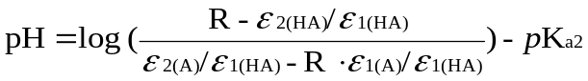where A₁ and A₂ are the peak absorbance at acid and base wavelengths, respectively; and A_{ref} is the absorbance at the reference wavelength. For all four parameters measured, R is used to calculate pH via the following equation:
where ε_{1(HA)} and ε_{2(HA)} are the molar absorptivities of the acid form (HA⁻) of indicator at two peak-absorbance wavelengths; ε_{1(A)} and ε_{2(A)} are the molar absorptivities of the A²⁻ (fully unprotonated) form of indicator at two peak-absorbance wavelengths; and K_{a2} is the second dissociation constant of the indicator used. Molar absorptivities and K_{a2} for all indicators are determined in the laboratory at 25°C before the cruise. They are treated as constants since we only measure samples at 25°C.
From the above equations, pH can be directly calculated from absorbance ratios and pCO₂/XCO₂ and TCO₂ are calculated by referencing R to their respective standards.
Our sea water pCO₂ measurement reflects pCO₂ at 25°C with 100% water vapor content. It can be corrected for temperature and water vapor to compare with LiCOR underway pCO₂ measurement.
The precisions of all parameters measured, estimated by replicate measurements, are given as follows:
pH | ± 0.001
XCO₂/pCO₂ | ± 1 uatm
TCO₂ | ± 3 umol/kg
Details on the mathematical treatment and calculation procedure are being prepared for publication.
Problems:
Due to the huge temperature difference between surface sea water and the water bath, a 10 foot pre-heating Tygon tube was added to the sea water sample line and resided in the water bath during the first three weeks of the cruise. Over time, organisms grew inside this tube and contaminated the sea water samples. This problem was identified on February 03, 2005 and measures were taken to prevent contamination thereafter.
The air channel experienced a drift problem throughout the cruise. After each calibration of the air channel, the air XCO₂ readings drifted away from the LiCOR air XCO₂ readings within a few days of continuous measurement. The drift seemed to stop thereafter, and the difference between the two systems was approximately 10 ppm. Many measures were taken to identify the problem. Unfortunately, we did not resolve the issue during the cruise.
References
Byrne, R.H., L. Xuewu, E. Kaltenbacher, and K. Sell, 2002: Spectrophotometric measurement of total inorganic carbon in aqueous solutions using a liquid core waveguide. Anal. Chim. Acta, v. 451, pp. 221-229.
Clayton, T.D., and R.H. Byrne, 1993: Spectrophotometric seawater pH measurements: Total hydrogen ion concentration scale calibration of m-cresol purple and at-sea results. Deep-Sea Res., v. 40, pp. 2315-2329.
Wang, Z.A., W. Cai, Y. Wang, and B.L. Upchurch, 2003: A long pathlength liquid-core waveguide sensor for real-time pCO₂ measurements at sea. Mar. Chem., v. 84, pp. 73-84.
Yao, W. and R.H. Byrne, 2001: Spectrophotometric determination of freshwater pH using bromocresol purple and phenol red. Environ. Sci. Technol., v. 35, pp. 1197-1201.
2.8. Aerosol Sampling
Principal Investigator: Anne M. Johansen, Central Washington University
Department of Chemistry, 400 East University Way
Ellensburg, WA 98926-7539
Phone: (509) 963-2164; Fax: (509) 963-1050
johansea@cwu.edu
Sampler: Matt Lenington
Central Washington University
Phone: (509) 963-1086
leningtm@cwu.edu
Aerosol Sampling Setup:
Atmospheric aerosols and acidic gases were collected with two types of collectors: 1) A high volume cascade impactor (ChemVol Model 2400, Rupprecht and Patashnik) to separate aerosols into four size fractions (large particles (>10 um aerodynamic diameter (AD)), coarse particles (10 to 1 um AD), fine particles (1 to 0.1 um AD), and ultrafine particles (< 0.1 um AD)), and 2) Two low volume collectors to collect total suspended particulates (TSP) and acidic gaseous species in a filter pack configuration. On the first part of the leg, to approximately 30°S, these collectors were located on the O₃ deck forward of the captain’s cabin to avoid excessive seaspray from reaching the collector. However, this location turned out to be unsatisfactory due to eddying of the air and once the seas got milder (north of 30°S) the whole setup was moved forward and down to the forward edge of the O₂ deck to assure the collection of uncontaminated air.
The vacuum pumps for the collectors were controlled by a datalogger through a series of relay boxes whereby they were automatically shut off when rain was sensed with a rain sensor or when the wind speed and direction were unfavorable as determined by a weather vane; the low limit wind speed cut-off was 0.2 m s⁻¹ and, while the wind direction varied throughout the trip, a guideline of 60 degrees in either direction off the bow was used to set the limits.
Flow rates on the high volume collector were determined by measuring the pressure drop across a critical orifice. A valve was used to adjust the flowrate to 760+-5% L min⁻¹ to ensure correct size fractionation. The flow rate for the low volume collectors was fixed with a critical orifice to approximately 12 L min⁻¹ and checked with a flowmeter.
Although the goal was to collect daily samples, collection periods had to be adjusted due to two factors: low ambient concentrations of particulates in the southern part of the Atlantic Ocean and the reduced collection times due to rain (or heavy fog) and the wind direction being out of sector. A collection time of 30 hours per set of filters was used as a guideline to collect enough material to ensure analysis above detection limits. Typically, sample change occurred at dawn.
Substrate Handling and Storage:
All sample handling was carried out in a laminar flow hood with HEPA filtration and all substrates had been precleaned in lab following established procedures. For the high volume collector flat segments of polyurethane foam (PUF) were used for the impaction of particles in the three larger size fractions. These are rings of PUF of varying width, depending on the size fraction. The outer diameter is approximately 17 cm. The final collection stage (i.e., for the ultrafine particles) is based on filtration through a multilayer polypropylene filter of approximately 17 cm diameter. Storage of these substrates required cutting into segments that could be placed in precleaned polystyrene Petri dishes of 15 and 9 cm diameter. Cutting was performed with ceramic scissors or ceramic exacto knives on a sheet of Teflon. For the low volume collectors, a 47 mm diameter Teflon membrane filter was used to collect particles followed by two carbonate impregnated paper filters in series to trap acidic gaseous species. These filters were stored in 47 mm polystyrene Petri dishes. All Petri Dishes were sealed with Teflon tape, doubly bagged and stored in the freezer.
Samples were sent to the lab overnight on ice in coolers and are stored in a freezer until analysis.
Analysis:
16 sets of samples were collected. Since each sample set consists of 4 high volume and 6 low volume substrates, overall there are 16x10 = 160 aerosol samples. In addition, 5 sets of field blanks were obtained, amounting to a total of 210 samples that will be analyzed with the following procedures.
Chemical analysis on all high volume size fractions will consist of iron speciation with long pathlength UV-Vis, trace metals with ICP-MS, and anions and cations with IC. The Teflon filters from the low volume collectors will be weighed (they were preweighed in a microbalance before the trip) and analyzed for trace metals and anions and cations. The carbonate impregnated filters will be analyzed for anions of the corresponding acidic gases. These analyses are expected to be carried out within a year. Subsequently, data will be analyzed statistically with principal component and linear regression analyses and interpreted in conjunction with air mass trajectories computed with HYSPLIT.
Furthermore, during this cruise, blue agar plates were inoculated with extracts of filter from 10 different samples sections in an attempt to look for siderophore producing microorganisms in the remote marine atmosphere. The blue plates did turn orange for most of the inoculations thus indicating the production of siderophores. As of now (Aug 05) these organisms have been further cultured and are being characterized.
This study is part of a project (NSF-ATM 0137891) to further elucidate mechanisms that influence iron speciation, and thus iron bioavailability, in aerosol particles over the remote open oceans.

