Kineret™ (anakinra)
(Recombinant Methionyl Human Interleukin-1 Receptor Antagonist)
FDA Arthritis Drugs Advisory Committee
Briefing Package
Meeting Date: 16 August 2001
Document Date: 17 July 2001

Volume 1 of 1

Amgen Inc.
One Amgen Center Drive
Thousand Oaks‚ CA 91320-1799
TABLE OF CONTENTS
1. Scientific Rationale 5
2. Product Description 6
2.1 What is Kineret™ (anakinra) 6
2.2 Overview of the Clinical Development Program 6
2.3 Proposed Indication and Dose 8
2.4 Subject Exposure 8
2.5 Clinical Trial Data for Licensure 10
2.6 Content of the Briefing Package 11
3. Nonclinical Pharmacology, Pharmacokinetics, and Toxicology 12
3.1 Pharmacology 12
3.1.1 Role of IL-1 in Rheumatoid Arthritis 12
3.1.2 Effects of Anakinra in Animal Models of Arthritis 13
3.1.3 Effects of Anakinra Co-administered With Other Therapies 16
3.2 Nonclinical Pharmacokinetics of Anakinra 18
3.3 Toxicology 18
3.4 Summary of Nonclinical Studies 20
4. Clinical Data 21
4.1 Introduction 21
4.2 Human Pharmacokinetics and Bioavailability 22
4.3 Placebo-controlled Clinical Trials in Rheumatoid Arthritis 24
4.3.1 Study Designs: Placebo-controlled Trials 24
4.3.2 Subject Disposition and Baseline Characteristics 36
4.4 Clinical Data - Efficacy 40
4.4.1 Signs and Symptoms Data 40
4.4.2 Monotherapy Study (0560): Radiographic Data 61
4.4.3 Summary of Efficacy 70
4.5 Clinical Data - Safety 72
4.5.1 Introduction 72
4.5.2 Exposure for Safety Analyses 76
4.5.3 Adverse Events 77
4.5.4 Serious Adverse Events 82
4.5.5 Deaths 86
4.5.6 Infectious Events 94
4.5.7 Malignancies 107
4.5.8 Adverse Events By Gender 114
4.5.9 Adverse Events By Age 114
4.5.10 Laboratory Parameters 115
4.5.11 Antibodies 125
4.5.12 Anakinra Combination With Etanercept: Study 20000125 128
4.5.13 Overall Adverse Event Profile 131
4.5.14 Summary of Safety 134
5. Risk/Benefit Assessment 136
5.1 Proposed Indication 138
6. References 139

LIST OF APPENDICES
Appendix 4-1: Study 990145 – LOE Designation
Appendix 4-2: Study 0560 – Week 24 ACR₂₀ Response by ISRs
Appendix 4-3: Study 0560 – Sustained Week 24 ACR₂₀ Response by ISRs
Appendix 4-4: Study 960180 – ACR Components for Lower Anakinra Doses
Appendix 4-5: Study 960180 – Week 12 ACR₂₀ Response by ISRs
Appendix 4-6: Study 960180 – Week 24 ACR₂₀ Response by ISRs
Appendix 4-7: Study 960180 – Sustained Week 24 ACR₂₀ Response by ISRs
Appendix 4-8: Study 990145 – Week 24 Changes in ACR Components
Appendix 4-9: Randomized, Placebo-controlled Studies - AEs
Appendix 4-10: SAEs for Randomized, Placebo-controlled Studies
Appendix 4-11: Narratives - Deaths
Appendix 4-12: Withdrawals due to AES in Randomized, Placebo-controlled Studies
Appendix 4-13: Infections by Preferred Term for Randomized, Placebo-controlled Studies
Appendix 4-14: WHO Toxicity Grading Scales for Laboratory Parameters

Scientific Rationale
Studies of the pathogenesis of rheumatoid arthritis (RA), in both experimental animal models and clinical settings, have established a critical role for the pro-inflammatory cytokine, interleukin-1 (IL-1),^{1,2,3} in tissue remodeling and inflammation. Evidence linking IL-1 to the pathogenesis of RA is strong. A correlation has been reported between IL-1 concentrations in the plasma of patients with RA and the activity of the disease.⁴ The appearance of IL-1 in synovial fluid from RA patients seems to correspond with acute inflammation of the joints, whether due to exacerbated symptoms or joint trauma.^{5,6} Production of IL-1 in vitro by explanted synovial tissues from patients with RA has been positively correlated with arthroscopic results that quantify the extent of inflammation.⁷ Therapies inhibiting the effects of IL-1 should provide benefit to patients by relieving signs and symptoms of the disease and retarding structural damage. Amgen’s anakinra is such a therapy.
Data from animal models support the hypothesis that a therapeutic agent specifically designed to inhibit IL-1 could provide benefit to patients. The role of IL-1 in cartilage destruction was demonstrated in mice with antigen-induced arthritis by administration of a neutralizing antibody to IL-1. This therapeutic intervention prevented IL-1 induced reduction in cartilage proteoglycan synthesis⁸ and was able to maintain chondrocyte proteoglycan synthesis in antigen-rechallenged joints.⁹ When treated with an antibody to IL-1, mice with type II collagen-induced arthritis showed profound amelioration of both established and developing disease.¹⁰⁻¹³
A naturally occurring interleukin-1 receptor antagonist (IL-1Ra) modulates the activity of IL-1 in patients.¹⁴⁻¹⁶ Both IL-1 and IL-1Ra have been identified in the synovial fluid and the synovial sublining of patients with RA or osteoarthritis (OA).¹⁵ The ratio of IL-1Ra to IL-1 in synovial cells of patients with RA is relatively low, and it is thought that this ratio is too low to block IL-1 effects.¹⁷ These findings indicate that the balance between IL-1Ra and IL-1 is important in determining disease outcome and suggest that raising levels of IL-1Ra in patients with RA may provide a therapeutic benefit.

Product Description

What is Kineret™ (anakinra)
Kineret™ (anakinra; r-met Hu-IL-1ra) is Amgen’s recombinant form of IL-1Ra. It is a protein manufactured in E coli using recombinant DNA technology. The protein consists of 153 amino acids with an approximate molecular weight of 17.3 kD. Anakinra is identical to the naturally occurring form of IL-1Ra except for the addition of an N-terminal methionine residue. Throughout this document anakinra will be used to distinguish Amgen’s recombinant protein from the naturally occurring form of IL-1Ra.
Anakinra has a unique mechanism of action. By binding to the IL-1 Type I receptor (IL-1RI), it competitively prevents IL-1 binding. Furthermore, because anakinra bound to
IL-RI does not recruit the IL-1R accessory protein (IL-1R AcP), no signal transduction occurs.
By specifically inhibiting the effects of IL-1, anakinra is the first RA therapy that targets IL-1 inhibition, thus providing patients with a novel therapeutic option that can relieve signs and symptoms of RA.

Overview of the Clinical Development Program
A total of 19 clinical trials (including extension trials and studies in healthy volunteers) constitute the clinical development program for anakinra in the RA indication
(Figure 1-1). In addition, a single-arm, open label study of anakinra in combination with etanercept (20000125) has recently been completed, and a study in subjects with juvenile RA is ongoing.
Among these, 5 randomized, placebo-controlled trials support the overall risk-benefit profile for reduction of the signs and symptoms of RA (Table 1-1). The Monotherapy Study (0560), the Methotrexate (MTX) Combination Study (960180) and the Low Dose Monotherapy Study (960182) were included in the BLA submission in December 1999. Additional data from the Safety Study (990757), and the Confirmatory Efficacy Study (990145) provide confirmatory safety and efficacy data at the proposed dose of 100 mg/day. Data from 5 randomized, placebo-controlled trials (Table 1-1) will be discussed in detail in this briefing package. Key safety information from the remaining supportive trials (consisting of clinical pharmacology, dose-ranging, dose-frequency, and active treatment extension trials) will also be summarized.
Figure 1-1. Anakinra Clinical Trials in Rheumatoid Arthritis

4-day Continuous Infusion PK Study (970189)
Multi-Dose PK Study (0502) and Extension (0502E)

Randomized,
Placebo-Controlled Studies
and Extensions

Other RA Studies
Clinical Pharmacology RA Studies
Monotherapy Study (0560)
MTX Combination Study (960180)
Low Dose Monotherapy Study (960182)
Monotherapy Extension Study (0564, 0564E1, 0564E2, 0564E3)
Dose and Frequency Study (0505)
MTX Combination Extension Study (960181)
Low Dose Monotherapy Extension Study (970102)
Single-Dose PK Study (0501)
Dose and Frequency Extension Study (0512)
Continuous Infusion Study and Extension (980220)
Safety Study (990757)
Confirmatory Efficacy Study (990145)
Healthy Volunteers PK Study (0530)
Healthy Volunteers PK Study (0540)
Renal Failure PK Study (0555)
Hepatic Failure PK Study (0563)
Healthy Volunteers PK Study (0541)
Other Clinical Pharmacology Studies
Table 1-1: Five Randomized, Placebo-Controlled Trials in RA
Study | Description | Daily Doses of Anakinra | N
0560 | Monotherapy Study | 0, 30, 75, 150 mg | 472
960182 | Low Dose Monotherapy Study | 0, 2.5, 10, 30 mg | 141
960180 | MTX Combination Study | 0, 0.04, 0.1, 0.4, 1.0, 2.0 mg/kg | 419
990145 | Confirmatory Efficacy Study | 0, 100 mg | 501
990757 | Safety Study | 0, 100 mg | 1399
 |  | Total | 2932
N = Number of subjects who received at least 1 dose of study drug

As indicated in Figure 1-1, most studies had “extensions” allowing subjects to continue treatment. All extension trials used active drug, and all but study 0564 (extension to 0560) were open label. Study 0564 was blinded to dose and prior treatment group as described later in Section 4.4.2.3.

Proposed Indication and Dose
The proposed indication is as follows: “Kineret™ (anakinra) is indicated for the reduction in signs and symptoms of active rheumatoid arthritis, in subjects 18 years of age or older. Kineret™ (anakinra) can be used alone or in combination with other disease-modifying antirheumatic drugs.”
The dose proposed for marketing is a fixed dose of 100 mg administered by daily subcutaneous (SC) injection. The 100 mg/day fixed dose was prospectively tested in 2 large, randomized, placebo-controlled clinical trials (the Safety Study [990757] and the Confirmatory Efficacy Study [990145]).

Subject Exposure
The anakinra development program in RA includes over 3000 RA subjects, of whom 2606 were treated with anakinra in the 5 randomized, placebo-controlled RA studies, the extensions and other supportive and clinical pharmacology studies (Table 2-1).
Table 2-1. RA Subjects in Anakinra Clinical Trials
 | Number of Subjects
 | Placebo | Anakinra
Randomized placebo-controlled
studies and extensions | 759 | 2332
Supportive studies | 3 | 199
Pharmacokinetic studies | 15 | 75
Total | 777 | 2606
Includes studies 0501, 0502, 0505, 0560, 0564 and extensions, 960180, 960181, 960182, 970102, 970189, 980220, 990145, and 990757.
Includes 6-month exposure for anakinra subjects in studies 990145 (N = 250) and 990757 (N = 1116). For all other studies cut-off date was 15 November 2000.
/stat/il1ra/fda_brfpkg/analysis/safety/statfiles/tables/t_exp.sas
Output: t_exp.rtf (generated 25JUN2001)

As shown in Table 2-2, a total of 1379 RA subjects have received anakinra for at least 6 months and 237 subjects have been treated for at least 12 months at or above the proposed marketed dose of 100 mg/day. These numbers exceed ICH exposure guidelines for drugs intended for long-term treatment of chronic diseases.
An additional 2100 subjects have participated in trials in a variety of non-RA clinical settings including sepsis, asthma, ulcerative colitis, chronic myelogenous leukemia (CML), graft versus host disease (GVHD), and psoriasis.
Table 2-2. Duration of Exposure in RA Subjects
 |  | Number of Subjects
 |  |  | All Anakinra
 |  | ≥ 100 mg | Doses
Duration of Exposure
 | < 6 months | 496 | 794
 | ≥ 6 months | 1379 | 1812
 | ≥ 1 year | 237 | 570
 | ≥ 2 years | 77 | 365
 | ≥ 3 years | 26 | 167
 | ≥ 4 years | 13 | 41
 | ≥ 5 years | 5 | 19
Includes studies 0501, 0502, 0505, 0560, 0564 and extensions, 960180, 960181, 960182, 970102, 970189, 980220, 990145, and 990757
Includes 6-month exposure for anakinra subjects in studies 990145 (N = 250) and 990757 (N = 1116). For all other studies cut-off date was 15 November 2000.
/stat/il1ra/fda_brfpkg/analysis/safety/statfiles/tables/t_expdur.sas
Output: t_expdur.rtf (generated 25JUN2001)

Clinical Trial Data for Licensure
Amgen filed a Biologics License Application (BLA) in December 1999. The core clinical data package for the BLA consisted of studies 0560, 960182 and 960180.
A study to assess the safety of combining anakinra with etanercept (20000125) was completed in March 2001. In order to meet the requirements of FDA’s Pediatric Rule, a trial in subjects with juvenile RA (JRA; 990758) was initiated; this study is in progress and remains blinded.
In response to CBER’s Complete Review letter, additional safety and efficacy data from the Confirmatory Efficacy Study (990145) and safety data from the large Safety Study (990757) were submitted (additional 1900 subjects evaluated for 24 weeks) and included signs and symptoms data for 501 subjects participating in the Confirmatory Efficacy Study (990145). In May 2001, safety data from the anakinra/etanercept combination study (20000125; N = 58) were submitted to CBER upon request.

Content of the Briefing Package
This package will discuss in detail the scientific rationale for developing anakinra for the treatment of the signs and symptoms of RA, as well as the safety and efficacy data from the 5 placebo-controlled trials depicted in Table 1-1. The data support the following conclusions:
- anakinra is the first therapy for RA that targets IL-1 inhibition
- there is extensive clinical experience with anakinra in RA patients
- signs and symptoms of RA are improved with anakinra therapy
- anakinra’s effects occur early and are sustained
- effects on the signs and symptoms of RA are consistent across different patient populations
- anakinra slows disease progression assessed radiographically, with effects apparent at 24 weeks, supporting its use in the treatment of RA
- anakinra has a favorable risk-benefit profile

Nonclinical Pharmacology, Pharmacokinetics, and Toxicology

Pharmacology
Interleukin-1 (IL-1) is a key mediator of immune and inflammatory processes.^{18,19} IL-1 mediates inflammation via recruitment of neutrophils into the joint, activation of macrophages, and stimulation of T- and B-cell growth and differentiation. Demonstrated effects of IL-1 include increased production of cytokines and chemokines by T-cells, macrophages, and several mesenchymal cells, increased production of nitric oxide, prostaglandin and collagenase by fibroblasts and chondrocytes, increased production of adhesion proteins by vascular endothelium, and release of histamine and thromboxane. IL-1 is synthesized by many cell types, including circulating leukocytes such as neutrophils, monocytes, and macrophages, and tissue cells such as synoviocytes.
There are three members of the IL-1 family (IL-1α, IL-1β, and interleukin-1 receptor antagonist [IL-1Ra]) that bind to interleukin-1 receptor type I (IL-1RI) with similar affinities. When present in excess, IL-1Ra blocks the association of IL-1α or IL-1β with IL-1RI or interleukin-1 receptor type II (IL-1RII). IL-1Ra binding to IL-1R does not allow association of the IL-1R with IL-1R-accessory protein (IL-1R AcP). Since this complex formation is required for IL-1 signaling, IL-1Ra binding to IL-1R is incapable of initiating signaling events and thus IL-1Ra has no agonist activity. ^{21,22,56}

Role of IL-1 in Rheumatoid Arthritis
Rheumatoid arthritis is a systemic inflammatory autoimmune disorder of unknown etiology, although it is thought to be mediated by antigen-driven T-cells and macrophages that produce proinflammatory cytokines such as IL-1 and tumor necrosis factor-alpha (TNFα).^{2,16,23-26} The evidence linking IL-1 to RA is compelling.^{27,28} In animals, direct injection of IL-1 into joints is arthritogenic and causes transient synovitis.^{20,29} Moreover, continuous infusion of IL-1α into knee joints of rabbits resulted in an arthritis with signs of both acute (serous and fibrinous exudation, polymorphonuclear cell infiltration) as well as chronic (synovial cell proliferation and fibrosis, pannus formation, cartilage and bone erosion) inflammation.³⁰ Similarly, constitutive intra-articular expression of human IL-1β following gene transfer to rabbit synovium produces all major pathologies of RA.³¹ Systemic administration of
IL-1 enhances the incidence and severity of arthritis in several animal models of inflammatory arthritis. For example, IL-1 can serve as an adjuvant in murine arthritis models by greatly enhancing the synovial inflammatory response.^{32,33} Furthermore, intra-articular injection of IL-1 during the chronic phase of murine antigen-induced arthritis results in exacerbation of the disease.⁸ In addition, IL-1 is found in the plasma and synovial fluid of RA patients, and a correlation has been reported between IL-1 concentrations in the plasma and the activity of the disease⁴. The appearance of IL-1 in synovial fluid from RA patients seems to correspond with acute inflammation of the joints, whether due to exacerbated symptoms or joint traumatization.^{5,6} Production of
IL-1 in vitro by explanted synovial tissues from RA patients has been correlated with arthroscopic results indicating the extent of inflammation.⁷
IL-1 is a potent stimulator of synoviocytes, chondrocytes, and osteoblasts. Upon exposure to IL-1, fibroblast-like synoviocytes proliferate and produce prostaglandins as well as metalloproteinases such as collagenases and stromelysin.³⁴ Thus, IL-1 activates effector molecules responsible for joint destruction in addition to its proinflammatory effects. IL-1 inhibits proteoglycan synthesis and stimulates collagen breakdown by chondrocytes.^{8,9} Increased RANK (receptor activator of NFκB) ligand production from IL-1-stimulated osteoblasts leads to osteoclast activation and proliferation, resulting in enhanced bone resorption.^{35,36}
In addition to IL-1, IL-1Ra also has been identified in the synovial fluid and synovial sublining of RA and OA patients.¹⁵ Studies of synovial tissue mRNA have shown that the IL-1Ra gene is expressed in RA synovium.³⁷

Effects of Anakinra in Animal Models of Arthritis
Anakinra was evaluated for its effects on inflammation and cartilage and bone destruction in several animal models of arthritis (Table 3-3). Representative data from the collagen-induced arthritis model in rats are shown in Figure 3-2. Immunization of rats with bovine type II collagen causes an immunologically mediated polyarthritis with histologic features resembling those of RA in humans. Principal lesions include mononuclear cell inflammation, pannus, cartilage degeneration, and bone destruction. Onset of the clinical signs of the disease occurs on days 13 to 15. In female Lewis rats, continuous SC infusion of 0.2 to 5 mg/kg/hour anakinra, initiated after onset of clinical signs of disease resulted in significant inhibition of arthritis (as assessed by paw swelling), with approximately 90% inhibition at the 5-mg/kg/hour dose (Figure 3-2).
Table 3-3. Anakinra Treatment: Animal Models of Arthritis
Animal Model | Species | Treatment | Dose | Inflammation  % Inhibition | Bone and Cartilage Effects* |  | Reference
Mycobacteria-induced adjuvant arthritis | Rat | SC CI for  7 days after onset of clinical signs | 5 mg/kg/hr  1 mg/kg/hr  0.2 mg/kg/hr | 27%  33%  13% | 74%  73%  26% | Inhibition of bone mineral density loss | Feige et al. (2000)³⁸
Lipoidal amine-induced adjuvant arthritis | Rat | SC CI for  7 days after onset of clinical signs | 10 mg/kg/hr  5 mg/kg/hr  2.5 mg/kg/hr  1 mg/kg/hr | 18%  18%  29%  12% | 79%  79%  85%  49% | Inhibition of bone resorption | Bendele et al. (1999;498)³⁹
Collagen-induced arthritis | Rat | SC CI for  7 days after onset of clinical signs | 5 mg/kg/hr  1 mg/kg/hr  0.2 mg/kg/hr | 90%  53%  32% | 89%  54%  27% | Inhibition of histological scores (pannus, cartilage damage, bone damage) | Bendele et al. (1999) ³⁹
Collagen-induced arthritis | Rat | Daily  SC injection in Hyaluronic Acid for 7 days after onset of clinical signs | 100 mg/kg QD | 74% | 75% | Inhibition of histological scores pannus, cartilage  damage, bone damage) | Bendele et al. (1998)⁴⁰
Streptococcal cell wall-induced  arthritis | Rat | SC CI for 7 days beginning 1 day before reactivation | 5 mg/kg/hr  1 mg/kg/hr  0.2 mg/kg/hr | 89%  87%  30% | -- | Not examined | Amgen, Inc.,  data on file SCW2
Streptococcal cell wall-induced  arthritis | Rat | Daily  SC injection for 4 days beginning 5 min before reactivation | 8 mg/kg BID  2 mg/kg QID | ~55%  55% | 11%  63% | Inhibition of histological scores (synovitis, cartilage damage, bone damage) | Schwab et al. (1991)⁴¹
Antigen-induced arthritis | Mouse | SC CI | 1.5 mg/kg/hr | Not determined |  | Complete prevention of suppression of proteoglycan synthesis | Van de Loo et al. (1995)⁹
Immune complex-induced arthritis | Mouse | SC CI | 1.7 mg/kg/hr | 80-90% |  | Complete prevention of suppression of proteoglycan synthesis | Van Lent et al. (1995)⁴²
Collagen-induced arthritis | Mouse | SC CI for  7 days after onset of clinical signs | 5 mg/kg/hr  1 mg/kg/hr | 92%  81% |  | Protection of cartilage metabolic integrity | Amgen, Inc., data on file CIIM3⁴⁵
* Bone and cartilage effects are expressed as % inhibition; however, measures tested vary between experiments and models as listed in the table and may not be comparable from one model to another.
SC CI = Continuous subcutaneous infusion
Figure 3-2. Effects of Continuous Subcutaneous Infusion of Anakinra on Ankle Swelling in Type II Collagen Arthritis in Female Lewis Rats
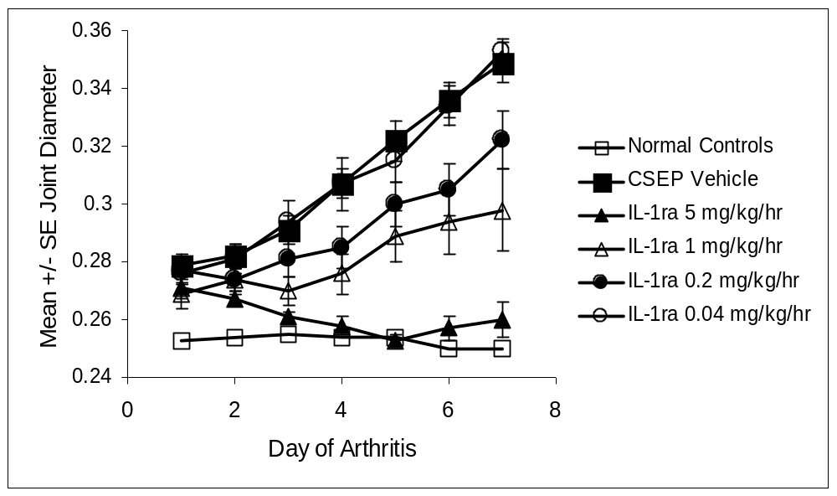
Mean±SE Ankle Joint Diameter (inches)

Lewis rats were injected with bovine type II collagen in incomplete Freund’s adjuvant SC on days 0 and 7. Anakinra was administered by continuous infusion for 7 days starting on the day of onset of clinical signs of arthritis (day 13 to 15). Anakinra doses of 5, 1, and 0.2 mg/kg/hour resulted in a statistically significant reduction in paw swelling analyzed as area under the curve (p < 0.05, Student's t-test). Symbols represent the mean + standard error of the mean for 8 animals per group.³⁹
CSEP = vehicle containing sodium citrate, sodium chloride, EDTA and polysorbate-80.

In animal models of arthritis, the effects of anakinra on inhibition of bone and cartilage destruction are similar, or better, than its effects on inflammation (Figure 3-3).^{39,40,43} The bone protective effect of anakinra is accompanied by a reduction in osteoclast numbers.^{39,43}
Figure 3-3. Anakinra Inhibits Inflammation as Well as Cartilage and Bone Damage in
Type II Collagen Arthritis in Female Lewis Rats

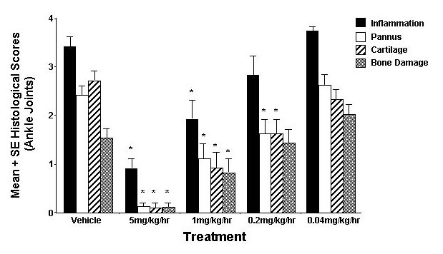
Lewis rats were injected with bovine type II collagen in incomplete Freund’s adjuvant SC on days 0 and 7. Anakinra was administered by continuous infusion for 7 days starting on the day of onset of clinical signs of arthritis (day 13 to 15). Anakinra doses of 5, 1, and 0.2 mg/kg/hour resulted in a statistically significant reduction in histological scores for inflammation, pannus, cartilage and bone damage
(*p < 0.05, Student's t-test). Bars represent the mean +/- standard error of the mean for 8 animals per group.³⁹

Effects of Anakinra Co-administered With Other Therapies
In clinical practice, co-administration of therapeutic agents has become standard practice in the treatment of RA. The efficacy of co-administering anakinra with other therapies has been evaluated in animal models (see Table 3-4). Anakinra added to treatment with MTX,^{44,45} or indomethacin⁴⁵ results in added benefit in animal models of arthritis. The efficacy of combining anakinra with anti-TNF therapies has also been evaluated in animal models. In most models, complete inhibition of inflammation can be achieved with anti-IL-1 or anti-TNF treatment, whereas in others, such as adjuvant arthritis induced by mycobacteria in Lewis rats, neither anti-IL-1 nor anti-TNF treatment will completely inhibit disease. However, combined anti-IL-1 and anti-TNF treatment can result in additive⁴⁶ or synergistic effects.³⁸
Table 3-4. Co-administration of Anakinra With Other RA therapies
Animal Model | Species | Treatment | Inflammation  % Inhibition | Bone and Cartilage Effectsª |  | Reference
Mycobacteria-induced adjuvant arthritis | Rat | IL-1ra 1mg/kg/hr sc days 9-16 of study  Indomethacin 0.3 mg/kg po days 9-16 of study  IL-1ra + Indomethacin Both | 25%  21%  → 68% | 22%  4%  → 18% | Inhibition of histologic score (bone, erosion) | Amgen, Inc., data on file  ADA 65⁴⁵
Collagen-induced arthritis | Rat | IL-1ra 0.2 mg/kg/hr sc day 1-6 post onset  Indomethacin 0.3 mg/kg po day 1-6 post onset  IL-1ra + Indomethacin Both | 30%  49%  → 68% | -2%  -6%  → 4% | Inhibition of histologic score (bone, erosion, pannus, cartilage) | Amgen, Inc., data on file  CILew-28⁴⁵
Mycobacteria-induced adjuvant arthritis | Rat | IL-1ra 1 mg/kg/hr sc days 9-16 of study  MTX 0.3 mg/kg days 9-16 of study  IL-1ra + MTX Both | 51%  12%  → 88% | 11%  4%  → 32% | Inhibition of histologic score (bone, erosion) | Amgen, Inc., data on file  ADA-56⁴⁵
Lipoidal amine-induced adjuvant arthritis | Rat | IL-1ra 5 mg/kg/hr sc days 8-15 of study  MTX 75 μg/kg/day po days 0-15 of study  IL-1ra + MTX Both | 6%  45%  → 78% | 53%  58%  → 97% | Inhibition of bone resorption | Bendele et al. (1999)⁴⁴
Mycobacteria-induced adjuvant arthritis | Rat | IL-1ra 0.2 mg/kg/hr sc days 9-16 of study  PEG-sTNF-RI 0.25 mg/kg/hr sc days 9-16 of study  IL-1ra + PEG-sTNF-RI^{b} Both | 13%  23%  → 78% | -16%  26%  → 64% | Inhibition of bone mineral density loss | Feige et al. (2000)³⁸
Lipoidal amine-induced adjuvant arthritis | Rat | IL-1ra 100 mg/kg (HA) day 8-13 of study  PEG-sTNF-RI^{b} 3 mg/kg sc days 9, 11, 13 of study  IL-1ra +PEG-sTNF-RI^{b} Both | 14%  44%  → 56% | 43%  56%  → 100% | Inhibition of bone resorption | Bendele et al. (2000)⁴⁶
Collagen-induced arthritis | Rat | IL-1ra 20 mg/kg (HA ) days 1-6 post onset  PEG-sTNF-RI^{b} 0.3 mg/kg day 1, 3, 5  IL-1ra + PEG-sTNF-RI^{b} Both | 11%  29%  → 54% | 4%  21%  → 61% | Inhibition of histologic scores (synovitis, cartilage damage, bone damage) | Bendele et al. (2000)⁴⁶
ª Bone and cartilage effects are expressed as % inhibition; however, parameters tested vary between experiments and models as listed in the table and may not be comparable from one model to another.
^{b} PEG sTNF-RI – PEGylated recombinant soluble TNF-Receptor I (Amgen, Inc.)

Nonclinical Pharmacokinetics of Anakinra
The pharmacokinetic profile of anakinra was examined in rats, rabbits, and monkeys. Anakinra disappeared rapidly from the plasma after either IV or SC bolus doses in all 3 species; the terminal half-life values after SC bolus administration were 0.89, 1.18, and 3.03 hours for rats, rabbits, and monkeys, respectively. The systemic exposure of anakinra increased proportionally with dose. Anakinra appeared to be cleared by glomerular filtration in the kidney, followed by metabolism in the kidney tubules. No apparent gender differences in the pharmacokinetics of anakinra were observed. No apparent changes in anakinra pharmacokinetics could be determined when either MTX or PEG sTNF-RI was administered concurrently.

Toxicology
Anakinra is similar, but not identical, to the analogous receptor antagonist proteins of other species, and has been shown to be biologically active in a wide variety of species, including those used in the toxicity studies. Subchronic and chronic toxicity studies were conducted in rats and subchronic studies were conducted in nonhuman primates. Because the principal biological action of anakinra is to antagonize the effects of IL-1 and because anakinra does not possess intrinsic agonist activity, no exaggerated pharmacologic effects from high doses of anakinra were expected, nor were any seen. Anakinra is a foreign protein in the species used for preclinical safety assessment; as such, anti-anakinra antibodies were an anticipated finding. Non-neutralizing anti-anakinra antibodies were detectable in both rats and monkeys.
The following is a brief summary of completed studies.
- In non-human primates, the no observed effect level (NOEL) based on systemic toxicity effects is considered to be 100 mg/kg/day; based on local injection site effects the NOEL is less than 10 mg/kg/day.
- Twice-daily SC administration of anakinra (BID) for 6 months to rats at total doses of 2, 20, and 200 mg/kg/day produced local injection site inflammation at all dosages, the incidence and severity of which increased with dose. Systemic toxicity at 200 mg/kg/day was limited to the kidney with increased kidney weights, proteinuria, and chronic progressive nephropathy being the principal findings after 6 months of dosing. Chronic progressive nephropathy is a background disease in aging rats,⁴⁷⁻⁴⁹ with higher incidence in males,⁵⁰ and is known to be influenced by protein levels.⁵¹⁻⁵⁴ Kidney toxicity was not evident at the 1-month interim necropsy or after the 1-month recovery period.
- No adverse effects of anakinra were noted in any reproductive toxicity or teratology studies in rats and rabbits, conducted at dosages up to 200 mg/kg/day.
- No evidence of genotoxicity was found in mutagenicity assays.
- Neither pre-neoplastic lesions nor tumors related to anakinra treatment were observed in a 6-month study of anakinra in rats at doses up to 200 mg/kg/day. Thus, there is no evidence of anakinra being involved in direct tumor production.
- In preclinical toxicology studies in rats and monkeys, no evidence of immunosuppression was seen. Additionally, anakinra had no effect on specific immune function tests, such as antibody formation to keyhole limpet hemocyanin or sheep red blood cells, cytolytic T lymphocyte response in mice or NK cell activity in rats and monkeys.
- Published studies, including studies on IL-1 knockout and IL-1Ra over-expressing mice ^{22,55-60} do not reveal a clear or consistent picture on the role of IL-1 inhibition in compromising host resistance to bacterial infection. For example, IL-1β or IL-1R knock-out mice showed no increased susceptibility to infectious challenges, while IL-1Ra over-expressing mice were more susceptible.
- In acute host resistance rat models infected with E coli, S aureus, and L monocytogenes, anakinra did not increase mortality following these infections and its effect on host resistance (based on CFU in blood, liver, or spleen) was slight to non-existent. Therefore, anakinra does not appear to greatly impair host resistance mechanisms.
- The effects of combined administration of anakinra with MTX or with cytokine inhibitors were investigated:
  - Coadministration of anakinra and MTX (in rats) or PEG sTNF-RI (in rats and monkeys), did not show any toxicity or pharmacokinetic interactions between the two agents.
  - There was no evidence in monkeys and rats of detrimental anakinra interaction with the cytokine inhibitors, etanercept and PEG sTNF-RI in blood cell counts, body and lymphoid organ (spleen, thymus) weights, lymphoid organ cellularity, lymphoid organ viability, NK cell function, immune cell phenotype, and antibody response to keyhole limpet hemocyanin or the anti-sheep red blood antibody-forming cell (AFC) assay.

Summary of Nonclinical Studies
In conclusion, preclinical studies demonstrate that anakinra has well characterized in vitro and in vivo profiles and is a selective antagonist of IL-1. Notable inhibition of inflammation, bone destruction, and cartilage degeneration have been observed in several animal models of arthritis following treatment with anakinra. The nonclinical pharmacokinetic studies demonstrate that anakinra appears to be cleared by glomerular filtration in the kidney, followed by subsequent metabolism in the kidney tubules.
The results of the nonclinical toxicity studies evaluating doses up to 200 mg/kg/day for 6 months demonstrate that the effects of anakinra are consistent with the clinical safety profile, with local injection site effects as the primary safety observation, and little to no systemic toxicity. Additionally, in toxicology studies of anakinra in combination with anti-TNF therapies there was no evidence of detrimental interaction of anakinra with the TNF inhibitors in cellular function assays of immune competence.

Clinical Data

Introduction
Clinical data to support the RA indication are discussed in the following sections. A total of 19 clinical trials (including extension trials and studies in healthy volunteers) have been conducted. A total of 2606 RA subjects have been treated with anakinra, of which 2332 were from the 5 randomized, placebo-controlled studies and their extensions. A brief overview of data from clinical pharmacology trials is provided in Section 4.2, followed by a detailed description of the 5 randomized, placebo-controlled RA trials, including study design and baseline characteristics (Section 4.3). Efficacy and safety data from these 5 studies are discussed in Section 4.4 and Section 4.5, respectively.
Anakinra has also been studied in other indications including sepsis, graft versus host disease, and asthma. While anakinra has not been marketed in these indications, the safety data in settings such as sepsis, where the immune system is drastically compromised, provide additional assurance that anakinra has an acceptable safety profile. Safety data from sepsis trials are summarized in Section 4.5.6.6.

Human Pharmacokinetics and Bioavailability
Anakinra was well absorbed after SC administration in healthy subjects (N = 11) with an absolute bioavailability of 95%. In subjects with RA, maximum plasma concentrations of anakinra occurred at 3 to 7 hours after SC administration of anakinra at clinically-relevant doses (1 to 2 mg/kg; N = 18). Since plasma clearance values of anakinra after SC administration are independent of dose (range = 84 to 124 mL/min), the systemic exposure of anakinra increases in a proportional manner with higher doses. The terminal half-life ranged from 4 to 6 hours. No unexpected accumulation of anakinra was observed after daily SC doses for up to 24 weeks.
After single IV administration of anakinra (1 to 2 mg/kg) in healthy subjects (N = 21), anakinra disappeared rapidly from the plasma with a terminal half-life of approximately 2 to 3 hours. The shorter half-life after IV administration than after SC administration suggests that the rate of anakinra clearance from plasma was limited by the absorption process. The initial volume of distribution approximated the plasma volume; at steady state, the volume of distribution was similar in magnitude to the extracellular water volume. The plasma clearance values of anakinra were independent of dose and ranged from 133 to 170 mL/min, which were moderately higher than the estimate of the glomerular filtration rate (estimated creatinine clearance range = 99 to 149 mL/min).
Animal data demonstrated that the kidney was the major organ responsible for elimination of anakinra (80% in rats). Since in humans very little anakinra appeared in the urine (< 10% of the dose administered), it was postulated that anakinra was filtered at the glomeruli and reabsorbed in the proximal tubules wherein it was metabolized.
Subjects with end stage renal disease on dialysis (N = 20) had a substantially lower plasma clearance of approximately 18 mL/min and a longer terminal half-life (approximately 7 hours) than healthy subjects after IV administration. Plasma clearance of anakinra was also lower in subjects with hepatic dysfunction (Child classification B, N = 12, CL = 95 mL/min) than in healthy subjects after IV administration; the decrease in plasma clearance correlated with a slight decrease in estimates of creatinine clearance in this population.
The effect of baseline covariates on the pharmacokinetics of anakinra was studied by population pharmacokinetic analysis of sparse data (1 to 5 data points per subject) obtained from 341 subjects with active RA over a 24-week treatment period in the Monotherapy Study (0560). Results showed that plasma clearance was reduced in subjects with lower estimates of creatinine clearance and lower body weight. Mean estimated plasma clearance after SC bolus administration was approximately 12% lower in women (N = 262) than in men (N = 79) and approximately 9% lower in subjects ≥ 65 years (N = 79) than in subjects < 65 years (N = 262); however, these differences could be explained by the differences in the estimated creatinine clearance and measured body weight.
In conclusion, anakinra reached maximum concentration at 3 to 7 hours after SC administration, and was eliminated from the plasma with a terminal half-life of 4 to 6 hours. Systemic exposure of anakinra increased proportionally to dose. Both creatinine clearance and body weight were predictors of plasma clearance of anakinra; plasma clearance was higher in subjects with higher creatinine clearance and body weight.

Placebo-controlled Clinical Trials in Rheumatoid Arthritis
Five randomized, placebo-controlled trials, representing the clinical experience of over 2900 subjects support the positive risk/benefit profile of anakinra for the treatment of RA, see Table 4-5. In particular, the Confirmatory Efficacy Study (990145) prospectively confirmed the efficacy of anakinra in reducing the signs and symptoms of RA at the proposed dose of 100 mg/day. In addition, the Safety Study (990757) with 1399 subjects, together with safety data from 501 subjects in the Confirmatory Efficacy Study (990145), established the safety of anakinra at the proposed dose of 100 mg/day.
The study designs for the 5 randomized, placebo-controlled trials are discussed in Section 4.3.1, followed by a review of the baseline characteristics of the subjects enrolled in each trial (Section 4.3.2). Efficacy and safety data from these studies are discussed in Section 4.4 and Section 4.5, respectively.
Table 4-5. Placebo-controlled Trials in Rheumatoid Arthritis
Study | Description | Daily Doses of Anakinra | N
0560 | Monotherapy Study | 0, 30, 75, 150 mg | 472
960182 | Low Dose Monotherapy Study | 0, 2.5, 10, 30 mg | 141
960180 | MTX Combination Study | 0, 0.04, 0.1, 0.4, 1.0, 2.0 mg/kg | 419
990145 | Confirmatory Efficacy Study | 0, 100 mg | 501
990757 | Safety Study | 0, 100 mg | 1399
 |  | Total | 2932
N = Number of subjects who received at least 1 dose of study drug

Study Designs: Placebo-controlled Trials
The key design features for each of the 5 trials are summarized in Table 4-6. All studies were randomized, double-blind, and placebo-controlled for a treatment period of up to 24 weeks, except for the Low Dose Monotherapy Study, 960182, which was a smaller pilot study of 12-weeks duration. The Monotherapy Study (0560) and Low Dose Monotherapy Study (960182) assessed the safety and efficacy of anakinra as a monotherapy. Subjects were not permitted to be on any concurrent DMARD therapy, and the subjects participating were representative of both a DMARD failure and DMARD naïve RA population. The MTX Combination Study (960180) and the Confirmatory Efficacy Study (990145) examined the safety and efficacy of anakinra in combination with background methotrexate (MTX). The Safety Study (990757) investigated the safety of anakinra in a large (N = 1399; 4:1 randomization ratio anakinra:placebo) RA population that included subjects with varying disease severity. The study also had minimal restrictions regarding the use of concomitant RA therapies. Eligibility criteria included subjects who were DMARD naïve, DMARD failures, or were receiving concurrent single or multiple DMARD therapies (DMARD “all comers” trial). The following sections describe the study design for each of these 5 trials in greater detail.

Monotherapy Study (0560)
The Monotherapy Study (0560) enrolled 473 subjects (472 treated) in 11 European countries, and was designed to evaluate the efficacy of anakinra as a monotherapy compared with placebo. The study was initiated in May 1994 and completed enrollment in November 1995. Subjects with early, active RA who had failed no more than 3 previous DMARDs or who were DMARD-naïve were enrolled into the study and randomized (using an equal allocation ratio) to receive either placebo or 1 of 3 doses of anakinra (30, 75, or 150 mg) administered as daily SC injections for a period of 24 weeks. Evidence of active RA required at least 10 swollen joints capable of response at screening and at least 3 of the following 4 criteria: 1) > 10 tender joints, 2) investigator assessment of severe or very severe disease activity, 3) subject assessment of severe or very severe disease activity, or 4) C-reactive protein (CRP) levels > 1.5 mg/dL. Subjects were not permitted to be on any concurrent DMARD therapy while participating in the trial.
The primary endpoint was the proportion of subjects exhibiting at least a 20% improvement from baseline in the American College of Rheumatology (ACR) composite score at week 24 (ACR₂₀). An important secondary endpoint was the change from baseline at week 24 in the Larsen score. Hand/wrist radiographs were taken at baseline and at 24 weeks and assessed joint destruction as measured by Larsen score. Although the Larsen score was the prespecified radiographic endpoint in the 0560 protocol, these same radiographs were later re-scored using a modified Sharp scoring system which is reported to be a more sensitive measure of joint destruction.^{61,62} The results for both the prespecified Larsen score and the modified Sharp score are provided (Section 4.4.2).
Table 4-6. Design Overview of Randomized Placebo-controlled Trials in RA
Study | Study Design | Country | Status | Primary  Objective(s) | Subject Population | N | Doses and Route | Duration  of Dosing
0560 | Double-blind, randomized, placebo-controlled | Europe | Complete | Efficacy  Safety | Active RA;  DMARD-naïve  DMARD Failures | 472 | Fixed Dosing  30, 75, or 150 mg/day  SC | 24 weeks
960182 | Double-blind, randomized, placebo-controlled | Europe | Complete | Efficacy  Safety | Active RA;  DMARD-naïve  DMARD Failures | 141 | Fixed Dosing  2.5, 10, or 30 mg/day  SC | 12 weeks
960180 | Double-blind, randomized, placebo-controlled | United States, Canada, and Australia | Complete | Efficacy  Safety | Active RA;  On MTX | 419 | Weight-Based Dosing  0.04, 0.1, 0.4, 1.0, or 2.0 mg/kg/day  SC | 12-24 weeks
990145ª | Double-blind, randomized, placebo-controlled  (Open-label after 12 months) | United States, Canada, and Australia | 6-month Signs and Symptoms Analysis Completeª | Efficacy  Safety | Active RA;  On MTX | 501^{b} | Fixed Dosing  100 mg/day  SC | 24 weeks^{c}
990757^{d} | Double-blind, randomized, placebo-controlled  (Open-label after 6 months) | United States,  Europe,  Canada, and Australia | 6-month Analysis  Complete^{d} | Safety | Active RA;  DMARD-naïve  DMARD Failures  Concurrent DMARDs | 1399 | Fixed Dosing  100 mg/day  SC | 24 weeks^{c}
N, number of subjects treated; SC, subcutaneous.
ª The trial continues to be double-blind and placebo-controlled for assessment of the 52-week radiographic endpoint.
^{b} Number of subjects randomized as of the 18 May 2000 cut-off date and received at least 1 dose of study drug for the analysis of signs and symptoms data.
^{c} 24-week period included in this analysis.
^{d} First 24-weeks is double-blind, placebo-controlled. After 24 weeks, the trial becomes open-label for an additional 2½ years.
The statistical analysis plan prespecified the primary efficacy subset to be the Modified Intent-to-Treat (M-ITT) subset. The M-ITT subset included subjects who received at least 1 dose of study drug as well as having at least 1 postbaseline measurement for the particular endpoint evaluated. The analysis plan also defined the last observation carried forward (LOCF) technique as the method for imputing missing data. Additional analyses for the ACR composite score evaluated the Intent-to-Treat (ITT) subset and included all subjects receiving at least 1 dose of study drug. For these additional analyses a non-responder (treatment failure) imputation method was employed for missing data. All subjects were followed for safety assessments.

Low Dose Monotherapy Study (960182)
The Low Dose Monotherapy Study (960182) was a 12-week randomized, double-blind, placebo-controlled pilot study conducted in 15 centers in 6 European countries. The study was designed to explore the lower anakinra dose range in a monotherapy setting using entry criteria similar to those in study 0560. As in the Monotherapy Study (0560), subjects were not permitted to receive concurrent DMARD therapy. The study was initiated in February 1997 and concluded in September 1997. A total of 141 subjects were randomized to receive either placebo or 1 of 3 anakinra doses: 2.5, 10, or 30 mg/day. The study employed an unequal allocation ratio randomizing a greater number of subjects to the 2.5 and 10 mg anakinra groups (N ~ 40 per group) relative to either the placebo or 30 mg groups (N ~ 25 per group) in order to gain more experience at these 2 new anakinra doses since the 30 mg had been previously studied in the Monotherapy Study (0560).
The primary endpoint was the proportion of subjects exhibiting at least a 20% improvement from baseline in the American College of Rheumatology (ACR) composite score at week 12 (ACR₂₀). These data were analyzed using the Intent-to-Treat (ITT) subset which included all subjects receiving at least 1 dose of study drug with a non-responder (treatment failure) imputation method. All subjects were followed for safety assessments.

MTX Combination Study (960180)
The therapeutic benefit of anakinra in combination with MTX was examined in the MTX Combination Study (960180). This study, which began in December 1996 and was completed in March 1999, was conducted at sites in United States, Canada, and Australia. The study was designed to evaluate the efficacy of anakinra in the reduction of signs and symptoms of RA across a range of doses using a mg/kg dosing scheme and enrolled subjects with RA who showed signs of active RA despite treatment with stable doses of MTX (15 to 25 mg/wk). Eligible subjects were required to have active RA as evidenced by at least 6 swollen joints, and 2 of the following 3 criteria: 1) ≥ 9 tender/painful joints, 2) morning stiffness ≥ 45 minutes duration, or 3) CRP ≥ 1.5 mg/dL.
A total of 419 subjects were randomized to receive daily SC injections of either placebo or 1 of 5 doses of anakinra (0.04, 0.10, 0.40, 1.0 or 2.0 mg/kg) for up to 24 weeks. All subjects were required to be on stable doses of MTX throughout the study period.
The primary efficacy endpoint was the proportion of subjects achieving an ACR₂₀ response at week 12. The primary analysis was a single test of dose-response examining the ACR₂₀ response rates at week 12 across the 6 randomized treatment groups. Due to the directional nature of the analysis, increasing ACR₂₀ response rates with increasing dose, an alpha level of 0.025 was used to assess statistical significance. If this overall omnibus test for dose-response was significant, individual pairwise comparisons of each anakinra dose group to placebo were to be conducted. This primary analysis was conducted using the ITT subset and a non-responder imputation algorithm for missing data. Secondary endpoints included the ACR₂₀, ACR₅₀, and ACR₇₀ responses at week 24. In addition, the sustained ACR₂₀ response rate, defined as an achievement of an ACR₂₀ response for a minimum of 4 of 6 monthly measurements (with at least one response at the week 12 or 24 time point) was also examined. This latter measurement provides an assessment of durability of response across the entire treatment period. All subjects were followed for safety assessments.
The original 960180 protocol was designed as a 12-week study with 3 anakinra doses (0.1, 0.4, and 2.0 mg/kg/day). In April 1997, prior to any blind break, an amendment increasing the study duration from 12 to 24 weeks and adding incremental visits at weeks 16, 20, and 24 was initiated. The amendment also expanded the number of anakinra dose groups, adding 2 new doses of 0.04 and 1.0 mg/kg/day. In addition, the sample size for the 12-week assessment was increased from 30 subjects per group to 70. A total of 314 additional subjects were randomized to receive either placebo or 1 of the 5 anakinra treatment groups after this amendment became effective.

Confirmatory Efficacy Study (990145)
The Confirmatory Efficacy Study 990145 is a randomized, double-blind, placebo-controlled trial conducted in the United States, Canada, and Australia. A total of 906 subjects on stable doses of background MTX (10 to 25 mg/wk) were randomized to receive either placebo or 100 mg/day of anakinra using a 1:1 allocation ratio. For the first 24 weeks, subjects were assessed every 4 weeks for the signs and symptoms of RA using the ACR composite score. Safety was to be assessed at each visit. Although originally designed and sized to evaluate the 52-week effects of anakinra on the prevention of structural damage (modified Sharp score), the 24-week signs and symptoms data for the first 501 subjects receiving study drug were evaluated to provide additional data confirming the efficacy of anakinra with respect to the signs and symptoms of RA. The 52-week radiographic assessment of disease progression, the study’s primary efficacy endpoint, remains blinded and will not be analyzed until all subjects have completed their 52-week double-blind treatment period. Subjects completing the 52-week double-blind portion of the study may continue on open-label anakinra treatment for an additional 2 years. The study design is illustrated in
Figure 4-1.
Figure 4-4. Schema: Confirmatory Efficacy Study (990145)
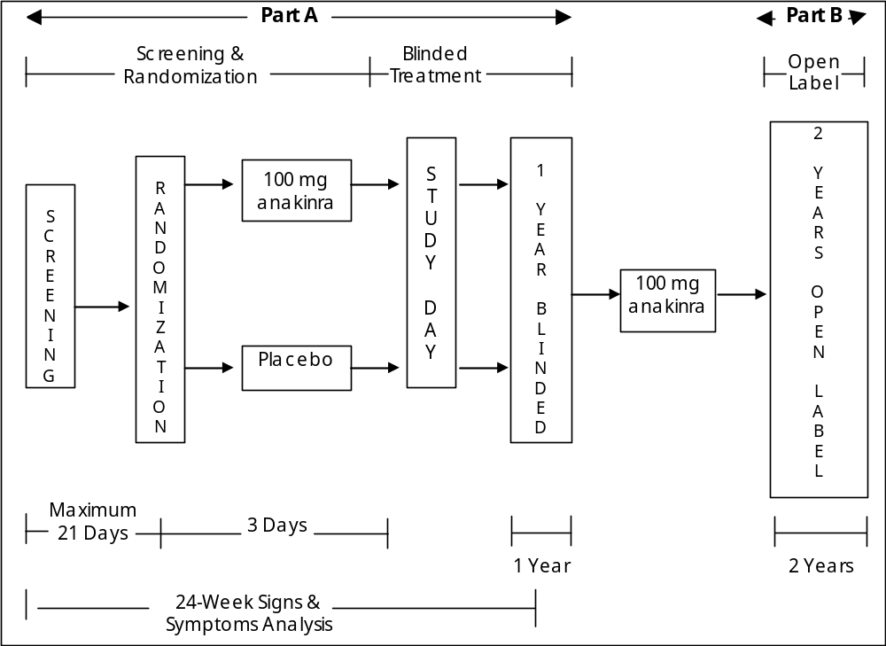

Eligibility criteria included radiographic evidence of at least 1 bone erosion in the hands/wrists or feet. Prior to randomization subjects were also required to have a minimum of 6 swollen joints and 9 tender/painful joints and 1 of the following:
CRP ≥ 1.5 mg/dL (15.0 mg/L), or erythrocyte sedimentation rate (ESR) ≥ 28 mm/hr.
The higher frequency of injection-site reactions (ISRs) with SC administration of anakinra relative to placebo seen in previous clinical studies of anakinra suggested there may be the potential for unblinding study assessors, and possibly introduce bias in their evaluation of signs and symptoms endpoints. In an attempt to minimize such potential bias, the 990145 protocol mandated that steps be taken to cover subjects’ injection sites with clothing during assessments of signs and symptoms. Additionally, independent assessors blinded to all other protocol-specified assessments were to be used for the evaluation of swollen and tender/painful joints. Further, postbaseline CRP and ESR values for individual subjects were kept blinded to Amgen and study site personnel, as anakinra is known to affect these 2 acute phase reactants. Sensitivity analyses to be discussed in the results section suggest that the potential of unblinding due to ISRs did not influence the study’s overall conclusions, see Section 4.4.1.4.
On-Study Medications
In cases of RA flare, NSAIDs or oral corticosteroids could be added or the dose could be temporarily increased postbaseline, with return to the maintenance (baseline) dose upon resolution of the flare. Investigators could also prescribe any other concomitant medications or treatments necessary for supportive care during the 52-week double-blind portion of the study except for the following: other investigational agents, DMARDs, azathioprine, chronic minocycline, cyclophosphamide, cyclosporine, etanercept, gold, hydroxychloroquine, infliximab, leflunomide, mycophenolate mofetil, sulfasalazine, and tacrolimus. Tetracycline could only be used for up to 10 days to treat infection.
In addition to the above medications, this study incorporated the use of a special subject status designation, Lack of Efficacy (LOE), with the objective of retaining subjects in the study for evaluation of the radiographic endpoint when they might otherwise withdraw from the study due to a flare in signs and symptoms of RA. LOE assessments were conducted using a pre-defined algorithm, which maintained the study blind regarding randomized treatment assignments. Declaration of LOE on or after week 16 allowed subjects to receive treatment with protocol-specified agents that could alleviate the signs and symptoms of RA with minimal effects on underlying structural damage (see Appendix 4-1).
For the assessment of the signs and symptoms endpoint, subjects whose dose of DMARDs or corticosteroids was increased from baseline for any reason, including LOE, were defined as non-responders in the analysis of the ACR composite score. The evaluation of the 24-week signs and symptoms data also included sensitivity analyses to evaluate the impact of on-study medication changes on the study’s primary conclusion (see Section 4.4.1.4).
Signs and Symptoms Endpoints
The primary efficacy endpoint for the assessment of signs and symptoms was the proportion of subjects exhibiting ≥ 20% improvement from baseline in the ACR composite score (ACR₂₀) at week 24.
Secondary endpoints included:
- The proportion of subjects achieving a sustained ACR₂₀ response defined as an ACR₂₀ response for a minimum of 4 of 6 monthly measurements, with at least one response being at week 12 or week 24,
- ACR₅₀ and ACR₇₀ responses at week 24, and
- The change from baseline at week 24 for each of the individual ACR components.
Safety Evaluations
Safety endpoints included treatment-emergent adverse events and serious adverse events during the first 24 weeks of treatment. A treatment-emergent adverse event was any clinical abnormality reported by the subject or noted by the investigator that appeared or worsened during the study, regardless of whether the investigator considered the event related to study medication. Serious adverse events were any events that suggested a significant hazard or side effect, regardless of the investigator’s or sponsor’s opinion on the relationship to study medication. These included, but were not limited to, events at any dose that were fatal, life threatening (placed the subject at immediate risk of death), required in-subject hospitalization or prolongation of an existing hospitalization, were a persistent or significant disability/incapacity, or were a congenital abnormality/birth defect. Adverse events of an infectious nature were designated as such by the principal investigator.
Statistical Methods
The statistical methodology employed for the analysis of signs and symptoms including the declaration of study endpoints, sample size, evaluable subsets, and statistical methods, was prospectively detailed in the statistical analysis plan and discussed with the Agency prior to any blind break. The sample size and analytic methods are briefly outlined below.
- Sample Size Determination
A sample size of approximately 500 subjects (250 per group) was prespecified as the number of subjects required for a complete and sufficient test of the primary hypothesis confirming the superiority of anakinra plus MTX versus placebo plus MTX in the reduction of signs and symptoms. Given a 2-tailed alpha level of 0.05 and using an uncorrected chi-square test as an approximation to the prespecified logistic regression analysis, the analysis of the ACR₂₀ response rates at week 24 had 90% power to detect a delta of 13% or more between the anakinra and placebo, 33% versus 20%, respectively.
The analysis for signs and symptoms was prespecified to be conducted at the full 0.05 alpha level yielding a definitive assessment of signs and symptoms. As such, there was no adjustment, or differential alpha spending, incorporated into the sample size determination or analytic methodology. In addition, there will be no adjustment to the alpha level used to assess the radiographic endpoint at the study’s conclusion since:
- the radiographic endpoint (baseline change at week 52 in the modified Sharp Total Score) is not included in the 24-week analysis, and all data associated with the Sharp score remain blinded, and
- the radiographic disease progression claim and the signs and symptoms claim are based on different endpoints.
To protect the integrity of the 52-week radiographic endpoint, procedures were implemented during the analysis and reporting of the signs and symptoms data for this study. As prespecified, for the purposes of conducting the analyses limited Amgen personnel were unblinded to the individual subject treatment assignments. The only data displayed by treatment group are aggregate (summary) statistical data. The randomized treatment assignments for individual subjects are not provided in any data presentations or narratives. Additionally, results that may inadvertently unblind individual treatment assignments (eg, a maximum age associated with a treatment group and easily identified to a particular subject) have been withheld from all data presentations.
- Evaluable Subset for Efficacy
All subjects who were randomized on or before 18 May 2000 and received ≥ 1 dose of study drug were included in all analyses of efficacy for the assessment of signs and symptoms. Subjects were analyzed according to their randomized treatment group regardless of the actual treatment received. This subset of subjects is referred to as the Intent-to-Treat (ITT) subset.
- Missing ACR Composite Scores: Non-Responder Imputation
If a subject’s ACR composite score could not be evaluated at a particular time point because of missing data or incomplete assessments, this subject was considered a non-responder (treatment failure) at that time point. In addition, if a subject’s dose of DMARDs or corticosteroids was increased from baseline for any reason, the subject was considered a non-responder after the first occurrence of the increase in dose.
- Primary Analysis for the ACR₂₀
The prespecified primary analysis for the ACR₂₀ response rate at week 24 was a logistic regression model adjusted for center. All subjects in the evaluable ITT subset were included in the analysis. Subjects with non-evaluable ACR₂₀ responses at week 24 due to missing data or increase in DMARDs or corticosteroids were considered non-responders.

Safety Study (990757)
The Safety Study (990757) is a 24 week randomized, double-blind, placebo-controlled trial with a 2.5 year open-label phase for subjects completing the 24-week double-blind portion. The primary objective and design of this study was to assess the safety of anakinra in a large RA population receiving a variety of concomitant RA medications, and with pre-existing co-morbid conditions including a variety of DMARD therapies. The study’s primary endpoint was the subject incidence of adverse events, including deaths, serious adverse events, discontinuations due to adverse events, and infections. The study is being conducted in the United States, Canada, Europe, and Australia. Eligible subjects were randomized to receive either 100 mg/day of anakinra or placebo using a 4:1 allocation ratio. There were minimal exclusionary criteria regarding background DMARDs; however, subjects who were being treated with DMARDs must have been receiving stable doses for a minimum of 2 months before randomization. Evidence of active RA required the presence of ≥ 3 swollen and ≥ 3 tender/painful joints or morning stiffness of at least 45 minutes duration.
The study design (Figure 4-5) included a concurrent placebo group during the first 6 months for comparison of the incidence of unexpected serious adverse events (eg, opportunistic infections) with those in the anakinra group during the same time interval. The safety data reported represent the results of the double-blind, placebo-controlled portion of the study. The open-label portion of the study is still in-progress.
Figure 4-5. Schema: Safety Study (990757)
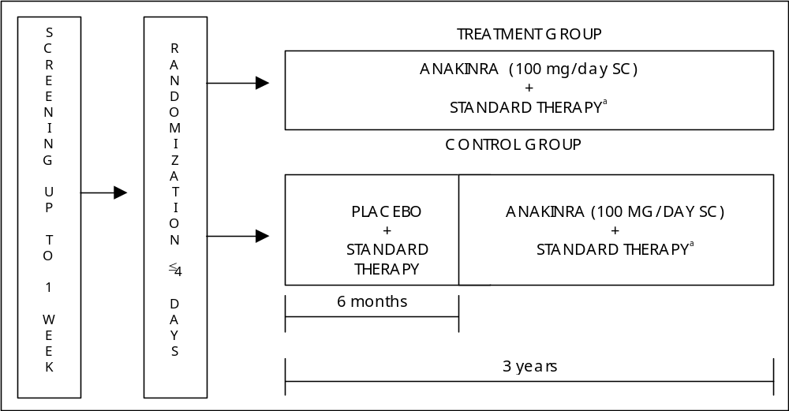
ª Standard therapy was defined as the medications and treatments the subject was receiving at screening.
Day 1 = first day study drug was administered. Study drug was to be given within 4 days after randomization.
Eligible subjects were randomized to anakinra or placebo treatment in a 4:1 allocation ratio.

With minimal restrictions regarding the use of concomitant RA therapies, the Safety Study (990757) was designed to provide safety data on the use of anakinra in combination with a variety of background RA medications. To achieve this objective, investigators were permitted to change the dose of medications, including NSAIDs, corticosteroids, or DMARDs to provide supportive care during the conduct of the study. Additionally, any medication taken regularly before entry into the study could be continued throughout the study with the exception of those prohibited by the exclusion criteria and the proscribed medications such as mycophenolate mofetil (CellCept®), tacrolimus (FK506, Prograf®), cyclophosphamide (Cytoxan®), etanercept (Enbrel®), sirolimus (Rapamune®), infliximab (Remicade™), PROSORBA® Column, cyclosporine, Zenapax (daclizumab), and Simulect (basiliximab).

Subject Disposition and Baseline Characteristics
Overall withdrawal patterns and descriptions of the RA populations evaluated across all 5 placebo-controlled trials are discussed in the section below. Differences in study-specific data by randomized treatment group are discussed where relevant.

Subject Disposition
Table 4-7 displays the subject disposition across all 5 placebo-controlled trials. Among the 2953 subjects randomized, 2932 (99%) received study drug. Overall, the study withdrawal rates were approximately 25% with the most frequently reported reason for early withdrawal being an adverse event (AE). In the MTX Combination Study (960180), the Confirmatory Efficacy Study (990145), and the Safety Study (990757), withdrawal due to AEs was more common among anakinra treated subjects in comparison with placebo subjects, however, this difference is primarily due to ISRs. Other notable differences include the withdrawal rates due to lack of efficacy or disease progression, which was generally more common in the placebo groups or among the lower anakinra doses. In the Safety Study (990757), 4 anakinra subjects (0.4%) and 1 placebo subject (0.4%) were classified as having withdrawn as a result of death. Within each of the 5 studies, the withdrawal patterns were similar among the randomized treatment groups.
In the Monotherapy Study (0560), one subject was randomized (150 mg group) but did not receive study drug. This subject was participating in a magnetic resonance imaging (MRI) sub-study and upon receipt of approximately 16 mL of contrast agent for a baseline MRI went into anaphylactic shock. This event, and the subject’s withdrawal, occurred prior to receipt of study drug.
In the Low Dose Monotherapy Study (960182) and the MTX Combination Study (960180) all randomized subjects received at least 1 dose of study drug.
In the Confirmatory Efficacy Study (990145), 5 subjects were randomized but did not receive study drug. Three of these subjects had study drug withheld due to medical conditions discovered after randomization, one subject discontinued their NSAIDs between screening and randomization, and one subject was lost to follow-up. As the blind for individual subjects remains intact, the randomized treatment groups for these individual subjects are not available; however, based on the aggregate results, 2 of these subjects were randomized to receive placebo and the other 3 anakinra.
Fifteen of the 1414 subjects in the Safety Study (990757) were randomized but never received study drug. Of the 15 subjects, 1 was randomized to receive placebo (0.4%) and 14 to receive anakinra (1.2%). Ten of these subjects withdrew consent, 3 were determined to be ineligible, 1 subject was unable to demonstrate the ability to self-inject, and 1 was lost to follow up.
Table 4-7. Subject Disposition
 |  |  | Study
 |  |  | 0560 | 960182 | 960180 | 990757 | 990145
Total randomized – n |  |  | 473 | 141 | 419 | 1414 | 506
Never received drug – n |  |  | 1 | 0 | 0 | 15 | 5
Completed - % |  |  | 72.9 | 87.9 | 79.0 | 78.1 | 75.7
Withdrew - % |  |  | 27.1 | 12.1 | 21.0 | 21.9 | 24.3
 | Reason for withdrawal - %
 |  | Adverse event | 17.3 | 5.7 | 7.2 | 10.4 | 10.9
 |  | Lack of efficacy | 5.5 | 3.5 | 8.4 | 1.3 | 2.6
 |  | Other | 4.2 | 2.8 | 5.5 | 9.9 | 10.9
 |  | Death | 0.0 | 0.0 | 0.0 | 0.3 | 0.0
/stat/il1ra/fda_slides/analysis/allstudy/statfiles/tables/t_disp.sas
Output: t_disp.rtf (generated 10MAY2001)
“Lack of efficacy” and “death” were considered withdrawal due to adverse events for analyses of safety.

Baseline Subject Characteristics, Disease Status, and RA Medications
Summary statistics for baseline subject demographics, disease status and RA medications are shown in Table 4-4, Table 4-5, and Table 4-6 respectively. In general, subjects had similar demographic profiles across the 5 studies, and are representative of the typical RA population. The majority of the subjects were Caucasian women, with a mean age ranging from 52 to 56 years, weighing on average approximately 75 kg at study entry (Table 4-8).
Table 4-8. Baseline Demographics
 | Study
 | 0560 | 960182 | 960180 | 990757 | 990145
Mean | (N = 472) | (N = 141) | (N = 419) | (N = 1399) | (N = 501)
Female - % | 75.0 | 76.6 | 77.6 | 74.7 | 77.0
Caucasian - % | 98.7 | 100.0 | 88.5 | 88.3 | 86.8
Age (yr) | 53.1 | 52.2 | 52.5 | 54.8 | 56.3
Weight (kg) | 69.6 | 70.1 | 78.6 | 76.8 | 81.1
/stat/il1ra/fda_slides/analysis/allstudy/statfiles/tables/t_base.sas
Output: t_base_demog_all.rtf (generated 05JUN2001)

As shown in Table 4-9, subjects participating in each of these 5 studies had clear evidence of active RA at baseline. Given the various inclusion/exclusion criteria, it is not unexpected to observe slight variations among the 5 studies; however, in general, the over 2900 subjects had moderate to severe RA. On average subjects had from 23 to 34 tender/painful joints and 18 to 26 swollen joints, as well as elevated ESR values at baseline (Table 4-9). As expected, baseline CRP values were generally lower in the 3 trials (960180, 990145, and 990757) that permitted concomitant MTX therapy.
Table 4-10 describes the RA medications at baseline. Approximately 40% to 65% of subjects were taking corticosteroids at baseline. The majority of subjects (> 70%) were taking baseline NSAIDs. The only variable in RA medications are with MTX and other DMARDS. These differences were protocol defined, with study 990757 as the only study that allowed inclusion of DMARDS other than MTX. With the exception of differences noted above, within each of the individual studies, baseline demographics, disease status and RA medications were well-balanced among the randomized treatment groups.
Table 4-9. Baseline Disease Status
 | Study
 | 0560 | 960182 | 960180 | 990757 | 990145
Mean | (N = 472) | (N = 141) | (N = 419) | (N = 1399) | (N = 501)
Duration of RA (yr) | 4.0 | 3.5 | 7.4 | 10.3 | 10.8
Tender/Painful (0 - 68) | 34.3 | 33.0 | 25.4 | 22.6 | 25.6
Swollen (0 - 66) | 26.1 | 23.7 | 18.3 | 18.7 | 20.0
HAQ (0 - 3) | 1.57 | 1.64 | 1.40 | 1.41 | 1.34
Physician's global (0 - 100) | 77.1 | 78.0 | 57.4 | 53.7 | 57.2
Subject's global (0 - 100) | 76.7 | 77.5 | 50.2 | 53.0 | 52.7
Subject's pain (0 - 100) | 62.9 | 59.9 | 50.8 | 55.5 | 57.4
CRP (mg/dL) | 4.14 | 3.17 | 1.91 | 2.67 | 2.63
ESR (mm/hr) | 49.5 | 43.2 | 36.7 | N/A | 42.2
Morning stiffness (min/day) | 134.2 | 127.4 | 130.2 | N/A | 106.5
/stat/il1ra/fda_slides/analysis/allstudy/statfiles/tables/t_base.sas
Output: t_base_disease_all.rtf (generated 10MAY2001)
Table 4-10. Baseline RA Medications
 | Study
 | 0560 | 960182 | 960180 | 990757 | 990145
 | (N = 472) | (N = 141) | (N = 419) | (N = 1339) | (N = 501)
Corticosteroid use at baseline - % | 42.6 | 44.0 | 64.2 | 57.8 | 52.7
NSAIDs use at baseline - % | 83.5 | 85.8 | 69.0 | 87.0 | 76.4
MTX alone use at baseline - % | 0% | 0% | 100% | 31.1% | 100%
Other DMARD excluding MTX use at baseline - % | 0% | 0% | 0% | 25.4% | 0%
MTX + other DMARD use at baseline % | 0% | 0% | 0% | 22.3% | 0%

Clinical Data - Efficacy
Efficacy results from the Monotherapy Study (0560), the Low Dose Monotherapy Study (960182), the MTX Combination Study (960180), and the Confirmatory Efficacy Study (990145) to support the signs and symptoms indication for anakinra are summarized separately for each study, followed by a review of the radiographic results for the Larsen and modified Sharp scores from the Monotherapy Study (0560).

Signs and Symptoms Data
The analysis of signs and symptoms data for the Confirmatory Efficacy Study (990145) confirmed the efficacy results seen in the Monotherapy Study (0560), and the MTX Combination Study (960180). After treatment with 100 mg/day anakinra, subjects were more likely to achieve symptomatic improvements of 20% or more by week 24 in comparison with placebo subjects, p < 0.001. The onset of action was rapid and sustained throughout the 24-week treatment period.

Monotherapy Study (0560)
The results for the prespecified analysis (M-ITT with LOCF imputation) of the primary endpoint, the ACR₂₀ at week 24, are displayed in Figure 4-6. Anakinra subjects were more likely to achieve an ACR₂₀ response at week 24 than were placebo subjects. The proportion of subjects achieving an ACR₂₀ response in the placebo group was 27% compared to response rates of 39%, 34%, and 43% for the 30, 75, and 150 mg anakinra dose groups, respectively (upper panel, Figure 4-6). While a clear dose response was not observed, and statistical significance was not attained at the 75 mg dose, the results for both the 30 mg and 150 mg doses were statistically different from placebo, p = 0.047 and p = 0.014, respectively. The original protocol did not specify an adjustment for multiple comparison; nevertheless, the observed statistical superiority over placebo for the 150 mg dose group was maintained even when adjustments for multiple comparisons were made at an adjusted two-tailed alpha level of 0.019 (Dunnett’s multiple comparison adjustment: 3 comparisons to placebo).
Additional analyses for the primary endpoint using the ITT subset (all subjects receiving at least one dose of study drug) with a non-responder imputation for missing data were also conducted. The ITT analyses include the 4 subjects excluded from the M-ITT subset due to missing postbaseline assessments. The results from the ITT analysis (lower panel, Figure 4-6), continue to demonstrate statistically significant effects for the 30 and 150 mg dose groups compared to placebo. When adjusted for multiple comparisons the nominal p-values were greater than the adjusted alpha level of 0.019.
From Figure 4-7 (upper panel), the effect of anakinra is shown to be rapid with clinically and statistically significant differences observed as early as week 2. When compared to placebo, anakinra subjects were also more than twice as likely to sustain their improvements, a result observed for each anakinra dose, p < 0.01 (middle panel, Figure 4-7). The magnitude of improvement was also greater among anakinra subjects. Examination of the week 24 ACR₅₀ response rates reveals that subjects in both the 30 and 150 mg dose groups were more than twice as likely to achieve improvements of 50% or more compared to subjects receiving placebo, p < 0.05 (lower panel, Figure 4-7).
Examination of the individual ACR components revealed a pattern of effect very similar to that observed for the ACR composite score. From Figure 4-8, it is clear that anakinra treated subjects achieved rapid improvements in all components with statistically significant effects observed at week 24 for the 150 mg dose group with respect to every component examined, p < 0.05.
Figure 4-6. Study 0560 - Proportion of Subjects Achieving an ACR₂₀ Response at
Week 24
M-ITT With LOCF Imputation
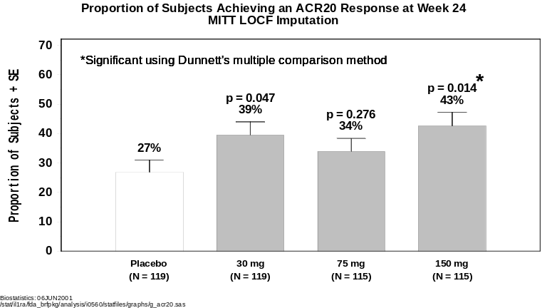

ITT With Non-Responder Imputation
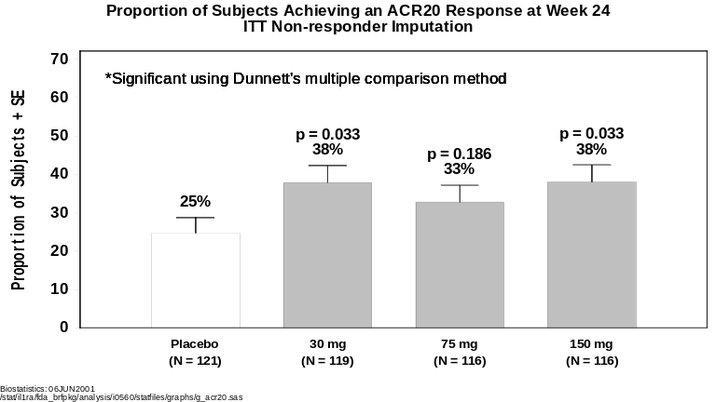
Figure 4-7. Study 0560 - ACR Composite Scores
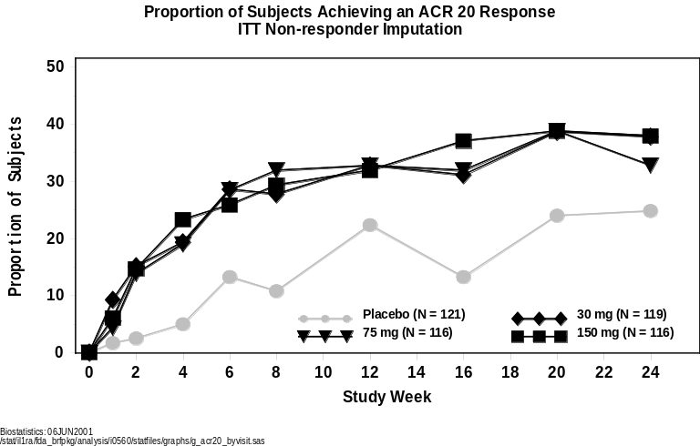

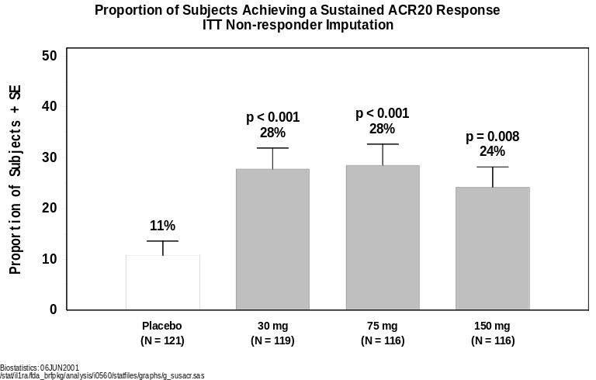

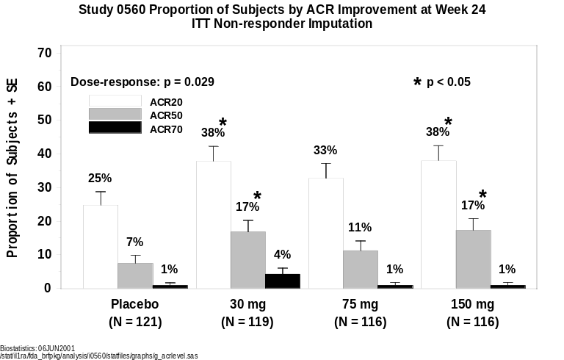
Figure 4-8. Study 0560 – Individual ACR Components Change From Baseline
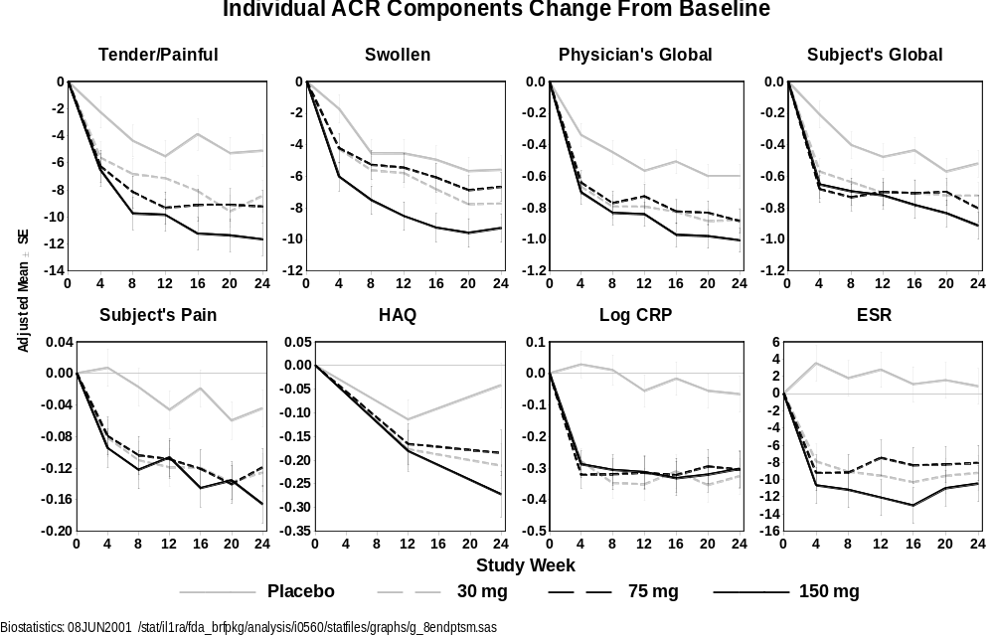
Sensitivity Analyses
Sensitivity analyses were conducted to determine the robustness of the signs and symptoms results from the Monotherapy Study (0560), specifically, to assess the potential impact of any inadvertent unblinding that may have occurred as a result of Injection Site Reactions (ISRs). As shown in Section 4.5.3.2, ISRs occur more frequently, although not exclusively, in the anakinra treatment groups and are dose-dependent.
To evaluate the treatment effect of anakinra in the absence of any influence due to ISRs, the ACR₂₀ response rates between anakinra and placebo treated subjects were examined within the subset of subjects who never experienced an ISR. This ISR-negative subset would be a group of subjects, for whom, presumably, the blind remained intact. The results of this analysis suggested that anakinra retained its clinical advantage over placebo for both the ACR₂₀ responses at week 24 and the sustained ACR₂₀ responses. Although the sample sizes were reduced in this smaller ISR-negative subset, clear trends were consistently evident, and for the sustained response, results reached statistical significance. As in the primary analysis, efficacy was most consistent at the higher anakinra dose of 150 mg (Appendix 4- 2 and Appendix 4-3).
Although ISRs were more common among subjects treated with anakinra, the results from this analysis indicate the presence of ISRs did not unduly influence the results and are supportive of the study’s overall conclusion: anakinra is effective in reducing the signs and symptoms of RA.

Low Dose Monotherapy (960182)
None of the anakinra dose groups (2.5, 10 and 30 mg/day) examined in the Low Dose Monotherapy Study (960182) demonstrated a statistically significant difference from placebo with respect to the ACR₂₀ response rates at week 12, the study’s primary endpoint (Figure 4-9). The lack of an effect for anakinra was observed for each efficacy endpoint examined. Further examination to determine if these results were due to baseline covariates, subject disease characteristics, or potential safety issues did not reveal any explanation for the lack of an effect. Relative to placebo, anakinra subjects did not appear to have worsening signs and symptoms scores; however, at these lower doses, anakinra subjects were unable to achieve improvements over and beyond those observed for placebo subjects.
Figure 4-9. Study 960182 – Proportion of Subjects Achieving an ACR₂₀ Response at Week 12
ITT With Non-Responder Imputation
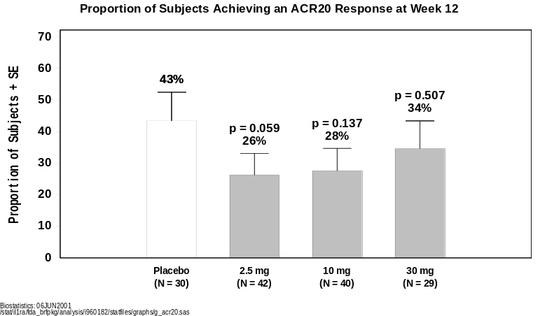

MTX Combination Study (960180)
There was a highly significant dose-response between ACR₂₀ response rates and anakinra dose at week 12, the study’s primary endpoint, and week 24, p = 0.001 and p = 0.004, respectively (Figure 4-10). Although not strictly linear, the results clearly indicate that increasing ACR₂₀ response rates are associated with higher anakinra doses.
The ACR₂₀ response rate for each time point examined for the placebo, and the higher anakinra doses of 0.4, 1.0 and 2.0 mg/kg dose groups are displayed in Figure 4-11 (upper panel). For clarity only the higher dose groups are shown; see Appendix 4-4 for the lower dose groups. As observed in the Monotherapy Study (0560), compared with placebo, there is a clear indication that anakinra achieves a rapid response that is maintained throughout the treatment period. The sustained ACR₂₀ response rates (middle panel, Figure 4-11), are also consistent with those observed in the Monotherapy Study (0560). Anakinra subjects at the 1.0 and 2.0 mg/kg doses were more than twice as likely to sustain their ACR₂₀ improvements when compared with placebo subjects, p = 0.039 and p = 0.013, respectively. Higher magnitudes of improvement in the ACR composite score were also associated with higher anakinra doses as evidenced by the overall test for dose-response, p = 0.003 (lower panel, Figure 4-11). This was most evident at the 1.0 mg/kg dose group, where 24% anakinra subjects achieved an ACR₅₀ and 10% an ACR₇₀, p < 0.05, when compared to placebo.
Examination of the individual ACR components graphically displayed in Figure 4-12 indicates an advantage for anakinra subjects over placebo subjects at the higher anakinra doses. At week 24, the prespecified time point for the individual ACR components, statistically significant differences between placebo and the 1.0 and 2.0 mg/kg doses were observed for HAQ, the physician’s and subject’s global assessment, subject’s pain assessment, and ESR. It should be noted that in this study, 49.9% of subjects had baseline CRP levels within the normal range (0 to 0.8 mg/dL) where all subjects were receiving concomitant MTX therapy.

Figure 4-10. Study 960180 – Proportion of Subjects Achieving an ACR₂₀ Response
Week 12
ITT With Non-Responder Imputation
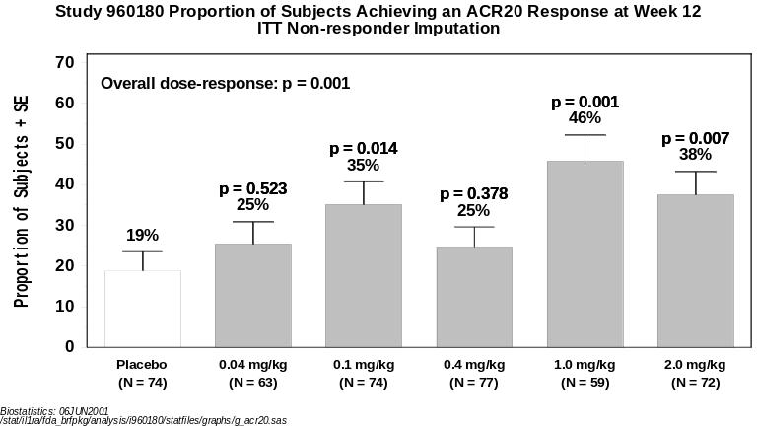
Week 24
ITT With Non-Responder Imputation
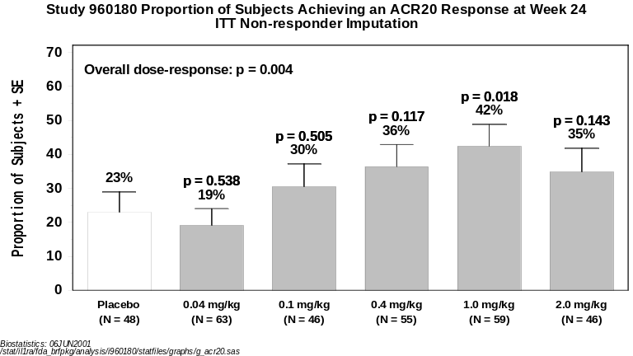
Figure 4-11. Figure Study 960180 - ACR Composite Scores
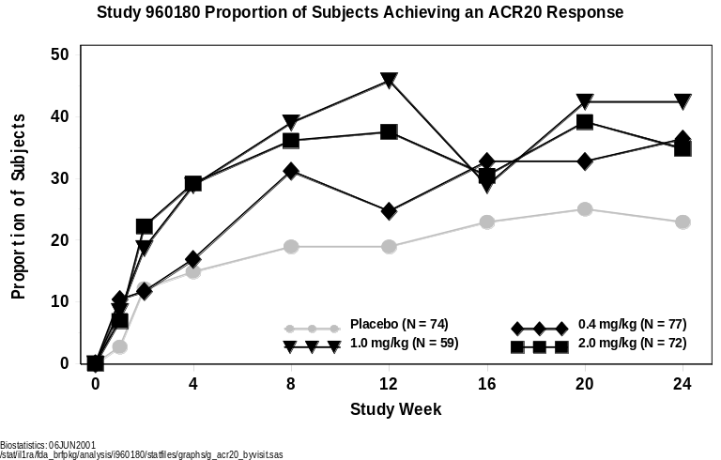

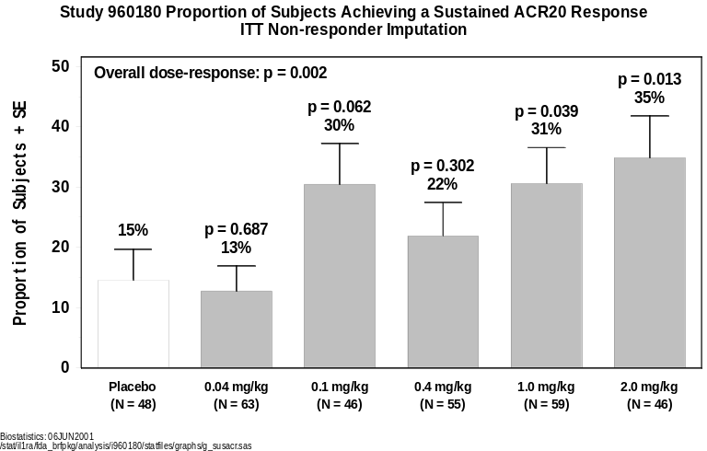

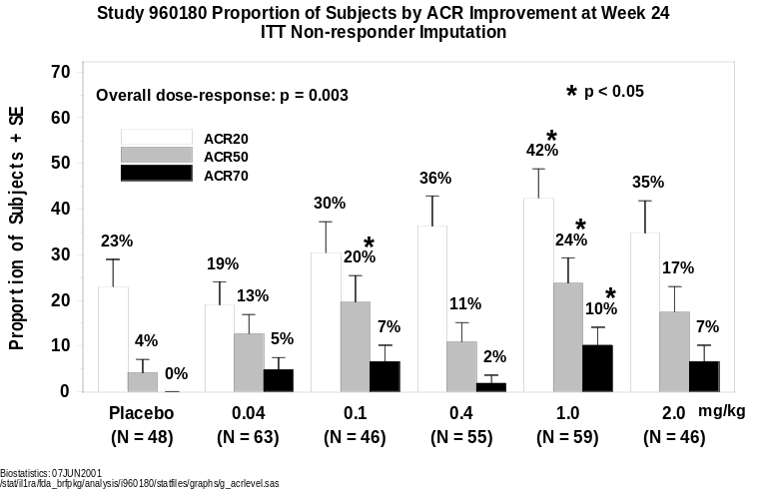
Figure 4-12. Study 960180 – Individual ACR Components Change From Baseline
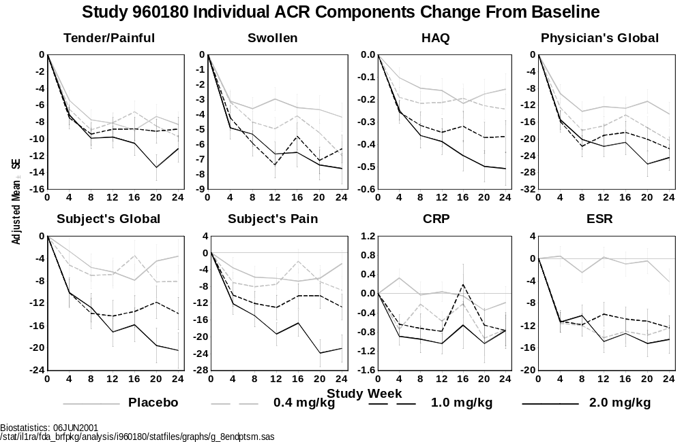
Sensitivity Analyses
As in the Monotherapy Study (0560), sensitivity analyses were conducted to examine the robustness of the results, particularly with regard to potential unblinding due to ISRs (Appendix 4-5, Appendix 4-6 and Appendix 4-7). Using a methodology similar to that used in the Monotherapy Study (0560), the analyses examined the ACR₂₀ results at week 12 and 24, as well as the sustained ACR₂₀ results for the cohort of subjects who had not experienced an ISR by the time the ACR assessment was made (either week 12 or week 24). The results of these sensitivity analyses are similar to those observed in the Monotherapy Study (0560). Among those subjects who did not experience an ISR, anakinra treated subjects, most notably at the 1.0 mg/kg dose group continued to do significantly better than placebo subjects with respect to an ACR₂₀ response at both weeks 12 and 24, (p < 0.05 and p < 0.01, respectively). Results for the ACR₂₀ sustained response were similar to those observed in the primary analysis for this study. Despite the smaller sample size for the subset of subjects with no ISRs, the proportion of subjects achieving a sustained improvement of at least 20% or more was greater in the 1.0 and 2.0 mg/kg anakinra dose groups compared with placebo subjects, (43% in both anakinra groups vs. 17% for placebo, p = 0.035, and p = 0.076, respectively). The results of these sensitivity analyses support the stable and robust nature of the overall study findings that anakinra is an effective treatment for the signs and symptoms of RA.

Confirmatory Efficacy Study (990145)
The Confirmatory Efficacy Study (990145; N = 501) confirmed that the proposed dose of 100 mg/day is effective in reducing the signs and symptoms. Subjects treated with 100 mg/day of anakinra plus background MTX were more likely to achieve an ACR₂₀ response at week 24, the prespecified confirmatory endpoint for signs and symptoms, than subjects treated with placebo and background MTX, p < 0.001 (Figure 4-13). In addition, clinically and statistically meaningful effects for each of the secondary signs and symptoms endpoints were also achieved. The effects of anakinra were rapid and sustained throughout the 24-week treatment period. Anakinra subjects were also able to achieve higher magnitudes of improvements, being twice as likely to achieve an ACR₅₀, and almost three times as likely to achieve an ACR₇₀ than placebo subjects receiving MTX alone.
ACR₂₀ Response
Figure 4-13 displays the results of ACR₂₀ at week 24, the primary endpoint for signs and symptoms of RA. Subjects receiving 100 mg anakinra plus MTX showed clinically and statistically significant improvement in the signs and symptoms of their RA at week 24 relative to subjects receiving placebo plus MTX as measured by the ACR₂₀ score. Of the 250 anakinra treated subjects included in the analysis, 38% achieved a minimum of 20% improvement in the ACR composite score compared with 22% of subjects receiving placebo (p < 0.001). The odds ratio of achieving a response in the anakinra group relative to the placebo group was 2.36 (95% confidence interval: 1.55, 3.62).
Figure 4-13. Percent of Subjects Achieving an ACR₂₀ Response at Week 24
ITT With Non-responder Imputation
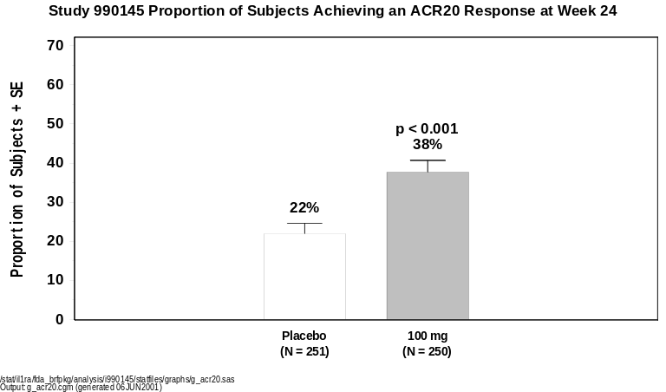

Anakinra’s effects on ACR₂₀ had an early onset of action, as reflected in Figure 4-14 which shows the ACR₂₀ response at each study visit. Anakinra subjects had a 2-fold higher ACR₂₀ response than placebo subjects by the first study visit at week 4, with values of 21% compared with 11%, respectively (p = 0.004). The clinical and statistical superiority of anakinra to placebo was maintained for each time point examined throughout the 24-week treatment period.
Figure 4-14. Percent of Subjects Achieving an ACR20 Response by Study Week
ITT With Non-responder Imputation
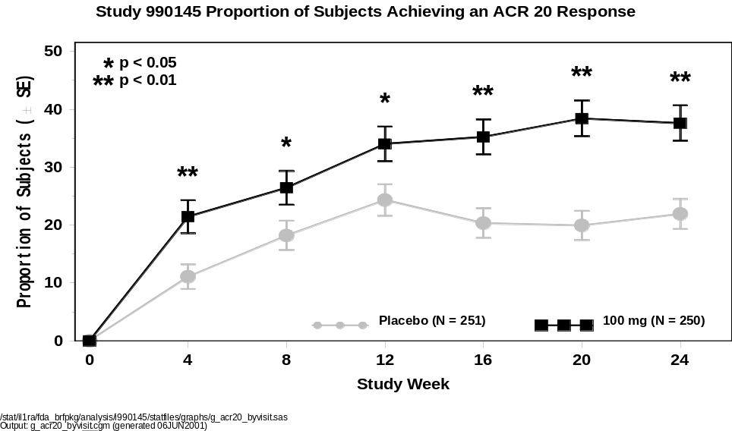
Anakinra subjects were more than twice as likely as placebo subjects to achieve a sustained ACR₂₀ response, Figure 4-15. Among anakinra subjects, 27% achieved a sustained response during the 24-week analysis period, compared with 12% of placebo subjects, p < 0.001. The odds ratio of achieving a sustained response was 3.43 (95% confidence interval: 2.05, 5.90) in favor of anakinra over placebo.
Figure 4-15. Percent of Subjects Achieving a Sustained ACR₂₀ Response
ITT With Non-responder Imputation
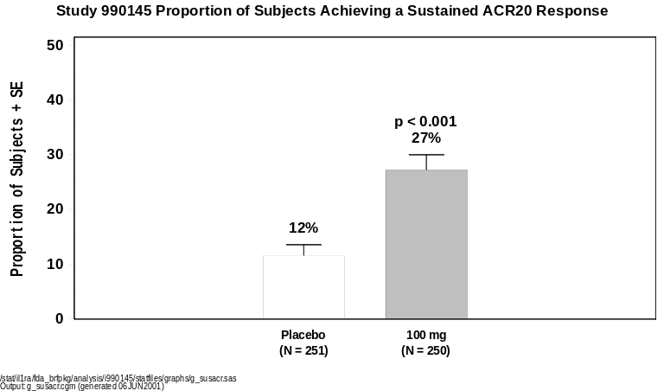

ACR₅₀ and ACR₇₀ Responses
Improvements of 50% and 70% in the symptoms of RA were observed more frequently among subjects receiving anakinra than for those receiving placebo (p < 0.001 and p = 0.024). The percentage of subjects achieving ACR₅₀ and ACR₇₀ at week 24 is graphically presented in Figure 4-16.
More than twice as many anakinra-treated subjects achieved ACR₅₀ responses at week 24 (17%) compared with placebo subjects (8%), p < 0.001. The odds ratio of achieving a response was 2.61 for anakinra subjects in comparison with placebo (95% confidence interval: 1.46, 4.84).
In addition to achieving improvements of 50% or more, anakinra subjects were almost three times more likely to achieve improvements of at least 70% compared with subjects receiving placebo (6% and 2%; respectively, p = 0.024).
Figure 4-16. Percent of Subjects by ACR Level of Improvement at Week 24
ITT With Non-responder Imputation
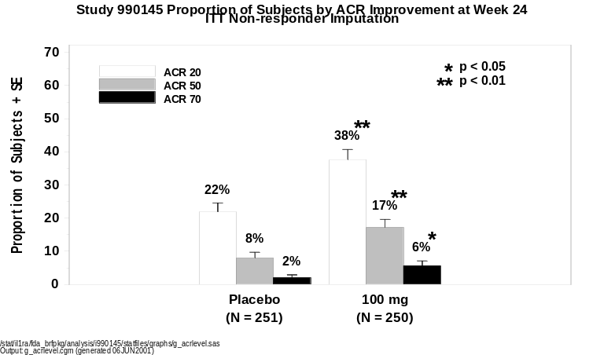

In summary, anakinra demonstrated a clinically and statistically significant advantage over placebo in ACR₂₀ response at week 24. Further, anakinra showed an early onset of action, with a 2-fold advantage in ACR₂₀ response evident by the first visit at week 4. Anakinra subjects were more than twice as likely as placebo subjects to have a durable improvement in the signs and symptoms of their RA as measured by the ACR₂₀ sustained response. Finally, higher levels of relief as reflected in both the ACR₅₀ and ACR₇₀ endpoints were more than twice as likely for anakinra subjects as placebo subjects.
Individual ACR components at 24 Weeks
The results for individual ACR components are shown in Figure 4-17. The time course of change in the signs and symptoms of RA generally demonstrate progressive improvement over the 24 weeks for subjects receiving anakinra, with early onset of improvement evident in all components of signs and symptoms.
Anakinra subjects experienced clinically and statistically significant improvement relative to placebo in all ACR components with the exception of the swollen joint count which did not achieve statistical significance at week 24, the prespecified time point (see Appendix 4-8). The largest between-treatment differences at week 24 were apparent for the objective endpoints of CRP and ESR. The decrease in log-transformed CRP was 5 times larger for anakinra subjects (-0.51) than for placebo subjects (-0.10; p < 0.001), and the decrease in ESR was almost 3 times larger (-16.19 vs -5.98 mm/hr, respectively; p < 0.001). The assessment of the tender/painful joint count indicated a 39% larger reduction from baseline with anakinra treatment (a mean improvement of -12.00 joints) than with placebo (-8.65 joints; p = 0.006). Subjects receiving anakinra experienced an improvement of -0.29 in disability status (HAQ) by week 24, a 61% better response than the improvement of -0.18 seen in the placebo group (p = 0.017). The physician’s and subject’s assessments of disease and subject’s assessment of pain also show clinically and statistically significant advantages for anakinra therapy (p = 0.012, p < 0.001 and p = 0.003, respectively).
Figure 4-17. Study 990145 Individual ACR Components Change From Baseline
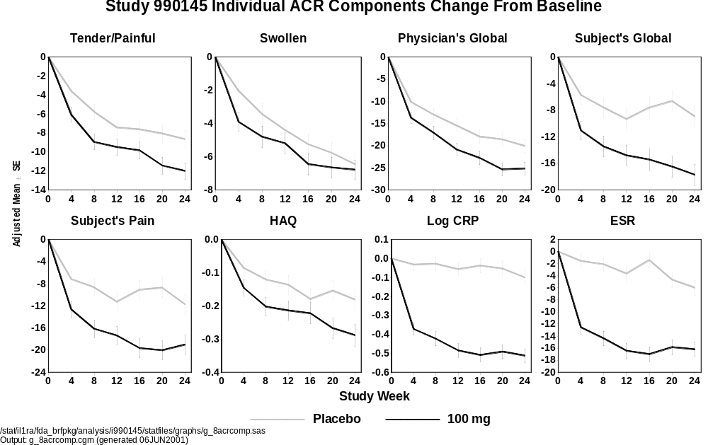

Sensitivity Analyses
This section presents the results of 3 sensitivity analyses designed to assess the robustness of the primary analysis for signs and symptoms in the Confirmatory Efficacy Study (990145). The first analysis, the completers analysis, examines the effect of missing signs and symptoms data on the week-24 ACR₂₀ response rates for each treatment group. The second sensitivity analysis examines the potential effect of increased on-study DMARD/corticosteroid use, while the final sensitivity analysis examines the potential impact of inadvertent unblinding due to ISRs on the assessment of signs and symptoms. Overall, the results of these analyses indicate that the observed ACR₂₀ response favoring anakinra in the primary analysis is robust and consistent.
Table 4-11 summarizes the week-24 ACR₂₀ results for the completer subset. This analysis excludes subjects who were missing ACR₂₀ responses at week 24 due to early withdrawal from study drug, a missed visit, or incomplete assessments. Of the total sample of 501 subjects, 387 (77.2%) had observed ACR₂₀ responses at week 24 and are included in the completer analysis presented in Table 4-11. The remaining 114 subjects (22.8%) had missing or incomplete assessments at week 24 and are excluded from the completers analysis.
The results of the completers analysis demonstrate a clear treatment advantage for anakinra similar to that seen in the primary analysis. The ACR₂₀ at week 24 was 29.4% for placebo and 47.0% for anakinra, with an odds ratio of 2.31 (95% confidence interval: 1.47, 3.68) in favor of anakinra (p < 0.001). Thus, these results show that the conclusions drawn from the primary analysis are not changed by the imputation of missing signs and symptoms data.
Figure 4-18. Percent of Subjects Achieving an ACR₂₀ Response at Week 24
Completer Analysis
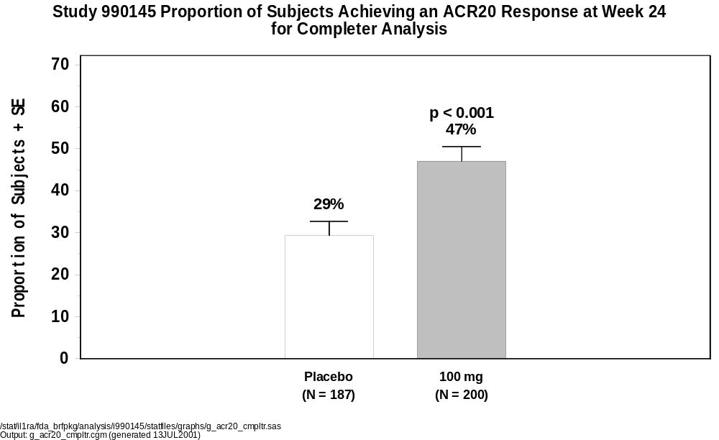
An important feature of the 990145 study design was the rules governing the use of corticosteroids and DMARDs thought to affect the signs and symptoms of RA without substantial effect on underlying structural damage. A subset of such medications was permitted under certain circumstances (Section 4.3.1.4). Regardless of the reasons for increased corticosteroid or DMARD use, subjects who increased their exposure from baseline levels were defined as non-responders from the time of increase onwards. Exceptions included subjects receiving the medication topically, rectally, opthalmically, as an inhalant, or by intra-articular injection (which resulted in censoring of the affected joint); administration by these routes was not considered to affect the assessment of signs and symptoms. Subjects with missing ACR responses were defined as non-responders regardless of their corticosteroid or DMARD use. Table 4-11 displays the number of subjects with observed ACR₂₀ responses at week 24 who were determined to have increased their steroid or DMARD use on or before week 24. Among subjects with observed week-24 assessments, only 38 subjects, 19 subjects (7.6%) in each treatment group, increased their steroid or DMARD exposure on study. Of these, most subjects were found to be non-responders in their actual assessments at week 24: 94.7% and 78.9% in the placebo and anakinra groups, respectively (Table 4-11). Hence, the increases in the use of steroids or DMARDs would be expected to have little impact on the primary results, a conclusion that is confirmed by the analysis. When the observed week-24 ACR₂₀ responses are analyzed for the 38 subjects (Table 4-12) who increased their on-study corticosteroids or DMARDs, implementing the non-responder imputation for only those subjects with missing 24-week values, the results remain essentially unchanged from the primary analysis, with significantly higher response in the anakinra group (39.2%) than in the placebo group (22.3%; p < 0.001) and an odds ratio favoring anakinra of 2.48 (95% confidence interval: 1.63, 3.81).

Table 4-11. Summary of ACR₂₀ Response at Week 24 for Completers
Who Increased Corticosteroids or DMARDs From Baseline
 |  |  |  |  |  | Placebo |  |  | Anakinra
 |  |  |  |  |  | (N = 251) |  |  | (N = 250)
Number of completers with increased medications |  |  |  |  |  | 19 | (7.6) |  | 19 | (7.6)
 |  | Observed ACR₂₀ response at week 24ª
 |  |  |  |  | Nonresponder | 18 | (94.7) |  | 15 | (78.9)
 |  |  |  |  | Responder | 1 | (5.3) |  | 4 | (21.1)
 |  | Reasons for increased medicationsª
 |  |  |  |  | Lack of efficacy criteria | 8 | (42.1) |  | 5 | (26.3)
 |  |  |  |  | Other^{b} | 11 | (57.9) |  | 14 | (73.7)
N = |  |  |  | Number of subjects who were randomized as of 18 May 2000 and who received
 |  |  |  | at least 1 dose of study drug
ª | Percents are based on the number of completers with increased medications.
^{b} | Includes protocol deviations and subjects who increased corticosteroids according to
 | protocol
Table 4-12. Percent of Subjects Achieving an ACR₂₀ Response at
Week 24 Using Non-responder Imputation Only for Missing Data
 |  |  |  | Placebo |  |  | Anakinra
 |  |  |  | (N = 251) |  |  | (N = 250)
Number of subjects included in analysis |  |  |  | 251 |  |  | 250
Number of responders (%) |  |  |  | 56 | (22.3) |  | 98 | (39.2)
Odds ratio |  |  |  |  |  |  | 2.48
95% confidence interval for odds ratio |  |  |  |  |  |  | (1.63, 3.81)
p-value |  |  |  |  |  |  | < 0.001
N = |  | Number of subjects who were randomized as of 18 May 2000 and who received
 |  | at least 1 dose of study drug
Odds ratio is a ratio of the odds of achieving an ACR response compared to placebo
 |  | using a logistic regression adjusted for center.

The final sensitivity analysis assesses the potential unblinding effects of ISRs on the evaluation of signs and symptoms. Although the protocol required assessors to be blinded to application site events, ISRs were the most frequent class of adverse events related to anakinra, and it is theoretically possible that the presence or absence of ISRs may have affected the study blind. To assess the impact of any potential effect, the ACR₂₀ response rates between the placebo and anakinra groups were compared within 2 subsets: subjects who experienced 1 or more ISRs during the study and those who did not experience an ISR (Table 4-13). The resulting ACR₂₀ response rates favor anakinra over placebo in subjects with and without ISRs. Among subjects without ISRs, in whom the blind presumably remained intact, the response rates of 19.3% and 36.8% for placebo and anakinra, respectively, were very similar to the corresponding rates of 22% and 38% seen in the primary analysis (Figure 4-13), and the difference between treatments was statistically significant (p = 0.002). Among subjects with ISRs, the response numerically indicated a treatment advantage for anakinra over placebo. Overall, these results suggest that the observed treatment effect favoring anakinra in the primary analysis was not the result of unblinding due to ISRs.
Table 4-13. Percent of Subjects Achieving an ACR₂₀ Response at Week 24
by Injection Site Reaction (ISR) Using Non-responder Imputation
 |  |  |  | Placebo |  |  | Anakinra |  |  | Chi-square
 |  |  |  | (N = 251) |  |  | (N = 250) |  |  | p-value
Subjects without ISR
 |  | n |  | 192 |  |  | 87
 |  | Number of responders (%) |  | 37 | (19.3) |  | 32 | (36.8) |  |  | 0.002
Subjects with ISR
 |  | n |  | 59 |  |  | 163
 |  | Number of responders (%) |  | 18 | (30.5) |  | 62 | (38.0) |  |  | 0.302
N = |  | Number of subjects who were randomized as of 18 May 2000 and who received
 |  | at least 1 dose of study drug

Monotherapy Study (0560): Radiographic Data
An important prespecified secondary efficacy endpoint in the Monotherapy Study (0560) was the Larsen score, a measure of radiographic disease progression. In addition to the prespecified Larsen score, these radiographs were subsequently re-examined by an independent assessor, and re-scored using the Modified Sharp score. The methods and results for these radiographic endpoints are discussed below.

Radiographic Endpoints: Larsen and Modified Sharp Scores
The Larsen and modified Sharp was designed earlier and modified in the 1970’s, and modifications of these methods are the most widely accepted methods in use today for assessing progression of joint damage in RA. The Larsen score is a single global composite score of overall damage assesses both erosions and cartilage destruction simultaneously.
In contrast, the modified Sharp scoring method formally distinguishes 2 aspects of joint damage; an erosion score (ES) and a joint space narrowing (JSN) score are calculated separately, and then added to provide a total modified Sharp score.
Both scoring methods thus provide a single composite measure of overall joint damage, with the modified Sharp score providing additional information that allows further assessment of erosions and joint space narrowing separately. Since the Larsen scoring method gained wide acceptance in Europe, where it was originally devised, it was the scoring method chosen prospectively for use in the Monotherapy Study (0560) and its extension (0564). The Sharp scoring method is considered more sensitive and is the most widely accepted scoring method in the United States.^{61,62} Consequently, the radiographs for the Monotherapy Study (0560) were reanalyzed using a modified Sharp scoring method.
Radiographs were viewed and scored according to the protocol using the Larsen method (Table 4-14) by 2 consulting radiologists (Drs Iain Watt and Mark Cobby, University of Bristol, UK) who were blinded to subject identification, treatment group, and chronology of radiographs. The radiologists sat side by side to read the radiographs, with the Larsen score categories and standard films on the view box next to the subject’s radiograph as a reference. Scores were assigned by comparison with the series of standard radiographs. The radiologists reached consensus when necessary, and always adopted the conservative (lower) score when in doubt. The radiographs were graded individually and not in pairs or triplicates.
Larsen’s method as used here assesses global changes and grades individual joints on a scale of 0 to 6 (Table 4-14).⁶³ The composite Larsen score is obtained by summing the scores for each of the joints examined. Joint grades are based on the presence of pathologic findings including both erosions and joint space narrowing, although the predominant characteristic of joint damage that is scored by the Larsen method relates to erosions.⁶⁴ Thus, the Larsen score does not distinguish between bone erosions and joint space narrowing. An erosion was defined as a definite loss of cortical outline that was clearly visualized at an appropriate site. Any possible erosion that was not seen in profile was disregarded.
The Larsen scoring system used in this study included a modification to the original Larsen scoring system added by the readers: A score of 6 was allocated to joints that had become fused (ankylosed).
Table 4-14. The Larsen Scoring Method
Score ª | Description
0 | Normal
1 | Slight abnormality, including ≥ 1 of the following lesions: periarticular soft tissue swelling, periarticular osteoporosis, and slight joint space narrowing
2 | Definite early abnormality, including definite erosion, with or without joint space narrowing
3 | Medium destructive abnormality
4 | Severe destructive abnormality
5 | Mutilating abnormality (original articular surfaces have disappeared)
6 | Fused joint ^{b}
ª Five areas are examined comprising 30 joints (15 per hand/wrist): interphalangeal of digit I, distal and proximal interphalangeal of digits II to V, metacarpo-phalangeal of digits I to V, and the wrist. Dislocation and bony ankylosis are considered; if present, the scoring is based on the concomitant bone destruction. Maximum score of both hands is 180.
^{b} This score, added by the readers, is a modification to the basic Larsen method.

In contrast to the Larsen score, the modified Sharp score formally distinguishes 2 aspects of joint damage. An erosion score (ES) and a joint space narrowing (JSN) score are calculated separately by summing the scores for individual joints, normalized to a scale of 0 to 100, and then added to provide a total modified Sharp score (Table 4-15).
After the completion of the Monotherapy Study (0560) and its extension (0564), the radiographs were collected from the study sites and supplied to an outside consultant, Dr Harry Genant (University of California, San Francisco), for scoring using a second validated scoring method, a modified Sharp method.^{69,70} All radiographs for each subject were scored together as pairs or triplicates, blinded to treatment group and sequence. Radiographs were scored with the modified Sharp method if ≥ 2 radiographs were available per subject. Radiographs were also only scored if they had been exposed adequately for interpretation. Some radiographs were only partially scored because of the position of the hand/wrist.
Table 4-15. Modified Sharp (Genant) Scoring Method
Erosion ª |  | Joint Space Narrowing ^{b}
0 | Normal | 0 | Normal
0.5 | Questionable or subtle change | 0.5 | Questionable or subtle Change
1 | Mild | 1 | Mild
1.5 | Mild worse | 1.5 | Mild worse
2 | Moderate | 2 | Moderate
2.5 | Moderate worse | 2.5 | Moderate worse
3 | Severe | 3 | Severe
3.5 | Severe worse | 3.5 | Severe worse
 |  | 4 | Ankylosis or dislocation
ª Fourteen joints per hand/wrist are examined: interphalangeal of digit I, proximal interphalangeal of digits II and V, metacarpo-phalangeal of digits I and V, metacarpal of digit I, scaphoid, distal radius, and ulna. Note: Maximum raw score of both hands is 98, which is normalized to 100.
^{b} Thirteen joints per hand/wrist are examined: interphalangeal of digit I, proximal interphalangeal of digits II and V, metacarpo-phalangeal of digits I and V, combination of carpometacarpal of digits III and V, combination of capitate, scaphoid lunate, and radiocarpal joint. Note: Maximum raw score of both hands is 104, which is normalized to 100.

24-week Larsen and Modified Sharp Results
Figure 4-19 displays the 24-week radiographic results for the prespecified Larsen score and the modified Sharp total score. Results of the Larsen scoring of joint radiographs did not yield a statistically significant result for any of the individual anakinra dose groups. However, visual trends favoring anakinra were evident with a statistically significant difference observed when all anakinra doses were combined, and compared with placebo, p = 0.03. The results for the modified Sharp total score yielded similar improvements, however, statistically significant differences were observed for each of the individual anakinra dose groups, as well as the combined anakinra doses, when compared with placebo. Results for each of the sub-scales for the modified Sharp score, JSN and ES (Figure 4-19) demonstrate a pattern similar to that seen with the total score. On average, after 24 weeks of treatment, anakinra subjects experienced reductions in disease progression of 40% or more compared with placebo subjects.
Figure 4-19. Radiographic Scores Change From Baseline at Week 24
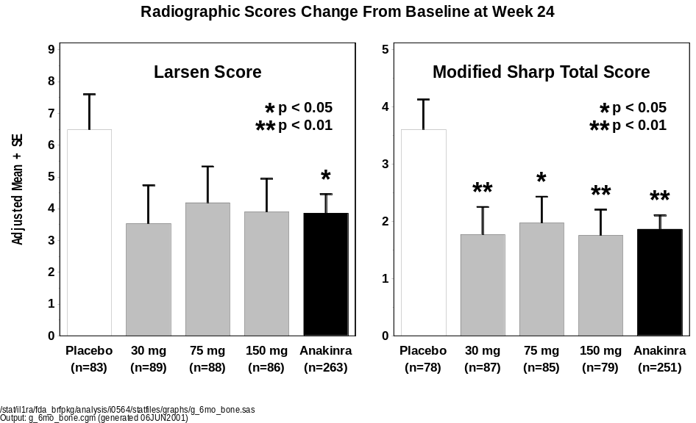
Modified Sharp Score
Sub-Scales
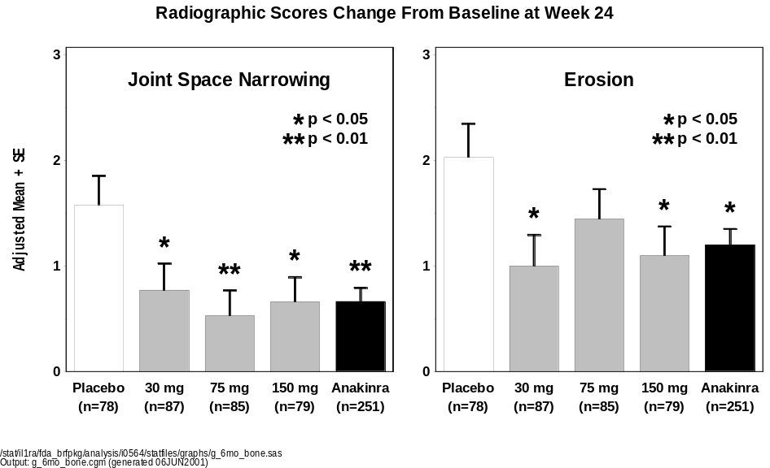
P-values compare each anakinra dose group and the all anakinra group to placebo.
Pairwise p-values are uncorrected nominal p-values from an Analysis of Variance model.

Monotherapy Study (0560) and Extension Study (0564):
48-Week Radiographic Data
Upon completion of the 24-week, double-blind, placebo-controlled phase of the Monotherapy Study (0560), subjects were eligible to continue anakinra treatment by enrolling into extension study 0564, which followed subjects for an additional 48 weeks for efficacy assessments. Subjects who received placebo in the Monotherapy Study (0560) were randomized to receive 1 of 3 anakinra doses (30 mg, 75 mg, or 150 mg) in study 0564, and anakinra-treated subjects continued on the anakinra dose that they were randomly assigned at entry into the Monotherapy Study (0560), (see Figure 4-20). All subjects and investigators remained blinded to the identity of their previous treatment in the Monotherapy Study (0560), and also to the anakinra dose they were receiving in study 0564. For subjects participating in both studies 0560 and 0564, radiographs were available for up to 48 weeks.
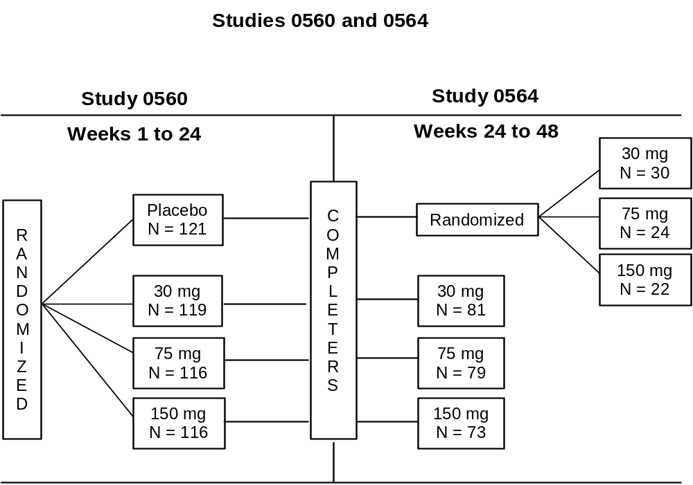
Figure 4-20. Schema for Studies 0560 and 0564
Although the study design did not include a placebo control for a full year, the cohort of placebo subjects crossing over from the Monotherapy Study (0560) to receive active treatment in extension study 0564 could be considered a scientifically valid 48-week control group under the null hypothesis that anakinra is no more effective than placebo. Assuming anakinra was effective in retarding radiographic disease progression, the comparison of 48 weeks of anakinra therapy against a placebo control group that received anakinra for half the treatment period may be viewed as conservative and biased against detecting a true anakinra effect. Any significant difference between these groups would then be evidence of the efficacy of anakinra over the 48-week period and would suggest that the true effect of long-term treatment with anakinra was probably greater than observed. To test this hypothesis, a repeated measures mixed model analysis of variance was used that included all observed data for subjects with a baseline and ≥ 1 post baseline Larsen or modified Sharp score.
Figure 4-21 displays the 24- and 48-week changes from baseline for all subjects as they were originally randomized in the Monotherapy Study (0560). Because previous anakinra effects on radiographic disease progression were generally found to be independent of dose, the 3 anakinra dose groups were combined to increase statistical power and simplify graphical displays.
Although significant differences between the anakinra and placebo groups were not observed in the Larsen score at 48 weeks, significant reductions in the progression of structural damage were seen after 48 weeks of anakinra therapy relative to placebo, as measured by the modified Sharp total score (TS) (p = 0.015) and the ES (p = 0.006), with a trend approaching statistical significance in JSN (p = 0.084). The adjusted mean change in TS was almost twice as high for placebo subjects (3.81) as for anakinra-treated subjects (2.12). A similar difference was evident for progression of JSN (1.53 vs 0.89) and ES (2.03 vs 1.15).
For the Larsen score, the 48-week results for each anakinra dose group revealed numerical improvements relative to placebo; although none of these differences reached statistical significance. The 48-week differences observed for the modified Sharp score also resulted in clinical improvements for each anakinra dose group, with statistical significance most notable at the 75 mg and 150 mg dose groups for the TS, and for all individual anakinra dose groups for the ES.
Consistent with the 24-week results in the previous section that used a One-way Analysis of Variance model, the Repeated-Measures Mixed Model Analysis employed here also showed significant anakinra treatment effects as early as 24 weeks in the Larsen score and all 3 Sharp endpoints: TS, JSN, and ES (p = 0.001, 0.002 and 0.047, respectively).
In summary, despite the conservative bias of this analysis against anakinra, the results are consistent with previous analyses demonstrating that anakinra acts as early as 24 weeks to retard structural damage in RA, and its effects are clinically and statistically significant through 48 weeks of treatment. Further, if the 48-week Larsen and modified Sharp scores for the placebo group in this mixed model analysis were attenuated because of anakinra treatment during the second 24 weeks, then these results constitute a conservative estimate of the true effects of anakinra in the reduction of radiographic progression.
Figure 4-21. Radiographic Scores Change From Baseline

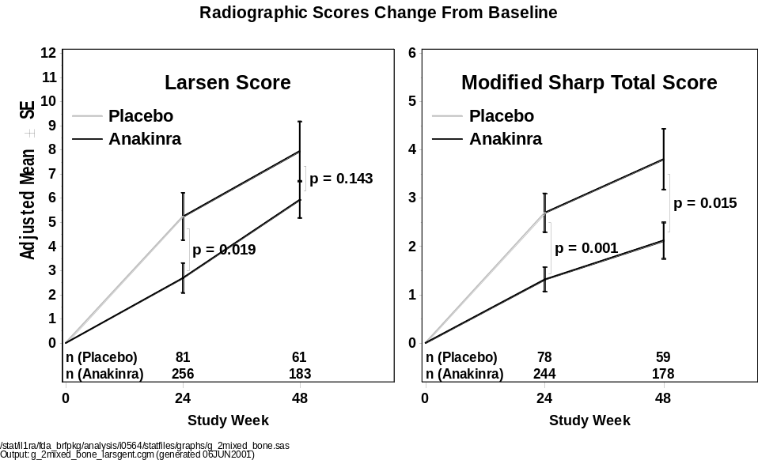

Modified Sharp Score
Sub-Scales

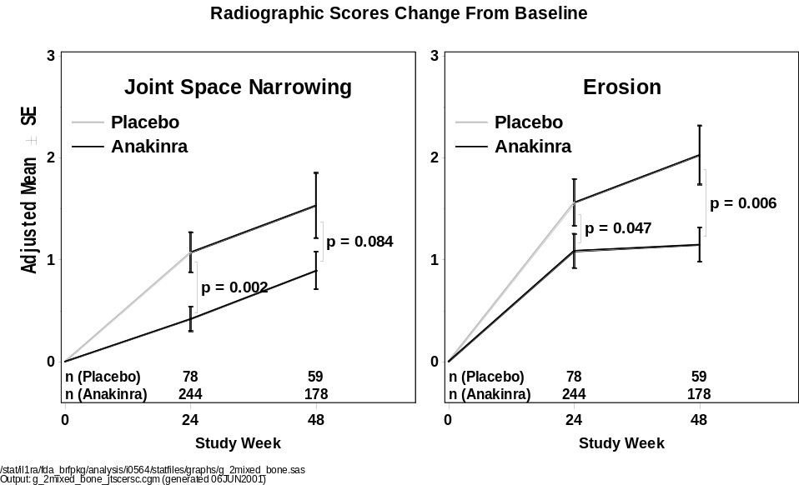
Note: Nominal p-values compare the all anakinra group to placebo based on a repeated measures mixed model Analysis of Variance.
Note: Due to missing baseline covariates adjusted in the repeated measures mixed model, 9 and 7 subjects were excluded from the analysis for the Larsen and modified Sharp scores, respectively.

Summary of Efficacy
The effectiveness of anakinra in the reduction of signs and symptoms of RA has been independently demonstrated in 3 separate placebo-controlled trials. Following the positive results observed in the Monotherapy Study (0560) and the MTX Combination Study (960180), the effects of anakinra were prospectively confirmed at a dose of 100 mg/day in the Confirmatory Efficacy Study (990145), representing data from over 500 RA subjects. The results across these 3 trials are remarkably consistent and robust. Whether as a monotherapy (study 0560), or in combination with MTX (studies 960180 and 990145), subjects treated with anakinra achieve both clinically and statistically meaningful improvements in the signs and symptoms of RA compared to control subjects. After 24 weeks of treatment with anakinra, approximately 40% of subjects achieved improvements of 20% or more in the ACR composite score (ACR₂₀). The improvements seen with anakinra treatment occurred rapidly and were sustained throughout the 24-week treatment period. Additionally, anakinra subjects were more than twice as likely as placebo subjects to achieve greater magnitudes of improvement, including improvements of 50% and 70% or more (ACR₅₀ and ACR₇₀) responses. Findings for the individual ACR components were consistent with the positive effects observed for the ACR composite score.
Sensitivity analyses revealed that the effects were not the result of potential unblinding due to ISRs or due to subject dropout rates. An important finding is that the results from each of the sensitivity analyses conducted were consistent from trial to trial, providing strong support for the overall conclusion that anakinra is an effective treatment for the reduction in signs and symptoms of RA.
The Low Dose Monotherapy Study (960182), conducted to explore the efficacy of anakinra at doses of 30 mg or less, failed to show efficacy, and provided support for utilization of a higher dose in treatment of subjects with RA.
Beyond the effects observed for signs and symptoms, the radiographic data from the Larsen and Sharp scores examined in the Monotherapy Study (0560) and its extension (0564), provide clinical evidence consistent with the biologic rationale suggesting anakinra may be an effective agent in the reduction of radiographic disease progression. These radiographic results provide additional support for the role of anakinra in the treatment of RA.
Figure 4-22. Proportion of Subjects Responding by ACR₂₀ at Week 24 Studies 0560, 960180, and 990145 Non-responder Imputation for Subjects Receiving at Least 1 Dose of Study Drug
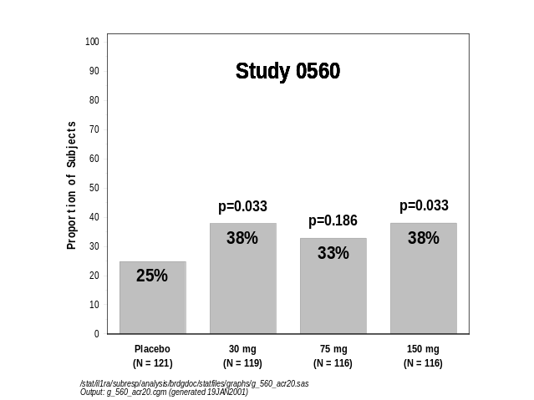
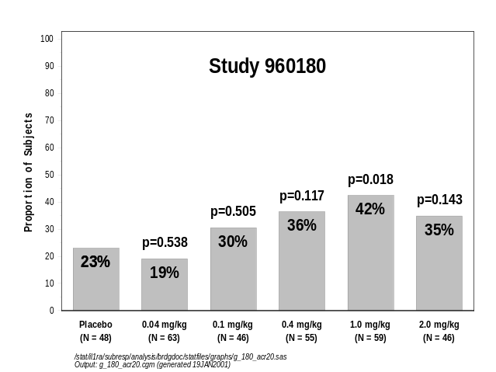
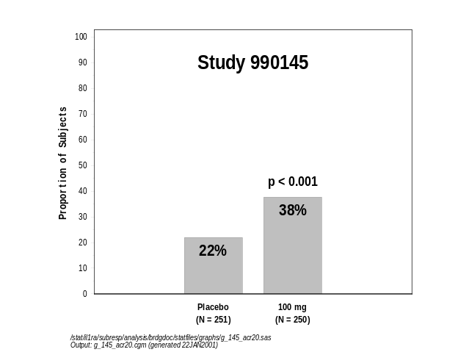

/stat/il1ra/subresp/analysis/brdgdoc/statfiles/graphs/g_acr20.doc (generated 31JAN2001)

Clinical Data - Safety

Introduction
The anakinra development program for RA includes dose ranging and frequency trials, clinical pharmacology studies, randomized placebo-controlled trials and long term extension studies (Figure 1-1). The 5 randomized, placebo-controlled studies provide data on the safety of anakinra as a monotherapy (0560 and 960182), in combination with MTX (960180 and 990145), and multiple DMARD combination therapy (990757). An open-label, single-arm trial exploring the use of anakinra in subjects receiving etanercept therapy (study 20000125) was recently concluded and the results from that trial are also summarized separately.
Rheumatoid arthritis therapies have historically been associated with a variety of adverse events including infections, bone marrow suppression and hepatotoxicity. Therefore, events in these categories and the analysis of relevant laboratory findings are discussed in more detail.
The safety analysis and discussion focuses on the 5 randomized, double-blind, placebo-controlled trials (Table 4-16) as these permit direct comparison to a control group for up to 24 weeks. To describe the longer term adverse event profile, additional safety analyses were conducted across all RA clinical trials including the long-term extension trials. After a brief discussion of the methodological approach for the safety analyses, the overall exposure to anakinra in RA subjects is reviewed, followed by a discussion of the results.
Table 4-16. Number of Subjects Treated In All Anakinra RA Studies
Study
 |  | Anakinra | Placebo | Total
Randomized Placebo-controlled Studies
 | Monotherapy Study (0560) | 351 | 121 | 472
 | Low Dose Monotherapy Study (960182) | 111 | 30 | 141
 | MTX Combination Study (960180) | 345 | 74 | 419
 | Confirmatory Efficacy Study (990145) | 250 | 251 | 501
 | Safety Study (990757) | 1116 | 283 | 1399
Total |  | 2173 | 759 | 2932
 |  | Anakinra | Placebo | Total
Supportive RA Studies
 | Dose and Frequency Study (0505) | 175 | NA | 175
 | Continuous Infusion Study (980220) | 18 | 3 | 21
Total |  | 193 | 3 | 196
In Extension Studies, subjects cross-over from: |  | Placebo to  Anakinra | Anakinra to Anakinra | Total
Long-term Studies
 | Multi-Dose PK Extension Study (0502E)ª | NA | 11 | 11
 | Dose and Frequency Extension Study (0512) | NA | 148 | 148
 | Monotherapy Extension Studies  (0564, 0546E1, 0564E2, 0564E3) | 76 | 233 | 309
 | MTX Combination Extension Study (960181) | 57 | 252 | 309
 | Low Dose Monotherapy Extension Study (970102) | 26 | 86 | 112
 | Continuous Infusion Extension Study (980220) | 6^{b} | 18 | 24
Total |  | 165 | 748 | 913
 |  | Anakinra | Placebo | Total
Clinical Pharmacology Studiesª
 | Single-Dose PK Study (0501) | 20 | 5 | 25
 | Multi-Dose PK Study (0502) | 15 | NA | 15
 | 4-Day Continuous Infusion PK Study (970189) | 40 | 10 | 50
Total |  | 75 | 15 | 90
ª Not included in the safety summary analyses due to limited exposure
^{b} Includes 3 subjects who were not randomized in the placebo-controlled continuous infusion study but only enrolled in the open-label SC phase
Output: /stat/il1ra/fda_brfpkg/analysis/safety/tables/t_exposure_treated.doc (11JUl2001)

Methodology

Analytic Groups
As noted previously, the primary safety analysis focuses on the 5 randomized, placebo-controlled trials (Table 4-16) which comprise 91% of all study subjects. To support the proposed dose of 100 mg/day, the safety data from subjects exposed to anakinra in these trials were categorized by dose as below, at, or above 100 mg/day, and are compared to placebo.
In addition to the analysis of these 5 placebo-controlled trials, adverse event data for subjects exposed to anakinra across all RA clinical trials, including the long-term extension trials, are provided. The group of all RA clinical trials includes the anakinra exposure contributed by the double-blind portion of the 5 placebo-controlled studies as well as the anakinra exposure contributed by the Supportive RA Studies, and Long-term Studies, see Table 4-16. The Clinical Pharmacology Studies are not included due to limited exposure, but results are described where relevant. In essence, 2 analytic groups have been established for the assessment of safety: 1) the combined data from the 24-week double-blind portions in the 5 randomized, placebo-controlled trials, and 2) the safety data for subjects exposed to anakinra in all RA clinical trials including those in the long term extension studies.
Since the 5 randomized, controlled studies include a placebo control group for up to 24 weeks (except the Low Dose Monotherapy Study, 960182), adverse event data are presented as the crude subject incidence of events, ie, the percentage of subjects having at least 1 event. Adjustments for exposure have not been made since exposure to study drug is similar among the 5 trials (see Section 4.5.2), and adjusting for exposure does not affect the overall conclusions.
As discussed earlier, the Confirmatory Efficacy Study (990145) remains blinded, and only a small number of Amgen personnel not directly involved in study conduct have been unblinded for the purposes of data analysis. In order to protect the blind and maintain the integrity of the study, safety data from this study will be presented in aggregate form, that is, unblinded to the treatment group, but blinded at the individual subject level. As such, treatment assignments for individual subjects in this study are not presented.
For the long-term assessment of safety (all RA clinical trials), the exposure-adjusted adverse event rates across anakinra groups are presented, thus taking into account varying study durations across trials, including subjects exposed to anakinra for as long as 5 years. Also, event rates, rather than subject incidences are analyzed in these long-term analyses to avoid censure of events occurring in patients who experienced similar events early on in their treatment. Exposure-adjusted adverse event rates are calculated as the total number of treatment-emergent adverse events in each category, divided by the total time on study drug, and expressed as the event rate per patient-year (or 100 patient-years).
Clinical Pharmacology Studies
Three clinical pharmacology studies (0501, 0502 and 970189) in RA subjects (and 1 extension, 0502E) were excluded from the analyses because they have a limited number of subjects (Table 4-16) and subject exposure, and because of inherent methodological differences in such pharmacology studies. For completeness, however, events of note in these studies are discussed where appropriate in this briefing package.

Adverse Events – Definitions
- Adverse events and serious adverse events (SAEs) as defined in 21 CFR 312.32(a) were collected by staff at the study site using study-specific case report forms. Severity and relatedness were judged by the principal investigators.
- Injection Site Reactions (ISRs) were collected as part of the general adverse event reporting procedures. Preferred terms such as injection site erythema, pruritus, rash, and inflammation are collectively referred to as ‘ISRs’ (Table 4-20).
- Infectious Episodes in earlier RA studies were categorized using a list of events considered infectious in nature based on data review by Amgen personnel. In the Confirmatory Efficacy Study (990145) and the Safety Study (990757), separate case report forms were designated for collection of events considered by the principal investigator to be of an infectious nature. Microbiologic confirmation of these events was not collected.

Exposure for Safety Analyses

Randomized, Placebo-controlled Studies
The total exposure (patient-years), mean and median subject exposure for the 5 randomized placebo-controlled RA studies are shown in Table 4-17. As expected, the median subject exposure for the placebo-controlled phases in these trials is 24 weeks. Therefore, the comparison of crude (ie, unadjusted for exposure) subject incidence rates across these dose categories is appropriate.
Table 4-17. Exposure by Dose Group for Placebo-controlled Studies
 |  | Anakinra (mg)
 | Placebo | < 100 | 100 | > 100 | All
 | (N = 759) | (N = 610) | (N = 1367) | (N = 196) | (N = 2173)
Total exposure (patient-years) | 296.2 | 214.7 | 559.3 | 70.9 | 845.0
Mean patient exposure (wks) | 20.4 | 18.4 | 21.3 | 18.9 | 20.3
Median patient exposure (wks) | 24.0 | 23.9 | 24.4 | 24.0 | 24.1
Includes studies 0560, 960180, 960182, 990145, and 990757
N = Number of randomized subjects who received at least 1 dose of study drug
Year conversion: 1 year = 365.25 days
/stat/il1ra/fda_brfpkg/analysis/safety/statfiles/tables/t_exposure_rct.sas
Output: t_exposure_rct.rtf (generated 29JUN2001)

All RA Studies
For all RA trials (including the 5 randomized, placebo-controlled studies), total exposure (patient-years), mean and median subject exposure are shown in Table 4-18. These exposure data include exposure beyond the initial placebo-controlled periods (up to 24 weeks) for those placebo-controlled trials with extensions. The follow-up period includes clinical data submitted in the BLA (cutoff date August 31, 1999), and the 24-week data from the Confirmatory Efficacy Study (990145) and the large Safety Study (990757). Some subjects are included in more than one group because in the extension studies those subjects were assigned to a different treatment group than that assigned in the original trial; eg, placebo in the original study, and 150 mg anakinra in the extension study. It is important to note that the total patient-years of exposure to anakinra (1872.9) is 6-fold greater than the total patient-years of exposure to placebo (296.7). Hence it is to be expected that the reported numbers of adverse events, unrelated to study drug, would be greater among anakinra subjects.
Table 4-18. Exposure by Dose Group for All RA Studies
 |  | Anakinra (mg)
 | Placebo | < 100 | 100 | > 100 | Allª
 | (N = 762) | (N = 980) | (N = 1367) | (N = 428) | (N = 2531)
Total exposure (patient-years) | 296.7 | 993.5 | 559.6 | 319.8 | 1872.9
Mean patient exposure (wks) | 20.3 | 52.9 | 21.4 | 39.0 | 38.6
Median patient exposure (wks) | 24.0 | 41.0 | 24.4 | 20.0 | 25.0
Includes studies 0505, 0512, 0560, 0564, 0564E1, 0564E2, 0564E3, 960180, 960181, 960182, 970102, 980220, 990145, and 990757
N = Number of randomized subjects who received at least 1 dose of study drug
Year conversion: 1 year = 365.25 days
ªSome subjects may be included in multiple dose groups (original trial and extension)
/stat/il1ra/fda_brfpkg/analysis/safety/statfiles/tables/t_exposure.sas
Output: t_exposure.rtf (generated 29JUN2001)

Adverse Events

Randomized, Placebo-controlled Trials
Table 4-19 presents the subject incidence of adverse events occurring in ≥ 5% of the anakinra group for the 5 randomized, placebo-controlled studies. Adverse events occurring in ≥ 5% of placebo subjects but < 5% of anakinra subjects are not shown. The most frequently reported adverse event in the anakinra groups is injection site reactions (ISRs). Although the overall incidence of adverse events is slightly higher in anakinra subjects compared with placebo and there appears to be a dose response, this effect is no longer evident when adverse events associated with ISRs are excluded (Table 4-44).
The majority of ISRs in the anakinra group (95.3%) were mild or moderate in nature. ISRs are discussed further in Section 4.5.3.2.
Events coded ‘Arthritis-Rheumatoid’ (ie, worsening of RA) were more common in placebo than anakinra subjects. Headaches were slightly more common in anakinra groups than in the placebo (Appendix 4-9).
All other most frequently observed adverse events occurred at a relatively similar incidence among groups.
Table 4-19. Subject Incidence of Treatment-Emergent Adverse Events for Placebo-controlled Studies (≥ 5% in
All Anakinra Group)
 |  |  |  |  | Anakinra (mg)
 |  | Placebo |  |  | < 100 |  |  | 100 |  |  | > 100 |  |  | All
Preferred Term - n (%) |  | (N = 759) |  |  | (N = 610) |  |  | (N = 1367) |  |  | (N = 196) |  |  | (N = 2173)
Any |  | 645 | (85.0) |  | 538 | (88.2) |  | 1254 | (91.7) |  | 190 | (96.9) |  | 1982 | (91.2)
Injection Site Reaction |  | 204 | (26.9) |  | 281 | (46.1) |  | 973 | (71.2) |  | 145 | (74.0) |  | 1399 | (64.4)
Arthritis Rheumatoid |  | 205 | (27.0) |  | 86 | (14.1) |  | 261 | (19.1) |  | 25 | (12.8) |  | 372 | (17.1)
URI |  | 105 | (13.8) |  | 63 | (10.3) |  | 189 | (13.8) |  | 23 | (11.7) |  | 275 | (12.7)
Headache |  | 60 | (7.9) |  | 65 | (10.7) |  | 168 | (12.3) |  | 22 | (11.2) |  | 255 | (11.7)
Nausea |  | 49 | (6.5) |  | 40 | (6.6) |  | 115 | (8.4) |  | 11 | (5.6) |  | 166 | (7.6)
Diarrhea |  | 43 | (5.7) |  | 37 | (6.1) |  | 97 | (7.1) |  | 11 | (5.6) |  | 145 | (6.7)
Sinusitis |  | 43 | (5.7) |  | 25 | (4.1) |  | 98 | (7.2) |  | 8 | (4.1) |  | 131 | (6.0)
Arthralgia |  | 56 | (7.4) |  | 40 | (6.6) |  | 76 | (5.6) |  | 11 | (5.6) |  | 127 | (5.8)
Flu-Like Symptoms |  | 39 | (5.1) |  | 29 | (4.8) |  | 82 | (6.0) |  | 14 | (7.1) |  | 125 | (5.8)
Pain Abdominal |  | 32 | (4.2) |  | 35 | (5.7) |  | 73 | (5.3) |  | 14 | (7.1) |  | 122 | (5.6)
Includes studies 0560, 960180, 960182, 990145, and 990757
Injection Site Reaction includes all preferred terms under the Application Site body system.
N = Number of randomized subjects who received at least 1 dose of study drug
n = Number of subjects reporting at least 1 occurrence of an adverse event
% = (n/N) x 100

Injection Site Reactions (ISRs)
In the 5 randomized, placebo-controlled studies, the incidence of ISRs is higher in anakinra groups (64.4%) compared with placebo (26.9%; see Table 4-19).
The incidence of ISRs increases with higher anakinra doses. In the majority of cases in the anakinra group (95.3%), these events were mild or moderate. In the placebo controlled studies, 5.6% anakinra and 1.3% placebo subjects withdrew as a result of ISRs (Table 4-27). ISRs were most frequently characterized by localized erythema, pruritus, rash, and/or pain (Table 4-20). Those ISRs reported by investigators as severe consisted of erythematous, indurated, and/or painful lesions. Events such as pain and ecchymosis may be associated more with injection site trauma than a true reaction to anakinra. This is evident from the relatively high incidence of these 2 events in the placebo group (12.3 and 12.4%, respectively). One subject, receiving 100 mg anakinra, reportedly had skin necrosis at an injection site. This occurred on study day 13 and resolved on study day 77. The adverse event was not considered serious by the investigator, was reported to be of moderate intensity, and the subject was not withdrawn from study due to this event.
The cumulative probability curves for the time to first ISR of subjects receiving 100 mg anakinra compared with placebo are shown in Figure 4-23 (combined data from the large Safety Study [990757] and the Confirmatory Efficacy Study [990145]). The estimated median time to first ISR in subjects who experienced at least 1 event is 11 days for anakinra subjects and 3 days for placebo subjects. Subjects who do not experience an ISR within 4 weeks of initiation of therapy are highly unlikely to experience an ISR subsequently.
Table 4-20. Injection Site Reactions by Preferred Term for Placebo-controlled Studies
 |  |  |  |  | Anakinra (mg)
 |  | Placebo |  |  | < 100 |  |  | 100 |  |  | > 100 |  |  | All
Preferred Term - n (%) |  | (N = 759) |  |  | (N = 610) |  |  | (N = 1367) |  |  | (N = 196) |  |  | (N = 2173)
Any |  | 204 | (26.9) |  | 281 | (46.1) |  | 973 | (71.2) |  | 145 | (74.0) |  | 1399 | (64.4)
ISR - Erythema |  | 35 | (4.6) |  | 150 | (24.6) |  | 505 | (36.9) |  | 90 | (45.9) |  | 745 | (34.3)
ISR - Pruritus |  | 14 | (1.8) |  | 60 | (9.8) |  | 412 | (30.1) |  | 36 | (18.4) |  | 508 | (23.4)
ISR - Rash |  | 10 | (1.3) |  | 61 | (10.0) |  | 315 | (23.0) |  | 32 | (16.3) |  | 408 | (18.8)
ISR - Pain |  | 93 | (12.3) |  | 37 | (6.1) |  | 250 | (18.3) |  | 10 | (5.1) |  | 297 | (13.7)
ISR - Ecchymosis |  | 94 | (12.4) |  | 59 | (9.7) |  | 200 | (14.6) |  | 15 | (7.7) |  | 274 | (12.6)
ISR - Inflammation |  | 3 | (0.4) |  | 6 | (1.0) |  | 137 | (10.0) |  | 7 | (3.6) |  | 150 | (6.9)
ISR - Urticaria |  | 2 | (0.3) |  | 16 | (2.6) |  | 116 | (8.5) |  | 6 | (3.1) |  | 138 | (6.4)
ISR - Edema |  | 8 | (1.1) |  | 24 | (3.9) |  | 63 | (4.6) |  | 15 | (7.7) |  | 102 | (4.7)
ISR - Not Specified |  | 4 | (0.5) |  | 29 | (4.8) |  | 47 | (3.4) |  | 19 | (9.7) |  | 95 | (4.4)
ISR - Pruritic Erythema |  | 0 | (0.0) |  | 6 | (1.0) |  | 13 | (1.0) |  | 1 | (0.5) |  | 20 | (0.9)
ISR - Hemorrhage |  | 8 | (1.1) |  | 4 | (0.7) |  | 10 | (0.7) |  | 2 | (1.0) |  | 16 | (0.7)
ISR - Hematoma |  | 1 | (0.1) |  | 5 | (0.8) |  | 3 | (0.2) |  | 5 | (2.6) |  | 13 | (0.6)
ISR - Paresthesia |  | 6 | (0.8) |  | 8 | (1.3) |  | 1 | (0.1) |  | 3 | (1.5) |  | 12 | (0.6)
ISR - Mass |  | 1 | (0.1) |  | 3 | (0.5) |  | 2 | (0.1) |  | 0 | (0.0) |  | 5 | (0.2)
ISR - Pigmentation Abnormal |  | 0 | (0.0) |  | 0 | (0.0) |  | 2 | (0.1) |  | 0 | (0.0) |  | 2 | (0.1)
ISR - Skin Discoloration |  | 0 | (0.0) |  | 0 | (0.0) |  | 2 | (0.1) |  | 0 | (0.0) |  | 2 | (0.1)
ISR - Skin Hyperpigmentation |  | 0 | (0.0) |  | 2 | (0.3) |  | 0 | (0.0) |  | 0 | (0.0) |  | 2 | (0.1)
ISR - Infection |  | 0 | (0.0) |  | 0 | (0.0) |  | 1 | (0.1) |  | 0 | (0.0) |  | 1 | (0.0)
ISR - Necrosis |  | 0 | (0.0) |  | 0 | (0.0) |  | 1 | (0.1) |  | 0 | (0.0) |  | 1 | (0.0)
Includes studies 0560, 960180, 960182, 990145, and 990757
N = Number of randomized subjects who received at least 1 dose of study drug
n = Number of subjects reporting at least 1 occurrence of an adverse event
% = (n/N) x 100

Figure 4-23. Time to First Injection Site Reaction for Studies 990145 and 990757
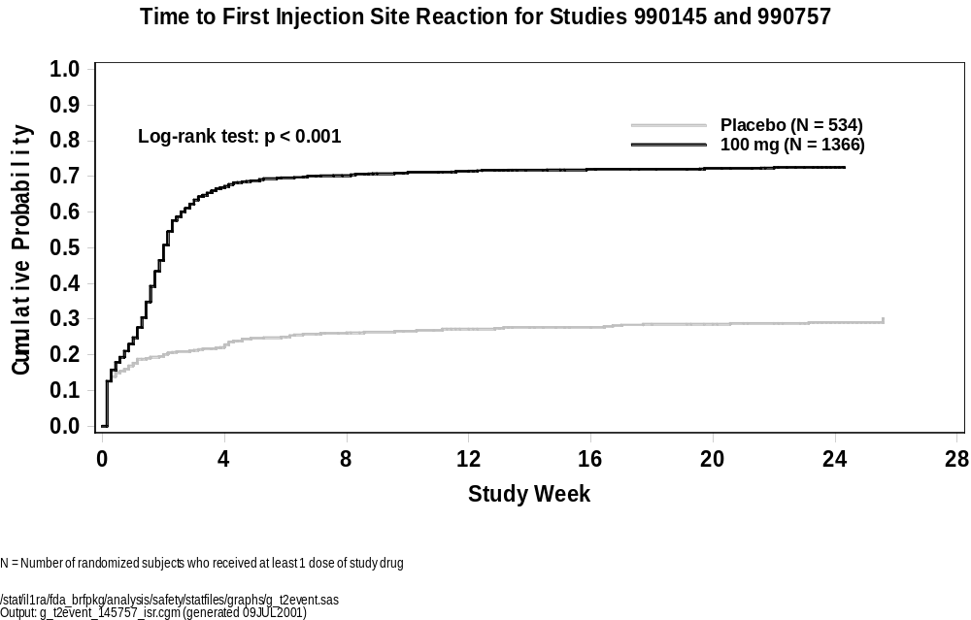

Serious Adverse Events
Table 4-21 summarizes all SAEs occurring in at least 0.2% of subjects in the All Anakinra group. Serious Adverse events occurring in ≥ 0.2% of placebo subjects but
< 0.2% anakinra subjects are not shown. A complete summary of all SAEs is provided in Appendix 4-10.
Overall, the most common SAE was worsening of RA (term “Arthritis Rheumatoid”). This occurred most commonly in the placebo group and the < 100 mg anakinra group. Among the 3 anakinra groups, the incidence was inversely related to dose. Most adverse events designated as ‘serious’ were associated with hospitalization and thus met the regulatory definition of a serious adverse event (Section 4.5.1.1.2).
The next most common SAE, pneumonia, is discussed in Section 4.5.6.2.
The other events in Table 4-21 occurred rarely and do not appear to be associated with anakinra therapy.

Table 4-21. Serious Adverse Events (Crude Subject Incidence) by Preferred Term for Placebo-controlled Studies
(Occurring in ≥ 0.2% of All Anakinra Subjects)
 |  |  |  |  | Anakinra (mg)
 |  | Placebo |  |  | < 100 |  |  | 100 |  |  | > 100 |  |  | All
Preferred Term - n (%) |  | (N = 759) |  |  | (N = 610) |  |  | (N = 1367) |  |  | (N = 196) |  |  | (N = 2173)
Any |  | 49 | (6.5) |  | 51 | (8.4) |  | 97 | (7.1) |  | 24 | (12.2) |  | 172 | (7.9)
Arthritis Rheumatoid |  | 12 | (1.6) |  | 10 | (1.6) |  | 10 | (0.7) |  | 1 | (0.5) |  | 21 | (1.0)
Pneumonia |  | 0 | (0.0) |  | 2 | (0.3) |  | 9 | (0.7) |  | 0 | (0.0) |  | 11 | (0.5)
Pain Abdominal |  | 2 | (0.3) |  | 5 | (0.8) |  | 4 | (0.3) |  | 0 | (0.0) |  | 9 | (0.4)
Arthralgia |  | 1 | (0.1) |  | 3 | (0.5) |  | 1 | (0.1) |  | 2 | (1.0) |  | 6 | (0.3)
Abdominal Hernia |  | 0 | (0.0) |  | 0 | (0.0) |  | 3 | (0.2) |  | 2 | (1.0) |  | 5 | (0.2)
Dyspnea |  | 0 | (0.0) |  | 1 | (0.2) |  | 4 | (0.3) |  | 0 | (0.0) |  | 5 | (0.2)
Cardiac Failure |  | 1 | (0.1) |  | 0 | (0.0) |  | 4 | (0.3) |  | 0 | (0.0) |  | 4 | (0.2)
Hemorrhage GI |  | 0 | (0.0) |  | 1 | (0.2) |  | 2 | (0.1) |  | 1 | (0.5) |  | 4 | (0.2)
Nausea |  | 1 | (0.1) |  | 1 | (0.2) |  | 3 | (0.2) |  | 0 | (0.0) |  | 4 | (0.2)
Vomiting |  | 1 | (0.1) |  | 2 | (0.3) |  | 2 | (0.1) |  | 0 | (0.0) |  | 4 | (0.2)
Fracture |  | 3 | (0.4) |  | 0 | (0.0) |  | 4 | (0.3) |  | 0 | (0.0) |  | 4 | (0.2)
Muscle Weakness |  | 0 | (0.0) |  | 1 | (0.2) |  | 3 | (0.2) |  | 0 | (0.0) |  | 4 | (0.2)
Tendon Disorder |  | 1 | (0.1) |  | 1 | (0.2) |  | 1 | (0.1) |  | 2 | (1.0) |  | 4 | (0.2)
Includes studies 0560, 960180, 960182, 990145, and 990757
N = Number of randomized subjects who received at least 1 dose of study drug
n = Number of subjects reporting at least 1 occurrence of an adverse event
% = (n/N) x 100
/stat/il1ra/fda_brfpkg/analysis/safety/statfiles/tables/t_ae_pterm.sas
Output: t_ae_ser_pterm.rtf (generated 15JUN2001)

All RA Studies
Table 4-22 shows the exposure-adjusted SAE incidence rates for all RA clinical trials. For comparison, the exposure-adjusted SAE incidence rates for the double-blind periods for the 5 randomized, placebo-controlled studies are also provided. SAEs are reported as the number of events per 100 patient-years of exposure to study drug. This table includes exposure-adjusted events that occurred at a rate of ≥ 0.45 events per 100 patients-years in the placebo-controlled anakinra group (N=2173). Comparing the 2 anakinra columns below, similar event rates for each of the SAEs listed are observed, indicating that the incidence of an SAE does not increase with longer exposure to anakinra.
Table 4-22. SAEs (Exposure-adjusted Event Incidence) by Preferred Term for Placebo-controlled and All Studies (≥ 0.45 events/100-patient-years in Placebo-controlled Anakinra)
 | Placebo-controlled Studiesª |  |  |  |  | All Studies^{b}
 | Placebo |  | Anakinra |  |  | Anakinra
n (events per 100 patient years) | (N = 759) |  | (N = 2173) |  |  | (N = 2531)
Any | 72 | (24.31) | 288 | (34.08) |  | 616 | (32.89)
Arthritis Rheumatoid | 12 | (4.05) | 22 | (2.60) |  | 45 | (2.40)
Pneumonia | 0 | (0.00) | 12 | (1.42) |  | 18 | (0.96)
Pain Abdominal | 2 | (0.68) | 9 | (1.07) |  | 20 | (1.07)
Arthralgia | 1 | (0.34) | 6 | (0.71) |  | 8 | (0.43)
Abdominal Hernia | 0 | (0.00) | 5 | (0.59) |  | 5 | (0.27)
Dyspnea | 0 | (0.00) | 5 | (0.59) |  | 9 | (0.48)
Fracture | 3 | (1.01) | 5 | (0.59) |  | 8 | (0.43)
Bursitis | 0 | (0.00) | 4 | (0.47) |  | 7 | (0.37)
Cardiac Failure | 1 | (0.34) | 4 | (0.47) |  | 6 | (0.32)
Hemorrhage GI | 0 | (0.00) | 4 | (0.47) |  | 13 | (0.69)
Muscle Weakness | 0 | (0.00) | 4 | (0.47) |  | 4 | (0.21)
Nausea | 1 | (0.34) | 4 | (0.47) |  | 7 | (0.37)
Tendon Disorder | 1 | (0.34) | 4 | (0.47) |  | 9 | (0.48)
Vomiting | 1 | (0.34) | 4 | (0.47) |  | 9 | (0.48)
ªIncludes studies 0560, 960180, 960182, 990145, and 990757
^{b}Includes studies 0505, 0512, 0560, 0564, 0564E1, 0564E2, 0564E3, 960180, 960181, 960182, 970102, 980220, 990145, and 990757
N = Number of randomized subjects who received at least 1 dose of study drug
n = Number of adverse events
Patient year of exposure is the duration between the first dose date and the last dose date.
/stat/il1ra/fda_brfpkg/analysis/safety/statfiles/tables/t_ae_event_rctall.sas
Output: t_ae_event_rctall_ser_pterm.rtf (generated 29JUN2001)

Clinical Pharmacology RA Studies
Serious adverse events from clinical pharmacology studies not included in the exposure-adjusted event rate analyses (studies 0501, 0502, 0502E, and 970189) are described below. These events do not alter the overall assessment of SAEs.
- Studies 0501 and 0502: no SAEs were reported.
- Study 970189: 1 SAE (pleuritis with back and chest pain, shortness of breath, and pleurisy), was reported in a subject receiving 2.0 mg/kg/day anakinra by continuous SC infusion (deemed unrelated). No cardiovascular pathology was identified.
- Study 0502E: 1 SAE (hives, edema of the upper lip, and pruritus) was reported in a subject in study 0502E leading to subject withdrawal from study drug. A 61- year old male subject received a cumulative dose of 32 mg/kg anakinra in the initial protocol (0502) over 75 days, 46 days of which comprised a washout period between treatment stages (during which no drug was administered). The subject developed hives, edema of the upper lip, and pruritus the day after he received his first injection of 100 mg anakinra (study 0502E day 1). These symptoms were treated with 1 injection of 40 mg methylprednisolone acetate (Depo-Medrol) IM and 25 mg oral hydroxyzine hydrochloride (Atarax) every 6 hours. The hives and edema resolved 5 days after onset. The pruritus resolved 6 days after it appeared. Anakinra was discontinued on study day 5 (0502E) after the subject had received a total of 2 injections of 100 mg anakinra. The investigator judged the hives and edema to be severe, while the pruritus was considered to be of moderate severity. This subject had no known history of allergy and was not concurrently exposed to other new drugs. These events were all assessed by the investigator as being probably related to study drug.
The anakinra safety database for RA studies was reviewed for serious hypersensitivity reactions coded to allergic reaction, anaphylactoid reaction, anaphylaxis, angioedema, and systemic hypersensitivity reaction. Only 1 other case reported as possibly related to anakinra meet these criteria:
- Study 960180: A 62-year-old female subject with a history of RA began receiving daily SC injections of anakinra. Approximately 90 days after the start of study drug, the subject developed diffuse urticaria and possible angioedema. The subject was treated in the emergency room and subsequently hospitalized 4 weeks later. The subject received IV methylprednisolone for 3 days. The angioedema and urticaria resolved after 4 days, and the subject was discharged on a tapering dose of oral steroids. The test article was continued unchanged. The subject’s medical and surgical history includes allergies to “sulfa”, iodine, codeine, and prochlorperazine. The investigator considered the development of possible angioedema and diffuse urticaria to be unrelated to study drug.
Serious systemic hypersensitivity reactions were rarely observed and were not assessed as life-threatening. One subject continued therapy with no reoccurrences, and in the other subject the event subsided after withdrawal of study drug.

Deaths
In the 24-week double-blind period of the 5 randomized, placebo-controlled studies, there have been 6 (0.3%) deaths reported for anakinra and 1 (0.1%) for placebo (Table 4-44). One death from study 990145 was not included in these calculations since the study is still blinded.
As shown in Table 4-24, Table 4-25, Table 4-26, to date, a total of 29 deaths have been reported, including the 23 deaths among subjects known to have received anakinra, 2 subjects known to have received placebo, and 4 subjects (study 990145) whose treatment assignment remains blinded. Narratives are provided where appropriate in . summarizes the cause of death among subjects known to have received anakinra. All subjects who died were ≥ 51 years old, and the majority had pre-existing illnesses other than RA, or predisposing comorbidities relevant to the cause of death. The most common cause of death was cardiovascular disease. Cancer and infection are discussed in Section 4.5.7 and Section 4.5.6, respectively.
Deaths reported in the BLA (December 1999) and the subsequent amendment containing 24-week data from the large Safety Study (990757) and the Confirmatory Efficacy Study (990145) are summarized below. For completeness, additional reports of deaths as of January 2001 not included in the BLA or subsequent amendment are summarized separately. See Appendix 4-11.
Table 4-23. Summary of Cause of Death Among Subjects
Known to Have Received Anakinra
Cause of Death | N
Cardiovascular disease | 9
Cancer | 5
Infection | 4
Chronic lung disease | 1
Suicide | 1
Asthma | 1
Gastrointestinal hemorrhage | 1
Unknown | 1
Source: bs-dg-causeofdeath_11JUL01
In summary, evaluation of deaths in the anakinra RA studies fails to establish an overall relationship between treatment with anakinra and events that resulted in death.

Deaths Reported in the BLA
Of the 29 deaths, a total of 13 deaths were reported in the BLA (total of 1321 subjects): 5 occurred on study, and 8 deaths were reported after subjects withdrew from study drug (Table 4-24). All 13 subjects were on anakinra treatment, 2 deaths were considered by the investigators to be related to anakinra (both subjects received 30 mg/day; Monotherapy Study 0560 and Monotherapy Extension Study 0564E1). The exposure in this anakinra group (1310 patient-years) is significantly greater than in this placebo group (76 patient-years), hence it is to be expected that more deaths would occur in the anakinra group, in the absence of a relationship to study drug. Four deaths among the anakinra-treated subjects occurred > 3 months after the last dose of study drug and were reported as unrelated to anakinra by the investigators. These deaths are excluded from the analyses in Table 4-44 and Table 4-45. See Appendix 4-11.

Deaths Reported in BLA Amendment (Studies 990757 and 990145)
As discussed earlier, data from 501 subjects in the Confirmatory Efficacy Study (990145) and 1399 subjects in the Safety Study (990757) were submitted as part of the Complete Response to questions received from CBER. Among the subjects for whom data were included in this amendment, there were 6 deaths, of which 1 was a placebo subject (study 990757); 1 death in study 990145 remains blinded. Of the 6 deaths, 1 was considered related to anakinra (100 mg/day; study 990757). See Appendix 4-11.

Deaths Reported in Ongoing Studies
In the ongoing clinical trials there have been 10 additional deaths reported. Three occurred in the Confirmatory Efficacy Study (990145) and treatment assignment remains blinded. Of the remaining 7 deaths, 1 occurred in a placebo subject (study 990757), and 1 was reported as related to anakinra (2 mg/kg; MTX Combination Extension Study 960181). See Appendix 4-11..
Table 4-24. By-Subject Listing of Deaths Submitted in BLA
Study | Age | Sex | Relevant medical history | Daily Dose | Days on study drug | Death  on study/  post-study |  | Cause of death | Relª
0560 | 75 | Male | Ten-year history of COPD | 75 mg | 126 | > 3 mo post |  | Respiratory infection/failure | No
 | 73 | Female | Transient ischemic attacks | 150 mg | 71 | < 30 d post |  | Cerebrovascular accident and hemiparesis | No
 | 55 | Male | Smoking | 30 mg | 168 | 3 mo post |  | Small cell lung cancer | Yes
0564 | 68 | Male | Ischemic heart disease, angina | 75 mg | 454 | On study |  | Ventricular fibrillation | No
 | 67 | Male | None | 75 mg | 532 | 3 mo post |  | Gastric carcinoma | No
0564E1 | 88 | Female | Diverticulitis | 150 mg | 636 | > 30 d post |  | Myocardial ischemia secondary to coronary artery disease | No
 | 72 | Female | Hypertension, renal insufficiency, pneumonia | 30 mg | 776 | < 30 d post |  | Endocarditis, circulatory failure | Yes
0564E2 | 79 | Male | None | 75 mg | 942 | > 30 d post | Pancreatic neoplasm |  | No
960181 | 70 | Female | Angina, hypertension, MI, CABG | 0.4 mg/kg | 151 | < 30 d post |  | Myocardial infarction | No
 | 76 | Female | Bowel obstruction, hypertension | 2.0 mg/kg | 531 | On study |  | Unknown; possibly cardiopulmonary failure | No
0512 | 51 | Female | UTI, hypertension, cerebral infarct | 70 mg | 124 | On study |  | Pneumonia and sepsis | No
 | 76 | Female | Transient ischemic attacks, phlebitis, uterine cancer | 70 mg 3x/wk | 105 | On study |  | Cerebrovascular accident | No
 | 58 | Male | DM, gout | 70 mg 1x/wk | 57 | On study |  | Cardiac arrest | No
ª Causality per investigator: No = not related or unlikely; Yes = possibly, probably, or definitely related to study drug.
DM = diabetes mellitus, MI = myocardial infarction, CABG = coronary artery bypass graft, UTI = urinary tract infection
Output: /stat/il1ra/fda_brfpkg/analysis/safety/statfiles/listings/t_death.doc (generated 05JUL2001)

Table 4-25. By-Subject Listing of Deaths Reported in the BLA Amendment (Studies 990757 and 990145)
Study | Age | Sex | Relevant medical history | Daily Dose | Days on study drug | Death  on study/  post-study | Cause of death |  | Relª
990757 | 60 | Female | Interstitial lung disease (possibly related to MTX), DM | 100 mg | 134 | On study |  | Pulmonary fibrosis and Respiratory failure | Yes
 | 67 | Female | Panic attacks and depression | 100 mg | 56 | On study |  | Suicide | No
 | 67 | Male | Melanoma | 100 mg | 105 | On study |  | Cerebral and pulmonary metastatic melanoma | No
 | 68 | Male | DM, hypertension | Placebo | 53 | On study |  | Myocardial infarction | No
 | 61 | Female | Esophagitis, gastric ulcers, gastritis | 100 mg | ~30 | < 30 d post |  | Upper gastrointestinal hemorrhage | No
990145 | 80 | Male | Chronic interstitial lung disease | Blinded | 87 | > 30 d post |  | Progressive interstitial lung disease with fibrosis | No
ª Causality per investigator: No = not related or unlikely; Yes = possibly, probably, or definitely related to study drug.
DM = diabetes mellitus, MI = myocardial infarction, CABG = coronary artery bypass graft, UTI = urinary tract infection
Output: /stat/il1ra/fda_brfpkg/analysis/safety/statfiles/listings/t_death.doc (generated 05JUL2001)

Table 4-26. By-Subject Listing of Deaths Reported in Ongoing Studies
Study | Age | Sex | Relevant medical history | Daily dose | Days on study drug | Death  on study/  post-study | Cause of death | Relª
960181 | 51 | Female | Smoker for 32 years; anemia | 2 mg/kg | 1056 | On study | Gastric carcinoma with brain and thigh metastases | No
 | 75 | Female | None | 2 mg/kg | 824 | On study | Cardiac arrest with sepsis following cholecysto-colonic fistula surgery | No
 | 70 | Male | CHF, MI | 2 mg/kg | 818 | < 30 d post | Sepsis from abdominal wall abscess | Yes
990145 | 71 | Female | Asthma | Blinded | 88 | On study | Unknown; died in sleep after flu-like symptoms, diarrhea, and fever | No
 | 74 | Male | DM, COPD | Blinded | 57 | On study | Cardiac failure | No
 | 53 | Male | Hypertension, smoking, hyperlipidemia, obesity, tooth abscess | Blinded | 185 | On study | MI | No
990757 | 51 | Male | Atrial fibrillation, alcohol abuse, CHF, aortic regurgitation, aspiration pneumonia, seizures | Placebo  100 mg | 171  157 | On study | Cardiac arrest and CVA | No
 | 55 | Male | Asthma, hypertension | 100 mg | 259 | > 30 d post | Asthma | No
 | 76 | Female | CAD, CHF, hypertension, MI | 100 mg | 271 | On study | Ventricular failure and CAD | No
 | 70 | Female | COPD, Herpes zoster | Placebo | 156 | > 30 d post | Respiratory failure due to pulmonary metastatic squamous cell carcinoma | No
ª Causality per investigator: No = not related or unlikely; Yes = possibly, probably, or definitely related to study drug.
DM = diabetes mellitus, MI = myocardial infarction, CABG = coronary artery bypass graft, UTI = urinary tract infection
Output: /stat/il1ra/fda_brfpkg/analysis/safety/statfiles/listings/t_death.doc (generated 10JUL2001)

Withdrawals Due To Adverse Events

Randomized, Placebo-controlled Studies
Table 4-27, summarizes the most common events (≥ 0.2% in the ‘all anakinra’ group) that resulted in withdrawal in subjects participating in the 5 randomized, placebo-controlled studies. Withdrawals occurring in ≥ 0.2% of placebo subjects but < 0.2% of anakinra subjects are not shown. A summary including all withdrawals due to adverse events is provided in Appendix 4-12.
Overall, the incidence of withdrawals due to adverse events is slightly higher in the 100 mg and > 100 mg anakinra groups compared with placebo and < 100 mg groups. The most common reasons for withdrawal are ISRs (5.6% in the ‘all anakinra’ group compared with 1.3% in the placebo group) and worsening of RA (2.9% for ‘all anakinra’ and 6.2% for placebo subjects, when the preferred terms “arthritis rheumatoid” and “arthralgia” are combined). ISRs are discussed in Section 4.5.3.2.
Protocol-mandated withdrawals due to leukopenia or granulocytopenia occurred as follows: 1 in the < 100 mg and 3 in the > 100 mg anakinra groups. Only 1 subject, a 63-year old man in the MTX Combination Study (960180), had Grade 3 neutropenia (Table 4-41). In the later studies (990757 and 990145) where such withdrawals were not mandated, only 1 of 1366 subjects (0.07%) had a Grade 3 neutropenia (ANC of 0.79 x 10⁹/L). Significant cases of neutropenia are discussed further in Section 4.5.10.
In summary, analysis of patient withdrawals supports the conclusion that anakinra was generally well tolerated.
Table 4-27. Subject Incidence of Treatment-Emergent Adverse Events Leading to Withdrawal for Placebo-controlled
Studies Occurring in ≥ 0.2% of All Anakinra Group
 |  |  |  |  | Anakinra (mg)
 |  | Placebo |  |  | < 100 |  |  | 100 |  |  | > 100 |  |  | All
Preferred Term - n (%) |  | (N = 759) |  |  | (N = 610) |  |  | (N = 1367) |  |  | (N = 196) |  |  | (N = 2173)
Any |  | 88 | (11.6) |  | 58 | (9.5) |  | 186 | (13.6) |  | 36 | (18.4) |  | 280 | (12.9)
Injection Site Reaction |  | 10 | (1.3) |  | 8 | (1.3) |  | 100 | (7.3) |  | 14 | (7.1) |  | 122 | (5.6)
Arthritis Rheumatoid |  | 46 | (6.1) |  | 28 | (4.6) |  | 22 | (1.6) |  | 7 | (3.6) |  | 57 | (2.6)
Headache |  | 4 | (0.5) |  | 0 | (0.0) |  | 8 | (0.6) |  | 0 | (0.0) |  | 8 | (0.4)
Pain Abdominal |  | 3 | (0.4) |  | 1 | (0.2) |  | 7 | (0.5) |  | 0 | (0.0) |  | 8 | (0.4)
Arthralgia |  | 1 | (0.1) |  | 1 | (0.2) |  | 3 | (0.2) |  | 2 | (1.0) |  | 6 | (0.3)
Fatigue |  | 1 | (0.1) |  | 0 | (0.0) |  | 5 | (0.4) |  | 1 | (0.5) |  | 6 | (0.3)
Leukopenia |  | 0 | (0.0) |  | 4 | (0.7) |  | 1 | (0.1) |  | 1 | (0.5) |  | 6 | (0.3)
Dizziness |  | 0 | (0.0) |  | 0 | (0.0) |  | 5 | (0.4) |  | 0 | (0.0) |  | 5 | (0.2)
Dyspnea |  | 1 | (0.1) |  | 1 | (0.2) |  | 4 | (0.3) |  | 0 | (0.0) |  | 5 | (0.2)
Pneumonia |  | 0 | (0.0) |  | 2 | (0.3) |  | 3 | (0.2) |  | 0 | (0.0) |  | 5 | (0.2)
Granulocytopenia |  | 0 | (0.0) |  | 1 | (0.2) |  | 0 | (0.0) |  | 3 | (1.5) |  | 4 | (0.2)
Nausea |  | 0 | (0.0) |  | 0 | (0.0) |  | 4 | (0.3) |  | 0 | (0.0) |  | 4 | (0.2)
Includes studies 0560, 960180, 960182, 990145, and 990757
Injection Site Reaction includes all preferred terms under the Application Site body system.
N = Number of randomized subjects who received at least 1 dose of study drug
n = Number of subjects reporting at least 1 occurrence of an adverse event
% = (n/N) x 100

Clinical Pharmacology RA Studies
Studies 0501 and 970189: no withdrawals due to adverse events were reported.
Study 0502: 3 subjects were withdrawn due to adverse events (balanitis; worsening of anemia; and neutropenia). The subject who withdrew due to neutropenia had received 1 dose of 4.0 mg/kg anakinra in the first stage of the study and 1.0 mg/kg daily in the second stage. The subject was withdrawn 10 days after receiving study drug in stage two. The subject, who may have had Felty syndrome, is discussed further in Section 4.5.10.1.2.
Study 0502E: 3 subjects withdrew due to adverse events (chest tightness, fever, headache, and thyroiditis [1]; constant tinnitus [1]; hives and edema of the upper lip [1; see SAE discussion Section 4.5.4.2].

Infectious Events

Randomized, Placebo-controlled Studies
Analysis of infectious events is provided as descriptive statistics in standard safety tables. In addition, the following post-hoc analyses are provided:
- cumulative probability curves for time to first infection (below),
- corticosteroid use (Section 4.5.6.3), and
- predisposing comorbid conditions (Section 4.5.6.4)
Table 4-28 presents an overview of events of possible infectious nature in the 5 randomized, placebo-controlled studies (≥ 1.0% in the ‘all anakinra’ group). Overall, the incidence of any infectious event is similar in anakinra (39.3%) compared with placebo (36.2%) subjects. Infection of the upper respiratory tract was the most common type of infection, experienced by 12.0% of anakinra subjects and 12.5% of placebo subjects. There were no reported cases of tuberculosis or opportunistic infections. A summary of all infections is provided in
Appendix 4-13.
The cumulative probability curves for the time to first infection in subjects receiving 100 mg anakinra compared with placebo are presented in Figure 4-24 for studies 990145 and 990757 combined, and for each study separately. This analysis reveals that there is no clinically meaningful difference in time to first infection for anakinra vs placebo-treated subjects.

Table 4-28. Infections by Preferred Term for Placebo-controlled Studies
(≥ 1.0% in the All Anakinra group)
 |  |  |  |  | Anakinra (mg)
 |  | Placebo |  |  | < 100 |  |  | 100 |  |  | > 100 |  |  | All
Preferred Term - n (%) |  | (N = 759) |  |  | (N = 610) |  |  | (N = 1367) |  |  | (N = 196) |  |  | (N = 2173)
Any |  | 275 | (36.2) |  | 227 | (37.2) |  | 544 | (39.8) |  | 84 | (42.9) |  | 855 | (39.3)
URI |  | 95 | (12.5) |  | 63 | (10.3) |  | 174 | (12.7) |  | 23 | (11.7) |  | 260 | (12.0)
Sinusitis |  | 36 | (4.7) |  | 25 | (4.1) |  | 86 | (6.3) |  | 8 | (4.1) |  | 119 | (5.5)
Flu-Like Symptoms |  | 35 | (4.6) |  | 29 | (4.8) |  | 74 | (5.4) |  | 14 | (7.1) |  | 117 | (5.4)
UTI |  | 37 | (4.9) |  | 23 | (3.8) |  | 62 | (4.5) |  | 10 | (5.1) |  | 95 | (4.4)
Bronchitis |  | 26 | (3.4) |  | 18 | (3.0) |  | 48 | (3.5) |  | 3 | (1.5) |  | 69 | (3.2)
Infection |  | 15 | (2.0) |  | 8 | (1.3) |  | 38 | (2.8) |  | 6 | (3.1) |  | 52 | (2.4)
Fever |  | 11 | (1.4) |  | 13 | (2.1) |  | 15 | (1.1) |  | 12 | (6.1) |  | 40 | (1.8)
Moniliasis Genitalª |  | 0 | (0.0) |  | 8 | (1.7) |  | 14 | (1.4) |  | 1 | (0.7) |  | 23 | (1.4)
Herpes Simplex |  | 9 | (1.2) |  | 10 | (1.6) |  | 14 | (1.0) |  | 1 | (0.5) |  | 25 | (1.2)
Conjunctivitis |  | 10 | (1.3) |  | 8 | (1.3) |  | 11 | (0.8) |  | 3 | (1.5) |  | 22 | (1.0)
Includes studies 0560, 960180, 960182, 990145, and 990757
N = Number of randomized subjects who received at least 1 dose of study drug
n = Number of subjects reporting at least 1 occurrence of an adverse event
% = (n/N) x 100
ª Reproductive AE rates are gender-specific.

Figure 4-24. Time to First Infection
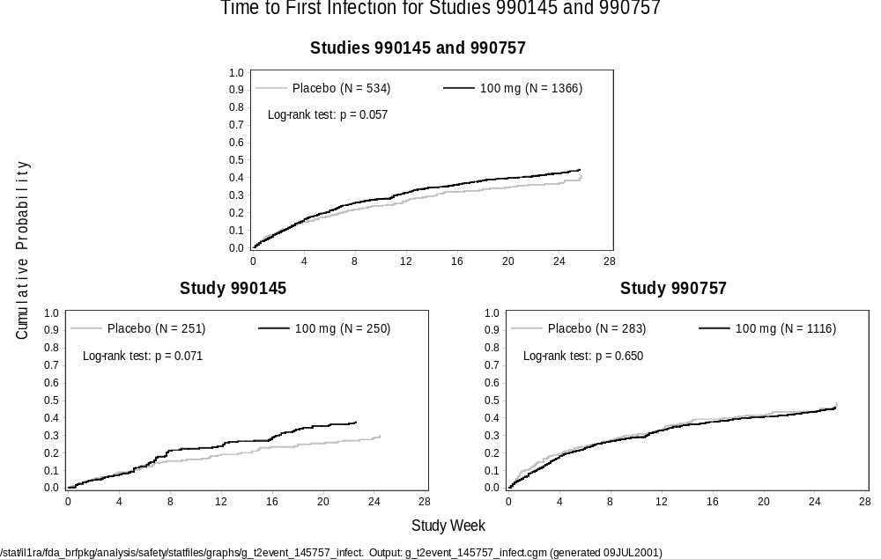

Randomized, Placebo-Controlled Studies: Serious Infections
When reviewed by preferred term, there are no serious infections with an occurrence in > 1% of subjects (Table 4-29). Pneumonia, at a frequency of 0.5%, was the most commonly reported serious infection in the ‘all anakinra’ group (0.0% in placebo). Overall, serious infections occurred in 1.7% of ‘all anakinra’ subjects compared with 0.7% in the placebo group. None of the 8 deaths reported in the 24-week double-blind portion of the 5 randomized, placebo-controlled studies were the result of an infectious event. Non-infectious events appearing in Table 4-29, eg, asthma and esophagitis, are included because they occurred with other infectious events.
As shown in Table 4-30, the incidence of withdrawals due to infections is 1.0% in the All Anakinra group compared with 0.8% in the placebo group.
The subject incidence of serious infections appears to be higher at the 100 mg dose relative to placebo (1.8% vs 0.7%, respectively). This difference in subject incidence of serious infection appears to be driven by the Safety Study (990757; 2.1% vs 0.4%), and not the Confirmatory Efficacy Study (990145; 0.4% vs 0.4%). Additionally, infections judged by the investigators as severe or life-threatening were noted among 3.1% of subjects at the 100 mg dose and 1.4% of subjects receiving placebo. In the Safety Study (990757), 3.3% of subjects at the 100 mg dose, and 1.1% of subjects receiving placebo experienced severe or life-threatening infections; in the Confirmatory Efficacy Study (990145) these events occurred in 2.0% and 1.2% of anakinra and placebo subjects, respectively. As discussed previously, subjects enrolled in the Safety Study (990757) differ from the other trials due to the broad entry criteria. In study 990757, the possible association of anakinra and the risk of infections with regard to the use of concomitant medications and the existence of co-morbid conditions is discussed in Section 4.5.6.3 and Section 4.5.6.4.
Table 4-29. Subject Incidence of Serious Infections by Preferred Term for Placebo-controlled Studies
 |  |  |  |  | Anakinra (mg)
 |  | Placebo |  |  | < 100 |  |  | 100 |  |  | > 100 |  |  | All
Preferred Term - n (%) |  | (N = 759) |  |  | (N = 610) |  |  | (N = 1367) |  |  | (N = 196) |  |  | (N = 2173)
Any |  | 5 | (0.7) |  | 7 | (1.1) |  | 25 | (1.8) |  | 4 | (2.0) |  | 36 | (1.7)
Pneumonia |  | 0 | (0.0) |  | 2 | (0.3) |  | 9 | (0.7) |  | 0 | (0.0) |  | 11 | (0.5)
Bursitis |  | 0 | (0.0) |  | 1 | (0.2) |  | 1 | (0.1) |  | 1 | (0.5) |  | 3 | (0.1)
Cellulitis |  | 0 | (0.0) |  | 0 | (0.0) |  | 3 | (0.2) |  | 0 | (0.0) |  | 3 | (0.1)
Infection |  | 0 | (0.0) |  | 0 | (0.0) |  | 3 | (0.2) |  | 0 | (0.0) |  | 3 | (0.1)
Abscess |  | 0 | (0.0) |  | 1 | (0.2) |  | 1 | (0.1) |  | 0 | (0.0) |  | 2 | (0.1)
Bronchitis |  | 1 | (0.1) |  | 1 | (0.2) |  | 1 | (0.1) |  | 0 | (0.0) |  | 2 | (0.1)
Osteomyelitis |  | 0 | (0.0) |  | 0 | (0.0) |  | 2 | (0.1) |  | 0 | (0.0) |  | 2 | (0.1)
Pneumonia Bacterial |  | 0 | (0.0) |  | 0 | (0.0) |  | 2 | (0.1) |  | 0 | (0.0) |  | 2 | (0.1)
Pelvic Inflammationª |  | 0 | (0.0) |  | 0 | (0.0) |  | 0 | (0.0) |  | 1 | (0.7) |  | 1 | (0.1)
Appendicitis |  | 0 | (0.0) |  | 0 | (0.0) |  | 1 | (0.1) |  | 0 | (0.0) |  | 1 | (0.0)
Asthma |  | 1 | (0.1) |  | 0 | (0.0) |  | 1 | (0.1) |  | 0 | (0.0) |  | 1 | (0.0)
Bronchopneumonia |  | 0 | (0.0) |  | 0 | (0.0) |  | 1 | (0.1) |  | 0 | (0.0) |  | 1 | (0.0)
Diarrhea |  | 0 | (0.0) |  | 0 | (0.0) |  | 1 | (0.1) |  | 0 | (0.0) |  | 1 | (0.0)
Empyema |  | 0 | (0.0) |  | 0 | (0.0) |  | 1 | (0.1) |  | 0 | (0.0) |  | 1 | (0.0)
Esophagitis |  | 0 | (0.0) |  | 0 | (0.0) |  | 1 | (0.1) |  | 0 | (0.0) |  | 1 | (0.0)
Gastroenteritis |  | 0 | (0.0) |  | 0 | (0.0) |  | 1 | (0.1) |  | 0 | (0.0) |  | 1 | (0.0)
Herpes Zoster |  | 0 | (0.0) |  | 0 | (0.0) |  | 0 | (0.0) |  | 1 | (0.5) |  | 1 | (0.0)
Infection Bacterial |  | 0 | (0.0) |  | 0 | (0.0) |  | 0 | (0.0) |  | 1 | (0.5) |  | 1 | (0.0)
Infection Respiratory Tract |  | 1 | (0.1) |  | 1 | (0.2) |  | 0 | (0.0) |  | 0 | (0.0) |  | 1 | (0.0)
LRI |  | 0 | (0.0) |  | 0 | (0.0) |  | 1 | (0.1) |  | 0 | (0.0) |  | 1 | (0.0)
Pleural Effusion |  | 0 | (0.0) |  | 0 | (0.0) |  | 1 | (0.1) |  | 0 | (0.0) |  | 1 | (0.0)
Pyelonephritis |  | 0 | (0.0) |  | 1 | (0.2) |  | 0 | (0.0) |  | 0 | (0.0) |  | 1 | (0.0)
Page 1 of 2
Includes studies 0560, 960180, 960182, 990145, and 990757
N = Number of randomized subjects who received at least 1 dose of study drug
n = Number of subjects reporting at least 1 occurrence of an adverse event
% = (n/N) x 100
ª Reproductive AE rates are gender-specific.
/stat/il1ra/fda_brfpkg/analysis/safety/statfiles/tables/t_ae_pterm.sas
Output: t_ae_pterm_ser_infect.rtf (generated 03JUL2001)
Table 4-25. Serious Infections by Preferred Term for Placebo-controlled Studies (continued)
 |  |  |  |  | Anakinra (mg)
 |  | Placebo |  |  | < 100 |  |  | 100 |  |  | > 100 |  |  | All
Preferred Term - n (%) |  | (N = 759) |  |  | (N = 610) |  |  | (N = 1367) |  |  | (N = 196) |  |  | (N = 2173)
URI |  | 0 | (0.0) |  | 0 | (0.0) |  | 0 | (0.0) |  | 1 | (0.5) |  | 1 | (0.0)
UTI |  | 1 | (0.1) |  | 0 | (0.0) |  | 0 | (0.0) |  | 1 | (0.5) |  | 1 | (0.0)
Cholecystitis |  | 1 | (0.1) |  | 0 | (0.0) |  | 0 | (0.0) |  | 0 | (0.0) |  | 0 | (0.0)
Gangrene |  | 1 | (0.1) |  | 0 | (0.0) |  | 0 | (0.0) |  | 0 | (0.0) |  | 0 | (0.0)
Page 2 of 2
Includes studies 0560, 960180, 960182, 990145, and 990757
N = Number of randomized subjects who received at least 1 dose of study drug
n = Number of subjects reporting at least 1 occurrence of an adverse event
% = (n/N) x 100
ª Reproductive AE rates are gender-specific.
/stat/il1ra/fda_brfpkg/analysis/safety/statfiles/tables/t_ae_pterm.sas
Output: t_ae_pterm_ser_infect.rtf (generated 03JUL2001)

Table 4-30. Subject Incidence of Infectious Episodes for Placebo-controlled Studies
 |  |  |  |  | Anakinra (mg)
 |  | Placebo |  |  | < 100 |  |  | 100 |  |  | > 100 |  |  | All
n (%) |  | (N = 759) |  |  | (N = 610) |  |  | (N = 1367) |  |  | (N = 196) |  |  | (N = 2173)
Any |  | 275 | (36.2) |  | 227 | (37.2) |  | 544 | (39.8) |  | 84 | (42.9) |  | 855 | (39.3)
 | Severe or Life-threatening | 11 | (1.4) |  | 5 | (0.8) |  | 42 | (3.1) |  | 7 | (3.6) |  | 54 | (2.5)
 | Serious | 5 | (0.7) |  | 7 | (1.1) |  | 25 | (1.8) |  | 4 | (2.0) |  | 36 | (1.7)
 | Withdrawal | 6 | (0.8) |  | 3 | (0.5) |  | 16 | (1.2) |  | 2 | (1.0) |  | 21 | (1.0)
Includes studies 0560, 960180, 960182, 990145, and 990757
N = Number of randomized subjects who received at least 1 dose of study drug
n = Number of subjects reporting at least 1 occurrence of an adverse event
% = (n/N) x 100
/stat/il1ra/fda_brfpkg/analysis/safety/statfiles/tables/t_ae_sersevwd_infect.sas
Output: t_ae_sersevwd_infect.rtf (generated 05JUL2001)

When the terms “pneumonia”, “pneumonia bacterial”, and “bronchopneumonia” are combined, 14 cases of serious pneumonia were reported (2 in the < 100 mg group and 12 in the 100 mg group). None of these were fatal. Seven were considered related to study drug by the investigator and all subjects recovered with antibiotic treatment. Three subjects were withdrawn from study due to pneumonia. Nine of the 14 subjects (64.3%) had a medical history of one or more chronic diseases predisposing them to an increased risk for infection: chronic obstructive pulmonary disease [COPD] (5), asthma (5), pneumonia (3), congestive heart failure [CHF] (1) and coronary artery disease (1). [Note: some patients had more than one predisposing disease.]
Bronchitis occurred in 3 subjects (1 each in the placebo, < 100 mg and 100 mg anakinra groups), of which 2 were asthmatic bronchitis (1 each receiving placebo and 100 mg anakinra). One of the 3 cases was reported by the investigator as related to study drug (receiving 100 mg anakinra). None of the subjects who experienced serious bronchitis were withdrawn from study. Of note is that 2 of the 3 subjects had a medical history of one or more chronic diseases predisposing them to an increased risk for infection: COPD (2), pneumonia (1), CHF (1), and diabetes mellitus (1). [Note, some patients had more than one predisposing disease.]
Investigators reported events coded as “infection” in 3 subjects receiving 100 mg anakinra daily, including 2 cases of “infection bacterial”. Two were infections of the toe or foot, and 1 was an infected cervical spine fusion. One subject was withdrawn from the study.
Bursitis occurred in 1 case each in the 3 anakinra groups: an olecranon bursitis (100 mg anakinra), hospitalization for bunion surgery (75 mg anakinra), and a bacterial elbow bursitis (150 mg anakinra).
Cellulitis occurred in 3 subjects in the 100 mg anakinra group, 2 of which were lower extremity cellulitis; the third was reported as unspecified “cellulitis”. Gangrene of the right little toe was reported in 1 placebo subject with confirmed atherosclerotic disease. Even though the latter was considered “infectious” by the investigator, antibiotics were not administered.
Two cases of osteomyelitis were reported in the 100 mg anakinra group. One occurred in a subject with a history of a herniated disc who developed an epidural abscess and osteomyelitis. S aureus and Pseudomonas were isolated. The subject was not withdrawn from study due to this event. The other, with a history of S aureus infection of a toe, was hospitalized for suspected osteomyelitis. The subject was treated with antibiotics, and was withdrawn from study after 105 days on study.

Serious Infections and Corticosteroid Use
The contribution of immunosuppressive agents, such as glucocorticosteroids, to the risk for infection was examined in the large Safety Study (990757). This evaluation is complicated by the low serious infection incidence (0.4%) in the placebo group in this study. Nevertheless, the percentage of subjects using steroids at baseline was somewhat higher among the 23 anakinra subjects with serious infections (19 subjects [82.6%]) than the other anakinra subjects (617 subjects [56.5%]) or placebo subjects without serious infections (171 subjects [60.6%]). Steroid use among anakinra subjects with serious infections at the time of their serious infection was higher (15 [65.2%]) compared with steroid use over the entire study period among anakinra subjects without serious infections (572 [52.3%]). These analyses suggest that concomitant use of corticosteroids with anakinra could increase the risk of infection. The mean doses of steroids did not vary greatly however: 8.0 mg/day for the 23 anakinra subjects with serious infections, 7.0 mg/day for the anakinra subjects without serious infections, and 7.2 mg/day for the placebo subjects without serious infections.

Serious Infections in Subjects With Comorbid Conditions
The incidence of serious infections was examined in subjects with or without a medical history of selected chronic diseases (asthma, CHF, COPD, diabetes mellitus, coronary artery disease, and pneumonia) in the 5 randomized, placebo-controlled studies combined.
- In subjects with a history of asthma receiving anakinra (Table 4-31), the incidence of serious infections is 4.5%, compared with 0.0% in those with a history of asthma receiving placebo. However, the incidence of serious infections is slightly higher in the subjects without asthma (anakinra 1.4%, placebo 0.7%).
- In subjects with a history of pneumonia receiving anakinra (Table 4-32) the incidence of serious infections is 2.7% compared with 0.0% for those with a history of pneumonia receiving placebo. However, the incidence of serious infections is only slightly higher in the anakinra group compared with placebo without a history of pneumonia (anakinra 1.6%, placebo 0.7%).
- The number of subjects with a history of CHF is too small (71/2932; 2.4%) to warrant analysis.
No effect of a history of coronary artery disease, diabetes mellitus, or COPD was seen on the risk for infection. History of asthma or pneumonia could increase the risk of infection for subjects receiving anakinra.
Table 4-31. Summary of Infection by History of Asthma for Placebo-controlled Studies
 |  | Placebo |  |  |  |  | All Anakinra
 |  | No Disease |  | Disease |  |  | No Disease |  | Disease
n (%) |  | (N = 709) |  | (N = 50) |  |  | (N = 1996) |  | (N = 177)
Any |  | 252 | (35.5) | 23 | (46.0) |  | 759 | (38.0) | 96 | (54.2)
 | Severe or Life-threatening | 11 | (1.6) | 0 | (0.0) |  | 41 | (2.1) | 13 | (7.3)
 | Serious | 5 | (0.7) | 0 | (0.0) |  | 28 | (1.4) | 8 | (4.5)
 | Withdrawal | 6 | (0.8) | 0 | (0.0) |  | 19 | (1.0) | 2 | (1.1)
Page 1 of 1
Includes studies 0560, 960180, 960182, 990145, and 990757
N = Number of randomized subjects who received at least 1 dose of study drug
n = Number of subjects reporting at least 1 occurrence of an adverse event
% = (n/N) x 100
/stat/il1ra/fda_brfpkg/analysis/safety/statfiles/tables/t_hxflags_infect.sas
Output: t_hxflags_infect_asthma.rtf (generated 05JUL2001)
Table 4-32. Summary of Infection by History of Pneumonia for Placebo-controlled Studies
 |  | Placebo |  |  |  |  | All Anakinra
 |  | No Disease |  | Disease |  |  | No Disease |  | Disease
n (%) |  | (N = 689) |  | (N = 70) |  |  | (N = 1990) |  | (N = 183)
Any |  | 254 | (36.9) | 21 | (30.0) |  | 760 | (38.2) | 95 | (51.9)
 | Severe or Life-threatening | 11 | (1.6) | 0 | (0.0) |  | 46 | (2.3) | 8 | (4.4)
 | Serious | 5 | (0.7) | 0 | (0.0) |  | 31 | (1.6) | 5 | (2.7)
 | Withdrawal | 6 | (0.9) | 0 | (0.0) |  | 17 | (0.9) | 4 | (2.2)
Page 1 of 1
Includes studies 0560, 960180, 960182, 990145, and 990757
N = Number of randomized subjects who received at least 1 dose of study drug
n = Number of subjects reporting at least 1 occurrence of an adverse event
% = (n/N) x 100
/stat/il1ra/fda_brfpkg/analysis/safety/statfiles/tables/t_hxflags_infect.sas
Output: t_hxflags_infect_pneum.rtf (generated 05JUL2001)

All RA Studies: Serious Infections
The exposure-adjusted event rates of serious infections (≥ 0.10 events per 100 patient-year) across all RA studies were similar for the all-studies anakinra group compared with the placebo-controlled studies anakinra group, despite the differential follow-up periods between groups (Table 4-33). The exposure-adjusted risk for serious infections among anakinra subjects does not appear to increase over time.
Table 4-33. Serious Infectious Episodes (Exposure-adjusted Event Incidence) by Preferred Term for Placebo-controlled and All Studies
(≥ 0.1 events/100 patient-years in Placebo-controlled Anakinra)
 | Placebo-controlled Studiesª |  |  |  |  | All Studies^{b}
 | Placebo |  | Anakinra |  |  | Anakinra
n (events per 100 patient years) | (N = 759)  296.2 pt-yrs |  | (N = 2173)  845.0 pt-yrs |  |  | (N = 2531)  1872.9 pt-yrs
Any | 6 | (2.03) | 46 | (5.44) |  | 110 | (5.87)
Pneumonia | 0 | (0.00) | 12 | (1.42) |  | 18 | (0.96)
Bursitis | 0 | (0.00) | 4 | (0.47) |  | 7 | (0.37)
Cellulitis | 0 | (0.00) | 3 | (0.36) |  | 12 | (0.64)
Infection | 0 | (0.00) | 3 | (0.36) |  | 9 | (0.48)
Abscess | 0 | (0.00) | 2 | (0.24) |  | 2 | (0.11)
Bronchitis | 1 | (0.34) | 2 | (0.24) |  | 4 | (0.21)
Osteomyelitis | 0 | (0.00) | 2 | (0.24) |  | 3 | (0.16)
Pneumonia Bacterial | 0 | (0.00) | 2 | (0.24) |  | 3 | (0.16)
Pelvic Inflammation^{c} | 0 | (0.00) | 1 | (0.16) |  | 1 | (0.07)
Appendicitis | 0 | (0.00) | 1 | (0.12) |  | 1 | (0.05)
Asthma | 1 | (0.34) | 1 | (0.12) |  | 1 | (0.05)
Bronchopneumonia | 0 | (0.00) | 1 | (0.12) |  | 1 | (0.05)
Diarrhea | 0 | (0.00) | 1 | (0.12) |  | 1 | (0.05)
Empyema | 0 | (0.00) | 1 | (0.12) |  | 1 | (0.05)
Esophagitis | 0 | (0.00) | 1 | (0.12) |  | 1 | (0.05)
Gastroenteritis | 0 | (0.00) | 1 | (0.12) |  | 2 | (0.11)
Herpes Zoster | 0 | (0.00) | 1 | (0.12) |  | 2 | (0.11)
Infection Bacterial | 0 | (0.00) | 1 | (0.12) |  | 3 | (0.16)
Infection Respiratory Tract | 1 | (0.34) | 1 | (0.12) |  | 2 | (0.11)
LRI | 0 | (0.00) | 1 | (0.12) |  | 2 | (0.11)
Pleural Effusion | 0 | (0.00) | 1 | (0.12) |  | 1 | (0.05)
Pyelonephritis | 0 | (0.00) | 1 | (0.12) |  | 2 | (0.11)
URI | 0 | (0.00) | 1 | (0.12) |  | 1 | (0.05)
UTI | 1 | (0.34) | 1 | (0.12) |  | 4 | (0.21)
LRI - lower respiratory infection
ªIncludes studies 0560, 960180, 960182, 990145, and 990757
^{b}Includes studies 0505, 0512, 0560, 0564, 0564E1, 0564E2, 0564E3, 960180, 960181, 960182, 970102, 980220, 990145, and 990757
^{c}Reproductive AE rates are gender-specific.
N = Number of randomized subjects who received at least 1 dose of study drug
n = Number of adverse events
Patient year of exposure is the duration between the first dose date and the last dose date.
/stat/il1ra/fda_brfpkg/analysis/safety/statfiles/tables/t_ae_event_rctall.sas
Output: t_ae_event_rctall_serinf_pterm.rtf (generated 29JUN2001)

Experience From Sepsis Trials
Because of its relevance to the use of anakinra in subjects at risk for infection, or having an infection, infectious events from anakinra trials in subjects with sepsis were reviewed. Data are available for 1688 subjects from 3 studies (0504, 0509, and 0556), of whom 1015 received anakinra at doses ranging from 17 mg/hour to 2 mg/kg/hour over a 72-hour treatment period. The calculated mean dose over the 72-hour period was up to 34.7 times the daily dose intended for use in the RA population (100 mg). The incidence of mortality over the first 28 days (clinical study endpoints) from these 3 studies is summarized in Table 4-34. The incidence of any new infections (categorized using a list of events considered infectious based on data review by Amgen personnel, and not confirmed microbiologically), and new infections developing after study day 3 from two of these studies are summarized in Table 4-35. The third study (0556) was terminated early based on a determination of lack of efficacy by the Data Monitoring Board, and complete data on new infections from this study are not available.
Table 4-34. Deaths by Treatment Group Within 28 Days in
Sepsis Studies 0504, 0509 and 0556
Study | Placebo  (N = 673)  n/n’ (%) | All Anakinraª  (N = 1015)  n/n’ (%)
0504 | 11/25 (44.0%) | 18/74 (24.3%)
0509 | 102/302 (33.8%) | 177/591 (29.9%)
0556 | 126/346 (36.4%) | 116/350 (33.1%)
All 3 studies | 239/673 (35.5%) | 311/1015 (30.6%)
ªCalculated mean anakinra dose from 1.3 to 10.4 g over 72 hours
N = total number of subjects in all 3 studies
n = number of deaths in each study
n’ = number of subjects in study
% = n/n’ x 100

Table 4-35. Treatment-Emergent Infections By Treatment Group in
Sepsis Studies 0504 and 0509 Combinedª
 | Placebo  n/N (%) | All Anakinra  n/N (%)
All Infections | 65/327 (19.9%) | 132/665 (19.8%)
All Infections After Study Day 3 | 48/290 (16.6%) | 111/633 (17.5%)
All Infections After Study Day 3 Resulting In Death | 5/290 (1.7%) | 13/633 (2.1%)
ªData from study 0556 were not available to summarize in this format.
N = total number of subjects in each study
n = number of infections in each study
% = n/N x 100
The incidence of mortality in the all anakinra group is consistently lower in all 3 sepsis studies compared with the placebo group, with an overall incidence of mortality of 30.6% in the anakinra group and 35.5% in the placebo group. The incidence of new infections in 2 of the 3 studies is similar in the two groups. These data from the sepsis trials further support the safety observations of anakinra use in subjects with RA.

Summary of Infections
Overall, in the randomized, placebo-controlled studies, the subject incidence of any infection is similar in the anakinra treatment group compared to the placebo group (39.3% anakinra, 36.2% placebo). Severe or life-threatening infections occurred in 2.5% of all anakinra subjects, compared with 1.4% of subjects in the placebo group. Serious infections occurred in 1.7% of all anakinra subjects compared with 0.7% in the placebo group, and the incidence of withdrawals due to infections is low in both anakinra and placebo groups (1% anakinra, 0.8% placebo).
The exposure-adjusted event rates of serious infections across all RA studies were similar for the all-studies anakinra group compared with the placebo-controlled studies anakinra group (5.44 vs 5.87 events/100 patient-years, respectively), despite the differential follow-up periods between groups. This finding suggests that the risk for serious infections among anakinra subjects does not increase over time.
Post-hoc analyses of potential risk factors for infection indicated that the risk of having a serious infection may be slightly higher in anakinra treated subjects either receiving corticosteroid treatment, or with a history of asthma or pneumonia.

Malignancies
All reported malignancies for subjects participating in any anakinra RA trials are listed in Table 4-36. A total of 30 subjects had malignancies (6 placebo [crude incidence = 0.8%], 23 anakinra [crude incidence = 0.9%], and 1 case in the Confirmatory Efficacy Study [990145], which remains blinded). The observed difference in numbers of subjects with malignancies between the anakinra and placebo groups is consistent with the greater number of subjects treated with anakinra versus placebo, as well as the longer mean patient exposure to anakinra (38.6 weeks) compared with placebo (20.3 weeks; Table 4-18).
The exposure-adjusted malignancy rate per 100 patient-years of study drug exposure is 1.2 for anakinra treated subjects and 2.0 for placebo subjects.
The most common event identified as a malignancy was breast cancer (6 cases in the anakinra group). Histology is available from 4 of these subjects and all were identified as ductal carcinomas. Five basal cell carcinomas were reported (1 placebo, 4 anakinra); 1 squamous cell skin carcinoma and 1 metastatic melanoma were reported in the placebo and anakinra groups, respectively. Lung cancer occurred in 4 subjects (2 placebo, 2 anakinra). Prostate cancer occurred in 2 subjects (1 anakinra, 1 blinded in the Confirmatory Efficacy Study [990145]). Thyroid cancer was reported in 2 anakinra subjects and 1 case each of bladder, pancreatic, cecal, oral, uterine, non-Hodgkin’s lymphoma, and gastric cancer occurred in the anakinra group. Finally, one case each of bladder cancer and Hodgkin’s lymphoma were reported in the placebo group.
Table 4-36. Listing of Malignancies Reported in All RA Studies
Study | Dose | Days exposure to anakinra prior to diagnosis | Age | Years since menopause | Relevant concomitant medications | Clinical presentation | Histology report
Female Ca breast
0564E1 | 150 mg/d | 775 | 73 | 30  (surgical) |  | 2 cm breast mass Mammography and ultrasound “suggestive of carcinoma”  Investigator states patient has Ca breast | Not available
960180 | 2.0 mg/kg/d | 60 | 69 | 19 |  | Breast mass  Diagnosis carcinoma | Not available
960181 | 0.4 mg/kg/d | 343 | 72 | 22 | Provera 4 y  Estrogen 4 y | Breast mass | Non-invasive ductal carcinoma
960181 | 0.4 mg/kg/d | 165 | 67 | 18 | Provera 8 y  Premarin 8 y | Lesion on screening mammogram | Ductal carcinoma in situ.
960181 | 0.4 mg/kg/d | 296 | 54 | 16 | Premarin 2 y | Mammogram | 0.4 cm infiltrating ductal carcinoma
960181 | 0.4 mg/kg/d | 274 | 67 | 16 |  | Nipple retraction | Infiltrating ductal carcinoma grade 3
 |  |  |  |  |  |  | Page 1 of 4
/stat/il1ra/fda_brfpkg/analysis/safety/statfiles/listings/l_malignancy.doc (12JUL2001)
Table 4-32. Listing of Malignancies Reported in All RA Studies (Continued)
Study | Dose | Days exposure to anakinra prior to diagnosis | Age | Sex | Relevant History |  | Clinical presentation |  | Histology report
Other Malignacies
0505/ 0512 | 20 mg/d | 126 | n/a | M |  |  | “Carcinoma of prostate” |  | Not available
0560 | 30 mg/d | 58 | 73 | M |  |  | Oral mass |  | Medium/highly differentiated squamous carcinoma of mouth
0560 | 30 mg/d | 183 | 55 | M | Smoker |  | Hoarseness and chest X-ray picture |  | Biopsy mediastinal nodes and marrow – small cell lung carcinoma
0560 | 150 mg/d | 125 | 74 | F | Two basal cell carcinomas pre-anakinra |  | Lesion R cheek |  | Basal cell carcinoma
0560 | 150 mg/d | 43 | 53 | F | Multinodular goiter |  |  |  | Papillomatous carcinoma of thyroid
0560 | 30 mg/d | 157 | 75 | M | Smoker |  | “Lung cancer” by CAT scan |  | Not available
0564 | 30 mg/d | 20 | 58 | F |  |  | Sweating and nodule |  | Undifferentiated carcinoma of thyroid
0564 | 75 mg/d | 498 | 67 | M |  |  | Dyspepsia and dysphagia |  | Adenocarcinoma in gastroscopic biopsy
 |  |  |  |  |  |  |  |  | Page 2 of 4
Table 4-32. Listing of Malignancies Reported in All RA Studies (Continued)
Study | Dose |  |  | Days exposure to anakinra prior to diagnosis |  | Age |  | Sex | Relevant History | Clinical presentation |  | Histology report
Others
0564E2 | 75 mg/d |  |  | 1235 |  | 79 |  | M |  |  |  | Adenocarcinoma of pancreas
960180 | Placebo |  |  | 0 |  | 64 |  | M | Smoker | 5 cm pulmonary mass on CT scan |  | Needle biopsy – large cell carcinoma
960181 | 0.4 mg/kg/d |  |  | 358 |  | 69 |  | M |  | Lesion on nose |  | Basal cell carcinoma
960181 | 0.4 mg/kg/d |  |  | 295 |  | 72 |  | M | Prior history basal cell carcinoma | “Basal cell carcinoma” upper right back |  | Not Available
970102 | 30 mg/d |  |  | 303 |  | 81 |  | F | Bladder Ca  Several previous resections | “Routine” cystoscopy  Bladder adenoma |  | Not available
980220 | 150 mg/d |  |  | 126 |  | 51 |  | F | Suspicious biopsy L post-auricular lymph node 1/98, 11 months before exposure to anakinra | Post-auricular, sub-occipital and jugular lymphadenopathy |  | Non-Hodgkin’s lymphoma
 |  |  |  |  |  |  |  |  |  |  | Page 3 of 4
Table 4-32. Listing of Malignancies Reported in All RA Studies (Continued)
Study | Dose | Days exposure to anakinra prior to diagnosis | Age | Sex | Relevant History | Clinical presentation | Histology report
Others
990757 | Placebo | 31 | 80 | F | Basal cell carcinoma of nose removed | Basal cell carcinoma (nose) | Not available
990757 | Placebo | 112 | 68 | M | Actinic ketatosis | Squamous cell carcinoma of the skin | Not available
990757 | Placebo | 142 | 36 | F |  | Hodgkin’s lymphoma | Hodgkin’s lymphoma
990757 | Placebo | 137 | 68 | F | Cystitis, renal infection | Bladder carcinoma | Papillary urothelial carcinoma, low grade
990757 | Placebo | 156 | 69 | F | COPD, shingles | Squamous cell carcinoma of the lung | Squamous cell carcinoma
990757 | 100 mg/d | 105 | 67 | M | melanoma | Metastatic malignant melanoma | Not available
990757 | 100 mg/d | 113 | 79 | F |  | Adenocarcinoma of cecum | Adenocarcinoma, moderately to poorly differentiated
990757 | 100 mg/d | 138 | 62 | F | Vaginal bleeding | Uterine carcinoma | Not available
990757 | 100 mg/d | 143 | 63 | M |  | Basal cell carcinoma | Not available
990145 | Blinded | 43 | 83 | M | Prostatism | Prostate cancer | Not available
n = not available Page 4 of 4
{Sources: Clinical Experience Summary (MAA amended) 5 May 2000; Listing provided by A. Wang on 15 June 2001.}

Malignancies: Comparison to SEER Statistics
The observed rates of malignancies in the anakinra group were compared with age- and sex-adjusted expected rates based on the National Cancer Institute’s Surveillance, Epidemiology, and End Results (SEER) program ⁷¹. Age- and sex-specific patient-years at risk were calculated from the date of first exposure to anakinra through the end of follow-up, withdrawal, or 31 August 1999 for data submitted in the original BLA, whichever occurred first. Six-month data from the Confirmatory Efficacy Study (990145) and the large Safety Study (990757) were also included. Eight malignancies in the anakinra group were excluded from the comparison with the SEER statistics. The 2 breast ductal carcinomas in situ and the 4 basal cell carcinomas were omitted because the SEER statistics exclude basal cell carcinoma and non-invasive (in situ) events. One case of bladder cancer and another of metastatic malignant melanoma were excluded because they are relapses rather than new events, and relapsed events and reoccurrences are not included in the SEER event rates. It should also be noted that the reported prostate cancer in study 990145 remains blinded; nevertheless, this event was included in this comparison to the SEER database under the conservative assumption that the subject was randomized to receive anakinra.
From (Table 4-37), the expected numbers of malignancies derived from the SEER database are similar to the rates observed for all anakinra treated subjects. In addition, these expected numbers are within the 95% confidence intervals calculated from the observed data. In summary, there does not appear to be any association between the risk of malignancy and long term anakinra treatment.
Table 4-37. Observed and Expected Events for Selected Invasive Malignancies
 | All Anakinra Subjects
 | Observed | 95% Confidence Interval | Expected ª
Total malignancies | 16 | 9.70, 26.22 | 15.6
Leukemias | 0 | 0.00, 4.76 | 0.84
Non-Hodgkin’s lymphoma | 1 | 0.00, 6.38 | 0.58
Women
All malignancies | 9 | 4.51, 17.43 | 10.24
Breast cancer | 4 | 1.21, 10.76 | 3.53
Men
All malignancies | 7 | 3.15, 14.70 | 5.38
Prostate cancer | 2 | 0.10, 7.84 | 1.82
ª Based on National Cancer Institute’s Surveillance Epidemiology and End Results (SEER) statistics.

Adverse Events By Gender
The adverse event profiles for men and women from the 5 randomized placebo-controlled studies are shown in Table 4-38. The profiles are similar for female and male subjects having any adverse events, SAEs, severe adverse events, or infections. The subject incidence of ISRs was higher in females subjects receiving anakinra (70.2%) compared with male subjects (46.0%).

Adverse Events By Age
The adverse event profiles for subjects < 65 and ≥ 65 years old from the 5 randomized placebo-controlled studies are shown in Table 4-39. The profiles are similar for subjects having any AEs, SAEs, or infections. Older subjects in both groups had a higher incidence of SAEs compared with younger subjects, which is not unexpected due to a higher likelihood of hospitalization for disease in the elderly. Interestingly, ISRs in the anakinra group occurred at a lower incidence in the older group compared with younger subjects.
Table 4-38. Summary of Overall AEs by Gender (Placebo/Anakinra) in
Placebo-Controlled Studies
 |  | Placebo |  | Anakinra
 |  | Female | Male | Female | Male
n (%) |  | (N = 567) | (N = 192) | (N = 1651) | (N = 522)
Any Adverse Event |  | 486 (85.7) | 159 (82.8) | 1536 (93.0) | 446 (85.4)
Serious Adverse Event |  | 36 (6.3) | 13 (6.8) | 128 (7.8) | 44 (8.4)
Severe Adverse Event |  | 84 (14.8) | 36 (18.8) | 268 (16.2) | 68 (13.0)
Infectious Episodes |  | 213 (37.6) | 62 (32.3) | 681 (41.2) | 174 (33.3)
Injection Site Reaction |  | 166 (29.3) | 38 (19.8) | 1159 (70.2) | 240 (46.0)
Includes studies 0560, 960180, 960182, 990145, and 990757
N = Number of randomized subjects who received at least 1 dose of study drug
n = Number of subjects reporting at least 1 occurrence of an adverse event
% = (n/N) x 100
Table 4-39. Summary of Overall AEs by Age (Placebo/Anakinra) in Placebo-Controlled Studies
 |  | Placebo |  | Anakinra
 |  | Age < 65 | Age >= 65 | Age < 65 | Age >= 65
n (%) |  | (N = 570) | (N = 189) | (N = 1709) | (N = 464)
Any Adverse Event |  | 483 (84.7) | 162 (85.7) | 1554 (90.9) | 428 (92.2)
Serious Adverse Event |  | 33 (5.8) | 16 (8.5) | 115 (6.7) | 57 (12.3)
Severe Adverse Event |  | 87 (15.3) | 33 (17.5) | 256 (15.0) | 80 (17.2)
Infectious Episodes |  | 214 (37.5) | 61 (32.3) | 690 (40.4) | 165 (35.6)
Injection Site Reaction |  | 160 (28.1) | 44 (23.3) | 1140 (66.7) | 259 (55.8)
Includes studies 0560, 960180, 960182, 990145, and 990757
N = Number of randomized subjects who received at least 1 dose of study drug
n = Number of subjects reporting at least 1 occurrence of an adverse event
% = (n/N) x 100

Laboratory Parameters
The inflammatory process in RA is associated with changes in several parameters, including platelet count (thrombocytosis), hemoglobin level (anemia), and WBC count (leukocytosis, leukopenia, eosinophilia). Based on the biological effects of anakinra (ie, blocking IL-1 effects), it is not unexpected to find that treatment with anakinra resulted in changes in these parameters towards more normal values.
Changes in mean values in laboratory parameters in the Confirmatory Efficacy Study (990145) and the Safety Study (990757) over time, are summarized. Abnormalities (Grade 2 to Grade 4 shifts) in hepatic, renal and hematologic parameters in all 5 randomized, placebo-controlled studies are also reviewed.

Mean Changes in Laboratory Parameters
Anakinra treatment results in a reduction in mean values for WBCs, platelets and neutrophils from slightly high baseline values to values which are closer to the midpoint of the reference range (Figure 4-25). Mean WBC and neutrophil counts in subjects receiving 100 mg anakinra or placebo in the large Safety Study (990757) and the Confirmatory Efficacy Study (990145), show a slight decrease in mean WBC counts, mainly caused by a decrease in neutrophil counts (Figure 4-25). This decrease occurs within the first 4 weeks on study, and mean values stay well within the reference range, and no further decreases are seen with continued treatment. Mean lymphocyte counts remain stable in both treatment groups.
A slight decrease in mean platelet counts relative to baseline in the anakinra group is also seen. Similar to the pattern observed for WBC and neutrophil counts, this decrease also occurs within the first 4 weeks on study, the mean value stays well within the reference range, and no further decrease is seen with continued treatment.
An increase in the mean hemoglobin level towards normal is seen in the 100 mg anakinra group compared with placebo.
Figure 4-25. Summary of Hematologic Parameters for Studies 990145 and 990757
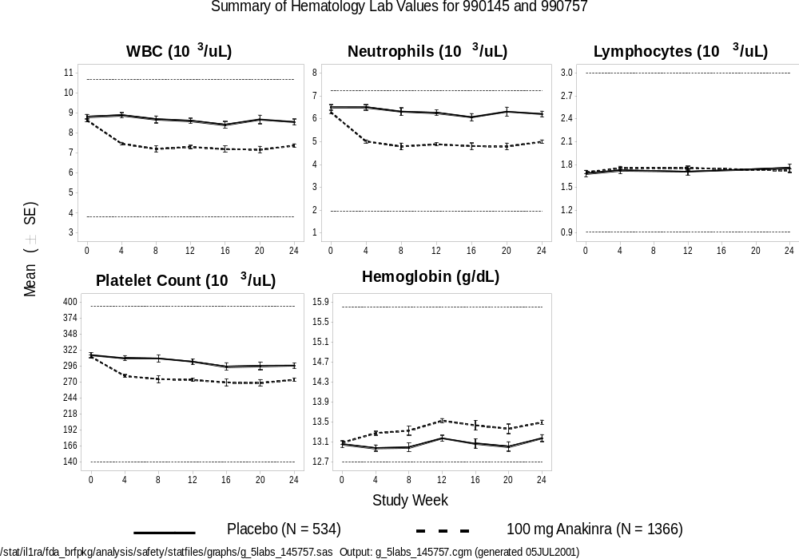

Grade 2 to Grade 4 Shifts in Laboratory Parameters
Treatment-emergent (worsening, or increase from baseline grade) Grade 2 to Grade 4 shifts in renal, hepatic, and hematologic laboratory parameters, based on Amgen-modified World Health Organization (WHO) toxicity criteria (Appendix 4-14), for all 5 randomized placebo-controlled studies are summarized in Table 4-40 and discussed in the following sections.
Hepatic and Renal Parameters
The distribution of Grade 2 and 3 shifts for hepatic and renal parameters is similar in the anakinra and placebo groups. No Grade 4 shifts were recorded for any of these parameters. No Grade 3 shifts were recorded for renal parameters.
Six Grade 3 hepatic shifts were observed, 2 (0.3%) with placebo and 4 (0.2%) with anakinra. All anakinra subjects who experienced these abnormalities were also receiving concomitant drugs, which are associated with liver enzyme abnormalities. There were no Grade 3 shifts in serum bilirubin levels.
- Placebo (2 subjects): alkaline phosphatase elevation from 415 IU/L to 609 IU/L and ALT elevation from 55 IU/L to 194 IU/L.
- 100 mg anakinra (3 subjects): ALT elevation from 24 IU/L to 185 IU/L (concomitant drug MTX), from 23 IU/L to 206 IU/L (concomitant drugs MTX, fexofenadine, atorvastatin, pravastatin), from 53 IU/L to 238 IU/L (concomitant drug leflunomide).
- > 100 mg anakinra (1 subject): ALT elevation from 20 IU/L to 238 IU/L (concomitant medication diclofenac).
Hemoglobin and Platelets
No Grade 4 hemoglobin decreases were seen. The distribution of Grade 2 and 3 decreases was similar across groups. No platelet decreases of Grade 2 or higher were recorded. Ten subjects (5 [0.7%] placebo, 5 [0.2%] anakinra) had Grade 3 decreases in hemoglobin. Events in the 5 anakinra subjects are described below:
- 1 subject (anakinra) had melena and a peptic ulcer at the time of the anemia (baseline hemoglobin 11.2 g/dL; 6.1 g/dL at the time of the event). Subject was also being treated concomitantly with NSAIDS.
- 1 subject (anakinra), with a history of multinodular goiter, was diagnosed with a thyroid neoplasm (baseline hemoglobin 11.8 g/dL; 8.7 g/dL at the time of diagnosis and 7.2 g/dL at the nadir).
- 3 subjects (anakinra) had baseline abnormalities (2 with Grade 1, and 1 with Grade 2). One of these 3 only had a spurious decrease (one value of 6.8 g/dL compared with values of 11.8 and 11.6 g/dL at adjacent time points). Another of these 3 subjects, who had a baseline hemoglobin of 10.0 g/dL, had ISR ecchymosis, URI and UTI, which likely contributed to the anemia.
WBCs
There was a somewhat higher number of Grade 2 decreases among anakinra subjects [34 (1.6%)] compared with placebo [2 (0.3%)].
One subject, in the MTX Combination Study (960180) receiving 0.4 mg/kg anakinra, with a normal baseline WBC count (4.8 x 10⁹/L), had a Grade 3 WBC decrease on day 88 which was the result of a Grade 3 neutropenia.
Table 4-40. Laboratory Parameters: Treatment-emergent Grade 2 to Grade 4 Toxicities (Worst Post Baseline Value)
in Placebo-controlled Studies
 |  |  |  |  |  | Anakinra (mg)
 |  |  | Placebo |  |  | < 100 |  |  | 100 |  |  | > 100 |  |  | All
n (%) |  |  | (N = 759) |  |  | (N = 610) |  |  | (N = 1367) |  |  | (N = 196) |  |  | (N = 2173)
Hepaticª |  |  | m = 741 |  |  | m = 607 |  |  | m = 1314 |  |  | m = 192 |  |  | m = 2113
 | Grade 2 |  | 12 | (1.6) |  | 6 | (1.0) |  | 22 | (1.7) |  | 1 | (0.5) |  | 29 | (1.4)
 | Grade 3 |  | 2 | (0.3) |  | 0 | (0.0) |  | 3 | (0.2) |  | 1 | (0.5) |  | 4 | (0.2)
 | Grade 4 |  | 0 | (0.0) |  | 0 | (0.0) |  | 0 | (0.0) |  | 0 | (0.0) |  | 0 | (0.0)
Renal^{b} |  |  | m = 741 |  |  | m = 607 |  |  | m = 1314 |  |  | m = 192 |  |  | m = 2113
 | Grade 2 |  | 0 | (0.0) |  | 0 | (0.0) |  | 1 | (0.1) |  | 1 | (0.5) |  | 2 | (0.1)
 | Grade 3 |  | 0 | (0.0) |  | 0 | (0.0) |  | 0 | (0.0) |  | 0 | (0.0) |  | 0 | (0.0)
 | Grade 4 |  | 0 | (0.0) |  | 0 | (0.0) |  | 0 | (0.0) |  | 0 | (0.0) |  | 0 | (0.0)
Hematologic
 | Hemoglobin decrease |  | m = 739 |  |  | m = 609 |  |  | m = 1307 |  |  | m = 191 |  |  | m = 2107
 |  | Grade 2 | 12 | (1.6) |  | 12 | (2.0) |  | 7 | (0.5) |  | 4 | (2.1) |  | 23 | (1.1)
 |  | Grade 3 | 5 | (0.7) |  | 2 | (0.3) |  | 1 | (0.1) |  | 2 | (1.1) |  | 5 | (0.2)
 |  | Grade 4 | 0 | (0.0) |  | 0 | (0.0) |  | 0 | (0.0) |  | 0 | (0.0) |  | 0 | (0.0)
 | Platelet decrease |  | m = 736 |  |  | m = 607 |  |  | m = 1300 |  |  | m = 190 |  |  | m = 2097
 |  | Grade 2 | 0 | (0.0) |  | 0 | (0.0) |  | 0 | (0.0) |  | 0 | (0.0) |  | 0 | (0.0)
 |  | Grade 3 | 0 | (0.0) |  | 0 | (0.0) |  | 0 | (0.0) |  | 0 | (0.0) |  | 0 | (0.0)
 |  | Grade 4 | 0 | (0.0) |  | 0 | (0.0) |  | 0 | (0.0) |  | 0 | (0.0) |  | 0 | (0.0)
Page 1 of 2
Includes studies 0560, 960180, 960182, 990145, and 990757
N = Number of subjects who were randomized and received at least 1 dose of study drug
m = Number of evaluable subjects with non-missing baseline and post-baseline WHOTOX grades
% = (n/m) x 100
ª Includes AST, ALT, Alkaline Phosphatase, and Total Bilirubin
^{b} Includes BUN and Creatinine
Table 4-36. Laboratory Parameters: Treatment-emergent Grade 2 to Grade 4 Toxicities (Worst Post Baseline Value)
in Placebo-controlled Studies (Continued)
 |  |  |  |  |  | Anakinra (mg)
 |  |  | Placebo |  |  | < 100 |  |  | 100 |  |  | > 100 |  |  | All
n (%) |  |  | (N = 759) |  |  | (N = 610) |  |  | (N = 1367) |  |  | (N = 196) |  |  | (N = 2173)
Hematologic (Cont'd)
 | WBC decrease |  | m = 739 |  |  | m = 609 |  |  | m = 1308 |  |  | m = 191 |  |  | m = 2108
 |  | Grade 2 | 2 | (0.3) |  | 12 | (2.0) |  | 17 | (1.3) |  | 5 | (2.6) |  | 34 | (1.6)
 |  | Grade 3 | 0 | (0.0) |  | 1 | (0.2) |  | 0 | (0.0) |  | 0 | (0.0) |  | 1 | (0.1)
 |  | Grade 4 | 0 | (0.0) |  | 0 | (0.0) |  | 0 | (0.0) |  | 0 | (0.0) |  | 0 | (0.0)
 | Neutrophil decrease |  | m = 736 |  |  | m = 609 |  |  | m = 1303 |  |  | m = 191 |  |  | m = 2103
 |  | Grade 2 | 2 | (0.3) |  | 5 | (0.8) |  | 26 | (2.0) |  | 3 | (1.6) |  | 34 | (1.6)
 |  | Grade 3 | 0 | (0.0) |  | 4 | (0.7) |  | 1 | (0.1) |  | 1 | (0.5) |  | 6 | (0.3)
 |  | Grade 4 | 0 | (0.0) |  | 0 | (0.0) |  | 0 | (0.0) |  | 0 | (0.0) |  | 0 | (0.0)
 | Lymphocyte decrease |  | m = 736 |  |  | m = 609 |  |  | m = 1304 |  |  | m = 191 |  |  | m = 2104
 |  | Grade 2 | 49 | (6.7) |  | 36 | (5.9) |  | 38 | (2.9) |  | 17 | (8.9) |  | 91 | (4.3)
 |  | Grade 3 | 17 | (2.3) |  | 14 | (2.3) |  | 13 | (1.0) |  | 6 | (3.1) |  | 33 | (1.6)
 |  | Grade 4 | 0 | (0.0) |  | 3 | (0.5) |  | 1 | (0.1) |  | 2 | (1.1) |  | 6 | (0.3)
 | Eosinophil increase |  | m = 736 |  |  | m = 609 |  |  | m = 1304 |  |  | m = 191 |  |  | m = 2104
 |  | Grade 2 | 1 | (0.1) |  | 3 | (0.5) |  | 6 | (0.5) |  | 1 | (0.5) |  | 10 | (0.5)
 |  | Grade 3 | 0 | (0.0) |  | 0 | (0.0) |  | 2 | (0.2) |  | 0 | (0.0) |  | 2 | (0.1)
 |  | Grade 4 | 0 | (0.0) |  | 0 | (0.0) |  | 0 | (0.0) |  | 0 | (0.0) |  | 0 | (0.0)
Page 2 of 2
Includes studies 0560, 960180, 960182, 990145, and 990757
N = Number of subjects who were randomized and received at least 1 dose of study drug
m = Number of evaluable subjects with non-missing baseline and post-baseline WHOTOX grades
% = (n/m) x 100
ª Includes AST, ALT, Alkaline Phosphatase, and Total Bilirubin
^{b} Includes BUN and Creatinine

Neutrophils
Among the 2103 evaluable anakinra-treated subjects, 6 (0.29%) were observed to have at least 1 Grade 3 (<0.98 x 10⁹/L) neutropenia. None of the anakinra subjects reported a Grade 4 neutropenia. No Grade 3 or 4 neutropenia cases were observed among the 736 evaluable subjects receiving placebo.
Table 4-41 lists the subjects with one or more Grade 3 or Grade 4 neutropenia laboratory values for the 5 randomized, placebo-controlled trials. Assuming a lower limit of normal of 2 x 10⁹/L, 3 of 6 subjects (50%) had a low baseline ANC. The median time to onset of the neutropenic event is 71 days, and the median duration is 6 days (based on the 5 cases for which data are available).
Three of 6 subjects (50.0%) were withdrawn due to the event and 5 of 6 subjects (83.3%) had a last available ANC value above the lowest value. One subject experienced a lower respiratory infection and a second subject experienced conjunctivitis and a tooth infection during the period of neutropenia. Neutrophil counts recovered in 2 of the 3 subjects who continued on anakinra therapy, and follow-up ANC values are not available for the third subject. Four of the 6 subjects who experienced neutropenia were concomitantly receiving MTX, which may have contributed to the events.
Of note is that in the large Safety Study (990757) and the Confirmatory Efficacy Study (990145), in which subjects received anakinra at the recommended dose of 100 mg daily for 24 weeks, only 1 of 1366 subjects (0.07%; in Safety Study [990757]) had a decrease in ANC to Grade 3.
No SAEs of granulocytopenia or neutropenia have been reported in the time period covered by this analysis. One subject in the large Safety Study (990757), who died following upper gastrointestinal hemorrhage, also had reported SAEs of renal failure, nausea, malaise, esophagitis, duodenitis, depression, exacerbation of RA, and leukopenia.
It should be noted that 2 neutropenia cases were also observed (1 each) in studies 0501 and 0502. In study 0501 a Grade 3 neutropenia was observed in a Caucasian woman of unknown age receiving 6 mg/kg of anakinra. Assuming a lower limit of normal of
2 x 10⁹/L, this subject had a baseline ANC below normal (1.76 x 10⁹/L). In addition, 1 subject (in study 0502) had Grade 4 neutropenia (< 0.5 x 10⁹/L). This subject, a 58-year old Caucasian woman, entered the study with neutropenia (1.026 x 10⁹/L), received a dose of 4 mg/kg anakinra SC for 1 day. After a washout period of 46 days, 10 daily doses of 1.0 mg/kg anakinra were administered, after which the subject was withdrawn from study due to neutropenia. A liver-spleen scan indicated a slightly enlarged spleen. She also had very high baseline rheumatoid factor levels (2070 IU/mL; normal 0-30) and high IgM levels (1070 mg/dL; normal 63-277). Although not indicated by the investigator, the subject may have had Felty syndrome, a disease sometimes seen in subjects with RA, and associated with neutropenia. During the trial the subject’s lowest ANC was 0.270 x 10⁹/L, 1 day after discontinuing 10 days of dosing, and 11 days later was 0.406 x 10⁹/L.
Table 4-41. By Subject Listing Of All Grade 3 or 4 Neutropenia Cases In All RA Studies
Study | Age | Sex | MTX  Use | Dose | Time to 1st Gr. 3/4 event (days)* | Baseline ANC | Lowest ANC | Duration of Grade 3 ANC* (days) | Last available ANC | Recovered while on anakinra? | Comments  (withdrawn, infections)
960180 | 63 | Male | Yes | 0.4 mg/kg | 24 | 1.73 | 0.96 | 4 | 1.48 | No | Withdrawn
960180 | 63 | Female | Yes | 0.04 mg/kg | 148 | 1.74 | 0.90 | 23 | 2.71 | No | Withdrawn
960180 | 62 | Female | Yes | 0.4 mg/kg | 88 | 2.94 | 0.56 | Unknown | 0.56 | No | Tooth infection, eye infection and oral ulcers
0560 | 52 | Female | No | 75 mg | 57 | 2.35 | 0.95 | 4 | 2.27 | Yes
0560 | 62 | Male | No | 150 mg | 8 | 1.90 | 0.91 | 9 | 1.06 | Yes | Chest infection
990757 | 58 | Female | Yes | 100 mg | 85 | 2.53 | 0.79 | 6 | 1.53 | No | Withdrawn
*Best estimate from available data
/stat/il1ra/fda_brfpkg/anlaysis/safety/statfiles/listings/l_lab_whotox34_hneuta.doc (generated 12JUL2001)
Source: /stat/il1ra/fda_brfpkg/anlaysis/safety/statfiles/listings/l_lab_whotox34_hneuta.lst

Lymphocytes
In the 5 randomized placebo-controlled studies, Grade 2 and 3 lymphopenia occurred at relatively similar incidence in anakinra and placebo subjects.
Grade 3 lymphopenia was reported in 50 subjects: 17 (2.3%) placebo and 33 (1.6%) anakinra subjects.
Six cases of Grade 4 lymphopenia were seen in the anakinra groups. On further evaluation 2 were noted as laboratory or data errors.
Eosinophils
Two subjects (100 mg anakinra) had Grade 3 eosinophilia. The highest values were 3.2 and 3.7 x 10⁹/L. Both subjects had no serious events, and both continued on study.

Summary of Laboratory Findings
Changes in the mean values were observed for white blood count, neutrophils, platelets and hemoglobin. For each of hematology parameter, the mean values changed towards the midpoint of the reference range. One interpretation of the mean changes in hematological parameters may be that inhibition of excess IL-1 activity in RA patients helps “normalize” the abnormalities often observed in patients with RA. Laboratory abnormalities, such as Grade 3 or 4 neutropenia, were rare, often occurring in subjects with baseline abnormalities or taking myelosuppressive drugs such as MTX. In the majority of instances these events were not of serious clinical consequence. There is no evidence that anakinra is nephrotoxic or hepatotoxic, or that treatment with anakinra is associated with abnormalities of routine serum chemistry analytes or urinalysis.

Antibodies
Serum samples from several studies were assayed for the presence of anti-anakinra antibodies. The assay methods used to detect these antibodies have evolved as the program has progressed. The earlier studies, the Monotherapy Study and its extension (0560, and 0564/0564E1) used an ELISA detecting IgG antibodies. Serum samples were considered seroreactive for the formation of antibodies capable of binding to anakinra if the optical density of the sample was 2-fold greater than the optical density of pre-dose sample. For the MTX Combination Study and its extension (960180, 960181) and the Low Dose Monotherapy Study (960182), the ELISA was used in conjunction with a BIAcore 3000 confirmatory assay. For these studies, samples were considered seroreactive by ELISA if binding was greater than a threshold defined as baseline + 2x standard deviation obtained from pre-dose samples. Seroreactive samples were then analyzed by both BIAcore and bioassay. The samples from the Safety Study (990757) were analyzed by ELISA and reactive samples further analyzed by BIAcore. The ELISA has been modified throughout the program to improve sensitivity and reduce background binding. A bioassay was used to determine whether the detected antibodies were capable of neutralizing the biological effect of anakinra in a cell-based assay. A monkey kidney epithelial cell line (COS-1 cells), which produces IL-8 upon treatment with IL-1beta was utilized for this purpose.
The percentage of subjects who were positive at one or more time points ranged from 3.8% to 57.2% across studies (Table 4-42). However, 0.2% to 29.1% of subjects were positive at 2 or more time points. The antibodies were rarely positive in the neutralizing bioassay (10/1303 subjects, 0.8%) and, of particular importance, antibody presence was transient, because none of the subjects tested remained positive at subsequent time points. The adverse event and treatment response profiles of the 9 subjects from the Safety Study (990757) who were positive in the bioassay were indistinguishable from the rest of the subject population. The increased incidence of observed binding antibodies in the Safety Study (990757) is likely the result of incremental improvements in the initial ELISA screening assay to detect lower affinity antibodies. Considering the low incidence of neutralizing antibodies from this study, and the transient nature of most of these antibodies, it is not likely that previous studies failed to detect important neutralizing antibodies.
In summary, while some subjects had evidence of anti-anakinra antibodies, the appearance of potentially neutralizing antibodies was transient in all cases and of no clinical significance.

Table 4-42. Summary of Seropositivity Data in RA Studies
 |  | Immunoassay |  |  | Bioassay
 | Subjects Tested  N | Positive at 1 or More Visits  n (%) | Positive at 2 or More Visits  n (%) | Positive at Last Available Visit  n (%) |  | Positive at 1 or More Visits  n (%) | Positive at Last Available Visit  n (%)
Studies 0560, 0564, 0564E1 | 412 | 21 (5.1%) | 10 (2.5%) | 2 (0.5%) |  | 0 (0.0%) | 0 (0.0%)
Studies 960180, 960181 | 351 | 14 (4.0%) | 1 (0.2%) | 5 (1.4%) |  | 1 (0.3%) | 0 (0.0%)
Study 960182 | 104 | 4 (3.8%) | 1 (1.0%) | 4 (3.8%) |  | 0 (0.0%) | 0 (0.0%)
Study 990757 | 802 | 459 (57.2%) | 233 (29.1%) | 396 (49.4%) |  | 9/436* (2.1%) | 0/436* (0.0%)
Combined | 1669 | 498 (29.8%) | 245 (14.7%) | 407 (24.4%) |  | 10/1303* (0.8%) | 0/1303* (0.0%)
% = n/N x 100
n = number of subjects positive in the assay
*All available assay results

Anakinra Combination With Etanercept: Study 20000125
In a 24-week open-label, single-arm, safety study (20000125), subjects who were receiving treatment with etanercept (Immunex Corp., USA) were treated concomitantly with anakinra (1 mg/kg/day SC). A total of 58 subjects who had been receiving 25 mg SC twice-weekly etanercept therapy for an average of 1.2 years, but still had residual disease (mean tender/painful joint count 26.4, swollen joint count 17.4), were enrolled. These subjects had RA for an average of 11.9 years. The primary purpose of the study was to determine whether anakinra could be used safely in subjects receiving standard etanercept therapy.
There were no deaths during the study. Seven subjects (12.1%) had SAEs over the course of the study: injury/accidental electrocution (1), withdrawal syndrome from combination opiates and barbiturates, along with possible sertraline toxicity (1), gastric ulcer hemorrhage (1), pneumonia (2 cases), and cellulitis (2 cases).
The most common adverse events were ISRs, experienced by 83% of the subjects. The only other events reported by at least 10% of subjects were URI (31%), RA flare (16%), and headache (12%).
Infections were reported by 48% of subjects (compared with 39% in the anakinra group in the 5 randomized, placebo-controlled studies; Table 4-28). The most common was URI (13 subjects, 22%) followed by influenza-like symptoms and urinary tract infection, each in 4 subjects (7%). Most infections were considered mild to moderate, with 2 severe infections reported: cellulitis and urinary tract infection (a non-serious event). Four subjects (6.9%) reported serious infectious episodes: cellulitis (2) and pneumonia (2). Of the 4 serious infections, the 2 subjects experiencing cellulitis had been exposed to etanercept for 112 and 184 days prior to initiation of anakinra treatment. Of the 2 subjects with pneumonia, prior etanercept exposure was 530 days and 1134 days. Three of the 4 subjects with serious infections were also receiving corticosteroid medications. Of the subjects who had infections, 61% of subjects received corticosteroids; 37% who did not experience infections were receiving corticosteroids. Thus, it may be possible that corticosteroid medications increase the risk of infections among subjects treated with the combination of anakinra and etanercept. No opportunistic infections were reported during this study.
It is possible that combination therapy with anakinra and etanercept increases the risk of infection compared with anakinra alone.
Eleven subjects (19%) withdrew from the study because of adverse events. Three of these were for serious infections mentioned above and a fourth was withdrawn due to URI. Two were withdrawn due to ISRs, and 1 each due to fatigue, worsening of RA, myalgia, cutaneous vasculitis, and depression.
No Grade 3 or 4 neutropenia was observed during the study. One subject had worsening to Grade 3 lymphopenia (the subject was hospitalized for pneumonia). No other Grade 3 laboratory abnormalities were observed.
Even though efficacy was not formally evaluated in this study, changes from baseline in selected components of the ACR score were assessed. The results for all treated subjects are summarized in Table 4-43. The completers analysis confirms these encouraging results, showing improvement in all parameters.
Table 4-43. Summary of Mean Disease Activity Measures in Study 20000125
All Treated Subjects
 | Joint Counts |  |  |  |  |  | Laboratory Parameters
Visit Week | Tender/Painful Joint Count |  | Swollen Joint Count |  | Health Assessment Questionnaire |  | C-Reactive Protein (mg/dL) |  | Erythrocyte Sedimentation Rate (mm/hr)
 | N | Mean (SD) | N | Mean (SD) | N | Mean (SD) | N | Mean (SD) | N | Mean (SD)
Baseline | 58 | 26.4 (14.0) | 58 | 17.4 (7.3) | 58 | 1.2 (0.7) | 56 | 2.2 (2.8) | 55 | 25.1 (24.9)
Week 2 | 58 | 22.4 (13.1) | 58 | 14.7 (8.4) | 58 | 1.1 (0.7) | 58 | 1.3 (1.8) | 55 | 20.6 (24.7)
Week 12 | 45 | 20.8 (16.0) | 45 | 10.8 (8.1) | 45 | 1.0 (0.7) | 44 | 0.9 (1.6) | 43 | 14.6 (15.7)
Week 24 | 39 | 18.7 (15.8) | 39 | 9.6 (9.3) | 39 | 1.0 (0.7) | 39 | 1.6 (2.6) | 38 | 19.3 (20.9)
N = number of subjects evaluable.
SD = standard deviation

Overall Adverse Event Profile

Randomized, Placebo-controlled Trials
An overview of the subject incidence of adverse events, including SAEs, serious infections, deaths and withdrawals for the 5 randomized, placebo-controlled studies is shown in Table 4-44.
Injection site reactions occur more commonly among anakinra-treated subjects, in a dose-dependent manner, than among placebo-treated subjects, and these events account for the differences in subject incidences of total adverse events between groups. The subject incidence of SAEs is 8.4%, 7.1% and 12.2% in subjects receiving < 100 mg, 100 mg and > 100 mg anakinra, respectively, compared to 6.5% in placebo subjects. Serious infectious episodes occurred in 1.7% anakinra subjects compared with 0.7% in placebo subjects. Six (0.3%) deaths in the anakinra group, and 1 death (0.1%) in the placebo group were reported in the 5 randomized, placebo-controlled studies. The treatment assignment for an additional death reported in the Confirmatory Efficacy Study (990145) remains blinded. The subject incidence of withdrawals due to adverse events is similar among the groups, with a higher incidence in the > 100 mg group.
Table 4-44. Safety Overview (Crude Subject Incidence) for Placebo-controlled Studies
 |  |  | Anakinra (mg)
 | Placebo |  | < 100 | 100 | > 100 | All
n (%) | (N = 759) |  | (N = 610) | (N = 1367) | (N = 196) | (N = 2173)
Any adverse event | 645 (85.0) |  | 538 (88.2) | 1254 (91.7) | 190 (96.9) | 1982 (91.2)
Adverse event excluding ISR | 623 (82.1) |  | 491 (80.5) | 1088 (79.6) | 169 (86.2) | 1748 (80.4)
Serious adverse event | 49 (6.5) |  | 51 (8.4) | 97 (7.1) | 24 (12.2) | 172 (7.9)
Serious infectious episode | 5 (0.7) |  | 7 (1.1) | 25 (1.8) | 4 (2.0) | 36 (1.7)
Deathª | 1 (0.1) |  | 1 (0.2) | 4 (0.3) | 1 (0.5) | 6 (0.3)
Withdrawal due to AE | 88 (11.6) |  | 58 (9.5) | 186 (13.6) | 36 (18.4) | 280 (12.9)
Includes studies 0560, 960180, 960182, 990145, and 990757
N = Number of randomized subjects who received at least 1 dose of study drug
n = Number of subjects reporting at least 1 occurrence of an adverse event
% = (n/N) x 100
ªExcludes 1 death in study 990145 due to blinded data
/stat/il1ra/fda_brfpkg/analysis/safety/statfiles/tables/t_ae_overall.sas
Output: t_ae_overall_crude.rtf (generated 13JUN2001)

All RA Studies
The exposure-adjusted adverse event rates reported in the all RA studies are shown in Table 4-45. The event rates for the placebo and anakinra groups from the 5 randomized, placebo-controlled studies are included for reference.
Table 4-45. Safety Overview (Exposure-adjusted Event Incidence)
for Placebo-controlled and All Studies
 | Placebo-controlled Studiesª |  |  | All Studies^{b}
 | Placebo | Anakinra |  | Anakinra
n (rate per patient year) | (N = 759) | (N = 2173) |  | (N = 2531)
Any adverse event^{c} | 2750 (9.284) | 10752 (12.724) |  | 15297 (9.392)
Adverse event excluding ISR^{c} | 2410 (8.136) | 7262 (8.594) |  | 11293 (6.934)
Serious adverse event | 72 (0.243) | 288 (0.341) |  | 616 (0.329)
Serious infectious episode | 6 (0.020) | 46 (0.054) |  | 110 (0.059)
Death per 100 patient years^{d} | 1 (0.338) | 6 (0.710) |  | 13 (0.694)
Withdrawal due to AE | 119 (0.402) | 514 (0.608) |  | 692 (0.369)
ªIncludes studies 0560, 960180, 960182, 990145, and 990757
^{b}Includes studies 0505, 0512, 0560, 0564, 0564E1, 0564E2, 0564E3, 960180, 960181, 960182, 970102, 980220, 990145, and 990757
N = Number of randomized subjects who received at least 1 dose of study drug
n = Number of adverse events
rate = n/(sum of patient years of exposure). Patient year of exposure is the duration between the first dose date and the last dose date
^{c}Excludes studies 0564E2, 0564E3 and 970102
^{d}Excludes 1 death in study 990145 due to blinded data
/stat/il1ra/fda_brfpkg/analysis/safety/statfiles/tables/t_ae_overall_rctall.sas
Output: t_ae_overall_rctall.rtf (generated 13JUN2001)

The rates of any adverse event (with or without ISRs), SAEs, serious infectious events, and deaths are similar for the all-studies anakinra group compared with the anakinra group from the 5 randomized, placebo-controlled studies. The rate of withdrawals due to adverse events is lower in the all-studies anakinra group compared with the 5 randomized, placebo-controlled studies anakinra group, possibly due to lower withdrawal rate due to ISRs later in the study phases.

Summary of Safety
The safety database with anakinra in the treatment of subjects with RA is extensive: 2531 subjects received at least 1 dose of anakinra and the total exposure is 1872.9 patient-years (excludes clinical pharmacology studies). At the recommended dose of 100 mg SC anakinra daily, 1367 subjects have received at least 1 dose, and the total exposure is 559.6 patient-years.
The incidence of mortality is 0.4% in both the placebo and anakinra groups in the large Safety Study (990757), and only 1 death (treatment assignment blinded) occurred in the 24-week phase for the Confirmatory Efficacy Study (990145; N = 501). It is not unexpected that the deaths in the remaining RA studies occurred mostly in anakinra subjects, because of the 17.2-fold greater duration of exposure between anakinra and placebo in these studies.
The subject incidence of SAEs at the 100 mg/day anakinra dose is low (7.1% compared with 6.5% in placebo group). Serious infectious episodes occur in 1.8% of 100 mg/day anakinra subjects and 0.7% of placebo subjects. The most common serious infectious event at a 100 mg/day anakinra is pneumonia (0.7%). The risk of experiencing a serious infection appeared to be higher in subjects receiving corticosteroid treatment, and in subjects with a history of asthma or pneumonia. There were no cases of tuberculosis or opportunistic infections reported.
Of interest, in the sepsis indication, the mortality rate in 3 anakinra trials where subjects received a mean dose of anakinra up to 34.7 times higher than the recommended daily dose for RA (100 mg), is numerically lower than the placebo mortality rate (anakinra 30.6%, placebo 35.5%). These findings suggest that anakinra does not severely impair the ability to respond to serious bacterial infections.
When data from all RA studies are considered, there is no indication that anakinra is associated with an increased risk of malignancy (16 observed malignancies compared with 15.6 expected based on the National Cancer Institute’s SEER statistics). Exposure-adjusted malignancy rates per 100 patient-years of study drug exposure are 1.2 for anakinra and 2.0 for placebo subjects.
ISRs were the only adverse event clearly associated with anakinra treatment, occurring in 64% of anakinra subjects compared to 27% of placebo subjects. ISRs occur more commonly among women. The most common reason for withdrawal is ISRs, occurring in 5.6% of anakinra subjects. Of the subjects who experienced ISRs in the 5 randomized, placebo-controlled studies, 95.3% of them had mild or moderate ISRs. Worsening of RA occurred more frequently in placebo subjects. In earlier studies, a few subjects were withdrawn due to protocol-specified criteria for neutropenia or leukopenia. Grade 3 or 4 neutropenia occurred rarely at the 100 mg anakinra dose (0.07%) and did not result in serious clinical sequelae. Anakinra treatment is associated with a slight mean decrease in neutrophil and platelet counts within the normal range, consistent with its biological effect of reducing inflammation. No severe cases of thrombocytopenia have been observed. Grade 4 lymphopenia occurred only in subjects with Grade 2 or 3 baseline abnormalities. There is a slight improvement in anemia. Also, there is no evidence of hepatic or renal toxicity, and no trends of abnormalities in routine serum chemistry analytes or urinalysis.
In general, the adverse event profile is similar in male and female subjects, as well as in younger (< 65 years) and older (≥ 65 years) subjects.
Although some subjects had evidence of anti-anakinra antibodies, the appearance of potentially neutralizing antibodies was transient in all cases, indicating that anakinra can be administered chronically.
Lastly, though experience is limited, concomitant use of anakinra with etanercept may result in improvement of RA signs and symptoms among some subjects. It is possible that the combination increases the risk of infections as compared with anakinra alone.
The 100 mg/day anakinra dose, which was demonstrated to be effective in treating subjects with RA, is preferred to a dose greater than 100 mg based on the overall safety profile. In general, the subject incidence of adverse events is higher in the > 100 mg anakinra group compared with placebo (see Table 4-44).
In conclusion, 100 mg/day SC anakinra was well tolerated by most subjects and the safety profile, in conjunction with the efficacy profile, indicate that anakinra will provide benefit to subjects suffering from RA, a chronic debilitating disease.

Risk/Benefit Assessment
Rheumatoid arthritis is a chronic autoimmune disease for which the goals of therapy include:
- Pain and inflammation relief
- Control of disease progression (bone and cartilage destruction)
- Halting or delaying systemic complications of RA
- Ultimately, improving the quality and longevity of life of RA sufferers
While trying to accomplish these goals, health care providers must also weigh the many side effects of various existing therapies, including hepatotoxicity and an increased risk of infections and cancers.
As discussed in Section 3, RA is mediated by antigen-driven T cells and macrophages which produce various cytokines, predominantly IL-1 and tumor necrosis factor TNFα. Although there are a number of therapeutic options available for RA, including TNF-specific inhibitors, a substantial number of subjects either do not respond, or partially respond to the existing therapies. In addition, responding subjects often become refractory to or intolerant of these medications as their disease progresses. For example, the most-widely used DMARD, MTX, has been shown to improve the signs and symptoms of RA and retard structural damage. However, use of MTX is often limited due to adverse effects and tolerability issues.
Recently, a number of newly approved biological agents that specifically target the proinflammatory cytokine TNFα have become available (ENBREL® and REMICADE™). Anakinra represents the first RA therapy that specifically inhibits the effects of IL-1, a pivotal proinflammatory cytokine that mediates many cellular responses including those important in synovial inflammation, proliferation of synoviocytes (pannus formation), cartilage degradation, and osteoclast-mediated bone erosions characteristic of RA. Anakinra, a recombinant form of interleukin-1 receptor antagonist (IL-1Ra), specifically targets the proinflammatory effects of IL-1.
The results of the anakinra clinical development program indicate that the benefits of anakinra therapy, alone or in combination with other DMARDs, include:
- Rapid and sustained improvement in ACR₂₀
- Improvement in ACR₅₀ and ACR₇₀
- Reduction of radiographic disease progression
The risks of anakinra therapy observed in these studies include:
- Injection site reactions
- Possible slight increase in serious infectious episodes, mostly attributed to pneumonia
The data presented here clearly demonstrate the clinical benefits of anakinra in RA trials. The positive effects of anakinra across these trials are consistent with respect to the ACR₂₀ results at 24 weeks, the durability of those effects (sustained response), and the magnitude of the effect achieved (ACR₅₀, ACR₇₀) at 24 weeks. Clinically important benefits were seen when anakinra was used either as a monotherapy or in combination with MTX. As predicted by the biology, anakinra also demonstrates an important RA therapeutic benefit by protecting bone and cartilage as seen on radiographic examination (Larsen and modified Sharp scoring systems).
As discussed in Section 2 and Section 4.5 anakinra has been studied in 2606 subjects with RA (~2000 patient-years experience), in a range of therapeutic settings, including subjects at both early and later stages of the disease and those receiving treatment with a variety of antirheumatic drugs. Overall, data from the large safety database provide support that anakinra is a well tolerated therapeutic for patients with RA. Injection site reactions (ISRs) were the only clearly identified adverse event associated with anakinra use. The majority of ISRs were mild to moderate and well-tolerated by most subjects. Serious infectious episodes are uncommon (1.7% in anakinra and 0.7% in placebo). There is no evidence that subjects on anakinra therapy are at an increased risk for malignancy.
Data from 5 randomized, placebo-controlled trials of anakinra in RA subjects indicates anakinra is efficacious either alone or in combination with other DMARDs.
The potential benefit of anakinra treatment outweighs the identified risks, and supports the use of anakinra for the treatment of RA. Anakinra’s effects on the signs and symptoms of RA occur early, are sustained and consistent. Additionally, preliminary radiographic data demonstrate anakinra may retard structural damage. The drug is well tolerated with the most common and consistently reported treatment-related adverse event being injection site reactions (ISRs). The safety, efficacy and unique mechanism of action demonstrate that anakinra offers RA patients a favorable risk/benefit profile.

Proposed Indication
“Anakinra is indicated for the reduction in signs and symptoms of active rheumatoid arthritis, in subjects 18 years of age or older. Anakinra can be used alone or in combination with other disease-modifying antirheumatic drugs (DMARDs).”

References
- Arend WP. Interleukin 1 receptor antagonist. A new member of the interleukin 1 family. J Clin Invest. 1991;88:1445-1451.
- Arend WP, Dayer JM. Cytokines and cytokine inhibitors or antagonists in rheumatoid arthritis. Arthritis Rheum. 1990;33: 305-15.
- Conti P. Interleukin-1 (IL-1) and interleukin-1 receptor anagonist (IL-1ra). Ann Medecine Interne. 1991;142:521-525.
- Eastgate JA, Symons JA, Wood NC, Grinlinton FM, di-Giovine FS, Duff GW. Correlation of plasma interleukin 1 levels with disease activity in rheumatoid arthritis. Lancet. 1988;2:706-709.
- Bendtzen K, Petersen J, Halkjaer KJ, Ingemann HT. Interleukin-1-like activities in synovial fluids of patients with rheumatoid arthritis and traumatic synovitis. Rheumatol Int. 1985;5:79-82.
- Nouri AME and Panayi GS. Cytokines and the chronic inflammation of rheumatic disease: III. J Rheumatlo. 1984;14:902-906.
- Miyasaka N, Sato K, Goto M, et al. Augmented interleukin-1 production and HLA-DR expression in the synovium of rheumatoid arthritis patients: Possible involvement in joint destruction. Arthritis Rheum. 1988;31:480-486.
- van-de-Loo FA, Arntz OJ, Otterness IG, Van-den-Berg WB. Protection against cartilage proteoglycan synthesis inhibition by antiinterleukin 1 antibodies in experimental arthritis. J Rheumatol. 1992;19: 348-356.
- van de Loo FA, Joosten LA, van Lent PL, Arntz OJ, van den Berg WB. Role of interleukin-1, tumor necrosis factor alpha, and interleukin-6 in cartilage proteoglycan metabolism and destruction. Effect of in situ blocking in murine antigen- and zymosan-induced arthritis. Arthritis Rheum. 1995;38:164-72.
- Geiger T, Towbin H, Cosenti VA, et al. Neutralization of interleukin-1 beta activity in vivo with a monoclonal antibody alleviates collagen-induced arthritis in DBA/1 mice and prevents the associated acute-phase response. Clin And Exp Rheumatol. 1993;11:515-522.
- Joosten LAB, Helsen MMA, Van-De-Loo FAJ, Van-Berg WB. Amelioration of established collagen-induced arthritis (CIA) with anti-IL-1. Agents Actions. 1994; 41:C174-C176.
- van den Berg WB, Joosten AB, Helsen M, van de Loo FAJ. Amelioration of established murine collagen-induced arthritis with anti-IL-1 treatment. Clin Exp Immunol. 1994;95: 237-243.
- Joosten LA, Helsen MM, van de Loo FA, van den Berg WB. Anticytokine treatment of established type II collagen-induced arthritis in DBA/1 mice. A comparative study using anti-TNF alpha, anti-IL-1 alpha/beta, and IL-1Ra. Arthritis and Rheum. 1996; 39:797-809.
- Felson DT, Anderson JJ, Boers M, et al. American College of Rheumatology. Preliminary definition of improvement in rheumatoid arthritis [see comments]. Arthritis Rheum. 1995;38: 727-35.
- Firestein GS, Berger AE, Tracey DE, et al. IL-1 receptor antagonist protein production and gene expression in rheumatoid arthritis and osteoarthritis synovium. J Immunol. 1992;149:1054-1062.
- Harris-ED J. Rheumatoid arthritis. Pathophysiology and implications for therapy [published erratum appears in N Engl J Med 1990 Oct 4; 323(14):996 [see comments]. N Engl J Med 1990;322:1277-1289.
- Firestein GS, Boyle DL, Yu C, et al. Synovial interleukin-1 receptor antagonist and interleukin-1 balance in rheumatoid arthritis. Arthritis Rheum. 1994;37:644-52.
- Dinarello CA. Biologic basis for interleukin-1 in disease. Blood. 1996;87:2095-2147.
- Dinarello CA. Interleukin-1, interleukin-1 receptors and interleukin-1 receptor antagonist. Int Rev Immunol. 1998;16:457-499.
- Chandrasekhar S, Harvey AK, Hrubey PS, Bendele AM. Arthritis induced by interleukin-1 is dependent on the site and frequency of intraarticular injection. Clin Immunol Immunopathol. 1990;55:382-400.
- Greenfeder SA, Nunes P, Kwee L, et al. Molecular cloning and characterization of a second subunit of the interleukin 1 receptor complex. J Bio Chem. 1995;270; 13757-13765.
- Arend WP, Malyak M. Interleukin-1 receptor antagonist: role in biology. Annu Rev Immunol. 1998:16;27-55.
- Utsinger PD, Zvaifler NJ, Ehrlich GE, et al. Rheumatoid arthritis, etiology, diagnosis and treatment. Rheumatoid Arthritis, Etiology, Diagnosis and Treatment; 1985.
- Brennan FM, Field M, Shu CQ, Feldman M, et al. Cytokine expression in rheumatoid arthritis. Br J Rheumatol. 1991;30: 76-80.
- Cunnane G., Hummel KM, Muller-Ladner U, Gay RE, Gay S. Mechanism of joint destruction in rheumatoid arthritis. Archivum Immunologiae et Therapiae Experimentalis; 1998:46: 1-7.
- Feldman M, Feldmann M, Brennan FM, Maini RN. Role of cytokines in rheumatoid arthritis. Annu Rev Immunol. 1996;14:397-440.
- Feldman M, Brennan FM, Maini R. Cytokines in autoimmune disorders. Intern Rev Immunol. 1998;17:217-228.
- Dayer JM, Feige U, Edwards C, Burger D. Anti-interleukin-1 therapy in rheumatic diseases. Curr Opin Rheumatol. 2001;13:170-176.
- Henderson B, Pettipher ER. Comparison of the in vivo inflammatory activities after intra-articular injection of natural and recombinant IL-1α and IL-1β in the rabbit. Biochem Pharmacol. 1988:37;4171-4176.
- Feige U, Karbowski A, Rordorf-Adam C, Pataki A. Arthritis induced by continuous infusion of rh-interleukin-1α into the rabbit knee-joint. Int J Tissue Reac. 1989; XI5:225-238.
- Ghivizzani SC, Kang R, Georgescu HI, Lechman ER, et al. Constitutive intra-articular expression of human IL-1β following gene transfer to rabbit synovium produces all major pathologies of human rheumatoid arthritis. Amer Assoc Immunol. 1997:3604-3612.
- Hom JT, Bendele AM, Carlson DG. In vivo administration with IL-1 accelerates the development of collagen-induced arthritis in mice. J Immunol. 1988:141;834-841.
- Hom JT, Cole H, Bendele AM. Interleukin 1 enhances the development of spontaneous arthritis in MRL/lpr miceClin Immunol Immunopathol. 1990 55:109-119.
- Dayer JM, de Rochemonteix B, Burrus B, et al. Human recombinant interleukin1 stimulates collagenase and prostaglandin E₂ production by human synovial cells. J. Clin. Invest. 1986 77: 645-648.
- Hofbauer LC, Lacey DL, Dunstan CR, et al. Interleukin-1β and tumor necrosis factor-α, but not interleukin-6, stimulate osteoprotegerin ligand gene expression in human osteoblastic cells. Bone. 1999:25;255-259.
- Morony S, Capparelli C, Lee R, et al. A chimeric form of osteoprotegerin inhibits hypercalcemia and bone resorption induced by IL-1β, TNF-α, PTH, PTHrP, and 1,25 (OH)₂ D₃. J Bone Miner Res. 1999;14:1478-1484.
- Deleuran BW, Chu CQ, Field M, Brennan FM, et al. Localization of Interleukin
1-α, type 1 interleukin-1 receptor and interleukin-1 receptor antagonist in the synovial membrane and cartilage/pannus junction in rheumatoid arthritis. Br J Rheumatol. 1992;31: 801-809.
- Feige U, Hu YL, Gasser J, et al. Anti-interleukin-1 and anti-tumor necrosis factor-alpha synergistically inhibit adjuvant arthritis in Lewis rats. Cell Mol Life Sci. 57 (2000) 1457-1470.
- Bendele A, McAbee T, Sennello G, et al. Efficacy of sustained blood levels of interleukin-1 receptor antagonist in animal models of arthritis. Comparison of efficacy in animal models with human clinical data. Arthritis Rheum. 1999; 42:498-506. BLA #16.
- Bendele A, McAbee T, Woodward M, et al. Effects of interleukin-1 receptor antagonist in a slow-release hylan vehicle on rat type II collagen arthritis. Pharm Res. 15 1998;(10):1557-1561.
- Schwab JH Anderle SK, Brown RR, et al. Pro- and anti-inflammatory roles of interleukin-1 in recurrence of bacterial cell wall-induced arthritis in rats. Infect Immun. 1991;4436-4442.
- Van Lent P, van de Loo F, Holthuysen A, et al. Major role for interleukin 1 but not for tumor necrosis factor in early cartilage damage in immune complex arthritis in mice. J Rheumatol. 1995;2250-2258.
- Bolon B; Morony S, Capparelli C, Hu Y, et al. IL-1ra and PEG sTNF-RI reduce osteoclast numbers in rats with adjuvant arthritis. Arthritis Rheum. 43 9(Suppl) (2000) S233 #1002.
- Bendele A, Sennello G, McAbee T, et al. Effects of interleukin 1 receptor antagonist alone and in combination with Methotrexate in adjuvant arthritic rats.
J Rheumatol. 1999;1225-1229.
- Amgen Inc., data on file. Mycobacteria-induced adjuvant arthritis - ADA 65; ADA-56. Collagen-induced arthritis - CILew-28; CIIM3.
- Bendele A, Chlipala ES, Scherrer J, et al. Combination benefit of treatment with the cytokine inhibitors interleukin-1 receptor antagonist and PEGylated soluble tumor necrosis factor receptor type I in animal models of rheumatoid arthritis. Arthritis Rheum.12 (2000) 2648-2659.
- Barthold S. Chronic progressive nephropathy, rat. In: Jones T, Hard G, Mohr U, eds. Urinary System. Washington DC: ILSI; 1998:228-233.
- Peter CP, Burek JD, van Zwieten MJ. Spontaneous nephropathies in rats. Toxicol Pathol. 1986;14:91-100.
- Short BG, Goldstein RS. Nonneoplastic lesions in the kidney. In: Mohr U, Dungwoth DL, Capen CC, eds. Pathobiology Of The Aging Rat. Washington DC: ILSI; Press 1992:212-225.
- Owen RA and Heywood R. Age-related variations in renal structure and function in Sprague-Dawley rats. Toxicol Pathol. 1986;14:158-167.
- Bertani T, Zoja C, Abbate M, Rossini M, Remuzzi G. Age-related nephropathy and proteinuria in rats with intact kidneys exposed to diets with different protein content. Lab Invest. 1989;60:196-204.
- Keenan KP, Soper KA, Hertzog PR, et al. Diet, overfeeding, and moderate dietary restriction in control Sprague-Dawley rats: II. Effects on age-related proliferative and degenerative lesions. Toxicol Pathol. 1995;23: 287-302.
- Klar S and Purkerson ML. Effects of dietary protein on renal function and on the progression of renal disease. Am J Clin Nutr. 1988;47:146-152.
- Rao GN, Edmondson J, Elwell MR. Influence of dietary protein concentration on severity of nephropathy in Fischer-344 (F-344/N) rats. Toxicol Pathol. 1993;21:353-361.
- Faherty DA, Claudy V, Plocinski JM, Kaffka K, et al. Failure of IL-1 receptor antagonist and monoclonal anti-IL-1 receptor antibody to inhibit antigen-specific immune responses in vivo. J Immuno.l 1992;148:766-771.
- Zheng H, Fletcher D, Kozak W, Jiang MH, et al. Resistance to fever induction and impaired acute-phase response in interleukin-1-beta-deficient mice. Immunity. 1995; 3:9-19.
- Glaccum MB, Stocking KL,Charrier K, Smith, JL, et al. Phenotypic and functional characterization of mice that lack the type I receptor for IL-1. J Immunol. 1997;159:3364-3371.
- Cheers C, McKenzie IF. Restriction inadoptive transfer of resistance to listeria monocytogenes. Cell Immunol. 1983;76: 304-310.
- Irikura VM, Hirsch E,Hirsh D, et al. Effects of interleukin-1 receptor antagonist overexpression on infection by listeria monocytogenes. Infect Immun. 1999;67: 1901-1909.
- Hirsch E, Irikura VM Paul SM, Hirsh D, et al. Functions of interleukin 1 receptor antagonist in gene knockout and overproducing mice. Proc Natl Acad Sci U S A. 1996;93:11008-11013.
- Cuchacovich M, Couret M, Peray P Gatica H, Sany J. Precision of the Larsen and the Sharp Methods of Assessing Radiologic Change in Patients with Rheumatoid Arthritis. Arthritis Rheum. 1992;35 736-739.
- Wassenberg S. Reliability, precision and time expense of four different radiographic scoring methods. Arthritis Rheum. 1998;41: S50-S50 abstract.
- Larsen A, Dale K, Eek M. Radiographic evaluation of rheumatoid arthritis and related conditions by standard reference films. Acta Radiol: Diagnosis. 1977;178:481-491.
- Sharp JT. An overview of radiographic analysis of joint damage in rheumatoid arthritis and its use in metaanalysis. J Rheumatol. 2000;27:254-260.
- Genant HK, Jiang Y,Peterfy C,Lu Y,Redei J,Countryman PJ. Assessment of rheumatoid arthritis using a modified scoring method on digitized and original radiographs. Arthritis Rheum. 1998;41:1583-1590.
- Jiang Y, Genant HK, Watt I, Cobby M, et al. A multicenter, double-blind, dose-ranging, randomized, placebo-controlled study of recombinant human interleukin-1 receptor antagonist in patients with rheumatoid arthritis. Arthritis Rheum. 2000;4:1001-1009.
- Ries LAG, Kosary CL, Hankey BF, Miller BA, Clegg L, Edwards BK (eds). 1999 SEER Cancer Statistics Review. 1973-1996, National Cancer Institute. Bethesda, MD.
Appendix 4- 1. Study 990145 – Criteria for Lack of Efficacy Designation
Study 990145 incorporated the use of a special subject status designation, Lack of Efficacy (LOE), with the objective of retaining subjects in the study for evaluation of the radiographic endpoint when they might otherwise withdraw from the study due to a flare in signs and symptoms of RA. LOE assessments were conducted using a pre-defined algorithm, which maintained the study blind regarding randomized treatment assignments. Declaration of LOE on or after week 16 allowed subjects to receive treatment with protocol-specified agents that could alleviate the signs and symptoms of RA with minimal effects on underlying structural damage.
Definition of Lack of Efficacy
- Failure to meet the ACR₂₀ criteria for improvement on the last three consecutive visits, on or after the Week 16 visit, beginning with the visit at which the LOE request is made.
- ACR₂₀ is defined as 20% improvement in tender and swollen joint count, and three out of the following five assessments:
- Subject assessment of disease activity
- Physician assessment of disease activity
- Subject assessment of pain
- Acute phase reactant: C-reactive protein
- HAQ

LOE Determination
- The ACR₂₀ will be calculated, by Amgen or it’s designee, by comparing the current visit assessment and the two prior assessments against baseline. Site staff will forward the ACR assessments to Amgen via Federal Express. Determination of LOE will take approximately 3-5 working days, and site staff will be informed only whether or not a subject meets LOE.
Changes in medications for subjects who meet LOE

• If a subject meets the objective criteria for LOE they may first obtain additional therapeutic treatment by optimizing their MTX, corticosteroid and/or NSAID doses. Optimization of these medications can be done based on the clinical judgment of the principal investigator, and must be documented in the source document. The MTX dose cannot be increased above 25 mg/wk.
• Subjects who optimize their dose of MTX, should wait at least 8 weeks before seeking additional therapy.
• Once a subject has optimized their dose of MTX (either prior to randomization or during the trial) and continues to manifest the criteria for LOE, they can modify their background therapy through the use of the medications listed below, however, they must continue to take the randomized study drug: (additional DMARD therapy will not be provided by Amgen Inc.). Additionally, the investigator may continue to adjust the subject’s DMARD therapy as needed, provided that adequate time is allowed for the medication to become beneficial to the subject. Amgen should be notified before the addition of a DMARD.
A. hydroxychloroquine
B. sulfasalazine
C. gold
D. minocycline
E. cyclosporine
END App.4-1
Appendix 4- 2. Proportion of Patients Achieving an ACR₂₀ Response at Week 24 by Injection Site Reaction
Study 0560
Intent-to-Treat Population Using Non-Responder Imputation
 |  |  |  | Anakinra
 |  | Placebo  (N = 121) |  | 30 mg  (N = 119) |  | 75 mg  (N = 116) |  | 150 mg  (N = 117) |  | All  (N = 352)
At Least One ISR
 | n | 30 |  | 59 |  | 85 |  | 94 |  | 238
 | Number of Responders (%) | 7 | (23.3) | 25 | (42.4) | 31 | (36.5) | 34 | (36.2) | 90 | (37.8)
 | Odds Ratio |  |  | 2.42 |  | 1.89 |  | 1.86 |  | 2.00
 | 95% Confidence Interval |  |  | (0.90, 6.51) |  | (0.73, 4.90) |  | (0.72, 4.79) |  | (0.82, 4.85)
 | p-valueª |  |  | 0.077 |  | 0.188 |  | 0.193 |  | 0.120
No ISR
 | n | 91 |  | 60 |  | 31 |  | 22 |  | 113
 | Number of Responders (%) | 23 | (25.3) | 20 | (33.3) | 7 | (22.6) | 10 | (45.5) | 37 | (32.7)
 | Odds Ratio |  |  | 1.48 |  | 0.862 |  | 2.46 |  | 1.44
 | 95% Confidence Interval |  |  | (0.72, 3.02) |  | (0.33, 2.27) |  | (0.94, 6.46) |  | (0.78, 2.66)
 | p-valueª |  |  | 0.283 |  | 0.764 |  | 0.062 |  | 0.245
N = Number of patients randomized
n = Number of evaluable patients
Patients with non-evaluable ACR criteria are non-responders
p-value and confidence intervals are exact if expected cell frequencies are less than 5
Biostatistics: 10AUG1999
/stat/il1ra/i0560/analysis/final/statfiles/tables/acr20nr_0560_anyisr_xtabs.rtf

Appendix 4-3. Proportion of Patients Achieving a Sustained ACR₂₀ Response by Injection Site Reaction
Study 0560
Intent-to-Treat Population Using Non-Responder Imputation
 |  |  |  | Anakinra
 |  | Placebo  (N = 121) |  | 30 mg  (N = 119) |  | 75 mg  (N = 116) |  | 150 mg  (N = 117) |  | All  (N = 352)
At Least One ISR
 | n | 30 |  | 59 |  | 85 |  | 94 |  | 238
 | Number of Responders (%) | 3 | (10.0) | 19 | (32.2) | 26 | (30.6) | 21 | (22.3) | 66 | (27.7)
 | Odds Ratio |  |  | 4.28 |  | 3.97 |  | 2.59 |  | 3.45
 | 95% Confidence Interval |  |  | (1.15, 15.87) |  | (1.10, 14.25) |  | (0.71, 9.38) |  | (1.01, 11.77)
 | p-valueª |  |  | 0.022 |  | 0.026 |  | 0.136 |  | 0.036
No ISR
 | n | 91 |  | 60 |  | 31 |  | 22 |  | 113
 | Number of Responders (%) | 10 | (11.0) | 14 | (23.3) | 7 | (22.6) | 7 | (31.8) | 28 | (24.8)
 | Odds Ratio |  |  | 2.47 |  | 2.36 |  | 3.78 |  | 2.67
 | 95% Confidence Interval |  |  | (1.01, 5.99) |  | (0.68, 7.71) |  | (1.03, 12.97) |  | (1.22, 5.84)
 | p-valueª |  |  | 0.042 |  | 0.134 |  | 0.022 |  | 0.012
N = Number of patients randomized
n = Number of evaluable patients
Patients with non-evaluable ACR criteria are non-responders
p-value and confidence intervals are exact if expected cell frequencies are less than 5
Biostatistics: 10AUG1999
/stat/il1ra/i0560/analysis/final/statfiles/tables/acrsusnr_0560_anyisr_xtabs.rtf

Appendix 4-4. Study 960180 – Individual ACR Components Change From Baseline Lower Anakinra Doses 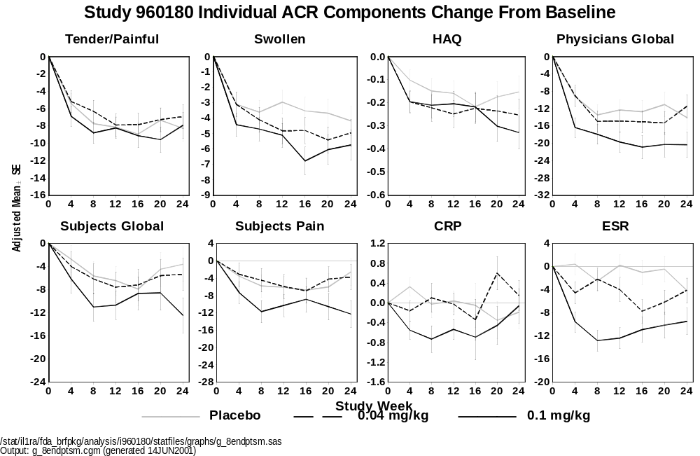
Appendix 4-5. Proportion of Patients Achieving an ACR₂₀ Response at Week 12 by Injection Site Reaction
Study 960180
Intent-to-Treat Population Using Non-Responder Imputation
 |  |  |  | Anakinra (mg/kg)
 |  | Placebo  (N = 74) |  | 0.04  (N = 63) |  | 0.1  (N = 74) |  | 0.4  (N = 77) |  | 1.0  (N = 59) |  | 2.0  (N = 72) |  | All  (N = 345)
At Least One ISR
 | n | 20 |  | 12 |  | 27 |  | 43 |  | 38 |  | 45 |  | 165
 | Number of Responders (%) | 4 | (20.0) | 1 | (8.3) | 9 | (33.3) | 12 | (27.9) | 14 | (36.8) | 18 | (40.0) | 54 | (32.7)
 | Odds Ratio |  |  | 0.364 |  | 2.00 |  | 1.55 |  | 2.33 |  | 2.67 |  | 1.95
 | 95% C.I. for Odds Ratio |  |  | (0.01, 4.49) |  | (0.52, 7.77) |  | (0.43, 5.58) |  | (0.65, 8.38 ) |  | (0.77, 9.28) |  | (0.62, 6.10)
 | p-value |  |  | 0.626 |  | 0.312 |  | 0.502 |  | 0.188 |  | 0.116 |  | 0.247
No ISR
 | n | 54 |  | 51 |  | 47 |  | 34 |  | 21 |  | 27 |  | 180
 | Number of Responders (%) | 10 | (18.5) | 15 | (29.4) | 17 | (36.1) | 7 | (20.5) | 13 | (61.9) | 9 | (33.3) | 61 | (33.9)
 | Odds Ratio |  |  | 1.83 |  | 2.49 |  | 1.14 |  | 7.15 |  | 2.20 |  | 2.26
 | 95% C.I. for Odds Ratio |  |  | (0.74, 4.57) |  | (1.01, 6.19) |  | (0.39, 3.35) |  | (2.34, 21.84) |  | (0.77, 6.31) |  | (1.06, 4.79)
 | p-value |  |  | 0.190 |  | 0.046 |  | 0.811 |  | 0.001 |  | 0.138 |  | 0.031
N = Number of patients randomized
n = Number of evaluable patients
Patients with non-evaluable ACR criteria are non-responders
p-value and confidence intervals are exact if expected cell frequencies are less than 5
Biostatistics: 02AUG1999
/stat/il1ra/i960180abr/analysis/final/statfiles/tables/acr2012nr_960180_anyisr_xtabs

Appendix 4-6. Proportion of Patients Achieving an ACR₂₀ Response at Week 24 by Injection Site
Study 960180
Intent-to-Treat Population Using Non-Responder Imputation

 |  |  |  | Anakinra (mg/kg)
 |  | Placebo  (N = 48) |  | 0.04  (N = 63) |  | 0.1  (N = 46) |  | 0.4  (N = 55) |  | 1.0  (N = 59) |  | 2.0  (N = (46) |  | All  (N = 269)
At Least One ISR
 | n | 13 |  | 12 |  | 14 |  | 30 |  | 38 |  | 32 |  | 126
 | Number of Responders (%) | 2 | (15.4) | 1 | (8.3) | 6 | (42.9) | 10 | (33.3) | 12 | (31.6) | 11 | (34.4) | 40 | (31.8)
 | Odds Ratio |  |  | 0.50 |  | 4.13 |  | 2.75 |  | 2.54 |  | 2.88 |  | 2.56
 | 95% C.I. for Odds Ratio |  |  | (0.01, 11.25) |  | (0.52, 49.59) |  | (0.45, 29.63) |  | (0.44, 26.68) |  | (0.48, 30.67) |  | (0.52, 24.68)
 | p-value |  |  | 1.000 |  | 0.209 |  | 0.290 |  | 0.472 |  | 0.287 |  | 0.344
No ISR
 | n | 35 |  | 51 |  | 32 |  | 25 |  | 21 |  | 14 |  | 143
 | Number of Responders (%) | 9 | (25.7) | 11 | (21.6) | 8 | (25.0) | 10 | (40.0) | 13 | (61.9) | 5 | (35.7) | 47 | (32.9)
 | Odds Ratio |  |  | 0.79 |  | 0.96 |  | 1.93 |  | 4.69 |  | 1.61 |  | 1.41
 | 95% C.I. for Odds Ratio |  |  | (0.29, 2.18) |  | (0.32, 2.90) |  | (0.64, 5.80) |  | (1.47, 15.01) |  | (0.33, 7.19) |  | (0.61, 3.26)
 | p-value |  |  | 0.655 |  | 0.946 |  | 0.241 |  | 0.007 |  | 0.503 |  | 0.414
N = Number of patients participating in the 24-week protocol
n = Number of evaluable patients
Patients with non-evaluable ACR criteria are non-responders
p-value and confidence intervals are exact if expected cell frequencies are less than 5
- : Due to zero events, statistics cannot be calculated
Biostatistics: 02AUG1999
/stat/il1ra/i960180abr/analysis/final/statfiles/tables/acr2024nr_960180_anyisr_xtabs

Appendix 4-7. Proportion of Patients Achieving a Sustained ACR₂₀ Response by Injection Site Reaction
Study 960180
Intent-to-Treat Population Using Non-Responder Imputation

 |  |  |  | Anakinra (mg/kg)
 |  | Placebo  (N = 48) |  | 0.04  (N = 63) |  | 0.1  (N = 46) |  | 0.4  (N = 55) |  | 1.0  (N = 59) |  | 2.0  (N = 46) |  | All  (N = 269)
At Least One ISR
 | n | 13 |  | 12 |  | 14 |  | 30 |  | 38 |  | 32 |  | 126
 | Number of Responders (%) | 1 | (7.7) | 1 | (8.3) | 6 | (42.9) | 6 | (20.0) | 9 | (23.7) | 10 | (31.3) | 32 | (25.4)
 | Odds Ratio |  |  | 1.09 |  | 9.00 |  | 3.00 |  | 3.72 |  | 5.46 |  | 4.09
 | 95% C.I. for Odds Ratio |  |  | (0.01, 92.68) |  | (0.78,447.61) |  | (0.30, 149.31) |  | (0.42, 176.62) |  | (0.61, 256.10) |  | (0.56, 180.00)
 | p-value |  |  | 1.000 |  | 0.077 |  | 0.412 |  | 0.419 |  | 0.136 |  | 0.301
No ISR
 | n | 35 |  | 51 |  | 32 |  | 25 |  | 21 |  | 14 |  | 143
 | Number of Responders (%) | 6 | (17.1) | 7 | (13.7) | 8 | (25.0) | 6 | (24.0) | 9 | (42.9) | 6 | (42.9) | 36 | (25.2)
 | Odds Ratio |  |  | 0.77 |  | 1.61 |  | 1.53 |  | 3.63 |  | 3.63 |  | 1.63
 | 95% C.I. for Odds Ratio |  |  | (0.24, 2.52) |  | (0.49, 5.29) |  | (0.43, 5.44) |  | (1.06, 12.44) |  | (0.73, 17.65) |  | (0.63, 4.23)
 | p-value |  |  | 0.664 |  | 0.429 |  | 0.513 |  | 0.035 |  | 0.076 |  | 0.316
N = Number of patients participating in the 24-week protocol
n = Number of evaluable patients
Patients with non-evaluable ACR criteria are non-responders
p-value and confidence intervals are exact if expected cell frequencies are less than 5
Biostatistics: 02AUG1999
/stat/il1ra/i960180abr/analysis/final/statfiles/tables/acrsusnr_960180_anyisr_xtabs.rtf

Appendix 4-8. Summary of Changes From Baseline
in Endpoints of Signs and Symptoms at Week 24 (Study 990145)
 |  |  |  | Placebo |  | Anakinra
 |  |  |  | (N = 251) |  | (N = 250)
Tender/painful joint count (0 - 68)
 | n |  |  | 168 |  | 183
 | Adjusted mean |  |  | -8.65 |  | -12.00
 | SE |  |  | 0.90 |  | 0.88
 | p-value |  |  |  |  | 0.006
Swollen joint count (0 - 66)
 | n |  |  | 168 |  | 183
 | Adjusted mean |  |  | -6.45 |  | -6.78
 | SE |  |  | 0.61 |  | 0.59
 | p-value |  |  |  |  | 0.686
Physician's assessment of disease activity (0 - 100)
 | n |  |  | 169 |  | 181
 | Adjusted mean |  |  | -20.08 |  | -25.16
 | SE |  |  | 1.49 |  | 1.45
 | p-value |  |  |  |  | 0.012
Subject's assessment of disease activity (0 - 100)
 | n |  |  | 169 |  | 181
 | Adjusted mean |  |  | -8.92 |  | -17.73
 | SE |  |  | 1.66 |  | 1.60
 | p-value |  |  |  |  | < 0.001
Subject's assessment of pain activity (0 - 100)
 | n |  |  | 169 |  | 181
 | Adjusted mean |  |  | -11.71 |  | -19.00
 | SE |  |  | 1.79 |  | 1.73
 | p-value |  |  |  |  | 0.003
Health assessment questionnaire (0 - 3)
 | n |  |  | 169 |  | 183
 | Adjusted mean |  |  | -0.18 |  | -0.29
 | SE |  |  | 0.03 |  | 0.03
 | p-value |  |  |  |  | 0.017
 |  | (Continued)
N = |  | Number of subjects who were randomized as of 18 May 2000 and who received
 |  | at least 1 dose of study drug
n = Number of subjects included in analysis at week 24
SE = Standard error of the adjusted mean
The adjusted mean and SE are estimated based on a repeated measures mixed model
 |  | adjusted for study week, treatment by study week interaction, center and baseline
 |  | value.
p-value corresponds to the comparison between anakinra and placebo.
ª Based on log transformed values
Appendix 4-8. Summary of Changes From Baseline
in Endpoints of Signs and Symptoms at Week 24 (Study 990145) (Continued)
 |  |  |  | Placebo |  | Anakinra
 |  |  |  | (N = 251) |  | (N = 250)
C-reactive protein (mg/dL)ª
 | n |  |  | 170 |  | 184
 | Adjusted mean |  |  | -0.10 |  | -0.51
 | SE |  |  | 0.04 |  | 0.03
 | p-value |  |  |  |  | < 0.001
Erythrocyte sedimentation rate (mm/hr)
 | n |  |  | 170 |  | 182
 | Adjusted mean |  |  | -5.98 |  | -16.19
 | SE |  |  | 1.25 |  | 1.22
 | p-value |  |  |  |  | < 0.001
Duration of morning stiffness (min/day)
 | n |  |  | 169 |  | 183
 | Adjusted mean |  |  | -35.66 |  | -48.17
 | SE |  |  | 5.81 |  | 5.62
 | p-value |  |  |  |  | 0.112
N = |  | Number of subjects who were randomized as of 18 May 2000 and who received
 |  | at least 1 dose of study drug
n = Number of subjects included in analysis at week 24
SE = Standard error of the adjusted mean
The adjusted mean and SE are estimated based on a repeated measures mixed model
 |  | adjusted for study week, treatment by study week interaction, center and baseline
 |  | value.
p-value corresponds to the comparison between anakinra and placebo.
ª Based on log transformed values
/stat/il1ra/i990145/analysis/interim/statfiles/tables/t_acrcomp.sas
Output: t_acrcomp.rtf (generated 18JAN2001)
Appendix 4-9. Adverse Events: Randomized, Placebo-controlled Studies
As shown in Table 4-19 adverse events were slightly more common in anakinra groups than in placebo. Adverse events such as ISRs and infections are discussed in Section 4.5. Other adverse events are discussed briefly below.
In the large Safety Study (990757), 14.4% and 11.7% of subjects reported headache in the 100 mg anakinra and placebo groups, respectively.
- 14 subjects (1.3%) in the anakinra group had severe headaches compared to none in the placebo group. All were female and the average time on study drug to onset of the event was 40.5 days. The median duration was 2 days.
  - 6 of the 14 (42.9%) were considered to be related to study drug by the investigators and 7 (50.0%) required medication.
  - None of 14 were considered serious and only 2 subjects was withdrawn from study due to the event.
  - 11 of 14 (78.6%) had a medical history of relevance:
    - 6 with headache or migraine, and 5 each with hypertension and visual disturbances, respectively.
- 3 cases of migraine were also reported (2 in anakinra and 1 in placebo). These also occurred in women, were not considered related to study drug and did not result in withdrawal from study. The 2 anakinra subjects had a history of headache or migraine, and 1 also had a history of hypertension and blurred vision.
All other most frequently observed adverse events had a relatively similar incidence among groups. The incidence of influenza-like symptoms and abdominal pain is slightly higher in the > 100 mg anakinra group compared with placebo. In these two categories, the incidence in the 100 mg anakinra group was lower than the > 100 mg group. In fact, in the large Safety Study (990757), conducted at 100 mg anakinra dose, the incidence of influenza-like symptoms was similar in the 100 mg anakinra and placebo groups (6.5% vs. 6.4%). The same was true for abdominal pain (5.6% anakinra compared with 5.7% placebo). Therefore, there does not appear to be an association between anakinra use and these events at the 100 mg dose.
Appendix 4-10. Serious Adverse Events by Body System and Preferred Term for Placebo-controlled Studies

 |  |  |  |  | Anakinra (mg)
BODY SYSTEM |  | Placebo |  |  | < 100 |  |  | 100 |  |  | > 100 |  |  | All
 | Preferred Term - n (%) | (N = 759) |  |  | (N = 610) |  |  | (N = 1367) |  |  | (N = 196) |  |  | (N = 2173)
ANY |  | 49 | (6.5) |  | 51 | (8.4) |  | 97 | (7.1) |  | 24 | (12.2) |  | 172 | (7.9)
MUSCULO-SKELETAL |  | 22 | (2.9) |  | 20 | (3.3) |  | 30 | (2.2) |  | 8 | (4.1) |  | 58 | (2.7)
 | Arthritis Rheumatoid | 12 | (1.6) |  | 10 | (1.6) |  | 10 | (0.7) |  | 1 | (0.5) |  | 21 | (1.0)
 | Arthralgia | 1 | (0.1) |  | 3 | (0.5) |  | 1 | (0.1) |  | 2 | (1.0) |  | 6 | (0.3)
 | Fracture | 3 | (0.4) |  | 0 | (0.0) |  | 4 | (0.3) |  | 0 | (0.0) |  | 4 | (0.2)
 | Muscle Weakness | 0 | (0.0) |  | 1 | (0.2) |  | 3 | (0.2) |  | 0 | (0.0) |  | 4 | (0.2)
 | Tendon Disorder | 1 | (0.1) |  | 1 | (0.2) |  | 1 | (0.1) |  | 2 | (1.0) |  | 4 | (0.2)
 | Bursitis | 0 | (0.0) |  | 1 | (0.2) |  | 1 | (0.1) |  | 1 | (0.5) |  | 3 | (0.1)
 | Osteoarthritis | 0 | (0.0) |  | 0 | (0.0) |  | 3 | (0.2) |  | 0 | (0.0) |  | 3 | (0.1)
 | Synovitis | 2 | (0.3) |  | 2 | (0.3) |  | 0 | (0.0) |  | 1 | (0.5) |  | 3 | (0.1)
 | Arthropathy | 1 | (0.1) |  | 1 | (0.2) |  | 0 | (0.0) |  | 1 | (0.5) |  | 2 | (0.1)
 | Herniated Disc | 1 | (0.1) |  | 0 | (0.0) |  | 2 | (0.1) |  | 0 | (0.0) |  | 2 | (0.1)
 | Osteomyelitis | 0 | (0.0) |  | 0 | (0.0) |  | 2 | (0.1) |  | 0 | (0.0) |  | 2 | (0.1)
 | Avascular Necrosis Femoral Head | 0 | (0.0) |  | 0 | (0.0) |  | 1 | (0.1) |  | 0 | (0.0) |  | 1 | (0.0)
 | Bone Disorder | 1 | (0.1) |  | 1 | (0.2) |  | 0 | (0.0) |  | 0 | (0.0) |  | 1 | (0.0)
 | Dislocation | 0 | (0.0) |  | 0 | (0.0) |  | 1 | (0.1) |  | 0 | (0.0) |  | 1 | (0.0)
 | Joint Swelling | 0 | (0.0) |  | 0 | (0.0) |  | 0 | (0.0) |  | 1 | (0.5) |  | 1 | (0.0)
 | Pain Back | 1 | (0.1) |  | 0 | (0.0) |  | 1 | (0.1) |  | 0 | (0.0) |  | 1 | (0.0)
 | Pain Limb | 1 | (0.1) |  | 1 | (0.2) |  | 0 | (0.0) |  | 0 | (0.0) |  | 1 | (0.0)
Page 1 of 12
Includes studies 0560, 960180, 960182, 990145, and 990757
N = Number of randomized subjects who received at least 1 dose of study drug
n = Number of subjects reporting at least 1 occurrence of an adverse event
% = (n/N) x 100
ª Reproductive AE rates are gender-specific.
/stat/il1ra/fda_brfpkg/analysis/safety/statfiles/tables/t_ae_pterm.sas
Output: t_ae_ser_bcpterm.rtf (generated 15JUN2001)
Appendix 4-10. Serious Adverse Events by Body System and Preferred Term for Placebo-controlled Studies

 |  |  |  |  | Anakinra (mg)
BODY SYSTEM |  | Placebo |  |  | < 100 |  |  | 100 |  |  | > 100 |  |  | All
 | Preferred Term - n (%) | (N = 759) |  |  | (N = 610) |  |  | (N = 1367) |  |  | (N = 196) |  |  | (N = 2173)
MUSCULO-SKELETAL (Cont'd)
 | Pain Neck | 1 | (0.1) |  | 0 | (0.0) |  | 1 | (0.1) |  | 0 | (0.0) |  | 1 | (0.0)
 | Joint Stiffness | 1 | (0.1) |  | 0 | (0.0) |  | 0 | (0.0) |  | 0 | (0.0) |  | 0 | (0.0)
 | Myopathy | 1 | (0.1) |  | 0 | (0.0) |  | 0 | (0.0) |  | 0 | (0.0) |  | 0 | (0.0)
 | Osteonecrosis | 1 | (0.1) |  | 0 | (0.0) |  | 0 | (0.0) |  | 0 | (0.0) |  | 0 | (0.0)
GASTROINTESTINAL |  | 4 | (0.5) |  | 12 | (2.0) |  | 22 | (1.6) |  | 4 | (2.0) |  | 38 | (1.7)
 | Pain Abdominal | 2 | (0.3) |  | 5 | (0.8) |  | 4 | (0.3) |  | 0 | (0.0) |  | 9 | (0.4)
 | Abdominal Hernia | 0 | (0.0) |  | 0 | (0.0) |  | 3 | (0.2) |  | 2 | (1.0) |  | 5 | (0.2)
 | Hemorrhage GI | 0 | (0.0) |  | 1 | (0.2) |  | 2 | (0.1) |  | 1 | (0.5) |  | 4 | (0.2)
 | Nausea | 1 | (0.1) |  | 1 | (0.2) |  | 3 | (0.2) |  | 0 | (0.0) |  | 4 | (0.2)
 | Vomiting | 1 | (0.1) |  | 2 | (0.3) |  | 2 | (0.1) |  | 0 | (0.0) |  | 4 | (0.2)
 | Appendicitis | 0 | (0.0) |  | 0 | (0.0) |  | 3 | (0.2) |  | 0 | (0.0) |  | 3 | (0.1)
 | Duodenal Ulcer | 1 | (0.1) |  | 2 | (0.3) |  | 1 | (0.1) |  | 0 | (0.0) |  | 3 | (0.1)
 | Esophagitis | 0 | (0.0) |  | 0 | (0.0) |  | 3 | (0.2) |  | 0 | (0.0) |  | 3 | (0.1)
 | Gastric Ulcer Hemorrhagic | 0 | (0.0) |  | 0 | (0.0) |  | 2 | (0.1) |  | 0 | (0.0) |  | 2 | (0.1)
 | Intestinal Obstruction | 0 | (0.0) |  | 1 | (0.2) |  | 1 | (0.1) |  | 0 | (0.0) |  | 2 | (0.1)
 | Abdominal Adhesions | 0 | (0.0) |  | 0 | (0.0) |  | 1 | (0.1) |  | 0 | (0.0) |  | 1 | (0.0)
 | Bleeding Gingival | 0 | (0.0) |  | 0 | (0.0) |  | 1 | (0.1) |  | 0 | (0.0) |  | 1 | (0.0)
 | Constipation | 0 | (0.0) |  | 0 | (0.0) |  | 1 | (0.1) |  | 0 | (0.0) |  | 1 | (0.0)
Page 2 of 12
Includes studies 0560, 960180, 960182, 990145, and 990757
N = Number of randomized subjects who received at least 1 dose of study drug
n = Number of subjects reporting at least 1 occurrence of an adverse event
% = (n/N) x 100
ª Reproductive AE rates are gender-specific.
/stat/il1ra/fda_brfpkg/analysis/safety/statfiles/tables/t_ae_pterm.sas
Output: t_ae_ser_bcpterm.rtf (generated 15JUN2001)
Appendix 4-10. Serious Adverse Events by Body System and Preferred Term for Placebo-controlled Studies

 |  |  |  |  | Anakinra (mg)
BODY SYSTEM |  | Placebo |  |  | < 100 |  |  | 100 |  |  | > 100 |  |  | All
 | Preferred Term - n (%) | (N = 759) |  |  | (N = 610) |  |  | (N = 1367) |  |  | (N = 196) |  |  | (N = 2173)
GASTROINTESTINAL (Cont'd)
 | Diarrhea | 0 | (0.0) |  | 0 | (0.0) |  | 1 | (0.1) |  | 0 | (0.0) |  | 1 | (0.0)
 | Diverticulitis | 0 | (0.0) |  | 0 | (0.0) |  | 1 | (0.1) |  | 0 | (0.0) |  | 1 | (0.0)
 | Diverticulosis | 0 | (0.0) |  | 1 | (0.2) |  | 0 | (0.0) |  | 0 | (0.0) |  | 1 | (0.0)
 | Duodenal Ulcer Perforated | 0 | (0.0) |  | 1 | (0.2) |  | 0 | (0.0) |  | 0 | (0.0) |  | 1 | (0.0)
 | Duodenitis | 0 | (0.0) |  | 0 | (0.0) |  | 1 | (0.1) |  | 0 | (0.0) |  | 1 | (0.0)
 | Esophageal Ulceration | 0 | (0.0) |  | 0 | (0.0) |  | 1 | (0.1) |  | 0 | (0.0) |  | 1 | (0.0)
 | Gastric Ulcer | 0 | (0.0) |  | 1 | (0.2) |  | 0 | (0.0) |  | 0 | (0.0) |  | 1 | (0.0)
 | Gastritis | 0 | (0.0) |  | 1 | (0.2) |  | 0 | (0.0) |  | 0 | (0.0) |  | 1 | (0.0)
 | Gastroenteritis | 0 | (0.0) |  | 0 | (0.0) |  | 1 | (0.1) |  | 0 | (0.0) |  | 1 | (0.0)
 | Hiccup | 0 | (0.0) |  | 0 | (0.0) |  | 1 | (0.1) |  | 0 | (0.0) |  | 1 | (0.0)
 | Oral Neoplasm | 0 | (0.0) |  | 1 | (0.2) |  | 0 | (0.0) |  | 0 | (0.0) |  | 1 | (0.0)
 | Peptic Ulcer | 0 | (0.0) |  | 0 | (0.0) |  | 0 | (0.0) |  | 1 | (0.5) |  | 1 | (0.0)
 | Stomach Perforation | 0 | (0.0) |  | 0 | (0.0) |  | 1 | (0.1) |  | 0 | (0.0) |  | 1 | (0.0)
 | Ileus Paralytic | 1 | (0.1) |  | 0 | (0.0) |  | 0 | (0.0) |  | 0 | (0.0) |  | 0 | (0.0)
 | Melena | 1 | (0.1) |  | 0 | (0.0) |  | 0 | (0.0) |  | 0 | (0.0) |  | 0 | (0.0)
RESPIRATORY |  | 5 | (0.7) |  | 7 | (1.1) |  | 22 | (1.6) |  | 1 | (0.5) |  | 30 | (1.4)
 | Pneumonia | 0 | (0.0) |  | 2 | (0.3) |  | 9 | (0.7) |  | 0 | (0.0) |  | 11 | (0.5)
 | Dyspnea | 0 | (0.0) |  | 1 | (0.2) |  | 4 | (0.3) |  | 0 | (0.0) |  | 5 | (0.2)
Page 3 of 12
Includes studies 0560, 960180, 960182, 990145, and 990757
N = Number of randomized subjects who received at least 1 dose of study drug
n = Number of subjects reporting at least 1 occurrence of an adverse event
% = (n/N) x 100
ª Reproductive AE rates are gender-specific.
/stat/il1ra/fda_brfpkg/analysis/safety/statfiles/tables/t_ae_pterm.sas
Output: t_ae_ser_bcpterm.rtf (generated 15JUN2001)
Appendix 4-10. Serious Adverse Events by Body System and Preferred Term for Placebo-controlled Studies

 |  |  |  |  | Anakinra (mg)
BODY SYSTEM |  | Placebo |  |  | < 100 |  |  | 100 |  |  | > 100 |  |  | All
 | Preferred Term - n (%) | (N = 759) |  |  | (N = 610) |  |  | (N = 1367) |  |  | (N = 196) |  |  | (N = 2173)
RESPIRATORY (Cont'd)
 | Bronchitis | 1 | (0.1) |  | 1 | (0.2) |  | 2 | (0.1) |  | 0 | (0.0) |  | 3 | (0.1)
 | Chronic Obstructive Pulmonary Disease | 0 | (0.0) |  | 1 | (0.2) |  | 1 | (0.1) |  | 0 | (0.0) |  | 2 | (0.1)
 | Embolism Pulmonary | 0 | (0.0) |  | 1 | (0.2) |  | 1 | (0.1) |  | 0 | (0.0) |  | 2 | (0.1)
 | Epistaxis | 0 | (0.0) |  | 0 | (0.0) |  | 2 | (0.1) |  | 0 | (0.0) |  | 2 | (0.1)
 | Interstitial Lung Disease | 0 | (0.0) |  | 0 | (0.0) |  | 2 | (0.1) |  | 0 | (0.0) |  | 2 | (0.1)
 | Pneumonia Bacterial | 0 | (0.0) |  | 0 | (0.0) |  | 2 | (0.1) |  | 0 | (0.0) |  | 2 | (0.1)
 | Pulmonary Carcinoma | 2 | (0.3) |  | 1 | (0.2) |  | 1 | (0.1) |  | 0 | (0.0) |  | 2 | (0.1)
 | Pulmonary Fibrosis | 0 | (0.0) |  | 0 | (0.0) |  | 2 | (0.1) |  | 0 | (0.0) |  | 2 | (0.1)
 | Asthma | 1 | (0.1) |  | 0 | (0.0) |  | 1 | (0.1) |  | 0 | (0.0) |  | 1 | (0.0)
 | Bronchopneumonia | 0 | (0.0) |  | 0 | (0.0) |  | 1 | (0.1) |  | 0 | (0.0) |  | 1 | (0.0)
 | Edema Pulmonary | 0 | (0.0) |  | 0 | (0.0) |  | 1 | (0.1) |  | 0 | (0.0) |  | 1 | (0.0)
 | Hemorrhage Pulmonary | 0 | (0.0) |  | 0 | (0.0) |  | 1 | (0.1) |  | 0 | (0.0) |  | 1 | (0.0)
 | Infection Respiratory Tract | 1 | (0.1) |  | 1 | (0.2) |  | 0 | (0.0) |  | 0 | (0.0) |  | 1 | (0.0)
 | LRI | 0 | (0.0) |  | 0 | (0.0) |  | 1 | (0.1) |  | 0 | (0.0) |  | 1 | (0.0)
 | Nasal Septum Perforation | 0 | (0.0) |  | 0 | (0.0) |  | 1 | (0.1) |  | 0 | (0.0) |  | 1 | (0.0)
 | Pleural Effusion | 1 | (0.1) |  | 0 | (0.0) |  | 1 | (0.1) |  | 0 | (0.0) |  | 1 | (0.0)
 | Pneumothorax | 0 | (0.0) |  | 0 | (0.0) |  | 1 | (0.1) |  | 0 | (0.0) |  | 1 | (0.0)
 | Pulmonary Neoplasm | 0 | (0.0) |  | 0 | (0.0) |  | 1 | (0.1) |  | 0 | (0.0) |  | 1 | (0.0)
 | Respiratory Depression | 0 | (0.0) |  | 0 | (0.0) |  | 1 | (0.1) |  | 0 | (0.0) |  | 1 | (0.0)
Page 4 of 12
Includes studies 0560, 960180, 960182, 990145, and 990757
N = Number of randomized subjects who received at least 1 dose of study drug
n = Number of subjects reporting at least 1 occurrence of an adverse event
% = (n/N) x 100
ª Reproductive AE rates are gender-specific.
/stat/il1ra/fda_brfpkg/analysis/safety/statfiles/tables/t_ae_pterm.sas
Output: t_ae_ser_bcpterm.rtf (generated 15JUN2001)
Appendix 4-10. Serious Adverse Events by Body System and Preferred Term for Placebo-controlled Studies

 |  |  |  |  | Anakinra (mg)
BODY SYSTEM |  | Placebo |  |  | < 100 |  |  | 100 |  |  | > 100 |  |  | All
 | Preferred Term - n (%) | (N = 759) |  |  | (N = 610) |  |  | (N = 1367) |  |  | (N = 196) |  |  | (N = 2173)
RESPIRATORY (Cont'd)
 | Respiratory Insufficiency | 0 | (0.0) |  | 0 | (0.0) |  | 1 | (0.1) |  | 0 | (0.0) |  | 1 | (0.0)
 | URI | 0 | (0.0) |  | 0 | (0.0) |  | 0 | (0.0) |  | 1 | (0.5) |  | 1 | (0.0)
BODY AS A WHOLE |  | 6 | (0.8) |  | 3 | (0.5) |  | 10 | (0.7) |  | 2 | (1.0) |  | 15 | (0.7)
 | Pain Chest | 2 | (0.3) |  | 1 | (0.2) |  | 2 | (0.1) |  | 0 | (0.0) |  | 3 | (0.1)
 | Fall | 0 | (0.0) |  | 0 | (0.0) |  | 1 | (0.1) |  | 1 | (0.5) |  | 2 | (0.1)
 | Malaise | 0 | (0.0) |  | 0 | (0.0) |  | 2 | (0.1) |  | 0 | (0.0) |  | 2 | (0.1)
 | Access Hematoma | 0 | (0.0) |  | 0 | (0.0) |  | 1 | (0.1) |  | 0 | (0.0) |  | 1 | (0.0)
 | Adenocarcinoma | 0 | (0.0) |  | 0 | (0.0) |  | 1 | (0.1) |  | 0 | (0.0) |  | 1 | (0.0)
 | Edema Peripheral | 0 | (0.0) |  | 1 | (0.2) |  | 0 | (0.0) |  | 0 | (0.0) |  | 1 | (0.0)
 | Incisional Complication | 0 | (0.0) |  | 1 | (0.2) |  | 0 | (0.0) |  | 0 | (0.0) |  | 1 | (0.0)
 | Injury | 1 | (0.1) |  | 0 | (0.0) |  | 1 | (0.1) |  | 0 | (0.0) |  | 1 | (0.0)
 | Metastatic Neoplasm | 0 | (0.0) |  | 0 | (0.0) |  | 1 | (0.1) |  | 0 | (0.0) |  | 1 | (0.0)
 | Pain Pelvic | 0 | (0.0) |  | 0 | (0.0) |  | 0 | (0.0) |  | 1 | (0.5) |  | 1 | (0.0)
 | Syncope | 0 | (0.0) |  | 0 | (0.0) |  | 1 | (0.1) |  | 0 | (0.0) |  | 1 | (0.0)
 | Abnormal Laboratory Findings | 1 | (0.1) |  | 0 | (0.0) |  | 0 | (0.0) |  | 0 | (0.0) |  | 0 | (0.0)
 | Inflammation | 1 | (0.1) |  | 0 | (0.0) |  | 0 | (0.0) |  | 0 | (0.0) |  | 0 | (0.0)
 | Mass | 1 | (0.1) |  | 0 | (0.0) |  | 0 | (0.0) |  | 0 | (0.0) |  | 0 | (0.0)
 | Neoplasm Benign | 1 | (0.1) |  | 0 | (0.0) |  | 0 | (0.0) |  | 0 | (0.0) |  | 0 | (0.0)
Page 5 of 12
Includes studies 0560, 960180, 960182, 990145, and 990757
N = Number of randomized subjects who received at least 1 dose of study drug
n = Number of subjects reporting at least 1 occurrence of an adverse event
% = (n/N) x 100
ª Reproductive AE rates are gender-specific.
/stat/il1ra/fda_brfpkg/analysis/safety/statfiles/tables/t_ae_pterm.sas
Output: t_ae_ser_bcpterm.rtf (generated 15JUN2001)
Appendix 4-10. Serious Adverse Events by Body System and Preferred Term for Placebo-controlled Studies

 |  |  |  |  | Anakinra (mg)
BODY SYSTEM |  | Placebo |  |  | < 100 |  |  | 100 |  |  | > 100 |  |  | All
 | Preferred Term - n (%) | (N = 759) |  |  | (N = 610) |  |  | (N = 1367) |  |  | (N = 196) |  |  | (N = 2173)
REPRODUCTIVE (FEMALE)ª |  | 1 | (0.2) |  | 1 | (0.2) |  | 3 | (0.3) |  | 3 | (2.1) |  | 7 | (0.4)
 | Menorrhagia | 0 | (0.0) |  | 1 | (0.2) |  | 1 | (0.1) |  | 0 | (0.0) |  | 2 | (0.1)
 | Breast Neoplasm Malignant | 0 | (0.0) |  | 0 | (0.0) |  | 0 | (0.0) |  | 1 | (0.7) |  | 1 | (0.1)
 | Endometriosis | 0 | (0.0) |  | 0 | (0.0) |  | 1 | (0.1) |  | 0 | (0.0) |  | 1 | (0.1)
 | Menstrual Disorder | 0 | (0.0) |  | 0 | (0.0) |  | 0 | (0.0) |  | 1 | (0.7) |  | 1 | (0.1)
 | Pelvic Inflammation | 0 | (0.0) |  | 0 | (0.0) |  | 0 | (0.0) |  | 1 | (0.7) |  | 1 | (0.1)
 | Uterine Carcinoma | 0 | (0.0) |  | 0 | (0.0) |  | 1 | (0.1) |  | 0 | (0.0) |  | 1 | (0.1)
 | Uterine Hemorrhage | 0 | (0.0) |  | 0 | (0.0) |  | 0 | (0.0) |  | 1 | (0.7) |  | 1 | (0.1)
 | Uterine Fibroid | 1 | (0.2) |  | 0 | (0.0) |  | 0 | (0.0) |  | 0 | (0.0) |  | 0 | (0.0)
MYO/ENDO/PERICARDIAL |  | 1 | (0.1) |  | 1 | (0.2) |  | 7 | (0.5) |  | 1 | (0.5) |  | 9 | (0.4)
 | Angina Pectoris | 0 | (0.0) |  | 0 | (0.0) |  | 2 | (0.1) |  | 0 | (0.0) |  | 2 | (0.1)
 | Coronary Artery Disorder | 0 | (0.0) |  | 0 | (0.0) |  | 2 | (0.1) |  | 0 | (0.0) |  | 2 | (0.1)
 | Myocardial Infarction | 1 | (0.1) |  | 0 | (0.0) |  | 2 | (0.1) |  | 0 | (0.0) |  | 2 | (0.1)
 | Pain Chest | 0 | (0.0) |  | 1 | (0.2) |  | 0 | (0.0) |  | 1 | (0.5) |  | 2 | (0.1)
 | Aortic Stenosis | 0 | (0.0) |  | 0 | (0.0) |  | 1 | (0.1) |  | 0 | (0.0) |  | 1 | (0.0)
 | Heart Valve Disorders | 0 | (0.0) |  | 0 | (0.0) |  | 1 | (0.1) |  | 0 | (0.0) |  | 1 | (0.0)
 | Pericarditis | 0 | (0.0) |  | 0 | (0.0) |  | 1 | (0.1) |  | 0 | (0.0) |  | 1 | (0.0)
 | Thrombosis Coronary | 0 | (0.0) |  | 0 | (0.0) |  | 1 | (0.1) |  | 0 | (0.0) |  | 1 | (0.0)
SKIN AND APPENDAGES |  | 2 | (0.3) |  | 2 | (0.3) |  | 5 | (0.4) |  | 2 | (1.0) |  | 9 | (0.4)
Page 6 of 12
Includes studies 0560, 960180, 960182, 990145, and 990757
N = Number of randomized subjects who received at least 1 dose of study drug
n = Number of subjects reporting at least 1 occurrence of an adverse event
% = (n/N) x 100
ª Reproductive AE rates are gender-specific.
/stat/il1ra/fda_brfpkg/analysis/safety/statfiles/tables/t_ae_pterm.sas
Output: t_ae_ser_bcpterm.rtf (generated 15JUN2001)
Appendix 4-10. Serious Adverse Events by Body System and Preferred Term for Placebo-controlled Studies

 |  |  |  |  | Anakinra (mg)
BODY SYSTEM |  | Placebo |  |  | < 100 |  |  | 100 |  |  | > 100 |  |  | All
 | Preferred Term - n (%) | (N = 759) |  |  | (N = 610) |  |  | (N = 1367) |  |  | (N = 196) |  |  | (N = 2173)
SKIN AND APPENDAGES (Cont'd)
 | Cellulitis | 0 | (0.0) |  | 0 | (0.0) |  | 3 | (0.2) |  | 0 | (0.0) |  | 3 | (0.1)
 | Basal Cell Carcinoma | 0 | (0.0) |  | 0 | (0.0) |  | 0 | (0.0) |  | 1 | (0.5) |  | 1 | (0.0)
 | Cyst Unspecified | 1 | (0.1) |  | 1 | (0.2) |  | 0 | (0.0) |  | 0 | (0.0) |  | 1 | (0.0)
 | Melanoma Malignant | 0 | (0.0) |  | 0 | (0.0) |  | 1 | (0.1) |  | 0 | (0.0) |  | 1 | (0.0)
 | Urticaria | 0 | (0.0) |  | 1 | (0.2) |  | 0 | (0.0) |  | 0 | (0.0) |  | 1 | (0.0)
 | Wound | 0 | (0.0) |  | 0 | (0.0) |  | 0 | (0.0) |  | 1 | (0.5) |  | 1 | (0.0)
 | Wound Dehiscence | 0 | (0.0) |  | 0 | (0.0) |  | 1 | (0.1) |  | 0 | (0.0) |  | 1 | (0.0)
 | Lesion Skin | 1 | (0.1) |  | 0 | (0.0) |  | 0 | (0.0) |  | 0 | (0.0) |  | 0 | (0.0)
CNS/PNS |  | 1 | (0.1) |  | 0 | (0.0) |  | 6 | (0.4) |  | 2 | (1.0) |  | 8 | (0.4)
 | Cerebrovascular Disorder | 1 | (0.1) |  | 0 | (0.0) |  | 2 | (0.1) |  | 1 | (0.5) |  | 3 | (0.1)
 | Dizziness | 0 | (0.0) |  | 0 | (0.0) |  | 1 | (0.1) |  | 0 | (0.0) |  | 1 | (0.0)
 | Gait Abnormal | 0 | (0.0) |  | 0 | (0.0) |  | 1 | (0.1) |  | 0 | (0.0) |  | 1 | (0.0)
 | Hemiparesis | 0 | (0.0) |  | 0 | (0.0) |  | 0 | (0.0) |  | 1 | (0.5) |  | 1 | (0.0)
 | Hemorrhage Subarachnoid | 0 | (0.0) |  | 0 | (0.0) |  | 1 | (0.1) |  | 0 | (0.0) |  | 1 | (0.0)
 | Hypoesthesia | 0 | (0.0) |  | 0 | (0.0) |  | 1 | (0.1) |  | 0 | (0.0) |  | 1 | (0.0)
HEMATOLOGIC |  | 1 | (0.1) |  | 3 | (0.5) |  | 2 | (0.1) |  | 3 | (1.5) |  | 8 | (0.4)
 | Anemia | 0 | (0.0) |  | 1 | (0.2) |  | 0 | (0.0) |  | 1 | (0.5) |  | 2 | (0.1)
Page 7 of 12
Includes studies 0560, 960180, 960182, 990145, and 990757
N = Number of randomized subjects who received at least 1 dose of study drug
n = Number of subjects reporting at least 1 occurrence of an adverse event
% = (n/N) x 100
ª Reproductive AE rates are gender-specific.
/stat/il1ra/fda_brfpkg/analysis/safety/statfiles/tables/t_ae_pterm.sas
Output: t_ae_ser_bcpterm.rtf (generated 15JUN2001)
Appendix 4-10. Serious Adverse Events by Body System and Preferred Term for Placebo-controlled Studies

 |  |  |  |  | Anakinra (mg)
BODY SYSTEM |  | Placebo |  |  | < 100 |  |  | 100 |  |  | > 100 |  |  | All
 | Preferred Term - n (%) | (N = 759) |  |  | (N = 610) |  |  | (N = 1367) |  |  | (N = 196) |  |  | (N = 2173)
HEMATOLOGIC (Cont'd)
 | Granulocytopenia | 0 | (0.0) |  | 1 | (0.2) |  | 0 | (0.0) |  | 1 | (0.5) |  | 2 | (0.1)
 | Leukopenia | 0 | (0.0) |  | 1 | (0.2) |  | 1 | (0.1) |  | 0 | (0.0) |  | 2 | (0.1)
 | Thrombocytopenia | 0 | (0.0) |  | 0 | (0.0) |  | 2 | (0.1) |  | 0 | (0.0) |  | 2 | (0.1)
 | Hematoma | 0 | (0.0) |  | 0 | (0.0) |  | 0 | (0.0) |  | 1 | (0.5) |  | 1 | (0.0)
 | Hodgkin's Disease | 1 | (0.1) |  | 0 | (0.0) |  | 0 | (0.0) |  | 0 | (0.0) |  | 0 | (0.0)
RESISTANCE MECHANISM |  | 0 | (0.0) |  | 1 | (0.2) |  | 5 | (0.4) |  | 2 | (1.0) |  | 8 | (0.4)
 | Infection | 0 | (0.0) |  | 0 | (0.0) |  | 3 | (0.2) |  | 0 | (0.0) |  | 3 | (0.1)
 | Abscess | 0 | (0.0) |  | 1 | (0.2) |  | 1 | (0.1) |  | 0 | (0.0) |  | 2 | (0.1)
 | Empyema | 0 | (0.0) |  | 0 | (0.0) |  | 1 | (0.1) |  | 0 | (0.0) |  | 1 | (0.0)
 | Herpes Zoster | 0 | (0.0) |  | 0 | (0.0) |  | 0 | (0.0) |  | 1 | (0.5) |  | 1 | (0.0)
 | Infection Bacterial | 0 | (0.0) |  | 0 | (0.0) |  | 0 | (0.0) |  | 1 | (0.5) |  | 1 | (0.0)
CARDIOVASCULAR |  | 2 | (0.3) |  | 0 | (0.0) |  | 7 | (0.5) |  | 0 | (0.0) |  | 7 | (0.3)
 | Cardiac Failure | 1 | (0.1) |  | 0 | (0.0) |  | 4 | (0.3) |  | 0 | (0.0) |  | 4 | (0.2)
 | Hypertension | 1 | (0.1) |  | 0 | (0.0) |  | 3 | (0.2) |  | 0 | (0.0) |  | 3 | (0.1)
 | Hypotension | 0 | (0.0) |  | 0 | (0.0) |  | 1 | (0.1) |  | 0 | (0.0) |  | 1 | (0.0)
VASCULAR DISORDERS |  | 6 | (0.8) |  | 0 | (0.0) |  | 7 | (0.5) |  | 0 | (0.0) |  | 7 | (0.3)
Page 8 of 12
Includes studies 0560, 960180, 960182, 990145, and 990757
N = Number of randomized subjects who received at least 1 dose of study drug
n = Number of subjects reporting at least 1 occurrence of an adverse event
% = (n/N) x 100
ª Reproductive AE rates are gender-specific.
/stat/il1ra/fda_brfpkg/analysis/safety/statfiles/tables/t_ae_pterm.sas
Output: t_ae_ser_bcpterm.rtf (generated 15JUN2001)
Appendix 4-10. Serious Adverse Events by Body System and Preferred Term for Placebo-controlled Studies

 |  |  |  |  | Anakinra (mg)
BODY SYSTEM |  | Placebo |  |  | < 100 |  |  | 100 |  |  | > 100 |  |  | All
 | Preferred Term - n (%) | (N = 759) |  |  | (N = 610) |  |  | (N = 1367) |  |  | (N = 196) |  |  | (N = 2173)
VASCULAR DISORDERS (Cont'd)
 | Thrombosis Venous Deep | 1 | (0.1) |  | 0 | (0.0) |  | 2 | (0.1) |  | 0 | (0.0) |  | 2 | (0.1)
 | Ischemia | 0 | (0.0) |  | 0 | (0.0) |  | 1 | (0.1) |  | 0 | (0.0) |  | 1 | (0.0)
 | Peripheral Ischemia | 0 | (0.0) |  | 0 | (0.0) |  | 1 | (0.1) |  | 0 | (0.0) |  | 1 | (0.0)
 | Thrombosis Venous | 0 | (0.0) |  | 0 | (0.0) |  | 1 | (0.1) |  | 0 | (0.0) |  | 1 | (0.0)
 | Transient Ischemic Attack | 1 | (0.1) |  | 0 | (0.0) |  | 1 | (0.1) |  | 0 | (0.0) |  | 1 | (0.0)
 | Vascular Disorder | 0 | (0.0) |  | 0 | (0.0) |  | 1 | (0.1) |  | 0 | (0.0) |  | 1 | (0.0)
 | Aneurysm | 1 | (0.1) |  | 0 | (0.0) |  | 0 | (0.0) |  | 0 | (0.0) |  | 0 | (0.0)
 | Arteritis | 1 | (0.1) |  | 0 | (0.0) |  | 0 | (0.0) |  | 0 | (0.0) |  | 0 | (0.0)
 | Gangrene | 1 | (0.1) |  | 0 | (0.0) |  | 0 | (0.0) |  | 0 | (0.0) |  | 0 | (0.0)
 | Thromboembolism | 1 | (0.1) |  | 0 | (0.0) |  | 0 | (0.0) |  | 0 | (0.0) |  | 0 | (0.0)
HEART RATE/RHYTHM |  | 1 | (0.1) |  | 0 | (0.0) |  | 5 | (0.4) |  | 1 | (0.5) |  | 6 | (0.3)
 | Arrhythmia | 0 | (0.0) |  | 0 | (0.0) |  | 2 | (0.1) |  | 0 | (0.0) |  | 2 | (0.1)
 | Fibrillation Atrial | 1 | (0.1) |  | 0 | (0.0) |  | 1 | (0.1) |  | 1 | (0.5) |  | 2 | (0.1)
 | Bundle Branch Block | 0 | (0.0) |  | 0 | (0.0) |  | 1 | (0.1) |  | 0 | (0.0) |  | 1 | (0.0)
 | Tachycardia | 0 | (0.0) |  | 0 | (0.0) |  | 1 | (0.1) |  | 0 | (0.0) |  | 1 | (0.0)
NOT CODED |  | 1 | (0.1) |  | 5 | (0.8) |  | 0 | (0.0) |  | 0 | (0.0) |  | 5 | (0.2)
 | Hosp for Surgery Rt Hand (Neurolysis, Synovectomie) | 0 | (0.0) |  | 1 | (0.2) |  | 0 | (0.0) |  | 0 | (0.0) |  | 1 | (0.0)
Page 9 of 12
Includes studies 0560, 960180, 960182, 990145, and 990757
N = Number of randomized subjects who received at least 1 dose of study drug
n = Number of subjects reporting at least 1 occurrence of an adverse event
% = (n/N) x 100
ª Reproductive AE rates are gender-specific.
/stat/il1ra/fda_brfpkg/analysis/safety/statfiles/tables/t_ae_pterm.sas
Output: t_ae_ser_bcpterm.rtf (generated 15JUN2001)
Appendix 4-10. Serious Adverse Events by Body System and Preferred Term for Placebo-controlled Studies
 |  |  |  |  | Anakinra (mg)
BODY SYSTEM |  | Placebo |  |  | < 100 |  |  | 100 |  |  | > 100 |  |  | All
 | Preferred Term - n (%) | (N = 759) |  |  | (N = 610) |  |  | (N = 1367) |  |  | (N = 196) |  |  | (N = 2173)
NOT CODED (Cont'd)
 | Left Ankle Replacement- Indication Unreported | 0 | (0.0) |  | 1 | (0.2) |  | 0 | (0.0) |  | 0 | (0.0) |  | 1 | (0.0)
 | Scheduled Hip Replacement Indication Unreported | 0 | (0.0) |  | 1 | (0.2) |  | 0 | (0.0) |  | 0 | (0.0) |  | 1 | (0.0)
 | Scheduled Hospitalization for Ia Injection | 0 | (0.0) |  | 1 | (0.2) |  | 0 | (0.0) |  | 0 | (0.0) |  | 1 | (0.0)
 | Withdrawal of Consent, Hospitalisation for Reintroduction | 0 | (0.0) |  | 1 | (0.2) |  | 0 | (0.0) |  | 0 | (0.0) |  | 1 | (0.0)
 | Hospitalisation- Indication Unreported | 1 | (0.1) |  | 0 | (0.0) |  | 0 | (0.0) |  | 0 | (0.0) |  | 0 | (0.0)
PSYCHIATRIC DISORDER |  | 0 | (0.0) |  | 1 | (0.2) |  | 3 | (0.2) |  | 1 | (0.5) |  | 5 | (0.2)
 | Depression | 0 | (0.0) |  | 1 | (0.2) |  | 1 | (0.1) |  | 0 | (0.0) |  | 2 | (0.1)
 | Anxiety | 0 | (0.0) |  | 0 | (0.0) |  | 1 | (0.1) |  | 0 | (0.0) |  | 1 | (0.0)
 | Drug Dependence | 0 | (0.0) |  | 0 | (0.0) |  | 0 | (0.0) |  | 1 | (0.5) |  | 1 | (0.0)
 | Suicide Accomplished | 0 | (0.0) |  | 0 | (0.0) |  | 1 | (0.1) |  | 0 | (0.0) |  | 1 | (0.0)
METABOLIC/NUTRITION |  | 0 | (0.0) |  | 0 | (0.0) |  | 4 | (0.3) |  | 0 | (0.0) |  | 4 | (0.2)
 | Dehydration | 0 | (0.0) |  | 0 | (0.0) |  | 2 | (0.1) |  | 0 | (0.0) |  | 2 | (0.1)
 | Acidosis | 0 | (0.0) |  | 0 | (0.0) |  | 1 | (0.1) |  | 0 | (0.0) |  | 1 | (0.0)
 | Hyponatremia | 0 | (0.0) |  | 0 | (0.0) |  | 1 | (0.1) |  | 0 | (0.0) |  | 1 | (0.0)
URINARY DISORDERS |  | 4 | (0.5) |  | 1 | (0.2) |  | 2 | (0.1) |  | 1 | (0.5) |  | 4 | (0.2)
 | Renal Failure | 0 | (0.0) |  | 0 | (0.0) |  | 2 | (0.1) |  | 0 | (0.0) |  | 2 | (0.1)
Page 10 of 12
Includes studies 0560, 960180, 960182, 990145, and 990757
N = Number of randomized subjects who received at least 1 dose of study drug
n = Number of subjects reporting at least 1 occurrence of an adverse event
% = (n/N) x 100
ª Reproductive AE rates are gender-specific.
/stat/il1ra/fda_brfpkg/analysis/safety/statfiles/tables/t_ae_pterm.sas
Output: t_ae_ser_bcpterm.rtf (generated 15JUN2001)
Appendix 4-10. Serious Adverse Events by Body System and Preferred Term for Placebo-controlled Studies

 |  |  |  |  | Anakinra (mg)
BODY SYSTEM |  | Placebo |  |  | < 100 |  |  | 100 |  |  | > 100 |  |  | All
 | Preferred Term - n (%) | (N = 759) |  |  | (N = 610) |  |  | (N = 1367) |  |  | (N = 196) |  |  | (N = 2173)
URINARY DISORDERS (Cont'd)
 | Pyelonephritis | 0 | (0.0) |  | 1 | (0.2) |  | 0 | (0.0) |  | 0 | (0.0) |  | 1 | (0.0)
 | UTI | 1 | (0.1) |  | 0 | (0.0) |  | 0 | (0.0) |  | 1 | (0.5) |  | 1 | (0.0)
 | Bladder Carcinoma | 1 | (0.1) |  | 0 | (0.0) |  | 0 | (0.0) |  | 0 | (0.0) |  | 0 | (0.0)
 | Renal Calculus | 2 | (0.3) |  | 0 | (0.0) |  | 0 | (0.0) |  | 0 | (0.0) |  | 0 | (0.0)
APPLICATION SITE |  | 0 | (0.0) |  | 1 | (0.2) |  | 2 | (0.1) |  | 0 | (0.0) |  | 3 | (0.1)
 | ISR - Inflammation | 0 | (0.0) |  | 0 | (0.0) |  | 2 | (0.1) |  | 0 | (0.0) |  | 2 | (0.1)
 | ISR - Erythema | 0 | (0.0) |  | 0 | (0.0) |  | 1 | (0.1) |  | 0 | (0.0) |  | 1 | (0.0)
 | ISR - Pain | 0 | (0.0) |  | 0 | (0.0) |  | 1 | (0.1) |  | 0 | (0.0) |  | 1 | (0.0)
 | ISR - Pruritus | 0 | (0.0) |  | 0 | (0.0) |  | 1 | (0.1) |  | 0 | (0.0) |  | 1 | (0.0)
 | ISR - Urticaria | 0 | (0.0) |  | 1 | (0.2) |  | 0 | (0.0) |  | 0 | (0.0) |  | 1 | (0.0)
LIVER AND BILIARY |  | 2 | (0.3) |  | 0 | (0.0) |  | 3 | (0.2) |  | 0 | (0.0) |  | 3 | (0.1)
 | Cholelithiasis | 0 | (0.0) |  | 0 | (0.0) |  | 2 | (0.1) |  | 0 | (0.0) |  | 2 | (0.1)
 | Hepatic Neoplasm Benign | 0 | (0.0) |  | 0 | (0.0) |  | 1 | (0.1) |  | 0 | (0.0) |  | 1 | (0.0)
 | Cholecystitis | 2 | (0.3) |  | 0 | (0.0) |  | 0 | (0.0) |  | 0 | (0.0) |  | 0 | (0.0)
DEVICE COMPLICATION |  | 0 | (0.0) |  | 1 | (0.2) |  | 0 | (0.0) |  | 0 | (0.0) |  | 1 | (0.0)
 | Device Complication | 0 | (0.0) |  | 1 | (0.2) |  | 0 | (0.0) |  | 0 | (0.0) |  | 1 | (0.0)
Page 11 of 12
Includes studies 0560, 960180, 960182, 990145, and 990757
N = Number of randomized subjects who received at least 1 dose of study drug
n = Number of subjects reporting at least 1 occurrence of an adverse event
% = (n/N) x 100
ª Reproductive AE rates are gender-specific.
/stat/il1ra/fda_brfpkg/analysis/safety/statfiles/tables/t_ae_pterm.sas
Output: t_ae_ser_bcpterm.rtf (generated 15JUN2001)
Appendix 4-10. Serious Adverse Events by Body System and Preferred Term for Placebo-controlled Studies

 |  |  |  |  | Anakinra (mg)
BODY SYSTEM |  | Placebo |  |  | < 100 |  |  | 100 |  |  | > 100 |  |  | All
 | Preferred Term - n (%) | (N = 759) |  |  | (N = 610) |  |  | (N = 1367) |  |  | (N = 196) |  |  | (N = 2173)
ENDOCRINE DISORDERS |  | 0 | (0.0) |  | 0 | (0.0) |  | 0 | (0.0) |  | 1 | (0.5) |  | 1 | (0.0)
 | Thyroid Neoplasm Malignant | 0 | (0.0) |  | 0 | (0.0) |  | 0 | (0.0) |  | 1 | (0.5) |  | 1 | (0.0)
REPRODUCTIVE (MALE)ª |  | 1 | (0.5) |  | 0 | (0.0) |  | 0 | (0.0) |  | 0 | (0.0) |  | 0 | (0.0)
 | Prostate Carcinoma | 1 | (0.5) |  | 0 | (0.0) |  | 0 | (0.0) |  | 0 | (0.0) |  | 0 | (0.0)
Page 12 of 12
Includes studies 0560, 960180, 960182, 990145, and 990757
N = Number of randomized subjects who received at least 1 dose of study drug
n = Number of subjects reporting at least 1 occurrence of an adverse event
% = (n/N) x 100
ª Reproductive AE rates are gender-specific.
/stat/il1ra/fda_brfpkg/analysis/safety/statfiles/tables/t_ae_pterm.sas
Output: t_ae_ser_bcpterm.rtf (generated 15JUN2001)

Appendix 4-11. Death Narratives

Monotherapy Study (0560)
No on-study deaths were reported. Two deaths were reported ≥ 3 months and 1 death was reported < 30 days after study drug was discontinued. Only 1 death was reported by the investigator as related to anakinra:
- A 55-year-old man with a history of smoking who received 30 mg anakinra daily in the Monotherapy Study (0560), was diagnosed with small cell lung cancer approximately 3 weeks after completing the study. The subject died approximately 7 weeks later. The small cell lung cancer was considered by the investigator to be possibly related to study drug.
Low Dose Monotherapy Study (960182)
No deaths were reported in this study.
MTX Combination Study (960180)
No deaths were reported.
Confirmatory Efficacy Study (990145)
One death was reported > 30 days after study drug discontinuation among the 501 subjects who were included in the 24-week analysis of signs and symptoms data:
- One subject died 37 days after discontinuing study drug (treatment assignment remains blinded) from an event that started during the study period. The investigator considered the event unrelated to study drug. The subject, an 80-year-old man with a history of chronic interstitial lung disease, was hospitalized approximately 2 months after start of study drug for congestive heart failure (CHF) deemed by the investigator to be related to the interstitial pulmonary disease. The subject was discharged from the hospital 2 days later and withdrawn from study drug. The subject’s respiratory status deteriorated, and he was re-hospitalized approximately 2 weeks later. During hospitalization, the subject developed atrial fibrillation, failed to respond to treatment and chose to be discharged home. He died 11 days later.
Safety Study (990757)
The 5 deaths (0.4%) reported among the 1399 treated subjects during the 24-week blinded study period are discussed below:
- The first subject (100 mg anakinra daily), a 60-year-old woman with a history of interstitial lung disease and diabetes, was hospitalized for respiratory distress after approximately 4.5 months on study. A chest radiograph revealed bilateral infiltrates. Anakinra was discontinued and treatment consisted of nasal oxygen, intravenous Solu-Cortef, piperacillin/tazobactam, and Bactrim. An opportunistic infection was suspected but never confirmed. The subject’s condition continued to deteriorate and she died after approximately 5 months on study. An autopsy revealed bilateral advanced chronic lung disease with honeycomb lung parenchyma and possible thromboemboli. The investigator thought there was a reasonable possibility that the event was related to study drug.
- The second subject (100 mg anakinra daily) committed suicide after 56 days on study drug. This subject had a psychiatric history that included panic attacks and depression dating from 1980 and continuing at the time of study entry.
- The third subject (100 mg anakinra daily) was diagnosed with metastatic melanoma 105 days after beginning blinded study drug. The admission documents at the time of the subject’s diagnosis mentioned a history of melanoma, but no date was given (the protocol specified that a history of cancer within 5 years is exclusionary). The subject subsequently died at home.
- The fourth subject (placebo) died of a myocardial infarction 53 days after beginning blinded study drug. The subject had a medical history of diabetes and hypertension.
- The fifth subject (100 mg anakinra daily) died of an upper GI hemorrhage after approximately 1 month on study drug. This subject had a medical history that included esophagitis, gastric ulcers, and gastritis. This patient died within 30 days post study.
Monotherapy Extension Study (0564)
Two subjects died in study 0564E1. One was considered related to anakinra therapy:
- A 72-year-old woman, who was hospitalized with endocarditis after 776 days of treatment with anakinra 30 mg daily. At the time of diagnosis, her white blood cell (WBC) count was 41.7 x 10⁹/L, CRP was 34.5 mg/dL, and temperature was 39°C. An echocardiogram revealed changes suspicious for endocarditis. Foot ulcerations were thought to be the source of the endocarditis. Despite treatment with IV penicillin and gentamicin, and later imipenem, her condition deteriorated. She died of pulmonary edema and circulatory failure 3 weeks later.
MTX Combination Extension Study (960181)
In study 960181, 5 subjects died. One was considered related to anakinra therapy:
This case involved a 70-year old man receiving 2.0 mg/kg who had sepsis. He received long-term methotrexate and corticosteroid treatment and was initially hospitalized with buttock cellulitis and an ischio-rectal abscess (considered unrelated to study drug). Methotrexate and anakinra treatment were withheld. He was treated with surgical drainage and IV antibiotics and initially recovered, but relapsed after groin trauma. He was hospitalized with retroperitoneal and abdominal wall abscesses. His condition subsequently deteriorated and he died 818 days after starting study drug.
Appendix 4-12. Subject Incidence of Treatment-Emergent AEs Leading to Withdrawal for Placebo-Controlled Studies
 |  |  |  |  | Anakinra (mg)
 |  | Placebo |  |  | < 100 |  |  | 100 |  |  | > 100 |  |  | All
Preferred Term - n (%) |  | (N = 759) |  |  | (N = 610) |  |  | (N = 1367) |  |  | (N = 196) |  |  | (N = 2173)
Any |  | 88 | (11.6) |  | 58 | (9.5) |  | 186 | (13.6) |  | 36 | (18.4) |  | 280 | (12.9)
Injection Site Reaction |  | 10 | (1.3) |  | 8 | (1.3) |  | 100 | (7.3) |  | 14 | (7.1) |  | 122 | (5.6)
Arthritis Rheumatoid |  | 46 | (6.1) |  | 28 | (4.6) |  | 22 | (1.6) |  | 7 | (3.6) |  | 57 | (2.6)
Headache |  | 4 | (0.5) |  | 0 | (0.0) |  | 8 | (0.6) |  | 0 | (0.0) |  | 8 | (0.4)
Pain Abdominal |  | 3 | (0.4) |  | 1 | (0.2) |  | 7 | (0.5) |  | 0 | (0.0) |  | 8 | (0.4)
Arthralgia |  | 1 | (0.1) |  | 1 | (0.2) |  | 3 | (0.2) |  | 2 | (1.0) |  | 6 | (0.3)
Fatigue |  | 1 | (0.1) |  | 0 | (0.0) |  | 5 | (0.4) |  | 1 | (0.5) |  | 6 | (0.3)
Leukopenia |  | 0 | (0.0) |  | 4 | (0.7) |  | 1 | (0.1) |  | 1 | (0.5) |  | 6 | (0.3)
Dizziness |  | 0 | (0.0) |  | 0 | (0.0) |  | 5 | (0.4) |  | 0 | (0.0) |  | 5 | (0.2)
Dyspnea |  | 1 | (0.1) |  | 1 | (0.2) |  | 4 | (0.3) |  | 0 | (0.0) |  | 5 | (0.2)
Pneumonia |  | 0 | (0.0) |  | 2 | (0.3) |  | 3 | (0.2) |  | 0 | (0.0) |  | 5 | (0.2)
Granulocytopenia |  | 0 | (0.0) |  | 1 | (0.2) |  | 0 | (0.0) |  | 3 | (1.5) |  | 4 | (0.2)
Nausea |  | 0 | (0.0) |  | 0 | (0.0) |  | 4 | (0.3) |  | 0 | (0.0) |  | 4 | (0.2)
Arthritis |  | 1 | (0.1) |  | 1 | (0.2) |  | 2 | (0.1) |  | 0 | (0.0) |  | 3 | (0.1)
Chronic Obstructive Pulmonary Disease |  | 0 | (0.0) |  | 2 | (0.3) |  | 1 | (0.1) |  | 0 | (0.0) |  | 3 | (0.1)
Pain Limb |  | 1 | (0.1) |  | 2 | (0.3) |  | 1 | (0.1) |  | 0 | (0.0) |  | 3 | (0.1)
Palpitation |  | 1 | (0.1) |  | 1 | (0.2) |  | 2 | (0.1) |  | 0 | (0.0) |  | 3 | (0.1)
Pruritus |  | 1 | (0.1) |  | 1 | (0.2) |  | 2 | (0.1) |  | 0 | (0.0) |  | 3 | (0.1)
Rash |  | 1 | (0.1) |  | 1 | (0.2) |  | 2 | (0.1) |  | 0 | (0.0) |  | 3 | (0.1)
Alopecia |  | 0 | (0.0) |  | 0 | (0.0) |  | 2 | (0.1) |  | 0 | (0.0) |  | 2 | (0.1)
Constipation |  | 0 | (0.0) |  | 0 | (0.0) |  | 2 | (0.1) |  | 0 | (0.0) |  | 2 | (0.1)
Depression |  | 0 | (0.0) |  | 1 | (0.2) |  | 1 | (0.1) |  | 0 | (0.0) |  | 2 | (0.1)
Diarrhea |  | 2 | (0.3) |  | 0 | (0.0) |  | 2 | (0.1) |  | 0 | (0.0) |  | 2 | (0.1)
Page 1 of 6
Includes studies 0560, 960180, 960182, 990145, and 990757
Injection Site Reaction includes all perferred terms under the Application Site body system.
N = Number of randomized subjects who received at least 1 dose of study drug
n = Number of subjects reporting at least 1 occurrence of an adverse event
% = (n/N) x 100
ª Reproductive AE rates are gender-specific.
/stat/il1ra/fda_brfpkg/analysis/safety/statfiles/tables/t_ae_isrpterm.sas Output: t_ae_isrpterm_wdraw.rtf (generated 15JUN2001)
Appendix 4-12. Subject Incidence of Treatment-Emergent AEs Leading to Withdrawal for Placebo-Controlled Studies
 |  |  |  |  | Anakinra (mg)
 |  | Placebo |  |  | < 100 |  |  | 100 |  |  | > 100 |  |  | All
Preferred Term - n (%) |  | (N = 759) |  |  | (N = 610) |  |  | (N = 1367) |  |  | (N = 196) |  |  | (N = 2173)
Edema Periorbital |  | 0 | (0.0) |  | 0 | (0.0) |  | 2 | (0.1) |  | 0 | (0.0) |  | 2 | (0.1)
Edema Peripheral |  | 0 | (0.0) |  | 1 | (0.2) |  | 1 | (0.1) |  | 0 | (0.0) |  | 2 | (0.1)
Eosinophilia |  | 0 | (0.0) |  | 0 | (0.0) |  | 1 | (0.1) |  | 1 | (0.5) |  | 2 | (0.1)
Infection |  | 0 | (0.0) |  | 0 | (0.0) |  | 1 | (0.1) |  | 1 | (0.5) |  | 2 | (0.1)
Interstitial Lung Disease |  | 0 | (0.0) |  | 0 | (0.0) |  | 2 | (0.1) |  | 0 | (0.0) |  | 2 | (0.1)
Muscle Weakness |  | 0 | (0.0) |  | 0 | (0.0) |  | 2 | (0.1) |  | 0 | (0.0) |  | 2 | (0.1)
Pain Chest Cardiac |  | 0 | (0.0) |  | 1 | (0.2) |  | 0 | (0.0) |  | 1 | (0.5) |  | 2 | (0.1)
Pneumonia Bacterial |  | 0 | (0.0) |  | 0 | (0.0) |  | 2 | (0.1) |  | 0 | (0.0) |  | 2 | (0.1)
Pulmonary Carcinoma |  | 2 | (0.3) |  | 1 | (0.2) |  | 1 | (0.1) |  | 0 | (0.0) |  | 2 | (0.1)
Pulmonary Fibrosis |  | 0 | (0.0) |  | 0 | (0.0) |  | 2 | (0.1) |  | 0 | (0.0) |  | 2 | (0.1)
Rhinitis |  | 0 | (0.0) |  | 0 | (0.0) |  | 2 | (0.1) |  | 0 | (0.0) |  | 2 | (0.1)
Thrombocytopenia |  | 0 | (0.0) |  | 0 | (0.0) |  | 2 | (0.1) |  | 0 | (0.0) |  | 2 | (0.1)
UTI |  | 0 | (0.0) |  | 0 | (0.0) |  | 1 | (0.1) |  | 1 | (0.5) |  | 2 | (0.1)
Urticaria |  | 0 | (0.0) |  | 1 | (0.2) |  | 1 | (0.1) |  | 0 | (0.0) |  | 2 | (0.1)
Breast Neoplasm Malignantª |  | 0 | (0.0) |  | 0 | (0.0) |  | 0 | (0.0) |  | 1 | (0.7) |  | 1 | (0.1)
Menorrhagiaª |  | 0 | (0.0) |  | 0 | (0.0) |  | 1 | (0.1) |  | 0 | (0.0) |  | 1 | (0.1)
Abdomen Enlarged |  | 0 | (0.0) |  | 0 | (0.0) |  | 1 | (0.1) |  | 0 | (0.0) |  | 1 | (0.0)
Abscess Oral |  | 0 | (0.0) |  | 0 | (0.0) |  | 1 | (0.1) |  | 0 | (0.0) |  | 1 | (0.0)
Acidosis |  | 0 | (0.0) |  | 0 | (0.0) |  | 1 | (0.1) |  | 0 | (0.0) |  | 1 | (0.0)
Adenocarcinoma |  | 0 | (0.0) |  | 0 | (0.0) |  | 1 | (0.1) |  | 0 | (0.0) |  | 1 | (0.0)
Albuminuria |  | 0 | (0.0) |  | 1 | (0.2) |  | 0 | (0.0) |  | 0 | (0.0) |  | 1 | (0.0)
Allergic Rash |  | 0 | (0.0) |  | 1 | (0.2) |  | 0 | (0.0) |  | 0 | (0.0) |  | 1 | (0.0)
Allergic Reaction |  | 0 | (0.0) |  | 1 | (0.2) |  | 0 | (0.0) |  | 0 | (0.0) |  | 1 | (0.0)
Anemia |  | 1 | (0.1) |  | 0 | (0.0) |  | 1 | (0.1) |  | 0 | (0.0) |  | 1 | (0.0)
Page 2 of 6
Includes studies 0560, 960180, 960182, 990145, and 990757
Injection Site Reaction includes all perferred terms under the Application Site body system.
N = Number of randomized subjects who received at least 1 dose of study drug
n = Number of subjects reporting at least 1 occurrence of an adverse event
% = (n/N) x 100
ª Reproductive AE rates are gender-specific.
/stat/il1ra/fda_brfpkg/analysis/safety/statfiles/tables/t_ae_isrpterm.sas Output: t_ae_isrpterm_wdraw.rtf (generated 15JUN2001)
Appendix 4-12. Subject Incidence of Treatment-Emergent AEs Leading to Withdrawal for Placebo-Controlled Studies
 |  |  |  |  | Anakinra (mg)
 |  | Placebo |  |  | < 100 |  |  | 100 |  |  | > 100 |  |  | All
Preferred Term - n (%) |  | (N = 759) |  |  | (N = 610) |  |  | (N = 1367) |  |  | (N = 196) |  |  | (N = 2173)
Anxiety |  | 1 | (0.1) |  | 0 | (0.0) |  | 1 | (0.1) |  | 0 | (0.0) |  | 1 | (0.0)
Aortic Stenosis |  | 0 | (0.0) |  | 0 | (0.0) |  | 1 | (0.1) |  | 0 | (0.0) |  | 1 | (0.0)
Appendicitis |  | 0 | (0.0) |  | 0 | (0.0) |  | 1 | (0.1) |  | 0 | (0.0) |  | 1 | (0.0)
Asthma |  | 0 | (0.0) |  | 0 | (0.0) |  | 1 | (0.1) |  | 0 | (0.0) |  | 1 | (0.0)
Bleeding Gingival |  | 0 | (0.0) |  | 0 | (0.0) |  | 1 | (0.1) |  | 0 | (0.0) |  | 1 | (0.0)
Bronchitis |  | 0 | (0.0) |  | 0 | (0.0) |  | 1 | (0.1) |  | 0 | (0.0) |  | 1 | (0.0)
Bursitis |  | 0 | (0.0) |  | 0 | (0.0) |  | 0 | (0.0) |  | 1 | (0.5) |  | 1 | (0.0)
Cellulitis |  | 0 | (0.0) |  | 0 | (0.0) |  | 1 | (0.1) |  | 0 | (0.0) |  | 1 | (0.0)
Cough |  | 0 | (0.0) |  | 0 | (0.0) |  | 1 | (0.1) |  | 0 | (0.0) |  | 1 | (0.0)
Cough Dry |  | 0 | (0.0) |  | 0 | (0.0) |  | 1 | (0.1) |  | 0 | (0.0) |  | 1 | (0.0)
Edema |  | 0 | (0.0) |  | 0 | (0.0) |  | 1 | (0.1) |  | 0 | (0.0) |  | 1 | (0.0)
Edema Tongue |  | 0 | (0.0) |  | 0 | (0.0) |  | 1 | (0.1) |  | 0 | (0.0) |  | 1 | (0.0)
Embolism Pulmonary |  | 0 | (0.0) |  | 1 | (0.2) |  | 0 | (0.0) |  | 0 | (0.0) |  | 1 | (0.0)
Epistaxis |  | 0 | (0.0) |  | 0 | (0.0) |  | 1 | (0.1) |  | 0 | (0.0) |  | 1 | (0.0)
Erythema |  | 0 | (0.0) |  | 0 | (0.0) |  | 1 | (0.1) |  | 0 | (0.0) |  | 1 | (0.0)
Fall |  | 0 | (0.0) |  | 0 | (0.0) |  | 0 | (0.0) |  | 1 | (0.5) |  | 1 | (0.0)
Fever |  | 0 | (0.0) |  | 0 | (0.0) |  | 1 | (0.1) |  | 0 | (0.0) |  | 1 | (0.0)
Fibrillation Atrial |  | 0 | (0.0) |  | 0 | (0.0) |  | 1 | (0.1) |  | 0 | (0.0) |  | 1 | (0.0)
Fracture |  | 1 | (0.1) |  | 0 | (0.0) |  | 1 | (0.1) |  | 0 | (0.0) |  | 1 | (0.0)
Gastroenteritis |  | 0 | (0.0) |  | 1 | (0.2) |  | 0 | (0.0) |  | 0 | (0.0) |  | 1 | (0.0)
Hematoma |  | 0 | (0.0) |  | 0 | (0.0) |  | 0 | (0.0) |  | 1 | (0.5) |  | 1 | (0.0)
Hemiparesis |  | 0 | (0.0) |  | 0 | (0.0) |  | 0 | (0.0) |  | 1 | (0.5) |  | 1 | (0.0)
Hemorrhage Pulmonary |  | 0 | (0.0) |  | 0 | (0.0) |  | 1 | (0.1) |  | 0 | (0.0) |  | 1 | (0.0)
Hemorrhage Subarachnoid |  | 0 | (0.0) |  | 0 | (0.0) |  | 1 | (0.1) |  | 0 | (0.0) |  | 1 | (0.0)
Page 3 of 6
Includes studies 0560, 960180, 960182, 990145, and 990757
Injection Site Reaction includes all perferred terms under the Application Site body system.
N = Number of randomized subjects who received at least 1 dose of study drug
n = Number of subjects reporting at least 1 occurrence of an adverse event
% = (n/N) x 100
ª Reproductive AE rates are gender-specific.
/stat/il1ra/fda_brfpkg/analysis/safety/statfiles/tables/t_ae_isrpterm.sas
Output: t_ae_isrpterm_wdraw.rtf (generated 15JUN2001)
Appendix 4-12. Subject Incidence of Treatment-Emergent AEs Leading to Withdrawal for Placebo-Controlled Studies
 |  |  |  |  | Anakinra (mg)
 |  | Placebo |  |  | < 100 |  |  | 100 |  |  | > 100 |  |  | All
Preferred Term - n (%) |  | (N = 759) |  |  | (N = 610) |  |  | (N = 1367) |  |  | (N = 196) |  |  | (N = 2173)
Hepatitis Infectious |  | 0 | (0.0) |  | 0 | (0.0) |  | 1 | (0.1) |  | 0 | (0.0) |  | 1 | (0.0)
Hypoesthesia |  | 0 | (0.0) |  | 0 | (0.0) |  | 1 | (0.1) |  | 0 | (0.0) |  | 1 | (0.0)
Hypotension |  | 0 | (0.0) |  | 0 | (0.0) |  | 1 | (0.1) |  | 0 | (0.0) |  | 1 | (0.0)
Joint Stiffness |  | 1 | (0.1) |  | 0 | (0.0) |  | 0 | (0.0) |  | 1 | (0.5) |  | 1 | (0.0)
Keratitis |  | 0 | (0.0) |  | 0 | (0.0) |  | 1 | (0.1) |  | 0 | (0.0) |  | 1 | (0.0)
LRI |  | 0 | (0.0) |  | 0 | (0.0) |  | 1 | (0.1) |  | 0 | (0.0) |  | 1 | (0.0)
Lymphadenopathy |  | 0 | (0.0) |  | 0 | (0.0) |  | 1 | (0.1) |  | 0 | (0.0) |  | 1 | (0.0)
Malaise |  | 0 | (0.0) |  | 0 | (0.0) |  | 1 | (0.1) |  | 0 | (0.0) |  | 1 | (0.0)
Melanoma Malignant |  | 0 | (0.0) |  | 0 | (0.0) |  | 1 | (0.1) |  | 0 | (0.0) |  | 1 | (0.0)
Metastatic Neoplasm |  | 0 | (0.0) |  | 0 | (0.0) |  | 1 | (0.1) |  | 0 | (0.0) |  | 1 | (0.0)
Migraine |  | 0 | (0.0) |  | 0 | (0.0) |  | 1 | (0.1) |  | 0 | (0.0) |  | 1 | (0.0)
Musculo-Skeletal Disorder |  | 0 | (0.0) |  | 0 | (0.0) |  | 1 | (0.1) |  | 0 | (0.0) |  | 1 | (0.0)
Nervousness |  | 0 | (0.0) |  | 0 | (0.0) |  | 1 | (0.1) |  | 0 | (0.0) |  | 1 | (0.0)
Osteomyelitis |  | 0 | (0.0) |  | 0 | (0.0) |  | 1 | (0.1) |  | 0 | (0.0) |  | 1 | (0.0)
Pain |  | 0 | (0.0) |  | 0 | (0.0) |  | 0 | (0.0) |  | 1 | (0.5) |  | 1 | (0.0)
Pain Back |  | 1 | (0.1) |  | 0 | (0.0) |  | 1 | (0.1) |  | 0 | (0.0) |  | 1 | (0.0)
Pain Chest Non-Cardiac |  | 1 | (0.1) |  | 0 | (0.0) |  | 1 | (0.1) |  | 0 | (0.0) |  | 1 | (0.0)
Pain Rectal |  | 0 | (0.0) |  | 0 | (0.0) |  | 1 | (0.1) |  | 0 | (0.0) |  | 1 | (0.0)
Pneumonia Viral |  | 0 | (0.0) |  | 0 | (0.0) |  | 1 | (0.1) |  | 0 | (0.0) |  | 1 | (0.0)
Pruritic Erythema |  | 0 | (0.0) |  | 0 | (0.0) |  | 1 | (0.1) |  | 0 | (0.0) |  | 1 | (0.0)
Rash Maculo-Papular |  | 0 | (0.0) |  | 1 | (0.2) |  | 0 | (0.0) |  | 0 | (0.0) |  | 1 | (0.0)
Renal Failure |  | 0 | (0.0) |  | 0 | (0.0) |  | 1 | (0.1) |  | 0 | (0.0) |  | 1 | (0.0)
Rigors |  | 0 | (0.0) |  | 0 | (0.0) |  | 1 | (0.1) |  | 0 | (0.0) |  | 1 | (0.0)
Sinusitis |  | 1 | (0.1) |  | 0 | (0.0) |  | 1 | (0.1) |  | 0 | (0.0) |  | 1 | (0.0)
Page 4 of 6
Includes studies 0560, 960180, 960182, 990145, and 990757
Injection Site Reaction includes all perferred terms under the Application Site body system.
N = Number of randomized subjects who received at least 1 dose of study drug
n = Number of subjects reporting at least 1 occurrence of an adverse event
% = (n/N) x 100
ª Reproductive AE rates are gender-specific.
/stat/il1ra/fda_brfpkg/analysis/safety/statfiles/tables/t_ae_isrpterm.sas
Output: t_ae_isrpterm_wdraw.rtf (generated 15JUN2001)
Appendix 4-12. Subject Incidence of Treatment-Emergent AEs Leading to Withdrawal for Placebo-Controlled Studies
 |  |  |  |  | Anakinra (mg)
 |  | Placebo |  |  | < 100 |  |  | 100 |  |  | > 100 |  |  | All
Preferred Term - n (%) |  | (N = 759) |  |  | (N = 610) |  |  | (N = 1367) |  |  | (N = 196) |  |  | (N = 2173)
Skin Nodule |  | 0 | (0.0) |  | 0 | (0.0) |  | 1 | (0.1) |  | 0 | (0.0) |  | 1 | (0.0)
Somnolence |  | 1 | (0.1) |  | 0 | (0.0) |  | 1 | (0.1) |  | 0 | (0.0) |  | 1 | (0.0)
Stomach Perforation |  | 0 | (0.0) |  | 0 | (0.0) |  | 1 | (0.1) |  | 0 | (0.0) |  | 1 | (0.0)
Stomatitis Ulcerative |  | 0 | (0.0) |  | 0 | (0.0) |  | 1 | (0.1) |  | 0 | (0.0) |  | 1 | (0.0)
Suicide Accomplished |  | 0 | (0.0) |  | 0 | (0.0) |  | 1 | (0.1) |  | 0 | (0.0) |  | 1 | (0.0)
Sweating Increased |  | 0 | (0.0) |  | 0 | (0.0) |  | 1 | (0.1) |  | 0 | (0.0) |  | 1 | (0.0)
Synovitis |  | 0 | (0.0) |  | 1 | (0.2) |  | 0 | (0.0) |  | 0 | (0.0) |  | 1 | (0.0)
Tachycardia |  | 0 | (0.0) |  | 0 | (0.0) |  | 1 | (0.1) |  | 0 | (0.0) |  | 1 | (0.0)
Thyroid Neoplasm Malignant |  | 0 | (0.0) |  | 0 | (0.0) |  | 0 | (0.0) |  | 1 | (0.5) |  | 1 | (0.0)
Tinnitus |  | 0 | (0.0) |  | 0 | (0.0) |  | 1 | (0.1) |  | 0 | (0.0) |  | 1 | (0.0)
Transient Ischemic Attack |  | 0 | (0.0) |  | 0 | (0.0) |  | 1 | (0.1) |  | 0 | (0.0) |  | 1 | (0.0)
URI |  | 1 | (0.1) |  | 0 | (0.0) |  | 0 | (0.0) |  | 1 | (0.5) |  | 1 | (0.0)
Wheezing |  | 0 | (0.0) |  | 0 | (0.0) |  | 1 | (0.1) |  | 0 | (0.0) |  | 1 | (0.0)
Abnormal Laboratory Findings |  | 1 | (0.1) |  | 0 | (0.0) |  | 0 | (0.0) |  | 0 | (0.0) |  | 0 | (0.0)
Arrhythmia |  | 1 | (0.1) |  | 0 | (0.0) |  | 0 | (0.0) |  | 0 | (0.0) |  | 0 | (0.0)
Arteritis |  | 1 | (0.1) |  | 0 | (0.0) |  | 0 | (0.0) |  | 0 | (0.0) |  | 0 | (0.0)
Asthenia |  | 1 | (0.1) |  | 0 | (0.0) |  | 0 | (0.0) |  | 0 | (0.0) |  | 0 | (0.0)
Cerebrovascular Disorder |  | 1 | (0.1) |  | 0 | (0.0) |  | 0 | (0.0) |  | 0 | (0.0) |  | 0 | (0.0)
Dermatitis Fungal |  | 1 | (0.1) |  | 0 | (0.0) |  | 0 | (0.0) |  | 0 | (0.0) |  | 0 | (0.0)
Duodenal Ulcer |  | 1 | (0.1) |  | 0 | (0.0) |  | 0 | (0.0) |  | 0 | (0.0) |  | 0 | (0.0)
Flatulence |  | 1 | (0.1) |  | 0 | (0.0) |  | 0 | (0.0) |  | 0 | (0.0) |  | 0 | (0.0)
Flushing |  | 1 | (0.1) |  | 0 | (0.0) |  | 0 | (0.0) |  | 0 | (0.0) |  | 0 | (0.0)
Gait Abnormal |  | 1 | (0.1) |  | 0 | (0.0) |  | 0 | (0.0) |  | 0 | (0.0) |  | 0 | (0.0)
Gangrene |  | 1 | (0.1) |  | 0 | (0.0) |  | 0 | (0.0) |  | 0 | (0.0) |  | 0 | (0.0)
Page 5 of 6
Includes studies 0560, 960180, 960182, 990145, and 990757
Injection Site Reaction includes all perferred terms under the Application Site body system.
N = Number of randomized subjects who received at least 1 dose of study drug
n = Number of subjects reporting at least 1 occurrence of an adverse event
% = (n/N) x 100
ª Reproductive AE rates are gender-specific.
/stat/il1ra/fda_brfpkg/analysis/safety/statfiles/tables/t_ae_isrpterm.sas
Output: t_ae_isrpterm_wdraw.rtf (generated 15JUN2001)
Appendix 4-12. Subject Incidence of Treatment-Emergent AEs Leading to Withdrawal for Placebo-Controlled Studies
 |  |  |  |  | Anakinra (mg)
 |  | Placebo |  |  | < 100 |  |  | 100 |  |  | > 100 |  |  | All
Preferred Term - n (%) |  | (N = 759) |  |  | (N = 610) |  |  | (N = 1367) |  |  | (N = 196) |  |  | (N = 2173)
Hallucination |  | 1 | (0.1) |  | 0 | (0.0) |  | 0 | (0.0) |  | 0 | (0.0) |  | 0 | (0.0)
Hematochezia |  | 1 | (0.1) |  | 0 | (0.0) |  | 0 | (0.0) |  | 0 | (0.0) |  | 0 | (0.0)
Hemorrhage Vaginalª |  | 1 | (0.2) |  | 0 | (0.0) |  | 0 | (0.0) |  | 0 | (0.0) |  | 0 | (0.0)
Hepatic Function Abnormal |  | 1 | (0.1) |  | 0 | (0.0) |  | 0 | (0.0) |  | 0 | (0.0) |  | 0 | (0.0)
Herpes Zoster |  | 1 | (0.1) |  | 0 | (0.0) |  | 0 | (0.0) |  | 0 | (0.0) |  | 0 | (0.0)
Hodgkin's Disease |  | 1 | (0.1) |  | 0 | (0.0) |  | 0 | (0.0) |  | 0 | (0.0) |  | 0 | (0.0)
Hypertonia |  | 1 | (0.1) |  | 0 | (0.0) |  | 0 | (0.0) |  | 0 | (0.0) |  | 0 | (0.0)
Infection Respiratory Tract |  | 1 | (0.1) |  | 0 | (0.0) |  | 0 | (0.0) |  | 0 | (0.0) |  | 0 | (0.0)
Inflammation |  | 1 | (0.1) |  | 0 | (0.0) |  | 0 | (0.0) |  | 0 | (0.0) |  | 0 | (0.0)
Joint Swelling |  | 1 | (0.1) |  | 0 | (0.0) |  | 0 | (0.0) |  | 0 | (0.0) |  | 0 | (0.0)
Lesion Genital Maleª |  | 1 | (0.5) |  | 0 | (0.0) |  | 0 | (0.0) |  | 0 | (0.0) |  | 0 | (0.0)
Melena |  | 1 | (0.1) |  | 0 | (0.0) |  | 0 | (0.0) |  | 0 | (0.0) |  | 0 | (0.0)
Muscle Contractions Involuntary |  | 1 | (0.1) |  | 0 | (0.0) |  | 0 | (0.0) |  | 0 | (0.0) |  | 0 | (0.0)
Myalgia |  | 1 | (0.1) |  | 0 | (0.0) |  | 0 | (0.0) |  | 0 | (0.0) |  | 0 | (0.0)
Myocardial Infarction |  | 1 | (0.1) |  | 0 | (0.0) |  | 0 | (0.0) |  | 0 | (0.0) |  | 0 | (0.0)
Myopathy |  | 1 | (0.1) |  | 0 | (0.0) |  | 0 | (0.0) |  | 0 | (0.0) |  | 0 | (0.0)
Prostate Carcinomaª |  | 1 | (0.5) |  | 0 | (0.0) |  | 0 | (0.0) |  | 0 | (0.0) |  | 0 | (0.0)
Pulse Weak |  | 1 | (0.1) |  | 0 | (0.0) |  | 0 | (0.0) |  | 0 | (0.0) |  | 0 | (0.0)
Sore Throat |  | 1 | (0.1) |  | 0 | (0.0) |  | 0 | (0.0) |  | 0 | (0.0) |  | 0 | (0.0)
Syncope |  | 1 | (0.1) |  | 0 | (0.0) |  | 0 | (0.0) |  | 0 | (0.0) |  | 0 | (0.0)
Thromboembolism |  | 1 | (0.1) |  | 0 | (0.0) |  | 0 | (0.0) |  | 0 | (0.0) |  | 0 | (0.0)
Page 6 of 6
Includes studies 0560, 960180, 960182, 990145, and 990757
Injection Site Reaction includes all perferred terms under the Application Site body system.
N = Number of randomized subjects who received at least 1 dose of study drug
n = Number of subjects reporting at least 1 occurrence of an adverse event
% = (n/N) x 100
ª Reproductive AE rates are gender-specific.
/stat/il1ra/fda_brfpkg/analysis/safety/statfiles/tables/t_ae_isrpterm.sas
Output: t_ae_isrpterm_wdraw.rtf (generated 15JUN2001)

Appendix 4-13. Infections by Preferred Term for Placebo-controlled Studies

 |  |  |  |  | Anakinra (mg)
 |  | Placebo |  |  | < 100 |  |  | 100 |  |  | > 100 |  |  | All
Preferred Term - n (%) |  | (N = 759) |  |  | (N = 610) |  |  | (N = 1367) |  |  | (N = 196) |  |  | (N = 2173)
Any |  | 275 | (36.2) |  | 227 | (37.2) |  | 544 | (39.8) |  | 84 | (42.9) |  | 855 | (39.3)
URI |  | 95 | (12.5) |  | 63 | (10.3) |  | 174 | (12.7) |  | 23 | (11.7) |  | 260 | (12.0)
Sinusitis |  | 36 | (4.7) |  | 25 | (4.1) |  | 86 | (6.3) |  | 8 | (4.1) |  | 119 | (5.5)
Flu-Like Symptoms |  | 35 | (4.6) |  | 29 | (4.8) |  | 74 | (5.4) |  | 14 | (7.1) |  | 117 | (5.4)
UTI |  | 37 | (4.9) |  | 23 | (3.8) |  | 62 | (4.5) |  | 10 | (5.1) |  | 95 | (4.4)
Bronchitis |  | 26 | (3.4) |  | 18 | (3.0) |  | 48 | (3.5) |  | 3 | (1.5) |  | 69 | (3.2)
Infection |  | 15 | (2.0) |  | 8 | (1.3) |  | 38 | (2.8) |  | 6 | (3.1) |  | 52 | (2.4)
Fever |  | 11 | (1.4) |  | 13 | (2.1) |  | 15 | (1.1) |  | 12 | (6.1) |  | 40 | (1.8)
Moniliasis Genitalª |  | 0 | (0.0) |  | 8 | (1.7) |  | 14 | (1.4) |  | 1 | (0.7) |  | 23 | (1.4)
Herpes Simplex |  | 9 | (1.2) |  | 10 | (1.6) |  | 14 | (1.0) |  | 1 | (0.5) |  | 25 | (1.2)
Conjunctivitis |  | 10 | (1.3) |  | 8 | (1.3) |  | 11 | (0.8) |  | 3 | (1.5) |  | 22 | (1.0)
LRI |  | 5 | (0.7) |  | 6 | (1.0) |  | 12 | (0.9) |  | 2 | (1.0) |  | 20 | (0.9)
Pharyngitis |  | 7 | (0.9) |  | 10 | (1.6) |  | 6 | (0.4) |  | 4 | (2.0) |  | 20 | (0.9)
Infection Fungal |  | 1 | (0.1) |  | 2 | (0.3) |  | 13 | (1.0) |  | 3 | (1.5) |  | 18 | (0.8)
Pneumonia |  | 1 | (0.1) |  | 4 | (0.7) |  | 14 | (1.0) |  | 0 | (0.0) |  | 18 | (0.8)
Cough |  | 3 | (0.4) |  | 0 | (0.0) |  | 17 | (1.2) |  | 0 | (0.0) |  | 17 | (0.8)
Abscess Oral |  | 3 | (0.4) |  | 3 | (0.5) |  | 10 | (0.7) |  | 3 | (1.5) |  | 16 | (0.7)
Bursitis |  | 5 | (0.7) |  | 8 | (1.3) |  | 5 | (0.4) |  | 3 | (1.5) |  | 16 | (0.7)
Gastroenteritis Viral |  | 4 | (0.5) |  | 4 | (0.7) |  | 11 | (0.8) |  | 0 | (0.0) |  | 15 | (0.7)
Sore Throat |  | 5 | (0.7) |  | 0 | (0.0) |  | 15 | (1.1) |  | 0 | (0.0) |  | 15 | (0.7)
Gastroenteritis |  | 5 | (0.7) |  | 2 | (0.3) |  | 10 | (0.7) |  | 2 | (1.0) |  | 14 | (0.6)
Infection Bacterial |  | 2 | (0.3) |  | 2 | (0.3) |  | 9 | (0.7) |  | 3 | (1.5) |  | 14 | (0.6)
Dermatitis Fungal |  | 8 | (1.1) |  | 6 | (1.0) |  | 5 | (0.4) |  | 2 | (1.0) |  | 13 | (0.6)
Page 1 of 6
Includes studies 0560, 960180, 960182, 990145, and 990757
N = Number of randomized subjects who received at least 1 dose of study drug
n = Number of subjects reporting at least 1 occurrence of an adverse event
% = (n/N) x 100
ª Reproductive AE rates are gender-specific.
/stat/il1ra/fda_brfpkg/analysis/safety/statfiles/tables/t_ae_pterm.sas
Output: t_ae_pterm_infect.rtf (generated 15JUN2001)
Appendix 4-13. Infections by Preferred Term for Placebo-controlled Studies

 |  |  |  |  | Anakinra (mg)
 |  | Placebo |  |  | < 100 |  |  | 100 |  |  | > 100 |  |  | All
Preferred Term - n (%) |  | (N = 759) |  |  | (N = 610) |  |  | (N = 1367) |  |  | (N = 196) |  |  | (N = 2173)
Herpes Zoster |  | 5 | (0.7) |  | 1 | (0.2) |  | 11 | (0.8) |  | 1 | (0.5) |  | 13 | (0.6)
Otitis Media |  | 2 | (0.3) |  | 5 | (0.8) |  | 7 | (0.5) |  | 1 | (0.5) |  | 13 | (0.6)
Stomatitis Ulcerative |  | 5 | (0.7) |  | 11 | (1.8) |  | 2 | (0.1) |  | 0 | (0.0) |  | 13 | (0.6)
Cellulitis |  | 3 | (0.4) |  | 3 | (0.5) |  | 9 | (0.7) |  | 0 | (0.0) |  | 12 | (0.6)
Infection Viral |  | 2 | (0.3) |  | 2 | (0.3) |  | 9 | (0.7) |  | 1 | (0.5) |  | 12 | (0.6)
Rigors |  | 6 | (0.8) |  | 7 | (1.1) |  | 3 | (0.2) |  | 2 | (1.0) |  | 12 | (0.6)
Otitis |  | 6 | (0.8) |  | 1 | (0.2) |  | 9 | (0.7) |  | 1 | (0.5) |  | 11 | (0.5)
Upper Respiratory Tract Congestion |  | 3 | (0.4) |  | 0 | (0.0) |  | 11 | (0.8) |  | 0 | (0.0) |  | 11 | (0.5)
Cystitis |  | 8 | (1.1) |  | 4 | (0.7) |  | 3 | (0.2) |  | 3 | (1.5) |  | 10 | (0.5)
Laryngitis |  | 4 | (0.5) |  | 4 | (0.7) |  | 6 | (0.4) |  | 0 | (0.0) |  | 10 | (0.5)
Diarrhea |  | 1 | (0.1) |  | 0 | (0.0) |  | 9 | (0.7) |  | 0 | (0.0) |  | 9 | (0.4)
Paronychia |  | 2 | (0.3) |  | 2 | (0.3) |  | 6 | (0.4) |  | 1 | (0.5) |  | 9 | (0.4)
Pharyngitis Bacterial |  | 2 | (0.3) |  | 3 | (0.5) |  | 4 | (0.3) |  | 0 | (0.0) |  | 7 | (0.3)
Stomatitis |  | 0 | (0.0) |  | 3 | (0.5) |  | 2 | (0.1) |  | 2 | (1.0) |  | 7 | (0.3)
Abscess |  | 1 | (0.1) |  | 2 | (0.3) |  | 4 | (0.3) |  | 0 | (0.0) |  | 6 | (0.3)
Infection Respiratory Tract |  | 3 | (0.4) |  | 2 | (0.3) |  | 3 | (0.2) |  | 1 | (0.5) |  | 6 | (0.3)
Moniliasis Oral |  | 1 | (0.1) |  | 1 | (0.2) |  | 4 | (0.3) |  | 1 | (0.5) |  | 6 | (0.3)
Vaginitisª |  | 4 | (0.7) |  | 1 | (0.2) |  | 3 | (0.3) |  | 0 | (0.0) |  | 4 | (0.2)
Dysuria |  | 2 | (0.3) |  | 4 | (0.7) |  | 1 | (0.1) |  | 0 | (0.0) |  | 5 | (0.2)
Furunculosis |  | 0 | (0.0) |  | 3 | (0.5) |  | 2 | (0.1) |  | 0 | (0.0) |  | 5 | (0.2)
Pustule |  | 0 | (0.0) |  | 4 | (0.7) |  | 1 | (0.1) |  | 0 | (0.0) |  | 5 | (0.2)
Respiratory Tract Congestion |  | 0 | (0.0) |  | 0 | (0.0) |  | 5 | (0.4) |  | 0 | (0.0) |  | 5 | (0.2)
Vomiting |  | 0 | (0.0) |  | 0 | (0.0) |  | 5 | (0.4) |  | 0 | (0.0) |  | 5 | (0.2)
Acne |  | 0 | (0.0) |  | 1 | (0.2) |  | 2 | (0.1) |  | 1 | (0.5) |  | 4 | (0.2)
Page 2 of 6
Includes studies 0560, 960180, 960182, 990145, and 990757
N = Number of randomized subjects who received at least 1 dose of study drug
n = Number of subjects reporting at least 1 occurrence of an adverse event
% = (n/N) x 100
ª Reproductive AE rates are gender-specific.
/stat/il1ra/fda_brfpkg/analysis/safety/statfiles/tables/t_ae_pterm.sas
Output: t_ae_pterm_infect.rtf (generated 15JUN2001)
Appendix 4-13. Infections by Preferred Term for Placebo-controlled Studies

 |  |  |  |  | Anakinra (mg)
 |  | Placebo |  |  | < 100 |  |  | 100 |  |  | > 100 |  |  | All
Preferred Term - n (%) |  | (N = 759) |  |  | (N = 610) |  |  | (N = 1367) |  |  | (N = 196) |  |  | (N = 2173)
Nausea |  | 0 | (0.0) |  | 0 | (0.0) |  | 4 | (0.3) |  | 0 | (0.0) |  | 4 | (0.2)
Pyuria |  | 0 | (0.0) |  | 2 | (0.3) |  | 1 | (0.1) |  | 1 | (0.5) |  | 4 | (0.2)
URI - Viral |  | 5 | (0.7) |  | 1 | (0.2) |  | 2 | (0.1) |  | 1 | (0.5) |  | 4 | (0.2)
Folliculitis |  | 1 | (0.1) |  | 1 | (0.2) |  | 2 | (0.1) |  | 0 | (0.0) |  | 3 | (0.1)
Osteomyelitis |  | 0 | (0.0) |  | 0 | (0.0) |  | 3 | (0.2) |  | 0 | (0.0) |  | 3 | (0.1)
Pleurisy |  | 1 | (0.1) |  | 1 | (0.2) |  | 2 | (0.1) |  | 0 | (0.0) |  | 3 | (0.1)
Rhinitis |  | 3 | (0.4) |  | 0 | (0.0) |  | 3 | (0.2) |  | 0 | (0.0) |  | 3 | (0.1)
Skin Ulceration |  | 0 | (0.0) |  | 0 | (0.0) |  | 3 | (0.2) |  | 0 | (0.0) |  | 3 | (0.1)
Wound |  | 4 | (0.5) |  | 0 | (0.0) |  | 3 | (0.2) |  | 0 | (0.0) |  | 3 | (0.1)
Cough Productive |  | 0 | (0.0) |  | 0 | (0.0) |  | 2 | (0.1) |  | 0 | (0.0) |  | 2 | (0.1)
Dermatitis |  | 2 | (0.3) |  | 1 | (0.2) |  | 0 | (0.0) |  | 1 | (0.5) |  | 2 | (0.1)
Gingivitis |  | 0 | (0.0) |  | 1 | (0.2) |  | 1 | (0.1) |  | 0 | (0.0) |  | 2 | (0.1)
Keratitis |  | 0 | (0.0) |  | 0 | (0.0) |  | 1 | (0.1) |  | 1 | (0.5) |  | 2 | (0.1)
Lymphadenopathy |  | 0 | (0.0) |  | 0 | (0.0) |  | 2 | (0.1) |  | 0 | (0.0) |  | 2 | (0.1)
Moniliasis |  | 0 | (0.0) |  | 1 | (0.2) |  | 1 | (0.1) |  | 0 | (0.0) |  | 2 | (0.1)
Nail Disorder |  | 0 | (0.0) |  | 0 | (0.0) |  | 2 | (0.1) |  | 0 | (0.0) |  | 2 | (0.1)
Pneumonia Bacterial |  | 1 | (0.1) |  | 0 | (0.0) |  | 2 | (0.1) |  | 0 | (0.0) |  | 2 | (0.1)
Sialoadenitis |  | 0 | (0.0) |  | 0 | (0.0) |  | 2 | (0.1) |  | 0 | (0.0) |  | 2 | (0.1)
Skin Nodule |  | 0 | (0.0) |  | 0 | (0.0) |  | 2 | (0.1) |  | 0 | (0.0) |  | 2 | (0.1)
Leukorrheaª |  | 3 | (0.5) |  | 1 | (0.2) |  | 0 | (0.0) |  | 0 | (0.0) |  | 1 | (0.1)
Pelvic Inflammationª |  | 0 | (0.0) |  | 0 | (0.0) |  | 0 | (0.0) |  | 1 | (0.7) |  | 1 | (0.1)
Vaginitis Bacterialª |  | 0 | (0.0) |  | 1 | (0.2) |  | 0 | (0.0) |  | 0 | (0.0) |  | 1 | (0.1)
Appendicitis |  | 0 | (0.0) |  | 0 | (0.0) |  | 1 | (0.1) |  | 0 | (0.0) |  | 1 | (0.0)
Asthma |  | 3 | (0.4) |  | 0 | (0.0) |  | 1 | (0.1) |  | 0 | (0.0) |  | 1 | (0.0)
Page 3 of 6
Includes studies 0560, 960180, 960182, 990145, and 990757
N = Number of randomized subjects who received at least 1 dose of study drug
n = Number of subjects reporting at least 1 occurrence of an adverse event
% = (n/N) x 100
ª Reproductive AE rates are gender-specific.
/stat/il1ra/fda_brfpkg/analysis/safety/statfiles/tables/t_ae_pterm.sas
Output: t_ae_pterm_infect.rtf (generated 15JUN2001)
Appendix 4-13. Infections by Preferred Term for Placebo-controlled Studies

 |  |  |  |  | Anakinra (mg)
 |  | Placebo |  |  | < 100 |  |  | 100 |  |  | > 100 |  |  | All
Preferred Term - n (%) |  | (N = 759) |  |  | (N = 610) |  |  | (N = 1367) |  |  | (N = 196) |  |  | (N = 2173)
Blepharitis |  | 1 | (0.1) |  | 0 | (0.0) |  | 0 | (0.0) |  | 1 | (0.5) |  | 1 | (0.0)
Blisters |  | 0 | (0.0) |  | 0 | (0.0) |  | 1 | (0.1) |  | 0 | (0.0) |  | 1 | (0.0)
Bronchiectasis |  | 0 | (0.0) |  | 0 | (0.0) |  | 1 | (0.1) |  | 0 | (0.0) |  | 1 | (0.0)
Bronchitis Viral |  | 0 | (0.0) |  | 0 | (0.0) |  | 1 | (0.1) |  | 0 | (0.0) |  | 1 | (0.0)
Bronchopneumonia |  | 0 | (0.0) |  | 0 | (0.0) |  | 1 | (0.1) |  | 0 | (0.0) |  | 1 | (0.0)
Colitis |  | 0 | (0.0) |  | 1 | (0.2) |  | 0 | (0.0) |  | 0 | (0.0) |  | 1 | (0.0)
Conjunctivitis Bacterial |  | 0 | (0.0) |  | 0 | (0.0) |  | 1 | (0.1) |  | 0 | (0.0) |  | 1 | (0.0)
Cough Dry |  | 0 | (0.0) |  | 0 | (0.0) |  | 1 | (0.1) |  | 0 | (0.0) |  | 1 | (0.0)
Cyst Unspecified |  | 1 | (0.1) |  | 0 | (0.0) |  | 1 | (0.1) |  | 0 | (0.0) |  | 1 | (0.0)
Dehydration |  | 0 | (0.0) |  | 0 | (0.0) |  | 1 | (0.1) |  | 0 | (0.0) |  | 1 | (0.0)
Diverticulitis |  | 1 | (0.1) |  | 0 | (0.0) |  | 1 | (0.1) |  | 0 | (0.0) |  | 1 | (0.0)
Dyspnea |  | 0 | (0.0) |  | 0 | (0.0) |  | 1 | (0.1) |  | 0 | (0.0) |  | 1 | (0.0)
Empyema |  | 0 | (0.0) |  | 0 | (0.0) |  | 1 | (0.1) |  | 0 | (0.0) |  | 1 | (0.0)
Erysipelas |  | 0 | (0.0) |  | 0 | (0.0) |  | 1 | (0.1) |  | 0 | (0.0) |  | 1 | (0.0)
Esophageal Ulceration |  | 0 | (0.0) |  | 1 | (0.2) |  | 0 | (0.0) |  | 0 | (0.0) |  | 1 | (0.0)
Esophagitis |  | 0 | (0.0) |  | 0 | (0.0) |  | 1 | (0.1) |  | 0 | (0.0) |  | 1 | (0.0)
Esophagitis Fungal |  | 0 | (0.0) |  | 0 | (0.0) |  | 0 | (0.0) |  | 1 | (0.5) |  | 1 | (0.0)
Fatigue |  | 0 | (0.0) |  | 0 | (0.0) |  | 1 | (0.1) |  | 0 | (0.0) |  | 1 | (0.0)
Gastritis Bacterial |  | 0 | (0.0) |  | 0 | (0.0) |  | 1 | (0.1) |  | 0 | (0.0) |  | 1 | (0.0)
Glossitis |  | 0 | (0.0) |  | 1 | (0.2) |  | 0 | (0.0) |  | 0 | (0.0) |  | 1 | (0.0)
Headache |  | 0 | (0.0) |  | 0 | (0.0) |  | 1 | (0.1) |  | 0 | (0.0) |  | 1 | (0.0)
Hemorrhoids |  | 0 | (0.0) |  | 0 | (0.0) |  | 1 | (0.1) |  | 0 | (0.0) |  | 1 | (0.0)
Hepatitis Infectious |  | 0 | (0.0) |  | 0 | (0.0) |  | 1 | (0.1) |  | 0 | (0.0) |  | 1 | (0.0)
ISR - Infection |  | 0 | (0.0) |  | 0 | (0.0) |  | 1 | (0.1) |  | 0 | (0.0) |  | 1 | (0.0)
Page 4 of 6
Includes studies 0560, 960180, 960182, 990145, and 990757
N = Number of randomized subjects who received at least 1 dose of study drug
n = Number of subjects reporting at least 1 occurrence of an adverse event
% = (n/N) x 100
ª Reproductive AE rates are gender-specific.
/stat/il1ra/fda_brfpkg/analysis/safety/statfiles/tables/t_ae_pterm.sas
Output: t_ae_pterm_infect.rtf (generated 15JUN2001)
Appendix 4-13. Infections by Preferred Term for Placebo-controlled Studies

 |  |  |  |  | Anakinra (mg)
 |  | Placebo |  |  | < 100 |  |  | 100 |  |  | > 100 |  |  | All
Preferred Term - n (%) |  | (N = 759) |  |  | (N = 610) |  |  | (N = 1367) |  |  | (N = 196) |  |  | (N = 2173)
ISR - Not Specified |  | 0 | (0.0) |  | 0 | (0.0) |  | 1 | (0.1) |  | 0 | (0.0) |  | 1 | (0.0)
ISR - Urticaria |  | 0 | (0.0) |  | 0 | (0.0) |  | 1 | (0.1) |  | 0 | (0.0) |  | 1 | (0.0)
Incisional Erythema |  | 0 | (0.0) |  | 0 | (0.0) |  | 1 | (0.1) |  | 0 | (0.0) |  | 1 | (0.0)
Infection Respiratory Tract Viral |  | 0 | (0.0) |  | 0 | (0.0) |  | 0 | (0.0) |  | 1 | (0.5) |  | 1 | (0.0)
Inflammation |  | 0 | (0.0) |  | 0 | (0.0) |  | 1 | (0.1) |  | 0 | (0.0) |  | 1 | (0.0)
Iritis |  | 0 | (0.0) |  | 0 | (0.0) |  | 1 | (0.1) |  | 0 | (0.0) |  | 1 | (0.0)
Keratoconjunctivitis |  | 0 | (0.0) |  | 1 | (0.2) |  | 0 | (0.0) |  | 0 | (0.0) |  | 1 | (0.0)
Pain |  | 0 | (0.0) |  | 0 | (0.0) |  | 1 | (0.1) |  | 0 | (0.0) |  | 1 | (0.0)
Parasitemia |  | 0 | (0.0) |  | 0 | (0.0) |  | 1 | (0.1) |  | 0 | (0.0) |  | 1 | (0.0)
Parasitism |  | 0 | (0.0) |  | 0 | (0.0) |  | 0 | (0.0) |  | 1 | (0.5) |  | 1 | (0.0)
Pleural Effusion |  | 0 | (0.0) |  | 0 | (0.0) |  | 1 | (0.1) |  | 0 | (0.0) |  | 1 | (0.0)
Pneumonia Viral |  | 0 | (0.0) |  | 0 | (0.0) |  | 1 | (0.1) |  | 0 | (0.0) |  | 1 | (0.0)
Pruritus Genital |  | 0 | (0.0) |  | 0 | (0.0) |  | 1 | (0.1) |  | 0 | (0.0) |  | 1 | (0.0)
Pulmonary Infiltration |  | 0 | (0.0) |  | 0 | (0.0) |  | 1 | (0.1) |  | 0 | (0.0) |  | 1 | (0.0)
Pyelonephritis |  | 0 | (0.0) |  | 1 | (0.2) |  | 0 | (0.0) |  | 0 | (0.0) |  | 1 | (0.0)
Rash Maculo-Papular |  | 0 | (0.0) |  | 0 | (0.0) |  | 1 | (0.1) |  | 0 | (0.0) |  | 1 | (0.0)
Tendinitis |  | 0 | (0.0) |  | 0 | (0.0) |  | 1 | (0.1) |  | 0 | (0.0) |  | 1 | (0.0)
Tooth Disorder |  | 0 | (0.0) |  | 0 | (0.0) |  | 1 | (0.1) |  | 0 | (0.0) |  | 1 | (0.0)
Tracheitis |  | 0 | (0.0) |  | 0 | (0.0) |  | 0 | (0.0) |  | 1 | (0.5) |  | 1 | (0.0)
Urethritis |  | 0 | (0.0) |  | 1 | (0.2) |  | 0 | (0.0) |  | 0 | (0.0) |  | 1 | (0.0)
Vasculitis |  | 0 | (0.0) |  | 0 | (0.0) |  | 1 | (0.1) |  | 0 | (0.0) |  | 1 | (0.0)
Verruca |  | 0 | (0.0) |  | 0 | (0.0) |  | 1 | (0.1) |  | 0 | (0.0) |  | 1 | (0.0)
Allergic Reaction |  | 1 | (0.1) |  | 0 | (0.0) |  | 0 | (0.0) |  | 0 | (0.0) |  | 0 | (0.0)
Allergic Rhinitis |  | 1 | (0.1) |  | 0 | (0.0) |  | 0 | (0.0) |  | 0 | (0.0) |  | 0 | (0.0)
Page 5 of 6
Includes studies 0560, 960180, 960182, 990145, and 990757
N = Number of randomized subjects who received at least 1 dose of study drug
n = Number of subjects reporting at least 1 occurrence of an adverse event
% = (n/N) x 100
ª Reproductive AE rates are gender-specific.
/stat/il1ra/fda_brfpkg/analysis/safety/statfiles/tables/t_ae_pterm.sas
Output: t_ae_pterm_infect.rtf (generated 15JUN2001)
Appendix 4-13. Infections by Preferred Term for Placebo-controlled Studies

 |  |  |  |  | Anakinra (mg)
 |  | Placebo |  |  | < 100 |  |  | 100 |  |  | > 100 |  |  | All
Preferred Term - n (%) |  | (N = 759) |  |  | (N = 610) |  |  | (N = 1367) |  |  | (N = 196) |  |  | (N = 2173)
Arthritis Rheumatoid |  | 1 | (0.1) |  | 0 | (0.0) |  | 0 | (0.0) |  | 0 | (0.0) |  | 0 | (0.0)
Cholecystitis |  | 1 | (0.1) |  | 0 | (0.0) |  | 0 | (0.0) |  | 0 | (0.0) |  | 0 | (0.0)
Dermatitis Contact |  | 1 | (0.1) |  | 0 | (0.0) |  | 0 | (0.0) |  | 0 | (0.0) |  | 0 | (0.0)
Gangrene |  | 1 | (0.1) |  | 0 | (0.0) |  | 0 | (0.0) |  | 0 | (0.0) |  | 0 | (0.0)
Gastritis |  | 1 | (0.1) |  | 0 | (0.0) |  | 0 | (0.0) |  | 0 | (0.0) |  | 0 | (0.0)
Hematoma |  | 1 | (0.1) |  | 0 | (0.0) |  | 0 | (0.0) |  | 0 | (0.0) |  | 0 | (0.0)
Leukoplakia Oral |  | 1 | (0.1) |  | 0 | (0.0) |  | 0 | (0.0) |  | 0 | (0.0) |  | 0 | (0.0)
Rash |  | 1 | (0.1) |  | 0 | (0.0) |  | 0 | (0.0) |  | 0 | (0.0) |  | 0 | (0.0)
Scleritis |  | 1 | (0.1) |  | 0 | (0.0) |  | 0 | (0.0) |  | 0 | (0.0) |  | 0 | (0.0)
Sinusitis Viral |  | 1 | (0.1) |  | 0 | (0.0) |  | 0 | (0.0) |  | 0 | (0.0) |  | 0 | (0.0)
Tooth Caries |  | 1 | (0.1) |  | 0 | (0.0) |  | 0 | (0.0) |  | 0 | (0.0) |  | 0 | (0.0)
Uveitis |  | 1 | (0.1) |  | 0 | (0.0) |  | 0 | (0.0) |  | 0 | (0.0) |  | 0 | (0.0)
Vaginitis Fungalª |  | 1 | (0.2) |  | 0 | (0.0) |  | 0 | (0.0) |  | 0 | (0.0) |  | 0 | (0.0)
Page 6 of 6
Includes studies 0560, 960180, 960182, 990145, and 990757
N = Number of randomized subjects who received at least 1 dose of study drug
n = Number of subjects reporting at least 1 occurrence of an adverse event
% = (n/N) x 100
ª Reproductive AE rates are gender-specific.
/stat/il1ra/fda_brfpkg/analysis/safety/statfiles/tables/t_ae_pterm.sas
Output: t_ae_pterm_infect.rtf (generated 15JUN2001)

Appendix 4-14. WHO Toxicity grading criteria for hematology and biochemistry variables

 | DIRECTION
VARIABLE | OF CHANGE | GRADE O | GRADE 1 | GRADE 2 | GRADE 3 | GRADE 4
HEMATOLOGY
Hemoglobin (g/L) | Decrease | >LL | <LL - 0.80xLL | <0.80-0.65xLL | <0.65-0.5xLL | <0.5xLL
Hematocrit (%) | Decrease | >LL | <LL - 0.80xLL | <0.80-0.65xLL | <0.65-0.5xLL | <0.5xLL
Total White Cell Count (x10⁹/L) | Decrease | >LL | <LL - 0.75xLL | <0.75-0.5xLL | <0.5-0.25xLL | <0.25xLL
Total Neutrophils (x10⁹/L) | Decrease | >LL | <LL - 0.75xLL | <0.75-0.5xLL | <0.5-0.25xLL | <0.25xLL
Segmented Neutrophils (x10⁹/L) | Decrease | >LL | <LL - 0.75xLL | <0.75-0.5xLL | <0.5-0.25xLL | <0.25xLL
Bands/Stabs Neutrophils (x10⁹/L) | Increase | <UL | >UL - 10.0xUL | >10.0- 25.0xUL | >25.0-50.0xUL | >50.0xUL
 | `
Lymphocytes (x10⁹/L) | Decrease | >LL | <LL - 0.75xLL | <0.75-0.5xLL | <0.5-0.25xLL | <0.25xLL
Eosinophils (x10⁹/L) | Increase | <UL | >UL - 2.5xUL | >2.5 - 5.0xUL | >5.0-10.0xUL | >10.0xUL
Platelets (x10⁹/L) | Decrease | >LL | <LL - 0.5xLL | <0.5-0.33xLL | <0.33-0.15xLL | <0.15xLL
Prothrombin Time (PT) (sec) | Increase | <1.5xUL | >1.5-2.0xUL | >2.0-2.5xUL | >2.5-3.0xUL | >3.0xUL
Partial Thromboplastin Time (PTT) (sec) | Increase | <1.5xUL | >1.5-2.0xUL | >2.0-2.5xUL | >2.5-3.0xUL | >3.0xUL
UL = upper limit of normal range
LL = lower limit of normal range
Page 1 of 3

Appendix 4-14. WHO toxicity grading criteria for hematology and biochemistry variables (Continued)

 | DIRECTION
VARIABLE | OF CHANGE | GRADE 0 | GRADE 1 | GRADE 2 | GRADE 3 | GRADE 4
LIVER FUNCTION TESTS
SGOT (AST) (IU/L) | Increase | <1.25xUL | >1.25-2.5xUL | >2.5-5.0xUL | >5.0-10xUL | >10xUL
SGPT (ALT) (IU/L) | Increase | <1.25xUL | >1.25-2.5xUL | >2.5-5.0xUL | >5.0-10xUL | >10xUL
LDH (IU/L) | Increase | <1.25xUL | >1.25-2.5xUL | >2.5-5.0xUL | >5.0-10xUL | >10xUL
Serum Alkaline Phosphatase (IU/L) | Increase | <1.25xUL | >1.25-2.5xUL | >2.5-5.0xUL | >5.0-10xUL | >10xUL
Total Bilirubin (mg/dL) | Increase | <1.25xUL | >1.25-2.5xUL | >2.5-5.0xUL | >5.0-10xUL | >10xUL
Albumin (g/L) | Decrease | >LL | <LL - 0.85xLL | <0.85-0.70xLL | <0.70- 0.55xLL | <0.55xLL
Total Protein (g/L) | Decrease | >LL | <LL - 0.85xLL | <0.85 - 0.70xLL | <0.70 - 0.55xLL | <0.55xLL
 | Increase | <UL | >UL - 1.15xUL | >1.15 - 1.30xUL | >1.30-1.45xUL | >1.45xUL
RENAL FUNCTION TESTS
Blood Urea Nitrogen (BUN) (mmol/L) | Increase | <1.25xUL | >1.25-2.5xUL | >2.5-5.0xUL | >5.0-10xUL | >10xUL
Creatinine (micromol/L) | Increase | <1.25xUL | >1.25-2.5xUL | >2.5 - 5.0xUL | >5.0-10xUL | >10xUL
Uric Acid (micromol/L) | Increase | <UL | >UL - 1.15xUL | >1.15 - 1.30xUL | >1.30-1.45xUL | >1.45xUL
UL = upper limit of normal range
LL = lower limit of normal range
Page 2 of 3

Appendix 4-14. WHO toxicity grading criteria for hematology and biochemistry variables (Continued)

 | DIRECTION
VARIABLE | OF CHANGE | GRADE O | GRADE 1 | GRADE 2 | GRADE 3 | GRADE 4
ELECTROLYTES
Sodium (mmol/L) | Decrease | >LL | <LL - 0.96xLL | < 0.96-0.93xLL | <0.93-0.89xLL | <0.89xLL
 | Increase | <UL | >UL - 1.03xUL | >1.03-1.07xUL | >1.07-1.10xUL | >1.10xUL
Potassium (mmol/L) | Decrease | >LL | <LL - 0.86xLL | <0.86 - 0.71xLL | <0.71 - 0.57xLL | <0.57xLL
 | Increase | <UL | >UL- 1.10xUL | >1.10 - 1.20xUL | >1.20 - 1.40xUL | >1.40xUL
Calcium (mmol/L) | Decrease | >LL | <LL - 0.91xLL | <0.91 - 0.77xLL | <0.77 - 0.68xLL | <0.68xLL
 | Increase | <UL | >UL - 1.12xUL | >1.12 - 1.19xUL | >1.19 - 1.31xUL | >1.31xUL
OTHERS
Glucose (fasting)  (mmol/L) | Decrease | >LL | <LL - 0.77xLL | <0.77 - 0.59xLL | <0.59 - 0.44xLL | <0.44xLL
 | Increase | <UL | >UL - 1.48xUL | >1.48 - 2.30xUL | >2.30 - 4.59xUL | >4.59xUL
Amylase (U/L) | Increase | <UL | >UL - 1.5xUL | >1.5 - 2.0 x UL | >2.0 - 5.0xUL | >5.0 x UL
Phosphorus (mmol/L) | Decrease | >LL | <LL - 0.8xLL | <0.8 - 0.6xLL | <0.6 - 0.4xLL | <0.4xLL
UL = upper limit of normal range
LL = lower limit of normal range
Page 3 of 3

a For graphical clarity only the higher anakinra doses of 0.4, 1.0 and 2.0 mg/kg are shown. See Appendix 4-4 for a graph of the lower anakinra doses.

