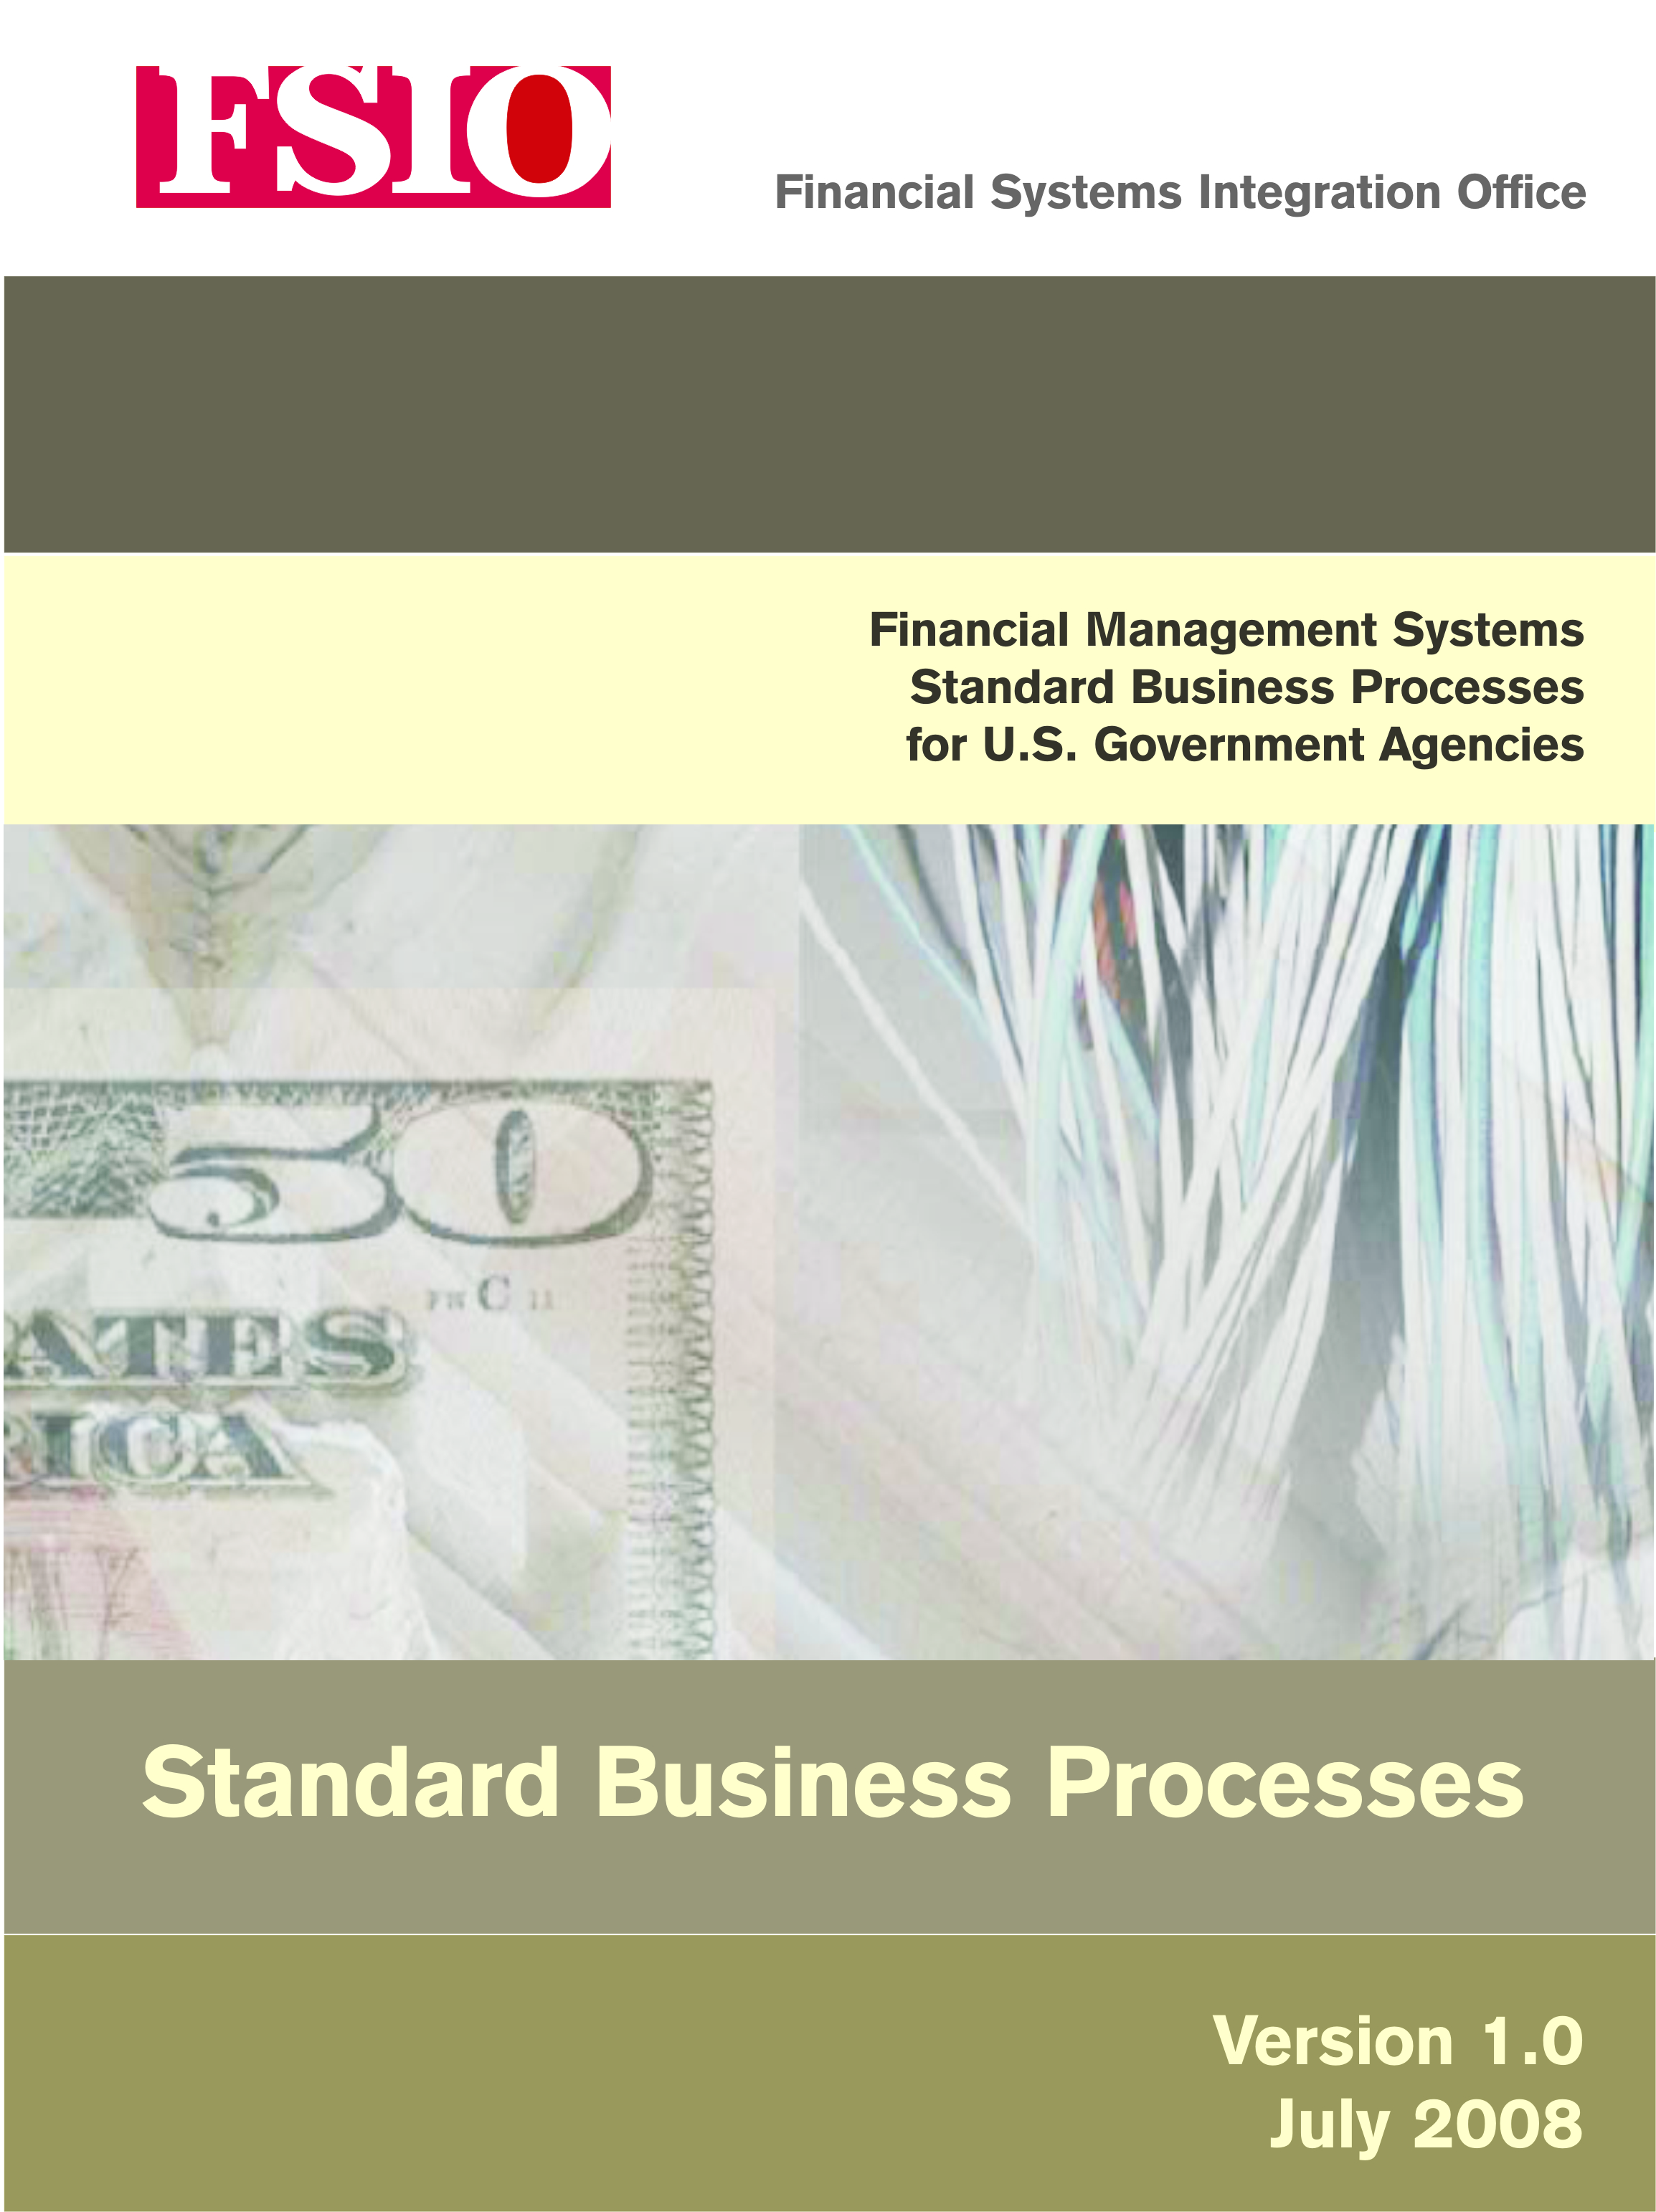

Table of Contents
Table of Contents i
Table of Figures iii
Listed Abbreviations iv
Foreword vi
Introduction 1-1
1.1. Background 1-1
1.2. Purpose and Scope of This Document 1-3
1.3. Standard Federal Financial Business Processes Within Context of Core Requirements 1-5
1.4. Summary of Standard Business Process Initiatives 1-6
Funds Management Processes 2-1
2.0 Funds Management Processes 2-1
2.1 Budgetary Authority Process 2-6
2.1.1 Budgetary Resources 2-7
2.1.2 Record Application of Budgetary Resources (Apportionment) 2-12
2.2 Funds Distribution 2-16
2.2.1 Allotment Distribution 2-16
2.2.1.1 Allotment for (Direct) Non-Anticipated, Non-Reimbursable Funding 2-17
2.2.1.2 Allotment for Anticipated Reimbursable Funding 2-20
2.2.1.3 Allotment for Anticipated Non-Reimbursable Funding 2-25
2.2.2 Sub-Allotment Distribution 2-30
2.2.3 Lower Level Distribution 2-35
2.3 Funds Control Process 2-40
2.3.1 Establishing Commitments and Obligations for Goods and Services 2-41
2.3.2 Establishing Obligations Not Requiring Commitment 2-50
2.3.3 Funds Check Prior to Obligation 2-55
2.3.4 Unexpired Funds Validation and Verification 2-59
2.3.5 Expired Funds Validation and Verification 2-65
Payment Management Processes 3-1
3.0 Payment Management Processes 3-1
3.1 Receipt and Acceptance of Goods 3-4
3.2 Receipt and Acceptance of Services 3-11
3.3 Accounts Payable and Invoicing Processes 3-18
3.3.1 Invoice Entry 3-18
3.3.2 Invoice Processing 3-25
3.3.3 Credit Memo 3-31
3.4 Disbursements 3-34
3.4.1 Disbursements for Bulk Files (ACH/EFT, CCD, CCD+. CTX, and Checks) 3-34
3.4.2 Disbursements for Small Volume and Same or Next Day Payments 3-45
3.5 Returned Payments – ACH, Check, Same Day 3-53
3.6 Data Objects and Data Elements 3-57
Receivable Management Processes 4-1
Reimbursable Management Processes 5-1
Reports Management Processes 6-1
Appendix A – FMLoB Business Approach A-1
Appendix B – FMLoB Glossary B-1
Appendix C – Business Process Flowcharts Symbols and Definitions C-1
Appendix D – Core Financial System Requirements D-1
Funds Management Core Financial System Requirements D-1
Payment Management Core Financial System Requirements D-5
Appendix E – Financial Management Laws and Regulations E-1
Appendix F - Contributors F-1

Table of Figures
Figure 1-1: Standard Federal Financial Business Process Vision/Approach 1-4
Figure 1-2: System Functions 1-5
Figure 1-3: Summary of Standard Business Process Relationships 1-7

Listed Abbreviations
ACH Automated Clearing House
ALC Agency Location Code
BETC Business Event Type Code
BRM Business Reference Model
BFELoB Budget Formulation and Execution Line of Business
CCD Cash Concentration Disbursement
CCD+ Cash Concentration Disbursement Plus Addendum
CCLR Claims Collection Litigation Report
CCR Central Contractor Registry
CFO Chief Financial Officer
CFR Code of Federal Regulations
CFSR Core Financial System Requirements
CGAC Common Government-wide Accounting Classification Structure
CIO Chief Information Officer
CO Certifying Officer
COR Contracting Officer’s Representative
COTR Contracting Officer’s Technical Representative
CPIC Capital Planning and Investment Control
CR Continuing Resolution
CTX Corporate Trade Exchange
CVFR Current Value of Funds Rate
DCIA Debt Collection Improvement Act of 1996
DEO Data Entry Operator
DUNS Dun and Bradstreet Number
EDI Electronic Data Interchange
EFT Electronic Funds Transfer
FAR Federal Acquisition Regulation
FASAB Federal Accounting Standards Advisory Board
FBWT Fund Balance With Treasury
FEA Federal Enterprise Architecture
FEAF Federal Enterprise Architecture Framework
FFMIA Federal Financial Management Improvement Act of 1996
FFMSR Financial Management Systems Requirements
FISMA Federal Information Security Management Act of 2002
FMLoB Financial Management Line of Business
FMS Financial Management Service
FOMF Financial Organization Master File
FRB Federal Reserve Bank
FSIO Financial Systems Integration Office
GAO Government Accountability Office
GPRA Government Performance and Results Act of 1993
ID Identification
IDD International Direct Deposit
IPAC Intragovernmental Payment and Collection
IPP Internet Payment Platform
IRM Information Resource Management
IRS Internal Revenue Service
IT Information Technology
JFMIP Joint Financial Management Improvement Program
NACHA National Automated Clearing House Association
NIST National Institute of Standards and Technology
OCR Optical Character Recognition
OFFM Office of Federal Financial Management (OMB)
OMB Office of Management and Budget
PMA President’s Management Agenda
PMD Payment Management Disbursing
PO Purchase Order
PPA Prompt Payment Act
PPD Pre-arranged Payment and Deposit
PPD+ Pre-arranged Payment and Deposit Plus Addendum
RTN Routing Transit Number
SFFAS Statement of Federal Financial Accounting Standards
SFFBP Standard Federal Financial Business Process
SPS Secure Payment System
TAFS Treasury Appropriation Fund Symbol
TAS Treasury Account Symbol
TFM Treasury Financial Manual
TIN Tax Identification Number
TOP Treasury Offset Program
TPA Trading Partner Agreement
TROR Treasury Report on Receivables and Debt Collection Activities
USSGL United States Standard General Ledger

Foreword
To meet the objectives of the Federal Financial Management Improvement Act of 1996 and OMB Circular A-127, Federal agencies must improve the cost, quality, and performance of Federal financial management systems by leveraging common standards, shared solutions, and implementing other government-wide reforms that foster efficiencies in Federal financial operations. Critical to these efforts is the definition and implementation of standard business processes for core financial management functions across government. Through standardization, Federal entities are better positioned to implement lower cost, lower risk, and higher performing financial management solutions.
The Standard Federal Financial Business Processes (SFFBP) Document is designed to standardize common financial business activities and processes to ensure that financial managers assess programs and make decisions with timely and accurate data. This publication was developed for the Federal financial community, vendors who support financial management system implementations, and contractors of financial management system products in full cooperation with the Chief Financial Officer (CFO) Act Agencies, and other contributors.
Financial Systems Integration Office

The Financial Systems Integration Office (FSIO) within the General Services Administration (GSA) supports government-wide financial management activities. FSIO is the successor organization to the Joint Financial Management Improvement Program (JFMIP), authorized under the Administrative Procedures Act of 1950. In December 2004, Program Management office roles and responsibilities of JFMIP were modified and transferred to FSIO. OMB and the Chief Financial Officers Council, working closely with the Federal financial management community, established FSIO to manage:
- Core financial systems requirements development, testing and product certification;
- Priority projects supporting the Federal financial community; and
- Outreach through an annual financial management conference and other related activities.
For more information, visit the FSIO website at http://www.fsio.gov

- Introduction

Background

Over the years, the Federal government has committed significant resources toward implementing Federal financial management systems that meet its needs for timely, useful, and reliable financial information. Agencies are making progress, but additional improvement is needed. To facilitate the move toward modern financial systems, standardizing financial management was identified as one of several government-wide initiatives to improve the management of the Federal government.
The financial management standardization initiative leverages shared solutions and technology investments across government by integrating agency operations and information technology investments by normalizing the underlying business processes of Federal agencies. OMB Circular A-127 prescribes policies and standards for executive departments and agencies to follow in managing financial management systems. A core financial system within the financial management system must be commercial off-the-shelf and certified by the Financial Systems Integration Office (FSIO). Previously, agencies had to implement systems that had been certified by FSIO as meeting the Core Financial System Requirements, but could configure those systems to support their agency-specific business processes. In the future, the certification process will include both the Core Financial Systems Requirements and the Standard Financial Processes (as defined in this document). Shared Service Providers will subsequently implement the FSIO tested and certified software which will include CGAC and the standard business processes and will be released as the Federal configuration.
One of the measures of success for this initiative is to implement financial management processes and systems that comply with the Federal Financial Management Improvement Act of 1996 (FFMIA). FFMIA requires that agency systems comply with: Federal financial management system requirements, applicable accounting standards, and United States Standard General Ledger (USSGL) at the transaction level.
In the short term, the standardization effort will help agencies:
- Promote a universal understanding of standard government financial business processes. Establishing standard financial business processes for Federal agencies promotes a uniform way of doing the government’s financial business. The defined processes and data no longer will vary from agency to agency or system to system. Use of standard financial business processes reduces training and start-up time for agency financial personnel transferring from one agency to another. Standard processes make it easier for managers to determine where controls need to be placed or implemented in the processing of accounting events.
- Incorporate best business practices. A number of agencies are in the process of moving from bureau-level systems to enterprise-wide systems. Each implementation begins with a task of defining the processes used within the agency. Standard business processes provide a uniform framework, reduce the burden of making decisions on how to conduct business, and facilitate the implementation process.
In the long term, the standardization effort will help agencies:
- Aid in the evolution of financial management throughout the Federal government. There is a logical sequence of steps to an overall standardization strategy for Federal financial management that includes common business processes, data definitions, and accounting classification elements. The standard government financial business processes are building blocks to a future state that will take a number of years to implement.
- Mitigate the risks associated with system implementation by providing a uniform starting point for configuration. FSIO certified vendors will provide a Core Financial System that not only incorporates the Standard Federal Financial Business Processes (SFFBP) (as defined in this document), but also includes the system configuration that was used to complete and pass the certification test. This pre-configured software will significantly reduce the time and effort it takes an agency to implement the Core Financial System, as well as minimize the risk of an incorrect configuration that could result in the inoperability of the Core Financial System.
- Ease the transition when an agency moves to a new financial management system or shared service provider. Considerable effort is usually dedicated to defining business processes when an agency moves to a new Core Financial System. The SFFBP establish uniform procedures that will be used across the Federal government. The use of these standard processes will significantly reduce the amount of process mapping and training that will be required when migrating to a new Core Financial System.
- Facilitate data exchange among an agency’s financial systems. The SFFBP are an integral step towards establishing standard data exchanges (interfaces) between an agency’s Financial Management System, which contains the Core Financial System, and an agency’s mixed systems (feeder systems). An additional benefit of the SFFBP is establishment of standard data exchanges (interfaces) between an agency’s Financial Management System and the central agencies for external regulatory reporting, e.g., Treasury Financial Management Service (FMS).
The Standard Business Processes Document encompasses applicable established financial standards used in the Federal government. The policy and governance for classifying the financial effects of the government’s business operations are as follows:

- Office of Management and Budget (OMB), including the Office of Federal Financial Management (OFFM), Circulars, Bulletins and Memorandums;
- Department of the Treasury, Treasury Financial Manual (TFM), including the USSGL and Managing Federal Receivables Guidance;
- Financial Systems Integration Office (FSIO) on behalf of the FSIO Transformation Team, a working-group of the Chief Financial Officers (CFO) Council, Core Financial Systems Requirements Document;
- Federal Accounting Standards Advisory Board (FASAB) Statements of Federal Financial Accounting Standards (SFFAS) and Concepts Implementation Guides; and
- Government Accountability Office (GAO) Auditing Standards.
Policies, procedures, and requirements detailed in authoritative guidance are not repeated in this document, rather they are cited as they apply to specific steps within the processes.

Purpose and Scope of This Document
This document presents government-wide common processes and activities, standard business rules, and data exchanges for core financial business processes. Standardizing business processes across the Federal government identifies opportunities to streamline processes and unify work across the agencies and within the Federal government’s financial management domain. The outcome will be a more citizen-centered, customer-focused government that maximizes technology investments to better achieve mission outcomes.
The Standard Federal Financial Business Processes (SFFBP) include:
- Sequenced activities for core business processes;
- Business rules governing the process steps;
- Data elements and definitions related to these business processes (e.g., information contained on an obligation – document source, document number, item number, price per item); and
- Relationships among the data elements as they exist in the actual business activities.

The SFFBP document is intended for use by the Federal financial management community to provide guidance for implementing efficient business processes that are consistent throughout the Federal government. Primary users will include accountants, budget analysts, financial and program staff, software vendors, and contractors who support financial management system implementations.
This document supports the financial management standardization vision as part of the standardization foundation, as highlighted in the following diagram.

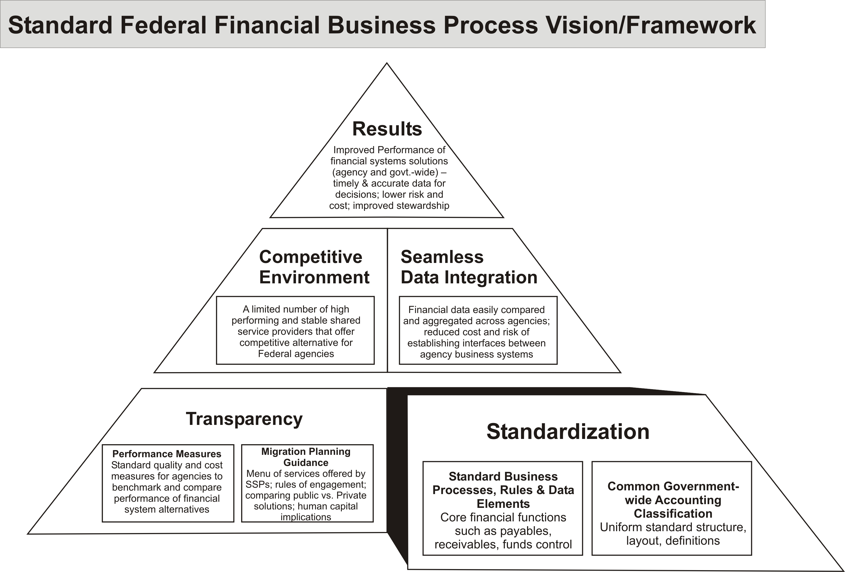
Figure 1-1: Standard Federal Financial Business Process Vision/Approach
The subsequent chapters in this document describe the business process flows for core financial business processes, the associated business rules, along with representative USSGL pro-forma entries for the process described. The document will also provide the standard data elements and business rules for the harmonized exchange of data between the common administrative systems (e.g., Grants, Acquisitions, Travel, and Payroll) and the core financial system.
Appendices include the financial management standardization vision and approach to developing SFFBP, a glossary of standard terms and definitions used in this document, a list of relevant laws and regulations affecting Federal financial management and standard business processes, and acknowledgement of those who contributed to this document.

Standard Federal Financial Business Processes Within Context of Core Requirements

Among the Federal Financial Management System Requirement (FFMSR) documents is the Core Financial System Requirements. It sets forth requirements for the core functions that must be supported in all Federal financial management core systems. The core system functions are as follows:

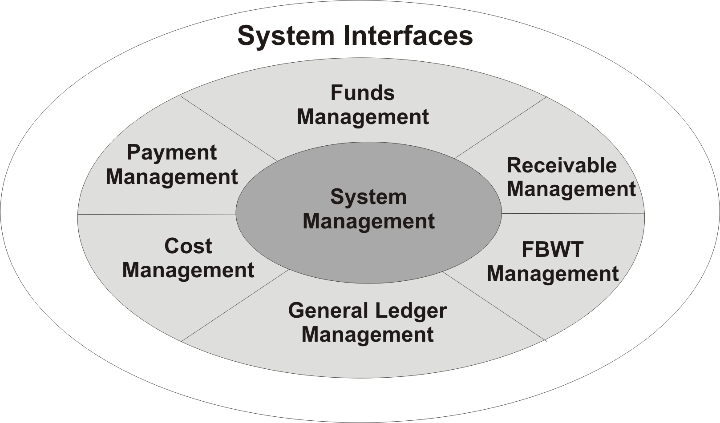

Figure 1-2: System Functions

Core financial systems provide specific functional capabilities necessary for managing a general ledger, controlling spending, making payments, managing receivables, measuring costs, reconciling the agency’s Fund Balance with Treasury, and reporting in the Federal environment.

The financial management standardization effort has identified the following business processes for standardization:
- Funds Management;
- Payment Management;
- Receivables Management;
- Reimbursables (which actually crosses all of the above processes); and
- Reporting.

Summary of Standard Business Process Initiatives
The financial management standardization effort includes four business processes: Funds Management, Payment Management, Receivables Management, and Reimbursables Management. The business processes are presented in chapters, which depict their respective processes in flowcharts. Following each flowchart are descriptions of the processes, steps and related business rules. The standard process steps reflect best practices in an electronic environment, sound internal controls, and compliance with Office of Federal Financial Management (OFFM) Core Financial System Requirements (CFSR).

The chapters of the financial management standardization business process document are described as follows:
- Funds Management. This chapter includes processes related to the establishment of budgetary authority, funds distribution and funds control. The Funds Management processes describe the recording of the Apportionment and Reapportionment Request (SF 132) and assist agencies in complying with all applicable financial management statutes, regulations, and requirements. In addition, the steps outlined provide standard processes for ensuring effective Funds Control policy.

- Payment Management. This chapter includes processes from requisition to payment for commercial contracts and small acquisitions disbursed by Treasury. The Payment Management processes described include goods/services receipt and acceptance, invoice entry and processing, and disbursement. The processes are written assuming best practices, which include, but are not limited to: electronic processing, information routing, review and approval, and separation of duties. In addition, the standard processes included ensure effective cash management.

- Receivables Management. The Receivables Management processes were developed in accordance with Treasury’s Managing Federal Receivables guidance. The chapter includes processes from establishment of a receivable due from the public to the application of receipts. The Receivables Management processes described include establishment and analysis of receivable, including billing and collection activities. The processes are written assuming best practices, which include, but are not limited to: cost effective debt collection and performance measures. In addition, the standard processes included ensure: customer responsiveness and effective cash management.

- Reimbursables Management. Development of this chapter is not yet complete and will be included in a future release. Note: This process contains elements of the Funds Management, Payment Management and Receivables Management processes.

- Reports. Development of this chapter is not yet complete and will be included in a future release. The format of this chapter has not been determined.
The diagram below depicts Payment Management, Receivables Management, and Reimbursables Management as processes within the Core Financial System under the parameters of Funds Management that are facilitated through the use of the Common Government-wide Accounting Classification structure. Reporting is used throughout the Core Financial System to provide management with accurate and timely information needed to support business decisions, financial statements and effective program operation.

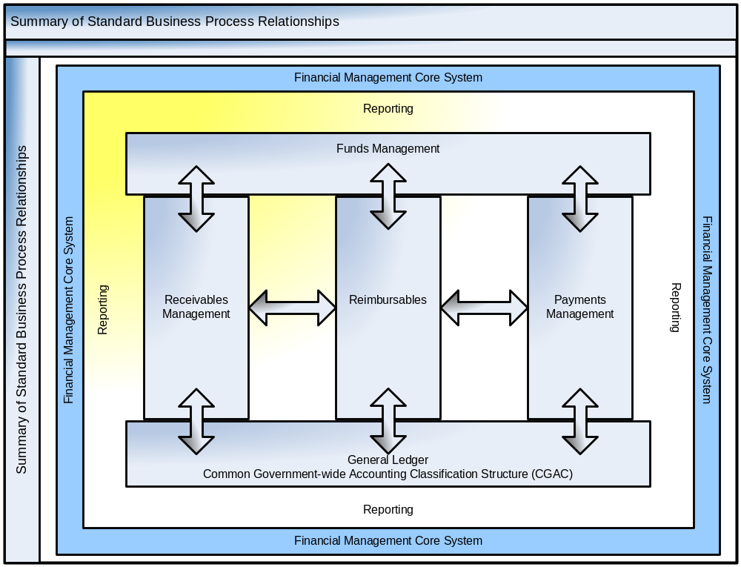

Figure 1-3: Summary of Standard Business Process Relationships
See Appendix C – Business Process Flowcharts, Symbols, and Definitions for an enlarged version of the flowchart

- Funds Management Processes

Funds Management Processes
A strong Funds Management mechanism ensures that Federal dollars are managed properly in the operation of all Core Financial Systems and provides an acceptable level of accountability. The Antideficiency Act requires that the head of each executive agency, subject to the approval of the President, prescribe by regulation a system of administrative control not inconsistent with accounting procedures. The system shall be designed to:
- Restrict obligations and payments from each appropriation or fund account to the lower of the amount provided in the account (31 USC 1341) or amount of the apportionment or reapportionment (31 USC 1514); and
- Enable the head of the agency to fix responsibility for an obligation or payment exceeding the amount provided in the account or the apportionment.
The President delegated this authority to the Director of the Office of Management and Budget (OMB). OMB issues instructions on the administrative control of funds in OMB Circular A-11. The terminology in OMB Circular A-11 shall be used in the Funds Management processes.
When an appropriation bill is enacted into law, funds are not automatically made available to agencies. The Antideficiency Act requires that OMB subdivide the appropriation and any other budgetary resources. OMB uses the apportionment and sub-apportionment schedule (SF 132) to review and subdivide the appropriation. This is intended to promote prudent fiscal management by preventing agencies from spending all available resources before the end of the fiscal year.
Apportionment requests are submitted to OMB by the agencies on an SF 132, “Apportionment and Reapportionment Schedule.” OMB reviews the requests and takes action. The Standard Form (SF) 132 has two sections: The first, Budgetary Resources, details the amounts available to the agency. The second, Application of Budgetary Resources, displays how the agency intends to use the resources: Category A (quarterly); Category B (by program); and Category C (planned for obligation after the current fiscal year). Please note that Apportionments are updated throughout the year. The SF 132 is a key legal document. It represents the President’s disposition of available resources within an appropriation of fund account.
Apportionments establish legal spending limits for the appropriation. These spending limits must be reflected in the Core Financial System so that the spending limitations can be enforced systematically. Entering these spending limits into the Core Financial System can be accomplished by Budget and/or Finance personnel as defined within an agency.
The approved SF 132 becomes the basis for funds control within the agency. However, agencies can further subdivide budgetary resources to lower levels of the organization.
Prior to making these internal subdivisions, agencies typically review their planned resource situation for the upcoming year. The result is a blueprint (sometimes called “operating plan”) for use of the available resources.
The Funds Management processes provide safeguards that ensure the distribution, obligation, and payments of funds within budgetary limitations. Specifically, these processes verify the availability of:
- Allotted and suballoted funds for commitment;
- Committed, allotted, and suballotted funds for obligations; and
- Obligated, allotted and suballoted funds for payment (cash outlay).

The Funds Management processes described in this chapter are intended to detail the funds control placed on the amounts located on lines 1 thru 12 of the SF 132 and to assist agencies in complying with all applicable financial management statutes, regulations, and requirements. In addition, the steps outlined in this document provide standard processes for ensuring effective Funds Control policy.
The flowcharts and process steps for the Funds Management Processes detailed in this chapter are:
- FM 2.1 - Budgetary Authority Process
- FM 2.1.1 - Budgetary Resources. This section describes the recording of lines 1 thru 6 of the SF 132 in the Core Financial System. Once recorded in the Core Financial System, these budgetary resource amounts are available for the recording of apportionments.
- FM 2.1.2 - Record Application of Budgetary Resources (Apportionment). This section describes the recording of lines 8 thru 11 of the SF 132 in the Core Financial System. Once recorded in the Core Financial System, these amounts may be further sub-divided by an agency into allotments, sub-allotments and any other lower level distribution of funds.
- FM 2.2 - Funds Distribution
- FM 2.2.1 - Allotment Distribution
- FM 2.2.1.1 - Allotment for (Direct) Non-Anticipated, Non-Reimbursable Funding. This section addresses the allotment process for direct or non-anticipated, non-reimbursable resources. Obligations or expenditures cannot be incurred until an allotment is made by the agency.
- FM 2.2.1.2 - Allotment for Anticipated Reimbursable Funding. This section addresses the allotment process for anticipated reimbursable funding. Obligations cannot be incurred if reimbursable work is performed on behalf of a non-federal customer until an advance is received or working capital is provided.
- FM 2.2.1.3 - Allotment for Anticipated Non-Reimbursable Funding. This section addresses the allotment processes for anticipated non-reimbursable resources. Anticipated amounts are not available for reuse until they are actually recovered. Offsetting collections are typically credited directly to expenditure accounts where they are generally available for obligation and outlay; however, any type of spending is prohibited unless there is cash on hand.
- FM 2.2.2 - Sub-Allotment Distribution. This section addresses the sub-allotment process for allotted resources; however, this process is not required and is optional based upon agency practice. If sub-allotments are used by an agency, obligations or expenditures cannot be incurred until a sub-allotment is made by the agency.
- FM 2.2.3 - Lower Level Distribution. This section addresses the lower level of budgetary distribution, which may be referred to as: allocations, sub-allocations, allowances, sub-allowances, or spending/operating plans. The lower level budgetary distributions are often based on program, projects, or organization/office and contribute to the administrative control of funds.
- FM 2.3 - Funds Control Process
- FM 2.3.1 - Establishing Commitments and Obligations for Goods and Services. This section describes the procedures necessary to prepare an obligation, for acquisitions or services, which has associated prior commitment accounting.
- FM 2.3.2 - Establishing Obligations Not Requiring Commitment. This section describes the procedures necessary to prepare an obligation for acquisitions that does not require commitment accounting.
- FM 2.3.3 - Funds Check Prior to Obligation. This section applies to acquisitions for which commitments and obligations are used and describes the procedures taken when performing a funds check prior to obligation of funds.
- FM 2.3.4 - Unexpired Funds Validation and Verification. This section addresses the process of validating and verifying the availability of funds for spending transactions.
- FM 2.3.5 - Expired Funds Validation and Verification. This section addresses the process of validating and verifying the availability of expired funds for the recording of previously unrecorded obligations and/or to make legitimate update adjustments to existing obligations until the expired authority is cancelled and the expired account is closed.

Note: The Focus Group for this effort decided that Treasury Warrants would not be included in this document, as they are, in effect, a verification of the appropriation (a Treasury FACTS II edit) and not an integral element of Funds Control.
Included in the scope of this chapter are the following:
- The Budgetary Resources (process of recording an agency’s budgetary resources to support the establishment of available funding) and Funds Distribution (the process of establishing the available funds within the Core Financial System (see OMB Circular A-127 for the definition of a Core Financial System)) which are used for funds validation and verification.
- The Funds Management business process standards enforce the distribution, obligation and payment of funds within budgetary limitations as established through the funds execution processes.
The following flowchart depicts the sequence and inter-relations of the Funds Management processes:
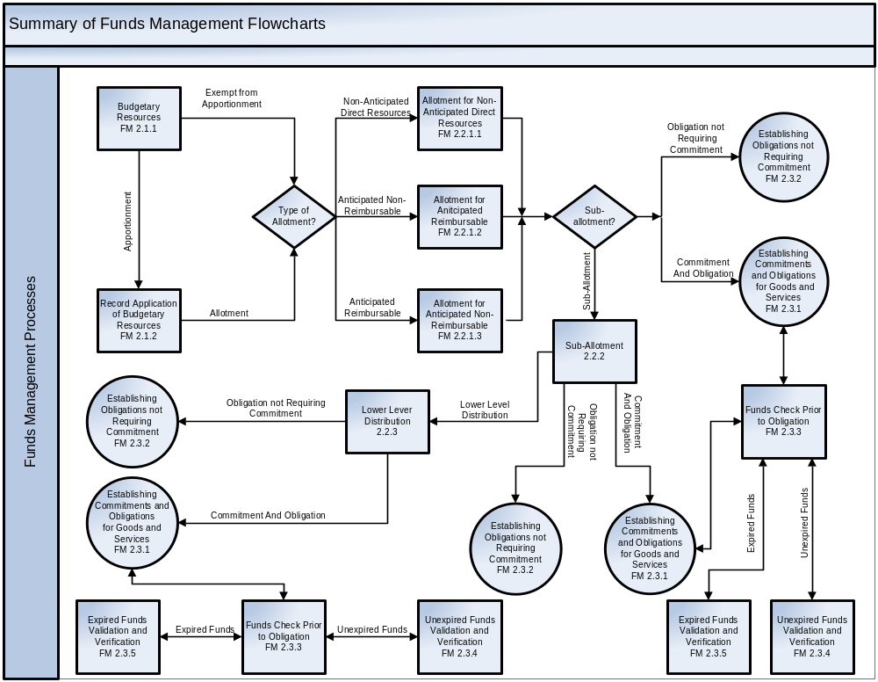

Budgetary Authority Process
Establishing budgetary authority is the beginning of the budget execution process. This process records an agency’s budgetary resources and supports the establishment of legal budgetary limitations within the agency, including appropriation warrants, apportionments, reapportionments, transfer allocations and continuing resolutions. It also supports the establishment of funding to agencies that are not subject to apportionment.
This section documents the recording of the apportionment and reapportionment request (SF 132) information in the Core Financial System in order to establish budgetary resources and the divisions of amounts per the Apportionment Schedule.
Budgetary resources are made available as follows:
- Apportionment of unobligated balances carried forward and available to the Treasury Appropriation Fund Symbol (TAFS). This is approved on an SF 132 from OMB.
- Apportionment of amounts made available under an interim Continuing Resolution (CR). This approval is issued by an OMB Bulletin and may be followed subsequently by an SF 132 from OMB.
- Apportionment of amounts made available under a regular annual appropriations act. This is automatically apportioned by authority cited in OMB Circular A-11 upon enactment and is followed by an SF 132 from OMB.
An agency’s Budget Office, or the CFO in concurrence with the Budget Office, will issue official documentation that will be used to establish budgetary resources (e.g., enacted appropriations, anticipated resources, prior year recoveries) as well as apportionment divisions. This official documentation may be in the form of an actual approved SF 132, an agency internal “mock” SF 132, a CR letter, or a resources letter. The form of official documentation will be dependent upon an agency’s internal policies and procedures. However, the intentional use of the ‘agency internal official document’ is to establish the resources and controls that support the distribution of funding in the agency’s Core Financial System.
Budget Authority is recorded in the Core Financial System for multiple uses:
- To establish availability of budgetary resources for use by agency program offices to obligate and expend in support of agency missions; and
- Once the appropriate distribution has been recorded in the Core Financial System, funds control verification can be performed on any spending chain transaction, i.e., commitment, obligation and payment.

Budgetary Resources
The Budgetary Resources process illustrates the recording of resources as defined on lines 1 thru 6 of the SF 132. Examples of resources recorded are: enacted appropriations; spending authority from offsetting collections; and recoveries of prior year obligations.
When agencies establish budgetary resources in their financial system, they typically employ use of an internal fund code, the agency-assigned code value for a fund. It enables the derivation of other accounting classification elements used to further classify funds. The internal fund code may be used to derive the account identification codes required for reporting externally to Treasury and OMB. The Common Government-wide Accounting Classification (CGAC) structure establishes several standard practices for segregating three types of internal funds below the Treasury Account Symbol (TAS) level:
- Funds that have multiple apportionment categories;
- Funds that have both discretionary and mandatory authority; and
- Funds that have both direct and reimbursable authority.
For guidance on CGAC, see FSIO’s Federal Financial Management Standards, Common Government-wide Accounting Classification Structure.
Once recorded in the Core Financial System, these budgetary resource amounts are then available for the recording of apportionments.
Note: “Certify” as used in this process is defined as “review and approve”.

FM 2.1.1 – Budgetary Resources Flowchart
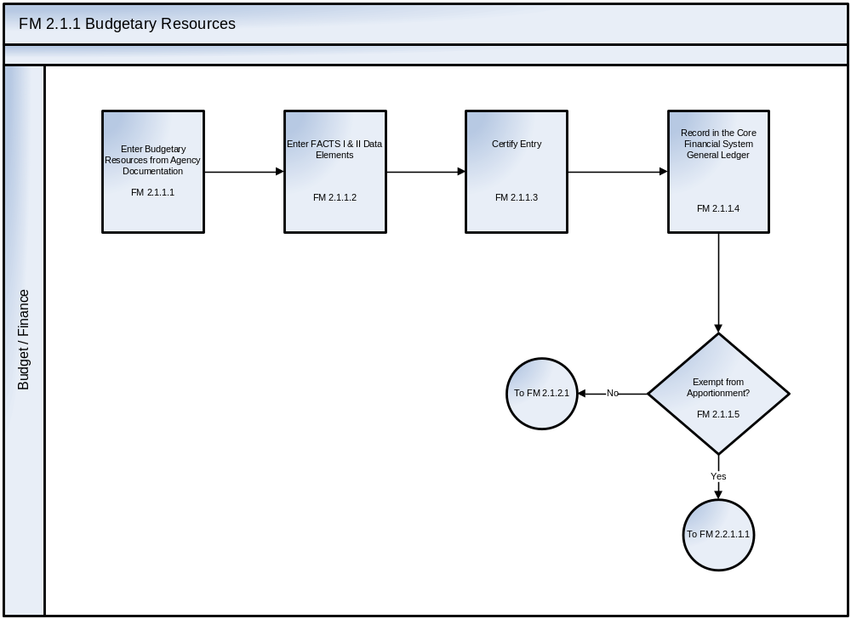

See Appendix C – Business Process Flowcharts, Symbols, and Definitions for an enlarged version of the flowchart
The Funds Management Budgetary Resource process steps are described as follows:
Step ID | Step Name | Step Description | Business Rules | CFSR Req.
FM 2.1.1.1 | Enter Budgetary Resources from Agency Documentation | Enter Budgetary Resources in the Core Financial System at the United States Standard General Ledger (USSGL) level and to record FACTS II attributes to begin the chain of monitoring resources. | Enter the budgetary resource breakdowns prescribed by OMB CIRCULAR A-11 for the SF 132 or official documentation (e.g., carryover, enacted appropriation, anticipated resources, and contract authority).  Official documentation from the Budget or CFO Office may take the form of a CR letter, actual or mock SF132, resource letter or other such official agency documentation. | FMC-01  FMC-03  FMC-07  FMC-08  FMC-09
FM 2.1.1.2 | Enter FACTS I & II Data Elements | Enter appropriate attributes and domain values for applicable USSGL accounts as they relate to resources recorded (e.g., public law, supplemental appropriation). | Only the FACTS II attributes not inherent in the internal fund code are entered.  Appropriate edits and validation rules have been configured for current USSGL crosswalks. | GLC-02  GLC-03  SMB-01
FM 2.1.1.3 | Certify Entry | After budgetary resource(s) are entered into the system, approval must be performed by appropriate personnel. | This step ensures a separation of duties for review and approval of transaction prior to recording in the General Ledger. | TLE-01  TLE-02  TLE-03  TLE-04  TLE-06  TLE-07  TLE-08
FM 2.1.1.4 | Record in the Core Financial System General Ledger | After the budgetary resource(s) are entered into the system and approved by appropriate personnel, the transaction is recorded in the Core Financial System General Ledger. | The budgetary resource entries are recorded using the USSGL Account Transaction Listing provided in the current Treasury Financial Manual (TFM).  Examples include, but are not limited to, the following transaction codes from the current TFM:  TFM-A104 To record the enactment of appropriations.  TFM-A702 To record anticipated reimbursements.  TFM-A138 To record estimated recoveries of prior-year obligations.  Note: If a reversing entry is being recorded, internal checks and edits must ensure that the net amount (e.g., original amount +/- any prior adjustments) is greater than or equal to zero. Reversals can never exceed the total amount recorded for the pro forma transaction code referenced in the original transaction(s). | GLB-01  GLC-01  GLC-05  GLC-07
FM 2.1.1.5 | Exempt from Apportionment? | Check to see if the budgetary resource is exempt from Apportionment. | Internal agency documentation would include a list of agency funds that are exempt from Apportionment.  Verify that this list of agency funds that are exempt from Apportionment is always consistent with OMB’s list.

Record Application of Budgetary Resources (Apportionment)

The Apportionment process documents the recording of the amounts from lines 8 thru 11 of the SF 132, “Application of Budgetary Resources”. The apportionment divides amounts that are available for obligation by specific time periods (typically by quarters, but could be for an entire fiscal year), activities, projects, object classes or a combination thereof. The apportionment may be further sub-divided by an agency into allotments, sub-allotments and any other lower level distribution of funds.
Note: “Certify” as used in this process is defined as “review and approve”.
FM 2.1.2 – Record Application of Budgetary Resources (Apportionment) Flowchart
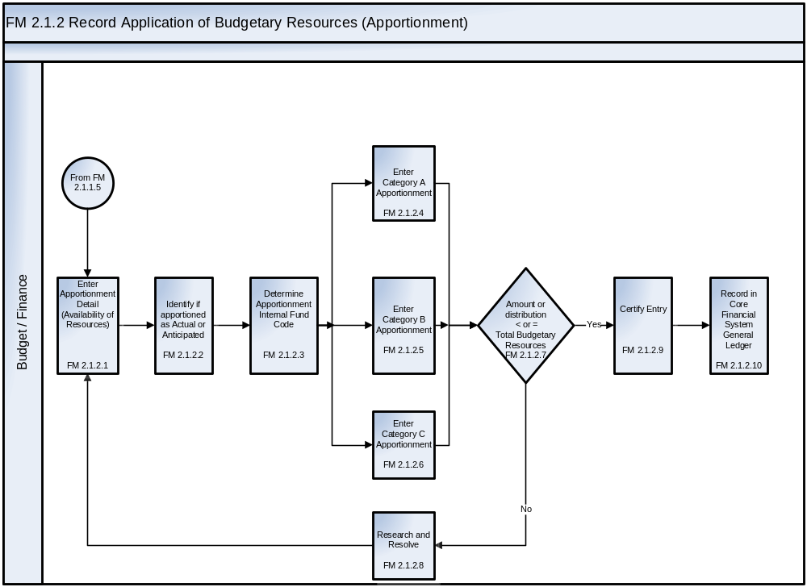
See Appendix C – Business Process Flowcharts, Symbols, and Definitions for an enlarged version of the flowchart.
The Record Availability of Resources process steps are described as follows:
Step ID | Step Name | Step Description | Business Rules | CFSR Req.
FM 2.1.2.1 | Enter Apportionment Detail (Availability of Resources) | Record lines 8 thru 11 of the SF 132. | The budgetary resource authority apportioned by OMB and available for allotment entries are recorded using the USSGL Account Transaction Listing provided in the current TFM.  The anticipated resources apportioned but not available for use until they are realized for anticipated resources in programs subject to apportionment entries are recorded using the USSGL Account Transaction Listing provided in the current TFM. | FMC-01  FMC-04  FMC-07  FMC-08  FMC-09  FMC-13
FM 2.1.2.2 | Identify if apportionment as Actual or Anticipated | User identifies the resource as Actual or Anticipated. If apportionment is anticipated, check whether resource is realized yet.
FM 2.1.2.3 | Determine Apportionment Internal Fund Code | User enters the internal fund code for the apportionment. The accounting classification elements are typically derived not entered. |  | FMC-04  GLC-02  GLC-03
FM 2.1.2.4 | Enter Category A Apportionment | Enter apportionment by fiscal quarter. | Category A apportionments are entered by fiscal quarter only with no further breakdown. Per OMB Circular A-11 instructions for section 1208, Category A apportionments distribute budgetary resources by fiscal quarter.
FM 2.1.2.5 | Enter Category B Apportionment | Enter apportionment by period. | Category B apportionments are entered by activity, beginning and end date, program, project, and object class as applicable. | SMA-03
FM 2.1.2.6 | Enter Category C Apportionment | Enter apportionment to be available in future fiscal year. | Enter as available in future fiscal year.  Note: OMB designates Category C as apportioned for future use.
FM 2.1.2.7 | Amount or distribution less than or equal to Total Budgetary Resources? | Is the budgetary resource less than or equal to total budgetary resources previously recorded? | Verify that this amount is less than or equal to Line 7 (Total Budgetary Resources) of the SF132.  For a reversal entry, verify that the amount of the reversal does not exceed the credit balance in USSGL accounts 4510 - Apportionments/ 4590 – Apportionments Unavailable. | SMB-11  SMB-12  SMB-13  SMC-09
FM 2.1.2.8 | Research and Resolve | Budget/Finance will resolve the funding issue. | Designated personnel resolve applicable funding issues in accordance with applicable rules, regulations, and agency guidelines. | SMB-16  SMC-09
FM 2.1.2.9 | Certify Entry | After the budgetary resource is entered into the system, it has to be approved by appropriate personnel. | This step ensures a separation of duties for review and approval of transaction prior to recording in the General Ledger. | SMC-09  TLE-01  TLE-02  TLE-03  TLE-04  TLE-06  TLE-07  TLE-08
FM 2.1.2.10 | Record in Core Financial System General Ledger | After the budgetary resource is entered into the system and approved by appropriate personnel, the transaction is recorded in the General Ledger. | After the entry passes validation edits, the applicable entry is recorded.  Examples include, but are not limited to, the following transaction codes from the current TFM:  TFM-A116 To record budgetary authority apportioned by OMB and available for allotment.  TFM-A118 To record anticipated resources apportioned but not available for use until they are realized for anticipated resources in programs subject to apportionment. | GLB-01  GLC-05  GLC-07

Funds Distribution

Funds distribution is the part of the budget execution cycle in which legally apportioned resources are distributed within an agency to support missions, programs, and other objectives. The process establishes multiple levels of budgetary control by allotting and sub-allotting apportioned resources for agency management.

Allotment Distribution
An Allotment is an authorization within an agency (either from the agency head or some other authorized individual) to lower levels of the organization to incur obligations or make expenditures within a specified amount. An agency would make these allotments in accordance with the general apportionment requirements as stated in OMB Circular A-11. The allotment would also be within the limitations established as a part of recording the apportionment in the Core Financial System in order to comply with the Antideficiency Act, which prohibits incurring any obligation or making any expenditure in excess of an apportionment or reapportionment. This section describes the distribution of funds as a part of the allotment processes for:

2.2.1.1 (Direct) Non-Anticipated, Non-Reimbursable funding;
2.2.1.2 Anticipated Reimbursable funding; and
2.2.1.3 Anticipated Non-Reimbursable funding.

2.2.1.1 Allotment for (Direct) Non-Anticipated, Non-Reimbursable Funding
Non-Anticipated, Non-Reimbursable funding refers to those resources that are directly appropriated through Congress and are prescribed in both OMB Circular A-11 and the USSGL portion of the Treasury Financial Manual. Specifically, obligations or expenditures cannot be incurred until an allotment is made by the agency. An Allotment Advice or Advice of Allotment document is the vehicle for the Program offices and/or other internal administrative organization structure of available funding.

Note: “Certify” as used in this process is defined as “review and approve”.
FM 2.2.1.1 – Allotment for (Direct) Non-Anticipated, Non-Reimbursable Funding Flowchart
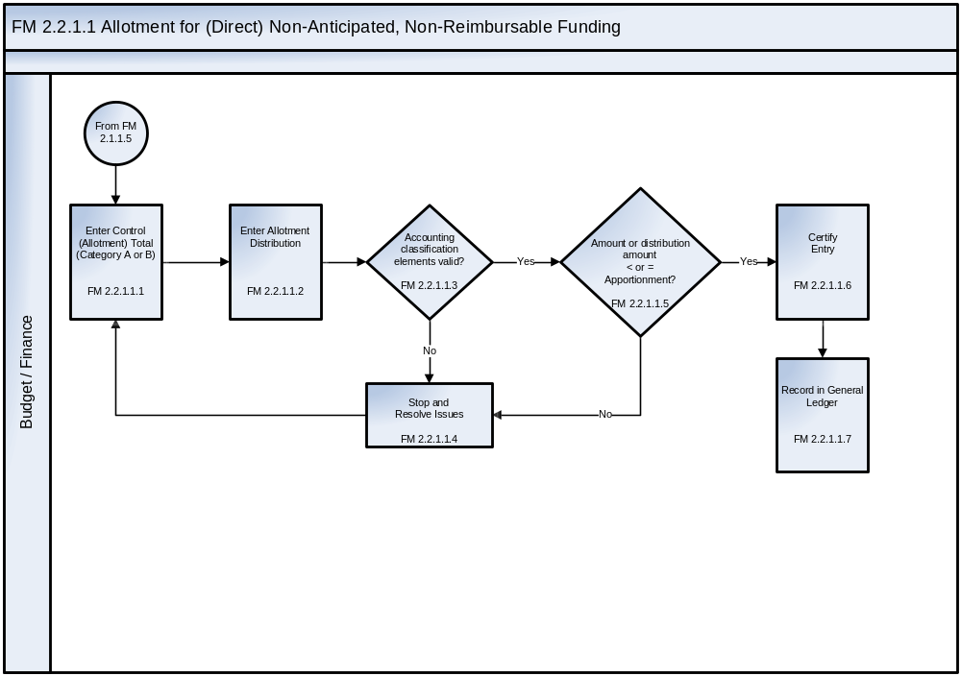
See Appendix C – Business Process Flowcharts, Symbols, and Definitions for an enlarged version of the flowchart.
The Allotment for Direct Resources process steps are described as follows:
Step ID | Step Name | Step Description | Business Rules | CFSR Req.
FM 2.2.1.1.1 | Enter Control (Allotment) Total (Category A or B) | Use official requests (i.e., allotment advice) to create allotment and enter control (allotment) total.  The control total is often at the header level of the record and is established to validate the line level entries. | Record control total, then distribute as necessary. | SMB-25
FM 2.2.1.1.2 | Enter Allotment Distribution | Enter Allotment to be distributed. |  | FMD-01
FM 2.2.1.1.3 | Accounting classification elements valid? | Reference appropriate accounting classification elements. | Verify combinations of accounting classification elements are valid and active. | CGAC  Compliance  SMA-03  SMB-11  SMB-12  SMB-13  SMB-30  SMC-09
FM 2.2.1.1.4 | Stop and Resolve Issues | If the accounting classification elements are not valid, Budget/Finance will resolve the issue. | Designated personnel resolve applicable issues in accordance with applicable rules, regulations, and agency guidelines. | SMB-16  SMC-09
FM 2.2.1.1.5 | Amount or Distribution less than or equal to the Apportionment? | Determine if the amount or distribution is less than or equal to the Apportionment. This is the Antideficiency check. | Agencies are required to control funds at a detail level (line 8 on SF 132).
FM 2.2.1.1.6 | Certify Entry | After the allotment(s) are entered into the system, it has to be approved by appropriate personnel. | This step ensures a separation of duties for review and approval of transaction prior to posting to the General Ledger. | SMC-09  TLE-01  TLE-02  TLE-03  TLE-04  TLE-06  TLE-07  TLE-08
FM 2.2.1.1.7 | Record in General Ledger | After the budgetary resource is entered into the system and approved by appropriate personnel, the transaction is recorded in the General Ledger. | After the entry passes validation edits, the applicable entry is recorded.  Examples include, but are not limited to, the following transaction codes from the current TFM:  TFM-A116 To record budgetary authority apportioned by OMB and available for allotment.  TFM-A118 To record anticipated resources apportioned but not available for use until they are realized for anticipated resources in programs subject to apportionment. | GLB-01  GLC-05  GLC-07

2.2.1.2 Allotment for Anticipated Reimbursable Funding
The recording of reimbursable resources is prescribed in both OMB Circular A-11 and the USSGL portion of the Treasury Financial Manual. Specifically, obligations cannot be incurred if reimbursable work is performed on behalf of a non-federal customer until an advance is received or working capital is provided by law. An anticipated reimbursable is recognized by the performing agency (seller) when a future order from a buying agency is reasonably expected. The basis of an anticipated reimbursable is the seller’s reasonable expectation rather than the existence of a valid order at the time the buyer’s expectation is realized.

After a valid order is received from the Federal buying agency (customer), the performing agency (seller) may incur obligations against the order if the order is valid—i.e., the performing agency receives a signed agreement from the Federal ordering agency and the Federal ordering agency has recorded an obligation in the amount of the order against its budgetary resources in the form of an undelivered order in the ordering agency's account.

The Allotment for Anticipated Reimbursable Funding process flow and corresponding step descriptions and business rules incorporate best business practices in order to verify and validate the following:

- Allotments for reimbursable activity should not be made unless appropriate obligation authority has been received, i.e., an accepted order or agreement from the Federal customer(s); and
- Total reimbursable allotments, in accounting terms, should not be greater than the total of unfilled customer orders recorded during the fiscal year to date (e.g., debits in USSGL accounts 4221 – Unfilled Customer Orders without Advance, 4222 – Unfilled Customer Orders with Advance, 4251 – Reimbursements and Other Income Earned – Receivable, and Reimbursements and Other Income Earned - Collected).

An Allotment Advice or Advice of Allotment document is the vehicle for informing the Program offices and/or other internal administrative organization structure of available funding.

Note: “Certify” as used in this process is defined as “review and approve”.

FM 2.2.1.2 – Allotment for Anticipated Reimbursable Funding Flowchart
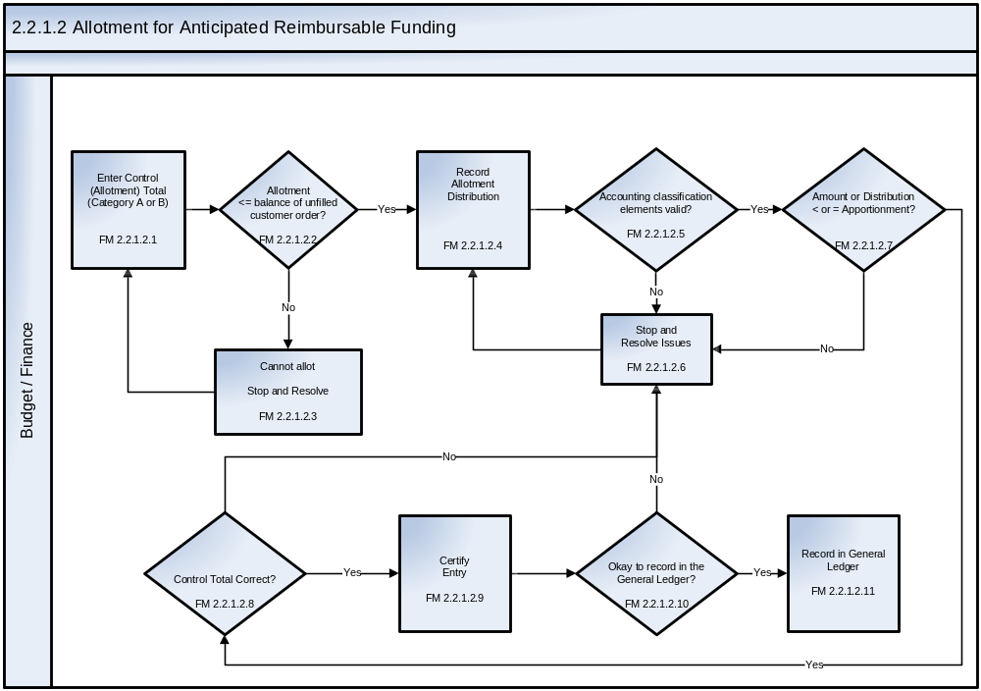
See Appendix C – Business Process Flowcharts, Symbols, and Definitions for an enlarged version of the flowchart.
The Allotment for Anticipated Reimbursable process steps are described as follows:
Step ID | Step Name | Step Description | Business Rules | CFSR Req.
FM  2.2.1.2.1 | Enter Control (Allotment) Total (Category A or B) | Enter control total for Allotment Advice.  The control total is often at the header level of the record and is established to validate the line level entries. | Enter control total, then distribute as necessary. | SMB-25
FM  2.2.1.2.2 | Allotment less than or equal to the balance of unfilled customer order? | Determine if the allotment is less than or equal to the balance of the unfilled customer order. | For anticipated reimbursable amounts, an agency cannot obligate greater than the balance of the accepted or unfilled customer orders. | FMC-10  FMC-12  SMB-11  SMB-12  SMB-13  SMC-09
FM  2.2.1.2.3 | Record Allotment Distribution | Record the Allotment distribution per the advice document. |  | FMD-01
FM  2.2.1.2.4 | Cannot Allot.  Stop and Resolve | If the allotment is greater than the balance of the unfilled customer order, Budget/Finance will resolve the funding issue. | Designated personnel resolve applicable funding issues in accordance with applicable rules, regulations, and agency guidelines (e.g., FAR, agency policies and procedures). | FMD-05  SMB-16  SMC-09
FM  2.2.1.2.5 | Accounting classification elements valid? | Reference appropriate accounting classification elements. | Verify combinations of accounting classification elements are valid and active. | CGAC  Compliance  SMA-03  SMB-11  SMB-12  SMB-13  SMB-30  SMC-09
FM  2.2.1.2.6 | Stop and Resolve Issues | If the accounting classification elements are not valid or active, Budget/Finance will resolve the issue.  If the amount is greater than or equal to the apportionment, Budget/Finance will resolve the issue.  If the allotment distribution is greater than the control total Budget/Finance will resolve the issue.  If the entry is not ready to be recorded in the General Ledger, Budget/Finance will resolve the issue. | Designated personnel resolve applicable issues in accordance with applicable rules, regulations, and agency guidelines (e.g., FAR agency policies and procedures).  Allotment distribution cannot exceed the control total. | SMA-05  SMA-06  SMB-16  SMC-09
FM  2.2.1.2.7 | Amount or Distribution less than or equal to the Apportionment? | Determine if the amount or distribution is less than or equal to the Apportionment. This is the Antideficiency check. | Ensure that the allotment does not exceed the apportionment as recorded in Step FM 2.1.1.4.
FM  2.2.1.2.8 | Control Total Correct? | Determine if the allotment distribution is equal to the control total. This is the entry approval step where the (1) accounting period is checked to see if it is open or closed, (2) the accounting classification elements are revalidated and (3) the control total is checked. | Allotment distribution cannot exceed the control total (e.g., all lines of distribution are added together to ensure they equal the control total). | SMB-25
FM  2.2.1.2.9 | Certify Entry | After the budgetary resource is entered into the system, it has to be approved by appropriate personnel. | This step ensures a separation of duties for review and approval of transaction prior to recording in the General Ledger. | TLE-01  TLE-02  TLE-03  TLE-04  TLE-06  TLE-07  TLE-08
FM  2.2.1.2.10 | Okay to record in the General Ledger? | Has the entry been reviewed and approved by the appropriate personnel? | This step is to verify that the review and approval of the transaction prior to recording in the General Ledger has taken place. | SMC-09
FM  2.2.1.2.11 | Record in General Ledger | After the budgetary resource is entered into the system and approved by appropriate personnel, the transaction is recorded in the General Ledger. | The allotment entries are recorded using the USSGL Account Transaction Listing provided in the current TFM.  Examples include, but are not limited to, the following transaction codes from the current TFM:  TFM-A120 To record the allotment of authority.  TFM-A122 To record the realization of previously anticipated and apportioned authority for programs subject to apportionment. | GLB-01  GLC-05  GLC-07

2.2.1.3 Allotment for Anticipated Non-Reimbursable Funding
The Allotment for Anticipated Non-Reimbursable Funding process addresses resources that are either 1) Anticipated Recoveries of Prior Year Obligations or 2) Spending authority from offsetting collections. Per Appendix H of OMB Circular A-11 and the USSGL Budgetary Accounting Guide, anticipated amounts are not available for reuse until they are actually recovered.
Anticipated Recoveries of Prior Year Obligations
Estimated amounts of anticipated recoveries, from either a Federal or non-federal source are recorded as an anticipated budgetary resource and apportioned on the SF 132. However, OMB Circular A-11 and the TFM prohibit any type of spending unless there are actual resources, i.e., actual recoveries.
In order to ensure proper internal controls and prevent Antideficiency Act violations, it is essential to verify and validate that the total amount of allotments from anticipated recoveries does not exceed the total of actual recoveries realized to date.
Offsetting Collections
Offsetting collections are typically credited directly to expenditure accounts where they are generally available for obligation and outlay. However, OMB Circular A-11 and the TFM prohibit any type of spending unless there are actual resources or for offsetting collections – cash on hand.
Anticipated collections, from either a Federal or non-federal source, are recorded as an anticipated budgetary resource and apportioned on the SF 132. Per OMB Circular A-11, this would be: (1) offsetting collections in a credit program or liquidating account, or (2) offsetting collections from (a) asset sales, (b) interest received on Federal securities, (c) compulsory collections for the public such as sales taxes, user charges, customs duties, license fees, (d) intergovernmental expenditure transfers with no benefit for the paying account, (e) donations, or (f) refunds.
In order to ensure proper internal controls and prevent Antideficiency Act violations, it is essential to verify and validate that the total amount of allotments from anticipated recoveries does not exceed the total of actual recoveries realized to date (e.g., USSGL accounts 4260 – Actual Collections of Government-Type Fees and 4261 – Actual Collections of Business Type Fees).
An Allotment Advice or Advice of Allotment document is the vehicle for informing the Program offices and/or other internal administrative organization structure of available funding.

Note: “Certify” as used in this process is defined as “review and approve”.

FM 2.2.1.3 – Allotment for Anticipated Non-Reimbursable Funding Flowchart
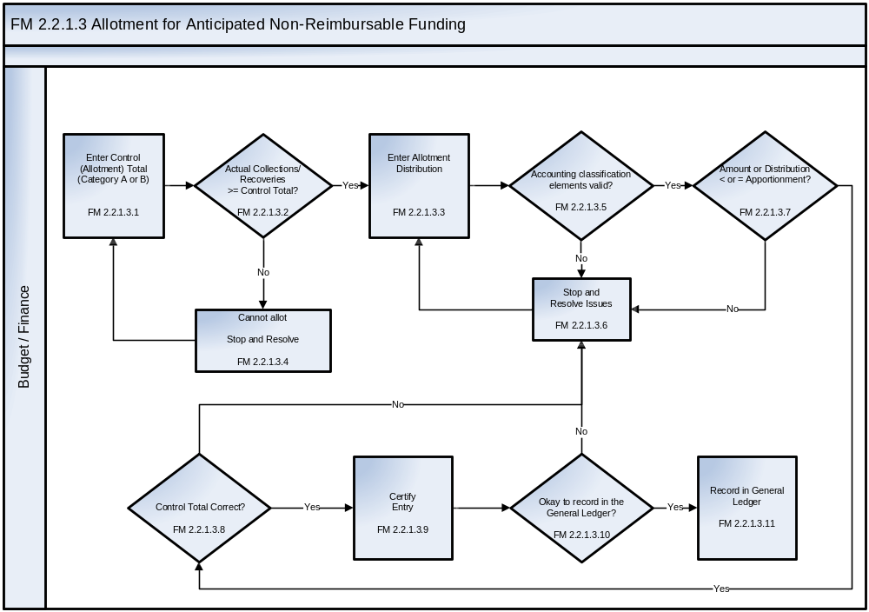
See Appendix C – Business Process Flowcharts, Symbols, and Definitions for an enlarged version of the flowchart.
The Allotment for Anticipated Non-Reimbursable process steps are described as follows:
Step ID | Step Name | Step Description | Business Rules | CFSR Req.
FM  2.2.1.3.1 | Enter Control (Allotment) Total (Category A or B) | Verify realization of anticipated resources.  Enter Control (Allotment) Total from the Administrative, Budget and/or Program Office.  The control total is often at the header level of the record and is established to validate the line level entries. | If obligation is classified as Direct then this is allotment total is for anticipated collections or recoveries.  Enter control total, then distribute as necessary. | SMB-25
FM  2.2.1.3.2 | Actual Collections/ Recoveries greater than or equal to the Control Total? | Determine if the balance of actual collections/recoveries is greater than or equal to the control total. | If the resource is anticipated, verify that actuals (either recoveries or collections) have been recorded for the fiscal year. | SMB-11  SMB-12  SMB-13  SMC-09
FM  2.2.1.3.3 | Enter Allotment Distribution | If the anticipated balance is less than the actual balance of the collection or recovery, then record the allotment. |  | FMD-01
FM  2.2.1.3.4 | Cannot Allot.  Stop and Resolve | If the anticipated balance is greater than the actual balance of the collection or recovery, Budget/Finance will resolve the funding issue. | Designated personnel resolve applicable funding issues in accordance with applicable rules, regulations, and agency guidelines. | FMD-05  SMB-16  SMC-09
FM  2.2.1.3.5 | Accounting classification elements valid? | Reference appropriate accounting classification elements. | Verify combinations of accounting classification elements are valid or active. | CGAC Compliance  SMA-03  SMB-11  SMB-12  SMB-13  SMB-30  SMC-09
FM  2.2.1.3.6 | Stop and Resolve Issues | If the accounting classification elements are not valid or active, Budget/Finance will resolve the issue.  If the amount is greater than or equal to the apportionment, Budget/Finance will resolve the issue.  If the allotment distribution is greater than the control total Budget/Finance will resolve the issue.  If the entry is not ready to be recorded in the General Ledger, Budget/Finance will resolve the issue. | Designated personnel resolve applicable funding issues in accordance with applicable rules, regulations, and agency guidelines (e.g., FAR, agency policies and procedures). | SMA-05  SMA-06  SMB-16  SMC-09
FM  2.2.1.3.7 | Amount or Distribution less than or equal to the Apportionment? | Determine if the amount or distribution is less than or equal to the apportionment.  This is the Antideficiency check. | Ensure that the allotment does not exceed the apportionment as recorded in step FM 2.1.1.4.
FM  2.2.1.3.8 | Control Total Correct? | Determine if the allotment distribution is equal to the control total. This is the entry approval step where the (1) accounting period is checked to see if it is open or closed, (2) the accounting classification elements are revalidated, and (3) the control total is checked. | Allotment distribution cannot exceed the control total (e.g., all lines of distribution are added together to ensure they equal the control total). | SMB-25
FM  2.2.1.3.9 | Certify Entry | After the budgetary resource is entered into the system, the transaction has to be approved by appropriate personnel. | This step ensures a separation of duties for review and approval of transaction prior to posting to the General Ledger. | TLE-01  TLE-02  TLE-03  TLE-04  TLE-06  TLE-07  TLE-08
FM  2.2.1.3.10 | Okay to record in the General Ledger? | Has the entry been reviewed and approved by the appropriate personnel? | This step is to verify that the review and approval of the transaction prior to recording in the General Ledger has taken place. | SMC-09
FM  2.2.1.3.11 | Record in General Ledger | After the budgetary resource is entered into the system and approved by appropriate personnel, the transaction is recorded in the General Ledger. | After the entry passes validation edits, the applicable entry is recorded.  Examples include, but are not limited to, the following transaction codes from the current TFM:  TFM-A116 To record budgetary authority apportioned by OMB and available for allotment.  TFM-A118 To record anticipated resources apportioned but not available for use until they are realized for anticipated resources in programs subject to apportionment. | GLB-01  GLC-05  GLC-07

2.2.2 Sub-Allotment Distribution
Recording sub-allotted resources is prescribed in both OMB Circular A-11 and the USSGL portion of the Treasury Financial Manual as a further agency sub-division of funds and is an optional step based upon agency business practices. Specifically, obligations or expenditures cannot be incurred until an allotment or sub-allotment is made by the agency. An Allotment Advice or Advice of Allotment document is the vehicle for informing the Program offices and/or other internal administrative organization structure of available funding.

Note: “Certify” as used in this process is defined as “review and approve”.

FM 2.2.2– Sub-Allotment Distribution Flowchart
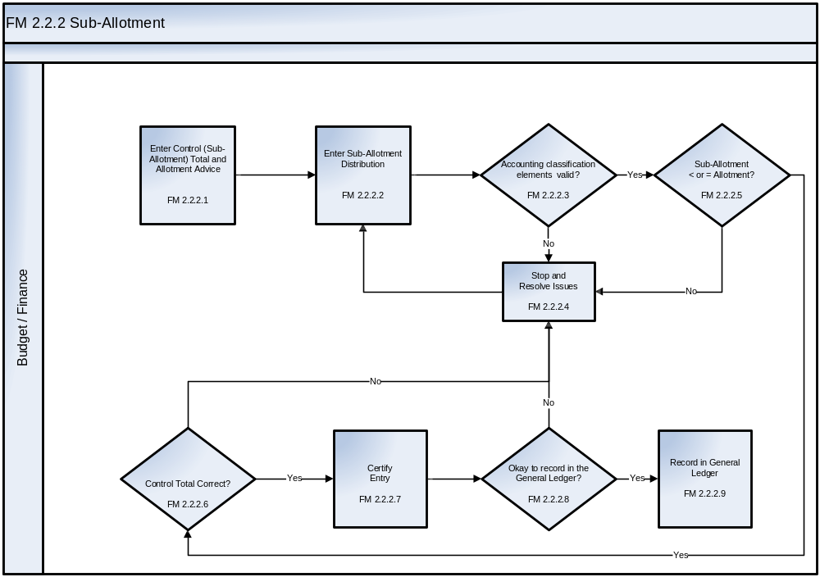
See Appendix C – Business Process Flowcharts, Symbols, and Definitions for an enlarged version of the flowchart.
The Sub-Allotment process steps are described as follows:
Step ID | Step Name | Step Description | Business Rules | CFSR Req.
FM 2.2.2.1 | Enter Control (Sub-Allotment) Total and Allotment Advice | Enter control (Sub-Allotment) total from the Administrative, Budget and /or Program Office.  The control total is often at the header level of the record and is established to validate the line level entries. | Establish amount of sub-allotment appending a unique sub-allotment identifier to an allotment advice.  Total of all distribution on this sub-allotment must not exceed control total.  Overall sub-allotments cannot exceed allotment. | SMB-25
FM 2.2.2.2 | Enter Sub-Allotment Distribution | Official requests (i.e., appropriate allotment advice) create sub-allotment.  Enter sub-allotment amounts for categories to be control. | Based upon allotment pools from referenced allotment advice (i.e., second level of the organization) | FMD-01  FMD-03
FM 2.2.2.3 | Accounting classification elements valid? | Reference appropriate accounting classification elements. | Verify combinations of accounting classification elements are valid and active. | CGAC  Compliance  SMA-03  SMB-11  SMB-12  SMB-13  SMB-30  SMC-09
FM 2.2.2.4 | Stop and Resolve Issues | If the accounting classification elements not valid, Budget/Finance must resolve the issue.  If the amount is greater than or equal to the Allotment, Budget/Finance must resolve the issue.  If the Allotment  distribution does not equal the control total, Budget/Finance must resolve the issue.  Determined that the entry is not ready to be recorded in the General Ledger. | Designated personnel resolve applicable funding issues in accordance with applicable rules, regulations, and agency guidelines (e.g., FAR, agency policies and procedures) | SMA-05  SMA-06  FMD-05  SMB-16  SMC-09
FM 2.2.2.5 | Sub-Allotment less than or equal to the Allotment? | Determine if the sub-allotment is less than or equal to the referenced allotment advice. This is the Antideficiency check. | Ensure that this sub-allotment and other sub-allotments do not exceed the allotment.
FM 2.2.2.6 | Control Total Correct? | Determine if the allotment distribution is equal to the control total. This is the entry approval step where the (1) accounting period is checked to see if it is open or closed, (2) the accounting classification elements are revalidated, and (3) the control total is checked. | Allotment distribution cannot exceed the control total (e.g., all lines of distribution are added together to ensure they equal the control total). | SMB-25
FM 2.2.2.7 | Certify Entry | After the sub-allotment(s) are entered into the system, the transaction must be approved by appropriate personnel. | This step ensures a separation of duties for review and approval of transaction prior to recording in the General Ledger. | TLE-01  TLE-02  TLE-03  TLE-04  TLE-06  TLE-07  TLE-08
FM 2.2.2.8 | Okay to record in the General Ledger? | Determine if the entry has been reviewed and approved by the appropriate personnel. | This step is to verify that the review and approval of the transaction prior to recording in the General Ledger has taken place. | SMC-09
FM 2.2.2.9 | Record in General Ledger | After the sub-allotment(s) are certified, the transaction is recorded in the General Ledger. | After the entry passes validation edits, the applicable entry is recorded.  Examples include, but are not limited to, the following transaction codes from the current TFM:  TFM-A116 To record budgetary authority apportioned by OMB and available for allotment.  TFM-A118 To record anticipated resources apportioned but not available for use until they are realized for anticipated resources in programs subject to apportionment.  Based on system configuration, the sub-allotment can be used for Funds Control.  Note: This entry would be a reclassification of a higher level accounting classification line to a lower level accounting classification line in USSGL account 4610 – Allotments – Realized Resources. . | GLB-01  GLC-05  GLC-07

2.2.3 Lower Level Distribution
The use of Lower Level Distribution processes allows agencies to maintain tighter administrative controls over obligations as prescribed by the Antideficiency Act. These lower levels of budgetary distribution, which are referred to as allocations, sub-allocations, allowances, sub-allowances, and spending/operating plans, are often based on program, projects, or organization/office. The recording of lower level distributions of resources is prescribed in an agency’s policies and regulations for Funds Control.

Note: “Certify” as used in this process is defined as “review and approve”.

FM 2.2.3 – Lower Level Distribution Flowchart
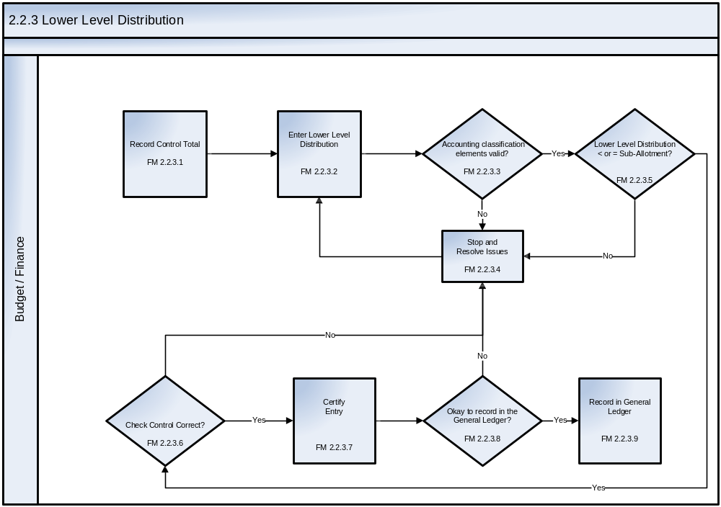
See Appendix C – Business Process Flowcharts, Symbols, and Definitions for an enlarged version of the flowchart.
The Lower Level Distribution process steps are described as follows:
Step ID | Step Name | Step Description | Business Rules | CFSR Req.
FM 2.2.3.1 | Record Control Total | Enter control total from the Administrative, Budget and/or Program Office. This process should start with the allotment posting entries.  The control total is often at the header level of the record and is established to validate the line level entries. | Enter control total, then distribute to lower levels as necessary. | FMD-01  SMB-25
FM 2.2.3.2 | Record Lower Level Distribution | Official requests (i.e., appropriate advice) create a lower level distribution. | The amount recorded is based upon allotment pools from referenced lower level distribution advice (i.e., second level of organization). | FMD-01  FMD-03
FM 2.2.3.3 | Accounting classification elements valid? | Reference appropriate accounting classification elements. | Verify combinations of accounting classification elements are valid and active. | CGAC  Compliance  SMA-03  SMB-11  SMB-12  SMB-13  SMB-30  SMC-09
FM 2.2.3.4 | Stop and Resolve Issues | If the accounting classification elements are not valid, the Business Unit must resolve the issue.  If the amount is greater than or equal to the Sub-Allotment, Budget/Finance must resolve the issue.  If allotment  distribution does not equal the control total, Budget/Finance must resolve the issue.  If it is determined that the entry is not ready to be recorded in the General Ledger, Budget/Finance must resolve the issue. | Designated personnel resolve applicable issues in accordance with applicable rules, regulations, and agency guidelines (e.g., FAR, agency policies and procedures). | SMA-05  SMA-06  FMD-05  SMB-16  SMC-09
FM 2.2.3.5 | Lower Level Distribution less than or equal to the Sub-Allotment? | Determine if the lower level distribution amount is less than or equal to the sub-allotment.  This is the Antideficiency check. | Ensure that this lower level distribution and other allowances do not exceed sub-allotment.
FM 2.2.3.6 | Control Total Correct? | Determine if the lower level distribution is equal to the control total. This is the entry approval step where the (1) accounting period is checked to see if it is open or closed, (2) the accounting classification elements are revalidated, and (3) the control total is checked. | Lower level distribution cannot exceed the control total (e.g., all lines of distribution are added together to ensure they equal the control total). | SMB-25
FM 2.2.3.7 | Certify Entry | After the lower level distribution(s) are entered into the system, it has to be approved by appropriate personnel. | This step ensures a separation of duties for review and approval of transactions prior to recording in the General Ledger. | TLE-01  TLE-02  TLE-03  TLE-04  TLE-06  TLE-07  TLE-08
FM 2.2.3.8 | Okay to record in the General Ledger? | Determine if the entry has been reviewed and approved by the appropriate personnel. | This step is to verify that the review and approval of the transaction prior to recording in the General Ledger has taken place. | SMC-09
FM 2.2.3.9 | Record in General Ledger | After the lower level distribution(s) are certified, the transaction is recorded in the General Ledger. | After the entry passes validation edits, the applicable entry is recorded.  Examples include, but are not limited to, the following transaction codes from the current TFM:  TFM-A116 To record budgetary authority apportioned by OMB and available for allotment.  TFM-A118 To record anticipated resources apportioned but not available for use until they are realized for anticipated resources in programs subject to apportionment.  Based on system configuration, the sub-allotment can be used for Funds Management. | GLB-01  GLC-05  GLC-07

2.3 Funds Control Process
The funds control process validates and verifies the availability of funds for spending transactions, (e.g., commitments, obligations and expenditures). The requisition document from the agency’s acquisition system will initiate creation of a commitment in the agency’s financial system. Although OMB Circular A-11 addresses the authority to incur obligations and expenditures (the outlay of the obligation), a commitment is an “administrative reservation of allotted funds in anticipation of an obligation” and therefore does draw down on fund balances, similar to obligations and expenditures. However, an agency is responsible for keeping appropriate fund balances, as well as the balances for commitments, obligations and expenditures, to ensure accurate and timely verification and reporting of available funding.
OMB Circular A-11, Appendix H – Checklist For Fund Control Regulations stipulates that the following steps be addressed in an agency’s policy that states the regulations under which basic fund control principles and concepts will be put into operation:
- Establish a policy with regard to the administrative control of funds;
- Prescribe a system for positive administrative control of funds designed to restrict obligations and expenditures (disbursements) to the amount available in each appropriation or fund account;
- Restrict both obligations and expenditures from each appropriation or fund account to the lower of the amount of apportionments made by OMB or the amount available for obligation and/or expenditure in the appropriation or fund account;
- Enable the head of your agency to identify the person responsible for any obligation or expenditure exceeding the amount available in the appropriation or fund account, the OMB apportionment or reapportionment, the allotment or sub-allotments made by the agency, any statutory limitations, and any other administrative subdivision of funds made by the agency; and
- Provide procedures for dealing with violations of the Antideficiency Act as well as violations of other administrative subdivision of funds that are not violations of the Antideficiency Act. An agency is responsible for establishing a policy for administrative control of Funds.
Please see OMB Circular A-11, Appendix H – Checklist for Fund Control Regulations for additional guidance.
Note: In addition, the agency also must establish the level at which funds management will be verified and validated, e.g., once allotments and any lower level distributions of funding have been completed, the active accounting classification elements at which available funding will be checked must be established both as a part of the current year’s funding internal controls and in the Core Financial System to enable proper editing.

2.3.1 Establishing Commitments and Obligations for Goods and Services
The establishment of commitments and obligations for goods and services result in outputs to the accounts payable and invoicing processes. The requisition document from the agency’s acquisition system will initiate creation of a commitment in the agency’s financial system. Vendor maintenance that may be associated with requisitions, commitments, and obligations is not within the scope of this chapter.
The steps contained in the flowchart below describe the procedures necessary to prepare an obligation that has a prior commitment. Please note that the “Verify Funding Available” step included in the flowchart is the trigger point for the Funds Validation and Verification flows (2.3.4 and 2.3.5).

FM 2.3.1 – Establishing Commitments and Obligations for Goods and Services Flowchart
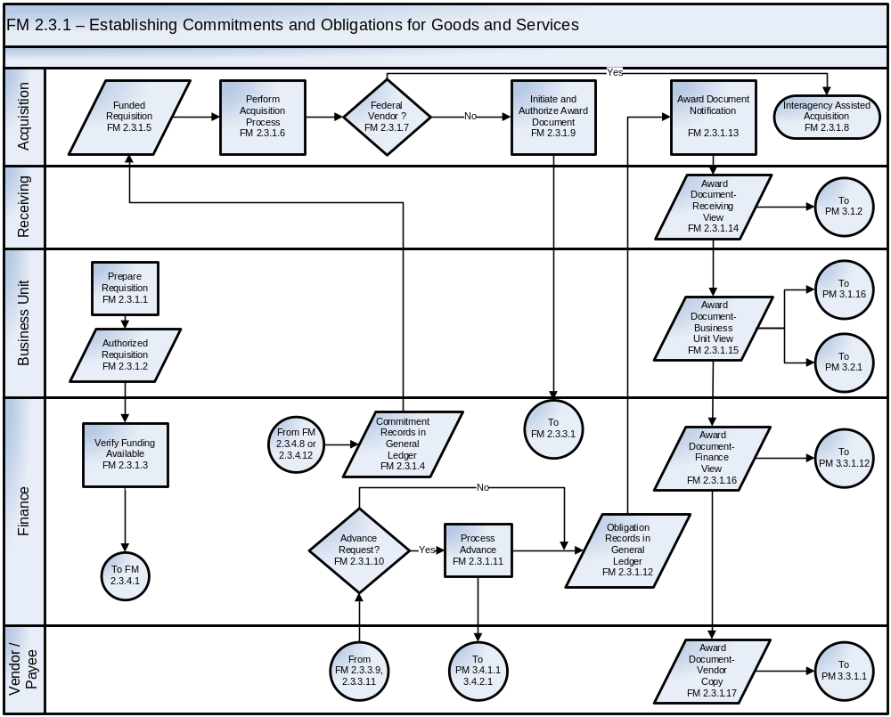

See Appendix C – Business Process Flowcharts, Symbols, and Definitions for an enlarged version of the flowchart.
The Funds Management process steps Establish Commitments and Obligations for goods and services are described as follows:
Step ID | Step Name | Step Description | Business Rules | CFSR Req.
FM 2.3.1.1 | Prepare  Requisition | Personnel authorized by the Business Unit prepare a requisition for purchase of goods or services to fulfill a bona fide need for acquisition. | Authorized personnel who are designated as requistioners should be the only personnel assigned authority within the system to initiate a requisition.  This designated requisition personnel enters required information on the requisition including the following:  - Suggested or recommended vendors, as applicable (or a justification for a specific vendor)  - When the goods or services are needed  - For services, the necessary period of performance  - An estimate of the cost to procure the goods or services  - Appropriate accounting classification elements  - Point of contact information for the agency official(s) ordering and/or receiving the goods or services | CGAC Compliance  FME-19
FM 2.3.1.2 | Authorized  Requisition | The requisition is reviewed and validated by a designated official.  The output is an authorized requisition. | The requisition is reviewed to ensure the data entered matches the requisition supporting documentation.  This designated requisition personnel signs the form (preferably electronically) to authorize the request.  An agency may define certain types and/or amounts of acquisition requests (e.g., property, information technology), for which the requisition must be authorized by an additional person or persons with applicable supervisory or managerial authority.  Personnel with the appropriate authority must review the accounting classification elements, including the Treasury Account Symbol and Business Event Type Code (TAS-BETC).  Capital assets should be identified during the requisition phase of the Payment Management chapter.  A manager with funding authority reviews and electronically authorizes the commitment of funds for the requisition. This occurs as part of step FM 2.3.1.3, "Verify Funding Available” | TLE-03
FM 2.3.1.3 | Verify Funding Available | The Core Financial System (Core Financial System) checks whether funding is available to commit funds from applicable budgetary resources. This process is executed by performing the applicable steps in FM 2.3.4 (Unexpired Funds Validation and Verification) as referenced on the flowchart. | The system certifies availability of required funding prior to committing budgetary resources. | FME-01  SMB-11  SMB-12  SMB-13  SMC-09
FM 2.3.1.4 | Commitment Records in General Ledger | After the requisition is entered into the system and approved by appropriate personnel, funds are checked and a commitment transaction is recorded in the General Ledger. | The entries are recorded in the General Ledger using the USSGL Account Transaction Listing provided in the current TFM.  Examples include, but are not limited to, the following transaction codes from the current TFM:  TFM-B302 To record a commitment of unobligated amounts in programs subject to apportionment.  TFM-B304 To record a commitment of unobligated balances in programs exempt from apportionment. | FME-02  FME-03  FME-08  FME-12  GLB-01  GLC-01  GLC-05  GLC-06
FM 2.3.1.5 | Funded  Requisition | The funded requisition is automatically routed to the Acquisition Office. | Acquisition Office officials who have completed standardized training programs are certified to act as purchasing agents on behalf of the agency and have been granted access to the agency’s Acquisition System.  These qualified Acquisition officials may be referred to as a Contracting Officer’s Technical Representative (COTR) or a Contracting Officer’s Representative (COR).  Upon receipt of a requisition, the Acquisition official reviews it to determine whether it has been appropriately completed and authorized.  If the Acquisition official notes errors or omissions in the requisition, it is returned to the Business Unit to be corrected and resubmitted. | TLE-07
FM 2.3.1.6 | Perform Acquisition Process | Once the contractor has been chosen, an Acquisition official prepares the award documents (such as contracts, purchase orders, and delivery orders). Although multiple steps comprise this part of the process, such steps are beyond the scope of this document. | Acquisition performs the procurement process in accordance with applicable regulations (e.g., FAR, agency guidelines).  Federal (intragovernmental) buy and sell transactions will be included in a future release of the Standard Business Process document.
FM  2.3.1.7 | Federal Vendor? | The contractor/vendor is identified as either a federal or non-federal vendor. |  | SMC-01  PMA-01
FM 2.3.1.8 | Interagency Assisted Acquisition | Applicable procedures are performed to acquire goods/services through the assistance of another agency or agencies. | Goods/services to be acquired via an interagency assisted acquisition, are subject to the procedures and responsibilities outlined in the OMB Office of Federal Procurement Policy (OFPP) Interagency Acquisition Memo.  An interagency acquisition is the term used to describe the process by which one agency (requesting agency), uses the contracts and/or contracting services of other agencies (servicing agencies) to obtain supplies and services.
FM 2.3.1.9 | Initiate and Authorize Award Document | The Acquisition official prepares and authorizes an electronic award document. | Vendors must be registered in the Central Contractor Registration (CCR) database except for contracts and agreements identified in FAR Volume I, Part 4, Subpart 4.11.  A unique obligation number is assigned to the award document. The number must reference the commitment number.  The obligation number, document ID, and accounting classification elements must be included in the obligation data maintained in the General Ledger and subsidiary ledger.  An award document must not be routed to end-users until an obligation is recorded in the General Ledger and subsidiary ledger. Once the Acquisition official prepares and authorizes the award document, funds checks are performed in the Core Financial System to determine whether required funding is available for each line item of the obligation.  The requested obligation amounts are subjected to tolerance checks against the referenced commitment(s). | FME-01  FME-21  PMA-01  PMA-02  PMA-04  PMA-05  PMA-06  PMA-07  PMA-08  PMA-09  PMA-10  PMA-15  PMA-16  PMA-17  SMA-01  SMB-01  SMB-03  SMB-08  SMB-24  SMC-01
FM 2.3.1.10 | Advance Request? | The agency determines whether an advance has been properly requested on the obligation. | The agency must follow FAR requirements and agency policies and procedures for the issuance of advances. FAR Volume I, Part 32, Subparts 200 through 207, provides regulations for commercial item purchase financing.
FM 2.3.1.11 | Process Advance | An advance request is processed and warehoused for payment. |  | FME-02  FME-29  SMC-02
FM 2.3.1.12 | Obligation Records in General Ledger | An obligation is recorded in the General Ledger. | Once an obligation document passes funding and tolerance checks, it is recorded in the General Ledger and the appropriate amount of the commitment is liquidated.  This designated business unit requisition person is notified electronically of the approved order and obligation.  The entries are recorded using the USSGL Account Transaction Listing provided in the current TFM.  Examples include, but are not limited to, the following transaction codes from the current TFM:  TFM-B306 To record current-year undelivered orders without an advance.  TFM-B308 To record current-year undelivered orders with an advance.  TFM-B310 To record a current-year undelivered order without an advance where the commitment is more than the undelivered order for commitments in programs subject to apportionment.  TFM-B312 To record a current-year undelivered order without an advance where the commitment is more than the undelivered order for commitments in programs exempt from apportionment.  TFM-B314 To record a current-year undelivered order without an advance where the commitment is less than the undelivered order for commitments in programs subject to apportionment.  TFM-B316 To record a current-year undelivered order without an advance where the commitment is less than the undelivered order for commitments in programs exempt from apportionment. | FME-02  FME-08  FME-12  GLB-01  GLC-01  GLC-05  GLC-06  SMC-02  TLE-07
FM 2.3.1.13 | Award Document  Notification | Notification of the system-generated award document is provided to the Receiving, Business Unit, and Finance functional areas of the agency and to the vendor/payee. | The document must be available to applicable offices that perform the receipt, acceptance, and invoice processing activities as well as the vendor/payee.  The award document copy should include at a minimum, but is not limited to, the obligation number, line item information, accounting classification elements, TAS, applicable vendor information, and contract terms. | TLE-07
FM 2.3.1.14 | Award Document- Receiving View | The Receiving view includes information applicable to the Receiving functions. | The Core Financial System must enable access to the Receiving view of the award document to applicable authorized personnel.  A view does not represent physical storage, but the ability to view a particular segment of stored data. | TLF-01  TLH-03
FM 2.3.1.15 | Award Document-  Business Unit View | The Business Unit view includes information applicable to the Business Unit functions. | The Core Financial System must enable access to the Business Unit view of the award document to applicable authorized personnel.  A view does not represent physical storage, but the ability to view a particular segment of stored data. | TLF-01  TLH-03
FM 2.3.1.16 | Award Document- Finance View | The Finance view includes information fields applicable to the Finance functions. | The Core Financial System must enable access to the Finance view of the award document to applicable authorized personnel.  A view does not represent physical storage, but the ability to view a particular segment of stored data. | TLF-01  TLH-03
FM 2.3.1.17 | Award Document- Vendor Copy | The Vendor Copy includes information applicable to the vendor's legal obligation to provide goods and services to the agency. | The vendor copy of the award document is sent to the vendor/payee.  A view does not represent physical storage, but the ability to view a particular segment of stored data.

2.3.2 Establishing Obligations Not Requiring Commitment

Obligations not requiring commitment refers to those events, such as training and travel, which do not require commitment accounting. Agencies should have policies in place that delineate the types of obligations that can be made without commitment accounting.
The steps contained in the flowchart below describe the procedures necessary to prepare an obligation without a prior commitment. Please note that the “Verify Funding Available” step, which is included on the flowchart, is the trigger point for the Funds Validation and Verification flows (2.3.4 and 2.3.5).

FM 2.3.2 – Establishing Obligations Not Requiring Commitment Flowchart
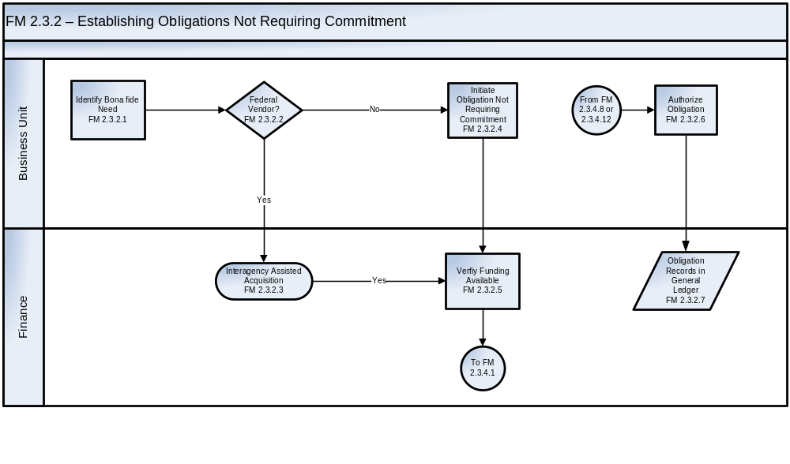
See Appendix C – Business Process Flowcharts, Symbols, and Definitions for an enlarged version of the flowchart.
The Funds Management Establishing Obligations not Requiring Commitments process steps are described as follows:
Step ID | Step Name | Step Description | Business Rules | CFSR Req.
FM 2.3.2.1 | Identify Bona fide Need | The Business Unit official has a bona fide need for a properly incurred expense not requiring commitment accounting and generates an obligation in the system based on data entered to record the goods, services, grant or cooperative agreement. | Agencies should implement policies and procedures describing which type of obligations may be made without commitment accounting. | FME-21  FME-24  PMA-01  PMA-02  PMA-04  PMA-05  PMA-06  PMA-07  PMA-08  PMA-09  PMA-10  PMA-16  PMA-17  SMA-01  SMB-01  SMB-22  SMB-24
FM 2.3.2.2 | Federal Vendor? | The contractor/vendor is identified as either a federal or non-federal vendor.  Federal (intragovernmental) buy and sell transactions will be included in a future release of the Standard Business Process document. |  | SMC-01  PMA-01
FM 2.3.2.3 | Interagency Assisted Acquisition | Applicable procedures are performed to acquire goods/services through the assistance of another agency or agencies. | Goods/services to be acquired via an interagency assisted acquisition are subject to the procedures and responsibilities outlined in the OMB Office of Federal Procurement Policy (OFPP) Interagency Acquisition Memo.  An interagency acquisition is the term used to describe the process by which one agency (requesting agency), uses the contracts and/or contracting services of other agencies (servicing agencies) to obtain supplies and services.
FM 2.3.2.4 | Initiate Obligation Not Requiring Commitment | The Business Unit official prepares the order for goods and services not requiring commitment. | A unique obligation number is assigned to the obligation document recorded.  The obligation number, document ID and accounting classification elements must be included in the obligation data maintained in the General Ledger and subsidiary ledger.  The Core Financial System must prevent new obligations to inactive or debarred vendors or vendors with expired CCR registrations.  An agency may develop and implement policies and procedures to determine threshold amounts under which acquisitions may be made without requiring the recording of commitments. | FME-21  FME-24  PMA-01  PMA-02  PMA-04  PMA-05  PMA-06  PMA-07  PMA-08  PMA-09  PMA-10  PMA-16  PMA-17  SMA-01  SMB-01  SMB-22  SMB-24
FM 2.3.2.5 | Verify Funding Available | The Core Financial System checks whether funding is available to obligate funds from applicable budgetary resources. This process is executed by performing the applicable steps in FM 2.3.4 (Unexpired Funds Validation and Verification) as referenced on the flowchart. | Once the Acquisition official electronically prepares the obligating document, funds checks are performed in the Core Financial System to determine whether required funding is available for each line item of the obligation.  The system certifies availability of required funding prior to obligating budgetary resources. | FME-01
FM 2.3.2.6 | Authorize Obligation | A request for authorization is electronically routed to the appropriate individual within the Business Unit to authorize the obligation. | Another official within the Business Unit must review the obligation to ensure it is authorized and valid. | TLE-01
FM 2.3.2.7 | Obligation Records in General Ledger | An obligation is recorded in the General Ledger. | Once an obligating document passes funding and tolerance checks, it is recorded in the General Ledger.  Entries are recorded using USSGL Account Transaction Listing provided in the current TFM.  Examples include, but are not limited to, the following transaction codes from the current TFM:  TFM-B306 To record current-year undelivered orders without an advance.  TFM-B308 To record current-year undelivered orders with an advance. | FME-02  FME-08  FME-12  GLB-01  GLC-01  GLC-05  GLC-06

2.3.3 Funds Check Prior to Obligation
The Funds Check Prior to Obligation process refers to contractual acquisitions for which commitments and obligations are used. Included are steps to compare an obligation request to an underlying commitment, assess availability of funds, and liquidate commitments at the time of obligation.
Please note that the ‘yes’ response for decision point FM 2.3.3.3 “Pass Tolerance Check?” is the trigger point for the Funds Verification and Validation flows (2.3.4 and 2.3.5).

The steps contained in the flowchart below describe the procedures necessary to perform a funds check prior to the obligation of funds.

FM 2.3.3 – Funds Check Prior to Obligation Flowchart
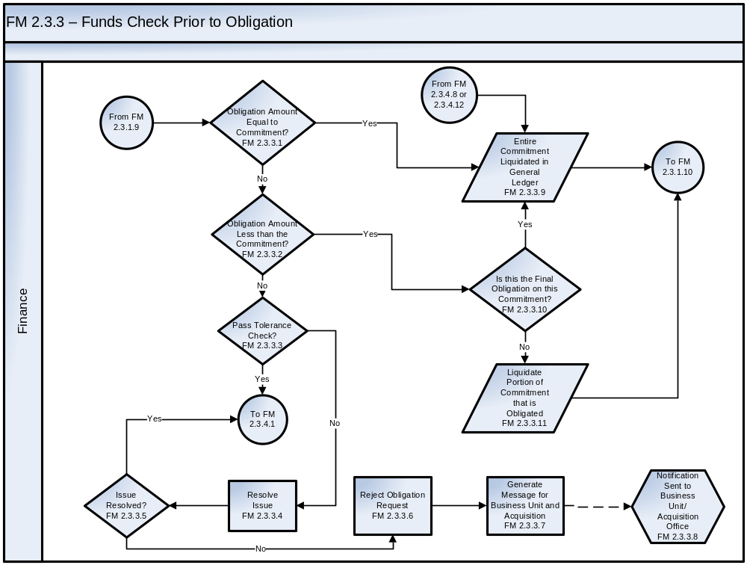
See Appendix C – Business Process Flowcharts, Symbols, and Definitions for an enlarged version of the flowchart.
The Funds Management Funds Check Prior to Obligation process steps are described as follows:
Step ID | Step Name | Step Description | Business Rules | CFSR Req.
FM 2.3.3.1 | Obligation Amount Equal to Commitment? | The amount of the pending obligation is compared to the amount of the applicable commitment to determine if the obligation is equal to the commitment recorded in the Core Financial System. | Once the Core Financial System determines a commitment exists related to this obligation, it determines if the obligation amount equals the commitment amount. | FME-02  SMB-03  SMC-02  SMC-08
FM 2.3.3.2 | Obligation Amount Less than the Commitment? | The amount of the pending obligation is compared to the amount of the applicable commitment to determine if the obligation amount requested is less than the commitment recorded in the Core Financial System. | If the obligation amount is not equal to the commitment amount, determine if the obligation amount requested is less than the commitment recorded in the Core Financial System. | FME-02  SMB-03  SMC-02  SMC-08
FM 2.3.3.3 | Pass Tolerance Check? | The amount by which an obligation exceeds a commitment is compared line item by line item to pre-determined tolerance levels for quantities and prices of goods or services. | Agencies set tolerance levels in accordance with applicable rules, regulations, and agency guidelines (e.g. FAR, agency policy and procedures). | SMB-19  SMB-20
FM 2.3.3.4 | Resolve Issue | Designated personnel perform applicable actions to resolve the funding issue. | Designated personnel resolve funding issues in accordance with applicable rules, regulations, and agency guidelines.  If funding is not made available, the obligation request is rejected. | FMD-05  SMB-16  SMB-18  SMC-09
FM 2.3.3.5 | Issue Resolved? | If the amount of the obligation request exceeds the tolerance level within the Core Financial System and/or funds are not available, research must be performed to identify and resolve the funding issue. | The Core Financial System should route the funding issues to applicable authorized personnel who will either discontinue the transaction or make funds available.
FM 2.3.3.6 | Reject Obligation Request | If the issue is not resolved, the obligation request is rejected. | Agencies should designate applicable personnel to monitor obligation requests, which fail to pass funds checks and reject such requests as required. | SMB-18
FM 2.3.3.7 | Generate Message for Business Unit and Acquisition | Following the rejection of the obligation request, a message is generated for the Business Unit and Acquisition Office. | The message should be initiated electronically once the obligation request is rejected. | TLE-07  TLE-08
FM 2.3.3.8 | Notification Sent to Business Unit/Acquisition Office | Notification is sent to the Business Unit/Acquisition Office of the rejected obligation. | The message should be electronically routed to applicable personnel within the Business Unit and Acquisition Office (e.g., requisitioner, acquisition official). | TLE-07  TLE-08
FM 2.3.3.9 | Is this the Final Obligation on this Commitment? | Determine if this is the last obligation to be made from this commitment. | The Core Financial System should check whether funds will remain on the commitment based upon whether the requisitioner has indicated in the system that remaining funds should be de-committed.
FM 2.3.3.10 | Liquidate Portion of Commitment that is Obligated | The portion of the commitment applicable to the obligation is liquidated. | The agency must liquidate the commitment by posting entries to the Core Financial System using the USSGL Account Transaction Listing in the current TFM. The agency reverses (only for the portion of the commitment that is obligated) the previously identified (FM 2.3.1.4, Commitment Records in General Ledger) entries.  Examples include but are not limited to, the following transaction codes from the current TFM:  TFM-B302 To record a commitment of unobligated amounts in programs subject to apportionment.  TFM-B304 To record a commitment of unobligated balances in programs exempt from apportionment. | SMC-02
FM 2.3.3.11 | Entire Commitment Liquidated in the General Ledger | If the obligation and commitment are equal or if the obligation has been identified as the final one to be made against the commitment, the entire commitment or remaining amount is liquidated in the General Ledger. | The agency reverses the previously identified (FM 2.3.1.4, Commitment Records in General Ledger) transaction codes from the current TFM.  Examples include, but are not limited to, the following transaction codes from the current TFM:  TFM-B302 To record a commitment of unobligated amounts in programs subject to apportionment.  TFM-B304 To record a commitment of unobligated balances in programs exempt from apportionment.

2.3.4 Unexpired Funds Validation and Verification
Unexpired funds refer to balances, which are still available under the agency’s spending authority. As prescribed in OMB Circular A-11, Agencies are responsible for keeping appropriate fund balances, including the balances for commitments, obligations and expenditures, to ensure accurate and timely verification and reporting of available funding. The Unexpired Funds Validation and Verification process describes the steps required to validate and verify the availability of unexpired funds for spending transactions.
FM 2.3.4 – Unexpired Funds Validation and Verification Flowchart
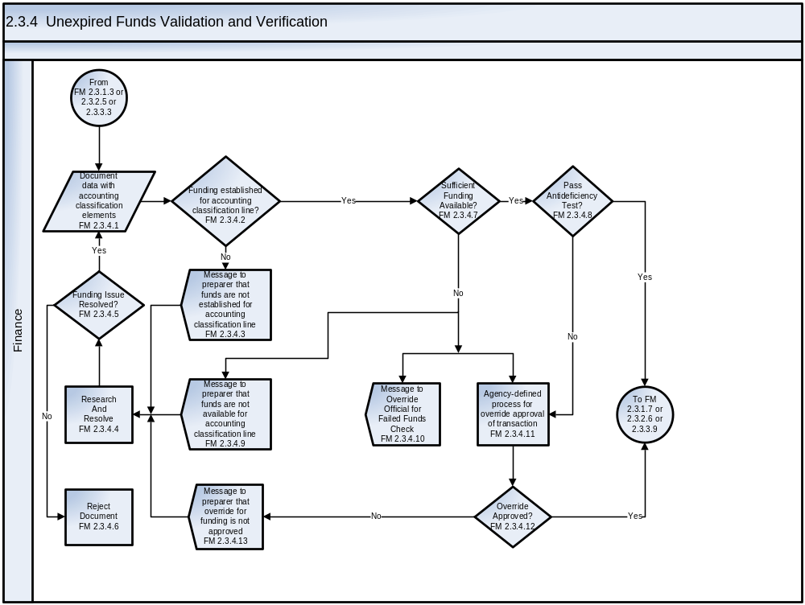
See Appendix C – Business Process Flowcharts, Symbols, and Definitions for an enlarged version of the flowchart
The Unexpired Funds Validation and Verification process steps are described as follows:
Step ID | Step Name | Step Description | Business Rules | CFSR Req.
FM 2.3.4.1 | Document data with accounting classification elements | The document represents the detailed account distribution, including appropriate accounting classification elements to be submitted for funds availability verification. | Combinations of accounting classification elements must be valid and active. | SMB-21
FM 2.3.4.2 | Funding established for accounting classification line? | Verification that an Allotment or any lower level distribution was made to the Allotment pool indicated by the account distribution (accounting classification line) and the established level of Funds Control as established by the agency as per Appendix H of OMB Circular A-11. | An agency is responsible for establishing a policy for administrative control of Funds.  The policy must also address restricting obligations and expenditures from exceeding the lower of the amount of apportionments made by OMB or the amount available for obligation and/or expenditure in the TAFS.  See OMB Circular A-11, Appendix H – Checklist For Fund Control Regulations. | FME-01
FM 2.3.4.3 | Message to preparer that funds are not established for accounting classification line | Electronic notification to document preparer that funds were never established for the account distribution line. | Business unit to be notified an Allotment or lower level distribution was never established for the accounting classification element specified in the account distribution. | SMB-12  TLE-07  TLE-09
FM 2.3.4.4 | Research and Resolve Issues | If funds are not available, the Business Unit will research and resolve the issue. | Designated personnel resolve applicable issues in accordance with applicable rules, regulations, and agency guidelines. | FMD-05  SMB-16  SMC-09
FM 2.3.4.5 | Funding Issue Resolved? | The appropriate functional area determines if funding issues related to the document can be resolved. | The agency shall resolve funding issues in accordance with agency-established policies and procedures. | SMC-09
FM 2.3.4.6 | Reject Document | Documents that do not pass funding validation and verification checks are rejected. | Agencies should designate applicable personnel to monitor documents that fail to pass funds checks and reject such documents.  The originator of the document is electronically notified that the document has been rejected due to lack of available funding. | SMB-11  SMB-12  SMB-13  SMB-18  SMC-09
FM 2.3.4.7 | Sufficient Funding Available? | Verification that an Allotment or any lower level distribution was made to the ‘funding pool’ as indicated by the account distribution (accounting classification line) and the established level of Funds Control as established by the agency as per Appendix H of OMB Circular A-11. | An agency is responsible for establishing a policy for administrative control of Funds.  The policy must also address restricting obligations and expenditures from exceeding the lower of the amount of apportionments made by OMB or the amount available for obligation and/or expenditure in the TAFS.  See OMB Circular A-11, Appendix H – Checklist for Fund Control Regulations | FME-01  FME-02  FME-03  FME-04  FME-10
FM 2.3.4.8 | Pass Antideficiency Test? | Validation that the amount of funding ‘drawn down’ does not put the TAFS into an Antideficiency condition. | The agency must verify that the amount of the transaction for the fund code cited, when added together with any and all other fund codes (if applicable) for the specific TAFS does not exceed the overall amount apportioned by OMB. | FME-01  FME-10
FM 2.3.4.9 | Message to preparer that funds are not available for accounting classification line | Electronic notification to document preparer that there are insufficient funds available for the account distribution line. | Business unit to be notified that funds are not available and that the Funds Override Official has been notified. | SMB-12  TLE-07  TLE-09
FM 2.3.4.10 | Message to Override Official for Failed Funds Check | Electronic notification to the designated Funds Override Official that there are insufficient funds available for the account distribution line. | As a part of providing OMB with the agency’s Funds Control policy and regulations, an appropriate individual is identified who is responsible for any obligation or expenditure exceeding the amount available in the appropriation or fund account, the OMB apportionment or reapportionment, the allotment or sub-allotments made by the agency, any statutory limitations, and any other administrative subdivision of funds made by the agency.  The agency must also provide procedures for dealing with violations of the Antideficiency Act as well as violations of other administrative subdivision of funds that are not violations of the Antideficiency Act.  See OMB Circular A-11, Appendix H – Checklist for Fund Control Regulations. | TLE-07
FM 2.3.4.11 | Agency-defined process for override approval of transaction | Process to allow review and, if appropriate, approval for the transaction. This would occur under a CR or other circumstances where the Funds Override Official is aware of additional funding available to cover the transaction amount so as not to put the TAFS into an Anti-deficiency condition. | As a part of providing OMB with the agency’s Funds Control policy and regulations, an appropriate individual is identified who is responsible for any obligation or expenditure exceeding the amount available in the appropriation or fund account, the OMB apportionment or reapportionment, the allotment or sub-allotments made by the agency, any statutory limitations, and any other administrative subdivision of funds made by the agency.  The agency must also provide procedures for dealing with violations of the Antideficiency Act as well as violations of other administrative subdivision of funds that are not violations of the Antideficiency Act.  See OMB Circular A-11, Appendix H – Checklist for Fund Control Regulations. | SMB-10
FM 2.3.4.12 | Override Approved? | If override approval has occurred, the transaction posts to the General Ledger. If override approval has not occurred, notification is sent to the Business Unit and the transaction is cancelled. | The agency Funds Override Official must ensure sufficient applicable funding is available prior to allowing the transaction to record to the General Ledger. | SMC-09
FM 2.3.4.13 | message to preparer that override for funding is not approved | Electronic notification to document preparer that override approval was not granted. | Business Unit to be notified that funds are not available and that the Funds Override Official has not approved the override transaction. | TLE-07  TLE-08

2.3.5 Expired Funds Validation and Verification
Expired funds refer to balances that are no longer available under the agency’s spending authority. However, agencies are still responsible for keeping appropriate fund balances for expired funds to ensure accurate and timely verification and reporting of expired/cancelled funding. The process requires validating and verifying the availability of expired funds for the recording of previously unrecorded obligations and/or making legitimate upward adjustments to existing obligations until the expired authority is cancelled and the expired account is closed.
Please see OMB Circular A-11 for additional guidance.
Note: Verification of available funding in expired accounts is performed at the fund account or TAFS level as opposed to the detailed Allotment pool or accounting classification line level for the year-end closing entries (e.g., when a fund account expires and rolls up all unobligated balances to USSGL account 4650 Allotments – Expired Authority).
FM 2.3.5 – Expired Funds Validation and Verification Flowchart
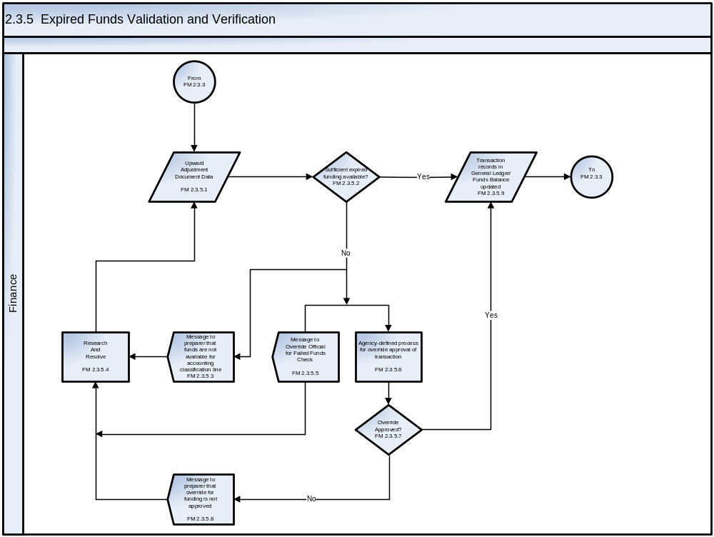
See Appendix C – Business Process Flowcharts, Symbols, and Definitions for an enlarged version of the flowchart
The Expired Funds Validation and Verification process steps are described as follows:
Step ID | Step Name | Step Description | Business Rules | CFSR Req.
FM 2.3.5.1 | Upward Adjustment Document Data | The detailed upward adjustment data to be submitted to funds availability verification. | The detail data from the document being processed and submitted for a funds check. | SMB-21
FM 2.3.5.2 | Sufficient expired funding available? | Verification that there is sufficient monies available in the Allotments-Expired Authority account to cover the upward adjustment to an existing obligation. | An agency is responsible for establishing a policy for administrative control of Funds. | FME-02  FME-03  FME-04  FME-10  SMB-11  SMB-12  SMB-13  SMC-09
FM 2.3.5.3 | Message to preparer that funds are not available for accounting classification line | Electronic notification to document preparer that there are insufficient funds available for the account distribution line. | Business Unit to be notified that funds are not available and that the Funds Override Official has been notified. | TLE-07  TLE-08
FM 2.3.5.4 | Research and Resolve Issues | If funds are not available, the Business Unit will research and resolve the issue. | Designated personnel resolve applicable issues in accordance with applicable rules, regulations, and agency guidelines. | FMD-05  SMB-16  SMC-09
FM 2.3.5.5 | Message to Override Official for Failed Funds Check | Electronic notification to the designated Funds Override Official that there are insufficient funds available for the account distribution line. | As a part of providing OMB with the agency’s Funds Control policy and regulations, an appropriate individual is identified who is responsible for any obligation or expenditure exceeding the amount available in the appropriation or fund account, the OMB apportionment or reapportionment, the allotment or sub-allotments made by the agency, any statutory limitations, and any other administrative subdivision of funds made by the agency.  The agency must also provide procedures for dealing with violations of the Antideficiency Act as well as violations of other administrative subdivision of funds that are not violations of the Antideficiency Act.  See OMB Circular A-11, Appendix H - Checklist for Fund Control Regulations. | TLE-07  TLE-08
FM 2.3.5.6 | Agency-defined process for override approval | Process to allow review and, if appropriate, approval for the transaction. This would occur under a CR or other circumstances where the Funds Override Official is aware of additional funding available to cover the transaction amount so as not to put the TAFS into an Antideficiency condition. | As a part of providing OMB with the agency’s Funds Control policy and regulations, an appropriate individual is identified who is responsible for any obligation or expenditure exceeding the amount available in the appropriation or fund account, the OMB apportionment or reapportionment, the allotment or sub-allotments made by the agency, any statutory limitations, and any other administrative subdivision of funds made by the agency.  The agency must also provide procedures for dealing with violations of the Antideficiency Act as well as violations of other administrative subdivision of funds that are not violations of the Antideficiency Act  See OMB Circular A-11, Appendix H - Checklist for Fund Control Regulations | TLE-01
FM 2.3.5.7 | Override Approved? | If override approval has occurred, the transaction posts to the General Ledger. If override approval has not occurred, notification is sent to the Business Unit and the transaction is cancelled. | The agency Funds Override Official must ensure sufficient applicable funding is available prior to allowing the transaction to record to the General Ledger. | SMB-18
FM 2.3.5.8 | Message to preparer that override for funding is not approved | Electronic notification to document preparer that override approval was not granted. | Business Unit to be notified that funds are not available and that the Funds Override Official has not approved the override transaction. | TLE-07  TLE-08
FM 2.3.5.9 | Transaction records in General Ledger/Funds Balance updated | The transaction is recorded in the General Ledger. | The transaction is recorded in the General Ledger. At the same time, the appropriate funds balances are also updated thereby keeping the balances in line with the General Ledger.  Examples include, but are not limited to, the following transaction codes from the current TFM:  TFM-D126 To record an upward adjustment to prior-year paid delivered orders.  TFM-D106 To record an upward adjustment of prior-year unpaid delivered orders and to accrue additional liability when the adjustment is not recorded as a prior-period adjustment (USSGL account 7400 or 7401). The authority has expired. | FME-02  FME-04  FME-08  FME-10  FME-12  GLB-01  GLC-01  GLC-04  GLC-05  GLC-06  GLD-01  GLD-02  GLD-03  GLD-04  GLD-05  GLD-06  GLD-07  SMC-02

- Payment Management Processes

Payment Management Processes
An effective payment management process ensures payments to vendors are done so in a timely manner ensuring good stewardship of government funds. Under the Prompt Payment Act, agencies are required to practice effective cash management practices in the payment for goods and services to ensure that invoices are paid within seven (7) days of their payment due dates and interest penalties for late payments are avoided. Agencies must also have proper controls in place for monitoring any interest penalties paid and implementing corrective actions where necessary.

In addition to the Prompt Payment Act, Chapter 52.232-25—Prompt Payment of the Federal Acquisition Regulation (FAR) establishes the contractual requirement between Federal agencies and vendors for prompt payment of invoices, including the notification process for invoice defects. Late payment interest is calculated based on the rate established by the Secretary of the Treasury and published semi-annually via the Federal Register.

All vendors, including sole proprietors, corporations, partnership, and governmental organizations, are required to register in the Central Contractor Registration (CCR), which is the primary registrant database for the Federal government. Through validation of registrant information, CCR shares the data with agencies’ finance office and facilitates the electronic funds transfer (EFT) process.

Included in this chapter are key steps in the processes from requisition to payment for commercial contracts and small acquisitions disbursed by Treasury. Although this chapter focuses on payment requests that are the result of vendor invoices, it must be noted that there are several other payment request types including, but not limited to, grants, employee reimbursements, employee awards and payroll. The flowcharts and process steps for the Payment Management processes detailed in this chapter are:
- PM 3.1 – Receipt and Acceptance of Goods. This section describes the procedures necessary for the inspection, receipt, acceptance and return of goods.
- PM 3.2 – Receipt and Acceptance of Services. This section describes the process for the receipt and acceptance of services.
- PM 3.3 – Accounts Payable and Invoicing Processes
- PM 3.3.1 Invoice Entry. This section describes the process for entering an invoice into the Core Financial System and matching the required supporting documentation. Also included are related accounting entries and the steps to ensure proper approval and verification of an invoice.
- PM 3.3.2 Invoice Processing. This section describes the steps associated with processing an invoice in the Core Financial System. Also included are related accounting entries and the steps to ensure proper approval and verification of an invoice.
- PM 3.3.3 Credit Memo. This section describes the steps associated with processing a credit memorandum. Credit memos are warehoused and offset against outstanding invoices. The payment is processed when the amount of the invoice or invoices exceed the credit memo balance.
- PM 3.4 – Disbursements
- PM 3.4.1 Disbursements for Bulk Files (ACH/EFT, CCD, CCD+, CTX, and Checks). This section depicts the actions performed from the warehousing of a bulk file through payment to a payee. Key steps include submitting the bulk file to Treasury, certification of payments to be disbursed, and disbursements.
- PM 3.4.2 Disbursements for Small Volume and Same or Next Day Payments. This section depicts the actions performed for payments which must be expedited. Key steps include submitting the file to treasury, certification of payments to be disbursed, and disbursements.
- PM 3.5 – Returned Payments – ACH, Check, Same Day. This section provides the key steps for the cancellation and return of payments from Treasury to the agency. The payment instruments include checks, ACH, CTX, CCD, CCD+, and Fedwires.
- PM 3.6 – Data Objects and Data Elements. This section is currently under development with Treasury FMS.
Excluded from the scope of this chapter are the following:
- Payment management processes for payments not disbursed by Treasury
- Acquisition processes
- Processes for maintenance of the Central Contractor Registry
- Intragovernmental Payment and Collection (IPAC) transactions
- Reimbursable activity
- Imprest Funds
- Travel
- Payroll
- Employee awards
- Credit card payments
- Grants
- Loans
- Cooperative agreements
- Canceled funds
- Foreign currency
- Internal offsets between Accounts Payable and Accounts Receivable.

The following flowchart depicts the sequence and inter-relationship of the Spending Chain Processes:
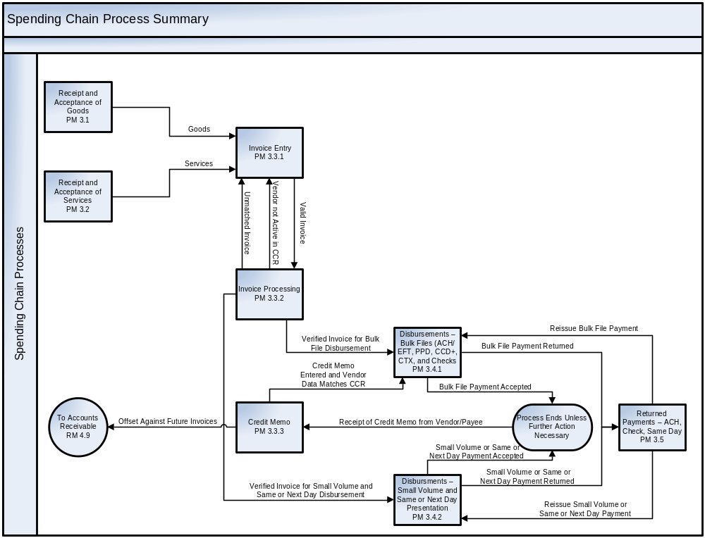
See Appendix C – Business Process Flowcharts, Symbols, and Definitions for an enlarged version of the flowchart

Receipt and Acceptance of Goods
Receipt and Acceptance of Goods refers to the process of receiving physical goods, performing an inspection, and either accepting or rejecting the delivery based on damage, quantity, or other criteria as defined by the contract. Depending on the nature of the goods received and the functional organization of an agency, the “Receiving” swim lane in the flowchart refers to a variety of locations in an agency rather than a specific office or area within an agency.
PM 3.1 – Receipt and Acceptance of Goods Flowchart
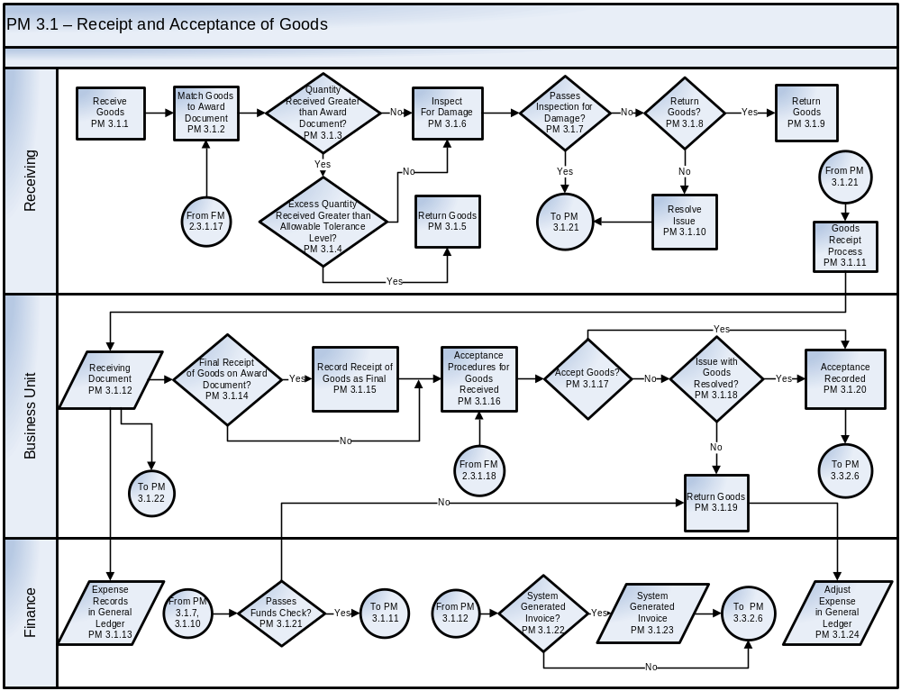
See Appendix C – Business Process Flowcharts, Symbols, and Definitions for an enlarged version of the flowchart
The Payment Management Receipt and Acceptance of Goods process steps are described as follows:
Step ID | Step Name | Step Description | Business Rules | CFSR Req.
PM 3.1.1 | Receive Goods | Physical goods are received at a designated receiving area. | Goods should be delivered according to delivery information on the award document. Agency procedures should call for rejecting delivery of goods received at locations other than the appropriate receiving site, which may be a receiving dock or at the business unit. | PMB-01  PMB-04
PM 3.1.2 | Match Goods to Award Document | When goods are received, Receiving personnel compare the items to the award document. Any discrepancies are noted electronically. | Access to the Receiving system and receiving transactions in the Core Financial System must be restricted to authorized personnel.  Goods must be recorded in the agency’s asset management system as applicable.
PM 3.1.3 | Quantity Received Greater than Award Document? | If the quantity received exceeds the quantity ordered, the excess is compared to an allowable tolerance level (see step PM 3.1.4). This comparison may be performed electronically.  If the quantity received is equal to or less than the quantity ordered the goods are inspected for damage (see step PM 3.1.6).
PM 3.1.4 | Quantity Received Greater than Allowable Tolerance Level? | If the quantity received exceeds the quantity ordered, the excess is compared to an allowable tolerance level. This comparison may be performed electronically.  If the quantity received is within the allowable tolerance level, it is determined if this is the final receipt of goods on the award document. | Agencies can set tolerance levels as allowed under applicable rules, regulations, and agency guidelines (FAR Volume 1, Part 11, Subpart 11.7, agency policies and procedures). | SMB-19  SMB-20
PM 3.1.5 | Return Goods | All or a portion of the goods are returned to the originator as applicable under the terms of the contract. | The return of items must be recorded in the applicable system.
PM 3.1.6 | Inspect for Damage | Goods are inspected for damage once the goods are received and matched to the award document. | Goods should be inspected for damage at the time of delivery by applicable Receiving personnel.
PM 3.1.7 | Passes Inspection for Damage? | Confirm goods are free of visible damage and note that the goods pass inspection. Damaged goods are noted electronically. | Receiving personnel assess visible damage to goods in accordance with applicable rules and regulations and agency guidelines (e.g., FAR, agency policy and procedures).
PM 3.1.8 | Return Goods? | If the goods are determined to be damaged and repair or replacement of parts is not appropriate, all or a portion of the goods should be returned.  Any discrepancies are noted electronically. | The return of goods must be within the contract terms.  In accordance with the contract terms, replacement components or parts may be obtained from the vendor to correct the issue.
PM 3.1.9 | Return Goods | Goods are returned if the quantity is in excess of the allowable tolerance level.  Any discrepancies are noted electronically. | A modification to the applicable acquisition instrument is required to increase the obligation of funds for quantities of goods exceeding tolerance levels. Such modification must occur prior to performing receipt and acceptance of the goods. Otherwise, the goods are returned.
PM 3.1.10 | Resolve Issue | Inspection issues with the goods must be resolved, as applicable, if goods are not to be returned.
PM 3.1.11 | Goods Receipt Process | Goods are processed for receipt. | Policies and procedures must comply with FAR where applicable. The receipt of goods must be performed within the contract terms.
PM 3.1.12 | Receiving Document | Receiving personnel enter receiving data to the applicable system to create a receiving document. The system accesses and populates applicable fields of the receiving document with information from the award document. | The receiving document becomes available to the Business Unit. The applicable system electronically notifies the requisitioner in the Business Unit that goods have been received.  The receiving document becomes available to the Core Financial System to be matched with the invoice and award document information.  Notice of receipt is sent to the agency’s Acquisition system.  A proprietary expense and budgetary expenditure for delivered goods is recorded in the General Ledger. Applicable obligations, advances, or pre-paid expense balances are liquidated.
PM 3.1.13 | Expense Records in General Ledger | A proprietary expense, a budgetary expenditure for received goods, and liquidation of the associated obligation is recorded in the General Ledger. Applicable advances or pre-paid expense balances are liquidated. | The entries are recorded in the General Ledger using the USSGL Account Transaction Listing provided in the current TFM.  Examples include, but are not limited to, the following transaction codes from the current TFM:  TFM-B402 To record the delivery of goods or services and accrue a liability.  TFM-B404 To record the delivery of goods and services in the same year the order was placed and accrue a liability. The current-year expended authority is less than the original obligation.  TFM-B406 To record the delivery of goods and services in the same year the order was placed and accrue a liability. The current-year expended authority is more than the original obligation.  TFM-B410 To record the delivery of goods or services for construction. | PMB-02
PM 3.1.14 | Final Receipt of Goods on Award Document? | Determine if this is the final receipt of goods for this award document. Confirm that the receipt satisfies the quantity on the award document. | Personnel designated to perform acceptance procedures for receipt of goods indicate in the Core Financial System whether this is the final receipt of goods for the award document.
PM 3.1.15 | Record Receipt of Goods as Final | If the receipt of goods represents the final outstanding obligation on the award document, it is recorded as the final receipt of goods. | Appropriate procedures should be performed to reconcile the award document to documentation of goods received.
PM 3.1.16 | Acceptance Procedures for Goods Received | The Business Unit or personnel with authority to approve acceptance of goods inspects the goods. This person reviews the electronic receiving document and is responsible for validating that goods are in compliance with contractual requirements. | Depending on contractual terms and FAR guidelines, “constructive receipt” may apply to certain goods. In these cases, acceptance procedures may not be required as the services are considered “accepted” after an applicable amount of time.  The receipt and acceptance of goods must be done within the contract terms.  Acceptance is electronically routed to Finance to be matched with the invoice and award document. | PMB-05
PM 3.1.17 | Accept  Goods? | If the certifier accepts all or a portion of the goods received, the applicable quantities of line items from the award document are accepted. The electronic documentation of acceptance is available to the Finance area. | If a required invoice has yet to be received in Finance, certification of receipt and acceptance of goods is stored in the system pending receipt of the invoice.  Acceptance issues must be resolved, as applicable.
PM 3.1.18 | Issue with Goods Resolved? | If the issue with the goods is resolved and the goods are accepted, acceptance is recorded. If the goods are not accepted, the goods should be returned. | In accordance with rules, regulations and agency guidelines (e.g., agency policies and procedures, FAR), designated officials review applicable issues related to goods and determine steps to be taken to resolve these issues.  Issue resolution must be made in accordance with prompt payment requirements, as applicable, and contract terms.  If the personnel with authority for performing acceptance determine goods are to be rejected and returned, he/she electronically records the items being rejected and the expenses recorded at the time of receipt of goods are adjusted accordingly.
PM 3.1.19 | Return Goods | Return goods to the appropriate originator. | Return of goods must be appropriately recorded in the agency asset management system.
PM 3.1.20 | Acceptance Recorded | Personnel document acceptance for goods that have been received. | Appropriate personnel should be authorized for documenting acceptance of goods.  Expenses are reviewed periodically by responsible personnel in the Finance area. Appropriate personnel should follow up on items for which receipt and/or acceptance are missing.
PM 3.1.21 | Passes Funds Check? | The amount that a receiving document exceeds an obligation is subjected to an edit check to determine whether sufficient funds are available for the additional funding of the overage amount within the tolerance.  If funds are available, the expense records in the General Ledger. If funds are not available, notification is sent to the Business Unit and Acquisition to resolve the issue. | The Core Financial System must ensure sufficient applicable funding is available prior to allowing an expense to be recorded in the General Ledger.
PM 3.1.22 | System Generated Invoice? | An invoice is generated within the Core Financial System for applicable transactions for which an invoice is not required. | Award documents should indicate whether a vendor invoice is required for payment. (The vendor invoice may be required by Finance prior to payment but is not required as part of the Receiving process. Rather, it may be made available to applicable personnel in the Business Unit for informational purposes.)  In the event a vendor invoice is not required, the Core Financial System should generate an internal invoice document based on vendor, obligating, receiving, and acceptance information.
PM 3.1.23 | System Generated Invoice | A system-generated invoice is the result of step PM 3.1.22.
PM 3.1.24 | Adjust Expense in General Ledger | For goods being rejected, expenses recorded at the time of receipt of goods are adjusted accordingly by entering the item return into the system (negative goods receipt). | Based on the specific financial event, the expense is adjusted in accordance with the current TFM.

Receipt and Acceptance of Services
Receipt and Acceptance of Services refers to the process of receiving services, determining whether the services received met the contractual obligation, and accepting or rejecting the services based on quality, quantity, or other criteria as defined by the contract. The following flowchart depicts the steps for the Payment Management process for the receipt and acceptance of services. Steps include receipt and acceptance of services and related actions in the Business Unit and Finance functional areas.
PM 3.2 – Receipt and Acceptance of Services Flowchart
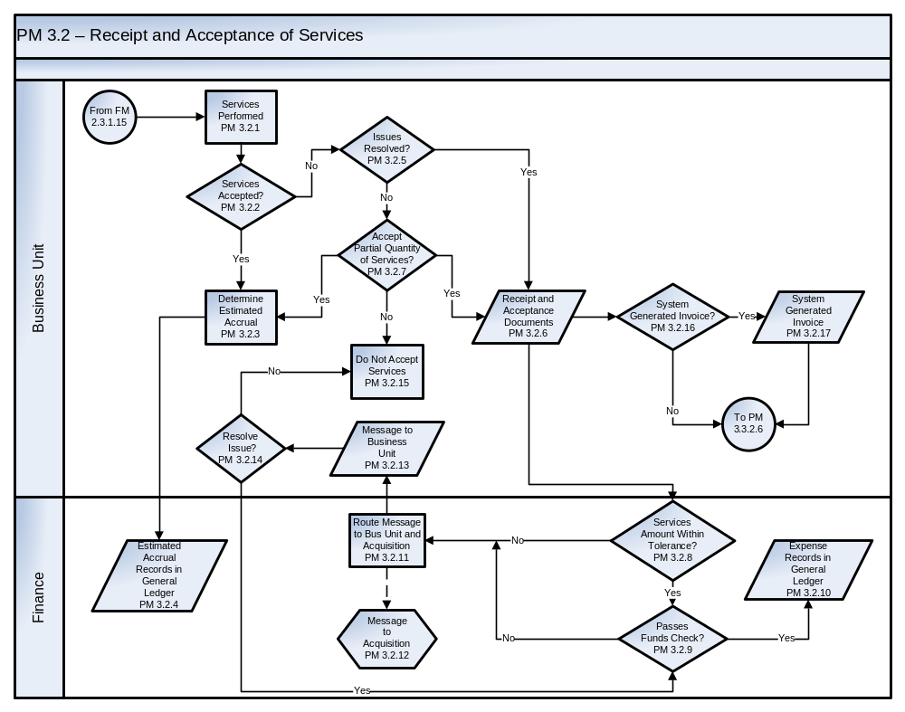
See Appendix C – Business Process Flowcharts, Symbols, and Definitions for an enlarged version of the flowchart
The Payment Management Receipt and Acceptance of Services process steps are described as follows:
Step ID | Step Name | Step Description | Business Rules | CFSR Req.
PM 3.2.1 | Services  Performed | Services are performed on behalf of the applicable Business Unit. | Authorized officials in the Business Unit and/or Acquisition monitor services for compliance with contractual terms.  Receipt of services should be documented in the Core Financial System by the time the invoice for the services is received.
PM 3.2.5 | Services Accepted? | Authorized officials in the Business Unit access an electronic award document and vendor invoice for services provided. The authorized official in the Business Unit is electronically notified by Finance of the receipt of an invoice for services. | Depending on contractual terms and FAR guidelines, “constructive receipt” may apply to certain services. In these cases, acceptance procedures may not be required as the services are considered “accepted” after an applicable amount of time.  The receipt and acceptance of services must be performed within the contract terms.
PM 3.2.3 | Determine Estimated Accrual | An estimated accrual is determined using the agency’s guidelines. | The agency’s guidelines for estimating accruals must be reassessed on a regular basis.
PM 3.2.4 | Estimated Accrual Records in General Ledger | Based on services performed, an estimated accrual of expenses for the delivered services is recorded in the General Ledger. | The entries are recorded using the USSGL Account Transaction Listing provided in the current TFM.  Examples include, but are not limited to, the following transaction codes from the current TFM:  TFM-B402 To record the delivery of goods or services and accrue a liability.  TFM-B404 To record the delivery of goods and services in the same year the order was placed and accrue a liability. The current-year expended authority is less than the original obligation.  TFM-B406 To record the delivery of goods and services in the same year the order was placed and accrue a liability. The current-year expended authority is more than the original obligation.  TFM-B410 To record the delivery of goods or services for construction.  Accruals should be reversed as appropriate each reporting period.
PM 3.2.5 | Issues Resolved? | Appropriate messages are routed to Business Unit, Acquisition, and Finance personnel and appropriate actions are taken to resolve any issue(s). If appropriate actions are taken and appropriate personnel determine that issues are resolved, the services are accepted.  The authorized official may decline to accept services due to concerns that contractual criteria have not been met. | Issues must be evaluated and resolved in accordance with applicable laws and regulations, rules, and agency guidelines (e.g., FAR, agency policies and procedures), including the Prompt Payment Act.
PM 3.2.6 | Receipt and Acceptance  Documents | Based on appropriate monitoring of vendor performance, the authorizing official electronically performs receipt and acceptance of services. |  | PMB-01  PMB- 05
PM 3.2.7 | Accept Partial Quantity of Services? | If the full amount of services are not accepted and issues are not resolved, the agency determines whether to accept a partial quantity of the services.  If there is partial acceptance, the receipt and acceptance documents for the portion of services accepted are processed. | Partial receipt of services are possible for certain types of services and can be governed by the “Service Level Agreement” (SLA) for acceptance of services.  Partial receipt and acceptance of services may result from variances from contractual terms (e.g., rate discrepancy, contracted quantity of services (e.g., hours) received, quality of content and performance).  If an invoice or other applicable documentation per the contract is received from the vendor but the agency does not accept the services because of unresolved issues, the invoice should be rejected within the specified number of days based on Prompt Pay type.
PM 3.2.8 | Services Amount Within Tolerance? | If the quantity of hours or hourly rate of services received exceeds the quantity or rate ordered, the excess is compared to an allowable tolerance level. If the quantity received is within the allowable tolerance level and the monetary value of any applicable line item of the bill exceeds the obligation but is within tolerance, it is subjected to a “Funds Check”. | Agencies set tolerance levels in accordance with applicable rules, regulations, and agency guidelines (e.g., FAR, agency policies and procedures). | SMB-19  SMB-20
PM 3.2.9 | Passes Funds Check? | The amount by which services received exceed an obligation is subjected to an edit check to determine whether sufficient funds are available for the additional funding.  If funds are available, the expense is recorded in the General Ledger. If funds are not available, notification is sent to the Business Unit and Acquisition, as applicable, to resolve the issue. | The Core Financial System must ensure sufficient applicable funding is available prior to allowing an expense to record in the General Ledger.
PM 3.2.10 | Expense Records in General Ledger | Based on receipt of the services, a proprietary expense and budgetary expenditure for the delivered services is recorded in the General Ledger. | The entries are recorded using the USSGL Account Transaction Listing provided in the current TFM.  Examples include, but are not limited to, the following transaction codes from the current TFM:  TFM-B402 To record the delivery of goods or services and accrue a liability.  TFM-B404 To record the delivery of goods and services in the same year the order was placed and accrue a liability. The current-year expended authority is less than the original obligation.  TFM-B406 To record the delivery of goods and services in the same year the order was placed and accrue a liability. The current-year expended authority is more than the original obligation.  TFM-B410 To record the delivery of goods or services for construction.
PM 3.2.11 | Route Message to Business Unit and Acquisition | If either the quantity of services received exceeds the allowable tolerance level or the funds check fails, a message is routed to the appropriate personnel in the Business Unit and Acquisition to resolve the issue(s). | The message should be initiated electronically once a transaction fails the tolerance or funds checks.
PM 3.2.12 | Message to Acquisition | An applicable message is routed to Acquisition with the tolerance and/or funding issue(s).
PM 3.2.13 | Message to  Business Unit | An applicable message is routed to the Business Unit with the tolerance and/or funding issue(s).
PM 3.2.14 | Resolve Issue? | The Business Unit and/or Acquisition will resolve the tolerance and/or funding issue(s).  If the issue is resolved, the amount of services received is subject to a funds check. | Issues must be evaluated and resolved within the guidelines and requirements of applicable laws and regulations, including the Prompt Payment Act and FAR.
PM 3.2.15 | Do Not Accept Services | The certifier of acceptance electronically records the service items being rejected.  The associated invoice will be returned to the vendor/payee. A new invoice may be requested if applicable. | If services are to be rejected, it must be done in accordance with applicable award documents, the FAR, and agency guidelines.
PM 3.2.16 | System-Generated Invoice? | An invoice is generated within the Core Financial System for applicable transactions for which an invoice is not required. | Award documents should indicate whether a vendor invoice is required for payment. (The vendor invoice may be required by Finance prior to payment but is not required as part of the Receiving process. Rather, it may be made available to applicable personnel in the Business Unit for informational purposes.)  In the event a vendor invoice is not required, the Core Financial System should generate an internal invoice document based on vendor and associated obligating, receiving, and acceptance information.  Acceptance is electronically routed to Finance to be matched with the invoice and award document.
PM 3.2.17 | System-Generated Invoice | A system-generated invoice is generated within the Core Financial System. | Acceptance is electronically routed to Finance to be matched with the invoice and award document.

Accounts Payable and Invoicing Processes
The Accounts Payable and Invoicing processes described in the sections 3.3.1, 3.3.2, and 3.3.3 refer to the procedures necessary to enter an invoice into the Core Financial System, match supporting documentation with an award document, and process a credit memo received from a vendor/payee. Further, related accounting entries and the steps to ensure proper approval and verification of an invoice are contained within this section.

Invoice Entry
Invoice Entry refers to the process of receiving invoices from vendors, verifying and validating invoice information, and approving or rejecting the invoices for payment. This section is based on the assumption that under best business practices, invoices should be submitted and processed electronically. Agencies should implement procedures to automate the invoice submission process. This chapter addresses one type of payment requests, invoices. Other types of payment request which are used to authorize disbursements include, but are not limited to, grants, employee reimbursements, employee awards and payroll.
In cases where an agency must continue to accept paper invoices, electronic tools can be used to improve the efficiency of invoice processing. Examples include digital imaging and Optical Character Recognition (OCR).

PM 3.3.1 - Invoice Entry Flowchart
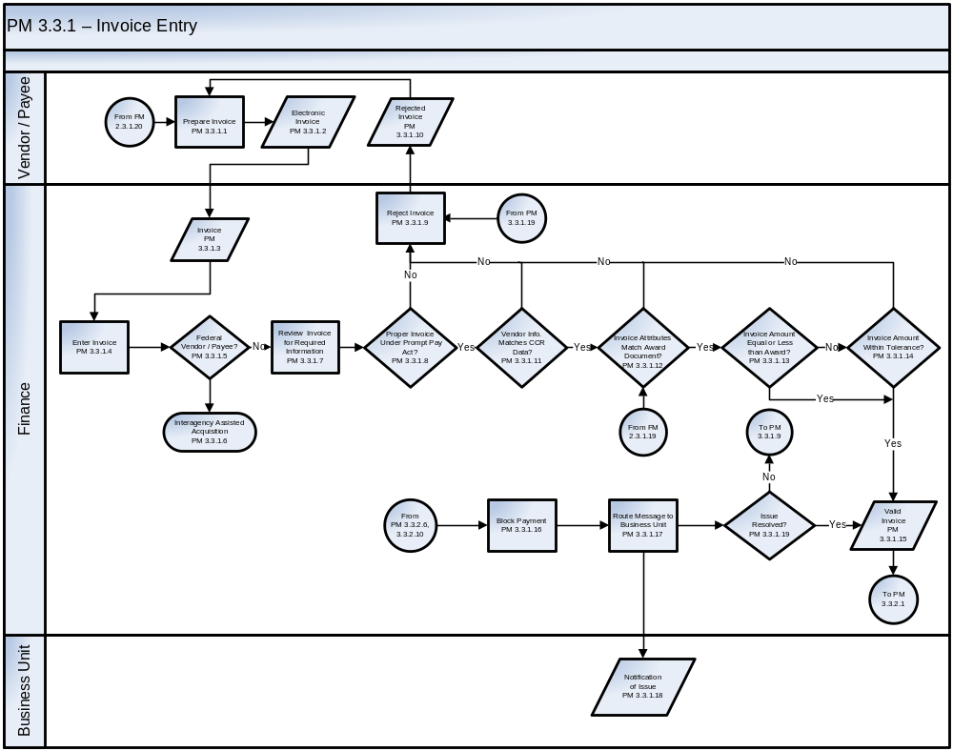
See Appendix C – Business Process Flowcharts, Symbols, and Definitions for an enlarged version of the flowchart
The Payment Management Accounts Payable and Invoice Entry and Processing steps are described as follows:
Step ID | Step Name | Step Description | Business Rules | CFSR  Req.
PM 3.3.1.1 | Prepare  Invoice | The vendor/payee prepares and submits to the agency an invoice for goods and/or services. | Agencies must communicate to vendor/payees that invoices must be prepared in accordance with prescribed data and format requirements.
PM 3.3.1.2 | Electronic Invoice | Under best business practices, invoices are submitted electronically. | The Core Financial System must provide automated functionality for capturing invoice data. | PMC-01  PMC-02  PMC-03
PM 3.3.1.3 | Invoice | Invoices are received in Finance (should be via electronic transmission).  In the case of paper invoices, invoices are forwarded to appropriate Finance or other applicable personnel. | Paper invoices received should be imaged to enable the flow of invoice documents electronically through the accounts payable and invoicing processes.
PM 3.3.1.4 | Enter Invoice | Invoices are entered into the agency’s accounts payable system creating a payment request. | The invoice date and the date the invoice was received in the proper billing office (log date) should be entered into the system in accordance with Prompt Payment Act requirements.  The payment due date and the date on which interest will begin to accrue if a payment is late must be determined in accordance with Prompt Payment Act requirements.  Under best business practices in an electronic environment, invoices are imported into the agency’s accounts payable system.
PM 3.3.1.5 | Federal Vendor / Payee? | The vendor/payee is identified as either a federal or non-federal vendor/payee. | If the payee is a Federal vendor, Finance performs IPAC procedures in accordance with an approved Trading Partner Agreement and Treasury guidelines.
PM 3.3.1.6 | Interagency Assisted Acquisition | Federal vendor/payees are paid through the IPAC system  Federal (intragovernmental) buy and sell transactions that are processed through IPAC will be included in a future release of the Standard Business Processes document. | A federal agency is any executive agency or any independent establishment in the legislative or judicial branch of government (except the Senate, the House of Representatives, the Architect of the Capitol, and any activities under the Architect’s direction).
PM 3.3.1.7 | Review Invoice for Required Information | Edit checks are performed to evaluate whether an invoice includes information required under the Prompt Payment act. | Automated system edit checks should be performed to verify that each invoice includes the required information under the Prompt Payment Act. As necessary, some edit checks may be performed manually.  Under best business practices in an electronic environment, edit checks should include tests of validity, accuracy, and completeness of information submitted. Such edit checks (as described in subsequent steps) may be executed simultaneously. An exception report should be generated. | PMA-02
PM 3.3.1.8 | Proper Invoice Under Prompt Pay Act? | Based on the results of the edit checks performed in the previous step, the agency determines whether the invoice is proper under the requirements of the Prompt Pay Act. | Agency procedures must enable the return of improper invoices within the required number of days as required under the Prompt Payment Act.
PM 3.3.1.9 | Reject Invoice | If the invoice fails Prompt Pay information requirements, cannot be matched to a valid obligation, or key vendor/payee information does not match the vendor/payee file, it is rejected and returned to the vendor/payee. | The agency must provide the vendor/payee a system-generated notice of return of an improper invoice.  If the award was made to a CCR registered vendor/payee and the vendor/payee no longer has an active registration in CCR, the Prompt Pay Act requires the invoice be returned as an improper invoice.  Vendor/payees are not required to be registered in CCR but must be active in the official agency vendor/payee file, or the invoice is rejected.  Mark the vendor/payee invoice with the date the invoice is returned in order to stop the accrual of interest.  The vendor/payee may be contacted as applicable, but such communication should not delay compliance with the Prompt Payment Act. | PMC-19  PMC-21  PMC-22
PM 3.3.1.10 | Rejected Invoice | A rejected invoice is returned to the vendor/payee for correction or other appropriate action in order for the vendor/payee to prepare a proper invoice. | Vendor/payees are required to prepare invoices in accordance with the FAR and agency guidelines.
PM 3.3.1.11 | Vendor Info. Matches CCR Data? | System edit checks verify that vendor/payee information matches the vendor/payee file based on the latest vendor/payee database update. | Core Financial System vendor/payee data must be regularly updated with changes to CCR data. Vendor/payee file fields must accommodate CCR data.  The Core Financial System must prevent CCR vendor/payee data from being changed by the agency for those vendor/payees required to register in the CCR. | PMA-04
PM 3.3.1.12 | Invoice Attributes Match Award Document? | Finance determines that system edit checks have validated the consistency of information on the invoice with the relevant award document (i.e., order number, product description, quantity, vendor/payee name, address, and date). | Automated edit checks should verify an invoice is originated by an approved vendor/payee. System edit checks verify that vendor/payee information on the invoice matches the information for the approved vendor/payee in the system. For vendor/payees not required to be registered in CCR, the invoice is validated against agency-defined criteria.  The Core Financial System must process each vendor/payee invoice through edit criteria designed to identify duplicate vendor/payee invoices. Edit criteria and should be developed based on appropriate agency defined criteria. Criteria may include agency identifier, vendor/payee number, vendor/payee account number, vendor/payee TIN, vendor/payee invoice number, invoice date, invoice amount, referenced obligation document number, or DUNS number. An exception report must be generated and reviewed by a supervisory official. | PMC-04  PMC-05  PMC-06
PM 3.3.1.13 | Invoice Amount Equal or Less than Award? | The invoice amount is compared to the award document amount. | The Core Financial System must incorporate edit checks to facilitate this comparison of quantities and amounts by document lines and totals.
PM 3.3.1.14 | Invoice Amount within Tolerance? | The amount by which an invoice amount exceeds an obligation is compared to allowable tolerance levels. | Agencies should determine tolerance levels for prices, quantities of items, and applicable amounts (e.g., freight) for which further approval is not required.  An additional obligation document is not required for invoice amounts within tolerance.  In cases where the funding need exceeds the tolerance limits, policies or business practices may allow officials with funding authority to be notified to consider obligating more funds (rather than rejecting the invoice). | SMB-19  SMB-20  PMC-13
PM 3.3.1.15 | Valid Invoice | Once the invoice passes the edit checks, the invoice is considered a valid invoice. | Valid invoice must be populated with applicable valid data elements.
PM 3.3.1.16 | Block Payment | If matching criteria are not met, the invoice is blocked from payment. | The Core Financial System must block from payment any invoice for which matching criteria are not met or an invoice lacks required approvals and/or verifications. | PMC-08
PM 3.3.1.17 | Route Message to Business Unit | Once an invoice has been received and the system lacks evidence of receipt of goods and/or acceptance, the system routes a message to the applicable Business Unit personnel of the need for required documentation. In the case of services, the invoice copy is routed to the Business Unit for review. | The Core Financial System should automatically identify and route a message to applicable personnel of open requirements related to pending invoices.  Applicable personnel take appropriate actions within Prompt Payment Act requirements. | TLE-07
PM 3.3.1.18 | Notification of Issue | The Business Unit is notified electronically of the need for required documentation.
PM 3.3.1.19 | Resolve Issue | Additional documentation is provided.

Invoice Processing
Invoice Processing refers to the process of performing a funds check, determining if the proper obligation or receiving document has been established, and accepting or rejecting the invoice. The verification process also includes two-way, three-way, and four-way matches, confirmation of vendor’s status in the CCR, and notification of any funds that may be deobligated.
PM 3.3.2 - Invoice Processing Flowchart
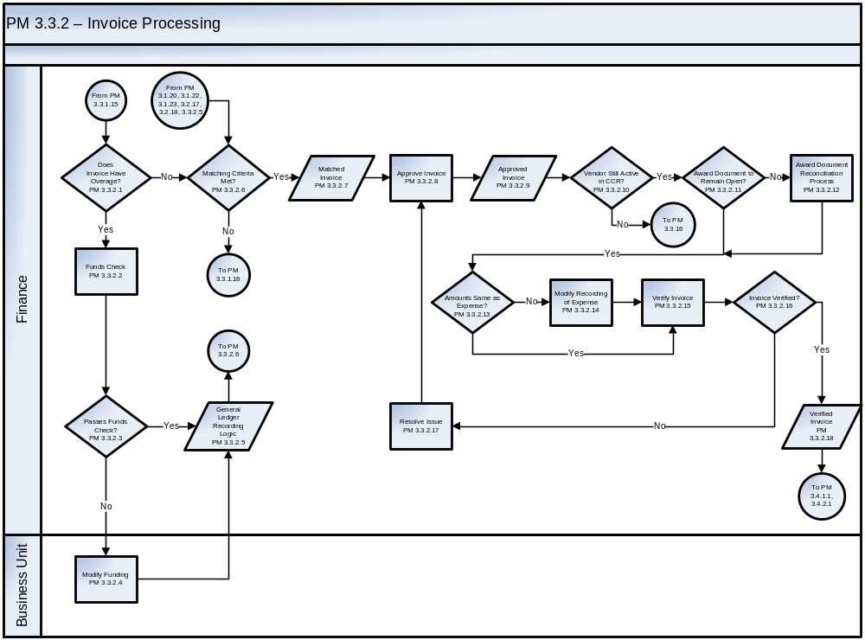
See Appendix C – Business Process Flowcharts, Symbols, and Definitions for an enlarged version of the flowchart
The Payment Management Invoice Processing process steps are described as follows:
Step ID | Step Name | Step Description | Business Rules | CFSR Req.
PM 3.3.2.1 | Does Invoice Have Overage? | Determine if the invoice amount is greater than the approved original funding amount while being within the allowable tolerance for overages.
PM 3.3.2.2 | Funds Check | The amount of an invoice is subjected to a check to determine whether sufficient funds are available for the payment. | The Core Financial System must ensure sufficient applicable funding is available prior to allowing an invoice to be paid.
PM 3.3.2.3 | Passes Funds Check? | The funds check process is completed. | The Core Financial System must ensure sufficient applicable funding is available prior to allowing an expense to be recorded in the General Ledger.
PM 3.3.2.4 | Modify Funding | Funding authorities identify, realign or reprogram funds as applicable to fund the full amount of the obligation (for invoice overages within the allowable tolerance for overages). | Funding authorities fund the obligation in accordance with applicable rules, regulations and agency guidelines (e.g., FAR, OMB Circular A-11, agency policies and procedures).
PM 3.3.2.5 | General Ledger Recording Logic | The system performs a series of logical steps before recording the appropriate entries to the General Ledger.  The system performs edits on the entries to determine the accounting classification elements are valid, the accounting period is open, the fund is open, CCR edits are passed, etc.  After the entries pass validation edits and funds checks, the applicable entries are recorded. | In cases where the award document is closed out, entries to deobligate any remaining obligations are recorded.  Where the expense is modified, the appropriate expense adjustment for the overage on the invoice is recorded.  The entries are recorded using USSGL Account Transaction Listing provided in the current TFM.  Examples include, but are not limited to, the following transaction codes from the current TFM:  TFM-B402 To record the delivery of goods or services and accrue a liability.  TFM-B404 To record the delivery of goods and services in the same year the order was placed and accrue a liability. The current-year expended authority is less than the original obligation.  TFM-B406 To record the delivery of goods and services in the same year the order was placed and accrue a liability. The current-year expended authority is more than the original obligation.
PM 3.3.2.6 | Matching Criteria Met? | The invoice must be matched to required documentation for the applicable acquisition. | Finance must match invoices to appropriate obligations, receiving reports, and acceptance information by document line item and quantity.  The Core Financial System must process invoices for payment of partial quantities received. | PMC-08  PMC-09
PM 3.3.2.7 | Matched Invoice | Applicable document information is compared and matched depending on the applicable criteria for a two-way, three-way, or four-way matching process. | The agency must define and implement criteria for types of invoices for which two-way (obligation and invoice), three way (invoice, obligation, simultaneous receipt and acceptance) or four-way matching (invoice, obligation, receipt, and acceptance) is required. The applicable matching criteria should be determined prior to placing an order.  Agencies should establish criteria and procedures under which a payment not requiring an invoice can be made. Such a payment would be based on a contract schedule or other such agreed upon payment schedule.  Agency policies and procedures and system edits should require a receiving report for pre-defined types of goods (e.g., machinery, equipment). Such goods can be identified systematically based on applicable data fields within the accounting classification elements used for the transaction (e.g., object class).  Expenses should be reviewed periodically by a supervisor or other applicable personnel in the Finance area. An exception report is generated for items for which acceptance is missing. Finance personnel follow up on the items with Business Unit personnel. | PMC-08  PMC-10  PMC-11
PM 3.3.2.8 | Approve Invoice | Finance reviews and approves the invoices in the Core Financial System. Finance may rely on the Core Financial System to perform the matching function. Invoices may be approved electronically if automated edit checks serve to verify that required criteria have been met. | Finance personnel review electronic evidence of the existence and matching of the award document or contract, invoice, documents of receipt and acceptance, as applicable, to determine that the goods or services billed were in fact ordered and received prior to approving the invoice.  Automated edit checks are completed without exception prior to electronic approval of the electronically matched invoice.  A well-designed automated payment system will include evidence to verify that the system is designed and operating properly. Such evidence is used by an approver to verify the system is designed and operating properly. | TLE-01 TLE-02 TLE-03 TLE-04 TLE-05 TLE-06 TLE-07 TLE-08
PM 3.3.2.9 | Approved Invoice | Once the vendor/payee is verified as “active” in CCR and previous steps have been successfully accomplished, the invoice is considered approved.
PM 3.3.2.10 | Vendor Still Active in CCR? | The agency verifies that the vendor/payee is still active in CCR prior to payment. | System edit checks verify that the vendor/payee is active in CCR prior to payment. | PMC-07
PM 3.3.2.11 | Award Document to Remain Open? | If the invoice fulfills remaining line items on the award document, the quantities and amounts remaining on the obligating document are closed to prevent further payment activity. | The Core Financial System must record an applicable invoice as the “final” invoice against a referenced obligation.  Acquisition is notified when final payment has occurred on an obligation to facilitate the update of acquisition documents. | PMC-09
PM 3.3.2.12 | Award Document Reconciliation Process | Documentation of contract performance is reconciled to supporting documentation prior to closeout. | A message should be routed to Acquisition/requisitioner, as applicable, to review remaining undelivered orders for possible deobligation.
PM 3.3.2.13 | Amounts Same as Expense? | In the case of goods and/or services received, the system checks whether the amount of the invoice is the same as the amount expensed at the time of receipt of goods and/or services. | The Core Financial System must check for differences between recorded expenses and approved invoice amounts.
PM 3.3.2.14 | Modify Recording of Expense | The Core Financial System determines the amount by which the recorded expense must be modified to equal the amount of the approved invoice. | The recorded expense should be modified consistent with the additional shipping and other charges that were previously authorized.
PM 3.3.2.15 | Verify Invoice | Finance personnel will perform a second level review and approval of invoices meeting agency-defined criteria (e.g., invoice dollar amount greater than threshold). | Based on agency internal control procedures, selected invoices could be subjected to an additional review and approval based on agency established controls and criteria (e.g., invoices greater than specified threshold amounts, applicable invoice types).
PM 3.3.2.16 | Invoice Verified? | The agency determines whether invoices subjected to additional review pass or fail such review.
PM 3.3.2.17 | Resolve Issue | Issues noted during the “Verify Invoice” step must be resolved prior to approval of an invoice. Appropriate notifications to personnel are made and actions taken to resolve the issue. | The Core Financial System should enable routing of the invoice issue to authorized personnel.
PM 3.3.2.18 | Verified Invoice | An authorized approver reviews all documents for completeness and accuracy. The output is a verified invoice that includes all documents reviewed by the authorized approver. Upon approval, the invoice is warehoused for payment. | Documentation of the invoice, award document, receipt, evidence of inspection (physical goods), and acceptance are required for an invoice to be valid for payment. | TLE-03  TLE-06  TLE-07  TLE-08

Credit Memo
Credit Memos are issued by vendors in the event that previously accepted goods are returned by an agency and are either offset by the invoice or forwarded to the accounts receivable functional area for collections. Integration of accounts payable and accounts receivable is excluded from this chapter; however, where the process is performed the process flow indicates that the credit memo is forwarded to accounts receivable. In the event that the amount of the invoice exceeds that of the credit memo, payment is made for the difference. The steps contained in PM 3.3.3 outline the procedures for managing the credit memo process.
PM 3.3.3 – Credit Memo Flowchart
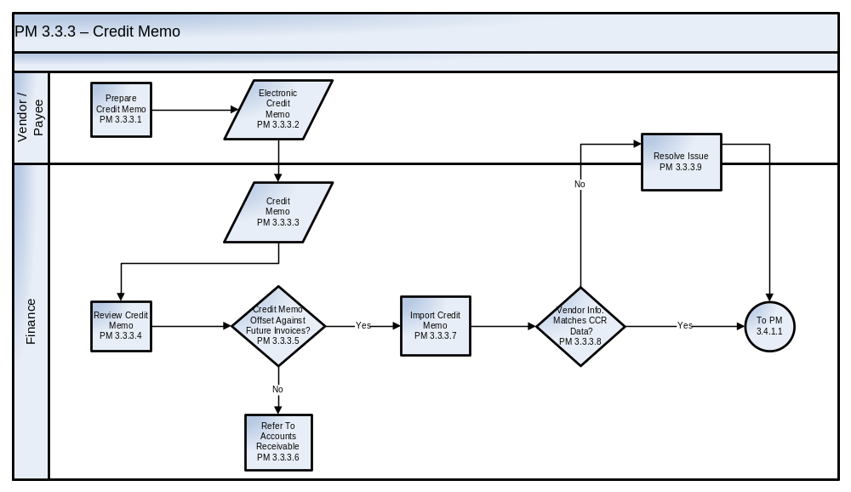
See Appendix C – Business Process Flowcharts, Symbols, and Definitions for an enlarged version of the flowchart
The Payment Management Credit Memo process steps are described as follows:
Step ID | Step Name | Step Description | Business Rules | CFSR  Req.
PM 3.3.3.1 | Prepare  Credit Memo | The vendor/payee prepares and submits to the agency a credit memo to settle a claim. | Agencies must communicate to vendor/payees that credit memos must be prepared by the vendor/payees in accordance with the agency’s prescribed data and format requirements.  Credit memos are warehoused and offset against outstanding invoices. Payment is processed when the amount of the invoice exceeds the credit memo balance.
PM 3.3.3.2 | Electronic Credit Memo | Under best business practices, credit memos are submitted electronically. | The Core Financial System must provide automated functionality for capturing credit memo data. | PMD-50  PMD-51 PMD-52 PMD-53 PMD-54
PM 3.3.3.3 | Credit Memo | Credit Memos are received in Finance (should be via electronic transmission).  In the case of paper credit memos, they are forwarded to appropriate Finance or other applicable personnel. | Paper credit memos received should be imaged to enable the flow of invoice documents electronically through the accounts payable and invoicing processes.
PM 3.3.3.4 | Review Credit Memo | Finance personnel should review credit memos to determine appropriate disposition. | Finance personnel should review the credit memo to determine the likelihood that the agency will have future business with the vendor/payee.
PM 3.3.3.5 | Credit Memo Offset Against Future Invoice? | Finance personnel must determine if the credit memo should be input and warehoused with invoices for agency offset. | Finance personnel must determine if the credit memo will be offset against a future invoice or processed as if a receivable should be established.
PM 3.3.3.6 | Refer to Accounts Receivable | Credit memo is referred to accounts receivable personnel for setup and collection.
PM 3.3.3.7 | Import Credit Memo | Credit memo is imported into the agency’s accounts payable system. | Under best practices, data is imported.
PM 3.3.3.8 | Vendor Info. Matches CCR Data? | System edit checks verify that vendor/payee information matches the vendor/payee file based on the latest vendor/payee database update. | Core Financial System vendor/payee data must be regularly updated with changes to CCR data. Vendor/payee file fields must accommodate CCR data.  The Core Financial System must prevent CCR vendor/payee data from being changed by the agency for those vendor/payees required to register in the CCR. | PMA-04
PM 3.3.3.9 | Resolve Issue | Vendor must make appropriate changes to CCR data or credit memo.

Disbursements
The Disbursement processes described in Sections 3.4.1 and 3.4.2 refer to the actual payment processes performed by the Department of the Treasury. Depending on Prompt Payment Act or other agency-specific requirements, payments may be submitted to the Treasury as either bulk files or smaller files for overnight or next day payment.

Disbursements for Bulk Files (ACH/EFT, CCD, CCD+. CTX, and Checks)
Bulk File payment types may be submitted via ACH/EFT (Automated Clearing House/Electronic Funds Transfer), Cash Concentration Disbursement (CCD), Cash Concentration Disbursement Plus Addendum (CCD+), Corporate Trade Exchange (CTX) and checks. Key steps include submitting a bulk file to Treasury, certification of payments to be disbursed, and disbursement. The following flowchart includes the steps for the disbursement of bulk files within the payment function. These steps depict the actions performed from the point at which a Bulk File payment is warehoused through payment to a payee.
PM 3.4.1 Bulk Files (ACH/EFT, CCD, CCD+, CTX and Checks) Flowchart

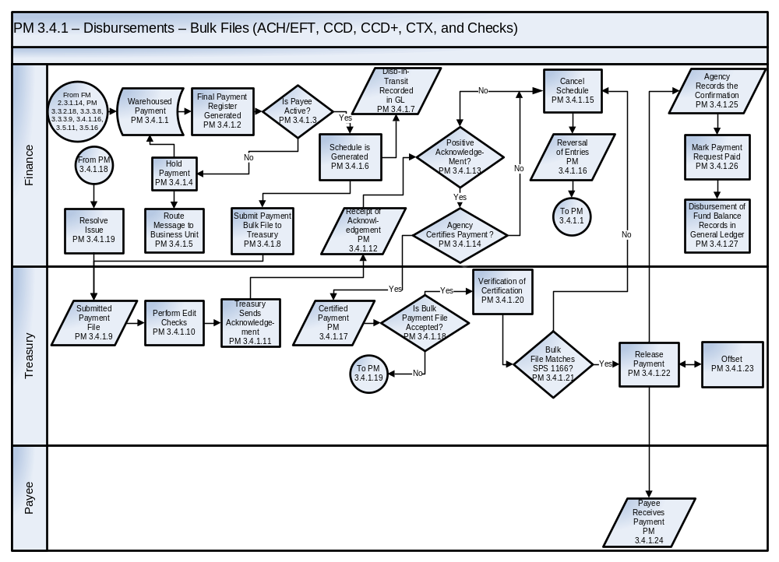
See Appendix C – Business Process Flowcharts, Symbols, and Definitions for an enlarged version of the flowchart
The Payment Management Disbursement – Bulk Files (ACH/EFT, CCD, CCD+, CTX, and Checks) process steps are described as follows:
Step ID | Step Name | Step Description | Business Rules | CFSR Req.
PM 3.4.1.1 | Warehoused  Payment | Upon certification of payment requests, the payment is warehoused awaiting scheduled payment in accordance with contract terms. These payments are queued based on due date for compliance with the Prompt Payment Act. A Preliminary Payment Register and Batch Report are run, and the data is reviewed by the Certifying Officer to ensure the information is accurate and complete. | As stated in Treasury FMS Supplement to the TFM, Volume I, Part 4-1000, a well- designed automated payment system will include evidence to verify that the system is designed and operating properly. Such evidence is used by an authorized Certifying Officer to verify the system is designed and operating properly.  Personnel with funding authority must review the accounting classification elements, including the TAS-BETC, during payment request entry and processing.  The agency Certifying Officer compares the control totals in the Core Financial System that were used to generate the payment schedules with the control totals that will be certified in the Secure Payment System (SPS) for the same schedules. | PMC-16  PMD-01  PMD-17  PMD-13
PM 3.4.1.2 | Final Payment Register Generated | The Certifying Officer reviews the payment batch and generates a Final Payment Register report.  The payment clock of the system tracks a scheduled payment, including discount, prompt payment interest (calculated within the Core Financial System) and contract holdbacks (retainage) according to the projected payment date. | The agency shall comply with the Prompt Payment Act and agencies must follow the applicable SPS user guide and current TFM guidance. | PMD-12
PM 3.4.1.3 | Is Payee Active? | If the payee is active in the CCR system, a payment schedule is generated. If the payee is inactive, the payment is put on hold.  If the payee is not required to be registered in CCR, the payment is processed and a payment schedule is generated. | The payee is a person, corporation, or other public or private entity that is authorized to receive a payment from a federal agency. | PMC-06
PM 3.4.1.4 | Hold Payment | The payment is put on hold. | Payments placed on hold must be handled in accordance with Prompt Payment Act requirements.  The payee is notified of the payment being placed on hold.
PM 3.4.1.5 | Route Message to Business Unit | The system routes a message to the applicable Business Unit personnel that the payment has been put on hold. | Business Unit personnel shall be designated for notification of held payments. | TLE-07
PM 3.4.1.6 | Schedule is Generated | A payment schedule is generated.  The Certifying Officer then generates and reviews, as applicable, an SPS 1166 Voucher and Schedule of Payments report. (Depending on the agency, this action may be automated.) | The payment schedule shall be generated to include applicable attributes required by the TFM and agency guidelines.  The agency must comply with the Prompt Payment Act.  Agencies must follow the applicable SPS user guide, Treasury Green Book, and current TFM guidance.  The Certifying Officer must verify the TAS-BETC.  Agencies may include up to 60 payment records per schedule.  The agency must capture TAS information on payment records, up to 10 per schedule for a Non-Government-wide Accounting (Non-GWA) reporting agency and up to 100 TAS-BETCs for a GWA reporting agency.  The schedule must be submitted to Treasury on the day it is generated.  The agency must generate payment schedule totals by TAS/BETC for each payment file. In addition, they must combine payment schedules into a single file for transmission to Treasury with a summary total by the ALC and TAS for the entire file for certification purposes. | PMD-02  PMD-07  PMD-08  PMD-10  PMD-11  PMD-20  PMD-22  PMD-23  PMD-24  PMD-25  PMD-26  PMD-27  PMD-28  PMD-34  PMD-35  PMD-36
PM 3.4.1.7 | Disbursements-in-Transit Recorded in General Ledger | Disbursements-in-Transit are recorded in the General Ledger when the schedule is generated. | Agencies record the Disbursements-in-Transit General Ledger entries by the time the payment is certified by a Certifying Officer. If the schedule is not certified, then the Disbursements-in-Transit entry must be reversed.  The entries are recorded in the general ledger using the USSGL Account Transaction Listing provided in the current TFM.  Examples include, but are not limited to, the following transaction code from the current TFM:  TFM-B408 To reclassify payable schedules for disbursements to “in-transit” until the payment schedule is confirmed. | PMD-15
PM 3.4.1.8 | Submit Payment Bulk File to Treasury | The agency transmits an electronic (Bulk) payment file or Disbursing Office Schedule (EFT/ACH or Check) to Treasury. The payment information is reviewed for accuracy by a Certifying Officer or other qualified staff and then submitted to Treasury for pre-edit of the file to determine if the file can be processed. | The agency must comply with the Prompt Payment Act.  The agency compares the Disbursing Office Schedules to the supporting financial documents, as applicable, in order to verify the amount and number of payments.  The file must be submitted to Treasury on the day it is generated.  The check and EFT payment files must be exported in the current Treasury FMS defined formats. | PMD-20
PM 3.4.1.9 | Submitted Payment File | The electronic payment submission is received by Treasury and subjected to pre-edit procedures. | Agencies shall format payment files to comply with current Treasury data attributes and requirements.
PM 3.4.1.10 | Perform Edit Checks | Edit checks are applied to the payment file. | Agencies shall format payment files to comply with current Treasury data attributes and requirements.  Treasury will not process a file that does not pass edit checks. The agency will need to generate and transmit a new payment file for Treasury to process.
PM 3.4.1.11 | Treasury Sends Acknowledge-ment | Treasury performs a review and pre-edit of the bulk payment file submitted by the agency. If the file is accepted for processing, Treasury generates a file control number that is sent as part of the acknowledgement to the agency.
PM 3.4.1.12 | Receipt of Acknowledge-ment | Notification is received by the agency from Treasury acknowledging that the file can be processed by Treasury. A control number is assigned to the bulk payment file by Treasury. | The agency includes the control number in their submission of the corresponding SPS 1166 schedule voucher.  If the agency does not receive acknowledgment that the bulk payment file has been accepted for processing, it must follow up with Treasury in order to identify and resolve any potential issue.
PM 3.4.1.13 | Positive Acknowledge-ment? | If positive acknowledgement is received, the agency Certifies Payment. If positive acknowledgement is not received, issue(s) must be identified and resolved or the payment schedule is canceled. | The agency will implement procedures for timely determination of positive versus negative acknowledgement.  The process of certification is as follows:  Upon receipt of the system acknowledgement from Treasury, the agency Data Entry Operator (DEO) accesses SPS and completes the SPS 1166 with the following:  - Total amount of the file  - Total number of payment records  - ALC  - Appropriation number (TAS-BETC)  - Payment date  - Payment schedule number(s),  - Bulk file control number.  Depending on the agency, this process may be automated, whereby the agency DEO uploads into SPS the SPS SF 1166 certification controls totals from the agency’s Core Financial System.
PM 3.4.1.14 | Agency Certifies Payment? | The agency determines whether to certify the payment file. | The agency must comply with Title 31 U.S.C. 3528 for responsibilities of a Certifying Officer.  After the DEO enters the SPS 1166 data in SPS, the agency Certifying Officer reviews the entries and then certifies the schedule or schedules of payments in SPS.
PM 3.4.1.15 | Cancel Schedule | If positive acknowledgement is not received and any applicable issues cannot be resolved on a timely basis, the payment schedule is canceled. | An agency can inform Treasury within one day to cancel payment of a previously certified payment.  The agency shall institute and follow procedures for canceling payments in accordance with applicable SPS user guide and current TFM guidance.
PM 3.4.1.16 | Reversal of Entries | Once a payment schedule is canceled, the Disbursement-in-Transit General Ledger entries are reversed in the Core Financial System.  If positive acknowledgement is not received, the schedule is canceled and the Disbursement-in-Transit General Ledger entries are reversed. Similarly, if the agency declines to certify payment, the entries are reversed in the Core Financial System. | Agencies recorded the Disbursements-in-Transit General Ledger entries at the time the payment was certified by a Certifying Officer. If the schedule is not certified, then the Disbursements-in-Transit entry must be reversed.  The entries are recorded in the general ledger using the USSGL Account Transaction Listing provided in the current TFM.  Examples include, but are not limited to, the following transaction code from the current TFM:  TFM-B408 To reclassify payable schedules for disbursements to “in-transit” until the payment schedule is confirmed. | PMD-15  PMD-55
PM 3.4.1.17 | Certified Payment | The Certified SPS 1166 summary schedule is verified against its corresponding Bulk payment file. | Payment summary schedules are imported or entered in SPS by a DEO and certified in SPS by a Certifying Officer.
PM 3.4.1.18 | Is Bulk Payment File Accepted? | Bulk payment files that do not match corresponding SPS 1166s will be rejected by Treasury.
PM 3.4.1.19 | Resolve Issue | Finance performs applicable actions to resolve the issue.
PM 3.4.1.20 | Verification of Certification | Treasury receives the certified payment file from the agency and verifies the SPS 1166 certification against the bulk payment files. | The agency must comply with Title 31, U.S.C. 3327.  The SPS system automatically verifies the Certifying Officer and the ALC prior to the time of certification. If the Certifying Officer and the ALC are not properly linked, the Certifying Officer cannot certify the payment schedule.
PM 3.4.1.21 | Bulk File Matches SPS 1166? | Treasury compares key totals for the Bulk File to the SPS 1166. | Treasury verifies integrity of certified payment information for completed matches between the payment amount, schedule number(s), and item count. If the payment file and SPS 1166 do not match, then the file and certification are rejected and the General Ledger entries are reversed in the agency’s Core Financial System.
PM 3.4.1.22 | Release Payment | If the certified payment information in the payment (Check or EFT/ACH) and the bulk file match, then the payments are released for disbursement. | Once the payment process is completed, Treasury records confirmation of disbursement for agency access.
PM 3.4.1.23 | Offset | After receipt, acceptance and issuing payment numbers, but prior to releasing the payment to the payee, the payment file is sent through the Treasury Offset Program.  If a debt is owed by the payee, the payment due is offset and, if applicable, any residual amount is sent to the payee. If no debt is owed, the payment is made in full. | The agency must follow Treasury guidance and applicable procedures for the Treasury Offset programs (PL 104-134-APR 26, 1996, 31 CFR 285, 900-904, 5 CFR 550).
PM 3.4.1.24 | Payee Receives Payment | EFTs are sent to the appropriate Federal Reserve Bank (FRB). Checks are mailed through the Postal Service to the payee. | Fund transfers are sent to the appropriate FRB.  Under best business practices, EFT is the preferred method of payment.
PM 3.4.1.25 | Agency Records the Confirmation | Electronic confirmation is made available to the agency from Treasury. Information provided includes acknowledgement of the disbursement of the certified payment schedule, schedule number and check/trace number. | Treasury makes available to the agency through the Government-wide Accounting (GWA) Treasury Disbursing Office (TDO) Support Listings an electronic confirmation of disbursement of the certified payment schedule.  The agency receives this confirmation, which triggers changing the status of the Disbursements-in-Transit to a Disbursement in the General Ledger.  The agency should record the schedule number and check/trace number received from Treasury.
PM 3.4.1.26 | Mark Payment Request Paid | General Ledger impact is recorded based on system-generated disbursement confirmation. | The agency marks the payment request and/or line items paid in the Core Financial System, which occurs simultaneously with the Disbursement of “Fund Balance Records in to General Ledger” step PM 3.4.1.27.
PM 3.4.1.27 | Disbursement of Fund Balance Records in General Ledger | Once disbursed, the Paid Disbursement Voucher supports updating of the General Ledger and the Fund Balance with Treasury (FBWT). | The entries are recorded in the general ledger using the USSGL Account Transaction Listing provided in the current TFM.  Examples include, but are not limited to, the following transaction code from the current TFM:  TFM-B110 To record a confirmed disbursement schedule. | PMD-39

Disbursements for Small Volume and Same or Next Day Payments
Same or next day payments are expedited in order to be disbursed more quickly than those included in bulk files submitted by agencies for disbursement. Agencies would typically expedite disbursements for these types of payments more quickly than bulk file payments in the case of emergencies. Under these circumstances the originating agency must have the funds deposited in the payee’s account on the same date as the certification of the payment. These types of small volume or same/next day payments are typically processed through Fedwire and are notable for high dollar low volume payments.
The following flowchart provides the steps relating to the submission of a small volume payments file, same or next day payments to Treasury, certification of payment, release of payment and the confirmation of disbursement.

PM 3.4.2 - Small Volume and Same or Next Day Payments Flowchart
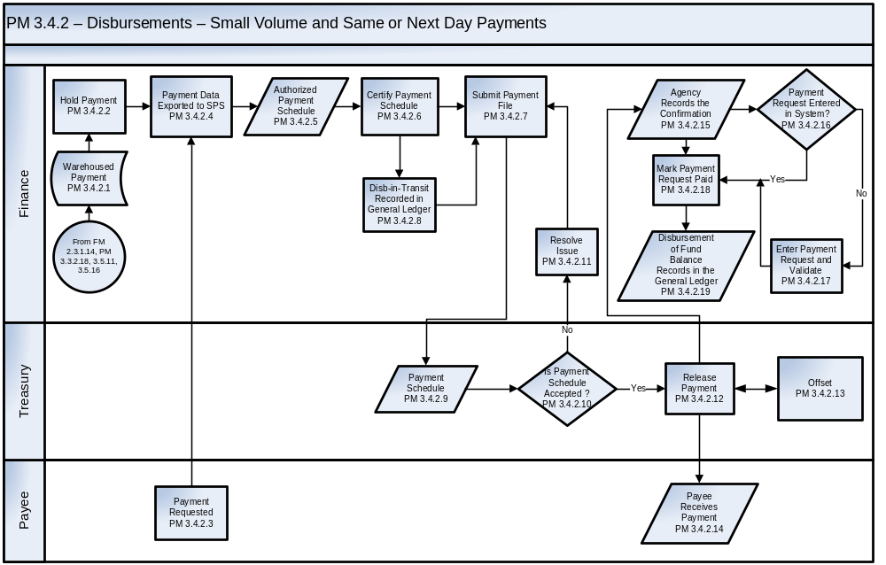
See Appendix C – Business Process Flowcharts, Symbols, and Definitions for an enlarged version of the flowchart
The Payment Management Disbursements – Small Volume and Same or Next Day Payments process steps are described as follows:
Step ID | Step Name | Step Description | Business Rules | CFSR Req.
PM 3.4.2.1 | Warehoused  Payment | Upon certification of payments, the payment is warehoused awaiting scheduled payment in accordance with contract terms. These payments are queued based on due date for compliance with the Prompt Payment Act. A Preliminary Payment Register and Batch Report are run and the data is reviewed by the certifying official to ensure the information is accurate and complete. | The agency must comply with the Prompt Payment Act.
PM 3.4.2.2 | Hold Payment | Warehoused small volume same or next day payments are placed on hold. | Warehoused payments that are going to use the small volume or next day payment process should be placed on hold in the system to keep them from being selected in the automated payment process to prevent duplicate payment.
PM 3.4.2.3 | Payment Requested | The payee requests the agency to make a payment that is not already a warehoused payment. | Internal control steps should be in place to supplement automated controls when manual processing of payment schedules is performed.  The Certifying Officer must verify the TAS-BETC of the scheduled payment as applicable.  Treasury requires that payments submitted for Same Day Payment Request (SDPR) include TINs. When the SDPR is submitted, Treasury will validate the TIN against the debtor database. If it is determined that the TIN has debt to the Federal government, the agency is informed that the payee has been identified as having a “federal debt".  Agencies have the option to change the payment to next day ACH, check payment or submit the payment for SDPR.
PM 3.4.2.4 | Payment Data Exported to SPS | The DEO exports the payment data to SPS, through a small volume upload process.  Alternatively, the payment data may be manually entered into SPS.  The payment data is imported or entered and processed in the Treasury SPS system. | The agency must comply with the Prompt Payment Act.  Agencies must follow the applicable SPS user guide, and current TFM guidance.  Agencies may include up to 60 payment records per schedule.  The agency must capture TAS information on payment records, up to 10 per schedule for a Non-Government-wide Accounting (Non-GWA) reporting agency and up to 100 TAS-BETCs for a GWA reporting agency.  The SPS 1166 schedule must contain the following:  - Total amount of the schedule  - Total number of payment records  - ALC  - Appropriation number (TAS-BETC)  - Payment date,  - Payment schedule number. | PMD-31
PM 3.4.2.5 | Authorized Payment  Schedule | A document is generated to support the entry into SPS for the payment. This document will be used to record the Disbursements-in-Transit entries into the system.
PM 3.4.2.6 | Certify Payment Schedule | The agency DEO accesses SPS and imports payment records or enters the payment records online into the  Treasury Type A SPS 1166 schedule voucher function.  The payment schedule is imported or entered and processed in the Treasury SPS system. | The agency will comply with Title 31 U.S.C. 3528.  The Certifying Officer must verify the TAS-BETC.  The CO verifies the entries and then certifies the schedule(s), for submission to SPS.
PM 3.4.2.7 | Submit Payment File | Once the Certifying Officer certifies the schedule, it is automatically transmitted to Treasury. | Agencies must follow applicable SPS user guide and TFM guidance.  Payment summary schedules are imported in SPS by a DEO and certified in SPS by a Certifying Officer.
PM 3.4.2.8 | Disbursements-in-Transit Recorded in General Ledger | Disbursements-in-Transit is recorded in the General Ledger when the schedule is generated. | Agencies record the Disbursements-in-Transit General Ledger entries by the time the payment is certified by a Certifying Officer. If the schedule is not certified, then the Disbursements-in-Transit entry must be reversed.  The entries are recorded in the general ledger using the USSGL Account Transaction Listing provided in the current TFM.  Examples include, but are not limited to, the following transaction code from the current TFM:  TFM-B408 To reclassify payable schedules for disbursements to “in-transit” until the payment schedule is confirmed. | PMD-15
PM 3.4.2.9 | Payment Schedule | The transmitted file that is sent to Treasury contains the information needed for issuing the payment. | An agency can inform Treasury within one day to cancel payment of a previously certified payment.
PM 3.4.2.10 | Is Payment Schedule Accepted? | The certified SPS 1166 summary schedule is verified against its corresponding Bulk payment file. Bulk payment files that do not match corresponding SPS 1166s will be rejected by FMS.
PM 3.4.2.11 | Resolve Issue | Finance performs applicable actions to resolve the issue.
PM 3.4.2.12 | Release Payment | The transmitted file (payment schedule) is edited for accuracy and the payment is issued.  If the agency has used a duplicate schedule number and ALC, or the ALC and CO are not linked and active in SPS, then the schedule will be rejected. The summary total for amounts and items must also be accurate. | The agency must schedule and disburse U.S. dollar payments (Treasury SPS 1166) through the Treasury’s SPS, containing up to the limit of 60 payments per schedule.  Agencies will comply with Title 31, Chapter 33, Subchapter II (a), U.S.C. 3325.  The SPS system automatically verifies the Certifying Officer and ALC prior to the time of certification. If the Certifying Officer and ALC are not properly linked, the Certifying Officer will only be able to view the payment schedule and will be unable to certify it. | PMD-30
PM 3.4.2.13 | Offset | After receipt, acceptance and issuing payment numbers, but prior to releasing the payment to the payee, the payment file is sent through the Treasury Offset Program.  If a debt is owed by the payee, the payment due is offset and, if applicable, any residual amount is sent to the payee. If no debt is owed, the payment is made in full. | The agency must follow Treasury guidance and applicable procedures for the Treasury Offset programs (PL 104-134-APR 26, 1996, 31 CFR 285, 900-904, 5 CFR 550).
PM 3.4.2.14 | Payee Receives Payment | EFTs are sent to the appropriate Federal Reserve Bank (FRB). Checks are mailed through the Postal Service to the payee. | Funds transfers are sent to the appropriate FRB.  Under best business practices, EFT is the preferred method of payment.
PM 3.4.2.15 | Agency Records the Confirmation | Electronic confirmation is made available to the agency from Treasury. Information provided includes acknowledgement of the disbursement of the certified payment schedule, schedule number, and check/trace number. | The agency receives this confirmation, which triggers changing the status of the Disbursements-in-Transit to a disbursement in the General Ledger.  Treasury makes available to the agency, through the Government-wide Accounting (GWA) Treasury Disbursing Office (TDO) Support Listings, an electronic confirmation of disbursement of the certified payment schedule.  The agency receives this confirmation, which triggers changing the status of the Disbursements-in-Transit to a disbursement in the General Ledger.  The agency should record the schedule number and check/trace number received from Treasury.
PM 3.4.2.16 | Payment Request Entered in System? | The agency determines whether the payment request results from a warehoused payment that had been previously entered into the Core Financial System.
PM 3.4.2.17 | Enter Payment Request and Validate | A payment request is entered in the system by Finance and validated against the payment schedule to record the information related to the payment request for items that did not come through the standard payment request process. | The Finance official makes sure the payment is not a duplicate request.  Under best business practices, payment requests should be submitted electronically.  If the payment request has not been entered into the system, the payment request will be entered and manually approved for payment and marked as paid.
PM 3.4.2.18 | Mark Payment Request Paid | General Ledger impact is recorded based on system-generated disbursement confirmation. | The agency marks the payment request and/or line items paid in the Core Financial System, which occurs simultaneously with the Disbursement of Fund Balance Records in General Ledger in step PM 3.4.2.19.
PM 3.4.2.19 | Disbursement of Fund Balance Records in the General Ledger | Once disbursed, the voucher supports updating of the General Ledger and the Fund Balance with Treasury (FBWT). | The entries are recorded using the USSGL Account Transaction Listing provided in the current TFM for the payment of advances and pre-paid expenses, as applicable.  Examples include, but are not limited to, the following transaction code from the current TFM:  TFM-B110 To record a confirmed disbursement schedule. | PMD-39

Returned Payments – ACH, Check, Same Day
Use of EFT represents the best practice for making governmental payments. Payments can be returned to the Treasury due to issues such as lack of a correct address, death of the payee, or an invalid ACH account. This section presents key steps for the cancellation and return of payments from Treasury to the agency. All returned and canceled payments include: checks, ACH, CTX, CCD, CCD+ and Fedwire.

PM 3.5 Returned Payments - ACH, Check, Same Day Flowchart
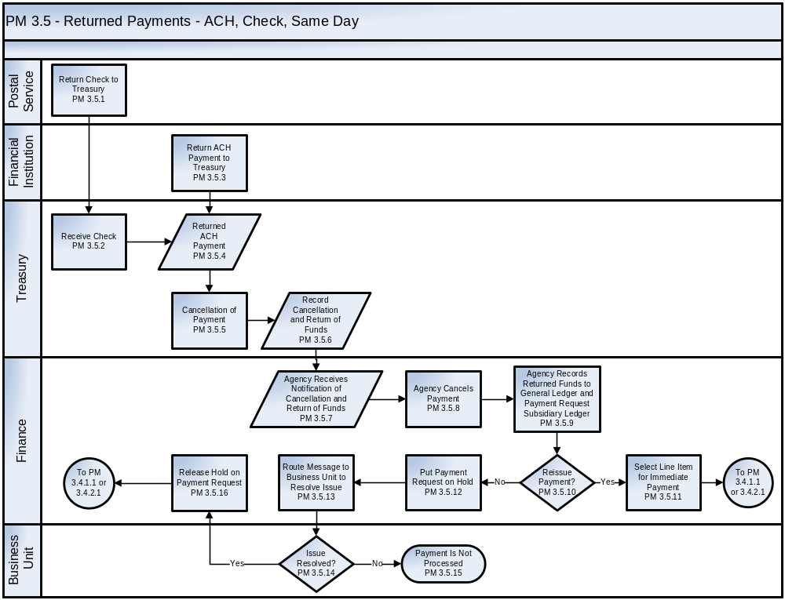
See Appendix C – Business Process Flowcharts, Symbols, and Definitions for an enlarged version of the flowchart

The Payment Management Returned Payments process steps are described as follows:
Step ID | Step Name | Step Description | Business Rules | CFSR Req.
PM 3.5.1 | Return Check to Treasury | A check payment is returned to Treasury by the U.S. Postal Service when there is an incorrect or incomplete address, or death of the payee.  Check payments may also be withheld from being mailed at the request of the agency authorizing the payments. | Agencies must follow applicable TFM guidance.
PM 3.5.2 | Receive Check Payment | Treasury receives the check payment.
PM 3.5.3 | Return ACH Payment to Treasury | Payments processed through the Government Automated Clearing House (ACH), which include CTX, CCD, CCD+ and Fedwire, are returned when payments cannot be recorded to a valid account.  ACH payments may be withheld by Treasury from submission to the applicable Financial Institution at the request of the agency authorizing the payments. | Financial Institutions, agencies, and the vendor/payee must follow applicable 31 CFR Part 210, Federal Participation in ACH guidance.
PM 3.5.4 | Returned ACH Payment | Treasury receives the returned ACH Payment.
PM 3.5.5 | Cancellation of Payment | ACH and Check Payments are immediately canceled upon receipt by Treasury. |  | PMD-55
PM 3.5.6 | Record Cancellation and Return of Funds | Payment cancellation and the return of funds are recorded by Treasury to the agency’s account.
PM 3.5.7 | Agency Receives Notification of Cancellation and Return of Funds | Electronic confirmation is made available to the agency from Treasury acknowledging payment cancellation and return of funds. | Agencies shall institute and follow procedures for confirming payment cancellations and return of funds.
PM 3.5.8 | Agency Cancels Payment | The agency cancels the payment in the Core Financial System.
PM 3.5.9 | Agency Records  Returned Funds to General Ledger and Payment Request Subsidiary Ledger | A transaction is recorded to the General Ledger and payment request subsidiary ledger to reflect the applicable funds returned by Treasury. | The entries are recorded to the General Ledger using the USSGL Account Transaction Listing provided in the TFM. The applicable entry is recorded based on the entry originally made to record the payment balance. | PMD-55
PM 3.5.10 | Reissue Payment? | Finance will determine if the payment can be reissued. | Determinations must be made within guidelines and requirements of applicable laws and regulations, including the Prompt Pay Act and FAR.
PM 3.5.11 | Select Line Item for Immediate Payment | If the payment can be reissued, specific line items to be paid are identified.
PM 3.5.12 | Put Payment Request on Hold | If the payment cannot be reissued, the payment request is put on hold. | Putting a payment request on hold must be done in accordance with applicable laws and regulations, rules, and agency guidelines (e.g., FAR, agency policies and procedures), including the Prompt Payment Act.
PM 3.5.13 | Route Message to Business Unit to Resolve Issue | A message is routed to the Business Unit of the issue and the final disposition of the payment is determined. | The Core Financial System should automatically identify and route a message to applicable personnel of open issues related to payment requests.  Applicable personnel must take appropriate actions within Prompt Payment Act requirements.
PM 3.5.14 | Issue Resolved? | The Business Unit performs the necessary actions to resolve the payment issue and, as applicable, provides the information required to resubmit the payment request. | The agency shall comply with the Prompt Payment Act, SPS user guide, and current TFM guidance.
PM 3.5.15 | Payment Is Not Processed | If the issue is not resolved, the payment is not processed.
PM 3.5.16 | Release Hold on Payment Request | If the issue is resolved, the hold on the payment request is released. | The agency must calculate the due date of payee payments in accordance with 5 CFR 1315 (OMB Circular A-125, Prompt Payment) key factors (e.g., commodity type, contract terms, invoice receipt date). | PMD-01

Data Objects and Data Elements

THIS SECTION IS CURRENTLY UNDER DEVELOPMENT WITH TREASURY FMS

- Receivables Management Processes

To Be Provided for Insert at a Future Date

- Reimbursables Management Processes

To Be Provided for Insert at a Future Date

- Reports Management Processes
To Be Provided for Insert at a Future Date

- Appendix A – FMLoB Business Approach
The FMLoB Business Process work stream follows a standard approach in the development of each business process area. The FMLoB Business Process was developed through a collaborative effort of the Federal financial management community. The project objectives were to:
- Define the objectives of standard business process
- Document the current business processes used within the 24 Chief Financial Officer Act agencies (the “as-is” environment)
- Determine which business processes should be included in the standard business process.
The FMLoB Business Process project was divided into four phases:
- Project initiation
- Development of FMLoB Business Processes vision and draft proposal
- Validation of the FMLoB Standard Business Processes
- Issuance of an exposure draft of the proposed Standard Business Processes.
During the initial phase of the project, the sponsors were engaged to help ensure that expectations were known, the project approach was acceptable, and requirements for government participation were defined.
The second phase established the vision for Standard Business Processes that defined the objectives of developing a standard structure and its contribution to the goals of the FMLoB initiative.
During the third phase, the draft proposal was refined and validated with three key stakeholder groups:
- Representatives of the 24 Chief Financial Officers Act agencies
- Vendors of financial management systems
- Federal shared service providers.
From April through August 2006, FSIO conducted a number of workshops with program agencies and vendors to address payments and receipts, funds management, and reporting.
During the final phase of the project, the team began to develop the Financial Management Systems Standard Business Processes for U.S. Government Agencies document.
- Appendix B – FMLoB Glossary
Term | Definition | Source
Accounting Classification | A subset of the agency financial information classification. The accounting classification structure provides a means for categorizing financial information along several dimensions as needed to support financial management and reporting functions. The data elements an agency includes in its accounting classification structure will depend in part on the implementation strategy for the U.S. Standard General Ledger, data aggregation requirements for preparation of financial statements under the Chief Financial Officers Act, appropriation structure, and other reporting and management needs of the agency. | Joint Financial Management Improvement Program Financial System Requirements;  http://www.fsio.gov/fsio/fsiodata/fsio_systemrequirements.shtml  Multiple sources
Accrual | The term “accrual” is used in this document to refer to an accounting transaction to record expenses that have been incurred or revenues that have been earned without regard to when cash is received or disbursed. | Online Accounting Dictionary  http://www.accountingcoach.com/accounting-terms/accounting-dictionary/#accrual%20type%20adjusting%20entry
Acquisition Processes | Acquisition includes the functions, processes, and activities that Federal agencies use to acquire products and services.  The Acquisition process begins at the point when agency needs are established and includes the description of requirements to satisfy agency needs, solicitation and selection of sources, award of contracts, contract financing, contract performance, contract administration, and those technical and management functions directly related to the process of fulfilling agency needs by contract. | Acquisition System Requirements: Exposure Draft Version 2.0 April 2008
Agency | The term "agency" means any executive department, military department, government corporation, government controlled corporation, or other establishment in the executive branch of the Federal government, or any independent regulatory agency. Within the Executive Office of the President, the term includes only OMB and the Office of Administration. | OMB Circular A-130, Transmittal Memorandum No. 4, Management of Federal Information Resources (11/28/2000)  http://www.whitehouse.gov/omb/circulars/a130/a130trans4.pdf
Allotment | A subdivision of an apportionment made by an agency. | OMB Circular A-11, Preparation, Submission and Execution of the Budget (6/30/2006)  http://www.whitehouse.gov/omb/circulars/a11/current_year/a11_toc.html
Apportionment | A distribution made by OMB of amounts available for obligation in an appropriation or fund account into amounts available for specified time periods, program, activities, projects, objects, or any combinations of these. The apportioned amount limits the obligations that may be incurred. An apportionment may be further subdivided by an agency into allotments, sub- allotments, and allocations. | OMB Circular A-11, Preparation, Submission and Execution of the Budget (6/30/2006)
Appropriation | A provision of law (not necessarily an Appropriation act) authorizing the expenditure of funds for a given purpose. Usually, but not always, an appropriation provides budget authority. | OMB Circular A-11, Preparation, Submission and Execution of the Budget (6/30/2006)
Award Document | The term “Award Document” is used to represent the applicable instrument used by an agency to initiate a contractual arrangement with a provider of goods and/or services. | FSIO Payments Management Focus Group
Budget | The Budget of the United States Government setting forth the President’s comprehensive financial plan for allocating resources. The Government uses the budget system to allocate resources among its major functions and individual programs. The budget process has three main phases: formulation, congressional action on the budget, and execution. | FASAB  Statement of Federal Financial Accounting Standards No. 24  http://www.fasab.gov/pdffiles/sffas-24.pdf
Budget Authority | The authority provided by law to incur financial obligations that will result in outlays. Specific forms of budget authority include Appropriation, borrowing authority, contract authority, and spending authority from offsetting collections. | OMB Circular A-11, Preparation, Submission and Execution of the Budget (6/30/2006)
Budget Execution | Includes Funds Control and provides features to record, distribute, and control budget authority and spending in accordance with the provisions of OMB Circular A-11, Part 4, Instructions on Budget Execution. Budget execution provides the ability to track the effects of financial events on the sources and uses of budgetary resources authorized by the President and Congress. Its primary purpose is to ensure that spending does not exceed funds appropriated or authorized. | OMB Circular A-11, Preparation, Submission and Execution of the Budget (6/30/2006)
Budget Formulation | During this phase of the budget cycle, the Executive Branch prepares the President's budget. OMB and the Federal agencies begin preparing the next budget almost as soon as the President has sent the last one to Congress. OMB officially starts the process by sending planning guidance to Executive Branch agencies in the spring. The President completes this phase by sending the budget to Congress on the first Monday in February, as specified in law, although occasionally Presidents have sent it later for various reasons. | OMB Circular A-11, Preparation, Submission and Execution of the Budget (6/30/2006)
Business Unit | For the purpose of this document, business unit refers to any program or administrative office/unit other than Finance or Acquisition units.
Canceled Funds | A reduction in budgetary resources as a result of legislative action taken by the Congress, including rescission proposed by the President. Cancellation can either be temporary or permanent. | OMB Circular No. A-11, Preparation, Execution and Submission of the Budget  http://www.whitehouse.gov/omb/circulars/a11/current_year/a11_toc.html
Carryover | Funding collected in one fiscal year that was not obligated and is available to be used to meet requirements in the next fiscal year. | Treasury Directive: 31-04  http://www.treas.gov/regs/td31-04.htm
Commitment | A commitment is an administrative reservation of funds that have not yet been obligated. Agencies use commitment accounts for the internal control of budgetary resources and to help prevent unauthorized use of available resources. | OMB Circular A-11, Preparation, Submission and Execution of the Budget (6/30/2006)
Cooperative Agreements | A legal instrument used by a Federal agency to enter into a relationship whose principal purpose is assistance (that is, the transfer of something of value to the recipient to carry out a public purpose of support or stimulation). When using a cooperative agreement, the funding agency expects to be substantially involved with the recipient of the funds in carrying out the funded activities. | OMB Circular A-102 and A-110
Credit Card Payments | Payments made for the cost of goods and services purchased with a government charge card.  A government charge card is an account established by a commercial financial institution (subsequently referred to as “charge card vendor”) on behalf of agencies or individual agency employees. Although actual plastic cards are associated with most of these accounts, this term may also be applied to certain accounts established by these same commercial companies that are billed directly to agencies, and therefore, are cardless accounts. | OMB Circular A-11, Preparing, Executing, and Submitting the Budget  Appendix B  (6/30/2006)
Disbursements | Amounts paid out by Federal agencies during the fiscal year. This term is used interchangeably with the term outlay. | Treasury Financial Manual, Supplement to Volume I  http://www.fms.treas.gov/TFM/
Employee Rewards | Agencies have discretionary authority to authorize an employee a lump-sum cash. agencies also may authorize a cash award to an employee, individually or as a member of a group, in recognition of accomplishments that contribute to the efficiency, economy, or other improvement of Government operations. | United States Office of Personnel Management: HR Flexibilities and Authorities Handbook  http://www.opm.gov/omsoe/hr-flex/index.asp
Enterprise Architecture | A strategic information asset base that defines the business, information necessary to operate the business, technologies necessary to support the business operations, and transitional processes for implementing new technologies in response to the changing needs of the business. | Federal Enterprise Architecture Framework, V.1.1, Federal Chief Information Officers Council, September 1999  http://www.cms.hhs.gov/EnterpriseArchitecture/02_FEAF.asp
Federal Agency | A federal agency is any executive agency or any independent establishment in the legislative or judicial branch of the government (except the Senate, the House of Representatives, the Architect of the Capitol, and any activities under the Architect’s direction.) | Federal Acquisition Regulation 2.101  http://www.acquisition.gov/far/index.html
Federal Enterprise Architecture (FEA) | To facilitate efforts to transform the Federal government to one that is citizen-centered, results-oriented, and market-based, OMB is developing the Federal Enterprise Architecture, a business-based framework for Government-wide improvement.  The FEA is being constructed through a collection of interrelated “reference models” designed to facilitate cross-agency analysis and the identification of duplicative investments, gaps, and opportunities for collaboration within and across Federal agencies. | Federal Enterprise Architecture Program Management Office  http://www.whitehouse.gov/omb/egov/a-1-fea.html
Federal Enterprise Architecture Business Reference Model (BRM) | The BRM is a function-driven framework for describing the Lines of Business and internal functions performed by the Federal government independent of the agencies that perform them. The BRM serves as the business layer of the Federal Enterprise Architecture. It provides a foundation on which the applications, data, and technology layers of the FEA are developed. Agency Capital Asset Plans (Exhibit 300s that accompany an agency’s budget submission) will be mapped against this framework to identify opportunities for cross-agency collaboration and potential system redundancies. | OMB Circular A-11, Preparing, Executing, and Submitting the Budget (6/30/2006)
Federal Enterprise Architecture Framework | The Federal Enterprise Architecture Framework (FEAF) provides an organized structure and a collection of common terms by which Federal segments can integrate their respective architectures into the Federal Enterprise Architecture. | Federal Enterprise Architecture Framework, V.1.1, Federal Chief Information Officers Council, September 1999
Federal Payment | Any payment made by an agency. The term includes, but is not limited to: (1) Federal wage, salary, and retirement payments; (2) vendor and expense reimbursement payments; (3) benefit payments; and (4) miscellaneous payments including, but not limited to, interagency payments; grants; loans; fees; principal, interest, and other payments related to United States marketable and nonmarketable securities, overpayment reimbursements; and payments under Federal insurance or guarantee programs for loans. | Treasury Green Book (Guide to Federal ACH [Automated Clearing House] Payments and Collections)  http://www.fms.treas.gov/greenbook/index.html
Financial Accounting | A branch of accounting. The most noteworthy interpretations or classifications are those about which data pertain to the past and which pertain to the future. In other words, financial accounting is largely concerned with assigning the value of past transactions to appropriate time periods. | FASAB, Statement of Federal Financial Accounting Concepts No. 1: Objectives of Federal  Financial Reporting  http://www.fasab.gov/pdffiles/sffac-1.pdf
Financial Event or Activity | Any occurrence having financial consequences to the Federal government related to the receipt of Appropriation or other financial resources; acquisition of goods or services; payments or collections; recognition of guarantees, benefits to be provided, or other potential liabilities; or other reportable financial activities. | OMB Circular A-127, Financial Management Systems (7/23/1993)  http://www.whitehouse.gov/omb/circulars/a127/a127.html  http://www.whitehouse.gov/omb/memoranda/fy2005/m05-02.html
Financial Management Systems | Financial systems and the financial portions of mixed systems necessary to support financial management, including manual or automated processes, procedures, controls, hardware, software and support personnel. Financial systems include an information system, comprised of one or more applications, that is used for (1) collecting, processing, maintaining, transmitting or reporting data about financial events; (2) supporting financial or budgeting activities; (3) accumulating and reporting cost information, or: (4) supporting the preparation of financial statements. | Federal Financial Management Improvement Act (FFMIA)  http://frwebgate.access.gpo.gov/cgi-bin/getdoc.cgi?dbname=104_cong_public_laws&docid=f:publ208.104.pdf  OMB Circular A-127, Financial Management Systems (07/23/1993)
Financial System | An information system, comprised of one or more applications, that is used for any of the following:  collecting, processing, maintaining, transmitting, and reporting data about financial events;  supporting financial planning or budgeting activities;  accumulating and reporting cost information; or  supporting the preparation of financial statements.  A financial system supports the financial functions required to track financial events, or provide financial information significant to the financial management of the agency, and/or required for the preparation of financial statements. A financial system encompasses automated and manual processes, procedures, controls, data, hardware, software, and support personnel dedicated to the operation and maintenance of system functions. A financial system may include multiple applications that are integrated through a common database or are electronically interfaced, as necessary, to meet defined data and processing requirements. | FFMIA; OMB Circular A-127, Financial Management Systems (07/23/1993)
Foreign Currency | Money of a country other than one’s own. | Treasury Financial Manual Volume I Part IV Chapter 9000, Foreign Exchange  http://www.fms.treas.gov/tfm/vol1/index.html
Grants | A federal financial assistance award making payment in cash or in kind for a specified purpose. Grants differ from cooperative agreements in that the Federal government does not have substantial involvement with the recipient while carrying out the activity funded by the grant. | GAO: Glossary of Terms Used in the Federal Budget Process  http://www.gao.gov/new.items/d05734sp.pdf
Imprest Funds | A fixed- or petty-cash fund in the form of currency or coin that has been advanced as Funds Held Outside of Treasury. Federal agencies are required to report their imprest funds in General Ledger Account 1120 - Imprest Funds on their annual financial statements. | Financial Management Service: A bureau of the Department of the Unites States Treasury: Imprest Funds Policy Directive http://www.fms.treas.gov/imprest/regulations.html
Information Security | The protection of information and information systems from unauthorized access, use, disclosure, disruption, modification, or destruction in order to provide: (1) integrity, which means guarding against improper information modification or destruction, and includes ensuring information non-repudiation and authenticity; (2) confidentiality, which means preserving authorized restrictions on access and disclosure, including means for protecting personal privacy and proprietary information; and (3) availability, which means ensuring timely and reliable access to and use of information. | Federal  Information Security Management Act of 2002  http://frwebgate.access.gpo.gov/cgi-bin/getdoc.cgi?dbname=107_cong_public_laws&docid=f:publ347.107.pdf (See title III)
Information System | A discrete set of information technology, data, and related resources, such as personnel, hardware, software, and associated information technology services organized for the collection, processing, maintenance, use, sharing, dissemination or disposition of information. | OMB Circular A-11, Preparation, Submission and Execution of the Budget (6/30/2006)
Information Technology | Any equipment, or interconnected system(s) or subsystem(s) of equipment, that is used in the automatic acquisition, storage, manipulation, management, movement, control, display, switching, interchange, transmission, or reception of data or information by the agency. | Federal Acquisition Regulation 2.101  http://www.acquisition.gov/far/index.html
Internal Control | A subset of management controls are the internal controls used to assure that there is prevention or timely detection of unauthorized acquisition, use, or disposition of the entity's assets. | OMB Circular A-123, Management’s Responsibility for Internal Control (Revised 12/21/2004)  http://www.whitehouse.gov/omb/circulars/a123/a123_rev.pdf
Internal Control over Financial Reporting | Process for assessing the effectiveness of an entity’s internal control over financial reporting. | OMB Circular A-123, Management’s Responsibility for Internal Control, Appendix A (Revised 12/21/2004)
Internal Offsets Between Accounts Payable and Accounts Receivable | An internal offset occurs where an agency that is owed a debt and is also making one or more payments to its debtor determines that the payments can be offset to collect the debt, unless restricted by law. | Treasury’s Managing Federal Receivables  http://fms.treas.gov/debt/Guidance_MFR.html
Intra-Governmental Payments and Collection (IPAC) | Intra-Governmental Payment and Collection (IPAC) System is comprised of three interrelated subsystems: (1) The IPAC application that processes Intra-Governmental Federal funds transfers between Agencies, (2) The Retirement and Insurance Transfer System (RITS) that processes retirement and health insurance payments by Federal Agencies to the Office of Personnel Management (OPM), and (3) the Treasury Receivable Accounting and Collection System (TRACS) that processes check disbursement data returned to Federal Agencies for which Treasury has disbursing authority. | Treasury Financial Manual
Loans | Financial assets created by the Government by providing money, goods or services directly or indirectly to the beneficiary entities, which entails a contractual right to receive back the moneys (or equivalents) along with interest there-on, if any, as per terms and conditions of the loan agreements. | Government Accounting Standards Advisory Board Publication: Accounting Standards for the Union Government and the State Governments, Exposure Draft 6, Issued March 30, 2007.  http://www.gasab.gov.in/pdf/Exposure%20Draft%206%20%20Loans%20and%20Advances%20Made%20by%20Governments.pdf
Management Controls | Management controls are the organization, policies, and procedures used by agencies to reasonably ensure that (1) programs achieve their intended results; (2) resources are used consistent with agency mission; (3) programs and resources are protected from waste, fraud, and mismanagement; (4) laws and regulations are followed; and (5) reliable and timely information is obtained, maintained, reported and used for decision making.  Management controls, in the broadest sense, include the plan of organization, methods and procedures adopted by management to help ensure that its goals are met. Management controls include processes for planning, organizing, directing, and controlling program operations. | OMB Circular A-123, Management’s Responsibility for Internal Control (Revised 12/21/2004)
Managerial Cost Accounting | Managerial cost accounting should be a fundamental part of the financial management system and, to the extent practicable, should be integrated with other parts of the system. Managerial costing should use a basis of accounting, recognition, and measurement appropriate for the intended purpose. Cost information developed for different purposes should be drawn from a common data source, and output reports should be reconcilable to each other | FASAB, SFFAS No. 4: Managerial Cost Accounting Standards and Concepts  http://www.fasab.gov/pdffiles/sffac-1.pdf
Outlay | Outlay means a payment to liquidate an obligation (other than the repayment of debt principal). Outlays generally are equal to cash disbursements but also are recorded for cash-equivalent transactions, such as the subsidy cost of direct loans and loan guarantees, and interest accrued on public issues of the public debt. Outlays are the measure of Government spending. | OMB Circular A-11, Preparation, Submission and Execution of the Budget (6/30/2006)
Payment | A government disbursement of monies to any payee, including vendors, employees, private citizens, state, local and foreign governments) in accordance with contract terms. The payments management function consists of the following processes: payee information maintenance, payment warehousing, payment execution, and payment confirmation and follow-up. | Treasury Financial Manual
Payment Management Processes for Payments not Disbursed by Treasury | Payment processes performed by a disbursing office whose authority to disburse public funds has been delegated at the discretion of the Treasury or established by statute. | Federal Register : January 3, 2001 (Volume 66, Number 2)  http://csrc.nist.gov/drivers/documents/FedRegister-fms.txt
Payroll | Compensation provided from Federal employers to employees for hours worked, salaries, wages, commissions, bonuses, vacation/sick pay, contributions to qualified health and pension plans, net pay and deductions where the employer maintains documentation created in support of such activity. | HRmarketer.com: Human Resource & Marketing Glossary of Terms  http://www.hrmarketer.com/home/hcm_glossary.htm
Processes for Maintenance of the Central Contractor Registry (CCR) | Central Contractor Registration (CCR) is the primary registrant database for the U.S. Federal government. CCR collects, validates, stores and disseminates data in support of agency acquisition missions.  The processes by which agencies maintain their records in the CCR are not covered in this document. The focus of the CCR, specific to the purpose of this document, is to ensure prospective vendors are registered in CCR prior to the award of a contract, basic agreement, basic ordering agreement, or blanket purchase agreement unless otherwise exempted from registration by the Federal Acquisition Regulation. | Central Contractor Registration  http://www.ccr.gov/
Program | Generally defined as an organized set of activities directed toward a common purpose or goal, undertaken or proposed by an agency in order to carry out its responsibilities. In practice, however, the term has many uses and thus does not have a well-defined, standard meaning in the legislative process. It is used to describe an agency’s mission, programs, functions, activities, services, projects, and processes.
Reimbursable Activity | A sum (1) that is received by an agency as a payment for commodities sold or services furnished either to the public or to another government account and (2) that is authorized by law to be credited directly to specific appropriation and fund accounts. | GAO: Glossary of Terms Used in the Federal Budget Process  http://www.gao.gov/new.items/d05734sp.pdf
Shared Services | Shared services is a bringing together of functions that are frequently duplicated across component agencies, and delivering these services more efficiently and with a customer service orientation. It is the focus on the customer service aspect of the process that distinguishes the shared services model from the concept of consolidation. The focus is on the customers because they demand the best quality, timely, accurate and reliable product(s) attainable. Sharing services leads to the elimination of redundancies. The concurrent redesign of accounting processes, organizations and supporting systems leads to radical improvements in time, cost, quality and user satisfaction in regard to the service provided.
Single Integrated  Financial  Management System | A unified set of financial systems and the financial portions of mixed systems (e.g., acquisition) encompassing the software, hardware, personnel, processes (manual and automated), procedures, controls, and data necessary to carry out financial management functions, manage the financial operations of the agency, and report on the agency’s financial status to central agencies, Congress, and the public. | OMB Circular A-127, Financial Management Systems (7/23/1993)
Travel | The Federal Travel Regulations (FTR) is the regulation contained in 41 Code of Federal Regulations (CFR), Chapters 300 through 304, that implements statutory requirements and Executive branch policies for travel by federal civilian employees and others authorized to travel at government expense.  The Administrator of General Services promulgates the FTR to: (a) interpret statutory and other policy requirements in a manner that balances the need to ensure that official travel is conducted in a responsible manner with the need to minimize administrative costs, and (b) communicate the resulting policies in a clear manner to federal agencies and employees | The Federal Travel Regulation (FTR) was established in 2004. The Code of Federal Regulations (FTR) is available at www.gpoaccess.gov/cfr. Each version is updated as official changes are published in the Federal Register (FR). FR publications and FTR loose-leaf pages are available at www.gsa.gov/ftr.
Treasury Financial Manual | Guidance issued by the Department of the Treasury containing procedures to be observed by all agencies, Federal Reserve Banks, and financial institutions with respect to payments, collections, central accounting, financial reporting, and other government-wide fiscal responsibilities of the Treasury. | Treasury Green Book, Glossary
United States Standard General Ledger (USSGL) | A uniform list of accounts that support transactions that standardizes Federal agency accounting and supports the preparation of standard external reports. The U.S. Government Standard General Ledger Chart of Accounts (1) provides control over all financial transactions and resource balances, (2) satisfies basic reporting requirements of OMB and Treasury, and (3) integrates proprietary and budgetary accounting. | Treasury Financial Manual, Volume I
USSGL Account: | An account, within the uniform chart of accounts used by Federal agencies to record budgetary and proprietary accounting transactions. | Treasury Financial Manual, Supplement to Volume I

- Appendix C – Business Process Flowcharts Symbols and Definitions
Flowchart Symbols Defined:

Name | Symbol | Definition
Connector |  | This symbol indicates a jump from one point to another in a process flow.
Data |  | This symbol represents electronic input to and/or outputs from a process.
Data Transmission |  | This symbol indicates the transfer of data to an external location. This symbol is used with a dashed connector line when the recipient is not depicted on the flowchart.
Decision |  | This symbol indicates a question or branch in the process flow.
Electronic Notification |  | This symbol indicates a message transmitted for the purpose of electronically communicating the result of an action
Process |  | This symbol represents a process or action step.
Terminator |  | This symbol indicates that the current process flow is ending at this point and is part of a separate process flow.

.

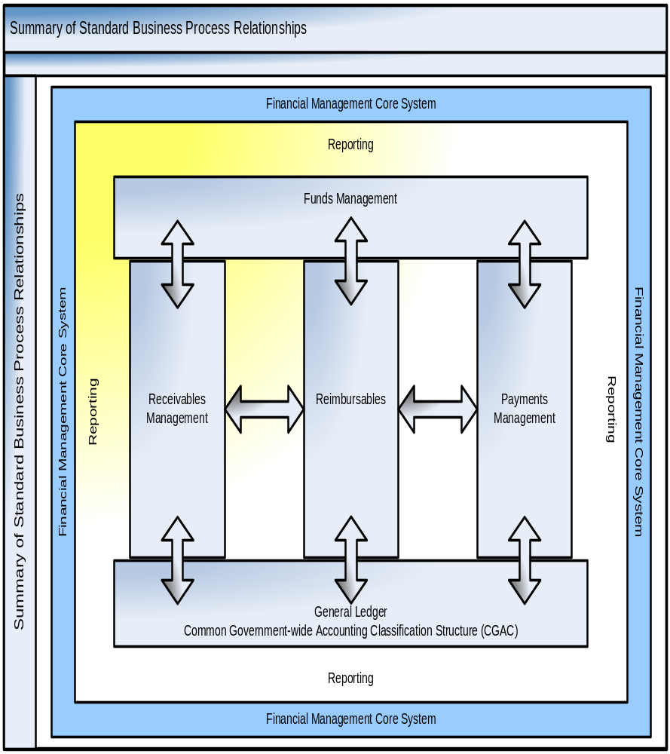
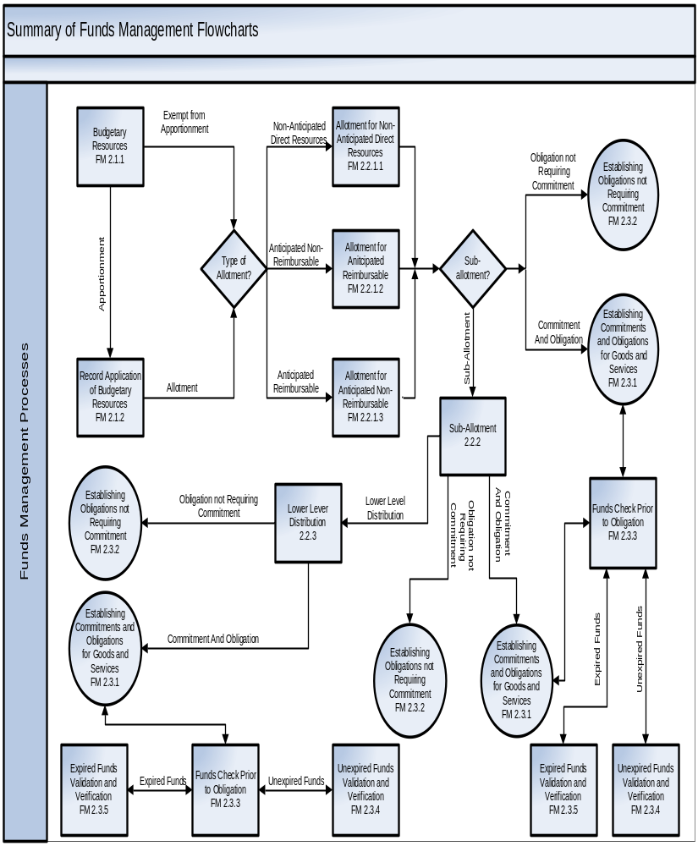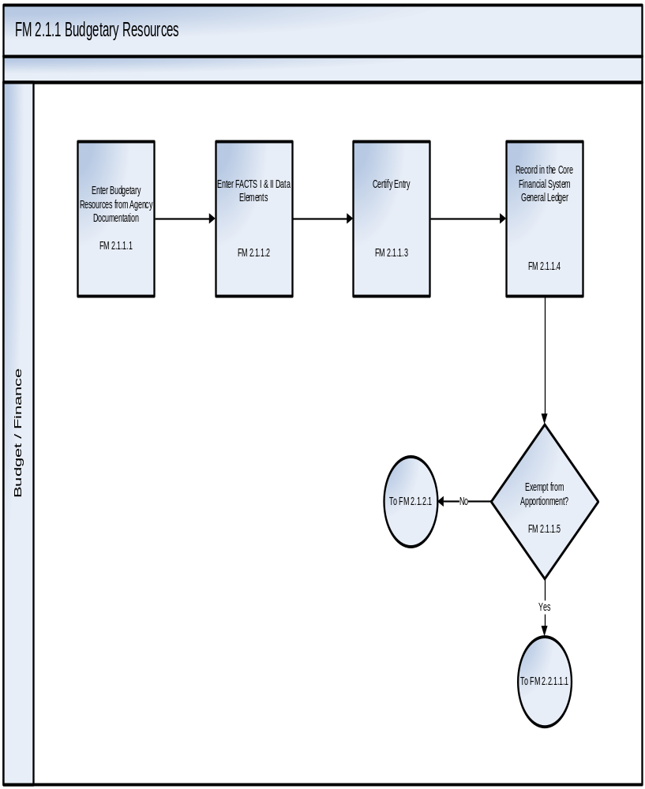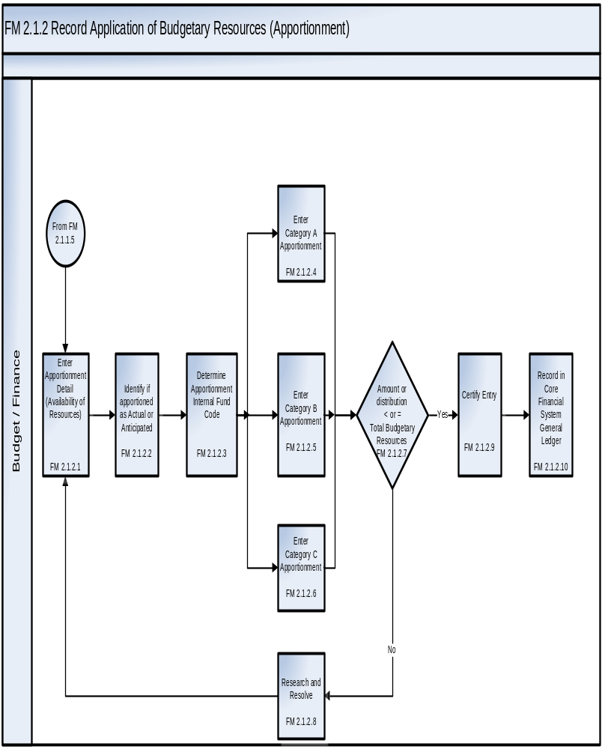

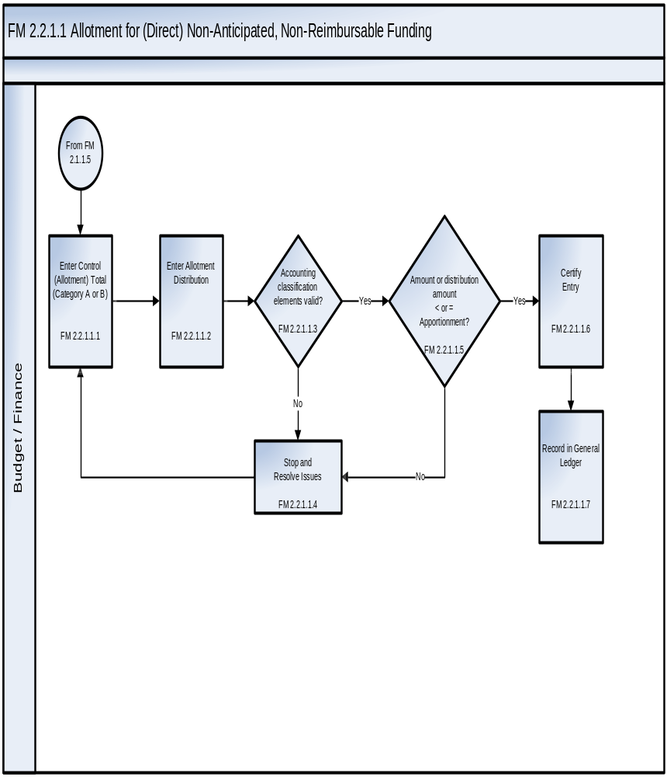
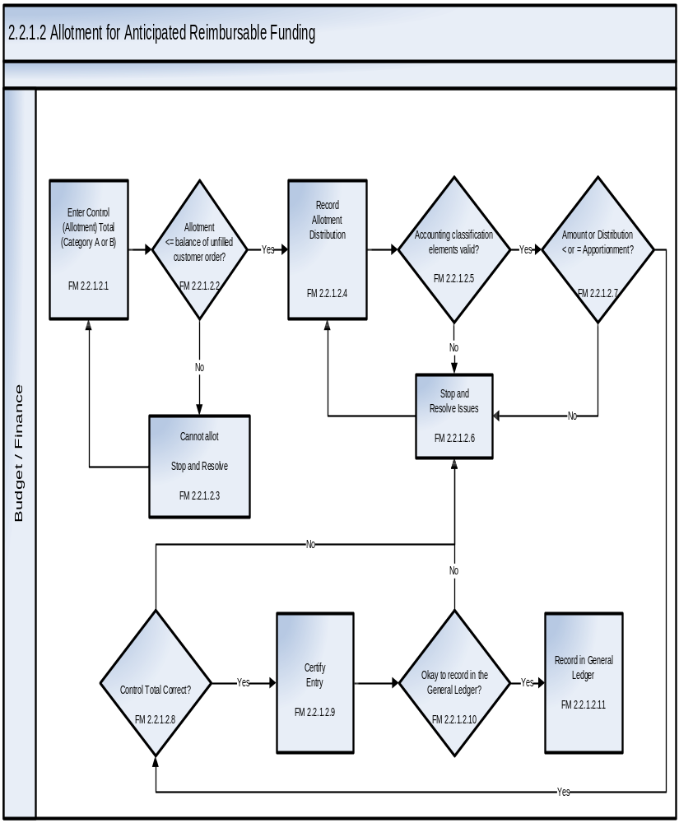
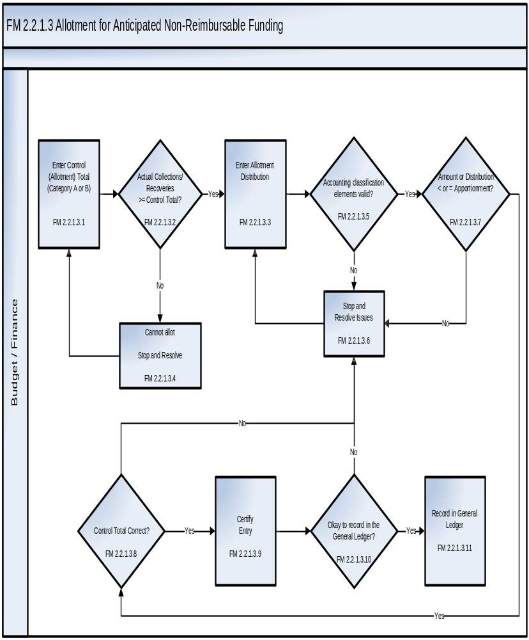

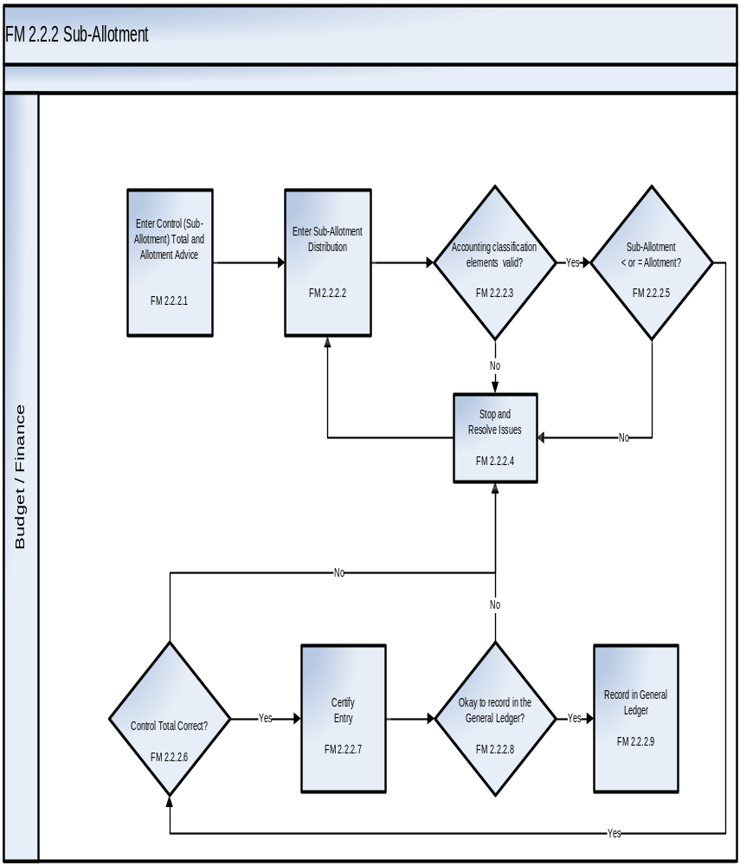

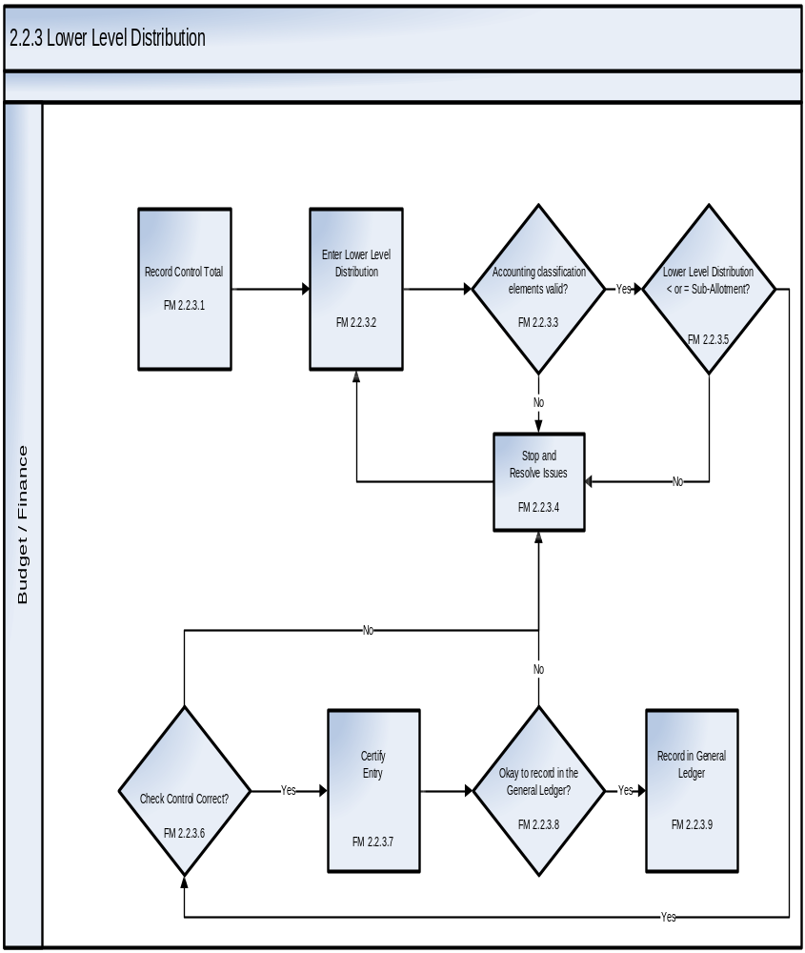
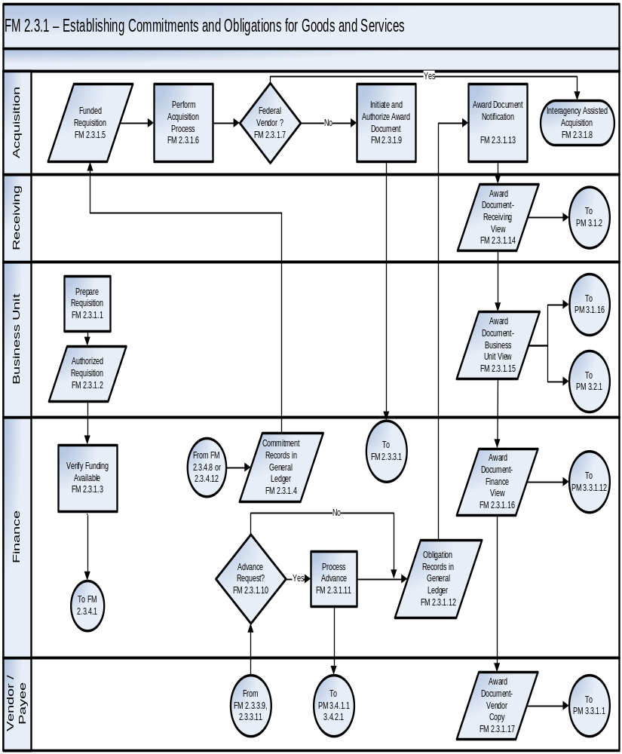
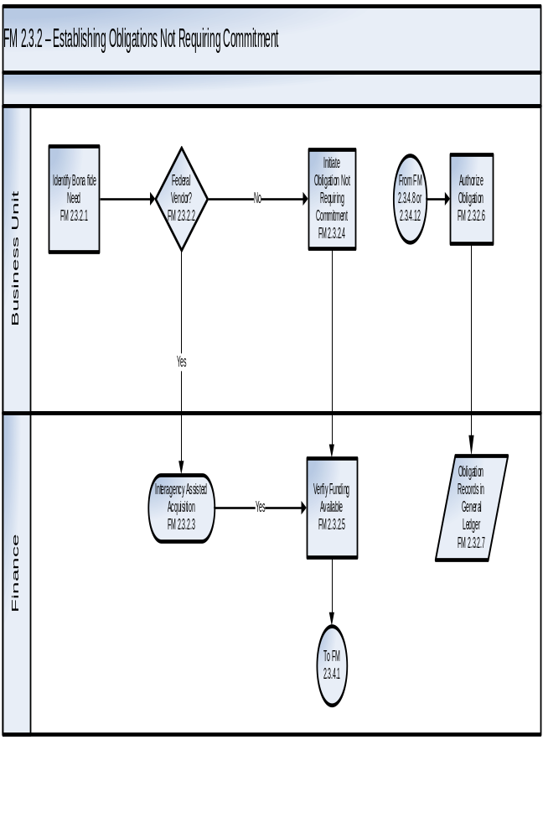
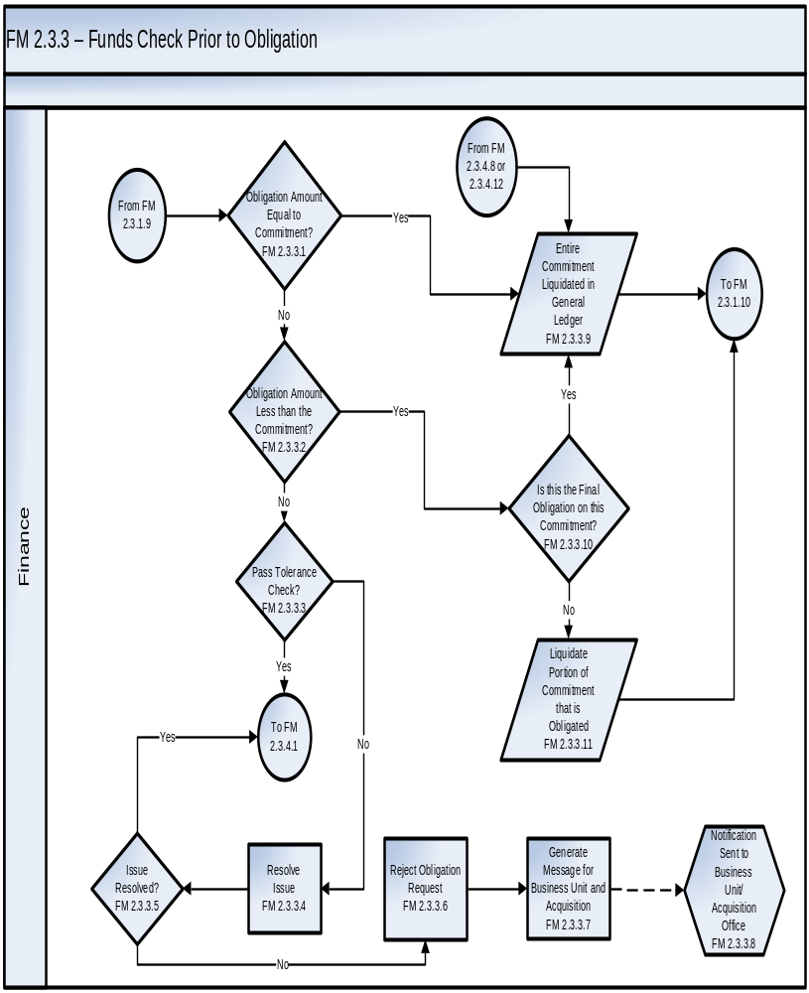
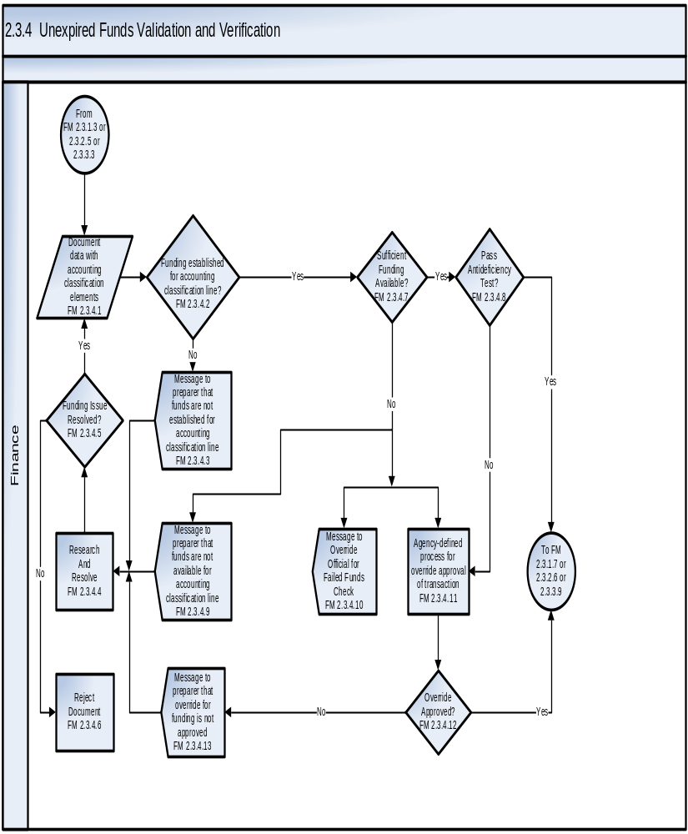
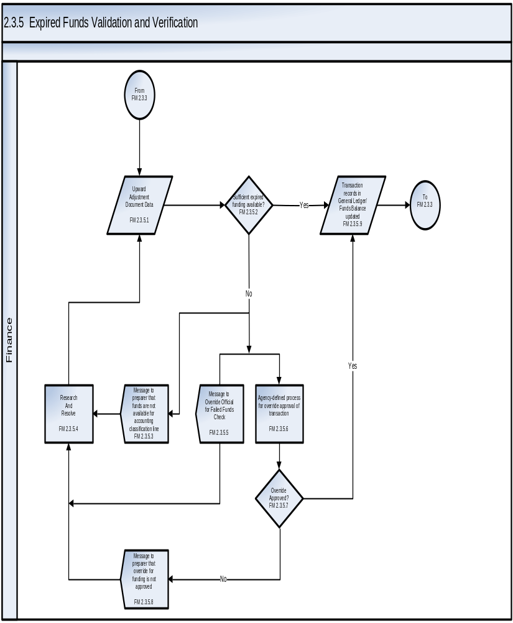
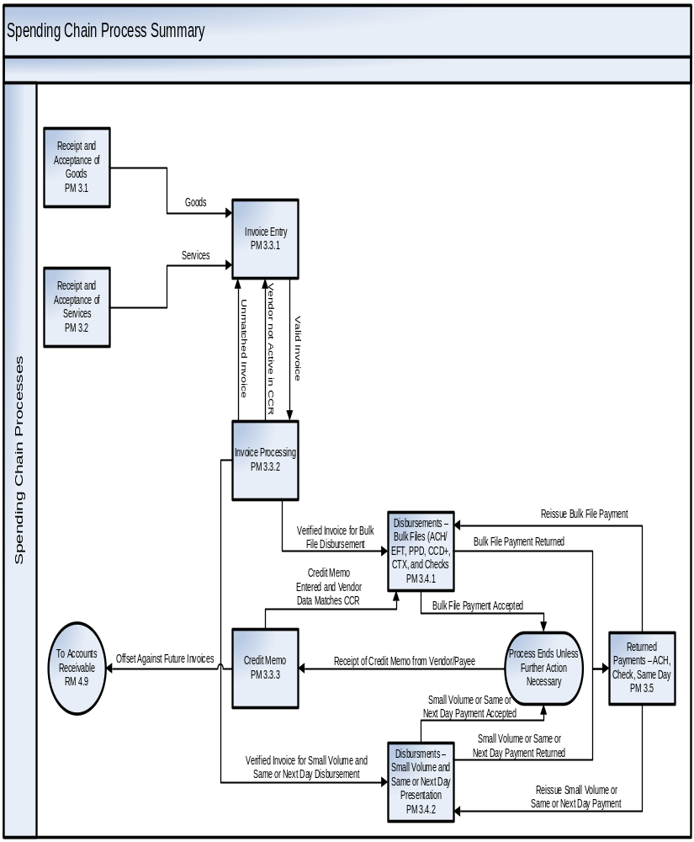
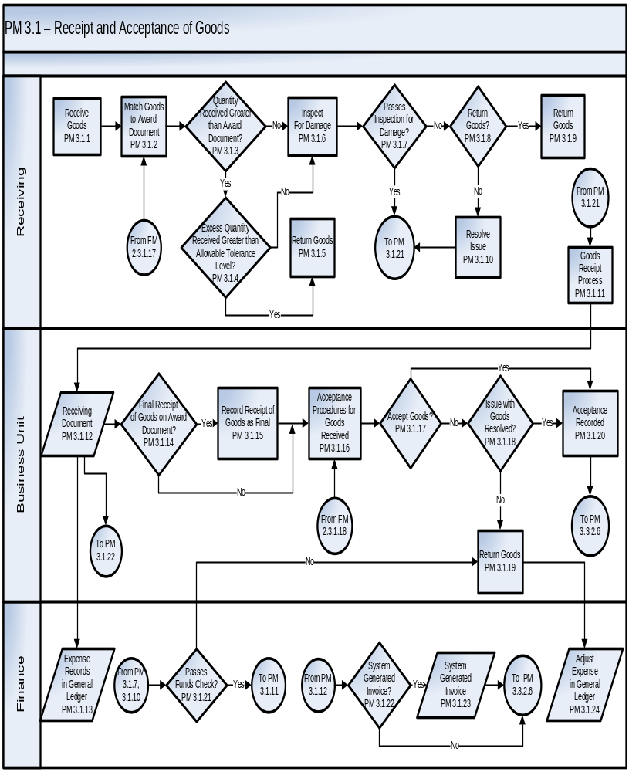
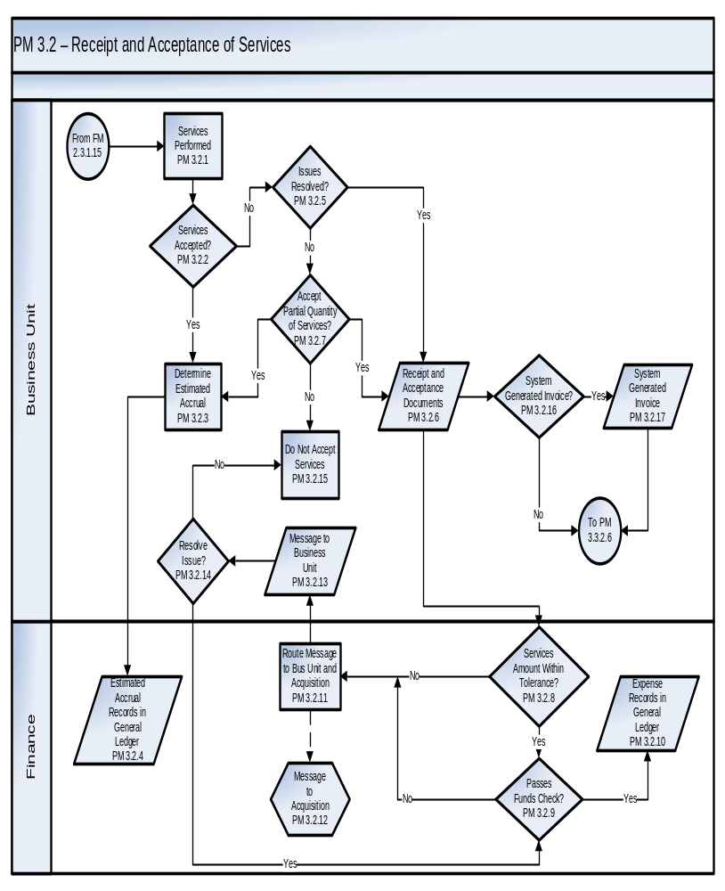

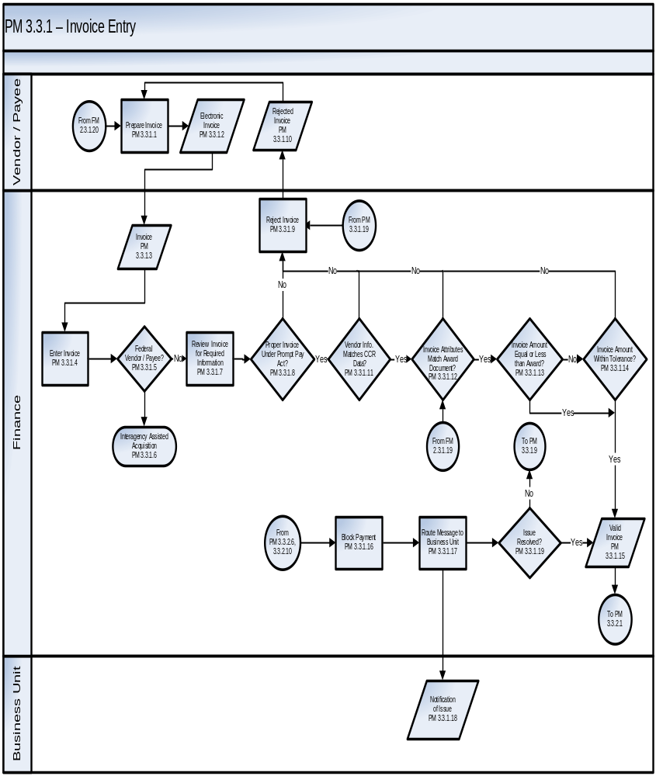
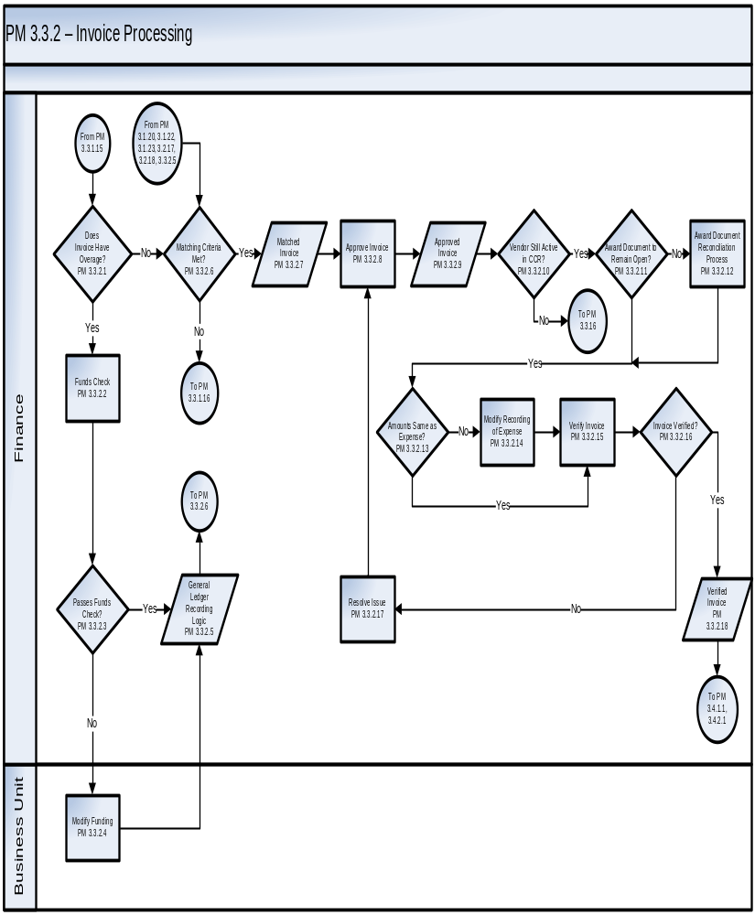
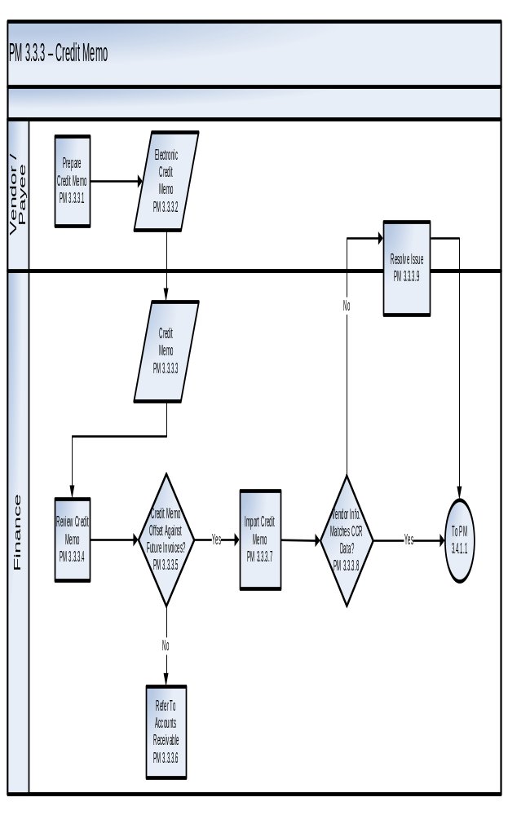
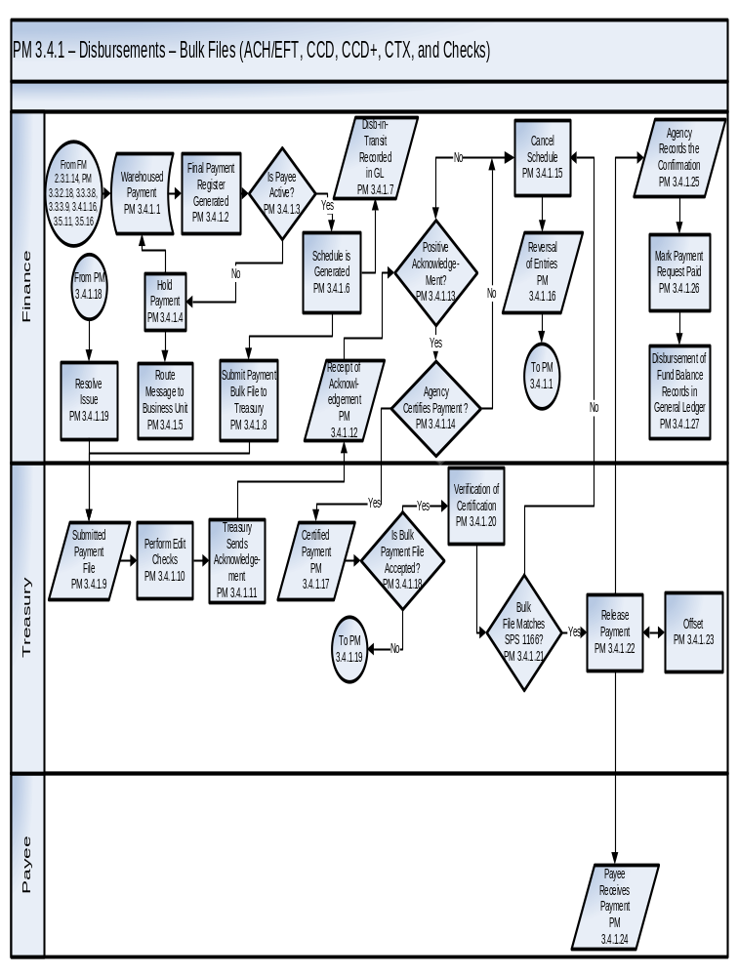
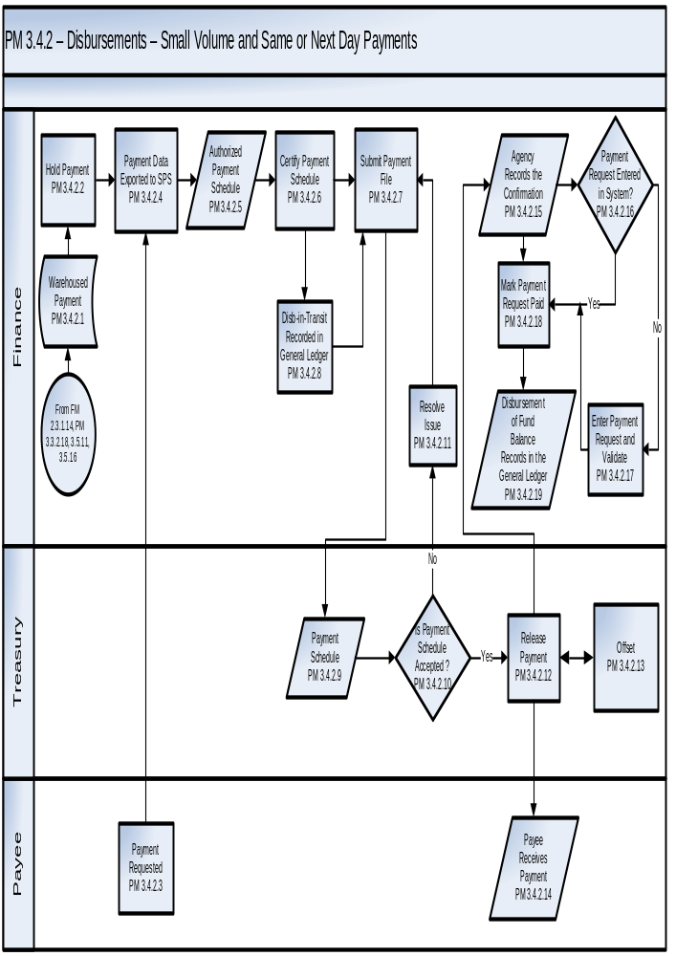

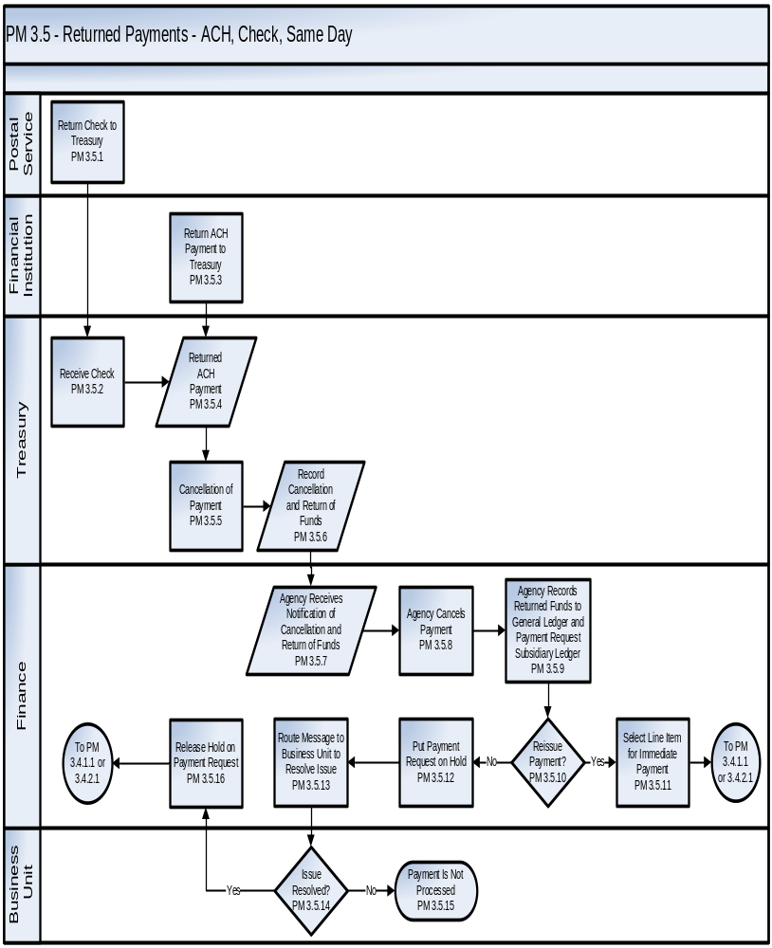
- Appendix D – Core Financial System Requirements

Funds Management Core Financial System Requirements
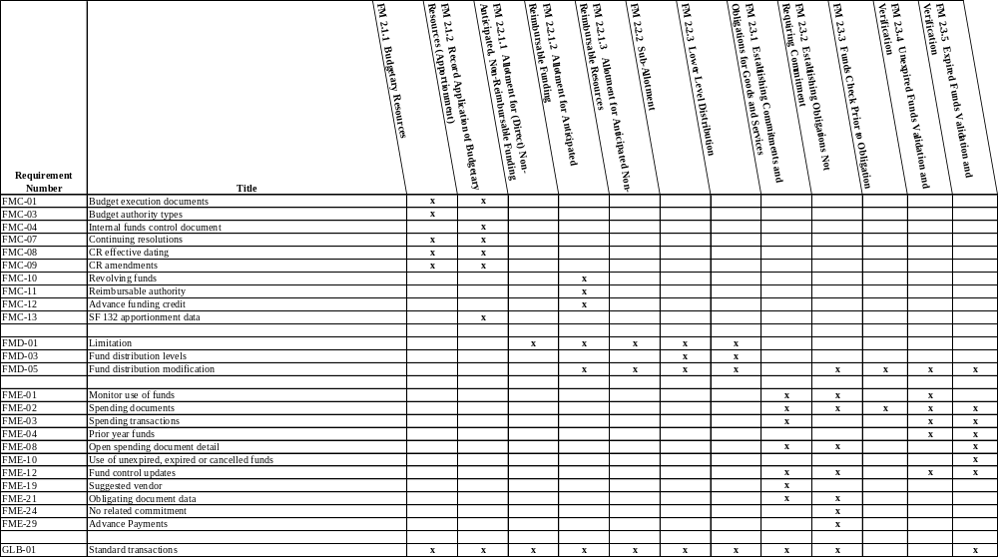
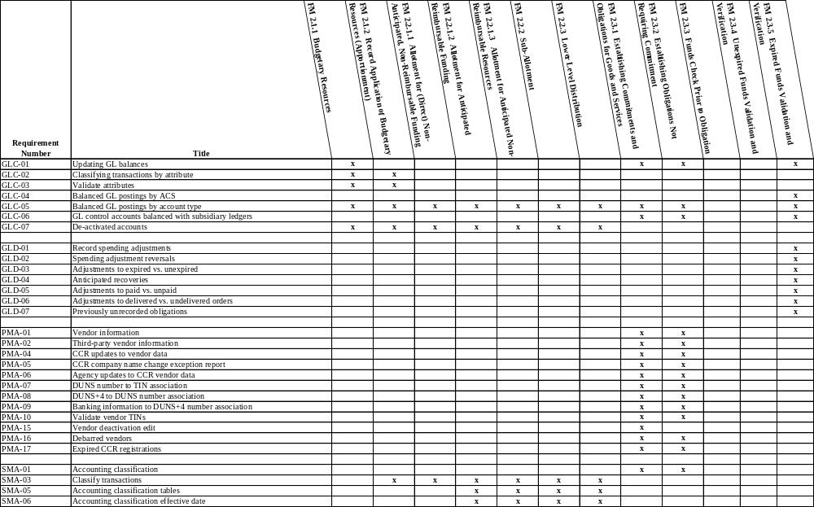
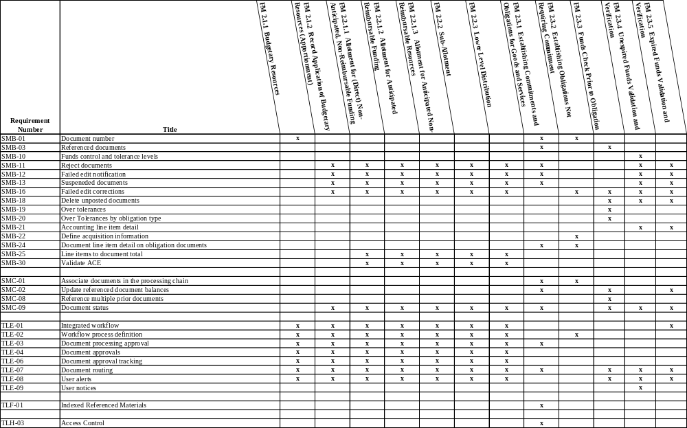
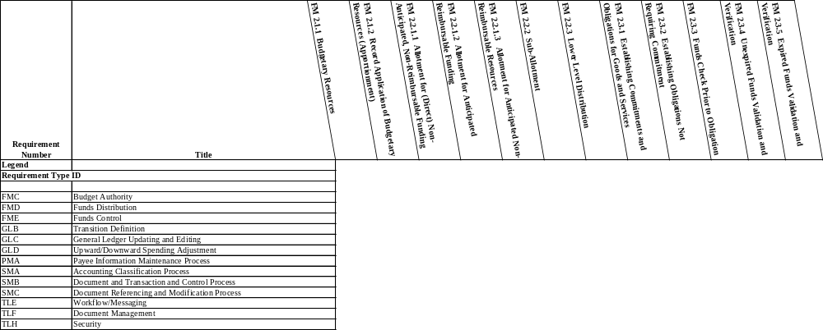
Payment Management Core Financial System Requirements

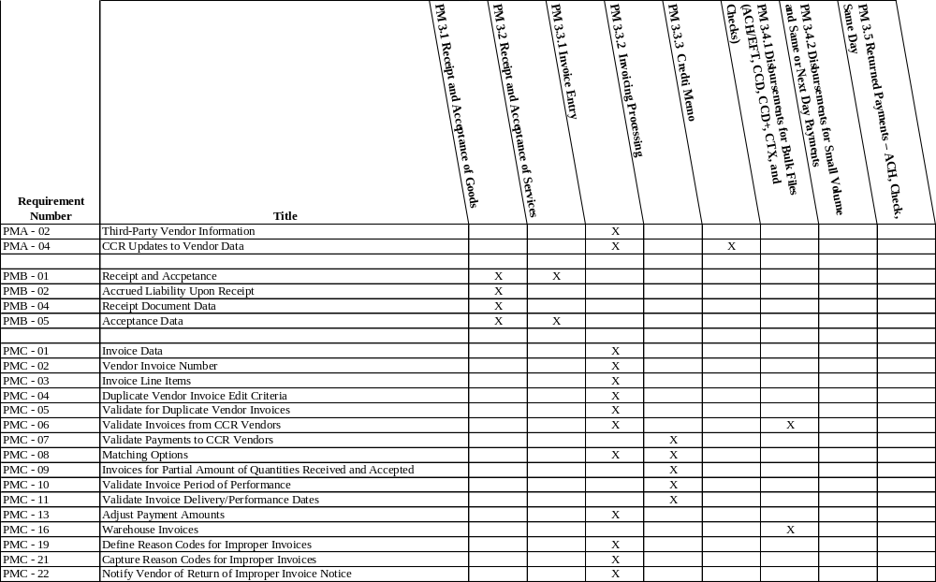
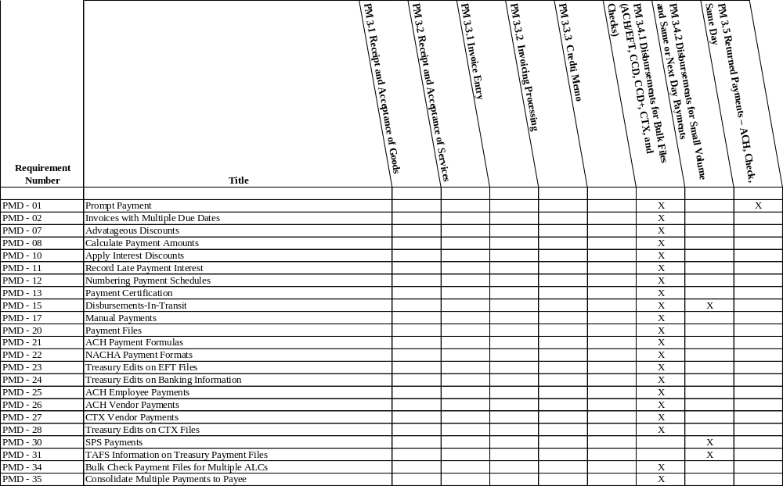
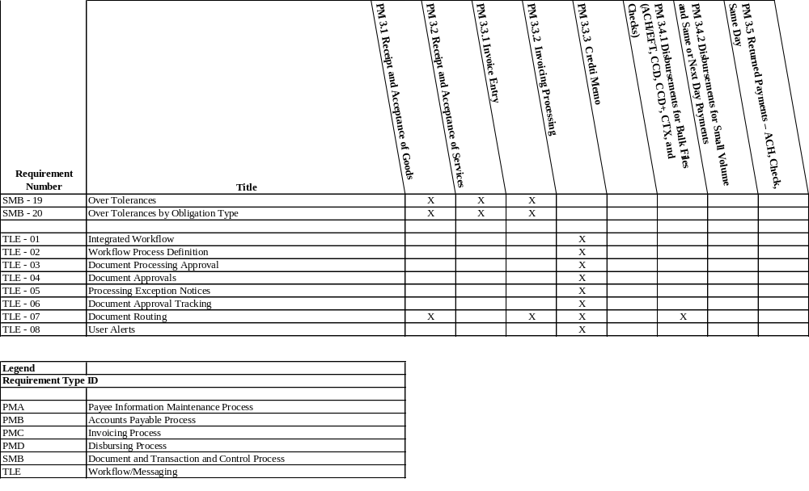

- Appendix E – Financial Management Laws and Regulations
Federal Statutes:
Appropriations Law
Fundamental, long-standing statutes deal with the appropriation of monies to agencies from Congress, including the appropriate use and control of these monies. These statutes deal with the purpose, amount, and time of appropriations, as well as the availability of the associated monies. The following summary provides specific citations to these statutes, their common names, and their requirements.
Federal Managers’ Financial Integrity Act of 1982
The Federal Managers’ Financial Integrity Act (FMFIA) of 1982 amended the Accounting and Auditing Act of 1950 to require ongoing evaluations and reports of the adequacy of the systems of internal accounting and administrative control of each executive agency. FMFIA is comprised of two parts. OMB Circular A-123, Management’s Responsibility for Internal Control (Effective beginning with Fiscal Year 2006) (Revised 12/21/2004), is the primary vehicle for implementing FMFIA in the executive branch and describes internal control requirements. Agencies are also required to report annually on whether the agency accounting system complies with OMB Circular A-127.
The FMFIA requires agency heads to establish controls that reasonably ensure:
- Obligations and costs are in compliance with applicable law
- Funds, property, and other assets are safeguarded against waste, loss, unauthorized use or misappropriation
- Revenues and expenditures are properly recorded and accounted for.
OMB revised Circular A-123 in 1995 to incorporate ideas from subsequent management legislation, such as the Chief Financial Officers Act. The Circular provides guidance on improving the accountability and effectiveness of federal programs and operations by establishing and reporting on management controls.
Chief Financial Officers Act of 1990 and Government Management Reform Act of 1994
The Chief Financial Officers Act of 1990 laid the foundation for significant financial management reform in the Federal government. The Act emphasizes strong financial leadership, improved systems of accounting, financial management and internal control, and reliable financial information. A key element of the Act is the requirement for Federal agencies to produce audited financial statements. The Government Management Reform Act (GMRA) expanded financial statement audit coverage to include Department-wide and Government-wide audited financial statements.
The CFO Act mandates three actions:
- Strong financial management leadership: The CFO Act established, in OMB, the Deputy Director for Management and the Office of Federal Financial Management, and created chief financial officer positions in major agencies to provide financial management direction.
- Enhanced financial management systems: The CFO Act mandates that agency CFOs develop and maintain agency financial management systems that comply with applicable accounting principles, standards, and requirements; internal control standards; and requirements of OMB and Treasury; and
- Improved financial information: By requiring agency CFOs to maintain systems that report cost information, integrate accounting and budgeting, and systematically measure performance, the CFO Act emphasizes improved reliability and usefulness of agency financial information. Most importantly, the CFO Act requires that financial statements be prepared and audited.
Government Performance and Results Act of 1993
The Government Performance and Results Act (GPRA) of 1993 holds Federal agencies accountable for achieving program results and requires them to identify missions, set goals, measure performance, and report on their accomplishments.
Under GPRA, each Federal agency must develop and submit a multiyear strategic plan, which contains the agency’s mission statements and long-term strategic goals. Agencies must also submit annual performance plans, which include performance goals linked to the budget and indicators of how performance will be measured. Annual performance reports, also required under the Act, provide information on the extent to which the agency met its annual performance goals.
Federal Financial Management Improvement Act of 1996
The Federal Financial Management Improvement Act (FFMIA) of 1996 requires agencies to implement and maintain systems that substantially comply with (1) Federal accounting standards, (2) the United States Government Standard General Ledger (USSGL) at the transaction level, and (3) Federal financial management systems requirements. In addition, the FFMIA requires agencies’ auditors to report whether agency systems comply with FFMIA’s systems requirements. Agencies that determine their systems do not substantially comply must develop and submit remediation plans to OMB.
To comply with Federal financial management system requirements, OMB implementation guidance requires that systems meet the Circular A-127 requirements, JFMIP’s Federal Financial Management Systems Requirements, and Circular A-130, Appendix III.
Debt Collection Act of 1982 and Debt Collection Improvement Act of 1996
The Debt Collection Improvement Act (DCIA) is an extension of the Debt Collection Act. The purpose of these Acts is to require proper collection of debts, to authorize the compromise or suspension of some debts, and to authorize the use of certain collection tools that are available in the private sector. The use of electronic payment and offset methods is required.
Federal Information Security Management Act (FISMA) of 2002 (Public Law 107-347, Title III)
The FISMA reiterates security requirements contained in existing OMB policies and in Federal laws such as the Computer Security Act of 1987, the Paper Reduction Act of 1995, and Clinger-Cohen Act of 1996. The Act mandates that Federal agencies implement an information security program and designate a senior information security officer. FISMA also established evaluation and reporting requirements that require each agency to report any significant deficiencies in an information security policy, procedure, or practice if relating to financial management systems as a lack of substantial compliance with FFMIA.

Reports Consolidation Act of 2000
This Act gives OMB the authority to combine financial reports to the President and Congress that contain performance and accountability information.
Clinger-Cohen Act (CCA) –- The Information Technology Management Reform Act of 1996
This Act provides that the Government information technology shop be operated exactly as an efficient and profitable business would be operated. Acquisition, planning, and management of technology must be treated as a “capital investment.” While the law is complex, all consumers of hardware and software in the Department should be aware of the Chief Information Officer’s leadership in implementing this statute.
Regulatory Guidance:
OMB Circular A-11, Preparation, Submission and Execution of the Budget (6/30/06)
OMB made major revisions to Circular A-11 that merged the budget formulation and execution guidance to reinforce the requirement for agencies to integrate budget and performance and to improve the quality of their financial information. In addition, OMB Circular A-11 contains new guidance on managing physical and financial assets.
OMB Circular A-25, User Charges
The Circular:
- Establishes Federal policy regarding fees assessed for Government services and for sale or use of Government goods or resources
- Provides information on the scope and types of activities subject to user charges and on the basis upon which user charges are to be set
- Provides guidance for agency implementation of charges and the disposition of collections.
OMB Circular A-123, Management’s Responsibility for Internal Control (Effective beginning with Fiscal Year 2006) (Revised 12/21/2004), Management Accountability and Control (or Successor Documents) (6/21/1995)
This Circular, which is the primary OMB guidance for FMFIA, is described in the section that relates to that Act.
Prompt Payment Final Rule (Formerly OMB Circular A-125, Prompt Payment) (9/29/1999)
The Final Rule, the primary OMB guidance for the Prompt Payment Act, is described in the section related to the specific act.
OMB Circular A-127, Financial Management Systems (07/23/1993), Financial Management Systems (or Successor Documents) (7/23/1993)
This circular augments FFMIA by specifically mandating that Federal agencies implement integrated core accounting and financial management systems. To be fully integrated, the system must address:
- Standard data classification (both data and format)
- Common processes for handling similar accounting events
- Consistent internal control mechanisms
- Elimination of duplicate transaction entry.
Circular A-127 also prescribes policies and standards for agencies to follow in developing, operating, evaluating, and reporting on financial management systems generally. It incorporates, by reference, Circulars A-123 and A-130, as well as all federal financial management systems requirements published by JFMIP.
OMB Circular A-129, Managing Federal Credit Programs (11/2000)
This Circular prescribes policies and procedures for justifying, designing, and managing Federal credit programs, and for collecting non-tax receivables. It sets principles for designing credit programs, including:
- Preparation and review of legislation and regulations
- Budgeting for the costs of credit programs and minimizing unintended costs to the Government
- Improving the efficiency and effectiveness of Federal credit programs.
Circular A-129 also sets standards for extending credit, managing lenders participating in Government guaranteed loan programs, servicing credit and nontax receivables, and collecting delinquent debt.
OMB Circular A-130, Management of Federal Information Resources (11/28/2000)
OMB reissued Circular A-130 in revised form in December 2000 as Transmittal Memorandum No. 4. The expanded version of Circular A-130 provides guidance on the Paperwork Reduction Act, the Clinger-Cohen Act, the CFO Act, and others. This includes the requirement for all electronic systems, including financial management systems, to have a defined association with the agency’s enterprise architecture.
The Circular provides specific guidance on collecting and managing information and records management, including:
- Electronic information collection
- Provision of information to the public
- Information dissemination systems
- Information safeguards.
It further mandates agencies to establish a capital planning and investment control process (CPIC) that links information technology investments to improved mission performance. The CPIC also establishes the links among agency processes including strategic planning, IT planning, enterprise architecture integration, performance planning, financial management planning pursuant to the Chief Financial Officers Act of 1990, and budget formulation and execution. Specifically, sections of Circular A-130 cover these four areas:
- Capital planning and investment control processes must be followed and documented by all agencies. These processes, stemming from Clinger-Cohen, must integrate IRM strategic and performance plans, financial management plans, the agency’s IT enterprise architecture, and its budget. The agency’s process for capital planning and investment control should include an IRM strategic plan, an IT capital plan, and an IT investment portfolio as described in OMB Circular A-11, Preparation, Submission and Execution of the Budget (6/30/06), Preparation, Submission and Execution of the Budget (6/30/06), the annual budget Circular.
- Enterprise architecture framework and planning processes require an agency to document (and submit to OMB its current and target IT architecture and related support strategies, transition roadmaps, and IT and security standards, as well as a summary of the information services used throughout the agency. The enterprise architecture framework anticipated by Circular A-130 is driven by the business needs of the agency and is composed of layers complying with the Federal Enterprise Architecture Framework (FEAF) developed by the CIO Council.
- Ensuring security in information systems is accomplished by explicitly incorporating security into the enterprise architecture and life-cycle planning for systems, and ensuring that security supports the agency’s business operations. The agency’s security plan must comply with the procedures and policies outlined in Appendix III to Circular A-130, Security of Federal Automated Information Resources; the Federal Information Security Management Act (Public Law 107-347); Title III; and guidance provided by the National Institute of Standards and Technology (NIST). Independent advice and comment on the security plan must be solicited prior to the plan’s implementation.
- Information technology acquisition requires the use of adequate competition in contracting, allocating risk between the Federal government and the contractor, and maximizing the return on investment. Major information systems should be structured into useful segments with narrow scope and brief duration. Off-the-shelf software should be used unless analysis clearly documents other approaches are more effective.
Statements of Federal Financial Accounting Standards
The FASAB was created in 1990 to develop and recommend Statements of Federal Financial Accounting Standards (SFFASs) for use by the Federal government. The growing body of SFFAS issued by FASAB is considered to be Generally Accepted Accounting Principles for Federal government entities.
The accounting standards that have resulted from FASAB’s work are central to effectively meeting financial management improvement goals of the CFO Act and other legislation. In particular, FASAB’s standards for managerial cost accounting, as described in SFFAS 4, are a primary source of guidance. This and other FASAB standards foster financial information and reporting that is understandable, relevant, and reliable concerning the financial position, activities, and results of operations for the Federal government and its departments and Agencies. Furthermore, the standards prescribe accounting systems and internal control that help demonstrate that Federal programs are conducted in compliance with laws and regulations.

- Appendix F - Contributors
The following list identifies the focus and working group members who contributed in the development of the Funds Management document.

Table F-1. Funds Management Contributors
Organization | Name
Department of Commerce | Karen McBride
Department of Defense | Kathy Hammer  Nello Lavorini
Department of Education | Sylvester Osineme  Winifred Shapiro
Department of the Interior | Jan Smith
Department of the Treasury | Holden Hogue
Environmental Protection Agency | Kyana Bundy-Evans  Melajo Kubacki
Social Security Administration | Ron Hallameyer  Richard Hull
Office of Management and Budget | Bing Bradshaw  Kim Farington  Adam Goldberg  Teresa Tancre
Financial Systems Integration Office  (formerly JFMIP) | Dianne Copeland  Michael Ploen
Program Office Support (KPMG) | David Fitz  Constance Herron  Ryan Patalune
The following list identifies the focus and working group members who contributed in the development of the Payments Management document.

Table F-2. Payments Management Contributors
Organization | Name
Department of Commerce | Karen McBride
Department of Education | Angela Butler  Danny Harris  Sylvester Osineme
Department of the Treasury | Brian Brotsos (Financial Management Service)  Ed Coia (Financial Management Service)  Vicki Fleming (Financial Management Service)  Andrew Ganahl (Financial Management Service)  Holden Hogue (Financial Management Service)  Marcel Jemio (Financial Management Service)  Margot Kaeser (Financial Management Service)
Department of Veterans Affairs | Kevin Ruffley
Environmental Protection Agency | Anita Jones
Social Security Administration | Ron Hallameyer  John Shelby
Office of Management and Budget | Kim Farrington  Adam Goldberg
Financial Systems Integration Office (formerly JFMIP) | Dianne Copeland  Dale Miller  Mary Mitchell  Keith Thurston
Program Office Support (KPMG) | David Fitz  Robert Frank  Marsha Pollard  Constance Herron  Ryan Patalune

Sources are provided if available, otherwise the term definition was developed for clarification of terminology.

