Proceedings of the

EIGHTH
Federal Interagency
Sedimentation Conference

April 2–6, 2006
Reno, Nevada USA

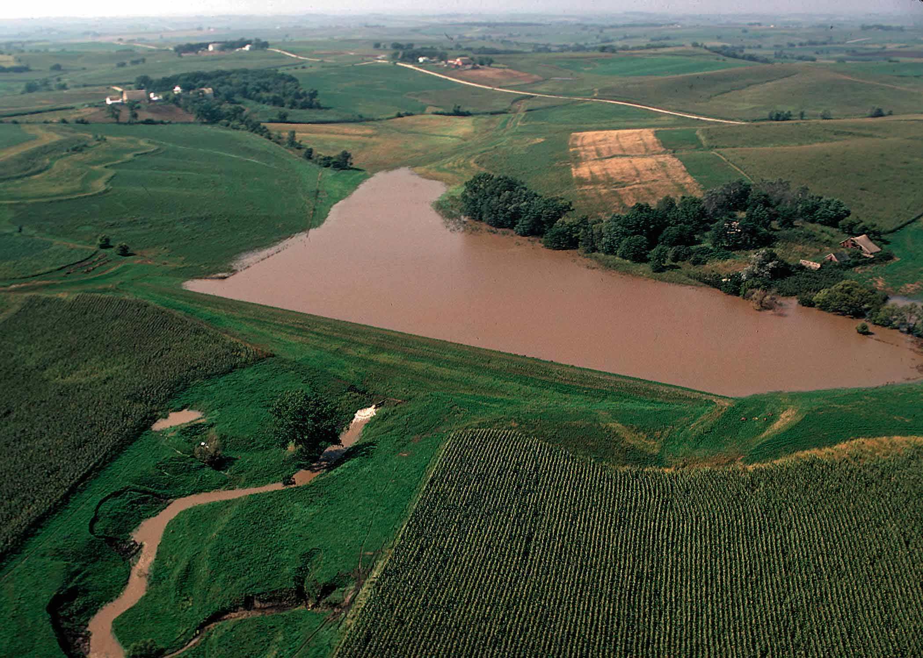

Sponsored by the Subcommittee on Sedimentation
(a subcommittee of the Advisory Committee on Water Information)

About the Conferences
Go To Table of Contents
PROCEEDINGS
OF THE
EIGHTH FEDERAL INTERAGENCY
SEDIMENTATION CONFERENCE (8thFISC)
April 2 – 6, 2006
RENO, NEVADA
Subcommittee on Sedimentation

Agricultural Research Service (ARS)
American Society of Civil Engineering (ASCE)
Army Corps of Engineers (USACE)
Bureau of Land Management (BLM)
Bureau of Reclamation (USBR)
Colorado Water Resources Institute
Electric Power Research Institute (EPRI)
Environmental Protection Agency (USEPA)
Federal Highway Administration (FHWA)
Forest Service (USFS)
Geological Survey (USGS)
National Park Service (NPS)
Natural Resources Conservation Service (NRCS)
Office of Surface Mining Reclamation and Enforcement (OSMRE)
Universities Council on Water Resources

PREFACE
These proceedings of the Eighth Federal Interagency Sedimentation Conference contain over 190 technical papers. This conference is sponsored by the Subcommittee on Sedimentation, which is chartered under the Advisory Committee on Water Information. The ACWI and all of its subcommittees function according to the requirements of the Federal Advisory Committee Act, which encourages nonfederal participation. Member agencies of the Subcommittee on Sedimentation, as shown above, are therefore a mix of Federal agencies and non-federal organizations.
The enclosed technical papers document scheduled oral presentations and poster sessions. The proceedings have been prepared in advance of the conference so that all papers could be available to conference participants.
The Subcommittee has organized seven previous interagency sedimentation conferences:

 | 1st | 1947 | Denver, CO
 | 2nd | 1963 | Jackson, MS
 | 3rd | 1976 | Denver, CO
 | 4th | 1986 | Las Vegas, NV
 | 5th | 1991 | Las Vegas, NV
 | 6th | 1996 | Las Vegas, NV

7th | 2001 | Reno, NV
The first four meetings were conferences involving federal agencies only: papers and discussions were given only by the staff of the agencies on the Subcommittee and by individuals engaged in cooperative sedimentation work with the agencies. Beginning with the Fifth and continuing through with the 8th FISC, however, a limited number of technical papers are being presented by nonfederal agencies in order to capture the full spectrum of sedimentation issues that relate to the condition of natural resources and their management.

The 8th FISC was held in conjunction with 3rd Federal Interagency Hydrologic Modeling Conference under the umbrella of the Joint Interagency Sedimentation Conference, with the theme “Interdisciplinary Solutions for Watershed Sustainability.” It brings together professionals and others from (1) the federal government, (2) state and local agencies, (3) universities, (4) the private sector, and (5) international organizations. Since 1946, the Subcommittee on Sedimentation has focused on interagency coordination.

Organizing Committee for the 8th FISC
Chairman: | Jerry M. Bernard | USDA-NRCS
Technical Program Committee Chair: | Jerry W. Webb | USACE
Presentations: | Marie M. Garsjo | USDA-NRCS

Organizing Committee, Joint Federal Interagency Conference

Doug Glysson, Joint Conference Chair, US Geological Survey
Paula Makar, Operations Chair, US Bureau of Reclamation
Francisco Simões, Proceedings Coordinator, US Geological Survey
Jeff Rieker; Registration Chair, US Bureau of Reclamation
Gary Barbato, Field Trip Coordinator, National Weather Service
Tom Donaldson, Poster/Demonstration Coordinator, National Weather Service
Larry Schmidt, Local Contact, US Forest Service (retired)
Joe Treadway, Exhibitor Coordinator, US Geological Survey
Jayantha Obeysekera, Short Course Coordinator, South Florida Water Mgt. Dist.
Roland Viger, Computer/AV Equipment Coordinator, US Geological Survey
Christi Young, Publicity Coordinator, US Bureau of Reclamation

ISBN 0-9779007-1-1
TABLE OF CONTENTS
Sediment Yield and Transport | Stream Restoration
Sediment and Wildlife Habitat | Gully Erosion
Watershed Modeling | Sediment Research
Reservoir Sedimentation | Sediment Surrogates
Dam Removal and Rehabilitation | Turbidity and Sediment Tracers
Geomorphology | Instrumentation Monitoring
Farm Bill / Conservation | POSTERS/DEMOS

sediment yield & transport | 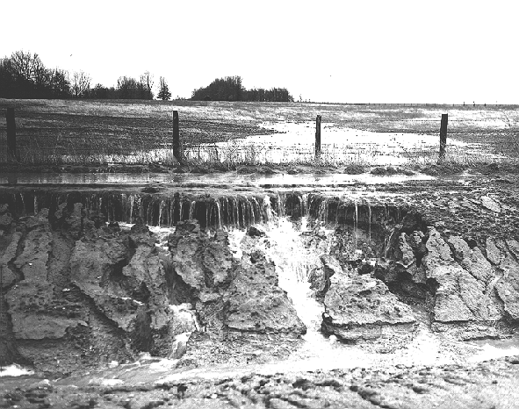
Title | Author(s) | Paper
Development and Application of GSTAR-1D | Jianchun Huang, Blair P. Greimann, and Travis Bauer | 
Application of GSTAR-1D Sediment Transport Model on the Rio Grande, NM – San Acacia Diversion Dam to Elephant Butte Reservoir | Christopher L. Holmquist-Johnson | 
Bureau of reclamation Automated Modified Einstein Procedure (BORAMEP) Program for Computing Total Sediment Load | David A. Raff and Chris Holmquist-Johnson | 
FRAMEWORK OF YEARLY STREAM SEDIMENT INPUT | Aaron Byrd | −
predicting sediment discharge from forest roads: The role of surface runoff and rainfall intensity | Joseph R. Amann and Arne Skaugset | 
Erosion Control in Cotton Production through the Use of Ultra Narrow Row | R. F. Cullum, G. V. Wilson, J. R. Johnson, K. C. McGregor | 
Hillside Erosion and Small Watershed Sediment Yield Following a Wildfire on the San Dimas Experimental Forest, Southern CA | Peter M. Wohlgemuth | 

SIMULATION OF FLOOD FLOW AND SEDIMENT TRANSPORT ON ALLUVIAL FANS OF COACHELLA VALLEY, CALIFORNIA | Andrey Shvidchenko, Brad Hall, Joseph Howard, Rene Vermeeren, and Cuong Ly | 
SEDIMENT TRANSPORT COMPUTATIONS WITH HEC-RAS | Stanford Gibson, Gary Brunner, Steve Piper, and Mark Jensen | 
IMPLEMENTATION OF THE SEDIMENT IMPACT ASSESSMENT MODEL (SIAM) IN HEC-RAS | Stanford A. Gibson and Charles D. Little Jr. | 
SEDIMENT INVESTIGATION AND STABLE CHANNEL DESIGN FOR THE LOWER MUD RIVER | Martin J. Teal and Phillip A. Anderson | 
SIAM-UK SEDIMENT BUDGETING PROGRAM TO ASSESS INTERACTIONS BETWEEN FLOOD DEFENCE INFRASTRUCTURE AND SEDIMENT DYNAMICS IN A FLUVIAL SYSTEM | Ian M. Tomes, Oliver P. Harmar, and Colin R. Thorne | 
PERFORMANCE OF BED LOAD TRANSPORT EQUATIONS IN MOUNTAIN GRAVEL-BED RIVERS: A RE-ANALYSIS | Jeffrey J. Barry, John M. Buffington, John G. King, and Peter Goodwin | 
PREDICTABILITY OF BEDLOAD RATING AND FLOW COMPETENCE CURVES FROM BED ARMORING, STREAM WIDTH AND BASIN AREA | Kristin Bunte, Steven R. Abt, and Kurt W. Swingle | 
RADIONUCLIDE AND RARE EARTH ELEMENT TRACERS OF EROSIONAL PROCESSES ON THE PLOT SCALE | A.P. Stubblefield, C. Fondran, M.E. Ketterer, G. Matisoff, and P.J. Whiting | 
Dredged Material Management in a Watershed Context: Seeking Integrated Solutions | Craig Vogt, Barry Holiday, Elizabeth Kim and Molly Madden | −
A FARM SEDIMENT TRAP AND POND IN COLUSA COUNTY, CA | Jack Alderson | 
USE OF MONITORING DATA TO EVALUATE WATERSHED MANAGEMENT PRACTICES IN A MIXED-LAND USE WATERSHED IN NORTHERN IDAHO | K. Ostrowski, J. Boll, E.S. Brooks, and J. Newson | 
PRELIMINARY SEDIMENT BUDGETS FOR FOUR WATERSHEDS AT THE KINGS RIVER EXPERIMENTAL WATERSHED IN THE SOUTHERN SIERRA NEVADA | Sean Eagan, Carolyn Hunaker, Abbey Korte, Sarah Martin, and Lee McDonald | −
CALIBRATION OF THE WATBAL SEDIMENT AND WATER YIELD MODEL CLEARWATER NATIONAL FOREST | Dick Jones and Rick Patten | 
ESTIMATING SEDIMENT YIELD IN THE SOUTHERN APPALACHIANS USING WCS-SED | Paul Bolstad, Andrew Jenks, Mark Riedel, and James M. Vose | 
Reconstructing reservoir stratigraphy from hydrologic history and simple transport calculations: Englebright Lake, Yuba River, northern California | Scott A. Wright and Noah P. Snyder | −
SEDIMENT TRANSPORT RESEARCH IN SHALLOW OVERLAND FLOW | M.J.M. Romkens, S.N. Prasad, and S. Madhusudana Rao | 
Chester Morse Lake Outlet Channel Alternatives evaluation | Hans Hadley, Thomas R. Grindeland, and Dalong “Daniel” Huang | −
geomorphology | 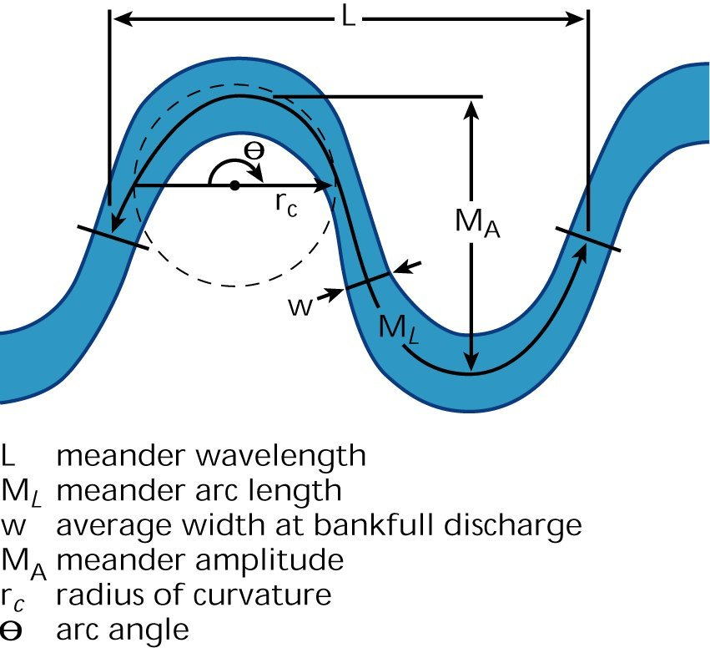
Title | Author(s) | Paper
Bed Forms in the Low Flow Conveyance Channel | Drew C. Baird | 
path of gravel movement in a coarse stream channel | Kristin Bunte, John P. Potyondy, Steven R. Abt, Kurt W. Swingle | 
Comparison of sediment-transport and bar-response results from the 1996 and 2004 controlled experiments on the Colorado River in Grand Canyon | David J. Topping, David M. Rubin, John C. Schmidt, Joseph E. Hazel, Theodore S. Melis, Scott A. Wright, Matt Kaplinski, Amy E Draut, and Michael J. Breedlove | 
Streambank Stability Assessment in Grazed Riparian Areas | Mark S. Riedel, Kenneth N. Brooks and Elon S. Verry | 
Geomorphic Response to a dam failure in the dead River watershed, Michigan: Integration of Empirical and Analytical Techniques in a GIS Framework | Alex Brunton, Rob Nairn and Jim Selegean | −
Temporal Variations of Scour and Fill Processes at Selected Bridge Sites in Alaska | J.S.Conaway | 
Geomorphic Context for Historical Determination of Sediment Sources, Transport, and Deposition in the Bad River Watershed, Bad River Reservation, Wisconsin | Faith A. Fitzpatrick, Kirsten A. Cahow-Scholtes, and Marie C. Peppler | −
A river evolution of adjacent stable and unstable urban watersheds in san jose, california | Brett Jordan, W.K. Annable, C.C. Watson | −
Integrating Two Sedimentation Rate Methods to determine channel adjustment rates | Laura L. Keefer, Richard A. Cahill, Richard L. Allgire | 
Effects of Regularly Reversing Energy Gradients on Sediment Transport in a Tidal wetland System | Kevin Knuuti | 

Recent Channel Incision and Floodplain Evolution within the Middle Rio Grande, NM | Tamara Massong, Paul Tashjian, and Paula Makar | 
Temporal and Spatial variability in root-reinforcement of streambanks: Accounting for geotechnical properties and moisture | Natasha Pollen and Andrew Simon | 
Morphologic Evolution in the USGS Surface Water Modeling Interface | Jonathan Nelson, Richard McDonald, and Paul Kinzel | 
CHANNEL MIGRATION MODEL FOR MEANDERING RIVERS | Timothy J. Randle | 
Environmentally Sensitive Gravel Bar Scalpingn | Frank Reckendorf | 
Computational Model for the Development of Sediment Plugs in Alluvial Rivers | Craig B. Boroughs, Steven R. Abt, and Drew Baird | 
sediment research | 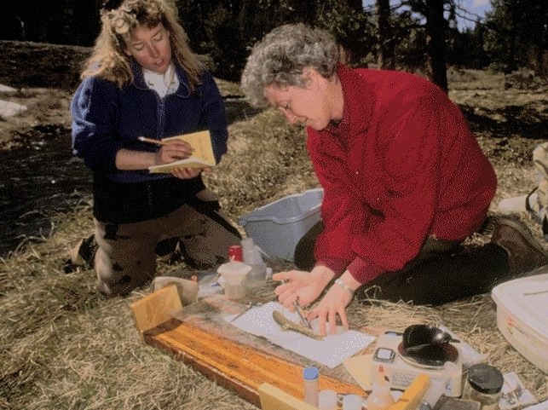
Title | Author(s) | Paper
How incipient motion determination judgment affects different parameters in sediment transport investigation | Muhammad Ashiq and John C Doering | 
A REGIONAL PROTOCOL FOR EVALUATING THE EFFECTIVENESS OF FORESTRY BEST MANAGEMENT PRACTICES AT CONTROLLING EROSION AND SEDIMENTATION | Roger Ryder and Pamela Edwards | 
Floods and Sediment Yields from Recent Wildfires in Arizona | Daniel G. Neary, Gerald J. Gottfried, Jan L. Beyers, and Peter F. Ffolliott | 
Estimation of sediment and Nutrient Loads from Mixed land Use watersheds in the Upper Mississippi River Basin and the Role of Wetlands in reducing Them | J.P. Schubauer-Berigan, W.B. Richardson, P. Hughes, L. Bartsch, J. Cavanaugh, R. Kreilling, and M. Morrison | −
The Isokinetic Streamlined Suspended Sediment Profiling LISST-SL – Status and Field results | Y.C. Agrawal and H.C. Pottsmith | 

FISP’S SUITE OF FEDERALLY APPROVED SUSPENDED-SEDIMENT / WATER QUALITY COLLAPSIBLE-BAG SAMPLERS | Broderick Davis | 
A TIDALLY- AVERAGED SEDIMENT TRANSPORT MODEL OF THE SAN FRANCISCO BAY, CALIFORNIA | Megan A. Lionberger, David H. Schoellhamer, Jon Leatherbarrow, and Kris May | 
A UNIFIED APPROACH FOR RIVER MORPHOLOGY, SEDIMENT TRANSPORT, AND EROSION STUDIES | Chih Ted Yang | −
REGEM: THE REVISED EPHEMERAL GULLY EROSION MODEL | Lee Gordon, Sean Bennett, Fred Theurer, Ron Bingner, and Carlos Alonso | 
SEDIMENT INVESTIGATIONS IN THE VICINITY OF THE OLD RIVER COMPLEX, LOUISIANA: RED RIVER ABOVE OLD RIVER OUTFLOW CHANNEL | Nina J Reins and Tonja L. Koob | 
AN APPARATUS FOR BED MATERIAL SEDIMENT EXTRACTION FROM COARSE RIVER BEDS IN LARGE ALLUVIAL RIVERS | Michael Bliss Singer, Stacy Cepello, and Adam Henderson | −
ANALYZING SEDIMENT YIELDS IN THE CONTEXT OF TMDL’S | Mary Ann Madej, Randy Klein, Vicki Ozaki, and Tom Marquette | 
turbidity AND SEDIMENT TRACERS | 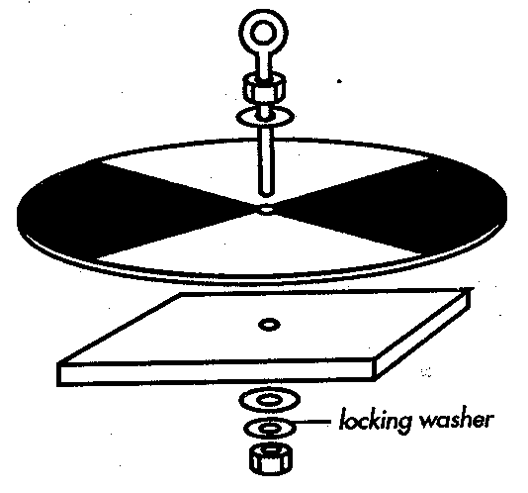
Title | Author(s) | Paper
overview of selected surrogate technologies for continuous suspended-sediment monitoring | John R. Gray and Jeffrey W. Gartner | 
Turbidity sensors track sediment concentrations in runoff from agricultural fields | S. M. Dabney, M. A. Locke, and R. W. Steinriede | 
A New Sensor for Turbidity and Sediment Analyses in natural waters | Stuart Garner | 
Impact of the Rosewood Creek Restoration Project ON SUSPENDED SEDIMENT LOADING TO LAKE TAHOE: PRE-MONITORING AND YEAR 1 | Rick Susfalk | 

Identifying sources of fine-grained Suspended-Sediment for the Pocomoke River, an Eastern Shore Tributary to the Chesapeake Bay | Allen C. Gellis and Jurate M. Landwehr | 
The use of turbidity sensors in monitoring sediment loads following wildfire | Sandra E. Ryan, Mark K. Dixon, and Kathleen A. Dwire | 
Turbidity measurements for determination of sediment source and retention in river and marsh environments | A. P. Stubblefield, J. E. Reuter, E. W. Larsen, M. I. Escobar, and C. R. Goldman | 
Stream Restoration | 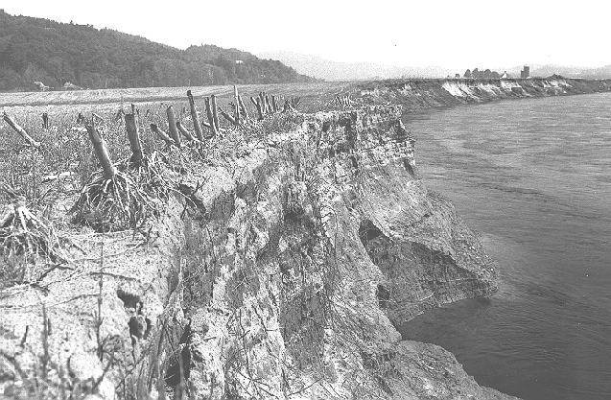
Title | Author(s) | Paper
river restoration using a geomorphic approach for natural channel design | David L. Rosgen | 
The Hydraulics of Bendway Weirs | C. I. Thornton, D. C. Baird, S. R. Abt ,and R. S. Padilla | −
Research, coordination, and open-source models to improve stream restoration practice | Peter R. Wilcock and Gary Parker | 
Empirical and analytical approaches for stream channel design | F. Douglas Shields, Jr. and Ronald R. Copeland | 
Restoration of Lower Las vegas wash – Upper Diversion Weir | Chris Bahner, Gerry A. Hester, and Syndi J. Dudley | −
SIAM,Sediment impact analysis methods, for evaluating sedimentation causes and effects | David Mooney | 
Rio Salado (Salt River) Habitat Restoration - Low Flow Channel Design | Dennis L. Richards and Glenn Mashburn | 
judy’s branch, illinois Rehabilitation Plan | Chester C. Watson, David S. Biedenharn, and Moosub Eom | 

Watershed Modeling | 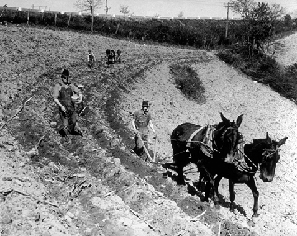
Title | Author(s) | Paper
evaluating sediment processes, and transport processes in the upper yuba river watershed, california | Jennifer A. Curtis, Lorraine E. Flint, Charles N. Alpers, and Scott A. Wright | 
Effects of climate on flow and sediment transport in the Upper Yuba River Basin, northern Sierra Nevada | Lorraine E. Flint, Joel R. Guay, Alan L. Flint, and Jennifer A. Curtis | −
modeling systems for sediment management and bmp evaluation in large great lakes tributary watersheds | Theresa Possley, Alex Brunton and Rob Nairn, and Jim Selegean | 
Development of upper boundary conditions for a watershed model in the Upper Yuba River Basin, northern Sierra Nevada | Alan L. Flint and Lorraine E. Flint | −
Watershed Simulation with an Enhanced Distributed Model | Yong G. Lai | 
AnnAGNPS: Accounting for Snowpack, Snowmelt, Freezing and soil freeze-thaw | Daniel S. Moore, Fred D. Theurer, and Ronald L. Bingner | 
Wash Load / Bed material Load Concept in Regional sediment management | David S. Biedenharn, Colin R. Thorne, and Chester C. Watson | 
one-dimensional modeling of incision through reservoir deposits | Blair Greimann and Victor Huang | 
Predicting Watershed Impacts of Forest Fuel Management with WEPP Technology | William J. Elliot | 
A Geomorphic Evaluation, with Calibrated Hydraulic and Hydrologic Modeling of the Hop Brook Watershed in Massachusetts | Thomas Garday | 
Multiple approaches to assessing the impact of dams on sediment delivery in the St. Joseph River Watershed, Michigan/Illinois | Rob Nairn, Alex Brunton, and Jim Selegean | 
Cumulative Watershed Effects analysis with the Geospatial Interface for the Water Erosion Prediction Project (GeoWEPP) | Chris S. Renschler and William J. Elliot | −

Sediment Surrogates | 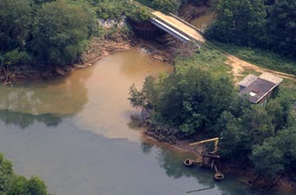
Title | Author(s) | Paper
Development of an Acoustic suspended sediment monitoring System | Daniel E. Kleinert, Daniel Wren, Chris Smith, and James Chambers | 
Estimation of particle sizes for a range of narrow size distributions of natural sands suspended in water using multi-frequency acoustic backscatter | Christopher K. Smith, Daniel Wren, and James P. Chambers | 
High-resolution monitoring of suspended-sediment concentration and grain size in the Colorado River in Grand Canyon using laser-diffraction instruments and a three-frequency acoustic system | David J. Topping, Theodore S. Melis, Scott A. Wright, and David M. Rubin | 
comparison of Suspended-Sediment Load estimates using a Turbidityand suspended-sediment concentration regression and the Graphical Constituent Loading Analysis System (GCLAS) | Mark A Uhrich and Heather M Bragg | 
A Method for Comparing the LISST 100 to the USGS Pipette method for Suspended Sediment Particle Size Analysis in the Marina Sediment Lab, U.S. Geological Survey, California Water Science Center | Lawrence A. Freeman | 
Use of an ADCP tocompute Suspended Sediment Discharge in the Tidal Hudson River, NY | Gary R. Wall, Elizabeth Nystrom, and Simon Litten | 
Calculation of suspended sediment at gaging stations | Jason Kean and Dungan Smith | 
CROSS-SECTIONAL PROGRESSION OF APPARENT BEDLOAD VELOCITIES | Terry A. Kenney | 
Continuous in-stream monitoring to estimate water-quality characteristics and sediment sources in the Little Arkansas River, Kansas | Andrew C. Ziegler, Victoria G. Christensen, and Patrick P. Rasmussen | −
Real-time analysis of concentrated fluvial suspended sediments | Chris Konrad, Chuck Pottsmith, Ted Melis, and David Rubin | 

Prediction of Grain Size of Suspended Sediment: implications for calculating suspended sediment concentrations using single frequency acoustic backscatter | Roger Kuhnle, Daniel Wren, and James P. Chambers | 
using acoustic backscatter technology to measure suspended sediment concentrations in idaho strEams | Jon Hortness | 
A Comparison of Two Field studies of Acoustic Bed Velocity: grain size and Instrument Frequency Effects | David Gaeuman and Colin D. Rennie | 
using high resolution bathymetric data for measuring bed-load transport | David D. Abraham and Roger Kuhnle | 
Passive acoustic monitoring of coarse bedload transport on the trinity river | Jonathan Barton, Rudy Slingerland, Thomas B. Gabrielson, and Smokey Pittman | 
Sediment Tracking: a complementary method for measurement of sediment transport in rivers | Kevin Black, Sam Athey, and Peter Wilson | −
Dam Removal / Rehabilitation | 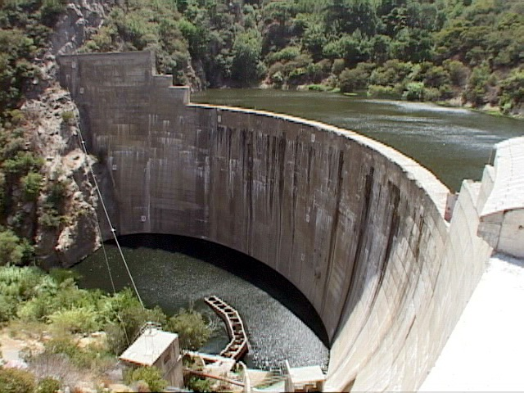
Title | Author(s) | Paper
Geomorphic response of rivers to dam removal: new insights from flume experiments and field studies | Gordon E. Grant, Gregory Stewart, and Chris Bromley | −
Sediment Dynamics Post Dam Removal: State of the Science and Practice | Laura Wildman, Cassie Klumpp, Blair Greimann, James MacBroom, Martin Doyle, Yantao Cui, and Rollin Hotchkiss | −
Natural resources conservation service Watershed Rehabilitation in Oklahoma – A Geological Perspective | Glen B. Miller | 
Numerical simulation of channel adjustment of the Kalamazoo River following the removal of two low-head dams between Otsego and Plainwell, Michigan | Eddy J. Langendoen and Robert R. Wells | 

Gully Erosion | 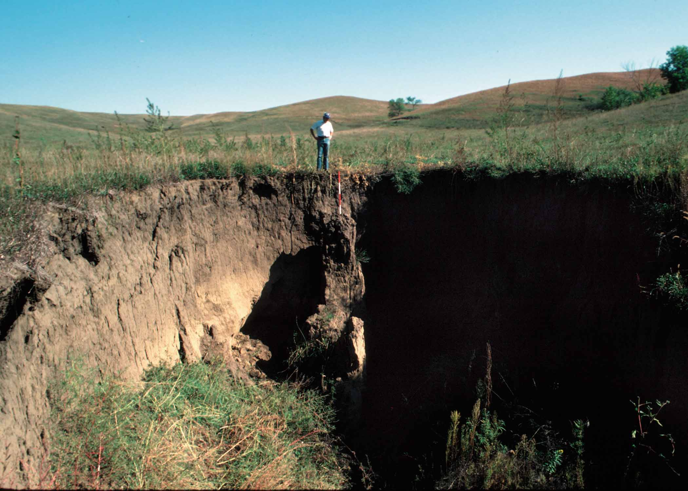
Title | Author(s) | Paper
impact of non-erodible layer on Ephemeral Gully Development | Robert R. Wells, Lee Gordon, Sean Bennett, and Carlos Alonso | 
Study of the Effects of Lateral Seepage Forces on Tension-Crack Development, Bank-Failure Dimensions and Migration of Edge of Field Gullies | Andrew Simon and Robert R. Wells | 
Evaluation of the Impact of Ephemeral Gullies on sediment Loading within Watersheds using AGNPS | Ronald L. Bingner, Fred Theurer, and Jim Stafford | −
Assessing ephemeral gully erosion in the Cheney Lake Watershed using GIS, REGEM and the AnnAGNPS model | Lyle Frees, Jeffery Neel, Kent McVay, and Daniel Devlin | 
Termination of Gully Processes, Southeastern Nigeria | Peter P. Hudec, Frank Simpson, Enuvie G. Akpokodje, and Meshach O. Umeneke | 
aspects of gully erosion related to embankment overtopping and breach | Greg Hanson and Darrel Temple | −
Pipe flow impacts on Ephemeral Gully Erosion | G.V. Wilson, R.J. Cullum, and M.J.M. Romkens | 
Ephemeral Gully Erosion Process and Modeling on the Loess Plateau in China | Fen-li Zheng, Zhong-shan Jiang, and Min Wu | 
Reservoir Sedimentation | 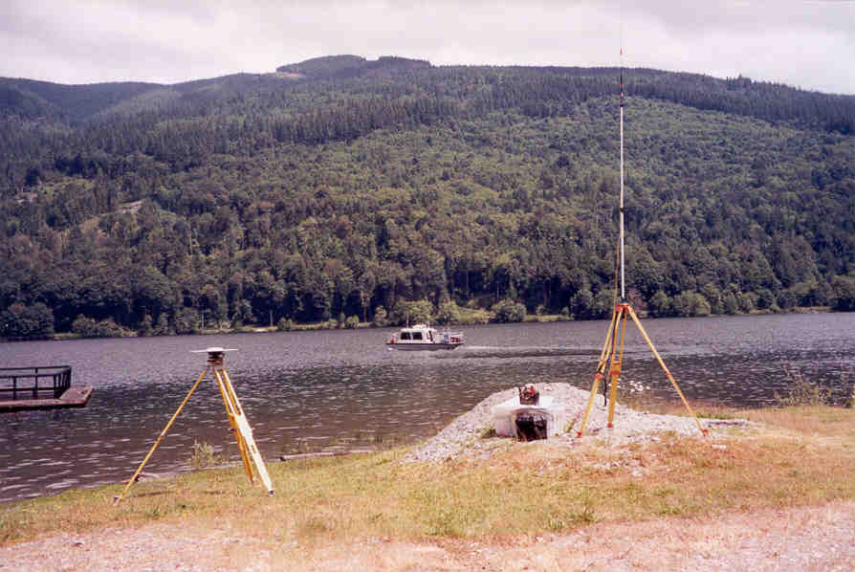
Title | Author(s) | Paper
Comparison of Numerical Models Applied to removal of Savage Rapids Dam near Grants Pass, Oregon | Jennifer Bountry, Yong Lai, and Timothy Randle | 
TEMPORAL AND SPATIAL TRENDS IN SEDIMENT CHEMISTRY IMPOUNDED WITHIN A FLOOD CONTROL RESERVOIR: GRENADA LAKE, MS | Sean J. Bennett, Fred E. Rhoton, ShuMin Hsu, and Carlos V. Alonso | 
Acoustic Profiling of Sediment Accumulation in Three Small Erosion Control Reservoirs in North Mississippi | Del Leary, Craig J. Hickey and Daniel G. Wren | 
Sedimentation in Three Small Erosion Control Reservoirs in North Mississippi | Daniel G. Wren, Robert R. Wells, Christopher G. Wilson, Charles M. Cooper, Del Leary, and Craig J. Hickey | 
Sediment Chemistry in the Colorado River delta, Lake Powell, Utah | Robert J. Hart | −
Effects of non-agricultural Human Activity on Sediment Quality: A Comparison of Trace Element Concentrations in Eight Small Reservoirs | Kyle Juracek and Andrew Ziegler | 
Small Artificial ponds in the United states: Impacts on sedimentation and carbon budget | W.H. Renwick, R.O. Sleezer, R.W. Buddemeier, and S.V. Smith | 
Modeling Suspended Sediment and Water Temperature in Detroit Lake, Oregon | Annett B. Sullivan, Stewart A. Rounds, Mark A. Uhrich, and Heather M. Bragg | 
sediment & wildlife habitat | 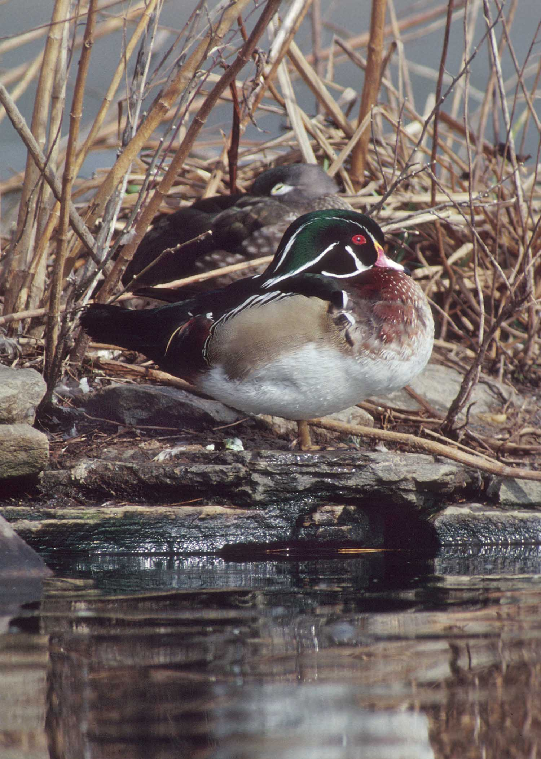
Title | Author(s) | Paper
Adaptive Management Case Studies for River Engineering and Restoration Projects on the Middle Rio Grande, New Mexico | Mark S. Nemeth and Kristi-Irene Smith | −
Quantitative linkages between sediment supply, streambed fine sediment, and benthic macroinvertebrates in the Klamath Mountains, Northern California | Matthew R. Cover, Christine L. May, William E. Dietrich, and Vincent H. Resh | 
Flow-Sed / Power-Sed – prediction models for Suspended and Bedload Transport | David L. Rosgen | 
Use of Aerial Thermography to map Emergent Riverine sandbars | Ashley K. Heckman, Paul J. Kinzel, and Jonathan M. Nelson | 
Modeling of Special High-Flow Release along Platte River in central nebraska | Mohammed A. Samad and Timothy J. Randle | 
The Implications of Recent Floodplain Evolution on Wildlife Habitat within the Middle Rio Grande, NM | Paul Tashjian and Tamara Massong | 
Safety and Fish passage for Low-Head Dams | Aaron W. Buesing | 
farm bill / conservation | 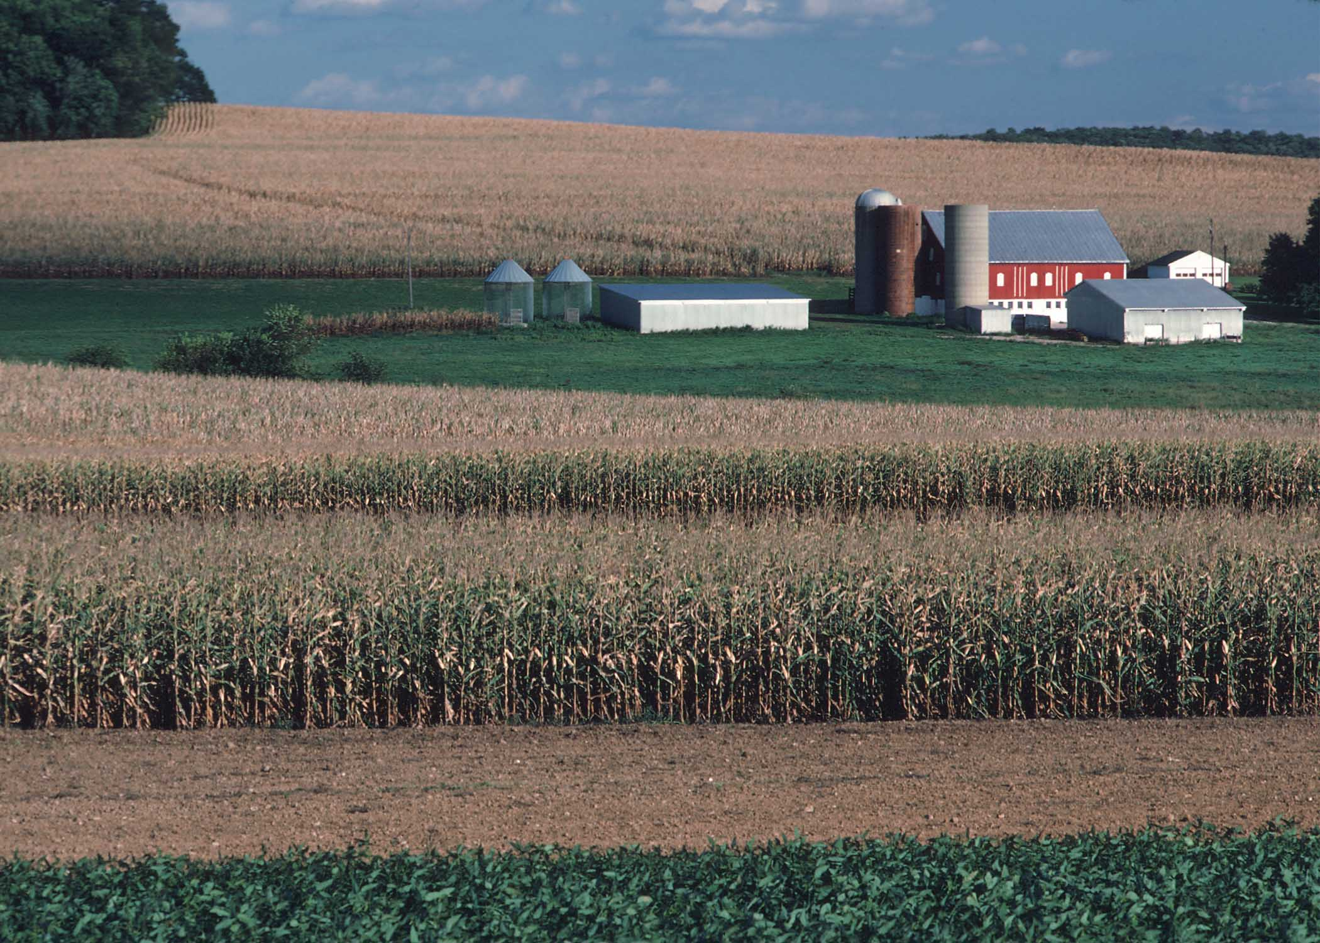
Title | Author(s) | Paper
Assessing Effects of Conservation at the Watershed Scale | Tom Drewes, Kelsi Bracmort, and Jerry Bernard | 
Assessing the National Effects of Conservation- For the First Time (CEAP) | Robert L. Kellogg, Charles Rewa, and Diane Eckles | 
Evaluation of the Importance of Channel processes in CEAP-Watershed Suspended Sediment Yields | Andrew Simon | 
Determination of Sediment sources on the CEAP Benchmark watersheds | Christopher Wilson and Roger Kuhnle | 

instrumentation monitoring | 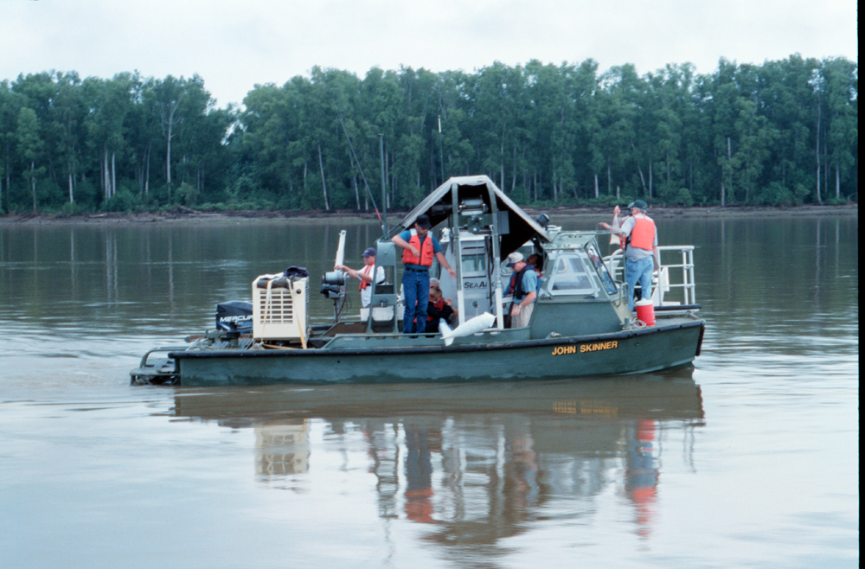
Title | Author(s) | Paper
MONITORING THE EFFECTS OF SEDIMENTATION FROM MOUNT ST. HELENS | Patrick S. Obrien, Alan D. Donner, and David S. Biedenharn | 
Modeling Sediment Transport During Overbank Flow in the Rio Puerco, New Mexico | Eleanor Griffin, J. Dungan Smith, Jason Kean, and Kirk Vincent | −
The Effects of Enso Phase on the occurrence of coarse particle motion in california coastal streams | E.D.Andrews and Ronald C. Antweiler | −
The value of continuous turbidity monitoring in TMDL programs | Teresa J. Rasmussen, Andrew C. Ziegler, Patrick P. Rasmussen, and Thomas C. Stiles | 
posters presentations and computer demonstrations | 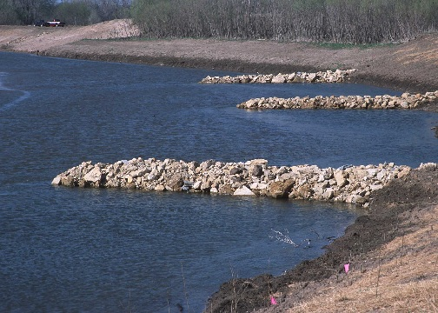
Title | Author(s) | Paper
primary factors affecting water clarity at shallow water sites throughout the chesapeake and maryland coastal bays | Julie M. Baldizar and Nacy B. Rybicki | 
EQUATIONS FOR ESTIMATING BANKFULL-CHANNEL GEOMETRY AND DISCHARGE FOR STREAMS IN THE NORTHEASTERN UNITED STATES | Gardner C. Bent | 
multi-disciplined approach on the upper quinault river geomorphic study, 18 km reach upstream of lake quinault | Jennifer Bountry, Lucy Piety, Ed Lyon, Tim Randle, Tim Abbe, Galen Ward, Kevin Fetherston, Bill Armstrong, Larry Gilbertson, and Chase Barton | 
EAST CHICAGO SEDIMENT REMEDIATION DEMONSTRATION PROJECT | David F. Bucaro and Kirsten Buczak | 
Comparison between Conceptual physical model of Reservoir Sedimentation and a 3D Numerical Model | Omid Reza Safiyary and Amin Chegenizadeh | 
Effects of the 1997 Flood on the Klamath National Forest, Northern California: Lessons learned & Implications to Future Forest Management | Juan de la Fuente, Don Elder, and Alisha Miller | 
Turbidity Threshold Sampling: Instrumentation and Methods | Rand Eads and Jack Lewis | 
The challenges of sampling suspended sediment in a mobile channel with highly dynamic transport | Rand Eads | 
preliminary sediment budgets for four watersheds at kings river experimental watershed in southern sierra nevada | Sean Eagan, Carolyn Hunaker, Abbey Korte, Sarah Martin, and Lee McDonald | 
Reconnaissance Technique for Reservoir Surveys | Ron Ferrari and Kent Collins | 
alluvial fan erosion and Sediment Investigations using the hydraulic modeling tool FLO-2D | Joe Gasperi and John McClung | 
Integrated River Morphology and Vegetation Modeling of the Sacramento river | Blair Greimann, Jennifer Bountry, Yong Lai, David Mooney, and Timothy Randle | 
LOGARITHMIC MATCHING AND ITS APPLICATIONS IN DATA ANALYSIS | Junke Guo | 
SELF-SIMILARITY OF OPEN-CHANNEL TURBULENCE | Junke Guo | 
soil erosion on cropland in the united states: Status and Trends for 1982-2003 | Carla A. Kertis and Thomas A. Iivari | 
U.S.Geological Survey Pilot Study Results for Particle Size Distribution Analyses of Quality Assurance Samples | Natalie Latysh | 
A FIVE-YEAR RECORD OF SEDIMENTATION IN THE LOS ALAMOS RESERVOIR, NEW MEXICO, FOLLOWING THE CERRO GRANDE FIRE | Alexis Lavine, Gregory A. Kuyumjian, Steven L. Reneau, Danny Katzman, and Daniel V. Malmon | 
Evaluation of Techniques to Estimate Suspended-Sediment Concentrations in the Kansas River | Casey J. Lee, Patrick P. Rasmussen, and Andrew C. Ziegler | 
Channel Widths Changes along the Middle Rio Grande, NM | Paula Makar, Tamara Massong, and Travis Bauer | 
Landslide Sediment Production Rates in the Middle Fork and Upper Main Eel River Basins, Northern california | Juan de la Fuente, Alisha Miller, Don Elder, Robert Faust, and William Snavely | 
Spatial patterns of soil erosion and deposition in two small, semi-arid watersheds | M.A.Nearing, Akitsu Kimotol,Mary H. Nichols, and Jerry C. Ritchie | 
Geomorphic change and controlling variables in an ephemeral alluvial channel | M.H. Nichols, M. Nearing, and B. Yuill | 
Monitoring Coarse Sediment Particle Displacement Using a Radio Frequency Identification SystEM | Mary Nichols | 
monitoring Aggradational and Degradational Trends of the Middle Rio Grande, NM | Robert Padilla and Christi Young | 
Numerical Study of the Response of a Reservoir Deposit to Sudden Dam Removal | Allesandro Cantelli, Miguel Wong, and Gary Parker | 
The USDA’s Conservation Effects Assessment Project (CEAP) | Roberta Parry | 
Lower Clear Creek Floodplain Rehabilitiation Project: Geomorphic Monitoring of Phase 3A | Smokey Pittman, Graham Matthews | 
analysis of marine sediments from off the u.s.coast: methodology and data on dvd | L.J. Poppe, S.J. Williams, and V.F. Paskevich | 
Identification of Sediment Sources in a Semiarid Watershed using Multiple Diagnostic Properties | Fred Rhoton, William Emmerich, Mark Nearing, Jerry Ritchie, Christopher Wilson, and David DiCarlo | 
Influences of Off-Highway Vehicles on Fluvial Sediment Regimes | Mark S. Riedel | 
USDA-NRCS Stream Restoration Design Handbook | Kerry M. Robinson, Jon Fripp, and Jerry Bernard | 
Designing Log Erosion Barriers for Maximum Effectiveness: The Contour-Log-  Basin Approach | Larry J. Schmidt | 
Use of Wet Sieving to Improve the accuracy of sediment and Sediment-Associated constituent concentrations in whole-water samples | Bill Selbig, Roger Bannerman, and George Bowman | 
A Model of Streambank Stability Incorporating Hydraulic Erosion and the Effects of Riparian Vegetation | Andrew Simon and Natasha Pollen | 
Use of dimensionless ratios in stream restoration planning | W. Barry Southerland | 
A MULTIDIMENSIONAL MARKER-IN-CELL HYDRAULIC AND SEDIMENT TRANSPORT MODEL FOR BRAIDED RIVER FLOW | Robert E. Thomas and Jim Best | 
Results of a Two-Dimensional Hydrodynamic and Sediment-Transport Model of the Construction and Operation of the Olmsted Locks and Dam, Ohio River | Chad R. Wagner | 
Determining Relative Contributions of Eroded Landscape Sediment and Bank Sediment to the Suspended Load of Goodwin Creek Using Radionuclides | Christopher Wilson and Roger Kuhnle | 
Measurements of velocity profiles and suspended- sediment concentrations in a colorado river eddy during high flow | Scott A. Wright & Jeffrey W. Gartner | 
SEDIMENT ANALYSIS OF A GRADUAL DAM REMOVAL ON BREWSTER CREEK NEAR ST. CHARLES, ILLINOIS | Timothy D. Straub, Donald P. Roseboom, Gary P. Johnson, Robert R. Holmes, Jr., Chester C. Watson, and Dave Schrader | 



