NAS2-98005 RTO-41
Technical Research in Advanced Air Transportation Technologies

Detailed Description for CE-7
En route: Collaboration for Mitigating Local TFM Constraints due to Weather, SUA, and Complexity Constraints

Robert A. Vivona

November 2000

Prepared For: NASA Ames Research Center

Moffett Field, CA 94035-1000



Preface

This report is the first version of a detailed description for the Distributed Air/Ground Traffic Management (DAG-TM) Concept Element (CE) 7, En Route: Collaboration for Mitigating Local TFM Constraints due to Weather, SUA, and Complexity Constraints. The ideas presented here are preliminary and require additional work.

NASA is soliciting review of this report and welcomes comments. Comments should be sent to:
- Del Weathers, Manager, AATT ATM Concept Definition Sub-element, NASA Ames Research Center – dweathers@mail.arc.nasa.gov
- Steve Green, Manager, AATT En Route Systems and Operations Sub-element, NASA Ames Research Center – sgreen@mail.arc.nasa.gov

Table of Contents

Preface ii
Table of Contents iii
Table of Figures iv
1.0 Introduction 1
1.1 Background 1
1.2 Objectives 1
1.3 Scope 2
2.0 Problem Definition 2
2.1 Constrained Airspace Problem Definition 2
2.2 Constrained Airspace Problem Types 3
2.3 Efficiency and Capacity Limitations to Traffic Flow Management in Constrained Airspace 4
3.0 Approach 6
3.1 High Level Benefit Mechanisms 6
4.0 Operational Requirements 7
5.0 Operational Environment 7
5.1 Airspace Structure and Constraints 8
5.2 Traffic Mix and Equipage 9
5.3 CNS Infrastructure 9
5.4 ATM Environment 9
6.0 Operational Characteristics 10
6.1 ATSP View 12
6.2 Pilot View 15
6.3 AOC View 17
7.0 NAS Functional Impacts 18
7.1 Functional Requirements 18
7.2 Functional Design 23
8.0 User/Operator Roles and Responsibilities 24
8.1 ATSP 24
8.2 Pilot 25
8.3 AOC 25
9.0 Operational Modes and Scenarios 25
9.1 Normal or Nominal Mode Scenarios 25
9.2 Off-Nominal Mode Scenarios 29
9.3 Failure Mode Scenarios 29
10.0 Operational Process/Sequence Diagrams 29
11.0 Benefits 31
12.0 Issues and Key Decisions 33
References 35
Appendix A: Operational Requirements Table 36
Appendix B: Operational Requirements References 43

Table of Figures

Figure 1: Problems in Constrained En Route Airspace 5
Figure 2: Relationship of CE-7 Operational Environment to other NASA and FAA Efforts 7
Figure 3: Stages of User-ATSP Collaboration as Function of Time to Constrained Airspace 10
Figure 4. Dynamic Re-Sectorization 13
Figure 5. Dynamic SUA Access and Negotiation 14
Figure 6: Functional Flow of Data between CE-7 DSTs 24
Figure 7: Example Scenario 26
Figure 8: Constrained Airspace Resolution Sequence Diagram 30

- Introduction

  - Background

The Distributed Air/Ground Traffic Management (DAG-TM) concept describes potential modes of operation within the Free Flight concept defined by the RTCA Task Force 3. The goal of DAG-TM is to enhance user flexibility and efficiency and increase system capacity, without adversely affecting system safety or restricting user accessibility to the National Airspace System (NAS).

To explore the DAG-TM concept, the AATT Project formed a DAG-TM Team that met during 1999 and developed a Concept Definition [1]. This document defined 15 DAG-TM “concept elements”, covering ATM operations in all phases of flight. The defined phases were:
- Gate-to-Gate (information access and exchange)
- Pre-Flight Planning
- Surface Departure
- Terminal Departure
- En Route
- Terminal Arrival
- Terminal Approach
- Surface Arrival

In 2000, the AATT Project selected an initial set of four concept elements (CEs) to pursue further concept exploration (research) activities.
- CE-5: En Route Free Maneuvering
- CE-6: En Route Trajectory Negotiation
- CE-7: En Route: Collaboration for Mitigating Local TFM Constraints due to Weather, SUA, and Complexity
- CE-11: Terminal Arrival: Self-Spacing for Merging and In-Trail Separation

In May 2000, a DAG-TM Workshop [2] was held at the NASA Ames Research Center to explain to industry the AATT Project’s activities and plans for the concept. The workshop focus was on the four initial CEs being developed. Under Task Order 41, a contractor team consisting of System Resources Corporation and Seagull Technology is preparing detailed descriptions of each of the four selected CEs. This document is a detailed description of CE-7, En Route: Collaboration for Mitigating Local TFM Constraints due to Weather, SUA, and Complexity.

  - Objectives

The objectives of Task Order 41 include:
- Evaluate the concept through existing documents that define the current level of understanding.
- Identify ambiguities within the concept and resolve issues through interviews with NASA experts.
- Identify and resolve inconsistencies between AATT objectives and the concept.
- Develop a detailed concept description to provide guidance for the continued research in this concept through 2004.
- Provide updates/enhancements to the AATT Air Traffic Management Operations Concept (ATM/OPSCON) to incorporate the relevant aspects of the DAG CE.

  - Scope

The description of CE-7 is intended to add further detail to facilitate further research into the concept. It is not, however, a research plan. The research plan is a separate document being developed by NASA that describes how the concepts presented here will be investigated.

The detailed description has a focus of operational and system requirements, and deliberately avoids design information to the extent possible. The detailed description will provide concept definition and clarification to assist in defining the design of decision-support automation, roles and procedures, and experimental assessments to test the CE-7 concept.

Finally, specifications are beyond the scope of this document, since capabilities to support the CE-7 concept should evolve as a result of the research to be conducted. To avoid confusion with widely discussed tools such as Controller Pilot Data Link Communications (CPDLC) whose specifications are being developed or discussed external to AATT, this description uses general terms to describe the capabilities necessary to support this concept.

- Problem Definition

  - Constrained Airspace Problem Definition

CE-7 is focused on efficient traffic flow management (TFM) solutions to “constrained airspace” problems. For this discussion, constrained airspace is defined as impacted en route airspace that contains flights that transit a common region but do not share a common destination. For each flight, a constrained airspace problem causes flight deviations due to en route impediments independent of the flight’s destination. This definition distinguishes constrained airspace from transition airspace, where the impacted en route airspace contains flights that transit a common region to a common terminal area. Transition airspace problems (the classical focus of the Center TRACON Automation System (CTAS)) cause flight deviations (delay) due to impediments related to the flight’s common destination (e.g., arrival metering and spacing in response to terminal congestion).

Though constrained airspace and transition airspace have been defined independently, the reality is that an en route facility may have to handle both constrained airspace problems and transition airspace problems simultaneously. For example, Denver Center may have to handle metering to Denver Terminal Radar Approach Control (TRACON) at the same time as handling weather that is causing deviations to over-flight traffic into adjacent centers. The aircraft that are being metered are being impacted by a transition airspace problem (predicted traffic demand exceeding the Denver TRACON acceptance rate). The over-flight traffic is being impacted by a constrained airspace problem (predicted traffic demand exceeding acceptable sector loading in weather impacted sectors). The metered traffic are all transitioning to Denver TRACON (the common destination) whereas the over-flight traffic do not all have the same destination airport.

  - Constrained Airspace Problem Types

There are three basic types of constrained airspace problems: negative impacts caused by losing a section of airspace (“Lost Airspace” problem), controllers/users not taking advantage of newly available airspace (“Gained Airspace” problem), and unexpected negative impacts caused by acceptance of user requests or preference changes (“User Request” problem).

    - Lost Airspace Problem

Airspace is “lost” when traffic demand exceeds the airspace’s allowable capacity level. There are two ways that a section of airspace can be lost: either traffic demand increases above the allowable capacity level or the allowable capacity level drops below traffic demand. When traffic demand exceeds the allowable capacity level, the flow through the impacted airspace must be reduced by rerouting traffic away from the airspace and/or adding flow-rate restrictions into the airspace. The size of lost airspace can be smaller than a sector or as large as many sectors. Since CE-7 is focused on solutions to TFM problems, the impact of the lost airspace is assumed to affect the traffic flow of more than one sector controller.

A sector’s capacity may be monitored in terms of its “dynamic density.” The dynamic density concept postulates that the air traffic control (ATC) workload of a sector (or more generally, a region of airspace) can be measured based on the density and complexity of its predicted traffic [3, 4, 5]. The maximum operationally allowable value of dynamic density (i.e., a maximum allowable controller workload) can then be established by traffic managers, as a function of traffic/airspace situation, based on empirical data and experience. When dynamic density is predicted to exceed this acceptable value, the sector is considered “lost.”

There are three main causes of lost airspace problems. The first cause is due to excessive traffic demand. When the predicted number of aircraft in a sector causes that sector’s dynamic density to increase above its allowable level, some of the traffic demand must be alleviated (either through rerouting aircraft or flow rate reduction) to bring the dynamic density below accepted levels. The second cause is the activation of Special Use Airspace (SUA). When an SUA becomes active, it has to be avoided and any aircraft predicted to enter the SUA while active must be re-routed. The third cause is the formation of weather that is unsuitable or undesirable for flight operations (e.g., turbulence, convective activity). Weather can impact airspace by forcing deviations around hazardous airspace as well as decreasing the acceptable dynamic density in those sectors that are impacted (e.g., increased workload per flight due to re-routing around weather within a sector). Weather also is dynamic and can move from one sector to another, causing the acceptable dynamic density for sectors to be a function of time. Like all lost airspace problems, when the weather causes allowable sector dynamic densities to decrease below the predicted dynamic density for the existing traffic demand, there must be a decrease in flow rate (either through rerouting or flow rate reductions) to achieve the acceptable levels.

    - Gained Airspace Problem

Airspace is “gained” when traffic demand drops below the airspace’s allowable capacity level or the capacity level is increased above current traffic demand. This is not a problem as much as it is potentially a missed opportunity to achieve user and/or service provider benefits. The newly available airspace presents options to decrease congestion in other airspace or to enable user flexibility to increase flight efficiency or make up time.

The causes of airspace to be gained are the exact opposites of those for lost airspace. A decrease in traffic demand allows more aircraft to be sent through impacted sectors. De-activation of SUA airspace opens that airspace for flights that are currently routed around the airspace. Weather dissipation returns acceptable levels of dynamic densities to their previous maximum values, allowing more traffic to be accepted.

It should be noted that lost and gained airspace problems often interact. The most obvious example is when weather is moving through a facility. As the weather leaves one sector and enters another, the first sector’s allowable capacity increases (gained airspace) while the second sector’s capacity decreases (lost airspace).

    - User Request Problem

Controller acceptance of user-preferred requests for flight path changes may have a negative downstream impact on air traffic operations that neither the controller nor user can predict. This impact may be in the form of increased congestion/workload for a downstream sector, and/or unanticipated delays for the user (which may outweigh the potential benefit originally sought by the user). This situation may occur today because of two factors. First, users do not have access to an accurate prediction of the future state of the NAS to form “intelligent” requests that account for probable downstream impacts. Secondly, controllers that receive a user’s request do not have the predictive ability (beyond a tactical conflict probe) to anticipate downstream congestion and TFM restrictions. It should be noted that the negative impacts observed in User Request Problems are usually Lost Airspace Problems.

Emphasis on the use of preferential routing in future free flight concepts makes this a problem of continuing interest.

  - Efficiency and Capacity Limitations to Traffic Flow Management in Constrained Airspace

All three constrained airspace problems effectively relate to limitations in the capacity of en route airspace. Lost airspace causes a direct decrease in available airspace capacity. Under-utilized gained airspace is effectively a wasteful “loss” of airspace. User requests that cause downstream complexity problems also result in lost airspace. In the presence of capacity decreases, NAS operations become restricted.

Currently, the air traffic service provider (ATSP) imposes constraints on users when NAS operations are predicted to be restricted in certain regions of en route airspace due to bad weather, SUA and airspace congestion/complexity (see Figure 1). These constraints may take the form of speed changes, altitude changes, or path changes, all of which represent a deviation from the preferred trajectory planned by the user. In some instances, these NAS operational constraints may affect aircraft long before they are near the affected region of airspace.

In many cases, the deviations issued by the ATSP are different from what would be preferred by the user (both flight deck (FD) and airline operations center (AOC)). There may be multiple ways in which the constraint can be satisfied, and the deviations imposed by the ATSP may not be the most efficient (or desired) in terms of meeting the users’ business objectives. Examples may include: the choice of flights to be deviated, the direction of the deviation, the type of deviation (route, altitude, speed), route deviations around airspace/weather through which the user might be willing to fly, or route deviations that involve flying through airspace/weather that the user would prefer not to penetrate.



Figure 1: Problems in Constrained En Route Airspace

Inefficiencies occur in the resolution of constrained airspace problems due to current-day limitations (including the lack of decision support) in the ability of controllers and traffic managers to select the most advantageous combination of aircraft, route of flight and operational constraints for the airspace. TFM initiatives tend to focus on “easy to control” streams of traffic (e.g., easiest solution, not most efficient), which causes in-equitable distribution of deviations among aircraft. The lack of an ability to reliably identify and diagnose constrained airspace problems well before they occur creates reactive, non-collaborative solutions.

Inefficiencies arise during selection of the most advantageous solution when confronted with a mandatory change (lost airspace), through the inability to identify whether non-mandatory opportunities exist to gain operational benefits (gained airspace) and through the inability to identify and avoid negative impacts of proposed user requests.

- Approach

An approach to solving local TFM inefficiencies associated with Constrained Airspace Problems is to create system-wide collaboration between the ATSP at the impacted Air Route traffic Control Center (ARTCC) and the users (represented by FD crews and/or AOC) with the objective of eliminating or mitigating the impact of predicted NAS operational constraints. This approach is consistent with the collaborative decision-making approach used at the national level between users and the Air Traffic Control System Command Center (ATCSCC).

For lost airspace problems, the objective is to mitigate the airspace capacity impact by involving users in the flow-restriction decision. Solutions are characterized by user-ATSP collaboration that may vary in form as a function of time horizon (i.e., time to go until a particular flight, or group of flights, are predicted to reach the “constrained airspace”). Prior to the formulation of a TFM initiative by the local Traffic Management Unit (TMU), users have the ability to identify potential airspace constraints and request deviations to avoid them. When a TFM initiative is required, users have the opportunity to collaborate on the flights selected and the methods of deviation to maximize user preference. When a TFM initiative needs to be implemented, user preference information is known by the local TMU and deviations are as consistent with the preferences as is allowable.

For gained airspace problems, both ATSP and users have the ability to identify aircraft deviations that gain operational benefit (to users and/or ATSP) by utilization of the additional airspace. Gained airspace presents an opportunity to the ATSP to reduce the complexity of neighboring sectors that are congested (i.e., lost airspace). For users, gained airspace presents an opportunity to improve flight characteristics, such as reductions in time to fly and fuel consumption.

For user request problems, the negative downstream TFM impacts of user’s request are avoided by ATSP evaluation of requests for constrained airspace impacts prior to acceptance. Similarly, users can avoid requesting changes that cause (or are impacted by) downstream congestion by evaluating the request against predictions of future NAS state.

To enable such a collaborative approach, decision support tools (DSTs) are required for the ATSP and the users. These DSTs provide the stakeholders with the ability to predict constrained airspace problems and support collaborative resolutions.

  - High Level Benefit Mechanisms

The benefits for this approach are created through:

- Enabling of collaborative solutions
- Early notification of advantageous/disadvantageous events
- Support in developing minimum impact resolutions

The use of collaborative solutions provides user input into the solution of constrained airspace problems, creating solutions consistent with user business models and enabling user benefits. Users even have the ability to identify and resolve potential constrained airspace problems before a TFM initiative is initiated, allowing for a completely user defined solution.

Early notification of constrained airspace problems enables solutions that require less impact on user-preferred trajectories for resolution. Early notification also enables the identification and utilization of gained airspace, providing direct capacity and efficiency benefits.

DST support in developing minimum impact resolutions ensures that the selection and implementation of a TFM initiative is not excessive, increasing efficiency over today’s operations. By developing solutions that minimize deviations from existing user preferences, user benefit is maximized.

The expected benefits of this concept are described in detail in Section 11.0.

- Operational Requirements

Appendix A contains a table of Operational Needs Statements (ONS) extracted from the ATS Concept of Operations for the NAS in 2005 [6], and 26 other NASA, FAA, RTCA and Eurocontrol documents (see Appendix B for a complete listing of document titles). These ONS represent requirements for the future NAS, as identified by the ATC community. The selected ONS are consistent with the approach and concepts presented in this document and provide implicit traceability between CE-7 and the ideas expressed within these ATC community documents.

- Operational Environment

The operational environment of CE-7 is within en route airspace, specifically dealing with operational problems that are not concerned with the transition of aircraft to a terminal airspace. This concept is concerned with TFM at the local (ARTCC) level as opposed to the national (ATCSCC) level. Figure 2 illustrates the relationship of CE-7’s operational environment relative to the environment for DAG CE-8 (“En Route/Terminal Arrival: Collaboration for User-Preferred Arrival Metering”) and the role of the FAA’s ATCSCC.

 | Local TFM | National TFM
Constrained Airspace | CE-7  (e.g., Weather, SUA, and Sector Complexity Problems) | ATCSCC  (e.g., Collaborative Re-Routing)
Transition Airspace | CE-8  (e.g., Metering/ Miles-in-Trail) | ATCSCC  (e.g., CDM for Ground Delay Program)
Figure 2: Relationship of CE-7 Operational Environment to other NASA and FAA Efforts

At the local TFM level, the CE-7 concept supports collaboration during the application of TFM initiatives within constrained airspace while the CE-8 concept supports collaboration during the application of TFM initiatives within the transition environment. Though both concept elements may use similar TFM methods and would both be implemented primarily within the local TMU, the transition airspace solution for CE-8 is characterized by a different TFM environment than that for CE-7. For example, predicting the cause, start and size of a TFM initiative within transition airspace can often be estimated well in advance of the initiative, since transition problems are usually caused by the arrival of scheduled flights to the terminal airspace (e.g., the “noon balloon” rush at ZFW). CE-8 TFM initiatives are also impacted by the presence of existing TFM tools (e.g., TMA) and restricted in the choice and extent of certain control strategies (e.g., re-routing has limited applicability since all aircraft must eventually penetrate the terminal airspace). Both the CE-7 and CE-8 solutions will ultimately need to be combined or at a minimum, coordinated since a single TMU may have to deal with constrained and transition problems simultaneously.

At the National TFM level, only the ATCSCC would be responsible for user collaboration in dealing with problems in both constrained and transition airspace. In constrained airspace, the ATCSCC will develop and implement the appropriate TFM initiative when there are multiple facilities involved (i.e., three or more) or when the TFM constraint is beyond the time horizon of CE-7 (i.e., 2 hours or more) and involves two facilities. An example of collaboration at the National Level in constrained airspace is the Collaborative Re-routing program under development by the FAA. If a TFM initiative is developed at the local level (i.e., within CE-7) but involves more than one facility, then the ATCSCC will facilitate the coordination between the two facilities, but will not be involved in the development of the initiative. In transition airspace, the ATCSCC will develop and implement the TFM initiatives when transition problems are extreme enough to require pre-emptive action several facilities in advance of the terminal airspace (e.g., a weather cell causing extreme delays at JFK would effect all inbound flights, including those as far away as LAX). An example of such a collaborative National TFM initiative is the use of Collaborative Decision Making (CDM) during ground-delay programs. The coordination of transitioning TFM initiatives from the local (CE-7 and CE-8) to the National (ATCSCC) levels, when necessary, is an area requiring further definition.

A detailed description of the CE-7 operational environment is broken up into four sections: airspace structure and constraints; traffic mix and equipage; CNS infrastructure; and ATM environment.

  - Airspace Structure and Constraints

The CE-7 concept applies to all airspace structures envisioned from today’s domestic airspace through those planned for future free flight concepts. The concept is not impeded by the lack of a fixed route structure or by variable sector and/or facility boundaries.

The concept assumes dynamic re-sectorization is an available TFM control strategy for the ATSP, but does not require its availability. In this strategy, the sector geometry of the airspace is dynamically changed to distribute the traffic load among sector controllers to better match airspace structure (dynamically) to actual traffic demand/routing. [7] This has the potential to better balance situations where one sector is overloaded while another is not. Dynamic density measures are used to identify optimal sectorization. This concept is described in more detail in Section 6.1. The CE-7 concept takes advantage of whatever level of dynamic sectorization is available. Initial implementations are expected to be limited to a selection of fixed geometry shapes due to limitations in Host computer (fix posting area) processing. The final implementation should provide complete flexibility in selection of sector geometry to dynamically match traffic demand.

The use of SUA is assumed to exist and possibly be expanded to include commercial access to space and other future applications. The ability to dynamically negotiate SUA availability is a concept control strategy that will be discussed in more detail in Section 6.1.

Constraints are caused when traffic demand exceeds local-airspace capacity. They either occur to aircraft after entering en route airspace or after the aircrafts’ predicted arrival time into en route airspace (e.g., as in the case of satellite departures). Constraints include all en route constraints except those caused by transition to a terminal airspace (see Section 2.1). The main constraints are caused by weather (turbulence, convective activity), SUA activation, and excessive traffic complexity within a sector(s). No additional constraints above those experienced today are expected.

  - Traffic Mix and Equipage

The CE-7 concept applies to all traffic mixes and aircraft equipage levels, from today through mature free flight concepts. The concept does not require advanced cockpit equipage, but additional benefits are achievable by some users if available.

Advanced cockpit systems are required to support collaboration between the FD and the ATSP, though collaboration from the FD is not mandatory. For users without AOC (e.g., in-flight re-planning support), FD to ATSP collaboration is the only available form of user collaboration. Aircraft are assumed to equip to various levels of collaboration capability, based on individual user business models. Not all aircraft are assumed to have FD collaboration capability. Minimally equipped users may gain some benefits (compared to the current system) due to the improved overall efficiency of NAS operations and greater accommodation of user-preferences by the ATSP.

The traffic mix for this concept assumes a mixture of aircraft with various levels of advanced cockpit automation. It is assumed that there is a mixture of aircraft with/without AOCs and with/without airborne (FD) collaboration capability. The minimum equipage required to operate will be the same as that required for the current ATC system, in order to facilitate NAS access by all users.

  - CNS Infrastructure

The Communications, Navigation, and Surveillance (CNS) infrastructure of the NAS must support advanced data sharing between users and ATSP to facilitate a common awareness of NAS state and support effective collaboration. This infrastructure must include a suitable air-to-ground data transfer mechanism between the FD and ATSP and the FD and AOC in the form of a datalink system. A ground-to-ground data transfer system between the AOC and ATSP must also be available. No other significant changes from today’s CNS capabilities are anticipated.

  - ATM Environment

The CE-7 concept applies to all Air Traffic Management (ATM) environments from today through mature free flight concepts. The need for traffic flow management is required in free flight environments because localized areas of congestion will still form and ground-based TFM remains the main resolution method.

CE-7 assumes that user flexibility is the rule, not the exception. All aircraft are on either an approved flight plan that represents the flight’s user-preferred trajectory or that the aircraft is free maneuvering and broadcasting a representation of the flights intent. It is assumed that some aircraft do require ground-based positive control, but that these aircraft exist within the same environment as the free-maneuvering aircraft. Deviations from user-preferred trajectories are due to ATM actions for congestion relief and separation assurance or due to changes in user preferences. All aircraft (including free-maneuvering aircraft) are subject to TFM initiatives developed by the local TMU.

CE-7 TFM provides system-wide collaboration and distributed decision-making between the ATSP at the local (ARTCC) level and multiple users (FD and/or AOC). TFM constraints, when necessary, are goal oriented (e.g., RTA) as opposed to solution oriented (e.g., reduce to 250 kt). Solutions are implemented at the lowest level in ATM to facilitate quick response and maximum TFM attention to individual flights. Local TFM procedures are consistent with, but independent of collaboration between users and National TFM (ATCSCC).

- Operational Characteristics

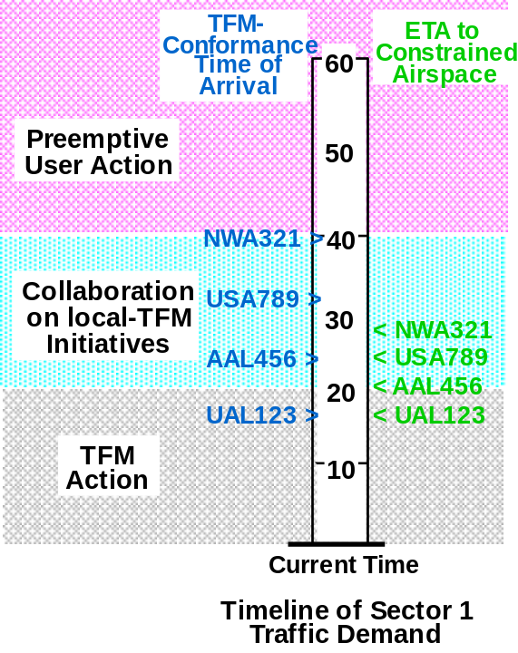
User-ATSP collaboration to resolve constrained airspace problems varies as a function of time horizon (i.e., time to go until a particular flight, or group of flights, are predicted to reach the “constrained airspace”). The amount of distributed decision-making varies widely with time horizon, focusing on user solutions for longer time horizons and ATSP solutions for shorter time horizons. In all three stages, the goal is to identify lost airspace, gained airspace, and user request problems and facilitate efficient resolutions. A general description of the collaboration and decision-making in each stage of the resolution process is described below. Details of the ATSP, pilot, and AOC views during each stage follows in the subsequent subsections. An example scenario illustrating ATSP and user participation is provided in Section 9. An operational sequence diagram showing the functional flow between the ATSP (sector and TMU), FD, and AOC is presented in Section 10.

Figure 3: Stages of User-ATSP Collaboration as Function of Time to Constrained Airspace

The three stages of user-ATSP collaboration as a function of time horizon are illustrated in Figure 3. The first stage, Preemptive User Action, involves traffic upstream of potentially impacted airspace (e.g., lost airspace due to congestion), but at a time horizon larger than when the local TMU would begin to formulate a traffic management initiative to resolve the constraint. During this stage, the user can decide to avoid (in the case of lost airspace) or utilize (in the case of gained airspace) the potentially impacted airspace by making user preference change(s) through user request(s) to the ATSP. The user can also decide to make no action, preferring to wait and see if the airspace change (lost or available airspace) actually materializes. Because this is the longest time horizon stage, users make trade-offs between the likelihood (probability) of the airspace change occurring and the impact to flights if the change does occur. In this preemptive stage, the user is initiating solutions through user requests without explicit collaboration with the ATSP. Therefore, the ATSP handles these requests in the same manner as other, non-flow conformance-induced requests. If the preference change requests are accepted by the ATSP, the need for a TFM initiative may be avoided using user-preferred deviations without involving explicit collaboration between user and ATSP.

The second stage, Collaborative TFM, occurs as traffic approaches the impacted airspace, and is characterized by a collaborative (user-ATSP) process for mitigating the impact of user deviations arising from en route TFM initiatives. The process starts by the TMU selecting a control strategy for the TFM initiative (e.g., rerouting and/or spacing) and notifying the affected users of this strategy and any collaboration constraints. This allows the users to define preference changes based on the impending initiative (i.e., user preferred modifications or alternatives to the proposed initiative) and to submit them to the TMU as user requests. The TMU can accept and implement the request if it is an acceptable modification to the TFM solution, or reject the request. After acceptance of user requests, the TMU re-evaluates the TFM initiative to determine if further deviations are necessary. If the user preference changes resolve the impact on the airspace, then no further TFM action needs to be taken.

If the problem is not resolved within the Collaborative TFM time horizon window, then the process enters the third stage: TFM Action. During this stage, the ATSP decides upon and implements a TFM initiative to off-load the impacted airspace. Assuming completion of the Collaborative TFM stage prior to initiation of TFM Action (i.e., the problem did not “pop-up” within the TFM Action time horizon), the ATSP has user preferences to resolve the problem, but these preferences are not enough for a complete resolution. The ATSP identifies any additional changes to the traffic flow, possibly considering one-way (non-collaborative) inputs from the users (workload permitting), to complete the problem resolution.

To support user-ATSP collaboration, “intelligent” generation of user preferences, and effective TFM control strategies and initiatives, a shared model (between users and ATSP) of the predicted state of the NAS is essential. Users need accurate predictions of future NAS states, including the impact of any planned/proposed/potential TFM actions, to generate user preferences during the Preemptive User Action and Collaborative TFM stages that support the resolution of constrained airspace problems. The ATSP needs accurate NAS predictions, including user preferences and actions, to support effective TFM problem identification and resolution in all three stages. The ATSP must also be able to identify the effect of planned/proposed TFM initiatives to successfully “close the loop” and ensure minimum impact initiatives.

  - ATSP View

Supporting the ATSP in each stage of user-ATSP collaboration is a TMU-based DST. The purpose of this DST is to support the ATSP in early identification and resolution of constrained airspace problems. The DST resides in the TMU and supports Traffic Management Coordinators (TMCs) in identifying the need for and developing efficient, user-preferred TFM initiatives. Each ARTCC TMU has its own TMU DST. Inter-facility (TMU –to-TMU) procedures support the integration of TFM initiatives across ARTCC facilities.

The TMU DST provides the TMC with identification of constrained airspace problems and the impact on the predicted traffic flow. This includes identification of flights impacted by scheduled and unscheduled SUA activation, weather cell formation, and sector overloading caused by congestion (i.e., traffic predicted to exceed allowable sector capacity). The tool also supports the identification of flights that can take advantage of scheduled and unscheduled SUA de-activation and weather cell dissipation. When a user request for a preference change is received, the TMU DST evaluates this request and identifies any predicted sector congestion problems that will arise if accepted.

To support user requests received by the sector controller from the FD, the TMU DST is integrated with the sector DSTs (e.g., En Route Descent Advisor (EDA) or User Request Evaluation Tool (URET)). The TMU DST automatically evaluates requests received by the sector controller DST for congestion problems. Sector controllers are alerted to traffic flow management problems outside of their sectors before accepting the request. The sector controller DST has complimentary functionality to the TMU DST to resolve unavoidable, very short time horizon (intra-sector) problems (e.g., Conflict Probe for Weather Avoidance).

The TMU DST also provides the TMC with automatic and manual resolution support for constrained airspace problems. Automatic resolutions provide advisories to the TMC on which TFM control strategy should be implemented, which aircraft should be deviated, and the magnitude of the deviation. Manual (or “what-if”) resolutions allow the TMC to evaluate different TFM control strategies, aircraft selections and deviation magnitudes, for their impact on the NAS, and select the appropriate strategy. The TMU DST supports automatic transfer of TFM initiative information to the AOC(s) (e.g., affected aircraft, proposed route changes and flow constraints, etc.), FD (e.g., proposed constraints) and sector controllers (e.g., clearances) for collaboration and implementation.

A key function of the TMU DST is to support the TMC in selecting an appropriate TFM control strategy for resolving the constrained airspace problem. The TMC can choose from four options:

- Re-routing
- Spacing
- Dynamic re-sectorization
- Dynamic access to SUA

Route changes simply deviate the impacted flights away from/to the lost/newly available airspace. Route changes are available for all lost and gained airspace problems. Care must be taken to not exceed acceptable levels of dynamic density of sectors along the new routing. If re-routing is selected as the TFM control strategy, the TMU DST supports the TMC in selecting which flights to re-route and their new route to minimize deviations from the user preferred routes and avoid new congestion problems.

Spacing involves throttling down the flow rate to reduce the amount/complexity of traffic into congested airspace. The same flights penetrate the impacted airspace, albeit at a lower rate. Spacing is available for lost airspace problems except when the available airspace capacity is zero (e.g., for SUA activation). Spacing may be achieved by spacing en route flights and/or the timed-control of near-by departures that contribute to the congestion. This form of departure control is characterized by the coordination/control of a few flights, at the local facility level, as opposed to the larger-scale national ground delay program coordinated through the ATCSCC. During spacing operations, the TMU DST supports the controller in the selection of appropriate spacing parameters (e.g., miles-in-trail) for the aircraft entering the impacted airspace.

Dynamic re-sectorization, illustrated in Figure 4, involves the modification of the NAS configuration to balance resources (sector boundaries) with traffic demand. In the case of Figure 4, sector A was re-configured to a smaller region (reducing the flow of traffic within it) while sector B becomes larger to accommodate the flow. Dynamic re-sectorization is used to distribute traffic load from one sector to another. During re-sectorization, the TMU DST supports the TMU in identifying the new sector boundaries to most effectively distribute the traffic load.

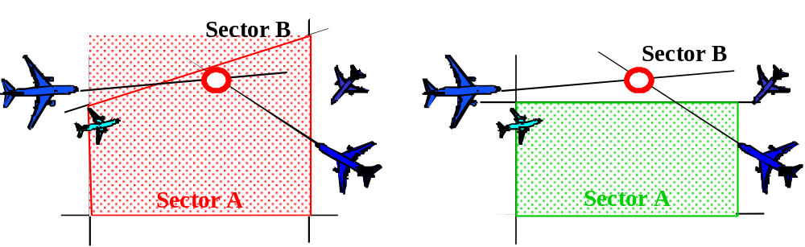
Figure 4. Dynamic Re-Sectorization

The fourth control strategy is a novel one that involves the negotiation of dynamic access to SUA. The concept is to enable the ATSP to negotiate with the authority controlling the SUA (e.g., Department of Defense, space-launch management) to gain access to the SUA when additional airspace is required (e.g., during lost airspace problems due to weather or congestion) when the SUA is scheduled to be active. Dynamic access to SUA has the potential to dramatically increase airspace/capacity resources for the ATSP during constrained operations.

Under certain conditions, the value of the SUA to its authority may decline while its potential value to the user community rises (see Figure 5).

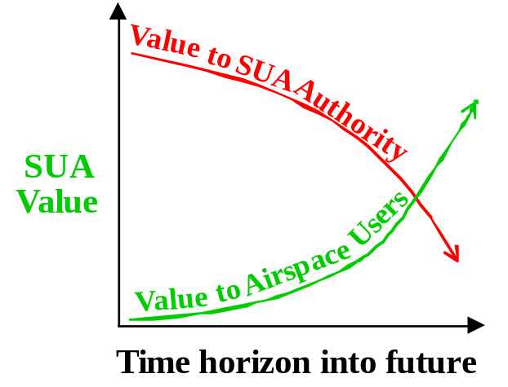

Figure 5. Dynamic SUA Access and Negotiation

For example, under poor weather conditions, certain military training operations (or launch activities) may become less desirable. The controlling authority may consider a postponement of operations depending on their constraints in budget and schedule. At the same time, the same weather may be the cause (or related to) a near-by area of congestion that is resulting in significant user deviations. The dynamic value of the user’s access to that SUA may rise dramatically. If a negotiation process could be developed along with a supporting mechanism for “trading” airspace resources, dynamic SUA access may prove to be an economically critical element in the TFM control-strategy “toolbox.” During constrained operations, the TMU DST evaluates the dynamic value of the SUA to the ATSP and suggests a negotiable “window of availability” for when the ATSP could most take advantage of the airspace. This enables the ATSP to negotiate for the least amount of SUA de-activation time required to relieve the congestion in other airspace. If negotiation is successful, then the re-routing procedures for newly available airspace are used to relieve the congestion.

    - Preemptive User Action Stage

During this stage, the ATSP is receiving user preference change requests and using the sector and TMU DSTs to evaluate the impact of the requests on the airspace. The sector controller DST receives the user preference changes, checks them for local (sector oriented) acceptability and if acceptable, transmits them to the TMU DST for evaluation. If the sector DST finds a local problem with the request (e.g., a conflict within the sector), the sector controller rejects the request. If the TMU DST identifies a flow conformance issue with the preference change, the sector controller is alerted and the change is rejected. Preference changes are received by the sector controller from the FD, instead of by the TMU from the FD or AOC, because user-ATSP collaboration has not yet begun. At this stage, these preference change requests are handled by the ATSP just like any other non-TFM user request changes.

Because the TMU has access to the same predictions of future NAS state as the user, the TMC is aware that the increase in user preference change requests to the sectors are attempts by the users to avoid a potential TFM initiative (the potential problem is identified by the TMU DST). If the user requests do not cause additional congestion problems and support the resolution of the potential constrained airspace problem, the change request is approved and notification sent to the sector controller. If any of the requests are predicted to cause additional constrained airspace problems, they are denied. If the user request is acceptable for both control and TFM, the sector controller alerts the FD that the user request is accepted.

It should be noted that this process does not occur for free-maneuvering aircraft. Because a TFM initiative is not currently being collaborated on or implemented by the TMU, TFM constraints have not been issued to free-maneuvering aircraft. Until they have been constrained by the TMU, free-maneuvering aircraft can freely change their intent with interaction with the ATSP.

    - Collaborative TFM Stage

During this stage, the TMC identifies the constrained airspace problem using the TMU DST and selects a control strategy (supported by the TMU DST) that most efficiently resolves the problem. The TMC notifies the affected users of the predicted operational constraint and transfers the data necessary to support user analysis of preferred options for potentially impacted flights. A key aspect of this supporting data is the identification of the TFM initiative that would be implemented, if necessary, including the intended control strategies and projected extent of deviations. Any restrictions to degrees of freedom allowed for collaboration (e.g., no southerly route changes accepted due to other issues in that area) are also sent to the users. As user preference change requests are received, the TMC re-evaluates the need for the initiative (using the TMU DST), accepts appropriate user requests and makes any necessary modifications to the planned initiative. Accepted user requests are implemented by the TMU by either: (1) sending the preference change to the sector controller as a clearance or (2) directly approving a request made by a free-maneuvering aircraft.

If the problem is resolved by the user requests, the initiative is cancelled. If the end of the Collaborative TFM time horizon is reached, the TMC begins the implementation of the initiative in the TFM Action stage.

    - TFM Action Stage

During this stage, the TMC implements the TFM initiative begun in the Collaborative TFM stage. Any preference change requests received during the Collaborative TFM stage are used to identify potential preferred solutions to the constrained problem. The TMU receives one-way (no collaboration) preferences from users (e.g., would rather move aircraft A than aircraft B), which they will attempt to accommodate. The final TFM initiative is implemented similar to today (through sector controller clearance changes) for all aircraft other than free-maneuvering aircraft. For free-maneuvering aircraft, restrictions are sent directly to the FD for implementation.

  - Pilot View

For all non-free-maneuvering aircraft, the FD receives clearances from the ATSP (to implement initiatives) and provides local user preference change requests to the sector controllers. If the user has an AOC, the aircraft compliments AOC information by identifying safety concerns to proposed trajectory modifications. For aircraft without AOCs, if collaboration is desired, the FD fully represents the user in collaboration with the TMU. In this case, the FD is supported by advanced cockpit automation enabling the crew to perform long term flight plan optimization, determine desired user preferences and negotiate with the ATSP. Collaboration from the flight deck is not mandatory.

    - Preemptive User Action Stage

For FD-based collaboration with the ATSP, the FD monitors the predicted status of the NAS for sector complexity, weather, and available airspace. The pilot must consider both the probability of an event occurring (e.g., a TFM initiative with corresponding trajectory deviations, or newly available airspace), and the cost/benefit of taking preemptive action. If the user desires a preemptive action, the FD either (1) develops and requests from the sector controller a trajectory modification or (2) directly implements the deviation if the aircraft is free maneuvering. If a requested trajectory modification is accepted by the ATSP, the FD initiates the new trajectory.

If the aircraft has an AOC, then the FD still monitors the predicted status of the NAS, if so equipped. In this case, the FD performs the same function as in FD-based collaboration, but with the added responsibility to coordinate flight changes with the AOC. Either the FD or the AOC could develop the desired trajectory modification, but in both cases, the FD makes the request to the sector controller or implements the desired change (if free maneuvering).

If the aircraft is not equipped for collaboration (assumed also not equipped for free maneuvering) but has an AOC, the AOC coordinates any desired pre-emptive trajectory modifications with the FD. After resolving any safety or comfort issues, the FD makes the request to the sector controller. If accepted by the ATSP, the FD initiates the new trajectory. If the aircraft can free maneuver, the FD would implement this change after receipt from the AOC.

    - Collaborative TFM Stage

For FD-based collaboration with the ATSP, the FD receives the predicted operational constraint (control strategy) and the degrees of freedom available for collaboration. Using advanced cockpit automation, the FD determines whether to modify their trajectory and if so, what new trajectory path is desired. The FD communicates any preferred trajectory modifications to the TMU. If accepted by the ATSP, the FD initiates the new trajectory either (1) through receipt of a new clearance from the sector controller or (2) by directly changing their path if free maneuvering.

If the aircraft has an AOC, then the FD may still perform collaboration with the TMU. In this case, the FD performs the same function as in FD-based collaboration above, but with the added responsibility to coordinate flight changes with the AOC. It is more likely that the AOC would chose to perform the collaboration, especially if the AOC were planning to collaborate on a number of aircraft. In either case, the FD would implement the desired modification after either receiving an updated restriction from the TMU (for free-maneuvering aircraft) or a new clearance from the sector controller.

If the aircraft is not equipped for collaboration (assumed also not equipped for free maneuvering) but has an AOC, the AOC coordinates any desired user preference modifications with the FD. After resolving any safety or comfort issues, the AOC collaborates with the TMU. If accepted by the ATSP, the FD initiates the new trajectory when received as a new clearance. If the aircraft can free maneuver, the FD would implement this change after receipt of the new restriction from the TMU.

    - TFM Action Stage

During this stage, the FD implements the TFM initiative by accepting sector controller clearances that were developed by the sector controllers to safely conform with the constraints/restrictions of the TFM initiative or adapting to TMU restrictions (free-maneuvering aircraft).

  - AOC View

It is assumed that each AOC has automation and procedures developed to provide individual user business case decision-making support for that user. The details of these procedures and automation are beyond the scope of this document. It is assumed that a reasonable prediction of the NAS state from the ATSP is required to support the intelligent selection of user preference changes by the AOC.

    - Preemptive User Action Stage

During this stage, the AOC monitors the predicted status of the NAS for sector complexity, weather, and available airspace. The AOC then evaluates, for each flight, the probability of a TFM initiative (and corresponding trajectory deviations) or newly available airspace, and the cost/benefit of taking preemptive action to request a flight-plan change to avoid potential problem areas or utilize the new airspace. If the benefit of preemptive preference changes is determined to be significant, the AOC selects the flights to deviate and develops new preferred trajectories for each flight. If the impact of the constrained airspace is high cost or if the cost of the preference change is low, the AOC may select to make a change even if the probability of the problem actually occurring is low. Proposed user requests are coordinated with the FD to remove any aircraft safety concerns in implementing the change. To avoid both the FD and the AOC trying to submit preferences at the same time (e.g., FD making non-TFM related preference changes), the AOC will alert the FD when they are involved in a possible TFM preference request change situation. If a user request change is determined to be favorable by the AOC and FD, the AOC submits the change request to the FD to (1) submit to the sector controller or (2) implement if free-maneuvering. If submitted to the sector controller, the FD implements the preference change when accepted by the sector controller.

    - Collaborative TFM Stage

During this stage, the AOC receives from the TMU the predicted operational constraint and data necessary to support user analysis of preferred options for potentially impacted flights. This includes the proposed TFM initiative, control strategy, affected flights, and any restrictions to degrees of freedom allowed for collaboration (e.g., no southerly route changes accepted due to other issues in that area). The AOC then develops (using AOC automation) preferred selection of flights and trajectory modifications to avoid the impacted airspace. Proposed user requests are coordinated with the FD to remove any aircraft safety concerns in implementing the change. To avoid both the FD and the AOC trying to submit preferences at the same time (e.g., FD making non-TFM related preference changes), the AOC will alert the FD when they are involved in a possible TFM preference request change situation. The desired user preference changes are submitted to the ATSP by the AOC. If the request is accepted, the FD implements the preference change when received as a new clearance by the sector controller or when received from the AOC if free-maneuvering. If any requests are rejected and time permits, the AOC initiates a second round of collaboration with the TMU to identify acceptable preference changes.

    - TFM Action Stage

During this stage, the AOC provides one-way input preferences to the TMU (e.g., would rather move aircraft A than aircraft B), but does not collaborate on these preferences. The AOC re-evaluates their current plan for the airline fleet based on the implemented TFM initiative and develops any new user requests.

- NAS Functional Impacts

  - Functional Requirements

    - Communications

The CE-7 concept impacts the current NAS communications architecture by requiring a datalink between the FD and both the ATSP (TMU and sector controllers) and AOC, and improved ground communication between the ATSP and the AOCs.

Datalink must support the transfer of information for a range of FD capabilities. This includes, at a minimum, the transfer of preferences to the ATSP and the transfer of data between the FD and the AOC to support collaboration on desired preference changes. For aircraft without an AOC, the datalink must also support the distribution of data required for FD collaboration with the ATSP, if so equipped. This data includes predictions of the future NAS state, schedule and status of SUA, weather models and identified constrained airspace problems and their proposed TFM initiatives

Ground communications between the ATSPs, AOCs and other agencies must be able to support the transfer of data required for collaboration. Data going to the user includes predictions of the future NAS state, schedule and status of SUA, weather models and identified constrained airspace problems and their proposed TFM initiatives. Data going to the ATSP includes user preferences and schedule and status of SUA. Internal ATSP data includes weather models and wheels-up times for en route departure aircraft.

    - Navigation

The CE-7 concept does not directly impact the current NAS navigation architecture. Advanced airborne system functions, such as conflict detection and resolution and required time of arrival, can be leveraged to enable additional benefits, but are not a requirement for the concept. Other advanced navigation functions such as area navigation (RNAV) may provide the ATSP more flexibility in implementing TFM initiatives (e.g., more accurate re-routing of aircraft).

    - Surveillance

The CE-7 concept impacts the current NAS surveillance architecture by requiring improved calculation of wheels-up times for en route departure aircraft. More accurate wheels-up times improves the predictability of en route departure aircraft entrance into potentially constrained airspace which leads to better departure time control (one of the available TFM control strategies).

The use of current Enhanced Traffic Management System (ETMS) and Host surveillance data, or their equivalent, is assumed.

    - Automation

CE-7 requires the addition of four new DSTs to the current NAS automation architecture. They are the ARTCC TMU DST, the ARTCC sector DST, the FD DST and the AOC DST.

      - ARTCC TMU DST

The TMU DST supports the ATSP in accepting user preferences while avoiding future congestion problems, identifying constrained airspace problems, collaborating with users, and developing efficient and user-preferred TFM initiatives.

The identified inputs for this DST include:

- Track and flight plan data
- User preference change requests
- Schedule and status of SUA
- Weather models (size, severity and probability to penetrate)
- Wheels-up times for local en route departures

The identified functionality for this DST includes:

- Trajectory generation
- 4D prediction of flights
- 30-90+ minute time-horizon (30+ minutes) predictions
- Route transitions predictions (e.g., departure) to en route airspace

- Area Hazard detection
- Detect intersection of flight trajectories with dynamic areas of airspace
- Calculate time duration of penetration

- Identification of constrained airspace problems
- Identify projected lost airspace, affected flights, and time duration
  - Dynamic density measure used to identify congested airspace
  - SUA schedule and status used to identify activation/de-activation
  - Weather models used to identify impacted airspace (display of weather cell intensity)
- Identify projected gained airspace and flights that could utilize this airspace to:
  - Reduce other airspace sector complexity
  - Achieve user benefit
- Identify user requests that cause longer term negative impacts

- Develop TFM Initiative
- Select “best” control strategy for problem
  - Develop efficient route modifications for affected aircraft
  - Develop spacing restriction values for affected en route aircraft and time control values for local en route departure aircraft
  - Develop new sectorization to distribute traffic load
  - Identify negotiable SUA, window of de-activation, and affected flights to offload congested airspace
  - Select optimum combination of above choices
- Provide “what if” capability to try out different control strategies
- Identify user benefit of newly available airspace and make available to user

- Support Collaboration
- Send NAS info to support “pre-emptive” and collaborative user decisions
  - Predicted dynamic density
  - Acceptable levels of dynamic density
  - Weather
  - SUA
- Send proposed TFM initiative and collaboration constraints to AOC or FD
- Send projected user benefit of newly available airspace to user
- Accept user preferences (original and revised) and update proposed TFM initiative
- Send proposed TFM initiatives to adjacent ARTCC TMU for inter-facility coordination
  - Manually update the TFM initiative based on other TMU requirements
- Manually input SUA revised de-activation window and update TFM initiative analysis during SUA negotiation

- Implement TFM Initiative
- Send re-route directions to appropriate sector controllers for clearance change
- Send spacing restrictions to sector controllers
- Send time control values to the appropriate departure control facilities/positions (may be an en route controller, terminal, or tower controller)
- Send new airspace sectorization to ARTCC staff for implementation

The identified outputs of this DST include:

- Future NAS state predictions
- Identified constrained airspace problems
- Proposed TFM initiatives, including collaboration constraints
- Potential benefits for newly available airspace
- Route modifications
- Spacing restrictions
- Departure time control values
- New airspace sectorization

      - ARTCC sector DST

For CE-7, the sector DST supports the ATSP in accepting user preferences and delivering clearances to aircraft. It is assumed that this DST has other functionality related to non-CE-7 requirements (e.g., resolve tactical situations). The functionality described below should be considered in addition to any other requirements for this DST imposed by other concepts.

The identified inputs for this DST include:

- Track and flight plan data
- User preference change requests
- Schedule and status of SUA
- Weather models (size, severity and probability to penetrate)
- Route modifications
- Spacing restrictions
- New airspace sectorization
- Acceptance/rejection of user requests

The identified functionality for this DST includes:

- Evaluate user requests
- Send request to TMU DST for evaluation
- Alert the sector controller to negative impacts of request beyond that controller’s awareness
- Enable automated acceptance/rejection of request

- Implement TFM control strategies
- Implement spacing (flow-rate) restrictions (e.g., EDA functionality)
- Implement route modifications
- Adapt to new sectorization

The identified outputs of this DST include:

- ATSP clearances
- Accept/reject preferences from the FD
- Accept/reject flow conformance modifications from TMU

      - AOC DST

The AOC DST is required to support the user’s development of user preferences in consideration of the current and probable future state of the NAS.

The identified inputs for this DST include:

- Future NAS state predictions
- Schedule and status of SUA
- Weather models (size, severity and probability to penetrate)
- Identified constrained airspace problems
- Predicted TFM initiatives, including collaboration constraints
- Potential benefits for newly available airspace
- FD preferences and constraints for collaboration with AOC

The identified functionality for this DST includes:

- The development of this automation is based on the specific business model of each user and a list of their specific functionality is beyond the scope of this document.

The identified outputs of this DST include:

- User preference change requests
- AOC preference information for collaboration with FD

      - FD DST

The FD DST is required to support the user’s development of user preferences. It is assumed that this DST has other functionality related to non-CE-7 requirements (e.g., free-maneuvering). The functionality described below should be considered in addition to any other requirements for this DST imposed by other concepts.

The identified inputs for this DST include:

- Schedule and status of SUA
- Weather models (size, severity and probability to penetrate)
- Future NAS state predictions
- Identified constrained airspace problems
- Proposed TFM initiatives, including collaboration constraints
- Potential benefits for newly available airspace
- AOC preferences
- ATSP clearances

The identified functionality for this DST includes:

- The development of this automation is based on the specific business case of each user and a list of their specific functionality is beyond the scope of this document.

The identified outputs of this DST include:

- User preference change requests
- FD preference information for collaboration with AOC

    - Weather

The CE-7 concept impacts the current NAS weather architecture by requiring improved weather modeling designed for TFM applications. The definition of these weather products is still a subject of research, but aspects of the weather model must include:

- Size and severity of weather cells
- Impact of weather on traffic flow
- All weather types (icing, fog, status, etc.)
- Definition of whether aircraft preferences will allow penetration of weather
- Effect of weather could be a function of aircraft type (e.g., jets will penetrate but turboprops won’t) or aircraft position (e.g., the closer a flight is to its destination, the more likely it will be to penetrate)

    - Traffic Management

The CE-7 concept impacts the current NAS traffic management architecture by assuming the availability of two new traffic flow management control strategies: dynamic re-sectorization and dynamic access to SUA. Dynamic re-sectorization is an existing concept that is being leveraged by CE-7. Each proposed implementation stage is incorporated into the CE-7 concept when available. Dynamic access to SUA is a new control strategy concept that requires future study.

The relationship between CE-7 activities at the local TFM level and ATCSCC TFM activities at the national level (see Section 5.0) is consistent with the current traffic management architecture. CE-7 focuses mainly on intra-facility problems with the ability to handle adjacent ARTCC issues through coordination with the other ARTCC TMU. Large, multi-ARTCC problems (e.g., ground delay programs) are still handled by the ATCSCC.

When lost airspace problems impact an ARTCC’s available airspace to the extent that a largely coordinated effort between ARTCCs is required, usually caused by large weather systems, the ATCSCC becomes involved in the solution. DST functionality residing in the ATCSCC with a dynamic density metric (same as in local TMUs) to evaluate the impact of weather on lost airspace can provide the cues necessary to identify when the ATCSCC becomes involved. CE-7 complements the national strategic ATCSCC TFM service by supporting more localized TFM activities at the operational level closest to an actual “problem” in the en route airspace.

  - Functional Design

Figure 6 shows the functional flow between the DSTs described in section 7.1.4.

The TMU DST receives track, flightplan, SUA schedules and status, weather information, and local en route departure wheels-up times from external, ground-based sources (1). The TMU DST also receives user preference change requests from the AOC DST (3a), the Sector DST (4a), and the FD DST (5A).

The Sector DST receives track, flight plan, SUA schedules and status, and weather information from external, ground-based sources (2). The Sector DST also receives user preference change requests from the FD DST (6a). Route modifications, spacing restrictions, new airspace sectorization, and user request acceptance/rejection notifications are received by the Sector DST from the TMU DST (4b).

The AOC DST receives SUA schedules and status, weather information, future NAS state predictions, identified constrained airspace problems, proposed TFM initiatives, and potential benefits for newly available airspace from the TMU DST (3b). The AOC DST also receives FD preferences and constraints from the FD DST (7a).

The FD DST receives SUA schedules and status, weather information, future NAS state predictions, identified constrained airspace problems, proposed TFM initiatives, and potential benefits for newly available airspace from the TMU DST (5b). The FD DST also receives ATSP clearances from the Sector DST (6b). The FD DST receives AOC preferences for collaboration from the AOC DST (7b).
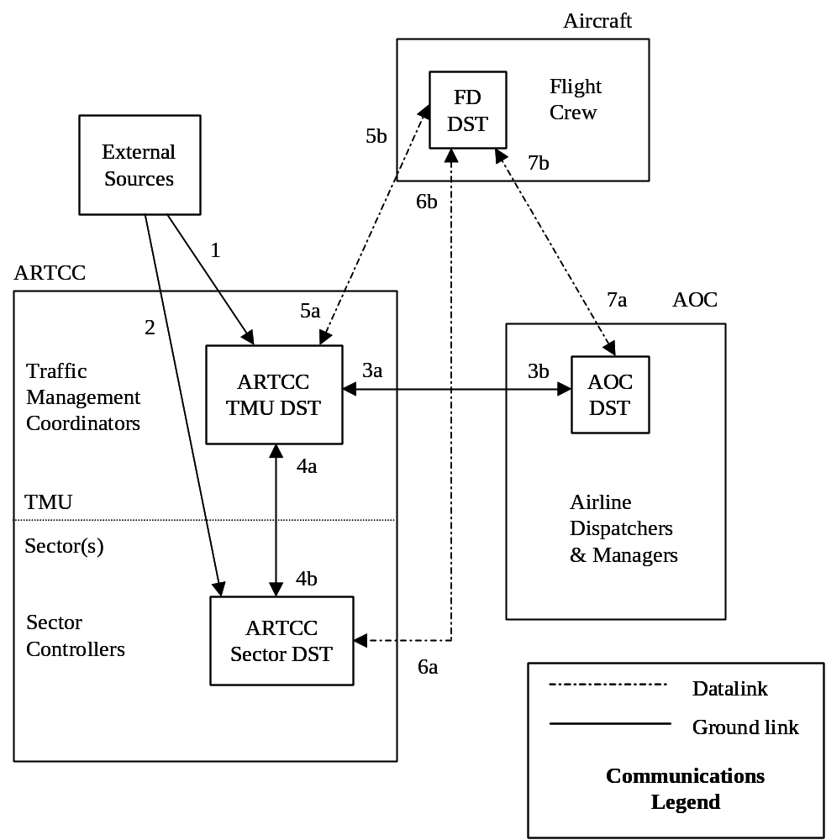
Figure 6: Functional Flow of Data between CE-7 DSTs

- User/Operator Roles and Responsibilities

Based on the operational characteristics described in Section 6.0, the roles and responsibilities of the ATSP, Pilot, and AOC are summarized below.

  - ATSP

- Collaborate with users (AOC and/or FD as appropriate) to avoid/resolve TFM initiatives
- Identify and alert users to constrained airspace problems
- Facilitate acceptance of user requests without undue negative impact on air traffic operations and unexpected delays
- Select operationally viable control strategy to maximize NAS performance (throughput) while accommodating user preferences to the extent possible.
- Implement TFM initiatives
- Minimize deviations to preferences to maximum extent possible.
- Maximize user flexibility to identify impacted flights and deviation degrees of freedom
- Minimize impact of losing airspace
- Gain benefits by allowing aircraft to take advantage of newly available airspace
- All other ATSP roles and responsibilities remain the same

  - Pilot

- Monitor for constrained airspace problems and proactively update their fight plan preferences to reduce the problem with consideration for their individual missions, if so equipped.
- Develop and provide user preferences to ATSP, if so equipped
- Collaborate with ATSP to avoid/resolve TFM initiatives, if so equipped
- Ensure preference changes are safe for aircraft
- Coordinate preferences with AOC to effectively result in one common user representation
- Adhere to restrictions applied by ATSP for TFM constraints, if equipped for free-maneuvering
- All other pilot roles and responsibilities remain the same

  - AOC

- Monitor for constrained airspace problems and proactively update fleet preferences to reduce the problem with consideration for their individual business models.
- Develop and provide user preferences to ATSP
- Collaborate with ATSP to avoid/resolve TFM initiatives
- Coordinate preferences with pilot to effectively result in one common user representation
- All other AOC roles and responsibilities remain the same

- Operational Modes and Scenarios

  - Normal or Nominal Mode Scenarios

The following scenarios illustrate the CE-7 concept’s nominal interactions between participants and DSTs. The time windows for the different stages of user collaboration are illustrative and not to be taken as literal values. The exact values to support the CE-7 concept will depend on the operational nature of specific scenarios and are a subject for future research.

Figure 7 illustrates a group of en route, high altitude sectors. The six aircraft displayed are all predicted to enter sector 29 during the same time period. The two Federal Airlines (FAL) flights and the two National Airlines (NAL) flights are all commercial jet transport aircraft (e.g., Boeing 737, Boeing 747, and Airbus 300). Both Federal and National have AOCs and neither of these aircraft is assumed equipped to perform their own TFM collaboration with the ATSP. N1729 is a business jet (e.g., Gulfstream IV). This aircraft is equipped for free maneuvering and to perform its own TFM collaboration with the ATSP. N203R is a private business jet not equipped for TFM collaboration with the ATSP and without an AOC. The Economy Airlines (ECA) aircraft is a Boeing 737 commercial jet transport that is scheduled to depart from a satellite airport within sector 15. Other aircraft are assumed impacting sector 29, but these seven are the only ones presented for discussion.
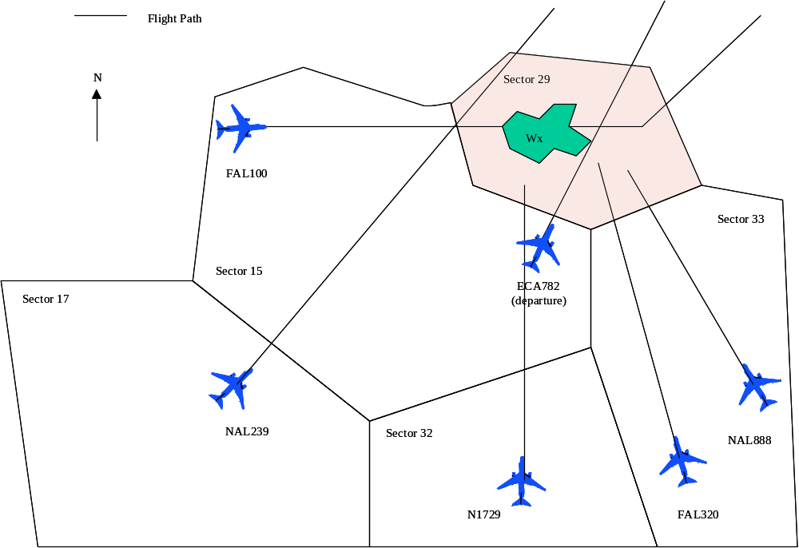
N203R

Figure 7: Example Scenario

The scenario begins with user identification of predicted weather impacts on sector 29. Both Federal’s and National’s AOC have received current weather predictions for the airspace, a prediction of the future NAS State and acceptable dynamic density levels from the TMU. Using their AOC DSTs, they identify that the allowable dynamic density for sector 29 is predicted to decrease (due to the weather) below the currently predicted traffic load for that sector. The crew of N1729 has also received the weather, NAS state, and dynamic density predictions and using their FD DST have also identified that sector 29 is predicted to have congestion problems based on the current traffic predictions. Since the sector is not predicted to experience congestion for another 60 minutes, the ATSP has not yet developed a TFM initiative to relieve the problem and the users have a chance to request preference changes to avoid the airspace (Preemptive User Action stage).

In the National Airlines’ AOC, the AOC DST identifies NAL 239 and NAL 888 as the two aircraft impacted by the predicted congestion. Using the AOC DST, it is decided that NAL239’s flight path should be changed to avoid the congested area since the modification would have negligible impact on the aircraft’s flight time and fuel burn. If the aircraft were to continue on its original flight path and be deviated, the impact could be significantly larger. On the other hand, moving NAL888 would have a much larger impact. National’s AOC is hoping that by removing one aircraft from the congested sector, combined with other airlines removing aircraft from the sector, that the congestion problem will be resolved and NAL888’s flight path will not need to be modified. The Federal Airlines’ AOC determined that there is a chance that the weather may dissipate prior to their aircraft entering sector 29. The flight deck of N1729 determined the weather was not hazardous and decided to penetrate the weather, risking possible restrictions by the ATSP. Neither user decides to modify any flights at this time.

To implement the change for NAL239, National’s AOC contacts the flight and alerts them of the AOC desire to request a route change to avoid the potentially impacted sector. The flight crew evaluates the proposed change and works with the AOC to develop a new flight path that avoids the congested airspace and is desirable by the crew (e.g., avoiding any nearby areas of reported turbulence). When complete, the flight crew then submits (via datalink) a user request to the sector controllers in sector 17 for the new flight path. The sector DST in sector 17 receives the route modification request and checks the new flight path within the sector and into sector 15 to confirm that the flight path is conflict free and acceptable to the controller (i.e., conforms to any other known constraints). The sector DST also automatically sends the request to the TMU DST to be checked for TFM acceptability. The TMU DST confirms that the new path improves the overall TFM situation (in this case, by reducing the predicted dynamic density of a potentially congested sector downstream) and sends back an approval to the sector DST. The sector controllers, evaluating the change is locally acceptable and approved for TFM, accept the route modification and send the approval clearance to the flight crew (either verbal or via datalink).

After the modification of NAL239’s route, the dynamic density in sector 29 has been reduced, but not enough to bring it under the allowable limits due to the impact of the weather cell. When the TMU identifies (using the TMU DST) that the dynamic density of sector 29 is predicted to exceed allowable limits in less than 30 minutes, the TMU initiates development of a TFM initiative (Collaborative TFM Stage). Using the TMU DST, the TMC evaluates the different control strategies. In this case, there is no SUA local to the area, so dynamic access to SUA is not an option. Because the congestion is due to weather, it is determined that dynamic re-sectorization and spacing are not as desirable as rerouting around the weather, though a ground hold on ECA782 is a viable option. The decision is made to reroute N1729 and FAL320 to relieve the congestion. This information, along with the restriction that deviations east of sector 33 are not acceptable (due to other TFM issues in that area), is sent to the impacted users (Federal’s AOC and the N1729 flight deck).

In Federal’s AOC, it is preferred to modify FAL100’s flight path over FAL320, since FAL320 is currently behind schedule and needs to make a tight connection at its arrival airport. Using the AOC DST, the Federal AOC develops (in coordination with FAL100’s FD) a preference change for FAL100 instead of FAL320 that sufficiently reduces the predicted dynamic density of sector 29 below allowable levels. This new preference must combine with the rest of the proposed initiative to resolve the congestion problem or the TMU will not accept the change to the initiative. If the change from FAL320 to FAL100 is not “equivalent” (i.e., interacts with the rest of the initiative to completely resolve the problem), the TMU may accept the change to FAL100, but still implement the change to FAL320 to complete the problem resolution. Once an equivalent preference change is developed, the Federal AOC sends the request to the TMU. The TMU DST receives the request, evaluates its impact on the proposed TFM initiative, and either accepts or rejects the request. If rejected, the AOC has another opportunity to make adjustments and resubmit a request. In this case, the FAL100 preference change is accepted. The TMU DST sends this request as a clearance change to the sector 15 DST and the sector controller implements the requested change (after sector DST evaluation) as a clearance.

In the case of N1729, the aircraft receives the proposed restriction from the TMU as part of the TFM initiative. The free-maneuvering aircraft then plans a new trajectory that will avoid the restricted airspace (sector 29). When the new trajectory is completed, N1729 implements the trajectory change independent of the ATSP. N1729 could have waited until the TFM initiative was implemented (at this stage, the restriction is just the TMU’s proposed initiative), but decided that an earlier deviation would be more beneficial and the likelihood that the restriction would be removed was small.

Because the collaboration successfully resolved the congested airspace problem, no TFM Action stage is required. If collaboration with Federal Airlines or N1729 were not completed in time, the proposed TFM initiative would be implemented by the TMU by sending the route modifications to the sector DSTs as clearance modifications or by issuing the restriction to the free-maneuvering aircraft.

An alternative solution to the above scenario can be illustrated by having the TMU select a different control strategy for the TFM initiative in the Collaborative TFM stage. Again, the scenario begins with user identification of predicted weather impacts on sector 29 and the pre-emptive action by the National Airlines AOC to modify NAL 239. When the TMU identifies (using TMU DST) that the dynamic density of sector 29 is predicted to exceed allowable limits in less than 30 minutes, the TMU initiates development of a TFM initiative (Collaborative TFM Stage). Using the TMU DST, the TMC evaluates the different control strategies. This time, the TMU decides to use spacing instead of re-routing.

The TMU sends the spacing initiative, along with the restriction that deviations east of sector 33 are not acceptable, to the impacted users (National’s AOC, Federal’s AOC, and the N1729 flight deck). In National’s AOC, it is determined that even though there will be delay to NAL888, a re-route would be less beneficial and the airline does not collaborate to modify the TFM initiative.

The flight deck of N1729 receives from the TMU that they will be subject to spacing if they enter sector 29. The free-maneuvering aircraft determines that it would prefer to re-route around the sector than to incur the spacing delay. N1729 then develops and implements a new trajectory that avoids the restricted airspace (sector 29). Because N1729’s path no longer enters sector 29, it will not be impacted by the spacing restriction. After N1729 updates its broadcasted intent, the TMU and AOC DSTs identify a reduction in the spacing delay for the other aircraft entering sector 29, due to a reduction in sector complexity caused by N1729 no longer entering the sector.

In the Federal Airlines’ AOC, the AOC DST identifies FAL100 and FAL320 as the two aircraft impacted by the TFM initiate. Using the AOC DST, it is decided that re-routing FAL100’s flight path to avoid the congested area is desired to reduce the potential spacing delay on FAL320. With N1729 no longer entering the sector, Federal Airlines is predicting that re-routing FAL100 should remove all spacing delay within the sector. The Federal Airlines AOC follows the same procedure as in the previous scenario to change FAL100’s trajectory.

After the modification of N1729 and FAL100’s route, the dynamic density in sector 29 was reduced enough to bring it under the allowable limits due to the impact of the weather cell. When the TMU identifies (using the TMU DST) that the dynamic density of sector 29 is not predicted to exceed allowable limits, the TMU lifts the TFM initiate (spacing) developed earlier and the potentially impacted flights continue with their original flight paths. Because the collaboration successfully resolved the congested airspace problem, no TFM Action stage is required.

  - Off-Nominal Mode Scenarios

There are no currently identified off-nominal mode scenarios that drive concept development.

  - Failure Mode Scenarios

There are no currently identified failure mode scenarios that drive concept development. If the TMU DST fails, then operations occur as today. If an AOC or FD DST fails, then that airline or aircraft does not collaborate on a solution and the TMU DST develops the most acceptable resolution given the available information. If the sector DST fails, then operations at the sector work as today.

- Operational Process/Sequence Diagrams

Figure 8 illustrates the interaction among the users and ATSP for the CE-7 concept. The lines in black show the interactions when an AOC, non-collaborating FD, TMU and sector controller are involved. The red information represents additional interactions that occur when the FD is performing collaboration. The light green information shows the additional interactions when the aircraft is free maneuvering. If no AOC is present, then the FD follows the red (if collaborating), light green (if free maneuvering) and black line interactions and the AOC column is ignored.

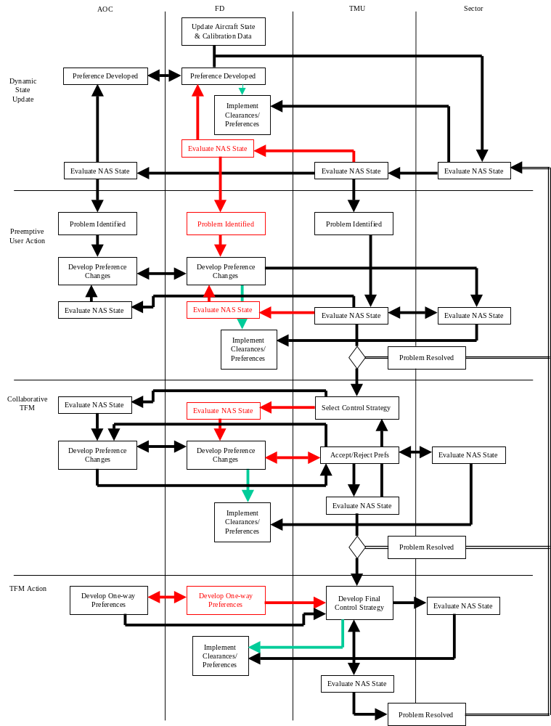

Figure 8: Constrained Airspace Resolution Sequence Diagram

Constrained airspace problem identification starts with a continual process of dynamically updating the state of the NAS for accurate predictions of future states. As aircraft fly through the system, the ATSP (TMU and sector) continually monitor the state of operations and evaluate whether there are problems that need resolution. The sector controller focuses on control issues (e.g., conflicts between aircraft) while the TMU focuses on TFM issues (e.g., constrained airspace problems). Users also evaluate the state of the NAS, as well as the state of their fleet (AOC only), and change their preferences based on their own business models. Preference changes are negotiated between AOC and FD and (1) submitted by the flight deck to the sector controllers and implemented as updated clearances or (2) implemented by the FD directly if free maneuvering. Aircraft state and other data are also sent to ground-based DSTs to calibrate their performance data, enabling more accurate NAS state predictions.

When a constrained airspace problem is identified, both the user (AOC and/or FD depending on which has collaboration responsibility) and TMU are alerted of the problem (through their shared model of predicted NAS state). In this stage, the user (AOC and/or FD) develops preference changes, coordinates them between the FD and AOC, and has the flight deck (1) submit them to the sector controller or (2) implement them if free maneuvering. If submitted to the sector, the sector controller’s DST, integrated with the TMU DST, evaluates the acceptability of the request and either accepts or rejects the request. Accepted requests are implemented by the flight deck and added to NAS state predictions, allowing the user to identify if more preference changes are desired. If the potential problem is resolved, then the AOC and TMU resume their normal operations.

If the problem is not resolved, the TMC selects a control strategy and sends this and other collaboration data to the users. The users evaluate the proposed TFM initiative and develop preference changes (in either the AOC or FD) to modify its implementation towards a more user-preferred solution. These preference changes, coordinated between the FD and AOC, are sent by the user (AOC and/or FD) to the TMU for acceptance. If accepted, the TMU alerts the user and, if the aircraft is not free maneuvering, sends the preference to the sector controller as a clearance. The trajectory change is added to the state of the NAS prediction. The TMU evaluates the current proposed initiative and makes modifications as necessary. If the potential problem is resolved, then the user and ATSP resume their normal operations.

If the problem is not resolved, then the TMC selects the final control strategy, using user preferences as input, and begins implementing the TFM initiative through clearances to the sector controller or restrictions to free-maneuvering aircraft. The TMU evaluates the state of the NAS and refines the initiative as necessary until the problem is completely resolved. Once the problem is resolved, the user and ATSP resume their normal operations.

- Benefits

The goal of the CE-7 concept is two-fold:

- Increase the accommodation of user-preferred deviations in constrained en route airspace
- Increase user efficiency, ATSP productivity and system capacity

The concept mechanisms to provide capacity, flexibility, user and ATSP efficiency, predictability, access and environment benefits are described below. Safety impacts are also discussed.

Capacity
Capacity benefits are achieved through maximum utilization of en route airspace. Improved (DST supported) early and collaborative planning by the TMU and AOC avoids the creation of capacity limited airspace and mitigates its impact when unavoidable. Dynamic access to SUA increases the TMUs airspace capacity resources by providing airspace that is not currently available today. The use of existing airspace capacity resources is increased through DST support in the identification of newly available (gained) airspace. Through improved utilization of airspace at the local (ARTCC) level, the negative impacts of imposing broader initiatives at the national (ATCSCC) level are avoided.

Flexibility
Flexibility benefits are achieved through increased accommodation of user preferences enabling user optimization of individual flights and fleet/banks of flights. By enabling collaborative TFM, including a pre-emptive user action stage, user preferences are incorporated into all resolutions of constrained airspace problems. Early detection of newly available airspace provides user opportunity to request preference changes to take advantage of this airspace. Use of DSTs by user and ATSP avoids the request/acceptance of preference changes that do not provide the expected flexibility benefits.

Efficiency: Users & Service Provider
User efficiency benefits are achieved through improved, collaborative TFM and acceptance of user preferences. Early identification of congested airspace and DST support in accepting user preference changes in resolving congestion decreases user costs by minimizing deviations from preferred routes. User collaboration in TFM solutions and ATSP DST support enables selection of the most advantageous (benefits driven) combination of route of flight and operational constraints for each flight to reduce flight arrival and departure delays, flight time, distance, and/or fuel consumption. Collaboration enables the user to optimize selection of flights deviated, and the direction, type (route, altitude, or speed), and magnitude of deviations. Early detection of newly available airspace provides user opportunity to request preference changes to reduce operating costs for each flight. Use of DSTs by users and ATSP avoids the request/acceptance of preference changes that do not provide the expected efficiency benefits.

Service provider efficiency benefits are achieved through improved, collaborative TFM. Early decisions and distributed decision-making increase ATSP productivity through decreased workload. Early detection of newly available airspace and dynamic use of SUA provide efficient mechanisms for reducing TFM constraints while decreasing congestion during constrained operations.

Predictability
Predictability benefits are achieved through early collaborative planning providing increased NAS state predictability.

Access
Access benefits are achieved through dynamic SUA access maximizing the availability of airspace resources for user planning and ATSP utilization.

Environment
Environment benefits are not specifically addressed in this concept.

Safety Impacts
Safety improvements may be achieved through improved TFM decision-making decreasing the chance of flow rates exceeding the capacity limits of NAS resources.

- Issues and Key Decisions

The CE-7 concept is still in an early stage of development. The main issues concerning the concept revolve around validation/refinement of the basic concept and development of the details. Validation of the concept should be done with operations staff at an early stage to confirm the concept is going down the right path. Functionality and actor relationships can be refined through discussions with TMC and AOC staff. Lessons learned from Mitre’s CRCT tool development can be used to directly refine the basic CE-7 concept.

One large issue still remaining to be resolved is the transition from local TFM solutions (i.e., CE-7) to National TFM solutions (i.e., ARTCSCC). Today, the ARTCSCC can dictate TFM solutions whenever more than one facility’s operations are impacted. Since increased user benefits can be achieved using local (as opposed to national) TFM solutions, it is desired to allow CE-7 solutions to extend beyond one Center’s boundaries into adjacent en route airspace, when appropriate. At some point, the additional workload due to increased coordination between the facilities will negate the benefit of developing multi-facility TFM solutions at the local level. CE-7 needs to: (1) determine when the transition from a local to a National solution is most beneficial; (2) develop a concept for coordinating efforts between the TMUs to support local multi-facility solutions; and (3) develop a concept for coordinating efforts between the local TMUs and the ATCSCC to support the transition.

Another large issue still remaining to be resolved is how to effectively create a common prediction of the NAS state. CE-7 relies on the users and ATSP having a common prediction of the NAS state to enable effective collaboration and intelligent preferences. However, the process for developing this prediction, including what information is shared between users and the ATSP, is still undefined. Some of the questions to be answered include:

- How is congestion and its related impacts predicted
- Is the data shared identical or do the users and ATSP have data tailored specifically for their use
- Are there other key states for TFM and user decisions, other than ones already mentioned (e.g., weather, SUA status, acceptable levels of dynamic density)
- What other TFM initiatives may be implemented and how is initiative data presented to the users

Concurrent with resolving the remaining concept issues, development of key technologies for the concept can progress in preparation for the development of a CE-7 prototype TMU DST. A list of development efforts includes:

- Development and validation of using dynamic density, including
- Validation of the basic metric
- Impact of spacing
- Subjective selection of acceptable dynamic density levels
- Development and selection of TFM control strategies
- How to best apply combinations of spacing/metering and re-routing?
- Development of dynamic SUA negotiation
  - Economic (business case) analysis of the value of SUA negotiation
- Development of time horizon windows for each collaboration stage
- Required DST capability to support collaboration
- Required accuracy of NAS state predictions
- Definition of ATM-focused meteorological research and development, including:
- Prediction accuracy and metrics defined for TFM applications
- Distribution for shared situation awareness (ATSP-FD-AOC)
- Weather prediction probability
- Models of severity used in conflict probing

References

1. AATT Project, “Concept Definition for Distributed Air/Ground Traffic Management (DAG-TM)” Version 1.0, September 30, 1999.

2. Free Flight DAG-TM Workshop, NASA Ames, May 23-24, 2000.

3. Sridhar, Banavar, Kapil S. Sheth and Shon Grabbe, “Airspace Complexity and its Application in Air Traffic Management," MS 210-10, NASA Ames Research Center, Moffett Field, CA, December 1998.

4. Brinton, Chris, Bill Pawlak, Ken Lancaster, Kim Crouch and David Rothenberg, “Air Traffic Control Complexity Research and Application” (Presentation), Wyndemere Incorporated, William J. Hughts Technical Center, August 29, 1997.

5. Heimerman, Kathryn, "Proceedings of the First FAA Dynamic Density / Air Traffic Control Complexity Technology Exchange Meeting," MT98W0000015, MITRE Corporation, McLean, VA, November 1997.

6. Federal Aviation Administration, “ATS Concept of Operations for the National Airspace System in 2005-Narrative (Narrative)”, Washington DC, September 30, 1997.

7. Pawlak, William S., Anita Bowles, Vikas Goel, and Christopher Brinton, “Initial Evaluation of Dynamic Resectorization and Route Coordination (DIRECT) System Concept," Wyndemere Incorporated, August 27, 1997.

8. System Resources Corporation, “TO-42 AATT Operational Concept for ATM Year 2001 Update (AATT01),” for NASA Ames Research Center, Moffett Field CA, November 2000.

Appendix A: Operational Requirements Table

This table contains the Operational Needs Statements (ONS) extracted from the ATS Concept of Operations for the NAS in 2005, and 26 other NASA, FAA, RTCA and Eurocontrol documents. The following ONS represent requirements for the future NAS, as identified by the ATC community. The selected ONS are consistent with the approach and concepts presented in this document and provide implicit traceability to the concepts established within existing community concepts. Appendix B contains a complete list of documents from which the ONS were extracted.

The following ONS were extracted from the Traffic Management– Synchronization Enhancement Area of the AATT Operational Concept for ATM Year 2001 Update document [8].

OPSCON Number | OPSCON Description
1_220, 5_270 | These tools (automated coordination) reduce the burden of routine tasks while increasing the provider’s ability to evaluate traffic situations and plan the appropriate response. This increases productivity and provides greater flexibility to user operations, which is especially important given the potential for reduced vertical separation minima and increased traffic density.
1_375, 4_370 | Through a data link to the properly equipped cockpit, provide users- routine communications- updated charts, current weather, SUA status, and other data- basic flight information services, including forecast weather, NOTAMs, and hazardous weather warnings- airport information, including Runway Visual Range (RVR), braking action and surface condition reports, runway availability, and wake turbulence and wind shear advisories  - clearances and frequency changes in the form of pre-defined messages.
1_422 | The most obvious user benefit is a reduction in the per-flight direct operating cost that every user operating under IFR can obtain through real-time optimization of their flight trajectory.
1_435 | Controller workload under peak traffic remains equivalent to the workload controllers absorbed in the 1990s under lighter traffic demand. This increased ATC efficiency has been achieved through the implementation of decision support systems for traffic management and control, dynamic alteration of airspace boundaries, reduced vertical separation minima, improved air/ground communications and coordination, and enhanced ground/ground coordination aids.
1_438 | Before changing a flight’s trajectory, the controller must ensure not only that the revised trajectory is free of conflicts, but that the transition to that trajectory is also conflict free. The system therefore provides a ‘trial plan’ conflict probe for testing alternative trajectories.
2_195 | Real-time trajectory updates reflect more realistic departure times, resulting in more accurate traffic load predictions, and increased flexibility due to the imposition of fewer restrictions.
3_185 | continuous updating of the flight object improves real-time planning for both the user and the service provider. ... improves the effectiveness of ongoing traffic management initiatives and the collaborative decision making
3_220, 3_635 | Through the system, provide access to -Automated Terminal Information System (ATIS) and other airport environmental information, including RVR, braking action and surface condition reports, and current precipitation, runway availability, and wake turbulence and wind shear advisories- arrival, departure, taxi schedules, and taxi routes- airborne and surface surveillance information- flight information and pilot reports- weather information, including current weather maps- clearance delivery and taxi instructions- traffic management initiatives.
4_450 | more effective collaborative decision making, with the AOCs collaborating with ATM in deciding TFM initiatives which are then data linked to the pilots and service providers.
4_541 | Information outputs make all relevant flight object data available to the operational position (ATC, TM, and FAS)
4_600 | service providers utilize the decision support systems to monitor traffic flows, NAS performance, and weather.
4_755 | the pilot will be able to select which route he wishes to follow.
4_765 | Pilots ... fly to meet required times of arrivals
4_770  5_355 | Free maneuvering operations in low density areas is being performed.
4_775 | High density areas still require the oversight from ATC for sequencing and primary separation assurance.
5_125 | By the year 2000, ATC considers AOC and flight deck preferences while assigning routes and controlling aircraft.
5_145 | These metering and merging separation procedures could provide the crew the flexibility to more efficiently manage their flight with respect to aircraft performance, crew preferences, and ATC considerations by allowing aircraft to stay on the cleared route in cases were ATC would otherwise have to vector the aircraft to achieve the desired spacing.
5_210 | Decision support systems such as the conflict probe assist the provider in developing safe and effective traffic solutions.
5_235, 5_440 | Additional intent and aircraft performance data is provided to decision support systems, thus improving the accuracy of trajectory predictions. This information is combined and presented on the service provider’s display.
5_295 | Improved decision support tools for conflict detection, resolution, and flow management allow increased accommodation of user-preferred trajectories, schedules, and flight sequences.
5_330 | The NAS-wide information system is continually updated with changes in airspace and route structures, and with the positions and predicted time-based trajectories of the traffic.
5_420 | user intent and aircraft performance data to decision support systems, thus improving the accuracy of ground-based trajectory predictions.
5_510 | Cockpit technology improvements will allow more user-preferred routings, SID to STAR or from airport-to-airport.
5_530 | This will facilitate more effective collaborative decision making, allowing users to collaborate with ATM in deciding TFM initiatives.
5_545b | traffic management services are provided in the en route area
5_575 | Decision support systems will assist in conflict detection and the development of conflict resolutions.
5_620 | Decision support tools will also help service providers to collaborate with users when SUA restrictions are later removed or changed.
5_640 | The profile is produced through improved information sharing, collaborative decision making, and the projection of flows based on weather and wind patterns.
5_670 | The traffic flow service provider will have the same automation tools as those providing separation assurance.
5_685 | The service provider will also be involved in the coordination of modified flight trajectories for active flights.
5_695 | This will allow earlier and immediate coordination with either the pilot or the airline operations center to provide adjustments with minimal intervention and movement.
5_700 | Traffic flow service providers will work with the service provider in active communication with the pilot to re-plan the flight trajectory.
5_740 | Modified routes can be developed collaboratively between the AOC and the service provider and then data linked to the cockpit and downstream ATC facilities.
5_790 | high density areas still require the oversight from ATC for sequencing and primary separation assurance.
6_205 | Rapid delivery of clearances by the service providers, and responses by the flight deck, are achieved through increasingly common use of data link.
6_300 | Provide additional user intent and aircraft performance data to decision support systems, thus improving the accuracy of ground-based trajectory predictions.
6_415b, 6_455b | Service providers, aided by supporting automation and electronic visual displays, are able to acquire and view timely and reliable flight information to dynamically address necessary changes to the trajectories.
6_430 | The service provider has access to the NAS-wide information system as well as projected demand for the day.
6_525b | ATC oversight is still required for sequencing, but collaborative decision making has greatly increased among the service provider, AOC, and the aircraft.
7_160 | Through collaborative decision making, future service providers will focus on providing the best, seamless service to all users.
7_300 | Using increased knowledge of the intent of traffic flow initiatives, arrange user resources to help solve traffic flow problems.
7_650 | Increasingly, national and local TFM service providers adapt to an environment of increased user flexibility, collaborative partnership, and information sharing among themselves and with the airspace users
7_655 | in a severe weather situation, increased collaboration among users and service providers enables shared decisions on how to avoid the severe weather and deal with the resultant short-term capacity shortage

The following ONS draw a parallel between the CE-7 approach at the Local TFM (ARTCC TMU) level and the current concepts for TFM at the National (ATCSCC) level. The selected ONS are consistent with the approach and concepts presented in this document and illustrate how the CE-7 approaches to TFM collaboration at the local level is consistent with FAA approaches to TFM collaboration at the National level. These ONS were extracted from the Traffic Management – Strategic Flow Enhancement Area of the AATT Operational Concept for ATM Year 2001 Update document [8].

OPSCON Number | OPSCON Description
1_374 | To support current flow management capabilities and planned enhancements, the TFM infrastructure will be upgraded to an open client-server infrastructure.
1_421 | the flying public and private sector will directly benefit from reduced transportation costs and increased schedule/connectivity. The general public will indirectly benefit from the resulting economic growth (national productivity and gross national product) enabled by a more productive and efficient transportation system.
2_195 | Real-time trajectory updates reflect more realistic departure times, resulting in more accurate traffic load predictions, and increased flexibility due to the imposition of fewer restrictions.
2_225 | When a flight plan is filed, update projections of NAS demand in the NAS information system.
2_275 | Service providers will move to a collaborative interaction with the user, where both reveal strategies and constraints and mutually develop solutions to problems.
2_350 | Air traffic service providers maintain a continuously updated data base of airspace and flow restrictions.
4_290, 5_340, 6_225, 3_240 | Consider user preferences when it is necessary to assign routes and control aircraft. User preferences may be received from the AOC or the flight deck
4_430 | Service providers also remain informed on distant weather conditions in order to anticipate changes to the daily traffic flow, and requests from other facilities. This is especially important when working with tower service providers to manage runway configuration changes.
4_440, 4_640 | When traffic management initiatives are required, service providers collaborate with users to resolve congestion problems through adjustment of user schedules.
4_450 | more effective collaborative decision making, with the AOCs collaborating with ATM in deciding TFM initiatives which are then data linked to the pilots and service providers.
4_500 | Data acquisition from the flight deck, airline operations center, service provider, and interfacing NAS systems ... These inputs provide more information concerning traffic status and predictions, status of individual flights, pilot intent, user preferences, and traffic plans generated by upstream and downstream automation systems
4_541 | Information outputs make all relevant flight object data available to the operational position (ATC, TM, and FAS)
4_600 | service providers utilize the decision support systems to monitor traffic flows, NAS performance, and weather.
4_605 | They will also use these tools to report on departure/arrival resources, and to identify airspace and airport congestion problems.
4_620 | Through the NAS-wide information system, service providers also remain informed on distant weather conditions in order to anticipate changes to the daily traffic flow, and requests from other facilities.
4_641 | incorporation of user preferences such as desired arrival or departure sequences.
4_645, 4_445 | the service providers work with the national traffic management function to solicit user input concerning flow constraints, and these constraints are entered into the NAS-wide information system as planned or current operational requirements.
4_730 | secure data link capabilities are introduced for tactical control.
5_125 | By the year 2000, ATC considers AOC and flight deck preferences while assigning routes and controlling aircraft.
5_245 | flights will be routinely operated on user-preferred en route trajectories, with fewer aircraft constrained to a fixed route structure. These trajectories are accommodated earlier in the flight and continue closer to the destination than is currently allowed.
5_280, 5_500 | More aircraft provide real-time winds and temperatures aloft, resulting in better weather information for forecasting and traffic planning.
5_295 | Improved decision support tools for conflict detection, resolution, and flow management allow increased accommodation of user-preferred trajectories, schedules, and flight sequences.
5_320 | Demand and capacity imbalances are resolved, in collaboration with the users, via voluntary changes in trajectories or through the establishment of temporary routes and transition points in the affected area.
5_330 | The NAS-wide information system is continually updated with changes in airspace and route structures, and with the positions and predicted time-based trajectories of the traffic.
5_525 | The status of active and proposed flights and NAS infrastructure will be available to NAS users and service providers.
5_625 | the traffic flow service provider’s role will have changed to include coordination of dynamic airspace structuring, more strategic management of traffic, coordination of new trajectories, and the management of major flows.
5_650 | Any capacity problems due to SUA schedules, staffing, or weather are identified.
5_660 | The service provider will be given demand forecasts throughout the day via the continually updated NAS-wide information system.
5_665 | As conditions change, initiatives will be reviewed and adjustments made, through coordination with all affected facilities and users.
5_675 | By resetting control parameters ... the probe becomes a density tool which the service provider uses to identify areas and times of higher density.
5_680 | By working strategically with upstream separation assurance providers and the users, some density problems will be mitigated
5_700 | Traffic flow service providers will work with the service provider in active communication with the pilot to re-plan the flight trajectory.
5_705 | Modified trajectories will also be developed collaboratively with the airline operations center and distributed to the flight deck via data link, and to downstream facilities via the NAS-wide information system.
5_735 | Increased collaboration between the airline AOC and the ATM system occurs as the AOC interactively probes proposed route changes.
5_745 | working with TFM specialists, the AOC helps define and implement TFM initiatives to relieve airspace congestion. Collaboration is extended as AOCs have an expanded role in determining the landing sequence of company flights.
5_795 | With the reduction in analog voice communications as the result of full use of data link capabilities and the implementation of new traffic management procedures and technology, dynamic resectorization allows fewer communication frequency changes for en route aircraft.
6_185 | Automation and procedural changes will help service providers to be more strategic in solving potential conflicts, traffic congestion, and demand for user preferred trajectories.
6_250, 6_420, 6_485 | Adjust the airspace structure and/or trajectories when demand exceeds capacity.
7_100 | Information exchange and collaboration continue to be critical components of traffic management through the year 2000.
7_105 | Improved information exchange among users and service providers enables shared insight about weather, demand, and capacity conditions and allows for improved understanding of NAS status and TFM initiatives.
7_110 | Users are key participants in the planning process of traffic flow initiatives. As users receive improved knowledge of the intent of traffic flow initiatives, they may arrange their own resources to help solve the flow problems.
7_130 | Improved information about capacity constraints allows these users to adjust their operations accordingly, helping to resolve problems without TFM intervention.
7_145 | An increase in collaboration among users and service providers for both planning and strategic problem resolution emerges as a result of increased information exchange.
7_150 | Databases and decision support systems that use these databases enable a shared view of traffic and weather among all parties so that proposed strategies can be evaluated.
7_160 | Through collaborative decision making, future service providers will focus on providing the best, seamless service to all users.
7_165 | Traffic Flow Management (TFM) initiatives affect all users similarly
7_170 | users with an AOC or AOC-like capability have an opportunity to collaborate more efficiently and effectively with TFM service providers to address specific flow restrictions.
7_175 | users will be better able to plan their flight ... and to minimize congestion or possible delays due to the ... information made available by the NAS-wide information system.
7_180 | This system (NAS-WIS)will include up-to-date information such as capacity and aggregate demand at airports and other NAS resources, airport field conditions, traffic management initiatives in effect, and Special Use Airspace status
7_182 | Users equipped with advanced FMS and datalink continually provide updates to ETAs at ATM-designated waypoints. This enables an accurate depiction of current and forecast traffic loads in critical airspace
7_190, 7_285, 7_315 | Traffic Flow Management (TFM) employs the philosophy of problem resolution at the lowest level possible.
7_210 | ‘what-if’ tools for both the service provider and the NAS user allow proposed strategies to be evaluated.
7_215 | Because NAS users will have increased flexibility in planning routes and schedules, and because the NAS relies less on routine restrictions and fixed routes to structure traffic, managing NAS resources becomes more dynamic and adaptive.
7_220 | Better decision support systems will help service providers visualize demand and manage the more complex traffic flows.
7_225 | decision support systems that evaluate NAS performance in real-time will enable the service provider to be more responsive and develop more effective traffic management strategies.
7_251 | a system-wide perspective is presented in the form of ‘national profiles’ that describe national operational conditions, including the overall NAS environment, and national capacity and demand.
7_252 | The national operational environment information just discussed provides all traffic managers with an overall view of conditions at cardinal points within the NAS that will affect operations from the current time through several hours into the future.
7_255 | Manage programs and flow initiatives to mitigate instances where demand exceeds capacity.
7_270 | Monitor user compliance with traffic flow management initiatives and apply punitive controls as necessary.
7_305 | Resolve traffic flow management issues collaboratively.
7_395 | Increased collaboration between service providers and users in problem resolution improves overall system effectiveness.
7_400, 7_340 | Enhanced decision support systems improve NAS monitoring, performance measurement, and strategy development.
7_441 | In appropriate situations, automation enables TM Initiative developer, TM personnel, ATC personnel, and user personnel to negotiate revisions to the planned Initiative, using the system’s fast-time simulation/analysis and information-sharing functions
7_475 | They use the NAS-wide information system to manage information about current and predicted NAS conditions as well as past performance.
7_485, 7_320, 6_495 | Because local service providers have access to the NAS-wide information system, projected demand for the day, and tools to strategically identify areas and times of higher density, traffic flow management issues can be efficiently resolved at the local level.
7_490, 5_655 | In coordination with the national flow management, and in collaboration with the user, local traffic flow management explores alternatives for managing the potential problems.
7_495 | The ATCSCC stays informed about traffic flow restrictions initiated locally.
7_500 | Working with service providers at terminal and en route facilities, the ATCSCC also initiates and coordinates traffic flow restrictions of a broad scope, strategic/tactical nature when required.
7_505 | ATCSCC service providers also play a lead role in improving overall NAS service by managing national programs that modify national procedures and techniques governing daily operations.
7_510 | Keeping abreast of NAS status and local traffic management initiatives is efficiently done with the NAS-wide information system.
7_515 | Less time is spent on status checking, allowing service providers and users to focus on analyzing situations and on coordinating traffic management strategies.
7_555 | To anticipate where and when demand might exceed capacity, both local and national traffic flow managers rely on decision support systems.
7_565 | A decision support system helps the service provider evaluate the impact of proposed strategies on the NAS by identifying options for avoiding problematic traffic situations.
7_570 | The NAS-wide information system makes information available to all service providers for a common understanding of situations ... they can collaboratively plan strategies that are not only more responsive to the situation, but also consider the needs of the entire NAS.
7_650 | Increasingly, national and local TFM service providers adapt to an environment of increased user flexibility, collaborative partnership, and information sharing among themselves and with the airspace users

Appendix B: Operational Requirements References

The following is a complete list of documents from which the ONS were extracted.

EUROCONTROL, “Air Traffic Management Strategy for 2000+ Volume 2”, November 1998.

Federal Aviation Administration, “Addendum 1: Operational Tasks & Scenarios (Addendum)”, US Department of Transportation, Washington DC, July 23, 1998.

Federal Aviation Administration, “Air Traffic Services Performance Plan for Fiscal Years 1998-2000, Air Traffic Services”, Washington DC, August 13, 1999.

Federal Aviation Administration, “ATS Concept of Operations for the National Airspace System in 2005-Narrative (Narrative)”, Washington DC, September 30, 1997.

Federal Aviation Administration, “ATS Concept of Operations for the National Airspace System for the Mature State of Free Flight”, US Department of Transportation, Washington DC, 1998.

Federal Aviation Administration, “National Airspace System Architecture Version 4.0”, US Department of Transportation, Washington DC, January 1999.

Federal Aviation Administration, “Safe Flight 21: Functional Specification”, US Department of Transportation, Washington DC, May 15, 1999.

National Aeronautics and Space Administration, “Concept Definition for Distributed Air/Ground Traffic Management (DAG-TM) Version 1.0”, Advanced Air Transportation Technologies (AATT) Project, Aviation System Capacity (ASC) Program, September 30, 1999.

RTCA, Inc., “A Joint Government/Industry Operational Concept for the Evolution of Free Flight”, Prepared by the RTCA Select Committee on Free Flight Implementation, Washington DC, August 1997.

System Resources Corporation, “TO-7 En-Route Constrained Airspace Concept Definition”, For NASA Ames Research Center, Moffett Field CA, September 1999.

System Resources Corporation, “TO-16 Multi-Facility TMA Requirements for Philadelphia Installation”, For NASA Ames Research Center, Moffett Field CA, January 15, 1999.

System Resources Corporation, “TO-23 Assessment of Research and Development Efforts Supporting Future Operational Concepts for the National Airspace”, For NASA Ames Research Center, Moffett Field CA, August 1999.

Over-flight traffic is defined as traffic within an en route center that enters from an adjacent center and exits to another adjacent center. This definition separates this traffic from arrival traffic (traffic that transitions to its destination terminal area within the center) and departure traffic (traffic that transitions from its origin terminal area within the center).
The term “lost” is used to refer to the need to reduce the predicted traffic load below the accepted capacity level of the airspace. It is not intended to mean that a section of airspace is unusable, though the activation of an SUA could definitely create such a situation. The term “lost” will be used throughout this document to describe all situations where a region of airspace is predicted to exceed its traffic capacity.
Dynamic density is also sometimes referred to as sector or airspace complexity, but dynamic density is the more widely published term and will be used synonymously with sector and airspace complexity throughout this document.
There are cases where aircraft can enter SUA airspace when active (e.g., within a Military Operations Area if separation assurance can be maintained), but the concept is unaffected by this distinction since the number of allowable aircraft would be very small, requiring the majority of flights to be rerouted.
Current conflict probes, including URET, do have the capability to probe for conflicts into downstream sectors (approximately a 20 minute time horizon) and to identify SUA penetration, but they are not capable of supporting the identification of TFM problems and restrictions.
Prior to “free routing,” ATC preferred routes procedurally restricted flights through congested areas along predictable routes. With the advent of free routing, the connection between routes and congested airspace isn’t nearly as clear since many areas of congestion are managed through control of fixed-route traffic streams.
The extent to which the flight plan reflects the actual flight’s user-preferred trajectory is based on the equipage level of the flight. The flight plan could be anything from today’s flight plan to a user-negotiated flight plan that does not follow a fixed route structure (e.g., CE-6).
A similar situation occurs for traffic when they are outside of the time horizon for an existing traffic flow initiative. Though traffic close to the constrained airspace may currently be affected by the initiative, users could continue to make preemptive preference changes to avoid their aircraft from being added to the initiative (e.g., maneuver early to avoid a congestion area, before the TMU constrains them).
During the end stages of the preemptive user action stage, the ATSP may alert the users as to when the Collaborative TFM stage will begin. Alternately, the stage would begin when the control strategy and collaboration constraints are initially sent to the users.
Theoretically, multiple rounds of collaboration could occur until the time horizon enters the next stage (TFM Action).
The issues surrounding multi-facility coordination between TMUs are covered in Section 12.
The decision of whether the FD will equip to enable FD collaboration when AOC collaboration is available is a decision that will be made based on each user’s business model. CE-7 assumes that a user may have both FD and AOC collaboration capability available and dictates the requirements for collaboration in this case.
Free-maneuvering aircraft have the opportunity to collaborate on the type of restriction imposed during this stage. For example, an aircraft that is being spaced may request the option to avoid the airspace instead. This is a different interaction than if the aircraft is not free-maneuvering and wants to collaborate a different path to avoid a piece of airspace.
The spacing restriction is not removed, but since the aircraft does not enter the sector, the restriction will not have an impact on the aircraft’s trajectory.

