USDA Foreign Agricultural Service
GAIN Report

Template Version 2.09

Global Agriculture Information Network

Required Report - public distribution
Date: 11/7/2006
GAIN Report Number: CH6821
CH6821
China, Peoples Republic of
Exporter Guide
China Exporter Guide 2006
2006

Approved by:
Wayne A. Batwin
ATO Shanghai
Prepared by:
David Kiefner, Sonny Chu, Freddy Xu

Report Highlights:
In 2005, China Customs reported total agriculture, fisheries and forest product imports of over $35 billion. Imports of consumer-oriented agricultural products ( not including fisheries, bulk or intermediate products )accounted for over $3 billion of this total. The U.S. continues to hold the top position in both overall agricultural exports to China and in consumer-oriented products, despite setbacks in beef exports to China. As incomes continue to grow, China is showing signs of becoming a more consumption-driven economy.

Includes PSD Changes: No
Includes Trade Matrix: No
Annual Report
Shanghai ATO [CH2]
[CH]
Table of Contents
Section I. Overview 3

I.1. Economic Situation 3
I.2. Demographic Developments 3
I.3. Consumer Buying Habits 4
I.4. Consumer Foods Market Size and Growth 4
I.5. Advantages and Challenges Facing U.S. Suppliers of Food Products to China 5

Section II. Exporter Business Tips 6

II.1. Local Business Customs 6
II.2. Consumer Tastes 6
II.3. Regulatory Framework 7

Section III. Market Sector Structure and Trends 8

III.1. Food Retail 8
III.2. Hotel, Restaurant and Institutional (HRI) 9
III.3. Food Processing 9

Section IV. Best High-Value Product Prospects 11

Section V. Key Contacts and Further Information 12

Appendix 1. Statistics 12

Section I. Overview

I.1. Economic Situation
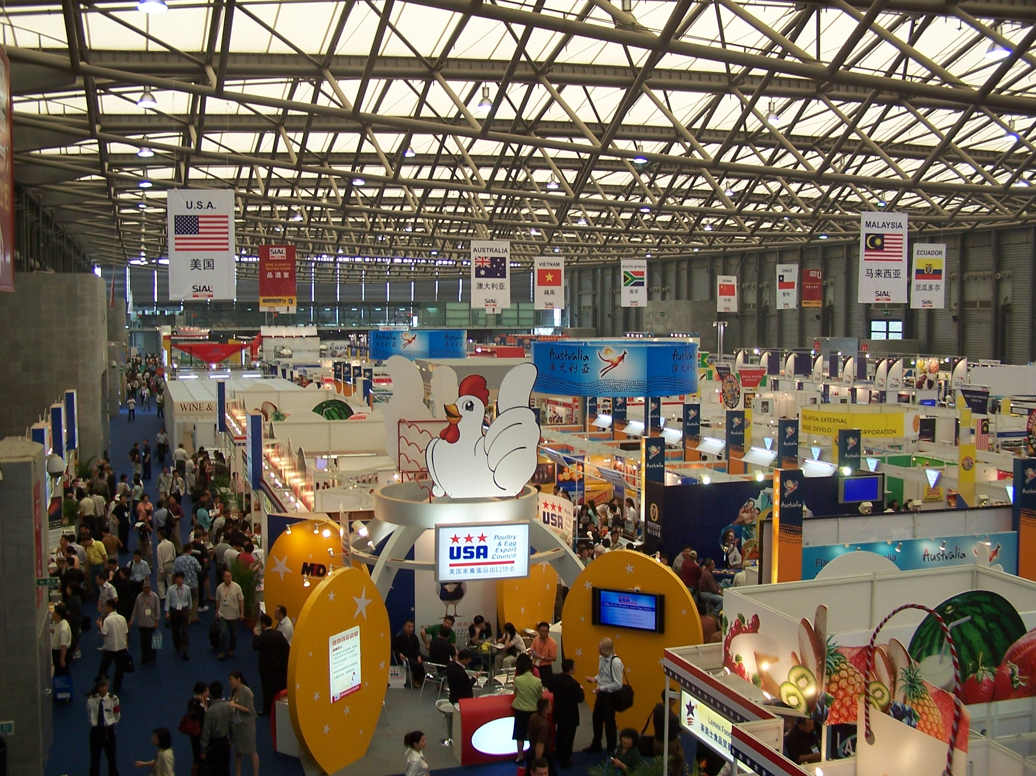
Crowds at the SIAL 2006 trade show in Shanghai.
China’s economy, now the fourth largest in the world, continues to grow rapidly, posting 10.2% growth in 2005 and a forecast 10.5% in 2006, despite government efforts to cool the economy. Concerns about overheating continue to weigh on Chinese policymakers, as inflation continues to creep up, although it is still low at less than 2%. Much of the increase has taken place in food prices, causing ambivalence among policymakers who are worried about inflation but also seeking ways to improve farm incomes.
Efforts to cool down property markets have yielded mixed but generally good results as central government authorities moved to pull back on bank lending and tighten approvals for new industrial and real estate developments.

I.2. Demographic Developments

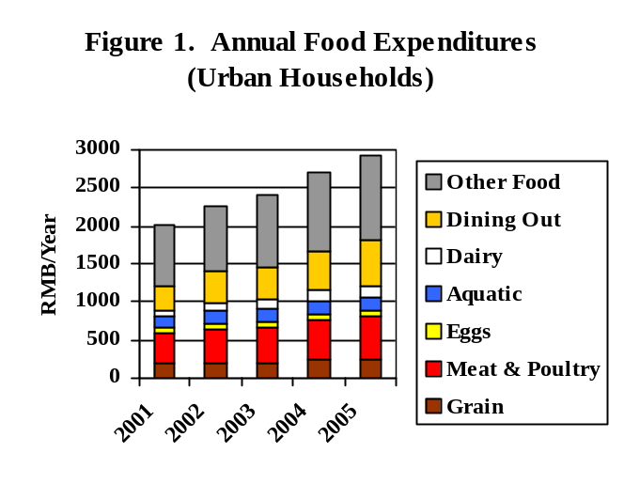Although China has relaxed restrictions on the movement of rural residents, the largest cities continue to restrict employment and housing for unlicensed migrants. In addition, production costs in the major metropolitan areas have risen. The result has been a boom in the growth of second and third-tier cities across China. These emerging city markets fall into three broad categories: coastal population centers, satellite cities, and inland giants. Coastal Population Centers: China’s eastern coast is dotted with major cities that have cashed in on growth in export markets to fuel an economic boom independent of the major urban centers of Guangzhou and Shanghai. Cities such as Qingdao, Dalian and Xiamen are becoming independent export powers. Satellite Cities: By contrast, a large number of satellite cities close to and economically dependent on Guangzhou and Shanghai have also sprung up in large numbers in recent years. Growth in these cities is driven by businesses seeking to escape ever higher costs in the metropolis, while still cashing in on the large consumer and export markets, distribution, and logistics infrastructure. These include both freewheeling commercial boomtowns like Shenzhen (Guangdong) and Jiaxing (Zhejiang), and storied, historic power centers like Suzhou (Jiangsu) and Hangzhou (Zhejiang). Inland Giants: Growth is no longer passing China’s interior cities by—some cities such as Chengdu and Nanchang have seen aggressive growth in the past two or three years and are becoming focal points for industrial development. These cities are focused on a mix of domestic and low-end export manufacturing. Although large, the regulatory climate in these cities can be unpredictable and they are overall considerably less wealthy than coastal cities. These are good markets for exporters with a long-term focus. Those interested in Chinese markets should also keep an eye on the government’s drive to build new cities to relieve the population pressure on major cities. The flagship project for this policy is a planned community for 700,000 people being constructed near Suzhou, just an hour’s train ride from Shanghai.
Source: CSB 2006 Yearbook, Table 10-16

Another important demographic element is generational. The population currently is divided into three groups: those born from 1946-1964, who have lived through some of China’s most turbulent times; those born from 1965-1976, who came of age during China’s drive to development; and those born after 1976, who have grown up in an increasingly affluent and stable environment. While there are significant differences between the first two groups, they share similar spending habits: they are both extremely price sensitive and conservative about spending, with extremely high savings rates. The most recent generation of consumers is different, having embraced a consumption-oriented lifestyle. They are more willing to spend money, willing to experiment, are much more style conscious, and are more sensitive to advertising. These consumers are gaining rapidly in importance, as they become income earners in their own right. This generation also does not shy away from taking loans: a significant part of China’s housing boom is being led by young, white collar workers who are taking advantage of newly available long-term mortgages with low interest rates to buy their own apartments. In the process, they are leaving home and establishing households before they get married, yet another major break with tradition.
Source: China National Statistical Bureau, 2003 Yearbook
Table 10-7

I.3. Consumer Buying Habits

According to official statistics, total consumer expenditure (GDP by expenditure: China Statistics Book) increased by 10.4% in 2005 compared to 11.7% in 2004. In 2005, consumer expenditures grew faster for rural households, growing by 10% compared with 8.2% for urban households. However, the urban/rural consumption ratio remained almost the same. Long-term consumption is expected to continue growing. China’s increasingly wealthy citizens have limited vehicles for investment and low interest rates for home loans, a situation that encourages consumers to spend or to put their money into homes.
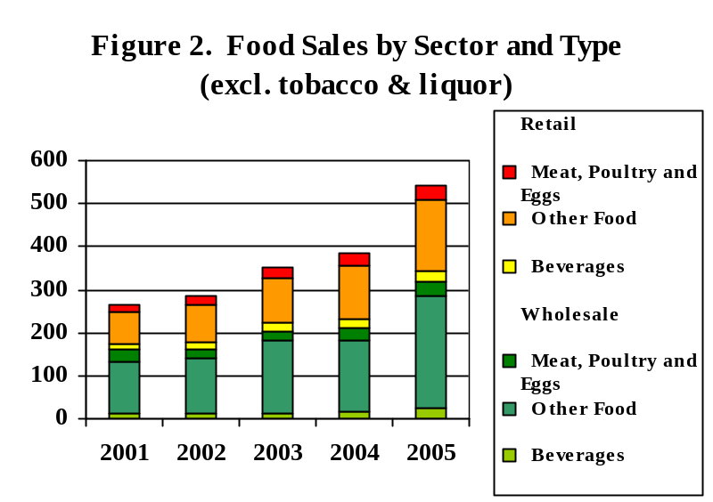
Generational distinctions aside, Chinese consumers tend to be conservative and price sensitive when it comes to personal spending. Exceptions to this rule include spending on education, medical care, gifts and entertainment, and children. The greatest successes for high-end U.S. food products have been those aimed at hotels and restaurants (seafood and pork, for example), and high-end products given as gifts (fresh fruit, wine and liquor). Acceptance of imported products as guarantee of safety and high quality is common, and U.S. products in particular have benefited.
(Billion RMB)
Source: CSB 2006 Yearbook, Table 17-10

Food safety itself has become a major issue, especially in the major urban centers. Food safety or adulteration problems are nothing new in China, but they have recently become favorite topics for the Chinese media, and even minor incidents in the most far-flung areas are now often reported nationwide. This, along with SARS, swine disease and avian influenza scares, has created a widespread perception that many food products are unsafe. This feeling appears to be strongest at higher income levels, where consumers rely more heavily on processed or pre-packaged foods. As a result, consumers in these income brackets are placing a premium on famous brands or buying in venues with a solid reputation. Also, higher-income consumers tend to be very health and nutrition conscious, from both a traditional Chinese and a more science-based perspective.

I.4. Consumer Foods Market Size and Growth

The total value of the Chinese food market has continued to grow at a rapid clip. This trend was bolstered as the inflationary trend of 2003 accelerated. Price changes for food through the years 2000 – 2005 were 2.6%, 0%, -0.6%, 3.4%, 9.9% and 3.1%, respectively (CSB Yearbook, 2006). Combined wholesale and retail food sales exceeded RMB 1 trillion in 2005, but this figure falls to RMB 503 billion when tobacco and liquor revenues are excluded. Total dining revenue, including restaurants, snack counters and cafes reached nearly RMB 38 billion. The actual figure is likely several times higher, since many restaurants in China under-report their total sales revenue. Stagnation in food wholesaling appears to be ending, as consolidation and modernization start to pay off. If tobacco and liquor are excluded, however, retail and catering continue to grow at a faster pace. This reflects rapid development in modern retail formats and a growing trend toward dining out.

I.5. Advantages and Challenges Facing U.S. Suppliers of Food Products to China

Advantages | Challenges
Chinese consumers spend nearly half of their disposable income on food and beverages. | Chinese consumers are price-sensitive: imported products have difficulty competing with domestic substitutes on price.
Imported goods are generally regarded as safe and high in quality. | Imports are regarded as luxury goods: the vast majority of consumers do not believe they can afford them.
New markets for imported products are appearing in fast-growing cities throughout China. | Transportation and logistics for these cities remains difficult, and many lack the presence of a qualified distributor for imports.
Many U.S. brands, such as Budweiser, Coca-Cola, M&Ms and Pringles are widely recognized in China. | Most of the U.S. brands widely available in China are manufactured locally or in other parts of Asia.
Overseas fast-food chains are extremely popular, and provide exposure for foreign foods. | Foreign fast-food chains source most of their products locally.
Overseas retail chains are growing quickly, and carry more imported products than domestic counterparts. | Few of these chains import directly from overseas, working instead through distributors. Many charge high listing fees to promote new products.
Overseas retail chains and convenience chains are increasingly interested in establishing house brands. This is creating opportunities for bulk shipment of quality foods. | Although interested in quality for their house labels, these chains are tough negotiators, and will leave suppliers with little room for profit.
Under WTO, China’s duties on imported foods have fallen, and more products are shipped directly to China, instead of through Hong Kong. | Increased access for imports has resulted in greater competition from other exporting countries for products like beef, seafood and pistachios.
Food is an essential part of Chinese culture and social life. Key life events revolve around food, and little expense is spared. | The Chinese have very strong taste preferences. While they are willing to experiment, they are less willing to incorporate foreign tastes into their daily life.
China is incomprehensibly large. Though many consumers still lack the income to purchase imports, millions join the middle class every year. | China is incomprehensibly large. Regional differences in culture and taste can be quite stark. Promotions with limited budgets must target specific groups.
The Chinese market often moves en-masse. If a product becomes trendy, sales can skyrocket overnight. | If a product is successful, it is likely to be counterfeited or imitated.

Section II. Exporter Business Tips

II.1. Local Business Customs

China possesses an ancient and vibrant mercantile culture of its own. Although this culture values efficiency, value and profit, there are important differences from western business culture. Key features include: a) respect for age and hierarchical position, b) the importance of personal relationships, c) group orientation and d) the concept of face. Food is a key component of Chinese culture, and this extends to business culture: working lunches and dinners are an important part of doing business in China. These events help to build those all-important personal relationships, provide information not available in formal business meetings, and are an opportunity to establish face with your business contacts. To help U.S. exporters on their travels in China, FAS has prepared several reports outlining the key points: Chinese Business Etiquette (CH6820) and Business Travel in China (CH4836). These reports are available on the FAS website at www.fas.usda.gov (look under ‘Attache Reports’).

II.2. Consumer Tastes

It is dangerous to assume anything about China. Tastes vary widely from place to place and are constantly evolving. As a general rule, Chinese tastes favor Asian products, particularly those with a strong similarity to Chinese foods or heavily influenced by China. For example, some local quick service restaurants have learned that although Chinese customers like the efficiency and atmosphere of American style chain restaurants, they want to see more traditional Chinese food items such as rice, noodles or spicy dishes on the menu. Moreover, in a country where refrigerated trucks are still scarce, it is difficult for the modern supermarkets to match the fresh produce – and low prices – of typical wet markets where most Chinese traditionally shop. The lack of refrigerated trucks also encourages each region to develop its own dairy, brewing and meat industries, making bulk purchasing harder.

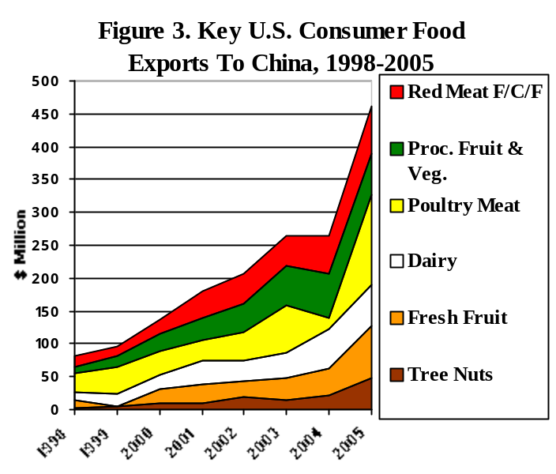
Nonetheless, consumers are willing to experiment with new tastes, and it is difficult to predict what products will succeed without conducting actual research. For example, pizza has proven immensely popular, despite a widespread myth that Chinese people do not like cheese. One promotion in the inland city of Wuhan found Mexican foods to be a runaway success, while another in Chengdu scored a success for boneless pork butt. Key regional distinctions include North and Northeast China (Beijing and north), where dishes tend to be salty; East China (centered on Shanghai) where the taste is sweet and spicy dishes are unpopular; Central China (Sichuan and Hunan), which are famous for hot and spicy food; and South China, famous for delicate tastes, seafood and an appetite for the exotic. Keep in mind, though, that consumers in any of these places may be willing to experiment with new tastes, including those from other parts of China.
Source: USDA,
BICO report

In addition to regional patterns, there are some overall preferences shared by most Chinese consumers:

- Chinese prefer fresh meats, soups and produce to canned or processed ones. Many buy fish or fowl live to be butchered on the spot.

- Consumers prefer small-sized packages to ‘economy’ sizes, even though the unit cost may be higher.

- In the case of snacks, candies or breakfast cereals, Chinese consumers like to see the actual product inside the package. It is a good idea to include a transparent ‘window’ on the package. This goes double for new-to-market products.

- The attractiveness of the package is important. Size, colors and design are all taken into consideration.

- Chinese buyers are attracted to established brand names, which are seen as a guarantee of authenticity and superior quality.

Before jumping into the Chinese market, U.S. exporters are advised to invest in targeted market research and taste testing. In a country the size of China, it is absolutely critical to identify a specific target group of consumers, and confirm the product’s appeal to that group. For example, one might target new mothers in the Shanghai area, or, alternatively, teens from affluent families in Guangzhou. Whichever group one chooses to target, both the product and the approach will be entirely different. Failure to take the preferences of Chinese consumers into account is a common reason for the failure of new products.

II.3. Regulatory Framework

II.3.1 Import Regulations and Standards

Over the past few years, the Chinese government has published a host of regulations governing standards and labeling for food products. Enforcement of these regulations is also becoming more rigorous. Although reputable distributors often deal with these issues on the exporter’s behalf, exporters making a serious commitment to the China market are advised to study the relevant laws carefully and ensure that they are in compliance.

To help U.S. exporters understand these regulations, FAS has prepared a series of unofficial translations. Collectively, these reports are called the China Food and Agricultural Import Regulations and Standards Report (or China FAIRS Report). The translations available are listed in the FAIRS Report Working Index, which is posted on the FAS website (www.fas.usda.gov).

II.3.2. Intellectual Property Rights (IPR) Protection

Though China strengthened its legal framework and amended its intellectual property rights (IPR) laws and regulations to comply with its WTO agreements, IPR infringements of U.S. agriculture and food products remain a serious problem. Examples include:

- “Stickering” and labeling domestic and third-country product with U.S. identifications such as Washington apples, California table grapes and pistachios, Wisconsin ginseng, etc.
- False branding and packaging of domestic and third-country products with U.S. identification such as Sunkist citrus, Sunmaid raisins, U.S. wines and even U.S. grass seeds.
- Counterfeiting or mixing of domestic or third-country product together with U.S. food and beverage products, including poultry, beef, pork, mohair or wool.
- Unauthorized sale and use of U.S. PVP protected plant materials and germplasm.

The U.S. industry needs to play an active role to protect food product IPR’s – initially identifying that problems exist in the first place. Ideally, IPR protection should begin prior to when companies or trade associations begin exploring the China market for their food or beverage goods. Interested parties should also recognize the importance of registering and protecting trademarks in both English and Chinese languages, including obtaining collective marks for U.S. collective organizations and USDA Cooperators or certification marks.

Furthermore, it is essential to recognize that even if U.S. goods are not being sold in China, IPR protection could be helpful to prevent infringed-upon goods produced in China from being exported to third country markets. Chinese Customs provides an on-line recordal service that is usually a prerequisite for Customs detention of infringing goods bound for export.

Interested parties are strongly encouraged to review the U.S. Embassy’s “China IPR Toolkit which can be found at http://www.usembassy-china.org.cn/ipr/ and FAS Beijing on-line reports CH2049, containing information on China’s patent, trademark and copyright legislation and enforcement and CH4059, on plant variety protection, both found at http://www.fas.usda.gov/scriptsw/AttacheRep/default.asp.

Section III. Market Sector Structure and Trends

III.1. Food Retail

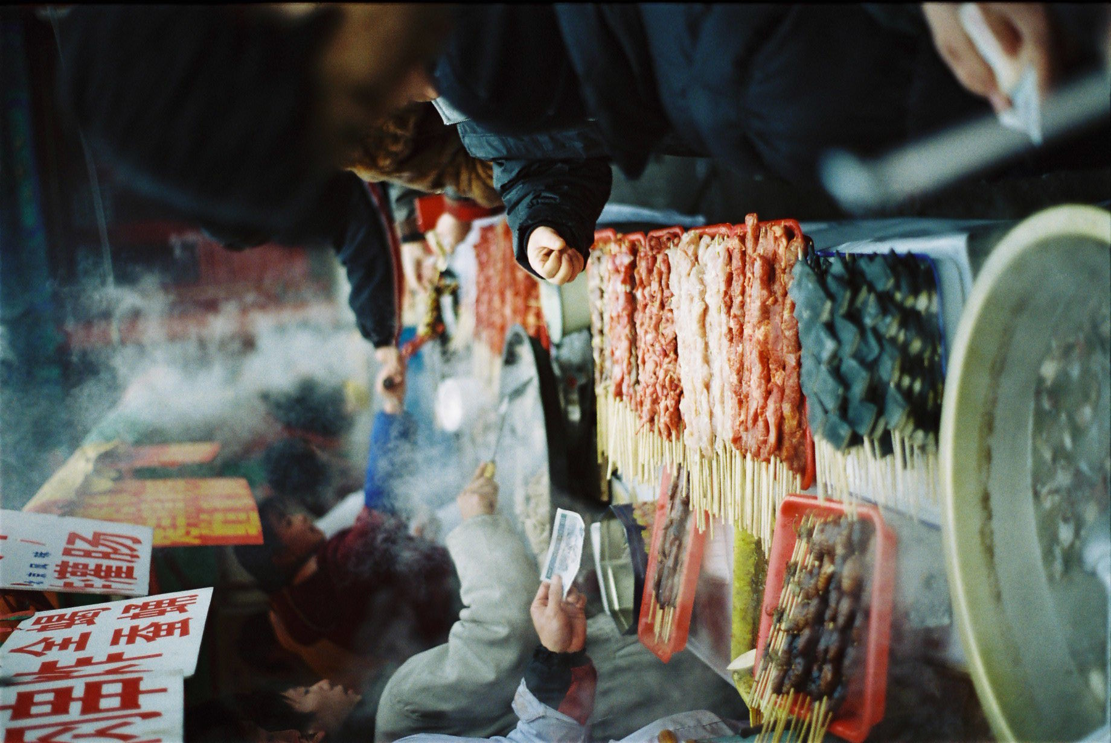
Growth in retail sales has been driven by the rapid development of food retail chains across China. Supermarket chains are now present in virtually every city in China, while hypermarkets exist in most large cities. Of particular interest to exporters is the rapid growth of foreign-invested hypermarket chains such as Wal-Mart, Carrefour, Lotus and Metro, which are more aggressive than local chains in seeking out and promoting high-margin imported products. While some of these chains are moving toward centralized purchasing, initial efforts have been largely unsuccessful. Foreign-invested stores are popular with the large and growing expatriate population, but are also favored by local Chinese as venues for buying food and other items to be given as gifts, especially during the spring festival. The spring festival, which takes place generally around late January and early February, is a 15-day celebration of the Lunar New Year. This is the period of high consumption as local Chinese purchase food product for themselves, as well as gifts for relatives, co-workers, and friends; therefore packaging is critical in this particular niche. Many exporters and/or distributors have developed special gift package versions of their products. China’s packaging industry is extremely sophisticated, and a growing number of U.S. exporters are choosing to ship in bulk and pack their products in China, a practice that may also help to resolve product labeling issues.
Food Kiosks at a Temple Fair in Beijing.

In response to the growth of foreign-invested retailers, Chinese retail chains are consolidating, and now have nationwide reach. Although the recent merger of China’s two largest food retail chains, Lianhua and Hualian, created an entity several times larger than any other chain operating in China, the two retailers appear to be continuing to operate independently. Both had previously absorbed a large number of smaller chains, and are still incorporating them into their management structure. Domestically-owned hypermarkets are a reasonable prospect for imported products, but loose management of supermarket chains continues to make that sector a poor prospect for imports other than dried fruit, nuts and frozen vegetables.

Retail sales have also been boosted by the rapid growth of convenience store chains, particularly in East China. Shanghai alone is home to as many as 4,000 convenience stores, mostly domestic chains. Foreign-invested convenience stores have established a significant presence in Guangzhou, and the convenience store format is now making an appearance in Beijing. Management of these chains is strong, and most relies on centralized purchasing and distribution. These stores also rely less on deep discounting, making them a reasonable prospect for imported products. An ATO/Shanghai sponsored food promotion with Lawson’s convenience stores introduced a wide variety of new products, and encountered fewer complications than promotions at hypermarkets, due to the high level of standardization and well-developed distribution systems. Refrigerator and freezer cases are routinely available in hypermarkets, supermarkets and convenience stores, and microwave ovens are common in both convenience stores and homes. USDA’s Cold Chain Initiative, supported by ATOs in Shanghai and Guangzhou, is further helping to ensure that the quality of temperature sensitive imports can be maintained, creating opportunities for new products.

Retail growth received a boost in 2005, when China removed restrictions on foreign ownership of businesses, leading Wal-Mart to open its first store in Shanghai. There are now 66 Walmart stores in China, second only to the Carrefour chain with more than 80 stores. Other important trends in the retail sector include a rapid increase in personal ownership of refrigerators, freezers and microwave ovens, which has boosted sales of frozen and heat-and-eat products. Hypermarkets and convenience stores also now offer a wide variety of ready-to-eat foods, including box lunches and rotisserie chicken. For more detail on China’s retail food sector, please refer to FAS/China’s Food Retail Sector reports, available on the FAS website at www.fas.usda.gov.

III.2. Hotel, Restaurant and Institutional (HRI)

HRI is one of the most dynamic sectors of the economy, as seen in the rapid growth of revenue for the dining industry. This sector covers the entire spectrum, from roadside stands to massive cafeterias to world-class gourmet restaurants. Previous statistical series have been discontinued, making it difficult to identify trends in the HRI sector. Under the new nomenclature, statistics are only available for chain catering services, which excludes the legions of independent family restaurants that form the bulk of the industry. Using these definitions, snack counters dominate the catering industry, at nearly 60% of total industry revenues, with restaurants lagging behind at 39%. The new series is useful, however, in showing the extremely rapid growth of the snack counters, which increasingly provide quick meals (steamed dumplings, for example) or meal starters (such as roasted chickens) for China’s growing population of busy professionals.
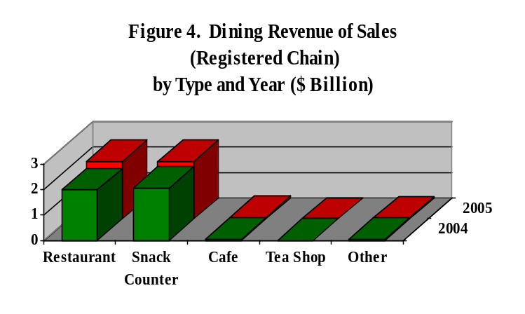
Source: CSB 2006 Yearbook, Table 17-30
HRI is a key player in introducing imported foods. High-end restaurants and hotels are less constrained by price considerations and more interested in presenting dishes and products that are unique. If successful, their efforts are likely to be copied by other restaurants, bringing them closer to mainstream middle-class consumers. Another important trend is the recent emergence of medium to high-end restaurant chains. Like other high-end restaurants, these are interested in offering consumers something different and unique, but unlike them, if a product is successful, they can purchase directly and in bulk, reducing cost considerably. This development holds a great deal of promise, as Chinese consumers view restaurant chains as a guarantee of quality in a largely unregulated industry. Though still in its infancy, this trend may become an important factor for imports.

It is important to note that while the sector as a whole has great potential, many parts of the HRI industry are not strong candidates for imported foods. Catering operations that run cafeterias and provide box lunches as well as small family-owned restaurants, account for a large portion of the industry and are extremely price-sensitive. For example, lunch box manufacturers typically aim for a production cost of $1.00 or less, making them a poor candidate for most imported foods. Once again, exporters are advised to research the market and pick their targets carefully. For more analysis on China’s HRI sector, please refer to FAS/China’s HRI Sector reports, available on the FAS website at www.fas.usda.gov.

III.3. Food Processing

The food processing industry is another of the fastest growing segments in the Chinese economy, with the China Food Industry Association citing annual growth of 10-12%, while official statistics (which typically exclude the legions of small-scale processors) show significantly higher growth. Still in its infancy, the recent development of this sector also makes it one of the most modern. Poor regulation, however, makes it difficult to determine the exact size of the industry. Official statistics indicate that there were 23,647 food processing ventures with total sales of $158 billion in 2005. The majority of these are involved in primary processing, while food and beverage manufacturing account for roughly 20% each. Currently, only 30% of China’s food consumption is processed, as compared to 80% in more developed countries. According to Chinese officials, the main barrier to further development of this sector is China’s underdeveloped agricultural production and distribution systems.

Food safety has become a major concern for the Chinese government, after a series of poisoning and contamination incidents culminated in a major scandal over sales of substandard infant formula, which resulted in the deaths of a number of infants. Food contamination incidents get widespread media coverage, and have become a fixture in many consumers’ minds. Many will now buy food only from well-known and reputable manufacturers, and some manufacturers have opened their own retail stores or booths in order to prevent adulteration of their products. Government efforts to improve quality and inspection of food manufacturing facilities are likely to accelerate the trend toward consolidation.

The food processing sector provides growing opportunities for U.S. exporters. The industry is concentrated primarily in Guangdong, Shanghai and Shandong provinces. Although inputs are primarily domestic, many processors are seeking new ingredients to help distinguish their products from competitors. U.S. products that have been particularly successful in this area include nuts (almonds and pistachios), dried fruit (particularly raisins and prunes), soy flour, flavorings and sauces, and dairy ingredients and supplements. ATOs in Shanghai and Guangzhou have launched a series of seminars for Chinese bakeries, promoting the use of U.S. food ingredients, and baking ingredients continue to be one of the best export prospects. Frozen and dehydrated potato products continue to be successful, due largely to the lack of local equivalents. For a more in-depth analysis of the food processing sector, please refer to FAS/China’s Food Processing Sector reports, available on the FAS website at www.fas.usda.gov.

Section IV. Best High-Value Product Prospects

The following chart shows China import statistics on the most valuable export products from the U.S., as well as their market development constraints.

Product Category | 2005  Imports ($million) | 3-Yr Avg Import Growth | Import Tariff Rate | Key Constraints on Market Development
Red Meats Fr/Ch/Fz | 252 | -6.48% | 12 – 25% | Competition from other import sources (Australia), limited capacity for handling fresh imports, growing competition from domestic product, BSE restrictions on beef.
Processed Fr. & Veg. | 612 | 35.2% | 5 – 30% | Competition from Asian countries with similar tastes; rapid development of domestic industry.
Poultry Meat | 335* | 25.4%* | 20%  (specific duties are applied to broiler cuts) | Import quotas, sanitary barriers, and competition from other exporting countries.
Dairy Products | 476 | 14.5% | 6 – 20% | Competition from New Zealand and Australia.
Fresh Fruit | 483 | 17.5% | 10 - 30% | Competition from domestic products. U.S.’ advantage is in special varieties.
Tree Nuts | 100 | 10.7% | 0 – 25% | Competition from low-price, low quality exporters; counterfeits.
Fruit & Veg. Juices | 74 | 1.3% | 7.5 – 30% | Competition from other exporting countries.
Breakfast Cereals | 8 | 7.2% | 20 – 30% | Breakfast cereals are still a novelty in China.
Cheese | 26 | 69.1% | 12-15% | Strong competition from New Zealand and Europe.
Nursery Products and Cut Flowers | 69 | 24.3% | 0-23% | Lack of phyto protocols, lack of approved import quarantine facilities.
Salmon | 239 | 53.2% | 10 – 14% | Cost and competition from other exporters, esp. Norway.
Groundfish & flatfish | 1,592 | 31.9% | 10% | Limited supplies
Crustaceans | 306 | 7.9% | 5 – 19.2% | Limited supplies.
*2004 poultry imports suffered a sharp drop due to avian influenza concerns, drawing down the long-term average. Data indicates that the market had recovered in 2005.
Note: All data are derived from Global Trade Atlas. Commodity groupings are based on FAS BICO report categories.

Section V. Key Contacts and Further Information

For a list of Chinese government regulatory agencies in Beijing, Shanghai and Guangzhou, please see FAS/China report number CH1068, available on the FAS website at www.fas.usda.gov.

For a list of importers and distributors, please see FAS/China report number CH1068, also available on the FAS website.

For further information, please contact the appropriate ATO office. FAS/China has ATOs in Beijing, Shanghai and Guangzhou. E-mail and fax numbers are as follows:

ATO Beijing; ATOBeijing@usda.gov, (8610) 8529-9962
ATO Shanghai: ATOShanghai@usda.gov, (8621) 6279-8336
ATO Guangzhou: ATOGuangzhou@usda.gov, (8620) 8667-0703

FAS/China will also open two additional offices in the future: Chengdu (Spring 2007), and Shenyang (Summer 2008).

Appendix 1. Statistics

Table 1. Key Trade and Demographic Information

Agr. Imports From All Countries (2005) ($mil)/US Market Share (%) | 34,952/20%
Consumer Food Imports From All Countries ($mil)/US Market Share (%) | 3,463/19%
Edible Fishery Imports from All Countries ($mil)/US Market Share (%) | 2,914/12%
Total Population (millions)/Annual Growth Rate (%) | 1,307/0.6%
Urban Population (millions)/Annual Growth Rate (%) | 562/3.6%
Size of Middle Class (Millions)/Growth Rate (%) | NA
Per Capita Gross Domestic Product (US Dollars) | 1,755/14%
Unemployment Rate | 4.2%
Per Capita Food Expenditures (urban residents only; rural exp. NA) | $364
Percent of Female Population Employed | NA
Exchange Rate (as of October 27 2006) | 7.894
(Source: China Statistical Yearbook, 2006, except import statistics which are from UN Data sources)

Table 2. Consumer Food and Edible Fishery Product Imports

China (Peoples Republic of) Imports of Agriculture, Fish & Forestry Products
(In Millions of Dollars)
 | 2003 | 2004 | 2005
CONSUMER-ORIENTED AGRICULTURAL TOTAL | 2,827 | 3,206 | 3,463
Snack Foods (Excl. Nuts) | 77 | 94 | 112
Breakfast Cereals & Pancake Mix | 7 | 7 | 8
Red Meats, Fresh/Chilled/Frozen | 296 | 322 | 252
Red Meats, Prepared/Preserved | 8 | 3 | 4
Poultry Meat | 462 | 154 | 335
Dairy Products (Excl. Cheese) | 366 | 455 | 476
Cheese | 10 | 22 | 26
Eggs & Products | 2 | 0.9 | 0.9
Fresh Fruit | 351 | 436 | 483
Fresh Vegetables | 2 | 3 | 3
Processed Fruit & Vegetables | 342 | 528 | 612
Fruit & Vegetable Juices | 75 | 61 | 74
Tree Nuts | 85 | 113 | 100
Wine & Beer | 84 | 87 | 102
Nursery Products & Cut Flowers | 45 | 51 | 69
Pet Foods (Dog & Cat Food) | 3 | 4 | 4
Other Consumer-Oriented Products | 614 | 867 | 801
FISH & SEAFOOD PRODUCTS | 1,884 | 2,363 | 2,915
Salmon | 108 | 126 | 239
Crustaceans | 304 | 330 | 306
Groundfish & Flatfish | 917 | 1,156 | 1,592
Molluscs | 261 | 333 | 268
Other Fishery Products | 276 | 393 | 487
AGRICULTURAL PRODUCTS TOTAL | 24,133 | 33,871 | 34,952
Source: Global Trade Atlas

Table 3. Top Suppliers to China of Consumer Foods and Edible Fishery Products

Consumer Foods
Rank | Partner Country | US Dollars |  |  | % Share |  |  | % Change  2005/2004
Rank | Partner Country | 2003 | 2004 | 2005 | 2003 | 2004 | 2005 | % Change  2005/2004
 | World | 2,829,539,875 | 3,206,911,459 | 3,462,871,077 | 100.00 | 100.00 | 100.00 | 7.98
1 | United States | 1,001,886,933 | 657,986,636 | 660,401,879 | 35.41 | 20.52 | 19.07 | .37
2 | Thailand | 289,708,109 | 524,649,849 | 600,039,618 | 10.24 | 16.36 | 17.33 | 14.37
3 | New Zealand | 289,019,860 | 388,039,886 | 380,738,359 | 10.21 | 12.10 | 10.99 | -1.88
4 | Brazil | 50,292,688 | 110,283,709 | 192,822,056 | 1.78 | 3.44 | 5.57 | 74.84
5 | Australia | 90,155,865 | 136,995,630 | 126,212,571 | 3.19 | 4.27 | 3.64 | -7.87
6 | France | 67,860,224 | 81,079,913 | 120,912,064 | 2.40 | 2.53 | 3.49 | 49.13
7 | Japan | 92,717,884 | 116,131,947 | 116,208,472 | 3.28 | 3.62 | 3.36 | .07
8 | Netherlands | 52,728,883 | 73,709,206 | 114,989,847 | 1.86 | 2.30 | 3.32 | 56.00
9 | Vietnam | 112,542,768 | 85,992,898 | 112,751,303 | 3.98 | 2.68 | 3.26 | 31.12
10 | Denmark | 84,370,688 | 99,094,329 | 104,382,470 | 2.98 | 3.09 | 3.01 | 5.34
11 | Philippines | 86,094,677 | 88,709,576 | 97,372,643 | 3.04 | 2.77 | 2.81 | 9.77
12 | Canada | 77,572,804 | 101,650,640 | 87,310,106 | 2.74 | 3.17 | 2.52 | -14.11
13 | Chile | 50,011,515 | 77,496,437 | 78,133,377 | 1.77 | 2.42 | 2.26 | .82
14 | Singapore | 39,905,641 | 58,837,539 | 64,431,233 | 1.41 | 1.83 | 1.86 | 9.51
15 | Korea, South | 43,112,983 | 53,080,925 | 61,481,653 | 1.52 | 1.66 | 1.78 | 15.83
16 | Indonesia | 14,186,243 | 37,387,622 | 51,279,235 | .50 | 1.17 | 1.48 | 37.16
17 | Italy | 22,746,549 | 31,613,024 | 41,437,929 | .80 | .99 | 1.20 | 31.08
18 | Taiwan | 37,655,831 | 40,013,709 | 41,333,103 | 1.33 | 1.25 | 1.19 | 3.30
19 | Argentina | 6,133,981 | 92,902,526 | 38,231,849 | .22 | 2.90 | 1.10 | -58.85
20 | Ireland | 21,284,611 | 19,452,946 | 34,687,234 | .75 | .61 | 1.00 | 78.31

Edible Fishery Products
Rank |  | Partner Country | US Dollars |  |  |  | % Share |  |  | % Change  2005/2004
 |  | Partner Country | 2003 |  | 2004 | 2005 | 2003 | 2004 | 2005 | % Change  2005/2004
 |  | World | 1,884,258,819 |  | 2,363,457,436 | 2,914,950,213 | 100.00 | 100.00 | 100.00 | 23.33
1 |  | Russia | 663,177,145 |  | 780,877,650 | 1,093,710,979 | 35.20 | 33.04 | 37.52 | 40.06
2 |  | United States | 133,458,978 |  | 245,257,323 | 343,188,935 | 7.08 | 10.38 | 11.77 | 39.93
3 |  | Japan | 119,437,955 |  | 110,572,747 | 171,495,057 | 6.34 | 4.68 | 5.88 | 55.10
4 |  | Canada | 105,370,188 |  | 136,754,014 | 170,744,554 | 5.59 | 5.79 | 5.86 | 24.86
5 |  | Norway | 91,609,549 |  | 129,669,362 | 155,641,803 | 4.86 | 5.49 | 5.34 | 20.03
6 |  | Korea, South | 49,012,010 |  | 78,803,295 | 110,259,527 | 2.60 | 3.33 | 3.78 | 39.92
7 |  | Korea, North | 206,871,277 |  | 261,906,742 | 92,954,728 | 10.98 | 11.08 | 3.19 | -64.51
8 |  | New Zealand | 37,962,806 |  | 57,523,071 | 67,779,026 | 2.01 | 2.43 | 2.33 | 17.83
9 |  | Netherlands | 23,508,376 |  | 52,013,350 | 64,761,702 | 1.25 | 2.20 | 2.22 | 24.51
10 |  | Thailand | 27,903,010 |  | 41,642,063 | 59,796,825 | 1.48 | 1.76 | 2.05 | 43.60
11 |  | India | 47,015,945 |  | 47,502,762 | 57,255,185 | 2.50 | 2.01 | 1.96 | 20.53
12 |  | Iceland | 21,232,690 |  | 25,561,881 | 42,435,988 | 1.13 | 1.08 | 1.46 | 66.01
13 |  | Indonesia | 25,407,706 |  | 34,979,951 | 41,171,058 | 1.35 | 1.48 | 1.41 | 17.70
14 |  | Denmark | 28,391,247 |  | 24,052,414 | 33,731,250 | 1.51 | 1.02 | 1.16 | 40.24
15 |  | Germany | 10,286,265 |  | 10,093,860 | 32,971,428 | .55 | .43 | 1.13 | 226.65
16 |  | Greenland | 22,120,626 |  | 20,465,242 | 29,433,768 | 1.17 | .87 | 1.01 | 43.82
17 |  | Chile | 20,332,380 |  | 13,817,693 | 27,349,768 | 1.08 | .58 | .94 | 97.93
18 |  | Peru | 10,037,007 |  | 32,150,264 | 26,854,785 | .53 | 1.36 | .92 | -16.47
19 |  | United Kingdom | 15,445,734 |  | 16,322,934 | 26,771,587 | .82 | .69 | .92 | 64.01
20 |  | Vietnam | 12,253,305 |  | 16,081,767 | 26,613,400 | .65 | .68 | .91 | 65.49
 | Source: Global Trade Atlas

