Advanced Accelerators: Miniaturizing Accelerators
from Kilometers to Meters

D. Bruhwiler¹, A. Dragt², S. Habib³, T. Katsouleas⁴, K. Ko⁵ (co-PI), W. B.Mori⁶, R. Ryne⁷(co-PI), R. Samulyak⁸, P. Spentzouris⁹
¹Tech-X, ²U. Maryland, ³LANL, ⁴USC, ⁵SLAC, ⁶UCLA, ⁷LBNL, ⁸BNL, ⁹FNAL

Summary
Advanced accelerator research is aimed at finding new technologies that can dramatically reduce the size and cost of future high-energy accelerators. Supercomputing is already playing a dramatic and critical role in this quest. One of the goals of the SciDAC Accelerator Modeling Project is to develop code and software that can ultimately be used to discover the underlying science of new accelerator technology and then be used to design future high-energy accelerators with a minimum of capital expenditure on large-scale experiments.

1. Introduction
The long-term future of experimental high-energy physics research using accelerators depends on the successful development of novel ultra high-gradient acceleration methods. New acceleration techniques using lasers and plasmas have already been shown to exhibit gradients and focusing forces more than 1000 times greater than conventional technology. The challenge is to control these high-gradient systems and then to string them together. Such technologies would enable the development of ultra-compact accelerators. The potential impact on science, industry, and medicine of placing such compact accelerators in research organizations, high-tech businesses, and hospitals is staggering.

Under the Accelerator Modeling SciDAC Project, the Advanced Accelerator effort has emphasized developing a suite of parallelized particle-in-cell (PIC) codes, ensuring that all code be reusable and easily extendable, benchmarking these codes and their underlying algorithms against each other and against experiments, adding more realism into the models, and applying them to advanced accelerators as well as more mainstream problems in accelerator physics, such as the electron cloud instability. Furthermore, the effort has included running these codes to plan and interpret experiments and to study the key physics that needs to be understood before a 100+ GeV collider based on plasma techniques can be designed and tested. The Advanced Accelerator effort at the universities has supported PhD students at both UCLA and USC.

2. Accomplishments
In some advanced accelerator concepts a drive beam, either an intense particle beam or laser pulse, is sent through a uniform plasma. The space charge or radiation pressure creates a space-charge wake on which a trailing beam of particles can surf. To model such devices accurately usually requires following the trajectories of individual plasma particles. Therefore, the software tools developed fully or partially under this project, OSIRIS, VORPAL, OOPIC, QuickPIC, and UPIC rely on the particle-in-cell (PIC) techniques.

Among the major accomplishments are:

The rapid construction of QuickPIC: The development of QuickPIC is a success story for the rapid construction of a new code using reusable parallel code via a SciDAC team approach. The basic equations and algorithms were developed from a deep understanding of the underlying physics involved in plasma and/or laser wakefield acceleration while the code was constructed rapidly using the UPIC Framework. QuickPIC can completely reproduce the results from previous algorithms with a factor of 50 to 500 savings in computer resources. It is being used to study science in regimes not accessible before.

Rapidly adding realism into the computer models: The large electromagnetic fields from the intense drive beams can field ionize a gas forming a plasma. Early SciDAC research using two-dimensional codes revealed that this self-consistent formation of the plasma from the drive beam needs to be included in many cases. Via the SciDAC team approach, ionization models have been added and benchmarked against each other in the fully three-dimensional PIC codes, VORPAL and OSIRIS.

The development of UPIC: Using highly optimized legacy code a modern Framework for writing all types of parallelized PIC codes including electrostatic, gyrokinetic, electromagnetic, and quasi-static has been developed. The UPIC Framework has obtained 30% of peak speed on a single processor and 80% efficiency on well over 1000 processors. It is used across both the Accelerator and Fusion SciDAC projects.

Extending the plasma codes to model the electron-cloud instability: The electron cloud instability is one of the major obstacles for obtaining the design luminosity in circular accelerators, storage rings, and damping rings. A set of modules has been written for QuickPIC that models circular orbits under the influence of external focusing elements. This new software tool has already modeled 100,000 km of beam propagation of the CERN SPS machine. It is a major improvement over previously existing tools for modeling E-Cloud interactions.

Applying the suite of codes to discover new accelerator science: The suite of PIC codes has been used to model the E-157, E-162, E-164 particle beam accelerator experiments at SLAC and the laser-plasma experiments at the L’OASIS lab at LBNL. They have also been used to study key physics issues related the Afterburner concept in which the energy of an existing beam from an accelerator is doubled with gradients near 10 GeV/m. An example is shown below where the beam and plasma density is shown from a three-dimensional simulation for the afterburner including field ionization.

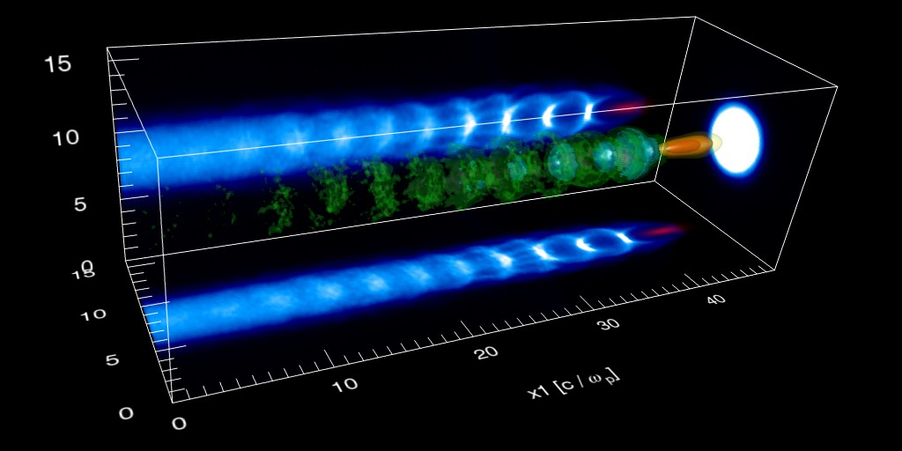

Figure 1. 3D afterburner simulation results.

3. Concluding Remarks
The field of accelerator physics has greatly benefited by the integration of codes and expertise that only a program like SciDAC can offer.

Prof. W.B.Mori
Dept. of Physics & Astronomy and Electrical Eng.
University of California Los Angeles
Los Angeles, CA 90095

Phone: 310-206-0372
E-mail: Mori@physics.ucla.edu

