Large-Scale Molecular Dynamics Simulations of Materials on Parallel Computers
Aiichiro Nakano,ª Timothy J. Campbell,^{a,b} Rajiv K. Kalia,ª Sanjay Kodiyalam,ª Shuji Ogata,^{a,c} Fuyuki Shimojo,^{a,d} Priya Vashishta,ª and Phillip Walshª
ªConcurrent Computing Laboratory for Materials Simulations
Department of Computer Science, Department of Physics & Astronomy
Louisiana State University, Baton Rouge, LA 70803, USA
^{b}Logicon Inc., Naval Oceanographic Office Major Shared Resource Center, Stennis Space Center, MS 39529, USA
^{c}Department of Applied Sciences, Yamaguchi University, Ube 755-8611, Japan
^{d}Faculty of Integrated Arts and Sciences, Hiroshima University, Higashi-Hiroshima739-8521, Japan
Abstract. Scalable space-time multiresolution algorithms implemented on massively parallel computers enable large-scale molecular dynamics simulations involving up to a billion atoms, which are applied to the study of nanosystems of great technological importance. These include sintering, structure, and mechanical properties of nanostructured ceramics and nanocomposites, structural transformation in semiconductor nanocrystals, nanoindentation, and oxidation of metallic nanoparticles.

Introduction
Advanced materials and devices with nanometer grain/feature sizes are being developed to achieve higher strength and toughness in ceramic materials and greater speeds in electronic devices. Below 100 nm, however, continuum description of materials and devices must be supplemented by atomistic descriptions [1]. Current state-of-the-art atomistic simulations involve 1 million to 1 billion atoms. Scalable multiresolution algorithms that enable these large-scale simulations are described. We discuss the application of these algorithms to molecular dynamics simulations of various nanosystems of great technological importance.

Scalable Atomistic Simulation Algorithms
We have developed a suite of scalable simulation, parallel-computing, and data-management algorithms [2,3]. Billion-atom molecular dynamics (MD) simulations have been demonstrated [4] on massively parallel computers using: i) space-time multiresolution algorithms; ii) wavelet-based adaptive load balancing in curvilinear computational space; and iii) spacefilling-curve-based adaptive data compression for scalable I/O.
We have also developed [4] scalable algorithms for quantum-mechanical (QM) calculations based on the density functional theory (DFT) [5], thereby demonstrating that 20,000-atom DFT-based QM calculations are feasible on massively parallel computers.

Space-time Multiresolution Molecular Dynamics
The MD approach obtains the phase-space trajectories (positions and velocities of all atoms at all time) by numerically integrating coupled ordinary differential equations. The dynamics is encoded in the interatomic potential energy, E_{MD}(r^{N}), which is a function of the positions of all N atoms, r^{N} = {r₁, r₂, ..., r_{N}}, in the system. In our many-body interatomic potential scheme, E_{MD}(r^{N}) is an analytic function of relative positions of atomic pairs and triplets [6].
We have developed highly efficient, multiresolution algorithms to carry out large-scale MD simulations on parallel computers. The most compute-intensive problem in an MD simulation is the O(N²) computation of the electrostatic energy for N charged atoms. We use the Fast Multipole Method (FMM) by Greengard and Rokhlin to reduce the complexity to O(N) by computing the electrostatic field recursively on an octree [7]. To extend the simulated time scales, we combine the FMM with a multiple time-scale (MTS) method that applies different force-updating schedules for different force components [8].
We have implemented this multiresolution molecular-dynamics (MRMD) algorithm on a number of parallel computers (1,280-processor IBM SP3, 1,088-processor Cray T3E, and 512-processor SGI Origin supercomputers as well as on our 166-node PC and 64-node Digital Alpha clusters) using spatial decomposition. The MRMD algorithm is highly scalable [4]: For a 1.02-billion-atom silica system, one MD step takes only 26.4 seconds on 1,024 Cray T3E processors. For this system, the parallel efficiency is 0.97.

Wavelet-based Adaptive Load Balancing
To overcome the load-imbalance problem associated with parallel computation of irregular atomic distribution, we have developed an adaptive load-balancing algorithm [9]. The “computational-space-decomposition” scheme is based on a novel idea that computational space shrinks where the workload density is high. The algorithm introduces a curvilinear coordinate transformation to partition workloads according to a uniform 3D-mesh topology in the curved computational space. This leads to curved partition boundaries in the physical Euclidean space. Subsequently simulated annealing is used to minimize load-imbalance and communication costs as a functional of the coordinate transformation. The multiresolution analysis based on wavelets allows compact representation of partition boundaries, leading to fast convergence of the minimization. The wavelet load balancer (WLB) achieves nearly perfect speed-up with negligible computational overhead.

Spacefilling-curve-based Adaptive Data Compression for Scalable I/O
For scalable input/output (I/O), we have designed a data compression algorithm, which uses octree indexing and sorts atoms accordingly on the resulting spacefilling curve [10]. By storing differences between successive atomic coordinates, the I/O requirement for the same error tolerance level reduces from O(NlogN) to O(N). An adaptive, variable-length encoding scheme is used to make the algorithm tolerant to outliers and optimized dynamically. The spacefilling-curve data compression (SCDC) algorithm achieves an order-of-magnitude improvement in the I/O performance for actual MD data with user-controlled error bounds.

Linear-scaling Quantum-Mechanical Algorithms
An atom consists of a nucleus and surrounding electrons, and quantum mechanics explicitly treats the electronic degrees-of-freedom. The DFT reduces the exponentially complex quantum problem to a self-consistent matrix eigenvalue problem, which can be solved with O(N_{wf}³) operations (N_{wf} is the number of independent wave functions, or electronic bands). The DFT can be formulated as a minimization of the energy, E_{QM}(r^{N}, ψ^{Nwf}), with respect to electron wave functions, ψ^{Nwf}(r) = {ψ₁(r), ψ₂(r), ..., ψ_{Nwf}(r)}, subject to orthonormalization constraints. Efficient parallel implementation of DFT is possible with real-space approaches based on higher-order finite differencing [11] and multigrid acceleration [12]. We include electron-ion interactions using norm-conserving pseudopotentials [13] and the exchange-correlation energy in a generalized gradient approximation [14]. For large systems (N_{wf} > 1,000), however, the O(N_{wf}³) orthonormalization becomes the bottleneck.
For scalable DFT calculations, linear-scaling algorithms are essential [15]. We have implemented [4] an O(N_{wf}) algorithm based on unconstrained minimization of a modified energy functional and a localized-basis approximation [16]. In the parallel linear-scaling DFT algorithm, the computation time scales as O(N_{wf}/P) on P processors, whereas the communication time scales as O((N_{wf}/P)^{2/3}). This is in contrast to the O(N_{wf}(N_{wf}/P)^{2/3}) communication in the conventional parallel real-space DFT algorithm. Global communication for calculating overlap integrals of wave functions (which scales as N_{wf}²logP in the conventional DFT algorithm) is unnecessary.
Our parallel linear-scaling DFT (LSDFT) algorithm is highly scalable: For a 22,528-atom GaAs system on 1,024 Cray T3E processors, the parallel efficiency is 0.96 [4]. Figure 1 shows the performance of our scalable MD and QM algorithms on 1,024 T3E processors.
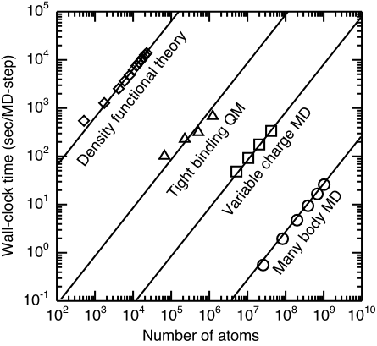
Figure 1. Computation time of MD and QM algorithms as a function of the number of atoms on 1,024 Cray T3E processors: (circles) classical MD based on many-body interatomic potentials; (squares) environment-dependant, variable-charge MD; (triangles) QM calculation based on the tight-binding method; and, (diamonds) self-consistent DFT-QM.

Large-Scale Atomistic Simulations of Nanostructured
The scalable simulation algorithms described in the previous section have been used to perform large-scale atomistic simulations of various nanosystems. In this section, we summarize some of our simulation results.

Sintering, Structure, and Mechanical Properties of Nanostructured Ceramics and Nanocomposites
Advanced structural ceramics are highly desirable materials for applications in extreme operating conditions. Light weight, elevated melting temperatures, high strengths, and wear- and corrosion-resistance make them very attractive for high-temperature and high-stress applications. The only serious drawback of ceramics is that they are brittle at low to moderately high temperatures. In recent years, a great deal of progress has been made in the synthesis of ceramics that are much more ductile than conventional coarse-grained materials [17]. These so called nanostructured materials are fabricated by in-situ consolidation of nanometer size clusters.
We have performed multimillion-atom MD simulations to investigate sintering, structure, and mechanical behavior of nanostructured Si₃N₄ [18-20], SiO₂ [21], and SiC [22].
Nanostructured Si₃N₄ is generated by consolidating a random cluster configuration [18-20]. Pair distribution functions and bond angle distributions reveal that interfacial regions in the consolidated nanophase Si₃N₄ are amorphous. Systems sintered at low pressures (1GPa) have percolating pores whose surface roughness exponents (0.46 and 0.86) are in excellent agreement with experiments. We also find that the dependence of elastic moduli on porosity and grain size in nanostructured Si₃N₄ can be understood in terms of a three-phase model for heterogeneous materials.
Nanocomposite materials often exhibit superior properties compared with conventional materials [23]. In recent years, large-scale MD simulations have played a central role in the investigation of dynamic fracture in such complex materials. For example, we are performing 1.5-billion-atom MD simulations to investigate fracture in a Si₃N₄ matrix reinforced with SiC fibers of linear dimension 0.3 μm. In order to simulate the effect of a glassy phase that lubricates the fiber-matrix interfaces, SiC fibers are coated with amorphous silica layer (Fig. 2). We are investigating the effect of interphase structure and residual stresses on the fracture toughness. Immersive and interactive visualization reveals a rich diversity of atomistic processes including fiber rupture, frictional pullout, and emission of molecular fragments, which must all be taken into account in the design of tough composites.
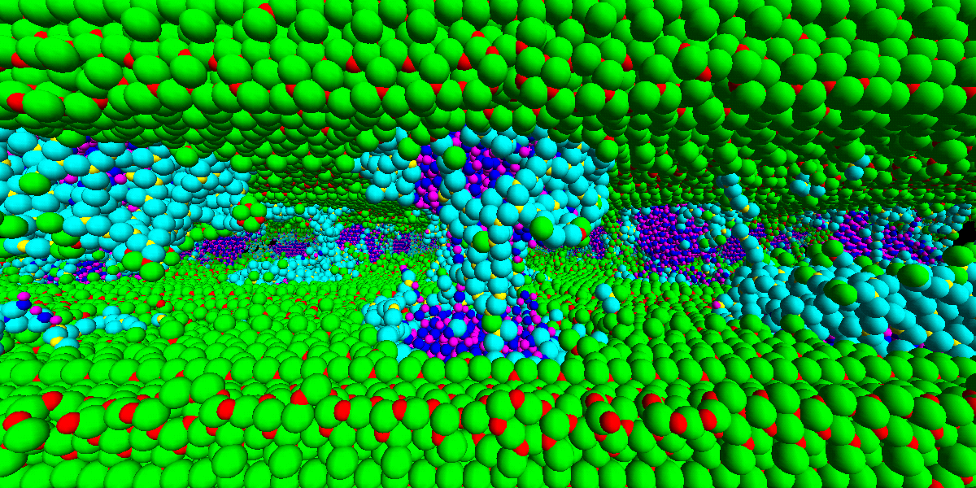
Figure 2. Atomistic model of fractured Si₃N₄ matrix reinforced with SiC fibers coated with amorphous silica. Small spheres represent silicon atoms, and large spheres represent nitrogen (green), carbon (magenta), and oxygen (cyan) atoms.

Structural Transformation in Semiconductor Nanocrystals
Despite numerous experimental studies, structural transformations in SiC and GaAs at high pressures are not well understood at the atomistic level. We have investigated the mechanisms of these transformations using MD simulations. In SiC, a reversible transformation between the four-fold coordinated zinc-blende structure and the six-fold coordinated rocksalt structure is found at a pressure of 100 GPa, in good agreement with experimental data [24]. We have found that the atomistic mechanism for the structural transformation is a cubic-to-monoclinic unit-cell transformation and a relative shift of Si and C sublattices in the [100] direction. This new transition path does not involve any bond breaking and it has a significantly lower activation energy compared with a previously proposed transformation mechanism.
We have also investigated pressure-induced structural transformations in GaAs nanocrystals of different sizes using MD simulations [25]. Semiconductor nanocrystals have numerous applications as optical devices and new synthetic paths to novel materials. It is found that the transformation from four-fold (zinc blende) to six-fold (rocksalt) coordination starts at the surfaces of nanocrystals and proceeds inwards with increasing pressure. Inequivalent nucleation of the rocksalt phase at different sites leads to an inhomogeneous deformation of the nanocrystal. For sufficiently large spherical nanocrystals, this gives rise to rocksalt structures of different orientations separated by grain boundaries (Fig. 3). The absence of such grain boundaries in a faceted nanocrystal of moderate size indicates sensitivity of the transformation to the initial nanocrystal shape. The pressure corresponding to the complete transformation increases with the nanocrystal radius and it approaches the bulk value for a spherical nanocrystal of ~ 5,000 atoms.
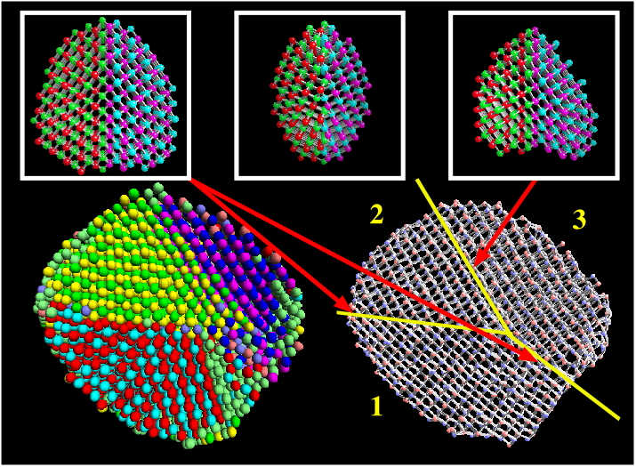
Figure 3. (Bottom left) Grain structure in a GaAs nanoparticle at a pressure of 22.5 GPa is color coded. Insets show grain boundary types.

Nanoindentation of Silicon Nitride
Nanoindentation testing is a unique probe of mechanical properties of materials. Typically, an atomic force microscope tip is modified to indent the surface of a very thin film. The resulting damage is used to rank the ability of the material to withstand plastic damage against that of other materials.
We have performed 10-million-atom MD simulations of nanoindentation of Si₃N₄ thin films [26]. The films were indented with a square-based pyramidal indentor to maximum depths of 8-9 nm. The hardness value calculated from the load-displacement curve at 300K (approximately 50 GPa) is reduced to approximately 90% of its value at 2000K. Figure 4 shows the local pressure distribution directly under the indenter for the fully loaded and fully unloaded configurations. These images have been used in conjunction with local bond-angle calculations to characterize a process of local amorphization under the indenter, which is arrested by either piling up of material along the indenter edges or by cracking under the indenter corners.
Figure 4. (a) A half-slice view of pressure in Si₃N₄ during nanoindentation. (b) An atomic view showing amorphization under the indentor and material pileup at the edges of the indentor. Red and yellow are silicon and nitrogen atoms, respectively.

Oxidation of Aluminum Nanoclusters
Oxidation plays a critical role in the performance and durability of various nanosystems. Oxidation of metallic nanoparticles offers an interesting possibility of synthesizing nanocomposites with both metallic and ceramic properties. We have performed the first successful MD simulation of oxidation of an Al nanoparticle (diameter 200Å, see Fig. 5) [27]. The MD simulations are based on an interaction scheme developed by Streitz and Mintmire, which can successfully describe a wide range of physical properties of both metallic and ceramic systems [28]. This scheme is capable of treating bond formation and bond breakage and changes in charge transfer as the atoms move and their local environments are altered [29,30].
The MD simulations provide detailed picture of the rapid evolution and culmination of the surface oxide thickness, local stresses, and atomic diffusivities. Clusters of OAl₄ coalesce to form a neutral, percolating tetrahedral network that impedes further intrusion of oxygen atoms into and of Al atoms out of the nanoparticle. As a result, a stable oxide scale is formed. Structural analysis reveals a 40Å thick amorphous oxide scale on the Al nanoparticle. The thickness and structure of the oxide scale are in accordance with experimental results.
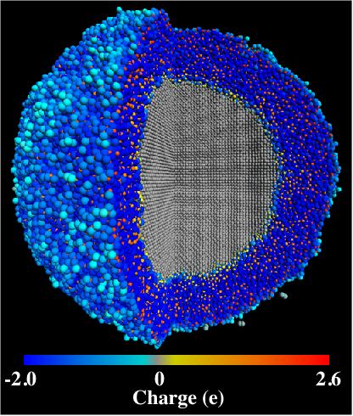
Figure 5. Snapshot of the Al nanocluster after 0.5 ns of simulation time. (A quarter of the system is cut out to show the aluminum/aluminum-oxide interface.) The larger spheres correspond to oxygen and smaller spheres to aluminum; color represents the charge on an atom.

Conclusion
Modern MD simulations of materials started in 1964, when Aneesur Rahman simulated 864 argon atoms on a CDC 3600 computer [31]. Assuming a simple exponential growth, the number of atoms that can be simulated in a classical MD simulation has doubled every 21 months to reach 1.02 billion atoms [4]. Similarly, the number of atoms in a DFT-based MD simulation (started by Roberto Car and Michele Parrinello in 1985 for 8 Si atoms [32]) has doubled every 16 months to reach 22,500 atoms [4]. Petaflop computers anticipated to be built in the next ten years will help maintain the growth rates in these “MD Moore’s Laws” [4], and enable trillion-atom MD and 10-million-atom DFT calculations, see Fig. 6. (Our latest benchmark on a 1,280-processor IBM SP3 including 8.1-billion-atom MD on silica and 140,000-atom DFT on GaAs indicates an even faster growth rate.)
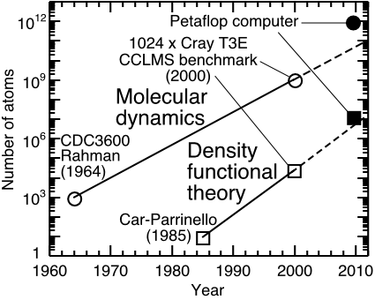
Figure 6. “Moore’s law” in molecular dynamics.
In future, metacomputing on a Grid of geographically distributed supercomputers, mass storage, and virtual environment connected via high-speed networks will revolutionize computational research by enabling i) very large-scale computations that are beyond the power of a single supercomputer, and ii) collaborative, hybrid computations that integrate distributed, multiple expertise [33]. A multidisciplinary application that will soon require Grid-level computing is emerging at the forefront of computational science and engineering. We have recently developed such a multiscale simulation approach which seamlessly combines continuum mechanics based on the finite-element (FE) method, MD simulations to describe atomistic processes, and QM calculations based on the DFT to handle breakage and formation of atomic bonds [34].

Acknowledgments
This work is partially supported by AFOSR, DOE, NASA, NSF, and USC-LSU MURI. A few million-atom simulations were performed using in-house parallel computers at the Concurrent Computing Laboratory for Materials Simulations at Louisiana State University. 10 million to billion atom simulations were performed using parallel computers at Department of Defense’s Major Shared Resource Centers under a DoD Challenge project.

References
1. Pechenik, A., Kalia, R. K., and Vashishta, P., Computer-Aided Design of High-Temperature Materials, Oxford: Oxford Univ. Press, 1999.
2. Nakano, A., Kalia, R. K., and Vashishta, P., Comput. Sci. Eng. 1 (5), 39-47 (1999).
3. Kalia, R. K., Campbell, T. J., Chatterjee, A., Nakano, A., Vashishta, P., and Ogata, S., Comput. Phys. Commun. 128, 245-259 (2000).
4. Shimojo, F., Campbell, T. J., Kalia, R. K., Nakano, A., Vashishta, P., Ogata, S., and Tsuruta, K., Future Generation Comput. Sys. 17, 279-291 (2000).
5. Hoenberg, P., and Kohn, W., Phys. Rev. 136, B864-B871 (1964).
6. Vashishta, P., Kalia, R. K., Nakano, A., Li, W., and Ebbsjö, I., in Amorphous Insulators and Semiconductors, edited by M. F. Thorpe and M. I. Mitkova, Dordrooht: Kluwer, 1996, pp. 151-213.
7. Greengard, L., and Rokhlin, V., J. Comput. Phys. 73, 325-348 (1987).
8. Tuckeman, M. E., Berne, B. J., and Martyna, G. J., J. Chem. Phys. 97, 1990-2001 (1992).
9. Nakano, A., Concurrency: Practice and Experience 11, 343-353 (1999).
10. Omeltchenko, A., Campbell, T. J., Kalia, R. K., Liu, X., Nakano, A., and Vashishta, P., Comput. Phys. Commun. 131, 78-85 (2000).
11. Chelikowsky, J. R., Saad, Y., Ögüt, S., Vasiliev, I., and Stathopoulos, A., Phys. Stat. Sol. (b) 217, 173-195 (2000).
12. Fattebert, J.-L., and Bernholc, J., Phys. Rev. B 62, 1713-1722 (2000).
13. Troullier, N., and Martins, J. L., Phys. Rev. B 43, 1993-2006 (1991).
14. Perdew, J. P., Burke, K., and Ernzerhof, M., Phys. Rev. Lett. 77, 3865-3868 (1996).
15. Goedecker, S., Rev. Mod. Phys. 71, 1085-1123 (1999).
16. Mauri, F., and Galli, G., Phys. Rev. B 50, 4316-4326 (1994).
17. Siegel, R. W., Scientific American, Dec. 1996, pp. 74-79.
18. Kalia, R. K., Nakano, A., Tsuruta, K., and Vashishta, P., Phys. Rev. Lett. 78, 689-672 (1997).
19. Kalia, R. K., Nakano, A., Omeltchenko, A., Tsuruta, K., and Vashishta, P., Phys. Rev. Lett. 78, 2144-2147 (1997).
20. Tsuruta, K., Nakano, A., Kalia, R. K., and Vashishta, P., J. Am. Ceram. Soc. 81, 433-436 (1998).
21. Campbell, T. J., Kalia, R. K., Nakano, A., Shimojo, F., Ogata, S., and Vashishta, P., Phys. Rev. Lett. 82, 4018-4021 (1999).
22. Chatterjee, A., Kalia, R. K., Loong, C.-K., Nakano, A., Omeltchenko, A., Tsuruta, K., Vashishta, P., Winterer, M., and Klein, S., Appl. Phys. Lett. 77, 1132-1134 (2000).
23. Evans, A. G., J. Am. Ceram. Soc. 73, 187-206 (1990).
24. Shimojo, F., Ebbsjö, I., Kalia, R. K., Nakano, A., Rino, J. P., and Vashishta, P., Phys. Rev. Lett. 84, 3338-3341 (2000).
25. Kodiyalam, S., Kalia, R. K., Kikuchi, H., Nakano, A., Shimojo, F., and Vashishta, P., Phys. Rev. Lett. 86, 55-58 (2001).
26. Walsh, P., Kalia, R. K., Nakano, A., Vashishta, P., and Saini, S., Appl. Phys. Lett. 77, 4332-4334 (2000).
27. Campbell, T. J., Kalia, R. K., Nakano, A., Vashishta, P., Ogata, S., and Rodgers, S., Phys. Rev. Lett. 82, 4866-4869 (1999).
28. Streitz, F. H., and Mintmire, J. W., Phys. Rev. B 50, 11996-12003 (1994).
29. Ogata, S., Iyetomi, H., Tsuruta, K., Shimojo, F., Kalia, R. K., Nakano, A., and Vashishta, P., J. Appl. Phys. 86, 3036-3041 (1999).
30. Ogata, S., Iyetomi, H., Tsuruta, K., Shimojo, F., Nakano, A., Kalia, R. K., and Vashishta, P., J. Appl. Phys. 88, 6011-6015 (2000).
31. Rahman, A., Phys. Rev. 136, A405-A411 (1964).
32. Car, R., and Parrinello, M., Phys. Rev. Lett. 55, 2471-2474 (1985).
33. Foster, I., and Kesselman, C., The Grid: Blueprint for a New Computing Infrastructure, San Francisco: Morgan Kaufmann, 1999.
34. Ogata, S., Lidorikis, E., Shimojo, F., Nakano, A., Vashishta, P., and Kalia, R. K., Comput. Phys. Commun., to be published.

