
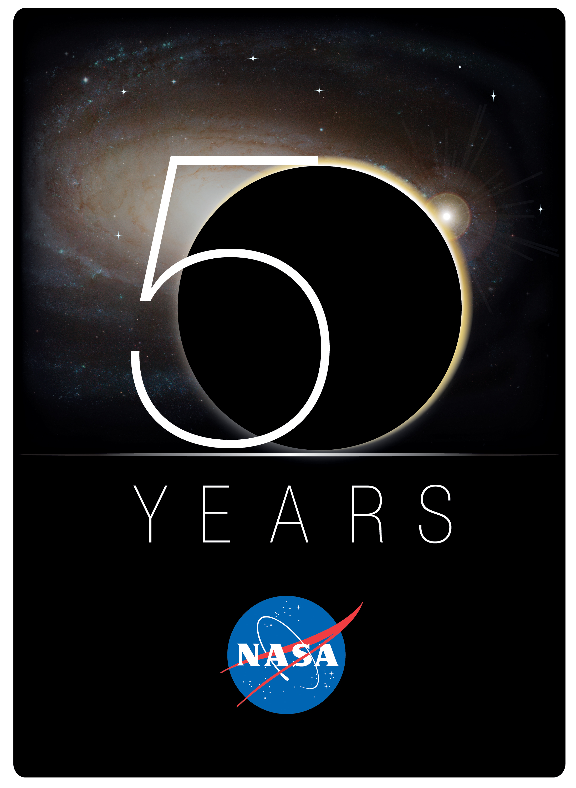

Suits: Step into the Void
An Educator Guide
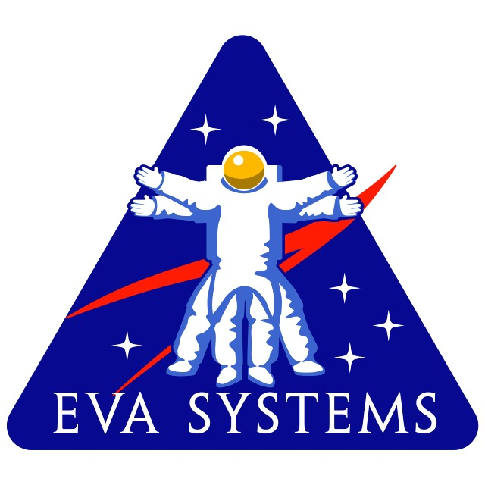

Discover NASA and You
A Digital Learning Network Experience

Suits: Step into the Void
A Digital Learning Network Experience



This Program is Designed To Share

NASA’s Space Exploration Program

This publication is in the public domain and is not protected by copyright. Permission is not required for duplication.

 Table of Contents

Digital Learning Network Expedition 4

Expedition Overview 5
Grade Level
Focus Question
Instructional Objectives
Benefits

Sequence of Events 6

Education Standards 7

Pre-Conference Requirements .12
Pre-Assessment
Pre-Conference Assessment Questions
Answers to Questions

Expedition Videoconference Guidelines .15
Audience Guidelines
Teacher Event Checklist

Expedition Videoconference Outline .16

Additional Classroom Activity .17

Post Conference .18
Post-conference Assessment Questions

NASA Education Evaluation Information System .19

Certificate of Completion .20

Vocabulary .21

Resources/Background Information .23

Contributors and Developers .24
Digital Learning Network (DLN) Expedition

A DLN Expedition is a one time connection that allows students to experience NASA first-hand. Each expedition features an integrated educational package of grade-appropriate instruction and activities centered around a 50 minute videoconference. Students will actively learn with a NASA education specialist or a NASA Subject Matter Expert.

The sequence for a DLN Expedition include:
- Students review vocabulary words and complete pre-classroom activities.
- A one time DLN videoconference connection with in-formal student participation.
- Students completing the post-activity assessment and online evaluation for teacher and students.

Expedition Overview

Grade Level(s) K-4

Focus Question
The National Aeronautics and Space Administration, or NASA, has accomplished many milestones which have broadened human kind’s knowledge of outer space. Perhaps the most visual symbol of space exploration is the astronaut conducting a space walk. What is a spacesuit and how does it assist in extravehicular activities (EVAs)? What are some math considerations of EVAs? How does NASA expect to carry out future EVAs?

Instructional Objectives
Students will first understand why humans must wear pressurized suits when going into outer space. The history of space suits will be traced from the 1950’s to 10-15 years into the future. Most focus will lie upon the current space suit, known as the Extravehicular Mobility Unit (EMU), and the development of the next generation of space suits. The training and practice that is involved for an EVA will also be discussed. During the program, students will be exposed to pictures, animations, historical evidence, props, and thought provoking questions. There will also be grade suited math extensions that will be introduced and worked out during the program. Please give students access to paper and pencil so they may carry out simple calculations!

Benefits
This program is designed to be cross curricular with STEM (Science, Technology, Engineering, and Math) subject matter. History will also be an important feature of this module. This program will heighten the public’s interest in NASA in general, while focusing student’s awareness on NASA’s successful and historical record of space walks. Excitement will also be generated by discussing what future space walks will look like and how students today will be the ones carrying them out.

SEQUENCE OF EVENTS

Pre-Conference Requirements
A pre-assessment tool is available to determine the students’ level of understanding prior to the videoconference. Suggested answers are included. This tool can be found on pg 12.

Expedition Videoconference
The Suits: Step Into the Void module is intended to be an all encompassing lesson on space suits with special attention paid to extravehicular activities. It can be suited to a K-12th grade audience. As NASA is celebrating its 50th anniversary in 2008, this lesson will serve to show students how using modern technology, humans will use space suits to further our understanding of the cosmos now, and in the years ahead. This module contains various teaching methods that will aim to increase interest in human space exploration.

The DLN’s hope is to inspire the next generation in becoming more involved with science and technology. By demonstrating all the great things NASA has accomplished in the past, and what NASA will achieve in the future, we hope to realize this goal.

Post-Conference Requirements
A post-assessment tool is available to determine changes in student levels of understanding. This tool can be found on pg 24.

NASA Education Evaluation Information System (NEEIS) Feedback Forms
Educator and student feedback forms are available online for all DLN events.
This link can be found on pg 25.

National Standards

National Standards

National Science Education Standards (NSES)
Unifying Concepts- Systems, order, and organization; Evidence, models, and explanation; Change, constancy, and measurement; Form and function

International Technology Education Association (ITEA)
Standard 1 –Characteristics and Scope of Technology
Standard 17 –Information and Communication Technologies

National Arts and Education Network (NAEN)
Visual Arts Content Standard 1- applying media, techniques, and processes
Visual Arts Content Standard 2- knowledge of structures and functions
Visual Arts Content Standard 3- choosing subject matter, symbols, and ideas
Visual Arts Content Standard 4- visual arts in relation to history and cultures

National Council of Teachers of English (NCTE)
Standard 3- Comprehend, interpret, evaluate, and appreciate texts
Standard 4- Adjust use of spoken, written, and visual language to communicate effectively
Standard 5- Employ a wide range of strategies as they write
Standard 12- Use spoken, written, and visual language to accomplish individual purposes

National Science Education Standards (NSES) (from www.nap.edu )

Science (K-12) | Spacesuit put together | Layered Astronaut
K-12 Content Standard: Unifying Concepts
Systems, order, and organization |  | X
Evidence, models and explanation | X | X
Change, constancy, and measurement |  | X
Form and Function |  | X

K-12 Content Standard – Unifying Concepts

Systems, order, and organization (K-12) - Scientists and students learn to define small portions for the convenience of investigation. The units of investigation can be referred to as "systems." A system is an organized group of related objects or components that form a whole. Systems can consist, for example, of organisms, machines, fundamental particles, galaxies, ideas, numbers, transportation, and education. Systems have boundaries, components, resources flow (input and output), and feedback

Evidence, models, and explanation (K-12) – As students develop and...understand more science concepts and processes, their explanations should become more sophisticated...frequently reflecting a rich scientific knowledge base, evidence of logic, higher levels of analysis, and greater tolerance of criticism and uncertainty.

Change, constancy, and measurement (K-12) – Changes in systems can be quantified. Evidence for interactions and subsequent change and the formulation of scientific explanations are often clarified through quantitative distinctions--measurement. Mathematics is essential for accurately measuring change.

Form and Function (K-12) – Form and function are complementary aspects of objects, organisms, and systems in the natural and designed world. The form or shape of an object or system is frequently related to use, operation, or function. Function frequently relies on form. Understanding of form and function applies to different levels of organization. Students should be able to explain function by referring to form and explain form by referring to function.

International Technology Education Association (ITEA) (from www.iteaconnect.org)

Technology (K-4) | DLN Event
Standard 1: The Characteristics and Scope of Technology
(K-2) B: All people use tools and techniques to help them do things | X
(3-5) D: Tools, materials, and skills are used to make things and carry out tasks | X
Standard 17: Information and Communication Technologies
(K-2) B: Technology enables people to communicate by sending and receiving information over a  distance. | X
(3-5) F: Communication technology is the transfer of messages among people and/or machines over distances through the use of technology | X

Standard 1 – Students will develop an understanding of the characteristics and scope of technology.
(K-2) All people use tools and techniques to help them do things –Students should be actively engaged in identifying the differences between the natural world and the human-made world, in addition to learning about some of the tools and techniques people use to help them do things.
(3-5) Tools, materials, and skills are used to make things and carry out tasks – When students observe how various things are made, grown, or used, they should begin to see that different processes and techniques are used.

Standard 17 – Students will develop an understanding of and be able to select and use information and communication technologies
(K-2) Technology enables people to communicate by sending and receiving information over a distance –Information and communication technologies use a specialized vocabulary that is important to understand, including words, symbols, and pictures
(3-5) Communication technology is the transfer of messages among people and/or machines over distances through the use of technology – Students at this grade level should be given various opportunities to use information and communication tools in order to experience firsthand how technology can be used to enhance the communication process.

National Arts and Education Network (NAEN) (from http://artsedge.kennedy-center.org/ )

Fine Arts (K-4) | Spacesuit put together | Layered Astronaut
Visual Arts Content Standard 1
applying media, techniques, and processes | X | X
Visual Arts Content Standard 2
knowledge of structures and functions | X | X
Visual Arts Content Standard 3
choosing subject matter, symbols, and ideas | X | X
Visual Arts Content Standard 4
visual arts in relation to history and cultures | X | X

Standard 1-Understanding and applying media, techniques, and processes
All K-4 benchmarks

Standard 2-Using knowledge of structures and functions
(K-4)Students know the differences among visual characteristics and purposes of art in order to convey ideas
(K-4) Students use visual structures and functions of art to communicate ideas

Standard 3-Choosing and evaluating a range of subject matter, symbols, and ideas
All K-4 benchmarks

Standard 4-Understanding the visual arts in relation to history and cultures
- (K-4) Students know that the visual arts have both a history and specific relationships to various cultures
(K-4) Students demonstrate how history, culture, and the visual arts can influence each other in making and studying works of art

National Council of Teachers of English (NCTE) (from www.ncte.org)

Language Arts (K-12) | Spacesuit put together | Layered Astronaut
Standard 3 (K-12) | X
Standard 4 (K-12) | X
Standard 5 (K-12) | X
Standard 12 (K-12) | X | X

Standard 3- (K-12) - Students apply a wide range of strategies to comprehend, interpret, evaluate, and appreciate texts. They draw on their prior experience, their interactions with other readers and writers, their knowledge of word meaning and of other texts, their word identification strategies, and their understanding of textual features (e.g., sound-letter correspondence, sentence structure, context, graphics).

Standard 4- (K-12) - Students adjust their use of spoken, written, and visual language (e.g., conventions,
style, vocabulary) to communicate effectively with a variety of audiences and for different purposes.

Standard 5- (K-12) - Students employ a wide range of strategies as they write and use different writing process elements appropriately to communicate with different audiences for a variety of purposes.

Standard 12- (K-12) - Students use spoken, written, and visual language to accomplish their own purposes (e.g., for learning, enjoyment, persuasion, and the exchange of information).

Texas Essential Knowledge and Skills (TEKS) (http://www.tea.state.tx.us/teks/)

Science (3-4) | Spacesuit put together | Layered Astronaut
§112.5 Grade 3 |  | b5B
§112.6 Grade 4 |  | b5B

Art (K-4) | Spacesuit put together | Layered Astronaut
§117.2 Kindergarten | b2A-C
§117.5 Grade 1 | b2A-C
§117.8 Grade 2 | b2A-C
§117.11 Grade 3 |  | b2A-C
§117.14 Grade 4 |  | b2A-C

Language Arts (K-4) | Spacesuit put together | Layered Astronaut
§117.2 Kindergarten | b14A-E,b15A-F
§117.5 Grade 1 | b17A-G,b18A-F
§117.8 Grade 2 | b14A-D,b15A-D
§117.11 Grade 3 |  | b12G
§117.14 Grade 4 |  | b13G

Pre-Conference Requirements

Pre-Assessment
A week before the event, please give students this pre-conference assessment. It will gauge what your students already know about space suits and EVAs. Shortly after the conference, give them the same questionnaire in order to determine student comprehension after participating in Suits: Step into the Void.

Pre-Conference Assessment Questions

- What must be provided to humans in order for them to survive in outer space?

- What are some of the goals of Program Constellation?

- Who was the first American to conduct a spacewalk?

- How might NASA train astronauts for a spacewalk?

- What do objects weigh in outer space?

- Why must mountain climbers sometime wear oxygen masks?

- What is a vacuum?

- What conditions are found in outer space?
Answers to Pre and Post Assessment Questions:

- What must be provided to humans in order for them to survive in outer space?

All of the requirements of life must be provided to humans in order to survive in outer space. This includes oxygen, atmospheric pressure, a suitable temperature, food, and water. Humans can adapt to microgravity however.

- What are some of the goals of Program Constellation?

To establish a permanent human presence on the Moon, and then to travel to Mars and beyond.

- Who was the first American to conduct a spacewalk?

Ed White was the first American to conduct a space walk. It happened during Gemini 4 on June 3rd, 1965

- How might NASA train astronauts for a spacewalk?

Currently the most effective way to train for space walks is to submerge astronauts inside their space suit under water. By attaching a certain amount of weights to a space suit, the astronaut inside will become neutrally buoyant (neither sinking nor floating). Astronauts then closely experience what microgravity is like in outer space. NASA uses a facility called the Neutral Buoyancy Laboratory (NBL) for practicing space walks. It is an enclosed body of water that is 202 by 102 feet wide and 40 feet deep.

- What do objects weigh in outer space?

Objects in space weigh essentially nothing. This is because in orbit, objects are in a state of “free fall”, or constantly falling around the Earth.

- Why must mountain climbers sometime wear oxygen masks?

The Earth’s atmosphere gets thinner as altitude increase. This means that there is less oxygen for humans to breathe. Mountains that are higher than 26,250 feet may have a 1/3 of the oxygen that is found at sea level. Mountain climbers attempting to scale very high mountains must sometimes breathe pure oxygen through a mask to help their body deal with the oxygen deprivation.

- What is a vacuum?

A vacuum is a volume of space that is void of most of everything. Basically, it is anyplace that is empty of “air”. A vacuum chamber is able to “suck” out all of the air inside a glass chamber to simulate what the conditions are in outer space.

- What conditions are found in outer space?

Outer space is a vacuum. There is no air, atmospheric pressure, and reduced gravity in outer space. In low Earth orbit, temperatures can vary widely (-250- 250F) and there is an increase in solar radiation and micrometeorites. Outer space can also be described as a “vacuum”.

Expedition Videoconference Guidelines

Audience Guidelines
Teachers, please review the following points with your students prior to the event:
- Videoconference is a two-way event. Students and NASA presenters can see and hear one another.
- Students should speak in a loud, clear voice. If a microphone is placed in a central location instruct the students to walk up and speak into the microphone.
- Teacher(s) should moderate students’ questions and answers.
- Students are expected to be respectful to the presenter. A quiet atmosphere should be maintained at all times to enhance the experience for all involved.
- Students are sometimes initially shy about responding to questions during a distance learning session. Explain to the students that this is an interactive medium and we encourage questions.

Teacher Event Checklist

Date  Completed | Pre-Conference Requirements
 | - Print a copy of the module.
 | - Have the students complete the pre-assessment.
 | - Email questions for the presenter. This will help focus the presentation on the groups’ specific needs.
 | - Review the audience guidelines.
 | Day of the Conference Requirements
 | - The students are encouraged to ask the NASA presenter qualifying questions about the expedition.
 | - Follow up questions can be continued after the conference through e-mail.
 | Post - Conference Requirements
 | - Students are administered the post-assessment to demonstrate their new knowledge of the subject.
 | - Teacher(s) and students fill out the event feedback online (NEEIS).

Expedition Videoconference Outline

Summary of Suits: Step into the Void Videoconference
Perhaps the most iconic image of space exploration is the space-walking astronaut. Outer space is absent of all that we are used to here on Earth. In order for humans to explore this environment, they must be protected from against the extremes of outer space. The space suit serves this purpose and extends the human reach beyond Earth.

After successfully putting men into orbit inside the Mercury space capsule, NASA pushed the envelope by conducting the first space walk during Program Gemini. Following Ed White’s historic EVA, space walking technology advanced to the point that in 1969, humans walked on the Moon.

After the remarkable manned lunar explorations of the 60’s and 70’s, NASA saw permanent space stations and the space shuttle come to prominence. This led to the development of the current space suit, known as the Extra Mobility Unit or EMU. The EMU in particular is the culmination of cutting edge technology and its development has led to spin-offs found in the home and industry.

NASA’s current Space Exploration Program calls for humans to return to the Moon by 2020 and establish a permanent base in preparation for future missions to Mars and beyond. This ambitious goal will be accomplished through a program called Constellation. Already the development of the next generation of space suits has begun. These suits will be referred to as the Constellation Space Suit System (CSSS).

General Outline for Video Conference (50 minutes)
- Welcome
- Introduction
- What it is like on Earth and in outer space
- The need for a space suit
- Humans in space (1960-1981)
- The EMU and the EVA
- Training for an EVA
- Future space suits and EVAs
- Careers/Website
- Q&A/Good-Bye

Additional Classroom Activity

K-4th
Space Food

Materials
- Instant chocolate pudding (several packages)
- Plastic self-sealing bags (sandwich size)
- Water
- Spoons

Procedure
Show how space foods are prepared in space by making chocolate pudding. Add about one quarter of a box of instant pudding mix to a plastic bag. Add water to the bag according to directions. Seal the bag and begin kneading it until it is ready to eat. This activity shows how astronauts prepare dry mix, and freeze-dried foods in space. Preparing the food inside plastic bags prevents water from escaping inside the Space Shuttle cabin. Other kinds of food used in space include fresh fruits, dried fruits, nuts, and pre-cooked foods in foil/plastic pouches.

Post-Conference

Online Post-Assessment
After the event, students will need to take this post-conference assessment. (These questions are the same questions used in the pre-assessment.) This short assessment will help you measure student learning and help us identify any changes that need to be made in future programs.

Post-Conference Assessment Questions
- What must be provided to humans in order for them to survive in outer space?

- What are some of the goals of Program Constellation?

- Who was the first American to conduct a spacewalk?

- How might NASA train astronauts for a spacewalk?

- What do objects weigh in outer space?

- Why must mountain climbers sometime wear oxygen masks?

- What is a vacuum?

- What conditions are found in outer space?

NASA Education Evaluation Information System (NEEIS)

Please complete an online evaluation form to provide feedback on the NASA Expedition.

Feedback from you and a few of your students would be appreciated.

http://dln.nasa.gov/dln/content/feedback/

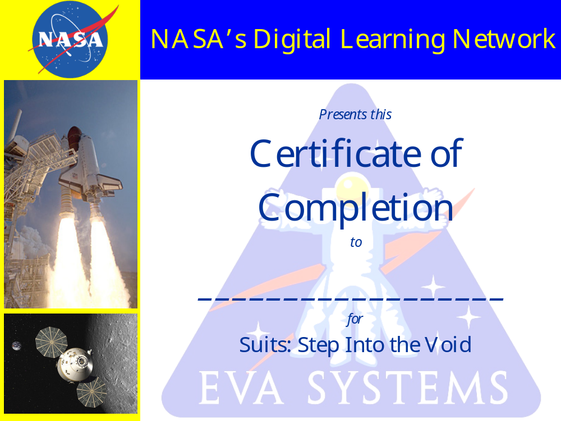

Vocabulary
*Some of these terms will be mentioned during this module. Use this list as a reference for student knowledge.
Vocabulary Terms
- Extra Vehicular Activity (EVA) - Operations that are performed outside of a spacecraft. The astronaut must wear a pressurized suit in order to be protected from the vacuum of space. Also referred to as a spacewalk.
- Ed White- the first American to conduct a space walk during Gemini 4 in 1966.
- Extravehicular Mobility Unit (EMU) - NASA’s current space suit. It is used when astronauts conduct EVAs during Space Shuttle or International Space Station missions.
- Constellation Space Suit System (CSSS) – the next generation space suit that will be used for microgravity, and lunar EVAs.
- Program Constellation – The program responsible for how NASA plans to return to the moon and travel elsewhere in the solar system.
- Atmospheric Pressure- Relates to the amount of air that is found on Earth at different levels. As the altitude increases, there are fewer air molecules and thus a lower atmospheric pressure.
- Microgravity- A very small amount of gravity (1/1,000,000 of gravity). This condition occurs when an object is in a state of free-fall. When the Space Shuttle or ISS are in orbit around the Earth, they are constantly “falling” around the Earth and experience microgravity or “weightlessness”.
- Micrometeorites- Very tiny particles of rock that travel at very high speeds in outer space. Space suits must provide protection from these micometeorites.
- Space Debris- Various metal or plastic pieces that have been discarded by humans in outer space. Space debris can be very small or very large. There is a considerable amount of space debris in outer space and NASA has the technology to track most of it.
- Solar radiation- The sub-atomic particles that are continually given off by the sun. The Earth’s magnetosphere and atmosphere acts as a protective shield from these particles. When humans explore outer space, they must monitor their exposure to solar radiation.
- Vacuum- A volume of space that is empty of matter (e.g. no air, or atmospheric pressure). Outer space is considered a vacuum.
- Space Suit- A pressurized garment that an astronaut wears when outside a spacecraft. It is basically a miniature spacecraft that provides all the requirements of life (air, pressure, and suitable temperature).
- Neil Armstrong- The first person to step foot on the Moon. The space suit he wore was called the A7L and was specially designed to be self contained so astronauts could freely explore the Moon.
- Neutral Buoyancy Laboratory- A large body of water that contains 6.2 million gallons of water. It provides a simulation of microgravity when astronauts become neutrally buoyant underwater by attaching weights to their space suit.
- Desert RATS- NASA conducted EVA field trials that are tested on Earth landscapes that closely simulate conditions found on the Moon or Mars. Suit and rover prototypes are evaluated for their effectiveness and usefulness for extra-terrestrial exploration.
- NEEMO- NASA extreme Environment Mission Operations, an underwater habitat that is located near Key Largo, FL. “Aquanauts” remain aboard NEEMO for several days in order to simulate the experience of outer space habitation. EVAs are also practiced on the surface of the ocean to simulate space walks.
- Spin-off- Technology that was first created by NASA for space exploration that has now found its way in different forms into the common home and in industry.
- Reduced Gravity Plane- A NASA airplane that flies consecutive parabola’s (or hills). As the plane approaches the crest of a hill, occupants inside will experience microgravity for 25-30 seconds.

(ARL) Acronym Reference List
ACES- Advanced Crew Escape Suit
CSSS- Constellation Space Suit System
DCM- Display and Control Module
Desert RATS- Desert Research and Technology Studies
ECLS- Environmental Control and Life Support
EMU- Extravehicular Mobility Unit
EVA- Extravehicular Activity
HUT- Hard Upper Torso
LCVG- Liquid Cooling and Ventilation Garment
LTA- Lower Torso Assembly
MAG- Maximum Absorption Garment
MMU- Manned Maneuvering Unit
NBL- Neutral Buoyancy Laboratory
NEEMO- NASA Extreme Environment Mission Operations
PGT- Pistol Grip Tool
PLSS- Primary Life Support System
SAFER- Simplified Aid for Extravehicular Activity Rescue
SAW- Solar Array Wing
STS- Shuttle Transport System

Resources

NASA
www.nasa.gov

NASA 50th anniversary
http://www.nasa.gov/50th/home/index.html

NASA Constellation Project
www.nasa.gov/constellation

ILC Dover- history of space suits
http://history.nasa.gov/spacesuits.pdf

Suited for Space Walking

http://www.nasa.gov/audience/foreducators/topnav/materials/listbytype/Suited_for_Spacewalking_Educator_Guide.html

Personal conversation with Heather Paul, space suit engineer- 7/2008

Personal conversation with Robert Durkin, NBL facilitator- 7/2008

Background Information

Websites:

Space Suit Evolution from Custom Tailored to Off-the-Rack
http://history.nasa.gov/spacesuits.pdf

Dress Me for Space (K-4)
http://www.nasa.gov/audience/forstudents/k-4/playandlearn/dress-me-for-space.html

Contributors and Developers

Ryan Schaffer Johnson Space Center Project Lead/Education Specialist
Michelle Leggett Johnson Space Center DLN Supervisor
Robin Hart Johnson Space Center Administrator
Don Caminati Johnson Space Center Technology Specialist
Erin McKinley Johnson Space Center Education Specialist
Nathan Lang Johnson Space Center Education Specialist
Michael Hare Johnson Space Center Education/Production Specialist
Sherry Bartkowicz Johnson Space Center Education Intern

Special Thanks to the following people:

Heather Paul- Space suit engineer

Mallory Jennings- NASA Coop

Richard Durkin- NBL facilitator

Kelly McCormick- Teaching from Space administrator

Rene Flores- Education specialist, Teaching from Space

Linus Guillory- Education specialist, Teaching from Space

