II.C. Position and Momentum
We now begin our exploration of the non-destructive measurement of position and momentum, using the deposited ionization energy (Section 6) and limited in accuracy by the multiple scattering in the medium (Section 5). The goal is to measure the vector momentum which we indicated in Figure I.1 as part of the general task of the detector designer.
To that end we first look at particle motion in magnetic fields in Section 7. Since the helical trajectory depends on the magnitude of the momentum, we deploy gaseous detectors in Section 8, which use localized ionization deposition to locate points along the trajectory. Since the charge is collected on electrodes, we also must explore motion in electric fields. Finally, if greater spatial accuracy is needed, silicon detectors are employed, as explicated in Section 9. The points are fit to a hypothesis regarding the trajectory. The simplest example of a straight line is treated in the Appendices. A more complex helical path hypothesis yields best-fit estimates for the vector momentum and their errors of the particles leaving the track points.

7. Magnetic Fields
“Of Newton with his prism---voyaging through strange seas of thought, alone.”....William Wordsworth
“The wheel is come full circle.”....Shakespeare, ‘King Lear’
The use of magnetic fields in particle detectors has several aspects. As we will discuss, magnetic fields are used to prepare the “beams” that impinge on experiments. In addition, the creation of a large volume with a magnetic field and associated detectors allows us to measure the trajectory of charged particles in the field (the jargon is “tracking”) by detecting the ionization caused by the particle passage. Tracking allows us to measure the position and momentum of charged particles (see Section 13 for some examples of tracking in large detectors).

7.1 Solenoidal Fields
We begin by considering electromagnets in “colliding beam” applications, i.e. where 2 oppositely directed beams collide head on. The most common topology for such an experimental electromagnet is the solenoid. Consider a solenoid coil of N total turns, each carrying a current I, with full length L and radius a. The magnetic field in CGS units is, at a point along the axis where the ends subtend angles 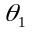 and 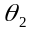, defining n as the turns/length = N/L.
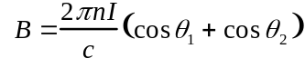 (7.1)
The result at the centerline of a very long solenoid approaches the elementary result which follows from Amperes law.
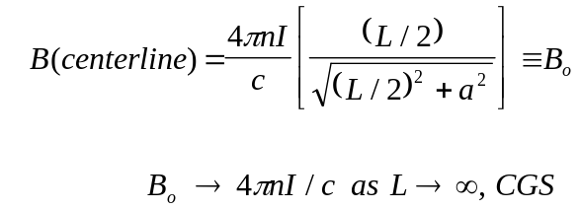 (7.2)
In MKS units the result for the magnet center line is (see Table g3.1, 1/c 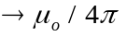);
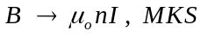 (7.3)
In the center of an infinitely long solenoid the field depends only on the current carried by each turn I and the turns per unit length n. For reference purposes, 1 Tesla is 10 kG or 1 N/(Am²). The electromagnetic constants that are needed for all our calculations can be found either in Table 3.1 or in Table 1.1.
For example, to produce a 20 kG field with 1 turn per centimeter, n, requires 16 kA of current I. Thus a copper bus (water-cooled) of 1 centimeter diameter at 16 kA produces a 2 Tesla solenoidal field. The energies stored in such magnets may be enormous, 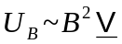. Typical experiments in high-energy physics or magnetic fusion devices now utilize magnets with stored energies in the 10-100 MJ range.

7.2 Dipole Fields - Fringe Fields
We can also look at a typical “fixed target” topology for the field i.e. where a beam is directed to a target at rest in the laboratory. A “dipole” magnet is illustrated schematically in Fig.7.1a. The iron “return yoke” shapes the field produced by the coils and produces a roughly constant field in the air gap. Given that the physical magnet length is ~ L, the field has a finite spatial extent. There is a "fringe field” due to the constraints imposed by Maxwell’s equations. For example, in the absence of sources, if the field ramps down (from magnitude B₀) in the z direction over a characteristic distance, , then a component B_{z} is induced. Since all fields are finite in extent, a “fringe field” is guaranteed to exist.
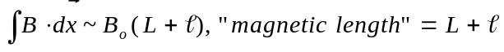 (7.4)
Outside the sources, the curl of the magnetic field is zero. Looking at one component of that vector equation, we find that the 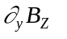 is equal to 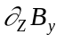. Therefore, B_{Z} arises because the change of the y component of the field is nonzero. An estimate of the size of Bz and its sign is given in Eq. 7.5 and is shown schematically in Fig. 7.1c. Note that what started as a simple uniform field has now grown a lens, i.e. B field proportional to deviation from magnet centerline, at both it’s exit and entrance. We discuss magnetic lenses further in Section 7.6 and 7.7 below.
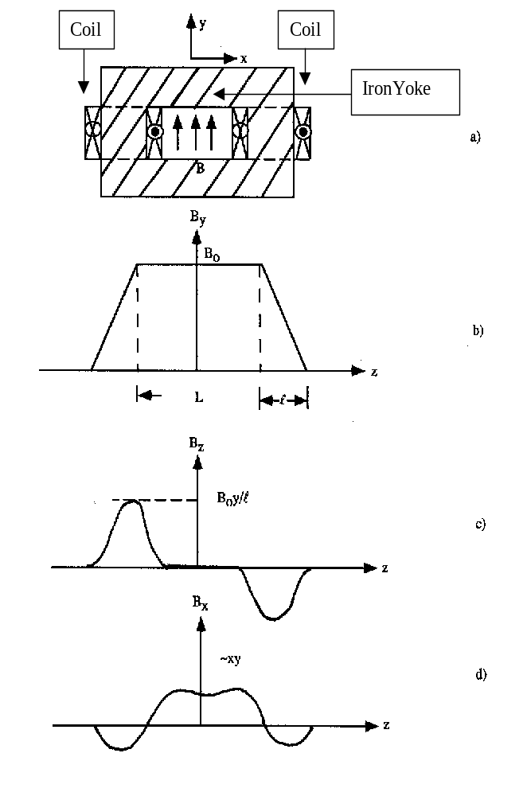
Fig. 7.1: a) Layout of a dipole electromagnet, b) By as a function of z, c) Fringe field Bz as a function of z, and d) Fringe field Bx as a function of z.

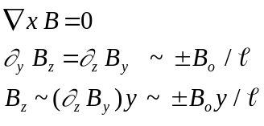 (7.5)
The divergence of the magnetic field is also zero. The 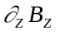 must be compensated by, for example, 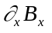. That implies the existence of an x component of the field proportional to the second z partial derivative of B_{y}. (See Fig. 7.1d.)
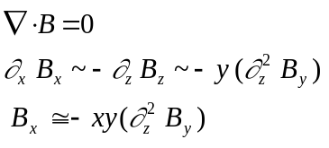 (7.6)
The “fringe fields” B_{Z} and B_{x} vanish at the centerline, B_{x}(0,0) = B_{z}(0,0) = 0 and hence act on off axis particles as lenses.
A photo of a “fixed target” style dipole magnet installed in a high-energy physics experiment is shown in Fig. 7.2. This photo is a concrete realization of the schematic diagram already shown in Fig. 7.1a. In that photo the coils of the electromagnet and the iron return yoke which shapes the field can be readily identified. A fixed target “bubble chamber”, such as that used to make the picture shown in Fig. 6.6, is also immersed in a reasonably uniform dipole field. A prepared “beam” of particles of roughly the same momentum and all moving with about the same angle impinges on the “bubble chamber” from below in Fig. 6.6. Assuming that momentum goes inversely with radius of curvature (Eq. 7.8 below), the momentum of the beam particles is clearly larger than that of the decay products since the radius of curvature of the beam is seen to be large.

7.3 Particle Motion in a Uniform Field
Let us now look at the trajectory of a particle, of charge q, in a uniform solenoidal magnetic field oriented along the z axis. Since we are doing numerical estimates, we will use MKS units here. The force 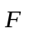 due to the magnetic field is given by the Lorentz force equation, Table 3.1. Since this force is perpendicular to the velocity, the power dissipated is zero. Hence, the momentum vector is of constant magnitude.

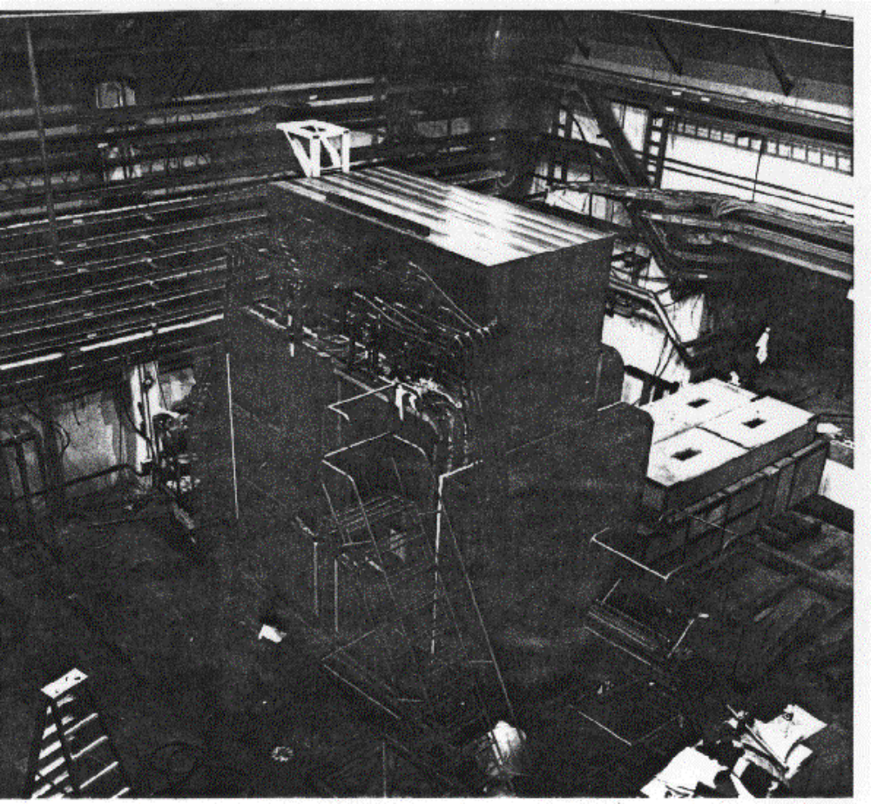

Fig. 7.2: Photograph of an analysis magnet showing the coils of the electromagnet and the iron yoke. (Photo - Fermilab)

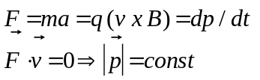 (7.7)
Since there is no force along the field direction, the path in z, as a function of arc length, is a straight line with a constant direction cosine, α_{Z} = dz/ds. In the transverse plane, (x,y), the equations of motion imply a solution where the momentum vector simply rotates in that plane by an azimuthal “bend” angle φ_{B}.
The centrifugal force in the non-relativistic case can be equated to the Lorentz force to yield an expression for the radius of curvature of the momentum vector in the x-y plane.
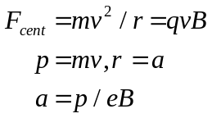 (7.8)
In MKS units, 1/e is 33.3 when the momentum, p, is given in units of GeV (10⁹ eV), the magnetic field, B, is given in kG, and the radius of curvature, a, is given in meters. For example, a 100 GeV proton in a 10 kG field has a radius of a curvature of 336 meters.
Since, in the non-relativistic case, 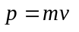 Eq. 7.7 becomes
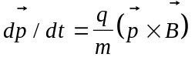 (7.9)
The form of Eq. 7.10 implies circular motion which we could prove by assuming a circular trajectory and substituting into the equations of motion. Since the forces is transverse to momentum it always acts so as to bend the path into a circular arc just as in the case of a satellite in Earth orbit. The frequency can be read off directly, ωp = qpB/m, and is given by the “cyclotron frequency”, _{c}, quoted in Table 1.1.
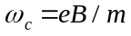 (7.11)
For constant field we have a constant rotation frequency which is important in the design of cyclotrons because then simple radio frequency (r.f.) drivers of fixed frequency can be used. For reference 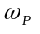 = 9.6 x 10⁶ rad/(sec kG) and 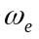 = 1.7 x 10¹⁰ rad/(sec kG) for protons and electrons respectively, (see Table 1.1.) For example, a 10 MeV proton cyclotron has a final T = 10 MeV or p = 141 MeV. If the bending field is 10 kG then the protons at a full energy have a 0.47 m orbital radius. The r.f. system works at = 9.6 x 10⁷ rad/sec or f ~ 15 MHz. These values are typical of cyclotron parameters.
The situation is modified in considering relativistic motion. Non-relativistic motion is circular with a fixed frequency, whereas in relativistic motion the inertial mass increases by a factor of γ as is evident in Eq. 7.8, p = γmv. Thus, ω goes from ω_{c} to eB/γm which means that the radio frequency power must be applied at variable frequency. For a practical high-energy circular accelerator, we need to increase the magnetic field B as the particles gain energy, or γ, in order to keep the beam within a fixed radius vacuum pipe. For example, the Fermilab Tevatron magnets are “ramped” up to full field of ~30 kG during the acceleration cycle which takes ~10 sec to go up to ~ 1 TeV.
It is this effect which defines the ultimate size of a circular accelerator. The physics of magnetic solids implies that there is a maximum field which we can get from iron magnets of about 2.0 Tesla due to domain saturation; all the domains are aligned at that point. Therefore, the radius of an accelerator must grow proportionally to the maximum momentum 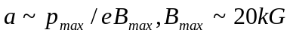. For example, a 1 TeV (10¹² eV = 1000 GeV) accelerator would have a 1.65 km radius. The use of higher field “superconducting” electromagnets allows us to somewhat relax this limit but only by a factor of 2 or 3.
A concrete visualization of the circular trajectories is given in Fig. 6.6. This is a “bubble chamber” picture of an event featuring the production of two neutral particles, which leave no ionization in the chamber, each decaying into two charged particles. We can tell that the charged particle pairs are positive and negative since the sense of the rotation in the magnetic field in which the chamber is immersed is opposite for the elements of the pair. Looking at Eq. 7.8 the sense of rotation in a magnetic field depends on the charge. In the lower pair it is also clear that one of the decay products is much more energetic, "stiffer", than the other one. The higher momentum track has a much larger radius of curvature. The lower most charged particle in the pair has a lower momentum.
We can also observe that momentum conservation, (Appendix A), in the decays means that the neutral parent should point back to the production vertex which is visible. In the case of the upper pair the plus and minus daughter tracks roughly share the momentum, so that the charged pair bisector goes close to the production vertex. In the lower pair the neutral parent particle’s momentum vector must be near to the direction of the “stiff” track of the pair. Indeed that track by itself approximately points back to the production vertex. We can look at these bubble chamber pictures and do the vector momentum conservation kinematics with rulers and protractors which is a very instructive exercise highly recommended to the student. You really believe in energy-momentum conservation after you do the kinematics yourself by hand.

7.4 Momentum Measurement and Error
It's also possible to use solid electromagnets without an air gap, simply as an iron core wound with exciting coils. The deflection angle, 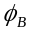, on traversing a length, L, in a direction transverse to the magnetic field, B, is given in small angle approximation as the length divided by the radius of curvature, a. (See Appendix F and Eq. 7.8.)
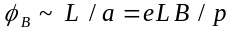 (7.11)
Using Eq. 7.8 for the radius of curvature, we find that the bend angle is the transverse momentum impulse divided by the momentum.
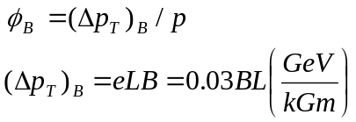 (7.12)
This result is similar to the treatment that was given for multiple scattering where the physics defined the transverse momentum impulse which was independent of the incident particle save for its charge. The bend angle goes as the inverse of the incident particle momentum. For example, 1.5 meters of iron magnetized to near saturation at 18 kG gives a momentum impulse of roughly 0.82 GeV. Thus a 8 GeV particle bends ~0.1 rad ~ 6º in traversing the iron.
Closer to home, we all have an electron accelerator in our home – the T.V. set – with which we can do experiments. Inside there is an electron gun which accelerates through about 10 kV, an energy needed to excite the phosphers on the screen. We can use permanent magnets to make a ~ 1 kG field extending over about 1 cm. Thus, a refrigerator magnet put in close proximity to the TV screen will cause a noticeable deformation of the TV image. Note that a 10 keV energy electron has a ~ 100 keV momentum, to compare to the 300 keV momentum impulse due to a 1 kG field extending over 1 cm. The student is encouraged to do this experiment.
We recall that the transverse momentum impulse due to multiple scattering has a characteristic two-dimensional scattering energy of 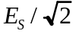 or 14 MeV. Traversing the 1.5 meters of iron, given that the radiation length of iron is 1.76 cm (Table 1.2), a particle crosses 85 radiation lengths and therefore suffers a multiple scattering momentum impulse of 0.13 GeV.
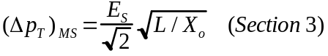 (7.13)
The ratio of the momentum impulses is about 16%. It defines the achievable momentum resolution in such a system, since which is limited by the multiple scattering. Note that the best possible resolution, (Δp_{T})_{MS}/(Δp_{T})_{B} scales as 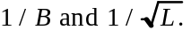 Therefore, it is extremely costly to improve performance by increasing the length, and there is a natural limitation to the magnetic field when you reach saturation in the iron, B ~ 2 T. Thus, the example given above is fairly typical and difficult to improve on much.
A photo of a typical solid iron magnet is shown in Fig.7.3. The iron toroid in this device is used both for the detection and identification of muons. We can see that the steel is excited by the copper coils which are visible in the photograph. The absorber mass is useful in removing particles which interact in the steel and do not escape into the muon tracking system which is located outside the steel and thus not visible. The momentum measurement is limited, as discussed above, to about 16%. We will return to the topic of hadronic cascades, “punch through” and muon detection in Section 12 and Section 13.
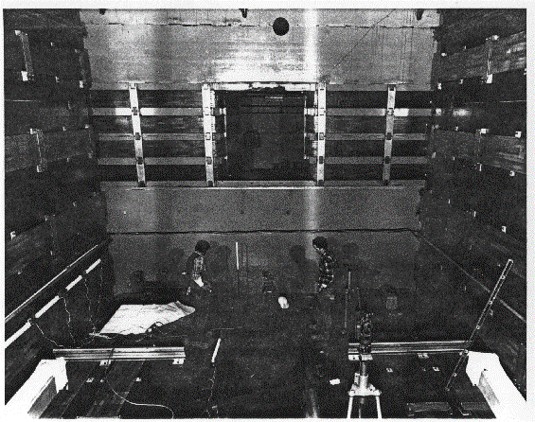
Fig. 7.3: Photograph of iron toroids for the detection and identification of muons. (Photo - Fermilab)

If we are operating in vacuum rather than in steel, the angle of deflection in the field goes as 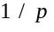, and thus the fractional error in the momentum measurement goes as 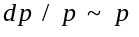. The achievable resolution in this case is ultimately limited by alignment and the systematic errors of the position measuring detectors limit the final accuracy of the angular measurement. The fractional momentum resolution, in the case of vacuum scales as p, whereas in the case where the multiple scattering limits it is a constant.
Assume that the bend angle is measured using detectors which make measurements having an error dx_{T} along an arc length L. For bend angle and momentum impulse 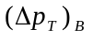;
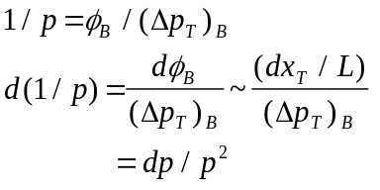 (7.14)
We have not specified the number of detectors, nor their optimal deployment along the path length of the track. Thus Eq. 7.14 is only indicative of the order of magnitude of the momentum error.
For example, with detectors having 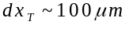 (e.g. diffusion limited gas detectors, see Section 8) deployed over L = 1 m in a field with momentum impulse 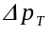 = 1 GeV, a 100 GeV particle is measured with a momentum accuracy of ~ 1%.
The multiple scattering fractional error is a constant, 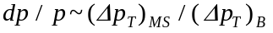. Thus, it is conventional to parameterize the momentum resolution of a tracking device as the statistical sum (“fold in quadrature”, see Appendix J) of measurement and multiple scattering errors characterized by the constants a and b respectively.
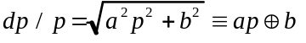 (7.15)

7.5 Exact Solutions - Cartesian and Cylindrical Coordinates
Consider now the exact solution for the orbit in a perfectly uniform magnetic field, B, oriented along the z axis. We use the arc length, s, as a track parameter since the velocity, , is constant. Eq. 7.7 using 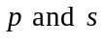 becomes
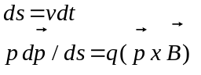 (7.16)
This equation implies that the momentum rotates with frequency, 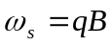 or (see Eq. 7.11) by angle 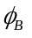 = s/a. For details see Appendix F. The solutions given in Appendix F for z are straight lines.
(7.17)
The direction cosines of the momentum rotate by φ_{B} in the (x,y) plane.
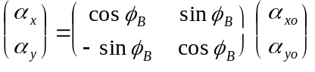 (7.18)
The “bend angle”, φ_{B} is the angle of azimuthal rotation of the momentum vector. The orbit is a helix.
We integrate to get the coordinates. Initial position and momentum components are indicated by the 0 subscript (see Appendix F). The orbit is a circle in the (x,y) plane.
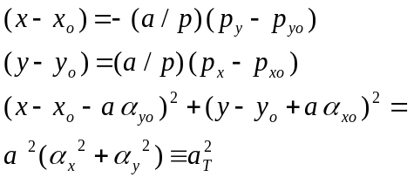 (7.19)
The solutions given in Eqs. 7.18 and 7.19 are exact. Although a completely uniform field is not possible (see Fig. 7.1), these solutions are still useful. For example, we can differentially “track” a particle through an inhomogeneous field because we can make a series of small “steps”, treating the field as locally uniform during each step, and applying the exact solution. This is a useful strategy, for example in “Monte Carlo” programs which are used to construct a computer model of a device. (See Appendix K.)
The forms given above are in Cartesian coordinates which are perhaps more appropriate to fixed target geometries. In collider experiments the experimenter is more likely to have built detectors around a basic solenoid in an axial geometry for which cylindrical coordinates are more appropriate. For example see Fig. 9.6 and Fig. 9.7 for two Si detector geometries.
The angular definitions are given in Fig. 7.4. A particle emitted from the origin with a transverse momentum vector labeled by the azimuthal angle 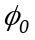 describes a circle in the x,y plane and the trajectory is evaluated at radius r. The azimuthal angle 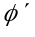 labels the position of the particle as it crosses radius r, whereas the azimuthal angle 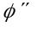 labels the angle of the momentum vector at that point. (See Appendix F.)
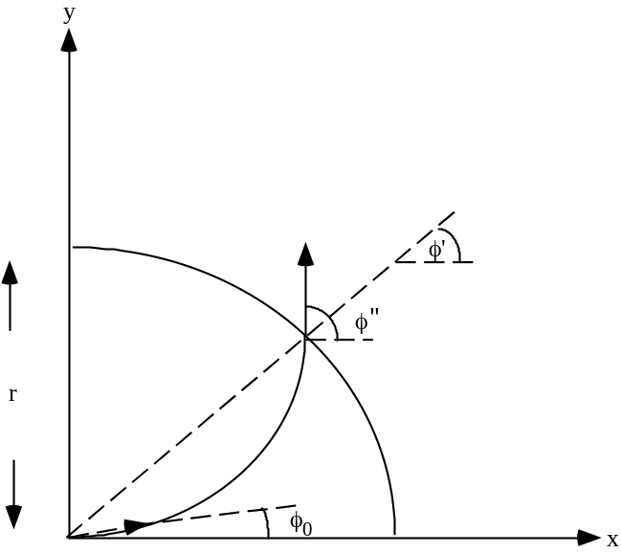
Fig.7.4: Definitions used in constructing the path of a particle in a purely axial solenoidal field emitted from the origin at angle φo. The particle at radius r is located at angle φ' and its momentum vector at that point has an azimuthal angle φ''.

We define a momentum transverse to the magnetic field, p_{T}, along with the corresponding transverse radius of curvature, 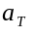. (See also Eq. 7.19.)
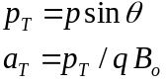 (7.20)
The initial angle of emission at the origin is specified by the initial momentum components. The exit position, 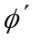, has no solution, if sin > 1, or if is less than half the radius. That is because the circular path has a small enough radius that it never reaches r. These are called “loopers” and they continue to rotate in the magnetic field until they drift out along the z direction as determined by Eq. 7.17, 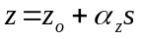. They are visible as circles in Fig. 6.6 where the drift direction is parallel to the line of sight and therefore, not apparent.
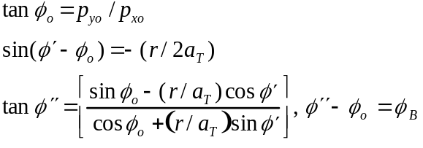 (7.21)
The small bend angle approximation to the exact expressions is given below, in the special case 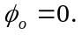
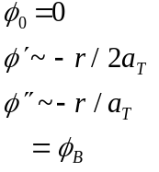 (7.22)
The exit angle is basically the azimuthal “bend angle” which is roughly the distance traveled, ~r, divided by the transverse radius . This is in accord with the Cartesian case. The circular trajectory can be approximated by two straight lines bent by the angle at the center of the path. Therefore, the label of the exit point is simply the bend angle divided by a factor of 2. Clearly, these small angle approximations have a nice transparent geometric interpretation as illustrated in Fig. 7.5.
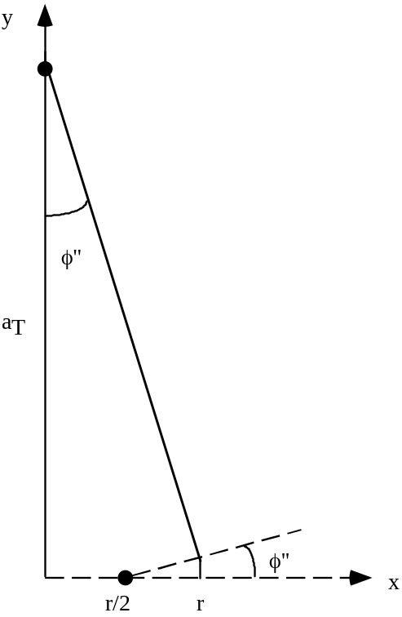
Fig. 7.5: Small bend angle approximation for motion in a uniform field. The exit angle is φ'' ~ r/a_{T} and the exit position is y ~ φ'' r/2 ~ r²/2a_{T}, for φ_{ο} = 0.

The circular path made by charged particles in a solenoidal field is illustrated in Fig. 7.6 which is derived from data taken at a Fermilab collider detector. Note for the various tracks that the sense of the rotation can be both positive and negative. Note also that the different radii of curvature reflect particles of different momenta emanating from the “event vertex” (recall Fig. I.1).
In contrast to the view in the x,y plane, we show the trajectories in a similar detector located at CERN, the European particle physics facility, immersed in a dipole field pointing along the y (vertical) axis, in the (y,z) view, in Fig. 7.7. In this case the particle trajectories are much straighter because there is no force in the y direction. We would have precisely straight line trajectories if y were plotted vs. s. Since the (y,z) view is not exactly congruent to (y,s) coordinates, the trajectories are only approximately straight.
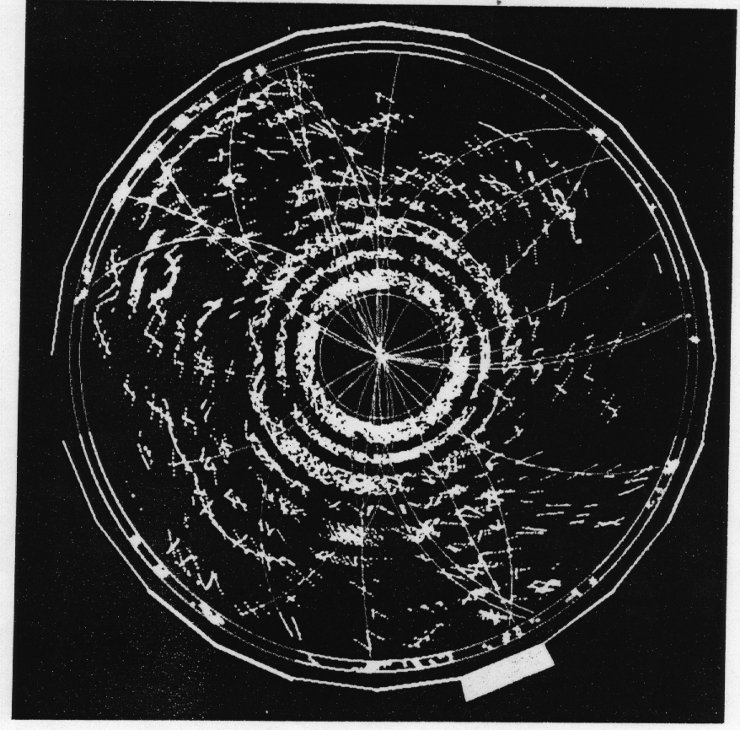
Fig. 7.6: Path of charged particles in a solenoidal field, “(x,y) view”. Note that the sense of the radius of curvature is + or - depending on charge and that the radius of curvature is proportional to the momentum. (Photo - Fermilab)

7.6 Particle Beam and Quadrupole Magnets
As a final topic we consider the simplest aspects of the preparation of beams of charged particles. Of necessity, we will need to understand the next most complicated magnetic multipole; the quadrupole magnet. The simplest elements of a particle beam transport line consist of dipole magnets, quadrupole magnets and collimators. In the case of accelerators, we require an accelerating system, such as a radio frequency, r.f., cavity and, since many traversals of a magnet are made in a circular machine, correction elements such as sextupoles. The study of accelerators is well outside the scope of this volume.

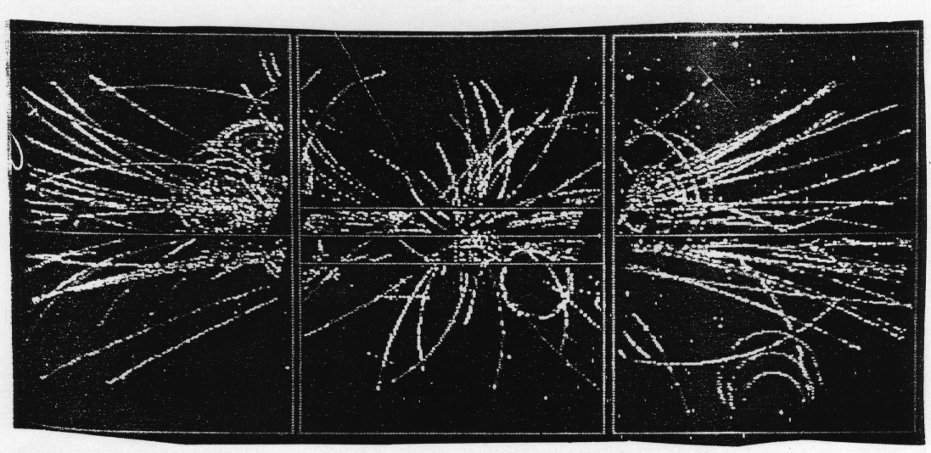
Fig. 7.7: Path of charged particles in a dipole field, (y,z) view. Note that the paths are nearly straight. (Photo - CERN Courier)

In traversing a dipole magnet different momenta have different bending angles. This momentum “dispersion” effect is like the spread of colors out of a prism. Clearly, using the thick material in collimators to absorb the unwanted high and low momenta, we can “momentum select” a beam to pass only particles with momenta within some limits.
A field free (or “drift”) space does not act on a particle. In what follows, we will represent passage through an element of the beam transport as a matrix. Multiplying the matrices of the individual elements can then represent complex systems of elements. The matrix representation, M_{D}, of a straight line trajectory over a distance L is;
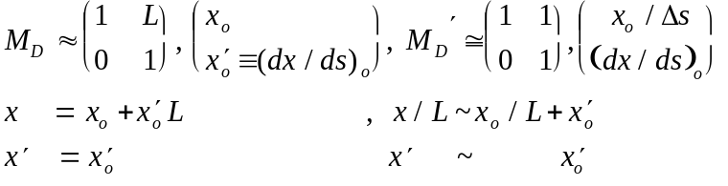 (7.23)
The arc length is s which is ~ the longitudinal distance L. The beam axis is conventionally taken to be z, and the motion is mostly along z, ds ~ dz. Motion in the x and y directions transverse to the beam axis is assumed to be small angle. It is traditional to use x and a “slope” dx/ds as the 2 variables used to label particle position and direction. However, that leads to “ugly” dimensionfull matrices. An alternative formulation using 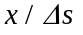 and dx/ds is also included in what follows in the approximation that 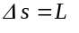 (the primed matrices). These objects, e.g. 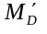, have dimensionless matrix elements.
For a dipole magnet of length L, in the approximation that it imparts a very small bend angle, the transformation is:
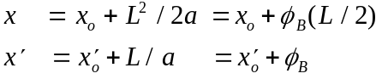 (7.24)
Note that the gradients in the field, Fig. 7.1, would act as thin lenses at the entrance and exit of the uniform field dipole. We ignore them here, but the quadrupole formalism we derive below can be directly applied if desired. Note that the gradient of 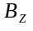 is, 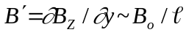. (Eq. 7.5.)
Consider next the case of a quadrupole magnet. The fields are shown in Fig. 7.8. The field 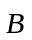 is zero at the magnet centerline by design. By construction there is a linear gradient, .
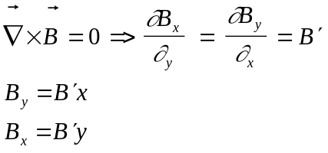 (7.25)

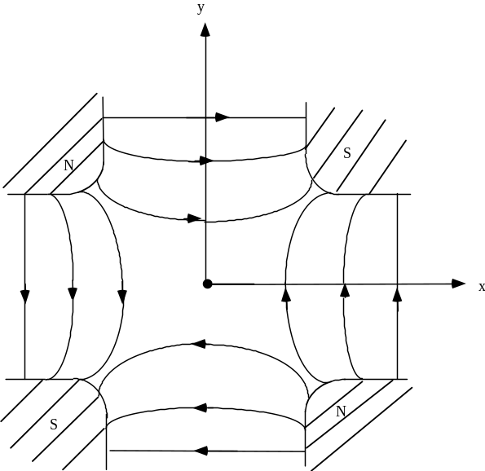

Fig. 7.8: Field orientation for a quadrupole.
The quadrupole field, outside of the currents, is derivable from a magnetostatic potential V_{B}, Table 3.1, 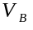 = 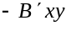, using 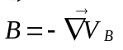. The force equation for the motion transverse to the direction of motion, assuming 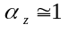, is;
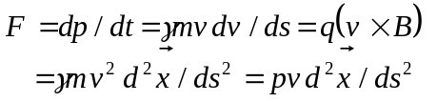 (7.27)
For example, in the x direction, pvd²x/ds² ~ -qvB_{y} = -qvB’x. The equations of transverse motion are those of a simple harmonic oscillator with “spring constant” .
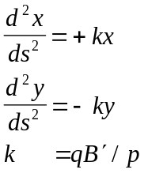 (7.28)
The dimension of 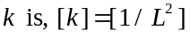. The equation of motion is one with solutions having harmonic oscillation in one transverse coordinate (called focussing or F type) and diverging hyperbolic trajectories in the other (call defocusing or D type). For the F type we define initial conditions 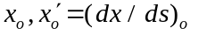and look at the solution of the equations of motion. The first integral of Eq. 7.27 in a “thin lens”, where x is ~ constant, is . Thus a thin lens quadrupole imparts an angular impulse which depends on the deviation from the magnet centerline, 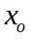. The “focal length”, f, is then defined to be the longitudinal distance over which an incident parallel, 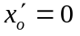, ray, 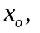 is brought to a focus, 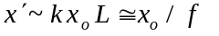 or
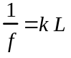 (7.28)
The geometric proof of this relationship is shown in Fig. 7.9a. All incident parallel rays are brought to the same point on the z axis, the focus. Hence the quadrupole acts as a charged particle lens. For example a 3 m long quadrupole magnet with a 5 kG gradient over a 5 cm aperture has a 11.2 m focal length for a 100 GeV beam.
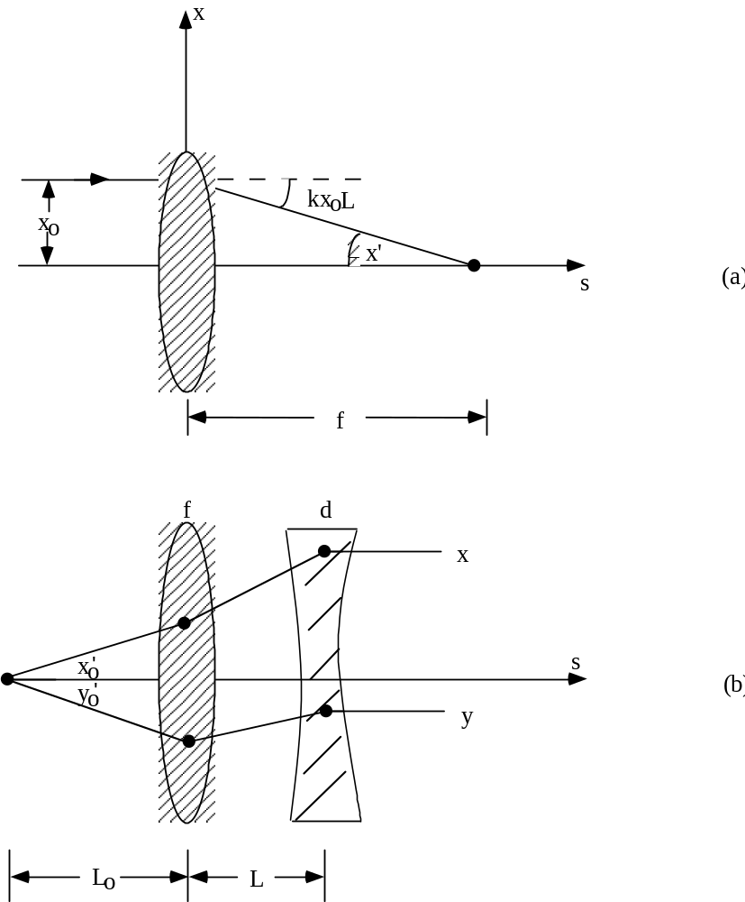

Fig. 7.9: a) Illustration of the meaning of focal length. b) A doublet lens system capturing a divergent beam and making it parallel, “point to parallel”.

The exact solution to the equations of motion comes from integrating Eq. 7.27 twice subject to initial conditions 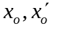. For the focusing case
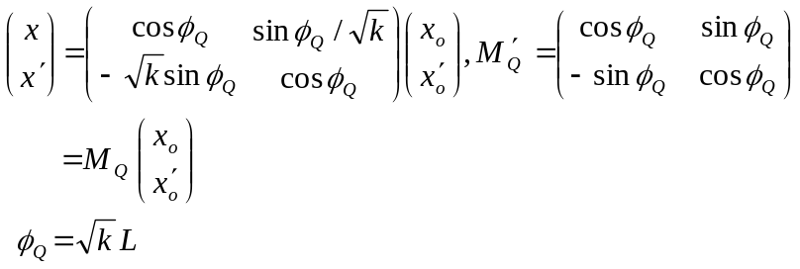 (7.29)
in the y or “defocusing” coordinate, 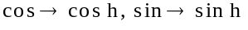 in both 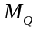 and 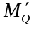. Note that, in our previous numerical example, φ_{Q} ~ 30º which is not a very thin lens.
In the thin lens case, 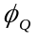 << 1, ignoring the change in x in drifting through the short quadrupole length, the matrix is
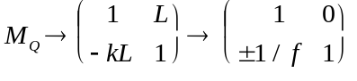 (7.30)
In Eq. 7.30 the ± sign refers to F and D type. The physical content of Eq. 7.30 is that the position does not change in traversing a thin lens and the angle 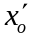 receives an impulse 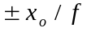
(- focussing, + defocusing) proportional to the offset from the beam axis.

The Quadrupole Doublet
Note that in geometric optics we can have simultaneous focusing in both transverse coordinates in a single lens. In particle beams, the fundamental constraint 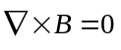 implies focusing (F) in one coordinate, and defocusing (D) in the other. Therefore, the simplest “element” exhibiting overall beam focusing in both transverse dimensions is not the single lens, but the quadrupole doublet which we treat here in the simplest possible (thin lens) approximation. Note that this approximation is often useful as a first iteration to a complete solution, for example as “starting values” to a complicated nonlinear computer code.
As the simplest application consider the quadrupole “doublet” of equal strength magnets arranged as in Fig. 7.9b. We can find the conditions needed to capture a beam diverging from a point target and make it parallel. The full “transport matrix” is the product of the matrices appropriate to traversing each beam element, 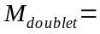 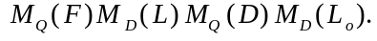 The parallel condition (for vanishing target size, x₀ = 0, y₀ = 0) is, 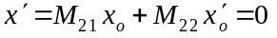 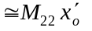 or 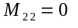 where M refers to 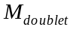. The final beam size is 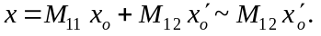 The algebra in the simplifying thin lens case, which we omit as an exercise for the reader, has a solution where the quadrupole focal length must be;
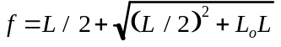 (7.31)
and the final beam size is, as can be visualized in Fig. 7.9b;
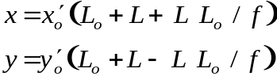 (7.32)
This solution is found by requiring both an x and y parallel beam. The matrix element M₂₂ must vanish simultaneously for both x and y motion. Those constraints lead to a quadratic equation for f. Note that, as Fig. 7.9b indicates, a cylindrical limiting magnet aperture, see Fig. 7.11, means an asymmetric angular acceptance for the doublet. That fact is also clear from Eq. 7.32 where, if , then 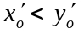. If the first element is y focussing, then the angular acceptance is the largest for y.
As a second example, the optical envelope for a thick lens doublet is shown in “point to point” focus conditions, M₁₂ = 0, in Fig. 7.10. Clearly, since the first quadrupole is y defocusing (x focusing) the capture angles for a circular quadrupole aperture is asymmetric 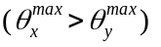. Complete computer optimization codes exist for both beam lines and accelerators. However, they require “starting values” being complex nonlinear systems without analytic solutions. Thus, a good physical intuition is called for even in designing such systems.
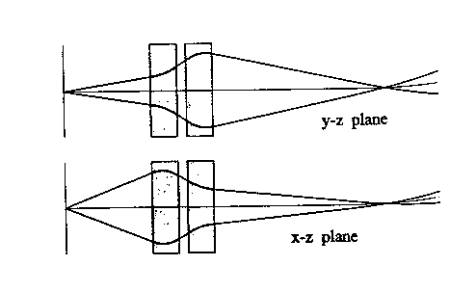
Fig. 7.10: Plot of beam envelope for a thick lens quadrupole doublet in a “point to point” optical configuration.

The design of secondary beams is an art unto itself, as is the design of accelerators. We have shown here only the simplest cases in order to give a flavor of the physics. Magnets should be thought of as detectors in the concrete sense that we use them to prepare beams to do experiments and to exert forces on particles so that the use of position measuring devices (Section 8 and 9) allow us to determine the particle charge and momentum. A photo of a beam line dipole and a quadrupole used in the Fermilab accelerator complex is shown in Fig. 7.11. These magnets are appropriate to prepared beams, with vacuum beam pipes of ~ 10 cm diameter.
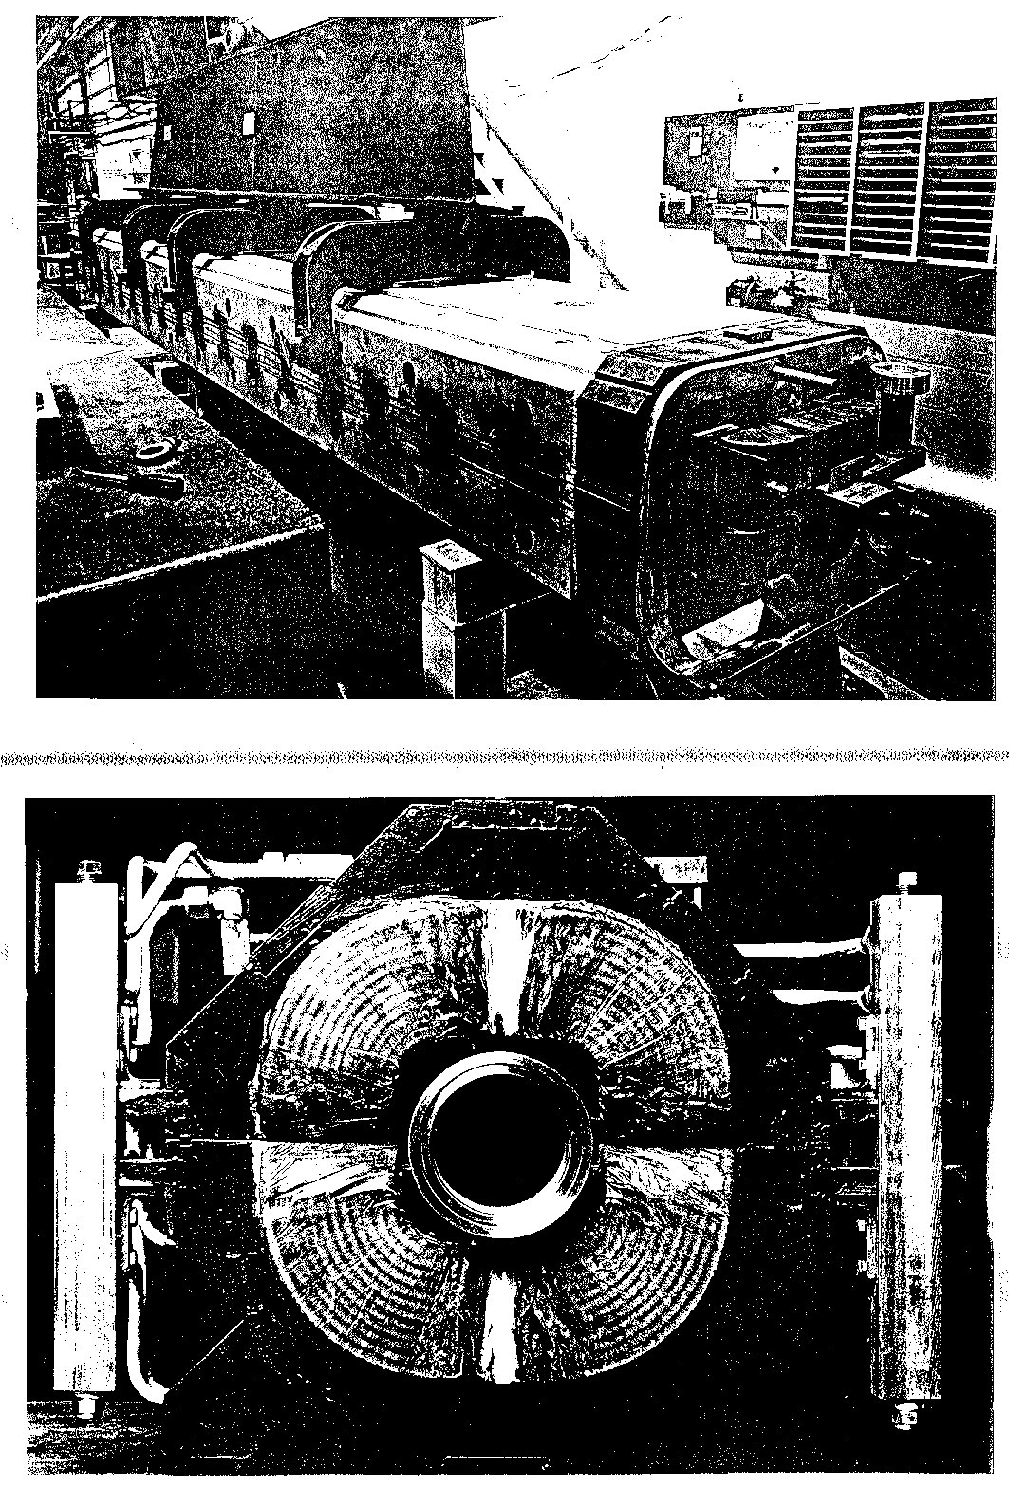
Fig. 7.11: Magnets appropriate for high-energy particle beams. a) A dipole. Note the 2 coils surrounded by the steel “yoke”. b) A quadrupole. Note the 4 coils surrounding the cylindrical vacuum pipe. Outside the coil is a steel yoke and water cooling plumbing. Photos - Fermilab)

References
Section 7: Magnetic Fields

[1] Superconducting Magnet Technology for Accelerators, R. Palmer, A.F. Tollestrup, Annual Review of Nuclear and Particle Science, 34 247 (1984).
[2] R.L. Gluckstern, Nucl. Inst. Meth., 24 381 (1963).
[3] R. Yamada, et al., Nucl. Inst. Meth., 138 567 (1976).
[4] An Introduction to the Physics of Particle Accelerators, D.A. Edwards, M.J. Syphers, FNAL FN (1988).
[5] The Physics of Charged-Particle Beams, J.D. Lawson, Clarendon Press (1988).
Table of Contents

II.C. Position and Momentum 1
7. Magnetic Fields 2
7.1 Solenoidal Fields 2
7.2 Dipole Fields - Fringe Fields 3
7.3 Particle Motion in a Uniform Field 5
7.4 Momentum Measurement and Error 8
7.5 Exact Solutions - Cartesian and Cylindrical Coordinates 11
7.6 Particle Beam and Quadrupole Magnets 15
7.7 The Quadrupole Doublet 20
References 23

