USDA Foreign Agricultural Service
GAIN Report

Global Agriculture Information Network
Template Version 2.09

Voluntary Report - public distribution
Date: 7/13/2004
GAIN Report Number: IN4071
IN4071
India
Agricultural Situation
Monsoon Progress Report No. 2
2004

Approved by:
Michael Riedel
U.S. Embassy, New Delhi
Prepared by:
A. Govindan

Report Highlights:
There has been a significant slowing of monsoon activity during the past two weeks, coinciding with the peak-planting season for most fall harvested crops. Unless the monsoon revives soon, crop production may be in jeopardy.

Includes PSD Changes: No
Includes Trade Matrix: No
Unscheduled Report
New Delhi [IN1]
[IN]
There has been a significant slowing of monsoon activity during the past two weeks, coinciding with the peak-planting season for most kharif (fall harvested) crops, including rice, coarse cereals, pulses, peanut, soybeans, and cotton. This is causing serious concern among farmers and government officials, prompting them to formulate contingency plans in case the monsoon fails. Inadequate rains have already slowed down planting operations of most crops. Unless the monsoon revives soon, production of kharif crops, particularly non-irrigated crops such as oilseeds, coarse grains, and pulses may be in jeopardy, as the window of opportunity for planting these crops will close soon.

Most parts of the country received significantly below normal rains during the weeks ending June 30 and July 7, taking the cumulative rainfall since the beginning of the monsoon season to about 10 percent below normal (see charts below). Twelve of the 36 weather subdivisions received below normal cumulative rainfall during the week ending July 7, compared with only 4 during the corresponding period of last year. Worst affected regions are Telangana and Raylaseema in the state of Andhra Pradesh (coarse grains, peanut), Rajasthan (coarse grains, pulses), West Madhya Pradesh (soybeans), Vidarbha in Maharashtra (cotton, soybeans), Jharkand (rice and coarse grains), west Uttar Pradesh and Punjab (rice), coastal Karnataka (rice), and Gujarat (peanut, cotton, coarse grains).

Some parts of Assam, Bihar, and West Bengal in northeast India, however, experienced severe flooding, resulting in loss of human life and damage to property. However, the impact of the flooding on crop production typically is minimal.

According to the latest available official data, inadequate rains have adversely affected sowing of almost all kharif crops, with the exception of cotton. Rice planting has so far covered 4.8 million hectares, compared with 5.2 million hectares during the corresponding period of last year. Coarse grain planting has taken place only in 6.5 million hectares compared to 8 million hectares during a comparable period last year. Planting of soybeans is lagging behind last year by almost 40 percent at 1.9 million hectares; peanut planting is slightly ahead of last year’s level, thanks to excellent rains in Gujarat during the last part of June. Sugarcane planting covered 3.7 million hectares compared with 4.5 million hectares last year. Area covered under cotton is 3.2 million hectares, compared with 2.6 million hectares during the corresponding period of last year.

Following relatively poor monsoon rains, the water tables in major reservoirs as of July 2, 2004, declined to 94 percent of the 10-year average level from 108 percent a week ago, although it is still 39 percent higher than last year’s level.

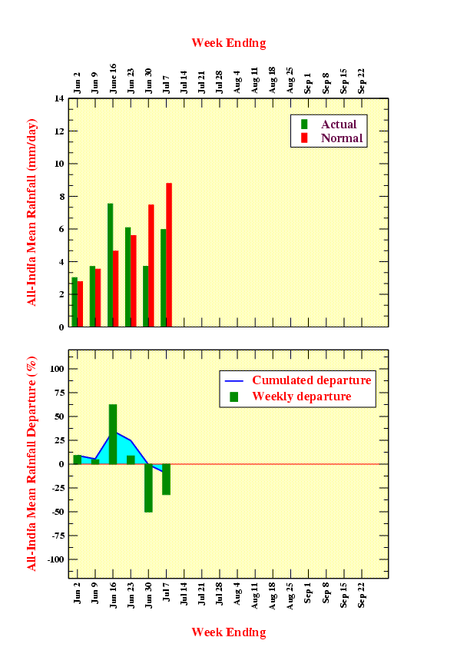

Source: Monsoon On Line by David Stephenson, K. Rupa Kumar, and Emily Black at: http://www.tropmet.res.in/~kolli/MOL/Monsoon/frameindex.html

