USDA Foreign Agricultural Service
GAIN Report

Global Agriculture Information Network
Template Version 2.09

Voluntary Report - Public distribution
Date: 10/5/2007
GAIN Report Number: CH7417
CH7417
China, Peoples Republic of
Market Development Reports
Tianjin ECM: Gateway to the North
2007

Approved by:
LaVerne E. Brabant
U.S. Embassy, Beijing
Prepared by:
Angie Han

Report Highlights: The largest port city in Northern China, and ranked as the world’s sixth largest port, Tianjin has evolved from an imperial capital into a major industrial hub. Easy to reach by land, air, and sea, it is an important distribution center for goods being transported to Northern and Western China. Given its proximity to Beijing, Tianjin has become a popular destination for Beijingers’ lavish weddings and banquets during festivals. Tianjin's status as co-host of the 2008 Olympic football games, its improving infrastructure, rising quality of life, continuing economic growth, and large population of foreign students and expatriates have all combined to create excellent market potential for food and agricultural product imports.

Includes PSD Changes: No
Includes Trade Matrix: No
Annual Report
Beijing ATO [CH4]
[CH]
Tianjin: An Emerging City Market

With a population of 10 million, Tianjin is one of the key emerging city markets in China. The city is the largest port city in northern China and the port of Tianjin ranked as the world’s sixth largest port in 2006, making it an important distribution center for northern China.

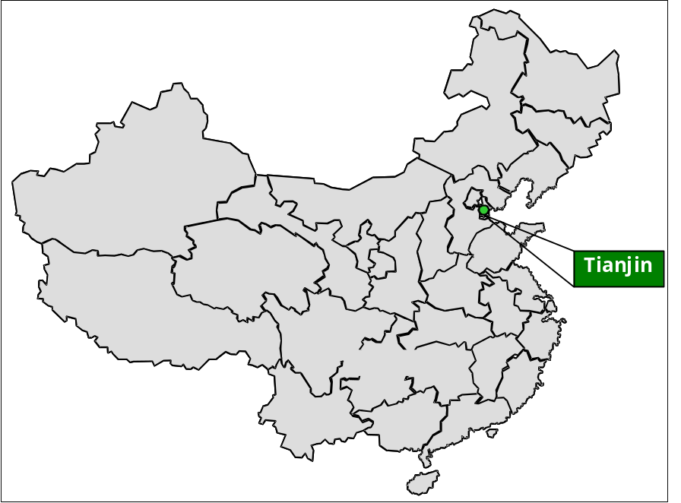Just 120 kilometers southeast of Beijing, Tianjin is the largest port city in China and third largest city in China behind Shanghai and Beijing. Tianjin, one of four special municipalities including Beijing, Shanghai, and Chongqing, and is a major trading hub and Beijing’s link to the Sea of Bohai. Given its special status, Tianjin is directly administered by the Central Government while enjoying provincial-level status.

History

The ideal location of Tianjin at the confluence of the Hai River and Grand Canal, connect it to the Yangtze River. It has been a major trade/transportation center since the time of the Yuan Dynasty in the 13th century.

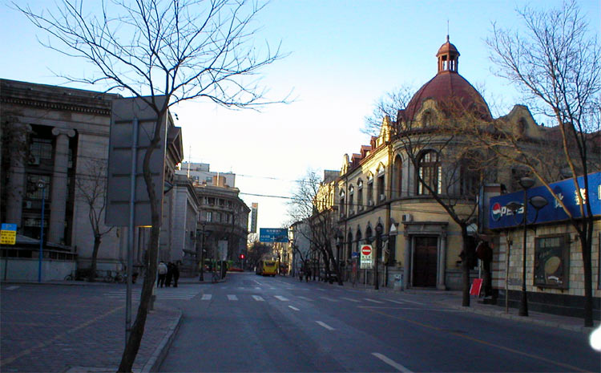
The name Tianjin means “the place where the emperor crossed the river.” Strategically located on the overland route to Manchuria, Tianjin has been a frequent military objective of foreign invaders since the late 18th century. Agreements exacted from China by the British and French during the Second Opium War (1856-60) made Tianjin a treaty port, one of the 11 Chinese ports opened to foreign trade. With the complete abolition of the remaining foreign concessions in 1946 Tianjin was completely restored to Chinese sovereignty. Some describe Tianjin as a more ‘Chinese’ city compared to other large Chinese cities such as Beijing or Shanghai. Due to its past history as a treaty port history, Tianjin’s architecture has a distinctly European influence. Some of the most interesting examples of this influence can be found in the ‘Five Avenues’ district where the British and French concessions were once located.

Booming Economy

Modern-day Tianjin is an industrial and commercial port on the Bohai Sea rim with a 152.8 km coastline, and is easy to reach by air, land, and sea. Tianjin has reserves of about 1 billion tons of petroleum, with its Dagang District containing important oilfields. Salt production is also an important industry, with Changlu Yanqu being one of China’s most notable salt production areas. Geothermal energy is another resource endemic to Tianjin, and the deposits of manganese and boron under Tianjin were the first to be found in China.

Major industries in Tianjin include petrochemicals, textiles, car manufacturing, mechanical and metalworking. Famous for its manufacturing industries, the first wristwatch, bicycle, and television made in China all came from Tianjin. One of China’s earliest domestic car manufacturers, Xiali, is located in Tianjin. In March 2005, China’s first private airline, Okay Airways (based in Tianjin), launched its first flight. The European aircraft maker, Airbus, plans to manufacture 300 A320 aircraft on its assembly line located in Tianjin by 2016.

Key Economic Indicators at a Glance 2001-2005
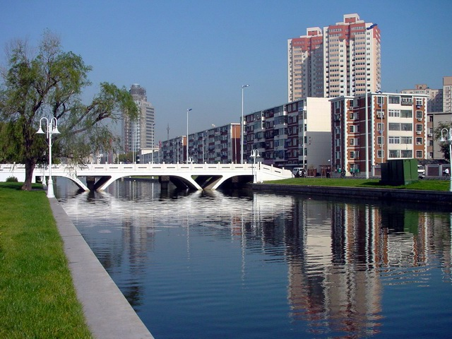
GDP (avg. annual growth) 14.0%
CPI 1.7%
Population 10.43 million
Car ownership 1:100 households
(Source: Global Insight)

Tianjin has a fairly large foreign student and expatriate population. The city has 37 higher education institutions, 159 scientific research institutes, and 10 state-level engineering technology research centers. More than 200 major international corporations, including more than 80 of the world’s top 500 companies, in over 60 industries, have settled in Tianjin.

Covering 11,900 sq km, Tianjin serves as an important grain and vegetable production base for the Tianjin-Beijing area, and farmland accounts for about 40 percent of Tianjin’s total area. Wheat, rice, and corn are the most important crops. However, production bases have also been established to produce meat, eggs, and poultry. Tianjin has excellent coastal conditions for marine life providing an ideal breeding ground for migratory and indigenous fish, shrimp, lobsters, and shellfish, making it an important location for the fishing industry. The natural conditions found in the vast inland waterways make Tianjin ideal for freshwater fish cultivation as well.
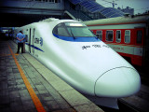
The Tianjin municipal government has announced plans to invest 110 billion Yuan by 2010 to improve the city’s transportation infrastructure. An estimated 36.7 billion Yuan is to be spent on expanding facilities and the overall throughput capacity of Tianjin Port, with the remaining funds to be concentrated on the development of the city’s Binhai International Airport and rail cargo handling facilities.

As a participant in the US Sister City Program, Tianjin established ties during the 1980s with Philadelphia, Pennsylvania through a variety of special economic and cultural partnerships and exchanges. Comparable programs have also allowed Tianjin to establish similar relationships with other global cities such as Kobe in Japan, Melbourne in Australia, and Nord-pas-de-Calais in France.
Tianjin-Beijing high-speed train

Binhai New Area

The Binhai New Area, also called the New Coastal District of Tianjin (NCD) is located at the juncture of the Beijing-Tianjin City Belt and the Circum-Bohai City Belt. At the center of Northeast Asia, Tianjin is gateway to North, Northeast, and Northwest China, and the nearest departure point for the Eurasian Continental Bridge. The NCD consists of Tianjin Port, the Tianjin Port Free Trade Zone, and Tanggu, Hangu, and Dagang development zones.
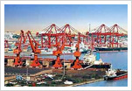
Created 20 years ago, the Tianjin Economic-Technological Development Area (TEDA) is one of the first coastal development areas opened to the outside world. The United Nations Industrial Development Organization (UNIDO) listed TEDA as one of the most dynamic areas of China along with Shenzhen, Suzhou, Wenzhou, Shanghai Pudong, and Xi’an High-tech Park. Major multinational companies like Motorola, Nestlé, Toyota, Novozymes, Con-Agra, and Samsung are located in the TEDA due to its highly attractive business environment, making TEDA the premier state-sponsored development area in North China.
Port view of Tianjin

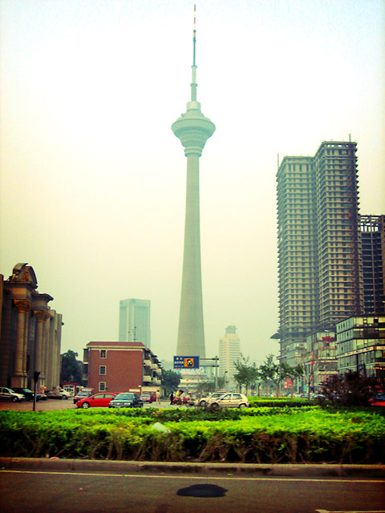
Tianjin Port is second only to Shanghai in terms of capacity and is the largest cargo terminal in northern China. Port facilities provide direct access to Tianjin International Airport and Beijing. Tianjin Port handles cargo for North and West China, which accounts for more than 60% of its handling capacity. In 2006, Tianjin’s cargo throughput reached 258 million metric tons, making it the world’s sixth-largest port by volume, mainly handling fruit, nuts, grains, dairy products, poultry and meat products, cotton, soybeans, wood and wood products. The Tianjin Free Trade Zone located inside the port is the only Free Trade Zone in China having special railway lines, making the movement of goods highly effective and cost efficient. International trade, bonded warehouses, and export processing are all major industries in the zone.

Tianjin has established long-term navigation and business relations with more than 300 ports in more than 170 countries and regions around the world. The port is expected to expand handling capacity to 300 million tons by 2010. Tianjin’s municipal government hopes to increase Tianjin Port’s throughput to 300 million tons and 12 million TEUs (twenty-foot container equiv. units), raise the volume of road freight to 300 million tons per year by expanding highways in the region to 12,500 km, and by boosting annual volumes at Binhai Airport to 10 million passengers and 500,000 tons of cargo.

Including its airport, Tianjin has 6 ports and Customs centers. The newest and largest Customs House Center is a unique one-stop-shopping customs office. The newly built five-story building resembles a five-star hotel more than a Customs House and combines AQSIQ, Chinese Customs, banking services, form processing, and other customs house broker services all under one roof. Traders claim it to be one of the most convenient and efficient Customs offices in China and are pleased with the ease the status of their documents can be tracked during processing, which now takes an average of 2-3 days from the time the goods arrive to the time they leave the port area. Also, the new Chinese Customs arrangement makes it possible to clear customs year round including holidays. On weekends Customs usually only processes exports, with import processing limited to weekdays. During major Chinese holidays like the Spring Festival and National holidays, customs clearance is still possible although the AQSIQ does not process documents during these periods. It is interesting to note that during the period leading up to the Spring Festival, goods clear customs quickly and often can be released even if taxes and fees have not been paid. Fee collecting agencies in China often use a quota based system, so near the end of the Lunar Calendar Year individual ports often try to slow revenues to prevent large increases, so the next year’s quota, based on the previous year’s quota, is smaller rather than larger.
Tianjin TV Tower
Tianjin Tanggu Ocean New-Technology Development Zone located near Tianjin New Port is 38 km from Tianjin International Airport and 143 km from Beijing. Transportation and complete infrastructure facilities are available in the zone. The zone was officially converted to a National Development Zone in 1995.
Tianjin Xiqing Economic Development Zone near Tianjin city has convenient transportation conditions and complete infrastructure facilities. This industrial park is home to electronics, chemistry, machinery, and food-processing industries.
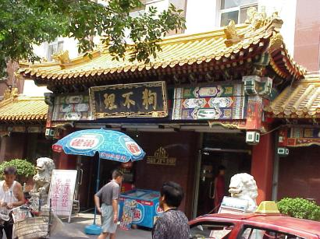
Hotel, Restaurant and Institutional Sector on the Rise: A Wedding Destination
A traditional Chinese restaurant
Due to its proximity to Beijing, easy access by car, and relatively lower cost of living, hotels and restaurants in Tianjin receive a lot of business by providing wedding banquets for newlyweds from Beijing. It is roughly 40 percent less expensive to hold a wedding banquet in Tianjin versus Beijing, with a larger range of food, especially high value seafood, available. The JinZhongHe exit along the Beijing-Tianjin expressway is a particularly popular exit for many Beijingers due to its closeness to Beijing and diversity of restaurants there. The busiest periods are during the Spring Festival, May Day and National Day Holidays.
Hotel facilities are highly developed in Tianjin and international hotel chains are all there including the Hyatt Regency, Sheraton, Holiday Inn, Renaissance, Ibis and Nikko. As Tianjin will co-host some of the football games for the 2008 Olympic Games, new hotels are also being built. The newest five-star hotel, the Nikko Tianjin, opened in 2007 with 400 rooms and suites. The Tianjin Westin is scheduled to open soon in anticipation of an influx of tourists due to the 2008 Olympic Games and the continued economic growth in Tianjin. Serviced residences/apartments are also on the rise. Ascott, one of the leading serviced residence providers in China, plans to add another property in Tianjin in 2008 in addition to its current property, the Somerset Olympic Tower.
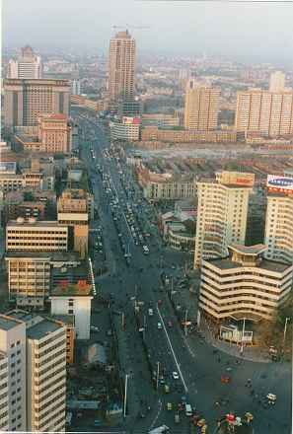
As indicated by the Hyatt Regency Tianjin, sourcing for imported food supplies in the HRI sector is usually from local or Beijing sources, with a wide product range including individual ingredients, meat, seafood, fruit, and beverages. However, limited volumes are required in most cases, making it difficult for outside suppliers to provide market appropriate supplies.
Tianjin is famous for its local snacks. To many, Tianjin is more ‘Chinese’ than other cities such as Beijing or Shanghai. However, as more Western style restaurants emerge, the younger generation’s taste desire for trendy Western foods and drinks is evolving. Broadway Cafe, Alibaba, as well as a variety of local bars and restaurants on the bar street are often visited by local white-collar workers, as well as expatriates. Dramatic changes in consumer consumption patterns and lifestyles have created a favorable market environment for imported goods and products, as well as Western style restaurants and retail outlets.
Retail
Like any other city in China, people in Tianjin consider the wet market to be their first choice for buying fresh produce, believing produce found there is fresher and cheaper than in supermarkets. Several international retailers are in the market along with local retailers. Imported products are not widespread in domestic supermarkets and even less common in smaller retail outlets, limited in part by lower income levels compared to those found in other major cities. The port area, including Tanggu and TEDA, has proven to be a better market for imported goods due to the large number of expatriates living there. As indicated in report CH7403 Emerging City Markets released in March 2007, Tianjin realized a 24 percent increase in its imports of U.S. foods over the past two years (2004-2006).
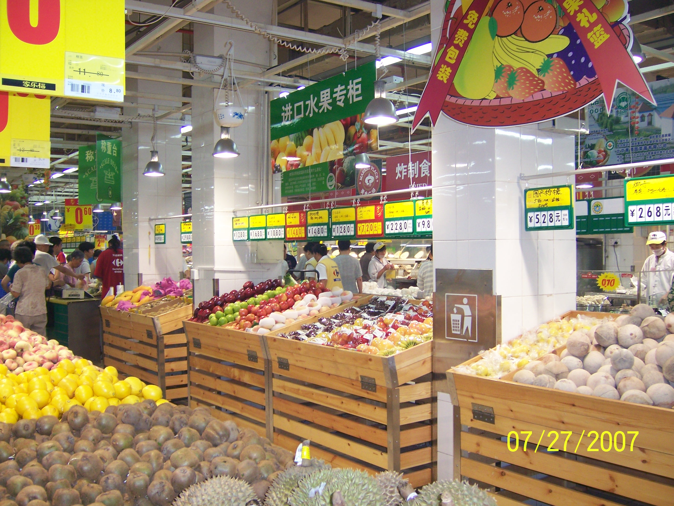
The first Carrefour store in Tianjin, the NanKai outlet, and the HaiGuanSi outlet are the only two Carrefours to carry a significant amount of imported goods. Korean and Japanese foods are dominant among these imports, especially in snacks, beverages, noodles, and various ingredients. The store manager explained that as the Korean student community is strong here (there are nearly a dozen universities are institutions in greater Tianjin), there is high demand for such products.

Tianjin Major Retail Outlets at a Glance
Store | Chinese Name | Ownership | Type | Outlets
Carrefour | Jia Le Fu | French | Hypermarket | 5
Tesco (Hymall) | Le Gou | British/Taiwanese | Hypermarket | 4
RT-Mart | Da Run Fa | Taiwanese | Supermarket | 1
Wal-Mart | Wo Er Ma | U.S. | Hypermarket | 2
Metro | Mai De Long | German | Cash-Carry | 1
Home World (VanGuard) | Jia Shi Jie | Hong Kong | Hypermarket | 17
Lotus | Yi Chu Lian Hua | Taiwanese | Hypermarket | 4
WuMart | Wu Mei | Mainland | Hypermarket  Supermarket  Minimart | 2  9  34
Processing
Tianjin is a major food & beverage processing, and packaging center. In addition to the growth of its port infrastructure and export processing trade, many food companies have established plants in Tianjin, especially in the trade zones. Hunt’s Chalkis, a newly established tomato processing plant in Tianjin is an example of one company that has benefited from Tianjin’s excellent port location as well as its trade friendly environment. A year after the plant was established it experienced strong sales as a successful supplier to the domestic Chinese market as well as export markets in Asia and the Middle East. Reduced processing costs, including labor, are perceived to be a benefit by most international companies, according to the general manager of Hunt’s Chalkis.
Bunge Limited, a leading U.S. agriculture and food company also established a joint venture in early 2007 to operate a soybean processing plant in Tianjin in order to produce feed for the region. Cargill, another leading U.S. agriculture and food company established a fertilizer-blending plant in Tianjin to produce high quality fertilizer.
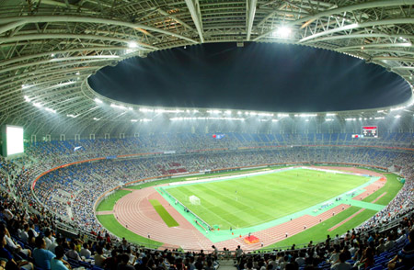
Towards the 2008 Olympics
Tianjin will host 12 of the Beijing 2008 Olympic football preliminaries; other cities co-hosting soccer events during 2008 Olympics (in addition to Beijing) are Shanghai and Shenyang. The construction of the Tianjin football stadium began in August 2003 and was completed in August 2007. Covering 78,000 sq meters, the Tianjin Olympic Center Stadium can accommodate 60,000 spectators.
Tianjin Olympic Center Stadium
The city is also building a new metro and magnetic levitation rail to connect Tianjin and Beijing, with the goal of reducing travel time to within 30 minutes. Tianjin’s third subway line is expected to be completed by 2009. At a total of 29.7 kilometers, the line will run from the southwest to the northeast of the city, connecting two overland rail stations with 23 stations between. The city’s government plans to build nine subway lines over the next 30 years, totaling 234.7 kilometers.
The municipal government in Tianjin is using the 2008 Olympics as an opportunity to spend some US$22 billion on further improving the city’s infrastructure and tourism-related projects, including converting the pungent Huaihai riverfront into an attractive tourist complex, and constructing new bridges, roadways, sewage-processing facilities and office buildings.
Tianjin’s Development Projects at a Glance:
1. No.1 Subway Line Project (6.9 billion Yuan)
2. Light-track Communication Tianjin Urban District/New Coastal Area (5.9 billion Yuan)
3. Tianjin-Ji County Expressway Project (5.5 billion Yuan)
4. Tianjin Part of Tianjin-Shanxi Expressway (3.5 billion Yuan)
5. Tangshan-Tianjin Expressway (south section in Tianjin) (3.0 billion Yuan)
6. Expanding construction of local railways (597 million Yuan)
7. Construction of Five Container-berths in the North Pond of Tianjin Port (3.1 billion Yuan)
8. Nanjiang Coal Dock in Tianjin Port (2.2 billion Yuan)
9. Reconstruction of Old Dock in the North Port area of Tianjin Port (2.0 billion Yuan)
10. Tianjin Port North Dongtudi Container Dock Reconstruction-Expansion (1.7 billion Yuan)
11. First-Stage Construction Tianjin Port Nanjiang Bulk Logistics Center (2.4 billion Yuan)
12. Second-Stage Construction of 100,000-ton Waterway in Tianjin Port (198 million Yuan)
13. First-Stage Construction of Beida Breakwater in Tianjin Port (180.5 million Yuan)
14. Ship Lock of Haihe River (283 million Yuan)
15. Expanding Construction of Tianjin Airport (492.8 million Yuan)
16. Long-distance Bus Passenger Transport Central Station (196 million Yuan)
17. Water Plant on Cuijia Dock (1.1 billion Yuan)
18. Sewage Treatment in Haihe River Basin (2.3 billion Yuan)
19. Beicang Sewage Treatment Project (371 million Yuan)
20. Sewage Treatment Plant Project in WuQing District (126.2 million Yuan)
21. Gas Station for Automobiles (520 million Yuan)
22. Trunk Pipeline for Natural Gas Distribution in the Coastal Areas (253.0 million Yuan)
23. Renovation of Combustion Equipments (150 million Yuan)
24. Trunk Natural Gas Pipeline in North Semi-ring of Outer Ring (120 million Yuan)
25. Reconstruction of Old Gas Pipe Network (50 million Yuan)

Market Entry Tips

The imported food market in Tianjin has yet to be fully developed, but continues to evolve. Some industry players offer the following tips for entering the market:

- Consumer Awareness: Many products fail because distributors and consumers are unfamiliar with the products, and are not sure how to handle or use them.
- Product Knowledge: In-store product demos and marketing promotions in Chinese can be very successful advertising methods. Promotions that focus on adapting US food ingredients to Chinese cuisine are suggested.
- Price and Food Safety: Tianjin is still a price-sensitive market and imported items must compete with low-priced domestic products. Establishing a brand or item as “premium quality” is a must for selling in a highly competitive environment, and American products are often appreciated for meeting stringent safety standards.
- Research: Take time to investigate the market and find a good distributor. Successful ventures require experienced distributors who know the local market.
- Test the Waters: Proceed with caution before attempting large-scale supply to the market. Be prepared to offer limited quantities and build your network slowly. If a product is new to the China market, it may be better to introduce it to already established markets where unfamiliar foods are easily adopted, like Beijing or Shanghai.
- Holidays: Demand for imported goods is increasing, particularly during holiday periods, when such goods are often given as presents, and are associated with upward mobility.
- Follow the Leader: Build relationships with successful exporters to China, and learn from their examples.

Contact Information and Useful Websites:

Agricultural Trade Office, Beijing

Embassy of the United States of America
Tel: (86-10) 8529-6418
Fax: (86-10) 8529-6692
Email: ATOBeijing@fas.usda.gov
Web: www.USDAChina.org

Office of Agricultural Affairs, Beijing
Embassy of the United States of America
Tel: (86-10) 6532-1953
Fax: (86-10) 6532-2962
Email: AgBeijing@fas.usda.gov

Animal and Plant Health Inspection Service
Embassy of the United States of America
Tel: (86-10) 6532-3212
Fax: (86-10) 6532-5813

Agricultural Trade Office, Guangzhou
Tel: (86-20) 8667-7553
Fax: (86-20) 8666-0703
Email: ATOGuangzhou@fas.usda.gov
Web: www.USDAChina.org

Agricultural Trade Office, Shanghai
Tel: (86-21) 6279-8622
Fax: (86-21) 6279-8336
Email: ATOShanghai@fas.usda.gov
Web: www.USDAChina.org

Official Tianjin Government Site
www.tj.gov.cn

Tianjin Customs Site
http://tianjin.customs.gov.cn/

