INTRODUCTION

A biennial survey of cost and staffing information (CCAS) has been conducted for educational institutions by the Association of Higher Education Facilities Officers (APPA). The 1997-98 survey has been completed, and this survey will be the last conducted under the CCAS umbrella, as energy is a subset of too limited interest within the overall scope of CCAS.

The energy data obtained for this survey have been shown to have significant quality problems over time, and the data for the 1997-98 survey are no exception. This is not uncommon, as dealing with energy consumption data across multiple fuels can be quite complicated and requires significant knowledge to maintain data consistency. APPA has a strategic partnership with the US Dept of Energy (DOE), and APPA requested that Oak Ridge National Laboratory, a multifunction laboratory of DOE, review the data for the 1997–98 survey year.

This review showed that the survey instrument was not precise enough and the energy data had many problems (revealed through internal consistency checks). The data were checked to determine if corrections could be made to restore the internal consistency among data quantities. As an example, one institution was reported as having over 800,000 students, with a resulting floor area per student of 1.7 square feet.

Most of the data were restored to apparent reasonable consistency, with only five institutions that had data that were definitely not reasonable, although other unreliable data were found subsequently, as reported below. Some institutions did not report enough data to check for reasonableness, so these will have no data reported in the tables in this report. The resulting data for approximately 180 institutions show a strong correlation of energy use and energy cost with floor area, having R² values of 0.81 and 0.80, respectively, which indicates that the overall data set is reasonably consistent and meets (indeed exceeds) expectations for these data quantities.

Despite the data restoration effort, some errors undoubtedly remain, and warnings will be stated along with the data throughout. However, the results available now should provide good information for institutions that wish to compare costs and performance indexes across institutions. A summary of all the data are also provided in a spreadsheet so that users who need to make data corrections can do so for their records.

Data structure inconsistencies for primary and secondary fuels were also a problem, e.g., reporting self-generated electricity kWh as well as the fuel used to generate the electricity in the first place. Fortunately, respondents usually reported costs consistently, so for cases where an energy quantity was reported without an associated cost, the energy was treated as a secondary quantity and not part of the consumption of the institution. In general, serious care is required to assure that primary and secondary energy quantities are reported separately.

Separation of fuel costs from energy operations costs is desirable for comparison purposes. Fuel cost was the primary interest of the work reported here. Some data may have operations costs included with fuel costs, but the overall impact appears slight. These problems appear to exist for some of the reported steam cost data, but there are only a few cases in total. Some slight problems in this vein may also exist for other fuels.

ANNUAL ENERGY PERFORMANCE INDEXES

Four annual energy indexes are calculated based on the revised data and tabulated in the energy performance indexes table:

- Dollars per million Btu of source energy
- Energy Use Index (EUI), thousands of Btu of total source energy per square foot of gross floor area of the overall institution
- Dollars per gross square foot of total gross floor area
- Dollars per student, although the reporting of number of students has difficulties

SOURCE ENERGY is calculated to provide an indication of the primary fuel used. Source energy is used because it provides a much more consistent basis for comparison of overall dollar and energy indexes than using 3,413 Btu per kWh, which would require stratification by fraction of total energy use that is electricity to allow internally consistent comparisons. Thus, some conversion of steam and electric data is required, where either was reported as a primary fuel quantity. For electricity, the conversion used was 10,280 Btu of fuel consumed to deliver a kWh to the user. This factor is not correct for all cases, but without more detailed information, one factor will have to suffice.

All fuels required a conversion factor to calculate Btu of fuel consumed. As with electricity, the conversion factors are the same for every institution, since institution-specific factors were not available. The conversion factors used were:

- Electricity, purchased or self-generated 10,280 Btu / kWh
- Natural gas 1,030 Btu / cu ft
- #1 Fuel oil 135,000 Btu / gal
- #2 Fuel oil 139,000 Btu / gal
- #6 Fuel oil 154,000 Btu / gal
- Coal 25 million Btu / ton
- Steam 1,250 Btu / lb delivered
- Other average Btu per $ of all other fuels

As indicated, there will be inaccuracies using these same factors for all institutions, and there are likely inaccuracies related to peculiarities in how costs were reported. But the overall results appear quite reasonable, and particular anomalies can be adjusted by specific institutions if appropriate and desired.

Facility energy data distributions are typically not normal, so reporting of mean values can be very misleading. Instead, percentile values such as quartiles should be given. For the approximately 180 institutions with reconstructed data, percentiles for each index are:

 | Percentile
Index | 5% | 10% | 25% | 50% | 75% | 90% | 95%
$ per million Btu | $2.82 | $3.10 | $3.83 | $4.65 | $5.50 | $6.73 | $7.45
EUI, kBtu / sq-ft | 122 | 137 | 173 | 223 | 298 | 387 | 428
$ per sq-ft | $0.55 | $0.66 | $0.80 | $1.09 | $1.37 | $1.78 | $2.01
$ per student | $104 | $140 | $216 | $356 | $598 | $907 | $1300

Eight institutions have suspect data on $ per million Btu. These eight are identified in the tables as: Pima Cnty Comm College -- AZ, Stanford Univ -- CA, Quinnipiac College -- CT, Brigham Young Univ/Hawaii -- HI, Wabash College -- IN, Boston Univ -- MA, Univ of Maryland/ Baltimore -- MD, Ocean County College – NJ. Of these eight, the data for Wabash College were determined to be unreliable. Data for Boston University, University of Maryland / Baltimore, and Ocean County College appear questionable, but they are still reported in the table. Users of the data beware of the reported values for these institutions. Data for the other four are somewhat questionable and should be used with caution.

Four institutions have suspect data on EUI, and these are reported in the tables as: Univ of Iowa -- IA , Michigan State Univ -- MI, Univ of Minnesota -- MN, Univ of Alberta -- ALB. The data for Iowa, Michigan State, and the University of Minnesota are questionable. There may be double-counting of fuels at Iowa, and the other two institutions may have low floor area values reported. The data for Alberta are somewhat questionable.

Five institutions have suspect data on $ per sq ft. Two were reported previously: Ocean County College – NJ and Univ of Minnesota – MN, so these institutions remain questionable. The three others are reported in the tables as: Dartmouth College -- NH, East Carolina Univ -- NC, and York Univ -- ONT. Data for all these institutions are questionable.

The $ per student data have to be viewed with some caution. Some institutions have significant functions beyond educating students, so the cost of energy for the whole institution divided by the number of students is quite high. The whole issue of enrollment values, and trying to develop an equivalent number of full-time students is a challenge in itself. Some institutions apparently chose to simply report total students, perhaps because most were part time. Whatever the case, some of the lower values of cost per student probably reflect different methods of counting enrollment.

Despite being able to flag the specific instances of questionable data here, there still likely remain data problems for other institutions, but the impact of the other data problems is hopefully minor.

CARNEGIE CLASSIFICATION BREAKOUT

A breakout of median and mean of the performance indices by Carnegie classification is probably more important than performing comparisons across the entire set of data. Additional breakouts would also be useful, but the data set is too limited to permit further disaggregation. Carnegie class was considered the most important to report. Median and mean values are given in tables first and then by index in figures.

Carnegie class | # | Median Value
 |  | $ per Million Btu | EUI | $/SF | $/student
K-12 | 7 | $5.94 | 124 | $0.80 | $114
Associate | 14 | $5.91 | 203 | $1.04 | $138
Baccalaureate | 25 | $5.20 | 194 | $0.92 | $507
Masters | 51 | $4.45 | 211 | $0.96 | $252
Doctoral | 21 | $4.31 | 209 | $0.97 | $357
Research | 51 | $4.17 | 291 | $1.20 | $487
Specialized | 10 | $5.53 | 233 | $1.37 | $1,300
All | 179 | $4.65 | 223 | $1.09 | $356

Carnegie class | # | Mean Value
 |  | $ per Million Btu | EUI | $/SF | $/student
K-12 | 7 | $5.66 | 147 | $0.83 | $202
Associate | 14 | $5.93 | 208 | $1.23 | $151
Baccalaureate | 25 | $5.36 | 188 | $0.98 | $576
Masters | 51 | $4.60 | 234 | $1.05 | $297
Doctoral | 21 | $4.37 | 237 | $1.06 | $471
Research | 51 | $4.38 | 308 | $1.28 | $592
Specialized | 10 | $5.82 | 265 | $1.44 | $1,433
All | 179 | $4.83 | 246 | $1.14 | $484

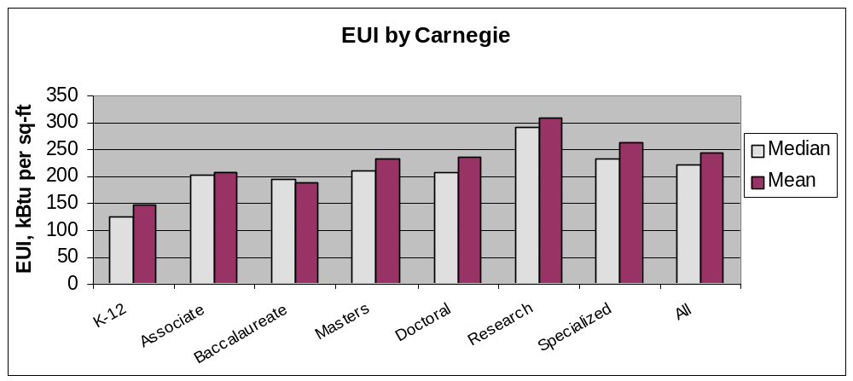

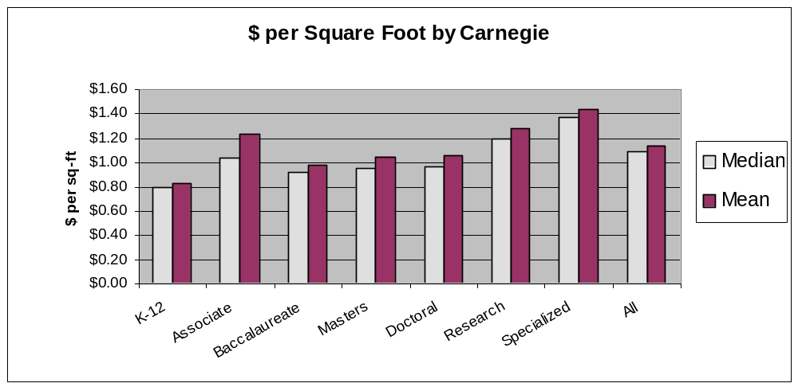

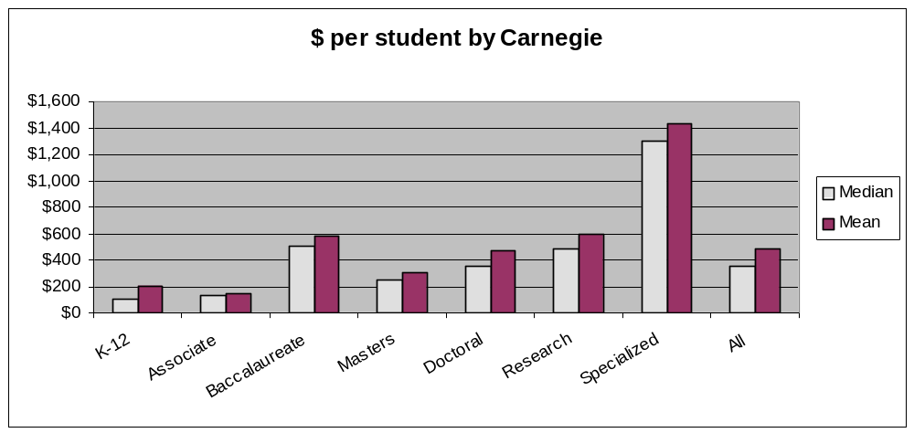
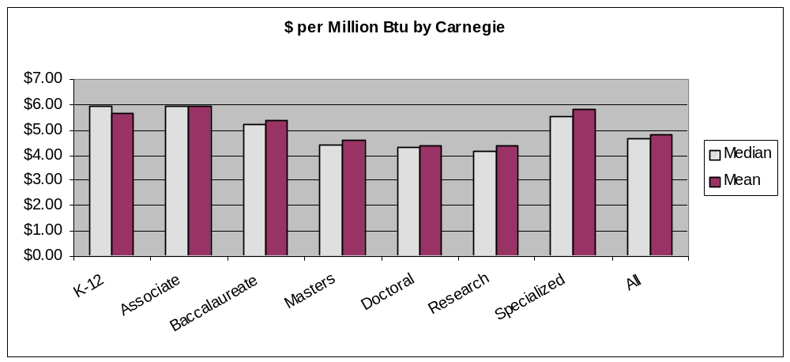

Overall, institutions should generally compare themselves to the medians of each index to see how they are doing.

EUI PERCENTILE PROFILES

Although much more could be done to present the data percentiles, the small sample sizes make meaningful statistics difficult to obtain. The following figure shows a distribution of EUI by Carnegie classification for the data reported here. These profiles are based on an initial statistical distribution that was adjusted in an ad hoc manner to smooth out the profiles. The profiles probably provide a reasonable representation of the general distribution of source EUI for the different classes, but larger samples are needed if one wants improved confidence in such distributions. Due to the ad hoc nature of the adjustment of the distributions, further work on the other indices was not conducted, and the statistically calculated percentile distributions are not reported.

Users can compare their EUI to the graph to estimate an approximate ranking of energy efficiency performance. However, all users are cautioned that adjustments for types of facilities on each campus would be appropriate to obtain more robust rankings. This author has a specific energy efficiency performance rating procedure that can be applied to compare campuses against the entire US commercial / institutional sector to obtain adjusted ratings of performance. Please consult the author for obtaining such a rating for a specific campus.

A high percentile ranking on this chart means a more energy efficient institution. However, this chart represents the first time that such information has been displayed, and there is still some uncertainty over whether the distributions should remain as they are. For instance, should research institutions really have such high energy use as shown here, or should efficient institutions use significantly less. For now, this is all that is available.

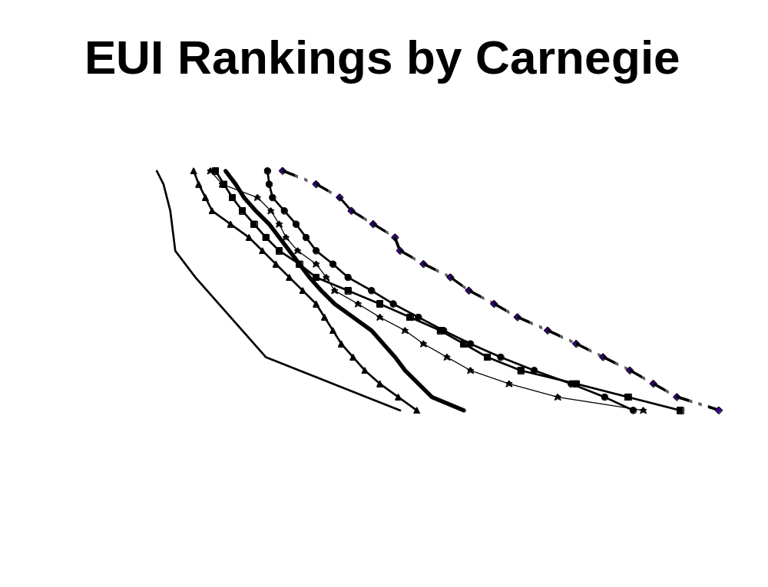

CONCLUSION

The energy data from the 1997–98 CCAS Survey conducted by APPA have been reviewed and adjusted. Statistical information from the corrected data are reported to allow higher education institutions to compare energy indexes among themselves. The spreadsheet containing all the base data is available and included with this report. The overall table of energy performance indexes for all institutions in the CCAS Survey follows. A second table on enrollment, floor area, and Carnegie classification is provided also.

Annual Energy Performance Indexes

Institution | State  / Prov | $ per  Million Btu | EUI  kBtu/sq-ft | Dollars  per sq-ft | Dollars  per student
UNIV OF NORTH ALABAMA | AL | $5.15 | 229 | $1.18 | $302
UNIV OF ALABAMA/HUNTSVILLE | AL | $5.43 | 209 | $1.14 | $473
JOHN BROWN UNIV | AR | $5.31 | 220 | $1.17 | $507
UNIV OF ARKANSAS/ LITTLE ROCK | AR | $3.65 | 411 | $1.50 | $326
UNIV OF ARKANSAS | AR | - - - - | - - - - | - - - - | - - - -
THUNDERBIRD/ GRAD SCH OF INTL MGMT | AZ | $5.87 | 219 | $1.29 | $419
PHOENIX COLLEGE | AZ | $7.45 | 233 | $1.73 | $164
ARIZONA STATE UNIV/ MAIN CAMPUS | AZ | $4.81 | 238 | $1.15 | $309
PIMA CNTY COMM COLLEGE* | AZ | $8.31 | 232 | $1.93 | $140
AZUSA PACIFIC UNIV | CA | $6.57 | 133 | $0.88 | $161
CALIFORNIA STATE UNIV/ LONG BEACH | CA | $5.31 | 173 | $0.92 | $189
CALIFORNIA POLYTECHNIC UNIV | CA | $4.55 | 182 | $0.83 | $178
CALIFORNIA STATE UNIV/ FRESNO | CA | $5.30 | 243 | $1.29 | $199
SAN JOSE STATE UNIV | CA | $4.57 | 206 | $0.94 | $235
COLLEGE OF SAN MATEO | CA | $5.03 | 190 | $0.96 | $64
STANFORD UNIV* | CA | $8.94 | 81 | $0.72 | $764
UNIV OF CALIFORNIA/ BERKELEY | CA | $4.36 | 225 | $0.98 | $458
UNIV OF CALIFORNIA/ SAN DIEGO | CA | $4.92 | 318 | $1.56 | $926
UNIV OF CALIFORNIA/ SAN FRANCISCO | CA | $7.00 | 257 | $1.80 | $1,720
UNIV OF CALIFORNIA/ SANTA BARBARA | CA | $5.86 | 190 | $1.11 | $291
UNIV OF CALIFORNIA/ SANTA CRUZ | CA |  |  |  | .
SAN MATEO CNTY COMM COLL DIST | CA | $5.79 | 188 | $1.09 | $69
CANADA COLLEGE | CA | $6.65 | 172 | $1.15 | $85
THE COLORADO COLLEGE | CO |  |  |  | .
UNIV OF COLORADO | CO | $6.77 | 187 | $1.27 | $457
JEFFERSON CNTY PUB SCHOOLS | CO | $5.94 | 113 | $0.67 | $85
TEIKYO POST UNIV | CT | - - - - | - - - - | - - - - | - - - -
QUINNIPIAC COLLEGE* | CT | $8.65 | 189 | $1.63 | $306
UNIV OF DELAWARE | DE | $4.76 | 300 | $1.43 | $558
EMBRY-RIDDLE AERONAUTICAL UNIV | FL | $6.94 | 211 | $1.46 | $408
FLORIDA A&M UNIV | FL |  |  |  | .
UNIV OF FLORIDA | FL | $5.24 | 241 | $1.26 | $668
UNIV OF MIAMI | FL | $6.73 | 110 | $0.74 | $186
GEORGIA INST OF TECHNOLOGY | GA | $3.91 | 280 | $1.09 | $782
GEORGIA SOUTHERN UNIV | GA | $4.70 | 204 | $0.96 | $202
UNIV OF GEORGIA | GA | $3.65 | 234 | $0.85 | $335
FULTON CNTY BOARD OF ED | GA | $6.85 | 116 | $0.80 | $114
BRIGHAM YOUNG UNIV/HAWAII* | HI | $8.75 | 121 | $1.06 | $478
GRACELAND COLLEGE | IA | $5.02 | 160 | $0.80 | $186
IOWA STATE UNIV | IA | $4.25 | 334 | $1.42 | $637
UNIV OF IOWA** | IA | $3.33 | 536 | $1.78 | $893
RICKS COLLEGE | ID | $3.70 | 152 | $0.56 | $128
UNIV OF IDAHO | ID | $3.13 | 197 | $0.62 | $226
EASTERN ILLINOIS UNIV | IL | $4.36 | 298 | $1.30 | $355
NORTHEASTERN ILLINOIS UNIV | IL | $4.14 | 283 | $1.17 | $182
SOUTHERN ILLINOIS UNIV/ CARBONDALE | IL | $3.26 | 355 | $1.16 | $433
UNIV OF ILLINOIS/ URBANA-CHAMPAIGN | IL | $3.07 | 387 | $1.19 | $585
UNIV OF ILLINOIS/ SPRINGFIELD | IL | $5.37 | 278 | $1.49 | $444
UIC COLL OF MEDICINE/ ROCKFORD | IL | $5.57 | 246 | $1.37 | $1,300
BUTLER UNIVERSITY | IN | $3.69 | 298 | $1.10 | $371
INDIANA UNIV/ BLOOMINGTON | IN | $2.82 | 311 | $0.88 | $399
INDIANA UNIV - PURDUE UNIV/ INDIANAPOLIS | IN | $4.59 | 186 | $0.85 | $396
PURDUE UNIV | IN | $1.50 | 429 | $0.64 | $259
UNIV OF NOTRE DAME | IN |  |  |  | .
WABASH COLLEGE | IN | - - - - | - - - - | - - - - | - - - -
SISTERS OF ST. BENEDICT MONASTERY | IN | $4.31 | 174 | $0.75 | $2,168
PITTSBURGH STATE UNIV | KS | $5.31 | 138 | $0.73 | $241
EMPORIA STATE UNIV | KS | $3.93 | 178 | $0.70 | $247
KANSAS STATE UNIV | KS | $5.20 | 370 | $1.92 | $672
UNIV OF KANSAS | KS | $4.33 | 237 | $1.03 | $316
GEORGETOWN COLLEGE | KY | $4.63 | 200 | $0.92 | $499
KENTUCKY STATE UNIV | KY | $5.32 | 168 | $0.90 | $549
UNIV OF KENTUCKY | KY | $3.65 | 231 | $0.84 | $376
MOREHEAD STATE UNIV | KY | $3.62 | 306 | $1.11 | $434
LSU SCH OF MEDICINE/ SHREVEPORT | LA | $3.92 | 389 | $1.53 | $1,533
LSU MED CENTER HOSP/ SHREVEPORT | LA | $3.92 | 351 | $1.38 | - - - -
BOSTON UNIV** | MA | $8.96 | 180 | $1.62 | $670
CLARK UNIV | MA | $4.12 | 137 | $0.57 | $427
MOUNT HOLYOKE COLLEGE | MA | $5.20 | 127 | $0.66 | $713
SMITH COLLEGE | MA | $4.18 | 260 | $1.09 | $1,075
UNIV OF MASSACHUSETTS/ AMHERST | MA | $4.65 | 292 | $1.36 | $591
WILLIAMS COLLEGE | MA | $4.73 | 194 | $0.92 | $843
NORTHFIELD MT HERMON SCHOOL | MA | $5.05 | 124 | $0.63 | $715
FROSTBURG STATE UNIV | MD | $5.05 | 173 | $0.88 | $273
TOWSON UNIV | MD | $4.97 | 211 | $1.05 | $246
UNIV OF MARYLAND/ BALTIMORE** | MD | $12.99 | 158 | $2.06 | $1,522
COLBY COLLEGE | ME | $5.78 | 215 | $1.24 | $875
UNIV OF SOUTHERN MAINE | ME | $6.71 | 137 | $0.92 | $265
MICHIGAN STATE UNIV** | MI | $2.95 | 514 | $1.52 | $740
OAKLAND UNIV | MI | $4.94 | 188 | $0.93 | $233
SIENA HEIGHTS UNIV | MI | $5.06 | 140 | $0.71 | $177
UNIV OF MICHIGAN | MI | $7.19 | 300 | $2.16 | $1,502
WESTERN MICHIGAN UNIV | MI | $5.39 | 342 | $1.84 | $764
MACALESTER COLLEGE | MN | $3.87 | 203 | $0.79 | $493
UNIV OF MINNESOTA** | MN | $5.83 | 471 | $2.75 | $1,034
HENNEPIN TECH COLLEGE | MN | $7.53 | 163 | $1.23 | $308
UNIV OF MISSOURI | MO | $2.61 | 461 | $1.20 | $826
UNIV OF MISSOURI/ ROLLA | MO | $4.61 | 402 | $1.85 | $945
UNIV OF MISSOURI/ KANSAS CITY | MO | $4.09 | 238 | $0.97 | $357
MILLSAPS COLLEGE | MS | $5.32 | 217 | $1.16 | $598
UNIV OF MISSISSIPPI | MS | $4.55 | 251 | $1.14 | $487
MONTANA STATE UNIV/ BILLINGS | MT | $4.45 | 181 | $0.81 | $350
UNIV OF MONTANA | MT | $3.16 | 149 | $0.47 | $156
NC A&T STATE UNIV | NC | $4.23 | 278 | $1.18 | $395
UNIV OF NORTH CAROLINA/ ASHEVILLE | NC | $5.58 | 305 | $1.70 | $501
CAMPBELL UNIV | NC | $3.73 | 329 | $1.23 | $369
CENTRAL PEIDMONT COM COLLEGE | NC | $6.58 | 123 | $0.81 | $171
DUKE UNIV | NC | $3.34 | 424 | $1.42 | $1,616
EAST CAROLINA UNIV** | NC | $6.67 | 338 | $2.25 | $521
ELON COLLEGE | NC | - - - - | - - - - | - - - - | - - - -
NORTH CAROLINA CENTRAL UNIV | NC | $4.04 | 206 | $0.83 | $227
NORTH CAROLINE STATE UNIV | NC | $5.21 | 271 | $1.41 | $485
UNIV OF NORTH CAROLINA/ GREENSBORO | NC | $5.90 | 307 | $1.81 | $614
WESTERN CAROLINA UNIV | NC | $4.07 | 234 | $0.95 | $374
UNIV OF NORTH CAROLINA/ WILLMINGTON | NC | $5.54 | 279 | $1.55 | $348
DARTMOUTH COLLEGE** | NH | $7.58 | 349 | $2.64 | $2,296
MIDDLESEX COUNTY COLLEGE | NJ |  |  |  | .
OCEAN COUNTY COLLEGE** | NJ | $11.47 | 251 | $2.88 | $295
RUTGERS/ THE STATE UNIV OF NEW JERSEY | NJ | $4.92 | 356 | $1.75 | $731
NEW MEXICO STATE UNIV | NM | $5.44 | 404 | $2.19 | $841
UNIV NEVADA/ LAS VEGAS | NV | $5.18 | 242 | $1.25 | $231
COLGATE UNIV | NY | $4.46 | 221 | $0.99 | $667
CORNELL UNIV | NY | $4.74 | 343 | $1.62 | $1,181
BOWLING GREEN STATE UNIV | OH | $3.93 | 302 | $1.19 | $394
DENISON UNIV | OH | $2.82 | 238 | $0.67 | $487
HIRAM | OH | $6.00 | 152 | $0.91 | $602
MIAMI UNIV | OH | $3.69 | 149 | $0.55 | $194
OHIO UNIV | OH | $3.10 | 252 | $0.78 | $269
XAVIER UNIV | OH | $5.19 | 168 | $0.87 | $175
UNIV OF CENTRAL OKLAHOMA | OK | $2.85 | 347 | $0.99 | $161
THE UNIV OF TULSA | OK | $2.90 | 417 | $1.21 | $488
LEWIS & CLARK COLLEGE | OR | $4.48 | 163 | $0.73 | $225
LINFIELD COLLEGE | OR | $3.30 | 144 | $0.47 | $252
OREGON STATE UNIV | OR | $3.46 | 221 | $0.77 | $300
PORTLAND STATE UNIV | OR | $4.41 | 91 | $0.40 | $130
UNIV OF OREGON | OR | $3.07 | 338 | $1.04 | $270
CATLIN GABLIN SCHOOL | OR | $5.00 | 109 | $0.54 | $100
BRYN MAWR COLLEGE | PA | $7.08 | 165 | $1.17 | $946
CARNEGIE MELLON UNIV | PA | $5.65 | 305 | $1.72 | $907
HARRISBURG AREA COM COLLEGE | PA | $6.06 | 269 | $1.63 | $197
HAVERFORD COLLEGE | PA | $6.80 | 129 | $0.88 | $997
MORAVIAN COLLEGE | PA | $6.26 | 136 | $0.85 | $560
PENN STATE UNIV | PA | $3.74 | 367 | $1.37 | $533
PENN STATE/ HARRISBURG | PA |  |  |  | .
UNIV OF RHODE ISLAND | RI | $7.17 | 207 | $1.48 | $528
CITADEL MILITARY COLL/ SOUTH CAROLINA | SC | $3.32 | 485 | $1.61 | $685
FURMAN UNIV | SC | $4.97 | 169 | $0.84 | $619
MIDLANDS TECHNICAL COLLEGE | SC | $5.76 | 196 | $1.13 | $113
UNIV OF SOUTH CAROLINA/SPARTANBURG | SC | $5.39 | 208 | $1.12 | $151
BLACK HILLS STATE UNIV | SD | $4.21 | 172 | $0.72 | $222
SOUTH DAKOTA STATE UNIV | SD | $2.89 | 376 | $1.09 | $379
UNIV OF SOUTH DAKOTA | SD | $2.20 | 171 | $0.38 | $120
UNIV OF MEMPHIS | TN | $5.13 | 167 | $0.86 | $282
MIDDLE TENNESSEE STATE UNIV | TN | $4.65 | 200 | $0.93 | $227
THE UNIV OF TENNESSEE/ KNOXVILLE | TN | $4.23 | 219 | $0.93 | $559
UNIV OF THE SOUTH | TN | $6.93 | 134 | $0.93 | $1,037
UNIV OF NORTH TEXAS | TX | $4.31 | 242 | $1.04 | $236
ALAMO COMM COLLEGE DISTRICT | TX | $3.72 | 253 | $0.94 | $56
ST. MARY'S UNIV | TX | - - - - | - - - - | - - - - | - - - -
TARLETON STATE UNIV | TX | $3.78 | 178 | $0.67 | $146
TEXAS LUTHERAN UNIV | TX | $5.00 | 206 | $1.03 | $460
TEXAS WESLEYAN UNIV | TX | $3.91 | 200 | $0.78 | $157
TRINITY UNIV | TX | $3.61 | 219 | $0.79 | $693
UNIV OF TEXAS/ ARLINGTON | TX | $4.18 | 274 | $1.14 | $257
UNIV OF TEXAS/ PERMIAN BASIN | TX | $6.72 | 285 | $1.91 | $630
TEXAS A&M UNIV/ CORPUS CHRISTI | TX | $4.34 | 344 | $1.49 | $230
TEXAS A&M UNIV/ TEXARKANA | TX | $4.00 | 192 | $0.77 | $86
UNIV OF UTAH | UT | $3.54 | 374 | $1.32 | $477
SALT LAKE COMM COLLEGE | UT | $2.65 | 288 | $0.76 | $96
COLLEGE OF WILLIAM AND MARY | VA | $4.24 | 163 | $0.69 | $275
JAMES MADISON UNIV | VA | $3.89 | 261 | $1.02 | $293
RADFORD UNIV | VA | $3.95 | 162 | $0.64 | $170
VIRGINIA COMMONWEALTH UNIV | VA | $4.71 | 209 | $0.98 | $263
UNIV OF VIRGINIA | VA | $3.81 | 327 | $1.25 | $771
VIRGINIA POLYTECH INST & STATE UNIV | VA | $3.57 | 329 | $1.18 | $363
VIRGINIA INST OF MARINE SCIENCE | VA | $5.50 | 354 | $1.95 | $4,700
FAIRFAX COUNTY PUBLIC SCHOOLS | VA | $6.04 | 156 | $0.94 | $134
PRINCE WILLIAM CNTY PUB SCHOOLS | VA | $6.02 | 241 | $1.45 | $164
LOUDOUN COUNTY PUBLIC SCHOOLS | VA | $4.69 | 170 | $0.80 | $104
NORWICH UNIV | VT | $5.05 | 137 | $0.69 | $302
UNIV OF WASHINGTON | WA | $2.84 | 248 | $0.70 | $338
WESTERN WASHINGTON UNIV | WA | $5.51 | 200 | $1.10 | $289
MARQUETTE UNIV | WI | $4.59 | 88 | $0.41 | $196
UNIV OF WISCONSIN/ MILWAUKEE | WI | $3.91 | 200 | $0.78 | $261
UNIV OF WISCONSIN/ LA CROSSE | WI | $2.79 | 215 | $0.60 | $161
UNIV OF WISCONSIN/ RIVER FALLS | WI | $2.90 | 165 | $0.48 | $157
UNIV OF WISCONSIN/ STEVENS POINT | WI | $3.01 | 225 | $0.68 | $216
UNIV OF WISCONSIN/ WHITE WATER | WI | $3.90 | 120 | $0.47 | $128
WEST VIRGINIA UNIV | WV |  |  |  | .
UNIV OF WYOMING | WY | $2.34 | 248 | $0.58 | $318
LARAMIE CNTY COMM COLLEGE | WY | $3.30 | 211 | $0.70 | $160
UNIV OF ALBERTA* | ALB | $3.96 | 508 | $2.01 | $886
BRITISH COLUMBIA INST OF TECH | BC | $4.78 | 184 | $0.88 | $135
OKANAGAN UNIV COLLEGE | BC |  |  |  | .
UNIV OF MANITOBA | MAN | $4.21 | 287 | $1.21 | $305
MEM UNIV/ NEWF’NDL’AND & LABRADOR | NEW | $5.06 | 241 | $1.22 | $216
ST. FRANCIS XAVIER UNIV | NOV | $6.33 | 243 | $1.54 | $481
UNIV COLLEGE OF CAPE BRETON | NOV | - - - - | - - - - | - - - - | - - - -
UNIV OF WESTERN ONTARIO | ONT | $4.39 | 291 | $1.28 | $369
UNIV OF WINDSOR | ONT | $4.22 | 303 | $1.28 | $659
YORK UNIV** | ONT | $6.41 | 386 | $2.47 | $420
MCGILL UNIV | QUE | $4.75 | 270 | $1.28 | $457
UNIVERSITE' LAVAL | QUE | $5.38 | 206 | $1.11 | $323

Notes: 1. Blank entries indicate data were not reported.
- ‘- - - -‘ indicates data were too difficult to correct or too suspect to report.
- ‘*’ indicates somewhat questionable data
- ‘**’ indicates questionable data

Classification Data

Institution | State  / Prov | Type | Enroll-ment | Area | Carnegie | APPA  Region
UNIV OF NORTH ALABAMA | AL | Public | 4,568 | 1,169,005 | Masters | Southeastern
UNIV OF ALABAMA/ HUNTSVILLE | AL | Public | 4,127 | 1,719,200 | Doctoral | Southeastern
JOHN BROWN UNIV | AR | Private | 1,257 | 546,000 | Baccalaureate | Central
UNIV OF ARKANSAS/  LITTLE ROCK | AR | Public | 7,999 | 1,738,073 | Masters | Central
UNIV OF ARKANSAS | AR | Public | 12,394 | 6,368,933 | Research | Central
THUNDERBIRD/ GRAD SCH OF INTL MGMT | AZ | Private | 1,530 | 498,000 | Specialized | Rocky Mountain
PHOENIX COLLEGE | AZ | Public | 4,650 | 440,000 | Associate | Rocky Mountain
ARIZONA STATE UNIV/  MAIN CAMPUS | AZ | Public | 39,109 | 10,540,200 | Research | Rocky Mountain
PIMA CNTY COMM COLLEGE | AZ | Public | 15,025 | 1,094,601 | Associate | Rocky Mountain
AZUSA PACIFIC UNIV | CA | Private | 6,000 | 1,100,000 | Masters | Pacific Coast
CALIFORNIA STATE UNIV/ LONG BEACH | CA | Public | 19,800 | 4,076,366 | Masters | Pacific Coast
CALIFORNIA POLYTECHNIC UNIV | CA | Public | 15,463 | 3,324,581 | Masters | Pacific Coast
CALIFORNIA STATE UNIV/ FRESNO | CA | Public | 16,800 | 2,598,586 | Masters | Pacific Coast
SAN JOSE STATE UNIV | CA | Public | 19,983 | 4,988,189 | Masters | Pacific Coast
COLLEGE OF SAN MATEO | CA | Public | 8,525 | 566,521 | Associate | Pacific Coast
STANFORD UNIV | CA | Private | 13,811 | 14,644,857 | Research | Pacific Coast
UNIV OF CALIFORNIA/ BERKELEY | CA | Public | 30,290 | 14,181,867 | Research | Pacific Coast
UNIV OF CALIFORNIA/  SAN DIEGO | CA | Public | 18,667 | 11,066,901 | Research | Pacific Coast
UNIV OF CALIFORNIA/  SAN FRANCISCO | CA | Public | 3,522 | 3,370,000 | Research | Pacific Coast
UNIV OF CALIFORNIA/  SANTA BARBARA | CA | Public | 20,097 | 5,257,394 | Research | Pacific Coast
UNIV OF CALIFORNIA/  SANTA CRUZ | CA | Public | 10,500 | 3,673,263 | Research | Pacific Coast
SAN MATEO CNTY COMM COLL DIST | CA | Public | 17,913 | 1,140,135 | Specialized | Pacific Coast
CANADA COLLEGE | CA | Public | 3,289 | 242,656 | Associate | Pacific Coast
THE COLORADO COLLEGE | CO | Private | 1,900 | 1,900,000 | Baccalaureate | Rocky Mountain
UNIV OF COLORADO | CO | Public | 25,109 | 9,060,600 | Specialized | Rocky Mountain
JEFFERSON CNTY PUB SCHOOLS | CO | Public | 82,756 | 10,506,494 | K12 | Rocky Mountain
TEIKYO POST UNIV | CT | Private | 598 | 237,000 | Specialized | Eastern
QUINNIPIAC COLLEGE | CT | Private | 5,289 | 989,927 | Masters | Eastern
UNIV OF DELAWARE | DE | Public | 17,655 | 6,889,527 | Research | Eastern
EMBRY-RIDDLE AERONAUTICAL UNIV | FL | Private | 4,145 | 1,153,988 | Masters | Southeastern
FLORIDA A&M UNIV | FL | Public | 9,098 | 2,642,537 | Masters | Southeastern
UNIV OF FLORIDA | FL | Public | 29,921 | 15,800,000 | Research | Southeastern
UNIV OF MIAMI | FL | Private | 12,626 | 3,181,595 | Research | Southeastern
GEORGIA INST OF TECHNOLOGY | GA | Public | 11,822 | 8,455,542 | Research | Southeastern
GEORGIA SOUTHERN UNIV | GA | Public | 13,126 | 2,765,097 | Masters | Southeastern
UNIV OF GEORGIA | GA | Public | 29,693 | 11,663,038 | Research | Southeastern
FULTON CNTY BOARD OF ED | GA | Public | 61,169 | 8,743,675 | K12 | Southeastern
BRIGHAM YOUNG UNIV/ HAWAII | HI | Private | 2,294 | 1,032,324 | Baccalaureate | Pacific Coast
GRACELAND COLLEGE | IA | Private | 2,399 | 556,745 | Baccalaureate | Midwest
IOWA STATE UNIV | IA | Public | 25,384 | 11,370,692 | Research | Midwest
UNIV OF IOWA | IA | Public | 27,871 | 13,972,142 | Research | Midwest
RICKS COLLEGE | ID | Private | 8,250 | 1,879,799 | Associate | Pacific Coast
UNIV OF IDAHO | ID | Public | 9,897 | 3,635,333 | Research | Pacific Coast
EASTERN ILLINOIS UNIV | IL | Public | 11,777 | 3,218,641 | Masters | Midwest
NORTHEASTERN ILLINOIS UNIV | IL | Public | 6,211 | 963,591 | Masters | Midwest
SOUTHERN ILLINOIS UNIV/ CARBONDALE | IL | Public | 18,583 | 6,964,939 | Research | Midwest
UNIV OF ILLINOIS/ URBANA-CHAMPAIGN | IL | Public | 35,979 | 17,752,285 | Research | Midwest
UNIV OF ILLINOIS/ SPRINGFIELD | IL | Public | 2,574 | 764,850 | Masters | Midwest
UIC COLL OF MEDICINE/ ROCKFORD | IL | Public | 200 | 189,669 | Specialized | Midwest
BUTLER UNIVERSITY | IN | Private | 3,858 | 1,300,000 | Masters | Midwest
INDIANA UNIV/ BLOOMINGTON | IN | Public | 31,239 | 14,221,000 | Research | Midwest
INDIANA UNIV - PURDUE UNIV/ INDIANAPOLIS | IN | Public | 18,208 | 8,472,977 | Doctoral | Midwest
PURDUE UNIV | IN | Public | 37,715 | 15,213,050 | Research | Midwest
UNIV OF NOTRE DAME | IN | Private | 10,281 | 7,219,776 | Research | Midwest
WABASH COLLEGE | IN | Private | 800 | 763,657 | Baccalaureate | Midwest
SISTERS OF ST. BENEDICT MONASTERY | IN | Private | 140 | 405,000 | Specialized | Midwest
PITTSBURGH STATE UNIV | KS | Public | 5,265 | 1,735,882 | Masters | Central
EMPORIA STATE UNIV | KS | Public | 4,625 | 1,637,188 | Masters | Central
KANSAS STATE UNIV | KS | Public | 20,306 | 7,092,664 | Research | Central
UNIV OF KANSAS | KS | Public | 25,108 | 7,714,181 | Research | Central
GEORGETOWN COLLEGE | KY | Private | 1,372 | 742,000 | Baccalaureate | Southeastern
KENTUCKY STATE UNIV | KY | Public | 1,798 | 1,101,546 | Masters | Southeastern
UNIV OF KENTUCKY | KY | Public | 24,171 | 10,800,000 | Research | Southeastern
MOREHEAD STATE UNIV | KY | Public | 6,357 | 2,492,168 | Masters | Midwest
LSU SCH OF MEDICINE/ SHREVEPORT | LA | Public | 705 | 708,467 | Specialized | Southeastern
LSU MED CENTER HOSP/ SHREVEPORT | LA | Public |  | 1,458,276 | Specialized | Southeastern
BOSTON UNIV | MA | Private | 23,036 | 9,554,649 | Research | Eastern
CLARK UNIV | MA | Private | 1,899 | 1,436,202 | Doctoral | Eastern
MOUNT HOLYOKE COLLEGE | MA | Private | 1,860 | 2,011,000 | Baccalaureate | Eastern
SMITH COLLEGE | MA | Private | 2,840 | 2,806,503 | Baccalaureate | Eastern
UNIV OF MASSACHUSETTS/ AMHERST | MA | Public | 21,823 | 9,480,000 | Research | Eastern
WILLIAMS COLLEGE | MA | Private | 2,164 | 1,991,754 | Baccalaureate | Eastern
NORTHFIELD MT HERMON SCH | MA | Public | 1,099 | 1,258,067 | K12 | Southeastern
FROSTBURG STATE UNIV | MD | Public | 4,316 | 1,345,613 | Masters | Eastern
TOWSON UNIV | MD | Public | 15,277 | 3,593,992 | Masters | Eastern
UNIV OF MARYLAND/ BALTIMORE | MD | Public | 5,975 | 4,417,554 | Specialized | Eastern
COLBY COLLEGE | ME | Private | 1,804 | 1,268,900 | Baccalaureate | Eastern
UNIV OF SOUTHERN MAINE | ME | Public | 6,234 | 1,792,756 | Masters | Eastern
MICHIGAN STATE UNIV | MI | Public | 42,603 | 20,780,498 | Research | Midwest
OAKLAND UNIV | MI | Public | 9,160 | 2,300,000 | Masters | Midwest
SIENA HEIGHTS UNIV | MI | Private | 2,000 | 500,000 | Baccalaureate | Midwest
UNIV OF MICHIGAN | MI | Public | 36,964 | 25,752,833 | Research | Midwest
WESTERN MICHIGAN UNIV | MI | Public | 17,073 | 7,073,334 | Doctoral | Midwest
MACALESTER COLLEGE | MN | Private | 1,698 | 1,066,362 | Baccalaureate | Midwest
UNIV OF MINNESOTA | MN | Public | 35,864 | 13,500,000 | Research | Midwest
HENNEPIN TECH COLLEGE | MN | Public | 3,192 | 800,000 | Associate | Midwest
UNIV OF MISSOURI | MO | Public | 18,890 | 12,957,826 | Research | Central
UNIV OF MISSOURI/ ROLLA | MO | Public | 4,050 | 2,064,376 | Doctoral | Central
UNIV OF MISSOURI/  KANSAS CITY | MO | Public | 7,183 | 2,629,702 | Doctoral | Central
MILLSAPS COLLEGE | MS | Private | 1,256 | 649,574 | Baccalaureate | Southeastern
UNIV OF MISSISSIPPI | MS | Public | 10,115 | 4,310,839 | Research | Southeastern
MONTANA STATE UNIV/ BILLINGS | MT | Public | 1,730 | 750,000 | Masters | Rocky Mountain
UNIV OF MONTANA | MT | Public | 10,924 | 3,634,631 | Doctoral | Rocky Mountain
NC A&T STATE UNIV | NC | Public | 6,777 | 2,272,271 | Masters | Southeastern
UNIV OF NORTH CAROLINA/ ASHEVILLE | NC | Public | 3,092 | 909,500 | Baccalaureate | Southeastern
CAMPBELL UNIV | NC | Private | 3,195 | 961,081 | Masters | Southeastern
CENTRAL PEIDMONT COM COLLEGE | NC | Public | 6,810 | 1,436,202 | Associate | Southeastern
DUKE UNIV | NC | Private | 11,000 | 12,562,929 | Research | Southeastern
EAST CAROLINA UNIV | NC | Public | 17,846 | 4,128,229 | Masters | Southeastern
ELON COLLEGE | NC | Private | 3,536 | 1,183,823 | Masters | Southeastern
NORTH CAROLINA CENTRAL UNIV | NC | Public | 5,664 | 1,541,557 | Masters | Southeastern
NORTH CAROLINE STATE UNIV | NC | Public | 27,529 | 9,448,183 | Masters | Southeastern
UNIV OF NORTH CAROLINA/ GREENSBORO | NC | Public | 10,613 | 3,591,036 | Doctoral | Southeastern
WESTERN CAROLINA UNIV | NC | Public | 6,007 | 2,355,330 | Masters | Southeastern
UNIV OF NORTH CAROLINA/ WILLMINGTON | NC | Public | 8,378 | 1,882,000 | Masters | Southeastern
DARTMOUTH COLLEGE | NH | Private | 4,302 | 3,737,500 | Doctoral | Eastern
MIDDLESEX COUNTY COLLEGE | NJ | Public | 7,577 | 734,000 | Associate | Eastern
OCEAN COUNTY COLLEGE | NJ | Public | 3,544 | 362,388 | Associate | Eastern
RUTGERS/ THE STATE UNIV OF NEW JERSEY | NJ | Public | 39,848 | 16,625,000 | Specialized | Eastern
NEW MEXICO STATE UNIV | NM | Public | 11,975 | 4,586,775 | Research | Rocky Mountain
UNIV NEVADA/ LAS VEGAS | NV | Public | 14,332 | 2,640,345 | Masters | Pacific Coast
COLGATE UNIV | NY | Private | 2,700 | 1,827,000 | Baccalaureate | Eastern
CORNELL UNIV | NY | Private | 18,428 | 13,400,000 | Research | Eastern
BOWLING GREEN STATE UNIV | OH | Public | 15,000 | 4,988,995 | Doctoral | Midwest
DENISON UNIV | OH | Private | 2,017 | 1,461,269 | Baccalaureate | Midwest
HIRAM | OH | Private | 1,066 | 703,494 | Baccalaureate | Midwest
MIAMI UNIV | OH | Public | 15,984 | 5,651,950 | Doctoral | Midwest
OHIO UNIV | OH | Public | 19,782 | 6,799,878 | Research | Midwest
XAVIER UNIV | OH | Private | 6,500 | 1,300,000 | Masters | Midwest
UNIV OF CENTRAL OKLAHOMA | OK | Public | 10,126 | 1,649,361 | Masters | Central
THE UNIV OF TULSA | OK | Private | 3,903 | 1,575,337 | Doctoral | Central
LEWIS & CLARK COLLEGE | OR | Private | 3,200 | 987,000 | Baccalaureate | Pacific Coast
LINFIELD COLLEGE | OR | Private | 1,516 | 805,255 | Masters | Pacific Coast
OREGON STATE UNIV | OR | Public | 14,300 | 5,603,264 | Research | Pacific Coast
PORTLAND STATE UNIV | OR | Public | 10,553 | 3,416,378 | Doctoral | Pacific Coast
UNIV OF OREGON | OR | Public | 17,207 | 4,470,945 | Research | Pacific Coast
CATLIN GABLIN SCHOOL | OR | Private | 870 | 159,139 | K12 | Pacific Coast
BRYN MAWR COLLEGE | PA | Private | 1,558 | 1,260,000 | Baccalaureate | Eastern
CARNEGIE MELLON UNIV | PA | Private | 7,379 | 3,884,211 | Research | Eastern
HARRISBURG AREA COM COLLEGE | PA | Public | 5,094 | 615,099 | Associate | Eastern
HAVERFORD COLLEGE | PA | Private | 1,125 | 1,281,200 | Baccalaureate | Eastern
MORAVIAN COLLEGE | PA | Private | 1,529 | 1,009,334 | Baccalaureate | Eastern
PENN STATE UNIV | PA | Public | 37,779 | 14,652,675 | Research | Eastern
PENN STATE/ HARRISBURG | PA | Public | 3,600 | 500,000 | Masters | Eastern
UNIV OF RHODE ISLAND | RI | Public | 9,008 | 3,211,369 | Research | Eastern
CITADEL MILITARY COLL/ SOUTH CAROLINA | SC | Public | 3,766 | 1,600,000 | Masters | Southeastern
FURMAN UNIV | SC | Private | 2,500 | 1,847,159 | Baccalaureate | Southeastern
MIDLANDS TECHNICAL COLLEGE | SC | Public | 5,958 | 600,000 | Associate | Southeastern
UNIV OF SOUTH CAROLINA/SPARTANBURG | SC | Public | 3,500 | 471,000 | Baccalaureate | Southeastern
BLACK HILLS STATE UNIV | SD | Public | 2,377 | 728,699 | Baccalaureate | Central
SOUTH DAKOTA STATE UNIV | SD | Public | 7,509 | 2,615,688 | Masters | Central
UNIV OF SOUTH DAKOTA | SD | Public | 6,197 | 1,974,506 | Doctoral | Central
UNIV OF MEMPHIS | TN | Public | 15,452 | 5,089,169 | Doctoral | Southeastern
MIDDLE TENNESSEE STATE UNIV | TN | Public | 15,455 | 3,753,017 | Doctoral | Southeastern
THE UNIV OF TENNESSEE/ KNOXVILLE | TN | Public | 21,389 | 12,894,555 | Research | Southeastern
UNIV OF THE SOUTH | TN | Private | 1,274 | 1,424,984 | Baccalaureate | Southeastern
UNIV OF NORTH TEXAS | TX | Public | 18,804 | 4,252,568 | Doctoral | Central
ALAMO COMM COLLEGE DISTRICT | TX | Public | 39,667 | 2,350,684 | Associate | Central
ST. MARY'S UNIV | TX | Private | 3,737 | 1,035,555 | Masters | Central
TARLETON STATE UNIV | TX | Public | 6,474 | 1,404,171 | Masters | Central
TEXAS LUTHERAN UNIV | TX | Private | 1,344 | 600,000 | Baccalaureate | Central
TEXAS WESLEYAN UNIV | TX | Private | 3,172 | 635,071 | Masters | Central
TRINITY UNIV | TX | Private | 2,325 | 2,037,608 | Masters | Central
UNIV OF TEXAS/ ARLINGTON | TX | Public | 17,165 | 3,854,050 | Doctoral | Central
UNIV OF TEXAS/ PERMIAN BASIN | TX | Public | 1,444 | 475,456 | Masters | Central
TEXAS A&M UNIV/ CORPUS CHRISTI | TX | Public | 4,403 | 679,406 | Masters | Central
TEXAS A&M UNIV/ TEXARKANA | TX | Public | 667 | 74,600 | Masters | Central
UNIV OF UTAH | UT | Public | 23,574 | 8,497,251 | Research | Rocky Mountain
SALT LAKE COMM COLLEGE | UT | Public | 12,731 | 1,595,020 | Associate | Rocky Mountain
COLLEGE OF WILLIAM & MARY | VA | Public | 7,571 | 3,013,339 | Doctoral | Southeastern
JAMES MADISON UNIV | VA | Public | 12,877 | 3,713,348 | Masters | Southeastern
RADFORD UNIV | VA | Public | 8,377 | 2,228,865 | Masters | Southeastern
VIRGINIA COMMONWEALTH UNIV | VA | Public | 18,121 | 4,856,257 | Research | Southeastern
UNIV OF VIRGINIA | VA | Public | 18,417 | 11,383,838 | Research | Southeastern
VIRGINIA POLYTECH INST & STATE UNIV | VA | Public | 25,213 | 7,779,792 | Research | Southeastern
VIRGINIA INST OF MARINE SCIENCE | VA | Public | 115 | 277,758 | Specialized | Eastern
FAIRFAX COUNTY PUBLIC SCHOOLS | VA | Public | 149,830 | 21,446,088 | K12 | Southeastern
PRINCE WILLIAM CNTY PUB SCHOOLS | VA | Public | 51,638 | 5,829,822 | K12 | Southeastern
LOUDOUN COUNTY PUBLIC SCHOOLS | VA | Public | 26,091 | 3,400,000 | K12 | Southeastern
NORWICH UNIV | VT | Private | 2,593 | 1,129,802 | Masters | Eastern
UNIV OF WASHINGTON | WA | Public | 33,600 | 16,156,000 | Research | Pacific Coast
WESTERN WASHINGTON UNIV | WA | Public | 10,890 | 2,852,230 | Masters | Pacific Coast
MARQUETTE UNIV | WI | Private | 8,996 | 4,342,081 | Doctoral | Midwest
UNIV OF WISCONSIN/ MILWAUKEE | WI | Public | 15,594 | 5,219,186 | Research | Midwest
UNIV OF WISCONSIN/  LA CROSSE | WI | Public | 8,080 | 2,170,250 | Masters | Midwest
UNIV OF WISCONSIN/  RIVER FALLS | WI | Public | 5,100 | 1,680,000 | Masters | Midwest
UNIV OF WISCONSIN/  STEVENS POINT | WI | Public | 7,673 | 2,447,955 | Masters | Midwest
UNIV OF WISCONSIN/  WHITE WATER | WI | Public | 8,901 | 2,446,054 | Masters | Midwest
WEST VIRGINIA UNIV | WV | Public | 23,000 | 6,076,372 | Research | Southeastern
UNIV OF WYOMING | WY | Public | 11,094 | 6,075,639 | Research | Rocky Mountain
LARAMIE CNTY COMM COLLEGE | WY | Public | 2,623 | 602,864 | Associate | Rocky Mountain
UNIV OF ALBERTA | ALB | Public | 26,977 | 11,904,628 | Research | Rocky Mountain
BRITISH COLUMBIA INST OF TECH | BC | Public | 15,134 | 2,330,604 | Associate | Pacific Coast
OKANAGAN UNIV COLLEGE | BC | Public | 6,045 | 93,118 | Baccalaureate | Pacific Coast
UNIV OF MANITOBA | MAN | Public | 21,083 | 5,319,374 | Research | Central
MEM UNIV/ NEWFOUNDLAND & LABRADOR | NEW | Public | 15,822 | 2,799,923 | Masters | Eastern
ST. FRANCIS XAVIER UNIV | NOV | Public | 3,200 | 1,000,000 | Baccalaureate | Eastern
UNIV COLLEGE OF CAPE BRETON | NOV | Public | 3,200 | 589,241 | Baccalaureate | Eastern
UNIV OF WESTERN ONTARIO | ONT | Public | 21,629 | 6,246,700 | Research | Eastern
UNIV OF WINDSOR | ONT | Public | 4,725 | 2,437,800 | Doctoral | Eastern
YORK UNIV | ONT | Public | 33,795 | 5,749,194 | Research | Eastern
MCGILL UNIV | QUE | Public | 21,325 | 7,607,320 | Research | Eastern
UNIVERSITE' LAVAL | QUE | Public | 24,779 | 7,222,400 | Research | Eastern

