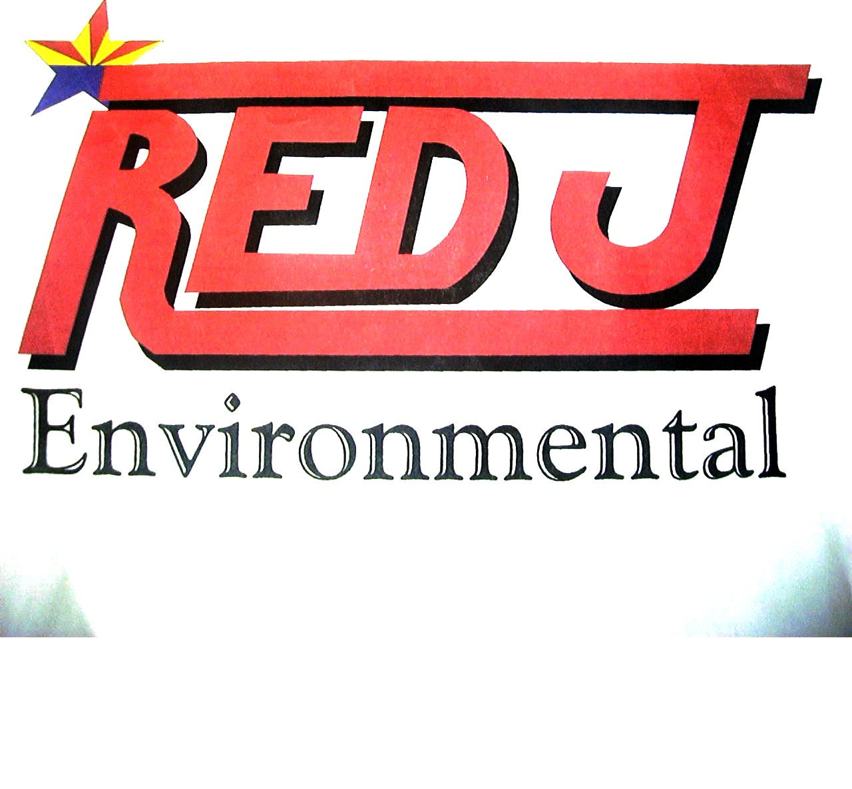
___________________________________________

General Services Administration
Federal Supply Schedule
Environmental Services

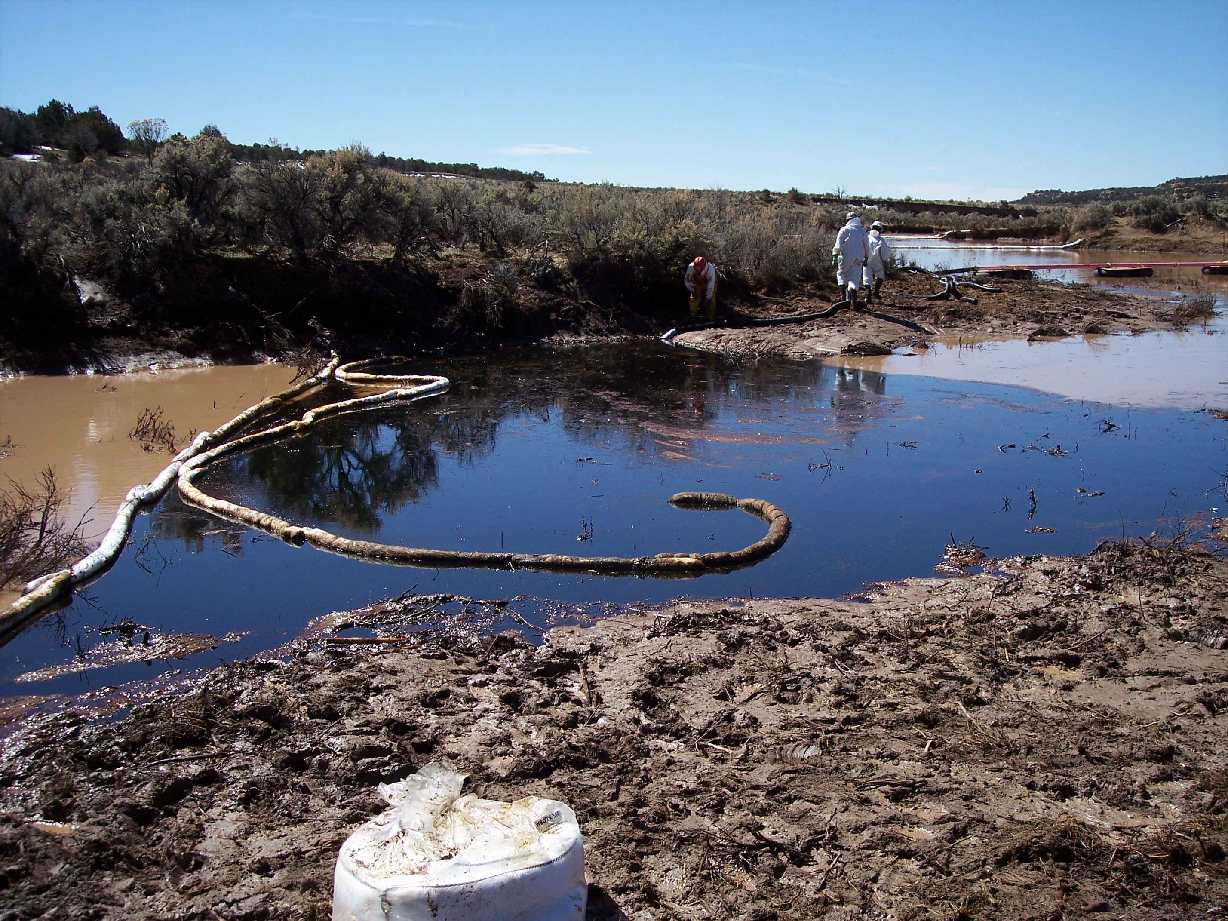

Federal Supply Group: 899
Contract Number: GS-10F-0246T
May 21, 2007 through May 20, 2012
General Services Administration
Federal Supply Services
____________________________________________________________________________

Environmental Services Schedule
Federal Supply Group 899
Contract Number GS-10F-0246T

Contractor
Red J Environmental Corporation
PO Box A
4593 Main Street
Joseph City, AZ 86032 0240

Business Contacts
Casey Fish, General Manager
Phone 928 288-3239
E-Mail casey@redjenvrionmental.com

Jim Moots, Program Manager
Phone 480 220-4840
E-Mail jim@redjenvironmental.com

Sheila Peterson, Contract Manager
Phone 928 288-3239
E-Mail sheila@redjenvironmental.com

Internet Address www.redjenvironmental.com

Business Size and Classification
Small Business, HUBZone

_______________________________________________________________________________________________
Red J Environmental Corporation

General Services Administration
Customer Information
____________________________________________________________________________

1. Awarded Special Item Numbers (SIN):
899-4, 899-4RC Waste Management Services
899-5, 899-5RC Reclamation, Recycling, and Disposal Services
899-8, 899-8RC Remediation Services

2. Maximum Order: $5,000,000.00

3. Minimum Order: $100.00

4. Geographic Coverage: Domestic only

5. Point(s) of production: Same as company address

6. Government Net Prices (discount already applied)

7. Quantity discounts: None Offered

8. Prompt payment terms: 1.5% - 10, Net 30 days

9a-b Government purchase cards will be accepted above the micro-purchase theshold.

10. Foreign items: N/A

11a-d Time of Delivery: Negotiated with ordering agency per Task Order

12. F.O.B. Points: Destination

13a. Ordering Address: Red J Environmental Corporation
PO Box A
Joseph City, AZ 86032
13b. Ordering procedures: For supplies and services, the ordering procedures, information on
Blanket Purchase Agreements (BPA’s), and a sample BPA can be
found at the GSA/FSS Schedule homepage (fss.gsa.gov/schedules).

14. Payment address: Payment via Check/U.S. Mail

RED J ENVIRONMENTAL CORPORATION
PO Box A
Joseph City, AZ 86032

15. Warranty provision: Contractor’s standard commercial warranty

16. Export Packing Charges: N/A

__________________________________________________________________________________________________________
Red J Environmental Corporation
General Services Administration
Customer Information
____________________________________________________________________________

17. Terms and conditions of Government purchase card acceptance (any thresholds above the micro-purchase level):
Contact Red J Environmental Corporation, for purchase card acceptance above the micro-purchase level.

18. Terms and conditions of rental, maintenance, and repair: N/A

19. Terms and conditions of installation: N/A

20. Terms and conditions of repair parts: N/A

20a. Terms and conditions for any other services: N/A

21. List of service and distribution points: N/A

22. List of participating dealers: N/A

23. Preventive maintenance: N/A

24. Environmental attributes: N/A

25. Data Universal Numbering System (DUNS) number: 94-9117030

26. Red J Environmental is registered with the Central Contractor Registration (CCR).

__________________________________________________________________________________________________________
Red J Environmental Corporation
Red J Environmental Capabilities
____________________________________________________________________________

Red J Environmental is an SBA HUBZone Certified environmental firm, located and operating in northeastern Arizona, since 1996. Red J is a relatively small company with a technically diverse and experienced staff providing regulatory, project management and field services. Our size allows us to be decisive and responsive to our clients throughout the Southwest servicing the private sector, local and state governments and Federal agencies.

Our dedicated team has serviced a diverse range of clients including Bureau of Land Management, U.S. Forest Service and a variety of private-sector clients including Waste Management of Arizona, the Town of Cave Creek and American Water. We have a proven record indicating our abilities to successfully complete a statement of work (SOW) while providing paramount services.

Red J has an established expertise in mine site remediation and reclamation including design modification for proper site and erosion control, mold investigation and remediation, excavation of hazardous and non-hazardous soils, containment cell construction, emergency response to incidents and transportation services and disposal as well as transfer station operations and the operation of waste water treatment facilities.

Red J has assembled a unique array of personnel within our core management and field crews. As a relatively small company with a technically diverse and experienced staff, our size allows us to be decisive and responsive to our clients throughout the Southwest. At Red J, we are committed to provide a well-managed and cost effective performance to our clients.

__________________________________________________________________________________________________________
Red J Environmental Corporation

Red J Environmental
Environmental Services Schedule
____________________________________________________________________________

SIN 899-4 WASTE MANAGEMENT SERVICES

Red J is a leader in providing waste management services in the southwest. Specific services provided are:

- RCRA and CERCLA Time Critical Investigations and Removal Actions
- Hazard and Exposure Assessments
- Waste Characterization, Preliminary Assessments/Site Inspections, Soil and Groundwater Investigations
- Feasibility Studies, Corrective Measures Studies, Pilot and bench Scale Testing, Treat-ability Studies
- Waste Management Plans
- Waste Determination
- Waste Audits
- Mold Investigations
- Solid Waste Management
- Waste Identification and Packaging
- Development of Emergency Response Plans

SIN 899-5 RECLAMATION, RECYCLING, AND DISPOSAL SERVICES

Red J’s capabilities span many of the services in SIN 899-5, specifically providing:

- Operation of Recycling Systems and Treatment Systems
- Collection and Packaging Hazardous and Non Hazardous Waste for Disposal
- Operation of Waste Water Treatment Facilities
- Concrete Recycling for Road Base Material
- Management, Audit, and or Operation of Disposal Operations
- Transportation Services and Disposal
- Transportation and Disposal or Recycling of Batteries, Metals, and
Chemicals
- Transfer Station Operations
- Waste Removal Services

Red J Environmental Corporation is currently contracted to manage and operate disposal facilities owned by Waste Management in northeastern Arizona. Red J does take ownership as managers of the Transfer Station Facilities owned by Waste
__________________________________________________________________________________________________________
Red J Environmental Corporation

Red J Environmental
Environmental Services Schedule
____________________________________________________________________________

Management disposing of Municipal Solid Waste; however we do not assume the responsibility as managers for the landfill located in northeastern Arizona.

Red J is also contracted to manage and operate the Waste Water Treatment Facility in Scottsdale, Arizona owned by Prima Commercial Services and takes ownership as managers of the facility.

SIN 899-8 REMEDIATION SERVICES

Red J has performed numerous remediation projects throughout the southwest and will provide a full range of methods, technologies and proven expertise on the following services:

- Long Term Monitoring/Long Term Operation
- Waste Sampling
- Wetland Restoration
- Emergency Response to Incidents
- Air Monitoring
- Mold Remediation
- Storage Tank Cleaning and Industrial Cleaning
- Removal of Lined and Unlined Pond Holding Areas, Including Liner Removal and Impacted Soils
- Mine Site Remediation and Reclamation, Stabilization of Tailings
- Excavation of Hazard and Non Hazardous Soils Including UST Removal and Demolition
- AST Removal and Remediation of Impacted Soils and Contaminants

__________________________________________________________________________________________________________
Red J Environmental Corporation
Red J Environmental
Services Price List
____________________________________________________________________________

GSA | GSA
Labor Category | Rates Per Hr
PROGRAM MANAGER | $ 71.00
PROJECT MANAGER | $ 64.83
REGISTERED ENVIRONMENTAL PROFESSIONAL | $ 95.00
ENVIRONMENTAL PROFESSIONAL | $ 71.43
TECHNICIAN II | $ 41.76
TECHNICIAN 1 | $ 38.46
EQUIPMENT OPERATOR | $ 43.96
LABORER | $ 32.97
CDL HAZMAT DRIVER | $ 32.00
CLERICAL | $ 25.00

GSA | GSA | GSA
Equipment Category | Rates Per Hr | Rates Per Day
BACKHOE (case 580) | $ 54.94 | $ 324.17
BACKHOE (case 9010) | $ 82.42 | $ 576.90
BARREL, filler, hopper type | N/A | $ 43.96
BARREL PUMP | $ 10.99 | $ 87.91
BULLDOZER D6 | $ 148.35 | $ 988.99
CELL PHONES | N/A | $ 15.00
COMBUSTABLE ATMOSPHERE METER | $ 16.48 | $ 98.90
COMPRESSOR, air 100 cfm | $ 38.46 | $ 175.82
COMPUTER, port pc | $ 16.48 | $ 82.42
CUSHION, pneumatic | $ 43.96 | $ 384.61
CUTTER, cold (for u/g tank removal) | $ 164.83 | $ 1,208.77
DECONTAMINATION SHOWER, portable | $ 5.49 | $ 82.42
DECONTAMINATION STATION, field (includes trash cans,
wash tubs, wash basins, chairs, water jugs, long handled
brushes | $ 27.47 | $ 131.87
DETECTOR, flame ionization | $ 82.42 | $ 659.33
DETECTOR, photo ionization | $ 32.97 | $ 120.88
DETECTOR, radiation | $ 49.45 | $ 329.66
DIGITAL CAMERA | N/A | $ 15.00
DISOLVED OXYGEN METER | $ 10.99 | $ 82.42
DRILL RIG, Little Beaver 3" | $ 197.80 | $ 879.10
DRUM LIFTER/SLING | N/A | $ 38.46
DRUM VACUUM | $ 38.46 | $ 109.89
EYE WASH, portable unit | N/A | $ 38.46
FORK LIFT (5000lb) | $ 82.42 | $ 439.55
GENERATOR | $ 16.48 | $ 120.88
GRAPPLER, drum | $ 27.47 | $ 164.83
__________________________________________________________________________________________________________
Red J Environmental Corporation
Red J Environmental
Services Price List
____________________________________________________________________________

HAZCAT TEST KIT | $ 60.44 | $ 329.66
HEPA VAC | $ 16.48 | $ 82.42
HYDROPUNCH | N/A | $ 1,868.10
JEROME METER | $ 32.97 | $ 274.72
LIGHTING, EMERGENCY | $ 49.45 | $ 351.64
MERCURY VACUUM | $ 49.45 | $ 164.83
PUMP, acid | $ 30.77 | $ 186.81
PUMP, diaphragm 2" | $ 60.44 | $ 384.61
PUMP, diaphragm 1" | $ 38.46 | $ 192.30
PUMP, Gas Trash 2" | $ 38.46 | $ 274.72
PUMP, diesel 3" | $ 60.44 | $ 428.56
PUMP, peristaltic (5-3,000 ml/min | $ 27.47 | $ 274.72
PUMP, personnel air sampling | $ 16.48 | $ 60.44
PUMP, portable diaphragm | $ 38.46 | $ 180.00
PUMP, vacuum 4" | $ 38.46 | $ 274.72
PUMP, vacuum 6" | $ 60.44 | $ 428.56
ROLL-OFF 20 CY | N/A | $ 15.00
ROLL-OFF 40 CY | N/A | $ 20.00
SAMPLER, Air High Vol | $ 10.99 | $ 60.44
STEAM CLEANER | $ 38.46 | $ 384.61
TANK, bulking | $ 16.48 | $ 120.88
TANK, portable 2000 gal | $ 27.47 | $ 120.88
TRAILER, emergency | $ 43.96 | $ 329.66
TRAILER, office | N/A | $ 300.00
TRUCK, 4-wheel drive pickup | $ 60.44 | $ 214.28
TRUCK, pick-up | $ 49.45 | $ 214.28
TRUCK, response 1 ton | $ 82.42 | $ 307.69
TWO-WAY RADIOS | N/A | $ 15.00
UTILITY TRAILER | $ 16.48 | $ 82.42
UTILITY VEHICLE, 4 wheel drive | N/A | $ 90.00
VEHICLE, emergency response | $ 82.42 | $ 439.55
WASHER, pressure | $ 16.48 | $ 164.83
WATER LEVEL METER | $ 10.99 | $ 82.42
WATER TRAILER 500 gal | $ 27.47 | $ 164.83
X-RAY FLUORESCENCE SPECTROMETER | $ 274.72 | $ 2,087.87

__________________________________________________________________________________________________________
Red J Environmental Corporation
Red J Environmental
Services Price List
____________________________________________________________________________

GSA | GSA | GSA
Operated Equipment Category | Rates Per Hr | Rates Per Day
TRUCK, end dump trailer 20 cy | $ 93.40 | N/A
TRUCK, flatbed trailer | $ 82.42 | $ 576.91
TRUCK, dump/vacuum 3800 | $ 197.80 | 934.05
TRUCK, hwy dump 10cy | $ 82.42 | $ 659.33
TRUCK, lift type 30' roll-off | $ 75.00 | $ 659.33
TRUCK, lowboy 35 ft., 24 ton | $ 93.40 | $ 780.20
TRUCK, stake bed 2 ton | $ 104.39 | $ 714.27
TRUCK, tanker 2000 gal | $ 82.42 | $ 637.35
TRUCK, tanker 5000 gal | $ 120.88 | $ 868.12
TRUCK, tanker, 6500 gal | $ 153.84 | $ 1,098.88
TRUCK, vactor | $ 180.00 | N/A
TRUCK, vacuum 6000 gal | $ 80.00 | N/A
TRUCK, van 45 ft w/lift gate | $ 93.40 | $ 648.34

GSA | GSA | GSA
Equipment Category | Daily Rates | Weekly Rates
LOADER, (CAT 938) | $ 538.45 | $ 2,527.42
LOADER, (CAT 966) | $ 824.16 | $ 3,846.08
TRACTOR, (CAT D8) | $ 2,071.00 | $ 6,194.00
BLADE, 140H | $ 826.50 | $ 2,460.50
EXCAVATOR, 320 | $ 1,076.90 | $ 4,615.30
EXCAVATOR, 345 | $ 1,425.00 | $ 4,265.50
TRACKHOE 3035 | $ 220.00 | $ 640.00
SKID STEER | $ 237.50 | $ 712.50
HYDRAULIC HAMMER ATTACHMENT | $ 1,440.00 | $ 4,320.00
SCRAPER, 623 g | $ 1,795.50 | $ 5,367.50
TRUCK, articulating dump 30 cy | $ 1,520.00 | $ 4,541.00

__________________________________________________________________________________________________________
Red J Environmental Corporation
Red J Environmental
Services Price List
____________________________________________________________________________

GSA | GSA
Materials Category | Rates Each
DRUM 55 gal (17E) | $ 49.45
DRUM 55 gal (17E) LINER | $ 4.40
DRUM 55 gal (17H) | $ 60.44
DRUM 55 gal (17H) LINER | $ 4.40
DRUM OVER-PACK POLY, 65 gal | $ 181.32
DRUM OVER-PACK POLY, 95 gal | $ 214.28
DRUM 5 gal | $ 13.19
DRUM OVER-PACK STEEL 8 gal | $ 32.97
DRUM OVER-PACK STEEL 15 gal | $ 41.76
DRUM OVER-PACK STEEL 30 gal | $ 54.94
DRUM OVER-PACK STEEL 55 gal | $ 65.93
DRUM OVER-PACK LINERS | $ 4.40
DRUM POLY 30 gal | $ 53.85
DRUM POLY 55 gal | $ 71.43
DRUM POLY LINERS | $ 4.40
DRUM POLY RECOVERY | $ 159.34
DRUM POLY RECOVERY LINERS | $ 4.40
DRUM THIEF | $ 21.98
FEDEX SHIPPING | $ 98.90
LABELS, lump sum per job | $ 32.97
OIL ABSORBENT | $ 21.98
ONE CUBIC YD BOX, disposable solids | $ 148.35
PADS sorbent (bail) | $ 107.69
POLY SHEETING (Roll) 6 MIL (20' X 100') | $ 87.91
POLY SHEETING (Roll) 10 MIL (20'X100') | $ 137.36
PUMP, Air monitoring detection tubes | $ 27.47
SAMPLER, water bailer | $ 32.97
SHIELD, Safety/Splash | $ 32.97
VERMICULITE | $ 27.47

GSA | GSA
Safety Gear Category | Rates Each
LEVEL A, per person/change | $ 549.44
LEVEL B, per person/change | $ 120.88
LEVEL C, per person/change | $ 60.44
LEVEL D, per person/change | $ 16.48

__________________________________________________________________________________________________________
Red J Environmental Corporation
Red J Environmental
Services Price List
____________________________________________________________________________

The following services are negotiable at Task Ordering Agency Level:

- Disposal Costs
- Fuel Surcharge
- Laboratory Analysis
- Mobilization/Demobilization
- Travel/Perdiem

__________________________________________________________________________________________________________
Red J Environmental Corporation

