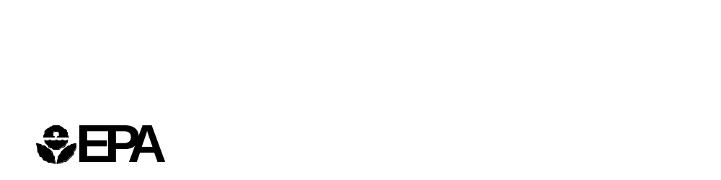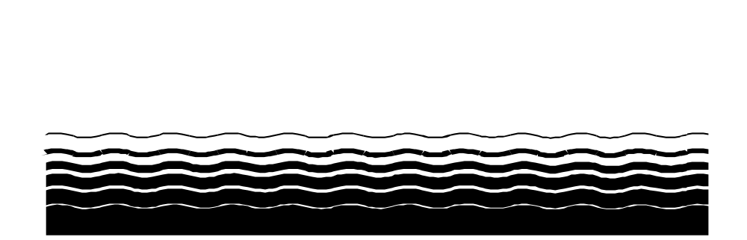

United States Office of Water EPA 815-R-99-011
Environmental Protection (4607) April 1999

Agency

Uncovered Finished
Water Reservoirs
Guidance Manual

DISCLAIMER

This manual provides a basic understanding of the potential sources of external contamination in uncovered finished water reservoirs and provides guidance to water treatment operators for evaluation and maintaining water quality in these reservoirs.

This document is EPA guidance only. It does not establish or affect legal rights or obligation. EPA decisions in any particular case will be made applying the laws and regulation on the basis of specific facts when permits are issued or regulations promulgated.

Mention of trade names or commercial products does not constitute an EPA endorsement or recommendation for use.

ACKNOWLEDGMENTS

The Environmental Protection Agency gratefully acknowledges the assistance of the members of the Microbial and Disinfection Byproducts Federal Advisory Committee and Technical Work Group for their comments and suggestions to improve this document. EPA also wishes to thank the representatives of drinking water utilities, researchers, and the American Water Works Association for their review and comment. In particular, the Agency would like to recognize the following individuals for their contributions:

Cheryl Capron, Seattle Public Utilities
Julie Hutchins, Seattle Public Utilities
Joe Glicker, Montgomery Watson
Mark Knudson, City of Portland Bureau of Water Works
John Miller, Los Angeles Department of Water and Power
Gary Stolarik, Los Angeles Department of Water and Power
Salome Freud, New York City Department of Environmental Protection
Mark LeChevallier, American Water Works Service Company, Inc.
Mark Stein, EPA Region I
Kevin Reilly, EPA Region I

CONTENTS
1. Introduction 1-1
1.1 Water Quality Degradation Concerns 1-3
1.2 Policies and Regulatory Background 1-5
1.2.1 USPHS Standard 1-5
1.2.2 Ten States Standards 1-6
1.2.3 AWWA Policy 1-6
1.2.4 EPA Policy 1-6
1.2.5 New EPA Regulations 1-7
2. Finished Water Reservoir Management Plan 2-1
2.1 General Information 2-1
2.1.1 Purpose 2-1
2.1.2 Background 2-1
2.1.3 Policies 2-2
2.1.4 Roles and Responsibilities 2-3
2.2 Reservoir-Specific Information 2-4
2.2.1 Background Information 2-4
2.2.2 Policies and Ordinances 2-5
2.2.3 Operations 2-5
2.2.4 Maintenance 2-6
2.2.5 Water Quality Monitoring 2-7
2.2.6 Staffing and Training 2-9
2.2.7 Safety 2-9
2.2.8 Construction 2-9
2.2.9 Recordkeeping and Reporting 2-10
2.2.10 Reservoir Security 2-10
2.2.11 Emergency Response Plans 2-10
3. Sources of Contamination and Associated Control Measures 3-1
3.1 Surface Water Runoff 3-2
3.2 Bird and Animal Wastes and Control 3-3
3.2.1 Bird Waste 3-3
3.2.2 Bird Control 3-5
3.2.3 Animal Waste 3-7
3.2.4 Animal Control 3-7
3.3 Human Activity 3-8
3.3.1 Pesticides and Fertilizers 3-8
3.3.2 Swimming 3-8
3.3.3 Discarded Debris 3-9
3.3.4 Deliberate Contamination 3-9
3.3.5 Human Activity Measures 3-9
3.4 Algal Growth 3-10
3.4.1 Increase in Bacteria Populations 3-11
3.4.2 Increase in Disinfection Byproducts 3-12
3.4.3 Increase in Taste, Odor, and Sediment Problems 3-13
3.5 Insects and Fish 3-13
3.5.1 Insect Larvae 3-13
3.5.2 Fish 3-14
3.6 Ground Water Intrusion 3-14
3.7 Airborne Deposition 3-15
4. Mitigating Water Quality Degradation 4-1
4.1 Reservoir Turnover 4-2
4.2 Disinfectant Residual 4-3
4.3 Hydraulic Effects 4-5
4.3.1 Flow Short-Circuiting 4-5
4.3.2 Hydraulic Circulation System 4-6
4.3.3 Reservoir Baffling 4-7
4.3.4 Submerged Mixer 4-8
4.3.5 Relocating Inlets and Outlets 4-8
4.3.6 Altering Flow Patterns at the Inlet and Outlet 4-9
4.3.7 Aerators 4-9
4.3.8 Analyzing Reservoir Hydraulics 4-9
4.4 Reservoir Cleaning 4-11
4.5 Water Quality Effects on the Distribution System 4-12
4.6 Covers 4-13
4.6.1 Floating Covers 4-14
4.6.2 Fixed Covers 4-15
4.6.3 Air-Supported Roofs 4-16
4.6.4 Costs 4-16
5. Water Quality Monitoring 5-1
5.1 Introduction 5-1
5.2 Types of Monitoring 5-1
5.2.1 Sampling and Analysis 5-1
5.2.2 Visual Inspection 5-2
5.3 Parameters to Monitor 5-3
5.4 Frequency of Monitoring 5-4
5.5 Issues Related to Water Quality Monitoring 5-15
5.5.1 Laboratory Testing 5-15
5.5.2 Recordkeeping and Reporting 5-15
5.5.3 Training 5-15
5.5.4 Water Quality Monitoring Equipment 5-15
6. References 6-1
Appendix A. Studies Performed A-1
A.1 Uncovered Finished Water Reservoirs in New Jersey A-1
A.1.1 Pathogens A-1
A.1.2 Other Contaminants A-2
A.2 Uncovered Finished Water Reservoirs in California A-2
A.2.1 Los Angeles Department of Water and Power A-2
A.2.2 Metropolitan Water District of Southern California A-2

FIGURES
Figure 1-1. Types of Finished Water Reservoirs 1-2
Figure 3-1. LADWP’s Open Reservoirs Subject to SWTR 3-4
Figure 3-2. Maximum TTHMFP (MTP) in LADWP’s Silver Lake Reservoir 3-12

TABLES
Table 1-1. Uncovered Reservoirs and Implication for Compliance with Drinking Water Regulations 1-7
Table 3-1. 1997 Nutrient Loadings by Bird Groups in Seattle’s Open Reservoirs 3-6
Table 4-1. Estimated Cost Ranges to Cover Existing Reservoirs at 1998 Cost Levels ¹ 4-17
Table 5-1. Utility Survey Water Quality Monitoring Parameters 5-5

ACRONYMS
APHA American Public Health Association
AWWA American Water Works Association
ASU Aerial Standard Unit
CDC Centers for Disease Control
CDHS California Department of Health
CFU Colony Forming Unit
CMU Concrete Masonry Unit
CSPE-R Reinforced Chlorosulfonated Polyethylene
CT Pathogen inactivation: disinfectant residual concentration (C, in mg/L) multiplied by contact time (T, in minutes)
CWC Culp/Wesner/Culp
D/DBP Disinfectants/Disinfection By Product
DEP Department of Environmental Protection
ECP Extra Cellular Product
EPA U.S. Environmental Protection Agency
ESWTR Enhanced Surface Water Treatment Rule
GWUDI Ground Water Under the Direct Influence of Surface Water
HDPE High-Density Polyethylene
HPC Heterotrophic Plate Count
IESWTR Interim Enhanced Surface Water Treatment Rule
LADWP Los Angeles Department of Water and Power
LCR Lead and Copper Rule
MCL Maximum Contaminant Level
MG Million Gallons
MPH Miles per Hour
MPN Most Probable Number
MSDS Materials Safety Data Sheet
MTP Maximum TTHMFP
MWD Metropolitan Water District of Southern California
NEWWA New England Water Works Association
NOM Natural Organic Matter
NPDES National Pollution Discharge Elimination System
NTU Nephelometric Turbidity Unit
ppb parts per billion
PP-R Reinforced Polypropylene
psi pounds per square inch
PVC Polyvinyl Chloride
SMCL Secondary Maximum Contaminant Level
SOP Standard Operating Procedure
SDWA Safe Drinking Water Act
SWTR Surface Water Treatment Rule
TCR Total Coliform Rule
THM Trihalomethane
TOC Total Organic Carbon
TTHMs Total Trihalomethanes
TTHMFP Total Trihalomethane Formation Potential
USPHS U.S. Public Health Service
WIDB Water Industry Data Base

Introduction
The purpose of this document is to provide a basic understanding of the potential sources of external contamination in uncovered finished water reservoirs and to provide guidance to water treatment operators for evaluating and maintaining water quality in these reservoirs. To achieve these objectives, this document discusses:
- Existing regulations and policies pertaining to uncovered reservoirs
- Developing a reservoir management plan
- Potential sources of water quality degradation and contamination
- Operation and maintenance of reservoirs to maintain water quality
- Mitigating potential water quality degradation.
This guidance document is based on a review of current literature and includes case studies of four large potable water utilities in the United States.
The term “finished water reservoir,” as used in this document, refers to any holding facility that stores potable water prior to its distribution for consumption in a public water system. Figure 1-1 presents examples of various types of finished water reservoirs used in the United States. Water is considered “finished” when it has received all treatment necessary to meet the requirements of the 1989 Surface Water Treatment Rule (SWTR) and is therefore suitable for human consumption. Almost all potable water systems in the United States include one or more finished water storage reservoirs in advance of or in the distribution system. These finished water storage reservoirs should not be confused with raw water supply reservoirs. Raw water supply reservoirs typically consist of a large surface water impoundment, such as a dammed river, and store thousands or even millions of acre-feet of untreated raw water. Finished water reservoirs are typically much smaller in volume and vary considerably with regard to design function, materials of construction, and capacity. A small system may have an elevated steel storage tank that stores several hundred gallons of finished water, while a large system may have a concrete-walled basin that stores on the order of 150 acre-feet (50-million gallons) of water for distribution and firefighting purposes.
Uncovered reservoirs that receive surface water runoff and/or ground water intrusion (particularly ground water under the influence of surface water) are subject to the regulatory provisions of the SWTR and are considered source water reservoirs. This guidance manual specifically addresses open reservoirs that have adequate protection measures and/or are adequately lined to prevent any surface water runoff or ground water intrusion, and therefore qualify as “finished water” reservoirs.
Finished water reservoirs are typically designed and constructed to meet peak demand, equalize distribution system pressure, or provide water for emergencies such as
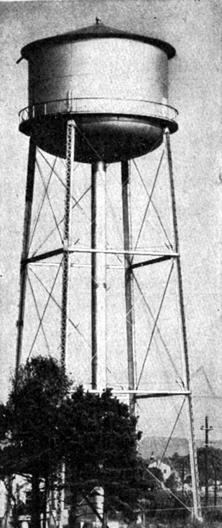
⬅ Elevated tank
Source: Babbit et al., 1967

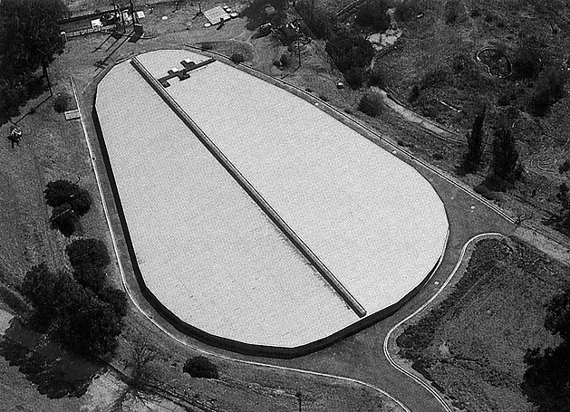
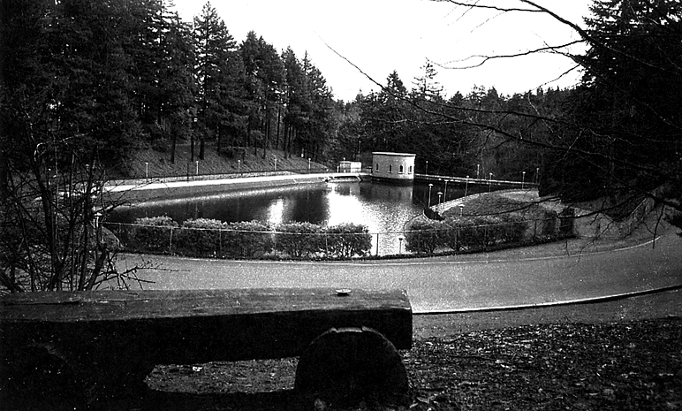
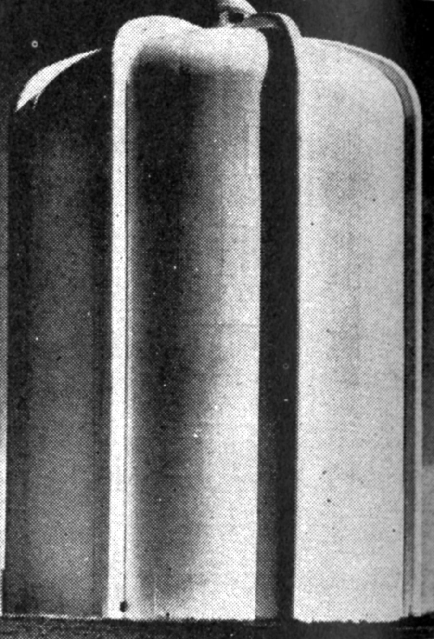
⬆ Covered finished water reservoir
Source: Los Angeles Department of Water and Power (LADWP), 1988
⬆ Uncovered finished water reservoir
Source: Montgomery Watson, 1998
➔ Standpipe
Source: Babbit et al., 1967
Figure 1-1. Types of Finished Water Reservoirs

firefighting. Finished water reservoirs may be designed to provide gravity outflow, depending on topographical and water distribution system constraints, thereby ensuring adequate water supply during power outages.
Finished water reservoirs may be constructed of various materials. Steel is commonly used for tanks, although wood has been used for smaller tanks. Tanks may be elevated, at ground level, or underground. Larger reservoirs are generally ground excavations consisting of earthen or lined bottom and walls that may be lined with impermeable materials. Lining materials include concrete, asphalt or asphaltic concrete, masonry, steel, plastic, and rubber compounds.
Because finished water reservoirs store treated water suitable for human consumption, care is generally taken to prevent contamination of the water and degradation of the water quality. Therefore, most finished water reservoirs in the United States are covered to provide substantial isolation from the external environment. Cover materials include reinforced concrete, steel, aluminum, and wood for tanks, and fixed reinforced concrete and floating flexible membranes for large surface reservoirs.
There are, however, finished water reservoirs still in use in the United States that are uncovered and open to the atmosphere. These uncovered finished water reservoirs, commonly referred to as “open reservoirs,” were constructed primarily during the late 1800s through the early 1940s. Although new Federal regulations require that all reservoirs for systems serving 10,000 or more people and using surface water or ground water under the direct influence of surface water (GWUDI) constructed after February 16, 1999, be covered, reservoirs constructed prior to that date are not required to provide a retrofit cover. Open reservoirs were once a common engineering design. The construction of large open reservoirs adjacent to urban centers was considered to be a cost-effective means of providing large quantities of water during emergencies. Water professionals of that era did not have a complete understanding of waterborne diseases and water quality degradation issues. Regulations to protect water quality were early in their developmental phases during that time. The first national water quality standard was not adopted until 1914 (McDermott, 1973).
In the mid-1970s, a nationwide survey found 750 open distribution water reservoirs in use (Pluntze, 1974). The 1992 American Water Works Association (AWWA) Water Industry Data Base (WIDB) identifies more than 10,000 finished water storage facilities in the United States. Approximately 3 percent, or 300 of the reservoirs identified in the WIDB, are classified as uncovered or open water reservoirs (Kirmeyer and Noran, 1997). Despite their relatively small numbers, open reservoirs provide drinking water for a significant portion of the population, including several large metropolitan areas.

Water Quality Degradation Concerns
The use of uncovered finished water reservoirs can lead to significant water quality degradation and increase health risks to consumers. This finding is clearly supported by literature on the subject, and several examples are summarized in Appendix A. Finished water quality degradation has been attributed to contamination from both internal and external sources and includes increases in the following:

- Algal growth
- Coliform bacteria growth
- Heterotrophic plate count (HPC) bacteria growth
- Turbidity
- Particulates
- Disinfection byproducts such as trihalomethanes (THMs)
- Metals
- Taste and odor
- Insect larvae
- Giardia and Cryptosporidium
- Nitrification of chloraminated waters.
Some of these water quality problems are exacerbated by the loss of a chlorine residual and poor hydraulic circulation that are characteristic of large open reservoirs.
Water degradation in open reservoirs has been a recognized concern for many decades. In his annual report of 1912, the City Engineer for Seattle, citing rapid urban growth and the potential for an epidemic disease outbreak, recommended that a reinforced concrete cover be considered for the Lincoln Reservoir (Pluntze, 1974). Reports published between 1929 and 1969, by the American Public Health Association (APHA), the U.S. Public Health Service (USPHS), and the AWWA recommended that all finished water reservoirs be covered (Pluntze, 1974). Many reservoirs remain uncovered, however, due to the capital cost of covering them and the difficulty in clearly quantifying the public health benefits of covering. Open reservoirs also are considered to have great aesthetic value by nearby homeowners who have strongly opposed covering them. In some instances, open reservoirs have been declared historic monuments, preventing utilities from implementing any significant modifications (Erb, 1989).
Although the occurrence of water quality degradation in open reservoirs is well documented, the literature also indicates that violations of drinking water standards are not commonly traced to their use. This finding may be the result of insufficient data to demonstrate clear cause-and-effect relationships. Bailey and Lippy (1978) found that there were no definitive studies on water quality parameter dynamics, contaminant introduction, or cause-and-effect. Bailey and Lippy concluded that there was a need for additional studies that focus on the correlation between drinking water contamination and the use of open reservoirs. Since then, numerous studies have documented the occurrence of water quality degradation in open reservoirs (AWWA, 1983; Geldreich and Shaw, 1993; Karimi and Singer, 1991; LeChevallier et al., 1997; Silverman et al., 1983).
In 1983, the AWWA emphasized the importance of selecting appropriate monitoring parameters based on suspected contamination sources, such as monitoring for Salmonella in reservoirs that are frequented by known carriers such as gulls. In 1993, a Salmonella outbreak in Gideon, Missouri, was attributed to pigeons roosting in a finished water tank. Although the tank was covered, openings in the cover (i.e., unscreened vents) allowed bird access. This waterborne disease outbreak resulted in seven deaths and caused illness in 60 percent of the population (CDC, 1996).
Water quality degradation and increased potential for drinking water standard violations and disease outbreaks resulting from the use of uncovered reservoirs requires serious consideration. Appendix A contains a summary of two published case studies that discuss the performance of eight open reservoirs in New Jersey and four open reservoirs in Southern California.

Policies and Regulatory Background
Requirements for open reservoirs vary greatly across the United States due to the lack of a Federal regulation that sets a uniform standard for existing reservoirs. The Interim Enhanced Surface Water Treatment Rule (IESWTR) requires that new reservoirs operated by systems serving at least 10,000 people and using surface water or GWUDI be covered, but does not contain requirements for existing reservoirs. The Long-Term 1 Enhanced Surface Water Treatment Rule, to be promulgated in November 2000, may contain a similar requirement for systems serving less than 10,000 people and using surface water or GWUDI. The fact that there has been no single, unified standard for existing open reservoirs has forced other regulatory and industry groups to implement and recommend procedures. Many State health departments, such as California, Oregon, Washington, and Arizona, have crafted their own policies and regulations to address open reservoirs. For example, Arizona requires that all finished water storage units be fitted with watertight roofs to prevent contamination and quality deterioration of the finished water. Arizona also requires that all existing open finished water storage units be eliminated or covered (Arizona Department of Health Services, 1978). Professional drinking water organizations also have developed policies and standards on open reservoir use. As a result, utilities should rely on their State and industry organizations to identify applicable standards and policies for use and operation.
Following is a sampling of existing standards and policies on the use and operation of uncovered reservoirs.

USPHS Standard
The USPHS published its first Manual of Recommended Water Sanitation Practice in 1946 (Pluntze, 1974). This manual states:
“A suitable and substantial cover should be provided for any reservoir, elevated tank, or other structure used for water storage. Covers should be watertight, of permanent material, and constructed so as to provide drainage away from the cover and prevent entrance of contamination into the stored water. The surface of covers on storage reservoirs should not be used for any purpose in connection with which contaminating matter is likely to be produced.”

Ten States Standards
The latest edition of Recommended Standards for Water Works (Ten States Standards) specifies in Section 7.0.2:
“All new finished water storage structures shall have suitable watertight roofs which exclude birds, animals, insects, and excessive dust”(SPHEM, 1992).

AWWA Policy
In 1975, the AWWA adopted the following policy regarding potable water reservoirs:
“The AWWA strongly supports the practices of filtration of surface water used as sources of public water supply, disinfection of public water supplies, including the maintenance of residual disinfectant in the distribution system, and the covering of reservoirs that store potable water for direct delivery to consumers and adequate monitoring to assure conformance with water quality standards (AWWA, 1997/1998).”
This policy was reaffirmed in 1984 and 1988. Clearly, the water industry supports and encourages the covering of finished water reservoirs.

EPA Policy
The Safe Drinking Water Act (SDWA) is the primary law in the United States for protecting the quality of drinking water. Congress enacted the SDWA in 1974 and amended it in 1986 and 1996. The intent of the SDWA is to protect public health by establishing standards and regulations for water treatment and to minimize or eliminate water quality degradation in finished water distribution systems. The SDWA and its amendments of 1986, and 1996 do not specifically address uncovered finished water reservoirs. In 1991, EPA published two guidance documents entitled Guidance Manual for Compliance with the Filtration and Disinfection Requirements for Public Water Systems Using Surface Water Sources (AWWA, 1991) and Manual of Small Public Water Supply Systems (USEPA, 1991b), both of which recommended that all finished water reservoirs and storage tanks be covered.

New EPA Regulations
In March, 1994, EPA proposed the Interim Enhanced Surface Water Treatment Rule (IESWTR) requesting comments on a “possible supplemental requirement” to cover finished water reservoirs and storage tanks. Promulgated on December 16, 1998, the IESWTR requires surface water and ground water under the direct influence (GWUDI) systems that serve 10,000 or more people to cover all new reservoirs, holding tanks or other storage facilities for finished water for which construction begins after the effective date of this rule, February 16, 1999 (EPA, 1998). The IESWTR does not apply these requirements to existing uncovered finished water reservoirs.

Table 1-1 provides a summary of existing and pending Federal drinking water regulations and the potential compliance concerns for utilities that operate uncovered finished water reservoirs.
Table 1-1. Uncovered Reservoirs and Implication for Compliance with Drinking Water Regulations
Regulation | Goal of Regulation | Potential Effect on Uncovered Reservoir Operations and Regulatory Compliance
Surface Water Treatment Rule (SWTR)  (54 FR 27486, June 19, 1989) | Control of turbidity and pathogens in drinking water through filtration and disinfection. | The SWTR requires all public water systems supplied by surface water sources to implement disinfection and filtration treatment practices. If certain source water quality requirements are met, systems may avoid filtration. Failure to meet requirements for detectable disinfectant residual throughout the distribution system violates SWTR requirements. Therefore, uncovered reservoirs should be managed to ensure the maintenance of a disinfectant residual.
Total Coliform Rule (TCR)  (54 FR 27544, June 29, 1989) | Prevent waterborne microbial disease through monitoring total coliform bacteria in the distribution system as an indicator of overall microbial contamination. | Open reservoirs increase opportunities for the introduction of coliform bacteria and microbial pathogens to the system, increasing the possibility of noncompliance with the TCR.
Table 1-1. Uncovered Reservoirs and Implication for Compliance with Drinking Water Regulations (continued)
Regulation | Goal of Regulation | Potential Effect on Uncovered Reservoir Operations and Regulatory Compliance
Total Trihalomethane (TTHM) Rule  (44 FR 68624, November 29, 1979) | Reduce cancer risk from exposure to THMs. Requires that public water systems serving at least 10,000 people analyze water in the distribution system for TTHM concentrations and maintain an annual average of less than 100 μg/L. The Stage 1 DBPR will replace the TTHM rule and for compliance purposes in 2001 for surface water and GWUDI systems serving at least 10,000 people and 2003 for surface water and GWUDI systems serving less than 10,000 people and all ground water systems. See summary of Stage 1 DBPR in this table. | The use of uncovered reservoirs in a public water system tends to increase the potential for TTHM formation. If the TTHM level in the treated water entering the reservoir is high (greater than approximately 80 μg/L), the potential contamination sources in the reservoir water could increase TTHM concentrations in the distribution system to unacceptable levels.
Lead and Copper Rule (LCR)  (56 FR 26460, June 7, 1991) | Reduce consumer exposure to lead and copper by developing and implementing a corrosion control program. LCR revisions are expected to be promulgated in 1999. | The primary effects of open reservoirs is that it is more difficult to control basic water chemistry that impacts the efficacy of corrosion control strategies (i.e., pH, alkalinity, temperature, etc.) due to the fact that the reservoir is an open system. Copper sulfate applications for algae control, if used by the utility, may increase copper levels in drinking water. If the levels of lead or copper are too high, the LCR may require the system to implement some treatment options to ensure that compliance is maintained.
Table 1-1. Uncovered Reservoirs and Implication for Compliance with Drinking Water Regulations (continued)

Regulation | Goal of Regulation | Potential Effect on Uncovered Reservoir Operations and Regulatory Compliance
Stage 1 Disinfectants and Disinfection Byproducts Rule (DBPR)  (63 FR 69390, December 16, 1998) | Reduces health risks through control of DBP occurrence in the distribution system. The DBPR replaces the current TTHM rule. It reduced the Maximum Contaminant Level (MCL) for TTHMs to 80 μg/L and established MCLs of 60 μg/L, 10 μg/L, and 0.8 μg/L for HAA5, bromate, and chlorite, respectively. | Uncovered reservoirs may provide conditions that lead to increases in DBP levels. Higher disinfection doses may be required to maintain effective disinfectant residuals. Some studies have shown DBP levels to increase in open reservoirs due to factors such as long detention times, algal growth, seasonal temperature variations, and heavy in-reservoir chlorination (Karimi, 1988; Karimi and Singer, 1991).
Interim Enhanced Surface Water Treatment Rule (IESWTR)  (63 FR 69477, December 16, 1998) | The IESWTR revises the SWTR to further protect against disease causing pathogens – viruses, Giardia lamblia, and Cryptosporidium – in drinking water for surface water and GWUDI systems serving at least 10,000 people. | This rule requires all finished water reservoirs built after February 16, 1999, to be covered. Uncovered reservoirs, particularly those that are strongly influenced by waterfowl and other sources of external contamination, increase a system’s exposure to pathogens controlled by the rule.

THIS PAGE INTENTIONALLY LEFT BLANK

Finished Water Reservoir Management Plan
As discussed in Chapter 1, the use of uncovered finished water reservoirs can lead to water quality degradation and therefore increase health risks to consumers. Utilities that have uncovered reservoirs should develop and implement a comprehensive reservoir management plan to efficiently and effectively protect water quality. The plan should unite all relevant information in a single document for use by all levels of utility staff, and it should ensure the proper management of each reservoir, and the system as a whole.
This chapter provides general guidance for the preparation of a reservoir management plan. It was created largely from information provided by two utilities that currently operate uncovered finished water reservoirs (Knudson, 1998a, 1998b, 1998c; Capron, 1998). Because of the complexity of factors affecting the management of each reservoir and system, each utility should develop a plan that addresses its own specific needs and circumstances. The guidance offered in this chapter should be applied accordingly.

General Information
A utility may operate one or more uncovered reservoirs as part of its system. The first section of the plan should provide general information addressing concerns that apply to the management of all of a utility’s open reservoirs in the context of the entire system. This section outlines the topics that should be covered under general information.

Purpose
The goal of the management plan is to protect water quality in the utility’s uncovered finished water reservoirs. Achieving this goal involves attaining certain objectives, such as the continued maintenance of regulatory compliance, water quality at the highest possible standard, and prevention of waterborne disease outbreaks.

Background
The plan should discuss background information that establishes the basis for its development. This may include the following elements:
- A description of the events that lead to the utility’s decision to develop the plan
- Any applicable statutory and regulatory requirements
- Historic perspective of water quality issues for the system and its open reservoirs
- Narrative and schematic exhibits that describe the system
- General description of system operations with emphasis on the uncovered finished water reservoirs.

Policies
The plan should clearly define all utility policies that pertain to the management of its uncovered or open reservoirs. This may be a single policy that states that the system’s water quality goals and objectives will be met through a comprehensive management program, or there may be multiple policies, each of which applies to a program element. The following policies should be considered for inclusion in a management plan:
- General Policies and Ordinances – General utility policies and city ordinances that govern the overall management of the utility.
- Operations – Defines the goals of open reservoir operations and the various procedural options that are acceptable in achieving those goals such as increased turnover, overflowing and flushing, by-passing the reservoir, runoff prevention, waterfowl/other bird control, algae, etc.
- Maintenance – Describes the need for maintaining open reservoirs and related facilities and establishes the minimal requirements for preventive maintenance (e.g., each open reservoir will be drained and cleaned at least annually).
- Water Quality Monitoring – Requires the maintenance of a minimum chlorine residual at the reservoir outlet, describes known contamination sources and accepted control measures, or establishes water quality monitoring parameters and frequencies.
- Staffing and Training – Establishes that adequate staffing will be maintained to fulfill all open reservoir management requirements and that all staff receive appropriate training at regular intervals.
- Safety – Establishes employee safety as a high priority and ensures that employees will not be at risk in fulfilling their responsibilities. This includes ensuring that all hazardous materials are stored and handled in accordance with all applicable Federal, State and local requirements.
- Construction – Requires that all construction activities within or near open reservoirs are conducted in a manner such that water quality impacts are prevented or mitigated.
- Recordkeeping and Reporting – Requires the preparation of accurate and complete records, minimum record retention time, preparation of routine reports at regular intervals, and the prompt reporting of deficiencies and discrepancies to the appropriate utility staff and external agencies.
- Reservoir Security – Defines the major security concerns for the system’s open reservoirs and establishes security methods and frequencies.
- Emergency Planning and Response – Resolves to respond promptly and effectively to all emergencies with special regard to threats to public health or safety.

Roles and Responsibilities
For each of the major management program elements indicated below, there should be a detailed description of the roles and responsibilities of specific individuals (by job title) or organizational groups (by section or department name). The plan should clearly describe the tasks that need to be accomplished, how and when the tasks will be performed, and who will perform the tasks. The plan also should describe the process for review and modification of the plan itself to account for changes in utility policies, treatment goals, or treatment practices.
The major management program elements for which general roles and responsibilities should be defined are as follows:
- General Policies and Ordinances –Develop and implement all general policies and ordinances to provide necessary reservoir protection and to address any changes that may impact reservoir management.
- Operations – Develop standard operating procedures (SOPs) and provisional procedures considering turnover time, hydraulics, and water quality changes across reservoirs.
- Maintenance – Identify requirements and develop schedules and procedures for preventive maintenance of major equipment or of the reservoir itself, and frequency for cleaning reservoirs.
- Water Quality Monitoring – Identify potential contamination sources, regulatory requirements, water quality monitoring parameters, and monitoring frequencies and procedures.
- Staffing and Training – For each staff position, identify commensurate training requirements and implement a program that provides for all orientation training, refresher training, and certifications.
- Safety – Identify dangerous situations that should be recognized and avoided by personnel, develop procedures for reporting and responding to unsafe conditions. This should include the identification of all hazardous materials in use and applicable requirements for storage and handling including material safety data sheets, risk management plans, and special personnel requirements.
- Construction –Develop procedures for performing construction activities that can impact water quality and provide oversight responsibilities for ensuring that construction activities are carried out in accordance with established policies and procedures.
- Recordkeeping and Reporting – Develop standard forms for all aspects of data collection, develop a document control system, identify all required reports, and develop standards for format and content.
- Reservoir Security – Describe roles and responsibilities for conducting regular security inspections, identifying appropriate access control measures, identifying trespassing routes, posting signage, and coordinating with the local police department.
- Emergency Planning and Response – Develop emergency planning and response procedures as a separate section in the plan.

Reservoir-Specific Information
This section of the reservoir management plan is intended to address reservoir-specific issues and procedures. The plan should address elements that include background information for each reservoir, operations criteria and procedures, and a program for water quality maintenance that includes monitoring, visual inspections, and contamination control. It should also include maintenance requirements, as well as security requirements and staffing and training information.

Background Information
The reservoir management plan should include a section containing background information for each reservoir. The information should include the following basic information identifying the reservoir:
- Reservoir name
- Location
- Pressure level or zone
- Overflow elevation
- Storage volume rating curve (graph of reservoir level versus storage volume)
- Service area map
- Overflow point of discharge (e.g. sewer, storm drain, or creek)
- Contact name and telephone number
- Applicable regulations and policies.
It also may be helpful to compile other information about each reservoir that will provide a quick understanding of the reservoir for use in analysis of problems. This information may include a summary of the following:
- History (age, construction, materials used, level of maintenance performed)
- Reservoir Operations (Drawdown, Refill, Turnover Rate, Short-Circuiting)
- Treatment methods
- Surrounding area and land use
- Known water quality problems
- Known sources of contamination
- Previous problems with reservoir and solutions.

Policies and Ordinances
Any policies and ordinances that are specific to particular reservoirs within the system should be included in the reservoir management plan. This section also includes policies that pertain to reservoirs of different construction types or different sizes. These could include ordinances or policies regarding construction, pesticide or herbicide use, public access, or other activities in the vicinity of the open reservoir. A utility may need to obtain the authority to issue such ordinances, or may need to request the issuance of such ordinances by the local government.

Operations
The reservoir management plan should include information concerning the overall operation of the reservoir as part of the larger water system, as well as information related to the reservoir disinfection system. It also should include information related to the operation of any other equipment, such as a mixing system, that is used at a particular reservoir.

Reservoir Operations
The plan should include a section identifying basic reservoir operation criteria, including level operating targets and set points, level alarms and critical conditions, as well as criteria for turnover rate. The section also should include SOPs for filling and draining the reservoir, overflowing the reservoir, internal notification, and emergency shutdown of the reservoir. The plan should refer to the utility’s emergency response procedures, discussed in greater detail later in this chapter. Procedures for disinfection of the reservoir and dechlorination of water that is drained or overflowed should also be included (Knudson, 1998b). Utilities discharging directly or indirectly to water bodies of the United States should consult with the National Pollution Discharge Elimination System (NPDES) permitting authority regarding requirements for dechlorination.

Disinfection Operations
Disinfection operations are important to the proper functioning of the reservoir. A utility should ensure that a minimum residual is maintained in the water that is entering the distribution system and that an adequate pathogen inactivation is achieved. The disinfection residual of a reservoir will vary seasonally, therefore, disinfectant dosages should be varied accordingly. Outlet disinfection is a high priority, especially in systems that use unfiltered water sources. Responsibility for the maintenance of disinfection equipment needs to be specifically outlined and assigned. The possibility of a failure in the disinfection system should be considered and emergency response plans outlined (Capron, 1998).
The plan should include information about the type of disinfectant and disinfection equipment used at the plant, as well as SOPs for the disinfection system. Disinfection system data such as a system schematic, design criteria for the system, and chemical supplier contact information should be included in the plan. SOPs should be included for routine operations and treatment targets, chemical handling and delivery, as well as procedures for chemical testing and quality assurance and quality control of the chemicals. This section also might include a safety management and/or risk management plan for the disinfection system along with emergency response information identifying responsibilities and procedures.

Other Equipment
Information explaining the operation of any other equipment used in the operation of the reservoir should be included in the management plan. This equipment includes pumps or mixers used in a circulation system. Design criteria for these systems should be included and responsibilities for these systems should be assigned.

Maintenance
This section of the reservoir management plan should address maintenance of the reservoir, reservoir facilities, and equipment used to operate the reservoir. Maintenance of the reservoir itself usually consists of cleaning the reservoir and repairing the liner and sealing joints. Maintenance of the facilities includes maintaining security measures, contamination control measures, and other facilities critical to maintaining water quality in the reservoir. Equipment maintenance includes maintaining disinfection equipment or other equipment such as pumps or mixers that impact the operation or water quality in the reservoir.

Reservoir Cleaning
Cleaning strategies for reservoirs will vary. Some reservoirs can be cleaned easily once emptied. Some must be cleaned while remaining full or in service. It may not be feasible to clean some reservoirs due to the size or nature of the reservoir.
Reservoirs that can be removed from service and drained should be cleaned to prevent accumulations of silt and algae on the sides and bottom of the reservoir. Utilities should develop criteria used to initiate reservoir cleaning and plan the removal of a reservoir from service to ensure that the reliability of the distribution system is not compromised. It is critical not only to look at the other storage facilities that are out of service at the same time, but also at projected construction schedules for adjacent water distribution pipelines and feeder mains so that either the pipeline or reservoir remain in service.
Weather may be a factor in planning a washing schedule. During freezing weather it may be necessary to keep a reservoir full to prevent damage to the structure from ground heaving, freeze-thaw cycling, and concrete contraction. Reservoirs also should be kept wet in extremely hot weather because hot weather can melt joint sealant, which could increase leakage from the reservoir (Capron, 1998).
The data collected during water quality monitoring can be used to plan or initiate a cleaning schedule. Security reports and breaches in security also should be considered when planning reservoir cleaning.
SOPs should be developed for all activities performed during reservoir cleaning. Cleaning procedures should be developed along with procedures for the disposal of debris and sediment. Cleaning SOPs also should incorporate routine cleaning activities as well as spot-cleaning activities in and around the reservoir. These SOPs should address the removal of any debris, garbage, or other objects near the reservoir or floating on the surface.

Facilities Maintenance
The plan should include SOPs for the maintenance of the reservoir structures. This would include paving repair and weed control. Typically, structural maintenance is performed on structures in the reservoir whenever a reservoir is taken out of service.

Equipment Maintenance
The reservoir management plan should include preventative maintenance strategies for all equipment necessary to properly operate the reservoir and control water quality. Routine maintenance should be performed consistently, so as to keep reactive maintenance to a minimum. It is a good idea to perform maintenance activities whenever a reservoir is taken out of service.

Water Quality Monitoring
Water quality monitoring is an essential element of a reservoir management plan. A water quality maintenance program should consist of water quality monitoring, visual inspections, and control of contamination sources. Water quality monitoring not only aids a utility in meeting regulatory requirements but also helps to identify normal or baseline operational characteristics of the reservoir. Visual inspection is another method that should be used to monitor problems since it can help to identify the causes of water quality problems or even to prevent them. Both water quality monitoring and visual inspections will give information that will identify contamination sources of particular concern to each reservoir and will help to develop control strategies for mitigation.

Monitoring Parameters
Monitoring parameters should be identified for each reservoir. The SWTR Guidance Manual is a good reference for identifying parameters for a monitoring program (AWWA, 1991). Additional parameters will depend upon specific reservoir and downstream quality requirements. Chapter 5 discusses water quality monitoring in greater detail.

Monitoring Criteria
Water quality monitoring criteria should be established for each reservoir. Operating targets and operation limits should be established for water quality parameters such as disinfectant residual, pH, and turbidity. Alarms should be activated when parameters reach critical conditions. Samples should be collected downstream of the treatment process and used to verify that the treatment process is working properly.

Monitoring Program
Once monitoring parameters have been defined for each reservoir, a monitoring program can be developed to sample, analyze, and monitor the parameters. This information can be used to develop specific strategies to control the parameter of interest. Data are necessary to implement the strategies (i.e., to make control decisions). A consistent sampling program will also help verify the effectiveness of control strategies. Additionally, this information can be compiled in a database to establish a history of typical variations in the reservoir water quality.
Some water quality parameters will be monitored using discrete sampling locations and frequencies. These parameters may include bacteriological monitoring or disinfectant residual monitoring at locations within the reservoir. Other parameters, such as pH and chlorine residual, may be monitored continuously at key locations (e.g., at the outlet). The sampling frequency of discretely monitored parameters will depend upon the amount of risk associated with the parameter. If an elevated risk is associated with a specific parameter, increasing the monitoring frequency of the parameter may be necessary. For instance, if the disinfectant residual concentration drops below a specified level in a storage tank, monitoring should be increased until disinfectant residual levels return to normal.

Visual Inspections
Visual inspections of the reservoir should be performed on a routine basis. Inspections of the water surface of the reservoir and the fence line should be performed daily. Inspections should identify and monitor factors that are used to indicate that a reservoir needs to be cleaned. The storm water drainage system should be inspected frequently during the rainy season and monitored during a large rain event. Routine inspections of the disinfection equipment, as well as other equipment, should be performed to verify that the equipment and processes are working properly, to verify that there is adequate disinfectant, and to adjust feed rates, if necessary.
Reservoir underdrains and other submerged structures should be inspected every time the reservoir is taken out of service. Inspection of the drained reservoir also will help identify the nature of contaminants that enter the reservoir. This includes the identification of foreign objects, as well as the nature of sediments and algae. Consistent patterns of foreign objects that are found can help identify security problems.

Contamination Control
Potential contamination sources should be evaluated at each reservoir. Contamination sources such as surface water runoff, bird and animal wastes, human activity, algal growth, insects and fish, ground water intrusion, airborne deposition, and any other identified sources should be considered as part of the evaluation. The reservoir management plan should address these different sources of contamination and identify control methods or strategies employed by the utility. As discussed previously, reservoirs receiving surface water runoff or ground water intrusion are considered source water reservoirs that are not compliant with provisions of the SWTR.
Control methods should be implemented to minimize the risk caused by exposure to a contamination source. Routine observation of the water surface may reveal the type of contaminants that are delivered to the reservoir, which in turn will help in determining possible control and response strategies. Information regarding these specific potential sources of contamination and their associated control measures are discussed further in Chapter 3. In addition, general methods to protect and maintain water quality in uncovered finished water reservoirs are presented in Chapter 4.

Staffing and Training
The plan should contain information concerning staffing and training that is unique to specific reservoirs. Additional or unique types of training could be based on, for example, the location of a reservoir, the construction of a reservoir, or the disinfection system used in a reservoir. Training should be provided both for any new staff and periodically for existing staff in order to enforce the goals of the reservoir management plan.

Safety
Safety issues that are specific to a reservoir should be included in the reservoir management plan. Chemicals that are used at the different reservoirs should be identified. Additionally, a Materials Safety Data Sheet (MSDS) should be maintained for each chemical stored on-site to provide a reference for potential hazards. Safety issues related to activities performed at specific reservoir sites also should be addressed.

Construction
The reservoir management plan should have procedures that will ensure that construction activities do not affect the reservoir water quality. A procedure should be developed to address onsite painting activities. If a reservoir has multiple basins and one of these basins must be taken offline to perform construction activities, the utility should address the problem of minimizing or eliminating the effect of the activities on the water quality in the adjacent basins.

Recordkeeping and Reporting
Recordkeeping and reporting requirements should be designed to meet any regulatory requirements that are imposed upon the utility. Beyond the need to meet regulatory requirements, accurate recordkeeping and reporting will help identify how a reservoir is operating and will provide information that can be used to compare a present situation with past experiences. It also can help to predict the effectiveness of potential reservoir management strategies.
Data management, reporting, and tracking is important for a variety of reservoir management functions such as reservoir operations, disinfection operations, water quality monitoring, control of contamination sources, and reservoir cleaning activities. Records for the operation and maintenance of the disinfection facilities should be maintained, and any lapses in disinfection should be documented. Occurrences of security and equipment breakdown should be documented. Records also should be kept of any debris found in the reservoir, consumer complaints, algal control methods used, and water quality parameters that are relevant to aquatic growth. Episodes of actual or threatened contamination should be recorded and documented as well as any security violations, actual or attempted. Example data sheets should be included in the document for each set of information that a utility wants to collect, such as security information, water quality information, or information derived from routine inspections.

Reservoir Security
Each reservoir needs to be evaluated to determine the level of protection that is required. Major security problems should be defined and corrective responses identified. Specific procedures need to be formulated to determine who corrects security problems and the necessary time frame. A summary of the security measures employed at each reservoir should include identifying fence height, setback distance, surveillance measures, and the like.

Emergency Response Plans
The plan should provide policy and describe the roles and responsibilities with regard to planning for and responding to emergencies at a utility’s open reservoirs. In addition, the plan should include emergency planning and response procedures for the different types of emergency events that have a reasonable potential for occurring. As a minimum, emergency procedures should be developed for each of the following scenarios: loss of disinfection residual, breach of security, water quality contamination, hazardous chemical release, and loss of structural integrity. Each type of emergency scenario should be defined in the plan, including examples and subcategories as appropriate. Preventive measures, warning measures, specific response procedures, persons/entities to be contacted, recordkeeping and reporting requirements should be described for each type of emergency.
If the reservoir is classified as a dam and regulated by either a Federal or State dam agency, additional guidance should be developed. An operations and maintenance manual needs to be developed for the operation of the dam as well as an emergency action plan addressing how the utility will respond to a dam failure.

THIS PAGE INTENTIONALLY LEFT BLANK

Sources of Contamination and Associated Control Measures
Utilities that operate open reservoirs should assess the water quality dynamics of their facilities. The goal of the assessment is to characterize the potential sources of water quality degradation and develop appropriate mitigation measures. The assessment should consider all relevant environmental and operational factors, such as source water quality, the watershed from which source water is drawn, adjacent land uses, ground water quality in the surrounding watershed, and the presence or absence of a reservoir liner.
A thorough understanding of the potential sources of contamination is required for each reservoir in the system so that mitigation measures can be implemented efficiently and promptly at the first sign of contamination. The prevention of contamination should be emphasized to the maximum extent possible. Utilities may want to consider the feasibility of eliminating the open reservoir or implementing preventive controls such as reservoir covers and liners, regular draining and washing, proper security and monitoring, and drainage design to prevent surface runoff from entering the facility.
Failure to identify a potential water quality degradation problem, and control its occurrence during initial developmental phases, can compound the problem and increase the corrective effort required. An uncontrolled algal bloom, for example, will support bacterial growth. Failing to prevent an algal bloom may significantly increase public health risk, and increase the cost to control the problem using either additional chlorination, other chemicals, or by removing the reservoir from service for cleaning.
Extracellular products from algae and algal biomass will contribute to the oxidant demand of the reservoir; this is discussed later in the chapter. This oxidation may in turn result in the formation of disinfection byproducts, such as THMs.
As discussed earlier, water works professionals have associated water quality issues and threats to public health with open reservoirs for more than 80 years. Geldreich and Shaw (1993) found that early studies of water contamination in open reservoirs identified the following contamination sources: birds, animals, airborne deposition, plant growth, and human activity (primarily swimming). More recent studies have expanded on the traditional list of open reservoir contamination sources and include:
- Surface water runoff
- Bird and animal wastes
- Human activity
- Algal growth
- Insects and fish
- Ground water intrusion
- Airborne deposition
Each of these sources of contamination and methods to mitigate their impact are discussed below.

Surface Water Runoff
Any reservoir that receives surface water runoff is not in compliance with the SWTR, nor is it a finished water reservoir but instead is a raw water storage reservoir (40 CFR 141.70(a)(1); 141.70(a)(2)). To maintain water quality and control risks, utilities must completely eliminate all surface water runoff into their reservoirs. Any surface water entering the reservoir is unacceptable for proper operation and regulatory compliance. Surface runoff must never be allowed to enter the reservoir because contaminants may be introduced to the treated water.
Contaminants that may be found in surface water runoff include soil, agricultural fertilizers, pesticides, microbial pathogens, oil and other automotive fluids, vehicle tire and brake wear residuals, and organic litter. Surface water runoff also can be a significant source of turbidity, sediment, nutrients, natural organic matter (NOM), and some metals. One study by Karimi and Ruiz (1991) of the Stone Canyon Reservoir complex of the Los Angeles Department of Water and Power (LADWP) found a direct relationship between heavy rainfall and high turbidity attributed to surface water runoff. Erb (1989) indicated that Lower Stone Canyon Reservoir is one of three large open reservoirs operated by LADWP that are essentially canyons with dams. As such, LADWP has indicated that it is impossible to completely isolate these reservoirs from the effects of surface water runoff, and it is not feasible to cover them. The California Department of Health (CDHS) has declared four of LADWP’s open finished water reservoirs to be untreated surface water because of their exposure to surface runoff. The CDHS has mandated that these reservoirs either be removed, covered, or their effluent treated by filtration. Figure 3-1 shows the LADWP reservoirs and indicates how LADWP intends to achieve compliance with CDHS requirements.
Credit toward achieving the filtration and disinfection requirements of the SWTR begins after the water is no longer subject to surface water runoff (40 CFR 141.70(a)(1)). Disinfection that is applied prior to an open reservoir that is subject to surface water runoff is not creditable under the SWTR. Adequate treatment is necessary after the point in which the surface runoff enters the reservoir.
Several common methods exist to protect open reservoirs from surface runoff contamination (AWWA, 1983; Bailey and Lippy, 1978). Observation of the reservoirs can help determine where runoff is entering a reservoir and will help to determine how to control it. If possible, samples of the runoff should be collected to determine the effect on the reservoir and the steps needed to minimize the impact. The local drainage utility or surface water management agency also may aid in identifying drainage basins and known contaminants within the basins.
The fences surrounding many reservoirs are built upon a parapet wall to prevent runoff from entering the reservoirs. Some facilities use a drainage system to channel runoff water to the closest storm sewer. Other reservoirs are built between earthen berms that are high enough to eliminate runoff into the reservoirs. Drainage improvements generally employ a multiple barrier approach and may include a combination of the above methods along with gutters and pipe storm drainage systems. Surface runoff must be completely prevented from entering an open reservoir system.

Bird and Animal Wastes and Control
Open reservoirs provide attractive habitats for birds and animals. Birds and animals may carry microbial contaminants, including human pathogens. Contaminants may be carried externally on the feathers, fur, and skin and transmitted to the reservoir through direct body contact with the water. Contaminants also may be carried internally in the digestive system, and may be transmitted to the reservoir through natural biological processes, such as defecation occurring in or near the reservoir.

Bird Waste
Birds, particularly gulls and waterfowl, commonly visit or inhabit open reservoirs. Identification of the type of birds that frequent a reservoir is important when deciding on avian control measures, as well as determining how much of a problem is attributable to a specific species. Birds are widely reported to be one of the most common and significant sources of contamination at open reservoirs. Feces from these birds are a source of coliform bacteria, viruses, and human pathogens, including vibrio cholera, Salmonella, Mycobacteria, Typhoid, Giardia, and Cryptosporidium (Geldreich and Shaw, 1993). Some Cryptosporidium species that are pathogenic to humans do not affect birds, but birds may be carriers (Clement, 1997). Some of these carriers, such as gulls, are scavengers and may ingest the pathogens while feeding at landfills or wastewater treatment plants prior to visiting a reservoir. It is believed that these birds also carry pathogens on their feet and feathers. It has been estimated that 5 to 20 percent of the bird population is periodically infected with Salmonella and other intestinal organisms that are pathogenic to humans.
As noted earlier, a 1993 waterborne Salmonella outbreak in Gideon, Missouri, that resulted in seven fatalities, was traced to pigeons that had been roosting in a finished water storage tank. Although the tank was provided with a cover, there were openings in the cover that allowed birds access.
Several early studies found that the presence of waterfowl increased levels of coliform bacteria in small recreational lakes by a factor of 20 times normal levels (Morra, 1980). In 1993, an Escherichea coli occurrence in the New York City system partially was attributed to large numbers of seagulls frequenting the finished water reservoirs. Bird carcasses have

➔ Lower Stone Canyon Reservoir. A filtration plant has been proposed but must be approved through the environmental review process.

⬅ Upper Hollywood
Reservoir. This reservoir will be replaced by covered tanks.
➔ Lower Hollywood Reservoir. A small microfiltration plant has been approved through the environmental review process and is currently in the design phase.
Figure 3-1. LADWP’s Open Reservoirs Subject to SWTR
(source: LADWP, 1988)
⬅Upper Hollywood
Reservoir. This reservoir will be replaced by covered tanks.
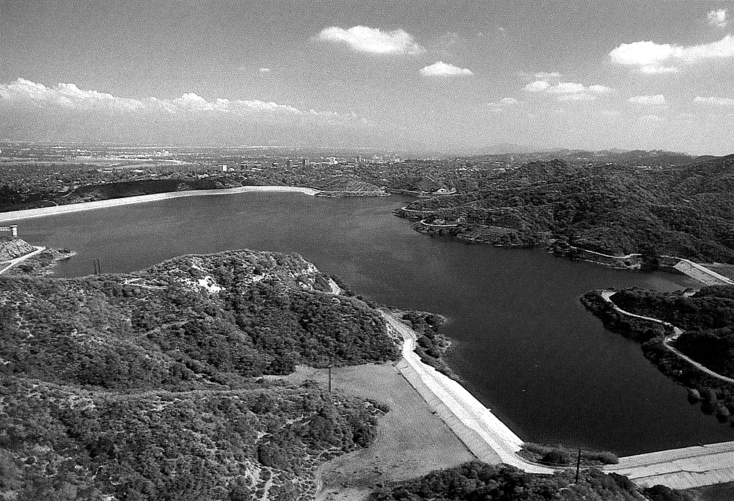
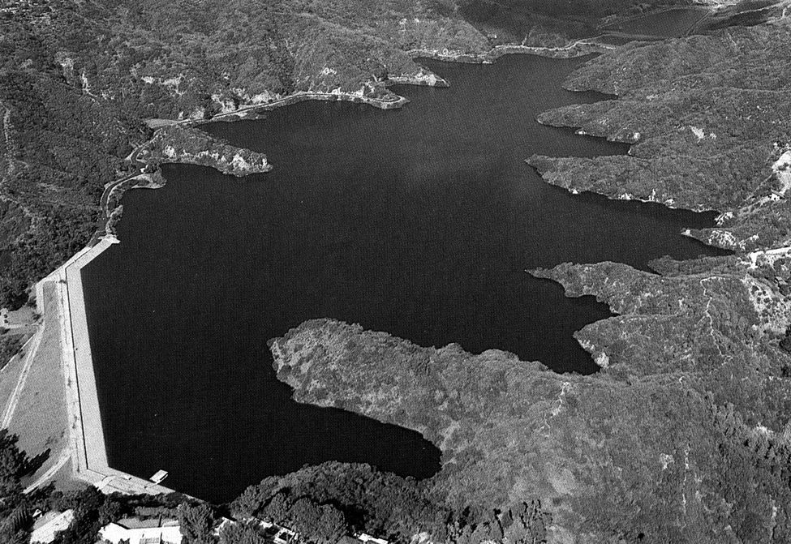
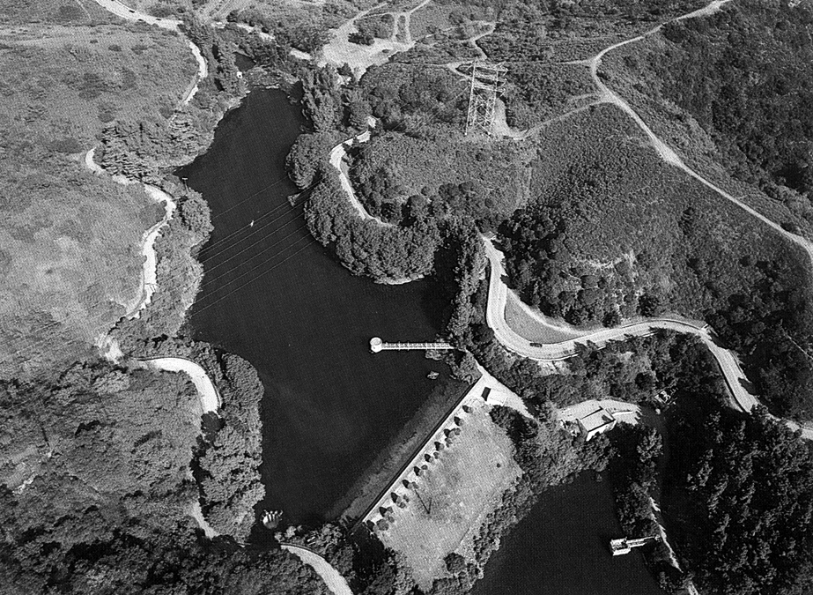
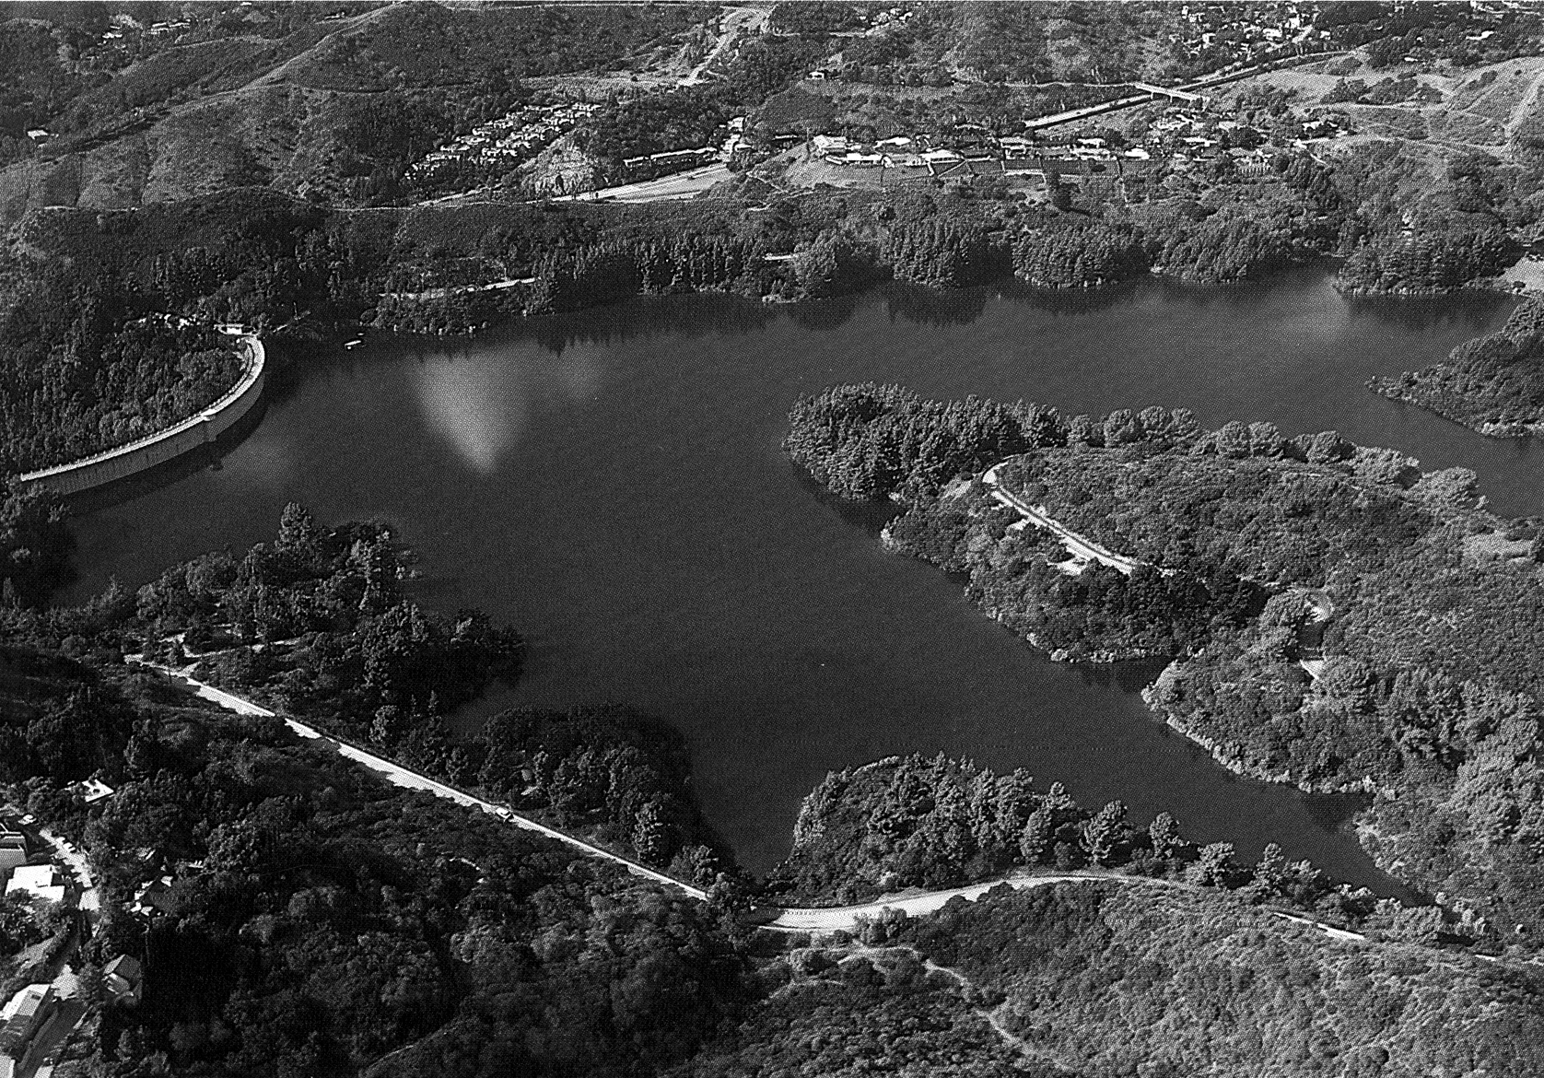
⬅Encino Reservoir. A filtration plant has been proposed but must be approved through the environmental review process.
➔Lower Stone Canyon Reservoir. A filtration plant has been proposed but must be approved through the environmental review process.
⬅Upper Hollywood Reservoir. This reservoir will be replaced by covered tanks.
➔Lower Hollywood Reservoir. A small microfiltration plant has been approved through the environmental review process and is currently in the design phase.
Figure 3-1. LADWP’s Open Reservoirs Subject to SWTR
Source: LADWP, 1988

been found within open reservoirs during cleaning, providing another source of bacteria from the decomposition process.
As indicated in Table 3-1, bird feces may contribute nutrient loadings that can enhance algal growth in the reservoir. Decaying carcasses of birds and animals that may be found in open reservoirs also contribute to microbial growth. Reservoirs with large bird populations also tend to have feathers and scavenged garbage carried into or nearby the reservoir by the bird population.

Bird Control
Historically, many different methods of discouraging waterfowl from residing in or near open treated water reservoirs have been practiced. Examples of methods to repel birds include habitat modification, decoys, eagle kites, noisemakers, scarecrows, plastic owls, dog hazing, and wires strung across the reservoir.
The installation of bird deterrent wires appears to be the most effective and economical bird repellent method. Several utilities have had success using the wires, reporting significant decreases in birds, coliform bacteria, and nutrients. The use of bird deterrent wires at some large reservoirs, however, is not practical because of the extensive surface areas to be covered. Some bird harassment methods may have adverse impacts associated with their use. Noisemakers, such as cannon fire, may generate complaints from nearby residents. Further, a bird harassment program may be more expensive than wires because of the ongoing effort required of utility personnel responsible for performing harassment activities; however, not all bird problems are continuous throughout the year. They are generally dependent on seasonal activities, such as migration, nesting, and molting. Large urbanized birds such as gulls and geese may become accustomed to noisemakers and visual scaring devices within 2 to 3 weeks, necessitating frequent changes to the devices to maintain effectiveness.
Observations at reservoirs where bird deterrent wires have been installed indicate that the wires decrease the area available for the birds to land on the water surface. Upon sighting the wires, birds that are approaching the reservoir have been observed to turn and fly away. The wires are particularly effective against species that require relatively large landing areas, such as waterfowl. Wires also have been installed on top of the parapet walls that surround many open reservoirs to effectively prevent birds from perching on the walls.
The City of Newport Beach, California, significantly reduced waterfowl landings by stringing lengths of 0.015-inch stainless steel wire at 40-foot intervals over the 800-foot length of a 20-acre open reservoir (Morra, 1980). Seagull activity at the Garvey Reservoir operated by the Metropolitan Water District of Southern California also has been significantly reduced by the installation of piano wire at 100-foot intervals (AWWA, 1983).

Table 3-1. 1997 Nutrient Loadings by Bird Groups in Seattle’s Open Reservoirs

Soluble Nutrient Loadings by Bird Groups
Reservoir | Geese |  | Gulls |  | Ducks |  | Overall | Nutrient
Reservoir | Nitr. | Phos. | Nitr. | Phos. | Nitr. | Phos. | Total | Conc.
Reservoir | kg/yr | kg/yr | kg/yr | kg/yr | kg/yr | kg/yr | kg/yr | (μg/L)
Beacon Hill* | 0.00 | 0.00 | 0.00 | 0.00 | 0.00 | 0.00 | 0.00 | 0.00
Bitter Lake | 0.82 | 0.24 | 0.01 | 0.00 | 0.06 | 0.02 | 1.15 | 14.09
Green Lake | 1.78 | 0.52 | 0.03 | 0.01 | 0.53 | 0.16 | 3.04 | 16.05
Lake Forest | 2.23 | 0.65 | 0.36 | 0.11 | 0.07 | 0.02 | 3.43 | 15.09
Lincoln | 0.00 | 0.00 | 0.24 | 0.07 | 0.01 | 0.00 | 0.31 | 3.96
Maple Leaf | 2.16 | 0.63 | 0.13 | 0.04 | 0.35 | 0.10 | 3.42 | 15.43
Myrtle | 0.00 | 0.00 | 0.08 | 0.02 | 0.01 | 0.00 | 0.12 | 4.35
Volunteer | 0.00 | 0.00 | 0.01 | 0.00 | 0.01 | 0.00 | 0.03 | 0.42
West Seattle | 0.40 | 0.12 | 0.38 | 0.11 | 0.02 | 0.01 | 1.03 | 4.00

*Beacon Hill has a chain-link fence around the water and a bird wire canopy, which excludes the birds from the water. Birds counted on the site were outside the wire enclosure.
Notes:
Loadings (L) = D × F × N × S × P
Where:
L = Nitrogen or phosphorous loading
D = Number of days in consideration
F = Dry weight of feces produced per bird per day
N = Percent of nitrogen or phosphorous by dry weight feces
S = Solubility of nitrogen or phosphorous as percent of dry weight feces
P = Probability that feces enter the lake over a 24-hour period:
Geese 50%
Gulls 60%
Ducks 80%

Source: Seattle Public Utilities, 1997
Such wire systems are relatively inexpensive and have proven to have no serious adverse affect on the birds. One of Seattle’s open reservoirs had a severe problem caused by gulls and waterfowl. This problem was completely eliminated through the installation of a wire canopy and a chain-link fence. The City of New York’s Department of Environmental Protection (DEP) is a strong proponent of bird deterrent wires, reporting significant decreases in both birds and coliforms following the installation of wires at their Hillview Reservoir (Ashendorff et al., 1997). The city of Tacoma, WA has also installed bird deterrent wires to combat this problem.
The City of New York DEP has implemented an effective bird mitigation program at their Kensico Reservoir, a source water reservoir considered too large for bird wires. The program consists of habitat modification and bird harassment components. The City constructed fences to inhibit the birds’ access to the landscape areas. The harassment program is implemented by a full-time manned patrol that scares birds away from the reservoir by using guns, cannons, and other noisemakers. The DEP has reported that its bird mitigation program at Kensico has been very effective. While this program is being implemented on a source water reservoir, the techniques used there have practical value for finished water reservoirs as well.
The City of Seattle experienced significant decreases in gulls and associated nutrient loadings through the use of gull decoys and eagle kites. Seattle also has successfully deterred geese by placing weighted plastic jugs on grassy areas.

Animal Waste
Animals known or suspected to contaminate open reservoirs include dogs, cats, deer, rats, mice, opossums, squirrels, raccoons, beavers, and frogs. It is likely that some portion of the animal population is infected with human pathogens that may be discharged to the reservoirs in feces or transmitted by direct contact between animals and the water. Dogs may cause contamination at reservoirs that are located in a park-like setting in residential areas. In such environments, people tend to exercise their dogs in areas adjacent to the reservoirs. This activity results in the deposition of waste products from the dogs that may eventually reach the reservoirs in storm water runoff or by other means.
One major utility had a designated off-leash dog run area located adjacent to two of its open reservoirs, although it did not have a problem with surface runoff. This area was heavily used by pet owners, resulting in the deposition of fecal matter and significant erosion of slopes adjacent to the reservoirs, thus increasing the potential for reservoir contamination. Off-leash dogs also became more prevalent in other areas adjacent to the reservoirs, resulting in feces deposition in all areas adjacent to the reservoirs and the discovery of items such as dog toys and feces scoop bags in the reservoirs. Restricting off-leash dogs to an area that was physically separated from the reservoirs solved this contamination source.
Another concern with dog fecal matter is the risk of infection of other wildlife in the area caused by organisms in dog fecal matter. If organisms in dog fecal matter infect other animals in the vicinity of the reservoir, the risk of contamination to the reservoir is increased, even if the dog fecal matter does not directly contaminate the reservoir (Knudson, 1998c).

Animal Control
Utility owners should conduct surveys to characterize any animal contamination issues and to aid in developing appropriate control measures. Such control measures may include the following: modification of the perimeter security fence to reduce the risk of animal entry, increasing fence setback distances, prohibiting pets within the vicinity of the reservoirs, altering the nearby habitat to discourage animal entry, and trapping and removing or exterminating nuisance animals.

Human Activity
While some open reservoirs are visited only rarely by persons other than operating personnel, other reservoirs are visited frequently by the general public. Reservoirs that are close to housing or are in a park setting may be exposed to significant human activities. Some open reservoirs have become cultural centerpieces, the surrounding development providing recreational and aesthetic amenities such that people and pets are drawn to the very edge of the reservoirs. Although such reservoirs might have some controls, such as decorative wrought-iron fences mounted on the reservoir’s parapet walls, these may be inadequate. For example, lack of sufficient fence setback and existence of an elevated topography adjacent to the reservoir may leave a reservoir vulnerable to contamination.
Various activities, such as swimming and discarding of debris can directly contaminate open reservoirs. Other human activities that occur outside of a reservoir’s drainage area, including some that may occur miles away, can create airborne deposition that may degrade reservoir water quality. Airborne deposition is discussed further in Section 3.7.

Pesticides and Fertilizers
Pesticides and fertilizers may be applied to maintain landscaped areas adjacent to open reservoirs. Airborne drifts from spray applications may carry these contaminants into the reservoir. No-spray zones should be identified around open reservoirs to avoid surface runoff and airborne deposition.

Swimming
In a 1998 water quality study of its system, Portland, Oregon found that bacteria and viruses that cause disease in humans may be passed in the feces, shedded skin, and mucus membranes of infected persons swimming in a reservoir. A single infected person can shed a significant number of pathogenic fecal organisms in a single fecal event; up to 10⁹ protozoa and 10¹⁴ virus. One open reservoir operated by a large utility was reported to be a favorite swimming hole for the local high school students who repeatedly cut through the security fence to gain access. Contamination from swimming is considered significant in Portland, Oregon, where illegal swimming in the city’s open reservoirs is reported almost every year. The problem is aggravated by the inability to conduct primary disinfection in the reservoirs and by hydraulic short-circuiting that could result in the contamination rapidly reaching the reservoir outlet. Based on these factors, Portland, Oregon was advised to develop an emergency protocol for the immediate shutdown and disinfection of any reservoir in which swimming is observed.

Discarded Debris
When cleaning and inspecting open reservoirs, utilities routinely find a great variety of items that have been thrown or otherwise deposited into the water. These items are a potential source of pathogens and toxic substances. A study conducted in 1969 found numerous items in an annual cleanup of Seattle’s Volunteer Park Reservoir including a dead cat, a plastic garbage can, beer cans, a pay phone, shoes, bottles, a shovel, and other items. (Pluntze, 1974). These items were found in the reservoir despite the 8-foot high chain-link fence topped with barbed wire and set back 10 feet from the reservoir. Even though this study was conducted before open reservoir protection measures were introduced in the 1970s, it underscores the importance of providing the maximum fence setback possible and keeping humans away from a reservoir’s immediate vicinity.

Deliberate Contamination
The susceptibility of open reservoirs to vandalism suggests that water quality sabotage is possible. The City of Portland, Oregon initiated a risk potential study of the deliberate contamination of the city’s open reservoirs (Montgomery Watson, 1998). The study concluded that deliberate contamination should be classified as “high hazard.” No incidents related to sabotage of open reservoirs have been documented as of this date.
Deliberate contamination can be avoided by implementing security measures such as installing surveillance cameras or hiring security guards. Measures taken to provide security at water treatment plants should also be used at reservoirs.

Human Activity Measures
Many water utilities maintain a perimeter security fence system around their open reservoirs to minimize access by humans and animals to and near the water. Security fences are considered to be an important and cost-effective measure to mitigate contamination caused by human activity. Fences help secure the reservoir from illegal swimming and the resultant contamination from body bacteria, fecal and urinary releases. Utilities are strongly encouraged to install a security fence around each open reservoir with a maximum possible setback distance from the reservoir as a standard preventative measure. Impacts from human activity, such as debris discarded in the reservoir generally decrease as fence-setback distance increase.
The Washington State Department of Health requires a 7-foot-high perimeter fence with a 100-foot setback from the edges of an open reservoir, or a 12-foot-high fence with a 50-foot setback. In Washington, fences surrounding open reservoirs must be topped with two strands of barbed wire and inspected at least daily. If site-specific constraints make these requirements infeasible for a given facility, alternative security measures are required, such as area lighting, fence motion alarms, closed-circuit television surveillance, or a hired watchman who periodically inspects the premises. These types of security measures are highly effective at discouraging trespassers. Several water utilities have installed video cameras that feed to the central control room enabling the operator to continually monitor the reservoir perimeter.
Public education programs also may be effective in preventing human contamination. Some studies show that many people living near open reservoirs are unaware that they contain finished drinking water. Utilities should identify whether such an awareness gap exists and, if it does, consider developing a public education program. This educational program should explain the use of the reservoir water as drinking water, the consequences of contamination, and how to prevent contamination. The public education program may include measures involving the posting of appropriate signs on the reservoir perimeter security fence and distributing informational brochures at public counters and as enclosures in water bills. Utilities may wish to discuss open finished water reservoirs in their Consumer Confidence Report as well.
Open reservoir operations plans and monitoring programs should include provisions for maintaining reservoir security. Responsibilities and procedures should be established for identifying and responding to security breaches and for inspecting and repairing fences and locks.

Algal Growth
Algal growth is a common source of water quality degradation in open and closed reservoirs. A 1978 water quality survey of three public water systems serving customers in California, Washington, and New Jersey found algae to be a major factor in water quality degradation in all three systems (Montgomery Watson, 1998). A recent survey of 10 utilities in the United States and Canada indicated that algal growth is the most common water quality problem in open reservoirs. Algal growth is a direct cause of aesthetic degradation consisting of color, taste, and odor and can be evidenced in changes in pH. In addition, algae play a fundamental role in the increase of other contaminants in open reservoirs. These secondary contaminants, including pathogenic bacteria and DBPs (such as THMs), may result in public health threats and waterborne disease if not adequately controlled. Algae, especially blue-green algae, may contain toxins called cyanobacterial toxins. These toxins are known to cause headaches, fever, diarrhea, abdominal pain, nausea, and vomiting (Health Canada, 1998). Algal growth can increase system maintenance requirements, such as more frequent reservoir cleaning and distribution system flushing. It also may lead to consumer complaints.

Algal growth can be monitored. One utility monitors algal growth using a network of sensors that identifies the prevalence of algae in the reservoir. This information is used to identify locations for and timing of disinfectant application to curb the growth of algal blooms (White et al., 1991).
Algal growth is stimulated in open reservoirs by the presence of sunlight and nutrients provided by NOM. Algal growth increases biomass within reservoirs. The decomposition of dead algal cells and other organic matter in the reservoir sediment can increase oxygen loss and release iron, manganese, and nutrients, which in turn, supports further biological growth.
Typically, algal growth in open reservoirs is controlled through the application of chlorine or copper sulfate. Potassium permanganate and chlorine dioxide are also used to control algal growth, but their use may be limited since these compounds are hazardous to humans. Their potential health effects include skin and eye damage and these compounds are potentially fatal if swallowed. Copper sulfate use is banned in several states and also has similar health effects. LADWP controls algae in its Silver Lake Reservoir using batch applications of dry copper sulfate and continuous applications of aqueous chlorine. Copper sulfate is spread around the reservoir from a power boat or crop dusting plane, while chlorine is injected through lengths of diffuser piping located near the reservoir surface and bottom. Some utilities also may choose to drain and wash their open reservoirs, however this is dependent on the character of the raw water, the climate of the specific locale, and the treatment practices currently in place.
If copper sulfate and chlorine are applied to control intermittent algal growth, it is important that they are applied while algal populations are low. Applying control measures after the algal bloom has occurred makes the problem more difficult to control, results in additional decaying biomass in the reservoirs, and poses a threat to water quality. Killing mature algae also can cause the release of substantial amounts of absorbed manganese.
Historically, LADWP has experienced chronic algal growth problems in several of their large open reservoirs and has found that the prevention of algal blooms is the most important aspect of maintaining water quality. In recent years, LADWP has developed procedures to prevent algal blooms in these reservoirs through controlled chlorine disinfection on an as-needed basis. These procedures are based on a type of reflectance radiometer technology using electronic optical sensor equipment to monitor algal growth. These procedures allow LADWP to chlorinate only when necessary and have reduced chlorine use by approximately 30 percent.

Increase in Bacteria Populations
Several studies of natural waters have found correlations between algal growth and the presence of bacteria. As part of a 1978 AWWA study, the Metropolitan Water District of Southern California discovered that algal growth had resulted in the increase of the number and types of bacteria in its open reservoirs, including a substantial population of opportunistic pathogens. Furthermore, studies have shown that algae shield bacteria from the effects of disinfection. LeChevallier et al. (1981) showed that bacteria are physically protected within turbidity particles. Geldreich and Shaw (1993) determined that turbidity particles greater than 1.2 microns are an optimal size for bacterial protection. Algae can comprise a significant portion of the total turbidity in an open reservoir, including particles of this optimal size. All these factors associated with algal growth (i.e., increases in algae, bacteria, and turbidity) increase chlorine demand for disinfection of reservoir water.

Increase in Disinfection Byproducts
DBPs are water contaminants that may form as a result of the free chlorine disinfection process. The combination of the presence of algae and free chlorine that often occurs in open reservoirs contributes to the formation of DBPs, significantly degrading water quality in finished water reservoirs and the distribution system (Karimi, 1988; Karimi and Singer, 1991). DBP formation is enhanced in warmer water. Studies indicate that algae release extracellular products (ECPs) during growth that are known to be THM precursors (Karimi and Singer, 1991). During active photosynthesis, ECPs have a high total trihalomethane formation potential (TTHMFP). In one instance, approximately 25 μg/L of TTHMFP was found to be produced per 1,000 aereal standard units (ASU) per milliliter of algae cells. Figure 3-2 indicates that the maximum TTHMFP (MTP) in LADWP’s Silver Lake Reservoir was found to lag by approximately 1 month behind peak algal growth periods. This study showed that bypassing the treated water around the reservoir reduces THM formation by 40 percent. A direct correlation between THM formation and chlorination was observed, with peak THM levels lagging approximately 1 month behind maximum chlorine application.
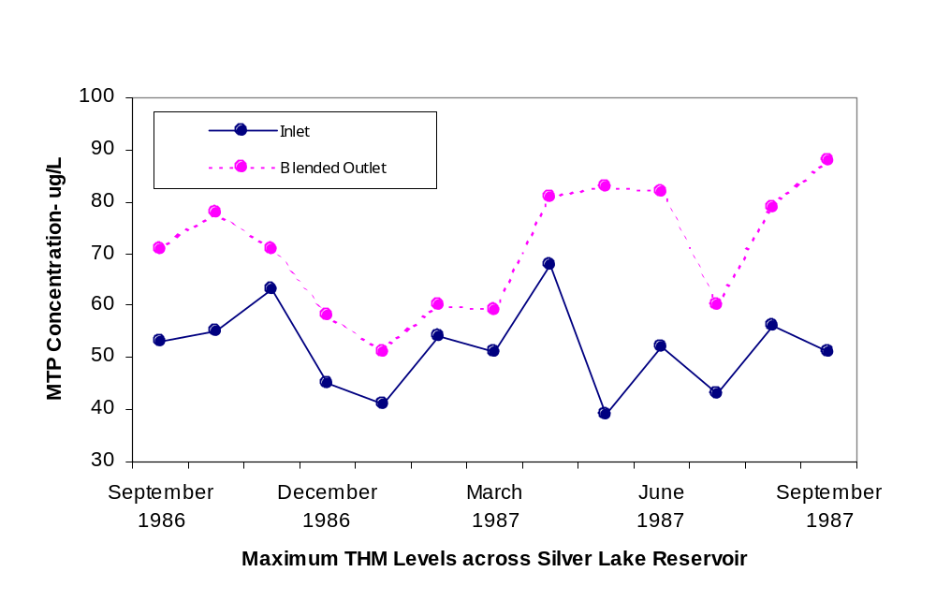
Source: Karimi and Singer, 1991

Figure 3-2. Maximum TTHMFP (MTP) in LADWP’s Silver Lake Reservoir

It should be noted, however, that DBP levels do not necessarily increase in all open reservoirs. Although the high TTHMFP values correlated with peak algal levels at LADWP’s Silver Lake Reservoir, studies conducted at an open reservoir in Seattle indicated that algae are not causative agents contributing to DBP formation. Other types of organic substrate also have the potential to affect DBP formation.
Some utilities have observed no significant changes and some have actually experienced decreases in DBP levels across their open reservoirs (AWWA, 1983). One utility has conjectured that DBP levels may decrease through volatilization or through oxidation of precursors by heterotrophic bacteria. As there are many potential variables involved with this subject, further study is necessary.

Increase in Taste, Odor, and Sediment Problems
Algae are a common cause of taste and odor problems in open reservoirs. High doses of chlorine reacting with the algae during summer months has prompted numerous customer complaints of foul taste and odor (Kittredge, 1994). Decaying microorganisms can form a sediment layer at the bottom of the reservoir. When the reservoir level is low during dry seasons or periods of high demand, these sediments can be drawn into the distribution system. These sediments in the distribution system can severely compromise water quality and appearance and increase health risks to consumers. Long-term deposition of sediments in the distribution system can cause operational problems and harm the hydraulic efficiency of the system.
One utility reported that severe taste and odor problems occurred in several of its open reservoirs during 1997 to 1998. This water quality degradation was related to blue-green algae and required removal of the reservoirs from service during peak demand season, despite acceptable microbiological quality. The utility was unable to determine why this problem occurred only in its lined reservoirs. Accumulation of sediment, including organic matter and silt, also was observed in these reservoirs, although this is common in both open and closed reservoirs. Sediment accumulations are due partially to the fact that the source water is unfiltered. The affected reservoirs needed to be cleaned twice as frequently as the other system reservoirs. Increased distribution system flushing was required to alleviate taste and odor concerns.
Algal blooms occur regularly in the open reservoirs of one major utility, primarily during spring as water temperature increases. These blooms are caused by green algae and have contributed to taste and odor problems in the system. Blue-green algae, although present in viable numbers, do not cause the blooms and are believed to be controlled by environmental conditions within the reservoirs, such as cool water temperatures and nutrient-deficient waters.

Insects and Fish

Insect Larvae
Uncovered reservoirs are occasionally infested with the larvae of insects such as midge flies and water fleas (Moore, 1979; Atherholt, 1997). Infestations are typically discovered at the customer’s tap because the larvae and can be carried through the distribution system from the reservoir. Several utilities experienced exacerbated infestations once or twice in a 10-year period. Since chlorination is ineffective against midge fly larvae, one utility employs seasonal malathion spraying to control the larvae. The spraying is conducted on the trees and shrubs around the perimeter of the reservoir and only when winds are less than 15 mph. Another midge fly control measure involves the temporary removal of the affected reservoir from service for cleaning. A secondary impact of midge fly outbreaks that may occur is the temporary increase in insect-eating birds, such as swallows, that arrive at the affected reservoir to feed on the adult flies swarming above the water surface. Because they are open to colonization by insects, the potential for infestation; may be greater in an open reservoir. Covering a reservoir, however, is not a guarantee against infestation if the reservoir is infested before covering (Bay, 1993).

Fish
Some open finished water reservoirs have been found to support fish populations. In one instance, extensive chlorination killed approximately a thousand fish that had been living undetected in a 120-foot-diameter open reservoir. Upon discovery of the fish, the reservoir was cleaned and an accumulation of 2 feet of fish droppings was found at the bottom. This waste had been periodically drawn into the distribution system (Morra, 1980). Utilities can shock reservoirs to determine whether fish are present. If detected, they should be removed or eliminated.

Ground Water Intrusion
Both open and closed reservoirs may experience problems with ground water intrusion. Ground water can contaminate the water in a reservoir and may contain significant levels of nitrogen and/or phosphorus, each of which can increase algal growth and aid in THM formation. Bromide ion levels in the water also may affect DBP formation. Ground water can be contaminated from a number of sources, including substances leaking from underground storage tanks and municipal and industrial wastes entering an aquifer.
Utilities should line their reservoirs with impermeable substances to prevent the intrusion of adjacent ground water. Effective reservoir liner materials include concrete, asphalt, and chlorosulfonated polyethylene. Concrete and asphalt liners need to have sealers between slabs. Several considerations should be accounted for when designing a liner for a finished water reservoir. These considerations include material characteristics, cost and life expectancy, climatic conditions, and the reservoir geotechnical characteristics. These considerations are discussed in greater detail in the AWWA Manual M25 entitled “Flexible-Membrane Covers and Linings for Potable-Water Reservoirs” (AWWA, 1996). All liners should be inspected periodically to identify leaks and make necessary repairs. A properly maintained liner typically lasts 25 to 30 years, while a poorly maintained liner may last only 15 years.
Finished water reservoirs subject to intrusion of ground water under the direct influence of surface water are in violation of the SWTR (40 CFR 141.70(a)(1)). These systems require treatment (including disinfection) to meet the SWTR requirements.

Airborne Deposition
Open reservoirs also are subject to airborne deposition from contaminants, such as industrial pollutants, volcanic ash, automobile emissions, pollen, dust, and particulate matter. Deposition occurs during all types of weather conditions, but is likely to be accelerated during precipitation events as air pollutants are transported from the air column above the reservoir by rain or snow. Furthermore, bacteria may enter open reservoirs through airborne pathways. Studies have shown, however, that the impact of dust and other airborne contaminants on reservoir water quality is minimal (AWWA, 1983).
The process of airborne deposition is well illustrated by the historical data on lead contamination in the sediment of Portland, Oregon’s reservoirs (Montgomery Watson, 1998). Based on a laboratory detection limit of 0.001 mg/L, lead was not detected in the source water or in water leaving the reservoir.
THIS PAGE INTENTIONALLY LEFT BLANK

Mitigating Water Quality Degradation
This chapter focuses on general methods to protect and maintain water quality in uncovered finished water reservoirs. Covering reservoirs with fixed or floating covers may be the best way to protect water quality. Additional measures to protect and maintain water quality can be accomplished through operational measures such as the adjustment of detention time, turnover rate, disinfection, and hydraulic flow-through. The feasibility of implementing a mitigation measure varies with individual site conditions. Detailed feasibility analysis is required to identify the most technically and economically suitable solution and determine whether the reservoir can be eliminated, replaced, or provided with a fixed or floating cover.
Uncovered finished water reservoirs are susceptible to contamination from a variety of sources, as described in Chapter 3, because they are open and exposed to external influences. These contamination sources can include bird and animal wastes, human activity, algal growth, insects and fish, surface water runoff, ground water intrusion, and airborne deposition. This chapter describes control measures not necessarily associated with a particular source of contamination.
Three primary types of water quality degradation problems may occur in open reservoirs:
- Microbiological – algal growth, HPC bacteria, coliform bacteria populations, pathogens, animal contamination, taste and odor problems, nitrification when chloramines are used as a disinfectant
- Chemical – elevated DBP levels and increased DBP formation potential
- Physical – increased particulate levels from airborne dust contamination and animal contamination.
The single most important factor adversely influencing water quality degradation is excessive detention time (Kirmeyer and Noran, 1997). Excessive detention time leads to the loss of chlorine residual and contributes to all three types of water degradation problems.
Finished water is a precious and perishable resource that cannot be stored for an indefinite period of time without incurring serious risk of water quality degradation. The longer water resides in a reservoir, the greater the opportunity for degradation by contaminants and chemical processes. The adoption and reinforcement of this fundamental concept is the crucial first step toward an understanding of the proper storage of potable water.

Reservoir Turnover
Reservoir flow-through rate, or turnover rate, is a measure of the frequency with which water is replaced in the reservoir. Excessive detention time will occur if a reservoir’s turnover rate is too slow, or if there is hydraulic short-circuiting. Water degradation results when the chlorine residual decreases as detention time increases. The loss of chlorine residual is a typical problem in open reservoirs and is of concern because it allows bacteria and other microorganisms that pose a threat to public health to multiply.
In developing an effective turnover rate for its reservoirs, a utility should consider all reservoir functions to achieve a proper balance in system operations. Some traditional reservoir management practices that are used to achieve non-water quality related functions tend to result in turnover rates that are too slow. The constant maintenance of sufficient reservoir water storage to meet system pressure and emergency requirements, for example, may have to be balanced against the water level drawdown/refilling operations needed to obtain an adequate turnover rate.
The maintenance of an adequate turnover rate is an effective and economic tool for controlling water quality degradation problems (Silverman et al., 1983). Proper reservoir management dictates that utilities actively identify and maintain the best practicable turnover rates in their open reservoirs. The optimal average turnover rate is determined by site-specific factors and will therefore be specific to each reservoir within a system. The desired turnover rate also may vary over time for a given reservoir in response to seasonal or other periodic changes in controlling factors. To determine the desired turnover rate for a reservoir, a utility should define and evaluate at least two primary factors: (1) the chlorine decay rate in the reservoir and (2) the configuration of the reservoir.
Based on the chlorine residual at the reservoir inlet and chlorine decay rate in the reservoir, the utility can determine the theoretical turnover rate needed to achieve a pre-established chlorine residual goal. This method of calculating the turnover rate is most applicable to reservoirs in which the water-flow regime most closely approximates ideal plug flow. Ideal plug flow, a flow regime in which a well-mixed volume of water will proceed at a steady rate from an inlet at one end to an outlet at the opposite end, is best suited to rectangular-shaped reservoirs with smooth and even surfaces.
Open reservoirs, which are often circular or irregularly shaped and not well mixed, typically do not exhibit ideal plug flow. Hydraulic “dead spots” of stagnant water, for example, are frequently found in reservoirs having an inlet and outlet in close proximity of one another. In this type of reservoir, the water that is hydraulically short-circuited near the inlet and outlet may have an adequate chlorine residual, but significant water quality degradation can occur in the dead spots that may form outside of the inlet/outlet area of influence. The water in these dead spot areas may have a detention time as high as several weeks and will therefore not have a chlorine residual. These dead spots and short-circuiting can be located by monitoring at multiple locations and depths to characterize chlorine residual dynamics throughout the reservoir. The chlorine residual monitoring data can be used to determine an optimal average turnover rate for the reservoir that will result in an adequate chlorine residual throughout the reservoir.
To ensure that the optimal turnover rate for each reservoir is actually achieved during day-to-day operations, the utility should develop and implement a water-level fluctuation strategy. The objective of this strategy is to force most of a reservoir’s water to turn over in one continuous cyclical operation of water drawdown and refilling. A cycle consists of draining a large percentage of the reservoir and allowing a pre-determined period of time to pass before refilling. Another, but less desirable method, involves periodic flushing of the reservoir by overflowing. Turnover rate management programs that include water-level fluctuation strategies will avoid the long detention times that might occur in dead spots, or poorly circulating areas. The frequency and amount of water fluctuation necessary will depend on the flow characteristics of the reservoir. This type of strategy is critically important for reservoirs that have common inlets and outlets such as standpipes.
Some utilities have developed turnover rate management programs that include water-level fluctuation strategy as an important tool for the correction of water quality degradation, preventing conditions from worsening. One large utility, faced with a water quality problem such as taste and odor, will increase the turnover rate using any of the following water-level fluctuation methods: (1) flushing out the affected reservoir by overflowing at high rates, (2) adjusting distribution system valves to increase flows from the affected reservoirs, and (3) using auxiliary pump stations to draw down the reservoir at an accelerated rate. This utility’s open reservoir management plan includes a turnover rate goal of 5 days and a minimum chlorine residual goal of 0.6 mg/L at the reservoir outlet.
If a system chooses to incorporate a water level fluctuation strategy, it should address potential algal growth problems. Algae growth can cause problems because it tends to colonize on the surface of the sides of the reservoir. As a water-level fluctuation strategy is implemented and the water level is decreased, the algae on the sides of the reservoir may perish. Once the water level is increased, the water will come in contact with these dead organisms, which may result in water quality degradation. It is important to address this possibility while deciding whether to implement a water fluctuation strategy.
Although turnover rate can be used to effectively decrease water quality degradation, only one State has regulations that address turnover. Ohio requires that at least 20 percent of the reservoir volume turns over daily. Internationally, Germany limits maximum detention time to between 5- to 7-days for concrete-lined reservoirs, while Switzerland limits a 1- to 3-day maximum, based on the lower chlorine residuals maintained at Swiss facilities. Kirmeyer and Noran (1997) indicated that an average turnover rate should range from 3-to 7-days.

Disinfectant Residual
As stated in the previous section, the maintenance of a chlorine residual within a reservoir is an important measure for controlling the growth rate of bacteria and microorganisms. Long detention times that result from insufficient reservoir turnover cause a decline in chlorine residual and degradation of water quality. Sunlight also will react with the chlorine, making it especially difficult to maintain a residual.
The chlorine residual required to maintain water quality is unique to each reservoir. The required chlorine residual is based on reservoir size, detention time, water quality, and hydraulic characteristics. The initial chlorine dosage required to maintain the residual level will vary with the season and the quality of the source water. However, other factors may contribute to making it difficult to maintain a chlorine residual even during periods of higher water use. For instance, the higher temperatures that lead to higher water use also may promote greater biological growth in the reservoir, which will increase chlorine demand. The chlorine demand also may increase because of the greater exposure of the reservoir to sunlight during the warmer summer months, which will tend to degrade the chlorine residual. These two factors alone may make it difficult to maintain a chlorine residual even when the detention time is shortened due to high water usage.
Chlorine levels should be monitored frequently to ensure that proper disinfection and water quality are maintained. The frequency of chlorine monitoring is specific to a reservoir and to the quality of the source water. Utilities should monitor the residual regularly for two reasons: (1) to ensure that a protective level of disinfection is maintained, and (2) to detect a sudden loss in residual, or a sudden decrease in residual that is indicative of deteriorating water quality in the reservoir, or of some other event occurring that should be addressed (e.g., an algal event in the reservoir or a source water problem).
Chlorine levels should be monitored in various locations in the reservoir to determine the location of “dead spots” where water can reside for extended periods. These hydraulically stagnant areas can be located by sampling for chlorine residual at different locations and depths and identifying those areas having the lowest chlorine residual concentrations. The subject of dead spots is discussed further in Section 4.3.
Chloraminated systems are subject to the threat of nitrification. During nitrification, nitrifying bacteria convert ammonia (NH₃) to nitrite (NO₂) and nitrate (NO₃). Nitrite and nitrate are inorganic chemicals that are contaminants under the SDWA. The MCLs for nitrite and nitrate are 1 mg/L-N and 10 mg/L-N, respectively, at the entry point to the distribution system. Utilities should strive to maintain nitrite and nitrate levels as far below their MCLs as possible because additional nitrification may occur in the distribution system. Excess amounts of nitrate and nitrite are known to cause methemoglobinemia (blue baby syndrome). Maintaining short detention times and frequent turnover will allow utilities to minimize nitrification potential (Kirmeyer and Noran, 1997). This will ensure that nitrifying bacteria populations cannot grow sufficiently large to produce an unsafe amount of contaminants. The utility may need to adjust the chlorine:ammonia:nitrogen ratio at the water treatment plant to control nitrification. Monitoring the chloramine residual and levels of nitrifying bacteria is a site-specific activity that is vital for proper management of a chloraminated system. Monitoring should be frequent enough to identify problems before they become serious.

Hydraulic Effects
A properly designed reservoir provides sufficient mixing within the reservoir to eliminate any hydraulically stagnant areas and ideally has flow characteristics approaching ideal plug flow. These design considerations will help to maintain uniform chlorine residual concentrations throughout the reservoir. As stated in Section 4.1, long detention times and low chlorine residual concentrations result in HPC and coliform bacteria growth, algal growth, and nitrification of chloraminated waters. The chlorine demand is then increased in these types of situations, especially in warmer waters.
In contemplating any potential remedial or mitigation improvements, it is appropriate to conduct initial modeling to evaluate potential sources of the problems, conduct modeling studies to evaluate alternative mitigation options, and conduct follow-up monitoring to assess the potential effectiveness of improvements.

Flow Short-Circuiting
In an ideal reservoir all water molecules will spend an equal amount of time in the reservoir. Inconsistencies in the physical configuration of a reservoir, however, can often lead to dead spots and short-circuiting of water flows. The following reservoir characteristics are common causes of flow short-circuiting:
- Common inlet and outlet location – Water is not allowed to flow throughout the reservoir and displace water further away from the inlet/outlet location. Therefore, the water that most recently has flowed into the reservoir can be the first to flow out of the reservoir. Thus, the most likely location for dead spots is the end of the reservoir opposite the inlet/outlet structure.
- Poor location of inlets and outlets – Water will naturally tend to flow in the path of least resistance from reservoir inlet to outlet. Hydraulic dead spots and short-circuiting will form in reservoirs with poor inlet and outlet locations and no baffles to direct the water flow. Ideally, the reservoir outlets should be located on the side opposite the inlets. Common inlets and outlets, and inlets that are in close proximity of outlets, will result in undesirable flow patterns. Water will short-circuit along the natural flow path between inlet and outlet, and the dead spots will form in areas outside of that path.
- Uneven reservoir depths – If the reservoir has any spots that are significantly deeper than adjacent areas, the water in the deeper areas will tend to stagnate. Water in these stagnant zones will tend not to mix with the water flowing above.
- Shape of the reservoir – The potential for flow short-circuiting and dead spots increases if the shape of the reservoir has any irregularities, such as bays, peninsulas, or uneven sides.
- Thermal stratification – Seasonal temperature changes and reservoir water flow patterns can lead to the thermal stratification of the reservoir water. Thermal stratification results in the formation of distinct thermoclines that separate into warm and cold water zones. This condition can be hydraulically stable and can inhibit water movement between the thermally stratified water zones. LADWP discovered that thermal stratification significantly decreased disinfection efficiency in some of their reservoirs (White, 1998). In this stratified environment, chlorine tended to accumulate at the bottom of warm water thermoclines, forming a lens of chlorine concentration in those areas and chlorine residual deficiencies in surrounding areas.

Hydraulic Circulation System
The reservoir characteristics described above often cannot be readily changed in an existing reservoir. Therefore, systems may choose to install hydraulic circulation systems.

In a circulation system, water is pumped out of the reservoir and returned to another location in the reservoir, to ensure homogeneous water quality throughout the entire reservoir. Hydraulic circulation is optimized when the distance between the circulation system inlet and outlet is maximized.
Kirmeyer and Noran (1997) proposed that the velocity gradient be used as a basis for establishing the power needed to maintain adequate mixing in a reservoir. The equation is:
P
G = or P = G²µV
Vµ

where G = velocity gradient, sec⁻¹
P = power input, ft-lb/sec
µ = dynamic viscosity, lbf-sec/ft²
V = Volume, ft³

The velocity gradient is a widely accepted general design criterion for rapid mixing and flocculation unit operations. However, the use of the velocity gradient in establishing power requirements for reservoir mixing is a relatively new concept. A “G” factor of 10/sec has been suggested as an acceptable velocity gradient for reservoirs (Kirmeyer and Noran, 1997). The following is an example of the use of this equation in determining the required power input.
Example calculation
Given G = 10 sec-¹
µ = 2.39 × 10⁻⁵ lbf-sec/ft²
V = 1.34 × 10⁵ ft³ (1 million gallons)

Determine mixing power requirements:

P = G²µV = (10²)( 2.39 × 10⁻⁵)(1.34 × 10⁵) = 320 ft-lb/sec
Since 1 ft-lb/sec = 550 hp
P = 0.58 hp
This calculation does not take into account the inefficiency of the pump motor, pump, piping head losses, or discharge losses. The velocity gradient calculation estimates the total power required to mix a reservoir but does not consider how this energy should be distributed. The proper distribution of this energy is crucial in achieving adequate mixing.
Circulated water should be introduced into the reservoir as uniformly as possible to promote mixing within the reservoir. This can be accomplished using diffusers. Diffusers, in this application, are pipes with a series of strategically placed and sized orifices or ports.
The following procedure may be used as an approach for design of the circulation system (Kirmeyer and Noran, 1997).
- Select the velocity gradient goal
- Determine diffuser port spacing and placement
- Select diffuser port diameter and circulation system flow
- Design piping system, compute head losses and check piping system for proper distribution of flow between nozzles
- Choose the orientation of jets
- Select pump
- Decide whether a rechlorination system is needed.

One additional benefit of a pumped circulation system is the possibility of introducing a chemical feed system to adjust chlorine residual. The chemical feed pump in this system could be automatically operated using feedback from a chlorine residual analyzer that tests water entering the circulation system. This system could be designed to operate continuously or intermittently with either timer control or residual pacer control.

Reservoir Baffling
Baffles that are properly designed to promote uniform plug flow inside the reservoir can minimize short-circuiting. A properly designed baffle will not inhibit reservoir maintenance or cleaning. All baffles should extend from the floor of the reservoir to above the maximum water level. Small openings in the baffles at floor level can be provided to facilitate drainage and cleaning. Preferably, any openings in the baffles should be sealed when not in use to prevent short-circuiting. Removable doors and walk-through openings have been used in baffles to facilitate inspections and reservoir maintenance activities.
For a rectangular reservoir, baffling should be designed to provide a length-to-width ratio of 20:1. The width is measured as the spacing, or channel width, between baffles. The length is the total distance traveled through all channels. Length-to-width ratios of 20:1 are considered to be the optimal for rectangular reservoirs because greater ratios have not been found to significantly improve the desired plug flow regime. Baffling may not be appropriate if dead zones of stagnant water are not expected to be a problem.
For a circular reservoir, a baffling configuration of three to seven baffles is suggested. The number of baffles and their placement are primarily determined by water quality concerns and the occurrence of stagnant water areas.
Many construction materials and design configurations are available for a baffling system. Materials of construction include cast-in-place concrete, concrete masonry units (CMUs), and framing, such as stainless steel, aluminum, or fiber-reinforced plastic. If a floating cover will be installed, there is a variation of baffling known as hanging baffles in which weighted flexible baffles hang from the cover and are not attached to the reservoir floor. All of these options should be weighed according to the needs of the site and the cost of construction. Cast-in-place concrete and CMUs have a high capital cost but are durable and long lasting.

Submerged Mixer
Submerged mixers can be installed in a few key locations in the reservoir to create instability in the reservoir flow. The mixer accomplishes this by introducing a source of kinetic energy that disturbs the equilibrium that normally evolves in the reservoir. Even one small mixer in the center of the reservoir will create an unstable area that affects the entire reservoir. Water surrounding the instability will be attracted toward the unstable area in an effort to reach a stabilized condition. The energy required to create this disturbance does not need to be substantial. As with the hydraulic circulation system above, a “G” factor in the range of 10/sec has been suggested as an acceptable velocity gradient for reservoir mixing.

Relocating Inlets and Outlets
Ideally, the reservoir inlet and outlet are positioned to maximize the length of the water flow path. In a reservoir without baffling, it is best to maximize the distance between the inlet and outlet. Separation of the inlet and outlet may reduce short-circuiting through the reservoir and improve circulation. If a utility is considering relocating an inlet or outlet of a reservoir, it should compare the costs to the cost of a baffle system that will increase mixing and increase the length of the flow path.

Altering Flow Patterns at the Inlet and Outlet
The design of the inlet and outlet also can have an affect on the flow in the reservoir. One design that has been used successfully in circular shaped reservoirs involves realigning the inlet pipe. For example, providing a 90-degree bend on the inlet oriented parallel to the wall of a circular reservoir will promote water flow around the perimeter of the reservoir, thereby increasing the flow distance between inlet and outlet.

Aerators
Aerators are mechanical mixing devices that can be used in reservoirs to prevent thermal stratification. Two types of aerators normally used in reservoirs include bubble plume aerators and deep draw aerators.
Bubble plume aerators, also known as air curtains, consist of low-pressure air lines installed on the floor of the reservoir. The air lines have groupings of small-diameter holes along their length, resulting in a curtain of air that flows from the reservoir bottom to the water surface. The air bubbles move colder water from the reservoir bottom toward the surface, resulting in the colder water mixing with the overlying layers of warmer water. The mixing of warm and cold water creates instability as the water seeks thermal equilibrium.
Deep draw aerators are similar to bubble plume aerators. An air line is extended to the bottom of a reservoir. A draft tube may be used to guide the initial upward rise of bubbles. The rising bubbles cause a roll-type blending of the warm and cold water layers.

Analyzing Reservoir Hydraulics
Reservoir hydraulics can be investigated and better understood by using tracer tests or finite element modeling. Tracer testing involves introducing a tracer chemical into the reservoir water stream and measuring the concentration of the tracer at the reservoir effluent at various time intervals. The results provide insight on the hydraulic characteristics of the reservoir. Finite element modeling is a powerful computer simulation method that can model the dynamics of reservoir flow. The following sections provide more detailed information on tracer testing and the benefits of finite element modeling.

Tracer Study
As mentioned above, reservoir hydraulics can be analyzed using a tracer test. A tracer test is performed by injecting a known amount of tracer into the inlet of the reservoir. The concentration of the tracer is then measured at the effluent of the reservoir at various time intervals. The test results are summarized graphically as tracer concentration versus time. The resulting graph provides insight on the hydraulic characteristics of the reservoir. A more detailed discussion of how to perform a tracer test provided in the SWTR Guidance Manual, Appendix C (AWWA, 1991), is summarized below.
The effective contact time of the reservoir, T₁₀, is obtained from the test data. T₁₀ is defined as the time at which a portion of the water has passed through the effluent sampling point. The hydraulic efficiency of the reservoir is represented by T₁₀/T, where T is the theoretical detention time. A T₁₀/T of 1.0 represents ideal plug flow conditions. A reservoir with a high hydraulic efficiency has a T₁₀/T in the range of 0.5 to 0.8. A T₁₀/T below 0.3 represents a low hydraulic efficiency, which indicates short-circuiting and dead spots.
The two basic methods of tracer addition include the step-dose method and slug-dose method. Both methods are theoretically equivalent for determining T₁₀. In the step-dose method, the tracer is dosed at a constant rate until the concentration reaches a steady-state level. An advantage of the step-dose method is that T₁₀ can be determined directly from test results. One of the disadvantages of the step-dose method is that it requires chemical feed equipment. Another disadvantage of the step-dose method is that a concentrated tracer is needed to adequately define concentration versus time.
In the slug-dose method, the tracer is dosed as a one-time application. The slug-dose method does not require chemical feed equipment; however, intensive mixing of the influent, following tracer addition, is required. Further, additional data manipulation is required in the slug-dose method to determine T₁₀.
The selected tracer chemical should be readily available, nonreactive, easily monitored, and approved for use in potable water supply. Commonly used tracers include fluoride, Rhodamine WT, lithium, sodium, and chloride. Fluoride is the least expensive of these tracers.
The tracer concentration should be sufficiently high to allow the tracer to be detected, but should not exceed the Secondary Maximum Contaminant Level (SMCL) for the chemical. With the step-dose method, the ideal tracer concentration is at least four times the background concentration of the chemical. With the slug-dose method, the tracer concentration depends on the anticipated hydraulic efficiency of the reservoir. A reservoir with an anticipated low hydraulic efficiency would need a larger amount of tracer compared with the reservoir with a high hydraulic efficiency because of a lower peak concentration.
It is important to maintain a constant flow and a constant water level in the reservoir during the tracer test. Since reservoir hydraulics will change depending on the level of the reservoir, several tests should be conducted, each at different reservoir levels. At a low reservoir level, the hydraulic efficiency may be high because of less dead volume due to the lower depth. At a higher reservoir level, the dead volume may increase, leading to a lower hydraulic efficiency.
Water temperature also may be an important variable in the tracer study. If a reservoir is known to experience wide variation in temperature over a short period of time, it may be useful to conduct additional tracer tests at different temperature conditions to determine if temperature currents are causing short-circuiting problems.
As noted previously, chlorine residual monitoring also can be used to roughly characterize reservoir hydraulics.

Finite Element Modeling
Finite element modeling is another method to locate dead spots. Finite element modeling is a method of computer simulation that simplifies complex systems, such as a reservoir system, by dividing it into many small elements. The hydraulics within each of these smaller, simpler elements can be modeled and the results used to estimate the overall reservoir system hydraulic flow.
Finite element modeling can be used to model not only the existing reservoir hydraulic characteristics, but also the characteristics of the reservoir hydraulics when influenced by a mixer, other water circulation device, or baffles. Results provided from the modeling are in two or three dimensions and include speed contour plots, velocity vector plots, kinetic energy (turbulence) plots, and other parametric plots. In more complex modeling, chemical feed applications such as chlorine can be modeled if chemical diffusivity, mass flow rate, rate reaction constants, and injection points are described. Chemicals can alternatively be modeled as particulates, with the trajectories plotted (Stolarik and Miller, 1998; Henry, 1996).
Finite element modeling does have limitations that result from the lack of detailed input information or the inability of the program to simulate extremely complex phenomena. These limitations include the inability to simulate thermally induced convection and wind induced currents, and are derived from complex phenomena such as density variations and chemical decay.

Reservoir Cleaning
To maintain water quality, a reservoir maintenance schedule should include cleaning to remove floating debris, sediment, and algal growth that can enter the distribution system or otherwise contribute to water quality degradation. The lining of reservoirs, whether it is constructed of asphalt, concrete, or HDPE, provides a surface to which algae, slimes, and other aquatic organisms can attach and accumulate. It is necessary to periodically remove these organisms because they increase disinfectant demand and react to form DBPs. Reservoir cleaning should include the following activities:
- Routine inspection for floating debris and for sources of contamination that could affect water quality, with documentation and removal of any threats of contamination.
- A thorough cleaning should be conducted on a time schedule that is site-specific and best for the particular facility (e.g., every six months, once per year, every two years). This time-frame depends on the monitoring of water quality parameters such as pH, temperature, nutrient loadings, quality of the influent, etc. that will have an affect on algal growth in the reservoir. This cleaning should coincide with draining the reservoir and inspecting the integrity of all liners as well as other reservoir structures such as inlet flapper gates, outlet piping, valves, detention chambers, and so on. A high-pressure hose or equivalent should be used to remove accumulated sediment, debris, and aquatic growth. One large utility uses a concrete scrubbing machine to clean the liner. This machine has brushes and rotating jets driven by high-pressure water and is designed to clean paved surfaces such as parking lots. This machine is designated by the utility for reservoir cleaning only and has been adapted for use in cleaning reservoir sidewalls of concrete or asphalt.

Water Quality Effects on the Distribution System
The water distribution system is a dynamic chemical and biological system. Open reservoirs can cause significant changes to the quality of the water entering the distribution system. Rates and severity of corrosion and biofilm growth within the distribution system are heavily influenced by the chemistry of the water flowing through the system. Utilities should maintain a certain level of water quality stability by maintaining parameters within optimal concentration levels, to ensure pipes are protected and regulatory requirements are met under rules such as the LCR and D/DBP Rule.
Utilities should maintain stable water quality in the reservoir for the following reasons:
- Determine water quality parameters such as pH, dissolved organic carbon, phosphate, dissolved oxygen, total inorganic carbon, and the solubility of solids, which can form passivating films that protect the pipe.
- Red and blue water can result from poor corrosion protection.
- A stable pH is necessary for corrosion control strategies to work effectively and consistently (i.e., compliance with the LCR).
The stability of the distributed water (particularly pH) is critical in achieving any positive corrosion control results. It is unlikely that any corrosion inhibitor program can be effective on lead bearing surfaces unless there is stability in the distribution system pH. Excursions that drop the distribution pH by greater than 0.5 units, even for brief periods, appear to disrupt the effective passivation of the corrosion surfaces, especially on brass and lead/tin solder surfaces. Fluctuations of pH in uncovered reservoirs easily can exceed this.
The pH in the distribution system should remain in a certain range for a specific corrosion control strategy to work. The pH can range from 7.2 to 7.8 for systems using orthophosphate treatment and between a pH of 9 or 10 for those using pH/alkalinity control. Shifts in pH can be caused by photosynthetic reactions. To maintain good corrosion control, the water should have adequate buffering to resist diurnal changes in pH and major cyclical shifts in the dissolved inorganic carbonate content.
Stability also plays a role in the release of corrosion products from iron surfaces. It is believed that many well-publicized distribution problems stem from the inability to maintain a consistent water quality, resulting in severe and extended red water problems.
Many utilities that blend different water qualities in the distribution network have reported adverse corrosion impacts attributed to chemical variability, the impact being especially pronounced on lead-bearing surfaces. Adjusting the pH of the source waters before blending has proven useful. Heavy dosages of phosphate-based inhibitors also have been used with success.
Using corrosion inhibitors such as orthophosphate or blended ortho/polyphosphate can aggravate the growth of algae and possibly other aquatic organisms when applied to or before open reservoirs. Chemical methods of controlling algae that are widely accepted by industry include applications of copper sulfate and aqueous chlorine as discussed in Section 3.4. However, these chemicals also may attack plumbing materials and corrode piping. Utilities should not maintain excessive chlorine residuals in the reservoir since extreme levels in pH in the distribution system accelerate corrosion rates. Disinfectant residual and bacterial monitoring will help utilities maintain adequate but not excessive disinfectant residual.

Covers
Covers have been used successfully to protect treated water reservoirs from contamination. Reservoir covers can eliminate water quality deterioration caused by airborne deposition, bird and animal wastes, human activities such as swimming, and deliberate contamination or sabotage. In addition to providing public health protection, covers prevent algal growth and reduce the amount of chlorine lost during storage by excluding sunlight (Griffith, 1988). Covers also have been shown to dramatically improve the bacteriological quality of the reservoir water (Krasner, 1985).

Numerous types of covers exist. Covers may be designed as a flexible membrane floating or as a fixed structure on the water surface. They can be made from a variety of materials including reinforced concrete, steel, aluminum, wood, or polypropylene. The type of cover that is best suited for a particular reservoir depends upon a number of factors:

- Location, size, and shape of the reservoir
- Materials used in the construction of the reservoir
- Footing and other support conditions (soil/geotechnical considerations)
- Estimated snow, wind, and seismic loads
- Aesthetics
- The length of time, if any, that the reservoir can be removed from service
- The capital and maintenance costs and other economic factors involved.
The capital cost of covering existing open reservoirs with fixed covers has been a deterrent in the past. Within the past 20 years, however, the advent and acceptance of floating covers has substantially reduced the costs of covers. This has led to a large increase in the number of covered finished water reservoirs (CWC-HDR, 1986). The following sections discuss the two general options for covering finished water reservoirs, floating covers, and fixed covers.

Floating Covers
A floating cover consists of a flexible-membrane that is designed to float on the surface of the reservoir. Floating covers typically consist of relatively rigid flat sheets that cover the majority of a reservoir. Floating covers also have strategically placed flexible areas that create folds to allow the cover to compensate for changing reservoir levels. These flexible areas also act as natural drainage channels to collect rainwater or washwater.
Several considerations should be taken into account when designing a floating cover for a finished water reservoir. The primary considerations that should be evaluated include the following:
- Construction materials
- Cost and life expectancy
- Climatic conditions
- Cleaning and maintenance.
Other design considerations include air vents, rainwater collection and drainage, reservoir level fluctuation, piping, and seams. These considerations are discussed in greater detail in the AWWA Manual M25, “Flexible-Membrane Covers and Linings for Potable Water Reservoirs” (AWWA, 1996). Although the AWWA M25 document provides information on the design of flexible-membrane covers and linings, it does not provide minimum design standards. However, the AWWA California-Nevada Section Reservoir Floating Cover Task Force is creating a summary of minimum design standards for reservoir floating covers for the California Department of Health Services.
Many of the first-used floating covers were constructed of ethylene-propylene-diene monomer (EPDM) rubber or polyvinyl chloride (PVC). Experience with these materials, however, showed that they were not designed for harsh climatic conditions. For example, field seams in the EPDM covers exhibited a low tolerance to the bending and twisting action caused by ice movement and reservoir level fluctuation.
In recent years, flexible-membrane covers have been constructed of reinforced chlorosulfonated polyethylene (CSPE-R) and polypropylene (PP-R). Each of these flexible- membrane materials has unique physical characteristics and methods of construction and repair that should be evaluated thoroughly before a particular product is specified. For instance, potable grade PP-R is available in a variety of colors such as tan, white, blue, black, and gray, while potable grade CSPE-R membrane is only available in black. Another difference between these different types of cover material is the method used to bond pieces together. PP-R can be thermally welded, even after years of use and exposure to sunlight. CSPE-R membrane can be thermally welded when only new. After years of exposure to solar radiation the new membrane material becomes incompatible; resulting in the need to use a solvent-welding process for most repairs.
Cover materials should be at least 45-milimeters thick and consist of multiple plies of flexible-membrane material ensuring a pinhole-free sheet. Additional information on choosing the appropriate floating cover material for a reservoir can be found in AWWA D130-96, Standard for Flexible-Membrane Lining and Floating Cover Materials for Potable Water Storage (AWWA, 1996).
Previous performances of floating cover materials should be evaluated and a conservative economic life expectancy assigned before choosing an appropriate floating cover material. A floating cover is normally warranted for 20 years. If a floating cover is well maintained it may last as long as 25 or 30 years. Conversely, if a cover is not properly maintained it may last for only 15 years. The cost to install a floating cover currently ranges from approximately $1.50 to $2.50 per square foot of covered reservoir area.
Cleaning and properly maintaining a floating cover is very important to the quality of protection that the cover will provide and to the life expectancy of the cover. Daily inspections of the cover may be appropriate, but this frequency is dictated by site-specific conditions. Regular inspections will identify any problems such as vandalism, wildlife, or large tears. Maintenance and repair of the cover should be performed weekly and involves two steps: inspection and identification of tears or breaks in the liner, and the repair of these problems.
It may be appropriate to clean the cover four times per year, depending on site-specific conditions and previous experience. Flushing and cleaning of the cover may prove more labor intensive on covers that are not designed and constructed with adequate tension across the cover membrane. The cost of a maintenance program for flexible-membrane covers depends on the level of maintenance provided. One utility that performs the suggested maintenance estimates that its maintenance program costs approximately $50,000 per year for a 1-million-square-foot floating cover.

Fixed Covers
Fixed covers are permanent structures constructed to provide drainage away from the reservoir and to prevent entrance of contamination into the stored water. These covers are constructed from a variety of materials including reinforced concrete, steel, aluminum, and wood. They can be designed as flat, conical, or dome-shaped. In general, fixed covers are economically limited to fairly small-sized reservoirs, up to a maximum of 10- to 20-million gallons (MG) (approximately 100,000 square feet in surface area). Concrete roofs constructed over an existing open reservoir can be a pre-cast T-beam/membrane roof with concrete column supports, or a cast-in-place concrete roof with concrete column supports.
Reinforced concrete options include a completely new covered tank made of prestressed concrete. This option may be considered for a size of about 1- to 10-MG. A prestressed concrete tank is not an option when the existing finished water reservoir contains a water storage volume much larger than 10 MG. Steel water storage tanks also should be considered along with prestressed tanks since steel tanks have a lower capital cost than prestressed tanks and can be used for reservoirs up to a maximum size of about 10- to 20-MG.
The all-aluminum geodesic dome is another example of a fixed cover, although it is limited to covering circular reservoirs. This dome consists of a skeleton of aluminum trusses and a skin of aluminum panels. The advantages of the geodesic dome are its long life (50-to 100-years), no maintenance requirements, no painting requirements, its light weight, no interior columns or supports, and fast construction. The dome can be installed while the reservoir is in operation. Disadvantages of the geodesic dome include high initial cost and its span and shape limitations. The largest dome installed, as of 1986, had a span of 230 feet. A dome this size could cover a 35-foot-deep 11 MG storage tank.

Air-Supported Roofs
The air-supported roof is another type of cover initially used for swimming pools, greenhouses, and similar enclosures, but was eventually adapted for use on reservoirs. The covers can be circular-, square-, or rectangular-shaped. Air-supported covers are inflated and kept in place with blowers that operate continuously to maintain about 2 pounds per square inch (psi) (14 kPa) more pressure inside the cover than outside. Two blowers, with one serving as a standby, and a standby emergency generator should be included in this type of design to support the roof during emergencies. Materials for fabric include polyester-reinforced vinyl, CSPE, and Teflon-coated fiberglass, with service lives of 5 to 10, 10 to 20, and 25 or more years, respectively. Cost of the material used to fabricate an air-supported roof increases proportionally with the desired service life.

Costs
Costs of four different types of fixed cover systems were compared to the costs of a CSPE floating cover in an article published in the New England Waterworks Association (NEWWA) Journal (Kittredge, 1984). Although these costs are outdated, they illustrate the relative comparison of capital costs for the different types of cover designs. These cost estimates show that the capital costs for fixed covers are up to 5 to 10 times the cost of floating covers and air-supported fabric.

A summary of the estimated cost ranges for covering an existing reservoir at 1998 cost levels is included in Table 4-1 (CWC-HDR, 1986). It should be noted that these costs do not include design of the floating cover, which can be considerable depending on the complexity of the design. Furthermore, these costs do not include other construction costs that will be necessary when installing covers. These additional costs may include rehabilitating the existing reservoir, upsizing the impacted storm water drainage facilities surrounding the reservoir, and/or adding partition walls or baffles to the reservoir to allow the proper functioning of the reservoir with the cover. Storm water drainage facilities may need to be upsized due to the creation of a significant additional surface area that will cause the accumulation of runoff from rainfall. These costs will vary from application to application depending on a variety of factors such as size, complexity, or even the time of the year (Schader, 1998)
Table 4-1. Estimated Cost Ranges to Cover
Existing Reservoirs at 1998 Cost Levels ¹
Type of Cover | Estimated Cost, 1998,  $ per Sq. Ft. | Estimated Service Life,  Years
Air Supported Fabric | $2.00 to $5.50 ² | 5 to 25
Floating, Polypropylene | $1.50 to $2.50 ³ | 15 to 30
Wooden | $13.00 to $23.00 | 25 to 50
Steel | $14.00 to $22.00 | 30 to 60
Concrete | $21.00 to $29.00 | 50 to 100
Aluminum Dome | $14.00 to $32.00 | 50 to 100
1 - Costs were inflated to 1998 levels using Means cost indices.
2 - This cover would have an energy operation and maintenance cost also.
3 - Based on actual 1998 bid costs for floating covers.
As noted in Table 4-1, the current cost of installing a floating cover on a reservoir will range from $1.50 to $2.50 per square foot. This cost includes only the cost of the cover material, the rain collection system, and installation of the cover. A recent replacement of a floating cover on the 2-million-square-foot Garvey Reservoir in California cost $3.5 million ($1.75 per square foot). Other costs also could significantly increase the cost of implementing a cover. A recent New York study estimated that the total cost of covering a 3.9 million-square-foot reservoir ranged from $42.6 million ($10.87 per square foot) for a floating cover to $218 million ($55.60 per square foot) for a concrete cover (Freud, 1998). These estimates include the costs of the covers along with other associated costs that pertain to the individual application.

THIS PAGE INTENTIONALLY LEFT BLANK

Water Quality Monitoring

Introduction
The two primary objectives of water quality monitoring in uncovered finished water reservoirs are: (1) to ensure that the quality of water exiting the reservoir complies with applicable water quality requirements, and; (2) to identify reservoir contamination or water quality degradation quickly so that swift remedial action can be taken.
An adequate monitoring program is essential for providing accurate and useful data. Before a program is formulated, each utility should determine what is expected to be accomplished, identified, or measured by the program. Based on analysis of the water quality data, the utility can characterize the effects that an open reservoir has on the downstream system water quality and develop an effective reservoir management plan. Chapter 2 provides a general outline of the topics and issues that should be addressed in an open reservoir management plan. Each utility should design a plan that specifically addresses the issues that are encountered within its system of reservoirs.
The water quality monitoring program should be designed to alert responsible individuals of the development, or potential development, of significant water quality degradation in a reservoir, and should characterize both the short-term and long-term water qualities in the reservoir. The plan should ensure that monitoring data are analyzed regularly by personnel who have been trained to interpret the information and initiate any necessary response action. All utility personnel in the monitoring program should be trained to a level commensurate with their responsibilities. Training should include familiarity with applicable portions of the reservoir management plan.

Types of Monitoring
The overall water quality monitoring program for an open reservoir system should consist of subprograms that are designed to support a specific portion of the reservoir management plan through sampling and analysis and visual inspection.

Sampling and Analysis
Water sampling and laboratory analyses are necessary to monitor the chemical and biological status of the reservoir water. Monitoring of the water quality falls into three categories: routine, follow-up, and special study monitoring.

Routine Monitoring
Routine monitoring of baseline parameters should be conducted on a regular, continuous schedule. The routine monitoring program should include the establishment of threshold levels for specific parameters such as chlorine/chloramine residuals and fecal and total coliforms. When these threshold levels are exceeded, follow-up monitoring and a specific response action for any necessary adjustment in system operations and management may be required. Monitoring parameters and threshold levels may vary from utility to utility and from reservoir to reservoir to reflect site-specific conditions.
The results of the analysis of these data provide a guide to day-to-day management of the system for maintaining compliance with applicable water quality requirements. The results also facilitate the rapid identification of any water quality degradation or contamination, thereby enabling a timely and efficient response.

Follow-Up Monitoring
Follow-up monitoring is performed on specific parameters that present a potential or actual water quality concern. In some instances, follow-up monitoring may consist of a more frequent version of the routine monitoring program, or portion thereof. For example, one large utility samples total coliforms biweekly and conducts follow-up sampling when coliform bacteria are present in reservoir outlet samples. Procedures also should be developed to initiate follow-up monitoring based on other criteria, such as certain operator inspection observations and customer complaints.

Special Study Monitoring
Special study monitoring is a self-contained monitoring program designed to study a specific issue, usually on a one-time or as-needed basis. Examples include developing computer monitoring programs, assessing a new water treatment facility or procedure, and characterizating a potential contamination source.

Visual Inspection
Visual inspection of the reservoir and grounds should be performed daily to identify and prevent water contamination and water quality degradation caused by external factors such as discarded trash, trespassing, and wildlife. Visual inspections can be routine, follow-up, or conducted as part of a special study.

Routine Observation
Routine observation is conducted on a regular ongoing schedule to identify sources of contamination affecting water quality. Routine visual observation should include inspection of the fence line, the grounds between the fence and the reservoir, the surface of the reservoir, and the color of the water in the reservoir. Any changes in water color should be noted and followed by sampling and analysis. An inspection also should include the storm water drainage system, curbs and gutters, parapet wall, and so on. Any trash that is observed in the vicinity of or on the surface of the reservoir should be removed. Bird control devices or structures and animal traps should be checked.

The type and frequency of inspection is driven by factors such as the type of reservoir, susceptibility to vandalism, age, condition, time lapse between cleaning or maintenance, and history of water quality. Exterior inspections for indications of vandalism or trespassing may be made daily or weekly, while inspection of overflows might be appropriate on a weekly or monthly basis.

Follow-Up Observation
Follow-up observation is performed in specific locations identified as a source, or potential source, of contamination. These locations may include areas in which trash is usually found or areas in which the fence has been damaged. In some instances, this follow-up observation may consist of a more frequent version of the routine observation program, or of a portion thereof.

Special Study Observation
A special study observation program is designed to study a specific issue and usually is conducted on an as-needed basis. Examples include the identification of a contamination source, the study of wildlife to determine possible mitigation measures, and the observation of continually trespassed areas.

Parameters to Monitor
The selection of monitoring parameters for a particular reservoir requires careful consideration of the types of contamination sources present. The utility first should identify potential contaminants of concern for each open reservoir. The assessment should cover elements such as historical water quality data, potential sources of watershed contamination, and system dynamics. The initial assessment should be followed periodically with additional assessments to update information and identify trends. For some systems, these trends, and therefore monitoring parameters, may vary seasonally. In addition to identifying parameters based on the probable types of contamination sources, the utility may monitor other parameters that would pose a significant hazard if present. Table 5-1 summarizes information on water quality parameters that are monitored by some large utilities currently operating uncovered finished water reservoirs.
The parameters monitored by individual utilities may be different than those listed in Table 5-1 to address any site-specific concerns and conditions. For example, if gulls are a known concern, Salmonella and coliform bacteria monitoring are appropriate. If nearby motor vehicle traffic is a potential contamination source, it may be necessary to monitor for asbestos, metals, oil, and grease.
Table 5-1, on the following pages, provides examples of monitoring schemes some utilities employ at their uncovered reservoirs. EPA does not endorse or recommend that systems use these examples to develop their own monitoring scheme, nor is EPA judging the adequacy of the schemes by providing them as examples. Systems should develop a monitoring plan and response actions based upon site-specific conditions and needs. The monitoring plan and response actions should be sufficiently robust to provide confidence that water quality goals are being met and water quality degradation is identified in a timely manner. With regard to the far right column in Table 5-1, “Utility Survey Response,” EPA recommends that systems consider the reservoir water quality that should be maintained in the reservoir to meet TCR and other regulatory requirements.
Special studies to investigate a particular concern may require monitoring a completely different set of parameters than routine water quality monitoring. A study of contamination in reservoir sediments, for example, should consider parameters that are typically found in sediment. These may include heavy metals, synthetic organic pesticides, and other non-biodegradable or slowly degrading parameters. It may be appropriate to sample and analyze sediment each time the reservoir is drained.
Some studies may require a more detailed investigation. For example, to determine the impact of turbidity on chlorine demand, monitoring should provide information on particle size distribution. As such, the laboratory should be requested to provide information to determine the proportion of particles in excess of 1.2 microns, the size above which particles offer significant protection to bacteria from the effects of chlorination (Geldreich and Shaw, 1993).
In addition to determining appropriate parameters, sampling locations that are indicative of water quality should be selected. In-reservoir sampling locations may be appropriate when performing a special study to evaluate reservoir hydraulics.
Pertinent information that may affect the interpretation of data should be collected during water quality monitoring. These include water level elevations, hydraulic conditions, flow conditions, flow directions, inlet and outlet configurations, and valve positions.

Frequency of Monitoring
Water systems typically have many continually fluctuating water parameters. Some parameters are adjusted intentionally, such as orthophosphate for corrosion control and chlorine residual for disinfection. Other parameters will vary according to environmental factors, such as coliform bacteria and turbidity. Together, these continually changing parameters result in a system water quality that is also in a continuous state of flux. As noted in Section 5.2, monitoring should vary with actual or potential system variability.
When certain thresholds are exceeded for indicator parameters, increased monitoring frequency for other parameters may be necessary. Thresholds that indicate a need for an increase in chlorine residual include instances when the water has a pH greater than 8, a color greater than 10 units, or if the chlorine residual is found to be less than 0.2 mg/L.
Table 5-1. Utility Survey Water Quality Monitoring Parameters

Parameter | Monitoring Rationale | Utility Survey Response
Escherichia coli | Indicates fecal contamination and likelihood of pathogens of intestinal origin. Some species are human pathogens. Also monitors effectiveness of bird and animal control program. | A has set follow-up action levels at greater than 40 Most Probable Number (MPN)/100 mL. B monitors biweekly as part of its in-reservoir limnology program and collects one influent sample and eight effluent samples daily. Each of the effluent samples is a composite of samples collected at six different times and three grab samples.
Fecal coliforms | Similar to E. Coli. | B does not monitor fecal coliforms. D samples weekly and discharges contaminated water to waste when levels reach greater than 20 colonies/100 mL in 2 consecutive samples collected from finished water.
Note: Utilities surveyed are differentiated by letters A–F.
Table 5-1. Utility Survey Water Quality Monitoring Parameters (continued)
Parameter | Monitoring Rationale | Utility Survey Response
Total coliforms | Determines effectiveness of treatment and distribution system integrity. Indicates a system’s vulnerability to fecal contamination, not whether fecal contamination actually exists. | A monitors daily in-reservoir and weekly at outlets of reservoirs impacted by surface runoff. For other reservoirs, weekly in-reservoir monitoring is done. Follow up action threshold level is greater than 500 MPN/100 mL. B monitors biweekly as part of its in-reservoir limnology program collects one influent sample and eight effluent samples daily. Each of the effluent samples is a composite of samples collected at six different times and three grab samples. C collects daily in-reservoir samples. D samples weekly at both in-reservoir and reservoir checkpoint locations, and conducts follow-up sampling and response action when levels reach greater than 100 colonies/100mL or when coliform bacteria are present in reservoir outlet samples. Follow-up action consists of adding calcium hypochlorite tablets to the reservoir, and discharging water to waste if no improvement occurs.
Note: Utilities surveyed are differentiated by letters A–F.
Table 5-1. Utility Survey Water Quality Monitoring Parameters (continued)

Parameter | Monitoring Rationale | Utility Survey Response
HPC | Indicates bacterial growth and overall water quality. A few types of HPC may cause gastrointestinal illness. | B monitors biweekly as part of its in-reservoir limnology program. D samples weekly at both in-reservoir and reservoir checkpoint locations, and conducts follow-up sampling when levels reach greater than 500 colonies/100 mL in 2 consecutive samples. Follow up action consists of increasing the turnover rate and, if no improvement occurs, adding calcium hypochlorite tablets to the reservoir.
Note: Utilities surveyed are differentiated by letters A–F.
Table 5-1. Utility Survey Water Quality Monitoring Parameters (continued)

Parameter | Monitoring Rationale | Utility Survey Response
Chlorine/chloramine residual (free and total) | Ensures adequate disinfection through maintenance of target residual goals. Avoids over-chlorination that may contribute to DBP formation and pipe corrosion. | A monitors free and total residual continuously at outlets, and daily before and after the point of chlorination at reservoirs impacted by surface runoff. B monitors biweekly in-reservoir and continuously at reservoir inlets/outlets. Increases chlorine residual when < 0.2 mg/L is reached. C monitors chlorine residual continuously at each of two open reservoir system outlets and collects daily in-reservoir samples. D monitors weekly at reservoir checkpoints and also records data continuously. For any single reservoir, when chlorine residual is < 0.2 mg/L in a downstream distribution system, follow-up actions may include flushing, revised operations, or increasing chlorine dosage at reservoir outlet. For other reservoirs, when residual is < 0.6 mg/L, the Water Treatment Section is notified. E monitors its chlorine residual continuously at one reservoir outlet.
Note: Utilities surveyed are differentiated by letters A–F.
Table 5-1. Utility Survey Water Quality Monitoring Parameters (continued)

Parameter | Monitoring Rationale | Utility Survey Response
Algal populations/ type | Avoids problems associated with algal blooms, including color, taste and odor, bacterial growth, THM formation, and turbidity. Some blue-green species produce toxins that may be harmful or fatal to humans and animals. Blooms may clog filters. Monitoring should identify algal species and/or toxins present at “high” levels. | A monitors continuously in reservoirs impacted by surface runoff, weekly in other reservoirs (chlorophyll grab sample). For one reservoir that is subject to surface runoff, follow-up action levels have been set: (1) chlorination is initiated when chlorophyll is greater than 1 parts per billion (ppb) and growth rate is greater than 0.1 ppb/day, and (2) chlorination is terminated when chlorophyll is 0.5 ppb and growth rate is < 0.1 ppb for two consecutive days. B monitors biweekly. C samples biweekly. D samples biweekly, conducts follow-up sampling if nonsource water resident species are found. E monitors algae.
Nitrates, nitrites, phosphorous | Comply with MCLs. Avoid conditions that lead to “blue baby syndrome.” Identification of the availability of nutrients is required for algal growth. | C monitors nitrates/nitrites biweekly and total phosphorous monthly.
Ammonia | Indicates nitrification potential. | C monitors biweekly.
Note: Utilities surveyed are differentiated by letters A–F.
Table 5-1. Utility Survey Water Quality Monitoring Parameters (continued)

Parameter | Monitoring Rationale | Utility Survey Response
Specific conductance | Identifies water source when a reservoir may be supplied by multiple source waters. | A monitors daily, before and after point of chlorination at reservoirs impacted by surface runoff. B monitors biweekly and samples are collected at intervals throughout the water column. C monitors weekly. D monitors weekly at in-reservoir (5 feet from side and 15 feet below surface) and at the reservoir checkpoint after chlorination.
pH | Identifies chemical feed problems. Measures water corrosivity. Maintains optimal corrosion control in distribution system. | A monitors continuously at outlets and daily before and after points of chlorination at reservoirs impacted by surface runoff. B monitors biweekly in-reservoir, continuously at reservoir inlets/outlets, and increases chlorine residual when pH is 8 or greater. D monitors weekly at in-reservoir (5 feet from side and 15 feet below surface) and at the reservoir checkpoint after chlorination.
Note: Utilities surveyed are differentiated by letters A–F.
Table 5-1. Utility Survey Water Quality Monitoring Parameters (continued)

Parameter | Monitoring Rationale | Utility Survey Response
Temperature | Identifies mixing problems (thermoclines). Avoids conditions conducive to algal and bacterial growth. | A monitors continuously at three different depths at outlets and daily before and after points of chlorination at reservoirs impacted by surface runoff. B monitors daily at the reservoir effluent and biweekly at intervals throughout the water column. C monitors daily. D monitors weekly in-reservoir (5 feet from side and 15 feet below surface) and at the reservoir checkpoint after chlorination.
Turbidity | Measures a wide variety of suspended colloidal particles. Identifies chlorine demand and disinfection interference. Meets aesthetic water quality requirements. Evaluates erosion/sedimentation control programs. Indicates presence of other contaminants, such as heavy metals and synthetic organic compounds, that may bind to turbidity particles. | A monitors daily, before and after chlorination points of reservoirs impacted by surface runoff and weekly for other reservoirs. B monitors daily at the reservoir effluent and biweekly in reservoir. B Conducts follow-up monitoring when greater than a 0.7 nephelometric turbidity units (NTU). C monitors weekly. D monitors weekly at in-reservoir (5 feet from side and 15 feet below surface) and at the reservoir checkpoint after chlorination. E monitors continuously at one reservoir.
Note: Utilities surveyed are differentiated by letters A–F.
Table 5-1. Utility Survey Water Quality Monitoring Parameters (continued)
Parameter | Monitoring Rationale | Utility Survey Response
Taste and odor | Meet aesthetic requirements. | B monitors daily at the reservoir effluent. D monitors weekly at the reservoir checkpoint after chlorination for one of its reservoirs. When the Flavor Rating Assessment is greater than 6.5 and is 2 units greater than the source water, and customer complaints reach 10 to 12 calls/day, follow-up action consists of dilution with disinfected source water, overflow, or blending reservoir outflow. When the Flavor Rating Assessment reaches 8 or greater and customer complaints are greater than 20, evaluation to remove the reservoir from service is initiated.
Color | Indicates of algal growth and aesthetic quality. | B monitors biweekly and daily at the reservoir effluent.
Pseudomonas | May act as a human pathogen, particularly for immuno-compromised individuals (e.g., has been found to cause fevers in hospital dialysis patients, and also may cause pneumonia and secondary infections). | B speciates all atypical growths greater than 25 Colony Forming Units (CFU) identified during its coliform monitoring. D samples weekly and conducts follow-up sampling/action when levels reach greater than 100 colonies/100 mL in 2 consecutive samples. Follow-up action consists of adding calcium hypochlorite tablets to the reservoir and discharging water to waste if no improvement occurs.
Note: Utilities surveyed are differentiated by letters A–F.
Table 5-1. Utility Survey Water Quality Monitoring Parameters (continued)

Parameter | Monitoring Rationale | Utility Survey Response
Giardia and Cryptosporidium | Cause giardiasis and cryptosporidiosis, which are associated with surface runoff. Monitoring for these pathogens verifies that a finished water reservoir is not receiving surface runoff and fecal contamination. | C monitors occasionally. F monitors Giardia annually, Cryptosporidium biannually.
Total organic carbon (TOC) | Indicates presence of organic compounds. | B monitors monthly at the reservoir influent and effluent. E monitors TOC.
Redox | Characterizes water chemistry. | A continuously monitors at one depth to track chlorine dynamics. B monitors biweekly and samples at intervals throughout water column.
Dissolved oxygen | Characterizes water chemistry. | A monitors weekly from locations near water surface and reservoir bottom. B monitors biweekly and samples at distance of 3.3 feet from water surface and reservoir bottom (two locations).
Total plankton | Characterizes biological activity. Meets taste and odor requirements. | B monitors biweekly and sometimes analyzes species population counts.
Midge fly larvae | Meet aesthetic requirements. | B monitors biweekly using vertical tow methods.
Note: Utilities surveyed are differentiated by letters A–F.
Table 5-1. Utility Survey Water Quality Monitoring Parameters (continued)

Parameter | Monitoring Rationale | Utility Survey Response
Secchi disk | Measures water transparency. | A monitors weekly. B monitors biweekly.
Amorphous matter | Characterizes potential for biological activity. | B monitors biweekly.
Bird counts | Potential sources of coliform and human pathogens. | A monitors weekly. B conducts weekly surveys at night. D monitors daily, recording species and population data.
Zooplankton | Monitors biological activity. | A monitors weekly. B monitors biweekly as part of its in-reservoir limnology program.
Debris/sediment | Indicates impact of external contamination sources. | D monitors annually when reservoir is cleaned.
Phytoplankton | Indicates chlorine demand, DBP formation potential, and biological activity. | B monitors biweekly as part of its in-reservoir limnology program. D monitors bimonthly in-reservoir (at a location 5 feet from sides and 15 feet below the surface) and weekly at a reservoir checkpoint after chlorination. In-reservoir monitoring includes species identification and enumeration.
Note: Utilities surveyed are differentiated by letters A–F.

Issues Related to Water Quality Monitoring

Laboratory Testing
Laboratory analysis of samples collected in compliance with monitoring requirements should be conducted in accordance with the approved methods specified in the regulations, and in some states the analysis must be performed by a state-approved laboratory. Samples collected for operational purposes or to monitor unregulated contaminants should be performed in accordance with Standard Methods (1995) to insure consistency.

Recordkeeping and Reporting
Forms and checklists should be used for thoroughness and consistency in data collection. Findings should be quantified and recorded as often as possible. Photographs, videotapes, and audiotaped explanations should supplement written field notes. A comprehensive report summarizing water quality issues should be prepared annually for the utility’s manager. Some utilities have developed an automated database and reporting capability.

Training
Laboratory technicians should receive onsite training at each reservoir. Technicians should be trained to collect and analyze representative samples, maintain accurate and complete records, perform water quality studies, and recognize algal blooms and other sources of contamination.

Water Quality Monitoring Equipment
Water utilities should consider online continuous monitoring equipment, especially at reservoir inlets and outlets. Data from continuous monitoring will help establish a correlation between reservoir and distribution system water quality. Utilities also should consider the use of permanently installed sampling lines to facilitate sample collection.

THIS PAGE INTENTIONALLY LEFT BLANK

References
Atherholt, T., W. Norton, and M. LeChevallier. 1997. “Survey of Open Finished Water Reservoirs for Giardia Cysts and Cryptosporidium Oocysts.” New Jersey Department of Environmental Protection, Division of Science and Research. March.
AWWA (American Water Works Association). 1997/1998. “Statements of Policy on Public Water Supply Matters.”
AWWA. 1996. American Water Works Association Manual M25 - Flexible-Membrane Covers and Linings for Potable-Water Reservoirs. Second Edition.
AWWA. 1991. Guidance Manual for Compliance with the Filtration and Disinfection Requirements for Public Water Systems Using Surface Water Sources. Washington, D.C.
AWWA. 1983. “Deterioration of Water Quality in Large Distribution Reservoirs (Open Reservoirs).” Committee Report. J. AWWA. 75(6):313-18.
AWWA. 1975. “Statement of Policy on Water Supply Matters.” Treatment of Public Water Supplies and Quality Control in the Distribution System.
Arizona Department of Health Services. 1978. “Guidelines for the Construction of Water Systems.” Engineering Bulletin No. 10. May.
Ashendorff, A., M. Principe, A. Seely, J. LaDuca, L. Beckhardt, W. Faber Jr., and J. Mantus. 1997. “Watershed Protection for New York City’s Supply.” J. AWWA. 89(3):75-88.
Babbit, H.E., J.J. Doland, and J.L. Cleasby. 1967. Water Supply Engineering. Sixth Edition. McGraw Hill Book Company, Inc., New York, NY.
Bailey, S.W., and E.C. Lippy. 1978. “Should All Finished Water Reservoirs Be Covered?” Public Work. 109(4):66-70.
Bay, E.C. 1993. “Chironomid Larvae Occurrence and Transport in a Municipal Water System.” J. American Mosquito Control Association. 9(3):283.
Beuhler, M.D., D. Foust, and R. Mann. 1994. “Monitoring To Identify Causative Factors of Degradation of Water Quality: What to Look For.” Conference proceedings, AWWA Conference, New York, NY.
Capron, C. 1998. Personal communication. Cheryl Capron of Seattle Public Utilities. August 17.
CDC (Centers for Disease Control). 1996. “CDC Surveillance Summaries.” Morbidity, Mortality Weekly Report. 45(SS-1). April.
Clement, B. 1997. Issue Paper Concerning Possible Regulatory Requirements for Uncovered Finished Water Reservoirs and Cross-Connection Control. U.S. Environmental Protection Agency, Office of Research and Development. July 2.
CWC-HDR (Culp/Wesner/Culp – HDR Engineering Inc.). 1986. Handbook of Public Water Systems. New York, NY: Van Nostrand Reinhold Company.
Dial, H.S. 1975. “Floating Covers for Hydraulic Installations.” Opflow. 1(12):1,7.
Erb, T.M. 1989. “Implementation of Environmental Regulations for Improvements to Distribution Reservoirs in Los Angeles.” Conference proceedings, AWWA Annual Conference, Los Angeles, CA.
Ford, J. 1994. “Open Distribution Reservoir Disinfection, Security and Water Quality Protection Enhancement Measures.” Seattle Water Quality Program Technical Memorandum. January 14.
Freud, S. 1998. Personal communication. Salome Freud of the New York City Department of Environmental Protection. November 2.
Geldreich, E.E. 1996. Microbial Quality of Water Supply in Distribution Systems. Boca Raton, FL: CRC Press, Inc.,
Geldreich, E.E., and S. Shaw. 1993. New York City Water Supply Microbial Crisis. U.S. Environmental Protection Agency.
Griffith, C. 1988. “Floating Reservoir Cover Controls Algae Growth, Allows Lowered THM’s.” J. AWWA. 80(10):66,68-69.
Health Canada. 1998. “Blue-Green Algae (Cyanobacteria) and Their Toxins.” It’s Your Health.”
Henry, D.J. 1996. Proposal: FEA Modeling of the Los Angeles Department of Water and Power’s Encino Reservoir. August.
Henry, D.J. and E.M. Freeman. Finite Element Analysis and T₁₀ Optimization of Ozone Contactors. MWD (Metropolitan Water District) of Southern California.
Hoehn, R, D. Barnes, B. Thompson, C. Randall, T. Grizzard, and P. Shaffer. 1980. “Algae as Sources of Trihalomethane Precursors.” J. AWWA. 72(6):344-350.
Karimi, A.A. 1988. “Water Quality Characterization of Silver Lake Reservoir.” Los Angeles Department of Water and Power, Water Engineering Design Division, Planning Section. Water Quality Research and Development. Los Angeles, CA.
Karimi, A.A. and R.F. Ruiz. 1991. “Water Quality Characterization of Stone Canyon Reservoir Complex.” Los Angeles Department of Water and Power, Water Engineering Design Division, Planning Section, Water Quality Research and Development. Los Angeles, CA.
Karimi, A.A., and P.C. Singer. 1991. “Trihalomethane Formation in Open Reservoirs.” J. AWWA. 83(3):84-88.
Kirmeyer, G.J., and P. Noran. 1997. Operating and Maintaining Finished Water Storage Reservoirs to Maintain Water Quality. Conference proceedings, AWWA Distribution System Symposium, Norfolk, VA.
Kittredge, D. 1994. “Experience With Floating Covers at the Manchester Water Works.” Conference proceedings, AWWA Annual Conference, New York, NY.
Kittredge, D. 1984. “Design and Operation of Flexible-Membrane Covers for Distribution Storage Reservoirs.” J. New England Water Works Assoc. 98(3):259-270.
Knudson, M. 1998a. Personal communication. Mark Knudson of the City of Portland Bureau of Water Works.
Knudson, M. 1998b. Personal communication. Mark Knudson of the City of Portland Bureau of Water Works. August 17.
Knudson, M. 1998c. Personal communication. Mark Knudson of the City of Portland Bureau of Water Works. October 19.
Krasner, S.W. 1985. “Returning a Newly Hypalon-Covered Finished Water Reservoir to Service: Health and Aesthetic Considerations.” Conference proceedings, AWWA Conference, Managing a Priceless Resource, Washington, D.C.
Kreft, P., M. Umphres, J. Hand, C. Tate, M. McGuire, and R. Trussel. 1985. “Converting From Chlorine to Chloramines: A Case Study.” J. AWWA. 77(1):38-45.
LADWP (Los Angeles Department of Water and Power). 1988. “Safeguarding a Vital Asset.” Los Angeles, CA.
LeChevallier, M.W., T.M. Evans, and R.J. Seidler. 1981. “Effect of Turbidity on Chlorination Efficiency and Bacterial Persistence in Drinking Water.” J. AWWA. 42(1):159-167.
LeChevallier, M.W., W.D. Norton, and T.B. Atherholt. 1997. “Protozoa in Open Reservoir.” J. AWWA. 89(9):84-96.
McDermott, J.H. 1973. “Federal Drinking Water Standards Past, Present, and Future.” J. Environmental Engineering. 99:EE4:469.
Montgomery Watson. 1998. “City of Portland Water Bureau Open, Reservoir Study.” Technical Memorandum 2.7, Water Quality Evaluation. Portland, Oregon.
Moore, L.L. 1979. “Viewpoint: Open Finished Water Reservoirs.” J. AWWA. 71(8):11.
Moore, L.L. 1978. Monitoring Quality in Open Finished Water Reservoirs. Conference proceedings, AWWA Conference, Louisville, KY.
Morra, J.J. 1980. “A Review of Water Quality Problems Caused by Various Open Distribution Storage Reservoirs.” J. New England Water Works Assoc. 94(4):316-21.
Pluntze, J.C. 1974. “Health Aspects of Uncovered Reservoirs.” J. AWWA. 67(8):432-7.
Safe Drinking Water Act, 1996. U.S. Congress. Amended August 6.
Safe Drinking Water Act Advisor. 1994. AWWA Regulatory Update Service.
Schader, L.R. 1998. Personal communcation. Larry Schader of Steven Geomembranes. June 12 and November 6.
Seattle Public Utilities. 1998. Open Distribution Reservoir Protection Program 1997 Annual Report for Seattle Public Utilities. Water Quality and Supply Division. Seattle, WA.
Seattle Water Department. 1995. “A Plan To Cover Open Reservoirs.” Seattle, WA.
Silverman, G.S., L.A Nagy, and B.H. Olson. 1983. “Variations in Particulate Matter, Algae, and Bacteria in an Uncovered, Finished Drinking Water Reservoir.” J. AWWA. 75(4).
SPHEM (State Public Health and Environmental Managers). 1992. “Great Lakes Upper Mississippi Board.” Recommended Standards for Water Works (“Ten State Standards”).
Standard Methods. 1995. Standard Methods for the Examination of Water and Wastewater (Standard Methods). Nineteenth Edition. Franson, M.H., Eaton, A.D., Clesceri, L.S., and Greenberg, A.E., Editors. American Public Health Association, American Water Works Association, and Water Environment Federation, Washington D.C.
Stolarik, G. and J. Miller. 1998. Personal communication. Gary Stolarik and John Miller of the LADWP. July 27.
USEPA (U.S. Environmental Protection Agency). 1998a. “National Primary Drinking Water Regulations: Disinfectants and Disinfection Byproducts; Final Rule.” 63 FR 69390. December 16.
USEPA. 1998b. “National Primary Drinking Water Regulations: Interim Enhanced Surface Water Treatment Rule; Final Rule.” 63 FR 69477. December 16.
USEPA. 1991a. “Maximum Contaminant Level Goals and National Primary Drinking Water Regulations for Lead and Copper; Final Rule.” 56 FR 26460. June 7.
USEPA. 1991b. Manual of Small Public Water Supply Systems. Washington, D.C.
USEPA. 1989a. “Drinking Water; National Primary Drinking Water Regulations; Filtration, Disinfection, Turbidity, Giardia Lamblia, Viruses, Legionella, and Heterotrophic Bacteria (“Surface Water Treatment Rule”); Final Rule. 54 FR 27486. June 29.
USEPA. 1989b. “Drinking Water; National Primary Drinking Water Regulations; Total Coliforms (Including Fecal Coliforms and E. Coli) (“Total Coliform Rule”); Final Rule. 54 FR 27544. June 29.
USEPA. 1979. “National Interim Primary Drinking Water Regulations; Control of Trihalomethanes in Drinking Water (“Total Trihalomethane Rule”); Final Rule). 44 FR 68624. November 29.
U.S. Public Health Services. 1946. Manual of Recommended Water Sanitation Practice.
Waller, K., S. Swan, B. Hopkins, G. Windham, L. Fenster, C. Schaefer, and R. Neutra. 1998. “Trihalomethanes in Drinking Water and Spontaneous Abortion.” Epidemiology. 9(2).
Weldon, C.K.T. 1993. “Enhancing Public Participation Through a Consensus Process: Recent Experiences of the Los Angeles Department of Water and Power.” Conference proceedings, AWWA Conference, San Antonio, TX.
White, B.N., D. Kiefer, J. Morrow, and G. Stolarik. 1991. Remote Biological Monitoring in an Open Finished Water Reservoir. J. AWWA. 83(9):107-12.
White, B.N. 1998. Personal communication. Brian White of Los Angeles Department of Water and Power, Water Quality Section. April 2.

THIS PAGE INTENTIONALLY LEFT BLANK
Appendix A. Studies Performed
Numerous studies and monitoring projects have been undertaken to evaluate the impacts that uncovered finished water reservoirs have on water quality. These studies have shown that drinking water quality deteriorates in open reservoirs (Pluntze, 1974; Morra, 1980; Silverman et al., 1989; Erb, 1983; Atherholt et al., 1997). Because of the large number of variables and site-specific issues associated with each open finished water reservoir, the results vary widely from study to study. Generally, however, the larger open reservoirs show greater water quality degradation than do the smaller reservoirs. This greater deterioration of water quality in larger open reservoirs is due to the greater difficulty and cost of implementing contamination control measures at a larger reservoir, such as lining the reservoirs, and controlling the access of humans and animals.
The monitoring programs discussed in this appendix were conducted in New Jersey and California, but studies were also performed in Washington, New York, Maryland, and Pennsylvania (AWWA, 1983; Geldreich and Shaw, 1993; Bailey and Lippy, 1978). These studies all suggest that water quality degradation in uncovered finished water reservoirs is a common and widespread problem.
A.1 Uncovered Finished Water Reservoirs in New Jersey

A.1.1 Pathogens
The New Jersey Department of Environmental Protection conducted a study in 1997 in which six uncovered finished water reservoirs were monitored for Giardia cysts and Cryptosporidium oocysts at the inlets and outlets. These reservoirs range in capacity from 19-to 679-million gallons. Water entering and exiting each reservoir was sampled 10 times over 1 year, giving a total of 120 samples. The water samples were filtered through a 1-micron polypropylene filter and the filters were analyzed using the methods specified in the EPA’s Information Collection Rule.
The results reported that: “Giardia cysts were detected in 8 (13%) inlet and 9 (15%) outlet samples and average concentrations were 1.9 and 6.1 per 100 liters, respectively. Cryptosporidium oocysts were observed in 3 (5%) inlet and 7 (12%) outlet samples at average concentrations of 1.2 and 8.1 per 100 liters, respectively” (Atherholt et al., 1997). The researchers did not find the difference in the presence of Giardia in the outlet samples as compared to the inlet samples to be statistically significant. However, the study did find a statistically significant difference between Cryptosporidium in the samples taken from the inlets and outlets. It was concluded that the increase in these pathogen levels in the reservoirs most likely comes from the fecal wastes of animals (Atherholt et al., 1997; LeChevallier et al., 1997).

A.1.2 Other Contaminants
In addition to the increase in Giardia and Cryptosporidium, increases also were found in turbidity levels, particle counts, chlorine residual, bacteria as measured by HPC, and total coliform and fecal coliform bacteria levels (Atherholt, 1997). An additional concern exists with the increase in total and fecal coliform levels because they are potentially pathogenic organisms regulated under the TCR (Atherholt, 1997).
In a 1980 study, two open finished water reservoirs in New Jersey were monitored weekly. The samples were analyzed in a laboratory certified by the States of New York and New Jersey. The reported results were that “Turbidity levels increased in the reservoirs, occasionally exceeding 1 NTU …. Color levels increased in the reservoirs, occasionally exceeding the recommended limit of 10 units…” (AWWA, 1983). The increases in turbidity and color appeared to be influenced mainly by algal growth in the reservoirs; an increase in bacterial population also was observed. The nutrient concentrations monitored were not significantly affected. Despite the observed changes in water quality, the reservoir effluent quality met the standards of the New Jersey Department of Environmental Protection at all times.

A.2 Uncovered Finished Water Reservoirs in California

A.2.1 Los Angeles Department of Water and Power
In 1991, the LADWP conducted studies of both the Stone Canyon Open Reservoirs and the Silver Lake Reservoirs. The Stone Canyon Reservoir complex comprised two separate reservoirs, upper and lower, in the Santa Monica Mountains. The studies concluded that turbidity at the lower reservoir averaged slightly less than 1 NTU, exceeding the 0.5 NTU standard set by the CDHS. However, the lower reservoir is not protected from surface water runoff, therefore a filtration plant has been proposed and is currently going through the approval process. High algae counts occurred seasonally during the summer. The THM values measured in these reservoirs had an average of about 24 μg/L. Data suggested that coliform bacteria levels in the lower reservoir were greater than those in the upper reservoir (Karimi and Ruiz, 1991). The information confirmed that water quality was deteriorating in the Stone Canyon Open Reservoirs.
The investigation at Silver Lake Reservoir focused on THMs, turbidity, and coliforms. The water samples indicated that the average THM concentration at the reservoir outlet is 25.4 μg/L, whereas the average inlet concentration is 16.3 μg/L. The turbidity samples taken at various locations were inconsistent and inconclusive. Coliform sampling and analysis indicated that in two cases the measured level of total coliform bacteria was slightly higher than 100/100 mL (Karimi, 1988).

A.2.2 Metropolitan Water District of Southern California
The Metropolitan Water District (MWD) of Southern California studied water quality at both the Garvey Reservoir and the Palos Verdes Reservoirs in 1979. The results (AWWA, 1983) indicate that turbidity occasionally increased to levels exceeding 1 NTU and the total coliform bacteria count frequently was greater than 100/100 mL. Algal populations grew to extensive proportions during the study and the bacterial population was substantial. Although the water quality deterioration was evident, the measured water quality met the 1977 standards of the CDHS at all locations and all times.

THIS PAGE INTENTIONALLY LEFT BLANK

