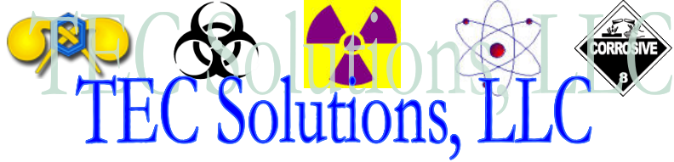
“Preparing the BEST to handle the WORST”

TRAINING & COURSE
CATALOG
(SIN 426-4F EMERGENCY PREPAREDNESS
AND FIRST RESPONDER EQUIPMENT AND SERVICES
SCHEDULE 84)

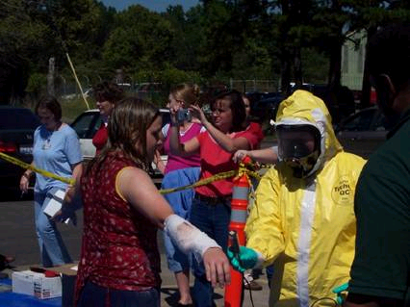

P.O. Box 45965
Little Rock, AR 72214-5965
www.tecsolutionsllc.com

Phone: 501.565.6677
Fax: 888.284.1026

E-mail: info@tecsolutionsllc.com

Revised March 1, 2004
About TEC Solutions

TEC Solutions, LLC is a consortium of experienced Weapons of Mass Destruction (WMD)/Hazardous Material (HAZMAT) Specialists, Health Physics, Law Enforcement, Medical and Fire Service Professionals capable of providing long-term solutions to businesses, corporations and Governmental agencies facing Homeland Security issues. Our organization, based in North Little Rock, AR, delivers confidential, reliable, and comprehensive planning, training, Crisis, Consequence and Contingency Management solutions for private industry, Healthcare institutions, Local, State and Federal municipalities. Our technical staff and consultants have over 180 years of combined experience in planning, responding, mitigating and training which we will use to assist in planning, implementing and sustaining your Homeland Security and bioterrorism response needs.

TEC Solutions is a 100% veteran owned business. We are a certified Minority Business Enterprise (MBE) through the National Minority Supplier Diversity Council and the States of Arkansas and Tennessee. We are registered and in good standing with the Better Business Bureau®.
TEC Solutions, LLC has been providing quality WMD/bioterrorism training and consultation services as its own entity since our founding in January 2004. Although some may consider us a “9/12 company” (company formed in the wake of the events of September 11th), our Staff and Consultants have been serving in the first responder/emergency response community for several years pre-9/11.
TEC Solutions, LLC is composed of qualified professionals with extensive experience in health physics/radiation safety and people-oriented managerial fields. We have over 80 years combined experience in applied Health Physics, radiation safety, radiological emergency response, power plant operation and safety, licensing and inspection of radioactive materials users, packaging, shipping and transportation of radioactive material in accordance with Federal and State regulations. When you add our field service experience, you have consultants that bring a unique quality to radiation consulting.

TEC Solutions is authorized by the State of Arkansas, Division of Radiation Control and Emergency Management to provide radioactive materials training and consulting to US Nuclear Regulatory Commission (USNRC) and Agreement State Licensees.

One of our greatest strengths is experience. TEC Solutions’ specialists have actively worked in the fields of WMD/bioterrorism defensive/response planning, Chemical, Biological, Radiological and Hazardous Materials management, Fire, Medical Services and Law Enforcement. Our staff has extensive real world experience in the areas which we offer assistance.

Many companies in the WMD/bioterrorism arena offer staff with only classroom or limited practical experience. We understand the threat, the weapons terrorists may use, and we know how to effectively defend against them. We have extensive experience with chemical, biological, and radiological materials and understand them not simply as hazards, but as weapons that are employed in a manner to defeat the intended target. With this knowledge, we are able to proactively identify and address vulnerabilities others often fail to recognize. Our technical specialists have been there in live environments where lives were on the line…and will share that experience with our clientele.

It is our mission to provide superior WMD, bioterrorism, radiological and HAZMAT related technical and consulting services to assist corporate, private and government agencies worldwide. We believe the best way to achieve this goal is to provide innovative, quality services that are able to both expand our customer’s existing capabilities and create new ones.

When you need experience, you call on professionals who have real-world experience in resolving issues you face. This is where TEC Solutions can help you.
With TEC Solutions, you secure highly trained professionals with the technical skills needed to develop programs that are specific to your needs. This approach eliminates costly, less effective generic programs that may not provide the individualized training that allow you to perform at peak efficiency and productivity.

Key Personnel

Company Management Team:

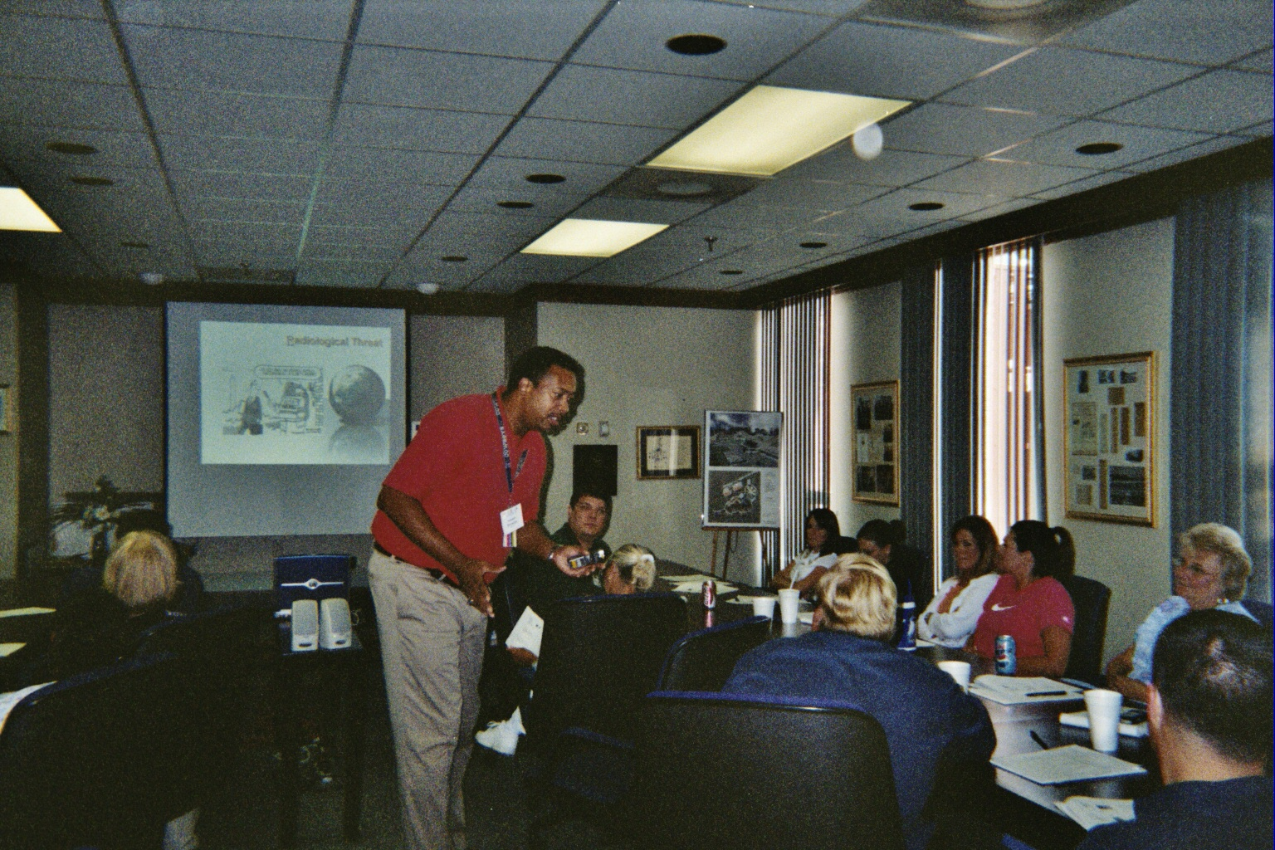
Hamp R. Stokes Jr. is the President of TEC Solutions, LLC. Hamp served as a Nuclear, Biological and Chemical Defense Officer during his 17-year career in the US Army Reserve. He simultaneously served for 10 year as the Senior Health Physicist for the Arkansas Department of Health; responding to radiological incidents and emergencies within the State. Hamp left the State to pursue a career in the Domestic Preparedness Equipment Technical Assistance Program (DPETAP), sponsored by the US Department of Justice (DOJ) pre-9/11 and US Department of Homeland Security (DHS) post-9/11. Hamp was instrumental in the start-up and pilot of this program. He taught First Responders nationwide on the proper use of chemical, biological and radiological detection, decontamination, personal protection (PPE), sampling and survey techniques; mastering over 30 WMD related courses taught by DPETAP. During his 5 year tenure there, he was promoted several times to Team Leader, Supervisory Instructor, Mobile Operations Supervisor and interim Deputy Project Manager. He managed over $18 million dollars in assets and instructed, or supervised the instruction of over 30,000 First Responders in over 500 agencies nationwide with this program. Hamp also co-authored the Advanced Radiological Survey Techniques course offered through DPETAP as well as the Instructor Qualification Program (IQP) used to qualify instructors. He has received specialized training from several Federal agencies including FEMA, DOD, FDA, US Nuclear Regulatory Commission (USNRC), DHS and DOE. Hamp holds a Bachelor’s degree in Sociology from Henderson State University.
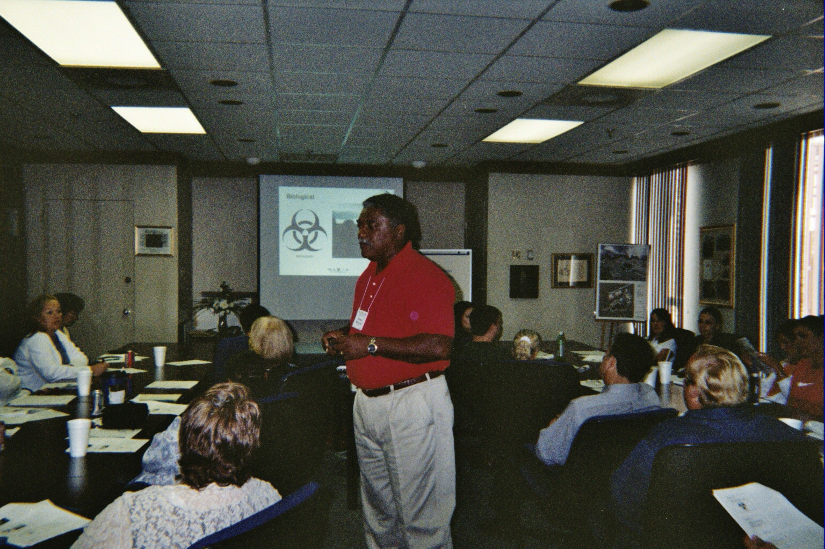
Tommy L. Sproles Sr. is the Vice-President of TEC Solutions, LLC. He has over twenty years of management experience in healthcare and healthcare administration. His health care experience began in the U.S Navy as a hospital corpsman during the Vietnam War. He also served as an x-ray technician. After discharge, he worked as a Physician Assistant for several years. In 1983, he was appointed by then Governor Bill Clinton as Commissioner of the Arkansas Game and Fish Commission. After leaving that agency, he founded and operated Central Arkansas Home Health Agency and Midway Medical Equipment and Supply Company for more than ten years. He sold the company to the State of Arkansas and became the Director of the Office of Primary Care for the Arkansas Department of Health. He created the Arkansas Minority Health Commission in 1992 and served as its Director until March 2002. His budget went from $150,000 to nearly $8,000,000 when he was successful in acquiring funds from the tobacco settle fund. Tommy left the State of Arkansas to join the Domestic Preparedness Equipment Technical Assistance Program (DPETAP), sponsored by the US Department of Justice (DOJ) pre-9/11 and US Department of Homeland Security (DHS) post-9/11. He served as Assistant Project Lead for the Grant Assistance Program. Tommy holds a Bachelor’s degree in Biology and a Master’s degree in Public Administration from the University of Arkansas at Little Rock.
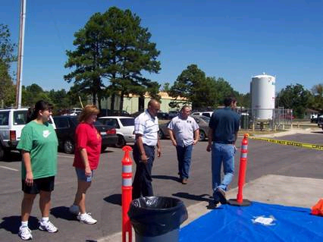
John D. Robbins, a Hazardous Materials (HAZMAT) Technician, is the Operations Officer of TEC Solutions, LLC. He has over 13 years of service to the Active Duty Army and Army Reserve. 10 of his 13 years were spent in the Army Chemical Corps. John has served as a Technical Escort Officer in the US Army’s Technical Escort Unit and has responded to chemical, biological and radiological incidents worldwide. He has also served on Johnston Atoll, destroying chemical stockpile munitions. After departing the military, John worked at Dugway Proving Grounds in Utah, where he assisted in destroying VX and GB munitions. John then relocated to the Domestic Preparedness Equipment Technical Assistance Program (DPETAP), sponsored by the US Department of Justice (DOJ) pre-9/11 and US Department of Homeland Security (DHS) post-9/11. During his 3 years there, he taught First Responders nationwide on the proper use of chemical, biological and radiological detection, decontamination, personal protection (PPE), sampling and survey techniques; mastering over 30 WMD related courses taught by DPETAP. He was promoted several times to Team Lead, Project Lead and Equipment Group Supervisor. John created the Personal Protective Equipment Course offered by DPETAP. John has also served as a Senior Escort for the Defense Threat Reduction Agency (DRTA) in support of the Chemical Warfare Convention Treaty at the Pine Bluff Arsenal. He has received specialized training from several Federal agencies including FEMA, CDC, DOD, OSHA, EPA, DOE and DHS.

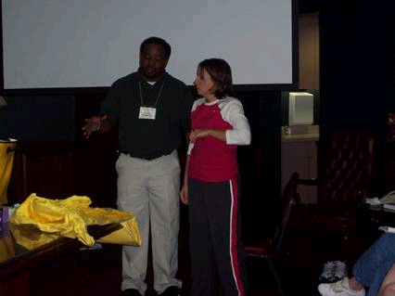
Mark C. Hammond is the Administrative Officer of TEC Solutions, LLC. He has 10 years of Active Duty Army service and 5 years of Army Reserve service. Mark’s emergency response experience started as a Medic. He then received specialized training in Health Physics, Nuclear Weapons, and radiological response. Then, he received a certification in Environmental Health, which deals with disease, non-battle injuries (DNBI), health and safety training and industrial hygiene. Mark also served as Senior Instructor for the US Army’s Health Physics Course. He left the military to pursue a career with the Arkansas Department of Health, where he served as the Technical Assistant to the Director for the Division of Radiation Control and Emergency management, a first responder for radiological events and State Health EOC manager for non- radiological emergencies. He then moved to the Nevada State Health Commission; serving as a Radiation Control Specialist and Deputy Food and Drug Commissioner. During his stay in Nevada, Mark also served as a Nuclear, Biological and Chemical Non-Commissioned Officer for a Reserve Chemical unit. Mark then decided to further pursue service to his country by relocating to the Domestic Preparedness Equipment Technical Assistance Program (DPETAP), sponsored by the US Department of Justice (DOJ) pre-9/11 and US Department of Homeland Security (DHS) post-9/11. During his 3.5 years there, he taught First Responders nationwide on the proper use of chemical, biological and radiological detection, decontamination, personal protection (PPE), sampling and survey techniques; mastering over 30 WMD related courses taught by DPETAP. He instructed, or supervised the instruction of over 30,000 First Responders in over 500 agencies nationwide with this program. He was promoted several times to Team Leader, Supervisory Instructor, Training Support Supervisor, Project Lead, Grant Assistance Program, Instructional Support Group Supervisor and Project Planner for Office of Domestic Preparedness (ODP) Programs within DPETAP. His major accomplishments included creating the technical training used to support the US Departments of Energy/Homeland Security’s Homeland Defense Equipment Reuse (HDER) Program as well as co-authoring the Advanced Radiological Survey Techniques Course. He also co-created the Instructor Qualification Program (IQP) currently used to certify instructors under the DPETAP program. Mark has received specialized training from several Federal agencies including FEMA, FDA, DOD, USNRC, EPA, OSHA, DHS and DOE.

Consultants

TEC Solutions has several consultants from across the country with varied experience in fire service, emergency response and management, law enforcement, hazardous materials management, medical service, health physics, and safety also available to serve our clients. Our consultants are actively working in their respective professions and consist of Fire and Police Chiefs, Nurses and Emergency Medical Technicians, Hazardous Materials Managers, Health Physicists and Military Chemical, Biological and Radiological Specialists.

We believe in quality. Any consultant TEC Solutions employs must have a minimum of ten years experience in their field.

An example of personnel we would use in support of this effort includes:

Michael Hastings is a Consultant for TEC Solutions. He has over 19 years of experience in hazardous/radioactive materials in the US Navy and private sector. He was a Navy Nuclear Power plant Operator during his service to the US Navy. Michael’s individual experience also includes Safety and Technical Instruction, Course Development using the Systems Approach to Training, HAZMAT Technician and Trainer, and Superfund site remediation.
Michael continued to serve his country by working for the Domestic Preparedness Equipment Technical Assistance Program (DPETAP), sponsored by the US Department of Justice (DOJ) pre-9/11 and US Department of Homeland Security (DHS) post-9/11. During his 2 years there, he taught First Responders nationwide on the proper use of chemical, biological and radiological detection, decontamination, personal protective equipment (PPE), sampling and survey techniques; mastering over 30 WMD related courses taught by DPETAP. He also co-authored the Homeland Defense Equipment Reuse Radiological course.
He instructed, or supervised the instruction of over 20,000 First Responders in over 500 agencies nationwide with this program. He was promoted several times to Team Leader, Assistant Supervisory Instructor and HDER Project Lead.

Michael currently works full time at Idaho National Environmental Engineering Laboratories (INEEL) as the Assistant Project Manager and Senior Radiation Protection Technician. He has developed and delivered initial/continuing training programs and serves as Training coordinator for 80 Radiation Control Technicians. He also supervises Radiation Controls for the CERCLA disposal facility.

Charles Williams, MS, RRPT, a certified Radiation Protection Technologist is a Consultant for TEC Solutions. Charles as served as an instructor for the Army’s Health Physics Specialty Course and the Army’s Combat Medic Course. He was formerly certified as an Emergency Medical Technician – Intermediate (EMT-I). He has over 21 years of experience in hazardous/radioactive materials in the US Army and private sector.

Charles, a career Health Physicist specializes in consulting, training, and management to increase productivity and ensure regulatory compliance and safety. He has over 19 years of health physics experience encompassing medical, industrial, academic, research, military, and environmental operations. He has experience with portable and laboratory counting instruments, including ionization chambers, Geiger-Mueller instruments, proportional counters, liquid scintillation counting systems, auto gamma counting systems, and portable survey instruments using scintillation detectors for gamma and alpha radiation. He has developed and presented training for audiences of all levels and sizes. He has presented training from small group to large lecture format.

Charles has received specialized training from several Federal agencies including DOD, OSHA and FEMA. He holds a Bachelor’s Degree in Health Sciences from Wayland Baptist University and a Master’s Degree from Webster University.

Matt Wade, an Explosive Ordinance Disposal (EOD) Technician, has more than 16 years of progressive leadership and operational experience in both military and civilian environments, 12 years have been directly related to Weapons of Mass Destruction. He is a proven leader with excellent communication skills.
Matt functioned as an Operations and Personnel manager in the US Army. He was responsible for unit readiness and daily support missions to outside agencies such as the United States Secret Service and the Pentagon. He conducted annual performance reviews of the company personnel as well as training performance reviews of companies within our region of the U.S. He provided direct EOD support to several high profile events including EOD support to the Pentagon following 9/11, managed over 400 EOD support missions for the US Secret Service, and the 1996 Summer Olympics.
Matt currently serves as the Senior Surety specialist working at the Pine Bluff Chemical Disposal Facility. His responsibilities include tracking the Personnel Reliability Program (PRP) for 434 personnel. This program covers Site access, Required Training, Security clearances, and Reliability standards of those individuals. Responsibilities also include oversight of all operations of the site to ensure compliance with the Army Chemical Surety requirements.

TECSOLUTIONS, LLC

TEC SOLUTIONS, LLC offers the following services to its clients:

Service Offered | Description
Emergency Response Basics | This 24-hour course covers everything from arrival at the scene, basic incident command, site set-up and survey, and hazard analysis. Our consultants will take you from beginning to end using group discussions, tabletop exercises and a 3-hour exercise scenario at the conclusion of the course. Prerequisite- none
WMD Responder Awareness | An 8-hour instructor lead course designed to increase the knowledge base of First Responders who may be confronted with the challenges created in a WMD terrorist incident involving the use of chemical, biological, radiological/nuclear and/or explosive (CBRNE) threats. Prerequisite- none
WMD Responder Operations | Our WMD Responder Operations training is a 24- hour hands-on, instructor lead course designed to build upon the information learned in WMD Responder Awareness and introduce tactical operations in a WMD environment. Fire, Law Enforcement, Medical personnel and Incident Commanders are advised of their role and specific challenges created in a WMD terrorist incident involving the use of chemical, biological, radiological/nuclear and/or explosive (CBRNE) threats. Prerequisite- WMD Awareness

WMD Responder for Technicians | Our WMD Responder for Technicians training is the third course in our WMD Responder Series. It is a 40-hour hands-on, instructor lead course designed to build upon the information learned in WMD Responder Operations and introduce monitoring and detection, mass-casualty incident considerations, and survivability in a WMD environment. Although it is primarily designed for HAZMAT Technicians and Specialists, anyone with a detailed knowledge of the threat or has completed the previous two courses are encouraged to attend. Prerequisite- Must be a HazMat Technician
WMD/HAZMAT Mass Casualty Decontamination | Our WMD/HAZMAT Mass Casualty Decontamination course is a 16-hour classroom and practical exercise designed to familiarize the target audience with the basic threat and aspects of decontamination. An additional four-hour exercise can be added in which the students will assemble a decontamination site and perform limited decontamination operations using their own equipment. Our exercise will be modified to fit the institution’s individual needs and level of expertise. The exercise will also be graded and the results shared with the management/leadership of the institution to identify any shortcomings in the institution’s decontamination plan. Prerequisite- none
Personal Protective Equipment (PPE) | Our 12-hour PPE training is tailored to suit the individual customer’s needs. It begins by providing an overview of the components of PPE ensembles and the different OSHA levels of PPE. Then, tactical considerations will be discussed including respiratory protection program requirements, heat and cold stress. Based upon the agency’s requirements, our staff and consultants will provide donning and doffing procedures for the level(s) of PPE the customer may have. Prerequisite- none

Radiological Emergency Management | Our 24-hour Radiological Emergency Management training is designed to enhance the capabilities of personnel who may respond to radiological incidents. It begins by providing an overview of the hazards associated with the incident, including biological effects, monitoring, decontamination and response policies. It concludes with a field practical exercise which will test the participant’s ability to manage a radiation incident. Prerequisite- None
Economic Impact of WMD Events | Our 8-hour Economic Impact training is designed to illustrate how WMD events affect all walks of life. It outlines the financial impact of several WMD incidents in recent history including Tokyo, Oklahoma City and 9/11. A group discussion including considerations for planning and preparedness will conclude this training session. Prerequisite- None
WMD For Senior Management | Our 8-hour WMD for Senior Management training is designed to familiarize management personnel with the basics of WMD incidents. It outlines the basics of terrorism, WMD materials and concludes with financial considerations for staffing response teams and response guidelines. Prerequisite- None
Law Enforcement WMD Response | Our 16-hour Law Enforcement WMD Response training is designed to familiarize Law Enforcement personnel with the basic aspects of emergency response, scene considerations, personal protection (PPE) and properties of WMD materials. They will receive hands-on training and a tabletop exercise to evaluate their understanding of the learning objectives at the conclusion of the training. Prerequisite- None
WMD/HAZMAT Detection and Monitoring Equipment Training | Our 8-hour course in WMD/HAZMAT detection and monitoring equipment training is specifically designed for First Responders and other emergency response personnel who might be involved in the response to a terrorist event involving weapons of mass destruction. Giving you the ability to detect and sample CBRN agents and detect incendiary and secondary explosive devices. Prerequisite- None

HazMat Awareness | This 8-hour is designed to learn to recognize the presence of hazardous materials and take appropriate action as a first responder at the awareness level. This course is designed for first responders who are mandated by law or necessity to prepare for and respond to emergency incidents involving hazardous materials. The course provides responders with awareness level training to take initial protective actions when hazardous materials are encountered. It meets OSHA, EPA and NFPA training objectives. This course is IFSAC accredited. (Prerequisite- none)
HazMat Operations | This 16-hour is designed to recognize the presence of hazardous materials and take appropriate action as a first responder at the operations level. This course is designed for first responders who at the Operations level respond to releases or potential releases of hazardous substances as part of the initial response to the site for the purpose of protecting nearby persons, property or the environment from the effects of the release. They are trained to respond in a defensive fashion without actually attempting to stop the release. Their function is to contain the release at a safe distance, keeping it from spreading and preventing exposures. It meets OSHA, EPA and NFPA training objectives. This course is IFSAC accredited. (Prerequisite- HazMat Awareness)
HazMat Technician | 80-hour course is designed to control the release of hazardous materials and take appropriate action as a first responder at the technician level. This course is designed for first responders who at the Technician level respond to releases or potential releases of hazardous substances for the purpose of controlling the release. They are more aggressive in that they will take action to plug, patch or otherwise stop the release. They are required to use specialized chemical protective clothing and specialized control equipment. The course meets OSHA, EPA and NFPA training objectives. (Prerequisite-HazMat Operations)

HazMat Technician Refresher | 24-hour course is designed as refresher for first responders who at the Technician level respond to releases or potential releases of hazardous substances for the purpose of controlling the release. They are more aggressive in that they will take action to plug, patch or otherwise stop the release. They are required to use specialized chemical protective clothing and specialized control equipment. The course meets OSHA, EPA and NFPA training objectives. (Prerequisite- Haz Mat Tech)
HazMat ICS Course | 16 hours This course references National Fire Protection Association (NFPA) standards; specifically, NFPA Standard 472: Professional Competence of Responders to Hazardous Materials Incidents, 1997 edition, which covers Hazardous Materials – Incident Commander. (Prerequisite-HazMat Awareness & Operations)
Basic Life Support and Hazardous Materials Response | 16 hours  This course assists participants to understand and comply with Federal regulations and national recommendations concerning emergency medical response to hazardous materials incidents. (Prerequisite- None)
Chemistry for Emergency Response | 40 –hour course gives Emergency Responders the knowledge to ensure a hazard-based response and risk-based decisions when confronted with incidents involving hazardous materials and weapons of mass destruction. (Prerequisites-HazMat Awareness, HazMat Operations & HazMat Technician)

Meth Lab Awareness | 4-hour Course Trains first responders to recognize a clandestine methamphetamine laboratory or drug laboratory paraphernalia/supplies and to implement actions to protect themselves and the public. Describes the general hazards of clandestine methamphetamine laboratories, the risks and potential negative outcomes they present to first responders, and describe the role of the First Responder at the awareness level. (Prerequisite-none)
Meth Lab Operations | 8-hours Trains first responders to recognize a clandestine methamphetamine laboratory or drug laboratory paraphernalia/supplies and to implement actions to protect themselves and the public and identify the purpose and need to safely initiate command. Describes the general hazards of clandestine methamphetamine laboratories, the risks and potential negative outcomes they present to first responders, and describe the role of the First Responder at the Awareness level. Identifies the purpose and need to safely initiate command and explains the purpose and procedures of scene control; describes the basic implementation of the appropriate site specific Incident Command System (ICS); and, demonstrates proper information flow from the First Responder to the Incident Commander. (Prerequisite- Meth Lab Awareness)
Emergency Response Guidebook (ERG) Course | This 4-hours course has been developed to provide emergency responders with training in the use of the Emergency Response Guidebook before they are called upon to use the book in an emergency. This training is targeted to all emergency responders including Fire, Police and EMS. (Prerequisite-none)

Emergency Response to a Criminal/Terrorist Incident | 8 hours The purpose of the Emergency Response to Criminal/Terrorist Incident training is to increase local emergency responders’ ability to preserve evidence while performing rescue and fire suppression activities, foster a cooperative working relationship when working together in responding to criminal incidents, and prepare for incidents when Federal responders are involved. (Prerequisite) Course participants must be certified in their agencies as firefighters, law enforcement officers, or emergency medical response personnel, or be assigned to a position in another agency that provides initial response to suicide bombing incidents.
WMD Crime Scene Management  for Emergency Responders Training | This 8 hours course provides emergency responders with an understanding of the crime scene process. Responders will also learn how to assist in crime scene protection and interact with crime scene investigators. This awareness-level course was developed to serve the needs of emergency responders who have no previous training in responding to weapons of mass destruction (WMD) crime scenes. (Prerequisite-none)

Incident Response to Terrorist  Bombings – Awareness | This 8-hours course provides basic instruction on response procedures for terrorist incidents involving energetic materials (explosives and incendiaries). The course includes classroom presentations that address potential terrorist bombing targets in U.S. communities, common military and commercial explosives available to terrorists, improvised explosive devices (IED’s), and response procedures that support safe and effective operations during bombing incidents. This course will conclude with a practical exercise dealing with a terrorist bombing.  Prerequisite-Course participants must meet one of the following criteria:  - Be certified by their department as a firefighter, law enforcement officer, emergency medical response personnel, or be assigned to a position in another agency that provides initial response to bombing incidents.  - Be employed by a Federal, State or local government crisis-planning organization or civil defense organization; civil public works department or publicly owned utility; mutual-aid partners in crisis management; public or private health community; Red Cross and shelter operations; public school system; allied professionals (on a need-to-know basis); and other responding personnel with a need to know.

Basic Terrorism Operations | This 8-hours course trains responders to initiate the correct operations Level defensive response actions in a Nuclear, Biological, and Chemical (NBC) incident, to include: Agent detection and identification procedures, Emergency Decontamination, Selection and employment of PPE and Downwind hazard analysis. Evaluates the response to an NBC incident during the conduct of practical exercises. (Prerequisite-Terrorism Awareness) Course participants must be certified in their agencies as firefighters, law enforcement officers, or emergency medical response personnel, or be assigned to a position in another agency that provides initial response to suicide bombing incidents.
Basic Terrorism ICS | In this 8-hours course participants will understand the differences between an “everyday” HAZMAT incident and an NBC terrorism incident (the “NBC Deltas”). Understand the importance of NBC terrorism incident response planning and preparation. Identify the principles and tactics in NBC terrorism incident response. Identify the key decisions and policies required by an NBC incident. Understand the roles of the Federal government in an NBC terrorism incident. Conduct an NBC terrorism incident tabletop exercise. (Prerequisite-Terrorism Awareness and Operations) Course participants must be certified in their agencies as firefighters, law enforcement officers, or emergency medical response personnel, or be assigned to a position in another agency that provides initial response to suicide bombing incidents.

Table Top Exercise (TTX) | This 8 hour exercise involves senior Staff, elected officials, or key staff in an informal setting to discuss simulated situations and potential threats. The intent is to stimulate discussions based on a hypothetical Situation. It is used to assess planes, policies, and procedures, or to assess the type of systems needed to guide the prevention of, response to, and recovery from the defined event. TTXs can be a cost-effective tool when used in conjunction with more complex exercises. The TTX’s effectiveness is derived from the energetic involvement of participants and their assessment of recommended revisions to current policies, procedures and plans.
Prevention of and Response to  Suicide Bombing Incidents training | This 4 hours course provides training on the suicide bombing threat. The course includes familiarization with improvised explosive devices (IEDs) and explosive materials typically used in suicide bombings. It also addresses actions that individual emergency responders can take to assist in preventing or deterring suicide bombings, as well as techniques, tactics, and procedures that support an effective and safe response to a suicide bombing.  Prerequisite Course participants must be certified in their agencies as firefighters, law enforcement officers, or emergency medical response personnel, or be assigned to a position in another agency that provides initial response to suicide bombing incidents.

THIS PAGE LEFT BLANK
TEC SOLUTIONS, LLC SERVICES

COMPANY | COURSE No. | NUMBER  0F  STUDENTS | TRAINING  COURSE  NAME | SIN | PRICE | TRAINING  LOCATION
TEC Solution, LLC | WMDT  1000 |  | Emergency Response Basics
 |  | Minimum 15 | Training course (24 hours)
 |  | Max 50/session | Client site or TEC Solutions site
 |  |  | Price per Student | 426-4F | $515.00 | USA
TEC Solution, LLC | WMDT  1010 |  | WMD Responder Awareness
 |  | Minimum 15 | Training course (8 hours)
 |  | Max 50/session | Client site or TEC Solutions site
 |  |  | Price per Student | 426-4F | $140.00 | USA
TEC Solution, LLC | WMDT  1020 |  | WMD Responder Operations
 |  | Minimum 15 | Training course (24 hours)
 |  | Max 30/session | Client site or TEC Solutions site
 |  |  | Price per Student | 426-4F | $515.00 | USA
REVISED MARCH 1, 2004

COMPANY | COURSE No. | NUMBER  0F  STUDENTS | TRAINING  COURSE  NAME | SIN | PRICE | TRAINING  LOCATION
TEC Solution, LLC | WMDT  1030 |  | WMD Responder for Technicians
 |  | Minimum 15 | Training course (40 hours)
 |  | Max 30/session | Client site or TEC Solutions site
 |  |  | Price per Student | 426-4F | $815.00 | USA
TEC Solution, LLC | WMDT  1040 |  | WMD/HAZMAT  Mass Casualty  Decontamination
 |  | Minimum 15 | Training course (16 hours)
 |  | Max 20/session | Client site or TEC Solutions site
 |  |  | Price per Student | 426-4F | $365.00 | USA
TEC Solution, LLC | WMDT  1050 |  | Personal Protective  Equipment (PPE)
 |  | Minimum 15 | Training course (12 hours)
 |  | Max 20/session | Client site or TEC Solutions site
 |  |  | Price per Student | 426-4F | $335.00 | USA
REVISED MARCH 1, 2004

COMPANY | COURSE No. | NUMBER  0F  STUDENTS | TRAINING  COURSE  NAME | SIN | PRICE | TRAINING  LOCATION
TEC Solution, LLC | WMDT  1060 |  | Radiation Emergency  Management
 |  | Minimum 15 | Training course (24 hours)
 |  | Max 30/session | Client site or TEC Solutions site
 |  |  | Price per Student | 426-4F | $450.00 | USA
TEC Solution, LLC | WMDT  1070 |  | Economic Impact  WMD Event
 |  | Minimum 15 | Training course (8 hours)
 |  | Max 30/session | Client site or TEC Solutions site
 |  |  | Price per Student | 426-4F | $215.00 | USA
TEC Solution, LLC | WMDT  1080 |  | WMD for Senior  Management
 |  | Minimum 15 | Training course (8 hours)
 |  | Max 30/session | Client site or TEC Solutions site
 |  |  | Price per Student | 426-4F | $215.00 | USA
TEC Solution, LLC | WMDT  1090 |  | Law Enforcement  WMD Response
 |  | Minimum 15 | Training course (16 hours)
 |  | Max 30/session | Client site or TEC Solutions site
 |  |  | Price per Student | 426-4F | $365.00 | USA
REVISED MARCH 1, 2004

COMPANY | COURSE No. | NUMBER  0F  STUDENTS | TRAINING  COURSE  NAME | SIN | PRICE | TRAINING  LOCATION
TEC Solution, LLC | WMDT  2000 |  | WMD/HAZMAT  Detection and  Monitoring Equipment  Training
 |  | Minimum 15 | Training course (8 hours)
 |  | Max 30/session | Client site or TEC Solutions site
 |  |  | Price per Student | 426-4F | $215.00 | USA
TEC Solution, LLC | WMDT  2010 |  | WMD Crime Scene  Management for  Emergency Response  Training
 |  | Minimum 15 | Training course (8 hours)
 |  | Max 30/session | Client site or TEC Solutions site
 |  |  | Price per Student | 426-4F | $215.00 | USA
TEC Solution, LLC | WMDT  2020 |  | Emergency Response  to a Criminal/Terrorist  Incident
 |  | Minimum 15 | Training course (8 hours)
 |  | Max 30/session | Client site or TEC Solutions site
 |  |  | Price per Student | 426-4F | $215.00 | USA
REVISED MARCH 1, 2004

COMPANY | COURSE No. | NUMBER  0F  STUDENTS | TRAINING  COURSE  NAME | SIN | PRICE | TRAINING  LOCATION
TEC Solution, LLC | WMDT  2030 |  | Incident Response  to Terrorist Bombing-  Awareness
 |  | Minimum 15 | Training course (4 hours)
 |  | Max 30/session | Client site or TEC Solutions site
 |  |  | Price per Student | 426-4F | $125.00 | USA
TEC Solution, LLC | WMDT  2040 |  | Basic Terrorism  Operations
 |  | Minimum 15 | Training course (8 hours)
 |  | Max 30/session | Client site or TEC Solutions site
 |  |  | Price per Student | 426-4F | $215.00 | USA
TEC Solution, LLC | WMDT  2050 |  | Basic Terrorism ICS
 |  | Minimum 15 | Training course (8 hours)
 |  | Max 30/session | Client site or TEC Solutions site
 |  |  | Price per Student | 426-4F | $215.00 | USA
REVISED MARCH 1, 2004

COMPANY | COURSE No. | NUMBER  0F  STUDENTS | TRAINING  COURSE  NAME | SIN | PRICE | TRAINING  LOCATION
TEC Solution, LLC | WMDT  2060 |  | Prevention of and  Response to Suicide  Bombing Incident Training
 |  | Minimum 15 | Training course (4 hours)
 |  | Max 30/session | Client site or TEC Solutions site
 |  |  | Price per Student | 426-4F | $125.00 | USA
TEC Solution, LLC | HAZM  1010 |  | HazMat  Awareness
 |  | Minimum 15 | Training course (8 hours)
 |  | Max 30/session | Client site or TEC Solutions site
 |  |  | Price per Student | 426-4F | $215.00 | USA
TEC Solution, LLC | HAZM  1020 |  | HazMat  Operations
 |  | Minimum 15 | Training course (16 hours)
 |  | Max 30/session | Client site or TEC Solutions site
 |  |  | Price per Student | 426-4F | $365.00 | USA
REVISED MARCH 1, 2004

COMPANY | COURSE No. | NUMBER  0F  STUDENTS | TRAINING  COURSE  NAME | SIN | PRICE | TRAINING  LOCATION
TEC Solution, LLC | HAZM  1030 |  | HazMat  Technician
 |  | Minimum 20 | Training course (80 hours)
 |  | Max 50/session | Client site or TEC Solutions site
 |  |  | Price per Student | 426-4F | $1,200 | USA
TEC Solution, LLC | HAZM  1040 |  | HazMat  Technician Refresher
 |  | Minimum 20 | Training course (24 hours)
 |  | Max 50/session | Client site or TEC Solutions site
 |  |  | Price per Student | 426-4F | $515.00 | USA
TEC Solution, LLC | HAZM  1050 |  | HazMat  ICS Course
 |  | Minimum 20 | Training course (16 hours)
 |  | Max 40/session | Client site or TEC Solutions site
 |  |  | Price per Student | 426-4F | $365.00 | USA
REVISED MARCH 1, 2004

COMPANY | COURSE No. | NUMBER  0F  STUDENTS | TRAINING  COURSE  NAME | SIN | PRICE | TRAINING  LOCATION
TEC Solution, LLC | HAZM  1060 |  | Basic Life Support  And Hazardous Materials  Response
 |  | Minimum 20 | Training course (16 hours)
 |  | Max 40/session | Client site or TEC Solutions site
 |  |  | Price per Student | 426-4F | $365.00 | USA
TEC Solution, LLC | HAZM  1070 |  | Chemistry for  Emergency Response
 |  | Minimum 20 | Training course (40 hours)
 |  | Max 40/session | Client site or TEC Solutions site
 |  |  | Price per Student | 426-4F | $815.00 | USA
TEC Solution, LLC | HAZM  1080 |  | Meth Lab  Awareness
 |  | Minimum 30 | Training course (4 hours)
 |  | Max 50/session | Client site or TEC Solutions site
 |  |  | Price per Student | 426-4F | $125.00 | USA
REVISED MARCH 1, 2004

COMPANY | COURSE No. | NUMBER  0F  STUDENTS | TRAINING  COURSE  NAME | SIN | PRICE | TRAINING  LOCATION
TEC Solution, LLC | HAZM  1090 |  | Meth Lab  Operations
 |  | Minimum 15 | Training course (8 hours)
 |  | Max 40/session | Client site or TEC Solutions site
 |  |  | Price per Student | 426-4F | $215.00 | USA
TEC Solution, LLC | HAZM  2000 |  | Emergency Response  Guidebook  (ERG)  Course
 |  | Minimum 15 | Training course (4 hours)
 |  | Max 50/session | Client site or TEC Solutions site
 |  |  | Price per Student | 426-4F | $125.00 | USA

TEC Solutions, LLC |  |  | Table Top Exercise  Homeland Security Exercise Evaluation Program (HSEEP) Compliant
 | TTX 1 | MAX 1-40 | Training Exercise  (8 hours TTX 4 hour Hot wash next day) |  | *$8,400
 |  | Max 41-80 | Client Site |  | *$16,400
 |  | Max 81-120 | Price per Table Top Exercise | 426-4F | *$25,200 | USA
REVISED MARCH 1, 2004

Note: * The TTX 3% discount is for the TTX only. GSA clients will receive a 3% discount on the price listed. Other Discounts does not apply to the TTX.

- All training courses needs to have 30 days of lead time. If needing training sooner, please call.

- Training prices does not include perdiem. Government agency, please provide us with a letter to allow us to use Government JTR.

- All training will have a minimum of two instructors. For every increment of 15 students over 15 an additional instructor will be added. Example; 15 students=2 instructors, 30 students=3 instructors, 31 to 45 students=4 instructors, 41 to 60 students=5 instructors etc…

- When conducting training, we are on the client’s site one day prior to the training to set up and meet the point of contact (POC).

- Payment of all training shall be 2%/20 net 30.

- There is a 3% discount if payment in full for all students is paid 15 days prior to training start date. You can combine these savings with the discount in #7 below.

- There is a1% discount for 1 to 499, 2% discount for 500 to 5,000 hours of training, 4% discount for 5,001 to 10,000 hours and 6% discount for 10,001 and up hours of training.

- Training can be tailored to exceed your needs. The point of contact is Hamp Stokes or Mark Hammond. We can be reached at 501-565-6677 or e-mail us at info@tecsolutionsllc.com .

