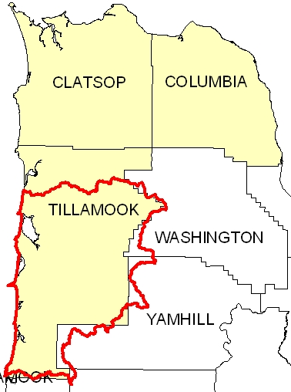
Introduction
The Wilson/Trask/Nestucca 8-Digit Hydrologic Unit Code (HUC) subbasin is comprised of 605,000 acres, of which 65 percent is public forestland. Ninety percent of the subbasin is in Tillamook County, and the other ten percent is divided among four other counties. Thirteen percent of the private land is used as pastureland, grassland, and hayland and includes commercial dairy and beef production. There are 147 dairies in the subbasin. Resource concerns associated with the pastureland and livestock include soil compaction, streambank erosion, surface water contamination, unreliable profits, and the need for timely technical assistance

There are 413 farms and ranches in the Wilson/Trask/Nestucca subbasin. More than 80 percent are less than 180 acres in size, and many of the operators are new landowners seeking a rural lifestyle. The remaining agricultural operations are viable forest or commercial dairy operations.

One NRCS service center, the Tillamook Soil and Water Conservation District, the Northwest Oregon Resource Conservation and Development (RC&D) office, and other local organizations provide conservation assistance in the subbasin.

Profile Contents

Introduction
Physical Description
Land Use Map & Precipitation Map
Common Resource Area
Resource Concerns
Census and Social Data
Progress/Status
Footnotes/Bibliography

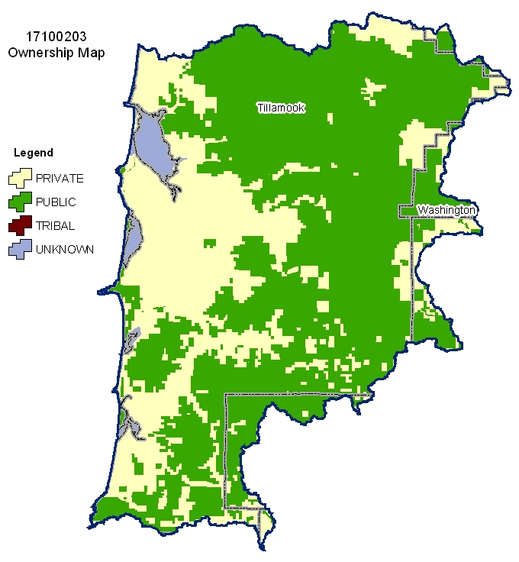
Relief Map
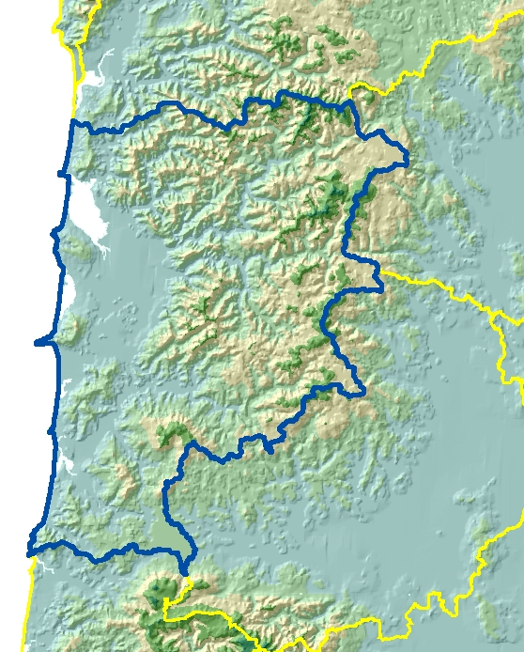

Produced by the Water Resources Planning Team Portland, OR
The United States Department of Agriculture (USDA) prohibits discrimination in all its programs and activities on the basis of race, color, national origin, sex, religion, age, disability, political beliefs, sexual orientation, and marital or family status. (Not all prohibited bases apply to all programs.) Persons with disabilities who require alternative means for communication of program information (Braille, large print, audiotape, etc.) should contact USDA’s TARGET Center at 202-720-2600 (voice and TDD).
To file a complaint of discrimination, write USDA, Director, Office of Civil Rights, Room 326W, Whitten Building, 14th and Independence Avenue, SW, Washington DC 20250-9410 or call (202) 720-5964 (voice and TDD). USDA is an equal opportunity provider and employer.

Physical Description Back to Contents
ALL NUMBERS IN THIS PROFILE ARE FOR OREGON ONLY
Land Cover/Land Use  (NLCD^{/2}) | Ownership - (2003 Draft BLM Surface Map Set^{/1})
Land Cover/Land Use  (NLCD^{/2}) | Public |  | Private |  | Tribal |  | Totals | %
Land Cover/Land Use  (NLCD^{/2}) | Acres | % | Acres | % | Acres | % | Totals | %
Forest | 389,100 | 64% | 177,000 | 29% | * | --- | 566,100 | 94%
Grain Crops | 0 | 0% | 0 | 0% | 0 | 0% | 0 | 0%
Conservation Reserve Program Land ª | 0 | 0% | 0 | 0% | 0 | 0% | 0 | 0%
Grass/Pasture/Hay | 3,100 | 1% | 23,900 | 4% | 0 | 0% | 27,000 | 4%
Orchards/Vineyards | 0 | 0% | 0 | 0% | 0 | 0% | 0 | 0%
Row Crops | * | --- | * | --- | 0 | 0% | * | ---
Shrub/Rangelands | * | --- | * | --- | 0 | 0% | * | ---
Water/Wetlands/Developed/Barren | * | --- | 5,800 | 1% | 0 | 0% | 7,300 | 1%
Oregon HUC Totals b | 394,300 | 65% | 207,800 | 34% | 0 | 0% | 602,100 | 100%
*: Less than 1 percent of total acres. See below for special considerations.
a: Estimate from Farm Service Agency records and includes CRP/CREP.
b: Totals are approximate due to rounding and small unknown acreages.
Special Considerations for this 8-Digit HUC:

- Approximately 73 percent of the private forestland is under industrial forest ownership (OSU, Forestry Sciences Laboratory).

- Pasture includes commercial dairy and beef operations as well as small farms and ranchettes.

- Hayfields commonly are green-chopped for silage.

- Minor acres of specialty crops, such as lilies, artichokes, and hydrangeas, are in the watershed.

- Some Christmas trees and hybrid poplars are grown in the watershed.

Irrigated Lands  (1997 NRI^{/3} Estimates for Non-Federal Lands Only) | Type of Land | ACRES | % of  Irrigated Lands | % of  HUC
 | Cultivated Cropland | 0 | 0% | 0%
 | Uncultivated Cropland | 0 | 0% | 0%
 | Pastureland | 2,400 | 100% | 0%
 | Total Irrigated Lands | 2,400 | 100% | 0%
(Continued on the following pages)

Back to Contents
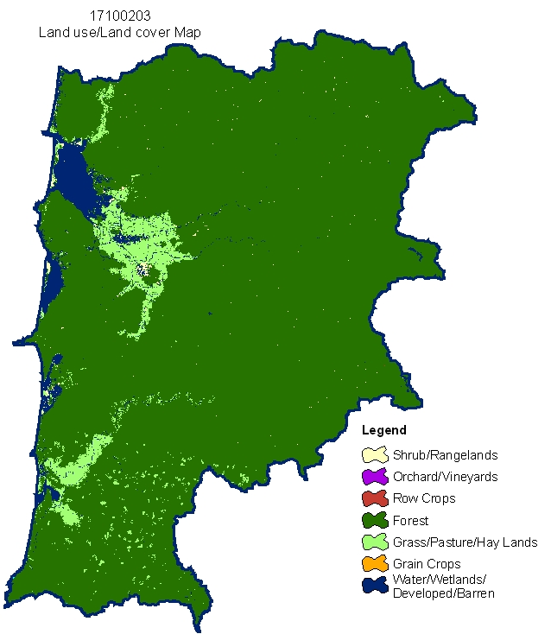

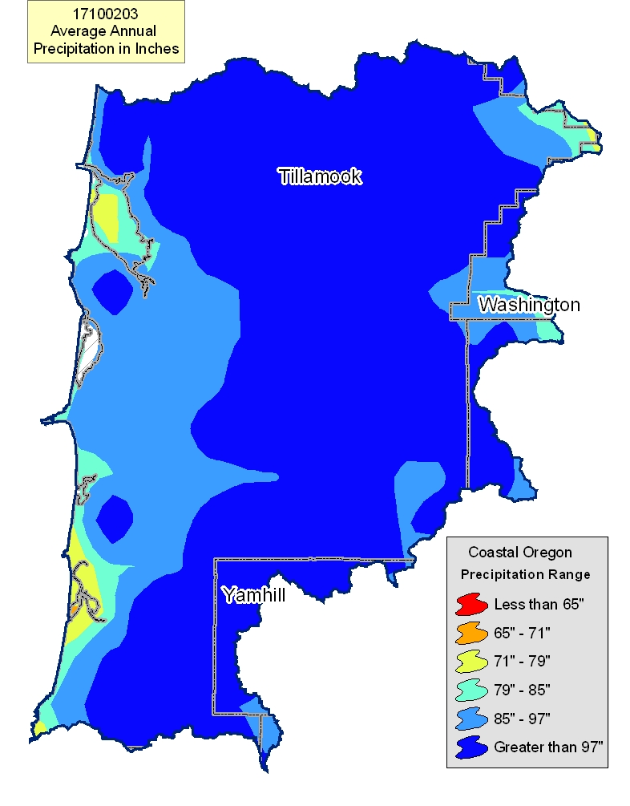

Common Resource Area Map Back to Contents

Only the major units are described below - for descriptions of all units within the HUC, go to: http://ice.or.nrcs.usda.gov/website/cra/viewer.htm
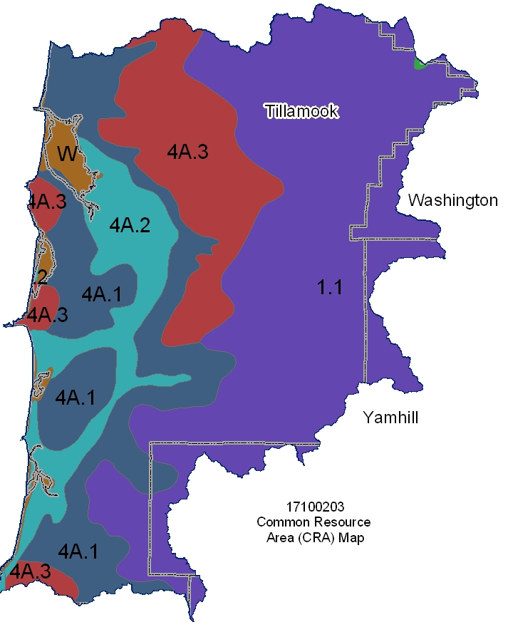

1.1 - Northern Pacific Coast Range, Foothills, and Valleys – Volcanics: This unit is comprised of mountains that consist of basalt and are outside of the "fogbelt." The temperature regime is mesic or frigid with a small area that is cryic, and the moisture regime is udic. The vegetation is Douglas fir and western hemlock.

4A.1 – Sitka Spruce Belt - Coastal Sedimentary Uplands: This unit is comprised of mountains that consist of sedimentary rock and are in the "fogbelt." The temperature regime is isomesic, and the moisture regime is udic. Sitka spruce is present, which separates this unit from unit 1.1.

4A.2 – Sitka Spruce Belt - Coastal Lowlands: This unit is comprised of marine terraces, diked and undiked flood plains, and estuaries. The temperature regime is isomesic, and the moisture regime is udic.

4A.3 – Sitka Spruce Belt - Coastal Volcanic Uplands: This unit is comprised of mountains that consist of basalt and are in the "fogbelt." The temperature regime is isomesic and isofrigid, and the moisture regime is udic. Sitka spruce is present.

Physical Description – Continued Back to Contents
 |  | ACRES | ACRE-FEET
Irrigated Adjudicated Water Rights (OWRD^{/4}) | Surface | 6,726 | 16,815
Irrigated Adjudicated Water Rights (OWRD^{/4}) | Well | 1,079 | 2,697
Irrigated Adjudicated Water Rights (OWRD^{/4}) | Total Irrigated Adjudicated Water Rights | 7,805 | 19,513
Stream Flow Data | USGS 14303600 NESTUCCA RIVER, NEAR BEAVER, OR | Total Avg. Yield | 759,806
Stream Flow Data | USGS 14303600 NESTUCCA RIVER, NEAR BEAVER, OR | May – Sept. Yield | 86,354
Stream Flow Data | USGS 14302500 TRASK RIVER, NEAR TILLAMOOK, OR | Total Avg. Yield | 706,566
Stream Flow Data | USGS 14302500 TRASK RIVER, NEAR TILLAMOOK, OR | May – Sept. Yield | 74,600
Stream Flow Data | USGS 14301500 WILSON RIVER, NEAR TILLAMOOK, OR | Total Avg. Yield | 852,904
Stream Flow Data | USGS 14301500 WILSON RIVER, NEAR TILLAMOOK, OR | May – Sept. Yield | 83,942
Stream Flow Data | OWRD 14301300 MIAMI RIVER, NEAR GARIBALDI, OR | Total Avg. Yield | 167,277
Stream Flow Data | OWRD 14301300 MIAMI RIVER, NEAR GARIBALDI, OR | May – Sept. Yield | 21,068
Stream Flow Data | OWRD 14302700 TILLAMOOK RIVER, NEAR BEAVER, OR | Total Avg. Yield | 182,548
Stream Flow Data | OWRD 14302700 TILLAMOOK RIVER, NEAR BEAVER, OR | May – Sept. Yield | 19,530
Stream Flow Data |  | MILES | PERCENT
Stream Data^{/5}  *Percent of Total Miles  of Streams in HUC | Total Miles – Major (100K Hydro GIS Layer) | 1,116 | ---
Stream Data^{/5}  *Percent of Total Miles  of Streams in HUC | 303d/TMDL Listed Streams (DEQ) | 239 | 21%
Stream Data^{/5}  *Percent of Total Miles  of Streams in HUC | Anadromous Fish Presence (StreamNet) | 209 | 19%
Stream Data^{/5}  *Percent of Total Miles  of Streams in HUC | Bull Trout Presence (StreamNet) | 0 | 0%
 |  | ACRES | PERCENT
Land Cover/Use^{/2}  Based on a 100-foot stretch on both sides of all streams in the 100K Hydro GIS Layer | Forest | 23,756 | 88%
 | Grain Crops | 0 | 0%
 | Grass/Pasture/Hay | 2,076 | 8%
 | Orchards/Vineyards | 0 | 0%
 | Row Crops | 0 | 0%
 | Shrub/Rangelands – Includes CRP Lands | 163 | 1%
 | Water/Wetlands/Developed/Barren | 1,042 | 4%
 | Total Acres of 100-foot Stream Buffers | 27,038 | ---
Land Capability Class  (Croplands & Pasturelands Only)  (1997 NRI^{/3} Estimates for  Non-Federal Lands Only) | 1 – slight limitations | 0 | 0%
 | 2 – moderate limitations | 3,000 | 13%
 | 3 – severe limitations | 9,200 | 41%
 | 4 – very severe limitations | 3,800 | 17%
 | 5 – no erosion hazard, but other limitations | 0 | 0%
 | 6 – severe limitations; unsuitable for cultivation; limited to pasture, range, forest | 6,600 | 29%
 | 7 – very severe limitations; unsuitable for cultivation; limited to grazing, forest, wildlife habitat | 0 | 0%
 | 8 – miscellaneous areas; limited to recreation, wildlife habitat, water supply | 0 | 0%
 | Total Croplands & Pasturelands | 22,600 | ---

Confined Animal Feeding Operations – Oregon CAFO Permit – 12/2004
Animal Type | Dairy | Feedlot | Poultry | Swine | Mink | Other
No. of Permitted Farms | 147 | 1 | 0 | 0 | 0 | 1
No. of Permitted Animals | 48,061 | 430 | 0 | 0 | 0 | 80

Resource Concerns Back to Contents

Tons of Soil Loss by Water Erosion: Due to the limited amount of non-Federal cropland and pastureland within this HUC, no reliable NRI soil loss estimates are available.

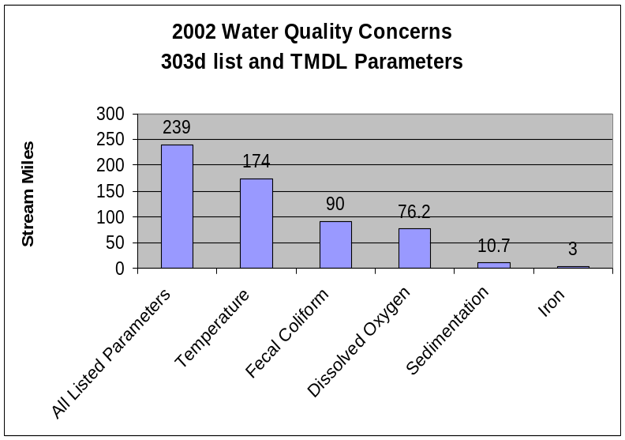
- Seventy-three percent all of the listed stream miles exceed State water quality standards for temperature. Elevated stream temperatures may be due to inadequate riparian shade, stream channel widening, and other anthropogenic or natural causes.

- Fecal coliform can be indicative of livestock wastes, but it also is associated with improperly operating onsite sewage disposal systems.

- Conservation practices that can be used to address these water quality issues include livestock waste management, grazing management, and use of riparian buffers.

Watershed Projects, Plans, Studies, and Assessments
NRCS Watershed Projects⁶ |  |  | NRCS Watershed Plans, Studies, and Assessments⁷
Name | Status |  | Name |  | Status
North Side Big Nestucca  Lower Tillamook Bay | Active 1986  Active 2001 |  | Lower Tillamook Bay Watershed Plan |  | Completed 2001
ODEQ TMDL’s⁸ |  |  | ODA Agricultural Water Quality Management Plans⁹
Name | Status |  | Name |  | Status
North Coast Subbasins  Tillamook Bay | Completed  Completed |  | North Coast |  | Completed
OWEB Watershed Council¹⁰ |  | Watershed Council Assessments¹¹ |  | NWPCC Subbasin Plans and Assessments¹⁸
Nestucca/Neskowin Watershed Council, Tillamook Bay Watershed Council |  | Tillamook Bay National Estuary Plan, Kilchis Watershed Assessment, Miami River Watershed Assessment |  | None

(Continued on page 8)

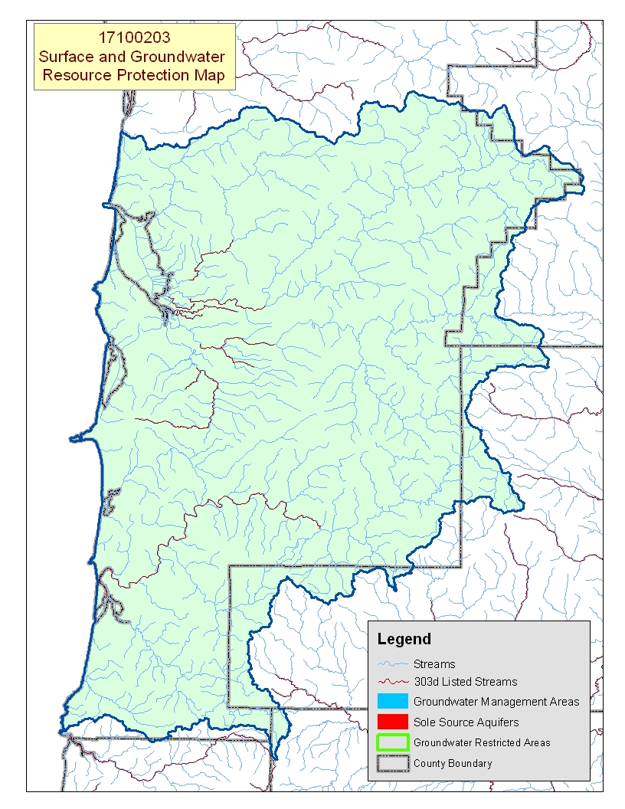
Map Footnote ^{/17}

Resource Concerns - Continued Back to Contents

Resource Concerns/Issues by Land Use
SWAPA +H Concerns | Specific Resource Concern/Issue | Grass\Pasture\Hay | Grain Crops | Row Crops | Perennial Crops (Orch/Vine/ Berries) | Shrub/Range | Forest
Soil Erosion | Streambank | X
Soil Condition | Soil Compaction | X
Water Quantity | Ponding & Flooding | X
Water Quality, Surface | Nutrients & Organics | X
Water Quality, Surface | Temperature | X |  |  |  |  | X
Water Quality, Surface | Pathogens | X
Water Quality, Surface | Aquatic Habitat Suitability | X |  |  |  |  | X
Air Quality | Undesirable Odors from Agricultural Sources | X
Plant Condition | Productivity, Health, & Vigor | X |  |  |  |  | X
Animal Habitat, Wildlife | Food, Cover, &/or Shelter | X |  |  |  |  | X
Human, Economics | High Capital/Financial Costs | X
Human, Economics | High Management Level Required | X
Human, Political | Inadequate Availability of Cost Share Programs | X
Human, Political | Lack of Technical Assistance | X

Grass/Pasture/Hay
- Resource concerns such as soil compaction, nutrients and organics, pathogens, and odors are typical for areas that have a high number of livestock.
- Noxious weeds can be a significant problem, especially on overgrazed pastures.
- Pasture condition overall is good; however, some health and vigor problems may occur because of prolonged grazing and the impact of wildlife.
- Smaller, hobby operations also commonly suffer from inadequate forage management.
- Livestock waste and wildlife might impact offsite aquatic suitability for oyster production and other organisms.

Forestland
- Over one-half of the private forestland is under industrial forest management.
- Invasive, noxious weeds (Japanese knotweed, purple loosestrife, and tansy ragwort) are a major concern.
- Much of the private, non-industrial forestland is used as rural homesites and recreational property. Only a portion is used for long-term timber production.

Other Concerns
- Wind erosion occurs in the dune areas near Pacific City.
- Streambank erosion occurs along all streams and tributaries.
- Frequent flooding occurs along lowland streams, and the concern is increased by bedload deposition and inadequate stream outlets.

Federally Listed Threatened And Endangered Species¹²
THREATENED SPECIES | CANDIDATE SPECIES
Marine – Steller (northern) sea lion  Birds – Marbled murrelet , Western snowy plover, Bald eagle, Brown pelican, Short-tailed Albatross, Northern spotted owl  Fish – Coho salmon  Invertebrates – Oregon silverspot butterfly  Plants – Nelson's checker-mallow | Fish – Steelhead  Birds – Streaked horned lark
 | PROPOSED SPECIES None
Essential Fish Habitat¹³ - Chinook, Coho

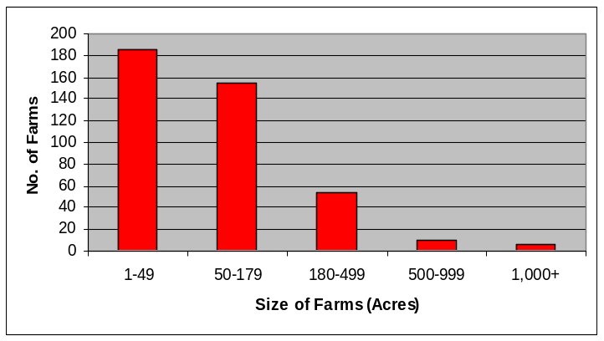
Census and Social Data^{/14} Back to Contents
Number of Farms: 413
Number of Operators: 717
- Full-Time Operators: 289
- Part-Time Operators: 428
Estimated Level of Willingness and Ability to Participate in Conservation^{/15}:
High (large acreage operators);
Low (small acreage operators)

Operators of viable commercial dairy operations of more than 180 acres are reported to understand and appreciate the benefits of conservation and have a history of conservation adoption. They tend to have the ability and stewardship attitude amenable to practicing conservation and natural resource management.

Smaller acreage operators (less than 180 acres) and absentee landowners tend to lack awareness of local resource concerns, lack resources to adopt conservation practices, and require significantly more time to inform, persuade, and assist with natural resource management. Absentee landowners tend also to lack ties to the community that are normally requisite to widespread conservation diffusion in a watershed.

Evaluation of Social Capital^{/16} Low
Social capital in the Wilson/Trask/Nestucca watershed and the community’s ability to successfully address local resource concerns tends to be low. The community’s greatest strength is its ties to agricultural organizations. The community gets good participation in civic activities, public meetings, and community projects.

Social capital might improve if local leaders were able to increase the general public’s participation (including minorities) in community issues and decisions. Participation of all local landowners (full-time, part-time, and absentee) in farm, ranch, and environmental organizations would likely help the community more successfully address local resource concerns.

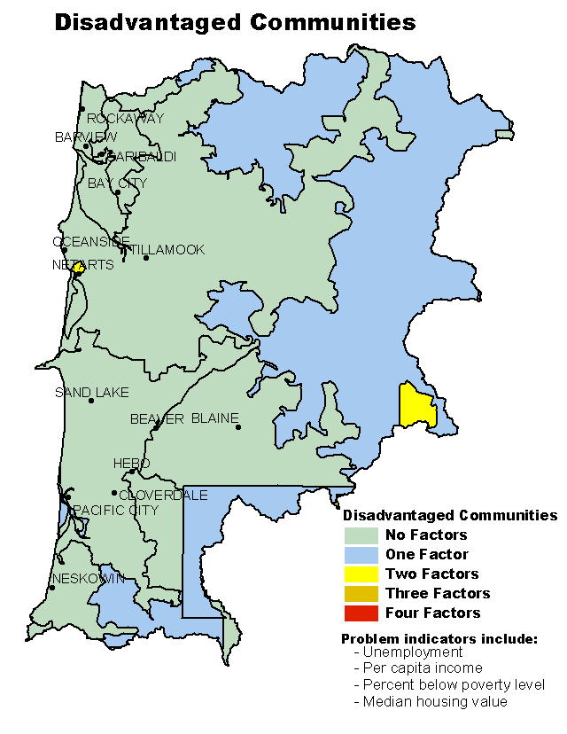
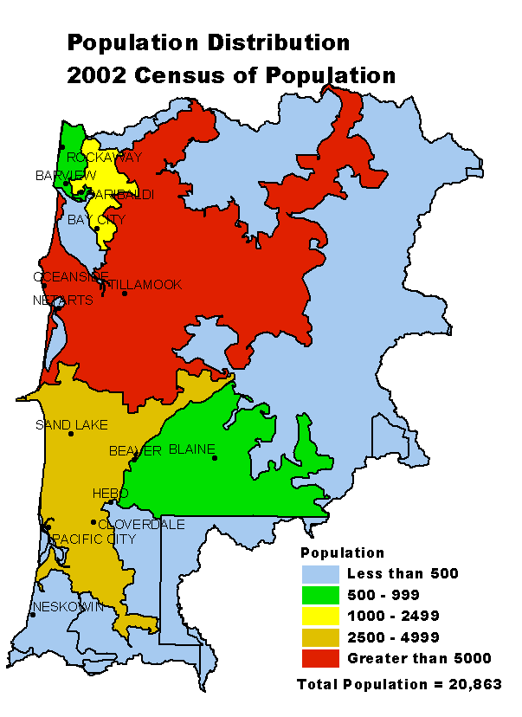

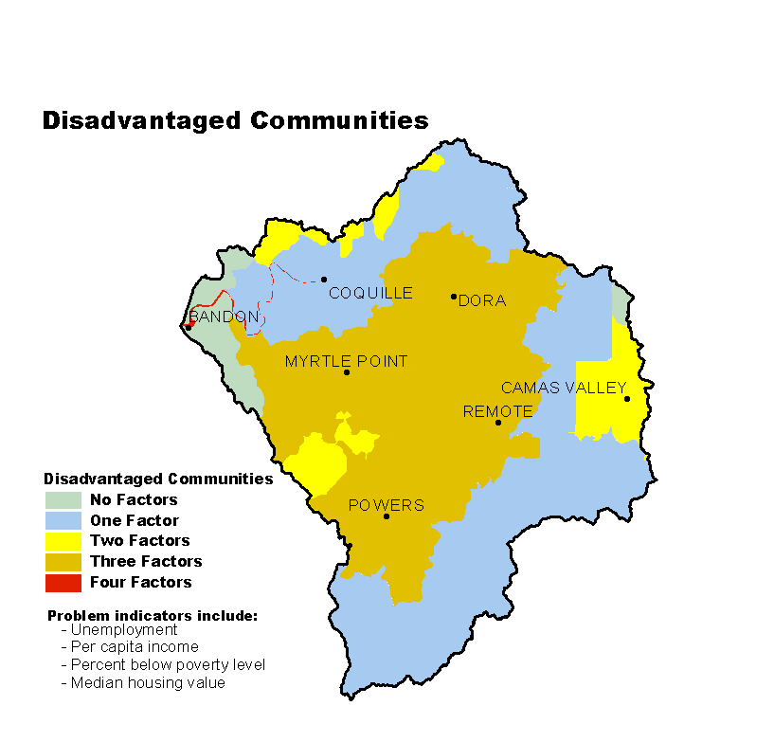

Progress/Status Back to Contents
PRMS Data | FY99 | FY00 | FY01 | FY02 | FY03 | Avg/Year | Total
Total Conservation Systems Planned (Acres) | 2,100 | 3,273 | 1,720 | 199 | 3,034 | 2,065 | 10,326
Total Conservation Systems Applied (Acres) | 1,364 | 1,673 | 2,368 | 0 | 2,187 | 1,518 | 7,592
Conservation Treatment Acres
Waste Management (Number) | 14 | 7 | 6 | 6 | 6 | 8 | 39
Buffers (Acres) | 0 | 0 | 0 | 0 | 0 | 0 | 0
Erosion Control (Acres) | 1 | 0 | 0 | 0 | 0 | 0 | 1
Irrigation Water Management (Acres) | 0 | 0 | 0 | 0 | 0 | 0 | 0
Nutrient Management (Acres) | 521 | 596 | 475 | 0 | 536 | 426 | 2,128
Pest Management (Acres) | 5 | 1,008 | 1,372 | 0 | 0 | 477 | 2,385
Prescribed Grazing (Acres) | 424 | 1,851 | 2,021 | 105 | 1,038 | 1,088 | 5,439
Trees & Shrubs (Acres) | 16 | 101 | 70 | 0 | 0 | 37 | 187
Conservation Tillage (Acres) | 0 | 0 | 0 | 0 | 0 | 0 | 0
Wildlife Habitat (Acres) | 27 | 302 | 61 | 0 | 0 | 78 | 390
Wetlands (Acres) | 9 | 21 | 7 | 0 | 57 | 19 | 94
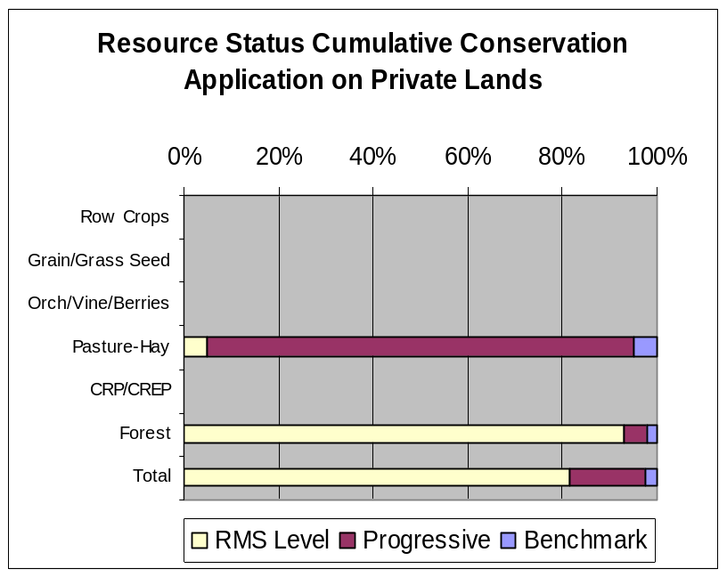
- Progress over the last 5 years has been focused on:
- Nutrient and pest management and prescribed grazing on CAFOs.
- Wildlife habitat management in riparian and wetland areas.
- Most commercial dairies are at the progressive level. Ownership turnover and high capital costs have kept conservation adoption to the RMS level.
- Focus during the last decade has been on meeting State CAFO permit regulations. Attention now is turning toward practices such as pasture and wildlife habitat management.
- Private industrial forestland owners typically do not work with NRCS and SWCDs; however, their land commonly complies with State forest practices act requirements.
- Some of the non-industrial, private forestland is used for long-term timber production, but most is used as rural homesites or recreational property.

Estimates are based on information received from local conservationists in the watershed.

Lands Removed from Production through Farm Bill Programs
- Conservation Reserve Program (CRP): None
- Wetland Restoration Program (WRP): None
- Conservation Reserve Enhancement Program (CREP): None

Footnotes/Bibliography Back to Contents
All data is provided “as is.” There are no warranties, express or implied, including the warranty of fitness
for a particular purpose, accompanying this document. Use for general planning purposes only.

- Ownership Layer – Source: The 1:24,000 scale public ownership layer is the land ownership/management for public entities, including Federal, Tribal, State, and local entities. This is a seamless, statewide Oregon Public Ownership vector layer composed of fee ownership of lands by Federal, State, Tribal, county, and city agencies. The layer is comprised of the best available data compiled at 1:24,000 scale or larger, and the line work matches GCDB boundary locations and ORMAP standards where possible. The layer is available from the State of Oregon GIS Service Center: http://www.gis.state.or.us/data/alphalist.html. For current ownership status, consult official records at appropriate Federal, State, and county offices. Ownership classes grouped to calculate Federal ownership vs. non-Federal ownership by the Water Resources Planning Team.

- National Land Cover Dataset (NLCD) - Originator: U.S. Geological Survey (USGS);
Publication date: 19990631; Title: Oregon Land Cover Data Set, Edition: 1;
Geospatial data presentation form: Raster digital data; Publisher: U.S. Geological Survey,
Sioux Falls, SD, USA; Online linkage: http://edcwww.cr.usgs.gov/programs/lccp/nationallandcover.html; Abstract: These data can be used in a geographic information system (GIS) for any number of purposes, such as assessing wildlife habitat, water quality, pesticide runoff, land use change, etc. The State data sets are provided with a 300-meter buffer beyond the State border to facilitate combining the State files into larger regions.

- ESTIMATES FROM THE 1997 NRI DATABASE (REVISED DECEMBER 2000) REPLACE ALL PREVIOUS REPORTS AND ESTIMATES. Comparisons made using data published for the 1982, 1987, or 1992 NRI may produce erroneous results. This is because of changes in statistical estimation protocols and because all data collected prior to 1997 were simultaneously reviewed (edited) as 1997 NRI data were collected. All definitions are available in the glossary. In addition, this December 2000 revision of the 1997 NRI data updates information released in December 1999 and corrects a computer error discovered in March 2000. For more information: http://www.nrcs.usda.gov/technical/NRI/

- Irrigated Adjudicated Water Rights – Water Rights Information System (WRIS), Oregon Water Resources Department, http://www.wrd.state.or.us/maps/wrexport.shtml

- StreamNet is a cooperative venture of the Pacific Northwest's fish and wildlife agencies and tribes and is administered by the Pacific States Marine Fisheries Commission. StreamNet provided data and data services in support of the region's fish and wildlife program and other efforts to manage and restore the region's aquatic resources. Official StreamNet website: http://www.streamnet.org/

- Natural Resources Conservation Service, Watershed Projects Planned and Authorized, http://www.nrcs.usda.gov/programs/watershed/Purpose.

- Natural Resources Conservation Service, Watershed Plans, Studies, and Assessments completed, http://www.nrcs.usda.gov/programs/watershed/Surveys_Plng.html#Watershed%20Surveys%20and%20Plan

- Oregon Department of Environmental Quality Total Maximum Daily Loads, http://www.deq.state.or.us/wq/TMDLs/TMDLs.htm

- Oregon Department of Agriculture, Agricultural Water Quality Management Plans, http://www.oregon.gov/ODA/NRD/water_agplans.shtml

Footnotes/Bibliography Continued Back to Contents
All data is provided “as is.” There are no warranties, express or implied, including the warranty of fitness
for a particular purpose, accompanying this document. Use for general planning purposes only.

- Oregon Watershed Enhancement Board, http://oregon.gov/OWEB/WSHEDS/index.shtml

- Watershed Assessments completed by local watershed councils following the Oregon Watershed Assessment Manual, http://oregon.gov/OWEB/docs/pubs/ws_assess_manual.shtml.

- NRCS Field Office Technical Guide, Section II, Threatened and Endangered List.

- Magnuson-Stevens Fishery Conservation and Management Act, Public Law 94-265. As amended through October 11, 1996.

- Data were taken from the 2002 Agricultural Census and adjusted by percent of HUC in the county or by percent of zip code area in the HUC, depending on the level of data available. Data were also taken from the U.S. Population Census, 2000.

- Conservation participation was estimated using NRCS Social Sciences Technical Note 1801, Guide for Estimating Participation in Conservation, 2004. Four categories of indicators were evaluated: Personal characteristics, farm structural characteristics, perceptions of conservation, and community context. Estimates are based on information received from local conservationists in the watershed.

- Social capital is an indicator of the community’s ability and willingness to work together to solve problems. A high amount of social capital helps a community to be physically healthy, socially progressive, and economically vigorous. A low amount of social capital typically results in community conflict, lack of trust and respect, and unsuccessful attempts to solve problems. The evaluation is based on NRCS Technical Report Release 4.1, March, 2002: Adding Up Social Capital: An Investment in Communities. Local conservationists provided information to measure social capital. Scores range from 0 to 76.

- Surface and Groundwater Resource Protection Map
  - 2002 303d Listed Streams designated by Oregon Department of Environmental Quality and approved by the Environmental Protection Agency, Section 303d Clean Water Act, http://www.deq.state.or.us/wq/303dlist/303dpage.htm
  - Groundwater Management Areas designated by the Oregon Department of Environmental Quality, Oregon Revised Statutes – Ground Water ORS 468B.150 to ORS 468B.190, http://www.deq.state.or.us/wq/groundwa/wqgw.htm
  - Groundwater Restricted Areas designated by Oregon Water Resources Commission, Oregon Department of Water Resources, http://egov.oregon.gov/OWRD/PUBS/aquabook_protections.shtml
  - The Sole Source Aquifer (SSA) Protection Program is authorized by Section 1424(e) of the Safe Drinking Water Act of 1974 (Public Law 93-523, 42 U.S.C. 300 et. seq), http://www.epa.gov/safewater/ssanp.html

- Subbasin assessments and plans are developed by local groups (SWCDs, watershed councils, tribes, and others) as part of the Northwest Power and Conservation Council’s fish and wildlife program in the Columbia River Basin. This program is funded and implemented by the Bonneville Power Administration. http://www.nwcouncil.org/fw/subbasinplanning/Default.htm.

