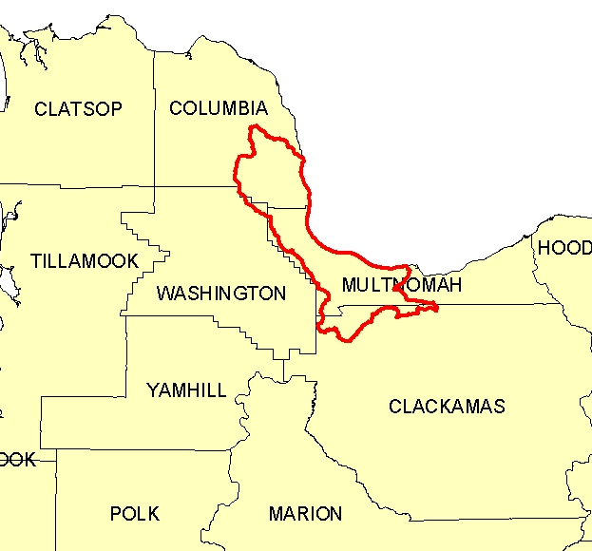
Introduction
The Lower Willamette 8-Digit Hydrologic Unit Code (HUC) subbasin is comprised of 260,900 acres in northwest Oregon. It includes the Portland metropolitan area. Eighty-five percent of the subbasin is in Multnomah and Columbia Counties. Eighty percent of the 1,126 farms in the subbasin are less than 50 acres in size.

Over 90 percent of the subbasin is privately owned, and approximately one-third of that is developed. More than one-half of the private land is forest land. The remainder of the private land (52,500 acres) is used for pasture and hay, row crops, shrubs, nurseries, Christmas trees, and grain crops.

Conservation assistance is provided by three NRCS service centers, one resource conservation and development (RC&D) office, and four soil and water conservation districts.

Profile Contents

Introduction
Physical Description
Land Use Map & Precipitation Map
Common Resource Area
Resource Concerns
Census and Social Data
Progress/Status
Footnotes/Bibliography

Relief Map

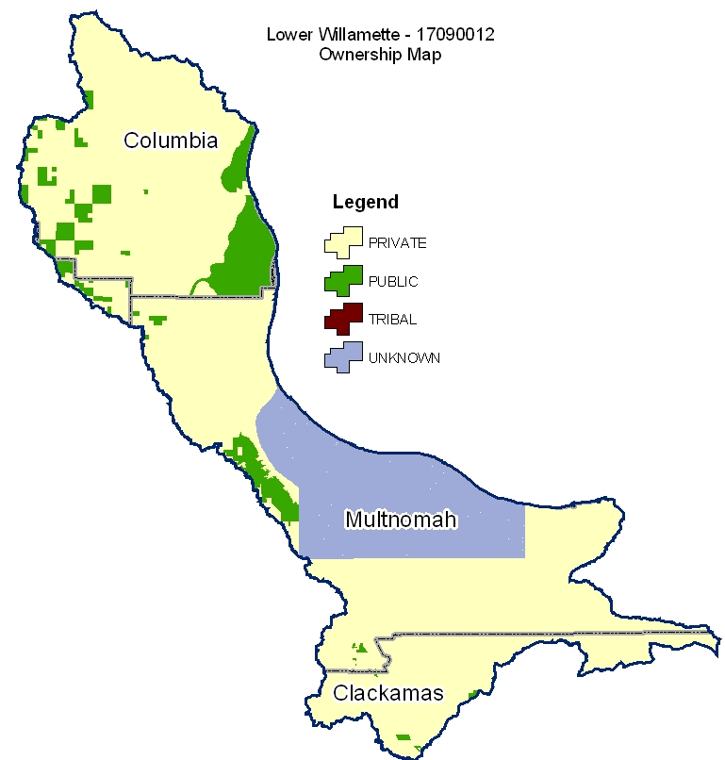

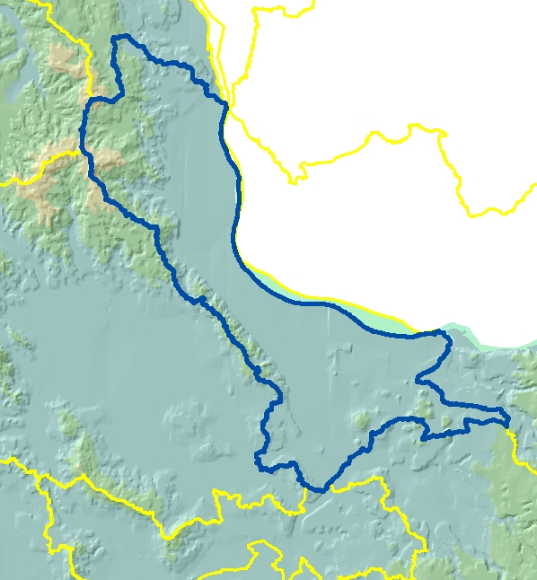

Produced by the Water Resources Planning Team Portland, OR
The United States Department of Agriculture (USDA) prohibits discrimination in all its programs and activities on the basis of race, color, national origin, sex, religion, age, disability, political beliefs, sexual orientation, and marital or family status. (Not all prohibited bases apply to all programs.) Persons with disabilities who require alternative means for communication of program information (Braille, large print, audiotape, etc.) should contact USDA’s TARGET Center at 202-720-2600 (voice and TDD).
To file a complaint of discrimination, write USDA, Director, Office of Civil Rights, Room 326W, Whitten Building, 14th and Independence Avenue, SW, Washington DC 20250-9410, or call (202) 720-5964 (voice and TDD). USDA is an equal opportunity provider and employer.

Physical Description Back to Contents

Land Cover/Land Use  (NLCD^{/2}) |  | Ownership - (2003 Draft BLM Surface Map Set^{/1})
 |  | Public |  | Private |  |  | Tribal |  |  | Totals ^{b} |  | %
 |  | Acres | % | Acres |  | % | Acres |  | % |  |  | %
Forest |  | 12,400 | 5% | 93,300 |  | 38% | 0 |  | 0% | 111,000 |  | 43%
Grain Crops |  | * | --- | * |  | --- | 0 |  | 0% | * |  | ---
Conservation Reserve Program Land ª |  | 0 | 0% | * |  | --- | 0 |  | 0% | * |  | ---
Grass/Pasture/Hay |  | * | --- | 21,600 |  | 8% | 0 |  | 0% | 24,900 |  | 10%
Orchards/Vineyards/Nurseries |  | * | --- | 3,100 |  | 1% | 0 |  | 0% | 3,100 |  | 1%
Row Crops |  | * | --- | 13,200 |  | 5% | 0 |  | 0% | 14,300 |  | 5%
Shrub/Rangelands |  | * | --- | 6,000 |  | 2% | 0 |  | 0% | 9,300 |  | 4%
Water/Wetlands/Developed/Barren |  | 5,500 | 2% | 56,400 |  | 21% | 0 |  | 0% | 97,200 |  | 37%
Oregon HUC Totals b |  | 20,400 | 8% | 194,600 |  | 74% | 0 |  | 0% | 260,900 |  | 100%
*: Less than one percent of total acres. See below for special considerations.
a: Estimate from Farm Service Agency records and includes CRP/CREP.
b: Totals are approximate due to rounding and small unknown acreages.
Special Considerations for This 8-Digit HUC:

- Thirty-six percent of the private forest land is under industrial forest ownership (OSU, Forestry Sciences Laboratory).
- Much of the non-industrial private forest land is on farms that are less than 50 acres in size.
- As of December 2004, there are 58 acres applied to CREP (FSA).
- Orchards/Vineyards/Nurseries includes other perennial crops such as nursery stock, hybrid poplar, and Christmas trees.
- Grass/Pasture/Hay includes approximately:
  - 2,700 acres of grass seed (Pacific Northwest Ecosystem Research Consortium).
  - 8,900 acres of pasture (Pacific Northwest Ecosystem Research Consortium).
  - 5,300 acres of hay (Pacific Northwest Ecosystem Research Consortium).
  - 4,700 acres of miscellaneous grassland (open space/vacant parcels) within metropolitan areas in Multnomah, Washington, and Columbia Counties.
- Row crops include a variety of field and vegetable crops grown for cannery processing and fresh markets.
- There are approximately 2,900 acres of grain (Pacific Northwest Ecosystem Research Consortium).
- Shrub/Rangelands consists of oak savannah and other open areas.
- Thirty-seven percent of the watershed consists of urban land within the metropolitan areas.

Irrigated Lands  (1997 NRI^{/3} Estimates for Non-Federal Lands Only) | Type of Land |  |  |  | ACRES |  |  | % of  Irrigated Lands |  |  | % of  HUC
 | Cultivated Cropland |  |  |  | 6,000 |  |  | 77% |  |  | 2%
 | Uncultivated Cropland |  |  |  | 400 |  |  | 5% |  |  | 0%
 | Pastureland |  |  |  | 1,400 |  |  | 18% |  |  | <1%
 | Total Irrigated Lands |  |  |  | 7,800 |  |  | 100% |  |  | 3%

(Continued on following pages)

Back to Contents
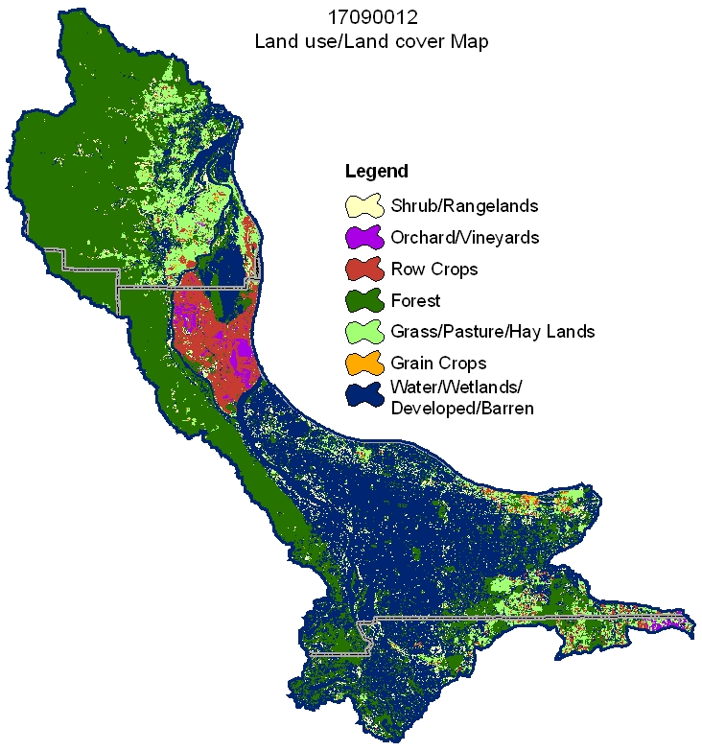

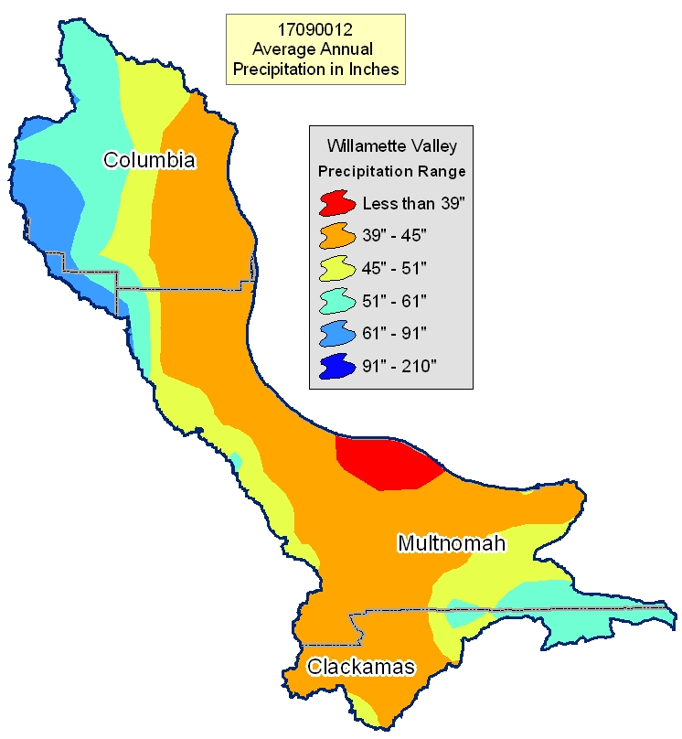

Common Resource Area Map Back to Contents

Only the major units are described below - for descriptions of all units within the HUC, go to: http://ice.or.nrcs.usda.gov/website/cra/viewer.htm

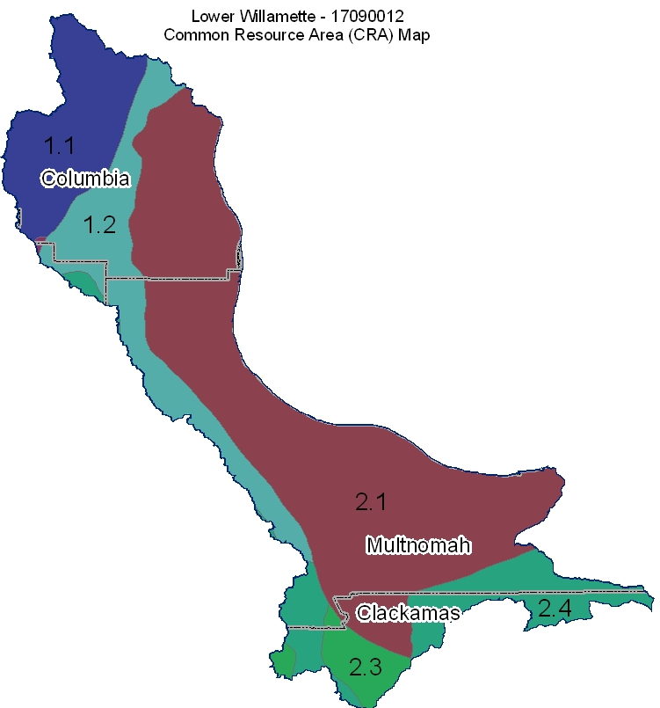

1.1 - Northern Pacific Coast Range, Foothills, and Valleys – Volcanics: This unit is comprised of mountains that have basalt bedrock and are outside of the "fogbelt." The temperature regime is mesic and frigid with a small area that is cryic, and the moisture regime is udic. The vegetation is Douglas-fir and western hemlock.

1.2 - Northern Pacific Coast Range, Foothills, and Valleys - Willapa Hills: This unit is comprised of lower elevation mountains and foothills in the Coast Range. The soils are underlain by sedimentary rock and are silty and clayey throughout. Some of these soils have a fragipan. The temperature regime is mesic, and the moisture regime is udic. The vegetation is Douglas-fir and western hemlock.

2.1 - Willamette and Puget Valleys - Portland/Vancouver Basin: This unit is comprised of the terraces and flood plains of the Willamette and Columbia Rivers in the Portland/Vancouver metropolitan area. The landforms, soils, and vegetation are similar to those of the remainder of the Willamette Valley, but different management concerns need to be addressed (urban uses, nurseries, etc.) because of the H component (humans) within the SWAPA +H. The temperature regime is mesic, and the moisture regime is xeric.

2.3 - Willamette and Puget Valleys - Prairie Terraces: This unit is comprised of the terraces in the Willamette Valley. The soils are well drained to poorly drained. Land use is variable. The temperature regime is mesic, and the moisture regime is xeric. It includes numerous ponded seasonal wetlands.

2.4 - Willamette and Puget Valleys - Valley Foothills: This unit is comprised of the foothills of the Willamette Valley. The soils are underlain by basalt and sedimentary rock and typically are red and clayey. The vegetation is Douglas-fir and Oregon white oak. The temperature regime is mesic, and the moisture regime is xeric. The unit does not support western hemlock, which is characteristic of the adjacent units in the Coast and Cascade MLRA's.

Physical Description – Continued Back to Contents
 |  | ACRES | ACRE-FEET
Irrigated Adjudicated Water Rights (OWRD^{/4}) | Surface | 13,624 | 34,099
Irrigated Adjudicated Water Rights (OWRD^{/4}) | Well | 5,699 | 14,263
Irrigated Adjudicated Water Rights (OWRD^{/4}) | Total Irrigated Adjudicated Water Rights | 19,323 | 48,362
Stream Flow Data | USGS 14211720 WILLAMETTE RIVER AT PORTLAND, OR | Total Avg. Yield | 24,005,671
Stream Flow Data | USGS 14211720 WILLAMETTE RIVER AT PORTLAND, OR | May – Sept. Yield | 4,486,784
 |  | MILES | PERCENT
Stream Data^{/5}  *Percent of Total Miles  of Streams in HUC | Total Miles – Major (100K Hydro GIS Layer) | 372 | ---
Stream Data^{/5}  *Percent of Total Miles  of Streams in HUC | 303d/TMDL Listed Streams (DEQ) | 183 | 49%
Stream Data^{/5}  *Percent of Total Miles  of Streams in HUC | Anadromous Fish Presence (StreamNet) | 54 | 15%
Stream Data^{/5}  *Percent of Total Miles  of Streams in HUC | Bull Trout Presence (StreamNet) | 0 | 0%
 |  | ACRES | PERCENT
Land Cover/Use^{/2} Based on a 100-foot stretch on both  sides of all streams  in the 100K Hydro GIS Layer | Forest | 4,151 | 46%
 | Grain Crops | 38 | 0%
 | Grass/Pasture/Hay | 651 | 7%
 | Orchards/Vineyards | 107 | 1%
 | Row Crops | 508 | 6%
 | Shrub/Rangelands – Includes CRP Lands | 280 | 3%
 | Water/Wetlands/Developed/Barren | 3,267 | 36%
 | Total Acres of 100-foot Stream Buffers | 9,002 | ---
Land Capability Class  (Croplands & Pasturelands Only)  (1997 NRI^{/3} Estimates for Non-Federal Lands Only) | 1 – slight limitations | 0 | 0%
 | 2 – moderate limitations | 16,700 | 37%
 | 3 – severe limitations | 13,400 | 30%
 | 4 – very severe limitations | 2,100 | 5%
 | 5 – no erosion hazard, but other limitations | 0 | 0%
 | 6 – severe limitations; unsuitable for cultivation; limited to pasture, range, forest | 12,400 | 28%
 | 7 – very severe limitations; unsuitable for cultivation; limited to grazing, forest, wildlife habitat | 0 | 0%
 | 8 – miscellaneous areas; limited to recreation, wildlife habitat, water supply | 0 | 0%
 | Total Croplands & Pasturelands | 44,600 | ---

Confined Animal Feeding Operations – Oregon CAFO Permit – 12/2004
Animal Type | Dairy | Feedlot (Cattle) | Poultry | Swine | Mink | Other
No. of Permitted Farms | 2 | 1 |  |  | 1 | 1
No. of Permitted Animals | 1,050 | 850 |  |  | 3,700 | 150

Resource Concerns Back to Contents
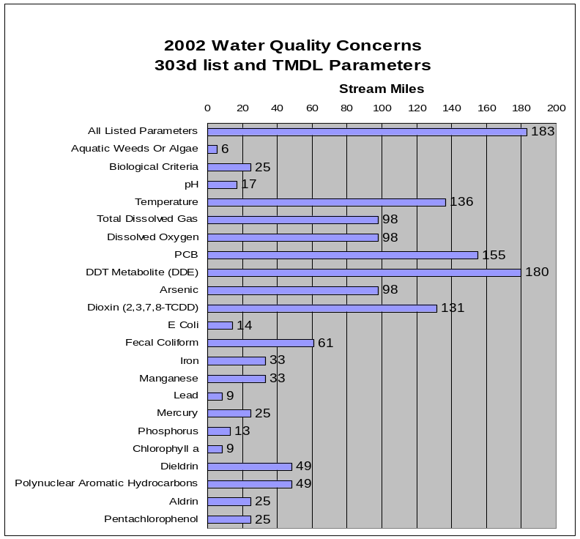
- 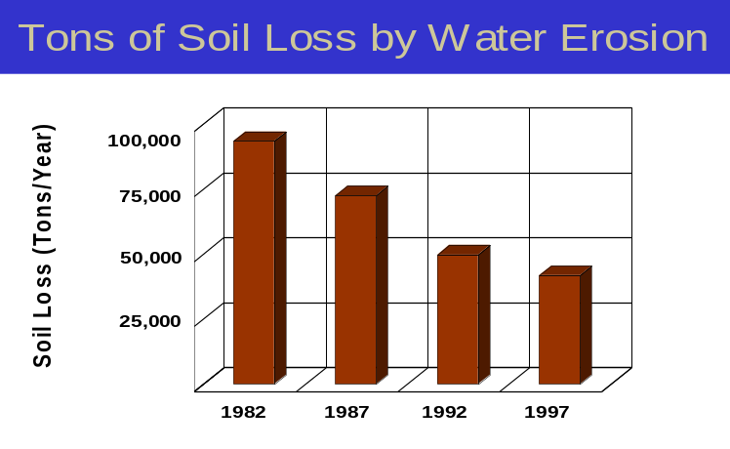Sheet and rill erosion by water on croplands and pasturelands have been reduced by more than 50,000 tons of soil per year from 1982 to 1997.
- NRI estimates indicate that 1,400 acres of the agricultural lands still had water erosion rates above a sustainable level in 1997.
- Controlling erosion not only sustains the long-term productivity of the land, but it also affects the amount of soil, pesticides, fertilizer, and other substances that move into the Nation’s waters.
- Through NRCS programs, many farmers and ranchers have applied conservation practices to reduce the effects of erosion by water. As a result, erosion rates on croplands and pasturelands fell 40 percent, from 1.6 tons/acre/year to 0.9 ton/acre/year, from 1982 to 1997.

- The wide array of listed water quality parameters is indicative of more intense agricultural uses and suburban, urban, and commercial/industrial uses.

- Conservation practices that can be used to address these water quality issues on agricultural lands include erosion control, irrigation water management, nutrient and pest management, livestock waste management, grazing management, and use of riparian buffers.

Watershed Projects, Plans, Studies, and Assessments
NRCS Watershed Projects⁶ |  |  |  | NRCS Watershed Plans, Studies, and Assessments⁷
Name | Status |  |  | Name |  |  | Status
None |  |  |  | None
ODEQ TMDL’s⁸ |  |  |  |  | ODA Agricultural Water Quality Management Plans⁹
Name |  | Status |  |  | Name |  | Status
Columbia & Willamette Rivers  Columbia Slough  Willamette Basin |  | EPA Approved – 1991  EPA Approved – 1998  Draft for Review |  |  | Lower Willamette  North Coast |  | Completed  Completed
OWEB Watershed Councils¹⁰ |  |  | Watershed Council Assessments¹¹ |  |  | NWPCC Subbasin Plans & Assessments¹⁸
Columbia Slough, Fairview Creek, Johnson Creek, Scappoose Bay, and Tryon Creek Watershed Councils |  |  | Fairview Creek, Scappoose Bay, and Tualatin River Watershed Assessments |  |  | Willamette

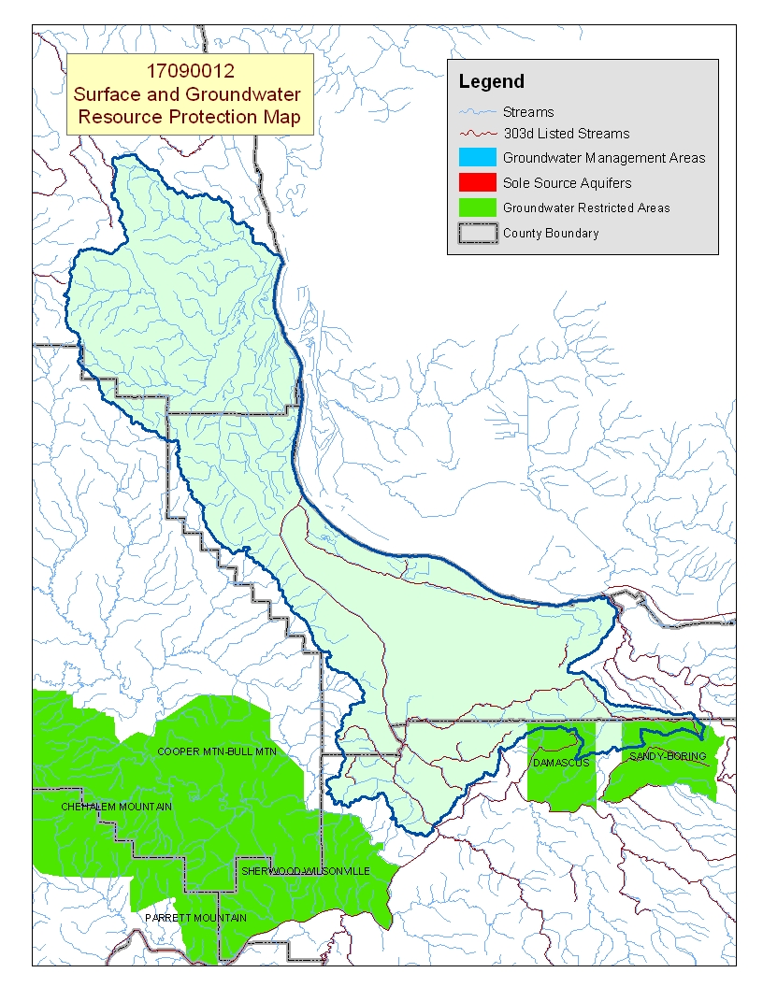
Map Footnote ^{/17}

Resource Concerns - Continued Back to Contents
Resource Concerns/Issues by Land Use
SWAPA +H Concerns | Specific Resource Concern/Issue | Pasture\Hay | Grain Crops | Row Crops | Orchard/Vine | Shrub/Range | Forest
Soil Erosion | Sheet and Rill |  | X | X | X
Soil Erosion | Concentrated Flow or Gully |  |  | X | X |  | X
Soil Erosion | Classic Gully |  |  |  |  |  | X
Soil Erosion | Streambank | X |  |  |  |  | X
Soil Erosion | Irrigation Induced |  |  | X | X
Soil Condition | Tilth, Crusting, Infiltration, Organic Matter |  | X | X | X
Soil Condition | Soil Compaction | X | X |  |  |  | X
Water Quantity | Ponding and Flooding |  | X
Water Quantity | Water Management For Irrigated Land |  |  | X | X
Water Quality, Groundwater | Pesticides |  |  |  | X |  | X
Water Quality, Groundwater | Nutrients and Organics | X |  |  | X |  | X
Water Quality, Groundwater | Pathogens | X
Water Quality, Surface | Pesticides | X | X |  |  |  | X
Water Quality, Surface | Nutrients and Organics | X | X |  | X |  | X
Water Quality, Surface | Suspended Sediments and Turbidity |  |  |  |  |  | X
Water Quality, Surface | Pathogens | X
Water Quality, Surface | Aquatic Habitat Suitability |  |  |  |  |  | X
Plant Suitability | Site and Intended Use Suitability | X |  |  |  |  | X
Plant Condition | Productivity, Health, and Vigor
Plant Condition | Noxious and Invasive Plants |  |  | X | X | X | X
Plant Management | Establishment, Growth, and Harvest |  | X | X | X |  | X
Animal Habitat, Domestic | Management | X
Animal Habitat, Wildlife | Management |  |  |  |  |  | X
Human, Economics | Land Use Constraints/Restrictions |  |  |  | X |  | X
Human, Economics | High Capital/Financial Cost | X
Human, Economics | High Labor Cost or Availability |  |  |  |  |  | X
Human, Economics | High Management Level Required | X | X | X
Human, Economics | Low or Unreliable Profitability | X | X | X | X
Human, Political | Inadequate Availability of Cost Share Programs |  |  |  |  |  | X

Grass/Pasture/Hay
- Complications related to overgrazing include poor pasture condition, soil compaction, and water quality.
- Control of noxious and invasive plants is an ever-increasing problem.
- The small, part-time farms are less likely to adopt conservation practices because of cost and low income.

Row and Perennial Crops (Orchards/Vineyards/Nurseries)
- Management of residue, nutrients, and pests is needed to control erosion and to maintain water quality.
- The small, part-time farms are less likely to adopt conservation practices because of cost and low income.

Forest Land
- Erosion, water quality, and productivity are issues on the private, non-industrial forest land.
- On non-industrial forest land, landowner objectives commonly do not include actively managing the land for timber production. Land use constraints and lack of economic incentives further discourage use of conservation practices.

Federally Listed Threatened And Endangered Species^{/12}
THREATENED SPECIES | CANDIDATE SPECIES
Mammals – Columbian white-tailed deer, Canada lynx  Birds - Bald eagle, Northern spotted owl  Fish - Chum salmon, Steelhead, Chinook salmon, Bull trout  Plants – Golden Indian paintbrush, Willamette daisy, Howellia, Bradshaw's lomatium, Kincaid’s lupine, Nelson's checker-mallow | Fish - Steelhead (Oregon Coast), Coho salmon (Lower Columbia River)  Birds – Yellow-billed cuckoo, Streaked horned lark  Amphibians and Reptiles – Oregon spotted frog
 | Proposed Species None
Essential Fish Habitat^{/13} – Coho, Chinook

Census and Social Data^{/14} Back to Contents

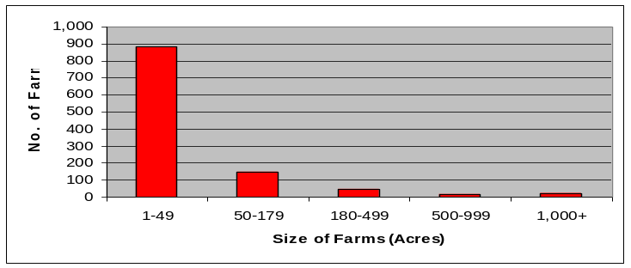
Number of Farms: 1,126
Number of Operators: 1,860
- Full-Time Operators: 526
- Part-Time Operators: 1,334

Estimated Level of Willingness and 987Ability to Participate in Conservation^{/15}: LOW TO MODERATE
Generally, agricultural landowners in the watershed are well educated and have a positive stewardship attitude. To increase conservation participation, however, many need substantial technical assistance to overcome a lack of management experience, to increase their knowledge of the effect of their operation on local resources problems, and to gain an appreciation of the benefits of conservation. The primary occupation of a majority of the operators is not agriculture; thus, they have difficulty finding the time to plan and implement conservation on their land.

Evaluation of Social Capital^{/16}: LOW TO MODERATE
The communities in the watershed have adequate leadership and some experience working together to solve problems, but the leadership and experience is largely in the urban areas. Rural communities might be better able to promote conservation and assist their residents in adoption of conservation systems if community development efforts focused on increasing public participation in community groups, expanding the awareness of natural resources issues throughout the rural community, and initiating locally-led planning efforts.

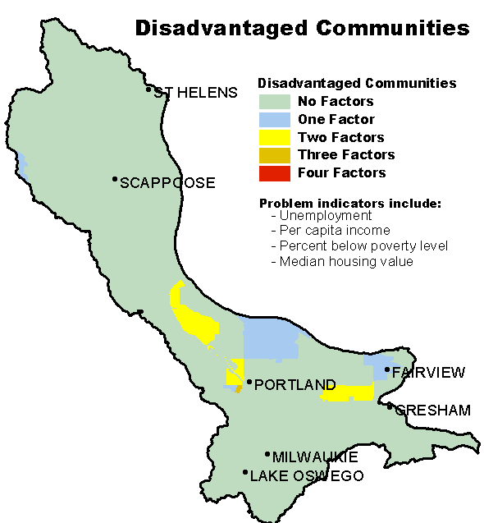
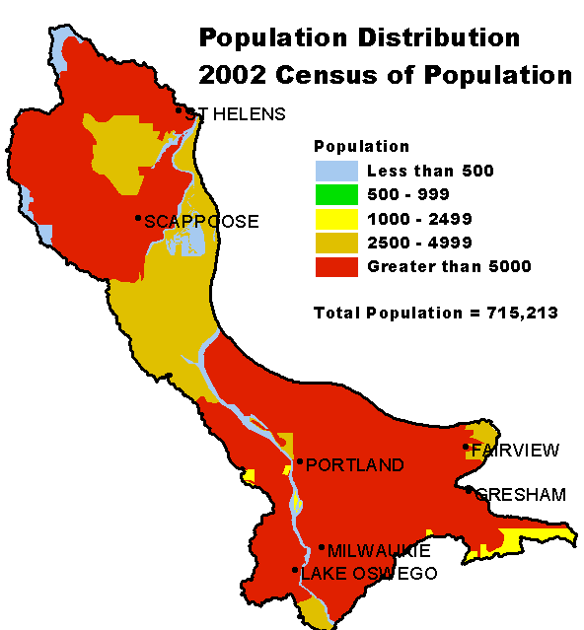

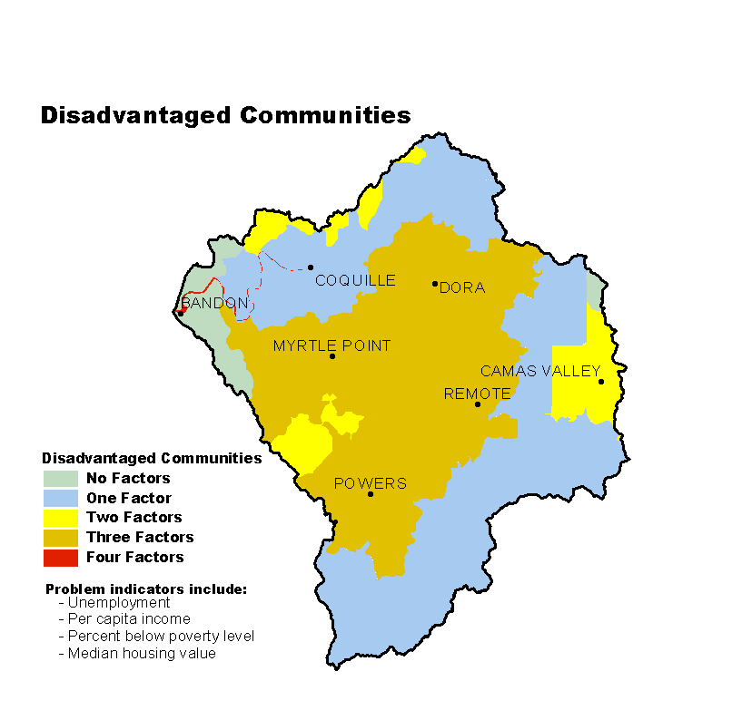

Progress/Status Back to Contents
PRMS Data | FY99 | FY00 | FY01 | FY02 | FY03 | Avg/Year | Total
Total Conservation Systems Planned (Acres) | 4,845 | 424 | 115 | 128 | 44 | 1,111 | 5,556
Total Conservation Systems Applied (Acres) | 3,880 | 430 | 1,394 | 5 | 38 | 1,149 | 5,747
Conservation Treatment
Waste Management (Number) | 2 | 0 | 0 | 0 | 2 | 1 | 4
Riparian Forest Buffers (Acres) | 0 | 259 | 3 | 2 | 5 | 54 | 269
Erosion Control (Acres) | 1,763 | 97 | 12 | 0 | 150 | 404 | 2,022
Irrigation Water Management (Acres) | 424 | 207 | 38 | 22 | 0 | 138 | 691
Nutrient Management (Acres) | 1,222 | 0 | 313 | 22 | 75 | 326 | 1,632
Pest Management (Acres) | 490 | 236 | 393 | 1 | 97 | 243 | 1,217
Prescribed Grazing (Acres) | 527 | 202 | 134 | 4 | 118 | 197 | 985
Trees and Shrubs (Acres) | 789 | 131 | 33 | 1 | 49 | 201 | 1,003
Conservation Tillage (Acres) | 295 | 122 | 139 | 0 | 0 | 111 | 556
Wildlife Habitat (Acres) | 2,375 | 555 | 1,224 | 3 | 117 | 855 | 4,274
Wetlands (Acres) | 2 | 224 | 475 | 0 | 142 | 169 | 843

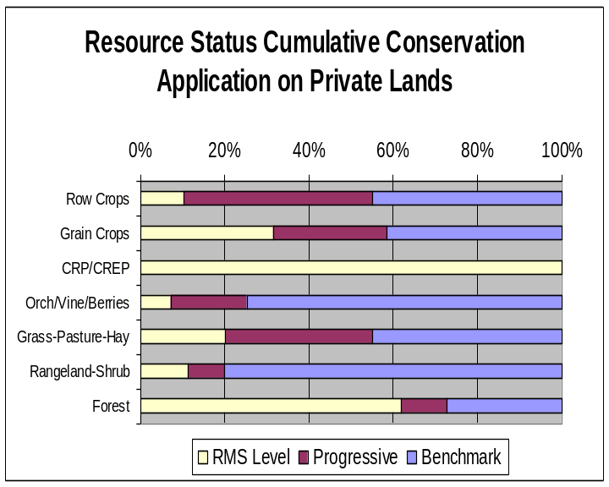
- Progress over the last five years has been focused on:
- Erosion control and nutrient and pest management on cropland.
- Wildlife habitat management in riparian areas and on uplands.
- Farmers producing row crops typically rely upon cannery consultants and fertilizer dealers.
- Farmers producing perennial crops such as nursery stock and Christmas trees commonly do not seek assistance from NRCS or SWCDs.
- Much of the pasture that is at the benchmark level is on small farms.
- Private industrial forest landowners typically do not work with NRCS and SWCDs; however, their land usually complies with State forest practice requirements.
- Much of the rangeland and forest land in the watershed is on farms less than 50 acres in size and is not managed for forage or timber. The non-industrial private forest land commonly does not comply with the State forest practice requirements.
Estimates are based on information received from local conservationists.

Lands Removed from Production through Farm Bill Programs
- Conservation Reserve Program (CRP): none
- Wetland Restoration Program (WRP): 294 acres
- Conservation Reserve Enhancement Program (CREP): 58 acres

Footnotes/Bibliography Back to Contents
All data is provided “as is.” There are no warranties, express or implied, including the warranty of fitness
for a particular purpose, accompanying this document. Use for general planning purposes only.

- Ownership Layer – Source: The 1:24,000 scale public ownership layer is the land ownership/management for public entities, including Federal, Tribal, State, and local entities. This is a seamless, statewide Oregon Public Ownership vector layer composed of fee ownership of lands by Federal, State, Tribal, county, and city agencies. The layer is comprised of the best available data compiled at 1:24,000 scale or larger, and the line work matches GCDB boundary locations and ORMAP standards where possible. The layer is available from the State of Oregon GIS Service Center: http://www.gis.state.or.us/data/alphalist.html. For current ownership status, consult official records at appropriate Federal, State, and county offices. Ownership classes grouped to calculate Federal ownership vs. non-Federal ownership by the Water Resources Planning Team.

- National Land Cover Dataset (NLCD) - Originator: U.S. Geological Survey (USGS);
Publication date: 19990631; Title: Oregon Land Cover Data Set, Edition: 1;
Geospatial data presentation form: Raster digital data; Publisher: U.S. Geological Survey,
Sioux Falls, SD, USA; Online linkage: http://edcwww.cr.usgs.gov/programs/lccp/nationallandcover.html; Abstract: These data can be used in a geographic information system (GIS) for any number of purposes, such as assessing wildlife habitat, water quality, pesticide runoff, land use change, etc. The State data sets are provided with a 300-meter buffer beyond the State border to facilitate combining the State files into larger regions.

- ESTIMATES FROM THE 1997 NRI DATABASE (REVISED DECEMBER 2000) REPLACE ALL PREVIOUS REPORTS AND ESTIMATES. Comparisons made using data published for the 1982, 1987, or 1992 NRI may produce erroneous results. This is because of changes in statistical estimation protocols and because all data collected prior to 1997 were simultaneously reviewed (edited) as 1997 NRI data were collected. All definitions are available in the glossary. In addition, this December 2000 revision of the 1997 NRI data updates information released in December 1999 and corrects a computer error discovered in March 2000. For more information: http://www.nrcs.usda.gov/technical/NRI/

- Irrigated Adjudicated Water Rights – Water Rights Information System (WRIS), Oregon Water Resources Department, http://www.wrd.state.or.us/maps/wrexport.shtml

- StreamNet is a cooperative venture of the Pacific Northwest's fish and wildlife agencies and tribes and is administered by the Pacific States Marine Fisheries Commission. StreamNet provided data and data services in support of the region's fish and wildlife program and other efforts to manage and restore the region's aquatic resources. Official StreamNet website: http://www.streamnet.org/

- Natural Resources Conservation Service, Watershed Projects Planned and Authorized, http://www.nrcs.usda.gov/programs/watershed/Purpose.

- Natural Resources Conservation Service, Watershed Plans, Studies, and Assessments completed, http://www.nrcs.usda.gov/programs/watershed/Surveys_Plng.html#Watershed%20Surveys%20and%20Plan

- Oregon Department of Environmental Quality Total Maximum Daily Loads, http://www.deq.state.or.us/wq/TMDLs/TMDLs.htm

- Oregon Department of Agriculture, Agricultural Water Quality Management Plans, http://www.oregon.gov/ODA/NRD/water_agplans.shtml

Footnotes/Bibliography Continued Back to Contents
All data is provided “as is.” There are no warranties, express or implied, including the warranty of fitness
for a particular purpose, accompanying this document. Use for general planning purposes only.

- Oregon Watershed Enhancement Board, http://oregon.gov/OWEB/WSHEDS/index.shtml

- Watershed Assessments completed by local watershed councils following the Oregon Watershed Assessment Manual, http://oregon.gov/OWEB/docs/pubs/ws_assess_manual.shtml.

- NRCS Field Office Technical Guide, Section II, Threatened and Endangered List.

- Magnuson-Stevens Fishery Conservation and Management Act, Public Law 94-265. As amended through October 11, 1996.

- Data were taken from the 2002 Agricultural Census and adjusted by percent of HUC in the county or by percent of zip code area in the HUC, depending on the level of data available. Data were also taken from the U.S. Population Census, 2000.

- Conservation participation was estimated using NRCS Social Sciences Technical Note 1801, Guide for Estimating Participation in Conservation, 2004. Four categories of indicators were evaluated: Personal characteristics, farm structural characteristics, perceptions of conservation, and community context. Estimates are based on information received from local conservationists in the watershed.

- Social capital is an indicator of the community’s ability and willingness to work together to solve problems. A high amount of social capital helps a community to be physically healthy, socially progressive, and economically vigorous. A low amount of social capital typically results in community conflict, lack of trust and respect, and unsuccessful attempts to solve problems. The evaluation is based on NRCS Technical Report Release 4.1, March, 2002: Adding Up Social Capital: An Investment in Communities. Local conservationists provided information to measure social capital. Scores range from 0 to 76.

- Surface and Groundwater Resource Protection Map
  - 2002 303d Listed Streams designated by Oregon Department of Environmental Quality and approved by the Environmental Protection Agency, Section 303d Clean Water Act, http://www.deq.state.or.us/wq/303dlist/303dpage.htm
  - Groundwater Management Areas designated by the Oregon Department of Environmental Quality, Oregon Revised Statutes – Ground Water ORS 468B.150 to ORS 468B.190, http://www.deq.state.or.us/wq/groundwa/wqgw.htm
  - Groundwater Restricted Areas designated by Oregon Water Resources Commission, Oregon Department of Water Resources, http://egov.oregon.gov/OWRD/PUBS/aquabook_protections.shtml
  - The Sole Source Aquifer (SSA) Protection Program is authorized by Section 1424(e) of the Safe Drinking Water Act of 1974 (Public Law 93-523, 42 U.S.C. 300 et. seq), http://www.epa.gov/safewater/ssanp.html

- Subbasin assessments and plans are developed by local groups (SWCDs, watershed councils, tribes, and others) as part of the Northwest Power and Conservation Council’s fish and wildlife program in the Columbia River Basin. This program is funded and implemented by the Bonneville Power Administration. http://www.nwcouncil.org/fw/subbasinplanning/Default.htm.

