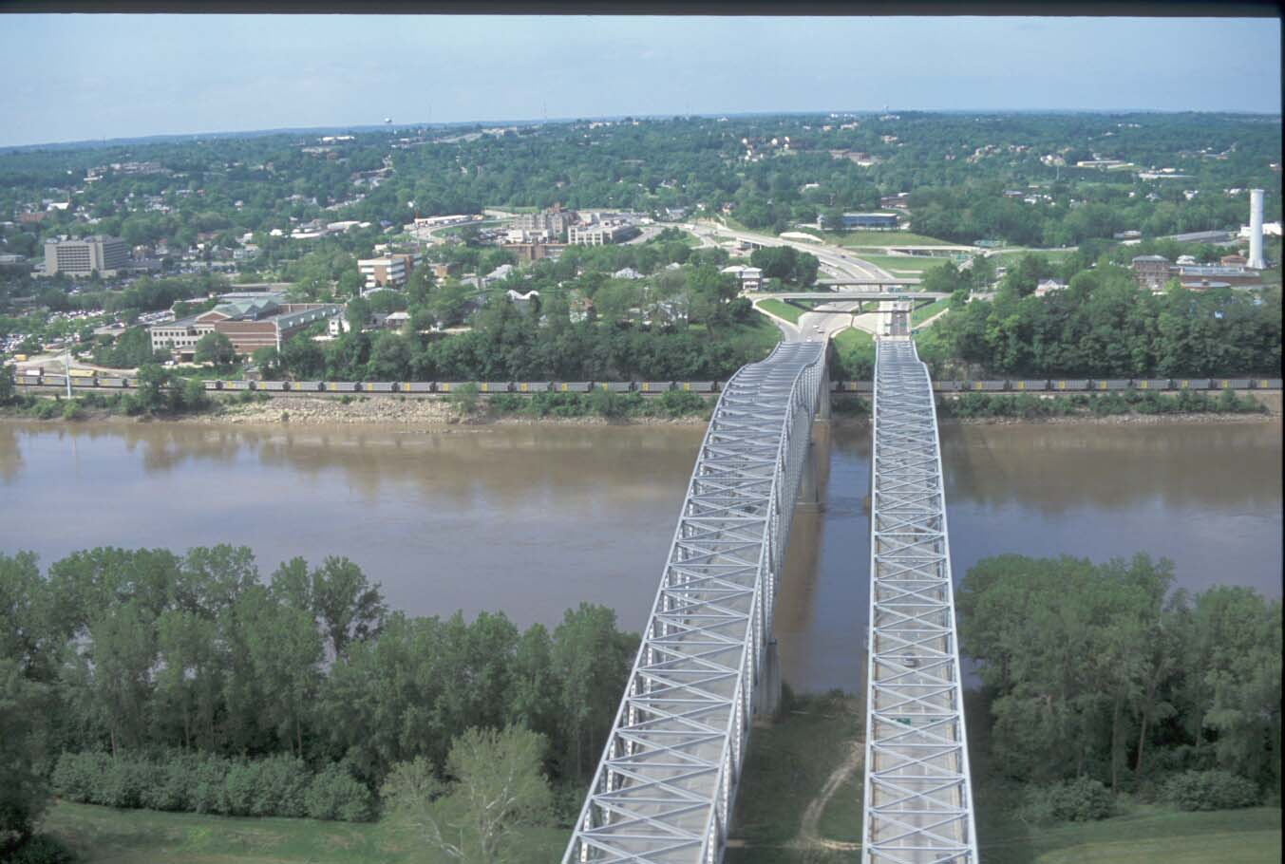
Twin bridges crossing the Missouri River at Jefferson City, Missouri.
Big River Bottomland Forest Management in Missouri

Preface

Management of Big River bottomland forests in Missouri is a challenging issue. Big River bottomland forests are dynamic ecosystems that are prone to periodic flood events. In addition, these big rivers and associated bottomland forests have been severely altered by levee systems, locks and dams, channelization, and other practices designed to move water through the system. All of these changes have combined to dramatically change historic flow patterns in Missouri Big Rivers and add unique complexity to the river system.
This document is intended to serve as an introductory guide for land use managers and private landowners who are interested in learning about big river bottomland forests and their successful management. General information on Missouri Big River bottomland forests – ecology, history, issues and needs, and potential economic markets are covered in this guide along with essential planning guidance and activities needed to successfully create a site specific management plan. While this document focuses on major bottomlands associated with the Mid-west sections of the Mississippi and Missouri Rivers, many of the management techniques and recommendations discussed in this document can apply to both major and minor bottomlands. The difference in sediment origin, as well as flooding intensity, duration, and frequency, need to be considered carefully for each site specific management area.
Table of Contents

Preface

Introduction
Big River Issues and Needs
Restoration Levels
Catastrophic Flood Events
Altered Wildlife Habitat
Species of Concern
Terrestrial Natural Communities
Exotics
Markets and Economic Opportunities
Forest Products
Wildlife Products
Future Products and Markets

Bottomland Forest Planning Considerations
Introduction
Step 1: Identifying Goals and Objectives
Step 2: Inventory Resources
Climate
Hydrology
Landscape Information and Resources
Soil Survey
Internet Sites
Wildlife
Birds
Mammals
Forests
Types of Forest Inventories
Variable-radius
Fixed-radius
Plot layout
Step 3: Analyze Resource Data
Wildlife Assessment
Soil Assessment
Forest Assessment
Step 4: Develop the Plan
Prescriptions
Step 5: Evaluate and Monitor the Plan
Cost Share Opportunities

Bottomland Forest Management Alternatives
Reforestation – New Plantings
Species Selection
Site Preparation
Specific Guidelines
Cropland/Grassland Cover
Woodland Cover
Planting Stock Considerations
Direct seeding
Bare-root Seedlings
Containerized Stock
Cuttings
Planting Techniques
Calculating Number of Seedlings
Care of planting stock
Establishment methods
Hand Tree Planting
Machine Planting
Natural Regeneration
Additional Planting Considerations
Post-planting Considerations
Vegetational control
Chemical application
Prescribed burning
Mulches
Mechanical disking
Browse protection
Regeneration/rehabilitation – Existing Stands
Silvicultural activities
Regeneration
Thinning
Best Management Practices
Wildlife habitat
Water quality
Aesthetic
Planting/site preparation
Harvesting
Roads and skid trails

Acknowledgements
Glossary
Appendix
Introduction

The Missouri River drains one-sixth of the United States and encompasses 529,350 square miles. It flows 2,341 miles from its headwaters at the confluence of the Gallatin, Madison, and Jefferson Rivers in the Rocky Mountains at Three Forks, Montana, to its confluence with the Mississippi River at St. Louis, Missouri. From bluff to bluff, the river-floodplain or bottomland below Sioux City, Iowa, covers 1.9 million acres. (Missouri River Natural Resources Committee, 1998)
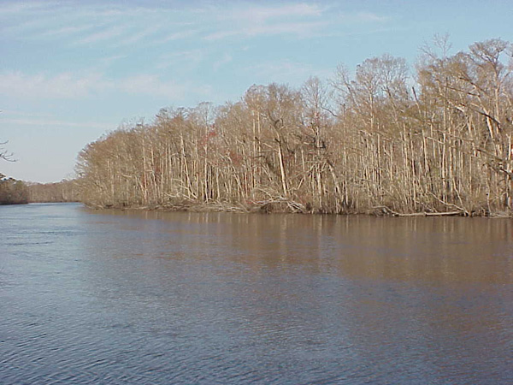
A bottomland is defined as a location in the landscape that periodically floods (often within a 100-year floodplain), but standing water is absent during the growing season (Hodges 1997). In addition to the frequency of the flooding, the vegetation in a bottomland is typically dominated by woody vegetation. The bottomland area is sometimes considered a component of broader wetland environments such as swamps, marshes, or bayous.
Figure 1. The vegetation in a bottomland is typically dominated by woody vegetation.
In Missouri, two distinct types of bottomlands can be found: major bottomlands and minor bottomlands. A major bottomland is associated with large rivers and is formed with alluvium of regional origin (Hodges 1997). Major bottomlands often experience a long flooding duration that is less frequent than a minor bottomland. Because of the flooding duration and intensity, soils formed from material of regional origin vary greatly in texture and content and are often richer and more productive than a minor bottomland. Minor bottomlands are associated with smaller streams having alluvial soil deposits formed of local origin and more consistent texture and mineralogy (Hodges 1997). Consequently, minor bottomlands may be less rich and productive, although that is not always the case.
Throughout any major bottomland, very subtle but distinct differences in topography can have profound impact on the soils and other abiotic features that ultimately influence the species composition of the forests found there. A concise examination of bottomland relief and soils is presented in the section “Landscape Information and Resources”.

Big River Issues and Needs
Historically the bottomland areas adjacent to the Mississippi and Missouri rivers were forested. These forests provided many important economic and ecological services for early inhabitants. Since this time of settlement, over 95% of these forests have been converted to agricultural land and other uses. The remaining forestlands have been impacted by changes in hydrology due to channelization, locks and dams, levees, loss of wetlands, harvesting activities, and other human induced causes.
These remaining bottomland forests provide: 1) important nurseries for channel fish and invertebrates, 2) food resources for migrating birds, waterfowl and mammals, and 3) diverse economic resources. Additional services provided by bottomland forests are flood mitigation, bank stabilization, and the deposition of nutrient rich sediments. Although these services may be difficult to quantify, the restoration and management of today’s bottomland forests can provide valuable benefits to an individual landowner and society in general.
Restoration Levels
Current restoration efforts are attempting to revitalize important ecological and economic services of bottomland forests through the establishment, management, and/or enhancement of big river bottomland areas.
The Society of Restoration Ecology defines restoration as “returning damaged ecosystems to a condition that is structurally and functionally similar to the pre-disturbance state”. This definition is incomplete, however, as it applies to current large river management. Two unresolved issues constraining restoration efforts are the competing interests in the management of these rivers and defining when an ecosystem is restored. Clearly there are many competing interests on the Mississippi and Missouri rivers that inhibit effective restoration of bottomland forests to a “pre-disturbance” condition. The current altered hydrology and geomorphology needs to be maintained as many communities now depend on the changed river landscape for their economic and social well-being. Complicating this issue are restoration activities that mean different things to different individuals and organizations. For example, the restoration of a big river ecosystem to a conservation biologist may mean using management practices that mimic the natural factors that allowed endangered species such as the palid sturgeon (Scaphirhynchus albus) and least tern (Sterna antillarum) to survive and reproduce. However, for a duck hunter, restoration may mean that wetland areas are managed to allow for the re-establishment of duck populations regardless of the previous natural factors associated with these areas.
Regardless of differing restoration goals and objectives, even a partial restoration of bottomland forests can bring back some of the original ecological services once provided by these forests. For example, researchers (Mitsch and Gosselink 2000) have discussed the need to restore altered acres in the Mississippi river floodplain to reduce the
effects of hypoxia at the Gulf of the Mississippi. While wholesale land conversion would
Hypoxia is a condition that exists in the Gulf of Mexico that has resulted in a large and increasing zone that is devoid of plant and animal life. High nutrients inputs from agricultural land runoff are suspected of causing this condition.
be impractical, linear belts of riparian forest buffers along major rivers and adjacent upstream tributaries could have a significant impact on the hypoxia situation.
Other examples of the ecological services provided by the restoration of bottomland forests include improved protection of levees, increased floodwater storage, and greater bank stabilization. Researchers at the University of Missouri (Dwyer et al. 1997; Allen et al. 2003) found during the flood of 1993 that levee breaks along the Missouri River were less common in areas that had at least 300 feet of forest between the levee and the main channel. Other researchers from the Midwest (Burkhart and Todd, 1998; Geyer et al., 2000) found that lateral stream migration was greatly reduced in areas with trees because of greater bank stabilization compared to agricultural areas with no trees.
Catastrophic Flood Events
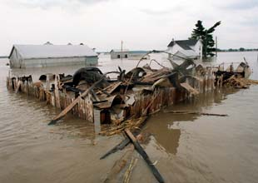
The devastating floods of 1993 throughout the Missouri and upper Mississippi River systems provided an important thrust for the current interest in floodplain forest research. The floods of 1993 caused a $500 million dollar loss to Missouri’s economy with floodplain crop losses put at $247 million dollars. It is estimated that Missouri alone lost 14% of its corn and 11% of its soybean 1993 production. In addition, to the loss of crops that year, 237,000 acres of agricultural land were covered with at least six inches of sand deposited by the flood (Soil Conservation Service 1993a,b).
University of Missouri forest researcher (Colbert 1998, MS thesis) found that normal mortality rates in bottomland forests increased between four and twenty-five times the expected rates following the 1993 flood. Notwithstanding, one-third of all forest tree species died as the result of the flood. In particular, hackberry (Celtis occidentalis) and pin oak (Quercus palustris) exhibited especially high mortality rates regardless of tree size. On the other hand, two species - black willow (Salix nigra) and sycamore (Plantanus occidentalis) showed the least mortality.
Figure 2. The ruins of a barn in St. Charles County that burned when it was struck by lightning during the 1993 flood. Karen Elshout. Post-Dispatch

Altered Wildlife Habitat
While several environmental impacts combine to affect the big river ecosystem, habitat loss is by far the most pervasive and dramatic. The pre-settlement Missouri River basin represented one of North America’s most diverse ecosystems with channels, riparian lands, chutes, sloughs, islands, sandbars, and backwater areas. Currently, much of the Missouri River ecosystem has been impacted by human actions. Today, 35% of the entire Missouri River system is impounded, 32 % has been channelized, and 33% is unchannelized. Channelization alone has shortened the river by 72 miles, resulting in the loss of 127 miles of river shoreline habitat. In addition, 168,000 acres of aquatic habitat was lost as sediment accumulated behind wing dikes, forming new land (Missouri River Natural Resources Committee, 1998).
Another type of activity which has contributed significantly to the loss of wildlife habitat, was the conversion of nearly 354,000 acres of meander belts to urban and agricultural floodplain development. This meander belt conversion is considered critical habitat loss because it contained a variety of fish and wildlife habitats, including wetlands, wet prairies, and bottomland forests (Missouri River Natural Resources Committee, 1998).
As a result of these human-induced changes, populations for many fish, bird, and mammal species that were once abundant in and along Missouri big rivers, are now in a state of decline, some to the extent that they are now federally or state-listed as threatened or endangered species.
The Missouri Department of Conservation (MDC) is the agency which enforces both state and federal laws in Missouri regarding all threatened and endangered species. A plant or animal is deemed to be endangered if it is “…in danger of extinction throughout all or a significant portion of its range…” and is considered to be threatened when the species “…is likely to become an endangered species within the foreseeable future throughout all or a significant portion of its range” (Endangered Species Act, Public Law 93-205, 1973).

Even though many of Missouri’s threatened and endangered plants and animals are linked more closely with the loss of wetlands and hydrologic alterations, there are species that would benefit from the restoration of woodlands and bottomlands along the Missouri River. Appendix, Tables A and B, are examples of endangered wildlife found in Missouri, their requisite habitat, and some actions landowners and land managers can take to help prevent further population losses.
Species of Concern
The Missouri Ecological Classification System (ECS) Project has identified 31 ecological sub-sections in Missouri. An ecological classification system is a conceptual framework that allows natural resource managers to identify, describe, and map units of land with similar physical and biological characteristics for planning and management. The Atlas of Missouri Ecoregions, (Nigh and Schroeder, 2002) that was the creation of the ECS project, has identified 7 subsections that contain big river components along with comments on plant and animal species that are considered rare or endangered. Discussions on the rare or endangered species found in the 7 subsections follow.
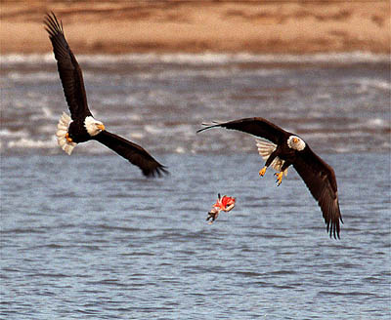
The Missouri River Alluvial Plain subsection contains about 73 state-listed species, many of which are fish, mussels, birds, and plants associated with the river and wetlands along it. Two species of federal concern are the bald eagle (Haliaeetus leucocehpalus) and pallid sturgeon (Scaphirhynchus albus).
The Gasconade River Hills subsection contains approximately 76 state-listed species, with caves, bottomland forests, river, and stream habitats supporting an exceptionally high number of listed species. In addition to the state-listed species, federally listed species include the gray bat (Myotis grisescens) and the Indiana bat (Myotis sodalis), as well as the bald eagle (Haliaeetus leucocehpalus).
Figure 3. Bald eagles scuffle over a piece of fish with the prize dropping into the river out of everyone's reach. Photograph by Chris Young.
The Outer Ozarks Border subsection contains approximately 156 state-listed species. This incredibly high number of species and are mostly associated with cliffs, caves, and bottomland forests. Federally listed species from this region include: decurrent false aster (Bolyonia decurrens), running buffalo clover (Trifolium stoloniferum), pink mucket (Lampsilis abrupta), Topeka shiner (Notropis topeka), bald eagle (Haliaeetus leucocehpalus), gray bat (Myotis grisescens) and Indiana bat (Myotis sodalis).
The Missouri River Alluvial Plain subsection of the Ozarks Highlands Section contains about 47 state-listed species, 18 of which are fish species. Seven species are of federal concern, including the bald eagle (Haliaeetus leucocehpalus), decurrent false aster (Bolyonia decurrens), running buffalo clover (Trifolium stoloniferum), pink mucket (Lampsilis abrupta), gray bat (Myotis grisescens), Indiana bat (Myotis sodalis) and pallid sturgeon (Scaphirhynchus albus).
The Black River Alluvial Plain subsection contains approximately 117 state-listed species. This is an exceptionally high number given the almost complete land conversion to agricultural uses. Many of the rare species are fish, reptiles, and amphibians associated with the streams and backwaters of the region. Bottomland forests, swamps, and dune-swale habitats are also important to rare species. Three species of federal concern for this region are the bald eagle (Haliaeetus leucocehpalus), pink mucket (Lampsilis abrupta), and pondberry (Lindera melissifolium).
The St. Francis River Alluvial subsection contains approximately 60 state-listed species. Most species in this area are associated with the streams and backwaters of the region, but bottomland forests and swamps are also important habitats.
The Mississippi River Alluvial Plain subsection contains approximately 132 state-listed species, 16 of which have more than 80% of their statewide occurrences in this subsection alone. Most of the listed species are fish, amphibians, reptiles, and mussels associated with the streams and backwaters of the region, but bottomland forests and swamps are also important habitats to maintain. Only three species of federal concern are known: bald eagle (Haliaeetus leucocehpalus), fat pocketbook mussel (Potamilus capax), and interior least tern (Sterna antillarum athalassos).
Terrestrial Natural Communities

Terrestrial Natural Communities are interrelated assemblages of plants, animals and other living organisms, including geologic substrate, soils, topography and aspect. Table 1 reflects the bottomland terrestrial communities in Missouri that are considered to be the most threatened and why their loss has become a cause for concern (Nelson 2002; Missouri Natural Heritage Program 2003).
Table 1. Terrestrial Natural Communities of Conservation Concern
Community | Type | Reason for Concern
Forest | Mesic sand forest - beech, sugar maple and sweetgum | Imperiled in the state because of rarity or due to factors that make it vulnerable to extirpation from the state (6 – 20 occurrences or few remaining individuals or acres)
Forest | Mesic bottomland forest - red oak, sugar maple and bitternut hickory | Imperiled in the state because of rarity or due to factors that make it vulnerable to extirpation from the state (6 – 20 occurrences or few remaining individuals or acres)
Woodland | Wet-mesic bottomland woodland - bur oak, swamp whit oak, shellbark hickory, cottonwood and willow | Critically imperiled in the state because of extreme rarity or due to factors making it especially vulnerable to extirpation from the state (typically 5 or fewer occurrences or very few remaining individuals or acres)
Woodland | Bottomland flatwoods - pin oak, post oak, and cherrybark oak | Imperiled in the state because of rarity or due to factors that make it vulnerable to extirpation from the state (6 – 20 occurrences or few remaining individuals or acres)
Woodland | Mesic bottomland woodland - bur oak, swamp whit oak, shellbark hickory, cottonwood and willow | Historical: Elements occurred historically in the state

Exotics
Missouri does have some issues with introduced exotics such as zebra mussel, purple loosestrife, Johnson grass, Reed canary grass, kudzu, and others. However, there are few exotic species directly associated with either the loss or the hindrance of restoration activities associated with bottomland forests.
Markets and Economic Opportunities
Because bottomlands are some of the most highly productive agricultural lands in the Missouri, it may be a challenge to take much of this land out of agricultural production and into trees. However, agricultural land that is marginal due to flooding damage on crops or disrupted field access offers improved opportunities for land conversion to bottomland forests.
How the landowner and others value the bottomland forest resource equates directly to its market potential. With proper marketing and market recognition, managed bottomland forest offer many opportunities for landowners to realize improved returns on their investment.
In the case of a bottomland forested situation there are a number of market opportunities which may or may not directly translate into an assessed price or dollar amount. However, most markets are related to some value that individuals or society place on the forested environment. This may either be for the production of material goods or be a value resulting from its role and function in a larger environmental system. These markets may be well defined, as in the case of timber and lease hunting, or it may be less well defined relying more on the entrepreneurial spirit of the landowner, such as the promotion and sale of specialty forest products.
Forest Products
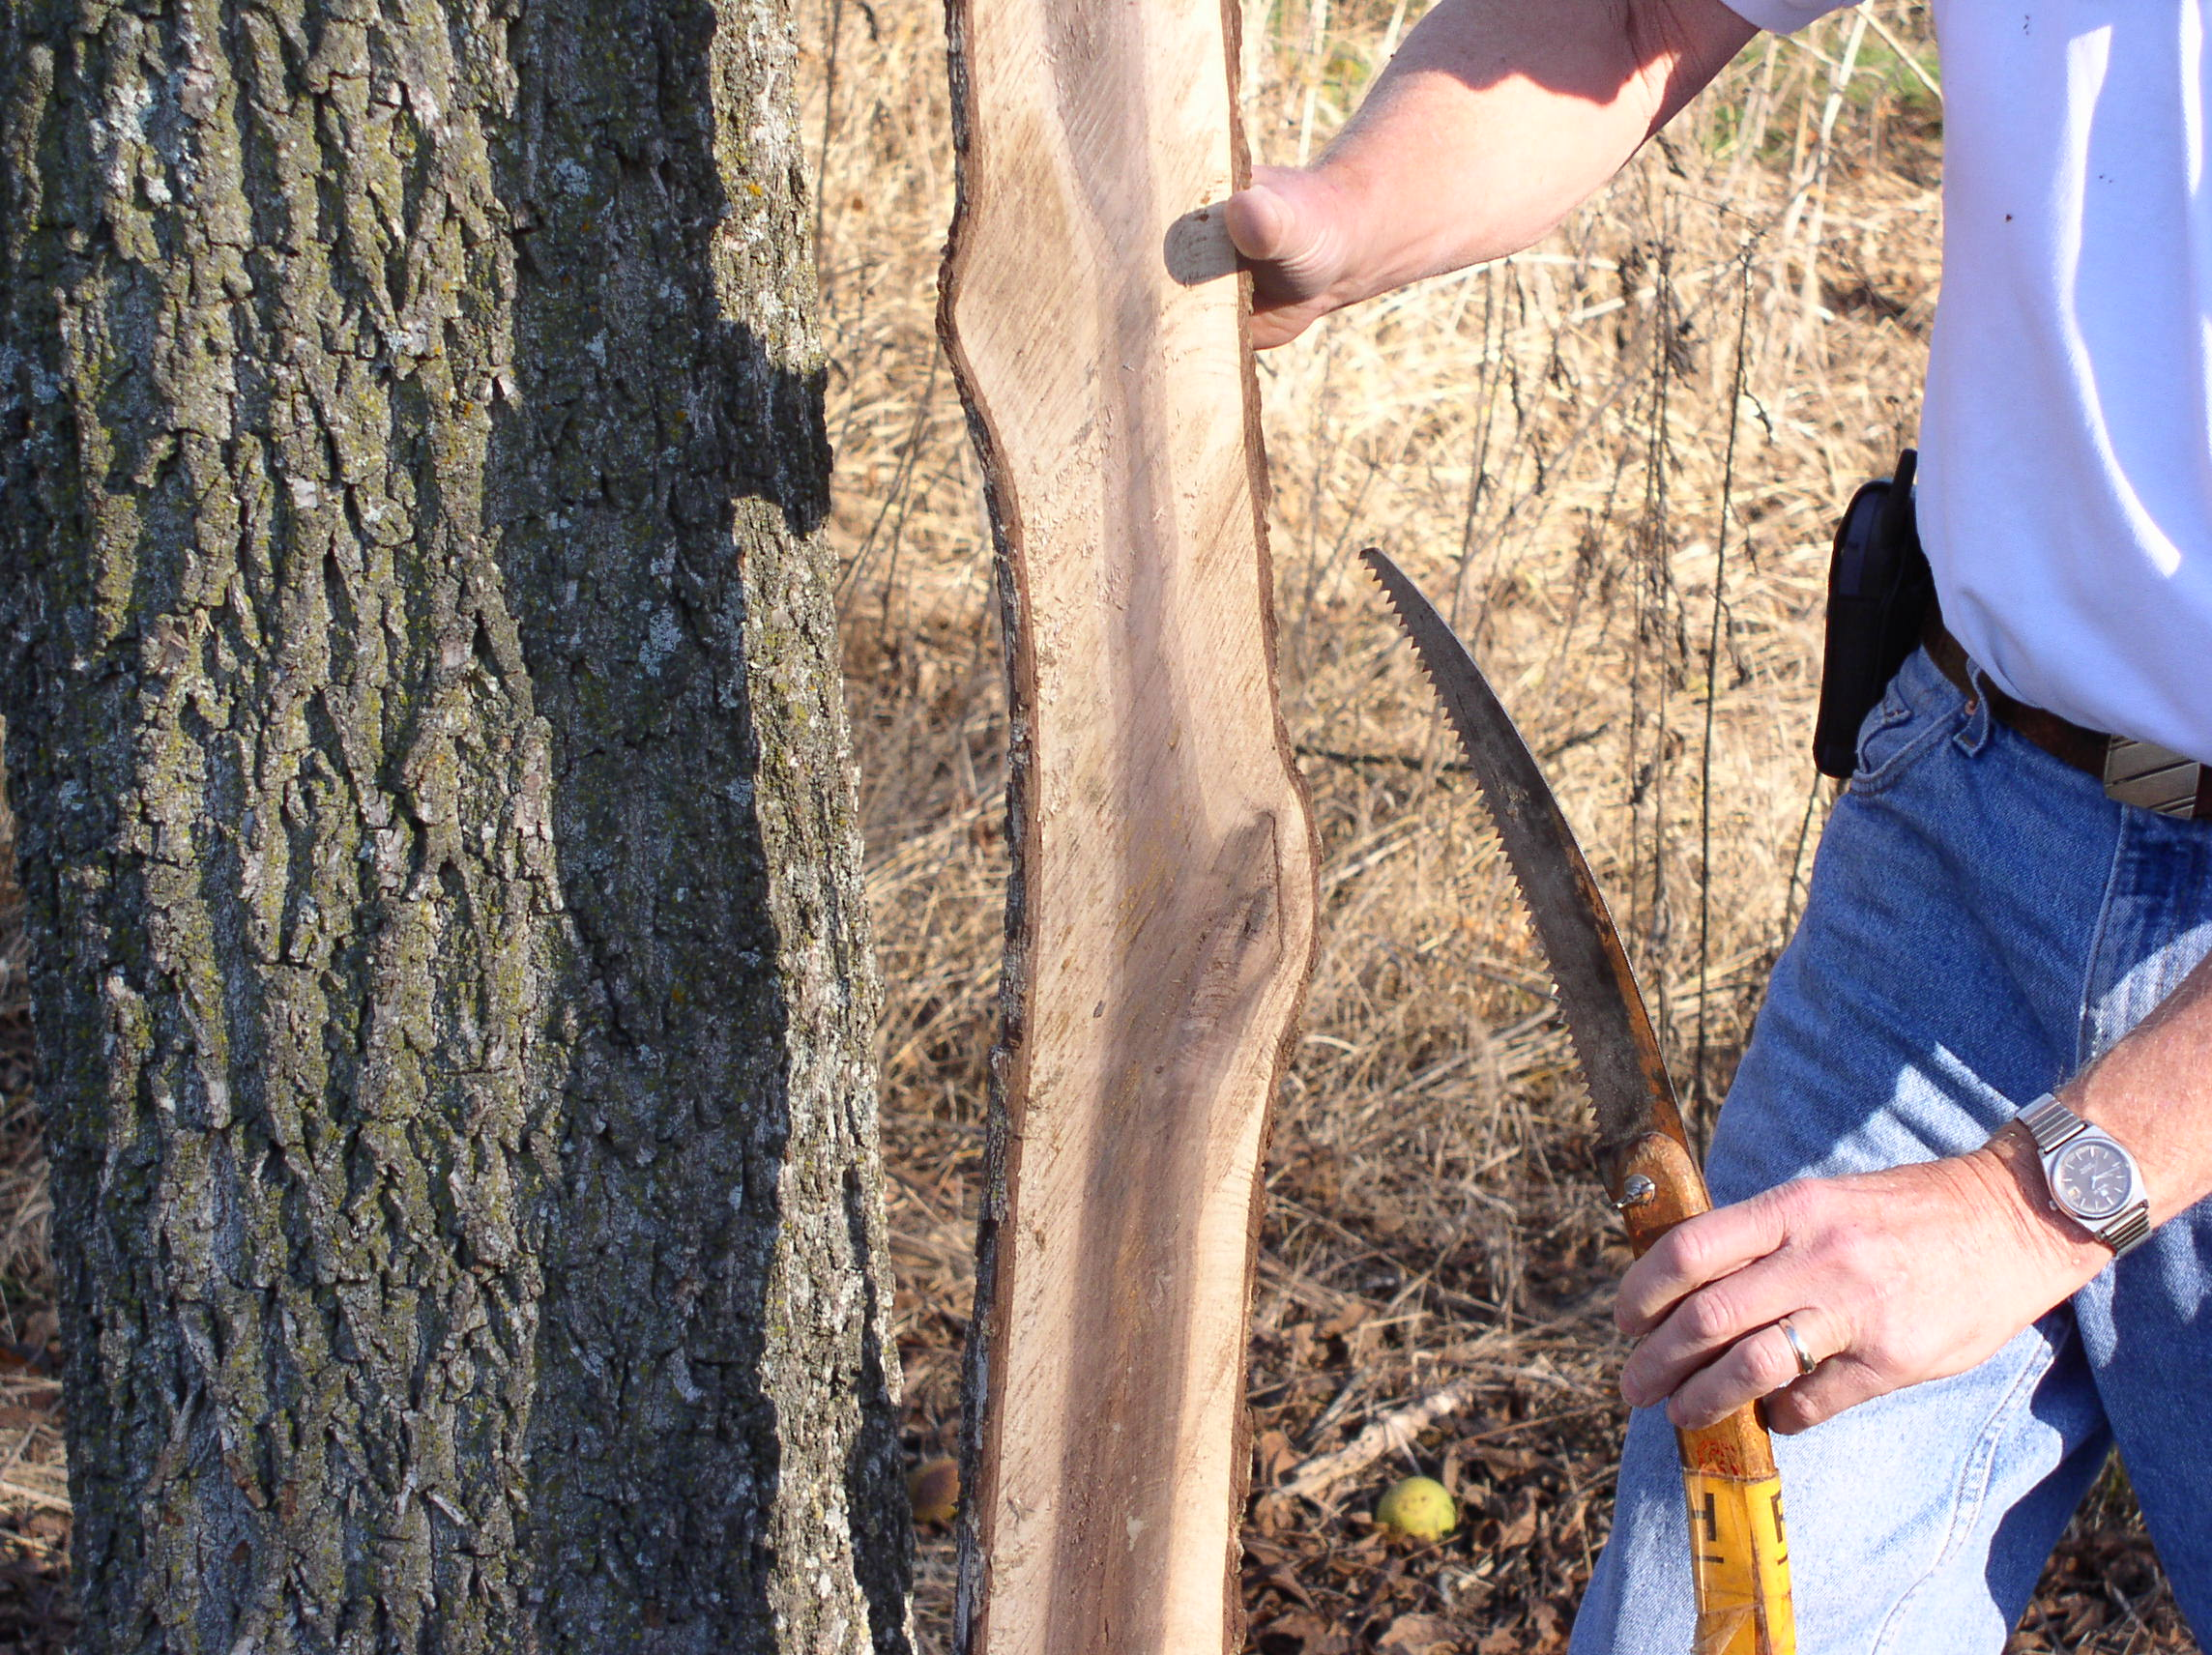
Numerous material goods come from a bottomland forest. And, while the value of a given tree is related to any number of factors, ranging from species and wood-quality to end-product use and consumer demand, most tree species have the potential to be marketed for use as a wood product. These products can range from fine furniture construction to bio-fuel cuttings.
Figure 4. Pruning can increase the value of wood products by elminating smaller branches that, if left in place, would create knots and lower wood quality.
Quality and volume are two typical specifications that will improve or detract from the ultimate value of timber. Quality wood is typically free from branches and any evidence that at one time there existed a branch at that spot. Also, a quality tree is a tree that grows straight. Additionally, large trees are typically more highly valued than small trees. Combine high quality and high volume with high value species and you have a product with good market potential.
Other non-timber products that may grow in the bottomland forest environment are often referred to as alternative or specialty forest products. Often the markets are less well defined for special forest products and becomes the landowner's responsibility to identify products and buyers. A few specialty forest products that may be grown in the bottomland forest include: mushrooms, berries, nuts, fruit, woody decorative florals, and medicinal and botanical plants.
Wildlife Products
In addition to the wood and other specialty products being grown on the site, the wildlife aspects associated with bottomland forests are increasingly being recognized as valuable. An example of this use is leasing access rights for wildlife hunting. Hunting leases are a part of a broader concept of recreational leases, all of which may provide supplemental income from a given land area.
Access to land and its associated wildlife is often marketed as fee hunting. The most common types of fee hunting are lease fees ($/acre/year), daily fees ($/day), and seasonal fees ($/game-season). In the case of wildlife, the hunting lease holder, although retaining rights to access the land for hunting, is still responsible to only take game in accordance with state and federal game laws and seasons. For more on lease hunting, including a sample agreement, please refer to the following publication :
University of Missouri Outreach and Extension guide sheet, G9420, Lease Hunting: Opportunities for Missouri Landowners by Robert A. Pierce II.

Future Products and Markets
There are several areas that hold promise for landowners looking to market their bottomland forest outside traditional wood products. These markets have potential, but are still in their infancy. It is therefore recommended that any forest planning that relies on these markets proceed with caution. Two areas of immediate potential include using bottomland forests for “carbon sequestration” (the storage of carbon removed from the atmosphere) and the use of wood for power generation.
The world market is moving towards recognizing and rewarding efforts that remove greenhouse gasses from the environment. One of the important atmospheric gasses is carbon. Trading exchanges are being established to create forums around cap-and-trade programs that hope to reduce emissions of greenhouse gasses through market based solutions. A commodity likely to be traded will be the long term storage opportunities afforded through tree establishment and maintenance. Several states have passed legislation recognizing the potential of trees established for carbon sequestration including Oklahoma (HB 1192) and Nebraska (LB 957).
Additionally, wood has the potential to reduce our reliance on fossil fuels. Wood can be chipped and then burned in the production of power so that the amount of coal and other energy sources is decreased. Similarly, wood can be processed to produce ethanol, methanol, and diesel based products. As technologies improve and the cost of fossil fuels increases (both directly as in the cost of oil and indirectly as in the environmental cost) the feasibility of utilizing wood for power becomes more realistic.

References used in this section:
Allen, S.B., J.P. Dwyer, D.C. Wallace, and E.A. Cook, 2003. “Missouri River Flood on 1993: Role of Woody Corridor Width in Levee Protection.” Journal of the American Water Resources Association 39(4): 923-933.

Burkhart and Todd, 1998.”Riparian Forest Effect on Lateral Stream Channel Migration in the Glacial Till plains”. Journal of the American Water Resources Association 34(1): 179-184.

Colbert, K. 1998. Height-diameter equations and mortality rates for thirteen Midwest bottomland hardwood species. MS thesis, University of Missouri-Columbia. 68pp.

Dwyer, J.P., D. Wallace, and D.R. Larsen, 1997. “Value of Woody River Cooridors in Levee Protection Along the Missouri River in 1993.” Journal of the American Water Resources Association 33(2): 481-489

Geyer, W.A., T. Neppl, K. Brooks, and J. Carlisle, 2000. “Woody Vegetation Protects Streambank Stability During The 1993 Flood in Central Kansas”. Journal of Soil and Water Conservation 55(4): 483-486.

Hodges, J.D. (1997). “Development and ecology of bottomland hardwood sites.” Forest
Ecology and Management 90, 117-125.

Missouri Department of Natural Resources. Missouri River Corridor Inventory Report. February 1981.
Missouri Natural Heritage Program, 2003. Missouri Species and Communities of Conservation Concern Checklist. Missouri Department of Conservation. Jefferson City, MO. 29 pp.

Missouri River Natural Resources Committee, June 1998. “Missouri River Environmental Assessment Program”. 33 pp.

Mitsch, W.J. and Gosselink, J.G. (2000) Wetlands, 3rd Edition, edn. NY: John Wiley & Sons, Inc.

Nelson, Paul. 2002. The Terrestrial Natural Communities of Missouri. Missouri Department of Conservation. Jefferson City, Missouri. 90 pp.

Nigh, Timothy A., and Walter A. Schroeder. 2002. Atlas of Missouri Ecoregions.
Conservation Commission – State of Missouri. 212 pp.

Soil Conservation Service, 1993a. Impacts of the 1993 Flood on Missouri’s Agricultural Land. USDA, Columbia, Missouri, 1p.

Soil Conservation Service, 1993b. Estimate of 1993 Disaster Damage to Soil and Water Conservation Practices in Missouri. USDA, Columbia, Missouri, 1p.

Bottomland Forest Planning Considerations

A critical element in the management process for a forested area is the development of a comprehensive plan or prescription. Without laying out a course of action it is difficult for the landowner or land manager to know where to begin and where to go. A management plan serves as a “road map” or “blueprint" for the future. This process involves a number of steps or actions that will facilitate the development of the management plan. Each individual should take the time to plan out what ultimately is wanted from their land and the timeframe for all this to occur. The planning process is a step-by-step approach to help the land owner manage their bottomlands toward a
desired future condition (adapted from NRCS National Planning Procedures Handbook, 2003). These steps are listed below and will be covered in detail in separate sections.
Although the steps are shown in typical sequence, the planning process is very dynamic. The process could start with any of the steps. Cycling back to previous steps is often necessary. Also some planning activities may overlap planning steps, and some activities may not necessarily occur in a particular planning step each time.
Step 1—Identify Goals and Objectives: Identify resource problems, opportunities, and concerns in the planning area. Identify and document the client’s goals and objectives.
Step 2—Inventory Resources: Inventory the natural resources and their condition, and the economic and social considerations related to the resources. This includes on-site and related off-site situations.
Step 3—Analyze Resource Data: Analyze the resource information gathered in planning step three to clearly define the natural resource conditions, along with economic and social issues related to the resources. This includes problems and opportunities.
Step 4—Develop the Plan: Formulate actions that will achieve the client’s objectives, solve natural resource problems, and take advantage of opportunities to improve or protect resource conditions.
Step 5—Evaluate and Monitor the Plan: Evaluate the effectiveness of the plan as it is implemented and make adjustments as needed.

References used in this section:
United States Department of Agriculture, Natural Resources Conservation Service, March 2003. National Planning Procedures Handbook, Amendment 4. Washington D.C.

Identifying Goals and Objectives
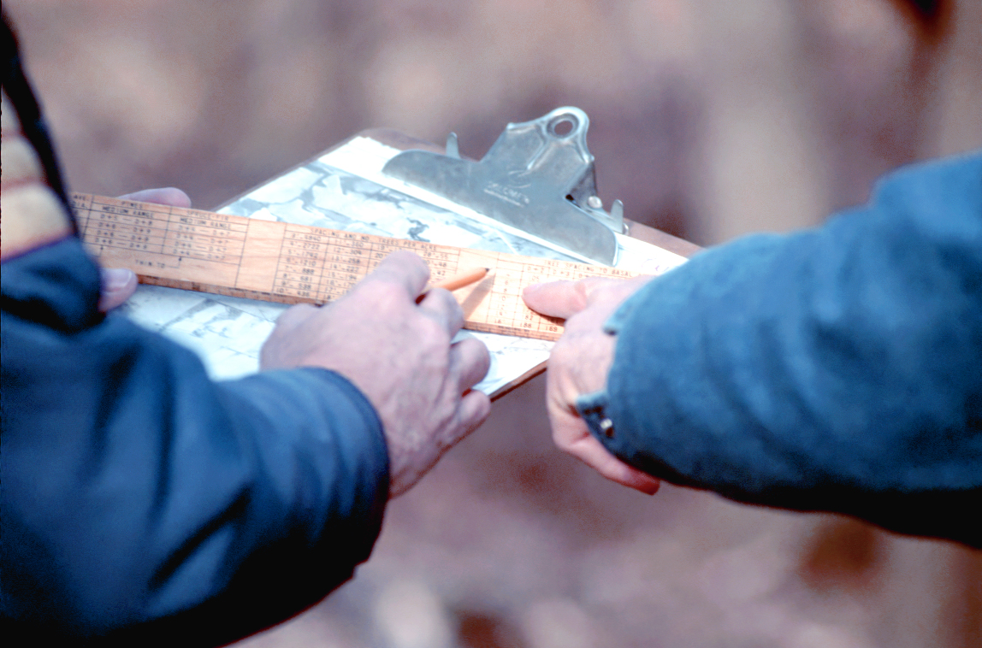
An essential first step in any management planning scenario is the identification of landowner or user goals and objectives. With any forestry management plan, the major issues and concerns need to be considered and addressed. When developing a plan for bottomlands that have been mismanaged, neglected, or have been used as agricultural lands, there are two main avenues of addressing these issues: reforestation or rehabilitation. Reforestation seeks to re-establish the forest where there currently is none. This is mainly done through planting, seeding, or natural regeneration. Rehabilitation repairs an already existing forest by manipulating the existing stand. Intermediate treatments can be used to release good quality trees.
Once the user has developed a vision of the desired future condition of their land, it should be recorded somewhere. This vision should be broad and general in nature stating what the landowner sees their land producing or becoming in the future. After it is written down, it is time to ask some questions. These questions will determine how the land is going to get from point “A” (current condition) to point “B” (desired future condition). Some suggested questions that could be addressed are: What are the current land uses and what might be some of the desired land uses? Are trees going to be introduced on the land? Is the rehabilitation of an existing forest desired?
Figure 5. A plan, outlining landowners goals and objectives, is a critical step in properly managing resources.
Next the user should consider what issues or challenges exist between the current land condition and the vision. These issues should be clearly stated in the management plan. These issue statements should not become overwhelming or too numerous to handle but should try to cover all the major questions which the landowner needs to address. An issue statement could address questions such as these: Are the site conditions (i.e. hydrology, topography, competing vegetation) going to pose a challenge to this desired future condition? Does your land currently have the habitat necessary for the desired wildlife? What are the economic costs of managing for this desired future condition?
Achieving this vision and successfully addressing the issues is highly dependant on clearly defined goals. Set a goal or series of goals that directly relates to each issue, remembering to vary the time durations for the individual goals. This helps see results in the short term. An example of a specific goal might be “Increase hazelnut shrubs on the farm for improved turkey habitat”.
After the goals have been established, the next step is to list the objectives. Objectives answer the question: What will be done to accomplish these goals? They are concise statements that tell what will be accomplished, when it will be accomplished, where it will be accomplished and by whom. These statements are the “building blocks” of guidance for the forest prescription. The development of the vision, issues, goals and objectives may find some redundancy in ideas and wording, however each of these are important aspects to consider in devising a well thought-out plan.
Inventory Resources
This second step is extremely important. It is absolutely imperative that a comprehensive knowledge of critical resources associated with the forest bottomland site be known. In conducting a site inventory of the natural resources, there are certain methods and procedures for collecting, recording and analyzing site information. Site evaluation can be formal involving elaborate techniques and equipment or more informal such as walking through each field and taking notes. Whatever the method, this information will then become the basis for determining the current condition of site resources (Analyize Resource Data – Step 3) and help determine a future course of action (Develop the Plan - Step 4) that will become a plan for reaching user objectives.
Some important basic resources to inventory include climate, hydrology, landscape information (such as topography and soils), wildlife, and trees.
Climate
Climate variations are important considerations when making a schedule of management activities. Climatic factors influence tree growth and development through precipitation (distribution and amount), temperature range, and evapo-transpiration. (Allen, et. al. 2001) Missouri’s climate is characterized as a continental climate that has
distinct summer and winter seasons. In Table 2 several important differences are shown for the various regions of Missouri’s big river subsections. This table is a compilation of climate data from Nigh and Schroeder’s (2002) Atlas of Missouri Ecoregions. These differences can influence the species selection and limit the regions from which nursery stock should be utilized. For example, the Mississippi River Alluvial Basin Section experiences 220 to 250 growing season days per year. Therefore, seed stock taken from this region would be best utilized where the growing season is a similar length. Similarly, stock taken from a region or state where the growing season is significantly shorter would not be well suited for regions with a longer growing season. It is best to utilize stock collected in a similar climate with similar growing conditions relative to the site under management consideration.
In general, selection of species to be planted should be from a seed source originating
within a 100 mile zone north and south of the planting area.

Table 2. Climate data by selected ecoregion subsections
Ecoregion | MA Precip. | Wettest Months | Min. Temp. | Max. Temp. | Growing Season
 | Inches | Months | January (F) | July (F) | Days
Missouri River Alluvial Plain Subsection | 40 | May-June and September | 17 to 18 | 90 | 210
Missouri River Alluvial Plain Subsection | 34 to 39 | May-October | 12 to 17 | 89 to 90 | 200 to 208
Mississippi River Alluvial Plain Subsection | 40 to 47 | March-May and August | 18 to 22 | 90 | 210 to 215
Mississippi River Alluvial Basin Section | 48 to 52 | Equal Monthly Distribution | 25 | 91 | 220 to 250

Hydrology
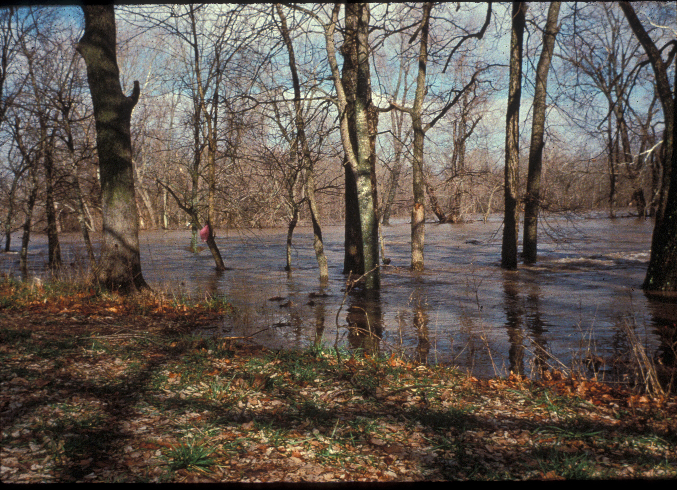
Bottomland forests are intimately tied to hydrology. Direct and indirect impacts of hydrology interact with soils and topography to influence the species that establish and develop on micro-sites within the floodplain. Two direct effects of flooding on floodplain forest composition are oxygen availability within the soil and physical impacts on vegetation. Through diffusion, there is 10,000 times less available oxygen in water than in air, so when soil is inundated by flooding, oxygen is deprived from plant roots and plant growth is retarded (Ponnamperuma 1972).
Figure 6. Flooding frequency influences species composition on many bottomland sites.
A second direct effect of flooding is physical damage to vegetation from scouring, debris and ice. Typically, smaller diameter trees are more susceptible to damage from scouring and debris carried in flood waters (Ponnamperuma 1972).
Indirect flooding effects are largely the result of nutrient availability due to soil oxygen levels. The availability of two nutrients, phosphorus and nitrogen, may limit forest productivity. Phosphorus is bound to sediments. The phosphorus content of some floodplain forests is high due to sediment deposition, however its availability to plants is dependent on many factors. Nitrogen primarily moves in solution and is also brought in by flooding events and is thought to be the most limiting nutrient in flooded soils (Ponnamperuma 1972). Anaerobic conditions convert nitrate (NO₃) to nitrous oxide (N₂O) where it is lost from the bottomland system. These direct and indirect effects on floodplain forest composition are regulated by the hydrologic regime of the floodplain.
The important factors of a hydrologic regime, as they relate to forest communities, are: 1) timing - time of year that the flooding occurs; 2) duration - the length of time that the floodplain is inundated with water; 3) frequency - how often the flooding occurs during the year and between years; 4) depth - height of water above the floodplain surface; 5) rate of change - how fast the water rises or falls (Poff and Allen 1997).
The combination of these five factors plays a large role in the woody species that can be successfully established on particular sites. In addition, growth rates can also be affected by these five factors. On certain microsites a number of species, such as Eastern cottonwood (Populus deltoides), silver maple (Acer saccharium) and willow (Salix spp.), may be successfully regenerated in response to timing and duration of flooding events. On sandy soils near the active channel, flooding events kill competing herbaceous vegetation and allow for adequate soil moisture for cottonwood establishment. Moreover, the speed at which the waters recede is critical to the survival of cottonwood reproduction (Segelquist, et al., 1993). Timing also plays a large role in the management of Green Tree Reservoirs (GTR). These GTRs are flooded in late fall and winter when
trees are dormant and the flooding is thought not to have a large affect on the survival of the trees (Fredrickson and Batema, 2000). This interaction between frequency and duration of flooding events is less well studied.
There are situations that flooding into the growing season restricts species establishment and growth. An example in Missouri of the effect of flooding frequency on species composition was evident at Ted Shanks MDC Conservation Area, near Hannibal, Missouri. Increased flooding frequency prior to the 1993 flood stressed pin oak (Quercus palustris) to the extent that it was removed from the bottomland community.
Green Tree Reservoirs are floodplain forests that are leveed and flooded to create habitat for early migratory waterfowl.
Depth of flooding also has important implications for both seedling and tree survival. Research studies have found that hardwood seedling survival is directly related to flooding depth (Siebel et al., 1998; Yanosky, 1983).
Landowners typically possess a good knowledge of the flooding events (frequency and duration) on their property. Existing information on precipitation events, soils, vegetation cover, size and shape of the watershed, and micro relief of the floodplain can assist landowners in understanding the hydrology of these areas.
Stream Flow Information: The United States Geological Survey (USGS) currently provides access to stream flow data by means of the internet. Approximately 400,000 station years of historical daily mean flows for about 18,500 stations are available through USGS. The USGS url address for access to stream flow data is: http://water.usgs.gov

Landscape Information and Resources
Landscapes and their features can be characterized in many different ways. Important resources associated with bottomland forested landscapes are topographic maps, aerial photography, soil maps, and ownership boundaries. The following discussion illustrates these different representations.
Topography – Topography is characterized by the length, shape, aspect, elevation and degree of slope. It is important in determining and influencing the pattern and distribution of soils, vegetation and hydrology. While distinct topographic features exist in big river bottomland floodplains, relief on the alluvial floodplain is generally less than 10 feet in any square mile. These small differences in relief (micro-relief) can, none-the-less, have strong influences in bottomland floodplain responses.
Floodplain micro-relief features include meander scroll, natural levee, chute, oxbow, splay, slough, swamp, ridge and flat (Figure 1). The rivers within these areas have periodically shifted courses during flood events. This shifting has resulted in the

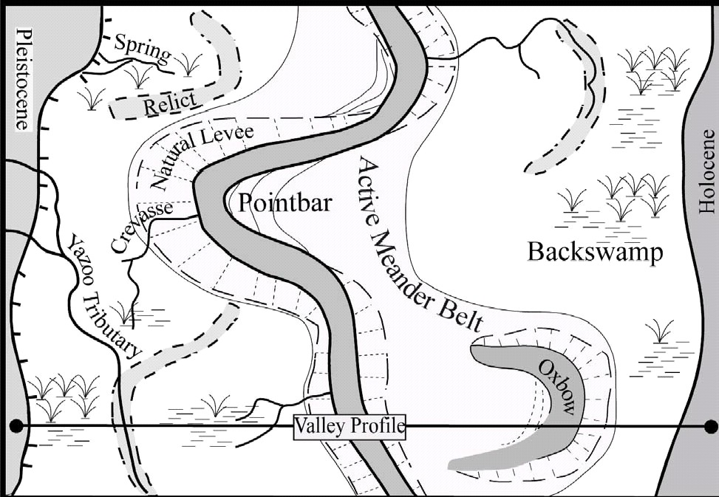
development of meandering river channels. These abandoned channels, called meander scrolls, exist as ridges (remnants of a natural river levee) and depressions (remnants of the river channel). Natural levees develop along river banks due to the deposition of heavier sand and silt sediments in the area adjacent to the river channel during flood events. These natural levees are often the highest and better drained areas within a floodplain. A gentle back-slope occurs on the floodplain side of the natural levee, so the effective floodplain typically contains low flats far from the river. Oxbow lakes are formed within floodplains when meanders are cut off from the main river channel. These oxbow lakes hold water permanently. Sloughs are smaller than oxbows and form within the meander scrolls previously discussed. Sloughs also hold water but they are often dry during part of the year. The formation of meander scrolls, natural levees, sloughs, and other features result in a fairly complex floodplain topography dominated by micro-relief features (Flynn 1999).
Figure 7. Example of micro-relief features typically found in a floodplain landscape.

These topographic features are represented visually on a topographic map. These maps represent horizontal and vertical positions of physical features by using standard symbols. Standard topographic maps are published in quadrangles bounded by lines of latitude and longitude. Generally, topographic quadrangles cover 7 ½ minutes of latitude and longitude with a scale of 1:24,000. The scale symbolizes 1.0-inch on the map to 24,000 inches (2,000 feet) on the ground. A quadrangle map area typically represents an average of 63 square miles.
Topographic maps of Missouri are highly detailed maps of the Missouri landscape, showing hills, valleys, forest cover, roads, streams, houses, barns, and other landscape features. Topographic maps accurately represent the natural and man-made features of the land. They do so through the use of symbols, lines, text and color. Color plays an important role in designating major features on topographic maps. Black is used for human developed features such as buildings, roads, transmission lines, names and boundaries. Blue symbolizes water, showing lakes, ponds, rivers and streams. Red is used to show major roads or highways, section lines and numbers. Green depicts woodland cover and orchards. Brown is used for contour lines, which symbolize land shapes and elevations. Contour lines are imaginary lines that follow the ground surface at a constant elevation, meandering around hills and up and down valleys. Contour lines are useful for determining elevations and the shapes of the land (Figure 8).
The 71/2-minute, 1:24,000-scale map series of Missouri was completed in 1988 through the cooperative effort of the U.S. Geological Survey and the Missouri Department of Natural Resources. There are 1,283 maps in the series for Missouri, and each one has a unique name. The number of 71/2-minute maps needed to cover an entire
county varies from 1 to 20 depending upon the size and shape of the county.
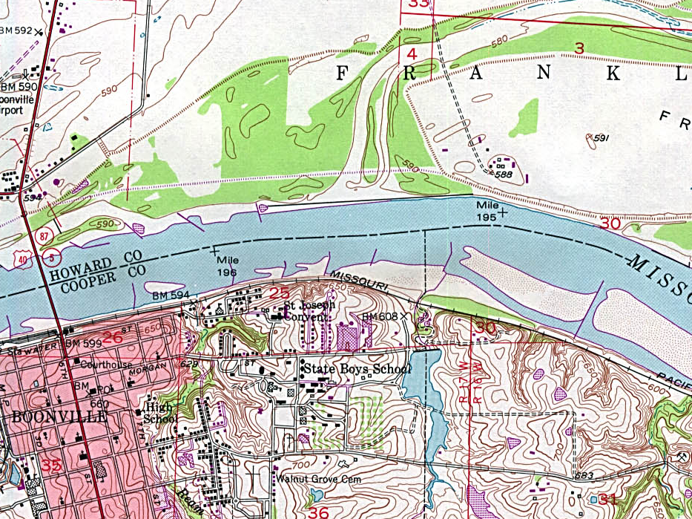
Topographic maps may be obtained at various locations across Missouri. One of the best sources is through the Maps and Publications service of the Missouri Department of Natural Resources Geological Survey and Resource Assessment Division (GSRAD). Topographic quadrangle maps should be ordered by name, because there are more than a thousand individual maps available. (Weaver 1998). For a free catalog of publications and a list of available topographic maps, prices and other information, contact the Missouri Department of Natural Resources’ Geological Survey and Resource Assessment Division, P.O. Box 250, Rolla, MO 65402-0250, or call (573) 368-2125. Web address: http://pubs.usgs.gov/
Figure 8. A topographic 7 ½ minute quadrangle map example near Boonville, Missouri in Cooper and Howard Counties along the Missouri River.

Aerial Photos – Aerial photography is one of the oldest and most versatile forms of remote sensing to assist in documenting visual information. A useful aerial photograph is the orthophotograph. An orthophotograph is an aerial photograph with nearly all the image displacement and scale errors removed. Photographs are routinely taken in black and white panchromatic, black and white infrared, color-visible, color-infrared, and multiband types. Aerial photographs may be taken in vertical, low-oblique or high-oblique positions; standard air photos are vertical views of the ground. Vertical photographs are normally acquired in overlapping pattern, so as to create a stereoscopic effect when adjacent pairs are viewed together. Aerial photos can be obtained from county USDA Service Centers or through various internet sites.

Ownership Boundaries - Ownership boundaries are important reference points for inventory activities. Failure to distinguish accurate boundaries can result in incorrect resource information and possible legal problems.
Ownership boundaries are based on a legal description of the parcel or parent land tract taken from the title of record maintained at the County Court House, Recorder of Deeds. The survey shows sufficient data (distances and directions) to positively locate the parcel surveyed within the United States Public Land Survey area. The deed descriptions of tracts divided by the rectangular system of public land survey includes the principal meridian, township, range, section, and fraction of section (Figure 3). (Code of State Regulations, 2001). A 40 acre tract in Callaway County might read: the NE ¼, SW ¼, Section 6, T47N, R9W, 5th Principal Meridian. (Figure 9)

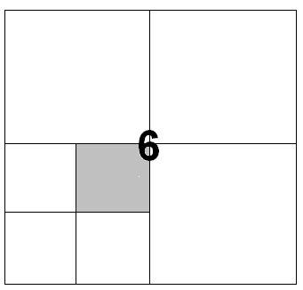
Figure 9. Example layout of a typical section with quarter sections noted.

Figure 9. Example layout of a typical section with quarter sections noted.
Forest property lines are usually maintained by at least one of three methods: (1) hack or blaze marks, (2) purple paint bands, or (3) 3x3 inch aluminum tags bearing the landowners name. Owners should be careful in accepting evidence of older property lines. Such boundaries should always be checked by running lines from known corners.
SE 1/4
SW 1/4
SE 1/4
SW 1/4

NW 1/4

SW 1/4
NW 1/4
NE 1/4
NW 1/4
NE 1/4
NE 1/4

Soil - Soil is a natural, three-dimensional volume at the earth’s surface. It is capable of supporting plants and has properties resulting from the integrated effects of climate and living matter acting on parent material, as conditioned by topography over periods of time (United States Department of Agriculture, 1993). Knowing what soils are present on any tract of land is basic inventory information that is critical to resource management activities relating to plant growth, potential uses, and site limitations.
Soils associated with the big river bottomlands in Missouri are very deep and were formed from alluvial sediments. Subsoil development is generally young and soil profile textural stratification is common. Soil texture, drainage, flooding, and deposition, vary depending on the topography within the floodplain (Figure 10).
Figure 10. Example of a typical pattern of soils, topography, and parent material (From Callaway County Soil Survey, 2001 )
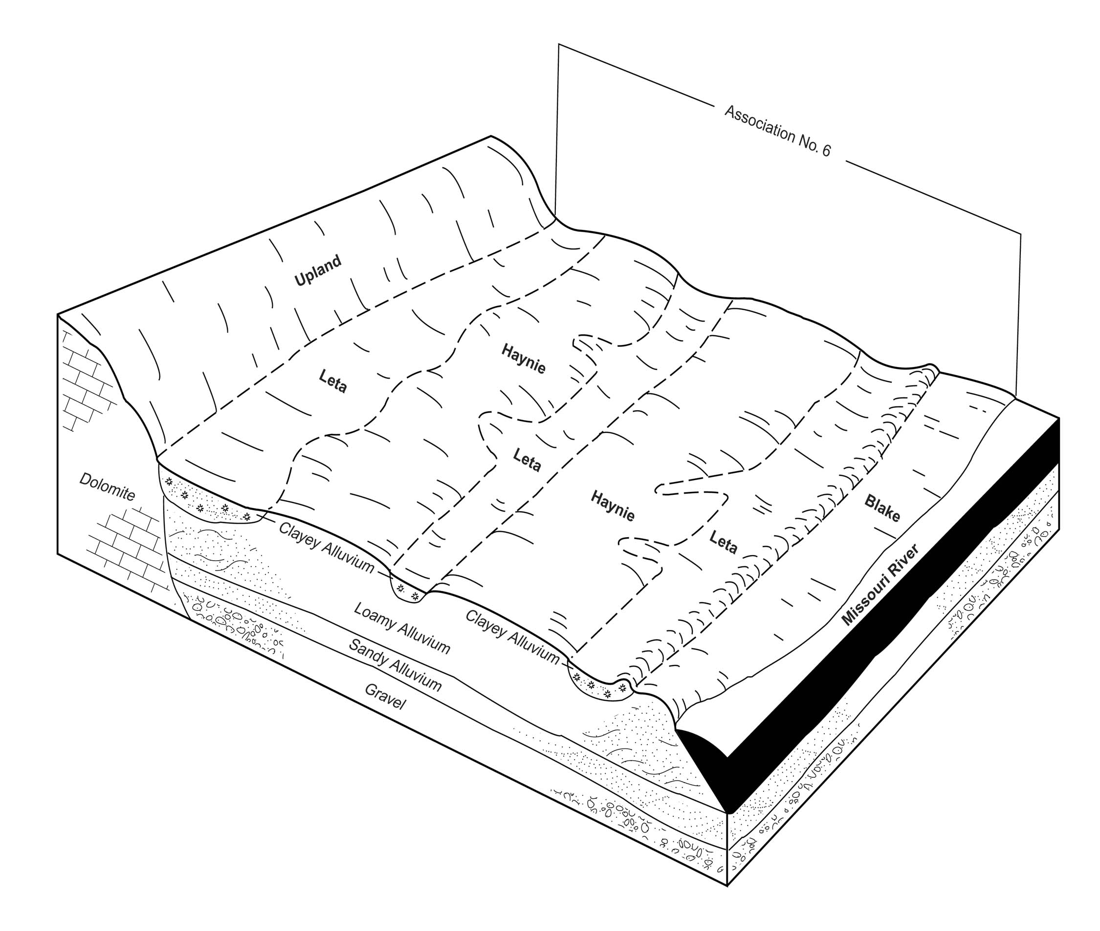
Sandy soils occur in splay deposits and natural levees. Silty soils are on natural levees and ridges. Clayey soils are generally farthest from the river on broad flats and within depressional areas such as sloughs and chutes. In certain areas, older deposits are inter-fingered with newer ones, creating a mosaic of texture, drainage, and elevation within relatively short distances. In addition, some soils have strongly contrasting textures within the profile, reflecting changes in river position and flooding periods. Soil drainage varies widely throughout the floodplain and are related primarily to elevation and textural differences. In general, however, many soils are somewhat poorly to poorly drained. The soils of lower elevations will experience more frequent and longer periods of flooding or saturation than will higher sites. Elevation and textural differences generally influence the boundaries of soils and drainage conditions (United States Department of Agriculture, 1993).
All soils contain properties that determine their suitability for specific uses and their influence on plant growth. The following is a listing of major soil properties that affect the suitability of bottomland soils for selected uses. (United States Department of Agriculture, 1993)
- Permeability (Hydraulic conductivity) (the rate at which a saturated soil transmits water down through the profile.) The ability to move water through the soil profile will have an impact on species composition and plant growth. Moderate permeability is the optimum condition in most cases. Too slow or too rapid are both undesirable rates.

- Available water capacity (the capacity of soil to hold water available for use by most plants.) It is commonly defined as the difference between the amount of soil water at field moisture capacity and the amount at wilting point. The higher the available water capacity the better potential plant growth.

- Soil texture (the relative proportions of sand, silt and clay particles in a mass of soil.)
The basic textural classes in order of increasing fine particles are: sand, loamy sand, sandy loam, loam, silt loam, silt, sandy clay loam, clay loam, silty clay loam, sandy clay, silty clay, and clay. Extremely fine or coarse textures may have a negative influence on plant growth and other site uses.

- Flooding (overland flow of free water from a storm event). Flooding impacts are related to flooding frequency, duration, velocity and depth. Species composition, plant survival and growth, and potential uses will vary with the type of flooding the site experiences.

- Ponding (standing water in closed depressions). The duration, depth and time of year of standing water have a strong influence on site use and species composition.

- Soil drainage (frequency and duration of the existing wetness condition). The natural drainage is related to soil texture, depth to water table, and landscape position. (See Figure 5). The basic drainage classes in order of increasing wetness are: excessively drained, somewhat excessively drained, well drained, moderately well drained, somewhat poorly drained, poorly drained, and very poorly drained.

Figure 11. Relationship of water table and topography to drainage classes. In general, as the water table gets closer to the land surface, the soil drainage will decrease.

River Water Table

Soil Survey
A soil survey contains information that can be used in land planning activities. Soil maps can be obtained from completed soil surveys available at local USDA Service Centers. A modern soil survey contains a wealth of useful information about the soils of a county. Some soils are seasonally wet or subject to flooding; some are shallow to bedrock; some are too unstable to be used as a foundation for buildings or roads; some are too clayey or wet soils to use as septic tank absorption fields; and some have a high water table that makes soil poorly suited to basements or underground installations. These and many other soil properties that affect land use are described in a soil survey.
Soil survey information includes discussions on the use and management of soils, data on soil properties, detailed soil descriptions and classification of the soils. The soil survey contains predictions of soil behavior for various land uses. The survey also highlights limitations and hazards inherent in the soil, improvements needed to overcome the limitations, and the impact of selected land uses on the environment.
One of the most valuable pieces of information in a soil survey is the detailed soil map. The location of each soil is shown on the detailed soil maps through the use of lines representing soil map unit boundaries. Each map unit (identified with a map symbol) represents an area on the landscape and consists of one or more soils for which the unit is named (See Figure 12 ). A map unit is identified and named according to the taxonomic

Figure 12. Example of a soil survey map from Callaway County Soil Survey along the Missouri River
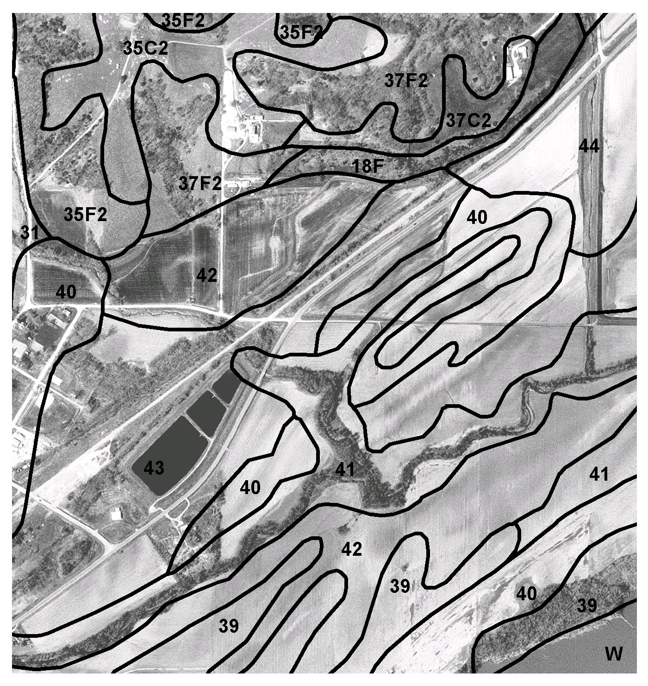
Legend:

Symbol Name
35 C2 Menfro silt loam 3-9% slopes
35 F2 Menfro silt loam 20-30% slopes
18 F Goss-Gasconade-Rock 5-35% slope
39 Hodge fine sand, loamy substratum
40 Grable very fine sandy loam
40 Leta silty clay loam, sandy substratum
44 Dupo silt loam

Map symbols consist of numbers or a combination of numbers and a letter. The initial number represents the kind of soil. The capital letter following the map number indicates the class of slope. The higher the letter is in the alphabet the steeper the slope. Symbols without a letter are nearly level. Symbols with the number of “2” following the slope letter indicate the soil is eroded. The newer soil surveys in Missouri use a 5-digit number sequence that represents a given Major Land Resource Area (MLRA) and land form within the sequence.

classification of the dominant soils. Map unit areas rarely can be mapped without including areas of other taxonomic classes due to scale of mapping. As a result, every map unit is made up of the soils for which it is named and other closely associated minor components (United States Department of Agriculture, 1993).

Internet Sites

Several Internet sites have been developed to assist in providing natural resource information to the public. Below is a listing of sites that may be beneficial.
www.mo.nrcs.usda.gov This is the home page for the Missouri Natural Resources
Conservation Service. You can find out about Soil Survey (hard copy) status and other services offered.

www.cares.missouri.edu/soils The Center for Agricultural, Resource and Environmental Systems (CARES)Missouri Digital Soil Survey website can be used to view online surveys, develop maps based on your queries, and download data.

www.statlab.iastate.edu/soils/nssc This is the USDA-NRCS National Soil Survey Center website. It provides information on soil science education, soil survey maps, soil information and data, soil geography, soil use and management, standards for soil surveys, research and investigations and professional development.

www.ftw.nrcs.usda.gov/ssur_data.html This is the USDA-NRCS National Soil Survey Geographic Database (SSURGO) website. Options for further exploration include general SSURGO description, SSURGO listing, archived SSURGO map, SSURGO Data Users Guide, download SSURGO data, order SSURGO data on CD-ROM.

www.misdis.missouri.edu Digital soils data for Missouri are available for download on the Missouri Spatial Data Information Service (MISDIS) website as ArcInfo coverages and ArcView shapefiles. Many other types of Geographic Information Systems (GIS) data for Missouri are also available for download on this site.

Wildlife

Numerous wildlife species depend on big river bottomland forests and their associated habitats for feeding and breeding sites in order to sustain their populations. While it may be difficult or impractical for a user to inventory wildlife on a farm, there are numerous reference sources that can provide information relating to the potential occurrence of any given species. Knowing the type of species that could use habitat in the area will allow the landowner to develop activities and actions in the plan that will encourage or support interested wildlife species. In many cases, the wildlife inventory will simply be a visual catalog of species noted while moving around on the bottomland tract. Species occurrences for common birds and mammals follow.
There are several state and federal laws which govern the conservation and management of all wildlife species. The Missouri Department of Conservation is the agency which enforces these laws and is the agency which should be contacted when a landowner wants to restore certain habitats to encourage wildlife to use their property or if a landowner has questions regarding land management activities and potential impacts on wildlife populations.

Birds
The Missouri River valley is an important breeding and wintering ground for many native songbirds, migratory waterfowl, and shore bird species as it lies between the Mississippi Flyway and the Central Flyway. Mallards (Anas platyrhincos) and Canada geese (Branta Canadensis) are the most common migratory waterfowl in the Missouri River valley. Other common species are shown in Table 3.
Table 3. Migratory waterfowl common to the Missouri River Valley.
Common Name | Scientific Name
snow goose | Chen caerulescens
American black duck | Anas rubripes
northern pintail | Anas acuta
green-winged teal | Anas crecca
blue-winged teal | Anas discors
cinnamon teal | Anas cyanoptera
Shovelers
American widgeon | Anas Americana
wood duck | Aix sponsa
Redhead | Aythya americana
Canvasback | Aythya valisineria
lesser scaup | Aythya affinis
Bufflehead | Bucephala albeola
ruddy duck | Oxyura jamaicesis
pied-billed grebe | Podilymbus podiceps
American coot | Fulica Americana

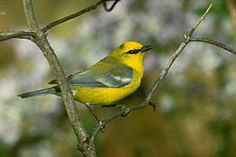
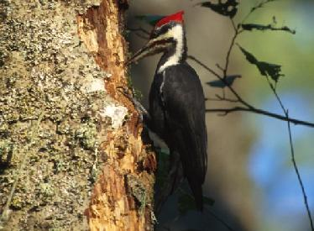
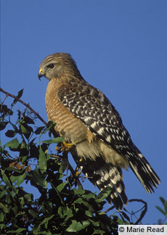
Bottomland forests along the river provide a rich habitat for many forest-dwelling birds. This habitat is important for several species near the edge of their range, such as the red-shouldered hawk (Buteo lineatus), pileated woodpecker (Dryocopas pileatus), Carolina chickadee (Parus carolinensis), white-eyed vireo (Vireo griseus), yellow-throated vireo (Vireo flavifrons), and blue-winged warbler (Vermivora pinus).
Figure 13. Blue-winged warbler, pileated woodpecker, and red-shouldered hawk

Furthermore, the state-wide reintroduction of wild turkeys (Meleagris gallpavo) has returned this species to game status in many bottomland forest corridors.

Mammals
Wild mammal populations in the Missouri River corridor depend on bottomland habitat and bordering uplands for their maintenance and survival. Mammals use forest, marsh, backwater meadow, and sandbar and dune areas located on or near the banks of the Missouri (Table 4). The bluff caves along the river and the dense bottomland
Table 4. Typical mammal species found in riverine woodland habitats.
Common Name | Scientific Name
White tailed deer | Odocoileus virginiana
Beaver | Castor canadensis
Mink | Mustela vison
Raccoon | Procyon lotor
Red fox | Vulpes vulpes
Gray fox | Urocyon cinereoargenteus
Opossum | Didelphis virginiana
Squirrels | Family Sciuridae
Skunks | Family Mephitidae
Coyote | Canis latrans
Shrews | Family Soricidae
13-lined ground squirrel | Spermophilus franklinii
Mice and voles | Family Muridae
Gray bat | Myotis grisescens
Indiana bat | Myotis sodalis
woodlands provide good habitat for several species of bats in addition to many other wildlife species (Schwartz and Schwartz, 2001).
Forests
The purpose of a forest inventory is to acquire detailed information about a forest. An inventory may be needed to buy or sell timber products, to evaluate damage to the forest, or to determine the condition or extent of a forest. The forest inventory is a compilation of information that becomes the essential starting point for bottomland forest management decisions. The information collected will help clarify the condition of the forest resource and serve as a guide to future management decisions.
Floodplain forests are typified by tree species that are adapted to an environment that is characterized by frequent flooding events (Table 5). The flooding events create dynamic landscapes that continually modify soil resources and affect species distribution and composition.
Table 5. Species typically found in floodplain landscapes.

Swamp privet Foresteria acuminate
Green ash Fraxinus pennsylvanica
Deciduous holly Ilex decidua
Water elm Planera aquatica
Overcup oak Quercus lyrata
Nuttall oak Quercus nuttallii
Black willow Salix nigra
Baldcypress Taxodium distichum
Boxelder Acer negundo
Red maple Acer rubra
Silver maple Acer saccharinum
Native pecan Carya illinoensis
Sugarberry Celtis laevigata
Hackberry Celtis occidentalis
Persimmon Diospyros virginiana
Sweetgum Liquidambar styraciflua
Sycamore Platanus occidentalis
Cottonwood Populus deltoides
Pin oak Quercus palustris
Water oak Quercus nigra
Willow oak Quercus phellos
River birch Betula nigra
Shellbark hickory Carya laciniosa
Green hawthorn Crataegus virdis
Honeylocust Gleditsia triacanthos
Swamp white oak Quercus bicolor
Bur oak Quercus macrocarpa
American elm Ulmus Americana
Cherrybark oak Quercus pagodaefolia
Red elm Ulmus rubra

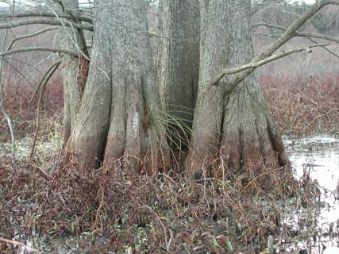
Figure 14. Many species of trees such as bald cypress are highly adapted to wet conditions.
Because tree growth is intricately linked with factors of site productivity, areas of existing forest are often broken down into manageable divisions called stands for inventory purposes. The forest stand is the unit by which large forested areas are subdivided and each individual stand managed for improved sustainability. There is no set size for this land unit. Rather, the soils, topography, or other natural land features that affect tree growth are often used to delineate the forest stand. Since variations including size, density, composition, and age exist across the forested land area, it is important to break the forest area into homogeneous stands prior to making management recommendations. Forest inventories should include a map that references where each forest stand is located and how many acres it contains.
How is a forest inventoried? Typically only a portion of the forest is sampled or inventoried. For example, if there were 300 trees per acre on 40 acres that means there are 12,000 trees that would have to be measured to do a complete inventory. This is a formidable of a task, so an inventory should attempt to obtain information on a representative sample of the trees that are of interest. If all trees were identical on the 40 acres then only one tree would have to be sampled to get a picture of the total forest. In reality, trees in a forest, or any natural resource for that matter, are never uniform in species, size, distribution, or any other characteristic. Therefore, the forest stand is partially sampled using various methods to inventory or “cruise” the forest to provide an estimate of the actual forest stand (Husch, et al.,1972).
Types of Forest Inventories
Basically, there are two types of inventories used to sample trees: fixed-radius plot inventory and variable-radius plot inventory. Regardless of the inventory type, the tree measurements observed on each sample plot should include most, if not all of the following pieces of data, recorded by species: diameter at breast height (DBH) measured in inches at 4.5 feet above ground line, the age (years) of a few representative mature trees, the tree height measured as total or to some point on the bole (main tree trunk) specified as merchantable, and maybe something about tree quality or grade. From these inventories basal area (BA) measured in square feet, tree count, and volume can be determined (Husch, et al.,1972).
The fixed-radius plot is a fixed area that is established for inventorying. All trees within this plot radius are measured. These plots can be randomly or systematically located within the forest stand. The arrangement and number of plots will depend upon the uniformity of the forest, site conditions, type of information needed, and landowner time and objectives. The typical fixed radius plot has a plot center from which a known radial distance is measured out from that plot center. The size of the fixed plot should vary with the size of the vegetation.
Whether using a variable plot size or a fixed plot size, each counted tree should have its diameter measured at DBH. This may then be used to calculate BA per acre (BA/acre = 0.005454 x DBH² x the expanded # of trees per acre). The tree count can also be used to calculate an average diameter for the stand and will be useful in making management decisions based on a stocking guide (Husch, et al.,1972).
Variable-radius. The variable-radius (prism plot) is a plot whose center is fixed but whose radius varies depending upon the size of the individual tree. Two specialized forestry tools, the wedge prism and angle gauge, are used to sample trees with this type of inventory. Both tools are used to project a fixed angle from the plot center to a tree at DBH. These tools create a visual perspective that when held at a set distance from the eye and superimposed on the tree of interest determine whether the tree is to be inventoried.
The wedge prism (Figure 15) is a wedge-shaped piece of glass calibrated to a pre-determined angle factor (In the Midwest, a 10-factor prism is commonly used). The prism is held over plot center and rotated in a 360-degree circle to view trees in the line of sight of the prism. When viewing the tree through the prism the tree will appear to be displaced. Any tree whose bole image is superimposed over the real tree is counted as an “in” tree.

The second tool used in variable radius sampling is referred to as an “angle gauge”. This tool has an opening that when viewed through creates a visual reference angled opening. While standing at plot center the angle gauge is held at 25.0 inches from the eye and rotated in a circle the angle gauge to count trees. Trees that at least fill the opening are counted as an “in” tree.
Wedge Prism
Figure 15
Individually, or in combination, basal area and tree count will provide an estimate of stand density within a stand. Another term often used when referring to stand density is stand stocking. Stocking becomes a significant measure of how much space is being utilized by trees. Ideally, a stand density or stocking is sought that will provide for optimum utilization of the sites resources (light, water and nutrients), while providing for consistent tree growth rates for a given site. Stocking guides are available for many forest stand types and is an important parameter used in forest assessment.
To calculate basal area multiply the number of “in-trees” sampled in the plot times 10. (referring to the 10-factor prism). For example, if there are 8 “in-trees” using your prism then the basal area in square feet is: 8 trees x 10-factor = 80 sq.ft. of basal area (BA).
Basal area and trees per acre (TPA) relate directly to the density of a forest stand. Basal area is the cross-sectional area in square feet of each individual tree measured at DBH. In most cases a 10-factor prism or angle gauge is used to count basal area.
See Forest Management for Missouri Landowners for an in-depth description of taking a sample plot basal area.
Fixed-radius. A second way to sample the forest is through the use of fixed plots. These fixed plots allow sampling of trees within a certain sized (fixed) area, and each tree counted in that area is representative of a certain number of trees within the forest stand. The expansion factor of each counted tree is based on the size of the sample area relative to an acre. For example, in a fifth acre plot of radius 52.7 feet, each tree counted would be multiplied by five, giving then TPA based on that one sample plot. Likewise, in a twentieth acre plot of radius 26.3 feet, each counted tree would be multiplied by 20 to arrive at TPA. Typically, one size of sample plot is used to count overstory trees and another, much smaller plot, is used to count smaller regeneration species. While they may share the same plot center, regeneration plots are often 1/750th or 1/1000th acre in size. The smaller plot size reflects the fact that many more stems of regeneration (smaller trees by nature) can be grown or carried on a site of a given level of productivity.
4-factors to consider in sampling
1. Size of the tract.
2. Variability of the resource.
3. Desired degree of precision.
4. Value of the resource
5. Time and cost
As a general rule, you should establish at least 1-plot per acre in stands of 30-acres or less.
For stands greater than 30-acres there should be 24 sample plots plus one additional plot for each 5-acres of the total stand acreage. For example, on a 50-acre stand you would have a total of 34 plots (24 + (50/5) = 34 sample plots). Increasing the number of sample plots will improve the accuracy of the inventory. However, the number of sample plots established is typically a balance between the time and cost as compared to some level of improved accuracy. The goal with sampling should be to take enough plots to account for variability in the stand (tree size, height, species composition, etc. (Husch, et al.,1972)).
Plot layout. There are typically three methods of layout for locating sample plots within a forest stand: systematic line plot, systematic strip plot and random plot. The systematic line plot establishes plots on transects at predetermined spacings across the stand. Systematic strip plots are similar except that samples are taken from strips of predetermined widths, on either side of the transect. On the other hand, the random plot method of sampling places variable or fixed radius plots in nonsystematic locations within the stand. For ease of sampling within the bottomland forest the systematic line plot method is highly recommended (Husch, et al.,1972).
Applying the Systematic Line Plot Method

- Transect lines should be parallel. Use a compass to assist in developing consistent lines.
- Use the following formula to set the distance between lines and plots on a line for a given acreage an number of plots needed.

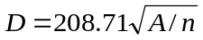

Where ‘D’ is the distance between lines and plots (208.71 is the length of the side of a square-acre in feet); ‘A’ is the acreage of the stand; ‘n’ is the number of sample plots being used.

References used in this section:
Allen, J.A., B.D. Keeland, J.A. Stanturf, A.F. Clewell, and H.E. Kennedy Jr. 2001. A guide to bottomland hardwood restoration: U.S. Geological Survey. Report USGS/BRD/ITR-2000-0011. U.S. Department of Agriculture, Forest Service, Southern Research Station, General Technical Report SRS-40. 132 p.

Code of State Regulations, 2001. Missouri Minimum Standards for Property Boundary Surveys. Rules of Department of Natural Resources, Division 30 – Land Survey. 10 CSR 30-2, 1-7.
Fredrickson, L.H. and Batema, D.L. (2000) Greentree Reservoir Management Handbook, Puxico, MO: Gaylord Memorial Laboratory.

Husch, B., C.I. Miller, and T.W. Beers, 1972. Forest Mensuration, Second Edition. Ronald Press Company, New York. 410p.

Missouri Department of Conservation. Forest Management for Missouri Landowners. Missouri Department of Conservation. 108p.

Nigh, Timothy A., and Walter A. Schroeder. 2002. Atlas of Missouri Ecoregions.
Conservation Commission – State of Missouri. 212 pp.

Poff, N.L., Allen, J.D., Bain, M.B., Karr, J.R., Prestegaard, K.L., Richter, B.D., Sparks, R.E. and Stromberg, J.C. (1997) The Natural Flow Regime: A Paradigm for River Conservation and Restoration. BioScience 47, 769-784.

Ponnamperuma, F.N. (1972) The Chemistry of Submerged Soils. Advances in Agronomy 24, 29-96.

Schwartz, C.W. and E.R. Schwartz. 2001. The wild animals of Missouri. University of Missouri Press and Missouri Department of Conservation, Columbia. Pp. 368.

Segelquist, C.A., Scott, M.L. and Auble, G.T. (1993) Establishment of Populus deltoides under Simulated Alluvial Groundwater Declines. American Midland Naturalist 130, 274-285.

Siebel, H.N., Van Wijk, M. and Blom, C.W.P.M. (1998) Can Tree Seedlings Survive Increased Flood Levels of Rivers? Acta Bot. Neerl. 47, 219-230.

United States Department of Agriculture, 1993. Soil Survey Manual. Agricultural Handbook No. 18. U.S. Government Printing Office. 437p.

Weaver, H.D., 1998. The Topographic Quadrangle: Missouri’s All-Purpose Map. Missouri Resources. Fall. 3p.

Yanosky, T.M. (1983) Professional Paper 1296, Washington, DC: US Government Printing Office.

Analyze Resource Data
The next important step (step 3) is to analyze the resource information gathered during the inventory phase to clearly define the natural resource conditions, along with any economic and social issues related to the natural resources. This assessment step will help to identify problems, concerns, and opportunities that can be addressed with the plan.
Analysis of the resources can be used to appraise and evaluate the status of existing resource conditions, such as:
- desirability of tree species for the products, production, and economic returns desired
- health of existing forest stands
- effects of current management programs on plant and animal communities
- wildlife habitat values in relation to potential for the site
- significance of cultural resources, if present
- presence of endangered or threatened plant or animal species
- opportunity for new enterprises
- feasibility of the current forest community and site management providing the desired attributes of production, habitat, water quality and quantity, air quality, and soil protection.
The basis for all management decisions comes from the knowledge gleaned through inventory work. By understanding the potential of a site for growing trees (identified through soil types and profiles, and such factors as flood duration), potentials for wildlife development, soil limitations and potentials and comparing those issues to inventory results, a more realistic picture is gained concerning what to plant, when to thin, where to place roads, and potential soil productivity levels.
Wildlife Assessment
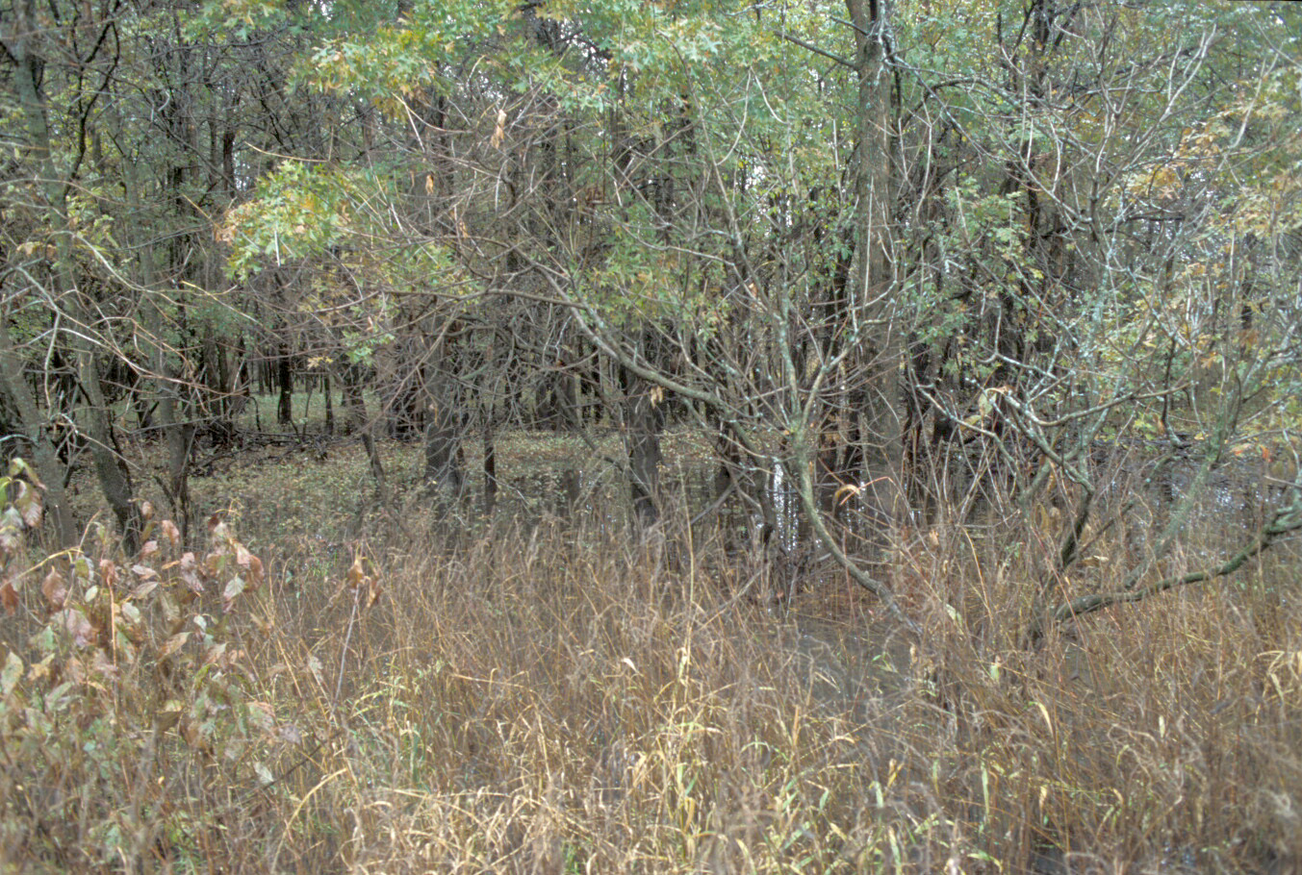
When a landowner wants to restore wildlife habitats to attract desirable species, an effective approach is to use wildlife assessment guides. One such example of an assessment tool is the NRCS Wildlife Habitat Appraisal Guide (WHAG). This guide is a field evaluation procedure designed to measure the quality of habitat for a particular species of wildlife. It not only rates the quality of existing vegetative cover, but also accounts for man’s use and management of the habitat. The appraisal guide will produce a habitat quality index for a specific field, woodland, or wetland as well as for an entire farm or management unit of land.
The wildlife habitat appraisal guide sheet breaks habitat into the most important characteristics that are rated on a 1 – 5 or 1- 10 scale, depending on their importance. The assessment index ranges from a low of 0.1 to a high of 1.0, resulting in a rating of excellent, good, fair or poor which can then be applied to the numerical index.
Figure 16. Diverse habitat is important to wildlife.
Another benefit to using wildlife habitat appraisal guide sheets is that the appraisal can identify weak or missing elements in the habitat as a basis for making improvements. For example, if a landowner wants to attract wild turkey, using the guide sheet dominant tree species other than oak species (<50%) rate a point value of 1. However, by changing the woodland’s dominant tree species to a mix of white and black oaks, the landowner could raise the value of their woodland for that characteristic, from 1 to 10, a gain of 9 value points. There are different NRCS WHAG sheets for many other species such as deer, turkey, quail, squirrel, songbirds, and migratory waterfowl.
Soil Assessment
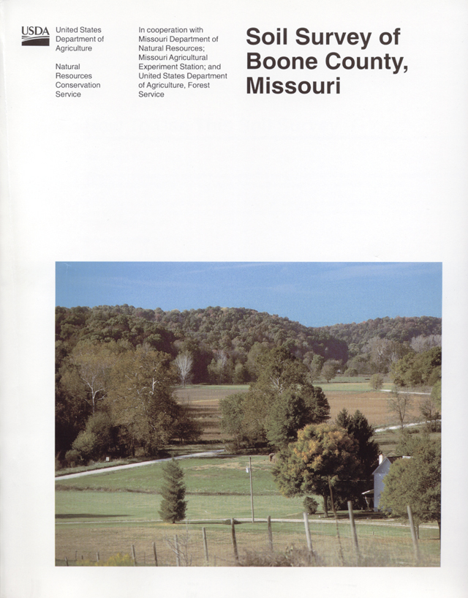
Accurate soil resource assessments and analyses can be made using soil interpretation information found in county Soil Surveys (Figure 17). Soil interpretations provide numerical and descriptive information pertaining to a wide range of soil properties. Knowledge of soil properties that limit the land use or establish the severity of limitations related to the use of resources is important. A number of considerations should be kept in mind with the use of soil interpretations:
- An interpretation has a specific purpose.
- Application of interpretations for a specific area of land has an inherent limitation related to the variability in the composition of delineations within a map unit.
- The inherent variability of soils in nature defines the restraints in soil interpretations and the precision of soil behavior predictions for specific areas.
Figure 17. Example cover of a county soil survey manuscript in Missouri.
- Certain considerations that determine the economic value of land are not part of soil interpretations.
- Some interpretations are more sensitive to changes in technology and land uses than others.
- Interpretations based on properties of the soil in place are only applicable if characteristics of the area are similar to what they were when the soil mapping was done.
Soil map unit interpretations for forestry-related activity are an integral part of analysis and decision making. These interpretations help provide guidance into what problems and/or opportunities may occur based on inherent soil characteristics by map units (United States Department of Agriculture, 1993).
For example, a soil map unit on a bottomland field may have a clay surface texture rated “very limited – low strength” for a “natural surface road.” This rating indicates that the road needs to be relocated or that mitigation for low strength properties should be developed to make the road functional for the intended use.
Typical interpretation tables found in soil surveys include Forest Productivity, Forest Management, Physical Properties, Water Management, Water Features, Engineering Properties. An example of a Forest Management interpretation table is shown in the Appendix, Table C.
Forest Assessment
When conducting an inventory of the forest, its condition should be continually assessed. Following the field inventory, it may be useful for analysis to refer to site index
curves for individual species (i.e. cottonwood, silver maple, green ash, etc.) that are desirable components of the stand. Site index curves represent tree growth potential, expressed in height, as a measure of site productivity. Site index is the average height of a dominant or co-dominant tree species at a given age.
In Missouri, the age used to index site productivity is often 50 years, though a few tree species, such as cottonwood (Populus deltoids), may use an age of 25 years as a base.
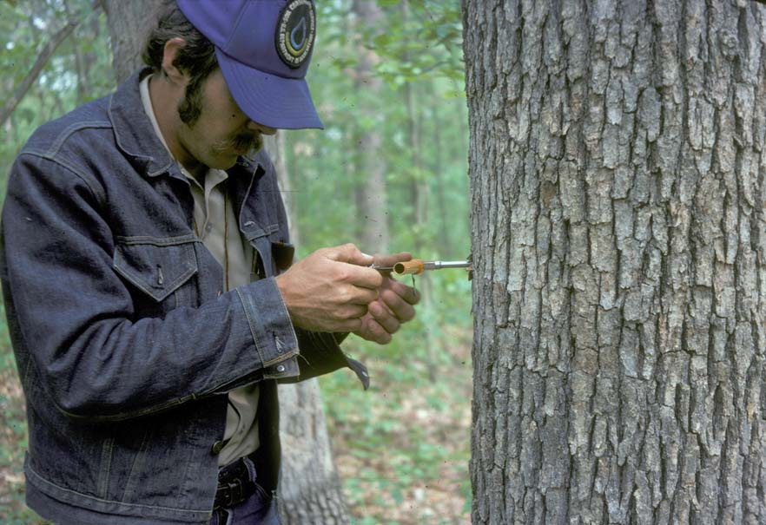
To measure site index, select 5 to 10 dominant or co-dominant trees of a given species that are representative of an identified stand. Measure the height of those selected trees. Then carefully age those trees by taking an increment core and counting growth rings. Based on charts developed for a specific species, use the collected information to identify the site index of that forest stand. The higher the site index the better the productivity potential for each specific species (Missouri Department of Conservation, 2000).
Figure 18. The use of an increment borer allows a non-destructive method of estimating tree age.
Based on the tree count and diameters measured from the sampling inventory, a diameter distribution can be created. The diameter distribution graph places tree diameters on the X-axis and TPA on the Y-axis. By graphing the diameters in such a fashion the progression of a stand’s development, and the impacts of management, can be more clearly identified. This graph will also facilitate management that emphasizes making changes to specific size classes, and improve the likelihood of achieving stated or desired objectives. Distributions can also be created for individual species within a stand and is useful for identifying size classes of desirable species that are deficient in numbers of trees. A gap or deficiency in desirable trees of a certain size may indicate future problems.
The initial inventory and assessment helps identify the current resource state and becomes the tool through which management choices can be justified. However, a single inventory and assessment is never enough, rather this work should take place periodically so that management can be adjusted and success or failure at achieving the stated objectives may be judged.
Much of the data collected will be useful in understanding the stocking level of the forest stand and the resultant management implications. Stocking is important for many reasons that relate directly to health and forest vigor. As trees become crowded (high density or too many TPA) the competition between trees increases both above and below ground. This is typically reflected in a reduction of crown area (breadth and height of a tree's crown) for individual trees. While some competition is desirable and facilitates straight stem development and dieback of lower limbs which are ultimately beneficial for log quality, too much competition causes extensive crown dieback and decreases the growth rate of a tree (reduced vigor). It is desirable to maintain one-half to one-third of the trees total height in a live crown. All forest and trees suffer mortality as a natural part of forest development. Therefore, when taking an inventory also be aware of each sampled tree’s crown health. If a tree has numerous dead limbs or leaves when all the other trees are in full leaf, then a problem may exist with that tree. The role of a forest manager through inventory work is to select when and which trees are to be removed from the forest, and to notice when inappropriate tree death may be a result of abnormal disease and insect problems.
For answers to questions related to tree health, there are several good sources of information. The Missouri Department of Conservation has a publication titled Manual to Common Insects and Diseases of Trees in Missouri. The USDA Forest Service also has a colored publication Oak Pest: A Guide to Major Insects, Diseases, Air Pollution and Chemical Injury (General Report SA-GR11). In addition to State and Federal agencies, local University Extension offices will typically provide assistance with identifying the cause of tree decline or death, as well as making recommendations to correct undesirable tree loss.
A final source of excellent forest health issues can be found on the internet. The following selected web sites provide up-to-date forest health alerts, diagnostic help and informational data.
Forest and Shade Tree Pathology. This site is provided as an aid to those learning forest and shade tree pathology. It is maintained by the State University of New York, College of Environmental Science and Foresty. http://www.forestpathology.org/
Forest Health Protection. U.S. Bureau of Entomology and Plant Quarantine, Forest Health Protection (FHP) has built an organization of specialists trained to provide technical assistance on forest health-related matters, particularly those related to disturbance agents such as native and non-native insects, pathogens, and plants. They are part of the State and Private Forestry Deputy Area of the U.S. Department of Agriculture (USDA) Forest Service and offer specialized assistance to incorporate disturbance considerations into forest plans and decisions. http://www.fs.fed.us/foresthealth/
Plant Disease Diagnostics. Plant Disease Diagnostics is a web page designed to help individuals diagnose plant disease problems in their yard and garden. Diagnoses made by 'Plant Disease Diagnostics' are based on visual observations of symptoms expressed by the infected plant. http://www.extension.umn.edu/projects/yardandgarden/diagnostics/
Integrated Pest Management Center. Pest Alerts from the North Central Region network of Pest Management Centers was authorized by Section 406 of the Agricultural Research, Extension, and Education Reform Act of 1998.As the result of a competitive process, four Pest Management Centers spread geographically across the United States were formed. http://www.ncpmc.org/NewsAlerts/index.html

References for this section:
Missouri Department of Conservation. Forest Management for Missouri Landowners. Missouri Department of Conservation. 108p.

United States Department of Agriculture, 1993. Soil Survey Manual. Agricultural Handbook No. 18. U.S. Government Printing Office. 437p.

Develop the Plan
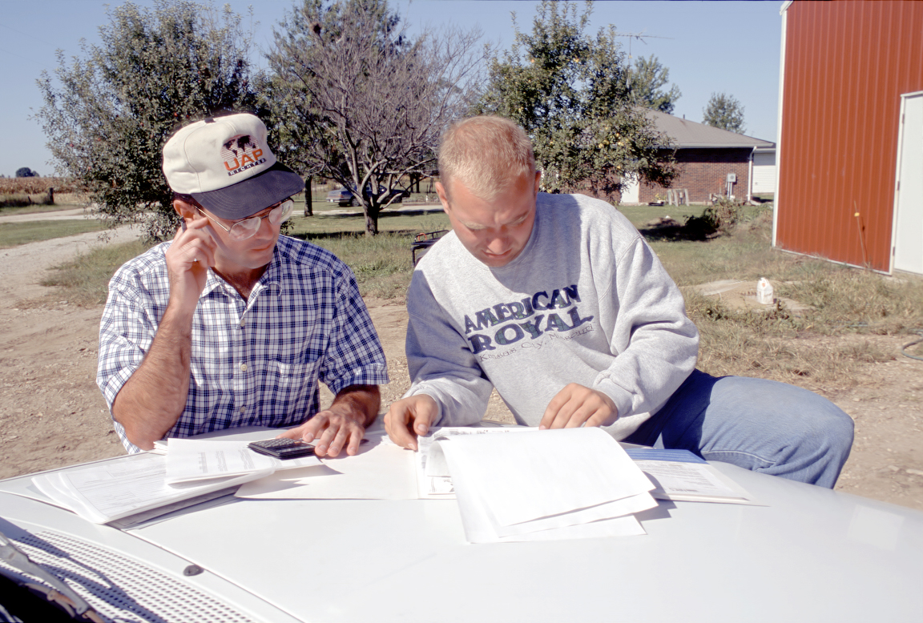
A key to assessing the progress of forest management activities is developing a forest management plan (Step 4). This plan will serve as a guide to direct the activities associated with establishment and the use of the natural resources, as well as specify various intermediate activities that will carry the developing forest through to maturity. The documentation of these management activities becomes an essential tool by which the achievement of “desired future conditions” is assessed. This set of written activities for a given forest area are typically referred to as a plan (Figure 19). A forest plan is not only essential in defining the activities to be implemented, but also for defining the timeline of their application to the management of the forest land (Missouri Department of Conservation, 2000).
Figure 19. A key to assessing the progress of forest management activities is developing a forest management plan.
A plan will assist in guiding the growth and development of the forest in an effort to maximize their value related to a final product. A plan’s details may indicate the appropriate species to plant based on local sawmill markets. It might mean thinning an existing forest to promote the growth of a preferred species. It could involve developing critical habitat to attractive specific wildlife species. In any event, the specifications related to the final product or forest utilization will influence management decisions associated with the plan.
Simply stated, a comprehensive management plan answers the basic questions - what, where, who, and when in relation to desired activities. These identifiable descriptors are intricately linked to one another and to the objectives of any management plan. By utilizing aerial photographs, topographic maps, soil survey maps and an intimate knowledge of the land, certain areas can be identified, by the landowner or resource professional, for unique management opportunities. This essentially involves an evaluation of the site data previously collected under Inventory Resources. Identification of where certain management or silvicultural practices (such as tree planting, thinning, weed control, etc.) should occur is essential for developing any plan of action. Often, in the process of defining where, the question of what needs to be addressed or more specifically what practice or practices should be implemented.
A well developed forestry management plan will answer four basic questions. What forestry activities are needed? Where will these forestry activities occur? Who will be doing the forestry activity? When will the forestry activities occur?
For instance, when viewing a piece of property that boarders a river, it may be possible to note changes or variations in land features, soils or topography, any or all of which may dictate dividing that land area into smaller more manageable zones. For example, a zone adjacent to the waters edge, a middle piece of ground, or a zone furthest from the river is generally is identifiable by unique topographic and soil characteristics. Topography, soils, and hydrology can all indicate differences in duration and depth of flooding, as well as the depth to the water table. In this example, these three distinct zones, associated with the representative piece of property, become the where identifier that is tied to what different management activities will be applied.
Having identified what and where associated with the parcel of land to be managed, it is often prudent to consider options for who will conduct the planned management. Is a trained resource professional, either a consultant or a government employee, needed to oversee this project? Is there specialized equipment needed, for the desired practice to be implemented, and is that equipment available to the landowner or the resource professional? Based upon the answer to these questions, who will be able to conduct the planned management for the specified land will be answered?
Next, an activities schedule will need to be established for when these various management practices will take place. When identifies a logical timeline for achieving specific objectives through appropriately timed activities. The schedule describes the timing, methods and conditions by which the vegetation and other resources should come under management. One example might be the activity of establishing seedlings in a floodplain. There may be several activities that need to be implemented prior to planting. Understanding when these must take place in order for a spring planting is important. The schedule of activities should be as explicative as possible. Perhaps a landowner has noted that each April, in three of the past five years, flooding has been a problem on a specific piece of ground. Further, by referring to the USGS web site, it is confirmed that this land will normally be under water at various times, during the month of April. So, a plan for tree planting on this example property may indicate an activities timeline that dictates tree establishment sometime in May. The plan might also include an alternate timeline for a fall tree planting date in the fall.
In addition to identifying who, what, when, and where in a plan, record keeping should involve tracking progress and the economic costs associated with various management activities. The monetary cost should be recognized for each specific management practice associated with achievement of the stated objectives. These costs may include, but are not limited to, site preparation (clearing, burning, disking, etc.), competition control (herbicide, burn, etc.) fertilization, soil mounding, seedlings, regeneration cost (planting or seeding), intermediate treatments (thinnings), or logging operations. The benefits of good record keeping will be realized in developing a future budget for similar operations or practices, and for tax purposes.
Plan schedules that include when activities occur, should be flexible and adjusted according to this treatment tracking and monitoring data.
Prescriptions
After the plan is developed, site specific activities or prescriptions should be developed for planned activities. Prescriptions offered detailed information on how to complete the identified practice, detailing site specific parameters such as which trees need to be removed from stand B, what species of trees and shrubs will be planted along a stream in field C, which area should be used for a log landing during a timber harvest, or where wildlife openings need to be developed in stand A.
Prescriptions should be developed at the time the practice or activity is to be implemented and provide sufficient detail to insure its successful installation and completion of all outlined standards and specifications.
References used in this section:
Missouri Department of Conservation. Forest Management for Missouri Landowners. Missouri Department of Conservation. 108p.
Evaluate and Monitor the Plan
An often overlooked final step (Step 5) of the planning process is determining how outcomes will be assessed and measured. Careful record keeping from the beginning can help detail the condition of land resources over time. Success or failure to achieve stated objectives may not be realized without records of treatment effects, survival and growth of seedlings or the condition of an existing forest stand. Monitoring of growth at specified intervals allows numerical projections that directly relate to future management activities such as intermediate treatments that might include thinnings or future logging events. Thus, measurements should be taken periodically before and after the initiation of the management practice so that a determination of success can be made. Possible measurements include, but are not limited to, seedlings per acre (planted or natural), seeds planted or number of seedlings growing, trees per acre (TPA), and basal area (BA). Positive or negative variations in these measures over a specified time period can help better understand the resource and allow for planned intermediate management practices. This tracking over time of a particular resource will also enable a land owner to set and change budgets as well as allocation of other resources. These records may also have important implications for tax purposes (Missouri Department of Conservation, 2000).
.Cost Share Opportunities
In an effort to reduce cost, improve income opportunities, and provide societal benefits to landowners willing to implement conservation practices, government monetary incentives are often available. These incentives, often titled cost-share programs, reduce the direct cost to the landowner by reimbursing actual costs from the implementation of approved practices. In addition, incentive payments for certain conservation practices may also be available.
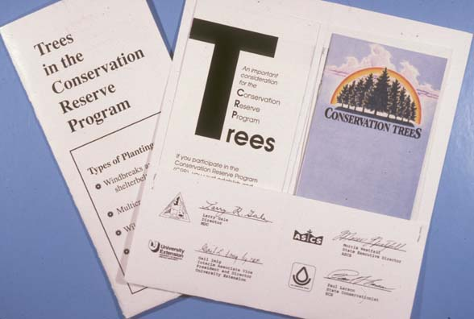
The lands enrolled under these programs will provide benefits to society such as reduced damage from flooding, improved water quality or increased carbon sequestration. For additional information on ways to reduce the cost associated with establishing or maintaining bottomland forest contact your local USDA Service Center or Missouri Department of Conservation office.
Figure 20. Many federal cost share and incentive and rental payment programs, such as the Conservation Reserve Program, are available to landowners who want to implement forest conservation.

References used in this section:
Missouri Department of Conservation. 2000. Forest Management for Missouri Landowners. Missouri Department of Conservation. 108p.

Bottomland Forest Management Alternatives

This section discusses management alternatives or options associated with big river bottomlands. There are two basic situations that will be considered – reforestation and regeneration/rehabilitation, each situation possessing its own unique requirements and issues.
Reforestation – New Plantings
Species Selection
Woody species selection is a critical aspect of any reforestation project. Inappropriate or unsuitable choices can lead to planting failures, poorly stocked stands, landowner disappointment, site damage, or loss of income. Species choice should be guided by landowner goals and objectives, site characteristics, natural near-by species composition, geographic location, and costs (Natural Resources Conservation Service, 2002).
Landowner objectives. To meet any expected desired future condition, careful thought should be given to choosing species that will accomplish the landowner’s goals and objectives. Examples of goals that would influence species selection include production of high quality timber, improvement of wildlife habitat, control of soil erosion, enhancing site aesthetics, or even changing existing land use.
Site characteristics. Site characteristics can have a major influence on the successful establishment of any species. On bottomland sites, micro-site changes such as soil drainage, depth to water table, flooding duration, elevation, and soil texture will influence the growth and survival of any species. Be sure and choose species that will be compatible with any of these micro-site characteristics.
Existing species. Woody species growing near-by on similar sites can be an effective means of choosing appropriate species for the site. These natural growing woody plants have been “tested” over time and have experienced many environmental conditions and should be given initial consideration when decided what species may do well on the site.
Geographic location. National plant hardiness zones can be used as a guide to help select species. Many plants can be planted outside suggested zones but may be susceptible to floral damage, vegetative die back or increased disease or insect problems. Generally, species can be planted easier south than north from their suggested planting zones. Native ranges of species are also important to think about when making species selection. If ecological integrity is an objective or consideration, choosing species that are native to the general area is important and may limit the type of species that would adaptive to the site.
Costs. The availability of species, type of species, type of planting stock, or size of plants will all have variable costs associated with each factor. If cost is a limiting factor, this may reduce the number of species or type and size that can used to reforest the site. This is a highly personal factor and therefore will vary considerably from landowner to landowner.
The following tables provide guidance in the selection of species. Table 6 gives relative flooding tolerances for selected species found in Missouri. Tables 7 and 8 give examples of potential hardwood woody species for use with various potential landowner objectives. Table 9 provides additional guidance on flooding tolerance and values plus estimates of species characteristics relative to bottomland concerns.
Table 6. This table combines research results from the Lower Mississippi Valley and the Missouri River divisions. Since classification is relative, flood tolerances ratings should be viewed as a guide to flooding tolerance and not an absolute determination. Most species can be planted in a less tolerant flooding situation but not the opposite.(adapted from US Forest Service, 1993)

Very Tolerant. Able to survive deep, prolonged flooding for more than one year.

Water hickory Carya aquatica Baldcypress Taxodium distichum
Buttonbush Cephalanthus occidentalis Black willow Salix nigra
Swamp privet Foresteria acuminate Nuttall oak Quercus nuttallii
Green ash Fraxinus pennsylvanica Overcup oak Quercus lyrata
Water locust Gleditsia aquatica Water elm Planera aquatica
Deciduous holly Ilex decidua Water tupelo Nyssa aquatica

Tolerant. Able to survive flooding for one growing season, with significant mortality occurring if flooding is repeated the following year.

Boxelder Acer negundo Willow oak Quercus phellos
Red maple Acer rubra Water oak Quercus nigra
Silver maple Acer saccharinum Pin oak Quercus palustris
Native pecan Carya illinoensis Sycamore Platanus occidentalis
Sugarberry Celtis laevigata Hackberry Celtis occidentalis
Persimmon Diospyros virginiana Sweetgum Liquidambar styraciflua
Eastern cottonwood Populus deltoides

Somewhat tolerant. Able to survive flooding or saturated soils for 30 consecutive days during the growing season.

Hazel alder Alnus rugosa Red elm Ulmus rubra
Cherrybark oak Quercus pagodaefolia River birch Betula nigra
Shellbark hickory Carya laciniosa American elm Ulmus Americana
Green hawthorn Crataegus virdis Shingle oak Quercus imbricaria
Honeylocust Gleditsia triacanthos Bur oak Quercus macrocarpa
Blackgum Nyssa sylvatica Swamp white oak Quercus bicolor

Table 7. Examples of potential hardwood tree species for use in bottomlands (adapted from Natural Resources Conservation Service, 2002a).

Common Name | Wood Products | Biomass  /fuelwood | Food Products¹ | Wildlife  Food | Canopy Shade | Comments
Basswood | X |  |  |  | full | Wood used for carving
Black walnut | X |  | X | X | light | Deep well-drained sites
Bur oak | X |  |  | X | full | Drought and flood tolerant
Green ash | X |  |  |  | medium | Adapted to many sites
Honey locust |  | X |  | X | light | Use thornless variety
Hybrid poplar | X | X |  |  | light | Rapid growth; deep rooting
Paulownia | X | X |  |  | medium | Wood prized in the orient
Pecan | X |  | X | X | medium | Use native stock for grafting
Silver maple | X |  | X |  | full | Maple syrup and wood
Sycamore | X | X |  |  | medium | Tolerates wet sites
Yellow poplar | X |  |  |  | medium | Fast growing

- Includes fruits, nuts, jellies, jams, wine, syrup, honey, herbals, etc.

Table 8. Examples of potential shrub/small tree species for use in bottomlands (adapted from Natural Resources Conservation Service, 2002a).

Common Name | Human Products | Wildlife  Food | Showy  Flowers | Plant size (feet) | Comments
American plum | X | X | X | 15 to 20’ | Jellies, preserves, and wine
Crabapple |  | X | X | 20 to 25’ | Jellies, preserves
Hazelnut | X | X |  | 3 to 10’ | Sweet nuts
Pawpaw | X | X |  | Up to 30’ | Large, edible, nutritional fruit
St. John’s Wort | X |  | X | Up to 6’ | Herbal remedies; nectar source
Witch hazel | X |  |  | Up to 30’ | Numerous medicinal uses

Table 9. Potential Plant List for Use in Riparian Buffers (Natural Resources
Conservation Service, 2000b).

Species Flooding Large Shade Wildlife Height Growth Soil
(Common/Scientific) Tolerance Debris Value Merit (feet) Rate Group

ash, green Fraxinus pennsylvanica M M H M 60 H 1,2
white Fraxinus americana M M H M 70 M 1
baldcypress Taxodium distichum VH M M M 80 M 1,2
birch, river Betula nigra M H M M 50 M 1,2
buttonbush Cephalanthus occidnetalis VH L L L 10 M-H 2
cottonwood Populus deltoides H H M H 90 H 1.2
dogwood, silky Cornus obliqua H L L H 12 M-H 1,2
red-osier Cornus stolonifera H L L H 12 M-H 1,2
hackberry Celtis occidentalis M-L M M M 60 M 1
hawthorn, green Crataegus virdis M L L H 20 M 1,2
hickory, shellbark Carya laciniosa M M H H 70 M 1
holly, deciduous Ilex opaca VH L L M 16 M 1,2
maple, boxelder Acer negundo M H M M 40 H 1
silver Acer saccharinum M-H H H M 80 H 1,2
red Acer rubrum M M H M 70 M 1
oak, bur Quercus macrocarpa H M H H 80 L 1,2
pin Quercus palustris M-L H M H 75 M-H 1,2
Nuttall Quercus nuttallii VH M H H 70 M 2
willow Quercus phellos M M H H 70 M 1
overcup Quercus lyrata VH M H H 70 M 2
swamp white Quercus bicolor M-H M H H 70 M 1,2
cherrybark Quercus pagodafolia M M H H 75 M 1
shumard Quercus shumardii M M H H 80 M 1
pecan Carya illinoensis M M H H 80 L-M 1,2
persimmon Diospyros virginiana M M M H 50 L 1
privet, swamp Forestiera acuminata VH L L L 14 M 1,2
sugarberry Celtis laevigata M-L H M M 60 M 1
sycamore Platanus occidentalis H H M H 90 H 1,2
wahoo Euonymus atropurpureus M-L L L M 12 M 1
walnut, black Juglans nigra M-L M M H 80 M 1
willow, black Salix nigra VH-H H L M 60 H 1
sandbar Salix exigua (interior) VH L L L 6 H 1,2
peachleaf Salix amygdaloides H L L L 30 H 1,2
pussy Salix discolor H L L L 20 H 1,2

Notes: VH = very high; H = high; M = medium; L = low

Flooding Tolerance. General capacity of the plant to withstand standing water. VH = able to survive deep, prolonged flooding for more than one year; H = able to survive deep flooding for one growing season, with mortality occurring if flooding is repeated the following year; M = able to survive flooding or saturated soils for 30 consecutive days during the growing season; L = unable to survive more than a few days of flooding during the growing season without mortality.
Large Debris. Potential for the plant to produce debris larger than ten inches in diameter before secensence. H = large debris likely within life span of the plant; M = large debris possible within life span of the plant; L = large debris unlikely within life span of the plant.
Shade Value. The density or fullness of shade provided by an individual plant's crown in full leaf-out condition. H = large crown providing full shade; M = paritally open or medium sized crown that provides patchy or incomplete shade; L = very open or small crown that provides minimal shade.
Wildlife Merit. The potential for the plant to provide useful cavity sites and/or quality fruit production for wildlife. H = excellent large cavity potential and/or high quality fleshy fruit or nut production; M = moderate cavity potential or fruit production; L = low cavity potential and dry, non-nut fruit production.
Height. Typical potential height at physical maturity.
Growth Rate. The rate at which the plant grows in height during its development period (after seedling stage and before final maturity stage). H = Rapid growth of 3 or more feet per year; M = Medium growth of 1 to 3 feet per year. L = Low growth rates of generally less than 1 feet per year.
Soil Group. Trees and shrubs based on soil suitability. Group 1 = somewhat poorly drained soils with a water table at 1 to 3 feet in the spring or subject to flooding. Permeability is moderately slow to rapid. Group 2 = poorly drained soils with slow to rapid permeability or somewhat poorly drained soils with slow permeability. Subject to ponding and/or frequent flooding.
Site Preparation
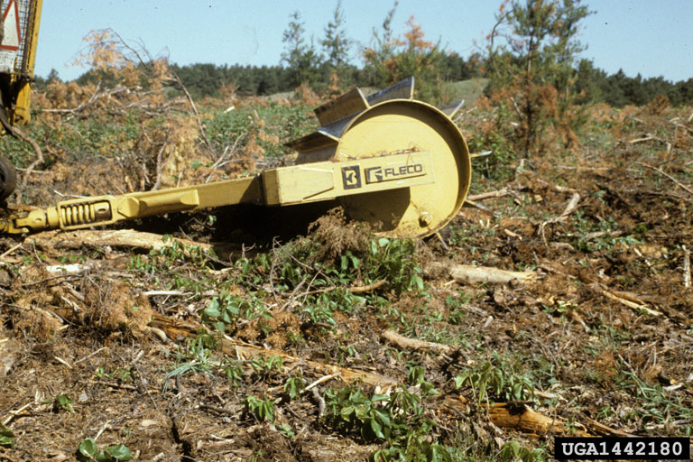
The purpose of any site preparation activity is to encourage natural regeneration of desirable woody plants or to permit artificial establishment of woody plants by creating suitable planting conditions for tree seedlings or seeds. The method, intensity, and timing of site preparation should match the limitations of the site, safety, and equipment and the requirements of the regeneration species. Before beginning any site preparation activities, take in to account the weather, soil properties, topography, existing vegetation, planting methods, and the species selected for planting. All these factors will influence the type of site preparation needed (Natural Resources Conservation Service, 2001).
Figure 21. A roller chopping logging slash to prepare the site for tree planting. Photograph – US Forest Service
Site preparation may not always be necessary, but if warranted, follow these important general criteria:
- Maintain necessary filter strips and/or riparian forest buffer areas.
- Reduce or remove slash and debris to minimize habitat for harmful levels of pests, or hinder needed equipment operations, or create undue fire hazard.
- Control excessive erosion and/or runoff.
- Minimize soil compaction and soil displacement.
- Comply with applicable federal, state, and local laws and regulations.
- Use all chemicals in accordance with label guidelines. Chemical containers should be disposed in a safe, approved manner.
- Fence out livestock to prevent damage to site preparation areas and new woody plants.
- Protect cultural resources, wildlife habitat, springs, seeps, wetlands and other unique areas.
- Consider visual quality objectives when selecting site preparation methods..
- Consider the affect that carry-over herbicide residue could have on the planted tree species when preparing sites in cropland fields.

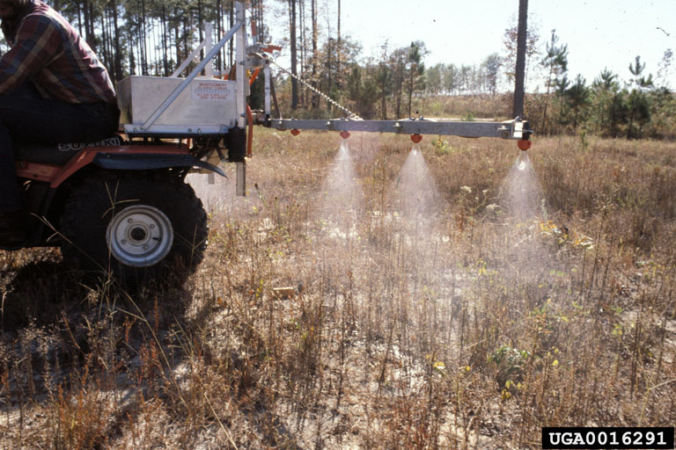
Water quality issues should always be a concern on bottomland sites. Forest site preparation activities can impact water quality by causing a temporary increase in erosion rates and sediment yield. If chemical site preparation is used to control vegetation, the potential for surface and/or ground water contamination can also exist. Access by
vehicles during site preparation or after (i.e., before adequate tree and shrub establishment occurs) should be controlled to minimize erosion, compaction and other site impacts (Natural Resources Conservation Service, 2001).
Figure 22. Always follow label instructions when spraying with chemicals. Follow set-back guidelines when near water surfaces.

Specific Guidelines
Proper site preparation methods are needed to reduce competition from existing vegetation so newly planted trees have the best chance for survival. Use Table 10 as a guide in determining appropriate site preparation methods.
Table 10. Suitable site preparation guidelines. (NOTE: Specific site conditions may not allow indicated site preparation guidelines. Make appropriate adjustments)

Cover | Establishment Methods:  Direct Seeding Natural Regeneration Seedlings
Cropland  Residue level  < 50% cover  >50% cover | C,N C,N C,N  C,M,MC C,M,MC C,M,MC
Grassland | C,M,MC C,M,MC C,M,MC
Woodland  understocked  undesirable | C,H C,H  C,M,MC,B,MB,CMB,H C,M,MC,B,MB,CMB,H C,M,MC,B,  MB,CMB,H

M - Mechanical
C - Chemical
B - Prescribed Burning
N - Not necessary
MB - Mechanical and prescribed burning
MC - Mechanical and chemical
CB - Chemical and prescribed burning
CMB - Chemical, mechanical and prescribed burning
H - Harvest cut

Cropland/Grassland Cover. Cropland residues with cover less than 50% may not require site preparation. With the exception of soybean residue, residue cropland covers greater than 50% will generally require site preparation. In cases where soil compaction is severe, the cropland field should be subsoiled by using a chisel plow or deep ripper. Subsoiling should be done when the soil is dry (at or below field capacity) and should be done in advance of planting to allow the soil to re-settle. Normally ripping should be done to a depth of 18 to 24 inches.
Grassland covers should always have some type of site preparation. Uncontrolled grass competition can cause severe mortality and/or growth rates. For either type of residue cover, follow one or more of the following methods (Natural Resources Conservation Service, 2001):
Mechanical: Expose mineral soil with tillage operations. Limit tillage to no more than 2 months prior to planting or seeding. Till earlier if flooding is a possibility. Fall tillage is an option for early spring planting. Use contour strip tilling on slopes greater than 3 percent. Planting strip widths should be greater than 3 feet in width with inter-widths of 5 feet or greater.
Chemical: Apply appropriate chemical(s) in 3 to 4 feet bands over projected planting rows. If slopes exceed 3 percent, apply on contour. Use a pesticide risk-assessment tool to evaluate leaching and runoff potentials. Pesticide/soil hazard risk ratings of “extra high” or “high” should be accompanied by mitigating practices and/or substitution of pesticides to lower risk ratings. Use low volatile formulations. Some chemicals need extended time to work. If that is the case, consider applying the chemicals in the fall or early spring prior to establishment activities.
Cover Crops
If a permanent cover crop is needed or desired after site preparation, use one of the following species at the specified rates to control potential erosion or weed competition between woody planting zones:

Table 11. Recommended crop cover species for tree planting (Natural Resources Conservation Service, 2001)

Species | Rate – Pure Live Seed /Acre
Ladino clover | 2.25 lbs/acre
Annual lespedza | 5.6 lbs/acre
Orchardgrass | 3.2 lbs/acre
Kentucky bluegrass | 1.6 lbs/acre
Timothy | 2.3 lbs lbs/acre
Redtop | 1.3 lbs/acre
Virginia wild rye | 7.0 lbs/acre

Note: Above rates are for good planting conditions. Rates should be increased by 50% for fair planting conditions.

Woodland Cover
Desirable Vegetation
Reduce competition from woody plants less than 2 inches DBH and other herbaceous competitors by mechanical or chemical means before underplanting. Make a harvest cut and leave a well-spaced overstory of no more than 55 percent stocking. No cutting is necessary if the stand is already 55 to 65 percent stocked. Remove the remaining overstory during the dormant season after 3 to 6 years.
Undesirable Vegetation
First harvest any merchantable material from the site. Then use one or more of the following site preparation methods (Natural Resources Conservation Service, 2001):
Mechanical: Remove remaining cover and expose mineral soil. Pile debris in windrows. On slopes greater than 3 percent, operations should be on the contour. On land that is gullied, some additional grading or erosion control may be necessary.
Chemical: Apply appropriate chemical(s) in 3 to 4 feet bands over projected planting rows. If slopes exceed 3 percent, apply on contour.
Prescribed Fire: Conduct burning only under controlled, predetermined conditions as outlined in a prescribed burn plan. To reduce surface litter, burn after leaf fall in late November or early December. To control competing vegetation, burn in late spring.

Planting Stock Considerations
When deciding to plant trees several general factors must be considered. First, what stock type is going to be planted? Second, what is the source of the seed to be planted? A general rule (Smith 1997) is that seeds should be gathered no more than 100 miles north or south in latitude of the area to be planted. Additional considerations presented in the section “Climate” also apply.
There are several stock types to consider when establishing new reproduction in a forest. These stock types are: 1.) direct seeding, 2.) bare-root seedlings, 3.) containerized seedlings, and 4.) cuttings. There are many advantages and disadvantages with each of these stock types.
Direct seeding
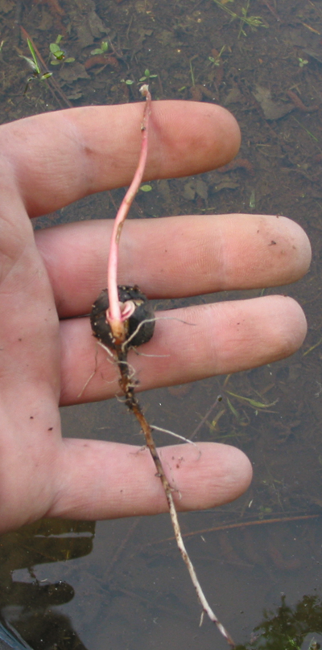
Sowing seeds is a low cost, easy endeavor. However, establishing trees with seeds may be more difficult than other methods. The collection, handling, and timing of sowing are critical for successful establishment. When collecting seed, the timing of maturation and the seed storage requirements are species-specific considerations. Nursery operators and foresters are a valuable source of information regarding seed collection storage. The timing of seeding has been shown to be significant. (Wood 1998) found that willow and Nuttall oaks were 70% successful when sown in December, whereas, 50% were successful in March, and only about 15% of the acorns germinated when planted in June. Seeking the advice of a nursery operator or forester will help insure the success of the seeding operation. Species-specific seed maturity and storage requirements can also be found in two volumes of The Silvics of North America. (Burns et al., 1990) Also included in these volumes is the number of seeds per pound, which is critical when determining the amount of seed to order from your supplier. A number of techniques may be employed to sow seed. These include aerial, broadcast, and mechanical sowing. A further discussion on direct seeding can be found on page 82.
Bare-root Seedlings
Figure 23. Pin oak growth following acorn sowing at Duck Creek Conservation Area, Puxico, Missouri
The main advantage bare-root seedlings offer is the ability to carry and transport many seedlings to the field for planting. Additionally, bare-root seedlings have a developed root system that is free from soil. Planting bare root seedlings is rather easy and quick. In addition to easy transport and installation, bare-root seedlings are inexpensive relative to containerized stock. Fall and winter are the best times to plant bare-root seedlings as long as the ground is not frozen. In addition to timing, size must also be considered. Larger bare-root seedlings (24 inches in length above the root collar with a root collar diameter of 3/8 to 1/2 inch) are more apt to out grow competing vegetation but may be more expensive (Allen et al. 2001). Success of planting may outweigh this initial expense particularly on drought prone or weedy areas.
Root pruning usually occurs when the seedlings are lifted in the nursery. After this initial pruning, roots should not be pruned or broken. Roots serve as an energy source for these young trees during establishment, so pruning roots will only weaken the seedling and lessen its chance of survival and establishment.
Containerized Stock
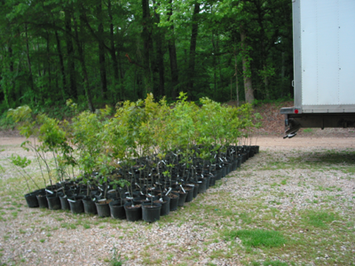
There are many types of containerized stock that have been successfully used in planting operations. “Tubes,” “Plugs,” “Sacks,” “Pots,” and other containers are commonly used in nursery operations. Each of these planting types is similar in that the roots are contained and protected by the soil in which they were raised. This protection offers several advantages when the young trees are planted. First, the planting season can be extended out of the dormant season. By watering the trees in their containers after the leaves have flushed, the roots are maintained. Unlike bare root seedlings, desiccation may be prevented after the trees have broken dormancy. Additionally, by reducing the root system shock, plantings in harsh environments can be successful.
Figure 24. Containerized RPM® pin oak seedlings prior to an under planting at Duck Creek Conservation Area, Puxico, Missouri

Unlike direct seeding and bare-root seedlings, containerized stock is bulky and transporting containers should be carefully considered when estimating the time requirements of planting. In addition to transport, the ease of planting that bare-root seedlings offer is reduced with larger containerized stock. However, the time and cost for each successfully established tree may outweigh the additional transport and planting costs.
Cuttings
Many bottomland species are able to reproduce vegetatively. Advantageous buds on the surface of the shoots of several species are able to differentiate into roots and shoots when buried or planted into soil. Common bottomland species that exhibit this ability include Eastern cottonwood, American sycamore, and most willow species. Cuttings from these species can be utilized to establish these trees in a planting operation.
Commonly, cuttings vary in length between 16 to 20 inches with a minimum diameter of 1/4th of an inch, but smaller cuttings between 4 to 6 inches and larger cuttings, up to ten feet, have been used to successfully establish trees (Allen et al. 2001). These cuttings can either be planted vertically with two to three inches exposed above the ground or horizontally about 1 to 2 inches below the surface.
Cuttings are not recommended for areas that are prone to early season flooding, nor should they be planted during the growing season. Early spring is the best time for planting just before bud break. They should be stored and handled much like bare-root seedlings with care to plant them well before they have broken dormancy.

Planting Techniques
Tree survival greatly depends upon a high quality planting work. The primary objective is to get the plant properly planted so that the roots are in contact with soil. Good soil-seedling contact is very important for essential water and nutrient uptake. A poor planting technique will mean reduced plant growth or even plant mortality.
The discussion in this section assumes that either bare-root or container seedlings grown in a nursery are being used. However, there are other planting materials available such as seeds and cuttings. Most of these planting considerations are applicable to these planting materials as well.

Calculating Number of Seedlings
To determine how many seedlings to order you need to know two things: distance between trees within the row and the distance between the rows. For example, if planting is on a 10 x 10 feet spacing (i.e., 10 feet between trees within a row and 10 feet between the rows) then this simple formula can be used:
Seedlings needed per acre = 43,560 (square feet per acre)
(Spacing (feet) within row) x (Spacing (feet) between rows)
To continue with the example from above, the number of seedlings needed per
acre is calculated as follows:
Seedlings needed per acre = 43,560 = 435.6 or 436 seedlings per acre
(10 feet) x (10 feet)

After the number of seedlings per acre is determined, multiply that number times the number of acres to be planted. It is always a good practice to increase a seedling order by 10 percent to allow for adjustments (culls and mortality) when field planting.
Care of planting stock
After considering how many trees to order from the nursery, the order should be place as soon as possible, preferably in the fall prior to spring planting. Plant the trees as soon possible after receiving them. If the seedlings arrive and they are unable to be planted immediately, store the seedlings in a cool damp environment until planting. In the field, keep the seedlings moist and protected from wind and sunlight. Only take to the field what can be planted in about 3-4 hours. Check periodically to make sure that the correct number of seedlings per acre are being planted.
Establishment methods
There are three general methods of establishing woody plants:
- Hand Planting
- Machine Planting
- Natural Regeneration

The decision on which method to use is dependant upon many factors. One major factor is how has the site been prepared prior to planting. If the site is clean and relatively free of large debris then machine planting is a good option. However, if the site has old debris from past use or the planting spot is small in size then hand planting should be considered.
Another major factor is the size of the project. If there are several thousand seedlings to plant then a machine planting may be the better choice. If planting in heavy clay soils, it is recommended that these soils be somewhat dry before using a machine planter. The planting trough from a machine planer creates a seam along the ground into which the seedlings are placed right before the packing wheels close the seam. The seam will be hard to close if the soil is highly plastic or clayey in texture or close the top of the planting slit but not the bottom thus creating an air pocket at the bottom of the seam.
Use the following list as a guide for choosing the appropriate planting method (Natural Resources Conservation Service, 2001). Hand planting:
- Small areas
- Steep terrain
- Rough, rocky land
- Debris covered surface
- Large planting stock

Machine planting:

- More than 1000 seedlings
- Gentle terrain
- Time constraints
- Site accessibility

Natural regeneration

- Bare mineral soil
- Narrow areas (2-3 times the height of nearby trees) near existing forests
- Light-seeded seed source
- Periodic flooding

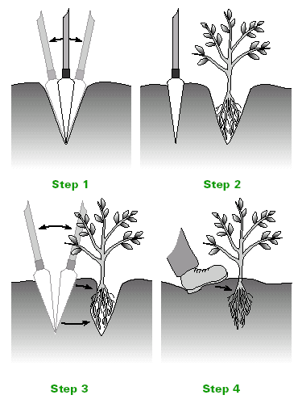
Hand Tree Planting. There are numerous kinds of tools that can be used for hand planting tree and shrub seedlings. Some typical examples include a planting (dibble) bar, sharp-shooter (tile spade), hoe-dag (specialized tree planting shovel) or post-hole digger.
Figure 25. Using a dibble bar to plant tree seedlings. The choice of tool for hand planting will depend upon the size of the seedling stock, size of hole needed, soil condition and soil texture. From “Tree Planting: Establishment and Care”;March 2004; Iowa State University

Once the tool is chosen, carry seedlings in a bag or bucket and make sure they are kept moist. A seedling will have a “root collar” or mark on the stem where the seedling grew at ground-line in the nursery. Try to plant at this depth or a little deeper than the root collar (1.0-inch or less) making sure the seedling roots are planted in close contact with the soil. After placing the seedling, close the bottom and top of the hole. Firmly apply pressure with a shoe heel where the tool was used to create the hole to make sure the seedling is tight. Be careful not to strike the seedling. Make sure the tree is planted as straight as possible and that the roots are pointing downward in the hole. Avoid cramming the root system into the bottom of the hole because bending or J-rooting the taproot may retard future growth or even cause mortality. If this problem is occurring frequently, then switching planting tools may be necessary. Under no circumstances should any of the long lateral or tap roots be pruned or cut off in order to make them fit the hole. These roots are important for early survival and growth.
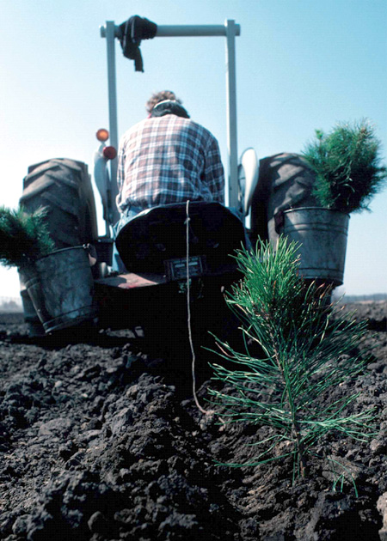
Machine Planting. This is generally a three person operation: one person operating the tractor or pulling vehicle, one person riding the planter, and one person checking behind the operation to make sure that the seedlings are properly planted. Make sure the planting trench is deep enough to permit the roots to point downward without bending or J-rooting. The seedlings should be kept moist and protected while in the holding tray of the planter. Many local state conservation agencies or USDA Service Centers have tree planting machines available for rent or use.
Figure 26. Machine planting is a fast, labor-saving method for large tree planting jobs (more than 1,000 plants).
Natural Regeneration. This method of establishing trees from natural sources is a cost effective means for restoration. Major disadvantages are that species composition can not be controlled and not all sites are well suited for this method. However, various sites may be suitable if care is taken to screen for acceptable sites. (Natural Resources Conservation Service, 2002):
Additional Planting Considerations
In imperfectly drained areas or heavy clay, it may be beneficial to mound or create an elevated planting bed. This bed should be a few feet wide and six to twelve inches in height. A bed of this type can be constructed using a rice plow or other similar bedding machinery. The bedded area can then be machine or hand planted.
Size of the planting equipment is an important consideration in determining the layout of the planting. The distance between rows and trees should also take into consideration the size of the equipment that will be used to maintain the planting over time.
Planting row orientation is also an important consideration. A uniform planting can have several later advantages in terms of mowing, disking, herbicide application, thinning and final harvest. Row orientation is an important consideration for site drainage. This is especially true if using mounds because the mounds have to be laid out to facilitate drainage and not act as a check dike or dam.
If contracting, ask and check credentials and references and arrange a planting time with the contractor to plant the trees as soon as possible after the seedling delivery date.

What is direct seeding?
Direct seeding is a method to establish woody vegetation by planting seed by hand or by mechanical methods.

SPECIES SELECTION
Species selected should be adapted to the soil-site conditions and should be suitable for the planned purpose. Only viable, high quality seed should be used. It is recommended that the seed source be located within a 100 mile latitude of the planting site.

SEEDBED PREPARATION
Before seeding, all competing vegetation should be eliminated using conventional tillage or systemic herbicides. Follow all local, state and federal guidelines and labels related to the use of pesticides. Consult the landowner or operator for potential herbicide carryover when planting into cropland fields before direct seeding as soil applied herbicides may prevent seed germination. Cultipacking the tilled soil to firm the seedbed before and after the seeding is recommended. A no-till drill suitable for the species selected may also be used.

SEEDING HANDLING, SEED STORAGE AND SEEDING METHODS
Seed should be sown in the fall between September 15th and December 1st or stratified seed may be sown in the spring before May 15th. All seed should be planted under favorable soil site specific conditions. Only clean seed be purchased or collected. Store seed under refrigeration in plastic bags keeping the seed moist between seed purchase/collection and planting. If the seeding cannot be completed in the fall, proper seed storage is critical to keep the seed viable for a spring seeding. For long term storage (more than 1 week) store seed moist under refrigeration between 34°and 40° F. Before planting allow seed coat to air dry.

Seed may be broadcast using a hand seeder, or planted using a drill. Seed should be carefully sown to insure that the proper rate is being used. If the seed is hand sown it should be covered using a cultipacker with care not to cover too deep. In general seed should be planted no deeper than 1/4 inch.

SEEDING RATES
In most instances it is advisable to use a mixture of species for a direct seeding. A mixture will enhance wildlife habitat by providing a variety of food types that will fruit at different times of the year. A mixture also has a better chance for success due to the variability of seed germination of the different species.

All direct seedings should have a nurse crop of wheat sown to help prevent frost heaving and for weed suppression. Before seeding, the proper equipment must be selected as the larger seed may not go thru some drills. However, some newer drills with multiple seed boxes may be satisfactory. In addition a soybean drill or corn planter may work for the some species. When using a corn planter or soybean drill the small seeded species would need to be planted separately with a drill able to handle the smaller seeds.

To control weedy vegetation during shrub establishment mow high so newly emerged seedlings are not damaged. If winter wheat has been used a nurse crop mow wheat before seed heads appear. Spot treatment of herbicides or a rope wick applicator may also be used to control noxious weeds. Follow all local, state and federal guidelines and labels related to the use of pesticides.

Post-planting Considerations
Following the planting operation it is important to protect the planting investment. Controlling the composition of the stand and maintaining the planted seedling population are two important concerns. Uncontrolled competing vegetation, disease, insects, and animal browse can all but wipe out a new seedling crop. One or more methods of protection may be necessary to safeguard the planting investment and develop the land towards the desired future condition. Without these measures most, if not all of an investment can be lost. It is also important to consider the costs of protecting plantations.
Before scheduling or deciding upon any protection scheme, it is important to consult with a qualified resource professional. The timing of the planting and the specific site characteristics will determine which protection measure is implemented. Generally, browse protection should be accomplished as soon as possible. While, the timing of vegetation controls is more lenient.
Vegetational control
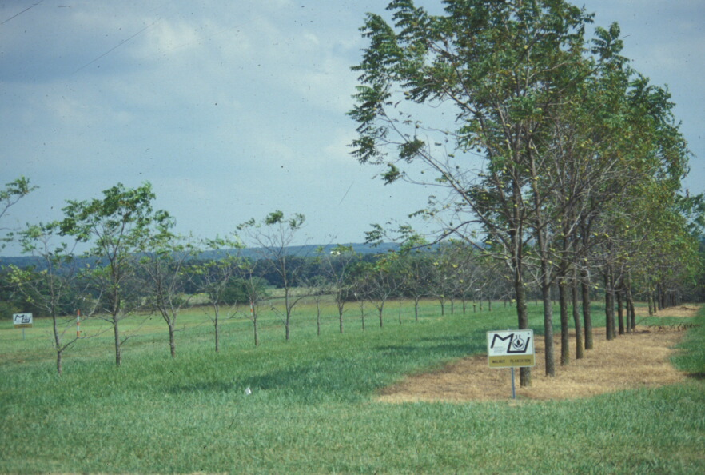
Some of the weed control methods commonly employed for tree planting are (Natural Resources Conservation Service, 2001):
- Chemical application
- Prescribed burning
- Mulches
- Mechanical disking
Figure 27. Weed control can greatly influence tree development. All the trees in this photograph are the same age. The trees on the right have had chemical weed control. The trees on the left have had only mowing.

At a minimum, a 2 to 3 feet diameter weed-free zone should be established around each tree or shrub. Whatever method is used, it is important to remember that only the undesired species and types that will negatively impact the growth of the planting should be controlled. Understanding this will help focus the control activity and minimize costs.
Chemical application. Chemical weed control methods consists of using herbicides to control competing vegetation. The type of herbicide to use should be based on the vegetation that needs to be controlled, site conditions, herbicide cost, and woody species herbicide tolerance. Always follow label instructions.
Prescribed burning. Prescribed burning is a very difficult method of vegetational control after planting. Care must be taken to protect the new planting from the effects of fire. This method can be costly, time consuming and hazardous and therefore should only be used as a last resort. A burn plan should always be developed and followed.
Mulches. Two types of mulches are available for controlling vegetation in woody plantings: non-living mulches and living mulches. Examples of non-living mulches can include plastic weed mats, wood chips, ground corn cobs, and wheat straw. Living mulches, if used, should include plants that are non-competitive such as ladino clover, alsike clover, orchard grass and red clover.
Mechanical disking. Removing competing vegetation through mechanical means should be done with care to avoid physical damage to plantings. Tillage depths should be kept shallow to keep away from root damage.

Browse protection
Knowing the species, domestic or wildlife, and their approximate animal numbers on site, is the first step in assessing what, if anything, will have to be done to protect the planting investment from small and large mammal damage. Insects can also destroy a plantation by defoliation or the spreading of pathogens, but may be harder to control.
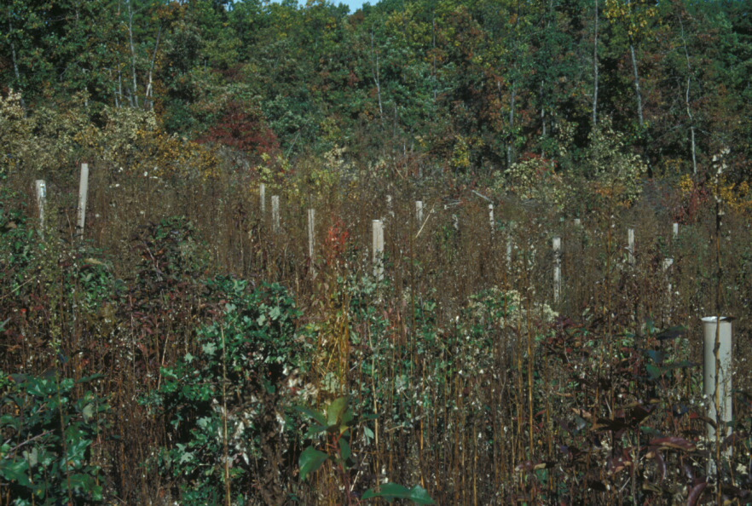
To help control mammal damage a number of alternatives are available. If the mammal damage is being caused by larger animals, fencing should provide the necessary protection especially for domestic livestock damage. Fencing to exclude deer is possible, but may be expensive. If wildlife damage from small animals is occurring, tree shelters or tubing may be effective in protecting woody plants until they reach a suitable height.
Figure 28. Tree shelters or tubing may be effective in protecting young seedlings from wildlife damage.
Insect damage control can be done through chemical or management means. If chemicals are used label instructions should always be followed. Management controls for insect damage are primarily preventative. These management tools include proper seedling spacing, species selection that has natural insect resistance, and plantings that have a variety of different species. Monocultures should be avoided.

References for this section
Allen, J.A., B.D. Keeland, J.A. Stanturf, A.F. Clewell, and H.E. Kennedy Jr. 2001. A guide to bottomland hardwood restoration: U.S. Geological Survey. Report USGS/BRD/ITR-2000-0011. USDA Forest Service, Southern Research Station, General Technical Report SRS-40. 132 p

A Guide for Prescribed Fire in Southern Forests; USDA Forest Service, Southeastern Area; 1978.

Bottomland Hardwood Reforestation in the Lower Mississippi Valley; USDA Forest Service; 1989.

Burns, Russell M., and Barbara H. Honkala, tech. coords. 1990. Silvics of North America: 1. Conifers; 2. Hardwoods. Agriculture Handbook 654.
U.S. Department of Agriculture, Forest Service, Washington, DC. vol.2, 877 p.

Fish and Wildlife Service. 1977. Impact of Water Level Changes on Woody Riparian and Wetland Communities; Volume III;; FWS/OBS-77/60; 36 p.

Natural Resources Conservation Service, 2000a. Alley Cropping (311); Missouri Field Office Technical Guide, Section IV; USDA-NRCS; 6 p.

Natural Resources Conservation Service, 2000b. Riparian Forest Buffer (391); Missouri Field Office Technical Guide, Section IV; USDA-NRCS; 8 p.

Natural Resources Conservation Service. 2001. Forest Site Preparation (490); Missouri Field Office Technical Guide, Section IV; USDA-NRCS; 4 p.

Natural Resources Conservation Service. 2002. Tree/Shrub Establishment (612); Missouri Field Office Technical Guide, Section IV; USDA-NRCS; 7 p.

Planting Northern Red Oak in the Missouri Ozarks. Paul Johnson. USDA Forest Service. 1985.

Silvics of North America; Vols. 1 and 2. Handbook #654. USDA Forest Service. 1990.

Smith, D. M. 1997. The Practice of Silviculture: Applied Forest Ecology (9th ed.). New York, New York. John Wiley and Sons. 537 p.

US Forest Service, 1993. Flooding and its effects on trees. USDA Forest Service, Northeastern Area State and Private Forestry. St. Paul, MN.
Wood, F. A. 1998. First-year performance of direct seeded Nuttall and willow oak in response to flooding in a farmed wetland of the Mississippi delta. Mississippi State University. M.S. thesis. 124 p.

Regeneration/rehabilitation – Existing Stands

This section presents basic information on bottomland silviculture and the species that are associated with bottomland sites. For most species, their silval characteristics determine their potential growth and development under any given management regimes.
Silviculture is defined as “the theory and practice of controlling forest establishment, composition, structure, and growth” (Smith 1997). The foundation of silviculture is silvics, which is the study of the growth and development of trees and forested ecosystems (Smith 1997). Important silvic characteristics of trees include shade tolerance, growth rate, longevity, reproductive strategy, soils and hydrologic conditions.
For example, the continuing establishment of shade-intolerant species will require different forest management activities than species that are shade tolerant. Likewise, oak species and cottonwood, both shade-intolerant trees, have different management strategies for regeneration because cottonwoods have much higher growth rates than oaks. Silviculture involves using this ecological knowledge or silvics of tree species in the management of forest stands to provide for the successful regeneration, growth, and harvesting of desired species.
The choice of a silvicultural system (or systems) will depend upon the management goals for the forest, constraints imposed by the condition of the stand, desired future stand condition, site conditions, financial cost, net returns, time elements, and state and local laws or ordinances.
Silvicultural activities
Regeneration
Silvicultural regeneration techniques can be divided into two main groups - even-aged and uneven-aged management. Even-aged management creates forest stands in which all trees are the basically the same age. These even-aged techniques consist of clearcutting, seed-tree, and shelterwood. Uneven-aged management creates forest stands where trees are of different ages. This technique consists of harvesting single trees or small groups of trees.
The type of method chosen to regenerate any forest stand depends on the management objectives for the stand and the silvics of the target tree species. For example, the maintenance of mid to late successional wildlife habitat may necessitate an uneven-aged management strategy and therefore exclude the regeneration of many types of shade-intolerant species, such as oaks.
A description for the regeneration of every type of bottomland species is beyond the scope of this guide. There are over forty-five woody species that are found in bottomlands (Kabrick and Dey 2001), each with different environmental requirements for their successful regeneration. The following paragraphs provide a brief introduction to each of the general silvicultural techniques that can be used in bottomland situations.
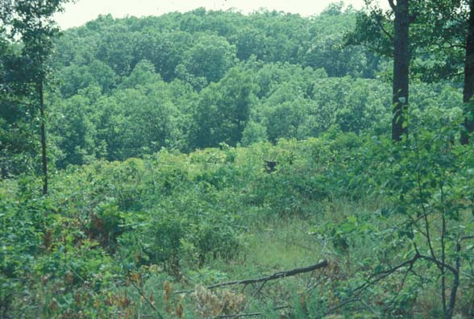
Clearcutting. Clearcutting involves the removal or killing of all trees on acreages usually larger than 10 acres. By opening up the stand, which allows full sunlight to reach the forest floor, regeneration of many shade-intolerant species is possible. Economically important species that are promoted by clearcutting include oaks and cottonwood.
Figure 29. Shade-intolerant species respond well to clearcutting for regeneration purposes.
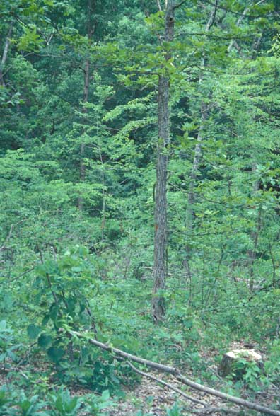
Shelterwood and seed-tree. Seed-tree and shelterwood methods resemble a clearcutting operation that has left some of the better and most desirable canopy trees in place after the initial harvest cut. The residual trees are left in place to act a seed source for the new stand. Once regeneration has started the remaining overstory trees are harvested. The primary difference between a seed-tree stand and a shelterwood stand are the number of trees left after the first harvest. The shelterwood stand will generally have 50% of the original canopy trees remaining while the seed-tree stand will consist of scattered, evenly distributed trees that may only make up only 10-20% of the original canopy. Both these methods tend to promote the regeneration of species that are light-seeded such as cottonwoods and willows Salix sp.
Single-tree. This method consists of harvesting single mature trees. Single-tree selection favors the establishment of shade-tolerant species, as the openings created allow limited sunlight to reach the forest floor. Repeated application of single-tree harvesting will eventually create an uneven-aged stand with the lower age classes dominating in numbers with subsequent older age classes becoming fewer in number. In addition the stand will shift to more shade tolerant species such as hackberry, ashes, maples, and elms.
Figure 30. Single tree harvesting will eventually create an unevenaged stand.
Group selection. Group selection involves the removal of small groups of trees at periodic intervals. As a general rule, the opening is limited to a size twice of the heights of the mature trees (Meadows and Stanturf 1997) or less than 5 acres. This activity generally creates a patchy environment of small even-aged mini-stands scattered throughout the main stand. Carefully application of the method will provide an opportunity for oaks to establish as well as favor wildlife with the variety of vegetational habitat age classes.

Thinning
Another important part of silviculture when rehabilitating an existing stand is thinning. There are several reasons to conduct a thinning but the primary reason is to improve the growth of desired existing tree species. Releasing desired trees from competition with non-desired species or poorly formed trees can improve growth rates, health, and the timber quality of the remaining trees.
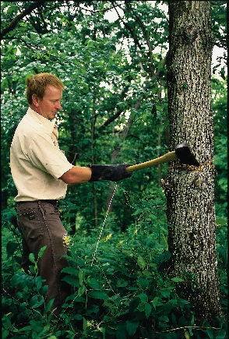
There are four basic methods of thinning: low, crown, selection, and geometric or mechanical (Smith 1997). In low thinning, trees are removed from the lower crown classes. A crown thinning involves removing trees from the middle and upper crown classes. A selection thinning involves the removal of dominant trees to stimulate the growth of subordinate crown classes. A geometric thinning involves the removal of trees in a predetermined pattern on the landscape without regard to their crown position.
The application of thinning operations along with silvicultural regeneration techniques that have been just discussed will provide the landowner with a source of revenue and improve or change existing stands to desired future conditions.
Figure 31. Bark frilling with a hatchet and applying a herbicide is an effective method of thinning a stand of pole sized trees. Photograph - NRCS Iowa
Best Management Practices
The use of Best Management Practices (BMP) is good land stewardship, which, when used properly can protect the value of harvestable timber, guard the water quality of nearby rivers, lakes, streams, and ponds, improve wildlife habitat, develop aesthetic landscape elements and reduce site degradation. BMPs will protect the components of a forest (vegetation, soil, wildlife habitat, aesthetics, and water resources) while still allowing the appropriate use of the natural resource. All BMPs should be planned and designed prior to timber harvesting. Some general rules to follow are:
- Limit the number of entries into your stand by heavy machinery.
- Limit the amount (area) of skidding trails
- Stay away from wet areas and wet weather logging.
- Build a permanent road system that can be easily maintained.
- Use soil maps to facilitate trail and landing layouts.

The Missouri Department of Conservation (MDC) has established state guidelines for reducing non-point sources of water pollution from silvicultural activities (Missouri Department of Conservation, 1997). The implementation of best management practices (BMPs) in big river bottomlands offers many challenges as well as opportunities. Unique site conditions such as micro-relief, fluvial geomorphology, and the possibility that a site may contain both the Big River and its tributaries only add to this challenge. Soil erosion, compaction, or movement may occur any time there is disturbance activity in a stand. Planting, tending, maintenance, or harvesting techniques all have differing degrees of site impacts. With any BMP practice, one of the most important issues to remember is the minimization of soil disturbance and soil movement.
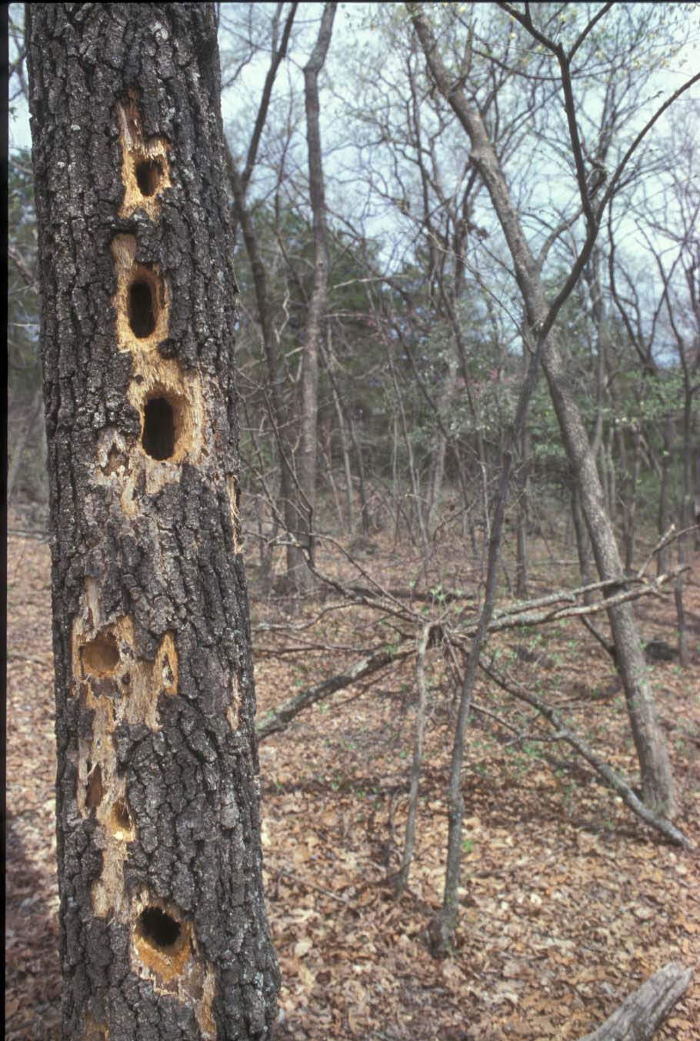
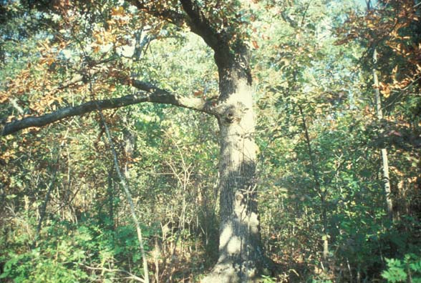
Wildlife habitat
Figure 32. Leaving 3-4 large den (above) and/or dead snag (left) trees per acre can greatly enhance the wildlife values of a bottomland forest.

Numerous BMP practices can be used to enhance wildlife habitat in bottomland forests (Missouri Department of Conservation, 1997. Listed below are some general examples of BMPs, which will protect the site and enhance habitats for many wildlife species.
- Maintain stands of trees in different age and size classes
- Leave corridors of trees connecting existing mature stands to serve as cover and travel lanes for wildlife
- Leave snags and hollow den trees for cavity-dependent species
- Re-seed open areas such as logging decks, edges of clear-cuts, and old firebreaks with native herbaceous vegetation.
- Create woodland openings to increase habitat diversity
- Develop cut-back borders along field edges to provide a transition zone for wildlife
- Create wildlife food plots throughout the stand

Water quality

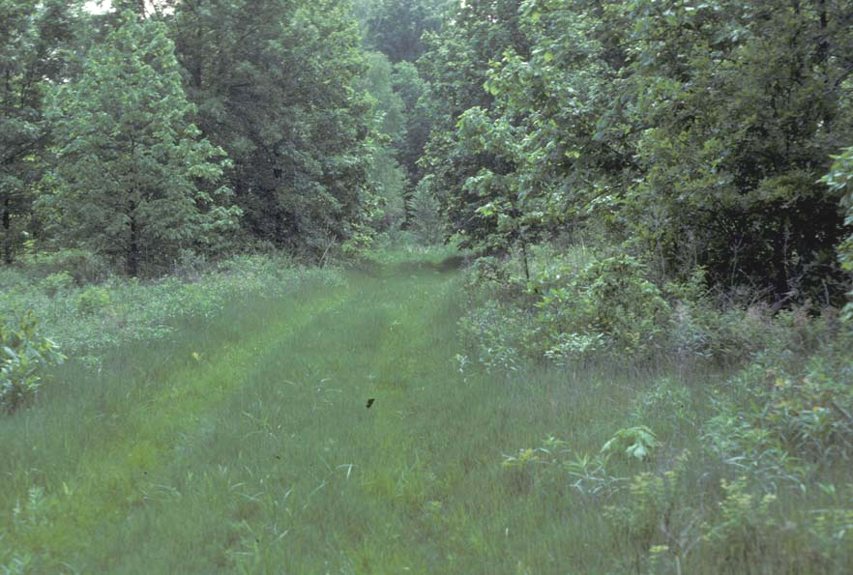
Vegetation and organic matter on the forest floor protect the soil from the erosive power of raindrops and storm-water runoff. Forest management activities associated with harvesting after the tree is cut, such as tree skidding, roads, trails, and log landings, can remove this protective layer, resulting in soil erosion and sediment. Forest roads and skid trails with stream crossings act as direct pathways for sediment transport into adjacent waterways. Deposited sediment constricts naturally flowing channels and reduces the holding capacity of streams and lakes. The changes to these natural systems can lead to increased channel erosion and possibly flooding. In addition it can be difficult for many aquatic species to locate their prey in turbid water. Suspended sediments have also been found to clog the gills of fish, literally suffocating them. Furthermore, high sediment loads make it difficult for light to penetrate the water preventing beneficial aquatic plants to grow. The deposition of particles in suspension can fill the interstitial spaces altering aquatic habitats, suffocating fish eggs and altering spawning grounds for fish as well as the many invertebrates important to the aquatic food web.
Figure 33. Seeding retired logging trails is an important BMP to reduce or eliminate sediment moving offsite.
A critical and important BMP for water quality is the establishment of streamside management zones (SMZs) - vegetated areas next to rivers, lakes and streams (Missouri Department of Conservation, 1997. These streamside zones should range in size from 25 to 50 feet in width and are complex ecosystems that provide food, habitat and movement corridors for both aquatic and terrestrial wildlife. In addition, these areas help to minimize movement of non-point source pollution into surface waters.
Within the SMZ:
- harvesting should be minimized,
- wheeled or tracked vehicles should be restricted
- chemicals should be labeled for use near water
- roads or landings avoided

Aesthetics
Managing the appearance of a bottomland forest is recognized as an important resource consideration for many land users. To accomplish this objective will necessitate active management of the site and vegetation using appropriate silvicultural and landscape BMPs. The following list developed (Forest Service, 1990) provides some common landscape design actions that can be used:
- Plan comprehensively – achieve a comprehensive visual effect by planning for the entire site rather than one stand or area at a time.
- Make openings – vary the size, shape, and location of openings relative to the scale and appearance of the surrounding area.
- Shape stand boundaries – make stand boundaries as natural as possible following natural topographic features and vegetation changes.
- Soften large openings – add visual variety and wildlife benefits such as large trees, flowering trees, extension of peninsulas of vegetation or groups, leave unusual trees for visual variety, avoid linear openings, retain snags and den trees.
- “Feather” edges – soften sharp edges along borders to create transition zones.
- Design roads and landings carefully – keep the amount of road and trail construction to a minimum. Retire unused sections with appropriate vegetative cover.
- Utilize the whole tree – full utilization of the entire tree minimizes residue slash.
- Treat slash – chip, lop and scatter slash and keep it low to the ground to improve the appearance and encourage rapid decay.
- Reduce activities – reduce entry access time into the area to decrease the impact of machinery movement
- Enhance beauty – look for opportunities to create vistas, views of rock outcroppings, water bodies, and other visually appealing natural features.

Planting/site preparation
Planting and site preparation BMPs should be followed whether you are establishing a tree planting area for the first time or you are re-planting after a logging operation. These procedures will minimize the amount of disturbance and compaction to the forest floor and therefore decrease the creation of areas susceptible to erosion. It is also important to limit site preparation to the minimum amount needed to establish a well stocked stand. Some examples of planting/site preparation BMPs are:
- Avoid preparation techniques that expose soil, especially on steep slopes
- Seed ground cover as soon as possible.
- Bedding (raised earth ridges) for drainage relief should follow the contour on even gentle slopes and follow the drainage patterns. Do not bed in wetland areas.
- Provide for drainage needs with culverts, bridges and crossings.
- Raking and windrowing should be oriented parallel to any body of water and on the contours to slow runoff and reduce sediment movement.
- Consider the effects of pesticides near water features. Follow all label instructions.
- Avoid planting into excessively wet soils

Harvesting
Harvesting BMPs have been designed not only to reduce sedimentation and erosion but also to protect the land and other values associated with the land. Harvesting BMPs should be planned early so that problems can be dealt with before they arise. Some essential BMPs are listed below:
- Directional felling should be done carefully to reduce residual stand damage and to minimize the size and length of skid trails.
- Stream channels and other wet areas should be avoided by harvesting equipment. If channels need to be crossed follow proper stream crossing BMPs.
- Skidding activities should be direct away from water courses.
- Do not change oil in machinery where it can impact water quality and collect any used oil for proper disposal
- Logging slash should be left in place and cut as low as possible to facilitate decomposition.
- Portable sawmills should be located away from streams or water bodies.

Roads and skid trails
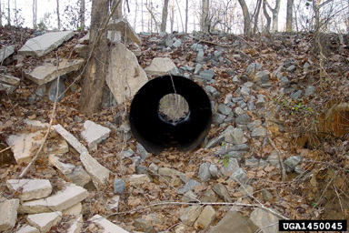
For most harvesting operations in Missouri, the construction of special logging permanent access roads is not required (Missouri Department of Conservation, 1997). Nearly 90% of the soil erosion from timber harvests comes from the use and development of skid trails, landings and temporary roads. To help minimize this erosion potential, the following BMPs should be considered:
Figure 34. Use culverts as needed to route water away from the road and to maintain good drainage. Photograph - Billy Humphries, Forest Resource Consultants, Inc.
- Skid trails, roads, and decks should be properly placed and be minimized. Any road system should be laid out with the help of soil maps and interpretations.
- Use culverts as needed to route water away from the road.
- Water bars should be used when retiring temporary roads and trails.
- Roads and trails should be planned, located, and constructed to provide adequate water drainage from road surfaces.
- Remove shading trees along roads as needed to expose the road surface to sunlight and air movement.
- Roads constructed with SMZs should have all exposed soil stabilized as soon as possible after harvesting operations have ceased.
- Limit using roads during wet or saturated site conditions.

References used in this section:

Forest Service, 1990 Central Hardwood Notes – Visual Management of Central Hardwoods. USDA Forest Service, North Central Experiment Station. Columbia, MO.

Kabrick, J. and Dey, D. 2001. Jefferson City, MO: Missouri Department of Conservation.

Meadows, J.S. and Stanturf, J.A.. 1997. Silvicultural Techniques for Southern Bottomland Hardwood Forests. Forest Ecology and Management 90, 127-140

Missouri Department of Conservation, 1997. Missouri Watershed Protection Practice: 1997, Management Guidelines for Maintaining Forested Watersheds to Protect Streams. Conservation Commission of the State of Missouri. 28 p.

Smith, D. M. 1997. The Practice of Silviculture: Applied Forest Ecology (9th ed.). New York, New York. John Wiley and Sons. 537 p.

Acknowledgements

This guide was developed as a graduate class project at the University of Missouri during the spring semester 2003. Douglas Wallace served as the primary editor. Dr. John Dwyer, Professor, UMC School of Natural Resources, presided as course instructor and provided outstanding guidance throughout the development of this guide. The class was comprised of the following students:
- Douglas Wallace
- William “Dusty” Walter
- Faren McCord
- Thomas Faust
- John Kluthe
- David Shostak
- Nicholas Krekeler

Wood is Good

Glossary

Advance regeneration - Advance growth seedlings or saplings present in the understory that when released will form the future canopy.

Basal area - The cross-sectional area of a stand of trees measured at breast height ( 4 ft 1/2 feet aboveground). The area is expressed in square feet per acre and is a measure of stocking density.

DBH (diameter at breast height) - The diameter of a standing tree measured 4.5 ft from the ground.

Deciduous - Pertaining to perennial plants that lose their leaves part of the year, such as hardwood trees such as oak, hickory, and maple.

Epicormic branching - The development of small branches along the bole, or trunk, of a tree. This often develops in response to thinning operations where substantially greater sunlight reaches the tree stems.

Even-aged management - Silvicultural system in which the individual trees originate at about the same time and are removed in one or more harvest cuts, after which a neweven-aged stand is continued.

Exotic species - Species that are not native to an area.

Hard mast-producing - Species such as oaks, pecans, or hickories that produce a large nut (acorn) that in turn provide food for a variety of wildlife such as deer, turkey, and some waterfowl.

Herbaceous - Soft and green vegetation which dies back to the ground each year generally containing little woody tissue.

High grading - Forest harvesting where only the best commercially valuable trees are cut. This method of harvest often results in a forest stand dominated by undesirable or weedy tree species.

Hydrologic regime - The pattern of water level dynamics referring to the timing, frequency, depth, and duration of aboveground flooding, but also refering to belowground water level fluctuations.

Hydrology - The study of the processes that involve the transport or movement of water.

Improvement cutting - A cutting made in a stand past the sapling stage primarily to improve composition and quality by removing less desirable trees of any species.

Light-seeded species - Species such as cottonwood, elm, willow, and sycamore that have light weight seeds that can be easily dispersed by wind or water. Many of these seeds, however, can also be dispersed by animals.

Non-point source pollution - Pollution that is not from a single, well-defined site such as a factory or tile outlet.

Reforestation - Activities to re-establish the forest where there currently is none. This is mainly done through planting, seeding, or natural regeneration.

Regeneration - The natural or artificial replacement of mature trees with new tree growth.

Rehabilitation – Actions that repair an already existing forest by manipulating the existing stand. Intermediate treatments can be used to release good quality trees.

Shelterwood cut - A cut in which the mature stand is generally removed in a series of two or more cuts, the last of which is when the new even-aged stand is well developed.

Silviculture - The science and art of regenerating and managing a forest to meet specific objectives.

Soil horizon - A distinct layer of soil parallel to the surface that has definitive physical, chemical, and hydrologic characteristics.

Stand - A contiguous group of trees sufficiently uniform in age class distribution, composition, and structure, and growing on a site of sufficiently uniform quality to be a distinguishable unit.

Stocking – A relative term used to describe the adequacy of growing stock in a given stand that will meet a management objective.

Thinning - Intermediate cuttings aimed primarily at controlling growth of timber stands by adjusting stand density and quality.

Understory - Any plants growing under the canopy formed by other plants, such as herbaceous and shrub vegetation under a taller tree canopy.

Uneven-aged management - Silvicultural system in which individual trees originate at different times and result in a forest stand with trees of various ages and sizes. Harvest cuts are often on an individual-tree selection basis.

Appendix

Table A. Endangered Missouri Avian Species for Associated Bottomland Forest Habitats.

Bird Species | Habitat | Cause for Concern | How You Can Help
Swainson’s Warbler  Limnothlypis swainsonii | Inhabits dense stands of giant cane that grow along big river floodplains and swamps. | The draining and deforestation of Missouri’s Bootheel swamps for agriculture and the inundation of bottomland habitat by reservoirs has impacted this neo-tropical migrant. Furthermore, the vast canebrakes within extensive forests that once lined the Missouri river are gone. | Landowners who own land along the rivers can help by recognizing the importance of canebrakes, as well as leave a 100-foot buffer of natural vegetation on both sides of a river or stream.
Cerulean Warbler  Dendroica cerulea | Frequently nest in mature contiguous hardwood forests in river valleys, where the trees are tall and the understory is relatively open. | Forests that are fragmented by human development and logging not only destroy important cerulean warbler habitat, but also increases the potential for brown-headed cowbird nest parasitism. | Landowner scan help by setting aside contiguous blocks of mature hardwood forest habitat. Forests should be managed for timber harvests in a way that ensures that mature, relatively open stands are available for these canopy dwelling neo-tropical migrants.

Table B. Endangered Missouri Mammalian Species

Mammal Species | Habitat | Cause for Concern | How You Can Help
Indiana Bat  Myotis sodalis | In the spring, females fly north of their hibernation caves in search of large diameter trees with loose bark where they roost and raise their single young. In general, most young bats are raised in the northern half of the state. Some males will spend the summer in caves, but most wander about the state in small groups and nest under the loose bark of trees. | Indiana bats are listed as endangered both in Missouri and federally. They have declined significantly over the last 20 years, particularly in Missouri, and many biologist suspect a connection to pesticide contamination through their insect prey. | Reducing the amount and frequency of pesticides used for home or agricultural purposes. Landowners should also refrain from cutting dead or living trees larger than nine inches in diameter that could serve as suitable nursery roost trees.
Swamp Rabbit  Sylvilagus aquaticus | Live in cane thickets along rivers, in brush bordering swamps or in bottomland forests in southeastern and southern Ozark regions of Missouri. | Their decline is directly related to the dramatic loss of forested and brushy bottomland habitat in the Bootheel over the last 50 years. Also, large-scale changes in lowland habitat and channelization and dredging of the big rivers and their tributary streams have caused floods to be more frequent and sustained during prime breeding months (February – June) | Landowners in southeastern Missouri can help improve conditions for swamp rabbits by protecting forested corridors along rivers and bottomlands or by replanting those areas in native tree species.

Table C. Forestry Soils Interpretation Chart for Boone County, Missouri.
Forest Management

The information in this table indicates the dominant soil condition but does not eliminate the need
for onsite investigation. The numbers in the value columns range from 0.00 to 1.00. The larger the value, the greater the potential limitation.

_____________________________________________________________________________________________________
| | | |
Map symbol and | Hand planting | Mechanical planting |Use of harvesting equipment|
soil name | | | |
|___________________________|___________________________|___________________________|
| Rating class and |Value| Rating class and |Value| Rating class and |Value|
| limiting features | | limiting features | | limiting features | |
________________|_____________________|_____|_____________________|_____|_____________________|_____|
| | | | | | |
50011: | | | | | | |
Winnegan-------|Slightly limited | |Very limited | |Limited | |
|~slope |0.19 |~slope |1.00 |~slope |0.76 |
| (slightly limited) | | (very limited) | | (limited) | |
| | | | |~low strength |0.50 |
| | | | | (moderately limited)| |
| | | | | | |
60030: | | | | | | |
Winfield-------|Not limited | |Slightly limited | |Moderately limited | |
| | |~slope |0.30 |~low strength |0.50 |
| | | (slightly limited) | | (moderately limited)| |
| | | | |~seasonal wetness |0.10 |
| | | | | (slightly limited) | |
| | | | | | |
| | | | | | |
| | | | | | |
60031: | | | | | | |
Winfield-------|Not limited | |Moderately limited | |Moderately limited | |
| | |~slope |0.43 |~low strength |0.50 |
| | | (moderately limited)| | (moderately limited)| |
| | | | | | |
| | | | | | |
| | | | | | |
66015: | | | | | | |
Blake----------|Not limited | |Not limited | |Moderately limited | |
| | | | |~low strength |0.50 |
| | | | | (moderately limited)| |
| | | | | | |
| | | | | | |
| | | | | | |
Ma: | | | | | | |
Malden---------|Moderately limited | |Moderately limited | |Moderately limited | |
|~very sandy (surface)|0.50 |~very sandy (surface)|0.50 |~very sandy (surface)|0.50 |
| (moderately limited)| | (moderately limited)| | (moderately limited)| |
| | | | | | |
| | | | | | |
73095: | | | | | | |
Gravois--------|Slightly limited | |Limited | |Moderately limited | |
|~slope |0.04 |~slope |0.68 |~low strength |0.50 |
| (slightly limited) | | (limited) | | (moderately limited)| |
| | | | |~seasonal wetness |0.26 |
| | | | | (slightly limited) | |
| | | | |~slope |0.15 |
| | | | | (slightly limited) | |
| | | | | | |
________________|_____________________|_____|_____________________|_____|_____________________|_____|

