Module 11 – Performance-Based Acquisitions

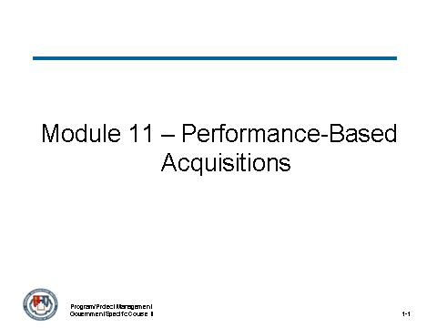
___________________________________________________________________________________
___________________________________________________________________________________
___________________________________________________________________________________
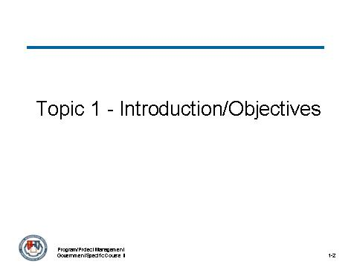
___________________________________________________________________________________
___________________________________________________________________________________
___________________________________________________________________________________

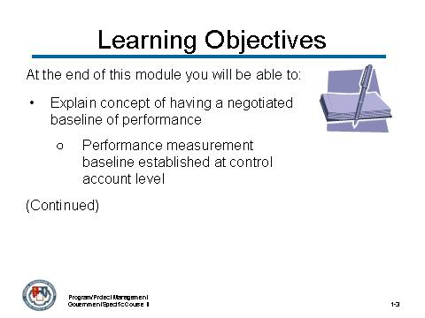
___________________________________________________________________________________
___________________________________________________________________________________
___________________________________________________________________________________
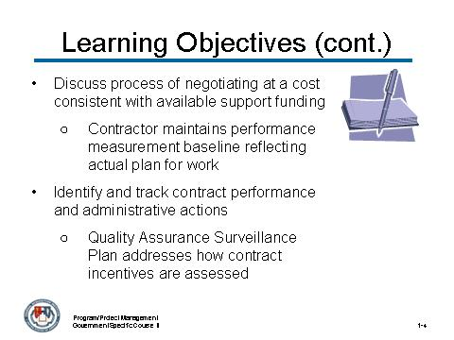
___________________________________________________________________________________
___________________________________________________________________________________
___________________________________________________________________________________

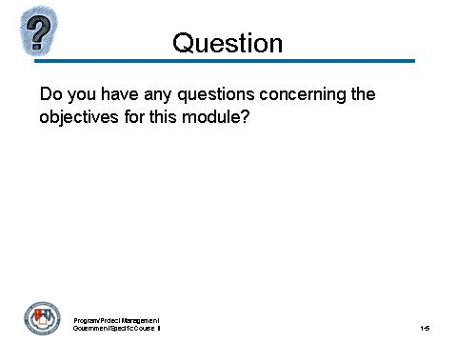
___________________________________________________________________________________
___________________________________________________________________________________
___________________________________________________________________________________
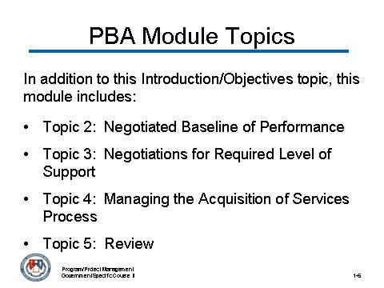
___________________________________________________________________________________
___________________________________________________________________________________
___________________________________________________________________________________

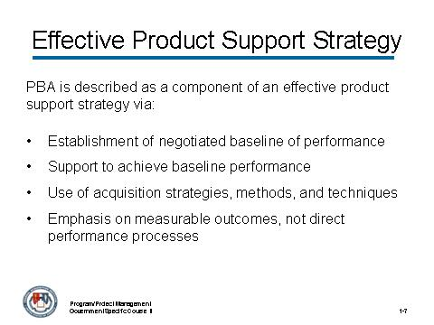
___________________________________________________________________________________
___________________________________________________________________________________
___________________________________________________________________________________
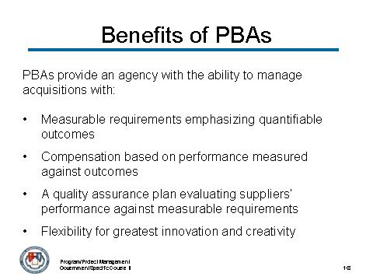
___________________________________________________________________________________
___________________________________________________________________________________
___________________________________________________________________________________

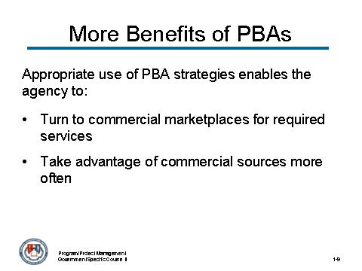
___________________________________________________________________________________
___________________________________________________________________________________
___________________________________________________________________________________
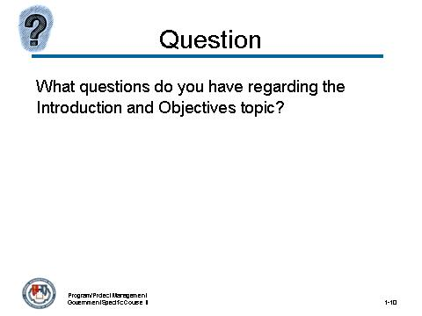
___________________________________________________________________________________
___________________________________________________________________________________
___________________________________________________________________________________

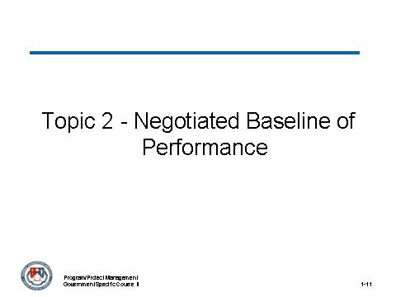
___________________________________________________________________________________
___________________________________________________________________________________
___________________________________________________________________________________
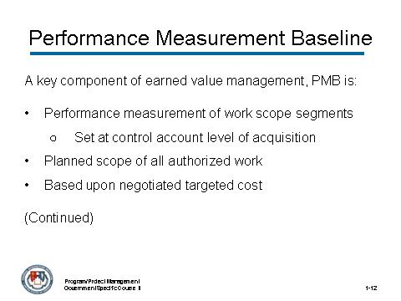
___________________________________________________________________________________
___________________________________________________________________________________
___________________________________________________________________________________

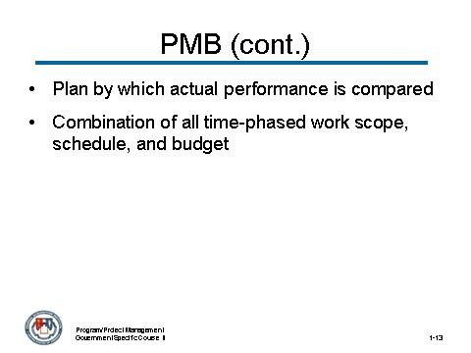
___________________________________________________________________________________
___________________________________________________________________________________
___________________________________________________________________________________
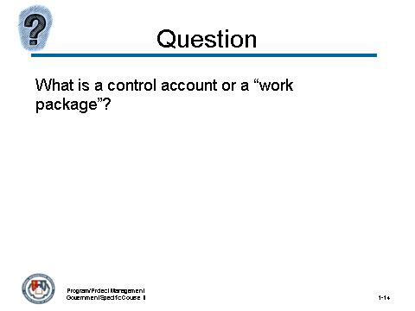
___________________________________________________________________________________
___________________________________________________________________________________
___________________________________________________________________________________

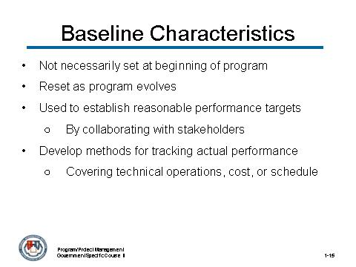
___________________________________________________________________________________
___________________________________________________________________________________
___________________________________________________________________________________
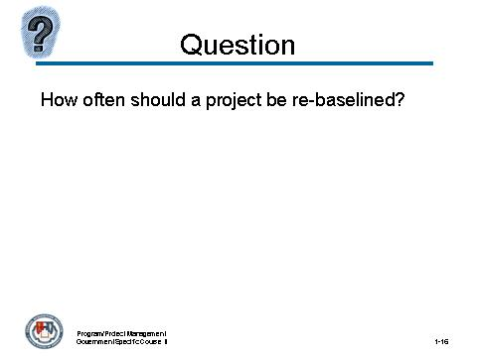
___________________________________________________________________________________
___________________________________________________________________________________
___________________________________________________________________________________

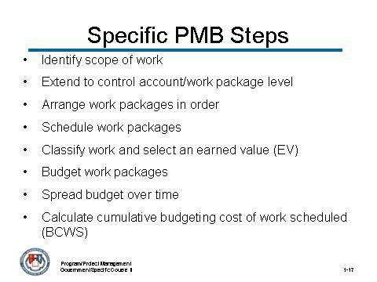
___________________________________________________________________________________
___________________________________________________________________________________
___________________________________________________________________________________
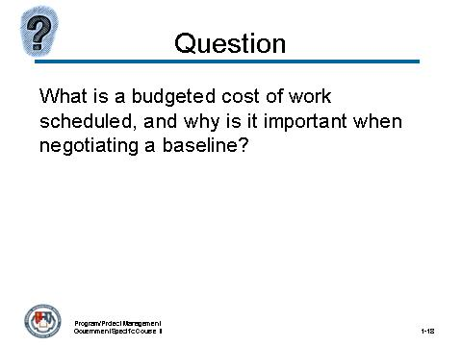
___________________________________________________________________________________
___________________________________________________________________________________
___________________________________________________________________________________

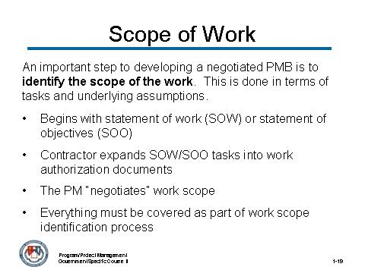
___________________________________________________________________________________
___________________________________________________________________________________
___________________________________________________________________________________
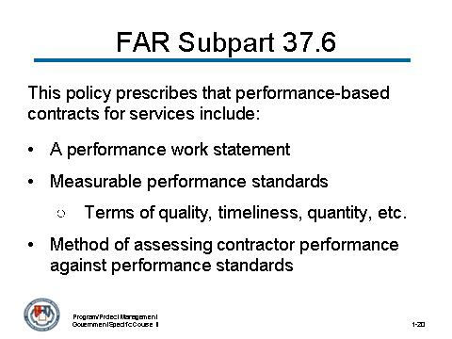
___________________________________________________________________________________
___________________________________________________________________________________
___________________________________________________________________________________

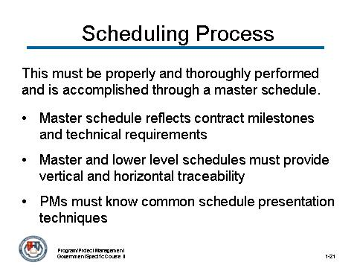
___________________________________________________________________________________
___________________________________________________________________________________
___________________________________________________________________________________
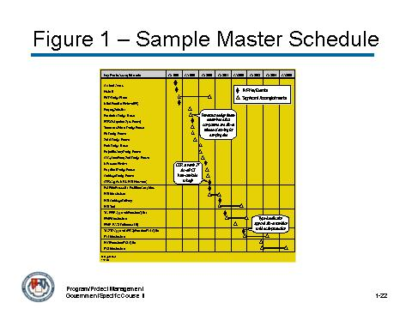
___________________________________________________________________________________
___________________________________________________________________________________
___________________________________________________________________________________

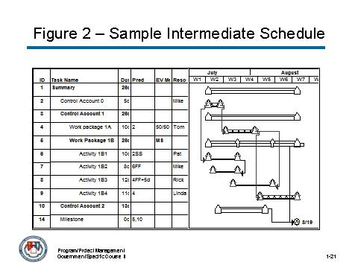
___________________________________________________________________________________
___________________________________________________________________________________
___________________________________________________________________________________
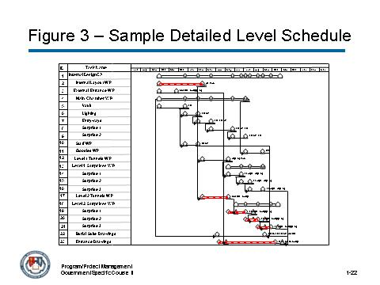
___________________________________________________________________________________
___________________________________________________________________________________
___________________________________________________________________________________

Activity

The National Security Agency (NSA) has awarded a major acquisition contract to a team led by Sciences Acquisition Corporation (SAC), on September 18, 2007 for development of the Technology Demonstration Platform (TDP) project in support of the Agency's TRAILBLAZER initiative. TRAILBLAZER is one of the Agency's modernization programs to apply enterprise technology to achieve the scale necessary in today's environment.
The SAC team will provide and integrate commercial technologies proven to be scalable, agile, robust, secure, and interoperable to produce and deploy state-of-the-art solutions to challenges facing the NSA today and in the future.
This contract is a continuation of NSA's effort to transform its national security missions of providing foreign signals intelligence and protecting national security-related information systems using the innovation of industry partners.

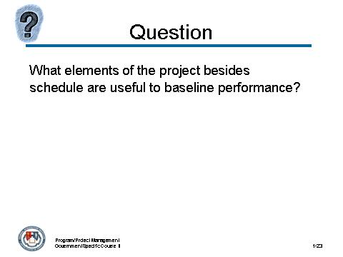
___________________________________________________________________________________
___________________________________________________________________________________
___________________________________________________________________________________
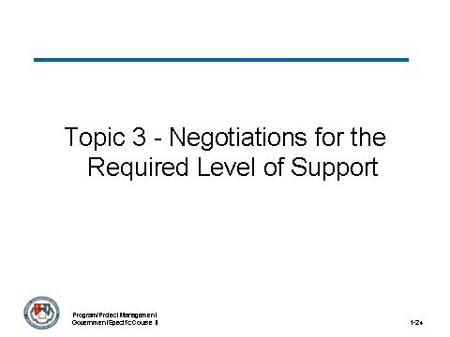
___________________________________________________________________________________
___________________________________________________________________________________
___________________________________________________________________________________


___________________________________________________________________________________
___________________________________________________________________________________
___________________________________________________________________________________
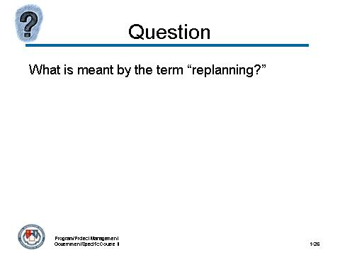
___________________________________________________________________________________
___________________________________________________________________________________
___________________________________________________________________________________

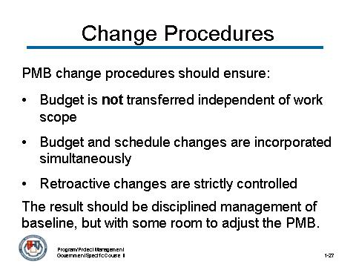
___________________________________________________________________________________
___________________________________________________________________________________
___________________________________________________________________________________
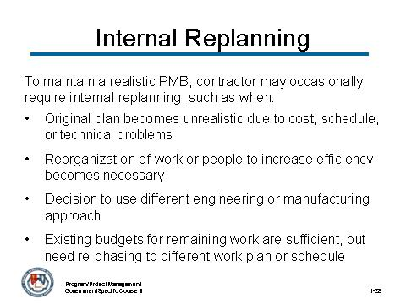
___________________________________________________________________________________
___________________________________________________________________________________
___________________________________________________________________________________


___________________________________________________________________________________
___________________________________________________________________________________
___________________________________________________________________________________
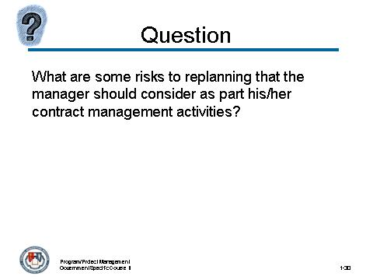
___________________________________________________________________________________
___________________________________________________________________________________
___________________________________________________________________________________

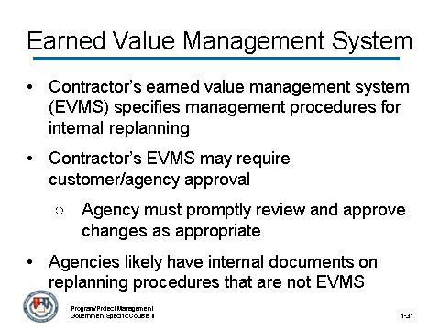
___________________________________________________________________________________
___________________________________________________________________________________
___________________________________________________________________________________
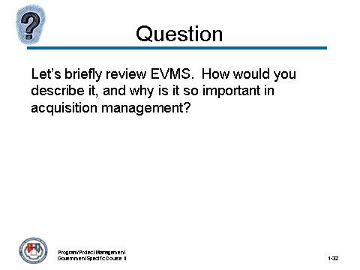
___________________________________________________________________________________
___________________________________________________________________________________
___________________________________________________________________________________

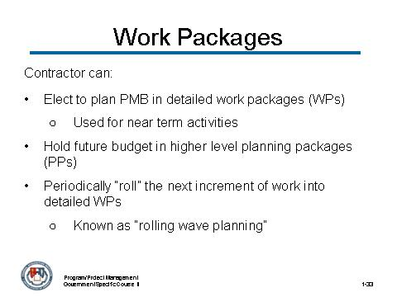
___________________________________________________________________________________
___________________________________________________________________________________
___________________________________________________________________________________
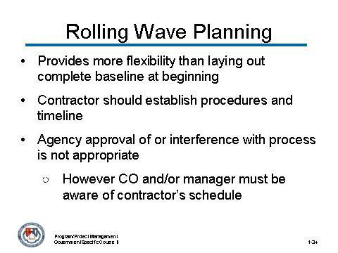
___________________________________________________________________________________
___________________________________________________________________________________
___________________________________________________________________________________

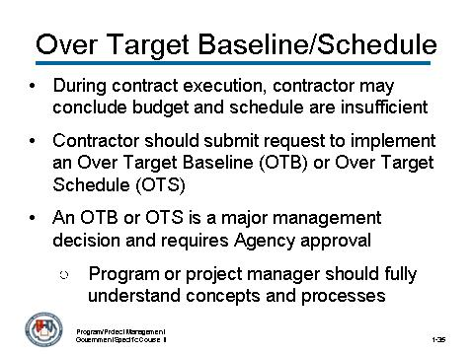
___________________________________________________________________________________
___________________________________________________________________________________
___________________________________________________________________________________
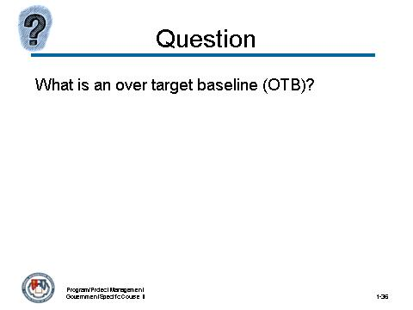
___________________________________________________________________________________
___________________________________________________________________________________
___________________________________________________________________________________

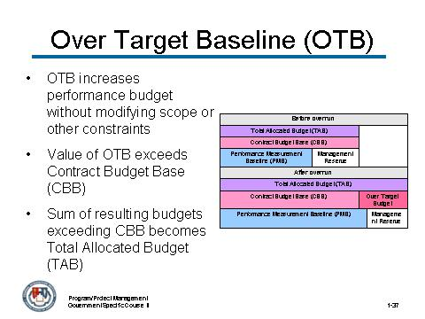
___________________________________________________________________________________
___________________________________________________________________________________
___________________________________________________________________________________
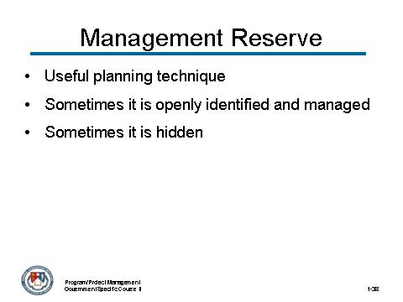
___________________________________________________________________________________
___________________________________________________________________________________
___________________________________________________________________________________

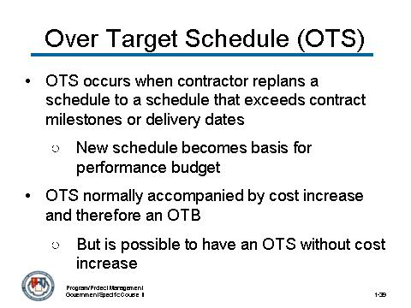
___________________________________________________________________________________
___________________________________________________________________________________
___________________________________________________________________________________
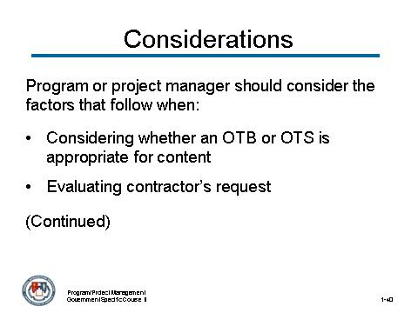
___________________________________________________________________________________
___________________________________________________________________________________
___________________________________________________________________________________

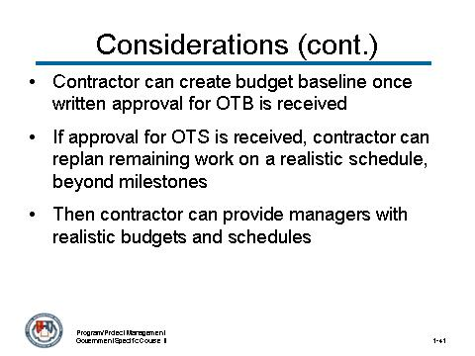
___________________________________________________________________________________
___________________________________________________________________________________
___________________________________________________________________________________
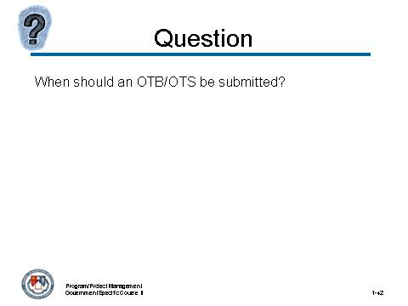
___________________________________________________________________________________
___________________________________________________________________________________
___________________________________________________________________________________

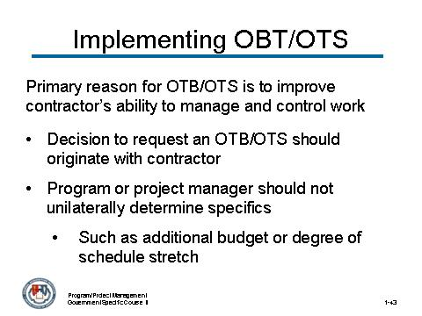
___________________________________________________________________________________
___________________________________________________________________________________
___________________________________________________________________________________
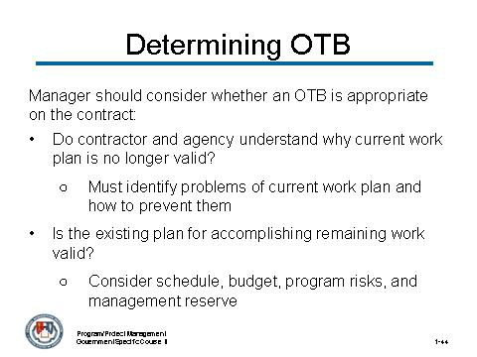
___________________________________________________________________________________
___________________________________________________________________________________
___________________________________________________________________________________

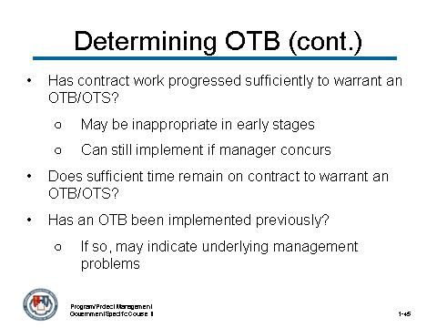
___________________________________________________________________________________
___________________________________________________________________________________
___________________________________________________________________________________

Activity

The National Security Agency (NSA) has awarded a major acquisition contract to a team led by Sciences Acquisition Corporation (SAC), on September 18, 2007 for development of the Technology Demonstration Platform (TDP) project in support of the Agency's TRAILBLAZER initiative. TRAILBLAZER is one of the Agency's modernization programs to apply enterprise technology to achieve the scale necessary in today's environment.
The SAC team will provide and integrate commercial technologies proven to be scalable, agile, robust, secure, and interoperable to produce and deploy state-of-the-art solutions to challenges facing the NSA today and in the future.
SAC is approaching the Critical Design Review milestone when they are scheduled to present for approval the design that they will build to following the milestone. The design includes a large number of subsystems, interfaces, and databases.
Thus far SAC has been progressing according to the performance baseline established at the beginning of the project and confidence has been established by both the government program manager and SAC in the accuracy of the reporting. The EVMS indicates that the $100M 3 year project SPI and CPI are both very close to 1.0.
As the program or project manager, you are called into your manager’s office and informed that an OTB/OTS request has been received from SAC for $2M and two additional months.


___________________________________________________________________________________
___________________________________________________________________________________
___________________________________________________________________________________
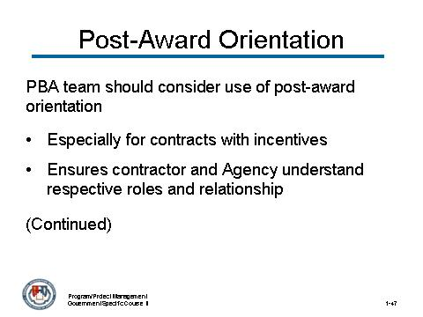
___________________________________________________________________________________
___________________________________________________________________________________
___________________________________________________________________________________

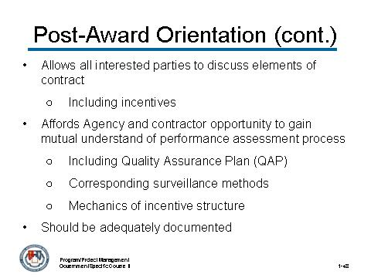
___________________________________________________________________________________
___________________________________________________________________________________
___________________________________________________________________________________

___________________________________________________________________________________
___________________________________________________________________________________
___________________________________________________________________________________

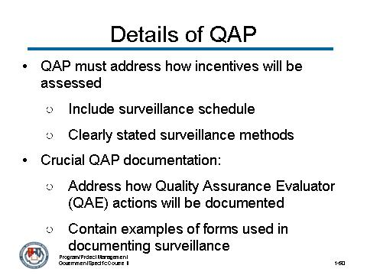
___________________________________________________________________________________
___________________________________________________________________________________
___________________________________________________________________________________
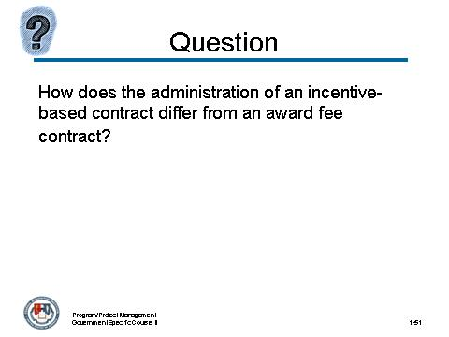
___________________________________________________________________________________
___________________________________________________________________________________
___________________________________________________________________________________

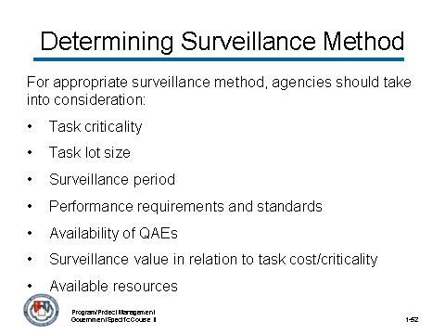
___________________________________________________________________________________
___________________________________________________________________________________
___________________________________________________________________________________
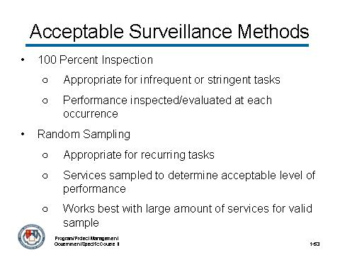
___________________________________________________________________________________
___________________________________________________________________________________
___________________________________________________________________________________

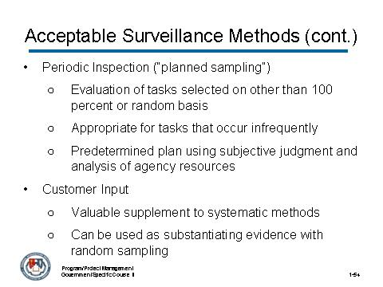
___________________________________________________________________________________
___________________________________________________________________________________
___________________________________________________________________________________

Activity

The National Security Agency (NSA) has awarded a major acquisition contract to a team led by Sciences Acquisition Corporation (SAC), on September 18, 2007 for development of the Technology Demonstration Platform (TDP) project in support of the Agency's TRAILBLAZER initiative. TRAILBLAZER is one of the Agency's modernization programs to apply enterprise technology to achieve the scale necessary in today's environment.
The SAC team will provide and integrate commercial technologies proven to be scalable, agile, robust, secure, and interoperable to produce and deploy state-of-the-art solutions to challenges facing the NSA today and in the future.
At the Critical Design Review SAC identifies a few changes that they think appropriate for the Quality Assurance Plan that was approved earlier in the project. Specifically, they want to change the surveillance method for: compatibility of TDP with actual NSA systems, security of TDP, scalability of TDP, and speed of TDP.






