Conceptual Design Study for
ITER Divertor Interferometer Diagnostic

D.L. Brower
University of California at Los Angeles

14 December 2005

Conceptual Design Study for
ITER Divertor Interferometer Diagnostic

Diagnostic Requirements:

The ITER design report calls for a measurement of the divertor electron density. Specifications given for this measurement are

  - density range from 10¹⁹ to 10²² m⁻³, no density resolution is specified but a minimum of 1% should be required.
  - time response of 1 msec, and
  - spatial resolution of 5 cm along the leg and 3 mm across the divertor leg.
  - Realtime density output is not specified but presumed necessary for ITER operations

These specifications were originally put forward when various reflectometer systems were envisioned for each divertor leg. At present, for the ITER divertor interferometer system, the lines of sight planned are shown in Fig. 1, which shows 5 chords (~10 cm spacing) on the outer leg and 3 chords (~20 cm spacing) on the inner leg. This is considered to be the maximum number of chords that will be available. Other possibilities put forward in ITER documents are 4 outer and 2 inner chords or even a reduced set of 2 outer and 1 inner chord is possible.

Regarding the density range: The density range anticipated for the ITER divertor and the range which must be covered by the interferometer spans three orders of magnitude. For any interferometer system envisaged for ITER, no single wavelength can cover the entire density range from 10¹⁹ to 10²² m⁻³, with the density resolution of 1%. It is not specified whether the peak density of 10²² m⁻³ would occur continuously in time or be limited to discrete events such as giant ELMs which would last ~1-10 msec. If the peak density were only reached during discrete short duration events, then it might be possible to lose phase during the event (and density information) and have the interferometer recover immediately after the event. This would considerably reduce the design constraint. More on this later. The anticipated electron density distribution for a standard ITER discharge scenario is shown in Fig. 2, where the density profile is provided for 8 different lines of sight along the outer divertor leg. The maximum density is expected to occur along path 2 (1.8 x 10²¹ m⁻³) and minimum along path 8 (1.8 x 10²⁰ m⁻³). A minimum density of ~10¹⁹ m⁻³ would then occur near the wall. Divertor path lengths are relatively short and vary from 0.05 m (Path 2) to 0.45 m (Path 8). For purposes of this conceptual design study, we will take this discharge scenario [covering from 1x10¹⁹ m⁻³ edge(or wall) to 1.8 x 10²¹ m⁻³ core] as the baseline for designing the interferometer system. This discharge corresponds to an ITER divertor case with 75 MW into SOL. For the maximum density put forward in the ITER design specifications, we will simply scale each profile by a factor of ~5 so that the peak density along path 2 reaches 10²² m⁻³. On this basis, the local density distributions shown in Fig. 2 can be converted into line integrals along each sight line for both the ITER divertor baseline [Fig. 3(a)] and maximum density [Fig. 3(b)] cases.

If the divertor interferometer does actually require a capability to measure a peak density of 10¹⁹ m⁻³ (assuming it is along path 8), then all the profiles shown in Fig. 2(b) must be scaled down by a factor of ~18. This will require longer interferometer wavelengths to obtain the specified resolution. This situation will only be treated briefly in this report. It is anticipated that divertor reflectometer systems operating at frequencies up to 155 GHz (private communication with G. Vayakis) will be able to accommodate densities from the lowest density range up to 3 x 10²⁰ m⁻³.

By comparing Fig. 1 with Fig. 2, it can be deduced that for the outer divertor leg, path 4 most closely corresponds to the interferometer chord labeled O1 in Fig. 1(b). This is the interferometer chord that will see the highest peak density in the divertor. Paths 5-8 would then correspond to chords O2-O5, respectively, in Fig. 1(b).

Regarding the time response: Existing interferometers systems can easily obtain time resolution of 1 msec and even 1 μsec is readily feasible. Interferometers with optimum time response will have the added measurement capability of looking at both equilibrium and fluctuating quantities. This may be important for the divertor region where density structures (or ‘blobs’) may be moving down the divertor leg. A high time response interferometer would be able to resolve these structures. Time delay measurements from chord-to-chord would also allow determination of the propagation velocity as well as size. Consequently we recommend decreasing the time response to 1-10 μsec.

Regarding spatial resolution: For any line-of-sight interferometer measurement, there will be no spatial resolution across the divertor leg. Interferometers only measure along a given chord (λ is the radiation wavelength and dl is the path length in the plasma). Spatial resolution along the divertor leg will be limited to the number of chords. As shown in Fig. 1, this spacing is currently set at ~10-20 cm for a very limited number of chords. Inversion of interferometry data to obtain local density should not be considered likely due to the limited number of chords and the lack of symmetry in the divertor region. Meeting the spatial resolution requirements with the number of chords specified is not possible.

Interferometer Diagnostic Issues to be addressed:

- optimum diagnostic technique:

  - standard interferometry
  - two-color system to compensate for vibrations and thermal expansion
  - single or multiple pass systems
  - dispersion interferometer
  - Cotton-Mouton effect interferometer

Due to the harsh environment in the ITER divertor region, a standard single-frequency interferometer system would not be suitable. The two-color interferometer system typically employed by the fusion community to compensate for optical system vibrations is feasible for ITER as it would also compensate for mechanical stresses and thermal expansion which are expected to be significant. Due to the anticipated large thermal expansion, perhaps up to a centimeter, development may be required to be able to make the correction and provide realtime density output from the phase measurement. Changes in pathlength will be much greater than the source wavelength generating huge phase errors (many fringes) that must be removed from the measurement. However, it is also important to note that fringe skips are still possible (due to plasma or instrument instability) which would result in loss of the phase information.

A potential resolution to this problem would be to employ a Cotton-Mouton interferometer in the divertor. In this instance, one is measuring a phase directly proportional to , where is the perpendicular magnetic field or, for the case of ITER, the toroidal magnetic field which is known. Using this approach, the total measured phase is always <<2π thereby removing the problem of fringe skips. In this approach, two probe beams are employed with orthogonal polarizations (O- and X- mode). The phase difference between the two probe beams, upon traversing the plasma, is the Cotton-Mouton effect. Since both beams experience the same vibrations, mechanical stresses and thermal expansion, errors induced by these effects automatically cancel when evaluating the phase difference. If fringe information is temporarily lost, for instance due to a giant ELM, the correct phase is automatically recovered after the event. This type of system has been successfully demonstrated on the WVII-AS stellarator (Fuchs and Hartfuss, Phys. Rev. Lett. 81,1626(1998)).

Both the two-color interferometer and Cotton-Mouton effect interferometer systems have their strengths and weaknesses. These will be outlined in the following section. Before proceeding, it should be noted that the dispersion interferometer approach was considered but eliminated due to lack of a demonstrated track record for performance and reliability. However, if a 10.6 micron interferometer is used for the divertor, commercial components do exist for implementing the dispersion interferometer approach. Should future development work prove successful, this technique can potentially be applied by inserting the proper optical components in the probe and signal beam paths in the diagnostic hall. Interferometer design should be kept sufficiently flexible to allow for potential future modification. For any interferometer approach applied, it has also been determined that a single pass system would be most appropriate due to the harsh environment (bad for retroreflecting optics) and refractive effects (double pass). For some wavelength choices (e.g., 10.6 microns), multiple passes would be useful for increasing the total phase shift, but the downside considerations outweigh the advantages. This will be addressed later in the discussion of wavelength choices.

- wavelength selection

Proper choice of source wavelength depends on the density range being measured, refraction due to transverse gradients, and density resolution required. Since the measured interferometer [Cotton-Mouton interferometer] phase is proportional to the source wavelength λ [λ³], longer wavelength is desired to increase the phase and improve resolution. However, refractive effects are proportional to λ² leading to beam deflection problems as one increase the wavelength. In order to balance these two competing effects, the wavelength must be chosen to maximize the total phase while experiencing acceptable beam refraction.

For ITER densities and chord lengths, three wavelengths fall into a range that appears potentially suitable. These wavelengths are 10.6, 57 and 118 μm which span the spectrum from the infrared to far-infrared. Each of these sources corresponds to frequencies well above any cutoff effects. Laser sources exist at each of these wavelengths. Using the density profiles provided for the 8 paths shown in Fig. 2, the calculated phase at each wavelength is shown in Fig. 4(a) for the baseline ITER divertor case. At each wavelength, the largest phase is measured for path 2 where the density is maximum [although path length is minimum]. However, the variation from chord to chord is only a factor of two. For the baseline ITER divertor scenario, the range of phase is from 400-800 degrees at 118 μm, 200-400 degrees at 57 μm, and 35-70 degrees at 10.6 μm. If we scale the density such that the peak density along path 2 is 1 x 10²² m⁻³, the maximum density case, the measured phase at each wavelength would increase as shown in Fig. 4(b). Here, the range of phase is from 2000-4000 degrees at 118 μm, 950-2000 degrees at 57 μm, and 180-360 degrees at 10.6 μm. An expanded view of the phase plots is also shown in Fig. 4.

Since the phase noise of an interferometer is typically around 1-2 degrees at best (worse depending on vibration compensation, etc.), and a resolution of 1% is desired, it appears from the modeling of Fig. 4, that 57 microns (or longer wavelength) is the best choice of source radiation wavelength. For the case of Fig. 4(a), 1% resolution would correspond to 2-4 degrees or just above the phase noise limit for 57 microns. For the case of Fig. 4(b), 1% resolution would correspond to 10-20 degrees or well above the phase noise limit. For source wavelength of 10.6 microns, the total phase change is too small for the Fig. 4(a) case to obtain the desired resolution. At 118 microns, the total phase is large in both cases, but as we’ll see in the following, beam refraction may be too large at this longer wavelength.

As mentioned earlier, employing a Cotton-Mouton (CM) interferometer involves the measurement of the phase difference between the extraordinary (X) and ordinary (O) refractive indices. In this setup, there would be two collinear, orthogonal probe beams at offset frequency of a ~1 MHz. Since both beams traverse the same optical path and experience the same thermal expansion (and other mechanical stresses on optics plus vibrations), the phase difference between the two would be immune to these effects. This would be a huge advantage in the difficult ITER environment. Minimum phase resolution obtainable in such a configuration would be ~50-100 times better than for a conventional interferometer. This has been demonstrated by the Faraday rotation system on MST where R and L wave were used instead of X and O [Brower, Ding, et al., Rev. Sci. Instrum. 74,1534-1540(2003)].

For the same three wavelengths identified previously, plots of the anticipated Cotton-Mouton effect phase in the ITER divertor are shown in Fig. 5, for the baseline and maximum density cases, respectively. This was done for the same two cases provided in Fig. 4 and the toroidal field was taken as B_{T}=6 T (outer divertor leg). For the inner divertor leg, B_{T}=7 T giving a 59% increase in the CM induced phase shift. The range of CM phase is from 2-4 degrees at 118 μm, 0.2-0.4 degrees at 57 μm, and 0.001-0.002 degrees at 10.6 μm. If we scale the density traces from Fig. 2 such that the peak density along path 2 is 1 x 10²² m⁻³, the measured phase at each wavelength would increase as shown in Fig. 5(b). This is considered to be the maximum density scenario for the ITER divertor. Here, the range of phase is from 10-20 degrees at 118 μm, 1-2 degrees at 57 μm, and 0.005-0.01 degrees at 10.6 μm. Existing Faraday rotation systems can readily resolve profile information with maximum phase shifts in the range of a few degrees. The MST Faraday rotation system operating at 432 microns has 0.05 degree resolution with 20 kHz bandwidth. Similar resolution should be expected for a CM interferometer. From the above estimates, making the CM interferometer work at wavelengths of 118 or 57 microns appears feasible. The CM effect at 10.6 microns is too small to be measurable by existing standards for any anticipated ITER divertor density.

If we consider the ITER discharge scenario where the maximum density in the lowest density path (i.e., path 8) is 1x10¹⁹ m⁻³, then by simple scaling the peak density in path 2 would be 1x10²⁰ m⁻³. The calculated phase shifts for this discharge are shown in Fig. 6. Only a conventional two-color interferometer at 118 (possibly 57) microns could be expected to provide useful density data for this low density scenario. Phase shifts for the CM measurement would be too small to resolve.

Refraction:

Another critical consideration for each of these wavelengths is the effect of refraction. No detailed ray tracing has been done to evaluate this effect but a simple (crude) estimate has been performed. Here x is taken the direction perpendicular to the chord and y is the path along the chord. The equation used to estimate the refractive effects is

,

where n_{c} is the critical density for a given wavelength and n_{e0} is taken as the peak density along the chord. In this calculation, the density is treated as a constant along the chord (making the estimate an upper bound) and the transverse gradient is estimated by simply taking the perpendicular gradient, dn/dx, for adjacent paths shown in Fig. 2. This serves only as a crude estimate (perhaps within a factor of 2) and more detailed ray tracing is required to evaluate this parameter more accurately.

The results for ITER density cases used in Figs. 4 and 5 are shown in Table 1. This refraction angle leads to a deflection of the beam which causes a displacement at the receiver waveguide as compared to the no plasma case. The displacement depends on the path length and is maximum for paths 6-7 where the chord length is longer. The transverse gradient is roughly constant from path to path. Since the waveguide being considered presently are 1x2 and 1x1 cm in dimension (these dimensions are subject to change), a displacement of ~1/10 the waveguide dimension is taken as being tolerable. The displacement of the beam, δ, at the exit waveguide entrance is also calculated and shown in Table 1. Here we see that the 118 micron radiation may potentially work for the baseline density case (depending on waveguide size) but at high density, refractive effects are too large and the interferometer would fail. For λ=57 μm, refractive effects are manageable at the baseline density but may become borderline for maximum density scenario. To evaluate this more accurately, detailed ray tracing must be done. However, to first order, it looks like 57 microns is workable at the high density. At 10.6 microns, refraction does not pose a problem.

 | Baseline Case |  | Maximum Density Case
 | ne=1.8x10^21 m^-3 |  | ne=1x10^22 m^-3
λ (microns) | α (deg) | δ (cm) | α (deg) | δ (cm)
118 | 0.65 | 0.17 | 4 | 1.05
57 | 0.15 | 0.04 | 0.9 | 0.24
10.6 | 0.005 | 0.005 | 0.03 | 0.008

Table 1. Refraction angle estimates for various wavelengths in the ITER Divertor interferometer (caution: this is a crude estimate). The displacement, δ, is computed for path 8 where it is maximum.

Based on the these estimates, it seems that when one takes into account both the total phase measured and refractive effects, that 57 microns would provide the best wavelength for an ITER divertor interferometer. At 118 microns beam refraction is potentially too large while at 10.6 microns the total phase measured is too small to obtain sufficient resolution.

A two-color interferometer using 57 microns requires a second wavelength. Japanese researchers have already found a suitable laser line at 48 microns that could be used (Kondoh et al., Rev. Sci. Instrum. 75,3420(2004)). This wavelength should be useful in all anticipated density regimes. Another possible choice would be to use 10.6 microns for the expansion/vibration compensation instead of 48 microns. This would actually be best for the two-color system accuracy since 10.6 would have the smallest plasma phase change (∼λ) but a very large shift due to thermal expansion (~1/λ). For a two-color interferometer, the line-integrated density is equal to

,

where λ₁, λ₂ and φ₁, φ₂ are the wavelengths and measured phase for the two colors. The further λ₁ and λ₂ are separated the more accurate the cancellation of vibrations and thermal expansion effects.

However, it also may be useful to use 118 microns, especially for lower density divertor plasmas (see Fig. 6). The reason for including 118 microns is to allow for better resolution in lower density ITER divertor plasmas. This may be especially useful during commissioning phases of the ITER device before actual burning plasma operation. In addition, with 118 microns, making a CM measurement can be achieved at lower densities while the 57 microns can be used at the higher density. Having the ability to make the CM effect measurements lends critical flexibility to the interferometer system which may be crucial to its success on ITER. Using a two-color interferometer to deal with thermal expansion of up to 1 cm results in a phases error correction of many fringes. As mentioned earlier, a CM interferometer system would not be subject to this limitation. In addition, if the maximum density of 10²² m⁻³ is only reached during discrete giant ELM events (~1-10 msec in duration), the loss of signal/phase due to refraction would only be temporary. Since the CM effect phase is << 180 deg, the correct phase information would be quickly recovered after the ELM event. If this scenario held true for the bulk of ITER plasmas, a CM interferometer would be vastly superior to the two-color system. As is being done for the tangentially-viewing interferometer system where both two-color interferometry and Faraday effects will be measured to obtain the density, it is recommended the same be done in the divertor. Only in this instance, the CM effect should be used to replace the Faraday effect. In addition, a two-color interferometer using 57 and 118 micron sources would be an excellent choice for low density divertor plasmas.

Finally, due the importance of each discharge during ITER operation, the reliability of the interferometer system is a critical issue. Ideally, a separate laser system should be provided for each channel. Redundancy would optimize the chances of obtaining at least some useful information for each ITER plasma. If this argument is supported, then one can imagine having separate laser systems at 10.6(9.27), 57(48) and 118 microns. For 118 microns, the source would be dedicated to chord (O5), 57 microns for chords O2-O4, and 10.6 microns for chord O1 (see Fig. 1(b)). In this configuration, the divertor interferometer system could handle essentially any ITER discharge scenario by providing at least some information from one of the chords. The WG used for 57(48) and 118 microns can most likely be made the same so plumbing of this radiation to various chords could be modified on a shot-to-shot basis from the diagnostic hall. The following represents a few example scenarios. CASE 1: For the low-density divertor scenario (Fig. 6) you might lose data from O1 because the phase shift would be too small (at 10.6 microns) but the 57-118 micron systems would provide data from the other paths using both the two-color interferometer and C-M measurements. CASE 2. For the baseline divertor density (Fig. 4(a)), the 118 micron might fail but the 57 micron chords will have provide useful information along with the 10.6 micron chord for paths O1-O4. CASE 3. Finally, for the maximum density case, under almost any scenario, the 10.6 micron system should be operational providing information along path O1. In addition, the 57 micron system would likely be functional in most high density cases for chords O2-O4. Consequently, having separate laser systems for individual chords provides sufficient redundancy to optimize availability as well as making the system sufficiently flexible to be useful for all anticipated ITER divertor scenarios.

- Single pass or double pass with retro-reflectors:

I see no advantage to double pass if both launch and receive antennae are available. Double refraction with double pass is a problem for long wavelengths. For 10.6 μm, double pass would give a larger phase shift but the environment for the retro-reflecting mirror is especially harsh at this wavelength. The issue of mirror survivability in the divertor region where heat and neutron flux may be large should not be discounted. Sensitivity to these effects is increased as the wavelength is reduced. This would then argue for using the 57 μm source compared to 10.6 μm. Future mirror development work should be closely monitored to determine viability of materials for mirrors in the divertor region.

- Diagnostic Layout

A rough schematic of the diagnostic layout for the combined two-color interferometer and Cotton-Mouton interferometer is shown in Fig. 7. Here, a 57 micron laser source serves as the primary interferometer and CM-effect system and vibration compensation is provided by the second color at 48 microns. If more density range were desired at the lower densities, a third source at 118 microns could also be added to replace the 57 micron source. While this could not all be accomplished simultaneously, depending on the ITER operation scenario, different wavelength source radiation could be optically connected to the waveguide system in the diagnostic hall. The overmoded waveguide would be designed to efficiently pass radiation at 48, 57 and 118 microns while maintaining the polarization integrity.

The 48 micron mixers would provide the reference and probe waveforms at the beat frequency of 1 MHz. Phase electronics would then provide signals proportional to the line-integrated plasma phase plus any vibration/expansion effects. The 57 micron mixers would simultaneously carry information at three frequency bands (1.5, 1.0 and 0.5 MHz) multiplexed into a single time series trace. Phase electronics would then provide signals of the O- mode index, X- mode index and their difference (CM effect). These outputs would then be combined to provide two independent measures of the electron density along the chord.

Depending on anticipated ITER divertor plasma conditions, having an extra 118 micron source in the Diagnostic Hall would offer flexibility to swap wavelengths. For instance, the 48 micron laser could be kept for vibration compensation and the 118 micron laser used to measure plasma density and CM effect in place of the 57 micron source. This would be done for lower density cases. This need to switch sources should be incorporated into the diagnostic design so that it could be accomplished between ITER discharges.

- Does divertor cassette provide adequate space

  - optics,
  - waveguide
  - real-time alignment hardware

I do not have much information on this matter but it is a crucial issue. Space for waveguide must be maximized. Close interaction with ITER mechanical design considerations is required. End result has a large impact on the next section (Sec. 6).

- Radiation propagation from diagnostic hall to plasma and back

For any interferometer system, a significant unknown is the beam propagation (waveguide) techniques required to transmit the source radiation from the diagnostic hall to the launch antenna and from the receive antenna back to the diagnostic hall where the detectors will be located. In addition, since the signal mixer will likely be located in the diagnostic hall, ~30-40 m from the divertor plasma, even small deviation of the beam from its optical path (due to refraction or optics shift due to expansion, etc.) must be considered in detail. Ideally, for the use of 118 and 57 microns, overmoded waveguide that can accommodate both wavelengths is desired. This seems to be feasible but detailed testing needs to be done, especially under ITER environment conditions where mechanical stresses may be high, thermal expansion is large, and vibrations exist. R&D is required to develop a waveguide test facility and confirm that broadband, overmoded waveguide can pass radiation at 48, 57 and 118 microns while maintaining polarization integrity and minimizing losses. Tests must also be conducted to ensure that no index sensitive effects occur within the waveguide system or vacuum windows which would act to add error to the density measurement.

Current ITER diagnostic plans call for two types of beam transmissions systems as shown in Fig. 8. One would take the radiation from the diagnostic hall, where the sources are located, to inside the vacuum vessel between the blanket and vessel wall. This is referred to as the transmission waveguide. At this point, ITER drawings call for a conversion box where the radiation would be transferred from the transmission waveguide to the cassette waveguide to cover the final distance to the actual plasma. This final distance appears to be ~4 m. When the beam is in the transmission waveguide, from the diagnostic hall to conversion box in the divertor cassette, there is ample room for overmoded waveguide (say ~75 mm diameter) to transport the beams at 57 and 118 microns. Waveguide is not necessary at 10.6 microns under any scenario, as will be shown shortly. Once conversion has been made to the cassette waveguide, space constraints are much more demanding and present drawings call for metallic waveguide, 1x2 cm rectangular. This waveguide was chosen for the original design which called for divertor reflectometer systems, not laser interferometer systems. This cassette waveguide would then be used to transfer the radiation the final ~4 m to the plasma as well as the 4 m path back to the conversion box for the signal beam. A roundtrip distance of at least 8 m is anticipated. In the divertor cassette, waveguide may be needed depending on beam size and wavelength of the source.

Simple calculations can be made to provide information on potential waveguide needs. If at the conversion box we take a source radiation beam with waist diameter d_{o} (at the e⁻¹ point of the intensity distribution), wavelength λ, and propagate it some distance z, the beam diameter at that distance is given by

.

Below, in Table 2, is a chart showing how the beam diameter varies with wavelength and distance. We will examine source radiation using two different initial beam waists.

This first thing to note from Table 2 is that at 10.6 microns, beam divergence is always negligible for path lengths in the divertor cassette. This is also true for the longer transmission path from the diagnostic hall to the conversion box in the divertor cassette (~ 30 m). However, any type of protective cover to maintain the integrity of the beam path would need to have a diameter at ~3 times the beam size. This cover would not act as a waveguide. Also, any optical element, such as a mirror, would need to have a diameter at least 2 times the beam diameter. For 57 microns, if the initial beam waist is 2 (1) cm, beam expansion from the conversion box to the plasma is small but the return path to the conversion box would result in a beam diameter expansion to 2.5 (3.6) cm. This may still be manageable, depending on the actual space available, for the d_{o}=2 cm case. It is most likely though that waveguide will be need at this wavelength. At 118 microns, the need for transmission waveguide is increased.

Table 2
λ (microns) | z (m) | do (m) | d (m)
10.6 | 4 | 0.02 | 0.02
57 | 4 | 0.02 | 0.0214
118 | 4 | 0.02 | 0.025
10.6 | 8 | 0.02 | 0.02
57 | 8 | 0.02 | 0.025
118 | 8 | 0.02 | 0.036
10.6 | 8 | 0.01 | 0.01
57 | 8 | 0.01 | 0.032
118 | 8 | 0.01 | 0.061

Table 2. Change in source radiation beam size with distance.

Divertor Cassette Waveguide: ~4 m length both to and from the divertor region:

  - at present 1x1 and 1x2 cm metallic waveguide.
  - For interferometer system, ~2 cm ID circular waveguide would be better for 57 and 118 micron sources (design work required).
  - 10.6 micron (and possibly 57 micron) radiation would need no waveguide. Requires optics ~ 2-4 cm dia. Even if waveguide is not required, due to restricted space and safety, some type of enclosure will be required for the laser beam and its dimensions need to be considered.

Transmission Waveguide: from inside the vacuum vessel to the diagnostic hall, ~30 m:

  - use overmoded waveguide at 57 and 118, space restrictions much less severe
  - 10.6 micron would still not require waveguide

Once final the wavelength choice is made and actual ITER optical path (and space) is known (both are connected), then the waveguide design can be proposed and tested. It is a critical step to test the waveguide under conditions where large expansion (thermal or otherwise) occurs. Real-time alignment may prove necessary to keep radiation on the optical path of the waveguide otherwise unacceptable losses may occur.

  - realtime alignment

Due to both refractive effects and possible movement of optical elements due to thermal expansion, plus the large distance from the plasma to the actual signal mixer in the diagnostic vault, real-time alignment of the beams (especially the signal beam after plasma) will most likely be required. This type of control could be used to offset beam drifts due to thermal expansion as well as plasma refractive effects. Since the thermal expansion effect on the optical system is largely unknown at this time, it is feasible that the beam could be entirely lost from the optical path due (unless the optics are made so large as to accommodate any likely misalignment). Even at 10.6 microns, where refractive effects can be safely neglected, it may still be necessary to have real time alignment control in order to compensate for the unknown thermal expansion (or structure movement) effects. This realtime control would need to included on both the source beam going out to the plasma as well as the signal beam returning to the diagnostic hall.

- Source and Receiver Technology

Suitable laser sources are readily available at wavelengths of 10.6 (9.27) and 118 μm. These sources have been used for many years in plasma diagnostic applications comparable to those expected in ITER. High-speed detector technology is also commercially available for the receiver. The same is not true at 57 (48) μm. Development work in this wavelength region has only been initiated fairly recently by Japanese researchers [Okajima et al., Rev. Sci. Instrum. 72,1094-1097(2001)]. Output power up to 1.6 W has been measured at 57 μm and 0.8 W at 48 μm for the CH3OD molecular gas laser [Kawahata et al., Rev. Sci. Instrum. 75,3508-3510(2004)]. Non-optimized Schottky barrier diode mixers with high time response have been successfully used to measure radiation at 57 μm. Since this a fairly recently identified wavelength, detector technology remains to be optimized at both 57 and 48 μm. Schottky barrier diode mixers are a possibility along with He-cooled InSb detectors and Ge:Ga photoconductor detectors. Since responsivity for these short wavelengths is known to be poor, detector development work will be required.

- What are the "high leverage" issues that would be part of such a development? What R&D would be wise to invest in?

- Waveguide testing at 57 (48) and 118 microns
- high speed detector development at 57 and 48 μm.
- Effect of heat expansion on alignment and phase (index effects)
  - Movement of launch and receive waveguides/horns due to thermal expansion or any other effect.
  - Ray-tracing in the divertor region at each wavelength
  - Window materials (diamond?)
  - Real-time alignment tests to compensate for both thermal expansion and refraction (using the waveguide). This can and should be mocked up and tested in great detail.

Conceptual Design Study Conclusions for ITER Divertor Interferometer Diagnostic System:

- Realtime information on the divertor density is important for the plasma control and safety in ITER. Any interferometer system must be robust and have suitable redundancy and reliability. It is recommended that each chord be an independent system with separate source, optics, receiver and waveguide. This allows better optimization of source to task, makes the interferometer system useful under any divertor plasma scenario, and provides sufficient redundancy in case of source failure. Source radiation at 10.6 (9.27), 57 (48) and 118 microns appears best suited for the ITER divertor. The shortest wavelength source would be used for chord O1, the longer wavelengths would be used for chord O2-O5. Since the same waveguide can be used for all wavelengths >40 microns and separate waveguide is used for each chord, the actual radiation wavelength for chords O2-O5 can be changed in the diagnostic hall to accommodate specific experimental needs.

- Both a two-color interferometer combined with a Cotton-Mouton effect interferometer should be used to make the density measurement. This is analogous to using a combined two-color interferometer and Faraday measurement for the tangential-view system, which is already planned for ITER.

- Source and receiver technology is available for all wavelengths under consideration. Currently, no US research facility has familiarity with laser sources at 57 and 48 μm. A prototype diagnostic should be developed using these wavelengths. Detectors for wavelengths of 57 and 48 μm need to be optimized. Schottky barrier diode detectors are a possibility or perhaps InSb He-cooled detectors.

- Detailed ray-tracing is needed to fully assess refractive effects on probe beams. In addition, access to equilibrium field data/modeling will be necessary to evaluate toroidal field in the divertor region.

- A significant technological challenge is faced when propagating source radiation from the diagnostic hall to the plasma and back while maintaining alignment and minimizing losses. Conventional waveguide or free space propagation techniques can be used from the D-Hall to the vacuum vessel and conversion box interface (~30 m path length). Beyond this point, space for waveguide is extremely restricted (~4-5 meter path length, each way to and from the plasma). R&D needs to be performed to establish whether low-loss waveguide can be used that satisfies both space and environment requirements. No waveguide is needed at 10.6 microns. It should be possible to accommodate both 57 and 118 micron radiation in the same waveguide.

- It should be confirmed that the density range for which this feasibility study was conducted is valid. In particular, at the low-density range of 10¹⁹ m⁻³, I assumed that this referred to the edge density along each chord where the peak was of order 10²¹ m⁻³. For the originally planned reflectometry measurements, where the density profile was to be measured across the divertor leg, a density resolution of 10¹⁹ m⁻³ would be needed. For an interferometer measurement, I’m assuming it is no longer necessary to meet this constraint. However, including the wavelength choice of 118 microns might be necessary to cover the low-density range of ITER divertor plasmas as well as enhancing the CM-interferometer measurement capability at higher densities.

- Once the conceptual design of the diagnostic is established, strong interaction should be immediately sought with ITER design engineers to ensure that access for beam lines, optics and waveguides is maximized. Also, identifying proper mirror materials is a critical issue (especially at 10.6 μm).

- If forced to choose a single system, it would be a combined two-color interferometer and Cotton-Mouton effect polarimeter system operating at 57 (48) and 118 microns. The two-color interferometer could operate using either 57 and 48 or 57 and 118 microns. The CM effect would be measured using either 118 or 57 microns. All three wavelengths could use the same waveguide and radiation choice for a given chord could be selected in the diagnostic hall on a shot-to-shot basis. Realtime alignment mirrors (for probe and signal beams) would be used to correct for movement of the optics due to thermal expansion or movement of the beam due to refraction. This type of system would provide reliable density information over the largest range of ITER divertor parameters.

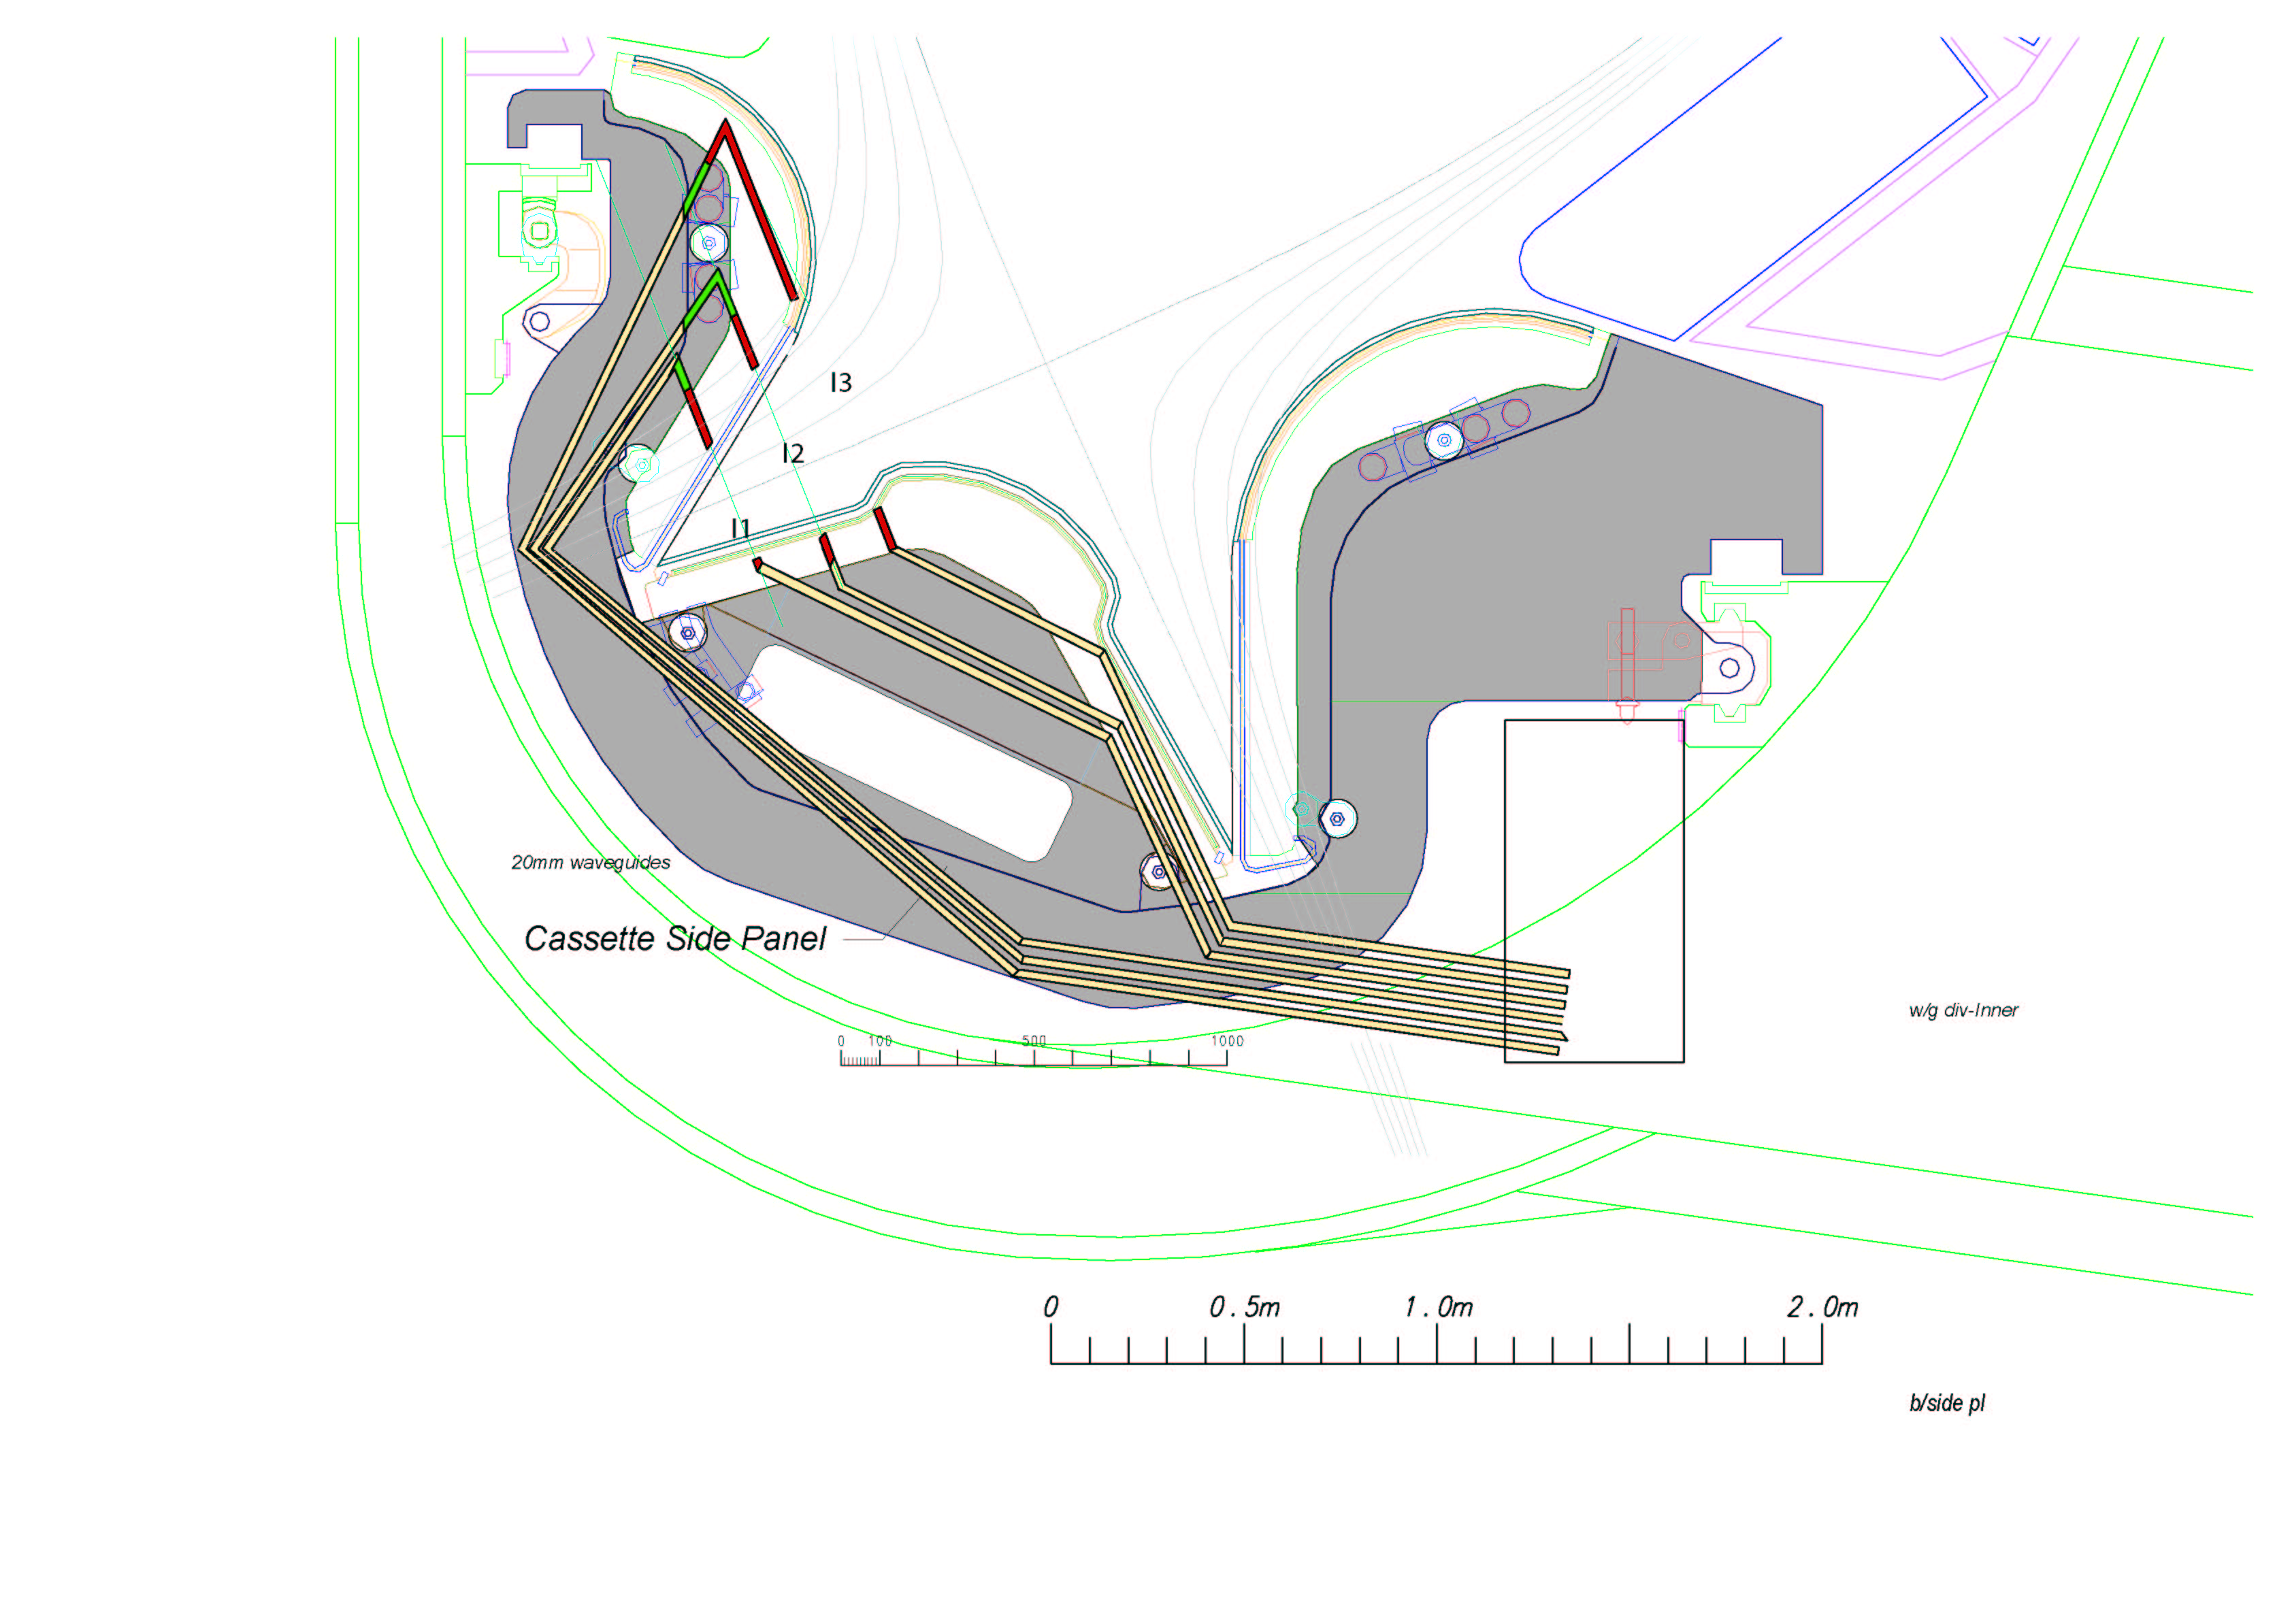
(a)

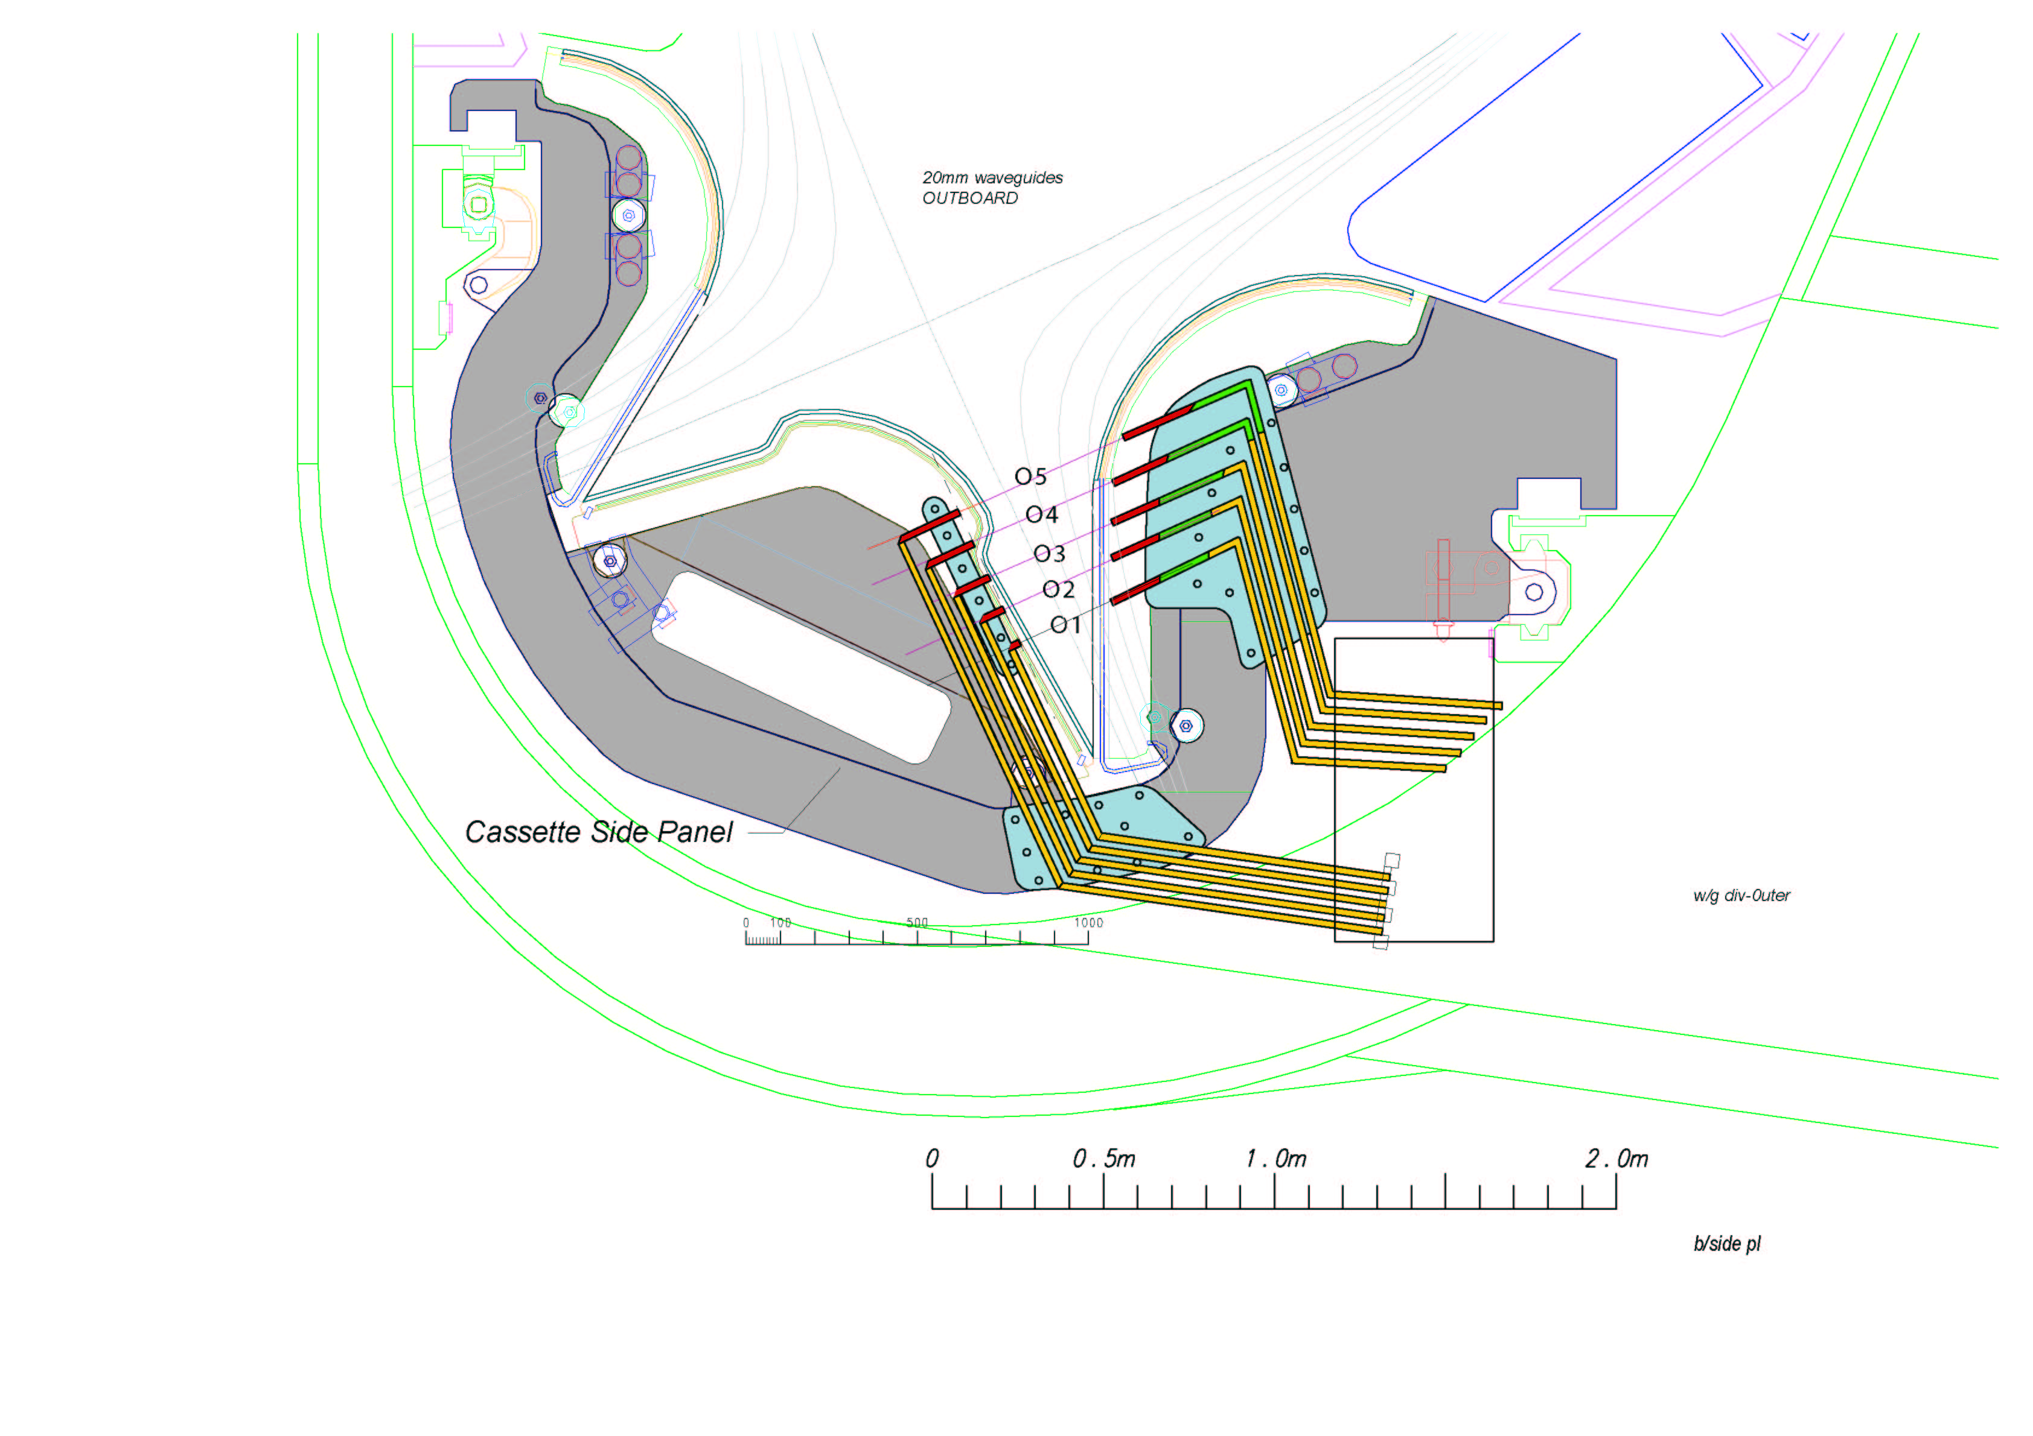

(b)

Figure 1. Divertor interferometer chords planned for ITER, (a) inner leg; three chords shown with spacing ~20 cm, (b) outer leg; five chords shown with spacing ~10 cm.

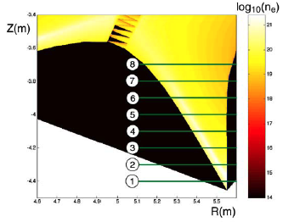

Figure 2. Modeled density distribution for ITER divertor (outer divertor leg).

Figure 3. Anticipated line-integrated densities for (a) baseline [path 2, peak 1.8x10²¹ m⁻³] and (b) maximum density [path 2, peak 1x10²² m⁻³] cases.

Figure 4. Wavelength dependence of computed phase for peak density [path 2] (a) baseline case: 1.8x10²¹ m⁻³, and (b) maximum density case: 1x10²² m⁻³.

Figure 4. Expanded view

Figure 5. Computed Cotton-Mouton phase for peak density [path 2] (a) baseline case: 1.8x10²¹ m⁻³, and (b) maximum density case: 1x10²² m⁻³.

Figure 6. Computed (a) standard interferometer phase and (b) Cotton-Mouton phase for peak density [path 2] equal to 1x10²⁰ m⁻³. This is the low density ITER divertor scenario.

Figure 7. Combined two-color interferometer and Cotton-Mouton interferometer experimental setup using nominal laser wavelengths of 48 and 57 microns.

Transmission Waveguide

Figure 8. ITER design schematic showing transmission waveguide, conversion box inside the vacuum vessel, and cassette waveguide to the plasma.

