
National Park Service
U.S. Department of the Interior

Haleakalä National Park

Environmental Assessment

Kïpahulu Recreational Fee Demonstration Projects

Kïpahulu District, Maui, Hawai‘i

Haleakalä National Park
P.O. Box 369
Makawao, HI 96768

January 2003

TABLE OF CONTENTS

1. Introduction 1
2. Purpose and Need
3. Background 4
Issues Selected for Detailed Analysis
Issues Dismissed from Detailed Analysis 6
4. Alternatives
Description of Alternatives Selected for Analysis
Alternative One

Alternative Two 8
Alternative Three 13
Alternative Four
Alternative Five 15
Alternatives Dismissed from Analysis 16

Environmentally Preferable Alternative 17
5. Affected Environment
Natural Resources
Air Quality

Threatened and Endangered Species 18
Topography, Soils and Geology
Vegetation
Water Resources
Wetlands and Floodplains 20

Wildlife
Cultural Resources 21
Archeological Resources
Cultural Landscapes 22
Historic Structures 24 Museum Objects
Socioeconomic Resources
Environmental Justice Issues
Park Operations 25
Traffic
Visitor Use and Experience
Visual/Scenic Resources
6. Environmental Impacts
Methodology
Natural Resources 26

Air Quality 27
Threatened and Endangered Species 28
Topography, Soils and Geology 29
Vegetation 30
Water Resources 31
Wetlands and Floodplains 33
Wildlife 35

Cultural Resources
Archeological Resources 36
Cultural Landscapes 37
Historic Structures 38
Museum Objects 39
Socioeconomic Resources 40
Environmental Justice Issues 41
Park Operations
Traffic 43 Visitor Use and Experience 44
Visual/Scenic Resources 45
Environmentally Preferable Alternative 46
7. Consultation and Coordination
Preparers
Contributors
Compliance with Federal and/or State Laws
Regulations 47
8. References
9. Appendix 1: Vascular Plant Species List for the Kïpahulu
Coastal Area of HALE 50
10. Appendix 2: List of Recipients of this EA 55

FIGURES

Figure 1. The Kïpahulu Coastal Area and Project Area within
Haleakalä National Park 2
Figure 2. Existing Visitor Facilities within the Kïpahulu Coastal Area,
Haleakalä National Park 3
Figure 3. Proposed Visitor Facilities for the Kïpahulu Coastal Area,
Haleakalä National Park 7
Figure 4. Interior of Proposed Restrooms for the Kïpahulu Coastal
Area, Haleakalä National Park 9
Figure 5. Proposed Septic Tank/Wetlands Wastewater Treatment and
Soil Absorption Field Disposal System for Alternatives 1 and 3 10
Figure 6. Proposed Expanded Day-Use Parking Lot for the Kïpahulu
Coastal Area, Haleakalä National Park 11
Figure 7. Proposed Upgrades to Campground and Campground Access
Road for the Kïpahulu Coastal Area, Haleakalä National Park 12
Figure 8. Proposed Septic Tank/Re-circulating Sand Filter Wastewater
Treatment and Soil Absorption Field Disposal System for
Alternatives 2 and 4 14
Figure 9. Area of Vegetation and Archeological Surveys and Project
Area within the Kïpahulu Coastal Area 19
Figure 10. The Kïpahulu Coastal Area, Project Area and the Cultural
Landscape within the Kïpahulu Historic District 23

TABLES

Table 1. Summary of Alternatives for the Proposed Project 15
Table 2. Archeological Sites 22
Table 3. Historic Structures 24
Table 4. Summary of Impacts on Air Quality 27
Table 5. Summary of Impacts on TES 28
Table 6. Summary of Impacts on Topography, Soils and Geology 29
Table 7. Summary of Impacts on Vegetation 31
Table 8. Summary of Impacts on Water Resources 33
Table 9. Summary of Impacts on Wetlands and Floodplains 34
Table 10. Summary of Impacts on Wildlife 35
Table 11. Summary of Impacts on Archeological Resources 37
Table 12. Summary of Impacts on Cultural Landscapes 38
Table 13. Summary of Impacts on Historic Structures 39
Table 14. Summary of Impacts on Museum Objects 40
Table 15. Summary of Impacts on Environmental Justice Issues 41
Table 16. Summary of Impacts on Park Operations 43
Table 17. Summary of Impacts on Traffic 44
Table 18. Summary of Impacts on Visitor Use and Experience 45
Table 19. Summary of Impacts on Visual/Scenic Resources 46

1. INTRODUCTION

Located on the eastern portion of the island of Maui, Haleakalä National Park (HALE) encompasses Haleakalä crater and portions its outer flanks; an area of approximately 30,000 acres. The Kïpahulu coastal area of the park is located on Haleakalä’s southeast flank, about eight miles south of Häna Town (Figure 1). The Kïpahulu community is located just west and east of the park.

2. PURPOSE AND NEED FOR PROJECT

The purpose of this project is to fulfill plans to develop “limited, informal, and necessary facilities” in the Kïpahulu coastal area of the park as proposed in the 1977 Development Concept Plan (DCP) and 1995 General Management Plan (GMP). The GMP (1995:20) states proposed facilities to accommodate visitors would provide:
- expanded restrooms and potable water from well water;
- limited day-use parking; and
- informal camping to accommodate about 40 sites, some adjacent to parking and some designed as walk-in sites.

Currently visitor facilities in this area of the park include the Kïpahulu Visitor Center (KVC), restrooms, day-use parking lot and overflow parking area, campground with a vault toilet and campground access road, all of which are located below the Hana Highway going towards the ocean (Figure 2).

Over the past 20 years there have been large increases in visitation to HALE with no major improvements or additions made to visitor facilities. According to park records, in the year 2000, the Kïpahulu coastal area of park received approximately 850,000 visitors. This equates to approximately 2,300 visitors per day. It is anticipated that future visitation will equal or exceed this figure. HALE has, therefore, determined that the proposed improvements and additions to visitor facilities in this area of the park are a critical need.

Existing visitor facilities do not adequately accommodate current visitor use. The existing restrooms consist of eight composting toilets. These toilets are designed to evaporate the majority of the liquid waste while producing compost for annual disposal. Due to the number of visitors to this area of the park, these toilets are used beyond the capacity of the system and are unable to perform as composting toilets. These units are performing instead as vault toilets, which require biannual removal of sludge.

The existing gravel parking lot also does not adequately accommodate the amount of day-use visitation to this area of the park, nor does it meet the Americans with Disabilities Act (ADA) accessibility requirements.

Daily rain showers are common in this area of the park. The existing campground is a large grassy field. Currently there is no defined road within the campground or defined
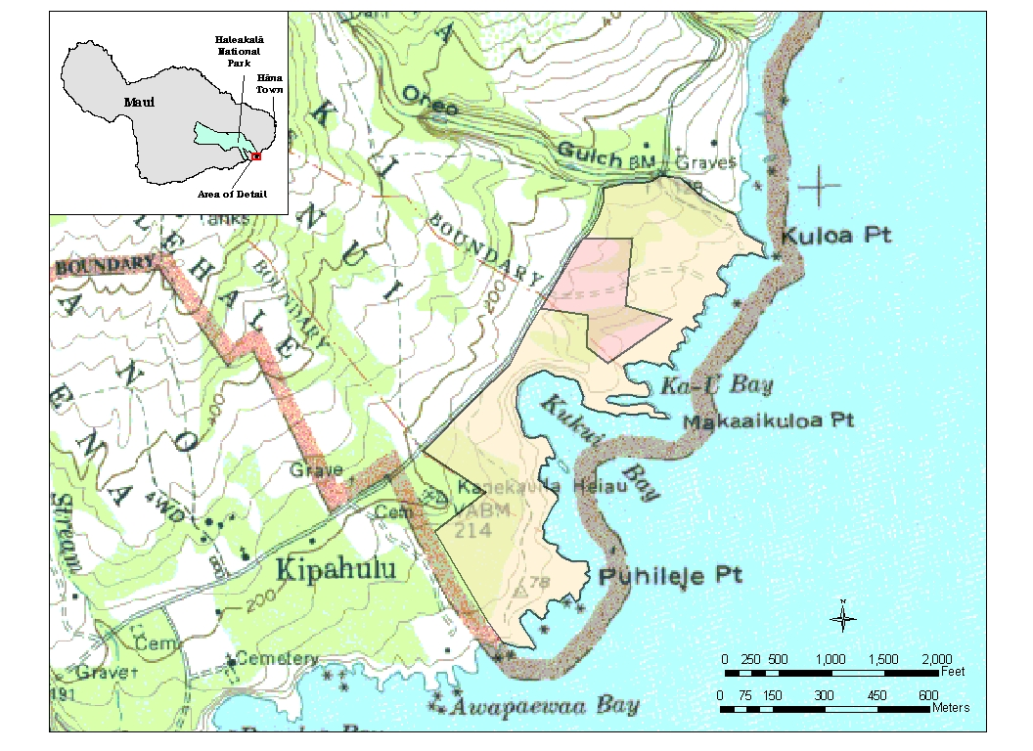

Figure 1. The Kïpahulu Coastal Area (orange-shaded) and Project Area (red-shaded) within Haleakalä National Park (Source: U.S. Geological Survey 1983 Kipahulu 7.5 Quad Map)
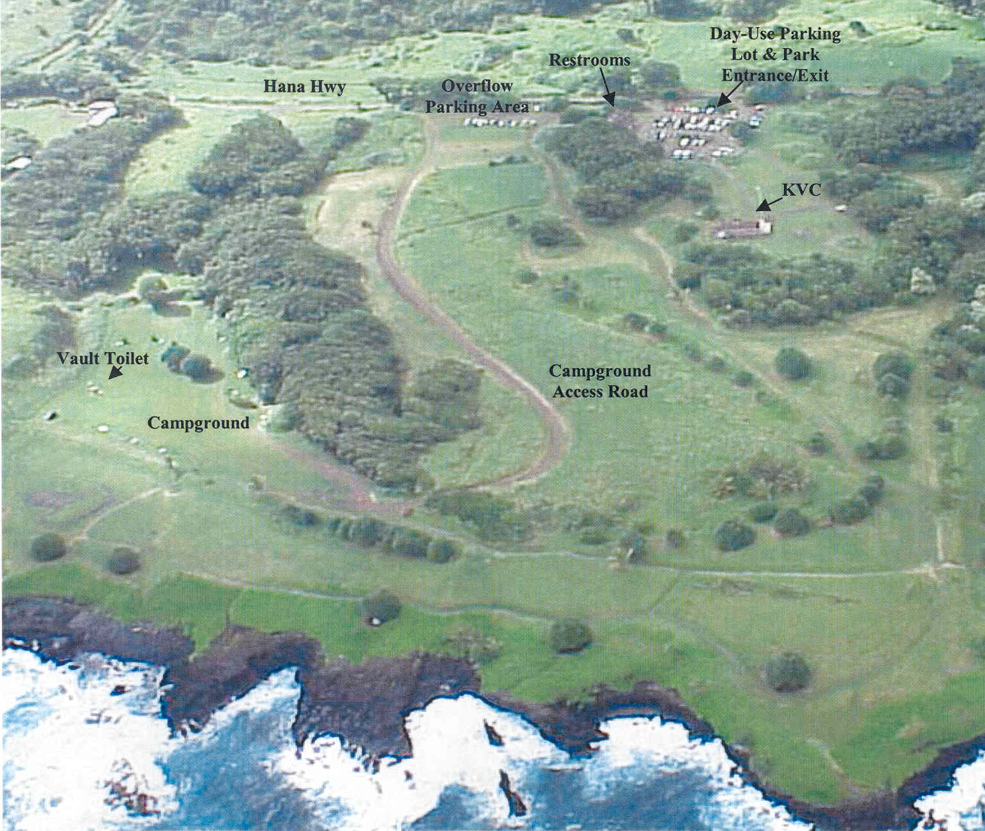

Figure 2. Existing Visitor Facilities within the Kïpahulu Coastal Area, Haleakalä National Park
parking areas near campsites, thus visitors drive and park anywhere. This becomes problematic when it rains because these vehicles tear up the campground to avoid or escape from the mud. The dirt access road to the campground also becomes muddy when it rains and impassable for vehicles lacking 4-wheel drive.

There is only one existing plastic vault toilet in the campground. This vault toilet has not been able to withstand environmental conditions in this area of the park or accommodate the level of campground visitation.

3. BACKGROUND

The park is funding this project under the 80% Recreational Fee Demonstration (Fee Demo) Program. Congress authorized the Recreational Fee Demonstration Program to allow the National Park Service (NPS), Bureau of Land Management, U.S. Fish and Wildlife Service and U.S. Forest Service, to implement fees at up to 100 sites (per agency) that they manage and retain all the revenues. Under the Fee Demo program, HALE is allowed to retain 80% of the revenues collected at the park. The remaining 20% of the revenues are transferred to a general NPS funding source that distributes money to servicewide initiatives and parks that are not part of the Fee Demo program. All NPS projects funded under the Fee Demo program must be completed by September 30, 2007.

a. Issues Selected for Detailed Analysis

During the internal scoping process, park staff identified a number of potential issues that were kept for analysis under impact topics in this Environmental Assessment (EA). Other potential issues had to be considered as directed by various Executive Orders.

Air Quality
Air quality could be affected by dust and other particles generated by the proposed project during construction.

Archeological Resources
Archeological sites and features located within this area of the park could be affected by the proposed project.

Cultural Landscapes
A cultural landscape located within this area of the park could be affected by the proposed project.

Environmental Justice Issues
Executive Order 12898, “Federal Actions to Address Environmental Justice in Minority Populations and Low-Income Populations,” requires all federal agencies to identify and address, as appropriate, disproportionately high and adverse human health or environmental effects of its programs, policies and activities on minority and low-income populations and Native Americans. Native Hawaiians and area residents have traditionally used the Kïpahulu coastal area of the park to access and gather marine resources for subsistence. The patterns of subsistence consumption of marine resources in this area of the park could be affected by the proposed project.

Historic Resources
Historic resources located within this area of the park could be affected by the proposed project.

Museum Objects
Museum objects exhibited at the KVC could be affected by the proposed project.

Park Operations
The proposed project could affect the management of facilities and utilities within this area of the park.

Threatened and Endangered Species
Threatened and Endangered (T&E) animals and plant species located within this area of the park could be affected by the proposed project.

Topography, Soils and Geology
The topography, soils and geology within this area of the park could be affected by the proposed project.

Traffic
The communities bordering this area of the park could be affected by the traffic generated by construction activities.

Vegetation
Native and Polynesian-introduced plant species located in this area of the park could be affected by the proposed project. The movement of construction equipment and materials could result in the introduction of additional non-native plant species into this area of the park and elsewhere in the park.

Visitor Use and Experience
The use of facilities in and the enjoyment of this area of the park by visitors could be affected by the proposed project. The proposed project could change the number of people visiting this area of the park.

Visual/Scenic Resources
The location and appearance of the proposed project could affect the scenic viewsheds within this area of the park.

Water Resources
A well was drilled in 1980 and a distribution system developed in 1998 to provide a reliable, continuous source of potable water for this area of the park. Currently there is limited use of this water. The quantity of water needed to sustain the demands of the proposed project could affect this water resource. The various onsite wastewater treatment and disposal systems proposed by the project could affect the quality of water at the shoreline in this area of the park.

Wetlands and Floodplains
Executive Order 11990, “Protection of Wetlands,” requires all federal agencies to avoid to the extent possible the long and short-term adverse impacts associated with the destruction or modification of wetlands, and to avoid new construction in wetlands wherever there is a practicable alternative. Executive Order 11988, “Floodplain Management,” requires all federal agencies to avoid to the extent possible the long and short-term adverse impacts associated with the occupancy and modification of floodplain development wherever there is a practicable alternative. Wetlands and floodplains are located within this area of the park and could be affected by the proposed project.

Wildlife
Native and migratory wildlife located in this area of the park could be affected by the proposed project. The movement of construction equipment and materials could also result in the introduction of additional non-native animal species, particularly invertebrates, into this area of the park and elsewhere in the park.

b. Issues Dismissed from Detailed Analysis

During the internal scoping process, park staff dismissed a number of issues from further study in this EA.

Land Use
Since there will be no change to existing uses of park lands associated with the proposed project, this topic was dismissed from further consideration.

Prime and Unique Agricultural Lands
In 1980, the Council on Environmental Quality directed that federal agencies must assess the effects of their actions on farmland soils classified by the U.S. Department of Agriculture’s Natural Resources Conservation Service as prime or unique. There are no “prime or unique farmlands” within this area of the park.

4. ALTERNATIVES

a. Description of Alternatives Selected for Analysis

The following is a list of reasonable alternatives that were selected for evaluation in this EA based upon the internal NPS scoping process.

Alternative One: Replace restrooms at the existing location; construct a septic tank/wetlands wastewater treatment and soil absorption disposal system; enlarge and hard-surface the day-use parking lot and change the park entrance/exit; gravel a separate parking area for commercial vehicles; and upgrade the visitor facilities at and the access road into the campground (Figure 3).

This alternative would involve demolishing the 1,200 square foot (SF) restrooms and constructing a new building (approximately 1,600 SF) with flush toilets at the same site.
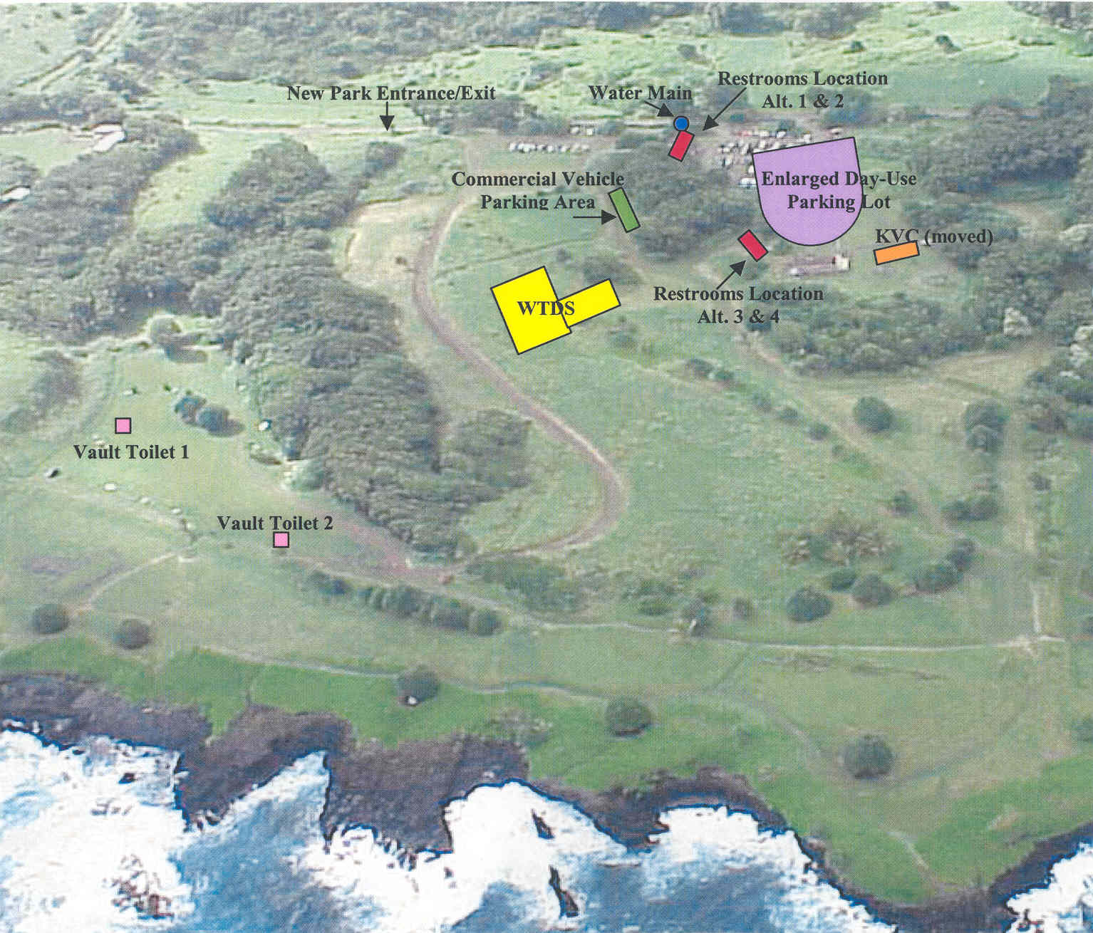
*WTDS = Wastewater Treatment and Disposal System, KVC = Kipahulu Visitor Center

Figure 3. Proposed Visitor Facilities for the Kïpahulu Coastal Area, Haleakalä National Park

The new restrooms would consist of—a Women’s Room with six toilets, three sinks and a changing area; and a Men’s Room with three toilets, three urinals, three sinks and a changing area (Figure 4). The new building would also include a Utility Room with one service sink, and a Family Room with one toilet and one sink.

Primary wastewater treatment would involve one underground 15,000-gallon septic tank (about 348 SF in area and 9.5 feet in depth) and one 1,000-gallon septic tank (about 49 SF in area and 6.5 feet in depth) constructed in a series south of the KVC (Figure 5). Septic tank effluent would then flow from three dosing tanks (two - about 25 SF in area and 5 feet in depth, and one – about 54 SF in area and 6 feet in depth) through three subsurface wetland cells (about 21,000 SF total area and 2 feet in depth) constructed in a series for secondary wastewater treatment. The treated effluent would then flow into a soil absorption field (about 18,000 SF in area and 2.5 feet in depth) for wastewater disposal. There would be no standing surface water in this system. A 5-foot high fence would be constructed around the perimeter of the wastewater treatment site.

To provide water, a trench (approximately 100 feet in length, 2 feet in width and 2 feet in depth) would be dug from a water main located near Pi‘ilani Highway to the new restrooms. To connect the sewer line, a trench (approximately 1300 feet in length, 2 feet in width and 1-3 feet in depth) would be dug from the new restrooms to the wastewater treatment and disposal system. A photovoltaic system to provide electricity would be installed on the roof of the new restrooms.

The existing 32,000 SF day-use parking lot would be expanded to about 48,400 SF (a 51% increase). The expanded lot would be hard-surfaced with colored (i.e., non-black), patterned asphalt and have 81 delineated parking spaces (75 regular spaces and 4 accessible spaces for visitors and 2 spaces for Government vehicles; Figure 6). A new entrance/exit into this area of the park would be created about 380 feet to the left of the existing entrance/exit. The existing entrance/exit would be sealed. The access road to the day-use parking lot would also be hard-surfaced with colored (i.e., non-black), patterned asphalt. A graveled road off this access road would lead to a separate graveled parking area (approximately 3,600 SF) for commercial vehicles.

The existing access road to the campground would be resurfaced primarily with gravel, except for a small portion that would be hard-surfaced with colored (i.e., non-black), patterned asphalt. A graveled loop road with 21 parking spaces would be added within the existing campground (Figure 7). A pre-cast concrete two-seater vault toilet (above ground dimensions – about 150 SF in area and 9.5 feet in height; below ground dimensions – about 140 SF in area and 4.5 feet in depth) would replace the existing vault toilet. A second pre-cast concrete two-seater vault toilet would be added in the campground.

After the construction work is completed, areas within the day-use parking lot and campground would be landscaped with native or Polynesian-introduced plants.

Alternative Two: Replace restrooms at the existing location; construct a septic tank/re-circulating sand filter wastewater treatment and soil absorption disposal system; enlarge

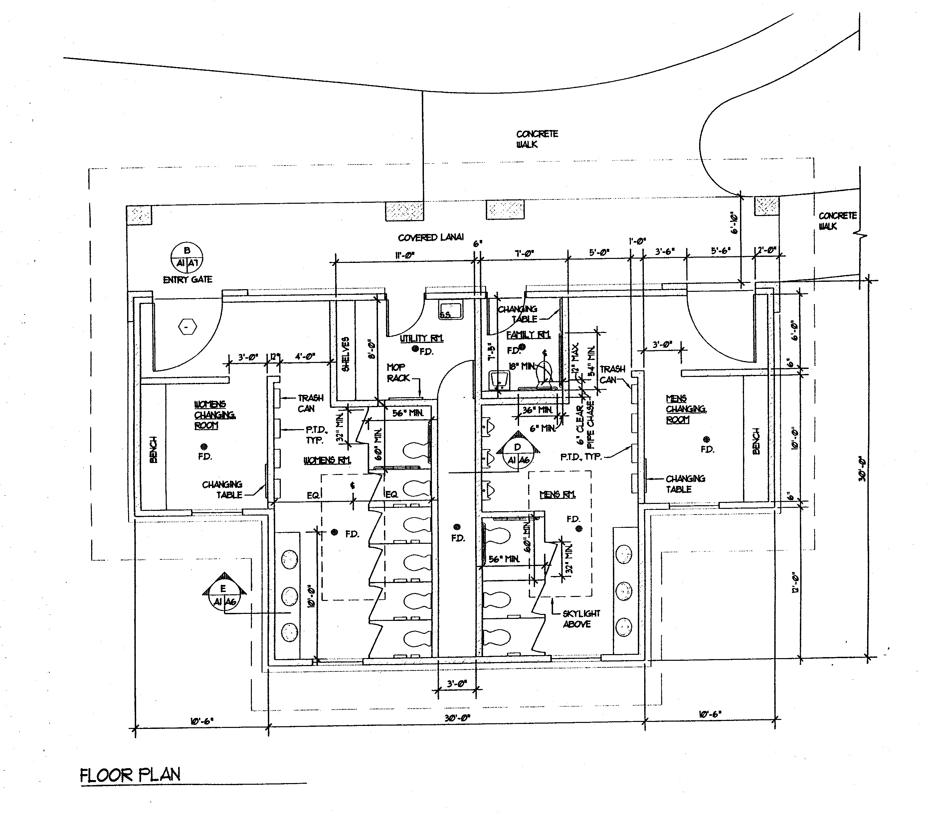

Figure 4. Interior of Proposed Restrooms for the Kïpahulu Coastal Area, Haleakalä National Park
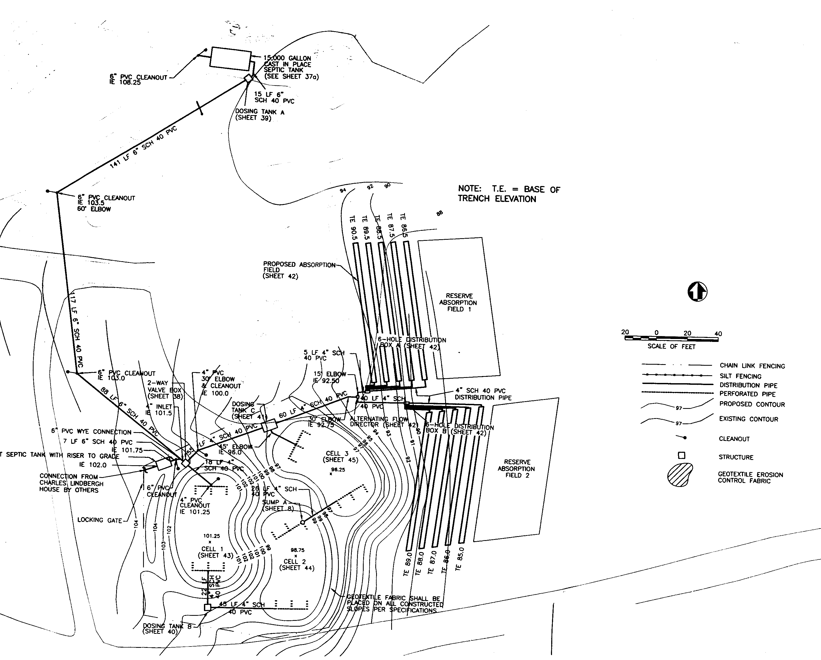
Figure 5. Proposed Septic Tank/Wetlands Wastewater Treatment and Soil Absorption Field Disposal System for Alternatives 1 and 3

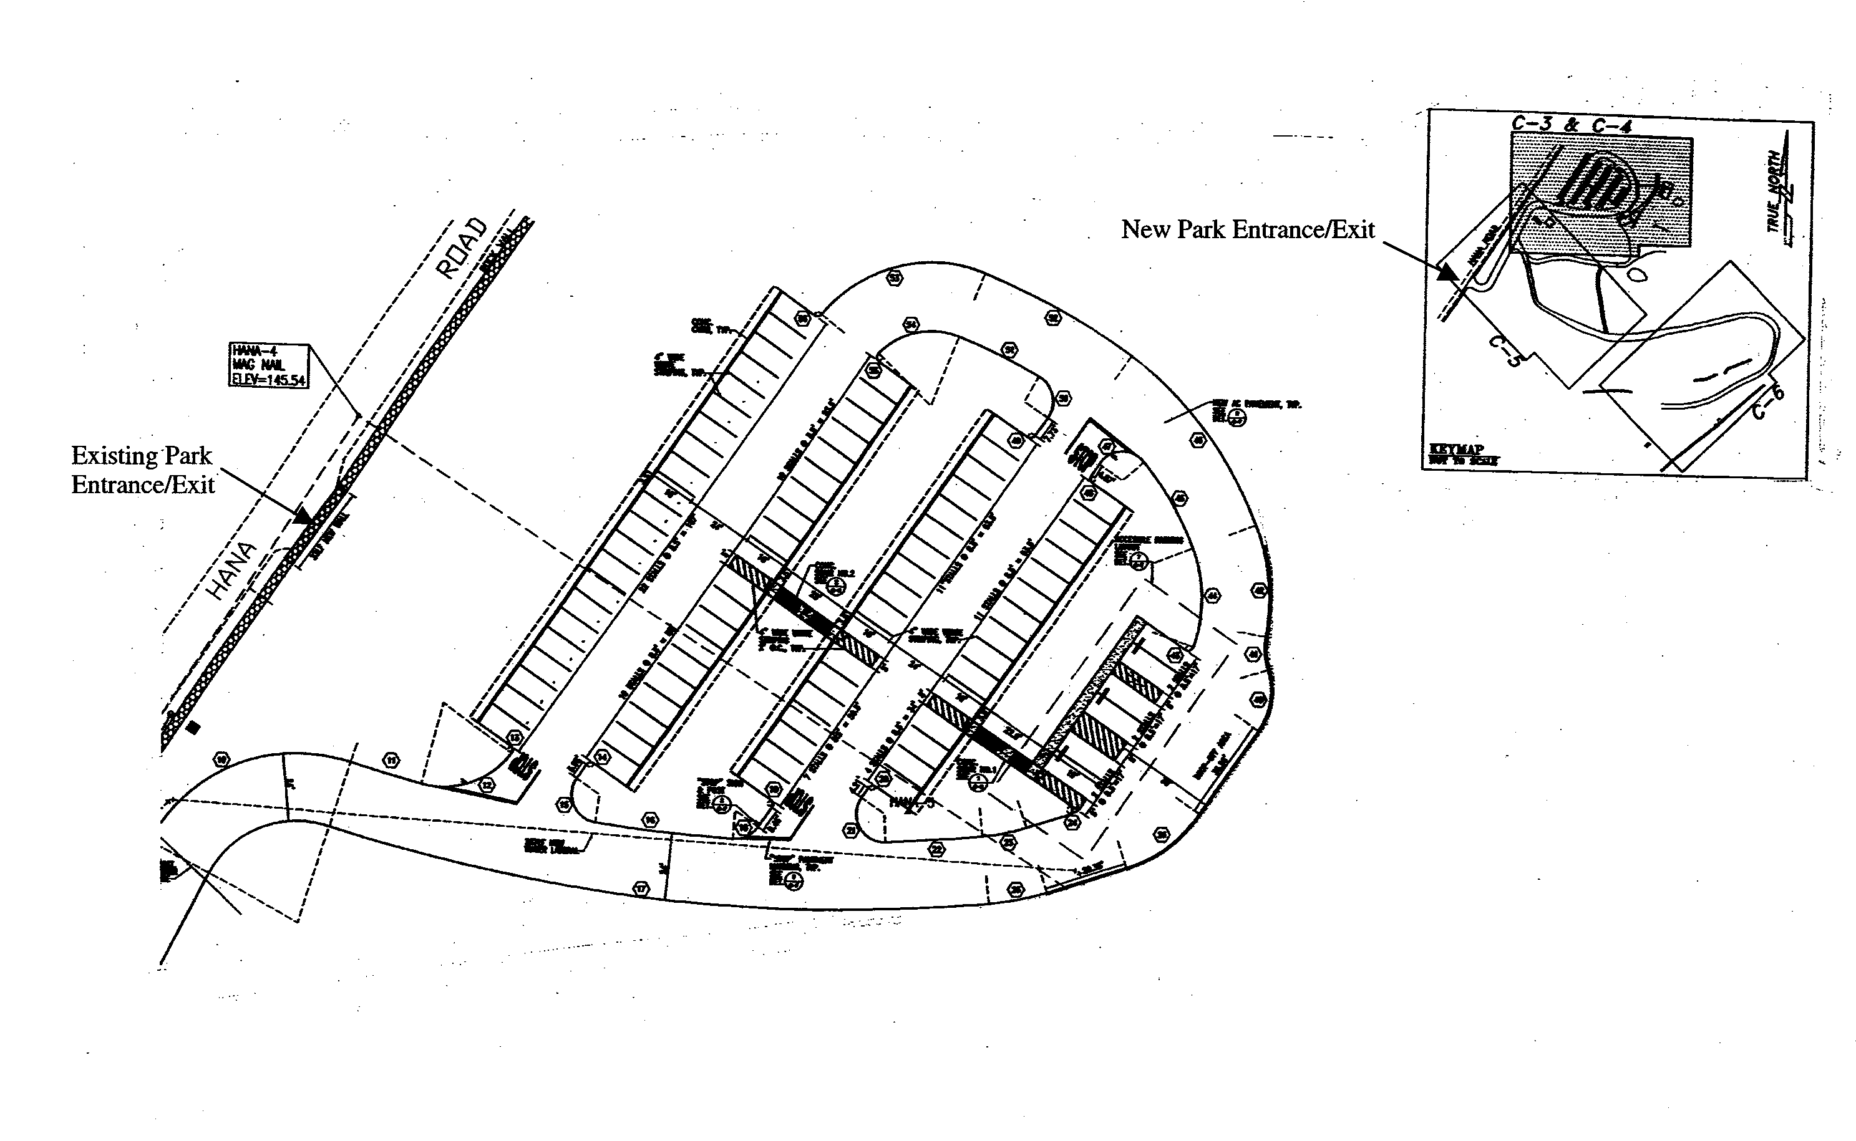

Figure 6. Proposed Expanded Day-Use Parking Lot for the Kïpahulu Coastal Area, Haleakalä National Park
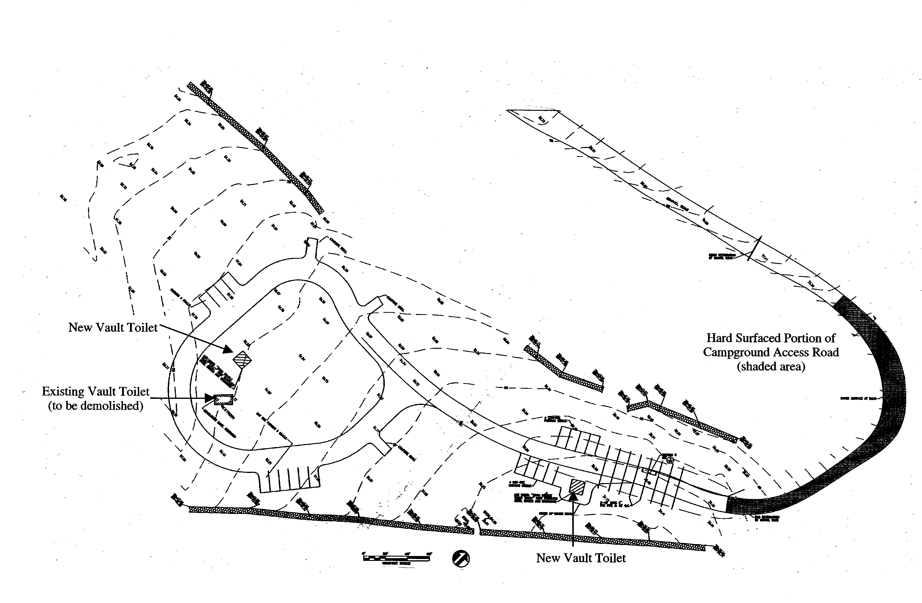
Figure 7. Proposed Upgrades to Campground and Campground Access Road for the Kïpahulu Coastal Area, Haleakalä National Park

and hard-surface the day-use parking lot and change the park entrance/exit; gravel a separate parking area for commercial vehicles; and upgrade the visitor facilities at and the access road into the campground.

This alternative differs from Alternative One only in the proposed wastewater treatment system. Primary wastewater treatment would involve one underground 15,000-gallon septic tank (about348 SF in area and 9.5 feet in depth) and one 1,000-gallon septic tank (about 49 SF in area and 6.5 feet in depth) constructed in a series south of the KVC. Septic tank effluent would then flow through a pump (about 25 SF in area and 6 feet in depth) into a below ground filter area (approximately 2,000 SF in area and 4 feet in depth) through another pump (about 25 SF in area and 6 feet in depth) into the filter area again for secondary treatment (Figure 8). The filter area would consist of two layers of parallel PVC pipes covered with sand; the top of the area would be open. A freestanding photovoltaic system (approximately 18 feet in length and 12 feet in
height) would also be installed to power the pumps. The treated effluent would then flow into a soil absorption field (about 18,000 SF in area and 2.5 feet in depth) for disposal. There would be no standing surface water in this system.

Alternative Three: Replace restrooms with restrooms closer to the KVC and move the KVC; construct a septic tank/wetlands wastewater treatment and soil absorption disposal system; enlarge and hard-surface the day-use parking lot and change the entrance/exit; gravel a separate parking area for commercial vehicles; and upgrade the visitor facilities at and the access road into the campground (Figure 3).

This is the preferred alternative. This alternative would involve demolishing the 1,200 SF restrooms and constructing the new building (approximately 1,600 SF) with flush toilets southwest of the KVC, and moving the KVC approximately 85 feet north of its current position. The existing pay phone next to Pi‘ilani Highway would also be removed and a new pay phone installed by the new restrooms. The phone line would be placed in the waterline trench.

This alternative differs from Alternatives One and Two in the location of the new restrooms and pay phone, the moving of the KVC, and the length of the water and sewer line trenches (approximately 1440 feet and 400 feet respectively). This alternative also differs from Alternative Two in the proposed wastewater treatment system.

Alternative Four: Replace restrooms with restrooms closer to the KVC and move the KVC; construct a septic tank/re-circulating sand filter wastewater treatment and soil absorption disposal system; enlarge and hard-surface the day-use parking lot and change the park entrance/exit; gravel a separate parking area for commercial vehicles; and upgrade the visitor facilities at and the access road into the campground.

This alternative differs from Alternatives One and Two in the location of the new restrooms and pay phone, the moving of the KVC, and the length of the water and sewer line trenches (approximately 1440 feet and 400 feet respectively). This alternative differs from Alternatives Two and Three in the proposed wastewater treatment and disposal system.

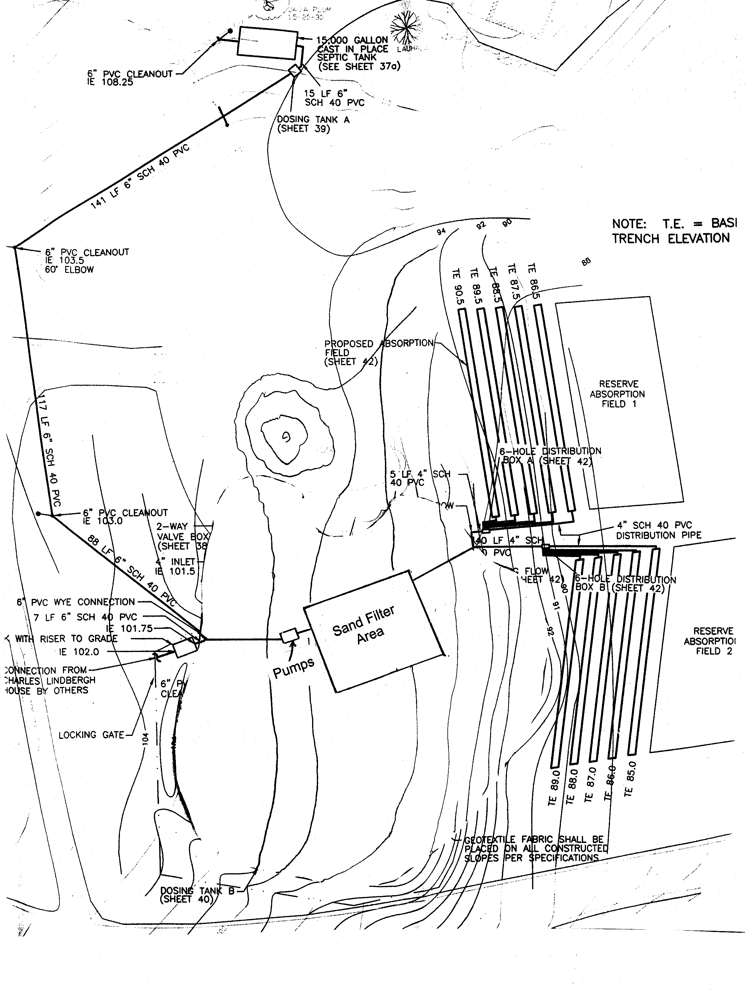

Figure 8. Proposed Septic Tank/Re-circulating Sand Filter Wastewater Treatment and Soil Absorption Field Disposal System for Alternatives 2 and 4

Alternative Five: The existing visitor facilities would be retained.

This is the no action alternative. The restrooms would remain as eight composting toilets. The park entrance/exit would remain in the current location. The day-use parking lot would remain as a 32,000 SF gravel lot with undesignated parking spaces. There would be no defined road or parking areas within the campground, and access to the campground would remain a dirt road. There would also be only one vault toilet within the campground.

Table 1. Summary of Alternatives for the Proposed Project

 | Alternative 1 | Alternative 2 | Alternative 3 (preferred) | Alternative 4 | Alternative 5 (no action)
Restrooms | New flush toilets at location of existing toilets | New flush toilets at location of existing toilets | New flush toilets located closer to the Kïpahulu Visitor Center | New flush toilets located closer to the Kïpahulu Visitor Center | Existing composting toilets retained
Wastewater Treatment and Disposal System | Septic Tank/ Wetlands Treatment and Soil Absorption Disposal | Septic Tank/ Re-circulating Sand Filter Treatment and Soil Absorption Disposal | Septic Tank/ Wetlands Treatment and Soil Absorption Disposal | Septic Tank/ Re-circulating Sand Filter Treatment and Soil Absorption Disposal | -
Day-Use Parking Lot | Enlarged to 48,400 SF and hard-surfaced with non-black colored patterned asphalt | Enlarged to 48,400 SF and hard-surfaced with non-black colored patterned asphalt | Enlarged to 48,400 SF and hard-surfaced with non-black colored patterned asphalt | Enlarged to 48,400 SF and hard-surfaced with non-black colored patterned asphalt | Existing 32,000 SF graveled lot retained
Park Entrance/Exit | Moved 380 feet left of existing entrance/ exit. Access road from new entrance/ exit to day-use parking lot hard-surfaced with non-black colored patterned asphalt | Moved 380 feet left of existing entrance/ exit. Access road from new entrance/ exit to day-use parking lot hard-surfaced with non-black colored patterned asphalt | Moved 380 feet left of existing entrance/ exit. Access road from new entrance/ exit to day-use parking lot hard-surfaced with non-black colored patterned asphalt | Moved 380 feet left of existing entrance/ exit. Access road from new entrance/ exit to day-use parking lot hard-surfaced with non-black colored patterned asphalt | Existing entrance/ exit retained
Commercial Vehicles Parking Area | 3,600 SF graveled area off graveled road off access road to day-use parking lot | 3,600 SF graveled area off graveled road off access road to day-use parking lot | 3,600 SF graveled area off graveled road off access road to day-use parking lot | 3,600 SF graveled area off graveled road off access road to day-use parking lot | -
Kïpahulu Visitor Center | - | - | Moved 85 feet north of current position | Moved 85 feet north of current position | -
Campground Visitor Facilities | Two new pre-cast concrete two-seater vault toilets to replace existing vault toilet and graveled loop road with 21 parking spaces added | Two new pre-cast concrete two-seater vault toilets to replace existing vault toilet and graveled loop road with 21 parking spaces added | Two new pre-cast concrete two-seater vault toilets to replace existing vault toilet and graveled loop road with 21 parking spaces added | Two new pre-cast concrete two-seater vault toilets to replace existing vault toilet and graveled loop road with 21 parking spaces added | Existing vault toilet retained
Campground Access Road | Resurfaced with gravel except for a portion that will be hard-surfaced with non-black colored patterned asphalt | Resurfaced with gravel except for a portion that will be hard-surfaced with non-black colored patterned asphalt | Resurfaced with gravel except for a portion that will be hard-surfaced with non-black colored patterned asphalt | Resurfaced with gravel except for a portion that will be hard-surfaced with non-black colored patterned asphalt | -

b. Alternatives Dismissed from Analysis

A number of other alternatives were initially considered during the internal NPS scoping process, but eliminated from further evaluation in this EA. These alternatives included different sizes and locations for the day-use parking lot and new restrooms, different hard-surfaces for the day-use parking lot, different types of and locations for the on-site wastewater treatment and disposal system, and alternatives for the access road into and visitor facilities at the campground.

Alternate locations for the day-use parking lot were determined not to be technically, economically and logistically feasible due to site topography, amount of grading needed to meet ADA accessibility requirements and the potential for erosion, and ability to tie-in to the KVC and existing trail system. The 1977 DCP for this area of the park set the size limit for the day-use parking lot at a maximum capacity of 80 vehicles. A management decision was made by the park to follow the recommendations of the 1977 DCP, therefore alternate sizes for the parking lot were determined not to be reasonable.

Alternate locations for the new restrooms were determined not to be logistically feasible due to distance from the day-use parking lot and ability to tie-in to the KVC and existing trails system. Alternate sizes for the restrooms were determined not to be economically feasible in terms of operational efficiency and sustainability. The restrooms fixture count was set using standard industry calculations for minimal need based on visitation figures and ADA accessibility requirements.

Other alternatives considered for hard-surfacing the day-use parking lot included “grasscrete” and “gravelpave.” These alternatives were determined not to be economically feasible in terms of operational efficiency and sustainability. These alternatives were also determined not be environmentally feasible because the gray water (i.e., storm water mixed with oil and other vehicle fluids) runoff from the parking lot cannot be controlled. For both of these alternatives the gray water would seep directly into the ground and could not be channeled into a filter system (e.g., oil/water separator) which would collect and store the oil and other fluids and direct the water into a disposal system (i.e., soil absorption field).

Other alternatives considered for the on-site wastewater treatment and disposal system included a septic tank wastewater treatment and soil absorption disposal system, a septic tank wastewater treatment and evapotranspiration disposal system, and an activated sludge wastewater treatment and soil absorption disposal system. The septic tank wastewater treatment and evapotranspiration disposal system alternative was determined to be technically infeasible because the system was effected by seasonal climate conditions. The other alternatives were determined to be environmentally infeasible because these systems did not sufficiently remove nitrates and phosphates from the effluent that could eventually reach the ground-water seeps located in this area of the park and the ocean. Alternate locations for the on-site wastewater treatment and disposal system were determined not to be technically, economically or logistically feasible due to proposed locations for the new restrooms, site topography, and the size of the area needed to construct the system.

Other alternatives considered for the visitor facilities at the campground and campground access road included not allowing vehicular camping and eliminating the access road, and expanding visitor facilities to included flush toilets, etc. A management decision was made by the park in the 1995 GMP to continue to allowing camping, therefore not allowing vehicular camping and eliminating the access road was determined to be unreasonable. Expanding the visitor facilities at the campground to include flush toilets, etc. was determined to be economically and environmentally infeasible.

c. Environmentally Preferable Alternative

NPS policy requires identification of the environmentally preferred alternative. The environmentally preferred alternative is the alternative/s that will promote the national environmental policy as expressed in the National Environmental Policy Act (Section 101(b)). This means the alternative/s that cause the least damage to the biological and physical environment, and afford the most protection, preservation and enhancement of the cultural and natural resources.

The environmentally preferred alternative will be identified at the conclusion of the environmental impact analysis.

5. AFFECTED ENVIRONMENT

The following is a description of the existing physical and socioeconomic environment relevant to understanding the potential impacts of the project alternatives.

a. Natural Resources

Air Quality
HALE has been designated a “class I” attainment area under the Clean Air Act. Class I areas are national parks over 6,000 acres and national wilderness areas over 5,000 acres that were in existence on August 7, 1977. The designation dictates the allowable increases in air pollution that are permitted for the area to ensure that attainment is, in fact, maintained.

HALE has been part of the NPS air quality monitoring network since May 1987 with the installation of a visibility camera on the inside slope of Haleakalä Crater. A standard NPS air quality meterological station and gaseous pollutant monitoring station was established at Olinda in July 1991. The visibility camera, meterological station and gaseous monitoring equipment was removed in the mid-1990s and a single unit IMPROVE (Interagency Monitoring of Protected Visual Environments) particulate sampler was installed. The IMPROVE sampler was upgraded to a four unit system in November 2000 and continues.

However, neither the park nor the State of Hawaii Department of Health monitors air quality in the Kïpahulu area. Based on the air quality monitoring data (particulate monitoring only; gaseous pollutants ended in the mid-1990s) and due to persistent trade winds, the air quality at HALE is considered “excellent.”

Threatened and Endangered Species
There is one plant and one animal located in the Kïpahulu coastal area of the park currently listed by the U.S. Fish and Wildlife Service (USFWS) as threatened or endangered under the Endangered Species Act. The grass, Hilo ischaemum (Ischaemum byrone (Trin.) Hitchc.), is found growing between rocks at the mouth of ‘Ohe‘o Gulch near sea level (Medeiros et al. 1998:47). The Hoary Bat or ‘öpe‘ape‘a (Lasiurus cinerius) roosts during the day in trees and rock shelters (Tomich 1986) and feed mostly on winged non-native invertebrates of small to large size (Whitaker and Tomich 1983). The Hoary Bat is often observed at the Resources Management/Maintenance baseyard after sunset (Hodges 2000). It is not known where the Hoary Bat roosts, or the types of non-native invertebrates it consumes, within this area of the park.

One species of goby, ‘o‘opu ‘alamo‘o (Lentipes concolor), located in this area of the park is currently listed by the USFWS as a species of concern. This freshwater fish has been observed in Pïpïwai and Palikea Streams and ‘Ohe‘o Gulch (Hodges 1994; Kinzie and Ford 1977).

Topography, Soils and Geology
The Kïpahulu coastal area of the park extends from below the Hana Highway to the ocean and from Puhilele Point to ‘Ohe‘o Gulch; an area of approximately 90 acres. The topography of this area ranges in elevation from 20 to 160 feet (6 to 49 meters) above mean sea level and slopes eastward towards the ocean. Based on a soils investigation conducted in 1979, the general geology of this area of the park can be characterized as “an ancient mudflow deposit and underlying volcanic flows” (Dames and Moore 1979:6). The mudflow deposit is characterized by large angular boulders in a clay-like silt and may represent debris materials from the upper part of the mountain that were at onetime set in motion by heavy rains, strong earthquakes or both (Dames and Moore 1979). The deposit is approximately 20 feet thick at Ka‘ü Bay and thins out to the northeast (Dames and Moore 1979). Beneath the mudflow deposit, basaltic ‘a‘ä flows of the Hana Series of East Maui exist down to sea level (Dames and Moore 1979:7).

Vegetation
Although non-native vegetation such as java plum (Syzygium cumini (L.) Skeels), christmas berry (Schinus terebinthifolius Raddi), elephant grass (Pennisetum purpureum Schumach.) and california grass (Brachiaria mutica (Forssk.) Stapf) dominate the landscape, HALE botanists have identified 22 species of native plants during a November 2000 vegetation survey of approximately sixty acres within the Kïpahulu coastal area of the park (Figure 9; Appendix 1). One of these plants, ko‘oko‘olau (Bidens hillebrandiana (Drake) Deg. subsp. polycephala Nagata and Ganders), has been designated by HALE as rare in the park. This herb is localized on the lava, or ‘a‘ä, ledges near sea level on the southern side of ‘Ohe‘o Gulch.

Water Resources
A well was drilled in 1980 and a distribution system developed in 1998 to provide a reliable, continuous source of potable water for this area of the park. The mouth of the well drilled for this area of the park is located above the Hana Highway at the 390-foot (119 meters) elevation level. The 410-foot deep well taps an artesian aquifer; no other well is known to be in the same aquifer. The well did not encounter a bottom to the aquifer, so the lateral extent, thickness and exact nature of the artesian system is not known (USGS 1983:22). Periodic sampling of the water by the U.S. Geological Survey (USGS) during aquifer testing established that the aquifer is
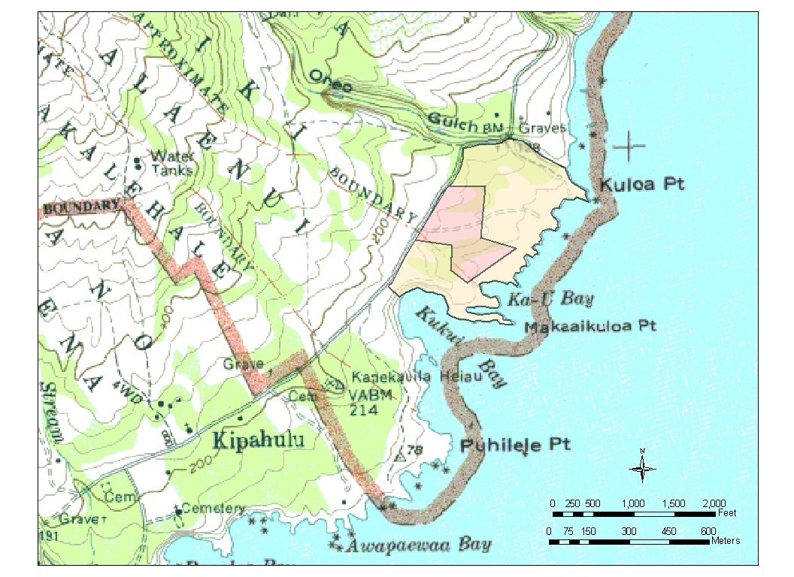

Figure 9. Area of Vegetation and Archeological Surveys (orange-shaded) and Project Area (red-shaded) within the Kïpahulu Coastal Area (Source: U.S. Geological Survey 1983 Kipahulu 7.5 Quad Map)

not hydraulically connected with the ocean (USGS 1983). The low temperature and pristine nature of the water indicates that the aquifer gets recharge water from very high-level rainfall at the head of Kïpahulu Valley (USGS 1983:16).

Based on the well pump tests conducted in 1980, the drawdown at a discharge rate of 335 gallons per minute (gpm) was 11.75 feet with almost instantaneous recovery (USGS 1983:13). The water distribution system was designed not to exceed the minimum capacity of the aquifer and consists of a solar-powered pump with a maximum pumping capacity of 17 gpm and two 8,000-gallon water storage tanks. Currently the pump runs for a maximum of 8 hours per day and it takes approximately 2 days to fill both storage tanks. Therefore, the minimum supply of water currently available is 8,000 gallons per day (gpd) vice the potentially available 16,000 gpd.

During a 1979 soils investigation, some small ground-water seeps were noted on the cliffs in the Kïpahulu coastal area of the park (Dames and Moore 1979:Plate 2). It is assumed these seeps represent very localized accumulations of groundwater derived from downward percolation within the boulder silt, and do not represent prolonged lateral migration (Dames and Moore 1979:9). A spring is also visible at low tide in the vicinity of the ground-water seeps seaward of the campground (Dames and Moore 1979:Plate 2). It is assumed this spring represents leakage at the shoreline of a relatively thin lens of basal fresh water generally found in this type of formation (Dames and Moore 1979:10).

Wetlands and Floodplains
Based on the U.S. Fish and Wildlife Service (USFWS) 1978 national wetlands inventory (Source: National Wetlands Inventory Center map and digital data for Maui Island), there are palustrine wetlands associated with ‘Ohe‘o Gulch and marine wetlands located off-shore within the Kïpahulu coastal area of the park. However, because of the scale of these maps and after receiving guidance from the NPS Water Resources Division, it was necessary to conduct a site visit of the project area to assure that no unmapped wetlands existed. Based on an examination of plant communities and topographic and hydrologic characteristics conducted on January 3, 2003, by a HALE botanist and local biologist trained in wetlands identification, no unmapped wetlands were found to exist within the project area.

Based upon the 100-year floodplains delineation for the Island of Maui performed by the Federal Emergency Management Agency in April 2001 (Source: 2001 Digital Flood Insurance Rate Map for Maui County), 100-year floodplains are located within the Kïpahulu coastal area of the park below the 20-foot elevation level and associated with ‘Ohe‘o Gulch, a drainage area.

Wildlife
Although non-native terrestrial vertebrates predominate, six native bird species have been identified as present in the Kïpahulu coastal area of the park (Hodges 2000; Stemmermann 1980). The white-tailed tropic bird or koa‘e kea (Phaeton lepturus dorotheae), black noddy or noio (Anous minutus melanogenys) are seabirds that nest in cliffs and rocky ledges. The great frigatebird or ‘iwa (Fregata minor palmerstoni) can be spotted flying inland over the pastured areas as well as in the coastal areas. The wandering tattler or ‘ülili (Heteroscelus incanus) and ruddy turnstone or ‘akekeke (Arenia interpres) are regular migrants to the area commonly seen along the coast. The Pacific golden plover or kolea (Pluvialis fulva) is also a regular migrant commonly seen along the coast and in all grasslands in the area. All migratory birds are protected under the Migratory Bird Treaty Act.

A total of 195 species of invertebrates have been identified as present in the Kïpahulu coastal area of the park (Gagne 1980; Takumi 2000). Only 14 percent (27 of the 195) of these species are native (Takumi 2000).

b. Cultural Resources

As defined by NPS Management Policies (2001) and Director’s Order #28: Cultural Resource Management, a cultural resource may be a tangible entity or cultural practice. Tangible cultural resources are categorized as archeological resources, cultural landscapes, historic structures, museum objects, and ethnographic resources for NPS management purposes.

The Kïpahulu District of HALE has cultural and spiritual value to Native Hawaiians. Kïpahulu was a moku (district) with rich and diverse, but scattered agricultural resources (Handy and Handy 1972:507). Its great valley and lower fringing forests nourished forest taro and other native food plants, as did the lower kula lands above the sea, where the native homes are today (Handy and Handy 1972:507). The Kïpahulu coastal area of the park encompasses the ahupua‘a or ancient land divisions of ‘Alae Iki, ‘Alae Nui, and Kakalehale. This area of the park continues to be used by Native Hawaiians for a variety of activities.

The Kïpahulu coastal area of the park is located within the Kïpahulu Historic District (Hawaii State Inventory of Historic Places [SIHP] Site # 50-50-17-299; Figure 10) which has been formally determined eligible for listing in the National Register of Historic Places (NRHP).

Archeological Resources
Based on an archeological survey (Dye et al. 2002; Figure 9) of sixty acres of the Kïpahulu Historic District, there are 65+ surface features grouped into 12 sites located within the Kïpahulu coastal area of the park associated with the Kïpahulu Historic District (Table 2). These sites are eligible for listing in the NRHP under criteria A, C and/or D as set out in 36 CFR Part 60.4.

Criterion A applies to properties associated with events that have made a significant contribution to the broad patterns of our history, or are significant to the cultural traditions of a community. Criterion C applies to properties that embody the distinctive characteristics of a type, period, or method of construction, or that represent the work of a master, or that possess high artistic values, or that represent a significant and distinguishable entity whose components may lack individual distinction. Criterion D applies to properties that have yielded, or may be likely to yield, information important in prehistory or history.

Several miscellaneous features were also relocated during archeological survey. These include isolated, small features, modern or recently reconstructed walls, and bulldozer mounds. These features are either not eligible for listing in the NRHP or are not associated with or do not contribute to the significant qualities of the nearest sites (Dye et al. 2002:25). These features have been recorded appear on the archeological base map (Rosendahl 1975).

Table 2. Archeological Sites (based on Dye et al. 2002)

SIHP Site #  50-50-17- | Site Description  (# of features) | Site Function | Calibrated Radiocarbon Date Range* | Probable Time Period | NRHP Criteria
1088 | Multi-component complex (3) | Ceremonial | A.D. 1164-1384 | - | A, C, D
1089 | Multi-component complex (3) | Habitation | A.D. 1625-1949 | - | C, D
3560 | Multi-component complex (27+) | Habitation/ Agriculture | A.D. 1486-1800 | - | D
3570 | Multi-component complex (8) | Habitation/ Burial | - | Prehistoric/Historic | A, D
3572 | Enclosure (1) | Habitation? | - | Historic? | D
3577 | Multi-component complex (6) | Ceremonial | - | Prehistoric/Historic | A, D
3580 | Multi-component complex (5+) | Habitation | A.D. 1401-1632 | - | D
3581 | Platform with abutting wall (2) | Unknown | - | ? | D
3763 | Multi-component complex (5+) | Habitation/ Agriculture | - | Historic | C, D
3766 | Remnant enclosures (2) | Unknown | - | ? | D
3771 | Remnant features (1+) | Ranching | - | Historic | D
5028 | Enclosure (1) | Habitation? | - | Historic? | D
* Date is from charcoal sample collected at the base of a feature from the site

Cultural Landscapes
As defined by NPS Management Policies (2001) and Director’s Order #28: Cultural Resource Management, a cultural landscape is a geographic area, including both cultural and natural resources and the wildlife or domestic animals therein, associated with a historic event, activity, or person, or exhibiting other cultural or aesthetic values. NPS has classified cultural landscapes into four non-mutually exclusive types: historic sites, historic designed landscapes, historic vernacular landscapes, and ethnographic landscapes.

Based on Level 0 Cultural Landscape Inventory for HALE, one cultural landscape is located within the Kïpahulu coastal area of the park associated with the Kïpahulu Historic District that may be eligible for listing in the NRHP (Figure 10). This landscape is listed on the NPS Cultural Landscapes Automated Inventory Monitoring Systems (CLAIMS) database as Cultural Landscape Inventory Identification #975094, “Hawaiian Homesteads (‘Ohe‘o)”. This landscape is associated with pä hale (house lot, yard, fence) built after the Mahele (i.e., government
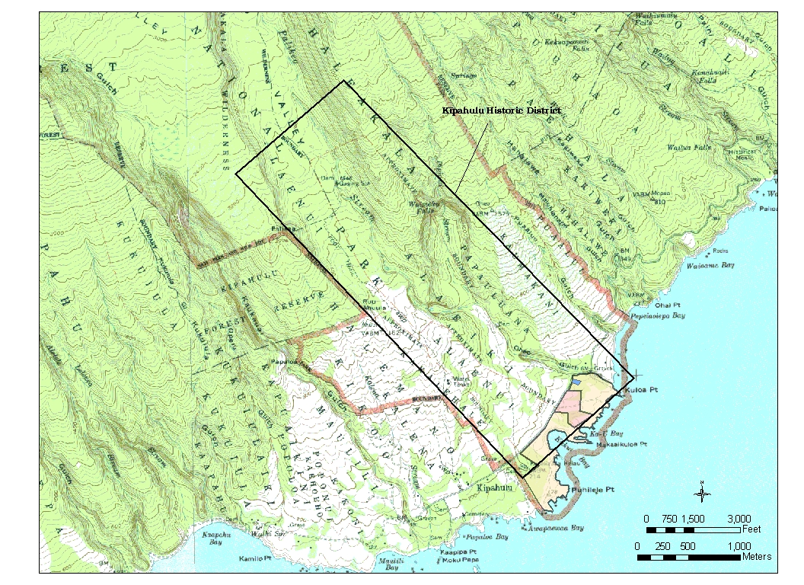

Figure 10. The Kïpahulu Coastal Area (orange-shaded), Project Area (red-shaded) and the Cultural Landscape (blue-shaded) within the Kïpahulu Historic District (Source: U.S. Geological Survey 1983 Kipahulu 7.5 Quad Map)
privatization of land ownership between 1848-1850). This landscape is also listed as an archeological resource associated with the Kïpahulu Historic District, SIHP Site # 50-50-17-3763. This landscape also contains four historic structures listed in the NPS List of Classified Structures (LCS), LCS ID# 014016, 058299, 05839 and 058434.

Historic Structures
There are nine historic structures identified within the Kïpahulu coastal area of the park associated with the Kïpahulu Historic District that may be eligible for listing in the NRHP. Seven of the nine structures are features of four archeological sites identified above. These structures are listed in the NPS LCS (Table 3).

Table 3. Historic Structures (based on the LCS)

LCS ID # | Structure Name | Comments
006734 | Early ‘Ohe‘o Gulch Bridge Supports | -
006735 | Kanalulu Tombs | -
014016 | Po‘onika Homesite Foundations | Part of SIHP Site # 50-50-17-3763
014017 | Ka‘u Bay Site #2 | Part of SIHP Site # 50-50-17-1088
014023 | Ka‘u Bay Site | Part of SIHP Site # 50-50-17-1089
058299 | Po‘onika Homestead Stone Walls | Part of SIHP Site # 50-50-17-3763
058389 | Po‘onika Homestead Animal Pens | Part of SIHP Site # 50-50-17-3763
058434 | Po‘onika Secondary Stone Walls | Part of SIHP Site # 50-50-17-3763
058512 | Po‘onika Tomb | Part of SIHP Site # 50-50-17-3570

Museum Objects
Seven ethnology objects associated with the park’s museum collection are on exhibit at the KVC located within the Kïpahulu coastal area of the park.

c. Socioeconomic Resources

Environmental Justice Issues
The ocean and coastline of Kïpahulu has been and continues to be used traditionally by Hawaiians and members of the local community for subsistence fishing and gathering of marine life. Although the State of Hawaii, Department of Aquatic Resources has jurisdiction over the marine life and from the ocean to the high water mark on shore, access to these resources in the Kïpahulu coastal area of the park is from the campground.

Park Operations
There are two districts of operations for the park: Summit and Kïpahulu (Strategic Plan 2000:6). The Kïpahulu District is staffed by 9.9 employees from the following divisions: Interpretation, Maintenance, Protection and Resource Management. The staff are supported by the assistance of park cooperators such as the Hawaii Natural History Association and the Research Corporation of the University of Hawai‘i.

Facilities in this area of the park include: a day-use parking lot and overflow parking area; visitor center with exhibits and interpretative literature sales; composting and portable chemical toilets including one vault toilet; campground and campground access road; trails and pedestrian bridges; well and water distribution system; and employee baseyard and shelter. Commercial power is not available in this area of the park. Photovoltaic systems are the only alternative source of renewable energy currently used in the area of the park. Phone lines run underground from overhead lines on the Pi‘ilani Highway to a pay phone at day-use parking lot, the KVC, and the employee baseyard.

Traffic
Vehicle access to this area of the park is via the Hana Highway, which runs through the park as part of the island road system. Park visitors in rental cars or commercial group van tours and East Maui residents primarily travel this road. Vehicle circulation within this area of the park is limited to the day-use parking lot and overflow parking area, campground and campground access road.

Visitor Use and Experience
Visitor use of HALE is year-round. Approximately 95 percent of the use is day use (GMP 1995:62). Based on the Spring 2000 Haleakalä National Park Visitor Use Survey, the primary visitor reasons for visiting the Kïpahulu coastal area of the park are “to sightsee/take scenic drive, for the recreational opportunities (e.g., hike, swim, camp, etc.), and to experience wilderness, Hawaiian culture, and solitude/quiet.” From the park’s perspective, the desired visitor experiences for this area of HALE are: 1) each visitor will understand, appreciate and respect the scientific and cultural value of Kïpahulu, and 2) visitors will understand and experience elements of an ahupua‘a (2001 Draft Long Range Interpretative Plan:29).

Visual/Scenic Resources
The scenic views identified as part of the park experience and worthy of protection in the Kïpahulu coastal area of HALE are 1) the view of the Kïpahulu Valley and the surrounding mountains and cliffs, and 2) the view of the ocean as seen from the KVC (2001 Draft Long Range Interpretative Plan:63).

6. ENVIRONMENTAL IMPACTS

a. Methodology

For the purposes of this EA, direct and indirect environmental impacts of project alternatives are based upon known characteristics of the affected environment, and analyzed in terms of geographical context (e.g., site-specific, local, state or national), temporal duration (i.e., short or long term) and intensity (i.e., negligible, minor and major). Short-term impacts are defined as lasting only for the duration of the project. Long-term impacts are defined as continuing in duration after the project is completed. The thresholds of change for intensity of an impact are defined under each resource topic below. Relevant laws, regulation, and park or other policies affecting the analysis of impacts are also briefly discussed under each resource topic below.

Cumulative impacts are the “additive” impacts on a particular resource from the proposed action and past, present, and reasonably foreseeable future actions. Other projects that could occur in or adjacent to the Kïpahulu coastal area of HALE are: 1) construction of a traditional hale (building) for cultural demonstrations (currently cultural demonstrations take place at the KVC); 2) the relocation/restoration of the Kïpahulu home of Charles Lindbergh and Anne Morrow Lindbergh, the Argonauta, and nearby writer’s cottage under the new name “Kïpahulu Conservation Center”; and 3) a line item construction project to build administrative/visitor protection and maintenance/resource management facilities and staff residences.

For the purposes of this EA, cumulative environmental impacts of project alternatives are also analyzed in terms of geographical context (e.g., site-specific, local, state, or national), temporal duration (i.e., short or long term) and intensity (i.e., negligible, minor and major). The same definitions used to analyze direct and indirect impacts and thresholds of change for intensity of an impact are used to analyze cumulative impacts.

The NPS Organic Act mandates that park resources are passed onto future generations “unimpaired”. An impairment is an impact that would harm a resource or value who conservation is: 1) necessary to fulfill specific purposes identified in the establishing legislation or proclamation of the park; 2) key to the natural or cultural integrity of the park or to opportunities for enjoyment of the park; or 3) identified as a goal in the park’s GMP or other relevant planning document (NPS Management Policies 2001:12).

NPS Management Policies (2001) and Director’s Order #12: Conservation Planning, Environmental Impact Analysis, and Decision-making require an impairment finding for each resource topic as part of the environmental analysis of project alternatives. While all impairments equal major impacts, not all major impacts equal impairments. For the purposes of this EA, impairment is defined as an adverse major impact.

b. Natural Resources

In the absence of quantitative data, best professional judgement by the NPS prevailed in defining the thresholds of change for analyzing the intensity of an impact on natural resources, and are as follows:

“Negligible impact” – No natural resources are present or there are natural resources are the present, but the action will have no direct and/or indirect impacts or only temporary impacts are expected.

“Minor impact” – the action will have permanent direct and/or indirect impacts on natural resources, however, the impacts are not substantial and highly noticeable or conditions can be imposed that mitigate and/or avoids the impacts being substantial and highly noticeable.

“Major impact” – the action will have permanent direct and/or indirect impacts on natural resources that are substantial and highly noticeable.

Air Quality
Alternative One – Construction activities associated with this alternative would temporarily generate particulate matter (e.g., dust, dirt, smoke, and liquid droplets) into the air within this area of the park from the site work (e.g., clearing, grading, and utilities installation) and construction equipment. Therefore, this alternative would have a short-term negligible impact on air quality. This alternative, if implemented, would not constitute an impairment on air quality.

Alternative Two – Same as Alternative One.

Alternative Three (preferred alternative) – Same as Alternative One.

Alternative Four – Same as Alternative One.

Alternative Five (no action alternative) – Retaining the existing visitor facilities within this area of the park has a negligible impact on air quality. This alternative does not constitute an impairment on air quality.

Cumulative Impact – Other projects that could occur in or adjacent to this area of the park are the hale, Kïpahulu Conservation Center and line item construction projects that would temporarily generate particulate matter (e.g., dust, dirt, smoke, and liquid droplets) into the air from the site work (e.g., clearing, grading, and utilities installation) and construction equipment. Cumulatively these projects and Alternatives One through Four would have a short-term negligible impact on air quality. Cumulatively these projects and Alternatives One through Four, if implemented, would not constitute an impairment on air quality. Alternative Five does not contribute to the cumulative impact on air quality.

Conclusions - The findings from analysis of the impacts of project alternatives on air quality are briefly summarized in Table 4.

Table 4. Summary of Impacts on Air Quality

Topic | Alternatives
Topic | One | Two | Three | Four | Five
Air Quality | Short-term negligible direct, indirect and cumulative impacts | Short-term negligible direct, indirect and cumulative impacts | Short-term negligible direct, indirect and cumulative impacts | Short-term negligible direct, indirect and cumulative impacts | Negligible direct, indirect and cumulative impacts

Threatened and Endangered Species
Alternative One – Construction activities associated with this alternative would not directly or indirectly impact the endangered Hilo ischaemum, designated critical habitat, and/or species of concern (i.e., the ‘o‘opu ‘alamo‘o) located in this area of the park. Construction activities associated with this alternative could temporarily disturb where the endangered Hoary Bat roosts and the winged non-native invertebrates of small to large size that the bat eats. Therefore, this alternative would have a short-term negligible impact on threatened and endangered species (TES). This alternative, if implemented, would not constitute an impairment on TES.

Alternative Two – Same as Alternative One.

Alternative Three (preferred alternative) – Same as Alternative One.

Alternative Four – Same as Alternative One.

Alternative Five (no action alternative) – Retaining the existing visitor facilities within this area of the park has a negligible impact on TES. This alternative does not constitute an impairment on TES.

Cumulative Impact – Other projects that could occur in or adjacent to the Kïpahulu coastal area are the hale, Kïpahulu Conservation Center and line item construction projects that would not directly or indirectly impact the endangered Hilo ischaemum, designated critical habitat, and/or species of concern (i.e., the ‘o‘opu ‘alamo‘o) located within the park. Construction activities associated with this alternative could temporarily disturb where the endangered Hoary Bat roosts and the winged non-native invertebrates of small to large size that the bat eats. Cumulatively these projects and Alternatives One through Four would have a short-term negligible impact on TES. Cumulatively these projects and Alternatives One through Four, if implemented, would not constitute an impairment on TES. Alternative Five does not contribute to the cumulative impact on TES.

Conclusions - The findings from analysis of the impacts of project alternatives on TES are briefly summarized in Table 5.

Table 5. Summary of Impacts on TES

Topic | Alternatives
Topic | One | Two | Three | Four | Five
TES | Short-term negligible direct, indirect and cumulative impacts | Short-term negligible direct, indirect and cumulative impacts | Short-term negligible direct, indirect and cumulative impacts | Short-term negligible direct, indirect and cumulative impacts | Short-term negligible direct, indirect and cumulative impacts

Topography, Soils and Geology
Alternative One – Construction activities associated with this alternative would disturb approximately 4 acres of soil out of the total 90 acres or about 5% of the Kïpahulu coastal area of the park; however, this impact would not be substantial and highly noticeable. The soil would be reused as fill material on-site or for other projects solely within the Kïpahulu coastal area of the park. Therefore, this alternative would have a long-term minor impact on topography, soils and geology. This alternative, if implemented, would not constitute an impairment on topography, soils and geology.

Alternative Two – Same as Alternative One.

Alternative Three (preferred alternative) – Same as Alternative One.

Alternative Four – Same as Alternative One.

Alternative Five (no action alternative) – Retaining the existing visitor facilities within this area of the park has a negligible impact on topography, soils and geology. This alternative does not constitute an impairment on topography, soils and geology.

Cumulative Impact - Other projects that could occur in or adjacent to this area of the park are the hale, Kïpahulu Conservation Center and line item construction projects that would disturb an area of approximately 600 square feet, 2,980 square feet, and 6 acres respectively. The soils from these projects would be reused as fill material on-site or for other projects solely within the Kïpahulu coastal area of the park. Cumulatively these projects and Alternatives One though Four would disturb approximately 5% of the Kïpahulu coastal area (i.e., 4.08 acres out of a total of 90 acres), and 1% of the Lower Kïpahulu Valley (i.e., 6 acres out of a total of 875 acres). This impact would not be substantial and highly noticeable, therefore, cumulatively these projects and Alternatives One through Four would have a long-term minor impact on topography, soils and geology. Cumulatively these projects and Alternatives One through Four, if implemented, would not constitute an impairment on topography, soils and geology. Alternative Five does not contribute to the cumulative impact on topography, soils and geology.

Conclusions - The findings from analysis of the impacts of project alternatives on topography, soils and geology are briefly summarized in Table 6.

Table 6. Summary of Impacts on Topography, Soils and Geology

Topic | Alternatives
Topic | One | Two | Three | Four | Five
Topography, Soils and Geology | Long-term minor direct, indirect and cumulative impacts | Long-term minor direct, indirect and cumulative impacts | Long-term minor direct, indirect and cumulative impacts | Long-term minor direct, indirect and cumulative impacts | Negligible direct, indirect and cumulative impacts

Vegetation
Alternative One – Based on the November 2000 vegetation survey, construction activities associated with this alternative would not directly or indirectly impact native plant species or the rare ko‘oko‘olu plant located in this area of the park. Landscaping within the day-use parking lot and the campground after the construction work is completed would add native or Polynesian-introduced plant species to this area of the park; however, this impact would not be substantial and highly noticeable. Reusing soils disturbed by construction activities as fill on-site or for other projects solely within the predominately non-native vegetated Kïpahulu coastal area of the park will limit the potential spread of alien plants elsewhere in the park. Therefore, this alternative would have a long-term minor impact on vegetation. This alternative, if implemented, would not constitute an impairment on vegetation.

Alternative Two – Same as Alternative One.

Alternative Three (preferred alternative) – Same as Alternative One.

Alternative Four – Same as Alternative One.

Alternative Five (no action alternative) – Retaining the existing visitor facilities within this area of the park has a negligible impact on vegetation. This alternative does not constitute an impairment on vegetation.

Cumulative Impact - Other projects that could occur in or adjacent to the Kïpahulu coastal area are the hale, Kïpahulu Conservation Center and line item construction projects that that would not directly or indirectly impact native plant species or the rare ko‘oko‘olu plant located within the park. Landscaping the sites after the construction work is completed would add native or Polynesian-introduced plant species to this area of the park; however, this impact would not be substantial and highly noticeable. Reusing soils disturbed by these projects as fill on-site or for other projects solely within the predominately non-native vegetated Kïpahulu coastal area of the park will limit the potential spread of alien plants elsewhere in the park. Cumulatively these projects and Alternatives One through Four would have a long-term minor impact on vegetation. Cumulatively these projects and Alternatives One through Four, if implemented, would not constitute an impairment on vegetation. Alternative Five does not contribute to the cumulative impact on vegetation.

Conclusions - The findings from analysis of the impacts of project alternatives on vegetation are briefly summarized in Table 7.

Table 7. Summary of Impacts on Vegetation

Topic | Alternatives
Topic | One | Two | Three | Four | Five
Vegetation | Long-term minor direct, indirect and cumulative impacts | Long-term minor direct, indirect and cumulative impacts | Long-term minor direct, indirect and cumulative impacts | Long-term minor direct, indirect and cumulative impacts | Negligible direct, indirect and cumulative impacts

Water Resources
Alternative One – Once completed, the volume of well water used by this project, an average daily use of 8,000 gpd, would be substantial and highly noticeable on the 8,000 gpd supply of water currently available. However, increasing the hours per day that the pump runs would mitigate these impacts being substantial and highly noticeable by increasing the supply of water to the potentially available 16,000 gpd.

The two-step on-site wastewater treatment (i.e., septic tank into subsurface wetland cells) associated with this alternative would produce an effluent with less pollutants and harmful bacteria compared to the effluent from the standard septic tank wastewater treatment that is typically approved by the Hawaii State Department of Health. Constructed wetlands are becoming a proven wastewater treatment technology in the United States (Hammer 1989). Constructed wetlands recreate the complex biological pollutant removal processes that occur in natural wetlands with little or no energy usage, no chemical and very few operational and maintenance requirements (New & Associates, Inc. 2001:7). Typical constructed wetlands pollutant removal efficiencies are as follows: 50-95% for biochemical oxygen demand; 75-95% for total suspended solids; 50-90% for ammonia; 50-90% for nitrates, 10-50% for phosphorus; 50-90% for zinc; 50-90% for copper; 70% for nickel; 50-90% for cadmium; 80-95% for lead; 54-92% for oil and grease (New & Associates, Inc. 2001:9).

Treatment capabilities of constructed wetlands function in response to their age, the climate they operate in, and the characteristics of the pollutant load they receive (New & Associates, Inc. 2001:9). With respect to age, wetland treatment efficiencies increase within the first two years of operation as the plant communities within the wetlands reach maturation (New & Associates, Inc. 2001:9). In terms of climate, treatment efficiencies are generally dependent on air temperature and are greatest during warm weather (New & Associates, Inc. 2001:9). Large amounts of rainfall falling directly onto the wetland cells should cause no direct harm to the system (New & Associates, Inc. 2001:8). Constructed wetlands are designed for rainfall storage and slow release into the disposal system through the use of flow control (New & Associates, Inc. 2001:8). The wetland cells are also protected by berms to prevent the introduction of stormwater runoff and associated sediments into the system (New & Associates, Inc. 2001:7).

Wastewater under this alternative would be treated and disposed of in a manner that would not have substantial and highly noticeable impacts on ground-water seeps located at the shoreline in this area of the park or the ocean. The Hawaii State Department of Health must also approve this on-site wastewater treatment and disposal system. Therefore, this alternative would have a long-term minor impact on water resources. This alternative, if implemented, would not constitute an impairment on water resources.

Alternative Two – Same as Alternative One for water usage. The two-step on-site wastewater treatment (i.e., septic tank into recirculating sand filter) associated with this alternative would also produce an effluent with less pollutants and harmful bacteria compared to the effluent from the standard septic tank wastewater treatment that is typically approved by the Hawaii State Department of Health. Recirculating sand filters are becoming a proven wastewater treatment technology in the United States (Ball and Dean 1997). Typical recirculating sand filter pollutant removal efficiencies are similar to constructed wetlands pollutant removal efficiencies for biochemical oxygen demand, total suspended solids, ammonia, and nitrates (Bounds et al. 2000). Unlike constructed wetlands, the treatment capabilities of recirculating sand filters are not effected by the climate they operate in (Ball and Dean 1997). The filter area would be protected by berms to prevent the introduction of stormwater runoff and associated sediments into the system. The filter area would also have either a roof or removable cover that would redirect rainfall that would otherwise enter the system.

Wastewater under this alternative would be treated and disposed of in a manner that would not have substantial and highly noticeable impacts on ground-water seeps located at the shoreline in this area of the park or the ocean. The Hawaii State Department of Health must also approve this on-site wastewater treatment and disposal system. Therefore, this alternative would have a long-term minor impact on water resources. This alternative, if implemented, would not constitute an impairment on water resources.

Alternative Three (preferred alternative) – Same as Alternative One.

Alternative Four – Same as Alternative Two.

Alternative Five (no action alternative) - Retaining the existing visitor facilities within this area of the park uses an average of 300 gallons of well water per day. This water usage is not substantial and highly noticeable on the 8,000 gpd supply of water currently available. Therefore, this alternative has a long-term minor impact on water resources. This alternative does not constitute an impairment on water resources.

Cumulative Impact - Other projects that could occur in the vicinity of the Kïpahulu coastal area are the hale, Kïpahulu Conservation Center and line item construction projects that would have an estimated average daily use of 0 gpd, 60 gpd, and 900 gpd respectively; a total average daily use of 960 gpd. The volume of well water cumulatively used by these projects and Alternatives One through Four, a total average daily use of 8,960 gpd, would be substantial and highly noticeable on the 8,000 gpd supply of water currently available. Increasing the hours per day that the pump runs would mitigate these impacts being substantial and highly noticeable by increasing the supply of water to the potentially available 16,000 gpd. The volume of well water cumulatively used by these projects and Alternative Five, a total average daily use of 1,260 gpd, would not be substantial and highly noticeable on the 8,000 gpd supply of water currently available.

The wastewater from the Kïpahulu Conservation Center project would used the same treatment and disposal system as proposed for this project (i.e., Alternatives One through Four) and would not substantially and highly noticeably impact ground-water seeps in this area of the park or the ocean. The wastewater from the item construction project also would be treated and disposed of in a manner approved by the Hawaii State Department of Health and would not substantially and highly noticeably impact ground-water seeps located at the shoreline in this area of the park or the ocean.

Cumulatively these projects and Alternatives One through Five would have a long-term minor impact on water resources. Cumulatively these projects and Alternatives One through Five, if implemented, would not constitute an impairment on water resources.

Conclusions - The findings from analysis of the impacts of project alternatives on water resources are briefly summarized in Table 8.

Table 8. Summary of Impacts on Water Resources

Topic | Alternatives
Topic | One | Two | Three | Four | Five
Water Resources | Long-term minor direct, indirect and cumulative impacts | Long-term minor direct, indirect and cumulative impacts | Long-term minor direct, indirect and cumulative impacts | Long-term minor direct, indirect and cumulative impacts | Long-term minor direct, indirect and cumulative impacts

Wetlands and Floodplains
Alternative One – All visitor facilities and construction activities associated with this alternative would occur upslope and 50 to 75 feet away from the 100-year floodplains located within this area of the park and more than 800 feet away from ‘Ohe ‘o Gulch, the nearest drainage area. Therefore, this alternative would not directly or indirectly impact floodplains.

All visitor facilities and construction activities associated with this alternative would occur more than 340 feet away from marine wetlands and more than 800 feet away from palustrine wetlands located in this area of the park. Therefore, this alternative would not directly or indirectly impact wetlands and further compliance with NPS Director’s Order 77-1 or Section 404 of the Clear Water Act will not be necessary.

Based on the above information this alternative would have a negligible impact on wetlands and floodplains and if implemented, would not constitute an impairment on wetlands and floodplains.

Alternative Two – Same as Alternative One.

Alternative Three (preferred alternative) – Same as Alternative One.

Alternative Four – Same as Alternative One.

Alternative Five (no action alternative) – The existing visitor facilities occur upslope and 50-75 feet away from the 100-year floodplains located within this area of the park and more than 800 feet away from ‘Ohe‘o Gulch, the nearest drainage area. Therefore, retaining the existing visitor facilities within this area of the park does not directly or indirectly impact floodplains.

The existing visitor facilities occur more than 340 feet away from marine wetlands and more than 800 feet away from palustrine wetlands located in this area of the park. Therefore, retaining the existing visitor facilities within this area of the park does not directly or indirectly impact wetlands.

Based on the above information this alternative has negligible impact on wetlands and floodplains. This alternative does not constitute an impairment on wetlands and floodplains.

Cumulative Impact - Other projects that could occur in or adjacent to the Kïpahulu coastal area are the hale, Kïpahulu Conservation Center and line item construction projects. The facilities and construction activities associated with these projects would occur upslope and more than 300 feet away from the 100-year floodplains located within this area of the park and more than 500 feet away from ‘Ohe‘o Gulch, the nearest drainage area. Therefore, these projects would not directly or indirectly impact floodplains.

The facilities and construction activities associated with these projects would occur more than 640 feet away from marine wetlands and more than 500 feet away from palustrine wetlands located in this area of the park. Therefore, these projects would not directly or indirectly impact wetlands.

Based on the above information cumulatively these projects and Alternatives One through Four would have a negligible impact on wetlands and floodplains. Cumulatively these projects and Alternatives One through Four, if implemented, would not constitute an impairment on wetlands and floodplains. Alternative Five does not contribute to the cumulative impact on wetlands and floodplains.

Conclusions - The findings from analysis of the impacts of project alternatives on wetlands and floodplains are briefly summarized in Table 9.

Table 9. Summary of Impacts on Wetlands and Floodplains

Topics | Alternatives
Topics | One | Two | Three | Four | Five
Wetlands and Floodplains | Negligible direct, indirect and cumulative impacts | Negligible direct, indirect and cumulative impacts | Negligible direct, indirect and cumulative impacts | Negligible direct, indirect and cumulative impacts | Negligible direct, indirect and cumulative impacts

Wildlife
Alternative One – The noise and work associated with construction activities for this alternative could temporarily disturb native bird species present within this area of the park. Site work could also kill native insects present within this area of the park; however, this impact would probably not be substantial and highly noticeable. Therefore, this alternative would have a short-term minor impact on wildlife. This alternative, if implemented, would not constitute an impairment on wildlife.

Alternative Two – Same as Alternative One.

Alternative Three (preferred alternative) – Same as Alternative One.

Alternative Four – Same as Alternative One.

Alternative Five (no action alternative) – Retaining the existing visitor facilities within this area of the park has a negligible impact on wildlife. This alternative does not constitute an impairment on wildlife.

Cumulative Impact - Other projects that could occur in the vicinity of the Kïpahulu coastal area are the hale, Kïpahulu Conservation Center, and line item construction projects that would temporarily generate noise and work that could disturb native bird species present within the park. The site work could also kill native insects present within the park; however, this impact would probably not be substantial and highly noticeable. Cumulatively these projects and Alternatives One through Four would have a short-term minor impact on wildlife. Cumulatively these projects and Alternative One through Four, if implemented, would not constitute an impairment on wildlife. Alternative Five does not contribute to the cumulative impact on wildlife.

Conclusions - The findings from analysis of the impacts of project alternatives on wildlife are briefly summarized in Table 10.

Table 10. Summary of Impacts on Wildlife

Topics | Alternatives
Topics | One | Two | Three | Four | Five
Wildlife | Short-term minor direct, indirect and cumulative impacts | Short-term minor direct, indirect and cumulative impacts | Short-term minor direct, indirect and cumulative impacts | Short-term minor direct, indirect and cumulative impacts | Negligible direct, indirect and cumulative impacts

c. Cultural Resources

Section 106 of the National Historic Preservation Act (NHPA) requires Federal agencies to take into account the effects of their actions on cultural resources listed or eligible for listing in the NRHP. Therefore, the thresholds of change for analyzing the intensity of an impact on cultural resources are defined in accordance with Section 106 of the NHPA, and are as follows:

“Negligible impact” – no historic properties affected (36 CFR Part 800.4). There are either no cultural resources present within the area of potential effect (APE) or there are cultural resources present but located more than 30 feet away and the action will have no direct and/or indirect impacts on them.

“Minor impact” – no historic properties adversely effected (36 CFR Part 800.5). There are cultural resources located within 30 feet of the APE, however, conditions can be imposed on the action that mitigate or avoids direct and/or indirect impacts on them.

“Major impact” – historic properties will be adversely effected (36 CFR Part 800.5). The action will directly or indirectly alter characteristics of a cultural resource that qualify it for inclusion in the NRHP by either diminishing the integrity of its location, design, setting, materials, workmanship, feeling, and/or association.

Archeological Resources
Alternative One – Based on site locations as depicted in the archeological survey (Dye et al. 2002), three archeological resources associated with the Kïpahulu Historic District are located within 30 feet of the APE, SIHP Site #s 50-50-17-1088, 50-50-17-3580, and 50-50-17-3766. This alternative would have a minor impact on archeological resources if buffer zones were established around these sites to ensure that construction activities avoid them. This alternative, if implemented, would not constitute an impairment on archeological resources.

Alternative Two – Same as Alternative One.

Alternative Three (preferred alternative) – Same as Alternative One.

Alternative Four – Same as Alternative One.

Alternative Five (no action alternative) – Retaining the existing visitor facilities within this area of the park has a minor impact on archeological resources associated with the Kïpahulu Historic District. Based on site locations as depicted in the archeological survey (Dye et al. 2002), three archeological resources, SIHP Site #s 50-50-17-1088, 50-50-17-3580, and 50-50-17-3766, are located within 30 feet of existing visitor-use facilities. However, existing vegetation and walls create buffer zones between these facilities and the archeological sites. This alternative does not constitute an impairment on archeological resources.

Cumulative Impact – Other projects that could occur in the vicinity of the Kïpahulu coastal area are the hale, Kïpahulu Conservation Center and line item construction projects. Based on site locations as depicted in the archeological survey (Dye et al. 2002), there are archeological resources associated with the Kïpahulu Historic District located within 30 feet of the APE for these projects. Buffer zones will be established around these archeological resources to ensure that construction activities associated with these projects avoid them. Cumulatively these projects and Alternatives One through Five would have a minor impact on archeological resources. Cumulatively these projects and Alternatives One through Five, if implemented, would not constitute an impairment on archeological resources.

Conclusions - The findings from analysis of the impacts of project alternatives on archeological resources associated with the Kïpahulu Historic District are briefly summarized in Table 11.

Table 11. Summary of Impacts on Archeological Resources

Topic | Alternatives
Topic | One | Two | Three | Four | Five
Archeological Resources | Minor direct, indirect and cumulative impacts | Minor direct, indirect and cumulative impacts | Minor direct, indirect and cumulative impacts | Minor direct, indirect and cumulative impacts | Minor direct, indirect and cumulative impacts

Cultural Landscapes
Alternative One - Construction activities associated with this alternative would not directly or indirectly impact the one cultural landscape associated with the Kïpahulu Historic District. This cultural landscape is located is more than 30 feet away from the APE. The visitor-use facilities associated with this alternative are also obscured by topography and vegetation and not in the direct line of sight of this landscape. Therefore, this alternative would have a negligible impact on cultural landscapes. This alternative, if implemented, would not constitute an impairment on cultural landscapes.

Alternative Two - Same as Alternative One.

Alternative Three (preferred alternative) – Same as Alternative One.

Alternative Four – Same As Alternative One.

Alternative Five (no action alternative) – Retaining the existing visitor facilities within this area of the park has a negligible impact on cultural landscapes associated with the Kïpahulu Historic District. This alternative does not constitute an impairment on cultural landscapes.

Cumulative Impact – Other projects that could occur in the vicinity of the Kïpahulu coastal area are the hale, Kïpahulu Conservation Center and line item construction projects. The Kïpahulu Conservation Center and line item construction projects would not directly or indirectly impact the one component cultural landscape associated with the Kïpahulu Historic District. This component cultural landscape is located is more than 30 feet away from the APE for these projects. These projects are also not in the direct line of sight of this component cultural landscape.

This component cultural landscape is, however, located within 30 feet of the APE for the hale construction project. Therefore, a buffer zone will be established around this landscape to ensure that construction activity avoids it. Also, the hale is a traditional Hawaiian building that is compatible with this landscape.

Cumulatively these projects and Alternatives One through Four would have at most a minor impact on cultural landscapes. Cumulatively these projects and Alternatives One through Four, if implemented, would not constitute an impairment on cultural landscapes. Alternative Five does not contribute to the cumulative impact on cultural landscapes.

Conclusion - The findings from analysis of the impacts of project alternatives on cultural landscapes associated with the Kïpahulu Historic District are briefly summarized in Table 12.

Table 12. Summary of Impacts on Cultural Landscapes

Topic | Alternatives
Topic | One | Two | Three | Four | Five
Cultural Landscapes | Negligible direct and indirect impacts and minor cumulative impacts | Negligible direct and indirect impacts and minor cumulative impacts | Negligible direct and indirect impacts and minor cumulative impacts | Negligible direct and indirect impacts and minor cumulative impacts | Negligible direct, indirect and cumulative impacts

Historic Structures
Alternative One – The closest historic structure associated with the Kïpahulu Historic District, LCS ID# 014017, is located within 30 feet of construction activities associated with this alternative. This alternative would have a minor impact on historic structures if a buffer zone was established around this structure to ensure that construction activity avoids it. This alternative, if implemented, would not constitute an impairment on historic structures.

Alternative Two - Same as Alternative One.

Alternative Three (preferred alternative) – Same as Alternative One.

Alternative Four – Same as Alternative One.

Alternative Five (no action alternative) – Retaining the existing visitor facilities within this area of the park has a minor impact on historic structures associated with the Kïpahulu Historic District. The closest historic structure associated with the Kïpahulu Historic District, LCS ID# 014017, is located within 30 feet of existing visitor-use facilities. However, an existing wall and vegetation creates a buffer zone between these facilities and the historic structure. This alternative does not constitute an impairment on historic structures.

Cumulative Impact – Other projects that could occur in the vicinity of the Kïpahulu coastal area are the hale, Kïpahulu Conservation Center and line item construction projects. The Kïpahulu Conservation Center and line item construction projects would not directly or indirectly impact historic structures associated with the Kïpahulu Historic District. These structures are located more than 30 feet away from the APE for these projects. These projects are also not in the direct line of sight of these historic structures.

Four historic structures (LCS ID#s 014016, 058299, 058389 and 058434) are, however, located within 30 feet of the APE for the hale construction project. Therefore, buffer zones will be established around these structures to ensure that construction activities avoid them. Also, the hale is a traditional Hawaiian building that is compatible with these historic structures.

Cumulatively these projects and Alternatives One through Five would have a minor impact on historic structures. Cumulatively these projects and Alternatives One through Five, if implemented, would not constitute an impairment on historic structures.

Conclusion - The findings from analysis of the impacts of project alternatives on historic structures associated with the Kïpahulu Historic District are briefly summarized in Table 13.

Table 13. Summary of Impacts on Historic Structures

Topic | Alternatives
Topic | One | Two | Three | Four | Five
Historic Structures | Minor direct, indirect and cumulative impacts | Minor direct, indirect and cumulative impacts | Minor direct, indirect and cumulative impacts | Minor direct, indirect and cumulative impacts | Minor direct, indirect and cumulative impacts

Museum Objects
Alternative One - Construction activities associated with this alternative would not directly or indirectly impact museum objects on exhibit at the KVC. Therefore, this alternative would have a negligible impact on museum objects. This alternative, if implemented, would not constitute an impairment on museum objects.

Alternative Two – Same as Alternative One.

Alternative Three (preferred alternative) – This alternative would involve moving the KVC and the museum objects on exhibit at the KVC. Therefore, this alternative would have a short-term minor impact on museum objects. This alternative, if implemented, would not constitute an impairment on museum objects.

Alternative Four - Same as Alternative Three.

Alternative Five (no action alternative) – Retaining the existing visitor facilities within this area of the park has a negligible impact on museum objects. This alternative does not constitute an impairment on museum objects.

Cumulative Impact – Other projects that could occur in the vicinity of the Kïpahulu coastal area are the hale, Kïpahulu Conservation Center and line item construction projects. The hale and line item construction projects would not directly or indirectly impact the museum objects on exhibit at the KVC. The Kïpahulu Conservation Center construction project could move the KVC and have a short-term minor impact on museum objects exhibited at the KVC. Cumulatively these projects and Alternatives One through Four would have at most a short-term minor impact on museum objects. Cumulatively these projects and Alternatives One through Four, if implemented, would not constitute an impairment on museum objects. Alternative Five does not contribute to the cumulative impact on museum objects.

Conclusions - The findings from analysis of the impacts of project alternatives on museum objects exhibited at the KVC are briefly summarized in Table 14.

Table 14. Summary of Impacts on Museum Objects

Topic | Alternatives
Topic | One | Two | Three | Four | Five
Museum Objects | Negligible direct and indirect impacts and short-term minor cumulative impacts | Negligible direct and indirect impacts and short-term minor cumulative impacts | Short-term minor direct, indirect and cumulative impacts | Short-term minor direct, indirect and cumulative impacts | Negligible direct, indirect and cumulative impacts

Socioeconomic Resources

In the absence of quantitative data, best professional judgement by the NPS prevailed in defining the thresholds of change for analyzing the intensity of an impact on socioeconomic resources, and are as follows:

“Negligible impact” – the action will have no direct and/or indirect impacts on socioeconomic resources or only temporary impacts are expected.

“Minor impact” – the action will have permanent direct and/or indirect impacts on socioeconomic resources, however, the impacts are not substantial and highly noticeable or conditions can be imposed that mitigate and/or avoids the impacts being substantial and highly noticeable.

“Major impact” – the action will have permanent direct and/or indirect impacts on socioeconomic resources that are substantial and highly noticeable.

Environmental Justice Issues
Alternative One – Construction activities associated with this alternative would temporarily disrupt the access from the campground in this area of this park for Hawaiians and members of the local community to conduct traditional subsistence fishing and gathering of marine life. Therefore, this alternative would have a short-term negligible impact of environmental justice issues. This alternative, if implemented, would not constitute an impairment on environmental justice issues.

Alternative Two – Same as Alternative One.

Alternative Three (preferred alternative) – Same as Alternative One.

Alternative Four – Same as Alternative One.

Alternative Five (no action alternative) - Retaining the existing visitor facilities within this area of the park has a negligible impact on environmental justice issues. This alternative does not constitute an impairment on environmental justice issues.

Cumulative Impact – Other projects that could occur in the vicinity of the Kïpahulu coastal area are the hale, Kïpahulu Conservation Center and line item construction projects that would not directly or indirectly impact environmental justice issues. Cumulatively these projects and Alternatives One through Four would have at most a short-term negligible impact on environmental justice issues. Cumulatively these projects and Alternatives One through Four, if implemented, would not constitute and impairment on environmental justice issues. Alternative Five does not contribute to the cumulative impact on environmental justice issues.

Conclusions - The findings from analysis of the impacts of project alternatives on environmental justice issues are briefly summarized in Table 15.

Table 15. Summary of Impacts on Environmental Justice Issues

Topic | Alternatives
Topic | One | Two | Three | Four | Five
Environmental Justice Issues | Short-term negligible direct, indirect and cumulative impacts | Short-term negligible direct, indirect and cumulative impacts | Short-term negligible direct, indirect and cumulative impacts | Short-term negligible direct, indirect and cumulative impacts | Negligible direct, indirect and cumulative impacts

Park Operations
Alternative One – This alternative would primarily replace existing visitor facilities; however, new visitor facilities (e.g., a separate commercial vehicles parking area, graveled loop road within the campground with parking spaces) would also be added that must be managed in this area of the park. These new visitor facilities meet an existing need for such facilities in this area of the park; therefore, the impact on park operations would not be substantial and highly noticeable. Since most of these facilities replace existing ones with existing utilities (i.e., phone, wastewater, photovolatic system for electricity), the impact of upgrading these utilities or adding utilities to the new facilities would not be substantial and highly noticeable. Therefore, this alternative would have a long-term minor impact on park operations. This alternative, if implemented, would not constitute an impairment on park operations.

Alternative Two – Same as Alternative One.

Alternative Three (preferred alternative) – Same as Alternative One.

Alternative Four – Same as Alternative One.

Alternative Five (no action alternative) – Retaining the existing visitor facilities within this area of the park has a long-term minor impact on park operations. This alternative does not constitute an impairment on park operations.

Cumulative Impact – Other projects that could occur in the vicinity of the Kïpahulu coastal area are the hale, Kïpahulu Conservation Center and line item construction projects. The Kïpahulu Conservation Center and line item construction projects would replace existing facilities and add new facilities that the park must manage. Most of these facilities meet an existing need for such facilities in this area of the park, therefore, the impact on park operations would not be substantial and highly noticeable. Since most of these facilities replace existing ones with existing utilities (i.e., phone, wastewater, photovolatic system for electricity), the impact of upgrading these utilities or adding utilities to the new facilities would not be substantial and highly noticeable.

The hale construction project would add a new facility that the park must manage, however, the partnership with the Kïpahulu Ohana for the maintenance of this structure mitigates these management costs, and building this structure would not increase the maintenance backlog for the park. This facility would not require any utilities.

Cumulatively these projects and Alternatives One through Five would have a long-term minor impact on park operations. Cumulatively these projects and Alternative One through Five, if implemented, would not constitute an impairment on park operations.

Conclusions - The findings from analysis of the impacts of project alternatives on park operations are briefly summarized in Table 16.

Table 16. Summary of Impacts on Park Operations

Topic | Alternatives
Topic | One | Two | Three | Four | Five
Park Operations | Long-term minor direct, indirect and cumulative impacts | Long-term minor direct, indirect and cumulative impacts | Long-term minor direct, indirect and cumulative impacts | Long-term minor direct, indirect and cumulative impacts | Long-term minor direct, indirect and cumulative impacts

Traffic
Alternative One - Construction activities associated with this alternative would temporarily disrupt traffic on the Hana Highway and the vehicles moving within this area of the park. Therefore, this alternative would have a short-term negligible impact on traffic. This alternative, if implemented, would not constitute an impairment on traffic.

Alternative Two – Same as Alternative One.

Alternative Three (preferred alternative) – Same as Alternative One.

Alternative Four – Same as Alternative One.

Alternative Five (no action alternative) – Retaining the existing visitor facilities within this area of the park has a negligible impact on traffic. This alternative does not constitute an impairment on traffic.

Cumulative Impact - Other projects that could occur in the vicinity of the Kïpahulu coastal area are the hale, Kïpahulu Conservation Center and line item construction projects. The hale construction project would not directly or indirectly impact traffic. The Kïpahulu Conservation Center and line item construction projects would temporarily disrupt traffic on the Hana Highway and vehicles moving within this area of the park. Cumulatively these projects and Alternatives One through Four would have at most a short-term negligible impact on traffic. Cumulatively these projects and Alternatives One through Four, if implemented, would not constitute an impairment on traffic. Alternative Five does not contribute to the cumulative impact on traffic.

Conclusions - The findings from analysis of the impacts of project alternatives on traffic are briefly summarized in Table 17.

Table 17. Summary of Impacts on Traffic

Topic | Alternatives
Topic | One | Two | Three | Four | Five
Traffic | Short-term  negligible direct, indirect and cumulative impacts | Short-term  negligible direct, indirect and cumulative impacts | Short-term  negligible direct, indirect and cumulative impacts | Short-term  negligible direct, indirect and cumulative impacts | Negligible direct, indirect and cumulative impacts

Visitor Use and Experience
Alternative One – This alternative would improve the quality of the facilities that visitors use while they are visiting this area of the park. However, these facilities are not a major reason why visitors visit this area of the park, nor a major part of the desire visitor experience from the park’s perspective. In fact, the reason why these improvements are considered a critical park need is because of the large numbers of visitors on day tours to Hana and Kïpahulu already stopping at the park as destination point in their trip. Therefore, this alternative would have a long-term minor impact on visitor use and experience. This alternative, if implemented, would not constitute an impairment on visitor use and experience.

Alternative Two – Same as Alternative One.

Alternative Three (preferred alternative) – Same as Alternative One.

Alternative Four – Same as Alternative One.

Alternative Five (no action alternative) – Retaining the existing visitor facilities within this area of the park has a negligible impact on visitor use and experience. This alternative does not constitute an impairment on visitor use and experience.

Cumulative Impact – Other projects that could occur in the vicinity of the Kïpahulu coastal area are the hale, Kïpahulu Conservation Center and line item construction projects. The line item construction project for staff facilities would not directly or indirectly impact visitor use and experience. The hale and the Kïpahulu Conservation Center construction projects would provide a new area for Hawaiian cultural demonstrations to take place and a new exhibit space for visitors to access. Increases in visitation resulting from these projects, however, would not be substantial and highly noticeable since exhibits and cultural demonstrations are already provided at the KVC, and because the majority of visitors on day tours to Hana and Kïpahulu already stop at the park as destination point in their trip.

Cumulatively these projects and Alternatives One through Four would have at the most a long-term minor impact on visitor use and experience. Cumulatively these projects and Alternatives One through Four, if implemented, would not constitute an impairment on visitor use and experience. Alternative Five does not contribute to the cumulative impact on visitor use and experience.

Conclusions - The findings from analysis of the impacts of project alternatives on visitor use and experience are briefly summarized in Table 18.

Table 18. Summary of Impacts on Visitor Use and Experience

Topic | Alternatives
Topic | One | Two | Three | Four | Five
Visitor Use and Experience | Long-term minor direct, indirect and cumulative impacts | Long-term minor direct, indirect and cumulative impacts | Long-term minor direct, indirect and cumulative impacts | Long-term minor direct, indirect and cumulative impacts | Negligible direct, indirect and cumulative impacts

Visual/Scenic Resources
Alternative One – The enlarged and hard-surfaced day-use parking lot constructed by this alternative would impact the view of the Kïpahulu Valley and the surrounding mountains and cliffs as seen from the KVC. This impact would be mitigated by landscaping sections of the parking lot with native or Polynesian-introduced plants and would not be substantial and highly noticeable. Therefore, this alternative would have a long-term minor impact on visual/scenic resources. This alternative, if implemented, would not constitute an impairment on visual/scenic resources.

Alternative Two – Same as Alternative One.

Alternative Three (preferred alternative) – Same as Alternative One.

Alternative Four – Same as Alternative One.

Alternative Five (no action alternative) – Retaining the existing visitor facilities within this area of the park has a negligible impact on visual/scenic resources. This alternative does not constitute an impairment on visual/scenic resources.

Cumulative Impact – Other projects that could occur in the vicinity of the Kïpahulu coastal area are the hale, Kïpahulu Conservation Center and line item construction projects. The hale and line construction would not directly or indirectly impact visual/scenic resources. The Kïpahulu Conservation Center project could locate structures to the far right side of the view towards the ocean as seen from the KVC. However, these structures would not be a substantial or highly noticeable part of this significant viewshed. Cumulatively these projects and Alternatives One through Four would have at the most a long-term minor impact on visual/scenic resources. Cumulatively these projects and Alternatives One through Four, if implemented, would not constitute an impairment on visual/scenic resources. Alternative Five does not contribute to the cumulative impact on visual/scenic resources.

Conclusions - The findings from analysis of the impacts of project alternatives on visual/scenic resources are briefly summarized in Table 19.

Table 19. Summary of Impacts on Visual/Scenic Resources

Topic | Alternatives
Topic | One | Two | Three | Four | Five
Visual/Scenic Resources | Long-term minor direct, indirect and cumulative impacts | Long-term minor direct, indirect and cumulative impacts | Long-term minor direct, indirect and cumulative impacts | Long-term minor direct, indirect and cumulative impacts | Negligible direct, indirect and cumulative impacts

e. Environmentally Preferable Alternative

Based on the findings of the environmental impact analysis as presented above, the environmentally preferred alternative (i.e., the alternative/s that cause the least damage to the biological and physical environment, and afford the most protection, preservation and enhancement of the cultural and natural resources) is Alternative Five, the no action alternative. Alternative Five has negligible impacts on more resource topics than all of the other alternatives (i.e., 12 out of a total of 16 resource topics). Like all of the other alternatives, Alternative Five has minor impacts on archeological resources, historic structures, park operations, and water resources.

7. CONSULTATION AND COORDINATION

The following people participated in the development of this EA:

a. Preparers
Elizabeth Gordon, Cultural Resources Program Manager and Archeologist, HALE
Ron Nagata, Chief of Resource Management, HALE

b. Contributors
Steve Anderson, Natural Resources Program Manager, HALE
Frank Baublits, Chief of Maintenance, HALE
Bill Haus, Biological Technician, HALE
Aaron Kogan, Resources Management Data Specialist, Research Cooperation of
the University of Hawai‘i
Cathleen Natividad Bailey, Wildlife Biologist, HALE
Raina Takumi, Biologist (Entomologist), HALE
Patti Welton, Botanist, HALE

In addition to the internal park scoping process, the following people, organizations and agencies were contacted for information prior to and during the preparation of this EA: Alliance for the Heritage of East Maui, the Regulatory Branch of the U.S. Army Engineer District Honolulu, J. Kalani English, Friends of Haleakalä National Park, Kïpahulu Community Association, Richard Kinser, Kïpahulu Ohana, Jonathon Starr, and Hawaii State Department of Health. Concerns were raised about the non-“rural” look of hard-surfacing the day-use parking lot with black asphalt. Concerns were also raised about contamination of the fresh water seeps and the ocean resulting from the wastewater treatment and disposal system associated with the proposed project.

Appendix 2 is the list of recipients of this EA.

c. Compliance with Federal and/or State Laws and Regulations

This EA has been prepared to provide the opportunity for the public to review the NPS decision-making process and the potential environmental consequences of the proposed project as required by the National Environmental Policy Act. Following public review of this document, the NPS will issue either a finding of no significant impact or a notice of intent to prepare an environmental impact statement.

Section 106 of the NHPA requires Federal agencies to take into account the effects of their undertakings on historic properties (i.e., cultural resources listed or eligible for listing in the NRHP) and afford the Advisory Council on Historic Preservation and/or the State Historic Preservation Officer (SHPO) a reasonable opportunity to comment on such undertakings. The NPS entered into formal Section 106 consultation with the Hawaii SHPO on the proposed project on November 7, 2002 stating that in accordance with 36 CFR Part 800.5 a finding of “no historic properties adversely effected” is appropriate for this undertaking. Hawaii SHPO concurrence on the “no adverse effect” determination was received on January 15, 2003.

Section 106 of the NHPA also requires Federal agencies to consult with Native Hawaiian organizations about the effects of their undertakings on resources of traditional religious and cultural significance listed or eligible for listing in the NRHP. Consultation with the Küpuna Group for the Kïpahulu District of HALE on the proposed project occurred on May 6, 2002. The küpuna didn’t have any objections to the proposed project. Consultation with the Office of Hawaiian Affairs took place concurrently with the Hawaii SHPO consultation.

Prior to implementing the proposed project, the Hawaii State Department of Health must approve the wastewater treatment and disposal system, and that the well water in this area of the park is safe for drinking.

8. REFERENCES

Ball, J.L. and G.D. Dean
1997 Design of Recirculating Sand Filters Using a Standardized Methodology. Sutherlin: Orenco Systems, Inc.

Bounds, T.R., E.S. Ball, and H.L. Ball
2000 Performance of Packed Bed Filters. Sutherlin: Orneco Systems, Inc.

Dames & Moore
1979 Soils Investigation Proposed Day-Use Visitors’ Facilities and Wastewater Disposal Systems, Kïpahulu District/‘Ohe‘o, Haleakalä National Park, Maui, Hawai‘i for National Park Service, Department of the Interior. Honolulu.

Dye, T.S., M.T. Carson, and M. Tomonari-Tuggle
2002 Archeological Survey of Sixty Acres of the Kïpahulu Historic District within the Kïpahulu District of Haleakalä National Park. Prepared for Haleakalä National Park under contract with the Department of the Navy, Pacific Division Naval Facilities Engineering Command, Pearl Harbor, Hawai‘i. Honolulu: International Archaeological Research Institute, Inc.

Gagne, W.C.
1980 “Insects and Myriapods of Kïpahulu Valley Below 2000 Feet” in C.W. Smith, ed. Resources Base Inventory of Kïpahulu Valley Below 2000 Feet. Honolulu: Cooperative National Park Resources Studies Unit Hawaii.

Hammer, D.A.
1989 Constructed Wetlands for Wastewater Treatment. Chelsea: Lewis Publishers, Inc.

Handy, E.S.C. and E.G. Handy
1972 Native Planters in Old Hawaii: Their Life, Lore, and Environment. Bernice P. Bishop Museum Bulletin 233. Honolulu: The Bishop Museum Press.

Hodges, C.
2000 Survey of Terrestrial Vertebrate Fauna in the Proposed ‘Ohe‘o Development Area. Makawao: Haleakalä National Park.

Hodges, M.H.
1994 Technical Report 93: Monitoring of the Freshwater Amphidromous Populations of the ‘Ohe‘o Gulch Stream System and Pua‘alu‘u Stream, Haleakalä National Park. Honolulu: Cooperative National Park Resources Studies Unit Hawaii.

Kinzie III, R.A. and J. I. Ford
1977 Technical Report 17: A Limnological Survey of Lower Palikea and Pïpïwai Streams, Kïpahulu, Maui. Honolulu: Cooperative National Park Resources Studies Unit Hawaii.

Medeiros, A.C., L.L. Loope, and C.G. Chimera
1998 Technical Report 120: Flowering Plants and Gymnosperms of Haleakalä National Park. Honolulu: Cooperative National Park Resources Studies Unit Hawaii.

National Park Service
1991 National Register Bulletin 15: How to Apply the National Register Criteria for Evaluation.

1995 General Management Plan/Environmental Impact Statement, Haleakalä National Park, Maui County, Hawai‘i.

- Strategic Plan for Haleakalä National Park: Fiscal Year 2000-2005 (October 1, 1999 – September 20, 2005).

- Haleakalä National Park Visitor Study, Spring 2000. Visitor Services Project Report 118. Cooperative Park Studies Unit, University of Idaho.

2001 Draft Haleakalä National Park Long-Range Interpretative Plan, Maui, Hawai‘i.

New, J.F. & Associates, Inc.
2001 Preliminary Engineering Feasibility Study: Constructed Wetland Treatment System, Kïpahulu Comfort Station, Haleakalä National Park, Maui, Hawai‘i. Indianapolis.

Rosendahl, P.H.
1975 Archeological Base Map, Lower Kïpahulu District, Haleakalä National Park, Maui. 105 sheets including Drawing 162/82003.

Stemmermann, M.
1980 “Birds of Kïpahulu Valley Below 2000 Feet” in C.W. Smith, ed. Resources Base Inventory of Kïpahulu Valley Below 2000 Feet. Honolulu: Cooperative National Park Resources Studies Unit Hawaii.

Takumi, R.L.
- Survey of Insect Fauna in the Proposed ‘Ohe‘o Development Area. Makawao: Haleakalä National Park.

Tomich, P.Q.
1986 Mammals in Hawai‘i. Honolulu: Bishop Museum Press.

United States Geological Survey (USGS)
- Exploratory Drilling and Aquifer Testing at the Kïpahulu District, Haleakalä National Park, Maui, Hawaii. Report 83-4066.

Whitaker, J.O., Jr., and P.Q. Tomich
1983 “Food Habits of the Hoary Bat, Lasiurus cinereus, from Hawaii” in Journal of Mammalogy 66:183-185.

9. APPENDIX 1: VASCULAR PLANT SPECIES LIST FOR THE KÏPAHULU COASTAL AREA OF HALE

 |  |  |  |  |  |  | Common Name |  |  |  |  | Status^
Pteridiophytes
 |  | Dryopteridaceae
 |  | Nephrolepis | multiflora | (Roxb.) Jarrett ex Morton |  |  | 'okupukupu |  |  |  |  | X
 |  | Polypodiaceae
 |  | Phymatosorus | scolopendria | (Langsd. & Fisch.) Brownlie |  |  | laua'e, lauwa'e |  |  |  |  | X
Monocotyledons
 |  | Agavaceae
 |  | Agave | sisalana | Perrine |  |  | sisal, malina |  |  |  |  | X
 |  | Cordyline | fruticosa | (L.) A. Chev. |  |  | ti, ki |  |  |  |  | PI
 |  | Amaryllidaceae
 |  | Pancratium | littorale | Jacq. |  |  | spider lily |  |  |  |  | X
 |  | Araceae
 |  | Alocasia | macrorrhiza | (L.) Schott |  |  | 'ape |  |  |  |  | PI
 |  | Arecaceae
 |  | Cocos | nucifera | L. |  |  | coconut, niu |  |  |  |  | PI
 |  | Cannaceae
 |  | Phoenix | canariense | Chabaud |  |  | Date Palm |  |  |  |  | X
 |  | Canna | indica | L. |  |  | canna, poloke |  |  |  |  | X
 |  | Commelinaceae
 |  | Commelina | diffusa | N. L. Burm. |  |  | honohono, makolokolo |  |  |  |  | X
 |  | Cyperaceae
 |  | Cyperus | gracilis | R. Br. |  |  | McCoy grass, mau`u hunehune |  |  |  |  | X
 |  | Fimbristylis | cymosa | R.B. subsp. umbellata-capitata (Hillebr.) T. Koyama |  |  | mau`u `aki`aki |  |  |  |  | I
 |  | Fimbristylis | dichotoma | (L.) Vahl |  |  | tall fringe rush |  |  |  |  | I
 |  | Kyllinga | nemoralis | (Forster & Forster) Dandy ex Hutchinson & Dalziel |  |  | kyllinga, kili'o'opu |  |  |  |  | X
 |  | Mariscus | javanicus | (Houtt.) Merr. & Metcalfe |  |  | marsh cypress, 'ahu'awa |  |  |  |  | I
 |  | Pycreus | polystachyos | (Rottb.) P. Beauv. ssp. holosericeus (Link) T. Koyama |  |  |  |  |  |  |  | I
 |  | Pycreus | polystachyos | (Rottb.) P. Beauv. ssp. polystachyos |  |  |  |  |  |  |  | I
 |  | Pandanaceae
 |  | Pandanus | tectorius | Warb. |  |  | hala, puhala |  |  |  |  | I
 |  | Poaceae
 |  | Brachiaria | mutica | (Forssk.) Stapf |  |  | california grass |  |  |  |  | X
 |  | Cynodon | dactylon | (L.) Pers. |  |  | bermuda grass, manienie-haole |  |  |  |  | X
 |  | Digitaria | ciliaris | (Retz.) Koeler |  |  | henry's crabgrass |  |  |  |  | X
 |  | Digitaria | insularis | (L.) Mez ex Ekman |  |  | sourgrass |  |  |  |  | X
 |  | Digitaria | pentzii | Stent |  |  | pangola grass |  |  |  |  | X
 |  | Digitaria | setigera | Roth |  |  | mau'u-kukaepua'a, itchy crabgrass |  |  |  |  | X
 |  | Eleusine | indica | (L.) Gaertn. |  |  | goosegrass, manienie-ali'i |  |  |  |  | X
 |  | Eragrostis | brownei | (Kunth) Nees in Hook. & Arn. |  |  | brown's lovegrass |  |  |  |  | X
 |  | Ischaemum | byrone | (Trin.) Hitchc. |  |  | Hilo ischaemum |  |  |  |  | *E
 |  | Oplismenus | hirtellus | (L.) Beauv. |  |  | basketgrass, honohono-kukui |  |  |  |  | X
 |  | Panicum | fauriei | Hitch var. latius (St.John) Davidse |  |  |  |  |  |  |  | E
 |  | Panicum | maximum | Jacq. |  |  | guinea grass |  |  |  |  | X
 |  | Paspalum | dilatatum | Poir. |  |  | dallis grass |  |  |  |  | X
 |  | Paspalum | urvillei | Steud. |  |  | vasey grass |  |  |  |  | X
 |  | Pennisetum | clandestinum | Hochst. ex Chiov. |  |  | kikuyu grass |  |  |  |  | X
 |  | Pennisetum | purpureum | Schumach. |  |  | elephant grass |  |  |  |  | X
 |  | Saccharum | officinarum | L. |  |  | sugar cane, ko |  |  |  |  | PI
 |  | Setaria | gracilis | Kunth |  |  | perennial foxtail, mau'u-kaleponi |  |  |  |  | X
 |  | Sporobolus | indicus | (L.) R. Br. |  |  | west indian dropseed |  |  |  |  | X
 |  | Stenotaphrum | secundatum | (Walt.) Ktze. |  |  | buffalo grass |  |  |  |  | X
Dicotyledons
 |  | Aizoaceae
 |  | Sesuvium | portulacastrum | (L.) L. |  |  | 'akulikuli, sea-purslane |  |  |  |  | I
 |  | Anacardiaceae
 |  | Mangifera | indica | L. |  |  | mango, manako |  |  |  |  | X
 |  | Schinus | terebinthifolius | Raddi |  |  | christmas berry, wilelaiki |  |  |  |  | X
 |  | Annonaceae
 |  | Artabotrys | hexapetalus | (L. f.) Bhandari |  |  | ylang-ylang |  |  |  |  | X
 |  | Apiaceae
 |  | Centella | asiatica | (L.) Urban |  |  | asiatic pennywort, pohekula |  |  |  |  | X
 |  | Apocynaceae
 |  | Catharanthus | roseus | (L.) G. Don |  |  | madagascar periwinkle |  |  |  |  | X
 |  | Asteraceae
 |  | Bidens | hillebrandiana | (Drake) Deg. ssp. polycephala Nagata and Ganders |  |  | ko'oko'olau |  |  |  |  | **E
 |  | Bidens | pilosa | L. |  |  | spanish needle, ki-nehe |  |  |  |  | X
 |  | Eclipta | alba | (L.) Hassk. |  |  | false daisy |  |  |  |  | X
 |  | Emilia | fosbergii | Nicolson |  |  |  |  |  |  |  | X
 |  | Emilia | sonchifolia | (L.) DC var.sonchifolia |  |  | lilac pualele |  |  |  |  | X
 |  | Pluchea | symphytifolia | (Miller) Gillis |  |  | sour bush |  |  |  |  | X
 |  | Sonchus | oleraceus | L. |  |  | sow thistle, pua-lele |  |  |  |  | X
 |  | Synedrella | nodiflora | (L.) Gaertn. |  |  | synedrella |  |  |  |  | X
 |  | Vernonia | cinerea | (L.) Less. |  |  | ironweed |  |  |  |  | X
 |  | Youngia | japonica | (L.) DC. |  |  | oriental hawksbeard |  |  |  |  | X
 |  | Crassocephalum | crepidioides |  | (Benth.) S. Moore |  |  |  |  |  |  |  | X
 |  | Elephantopus | spicatus |  | Juss. ex Aubl. |  |  |  |  |  |  |  | X
 |  | Bignoniaceae
 |  | Spathodea | campanulata |  | Beauv. |  |  |  |  | african tulip tree |  |  |  | X
 |  | Boraginaceae
 |  | Tournefortia | argentia |  |  | L. fil. |  | tree heliotrope |  |  | X
 |  | Caricaceae
 |  | Carica | papaya |  |  | L. |  | papaya |  |  |  |  |  | X
 |  | Caryophyllaceae
 |  | Drymaria | cordata |  |  | (L.) Willd. ex R. & S. |  | pipili |  |  |  |  |  | X
 |  | Casuarinaceae
 |  | Casuarina | equisetifolia |  |  | L. |  | ironwood, paina |  |  |  |  |  | X
 |  | Clusiaceae
 |  | Calophyllum | inophyllum |  |  | L. |  | kamani, alexandrian laurel |  |  |  |  |  | PI
 |  | Combretaceae
 |  | Terminalia | catappa |  |  | L. |  | tropical almond, false kamani |  |  |  |  |  | X
 |  | Convolvulaceae
 |  | Ipomoea | alba |  |  | L. |  | moon flower, koali-pehu |  |  |  |  |  | X
 |  | Ipomoea | indica |  |  | (J. Burm.) Merr. |  | morning glory, koali-awa |  |  |  |  |  | I
 |  | Ipomoea | pes-caprae |  |  | (L.) R. Br. |  | beach morning glory, pohuehue |  |  |  |  |  | I
 |  | Crassulaceae
 |  | Kalanchoe | pinnata |  |  | (Lam.) Pers. |  | air plant, 'oliwa-ku-kahakai |  |  |  |  |  | X
 |  | Euphorbiaceae
 |  | Aleurites | moluccana |  |  | (L.) Willd. |  | candlenut, kukui |  |  |  |  |  | PI
 |  | Chamaesyce | hirta |  |  | (L.) Millsp. |  | garden spurge, koko-kahiki |  |  |  |  |  | X
 |  | Manihot | esculenta |  |  | Crantz |  | cassava, tapioca plant |  |  |  |  |  | X
 |  | Manihot | glaziovii |  |  | Mull. Arg. |  | Ceara rubber tree |  |  |  |  |  | X
 |  | Phyllantus | sp.(tenellus or debilis) |  |  |  |  |  |  |  |  |  |  | X
 |  | Phyllantus | debilis |  |  | Klein ex Willd. |  | niruri |  |  |  |  |  | X
 |  | Fabaceae
 |  | Canavalia | cathartica |  |  | Thouars. |  | maunaloa |  |  |  |  |  | X
 |  | Chamaecrista | nictitans |  |  | (L.) Moench |  | partridge pea, lauki |  |  |  |  |  | X
 |  | Crotolaria | pallida |  |  | Aitin |  | smooth rattle pod |  |  |  |  |  | X
 |  | Desmodium | incanum |  |  | DC |  | spanish clover, ka'imi |  |  |  |  |  | X
 |  | Desmodium | sandwicense |  |  | E. Mey. |  | spanish or chili clover |  |  |  |  |  | X
 |  | Desmodium | triflorum |  |  | (L.) DC. |  | three-flowered beggarweed |  |  |  |  |  | X
 |  | Erythrina | sandwicensis |  |  | Deg. |  | wiliwili |  |  |  |  |  | E
 |  | Erythrina | variegata |  |  | Stickm. |  | tiger's claw |  |  |  |  |  | X
 |  | Indigofera | suffruticosa |  |  | Mill. |  | indigo |  |  |  |  |  | X
 |  | Leucaena | leucocephala |  |  | (Lam.) de Wit |  | koa-haole |  |  |  |  |  | X
 |  | Medicago | lupulina |  |  | L. |  | black medic, trefoil |  |  |  |  |  | X
 |  | Mimosa | pudica |  |  | L. var. unijuga (Duchass. & Walp.) Griseb. |  | sensitive plant, pua-hilahila |  |  |  |  |  | X
 |  | Mucuna | gigantea |  |  | (Willd.) DC. |  | ka'e'e |  |  |  |  |  | I
 |  | Senna | pendula |  |  | (Humb. & Bonpl. ex Willd.) Irwin & Barneby var. advena Barneby |  |  |  |  |  |  |  | X
 |  | Senna | surattensis |  |  | (Burm.) Irwin and Barneby |  | kolomona |  |  |  |  |  | X
 |  | Trifolium | sp. |  |  |  |  |  |  |  |  |  |  | X
 |  | Vigna | marina |  |  | (Burm.) Merr. |  | beach pea, nanea, pohilihili, pulihilihi, lemu o makili |  |  |  |  |  | I
 |  | Goodeniaceae
 |  | Scaevola | sericea |  |  | Vahl |  | naupaka, naupaka-kahakai |  |  |  |  |  | I
 |  | Lauraceae
 |  | Persea | americana |  |  | Mill. |  | avocado |  |  |  |  |  | X
 |  | Malvaceae
 |  | Hibiscus | tiliaceus |  |  | L. |  | hau |  |  |  |  |  | I
 |  | Sida | rhombifolia |  |  | L. |  | cuba jute |  |  |  |  |  | X
 |  | Thespesia | populnea |  |  | (L.) Soland. ex Correa |  | milo |  |  |  |  |  | PI
 |  | Moraceae
 |  | Broussonetia | papyrifera |  |  | (L.) Vent. |  | wauke, paper mulberry |  |  |  |  |  | PI
 |  | Ficus | microcarpa |  |  | L. fil. |  | chinese banyan |  |  |  |  |  | X
 |  | Moringaceae
 |  | Moringa | oleifera |  |  | Lam. |  | horse-radish tree, ben tree, kalimanggi |  |  |  |  |  | X
 |  | Myrsinaceae
 |  | Ardisia | elliptica |  |  | Thunb. |  | shoebutton ardisia |  |  |  |  |  | X
 |  | Myrtaceae
 |  | Psidium | cattleianum |  |  | Sabine |  | strawberry guava, waiawi |  |  |  |  |  | X
 |  | Psidium | guajava |  |  | L. |  | guava, common guava, kuawa |  |  |  |  |  | X
 |  | Syzygium | cumini |  |  | (L.) Skeels |  | java plum |  |  |  |  |  | X
 |  | Nyctaginaceae
 |  | Bougainvillea | sp? |  |  |  |  | bougainvillea |  |  |  |  |  | X

 | Oxalidaceae
 | Oxalis | corniculata |  | DC. |  | pink wood sorrel, 'ihi-pehu |  | PI
 | Oxalis | corymbosa |  |  |  | pink wood sorrel, 'ihi-pehu |  | X
 | Passifloraceae
 | Passiflora | edulis |  | Sims |  | liliko'i, passion fruit |  | X
 | Passiflora | subpeltata |  | Ortega |  | white passionflower |  | X
 | Plantaginaceae
 | Plantago | major |  | L. |  | broad-leaved plantain, laukahi-nunui |  | X
 | Polygalaceae
 | Polygala | paniculata |  | L. |  |  |  | X
 | Portulacaceae
 | Portulaca | lutea |  | Soland. ex G. Forster |  | `ihi |  | I
 | Portulaca | oleracea |  | L. |  | common purslane, 'akulikuli-kula |  | X
 | Rosaceae
 | Eriobotrya | japonica |  | (Thunb.) Lindl. |  | Loquat |  | X
 | Osteomeles | anthyllidifolia |  | (Sm.) Lindl. |  | 'ulei, eluehe |  | I
 | Rubiaceae
 | Coffea |  | arabica |  | L. |  | arabian coffee |  | X
 | Morinda |  | citrifolia |  | L. |  | indian mulberry, noni |  | PI
 | Spermacoce |  | assurgens |  | Ruiz & Pav. |  | Buttonweed |  | X
 | Scrophulariaceae
 | Bacopa |  | monnieri |  | (L.) Wettst. |  | water hyssop |  | I
 | Solanaceae
 | Lycium |  | sandwicense |  | Gray |  | 'ohelo-kai, 'ae'ae |  | I
 | Solanum |  | americanum |  | Mill. |  | popolo, black nightshade |  | I
 | Verbenaceae
 | Lantana |  | camara |  | L. |  | lantana, lakana |  | X
 | Stachytarpheta |  | urticifolia |  | (Salisb.) Sims |  | nettle-leaved vervain, oi, owi |  | X

^ E = Endemic
I = Indigenous
PI = Polynesian Introduction
X = Alien
*E = Endemic and listed by USFWS as threatened or endangered
**E = Endemic and designated rare in park

10. APPENDIX 2: LIST OF RECIPIENTS OF THIS EA

Senator Daniel Akaka, U.S. Senate
Elizabeth Anderson
Honorable Alan Arakawa, Mayor, County of Maui
Gary Barbano, NPS, Pacific Islands Support Office
John & Maile Bay
Tweetie Lind, Kïpahulu Community Association
John Blumer-Buell, Hana Community Association
Michael Buck, Administrator, Hawaii State Department of Land and Natural Resources, Division of Forestry and Wildlife
Representative Ed Case, U.S. House of Representatives
Councilmember Robert Carroll, Maui County Council
Glenn Correa, Director, Department of Parks and Recreation, County of Maui
Scott & Kekula Crawford
Evelyn Dana, Friends of Hana Coast
Linda Domen, Kaupö Community Association
Senator J. Kalani English, 6th District, Hawaii State Senate
Kathy English, Hawaii Natural History Association
Mary Evanson, Friends of Haleakalä National Park
James “Kimo” Falconer, Maui County Cultural Resources Commission
Charles Fein
Helen Felsing, NPS, Rivers and Trails Conservation Assistance Program
David Gray
Issac & Dana Hall
Lisa Hamilton
John Hanchett, Sr.
Bob Hobdy, Hawaii State Department of Land and Natural Resources, Division of Forestry and Wildlife, Maui Branch
Jon Holbrook, NPS, Denver Service Center
Senator Daniel Inouye, U.S. Senate
Farley Jacob
Representative Sol Kaho‘ohalahala, 13th District, Hawaii State House of Representatives
Richard Kinser
Librarian, Hana Public & School Library
Librarian, Kahului Public Library
Librarian, Wailuku Public Library
Edward Lincoln
John Lind
Carl & Rae Lindquist
Greg Marshall, The Argonauta Project
Charles Maxwell, Sr.
Mike Minn, President, Kïpahulu ‘Ohana
Leinaala Pua, Hana Cultural Center
Elizabeth Russell, Alliance for the Heritage of East Maui (AHEM)
David Scott, Executive Director, Historic Hawai‘i Foundation
Diane Shepherd, Chairperson, Sierra Club, Maui Group
Jonathon Starr
Mark White, The Nature Conservancy
Jack Williams, NPS, Pacific West Region
George Young, Regulatory Branch U.S. Army Engineer District Honolulu

