Appendix K

Catastrophic Risk Assessment of Lower Columbia and Willamette River ESUs for Endangered and Threatened Pacific Salmon
Thomas P. Good and Juliet Fabbri
National Marine Fisheries Service, Northwest Fisheries Science Center

Introduction
Catastrophic events are among the factors, along with long-term demographic processes and evolutionary potential, that need to be considered when relating viable salmonid populations (VSPs) to viable evolutionarily significant units (ESUs). Catastrophes are sudden (within-season) events that eliminate or severely reduce (by up to 75%) adult populations (McElhany et al. 2000). A variety of natural and anthropogenic catastrophic events occurring intermittently over evolutionary time scales can have long-term consequences. If preceded by gradual climatic change or overfishing, these events may result in ecosystem shifts (Scheffer et al. 2001). Natural catastrophes include volcanoes, earthquakes, floods, landslides, extreme weather (droughts), unusual fires, and disease epidemics. Anthropogenic catastrophic events include oil/chemical spills, dam construction or diversion/dam failure, floods, disease epidemics from hatcheries, and major miscalculations in harvest. Some catastrophic events can also result from the interaction of natural and anthropogenic factors.
The number of threats facing salmonid populations suggests that catastrophes may have a substantial influence on extinction risk. Salmon have enhanced their long-term stability in the face of ice ages, continental uplifts, and volcanic eruptions by maintaining diverse populations, habitats, and life-history diversity, thus spreading risk and providing redundancy (Levin and Schiewe 2001). The risk of extinction posed by catastrophic events for an entire ESU can be estimated by evaluating risk for separate populations (McElhany et al. 2000) as well as for nearby populations (correlated risks).
Catastrophic events are not commonly considered a part of species listing or recovery plans. Of 181 recovery plans reviewed by a National Center for Ecological Analysis and Synthesis (NCEAS) working group, 13 (≈ 7%) cited catastrophes/stochastic events as a factor in the listing decision, and 57 (≈ 31%) cited catastrophes/stochastic events as a factor in the recovery plan. (www.nceas.ucsb.edu/recovery/data). Only 31 (≈ 17%) listed catastrophes/ stochastic events as a major threat; however, 51% of those plans assigned the highest implementation priority to tasks that address these factors. Catastrophic events are of primary importance in a small number of cases; for example, the recovery plan for the federally listed sea otter in California identified catastrophic oil spills as the primary risk to population viability, with quantitative estimates of risks from oil spills forming the basis of the recovery goals (Ralls et al. 1996).
While catastrophic events vary in frequency, scope, and impact, they share features that make them amenable to quantification and of potential importance for salmon populations. This document investigates a variety of natural and anthropogenic catastrophes in order to make quantitative and qualitative assessments of catastrophic risk for threatened and endangered Pacific salmonid ESUs in the Lower Columbia and Upper Willamette Rivers, specifically chinook salmon (Oncorhynchus tshawytscha), steelhead trout (O. mykiss), and chum salmon (O. keta). Herein, we analyze catastrophic risks from volcanoes, glacial outbursts, earthquakes, landslides, disease epidemics from hatchery operations, and transportation oil/chemical spills. Risks from floods, fire, pollution from oil/chemical storage, and from land use (industrial zoning, pesticide use) are being analyzed to more fully understand the suite of catastrophic risks that exist for these endangered Pacific salmonid ESUs in the Lower Columbia and Upper Willamette Rivers.

Volcanoes and Glacial Outbursts
Volcanoes
Volcanoes and flows of water, mud, and debris associated with glaciers pose a considerable risk to populations in watersheds that emanate from the chain of volcanic mountains in the Cascade Mountains. In fact, Mount Rainier is considered an extremely dangerous volcano (Perkins 2001). Volcanic activity epitomizes extreme unpredictability— catastrophic events that may be statistically predictable, but only in time intervals much longer than the generation time of salmonids (Thorpe 1994). These catastrophic risks have an occurrence interval of 100–1,000 years (Bisson et al. 1997), and they can have devastating consequences for salmonids, especially in watersheds close to an eruption. Volcanism can result a variety of chemical and physical alterations, including increased delivery of fine sediments and organic matter, scouring of channels from mudflows, formation of mudflow terraces along rivers, destruction of riparian vegetation, damming of streams, and the potential creation of new lakes (NRC 1996). The effects on the salmon’s habitat include sedimentation of spawning gravels, loss of pool habitats from mudflows, short-term lethal levels of sediment and temperature during eruptions, and formation of migration blockages. Potential positive effects include creation of pool habitat in areas with tree blowdowns, creation of new overwintering habitat and side channels along mudflow terraces, and long-term benefits to lake-dwelling species (NRC 1996). Physical, biological, and chemical changes resulting from even modest volcanic eruptions can be extreme (Dorava and Milner 1999).
The 18 May 1980 eruption of Mount St. Helens in 1980 provides examples of the potential short and long-term consequences of volcanic activity. The effects of the Mount St. Helens eruption were dramatic and variable. The eruption damaged over 500 km² of forest and riparian vegetation, sending water temperatures soaring to 26˚C on some streams (Lucas 1986), and increasing hillside erosion, due to a lack of groundcover, contributed to stream bedloads. The resultant debris flow extended 24 km down the North Fork Toutle River, and mudflows buried stream channels in the North and South Fork Toutle Rivers, eliminating fish habitat (Lucas 1986). With the North Fork Toutle River buried to an average depth of 47 m (maximum 183 m), and smaller mudflows in the South Fork Toutle River and parts of the upper Lewis River and Kalama River, increased water levels flooded the Toutle and Cowlitz River Basins. Mudflow deposits that clogged the channels of the Cowlitz River also led to water temperatures in the lower reaches exceeding 32˚C. Lahars reduced the flood-stage capacity at Castle Rock on the Cowlitz River from 76,000 cubic feet per second (cfs) to less than 15,000 cfs, and reduced channel depth on the Columbia River (12 to 4.25 m), stranding 31 ships in upstream ports (Leider 1989).
Effects of the Mount St. Helens eruptions on salmonids were dramatic and variable; recovery of salmonid populations after volcanic eruptions can potentially be relatively quick due to temporary food abundances, recolonization potential, and relative scarcity of predators and competitors (Bisson et al. 1997). However, the majority of aquatic life in the Toutle River watershed was probably eliminated immediately (Leider 1989). Additional fatalities included approximately 12 million salmon fingerlings in hatcheries (Brantley and Myers 2000) as well as increased summer and winter mortality of stocked juvenile coho salmon related to high stream temperatures and the lack of large organic debris, respectively (Martin et al. 1986). Production of stocked juvenile coho in three impacted third-order streams increased annually, peaked six years after the eruption, and declined to normal thereafter (Bisson et al. 1988, 1997). Reduced invertebrate communities resulted in food impacts for subyearling chinook in the Columbia River estuary in 1980 and 1981, although effects on food resources were believed to be short-term (Kirn et al. 1986). Increased straying of fish to unaffected streams and rivers can result from blocked access to spawning grounds; many fish initially avoided the Toutle River and strayed extensively into other Columbia River tributaries (Lucas 1986), and the percentage of nonnatal steelhead in unaffected Columbia River tributaries increased from 16% to 45% (both winter and summer runs) (Leider 1989). Straying to the Kalama River and the North Fork Lewis River was also extensive, and the decline in fish numbers in the Cowlitz River continued to 1983–1984 before reverting to pre-eruption levels (Leider 1989).
Recent eruptions in a chain of volcanoes west of Cook Inlet, Alaska, further exemplify the direct and indirect effects on salmonids, including changes to water quality, channel geometry, and riparian vegetation (Dorava and Milner 1999). During the 1989–1990 Redoubt Volcano eruption, the riparian zone was removed or killed in place by lahars, which reduced allochthonous input and, subsequently, primary and secondary production. Such habitat decreases or degradation can persist for years, and subsequent effects include initial migratory impediments from lahar deposits, unstable streambeds, and silt in spawning gravel beds (Dorava and Milner 1999). Salmon populations were likely seriously affected due to changes to fish access. Thick deposits of fine sediment modified large channels and spawning sites, and food sources were eliminated for rearing fish. Being washed out by mud and debris flows likely immediately killed juveniles and affected future spawning activities. Food sources were subsequently eliminated for rearing fish. Although macroinvertebrate communities can recover as early as five years after a major volcanic eruption, it is not clear whether these are stable communities. Upstream sources of macroinvertebrates can hasten a return to normalcy as well, but comparison among volcanoes is problematic—macroinvertebrate recolonization at Mount St. Helens began rapidly but took place over a long time.

Glacial Outbursts
Glacial outbursts, from the sudden release of water stored within or at the base of glaciers, pose a serious hazard in river valleys on volcanoes. Glacial outbursts at Mount Rainier can be unrelated to volcanic activity, and the peak discharge of outbursts may be greater than
that of extreme meteorological floods. At least 36 outburst floods have been recorded from the Kautz, Nisqually, South Tahoma, and Winthrop Glaciers on Mount Rainier during the twenthieth century, destroying bridges, roads, and Mt. Rainier National Park visitor facilities 10 times since 1926. Well-studied outbursts—from South Tahoma Glacier—are correlated with periods of unusually high temperatures or heavy rain in summer or early autumn (Hoblitt 1998). Many of these glacial outburst floods transform to lahars by incorporating large quantities of sediment from channel walls and beds; consequently, they are included with lahars for purposes of hazard zonation (Hoblitt 1998). Discharges of water and debris have also occurred at Mount Hood, resulting in significant losses of salmonid spawning and rearing habitat on the East Fork of the Hood River (Kostow et al. 2000).

Earthquakes
Earthquakes, and secondary landslide hazards associated with ground motion, pose a risk to populations in watersheds associated with the offshore Cascadia subduction zone and to some extent with the Cascade Range volcanoes. Little literature exists on direct or indirect effects of earthquakes on Pacific salmonids. The hazard posed by ground shaking and related secondary damage to watersheds, and the fish habitat contained therein, has been estimated and can be used as a proxy for damage to fish resources.
Each year more than 1,000 earthquakes are recorded in Washington State, with 15 to 20 causing substantial ground shaking. Destructive earthquakes occur much less often; the last earthquake to cause widespread damage in Washington occurred in 1965. Larger earthquakes may have occurred every several hundred or thousand years in the Pacific Northwest; the most recent such earthquake occurred about 300 years ago (Noson et al. 1988). The effects of earthquakes include burial of nearby valley floors; such an avalanche was triggered by a moderate (magnitude 5) earthquake, which followed eight weeks of intense seismic activity beneath Mount St. Helens during the 18 May 1980 volcanic eruption (Noson et al. 1988).
Earthquakes may result in secondary damage from landslides (see “Landslides” below), such as the 14 earthquakes large enough to trigger landslides in Washington from 1872 to 1980. Earthquakes on Mount Rainier, Mount St. Helens, and around Puget Sound have been known to trigger landslides, and ground shaking produced by earthquakes can weaken and collapse bluffs. Future earthquakes in Washington are expected to generate more landslides and greater habitat changes than those reported for past earthquakes (Noson et al. 1988).
Earthquakes off the Pacific Northwest coast may also result in tsunamis when large, rapid movements in the seafloor displace the water column above, thus setting off the destructive waves. Offshore tsunamis can strike adjacent shorelines within minutes and cross the ocean at speeds of up to 600 mph. A 1946 earthquake in the Aleutian Islands of Alaska initiated a tsunami that reached Hawaii in less than five hours, had waves as high as 55 feet, and killed 173 people (Manson and Walkling 1998). A dozen very large earthquakes (magnitudes ≥ 8) have occurred in the Cascadia subduction zone. On the Pacific Northwest coast, risks exist from distant and local tsunamis and computer models indicate that tsunami waves generated by local events might reach 55 feet and affect the entire coastal region (Manson and Walkling 1998).

Landslides
Washington has many sites susceptible to landslides, including steep rocky slopes along the Columbia Gorge and rugged terrain in the Cascade Mountains. Although landslides are propelled by gravity, they can be triggered by geologic or anthropogenic forces. Volcanic eruptions can initiate earth movement on a grand scale, particularly lahars, mixtures of volcanic ash and water. Cascade volcanoes offer many sites for rock and ice avalanches, rock falls, and debris flows on their steep slopes. They are particularly vulnerable to landslides because of the layered and jointed volcanic rocks lying parallel to the mountain slopes, weakened by the effects of steam and hot groundwater and oversteepened by erosion. In addition, icefalls from glaciers can trigger landslides, and snow and ice add to the mobility of such slides.
The 1949 Olympia earthquake generated more than 20 landslides, as far as 180 km from the epicenter; the 1965 Seattle/Tacoma earthquake generated 21 landslides, as far as 100 km from the epicenter. Fourteen earthquakes from 1872 to 1980 are known to have triggered landslides in Washington. Landslides on Mount Rainier were reported for earthquakes in 1894, 1903, and 1917, and a massive 2.8-km³ rockslide/debris avalanche on the north side of Mount St. Helens during the catastrophic eruption of 18 May 1980 was triggered by a moderate (magnitude 5) earthquake that followed eight weeks of intense earthquake activity beneath the volcano. Sudden water displacement from landslides can also generate destructive water waves, such as occurred when a 300-foot bluff along the Tacoma Narrows, weakened by the 1949 earthquake, collapsed into Puget Sound three days later. Future earthquakes in Washington are expected to generate more landslides than were reported for the 1949 or 1965 earthquakes, when rainy-season precipitation was near or below average throughout the Puget Sound area.
Earthquakes notwithstanding, the major causes of landslides in the Northwest are continuous rains that saturate soils. Mud and debris flows are frequently the direct consequence of human activity. Seemingly insignificant modifications of surface flow and drainage may induce landslides, and building placement may lead to the loss of structures. In Portland, population pressure has pushed housing and highway construction into landslide-prone areas, where improper drainage induces disastrous sliding. Landslides result from agricultural irrigation and clearcutting of forests from naturally steep slopes. A 1996 Forest Service study of 244 landslides found that 91 were associated with logged-over lands, 93 with roads, and 59 in undisturbed forests; the combination of logging and road-building increases slide frequency fivefold over a 20-year period compared to undisturbed forested lands. Most of the 250 landslides in the Clackamas River watershed and in the Mount Hood National Forest during the floods of 1996 were in lands logged over or criss-crossed by dirt logging roads (http://www.oregongeology.com/landslide/landslidehome.htm).
The impact of landslides on stream drainages and reservoirs can pose significant risk to downstream areas. Landslides or debris flows into reservoirs or lakes may displace enough water to cause severe downstream flooding, and water ponded behind landslide-debris dams can cause severe floods when these natural dams are suddenly breached. Such outburst floods are most likely near volcanic centers active within the past 2 million years; the Toutle River was blocked by a debris flow triggered by an earthquake during the 1980 eruption of Mount St. Helens. The debris flow dam raised the level of Spirit Lake by 60 m, requiring the U.S. Army Corps of Engineers to construct a tunnel through bedrock to lower the lake level and reduce flood danger from a sudden release of water (Crandell and Mullineaux 1978).

Disease Epidemics from Hatchery Operations
Characteristics of host-pathogen interactions make disease epidemics potentially catastrophic events. Host-pathogen interactions are understudied and often indiscernible in the wild, and disease epidemics occur seemingly out of nowhere. While documentation of chronic background levels of diseases provides information on the past, future risks from new and deadly pathogens/parasites may be unrelated to past events. Moreover, while there is much information on disease incidence and effects on hatchery salmon and steelhead, our understanding of the effects of disease on released hatchery fish and interaction with wild fish is not well understood (NRC 1996).
Fish and pathogen strains have generally co-evolved in a way that common microorganisms do not kill the hosts (Schreck 1996). However, mutations may result in abnormally virulent strains and a series of mutual population expansions and crashes, not unlike predator/prey interactions. Epidemics may burn themselves out because hosts die, and thus pathogen density decreases and cannot be transmitted effectively, or there may be no loss of virulence, only a low rate of infection. Although it is recognized that pathogens reside in wild populations and that diseases are transferred between wild and hatchery fish, the initial introduction of pathogens into a population results largely from infected fish being moved by humans into susceptible populations (Reno 1998).
Variable susceptibility to pathogens is, in part, inherited, and wide variation exists in response to pathogen challenge in wild fish because of their wide genetic background (Anderson 1996). Individual differences have been identified in wild stocks and among hatchery strains (Beacham and Evelyn 1992). The variable susceptibility among fish might be considered normative in contrast to genetically selected hatchery strains, which might have lost much of this variability. While genetically diverse and spatially separated wild fish may be able to deny new or old virulent strains the opportunity to proliferate through close contact, hatchery fish, being possibly less diverse and more densely packed, may transmit a virulent strain that would otherwise subside as a result of competition with less-virulent counterparts (Coutant 1998).
Fish culture may strongly influence the number of asymptomatic carriers compared with their numbers in wild conditions (Coutant 1998). These carriers are common (Anderson 1990), and they can transmit pathogens to susceptible fish that they encounter. In wild fish, culling from disease early in life may be masked, because we expect fairly high early-life-stage mortality. However, prophylactics in hatchery culture situations may reduce progressive early mortality. A high loss of hatchery outplants, once dispersed in the wild, may merely be an expression of the delayed culling process through disease. The long-term effects for surviving wild and cultured fish might be equivalent, but the development of the disease(s) from the perspective of the pathogen’s normal ecology might be very different between infection of young fish and of older ones held in a hatchery for a year before release. The pathogen might thereby be held to its normative cycle of attack, infection, growth, and dispersal in early juveniles rather than creating an abnormal disease cycle with older fish (Coutant 1998).
In hatchery salmonids, the negative effect of rearing density on growth, condition factor, food conversion efficiency, as well as increased physiological stress and rates of mortality, have been extensively documented (Flagg et al. 2000). What role disease plays in these reduced performance measures remains unclear, however reductions in performance measures due to diseases, which themselves are related to rearing densities, are well documented. For example, infection by bacterial kidney disease (BKD), a major pathogen in Pacific Northwest fish hatcheries, significantly reduced the ability of juvenile chinook to avoid fish predators in laboratory experiments (Mesa 1998). The potential effect of high densities of salmon in hatchery facilities throughout the Pacific Northwest can be seen in surveys of hatchery disease (Table K.1). Pathogen detection varied from relatively rare at all facilities, such as with viral hemorrhagic septicemia (VHS), to extremely common, such as with BKD.
Despite improvements in hatchery disease management, many of these diseases continue to be chronic problems for salmonids in hatchery facilities. Disease mortality rates in hatchery populations can be very high, depending on environmental conditions, and vary considerably among pathogens (Table K.2).

Table K.1 Facilities (% in state, agency, or tribal hatcheries) testing positive for the major salmonid diseases (1998-1993).ª
 | Viral |  |  |  | Bacterial |  |  |  | Parasitic
 | IHN | IPN | VHS | EIBS | BKD | FUR | ERM | CWD | PKD | MC | CS | ICH
Oregon state | 18.1 | 0.3 | 0.0 | 24.6 | 53.1 | 35.9 | 17.8 | 84.8 | 0.0 | 2.9 | 33.3 | 26.2
Washington | 11.5 | 0.7 | 0.1 | 34.2 | 52.6 | 20.1 | 17.0 | 60.3 | 3.5 | 0.0 | 11.9 | 24.4
U.S. Fish and Wildlife Service | 37.5 | 1.0 | 0.0 | 27.2 | 84.9 | 23.7 | 20.0 | 34.9 | 0.0 | 0.6 | 30.6 | 24.0
Northwest Indian Fisheries Commission | 2.9 | 0.0 | 0.6 | ns^{c} | 51.5 | 14.0 | 18.1 | 39.9 | 56.3 | 0.0 | 0.0 | 15.0
Average ^{b} | 20.2 | 1.3 | 0.2 | 14.5 | 50.3 | 17.8 | 15.0 | 36.8 | 12.5 | 4.4 | 18.8 | 20.8
ª Adapted from Waknitz (2002), based on PNWFHPC 1993 report.
^{b} Average values, including data from Alaska, Canada, Idaho, and Montana.
^{c} NS = not surveyed

Key:
IHN Infectious hematopoietic necrosis
IPN Infectious pancreatic necrosis
VHS Viral hemorrhagic septicemia
EIBS Erythrocytic inclusion body syndrome
BKD Bacterial kidney disease
FUR Furunculosis
ERM Enteric redmouth disease
CWD Coldwater disease
PKD Proliferative kidney disease
MC Whirling disease (Myxobolus cerebralis)
CS Ceratomyxa shasta
ICH Ichthyopthirius

Infectious Haematopoietic Necrosis
Infectious haematopoietic necrosis (IHN) is an infectious viral disease of rainbow or steelhead trout (O. mykiss), chinook (O. tshawytscha), sockeye (O. nerka), chum (O. keta), and coho (O. kisutch) salmon (OIE 2000). IHN reservoirs are clinically infected fish and covert carriers among cultured, feral, or wild fish. Once established in a farmed stock or watershed, due to either spawning of infected migratory fish or from river restocking for recreational purposes, IHN may become established among carriers (OIE 2000).
Table K.2 Potential impact of diseases in Pacific salmonids.
Pathogen/Parasite | Mortality | Reference
IHN Infectious hematopoietic necrosis | High in cultured and wild stocks; temperature-dependent | Bootland and Leong 2001, OIE 2000
IPN Infectious pancreatic necrosis | High (0–95%), especially in fry and fingerlings | Reno 1999, OIE 2000
VHS Viral hemorrhagic septicemia | High; temperature-dependent | McAllister 1990,  OIE 2000
EIBS Erythrocytic inclusion body syndrome | Potentially high; however, co-occurs with other diseases | Piacentini et al. 1989
BKD Bacterial kidney disease | Low chronic to high acute epizootics at moderate temperatures | Bullock and Herman 1988, OIE 2000
FUR Furunculosis | High, especially at higher temperatures | Hiney and Olivier 1999
ERM Enteric redmouth disease | Sustained low- to large-scale, acute epizootics if stressed | Bullock and Cipriano 1990
CWD Cold-water disease | High (30–50%) in early fry stages; temperature-dependent | Shotts and Starliper 1999
PKD Proliferative kidney disease | Variable, but also temperature-dependent | Kinkelin and Loriot 2001
MC Whirling disease | High (up to 95%); temperature-dependent | Markiw 1992
CS Ceratomyxa shasta | High, especially if fish are previously unexposed | Bartholomew 1989,  OIE 2000
ICH Ichthyophthirius multifiliis | High, especially if crowded; temperature-dependent | Traxler et al. 1998

Infectious Pancreatic Necrosis
Infectious pancreatic necrosis (IPN) is a highly contagious viral disease of young salmonids held under intensive rearing conditions. The disease most characteristically occurs in rainbow and steelhead trout, brook trout (Salvelinus fontinalis), brown trout (Salmo trutta), and several Pacific salmon species (OIE 2000). Transmission within a hatchery may be horizontal, vertical, or both (Reno 1999).

Viral Hemorrhagic Septicemia
Viral hemorrhagic septicemia (VHS), a systemic viral infection, occurs in salmonids of any age and may result in significant mortality (OIE 2000). Epizootic losses occur at temperatures of 3° to 12°C (greatest at 3° to 5°C); low daily mortality over an extended time results in high cumulative mortality. At high water temperatures (15° to 18°C), the disease acts quickly with modest accumulated mortality and fewer carriers (OIE 2000). Reservoirs of VHS are clinically infected fish and cultured, feral, or wild carriers, and animate or inanimate surfaces in hatcheries, where the virus can be mechanically transferred (McAllister 1990). Once established in stocks and water systems, carriers make the disease enzootic (OIE 2000).

Erythrocytic Body Inclusion Syndrome
Erythrocytic body inclusion syndrome (EIBS) is a viral condition observed in hatchery salmonids from the Columbia River and its tributaries (Piacentini et al. 1989). This syndrome occurs at a higher rate in hatchery chinook (70%) than those produced naturally (50%) in the Snake River Basin (PNWFHPC 1998). The disease is more severe in coho and chinook salmon than in rainbow and cutthroat trout and is more severe at higher temperatures (Piacentini et al. 1989).

Bacterial Kidney Disease
Bacterial kidney disease (BKD) is a systemic bacterial infection from Renibacterium salmoninarum that commonly causes high mortality in wild and propagated salmonids. The disease is typically chronic, but acute outbreaks sometimes occur at moderate temperatures (13° to 18°C), and subclinically infected fish or carriers are reservoirs of infection (Bullock and Herman 1988). Naturally infected feral brook trout can transmit BKD to newly stocked rainbow, brown, and brook trout, which begin dying within nine months. The bacteria are excreted by clinically diseased trout, and can survive up to 21 days in feces or pond sediments. BKD can also be transmitted vertically to eggs. Although health control measures may contain the disease, and different methods have been suggested for improving detection of the agent in infected fish populations, there is as yet no general agreement on the value of these methods (OIE 2000).

Furunculosis
Furunculosis (FUR) is a systemic bacterial infection that has an asymptomatic form, an acute form with severe internal organ involvement and high numbers of mortalities, and a chronic form that may involve internal pathology with fewer mortalities over longer periods of time (Reno 1999). Among salmonids, susceptibility is lower in brook, rainbow, and brown trout than in other species (Reno 1999).

Enteric Redmouth Disease
Enteric redmouth disease (ERM) is an acute or chronic bacterial infection from Yersinia ruckeri. Isolated from coho, sockeye, and chinook salmon and from rainbow, cutthroat, and brown trout, outbreaks have also been confirmed in steelhead (Horne and Barnes 1999). ERM commonly causes sustained, low-level mortality, eventually resulting in high losses; however, large-scale, acute epizootics occur if chronically infected fish are stressed via intensive culture and poor water quality (Bullock and Cipriano 1990, Horne and Barnes 1999). In rainbow trout, 25% of survivors of an experimental ERM challenge became asymptomatic carriers with bacteria localized in the lower intestine (Busch and Lingg 1975). In streams receiving hatchery effluent, 60% (3/5) of rainbow trout were positive for Y. ruckeri (Altinok et al. 2001). While commercial vaccines have been effective, strains have developed resistance and questions remain about the nature of antigens involved (Horne and Barnes 1999).

Cold-Water Disease
Cold-water disease (CWD) is a bacterial infection that occurs in salmon and brook, rainbow, and brown trout. Morbidity ranges from 1% to 50%; at low temperatures (below 10°C), it approaches 75% (Shotts and Starliper 1999). Transmission is vertical or horizontal, and outbreaks can occur after stocking a habitat with infected fish or transferring fish from facilities where the infection had not been detected.

Proliferative Kidney Disease
Proliferative kidney disease (PKD) is caused by a parasitic myxozoan infection that also parasitizes bryozoans (Kinkelin and Boriot 2001). Mortality from PKD is variable and temperature dependent.

Whirling Disease
Whirling disease (MC) is a parasitic infection of trout and salmon by the myxosporean Myxobolus cerebralis. Susceptibility ranges from high to low in rainbow trout, sockeye salmon, golden trout (O. aguabonita), cutthroat trout, brook trout, steelhead, chinook salmon, brown trout, and coho salmon. Susceptibility is greater in younger fish than in older fish (Markiw 1992). The source of the infective agent for fish is usually the water supply or earthen ponds inhabited by aquatic tubificid worms. Mortalities up to 90% may occur between newly hatched fish exposed to the infective agent as sac fry.

Ceratomyxa shasta
Ceratomyxa shasta (CS) is a parasite that leads to mortality of hatchery-reared and wild juvenile salmonids as well as to pre-spawning mortality in adult salmon (Bartholomew 1989). Documented in chinook, coho, sockeye, and chum salmon, as well as steelhead, rainbow, brook, brown, and cutthroat trout, it involves an intermediate host, the polychaete worm Manaynukia speciosa. Control of the parasite in hatchery and wild populations depends on the introduction of resistant salmonids (Bartholomew 1989), thus epizootics are possible if infested water is transferred to native populations.

Ichthyophthirius
Ichthyophthirius (ICH), or "white spot disease," is a protozoan infection of freshwater fish caused by Ichthyophthirius multifiliis. The parasite is quite lethal, and epizootics occur with relative predictability. As the free-swimming infective stage is viable for only days, epizootics are more likely to occur in facilities with high-density fish populations. The “Ich” life cycle is influenced by crowding, and growth rate and development accelerate when water temperatures reach between 16° and 19°C (Traxler et al. 1998).
While data on occurrence and impact of hatchery diseases provide information on historical potential for catastrophic epidemics, continuing high production of hatchery fish may increase the risk of future epidemics despite hatchery practices that may have been instituted to mitigate or eliminate mortality in hatcheries. The densities at which hatchery populations are reared and released may increase the potential for known or heretofore unreported diseases to spread within hatchery populations and then from hatchery populations to wild populations. In dense populations, pathogen incidence can be high and transmission barriers can be low, which can lead to high virulence. Dense hatchery populations may act as reservoirs for exotic pathogens, and, if hatchery fish are asymptomatic, transmission to wild populations can be accelerated.

Pollution
Pollution in the form of oil and chemical spills can pose a risk to salmonid populations in the Lower Columbia and Upper Willamette ESU. Fish kills have been reported associated with such spills, and the frequency of these events has not necessarily been reduced by prophylactic measures and legislated improvements over the past few decades. There are point sources of spills and leaks at storage facilities and superfund sites as well as from the transportation of oil and chemicals.
In addition to the myriad anthropogenic factors that can affect the survival of outmigrating juveniles in freshwater, the biological effects of chemical contaminants on salmonids during their residency in certain urban estuaries can potentially lead to reduced survival. Concomitant with the increased chemical exposure, juvenile salmonids inhabiting certain urban estuaries exhibit evidence of impairment of physiological processes such as immune system alterations, impaired growth, and behavioral changes. There is evidence of linkage between the presence of elevated levels of complex mixtures of chemical contaminants in polluted estuaries and effects on health and survival of juvenile salmonids. Sublethal effects from toxic chemical exposure experienced by outmigrant juvenile salmonids during their residence in urbanized estuaries indicate the need to further investigate estuarine pollution as a contributing factor to declines in salmon stocks from urbanized watersheds (Casillas et al. 1997).

Methods
Volcanoes
To determine relative risk from volcanic activity, we assembled hazard assessment data from U.S. Geological Survey (USGS) sources for Mount Rainier (Hoblitt et al. 1998), Mount Adams (Scott et al. 1995), Mount St. Helens (Wolfe and Pierson 1995), Mount Hood (Scott et al. 1997), Mount Jefferson (Walder et al. 1999), and the Three Sisters region (Scott et al. 2001). In these reports, areas around volcanoes are divided into proximal and distal hazard zones—some zones are subdivided further—based on magnitude of past volcanic events inferred from deposits, mathematical models that use calibrations from other volcanoes to forecast the likely extent of future pyroclastic flows, debris avalanches and lahars, and experience and judgment of USGS scientists derived from observations and understanding of events at similar volcanoes.
Hazard assessments were overlaid, along with fish distributions, on maps of populations of the five Lower Columbia River and Upper Willamette River salmonid ESUs. The relative catastrophic risk among populations was assessed for Lower Columbia fall and spring chinook, Upper Willamette spring chinook, Lower Columbia winter and summer steelhead, Upper Willamette winter steelhead, and Lower Columbia chum by categorizing volcanic hazard for each population. Categories of relative catastrophic risk from volcanoes included negligible, low, medium, and high. Populations that did not overlap with any volcanic hazard zone were categorized as negligible. Populations that overlapped with low hazard zones were categorized as low. Populations that overlapped with low and medium volcanic hazard zones were categorized as medium. Populations that overlapped with medium and high volcanic hazard zones were categorized as high.

Earthquakes
To determine relative risk from earthquake activity, we assembled hazard assessment data for the Pacific Northwest from USGS report 97-131 (Frankel et al. 1997). Hazard probabilities were calculated from the largest ground motions to the smallest at a collection of sites and added up to a total probability, P, and in a particular period of time, T. For our analyses, we chose the hazard assessment of rare, large-scale events. The hazard contours in this analysis are represented as peak acceleration (% gravity [g]) or the percent acceleration force due to gravity with a 2% probability of exceedance (PE) in 50 years.
Hazard probabilities were overlaid with fish distributions on populations of the five Lower Columbia River and Upper Willamette River salmonid ESUs. The relative catastrophic risk among populations was assessed for Lower Columbia fall and spring chinook, Upper Willamette spring chinook, Lower Columbia winter and summer steelhead, Upper Willamette winter steelhead, and Lower Columbia chum by categorizing earthquake hazard for each population. Categories of relative catastrophic risk from earthquakes included low, medium, and high. Populations that overlapped with earthquake hazard zones with low peak acceleration values (18%–30% g) were categorized as low. Populations that overlapped with earthquake hazard zones with moderate peak acceleration values (30%–60% g) were categorized as medium. Populations that overlapped with earthquake hazard zones with high peak acceleration values (60%–120%g) were categorized as high.

Landslides/Glacial Outbursts
To determine relative risk from landslide activity, we assembled hazard assessment data from USGS sources (Godt 1997). The map was trimmed to the Lower Columbia River/Upper Willamette River ESU boundaries and overlaid with major rivers on populations of the five Lower Columbia River and Upper Willamette River salmonid ESUs. The relative catastrophic risk among populations was assessed for Lower Columbia fall and spring chinook, Upper Willamette spring chinook, Lower Columbia winter and summer steelhead, Upper Willamette winter steelhead, and Lower Columbia chum by categorizing landslide hazards for each population. The original USGS coverage categorized risk in two ways: landslide susceptibility/incidence and landslide incidence. We grouped these assessments into catastrophic risk categories of low, medium, and high based on the relative amounts of area in each population in the three categories and the proximity of hazard areas to salmonid-bearing streams in the population. Populations that overlapped with landslide hazard zones of low hazard values were categorized as low. Populations that overlapped with medium values or a combination of hazard zones that averaged medium were categorized as medium. Populations that overlapped with landslide hazard zones with high values or a combination of hazard zones that averaged or was dominated by high values, especially in fish-bearing streams, was categorized as high.

Disease Epidemics from Hatchery Operations
As a proxy for the potential for disease epidemics, we collected data on the extent of hatchery production within population boundaries for the five Lower Columbia River and Upper Willamette River salmonid ESUs. Data on hatchery production levels were compiled from a variety of sources, primarily the 2000 hatchery adipose-clip database (ftp://ftp.streamnet.org/ pub/streamnet/maps/massmarking), hatchery genetic management plans submitted to NMFS, Integrated Hatchery Operations Team (IHOT) reports (www.streamnet.org/ihot_audit/ hatchery.html), and the Northwest Indian Fisheries Commission Hatchery Releases Web page (www.NWIFC.org). Annual releases of salmonids (chinook, chum, coho, sockeye, steelhead, and cutthroat trout) and related species (rainbow, brown, brook, and golden trout) at on-site and at off-site locations were summed for facility and categorized as no risk (0 fish/year), low risk (0 to 500,000 fish/year), medium risk (500,000 to 5,000,000 fish/year) and high risk (>5,000,000 fish/year). Population boundaries were defined according to historical demographically independent populations identified in Myers et al. (2002).

Oil/Chemical Pollution (Transportation)
To determine relative risk of a catastrophic event due to oil/chemical pollution, we assembled information on transportation corridors in areas overlapping with the listed ESUs in the Lower Columbia and Upper Willamette Rivers. The road density GIS layer was obtained from the Regional Ecosystem Office Web site (http://www.reo.gov/reo/) and overlaid, along with fish distributions, on maps of populations of the five Lower Columbia and Upper Willamette River salmonid ESUs. A ratio of road density was calculated using ArcView 8.1 by dividing the linear extent (km) of all roads by the total area (km²) encompassed by each population. We mapped the ratio of road length/area of population (see Figures K.17–K.22) based on sorting the ratios into four equal intervals and labeled them accordingly: negligible, low, medium, and high. The relative catastrophic risk among populations was assessed for ESUs (Lower Columbia chum) and life history types within ESUs (Lower Columbia fall and spring chinook; Upper Willamette spring chinook; Lower Columbia winter and summer steelhead; Upper Willamette winter steelhead) by categorizing earthquake hazard for each population.

Correlated Catastrophic Risk Assessment
Single catastrophic events can affect a single population or an entire metapopulation. For Pacific salmon metapopulations, an intermediate case is appropriate, whereby a single catastrophic event will affect several populations, but not necessarily the entire metapopulation. For example, a volcanic eruption could drastically reduce spawning and rearing habitat for populations in multiple watersheds. It is possible to explore how these types of spatially correlated catastrophes affect metapopulation dynamics by simulating the effect of catastrophes on population-specific capacities within an ESU. Given a hypothesized spatial correlation in risk between 21 chinook populations of the Puget Sound ESU, the program RAMAS 4.0 applied catastrophes stochastically over 100 years, with a per-population catastrophic risk that was increased according to its correlation with other populations. For this ESU, catastrophic events can affect the performance of a metapopulation (Ruckelshaus et al. in prep.).

Results of Analyses
Volcanoes
The catastrophic risk from volcanic activity varied among populations within ESUs, but generally depended upon proximity to the north-south line of Cascade volcanoes. The populations and their risks are as follows:

Lower Columbia River fall chinook ESU (Figure K.1)
Negligible (9) Coast Range—Youngs Bay, Grays River, Big Creek, Elochoman River, Clatskanie River, Mill Creek, Scappoose Creek
Western Cascades—Coweeman and Clackamas River tributaries
Low (5) Western Cascades—upper and lower Cowlitz River, Washougal River
Columbia Gorge—lower and upper gorge tributaries
Medium (3) Western Cascades—Lewis River/Salmon Creek
Columbia Gorge—Big White Salmon River, Hood River tributaries
High (3) Western Cascades—Toutle, Kalama, Sandy Rivers

Lower Columbia River spring chinook ESU (Figure K.2)
Negligible (1) Western Cascades—Tilton River
Medium (5) Western Cascades—upper Cowlitz, Cispus, and Lewis Rivers
Columbia Gorge—Big White Salmon and Hood Rivers
High (3) Western Cascades—Toutle, Kalama, and Sandy Rivers

Upper Willamette spring chinook ESU (Figure K.2)
Negligible (3) Molalla, South Santiam, and Calapooia Rivers
Low (2) Clackamas and Middle Fork Willamette Rivers
Medium (2) North Santiam and McKenzie Rivers

Lower Columbia winter steelhead ESU (Figure K.3)
Negligible (4) Western Cascades—Tilton, Coweeman, and East Fork Lewis Rivers, and Salmon Creek
Low (5) Western Cascades—lower Cowlitz, Clackamas, and Washougal Rivers
Columbia Gorge—lower and upper gorge tributaries.
Medium (4) Western Cascades—Cispus, upper Cowlitz, and North Fork Lewis Rivers.
Columbia Gorge—Hood River
High (4) Western Cascades—North and South Forks Toutle, Kalama, and Sandy Rivers

Lower Columbia River summer steelhead ESU (Figure K.4)
Negligible (1) Western Cascades—East Fork Lewis River
Low (2) Western Cascades—Washougal and Wind Rivers
Medium (2) Western Cascades—North Fork Lewis River.
Columbia Gorge—Hood River
High (1) Western Cascades—Kalama River

Upper Willamette River winter steelhead ESU (Figure K.3)
Negligible (4) Willamette Valley—Coast Range tributaries, Molalla River, South Santiam River, and Calapooia River
Medium (1) Willamette Valley—North Santiam River

Lower Columbia River chum ESU (Figure K.5)
Negligible (8) Coast Range—Youngs Bay, Grays River (including Chinook River), Big Creek, Elochoman River, Clatskanie River, Mill Creek, Scappoose Creek
Western Cascades—Salmon Creek
Low (5) Western Cascades—lower Cowlitz, Clackamas, and Washougal Rivers
Columbia Gorge—lower and upper gorge tributaries
Medium (1) Western Cascades—Lewis River
High (2) Western Cascades—Kalama River, Sandy River

Correlated Catastrophic Risk from Volcanoes
The catastrophic risk posed by volcanic activity transcends population boundaries delineated for many ESUs. Some volcanoes present a clear and present danger for many ESUs and populations therein, and some populations were under hazard from multiple volcanoes. Because of the spatial arrangement of the Cascade Mountain volcanoes, correlated catastrophic risks are not necessarily reciprocal, especially where tributaries form distinct populations. For these reasons, as well as the categorical nature of the risk assessments, we did not construct a quantitative correlated catastrophic risk matrix. Simultaneous catastrophic risk to ESU populations, by volcano, are as follows:

Lower Columbia River fall chinook ESU
- Mount St. Helens—Lewis River/Salmon Creek, Kalama and Toutle Rivers, lower Cowlitz River population downstream of the Toutle
- Mount Rainier—upper and lower Cowlitz populations
- Mount Adams—Washougal River, Big White Salmon River, and lower and upper gorge tributaries
- Mount Hood—Hood and Sandy Rivers

Lower Columbia River spring chinook ESU
- Mount St. Helens—Toutle and Kalama Rivers
- Mount Rainier—upper Cowlitz River, but not the Cispus River population
- Mount Adams—Cispus River, upper Cowlitz River via the Cispus, and Big White Salmon River
- Mount Hood—Hood and Sandy Rivers

Upper Willamette spring chinook ESU
- Mount Jefferson—Clackamas and North Santiam Rivers
- Three Sisters—McKenzie and Middle Fork Willamette Rivers

Lower Columbia winter steelhead ESU
- Mount St. Helens—North and South Fork Toutle, Kalama, and North Fork Lewis Rivers
- Mount Rainier—upper and lower Cowlitz Rivers
- Mount Adams—Cispus River, upper and lower Cowlitz River via the Cispus River, and Washougal River, lower and upper gorge tributaries
- Mount Hood—Hood and Sandy Rivers

Lower Columbia River summer steelhead ESU
- Mount St. Helens—Kalama River and North Fork Lewis River
- Mount Adams—North Fork Lewis, Washougal, and Wind Rivers

Upper Willamette River winter steelhead ESU
- Mount St. Helens—North and South Fork Toutle, Kalama, and North Fork Lewis Rivers
- Mount Rainier—upper and lower Cowlitz River
- Mount Adams—Cispus River, upper and lower Cowlitz River via the Cispus, Washougal River, and lower and upper gorge tributaries
- Mount Hood—Hood and Sandy Rivers

Lower Columbia River chum ESU
- Mount St. Helens—lower Cowlitz, Kalama, and Lewis Rivers
- Mount Adams—Washougal River, lower and upper gorge tributaries
- Mount Hood—Hood and Sandy Rivers

Earthquakes
The catastrophic risk from earthquakes varied among populations within ESUs but generally declined from coastal to inland tributaries.

Lower Columbia River fall chinook (Figure K.6)
Low (5) Western Cascades—Sandy River
Columbia Gorge—lower and upper gorge tributaries, Big White Salmon River, Hood River
Medium (13) Coast Range—Grays River, Big Creek, Elochoman River, Clatskanie River, Mill Creek, Scappoose Creek
Western Cascades—Cowlitz, Coweeman, Toutle, and Kalama Rivers, Lewis River/Salmon Creek, Clackamas and Washougal Rivers
High (1) Coast Range—Youngs Bay

Lower Columbia River spring chinook (Figure K.7)
Low (3) Western Cascades—(Sandy River)
Columbia Gorge—Big White Salmon River, Hood River
Medium (6) Western Cascades—upper Cowlitz, Cispus, Tilton, Toutle, Kalama, and Lewis Rivers

Upper Willamette River spring chinook (Figure K.7)
Low (6) Willamette Valley and western Cascades—Clackamas, North and South Santiam, Calapooia, McKenzie, and Middle Fork Willamette Rivers
Medium (1) Willamette Valley—Molalla River

Lower Columbia River winter steelhead (Figure K.8)
Low (5) Western Cascades—Clackamas and Sandy Rivers
Columbia Gorge—lower and upper gorge tributaries and Hood River
Medium (12) Western Cascades—Cispus, Tilton, lower and upper Cowlitz, North and South Fork Toutle, Coweeman, Kalama, North and East Fork Lewis Rivers, Salmon Creek, and Washougal River

Lower Columbia River summer steelhead (Fiure K.9)
Low (2) Columbia Gorge—Hood and Wind Rivers
Medium (4) Western Cascades—Kalama, North and East Fork Lewis, and Washougal Rivers

Lower Columbia River winter steelhead (Figure K.8)
Low (3) Willamette Valley and western Cascades—North and South Santiam and Calapooia Rivers
Medium (2) Willamette Valley and western Cascades—Coast Range tributaries and Molalla River
Lower Columbia River chum (Figure K.10)
Low (2) Columbia Gorge—lower and upper gorge tributaries
Medium (13) Coast Range—Grays River (including Chinook River), Big Creek, Elochoman River, Clatskanie River, Mill Creek, Scappoose Creek
Western Cascades—lower Cowlitz River, Kalama River, Salmon Creek, Lewis River, Clackamas River, Washougal River, Sandy River
Coast Range—Youngs Bay

Correlated Catastrophic Risk from Earthquakes
The catastrophic risk posed by earthquake activity transcends population boundaries delineated for many ESUs and tends to vary along a gradient from the coast eastward toward the interior. Populations within ESUs are under the same level of hazard risk along this east-west gradient; thus, populations within ecoregions (Coast Range, western Cascades, Columbia Gorge) tend to be under correlated risk from catastrophic earthquake activity. For these reasons, as well as the categorical nature of the risk assessments, we did not construct a quantitative correlated catastrophic risk matrix. Simultaneous catastrophic risk to ESU populations by earthquakes are as follows:

Lower Columbia River fall chinook
Coast Range (7)—Youngs Bay, Grays River, Big Creek, and Elochoman River, Clatskanie River, Mill Creek, and Scappoose Creek
Western Cascades (9)
Columbia Gorge (4)

Lower Columbia River spring chinook ESU
Western Cascades (7)
Columbia Gorge (2)

Upper Willamette spring chinook
Willamette Valley/Western Cascades (7)

Lower Columbia winter steelhead
Western Cascades (14)
Columbia Gorge (3)

Lower Columbia River summer steelhead (6)
Western Cascades (4)
Columbia Gorge (2)

Upper Willamette River winter steelhead (5)
Coast Range—Molalla, Santiam, South Santiam, and Calapooia Rivers

Lower Columbia River chum
Coast Range (7)—Youngs Bay, Grays River (including Chinook River), and Big Creek, Elochoman River, Clatskanie River, Mill Creek, and Scappoose Creek
Western Cascades (9)
Columbia Gorge (2)

Landslides
The catastrophic risk from landslides varied among populations for populations within ESUs.

Lower Columbia River fall chinook (Figure K.11)
Low (5) Western Cascades—Upper Cowlitz River, Coweeman River, Lewis River /Salmon Creek
Columbia Gorge—Big White Salmon River, Hood River
Medium (5) Coast Range—Grays River, Elochoman River, Mill Creek
Western Cascades—Toutle and Washougal Rivers
High (10) Coast Range—Youngs Bay, Big Creek, Clatskanie River, Scappoose Creek
Western Cascades—Lower Cowlitz, Kalama, Clackamas, and Sandy Rivers
Columbia Gorge—lower and upper gorge tributaries

Lower Columbia River spring chinook (Figure K.12)
Low (4) Western Cascades—Cispus and Tilton Rivers
Columbia Gorge—Big White Salmon and Hood Rivers
Medium (3) Western Cascades—upper Cowlitz, Toutle, and Lewis Rivers
High (2) Western Cascades—Kalama and Sandy River

Upper Willamette River spring chinook (Figure K.12)
Low (1) Willamette Valley and western Cascades—Molalla River
Medium (3) Willamette Valley and western Cascades—Clackamas, McKenzie, and Middle Fork Willamette Rivers
High (3) Willamette Valley and western Cascades—North and South Santiam and Calapooia Rivers

Lower Columbia River winter steelhead (Figure K.13)
Low (6) Western Cascades—Cispus, Tilton, South Fork Toutle, Coweeman, and East Fork Lewis Rivers and Salmon Creek
Medium (6) Western Cascades—upper Cowlitz, North Fork Toutle, North Fork Lewis, Clackamas, and Washougal Rivers
Columbia Gorge—Hood River
High (5) Western Cascades—lower Cowlitz, Kalama, and Sandy River
Columbia Gorge—lower and upper gorge tributaries

Lower Columbia River winter steelhead (Figure K.14)
Low (3) Western Cascades—East Fork Lewis River
Columbia Gorge—Wind and Hood Rivers
Medium (1) Western Cascades—North Fork Lewis River
High (2) Western Cascades—Kalama and Washougal Rivers

Lower Columbia River winter steelhead (Figure K.13)
Low (1) Molalla River
Medium (1) Coast Range tributaries
High (3) North and South Santiam and Calapooia Rivers

Lower Columbia River chum ESU (Figure K.15)
Low (2) Salmon Creek, Lewis River
Medium (3) Western Cascades—Grays River, Mill Creek, Washougal River
High (11) Coast Range—Youngs Bay, Big Creek, Elochoman River, Clatskanie River, Scappoose Creek
Western Cascades—lower Cowlitz, Kalama, Clackamas, and Sandy Rivers
Columbia Gorge—lower and upper gorge tributaries

Correlated Catastrophic Risk from Landslides
The catastrophic risk posed by landslides transcends population boundaries delineated for many ESUs and is highly variable across the landscape. The catastrophic risk posed by landslide activity is highly influenced by several factors, including a variety of geologic factors and precipitation patterns, thus the few areas at a high risk from landslides may or may not be along salmonid spawning or rearing habitat. Landslide risk due to earthquake or volcanic activity will mirror those assessments, while those associated with flooding and precipitation will mirror those assessments. For these reasons, as well as the categorical nature of the risk assessments, we did not construct a quantitative correlated catastrophic risk matrix.

Disease Epidemics from Hatchery Operations
The potential for disease epidemics as represented by hatchery production varied among populations within ESUs and individual hatchery facilities.

Lower Columbia River fall chinook ESU (Figure K.16)
Negligible (4) Coast Range—Clatskanie River, Mill Creek, Scappoose Creek
Western Cascades—Coweeman River
Low (4) Western Cascades—Salmon Creek
Columbia Gorge—Big White Salmon and Hood Rivers
Medium (5) Coast Range—Youngs Bay, Grays River
Western Cascades—Toutle, Clackamas, and Sandy Rivers
High (8) Coast Range—Big Creek, Elochoman River
Western Cascades—Cowlitz, Kalama, Lewis, and Washougal Rivers
Columbia Gorge—lower and upper gorge tributaries

Lower Columbia River spring chinook ESU (Figure K.17)
Negligible (3) Western Cascades—upper Cowlitz, Cispus, and Tilton Rivers
Low (2) Columbia Gorge—Big White Salmon and Hood Rivers
Medium (2) Western Cascades—Toutle and Sandy Rivers
High (2 Western Cascades—Kalama and Lewis Rivers

Upper Willamette River spring chinook ESU (Figure K.17)
Negligible (2) Molalla and Calapooia Rivers
Medium (4) Clackamas, North Santiam, McKenzie, and Middle Fork Willamette Rivers
High (1) South Santiam River

Lower Columbia River winter steelhead ESU (Figure K.18)
Negligible (6) Western Cascades—Cispus, Tilton, upper Cowlitz, South Fork Toutle, Coweeman, and East Fork Lewis Rivers
Low (2) Western Cascades—Salmon Creek
Columbia Gorge—Hood River
Medium (3) Western Cascades—North Fork Toutle, Clackamas, and Sandy Rivers
High (6) Western Cascades—lower Cowlitz, Kalama, North Fork Lewis, and Washougal Rivers
Columbia Gorge—lower and upper gorge tributaries, Hood River

Upper Willamette River winter steelhead ESU (Figure K.18)
Negligible (2) Westside (Coast Range)— Molalla and Calapooia Rivers
Medium (1) North Santiam River
High (1) South Santiam River

Lower Columbia River summer steelhead ESU (Figure K.19)
Negligible (1) Western Cascades—East Fork Lewis River
Low (1) Columbia Gorge—Hood River
Medium (1) Columbia Gorge—Wind River
High (3) Western Cascades—Kalama, North Fork Lewis, and Washougal Rivers

Lower Columbia River chum ESU (Figure K.20)
Negligible Coast Range—Clatskanie River, Mill Creek, Scappoose Creek
Western Cascades—Coweeman River
Low (1) Western Cascades—Salmon Creek
Medium (4) Coast Range—Youngs Bay, Grays River
Western Cascades—Clackamas and Sandy Rivers
High (7) Coast Range—Big Creek, Elochoman River
Western Cascades—lower Cowlitz, Kalama, Lewis, and Washougal Rivers
Columbia Gorge—lower and upper gorge tributaries

Correlated Catastrophic Risk from Hatchery Disease Epidemics
Correlated catastrophes were considered for hatchery disease epidemics in populations within ESUs. The connection among populations in terms of correlated catastrophes depends on many factors. If infected fish were released into the wild to prevent die-offs at the hatchery, as has occurred in the past, potential infection of wild fish would be a function of infected hatchery fish and wild fish densities as well as of pathogen or parasite transmission rates. Further, the spread of infections up or downstream would depend on pathogen or parasite movement patterns as well as wild fish movement at the time of potential transmission. For these reasons, we did not construct a quantitative correlated catastrophic risk matrix.

Pollution
The catastrophic risk of oil/chemical pollution from transportation varied among populations within ESUs, but generally followed patterns of urban development throughout the river basins.

Lower Columbia River fall chinook ESU (Figure K.21)
Negligible (8) Coast Range—Big Creek
Western Cascades—upper and lower Cowlitz, Washougal, and Sandy Rivers
Columbia Gorge—lower and upper gorge tributaries, Big White Salmon River
Low (8) Coast Range—Youngs Bay, Grays River, Elochoman River, Clatskanie River, Scappoose Creek
Western Cascades—Toutle River, Lewis River/Salmon Creek
Columbia Gorge—Hood River
Medium (3) Coast Range—Mill Creek
Western Cascades—Coweeman and Kalama River
High (1) Western Cascades—Clackamas River

Lower Columbia River spring chinook ESU (Figure K.22)
Negligible (4) Western Cascades—upper Cowlitz, Cispus, and Sandy Rivers
Columbia Gorge—Big White Salmon River
Low (2) Western Cascades—Lewis River
Columbia Gorge—Hood River
Medium (2) Western Cascades—Tilton and Toutle Rivers
High (2) Western Cascades—Kalama River

Upper Willamette River spring chinook ESU (Figure K.23)
Negligible (2) McKenzie and Middle Fork Willamette Rivers
Low (3) Clackamas, North Santiam, and Calapooia Rivers
High (2) Molalla and South Santiam Rivers

Lower Columbia River winter steelhead ESU (Figure K.24)
Negligible (4) Western Cascades—Cispus, upper Cowlitz, and Sandy Rivers
Columbia Gorge—lower gorge tributaries
Low (4) Western Cascades—North and East Forks Lewis River
Columbia Gorge—upper gorge tributaries and Hood River
Medium (5) Western Cascades—Tilton, lower Cowlitz, North Fork Toutle, Clackamas, and Washougal Rivers
High (4) Western Cascades—South Fork Toutle, Coweeman, and Kalama Rivers and Salmon Creek

Lower Columbia River summer steelhead ESU (Figure K.25)
Negligible (3) Western Cascades—North Fork Lewis and Washougal Rivers
Columbia Gorge—Wind River
Low (2) Western Cascades—East Fork Lewis River
Columbia Gorge—Hood River
High (1) Western Cascades—Kalama River

Upper Willamette River winter steelhead ESU (Figure K.26)
Negligible North Santiam and Calapooia Rivers
High (3) Western (Coast Range) tributaries and Molalla and South Santiam Rivers

Lower Columbia River chum populations ESU (Figure K.27)
Negligible Coast Range—Big Creek
Columbia Gorge—lower and upper gorge tributaries
Low Coast Range—Youngs Bay, Elochoman River, Clatskanie River, Scappoose Creek
Western Cascades—Lewis, Washougal, and Sandy Rivers
Medium (5) Coast Range—Grays River, Mill Creek
Western Cascades—lower Cowlitz River, Kalama River, Salmon Creek
High (1) Western Cascades—Clackamas River

Correlated Catastrophic Risk from Oil/Chemical Spills from Transportation
Correlated catastrophes were considered for oil/chemical spills from transportation among populations in ESUs. Like for hatchery disease, however, the connection among populations in terms of correlated catastrophes would depend on many factors. The oil/chemical spills likely to occur during transportation over roadways would probably be confined within a watershed, and direct mortality from toxins would be on a subpopulation scale. However, spills from roadways into a tributary might affect its major river; spread of the mortality agent upstream or downstream would depend on volatility of the oil/chemical as well as movement of wild fish at the time of the potential transmission. For these reasons, we did not construct a quantitative correlated catastrophic risk matrix.

Conclusions
Catastrophic events need to be considered when relating viable salmonid populations (VSPs) to viable ESUs in the Lower Columbia and Willamette Rivers. Although documenting the frequency, intensity, and hazard risk of specific natural and anthropogenic catastrophes is possible across the landscape for ESUs, calculating correlated catastrophic risk can be problematic for some catastrophes. Harder still is the task of calculating cumulative effects of volcanoes, earthquakes, floods, landslides, fires, disease epidemics from hatcheries, and pollution from a variety of sources. Still, the preponderance of potential catastrophic events that could impact salmonids throughout the Columbia River Basin requires attention to their potential effects, and the paucity of such approaches belies its importance. The potential catastrophes cataloged herein represent an initial list of those where (1) the risks for salmonids have been documented or are known to represent a future risk, (2) actual risk information (or a reasonable proxy) has been collated or is accessible, and (3) there is potential for quantitative data in the future. Further analyses of catastrophic risks are ongoing (floods) or may be initiated (extreme weather such as droughts, unusual fires, water diversion/dam failure, major miscalculations in harvest) depending on the information available and the potential for rigorous analyses. More refined metrics may allow for further exploration of the risk of disease epidemics from hatchery operations.
The role that catastrophes may have played in the evolution of salmonids suggests that "bet-hedging" against large-scale catastrophes through maintaining diverse populations and life-history types is an appropriate strategy for recovery in the face of extinction risk. Such a strategy should foster enhanced long-term stability in the face of unpredictable catastrophes. Future research on the risk of extinction posed by catastrophic events for an entire ESU will hinge on quantitative estimates of correlated risk among populations within an ESU. Guidelines presented in McElhany et al. (2000) make clear that concern about catastrophic risks is relevant to long-term evolutionary potential. The probability that an ESU could be driven extinct by a single catastrophic event is nontrivial and thus requires multiple viable populations within a viable ESU, with careful consideration to which populations are restored or maintained at viable status.
This appendix explored the spatial distribution and frequencies of potential natural and anthropogenic catastrophic events affecting endangered Pacific salmonid ESUs in the Lower Columbia and Upper Willamette Rivers, specifically chinook salmon (Oncorhynchus tshawytscha), steelhead trout (O. mykiss), and chum salmon (O. keta). While this is a difficult field of study, we conclude that extinction risk, particularly with respect to catastrophic events, can be reduced if viable populations are spatially distributed through out the ESU. Spatially distributed populations utilizing different environments with different catastrophic risks reduce the likelihood that a single catastrophic event would affect every population in an ESU. Further, fish with different life histories that share the same river basin may be affected differentially by the same catastrophic event. This spreading of risk throughout spatially distributed populations and life-history strata, akin to the “bet-hedging” that occurred during the evolution of salmonids, holds promise for reducing the risk of extinction due to catastrophes for these endangered and threatened Pacific salmonid ESUs in the Lower Columbia and Upper Willamette Rivers.

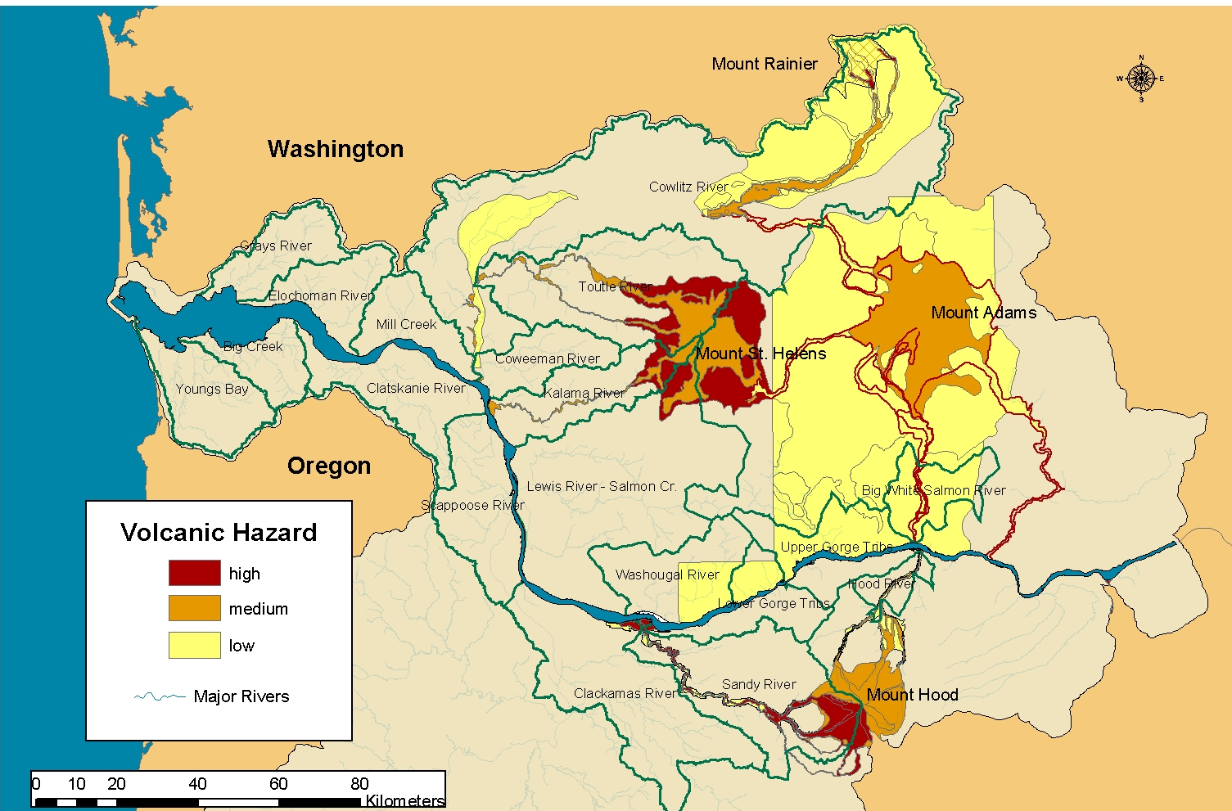
Willamette/Lower Columbia Salmonid Viability Criteria
K-26

Figure K.1 Fall chinook—Lower Columbia ESU volcanic hazards.

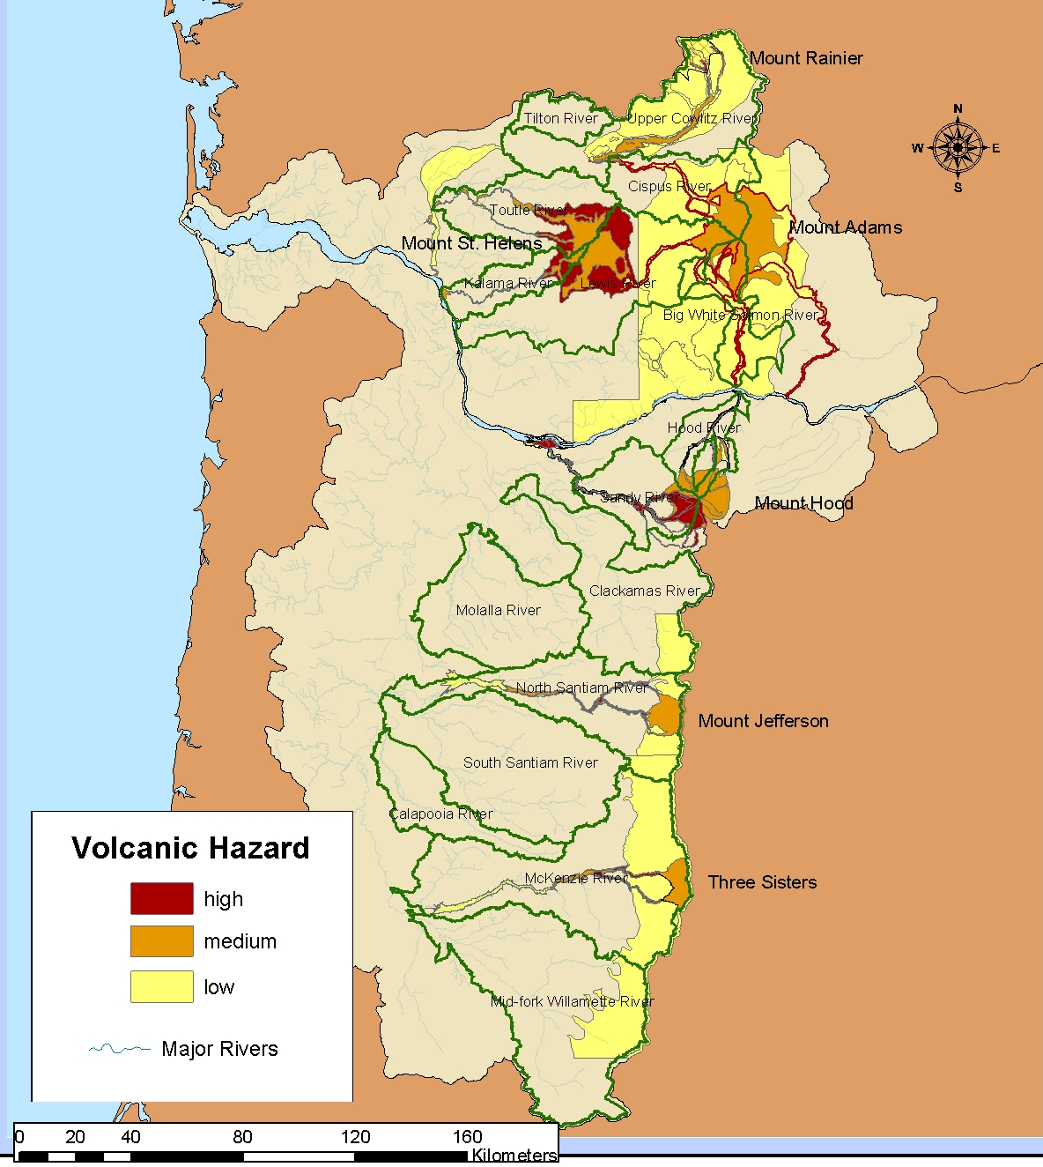

Figure K.2 Spring chinook—Lower Columbia and Willamette River ESUs volcanic hazards.

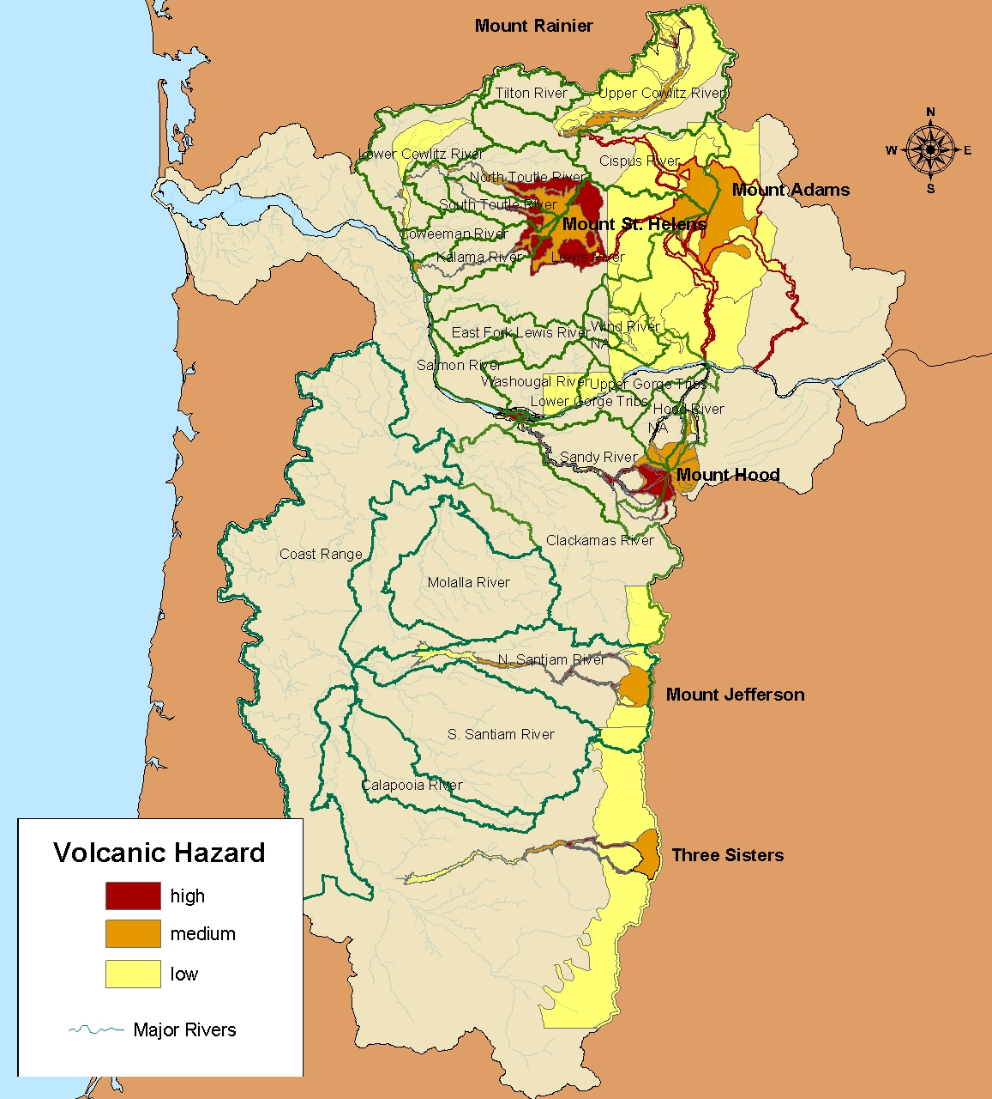

Figure K.3 Winter steelhead—Lower Columbia and Willamette River ESUs volcanic hazards.
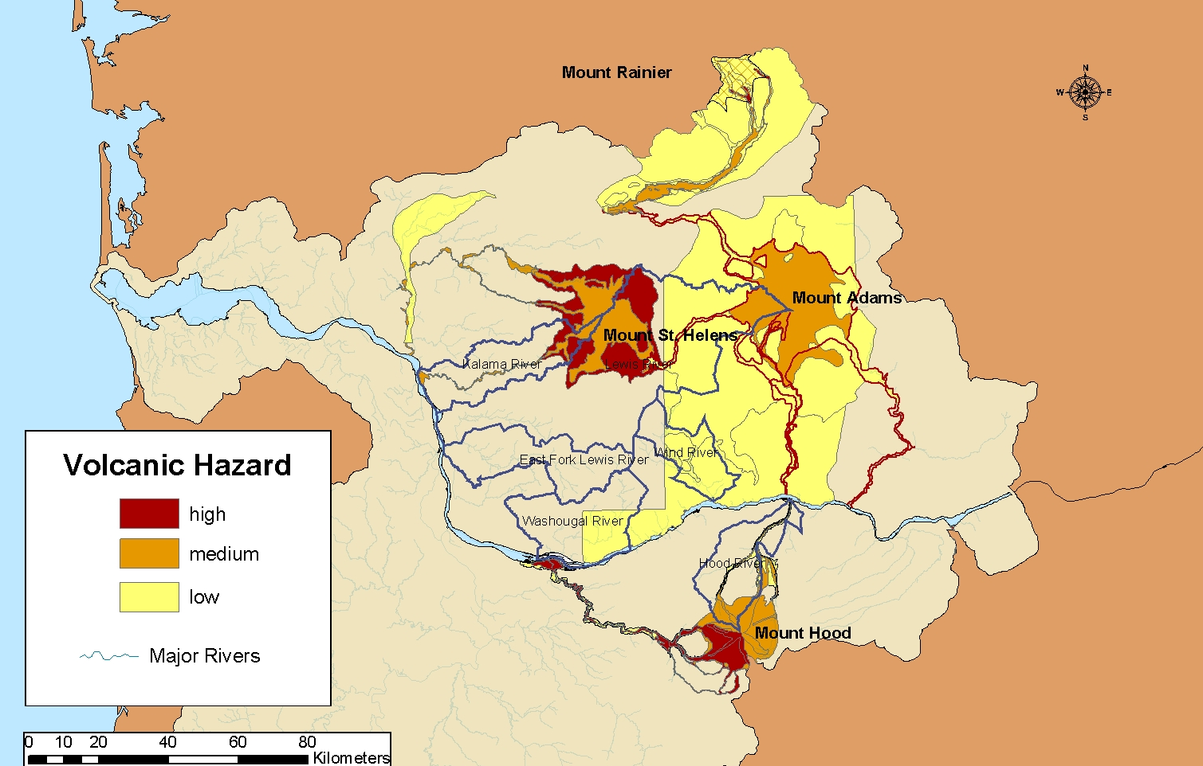
K-29
Appendix K: Catastrophic Risk Assessment

Figure K.4 Summer steelhead—Lower Columbia ESU volcanic hazards.

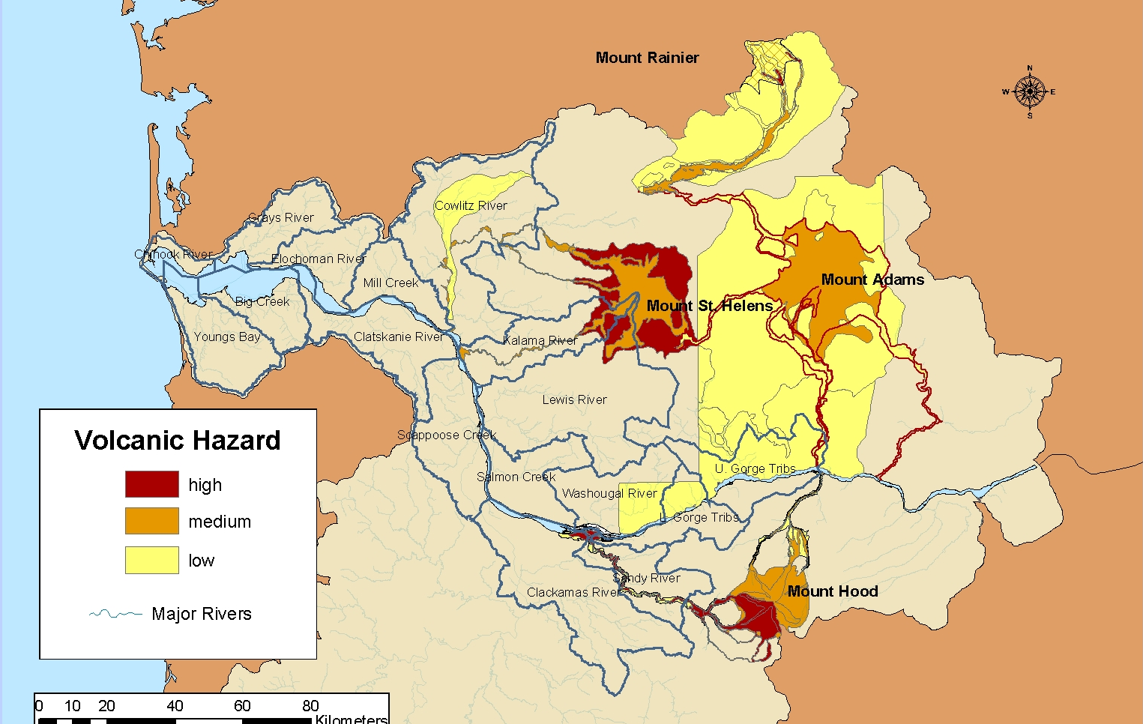
K-30
Willamette/Lower Columbia Salmonid Viability Criteria

Figure K.5 Chum—Lower Columbia ESU volcanic hazards.

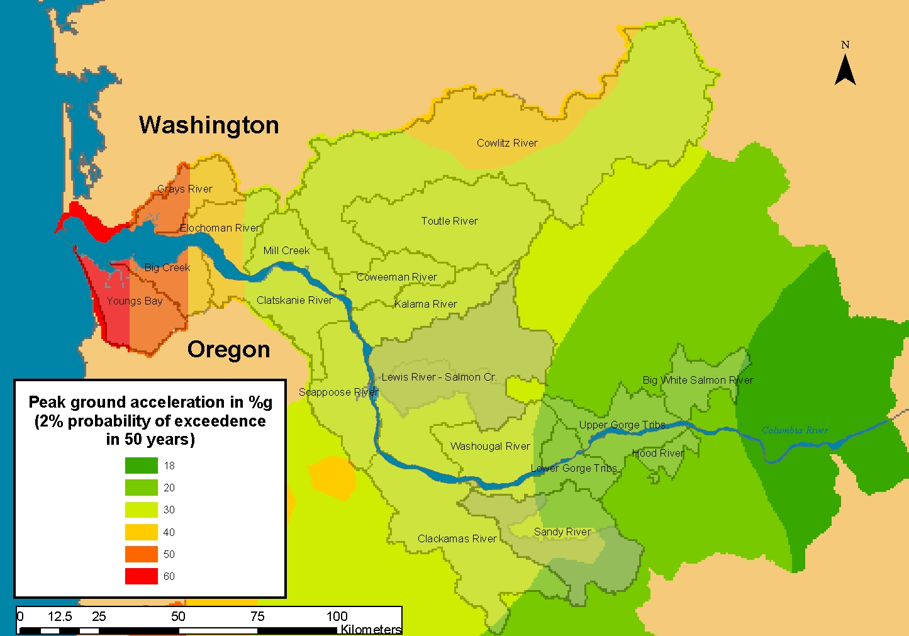
Figure K.6 Earthquake probabilities for fall chinook populations.
K-31
Appendix K: Catastrophic Risk Assessment

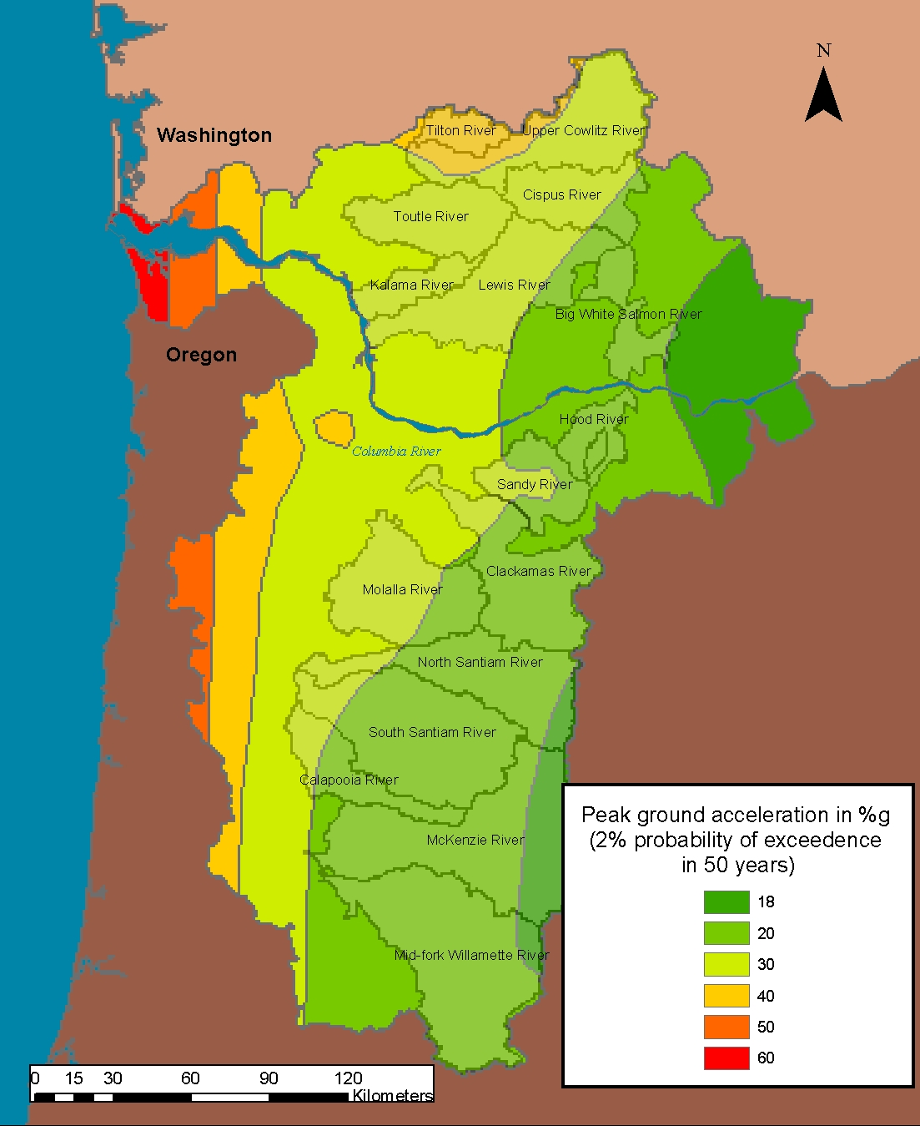

Figure K.7 Earthquake probabilities for spring chinook populations.

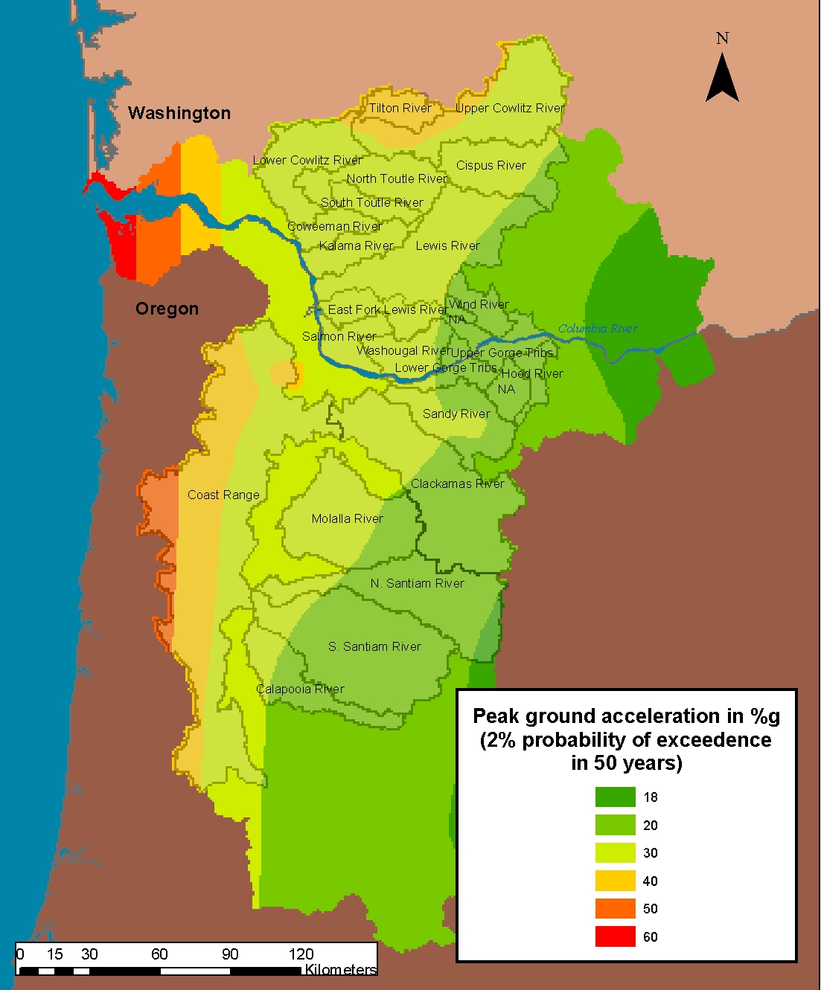

Figure K.8 Earthquake probabilities for winter steelhead populations.
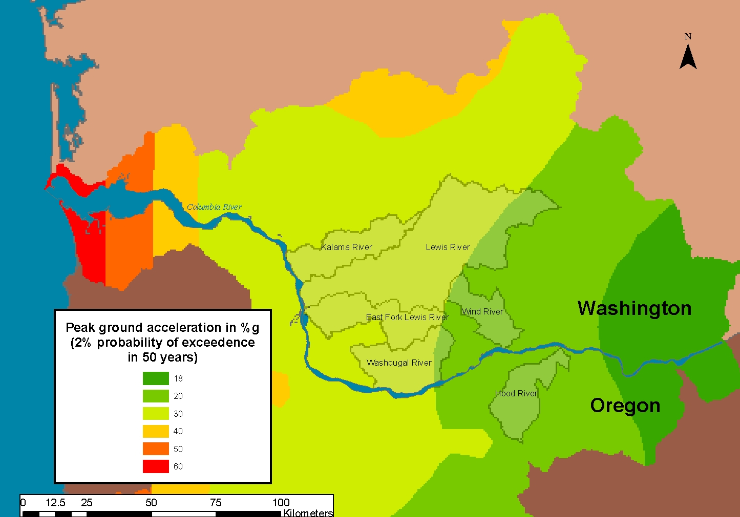
K-34
Willamette/Lower Columbia Salmonid Viability Criteria

Figure K.9 Earthquake probabilities for summer steelhead populations.

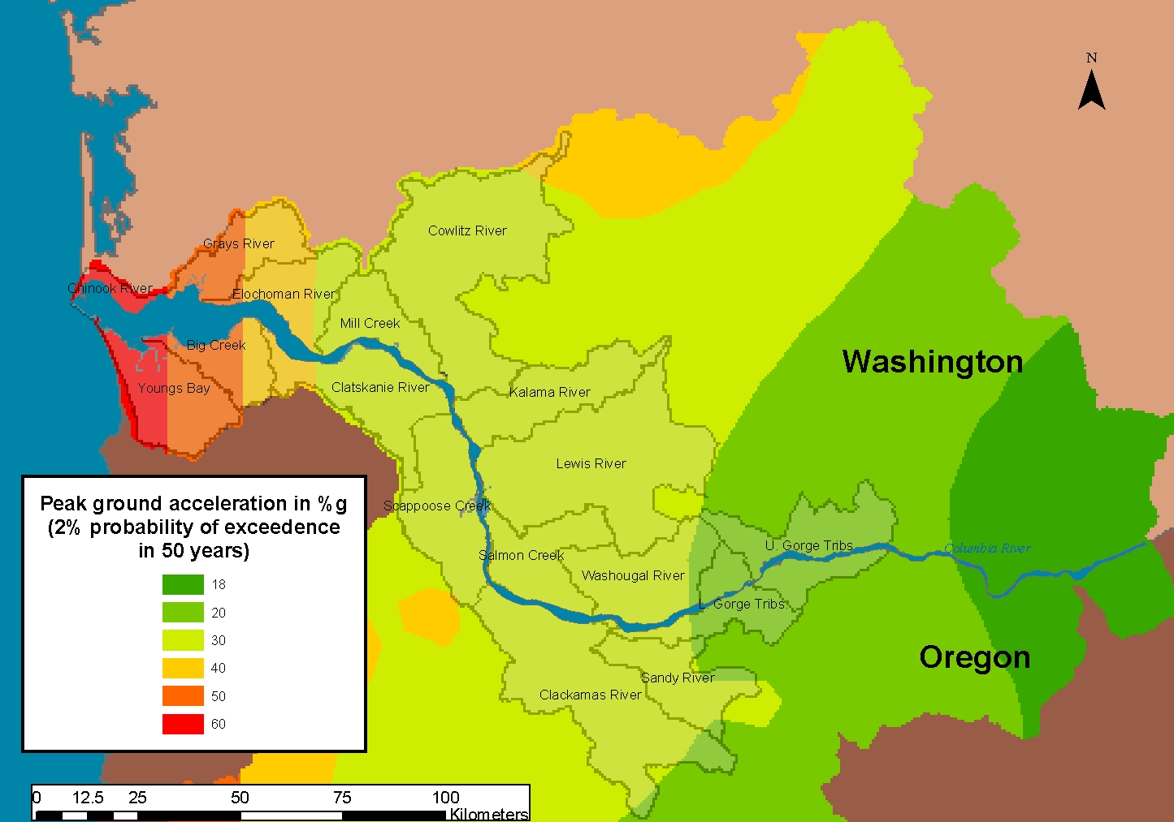
K-35
Appendix K: Catastrophic Risk Assessment

Figure K.10 Earthquake probabilities for chum populations.

Figure K.11 Landslide risk to fall chinook populations.
K-36
Willamette/Lower Columbia Salmonid Viability Criteria

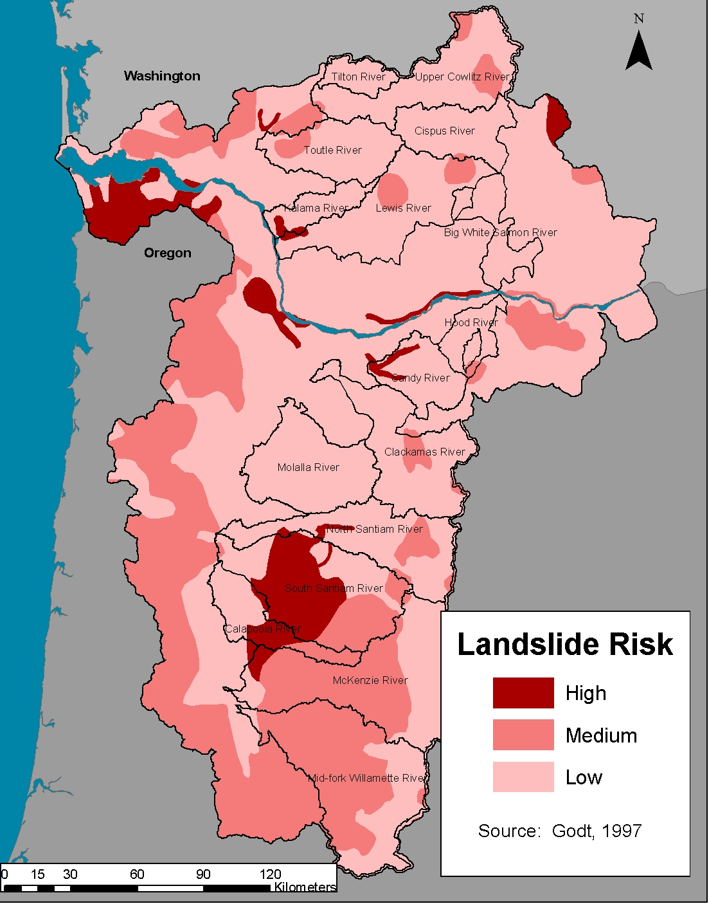
Figure K.12 Landslide risk to spring chinook populations.
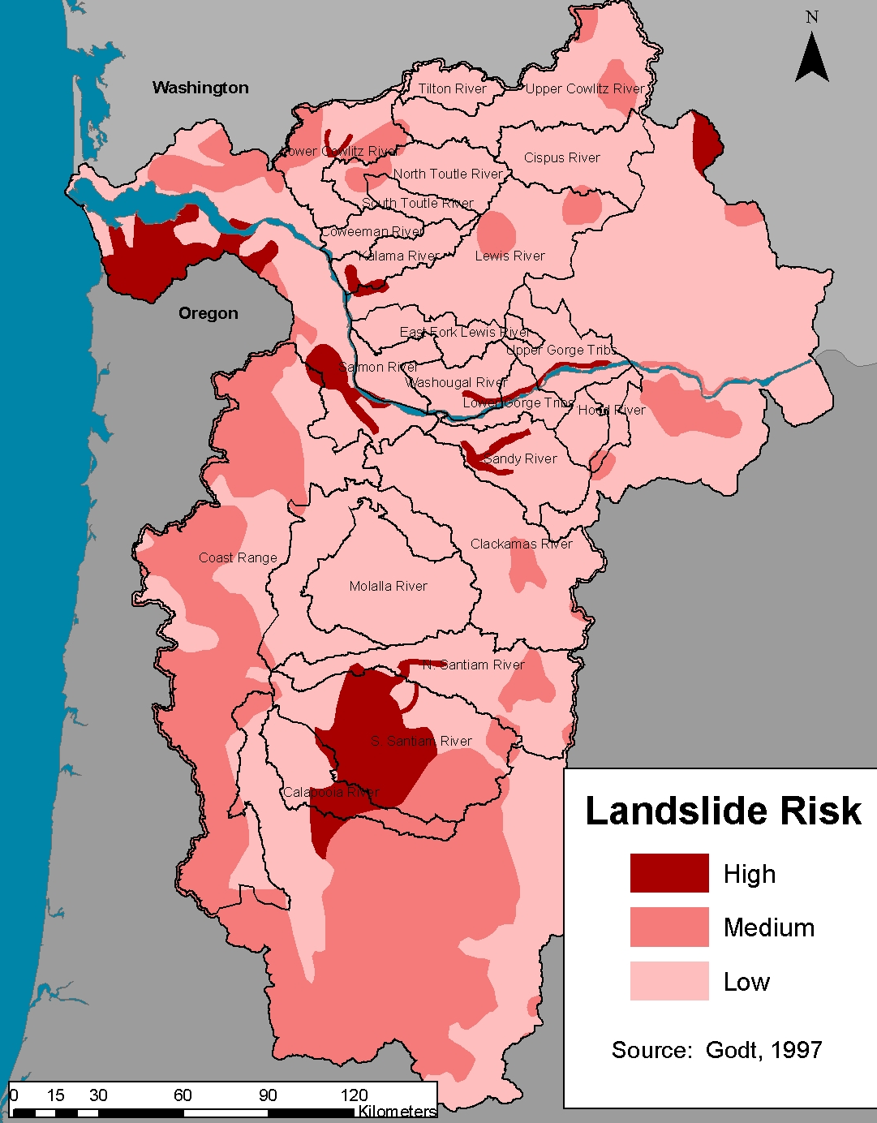

Figure K.13 Landslide risk to winter steelhead populations.
K-39
Appendix K: Catastrophic Risk Assessment

Figure K.14 Landslide risk to summer steelhead populations.

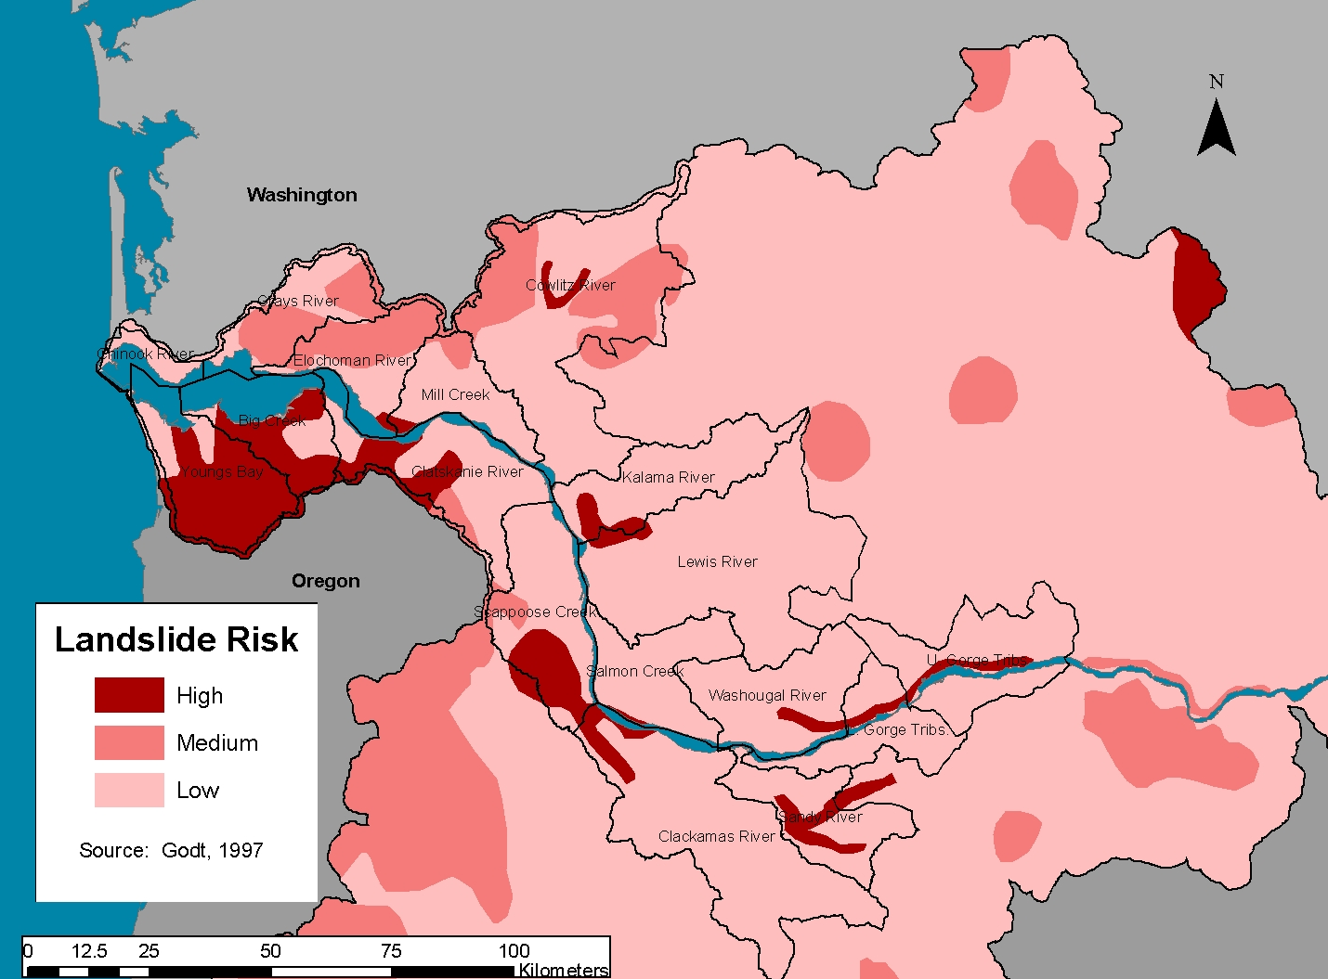
Figure K.15 Landslide risk to chum populations.
K-40
Willamette/Lower Columbia Salmonid Viability Criteria

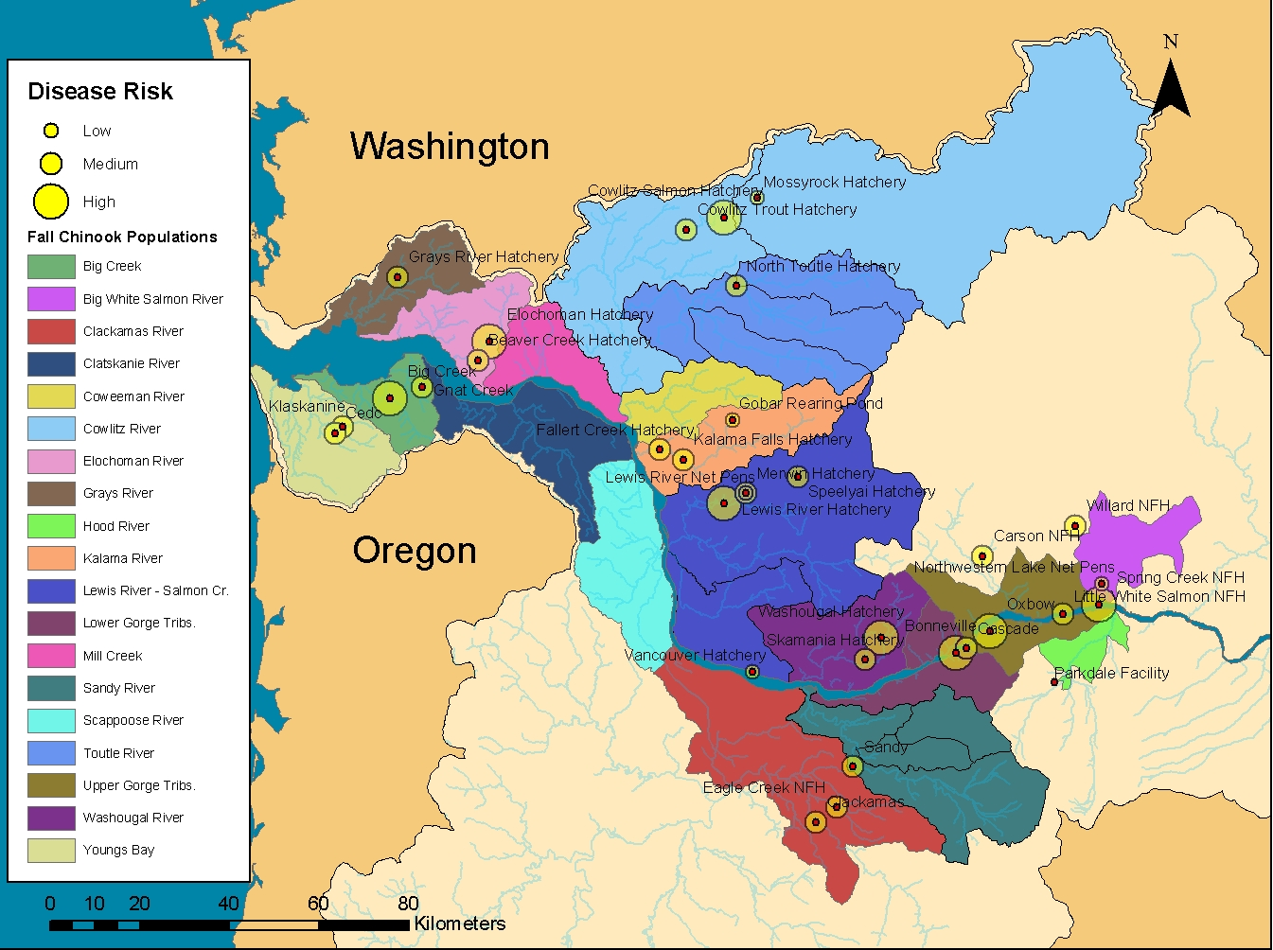
K-41
Appendix K: Catastrophic Risk Assessment

Figure K.16 Disease risk from hatchery releases to fall chinook.

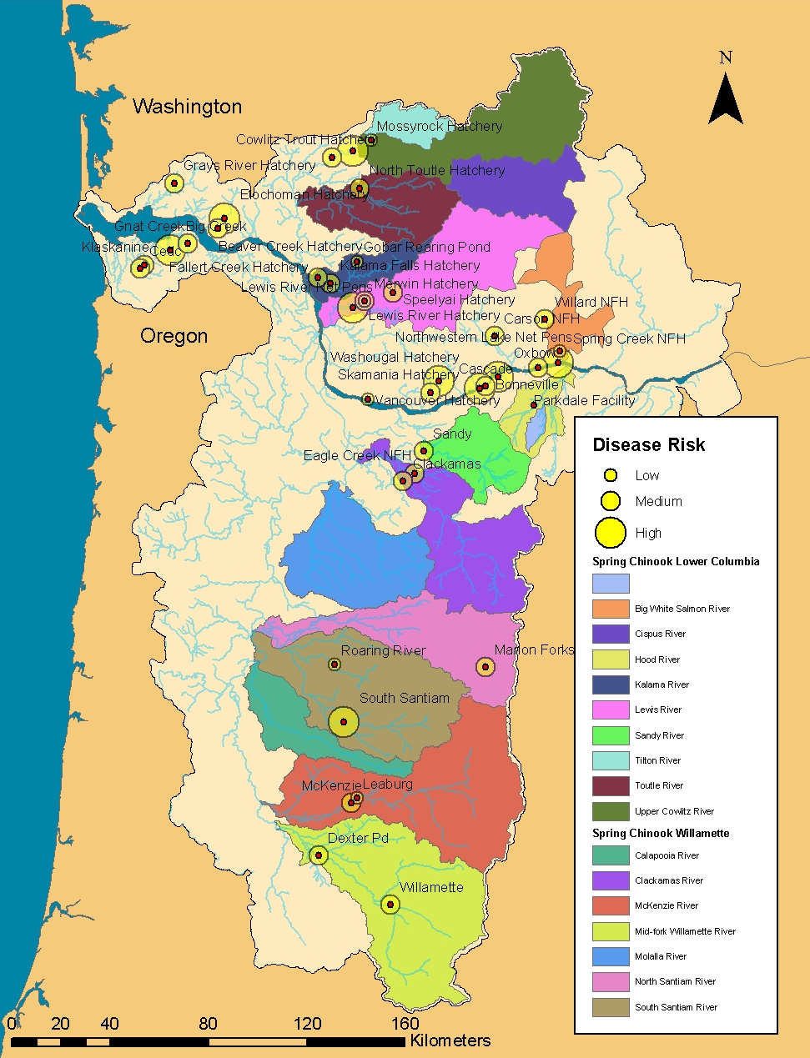

Figure K.17 Disease risk from hatchery releases to spring chinook.
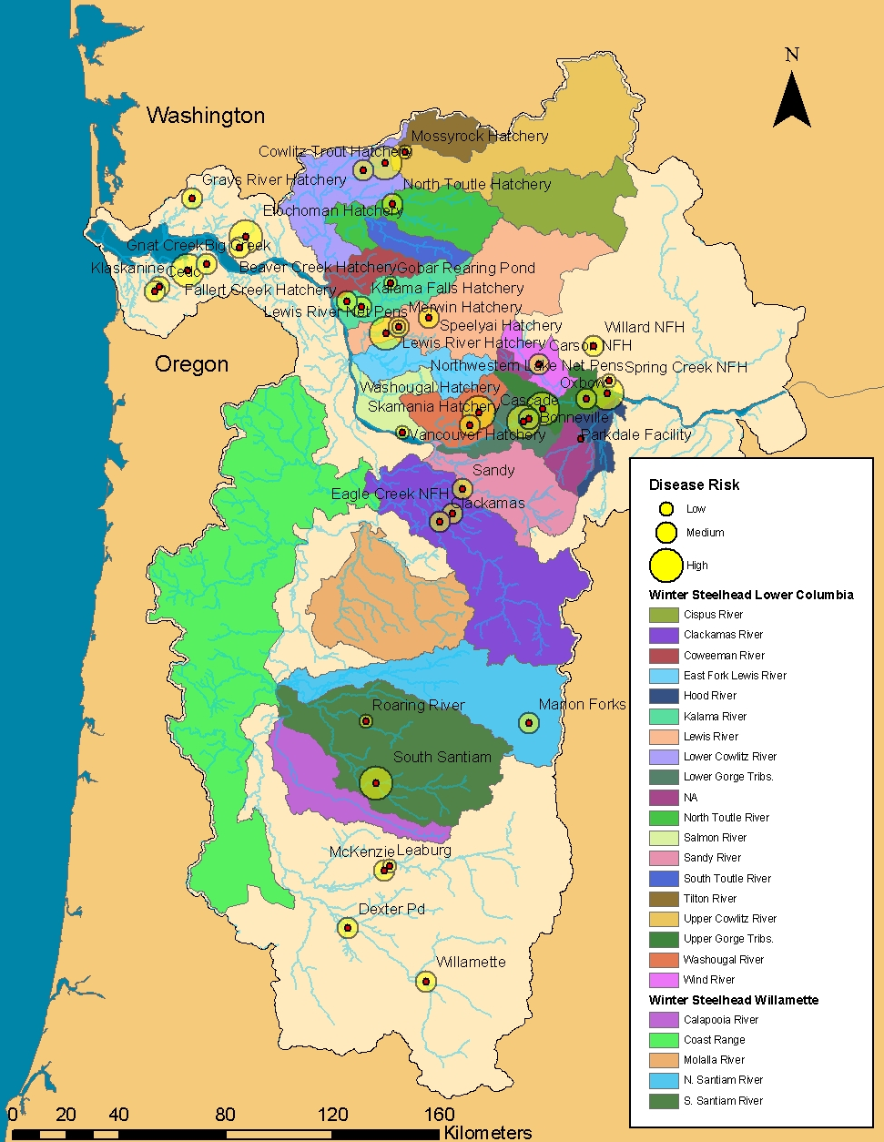
Figure K.18 Disease risk from hatchery releases to winter steelhead.

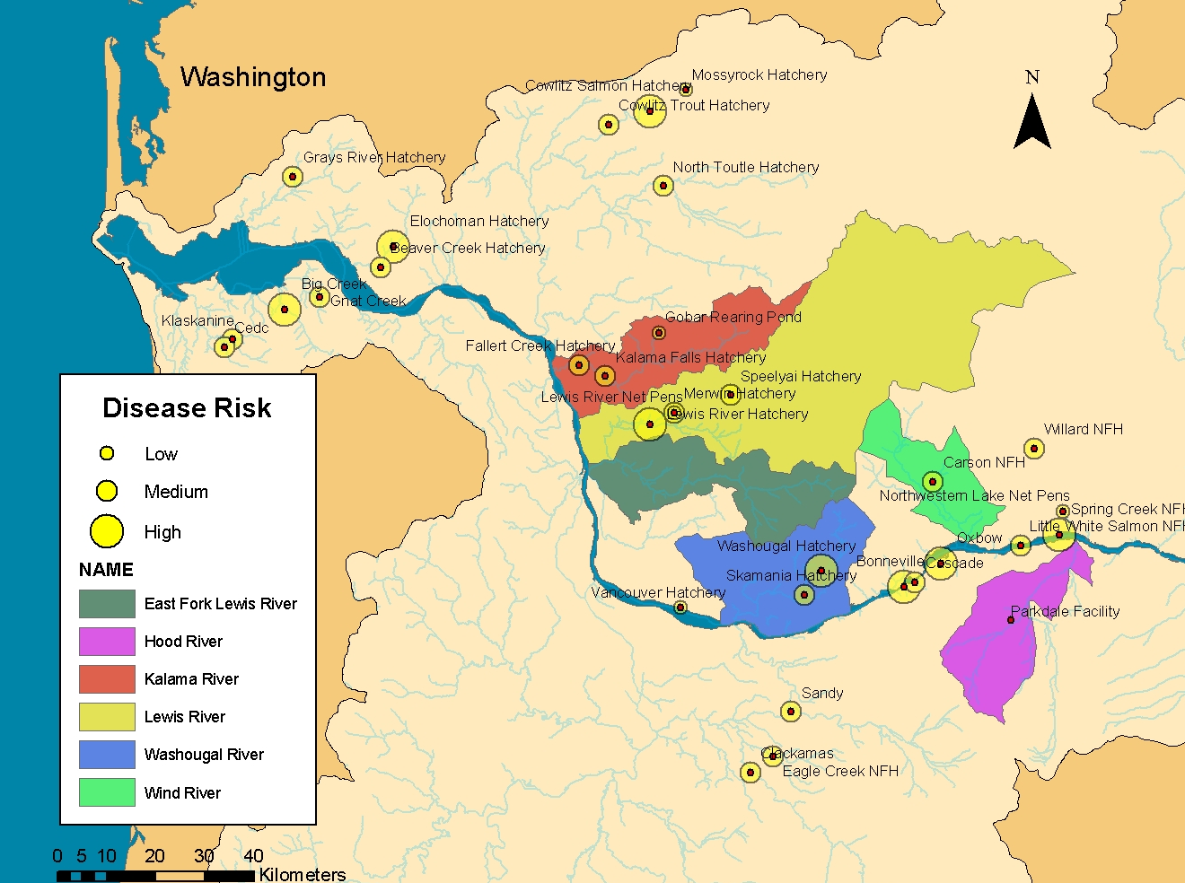
K-44
Willamette/Lower Columbia Salmonid Viability Criteria

Figure K.19 Disease risk from hatchery releases to summer steelhead.

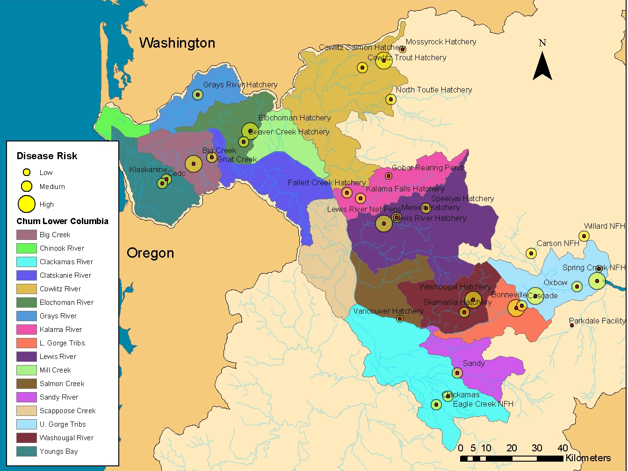
Figure K.20 Disease risk from hatchery releases to chum.
K-45
Appendix K: Catastrophic Risk Assessment

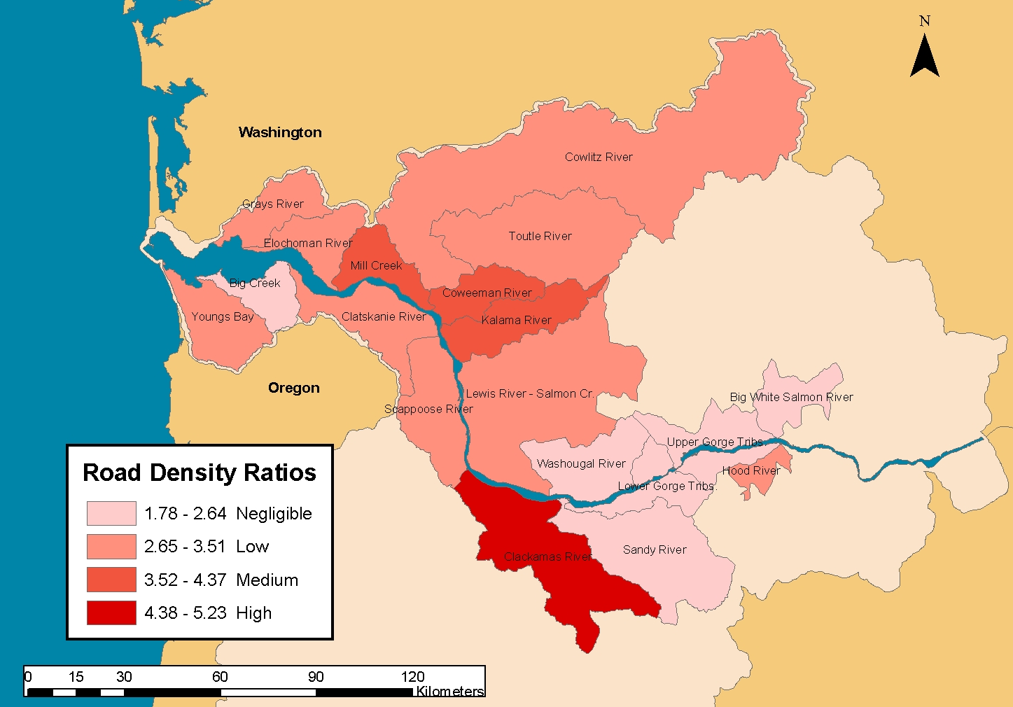
K-46
Willamette/Lower Columbia Salmonid Viability Criteria

Figure K.21 Relative road density ratios by fall chinook populations.

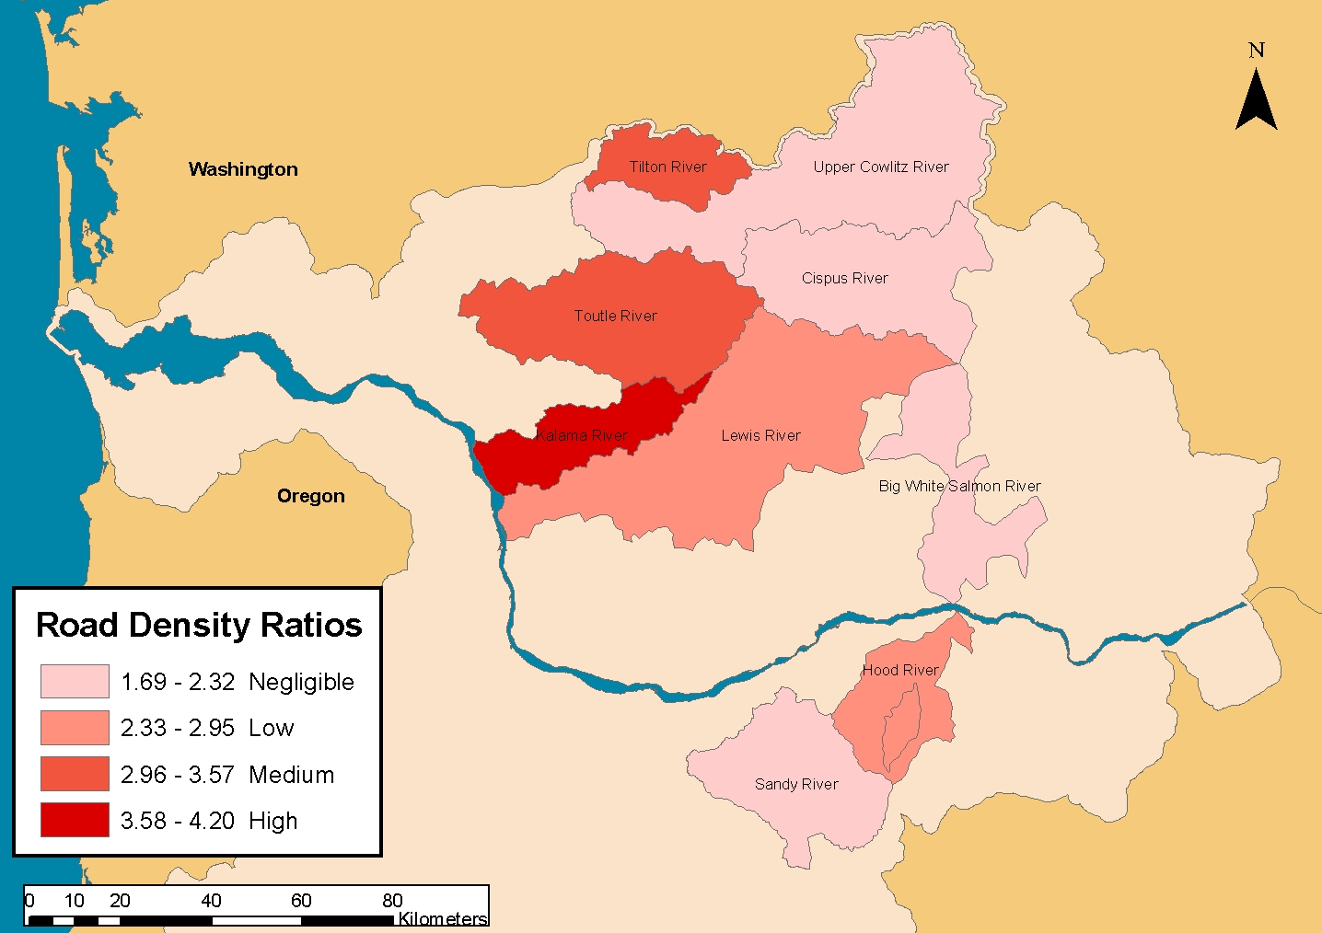
K-47
Appendix K: Catastrophic Risk Assessment

Figure K.22 Relative road density ratio by Columbia River spring chinook populations.

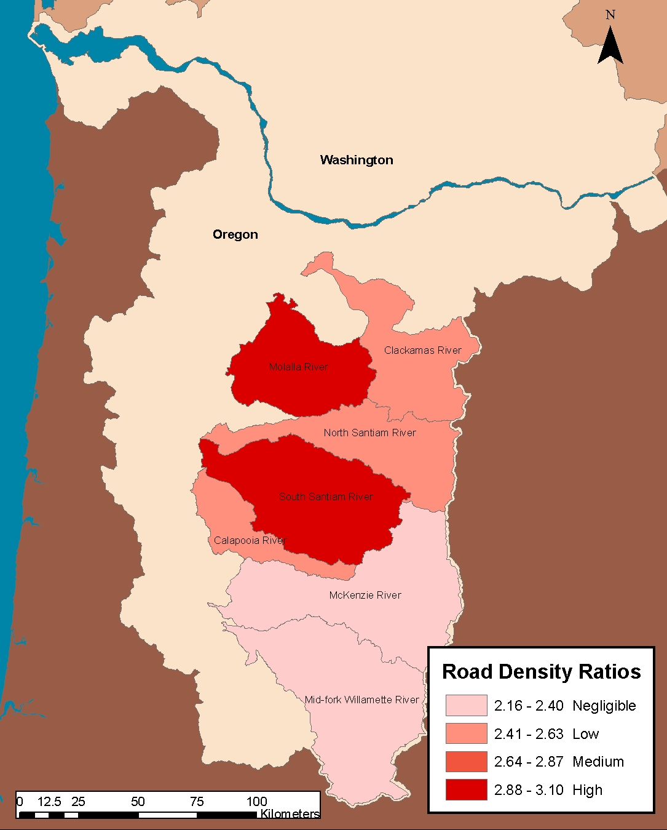

Figure K.23 Relative road density ratio by Willamette spring chinook populations.

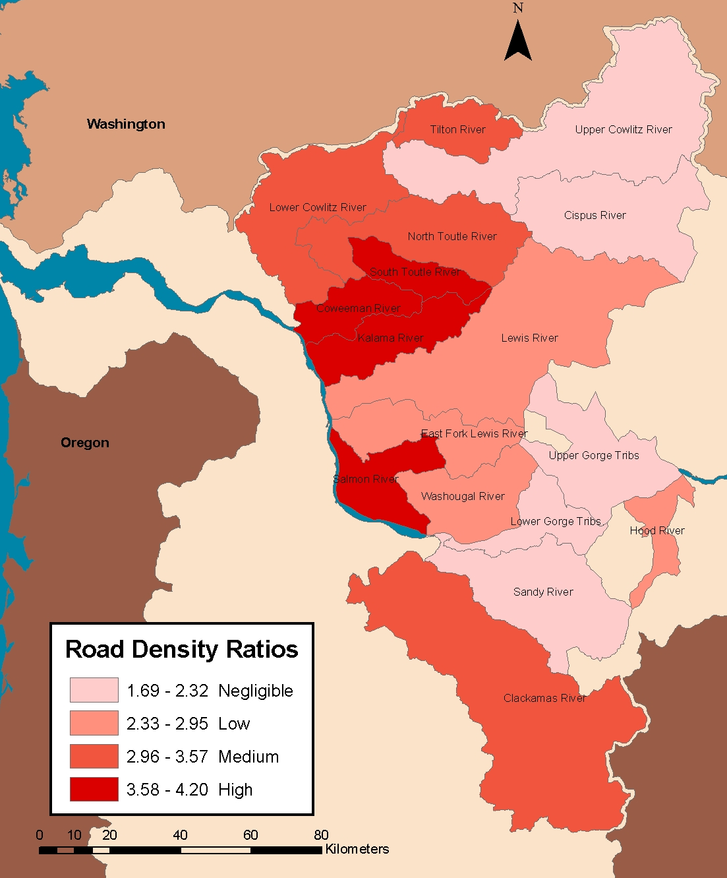
Figure K.24 Relative road density ratios by Lower Columbia winter steelhead populations.
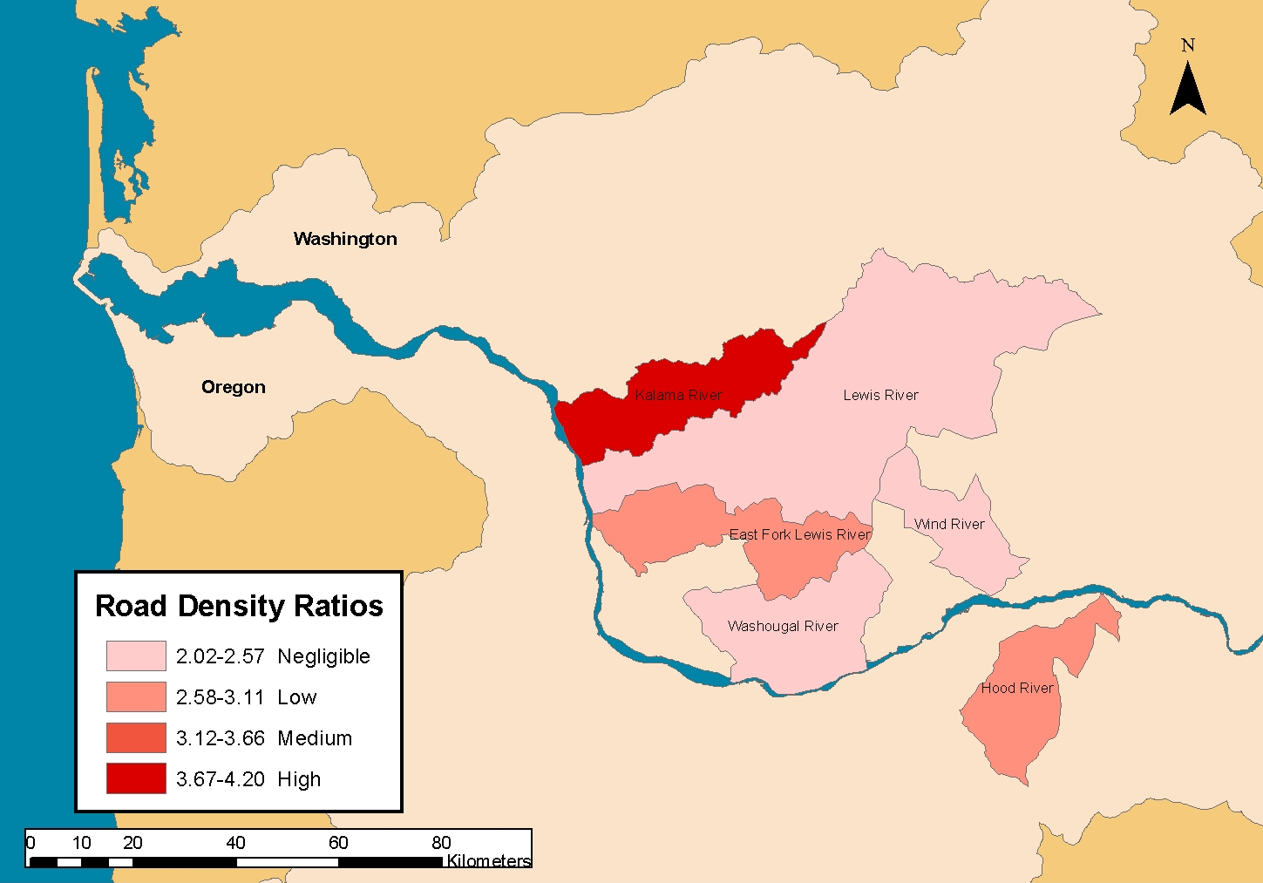
K-50
Willamette/Lower Columbia Salmonid Viability Criteria

Figure K.25 Relative road density ratios by summer steelhead populations.

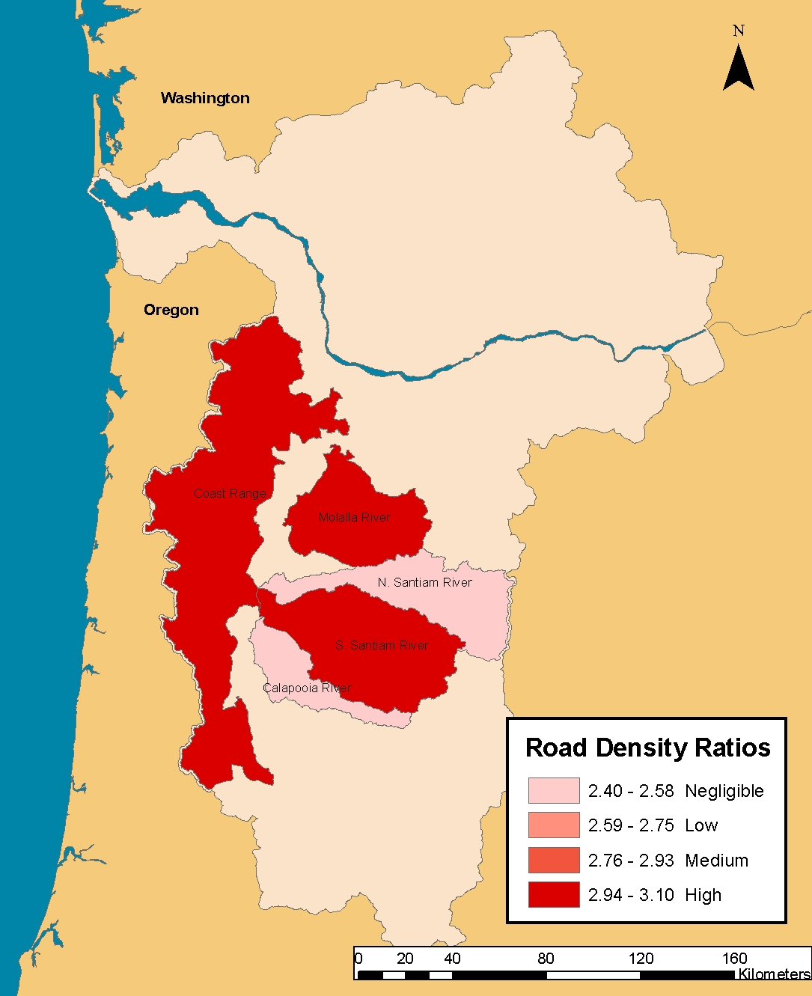

Figure K.26 Relative road density ratios by Willamette winter steelhead populations.
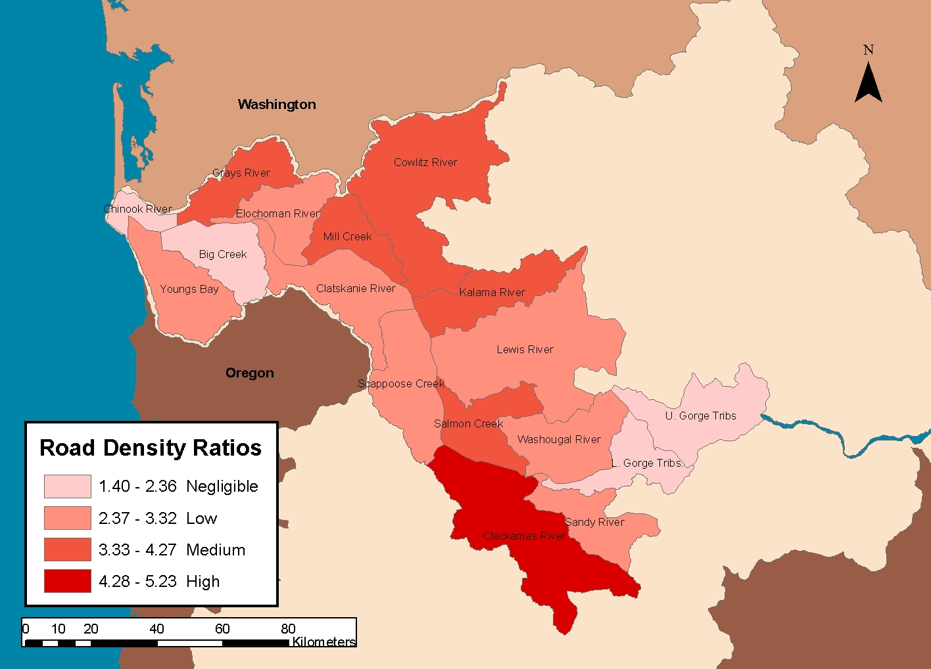
Figure K.27 Relative road density ratios by chum population.
K-52
Willamette/Lower Columbia Salmonid Viability Criteria

Literature Cited
Altinok, I., J. M. Grizzle, and Z. Liu. 2001. Detection of Yersinia ruckeri in rainbow trout blood by use of the polymerase chain reaction. Dis. Aquat. Org. 44: 29–34.

Anderson, D. P. 1990. Immunological indicators: Effects of environmental stress on immune protection and disease outbreaks. In S. M. Adams (ed.), Biological indicators of stress in fish. American Fisheries Society, Symposium 8, Bethesda, Md. p. 38–50.

Anderson, D. P. 1996. Environmental factors in fish health: Immunological aspects. In G. Iwama and T. Nakanishi (eds.), The fish immune system: Organism, pathogen, and environment. Academic Press, New York. p. 289–310.

Bartholomew, J. L., J. S. Rohovec, and J. L. Fryer. 1989. Ceratomyxa shasta, a Myxosporean parasite of salmonids. U.S. Fish and Wildlife Service Fish Disease Leaflet 80. National Fish Health Research Laboratory, Kearneysville, W.V.

Beacham, T. D. and T. P. T. Evelyn. 1992. Genetic variation in disease resistance and growth of chinook, coho, and chum salmon with respect to vibriosis, furunculosis, and bacterial kidney disease. Trans. Am. Fish. Soc. 121: 456–485.

Bisson, P. A., J. L. Nielsen, and J. W. Ward. 1988. Summer production of coho salmon stocked in Mount St. Helens streams 3–6 years after the eruption. Trans. Am. Fish. Soc. 117: 322–355.

Bisson, P. A., G. H. Reeves, R. E. Bilby, and R. J. Naiman. 1997. Watershed management and Pacific salmon: Desired future conditions. In D. J. Stouder, P. A. Bisson, and R. J. Naiman (eds.), Pacific salmon and their ecosystems. Kluwer Academic Publishers, New York.

Bootland, L. M. and J. C. Leong. 1999. Infectious haematopoietic necrosis. In P. T. K. Woo and D. W. Bruno (eds.), Fish diseases and disorders, Vol. 3. Viral, bacterial and fungal infections. CABI Publishing, Wallingford, Conn. p. 57–121.

Brantley, S., and B. Myers. 2000. Mount St. Helens—From the 1980 eruption to 2000. U.S. Geological Survey Fact sheet 036-00.

Bullock, G. L., and R. C. Cipriano. 1990. Enteric redmouth disease of salmonids. U.S. Fish and Wildlife Service Fish Disease Leaflet 82. National Fish Health Research Laboratory, Kearneysville, W.V.

Bullock, G. L., and R. L. Herman. 1988. Bacterial kidney disease of salmonid fishes caused by Renibacterium salmominarum. U.S. Fish and Wildlife Service Fish Disease Leaflet 78. National Fish Health Research Laboratory, Kearneysville, W.V.

Busch, R. A., and A. J. Lingg. 1975. Establishment of an asymptomatic carrier state infection of enteric redmouth disease in rainbow trout (Salmo gairdneri). J. Fish. Res. Board Can. 32: 2429–2433.

Casillas E., B. B. McCain, M. Arkoosh, and J. E. Stein. 1997. Estuarine pollution and juvenile salmon health: Potential impact on survival. In R. L. Emmett and M. H. Schiewe (eds.), Estuarine and ocean survival of Northeastern Pacific salmon: Proceedings of the workshop. U.S. Dept. Commer., NOAA Tech. Memo. NMFS-NWFSC-29, 313 p.

Coutant, C. C. 1998. What is “normative” for fish pathogens? A perspective on the controversy over interactions between wild and cultured fish. J. Aquat. Anim. Health 10: 101–106.

Crandell, D. R. and D. R. Mullineaux. 1978. Potential hazards from future eruptions of Mount St. Helens, Washington. U.S. Geological Survey Bulletin 1383-C, 26 p.

Dorava, J. M., and A. M. Milner. 1999. Effects of recent volcanic eruptions on aquatic habitat in the Drift River, Alaska, USA: Implications at other Cook Inlet region volcanoes. Environ. Manage. 23: 217–230.

Flagg, T. A., B. A. Berejikian, J. E. Colt, W. W. Dickhoff, L. W. Harrell, D. J. Maynard, C. E. Nash, M. S. Strom, R. N. Iwamoto, and C. V. W. Mahnken. 2000. Ecological and behavioral impacts of artificial production strategies on the abundance of wild salmon populations. U.S. Dept. Commer., NOAA Technical Memorandum NMFS-NWFSC-41, 92 p.

Frankel, A., C. Mueller, T. Barnhard, D. Perkins, E. V. Leyendecker, N. Dickman, S. Hanson, and M. Hopper. 1997. Seismic-hazard maps for the conterminous United States, U.S. Geological Survey Open-file Report 97-131.

Godt, J. W. 1997. Digital compilation of “Landslide overview map of the conterminous United States” by D. H. Radbruch-Hall, R. B. Colton, W. E. Davies, I. Lucchitta, B. A. Skipp, and D. J. Varnes, 1982. Landslide incidence and susceptibility illustrated for major physical subdivisions of the United States. Geological Survey Professional Paper 1183, U.S. Dept. of the Interior. U.S. Government Printing Office, Washington, D.C. U.S. Geological Survey Open-file Report 97-289.

Hiney, M. and G. Olivier. 1999. In P. T. K. Woo and D. W. Bruno (eds.), Fish diseases and disorders, Vol. 3. Viral, bacterial and fungal infections. CABI Publishing, Wallingford, Conn. p. 455–477.

Hoblitt, R. P., J. S. Walder, C. L. Driedger, K. M. Scott, P. T. Pringle, and J. W. Vallance. 1998. Volcano hazards from Mount Rainier, Washington, revised 1998. U.S. Geological Survey Open-file Report 98-428, 11 p.

Horne M. T., and A. C. Barnes. 1999. Enteric redmouth disease (Yersinia ruckeri). In P. T. K. Woo and D. W. Bruno (eds.), Fish diseases and disorders, Vol. 3. Viral, bacterial and fungal infections. CABI Publishing, Wallingford, Conn. p. 455–477.

Kinkelin, P. de, and B. Loriot. 2001. A water temperature regime which prevents the occurrence of proliferative kidney disease (PKD) in rainbow trout, Oncorhynchus mykiss (Walbaum). J. Fish Dis. 24: 489–493.

Kirn, R. A., R. D. Ledgerwood, and A. L. Jensen. 1986. Diet of subyearling chinook salmon (Oncorhynchus tshawytscha) in the Columbia River estuary and changes effected [sic] by the 1980 eruption of Mount St. Helens. NW Sci. 60: 191–196.

Kostow, K., E. Olsen, M. Jennings, and J. Newton. 2000. Hood River steelhead hatchery programs, goals, risk/benefit analysis and assessment of alternative operational protocols (Draft).

Leider, S. A. 1989. Increased straying by adult steelhead trout, Salmo gairdneri, following the 1980 eruption of Mount St. Helens. Environ. Biol. Fish. 24(3): 219–229.

Levin, P. S., and M. H. Schiewe 2001. Preserving salmon biodiversity. Am. Sci. 89: 220–227.

Lucas, R. E. 1986. Recovery of game fish populations impacted by the May 18, 1980 eruption of Mount St. Helens: Winter-run steelhead in the Toutle River watershed. In S. A. C. Keller (ed.), Mount St. Helens: Five years later. Eastern Washington University Press, Cheney, Wash., 441 p.

Manson, C. J., and L. Walkling. 1998. Tsunamis on the Pacific Coast of Washington State and adjacent areas—a selected, annotated bibliography and directory. Washington Division of Geology and Earth Resources Open-file Report 98-4, Wash. Dept. Nat. Res., 44 p.

Markiw, M. E. 1992. Salmonid whirling disease. U.S. Fish and Wildlife Service Fish Disease Leaflet 83. National Fish Health Research Laboratory, Kearneysville, W.V.

McAllister, P. E. 1990. Viral hemorrhagic septicemia of fishes. U.S. Fish and Wildlife Service Fish Disease Leaflet 83. National Fish Health Research Laboratory, Kearneysville, W.V.

Martin, D. J., L. J. Wasserman, and V. H. Dale. 1986. Influence of riparian vegetation on posteruption survival of coho salmon fingerlings on the west-side streams of Mount St. Helens, Washington. N. Am. J. Fish. Manage. 6: 1–8.

McElhany, P., M. H. Ruckelshaus, M. J. Ford, T. C. Wainwright, and E. P. Bjorkstedt. 2000. Viable salmonid populations and the recovery of evolutionarily significant units. U.S. Dept. Commer., NOAA Tech. Memo. NMFS-NWFSC-42, 156 p.

Mesa, M. G., T. .P. Poe, A. G. Maule, and C. B. Schreck. 1998. Vulnerability to predation and physiological stress responses in juvenile chinook salmon (Oncorhynchus tshawytscha) experimentally infected with Renibacterium salmoninarum. Can. J. Fish. Aquat. Sci. 55: 1599–1606.

Myers, J. M. 2002. Identifying historical populations of chinook and chum salmon and steelhead within the lower Columbia River and upper Willamette River evolutionary significant units. Draft report to the Willamette/Lower Columbia River Technical Recovery Team (10 May 2002).

National Research Council (NRC). 1996. Upstream: Salmon and society in the Pacific Northwest. National Academy Press, Washington, D.C.

Noson, L. L., A. Qamar, and G. W. Thorsen. 1988. Washington State earthquake hazards. Washington Division of Geology and Earth Resources Information Circular 85.

OIE (Office International des Epizooties). 2000. Diagnostic Manual for Aquatic Animal Diseases, 3rd Ed. OIE Fish Diseases Commission (http://www.oie.int/eng/normes/
fmanual/A_summry.htm).

Perkins, S. 2001. The mountain: Take a look at Mount Rainier, America’s most dangerous volcano. Sci. News 160: 334–335.

PNWFHPC (Pacific Northwest Fish Health Protection Committee). 1998. Fish health status reports 1998. Pacific Northwest Fish Health Protection Committee Meeting at Las Vegas, Nev., February 18–19, 1998.

Ralls, K., D. P DeMaster, and J. A. Estes. 1996. Developing a criterion for delisting the southern sea otter under the U.S. Endangered Species Act. Conserv. Biol. 10: 1528–1537.

Reno, P. W. 1998. Factors involved in the dissemination of disease in fish populations. J. Aquat. Anim. Health 10: 160–171.

Reno, P. W. 1999. Infectious pancreatic necrosis and associated aquatic birnaviruses. In P. T. K. Woo and D. W. Bruno (eds.), Fish diseases and disorders, Vol. 3. Viral, bacterial and fungal infections. CABI Publishing, Wallingford, Conn. p. 1–55.

Ruckelshaus, M., P. McElhany, M. McClure and S. Heppell. In press. How many populations are needed for persistence of listed salmon species? Exploring the effects of spatially correlated catastrophes using RAMAS 4.0. In R. Ackakaya and M. Burgman (eds.) Solving conservation problems for the new millennium: Using RAMAS 4.0. Island Press, Washington, D.C.

Schreck, C. B. 1996. Immunomodulation: Endogenous factors. In G. Iwama and T. Nakanishi, (eds.), The fish immune system: Organism, pathogen, and environment. Academic Press, New York. p. 311–338.

Scott, W. E., R. M. Iverson, S. P. Schilling, and B. J. Fischer. 2001. Volcano hazards in the Three Sisters region, Oregon. U.S. Geological Survey Open-file Report 99-437.

Scott, W. E., R. M. Iverson, J. W. Vallance, and W. Hildreth. 1995. Volcano Hazards in the Mount Adams region, Washington. U.S. Geological Survey Open-file Report 95-492.

Scott, W. E., T. C. Pierson, S. P. Schilling, J. E. Costa, C. A. Gardner, J. W. Vallance, and J. J. Major. 1997. Volcano hazards in the Mount Hood region, Oregon. U.S. Geological Survey Open-file Report 97-89.

Scheffer, M., S. Carpenter, J. A. Foley, C. Folke, and B. Walkerk. 2001. Catastrophic shifts in ecosystems. Nature 413: 591–596.

Shotts Jr., E. B., and C. E. Starliper. 1999. Flavobacterial diseases: Columnaris disease, cold-water disease and bacterial gill disease. In P. T. K. Woo and D. W. Bruno (eds.), Fish diseases and disorders, Vol. 3. Viral, bacterial and fungal infections. CABI Publishing, Wallingford, Conn. p. 559–576.

Thorpe, J. E. 1994. Salmonid flexibility: Responses to environmental extremes. Trans. Am. Fish. Soc. 123: 606–612.

Traxler, G. S., J. Richard, and T. E. McDonald. 1998. Ichthyophthirius multifiliis (Ich) epizootics in spawning sockeye salmon in British Columbia, Canada. J. Aquat. Anim. Health 10: 143–151.

Waitt, R. B., L. G. Mastin, and J. E. Begét. 1995. Volcanic-hazard zonation for Glacier Peak volcano, Washington. U.S. Geological Survey Open-file Report 95-499.

Waknitz, F.W., T.J. Tynan, C.E. Nash, R.N. Iwamoto, and L.G. Rutter. 2002. Review of potential impacts of Atlantic salmon culture on Puget Sound chinook salmon and Hood Canal summer-run chum salmon evolutionarily significant units. U.S. Dept. Commer., NOAA Tech. Memo. NMFS-NWFSC-53, 83 p.

Walder, J. S., C. A. Gardner, R. M. Conrey, B. J. Fisher, and S. P. Schilling. 1999. Volcano hazards in the Mount Jefferson region, Oregon. U.S. Geological Survey Open-file Report 99-24, 14 p.

Wolfe, E. W., and T. C. Pierson. 1995. Volcanic-hazard zonation for Mount St. Helens, Washington, 1995. U.S. Geological Survey Open-file Report 95-497.

