National Aeronautics and
Space Administration

John C. Stennis Space Center
SSC, Mississippi 39529

Decision Support Tools Evaluation Report for FAS/PECAD, Version 2.0

Earth Science Applications Directorate Integrated Product Team for Agricultural Efficiency
John C. Stennis Space Center, Mississippi

Acknowledgments
This work was supported by the NASA Earth Science Applications Directorate under contract number NAS 13-650 at the John C. Stennis Space Center, Mississippi.

Earth Science Application Directorate’s Integrated Product Team for Agricultural Efficiency
Rodney McKellip, NASA SSC/ESA–Team Leader
Ted Mason, NASA SSC/ESA  Vicki Zanoni, NASA SSC/ESA  Slawomir Blonski, LMSO RSD  Malinda Braland, LMSO RSD | Keith Morris, LMSO RSD  Christina O’Connor, LMSO RSD  Kenton Ross, LMSO RSD–Lead Author  Greg Terrie, LMSO RSD  Stan Woolley, LMSO RSD

Table of Contents
Executive Summary vi
1.0 Introduction 1
1.1 PECAD 2
1.2 Initial Partnering Activities 5
1.3 Systems Engineering Approach 6
2.0 Description of PECAD’s DSS 7
2.1 CADRE 9
2.2 Crop Explorer 11
2.3 Archive Explorer 12
2.4 Other Elements of PECAD’s DSS 13
2.5 PECAD’s DSS Organization and Classification 14
3.0 Consideration of NASA Inputs 15
3.1 PECAD’s DSS Requirements 15
3.2 Matching NASA Inputs Against PECAD Requirements 20
3.3 Planned NASA Inputs 23
3.3.1 MODIS Rapid Response Products 23
3.3.2 TRMM Tailored Products and Systems 25
3.3.3 Satellite Altimetry Products 28
3.3.4 Synthesized Products and Predictions 29
3.4 Potential NASA Inputs 31
3.4.1 Water Balance 32
3.4.2 Radiation Budget 33
3.4.3 Bare Earth Elevation 33
4.0 Identified NASA Technology Gaps in Meeting PECAD Needs 34
4.1 Insufficient System Redundancies 34
4.2 Questionable System Continuity 35
4.3 Data Timeliness Issues 35
5.0 Conclusions 36
5.1 Findings 36
5.2 Recommendations 36
5.3 Next Steps: Conceptual Plans for Verification and Validation of PECAD’s DSS 37
6.0 References 39
Appendix A. Glossary A-1
Appendix B. Acronyms and Initialisms B-1
Appendix C. Agricultural Efficiency Roadmap C-1
Appendix D. Relevant Earth Observing Missions and Sensors D-1
Appendix E. Relevant NASA Earth Observation Products E-1

Tables
Table 1. Breakdown of FAS/PECAD world agricultural region. 3
Table 2. Current PECAD sensor use. 4
Table 3. Inferred Requirements for PECAD’s DSS (based on sources listed in parentheses) 16
Table 4. Working assumptions regarding PECAD’s DSS requirements. 17
Table 5. A “typical” month of current and proposed PECAD DSS inputs. 19
Table 6. DSS requirement/NASA input match. 21
Table 7. Proposed MODIS products for PECAD. 24
Table 8. EOS Data Product Levels 26
Table 9. Proposed TRMM products for PECAD. 28
Table 10. Proposed Jason-1–TOPEX/Poseidon products for PECAD. 29
Table 11. Crop growth models used by PECAD. 29
Table 12. Proposed synthesized products and predictions for PECAD. 30
Table 13. Potential enhancing inputs still in development. 37

Figures
Figure 1. NASA Earth Science Enterprise applications of national priority. 2
Figure 2. Convergence of evidence methodology. 5
Figure 3. Systems engineering approach (adapted from Bahill and Gissing, 1998). 7
Figure 4. PECAD global agricultural production estimation processes. 8
Figure 5. CADRE data storage 1/8 mesh grids (AFWA, 2002). 9
Figure 6. PECAD’s Crop Explorer, located at http://151.121.3.218/rssiws. 11
Figure 7. Crop Explorer time series plots. 12
Figure 8. PECAD’s Archive Explorer. 13
Figure 9. PECAD’s Global Ports Mapper. 14
Figure 10. PECAD DSS subsystems (Hutchinson et al., 2003). 15
Figure 11. Microwave (HQ), IR (VAR), and combined (VARHQ) inputs to the TRMM near-real-time precipitation product. 27
Figure 12. Lakes and reservoirs monitored in December 2003. 28
Figure 13. Schematic for the integration of MODIS and TRMM products to develop crop condition and yield maps (Kempler et al., 2002). 30
Figure 14. Data assimilation schemes using MODIS data products (e.g., LAI). 31
Figure 15. Output of NASA’s soil moisture models on July 1, 2003 (image by Robert Simmon, based on data provided by Kristi Arsenault, NASA GSFC Laboratory for Hydrospheric Processes). 32
Figure 16. Demonstration of the MOD16 evaporation fraction (EF) product. 33
Figure 17. Improved accuracy of global elevation data with SRTM. The figure shows South America’s Guiana Highlands. Left: GTOPO30; Right: SRTM30. 34
Figure 18. V&V hierarchy. 38

Executive Summary
Global agricultural intelligence is a key element of decision support within the U.S. Department of Agriculture (USDA). Estimates of production and yield issued by the USDA for both foreign and domestic agriculture are primary sources of information for policy and management decision making. The USDA monitors the major global agricultural commodities through the Production Estimates and Crop Assessment Division (PECAD) of its Foreign Agricultural Service (FAS). Specifically, PECAD intelligence focuses on global agricultural production and on conditions that affect food security.
In conjunction with the USDA, NASA is evaluating the potential for products from NASA’s Earth Science Enterprise (ESE) missions to add value to PECAD’s decision support tools. NASA is using a systems engineering approach to evaluate the potential enhancement of PECAD’s decision support system (DSS) – first by understanding the components of the system and its input requirements, then by recommending NASA products that may be integrated as system inputs to improve the accuracy, quality, or efficiency of the DSS’s output. This report documents the evaluation phase of the systems engineering process and includes an examination of the system architecture, operations, and input requirements, as well as an initial assessment of specific ESE measurement systems and products that should be considered for their potential to enhance the PECAD DSS.
The PECAD DSS relies heavily on meteorological data, such as precipitation and temperature, to feed the various modeling routines that are central to the system. The analysts that drive the PECAD DSS also require timely information about the status of the crop in production and about the crop’s response to local meteorological conditions. Much of this information is collected from systems that were implemented long before the current Earth Observation System (EOS) was deployed by NASA. A systematic review of the entire EOS suite of measurements against the PECAD DSS requirements revealed a number of current PECAD input requirements for which a current or planned EOS system product may have value. Many of these matches are products derived from the Moderate Resolution Imaging Spectroradiometer (MODIS) instrument flown on the Terra and Aqua satellites of the EOS.
Several potential NASA inputs that have been identified as high priority by FAS have already been planned for adaptation into PECAD’s DSS: a University of Maryland-led project includes MODIS Rapid Response products, and a NASA Goddard Space Flight Center-led project incorporates Tropical Rainfall Measuring Mission (TRMM) precipitation-based products. Other potential inputs from ESE missions include products from the Shuttle Radar Topography Mission (SRTM), from the Advanced Microwave Scanning Radiometer for EOS (AMSR-E), and from the Clouds and the Earth’s Radiant Energy System (CERES), as well as additional MODIS products still in development.
The results of this evaluation demonstrate that NASA ESE assets could make important contributions to PECAD’s DSS. However, the nature of the ESE and of the instruments that it develops presents some limitations when considered for operational use instead of for research. Lack of system redundancies could cause data gaps if a system fails. System continuity may be an issue in several instances where sensor systems are nearing the ends of their scheduled missions. Finally, the data and products produced for the NASA science community may not always meet the data delivery requirements of PECAD. These concerns could be mitigated in the long-term by focusing PECAD integration efforts on ESE systems that have operational follow-on (such as the National Polar-orbiting Operational Environmental Satellite System) and planned system continuity (such as the Global Precipitation Measurement mission).
This evaluation report underpins the assumption made by both agencies when entering into this partnership – that ESE systems have the potential to enhance and to improve the decision support systems employed by the USDA. The report should be utilized by NASA and by the USDA to develop a roadmap for charting the long-term course for the integration of NASA ESE products into the PECAD DSS. The roadmap, along with this report, should provide guidance for future collaborative activities and for additional investments that will be needed to optimize the operational use of ESE assets by the Foreign Agriculture Service. The overall DSS enhancement effort should continue to be managed through a systems engineering approach so that the projects and products selected for implementation will have passed through a rigorous verification and validation process to ensure that PECAD DSS requirements are being met and that the resulting improvements in the system can be effectively benchmarked.

Introduction
To improve life here,
To extend life to there,
To find life beyond.
This is the NASA vision. This vision, in turn, has shaped NASA’s mission:
To understand and protect our home planet,
To explore the universe and search for life,
To inspire the next generation of explorers…as only NASA can.
The NASA vision and mission statements include a clear focus on the Earth and on life on Earth. NASA’s Earth Science Enterprise (ESE) is the primary manifestation of NASA’s mission in Earth science and applications. Dr. Ghassem Asrar, NASA’s Associate Administrator for Earth Science, has stated that, “The Earth Science Enterprise focuses NASA's space exploration spirit on our home planet Earth. Then we channel the resulting information in a timely fashion for policy decision making, and managing the precious natural resources for future generations” (NASA, 2003c).
As part of a systematic approach to extending the benefits of NASA’s Earth science to the broader community, the Earth Science Enterprise has identified 12 applications of national priority. These 12 national applications have been determined using criteria including the consideration of potential socio-economic return, application feasibility, appropriateness for NASA, and partnership opportunities (Figure 1). The Applications Division of the ESE, in partnership with public and private organizations, employs a systems engineering process to integrate and benchmark NASA inputs into operational decision support systems across these 12 application areas. This report is an element of the Agricultural Efficiency national application.
Agriculture is a crucial component of American society, and the agricultural sector plays a fundamental role in the national and global economy. Observations from airborne and spaceborne platforms have been used for decades to help the agricultural community, from individual growers to national policy makers, make decisions that affect agricultural management and policy. The U.S. Department of Agriculture (USDA) is a key partner with NASA in ensuring that new NASA technology is evaluated and, where appropriate, is integrated into the USDA’s operational decision-making process.
Providing agricultural intelligence is one of the many responsibilities of the USDA. The Production Estimates and Crop Assessment Division (PECAD) of the USDA’s Foreign Agricultural Service (FAS) delivers this intelligence. This report evaluates the potential for NASA to partner with the USDA to enhance PECAD’s decision support tools with NASA Earth science inputs.

 |  |  | 
Agricultural  Efficiency | Air Quality | Aviation | Invasive Species
 |  |  | 
Carbon  Management | Coastal  Management | Disaster  Management | Homeland  Security
 |  |  | 
Energy  Management | Public Health | Ecological  Forecasting | Water  Management
Figure 1. NASA Earth Science Enterprise applications of national priority.

PECAD
PECAD intelligence focuses on global agricultural production and conditions that affect food security. To that end, PECAD assesses current crop conditions and estimates planted area, yield, and production for grains (e.g., wheat), oilseeds (e.g., soybean), and cotton (USDA, 2002).
The importance of the agricultural intelligence that is currently provided by PECAD was officially recognized when the Foreign Agriculture Service was organized in 1954. Congress mandated the agricultural intelligence activity in Title IV of the Agriculture Act of 1954 (P.L. 83-690). As market barriers are reduced and as globalization of agricultural commodity markets is increased, the importance of the agricultural intelligence delivered by FAS becomes more critical. In the 2002-03 season, world trade in grains was over 230 million metric tons. With grain prices ranging from $100 to $200 per metric ton (World Bank, 2003), the world grain market alone can be estimated at $20 to $50 billion per year. Accurate agricultural intelligence allows agricultural markets to function smoothly, gives insight to national agricultural policy makers, and even gives individual producers meaningful information regarding the investment of their resources and the marketing of their products.
Agricultural Efficiency
According to the United Nations Food and Agricultural Organization’s FAOSTAT database, over 7 million metric tons of cereal aid was distributed in 2001 (FAO, 2003). The 2001 Aeronautics and Space Report of the President stated, “PECAD helped the USDA and other agencies "right size" food aid and other emergency response efforts by providing unbiased assessments of the influence of weather and other events on food supplies” (NASA, 2001). In addition to its impact on international disaster management, PECAD plays a role in assessing the agronomic impact of domestic disasters in support of the Farm Service Agency (FSA), a USDA sister agency that spearheads the department’s response to U.S. crop disasters.
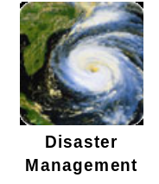
PECAD’s intelligence mission includes targeting, collection, analysis, and dissemination. Targeting involves constant attention to agriculturally productive areas and particular attention to areas with special food security issues. The world’s agriculturally productive regions are listed in Table 1. One of 12 PECAD regional analysts covers each of these regions except for the United States, which requires two analysts. Specific areas around the world may be targeted because of various emergencies either on an ad hoc basis or because of a specific request from the USDA or another agency.
Table 1. Breakdown of FAS/PECAD world agricultural region.
FAS Regions
- Argentina, Uruguay, Paraguay, Chile
- Brazil
- Mexico, Central America, Caribbean
- Canada, Western Europe
- Central Europe, North Africa
- Turkey, Middle East, Southwest Asia
- Russia, Ukraine, Other Former Soviet Union
- China, Koreas, Japan, South East Asia
- Australia, Bangladesh, India, Pakistan
- Central and Southern Africa
- United States
PECAD’s intelligence collection is multifaceted, using several Earth observing sensors either through direct analysis or as input into PECAD models (Table 2). According to the Aeronautics and Space Report of the President, “PECAD is the world’s most extensive and longest running (20 years) operational user of commercial satellite data, using numerous satellite platforms to evaluate agronomic situations worldwide” (NASA, 2001). World Meteorological Organization (WMO) weather station data are utilized as inputs. Attachés in all of the FAS regions report direct observations and regional perspectives. The PECAD regional analysts travel periodically in their areas of interest to gain direct information on crop conditions. PECAD also collects information from other sources, including government reports, trade publications, and news organizations. PECAD maintains historical databases of production, vegetation indices, and meteorological information for comparison with current information.

Table 2. Current PECAD sensor use.
 | Satellite | Sensor | System Operator | Product | Use in PECAD
Direct Inputs
Moderate Resolution | NOAA 14  NOAA 16 | AVHRR | NOAA | VINs: NDVI & simple difference (NIR-RED)* | Indicator of crop condition
Moderate Resolution | SPOT 4  SPOT 5 | SPOT-VEG | VEGETATION Programme | VINs: NDVI & simple difference (NIR-RED)* | Indicator of crop condition
 |  |  |  | 3rd party land cover products from AVHRR and SPOT-VEG | Crop land estimates
Finer Resolution | Landsat 7 | ETM+ | USGS | Multispectral images | PECAD analysts use these finer resolution images for crop classification and for vegetation stress and “area planted” estimates
Finer Resolution | SPOT 4  SPOT 5 | SPOT | CNES | Multispectral images
Finer Resolution | IKONOS | IKONOS | Space Imaging | Multispectral images
Finer Resolution | QuickBird | QuickBird | DigitalGlobe | Multispectral images
Indirect Inputs
Coarse Res. | DMSP | SSM/I | DOD | Inputs into AGRMET precipitation estimates | AGRMET precipitation estimate is PECAD’s primary global precipitation resource
Coarse Res. | GOES | GOES Imager | NOAA | Inputs into AGRMET precipitation estimates
Coarse Res. | Meteosat | Meteosat Visible and Infrared Imager (MVIRI) | Eumetsat | Inputs into AGRMET precipitation estimates
* The simple difference VIN is called the “EVI” by PECAD analysts. This EVI should not be confused with the MODIS Enhanced Vegetation Index (EVI). The simple difference version is the Environmental satellite Vegetative Index as defined by Boatwright and Whitehead (1986).
PECAD’s intelligence analyses flow from their “convergence of evidence” methodology (Figure 2). This methodology is based on an analysis of various independent source data to achieve a level of agreement on the prevailing conditions that affect final estimates, a process intended to minimize estimate error. The methodology is flexible. While individual analysts reach their conclusions in different ways, giving different weight to various inputs, analysts join experts from the USDA’s Economic Research Service and National Agricultural Statistics Service once a month in a “lock-up.” In this setting, the convergence of evidence approach is fully realized as analysts join together in committees formed by commodity. Final commodity production estimates are achieved by committee consensus.
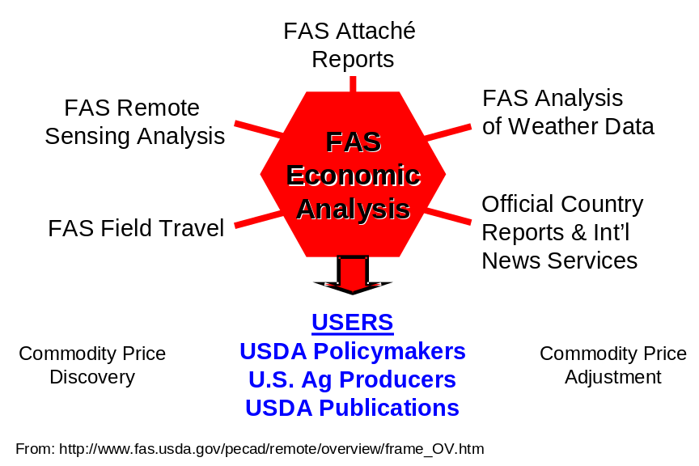
Figure 2. Convergence of evidence methodology.
FAS’s primary intelligence dissemination is through the monthly World Agricultural Production (WAP) estimates. The WAP estimates must be approved by a 26-person World Agricultural Outlook Board. The users of the WAP estimates include USDA policy makers, commodity traders, the agricultural industry, and those involved with global food security. In addition to the WAP estimates, PECAD provides online maps of vegetation indices derived from Advanced Very High Resolution Radiometer (AVHRR) data, relevant weather data, and soil moisture estimates through a Web site called Crop Explorer. Also, PECAD releases weekly crop production/crop security highlights in a Global Crop Watch Summary, and releases special reports and alerts as needed or requested.

Initial Partnering Activities
The collaboration between NASA and the USDA on the PECAD decision support system (DSS) enhancements is part of a larger partnership focused on the utilization of ESE capabilities in several areas of concern within the USDA. In 2002, a NASA/USDA Interagency Working Group (IWG) was established to develop the framework for the renewed collaboration between the two federal agencies. The IWG conducted a workshop in March 2003 to further develop the technical scope of the collaboration, and a May 2003 Memorandum of Understanding formally established the partnership. The USDA included FAS representatives on the IWG, and PECAD requirements were bought forward at the March workshop as a high priority within the Agriculture Efficiency focus area.
As the collaboration with PECAD began to mature within the ESE Applications Division, the Program Planning and Analysis component of the Division commissioned a team from the University of Arizona and the University of Missouri to baseline the PECAD DSS. This group established a rapport with PECAD, conducted interviews, reviewed processes, and issued a “zeroth order assessment” of PECAD’s DSS (Hutchinson et al., 2003).
In parallel with this effort, NASA’s Earth Science Applications Directorate at Stennis Space Center (SSC/ESA) initiated a “first-look evaluation” of PECAD’s DSS. SSC/ESA assigned the task to an integrated product team (IPT) focused on Agricultural Efficiency. The IPT developed a baseline one-page summary giving a short description of PECAD’s DSS, its function in the USDA, its relationship with the Agricultural Efficiency national application, and a cursory look at potential use of NASA data. Starting with information from the one-page summary, the IPT assessed the relevance of PECAD’s DSS to Agricultural Efficiency, the synergy with other DSSs and national applications, the primary users of the DSS, and possible NASA contributions to the DSS. The IPT then defined the next steps (e.g., a Federal agency visit) in possible NASA partnership with the DSS owner. The first-look evaluation gave careful consideration to the potential usefulness of NASA ESE data.
The USDA/FAS initially sought NASA’s assistance with PECAD because of the potential for NASA ESE results to add value to the information utilized to generate the agricultural intelligence. Several members of the PECAD team collaborated on proposals submitted in response to NASA ESE solicitations that sought to develop and integrate specific ESE mission products into the PECAD DSS. Two of these projects were selected by NASA ESE for funding. A proposal led by the University of Maryland was selected to build on the successful Rapid Response Moderate Resolution Imaging Spectroradiometer (MODIS) products developed for fire safety applications by developing similar products for PECAD (Justice et al., 2002). A proposal led by Goddard Space Flight Center (GSFC), submitted in response to the September 2002 Research, Education and Applications Solutions Network Cooperative Agreement Notice (REASoN CAN), put forward Tropical Rainfall Measuring Mission (TRMM) products to upgrade PECAD precipitation inputs (Kempler et al., 2002).
As the SSC Agricultural Efficiency IPT went through the discovery process with PECAD’s DSS, a third project came to light. This third project was a direct outgrowth of established NASA support of PECAD through the Global Inventory Monitoring and Modeling Studies (GIMMS) group from NASA/GSFC. The purpose of this project was to deliver a global set of lake and reservoir heights to PECAD based on Jason-1 and TOPEX/Poseidon satellite altimeters. Tools and data developed throughout 2002 and 2003 were incorporated into the “Global Reservoir Monitor” that became available through the PECAD Web site in December 2003. This third project has been funded by the USDA/FAS.

Systems Engineering Approach
This evaluation is based on the systems engineering approach outlined in Figure 3, which entails evaluation, verification and validation (V&V), and benchmarking of the DSS. In terms of this approach, the purpose of this report is to summarize what has been accomplished in the evaluation of PECAD’s DSS and to set in motion planning for the V&V phase.
This process has not been strictly linear. The steps of the system’s engineering approach need not be strictly linear and sequential (refer to Figure 3). After PECAD’s DSS was selected, NASA began to investigate PECAD’s requirements with the University of Arizona/University of Missouri team and with the SSC/ESA Agricultural Efficiency IPT. During the same period, in processes autonomous from this DSS enhancement effort, NASA awarded funding to the two projects whose proposals were mentioned above. These projects had their own perspective on PECAD requirements; they investigated a certain subset of NASA inputs, and they have begun to design and implement some potential DSS enhancements.
Figure 3. Systems engineering approach (adapted from Bahill and Gissing, 1998).
Systems Engineering Approach
A systems engineering approach leads to scalable, systemic, and
sustainable solutions and processes that contribute to the succe
ss of
Adapted from Bahill & Gissing (1998)
DSS
&
Enhanced
DSS
Refine
Refine
Refine
Refine
Evaluation
V&V
Benchmarking
&
Refine
Systems Engineering Approach
A systems engineering approach leads to scalable, systemic, and sustainable solutions and processes that contribute to the success of the mission, goals, and objectives of each National Application.
Adapted from Bahill & Gissing (1998)
Refine
Refine
Refine
Refine
Evaluation
V&V
Benchmarking
Refine
Define Requirements & Specifications
DSS
Selection
Enhanced
DSS
Investigate Alternative NASA Inputs
Design
&
Implement
Verify
&
Validate
Benchmark
(Baseline
&
Assess
Performance)
In generating this report, the SSC/ESA Agricultural Efficiency IPT seeks to capture all that has been learned in the various evaluation activities and to ensure that the overall NASA evaluation is comprehensive. In accomplishing these goals, this report draws heavily on the University of Arizona/University of Missouri assessment (Hutchinson et al., 2003), the University of Maryland-led Rapid Response MODIS proposal (Justice et al., 2002), the GSFC-led TRMM-based proposal (Kempler et al., 2002), a paper describing many elements of PECAD’s DSS written by one of PECAD’s own analysts (Reynolds, 2001), and the SSC/ESA internal first-look evaluation (Morris et al., 2003).

Description of PECAD’s DSS
Taken as a whole, PECAD’s production estimate processes constitute a decision support system (DSS) (Figure 4). The decision makers supported by this DSS are the 12 regional PECAD analysts. The DSS contains both automated and non-automated components. The main automated component is the Crop Condition Data Retrieval and Evaluation (CADRE) geospatial database management system (DBMS). CADRE integrates weather information, moderate resolution remote sensing, and crop and soil models. Other automated components include the following:
- Crop Explorer – delivers some of the information from CADRE to the Internet
- Archive Explorer – makes PECAD’s extensive archive of higher resolution remote sensing data available to PECAD and other USDA users
- Commercial-off-the-shelf (COTS) software – includes PCIWorks Geomatica for image processing and analysis and ArcGIS for geographic information system (GIS) functions, which provides the key function of integrating information from various scales and data types
- World Agricultural Production Archive – maintains a record of past production estimates
In addition to the automated DSS components, the PECAD regional analysts receive critical decision support through the assessments of the foreign attachés and PECAD economic analysts. Considered as a whole, PECAD’s DSS provides PECAD decision makers (the regional analysts) with a variety of parameters related to global crop production. By allowing access, comparison, and integration of these independent sources efficiently, the DSS enables the analysts to apply the convergence of evidence methodology both individually and then corporately during the monthly lock-up.
Through the lock-up, PECAD’s DSS plays an indirect but significant role in the generation of another decision support tool: the WAP global agricultural production estimate. This monthly assessment is a decision support tool for the users external to PECAD mentioned above. It is the result of the qualitative synthesis involved in the convergence of evidence methodology. As such it represents the integration of all the information available to PECAD.
To understand better the potential enhancements that NASA contributions might provide, a few elements of PECAD’s DSS must be examined more closely.
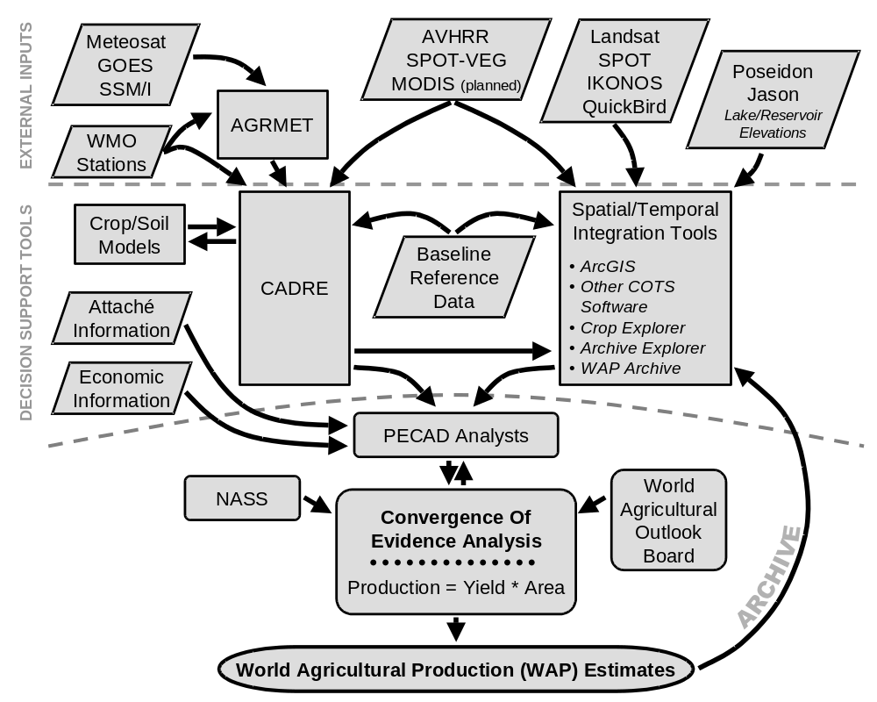
Figure 4. PECAD global agricultural production estimation processes.

CADRE
CADRE provides much of the decision support functionality of PECAD’s DSS and also serves as a connection point for most of the other DSS elements. CADRE is the linchpin of decision support to the PECAD regional analysts, including such inputs as moderate resolution remote sensing, agrometeorological information, and baseline reference data. CADRE serves as an interface to a group of crop and soil models, providing model inputs and archiving the results, and outputs its data via GIS software, time series plots, and Web interface displays.
All data is stored in CADRE in two polar stereographic grids known as “1/8 mesh grids.” This grid system is standard for data delivered by the Air Force Weather Agency’s (AFWA’s) Agricultural Meteorology Model (AGRMET) (Reynolds, 2001). The grid spacing is 25 nautical miles at 60º North and 60º South, which is about 47 km (AFWA, 2002). This grid spacing expands to 51 km at the poles and narrows to 25 km at the equator. Both the Northern and Southern Hemispheric grids are shown in Figure 5. The lines in the figure represent every 64th grid cell.

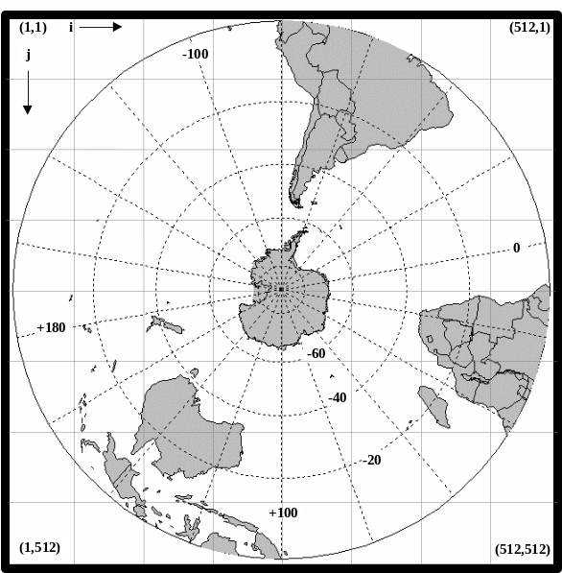
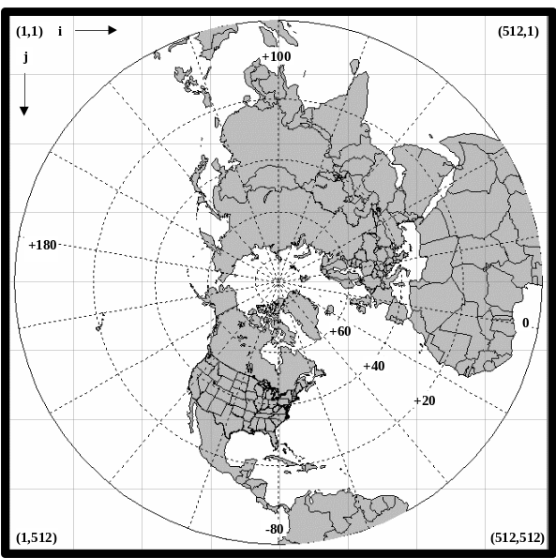
Figure 5. CADRE data storage 1/8 mesh grids (AFWA, 2002).
AGRMET and the WMO’s network of weather stations provide CADRE’s agrometeorological inputs. The WMO weather stations provide PECAD’s analysts with reference points of direct measurement and AGRMET provides global datasets in the 1/8 mesh grids. The parameters supplied by AGRMET include precipitation, temperature (minimum and maximum), snow depth, solar and longwave radiation, and potential and actual evapotranspiration (ET). Based on the temperature inputs, CADRE computes its own ET using the Penman-Monteith equation (Allen et al., 1998).
The AGRMET precipitation estimates are based on the best source given the following order of precedence (AFWA, 2002):
- Past/present weather estimate—based on past/present weather codes in surface observations and limited to those grid points closest to observation stations.
- Special Sensor Microwave Imager (SSM/I) estimate—based on data received from satellite SSM/I sensors of the Defense Meteorological Satellite Program (DMSP). (This estimate is confined to the tropics.)
- Cloud-Detection And Forecast System II (CDFSII) estimate—based on CDFSII cloud cover, climatological cloud cover, and climatological precipitation tables.
- GEO-PRECIP estimate—based on output from AFWA’s GEO-PRECIP model (limited geographically between 50º N to 50º S. GEO-PRECIP estimates rainfall from geostationary satellite brightness temperature data.
- Climatology estimate—based solely on climatology tables; a last resort if no other estimates are available (the data has complete worldwide coverage over all landmasses).
Current remote sensing inputs into CADRE include AVHRR and SPOT-VEGETATION Normalized Difference Vegetation Index (NDVI) products. PECAD receives operational support for these moderate resolution remote sensing systems from the GIMMS group at NASA/GSFC, which maintains a global archive of NDVI data that runs from 1981 to the present. The NASA/GSFC NDVI dataset is derived from National Oceanic and Atmospheric Administration (NOAA) AVHRR data. NASA/GSFC supplies the data to PECAD and ensures the consistency of the data over time. The data is stored in CADRE in the 1/8-mesh grid cell format and is preserved at original resolution in a separate archive. NASA/GSFC performs a similar service with SPOT-VEGETATION. PECAD has initiated discussion and planning for delivery of similar products from the MODIS sensor.
Baseline data includes the global ETOPO-5 digital elevation model (DEM), FAO (1996) Digital Soil Map of the World (DSMW) information, and historical crop and meteorological information. The ETOPO-5 DEM was originally gridded at 5 arc-minute resolution. A soil water-holding capacity data layer was extracted from the DSMW soils information. Historical crop information is from FAS records. Historical weather information includes monthly weather station normals obtained from WMO and NOAA and gridded information obtained from global climate maps prepared by Leemans and Cramer (1991) of the International Institute for Applied Systems Analysis (IIASA). Regardless of original resolution, all gridded data is aggregated to the 1/8 mesh grid for CADRE.
The models with which CADRE interfaces include various crop calendar models, crop stress models, and a two-layer soil moisture algorithm. In general, these models were developed in the Agriculture and Resources Inventory Surveys Through Aerospace Remote Sensing (AgRISTARS) program. The crop calendar models estimate crop growth stages and are based on growing degree days, so their only ongoing input is temperature. The crop stress models are meant to red flag crop regions under stress. The crop stress models depend on inputs from the crop calendar models and also from a two-layer soil moisture algorithm. The soil moisture algorithm tracks soil moisture balance by adding gains based on precipitation and by subtracting losses based on estimated ET.
Other models developed outside of the AgRISTARS program are also available for use with CADRE data. These models are primarily crop models that estimate relative yield reduction based on water balance. The use of these models is not a requirement of PECAD’s production estimation protocol, but they can be used at the discretion of individual analysts to provide additional information. Reynolds (2001) called attention to the Crop Estimation through Resource and Environment Synthesis (CERES) wheat model and to the Sinclair soybean model, stating that they were yield reduction models in which PECAD analysts had placed enough confidence for use within the monthly lock-up.
CADRE’s outputs include an automated push of information to the Crop Explorer every 10 days and interactive extraction routines for internal use. Information can be extracted by raster grid cell or by station location using ArcView 3.2 scripts, or information can be extracted to time series graphs using an internally programmed CADRE EX-PLOT function.

Crop Explorer
Crop Explorer (Figure 6) is a Web interface for a selection of PECAD archived information that is intended to make viewing of the CADRE database easier. The interface provides only visualization functions; data cannot be downloaded. CADRE’s full content is accessible behind a firewall, but content is also publicly accessible with potential limitations. Regions or attributes of the public content can be blocked if necessary.

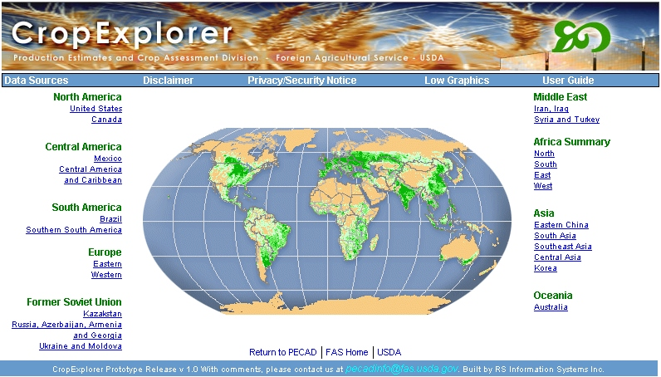
Figure 6. PECAD’s Crop Explorer, located at http://151.121.3.218/rssiws.
The current version of Crop Explorer is a prototype that has been in existence for only 1-2 years (Hutchinson et al., 2003). It gives the general public access to a significant amount of background information used in PECAD decision-making, extending the pool of decision makers supported by PECAD’s DSS.
In the current version, Crop Explorer content is grouped into predefined regions. When a user chooses a region, three information theme categories become available: Weather, Soil Moisture and Crop Models, and Vegetation Index. The “Weather” category currently contains various precipitation and temperature themes. The “Soil Moisture and Crop Models” category is currently limited only to soil moisture themes. The “Vegetation Index” category currently includes AVHRR NDVI themes. With the exception of the AVHRR NDVI, Crop Explorer inputs come from CADRE. AVHRR NDVI comes from NASA/GSFC and is resampled to 8 km instead of to the 1/8 mesh grid. The original AVHRR datasets for these themes are the 4 km resolution Global Area Coverage (GAC) AVHRR data as opposed to the 1.1 km Local Area Coverage (LAC) data.
Within each region, users are directed by default to the most recent data, but archived data can be accessed going back to year 2000 growing seasons. If desired, the current growing season’s data can be animated to examine temporal trends. At the sub-region level, users can access time series plots (Figure 7).
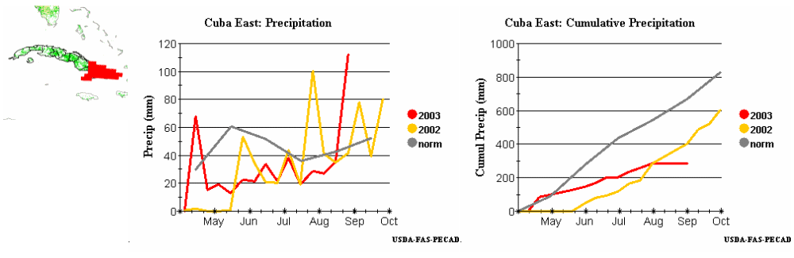
Figure 7. Crop Explorer time series plots.

Archive Explorer
Through its Archive Explorer, PECAD provides access to the centralized archive of moderate to high resolution remotely sensed data that it maintains for the USDA. At present this archive includes Landsat, SPOT, IKONOS, and QuickBird imagery. PECAD gives the USDA a single point of contact with image providers, avoiding waste from possible redundant purchases and streamlining procurement procedures. Archive Explorer allows users to search an image database, providing thumbnails of holdings (Figure 8). Archive Explorer is available only to USDA users. Access is controlled by user name and password.
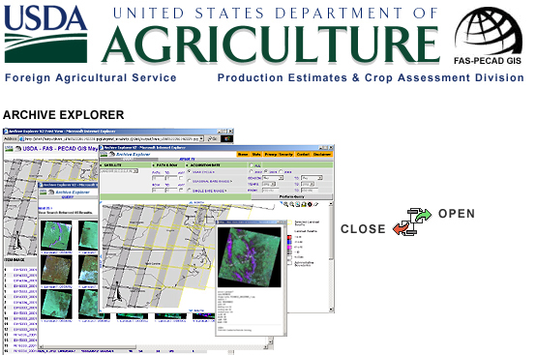
Figure 8. PECAD’s Archive Explorer.

Other Elements of PECAD’s DSS
In addition to the elements described in the previous sections, the PECAD DSS also contains several other elements of note.
Monthly WAP estimates dating from October 1996 are archived as documents or tables at http://www.fas.usda.gov/wap_arc.html. The Global Ports Mapper, an ArcIMS application, is being developed in concert with NIMA as a global ports database for internal use (Figure 9).
PECAD analysts complement customized DSS elements with certain COTS software. The primary geospatial integration software is ESRI’s ArcGIS. The primary image processing software is Geomatica by PCI Geomatics. While these software packages are unstructured DSS components, they provide an essential space for convergence of evidence. None of the more structured components can bring together the full range of data types that exist in PECAD’s database.
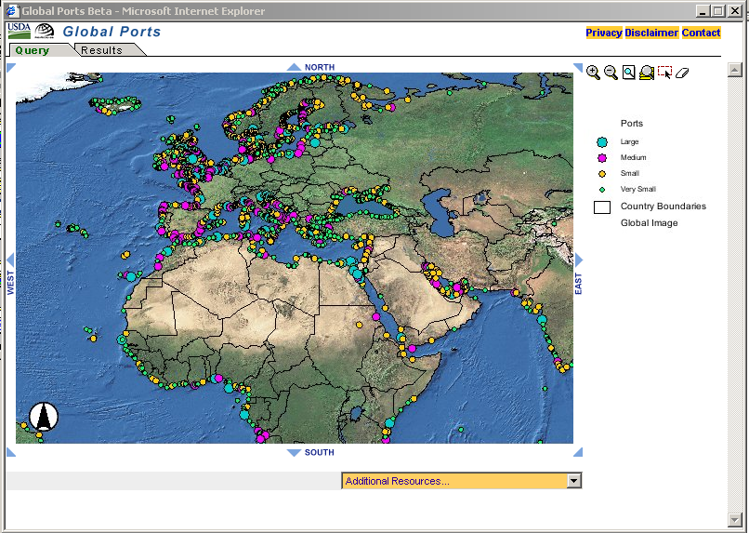
Figure 9. PECAD’s Global Ports Mapper.

PECAD’s DSS Organization and Classification
Hutchinson et al. (2003) describe the subsystems of PECAD’s DSS as shown in Figure 10. It is important to note that the geospatial DBMS that they describe is not simply CADRE DBMS, but the management of all PECAD data. Comparison to Figure 4 reveals that CADRE does not manage data from higher resolution sensors and it does not manage the data that is not amenable to grid representation, namely the attaché reports and economic information. These data sources are kept in separate databases.
While CADRE does not manage all PECAD data, Hutchinson et al. (2003) describe CADRE as PECAD’s “main decision support tool.” At the time of their assessment, they reported that CADRE contained 69 million records. For the data that it contains, CADRE also provides knowledge base management functionality (by data mining and expert systems). By supplying crop and soil models with vegetation index number (VIN) inputs, CADRE provides model base management functionality. Some user interface functions have been directly integrated into CADRE, but some require outputs from CADRE to be made available for use in COTS software external to CADRE (e.g., ArcGIS). Only in this COTS environment can PECAD analysts fully integrate their geospatial inputs.
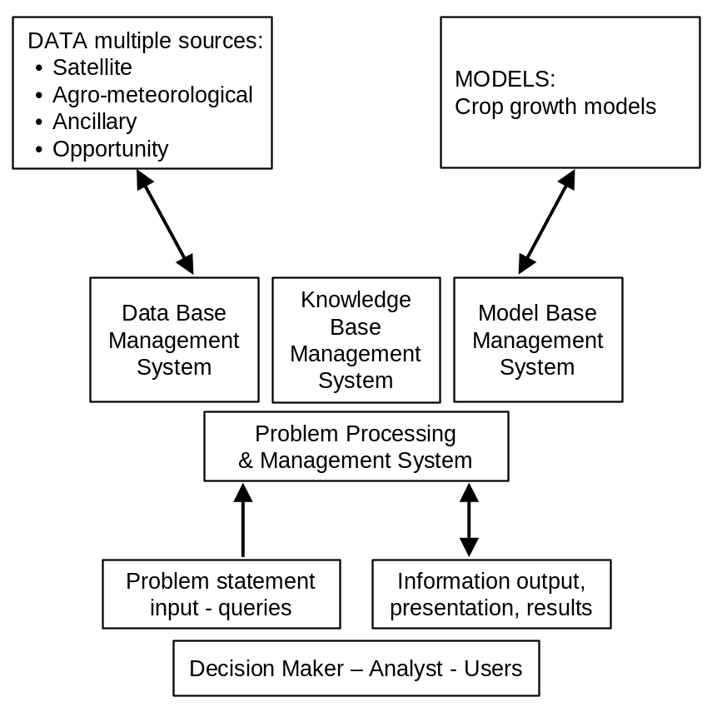
Figure 10. PECAD DSS subsystems (Hutchinson et al., 2003).

In their zeroth order assessment, Hutchinson et al. (2003) decided that “FAS-PECAD is a data based DSS with limited model based components.” Since crop models are used “sparingly,” and the DSS is not pushing actual crop production estimate alternatives directly into the final convergence of evidence, they found that PECAD’s DSS should be classified somewhere between semi-structured and unstructured.

Consideration of NASA Inputs

PECAD’s DSS Requirements
The start of the systems engineering approach as shown in Figure 3 is to define requirements and specifications. The requirements for PECAD’s DSS are not well defined. Some ideas extracted or inferred from available documentation that relate to requirements are summarized in Table 3. It is not clear that these notions represent PECAD consensus, and this list may not be exhaustive.

Table 3. Inferred Requirements for PECAD’s DSS (based on sources listed in parentheses)
PECAD On-Going Upgrades (Reynolds, 2001)
Upgrading all crop models for global coverage because many of the original crop models were only designed for a few specific countries
Geospatial information system with global coverage that will display agrometeorological and crop monitoring information on a nearly real-time basis
PECAD Requirements (Kempler et al., 2002)
Consistency with 10-day product time boundaries of existing FAS products
A year or more of previous data for comparison
Timeliness of data delivery (latency of 72 hours or less)
One year storage of product
PECAD Goals (Hutchinson et al., 2003)
DBMS to store AVHRR GAC (8 km), SPOT-VEGETATION (1 km) and MODIS (250 m) time-series data at original resolution
Require portable output models to data drill through time-series datasets at original resolutions (8 km, 1 km, and 250 m)
Automated and interactive data extraction (automation helps capture and preserve the science and knowledge base)
Use MODIS Land Product images over major agricultural regions and use rapid response, EVI and NDVI and RGB images derived from false-color and shortwave composites (from surface reflectance products)
Provide time-series graphs over major agricultural regions based on MODIS data
Data drilling and data mining of MODIS images at original resolution
New crop models
MODIS Primary Production product, without the use of ancillary weather data
Cloud-screened information products
To proceed with a systems engineering analysis then, it is necessary to make some reasoned assumptions regarding PECAD requirements. The results of this line of reasoning are summarized in Table 4. The rationale follows.

Table 4. Working assumptions regarding PECAD’s DSS requirements.
DSS Property |  | Requirement | Drivers
Data Frequency (time step) | Monthly reporting | 1 day, with 10-day summaries | Need to establish trends within 1-month cycle, legacy time step of CADRE
Data Frequency (time step) | Food security | 1 day | Time requirements of emergency response planners
Latency | Monthly reporting | 24 hours or less | Relevance of DSS inputs
Latency | Food security | 6 hours or less | Time requirements of emergency response planners
Spatial Resolution | Monthly reporting | Synoptic analysis: 25 km or better | Legacy spatial resolution of CADRE
Spatial Resolution | Monthly reporting | Field-level analysis: 50 m or better | Smallest interesting field dimension
Spatial Resolution | Monthly reporting | Port monitoring: 1 m or better | Width of railroad cars/containers
Spatial Resolution | Food security | 25 km or better | Legacy spatial resolution of CADRE
General Properties | Cost | Moderate resolution product should be free | Budget constraints
General Properties | Format | Simple (not HDF) | Capabilities of current and next generation of CADRE
General Properties | Accessibility | Web accessible | Continue greater public benefit leveraging being demonstrated in Crop Explorer
General Properties | Data validation | Validated and science team in place | Quality assurance
General Properties | Data redundancy | Multiple sources | Data continuity, convergence of evidence
Parameters | Precipitation | Unknown at this time | Needed for crop yield, crop stress, and soil moisture models; cumulative precipitation of stand-alone interest
Parameters | Min and max temperature | Unknown at this time | Needed for crop yield, crop calendar, crop stress, and soil moisture models
Parameters | Snow depth | Unknown at this time | Needed for soil moisture model
Parameters | Solar and longwave radiation | Unknown at this time | Needed for crop yield models
Parameters | Photosynthetically active radiation | Unknown at this time | Needed for crop yield models
Parameters | Potential and actual evapotranspiration | Unknown at this time | Needed for crop yield, crop calendar, crop stress and soil moisture models
Parameters | Vegetation index numbers | Unknown at this time | Needed for relative crop condition assessments
Parameters | Bare earth elevation | Unknown at this time | Needed for soil moisture model
Parameters | Soil moisture | Unknown at this time | Needed for crop yield models; soil moisture of stand-alone interest in regard to crop ability to reach potential yield
Parameters | Leaf area index | Unknown at this time | Needed as input or reference for crop yield models
Parameters | Biomass | Unknown at this time | Needed as input or reference for crop yield models
PECAD’s customers include agricultural policy makers, commodity market stakeholders, planners in arenas involving food security, and crop producers. Some of the users need data on a regular basis to anchor commodity price determination. By convention, the time step for these regular production estimates has been set at one month. When food security is involved, crop production impact estimates may be needed within one or two days of an emergency to assist decision makers in shaping responses. These two sets of PECAD users frame the temporal requirements of PECAD’s DSS: data frequency or revisit time, and data latency or delivery time.
The food security scenarios require data within a day, so data revisit time must be on the same order and delivery time must be minimal: a few hours at most. In short, PECAD’s food security intelligence mission requires near-real time data.
PECAD’s regular monthly estimates present different temporal demands. An “as is” representation of current and proposed input times is shown in Table 5. Remote sensing contributions for a given month should provide global coverage and should provide insight into trends. At least 3 summary global sets of remotely sensed data are desired for each month, so PECAD has built CADRE with a preferred time step of 10 days. At this time step, data latency should be no more than 24 hours. Since any given instant has a significant amount of global cloud cover, completeness of any one dataset requires multiple acquisitions. Assuming that three acquisitions would reduce the impact of clouds to a reasonable level, PECAD requires remote sensing systems that achieve global coverage in three days or less.
PECAD’s customers do not directly drive spatial resolution requirements for PECAD’s DSS data inputs. PECAD’s customers drive spatial resolution requirements indirectly by their desire for accuracy in the production estimates. The accuracy of any one analyst’s production estimates may be impacted by the quality of the remote sensing information that the analyst takes into account. If the analysts depend on synoptic views of cropping regions, then the range of moderate resolution systems (1 km to 250 m) that are able to satisfy the temporal requirements above are satisfactory. In fact, to date PECAD’s CADRE DBMS has aggregated its inputs to 25 km grid cells, which seems to have been satisfactory for the synoptic requirements. But synoptic views are not always enough. Analysts regularly “drill down” to higher resolutions to find more information at the field level, because only at field level can pixels of a specific crop’s canopy be resolved with assurance. Given that narrow dimensions of fields in some cropping regions can be as small as a few tens of meters, moderately high resolution systems are required. The maximum ground sample distance (GSD) for PECAD’s crop canopy viewing requirements is on the order of 50 meters. The optimum GSD for viewing crop canopies is probably somewhat less. In addition to viewing crops synoptically or in the field, PECAD analysts monitor important ports to assess export activity, which requires imagery with a spatial resolution of < 5 m to be able to monitor individual shipping and rail activity.
The spatial and temporal requirements of PECAD’s DSS cannot be met solely with current high resolution and moderately high resolution sensors, which cannot approach 3-day global coverage. PECAD must therefore maintain two data streams: a moderate resolution data stream to meet temporal requirements and a higher resolution data stream with as many acquisitions as are feasible.
The parameters required by PECAD’s DSS are listed by Reynolds (2001) as inputs and intermediate products of CADRE. The list includes several parameters that may be estimated from remote sensing: precipitation, minimum and maximum temperature, snow depth, solar and longwave radiation, potential and actual evapotranspiration, vegetation index numbers, bare earth elevation, and soil moisture.
Table 5. A “typical” month of current and proposed PECAD DSS inputs.
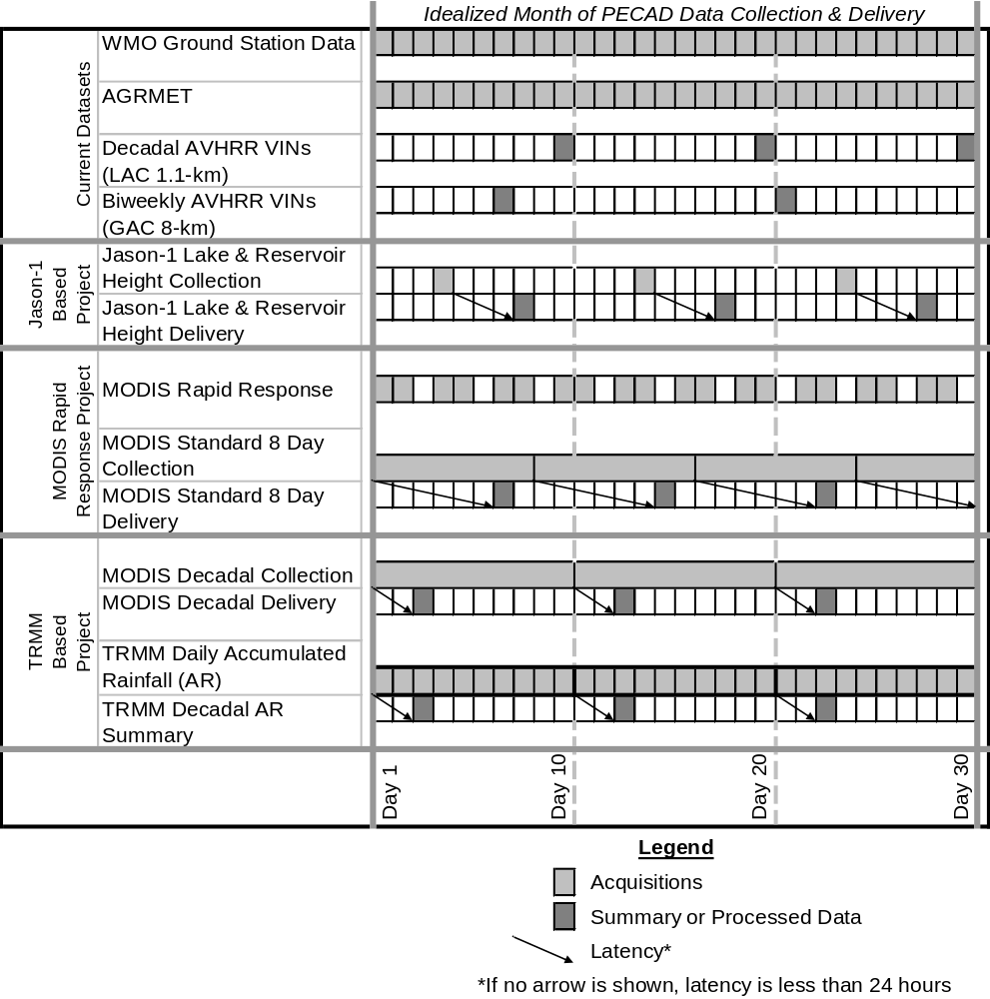
Notably, the only two parameters above that are directly tied to crop canopies are VINs and ET. Hutchinson et al. (2003) states that one of PECAD’s goals is to use new crop models. If models are to be used globally as suggested by Reynolds (2001), then they may need to be mechanistic models rather than empirical. Proper use of mechanistic crop models requires estimation of biophysical properties such as leaf area index (LAI) and biomass. Algorithms exist to measure both LAI and biomass with remote sensing. Other parameters may be needed for particular crop models.
The time step and latency for measurement of some of the parameters listed may not match the temporal requirements discussed. The spatial requirements may be relaxed if it can be shown that local variability of the parameter is insignificant with regard to crop yield estimation. The parameter-by-parameter accuracy requirements are not known. It would be ideal if PECAD could specify required parameter accuracy and discuss the reasoning underpinning accuracy requirements. However, if these requirements are evolving or incompletely understood, NASA could help PECAD define these requirements through systems engineering. Such an effort would involve careful investigation of processes driving parameter accuracy needs, study of models and algorithms dependent on the parameters, and possibly sensitivity analysis.

Matching NASA Inputs Against PECAD Requirements
Given the information requirements of PECAD’s DSS, it is important to inventory relevant NASA inputs as summarized in Table 6. Section A of Table 6 displays inputs from MODIS, which is of particular interest because it represents the evolution of the moderate resolution sensors currently used by PECAD, such as AVHRR. MODIS also is important as a transition to the next generation moderate resolution sensor: the Visible Infrared Imaging Radiometer Suite (VIIRS) that will be part of the National Polar-orbiting Operational Environmental Satellite System (NPOESS) and the NPOESS Preparatory Project (NPP) missions.
Section B of Table 6 displays other moderate resolution inputs that might be useful for CADRE in the structured portion of PECAD’s DSS. These inputs include products from sensors including TRMM, the Advanced Microwave Scanning Radiometer for EOS (AMSR-E), and the Clouds and the Earth’s Radiant Energy System (CERES). These products could provide independent data streams to complement inputs that PECAD currently receives from AGRMET, which is consistent with PECAD’s convergence of evidence approach. In the long term, PECAD might assess whether more direct measurements of agrometeorological parameters should supersede modeled and interpolated estimates, but that assessment could come after the DSS enhancement process when PECAD analysts have had significant operational experience with both types of input. In addition to agrometeorological parameters, Section B touches on baseline elevation data upgrade with the Shuttle Radar Topography Mission (SRTM) and on additional crop models that NASA is supporting through funded projects that are discussed in Section 3.3, “Planned NASA Inputs.”

Table 6. DSS requirement/NASA input match.
6A. MODIS
DSS Required Observation & Predictions | NASA Inputs | Met/Unmet Requirements
- Moderate Resolution Visible-IR Remote Sensing Information & Products | - MODIS data and products | - MET: 3-day global coverage → MODIS 1- to 2-day global coverage  - MET: 25-km spatial resolution → MODIS 250 m to 1 km  - PLANNED: Modify to 10-day time step  - PLANNED: Upgrade to 72-hour latency for regular delivery, 2- to 4-hour delivery for Rapid Response
- Surface Reflectance | - MODIS Surface Reflectance | - MET: Synoptic viewing capability  - UNCERTAIN: Accuracy requirement
- Moderate Resolution Vegetation Indices | - MODIS NDVI  - MODIS EVI | - PLANNED: Continuity to be established by back-processing to year 2000 data  - UNCERTAIN: Accuracy requirement  - NOTE: MODIS EVI is an enhanced ratio index. PECAD analysts have used an EVI that was a simple difference index (NIR – Red)
- Temperature (Min and Max) | - MODIS Land Surface Temperature | - MET: Measured land surface temperature as opposed to current interpolated temperatures  - UNCERTAIN: Accuracy requirement
- Snow Depth | - MODIS Snow Cover | - ISSUE: MODIS product is only snow cover, not depth; snow depth will be an AMSR Level 3 product. No AMSR Level 3 products will be available before March 2004
- Leaf Area Index | - MODIS LAI | - MET: This assumes that PECAD agrees that LAI should be a required parameter  - UNCERTAIN: Accuracy requirement
- Actual and Potential Evapotranspiration | - MODIS ET | - UNMET: There is no plan in writing to deliver the MODIS ET product to PECAD once it is validated. Current PECAD input is based on agrometeorological inputs alone with no direct sensing of canopies.  - UNCERTAIN: Accuracy requirement
- Solar and longwave radiation (perhaps including photosynthetically active radiation) | - Concepts in various stages of development | - UNMET: There is no plan in writing to work with PECAD to accelerate development of radiation budget products. Current PECAD input is based on interpolation of ground network measurements  - UNCERTAIN: Accuracy requirement
 | - MODIS Land Cover | - NO REQUIREMENT: This may prove useful to PECAD in crop area estimation, but there is no documented requirement for this MODIS Standard Product
 | - MODIS Vegetation Stress Index | - NO REQUIREMENT: This may prove useful, particularly in the case of drought related food emergencies, but there is no documented requirement for this 3rd party MODIS product

6B. Other moderate resolution products
DSS Required Observation & Predictions | NASA Inputs | Met/Unmet Requirements
- Moderate Resolution Precipitation Measurements | - TRMM near-real time, combined sensors rainfall | - MET: 25 km spatial resolution → TRMM ~25 km spatial resolution  - MET: 12-hour latency → TRMM 6-hour latency  - PLANNED: Sum to 10-day time step  - PLANNED: Continuity to be established by back-processing to SEP 2000 data  - NOTE: Near-global coverage → TRMM with combined sensors 3-hour near-global coverage between 50° North and 50° South  - UNCERTAIN: Accuracy requirement
 | - TRMM Surface Moisture Index | - NO REQUIREMENT: There is no documented requirement for this product, but it is consistent with the general approach in Crop Explorer of comparison to long term norms
- Lake/Reservoir Elevation Measurements | - Jason-1 altimetry (current)  - TOPEX/Poseidon altimetry (historical) | - MET: 10-day time step  - MET: 3-day latency  - MET: 10 cm vertical accuracy → Jason-1 altimetry yields 4-10 cm accuracy  - UNMET: Ground track and distribution of lakes and reservoirs that can be observed limit areas that may be monitored. Many agriculturally important regions have little or no coverage.
- New Crop Models, Global Crop Models | - USDA/ARS crop model  - WOFOST crop models | - PLANNED: Models may require additional development and will certainly require validation
- Bare Earth Elevation | - SRTM30 | - MET: Global coverage (SRTM original data only collected between 60° North and 54° South, but SRTM30 combined with other sources for complete coverage)  - UNCERTAIN: Accuracy requirement
 | - SRTM 90 m | - MET: 25 km spatial resolution → SRTM 90 m resolution for international data  - UNMET: Currently available only for North and South America. Data only collected between 60° North and 54° South, but this should cover all of PECAD’s traditional areas of interest.  - UNCERTAIN: Accuracy requirement
- Moderate Resolution Soil Moisture Measurements | - AMSR soil moisture product  - HYDROS soil moisture product | - UNMET: AMSR Level 3 soil moisture product is not yet available. It will be archived by the National Snow and Ice Data Center (NSIDC). Level 3 products are scheduled to be available in March 2004.  - UNMET: AMSR soil moisture intrinsic spatial resolution will only be 56 km although it will be gridded at 25 km  - ISSUE: AMSR soil moisture precision will be 0.06 g cm⁻³, but only where vegetation is less than 1.5 kg m⁻². This means it may only be valid for pre-season and early season conditions.  - UNCERTAIN: Accuracy requirement
- Moderate Resolution Radiation Budget Measurements (solar and longwave radiation) | - CERES Monthly Gridded Surface Flux Product | - UNMET: 25 km spatial resolution → CERES gridded product ~110 km spatial resolution (1° cells)  - UNMET: Current time step is only monthly, but 3-hourly product may be in beta version soon.  - UNCERTAIN: Accuracy requirement

Planned NASA Inputs
The relationship between PECAD and NASA is longstanding. According to Reynolds (2001), CADRE has its roots in the 1970s and 1980s in the Large Area Crop Inventory Experiment (LACIE) and AgRISTARS programs, in which the USDA partnered with NASA and NOAA. PECAD is currently incorporating inputs from several NASA Earth observing missions and sensors, including Landsat 7 Enhanced Thematic Mapper Plus (ETM+), Jason, and TOPEX/Poseidon.
As discussed earlier, PECAD receives operational support from the GIMMS group of NASA/GSFC. The NASA/GIMMS NDVI archive is a vital data stream for PECAD’s DSS. The NASA/GIMMS cross-validation work among the various AVHRR sensors has given PECAD confidence in the long-term VIN data quality and has allowed the group to focus more effort on its core mission.
NASA has funded two projects to help enhance PECAD’s DSS. One project, led by Dr. Chris Justice of the University of Maryland, plans to provide MODIS “Rapid Response” products to PECAD for its food security mission (Justice et al., 2002). A second project, led by Steven Kempler, manager of the GSFC Earth Sciences Distributed Active Archive Center (GES DAAC), proposes to develop precipitation-related products based on TRMM with secondary inputs from MODIS (Kempler et al., 2002). The TRMM precipitation products aim to refine PECAD’s water balance computations, which are critical to many crop yield indicators. After sensor-based products of each project are examined more closely, synthesized crop products from both projects will be considered as a group.

MODIS Rapid Response Products
PECAD’s planned use of MODIS is an evolution of its AVHRR and SPOT-VEGETATION use. MODIS improves these sensors’ spatial resolution with little decrease in temporal coverage (see Appendix D), and MODIS also has many more spectral bands. MODIS algorithms have already been developed for many products that relate to crop conditions.
The MODIS products that have been proposed for integration into PECAD’s DSS are shown in Table 7. These products can be classified into three groups: MODIS Standard Products, MODIS Rapid Response Products, and MODIS Decadal Products.
The MODIS Standard Products will be delivered through the GES DAAC. The University of Maryland-led team is responsible for all but one of the Standard Products. The value added by the project teams is data processing so that MODIS information is in the proper file/geographic format for PECAD’s use. Of the types of products being delivered, most types (VINs, surface reflectance, land surface temperature, and snow cover) are either already in use by PECAD or are closely akin to types already in use. The VINs and the surface reflectance products meet PECAD requirements by upgrading the data quality (radiometric, spectral, and spatial) of the information that PECAD receives. MODIS snow cover represents an independent source to compare with the AGRMET snow depth. Land surface temperature represents an independent source to compare to AGRMET temperatures. This independence has value in the convergence of evidence. LAI is worthy of consideration to compare with crop stress and crop calendar outputs currently used in PECAD’s DSS. The land cover product can be helpful as an independent source of information regarding planted area, especially with regard to regional planted area changes because of such factors as urbanization and deforestation. While LAI and land cover may not be driven directly by stated PECAD requirements, their usefulness in crop modeling is recognized, and there is little extra processing burden in adding them to the product suite for PECAD’s evaluation.
Table 7. Proposed MODIS products for PECAD.
Product Content | Latency | Time Steps | Notes | Team
Vegetation Indices (NDVI, EVI) | 7 days (nominal) | 8 day, 16 day, monthly | Project plans to deliver these MODIS Standard products | University of Maryland  NASA/GSFC  USDA/FAS
Surface Reflectance
Leaf Area Index
Land Surface Temperature
Snow Cover
Land Cover | 7 days (nominal) | Quarterly | Project plans to deliver these MODIS Standard products | University of Maryland  NASA/GSFC  USDA/FAS
Vegetation Indices (NDVI, EVI) | 2-4 hours | 1-2 days | Project plans to deliver these MODIS Rapid Response products using standard MODIS algorithms | University of Maryland  NASA/GSFC  USDA/FAS
Surface Reflectance
Snow Cover
Vegetation Moisture Stress | 2-4 hours | 1-2 days | Project plans to deliver this MODIS Rapid Response product using non-standard algorithms | University of Maryland  NASA/GSFC  USDA/FAS
Surface Reflectance | 3 days | 8 day | This Standard MODIS product will be used to establish data delivery. | NASA/GSFC  USDA/ARS  USDA/FAS  World Food Project
Surface Reflectance | 3 days | 10 day | This product will replace the Standard MODIS time step with time step used by PECAD’s DSS | NASA/GSFC  USDA/ARS  USDA/FAS  World Food Project
MODIS Rapid Response (RR) Products specifically address PECAD requirements related to Disaster Management. When PECAD is called upon to assess the agronomic impact of an emergency, the time required for a current look at the emergency area has a critical impact on the quality and speed of the agricultural intelligence that PECAD can provide. The RR Products are to be delivered in near-real- time (2-4 hours after acquisition), which will require a “bent pipe” delivery system that bypasses the normal data processing pathway. Scientists from the University of Maryland and from NASA/GSFC started just such a system for active fire data in 2000. That system now provides operational support to the U.S. Forest Service and to the National Interagency Fire Center (NASA, 2003a).
RR Products are to replicate three MODIS Standard Products: VINs, surface reflectance (only 2 bands: red and near infrared), and snow cover. In addition, Justice et al. (2002) propose to investigate a MODIS vegetation stress index based on short wave infrared and long wave infrared bands. This index is to be similar to the normalized difference temperature index (NDTI) discussed by Jupp et al. (1998). This vegetation stress index can provide an independent source regarding crop stress to compare with the crop stress models that are operational within PECAD’s DSS. PECAD’s crop stress models are based on agrometeorological data instead of on land surface remote sensing.
To meet the PECAD requirement for operational data on a decadal time step, the NASA/GSFC-led team plans to develop a 10-day version of the MODIS Standard Surface Reflectance Product. MODIS Standard Products do not include a 10-day time step; the nearest options are 8-day and 16-day time steps. Kempler et al. (2003) have proposed that the decadal data be delivered with 72 hours of completion of the 10-day acquisition window.

TRMM Tailored Products and Systems
Currently PECAD’s precipitation information comes from WMO weather stations or AFWA’s AGRMET estimates. The weather station information is limited to point estimates, which are sparse in some regions.
Essentially, in AGRMET a mix of passive microwave remote sensing and visible/infrared remote sensing estimates the large areas between stations. Algorithms estimating precipitation from visible/infrared remote sensing suffer from the weak relationship of cloud-top characteristics with the intensity or even the existence of precipitation at the surface. Passive microwave remote sensing is better because it can sense factors more directly involved in the process of making rainfall. But precipitation rate estimates derived from passive microwave remote sensing suffer if not calibrated frequently, because it is still difficult to determine if precipitation is reaching the ground.
TRMM calibrates its passive microwave sensor, the TRMM Microwave Imager (TMI) with simultaneous radar: the Precipitation Radar (PR). The radar can determine if precipitation is reaching the ground; in fact, it gives three-dimensional information about rain cloud structure. It is not feasible to achieve broad coverage with radar, but it can serve as a calibration source for the passive microwave sensor. This calibrated data can then be cross-calibrated with passive microwave sensors on other platforms to create a global precipitation measurement constellation. This constellation is the concept the Global Precipitation Measurement (GPM) mission for which TRMM is a precursor.
The cross-calibration of the TRMM’s TMI data with other microwave sensors, namely the DMSP’s SSM/I sensors, has already begun. A research group at NASA/GSFC is developing this level 3 (Table 8) TRMM product (3B42RT), the “TRMM Real-Time Multi-Satellite Precipitation Analysis” (Huffman and Bolvin, 2003). This product is being delivered online at http://daac.gsfc.nasa.gov/CAMPAIGN_DOCS/hydrology/TRMM_analysis.html

Table 8. EOS Data Product Levels
Level 0 | Level 0 data products are reconstructed, unprocessed instrument/payload data at full resolution; any and all communications artifacts (e.g., synchronization frames, communications headers, duplicate data) are removed.
Level 1A | Level 1A data products are reconstructed, unprocessed instrument data at full resolution, time-referenced, and annotated with ancillary information, including radiometric and geometric calibration coefficients and georeferencing parameters; e.g., platform ephemeric, computed, and appended but not applied to the Level 0 data.
Level 1B | Level 1B data products are Level 1A data that have been processed to sensor units (not all instruments will have a Level 1B equivalent).
Level 2 | Level 2 data products are derived geophysical variables at the same resolution and location as the Level 1 source data.
Level 3 | Level 3 data products are variables mapped on uniform space-time grid scales, usually with some completeness and consistency.
Level 4 | Level 4 data products are model output or results from analyses of lower level data; e.g., variables derived from multiple measurements.
Like the AGRMET, however, this TRMM product cannot attain global coverage with passive microwave instruments alone and must be supplemented by estimates derived from geosynchronous infrared (IR) imaging. The order of precedence for the 3B42RT inputs is as follows:
- TRMM-based measurements
- Cross-calibrated SSM/I measurements
- Geosynchronous IR-derived estimates
The contributions of the various elements are shown in Figure 11. In the future, the NASA/GSFC precipitation research team hopes to integrate additional passive microwave measurement from the Advanced Microwave Sounding Unit (AMSU) and the Advanced Microwave Scanning Radiometer (AMSR) sensors (see Appendix A).
The TRMM 3B42RT product is computed at a 0.25-degree resolution on a 3-hour time step. While the TRMM satellite operates only from about 35º N to 35º S, the cross-calibration with SSM/I allows the product to be computed between 50º N and 50º S. Shepherd and Smith (2002) state that the accuracy of the estimates obtained from geosynchronous IR satellites is greater than 20% in bias and greater than 50% in precision. The accuracy of the completed GPM passive microwave constellation is targeted at 5% in bias and 20% in precision, but characterization of the current microwave-based estimation is incomplete.

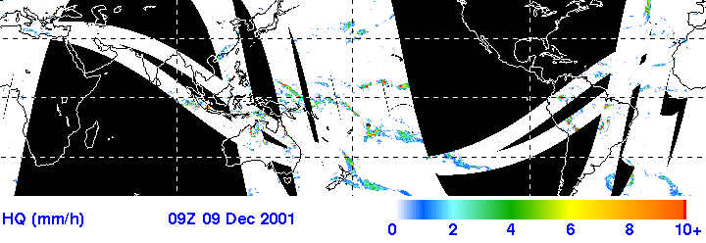
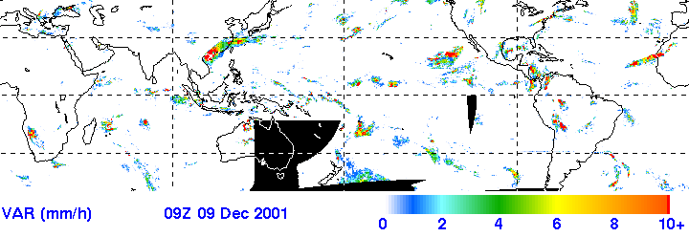
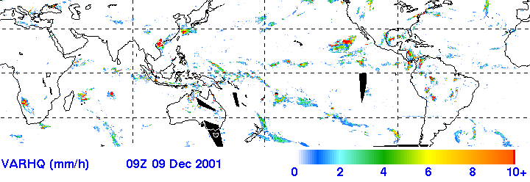
Figure 11. Microwave (HQ), IR (VAR), and combined (VARHQ) inputs to the TRMM near-real-time precipitation product.
The TRMM-based products that have been proposed for integration into PECAD’s DSS are shown in Table 9. These products can be classified into two groups: TRMM Decadal Products and TRMM Accumulation Products.
The NASA/GSFC-led project mentioned earlier is responsible for working with PECAD to integrate TRMM data into the PECAD DSS. This integration will be accomplished using a multi-tiered, online interface to be known as the Agricultural Information System (AIS). The system will be Internet accessible and will support direct integration into the GIS-based elements of PECAD’s DSS.
The relevance of precipitation to PECAD’s mission is well established. This relevance will be enhanced as the project tailors the TRMM-based products to PECAD’s requirements with 10-day time-step summaries., The project will produce historic products back to September 2000 for data comparison and will provide one-year storage of the product at the GES DAAC.

Table 9. Proposed TRMM products for PECAD.
Product Content | Latency | Time Steps | Notes | Team
Average Rainfall | 3 days | 8 days, 10 days | The 10-day version is meant for direct PECAD use. The 8-day version supports the TRMM-based project’s crop modeling. | NASA/GSFC  USDA/ARS  USDA/FAS  World Food Project
Accumulated Rainfall (AR) | 3 days | Daily | These products will be available as 0.25-degree grids and crop area polygons | NASA/GSFC  USDA/ARS  USDA/FAS  World Food Project
AR Anomaly
Standardized AR Anomaly (Surface Moisture Index)
Additionally, delivery within 72 hours of product generation (by FTP or courier) will help bridge the gap between standard nominal delivery of 7 days and the PECAD ideal requirement of 1-day latency.

Satellite Altimetry Products
Satellite altimetry of large inland water bodies has provided a new global data stream to global agricultural intelligence. The Poseidon sensors of the TOPEX/Poseidon and Jason-1 NASA ESE missions give a continuous record of large inland reservoir and lake heights that extends back to 1992. While these radar altimeters are designed for sea surface measurements, they are also applicable to inland lakes and reservoirs (Birkett, 1994; Morris and Gill, 1994).
The GIMMS group out of NASA/GSFC began operationally delivering inland reservoir and lake heights to PECAD in December 2003. About 150 lakes and reservoirs are to be included in the complete set to be monitored, but initially only 27 lakes are being tracked with the majority in Africa (Figure 12).
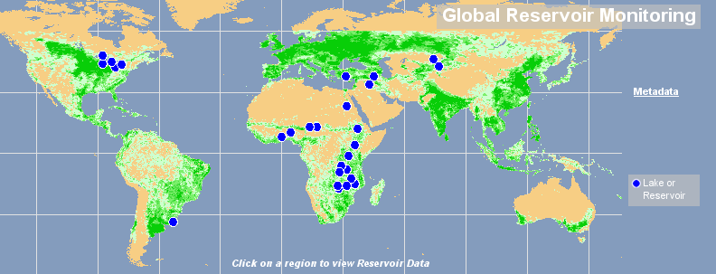
Figure 12. Lakes and reservoirs monitored in December 2003.
Water bodies for which this approach can be applied must be over 100 square kilometers in area, must not be in a deep valley, and must fall under the Jason-1 ground track. For water bodies that meet these criteria, the near-real-time relative vertical accuracy is about 15 cm. Final data used for archiving in time series requires about 1 month to process and achieves 2-3 cm relative vertical accuracy for ideal conditions and 10 cm accuracy for more complex water bodies. The Jason-1 ground track is on a 10-day repeat cycle. Time series for each lake have been made available in chart form through the Crop Explorer interface, and original data can be accessed by PECAD analysts through FTP (Birkett, 2003, personal communication).
Table 10. Proposed Jason-1–TOPEX/Poseidon products for PECAD.
Product Content | Latency | Time Steps | Notes | Team
Lake Level Variations | 4 days | 10 days | Available to PECAD as chart or ASCII data | GIMMS
The relevance of the data to PECAD’s mission will vary by context. For closed lakes and for certain open lakes, the variations in lake level are a barometer of climate change. In areas of limited water resources, the levels may give insight into availability and usage of water for irrigation. The data will also relate to flooding, flooding risk, and regional water management strategies. While some of these details may have been available previously from gauge or remote sensing data, no source could have provided this global look on a regular basis.

Synthesized Products and Predictions
Agricultural production estimation is usually the bottom line for PECAD. Crop growth models automate the estimation of production, so naturally PECAD has invested much time and resources in the use and refinement of these models. Surprisingly, Hutchinson et al. (2003) found that crop growth models are used sparingly in PECAD’s DSS. Reynolds notes that PECAD models are being upgraded “… because many of the original crop models were only designed for a few specific countries” (2001). Some crop growth models used by PECAD are shown in Table 11. In addition to crop growth models, PECAD’s DSS also employs crop stress models, crop calendar models, and a two-layer soil moisture algorithm for insight into crop condition.
Table 11. Crop growth models used by PECAD.
Crop Growth Models
Sinclair (soybean)
CERES (wheat)
AgRISTARS (wheat, corn, sorghum)
URCROP (wheat, corn, barley)
Maas
Some additional crop models and algorithms (shown in Table 12) have been proposed by the GSFC-led and University of Maryland-led projects. These models and algorithms are intended to add value in two ways: (1) to give broader applicability than the older country-specific models, and (2) to provide better linkage with remote sensing of the crops themselves, rather than depending solely on agrometeorological conditions.
Table 12. Proposed synthesized products and predictions for PECAD.
Product or Prediction Content | Latency | Time Steps | Notes | Team
USDA/ARS Crop Condition | 3 days* | 8 days, 10 days** | End goal is to deliver the model, not data layers. | NASA/GSFC  USDA/ARS  USDA/FAS  World Food Project
UDSA/ARS Crop Yield
WOFOST Crop Yield | 7 days* | 8 days, 16 days** | WOFOST products are a lower priority for the project. The project will initially focus on establishing the rapid response data flow and on delivering stand-alone MODIS products | University of Maryland  NASA/GSFC  USDA/FAS
WOFOST Crop Productivity Index
* Delivery times are based on the delivery times of input data
** Time steps are based on the time steps of underlying data. As proposed, these products and prediction would be generated on demand, rather than as regularly produced data layers.
The USDA Agricultural Research Service (ARS) Crop Condition product and Crop Yield prediction are synthesized from TRMM and MODIS products as shown in Figure 13.
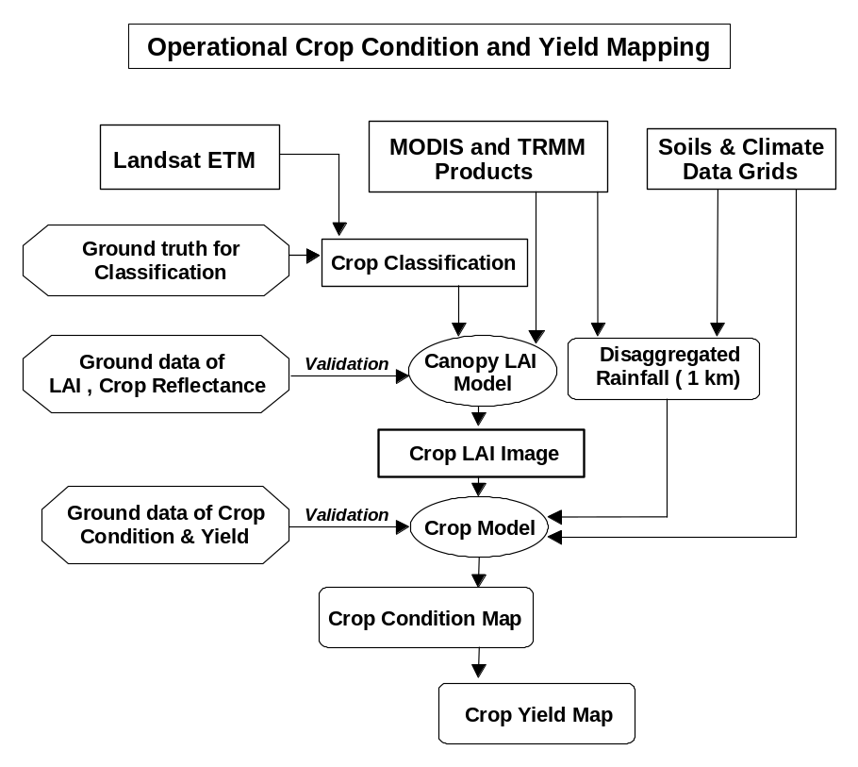
Figure 13. Schematic for the integration of MODIS and TRMM products to develop crop condition and yield maps (Kempler et al., 2002).
The heart of the USDA/ARS process is a simple mechanistic model with baseline inputs of soil and climate data (Doraiswamy et al., 2001, 2002). As the season progresses, the water balance is updated based on rainfall inputs derived from the GSFC project. To provide 1 km resolution rainfall inputs, the GSFC-led project proposes to disaggregate 25 km resolution TRMM rainfall data with 1 km MODIS thermal data. At the earliest opportunity, a crop classification map is required to determine the specific areas in which to apply the crop model. The resolution of MODIS is insufficient for this crop classification task, so the project will accomplish the classification with Landsat data. For each crop, LAI is computed from MODIS data using the crop areas determined in the classification. The resulting LAI map is compared with model-simulated LAI and used to update the model. The model can then output crop condition assessment and crop yield prediction. Rather than delivering yield information to PECAD’s DSS, the project will deliver the validated model. The model validation will be conducted for maize and winter wheat and will take place over large sites in Oklahoma and in Argentina.
The University of Maryland-led project proposed to use the WOFOST (World Food Studies) crop model (version 6.0). The WOFOST model is used operationally by the Monitoring Agriculture with Remote Sensing (MARS) project of the European Union’s Directorate General for Agriculture (DG AGRI). MARS is functionally similar to PECAD, but it is focused only on Europe.
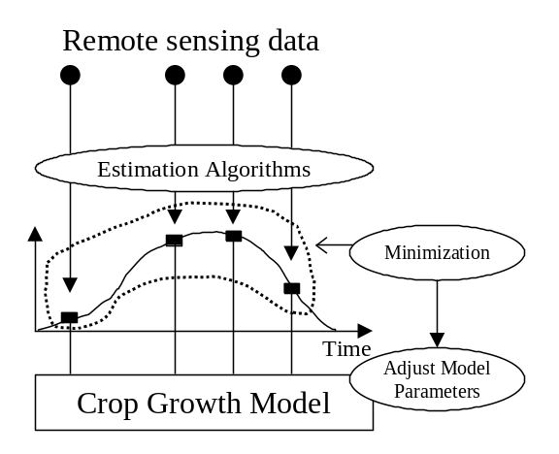
(adapted from Justice et al., 2002)
Figure 14. Data assimilation schemes using MODIS data products (e.g., LAI).

WOFOST, like the USDA/ARS model discussed above, is a mechanistic model that requires certain baseline data regarding climate and soils. The project suggested that precipitation inputs might come from satellite-derived precipitation estimates produced by the Naval Research Laboratory’s Marine Meteorology Division in Monterey, CA. This group is also working with TRMM and other passive microwave data (http://www.nrlmry.navy.mil/projects/sat_products.html). The method of integrating remote sensing with the WOFOST model (shown in Figure 14) will be similar to that discussed for the USDA/ARS model. One major difference of this technique compared with the USDA/ARS approach is that it will not perform a crop classification to estimate crop area. The WOFOST model intends to use area estimates for various crops at a regional level (or at least a country level). The first end product will be country-level crop yield estimates, not gridded yield maps. The second end product will be a crop productivity index found by comparing estimated production with average production. This yield estimation method is to be applied to wheat, maize, and soybean. Since the primary focus of the University of Maryland-led group is Rapid Response MODIS Products, this crop yield effort is a lower priority. (Note that in a teleconference with the USDA, the University of Maryland, and GSFC on 09/23/03, the USDA and the University of Maryland indicated that the WOFOST work would no longer be a part of the MD project.)

Potential NASA Inputs
The MODIS, TRMM, Lake Level Variation, and synthesized products discussed above are not the only NASA resources that might be of benefit to the PECAD DSS. More NASA assets have the potential to provide important required input data into the DSS. Several relevant NASA assets relate to water balance, radiation budget, and bare earth elevation. In all of these cases, PECAD currently has data products that feed into the DSS. At issue is whether NASA data can complement or even supersede the current data sources. Some of the data generation processes currently utilized by PECAD are dated, and some data products are estimated using modeling techniques that may be based on sparse data. Remotely sensed NASA alternatives may improve overall accuracy and also may do a better job of capturing spatial variation. Other NASA assets may help mitigate difficulties caused by the problems with the Landsat 7 ETM+, whose data play a crucial role in PECAD’s DSS.

Water Balance
For data pertaining to water balance, additional NASA input products to consider relate to soil moisture, snow depth, and evapotranspiration. Of these parameters, improvement in the estimation of soil moisture may have the greatest impact. Soil moisture information can give critical insight into crop yield potential. PECAD’s current soil moisture estimates have a prominent place within Crop Explorer, giving them high visibility even outside of the USDA. At present, though, PECAD does not have regular access to soil moisture estimates based on remote sensing of soils. The soil moisture estimates available to PECAD are computed using a two-layer soil moisture algorithm based on precipitation, evapotranspiration, and available soil water holding capacity estimates, all of which are sources of significant error. In particular, the estimation of available soil water holding capacity is uneven globally.
AMSR-E has a defined soil moisture product, but the product is valid only over bare soils and over areas with limited vegetation. Where much vegetation is present, the microwave emissions are tied to vegetation water content, so for many crops the product would be accurate only prior to planting and in early growth stages. The AMSR-E soil moisture product is scheduled for availability in spring 2004.
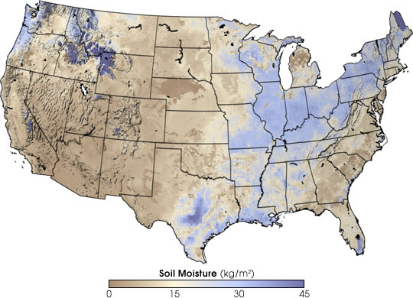
Figure 15. Output of NASA’s soil moisture models on July 1, 2003 (image by Robert Simmon, based on data provided by Kristi Arsenault, NASA GSFC Laboratory for Hydrospheric Processes).
Given its limitations, the AMSR-E soil moisture product alone will not satisfy PECAD’s requirements, but it can be of use to PECAD if integrated with precipitation and ET in a soil moisture algorithm. Researchers with NASA’s Land Data Assimilation System are working with land surface models that track soil moisture (Figure 15) and other properties, and they are studying the integration of AMSR-E data into their models (NASA, 2003b).
Data continuity is also necessary for a soil moisture product to be useful. The first planned operational sensor with the capability to measure soil moisture is the Conical Microwave Imager/Sounder (CMIS), but CMIS is not planned for launch until the 2010 NPOESS mission. The AMSR-E mission is designed to last only until 2005. The HYDROS mission, which is focused exclusively on the Earth’s hydrosphere, should bridge that gap. HYDROS has recently been funded for formulation within the Earth System Science Pathfinder Project, which means that the HYDROS team has been funded to finalize system design and operations concept. HYDROS’ combination of active and passive microwave sensors will represent a significant technological advance over AMSR-E.
PECAD’s requirement for snow depth is unmet by the planned NASA input of MODIS snow cover, but the passive microwave scanner on the Aqua mission, AMSR-E, has a defined snow cover product. While the AMSR-E sensor is operational, it is not scheduled to deliver a snow cover product before spring 2004. PECAD’s snow depth data is currently supplied by AGRMET.
AGRMET also supplies CADRE with actual and potential ET. Additionally, CADRE computes ET from the FAO-56 Penman Monteith equation. A Standard MODIS ET product has been defined and is being validated (Figure 16). This product should be validated in summer 2005 (S. Running, personal communication, 2004).
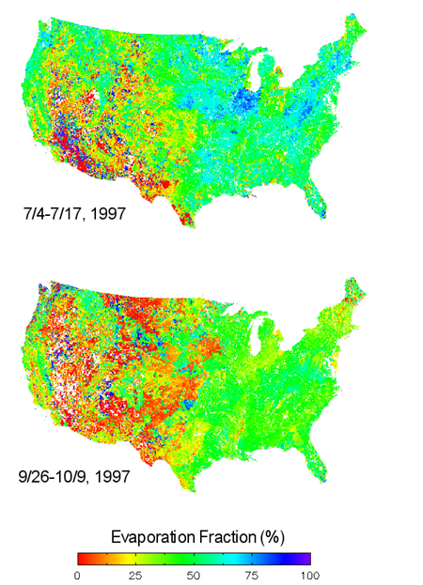
EF = ET/available energy
Figure 16. Demonstration of the MOD16 evaporation fraction (EF) product.

Radiation Budget
The NASA sensor that may be most directly applicable to PECAD’s radiation budget needs is the CERES sensor, which is focused on radiation budget measurements. CERES does not meet the PECAD spatial resolution requirement; the best spatial resolution of its products is only 1 degree (~110 km at the equator). However, CERES still may capture spatial variations in radiation flux better than the current ground network of sensors responsible for the AGRMET estimates. Another current shortcoming of CERES data is that the best time step currently available is one month. However, NASA’s Atmospheric Sciences Data Center at Langley Research Center has indicated that CER07, the Synoptic Cloud-Radiation Data Product, should be out in beta version in 2003 (Wielicki, 2003). The radiation balances provided by AGRMET and CERES apply to broad areas of the spectrum, which is sufficient for ET calculations but is not ideal for photosynthesis.
Some crop models require incoming radiation in the spectral region from 400-nm to 700-nm known as photosynthetically active radiation (PAR) that is important for photosynthesis. NASA is funding work to develop an algorithm for PAR that could be used with MODIS and other satellites. The principal investigator for this work is Dr. Shunlin Liang of the University of Maryland, who is also a co-investigator for the MODIS Rapid Response project discussed above.
Another MODIS product worthy of consideration is MOD17, Net Photosynthesis (PSN). While this parameter is not currently in use within PECAD’s DSS, the PSN product is already validated and is available through the Earth Resources Observation Systems (EROS) Data Center (EDC) DAAC. The research purpose of MOD17 is to study carbon flux, but it is possible to use MOD17 for crop yield estimation. This product might find a place within PECAD’s convergence of evidence methodology.

Bare Earth Elevation
For bare earth elevation, data from the Shuttle Radar Topography Mission represents a significant improvement over ETOPO-5, the elevation data used for baseline data within CADRE. ETOPO-5 had only a 5 arc minute resolution (~10 km). Another pre-SRTM elevation dataset was GTOPO30, which had a 30 arc second resolution (~1 km). These older data sources were assembled from disparate sources of varying accuracy. The SRTM mission, flown aboard Space Shuttle mission STS-99 in February 2000, provided an accurate synoptic view of the Earth’s elevation between 60° North and 54° South. A new global dataset based primarily on SRTM data, SRTM30, has been released (Figure 17). SRTM30 supersedes both GTOPO30 and ETOPO-5. SRTM elevation data is also being globally processed to a 90 m grid and could be an important data source for drill-down analysis. Processing at this level has been completed only for North and South America as this report is being written, but the global dataset is targeted for completion by the end of 2003.

Identified NASA Technology Gaps in Meeting PECAD Needs
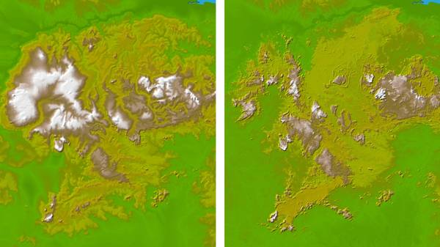Figure 17. Improved accuracy of global elevation data with SRTM. The figure shows South America’s Guiana Highlands. Left: GTOPO30; Right: SRTM30.
Although several NASA systems are applicable to PECAD’s mission, they do not meet all relevant requirements. These insufficiencies are gaps in the technological infrastructure that NASA might use to support PECAD. The existence of these technology gaps is not surprising given that NASA’s systems are typically designed for research purposes rather than for operational purposes. The general technology gaps that most impact potential NASA support of PECAD’s DSS involve the dependability and timeliness of NASA systems and whether these systems measure the parameters that are essential to PECAD’s success.
To be dependable, operational systems should minimize vulnerability to component failure through redundancy and should ensure continuous data streams through proper planning and commitment of resources. For example, NOAA’s weather monitoring systems, such as the Geostationary Operational Environmental Satellites (GOES), are operational satellites with redundant capabilities covering most areas of the United States at any one time and ensuring continuity with follow-on systems in place before older systems are retired. NASA’s research priorities and resource limitations often do not allow the benefit of redundancy or planned continuity.
Timeliness is crucial to decision makers, so operational systems are designed to deliver real-time or near-real-time data. Because of the specific needs of various research efforts, many NASA missions have traded timeliness for improved measurement accuracy or improvement in some other property of the information delivered.

Insufficient System Redundancies
PECAD analysts’ need for dependable inputs implies a requirement for redundant systems. Interruptions in the availability of key inputs negatively impact the consistency of analysts’ estimates. TRMM, a unique system co-sponsored by NASA and the Japanese Aerospace Exploration Agency, JAXA, is vulnerable to interruption of service due to its lack of redundancy. The solution may be a NASA/JAXA commitment to a “quick recovery” contingency similar to the Quick Scatterometer (QuikSCAT) effort. Alternately the remaining passive microwave sensors may be cross-calibrated with a ground radar network. This problem could also exist with MODIS, because the design life of the Terra mission ends in 2004.

Questionable System Continuity
PECAD analysts’ need to compare present crop conditions with conditions over time means that NASA or another U.S. government agency must be firmly committed to provide follow-on systems for any potential input system, and that the follow-ons should be planned with sufficient overlap with current systems.
The TRMM platform and sensors are all at or beyond the end of their design life. The follow-on launch of the GPM core spacecraft is not scheduled until 2007. The GSFC-led project proposes that TRMM precipitation estimates replace AGRMET precipitation estimates. In light of the tenuous nature of TRMM data continuity, such replacement does not seem prudent unless NASA commits to providing a back-up data stream.
System continuity has developed into an issue with Landsat 7 because of the Scan Line Corrector problem. This problem seems to be permanent, but it is not yet clear how seriously it will degrade Landsat 7 data for PECAD’s purposes.

Data Timeliness Issues
PECAD’s time-step requirement is 24 hours. PECAD’s latency requirement is 24 hours. The immediacy of the data is crucial because the PECAD mission is intelligence. PECAD’s AVHRR and AGRMET inputs have met these requirements. Ultimately, the ability of the MODIS and TRMM products (and of any other subsequent NASA input products) to meet similar temporal requirements could be the major determining factor for their utility within the PECAD DSS.
MODIS cannot achieve a true 24-hour time step because its ground track repeat time is more than a day. Perhaps MODIS products could be delivered as a running sum of 2 to 3 days, with more recent data taking precedence. This would allow global coverage data that could be presented with 1-day immediacy.
The TRMM products are being offered by the GSFC-led project with 72-hour latency. With this much delay, the products may never receive a fair evaluation against AGRMET. The 72-hour latency may need to be improved to ensure that the TRMM-based products are optimized in the PECAD DSS. TRMM precipitation products are currently being delivered within 12 hours on the main TRMM Web site: http://trmm.gsfc.nasa.gov/data/quicklook/3hrly/latest_big_3hrly.gif. While quality issues may exist when delivering data within 24 hours, perhaps a two-pronged strategy could manage these issues: initial “quick-look” data within 24 hours and archive-quality data within 72 hours or more.
The time step for summary of archival data is another important consideration. While analysts’ needs for current data drive a requirement for daily data collection, it is not necessary to store data that frequently. For historical images or for time-series data, PECAD has determined that a 10-day time step is sufficient, and PECAD has set this time step as its standard for archiving. For data viewed primarily as a time series, such as the Jason-1–TOPEX/Poseidon Lake Level Variations product, a 72-hour latency might be sufficient. Notably, the University of Maryland-led project leaves archival data in the MODIS standard 8- and 16-day versions, stopping short of re-casting Standard MODIS Products into PECAD’s DSS standard archival time step.

Conclusions

Findings
- The University of Maryland-led project focused on MODIS inputs and the NASA/GSFC-led project focused on TRMM inputs have identified two of the most important ESE data streams in terms of value added for PECAD.
- As proposed, the planned MODIS and TRMM inputs may fall short of PECAD temporal requirements.
- Several potential ESE data streams relating to the following areas have not been addressed by currently funded projects:
  - Water balance – soil moisture and ET
  - Radiation budget – solar and longwave radiation flux, perhaps PAR
  - Elevation – SRTM datasets
- Between the existing data push from the NASA/GSFC GIMMS group, the data archive being set up by the University of Maryland, and the Agricultural Information System to be set up the GES DAAC, a proliferation of distribution nodes exist between NASA and PECAD.
- Two crop models are being put forward. This redundancy is probably a positive because each has a somewhat different approach, and PECAD can make the final assessment of the value of each model. PECAD’s using both models is a potential outcome because of PECAD’s convergence of evidence methodology.
- FAS and PECAD have practical constraints on how much potential enhancement they can consider. At present, they are more interested in upgrading PECAD’s DSS inputs than in considering alternatives to model outputs (Doorn, teleconference discussion, September 11, 2003). Also, there is a limit to how many data streams PECAD’s analysts can be expected to compare and evaluate while accomplishing their operational mission.
- PECAD’s access to agricultural intelligence from moderately high resolution remote sensing data (currently Landsat 7 ETM+) has been diminished by the technical issues associated with the Landsat 7 ETM+ instrument. This problem may be exacerbated by the potential continuity gap between Landsat 7 and the Landsat Data Continuity Mission (LDCM).

Recommendations
- The GFSC-led project should evaluate the feasibility of delivering preliminary TRMM precipitation products within 24 hours.
- The University of Maryland-led project should evaluate its ability to address PECAD requirements more accurately by re-casting its delivery of Standard MODIS Products to Standard MODIS Products delivered on a 10-day time step.
- The two currently funded projects should evaluate the possibility using the GSFC/TRMM precipitation products being proposed for PECAD instead of using two different sources of precipitation data (This is not an issue if the WOFOST modeling work proposed by the University of Maryland team is no longer one of that team’s project objectives).
- Given the real possibility of a significant data interruption between TRMM and GPM, the NASA/GSFC-led project should clearly define how PECAD would continue to receive optimum and consistent precipitation inputs through such a period.
- The SRTM elevation products can be quickly and cheaply implemented. NASA should immediately facilitate their inclusion in PECAD’s DSS baseline datasets.
- Several other ESE-related inputs that could enhance PECAD’s DSS were identified. These inputs are based on MODIS, AMSR-E, and CERES products, several of which are still in development (Table 13). For each of these inputs, NASA should take the following action:
Table 13. Potential enhancing inputs still in development.
- AMSR-E Soil Moisture – perhaps in combination with land surface model
- MODIS ET (MOD16)
- MODIS PAR (third-party product over land, not to be confused with standard product over oceans)
- CERES Synoptic Cloud-Radiation Data Product (CER07)
  - Contact the principal investigators for each product, algorithm or model; learn more about each one; and seek an up-to-date assessment of availability.
  - Take these findings to PECAD and determine which of these products, algorithms, or models might be worthy of this round of DSS enhancement.
  - Work with NASA ESE researchers to accelerate development for any product, algorithm, or model that PECAD identifies as worthwhile for enhancement.
  - As the input products still in development become available, cross-validate these products against current PECAD analogs.
- NASA should work more closely with PECAD and the project teams to better understand data delivery preferences in an effort to consolidate the NASA-to-PECAD data streams.
- To reduce PECAD’s exposure to risk of loss of Landsat 7 ETM+ data, NASA should help facilitate PECAD’s introduction to ASTER data, familiarizing PECAD with ASTER data properties and with data acquisition pathways.

Next Steps: Conceptual Plans for Verification and Validation of PECAD’s DSS
Having characterized PECAD’s DSS and itemized NASA’s relevant inputs, the next part of the systems engineering process is V&V (Figure 3). V&V must take place for all potential enhancements to PECAD’s DSS. Any planned NASA input requires a detailed V&V plan. Each V&V plan should be assessed so that the overall V&V effort is complete and cohesive. NASA should put mechanisms for accountability in place for all participants in the V&V process.
Figure 18 shows the DSS V&V paradigm as a pyramid with the idea that V&V of a DSS must be “from the ground up.” Data and product characterization encompasses everything from intrinsic sensor data to information products generated by algorithm. The data quality of these fundamental information types must be understood before the models that make predictions based on these inputs can be evaluated. Only after proving the quality of all subordinate elements can the DSS components that integrate data, products, and models be verified and validated.

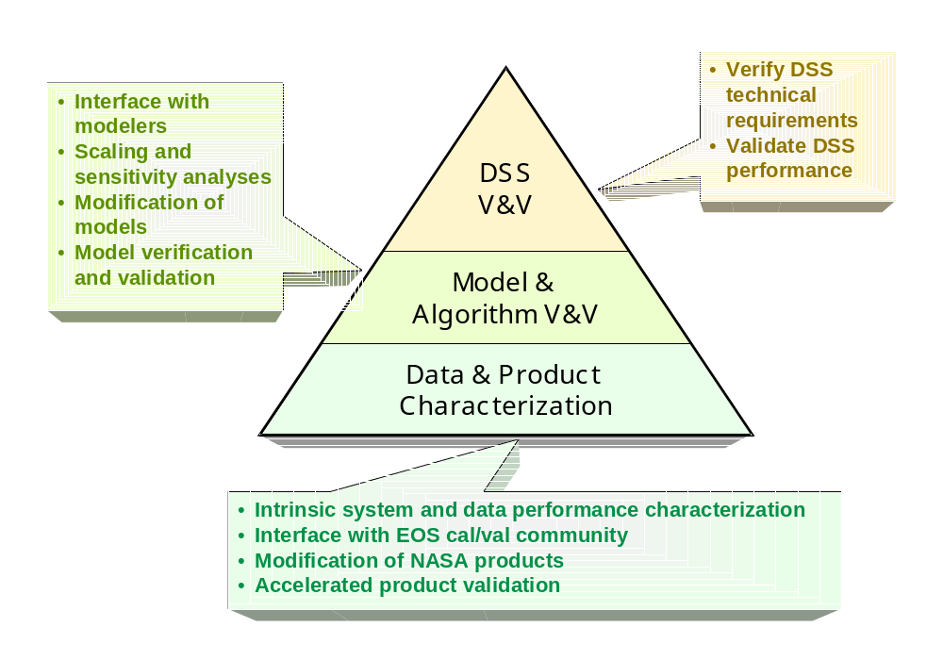
Figure 18. V&V hierarchy.
This V&V paradigm should be applied to potential enhancements of PECAD’s DSS. V&V should start with the two funded projects at the “data and product characterization” level. This level can also be described as “observations.” At this level, many individual pieces need to be characterized:
- MODIS Standard Products
- MODIS RR Products
- MODIS Decadal Products
- TRMM Decadal Products
- TRMM Daily Products
- TRMM/MODIS Disaggregated Rainfall
- JASON-1/TOPEX Reservoir Monitoring Product
The responsibility for V&V of the individual elements of the DSS enhancement is dispersed. The responsibility for the V&V MODIS Standard Products lies with the original product developers in the MODIS Land team. The responsibility for the MODIS RR Products belongs to the University of Maryland-led team. The GSFC-led team has responsibility for the MODIS Decadal Products and for the MODIS/TRMM Disaggregated Rainfall (an intermediate quantity for USDA/ARS crop modeling).
SSC/ESA has the responsibility for coordinating the V&V efforts, so all efforts meet consistent standards and so PECAD may have a single “ombudsman” for NASA data quality. Because PECAD information needs are time sensitive, one of the key activities will be V&V of latency or delivery time. Also, if NASA and PECAD agree to evaluate any additional enhancements, SSC/ESA should work these enhancements in to the overall V&V plan.
Models and the predictions they generate both fall within the scope of model V&V. A full understanding is needed of model error budgets and of model sensitivity for various parameters. For the potential enhancements to PECAD’s DSS, this V&V level includes (1) USDA/ARS crop model and its products/predictions, and (2) WOFOST crop model and its products/predictions [if pursued by UMD]
The general responsibility for the USDA/ARS crop model and its products and predictions falls to the GSFC-led project. The University of Maryland must perform V&V on any work related to WOFOST and its products and predictions. SSC/ESA may be able to contribute an independent assessment of model sensitivity with respect to scaling and various parameters.
The final assessment of an enhanced DSS will actually be the benchmarking process that follows V&V stages, but as sub-components are added or upgraded, they may be assessed pre-benchmarking to determine if they contribute properly to the overall system. New systems elements will be added in the potential enhancement of PECAD’s DSS, including the Agricultural Information System (AIS), and MODIS RR system utilizing Internet GIS technology.
These two information delivery systems must be assessed in terms of speed, throughput, reliability, etc. The AIS is the responsibility of the GSFC-led team, which will have additional requirements for user friendliness because the AIS is a public Web interface. The University of Maryland-led group will be responsible for measurement of the MODIS RR system performance.
Finally, SSC/ESA needs to work with PECAD to refine and summarize all of the requirements related to this potential DSS enhancement. Using its systems engineering capabilities, SSC/ESA needs to validate the requirements themselves to ensure that they match PECAD needs and enable PECAD mission success.
Cross Cutting Solutions: In addition to the direct societal benefits to Agricultural Efficiency and Disaster Preparedness through PECAD, any enhancements achieved for PECAD may be leveraged further by extending them to other National Applications and decision support tools. The Rapid Response delivery of MODIS products could be useful for Homeland Security since the same mechanisms that reveal crop conditions related to drought and other natural stresses could also show patterns stemming from agro-terrorism.
Precipitation and evapotranspiration solutions might be of use in Water Management. Specifically, TRMM precipitation products or the MODIS ET product (MOD16) might be of use in the Agricultural Water Resources and Decision Support (AWARDS) DSS of the U.S. Bureau of Reclamation. The AWARDS DSS assesses watershed water balances (Hartzell et al., 2003). ET and precipitation can also be helpful in estimating fire danger in the Disaster Management application.

References
Air Force Weather Agency, 2002. Data Format Handbook for AGRMET. http://www.mmm.ucar.edu/mm5/mm5v3/data/agrmet.html, accessed September 3, 2003.
Allen, R.G., L.S. Pereira, D. Raes, and M. Smith, 1998. Crop evapotranspiration - Guidelines for computing crop water requirements - FAO Irrigation and drainage paper 56, Food and Agriculture Organization, Rome, http://www.fao.org/docrep/X0490E/x0490e00.htm, accessed September 16, 2003.
Bahill, A.T., and B. Gissing, 1998. Re-evaluating systems engineering concepts using systems thinking. IEEE Transactions on Systems, Man and Cybernetics, Part C: Applications and Reviews, 28(4):516–527.
Birkett, C.M., 1994. Radar altimetry: a new concept in monitoring lake level changes. Eos, 75(24):273-275.
Boatwright, G.O., and V.S. Whitefield, 1986. Early warning and crop condition assessment research. IEEE Transactions on Geosciences and Remote Sensing, Vol GE-24, No 1, January.
Doraiswamy P., S. Hollinger, T.R. Sinclair, A. Stern, B. Akhmedov, and J. Pruger, 2002a. Application of MODIS-derived parameters for regional yield assessment. Proceedings of SPIE : Remote Sensing for Agriculture, Ecosystems, and Hydrology III (M. Owe and G. D'Urso, eds.), 17-21 September 2001, Toulouse, France, 4542:1–8.
Doraiswamy P., N. Muratova, T. Sinclair, A. Stern, and B. Akhmedov, 2002b. Evaluation of MODIS data for assessment of regional spring wheat yields in Kazakhstan. Proceedings of IEEE International Geoscience and Remote Sensing Symposium (IGARSS ’02), 24–28 June 2002, Toronto, Canada, vol. 1, pp. 487–490.
Food and Agricultural Organization, 2003. FAOSTAT Agriculture Data. http://apps.fao.org/page/collections, accessed July 28, 2003.
Food and Agricultural Organization, 1996. The Digitized Soil Map of the World Including Derived Soil Properties. Food and Agriculture Organization, Rome, CD-ROM.
Hartzell, C.L., T. Pruitt, S.M. Hunter, D.A. Matthews, W. Sharp, K.R. Arsenault, and P.R. Hauser, 2003. Applying high resolution land surface data, modeling and assimilation techniques to water supply and demand forecasts. The American Meteorological Society 83rd Annual Meeting/17th Conference on Hydrology–Impacts of Water Variability: Benefits and Challenges, 9-13 February 2003, Long Beach, CA.
Huffman and Bolvin, 2003. TRMM Real-Time Multi-Satellite Precipitation Analysis Data Set Documentation.ftp://aeolus.nascom.nasa.gov/pub/merged/3B4XRT_doc, accessed September 24, 2003, from NASA FTP site.
Hutchinson, C., V. Kaupp, S. Drake, T. Haithcoat, and W. van Leeuwen, 2003. Characterization of PECAD’s DSS: a Zeroth-Order Assessment and Benchmarking Preparation. Report commissioned by NASA and USDA, 55 pp.
Jupp, D.L.B., G. Tian, T.R. McVicar, Y. Qin, and F. Li, 1998. Soil Moisture and Drought Monitoring Using Remote Sensing I: Theoretical Background and Methods. CSIRO Earth Observation Centre Technical Report, 1998.1, Canberra, Australia, 95 pp.
Justice, C., A. Anyamba, C. Reynolds, J. Owens, S. Liang, and C.J. Tucker, 2002. Support of Application of NASA EOS MODIS Data by USDA Foreign Agriculture Service. Proposal submitted in response to CAN-02-OES-01: The Earth Science REASoN – Research, Education and Applications Solutions Network, 47 pp.
Kempler, S., W. Teng, P. Doraiswamy, R. Tetrault, L. Chiu, Z. Liu, and L. Milich, 2002. Integrating NASA Earth Science Enterprise Data into Global Agricultural Decision Support Systems, Proposal submitted in response to NASA Research Announcement (NRA-01-OES-05), 17 pp.
Leemans, R., and W. Cramer, 1991. The IIASA Database for Mean Monthly Values of Temperature, Precipitation and Cloudiness on a Global Terrestrial Grid. Research Report RR-91-18, November 1991, International Institute of Applied Systems Analyses, Laxenburg, 61 pp.
Morris, C.S., and S.K. Gill, 1994. Evaluation of the TOPEX/POSEIDON altimeter system over the Great Lakes. Journal of Geophysical Research, 99(C12):24,527-24,540.
Morris, D.K., C. O’Connor, and R. McKellip, 2003. CADRE First Look Evaluation. NASA Earth Science Applications Directorate internal report.
National Aeronautics and Space Administration, 2001. Aeronautics and Space Report of the President. NASA, Washington D.C., 155 pp.
National Aeronautics and Space Administration, 2003a. MODIS Rapid Response System. NASA/University of Maryland/U.S. Forest Service Rapid Response Team, http://rapidfire.sci.gsfc.nasa.gov/, accessed August 13, 2003.
National Aeronautics and Space Administration, 2003b. NASA Helping To Understand Water Flow In The West. Top Story, Goddard Space Flight Center, September 4, 2003, http://www.gsfc.nasa.gov/topstory/2003/0717watermgr.html, accessed September 13, 2003.
National Aeronautics and Space Administration, 2003c. Who We Are at the Earth Science Enterprise. Destination: Earth, NASA Earth Science Enterprise, http://www.earth.nasa.gov/Introduction/who.html, September 29, 2003.
Naval Research Laboratory, 2002. Satellite Meteorology. NRL Monterey Marine Meteorology Division, http://www.nrlmry.navy.mil/projects/sat_products.html, accessed September 3, 2003.
Reynolds, C.A., 2001. Input data sources, climate normals, crop models, and data extraction routines utilized by PECAD. Proceedings of the Third International Conference on Geospatial Information in Agriculture and Forestry, 5–7 November 2001, Denver, Colorado, CD-ROM.
Shepherd, J.S., and E.A. Smith, 2002. Global Precipitation Measurement – Report 7: Bridging from TRMM to GPM to 3-Hourly Precipitation Estimates. NASA Technical Memorandum TM-2002-211602, NASA Goddard Space Flight Center, Greenbelt, Maryland, 7 pp.
U.S. Department of Agriculture, 2002. PECAD. USDA Foreign Agricultural Service, http://www.fas.usda.gov/pecad/who_what.htm, accessed July 28, 2003.
U.S. House, 2003. Agricultural Act of 1954. P.L. 83-690, 68 Stat. 897, http://agriculture.house.gov/glossary/agricultural_act_of_1954.htm, accessed September 24, 2003.
Wielicki, B.A. 2003. CERES data products. CERES Data Products Workshop, 29–30 January 2003.
World Bank, 2003. Commodity Price Data, July 2003. Washington D.C.

Glossary
Agro-meteorology – the study and application of meteorology and climatology to specific problems in agriculture, such as crop-yield modeling and forecasting.
Agronomic – of or concerning the theory and practice of soil management and field crop production.
Benchmark – a standard by which a product can be measured or judged (i.e., How did the DSS that assimilated NASA measurements compare in its operation, function, and performance to the earlier version?). The benchmarking process is required to support adoption of innovative solutions into operational environments that affect life and property.
Biomass – the amount of living matter (as in a unit area or volume of habitat).
Decision Support System (DSS) – a computer-based information-processing system for scenario optimization through multi-parametric analysis. A DSS utilizes a knowledge base of information with a problem-solving strategy that may routinely assimilate measurements and/or model predictions in support of the decision making process. The DSS provides an interface to facilitate human inputs and to convey outputs. Outputs from a DSS would typically be used for making decisions at the local level and outputs from multiple DSSs may be used in establishing policy.
Decision Support Tools – a suite of solutions owned by NASA partners that are used in a variety of problem domains for decision and policymaking. These solutions could include assessments, decision support systems, decision support calendars, etc.
Evaluation – the process of identifying decision support tools (assessments and DSSs) that have been developed by Federal agencies and other partners that are a priority to citizens of our nation and that can be enhanced by NASA ESE results, and develop the specifications for how a candidate DSS can be augmented by assimilating NASA ESE observations and predictions.
Evapotranspiration – loss of water from the soil both by evaporation and by transpiration from the plants growing thereon.
High Resolution – the linear separation between two objects in an image of 1 m or better.
Leaf Area Index – the total area of leaves (one-sided) in relationship to the ground below them.
Low Resolution – the linear separation between two objects in an image of 1 km or better.
Mechanistic Crop Model – a quantitative scheme for prediction of the growth, development, and yield of a crop based on physiological and physical processes that considers cause and effect at the process level. Material (carbon, nitrogen, water) and energy balance are usually included.
Moderate Resolution – the linear separation between two objects in an image of 1 km to 250 m.
Moderately High Resolution – the linear separation between two objects in an image of a few tens of meters (20 m to 50 m).
Passive Microwave – (1) a general term referring to any sensor or instrument operating in the microwave band; (2) a sensing system that detects or measures radiation in the microwave band (1 mm to 1 m in wavelength) emitted or reflected by the target. The signal received by the passive sensor may be composed of energy emitted by the atmosphere, energy reflected from the surface, energy emitted by the target, or energy transmitted from and then emitted by the surface.
Radiation Budget – a quantitative statement of the amounts of radiation entering and leaving a given region of the Earth.
Verification – a life cycle process to ensure the products being developed meet the stated specifications (functional, performance, and design).
Validation – a process to ensure the completed products (software, algorithm, model) effectively serve the functional requirements.
Water Balance – a theoretical expression of water still available, obtained from the difference between the total rainfall and the evapotranspiration of a closed, well-irrigated grass canopy over a given period.

Acronyms and Initialisms
AFWA Air Force Weather Agency
AgRISTARS Agriculture and Resources Inventory Surveys Through Aerospace Remote Sensing
AGRMET Agricultural Meteorology Model
AIS Agricultural Information System
AMSR Advanced Microwave Scanning Radiometer
AMSR-E Advanced Microwave Scanning Radiometer for the EOS
AMSU Advanced Microwave Sounding Unit
AR Accumulated Rainfall
ARS Agricultural Research Service
ASTER Advanced Spaceborne Thermal Emission and Reflectance Radiometer
AVHRR Advanced Very High Resolution Radiometer
AWARDS Agricultural Water Resources and Decision Support
CADRE Crop Assessment Data Retrieval and Evaluation a.k.a. Crop Condition Data Retrieval and Evaluation
CDFSII Cloud-Detection and Forecast System II
CERES Clouds and the Earth’s Radiant Energy System (sensor)
ALSO Crop Estimation through Resource and Environment Synthesis (crop model)
CMIS Conical Microwave Imager/Sounder
COTS Commercial off-the-Shelf
DAAC Distributed Active Archive Center
DBMS Database Management System
DEM Digital Elevation Model
DG AGRI Directorate General for Agriculture
DMSP Defense Meteorological Satellite Program
DSMW Digital Soil Map of the World
DSS Decision Support System
EDC EROS Data Center
EF Evaporation Fraction
EOS Earth Observing System
EROS Earth Resources Observation Systems
ESE Earth Science Enterprise
ET Evapotranspiration
ETM+ Enhanced Thematic Mapper Plus
EVI Enhanced Vegetation Index
FAO Food and Agricultural Organization
FAS Foreign Agriculture Service
FSA Farm Service Agency
FTP File Transfer Protocol
GAC Global Area Coverage
GES GSFC Earth Sciences
GIMMS Global Inventory Monitoring and Modeling Studies
GIS Geographic Information System
GOES Geostationary Operational Environmental Satellites
GPM Global Precipitation Measurement
GSD Ground Sample Distance
GSFC Goddard Space Flight Center
HDF Hierarchical Data File
IIASA International Institute for Applied Systems Analysis
IPT Integrated Product Team
IR Infrared
JAXA Japanese Aerospace Exploration Agency
LAC Local Area Coverage
LACIE Large Area Crop Inventory Experiment
LAI Leaf Area Index
LST Land Surface Temperature
MARS Monitoring Agriculture with Remote Sensing
MODIS Moderate Resolution Imaging Spectroradiometer
NASA National Aeronautics and Space Administration
NDTI Normalized Difference Temperature Index
NDVI Normalized Difference Vegetation Index
NOAA National Oceanic and Atmospheric Administration
NPOESS National Polar-orbiting Operational Environmental Satellite System
NPP NPOESS Preparatory Project
NRL Naval Research Laboratory
PAR Photosynthetically Active Radiation
PECAD Production Estimates and Crop Assessment Division
PR Precipitation Radar
QuikSCAT Quick Scatterometer
REASoN CAN Research, Education and Applications Solutions Network Cooperative Agreement Notice
RR Rapid Response
SSC/ESA Earth Science Applications Directorate at Stennis Space Center
SPOT System Pour l'Observation de la Terre
SRTM Shuttle Radar Topography Mission
SSM/I Special Sensor Microwave Imager
TMI TRMM Microwave Imager
TRMM Tropical Rainfall Measuring Mission
USDA U.S. Department of Agriculture
V&V Verification & Validation
VIIRS Visible Infrared Imaging Radiometer Suite
VIN Vegetation Index Number
WAP World Agricultural Production
WMO World Meteorological Organization
WOFOST World Food Studies

Agricultural Efficiency Roadmap
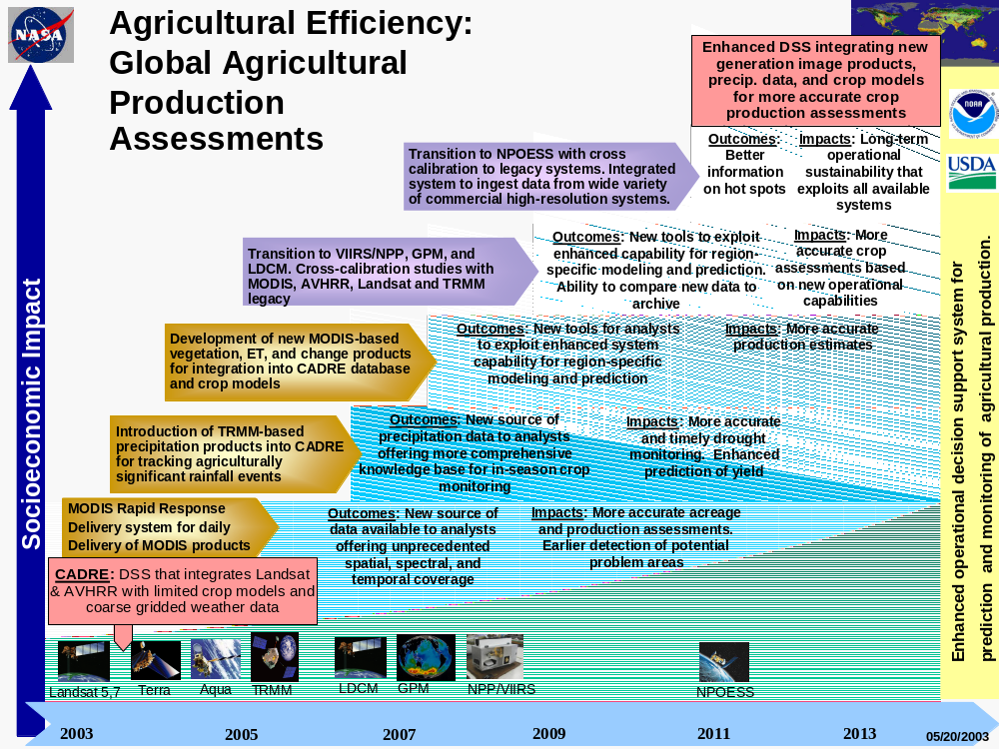

Relevant Earth Observing Missions and Sensors
D-. Sensors and missions discussed in this report.
Sensor | - AMSR  - CMIS  - ETM+  - MODIS  - TMI  - VIIRS  - VGT 1& 2
Mission | - Aqua  - GPM Core  - Topex/Poseidon  - TRMM  - Terra
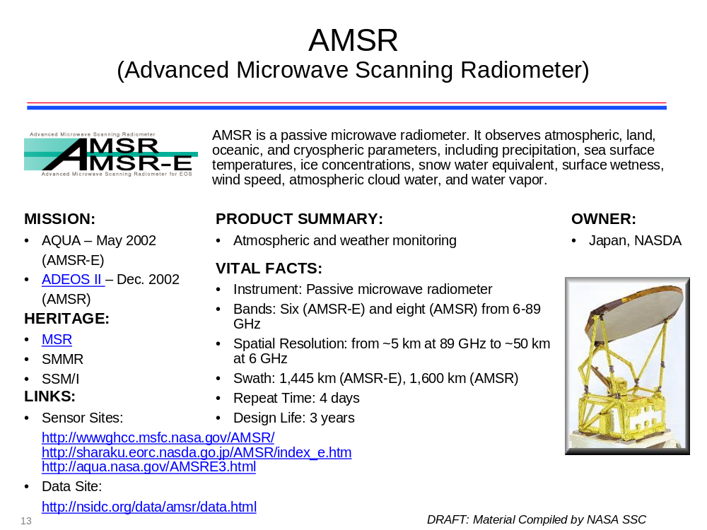
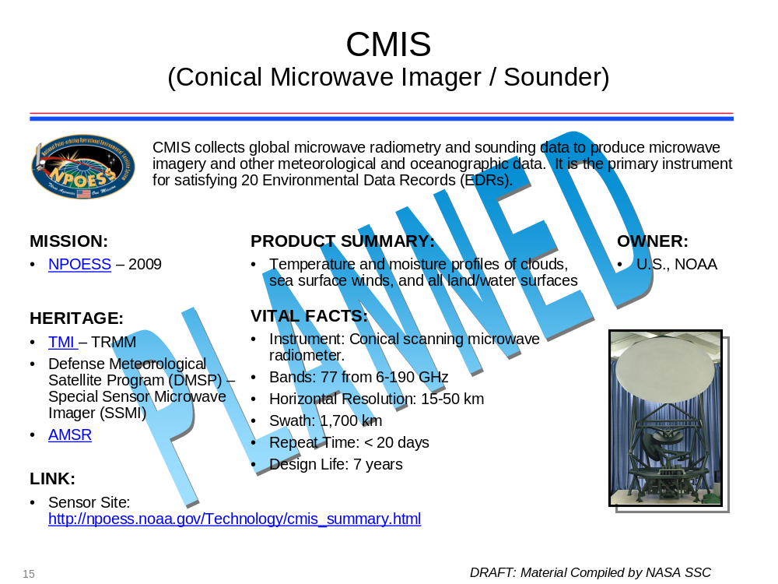
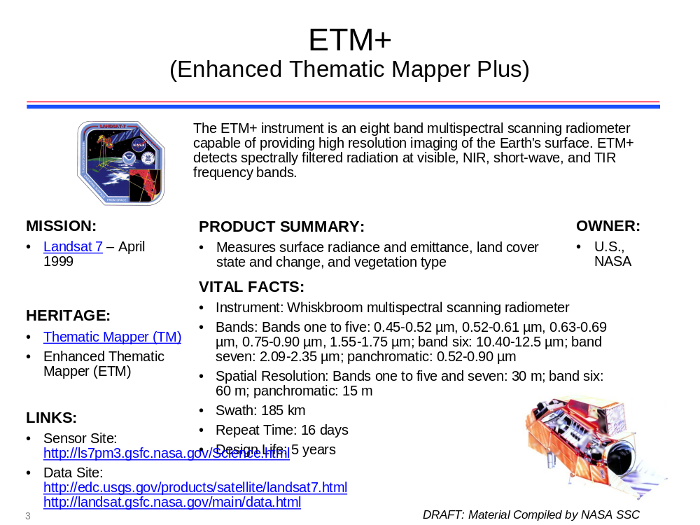
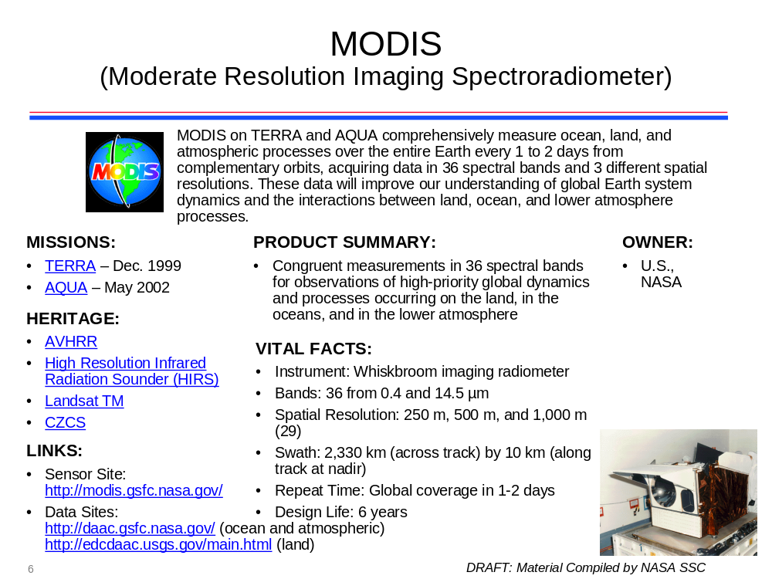
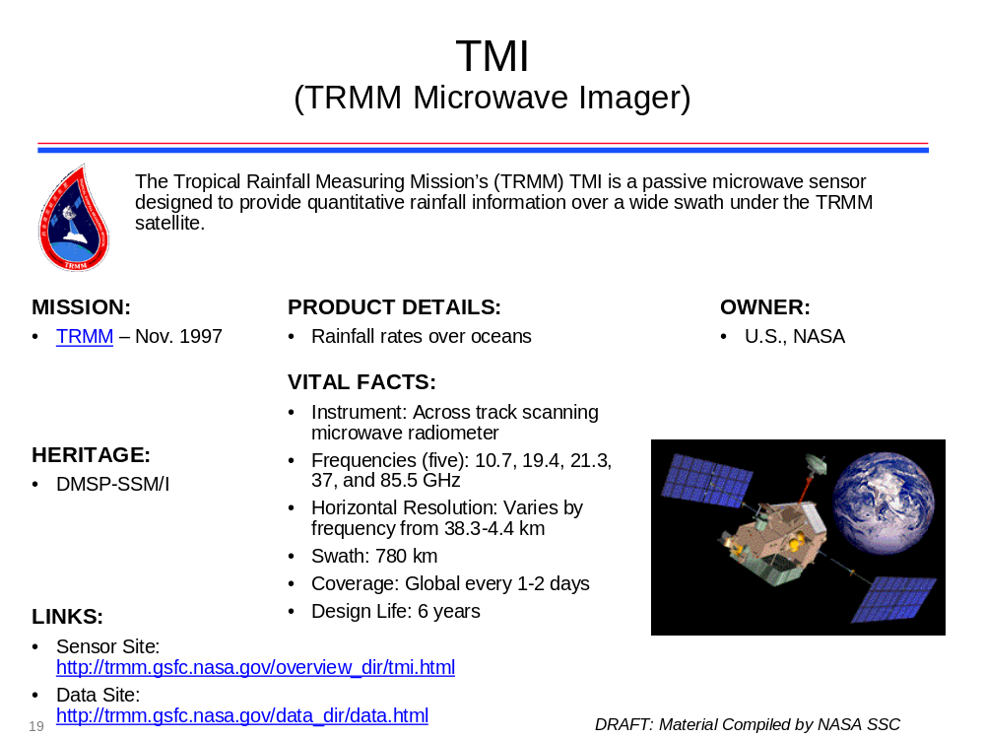
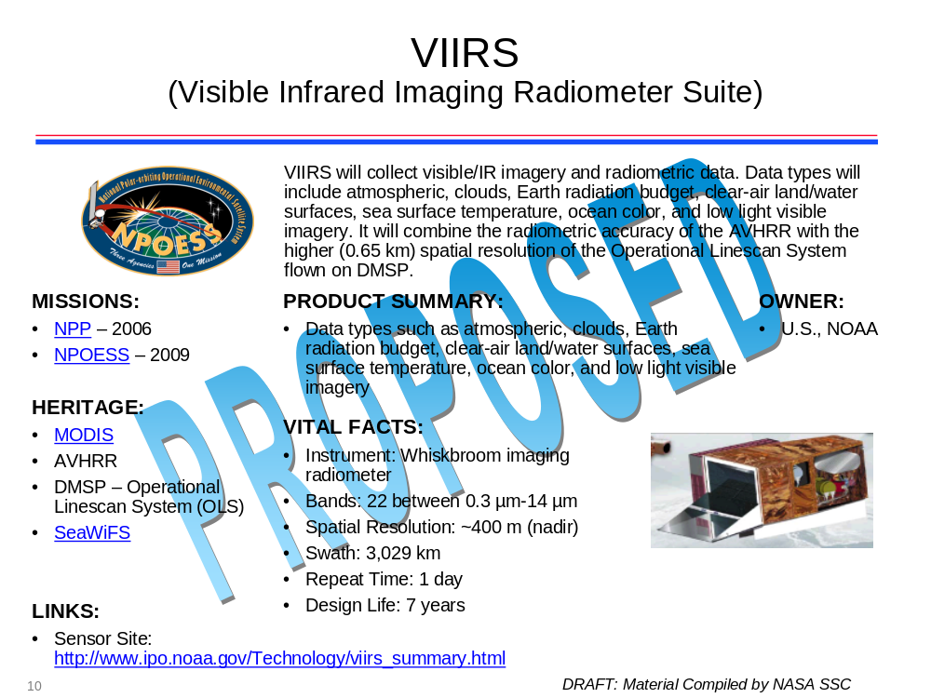
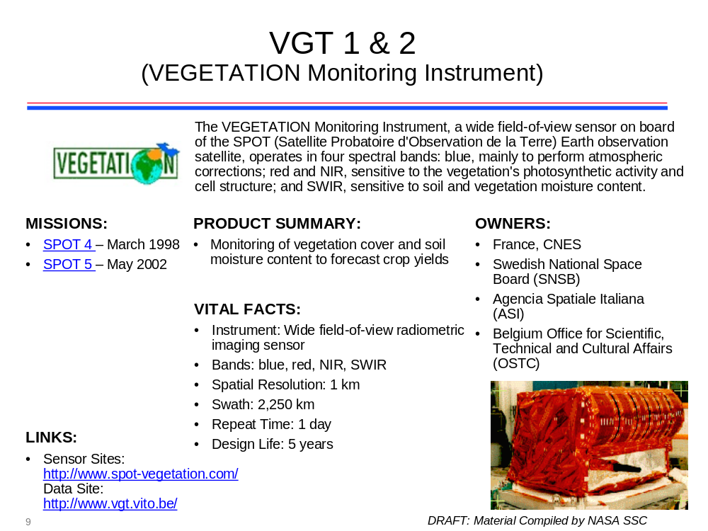
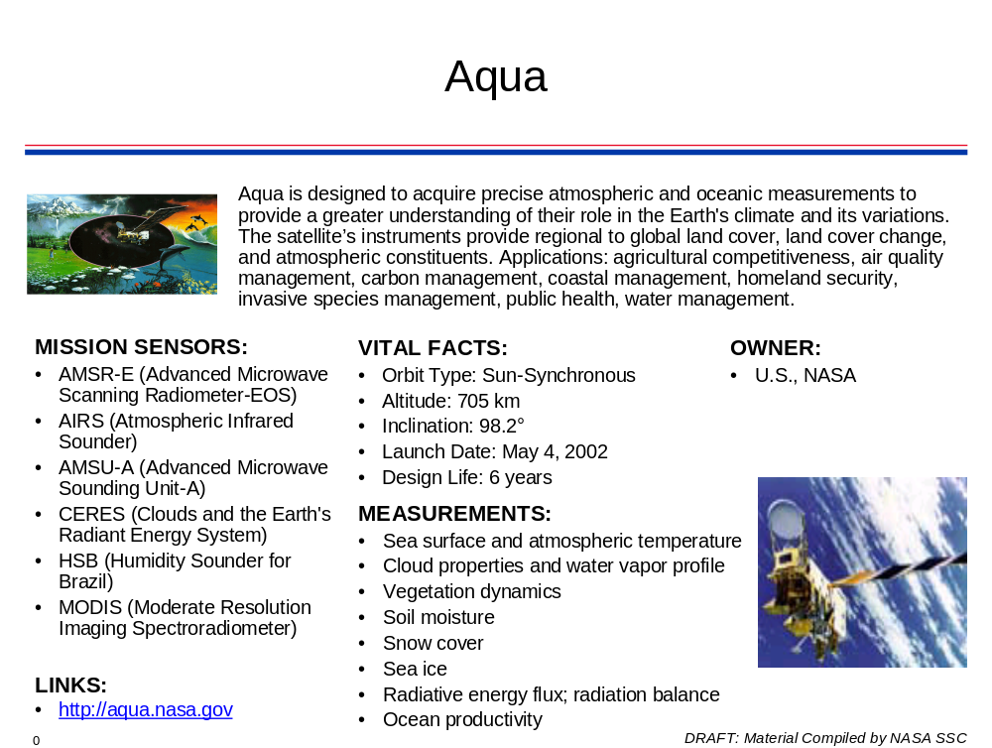
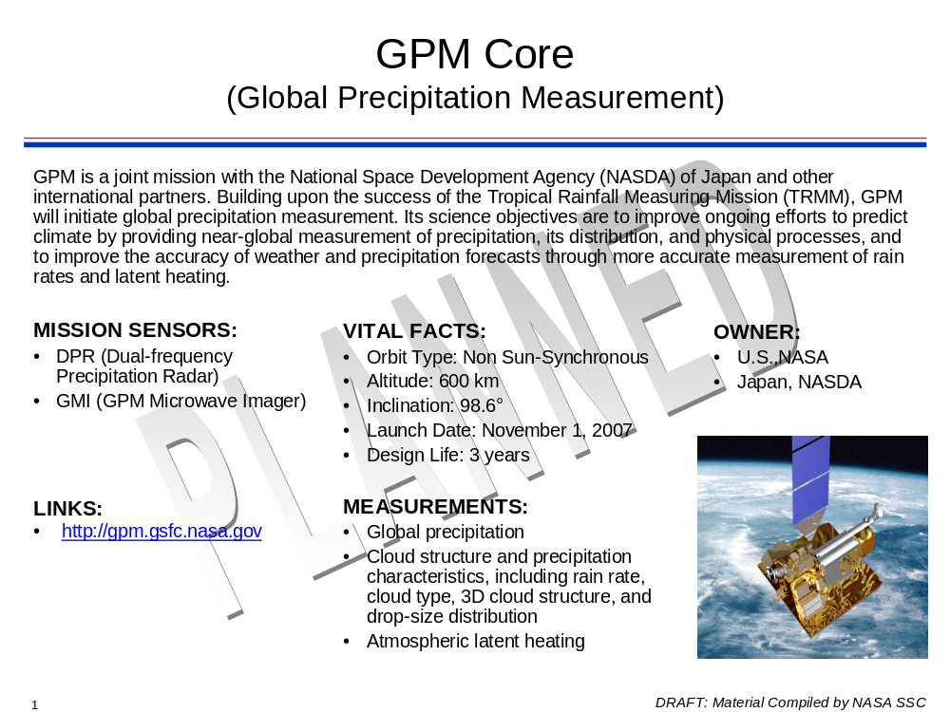
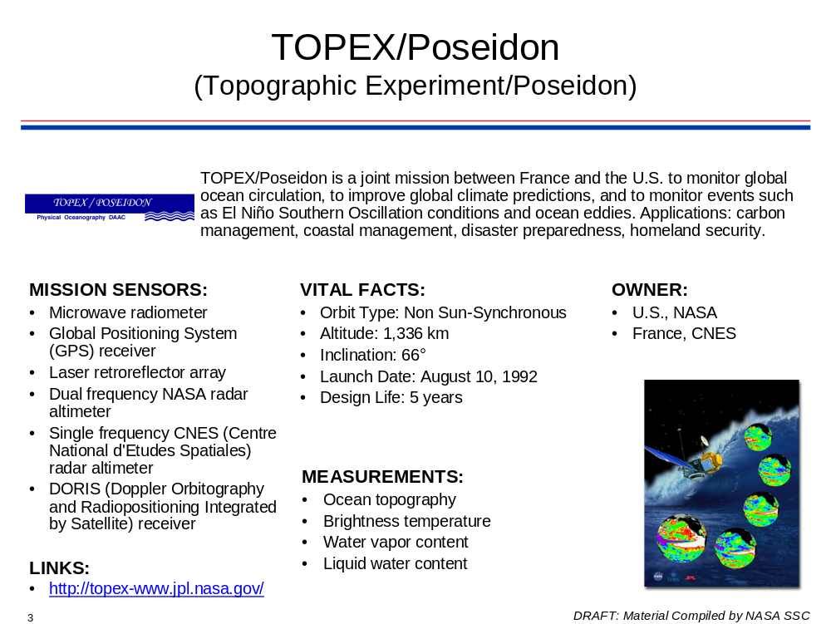
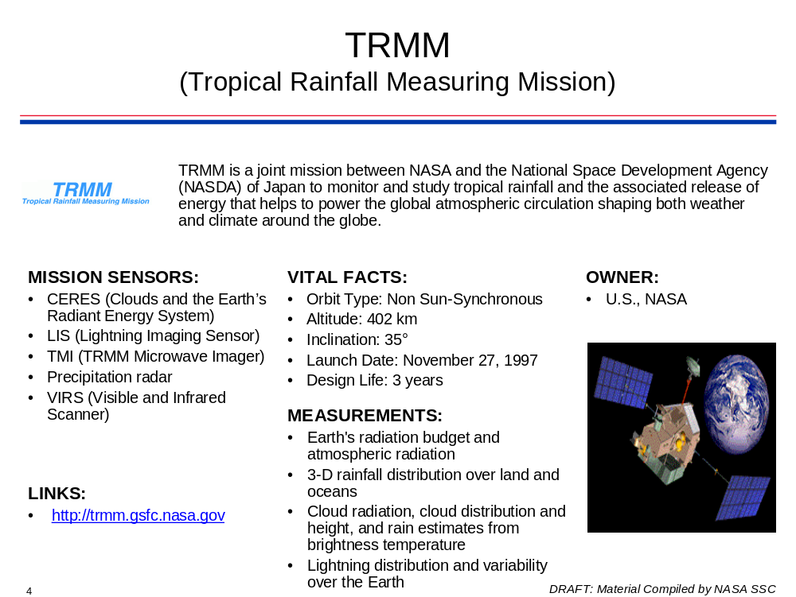
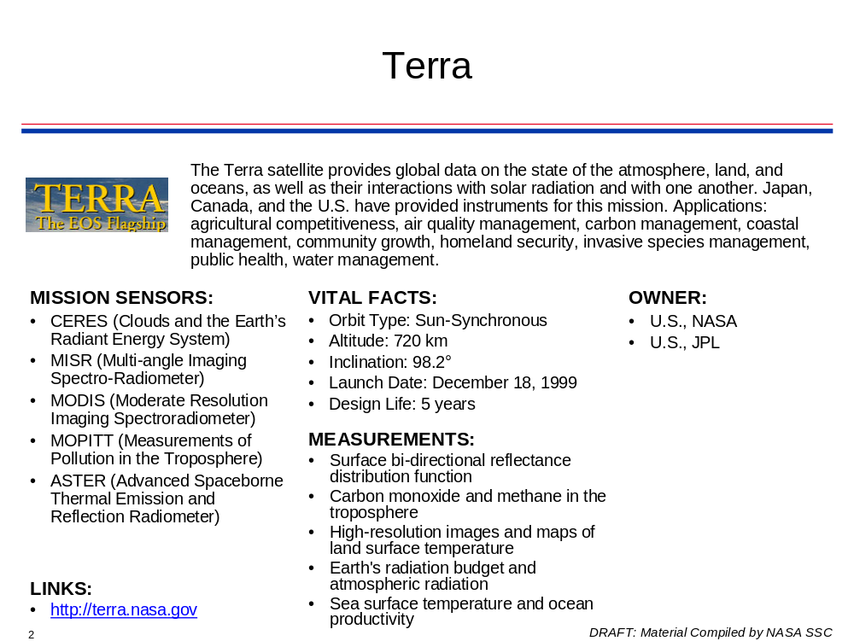

Relevant NASA Earth Observation Products

E-. Products.
MODIS | - MOD09: Surface Reflectance  - MOD10: Snow Cover  - MOD11: Land Surface Temperature and Emissivity  - MOD12: Land Cover  - MOD13: Vegetation Indices  - MOD15: Leaf Area Index/Fraction of Photosynthetically Active Radiation  - MOD16: Evapotranspiration & Surface Resistance  - MOD17: Net Photosynthesis
Jason-1 | - GDR, IGDR: Sea Surface Height
SRTM | - Interferometric Terrain Height
CERES | - CER07: Synoptic Radiative Fluxes and Clouds
TRMM | - 3B-42RT: TRMM-Adjusted Merged-Infrared Precipitation Real Time
AMSR-E | - AE_DySno: Snow-Water Equivalent and Snow Depth  - AE_Land3: Surface Soil Moisture


