Module 7: Introduction to Cost Estimating and Financial Management

Module Outline

Topic |  | Time Frame
Introduction/Objectives | 10 minutes
Cost Estimating | 60 minutes
Financial Management | 30 minutes
Other Forms of Performance Measurement | 70 minutes
Review | 10 minutes
Estimated/Approximate Time for Module Completion | 3 hours

Topic 1: Introduction/Objectives

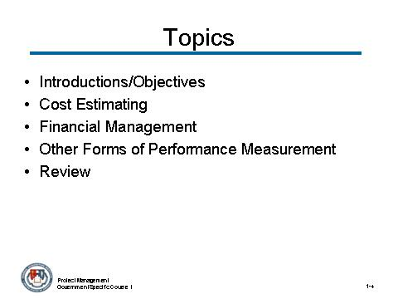 | Notes:

 CONTENT TO BE PRESENTED:
Key Points:
This module will discuss the different forms of cost estimating, cost analysis, reconciliation of cost estimates, financial planning, formulating financial projects and budgets, budget analysis/execution, cost-benefit analysis, earned value management (EVM), and other methods of performance measurement. It divided into five topics:
- Introduction/Objectives
- Cost Estimating
- Financial Management
- Other Forms of Performance Measurement
- Review

Topic 1: Introduction/Objectives (continued)

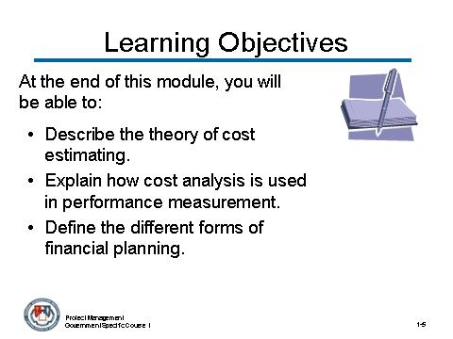 | Notes:

CONTENT TO BE PRESENTED:
Key Points:
Objectives
At the end of this module, you will be able to:
- Describe the theory of cost estimating.
  - You will describe cost estimating and how it differs from cost analysis.
- Explain how cost analysis is used in performance measurement.
  - You will learn the importance of performing a cost analysis.
- Define the different forms of financial planning.
  - You will learn the forms of financial planning including: formulating financial projects and budgets, and budget analysis/execution.

Topic 1: Introduction/Objectives (continued)

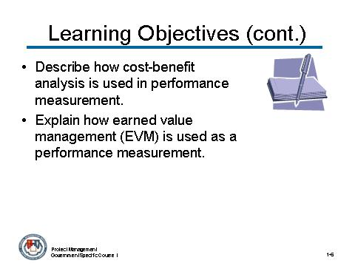 | Notes:

CONTENT TO BE PRESENTED:
Key Points:
Objectives (continued)
- Describe how cost-benefit analysis is used in performance measurement.
  - You will learn when to use cost-benefit analysis and cost-effectiveness analysis.
- Explain how earned value management (EVM) is used as a performance measurement.
  - EVM, when implemented, is a project management technique that can provide significant benefits to both the government and the contractor.

Topic 1: Introduction/Objectives (continued)

Instructor Notes:
This concludes the topic on the Introduction/Objectives. After addressing any questions the participants may have, inform them that we will be moving on to the next topic: Cost Estimating.

What questions do you have regarding the Introduction/Objectives?

Topic 2: Cost Estimating

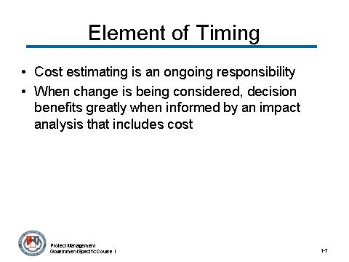 | Notes:

CONTENT TO BE PRESENTED:
Key Points:
Before we get started, it is important to consider the element of timing.
- One of the pitfalls you have likely encountered is the belief that cost estimating and financial management are largely completed at the beginning of a project. This presumption undercuts the important ongoing responsibilities in this area.
- As we progress through this module and the rest of this course, remember that, when a change is being considered, the decisions you make will benefit greatly if they are informed by an impact analysis that includes cost.

Topic 2: Cost Estimating (continued)

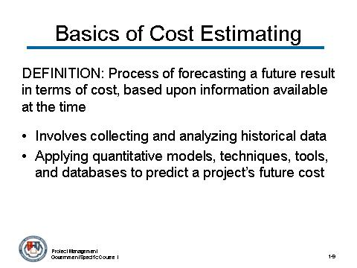 | Notes:

CONTENT TO BE PRESENTED:
Key Points:
Basics of Cost Estimating
Cost estimating is the process of forecasting a future result in terms of cost, based upon information available at the time.
- Cost estimating involves collecting and analyzing historical data and applying quantitative models, techniques, tools, and databases to predict a project’s future cost.
- More simply, cost estimating combines science and art to predict the future cost of something based on known historical data that are adjusted to reflect new materials, technology, software languages, and development teams.

Topic 2: Cost Estimating (continued)

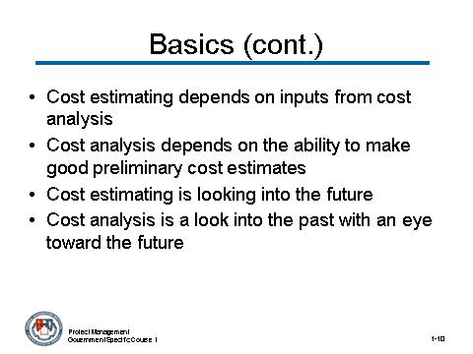 | Notes:

CONTENT TO BE PRESENTED:
Key Points:
Basic of Cost Estimating (continued)
Cost estimating depends on inputs from the cost analysis activity, which is the process of studying and organizing past costs and future estimates.
- Likewise, effective and timely cost analysis often depends on the ability to make good preliminary cost estimates.
- Cost estimating is principally a look forward into future occurrences, and cost analysis is principally a look into the past with and eye toward the future.
- Although “cost estimating” and “cost analysis” are often used interchangeably, cost estimating is a specific activity within cost analysis.

Topic 2: Cost Estimating (continued)

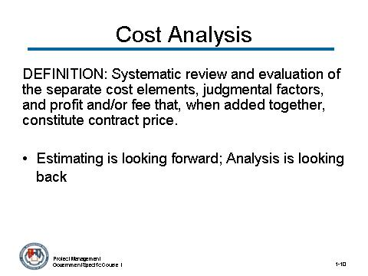 | Notes:

CONTENT TO BE PRESENTED:
Key Points:
Cost analysis – Definition
Cost analysis is the systematic review and evaluation of the separate cost elements, judgmental factors, and profit and/or fee that, when added together, constitute contract price.
- It can be used to evaluate an offeror’s or contractor’s proposal (including cost or pricing data or information other than cost or pricing data) to determine how well the proposed costs represent what the cost of the contract should be, assuming reasonable economy and efficiency.
- Cost analysis entails the examination of the basic cost building blocks: direct cost, facilities capital cost money, and profit.
- Estimating is looking forward; Analysis is looking back

Topic 2: Cost Estimating (continued)

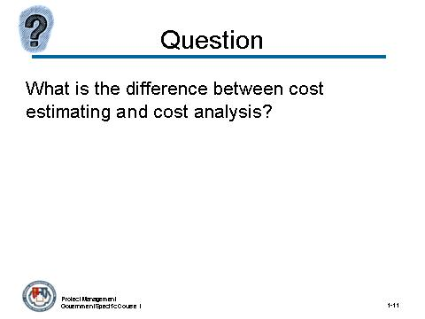 | Notes:

What is the difference between cost estimating and cost analysis?
Answer:
Cost estimating is principally a look forward into future occurrences, and cost analysis is principally a look into the past with and eye toward the future.

Topic 2: Cost Estimating (continued)

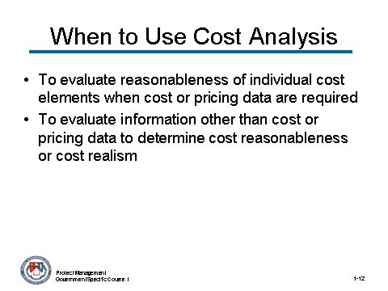 | Notes:

CONTENT TO BE PRESENTED:
Key Points:
When to Use Cost Analysis
The Federal Acquisition Regulation (FAR) offers the following two situations when you may use cost analysis:
- Cost analysis shall be used to evaluate the reasonableness of individual cost elements when cost or pricing data are required. Price analysis should be used to verify that the overall price offered is fair and reasonable. (Required)
- It may also be used to evaluate information other than cost or pricing data to determine cost reasonableness or cost realism. (Optional)

Topic 2: Cost Estimating (continued)

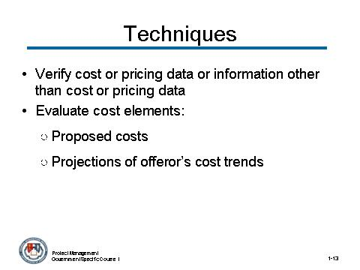 | Notes:

CONTENT TO BE PRESENTED:
Key Points:
Cost Analysis Techniques and Procedures
The FAR also establishes that the government uses various cost analysis techniques and procedures to ensure a fair and reasonable price, given the circumstances of the acquisition. As appropriate, use the following techniques and procedures to perform cost analysis:
- Verify cost or pricing data or information other that cost or pricing data.
- Evaluate cost elements, including:
  - The necessity for and reasonableness of proposed costs, including allowances for contingencies;
  - Projections of the offeror's cost trends, on the basis of current and historical cost or pricing data or information other than cost or pricing data;
(continued on next slide)

Topic 2: Cost Estimating (continued)

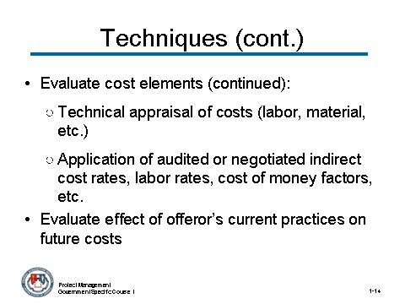 | Notes:

CONTENT TO BE PRESENTED:
Key Points (continued):
Cost Analysis Techniques and Procedures (continued)
  - A technical appraisal of the estimated labor, material, tooling, and facilities requirements, and scrap and spoilage factors; and
  - The application of audited or negotiated indirect cost rates, labor rates, cost of money factors, and other factors.
- Evaluate the effect of the offeror's current practices on future costs.
  - Ensure that the effects of inefficient or uneconomical past practices are not projected into the future.
  - In pricing production of recently developed complex equipment, perform a trend analysis of basic labor and materials even in periods of relative price stability.

Topic 2: Cost Estimating (continued)

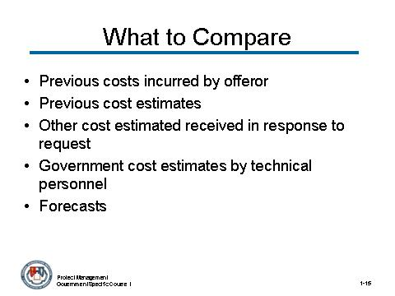 | Notes:

CONTENT TO BE PRESENTED:
Key Points:
- Compare costs proposed by the offeror for individual cost elements with:
  - Actual costs previously incurred by the offeror;
  - Previous cost estimates from the offeror or from other offerors for the same or similar items;
  - Other cost estimates received in response to the government's request;
  - Independent government cost estimates by technical personnel; and
  - Forecasts or planned expenditures.

Topic 2: Cost Estimating (continued)

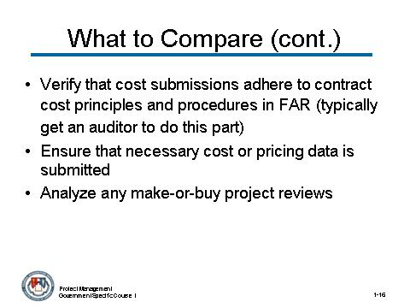 | Notes:

CONTENT TO BE PRESENTED:
Key Points:
- Verify that the offeror's cost submissions are in accordance with the contract cost principles and procedures in FAR Part 31 and any applicable Cost Accounting Standards Board. (typically get an auditor to do this part)
- Determine whether any cost or pricing data necessary to make the contractor's proposal accurate, complete, and current have not been either submitted or identified in writing by the contractor. If there are such data:
  - Attempt to obtain the data and negotiate using the data obtained, or
  - Make satisfactory allowance for the incomplete data.
- Analyze the results of any make-or-buy project reviews, in evaluating subcontract costs.

Topic 2: Cost Estimating (continued)

Instructor Notes:
Several pages of slides pointing to the same thing: We are trying to make a decision of some sort.

Topic 2: Cost Estimating (continued)

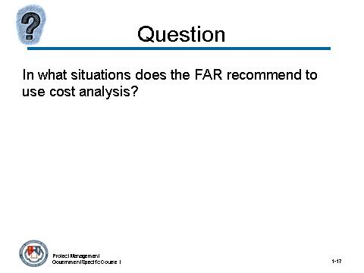 | Notes:

In what two situations does the FAR recommend to use cost analysis?
Answer:
- To evaluate the reasonableness of individual cost elements when cost or pricing data (from a contractor) are required
- To evaluate information other than cost or pricing data to determine cost reasonableness or cost realism.

Topic 2: Cost Estimating (continued)

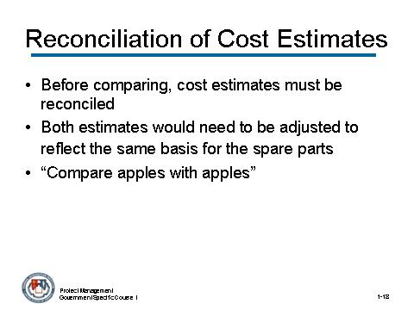 | Notes:

CONTENT TO BE PRESENTED:
Key Points:
Reconciliation of Cost Estimates
Before cost estimates can be fairly compared, they must be reconciled. As an example, let us consider that two competing approaches are being considered to accomplish the same goal:
- If the requirements were silent on some particular detail, such as the quantity of spare parts, it would not be surprising to see that one approach includes a different amount of parts from the competing approach.
- For the purpose of the reconciliation, both estimates would need to be adjusted to reflect the same basis for the spare parts. This enables you to “compare apples to apples.”
(continued on next page)

Topic 2: Cost Estimating (continued)

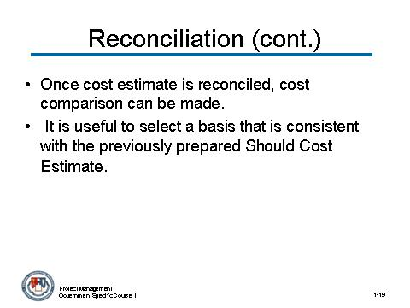 | Notes:

CONTENT TO BE PRESENTED:
Key Points (continued):
Reconciliation of Cost Estimates (continued)
Once the basis of your cost estimates is reconciled, then a cost comparison can be fairly made.
- Note: It is useful to select a basis that is consistent with the previously prepared Should Cost Estimate.

Topic 2: Cost Estimating (continued)

Activity
Activity Purpose:
This activity will present the participants two examples that demonstrate the importance to perform cost analysis.
Activity Length: 15-20 minutes
Activity Instructions:
Break the class into groups of four. Have the participants read the examples and answer the questions on the following page. At the end of the activity, discuss the questions with the participants.
Tell the participants the following:
The following examples came to light because the government was accused of overpayment of some contracts that were awarded to assist in the hurricane Katrina clean up and recovery of New Orleans in 2005. Although the Operation Blue Rood and the Carnival Cruise examples are unique situations that were the result of urgent requirements which may not have allowed sufficient time to conduct cost analysis, they demonstrate the importance of why cost analysis should be performed.

Example 1:
Highly criticized after the wake of Hurricane Katrina were some of the contracts awarded under Operation Blue Roof. This operation hired contractors to nail downs large blued tarpaulins on top of wind damaged roofs of the Gulf Coast residents in order to prevent furthers weather damage. These contractors were paid and average of $2,480 for less than two hours of work to cover each damaged roof with government provided supplies. It was later reported that the cost should have been closer of $300 to tarp a 2,000-square foot roof, a fraction of what the government paid.
Example 2:
The government awarded Carnival Cruise a $236 million deal to provide temporary housing on the Mississippi River and off of the Gulf Coast. According to Congressional investigators, the cost per person was $1,275 a week. That amount was nearly twice the typical cost of a weeklong cruise for a typical passenger.

Topic 2: Cost Estimating (continued)

Activity (continued)
Questions:
- Why do you think is it important to perform a cost analysis?
Answer:
It is important to perform cost analysis to make wise business decisions that protect the best interest of the government and the tax dollars.
- Do you think that the government should waste time reviewing and evaluating the contractor’s proposed cost, or not? Especially when the contractor knows best what it should cost to do the job?
Answer:
It is very important for you, as project manager, to spend time reviewing and evaluating the contractor’s proposed cost.
As we have seen in the previous examples in both cases, the government paid more money than they should have paid if they would have conducted a cost analysis.

Topic 2: Cost Estimating (continued)

Instructor Notes:
This concludes the topic on Cost Estimating. After addressing any questions the participants may have, inform them that we will be moving on to the next topic: Financial Management.

What questions do you have regarding Cost Estimating?

Topic 3: Financial Management

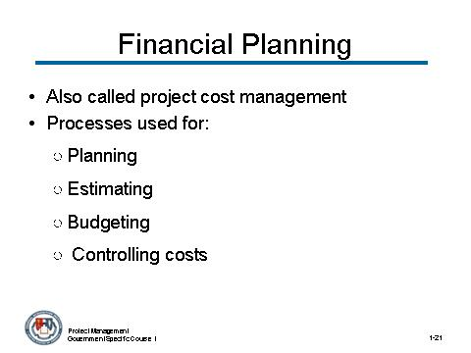 | Notes:

CONTENT TO BE PRESENTED:
Key Points:
Financial planning can also be called project cost management.
It involves processes that are used for planning, estimating, budgeting, and controlling costs so that the project can be completed within the budget that has been approved.

Topic 3: Financial Management

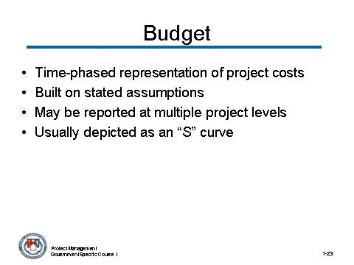 | Notes:

CONTENT TO BE PRESENTED:
Key Points:
- A project budget is a time-phased representation of the project costs to be spent
- Built on stated assumptions
- May be reported at multiple project levels
- Usually depicted as an “S” curve

Topic 3: Financial Management

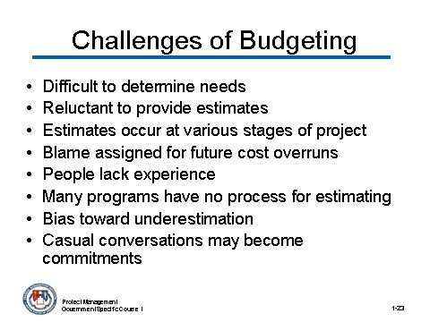 | Notes:

CONTENT TO BE PRESENTED:
Key Points:
There are challenges in creating a budget:
- Difficult to determine needs due to uncertainty of requirements
- Reluctant to provide estimates because equated with commitment
- Estimates occur at various stages of the project, and differ in accuracy
- Blame assigned for future cost overruns- the first estimate that you utter gets cast in concrete and you are forever held accountable to it
- People often lack experience in estimating
- Many programs have no process for estimating
- People have a bias toward underestimation
Casual conversations may become commitments

Topic 3: Financial Management

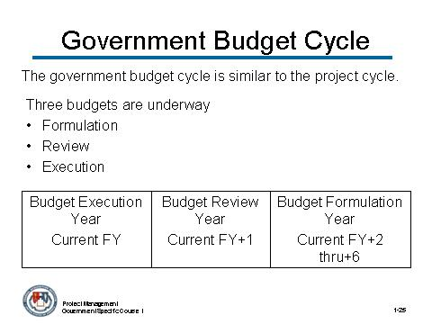 | Notes:

CONTENT TO BE PRESENTED:
Key Points:
The government budget cycle is similar to the project cycle.
- It has a baseline, configuration management, distinct periods and phases, and control gates
- Three budgets are underway
- Formulation
- Review
- Execution
This causes intense uncertainty among project managers in the government. They have to apply for funding every year – how do you run a four-year project when you’re not sure of the amount of money you’re getting from year to year?

Topic 3: Financial Management

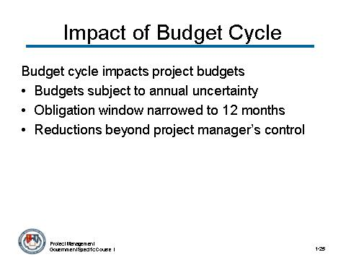 | Notes:

CONTENT TO BE PRESENTED:
Key Points:
The budget cycle has an impact on the project budgets.
- Project budgets are subject to annual uncertainty
- Obligation window is narrowed to less than 12 months (more like 6 months in reality)
- Project budget reductions that are beyond the project manager’s control may occur at any time

Topic 3: Financial Management

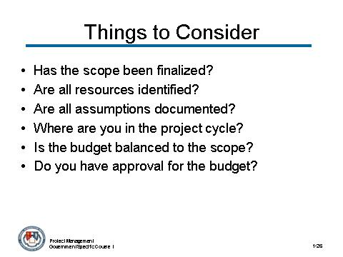 | Notes:

CONTENT TO BE PRESENTED:
Key Points:
Here are some things to consider when finalizing a budget.
- Has the scope been finalized?
- Are all resources identified?
- Are all assumptions documented?
- Where are you in the project cycle?
- Is the budget balanced to the scope?
- Do you have approval for the budget?
- Budgets are rarely approved by everybody – your job is to get money on your project as soon as possible. It is much harder to take it back once it is been given.

Topic 3: Financial Management

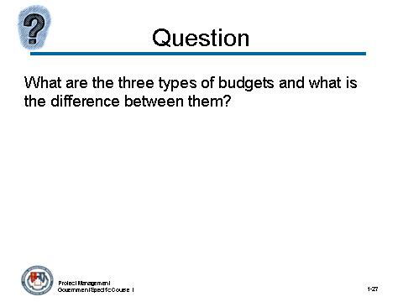 | Notes:

What are the three types of budgets and what is the difference between them?
Answer:
- Formulation
- Review
- Execution
Execution involves the current FY. Review involves the current FY plus on year. Execution involves the current FY plus two to six years.

Topic 3: Financial Management

Instructor Notes:
This concludes the topic on Financial Management. After addressing any questions the participants may have, inform them that we will be moving on to the next topic: Other Forms of Performance Measurement.

What questions do you have regarding Financial Management?

Topic 4: Other Forms of Financial Performance Measurement

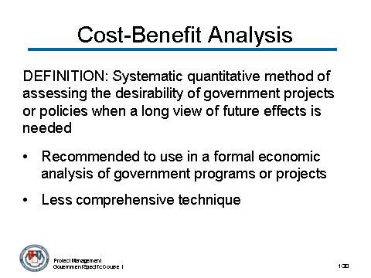 | Notes:

CONTENT TO BE PRESENTED:
Key Points:
Definition - Cost-Benefit Analysis
- Cost-Benefit analysis, also referred to as cost-benefit analysis, is a systematic quantitative method of assessing the desirability of government projects or policies when it is important to take a long view of future effects and a broad view of possible side-effects.
- It is recommended as the technique to use in a formal economic analysis of government programs or projects.
- When a cost-benefit analysis cannot be done cost-effectiveness analysis should be performed.
- Cost-effectiveness analysis is a less comprehensive technique, but it can be appropriate when the benefits from competing alternatives are the same or where a policy decision has been made that the benefits must be provided.

Topic 4: Other Forms of Financial Performance Measurement (continued)

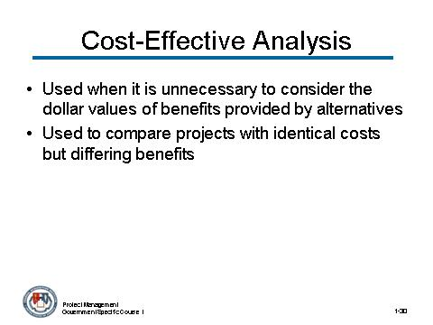 | Notes:

CONTENT TO BE PRESENTED:
Key Points:
Cost-Effective Analysis
- Cost-effective analysis is appropriate whenever it is unnecessary or impractical to consider the dollar value of the benefits provided by the alternatives under consideration. This is the case whenever each alternative has:
  - The same annual benefits expressed in monetary terms; or
  - The same annual affects, but dollar values cannot be assigned to their benefits.
- It can also be used to compare projects with identical costs but differing benefits. In this case, the decision criterion is the discounted present value of benefits. The alternative project with the largest benefits would normally be favored.

Topic 4: Other Forms of Financial Performance Measurement (continued)

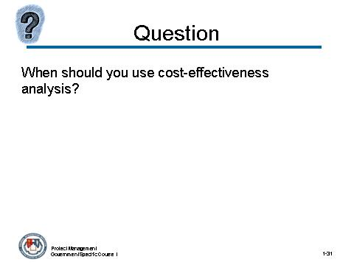 | Notes:

When should you use cost-effectiveness analysis?
Answer:
You should use cost-effectiveness analysis when the benefits of the alternatives cannot be quantified in terms of dollar.

Topic 4: Other Forms of Financial Performance Measurement (continued)

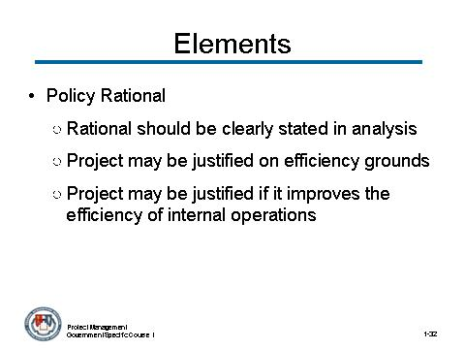 | Notes:

CONTENT TO BE PRESENTED:
Key Points:
Elements of cost- benefit analysis or cost-effective analysis
- Policy Rationale
  - The rationale for the government project being examined should be clearly stated in the analysis.
  - Projects may be justified on efficiency grounds where they address market failure, such as public goods and externalities.
  - They may also be justified where they improve the efficiency of the government's internal operations, such as cost-saving investments.

Topic 4: Other Forms of Financial Performance Measurement (continued)

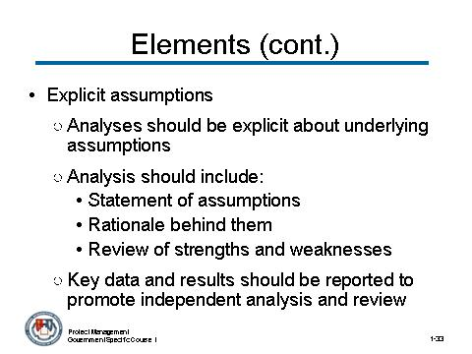 | Notes:

CONTENT TO BE PRESENTED:
Key Points:
Elements of cost- benefit analysis (continued)
- Explicit Assumptions
  - Analyses should be explicit about the underlying assumptions used to arrive at estimates of future benefits and costs.
  - In the case of public health projects, for example, it may be necessary to make assumptions about the number of future beneficiaries, the intensity of service, and the rate of increase in medical prices.
  - The analysis should include a statement of the assumptions, the rationale behind them, and a review of their strengths and weaknesses. Key data and results, such as year-by-year estimates of benefits and costs, should be reported to promote independent analysis and review.

Topic 4: Other Forms of Financial Performance Measurement (continued)

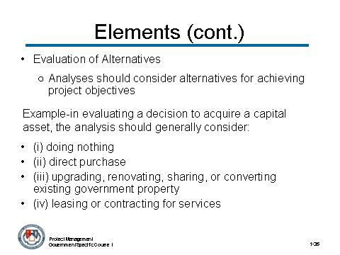 | Notes:

CONTENT TO BE PRESENTED:
Key Points:
Elements of cost- benefit analysis (continued)
- Evaluation of Alternatives
  - Analyses should also consider alternative means of achieving project objectives by examining different project scales, different methods of provision, and different degrees of government involvement.
  - For example, in evaluating a decision to acquire a capital asset, the analysis should generally consider: (i) doing nothing; (ii) direct purchase; (iii) upgrading, renovating, sharing, or converting existing government property; or (iv) leasing or contracting for services.
  - Most people can only handle 5-7 alternatives

Topic 4: Other Forms of Financial Performance Measurement (continued)

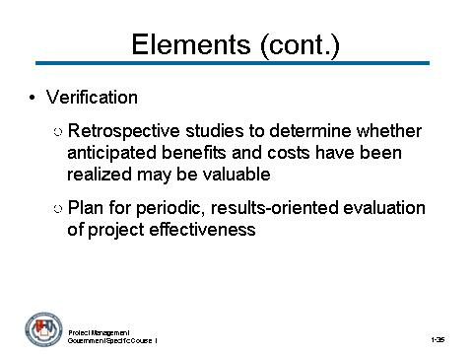 | Notes:

CONTENT TO BE PRESENTED:
Key Points:
Elements of cost- benefit analysis (continued)
- Verification
  - Retrospective studies to determine whether anticipated benefits and costs have been realized are potentially valuable. Such studies can be used to determine necessary corrections in existing projects, and to improve future estimates of benefits and costs in these projects or related ones.
  - Agencies should have a plan for periodic, results-oriented evaluation of project effectiveness.
  - They should also discuss the results of relevant evaluation studies when proposing reauthorizations or increased project funding.

Topic 4: Other Forms of Financial Performance Measurement (continued)

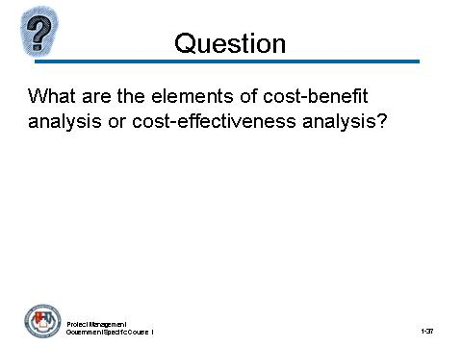 | Notes:

What are the elements of cost- benefit analysis or cost-effectiveness analysis?
Answer:
- Policy Rationale
- Explicit Assumptions
- Evaluation Alternatives
- Verification

Topic 4: Other Forms of Financial Performance Measurement (continued)

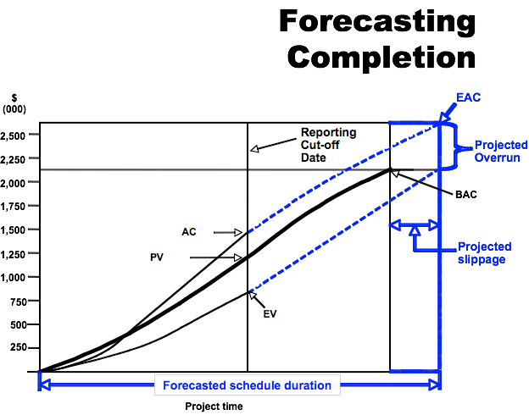 | Notes:

CONTENT TO BE PRESENTED:
Key Points:
Earned Value Management (EVM)
EVM is a tool considered by many in the project management community to be the best option currently available for holding all parties accountable for the effective management of large and complex projects.

Topic 4: Other Forms of Financial Performance Measurement (continued)

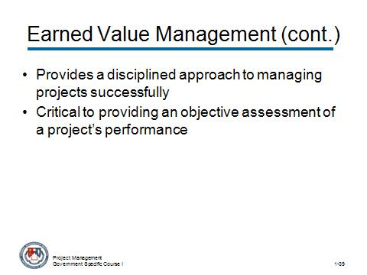 | Notes:

CONTENT TO BE PRESENTED:
Key Points:
Earned Value Management (EVM) (continued)
- It provides a disciplined approach to managing projects successfully through the use of an integrated system to plan and control authorized work to achieve cost, schedule, and performance objectives.
- The fidelity of the information produced by the EVM System (EVMS) is critical to providing an objective assessment of a project’s performance from which well informed management decisions can be made.

Topic 4: Other Forms of Financial Performance Measurement (continued)

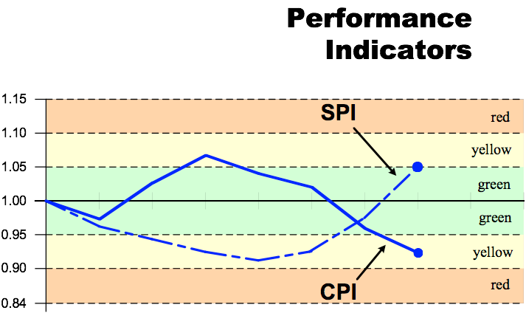 | Notes:

CONTENT TO BE PRESENTED:
Key Points:
Performance Indicators - EVM and Management Needs
A fundamental requirement for managing any major acquisition system is insight into the contractors' performance, specifically the management and control.

Topic 4: Other Forms of Financial Performance Measurement (continued)

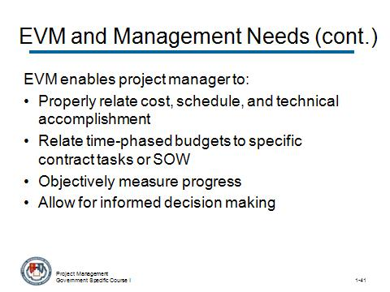 | Notes:

CONTENT TO BE PRESENTED:
Key Points:
Performance Indicators - EVM and Management Needs (continued)
Proper EVM implementation ensures that the project manager is provided contractor performance data that:
- Properly relates cost, schedule, and technical accomplishment.
- Relates time-phased budgets to specific contract tasks and/or statements of work (SOW).
- Objectively measures work progress.
- Allows for informed decision making and corrective action.
(continues on next slide)

Topic 4: Other Forms of Financial Performance Measurement (continued)

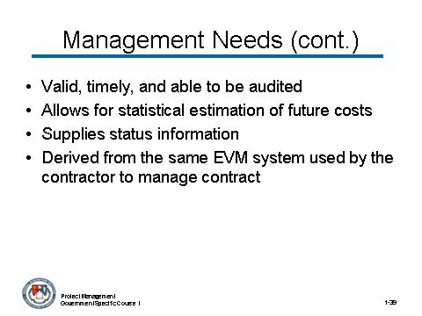 | Notes:

CONTENT TO BE PRESENTED:
Key Points:
EVM and Management Needs (continued)
- Is valid, timely, and able to be audited
- Allows for statistical estimation of future costs
- Supplies managers at all levels with status information at the appropriate level, and
- Is derived from the same EVM system used by the contractor to manage the contract.

Topic 4: Other Forms of Financial Performance Measurement (continued)

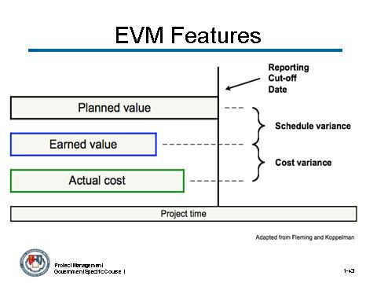 | Notes:

CONTENT TO BE PRESENTED:
Key Points:
EVM Features
EVM implementations for large or complex projects include many more features, such as indicators and forecasts of cost performance (over/under budget) and schedule performance (behind/ahead of schedule).
The most basic requirement of an EVM system, however, is that it quantifies progress using PV and EV.

Topic 4: Other Forms of Financial Performance Measurement (continued)

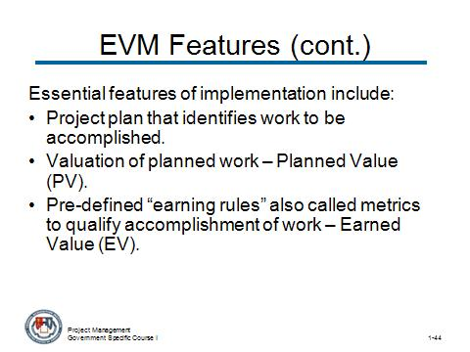 | Notes:

CONTENT TO BE PRESENTED:
Key Points:
EVM Features (continued)
- Essential features of any EVM implementation include:
  - A project plan that identifies work to be accomplished,
  - A valuation of planned work, called planned value (PV), and
  - Pre-defined “earning rules” (also called metrics) to quantify the accomplishment of work, called Earned Value (EV).

Topic 4: Other Forms of Financial Performance Measurement (continued)

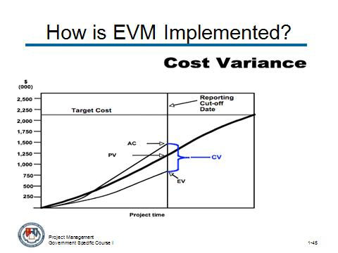 | Notes:

CONTENT TO BE PRESENTED:
Key Points:
How is EVM Implemented?
Cost Variance provides information for the implementation of EVM – highlighting target costs and project time against the reporting cut-off date.

Instructor Notes:
Review this chart and the following chart together to show the cost and schedule variances.

Topic 4: Other Forms of Financial Performance Measurement (continued)

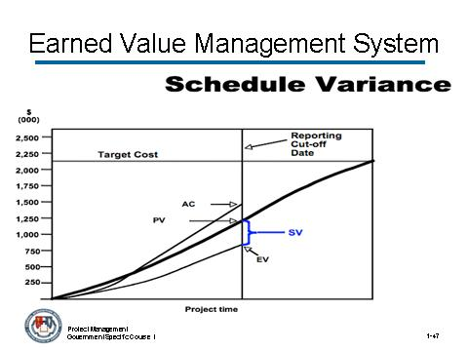 | Notes:

CONTENT TO BE PRESENTED:
Key Points:
How is EVM Implemented?
Schedule Variance provides information for the implementation of EVM – highlighting target costs and project time against the reporting cut-off date.

Topic 4: Other Forms of Financial Performance Measurement (continued)

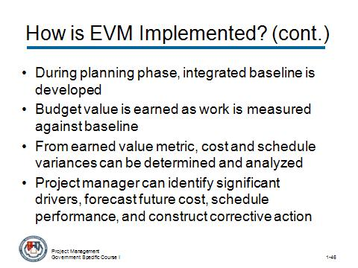 | Notes:

CONTENT TO BE PRESENTED:
Key Points:
How is EVM Implemented? (continued)
- During the planning phase, an integrated baseline is developed by time phasing budget resources for defined work.
- As work is performed and measured against the baseline, the corresponding budget value is “earned”.
- From this earned value metric, cost and schedule variances can be determined and analyzed.
- From these basic variance measurements, the project manager can identify significant drivers, forecast future cost and schedule performance, and construct corrective action plans to get the project back on track.

Topic 4: Other Forms of Financial Performance Measurement (continued)

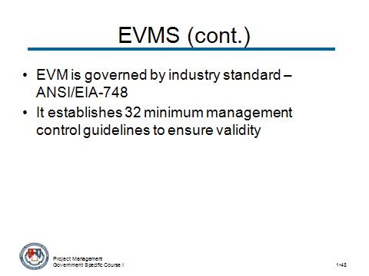 | Notes:

CONTENT TO BE PRESENTED:
Key Points:
Earned Value Management System (EVMS)
- The implementation and use of EVM is governed by an industry standard—ANSI/EIA-748, Earned Value Management Systems. ANSI/EIA stands for American National Standards Institute/Electronic Industries Alliance.
- The standard establishes 32 minimum management control guidelines for an Earned Value Management System (EVMS) to ensure the validity of the information used by management.

Topic 4: Other Forms of Financial Performance Measurement (continued)

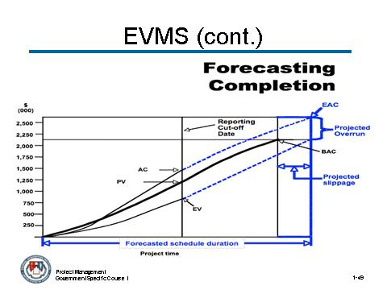 | Notes:

CONTENT TO BE PRESENTED:
Key Points:
Earned Value Management System (continued)
An EMVS can be defined as an integrated management system that allows for:
- Planning all work scope for the project to completion.
- Assignment of authority and responsibility at the work performance level.
- Integration of the cost, schedule and technical aspects of the work into a detailed baseline plan.
- Objective measurement of progress (earned value) at the work performance level.
- Accumulation and assignment of actual costs.

Topic 4: Other Forms of Financial Performance Measurement (continued)

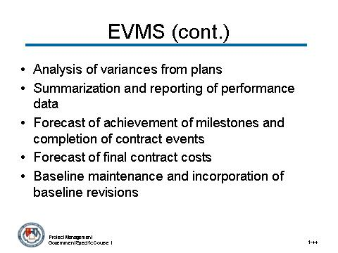 | Notes:

CONTENT TO BE PRESENTED:
Key Points:
Earned Value Management System (continued)
- Analysis of variances from plans.
- Summarization and reporting of performance data to higher levels of management for action.
- Forecast of achievement of milestones and completion of contract events.
- Forecast of final contract costs.
- Baseline maintenance and incorporation of baseline revisions in a timely manner.

Topic 4: Other Forms of Financial Performance Measurement (continued)

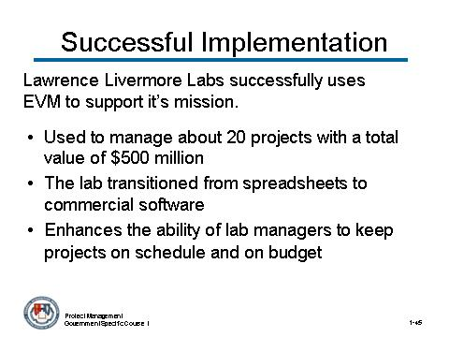 | Notes:

CONTENT TO BE PRESENTED:
Key Points:
Successful Government Implementation of EVM: Example
Lawrence Livermore Labs (part of the Energy Department’s National Nuclear Security Administration) successfully uses EVM to support its mission: to ensure that nuclear weapons are safe, secure and reliable. Some information about this example include:
- EVM is used to manage about 20 projects with a total value of about $500 million.
- In August 2005, the lab transitioned from spreadsheets to commercial software (Primavera Systems’ EVM suite) to simplify and automate project management.
- EVM enhances the ability of lab managers to keep projects on schedule and on budget.

Topic 4: Other Forms of Financial Performance Measurement (continued)

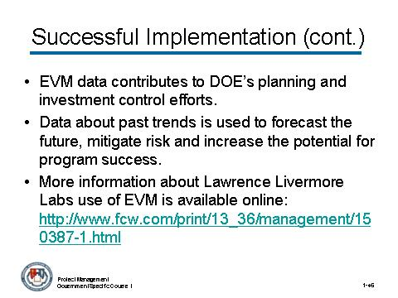 | Notes:

CONTENT TO BE PRESENTED:
Key Points:
Successful Government Implementation of EVM: Example (continued)
- EVM data contributes to DOE’s planning and investment control efforts. Data about past trends is used to forecast the future, mitigate risk and increase the potential for program success.
- Management wants to expand the use of EVM at Lawrence Livermore in the future.
- More information about Lawrence Livermore Labs use of EVM is available online:
http://www.fcw.com/print/13_36/management/150387-1.html

Topic 4: Other Forms of Financial Performance Measurement (continued)

Activity
Activity Purpose:
This activity is for the participants to review the elements of a successful Earned Value Management System program.
Activity Length: 5-10 minutes
Activity Instructions:
Read each statement to the class and ask participants to identify which ones contribute to the success of EVM (true), and which do not (false).
STATEMENT
_FALSE_ 1. It is best to keep EVM isolated within the project management area.
(It should be raised to the executive level, where important discussions can take place.)
FALSE 2. EVM managers and analysts require no to minimal training. It is a skill best learned on-the-job.
(Training is necessary in order to ensure that policies are enforceable and strong enough to make the whole set of management controls work.)
TRUE 3. Performance information, including cost and schedule variances, should be presented to senior management in nontechnical terms in order to increase executive accountability.
TRUE 4. Good, initial baseline data is essential in order for EVM to be an effective and valuable tool.
FALSE 5. The success of EVM can be measured on the amount of data that is generated.
(A successful EVM implementation is measured by how heavily the resulting data is relied on for use in management and oversight decision-making.)

Topic 4: Other Forms of Financial Performance Measurement (continued)

Activity (continued)
STATEMENT
FALSE 6. EVM can tell you if the outcome is the right one from a business perspective.
(EVM provides transparency in terms of project cost, schedule and performance. It should be used to educate an organization on why variances are occurring.)
TRUE 7. EVM compares baseline schedule and performance against the actual schedule and costs incurred.
TRUE 8. The biggest benefit of a mature, established EVM system is enhanced planning.
FALSE 9. The absence of an oversight agency is an asset to civilian agencies’ EVM efforts.
(The absence of an oversight agency could be an impediment to civilian agencies. In contrast, the Defense Contract Management Agency can certify Defense Department EVM systems and do analysis.)

Topic 4: Other Forms of Financial Performance Measurement (continued)

Instructor Notes:
This concludes the topic on other forms of performance measurement. After addressing any questions the participants may have, inform them that we will be moving on to the next topic: Module Review.

What questions do you have regarding other forms of performance measurement?

Topic 5: Review

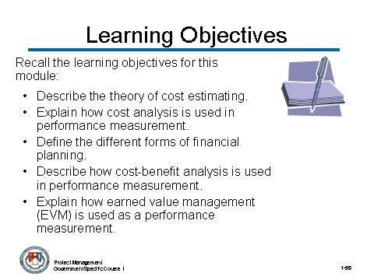 | Notes:

CONTENT TO BE PRESENTED:
Key Points:
Let’s review the learning objectives for this module on Introduction to Cost Estimating and Financial Management:
- Describe the theory of cost estimating.
- Explain how cost analysis is used in performance measurement.
- Define the different forms of financial planning.
- Describe how cost-benefit analysis is used in performance measurement.
- Explain how earned value management (EVM) is used as a performance measurement.

Topic 5: Review (continued)

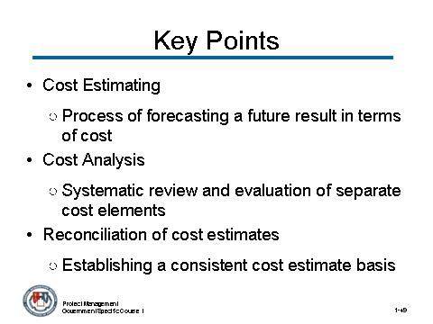 | Notes:

CONTENT TO BE PRESENTED:
Key Points:
Let’s review some Key Points in this module:
- Cost estimating is:
  - The process of forecasting a future result in terms of cost, based upon information available at the time.
- Cost analysis is:
  - The systematic review and evaluation of the separate cost elements, judgmental factors, and profit and/or fee that, when added together, constitute contract price.
- Reconciliation of cost estimates
  - Establishing a consistent cost estimate basis allows for fair comparison.

Topic 5: Review (continued)

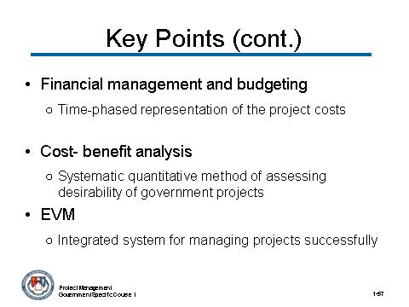 | Notes:

CONTENT TO BE PRESENTED:
Key Points:
Let’s review some Key Points in this module:
- Financial management and budgeting
- An important part of financial management is budgeting where a project budget is a time-phased representation of the project costs to be spent
- Cost-benefit analysis is:
  - A systematic quantitative method of assessing the desirability of government projects or policies when it is important to take a long view of future effects and a broad view of possible side-effects.
- Earned value management provides:
  - A disciplined approach to managing projects successfully through the use of an integrated system to plan and control authorized work to achieve cost, schedule, and performance objectives.

Topic 5: Review (continued)

Instructor Notes:
This concludes Module 7 – Introduction to Cost Estimating and Financial Management. Address any questions the participants may have before moving on to Module 8 – Cost Estimating.

What questions do you have about Module 7 – Introduction to Cost Estimating and Financial Management?

