Day 2
Multidisciplinary Workgroup Reports

Day 2 - Multidisciplinary Workgroup Reports

National Plan and Strategic Process

Operational Procedures and Processes

Training
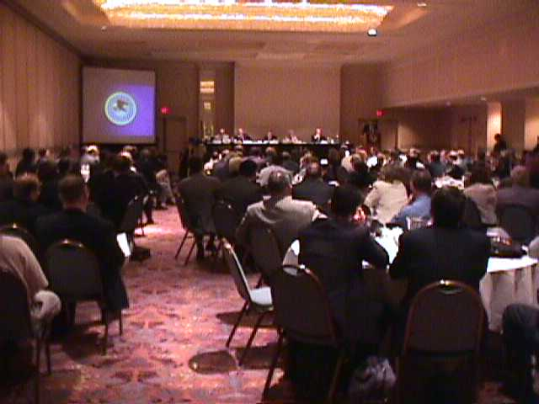

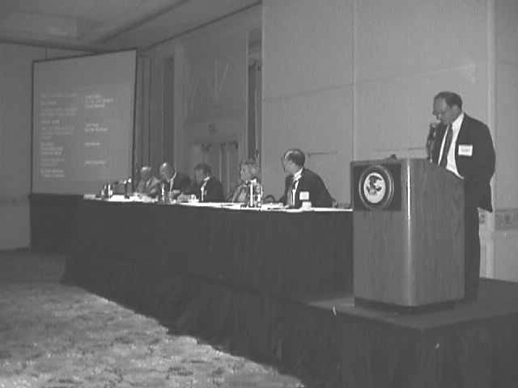
Equipment

Communications and Intelligence

National Plan and Strategic Process

This group was charged with developing recommendations for the Attorney General to address the development of a national plan and strategic process for responding to terrorism.

Needs and Strategies:
Need:
Prepare local communities to respond to terrorist acts. Ensure that a coordinated Federal, State, and regional system exists to support local response capabilities, including those of Native American tribes.

Strategy:
The group then recommended the following:

- The President of the United States will identify a single Lead Federal Agency (LFA) to implement a domestic preparedness plan and strategy. This agency will define and coordinate the programmatic roles and responsibilities of all Federal agencies.

- The LFA will also establish a national advisory group drawn from all jurisdictional stakeholders.

- Within 6 months, the LFA, with the advisory group, will produce a comprehensive systemic plan for implementation of:

- Training
- Equipment Delivery
- Infrastructure
- Intelligence Sharing
- Operational Processes and Procedures
- Sustainment Program
- Public Awareness

- In so doing, the LFA and advisory group will operate a “two-track” system; i.e., efforts currently under way will continue and any newly identified strategies will be an overlay to what is currently taking place.

Discussion:
In arriving at this needs statement and the recommendations that flowed from it, the group also discussed the following:

- One participant asked if another Federal model exists that could be replicated in the effort to respond to terrorist attacks. Programs mentioned included National Aeronautics and Space Administration (NASA), the interstate highway system, the War on Drugs, and Emergency Medical Services (EMS). However, other participants pointed out that some of these efforts involved only one agency rather than the multi-agency response that a terrorism incident would entail.

- Group members do not believe that jurisdictions currently have the necessary infrastructure to respond appropriately to disasters and terrorist attacks. The national plan must determine the acceptable level of risk and how that risk could be mitigated. Resources currently in inventory and resources needed should be identified. An equitable means to fulfill these needs must then be found.

- Development of the national plan should be accelerated. The sense of urgency needs to be communicated to leaders.

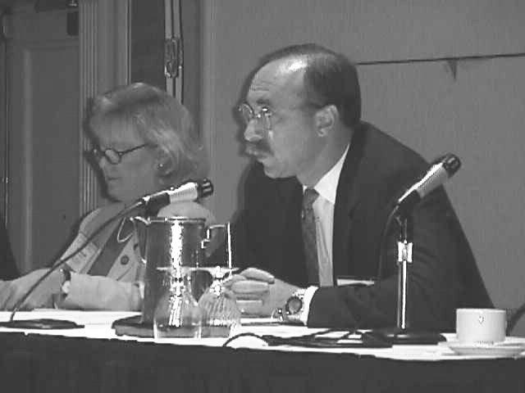
- Programs currently before Congress represent only half the nation. An approach that encompasses city, suburban, and rural concerns is required.

- The national plan should address the roles of all agencies at all levels in order to eliminate both the ambiguity that exists regarding those roles and the conflict that often results when different agencies must work together. If agencies are to work together effectively, they need to be willing to go beyond and outside “their box” in order accomplish their mutual goals. For example, the Federal Bureau of Investigation (FBI) currently does not want to be involved until it is assured that a terrorist incident has taken place.

- While recognizing that many of these agencies are involved in good work, participants noted a lack of communication and focus among Federal agencies. However, this lack of communication and focus results in multiple agencies with multiple strategies who disseminate multiple messages.

- Once a LFA is named, a lead agency needs to be named on the local level. The LFA needs to communicate that a credible risk exists to all levels of government. The Attorney General or another high-level Administration official also needs to address the nation’s Governors and the mayors of large cities to educate them regarding the terrorism threat. Leaders must recognize that this threat is unlike anything except war. Unlike war, however, terrorism is a continuous problem and not always a crisis situation.

- In addition to educating leaders, responders and the public also need to be informed.

- A political consensus must be reached regarding what constitutes success in the fight against terrorism. If an incident does not occur, leaders will only know that efforts have been successful by charting the progress made in this area.

- Hospitals are unprepared for a terrorist incident. Currently, most institutions cannot handle one or two decontamination patients at once, much less the onslaught that would result from a terrorist attack. Hospital administrators do not realize that terrorism is an issue. Hospitals also lack the funding sources to support their response to such crises.

- One agency needs to be given the responsibility for overseeing the tracking of HAZMAT incidents and outbreaks of infectious diseases.

- The nation needs a system that addresses pre- and post-incident occurrences.

- Interdiction and prevention are not the issues the plan most needs to address. Rather, the focus is on preparedness and the ability to respond.

- All jurisdictional levels need to be consulted in developing the national plan and strategy, including the 521 sovereign nations (Native American tribes).

- Just as the EMS is driven by patient needs, the national plan should be driven by the needs of first responders.

- Preparedness and the ability to respond cannot be terrorism specific. The system must be able to respond to any large-scale crisis.

- Even when a single LFA determines training needs, the training should be done through normal channels.

- Participants stated that Presidential Decision Directive (PDD)-39 is not specific enough. Others believe that PDD-62 needs to be brought down several levels.

Operational Procedures and Processes

The multidisciplinary workgroup on operational procedures and processes identified three top needs and provided a justification statement and action recommendations for each.

Needs and Strategies:
Need:
The nation needs to develop a standardized, coordinated, integrated response system. Existing Federal, State, county, tribal, local, and private operational processes and procedures to plan for and respond to terrorism are not coordinated, lack standardization, and need proactive, planned collaboration.

Strategy:
A Federal task leader should be assigned to develop the system, which should:

- Include common principles of the widely accepted command systems.
- Be tied to grants.
- Include an implementation plan.
- Mandate legislation.
- Include planning guidance.
- Be inclusive, including particularly the private sector and the health care community.
- Be funded.

Need:
The nation needs procedures and protocols for sharing threat assessment and information. Sharing critical information in a timely manner will save lives, prevent human suffering, and mitigate great property damage.

Strategy:
- Adopt a national policy for threat-based information sharing.

- Establish a multidisciplinary task force to develop criteria and protocols for sharing critical information.

Need:
The nation needs to integrate the health-care community into the planning, evaluation, and implementation of the response to terrorism. The health-care community is not fully integrated into current terrorism response planning and, therefore, is not able to provide the greatest good for the greatest number.

Strategy:
The Public Health System’s (PHS’s) implementation of terrorism response measures should be tied to Medicare and Medicaid reimbursement as an incentive to compliance. This connection should be mandated and accomplished through legislation.

Discussion:
The priorities stated above were articulated during a discussion based on needs and proposed strategies identified on Day 1. Summary comments from this discussion are as follows.

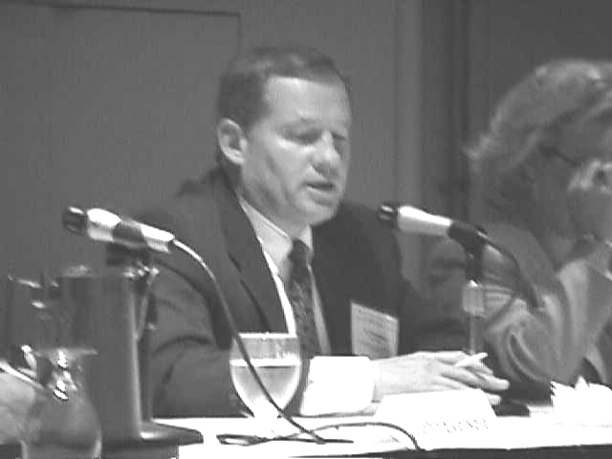
- We need a standardized system for how we manage disasters. The system must be mandatory. One effective way to achieve compliance is to tie participation to eligibility for disaster relief funds. Additional suggestions are to tie the system to the grant process, provide an implementation plan, and mandate the system.

- To be truly integrated, the Incident Command System (ICS) should include the hospitals. The system must be standardized and must include all disciplines. A system is already mandated, according to 1910.120.

- The Department of Defense (DoD) has their own command systems and will not play by civilian rules. The concepts are the same, but the terminology is not common.

- The beauty of a standardized system is that it will have across-the-board benefits that will encompass more than just terrorism.

- It would be helpful to have all Federal agencies follow whatever incident command system is adopted. We need one national model to follow. It should be a national blueprint or planning guidelines that can be modified for each State and region. The idea behind the ICS was that when another stakeholder came in, they would know where they fit. ICS is flexible and can accommodate all stakeholders.

In California, the initial resistance to the State ICS was very strong. In particular, Los Angeles law enforcement was opposed, but it has worked anyway.
ICS is incident specific. A terrorist act can create incidents within incidents.

This is why the California system was developed. The plan is scaleable, so multiple incidents can be managed. The operations and logistics officers know who to call. All disasters are local. Then the State gets involved, then the Federal Government. Weapons of mass destruction (WMD) is different, so it is critical that all Federal responders who arrive on the scene speak the same language.

- There is still a need for operational planning, but the needs statement today should focus on organizational and structural planning.

- The main flaw in the FEMA system is that is does not allow you to go straight to the FBI.

- We are all saying that the Federal Government at all levels needs a well-coordinated, well-integrated response capability. The Government needs to set minimal standards and terminology that will work with all those who will be involved: volunteers, private industry, etc. It is not just a government issue.

- The nation needs a coordinated and integrated response capability.

- The need isn’t for a response capability; the need is for a management system, a standardized management system.

- A more encompassing statement would be “Existing Federal, State, local, and private operational processes and procedures to plan for and respond to domestic terrorism are not coordinated, lack standardization, and need proactive, planned collaboration and information sharing.”

- Bullets two and three are out of context from how they were used in yesterday’s discussions. If we try to use them in this need statement, they won’t fit. We could have two overarching needs, one to do with a standardized emergency management system or structure and the other with a planning and equipment capability. One statement should not try to cover everything.

- Add county to the need. Add Indian Nations.

- Try to turn the negatives into positives.

- The group decided to develop a “why” statement as a justification and then back into the need statement.

California used a problem statement that is a variation of the “why” statement being discussed. “Most disasters and emergencies are handled by local and State agencies. They are only escalated to the Federal level when they exceed response capabilities within State; however, in the event of a WMD incident, agencies at all levels of government immediately have roles and responsibilities. Unfortunately, the relationship between these agencies has not been clearly established, which could lead to miscommunication and confusion during an actual event.” The statement explains why we need a standardized system, so we can communicate with the Federal level through a single point of contact (POC).

- It is important to state that we are not advocating that the Federal Government adopt what California has done. We are advocating that the Federal Government should go through the process that California went through to create a standardized system. Eventually, California might have to change its plans to conform to the new system.

- From a Federal perspective, it is important to endorse the need for the development of a system. The 10-year experience with the U.S. Coast Guard (USCG) after the Exxon Valdez incident has shown that it takes a long time to develop a response management system that incorporates common language and standards of things like Incident Command.

- The United States needs to develop a coordinated, integrated response management system.

- Keep it general, and follow with specifics like Incident Command and the other systems that are out there.

- Add “that would include the common principles of the ICS.”

- Also list some of the others: Incident Management System (IMS), National Integrated Incident Management System (used by the USCG).

- If we have the commonality of the principles of Incident Command, it can be worked out within that general category of Incident Command.

- Just say “and other widely accepted command systems” to get the idea across that the best of multiple systems is being used.

- Incident Command includes common structures that include planning and logistics. The common structure should address operations, logistics, planning, finance, general structure. Common terminology follows.

- Keep the need simple. What we are talking about now is the “why.” The “how” would be assigning some Federal department the responsibility over a specific time period to bring together groups of people from around the country to work out the plan. This group would bring all of the various systems in; we don’t need to list them.

- We should also make a statement about the funding needed. Funding is a separate issue. The bottom line is that we need to have an emergency management system we can all live with, that everybody uses. The “why” is because we don’t have one now. The “how” is there needs to be a Federal agency that puts together a task force that includes all the stakeholders. It should be a consortium of stakeholders. Funding is a big issue. At the State level, we don’t feel like we have any say. Funding decisions are being made at the Federal level without State input.

- The military side has been tried and tested. It works, and it will mesh. The key element is the early dialog between the military commander and the Incident Commander (IC), or the powers that be at the level that are injecting the resources.

- It needs to be inclusive: an interrelated and interdependent system. Incorporate the private sector.

- Again, single POC on the bulleted list is out of context. It refers to confusion about who is in charge at the Federal level. The Federal Government needs to clean the process up and communicate it to the State and locals. This issue does not really belong on this list.
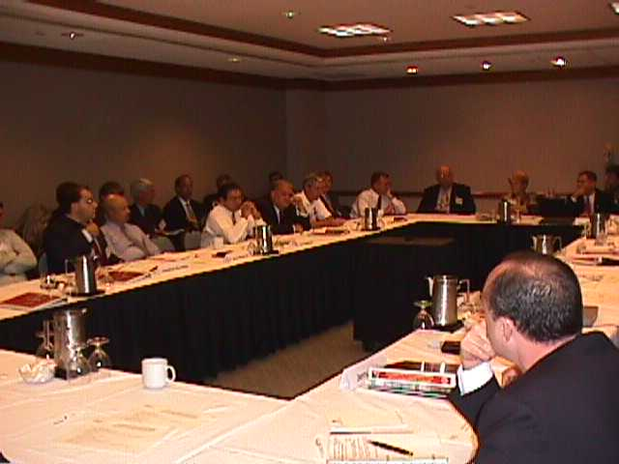
- A better term might have been a single point of coordination. It could be a task force or a body.

- We need a source. If people are coming in with rashes or diarrhea in a regional or multi-State area, we need a place to call, a contact point with the Federal Government. A chain upward and back down.

- Several bullets have an EMS focus. We could have a second needs statement that is broad and articulate some of these bullets under it.

- The National Response Center (NRC) could be the point of contact for information coming in during an incident.

- A time-specific information sharing plan is needed to monitor, for example, 911 calls to look for patterns, call hospitals, which call each other and then call Federal officials: some time-specific mechanism to alert red flags from the bottom up without waiting for an alert from the top down.

- The intelligence sharing bullet can have an entirely different meaning. The Fire/ HAZMAT group interpreted the main point as wanting to know in advance if a community threat was imminent.

- We should be talking about information and intelligence sharing writ large. Procedures and protocols for threat assessment, intelligence, and information sharing. It is part of the big plan. We need a common structure and then a common plan.

- The justification/why statement must be well crafted because it is not the nature of law enforcement to give up information. We need to express clearly why information sharing is important to the EMS community.

- The United States needs procedures and protocols for threat assessment, intelligence, and information sharing.
- The States are working on these issues. It needs to be integrated, expanded all the way from local to the Federal. The Centers for Disease Control and Prevention (CDC) already is a system. We need an expansion of the system to make it more aggressive in terms of surveillance.

- Information sharing before an event is also important. State and local levels need information early. Sources do not need to be compromised or information told that compromises national security. We need a formalized structure for cutting information loose sooner. There is an inherent problem. We don’t need the details that would compromise security, but we do need to know about the possibility, the threat.

- A policy of information sharing has to come first; systems and processes follow. It must be a life safety issue.

There Are Two Issues: One is reporting and monitoring; the other is pre-intelligence sharing.

1. It won’t happen. No matter what the policy is, everything is local. Law enforcement is only going to give the information they think you need to have. Who decides the need to know?

- At the national level, they have said that life safety is the priority over capturing the bad guy.

- There has to be a way to narrow it down to where information is still on a need to know basis but happens more often.

- Let’s tell the Attorney General what we’d like to see happen, not what shouldn’t happen. There is going to be a national shift, just like we saw changes in the military.

- You go for the gold, and then you build something acceptable. You establish criteria. There is a filtering process that takes time. But if we don’t have a policy that says that information needs to be shared, they definitely aren’t going to do it.

- The medical surveillance needs to be linked into the information sharing for first responders. It is a two-way process. Information needs to get into the right channels so it can be integrated.

- There needs to be a way to tie police and fire into the public health system.

Suggested Language: Policies, procedures, protocol, and criteria need to be developed on an integrated system-based process to share threat, intelligence, and post-incident information to the first responder community including a system of monitoring and reporting incidents related to medical and health surveillance.

- You’ve got to identify the threat and get the information out before it becomes a bigger problem.
- The word “intelligence” has different meanings for different groups. It will be a road block. We need a different word. We won’t get classified information, and we certainly won’t get raw intelligence. We want threat-based information that will help us prepare.

- We need procedures and protocols for threat assessment, threat-based information, and information sharing.

Fatality Management: A task force is needed to deal with it. Department of Health and Human Services (DHHS) is doing that.

- Medical community needs to get up to catch up with the Fire Community on weapon of mass destruction (WMD) preparedness. It’s a need that should be addressed.

- Disaster management is the genesis for all this. Now we’re talking about a more overwhelming number of people.

- The issue is communication. A firefighter knows who to tell, a nurse on the 3:00 a.m. shift does not know where to go with information. We need a national coordination system for hospitals.

- We need integrated information sharing among all disciplines: multidisciplinary integrated information sharing.

- A big missing link in the nation’s ability to deal with a mass casualty is for-profit hospital care providers. They don’t want to participate in any preplanning for WMD. In Houston, this has caused roadblocks in trying to establish our medical strike team. It is a national issue that needs to be addressed in the public health system. There is talk about tying it in to their accreditation. Tie it to Medicaid/Medicare reimbursement. The “incorporate private sector” bullet can encompass private hospitals.

- There is a need to distinguish between information sharing among responders (signs and symptoms) and awareness that there is a problem and that we need to deal with the issue of terrorism. Awareness and public education.

- We need to properly educate people at different levels throughout the country: first responders, the public, legislators.

- Medical supplies, caches, replacement are a policy and procedure problem that must be addressed.

- If we are going to use the grant system, more lead time is needed. (e.g.; it can take a week to get a mayor’s signature; 2 weeks is not enough time to complete the process.)

- The nation needs to develop a coordinated and integrated standardized response management system. Including common principles of the other widely accepted command systems.

Justification: Existing Federal, State, Tribes, county, local, and private operational processes and procedures to plan for and respond to domestic terrorism are not coordinated, lack standardization, and need proactive, planned collaboration and information sharing.

Take out domestic; could be international. Lose information sharing; is covered under another issue.

The Why’s: We want it to apply to all disciplines, reconcile all the plans; apply universally, have wide applicability and benefit, integrated planning and implementation (all levels).

The “how” has to be legislated by Congress as opposed to initiatives out of Department of Justice (DOJ) or Defense (DoD).

How: We want a Federal task leader tied to reimbursement, tied to grants, done by a consortium of stakeholders.

- Implementation plan to be mandated by legislation.

- Planning guidance to be inclusive (the private sector, including medical community).

The nation needs procedures and protocols for sharing threat assessment and information.

The issue is that the information is out there; there are just no procedures for getting it to us. They get ready, but we don’t.
The policy should be the recommendation: a policy for information sharing.

There have to be legal recommendations.

We need to articulate the why along with the need and the recommendation. Ramping up (preparedness) and life safety are the why.

To save lives, prevent human suffering, and mitigate great property damage, we need to share critical preincident threat-based information.

It is people we are trying to protect: first responders, fire, law. The military has acceptable losses, but the civil community does not have this outlook.

Add in a timely manner.

How: National policy for threat-based information sharing. The subsets are the process, protocols that allow them to implement the policy. We need a multidisciplinary/agency task force to develop protocols and procedures so the interests of law enforcement, health, fire, etc., are represented.

We scratched the public information/ public education campaign.

We Have Two Main Recommendation Areas: We should define health as the third critical issue/need.

The nation needs to integrate the health care community into the planning, evaluation, and implementation of the response to incidents, including terrorism.

Why: The health care community is not fully integrated into current terrorism response and as such is not able to provide the greatest good for the greatest number.

We need awareness, education, and training.

Training

The Training Workgroup developed a consensus on the following priorities for domestic preparedness. The most significant needs identified by the group and recommendations suggested by the group follow.

Needs and Strategies:
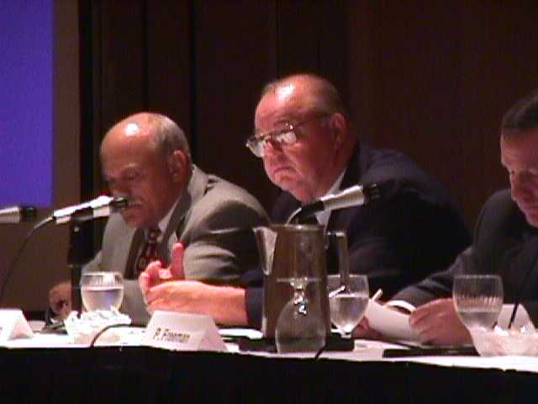
Need:
All emergency responders and managers including public and private entities need timely sustainable training at the appropriate level for weapons of mass destruction (WMD) incidents.

- There is no coordinated Federal training program for WMD:
- Multiple Federal versions of training curriculums are not the same (Department of Defense [DoD], Department of Justice [DOJ], Federal Emergency Management Agency [FEMA], Department of Transportation [DOT]).
- Certain training programs do not cover key segments such as health providers.

Strategy:
- Develop a single, integrated Federal training program based on needs assessments. It should be a core curriculum and have tiers appropriate for first responders, medical and hospital personnel, emergency management personnel, and State and local elected officials.
- Use the national standard (National Fire Protection Association [NFPA] 472, 473) as the basis for training.
- Coordinate with the Department of Health and Human Services (DHHS) on mandatory health care provider training dealing with WMD.
- Use existing training delivery mechanisms when available (do not reinvent the wheel).
- Integrate new modules into existing structures.

Need:
We need a sustained training and exercise effort. For example there is about a 20 percent turnover rate for firefighters. Additionally, there is a need for remedial, ongoing training.

Strategy:
- Funding for ongoing local training.
- A plan to update training materials regularly.
- A method for the funding to get to local jurisdictions.

Need:
Identify what training and exercise efforts are being planned and conducted and get the information to the response community.

Strategy:
- A single source clearinghouse should be established for research and development that includes training descriptions, availability, and schedules.
- DOJ should designate the director of the clearinghouse.
- The clearinghouse should have a feedback loop and act as a channel for two-way communication between the Federal Government and State and local jurisdictions.
Need:
It is a priority to provide training to State and local jurisdictions. Too much funding is staying at the Federal level and not enough is going to or getting to State and local jurisdictions. Reduce redundancy in training programs and in dissemination of those programs. Training must reach more local jurisdictions faster. Timing is key; many first responders need training and need it as soon as possible.

Strategy:
- Conduct a serious review of all funds available and how they are spent.
- Allocate dollars for local personnel costs associated with training. This includes the cost of substitute personnel when local first responders attend training and exercise efforts.

Background Discussion:
Most of the workgroup’s discussion centered around refining the wording of the issues that the group agreed upon, reflected in the consensus report.

The facilitator first asked the group to list what was missing from the outline of issues from the first day of the conference. The training workgroup listed the following.

- Timeliness of training.

- Use existing mechanisms.

- Training should be based on needs assessments with a tiered approach to training and different levels of training for different staff.

- Fill in gaps in training based on needs assessments.

- One problem with public information campaigns is that public information people may polish the information too much. They must use fact-based information and maintain a balance of clear information versus scaring people, include private industry in training. Training can be tuition based or grant subsidized.

- Another funding issue related to the provision of training is to fund transportation and other expenses for those who attend training and to fund substitutes for their jobs (e.g., firefighters, law enforcement officers).

Next, the group discussed their overarching statement about training, which led to a discussion of related issues. They had the following comments:

1. All emergency responders, including hospital personnel, need to be adequately trained. All response elements need appropriate levels of training for WMD terrorist incidents. Adequate training needs to match specific individuals’ level of responsibility.

2. Everyone needs to be educated. This could happen anywhere. The level of awareness needs to be pervasive.

3. Professional responders need to be trained at the appropriate level. This includes all personnel who are involved in mitigating WMD terrorist incidents.

4. All emergency responders and managers including public and private entities need appropriate training in a timely manner, including sustained, ongoing training. We need a core curriculum that can be fit to specific communities through needs assessments.

5. Use a single standard for training based on NFPA 472 and 473 (EMS).

6. Regarding training of hospital personnel, it is not National Hospital Accreditation that is the problem. It is that hospital staff are not trained. Although PHS is developing a training for medical personnel, such training should be mandated. Existing training delivery mechanisms.

7. Make this another standardized training like CPR with recertification on a regular basis. Hold governors accountable.

8. There is a precedent under DOT legislation that 75 percent of every Federally funded dollar must get to the local jurisdictions. Workgroup participants expressed concern that some cities can get access to Federal funding directly. They recommended that States be included and involved in the process and administration of funding.

The remainder of the Training Workgroup session was spent on refining the wording and focus of the key issues.

Equipment

The multidisciplinary Equipment Workgroup identified a clear and specific need and recommended several important strategies for significantly enhancing the nation’s ability to counter terrorist threats.

Needs and Strategies:

Need:

We need a better system for communications and intelligence.

Strategy:
The group recommended the following strategies:

- Support creation of a nationwide, standardized communications system that addresses:
- Interoperability among responders.
- Secure access.
- New technology.
- Sustainability.
- Removal of regulatory impediments.
- Funding.

- Improve the intelligence-sharing process to reflect an understanding of the real-time roles and responsibilities of local, State, and Federal governments before, during, and after a terrorist event.

- The system should be discipline-specific, but each discipline has a need to know. These needs can be addressed without affecting National Security.

- Share information. Information sharing is preparatory, preventive, and responsive.

Discussion:
The Equipment Workgroup extensively discussed a number of issues and possible courses of action intended to answer open questions. That discussion is captured here:

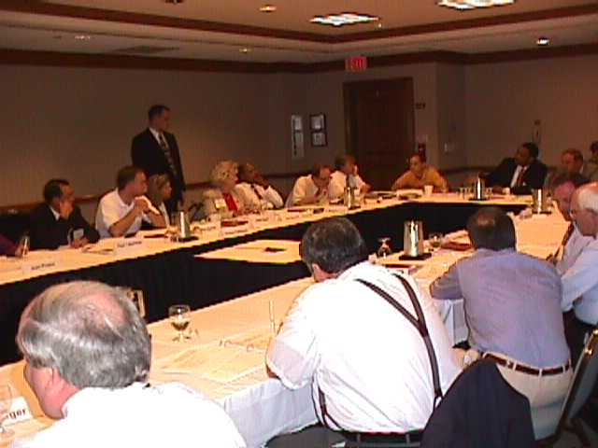
The group addressed the issue of standardization of personal protection equipment (PPE), with the goal of assuring that first responders are provided with the best available protective equipment. To accomplish this, local communities will need Federal support or guidance in determining their equipment needs, identifying the specific equipment that meets those needs, and purchasing equipment at fair and affordable costs.

- Comment: “You don’t want to have every community research and set specifications. We don’t want to reinvent the wheel every time.”

Several challenges were identified:

- PPE vendors are constantly developing and marketing new equipment, which makes it difficult for individuals at the local level to remain familiar with current technology or to know the capabilities of specific pieces of equipment. Group members expressed frustration with the constant evolution of PPE, which tends to make equipment purchases obsolete within months after it is acquired. Participants called for greater Federal involvement to avoid costly redundancy by responders. Also, it is difficult for purchasers at the local level to know if the prices quoted by vendors are fair and appropriate.

2. Comment: “It is hard to know what you really need.” “You are always concerned about being gouged by vendors.”

- States have different mandates and different standards. Thus, equipment will differ from State to State. National standards would be beneficial. Standardization will have to be a long-term goal, since communities will replace equipment only as it reaches the end of its useful life cycle. New purchases should be integrated with local communities’ current equipment assets.

- Standardization is more likely to occur as a result of consensus, rather than propagation of formal standards by a standard-setting agency.

- PPE purchased for use in terrorist incidents must also be useful in the day-to-day incidents faced by first responders. Communities cannot afford to purchase equipment for rare, one-time occurrences.

- The needs of local first responders vary significantly from geographic region to region. For example, weather-related challenges are drastically different in Honolulu, Chicago, or Anchorage. Thus, exact equipment needs vary from region to region. Each community must determine the needs of local first responders.

- Standardization of equipment could have the adverse effect of reducing competition among vendors and thus stifling innovation.

- Standards must be performance-based, enabling manufacturers to determine how they chose to meet those performance levels in their own equipment lines.

The group determined that a valuable commodity for local communities would be up-to-date information on equipment and performance testing data. Participants noted that Department of Defense (DoD) and Metropolitan Medical Strike Teams (MMSTs) have developed equipment lists and that most equipment has already been tested by some Federal agency. Access to this information would save time and money for local communities.

Not all first responders will need the same level of protection, and communities must identify the level of threat faced by different responders. Hazardous materials (HAZMAT) responders will need the highest level of protection (Level A, fully encapsulating, vapor protecting); firefighters need a different level of protection (Level B, self-contained breathing apparatus (SCBA) and splash protection); and emergency room (ER) teams would need a lower level of protection (Level C, air purifying and splash protection, or Level D, splash protection) and, in fact, would not be able to work on patients if they are outfitted in more protective equipment.

It is also useful for planners to assess each element of a terrorist event and determine what levels of protection would be needed to respond effectively to each element of the event. Each type of responder—fire/ HAZMAT, law enforcement, Emergency Medical Services (EMS)/medical—must assess what type of equipment would be needed and recommended for their roles in a weapons of mass destruction (WMD) event.

This discussion culminated in development of a recommendation for creation of a Federal workgroup to develop a matrix of protective levels of equipment to address different levels of risk. This work should be integrated with other agencies already working in the area of protective equipment, such as the Environmental Protection Agency (EPA) and DoD.

Excess military equipment is a potential source of PPE for local communities, but there are significant barriers to use by local first responders. Military equipment is not designed to meet requirements for civilian equipment established by Federal agencies such as Occupational Safety and Health Administration (OSHA) and EPA. Changes in these Federal regulations would be needed to permit use of military equipment by civilian first responders. In addition, Seattle Fire Department officials stated that they chose not to use military equipment, because it does not provide the best level of protection for the range of incidents that the department’s HAZMAT personnel encounter.

The group also identified concerns about costs and purchasing policies as a major area in which local communities could use assistance.

Standardization would be helpful in reducing costs through volume purchasing and standardizing pricing, but, as noted earlier, it was feared that this might result in loss of innovation and competition among vendors. In addition, some participants noted that local communities could negotiate lower prices than the Federal Government, even though they have limited resources to draw on.

3. Comment: “I can beat $450 claw hammers every day.”

Equipment needs are not uniform from geographic region to region, again working against standardization of equipment.

The panel concluded that what local communities need is not mandatory equipment lists, but rather more information about equipment available, levels of performance, and testing results. Information should also include guidelines on levels of protection needed for different responders and different exposures, and the equipment needed to achieve those levels of protection.

With that information, each local community can and will make individual decisions about the levels of protection to be provided to different responders. But first those communities will need information about levels of risk, performance of equipment, and costs.

Hospital preparedness to address a terrorist incident was a major concern raised by the Equipment Group. Preparation to protect medical personnel and handle and treat arriving patients is sporadic and erratic from facility to facility.

4. Comment: “There is a patchwork of disparate preparedness in hospitals across the country.”

Among the concerns identified were:

- The ability to handle contaminated patients is not required under hospital accreditation programs. HAZMAT regulations only address preparedness to respond to incidents occurring within the hospital. Hospitals need to employ specialists in HAZMAT and chemical and biological agents and need to work with and draw on the expertise of other responder agencies in their local communities, including fire/ HAZMAT and law enforcement. There is no consistency of efforts to coordinate with other agencies; some hospitals work with fire and police departments, others do not. Many hospitals do not have policies, plans, or training to deal with potentially-contaminated victims of a terrorist incident who self-refer and walk into the hospital ER. Once inside a hospital facility, a contaminated patient could seriously compromise the hospital’s ability to handle either its routine caseload or the patient load from the terrorist incident.

- The group determined that first responders are very vulnerable when they encounter a situation without knowing what WMD agents are involved. A critical requirement for responders is to determine the agents involved; thus, at the onset of an event the most critical need is detection equipment.

5. Comment: “Most of the time we are going into an unknown situation.” “Detection equipment is critical, and it is very expensive.”

Detection equipment is an area in which the first responders want access to the best equipment, education, and training available, and they want to see greater support from Federal assets. Detection equipment is critical to handling the initial stages of an incident and this equipment is very expensive. State National Guard units and regional Reserve units could be a source of this expertise and equipment.

The group identified a need for greater cooperation between Federal military units and State and local communities. National Guard units can work with the State in an emergency; Reserve units are available only in Federalized incidents.

Military resources can also be used for training of local first responders and can be the location of caches of equipment and pharmaceuticals for use in a major incident.

There was an identified need for changes in Federal policy that would enable creation of mutual aid pacts among local communities, States, and military units in the region. These types of agreements already exist in some communities. Group participants emphasized that this type of support is effective only if it is arranged and organized in advance and a point of contact (POC) individual identified; efforts to draw on military equipment in an emergency will encounter significant delays otherwise.

6. Comment: “We need to integrate our assets for better use of assets in rapid time.” “When using Federal assets, if you discuss it in advance, the response is better.” “You need POCs at the Guard, the Reserves, the State, and the local levels. You have got to put the team together.”

It was also emphasized that, because of timing, National Guard or Reserve personnel will rarely be the first responders to an incident. However, these units can be important in protecting second responders, especially hospital ER facilities and medical/EMS personnel. For example, these units can perform detection and decontamination at the hospital, particularly with self-referred patients who attempt to walk into the ER.

Local communities must always bear in mind that the military’s first responsibility is national defense; in the event that a National Security incident coincides with a local incident, military equipment will probably not be committed locally.

It is not possible to expect every community to prepare for a “doomsday scenario.” The task of the local community is to prepare to handle the first 24 hours of an incident (8 hours critical) until State, Federal, and military assistance is mobilized and arrives on the scene. The Federal Government should be the contingency beyond reasonable local risk.
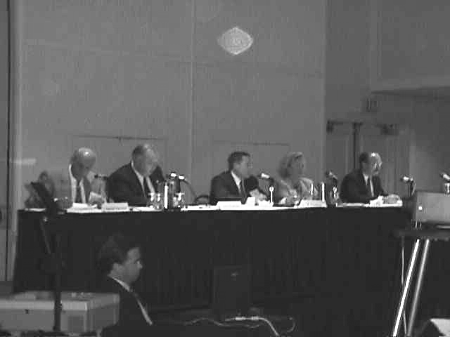
Civilian use of some military equipment (such as Military Protective Overgarment [MOPP] gear or vaccinations) is prohibited, because that equipment does not meet Federal standards for civilian use, for example, OSHA, National Institute of Occupational Safety and Health (NIOSH), Food and Drug Administration (FDA), the Nuclear Regulatory Commission (NRC).

Chemical agent detectors contain small amounts of radioactive material, thus civilian users will need clearance of the equipment from the NRC to use those detectors.

7. Comment: “We can’t wait a year for NIOSH to assess the detectors and determine that the equipment is usable.” “You are exposed to more radiation by a box of smoke detectors.”

The group suggested that DoD take responsibility for getting regulatory clearance for civilian use of its equipment. At the same time, group members recognized that military assets might not be usable or useful in civilian emergencies. For example, military auto-injectors are dangerous to use on children or the elderly. Some equipment for civilian use will have to be developed and purchased with public funds.

Support for first responders will be available from a new DoD Rapid Assessment Initial Detection Team program, which, in its initial stage, will place 10 teams across the country as of October 1998. Equipment available to these teams will be the most advanced technology available. There are plans to expand the number of Army-based teams in the future. A perceived benefit of these DoD teams is the ability to evaluate equipment and disseminate the information learned from that evaluation.

The group was generally in agreement that local communities cannot expect the Federal Government to fund and sustain purchases of equipment for use in terrorist incidents.

8. Comment: “We can’t expect the Federal Government to buy and sustain every piece of equipment that every community needs.”

What local communities need from the Federal Government is updated, current information on risks and the results of testing that will tell local purchasers what equipment will provide protection against identified risks. “Then let me determine what I need and go buy it.”

Federal funding programs, such as those from MMST, DoD, and Department of Justice (DOJ), often limit the types of equipment that can be purchased with granted funds. Local communities had to seek permission to buy different equipment if their needs differed. For example, the MMST funding did not include equipment for rapid identification of biological agents.

A DOJ program to fund local equipment purchases is currently before Congress. It is anticipated that the program will be funded for 3 years at approximately $90 to 95 million per year. The program would fund local purchases of PPE, chemical/biological detection equipment, and decontamination equipment, but not pharmaceuticals.

The Federal Government might help local communities by determining the appropriate price ranges for equipment. This would enable local purchasers to protect themselves against price gouging by vendors without having to use the Federal procurement system. Use of a single, unified procurement system, such as the Federal Government, might enable volume purchases, which should lower costs. However, it is important also to maintain competition among vendors that will encourage innovation and price competition.

Equipment has to be useful in day-to-day activities of responder agencies.

9. Comment: “It can’t sit in a box for 10 years.” “Locals need to recognize that terrorism response equipment should be useful in HAZMAT incidents and in day-to-day responses.”

Caching is a controversial area that has been the subject of previous studies on the national level. The group considered caches of both equipment, especially detection and PPE, and of pharmaceuticals, including vaccines, antidotes, and antibiotics.

A first step would be a comprehensive listing of equipment available in a local community, State, and region, including assets held by communities, counties, State responders, and Federal/military units in the area. This would lay the groundwork for planning, coordination, and timely mutual assistance in the event of a terrorist/WMD incident.

The caching of pharmaceuticals is more problematic. Many pharmaceuticals have limited lifetimes and become outdated and thus must be replaced. This recurrent process would incur significant costs. Some pharmaceuticals, such as smallpox vaccine, are no longer produced in quantity (or are profitable to produce), because the disease has been eliminated in the general population. In the case of pharmaceuticals available within the military, proper dosage is often a problem. Dosing is prepared for military personnel, generally healthy young males.

In the absence of caches, an efficient distribution system supported by surge production capability should be put in place to permit movement of needed pharmaceuticals to an incident site in timely fashion.

The group stressed that a major need for local communities is information on how to improve their response to terrorism. In this context, first responders sought timely, responsive, and well researched data on protection levels needed, equipment availability and performance, and pricing/purchasing options.

The group stressed that a major need for local responders is timely, ongoing, updated information from the Federal Government about terrorist/WMD threats. Local first responders stressed that they cannot possibly keep abreast of developments in terrorist activity without Federal assistance. Unfortunately, they say there is no mechanism for regular feedback/information from Federal agencies to all potentially affected responders. This information needs to be provided in practical form: description of threats, to-do lists, what to prepare for, and what protective level equipment needs to be on hand. “The Federal Government has to recognize that terrorism is ‘war’ under another name.”

A frequently overlooked asset in the local communities are facilities and equipment available from private companies, for example, cell phones for emergency communications, hospital supplies, and vehicles. It is also important that suppliers of equipment and pharmaceuticals have emergency contingency plans in place.

Communications and Intelligence

With a diverse workgroup makeup (Elected Officials, Law Enforcement, Fire Chief, Firefighters, Emergency Medical Services (EMS), Hazardous Materials (HAZMAT), Emergency Management, Public Works, etc) the task was to make recommendations to the Attorney General for specific strategic action regarding Communications and Intelligence.

Needs and Strategies:
Need:
We need a better system for Communications and Intelligence.

Strategy:
Support creation of a National Standardized Communications System which allows:

- Interoperability. Responders often cannot communicate with other response agencies from different jurisdictions or departments during an incident.

- Secure Communications (Data, Real-Time Video, FAS, with Encryption). The public safety community as a whole must have the ability to prevent the criminal or terrorist from eavesdropping in on relevant information.

- New Technology and Research and Development (R&D). Public Safety needs to be on the cutting edge of technology and R&D when it comes to response. With new technology, the public safety community will be able to overcome current obstacles in communications (overloaded frequency systems, cellular overload, etc).

- Sustainability. The ability to maintain and upgrade systems as enhancements become available.

- Removal of Federal Impediments. Federal impediments need to be removed to allow those involved in dealing with a weapon of mass destruction (WMD) incident to communicate effectively.

- Sustained Funding. A steady, reliable funding source is required that will allow agencies to provide training, equipment upgrades, purchases of new technology, etc.

Strategy:

Improve the intelligence-sharing process to reflect an understanding of the real-time roles and responsibilities of local, State, and Federal governments before, during, and after a terrorist event.

A process that provides an understanding of the real-time responsibilities of local, State, and Federal agencies pre-, during, and post-event.

- A process of intelligence sharing that is discipline specific and addresses only individual agencies need to know requirements.

- An intelligence mechanism, that will help agencies be proactive and responsive in nature but not affect national security.

- A funding mechanism to help maintain a continual intelligence training, sharing, and gathering process.

Discussion:
The Law Enforcement Workgroup’s recommendations came only after extensive discussion.

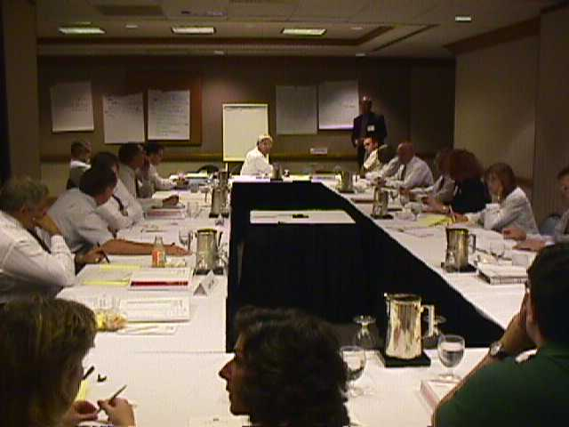
We need a national standardized system of communications that provides for interoperability, security, new technology, sustainability, removal of impediments, and funding.

- Interoperability. At present, public safety agencies often cannot communicate with agencies in different jurisdictions during a public safety crisis. At times they cannot communicate among different agencies in the same jurisdiction. There needs to be a communication system that allows for interoperability.

- Secure (data, encryption, real-time video). If we are going to become involved in terrorist activities, one of the key elements that is not present now in most of our communities is that our communications in public safety are secure. We must have secure communications for all of the agencies involved in public safety. Developments in communications technology may serve as a threat to security.

For example, for less than $100, a person can buy off-the-shelf equipment and listen in to a sheriff’s dispatcher and the people he or she is talking with as well as to conversations between Emergency Medical Services (EMS) people. Such ability to use communications technology is not difficult to use and does not require technically sophisticated individuals to operate. Terrorists can use the knowledge gained from listening in to such conversations for their own sinister purposes.
The military has a very sophisticated package that provides for a secure communications system. It would be possible to take the current military technology that they have developed (black box, etc.) and make it available for civilian use. The military system should be civilianized in such a way that we could also enter into their system and have a separate civilian national security system that has command, control, communications, and computer capabilities. Intelligence can be added into that. We need a secure communications system, a computer, the radio—the complete package—the civilianized version of the military equipment would be a public safety asset.

Communications must be secure for many reasons. If investigations are under way that are sensitive to law-enforcement people, it is important that the information be withheld from media attention during the investigation, lest such knowledge impede the work of law enforcement. In a situation involving a terrorist incident, maintaining secure communications is important to elected officials because they do not want to panic people.

- New technology. Public safety requires the use of equipment that applies new technology. In the new technology, communications and telecommunications seem to be blending in: a factor of importance to public safety agencies. Graphics and other things, mapping and building descriptions, are communicated through the same technology.

Here is one example of how the new technology may be used for public safety purposes. The offices of a fire prevention bureau or a building department may contain building layouts and plans review. It may be essential to transmit needed information to the mobile Emergency Operations Center (EOC) where, for instance, a building once stood. It would be possible through the technology to quickly know where the doorway was, where a particular office was located, and so on. Even in post-natural disaster situations investigators would be able to pursue their investigation thanks to the use of technologically advanced communications systems.

Investigators want to know all the areas, approaches, and roadways to the location where a perpetrator may have committed a criminal act. We also want to know if a building is in partial collapse and destruction so that if rescuers are going to go into that building and extricate people from the rubble, they will be safe.

To determine what kind of technology must be acquired, a study of the experience with different communities must be made. We need a needs assessment for communications. The needs assessment should address not only large city needs, but models that also address the needs of small localities.

- Removal of impediments. Impediments need to be removed to allow those involved in dealing with a WMD incident to communicate effectively. For example, the Federal Communications Commission (FCC) has imposed regulations on cross-banding. At times, however, cross-banding may be needed for communities in metropolitan areas to communicate.

Government must make certain that sufficient radio frequencies are available for emergencies. The nation is giving its frequencies away, a development that may hinder the work of public agencies in dealing with emergencies. There needs to be a reallocation of frequencies for public safety purposes. The FCC must step up to the plate and say: “This is public safety. Keep some channels free. We will not sell these channels.”

Some States and communities have been able to overcome impediments. For example, Illinois has a frequency called IREACH, which operates within a radius of a quarter of a mile. Any jurisdiction can use it. It allows the instant commanders to talk to the command center at the points of contact (POCs). The police commander can talk to the fire chief, the fire chief can talk to EMS, and so on despite the fact that they may have disparities and are using other frequencies.

Typically in this kind of operation, the users operate on this communications system within a quarter of a mile at an incident. So the main channel is not clustered with all kinds of communications. IREACH involves those who are on the site. It is only used if the instant command structure is in place. It is only POC. It operates from commander to commander and from the lowest unit up to the highest level of command. It provides for direction and control. If control and the instant command are solid, the system will work marvelously.

On the main channel, officials continue to provide service to the rest of the community for law enforcement, for medical, and for fire responses. The FCC does not interfere when communications are conducted within a quarter of a mile. The problem, however, is that not all communities in the nation have such a system. It is very difficult at times to obtain frequencies for public safety.

- Funding. Communications equipment that provides security and interoperability is already available in the public and private sectors. The problem for many communities is that they do not have the funding to purchase that equipment. Federal funding would be of enormous help.
Moreover, there needs to be a funding mechanism that will not have communities competing against each other for the budget dollar. The current grant system will not solve the problem.

In summary, the communications system needs to include everybody who has to buy into an emergency response. It must offer interoperability, up-to-date technology, security and sustainability, financial help to acquire it, and the removal of impediments to use it.

- Intelligence. Improved intelligence process, that provides an understanding of the real-time local, State, and Federal responsibilities, and roles pre-, during, and post-event.

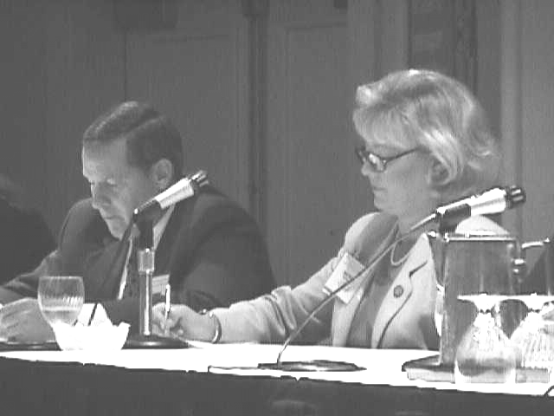
Local law enforcement officials often complain that they never know what is going on in the investigations by other agencies of government. They complain that Federal agencies do not share information with them. But particularly for WMD dangers, the sharing of intelligence information is necessary. It is essential, too, that needed intelligence be shared in real time if the information in that intelligence is to be used effectively.

It was noted that WMD officers in 62 FBI Field Offices in the United States might be able to provide intelligence information to the localities. They would not reveal tactical operations and classified information, which they are forbidden to do under law. But they do have the legal ability to share certain kinds of information with local law enforcement.
Part of the intelligence problem may be at the national level. Federal agencies that are involved in the WMD program may not communicate well with each other. There are 26 different Federal agencies charged with dealing with emergencies in the United States, so the problem of sharing information is complex.
Local authorities have their own problems of sharing information with individual local agencies. It is essential not only to share intelligence from the top (Federal Government) down to localities, but to share it from the bottom up to the top, as well.

Sometimes the information that local law enforcement people need is not available to them through no fault of Federal agencies, such as the FBI. For example, on the basis of the bombing events against the U.S. Embassies in Africa in August 1998, it was important for some local officials to know how many Afghan and Sudanese foreign students were attending various U.S. schools as well as organizations those students might have formed. But the FBI is not permitted by law to have such information if it does not have an open case allowing it to collect such information.

There is a need, however, to identify where intelligence information is located. It then is vital to devise a sharing process to obtain that information.

It was suggested that for matters of WMD, certain individuals get temporary security clearances. The U.S. Department of Energy (DOE) has procedures in place in matters dealing with the protection of nuclear reactors that permit it to grant such clearances under narrow restrictions in certain situations. Similar procedures could be adopted elsewhere for WMD matters.

The point was made that for WMD, there is a need to identify key people in each discipline of the local community. Those key people could be given limited intelligence information in the event of a WMD threat or event. A problem, however, is how far down intelligence should be shared, lest intelligence fall into the wrong hands. The Waco, TX, crisis emerged as a result of tipping off an ambulance.

This new system should be discipline specific. Each discipline has a need to know. Those needs may be somewhat different but share commonality, which would prompt information sharing without affecting national security.

Local agencies would have their own agency-specific responsibilities in a public safety matter involving a potential or actual act of WMD terrorism. They would need answers to many questions:

- Law Enforcement. Who from a possible terrorist organization is in town now? What has that organization done in the past? Law enforcement needs pre-intelligence, real-time, data. What’s going on? Who are the associates of a terrorist? What could be some of the targets? What is the history of the organization? What are their finances? Where is a dossier on them? What Federal resources would be brought to bear to assist our local needs?

- EMS. Do we have a threat against a Federal building? An airport? A mass gathering? Is the threat an anthrax agent? Is it a special event that we are covering? Is the fleet in? Is a big game going on in our community? Do we have to move our areas? Do we have to put on additional personnel? If it is a really serious threat in which we are really anticipating a multiple-casualty incident, do we have to put in additional resources? Are chemicals the threat? If so, what chemicals are they? What Federal resources would be brought to bear to assist our local needs?

- Fire and HAZMAT. If we are going to accomplish a rescue, what kind of protective equipment is required to do that? What kind of decontamination is required? Fire and HAZMAT would need to know PPE, how to decon, and what kind of emergency medical treatment was needed. Other questions are: What equipment requirements would be necessary for the type of incident that fire and HAZMAT are responding to? Is it a chemical incident? Can we know where the safe houses are so that emergency personnel will not be boobytrapped if they go to those sites? What Federal resources would be brought to bear to assist our local needs?

- City Official. Who was in the area? Are any of those types of people that intelligence or FBI were investigating living in or coming through our area? If there were any suspicion that the suspects had looked at our area as a possible target, should we call in more police and alert search and rescue and fire for any possible terrorist activities? What can we do to prevent an incident from happening?

- Public Works. What can we do to protect facilities? Should we begin to take action to assure that the water supply is protected?

- Hospitals. “We need to know what EMS knows.”

Each agency has its own needs. But there are common needs, too. There is, for example, a common interest among law enforcement, EMS, Public Works, and the Fire Department to protect their own employees.

Although local agencies need to obtain information for their own reasons, they do not need information that would breach national security.

- Information sharing is preventive, preparatory, and responsive in nature.

Intelligence information is valuable at all stages involving WMD. If utilized effectively, it could prevent an incident. If a WMD event does occur, the information would be helpful in minimizing the casualties and possibly in preventing other incidents from occurring.

- Need funding mechanism. As with communications, funding on intelligence matters should not pit community against community.

