USDA Foreign Agricultural Service
GAIN Report

Template Version 2.09

Global Agriculture Information Network

Required Report - public distribution
Date: 5/13/2004
GAIN Report Number: BR4611
BR4611
Brazil
Oilseeds and Products
Annual
2004

Approved by:
Ron Verdonk
U.S. Embassy
Prepared by:
Kimberly L. Svec

Report Highlights:
Despite record area of nearly 21.5 million hectares, Brazil’s yields fell due to weather problems. Brazilian 2003/04 soybean production is forecast at 52.58 million tons. Soybean area is forecast to increase by 10 percent to nearly 23.5 million hectares in 2004/05, with production forecast at 66 million tons. Soybean stocks are expected to be drawn down dramatically this year due to a smaller than expected crop, growing domestic use, and strong exports. Exports in 2004/05 are expected to increase by nearly 17 percent due increased production, greater exportable supply, and continued strong global demand for soybeans and meal. Cotton production in 2003/04 is forecast to reach a record 1.25 million tons on 1 million hectares. Post forecasts total cotton production in 2004/05 at 1.5 million tons on 1.25 million hectares as producers continue to expand area due to high expected profits.

Includes PSD Changes: Yes
Includes Trade Matrix: No
Annual Report
Brasilia [BR1]
[BR]
Table of Contents
Executive Summary 4
Economic Indicators 5
STATISTICAL TABLES 6
PRODUCTION, SUPPLY & DEMAND TABLES 6
TRADE MATRICES 12
Brazil Export Statistics 12
Brazil Import Statistics 12
Brazil Export Statistics 13
Brazil Import Statistics 13
Brazil Export Statistics 14
Brazil Import Statistics 14
Brazil Export Statistics 15
Brazil Import Statistics 15
Brazil Export Statistics 16
Brazil Import Statistics 16
NARRATIVE ON SUPPLY, DEMAND, POLICY & MARKETING 17
TOTAL OILSEEDS 17
Production 17
2003/04 Crop Forecast 17
2004/05 Crop Forecast 17
Soybean Rust 18
Financing 19
Stocks 20
Consumption 20
Trade 21
Policy 23
Minimum Prices 23
Import Tariffs 23
Interstate Movement Tax (ICMS) Exemption (Lei Kandir) 24
Biotechnology 24
Biodiesel 27
Key Elements of Domestic Support Programs 27
2003/04 Agricultural Plan 29
Marketing 30
Soybean Expansion Regions 30
The Other Frontier – The North and Northeast 30
Tocantins 30
Maranhao 30
Piaui 31
Para 31
Roraima 32
Amazonas 32
Rondonia 32
The Center-West 32
Mato Grosso 32
Mato Grosso do Sul 33
Goias 33
The South -- Room for Expansion? 33
Rio Grande do Sul 34
Parana 34
Infrastructure 34
Railways 35
Ports 36
Paranagua 36
Paraguay’s Dilemma 38
Rio Grande 39
San Francisco do Sul 39
Santos 39
Santarem 39
Porto Velho 40
TOTAL MEALS 40
Production 40
Consumption 40
Trade 40
Stocks 41
Marketing 41
FEED DEMAND STRATEGIC INDICATOR TABLE FOR BRAZIL 42
TOTAL OILS 43
Production 43
Consumption 43
Trade 44
Marketing 44
Other Oils 44
Sunflower 44
Castor Seed 45
Peanut 45
Palm Oil 45
Minor Oils 45

Executive Summary

Despite record area of nearly 21.5 million hectares, Brazil’s yields took a dive due to weather problems. Brazilian soybean production is forecast at 52.58 million tons for 2003/04. Southern Brazil was hit with a severe drought, with substantial losses in Rio Grande do Sul, Parana, and Mato Grosso do Sul. Meanwhile, much of the center-west and southeast experienced excessive rains, insufficient sunlight, and outbreaks of soybean rust. The northeast and part of the north were the only regions to enjoy improved yields this year, due to favorable weather patterns and good farm management, including preventative spraying for rust.

Soybean area is forecast to increase by 10 percent to nearly 23.5 million hectares in 2004/05. Post forecasts production at 66 million tons, with yields rebounding under more normal weather conditions. Strong soybean prices are expected to encourage expansion despite this year’s poor crop. Soybeans entail less risk and enjoy greater liquidity than competing crops such as rice, corn, and cotton. Additionally, soaring input costs will favor soybeans over the more input-intensive crops of corn and cotton. Limited expansion is expected in the South, as producers open up pasture lands. The center-west will continue to expand, particularly in Mato Grosso. However, the fastest expansion rates are expected in the Northeast and North, such as Tocantins, Maranhao, and Piaui.

Soybean stocks at harvest time this year were higher than normal, largely due to last year’s record crop. However, stocks are expected to be drawn down dramatically during the year due to a smaller than expected crop, growing domestic use, and strong exports. Soybean exports are forecast to increase nearly 10 percent this year, despite the disappointing crop. The value of the Real, vis-à-vis the U.S. dollar, and the exemption of soybeans and products from export taxation favor their exportation. Exports in 2004/05 are expected to increase by nearly 17 percent due increased production, greater exportable supply, and continued strong global demand for soybeans and meal.

Cotton production in 2003/04 is forecast to reach a record 1.25 million tons on 1 million hectares. Strong profit prospects induced producers to increase area 265,000 hectares over the previous year. Mato Grosso and Bahia led the charge with area in the two states expanding by approximately 200,000 hectares. Post forecasts total cotton production in 2004/05 at 1.5 million tons on 1.25 million hectares as producers continue to expand area due to high expected profits. Bahia should be the leading state in rate of area and production expansion with new areas in western Bahia being brought into cotton production. Mato Grosso will continue as the leading production state and expansion is again expected to be significant.
Economic Overview

The Brazilian economy grew 1.6 percent in 2001 with inflation at 7.3 percent, due to the effects of the Argentine economic crisis, energy rationing, political scandals, and the impact of the September 11, 2001 terrorist attacks. In 2002, the economy grew 1.5 percent with inflation at 12.5 percent because of the strong devaluation of the Real, and continued high interest rates for commercial loans. In 2003 the economy struggled and GDP fell –0.2 percent and inflation was 9.2 percent. For 2004, the Brazilian economic and political outlook is guardedly optimistic. Though Brazil’s President, Luiz Ignacio Lula da Silva, known as Lula, hails from the Labor Party, he has continued the sound macroeconomic policies of his predecessor, Fernando Henrique Cardoso, since taking power in January 2003.

Economic growth in 2004 is forecast at 3.5 percent, with inflation estimated at 6.0 percent. Credit terms have eased substantially with interest rates falling from 25 percent to 16 percent and thus investment is on the rise. More investment should create jobs and subsequently consumption is expected to increase. Evidence of a recovery in the economy came in the fourth quarter of 2003, which saw 6 percent annualized growth. Also contributing to the economic recovery is the booming export sector, to which agriculture continues to be the principal factor.

The agricultural sector (including agribusiness) accounts for 30 percent of Brazil’s gross domestic product. Agricultural exports represented 34 percent of Brazil’s total exports in 2003. Total Brazilian agricultural exports in 2003 reached US$24.9 billion, while Brazilian agricultural imports were only US$3.8 billion. Brazil's agricultural exports to the United States are seven times higher than U.S. agricultural exports to Brazil. Primary U.S. agricultural exports to Brazil (2003=$392 million) include cotton, wheat, rice, feeds, beverage bases, hides and skins, planting seeds, snack foods, processed fruit and vegetables and juices, and live animals. Primary Brazilian agricultural exports to the United States (2003 = $2.70 billion) include coffee, sugar, panel products, tobacco, fruit and vegetable juices, lumber, canned and processed meats, tree nuts, shrimp, cocoa, and lobster.

Economic Indicators

 | 1999 | 2000 | 2001 | 2002 | 2003 | 2004*
GDP Growth (%) | 0.9 | 4.0 | 1.6 | 1.5 | -0.2 | 3.5
Inflation (%) | 8.9 | 6.0 | 7.3 | 12.5 | 9.2 | 6.0
Average Exchange Rate (R$/US$) | 1.81 | 1.83 | 2.35 | 2.96 | 3.10 | 2.95
Total Exports  (US$ billion) | 48.1 | 55.0 | 58.2 | 59.6 | 73.1 | 85.0
Total Imports  (US$ billion) | 49.2 | 55.7 | 55.5 | 55.3 | 48.2 | 61.5
- *Forecast
- GDP growth and export and import forecasts provided by the Ministry of Planning
- Inflation and average exchange rate forecast provided by Central Bank of Brazil

STATISTICAL TABLES

PRODUCTION, SUPPLY & DEMAND TABLES

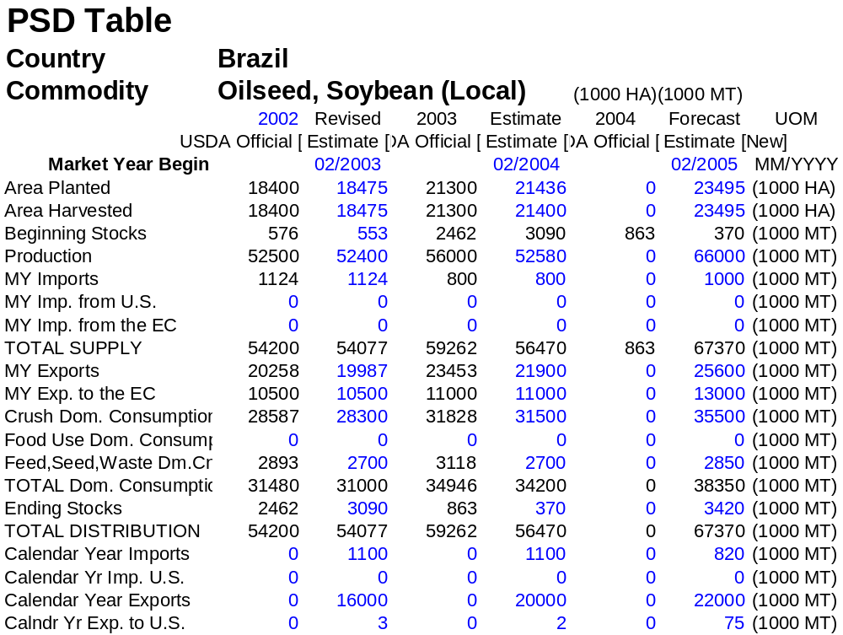

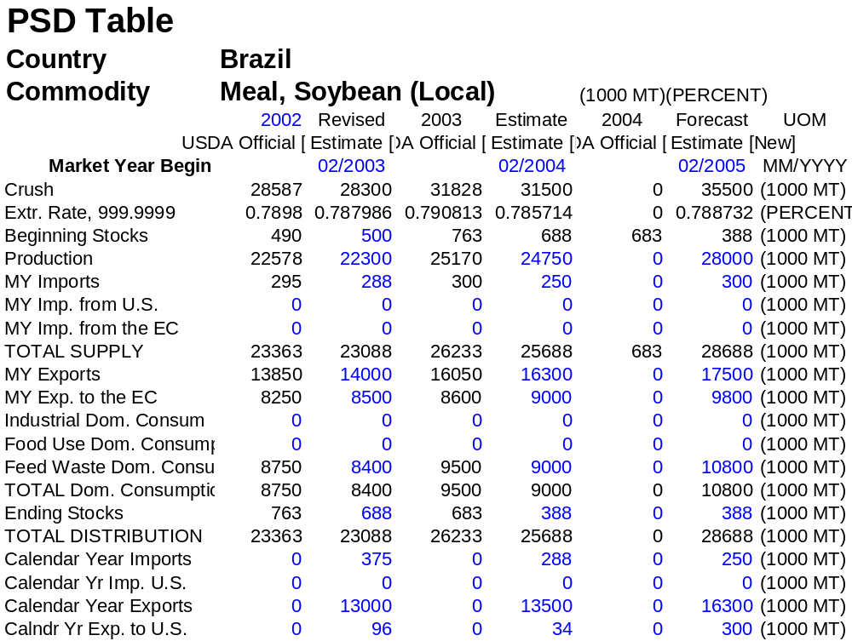

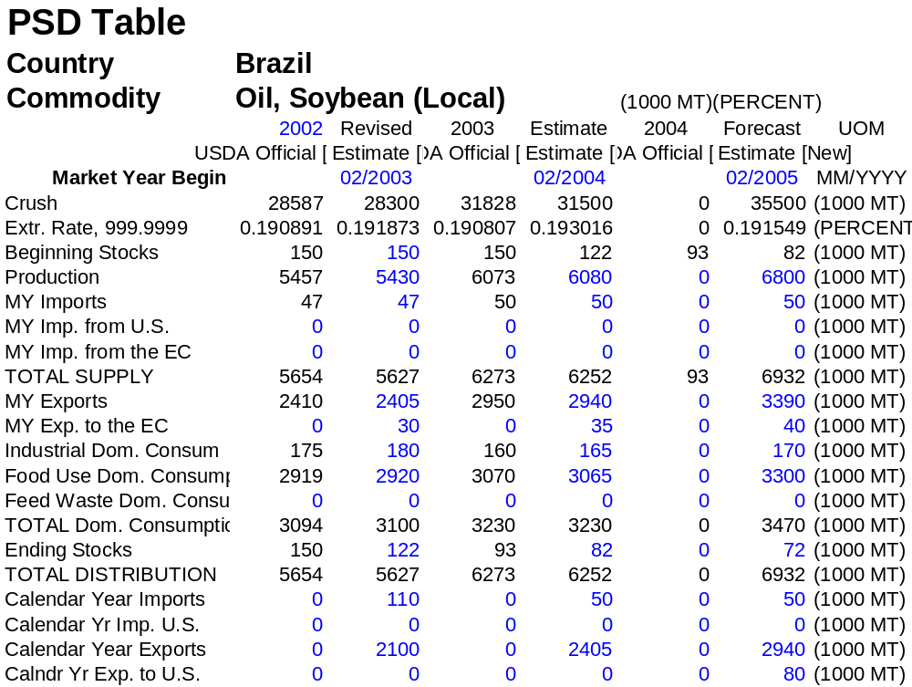

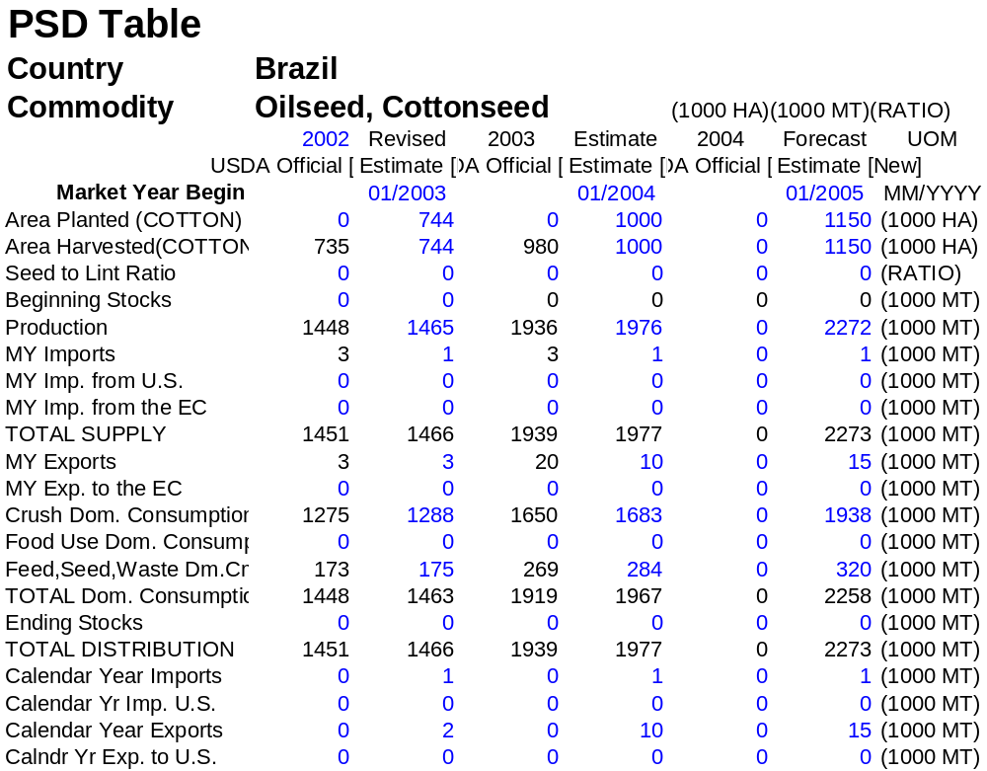

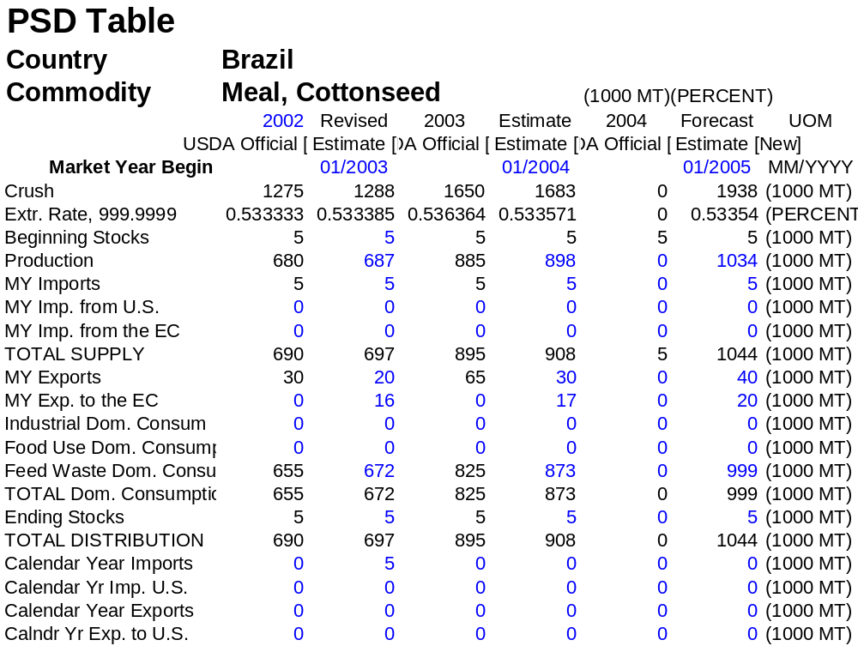

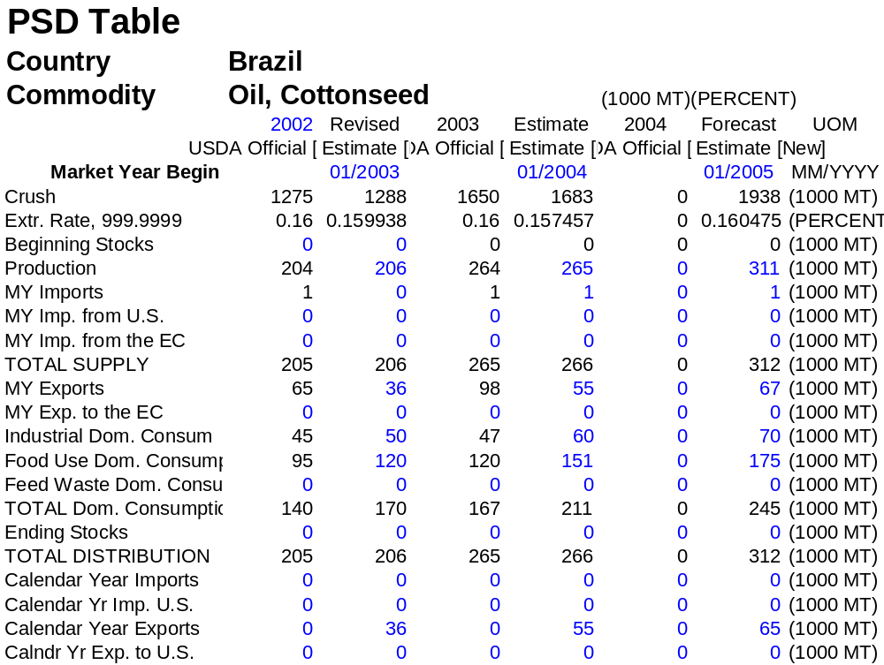

TRADE MATRICES

Brazil Export Statistics
Commodity: 1201, Soybeans, Whether Or Not Broken
Feb/Jan
Partner Country | Quantity 1000 Tons
Partner Country | 2002 | 2003 | 2004
United States | 3 | 3 | 2
China | 3,192 | 4,143 | 6,201
Netherlands | 3,309 | 3,053 | 3,586
Germany | 1,551 | 1,623 | 2,235
Spain | 1,368 | 1,210 | 1,570
Italy | 728 | 521 | 804
Belgium | 749 | 692 | 678
United Kingdom | 497 | 650 | 655
Japan | 768 | 712 | 625
France | 449 | 517 | 563
Taiwan | 253 | 192 | 556
Others | 2,656 | 2,757 | 2,513
World | 15,522 | 16,074 | 19,987

Brazil Import Statistics
Commodity: 1201, Soybeans, Whether Or Not Broken
Feb/Jan
Partner Country | Quantity 1000 Tons
Partner Country | 2002 | 2003 | 2004
United States | 0 | 0 | 0
Paraguay | 854 | 1100 | 1124
Colombia | 854 | 0 | 0
World | 854 | 1100 | 1124

Brazil Export Statistics
Commodity: 2304, Soybean Oilcake And Other Solid Residues Resulting From The Extraction Of Soy Bean Oil, Whether Or Not Ground Or In The Form Of Pellets
Feb/Jan
Partner Country | Quantity 1000 Tons
Partner Country | 2002 | 2003 | 2004
United States | 0 | 96 | 34
Netherlands | 3,142 | 3,756 | 3,798
France | 2,676 | 2,873 | 2,628
Germany | 808 | 585 | 924
Indonesia | 0 | 471 | 704
Korea South | 596 | 579 | 703
Italy | 659 | 624 | 660
Thailand | 268 | 490 | 603
Saudi Arabia | 254 | 335 | 541
United Kingdom | 559 | 484 | 476
Romania | 144 | 191 | 435
Iran | 46 | 87 | 387
Spain | 364 | 445 | 350
Others | 1,596 | 1,765 | 1,296
World | 11,110 | 12,783 | 13,542

Brazil Import Statistics
Commodity: 2304, Soybean Oilcake And Other Solid Residues Resulting From The Extraction Of Soy Bean Oil, Whether Or Not Ground Or In The Form Of Pellets
Feb/Jan
Partner Country | Quantity 1000 Tons
Partner Country | 2002 | 2003 | 2004
United States | 0 | 0 | 0
Paraguay | 230 | 372 | 288
World | 230 | 372 | 288

Brazil Export Statistics
Commodity: 1507, Soybean Oil And Its Fractions, Whether Or Not Refined, But Not Chemically Modified
Feb/Jan
Partner Country | Quantity 1000 Tons
Partner Country | 2002 | 2003 | 2004
United States | 0 | 0 | 0
Iran | 370 | 728 | 816
China | 17 | 300 | 607
India | 392 | 415 | 245
Bangladesh | 165 | 75 | 107
Hong Kong | 122 | 79 | 105
South Africa | 27 | 34 | 89
Senegal | 41 | 46 | 68
Russia | 21 | 35 | 58
Malaysia | 42 | 29 | 56
Egypt | 107 | 114 | 47
Netherlands | 10 | 7 | 27
Others | 302 | 239 | 181
World | 1,616 | 2,100 | 2,405

Brazil Import Statistics
Commodity: 1507, Soybean Oil And Its Fractions, Whether Or Not Refined, But Not Chemically Modified
Feb/Jan
Partner Country | Quantity 1000 Tons
Partner Country | 2002 | 2003 | 2004
United States | 0 | 0 | 0
Argentina | 645 | 100 | 31
Uruguay | 0 | 0 | 13
Paraguay | 22 | 10 | 3
Others | 200 | 0 | 0
World | 867 | 110 | 47

Brazil Export Statistics
Commodity: 230610 Cottonseed Meal
Jan-Dec
Partner Country | Quantity 1000 Tons
Partner Country | 2001 | 2002 | 2003
United States | 0 | 0 | 0
Belgium | 0 | 0 | 6,341
United Kingdom | 6,981 | 500 | 6,200
Germany | 0 | 871 | 3,500
Netherlands | 0 | 23,460 | 0
World | 15,522 | 16,074 | 19,987

Brazil Import Statistics
Commodity: 230610, Cotton Seed Oilcake And Other Solid Residues Resulting From The Extraction Of Cotton Seed Oil, Whether Or Not Ground Or In The Form Of Pellets
Jan-Dec
Partner Country | Quantity
Partner Country | 2001 | 2002 | 2003
United States | 0 | 0 | 0
Paraguay | 5 | 1 | 1
Argentina | 0 | 6 | 0
World | 5 | 7 | 1

Brazil Export Statistics
Commodity: 151229, Refined Cottonseed Oil
Jan-Dec
Partner Country | Quantity 1000 Tons
Partner Country | 2001 | 2002 | 2003
United States | 0 | 1,000 | 2,000
South Africa | 30,408 | 38,900 | 12,075
South Korea | 0 | 1,000 | 7,200
Iran | 0 | 0 | 5,512
Australia | 0 | 0 | 3,040
Malaysia | 0 | 3,000 | 3,000
China | 0 | 2,500 | 2,500
Japan | 0 | 0 | 865
Others | 19,862 | 11,407 | 7
World | 50,270 | 57,807 | 36,199

Brazil Import Statistics
Commodity: 151229, Cottonseed Oil And Its Fractions, Refined But Not Chemically Modified
Jan-Dec
Partner Country | Quantity
Partner Country | 2001 | 2002 | 2003
United States | 0 | 0 | 0
Paraguay | 1 | 2 | 0
Argentina | 0 | 1 | 0
World | 1 | 3 | 0

NARRATIVE ON SUPPLY, DEMAND, POLICY & MARKETING

TOTAL OILSEEDS

Production

2003/04 Crop Forecast

Despite record area of nearly 21.5 million hectares, Brazil’s yields took a dive due to weather problems. Brazilian soybean production is forecast at 52.58 million tons for 2003/04. Southern Brazil was hit with a severe drought, with substantial losses in Rio Grande do Sul, Parana, and Mato Grosso do Sul. Rio Grande do Sul was the most severely affected, and analysts estimated statewide losses were estimated at roughly 40 percent. Meanwhile, much of the center-west and southeast experienced excessive rains, insufficient sunlight, and outbreaks of soybean rust. The northeast and part of the north were the only regions to enjoy improved yields this year, due to favorable weather patterns and good farm management, including preventative spraying for rust. After being nearly devastated by soybean rust last year, western Bahia harvested a record crop in 2003/04 with some of the highest yields in the nation. The region enjoyed favorable weather, took preventative measures to combat soybean rust, and planted more appropriate seed varieties. This year’s weather difficulties in the center-west and south lowered quality and reduced protein and oil content.

Brazilian national crop estimates do not include the small, but numerically significant, winter soybean crop. Parana records the state soy winter crop, and safrinha soy area in the state has been as high as 57,000 hectares in the last decade. Post notes that even a winter crop of one-half of one percent in Brazil would be roughly equivalent to 100,000 hectares and 270,000 tons. Soybean seed crop produced under irrigation should be included in soybean production forecasts, as should any other winter soy production.

2004/05 Crop Forecast

Soybean area is forecast to increase by 10 percent to nearly 23.5 million hectares in 2004/05. Post forecasts production at 66 million tons, with yields rebounding under more normal weather conditions. Strong soybean prices are expected to encourage expansion despite this year’s poor crop. Soybeans entail less risk and enjoy greater liquidity than competing crops such as rice, corn, and cotton. Additionally, soaring input costs will favor soybeans over the more input-intensive crops of corn and cotton.

Brazilian soybean expansion is likely to continue in the short and medium term due to the following factors: 1) Growing world soy demand and consumption; 2) Increasing Brazilian consumption, largely due to poultry/swine expansion; 3) Income growth in developing countries, particularly in consuming Asian nations; 4) New industrial uses of soybeans, such as biodiesel; 5) Mad Cow fears reduce beef consumption (grass fed in Brazil), but increase soy use for chicken and pork feed; 6) Mad Cow fears increase global demand for soy meal in place of meat and bone meal; 7) Decreasing subsidies in developed countries would spur greater production in Brazil; 8) Improving infrastructure in Brazil, thereby reducing production and transport costs; 9) Large areas of cheap cerrado land; 10) Development of new region-appropriate soybean varieties; 11) Southern farmers bringing wealth and technology with them to the new frontier; 12) While most producing nations have limited expansion potential, much of the vast virgin Brazilian cerrado can easily be put into production; 13) Strong prices. Although planting doesn’t begin until October, most farmers will make their planting decisions within the next 60 days. Producers expect soy prices to fall from current levels, but remain strong; 14) Lower risk. Soybeans have high liquidity, unlike most commodities in Brazil, and produced for the export market earning dollars.

Post recently attended a speech by Embrapa Soja, which estimated potential Brazilian soybean production at 330-435 million tons on 110-145 million hectares, equal to twice the world production in 2003. However, the estimates do not take demand into account, and the limitations to expansion were also discussed, such as 1) high cost of transport; 2) bad roads and poor infrastructure; 3) high port costs; 4) insufficient storage; 5) excessive internal taxation; 6) international taxes and tariffs, particularly on oil and meal; 7) commercialization difficulties; 8) insufficient funds for financing; 9) insufficient funds for research; 10) low level of technology adopted by some farmers; and 11) new diseases such as rust; 12) Brazilian environmental laws limit expansion (Only 20 percent of rainforest land can be cleared, versus 50 percent in transitional areas and 65 percent in the cerrado). Regardless of the constraints, all parties agree that Brazilian soybean area and production will continue to expand, barring a collapse in international prices.

Despite the disappointing crop in 2003/04, soybean expansion is expected to continue at a strong rate. Producers with only moderate damage were able to recoup their losses due to higher prices, and most foresee prices remaining above their breakeven point through next year. Limited expansion is expected in the South, as producers open up pasture lands. The center-west will continue to expand, particularly in Mato Grosso. However, the fastest expansion rates are expected in the Northeast and North, such as Tocantins, Maranhao, and Piaui. Although the regions’ current production is relatively small, the expansion rate and potential will continue to draw greater attention.

Cotton production in 2003/04 is forecast to reach a record 1.25 million tons on 1 million hectares. Strong profit prospects induced producers to increase area 265,000 hectares over the previous year. Mato Grosso and Bahia led the charge with area in the two states expanding by approximately 200,000 hectares. Post forecasts total cotton production in 2004/05 at 1.5 million tons on 1.25 million hectares as producers continue to expand area due to high expected profits. Bahia should be the leading state in rate of area and production expansion with new areas in western Bahia being brought into cotton production. Mato Grosso will continue as the leading production state and expansion is again expected to be significant. (See Cotton and Products Annual BR4610 for more information).

Soybean Rust

CNA, the Brazilian Confederation of Agriculture and Livestock, estimates crop losses to soybean rust at above $1 billion, which does not include the added cost to production of nearly $800 million for fungicide applications. Fungicide application to prevent and combat rust costs roughly US$40 per hectare. Embrapa Soybean estimates that more than 15 million hectares of this year’s crop recorded incidences of the disease. The losses would have been substantially higher if the private and public sectors had not embarked on an extensive education campaign to alert producers to the risks, prevention, recognition, and treatment of the disease. The radical turnaround in yields in western Bahia is an example of the results of education on proper prevention and treatment. Meanwhile, the states with the greatest rust losses this year are those who did not suffer significant losses from the fungus last year and did not take proper preventative measures, such as parts of Minas Gerais, Sao Paulo, Goias, and Mato Grosso. It is difficult to determine which of this year's losses is due to rust versus excessive rains. Furthermore, the heavy rains prevented many farmers from proper spraying, and images of sprayed areas versus non-sprayed are dramatic. There were many obstacles to rust control this year, such as excessive rain, continuous soy production, shortage and rising cost of fungicide, large farm size, and farmer skepticism about rust. Meanwhile, the drought reduced the severity of the rust in the south.

Embrapa stresses the need for better farm management, including shortening the planting period and avoiding second crop soy. As a means to combat the spread of the disease, Embrapa is strongly advising against winter crop soy production. However, winter crop seed producers and safrinha soy farmers appear to be unresponsive to the advice. Shrinking the planting window will also be difficult to achieve, as many producers seek early quick-to-maturity varieties that enable more successful double cropping. Proper spraying and management is critical, as Embrapa estimates that the development of rust resistant varieties will take 8-10 years.

Reports that soybean rust has reached as far north as Roraima are particularly concerning for US soybean producers, as hurricanes and trade winds from this northern hemisphere state head towards North America. Scientists believe that soybean rust arrived in South America from Africa on transatlantic winds, and likewise, it is only a matter of time before the disease makes its way to the United States on northbound winds from Roraima.

Financing

Federal funding for the 2003/04 crop year increased by 25.8 percent from 2002/03 to R$32.6 billion (US$10.9 billion), of which R$27.2 billion is allocated to the Ministry of Agriculture (MAPA) and R$5.4 billion is designated for the Ministry of Agrarian Development (MDA). Farm leaders considered the total amount of rural credit announced by the government as insufficient to meet the needs of the sector, which is estimated at R$56.2 billion (US$18.7 billion). The amount of R$27.2 billion includes all programs managed by the Ministry of Agriculture’s Food Supply Agency (CONAB), such as those under the minimum price policy, and investment programs jointly managed with the National Bank of Economic and Social Development (BNDES), at subsidized interest rates. The subsidized credit is offered at an interest rate of 8.75 percent, which is considerably lower than the market rate of around 20 percent. A table in the policy section below provides a summary of these investment programs.

Due to a spectacular crop and profit in 2002/03, many producers increased inputs and technology on the current crop. Two-year term government credit for soybean producers is available up to an amount of R$200,000 (roughly US$70,000) for farmers in the Center-West and North regions as well as soy producers in Maranhão, Piaui and Bahia. For all other soy producing states, the limit is R$150,000(roughly US$52,000). The subsidized interest employed for these programs is 8.75% per year. Government financing covers a greater percent of production in the South, as farm sizes tends to be much smaller. Medium and large-scale soybean farmers, which dominate the frontier, depend little on government programs. Multinationals and seed suppliers provide much of the credit and inputs for larger producers. Local information indicates that 90 percent of agricultural chemicals are sold in crop terms (swap), while traders cover about 50 percent of soybean crop financing. Commercial banks, using the GOB required cash deposit focused to agriculture with GOB backing, can cover up to 60 percent of soybean producers’ needs, while input dealers cover up to about 25 percent.

In the frontier, opening costs are much higher and there is a greater dependence on multinationals. The companies take on the risks normally associated with banks, however, the value of soybeans has been literally as strong as gold, thereby encouraging the role as a lender. Multinationals began financing the soybean crop 8 years ago, largely through “swaps.” This guarantees supply to the industry and allows for plant operation planning. Furthermore, plants can forward contract sales of oil and meal, since they have guaranteed supply for roughly 20 percent of production.

Since July 2003, the Bank of Brasil has released R$17.8 billion (US$6 billion) for the planting, production, harvest, storage, and marketing of the 2003/04 total Brazilian grain crop, which ends June 30. The bank will release an additional R$2.2 billion before the end of the crop year, with the total representing more than 60 percent of the government’s farm support plan. The R$20 billion represents a 40 percent increase in resources from the previous crop year.

Stocks

Stocks at harvest time this year were higher than normal, largely due to last year’s record crop. However, stocks are expected to be drawn down dramatically during the year due to a smaller than expected crop, growing domestic use, and strong exports. Post is forecasting an 11 percent increase in crush and a 10 percent increase in exports. Soy meal consumption is forecast to increase 7 percent with a 16 percent increase exports. Domestic soy oil consumption is forecast to increase 4 percent and exports jump nearly 23 percent. Ending soybean stocks are forecast to fall 88 percent to only 370,000 tons, while meal stocks fall 44 percent to 388,000 tons, and oil stocks drop 32 percent to 82,000 tons.

The Brazilian government does not hold oilseed stocks. The majority of stocks are held by cooperatives, processors, or at the port. Domestic processors and cooperatives carry soybeans as "stocks" until the commodity is priced. The physical soybeans, however, may have already gone to processing or export. Brazil’s on-farm capacity is extremely small, and can currently accommodate only about 5 percent of the local crop. Although storage space is expanding at all levels, it is not keeping up with production growth. Over the past several years grain storage capacity has increased only 10 percent that of grain production. The grain storage deficit is about 35 percent. Although storage is increasing in the frontier, many farmers spend their profits buying more new farmland instead of building on-farm storage. However, soybean producers are now less inclined to quickly sell production that has not already been contracted for and are increasingly electing to pay to store new crop production to await better market prices.

Cooperatives in Parana are investing R$240 million (roughly US$80 million) in the construction of storage facilities, which should increase capacity by 1 million tons to a total of 7.5 million tons by the end of 2004. ADM is increasing its storage capacity by 285,000 tons in the center-west, with four new silos in Mato Grosso and one in Mato Grosso do Sul. The private sector will continue to increase storage capacity, but production growth will continue to outpace infrastructure improvements.

Consumption

The projected MY 2004 soybean crush, at 31.5 million tons, incorporates a more than an 11 percent increase in processing over the 2003 crop. Soybeans account for nearly all oilseed consumption. The MY 2004 cottonseed crush, projected at 1.68 millin tons thousand tons, is an increase of thirty percent over last year’s level because of a large expected boost in the size of this year’s cotton harvest. The current exemption of soybeans and derivatives that are exported from the domestic interstate movement tax (ICMS) is not expected to change, so there continues to be an incentive to move as much product through export channels as possible. While major importing countries continue to make investments in crushing and processing plants, major multinationals and local firms operating in Brazil are also expanding domestic crushing capacity. Demand for vegetable protein meals and market preference for “non-biotech” product in Europe help pull some of the Brazilian crush. Increased sales of poultry and pork products, for the domestic and export markets, contribute to steady demand for meal.

Soybean production is expanding in the center-west and northern regions of Brazil, yet 60 percent of domestic crush capacity continues to be located in the states from Sao Paulo southward. The south continues to lead in processing capacity since it was the traditional production area, has a higher concentration of agricultural processing in general, and has better infrastructure and proximity to ports. However, the frontier areas will continue to expand capacity. Current soybean crushing capacity by state is shown below.

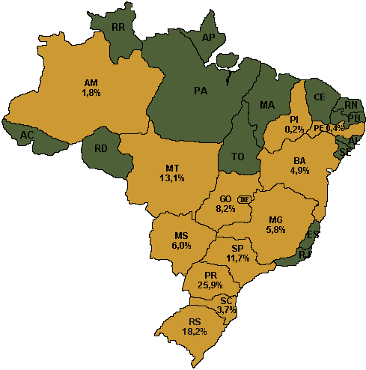
Installed Soybean Crush Capacity by State: 2002
State | Capacity  MT/Day | % of  Total
Paraná | 28,650 | 25.9
Rio Grande do Sul | 20,150 | 18.2
Mato Grosso | 14,500 | 13.1
São Paulo | 12,950 | 11.7
Goias | 9,060 | 8.2
Mato Grosso do Sul | 6,630 | 6.0
Minas Gerais | 6,450 | 5.8
Bahia | 5,460 | 4.9
Santa Catarina | 4,050 | 3.7
Amazonas | 2,000 | 1.8
Pernambuco | 400 | 0.4
Piaui | 260 | 0.2
Total | 110,560 | 100.0
Source: Brazilian Oilseed Crushers Association ABIOVE (www.abiove.com.br)

Trade

Soybean exports are forecast to increase nearly 10 percent this year, despite the disappointing crop. Soybeans account for essentially all Brazilian oilseed trade as most cottonseed is processed for domestic consumption. The value of the Real, vis-à-vis the U.S. dollar, and the aforementioned exemption of soybeans and products from export taxation favor their exportation. Exports in 2004/05 are expected to increase by nearly 17 percent due to increased production, greater exportable supply, and continued strong global demand for soybeans and meal. China and the EU are likely to increase imports and the US, Argentina, and Brazil will compete for these markets.

Oilseed imports, predominantly soybeans, are forecast to decline this year, as neighboring Paraguay and Argentina also had poor crops. The ICMS situation in Brazil and operational considerations result in some demand by local crushers for imported Paraguayan soybeans, on which ICMS is not charged, to maintain operations in southern plants rather than bringing domestic beans in from other states. Much of the resulting product then moves on to export.

Brazil is usually a major export avenue for Paraguayan soybeans moving to export via the Paraguayan export terminal at the port of Paranagua. However, Parana’s refusal of biotech soybeans has caused Paraguay to seek alternative export routes (see section on ports).

Going north to south, the line up of major Brazilian soybean export points are: Itacoatiara (Amazonas), Santarem (Para), Sao Luis (Maranhao), Ilheus (Bahia), Vitoria (Espírito Santo), Santos (Sao Paulo), Paranagua (Parana), Sao Francisco (Santa Catarina) and Rio Grande (Rio Grande do Sul). The ports of Caceres (Mato Grosso) and Corumba (Mato Grosso do Sul) are located on the Paraguay River, which then ship south to Atlantic export points in Argentina. As indicated in the following table, even though more and more Brazilian soybeans are grown and processed away from the traditional production areas of the south, the majority of Brazil’s soybean exports are shipped from Santos and ports southward.

Exports by Port, Soybeans
(Feb/Jan) (1000 MT)
Port | 2003/04 | 2002/03
Santos | 5766 | 5045
Paranagua | 5714 | 5130
Rio Grande | 3850 | 1799
Vitoria | 1656 | 1530
Sao Luis | 920 | 650
Sao Francisco | 844 | 787
Itacoatiara | 693 | 913
Caceres/Corumba | 147 | 207
Ilheus | 42 | 0
Others | 354.8 | 13
Total | 19,987 | 16,074
Source: DECEX/Safras & Mercados

China is an increasingly large and important market for Brazilian soybeans, accounting for nearly one-third of whole bean exports last year. Exports to China nearly doubled in two years to more than 6 million tons. That said, trade has been bumpy in the past year. China has complained about quality problems, such as excessive humidity, aflatoxin, damaged grains, dockage and impurities. China recently blocked a 58,000 ton shipment because it contained chemically treated seeds unfit for human or animal consumption. Considerable negotiations were required before China accepted Brazil’s export certificates regarding biotech content. Brazil’s double standard on biotechnology concerned China, as Brazil had not yet approved the use or safety of biotech soybeans for its own consumers but wanted China to take its word that the beans were safe. Brazil claimed that the varieties are the same as those grown in Argentina and the US, which have been proven safe by both countries and accepted by China. In late March 2004, China agreed to allow the import Brazilian soybeans after April 20, when the provisional rules expire. China accepted a CTNBio document stating that biotech soybeans pose no risks.

The extremely tight soybean supply situation in the US has been attracting considerable attention in Brazil, and it appears likely that the US will import both soybean meal and oil from Brazil this year. Post is forecasting 80,000 tons in Brazilian soy oil to the US this year, which would account for the majority of US soy oil imports. The Carolinas have been importing Brazilian soy meal for several years, owing to logistical difficulties in pulling it from the US heartland. Contacts report that more than 200,000 tons of Brazilian soymeal has been purchased by Carolina swine and poultry producers this year, and more imports are likely. Post is forecasting a total 300,000 tons of Brazilian soy meal exports to the US this year. The majority of Brazil’s exports to the US are expected to be oil and meal, although Post is forecasting 75,000 tons of whole soybean exports, as well.

Policy

Minimum Prices

The following table shows the official minimum prices. The minimum price does not come into play in the soybean sector. Current soybean prices are roughly four times the minimum price. In the cotton sector, GOB actions are more significant.

Official Minimum Prices
Product (Unit) / Crop Year | 2003/04 |  | 2002/03
Area | R$ | US$ | R$ | US$
Cotton (15 kg)
S, SE, CW & BA south | 44.60 | 14.53 | 33.90 | 11.61
NE (except BA) | 44.60 | 14.53 | 33.90 | 11.61
Cottonseed (15 kg)
S, SE, CW & BA south | 13.40 | 4.36 | 10.08 | 3.45
NE (except BA) | 13.40 | 4.36 | 10.08 | 3.45
Soybeans (60 kg)
S, SE, CW & RO | 14.00 | 4.56 | 11.00 | 3.77
N (except RO) & NE | 13.00 | 4.56 | 10.40 | 3.56
Source: Ministry of Agriculture, CONAB
Note: S=South; SE=Southeast; CW=Center-West; NE=Northeast;
CS=Center-South;BA=Bahia; MT=Mato Grosso; TO=Tocantins; PA=Para; PI=Piaui;
GO=Goias; AC=Acre; RO=Rondonia; MA=Maranhao; DF=Distrito Federal.
Exchange rate:1997/98-R$1.065/US$; 1998/99-R$1.15/US$; 1999/2000-R$1.83/US$;
2000/01-R$1.85/US$; 2001/02 -R$2.35/US$; 2002/03-R$2.92/US$; 2003/04- R$3.07/US$

Import Tariffs

The Brazilian Government’s import tariffs on oilseeds and products were lowered 1.5 percent from last year and are contained in the MERCOSUL Common External Tariff schedule (TEC). Brazil, Argentina, Paraguay and Uruguay are members of the MERCOSUL trade pact. Bolivia and Chile are associate members. The tariff rates are noted below.

MERCOSUL Common External Tariff
Tariff Code |  | Description | %
1201 |  | Soybeans
 | .00.10 | Seed for planting | 0
 | .00.90 | Other | 8
1207 |  | Cotton
 | .20.10 | Seed for planting | 0
 | .20.90 | Cottonseed | 8
1507 |  | Soybean oil, not chemically modified
 | .10.00 | Crude | 10
 | .90 | Other
 | .90.10 | Refined | 12
 | .90.90 | Other | 10
1512 |  | Cottonseed oil
 | .21.00 | Crude | 10
 | .29 | Other
 | .29.10 | Refined | 10
 | .29.90 | Other | 10
1208 |  | Oilseed flour
 | .10.00 | Soybean | 10
 | .90.00 | Other | 10
2304 |  | Meals resulted from extraction of soybean oil
 | .00.10 | Meals & pellets | 6
 | .00.90 | Other | 6
2306 |  | Meals resulted from extraction of vegetable oils
 | .10.00 | Cottonseed meal | 6
Source: Brazilian Government - Aduaneiras Tarifa Externa Comun (TEC)

Interstate Movement Tax (ICMS) Exemption (Lei Kandir)

In September 1996, through “Lei Complementar 95-A”, better known as the “Lei Kandir,” the GOB exempted exports of raw materials and semi-manufactured products from the interstate movement tax (ICMS - Imposto Sobre Circulação de Mercadorias e Serviços). In other words, it canceled this export tax on soybeans and derivative products. Prior to the change, interstate movements of soybeans going to export were taxed at 13 percent, while soybean meal and soybean oil were assessed lower rates: 11 and 8.5 percent respectively. While state governments are in desperate need of tax revenue sources and the domestic crushing sector continues to chafe under the exemption, elimination of the Lei Kandir does not appear likely in the foreseeable future. However tempting it may be for the Brazilian Government to consider an export tax because of the need for revenues in a taxation system that is in dire need of an overhaul, the prevailing sense is that such a tax will not be re-adopted.

An increase in a Brazilian social security tax is likely to favor soybean exports. The Brazilian congress is currently debating raising the Cofins tax from 3 percent to 7.6 percent. Exported soybeans are exempt from the tax, while soybeans crushed within Brazil are subject to the tax if the meal and oil are consumed domestically.

Biotechnology

Biotechnology continues to be a controversial subject in Brazil. The Government of Brazil, the scientific community, and consumer groups are deeply split and grapple with legality issues over biotech crops despite the recent Draft Bill PL 2401 Biosafety Law now before Congress and the Provisional Measure (MP) 131 legalizing the planting of biotech soybeans. The Presidential Decree MP 131 issued on September 25, 2003 legalizing the planting of biotech soybeans in Brazil for the 2003-04 crop was approved by the Congress and was signed into law by President Lula on December 17, 2003. The Law says that farmers with biotech seeds can plant them but must declare it. The majority of Brazil’s biotech soybean production is located in Rio Grande do Sul, although some farmers from nearly all producing states have declared biotech production.

On October 31, 2003, the Brazilian government released a draft of Brazil’s new Biosafety Law (Draft Bill PL 2401). The text of the Bill establishes a complicated mechanism for approval of biotech products by creating a national council attached to the Presidency that would consider political and economic factors, as well as scientific reports, before approving biotech research or planting. The Bill also authorizes the legal production and commercialization on biotech soybeans through the 2004/05-crop year. This most recent version of the Bill was passed by the Brazilian Chamber of Deputies on February 5, 2004, and is now awaiting a vote in the Senate. However, it is unlikely that the Bill will be voted on by the Senate before the October municipal elections. Congress goes on recess soon, and once they reconvene, the elections will dominate their time. President Lula recently pressed for a vote on the Bill before the Congress breaks for recess, however, it is uncertain if it will happen. Furthermore, considering the many unresolved questions in the Bill and points of contention with the agribusiness and scientific community, the Senate may make changes, which would necessitate sending the Bill back to the Chamber of Deputies. The Administration is likely to implement another Provisional Measure (MP) to allow biotech soybeans for the 2004/05 crop.

Southern farmers have stated that they will not return to conventional soybeans. Furthermore, even if biotech soybeans were ruled illegal, there would be insufficient conventional seed supply for Rio Grande do Sul. As biotech production continues to spread throughout the country, a return to conventional soybean production is increasingly difficult and unlikely. The majority of Rio Grande do Sul’s soybean crop is biotech, and as much as 15 percent of the Parana crop is planted to GMOs, despite the Governor’s law forbidding biotechnology in the state. As is indicated by the table below, biotech soybeans are being planted in almost every producing state. Total biotech plantings are estimated to be considerably higher than the chart indicates, as many farmers fear the consequences of signing the declaration. The chart below notes how many farmers signed the TCRAC (statement of commitment, responsibility and conduct adjustment for planting biotech soybeans) by mid-December for the 2003/04 crop. Note that the TCRAC is by farm, and the smaller number of TCRACs may account for significant area in the cerrado where farm sizes are generally very large.

Number of TCRACs (statement of commitment, responsibility and conduct adjustment for planting biotech soybeans ) by State
(As of mid-December 2003)
State | Number of TCRACs
Bahia | 18
Piaui | 47
Goias | 70
Santa Catarina | 121
São Paulo | 130
Minas Gerais | 136
Maranhão | 152
Mato Grosso do Sul | 173
Mato Grosso | 189
Paraná | 549
Rio Grande do Sul | 77,415
Total | 79,001

In October 2003, Parana Governor Roberto Requiao signed a law prohibiting the production, shipment, processing, and export of GMOs in the state of Parana. Requiao’s state law prohibiting biotechnology was never recognized by the Federal Minister of Agriculture, and was disallowed by the Federal Supreme Court (STF) in late 2003. However, attempts by the federal government to force acceptance of biotech beans for export at Paranagua have been ineffective, and governmental meetings have been unsuccessful in resolving the issue. The situation has also caused a bilateral dispute with neighboring Paraguay, who owns an export terminal at the port of Paranagua. An estimated 15 percent of Parana’s soybean production is biotech.

Mato Grosso Governor Blairo Maggi has stated that farmers in his state should follow Law #10,814, but since it is illegal to transport biotech seeds across state lines, only farmers with saved seed can produce. He noted that his state has not produced biotech soybeans in the past, so there should be no biotech seed available for planting now. However, nearly 200 farmers in Mato Grosso have signed agreements under the provisional measure to grow biotech soybeans in Mato Grosso. This implies that biotech soybeans were grown in Mato Grosso in 2002/03 and will be in the future.

The southern states of Rio Grande do Sul and Santa Catarina have agreed to pay royalties to Monsanto for their use of contraband Roundup Ready soybeans. Producers who pre-declare their biotech beans pay a royalty of R$0.60/bag of 60 kilos (US$7/ton). Producers who do not declare their beans will have their cargos tested, and if it is positive, they will be charged R$1.50/bag of 60 kilos (US$17/ton). Furthermore, those producers pay for the biotech testing. The fee is assessed when the soybeans are delivered from the farm to an elevator or crushing site. The elevator or cooperatives deducts the fee directly from the farmer's payment. The elevator, in turn, will pay Monsanto the fee. A few elevators in Rio Grande do Sul and Santa Catarina will be designated non-GMO. The others have openly agreed to accept biotech beans and therefore are willing to collect the fee. The non-GMO elevators will test every load, and assess the higher fee if GMO content is detected. The elevators and cooperatives will not see an increase in operating costs, as Monsanto is funding the start-up costs of the system. Monsanto does not expect to earn money during the first year due to the start-up costs. The negotiated fee is set until January 31, 2005. Monsanto is negotiating the value for 2005/06 and hopes to receive R$1.20/bag of 60 kilos.

Brazil enacted a new biotech labeling law, which went into effect on March 27, 2004. On April 2, 2004, the Civil Cabinet of the Presidency published Normative Instruction Number 1, signed by 4 cabinet ministers (Civil Cabinet, Justice, Agriculture, and Health) which established the conditions by which Directive 2,658/03 will enforce the labeling for products containing genetic modified organisms above one percent limit. In addition to the federal agencies, Normative Instruction Number 1 also provides authority to the state and municipal consumer defense officials to enforce the new labeling requirements.

Embrapa, similar to USDA’s ARS, has developed 11 biotech soybean varieties, which are in the pre-registration stage. If/when biotechnology is legalized in Brazil, Embrapa will begin producing seeds for commercial use. The varieties are region, climate, and soil specific, and are more appropriate for use in Brazil than contraband seeds from Argentina, which are currently used in Brazil.

While there is controversy surrounding the adoption of biotechnology for soybean production, Brazilian cotton producers would benefit noticeably from Bt cotton in terms of lowered input costs and producer risks, as well as from environmental advantages. Most cotton producers must spray their crop repeatedly in Brazil, with some areas requiring more than 30 chemical applications. The chemical runoff and residues are of considerable concern, and could be essentially eliminated with the adoption of biotech crops. Although sources believe that several large-scale cotton producers in Mato Grosso are using illegal biotech cottonseed from Argentina, most of Brazilian cotton production remains biotech-free.

Biodiesel

As the world’s leader in alcohol/ethanol (made from sugar in Brazil) production and consumption, Brazil is now eyeing biodiesel. 0n October 30, 2002, Brazil launched the Probiodiesel program, with Portaria MCT Number 702, Directive #702 of the Ministry of Science and Technology (MCT). The program aims to develop technology for the production, industrialization, and use of biodiesel, and its use in mixtures with diesel using pure and residual vegetable oils. Brazil wants to reduce its dependence on diesel imports, as it has successfully done with petroleum. Although Brazilian consumption of petroleum has been increasing, imports have declined due to growing domestic production and the use of ethanol. While most vehicles in Brazil no longer operate on 100 percent alcohol fuel, all Brazilian gasoline requires 25 percent alcohol content, which considerably reduces petroleum requirements. However, the situation with biodiesel is quite different. Consumption and imports have been rising rapidly with demand, and the Brazilian government is concerned with the growing dependence on diesel imports.

Brazil’s soil and climate diversity presents various crop possibilities for biodiesel, such as soybean, palm, coconut, castor seed, cottonseed, sunflower, etc. As soybeans account for the vast majority of Brazilian oilseed production, it presents the most viable option for large scale production. Furthermore, the processing sector is well developed and Brazilian soybean research is advanced and more easily mobilized. However, other commodities are better options for Brazil’s remote North and Northeast interior. Small-scale self-sufficiency is the aspiration for these regions, which are often remote and difficult to reach with imported fuels. The semi-arid Northeast is focusing on castor seed, while the Amazon region would likely adopt palm oil. However, the remoteness and isolation of these areas makes it highly unlikely that they could significant producers or exporters.

Variability of agricultural commodity prices has been more dramatic than that of oil, thereby reducing its attractiveness as an economic alternative. However, many believe that it is only a matter of time before biodiesel becomes permanently profitable, as natural diesel sources dry up. The President Lula Administration views biodiesel as a program for social inclusion and job creation, generating up to 200,000 jobs. Northeastern Brazil is encouraging the production of castor seed by small scale producers for biodiesel production. Other commodities are being explored in different regions, such as soy, sunflower, biodiesel, and used cooking oils. Brazil’s Probiodiesel program is still in its infancy, but offers great potential.

Key Elements of Domestic Support Programs

The Brazilian government maintains a rural credit system that offers various instruments to support agricultural production and farm income. The program which apply to most annual crops, including soybeans, are summarized below:

1. Government Commodity Loan Program (EGF):

This program is heavily used by farmers to finance the holding of their products in accredited warehouses as collateral for the bank lender. The loan amount is based on the value of product offered as guarantee, based on a minimum price set annually by the government for various products. Banks normally provide loans on the basis of 70 percent of the minimum price. Subsidized interest is available at annual rates of 8.75 percent interest (commercial rates are 26 percent). The volume of such subsidized credit available is limited.

2. EGF-Industry Commodity Loan Program:

This program is similar to EGF, but applicable only to processors of agricultural commodities under the Minimum Support Price Program, except for rice and soybeans. Access to this program is available between the processor and the farmer or cooperative. Financing is limited to 50 percent of the production capacity of the processors, and payment to the farmer cannot be lower than the government-established minimum commodity price in effect. Subsidized interest is available at annual rates of 8.75 percent.

3. Government Commodity Acquisition Program (AGF):

This program is similar to EGF and applicable to farmers who sell farm products to the federal government. Products must be in accredited warehouses, cleaned, dried and graded. The government, through the National Food Company (CONAB), an entity of the Ministry of Agriculture and Food Supply (similar to USDA/CCC), purchases the product at the minimum price.

4. Rural Promissory Note (CDR):

Processors of agricultural commodities can contract a CDR with accredited banks. Financing is limited to 50 percent of the processor’s production capacity. Processors must prove they have paid at least the minimum price to the producer. Products eligible for CDR are: cotton, rice, corn and wheat. Subsidized interest rates are 8.75 percent plus banking expenses.

5. Option Contract:

The federal government through CONAB offers a futures price, normally between harvest periods, for purchase of eligible (wheat, corn, rice, and cotton) product. The futures price is established by CONAB at the moment the contract is offered, and the price is always above the minimum price. The producer may acquire a put option to sell contracts of 27 metric tons. The producer of the option contract acquires the right to sell the contracted product to CONAB at a later date and price specified in the contract.

6. Other:

Long-term support for production and processing of agricultural products is centralized in the BNDES - Brazilian Bank for Economic and Social Development, along with the Special Agency for Industrial Financing (FINAME). Together these form the BNDES system. The BNDES system’s mission is to foster economic and social development in Brazil, acting as an agent for long-term investments. The BNDES system provides financial support to the following sectors of the Brazilian economy: agriculture, industry, infrastructure, commerce and services. The BNDES system offers a broad range of services to support various agribusiness project types. Among those are:
— FINAME Rural. A credit line destined for acquisition, maintenance and/or rebuilding of agricultural machinery. The annual interest rate is 14.5 percent for a period of 5 years, with a grace period of two years.
— BNDES Automatic. A credit line aimed at creating pasture, other animal production projects, and for production of forest products. Annual interest rates are similar to the credit line above and terms of financing are flexible according to each project.

2003/04 Agricultural Plan

Programs covered under the 2003/04 Agricultural Plan are listed below. Funding in 2003/04 increased to R$5.75 billion (U.S. $1.91 billion) from R$4.63 billion (U.S.$ 1.58 billion) in 2002/03.

2003/04 Agricultural Plan
Ministry of Agriculture and Supply
Program | Description  of Items Financed | 2002/03  Funding | 2003/04  Funding | Credit Limit  R$1,000/  Operation |  | Interest Rate  (%) | Maximum Payment Period (years)
Program | Description  of Items Financed | R$ Million |  |  |  | Interest Rate  (%) | Maximum Payment Period (years)
PRODEFRUTA | Fixed or semi-fixed investments related to the introduction and improvement of fruit varieties. | 380 | 240 | 200 |  | 8.75 | 8
MODERAGRO | Soil improvement, green fertilizer, soil conservation, reclamation of pastures, and designation of meadow. | 570 | 600 | 200 |  | 8.75 | 5
PRODEAGRO | Fixed and semi-fixed investments related to production of flower, goat & sheep, fish, honey, pork, poultry, and rubber. | 140 | 60 | 150 |  | 8.75 | 5
MODERINFRA | Fixed and semi-fixed investments directed toward irrigated agriculture and the installation or improvement of silos or rural properties. | 300 | 500 | 400 |  | 8.75 | 8
PRODECOOP | Fixed and semi-fixed investments for cooperative organizations seeking to aggregate the value of agricultural production. | 250 | 450 | 20,000 |  | 10.75 | 12
PROPFLORA | Fixed and semi-fixed investments for the commercial planting of forests. | 60 | 50 | 150 |  | 8.75 | 12
PROLEITE | Machinery and equipment for dairies. | 100 | 100 | 80 |  | 8.75 | 5
MODERFROTA | Agricultural tractors, implements, and harvesters, as well as equipment for coffee processing. | 1,000 | 2,000 | No Limit  except for coffee |  | 9.75 | 5
 |  |  |  | 20 coffee |  | 12.75 | 6
PROGER | Fixed and semi-fixed investments of small farmers. | 100 | 250 | 56 |  | 7.25 | 8
FINAME AGRICOLA ESPECIAL | Machinery and equipment for the processing of cotton, fruit, seeds, fish, and others. | 500 | 500 | 300 |  | 13.95 | 5
SUBTOTAL |  | 3,430 | 4,750
CONSTITUTIONAL FUNDS* |  | 1,200 | 1,000
TOTAL |  | 4,630 | 5,750
- Constitutional funds can be used in any of the above programs or other programs.

Marketing

Brazilian soybeans are widely regarded for their high levels of protein and oil content. Those favorable characteristics are attributed to the tropical environment with abundant sunshine, long days and good rain. In view of the further weakening in the Brazilian Real vis-à-vis the U.S. Dollar that has occurred since 1999, Brazilian exports have benefited significantly in the international market.

Brazil uses its “mostly non-biotech” status to try to differentiate their product. Information indicates that foreign buyers accept a “soft-IP” (identity preserved) from Brazilian exporters. This is reported to mean that soybeans and products exported from the port of Santos (Sao Paulo) north are assumed by the buyer to be mostly transgenic free. Soybeans shipped from more northern ports tend to be from production areas in the center-west, north, and northeast regions where the original contraband planting seed from Argentina is less suitable. Nevertheless, as noted above, Brazilian export data indicates that the majority of soybeans exported from Brazil are loaded at ports to the south of Santos. Likewise, with over 50 percent of the crushing capacity in their region, the ports south of Santos account for the majority of meal and oil exports, as well. Further, press reports indicate biotech soybeans are now being planted further north and sector comments indicate the planting seed is no longer all contraband from Argentina but, rather, is to a growing extent produced domestically.

Soybean Expansion Regions

Post discusses below some of the regions with soybean expansion potential. The list is not all inclusive.

The Other Frontier – The North and Northeast

The frontier region of Tocantins, western Bahia, southern Maranhao, and southern Piaui has been developing quickly, and analysts estimate that only 10 percent of cultivatable area in the region is in production.

Tocantins

The extension of the North/South Railway through Tocantins offers further incentive for production expansion by facilitating exports through the northern port at Sao Luis, Maranhao. While most of Tocantins’ soybean production is located in the north, Bunge recently opened a new elevator in Porto Nacional in south-central Tocantins and is providing incentives for soybean expansion in the region. Soybean area in southern Tocantins could jump from 22,000 hectares this year to more than 100,000 next crop year. Bunge has invested $63 million in Tocantins.

Maranhao

The Minister of Agriculture, Roberto Rodrigues, owns a soybean farm in Balsas, Maranhao, a city that rapidly evolved from almost nothing to a regional agribusiness center. State agricultural officials estimate 1 million hectares of potential soybean area in southern Maranhao.

The latest production boom area in Maranhao is taking place in the Chapadinha region of northeastern Maranhao, located approximately 250 kilometers southeast of the state capital, Sao Luis. According to Embrapa Meio Norte (Middle North), there are between 500,000 and 1 million hectares of cultivatable land in the region. Some newly cleared and planted farms in the region are harvesting yields of roughly 2,800 kg/ha, which is strong for the first year of production. Cheap land and favorable logistics are encouraging expansion, with the closest port and crushing facility each only 250 kilometers away. Although the lack of region-appropriate seed varieties remains a challenge, Embrapa research is advancing with seed varieties that could yield up to 4 tons per hectare. Soybean planting in the Chapadinha region begins in mid-January, versus mid-November to mid-December in the Balsas region, thereby allowing farmers to produce in both areas and transport their equipment between regions.

Piaui

Urucui is the agribusiness center of Piaui. Bunge installed a crushing facility in the city in 2003, with a crushing capacity of 658,000 tons per year rising to 1.3 million by 2007. The Bunge plant, cheap land, proximity to port of Sao Luis, and regional demand for soybean oil and meal are driving factors for soybean expansion in Piaui. An estimated 5 million hectares is suitable for soybean production within the cerrado of southern Piaui.

Para

Are soybeans the next boom in Santarem? After a history of booms and busts with rubber, gold, and wood, Cargill’s $20 million investment at the Amazon port of Santarem has encouraged soybean expansion in western Para. Although the region surrounding Santarem is the focal point for expansion, soybeans have gaining area along the Cuiaba-Santarem Highway (BR 163), along the Transamazonica Highway (BR 230), along the Santarem-Curua-Una Highway (PA-370), as well as areas north of the Amazon river in Para. Cheap land, proximity to Cargill’s Santarem export terminal, and the planned paving of Cuiaba-Santarem Highway 163 are the driving forces for the expansion.

However, land prices have been rising with increasing demand. Land which sold for only R$25 per hectare five years ago currently sells for R$1000 per hectare (US$340/ha). The agricultural expansion is spurring economic growth in the region, and Santarem’s GDP doubled in the last six years to R$1.2 billion (US$400 million).

Environmentalists have expressed concern with deforestation, although others argue that the two counties of Santarem and Belterra alone possesses more than 500,000 hectares of previously cleared land in that can be put into production without destroying more rainforest. Cargill’s new terminal, which has the capacity to export 800,000 tons per year, has also created controversy, and is being investigated for allegedly not completing an environmental impact study. Many producers are also believed to be clearing and farming without proper clearances, although they blame the formidable bureaucracy for the lack of proper paperwork. Ibama, with the Ministry of Environment, claims that it does not have adequate resources to perform its functions, as they only have seven inspectors to cover 25 counties totaling 1.7 million hectares. Contacts estimate more than 1 million hectares of arable land available for soybean production in Para.

The Tapajos River waterway may become an export route for soybeans, using barges and pushers similar to Madeira river. A R$141 million (US$50 million) lock is being planned upriver from Itaituba in order to improve navigability and facilitate the flow between the lower and mid Tapajos. The project would increase soybean shipments from northern Mato Grosso and western Para to the port of Santarem. Environmental concerns may block this project.

Roraima

Roraima is the northernmost state in Brazil, and the majority of its area sits above the equator. Much of the state rests on a high plateau with a savannah/cerrado ecosystem. Agriculture in the state has been evolving from cattle ranching to rice and corn production, with soybeans gaining recent attention. Land prices in Roraima are among the cheapest in Brazil, with prime farmland available for as cheap as $100 per hectare and uncleared land at $30-40 per hectare. Although current soybean area is only about 20,000 hectares, potential area is estimated above 1 million hectares. Soybeans in Roraima are planted in May and harvested in September. Roraima’s production is shipped out northward on BR-174 highway to Venezuela, or south on the Branco and Negro Rivers to the Amazon River.

Amazonas

Roughly 2 percent of the state of Amazonas is comprised of cerrado/savannah and natural pastures, which may be suitable for soybean production. Although production is small, it more than sextupled to 25,000 tons in the last year, with most of the growth in south near the borders with Mato Grosso and Rondonia. The largest concentration of production is in the county of Humaita, which sits along the BR-319 Manaus-Porto Velho Highway and the Madeira river, from where the soy heads upriver to the Amazon.

Rondonia

Although many soybeans are shipped up the Madeira river from Rondonia, most of the beans come from neighboring Mato Grosso. Pastures occupy more than 5 million hectares, yet Rondonia remains a minor soybean producer, with the majority of its production located near the border with Mato Grosso. Due to a government land resettlement plan implemented during the 1970s-1990s, Rondonia’s average farm size is substantially smaller than most frontier states, thereby reducing the financial viability of soybean farming.

More than 1 million tons of soybeans are shipped by barges more than 700 miles from Porto Velho, Rondonia northeast to the Amazon River port of Itacoatiara, Amazonas. At that point, 160 miles east of Manaus, ocean-going 50,000 ton vessels are loaded and moved out to export markets. Freight costs indicate that shipping by waterways results in transportation charges that are 25 to 40 percent less than roadway costs per metric ton. Additional capacity at Porto Velho will also move soybeans to the Amazon port of Santarem.

The Center-West

Mato Grosso

Mato Grosso is synonymous with soybeans, and that relationship will only continue to grow. Governor Blairo Maggi, who is also the largest individual soybean producer in the world, notes that Mato Grosso covers more than 906 square kilometers, and with production on 40 percent of the area, the state could produce 100 million tons of grain per year. In other words, Mato Grosso alone could double the nation’s grain production.

Paving BR-163 between Cuiaba and Santarem would bring an estimated US$46 million in savings per year in transport costs to Mato Grosso, which amounts to roughly US$38/ton. The BR-163 project is spurring soybean expansion along its route, as well as in northern and northeastern Mato Grosso. Finishing the BR-163 would significantly lower transportation time and costs in central, north-central, and northeastern Mato Grosso. The northeastern region around Querencia and Vale do Araguaia is often regarded as the latest agricultural frontier of Mato Grosso. In 18 months, land prices skyrocketed from roughly $100 per hectare to nearly $1000 per hectare with jump in demand and little land remains available for purchase. The area has significant cattle ranch land, but logistics previously limited the viability of soybean production. Successful completion of the BR-163 will revolutionize the region by offering an export outlet for production. Last year, Coinbra (part of Louis Dreyfus) announced R$200 million (US$70 million) in investments for crushing facilities in Alto Araguaia, Mato Grosso. Grupo Maggi is among those investing in the region with 83,000 hectares in contiguous farms and more than 200,000 tons of storage facilities.

Mato Grosso leads the nation in slash and burn hotspots, with more than twice as many as any other state, and Querencia leads within the state. Environmentalists are expressing great concern with the advancement of soybeans throughout the rainforest and cerrado. Querencia is earning considerable attention, since 40 percent of its land sits within the Indian reservation, Xingu National Park.

Under Brazilian environmental law, only 20 percent of rainforest land can be cleared, versus 50 percent in transitional areas and 65 percent in the cerrado. However, areas cleared before the law went into effect may farm maintain a higher percentage unforested and can be put into production. Vast areas of northeastern Mato Grosso were cleared before the environmental laws were put into place, thereby offering incentive to soybean producers to purchase and farm the land.

“Traditional” Mato Grosso growing areas are continuing to increase as well. For example, ADM aims to double capacity of its crushing plant in Rondonopolis to 2 million tons per year, which would require an investment of roughly R$50 million (US$17 million).

Mato Grosso do Sul

Mato Grosso do Sul, a leading cattle producing state, has more than 10 million hectares of degraded pasture. Better soil management, such as no-till planting, have allowed for productive soybean expansion even in areas of sandy soils similar to the region in northwestern Parana. Soybean production is expected to increase, although the rate will depend on relative commodity prices and crop performance.

Goias

In the past five years, Goias has doubled grain production. Improved pasture management is freeing up more land for crop production, and Goias has the potential to double soybean area through pasture conversion. Comigo, a cooperative in Goias, is constructing a R$50 million (US$17 million) soybean crushing plant in Rio Verde with a capacity of 2,500 tons per day, thereby increasing the coop’s total capacity to 3,500 tons per day. Meanwhile, Caramuru Oleos Vegetais, which already owns two processing plants in Goias, is constructing a R$70 million (US$25 million) plant in Ipamiris, Goias.

The South -- Room for Expansion?

The greatest source of soybean expansion in the south is from the shift from corn to soybeans during the summer crop, followed by a corn winter crop, or “safrinha.” Better farm management practices, such as no-till planting, have improved the soils, thereby allowing production in regions formerly considered unfavorable, such as the southern lowlands of Rio Grande do Sul and the sandy soiled region of northeastern Parana. This year’s poor crop may encourage some farmers to stick with corn next summer, which fared far better than soy. Although expansion will be slower than last year, post expects soybean production to continue to move into the pastures.

Rio Grande do Sul

The lowland meadows and wetlands of southern Rio Grande do Sul are experiencing an increase in soybean production. As many as 400,000 hectares may be suitable for soybeans, particularly in areas with better drainage and high elevation. Rice continues to dominate agricultural production in the area, but soybeans are gaining popularity in crop rotation in place of cattle ranching, sorghum, and corn. Despite the lack of appropriate lowland seed varieties, soybeans are expected to continue to gain force in crop rotation in the lowlands due to its agronomic benefits to the rice fields.

Parana

The sandy soil and degraded pasture region of northwestern Parana was once considered good for little more than cattle ranching. However, soybeans have expanded into the region with relative success largely due to improved soil management and no-till planting. Analysts estimate 2.3 million hectares of potential area in this region, and the pasture to soy conversion rate is roughly 35 percent per year.

Infrastructure

The greatest challenge facing Brazilian soybean producers continues to be logistical problems and the lack of infrastructure. Logistical improvements are not keeping up with the expansion in agribusiness. Brazil is larger than the continental United States, yet the US has nearly 40 times more distance in paved highways. Brazil’s total rail track is roughly one-sixth that of the United States, however, most of Brazil’s railways run north-south along the coast and few are useful for transporting grains from the production areas to the ports or processors. Furthermore, Brazil uses multiple gauges, thereby complicating transport and necessitating transfer of cargo. Total rail track has not grown in the past 80 years. More than 60 percent of Brazil’s soybeans are transported by truck, versus 33 percent by rail and 7 percent by waterway. In comparison, the US transports two-thirds of its soybeans by waterways, 22 percent by railway, and only 12 percent by road. No doubt, where available, shipping by railway or waterway in Brazil is less expensive than by road. Transport costs per 1000 kilometers are 40 percent cheaper by railway than by road. Waterways are even more cost effective, with savings of 70 percent over road transport.

Transportation and port infrastructure development will continue to be critical factors to the growth of Brazilian agriculture. While soils in the vast Cerrado region of central Brazil tend to be very receptive to good management, they also tend to be very poor in natural fertility and nutrients. Thus, in order to produce a soybean or cotton crop, every essential input, less rain and sunshine, must be transported to the production areas. Conversely, the resulting agricultural commodities, depending on location, may need to move in excess of 1,500 miles by truck to gain access to an export point. The majority of Brazilian soybeans continue to move great distances by truck over poor roads. The Ministry of Transportation states that 70 percent of roads are in poor or irregular condition, and railways are deficient. Current government investment in roads is only 0.1 percent of GDP compared to 1.8 percent in the 1970s.

Freight in Brazil has traditionally moved mostly by truck on a vast system of roads that vary in quality from very good freeways to very poor mud tracks. Trucks are still the dominant mode used to move inputs from port and interior origins to production areas and, conversely, commodities out to processors and export facilities. The privatization of major roads in several states has led to improved pavement but at a high cost in road tolls, which increase truck freight costs. This has also influenced routes used as truckers often seek to avoid toll roads. At the same time, the design of trucks and trailers used in Brazil has evolved. From the traditional single 27 metric ton straight-bed trailer, truckers are increasingly employing a double trailer arrangement that can carry close to 40 metric tons. It is increasingly obvious that Brazil has to resolve some of its transportation shortcomings as it appears that the prevailing infrastructure cannot accommodate much more growth in production. The logistical problems are the source of Brazils’ negative premium on Brazilian exports, and the discount will grow if infrastructure doesn’t expand more quickly to meet demand.

The government has initiated negotiations on Private-Public Partnerships (PPP), giving priority to roadways and railways. One of the most significant examples of a PPP is the Cuiaba-Santarem highway BR-163, which was launched in June 2003 in an event with President Lula and Blairo Maggi, Governor of Mato Grosso and the world’s largest individual soybean producer. The BR-163 PPP entails the federal government, the private sector, and the state governments of Mato Grosso, Para, and Amapa. A private consortium will have the responsibility for more than 750 kilometers of the roadway between Guaranta do Norte, Mato Grosso, and Itaituba, Para, while the PPP is responsible for the remainder of the road. Completion of BR-163 is projected for 2006, however many feel that this date is too optimistic. The Mato Grosso portion of the project could be completed fairly quickly, as much of the 700 kilometers in the state have already been paved, although certain segments need maintenance. Para’s portion of the BR-163 will present quite a challenge, with 1000 kilometers to be paved and 100 wooden bridges to be replaced.

Considerable press attention has been given to China’s interest in building infrastructure in Brazil. In February, the Brazilian Ministry of Agriculture stated that China wants to build railways and other infrastructure in exchange for Brazilian commodities such as soybeans, cotton, and sugar-based ethanol. China states that they can build railways 30 percent more cheaply than Brazil, and that they have US$400 billion in reserves for foreign investment. More recently, the press indicates that President Lula will try to attract Chinese capital to build infrastructure for the “Pacific Export Corridor,” which would allow shipments from the center-west to Pacific ports in Peru and/or Chile. It is unclear how likely it is that the project will materialize. Brazil frequently signs memorandums of understanding with countries that do not result in actual trade. Furthermore, agriculture is in the hands of the private sector, and the Brazilian government would have to purchase commodities in order to trade with China. Despite the difficulties and uncertainties, China is likely to attract greater press attention in the near future due to its enormous import potential. Brazil is actively pursuing greater trade and partnerships with developing countries, such as China, India, and South Africa.

Railways

Using railways to move more soybeans is a priority. Transport costs per 1000 kilometers are 40 percent cheaper by railway than by road. However, total rail track has not grown in the past 80 years. An ambitious plan to link Goias state with the port of Belem on the Atlantic in Para state to move soybeans would provide a northbound rail link to complement the Ferronorte railway which is moving soybeans from the southeast corner of Mato Grosso to the port of Santos, Sao Paulo. The time to cover the 800-mile trek to Santos was cut from four days to two. Ferronorte plans to extend its railway from the southeastern tip of Mato Grosso to Rondonopolis. The extension of the North-South railway will reduce transport costs and ease exports from Tocantins and Maranhao. Southern Brazil also has a number of rail projects underway that connect more western origination points to the main ports of Paranagua, Parana and Santos, Sao Paulo.

Information on government transportation projects can be found on the Ministry of Transportation website (www.transportes.gov.br), as well as maps (mapas) indicating the projects, ports, roads, etc.

Ports

Going north to south, the major Brazilian soybean export ports are Itacoatiara (Amazonas), Santarem (Para), Sao Luis (Maranhao), Ilheus (Bahia), Vitoria (Espirito Santo), Santos (Sao Paulo), Paranagua (Parana), Sao Francisco (Santa Catarina), and Rio Grande (Rio Grande do Sul). The ports of Caceres (Mato Grosso) and Corumba (Mato Grosso do Sul) are located on the Paraguay river, which then ship south to Atlantic export points in Argentina. As indicated in the following table, even though more and more Brazilian soybeans are grown and processed away from the traditional production areas of the south, the majority of Brazil’s soybean exports are shipped from southern and southeastern ports.

Exports by Port, Soybeans
(Feb/Jan) (1000 MT)
Port | 2003/04 | 2002/03
Santos | 5766 | 5045
Paranagua | 5714 | 5130
Rio Grande | 3850 | 1799
Vitoria | 1656 | 1530
Sao Luis | 920 | 650
Sao Francisco | 844 | 787
Itacoatiara | 693 | 913
Caceres/Corumba | 147 | 207
Ilheus | 42 | 0
Others | 354.8 | 13
Total | 19,987 | 16,074
Source: DECEX/Safras & Mercados

Paranagua

The port of Paranagua in Parana has had a difficult year with accumulating problems. Paranagua has lost its title as the leading Brazilian soybean export port. During 2003/04 (Feb/Jan), the post of Santos surpassed Paranagua by 52,000 tons. However, the difference has become much more dramatic this marketing year. In February and March 2004, Paranagua exported only 293,500 tons of soybeans, versus 669,200 tons in February and March 2003. During the same time period, Santos’ exports jumped 561,800 to more than 1 million tons, while the port of Rio Grande’s exports leapt from only 200 tons to nearly 200,000 tons. Brazil’s total soybean exports for February and March are 36 percent above last year, with exports of more than 2 million tons versus less than 1.5 million tons. Note the chart below using SECEX/Alice data showing the change in export patterns from March 2003 versus March 2004.

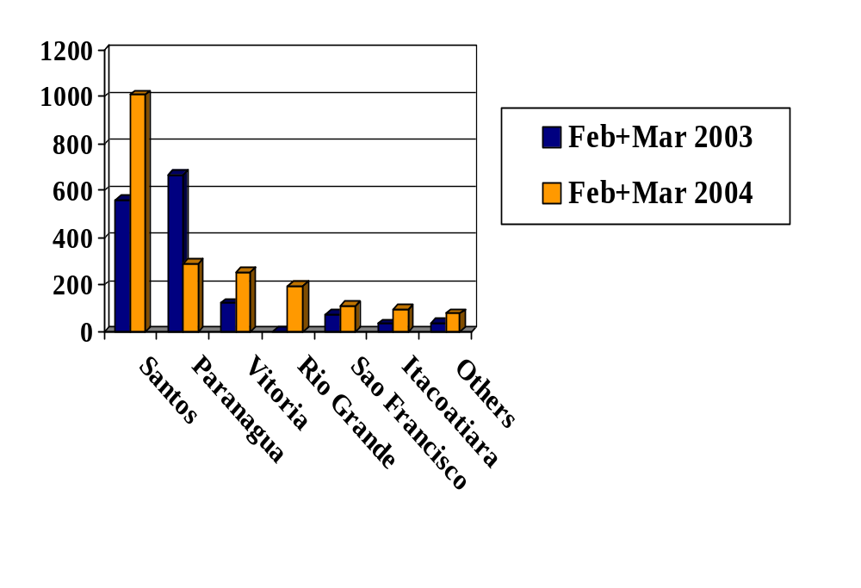
Brazilian Soybean Exports by Port
March 2003 vs. March 2004
1,000 Tons

Brazilian exports regularly suffer a negative premium of roughly $0.12 per bushel ($4.40/ton) during harvest due to logistical bottlenecks. However, the discount at Paranagua hit a record this year of $1.50/bushel $55/ton) due to a combination of difficulties, such as strikes by port workers and federal inspectors, heavy rains, restrictions on biotech exports, and the delays caused by biotech testing.

By March 13, Brazilian soybean producers were receiving up to US$51/ton (14.3%) less than US producers due to problems at the port of Paranagua. Exports from Paranagua were earning only $305/ton versus $356/ton from the Gulf of Mexico. According to analysts, the negative premium was due to poor liquidity and the delay in operations, primarily due to the biotech testing at the port and barriers to shipping biotech beans. Importers and exporters were concerned about the port loading delays, burdensome biotech testing, and barriers erected to block biotech shipments. Thirteen trucks suspected of carrying biotech beans were detained for weeks. The superintendent of the port of Paranagua, Eduardo Requiao (brother of the Governor of Parana), admitted that there are problems, but claimed that they are the same as in other Brazilian ports.

The problems at Paranagua worsened considerably a few days later with the onset of a strike of federal inspectors, which delayed inspection of soybean carrying trucks, causing backups of 60 kilometers on the main highway leading to the port. Early this year, Paranagua implemented a regulations aimed at reducing the yearly truck backups. The regulation allows to only receive trucks carrying cargos that have already sold and their departure by boat is already scheduled. Despite the new regulations, Paranagua continued to suffer long lines of trucks. Even worse, the rule resulted in a queue of waiting ships. Average daily demurrage costs for ships skyrocketed from US$10,000 to up to US$50,000.

On March 19, operations at the Port of Paranagua came to a standstill with the onset of a lockout/strike by port workers, shipping companies, and some local businesses. During a television interview, the Port Workers Union President stated that they were protesting "an unreasonable and hostile management style shown by the Port Authority," and demanded the resignation of Port Authority Director Requiao. Lengthy delays caused by GMO inspections were a key issue in the protest. By the time an agreement was reach and the port resumed operations in late March, nearly 50 ships were lined up at sea while thousands of trucks lined the highway for more than 100 kilometers from Paranagua to Curitiba. Truckers protested the lack of reimbursement for the delays by blocking the main highway linking Paranagua and Curitiba.

As if the Paranagua situation was not already confusing enough, the Port Authority of the Paranagua issued a Service Order on March 22, which opened a window for biotech exports. Service Order 27 allowed the segregation and labeling of biotech soybean lots for export. Following the release of the service order, the Governor of Parana and the port director declared the service order invalid, stated that the state remains free of GMOs, and asserted that the port continues to prohibit the export of biotech soybeans.

Greenpeace has been adding to the problems at Paranagua by blocking ships coming from Argentina from topping-off at Paranagua. Greenpeace claims it is trying to keep Paranagua pure, and it cannot be contaminated by GMO-filled boats from Argentina. Due to shallow waters in Argentine ports, boats cannot load up to capacity, and therefore regularly top-off at Brazilian ports.

The Governor of Parana believed that farmers in his state would receive a premium for their non-GMO soybeans. Unfortunately for Parana producers, the premiums realized have been negative. Not only are Parana’s exports being sold at a lower price, their farmers are also receiving less at state elevators than producers in other states. For example, Parana farmers have been receiving record discounts for their beans compared to Rio Grande do Sul producers. Parana farmers are accustomed to receiving greater values for their soybeans than other states, however the situation changed this year. On April 28, producers in Rio Grande do Sul earned R$56 per 60-kilo bag while Parana producers were earning only R$52 to R$53 per 60-kilo bag of soybeans. The discount is even more extreme when you consider that Rio Grande do Sul’s production costs are 20 to 30 percent lower, owing to their use of biotech soybeans.

On the bright side for the port, Paranagua is investing in three new berths and will increase the port capacity by 30 percent. A western platform will be constructed, and other platforms will be renovated and extended. The existing berths will be dredged and deepened to a minimum of 12 meters. The R$148 million (US$51 million) investment is projected to be completed within 2 years, and the port authority states that it would allow exports to nearly double.

Paraguay’s Dilemma

Parana’s prohibition of GMOs created a bilateral controversy with neighboring Paraguay, who owns a terminal at the port of Paranagua. Due to a bilateral agreement between the federal governments of Brazil and Paraguay, the state government of Parana cannot legally prevent the transshipment of Paraguayan soybeans to the port of Paranagua. However, Parana has effectively blocked Paraguayan shipments through a myriad of barriers, bureaucracies, and difficulties. Paraguay has been seeking alternative export ports, and has increased shipments through ports in Uruguay and Argentina, as well as through other Brazilian ports.

Rio Grande

The port of Rio Grande in the GMO-friendly state of Rio Grande do Sul (RS) has experienced a significant increase of transshipments of Paraguayan soy, corn, and wheat. The railway company America Latina Logistica (ALL) transported on 5,000 tons of Paraguayan grains from Paraguay to Rio Grande in 2002. This year, the port hopes to export at least 400,000 and possibly up to one million tons of Paraguayan grains, plus increase exports of grains from northern RS which previously left through Paranagua, estimated at 300,000 tons. Rio Grande is operating below capacity and can reportedly easily absorb the additional supply. Rio Grande aims to compete with other ports by offering fewer delays and no restrictions on biotech exports. ALL is increasing its investments in Paraguay, and estimates the nation’s soybean production potential at 10 million tons. ALL is currently operating at full capacity on the route to Rio Grande, transporting 40,000 tons per month, and is planning infrastructure investments to increase its capacity by 50 percent. ALL has invested R$185 million in Rio Grande do Sul infrastructure since 1997, and also operates in Santa Catarina, Parana, southern Sao Paulo, and part of Argentina.

San Francisco do Sul

The port of Sao Francisco do Sul in Santa Catarina is experiencing an increase in exports of biotech soybeans from Parana, as they can no longer depart through Paranagua. Roughly 550 producers in Parana signed the federal declaration of biotech planting, but the state government does not know the location of size of the farms. The first truckload of 19 tons of biotech beans from southeastern Parana arrived at Sao Francisco do Sul in early April. However, Sao Francisco do Sul is operating near capacity and cannot accommodate large amounts of diverted beans. The port expects to move 5.5 million tons of grains this year, which is nearly double the amount exported last year. Sao Francisco is studying the feasibility of building a new pier, which would entail an investment of roughly US$20 million. Bunge is investing US$ 30 million at Sao Francisco do Sul.

Santos

Santos has taken the lead in Brazilian grain exports, and will see increased demand due to growing Brazilian production and Paranagua’s non-biotech stance. Santos is backing the expansion of three grain terminals, which should expand handling capacity by 1.4 million tons over the next ten years. Bunge is investing U$ 100 million in its facilities in Santos.

Santos has experienced an increase in transshipments from Paraguay. Barge movements from the Paraguayan bank of the reservoir north of the Itaipu Dam, up the Parana and Tiete Rivers to a point just west of Sao Paulo city, make the port of Santos an attractive alternative loading point.

Santarem

Cargill’s new $20 million grain terminal in Santarem includes a 350-meter access bridge, pier and berths for Panamax-sized international ships and riverine barge convoys, thereby boosting port’s annual exports from 350,000 tons to 800,000 tons. Soybean production is expanding rapidly in Mato Grosso and other parts of the massive Center-West, and Santarem will allow Cargill to get freshly harvested soybeans to Asian and European customers faster. The Cuiaba-Santarem BR-163 highway project will significantly boost usage of this port.

Porto Velho

Expanding the use of the Madeira River which in 2003 should convey upwards of million tons of soybeans by barges over 700 miles from Porto Velho, Rondonia, northeast to the Amazon River port of Itacoatiara, Amazonas. At that point, 160 miles east of Manaus, ocean-going 50,000-ton vessels are loaded and moved out to export markets. Latest freight costs indicate that shipping by waterways results in transportation charges that are 25 to 40 percent less than roadway costs per metric ton. Additional capacity has been installed at Porto Velho to move soybeans to the Santarem Cargill facility.

TOTAL MEALS

Production

Soybean meal accounts for 98 percent of total Brazilian meal production, with the remainder mainly cottonseed meal. Brazilian soy meal production for MY 2004 is projected at 24.75 million tons, up 11 percent from last season, while MY 2005 production is forecast at 28 million tons due to expectations of a much larger crop. Cottonseed meal output is forecast for 898,000 tons in MY 2004 and slightly over 1 million tons for MY 2005, with growth due to increased cotton production.

Consumption

Meal consumption is projected to move in line with expanding domestic livestock and poultry production. Soybean consumption makes up more than 92 percent of total meal use. For MY 2004, soy meal demand is anticipated to reach 9 million tons, up seven percent from last season. Continued livestock and poultry expansion is expected to create demand for 10.8 million tons of soy meal and 1 million tons of cotton seed meal in MY 2005.

Though Brazil’s economy has been facing a challenging economic situation with considerable public sector debt and record interest rates to borrowers, its trade surplus has never been higher, and soybeans have led the way as the single largest contributor to the trade surplus. Increasing exports of poultry and pork products spur higher demand for feed inputs. Feed sector information indicates the poultry sector as the dominant consumer of soybean meal at approximately 65 percent, while the pork sector accounts for an additional 25 percent. The cattle sector takes nearly all of the cottonseed meal.

Trade

Except for a small level of cottonseed meal exports, basically all exports are soybean meal, which are projected to increase 16 percent in MY 2004 as the higher domestic crush and the potential for strong demand for vegetable protein meals in the world market present sales opportunities. The growth is expected to continue in MY 2005.
Brazilian soybean meal exports by port for MY 2002/03 and MY 2003/04 are reported by the GOB as follows:

Exports by Port, Soybeans Meal
(Feb/Jan) (1000 MT)
Port | 2003/04 | 2002/03
Paranagua | 5932 | 5524
Santos | 2935 | 2796
Rio Grande | 1881 | 1862
Vitoria | 1359 | 1358
Ilheus | 688 | 533
Sao Francisco | 553 | 653
Others | 193 | 57
Total | 13,542 | 12,782
Source: DECEX/Safras & Mercados

Relative to meal production, oilseed meal imports for MY 2003 are projected to remain minimal. Depending on price and logistics, very small quantities of meal may be imported from Argentina and Paraguay.

Stocks

There are no GOB held meal stocks; all stocks are held by feed millers and crushers/exporters.

Marketing

Brazilian soybean meal enjoys a “high-protein” reputation and exports have benefited from the relative low cost of the Real, vis-à-vis the U.S. dollar. The non-biotech label is also used by Brazilian exporters to attempt to differentiate their product from that of other international suppliers. However, as over 50 percent of the crush capacity is located in southern Brazil and two-thirds of Brazilian soybean meal is exported from ports on the southern coast, the commingling of transgenic and non-transgenic soybeans in the crush process is possible (See Total Oilseeds, Marketing). A final factor that results generates demand for meal is some lingering international concern over the use of animal-based protein sources for livestock feed.

FEED DEMAND STRATEGIC INDICATOR TABLE FOR BRAZIL

FEED DEMAND
STRATEGIC INDICATOR TABLES FOR BRAZIL
MEAT PRODUCTION
 |  | Last Year | Current Year | Out Year Forecast
Calendar Year: | 2002 | 2003 | 2004 | 2005
Poultry
Poultry Meat: | 7,449,000 | 7,645,000 | 8,105,000 | 8,610,000
Eggs: | 16,488 | 14,440 | 15,230 | 16,100
Pork: | 2,565,000 | 2,560,000 | 2,485,000 | 2,560,000
COMPOUND FEED SECTOR
 |  | Last Year | Current Year | Out Year Forecast
Calendar Year: | 2002 | 2003 | 2004 | 2005
Compound Feed Capacity | N/A | N/A | N/A | N/A
Total Compound Feed Produced | 41,600 | 43,870 | 46,070 | 48,400
------ by integrated producers | N/A | N/A | N/A | N/A
------ by commercial producers | 41,600 | 43,870 | 46,070 | 48,400
FEED GRAIN USE
 |  | Last Year | Current Year | Out Year Forecast
Marketing Year: | 2002 | 2003 | 2004 | 2005
Corn (Domestic consumption: feed) | 33,00,000 | 34,000,000 | 35,000,000 | 33,800,000
Other (specify) | N/A | N/A | N/A | N/A
PROTEIN - ENERGY USAGE
 |  | Last Year | Current Year | Out Year Forecast
Marketing Year: | 2002 | 2003 | 2004 | 2005
Total Protein Meal (feed waste domestic consumption) | N/A | N/A | N/A | N/A
Soy Bean Meal (feed waste domestic consumption) | 7,980,000 | 8,400,000 | 9,000,000 | 10,800,000
Other Protein Meal, e.g. Palm Kernel Meal, Rape Meal (feed waste domestic consumption) | N/A | N/A | N/A | N/A
Fish Meal | 16,328 | 18,700 | 20,100 | 22,300
Palm Crude Oil (feed waste domestic consumption) | 15,360 | 16,960 | 22,080 | 25,280
TRADE (Metric Tons)
 |  | Last Year | Current Year | Out Year Forecast
Year: | 2002 | 2003 | 2004 | 2005
Corn
Imports: | 800,000 | 450,000 | 400,000 | 400,000
Exports: | 4,620,000 | 4,000,000 | 4,500,000 | 4,000,000
Soy Beans
Imports: | 1,124,000 | 800,000 | 1,000,000 | 1,000,000
Exports: | 19,987,000 | 21,900,000 | 2,560,000 | 2,800,000
Soy Bean Meal
Imports: | 288,000 | 250,000 | 300,000 | 300,000
Exports: | 14,000,000 | 16,300,000 | 17,500,000 | 19,000,000
Fish Meal
Imports: | 11,546 | 13,572 | 13,900 | 14,600
Exports: | 3,900 | 534 | 2,300 | 3,500
Palm Crude Oil
Imports: | 9,270 | 24,375 | 22,320 | 25,000
Exports: | 7,310 | 640 | 8,200 | 12,300
PROTEIN PRODUCTS TARIFFS AND TAXES |  | Bound Rate | Applied Rate | Other
Report Year: 2004 | Product  Description 1/ | (%) | (%) | Import  Taxes/Fees*
0505.90 | FEATHER MEAL | 45 | 8 | 18
1501.00.00.60 | YELLOW GREASE | 45 | 8 | 18
1502.00.00.40 | INEDIBLE TALLOW | 45 | 8 | 18
1511 | PALM OIL | 55 | 10 | 18
1518 | ANML/VG FTS &OILS | 70 | 10 | 18
2301.10 | MEAT AND BONE MEAL | 55 | 6 | 18
2301.20 | FISH MEAL | 55 | 6 | 18
*ICMS( State Value Added Tax) assessed on the value of the product after unloading at the port, which includes the CIF cost plus the Applied Rate (Import tariff).

TOTAL OILS

Production

Soybean oil dominates Brazilian oil production. Meal demand is the most important crush driver, and oil prices have served to maximize output to the extent possible. Brazilian soy oil production is forecast for 6.08 million tons in MY 2004 and 6.8 million tons in MY 2005. Cottonseed oil production is expected to reach 265,000 tons and 311,000 tons in MY 2004 and MY 2005, respectively.

Consumption

Utilization of soybean oil is forecast at 3.23 million tons in MY 2004, while cottonseed oil consumption is forecast for 211,000 tons. The forecast for MY 2005 is for increased consumption of both oils. Soybean oil remains the principal home cooking oil in Brazil. Cottonseed oil goes largely to industrial uses, such as margarine. Other refined oils, such as corn, sunflower seed, canola and olive are readily available in many urban markets across Brazil.

Trade

Soy oil exports for MY 2004 are projected at 2.94 million tons, up markedly from last year, due to the increased soybean crush. Out year exports are forecast to increase significantly due to an expectation of increased production and crush.

Exports of soybean oil by port are reported by the GOB as below.

Exports by Port, Soybean Oil
(Feb/Jan) (1000 MT)
Port | 2003/04 | 2002/03
Paranagua | 1414 | 1150
Rio Grande | 515 | 545
Sao Francisco | 379 | 370
Santos | 2 | 1
Others | 95 | 35
Total | 35,933 | 30,956
Source: DECEX/Safras & Mercados

As is the case for meal and oilseeds, imports of vegetable oil are expected to stay small and will continue to originate predominantly from MERCOSUL countries.

Marketing

Brazilian soybean oil exports have benefited from the devalued Real, vis-á-vis the U.S. dollar. The non-transgenic label is also used by Brazilian exporters to attempt to differentiate their product from that of other international suppliers. However, as over 50 percent of the crush capacity is located in southern Brazil and nearly all of Brazilian soybean oil is exported from ports on the southern coast, the commingling of transgenic and non-transgenic soybeans in the crush process is a virtual certainty (See Total Oilseeds, Marketing).

Other Oils

Sunflower

Conab estimates Brazil’s 2003/04 sunflower area at 48,500 hectares, with production at 72,200 tons. Sunflower area increased more than 12 percent from 2002/03, but production is expected to jump 28 percent due to a 14-percent yield increase. Goias is the leading sunflower producing state in Brazil, with nearly 60 percent of the nation’s planted area and 64 percent of production. Mato Grosso do Sul, Rio Grande do Sul, and Mato Grosso account for an additional 17 percent of area and 21 percent of production.

Although Brazil remains a minor sunflower producer, production has jumped from less than 16,000 tons in 1998. Sunflower has gained particular appeal as a winter crop in Goias, and other states are looking at its attractiveness in diversification and crop rotation. The sunflower planting season differs by region in Brazil. Plating in the center-west runs from January through mid-February, while Sao Paulo plants in February and March. Rio Grande do Sul plants sunflowers in July and August, and Parana plants from August to October. Harvest begins 90-130 days after planting, depending on the seed variety. Brazilian sunflower oil production is estimated at 56,000 tons per year.

Castor Seed

Brazil is experimenting with castor oil for biodiesel production in the arid Northeast. Conab estimates Brazil’s castor bean production at 102,500 tons in 2003/04, on an area of 128,500 hectares. The state of Bahia accounts for nearly 98 percent of national production, although government incentives should stimulate greater production throughout the Brazilian Northeast. Castor seed oil estimated at 40,000 tons per year.

Peanut

Conab estimates Brazilian peanut production at 207,000 tons for 2003/04, on an area of 89,000 hectares. The state of Sao Paulo accounts for more than 80 percent of national production. Other significant states include Bahia, Minas Gerais, Parana, and Rio Grande do Sul, which combine for an additional 15 percent of production. Although production has increased 13 percent since 1998, area has fallen 11 percent. Nearly 85 percent of production occurs as a summer crop, although Sao Paulo dominates both the summer and winter crops. The Southeast produces a summer crop while the Northeast production occurs in the winter. Brazilian peanut oil production is roughly 28,000 tons per year.

Palm Oil

Brazil producers roughly 110,000 tons of palm oil per year, on an area of 66,000 hectares. Para is the leading palm producer, with roughly 80 percent of the national acreage. Bahia is the second largest palm producer. Brazil is not self sufficient in palm oil, and imports 180,000 tons of palm oil and derivatives annually.

Brazil’s leading palm oil producer, Agropalma, plans to increase its capacity from 250 tons to 350 tons per day. The company is investing R$1 million (US$340,000) in its Belem refinery, and hopes to increase its exports, particularly to the United States. Agropalma is producing palm oil biodiesel to fuel its diesel engines and supply energy needs in a poor neighborhood in Belem. Agropalma accounts for roughly 80 percent of Brazil’s palm oil production and is centered in Para.

Minor Oils

Brazil produces roughly 15,000 tons of rice oil, 2,000 tons of coconut oil, 15,000 tons of rapeseed/canola oil, and 46,000 tons of corn oil.

