


Connecting People to Employment:

An Evaluation of Job Access and Reverse Commute (JARC) Services Provided in 2006

FINAL REPORT

October, 2007

FTA-VA-5001-2007

REPORT DOCUMENTATION PAGE |  |  |  | Form Approved  OMB No. 0704-0188
Public reporting burden for this collection of information is estimated to average 1 hour per response, including the time for reviewing instructions, searching existing data sources, gathering and maintaining the data needed, and completing and reviewing the collection of information. Send comments regarding this burden estimate or any other aspect of this collection of information, including suggestions for reducing this burden, to Washington Headquarters Services, Directorate for Information Operations and Reports, 1215 Jefferson Davis Highway, Suite 1204, Arlington, VA 22202-4302, and to the Office of Management and Budget, Paperwork Reduction Project (0704-0188), Washington, DC 20503.
1. AGENCY USE ONLY (Leave blank) |  | 2. REPORT DATE  October 2007 |  | 3. REPORT TYPE AND DATES COVERED  Final Report—October 2007
4. TITLE AND SUBTITLE  Connecting People to Employment: An Evaluation of Job Access and Reverse Commute (JARC) Services Provided in 2006. |  |  |  |  | 5. FUNDING NUMBERS  FTA-VA-37-5001-2007
6. AUTHOR(S)
Susan Bregman, Christoph Berendes, Rosemary Gerty, Stephen Falbel, Jessica Eckhardt, and Lauren Miller
7. PERFORMING ORGANIZATION NAME(S) AND ADDRESS(ES)  Automated Communication System, Inc. (ACSI)  1425 25th Street,  Newport News, VA 23607  Transystems  1 Cabot Road  Medford, MA 02155 |  |  |  |  | 8. PERFORMING ORGANIZATION REPORT NUMBER
9. SPONSORING/MONITORING AGENCY NAME(S) AND ADDRESS(ES)  Federal Transit Administration  U.S. Department of Transportation  Washington, DC 20590 Website URL [www.fta.dot.gov] |  |  |  |  | 10. SPONSORING/MONITORING  AGENCY REPORT NUMBER
- Supplementary Notes.

12a. DISTRIBUTION/AVAILABILITY STATEMENT  Available From: National Technical Information Service/NTIS, 5285 Port Royal Road, Springfield, Virginia 22161. Phone 703.605.6000, Fax 703.605.6900,  Email [orders@ntis.fedworld.gov] |  |  |  |  | 12b. DISTRIBUTION CODE
ABSTRACT: The Job Access Reverse Commute (JARC) program was established to address the unique transportation challenges that welfare recipients and low-income individuals face in finding and keeping jobs. This study analyzed the JARC-funded services provided in FY 2006 and projects that these services provided access to 43.4 million jobs in FY 2006. An estimated 21.2 million jobs were categorized as low-wage and that these services provided 22.9 million one-way trips during the year.
14. SUBJECT TERMS  Job Access Reverse Commute (JARC), employment, public transportation. |  |  |  |  |  | - NUMBER OF PAGES
 |  |  |  |  |  | 16. PRICE CODE
17. SECURITY CLASSIFICATION  OF REPORT  Unclassified | 18. SECURITY CLASSIFICATION  OF THIS PAGE  Unclassified |  | 19. SECURITY CLASSIFICATION  OF ABSTRACT  Unclassified |  |  | 20. LIMITATION OF ABSTRACT

Disclaimer Notice
This document is disseminated under the sponsorship of the United States Department of Transportation in the interest of information exchange. The United States Government assumes no liability for its contents or use thereof.

The United States Government does not endorse manufacturers or products. Trade or manufacturer’s names appear herein solely because they are essential to the objective of this report.

Connecting People to Employment: An Evaluation of Job Access and Reverse Commute (JARC) Services Provided in 2006

October, 2007

Prepared by
Automated Communication System, Inc
1425 25th Street, Newport News, VA, 23607

And

Transystems
1 Cabot Road
Medford, MA 02155

Prepared for
Federal Transit Administration
U.S. Department of Transportation
Washington, DC 20590

Available Online [http://www.fta.dot.gov]
Federal Transit Administration
Office of Research, Demonstration, and Innovation
1200 New Jersey Avenue, SE, East Building, 4th Floor
Washington, DC 20590

Report Number
FTA-VA-37-5001-2007

Acknowledgments
The work in this document was performed by ACSI and TranSystems under Federal Transit Administration (FTA) contract number DTFT60-06-C-00ll. The lead author was Susan Bregman; Christoph Berendes and Rosemary Gerty were authors and reviewers. Stephen Falbel, Jessica Eckhardt, and Lauren Miller also contributed to the research and the report. Douglas Birnie was the FTA project manager, and Pamela Brown was the COTR.
The following individuals at FTA provided invaluable guidance and feedback throughout this project: Douglas Birnie, Henrika Buchanan-Smith, Ann Cihon, John Giorgis, Yvonne Griffin, Bryna Helfer, Pamela Johnson, David Schneider, David Simpson, and Maria Wright.
The authors would like to thank the other individuals and organizations who contributed to this analysis. They included Carolyn Jeskey of the Community Transportation Association of America (CTAA), the CTAA Joblinks Committee, Jeremy Wu and the program staff at the Longitudinal Employment-Household Dynamics program, and Oak Square Resources, LLC.

Acronyms

AFDC | Aid to Families with Dependent Children
CTAA | Community Transportation Association of America
DOT | Department of Transportation
FAQ | Frequently Asked Questions
FIPS | Federal Information Processing Standards
FTA | Federal Transit Administration
FY | Fiscal Year
GIS | Geographic Information Systems
HUD | United States Department of Housing and Urban Development
JARC | Job Access and Reverse Commute
LED | Local Employment Dynamics
LEHD | Longitudinal Employment-Household Dynamics
NAICS | North American Industry Classification System
OES | Occupational Employment Statistics
PRWORA | Personal Responsibility and Work Opportunity Reconciliation Act
QWI | Quarterly Workforce Indicators
SAFETEA-LU | Safe, Accountable, Flexible, Efficient Transportation Equity Act, A Legacy for Users
TANF | Temporary Assistance to Needy Families
TEA-21 | Transportation Equity Act for the 21st Century
U.S. | United States
UI | Unemployment Insurance
USDOT | United States Department of Transportation

Table of Contents
Disclaimer Notice i
Acknowledgments iv
Acronyms v
List of Tables and Figures vii
Executive Summary viii
1.0 Introduction 1
2.0 What’s New for FY 2006 2
2.1 Evolution of the JARC Program 2
2.2 Changes in Reporting 4
3.0 Data Collection 6
3.1 Overview 6
3.2 Data Responses 6
3.3 Reporting Period 6
3.4 Grantee Support 7
3.5 Grantee Follow-Up 7
4.0 Job Estimation Methodology 9
4.1 Define Jobs Accessed 9
4.2 Identify Employment Databases 9
4.3 Test Alternative Approaches 10
4.4 Obtain Feedback from Grantees 11
4.5 Estimate Jobs Accessed 11
5.0 Characteristics of JARC Grantees and Services 15
5.1 Transition to Formula Program 15
5.2 Service Types 15
5.3 Size of Urbanized Area 16
5.4 Geographic Coverage 17
6.0 JARC Performance Measures 21
6.1 Matrix Approach 21
6.2 Performance of JARC-Funded Services in FY 2006 23
Appendix A Information on the
Longitudinal Employment-Household Dynamics (LEHD) Program 32
Appendix B Joblinks Advisory Committee Members 34
Appendix C Accessing County-Based Job Data from LEHD 35
Appendix D Estimating Low-Wage Jobs 39
Appendix E JARC Service Matrix 41

List of Tables and Figures

Table 2-1 JARC Funds Authorized Under SAFETEA-LU 3
Table 5-1 Distribution of JARC-Funded Services by Service Type 16
Table 5-2 Services by Type and Urbanized Area Size (Row Percent) 18
Table 5-3 Services by Type and Urbanized Area Size (Column Percent) 19
Table 5-4 Service Type by Geographic Coverage 20
Table 6-1 J ARC Service Matrix 22
Table 6-2 FY 2006 JARC Service Matrix – Distribution of Services by
Primary Goal 24
Table 6-3 One-Way Trips by Service Type and Urbanized Area Size
(Row Percent) 27
Table 6-4 One-Way Trips by Service Type and Urbanized Area Size
(Column Percent) 28
Table 6-5 One-Way Trips by Service Type and Primary Goal 29
Table 6-6 Estimation of Jobs Accessed for Service Records without
Geographic Information 31
Table 6-7 Projection of Jobs Accessed in FY 2006 31
Table D-1 Percentage of Low-Wage Jobs by NAICS Category 40
Table E-1 JARC Service Matrix 43

Figure 3-1 Grantee Reporting Status 7
Figure 4-1 Factors for Developing Jobs per Linear Route Mile 13
Figure 5-1 Services by Type and Urbanized Area Size 18
Figure 5-2 Services by Type and Urbanized Area Size 19
Figure 5-3 Service Type by Geographic Coverage 20
Figure 6-1 One-Way Trips by Service Type 26
Figure 6-2 One-Way Trips by Service Type and Urbanized Area Size 27
Figure 6-3 One-Way Trips by Service Type and Urbanized Area Size 28
Figure 6-4 One-Way Trips by Service Type and Primary Goal 29

Executive Summary
The Job Access Reverse Commute (JARC) program was established as part of the Transportation Equity Act for the 21st Century (TEA-21) to address the unique transportation challenges that welfare recipients and low-income individuals face in finding and keeping jobs. JARC began as a discretionary grant program, but transitioned to a formula-based program under the Safe, Accountable, Flexible, Efficient Transportation Equity Act, A Legacy for Users (SAFETEA-LU). FY 2006 marks the first year of the restructured JARC program, now also known as Section 5316.
In June 2006, the Federal Transit Administration (FTA) contracted with ACSI and TranSystems to manage data collection and analysis for FY 2005 and FY 2006. Because of the transition Section 5316, the consultant team was also charged with developing a new approach for data collection and reporting starting with FY 2006.
Grantees with active JARC-funded grants in FY 2006 were required to file an annual report using an on-line system. JARC data collection focused on two key performance measures:
- Jobs accessed
- One-way trips provided
FTA tasked the consultant team with estimating jobs accessed on behalf of the grant recipients. Data sources included several public and proprietary databases, including the Longitudinal Employment-Household Dynamics program (LEHD) currently under development by the U.S. Bureau of the Census.
To better represent the accomplishments of nontraditional services, the JARC Service Matrix was intended to provide a relatively simple way to categorize JARC-funded services for reporting purposes. The matrix was organized so that grantees can follow three steps:
- Choose the service category that most closely matches the service provided locally.
- Select the primary goal that best describes the purpose of the service.
- Based on the combination of service and goal, identify the type of information requested for reporting.
The matrix includes three basic categories of service: (I) trip-based services, (II) information-based services, and (III) capital investment projects. The five primary goals are:
- Expanded geographic coverage
- Extended hours or days of service
- Improved system capacity
- Improved access or improved connections
- Improved customer knowledge
Based on the combination of service type and primary goal, the cells in the matrix identify the type of service output data to be provided by the reporting grantee. The output measures typically include then number of one-way trips for trip-based programs, the number of customer contacts for information-based services, and the number of units provided for capital investment projects.
For FY 2006, 155 grant recipients reported on 645 JARC-funded services. Key findings from these reports include the following:
- It is estimated that JARC-funded services provided access to approximately 43.4 million jobs, including 21.2 million low-wage jobs.
- It is estimated that JARC-funded services provided 22.9 million one-way trips in FY 2006.
- About three out of four JARC-funded services were traditional transit services – either fixed route (44%) or demand response (28%). Information-based services accounted for 8% of the programs and capital investment programs made up 7%.
- Fixed route services accounted for 44% of the services and 82% of the one-way trips. Demand response programs comprised 28% of the services and 11% of the trips.
- In rural areas, demand response made up 51% of the programs and carried 38% of the trips. In large cities, fixed route was responsible for 47% of the programs and 88% of the trips.
- About 31% of JARC-supported services cover counties and 26% operate in cities or towns. Some 25% are regional in nature and 12% serve multiple jurisdictions.
- About 40% of trip-based services were intended to expand geographic coverage and 29% extended days or hours of service.
- Most information-based programs were developed to improve customer information (58%) or increase system access (32%).
- Almost all capital investment services (98%) were intended to improve access.
In FY 2006 the JARC program continued to provide connections between people and jobs. The program is characterized by diversity – in terms of types of services, operating settings, and partnerships – as it provides service for individuals who need access to jobs.

Introduction
The Job Access Reverse Commute (JARC) program was established as part of the Transportation Equity Act for the 21st Century (TEA-21) to address the unique transportation challenges that welfare recipients and low-income individuals face in finding and keeping jobs. With many new entry-level jobs located in suburban areas, low-income workers and/or welfare recipients have found it difficult to access these jobs from their inner city, urban and rural homes on a daily basis. Car ownership can be prohibitively expensive, and many suburban job sites are not served by existing public transportation routes. Further, many entry-level jobs offer only night or weekend hours, when conventional transit services are limited or non-existent. Finally, for many individuals, transportation challenges also extend to reaching employment support services, such as childcare, training and counseling.
The Federal Transit Administration (FTA) has undertaken several evaluations of the JARC program since its inception. In June 2006, FTA contracted with ACSI and TranSystems to manage data collection and analysis for FY 2005 and FY 2006. Because the JARC program transitioned to a formula-based program in FY 2006 (Section 5316), the consultant team was also charged with developing a new approach for data collection and reporting starting with FY 2006.
The analysis of the FY 2005 data was summarized in a technical memorandum transmitted to FTA in October 2006. This report focuses on the new approach for data collection and reporting developed for FY 2006 and presents findings from the analysis of FY 2006 data.
It is projected that JARC-supported services provided access to 43.4 million jobs in FY 2006. An estimated 21.2 million jobs were categorized as low-wage.
These services provided 22.9 million one-way trips during FY 2006.

What’s New for FY 2006
FY 2006 saw the introduction of several major changes in the JARC program and the reporting process.
- JARC began the transition from a discretionary/earmark program to a formula-based program.
- FTA established a new measure of jobs accessed for JARC reporting
- FTA developed a new approach to better capture performance information on nontraditional programs.
- FTA introduced a requirement for grant recipients to provide narrative profiles describing their services.
These changes are discussed below.

Evolution of the JARC Program
In 1996, the Personal Responsibility and Work Opportunity Reconciliation Act (PRWORA) was signed into law. PRWORA ended the entitlement status of welfare and replaced the Aid to Families with Dependent Children (AFDC) program with Temporary Assistance to Needy Families (TANF). TANF, which operates as a state block grant program, required participants to obtain jobs within two years of receiving welfare, and limited them to five years of welfare benefits. The connection between transportation and access to employment and training opportunities was not specifically addressed in the initial welfare reform legislative process.
In 1998, the Transportation Equity Act for the 21st Century (TEA-21) established the Job Access and Reverse Commute Program. JARC made a direct link between transportation services and the ability to obtain and retain a job.
In 2005, Congress reauthorized the transportation funding bill, which was known as Safe, Accountable, Flexible, Efficient Transportation Equity Act – A Legacy for Users, or SAFETEA-LU. SAFETEA-LU increased the annual funding for the JARC Program, but also changed it to a formula-based program.

JARC Under TEA-21
TEA-21 provided competitive grants to local governments and non-profit organizations to develop transportation services to connect welfare recipients and low-income individuals to employment and support services.
The JARC Program had two parts: (1) Job Access and (2) Reverse Commute. Reverse Commute grants were targeted at programs serving suburban work sites, without regard to income status. Job Access grants were targeted at new transportation services for welfare recipients and other low-income persons. Eligible low-income individuals included persons whose family income was at or below 150% of the poverty line, adjusted to reflect family size. Although initially many individuals were also TANF beneficiaries, that was not (and still is not) a requirement to be eligible for JARC-funded services. A coordinated transportation/human service planning mechanism was required to develop Access to Jobs programs.
TEA-21 authorized up to $150 million annually from FY 1999 through FY 2003 for the Access to Jobs program. Total expenditures for Reverse Commute projects were capped at $10 million per year. An innovative funding aspect of JARC was that other federal transportation-eligible funds could be used to meet the local match for Access to Jobs projects, including TANF and Welfare to Work funding.
The first two rounds of JARC funding were awarded to projects through a competitive selection process. However, by 2001 Congress began earmarking the funds and all JARC project funds were earmarks by FY 2003. In addition, under TEA-21, JARC-funded services were viewed as “pilot” projects and it was expected that successful projects would and become self-sustaining and not depend on continued JARC funding.

SAFETEA-LU JARC Program
In 2005, after several continuing funding resolutions, SAFETEA-LU was enacted and continued funding for the JARC Program. JARC, which was an uncodified provision of TEA-21, is now codified in Section 5316 of Title 49, United States Code. Table 2.1 shows total JARC funds authorized under SAFETEA-LU.
Table 2-1
JARC Funds Authorized Under SAFETEA-LU

Year | 2005 | 2006 | 2007 | 2008 | 2009 | Total
JARC Mass Transit Account | $108 M | $138 M | $144 M | $156 M | $165 M | $711 M
General Funds | $16 M | $0 | $0 | $0 | $0 | $16 M
Total | $124 M | $138 M | $144 M | $156 M | $165 M | $727 M
Source: FTA Authorization Fact Sheet: Job Access and Reverse Commute.

The biggest change under SAFETEA-LU was to shift the JARC Program from a discretionary program to a formula-based program. The formula is based on the number of eligible low-income and welfare recipients in urbanized and rural areas. The distribution of allocations is as follows:
- 60% of funds go to designated recipients in areas with populations with 200,000 or more
- 20% of funds go to states for areas under 200,000
- 20% of funds go to states for non-urbanized areas
In addition, states may transfer funds between urbanized and non-urbanized area programs.
According to FTA, JARC projects are no longer viewed as “pilot projects,” but instead are considered a “stable and reliable” source of funds: SAFETEA-LU includes the following provisions:
- States and designated recipients must select projects competitively.
- Projects must be included in a locally developed human service transportation coordinated plan beginning in FY 2007.
- 10% percent of funds may be used for planning, administration, and technical assistance.
- Sources for matching funds are expanded (non-DOT Federal funds can be used as match) to encourage coordination with other programs such as those funded by the Department of Health and Human Services.
Although JARC funds increased overall under SAFETEA-LU, they are now spread over a larger number of potential recipients.

Changes in Reporting
Starting with FY 2006, FTA also introduced several changes in the JARC reporting system.
- Transition from employment sites/employers to jobs
- Better reflect the performance of nontraditional programs
- Require profiles of JARC-funded services
These changes and their implications for the data collection and analysis are discussed below.

Report on jobs accessed
Until and including the FY 2005 data reporting process, FTA required JARC recipients to estimate the number of employment sites reached as a result of JARC-funded services. FTA used the term employment site to measure new connections to employers based on geography or time of day. An employment site was defined as access to an employer not previously reached by public transportation or access to an employer during a time period not previously served by the public transportation system. Grantees were asked to estimate new employment sites reached via JARC-funded service using one of the several approaches. For fixed route services, employment sites were defined as service stops (usually equivalent to bus stops) that reached employers within one-quarter mile. For demand response, employment sites were defined as the number of addresses accessed or, alternatively, the number of employers within the service area.
This approach was intended to capture information about jobs accessed via JARC-supported services using measures that were familiar to grantees, like addresses, bus stops, or employers. However, feedback from grantees indicated that the estimates were not easy to develop and the data analysis confirmed that reported numbers were inconsistent.
In order to use a measure that better reflected the goals of the JARC program, FTA replaced employment sites with jobs accessed as a measure of JARC performance starting with FY 2006.

Better reflect the performance of nontraditional services
The majority of JARC grant recipients have used the funds to support fixed route or demand response services. The number of annual one-way trips is a standard performance measure for such services, and FTA has collected this information for the past several years of JARC reporting.
However, a hallmark of the JARC program is its support of a wide range of programs, including services that provide grantees with information and those that provide access to support services. Examples include programs that allow individuals to acquire personal vehicles, services that provide one-on-one travel training, and brokerage services that arrange transportation for individuals. While programs like these meet the overall goals of the JARC program, they cannot be measured in the same way as the demand response and fixed route programs.
Starting in FY 2006, FTA asked grantees to characterize their JARC-supported services in one of three ways:
- Trip-based
- Information-based
- Capital investments
Depending on the type of program, grantees could report performance measures that were directly relevant to the type of program. For example, grantees with programs that made information available on the Internet were asked to report on web hits. Grantees with programs that made cars available to individuals were asked to indicate the number of cars delivered or the number of loans subsidized. In this way, FTA will better capture the breadth of the JARC program and allow grant recipients to report on program performance in meaningful terms.

Collect service profiles
Starting in FY 2004, FTA asked JARC grantees to provide descriptive information about their programs. This request, which was optional in FY 2004-2005, allowed grant recipients to describe their programs in detail and to describe program successes and lessons learned. Originally intended as a way for grantees to share information with one another, the program profiles also allowed FTA to better communicate the success and diversity of the JARC program. As a result, FTA required grantees to provide profile information starting in FY 2006.

Data Collection
Grantees used an on-line system to file a series of reports on their JARC grants for FY 2006. This section provides an overview of the FY 2006 data collection process.

Overview
Grantees with active JARC-funded grants in FY 2006 were required to file an annual report using an on-line system. The on-line system was originally developed for FY 2003 and refined in subsequent years.
FTA continued its ongoing efforts to streamline the data collection process. For FY 2006, JARC data collection focused on two key performance measures:
- One-way trips provided
- Jobs accessed
Significantly, FTA did not require grantees to estimate the number of jobs accessed. Instead grantees were asked to provide information about services characteristics and geographic coverage that would enable the analysis team to develop the jobs estimate.
Grantees were also asked to provide descriptive information about their programs for FY 2006. Similar information was collected on an optional basis for FY 2004-2005, but the questions were made mandatory for FY 2006.

Data Responses
Starting in the spring of 2007, the JARC Evaluation Team worked with FTA to identify grantees with active programs during FY 2006. These grantees were contacted via email to confirm contact information. Based on this outreach effort, the JARC Evaluation Team invited 205 grantees to submit FY 2006 data reports. Of the 205 grantees contacted:
- 33 grantees indicated that they did not provide service in FY 2006
- 155 grantees indicated that they did provide service in FY 2006 and filed reports
- 17 grantees did not respond within the reporting period, although several contacted the team after the reporting deadline had passed.
This yielded a response rate of 91.7%.
The final database includes 645 services from the 155 grantees that reported active JARC-funded service during FY 2006.

Reporting Period
A small number of grantees were asked to test the reporting system during the week of June 11, 2007, and all grantees were invited to report on June 19. The official end of reporting was July 24. However, in an effort to maximize the response rate, the reporting system was kept online through the end of July. Figure 3-1 shows the reporting rate.
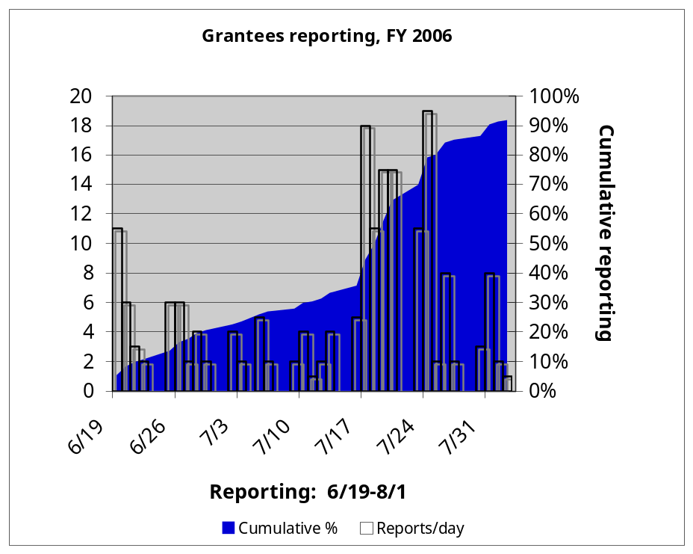
Figure 3-1
Grantee Reporting Status

Grantee Support
The JARC support team handled approximately 600 email messages from grantees during the reporting period. We also made or received approximately 80 telephone calls (in addition to the follow-up noted below) to assist grantees more directly.
The support website, consisting of 25 pages of instructions, definitions, and answers to frequently asked questions (FAQs), was entirely revised for FY 2006.

Grantee Follow-Up
The consultant team spent a significant amount of effort, with FTA help, to ensure that grantees received notice and reported.
Major email efforts during the spring and summer of 2007 included:
- May 15 – Email to all points of contact for grantees in the candidate list asking each recipient to confirm online that they were the correct contact, or to provide better contact information, if not.
- June 19 – Email to all points of contact, announcing the formal start of JARC FY 2006 data collection.
- June 25 – Email to grantees whose points of contact had not yet logged into the reporting system
- July 16 – Reminder to all points of contact for grantees who had not yet completed reporting, asking them to provide a date on which they would complete their reports.
Between July 23 and August 1, the contractor team also contacted 18 non-reporting grantees by telephone, making at least two efforts per non-reporting grantee to determine whether the grantee was required to report and, if so, to assist with reporting as needed.
In May and then again in July, we also worked with FTA headquarters and regional staff to ensure that we had up to date contact information for non-reporting grantees. In selected cases, FTA staff contacted grantees directly to encourage them to respond.

Job Estimation Methodology
Because most transportation organizations do not have ready access to employment data, FTA undertook the effort of estimating jobs accessed for JARC-supported services. The methodology for estimating jobs accessed had several steps.
- Develop a consistent definition for jobs accessed
- Identify sources of employment data that could be linked to geographical units
- Test alternative approaches
- Seek feedback from grantees
- Estimate jobs accessed
These steps are described below.

Define Jobs Accessed
The consultant team reviewed available sources of employment data to determine the best approach for estimating jobs accessed through the JARC program. Based on this review, two key issues were researched and resolved.
First, the issue of how to distinguish between full-time and part-time employment was reviewed. Although the definitions can vary across datasets, the distinctions were not considered relevant for the purposes of the JARC evaluation. Therefore, for this evaluation, we counted every job – whether full-time or part-time – as one job.
Second, we considered the issue of whether and how to distinguish between all jobs and those jobs that might be more appropriately targeted at JARC beneficiaries. We found that there is no standard definition of a low-wage job or low-income individual. Part of the issue has to do with family/household size and its effect on how much income is required to meet or exceed federal poverty guidelines established by the U.S. Department of Health and Human Services. For 2006, the federal poverty guideline for the 48 contiguous states and the District of Columbia was set at $20,000 a year for a family/household of four. As described earlier, the JARC program was developed to provide transportation targeted for persons at or below 150% of the Federal poverty guidelines, which would translate to $30,000 a year or $14.42 an hour. Therefore, for the JARC analysis, we classified jobs as “low-wage” if they pay $14.42 an hour or less.

Identify Employment Databases
Several government and proprietary databases were explored as possible sources for employment data that could be linked to appropriate units of geography. Two promising resources were identified, one private and one public:
- Dun & Bradstreet employer database
- Longitudinal Employer-Household Dynamics research program
Dun & Bradstreet maintains an employer database that contains detailed information on the number, type, and location of jobs. The firm uses multiple data sources and direct contact with employers to keep the information up to date. While no database of employers is perfect, Dun & Bradstreet is recognized as the best available data on the detailed location of employment sites (establishments) and the number of employees at each. Information is considered proprietary and is available for purchase. Although the cost per record drops with increased volume, total data costs can run into the thousands of dollars, which would be prohibitive for a project of JARC’s national scale.
The Longitudinal Employer-Household Dynamics (LEHD) program combines federal and state administrative data on employers and employees with core Census Bureau censuses and surveys while protecting the confidentiality of people and firms that provide the data. The LEHD program began in 1997 as an initiative to merge available data on households and employment using advanced statistical techniques. Its broad purpose is to integrate data from administrative records, the Census, and surveys to create new information on U.S. society and the economy.
The LEHD’s primary data sources on the employment side are the Unemployment Insurance database, ES-202 reports (on covered employment and wages) and the Business Register (to cover self-employed people and other firms with no paid employees). On the household side, the primary source is the Census Statistical Administrative Records System which includes data from the Social Security administration, the Internal Revenue Service, the American Community Survey, and similar sources. Information about federal employment is not included; however, the LEHD staff is working to add this information.
States supply employment data to the Census on the number of employees at establishments (individual worksites). The locations of these establishments are geocoded and mapped according to census geography. The figures are updated quarterly as part of an existing and ongoing reporting relationship between employers and the states.
To date, 43 states have joined the LEHD program and are supplying data to the Census Bureau. The database will ultimately have historical data as well as current data. As part of the LEHD program, a powerful mapping tool was developed, known as On the Map. While still in development, it is expected to be enhanced and deployed in a more final form by the fall of 2007. Ultimately, On the Map may allow FTA or grantees to define a geographical area on a map and then extract the number of jobs located in that area. Areas may be defined by and drawing a line on a map and choosing a buffer (appropriate for JARC fixed route services), via standard geography (such as ZIP codes) or by drawing a freeform shape on a map (appropriate for JARC demand response services), or by choosing a center point with a buffer. (More information about the LEHD can be found in Appendix A.)

Test Alternative Approaches
Based on this preliminary assessment, the most promising long-term approach was to define each service area and use the LEHD program to retrieve low-wage job information reported by establishments located within the defined service area. Unfortunately, as mentioned above, the LEHD program was still in development and would not cover the entire country in time for the FY 2006 JARC analysis.
Nevertheless, it was possible to field test the LEHD program in localities where the data were available in anticipation of full rollout in time for future analysis efforts. While no database of employers is perfect, Dun & Bradstreet is recognized as the best available data on the detailed location of employment sites (establishments) and the number of employees at each. Therefore, to supplement the available LEHD data, the team used data purchased from Dun & Bradstreet.
Pilot studies were conducted to compare these approaches to data collection and analysis. A pretest was conducted using data already available to the consultant team from the Chittenden County (VT) Transportation Authority in Burlington, Vermont. In addition, on-site case studies were conducted at the following agencies:
- Connecticut Department of Transportation
- Jacksonville (FL) Transportation Authority
- Central New York Regional Transportation Authority (Syracuse)
These agencies funded a mix of JARC-supported services, including fixed route, demand response, mobility manager, and childcare transportation. In addition, the team conducted a telephone-based study with King County Metro Transit, in Seattle (WA) to better understand the challenges of evaluating nontraditional services.
The case studies followed three basic steps: (1) identify service area, (2) identify employers, and (3) estimate number of jobs (and low-wage jobs) accessed. From the results the team developed strategies for estimating the number of jobs (and low-wage jobs) accessed by JARC-funded services.

Obtain Feedback from Grantees
The consultant team worked with the Joblinks Committee of the Community Transportation Association of America (CTAA). The committee included 10 JARC grantees along with several outside experts with detailed knowledge of the JARC program. The group helped the team identify and resolve data-related issues as we worked through the pilot tests and developed the final evaluation strategy. They provided particularly valuable feedback related to interaction with grantees. The committee membership list can be found in Appendix B.

Estimate Jobs Accessed
Based on the findings from the pilot tests, in combination with feedback from the project advisory committee, a methodology was developed to estimate jobs accessed.
As noted earlier, grantees were not asked to estimate jobs accessed. Instead, FTA asked grantees to provide information about service coverage and then used external data sources to develop estimates of jobs accessed. The only exception was for grantees with specialized services that targeted specific employers; services in this category included routes serving a factory or airport or night-owl services that accessed overnight work shifts. Grantees with services like these were asked to estimate the number of jobs reached for such services.
Because of the different characteristics of demand response and fixed route transportation, several approaches were used. These are described below.

Demand response services
To measure jobs accessed by demand response services, a policy decision was made to include every job in the service area. This calculation allowed FTA to identify the theoretical maximum number of jobs made accessible by JARC-supported services.
Grantees were asked to indicate the type of service area (e.g., state, county, city/town, region) and to select the county or counties served from a drop-down list. To the extent possible, the analysis used LEHD data to estimate the number of jobs accessed by demand response services. The consultant team developed an automated process to access this information efficiently. (Appendix C has more detailed information about this approach.)
When LEHD was not available, either because the county was not yet included in the dataset or the demand response service area did not correspond with county boundaries, data was used from the annual County Business Patterns dataset from the U.S. Census. About 25% of the demand response services did not correspond to county, municipal, or state boundaries. These were not analyzed further for this phase of the analysis; however a factor was developed to expand the data findings to include these records. (See Section 6.0.)

Fixed route services
A different approach was used for estimating jobs accessed by fixed route services. An assumption was made that fixed route services provided access to jobs located within one-quarter mile of the route in each direction.
The goal of the fixed route analysis was to find a way to estimate the number of JARC-funded jobs reached by fixed route bus services without imposing a large burden on grantees and without creating a very expensive and time-consuming analysis task that must be performed annually. The most efficient way to accomplish this goal was to develop a relationship between easily available information and the number of jobs accessed. A piece of easily available information from the grantees is the number of unique route miles traversed by a JARC-funded route.
Ideally, we would be able to calculate directly how many jobs are within reach (one quarter mile) of those route miles, but such calculations require detailed information on the locations of jobs and analysis with a geographic information system (GIS). Given the large number of fixed route services, this approach would be prohibitively expensive. Therefore, instead of trying to calculate this figure directly for each JARC-funded route, the estimation technique used was to calculate the average number of JARC jobs per route mile for a sample of routes, and then apply that figure to the number of route miles for other JARC routes.
As part of the pilot studies conducted for this study, the team purchased Dun & Bradstreet data to support analysis of JARC-funded services in the selected areas. Records were purchases for the State of Connecticut and the counties comprising the service areas for transit authorities in Jacksonville (FL) and Syracuse (NY). Records for Chittenden County (VT) were already available to the team. We were also able to obtain GIS representations of bus routes in these areas so that we could calculate directly how many jobs were reached by each route. Dividing the total number of jobs within the service area of the route (a half-mile buffer centered on the route) by the land area in that service buffer yields the number of jobs per square mile served by that route. Dividing that figure by two converts that figure from jobs per square mile to jobs per linear route mile (since there is a half square mile of service area per route mile). Figure 4-1 summarizes this approach. The final calculation is to transform total jobs to low-wage jobs. The team used information on median wages to estimate the percentage of low-wage jobs by industry group. The methodology is described in Appendix D.
As we approached the task of calculating the overall average number of JARC jobs per route mile, we assumed that there would be some salient differences in this figure correlated with some characteristic of the route. One relevant characteristic might be the type of development served by the route – whether it is in an urban area, runs along a strip development corridor, or serves a regional shopping mall. Another possibly relevant characteristic may be the state or the region of the country where the route is located. Another might be whether the route operates within a large metropolitan area or in a rural community.
The reason that such differences are important is that “variability is the enemy of a statistical estimate.” The more variable the figures in a sample are, the less confident one can be in the sample average and the more observations one needs to gain confidence. On the other hand, if all of the observations in a sample are relatively similar, then one can have a high degree of confidence that the sample average is close to the true population average, and it becomes easy to extrapolate to calculate population figures.
Inputs
Dun & Bradstreet data for Connecticut, Jacksonville (FL) metro area, Syracuse (NY) metro area, and Chittenden County (VT).
GIS shape files for selected fixed routes in these areas
Definition
SB (Service buffer area): ½ mile centered on route
Calculations
J_{sb} = Jobs within service buffer, based on intersection of shape files and D&B data
J/mile^2 (Jobs per square mile) = J_{sb} /SB
J/route mile = (J/mile^2)/2
Figure 4-1
Factors for Developing Jobs per Linear Route Mile
If there is known diversity in a sample, it is possible to stratify that sample, or divide it into layers, grouping elements that are similar to each other together, but keeping elements that are different from each other apart. This method allows us to calculate sample averages for subsets of the population in which we can have a high degree of confidence, even if the population as a whole is diverse. As long as one can then put new members into one of the existing categories, it becomes straightforward to apply the sample averages from the appropriate subset to the new members with confidence.
For example, if all routes classified as serving urban areas hovered around X jobs per route mile, while all routes classified as serving regional shopping malls hovered around Y jobs per square mile, but that X was significantly different from Y, then we would establish urban routes and regional shopping mall routes as separate strata and apply those separate averages to other routes belonging to those categories.
As it turned out, the number of jobs per route mile did not vary significantly by development style. There was variation in the figures by route, but the routes in one category were not different from the routes in another category in a significant way. Thus, for this stage of the analysis, all of the routes were combined into a single sample, and the overall sample average was calculated as 4,300 jobs per linear route mile and 1,850 low-wage jobs per route mile.
In order to give statistical measures about the possible error associated with this average, it would have to be the case that the routes in the sample were randomly selected from the full population of routes. That is not the case, as these routes were selected because there was readily available data for them. They are not geographically representative of the whole country, but they do represent the various types of development styles served by JARC-funded routes. A separate analysis found that percentage of population below the poverty level among the areas represented in this sample was 12.2%, which is very close to the national average of 12.4%.

Characteristics of JARC Grantees and Services
This section reports on the characteristics of JARC grantees and their services for FY 2006. The information is based on data collected from the 155 grantees that submitted complete reports. The collected data presents a snapshot of activity for JARC-funded services as of September 30, 2006, which was the last day of FY 2006.

Transition to Formula Program
As discussed earlier, starting in FY 2006, the JARC program began to transition from a discretionary/earmark program to a formula-based program. Accordingly, it was expected that the grantees reporting in FY 2006 would include a mix of those using discretionary/earmark funds authorized under TEA-21 and those using Section 5316 funds authorized under SAFETEA-LU.
FTA provided information about fund disbursements to JARC grantees. Almost all of the grantees receiving disbursements during FY 2006 were receiving funds through TEA-21. Only eight grantees reported accessing funds through the Section 5316 formula program during FY 2006, of which five grantees also received disbursements authorized through TEA-21 as well. Because disbursement information was available at the grantee level, rather than the service level, we cannot determine with certainty how many services were funded with Section 5316 funds in FY 2006. However, we can say that the three grantees new to the JARC program under Section 5316 each reported on one service, for a total of three new services funded exclusively under Section 5316 in FY 2006. This number is expected to increase as more transportation organizations prepare locally developed human service transportation coordinated plans, per program requirements, and apply for grant funds through the new program. Because of the small representation of grantees accessing Section 5316 funds during FY 2006, no separate analysis was conducted for these grantees.

Service Types
Grantees reported a total of 645 active JARC-funded services for FY 2006. Starting in FY 2006, grantees were asked to classify services in one of three ways:
- Trip-based services, which provide transportation directly to individuals. These include fixed routes, flexible routes, shuttles, demand response, and user-side subsidy programs (e.g., vouchers, ridesharing, and guaranteed ride home).
- Information-based services, which provide information about transportation services to individuals but do not provide direct transportation services. These include mobility managers/brokerages, trip or itinerary planning, Internet-based travel information, informational materials, and one-on-one training.
- Capital investment programs, including facilities and infrastructure to support transportation services. These included vehicle based programs (such as those making automobiles available to individuals or organizations), facility or amenity improvements, and technology to support transportation services.
Out of the 645 active services, the vast majority (85%) were trip-based. As Table 5-1 shows, the most commonly reported programs were fixed route (44%) and demand response (28%). Together, these traditional transit services accounted for nearly three out of four JARC-funded programs. About 8% of services were information-based and 7% were capital investment programs. Information-based services included mobility managers/brokerages, itinerary planning, marketing materials, individualized training, and one-stop centers. Most of the capital investment programs were vehicle-related, but it should be noted that one grantee (Ways to Work) reported on 30 separate subrecipients with vehicle loan services, accounting for most of the capital programs. However, because the information-based and capital investment categories each comprised fewer than 50 services each, the distribution by service type is not broken down for more detailed statistical analysis.

Table 5-1
Distribution of JARC-Funded Services by Service Type

Service Type | Services
Trip-based
Fixed route | 44%
Flexible route | 6%
Shuttle | 5%
Demand response | 28%
User-side subsidy | 2%
Trip-based | 85%
Information-based | 8%
Capital investment | 7%
All programs | 100%

Size of Urbanized Area
Just under half (47%) of all JARC-supported services operated in large urbanized areas (population over 200,000). The rest were evenly split between medium-size localities (population 50,000-200,000) and non-urbanized areas (population less than 50,000). As might be expected, half (50%) of fixed route programs were located in large cities but only 17% were in rural areas. In contrast, almost half (49%) of demand response programs operated in small communities and about a third (31%) in large urbanized areas. About 55% of information-based services were based in large urban service areas, 26% in medium size areas, and 19% in small urban/rural service areas. For capital investments, 88% were located in large urban service areas, 7% in medium size areas, and 5% in small urban/rural service areas. (This distribution is summarized in Table 5-2 and illustrated in Figure 5-1.)
Fixed route services made up the greatest share of programs in the larger geographic settings, comprising 47% of the services in large areas and 55% in medium-size settings. In rural localities, about 28% of services were fixed route. Here again demand response was the major service type, accounting for 51% of JARC-supported services. The demand response share fell to 21% in medium-size communities and 19% in large cities. In large urbanized areas, information-based programs made up 10% of all JARC services and capital investment programs accounted for 13%. In medium-size communities, information-based programs made up 8% of the total and capital programs were 2%. In rural localities, information-based services dropped to 6% and capital investment programs were 1%. (See Table 5-3 and Figure 5-2.)

Geographic Coverage
JARC grant recipients were asked to indicate the geographical boundaries of their service area. Overall, just under one third (31%) of programs provided county-wide service, with 26% serving municipalities and 25% offering regional service. About 12% of services were multi-jurisdictional, and only 2% were statewide. The “other” category included services covering neighborhoods and tribal areas, along with areas that the grantees did not define further. (See Table 5-4 and Figure 5-3.)
Trip-based services were fairly evenly distributed among counties (30%) and cities or towns (29%). Most information-based services were operating at the regional (38%) or county (36%) level. The rest were distributed among multi-jurisdictional settings (11%), municipalities (9%), or states (6%). Capital investment programs had a similar distribution, with 45% serving regions and 33% in counties. Far fewer programs were located in cities (12%), multi-jurisdictional settings (7%), or other locations (2%).
Table 5-2
Services by Type and Urbanized Area Size
(Row Percent)

 | Size of Urbanized Area
Service | Large | Medium | Small/Rural | Total
Fixed route | 50% | 33% | 17% | 100%
Flexible route | 42% | 16% | 42% | 100%
Shuttle | 53% | 41% | 6% | 100%
Demand response | 31% | 20% | 49% | 100%
User-side subsidy | 23% | 31% | 46% | 100%
Information-based | 55% | 26% | 19% | 100%
Capital investment | 88% | 7% | 5% | 100%
All programs | 47% | 27% | 27% | 100%
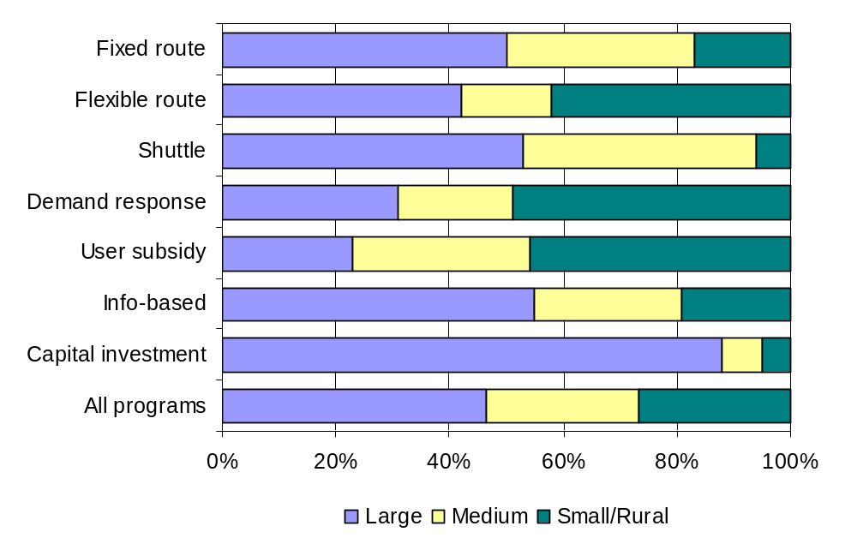
Figure 5-1
Services by Type and Urbanized Area Size
Table 5-3
Services by Type and Urbanized Area Size
(Column Percent)

 | Size of Urbanized Area
Service | Large | Medium | Small/Rural | Total
Fixed route | 47% | 55% | 28% | 44%
Flexible route | 5% | 4% | 9% | 6%
Shuttle | 6% | 8% | 1% | 5%
Demand response | 19% | 21% | 51% | 28%
User-side subsidy | 1% | 2% | 4% | 2%
Information-based | 10% | 8% | 6% | 8%
Capital investment | 13% | 2% | 1% | 7%
All programs | 100% | 100% | 100% | 100%

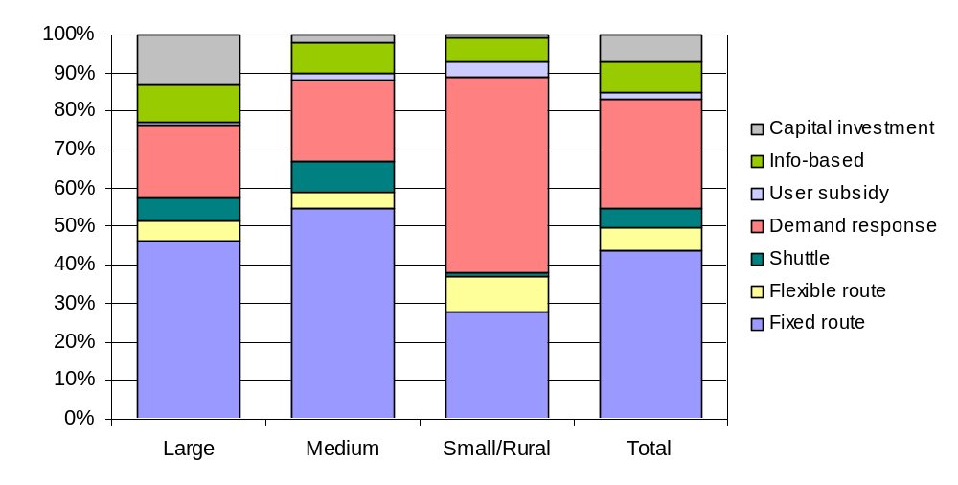

Figure 5-2
Services by Type and Urbanized Area Size

Table 5-4
Service Type by Geographic Coverage
Service Category | City/  Town | County | Region | Multiple | State | Other | Total
Trip-based | 29% | 30% | 22% | 12% | 1% | 5% | 100%
Info-based | 9% | 36% | 38% | 11% | 6% | 0% | 100%
Capital investment | 12% | 33% | 45% | 7% | 0% | 2% | 100%
Total | 26% | 31% | 25% | 12% | 2% | 4% | 100%

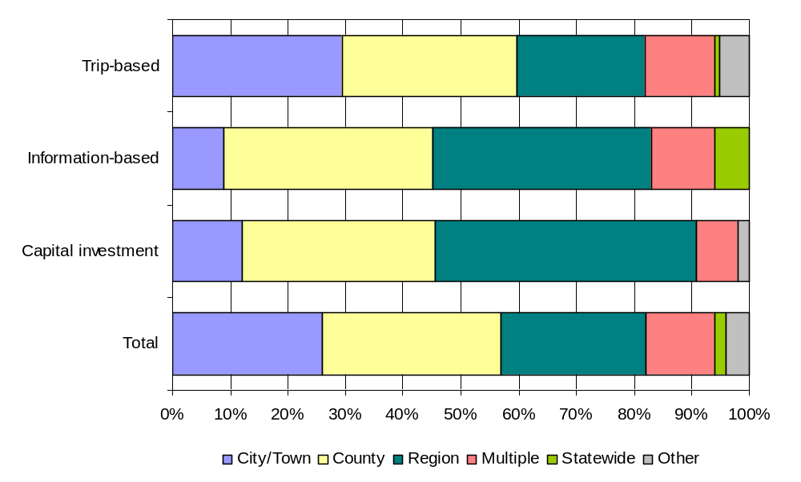
Figure 5-3
Service Type by Geographic Coverage

JARC Performance Measures
This section summarizes the new approach to measuring JARC performance implemented as part of the FY 2006 data collection effort.

Matrix Approach
As described in the previous section, most JARC expenditures were used to support trip-based services. While conventional fixed route and demand response services were the most commonly reported, the variety of trip-based services appeared to be growing and in FY 2006 included route deviation, shuttles, guaranteed ride home programs, and trip vouchers. In addition, about 15% of services funded through JARC were information-based services and capital investment projects. These trends in the JARC program suggested the need for a more comprehensive data collection tool to better reflect the diversity of services provided and more accurately portray the breadth and depth of the JARC program.
To address these concerns, the FTA JARC evaluation team worked with the CTAA Joblinks Advisory Committee to develop an improved and user-friendly tool for capturing information about JARC-funded services. This effort involved several conference calls from October 2006 through February 2007 and culminated in a two-day working session in Washington, D.C., held at the beginning of March 2007.
The result was development of a JARC Service Matrix, which was designed to make it easier for grantees to report on the services they provide (see Table 6-1). The JARC matrix was modeled after a performance measurement and evaluation method developed by the U.S. Department of Housing and Urban Development (HUD). The HUD approach was undertaken to address concerns about how to measure and evaluate the success of a diverse set of HUD-funded programs, each with different goals and output/outcome measures. Although the types of activities supported by the HUD programs are very different from JARC, in many cases they serve the same target populations as JARC, i.e., low-income and unemployed individuals. A more detailed description of the matrix development process was included in the Task 2 JARC Summary Report, submitted by the JARC evaluation team to FTA on April 23, 2007.
The JARC Service Matrix was intended to provide a relatively simple way to categorize JARC-funded services for reporting purposes. The matrix is organized so that grantees can follow three steps:
- Choose the service category that most closely matches the service provided locally.
- Select the primary goal that best describes the purpose of the service.
- Based on the combination of service and goal, identify the type of information requested for reporting.
As shown in Table 6-1, the JARC Service Matrix includes three basic categories of service: (I) trip-based services, (II) information-based services, and (III) capital investment projects. Five primary goals are listed across Columns A - E:
Table 6-1
JARC Service Matrix

PRIMARY SERVICE GOAL AND OUTPUT MEASURE
(select one per JARC-funded service)
JARC-FUNDED SERVICE | (A)  Expanded Geographic Coverage | (B)  Extended Hours/Days of Service | (C)  Improved System Capacity | (D)  Improved Access / Connections | (E)  Improved Customer Knowledge
I. Trip-Based Services
1. Fixed route | # one-way trips | # one-way trips | # one-way trips | # one-way trips
2. Flexible routing | # one-way trips | # one-way trips | # one-way trips | # one-way trips
3. Shuttle service | # one-way trips | # one-way trips | # one-way trips | # one-way trips
4. Demand response | # one-way trips | # one-way trips | # one-way trips | # one-way trips
5. User-side subsidy | # one-way trips | # one-way trips | # one-way trips | # one-way trips
II. Information-Based Services
1. Mobility manager*⁺ |  |  |  | # customer contacts
2. One Stop Center/referral |  |  |  | # customer contacts | # customer contacts
3. Trip/itinerary planning |  |  |  | # customer contacts | # customer contacts
4. On-on-one training |  |  |  | # persons trained | # persons trained
5. Internet-based information |  |  |  |  | # customer contacts
6. Information materials/ marketing |  |  |  |  | descriptive
III. Capital Investment Projects
1. Vehicle for individual* | # loans | # loans | # loans
2. Vehicle for agency* | # vehicles added | # vehicles added | # vehicles added
3. Vanpool* | # vehicles added |  | # vehicles added
4. Car-sharing* | # vehicles added |  | #vehicles added
5. Other capital projects | descriptive | descriptive | descriptive | descriptive | descriptive
* For these categories, grantees also will be asked to report the number of one-way trips provided, if applicable.
⁺ Although FTA funds “mobility managers” as an eligible capital expense, with an 80/20 federal to local match, they are categorized here as “information-based services” for reporting purposes.

- Expanded geographic coverage
- Extended hours or days of service
- Improved system capacity
- Improved access or improved connections
- Improved customer knowledge
Based on the combination of service type and primary goal, the cells in the matrix identify the type of service output data to be provided by the reporting grantee. The output measures typically include then number of one-way trips for trip-based programs, the number of customer contacts for information-based services, and the number of units provided for capital investment projects.
For example, a grantee funding a shuttle service with a primary goal of expanded geographic coverage would be asked to report the number of one-way trips provided during the year. A mobility manager with a primary goal of improved access/connections would be asked to report the number of customer contacts. If the mobility manager was also responsible for overseeing or providing trips, a second measure of the number of one-way trips would also be reported. As another example, a vehicle loan program for individuals would be asked to report the number of units provided (in this case, vehicles).
Because of the potential variability of actual project output for certain project types – such as providing marketing materials or funding facility/amenity improvements – a descriptive answer would be requested for reporting rather than a quantitative measure. An example would be a JARC project that provided marketing materials about local options for work transportation.
As noted, grantees were not asked to use the matrix when completing their reporting requirements for FY 2006. Instead, grantees answered questions about program characteristics, goals, and outputs. The FTA team then used this information to complete the matrix. This approach allowed the team to refine the matrix categories and measures before incorporating it into the online reporting instrument for the FY 2007 reporting year. A more detailed description of the matrix appears in Appendix E.
In addition, to better understand the range of JARC projects, and to assist with development of the matrix, grantees were also required to complete brief service profiles for FY 2006. During FY 2004 and FY 2005 reporting periods, similar profiles were requested on a voluntary basis. The profiles were used to document and describe how particular services were provided and to capture additional qualitative information about JARC services.

Performance of JARC-Funded Services in FY 2006
As described in the previous section, the JARC Service Matrix was developed to provide a user-friendly way to categorize JARC-funded services for reporting purposes. Earlier in this report, Table 5-1 showed the overall distribution of FY 2006 JARC-funded services by category. As the table showed, 85% of the services were trip-based, 8% were information-based, and 7% were capital investments. Table 6-2 illustrates the distribution of JARC projects provided during FY 2006 using the service matrix.
Table 6-2
FY 2006 JARC Service Matrix – Distribution of Services by Primary Goal

PRIMARY SERVICE GOAL AND OUTPUT MEASURE
JARC-FUNDED SERVICE | (A)  Expanded Geographic Coverage | (B)  Extended Service Hours/Days | (C)  Improved System Capacity | (D)  Improved Access / Connections | (E)  Improved Customer Knowledge | Total
I. Trip-Based Services | 40% | 29% | 11% | 19% | 1% | 100%
1. Fixed route | 37% | 40% | 5% | 18% | 0% | 100%
2. Flexible routing | 37% | 8% | 32% | 21% | 3% | 100%
3. Shuttle service | 56% | 9% | 16% | 19% | 0% | 100%
4. Demand response | 42% | 22% | 16% | 18% | 2% | 100%
5. User-side subsidy | 54% | 15% | 0% | 23% | 8% | 100%
II. Information-Based Services | 3% | 3% | 5% | 32% | 58% | 100%
1. Mobility manager*⁺ | 0% | 0% | 33% | 33% | 33% | 100%
2. One Stop Center/referral | 0% | 0% | 0% | 75% | 25% | 100%
3. Trip/itinerary planning | 0% | 0% | 0% | 20% | 80% | 100%
4. On-on-one training | 0% | 0% | 0% | 40% | 60% | 100%
5. Internet-based information | 0% | 0% | 0% | 0% | 0% | 100%
6. Information materials/ marketing | 11% | 11% | 0% | 22% | 56% | 100%
III. Capital Investment Projects | 0% | 0% | 2% | 98% | 0% | 100%
1. Vehicle for individual* | 0% | 0% | 0% | 100% | 0% | 100%
2. Vehicle for agency* | 0% | 0% | 0% | 0% | 0% | 100%
3. Vanpool* | 0% | 0% | 0% | 0% | 0% | 100%
4. Car-sharing* | 0% | 0% | 0% | 0% | 0% | 100%
5. Other capital projects | 0% | 0% | 33% | 67% | 0% | 100%
Note: in some cases the JARC evaluation team reassigned primary goals originally reported as “other” based the profiles or responses in the comments section.
* For these categories, grantees also will be asked to report the number of one-way trips provided, if applicable.
⁺Although FTA funds “mobility managers” as an eligible capital expense, with an 80/20 federal to local match, they are categorized here as “information-based services” for reporting purposes.

The table shows the percentage distribution of JARC-funded services by goal for each major section. For example, 40% of trip-based services reported a primary goal of providing expanded geographic coverage, 29% reported a primary goal of providing expanded days and hours of service, and so on. Within the category of trip-based services, the breakdown by service type shows the percentage of service represented by each goal. For example, 56% of those providing shuttle services had a primary goal of providing expanded geographic coverage, 54% of those providing trip subsidies also had a primary goal of providing expanded geographic coverage. Not surprisingly, for information-based services, 58% of services had a primary goal of improved customer knowledge, while for capital investment projects, 98% had a primary goal of improved system access/connections. (Note that some categories were added to the matrix based on the results of the FY 2006 analysis. In future years it would be likely that additional responses will be found in the information-based and capital-investment sections.)
Additional findings for JARC-supported services are presented below.

Trip-based services
As already indicated, trip-based services accounted for the vast majority of JARC-supported services in FY 2006. For trip-based services, FTA selected two performance indicators:
- One-way trips
- Jobs accessed
One way trips are discussed below; estimates of jobs accessed can be found at the end of the chapter.
As in previous years, JARC grant recipients were asked to report annual one-way trips. Most transit organizations collect this information and almost all grantees were able to provide this information for trip-based services.
For FY 2006, it is estimated that JARC-supported services provided 22.9 million one-way trips
As might be expected, most one-way trips were recorded on fixed route services (82%). Demand response carried 11%, followed by route deviation (4%). Shuttles accounted for 2% of trips and user-based subsidies 1%. Grantees funding information-based services or capital investment programs were not asked to report one-way trips and are not included here. (See Figure 6-1.)
Clear differences were apparent among geographic settings. For one-way trips on fixed route services, two thirds (66%) were reported in large urbanized areas, 25% in medium urbanized areas, and 10% in rural communities. In contrast, more than half of the demand response trips were in rural areas (53%), 12% in medium-size cities, and 36% in large cities. (See Table 6-3 and Figure 6-2.)
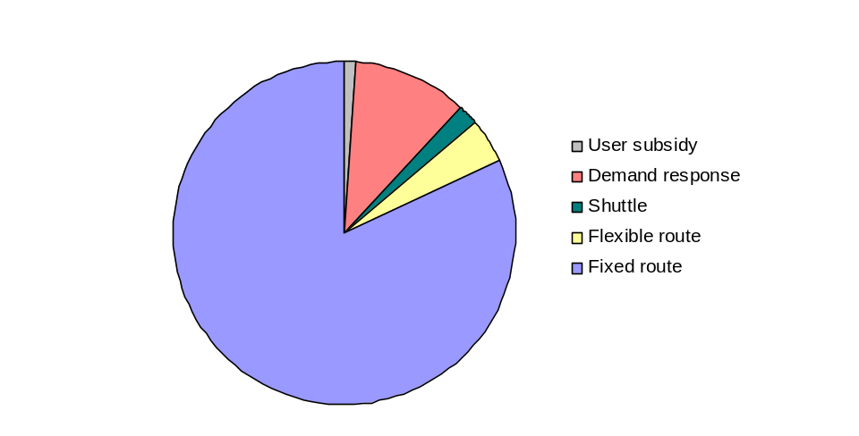
In large urbanized areas, fixed route services captured 88% of one-way trips while demand response served 6%. The breakdown was similar in medium-sized cities. In contrast, demand response served 38% of the trips in rural areas while the fixed route share was 55%. (See Table 6-4 and Figure 6-3.)
Figure 6-1
One-Way Trips by Service Type
Finally, using the JARC service matrix, the distribution of one-way trips was assessed by primary goal and service category. Table 6-5 and Figure 6-4 present that information. As the table shows, most of the riders on fixed route services were using services designed to expand geographic coverage (39%) or to extend service days or hours (32%). Based on ridership, flexible services were generally focused on improving system capacity (47%) or improving access or connections (33%). The goals of demand response services were distributed among increased geographic coverage (44%), expanded capacity (23%), and extended service span (20%).

Information-based services
As reported in Section 5.0, information-based services accounted for about 8% of JARC services provided during FY 2006 (see Table 5-1). Grantees reported on about 50 information-based services, and included data for about two-thirds of the programs. For these services, grantees reported about 66,000 customer contacts (including over 50,000 customer contacts for one brokerage/mobility manager) and one program with 30,000 customer mailings. Some projects also provided one-on-one training either on how to use public transit services or how to maintain and repair vehicles.

Capital investment programs
As reported in Section 5.0, capital investment programs accounted for about 7% of JARC-funded services provided during FY 2006 (see Table 5-1).
Most of the programs in this category provided low-interest loans for individuals to repair or purchase automobiles to access employment. Collectively, over 900 loans were made available to participants in 40 programs. Three programs reported providing funds for amenities such as bus shelters to improve access or increase capacity for fixed routes that serve low-income employment centers.

Table 6-3
One-Way Trips by Service Type and Urbanized Area Size
(Row Percent)

 | Size of Urbanized Area
Trip-Based Service Type | Large | Medium | Small/Rural | Total
Fixed route | 66% | 25% | 10% | 100%
Flexible route | 48% | 28% | 23% | 100%
Shuttle | 74% | 25% | 1% | 100%
Demand response | 36% | 12% | 53% | 100%
User-side subsidy | 31% | 56% | 14% | 100%
All trip-based services | 61% | 24% | 15% | 100%

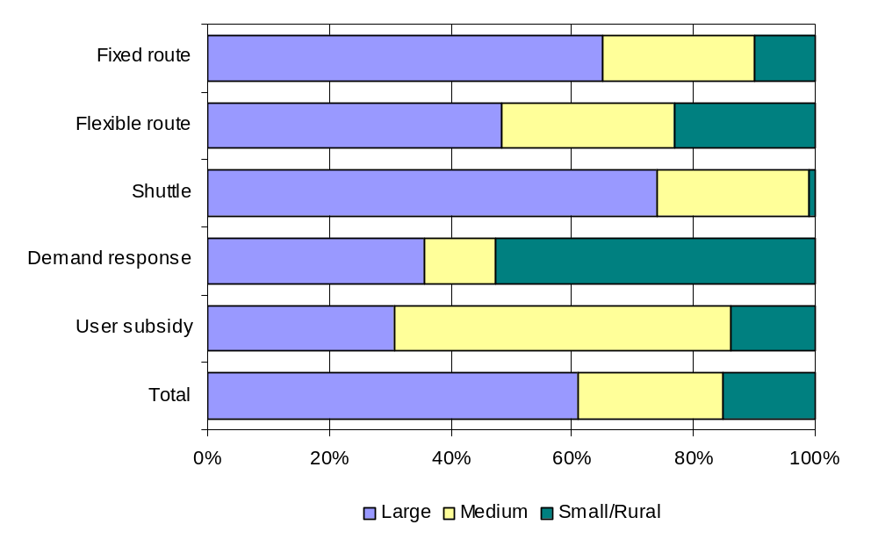
Figure 6-2
One-Way Trips by Service Type and Urbanized Area Size

Table 6-4
One-Way Trips by Service Type and Urbanized Area Size
(Column Percent)
 | Size of Urbanized Area
Trip-Based Service Type | Large | Medium | Small/Rural | Total
Fixed route | 88% | 85% | 55% | 82%
Flexible route | 3% | 5% | 6% | 4%
Shuttle | 2% | 3% | 0% | 2%
Demand response | 6% | 6% | 38% | 11%
User-side subsidy | 0% | 2% | 1% | 1%
All trip-based services | 100% | 100% | 100% | 100%

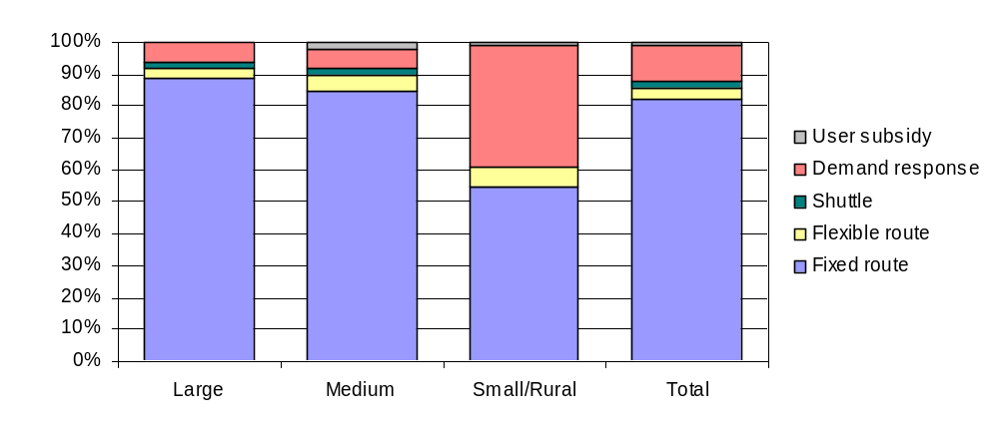

Figure 6-3
One-Way Trips by Service Type and Urbanized Area Size
Table 6-5
One-Way Trips by Service Type and Primary Goal

Trip-Based  Service Type | Primary Service Goal
Trip-Based  Service Type | (A)  Expanded Geographic Coverage | (B)  Extended Service Hours/Days | (C)  Improved System Capacity | (D)  Improved Access / Connections | (E)  Improved Customer Knowledge | Total
Fixed route | 39% | 32% | 5% | 18% | 1% | 100%
Flexible route | 17% | 2% | 47% | 33% | 0% | 100%
Shuttle | 63% | 2% | 20% | 15% | 0% | 100%
Demand response | 44% | 20% | 23% | 13% | 0% | 100%
User-side subsidy | 37% | 8% | 0% | 55% | 0% | 100%
All trip-based services | 39% | 29% | 9% | 22% | 1% | 100%

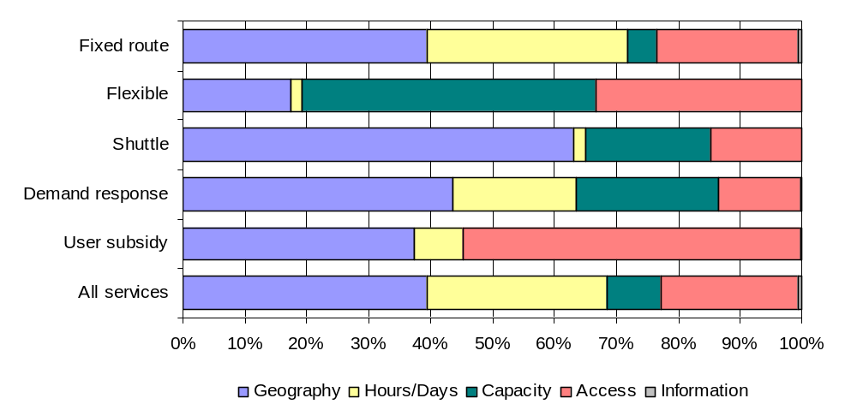
Figure 6-4
One-Way Trips by Service Type and Primary Goal

Low-wage jobs accessed
As discussed in previous sections, JARC grantees were not asked to report jobs accessed directly. Instead, the JARC analysis team used external data sources to estimate this measure. Several approaches were used to develop an estimate of jobs accessed:
- For demand response, jobs in the overall service area were estimated using data from LEHD or other Census sources.
- For fixed route, a factor was developed to estimate jobs per linear route mile.
- For trip-based services that targeted a specific employer or focused on a particular time of day, grantees were asked to indicate the number of jobs accessed.
- For all other trip-based services, grantees were asked to indicate the number of jobs accessed.
Using these multiple approaches, the FTA team developed estimates of jobs accessed. Although the team made the final calculations, all approaches depended on information supplied by JARC grantees. While the majority of grantees provided the required information, key data elements were not available for a subset of services.
About 25% of the reported demand response service reports did not include sufficient information to estimate jobs reached using the methodology described earlier. In some cases the service areas did not correspond to state, county, or municipal boundaries. Examples included demand response services in neighborhoods or commercial corridors. In other cases, the grant recipient did not define the service area.
Almost half (48%) of the reported fixed route service reports did not include sufficient information to estimate jobs reached. Grantees did not report the route length or estimate the number of jobs accessed.
To reflect the overall JARC program, the consultant team expanded the reported data to represent the universe of reporting JARC grantees. This approach was intended to replace the methodology used in previous years, which used data on JARC disbursements to estimate the number of jobs accessed and one-way trips made by grantees that did not report into the JARC system. Because nearly all the grantees reported in FY 2006, the expansion methodology was revised to use available information on one-way trips as reported by grantees. Because we were using data reported by grantees as a baseline for expansion, we considered this approach more reliable than previous efforts.
A simplified two-step methodology was used to expand the data.
First, a ratio was developed between jobs accessed and one-way trips. As indicated above, about 75% of demand response service records and 52% of fixed route service records included usable information on one-way trips and potential jobs accessed. Based on these records, factors were developed to represent jobs per one-way trip. Based on these services, we calculated that, per one-way trip reported:
- Each demand response service reached 7.23 total jobs and 3.98 low-wage jobs.
- Each fixed route service reached 1.21 total jobs and .55 low-wage jobs
Table 6-6
Estimation of Jobs Accessed for Service Records without Geographic Information

 |  | All Jobs |  | Low-Wage Jobs
 | One-way trips reported | Factor | Projected jobs reached | Expansion factor | Projected jobs reached
Demand response | 380,985 | 7.23 | 2,755,334 | 3.98 | 1,517,969
Fixed route | 9,267,732 | 1.21 | 11,207,917 | 0.55 | 5,076,351
Total | 9,648,717 |  | 13,963,251 |  | 6,594,320

Table 6-7
Projection of Jobs Accessed in FY 2006

 | Jobs Accessed
 | All Jobs |  | Low-Wage Jobs
 | # | % | # | %
Calculated from geographic information provided by grantees | 29.4 million | 68% | 14.6 million | 69%
Projected based on trip information provided by grantees | 14.0 million | 32% | 6.6 million | 31%
Total jobs accessed | 43.4 million | 100% | 21.2 million | 100%

Note that the demand response expansion factor was significantly larger than the fixed route factor because of the different assumptions regarding service area. For demand response services, the analysis included all jobs in the service area. For fixed route services, the analysis included only jobs within a one-quarter mile on either side of the route.
Second, we used these factors to project jobs reached for fixed route and demand response services when we were not able to calculate performance measures directly from LEHD or other Census sources. Table 6-6 summarizes these calculations for fixed route and demand response services that did not include enough information to estimate jobs accessed directly.
Table 6-7 shows the combined estimates of jobs accessed, including the calculations based on grantee information and the expanded information when grantees did not provide sufficient information to the analysis team.
It is therefore projected that JARC-supported services provided access to 43.4 million jobs in FY 2006. An estimated 21.2 million jobs were categorized as low-wage.

Appendix A
Information on the Longitudinal Employment-Household Dynamics (LEHD) Program

Source: http://lehd.dsd.census.gov/led/about-us/FAQ.html#lehd

What is LEHD?
Longitudinal Employer-Household Dynamics (LEHD) is an innovative program within the U.S. Census Bureau. We use modern statistical and computing techniques to combine federal and state administrative data on employers and employees with core Census Bureau censuses and surveys while protecting the confidentiality of people and firms that provide the data.
What is LED?
Local Employment Dynamics (LED) is a voluntary partnership between state labor market information agencies and the U.S. Census Bureau to develop new information about local labor market conditions at low cost, with no added respondent burden, and with the same confidentiality protections afforded census and survey data.
What is the difference between LEHD and LED?
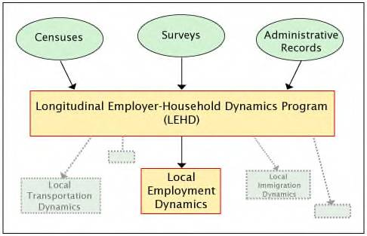
What are the QWI?
The Quarterly Workforce Indicators (QWI) are a set of economic indicators -- including employment, job creation, wages, and worker turnover -- that can be queried by different levels of geography -- state, county, metro, and workforce investment area -- as well as by detailed industry, gender, and age of workers. You can query the data directly by using the QWI Online tool on this site.
Why aren't QWI data available for all states?
QWI data are available for all states that are LED-state partners; however, not every state is currently a LED-state partner. A list of LED state partners can be found here. New partner states with data currently in production will have data available on the website as soon as production is complete.
What types of employment are included in the QWI?
The QWI are built upon wage records in the Unemployment Insurance (UI) system and information from state ES-202 data. The universe of QWI data is UI-covered earnings. UI coverage is broad, covering over 90% of total wage and salary civilian jobs.
When QWI private industry employment numbers are compared with other employment data, exclusions to UI coverage should be taken into account. Federal government employment is not generally included. Exempted employment varies slightly from state to state due to variations in state unemployment laws, but generally also excludes many farmers and agricultural employees, domestic workers, self-employed non-agricultural workers, members of the Armed Services, some state and local government employees as well as certain types of nonprofit employers and religious organizations (which are given a choice of coverage or noncoverage in a number of states).
A more in-depth discussion of UI-coverage issues is available in the technical paper "Employment that is not covered by state unemployment"

Appendix B
Joblinks Advisory Committee Members

JARC Grantees | Email
Susan Ames, Prairie Hills Transit (Spearfish, SD) | susanames@4-evergreen.net
Bob Flor, King County Metro (Seattle, WA) | Bob.flor@metrokc.gov
Peter Hallock, Iowa DOT | Peter.hallock@dot.iowa.gov
Mary Keating, DuPage County (IL) | Mary.Keating@dupageco.org
Joe Melvin, North Carolina DOT | JMelvin@dot.state.nc.us
Liz Peak JTA (Jacksonville, FL) | lpeak@jtafla.com
Betty Petrie, CENTRO (Syracuse, NY) | bpetrie@centro.org
Maureen Ring, SRTD (Sacramento, CA) | mring@sacrt.com
Lisa Rivers, Connecticut DOT | Lisa.Rivers@po.state.ct.us
Sandy Stutey, Mason County Transit (Shelton, WA) | Sstutey@masontransit.org
Technical Experts
Larry Harman, Bridgewater State College (MA) | lharman@bridgew.edu
Vonu Thakuriah, University of Illinois at Chicago | vonu-pt@uic.edu
Carolyn Jeskey, CTAA | Jeskey@ctaa.com
Jeremy Wu, LEHD | jeremy.s.wu@census.gov
JARC Evaluation Team
Christoph Berendes, ACSI | christoph.berendes@2acsi.com
Susan Bregman, Oak Square Resources LLC | susan.bregman@2acsi.com
Rosemary Gerty, TranSystems | rbgerty@transystems.com
Stephen Falbel, TranSystems | smfalbel@transystems.com
Jessica Eckhardt, TranSystems | jmeckhardt@transystems.com
Lauren Miller, ACSI | lauren.miller@2acsi.com

Appendix C
Accessing County-Based Job Data from LEHD
In our initial explorations, TranSystems staff determined that we should use LEHD county-level Total Employment by industry data for our analysis. These data are available from a US Census website: http://lehd.did.census.gov/led/datatools/qwiapp.html
LEHD provides total employment data by calendar quarter and industry for each covered county. TranSystems analysts developed a series of weights to use in estimating what proportion of total employment for each industry could be counted as low-wage jobs. Weights are shown below.
NAICS Industry | Weight
11 Agriculture, Forestry, Fishing, and Hunting | 0.70
21 Mining | 0.20
22 Utilities | 0.05
23 Construction | 0.45
31-33 Manufacturing | 0.40
42 Wholesale Trade | 0.30
44-45 Retail Trade | 0.80
48-49 Transportation and Warehousing | 0.55
51 Information | 0.20
52 Finance and Insurance | 0.10
53 Real Estate, Rental, and Leasing | 0.55
54 Professional, Scientific, and Technical Services | 0.20
55 Management of Companies and Enterprises | 0.02
56 Admin Support, Waste Management, Remediation Services | 0.75
61 Educational Services | 0.75
62 Health Care and Social Assistance | 0.55
71 Arts, Entertainment, and Recreation | 0.75
72 Accommodation and Food Services | 0.95
81 Other Services (except Public Administration) | 0.80
92 Public Administration | 0.40

TranSystems developed and documented a manual procedure for accessing the LEHD website, retrieving the data for each relevant county, and calculating Total Employment and JARC employment for the county. This procedure provided the basis for the following steps.

Automated Census data retrieval overview
To meet our goal of including all demand response services that covered LEHD counties in our analysis, we built a system that to retrieve LEHD data automatically.
We determined that the URL to retrieve a particular county and year of LEHD data could be generated programmatically. For instance: the following URL provides access to Total Employment data for Calhoun County (FIPS code 013) in the state of Florida (abbreviated fl) for the year of 2005.
http://lehd.did.census.gov/cgi-bin/lehdpivot/lehd/pvt/pivot_county.hsql?xpivot=Industry&xdata=Total_Employment&xyear=2005&head=ZZZZ&xstate=fl&xstyle=lehd&xfixed=Year&xgeofx=xcounty&xcounty=%3D&xsicdiv=%3C%3E&xsex=%3D&xagegroup=%3D&xowner=%3D&xsort=Year%2CQuarter%2CSic_Division&Xvalue=013
A portion of the web page retrieved is shown below: 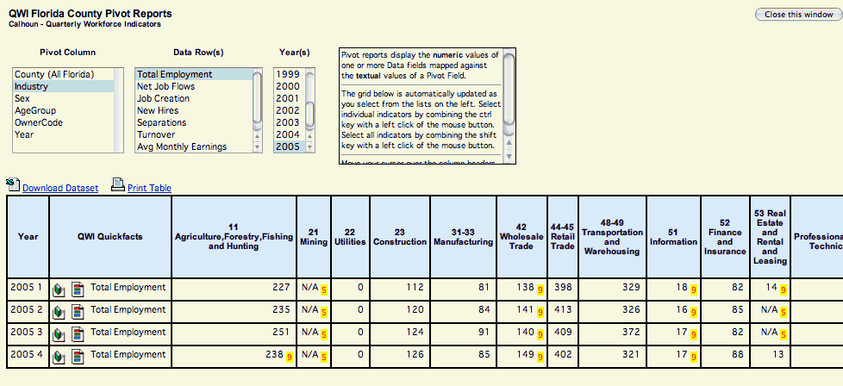
Each of these Quarterly Workforce Indicator (QWI) County Pivot report pages contains a link, labeled “Download Dataset”, that provides access to the data in spreadsheet format. A sample URL: http://lehd.did.census.gov/lehd/cache/lehd/pvt/pivot_county/fl-c/1e-ae-cn-dt-fy-llehd-pi-v013-xe-y2005-xownere.xls.

Auxiliary data

County FIPS codes
County FIPS codes were retrieved from the Census website: http://www.census.gov/geo/www/fips/fips65/data/national.txt Excerpts of this table are shown below:
State | FIPS | Code | County
AL | 01 | 001 | Autauga
AL | 01 | 003 | Baldwin
AL | 01 | 005 | Barbour
AL | 01 | 007 | Bibb
AL | 01 | 009 | Blount
AL | 01 | 011 | Bullock
AL | 01 | 013 | Butler

This table can be used to determine, for instance, that the FIPS code for Bullock County in Alabama is 011.

NA handling in LEHD data

QWI Quickfacts | Total Employment
11 Agriculture, Forestry, Fishing and Hunting | 135
21 Mining | 0
22 Utilities | N/A
23 Construction | 212
31-33 Manufacturing | 797
42 Wholesale Trade | 657
44-45 Retail Trade | 1,092
48-49 Transportation and Warehousing | 157
51 Information | 104
52 Finance and Insurance | 298
53 Real Estate and Rental and Leasing | 41
54 Professional, Scientific, and Technical Services | 128
55 Management of Companies and Enterprises | N/A

We discovered that in some cases LEHD contained NAs for particular industries and counties for 2005:02, for instance as shown below for Utilities and Management for Vernon County in Wisconsin.
NAs were treated as 0 for calculated Total Employment and JARC Employment for each county.

Excluded states
LEHD did not provide county level total employment data for nine states and the District of Columbia, as of 7/20/2007, as shown.
States not included in LEHD as of July 20, 2007
Arizona
Connecticut
District of Columbia
Massachusetts
Michigan
Nebraska
New Hampshire
New York
Ohio
South Dakota

Calculation steps
ACSI software performed seven steps:
- Identified, based on Grantee inputs, counties that were served by Demand Response services;
- Filtered out states not included in LEHD, as provided in Census documentation (see table);
- Converted county names, as provided by Grantees, to 3 digit FIPS codes, based on the FIPS code table provided by Census;
- Generated a URL based on the year and quarter required (2005), the state, the FIPS code for the county, and the Total Employment variable;
- Extracted the cached spreadsheet URL, and used it to retrieve the data and integrate it into an LEHD county data table;
- Summed the raw total employment figures for 2005:02 by industry to generate an overall “Total Employment” for the county, and summed the weighted industry figures to generate a low-wage employment figure
- Integrated these totals into spreadsheets provided to the analysts.

Verification and quality control
We reviewed each county name provided by Grantees to ensure that it could be mapped to a valid FIPS code. We performed edits as appropriate on these data. Generally, edits involved either fixing typographical errors (e.g. “Carroll” for “Carol”, or “Prince George’s” for “Prince Georges”) , eliding “County” or “Parish” at the end of the term, or separating multiple counties across multiple lines (e.g. one field containing “Wayne, Oakland” into two rows, one for “Oakland” county and one for “Wayne” county).
ACSI analysts also reviewed the notes provided by Grantees to ensure that Service Regions were specified as accurately as possible.

Appendix D
Estimating Low-Wage Jobs
The Federal Transit Administration (FTA) is developing an approach to measure jobs accessed as part of the evaluation process for the Job Access and Reverse Commute grant program (Section 5316). The proposed approach uses geographic information systems (GIS) software to measure jobs based on information available in several existing databases.
Two databases were compared for the pilot testing. Dun & Bradstreet is a private database developed primarily for business-to-business marketing. Information is available about individual employers at the corporate and local (i.e., street) level. The Longitudinal Employer-Household Dynamics (LEHD) is a program within the U.S. Census Bureau that combines federal and state employment data with basic census statistics. LEHD was designed to show employment information at the corporate level and is especially valuable for tracking commuting patterns.
Using GIS, the research team identified the number of jobs within a specific geographic area, base on existing (e.g., county) or user-defined (e.g., buffer around a bus route) geography.
Next the number of low-wage jobs was estimated. For the purposes of this analysis, low-wage was defined as 150% of the federal poverty level for a family of four, or $30,000 per year.
Because salary information was not readily available in the Dun & Bradstreet or LEHD datasets, the research team developed a factor to estimate the number of low-wage jobs accessed based on industry classifications.
Both datasets classified jobs by NAICS code. NAICS, or the North American Industry Classification System, assigns a six-digit code to each industry. This analysis reviewed codes at the two- and three-digit summary level, and determined that the two-digit level provided an acceptable level of detail for this effort.
The federal Bureau of Labor Statistics compiles the Occupational Employment Statistics (OES) survey. This survey presents average wage information by NAICS code. Using May 2005 data (the most recent available online) of median wages, the researchers estimated the percentage of jobs in each NAICS category that fell below the $30,000 target. Estimates were based on national quartile data for each two-digit NAICS code and assumed a straight-line distribution of wages within each quartile.
For example, for NAICS Code 72, Accommodation and Food Services, the QWI data indicated that 90% of the workers in the Food Services and Drinking Places category earned less than $27,230 per year and 75% in the Accommodation category earned less than $26,290. Therefore, it was estimated that 93% of all the workers in the overall Accommodation and Food Services category would be defined as low-wage for this analysis.
Table D-1 shows the estimated percentage of low-wage jobs in each NAICS category at the two-digit summary level.
Table D-1
Percentage of Low-Wage Jobs by NAICS Category

NAICS Code | Industry Category | Percentage of  Low-Wage Jobs
11 | Agriculture, Forestry, Fishing, and Hunting | 79%
21 | Mining | 33%
22 | Utilities | 15%
23 | Construction | 40%
31 | Manufacturing | 70%
32 | Manufacturing | 47%
33 | Manufacturing | 40%
42 | Wholesale trade | 36%
44 | Retail trade | 77%
45 | Retail trade | 84%
48 | Transportation and warehousing | 43%
49 | Transportation and warehousing | 38%
51 | Information | 29%
52 | Finance and insurance | 35%
53 | Real estate, rental, and leasing | 65%
54 | Professional, scientific, and technical services | 25%
55 | Management of companies and enterprises | 25%
56 | Administrative and support, waste management and remediation | 69%
61 | Educational services | 35%
62 | Health care and social assistance | 52%
71 | Arts, entertainment, and recreations | 74%
72 | Accommodation and food services | 93%
81 | Other services (except public administration) | 67%
92 | Federal, state, and local government | 40%
99 | Non-classifiable | 35%

Appendix E
JARC Service Matrix
The following information describes in more detail how the JARC Service Matrix was developed and how it is expected to be used by JARC grantees and the Federal Transit Administration for annual reporting purposes.
As described in this report and in the technical memorandum for Task 2 of this study, the JARC Service Matrix was developed through a collaborative effort between the JARC evaluation team and the CTAA Joblinks Advisory Committee. The intent was to make it easier for JARC grantees to identify service priorities and report on services provided through the annual JARC reporting process. At the same time, by organizing JARC-funded projects according to their primary goal as either trip-based service, information-based service or capital investment programs, the JARC evaluation team would be better able to calculate the number of low-wage jobs made accessible by JARC-funded services and to more accurately describe the information-based and capital-investment projects undertaken by JARC grantees. Table E-1 presents the JARC Service Matrix.
The matrix includes the five goals (columns A-E) that were identified to be core elements of JARC-funded services. The rows are grouped by the three categories of projects – trip-based, information-based, and capital investment. Each category includes a list of services or projects that are commonly provided in each category and supported by the JARC program. The cells within the table indicate the primary reporting information to be provided by each type of service, according to the primary goal related to the service.
For reporting purposes, the matrix will be used to identify the primary goal for each JARC-funded service operated during the reporting year and to report output and outcome information related to the services provided.
In addition to the measures shown in the table (i.e., # one-way trips, # customer contacts, # units, # vehicles added, and so on) as in the past grantees also will be asked to provide additional descriptive information about the service, such as the geographic boundary of the service area, length of the route segment added, and other measures related to each goal. Grantees also will be asked to indicate whether the trips provided were primarily for employment, childcare, training or other support services related to employment transportation. For those services that are offered during specific times or day (e.g., “Night Owl” service) or limited to a particular destination (e.g., a remote job locations), grantees will be asked to estimate the number of low-wage jobs accessed by that service. For services that are more general in nature (e.g., a route extension that serves employment sites along a corridor or demand response service offered through a county), the JARC evaluation team will use national Census data to develop estimates of low-wage jobs accessed. Taken together, this information will enable the JARC evaluation team to calculate the number of low-wage jobs accessed and to summarize other important impacts of the JARC program.
In the final rollout of the JARC Service Matrix, grantees will be provided specific information and training on how to use the reporting tools. Definitions will be provided to help guide grantees in their choice of service. For example, by definition, trip-based services that are categorized as “flexible routing” include route deviation, point deviation, and other community circulators that may go off route to pick up individuals on a request basis. A “user-side subsidy” refers to individuals whose trip costs are subsidized by JARC funds including taxi vouchers, mileage reimbursements, underwriting the cost of vanpool seats, and so on. In contrast, trips provided through a “demand response” service would involve payment to an agency to subsidize the cost of running the vehicle, and not provide a direct subsidy to the individual user.
“Mobility managers” are an emerging service approach and may require additional information. For example, in some cases, a mobility manager is a clearinghouse of information about transportation services provided locally. Other “mobility managers” may also schedule trips, but have nothing to do with the responsibility of providing (or paying for a trip). In these two cases, it would be appropriate to report the number of customer contacts as a performance measure. However, some “mobility managers” also oversee the actual provision of service either by contracting with a provider or directly operating service themselves. In the latter case, it would be appropriate for the mobility manager to report both the number of customer contacts enabled by the JARC program, as well as the number of one-way trips provided. Note that a “brokerage” that is primarily responsible for allocating trips among demand response providers would be directed to report only the number of JARC-related trips provided under the demand response category in the trip-based services, not as a mobility manager. It also should be noted that although FTA allows for “mobility managers” to be funded as a capital program, given the nature of the service for JARC reporting purposes they are considered information-based services.
Another example that may need additional explanation is “one-on-one training,” included under the category of information-based services. “One-on-one training” could include teaching an individual on how to use fixed route bus service or providing instruction on how to care for and maintain a vehicle. “Trip/itinerary planning” is another specific form of providing assistance that is very individualized and me be the primary focus of a JARC-funded service.
Finally, capital investment projects could range from providing vehicles to individuals through low-interest loan programs, providing a vehicle for an agency to provide transportation for its customers, or vanpool vehicles if the cost of the vehicle lease is underwritten. In these cases, grantees would be asked to report the number of units (vehicles) provided and if available the number of one-way trips taken by JARC-supported participants. Other capital investments could include providing amenities to make services more usable for low-wage individuals, such as adding bus shelters to waiting areas, bicycle racks on buses to allow access to a transit system, and so on. These types of programs may not lend themselves to traditional reporting on a unit basis and reports may be more descriptive in nature.
Table E-1
JARC Service Matrix

PRIMARY SERVICE GOAL AND OUTPUT MEASURE
(select one per JARC-funded service)
JARC-FUNDED SERVICE | (A)  Expanded Geographic Coverage | (B)  Extended Hours/Days of Service | (C)  Improved System Capacity | (D)  Improved Access / Connections | (E)  Improved Customer Knowledge
I. Trip-Based Services
1. Fixed route | # one-way trips | # one-way trips | # one-way trips | # one-way trips
2. Flexible routing | # one-way trips | # one-way trips | # one-way trips | # one-way trips
3. Shuttle service | # one-way trips | # one-way trips | # one-way trips | # one-way trips
4. Demand response | # one-way trips | # one-way trips | # one-way trips | # one-way trips
5. User-side subsidy | # one-way trips | # one-way trips | # one-way trips | # one-way trips
II. Information-Based Services
1. Mobility manager*⁺ |  |  |  | # customer contacts
2. One Stop Center/referral |  |  |  | # customer contacts | # customer contacts
3. Trip/itinerary planning |  |  |  | # customer contacts | # customer contacts
4. On-on-one training |  |  |  | # persons trained | # persons trained
5. Internet-based information |  |  |  |  | # customer contacts
6. Information materials/ marketing |  |  |  |  | descriptive
III. Capital Investment Projects
1. Vehicle for individual* | # loans | # loans | # loans
2. Vehicle for agency* | # vehicles added | # vehicles added | # vehicles added
3. Vanpool* | # vehicles added |  | # vehicles added
4. Car-sharing* | # vehicles added |  | #vehicles added
5. Other capital projects | descriptive | descriptive | descriptive | descriptive | descriptive
* For these categories, grantees also will be asked to report the number of one-way trips provided, if applicable.
⁺Although FTA funds “mobility managers” as an eligible capital expense, with an 80/20 federal to local match, they are categorized here as “information-based services” for reporting purposes.

FTA Circular 9050.1, March 29, 2007, p. I-5.
FY 2006 refers to Federal Fiscal Year 2006, which was October 1, 2005, through September 30, 2006.
Note that the project support website is posted on the Internet during the reporting period only.
For Alaska, the poverty guideline was set at $25,000 and for Hawaii that figure was set at $23,000.
Grantees reported on the size of the service area for each individual program, not for the grantee agency itself. For example, a statewide agency like the Connecticut Department of Transportation submitted reports for services operating in large, medium, and small settings.
Although it was not anticipated that trip-based services would provide customer information, several services indicated that this was their primary goal.

