1. Where do I start at NCBI ?
NCBI provides a queryable interface that enables navigation between inter-connected data types and between information for multiple genomes. NCBI brings together the power of large-scale computational analyses and an integrated system of data retrieval with detailed information on maps, sequence, expression, genomes, genes, diseases, phenotypes, publications, protein domains and structures. NCBI provides connections between these disparate types of data by pre-computing related records.

Searches at NCBI can begin in many places. Among these are NCBI’s home page (http://www.ncbi.nlm.nih.gov/ ), the Entrez home page (http://www.ncbi.nlm.nih.gov/Entrez/), the Zebrafish Genome Resources page (http://www.ncbi.nlm.nih.gov/genome/guide/zebrafish) and the Danio rerio Taxonomy database home page (http://www.ncbi.nlm.nih.gov/Taxonomy/Browser/wwwtax.cgi?mode=Info&id=7955&lvl=3&srchmode=1 ).

1. NCBI’s home page
Explore links provided at NCBI’s home page to navigate to NCBI’s databases, tools and resources. On NCBI’s home page, links are provided in the top menu bar, in the left blue bar and under the “Hot Spots” header on the right. From the NCBI home page, submit a direct query against any of the databases included in the pull down menu, including a query against all Entrez databases.
Announcements of new and updated resources are provided on the NCBI home page as Highlights in the center of the page and in detail in NCBI’s quarterly newsletter. NCBI’s newsletter also includes additional announcements, NCBI project descriptions and recent NCBI publications.

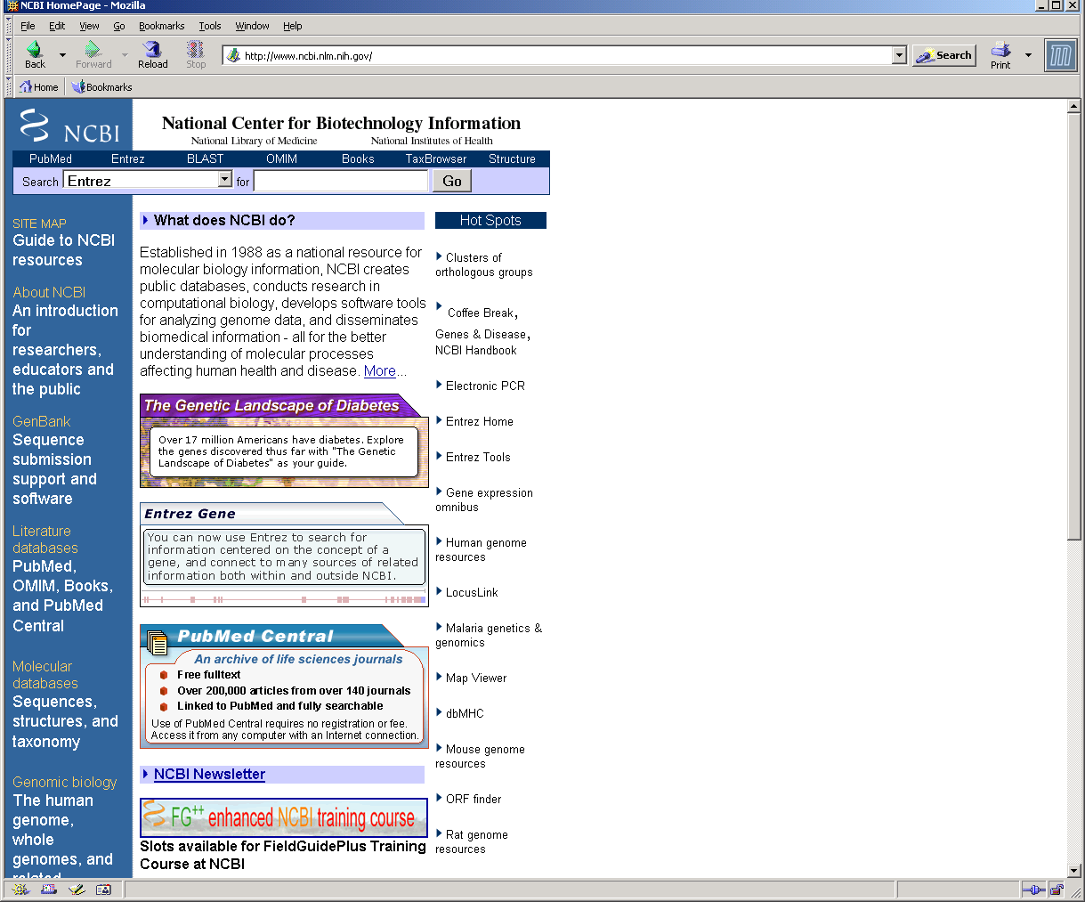

2. Entrez home page
The Entrez home page lists and provides links to all Entrez databases. From the home page, all Entrez databases can be searched simultaneously with a single query. Both simple (single text term) and more complex queries are supported. Complex queries of one or more terms that include boolean operators (AND, OR, NOT) and searches of specified fields. Field qualifiers can be upper or lower case, for example: [organism], [ORGN], [taxonomy_id], [keyword], or [KYWD]. A list of Entrez Search Fields and Qualifiers for each Entrez database is also available at: (http://www.ncbi.nlm.nih.gov/entrez/query/static/help/Summary_Matrices.html#Search_Fields_and_Qualifiers).
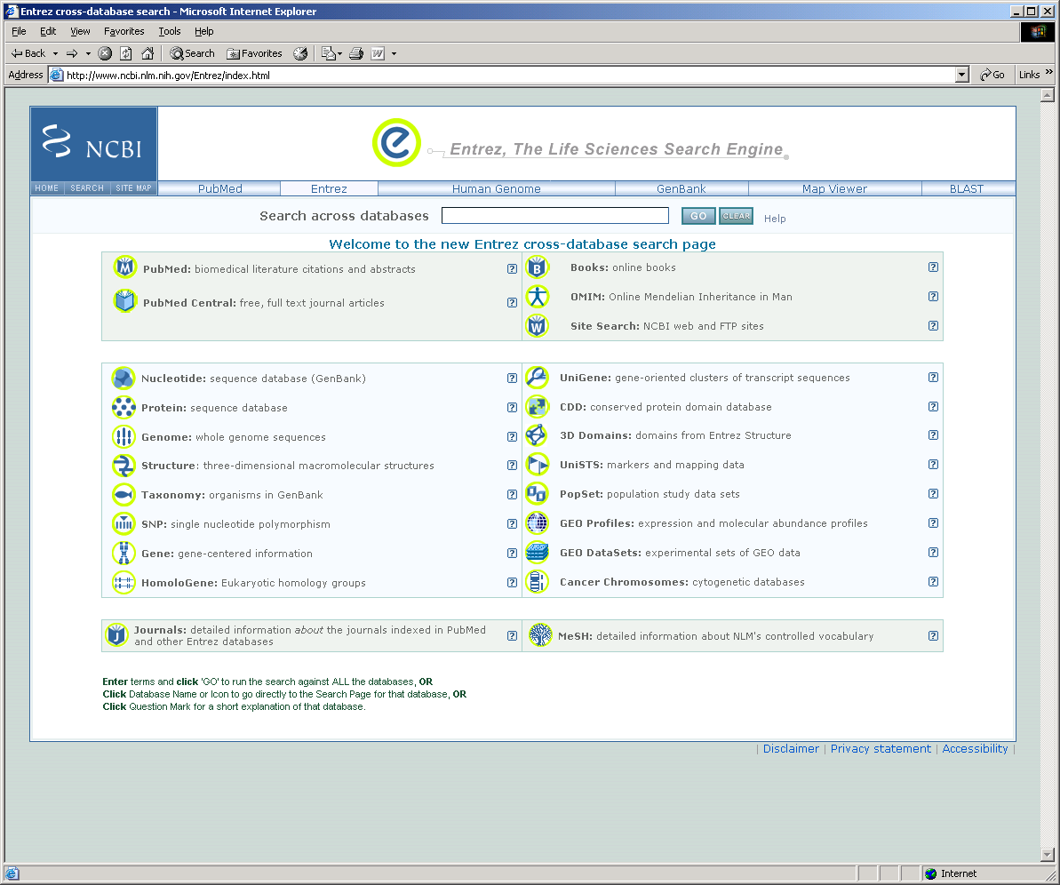
3. NCBI’s Zebrafish Genome Resources
Links to genome-specific resource pages can be found on the Genomic Biology page (http://www.ncbi.nlm.nih.gov/Genomes/index.html). A link to the Genomic Biology page is located in the left-hand blue side bar of NCBI’s home page.
The Zebrafish Genome Resources page (http://www.ncbi.nlm.nih.gov/genome/guide/zebrafish/index.html)
was created to provide a gateway to web resources and includes links to a number of NCBI sites and to external resources that may be of interest to members of the zebrafish community. The Zebrafish Genome Resources page also includes links to pre-set Entrez queries, including: papers or sequences submitted to NCBI’s PubMed or GenBank databases in the last 30 days or the current set of Zebrafish Gene Collection (ZGC) full-length cDNA clones in GenBank.
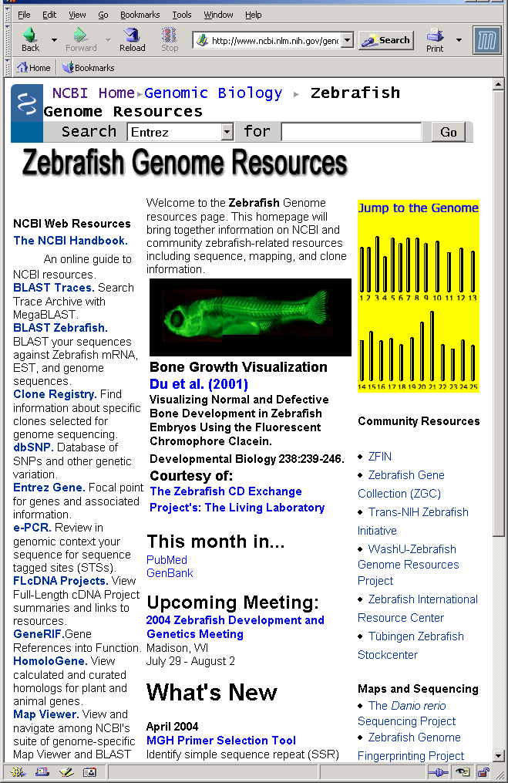

4. Danio rerio Taxonomy Page
Entrez’s Taxonomy page for Danio rerio (http://www.ncbi.nlm.nih.gov/Taxonomy/Browser/wwwtax.cgi?mode=Info&id=7955&lvl=3&srchmode=1) provides another entry point to zebrafish data at NCBI. From the Taxonomy home page (http://www.ncbi.nlm.nih.gov/entrez/query.fcgi?db=taxonomy), choose the Danio rerio (zebrafish) link to view the Danio rerio Taxonomy page. This page includes a table reporting the current number of zebrafish entries in each Entrez database. The number of entries is linked to the individual databases. Additionally, the Danio rerio Taxonomy page includes the list of centers submitting Trace Archive records. (Trace Archive: http://www.ncbi.nlm.nih.gov/Traces/trace.cgi?) For each type of Trace Archive record (Clone end, EST, Finishing, Shotgun, WGS, and ALL), view the number of records and follow links, by type, to the Trace Archive. The Danio rerio Taxonomy page also includes a list of links to external resources (LinkOuts).

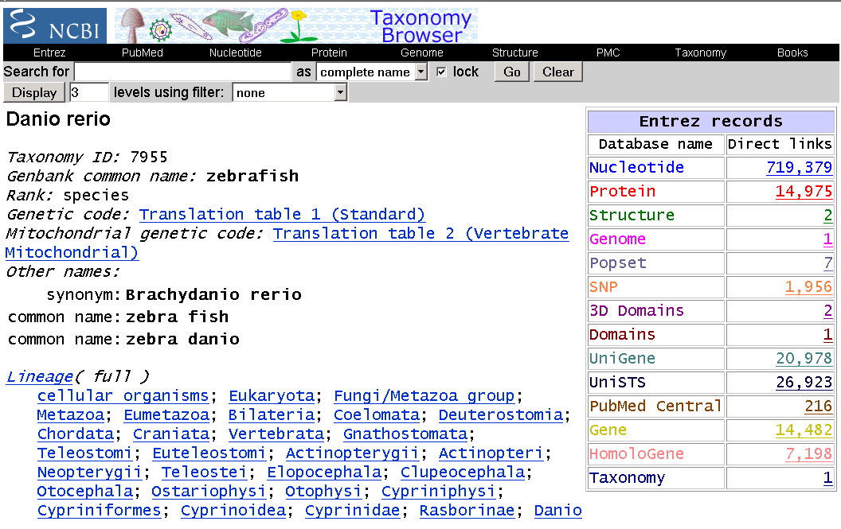

5. NCBI’s FTP resources
In addition to NCBI’s web resources, NCBI also provides unrestricted access to NCBI’s software and genome data. NCBI’s FTP home page: (http://www.ncbi.nlm.nih.gov/Ftp/index.html) or directly from NCBI’s ftp: ftp.ncbi.nih.gov.

6. NCBI’s Site Search
A site search (http://www.ncbi.nlm.nih.gov/entrez/query.fcgi?db=ncbisearch) of NCBI can be conducted either at NCBI’s home page by selecting ‘NCBI Web Site’ from the pull down menu in the top search bar found on most NCBI web pages. Queries submitted from the Entrez home page includes a search of NCBI’s web pages.

2. How do I find my gene ?

- How do I find my gene by searches based on text, sequence or map
position ?

Text searches submitted to the Entrez Gene database (http://www.ncbi.nlm.nih.gov/entrez/query.fcgi?db=gene) can include any gene attribute including: symbol, name, alias, identifier (e.g. ZFIN id, GeneID), accession, publication (PubMed ID), GO terms, linkage group or chromosome.

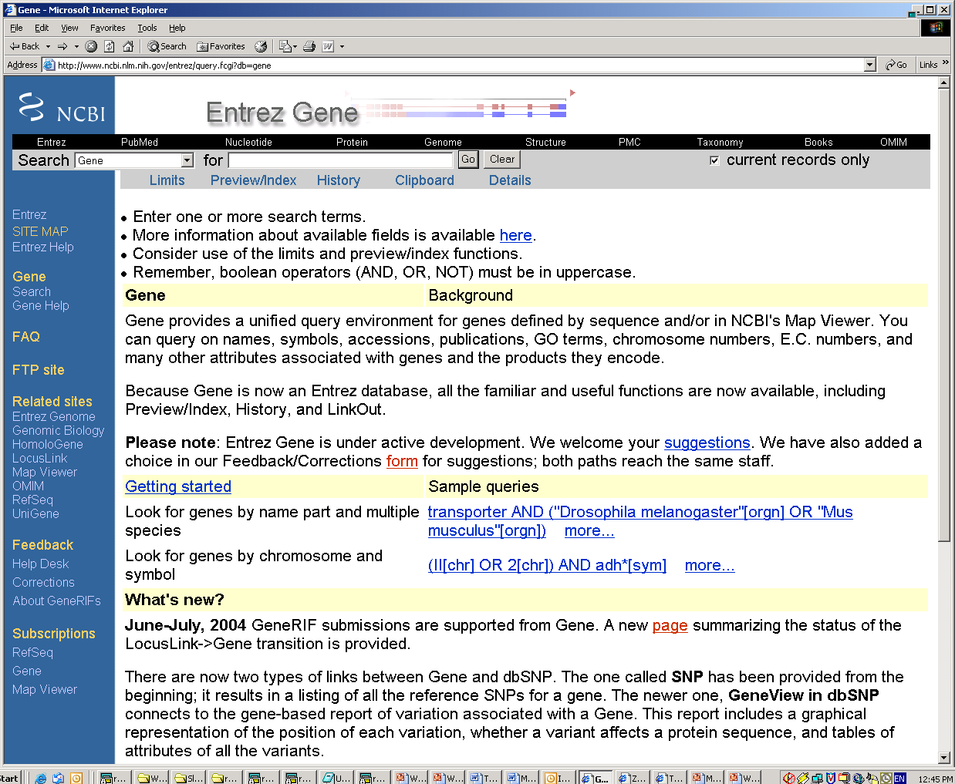

Search for a gene of interest by submitting a BLAST search by choosing the type of search from the BLAST home page (http://www.ncbi.nlm.nih.gov/BLAST).

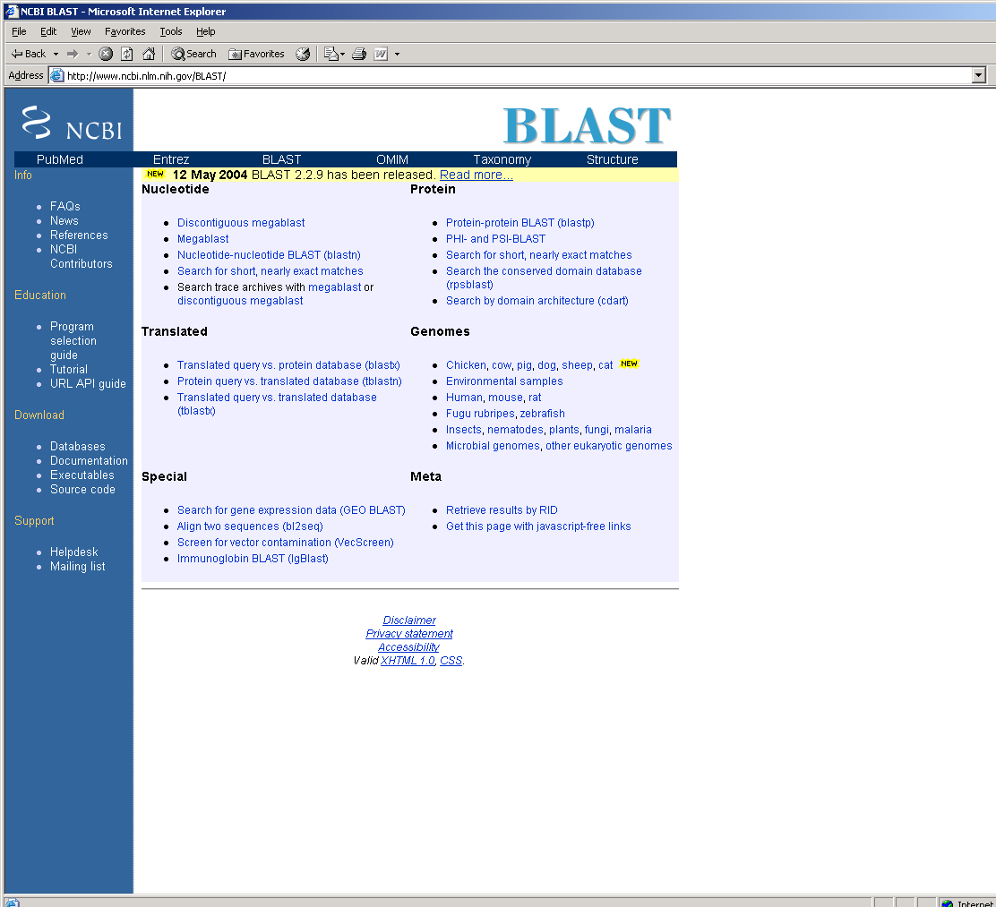

BLAST tools enable searches against nucleotide or protein databases, translational searches (protein vs. nucleotide), MegaBLAST comparisons, genome specific BLAST pages (including a zebrafish BLAST page: http://www.ncbi.nlm.nih.gov/genome/seq/DrBlast.html) and BLASTing of two nucleotide or protein sequences via bl2seq.

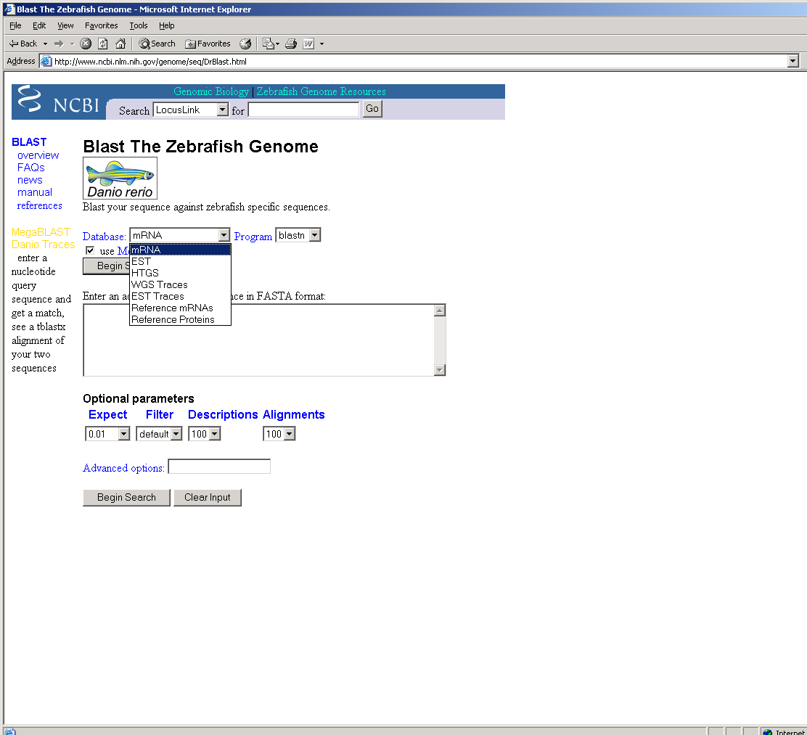
The “Options for advanced blasting” section on the BLAST query page allows searches for hits against two organisms with the “AND” option or to search for hits in either organism with the “OR” option such as: Xenopus tropicalis OR Takifugu rubripes.
Alternatively, view the pre-computed nucleotide and protein sequence comparisons available in NCBI’s HomoloGene
( http://www.ncbi.nlm.nih.gov/entrez/query.fcgi?db=homologene) and BLink (e.g.http://www.ncbi.nlm.nih.gov/sutils/blink.cgi?pid=42542497) resources.

Identify a gene of interest by it’s map position. Search by linkage group or chromosome in Entrez Gene or query map data by starting at NCBI’s Map Viewer home page (http://www.ncbi.nlm.nih.gov/mapview/) or the zebrafish genome view page (http://www.ncbi.nlm.nih.gov/mapview/map_search.cgi?taxid=7955 ).

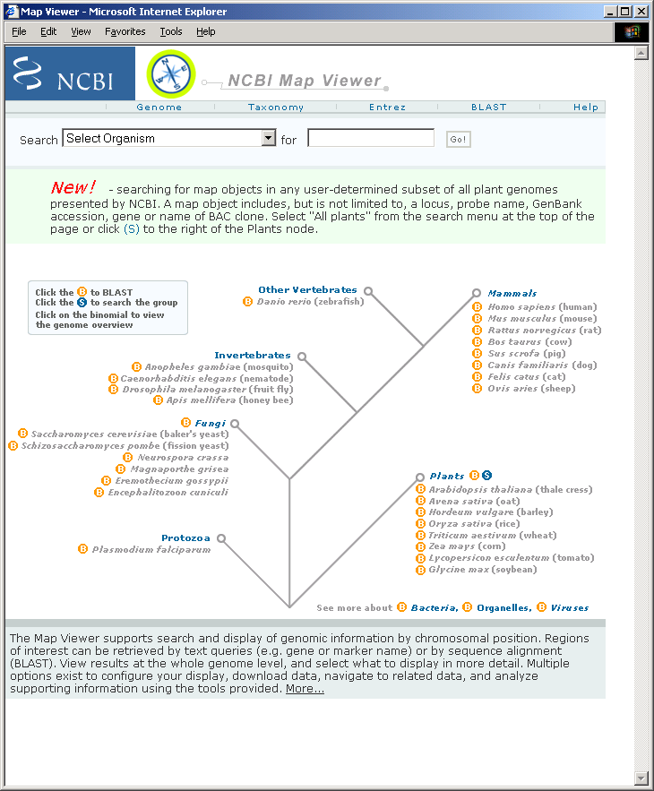
Search zebrafish map data at the Map Viewer home page by selecting an organism from the Search drop down menu and entering a gene symbol, accession or alias to the query bar at the top of the page. Other terms may be used for searching, depending on the data associated with each organism.
Following the link to any of the organism-specific genome view pages (from the Map Viewer home page), submit a search in the top menu bar or click on the “Advanced Search” button to further specify their query. For zebrafish, the search can be refined by linkage group, marker type (SNP or non-SNP) or
the map name.
Map data can also viewed by choosing any of the LG links in the “Jump to the Genome” figure on the Zebrafish Genome Resources page (http://www.ncbi.nlm.nih.gov/genome/guide/zebrafish). These links go directly to each linkage group in the zebrafish Map Viewer.

2. How do I find my gene when a text search does not work ?
One approach is to take advantage of the higher level of annotation available for other organisms to find a gene of interest. Although a gene may not yet be identified in one organism, it may be in another. Even though a gene of interest may not yet be identified, in zebrafish for example, mRNA or protein sequences representing that gene may be available either in the sequence databases (Entrez Nucleotide or Entrez Protein) or in an Entrez Gene record for an uncharacterized gene.
To begin, search Entrez Gene by the gene name or gene symbol of interest. If there is a matching Entrez Gene record, follow the links to related records provided in the Links pull-down menu to look for related mRNAs or proteins representing the zebrafish gene.
Following links to Homologene to view other highly related mRNAs and proteins.
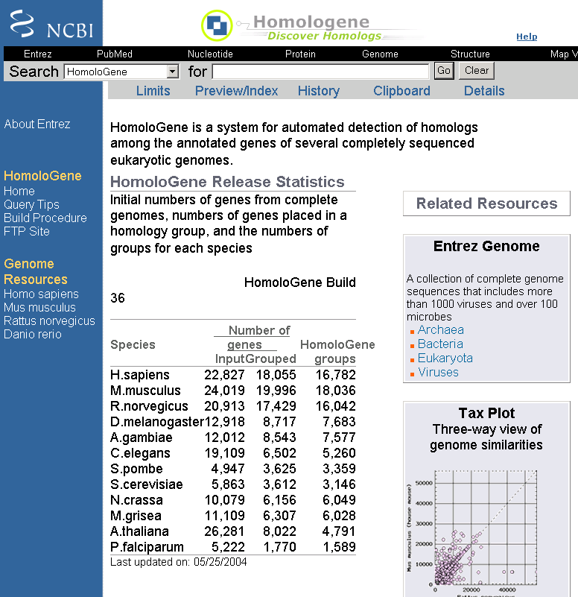
Each Homologene record also includes related UniGene clusters. Examine the sequences included in the UniGene cluster by following the link to the UniGene database. If an Entrez Gene record is associated with the UniGene cluster, a link to Gene will be provided in the UniGene Links menu.

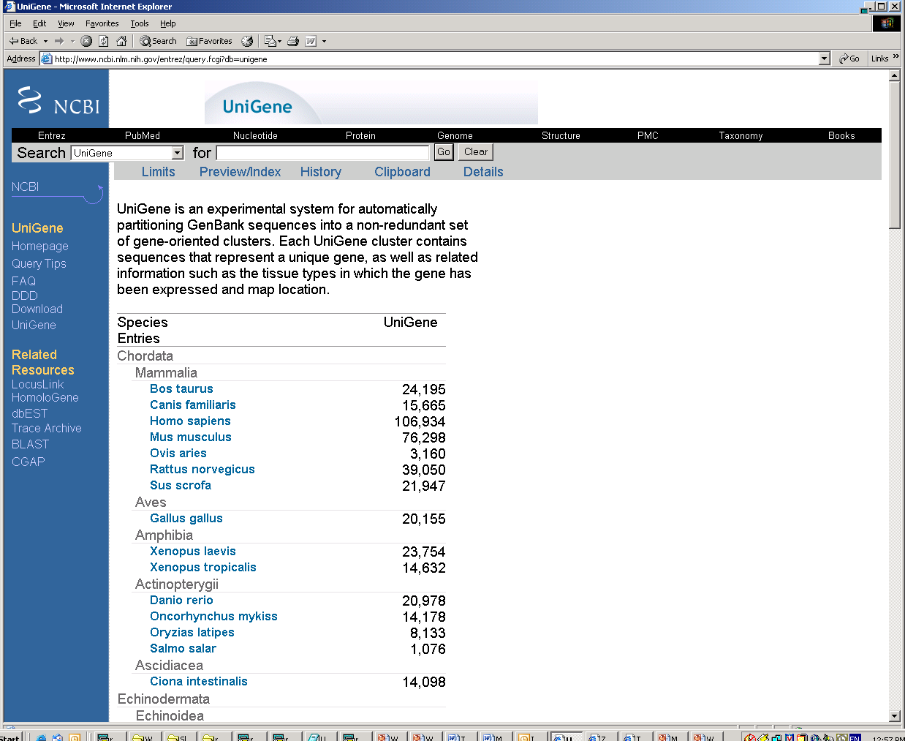
Alternatively, follow the Protein link to Entrez Protein to view related proteins by following the BLink (BLAST Link) associated with the Protein record. BLink provides a graphical display to view the pre-computed protein comparisons between the query protein and all other proteins in Entrez Protein. These results may identify a zebrafish protein that is highly similar to the query protein. Check the Links associated with the Entrez Protein record to determine if that protein is associated with an Entrez Gene record.

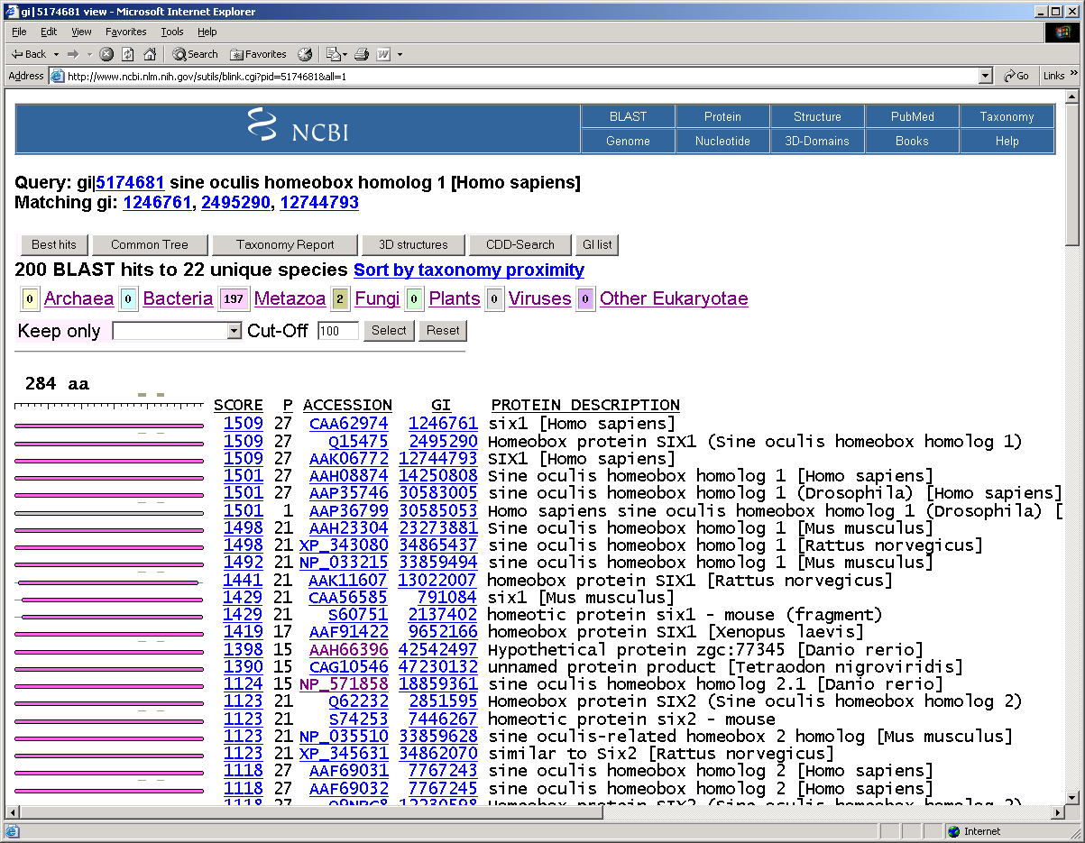

- How can I find the zebrafish homolog of a recently cloned mouse
gene?
If searches of the pre-computed comparisons in HomoloGene or BLink do not yield any likely candidates, another approach would be to submit a search of the mouse gene symbol to Entrez’s home page to determine if a similarly named zebrafish gene exists.
Alternatively, Homologene comparisons may have already identified a UniGene cluster containing ESTs or uncharacterized cDNAs that represent the zebrafish homolog. If a ZFIN marker or Entrez Gene record contains these uncharacterized sequences, a link to ZFIN or Entrez Gene will be at the top of the UniGene page.

3. How do I find gene-related information ?

1. What gene-related information is available in Entrez Gene ?

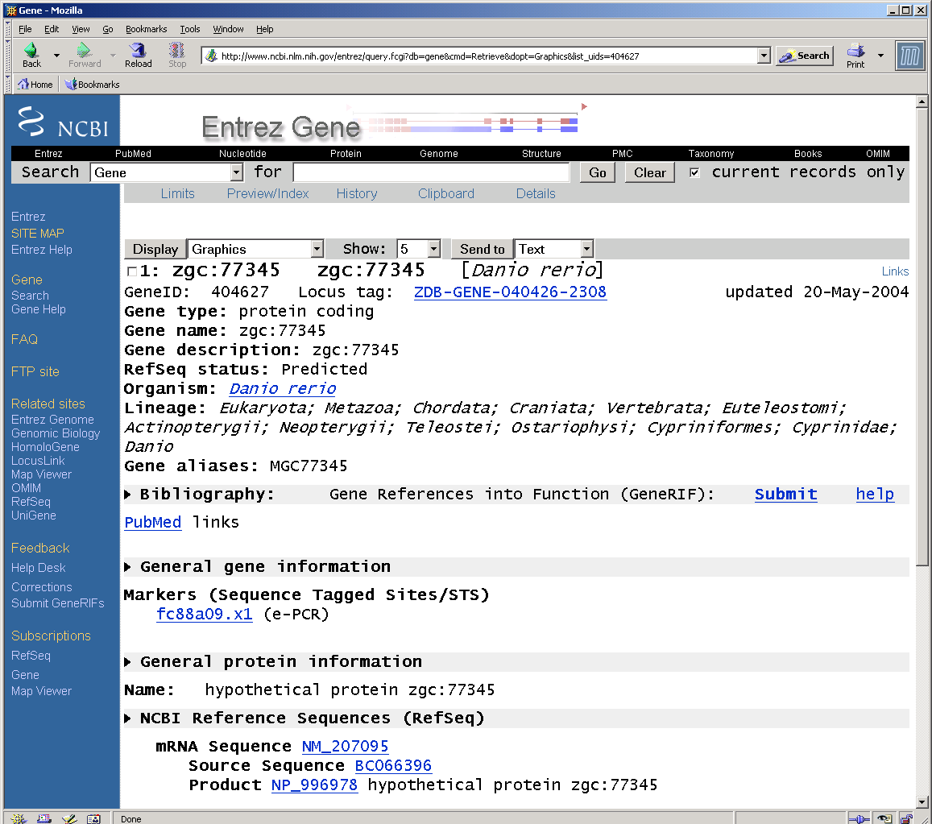

Entrez Gene records include gene symbols, gene names, links to external data providers (e.g. ZFIN, MGI, HGNC), aliases, related sequences (including RefSeqs (http://www.ncbi.nlm.nih.gov/R0fSeq/), map location, taxonomy information and links to publications (PubMed), marker information linked to UniSTS (http://www.ncbi.nlm.nih.gov/entrez/query.fcgi?db=unists). Links to other related resources are included at the bottom of the Entrez Gene page and in the Links pull-down menu.

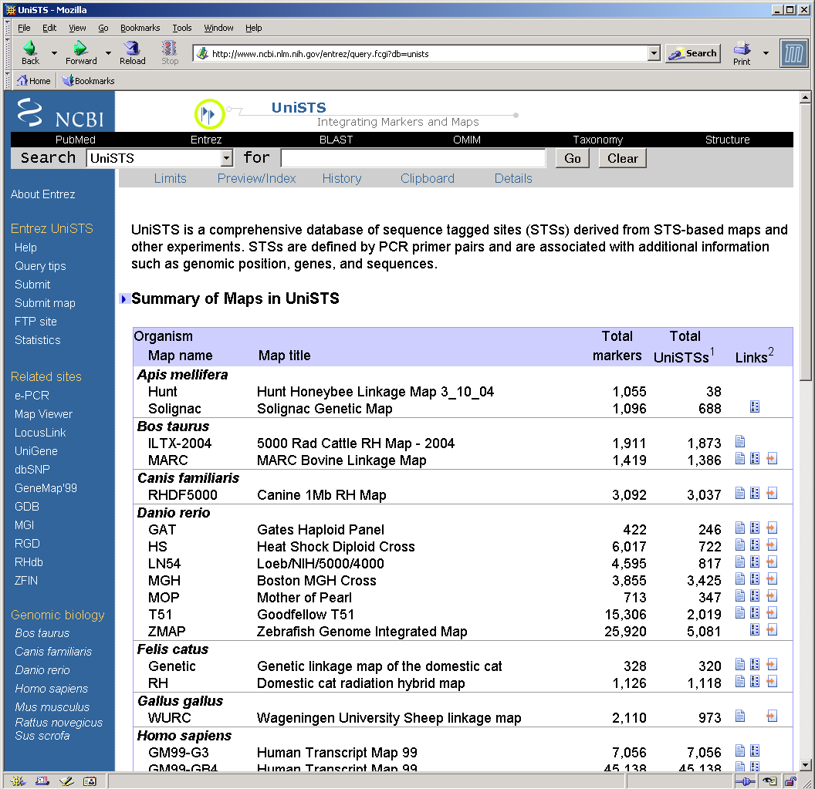

View suggested query options by clicking on the Limits tab at the top of the Entrez Gene page (http://www.ncbi.nlm.nih.gov/entrez/query.fcgi?CMD=Limits&DB=gene).
Subscriptions to announcement lists for changes to the RefSeq, Entrez Gene and Map Viewer projects are available. Links to the Subscription information pages are found at the bottom of the blue side bar in Entrez Gene.

RefSeq announce: http://www.ncbi.nlm.nih.gov/mailman/listinfo/refseq-announce
Gene announce: http://www.ncbi.nlm.nih.gov/mailman/listinfo/gene-announce
Map Viewer announce: http://www.ncbi.nlm.nih.gov/mailman/listinfo/mapview-announce

2. How do I identify a likely homolog for my gene ?

Highly related nucleotide and protein sequences representing putative homologs between multiple genomes are identified through computational analysis and presented in the Homologene database.

Submit a text based query to HomoloGene from the Homologene home page, (http://www.ncbi.nlm.nih.gov/entrez/query.fcgi?db=homologene), the Entrez home page or by choosing Homologene from any of the Search bars found at the top of most NCBI pages.

Links to Homologene are also provided in the drop down Links menu of the other Entrez databases including Entrez Gene, UniGene, Entrez Nucleotide, Entrez Protein, Taxonomy, GEO and PubMed.

3. Is my gene annotated on the zebrafish whole genome assembly ?
As NCBI has done for projects, the zebrafish genome sequence will become available in NCBI’s Map Viewer when the zebrafish assembly sequences are accessioned in GenBank/DDBJ/EMBL. At that time, the zebrafish genome sequence will be added to the set of organisms included in NCBI’s genome pipeline.

4. What map data is available for zebrafish at NCBI ?
The Zebrafish Map Viewer (http://www.ncbi.nlm.nih.gov/mapview/maps.cgi?taxid=7955 ) at NCBI includes the LN54 and T51 radiation hybrid maps, the genetic maps (MGH, HS, MOP, GAT), the Zebrafish Genome Integrated Map (ZMAP), and the SNP (Single Nucleotide Polymorphism) variation map.

5. What other genes, ESTs, STS markers or BACs are annotated near

my gene ?
Search NCBI’s Map Viewer to identify candidate genes or markers in a region of interest. View marker placement on the genetic and radiation hybrid maps by submitting a text query.
Identify a BAC clone that contains a marker or gene of interest or that is located in a specific genomic region by submitting a search to NCBI’s Clone Finder (http://www.ncbi.nlm.nih.gov/genome/clone/clonefinder/CloneFinder.html). At this time, Clone Finder searches are limited to mouse.

6. How can I identify BAC and PAC clones that would aid me in mapping
genomic clones to chromosomes?
Find all mapped PACs or BAC_ENDs in NCBI’s Map Viewer by submitting a search based on the naming schema for zebrafish PACs and BACs. Serach PACs with busm1* and BAC_ENDs with bz*.
NCBI’s clone registry of genomic clones (http://www.ncbi.nlm.nih.gov/genome//clone/) can be queried to view sequence, library, map, and distributor information. View library information for each organism in the Library Browser (http://www.ncbi.nlm.nih.gov/genome//clone/clbrowse.cgi) and links to clone distributors on the Distributors page (http://www.ncbi.nlm.nih.gov/genome//clone/distributors.html). Follow the pre-computed links associated with the nucleotide accession found on the Clone page to mine the data stored in other NCBI databases including UniSTS, UniGene, Map Viewer (for example: http://www.ncbi.nlm.nih.gov/genome/clone/clname.cgi?stype=Id&list=1145501&TransHist=0).

7. How do I find all ZGC clones ?
Download the list of full-length clones (http://zgc.nci.nih.gov ) by clicking on the Full Text button to view the Full length clone list or FASTA sequences (ftp://ftp1.nci.nih.gov/pub/MGC/fasta/) from the ZGC web site (http://zgc.nci.nih.gov/).
Another option is to submit a search against the Entrez Nucleotide database: “Danio rerio [organism] AND biomol_mrna [properties] AND MGC [keyword]” (
http://www.ncbi.nlm.nih.gov/entrez/query.fcgi?CMD=search&db=Nucleotide&orig_db=Nucleotide&Nucleotidefilters=truen&term=Danio+AND+rerio+AND+MGC[KYWD]).
A short-cut has also been provided for this query on the Zebrafish Genome Reources page (http://www.ncbi.nlm.nih.gov/genome//guide/zebrafish/).

8. How do I find library information for a ZGC clone ?
From the ZGC home page (http://zgc.nci.nih.gov/), choose the Table or Full Text option in the ZGC Full-length Clone Information table to view the zebrafish library list choose either the Table or Full text button for the ZGC library list on the ZGC home page (http://zgc.nci.nih.gov/) .
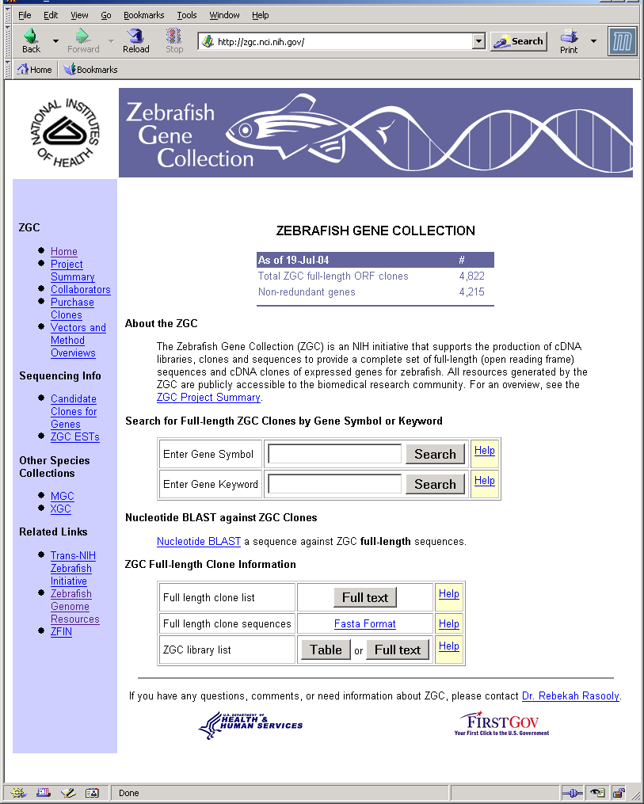

9. Are there any SNPs associated with my gene?
Query NCBI’s Single Nucleotide Polymorphism (SNP) database
(http://www.ncbi.nlm.nih.gov/entrez/query.fcgi?db=snp) (e.g. SNP identifier, rs372494: http://www.ncbi.nlm.nih.gov/SNP/snp_ref.cgi?rs=3729494 ).
Identify all zebrafish SNPs known to be associated with an Entrez Gene record, by the submitting the query: snp_gene[filter] AND “Danio rerio”[organism] to dbSNP.
Identify all mapped SNPs in NCBI’s by submitting the query: zsnp* to the zebrafish genome view page.

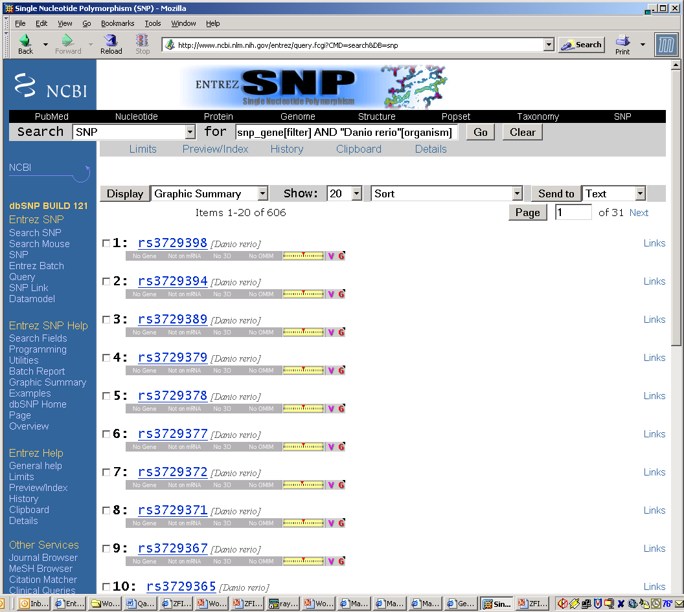

10. What Entrez Gene records have links to the ZFIN’s expression data ?

Entrez Gene records contain links to the Gene Expression Database (GXD) at ZFIN in the drop down ‘Links’ menu in the upper right corner of the Entrez Gene page, for example: http://zfin.org/cgi-bin/webdriver?MIval=aa-xpatview.apg&OID=ZDB-XPAT-020319-2.

Retrieve the list of all Entrez Generecords containing a GXD link with the query: “Danio rerio”[organism] AND ZFIN[Text Word] AND Expression[Text Word].

11. What resources are available to find expression data ?

Expression-related records in any of the Entrez databases can be found by submitting a query from the Entrez home page

( http://www.ncbi.nlm.nih.gov/Entrez/index.html) (e.g. notochord AND development AND "Danio rerio"[organism].
Additional expression-related resources include Gene Expression Omnibus (GEO, http://www.ncbi.nlm.nih.gov/geo/) to view GEO datasets and profiles. The GEO database can be queried by gene name, organism or tissue, and provide an additional source of functional information for multiple organisms. UniGene’s DDD (Digital Differential Display, ( http://www.ncbi.nlm.nih.gov/UniGene/info_ddd.html ) provides gene expression fingerprints for cancer cells and their normal counterparts and UniGene’s Library Browser (http://www.ncbi.nlm.nih.gov/UniGene/lbrowse2.cgi?TAXID=7955) includes the number of sequences and clusters associated with each library and detailed library information.

12. What are other possible ways to infer function for my gene?
Entrez Gene records may include submissions to the Gene References into Function (GeneRIF) database. GeneRIF submissions include short descriptions of a gene’s function and the associated publication. Information on the GeneRIF project can be found at: http://www.ncbi.nlm.nih.gov/projects/GeneRIF/GeneRIFhelp.html.
GeneRIFs can be submitted my the research community from any Entrez Gene page by clicking on the Submit link found in the Bibliography gray bar on the Entrez Gene details page (e.g. http://www.ncbi.nlm.nih.gov/entrez/query.fcgi?db=gene&cmd=Retrieve&dopt=Graphics&list_uids=30483).
Conserved domains may also provide functional information. The Conserved Domain database (CDD) can be queried by a text search (e.g. pham00757, smart00261, cd00064 or Furin-like) from the Entrez home page (http://www.ncbi.nlm.nih.gov/gquery/gquery.fcgi) or directly from the CDD home page (http://www.ncbi.nlm.nih.gov/entrez/query.fcgi?db=cdd) to domain details and an alignment of proteins containing that domain.
Conserved domains can be identified by submitting a protein sequence (accession, Gi or Sequence in FASTA format) to CDD’s CD-Search form (http://www.ncbi.nlm.nih.gov/Structure/cdd/wrpsb.cgi).

Functional information can also be inferred from homologous sequences identified in NCBI’s Homologene database (http://www.ncbi.nlm.nih.gov/Structure/cdd/wrpsb.cgi). Submitting the query “Danio rerio”[organism] against the Homologene database identifies all Homologene sets that contain a related zebrafish UniGene cluster.

13. How do I find cDNAs that have been derived from a specific library?
One approach would be to go to the Zebrafish Gene Collection home page (http://zgc.nci.nih.gov/), under the heading “ZGC Full-length Clone Information” select the “Table” or “Full Text” buttons to view the ZGC library list details (Library, Tissue, Vector or number of Clones). From the ZGC home page (http://zgc.nci.nih.gov), navigate to the ZGC library list page, choose the library name to go to the Library Info Page or the Clones link to view the list of IMAGE ids, GenBank accessions, symbols and the GenBank definition that correspond to each sequenced clone.
Another approach would be to begin in UniGene, navigate to the details for each EST by clicking on the EST accession number to view the Sequence Information page. View the Library Description, the Sequence Submitters, the number of UniGene clusters containing members of the library or the number of sequences in each cluster by clicking on the linked Library ID. The list of cDNAs for each cluster can be seen by then clicking on the UniGene cluster number.
Example: zebrafish shield stage whole embryo (dbEST Library ID.9774)
http://www.ncbi.nlm.nih.gov/UniGene/library.cgi?ORG=Dr&LID=9774 .

14. Where can I find a list of all Entrez records for Danio rerio ?
NCBI’s Taxonomy database includes an index of the records included in all Entrez databases for each organism represented by at least one sequence in either the Entrez Nucleotide or the Entrez Protein database.
From the Taxonomy home page (http://www.ncbi.nlm.nih.gov/entrez/query.fcgi?db=Taxonomy)
navigate to the zebrafish-specific page (http://www.ncbi.nlm.nih.gov/Taxonomy/Browser/wwwtax.cgi?mode=Info&id=7955&lvl=3&srchmode=1) by clicking on the Danio rerio (zebrafish) link.
The Taxonomy database page also includes links to each linkage group in Map Viewer and a table of Trace (raw DNA single-pass reads) record counts from each sequencing center, divided by the type of Trace (for example: CLONEEND, EST, FINISHING, SHOTGUN, WGS or ALL).
Further down the Taxonomy database page links are provided to external resources pertinent to that organism. These links are called LinkOuts. Detailed information on creating LinkOuts at NCBI can be found on the LinkOut home page (http://www.ncbi.nlm.nih.gov/entrez/linkout/).
Near the bottom of the Taxonomy database page, the “Show organism modifiers” link provide additional links to subsets of nucleotide (blue number) and protein (red number) sequences based on their strain names, isolate name, or specimen-voucher name. For example, clicking on the blue SJD link returns the set of nucleotide records sequenced from the SJD strain (http://www.ncbi.nlm.nih.gov/entrez/query.fcgi?db=nucleotide&cmd=Search&dopt=DocSum&term=txid7955[orgn]+AND+strain+SJD[tw]).

- Where can I ask questions or submit suggestions ?

NCBI welcomes questions and suggestions.
A link to contact information is provided at the bottom of the blue side bar on the NCBI home page (http://www.ncbi.nlm.nih.gov/About/glance/contact_info.html).
Submit questions directly to NCBI’s Help Desk at info@ncbi.nlm.nih.gov.
Questions or suggestions for NCBI’s RefSeq, Entrez Gene or OMIM databases can also be submitted via the Corrections form (http://www.ncbi.nlm.nih.gov/RefSeq/update.cgi). A link to this form is provided in the blue side bar of the Entrez Gene pages.

